Developing an Instrument to Measure Food Insecurity

among College Students

A Dissertation Presented for the
Doctor of Philosophy
Degree
The University of Tennessee, Knoxville

Hannah Emily Wright
August 2022

Copyright © 2022 by Hannah Emily Wright
All rights reserved.

Dedication

This body of work is dedicated to my late grandmother, Judy McClendon Wright, an educator, lover of all people, and advocate for every student she taught. Growing up, I would stay in her classroom before and after school and saw first-hand her dedication to each student and the field of education. She taught me early in life that everyone, every student has their own potential, deserved respect, and a chance to succeed. She was diagnosed with cancer right as I started the PhD program but even through her sickness, she continued to encourage me and push me forward. I wish she could be here today to celebrate this accomplishment with me, but I have no doubt she is smiling down from Heaven today.

Acknowledgements

There have been quite a number of people who have supported, guided, and encouraged me throughout this educational journey that I would like to acknowledge.

First and foremost, my parents Tim and Connie, who have been there to support me, encourage me, love me unconditionally, and be my best friends. The sacrifices you both have made for me all my life so I could succeed could never be repaid. You both are the hardest working people I know. I thank God every day for making me your child. Our relationship is special, and I love you both unconditionally. This dissertation and degree is as much yours as it is mine. Thank you…

The mentors teachers who made up my doctoral committee:
- Dr. Lisa Driscoll, my co-chair and mentor, I immensely thank you for your many hours of guidance, feedback, patience, encouragement, late nights and early mornings. Thank you for being there for me not only with my dissertation but in other areas of my personal life. I truly believe God puts people in your life at the right place and the right time and I am thankful our paths crossed. I only hope that I can be half the educator and mentor to students one day. You inspire me.
- Dr. Pamela Angelle, my committee co-chair. Dr. Angelle, thank you for taking a chance on me as I entered the PhD program. She accepted me for the quirky person with the agriculture background guided me, inspired me, directed me, and taught me to live with purpose.
- Dr. David Folz, a true mentor, who has encouraged and supported me in every decision I have made since I was in the Legislative intern program. You believe in your students and inspire each one to change the world.
- Dr. Terry Ishitani, thank you for your patience and guidance as I navigated this process. Through the multiple emails and calls, thank you for never giving up on me.
My grandparents, Thomas and Dorothy, for always being there to support me. From cow shows to speeches, my Papaw’s face was the first I looked for in the crowd and my first call after a big accomplishment. I love you both.

My “Sunday Dinner Crew” family… Deanna, James, Barbara, Ashley, Chris, Eli, Audrey, and Papaw Earl… thank you for your support, smiles, and love.

John Mark, Maya, Michael, and Jada… thank you for friendship and encouragement throughout this endeavor. You each are very special to me.

Dean Beyl and Drs. Stier and Lamons… thank you for your support in this research to survey the Herbert College of Agriculture.
Abstract

The purpose of this research was to develop a reliable and valid survey instrument to measure the prevalence and degree of food insecurity among college students with respect to their demographic characteristics. This survey instrument was piloted to a sample of college students at the University of Tennessee, Knoxville.
The College Student Food Insecurity (CSFI) survey instrument was designed using a Likert format with 5 levels of agreement. Items for the CSFI were created through brainstorming, a review of the USDA Food Insecurity Modules, and a review of the literature with a focus on three concepts: access or awareness of food insecurity, behaviors of food insecurity, and support or resources for food insecurity. Content validation was assessed via a panel of experts.
An exploratory factor analysis was performed to identify factors that comprised the construct of food insecurity in college students. The construct of food insecurity loaded on four components: behaviors of food insecurity, access to food options, support and resources for food insecure students, and food purchasing behaviors. The internal consistency for each factor was acceptable ranging from 0.35 to 0.83. Test-retest reliability was also completed with 20 students (p = 0.043, r = 0.74). The survey was distilled into 18 items and was emailed to 1,414 students with a return of 14.7%.
A binary logistic regression was performed using the survey data to determine the food insecurity probability unique to the individual students and whether there existed significant differences between levels of demographic variables, chi-square tests were performed to assess the relationships among the categorical demographic variables with food insecurity status. Being a male student, working 1 or more part-time job(s), and receiving a Pell grant were positively associated with being food insecure (p < 0.05). These findings may be limited by an over-representation of females in the sample and a positive bias that food insecure students would be more likely to complete the survey than others.
From a higher education administrative view, both academic professionals can assist in accelerating a growing body of support resources and improved environment for food insecurity college students in the United States.

Table of Contents
CHAPTER 1 INTRODUCTION TO THE STUDY 1
Measuring Food Insecurity 3
Statement of the Problem 5
Background 6
Lack of Direct Food Insecurity Measurements for College Students 6
Supplemental Nutritional Assistance Program (SNAP) 7
Federal Pell Grants 8
Conceptual Model 8
Purpose Statement 9
Research Questions 10
Research Question 1 (RQ1): 10
Research Question 2 (RQ2): 10
Research Question 3 (RQ3): 10
Significance of the Study 10
Definitions 12
Methodology 14
Organization of the Study 14
CHAPTER 2 REVIEW OF THE LITERATURE 16
Defining Food Insecurity in the United States 16
Prevalence of Food Insecurity in the United States 17
Prevalence of Food Insecurity among College Students in the United States 17
Coping Strategies Related to College Students with Food Insecurity 22
Health Outcomes of College Students with Food Insecurity 23
Quality of Studies on Food Insecurity in College Students 23
Low Generalizability of Study Findings 24
Different Measurements of Food Insecurity 24
Risk Factors Associated with Food Insecure Students 25
Behaviors of Students with Food Insecurity 27
Classifications of Food Insecurity 28
Lack of Direct Food Insecurity Measurement for College Students 28
U.S. Household Food Security Survey Module 29
U.S. Adult Food Security Survey Module 29
Six-Item Short Form of the Food Security Survey Module 30
Current Population Survey 30
Current and Proposed Policies and Programs Addressing Food Insecurity 31
Supplemental Nutrition Assistance Program (SNAP) for College Students 32
Summary 34
CHAPTER 3 METHODOLOGY 38
Organization of Chapter 3 39
Development of College Student Food Insecurity Instrument 39
Creating the Initial Instrument 39
Instrument Format 39
Awareness of Food Insecurity Scale Items 40
Behaviors of Food Insecurity Scale Items 41
Support or Resources for Food Insecurity Scale Items 42
Application of the Risk and Protective Model 42
Assessing Reliability and Validity 44
Validity 44
Reliability 46
Part II: College Student Food Insecurity (CSFI) Survey Exploratory Study 47
Administration and Statistical Analysis 47
Recruitment of Participants 50
Mode of Administration 50
Exploratory Factor Analysis Results 51
Unrotated Solution 52
Rotation Results 52
Binary Logistic Regression 60
Data Preparation for Binary Logistic Regression 60
Creation of the Composite Score for Food Security 62
Creation of the Dummy Variables 63
Other Considerations Important to the Binary Logistic Regression 67
Summary 68
CHAPTER 4 RESULTS 70
Descriptive Statistics of the Student Sample 70
Research Question 1: 73
Research Question 2: 73
Binary Logistic Regression 73
Research Question 3: 76
Assessing the Strength of the Relationship Between Independent Variables 78
Summary 80
CHAPTER 5 SUMMARY AND DISCUSSION 84
Food Insecure Findings Confirmed by Other Studies 85
Inconclusive Findings for Food Insecure 87
Design and Implementation of the College Student Food Insecurity (CSFI) Survey 88
Implications for Colleges and Universities 100
Future Directions for Research 102
Future Action Steps for the Herbert College of Agriculture 104
Conclusion 106
APPENDIX A 125
APPENDIX B 130
APPENDIX C 140
APPENDIX D 141
VITA 143
List of Tables

Table 1. USDA Categories, Sub-Categories, and Definitions of Food Security and Insecurity...33
Table 2: 2022 SNAP Eligibility Requirement ……………………………………………………...35
Table 3:2022 SNAP Income Requirements………………………………………………………...36
Table 4:2022 SNAP Benefit Amounts……………………………………………………………...37
Table 5: Comparison of Original and Proposed Rating Scale Survey Items……...…………………43
Table 6: Applying Risk and Protective Factors Framework to Survey Questions…………………...48
Table 7: Summary of Direct Oblimin Rotation for Factor 1……………………………………...…55
Table 8: Summary of Direct Oblimin Rotation for Factor 2 ………………………………………..56
Table 9: Summary of Direct Oblimin Rotation for Factor 3 ………………………………………..57
Table 10:Summary of Direct Oblimin Rotation for Factor 4 ……………………………………….58
Table 11: Descriptive Statistics of the Sample ………………………………………………….......71
Table 12: Alpha Coefficients for Each Factor ……………………………………………………...73
Table 13:Binary Logistic Regression Results …………………………………………………...….76
Table 14:Food Security Composite Score ………………………………………………………….80
Table 15: Response Rate to Question Two …………………………………………………………81
Table 16: Chi-Square Results …………………………………………………………………...….82

List of Figures

Figure 1. Scree Plot…………………………………………………………………….…... … 55

Figure 2. Map of the University of Tennessee, Knoxville Eating Locations………………….102

CHAPTER 1
INTRODUCTION TO THE STUDY

Food insecurity (FI) is a serious and pervasive problem in the United States today despite the successes of the nation’s food assistance programs. According to a report by the United States Department of Agriculture (USDA), out of a total of 130 million households, 13.8 million households (or 38.3 million persons or 11.8% of the population) were food insecure at one time during 2020 (Coleman-Jensen et al., 2020). These households reported having difficulty supplying adequate amounts of food for their household members due to a deficit in financial resources (Coleman-Jensen, et al., 2020). Since 1998, when food insecurity was first measured on a state and national basis by the USDA, household FI numbers have grown steadily (Coleman-Jensen et al., 2020).
A common misconception is that persons who can afford to go to college do not have the problem of food insecurity. Policymakers often assume students are adequately supported by parents or guardians (Wolfson et al., 2021). The facts, however, contradict this belief. Numerous studies (El Zein et al., 2019; Goldrick-Rab et al., 2018; McArthur et al., 2018; McCoy et al., 2022; Mialiki et al., 2021; Soldavini et al., 2021), reports (Cameron et al., 2021; Freudenberg et al., 2019; Larin, 2018) and newspaper articles or newsletters (Dewey, 2018; Mattoon, 2021) have chronicled the growing concern for U.S. college students and food insecurity nationally. A recent scoping review using a weighted approach to estimate food insecurity prevalence among college students in the U.S. found that food insecurity was between 31% (12 months) and 47% (9 months) depending on the length of the period surveyed (Nikolaus et al., 2020). These food insecurity rates are greater than the U.S. population average of 11.8%.
People attending postsecondary institutions in 2021 are more diverse and possess intersectionality along with multiple characteristics including age, marital status, dependents in the household, race-ethnicity, financial independence, and more recently, COVID-19. Food insecurity affects students from different backgrounds and situations. In some cases, food insecurity affects students who become financially independent from their parent or guardian households either when they start college or soon thereafter (Goldrick-Rab et al., 2018). Other studies have found that food insecurity was apparent among students who were independent financially, have dependents, younger, and from minorities based on race and ethnicity (Coffino et al., 2021; Ellison et al., 2021; El Zein et al., 2019; McArthur et al., 2018; Patton-Lopez et al., 2014; Thorman et al., 2021). In the last decade, the demographic traits of “traditional” college students have changed from the typical dependent student between the ages of 17 and 24, attending four-year colleges and living on-campus to those who are identified as “post-traditional.” “Post-traditional” students comprise a varied category of full-time employees, low-income students, adult learners, commuter students, and working parents (The Postsecondary National Policy Institute, 2021). Based on 2021 data, 80% of independent students are enrolled part-time; 43% have dependent children and 28% are single parents; and 41% work full-time (National Center for Education Statistics, 2021a).
In addition, since the COVID-19 pandemic ensued, peer-reviewed studies and preprints have documented increases in college student food insecurity at institutions (McCoy et al., 2022; Mialiki et al., 2021; Soldavini et al., 2021;), but not by state or nationally. According to Owens et al. (2020), 38.0% of students noticed differences in their food security during the COVID-19 pandemic. One of the largest determinants of food insecurity found in college students were changes in housing situations. Approximately 25% of students claimed to have their housing situations directly affected by the COVID-19 pandemic (Mialiki et al., 2021).
The rising costs of inflation continues to exacerbate the issue of food insecurity across the globe. Inflations rates are the highest the United States have experienced since the early 1980s. The annual inflation rate for the United States was 8.5% in March 2022. This results in higher food prices as the increased costs of inputs such as fertilizer and labor to agriculture production become apparent. This results in a trickled down effect to the ending consumer.
However, even before the pandemic and rising inflation rates, college students had increased rates of food insecurity (Owens et al., 2020). Food insecurity is becoming an undeniable issue for higher education. The prevalence of food insecurity is not consistent across institutions of higher education. Also, developing a consensus on the definition and measurement tools for food insecurity in higher education continues to be an obstacle.

Measuring Food Insecurity
To date measuring food insecurity among college students has been confined to institutional, regional, statewide, and as a part of collecting national data on financial aid recipients (Burns et al., 2021). However, there are no known national representative prevalence and degree estimates of food insecurity among college students that are done annually (Laska et al., 2020; Zein et al., 2019). This study employs a survey instrument designed to capture aspects of college student food insecurity through access, availability, awareness, behaviors, and resources.
Food insecurity is complex and multidimensional that presents itself differently according to income, race-ethnicity, age, and geographical location within each of its four stages. Of most concern are individuals considered low or very low for food security based upon their responses to a monthly survey distributed to their households. Coleman- Jensen et al. (2021) defined food insecurity as the “inability to acquire sufficient or appropriate food in a socially acceptable manner.”
The measurement of food insecurity has undergone several revisions and extensions. A Rasch measurement scale has been employed by the U.S. Census Bureau each year since 1995. The unit of analysis is the household. The scale has not been modified for specific individual use. The USDA core module queries a reference person on behalf of all household members regarding the household composition (adult, elderly adult, and children). A benefit of having a single informant for each household is efficient because within the household food is shared communally. However, a single informant survey process could be a disadvantage because it assumes each member is affected similarly by the food insecurity within that household (Coleman-Jensen et al., 2020). For example, some household units may include adults who are enrolled in postsecondary education and may be away for periods of time or need to take meals outside the household. Thus, if these adults were food insecure, it might not be recorded depending upon whether that individual was the reference person completing the survey.
While there are a growing number of studies and research regarding food insecurity among college students, these studies do not use a consistent measurement instrument to gauge the prevalence on a national basis. Furthermore, according to Bruening et al. (2017) the prevalence of food insecurity among college students is 33% in the non-peer reviewed literature and 42% in peer-reviewed literature. As such there is a need for a valid and reliable scale for the measurement of food insecurity of college students that can be used on the national level.

Statement of the Problem
The prevalence and degree of food insecurity in college students needs to be determined nationally. Currently, the unit of analysis for food insecurity is household. The present national survey does not identify college students within the adult category.
Currently, the USDA Household Food Security Survey Module (HFSSM) is comprised of responses to 18-items that are used to determine a composite score that ranges from 0 to 18 (0 indicates high food security and 18 indicates very low food security). The HFSSM is a household measure in it evaluates the food security status of adults and children as one unit within a household. It does not determine the food security status of each individual member. The survey does not identify the age of household members, the income of the household as a whole or any one of its members, number of dependents, or whether any household members attend an institution of higher education. Therefore, because the survey cannot identify the food security status of a household member who may be in college, there is a desire for a reliable and valid survey instrument to determine this status. Consequently, households are not the appropriate unit of analysis to determine whether individual students may experience food insecurity. Individual data also might reveal core characteristics such as income level, work status. Data on these measures might provide insight about the causal direction of these variables.
This justifies the development of a nationally reliable and valid quantitative instrument to measure the prevalence and degree of food insecurity among college students to accurately inform policies and programs to address this complex issue. Based on an exploration of the literature for existing research, there is not a valid and reliable instrument that determines and investigates the underlying behavioral dimensions of food insecurity among college students. Secondarily, this research examines the prevalence of food insecurity among students enrolled at the University of Tennessee, Knoxville, Herbert College of Agriculture.
There must be a thorough and methodical instrument developed with a specified purpose in mind. Otherwise, there will be a myriad of different instruments that will generate outcomes that are not comparable with each other. The development of an instrument that is specific in its intent to measure the food insecurity among college students is necessary as it informs policies and programs on the individual campus, state, and federal levels.

Background

Lack of Direct Food Insecurity Measurements for College Students
Well-founded measurement tools are essential from scientific and policy development angles. There is a need for a logical and commensurate measurement instrument to be used to gauge college student food insecurity. Not only from an academic perspective, but to provide facts and information in policy design and implementation. The systematic food insecurity measurement informs policy at all levels from university policies to the federal level.
Food insecurity data are collected annually by the Current Population Survey Food Security Supplement (CPS-FSS). USDA has established surveys of different lengths of 6, 10, and 18 questions (See Appendix A). However, there is not a scale that measures the prevalence and degree of college student food insecurity. Students enrolled in higher education have to rely on legislative attempts, state policies, grants, scholarships, food banks, personal loans, extracurricular activities where food is available, and friends to help fund nutritional needs.

Supplemental Nutritional Assistance Program (SNAP)
The Supplement Nutritional Assistance Program (SNAP), formally known as food stamps, is the federal food aid program. Based on 2018 estimates, the U.S. Government Accountability Office (GAO) found that roughly 7.3 million U.S. college students reported incomes levels that qualified them for SNAP benefits, but only 2.26 million or approximately 31% were enrolled in the program (Larin, 2018).
Under SNAP eligibility requirements (in effect before January 2021) students enrolled part-time (less than 50% of time) in a postsecondary institution were ineligible for SNAP benefits unless they met specific exemptions to this rule. For example, enrolled students are employed 20 hours or less per week could have an exemption from the eligibility criteria and receive SNAP benefits. On December 27, 2020, President Trump signed the Consolidated Appropriations Act of 2021 (Pub. L. 116-260) into law which temporarily expanded SNAP eligibility to include students who met one of the following:
- Are eligible to participate in state or federally financed work-study during the regular academic year, as determined by the institution of higher education; or
- Have an expected family contribution (EFC) of 0 in the current academic year. This includes students eligible for a maximum Pell Grant. (P.L. 116-260 §§(B)(a)(ii))
Based on policy estimates using national survey data, approximately 2.5 million undergraduates and almost 500,000 graduate students who could not previously qualify for SNAP are now eligible with the Consolidation Appropriations Act of 2021 (Granville, 2021).

Federal Pell Grants
The federal Pell grants provide funding opportunities for over 10 million low-income students (Protopsaltis & Parrot, 2017). Pell awards are contingent on a student’s enrollment status, length of an academic program, the cost of attendance, and Expected Family Contribution (EFC) (Protopsaltis & Parrot, 2017). The first Pell grant was awarded in 1972. When originally funded, the Pell Grants funded the cost of the typical community college; today it covers less than 60% (Freudenberg et al., 2018; Larin, 2018; Protopsaltis & Parrot, 2017). The maximum Pell Grant award was $6,345 for the 2020-2021 academic year (Federal Student Aid, 2020).
There are limited programs available to address the issue for college student food insecurity. College students rely on campus and state-specific programs, Pell grants, and limited SNAP benefits to have enough food to sustain themselves. A valid measure of food insecurity among college students can aid the development of programs and policies to address these issues in the future.

Conceptual Model
To further examine an instrument to address the prevalence and degree of food insecurity among students enrolled in institutions of higher education in the United States, this study relied on the risk and protective factors conceptual model. For this study, the risk and protective factors conceptual model can explain the context surrounding food insecurity and inform the constructs used in the proposed scale. These factors give reasonings behind the issue of people developing food insecurity. Risk factors are physical and emotional attributes at the biological, community, cultural, family, and psychological levels that foreshadow and are related to a greater probability of a bad outcome. Protective factors are the positive influences that can improve the lives of individuals (Nixon & Heath, 2009). Some risk and protective factors are fixed; they do not change over time. An example of a fixed biological risk factor is the condition of diabetes which necessitates selection of the specific dietary needs. Persons who have certain biological conditions cannot eat all foods. A protective factor for food insecurity is that some cultures prohibit the use of alcohol which in excess use could be harmful. Other risk and protective factors are considered variable and can change over time (U.S. Department of Health and Human Services, SAMHSA, 2019). Through providing the support needed for establishing protective factors, people are more prepared to withstand certain risk factors.
One critical part of understanding the risk-taking process is identifying factors that mediate risk and act as protective mechanisms. Students may possess multiple risk factors that increase the probability of a student encountering food insecurity (Shipley & Christopher, 2018). Zigmont et al. (2019) found that some of these risks include financial barriers and a family history of financial struggle or food insecurity. Martinez et al. (2018) concluded that food insecurity risk factors included factors such as receiving various forms of financial aid, coming from a minority background, age, living off-campus, and housing uncertainties.

Purpose Statement
The purpose of this study was to create a reliable and valid survey instrument to comprehend the construct of food insecurity among college students. Predicated on the exploration of the literature for existing research, there is not a valid and reliable instrument that determines and investigates the underlying behavioral dimensions of food insecurity among college students. This research was designed to exploratory the draft survey instrument used in determining the prevalence and degree of food insecurity among students enrolled in the University of Tennessee, Knoxville, Herbert College of Agriculture.

Research Questions

Research Question 1 (RQ1):

- Does the College Student Food Insecurity (CSFI) survey instrument possess adequate internal consistency?

Research Question 2 (RQ2):
- Are there differences between specific demographic variables on food insecurity status?

Research Question 3 (RQ3):
- To what extent is the prevalence and degree of food insecurity present among students enrolled in a major at the University of Tennessee, Knoxville, Herbert College of Agriculture?

Significance of the Study
The ability to measure the prevalence and degree of college student food insecurity is important. College student food insecurity is related to decreased academic performance (Ahmad et al., 2021). Food insecurity and academic performance has an apparent and perpetual association as food insecure students are not as likely to be among the highest 10% of GPAs when considering the GPAs of food secure students (Weaver et al., 2019).
College student food insecurity is related to decreased college graduation rates. This is especially true for first-generation students. Food insecurity during college is an obstacle that students must overcome to graduate with a 2-or 4-year degree (Wolfson et al., 2021). Based on the National Center for Education Statistics (2016) over 60% of college dropouts are considered low-income students with a family adjusted gross income (AGI) under $50,000. Baum and Payea (2005) released estimates that revealed that the government spends between $800 and $2,000 per year less on social programs for 30-year-old college graduates when compared to high school graduates.
College student food insecurity is related to poorer physical and mental health outcomes (Reeder et al., 2020). Studies have revealed that college students navigating the challenges of food insecurity have poor health, depression, and low grades (Zein et al., 2019; Gundersen et al., 2015; Raskind et al., 2019).
College student food insecurity is related to inefficient use of public funding for college access, and attendance. As of 2020, 41 states have implemented a performance-based funding model for higher education where a percentage of state appropriations are tied to performance measures such as enrollment and degree completion rates (Ortagus et al., 2020). With these education funding models, the focus will continue to be on college completion and food insecurity is one factor that hinders college graduation rates and academic success (Cady, 2014; Payne-Sturges et al., 2017; Wolfson et al., 2021). Addressing food insecurity among college students may help address the inefficiencies in the use of funding. Not addressing these issues leads to negative outcomes for college students, higher education, and society as a whole.
There are benefits associated with higher education on an individual and societal basis. Various states want to improve the welfare and economic development of their populations through higher education. Graduation rates are also an important factor when the money and time are not efficient. Perna (2005) found higher education benefits financially resulting in higher-than-average gross incomes, increased probability of health insurance coverage, and decreased instances of participating in public assistance programs.
On average, public spending on social programs for college graduates is lower than public spending on social programs. This study is significant as food insecurity during college is an obstacle in higher-degree attainment for first-generation students (Wolfson et al., 2021). The employment of a thorough and methodical survey instrument is pivotal for designing effective polices that will assist in addressing this complex issue and propel college students to degree attainment.

Definitions
For this study, the following terms have been operationally defined as follows:
College Student. For the conduct of this study, a college student is enrolled on either a full-time or a part-time basis at an institution of higher education. This definition is broken into subcategories of traditional and nontraditional students.
Traditional college student- is defined by the National Center for Education Statistics (NCES) as a student who is between the ages of 18 and 22, who lives on or near campus, is a full-time student, and receives financial support from parents or guardians (National Center for Education Statistics [NCES], 2021).
Non-traditional college student- National Center for Education Statistics (NCES) defines a “nontraditional” college student using three main criteria: time of enrollment, financial and family status, and high school graduation status. NCES defined students who delayed enrollment in postsecondary education by a year or more after high school or who attended part-time were considered nontraditional(National Center for Education Statistics [NCES], 2021). Students who had children, worked full-time, or were no dependent on their parent or guardians’ incomes were also considered non-traditional (NCES, 2021). Also, students who earned a certificate of complete such as a GED but not a standard high school diploma are considered non-traditional.
Federal Pell Grant program. The Pell Grant is the largest federal grant program offered to undergraduates in the United States and is intended to assist students from low-income households. A Federal Pell Grant is not a loan. In most situations, Pell grants does not have to be repaid. The Higher Education Act of 1965, as amended, Title IV, Part A, Subpart 1; 20 U.S.C. 1070a. (34 CFR 690) provides the legislative authority for the Pell grants (United States Department of Education, 2015).
Food Insecurity. The U.S. Department of Agriculture (USDA) defines “food insecurity as a lack of consistent access to enough food for active, healthy life” (Coleman-Jenson, et al., 2021, Definitions Section, para 1).
Food Security. Food security is “access by all people at all times enough food for an active, healthy life. Food security includes at a minimum: (1) the ready availability of nutritionally adequate and safe foods, and (2) an assured ability to acquire acceptable food in socially acceptable ways…” (Bickel et al., 2000, p. 6).
Household. “A household member is defined as all persons routinely living in the dwelling as a principal residence, except for live-in aides, foster children, and foster adults. If a member of the household that will make the dwelling their principal residence is temporarily absent, their income must be included” (7 CFR 3555.152).

Methodology
An exploratory factor analysis (EFA) to determine the factorial validity of the measure was conducted by employing a exploratory test at one college at the University of Tennessee. Exploratory factor analysis (EFA) is one type of multivariate statistical methods that is designed recognize the common factors that clarify the order and structure between the measured variables (Watkins, 2018). Given that one of the purposes of the study is to create a reliable and valid survey instrument to measure food insecurity of college students in the United States, employing a survey study was a suitable research method (Creswell, 2014). The survey will be designed to develop an understanding of the constructs of “food insecurity” in its varying dimensions.

Organization of the Study
Chapter 1 provides an overview, a statement of the problem, and the research questions this study addresses. Chapter 2 provides a review of the pertinent and existing literature on food insecurity among students enrolled in higher education and the need for a consistent measurement instrument. Chapter 3 focuses on the methodological selections and provides a basis for the selections and chosen analysis. The chapter outlines the details of the development of the measurement tool for food insecurity in college students and the procedures for exploratory testing the survey with students enrolled at the University of Tennessee, Knoxville, Herbert College of Agriculture. The particulars concerning the collection of the survey instrument data and factor analysis are discussed. Chapter 4 provides the results of the exploratory study and the prevalence of food insecurity on the college campus. The chapter covers the results of the exploratory study, reliability and validity statistics, the demographic differences, and associations among the data. Finally, Chapter 5 covers the discussion of the findings and provides suggestions regarding the future plans for a measurement tool for food insecurity in higher education.

CHAPTER 2

REVIEW OF THE LITERATURE
The objective of this study was to create a reliable and valid survey instrument to comprehend the constructs of food insecurity among college students. Predicated on the exploration of the literature for existing research, there is not a reliable and valid instrument that determines and investigates the underlying behavioral dimensions of food insecurity among college students. Secondarily, the research was designed to exploratory a survey instrument used in ascertaining the prevalence and degree of food insecurity among students enrolled in the University of Tennessee, Knoxville, Herbert College of Agriculture.
The availability of food is essential to well-being in all spheres of human activity. When persons do not have reliable means to obtain an acceptable quantity of affordable and nutritious food, they are classified food insecure. Food insecurity poses a risk to college student success through its relationship to poor mental health (Martinez et al., 2018), lower academic performance (Martinez et al., 2018), and an increased risk of leaving college without graduating (Maroto et al., 2015).
This literature review will focus on the prevalence of food insecurity in the United States and specifically among college students. The history of food support programs in the United States as well as the existing and proposed programs that directly affect food support programs for individuals enrolled in some form of higher education will also be discussed.

Defining Food Insecurity in the United States
There are different definitions of food insecurity used in studies in the United States. Food insecurity is hindered access to adequate food because they do not have the financial resources for food (Coleman-Jensen et al., 2020). Some define food insecurity as an inadequate amount of nutritionally sufficient and safe foods, or a limited capacity to obtain such foods in a socially admissible manner (Anderson, 1990). As noted in Chapter 1, the definition used for the study is the definition provided by USDA. Food-insecure household units do not have to be food insecure at all times. USDA notes that in some situations household’s report making trade-offs between important basic needs to purchase adequate amounts foods.

Prevalence of Food Insecurity in the United States
Food insecurity is present in every state, county, city, and community in the United States in some way (Coleman-Jensen et al., 2019). Over 38 million persons have encounters with food insecurity in the United States (Coleman-Jensen et al., 2020). A cross-sectional study (Myers et al., 2020) revealed that food insecurity in the U.S. has steadily increased from 1999 to 2016, making it a critical public health concern. The exact causes of food insecurity for certain populations are unknown. Low incomes are the most prevalent factor of food insecurity. Based on 2016 data, low-income households were at a greater risk to be food insecure (Coleman-Jensen, 2016).

Prevalence of Food Insecurity among College Students in the United States
College students include full- or part-time students enrolled at 2- and 4-year higher education institutions and those institutions that offer technical training and certificate programs for limited periods. Traditional students include individuals between the ages of 18–24, attend four-year colleges, and live in the on-campus housing. These students comprise approximately 15% of the undergraduate population (The Postsecondary National Policy Institute, 2021).
The first published term “non-traditional student” was formulated by Cross in 1981 to refer predominately to adult students who returned to school while also maintaining family and employment-related responsibilities. However, in the last forty years that definition has evolved. The National Center for Education Statistics (NCES) (2021) commonly describes nontraditional students as those who did not attend college at least one year after high school. Other characteristics can include caring for at least one dependent, being a single parent, working a minimum of 35 hours per week, being financially independent from parents or guardians, and enrolling as a part-time student.
Food insecurity is assessed at the household versus individual level; therefore, college students may or may not be included in those estimates. To my knowledge, no known national measure of food insecurity exits for the college student population.
In the early part of the twentieth century, college attendance was largely comprised of students whose parents could pay for their college education. There are heroic stories of needy students who managed to graduate despite all odds, including going without regular meals (Goldin & Katz, 1999), but there were many students who failed to graduate. Yet, food insecurity is not viewed or measured through a lens that separates persons who happen to be students from the population at large.
Food insecurity among college students first emerged in the literature when Chaparro et al. (2007) surveyed 441 students at University of Hawaii. They found that over 45% of the students were either at-risk of becoming food insecure or were already food insecure. Their study paved the way for more research and institutions to explore food insecurity in the college student context.
Other literature suggests that as many as 14% to 59% of college students across the United States have had encounters with food insecurity at some point during their college years (Dubick et al., 2016; Hagedorn & Olfert, 2018; McArthur et al., 2017; Mirabitur et al., 2016; Morris et al., 2016; Patton-Lopez et al., 2014; Payne-Sturges et al., 2017). Recent studies conducted during the COVID-19 pandemic found that 14.3% were very low secure and 20.2% of students surveyed were low food secure (Owens et al., 2020) and 31% of students that did not have employment because of COVID-19 became less food secure (Mialki et al., 2021).
Patton-Lopez et al. (2014) studied the prevalence and identified associations of food insecurity with 5,438 college students enrolled in a mid-size rural university in western Oregon. A total of 354 students completed the survey that used the USDA Household Food Security Survey Module (HFSSM): 6-Item Short Form and found that 59% of the students reported they were food insecure during the previous year. They also found that students who were employed, participated in food assistance programs, and had a yearly income of $15,000 or less were connected with issues of food insecurity (Patton-Lopez et al., 2014). Their research also concluded that students with a GPA of 3.1 or greater were inversely related to food insecurity (Patton-Lopez et al., 2014).
Payne-Sturges et al. (2015) researched the prevalence of food insecurity among 237 undergraduate college students at a large mid-Atlantic public university through convenience sampling. The survey identified that 16% were at-risk for and 15% were food insecure. The students most likely to be food insecure were students receiving financial aid (75%, p-value < .001), experiencing housing problems (54%, p-value < .0001) and identified as an African American (39%, p-value <.0001) (Payne-Sturges et al., 2015).
Maroto et al. (2015) researched specifically community college students for the prevalence of food insecurity and its relationship with a college student’s reported grade point average. Their research examined food insecurity status over the previous 12 months. They administered a survey that contained the USDA’s 10-item Adult Food Security Survey Module (AFSSM) (See Appendix A). This study included a convenience sample of 301 students with an intercept survey design to examine the food security status. For the sample, 150 students were enrolled at the urban community college and 151 at the suburban community college in Maryland. They found that 56% of the students in the overall sample of 301 community college students were grouped as food insecure. Students who lived alone or who had dependents were at an increased risk of experiencing food insecurity. Students who self- identified as African American or as multiracial posed a higher risk for food insecurity. Additionally, the study found that food insecure students were more likely report a lower GPA.
Morris et al. (2016) emailed the USDA Household Food Security Survey Module (HFSSM): 6-Item Short Form to a sample of 48,658 enrolled at four public Illinois universities. In this study, 1,882 undergraduate students (350 Eastern Illinois University, 484 NIU, 812 SIU and 236 Western Illinois University) responded with 35% of the students considering themselves food insecure. With this self-reported data, they also found an association between food security status and living arrangements. Students in housing off-campus reported more instances very low food security. It was probable that students who identified as food insecure had lower grade point averages and extensive loan use (Morris et al., 2016).
McArthur et al. (2017) conducted a food insecurity survey at a university in the Appalachian region of North Carolina with a convenience sample of 6,000 of persons beyond their freshman year. Students were recruited via email to participate with 1,000 students (317 males and 723 females) responding. Based on their findings over 46.2% of the respondents reported food insecurity in the past year. Of those students who identified as food insecure, 70.8% received financial, 61% held a part-time job, and 61.8% identified as female (McArthur et al., 2017).
Another study conducted by Hagedorn and Olfert (2018) investigated food insecurity among college students enrolled at a large, land grant university in the central Appalachia area. There sample was undergraduates across three campuses in the region. The study received 1,191 students respond and found that 36.6% (692 students) were food insecure. They found that students who spent more money on housing had an increased probability of being food insecure.
Bruening et al. (2018) looked at food insecurity at a southwestern university through a survey administered online. Their study involved a sample of college students who were both freshmen and living in on-campus housing, which required them to purchase a meal plan. Of the 1,138 students who participated in the study, they found that 32% reported being food insecure at some point within the last month and an additional 3 revealed they experienced food insecurity within the last three months.
A GAO analysis concluded that food insecurity tends to be higher at 2-year colleges by 40% or more when compared to 4-year colleges (Larin, 2018). The GAO analysis included a document review of 31 studies written and printed in U.S. journals for an eleven year span (from January 2007 through August 2018). These 31 studies included college students in the United States and provided authentic, forthright evaluations on college student food insecurity.
The largest research study conducted on food insecurity among college students was completed in 2016 by the Wisconsin HOPE Lab (Goldrick-Rab et al., 2017). The instrument asked questions on food insecurity and homelessness to more than 750,000 students, and the final survey response rate was 4.5%. The survey was administered at 66 community and four-year colleges in 24 states and Washington D.C. The survey had over 43,000 respondents. That survey revealed that 42% of community college students and 36% of four-year college students reported low or very low food security within the last month. Godrick-Rab et al. (2017) also found that 33% of the community college students who experience food insecurity were employed at a public job and drawing some form of financial aid. They also reported that students who were in foster children had the lowest levels of food insecurity (Goldrick-Rab et al., 2017).

Coping Strategies Related to College Students with Food Insecurity
Researching coping in the college student population is a growing area of study. Hagedorn and Olfert (2018) found that students who implemented coping strategies were more likely to be food insecure. McArthur et al. (2017) examined the coping strategies of college students. Over half of the students surveyed purchased cheap, processed food (57.4%) with others reporting that they stretched their food out (40.5%) and ate less healthy meals (35.4%). Broton and Goldrick-Rab (2018) found that students at 10 community colleges reported that they coped by working more jobs and participated in food assistance programs such as SNAP, WIC, or free/reduced-price lunches. These students also depended on obtaining free meals from family, friends, or private charities. On almost all the metrics used to determine coping behaviors, food-insecure students engaged strategies to deal with coping with more than food-secure students (Broton & Goldrick-Rab, 2018). Broton and Goldrick-Rab (2018) found that students in their study changed eating habits, borrowed money, or postponed bill payments to have enough to meet their financial needs. Other studies have found that food-insecure students cope through receiving financial loans, selling their personal items, and increasing credit cards use for food purchases (Farahbakhsh et al., 2015; Hanbazaza et al., 2017).

Health Outcomes of College Students with Food Insecurity
Food insecurity is one of the United States’ leading health issues and maybe one determinant, among others, of a person’s overall health complications (Gunderson & Ziliak, 2015). Food insecurity was associated with negative mental health outcomes such as self-injurious behaviors, depression, and anxiety in all levels of college students (Coffino et al., 2020; Reeder et al., 2020; Zickgraf et al., 2021). Payne-Sturges et al. (2015) also found more depression symptoms among over half of the students identified as at-risk or food insecure students and had lower self-rated health.

Quality of Studies on Food Insecurity in College Students
There has been increasing amount of research performed on college students that have identified varying ranges and rates of food insecurity. However, these results cannot be used to make inferences on all college students. There currently is not a consistent and widely adopted measurement tool available to assess food insecurity among college students. The studies found in the literature used different samples, methods, and surveys or measurement instruments; therefore, the estimates available cannot be used to infer relationships to the entire college student population.

Low Generalizability of Study Findings
Some studies found that food insecurity on college campuses is a consequential issue of consternation due to the continually increasing and varying rates of food security. Additionally, there is no like-minded procedure or measurement instrument used in higher education to ascertain the true prevalence of food insecurity. The most common critique of the current research is the limited generalizability of the studies because there is not a consistent and comparable measurement tool. Most of the research involves non-representative samples on individual campuses (Blagg et al., 2017; Gundersen, 2020). The estimates provided in these studies are not generalizable to all college students due to varying samples, methods, measurement instruments.

Different Measurements of Food Insecurity
The challenge in interpreting these results is the variation in the manner in which the food insecurity was measured from study to study. Not all the studies in the literature use the same survey instrument. Most studies employ the 10-item AFSSM or the shorten 6-item HFSSM rather than the 18-item HFSSM (See Appendix A). Nikolaus et al. (2020) found that the abbreviated versions of the HFSSMs result in increased food insecurity prevalence among college students. Studies in the college student population tend use 30 days for the time reference or semesters instead of the typical 12 month (Nikolaus et al. 2020). Food insecurity on college campus is an area of growing interest (Laska et al., 2020); therefore, policies, government programs and passed as well as proposed legislation must be viewed critically so that opportunities for financial resources can be consistent and comparable across college campuses.

Risk Factors Associated with Food Insecure Students
A behavior risk factor is any notable behavior or behavior pattern that negatively impacts health (Mendoza-Jiménez 2021). There are growing claims and research on the relationships between food insecurity and risk factors among college students. Gaines et al. (2014) studied the association between food insecurity and common risk factors such as student financial income, financial support from student’s families, student debt, credit card ownership, financial management skills and food. Most students reported high food security. About 20% of these students suffered from anxiety about their food resources and 14.06% had changed their food eating habits within the 12 months due to financial constraints (About 9% with low food security and 5% with very low food security). The student’s location also influences food insecurity.
Some evidence (Bruening et al., 2017; Phillips et al., 2018) report that students are up to four times more likely to experience food insecurity than the rest of the United States population. Food insecurity is related to poor nutritional, physical, and psychosocial well-being. Broton & Goldrick-Rab (2016) theorized that students with inapt food and housing needs experience more adversities with course work and are less likely to graduate from college. College students are faced with myriad of obstacles to their learning which can put them at risk of failing to achieve their academic and personal goals. Comprehension of these key risk factors develops a foundation for administrators and educators to expand student learning skills to give student’s resources to address their risk factors such as financial struggles, background, and health patterns.
Some college students are vulnerable to food insecurity. The traditional university population consists mostly of young adults that are 18-22 years of age. For many of these students, this is their first time away from home and managing their food and finances. There are several factors associated with food security that impeded student growth. Students experiencing food insecurity are significantly more likely to report depressive symptoms (Bruening et al., 2016; Bruening et al., 2018; Freudenburg et al., 2019) or fair/poor physical health (Knol, 2017; Patton-Lopez, 2014).
According to the National Center for Education Statistics, in the 2019-20 academic year, 33.6% of undergraduate students received a Pell grant which is related to lower-income homes. Federal data showed that low-income students had several known risk factors that were related with food insecurity in 2016. Many studies suggest that risk factors related with food insecurity co-occur (Morris et al., 2016; Perna et al., 2018; Soldavini et al., 2019).
One of the most described underlying causes of food insecurity among students in higher education is limited finances which has been exacerbated by the increasing cost of attending college (El Zein et al., 2019). GAO’s 2018 analysis found that the most prevalent risk factors for food insecurity among low-income students were self-reporting as a first-generation college student, participating in food assistance programs, and having dependents. Among the 7.3 million low-income students, 31% self-classified as a first-generation college student and 31% received SNAP. Additionally, 25% of these students were single parents (Larin, 2018). Also, the rapidly rising price of food due to price inflation could be a risk factors for students.
The prevalence of risk factors within low-income students was reduced at 4-year colleges in comparison to other colleges. Low-income students who were enrolled in 2-year programs had the highest prevalence for a majority of the risk factors (Marto et al., 2015; Meza et al., 2019). Zigmont et al., (2019) found similar risk factors in their 2019 study. In the Meza et al. (2019) the physical and mental influence of food insecure students was studied as it related to the their academic performance. Meza et al. (2019) found that students developed several themes related to the psychosocial impacts of food insecurity and success. These included the stress of food insecurity impeding with personal lives and daily activities, a trepidation of displeasing family members, a feeling of bitterness towards students in more stable food and financial situations, , and discouragement with their high education institution for not providing enough support.(Meza et al., 2019).
Financial struggles are some of the most common barriers associated with food insecurity (El Zein, 2019). Zigmont et al. (2019) also revealed other common barriers to food security which included lack of transportation, a family history of financial hardships, and the time or money demands on students who commuted to school. Students who were Pell grant recipients also pose a greater risk of experiencing food insecurity (Bruening et al., 2018; Goldrick-Rab et al., 2018). In recent studies, Pell grant eligibility was positively associated with food insecurity (Camelo & Elliott, 2019). Approximately 34% of undergraduate students receive a Pell grant (NCES, 2019). Over 86% of college students benefit from some form of financial aid.

Behaviors of Students with Food Insecurity
College food insecurity impacts both individual students and American as a whole. One of the most significant barriers to college graduation is food insecurity (El Zein, 2018; Wolfson et al., 2021). Case and Deaton (2017) suggested that successful completion of higher education is a crucial social predictor of health in the United States. Broton et al. (2018) found that food insecurity may compromise the ability for a student to earn a college degree. Stebelton et al. (2020) analysis of food insecurity among college students provided three themes centered on working around hunger, anxiety management, and accepting that food insecurity is a critical issue. Food insecurity is associated with lower academic performance, with food insecure students averaging 0.17 lower grade point averages (GPA) when compared with food-secure students (Amhad et al., 2021; Cameo & Elliott, 2019; Mareto et al., 2015; Phillips et al., 2018; Savoie-Roskos et al., 2021).

Classifications of Food Insecurity
Encounters with food insecurity can relate to exhausting a food supply and not having the resources to buy more, experiencing anxiety regarding affording meals or eating a poor-quality diet due to restricted finances (Economic Research Service [ERS], 2019). The USDA assigns individuals on a continuum in consideration of food security status. There are four categories of food insecurity shown Table 1. Low food security includes those individuals who report a reduction in selection choices and quality of food, but food consumption does not decrease. Very low food security suggest that the food consumption is hindered, and individuals reduce their food intake (Coleman-Jensen et al., 2016).

Lack of Direct Food Insecurity Measurement for College Students
Well-found measurement tools are essential from scientific and policy development angles. There is a need for consistent and comparable measurement for college student food insecurity. Not only from an academic perspective, but to provide facts and information in policy design and implementation. Systematic food insecurity measurement instructions policy at all levels from university policies to the federal level.
Food insecurity is measured on the household level. This means that the food security scale is representative of the condition of the household members as a group and not necessarily reflective of the condition of any individual. There is no known measurement tool to evaluate college student food security.
Annual food security statistics are collected by the Current Population Survey Food Security Supplement (CPS-FSS). USDA has established three surveys containing 6, 10, and 18 questions (See Appendix A), accordingly, to measure household food insecurity.

U.S. Household Food Security Survey Module
The U.S. Household 18-items Food Security Survey module contains a three-stage design with screeners (See Appendix A). The screening helps to not hinder respondents and receive the number of survey responses required to secure well-founded data. In the general population survey, most households are three questions or five if there are children involved. It includes questions such as “In the last 12 months, did you ever cut the size of your meals or skip meals because there wasn't enough money for food?”. Food security status is contingent upon the raw score calculation. These scores range from 0 to 18 with 0 having very high food security and 18 as very low food security. Households with high or marginal food security are considered food secure. Those with low or very low food security are considered food insecure.

U.S. Adult Food Security Survey Module
The U.S. Adult Food Security 10-item Survey Module also contains as a three-stage design with screeners (See Appendix A). As with the 18-item survey, the screening helps to not hinder respondents and receive the number of survey responses required to secure well-founded data. Households are asked only three questions and does not inquire about the food security of children or dependents. The raw score classifications for the 10-item survey module range from 0 being high food secure to 10 which indicated very low food security. .

Six-Item Short Form of the Food Security Survey Module
The U.S. Six-Item Short Form of the Food Security Survey Module is used when the 18-item or 10-item measures cannot be implemented. This Six-Item "Short Form" scale provides a logical proxy as the scale uses a subset of the standard 18 items (See Appendix A). The Six-Item “Short Form” is not as accurate as the 18-item measure. This survey does capture the severe levels of food insecurity. The Six-Item “Short Form” does not ask questions about the conditions of children or dependents in the household. It is a rating scale from 0-6 with 0 as high food security and 6 as very low food security.

Current Population Survey
The Current Population Survey has contained a Food Security Supplement (FSS) intended to survey households to obtain data on the food security, participation in food programs, and food consumption of U.S. households. The Current Population Survey has been the standard measure of food insecurity for the United States in 1995. This survey can be applied for use at the national, state, and local levels.
The numerical food security scale and related categorical food-security-status measures serve as the United States government’s primary gauge of food security. These food security survey modules include the U.S. Household Food Security Survey, U.S. Adult Food Security Survey, and the Six-Item Short Form.
With no validated measurement tool for college students, it is difficult to have accurate and representative data from this segment of the population. As data are collected now on the household level, the most vulnerable individuals could be left behind. Not all college students are still considered part of their family’s households or have contributions to help cover the costs that financial aid resources to dover. These are vague areas in policies and programs addressing food insecurity. This research study will incorporate specific questions through the literature review to aid in the development of a measurement tool that is reliable and valid for use with food insecurity. It is important that the measurement tool accounts for the uncommon, and sometimes limited, resources and hinderances for college students.

Current and Proposed Policies and Programs Addressing Food Insecurity
There have been several attempts to ameliorate food insecurity issues in the United States with a growing body of proposed legislation, current federal and state laws, executive orders, policies, and programs. Several federal agencies contribute to policies and program supports to address food insecurity in the United States with the United States Department of Agriculture (USDA) at the helm. USDA’s Food and Nutrition Services (FNS) division administers over 15 programs to address food insecurity.
Congress has passed legislation and appropriated funding over the years to address food insecurity on a household level. The three seminal pieces of legislation for food insecurity in the Agriculture Improvement Act, the National Nutritional Monitoring and Related Research Act of 1990 (P.L. 101-445), and the Child Nutrition Reauthorization (CNR). The Agriculture Improvement Act, better known as the “Farm Bill”, is the cornerstone of food security policies in in the United States. The farm bill is a package of legislation that is passed every four or five years with one of the main goals to ensure an adequate food supply to consumers. Title 4: Nutrition comprises over half of the farm bill (76%).

Supplemental Nutrition Assistance Program (SNAP) for College Students
The Supplemental Nutrition Assistance Program (SNAP) offers assistance in reducing food security among at-risk college students. Estimates indicate that 1 in 4 college students receive SNAP benefits (Freudenberg, 2019). SNAP eligibility is primarily determined by a household income and certain other financial factors such as cars, land, houses or ,other assets (Larin, 2018). The eligibility requirements of SNAP for both non-students and students are different (See Table 2) as well as income requirements (See Tables 3 and 4). Students have additional exemptions that allow them to participate in the program.
However, the Food Stamp Act of 1980 changed the eligibility for individuals enrolled in higher education. The requirements enacted in 1980 prevented those college students enrolled part-time from drawing SNAP benefits. As designed, this law precludes traditional college students from qualifying for SNAP benefits because they may be receiving financial support from guardians (Larin, 2018).
With over 70% college students in the United States corresponding with the “non-traditional” or returning student segment (NCES, 2018), many college students can receive food stamps because they qualify under other eligibility criteria (Food and Nutrition Service, 2021). College students may be eligible for SNAP based on one of the following: (1) Participate in a work-study program; (2) Work 80 hours per month; (3) Care for a child under age 6; (4) Single parents providing care for a dependent under 12 and enrolled full-time; (5) Be under age 18 or over age 49;(6), Have a documented physical or mental disability; (7) Receive a Families First (TANF) or Social Security benefits; and (8) Attend school as part of an employment readiness program (Food and Nutrition Service, 2020 & Tennessee Justice Center, 2019).
Table 1
USDA Categories, Sub-Categories, and Definitions of Food Security and Insecurity
Category | Sub-Category | Definition
Food Secure  Food Secure | High food security | Individuals do not experience any issues arising from dependable connections to adequate food items.
Food Secure  Food Secure | Marginal food security | Individuals exhibit signs of angst due to not having enough food in terms of quantity but still seem to have the options to obtain enjoyable or requested foods.
Food Insecure  Food Insecure | Low food security | Individuals typically do not decrease food intake but make necessary alterations to their diet in terms of quality and variety.
Food Insecure  Food Insecure | Very low food security | Individuals who have instances of very low food security exhibit several forms of behavior for disturbed eating methods and decreased consumption of food.
Source: United States Department of Agriculture, 2021.

Students aged 18 through 49 attending an institution of higher education more than 50% of time are not eligible for SNAP unless they meet an exemption. There are currently eight proposed pieces of legislation that pertain to SNAP edibility requirements for college students. These pieces of legislation aim to permanently extend a college student’s eligibility for the federal SNAP benefits.

Summary
Chapter 2 provided a review on the existing literature on prevalence of food insecurity among college students and its association with academic success. The chapter discussed the existing literature connected to food insecurity among college students and the policies and programs available to address food insecurity. Chapter 3 will discuss the methodological selections to illustrate the procedures that will be followed to develop and validate a scale for food insecurity measurement to determine the prevalence of food insecurity for college students.

Table 2
2022 Supplemental Nutrition Assistance Program (SNAP) Eligibility for Tennessee
Student SNAP Eligibility | Non-Student SNAP Eligibility
Under age 18 or are age 49 or older.  Physical or mental disability.  Work at least 20 hours a week in paid  employment.  Participate in a state or federally financed work-study program.  Participate in an on-the-job training program.  Care for a child under the age of 6.  Care for a child aged 6 to 11 and lack the necessary childcare enabling recipient to attend school and work 20 hours a week or participate in work-study.  Single parent enrolled full-time in college and taking care of a child under 12.  Receive Temporary Assistance for Needy Families (TANF) assistance.  Enrolled in a TANF Job Opportunities and Basic Skills (JOBS) program.  Assigned to, placed in, or self-placed in a college or other institution of higher education. | Applicants must be living in the United States to receive SNAP benefits from their state of residence.  Parents and their children (21 years old or younger) living together are considered one household Minors who apply on their own must be living without their parents.  Individuals living together and who purchase and prepare food together are treated as one household.  An applicant must be a U.S. citizen, a U.S. National, or a qualified immigrant to get SNAP benefits.  To receive SNAP benefits, most people, 16–59 years old, must:  Register for work.  Participate in the Employment and Training Program, if offered.  Accept offers of employment.  Not quit a job.  To be eligible, a household cannot have financial assets over a certain amount. For most households, this limit is $2,250. households containing a member who is disabled or 60 years of age, the limit is $3,500.
Source: Adapted from Tennessee Department of Human Services, 2022.
Table 3

2022 Supplemental Nutritional Assistance Program (SNAP) Income Requirements

Household Size | Gross Monthly Income  (130% of FPL) | Net Monthly Income  (100% of FPL)
  1
  2
  3
  4
  5
  6
  7
  8
  Each Additional Member
  $1,396
  $1,888
  $2,379
  $2,871
  $3,363
  $3,855
  $4,347
  $4,839
  + $492
  $1,074
  $1,452
  $1,830
  $2,209
  $2,587
  $2,965
  $3,344
  $3,722
  + $379
Source: United States Department of Agriculture, 2022

Table 4
2022 Supplemental Nutritional Assistance Program (SNAP) Benefit Amounts
Household Size | Maximum Monthly Benefit,  Fiscal Year 2022 | Estimated Average Monthly Benefit, Fiscal Year 2022
  1
  2
  3
  4
  5
  6
  7
  8
  Additional Person
  $250
  $459
  $658
  $835
  $992
  $1,190
  $1,316
  $1,504
  $188
  $175
  $334
  $520
  $638
  $748
  $869
  $941
  $1,137
Source: United States Department of Agriculture, 2022

CHAPTER 3

METHODOLOGY
The purpose of this study was to create a reliable and valid instrument to comprehend the constructs of food insecurity among college students. Predicated on the exploration of the existing literature and research, there is not a known reliable and valid instrument that evaluates and investigates the underlying behavioral dimensions of food insecurity among college students. Secondarily, the research was designed to exploratory a survey instrument to be used to ascertain the prevalence and degree of food insecurity among students enrolled in the University of Tennessee, Knoxville, Herbert College of Agriculture.
This chapter provides a detailed description of the development of the College Student Food Insecurity (CSFI) instrument and provides details regarding logic for the methodology selections and descriptions of the sample in the exploratory study. The next chapter provides detailed reasoning behind the investigation that spurred the scale item creation, survey instrument distribution, analysis methods used, and procedures concerning reliability and validity.
The research questions in this study are:

- Does the College Student Food Insecurity (CSFI) survey instrument maintain acceptable internal consistency?
- Are there differences in the demographic variables on a student food insecurity status?
- To what extent is the prevalence and degree of food insecurity present among students enrolled in a major at the University of Tennessee, Knoxville, Herbert College of Agriculture?

Organization of Chapter 3
The methods in this study are divided in two parts. The first part involved the development of the College Student Food Insecurity (CSFI) instrument. The second part involved the exploratory testing and analysis of the CSFI results.

Development of College Student Food Insecurity Instrument
This section provides information on the creation of the initial instrument, format of the instrument.

Creating the Initial Instrument
A search for an existing instrument that measured these constructs resulted in scales that measured awareness of food insecurity, CAs I wanted to have a measure to include all of these together, I decided to create the College Student Food Insecurity (CSFI) instrument. Items for the CSFI instrument (See Appendix B) were created through brainstorming, a review of the USDA Food Insecurity Modules (See Appendix A), and a review of the literature with a focus on three concepts: access or awareness of food insecurity, behaviors of food insecurity, and support or resources for food insecurity.

Instrument Format
With exception of the demographics section, the instrument relies mainly on a Likert scale format for the questions. A Likert scale is preferred over dichotomous measures which tend to force respondents to select one side or the other, when a more nuanced answer is more reflective of actual behaviors (Clark & Watson, 1995). By applying a number or figure to the categories, the Likert scale provides an assessment of attitudes, beliefs, and opinions for statements regarding food insecurity. In each question, a statement is presented in which the participant must express an amount or rate of agreement or disagreement with the posed statement. These responses range from Strongly Disagree to Strongly Agree and Rarely to Always with a 1-5 numerical scale as the single number can signify the participant’s response. The Likert scales are easily adaptable to a variety of questions and be administered through programs such as Qualtrics (used in this study). These factors make this a suitable approach for a survey instrument related to food insecurity. The specific items for this scale include the constructs or concepts of access, awareness of food insecurity, behaviors of food insecurity, and support or resources for food insecurity.

Awareness of Food Insecurity Scale Items
“Food insecurity is defined as the limited or uncertain access to nutritionally adequate, safe, and acceptable foods that can be obtained in socially acceptable ways” (Coleman et al., 2016, para. 6). Encounters with food insecurity can relate to exhausting a food supply and not having the resources to buy more; experiencing anxiety regarding affording meals or eating a poor-quality diet due to restricted finances (Coleman et al., 2016). The USDA groups individuals based on their food security status. Individuals with high food security do not encounter any known adversities in obtaining sufficient amounts of food. Those individuals who are marginally food-secure exhibit signs of angst due to not having enough food in terms of quantity, but still seem to have the option to obtain enjoyable or requested foods. Individuals with low food security typically do not decrease food intake but make necessary alterations to their diet in terms of quality and variety. Individuals who have instances of very low food security exhibit several forms of evidence for disturbed eating methods and decreased consumption of food.
Food insecurity awareness was measured by adapting the USDA 6-Item Short Form of the Household Food Security Scale to a five-point Likert Scale (Table 5). The USDA allows for the adaptation of the HSFFM for individual surveys. The original responses were in yes/no form. The points of strongly disagree (1) to strongly agree (5) were applied to have continuous data. Table 5 displays the comparison of the original and proposed rating scale survey items used in the CSFI instrument.

Behaviors of Food Insecurity Scale Items
Food insecurity among college students and the influences their actions impose on academic achievement have been investigated in a few studies (Cady, 2014; Farahbakhsh, et al., 2017; Silvia et al., 2015). A study by Hagedorn et al. (2019) found that many students exhibit changes in their behavioral patterns to cope with their situations due to the stresses they experience with food insecurity. Broton and Goldrick-Rab (2016) found that students have a greater tendency to implement coping behaviors that involve adapting their eating patterns or borrowing money to ensure they have enough money to stretch to the end of the month. Behavioral scales will be used to help identify coping strategies and academic progress and performance.
Example questions for this section include Likert items (Strongly Disagree to Strongly Agree) such as the following: My planned graduation date has changed because of my lack of money for food. During the last academic semester, I took fewer classes to have money for food. During the last academic semester, my grades dropped because I had to work more hours to pay for food.

Support or Resources for Food Insecurity Scale Items
The support or resources construct for the survey items are limited in the literature. These questions will focus on access to Supplemental Nutrition Assistance Program (SNAP), current or proposed legislation, statutes, and policies as well as food pantries or outreach organizations. College campuses differ in the support and financial resources they provide to food-insecure students.

Application of the Risk and Protective Model
One critical part of comprehending the risk-taking process is identifying factors that mediate risk and act as protective mechanisms. The CSFI applies the research conducted in the areas of the literature focused on food access, awareness, behaviors, and support resources and create one instrument.
Students describe multiple risk factors that increase the probability of suffering from food insecurity. Zigmont et al. (2019) found that some risks include financial barriers and a family history of financial struggle or food insecurity and protective factors such as access to resources and a negative impact on academic success. Researching the national trends with regard to risk factors associated with food insecurity, economics were elements of influence in several studies: students who had a job either part-time or full-time, took out student loans, and experienced higher financial needs were most commonly identified as food insecure. Some studies indicated that Pell Grant recipients, those students with housing insecurity or were financially independent from parents had higher rates of food insecurity. Commuter students report that time constraints

Table 5
Comparison of Original and Proposed Rating Scale Survey Items
Original Items | Proposed Items
5. In the last 12 months, did you (or other adults in your household) ever cut the size of your meals or skip meals because there wasn't enough money for food? | 2. During the last academic semester, I reduced the size of meals because I didn’t have enough money for food.
7. In the last 12 months, did you ever eat less than you felt you should because there wasn't enough money to buy food? | 3. During the last academic semester, I skipped meals because I didn’t have enough money for food.
10. In the last 12 months, were you ever hungry but didn't eat because you couldn't afford enough food? | 4. During the last academic semester, I took a day off from eating because I didn’t have enough money for food.
Source of Original Items: USDA; 1995; Source of Proposed Items: Author

and access to cash contributed to their food insecurity. Other food insecurity risk factors included factors such as financial aid status, ethnicities, age, and housing instability (Martinez et al., 2018).
Based on Hagedorn et al. (2019) study, the found that to cope with their experiences and situations with food insecurity many students develop behavioral patterns. Common protective factors found in the literature indicated that students changed their eating habits by purchasing snacks in the place of meals, cut the size of their meals, and saved food for other times. Consuming cheap fast food, splitting food with roommates, drinking large amounts of water or fluids and cutting the size of meals are the protective factors that Henry (2017) found in her study of food insecurity in college students. Other coping mechanisms mentioned briefly in the literature were payday loans, donating plasma, stealing, and getting second jobs (Raskind et al., 2019). To further provide context in the survey instrument development, the proposed survey instrument questions have been assigned the risk or protective factor they seek address (See Table 6).

Assessing Reliability and Validity
Crucial to the development of any survey instrument is to evaluate the survey instrument at various points during the process to check for reliability and validity of question items and general best practices with regard to structure and language.
Validity
Evaluating the survey instrument’s questions to determine the degree to which an instrument accurately measures what it intends to measure refer to a method known as validity (Jhangiani et al., 2019). To generate valid results, the content of the measurement method must involve all pertinent parts of the subject it intends to measure. To consider the questions on their face and content, I sought the feedback of experts in the field. I asked for the feedback from five individuals who were administrators, faculty, and staff at institutions of higher education. These individuals were context experts in college student affairs, food insecurity, and survey instrument development and program evaluation.
One content expert was a university administrator who leads, oversees, develops, and implements all initiatives related to advising and student success within the college; directs and leads the student services teams throughout the college and individual academic departments.
This individual oversees student success interventions for at-risk students, as well as collect and analyze data on student persistence, retention, probation, honors, undergraduate research, student engagement, student satisfaction, faculty needs, and curricular exceptions.
Two content experts were food insecurity experts who are tasked with administering the Supplemental Nutrition Assistance Program Education (SNAP-Ed) program for their state through the Expanded Food and Nutrition Program (EFNP). Theses specialists periodically send out surveys to their participants related to food security behaviors and SNAP benefits. These individuals will be consulted to assess the instrument’s content validity to ensure the questions are representative of behaviors and resources surrounding food security (Salkind, 2010).
Two experts were evaluation and survey development experts. Both have over forty years of experience in the field. One individual focuses research on social determinants of health, urban/rural differences in health outcomes, policy and program evaluation. The other individuals design and implements surveys for family consumer science programing at a university in conjunction with USDA funded grants.
These experts were confident in the overall content of the survey. They provided advice on the format of the survey and encouraged more matrix questions instead of single statement options. They also provided guidance on Question 2 and the matrix questions to be more focused on terminology college students used and were accustomed to hearing. Additionally, the provided suggestions on the meal per day and access questions to make them more applicable to the University of Tennessee, Herbert College of Agriculture.
Reliability
Survey reliability refers to the consistency with which survey instrument items are answered (Robinson & Leonard, 2019). The exploratory testing the food security survey was a critical way to assess overall reliability of this new instrument in order to determine the degree to which respondents provide consistent answers. In addition to the measures, I had already taken to create a reliable survey instrument, I used the test-retest method. To test reliability with this method, I presented the same survey instrument two different times to the same people and assesses if their responses are the same. To determine whether the survey instrument is reliable, or consistent, in measuring food insecurity, test-retest reliability was conducted. I used the active members of the University of Tennessee Collegiate 4-H and FFA Chapter (n=20) in the test and retest process. This process involved distributing the survey at least twice to the same group of participants and then conducting a Pearson r correlation to assess the relatability (Morrow, 2019). A high correlation between the initial test and the retest will result in a correlation of 0.80 or higher. The researcher can also check reliability through Cronbach’s alpha to evaluate internal consistency of the survey instrument. Cronbach’s alpha is typically evaluated with Likert questions with a threshold of 0.7 or higher.
Results of the Test-Retest. There were 20 pre-tests and 20 retests administered and completed by a sub-sample students enrolled at the Herbert College of Agriculture. I examined the correlation coefficient for the two sets of data (pre and retest). This is a typical method to determine the correlation between the two tests. For this test-retest, the p-value was 0.043 (less than p = 0.05), and the Pearson correlation coefficient is 0.74. Since the Pearson correlation coefficient is above 0.7, this step shows evidence acceptable test-retest reliability.

Part II: College Student Food Insecurity (CSFI) Survey Exploratory Study

Administration and Statistical Analysis
This section seeks to provide information on the process of the study including the IRB approval, recruitment of participants, mode of administration, factory analysis, steps in the binary logistic regression including data preparation, dummy variable procedures, processes followed and the summary. Once the IRB was approved, the survey instrument was named the College Student Food Insecurity (CSFI) survey.
University of Tennessee Institutional Review Board (IRB) Approval
To measure college students’ awareness of food insecurity, behaviors related to food insecurity, and the attitudes towards support/resources for food insecurity, a exploratory study was conducted with students enrolled in an agriculture major at the University of Tennessee, Knoxville. I submitted the survey instrument for review with the University of Tennessee’s Institutional Review Board (IRB) to obtain approval to publish the results of the survey. The study was fully approved as UTK IRB-22-06890-XM. See Appendix C for the IRB Outcome Letter and Related Forms.

Table 6

Applying Risk and Protective Factors Framework to Survey Questions

Survey Instrument Questions | Risk or Protective Factor | Literature Source
I enrolled in fewer classes to have money for food. | Risk- academic progress | Camelo & Elliott, 2019; Broton et al., 2017
Are you a Pell Grant recipient or Pell Grant eligible? | Risk-financial | Martinez et al., 2018; Zigmont et al., 2019
I enrolled in fewer classes to work so I would have money to buy food. | Risk-financial and academic progress | Broton et al., 2017  Elliott, 2019
I have missed class because of my lack of money for food. | Risk-academic progress | Broton et al., 2017  Elliott, 2019
My academic performance has declined because I did not have enough to eat. | Risk-academic progress | Broton et al., 2017  Elliott, 2019
My planned graduation date has changed because of my lack of money for food. | Risk-academic progress | Broten et al, 2017; Hagedorn & Olfert, 2018
I have experienced bodily weakness and/or other health symptoms because of limited food intake. | Risk-student health | Hagedorn & Olfert, 2018; McArthur et al., 2018
I have lost weight because I did not have enough money to buy food. | Risk-student health | Broton et al., 2017; Hagedorn & Olfert, 2018; McArthur et al., 2018
I have skipped meals because I didn’t have enough money for food. | Risk- student health | Camelo & Elliott, 2019
Table 6 (continued).
I have taken a day off from eating because I didn’t have enough money for food. | Risk- student health | McArthur et al., 2018
I could not afford to eat balanced meals. | Risk- student health | McArthur et al., 2018
Held more than 1 part- or full-time jobs. | Risk- financial and academic success | Martinez et al., 2018; Zigmone et al., 2019
Obtained food from a food bank or pantry. | Protective | Broton et al., 2017; McArthur et al., 2018
Attended an event or meeting because they offered free food. | Protective | McArthur et al., 2018
Asked parents/guardians or other relatives for money to buy food. | Protective | McArthur et al., 2018
Asked friends for money to buy food. | Protective | McArthur et al., 2018
Visited family on weekends to bring food back to school. | Protective | McArthur et al., 2018
Joined a group (e.g., a church or a club) where free meals are provided. | Protective | McArthur et al., 2018.

Recruitment of Participants
This study was exploratory. Students who were enrolled at a large, southern public university of over 31,701 students during the spring 2022 semester were recruited. Specifically, all eligible students (N = 1,414) at the University of Tennessee, Knoxville’s Herbert College of Agriculture comprised the population for this exploratory study.
Exclusion criteria included individuals who met any one or more of the following criteria: (1) under the age of 18 years, (2) enrolled in completely online academic major, or (3) a guest student. Two individuals were excluded on one or more of these criteria.
Inclusion criteria included students who met both criteria of (1) 18 years or older and (2) enrolled in a major within the Herbert College of Agriculture at the University of Tennessee, Knoxville. All students meeting inclusion criteria (N = 1,412) received an invitation via their university email address.

Mode of Administration
The survey instrument was administered online via Qualtrics Experience Management (XM), an online survey software that the I was able to access as a University of Tennessee (UT) student and employee. I coordinated the administration of the survey instrument with the IRB to ensure survey ethics and protocols were addressed (see Appendix C). Students were informed that all responses were confidential. The email was sent by the University of Tennessee, Knoxville, Herbert College of Agriculture’s Coordinator of Communications and Student Relations. Participants had two weeks to complete the survey. The survey opened on Wednesday, April 6, 2022, and collection stopped on Wednesday, April 20, 2022. After the initial recruitment email on April 6 was sent, one subsequent reminder was sent to the group the following Wednesday on April 13, 2022.

Exploratory Factor Analysis Results
Exploratory factor analysis is used to identify the smallest number of hypothetical unobservable characteristics (factors) that can explain the variation in an observed variable, in this case, food insecurity. For this section of the methods, I discuss the analysis of the initial reliability, intercorrelations, and assumptions considered prior to rotating the factor matrix. I used the results of the scree plot, eigenvalues, item factor loadings, reliability statistics, and general factor interpretability (See Appendix D) to assist in determining the factor solution. As a result, statistical information for a four-factor solution was evaluated.
The sample size, sample adequacy, and sphericity (See Appendix D) are elements that must be included when conducting an EFA. De Winter et al. (2000) suggests that a sample size of 50 is the absolute minimum for conducting an EFA. The sample of 208 was sufficient.
However, the sample (the survey respondents) was not representative of the population (Herbert College of Agriculture) with respect to some characteristics. The sample of 208 was over 90% female and the population was 56% female. Thus, female respondents were over-represented in the data. Regarding self-reported race, the sample and population were approximately the same percentage.
To measure the sampling adequacy of the initial 54 items the Kaiser-Meyer-Olkin measure was used. These results were considered adequate for a factor analysis based on the specifications provided by Beavers et al. (2013) with a Kaiser-Meyer-Olkin of 0.873.

Unrotated Solution
Based on the threshold and criteria set forth by Kaiser (1960) factors that are greater than 1 were reviewed. An eigenvalue equal to or greater than 1 explains more variance that a single observed variable. A total of 92.13% of the variance was accounted for by 15 factors with eigenvalues that were one or greater. A scree plot (see Figure 1) was examined to determine prospective relevant factors. A total of four factors had eigenvalues greater than 1 and each factor accounted for more than 5% of the variance in this exploratory study. In addition, the four factors that are included explained a total of 45.54% of the variance.

Rotation Results
The recommendations of Pituch & Stevens (2015) require that the minimum critical factor loadings are 0.364 for this sample of 208. Communalities were adequate, varying from 0.3 to 0.826, except for sixteen items, that did not amply load on any factor. The minimum level suggested by Pituch & Stevens (2015) was true for four factors. After the removal of the survey instrument items based on the criteria explained, a factor design and the loadings were explainable. There were 31 survey items/statements that characterized the four factors. Factor 1 (behaviors of food insecurity) is comprised of 15 items, factor 2 (access to food options) included 7 items, factor 3 (support and resources for food insecure students) included 6 items, and factor 4 (food purchasing behaviors) contained 3 items. The factor loadings varied from 0.35 to 0.83. The factor loadings of the items can be found in Tables 7, 8, 9, and 10, respectively.
Behaviors of Food Insecurity. The behaviors of food insecurity factor was different than the other three factors as the behaviors of college students emerged within their daily activities and reported choices. Some of the items making up the behaviors of food insecurity component were more subjective than the items in other factors. Consistent with other studies in the literature, the behaviors of food insecure students were important to note as they had the potential to affect academic results and overall expenditures (Hagedorn et al., 2019: Knol et al., 2019; Larson et al., 2020).
Access to Food Options on Campus. The food access component examined behaviors and options to access food while attending classes and work. The questions within this component were primarily concerned with the levels of difficulty accessing and finding food while on campus. This factor encompassed questions that involved where students shopped and how they obtained food. Some students reported joining a club or going to an event to get free food (41.2% of respondents). A few students retrieved food from a dumpster or the garbage (6.2% of respondents). As a higher education administrator or leader, it would be important to know where your students were obtaining food and what types of food choices to offer in student dining options.
Support and Resources for Food Insecure Students. Estimates for this component indicated that 1 in 4 college students received SNAP benefits (Freudenberg, 2019). Yet, for this sample more than 80% of those surveyed did not know of support or resources for food-insecure students. In addition, they reported being unaware of SNAP benefit availability for college students. Students (9.5%) reported participating in some type of food assistance program.
Food Purchasing. The food purchasing component provided a glimpse into how and why students determine what food options to buy. This ties well into the access factor in this study. This study revealed that price, quality of food, and proximity to their classes or places of residences were important factors for them.

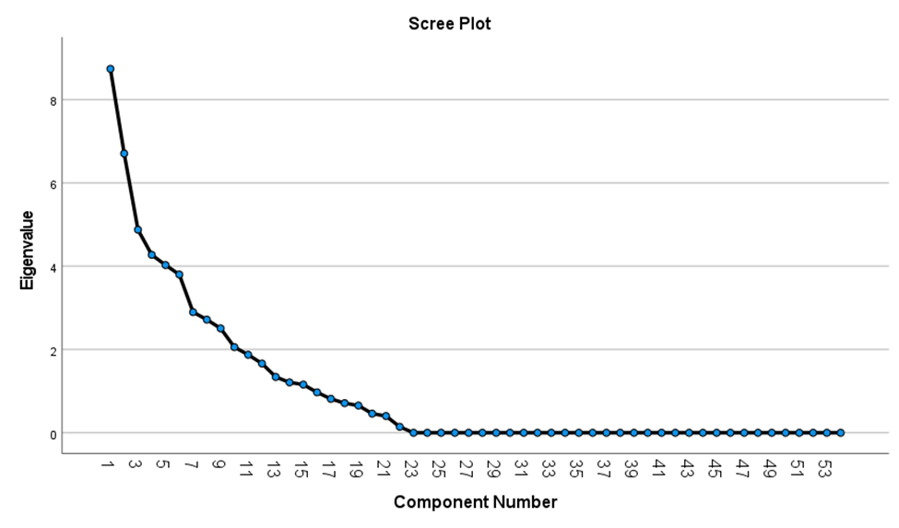
Figure 1
Cattell’s Scree Test

Table 7

Summary of Direct Oblimin Rotation for Factor 1

Item | Item Description |  | Factor Loadings
 |  |  | 1 |  | 2 |  | 3 |  | 4
 | Behaviors of Food Insecurity (15 items)
Q21_4 |  | I missed class because there was not enough money for food. |  | 0.83 |  |  |  |  |  | -0.37
Q21_7 |  | My planned graduation date has changed because of my lack of money for food. |  | 0.77
Q21_5 |  | My academic performance has declined because I did not have enough to eat. |  | 0.77
Q21_6 |  | My academic performance has declined because I had to work more hours to buy food. |  | 0.74
Q21_9 |  | I have lost weight because I did not have enough money to buy food. |  | 0.74
Q21_3 |  | Other adults in my home cut the size of meals because there was not enough money for food. |  | 0.72
Q4_5 |  | I could not afford to eat balanced meals. |  | 0.69 |  |  |  |  |  | 0.36
Q4_4 |  | I was concerned that my food would run out before I had the money to buy more. |  | 0.67 |  |  |  |  |  | 0.38
Q21_10 |  | I ate less healthy meals to eat more food. |  | 0.67
Q21_1 |  | I enrolled in fewer classes to have money for food. |  | 0.66 |  |  |  |  |  | -0.46
Q4_3 |  | I have taken a day off from eating because I didn't have enough money for food. |  | 0.65 |  |  |  | -0.44 |  | 0.34
Q21_2 |  | I enrolled in fewer classes to work so I could have money to buy food. |  | 0.64 |  | 0.37
Q7_6 |  | Importance of cleanliness in your decisions about what food to buy. |  | 0.59 |  |  |  |  |  | -0.33
Q4_2 |  | I skipped meals because I didn't have enough money for food. |  | 0.56 |  |  |  | -0.35 |  | 0.55
Q7_5 |  | Importance of Locally Grown your decisions about what food to buy |  | 0.83 |  |  |  |  |  | -0.37

Table 8

Summary of Direct Oblimin Rotation for Factor 2

Item | Item Description |  | Factor Loadings
 |  |  | 1 | 2 | 3 | 4
 | Access to Food Options (7 items)
Q23_1 | Obtained food from a food bank or pantry. |  |  | 0.79
Q3 | I am familiar with the term food security |  |  | 0.77
Q8 | Where do you regularly get food from? |  |  | 0.64 |  | -0.33
Q6_3 | How easy or difficult is it to travel by car to buy food? |  |  | 0.60
Q10 | How easy or difficult is it to find food options on the Ag Campus? |  |  | 0.59
Q9 | Do you buy food on the Ag Campus? |  |  | 0.57 | 0.39
Q23_2 | Attended an event or meeting because they offered free food. |  |  | 0.50 | -0.43
Q4_4 | I was concerned that my food would run out before I had the money to buy more. | 0.36 |  | -0.50
Q21_10 | I ate less healthy meals to eat more food. | -0.32 |  | 0.48
Q21_1 | I enrolled in fewer classes to have money for food. |  |  | 0.79
Q4_3 | I have taken a day off from eating because I didn't have enough money for food. |  |  | 0.77
Q21_2 | I enrolled in fewer classes to work so I could have money to buy food. |  |  | 0.64 |  | -0.33
Q7_6 | Importance of cleanliness in your decisions about what food to buy. |  |  | 0.60
Q4_2 | I skipped meals because I didn't have enough money for food. |  |  | 0.59
Q7_5 | Importance of Locally Grown your decisions about what food to buy |  |  | 0.57 | 0.39

Table 9

Summary of Direct Oblimin Rotation for Factor 3

Item | Item Description |  |  | Factor Loadings
 |  |  |  |  | 1 |  | 2 |  | 3 |  | 4
 |  | Support and Resources for Food Insecure Students (5 items)
Q22_2 |  | Participated in school/university meal plan. |  |  |  |  |  | 0.59 |  | 0.43
Q25 |  | Aware of resources on campus to help you determine eligibility thresholds for Supplemental Nutritional Assistance Program (SNAP) benefits |  |  |  |  |  | 0.57 |  | 0.49
Q22_1 |  | Participated in the food assistance program. |  |  |  | 0.46 |  | 0.52 |  | 0.36
Q23_6 |  | Talked with someone in the school administration or counselor about not having enough food. |  |  |  | 0.31 |  | 0.48
Q24 |  | Did you know that college students can meet student eligibility for Supplemental Nutrition Assistance Program (SNAP) benefits? |  |  |  | -0.38 |  | 0.47

Table 10

Summary of Direct Oblimin Rotation for Factor 4

Item | Item Description | Factor Loadings
 |  | 1 | 2 | 3 | 4
 | Food Purchasing Behaviors (3 items) |  |  |  | 0.43
Q23_4 | Asked friends for money to buy food. |  |  |  | 0.58
Q13 | Importance of price of food in your decisions about what food to buy. | 0.33 |  | -0.46 | 0.52
Q7_3 | Importance of quality of food in your decisions about what food to buy. |  |  |  | 0.51

The food purchasing factor will be especially important in the future due to increased food costs stimulated by rising inflation. The USDA released a report that indicated food price increases are expected to be between 3.0% and 4.0% (USDA, 2022). This increase will decrease the purchasing power of college students whether they purchase food from the grocery or have an institutional prepared meal plan as both are at the end of supply chain.

Binary Logistic Regression
A binary logistic regression was used to compute the food insecurity probability unique to the individual students. I used binary logistic regression to examine the relationship between important independent variables in my exploratory study and their odds in predicting food insecurity.
Binary logistic regression models were created to estimate the odds of student food security status while controlling for student demographic variables (predictors). For logistic regression, the dependent variable very high food secure is dichotomous. The logistic regression computes the food secure possibilities unique to individual students. The P in logistic regression shows the probability of food insecurity happening, and 1 –P indicates the probability of food insecurity not happening.
In this section I will explain the data preparation, homogeneity of variances, creation of the composite score, the procedure for coding dummy variables, and other considerations for the binary logistic regression.

Data Preparation for Binary Logistic Regression
Survey results were exported from Qualtrics into an Excel file and those data were organized for statistical analysis. All data were cleaned as recommended by Morrow (J. A. Morrow, personal correspondence, October 15, 2020) prior to analysis. These steps are listed below.

- The first step the data cleaning process was to create a codebook of the constructs and variables in the study to include names and labels, value labels, citations, and the reliability of the scale.
- Second, I developed a data analysis plan that included my research question, variables, and the survey items applied to address each question.
- As the third step in the process, I conducted the primary frequencies and descriptives for the data utilizing the Statistical Package for the Social Sciences (SPSS). This step allowed me to check for basic errors such as coding mistakes and missing values on all items excluding demographic items. I excluded four surveys for incompleteness regarding non-demographic items. There were 208 surveys in which students answered every non-demographic item out of 212 surveys attempted. Some students did not complete every demographic item such as income. These became the missing system variables. More detail on how the missing system variables were coded in the binary logistic regression.
- Following this step, I reverse coded, recoded, and created new variables as needed. More detail on specific coding will be provided under the binary logistic regression section.
- After these initial steps, I ran frequencies and descriptives in SPSS again for the variables and check for other assumptions. This helped me to address the outliers in the data set and the make the decisions on if they needed to be deleted, modified, or ignored. No outliers were found.
- The next step of the process was to assess for normality of the continuous variables. This assumption did not apply to this analysis as there were no continuous variables used.
- After I assessed for normality, I determined what to do with missing data. This step is important and can have a great impact on the reliability and validity of data results. For the income independent variable, there were 13 missing values. To account for the missing values, I created a dummy variable (“IncomeMiss”) to include in the analysis. More details on the missing variables are discussed in the binary logistic regression section.
- I repeated step 5 to recheck the frequencies and descriptives in SPSS again for the variables and check for other assumptions.
Hosmer-Lemeshow Goodness-of-Fit. For research questions two and three, the Hosmer-Lemeshow goodness-of-fit were tested. The Hosmer-Lemeshow is an extension of the chi-square and provides information on how well the data fits the model (Fagerland and Hosmer, 2012). The Hosmer-Lemeshow goodness-of-fit for this dataset resulted in a significance of 0.079 which indicates the model had good fit.

Creation of the Composite Score for Food Security
The composite scores were developed using a student’s level of agreement with the statements in the first matrix question (See Q2 in Appendix B) in the College Student Food Insecurity Instrument (See Appendix B). Each of these statements had a range of one to five, with “1” being “Strongly Disagree” and “5” as “Strongly Agree”. Averages were computed based on these responses. Students who averaged above a 3 (scale of 1 to 5) were classified as food insecure for examination in this exploratory study. The students were grouped into four categories: Very High Food Secure for all composite scores of less than 2; High Food Secure for all composite scores of 2 to 3.0; High Food Insecure for all composite scores 3.1 to 5.0; and Very High Food Insecure which included all composite scores greater than 4.0). Very High Food Secure was chosen as the dependent variable for this study. Descriptive statistics and frequency distributions were used to summarize the demographic data such as gender, race age, class year, employment status, income, GPA, financial aid, Pell grant status, borrowed money, and first-generation student.

Creation of the Dummy Variables
The categorical independent variables were “dummy” coded to be used in the binary logistic regression. Dummy coding is a method of using categorical predictor variables in the binary logistic regression. Dummy coding applies only the use ones and zeros to acknowledge all the essential information on group membership in a mutually exclusive and exhaustive category. The reference groups are the zeros in the groups. It is the value of the categorical variable that is not represented explicitly by a dummy variable. An explanation of how each variable was dummy coded is included in the subsequent paragraphs. As mentioned earlier, I recoded variables from the values used in the survey instrument. This dummy coding procedure was unique to this study sample. The dummy variables my vary based on how the survey is answered in the future.
Gender. The categorical data for student gender were dummy coded for males and females with 1coded for “yes” and 0 for “no”. Females were chosen to be the reference group in this regression as they were the largest group. For dummy variable of Female: Old Value is 1 and New Value is 1 -> 1; Else -> 0. For dummy variable of Male: Old Value is 2 and New Value is 2 -> 1; Else -> 0.
Age. The age groups of 18-22 and 23-26 were combined to create a variable names “traditional student” and the 27-30 were dummy coded to be “nontraditional” students with each variable coded 1 for “yes” and 0 for “no” for the regression. The traditional students were the largest group and served as the reference group; therefore, they were excluded from the regression. Specifically, for the dummy variable of Traditional: Old Value is 1 and New Value is 1 -> 1; Else -> 0 For dummy then for variable of Nontraditional: Old Value is 2 and New Value is 2 -> 1; Else -> 0.
Race. The categorical data for student race/ethnicity were dummy coded with two exhaustive and mutually exclusive dichotomous variables (Non-white and White) with each variable coded 1 for “yes” and 0 for “no”; for the regression, the excluded reference category was “White.” The specific races and ethnicities were combined to the “Non-white” category because of the low number in the sample. The “White” group served as the reference group as they were the largest and excluded from the regression. For the dummy variable of Non-white: Old Value is 1 and New Value is 1 -> 1; Else -> 0 and the dummy variable of White: Old Value is 2 and New Value is 2 -> 1; Else -> 0.
Class Year. The categorical data for a class year (Freshman, Sophomore, Junior, Senior, Graduate Student) were each dummy coded with five exhaustive and mutually exclusive dichotomous variables for the regression. Each variable coded 1 for “yes” and 0 for “no” with the excluded reference category as “Senior”. Senior was used as a reference group due to a normative assumption. Compared to the underclassmen, seniors are more likely to live off campus or have a job.
Specific coding included the following. The dummy variable of Freshman: Old Value is 1 and New Value is 1 -> 1; Else -> 0; dummy variable of Sophomore: Old Value is 2 and New Value is 2 -> 1; Else -> 0; dummy variable of Junior: Old Value is 3 and New Value is 3 ->1; Else -> 0; dummy variable of Senior: Old Value is 4 and New Value is 4 -> 1; Else -> 0; and for the dummy variable of Graduate Student: Old Value is 5 and New Value is 5 -> 1; Else -> 0
Employment Status. The same procedure followed for employment status were dummy coded with three exhaustive and mutually exclusive dichotomous variables (e.g., Unemployed, 1 or more part-time jobs, and Full-time job). Each variable coded 1 for “yes” and 0 for “no” with the excluded reference category as “Unemployed.” The unemployed were used as the reference group due to a normative assumption. If someone is unemployed it is assumed, they would pose a greater risk for being for insecure. • Specific coding included the following: dummy variable of Unemployed: Old Value is 1 and New Value is 1 -> 1; Else -> 0; dummy variable of 1 or more part-time jobs: Old Value is 2 and New Value is 2 -> 1; Else -> 0; and for dummy variable of Full-time job: Old Value is 3 and New Value is 3 ->1; Else -> 0.
Income. There were six categories within the income variable: Less than $500, $501 to $1,000, $1,001 to $1,500, $1,501 to $2,000, and $2,001 to $2,500. There were also 13 system missing variables for this group. For the purposes of running the regression, the categorical data for income were each dummy coded with six exhaustive and mutually exclusive dichotomous variables for the analyses. Each variable coded 1 for “yes” and 0 for “no”. I considered the two highest levels of income as the reference groups ($,1501 to $2,000 and $2,001 to $2,500) and excluded them from the regression.
The specific coding for income included the following steps. For dummy variable of IncomeLevel1 (Less than $500): Old Value is 1 and New Value is 1 -> 1; Else -> 0. For dummy variable of IncomeLevel2 ($501 to $1,000): Old Value is 2 and New Value is 2 -> 1; Else -> 0. For dummy variable of IncomeLevel3 ($1,001 to $1,500): Old Value is 3 and New Value is 3 ->1; Else -> 0. For dummy variable of IncomeLevel4 ($1,501 to $2,000): Old Value is 4 and New Value is 4 -> 1; Else -> 0. For dummy variable of IncomeLevel5 ($2,001 to $2,500): Old Value is 5 and New Value is 5 -> 1; Else -> 0. I also created a dummy variable for the 13 missing system values (“IncomeMiss”).
GPA. For the purposes of running the regression, the categorical data for GPA were each dummy coded with four exhaustive and mutually exclusive dichotomous variables for the analyses. The specific coding included the following. For dummy variable of GPALevel1 (2.1 to 2.5): Old Value is 1 and New Value is 1 -> 1; Else-> 0. GPALevel2 (2.5 to 3.0) was dummy coded for the Old Value is 2 and New Value is 2 -> 1; Else-> 0. GPALevel3 (3.1 to 3.5) was dummy coded for Old Value is 3 and New Value is 3 ->1; Else -> 0. The highest GPA level, GPALevel4 (3.51 to 4.0), was dummy coded for Old Value is 4 and New Value is 4 -> 1; Else -> 0. GPALevel4 served as the reference group do to the normative thought of those with higher GPA would have greater food security.
Yes/No Categories. The categorical data for a student’s Pell Grant, Financial Aid, First-Generation Student, and Borrowed Money Status were dummy coded with two exhaustive and mutually exclusive dichotomous variables (Yes or No) with each variable coded 1 for “yes” and 0 for “no”; for the analyses, the excluded reference category was “No” for each. I used the normative category of “no” as my reference group for Pell grant status, financial-aid, first-generation, and borrowed money status.
The specific coding are included below. Pell_ Yes(Pell Grant Recipients) were coded as Old Value is 1 and New Value is 1 -> 1; Else -> 0 and for dummy variable of Pell_No (Not a Pell Grant Recipient): Old Value is 2 and New Value is 2 -> 1; Else -> 0. For dummy variable of FinancialAid_ Yes (Recipients): Old Value is 1 and New Value is 1 -> 1; Else-> 0 and FinancialAid_No (Not a Recipient): Old Value is 2 and New Value is 2 -> 1; Else-> 0. The variable of FirstGen_ Yes (Parents attended college): Old Value is 1 and New Value is 1 -> 1; Else-> 0 and for dummy variable of FirstGen_No (Parents did not attend college): Old Value is 2 and New Value is 2 -> 1; Else -> 0. BorrowedMoneytoAttendCollege_ Yes (borrowed money to attend college): Old Value is 1 and New Value is 1 -> 1; Else -> 0 and for dummy variable of BorrowedMoneytoAttendCollege_No (did not borrow money to go to college): Old Value is 2 and New Value is 2 -> 1; Else -> 0.

Other Considerations Important to the Binary Logistic Regression
In the logistic regression, Wald statistics, Chi-square tables for critical values, and the Pseudo R-square Cox & Snell and Nagelkerke were taken into consideration. These coefficients were calculated to evaluate the relationship of dichotomous variables with continuous variables.
The data exhibits homoscedasticity. Homoscedasticity occurs when the variances positioned on the line of best fit continues to be consistent the line is followed. The standardized residuals were plotted against the unstandardized predicted values. To visually represent the data from the exploratory testing of the food insecurity survey, I incorporated a variety of tables to visually depict the differences among gender, age, and level responses to the food insecurity survey.
Lastly, to determine the strength of the relationship between the independent variables and food insecurity, the Pearson’s chi-square was used. The results of the Pearson’s chi-square are included in the last research question related to prevalence on the University of Tennessee, Herbert College of Agriculture.

Summary

This study was conducted in two parts that included the development and validation of the CSFI survey instrument to be used in determining the prevalence of food insecurity among college students and exploratory study involving students enrolled at the University of Tennessee, Knoxville, Herbert College of Agriculture. The survey instrument was reviewed by a panel of experts and revised based on a pre-test/post-test administration with a small group (n = 20) of students. The CSFI survey instrument was then administered in a exploratory study to a college student population (N = 1,414) comprised of both undergraduate and graduate, enrolled in the University of Tennessee, Knoxville, Herbert College of Agriculture.

Following its administration, the researcher utilized exploratory factor analysis (EFA) to analyze the fundamental structure of the data, provide direction on the adjustments to the College Student Food Insecurity (CSFI) instrument, and validated it as a research instrument. Binary logistic regression was conducted to determine if there were differences between levels of the salient demographic variables related to food security status. The chi-square tests were performed to test relationships between categorical variables. Results of the validity statistics, binary logistic regression, and Pearson's chi-squared test are discussed in the next chapter.

CHAPTER 4
ANALYSIS AND FINDINGS

Chapter 4 describes the demographics of the sample and data analysis results gathered from participants who completed the College Student Food Insecurity (CSFI) survey instrument. This chapter includes the analysis results for the studies’ three research questions.

Descriptive Statistics of the Student Sample
The data sample was analyzed using Statistical Package for the Social Sciences (SPSS) Release 28.0. The respondent’s food security status (food secure) served as the dependent variable and the respondent’s gender, race, age, class level, employment status, income, and financial aid status including Pell Grant recipients, GPA, and first-generation student served as the independent variables. Descriptive statistics, including means, standard deviations, and percentages, were examined for the sample. Table 11 includes the descriptive information of independent variables considered in the current study. Demographically, for the Herbert College of Agriculture 17% of all students identify as non-white, and 54% of all students identify as female.
Data collection produced a sample of 208 participants enrolled in the University of Tennessee, Herbert College of Agriculture. Over 90% of respondents identified as female and 86.1% identified as white. There were a small number of non-white race responses with African American/Black comprising 2.9% of the sample (6 students), 1.9% identified as Asian (4 students), 3.8% were Biracial (8 students), and 4.8% are Multiracial (10 students). Over 65% of the respondents classified themselves as first-generation students. All students were classified as traditional college students by age with 73.1% of students falling in the 18 to 22 years of age category and 24% reporting they were 23-26 years of age. Most of the students were identified as part of the undergraduate population. The breakdown includes 43.3% as Freshmen followed by 19.2% classified as Juniors, 17.3% classified as Sophomores followed by 13.5% classified as Seniors. Graduate students made up 6.7% of the respondents. All students responding to the survey had a self-reported grade point average (GPA) of greater than 2.1 with 45.2% of the respondents self-reporting a GPA in the range of 3.51-4.0 and 35.6% reported a GPA of 3.1-3.5.
Almost half of the survey respondents (47.1%) held 1 or more part-time jobs and 13.5% of the respondents held a full-time job while attending the University of Tennessee, Knoxville, Herbert College of Agriculture. All the respondents (100%) reported being full-time students at the university. Most of the respondents received some type of financial aid (75.0%); however, only 34.6% of the respondents reported being Pell grant recipients. Over 60.6% of the respondents reported borrowing money through the form of student loans to pay for their college education. Of the sample, 54.3% of the respondents report a monthly income of less than $1,000 with 34.6% reporting less than $500.
All of the values of the demographic variables reported by survey respondents were not available from the Herbert College of Agriculture. Therefore, I could not compare the sample with the college population on every variable. The three variables I could compare the sample with the population on gender, race, and class year.

Table 11
Descriptive Statistics of the Sample
Variable | Label | Count | %
Food Secure |  | 74 | 35.6
Food Insecure |  | 134 | 64.4
Gender | Female* | 188 | 90.4
 | Male | 20 | 9.6
Race | White* | 179 | 86.1
 | Non-white | 29 | 13.9
Age | Traditional* | 152 | 73.1
 | Non-traditional | 56 | 26.9
Class Year | Freshman | 90 | 43.3
 | Sophomore | 36 | 17.3
 | Junior | 40 | 19.2
 | Senior* | 28 | 13.5
 | Graduate Student | 14 | 6.7
Employment Status | Unemployed* | 82 | 39.4
 | Part-Time Job | 98 | 47.1
 | Full-Time Job | 28 | 13.5
Income | Less than $500 | 72 | 34.6
 | $501 to $1,000 | 41 | 19.7
 | $1,001 to $1,500 | 30 | 14.4
 | $1,501 to $2,000* | 44 | 21.2
 | $2,001 to $2,500* | 8 | 3.85
 | Unknown/Missing | 13 | 6.25
GPA | 2.1-2.5 | 11 | 5.3
 | 2.51-3.0 | 28 | 13.5
 | 3.1-3.5 | 74 | 35.6
 | 3.51-4.0* | 94 | 45.1
 | Unknown/Missing | 1 | 0.5
Financial Aid | Yes* | 156 | 75.0
 | No | 52 | 25.0
Pell Grant | Yes* | 72 | 34.6
 | No | 104 | 50.0
 | Not Sure | 32 | 15.4
Borrowed Money | Yes* | 126 | 60.6
 | No | 82 | 39.4
First-Generation Student | Yes* | 136 | 65.4
 | No | 72 | 34.6
*Denotes the reference group(s) in the binary logistic regression

Research Question 1:

Does the College Student Food Insecurity (CSFI) survey instrument possess adequate internal consistency?
The reliability of a survey instrument used with a particular sample may be determined by the internal consistency measure. Internal consistency evaluates the relationships among multiple items in an instrument that are designed to measure the same construct. Overall, the 54-item inventory of the CFIS produced a Cronbach‘s alpha of 0.79. Alpha coefficients were generated on the four factor items that constitutes each derived factor (see Table 12). Across each of the four factors, removing individual items would not considerably enhance the factor dimension’s reliability. As a result of these steps, internal consistency of each derived factor was sufficient, varied from 0.76 to 0.80. The four factors derived from this sample revealed adequate internal consistency and reliability.

Research Question 2:

Are there differences in the demographic variables related to food security status?

Binary Logistic Regression
Binary logistic regression was used to compute the food security status probabilities unique to individual students. Not all students have the same likelihood of being food insecure. This study investigates which variables have stronger effects on food insecurity status. The chi-square statistic for food security rates by student’s gender, race, class level, employment status, income, financial aid, first-generation status, and GPA was 44.348 (df = 21, p < 0.002) was statistically significant. The VIF ranged from 1.481 to 4.124 and Tolerance levels ranging from 0.242 to 0.675, which provides evidence of no imposing multicollinearity issues in this study.
Table 12
Alpha Coefficients for Each Factor
Factor | Number of Items | Reliability Cronbach's alpha
Academic Behaviors (1) | 15 | 0.79
Access to Food Options (2) | 7 | 0.75
Support for Food Insecure Students (3) | 6 | 0.80
Food Purchasing Behaviors (4) | 3 | 0.76

Additionally, the Hosmer-Lemeshow goodness of fit test suggested the fit was “good” with a p = 0.853 which is greater than p = 0.05.
For the purposes of this study, Pseudo R-square of Cox and Snell R-square and Nagelkerke R-square were analyzed. These two tools imitated the idea of R-squared in multiple linear regression. There is no true error variance in logistic regression because the outcome is a probability. Based on the Nagelkere R-square for this model is 0.262 or 26.2%. It is the idea of the percent of variance meaning that 26.2% of the variance of the very high food security is attributed to the independent variables.
Table 13 includes the binary logistic regression estimates. Table 13 contains the coefficients, standard error, odd ratios (OR), relative risks, and statistical significance. Odds ratios are employed explain the binary logistic results. An odds ratio greater than 1.00 shows a positive effect on college student food security, while an odds ratio of less than 1.00 indicates a negative effect. The relative risk is determined as odds ratio – 1.00 (DeMaris, 1995). Odds ratios that equal 1 mean that the coefficient has no effect on a student’s food insecurity. There were eight independent variables that were significant at the p < .0.5. These include males, sophomores, juniors, graduate students, received financial aid, received a Pell grant, borrowed money to attend college, and first-generation students. There was one independent variable that was significant at the p < 0.10, which were students who work 1 or more part-time jobs.
In comparison to female students, males were 4.953 times more likely to be very high food secure than females. When comparing the class status of the students, those students who were Graduate Students are 7.414 times more likely than Seniors to be very high food secure. Juniors were 7.764 times more likely than Senior to be very high food secure. Sophomores were 80.2% (1.82-1.00) times more likely than Seniors to be very high food secure. Those students who were first-generation were 3.294 times more likely to be very high food secure.
The employment status of students played a role in their food security. Students who worked 1 or more part-time jobs were 69.7% (0.303-1.00 = -0.697) less likely to be very high food secure than compared to those who were unemployed. A student who received a Pell grant is 67.1% less likely (0.329-1.00 = -0.6708) less likely than a student who did not receive a Pell grant to be food secure. A student who is not sure if they received a Pell grant is 77.2% (0.228-1.00 = - 0.772) less likely than a student who did not receive a Pell grant to be food secure. A student who received financial aid is 3.924 times more likely to be very high food secure when compared to those who did not receive financial aid. Also, students who borrowed money to attend college were 4.875 times more likely to be very high food secure than those who did not. Financial aid incorporates scholarships and grant opportunities afforded to the students. A student that borrowed money to attend college were the students that took out student loans, borrowed money from relatives, borrowed money from family friends, or had credit card balances.

Research Question 3:

To what extent is the prevalence and degree of food insecurity present among students enrolled in a major at the University of Tennessee, Knoxville, Herbert College of Agriculture?

The first set of matrix question, more specifically the awareness statements questions, of the College Student Food Insecurity (CSFI) survey instrument (Q4 in the analysis) were used to determine if a student identified as food insecure. A respondent’s composite score of the five
Table 13
Binary Logistic Regression Results
Dependent Var =
Very High Food Secure
Variable | Label | Coefficient | Std. Error | Wald | Odds Ratio | Sig.
Constant |  |  |  | 10.82 | 0.04
Gender | Male | 1.6 | 0.74 | 4.71 | 4.95 | **
Race | Non-White | -0.32 | 0.59 | 0.28 | 0.73
Age | Nontraditional | -2.30 | 2.16 | 1.13 | 0.10
Class Year | Freshman | 0.22 | 0.69 | 0.11 | 1.25
 | Sophomore | 0.59 | 0.65 | 0.82 | 1.82
 | Junior | 2.05 | 0.97 | 4.51 | 7.76 | **
 | Graduate Student | 2.00 | 0.95 | 4.44 | 7.41 | **
Employment Status | Part-time job | -1.19 | 0.66 | 3.29 | 0.30 | *
 | Full-time job | 0.14 | 0.79 | 0.03 | 1.16
Income | Less than $500 | 0.18 | 0.57 | 0.10 | 1.19
 | $501 to $1,000 | 0.03 | 0.71 | 0.00 | 1.03
 | $1,001 to $1,500 | -0.23 | 0.74 | 0.10 | 1.19
GPA | 2.1-2.5 | -0.25 | 1.29 | 0.04 | 0.78
 | 2.51-3.0 | 0.48 | 0.59 | 0.69 | 1.64
 | 3.1-3.5 | 0.51 | 0.48 | 1.12 | 1.66
Financial Aid | Received | 1.37 | 0.59 | 5.25 | 3.92 | **
Pell Grant | Received | -1.11 | 0.55 | 4.05 | 0.33 | **
 | Not Sure | -1.48 | 0.65 | 5.23 | 0.23 | **
Borrowed Money to Attend College | Yes | 1.58 | 0.69 | 5.28 | 4.88 | **
First-Generation Student | Yes | 1.19 | 0.51 | 5.57 | 3.29 | **
Nagelkerke R-square |  | 0.262
*** = < 0.01; ** = < 0.05; * = < 0.10

statements comprising Q4 could have ranged from 1.0 to 5.0. The composite score was calculated by averaging the value of each response. Statements were classified as Strongly Disagree (1), Disagree (2), Neither Disagree nor Agree (3), Agree (4), and Strongly Agree (5). A composite score of 3.0 or greater deemed the student as food insecure in the last academic year. Approximately 35.6% (75 respondents) were food insecure. Approximately 11% of the students who completed the survey had a composite score above 4.0 (see Table 14) and were identified as very high food insecure for this study. Of this sample, 64.4% of the students were identified as food secure.
The responses for each of the awareness statements in the first set of matrix questions are shown (see Table 15). Of the survey respondents, 35.5% of students reported they reduced the size and number of meals because of financial constraints (Responses were Agree with 28.8% and Strongly Agree with 6.7%). Approximately, 37.5% of survey respondents reported they did not eat every meal because they did not have enough money (Responses were Agree at 26.4% and Strongly Agree at 11.1%). Additionally, 38.0% reported they could not afford to eat balanced meals. Approximately one-fifth (17.3%) of survey respondents reported that they took a day off from eating because they did not have enough money for food.

Assessing the Strength of the Relationship Between Independent Variables
I used the chi-square statistic to determine the association and strength relationships between my independent categorical variables. A chi-square test tests a null hypothesis that no relationship exists on the categorical variables. In other words, the categorical variables are independent. The assumption of less than 20% of the cells with an expected count of less than five was met for all chi-square tests.
The chi-square distributions for students’ responses showed that 65.4% of the students in this sample were first-generation students. When considering the effect that first-generation status had on food security, the chi-square distribution showed that 29.4% (40 out of 136) of the total sample of first-generation students were food insecure (n = 136). The chi-square calculated value for first-generation student status was 6.516 and was significant (p = 0.011). This means that first-generation student status and food security are not independent. A small (Cramer’s V = 0.177) association between the two variables exists.
When considering gender, the sample (n = 208) was comprised of 90.4% female and 9.6% male. The chi-square distributions within the percentages for each gender in this sample showed that 37.7% of all female respondents or 188 females were food insecure and 15% of all male respondents to the survey or 20 males were food insecure. The chi-square calculated value for gender is 4.09 and was significant (p = 0.043). This value is greater that chi-square critical value threshold (CV = 3.84). I can conclude that there is a small association (Cramer’s V = 0.14) between gender and food security status. Therefore, based on this exploratory study, gender and food security status were not found to be independent of each other.
The GPA categories resulted in a chi-square value of 6.966 and it can be concluded that there is a small association (Cramer’s V = 0.183) between a student’s GPA range and their food security status. Over 60% or 28 students in the second lowest reported GPA range (2.51-3.0) are food insecure and 54.5% or 11 students in the lowest reported GPA range (2.1-2.5) are food insecure. Therefore, based on this exploratory study, GPA was not found to be independent of a student’s food security status.
Other variables (financial aid, Pell grant status, income, borrowing money, and age) analyzed in this exploratory study, as shown in Table 16, were found to be independent of a student’s food security status. For each of these variables, the Pearson Chi-Square value was less than 3.841 which allowed for the “fail to reject” the null hypothesis.

Summary
Chapter Four provided the results from the binary logistic regression, chi-square and reliability procedures conducted on the exploratory study data. A EFA to determine the measures of reliability, a binary logistic regression, and chi-square tests were all computed and analyzed. In addition, reliability, validity, odds ratios for probability of food security/insecurity, and Pearson’s Chi-Square were reported. In Chapter Five, I discussed the exploratory study findings, the study’s limitations, and made recommendations for future research and survey administration.

Table 14
Food Security Composite Scores
Composite Score | Number of Students | Percent of Students
1.0 | 42 | 20.2
1.2 | 19 | 9.1
1.4 | 5 | 2.4
1.6 | 6 | 2.9
1.8 | 5 | 2.4
2.0 | 20 | 9.6
2.2 | 5 | 2.4
2.4 | 10 | 4.8
2.6 | 0 | 0.0
2.8 | 22 | 10.6
3.0 | 0 | 0.0
3.2 | 18 | 8.7
3.4 | 14 | 6.7
3.6 | 9 | 4.3
3.8 | 10 | 4.8
4.0 | 0 | 0.0
4.2 | 4 | 1.9
4.4 | 5 | 2.4
4.6 | 5 | 2.4
4.8 | 4 | 1.9
5.0 | 5 | 2.4
Total | 208 | 100.0
Note: These were the author’s calculations based on the CSFI survey.

Table 15

Response Rates to Question Two
Question Matrix from the CSFI Survey | Strongly  Disagree  (1) | Disagree  (2) | Neither agree nor disagree  (3) | Agree  (4) | Strongly Agree (5)
I have reduced the size of meals because I didn’t have enough money for food. | 28.8% | 33.2% | 2.4% | 28.8% | 6.7%
I skipped meals because I didn’t have enough money for food. | 31.7% | 23.6% | 7.2% | 26.4% | 11.1%
I have taken a day off from eating because I didn’t have enough money for food. | 43.3% | 32.2% | 7.2% | 10.6% | 6.7%
I could not afford to eat balanced meals. | 35.1% | 19.7% | 7.2% | 31.7% | 6.3%
I was concerned that my food would run out before I had the money to buy more. | 37.0% | 22.6% | 4.3% | 25.5% | 10.6%

Table 16
Chi-Square Results
Variables | Labels | Food Secure  % | Food Insecure  % | Total | Chi-Square Value | Cramer’s V | Sig.
Gender | Female | 62.2 | 37.8 | 188 | 4.09 | 0.14 | **
 | Male | 85.0 | 15.0 | 20
First-Generation | Yes | 70.6 | 29.4 | 136 | 6.52 | 0.18 | **
 | No | 52.8 | 47.2 | 72
GPA | 2.1- 2.5 | 45.5 | 54.5 | 11 | 6.97 | 0.18 | *
 | 2.51-3.0 | 39.3 | 60.7 | 28
 | 3.1-3.5 | 24.3 | 75.7 | 74
 | 3.51 -4.0 | 59.6 | 40.4 | 94
Financial Aid | Yes | 63.5 | 36.5 | 156 | 0.25 | 0.04
 | No | 67.3 | 32.7 | 52
Borrowed Money | Yes | 62.7 | 37.3 | 126 | 0.42 | 0.05
 | No | 67.1 | 32.9 | 82
Pell Grant | Yes | 63.8 | 36.1 | 72 | 2.46 | 0.11
 | No | 68.3 | 31.7 | 104
 | Not Sure | 53.1 | 46.9 | 32
Income | Less than $500 | 70.8 | 29.2 | 72 | 3.24 | 0.13
 | $501 to $1,000 | 61.0 | 39.0 | 41
 | $1,001 to $1,500 | 60.0 | 40.0 | 30
 | $1,501 to $2,000 | 56.8 | 43.2 | 44
 | $2,001 to $2,500 | 75.0 | 25.0 | 8
Age | 18-22 | 65.1 | 34.9 | 152 | 0.58 | 0.05
 | 23-26 | 64.0 | 36.0 | 50
 | 27-30 | 50.0 | 50.0 | 6
*** = <0.01; ** = < 0.05; * = <0.10

CHAPTER 5

SUMMARY AND DISCUSSION

Food insecurity among college students is a serious, yet invisible, problem on campuses across the United States (Baker-Smith et al., 2020; Cady, 2014; Cady, 2016; Glik & Martinez, 2017; Broton & Goldrick-Rab, 2018; El Zein et al., 2019; Farahbakhsh et al., 2015; Hanbazaza et al., 2017; Hege et al., 2021). Currently, the USDA Household Food Security Survey Module (HFSSM) is comprised of responses to 18-items that are used to determine a composite score that ranges from 0 to 18 (0 indicates high food security and 18 indicates very low food security). The HFSSM is a household measure in it evaluates the food security status of adults and children as one unit within a household. It does not determine the food security status of each individual member. Therefore, because the survey cannot identify the food security status of a household member who may be in college, there is a need for a reliable and valid survey instrument to determine food insecurity status in students attending a postsecondary institution. To address this issue the purpose of this exploratory research was to develop a reliable and valid survey instrument to measure the prevalence and degree of food insecurity among college students with respect to their unique demographic characteristics.
This chapter is organized into five sections. First, are the findings in comparison with other studies. Second, the inclusive findings in this exploratory study are discussed. Third, a discussion on the limitations associated with design and implementation are provided. Finally, the implications for colleges and future directions for research as well as action steps for colleges are discussed.

Food Insecure Findings Confirmed by Other Studies
Overall, the study did find a comparable percentage of students that responded to the survey that showed evidence of food insecurity. This survey revealed the big picture of prevalence consist with other research, but when you drill down there are not a lot of things consistent with the existing literature. Other variables are significant but did not produce significant results with this sample. The findings revealed that there were some statistically significant differences between levels of the demographic variables on a student’s food security status. The significant variables will be discussed below and include gender, class year, financial aid which includes Pell grant status and borrowed money to attend college, as well as first-generation student.
Prevalence
First, the prevalence of food insecurity among students enrolled at the Herbert College of Agriculture, University of Tennessee, Knoxville is over 35% of the student population eligible to participate in the survey. According to Bruening et al. (2017), the prevalence of food insecurity among college students is 33% in the gray literature and 42% in peer-reviewed literature. A study done at a northeast land grant university in 2015 found that 25% of the students were food insecure (Davidson, 2020). A recent study conducted at the University of Kentucky found that over half of their student population experienced food insecurity in the last year (Hege et al., 2021).

Males
At the University of Tennessee, Knoxville’s Herbert College of Agriculture (“Ag Campus”) males were found to be 4.95 times more likely to be food insecure than females. This finding differs from the literature. The literature suggests that food insecurity is more prevalent in female students (El Zein et al., 2019; Riddle et al., 2020; Spaid, 2018). This is the first known study to find that males are more likely to be food insecure. However, the literature typically shows a more consistent sample of male to female. In this study, it is important to note that over 90% of the sample identified as female which could contributed to this differing result.
Class Year
Academic year was found to influence food insecurity in this exploratory study. Similar to other research found in the literature (Martinez et al., 2016; McArthur et al., 2017), food insecurity was associated with academic year. It was found to be at the highest prevalence during their junior year and as a graduate student. Hagedorn & Olfert (2018) also found this result in their study with almost half of students in their junior year experiencing food insecurity.
Financial Assistance Opportunities
The study findings were consistent with other studies that found that students borrowed money and received financial loans were more likely to be food insecure (Broton & Goldrick-Rab, 2018; Farahbakhsh et al., 2015; Hanbazaza et al., 2017). Additionally, this exploratory study found that students who received a Pell grant are more likely to be food insecure. The Pell grant are provided to students with financial needs and is a consistent factor among the literature (Bruening et al., 2018; Goldrick-Rab et al., 2018; Riddle et al., 2020).
First-Generation Students

The exploratory study found that there was association between first-generation students and food insecurity. However, I was surprised that first-generation students were less likely to be food insecure than the students who were not first-generation students. This is not consistent with current findings in the literature. In fact, Riddle et al. (2020) found that the students at the greatest risk of food insecurity were those who were classified as first generation at almost 40%. Other studies by Dubick et al. (2016) and Goldrick-Rab et al. (2018) found that almost half of the respondents classified as food insecure were first-generation students. It is assumed that first-generation students have less access to financial aid and decreased family support resources, and it would seem logical for these students to experience food insecurity (Riddle et al., 2020).

Inconclusive Findings for Food Insecure
There could be other variables that produce significant results given a different sample size and demographic as well as survey timing or distribution. While the results for this exploratory study were inclusive for race and GPA, other studies did find these to be significant factors. Maroto et al. (2015) both found race and GPA to be a significant factor in determining food insecurity especially within community college students. Additionally, Raskind (2019) found that a student’s GPA was inversely related to their food security status. El Zein et al. (2019) discovered implications for a student’s academic success and found that food insecure students are more likely to have a GPA below a 3.0. These are discussed more in the limitations in design and implementation of the College Student Food Insecurity (CSFI) survey.

Design and Implementation of the College Student Food Insecurity (CSFI) Survey
The CSFI was designed to fill a void in the availability of a reliable and valid survey to assess the prevalence and degree of food insecurity in the college student population. This section describes the post-administration issues involved in the design and implementation of the survey, how each may have affected or limited the survey findings, and recommendations for improvement. These include question modifications, additions, or order; small sample limitations; data collection issues; support for students; and special circumstances during the survey administration. It is unknown to the degree to which these issues may have affected the survey responses, however, it is prudent to consider them.
Design: Question Modifications and Additions
Although the questions used in the survey instrument were deemed valid and reliable for administration to college students, they could be improved through modification. A review of the post-administration survey results indicated that the survey results may have been more accurate if definitions had been embedded into the response items of the Demographic section of the survey (See Appendix B. Survey section V.)
Employment Status
One modification proposed is related to the wording of the demographic questions asked about the student’s employment status. The response options were: unemployed, work study, 1 or more part-time jobs, and full-time job. (See Appendix B. Survey section V. Question 10). The percentage of students responding to the choice 1 or more part-time jobs was 47.1% which was almost a majority of the respondents. This question was unclear as to how many part-time jobs a student may have held, to the number of hours students were working, or whether multiple part-time jobs would add up to more hours worked than a full-time job.
It is not known precisely how the responses to the current question affected the survey results. Based on the survey results 60.6% of the students held either part-time or full-time employment. This employment may have provided these employed students with additional funds to purchase food with. A recommendation is to revise this question or break into multiple subparts ascertain employment during periods of being contemporaneously enrolled in courses and not enrolled, i.e.., academic year employment, academic break employment, weekend only employment, and summer employment. A parallel question could then query food insecurity status during each of these periods by asking whether the income from employment provided resources to purchase food with and whether the student used the income in that manner.
Personal Gross Monthly Income (pretax, in dollars)
This demographic question, “Personal gross income (before taxes) monthly income ($) per year” (See Appendix B. Survey section V. Question 11) is related to the previous question pertaining to Employment Status on the survey. This question may be considered a sub question of the employment question, if the personal income is derived from employment. It is important to recognize that not all “personal” income students may receive during a month is from earned income activities, i.e.., employment. Students also may receive social security income (disability or survivors’ benefits), veteran’s benefits, graduate assistantships, and other support payments. Considering how these other sources of unearned income may add confusion that may lead to underreporting for this demographic variable, it would be beneficial to revise this survey question by providing definitions and examples of the types of income that students are to include.
Since there was a nonresponse rate of 6.25% for this question (coded as system missing in the analyses), there may have been confusion as to the definition of personal gross monthly income. It may have been helpful to have completed a nonresponse analysis to ascertain whether there was a pattern in the demographic variables of these students. An additional choice for this question could be added: “Prefer not to disclose”.
Finally, the question itself may have been unclear in that in specifically asked for “monthly gross income…per year”. It appears that most respondents may have ignored the “per year” part of the question as there were zero responses for the category of over $2,500 (or $30,000 per annum). This might be in line with earning $10 per hour for 2,000 hours per year which would yield $20,000 annually in pretax earned income for which the largest percentage of respondents (21.1%) reported between $1,500 and $2,000 per month income.
Grade Point Average Range
This modification concerns the clarity of the question Grade Point Average (GPA) question. The survey question asked, “What is your GPA range?” (See Appendix B. Survey section V. Question 12). There were 7 choices for students to respond with. The wording of this question and its responses may have produced some inaccurate responses.
First, the question did not clarify if the reference GPA was cumulative, the last semester, or within one’s major. Absent a clear definition of grade point average, the students may have unwittingly been inaccurate in their self-reporting. For example, it may be that a student had a higher semester or cumulative grade point average prior to a lower grade point average during a period of food insecurity. Also, it appears that the question assumes that either a cumulative or last semester grade point average is related to a current food insecurity experience, when it may be that contemporaneous decreases in a student’s grades may not be reflected in a historical GPA.
Next, the scale employed in the response items has an error in it. For example, the GPA range should be corrected to be “2.5 to 3.09” instead of the original “2.51 to 3.0.” Further, since no students answered the grade point average options 2.0 and below, the question utilized only 4 responses out of 7 possible. This is a curious phenomenon and may be indicative of an inflated self-report or a question that when encountered, the student elected not to complete this survey. More study is needed pertaining to the demographics of students who begin the survey and decline to compete the survey.
In future survey administrations, the question and response set should be revised by providing clear definitions to what is meant by grade point average (GPA). Adding a question that provide information on how a student’s academic performance was changing contemporaneously might distinguish present food insecurity affects from past grade point average. In this exploratory study, GPA was not found to be a significant predictor of food insecurity as it was shown to be significant in other studies (Broton & Goldrick-Rab, 2018; El Zein et al., 2019; Maroto et al., 2015). However, in this study there was a small association between GPA at the lower acceptable range (2.1 – 2.5) and food insecurity status.
Pell Grants
In 2021-22 Pell grants were awarded to students based on a calculation that indicated their family’s lower ability to pay for college and range from $650 to $6,495 per award year. Beginning in academic year 2020-2021 a last-dollar scholarship program was launched for eligible students, UT Promise, that paid the balance of tuition and mandatory fees ($13, 244) after payment from all other scholarships and grants were credited. It seemed counterintuitive that financial aid, loans, and Pell grant receipts were not significantly associated with food insecurity. Of note, the UT Promise does not fund room and board expenses, so students may still be at risk for food insecurity, although they may receive a Pell grant and the UT promise scholarship.
The demographic question concerning whether a student reports their acceptance of a Pell grant (See Appendix B. Survey section V. Question 1#) appeared to be unclear. The third response option, “Not sure”, was answered by 32 students with 53% of these students having a food secure status. It is recommended that the option to elect “Not sure” be eliminated.
Implementation: Timing, Representation, Self-Selection Bias, Respondent Support, data Collection Period, and Special Circumstances
During the conduct of this exploratory study there were several post survey implementation issues that came to light. These issues are reported here as their application can serve to improve both the instrument and its implementation and the results. Many issues suggest avenues for further study on food insecurity, also. These issues include the timing of survey deployment; the small, non-representative sample; self-selection biases; support for students; data collection period; and special circumstances.
Implementation: Timing Effects
Timing of the survey deployment may have affected the results. In the last weeks of semester, it may be more likely that students are limited in the money they must buy food with which may be a preferential time to period ask questions about food insecurity. So, implementing this survey at that time was likely good in that if food insecurity existed, it could be detected. On the other hand, students may be extremely busy completing assignments such that they do not participate in the survey. The date could be changed to mid-semester versus administering it towards the end as students are less busy.
One recommendation would be to ask a specific question of students as to whether they are food insecure more often during particular times during a semester such as weekends, semester breaks, or near the end of semester term. To determine whether the timing of the survey administration affects response rate or the response content, further research is needed.
Implementation: Small, Non-Representative Sample
This study relied on self-reported responses from a single subdivision of UTK, Herbert College of Agriculture. Therefore, inferences to an institutional or national population cannot be made based on the present study’s findings. Specifically, this sample was not balanced in terms of gender academic major, and race.
Gender. There was an oversampling of females in this exploratory study with over 90% of the respondents identify as female (n = 188, 90.4%). This larger percentage of female respondents compared with males was not consistent with the percentages of the target population enrolled in the college.
The under sampling of the males could have influenced the results and underestimates the serious problem of food insecurity. This is an important limitation to note in this study. Although being female was not a significant predictor of food insecurity, being male was. Given this wide difference in reported gender percentages of the sample and its intended populations, the findings may not be generalizable to all students enrolled in a major in the Herbert College of Agriculture at the University of Tennessee, Knoxville, and nationally. Strategies to enhance response to the survey should be implemented.
Major. A majority of the respondents were animal science majors (n = 166, 78.2%). This sample by major is not representative of the population in the Herbert College of Agriculture. It is unknown whether student responses are representative of other majors in the college and outside the college. As noted earlier regarding possible biases, deliberate strategies should be applied to increase the diversity of respondents to align with institutional and national population demographics.
Race. In this study race was not a significant predictor of food insecurity. The respondent sample was 86% white and was slightly higher than the 83% of students at the Herbert College of Agriculture that reported their race as white for college information. The small sample size of non-white students directly could influence significance; therefore, survey implementation strategies should be focused on increasing minority respondents. It warrants investigation as to whether the type is postsecondary institution plays a role in food insecurity among students from minority groups. This would make the survey more representative of the college population nationally. The sample recruitment methods and plan could be expanded to include other colleges, especially the Historically Black Colleges and Universities (HBCU) to assess whether this instrument is valid and reliable with these students.
In General. Since so many students are using their phone for quick communication, it might be feasible prepare flyers for recruitment that include a QR code that the students could scan and take the survey.
Implementation: Self-Selection Biases of Respondents
It is hypothesized that persons who do not have personal experience with an issue or persons for whom an issue may be embarrassing to them are not likely to complete a survey regarding that issue. Some students who are food insecure may not complete the survey. The social acceptance barriers and connotations of food insecurity for some respondents may be limitations. On the other hand, some students who are not food insecure may not complete the survey, because the issue does not apply to or interest them. The survey was titled College Student Food Insecurity (CSFI). If a student was food secure or had no barriers to access food, they may not have felt the need to participate in this survey. Also, students who were food insecure may not have wanted to reveal their situation. Like many social issues, some students want their situations to be private and to deal with the issues on their own. A recommendation to address these issues is to rename the survey the College Student Food Security Survey.
In future studies to minimize the self-selection biases, a quasi-experimental study could be done, in which students are randomly assigned to groups. With this design persons who are not food insecure would complete the survey regardless of their perceived value of the study. Additionally, more information should be provided to students and in recruitment materials to describe food insecurity and the potentially negative effects it has on students. To encourage more participation, incentives must be offered. Future research studies should offer an incentive for completing the survey.
Another strategy often used to get persons to participate an incentive is offered for completing the survey. This incentive could be awarding 10 individual $10 Starbucks card for completion by the first deadline in a random drawing and 10 individual $5 Starbucks card for completion by a second deadline in a random drawing selection.
Implementation: Support for Students

Food insecurity is a personal issue. It is not enough to ask students to provide information and then finding out that they are food insecure; an ethical survey directs students toward resources that can help them. Students who complete or started this survey might need support resources for the feelings prompted by the questions in the survey. Future surveys should include links to agencies, campus support resources, and student counselling that can offer information on coping with food insecurity and any unpleasant thoughts provoked through their participation.
Implementation: Data Collection Period
There were also limitations associated with data collection procedure. This study was administer online using Qualtrics Experience Management (XM). Electronic surveys are the standard procedure and norm in this day in time (Granello & Wheaton, 2011). However, a limitation was the time period the survey remained open. Due to time constraints, this exploratory study only allowed for data collection over a short period (two weeks). The allocated time frame may not have been adequate to attain more survey participants. The response rate was only about 14.9% of the Herbert College of Agriculture’s total student population. For a change, the survey could remain open for 4 weeks, and then a subsequent two weeks to try to obtain more responses.
Special Circumstances Affecting Responses
Although these results are consistent with other research focused on the prevalence college student food insecurity there existed special circumstances that may have influenced the survey results.
After the COVID-19 Pandemic. There is no way to assess the effect COVID-19 had on these surveys. The survey was implemented in April of 2022 which was less than a year after the university had implemented remote classes (taught via an online format instead of face-to-face). The remote instruction began in March 2020 and extended until Fall 2021, although in Spring semester 2022 some courses were still taught remotely. During this period many students lived with their parents or in apartments, therefore the students were likely responsible for their own food purchasing and meal preparation. The survey did not ask about housing arrangements which may influenced the responses to the survey.
Rising Inflation. The survey was also administered in a period of rapidly rising inflation, including the costs of fuel and food. Although students reported that they did not have enough money to buy food and that they adopted coping behaviors to mitigate that issue, it is not known the extent to which inflation directly contributed to their responses.
Geographic Isolation of the Survey Population. The geographic location of the Herbert College of Agriculture is colloquially called the “Ag Campus”. This name has its roots when in 1968 period when the Tennessee legislature established the University of Tennessee Institute of Agriculture. Today, the Herbert College of Agriculture and the College of Veterinary Medicine are administratively part of the University of Tennessee, Knoxville (UTK) and are both geographically located on the Ag Campus.
There are several factors that prevent students from getting the food they want to eat on the Ag Campus. Students reported (Question 12) that are they do not know where to find food (34.38%) and that time constraints between classes (29.69%) prevents them from getting food on the Ag Campus.
The Ag Campus is contiguous with but geographically separated from the main campus of the University of Tennessee, Knoxville. A map of the UTK campus eateries is shown in Figure 2. The Ag Campus is bordered by a river, four-lane road, and a bridge that separates it from the main area of the University of Tennessee. It is 1.5 miles from the UTK Student Union and 0.5 miles from the Presidential Complex Cafeteria. UTK campus buses are available to transport students to the eastern side of the UTK campus, but the drop off location is Neyland Stadium. Even with this service, the drop off location is an uphill walk to many eating locations.
A food desert is a geographic place where availability to affordable, healthy food options (especially fruits and vegetables) is limited. In many ways, the Ag Campus fits the definition of a food desert. Students were specifically asked about food access on the survey. Over half of the respondents reported difficulty accessing food while located on the Ag Campus with 32.61% reporting that it was somewhat difficult, and 21.74% believed it was extremely difficult. Over 65% of students surveyed said they did not buy food on the Ag Campus, and 61% reported they could not find the food they needed while on the campus.
Food options on the Ag Campus are limited in number and the hours they are open for business. A cafeteria located on the Ag Campus is open for breakfast and lunch but closes at 2 p.m. About 13% of the students reported utilizing the cafeteria. There is also a P.O.D. Market with coffee, drinks and to-go, and limited food options such as carry-out sandwiches and snacks on the Ag Campus, but few students reported utilizing that resource (13.04%). The P.O.D Market is open from 7:30 a.m. to 5 p.m. on Tuesday through Thursday and until 3 p.m. on Friday. Both locations are not open on the weekends. Thus, there are options for students during the day, but they are not available for students taking night classes or have activities during evenings. Therefore, the Ag Campus could be considered a food desert.
Students can access chain restaurants and food stores in a small commercial shopping area between the Ag Campus and the main campus. Most of these locations accept dining dollars (which are cash equivalents that are part of a meal plan that can be used at establishments that are not dining halls), but the menu options are expensive. From time to time eating a meal at these establishments may save time, but over time it is costly and not a sustainable option for students having limited budgets. According to the survey, the average price a student is willing to pay for a meal is $4 to $9. It is difficult to find food within that price range at those chain locations. Faculty and staff members have made statements such as the “cheapest meal is $15” or “there is no way a college student could afford meals at these prices”.

Implications for Colleges and Universities
College student food insecurity is related to decreased academic performance (Ahmad et al., 2021) and lower college graduation rates (Hege et al., 2021). College student food insecurity is related to poorer physical and mental health outcomes (Reeder et al., 2020). Food insecurity during college is a barrier to college degree completion and graduation, particularly for first-generation students (Wolfson et al., 2021).
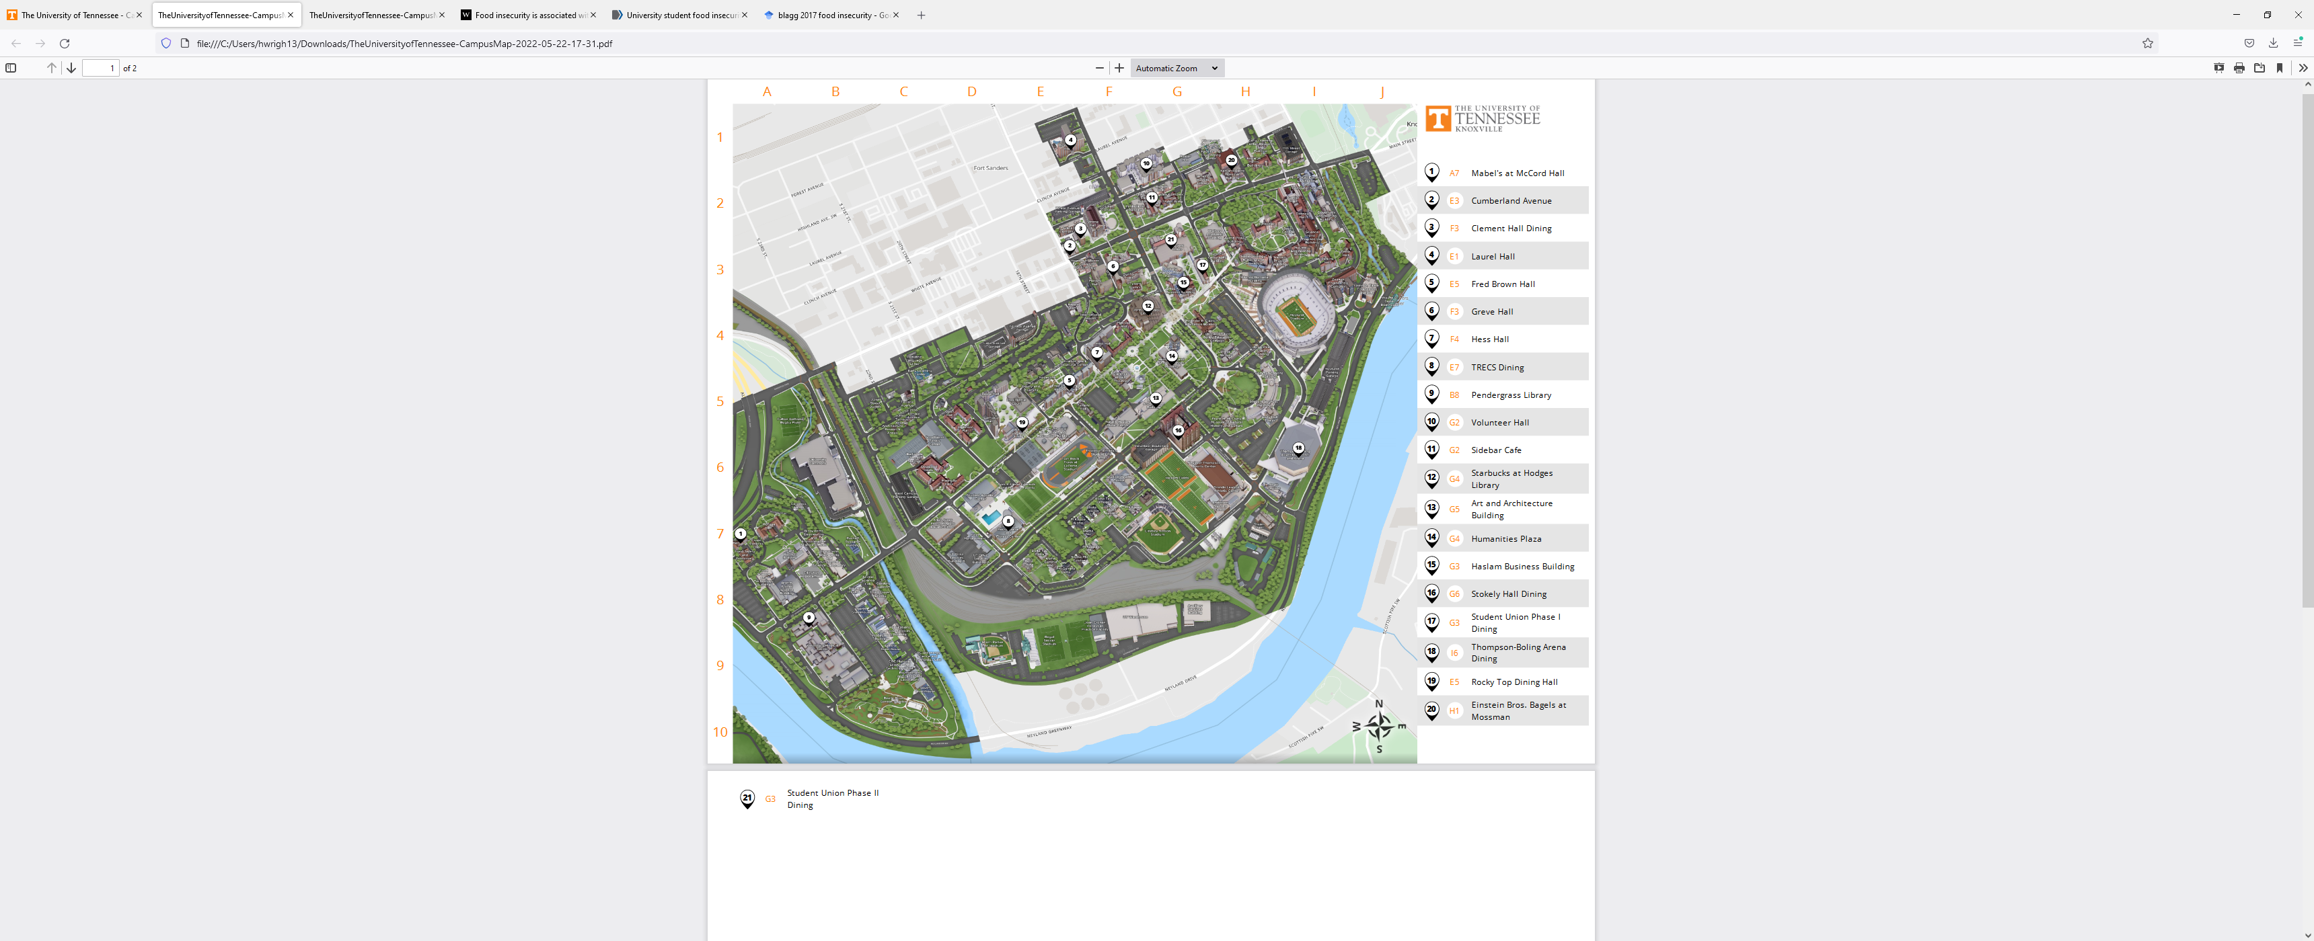
RAILROAD TRACKS
Commercial shopping center

Figure 2.

Map of the University of Tennessee, Knoxville Eating Locations

Note. The area in the red rectangle box denotes the Ag Campus which is the geographical name for the region administered by the Herbert College of Agriculture and the College of Veterinary Medicine. There are 21 places to eat at the University of Tennessee, Knoxville (UTK) denoted by white circles. Only two are located on the Ag Campus but are only open until 2 p.m. Monday through Friday. The Ag Campus is bordered by a stream, a river, a series of railroad tracks and a railroad car yard (fenced in), an interstate highway, and four-lane road along the river with heavy traffic.
In conclusion, the respondents in this study were students at a publicly funded flagship institution in Tennessee. Most of these students graduated from a public high school in Tennessee in which the state has invested in their education for the past 13 years. Other students (often graduate students) attend the University of Tennessee and contribute to its research and teaching mission by bringing their expertise from other states and countries. The state of Tennessee continues to make investments in the future learning and productivity of these students as they complete their degree programs through graduation. The most efficient use of resources, including monetary, by the state and the individual occurs when impediments to learning and earning a degree are diminished. Since food insecurity is associated with poorer physical and mental health outcomes, including being successful academically, a more efficient use of the state and personal resources can be realized by addressing this problem. Ultimately, it stands to reason that for all institutions of higher education when food insecurity can be ameliorated, society can benefit.

Future Directions for Research
The College Student Food Insecurity (CSFI) survey instrument has been created through item development, expert review, exploratory factor analysis, and validity/reliability testing procedures that indicate that it can be utilized as a relevant research instrument in future studies. A recommendation above promotes renaming the survey instrument the College Student Food Security Survey in order to forestall a triggered reaction by a student that has anxiety about the condition, and thus, not completing the survey. This stimulates the question – Is Food Security the opposite of Food Insecurity? In other words, if the conditions defining food insecurity are absent, can a person be food secure? A study examining these meanings may light the way for a nuanced approach for students.
This study was exploratory in nature and intended to be recognized as the introduction of the research for a food insecurity measurement tool. As indicated above, there were several areas of design and implementation that can be addressed through question revision and utilizing effective strategies to identify issues with nonresponse and attention to issues of institutions that enroll students that are different from UTK. Future research could involve partnerships with other institutions and test the findings from samples of students attending different types of institutions in various communities, states, and nations.
Comparing the responses to the survey and the demographic items did not seem to be consistent with other similar questions and failed to make sense at times. These apparent incongruent responses provide fertile ground for investigations that go deeper into how demographic characteristics are related or influential in producing behaviors and attitudes toward food insecurity and food security. For example, how the survey defines financial aid is important in terms of the limitations on different types of financial aid. Although loans can be used for almost any expense approved by law, do students use them to purchase food? How do the “free college” programs available in many states and institutions effect the prevalence of food insecurity? Many of these programs are “last dollar” programs that only fund tuition and fees and exclude room, board, textbooks, and transportation. If these scholarships were first dollar, how would the prevalence of food insecurity change?
This survey was developed to ascertain the food insecurity prevalence and degree of traditional, single college students residing outside of their parental household. Per the rationale applied for developing this survey, that the USDA Household Food Security Module (HFSSM) mentioned in Chapter 1 was inadequate for the measurement of these college students. It appears that this survey may need further research to account for food insecurity of students living in their parental households (8.70%). Further, a small percentage of students reported being “married” (2.17%), having children (2.17%), or in a “committed relationship” (13.04%) may bring additional factors to the condition of being food insecure that the survey which assumed largely single, traditional aged students in its target population. Studies that examine food insecurity in these groups would improve the validity of the instrument.
Qualitative research pertaining to food insecurity can be complementary to quantitative survey findings such as the CSFI, especially how students adapt and compensate to situations of limited access and availability to healthy food. Follow ups with focus groups and other qualitative approaches could be implemented to obtain more in-depth answers and understanding of experiences of students. These focus groups would be beneficial to obtain other information that the survey did not address or give the opportunity for students to explain in an open-ended format.

Future Action Steps for the Herbert College of Agriculture
The most important finding of this exploratory study is that over 37% of the student respondents reported being food insecure. Even considering the limitations of this study, this prevalence is in line with estimates from other studies. There are opportunities to provide support and resources to these students. The results could provide a baseline for administrators to understand to what extent students experience food insecurity and engage in coping behaviors especially for Pell grant recipients, first-generation, and graduate students. The Herbert College of Agriculture should consider available support resources and student outreach opportunities geared towards these students.
Additionally, the campus should undertake a process to observe students to ascertain if the risk factors associated with food insecurity are present among the students. The college could provide staff to provide information and data at departmental meetings to consider the known risk factors associated with food insecurity and training on the behaviors of food insecurity. Faculty members and instructors should be encouraged to view the student holistically and be aware of their student’s academic progress. For example, a student’s class attendance and grades could be related to food insecurity. If there is a fluctuation in the student’s grades, performance, and/or class participation, a faculty member may consider if these students could be categorized into one of the discussed risk profiles for food insecurity. Providing food vouchers could also be a short-term solution if a student is experiencing difficulties obtaining food daily.
With the prevalence of food insecurity on college campuses, university administrator and policy makers alike can be working to develop solutions to address this pervasive and serious problem plaguing students. The first step in ameliorating food insecurity is providing safe and affordable access to food options for all individuals. For the Ag Campus studied, it may involve the establishment of more dining options for affordable and healthy food for students. Perhaps a feasibility study could be launched to determine what types of food establishments are most cost effective for the over 2,000 students and faculty involved with both the Herbert College of Agriculture and the College of Veterinary Medicine. A higher percentage of students (20.45%) reported that the mid-day meal was missed most often. That time period between 11 a.m. and 2 p.m. might be a starting point for a food court on the Ag Campus.
It is imperative campus leaders are aware of the issues and working towards solutions to help these students. The first step in this process is using a reliable and valid instrument to assess the need and scope of the problem on individual campuses. Once such an instrument is designed and administered to a diverse population, then an annual administration could be used to develop a longitudinal trendline over time.
This survey could also serve as a tool to understand the focuses of their students to help determine the financial and academic support resources needed for the college to adopt and implement. The information and data regarding college student food insecurity should be included in application processes and annual reports to ensure student’s basic needs are fulfilled. University administrators and policy makers could view students holistically and consider their entire set of experiences and the effects those experiences bear on their academic successes. Ultimately, the success of each student is the success of college or institution.
Considerations should also be made to establish permanent faculty or staff positions to help address the basic needs resources and support for students. College students should have access to basic needs such as food. As colleges focus more on the well-being of students and attending to their basic needs, colleges and universities will create opportunities for the continued advancement of the entire student.
Policymakers could help provide a solution to this issue by passing legislation to extend federal and state assistance programs such as SNAP to enable college students to be eligible for benefits. Other school lunch programs designed for primary and secondary schools could be expanded to reach students in higher education. Based on the results of this study, there is a need for higher education administrators to take measures to reduce this problem for students. There should be a desire to work with local, state, and federal representatives to find a sustainable solution to ameliorate food insecurity for college students and even nationwide. If one student is hungry or food insecure, it is one too many. There is a push for more students to attend institutions for postsecondary education in Tennessee, but we have to provide them with the resources and supports they need to succeed. One of those resources is food and access to food sources.

Conclusion
In conclusion, there is a need for a reliable and valid instrument to measure food insecurity of college students and quantitatively capture their behaviors and experiences on college campuses in the United States. Other research conducted in this area has highlighted the prevalence of food insecurity but not the behaviors and coping strategies of these students. The exploratory study addressed behaviors, encounters, and available support resources for food-insecure students that are immersed in the underlying conditions of students on college campuses.
Without the support of Drs. Caula Beyl, (Dean of the Herbert College of Agriculture, University of Tennessee, Knoxville) John Stier (Associate Dean-Herbert College of Agriculture, University of Tennessee, Knoxville) and Brent Lamons (Director of Advising and Student Success - Herbert College of Agriculture, University of Tennessee, Knoxville) this research would not have been possible. From a higher education administrative view, both academic professionals can assist in accelerating a growing body of support resources and an improved environment for food insecurity college students in the United States.

REFERENCES
Ahmad, N., Sulaiman, N., & Sabri, M. F. (2021). Food insecurity: Is it a threat to university students' well-being and success? International Journal of Environmental Research and Public Health, 18(11), 5627. https://doi.org/10.3390/ijerph18115627
Blagg, K., Gundersen, C., Schanzenbach, D. W., & Ziliak, J. P. (2017). Assessing food insecurity on campus. The Urban Institute. https://www.urban.org/sites/default/files/publication/92331/assessing_food_insecurity_on_campus_4.pdf
Baker-Smith, C., Coca, V., Goldrick-Rab, S., Looker, E., Richardson, B., & Williams, T. (2020). #RealCollege 2020: Five years of evidence on campus basic needs insecurity. The Hope Center for College, Community, and Justice.
Baum, S., & Payea, K. (2004). Education pays 2004: The benefits of higher education for individuals and society. College Board.
Beavers, A. S., Lounsbury, J. W., Richards, J. K., Huck, S. W., Skolits, G. J., & Esquivel, S. L. (2013). Practical considerations for using exploratory factor analysis in educational research. Practical Assessment, Research & Evaluation, 18(6), 1-13.
Bickel, G., Nord, M., Price, C., Hamilton, W., & Cook, J. (2000). Measuring Food Security in the United States. Alexandria, VA: US Department of Agriculture, Food and Nutrition Service. https://www.fns.usda.gov/guide-measuring-household-food-security-revised-2000
Broton, K. M., & Goldrick-Rab, S. (2018). Going without: An exploration of food and housing insecurity among undergraduates. Educational Researcher, 47(2), 121–133. https://doi.org/10.3102/0013189X17741303
Bruening, M., Argo, K., Payne-Sturges, D., & Laska, M. N. (2017). The struggle is real: A systematic review of food insecurity on postsecondary education campuses. Journal of the Academy of Nutrition and Dietetics, 117(11), 1767–1791. https://doi.org/10.1016/j.jand.2017.05.022
Bureau of Labor Statistics. (2022, May). Consumer Price Index Summary. https://www.bls.gov/news.release/cpi.nr0.htm
Burns, R., Johnson, R., Lacy, T. A., Cameron, M., Holley, J., Lew, S., Wu, J., Siegel, P., & Wine, J. (2021). 2017–18 National Postsecondary Student Aid Study, Administrative Collection (NPSAS:18-AC): First Look at Student Financial Aid Estimates for 2017–18 (NCES 2021-476). U.S. Department of Education. National Center for Education Statistics. https://nces.ed.gov/pubsearch/pubsinfo.asp?pubid=2021476.
Cady. C. L. (2014). Food insecurity as a student issue. Journal of College and Character, 15(4), 265-272. https://doi.org/10.1515/jcc-2014-0031
Cameron, M., Lacy, T. A., Siegel, P., Wu, J., Wilson, A., Johnson, R., Burns, R., & Wine, J. (2021). 2019–20 National Postsecondary Student Aid Study (NPSAS:20): First Look at the Impact of the Coronavirus (COVID-19) Pandemic on Undergraduate Student Enrollment, Housing, and Finances (Preliminary Data) (NCES 2021-456). U.S. Department of Education. National Center for Education Statistics. https://nces.ed.gov/pubsearch/pubsinfo.asp?pubid=2021456.
Case, A., & Deaton, A. (2017). Mortality and morbidity in the 21st century. Brookings Papers on Economic Activity, 2017, 397–476. https://doi.org/10.1353/eca.2017.0005
Chaparro, M. P., Zaghloul, S. S., Holck, P., & Dobbs, J. (2009). Food insecurity prevalence among college students at the University of Hawai'i at Mānoa. Public Health Nutrition, 12(11), 2097–2103. https://doi.org/10.1017/S1368980009990735
Clark, L. A., & Watson, D. (1995). Constructing validity: Basic issues in objective scale development. Psychological Assessment, 7(3), 309–319. https://doi.org/10.1037/1040-3590.7.3.309
Coffino, J. A., Spoor, S. P., Drach, R. D., & Hormes, J. M. (2021). Food insecurity among graduate students: prevalence and association with depression, anxiety and stress. Public Health Nutrition, 24(7), 1889–1894. https://doi.org/10.1017/S1368980020002001
Coie, J. D., Watt, N. F., West, S. G., Hawkins, J. D., Asarnow, J. R., Markman, H. J., Ramey, S. L., Shure, M. B., & Long, B. (1993). The science of prevention. A conceptual framework and some directions for a national research program. The American Psychologist, 48(10), 1013–1022. https://doi.org/10.1037//0003-066x.48.10.1013
Coleman-Jensen, A., Rabbitt, M. P., Hales, L., & Gregory, C. A. (2021, September 8). Frequency of food insecurity. Economic Research Service, U. S. Department of Agriculture. https://www.ers.usda.gov/topics/food-nutrition-assistance/food-security-in-the-us/frequency-of-food-insecurity/
Coleman-Jensen, A., Rabbitt, M. P., Hales, L., & Gregory, C. A. (2021, September 8). Economic Research Service, United States Department of Agriculture. (2020, September 9). Food Security in the U.S. https://www.ers.usda.gov/topics/food-nutrition-assistance/food-security-in-the-us/key-statistics-graphics.aspx
Coleman-Jensen, A., Rabbitt, M. P., Gregory, C. A., & Singh, A. (2018). Household food security in the United States in 2017 (ERR-256). Washington, DC: US Department of Agriculture, Economic Research Service. https://www.ers.usda.gov/webdocs/publications/90023/err-256.pdf?v=8243.5
Corrigan, M. J., Loneck, B., Videka, L., & Brown, C. M. (2007). Moving the Risk and Protective Factor Framework toward Individualized Assessment in Adolescent Substance Abuse Prevention. Journal of Child & Adolescent Substance Abuse, 16, 17-34. https://doi.org/10.1300/J029v16n03_02
CoStar Group. (2022, May 6). Apartments.com publishes April 2022 rent growth report: National year-over-year multifamily rent growth at 10.6%, down from 11.4 % in March. https://www.costargroup.com/costar-news/details/apartments.com-publishes-april-2022-rent-growth-report
Creswell, J. W. (2014). Research design: qualitative, quantitative, and mixed methods approaches. (4th ed.) Sage.
Davidson, A. R., & Morrell, J. S. (2020) Food insecurity prevalence among university students in New Hampshire, Journal of Hunger & Environmental Nutrition, 15(1), 118-127. https://doi.org/10.1080/19320248.2018.1512928.
DeMaris, A. (1995). A tutorial in logistic regression. Journal of Marriage and the Family, 57, 965-968.
Dewey, C. (2018, April 3). The hidden crisis on college campuses: Many students do not have enough to eat. The Washington Post. https://www.washingtonpost.com/news/wonk/wp/2018/04/03/the-hidden-crisis-on-college-campuses-36-percent-of-students-dont-have-enough-to-eat/
de Winter, J. C., Dodou, D., & Wieringa, P. A. (2009). Exploratory factor analysis with small sample sizes. Multivariate Behavioral Research, 44(2), 147–181. https://doi.org/10.1080/00273170902794206
Dubick, J., Mathews, B., & Cady, C. (2016). Hunger on campus: The challenge of food insecurity for college students. College and University Food Bank Alliance. https://studentsagainsthunger.org/wp-content/uploads/2016/10/Hunger_On_Campus.pdf
Ellison, B., Bruening, M., Hruschka, D. J., Nikolaus, C. J., van Woerden, I., Rabbitt, M. P., & Nickols-Richardson, S. M. (2021). Viewpoint: Food insecurity among college students: A case for consistent and comparable measurement. Food Policy, 101, 102031. https://doi.org/10.1016/j.foodpol.2021.102031
El Zein, A., Shelnutt, K. P., Colby, S., Vilaro, M. J., Zhou, W., Greene, G., Olfert, M. D., Riggsbee, K., Morrell, J. S., & Mathews, A. E. (2019). Prevalence and correlates of food insecurity among U.S. college students: a multi-institutional study. BMC public health, 19(1), 660. https://doi.org/10.1186/s12889-019-6943-6
Farahbakhsh, J., Hanbazaza, M., Ball, G., Farmer, A. P., Maximova, K., & Willows, N. D. (2017). Food insecure student clients of a university-based food bank have compromised health, dietary intake and academic quality. Nutrition & Dietetics: The Journal of the Dietitians Association of Australia, 74(1), 67–73. https://doi.org/10.1111/1747-0080.12307
Fagerland, M. W., & Hosmer, D. W. (2012). A generalized Hosmer–Lemeshow goodness-of-fit test for multinomial logistic regression models. The Stata Journal: Promoting Communications on Statistics and Stata, 12(3), 447–453. https://doi.org/10.1177/1536867x1201200307
Food and Agriculture Organization of the United Nations, International Fund for Agricultural Development, United Nations International Children's Emergency Fund, World Food Program, & World Health Organization. (2021). The state of food security and nutrition in the world 2021: Transforming food systems for food security, improved nutrition and affordable healthy diets for all. Food & Agriculture Org. https://www.fao.org/3/cb4474en/cb4474en.pdf
Freudenberg, N., Goldrick-Rab, S., & Poppendieck, J. (2019). College students and SNAP: The new face of food insecurity in the United States. American Journal of Public Health, 109(12), 1652–1658. https://doi.org/10.2105/AJPH.2019.305332
Frey, B. B. (Ed.). (2018). The SAGE encyclopedia of educational research, measurement, and evaluation. Sage. https://dx.doi.org/10.4135/9781506326139
Gaines, A., Robb, C. A., Knol, L. L., & Sickler, S. (2014). Examining the role of financial factors, resources and skills in predicting food security status among college students. International Journal of Consumer Studies, 38(4), 374–384. https://doi.org/10.1111/ijcs.12110
Goldin, C., & Katz, L. F. (1999). The shaping of higher education: The formative years in the United States, 1890 to 1940. Journal of Economic Perspectives, 13(1), 37–62. https://doi.org/10.1257/jep.13.1.37
Granello, D .H., & Wheaton, J. E. (2011). Online data collection: Strategies for research. Journal of Counseling and Development, 82, 387-393. https://doi.org/10.1002/j.1556-6678.2004.tb00325.x
Goldrick-Rab, S., Richardson, J., Schneider, J., Hernandez, A. & Cady, C. (2018). Still hungry and homeless in college. Wisconsin Hope Lab. https://hope4college.com/wp-content/uploads/2018/09/Wisconsin-HOPE-Lab-Still-Hungry-and-Homeless.pdf
Gundersen, C. (2020). Are college students more likely to be food insecure than nonstudents of similar ages? Applied Economic Perspectives and Policy, 43(4), 1476-1486. https://doi.org/10.1002/aepp.13110
Gundersen, C., & Ziliak, J. P. (2015). Food insecurity and health outcomes. Health Affairs (Project Hope), 34(11), 1830–1839. https://doi.org/10.1377/hlthaff.2015.0645
Hagedorn, R. L., & Olfert, M. D. (2018). Food insecurity and behavioral characteristics for academic success in young adults attending an Appalachian university. Nutrients, 10(3), 361. https://doi.org/10.3390/nu10030361
Hanbazaza, M., Ball, G. D. C., Farmer, A. P., Maximova, K., Farahbakhsh, J., & Willows, N. D. (2017). A comparison of characteristics and food insecurity coping strategies between international and domestic postsecondary students using a food bank located on a university campus. Canadian Journal of Dietetic Practice and Research, 78(4), 208–211. https://doi.org/10.3148/cjdpr-2017-012
Hege, A., Stephenson, T., Pennell, M., Revlett, B., VanMeter, C., Stahl, D., Oo, K., Bressler, J., & Crosby, C. (2021) College food insecurity: Implications on student success and applications for future practice. Journal of Student Affairs Research and Practice, 58(1), 44-61. https://doi.org/10.1080/19496591.2020.1726359
Henry, L. (2017). Understanding food insecurity among college students: experience, motivation, and local solutions. Annals of Anthropological Practice, 41(1), 6-19. https://doi.org/10.1111/napa.12108
Hughes, R., Serebryanikova, I., Donaldson, K., & Leveritt, M. (2011). Student food insecurity: The skeleton in the university closet. Nutrition & Dietetics, 68(1), 27–32. https://doi.org/10.1111/j.1747-0080.2010.01496.x
Hunter College - New York City Food Policy Center. (2018, October 30). In New York state, no student goes hungry. https://www.nycfoodpolicy.org/in-new-york-state-no-student-goes-hungry/
Jhangiani, R., Chiang, I.A., Cuttler, C., & Leighton, D. C. (2019). Research methods in psychology.
Kaiser, H. F. (1960). The application of electronic computers to factor analysis. Educational and Psychological Measurement, 20, 141–151. https://doi.org/10.1177/001316446002000116
Keith-Jennings, B., Llobrera, J., & Dean, S. (2019, December). Links of the supplemental nutritional assistance program with food insecurity, poverty, and health: evidence ad potential. American Journal of Public Health, 109(12), 1636-1640. https://doi.org/.2105/AJPH.2019.305325
Landers, P. (2007). The food stamp program: History, nutrition education, and impact. Research Review, 107(11), 1945-1951. https://doi.org/10.1016/j.jada.2007.08.009
Larin, K. (2018). Food insecurity: Better information could help eligible college students access federal food assistance benefits. Report to Congressional Requesters. GAO-19-95. US Government Accountability Office. https://www.gao.gov/assets/700/696254.pdf
Laska, M. N., Fleischhacker, S., Petsoulis, C., Bruening, M., & Stebleton, M. J. (2020). Addressing college food Insecurity: An assessment of federal legislation before and during coronavirus disease-2019. Journal of Nutrition Education and Behavior, 52(10), 982–987. https://doi.org/10.1016/j.jneb.2020.07.001
Lawlis, T., Islam, W., & Upton, P. (2018). Achieving the four dimensions of food security for resettled refugees in Australia: A systematic review. Nutrition & Dietetics, 75, 182–192. https://doi.org/10.1111/1747-0080.12402
Leroy, J. L., Ruel, M., Frongillo, E. A., Harris, J., & Ballard, T. J. (2015). Measuring the food access dimension of food security: A critical review and mapping of indicators. Food and Nutrition Bulletin, 36(2), 167-195. https://doi.org/10.1177/0379572115587274
Lisnyj, K. T, Russell, R., & Papadopoulos, A. (2020). Risk and protective factors for anxiety impacting academic performance in post-secondary students. Canadian Journal of Higher Education. 50(2), 71–88. https://doi.org/10.7202/1071396a
Martinez, S. M., Frongillo, E. A., Leung, C., & Ritchie, L. D. (2018). No food for thought: Food insecurity is related to poor mental health and lower academic performance among students in California’s public university system. Journal of Health Psychology, 25(12), 1930-1939. https://doi.org/10.1177/1359105318783028
Martinez, S. M., Webb, K., Frongillo, E. A., & Ritchie, L. D. (2017): Food insecurity in California’s public university system: What are the risk factors? Journal of Hunger & Environmental Nutrition, 25(12), 1930-1939. https://doi.org/10.1177/1359105318783028
Maroto, M. E., Snelling A., & Linck, H. (2015). Food insecurity among community college students: Prevalence and association with grade point average. Community College Journal of Research and Practice, 39(6), 515–526, DOI: 10.1080/10668926.2013.850758
Mattoon, E. R. (2021, September 19). Food insecurity touches college students. Hopkins is no exception. The Johns Hopkins Newsletter. https://www.jhunewsletter.com/article/2021/09/food-insecurity-touches-college-students-nationwide-hopkins-is-no-exception
McArthur, L. H., Ball, L., Danek, A. C., & Holbert, D. (2018). A high prevalence of food insecurity among university students in Appalachia reflects a need for educational interventions and policy advocacy. Journal of Nutrition Education and Behavior, 50(6), 564–572. https://doi.org/10.1016/j.jneb.2017.10.011

McCoy, M., Martinelli, S., Reddy, S., Don, R., Thompson, A, Speer, M., Bravo, R., Yudell, M., & Darira, S. (2022). Food insecurity on campus: The invisible epidemic. Health Affairs Forefront. https://doi.org/10.1377/forefront.20220127.264905
Mendoza-Jiménez, M.-J., Hannemann, T.-V., & Atzendorf, J. (2021). Behavioral risk factors and adherence to preventive measures: Evidence from the early stages of the COVID-19 pandemic. Frontiers in Public Health, 9. https://doi.org/10.3389/fpubh.2021.674597
Meza, A., Altman, E., Martinez, S., & Leung, C. W. (2019). “It’s a feeling that one is not worth food”: A qualitative study exploring the psychosocial experience and academic consequences of food insecurity among college students. Journal of the Academy of Nutrition and Dietetics, 119(10), 1713-1721. https://doi.org/10.1016/j.jand.2018.09.006
Mialki, K., House, L. A., Mathews, A. E., & Shelnutt, K. P. (2021). Covid-19 and college student success: Food security status before and after the onset of a pandemic. Nutrients, 13, 628-641. https://doi.org/10.3390/nu13020628
Morris, L. M., Smith, S., Davis, J., & Null, D. B. (2016). The prevalence of food security and insecurity Among Illinois university students. Journal of Nutrition Education and Behavior, 48. https://doi.org/10.1016/j.jneb.2016.03.013
Morrow, J. A. (2017). Twelve steps of quantitative data cleaning: strategies for dealing with dirty data [Personal Communication]. Department of Educational Psychology and Counseling, University of Tennessee, Knoxville, TN.
Morrow, J. A. (2020). Week #3: measurement and validity/reliability [Class lecture]. Department of Educational Psychology and Counseling, University of Tennessee, Knoxville, TN.
Mvududu, N. H., & Sink, C. A. (2013). Factor analysis in counseling research and practice. Counseling Outcome Research and Evaluation, 4(2), 75-98. https://doi.org/10.1177/2150137813494766
Myers, C. A., Mire, E. F, & Katzmarzyk, P. T. (2020). Trends in adiposity and food insecurity among US adults. JAMA Network Open, 3(8), e2012767. https://doi.org/10.1001/jamanetworkopen.2020.12767
National Center for Education Statistics (NCES). (2021a). Characteristics of Postsecondary Students. Condition of Education. U.S. Department of Education, Institute of Education Sciences. https://nces.ed.gov/programs/coe/indicator/csb
National Center of Education Statistics (NCES). (2021b). Trends in Nontraditional Student Enrollment. U.S. Department of Education, Institute of Education Sciences. https://nces.ed.gov/pubs/web/97578f.asp
Nikolaus, C. J., Ruopeng, A., Ellison, B., & Nickols-Richardson, S. M. (2020). Food Insecurity among college students in the United States: A scoping review. Advances in Nutrition, 11(2), 327–348, https://doi.org/10.1093/advances/nmz111
Nixon, M. K., & Heath, N. L. (Eds.). (2009). Self-injury in youth: The essential guide to assessment and intervention. Routledge.
Ortagus, J. C., Kelchen, R., Rosinger, K., & Voorhees, N. (2020). Performance-Based funding in American higher education: A systematic synthesis of the intended and unintended consequences. Educational Evaluation and Policy Analysis, 42(4), 520–550. https://doi.org/10.3102/0162373720953128
Owens, M. R., Brito-Silva, F., Kirkland, T., Moore, C. E., Davis, K. E., Patterson, M. A., Miketinas, D. C., & Tucker, W. J. (2020). Prevalence and social determinates of food insecurity among college students during the covid-19 pandemic. Nutrients, 12(9), 2515. https://doi.org/10.3390/nu12092515
Patton-López, M. M., López-Cevallos, D. F., Cancel-Tirado, D. I., & Vazquez, L. (2014). Prevalence and correlates of food insecurity among students attending a midsize rural university in Oregon. Journal of nutrition education and behavior, 46(3), 209–214. https://doi.org/10.1016/j.jneb.2013.10.007
Payne-Sturges, D. C., Tjaden, A., Caldeira, K. M., Vincent, K. B., & Arria, A. M. (2018). Student hunger on campus: Food insecurity among college students and implications for academic institutions. American Journal of Health Promotion, 32(2), 349–354. https://doi.org/10.1177/0890117117719620
Perna, L. W., Leigh, E.W., & Carroll, S. (2018). “Free college:” A new and improved state approach to increasing education attainment? American Behavioral Scientist, 61(14), 1740-1756. https://doi.org/10.1177/0002764217744821
Perna, L. W. (2005). The benefits of higher education: Sex, racial/ethnic, and socioeconomic group differences. The Review of Higher Education, 29(1), 23–52. https://doi.org/10.1353/rhe.2005.0073
Phillips, E., McDaniel, A., & Croft, A. (2018). Food insecurity and academic disruption among college students. Journal of Student Affairs Research and Practice, 55(4), 353–372. https://doi.org/10.1080/19496591.2018.1470003
Pituch, K. A., & Stevens, J. P. (2015). Applied multivariate statistics for the social sciences: Analyses with SAS and IBM’s SPSS (6th ed.). Routledge. https://doi.org/10.4324/9781315814919
Postsecondary National Policy Institute. (2021, September). Post-Traditional Students in Higher Education. https://pnpi.org/post-traditional-students/
Poutre, A., & Voight, M. (2018b). Tennessee Promise: Does it help students with limited financial means afford college? (ED595381). ERIC. https://files.eric.ed.gov/fulltext/ED595381.pdf
Proptopsaltis, S., & Parrott, S. (2017, July 27). Pell grants - a key tool for expanding college access and economic opportunity- need strengthening, not cuts. Center on Budget and Policy Priorities. https://www.cbpp.org/research/federal-budget/pell-grants-a-key-tool-for-expanding-college-access-and-economic
Raskind, I. G., Haardörfer, R., & Berg, C. J. (2019). Food insecurity, psychosocial health and academic performance among college and university students in Georgia, USA. Public Health Nutrition, 22(3), 476–485. https://doi.org/10.1017/S1368980018003439
Reeder, N., Tapanee, P., Persell, A., & Tolar-Peterson, T. (2020). Food insecurity, depression, and race: Correlations observed among college students at a university in the Southeastern United States. International Journal of Environmental Research and Public Health, 17(21), 8268. https://doi.org/10.3390/ijerph17218268
Riddle, E.S., Niles, M. T., & Nickerston, A. (2020). Prevalence and factors associated with food insecurity across an entire campus population. PLOS ONE, 15(8): e0237637. https://doi.org/10.1371/journal.pone.0237637
Robinson, S. B., & Leonard, K. F. (2019). Designing quality survey questions. Sage.
Salkind, N. J. (2010). Encyclopedia of research design (Vols. 1-0) .Sage. https://doi.org/10.4135/9781412961288
Silva, M., Kleinert, W., Sheppard, A., Cantrell, K., Freeman-Coppadge, D., Tsoy, E., Roberts, T., & Pearrow, M. (2017). The relationship between food security, housing stability, and school performance among college students in an urban university. Journal of College Student Retention: Research, Theory & Practice, 19(3), 284–299. https://doi.org/10.1177/1521025115621918
Soldavini, J., Andrew, H., & Berner, M. (2021). Characteristics associated with changes in food security status among college students during the COVID-19 pandemic. Translational Behavioral Medicine, 11(2), 295–304. https://doi.org/10.1093/tbm/ibaa110
Stebleton, M. J., Lee, C. K., & Diamond, K. K. (2020). Understanding the food insecurity experiences of college students: A qualitative inquiry. The Review of Higher Education, 43(3), 727–752. https://doi.org/10.1353/rhe.2020.0005
Tabachnick, B. G., & Fidell, L. S. (2001). Using multivariate statistics Allyn and Bacon.
Tennessee Department of Human Services. (2022). Supplemental Nutrition Assistance Program (SNAP). https://www.tn.gov/humanservices/for-families/supplemental-nutrition-assistance-program-snap.html
Thorman, A., & Dhillon, H. (2021). No food for thought: Documenting the prevalence of food insecurity among medical students at one western university. Journal of Hunger & Environmental Nutrition, (6)5, 643-649. https://doi.org/10.1080/19320248.2021.1873885
U.S. Department of Agriculture, Economic Research Service. Definitions of food security. http://www.ers.usda.gov/topics/food…/food-security-in…/definitions-of-food-security/
U.S. Department of Agriculture, Economic Research Service. Food security in the U.S.: measurement. http://www.ers.usda.gov/topics/food-nutrition-assistance/food-security-in-the-us/measurement.aspx.
U.S. Department of Health and Human Services, Substance Abuse and Mental Health Services Administration (SAMHSA). (2019) Risk and Protective Factors.
van Woerden, I., Hruschka, D., Vega-Lόpez, S., Schaefer, D. R., Adams, M., & Bruening, M. (2019). Food insecure college students and objective measurements of their unused meal plans. Nutrients, 11(4), 904. https://doi.org/10.3390/nu11040904
Watkins, M. W. (2018). Exploratory factor analysis: A guide to best practice. Journal of Black Psychology, 44(3), 219–246. https://doi.org/10.1177/0095798418771807
Weaver, R. R., Vaughn, N. A., Hendricks, S. P., McPherson-Myers, P. E., Jia, Q., Willis, S. L., & Rescigno, K. P. (2020). University student food insecurity and academic performance. Journal of American College Health: 68(7), 727–733. https://doi.org/10.1080/07448481.2019.1600522
White, S. S. (2020). Student food insecurity and the social equity pillar of Campus Sustainability. International Journal of Sustainability in Higher Education, 21(5), 861–875. https://doi.org/10.1108/ijshe-06-2019-0207
Willis, D. E. (2021). Feeding inequality: Food insecurity, social status, and college student health. Sociology of Health & Illness, 43(1), 220-237. https://doi.org/10.1111/1467-9566.13212
Wolfson, J., Insolera, N., Cohen, A., & Leung, C. (2021). The effect of food insecurity during college on graduation and type of degree attained: Evidence from a nationally representative longitudinal survey. Public Health Nutrition, 25(2), 389-397. https://doi.org/10.1017/S1368980021003104
Zickgraf, H. F., Hazzard, V. M., & O'Connor, S. M. (2022). Food insecurity is associated with eating disorders independent of depression and anxiety: Findings from the 2020–2021 Healthy Minds Study. International Journal of Eating Disorders, 55(3), 354–361. https://doi.org/10.1002/eat.23668
Zigmont, V. A., Linsmeier, A. M., & Gallup, P. (2019): Understanding the why of college student food insecurity, Journal of Hunger & Environmental Nutrition, 16(5), 595-610. https://doi.org/10.1080/19320248.2019.1701600

APPENDIX A
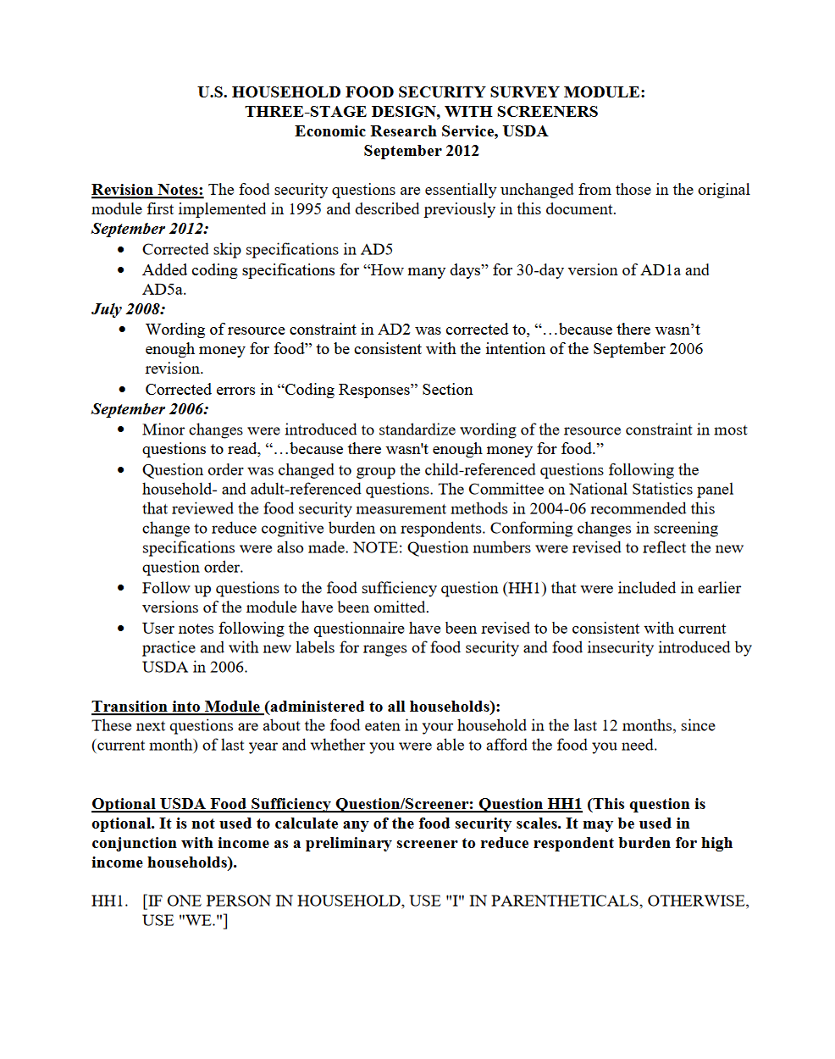
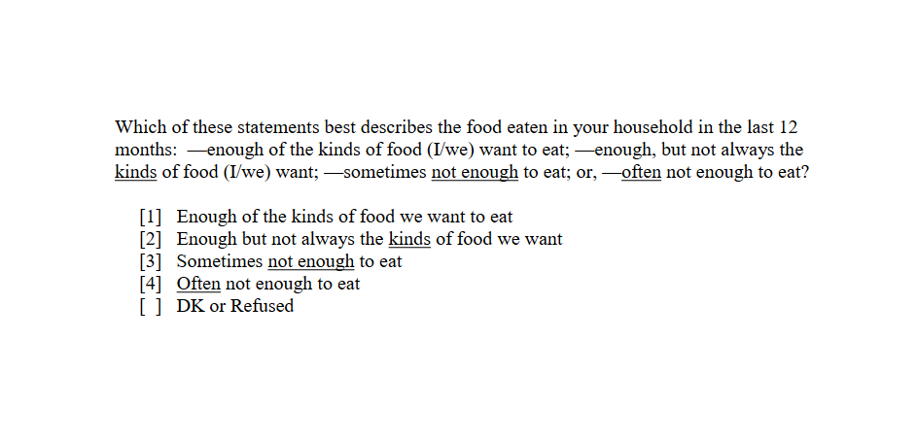
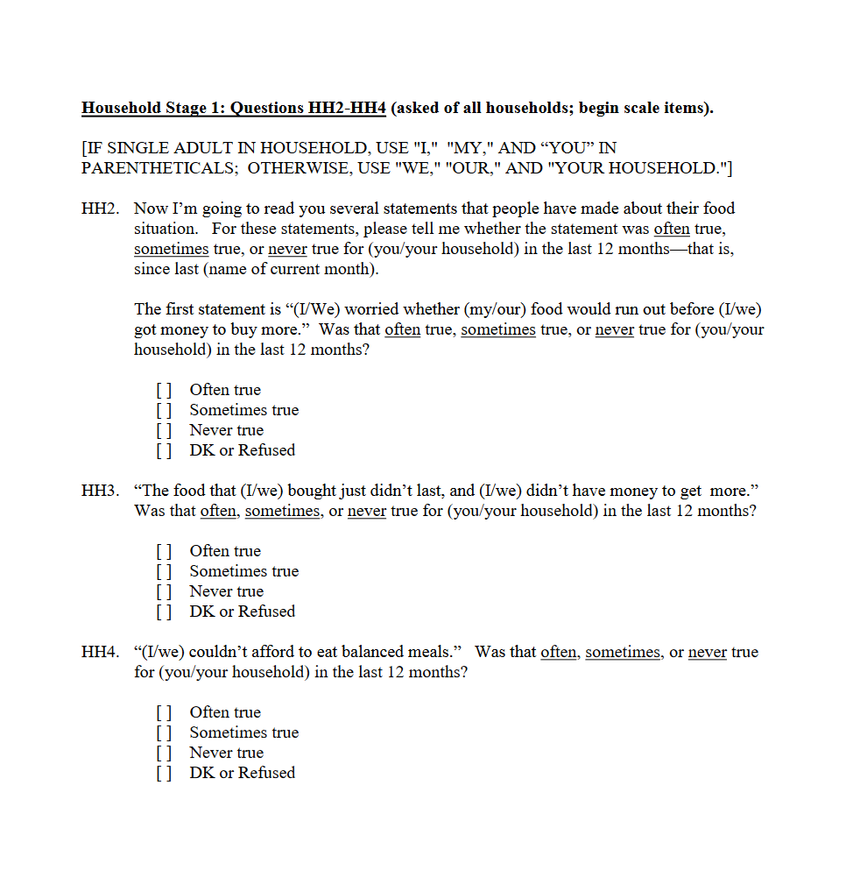

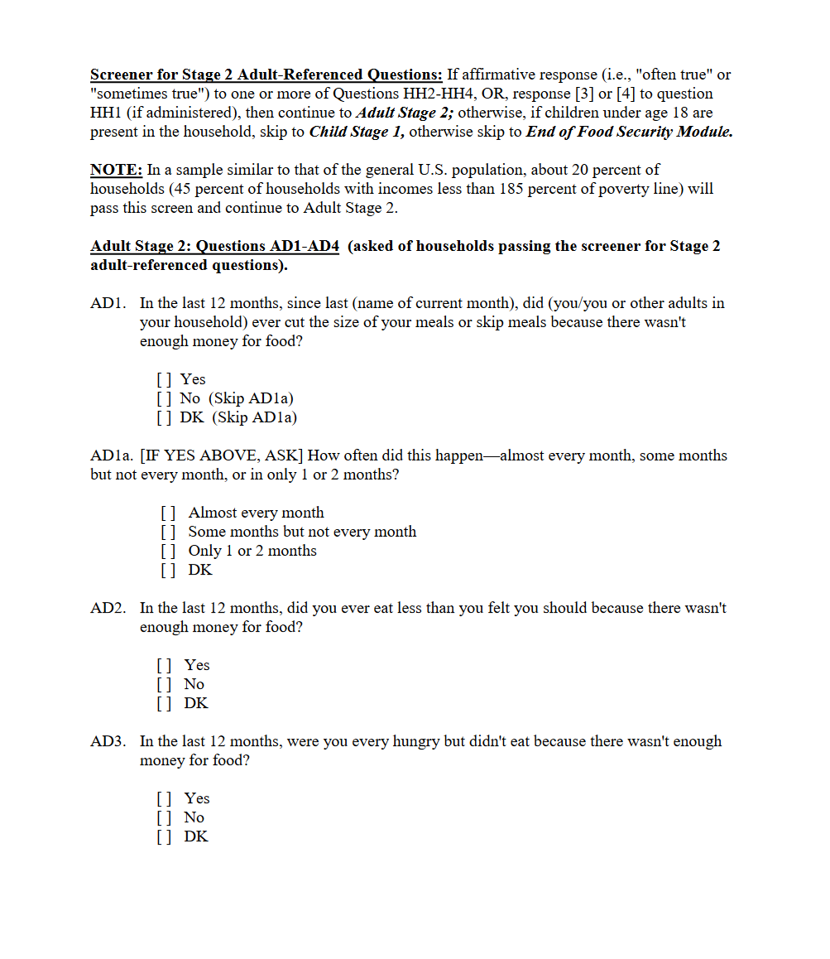

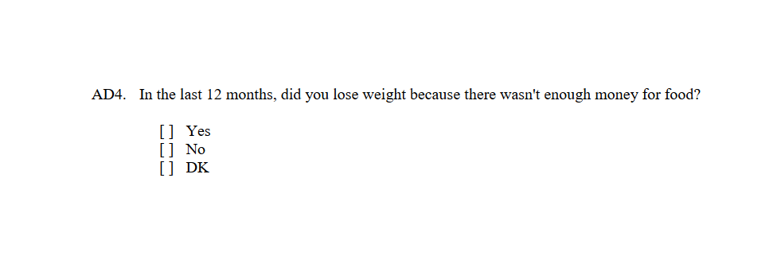
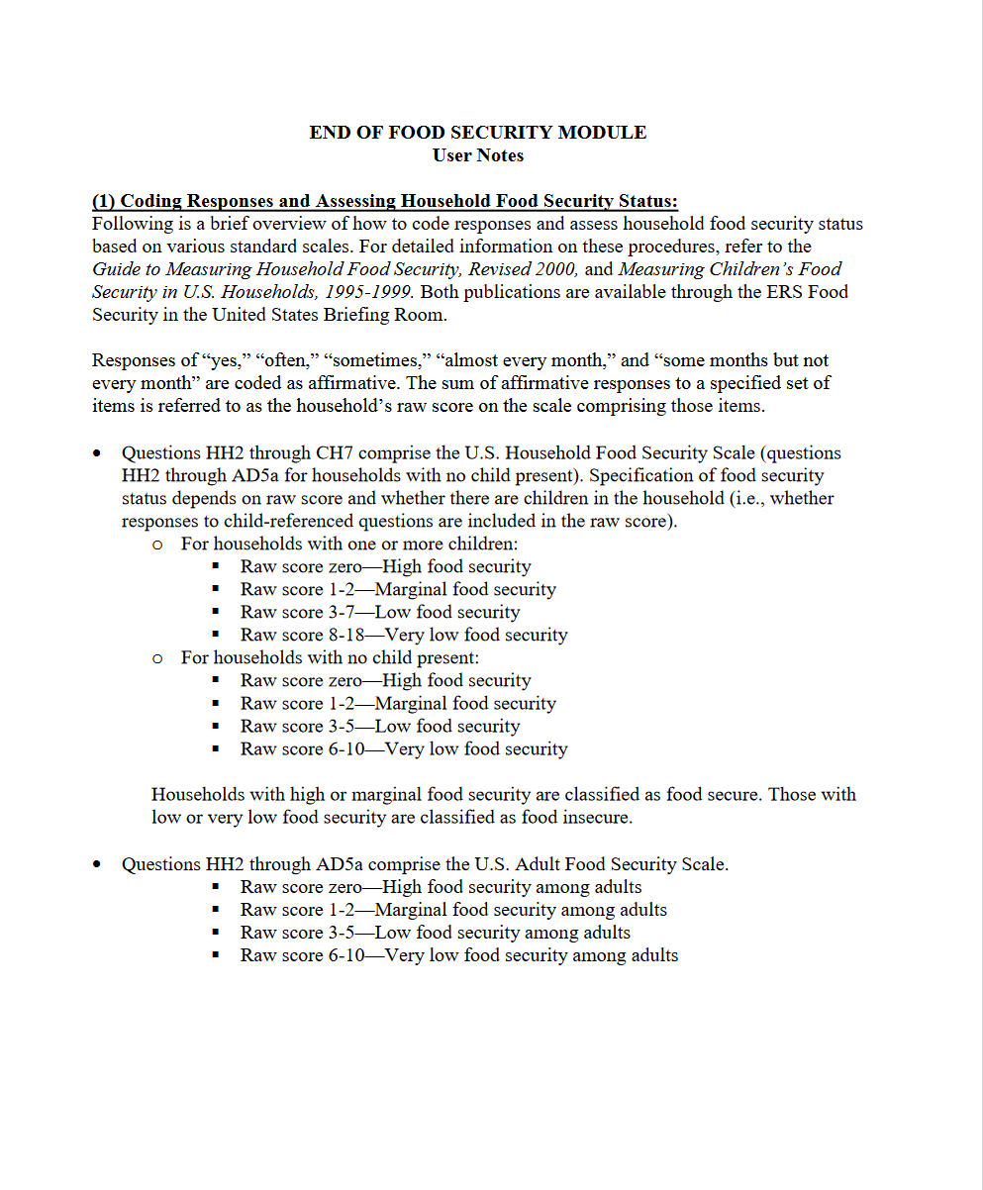

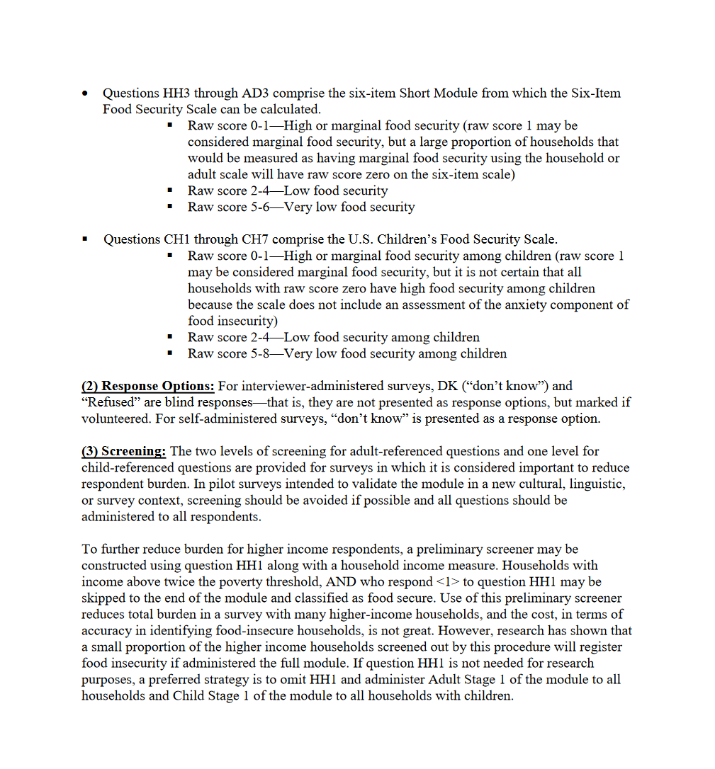

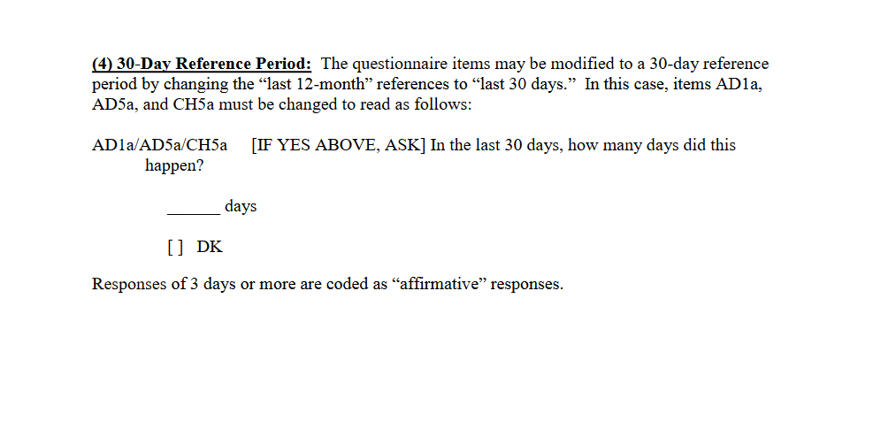

APPENDIX B
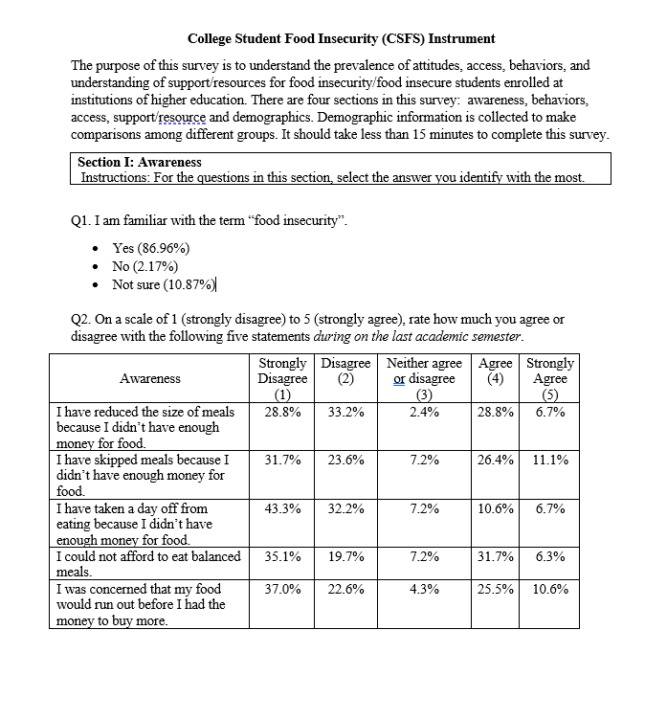

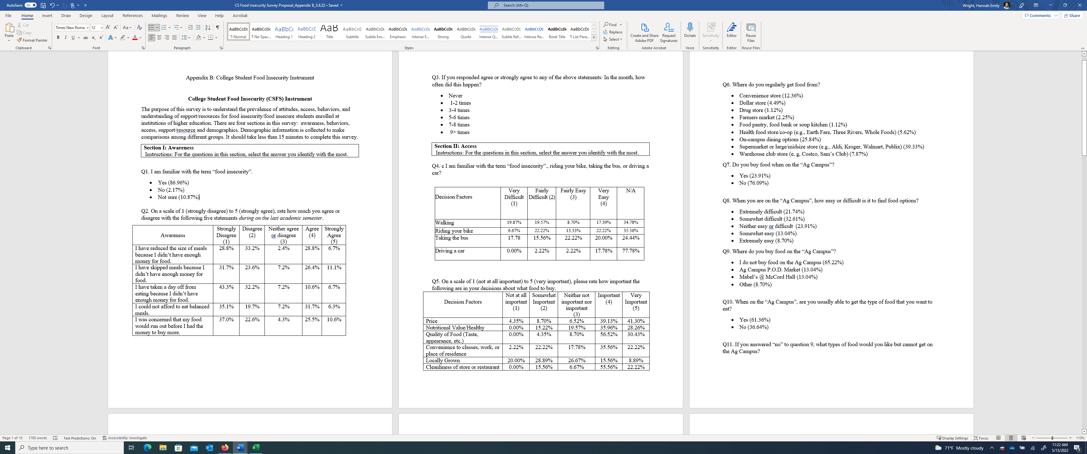

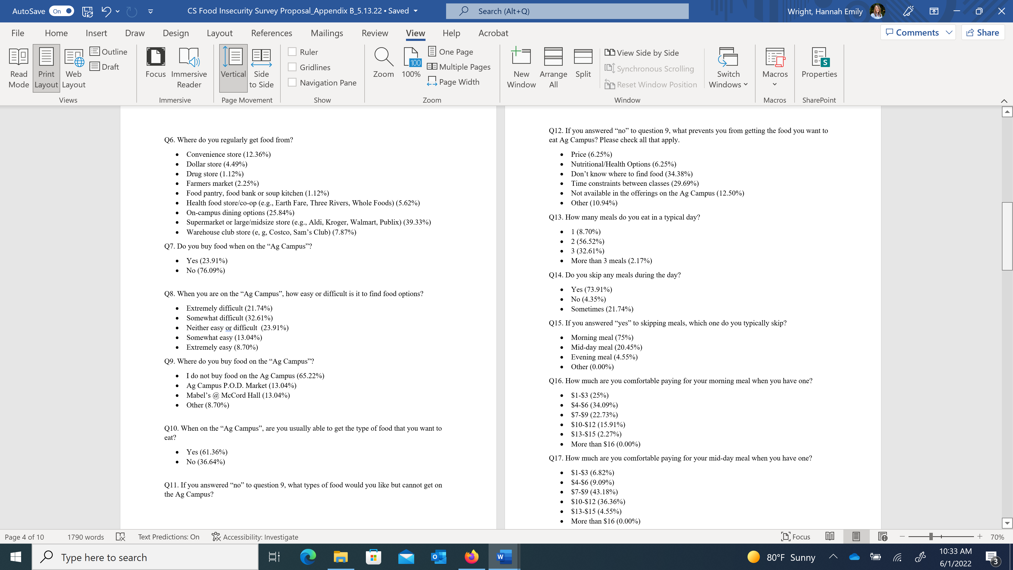
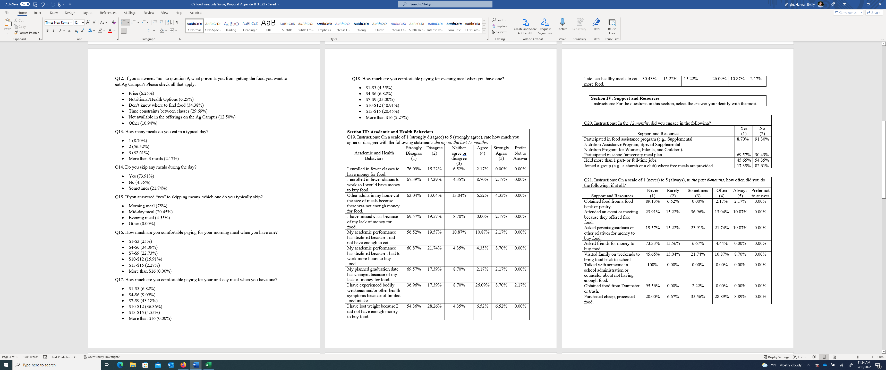

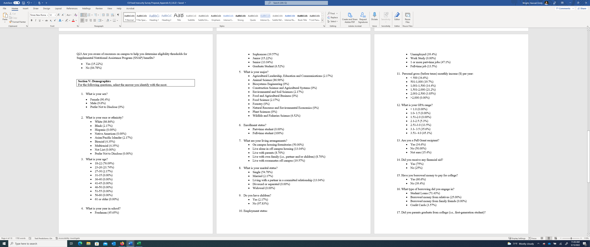

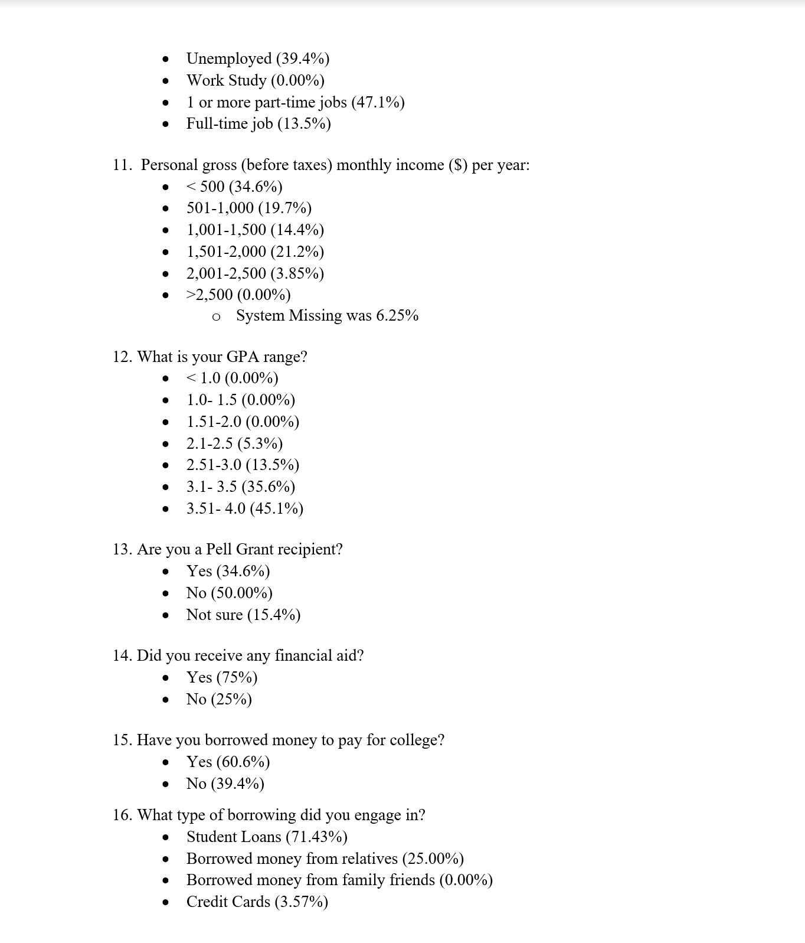



APPENDIX C
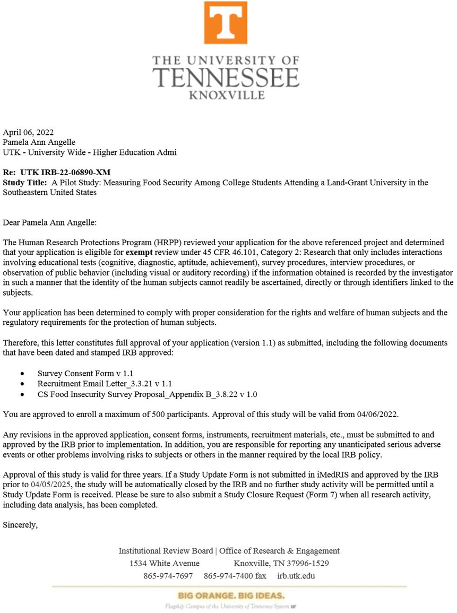

APPENDIX D

Exploratory Factor Analysis (EFA)
“This a statistical technique that is used to reduce data to a smaller set of summary variables and to explore the underlying theoretical structure of the phenomena. It is used to identify the structure of the relationship between the variable and the respondent” (Watkins, 2018, p. 221).

Principal Component Analysis, or PCA,
“This is a dimensionality-reduction method that is often used to reduce the dimensionality of large data sets, by transforming a large set of variables into a smaller one that still contains most of the information in the large set” (Watkins, 2018, p. 227).

Scree plot
“A scree plot is a graphical tool used in the selection of the number of relevant components or factors to be considered in a principal components analysis or a factor analysis. Proposed originally by Raymond Cattell in 1966 in his article The Scree Test for the Number of Factors, the scree plot has become a widely used tool to deal with the issue of component and factor selection. Conceptually, the scree plot is a way of visualizing the magnitude of the variability associated with each one of the components extracted in a principal component analysis” (Frey, 2018, p. 2).
Eigenvalues
“Eigenvalues are the special set of scalars associated with the system of linear equations. It is mostly used in matrix equations. ‘Eigen’ is a German word that means ‘proper’ or ‘characteristic’. Therefore, the term eigenvalue can be termed as characteristic value, characteristic root, proper values or latent roots as well. In simple words, the eigenvalue is a scalar that is used to transform the eigenvector” (Watkins, 2018),
The basic equation is Ax = λx.

Eigenvalues in this Study
Component | Eigenvalues | % of Variance | Cumulative %
1 | 8.738 | 16.182 | 16.182
2 | 6.705 | 12.417 | 28.599
3 | 4.876 | 9.030 | 37.629
4 | 4.273 | 7.913 | 45.542
5 | 4.028 | 7.459 | 53.000
6 | 3.800 | 7.037 | 60.038
7 | 2.897 | 5.365 | 65.402
8 | 2.717 | 5.031 | 70.433
9 | 2.507 | 4.642 | 75.075
10 | 2.057 | 3.809 | 78.884
11 | 1.874 | 3.470 | 82.353
12 | 1.663 | 3.080 | 85.434
13 | 1.341 | 2.483 | 87.917
14 | 1.210 | 2.242 | 90.158
15 | 1.158 | 2.145 | 92.303

Kaiser-Meyer-Olkin Measure of Sampling Adequacy

“This is a statistic that indicates the proportion of variance in your variables that might be caused by underlying factors. High values (close to 1.0) generally indicate that a factor analysis may be useful with your data” (Watkins, 2018, p. 226).

VITA
Hannah Emily Wright was raised on her family Angus operation near Spring City, Tennessee. She developed a passion for the agriculture industry at an early age. She graduated from Rhea County High School in 2010. From there she attended the University of Tennessee, Knoxville, where she graduated with a degree in Agricultural and Natural Resource Economics and a minor in Animal Science in 2014. After an internship with the Tennessee General Assembly, she became more interested in policy development and its effects on citizens. With this interest, she continued to graduate school and completed her Master of Public Policy and Administration (MPPA) in 2016 from the University of Tennessee. After graduating with her Masters, she took a position as an Extension Specialist with the University of Tennessee Cooperative Extension System working with rural development and value-added agriculture opportunities. This position allowed Hannah to have a positive influence on the farm and forest families of Tennessee.

The USDA Household Food Security Module (with 18 items) survey and core module: https://www.ers.usda.gov/topics/food-nutrition-assistance/food-security-in-the-u-s/survey-tools/
Other subgrouping categories in the survey include the race-ethnicity of the household reference person, household income to poverty ratio, area of residence, and census region.
The Institute (UTIA) began in 1968, when three agricultural units operating under the auspices of the University of Tennessee System were brought together to focus on Tennessee and its citizens. The units were the College of Agriculture, the Agricultural Experiment Station, and the UT Agricultural Extension Service. In 1974, the Tennessee legislature established the UT College of Veterinary Medicine as a fourth unit. In 2020, UTIA was dissolved into the Herbert College of Agriculture and College of Veterinary Medicine.

