In the News: An Exploration of
Starbucks and the Media

By: Caitlin Boone
Advised by: Dr. Diane Mollenkopf

Date: April 21, 2017

Table of Contents
Table of Contents 2
Abstract 3
Introduction 4
Literature Review 5
Corporate Social Responsibility and Sustainability 5
Starbucks & Sustainability 8
Media Influence and Interaction 9
Methodology 10
Findings & Discussion 12
Starbucks – a story 12
Origins – Red Highlight (Table 1) 16
Environment – Green Highlight (Table 1) 18
Community – Yellow Highlight (Table 1) 20
Goal Chart & KPI – Blue Highlight (Table 1) 22
Reporting Longevity 24
Media – a discussion 24
Future Research 28
References 29

Abstract
Over the past 25 years, corporate leaders have increasingly focused on integrating Corporate Social Responsibility (CSR) into the strategic management of their companies. The competitive environment of the 21st century has led to many companies adopting sustainability strategies related to environmental, social and economic performance. Part of the evolving business environment involves the growing role of the media in reporting on business activities – the positive, the negative, and the expected. As companies strive to implement social and environmental initiatives, firms and the media come together in telling the story. The purpose of this research is to explore the media’s relationship with a company’s sustainability initiatives over time. A single case study of Starbucks is the focus of the research because of Starbucks’ well-known evolution in sustainability thinking and implementation. By tracking Starbucks in the news, this research explores how media exposure can drive corporate direction and/or reflect corporate initiatives to stakeholders.

Introduction
Corporate Social Responsibility has been on the rise for the past twenty-five years as more and more firms implement CSR practices. Consumers have been more conscious of how companies deliver value not only to the shareholder but also to the communities in which they operate. Consumers become more loyal to a company based on if a consumer personally aligns or identifies with a company’s CSR initiatives (Inoue et al., 2017). Because of the more recent focus on sustainability and corporate social responsibility, firms across industries, countries, and facets of sustainability and CSR have been studied. A multitude of articles have been done including how more liberal-leaning firms engage in CSR (Gupta et al., 2016), how psychological mechanisms affect customers’ perceptions of CSR and price fairness (Habel et al., 2016), the relationship between CSR and sustainable development in developing countries (Simionescu 2015), how the communication landscape for CSR and sustainability is changing (Nwagbara et al., 2013), and so on.
More recently, a study was done on how corporate social responsibility activities are covered by news media and how they relate to an organization’s core business (Lunenberg et al., 2016). From each piece of research, a new facet of corporate social responsibility or sustainability is explored. One of the facets examined is news media. With technology increasing and most components of business converting from paper to electronic methods, the ways in which a firm contacts and connects with its consumers has evolved. For example, an article was written on how companies communicate CSR initiatives online (Castillo et al., 2012). The new generation is almost always connected to an online portal that can provide information about anything and everything.
As the media and the firm works to reach these consumers through different mediums, positive praise and negative criticism are captured. From Walmart to Patagonia to Nike to Starbucks, each of these companies have had a negative run in the media concerning their social performance (Clifford 2012; Phillips 2016; Marshall 1997; NY Times 2007). Also, each of these companies have a history of tracking their social performance and responsibility to some extent (Walmart 2005). For example, Starbucks has been around since the early 1970s, yet they did not begin tracking social performance until the early 2000s. Starbucks, being a Fortune 500 company with an international presence and a significant amount of employees, gets watched by the media and consumers alike. As Starbucks publicly addresses its social performance, the question can be posed: what is the relationship between a company like Starbucks and the media? As consumers of media and information, it is important to seek credible and truthful sources. Evaluating the way in which firms interact with the media can aid shareholders (customers, suppliers, investors, etc.) on how to measure the high profile companies in their intentions on social responsibility. Rather than seeing that a company is doing something good, a consumer can identify if the action aligns with a company’s intention or is a response to a media criticism. It is important to highlight examples by which companies are practicing well so other firms may learn from them and consumers can evaluate whether or not a company acts ethically or not.

Literature Review

Corporate Social Responsibility and Sustainability
In the early 1970s, Milton Friedman discussed the idea of a firm’s social responsibility. His perspective focused mainly on how corporations in a business context use Corporate Social Responsibility to hide self-serving actions (Ferraro et al. 2014). Companies will use the economic concern and desire to make money as the motivator of business decisions. Friedman’s interest started a dialogue of what is now known as Corporate Social Responsibility (CSR). In the late 1970s, Carroll defined CSR as a firm concerned with the economic, legal, ethical, and philanthropic responsibilities (1999). Carroll built upon Friedman’s initial idea of social responsibility and developed past the economic responsibility of making money. Carroll argued that not only is it important for a firm to make money in order to carry on its business, rather a firm must contribute to the community and environment that it operates in. After Carroll built upon Friedman’s original idea of social responsibility, many corporations and researchers alike adopted CSR practices and discussions. The use of CSR became more of a commonplace. Finally, one of the last major contributors to the discussion who brought about the Stakeholder Approach is Edward Freeman (2004). His main concern lacking from the CSR definition to date was the lack of a focus in value creation. Firms must understand the kinds of relationships they want and need to create in order to deliver on a firm’s purpose of creating value for their customer (Freeman 2004).
Thirty years later, there are still discrepancies as to what Corporate Social Responsibility entails and looks like in practice. With each of the individual contributions from Friedman, Carroll, and Freeman, the need for a holistic definition of CSR was established. Dahlsrud (2006) published an article that analyzed 37 definitions of CSR. In his research, Dahlsrud identified the top five dimensions of CSR based on frequency: stakeholder, social, economic, voluntariness, and environmental. Each of these different aspects and focus areas support the evolution of CSR from an economic responsibility to a stakeholder value creation necessity. In terms of companies today, it is important that firms are aware of why and how Corporate Social Responsibility has evolved and how it has become more important for the consumer to know and hear from companies their business case for social responsibility. This change in the business environment affects how firms make decisions which in turn affects the consumer.
A concept that is used interchangeably with CSR is sustainability. To help understand this difference, Elkington (1998) explains sustainability as a triple bottom line approach concerned with the social, the environmental, and the economic performance of business. Sustainability is the long term view of how today’s decisions and business environment affect the three facets outlined by Elkington (1998, 2004). Each piece of the triple bottom line is interconnected with the other, so a business must be aware and proactively concerned with all pieces of sustainability. From the comparison between Carroll’s CSR and Elkington’s Sustainability definitions, it appears that CSR is a subset of sustainability focused on the short term day to day business decisions and actions a firm makes. To further distinguish the two concepts, Amini and Bienstock (2014) created a sustainability framework that helps define and evaluate the corporate practice of sustainability. Their sustainability framework defines the five dimensions as (1) business level application and communication, (2) scope of organizational focus, (3) sustainability oriented innovation, (4) economic/environmental/social emphasis, and (5) compliance stance with a rating scale from one to four (Amini and Bienstock, 2014). This breadth in scope of sustainability allows for the practices to be identified and for their performance to be evaluated. Compared to Dahlsrud’s dimensional analysis for CSR, Amini and Bienstock discuss that sustainability not only concerns the economic, environmental, and social aspects, but also focuses on the long term contribution a company makes to industry, to policy, and to a company’s viability moving forward. In addition, a firm must work with their suppliers, other companies in industry, as well as create a strategic approach to sustainable practices’ implementation in order to develop a competitive advantage.

Starbucks & Sustainability

Starbucks began in 1971 with a different style of coffee company than any other in the market. They had the idea to build their foundation of values and principles in a socially responsible manner. To Starbucks today, corporate social responsibility means a commitment to ethical sourcing and environmental stewardship. Starbucks defines corporate social responsibility as “conducting our business in ways that produce social, environmental and economic benefits to the communities in which we operate. In the end, it means being responsible to our stakeholders” (Starbucks 2001). This manifests itself in Starbucks’ Mission Statement and guiding principles, which are at the forefront of each Corporate Social Responsibility Report. Starbucks’ mission statement says, “To establish Starbucks as the premier purveyor of the finest coffee in the world while maintaining our uncompromising principles as we grow” (Starbucks 2001).
Secondly, their six guiding principles are used as a measurement tool to evaluate the business decisions being made. The principles are as follows: “(1) Provide a great work environment and treat each other with respect and dignity, (2) Embrace diversity as an essential component in the way we do business, (3) Apply the highest standards of excellence to the purchasing, roasting and fresh delivery of our coffee. (4) Develop enthusiastically satisfied customers all of the time, (5) Contribute positively to our communities and our environment, and (6) Recognize that profitability is essential to our future success” (Starbucks 2001). While many companies openly share and discuss their mission, vision, and values similar to Starbucks, not all publish them annually with an evaluation of progress to date.

Media Influence and Interaction
Similar to most companies, Starbucks has not always had great rapport with the people or the press (Buckman 2000). A report chaired by John Elkington – writer of the triple bottom line approach – evaluated a variety of media outlets across different countries and tracked the frequency of discussion surrounding different sustainability and corporate social responsibility topics (Elkington 2002). More importantly, the SustainAbility report discussed how in recent years the media has become more powerful and influential on how people think about and act on CSR and sustainable development (SD) practices (2002). Another argument brought about by the SustainAbility report is that “media companies are both carriers and barriers when it comes to the CSR and SD agendas” (2002). By this, they mean that the media must decide what it reports to the masses, the immediate threats or the issues that could pose greater risks down the road. These two differences can be categorized into immediate threats as CSR and issues with greater risks as sustainable practices. Because the media decides what consumers want to read about and be informed on, it is interesting to see in what specific way do these companies interact with media outlets.
Another aspect to consider is the response that companies have to the media’s perception of their behavior. Ditlev-Simonsen (2014) evaluates seven companies through a case study format, who operate internationally in different industries, on how and to what extent they responded to media criticism in a Corporate Social Responsibility Report. This study and its coverage across sectors of industries, countries, and years demonstrates the importance of media interactions with companies and how each responds to the other. The main takeaway from the study argues that as companies respond to a negative media criticism, it does not matter how much they respond, rather it matters if they respond at all (Ditlev-Simonsen 2014). From this study companies can learn the importance of proper media interaction and that shareholders want to see that a company is responsible for and responsive to negative media attention.
On one hand of the discussion, the media leads consumers to the information necessary for them to know, and on the other hand, the media showcases a company’s sustainability initiatives and consumer interactions. This study looks to contribute the relationship between these two perspectives with the longitudinal aspect of a single case study.

Methodology
The main approach to the single case study of Starbucks is a content analysis of secondary data. The Starbucks Corporate Social Responsibility reports and various news sources provide the two sources of secondary data. The analysis proceeded in the following three steps: (1) read each Starbucks CSR report from 2001 to 2015, (2) research news article databases regarding Starbucks sustainability initiatives from 1/1/2000 to 1/1/2016, and (3) compare the topics found between the two sources.
Within each Starbucks report, the theme outlining process includes taking notes on the structure, topics, initiatives (new and ongoing), goal setting, measurements of practices, graphics (use of charts, tables, pictures), and the use of online reporting (videos, stories, online portal for employees to interact with Starbucks – providing feedback and insight to what they want). From these notes, patterns and trends are identified through an inductive method. When reading, look for repetition of ideas, words/phrases, and practices that get measured. From year to year, as similar topics were discussed, an outline of the transformation of headings was created in order to identify if the general topic was discussed year to year. So in order to do this, identify the headings in major topic areas that are discussed throughout the text. Within each topic area there will be subheadings for example within environment there is recycling, water, energy, green decor, etc. This was set up in a timeline format, so for 2001 – the topics were ranked in chronological order based on placement in report. Then in 2002 – the topics were ranked in chronological order based on placement in report, and so on and so forth for each year. For the timeline creation, subheadings were discarded and only headings were accounted for. At the end, the table was created to see what themes, which were typically topic section headers in the table of contents, prevailed for the longest amount of time.
For the second step of the process, an article written by Business Insider identified the top news sources without bias and that have the largest readership base to be the Wall Street Journal, the Washington Post, the New York Times, the Chicago Tribune, the LA Times, and USA Today (Engel 2014). This article established and identified the news sources used within the study as a search in the Factiva and Lexis-Nexis news article databases began. Using search terms “community," “ethical sourcing,” “CSR,” “sustainability,” “environment(al),” “recycle*,” “’paper cup,” “(renewable) energy,” “green,” and “goals” with the constraints of the news articles and dates, listings from 1 to 150 articles will show up. In the results page, sift through the article titles and summaries in order to classify each article into the timeline established by the CSR reports. Based on the comparison between the two timelines created, conclusions about Starbucks and the media’s interaction can be drawn.

Findings & Discussion

Starbucks – a story
Since the first store opening in 1971, Starbucks has incorporated Corporate Social Responsibility principles and initiatives into their business. However, their first Corporate Social Responsibility Report was not published until 2001. Within this report, Starbucks shares their view on responsible business practices, how this has impacted their view of business, as well as their vision and mission statement, which was not developed until 1990. For the next few years to follow, Starbucks used a set of six guiding principles to organize their reports under the headings: partners, products, society, environment, workplace, and eventually diversity. In 2003, the Starbucks CSR was themed “Living our Values” (Starbucks 2003). As a part of this initiative, Starbucks creates a benchmark for how the company, as a whole, measures up against the expectations set through the mission statement and guiding principles.
The first section of the report, “Partners,” headlines a partner’s personal story, then shares the results of a Partner View Survey. The survey reveals “that our partners have a high level of engagement – meaning they are emotionally and intellectually committed to Starbucks success. Engaged partners are more likely to say good things about the company, they often go beyond what is requested of them, and they indicate a desire to stay with Starbucks longer” (Starbucks 2003). Two accountability and follow through practices Starbucks utilizes for partners is Mission Review and the Standards of Business Conduct Helpline. Employees contact the Mission Review team with opinions on whether or not company practices at any level are in alignment with the guiding principles. Through the Helpline, employees speak with a third party directly to share opinions on company practices in an anonymous and confidential manner. The section ends with goals for the next year that Starbucks will be addressing throughout the organization. The unique aspect of the guiding principles is how Starbucks uses them to set goals, but also allows employees to provide feedback and updates to corporate Starbucks on goal progress.
To exemplify the principle concerning the purchase of coffee, the Starbucks report informs the reader of the coffee industry background, then dives into what it means to sustain a coffee community. This includes “Paying farmers fair prices and offering favorable terms, rewarding farmers who adopt Starbucks Coffee Sourcing Guidelines, investing in social programs that benefit coffee-producing communities, purchasing certified and conservation coffees, and providing farmers access to affordable credit” (Starbucks 2003). In the side bar of the report, Starbucks personalizes these concepts with real world examples. For a specific blend, Starbucks “searched the northern mountainous districts of Chiang Mai and Mae Hong Sorn, where local hill tribe farmers grow high-quality arabica coffee under the canopy of shade trees. The farmers are members of a Fair Trade cooperative and receive a Fair Trade Certified price” (Starbucks 2003). Furthermore, this style of informative initiative explanations followed by personalized, real life examples of how Starbucks lives out their mission statement and guidelines continues throughout each remaining section in the report. With this in mind, Starbucks declares an emphasis on these areas of business, affirming consumers that Starbucks lives out their commitment to their mission and vision, which align with socially responsible business practices.
Starbucks is not the only company with a focus on sustainability and corporate social responsibility. However, the way in which they pursued these avenues is innovative compared to their industry. Coffee is the second most traded commodity in the world. Their approach to the business case for sustainability and corporate social responsibility is “To sustain the prominence of Starbucks brand in the marketplace and build stakeholder trust, we must be accountable for our actions. As a measure of our accountability, last year we published Starbucks first Corporate Social Responsibility Annual Report to provide transparency on our business practices, measurements of our performance and benchmarks for future reporting” (Starbucks 2002). The overarching structure of the CSR report, which aligns with the accountability perspective, has had three major styles: guiding principles driven, year in review with the shared planet perspective, and a simplified report with the online component. Within each CSR Report (style does not matter) published annually, Starbucks explains each of their initiatives in relation to the communities, the partners, and their origins. Under each section, goals are set, measured, and updated for consumers to find information quickly. Rather than muddling through the descriptions of each initiative looking for the year to year improvements, Starbucks created “Key Performance Indicators” to quantify and quickly measure goal progress. For example, Figure 1 demonstrates a simplification of goal reporting:
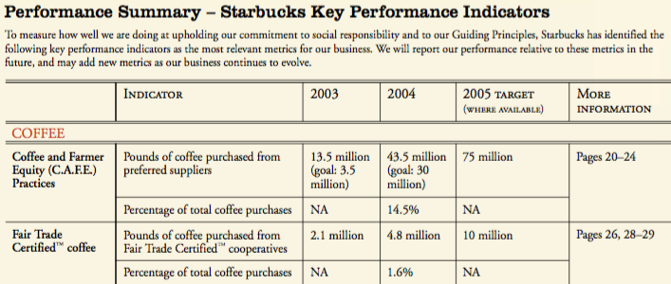
Figure 1. KPI Goal Chart
By creating these metrics, Starbucks made it easier on consumers and stakeholders to evaluate their progress and how Starbucks measures up to the expectations set for themselves. Above, the topic area is listed in red, “COFFEE,” followed by the specific subject area, “Coffee and Farmer Equity (C.A.F.E.) Practices,” then the indicator per subject area is identified and quantified for the previous and current year and projected for the next year (Figure 1). The measurement ideology reigns throughout the following eleven years of Starbucks reporting. Throughout those years, Starbucks sustainability initiative terminology transformed from specific line items to a more general, all-encompassing approach.
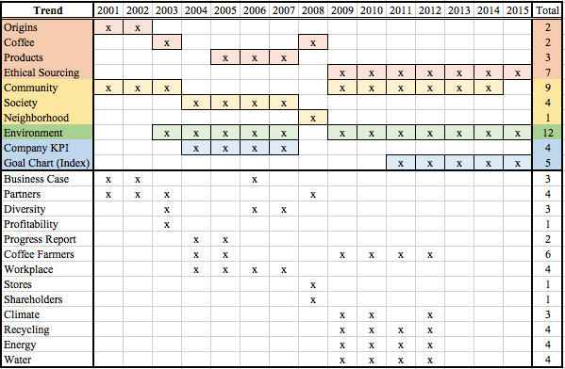
Table 1. Sustainability Trends in Starbucks CSR Reports
In Table 1, the main topic headings from the fifteen years of Starbucks CSR Reports are listed in the “Trend” column. Scanning from left to right by row, the topic is plotted with an “x” in the box corresponding with the year in which the topic was a focus area for Starbucks. Throughout the fifteen years, the topic headings transformed names, even though the content stayed consistent. The trends highlighted the same color yield topic areas with consistent content. The red highlight corresponds with “ethical sourcing” content; the yellow highlight corresponds with “community” content; the green highlight corresponds with “environment” content; and the blue highlight corresponds with “Goal Chart” content. The total in the right most column yield the number of years a specific topic was discussed. The color differentiation is important to understand because this is the format and breakdown by which sustainability themes are analyzed. The overall key takeaways from the table is how longitudinally these four themes prevail.

Origins – Red Highlight (Table 1)
From 2001 to 2002, Starbucks introduced their “commitment to origins” as the first and most important sustainability initiative. While coffee is the second most traded commodity in the world, Starbucks has an exceptionally high quality standard for coffee. Starbucks needs to secure and sustain their green coffee sources to ensure a continuous supply. With this motivation, Starbucks views their roles in the lives of farmers as critical to the coffee farmer as both a protector and a provider of the long term sustainability. In order to achieve a long term supply of high quality Arabica (green) coffee, Starbucks utilizes outright prices, long term contracts, higher quantity purchases from farms and cooperatives, affordable line of credit, coffee sourcing guidelines, financial support for CARE, Shade Grown Mexico coffee and Fair Trade certified coffee (Starbucks 2001). The CSR report of 2003 changes styles and verbiage when speaking of these various topics, for example, “Commitment to Origins” transforms into simply “Coffee” as an overarching topic that includes a look at the coffee industry, work that sustains the coffee communities, and a section dedicated to future goals (Starbucks 2003). Starbucks believes that their customers approach to this section of the report provides the reader with information, both descriptive and personal, about the coffee farmers and practices in doing business with them. Because of Starbucks dedication to their guiding principles, specifically in the CSR report of 2003, Starbucks embraces their obligation to the coffee communities and farmers as the necessary path to source the finest and highest quality of coffee in a socially responsible and respectable manner.
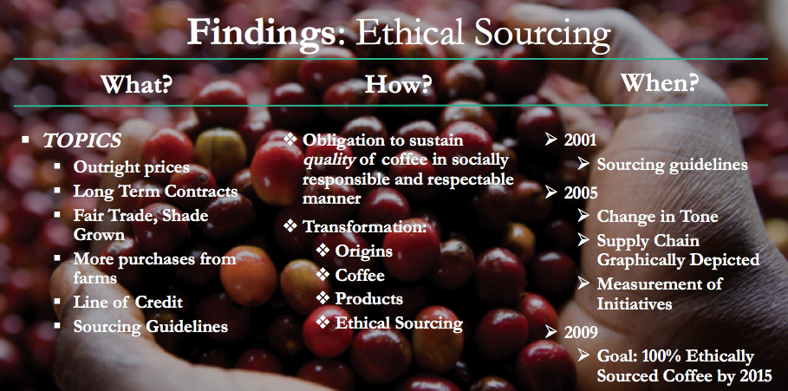
Figure 2. Ethical Sourcing
Figure 2 displays what Starbucks specifically did in regards to sustainability initiatives, how Starbucks thought about initiatives throughout the last fifteen years, and when changes to thought occur. For example, 2005 yields a turning point for Starbucks in the tone and manner by which the coffee sourcing section is portrayed. Rather than having a farmer oriented approach like the previous four years, Starbucks explains their commitment to high quality products using more technical speak. Starbucks outlines the coffee supply chain from raw material supplier to distributor to retailer and finally to the end consumer. The desire and need for a more technical approach to this topic represents how Starbucks measures each of their initiatives. At this point in their reporting, Starbucks has solidified and streamlined their evaluation process and created metrics by which customers can hold Starbucks accountable.
Under the Shared Planet Project of 2008, Starbucks restructures how they organize and emphasize their initiatives. For the next five years, the CSR reporting structure stays consistent with a combination of graphical and textual content of the various initiatives. In 2008, they announce a goal of 100% ethically or organically sourced coffee by 2015. With a long road ahead of them, an assumption can be made that this would be at the top of their priority list and the main topic of discussion for the next six years. However, the order in which the focus areas are presented change. Compared to 2009, ethical sourcing is discussed third until 2012 when it is reprioritized to the top of the list once again. This rearrangement can be attributed to a breakthrough made in the environment focus area in regards to recycling. Each focus area has their own set of goals and initiatives that Starbucks actively seeks to achieve, however at times the progress remains consistent from year to year without new knowledge or innovation aside from the usual annual growth. Even though it was discussed third in the report, it does not mean that ethical sourcing lost importance. The fact that the topic is included in some form in all fifteen years of Starbucks Corporate Social Responsibility Reporting displays a dedication and an active commitment to ethical sourcing.

Environment – Green Highlight (Table 1)
In addition to an ethical sourcing commitment, Starbucks intensely focuses on environmental stewardship. Since 1992, Starbucks has had an established environmental mission statement (Starbucks 2002), which supports the argument for a longstanding commitment to minimizing environmental impact. However, Starbucks business did not have standards or metrics established, so in the first reporting year, Starbucks committed to benchmarking current operations in order to prep for improvement (Starbucks 2001). From 2001 to 2002, Starbucks created a baseline of electricity/water/gas usage, transportation impact, as well as store design and operations. Moving forward, Starbucks enabled the ability to develop and implement policies and procedures that would improve their environmental impact in the specific topic areas. Starbucks devotes resources, time, and innovation capabilities to a “steadfast commitment to a journey with no end point” (Starbucks 2003). From this devotion, a focus on recycling, climate change, energy/water conservation, sustainable packaging, and store design/operations (Starbucks 2005). An example of this dedication manifests itself in the innovative invention of a hot beverage cup that contains 10 percent post-consumer paper fiber (Starbucks 2005).
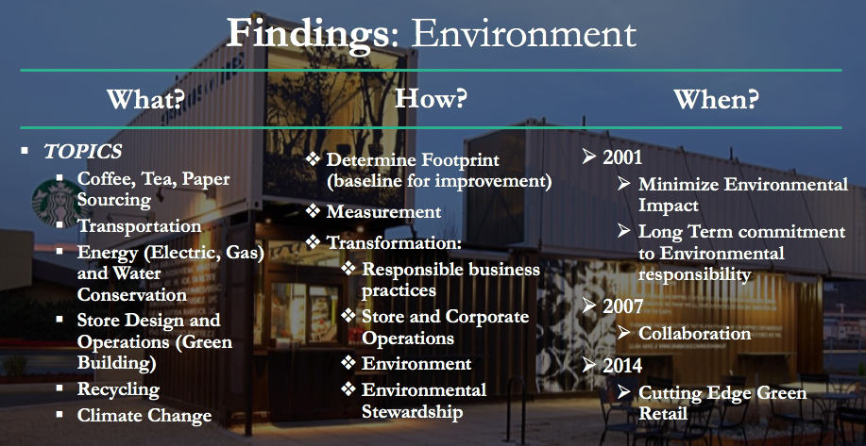
Figure 3. Environment
A second trend appears in 2007, as seen in figure 3, Starbucks enlists the help of suppliers, customers, non-governmental organizations, competitors, other industry leaders, and local governments to collaborate on climate change policy as well as green operations (LEED certification, recycling infrastructure, energy/water conservation techniques, etc.). Through collaboration, Starbucks leads change in the coffee industry by inspiring customers, suppliers, and competitors to take up their cause and follow. Starbucks utilizes their scale of operations and brand to reach a multitude of parties (Starbucks 2007). When Starbucks surpasses 500 stores being LEED certified, which is more than any other retailer (Starbucks 2014), a minor focus change occurs within the environmental discipline. This focus adjusts to continuing on the LEED certification growth on into 2015 alongside the desire for front of store recycling, renewable energy, and personal tumbler usage. While being on the forefront of change within the industry, Starbucks maintains a balance of focus in striving to reach all goals set. Through these two trends, Starbucks has evolved from minimizing to measuring to innovating to collaborating in order to enact change across the coffee industry.

Community – Yellow Highlight (Table 1)
Similar to Origins, Starbucks community trends transforms names from “community,” to “society,” and back to “community” again. In the beginning, Starbucks “recognize(s) the relationship between the success of our company and the strength and vitality of the communities where we operate,” so Starbucks views “investing in our communities (as) not only the right thing to do; it also creates better places for all of us” (Starbucks 2001). As Starbucks grows domestically and internationally, they are conscious of investing in the communities through the Starbucks Foundation’s contributions, partner community service involvement, and community stores. Starbucks pursues each of these initiatives year after year, in a general sense and through specific events. For example, community service and support is a principle Starbucks lives by and encourages partners to partake in, yet specifically, Starbucks promotes volunteering on Earth day by organizing large service projects throughout the communities Starbucks is located (Starbucks 2002). Another specific program Starbucks puts on is Make Your Mark, which is in honor of 9/11, seen in figure 4. Through this, Starbucks had a goal of 25,000 service hours for the month of September. Contrary to expectation, partners and customers together contributed 40,000 hours to service projects in local communities, which Starbucks then matched $250,000 in donations to community organizations of the partners’ and customers’ choice (Starbucks 2002).
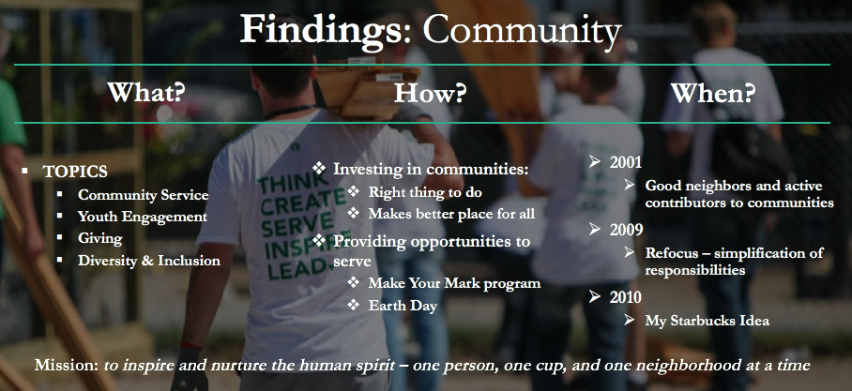
Figure 4. Community
The second trend appearing in Starbucks community involvement topic area is inspired by the Starbucks Mission, “to inspire and nurture the human spirit” (Starbucks 2009). Starbucks “collaborates with similarly driven nonprofit organizations, businesses, civic leaders, and individuals” (Starbucks 2009) to promote community service, youth engagement, and giving (Starbucks 2010). By simplifying their goals into three main areas, readers can follow the focus of involvement and be assured by Starbucks commitment to investing in communities.

Goal Chart & KPI – Blue Highlight (Table 1)
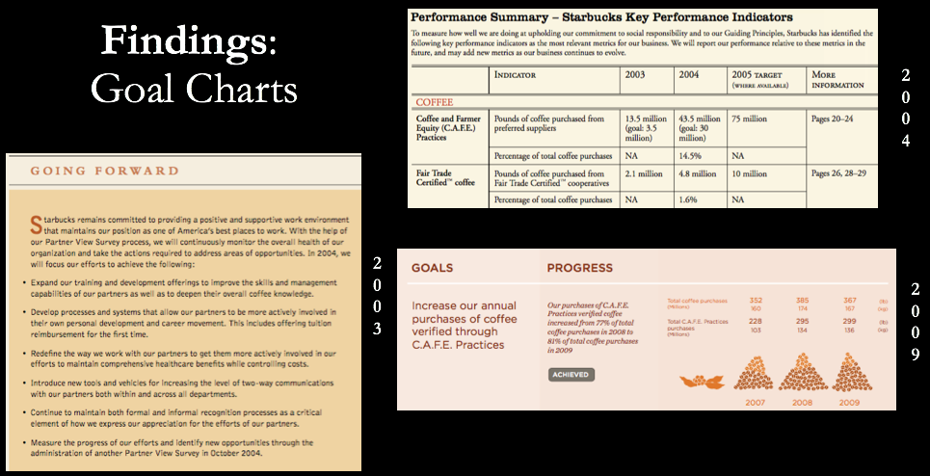
Figure 5. GC & KPI
Starbucks establishes a basic level of goal charting in the first report by quantifying growth of the principled sections and initiatives carried on by Starbucks from year to year and concerning forward looking plans. For example, there is a bar chart titled “Amount Purchased of Shade Grown Mexico (Coffee),” within the year 2000 having bought 304,000 pounds, within the year 2001 having bought 723,000 pounds, and within the year 2002 slated to purchase 1.5 million pounds of coffee beans. Adjacent to this graphic, the text discusses future goals for development and expansion of Shade Grown Mexico Coffee (Starbucks 2001). Contrary to this style, Starbucks solely relied upon bar chart graphs to represent and quantify the data for consumers and shareholders. Aside from the numbers update, no in text discussion reveals goals for the coming year or a progress report on claims made from the previous year’s CSR report (Starbucks 2002). Although in 2003, Starbucks changes their approach to goals by using text to explain and inform shareholders of Starbucks plans for the coming year.
Starbucks introduces the creation of Key Performance Indicators in 2004. As a part of this new metric, each focus area highlights specific goals worked on with updates of the progress made within the last year, the current year, and with projections on the next year (figure 5). Prior to each focus area, a Progress Report identifies the top goals and a status update of “achieved, making progress, or did not achieve” (Starbucks 2004). As a part of the Progress Report, Starbucks breaks down each report into the main focus area, then into “topics”, followed by “what we said in (previous year)” and “what we did in (current year),” and finishing with a visual “self-rating” (Starbucks 2005). Unlike other corporations who appear distant, machine-like, and bureaucratic to consumers, the level of transparency Starbucks utilizes in the context of goal measurement and evaluation gives Starbucks a level of relatability. Using a direct tone while delivering facts frees the reader from deciphering through corporate jargon and technical evidence of goal achievement and progress. It makes the reading of the report easier and more convenient for the consumer.
Along with the new structure of reporting, in 2009 Starbucks creates a new style of goal measurement graphic that combines the previous two (figure 5). It has four main areas: (1) description of goal, (2) update on progress, (3) quantified evaluation of goal growth for the prior two years and the current year, and (4) a visual graphic of goal progress. By combining all aspects of the previous goal charting styles, Starbucks connects with each type of reader from the one who needs literal numbers to the one who needs to see the growth, and to the one with little time to dive deep into the discussion. As Starbucks continues to grow, set new goals, and sustain socially responsible business practices, it is critical that they evaluate goals and update consumers on their progress, while adjusting the form and style by which they do so as the readership changes. The last addition to the goal charting occurs in 2014 when Starbucks includes a section on “Key Learnings” for each goal measured. Not only does Starbucks improve and make changes to physical aspects of sustainability, but also to the process and strategy used to implement sustainability initiatives.

Reporting Longevity
From 2009 to 2015, Starbucks revitalized the Corporate Social Responsibility reports with a new name and a new style. The sections explored above are separated out and evaluated specifically. From a surface level, big picture view, Starbucks puts it on the reader to find out more by “inviting you to learn more about our Starbucks Shared Planet community involvement goals, the programs we support, and our recent milestones” (Starbucks 2009). Instead of listing out all of the relevant and connected information on the topic, Starbucks only includes the pertinent information from achieving goals to skimming the top of each program and initiative to inform the reader of continued commitment in the focus areas. By doing this, Starbucks gives the reader the option to learn more or to not. At the time of the 2012 report the hyperlinks are relevant, however now, the link leads you to a “page not found.” Long term, Starbucks will need to include more in their reports to archive historical data for future learnings.

Media – a discussion
Prior to beginning this research, an expectation set by a previous article showed a necessity of responsiveness by a firm if the media negatively criticized them (Ditlev-Simonsen 2014). It seems as though the media is mainly concerned with the sustainability initiatives that directly affect consumers, instead of the sustainability initiatives that Starbucks invests a lot of time and money in or the initiatives that gain negative media attention. A big debacle in recent years was the customer uproar surrounding the color of the Starbucks winter cup that went viral. (Tadena 2015). Rather than how the cup’s composition has changed, the media captured the opinion and outcry of social media debate over the graphic design of the cup. Starbucks has put a major focus on recycling efforts in building new networks and infrastructure, developing cups made with recyclable material, as well as promoting the use of reusable cups, however this does not seem to line up with what consumers want to discuss.
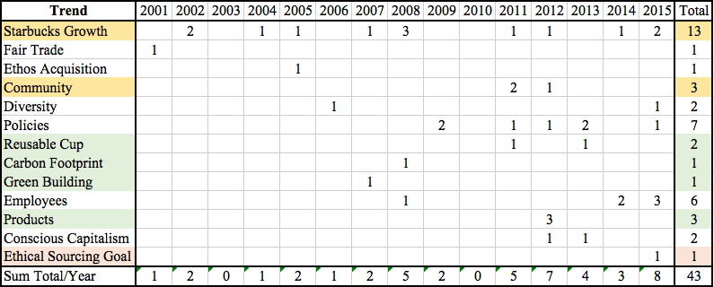
Table 2. Media Trends
Over the fifteen years of collected news articles, the media focused their writings on topics that directly affect their readership’s interests. As seen in Table 2, the thirteen discussion topic areas (on left) are organized by the number of times the topic appears in the news media. The yellow highlight classifies “community” content; the green highlight classifies “environment” content; and the red highlight classifies “ethical sourcing” content. These highlighted focus areas yield the news media themes that aligned with trends outlined by the Starbucks CSR Reports.
An example of topics affecting readership interests occurs when a Starbucks invades a small town or low income area, creates job opportunities, donates profit to a charitable organization, or exposes themselves to policy discussions (gun control), the media will document these events (figure 6). On the flip side of this discussion, Starbucks’ two main sustainability topics are ethical sourcing and environmental stewardship. However, these concepts are rarely discussed in the media as seen in Figure 6:
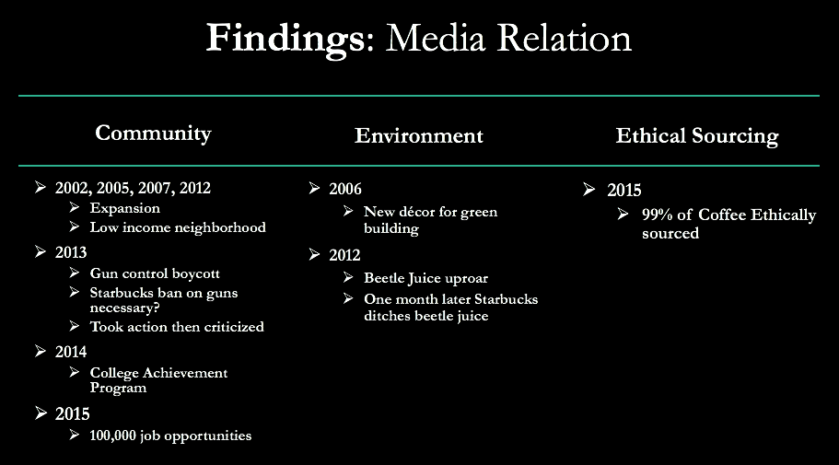
Figure 6. Media Findings
The two main focuses of Starbucks throughout the fifteen years of reporting is environment and ethical sourcing, however community aspects of Starbucks are discussed more than any other topic. Ideas such as expansion, gun control, college achievement, and job opportunities are larger topics of discussion compared to new décor for green building or accomplishing the ethical sourcing goal. The one media criticism and response example occurred in the environment section in regards to how Starbucks uses beetle juice to naturally color the strawberry Frappuccino (Horovitz 2012). The vegan community was upset when finding this out. After the news covered the story, within a month Starbucks had removed the beetle juice from the Frappuccino (Gasparro 2012). Since this specific story affected the health choices of consumers, Starbucks was quick to react. In comparison, ethically sourcing and minimizing environmental impact is not necessarily important to the consumers’ daily thought, actions, or dollar.
Based on the amount of times Starbucks expansion or a new store opening is discussed, it seems as though that is the media’s main concern for Starbucks. Depending on the town, city, or community socioeconomic status, each perspective had a varying opinion on Starbucks’ growth strategy. While an aggressive growth strategy is an important decision that drives business activities and developments, Starbucks views placement of stores as a community investment. By placing a store in a low income area or half a mile down the street from an existing Starbucks, the new store is an opportunity to help build up a community or area by investing in the local economy or improving customer satisfaction through convenience. In 1998, Starbucks partnered with Magic Johnson in a joint venture called “Urban Community Opportunities,” to promote the development of Starbucks stores in “ethnically diverse neighborhoods” (Starbucks 2002). The addition of these stores to these areas have the goal of spurring economic growth by attracting other companies, chains, and organizations to inhabit the area as well. However, in contrast to this socially responsible community initiative, the media and consumers are more or less upset by the opening of a new Starbucks to the neighborhood. To attract this sort of negative media attention is the opposite of Starbucks intention. The media (news sources) serves as informative mass communicators for their readership. The media provides an outlet and platform by which consumers can learn and read about social happenings, and firms can provide information to the masses on sustainability initiatives that directly affect their customers.

Future Research
Unlike Starbucks, some firms do not establish their company with socially responsible business practices, so an avenue for future research would involve applying this methodology to a company without this foundation. For example, Walmart began its socially responsible journey in compliance and auditing in 2005, which then evolved into developing metrics by which Walmart evaluated itself (Walmart 2005). Second to that discussion would be the idea of gaining consumer insight: “as a customer do you vote with your pocketbook?” The study’s discussion was a general view on how consumers feel about social responsibility and the media, but no specific evidence was shared to their thoughts and motivations for buying from a socially responsible company.

References

Amini, M., & Bienstock, C. (2014, February 24). Corporate sustainability: an integrative definition and framework to evaluate corporate practice and guide academic research. Retrieved November 10, 2016, from Journal of Cleaner Production 76 (2014) 12e19.

Buckman, R. (2000, September 25). Starbucks Rescinds Policy Banning Distribution of Free Newspapers. Retrieved February 17, 2017, from https://www.wsj.com/articles/SB969832865447584905
Carroll, A.B. (1999). Corporate Social Responsibility: Evolution of a Definitional Construct. Retrieved February 24, 2017, from Business and Society pg. 38, 3; ProQuest pg. 268.
Castillo, S., Illia, L., & Rodríguez-Cánovas, B. (2012 October). When CSR Clicks. Retrieved April 19, 2017, from http://www.iabc.com/cw
Clifford, S., & Greenhouse, S. (2012, April 29). Wal-Mart’s U.S. Expansion Plans Complicated by Bribery Scandal. Retrieved March 9, 2017, from http://www.nytimes.com/2012/04/30/business/wal-mart-bribery-scandal-complicates-us-expansion-plans.html

Dahlsrud, A. (2006, November 9). How Corporate Social Responsibility is Defined: an Analysis of 37 Definitions. Retrieved November 10, 2010, from Wiley InterScience (www.interscience.wiley.com) DOI: 10.1002/csr.132
Ditlev-Simonsen, C. (2014). Are Non-Financial (CSR) Reports Trustworthy? A Study of The Extent to Which Non-Financial Reports Reflect the Media’ Perception of The Company’s Behaviour. Retrieved February 17, 2017, from http://www.isea.icseard.uns.ac.id
Elkington, J. (1998). Cannibals with Forks: the Triple Bottom Line of the 21st Century. Retrieved November 10, 2016.
Elkington, J. (2004). Enter the triple bottom line. In: Henriques, A., Richardson, J. (Eds.), The Triple Bottom Line: Does it All Add up? Earthscan, London, UK, pp. 1e6. Retrieved November 10, 2016.
Elkington, J. (2002). Good News & Bad: The Media, Corporate Social Responsibility and Sustainable Development. Retrieved February 24, 2016.
Engel, P. (2014, October 21). Here Are The Most And Least Trusted News Outlets In America. Retrieved March 5, 2017, from http://www.businessinsider.com/here-are-the-most-and-least-trusted-news-outlets-in-america-2014-10
Freeman, E., Wicks, A., & Parmar, B. (2004). Stakeholder Theory and “The Corporate Objective”. Retrieved April 7, 2017, from Organization Science 15(3):364-369. http://dx.doi.org/10.1287/orsc.1040.0066
Ferraro, I., Hoffman, W., & McNulty, R. (2014). Must Milton Friedman Embrace Stakeholder Theory? Retrieved April 19, 2017, from Business and Society Review 119:1 37–59.
Gasparro, A. (2012, April 19). Starbucks Ditches Beetle Food Color. Retrieved February 17, 2017, from https://www.wsj.com/articles/SB10001424052702303513404577354022580498552

Gupta, A., Briscoe, F., & Hambrick, D. (2016, July 21). Red, blue, and purple firms: Organizational political ideology and corporate social responsibility. Retrieved April 19, 2017, from http://onlinelibrary.wiley.com.proxy.lib.utk.edu:90/doi/10.1002/smj.2550/full

Habel, J., Schons, L., Alavi, S., & Wieseke, J. (2016 January). Warm Glow or Extra Charge? TheAmbivalent Effect of Corporate Social Responsibility Activities on Customers’ Perceived Price Fairness. Retrieved April 19, 2017, from http://dx.doi.org/10.1509/jm.14.0389
Horovitz, B. (2012, March 29). Vegans bash Starbucks for beetle coloring in frappuccinos. Retrieved February 17, 2017, from https://usatoday30.usatoday.com/money/industries/food/story/2012-03-28/starbucks-strawberry-frappuccino-beetle-juice/53839006/1#mainstory
Inoue, Y., Funk, D., & McDonald, H. (2017 February 16). Predicting behavioral loyalty through corporate social responsibility: The mediating role of involvement and commitment. Retrieved April 19, 2017, from http://dx.doi.org/10.1016/j.jbusres.2017.02.005
Lunenberg, K., Gosselt, J., & De Jong, M. (2016, October 26). Framing CSR fit: How corporate social responsibility activities are covered by news media. Retrieved April 19, 2017. http://dx.doi.org/10.1016/j.pubrev.2015.11.016
Marshall, S. (1997, September 24). Nike's Labor Woes Leave Soiled Footprint on Image. Retrieved March 9, 2017, from https://www.wsj.com/articles/SB875037617478326500

NYTimes. (2007, July 15). Starbucks closes coffeehouse in Beijing's Forbidden City. Retrieved March 9, 2017, from http://www.nytimes.com/2007/07/15/world/americas/15iht-starbucks.4.6664994.html

Nwagbara, U., & Reid, P. (2013 July). Corporate Social Responsibility Communication in the Age of New Media: Towards the Logic of Sustainability Communication. Retrieved April 19, 2017, from Review of International Comparative Management Volume 14, Issue 3.

Phillips, A. (2014, August 21). Patagonia’s Balancing Act: Chasing Mass-Market Appeal While Doing No Harm. Retrieved March 9, 2017 from https://www.wsj.com/articles/patagonias-balancing-act-chasing-mass-market-appeal-while-doing-no-harm-1471426200

Simionescu, L. (2015 June). The Relationship Between Corporate Social Responsibility (CSR) and Sustainable Development (SD). Retrieved April 19, 2017, from Internal Auditing & Risk Management Anul X, Nr.2(38).

Starbucks. (2001). Corporate Social Responsibility Annual Report. Retrieved November 10, 2016, from https://www.starbucks.com/responsibility/global-report

Starbucks. (2002). Corporate Social Responsibility Annual Report. Retrieved November 10, 2016, from https://www.starbucks.com/responsibility/global-report

Starbucks. (2003). Living Our Values: Corporate Social Responsibility Fiscal 2003 Annual Report. Retrieved November 10, 2016, from https://www.starbucks.com/responsibility/global-report

Starbucks. (2004). Striking A Balance: Corporate Social Responsibility. Retrieved November 10, 2016, from https://www.starbucks.com/responsibility/global-report

Starbucks. (2005). Beyond the Cup: Corporate Social Responsibility Fiscal 2005 Annual Report. Retrieved November 10, 2016, from https://www.starbucks.com/responsibility/global-report

Starbucks. (2007). Fiscal 2007 Corporate Social Responsibility Annual Report. Retrieved November 10, 2016, from https://www.starbucks.com/responsibility/global-report

Starbucks. (2008). FY 2008 Global Responsibility Report. Retrieved November 10, 2016, from https://www.starbucks.com/responsibility/global-report

Starbucks. (2009). Starbucks Shared Planet: Global Responsibility Report 2009. Retrieved November 10, 2016, from https://www.starbucks.com/responsibility/global-report

Starbucks. (2010). Starbucks Global Responsibility Report: Goals & Progress 2010. Retrieved November 10, 2016, from https://www.starbucks.com/responsibility/global-report

Starbucks. (2012). 2012 Global Responsibility Report: Year In Review. Retrieved November 10, 2016, from https://www.starbucks.com/responsibility/global-report

Starbucks. (2014). 2014 Global Responsibility Report: What is the Role and Responsibility of a For-Profit Public Company. Retrieved November 10, 2016, from https://www.starbucks.com/responsibility/global-report

Tadena, N. (2015, November 9). Consumers Aren’t So Cheery About Starbucks’ Holiday Cup Controversy. Retrieved February 17, 2017, from https://www.wsj.com/articles/consumers-arent-so-cheery-about-starbucks-holiday-cup-controversy-1447099197

Walmart. (2005). 2005 Report on Ethical Sourcing. Retrieved November 10, 2016, from http://corporate.walmart.com/global-responsibility/global-responsibility-report-archive

