Global Implementation of IFRS
Robert Hibbard

Abstract

This report focuses on the adoption of International Financial Reporting Standards (IFRS) in the United States, European Union, and New Zealand. Using information gathered from academic literature in accounting, finance, and economics, the adoption of IFRS standards for individual countries are analyzed in regards to the development, method of adoption, benefits, costs, and response of adoption. The report highlights the strengths and weaknesses of IFRS adoption and suggests ways to improve the convergence process in the future.
In regards to the United States, the report summarizes FASB and IASB convergence project in its current state and identifies potential benefits, costs, and methods of adoptions in which the United States would benefit the most. Issues such as global comparability, transition costs, reporting quality, and access to capital are examined. In addition, the firms with the largest net benefit from adopting IFRS are identified.
The European Union’s adoption of IFRS is also examined. The report summarizes the development of the standards and the method in which the standards were implemented. The effects of individual countries are observed through brief case studies of Germany and Spain, and the response of the European Union as a whole is addressed.
New Zealand’s adoption of IFRS is the final focus of the report. New Zealand approached the IFRS adoption in a different manner than the European Union by allowing companies less time to prepare and applying IFRS to a wider range of reporting entities. This approach offers a different perspective to analyze. The report highlights IFRS development, method of adoption, and problems likely to be faced by New Zealand.

Table of Contents

1. Introduction
2. Adopting IFRS in the U.S.
2.1 Development 5
2.2 Benefits 7
2.3 Costs 10
2.4 Risks 13
2.5 Firms with Likely Largest Net Benefit 13
2.6 Possible Methods of Adoption 14
3. Adopting IFRS in the E.U.
3.1 Development 16
3.2 Method of Adoption 17
3.3 Adoption within Individual Countries 17
3.4 Response to Adoption 20
4. Adopting IFRS in New Zealand
4.1 Development 21
4.2 Problems Likely to Be Faced 23
4.3 Response to Adoption 24
5. Conclusion

1. Introduction

Accounting information provides past and current financial information about an economic unit to business managers, potential investors, and other interested parties. Internally-generated accounting information to help business managers with planning, controlling, and making decisions is referred to as managerial accounting information. This information is used primarily by internal users, and most of it is not required to be presented publically on the company’s financial statements. On the other hand, financial accounting information is targeted towards external users who have no control over the actual preparation of the reports and do not have access to the underlying details. Therefore, the ability to understand and compare financial reports directly depends upon standardization of the principles and practices that are used to prepare the reports. To ensure confidence in financial information, professional organizations were established to bring consistency and structure to financial reporting.
In the United States, the Financial Accounting Standards Board (FASB), a private-sector organization, is primarily responsible for establishing standards of financial accounting that govern the preparation of financial reports by nongovernmental entities. The FASB is comprised of five full-time members, appointed by the Foundation’s Board of Trustees, and may serve up to two five-year terms. The standards that the FASB promulgates are referred to as the generally accepted accounting principles (GAAP), and all public companies must report financial information under these standards. To recognize these standards as authoritative, the Securities and Exchange Commission (SEC), a federal agency, legally enforces the established accounting principles. The SEC’s oversight of accounting standards promotes integrity and reliability among financial statements (“Facts about FASB”).
To promulgate accounting principles internationally, the London-based International Accounting Standards Board (IASB) was established as a privately-funded, independent, accounting standard-setter. It consists of 15 full-time members, including members from the United States, and works towards developing “a single set of high quality, understandable, enforceable, and globally accepted financial reporting standards based upon clearly articulated principles.” (About the IFRS…) This single set of high-quality standards is referred to as the International Financial Reporting Standards (IFRS) and is becoming the global standard for the preparation of public company financial statements. The IFRS Foundation oversees and approves all accounting standards created by the IASB.
With many companies expanding to global markets, the need for global transparency among financial statements is becoming more and more important. Currently, there is no official set of accounting standards required for all international public companies. This approach has worked for many years, but it is becoming unfavorable as more companies seek to operate in foreign markets and raise capital from international creditors and investors. In its present state, financial information from certain countries has almost no global comparability, causing many potential investors to refrain from investing in these companies due to the lack of confidence in or understanding of the financial information used in that country. This underlines the increasing importance of global comparability among financial statements. To achieve this goal, many countries have already adopted IFRS as their required method of financial reporting. Since 2001, almost 120 countries have required or permitted the use of IFRS, and all remaining major economies have established time lines to converge with or adopt IFRS in the near future. Figure 1.1 shows the progress of adopting IFRS globally. While the United States already permits the use of IFRS for foreign issuers and subsidiaries, it has not fully adopted IFRS as the authoritative set of accounting standards. United States companies should be required to report financial statements using IFRS instead of U.S. GAAP.
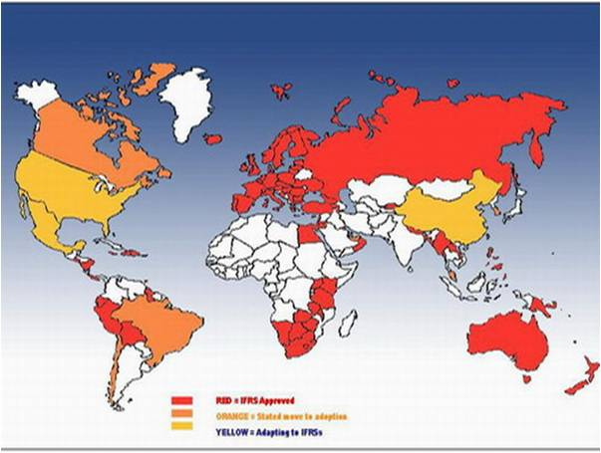Figure 1.1: Countries Adopting IFRS

2. Adopting IFRS in the U.S.

2.1 Development
For many years, the U.S. Securities and Exchange Commission has been a stronger leader in international efforts to develop a core set of accounting standards that could serve as a framework for financial reporting in cross-border offerings. It has repeatedly made the case that issuers wishing to raise capital in more than one country are faced with the increased compliance costs and inefficiencies of preparing multiple sets of financial statements to comply with different jurisdictional accounting requirements. In 2000, the International Organization of Securities Commissions (IOSCO), in which the SEC plays a leading role, recommended that its members allow multinational issuers to use 30 “core” standards issued by the IASB’s predecessor body in cross-border offerings and listings. A few years later, the SEC announced its support of a memorandum of understanding, the Norwalk Agreement, between the FASB and the IASB. This agreement, concluded in Norwalk, Connecticut, established a joint commitment to develop compatible accounting standards that could be used for both domestic and cross-border financial reporting. In a subsequent memorandum of understanding, the FASB and IASB agreed that a common set of high quality, global standards remained their long-term strategic priority and established a plan to align the financial reporting of U.S. issuers under U.S. GAAP with that of companies using IFRS (“SEC Leadership”).
In 2007, the SEC unanimously voted to allow foreign private issuers to file financial statements prepared in accordance with IFRS as issued by the IASB without reconciliation to GAAP. Of even greater importance, the SEC issued a Concept Release seeking input on allowing U.S. public companies to use IFRS when preparing financial statements. Most recently, the SEC issued a proposed roadmap that includes seven milestones for continuing U.S. progress toward acceptance of IFRS. The roadmap would allow for early adoption of IFRS for U.S. public companies that meet certain criteria. An updated timeline states 2011 as the goal for completion of major joint projects between the FASB and IASB, and the boards plan to update the Norwalk Agreement to lay out a plan for one set of accounting standards from which all major capital markets would be able to operate by 2013 (“SEC Leadership”). Although the SEC has been taking steps to prepare for IFRS adoption, the U.S. as a whole has not come to an agreement on if IFRS should be officially adopted or how the adoption should be implemented. Figure 2.1 shows the current roadmap to IFRS convergence.
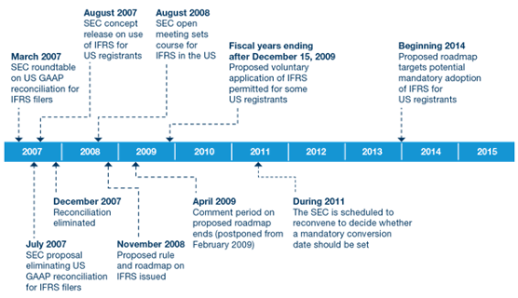 Figure 2.1: Roadmap to IFRS Adoption in the U.S.
2.2 Benefits
Adopting IFRS can bring significant benefits and costs to the United States. The most important benefit of adoption is global comparability. Switching to IFRS would allow investors and creditors from all over the world to view companies on the same plane. As willingness to trade increases, cross-border investment and integration of capital markets are easier with greater market liquidity and lower cost of capital (Hail 12). This means that investor bases would increase as the financial reports become more comparable. With better information, companies would be able to more effectively allocate their capital. However, having one standard does not guarantee comparability. The same set of standards can interpreted differently across firms and countries as practices and enforcement differ considerably. The diversity in accounting standards results from the diversity of the countries’ institutional infrastructure. Although there are currently more than 120 countries using IFRS, an estimated 29 countries using IFRS added their own exceptions, defeating the purpose of a global standard (Henry).
Another benefit of adopting the IFRS is cost savings, primarily for multinational companies. However, before companies can realize cost savings, transition costs are considerable. They include “preparation, certification, dissemination of reports, [and] opportunity costs” (Hail 13). Businesses will be “adjusting their computer systems and processes, updating documentation, training employees, and hiring outside specialists and consultants” (Hail 40). Similar costs were incurred when the European Union mandated its countries to switch to IFRS in 2005, and data compiled from surveying these companies indicated that it was possible to estimate the first-time preparation costs of IFRS consolidated financial statements for publicly traded firms. Using the survey’s measurements, the transition costs estimate “to be at least 8 billion dollars for the entire U.S. economy” (Hail 41). “The average one-time cost of $420,000” will be difficult to absorb for local and small firms (Hail 41). Figure 2.2 shows some common transition costs for European companies that U.S. companies will most likely experience.
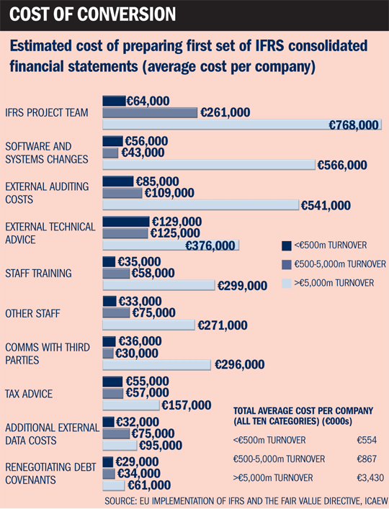 Figure 2.2: Cost of Conversion for European Firms
Conversely, “the average one-time cost of $3.24 million dollars” would benefit multinational corporations in the long run as these companies save money cutting down the number of financial statements from three to two or one (Hail 41). Currently, foreign subsidiaries of U.S. multinationals often have to comply with the domestic reporting standards of their domicile, usually for statutory or tax purposes. For example, each foreign subsidiary would either “(i) maintain and track its primary accounts in compliance with U.S. GAAP (but then have to translate its reports to the domestic GAAP of its domicile), or (ii) maintain and track its primary accounts in compliance with the domestic GAAP of its domicile and then translate or reconcile these accounts to U.S. GAAP for consolidation with the U.S. parent company’s accounts” (Hail 43). Because many countries have moved to IFRS for reporting consolidated accounts but not yet for statutory purposes, a foreign subsidiary of a U.S. multinational may have to maintain or reconcile up to three sets of accounts (U.S. GAAP, IFRS, and domestic GAAP). Switching to IFRS reporting by U.S. could produce cost savings by eliminating one set of accounts. If IFRS were to become the global set of accounting standards for statutory and parent-only accounts, U.S. multinationals would only have to maintain one set of accounts, resulting in significant reporting costs savings for U.S. multinationals (Hail 43).
2.3 Costs
Although comparability in general is a difficult goal in an international setting, the nature of IFRS itself also seems to hinder the process of becoming a global standard. The major difference between IFRS and U.S. GAAP is that IFRS requires more discretion and U.S. GAAP is much more detailed (Hail 7). IFRS has wider rules and less specific guidance applications, giving more room to interpretation. For example, a study by Jack T. Ciesielski of The Analyst’s Accounting Observer found that, among the 137 companies reporting 2006 results under both U.S. GAAP and IFRS, 63% showed higher earnings with the international standards. For the median company, profits jumped by 11% (Henry). Thus, IFRS incorporates the value judgment of an accountant in its financial report. These value judgments can be easily influenced by incentives a company may have, causing a variety of ways to implement IFRS. This further interferes with creating a global standard.
One of the disadvantages of the U.S. switching to IFRS in its current state is lower quality and less enforcement. It is little disputed that the U.S. already has a high-quality set of standards and superior enforcement. In fact, there was an instance in the 1990’s when European firms adopted U.S. GAAP. These European companies had similar goals that some U.S. firms have today: “reduce asymmetry and lower the cost of capital” (Wu 1). This would allow them to access capital markets, in which companies get most of their money. The European firms believed that by switching to U.S. GAAP, they would convey their economic conditions more credibly (Wu 2). They hoped to gain more trust from their capital providers and stakeholders by producing more accurate financial statements.
Another disadvantage of adopting IFRS is that the U.S.’s power over accounting would diminish. While switching to IFRS may “signal willingness by the US to cooperate internationally” (Hail 8), it would also give “monopoly status to London-based IASB” (Hail 7). This could pose several problems. First, the IASB would be a step closer to being a potentially dangerous monopolist. Since a monopolist faces no competition, IASB standards could slip and would not be corrected.
In order to prevent such an event from happening, the infrastructure of the IASB should be evaluated as part of the IFRS convergence project. Currently, the authority to set accounting standards in the U.S. rests not only with FASB, but also with Congress, the SEC, and other court precedents. Ceding power to the IASB would not only diminish the control of the FASB, but also that of other authoritative bodies. Even though the U.S. has members on the IASB, there are concerns of underrepresentation. Some firms want to have “influence in accordance to America’s equity markets, which account for almost half of global market capitalization” (“Closing the GAAP”). In general, U.S. companies worry that U.S.’s interests will not be served as well as they were under the FASB.
The last disadvantage of switching to IFRS is that the IASB does not have a stable source of funding. Its finances derive primarily from “corporate contributions from various countries” (Bogoslaw). For example, in October 2008, IASB had bowed to pressure from European regulators on the issue of fair value accounting. It had allowed a certain transfer of assets which FASB only allowed in “rare circumstances” (Bogoslaw). However, that would not be the last time when European and other governments would continuously try to interfere. Even the chairman of the IASB, Sir David Tweedie, acknowledges, “IASB needs more protection from political manipulation.” (“Mind the GAAP…”). The IASB’s susceptibility to outside influences may hamper the board’s duties in setting standards and overseeing practices fairly. This brings the U.S. to question whether or not the IASB is really ready to take charge of a global accounting industry. On the other hand, the FASB primarily receives its funding from a mandatory accounting support fee collected from all publicly traded companies. This fee is “based on market capitalization, and by sales of publications, as long as those sales do not impair the actual and perceived independence of the standards-setting body” (Williams). This system ensures that the FASB always receives a consistent source of funding and eliminates the risk of giving in to political pressure. The IASB should develop a similar system to eliminate future risks of being influenced by political pressure before U.S. companies adopt IFRS.
2.4 Risks
In addition to studied political and economic implications to the transition, there are some unknown risks that not even specialists can predict. Evidence of this comes from previous adoptions of IFRS around the world. Unintended effects occurred in almost every adoption, suggesting that the U.S. will also face some negative effects. However, this should not deter the U.S. from switching to IFRS. Unintended risks can occur in any transaction, but the benefits of the transaction usually outweigh the costs of the effects. Instead of avoiding the transaction all together, the U.S. should take steps to reduce risk and transition to the IFRS as smoothly as possible. One of the ways this can be done is through the method of adoption.
2.5 Firms with Largest Net Benefit
This section discusses which U.S. firms are likely to benefit the most (or have the smallest net costs) from IFRS adoption. Existing evidence on the determinants of voluntary IFRS adoption around the world can be used to predict which U.S. firms would likely incur larger net benefits (or smaller net costs) from adopting IFRS. The underlying assumption is that firms would only voluntarily switch to IFRS if they expect the benefits to outweigh the costs. “Prior research reveals that voluntary IFRS adopters are larger, more likely to have international cross-listings, more extensively rely on outside funding, have geographically dispersed operations, more diffuse ownership, and are more likely domiciled in countries with low-quality local reporting” (Hail 45). However, many of these determinants are derived from contexts where adopting IFRS could improve the reporting quality (relative to local GAAP reporting), which is not necessarily the case for the U.S. “For instance, the argument that firms switch to IFRS to reduce information asymmetries and hence improve their ability to satisfy their current and future financing needs does not really apply to U.S. firms and U.S. GAAP” (Hail 45). Most U.S. firms can obtain sufficient financing by utilizing the domestic capital market. Thus, the primary beneficiaries of IFRS adoption should be U.S. multinational firms. An additional major beneficiary should be U.S. investors who want to diversify their portfolios abroad and would no longer need to invest in understanding both U.S. GAAP and IFRS (Hail 45).
Another group of potential beneficiaries from IFRS adoption are large firms with Big Four auditors. Larger firms will most likely be at an advantage since switching to IFRS most likely involves a fixed-cost component. Moreover, Big Four audit firms have an advantage over local, non-affiliated auditors because Big Four firms are already experienced in implementing and auditing IFRS reports, allowing them to rely on an international network of professionals for special issues. On the smaller end of the size spectrum, smaller U.S. firms could also benefit from the adoption of IFRS because the reporting standards are less complex than U.S. GAAP. Lower complexity means lower risk of errors and lower audit costs, on average (Hail 46). While smaller firms have struggle to cover the initial transition costs of switching to IFRS, the firms would benefit from the transition in the form of future cost savings and less costly, higher quality financial statement reporting.
2.6 Possible Methods of Adoption
Two main methods of adopting IFRS have been discussed to implement the standards in the U.S.: the staggered approach and the big bang approach. The staggered approach, as its name suggests, implements accounting standards over a number of years. On the other hand, the big bang approach supports an instant implementation of the new standards on a predetermined date. While both methods have many benefits and detriments, they should be closely examined to determine the most effective method of adopting the IFRS while minimizing costs and reducing risks.
The staggered approach to IFRS adoption supports implementing the new standards over a period of time, leading to less misstatements of financial information and allowing companies more time to adopt the changes as they come. This should leave companies more prepared to report financial information accurately and let them allocate costs more efficiently over a number of years. However, this method could also lead to confusion among investors. With a mix of U.S.GAAP and IFRS standards on financial statements, investors will have difficultly comparing financial statements from year to year, as well as understanding what methods are currently being used. This method could potentially hurt companies trying to raise capital because investors will lose confidence in the financial reporting for the current period. Moreover, this method could prove to be more costly than the big bang approach. While the big bang approach forces companies to incur a large, one-time adoption expense, the staggered approach lets companies allocate their costs over future periods. While this seems conceptually ideal, a long adoption period with many unforeseen risks could leave companies spending money on training employees and updating supporting systems for years to come. In the long run, these expenses could add up to be more than the one-time expense incurred under the big bang approach.
The big bang approach supports a “light-switch” method of adopting IFRS. Companies will be required to start reporting in IFRS on a set date, and expenses will be incurred in a shorter amount of time. While instant adoption seems more risky, in practice it would most likely cause fewer problems than the staggered approach. For example, the European Union used the big bang approach during its mandatory adoption in 2005. Because individual countries in the European Union were allowed to adopt the standards differently, many problems occurred during the transition. These problems can easily be avoided with a proper lead time for companies to prepare for the adoption. During this long lead time, companies will have the opportunity to start allocating the expenses association with adoption earlier than with the staggered approach. Moreover, the U.S. could offer an early adoption option, allowing companies to start reporting in IFRS before the mandatory date. Early adoption can allow companies to allocate expenses over an even longer period of time, and it also gives companies an opportunity to catch mistakes before financial statements are released publically. By implementing the standards using a big bang approach with a long lead time and option to early adopt, the U.S. can minimize risks during the adoption and avoid a drawn-out, expense transition.

3. Adopting IFRS in the E.U.

3.1 Development
Historically, Europe has always had difficulty making meaningful comparisons of financial reports across borders. This is mostly due to diverse legal systems, combined with other political and economic factors. Prior to harmonization, each European country reported financial statements using extremely diverse, country-specific accounting systems. Recognizing this, members of the E.U. were the first countries to move towards harmonization of accounting standards.
The European Union issued several directives in the late 70’s and 80’s to harmonize financial reporting practices to reduce diversity and facilitate cross-border investments and cross-listings. In the 1990’s, accounting harmonization progressed with “the improvement of IAS (the precursor of IFRS), harmonization events in the E.U. economy (e.g. adoption of a single currency), and political changes (e.g. disappearance of border control within the Schengen area)” (Soderstrom 6). IFRS adoption was not mandatory until 2005, but firms in some European countries were allowed to use IAS as a substitute for domestic accounting standards in the late 1990’s.
3.2 Method of Adoption
The E.U. achieves its harmonization objectives through the Directives, mainly the Fourth and Seventh E.C. (European Community) Directives, which must be incorporated into the laws of the Member States (countries in the E.U.). The relevant body of law for accounting is company law (Bebbington 8). “A Directive is an instrument that is directly binding following the adoption by the Council of Ministers (since 1994, together with the Parliament). It obliged Member States to enact into national law the provisions of the Directive within a given timeframe” (Bebbington 8). “The Regulation, on the other hand, is an instrument, which after it has been adopted, is directly binding and effective on the Member States. This has been far less used for company law [harmonization] within the E.U.” (Bebbington 8). The European Community specifically pursued accounting harmonization through the implementation of the Directives in order to foster comparability and equivalence of financial information rather than absolute uniformity (Bebbington 8).
3.3 Adoption within Individual Countries
To examine the effects of IFRS adoption on individual countries in the E.U., Germany and Spain will be analyzed respectively. In the late 1980’s, the debate about international accounting practices in Germany was fueled by the increased capital needs of German companies, who pushed towards international capital markets that require relevant, reliable, and comparable accounting information. Disparities between financial reports consistent with U.S. GAAP and German standards harmed the credibility of German accounting principles in the international community and increased pressure of the German legislator. “As a result, the Kapitalaufnahmeerleichterungsgesetz’ (alleviation law regarding raising of capital) was enacted in 1988 to improve the competitiveness of German companies. This allowed groups headed by companies with listed shares (such as stock corporations) to prepare consolidated statements according to internationally accepted accounting standards, namely IAS or U.S. GAAP” (Heidhues 7). Figure 3.1 portrays Germany’s gradual transition to the implementation of IFRS.
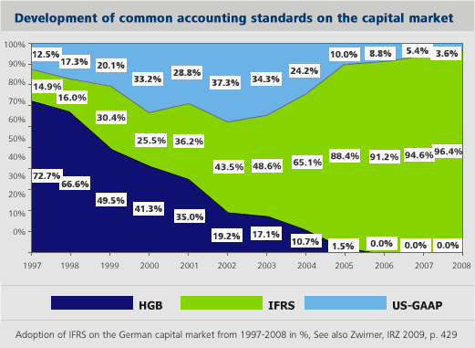 Figure 3.1: Development of common accounting standards on the capital market
In contrast to those countries where professional practice orients accounting standards, the accounting rules in Spain, a country where the legal system in based on Roman Law, are enacted in legislation. Hence, accounting rules in Spain have traditionally been a public issue and there has been scant input from the private sector. “Regulations have taken the form of companies legislation (e.g. the Commercial Code and the Spanish Companies Act), the General Chart of Accounts and the related implementing Regulations, and other Securities Market and Bank of Spain legislation. Consequently, the Spanish accounting system is of a Continental European nature” (Callao 149). Research concludes that the financial statements of Spanish firms adopting IFRS reflect:
- “Increases in cash and cash equivalents, long-term and total liabilities and in the cash ratio, indebtedness and return on equity.
- Decreases in debtors, equity, operating income and the solvency ratio and return on assets (measured in terms of the operating income)” (Callao 160).
Figure 3.2 shows a multivariate analysis of the impact of IFRS adoption of European listed firms in local GAAP and in IFRS.
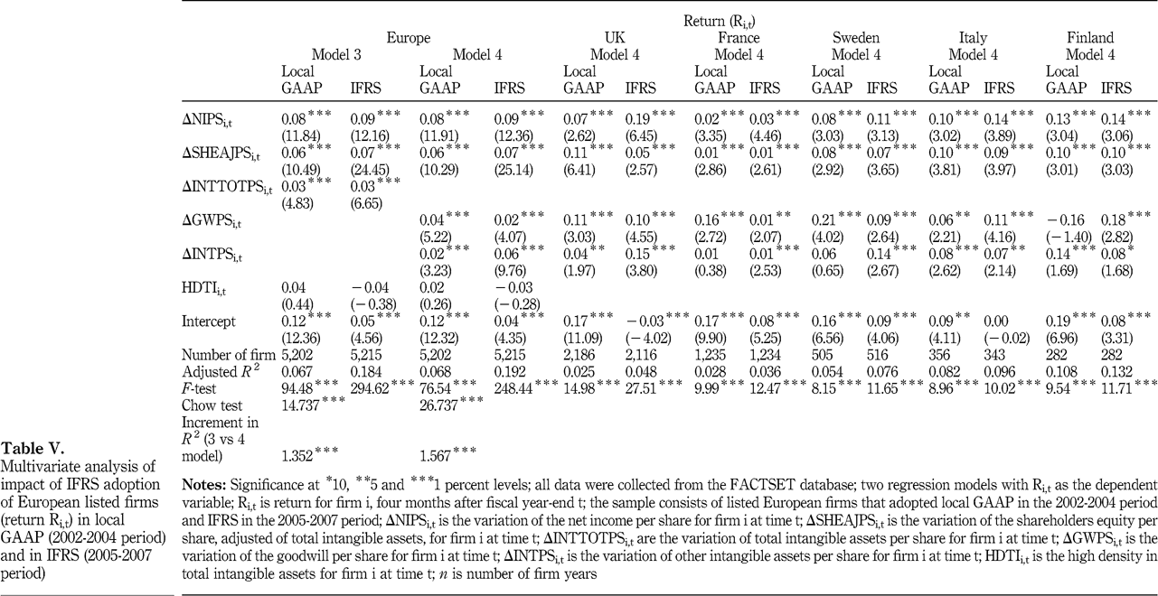Figure 3.2: Multivariate Analysis of Impact of IFRS Adoption of European listed firms in local GAAP and IFRS

3.4 Response to Adoption
The response from the requirement for listed E.U. companies to prepare their consolidated financial reports in according with IFRS from 2005 has generally been positive, both from the accounting profession and the E.U. companies affected. However, this excludes the financial services industry, which has responded unfavorably to some IFRS. Even though the response to the adoption was positive, studies show that E.U. companies are not preparing as well as they should be. In 2002, PricewaterhouseCoopers surveyed more than 650 chief financial officers across the 15 E.U. Member States to determine companies’ views on the requirement to adopt IFRS by 2005. The results showed that most companies believed that adopting IFRS would help establish a common European market, benefiting Europe as a whole. Most companies wanted the regulation to be extended to individual company accounts, but this may not be possible in some E.U. countries. (Bebbington 37).
Even though adopting IFRS has been received positively, E.U. companies remained relatively unprepared for the adoption date in 2005. When PricewaterhouseCoopers initiated another survey in 2003, “it was found that 34% of the respondents would be adopting IFRS in 2005. This is not surprising on its own, but 45% of respondents to the survey indicated that they would be required to adopt IFRS by 2005” (Bebbington 38). These results mean that some companies required to adopt IFRS by 2005 would not be doing so. A large group of companies waited until the IASB issued final standards, but this came as a surprise due to previous surveys that indicated companies wanted the freedom to adopt IFRS early (Bebbington 39).

4. Adopting IFRS in New Zealand

4.1 Development
After the announcement that E.U. listed companies would be required to prepare their consolidated financial reports in accordance with IFRS by 2005, Australia and New Zealand both announced that they would be following suit. The shocking announcement by Australia came as the result of the E.U.’s decision to adopt IFRS, and once Australia adopted IFRS, New Zealand had no choice but to follow. However, IFRS implementation will differ from that of the E.U. because IFRS will apply to a wider range of entities and financial statements. Figure 4.1 shows the timeline for New Zealand’s convergence.
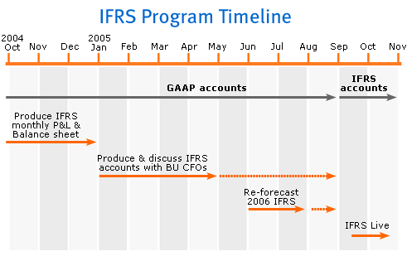 Figure 4.1: IFRS Adoption Timeline in New Zealand and Australia
In New Zealand, the primary statute governing the establishment of accounting standards is the Financial Reporting Act 1993 (FRA). This act gives legal backing to accounting standards. “The private sector standard setter in NZ is the Financial Reporting Standards Board (FRSB) and is part of the Institute of Chartered Accountants NZ (ICANZ).” (Bebbington 28). Although the FRSB does not have a monopoly over standard setting, it is still the only body to ever issue a standard in New Zealand. The Accounting Standards Review Board (ASRB), which is a crown entity, was set up under the FRA to review and approve accounting standards. “Standards issued by the FRSB do not receive legal backing until they are approved by the ASRB” (Bebbington 29).
On December 19, 2002, the ASRB announced that reporting entities in New Zealand will be “required to apply IFRS for periods commencing on or after [January 1,] 2007 and reporting entities have the option to adopt IFRS early from [January 1,] 2005” (Bebbington 29). However, the ASRB’s decision to adopt IFRS differs from that of the E.U. in a number of ways. The first is that the requirement to apply IFRS extends to all reporting entities in New Zealand rather than just listed companies in the E.U., including profit-oriented entities as well as public benefit entities. Next, New Zealand’s requirement is for both individual and consolidated financial reports, whereas it is only for consolidated financial reports in the E.U. Finally, New Zealand gives companies the option to adopt IFRS early in 2005, whereas the requirement is for 2005 in the E.U. (Bebbington 29).
4.2 Problems Likely to Be Faced
New Zealand is likely to encounter numerous problems due to the decision to switch to IFRS. Because of New Zealand’s decision to apply IFRS to a wider range of financial statements and entities, it will also encounter problems which the E.U. avoided. While IFRS and the former New Zealand standards are relatively similar, there are still differences which could have a significant impact on New Zealand companies, mostly arising from major differences between some IFRS and the corresponding New Zealand standard. Some examples of these are accounting for defeasance of debt, accounting for intangibles, and accounting for income taxes. There are also some New Zealand standards for which there is no corresponding IFRS Directive. Accounting for agriculture and accounting for share-based payment are examples of these (Bebbington 34).As IFRS continues to be revised, the new differences could also create a problem of uncertainty in the future.
Another problem which could also emerge is the difference between the application of true and fair view (TFV) principle in IFRS and N.Z. GAAP. In IFRS the TFV principle is overriding. “If the financial statements of an entity do not present a TFV after applying IFRS then the entity may depart from those requirements so that the financial statements do present a TFV” (Bebbington 35). However, the TFV principle is additive in N.Z. GAAP. “If the financial statements do not present a TFV after applying NZ GAAP then the entity must add extra disclosures, not depart from the standards” (Bebbington 35). Therefore, changing to IFRS will mean a change in the TFV principle in the FRA.
New Zealand will also be facing problems that the E.U. avoided because of its decision to require IFRS for a wider range of reporting entities. One problem that could arise is determining what entities will be reporting entities and what entities will qualify for full or partial exemptions from IFRS. This issue will inevitably create uncertainty for entities planning the adoption of IFRS because they may not know if IFRS actually applies to them. Another problem with the wider range of reporting entities is that IFRS could impose significant costs on unlisted and public benefit entities that arguably has no real benefits for them (Bebbington 35).
4.3 Response to Adoption
The response to the adoption of IFRS in New Zealand was one of shock. The first shock arose from the initial announcement from the FRC that Australian companies would be adopting IFRS by 2005. The move went against Australia’s prior harmonization policies, which made it completely unexpected. Not only was the announcement of adopting IFRS shocking for New Zealand companies, but also the announcement shocked the accounting profession. This unexpected announcement led to an unorganized transition. Since both New Zealand companies and accounting professionals were not expecting the transition, it gave them less time to prepare for the switch. Also, the unclear requirement about which reporting entities would qualify for IFRS left even more uncertainty in New Zealand’s operating environment. The lack of certainty made companies unable to adequately plan for the adoption, which resulted in an overall unorganized transition (Bebbington 48).

5. Conclusion

Adopting the IFRS in the U.S. has been a hot topic of debate for many years. While there are many significant benefits and costs of adopting IFRS, the benefits far outweigh the costs in the long run. Implementing a global set of accounting standards will allow companies to be more competitive in a global marketplace and find more sources to raise capital. Also, companies will be able to cut down the number of financial statements they prepare, lowering expenses. However, some issues need to be addressed before the U.S. officially switches to IFRS. First, the IASB should implement a system to create a consistent source of funding, eliminating the possibility of political pressure affecting the accounting standards released. Next, the effects of adoption on small companies should be considered to avoid bankrupting these companies through the adoption. Finally, the quality of the IFRS standards should be evaluated so that investors do not lose confidence in the reliability and accuracy of the new financial statements. If these issues are properly addressed and an effective method of implementation is used, the U.S. will experience a smooth transition to IFRS.
Past studies of IFRS adoption in the European Union and New Zealand also prove the benefits of IFRS adoption. In the E.U., IFRS adoption was able to increase comparability between Member States, which allowed the countries in the E.U. to have much greater access to both domestic and international capital funding. The added comparability also helps European investors have more certainty in the financial statements of the companies in their portfolios. While the overall adoption of IFRS was received positively by the Member States of the E.U., most companies were still not adequately prepared for the transition. If companies spent more time preparing for the switch, the IFRS adoption would have went even more smoothly.
In contrast, the New Zealand adoption of IFRS came as a surprise for both New Zealand businesses and New Zealand accounting professionals. Even though companies were given two years to adopt the standards early and at their own pace, the surprise announcement of the IFRS adoption gave companies little time to plan for the adoption. This made the transition very unorganized and more costly for firms in New Zealand. Also, New Zealand’s decision to apply IFRS to a wider range of reporting entities left the country in an uncertain environment. Because companies were unsure about whether or not IFRS adoption applied to them, they were unable to adequately plan for the adoption. These problems could have been avoided by better preparation and planning by the ASRB.

Works Cited

"About the IFRS Foundation and the IASB." IFRS. IFRS Foundation. Web. 11 Nov. 2010. <http://www.ifrs.org >.
Bebbington, Joseph, and Esther Song. "The Adoption of IFRS in the EU and New Zealand." National Centre for Research on Europe. University of Canterbury, Nov.-Dec. 2003. Web. 14 Nov. 2011. <http://www.europe.canterbury.ac.nz/research/finance1.shtml>.
Bogoslaw, David. "Global Accounting Standards? Not So Fast." Bloomberg BusinessWeek. 13 Nov. 2008. Web. 14 Nov. 2010. <http://www.businessweek.com>.
Callao, Susana, Jose I. Jarne, and Jose A. Lainez. "Adoption of IFRS in Spain: Effect on the Comparability and Relevance of Financial Reporting." Journal of International Accounting, Auditing and Taxation 16.2 (2007): 148-78. Print.
"Closing the GAAP." The Economist. 28 Aug. 2008. Web. 18 Nov. 2010. <http://www.economist.com>.
"Facts about FASB." FASB: Financial Accounting Standards Board. Web. 10 Nov. 2010. <http://www.fasb.org>.
Hail, Luzi, Christian Leuz, and Peter D. Wysocki. "Global Accounting Convergence and the Potential Adoption of IFRS by the United States: An Analysis of Economic and Policy Factors." Social Science Research Network. Social Science Electronic Publishing, 11 Mar. 2009. Web. 17 Nov. 2011. <http://papers.ssrn.com/sol3/papers.cfm?abstract_id=1357331>.
Heidhues, Eva, and Chris Patel. "Convergence of Accounting Standards in Germany : Biases and Challenges." Macquarie University ResearchOnline. East China University of Science & Technology. Web. 15 Nov. 2011. <http://hdl.handle.net/1959.14/102181>.
Henry, David. "Global Accounting Rules: Simpler, Yes. But Better?." BusinessWeek. 04 Sept 2008. Web. 20 November 2010. <http://www.businessweek.com >.
"Mind the GAAP: Analyzing the Proposed Switch to International Accounting Standards." Knowledge@Wharton. 1 Apr. 2009. Web. 22 Nov. 2010. <http://knowledge.wharton.upenn.edu/>.
"SEC Leadership in International Effort." AICPA: IFRS Resources. Web. 15 Nov. 2010. <http://www.ifrs.com>.
Soderstrom, Naomi S., and Kevin Jialin Sun. “IFRS Adoption and Accounting Quality: A Review.” Social Science Research Network. Social Science Electronic Publishing, 11 Mar. 2009. Web. 20 Nov. 2011. <http://papers.ssrn.com/sol3/papers.cfm?abstract_id=1008416>.
Williams, J. Richard. "Funding FASB: Public Money, Public Domain." NYSSCPA.ORG. Web. 27 Nov. 2010. <http://www.nysscpa.org/>.
Wu, Joanna S., and Ivy Zhang. "Voluntary IAS and U.S. GAAP Adoption by Continental European Firms: The Role of Labor Relations." Social Science Research Network. Nov. 2006. Web. 20 Nov. 2010. <http://papers.ssrn.com/sol3/papers.cfm?abstract_id=954599>.

Countries Adopting IFRS. Digital image. IFRS or GAAP: Not Which, but When? University of Southern California. Web. 23 Nov. 2011. <http://myportfolio.usc.edu/raarnold/2010/02/ifrs_or_gaap_not_which_but_when.html>.
Roadmap to IFRS Adoption in the U.S. Digital image. IFRS or GAAP: Not Which, but When? University of Southern California. Web. 23 Nov. 2011. <http://myportfolio.usc.edu/raarnold/2010/02/ifrs_or_gaap_not_which_but_when.html>.
Cost of Conversion for European Firms. Digital image. IFRS Will Be Big Burden for SMEs. AccountancyAge. Web. 23 Nov. 2011. < http://www.accountancyage.com/aa/analysis/1863330/analysis-ifrs-burden-smes>.
In an attempt to eliminate some of the factors that disrupt global comparability, the FASB and IASB started a convergence project, mentioned earlier, to make the standards more similar. Although some major differences still exist, the boards recently announced an extension of the project to further resolve differences believed to be impeding IFRS adoption in the U.S. Some of the major differences remaining are fair values, revenue recognition, leases, and consolidation. These differences are believed to be resolved by 2011, and all major capital markets would be able to operate under the new standards by 2013 (“SEC Leadership”).
One of the major reasons why U.S. GAAP was thought to be more transparent was that U.S. GAAP prohibits the practice of “hidden reserves.” “Hidden reserves” used to be widespread in Continental Europe, and it refers to a bundle of money that a company creates by increasing an expense account (Wu 6). These bundles were supposed to be stored in the case of potential future losses, and they were designed to be accessed later to cover up poor performances. Because companies created “hidden reserves” for unexpected future losses, financial statement users did not know how much money a company had stored away or whether the performance a company is claiming to have is legitimate (Wu 9). Thus, using U.S. GAAP, which prohibits this practice, resulted in more honest and truthful reports of a company’s economic performance. While questionable accounting practices such as “hidden reserves” decrease the quality of financial reporting, the IFRS convergence project was designed to address these types of standards before U.S. companies adopt IFRS.
Development of Common Accounting Standards on the Capital Market. Digital image. Adoption of IFRS on the German Capital Market from 1997-2008 . Zwirner. Web. 10 Oct. 2010.
Multivariate Analysis of Impact of IFRS Adoption of European listed firms in local GAAP and IFRS. Digital image. Review of Accounting and Finance . Emerald Group Publishing. Web. 20 Nov. 2011. <http://www.emeraldinsight.com/journals.htm?articleid=1944313&show=html>
IFRS Program Timeline for New Zealand and Australia. Digital image. IFRS Project . ANZ. Web. 20 Nov. 2011. <http://www.shareholder.anz.com/phoenix.zhtml?c=96910&p=irol-ifrs#option3>

