Evaluation of Insecticide Resistance in Populations of Tobacco Thrips, Frankliniella fusca (Hinds), and Plant Density Effects on
Thrips Injury to Cotton

A Thesis Presented for the
Master of Science
Degree
The University of Tennessee, Knoxville

Jessica Krob
May 2022

Dedication
I dedicate my work to my mom and dad. Thank you for your continuous support and guidance.

Acknowledgements

I would first like to thank Dr. Scott Stewart for his guidance and teaching. I also thank my committee members, Drs. Tyson Raper, Jerome Grant, and Liesel Schneider, for their expertise and guidance. I also appreciate cooperating researchers for providing tobacco thrips populations and maintaining field trial locations. A tremendous thank you to Sandy Steckel and Matthew Williams for maintaining the field trials in Tennessee. I would also like to thank the summer interns and the WTREC/MREC staff for their help in maintaining field trials. Also, I thank Dawson Kerns and Drs. Scott Graham and Clay Perkins for their help with the bioassays before 2021. Thank you to the fellow graduate students and friends: Kassie Hollabaugh, Trinity Hamm, Allyson Dekovich, Corey Day, Dakota Little, Dawson Kerns, Shelly Pate, Ty Smith, Sam Purdom, Sayantan Sarkar, Kurt Wedegaertner, Christian Baker, Autumn McLaughlin, Elias Zuchelli, Delaney Foster, and Claire Cooke for making our time at the WTREC and Knoxville fun and exciting. Thank you to the University of Tennessee for all of the opportunities.

Abstract

Two field studies were performed in Tennessee to evaluate the effects of plant density and seed spacing on thrips injury to upland cotton (Gossypium hirsutum L.). The plant density study consisted of seeding rate treatments that were low, normal, high, and very high, relative to university Extension recommendations. In the plant spacing study, treatments were implemented using nearly identical seeding rates but with relatively uniform seed spacing versus a clumped, “hill-dropped” spacing. In both studies, the seed was either treated with an insecticide (imidacloprid) and a fungicide or only with a fungicide. Due to variable environmental conditions, the results were not consistent for each test. In the plant density tests, where thrips pressure did not overwhelm the potential effects of the plant population treatments, more adult thrips were seen in plots with lower plant populations. In the seed spacing study, thrips injury ratings at the first true leaf stage showed higher injury for isolated plants than clumped plants. Future research investigating oviposition rates on newly emerged seedlings could aid in determining why thrips injury is higher in lower plant populations.
Standardized field trials and bioassays were done to evaluate the resistance of Tobacco Thrips, Frankliniella fusca (Hinds), to insecticides. From 2018 to 2021, field trials and bioassays were performed on tobacco thrips populations in the southern U.S. Classes of insecticides evaluated in these studies included organophosphates (acephate, dicrotophos, and dimethoate), a synthetic pyrethroid (lambda-cyhalothrin), a neonicotinoid (imidacloprid), and a spinosyn (spinetoram). Acephate is the most commonly applied foliar insecticide; however, observations in Tennessee suggest that its efficacy has declined. Discriminating dose bioassay and field trial results suggest that tobacco thrips have developed resistance to acephate and likely other organophosphate insecticides; however, this resistance seems to be concentrated in the upper Mid-South (Arkansas, Tennessee, and Mississippi Delta Region). Further research is needed to determine the heritability and mechanism of this resistance.

Table of Contents
Chapter I. Introduction 1
Cotton Production 1
Thrips 1
References 17
Chapter II. Effects of plant density, seed spacing, and seed treatment on thrips injury to cotton 34
Abstract 35
Introduction 36
Materials and Methods 37
Results 41
Discussion 46
Acknowledgements 51
References 52
Appendix 59
Chapter III. Standardized Field Trials and Bioassays to Evaluate Resistance of Tobacco Thrips, Frankliniella fusca (Hinds), to Insecticides 68
Abstract 69
Introduction 70
Materials and Methods 73
Results 78
Discussion 81
Acknowledgements 85
References 86
Appendix 93
Conclusion 102
Appendix 103
Vita 118

List of Tables
Table 1. The average percent change from initial to final plant population for each test of the plant density study (2020-2021: Jackson and Milan, TN) for different plant populations and whether an insecticide seed treatment (IST) was used. 59
Table 2. The collection location, host, generation tested, bioassay date, and percent water-check mortality for tobacco thrips populations tested in discriminating dose and dose response curve bioassays. 93
Table 3. Insecticides used in discriminating dose bioassays, showing concentrations of product and active ingredient used in bioassays, and the equivalent rate of product used per hectare. 95
Table 4. Insecticide treatments for regional thrips foliar-applied insecticide field trials. 96
Table 5. Effect of location on percent mortality for discriminating dose bioassays. See Table 3 for insecticides and rates used. 97
Table 6. LC50 values (g active ingredient /L) for acephate with 95% fiducial limits, slope, X² goodness of fit for the probit lines, and resistance ratios from three Tennessee field populations, a Tennessee population that was pre-selected with acephate, and the North Carolina laboratory susceptible population. 98
Table S1. Effect of seed density and insecticide seed treatment (IST) on the average initial plant population per meter for each test of the plant density study (2020-2021: Jackson and Milan, TN). 103
Table S2. Effect of seed spacing and insecticide seed treatment (IST) on the average number of plants per meter at the cotyledon and four-leaf stage for the test of the seed spacing study (2020-2021: Jackson and Milan, TN). 104
Table S3. Effect of seed density and insecticide seed treatment (IST) on the average number of total adult thrips per ten plants for each test of the plant density study (2020-2021: Jackson and Milan, TN). 105
Table S4. Effect of seed density and insecticide seed treatment (IST) on the average number of tobacco adult thrips per ten plants for each test of the plant density study (2020-2021: Jackson and Milan, TN). 106
Table S5. Effect of seed density and insecticide seed treatment (IST) on the average number of immature thrips per ten plants for each test of the plant density study (2020-2021: Jackson and Milan, TN). 107
Table S6. Effect of seed spacing and insecticide seed treatment (IST) on the average number of total adult thrips per ten plants for the test of the seed spacing study (Jackson, TN 2021). 108
Table S7. Effect of seed density and insecticide seed treatment (IST) on the average thrips injury (0=no injury, 5= maximum injury) on two-leaf cotton for each test of the plant density study (2020-2021: Jackson and Milan, TN). 109
Table S8. Effect of seed density and insecticide seed treatment (IST) on the average thrips injury ratings on four-leaf cotton for each test of the plant density study (2020-2021: Jackson and Milan, TN). 110
Table S9. Effect of plant grouping and insecticide seed treatment (IST) on the average thrips injury for the Jackson, TN 2021 and Milan, TN 2021 plant density tests. 111
Table S10. Effect of seed spacing and insecticide seed treatment (IST) on the average thrips injury ratings done at the two-leaf, three-leaf, and four-leaf stage for the test of the seed spacing study (Jackson, TN 2021). 112
Table S11. Effect of seed density and insecticide seed treatment (IST) on the average fraction green canopy cover from the Canopeo App for the Jackson, TN (2020 and 2021) and Milan, TN 2021 plant density tests. 113
Table S12. Effect of seed density and insecticide seed treatment (IST) on the average biomass (g) of four-leaf cotton for each test of the plant density study (2020-2021: Jackson and Milan, TN). 114
Table S13. Effect of seed density and insecticide seed treatment (IST) on the average height (cm) of four-leaf cotton for each test of the plant density study (2020-2021: Jackson and Milan, TN). 115
Table S14. Effect of seed density and insecticide seed treatment (IST) on the average seed cotton yield (kg/ha) for each test of the plant density study (2020-2021: Jackson and Milan, TN). 116
Table S15. Effect of seed spacing and insecticide seed treatment (IST) on average seed cotton yield (kg/ha) for the test of the seed spacing study (Jackson, TN 2021). 117

List of Figures
Figure 1. The average number of total adult thrips per ten plants for the plant density study showing (A) the main effects of seed density and insecticide seed treatment (IST) in each test (2020-2021: Jackson and Milan, TN), with an asterisk indicating an interaction (B) between seed density and insecticide seed treatment in the Jackson, TN 2020 test. Error bars represent 95% confidence intervals. Common letters above bars, within each test location, indicate treatments are not different (Tukey’s significant difference test, α=0.05). 60
Figure 2. The average number of immature thrips per ten plants for the plant density study showing (A) the main effects of seed density and insecticide seed treatment (IST) in each test (2020-2021: Jackson and Milan, TN), with an asterisk indicating an interaction (B) between seed density and insecticide seed treatment in the Milan, TN 2020 test. Error bars represent 95% confidence intervals. Common letters above bars, within each test location, indicate treatments are not different (Tukey’s significant difference test, α=0.05). 61
Figure 3. The average thrips injury ratings (0=no injury, 5= maximum injury) on two-leaf cotton for the plant density study showing (A) the main effects of seed density and insecticide seed treatment (IST) in each test (2020-2021: Jackson and Milan, TN), with an asterisk indicating an interaction (B) between seed density and insecticide seed treatment in the Milan, TN 2021 test. Error bars represent 95% confidence intervals. Common letters above bars, within each test location, indicate treatments are not different (Tukey’s significant difference test, α=0.05). 62
Figure 4. Effect of seed density and insecticide seed treatment (IST) on the average thrips injury ratings (0=no injury, 5= maximum injury) on four-leaf cotton in each test of the plant density study (2020-2021: Jackson and Milan, TN). Error bars represent 95% confidence intervals. Common letters above bars, within each test location, indicate treatments are not different (Tukey’s significant difference test, α=0.05). 63
Figure 5. Effect of plant grouping (isolated versus clumped) and insecticide seed treatment (IST) on the average thrips injury ratings in the Milan, TN 2020 and 2021 density tests. Error bars represent 95% confidence intervals. Common letters above bars, within each test location, indicate treatments are not different (Tukey’s significant difference test, α=0.05). 64
Figure 6. Effect of seed density and insecticide seed treatment (IST) on the average biomass (g) on four-leaf cotton in each test of the plant density study (2020-2021: Jackson and Milan, TN). Error bars represent 95% confidence intervals Common letters above bars, within each test location, indicate treatments are not different (Tukey’s significant difference test, α=0.05). 65
Figure 7. The average height (cm) of four-leaf cotton for the plant density study showing (A) the main effects of seed density and insecticide seed treatment (IST) in each test (2020-2021: Jackson and Milan, TN), with an asterisk indicating an interaction (B) between seed density and insecticide seed treatment in the Milan, TN 2021 test. Error bars represent 95% confidence intervals. Common letters above bars, within each test location, indicate treatments are not different (Tukey’s significant difference test, α=0.05). 66
Figure 8. The average seed cotton yield (kg/ha) for the density study showing (A) the main effects of seed density and insecticide seed treatment (IST) in each test (2020-2021: Jackson and Milan, TN), with an asterisk indicating an interaction (B) between seed density and insecticide seed treatment in the Milan, TN 2021 test. Error bars represent 95% confidence intervals. Common letters above bars, within each test location, indicate treatments are not different (Tukey’s significant difference test, α=0.05). 67
Figure 9. Predicted 24-h acephate (Orthene 97) mortality curves from probit analyses in grams of active ingredient (AI) per liter of three Tennessee tobacco thrips populations, an acephate-selected Tennessee population (TN6-S), and the North Carolina laboratory susceptible population. Uncorrected mean mortality data are represented by point markers. 99
Figure 10. Distributions (box and whisker plots) of the average percent reduction of foliar insecticides based on thrips injury ratings (top) and total numbers of thrips (bottom) observed in all foliar insecticide tests. The boxes show the inclusive interquartile range, with the top and bottom of the box representing the upper and lower quartiles. The whiskers at the end show the highest and lowest values. Common letters above plots indicate mean values are not different (Tukey’s significant difference test, α=0.05). The points represent the average percent reduction in thrips injury (top) and percent reduction of thrips numbers (bottom) observed in foliar insecticides tests by location. The percent reduction in thrips injury and thrips numbers were calculated for insecticide treatments relative to sample values in plots that did not receive an insecticide treatment. Foliar insecticide test locations included: TN-M and TN-J (2 Trials Milan and 3 trials Jackson), MS-H and MS-D (2 trials each in Hills (Starkville) and Delta (Stoneville)), AR-M and AR-T (2 trials each in Marianna and Tillar), and TX (3 trials). See Table 4 for insecticides and rates used. 100

Chapter I. Introduction

Cotton Production
Upland cotton (Gossypium hirsutum, L.) is a major commodity grown throughout the United States. In 2020, about 3.3 million hectares of upland cotton were harvested in the United States (USDA-NASS 2020c), and 1,772,000 of those hectares were harvested in the Mid-South cotton production region (Mississippi, Arkansas, Tennessee, Missouri, and Louisiana) (USDA-NASS 2020a). The total number of hectares harvested in Tennessee was 111,288 (USDA-NASS 2020a), with an average yield of 1,195 kg/ha (USDA 2020b) and a production value of about $236 million (USDA-NASS 2020d). In Tennessee, cotton is mainly grown in the western part of the state in a non-irrigated, no-till production system.
The main product of cotton is fiber, which is used to make a variety of different fabrics. However, cotton by-products can be found in ice cream, baseballs, and wallpaper (Cotton Today 2020). Cotton seed also has a diverse range of uses. The seed is used as feed for cows and to make cottonseed oil, and cottonseed oil can be used for cooking or incorporated into cosmetics, soaps, and chips (Cotton Today 2020). When cotton is ginned, a lot of gin trash (i.e., cotton leaves and burrs) is accumulated; this biomass can be used to create hydromulch and biodegradable packing material (Cotton Today 2020).

Thrips
Species that Infest Cotton. Thrips belong to the order Thysanoptera which consists of more than 5,000 species that are divided into two suborders (Tubulifera and Terebrantia) and nine families (Moritz et al. 2000, Capinera 2008). The key difference between these two suborders is their ovipositor. Tubuliferans have a tube-like 10th abdominal segment and chute-like ovipositor that does not have teeth, so they lay their eggs on the surface of the plant tissue; whereas, Terebrantians have a conical 10th abdominal segment with a saw-like ovipositor that allows them to insert their eggs into the plant tissue (Stannard 1968, Moritz et al. 2000, Reed et al. 2006, Capinera 2008, Cluever and Smith 2017). All thrips species that are cotton pests belong to the suborder Terebrantia (Reed and Jackson 2002, Reed et al. 2006).
Thrips are an early-season pest that can be found infesting cotton across southern United States (Burris et al. 1989, Stewart et al. 2013). In the United States, the main species of thrips found on cotton seedlings are tobacco thrips, Frankliniella fusca (Hinds); flower thrips, Frankliniella tritici (Fitch); western flower thrips, Frankliniella occidentalis (Pergande); onion thrips, Thrips tabaci (Lindeman); and soybean thrips, Neohydatothrips variabilis (Beach) (Leigh et al. 1996, Cook et al. 2003, Albeldaño et al. 2008, Reed et al. 2010, Stewart et al. 2013). The most abundant species in Mid-South cotton is tobacco thrips (Reed and Jackson 2002, Cook et al. 2003, Reed et al. 2010, Stewart et al. 2013). Stewart et al. (2013) found that tobacco thrips composed 67-78% of all adult thrips collected in Arkansas, Georgia, Louisiana, Mississippi, Missouri, North Carolina, South Carolina, Tennessee, Texas, and Virginia. The other two most common species found at these locations were western flower thrips and onion thrips (Stewart et al. 2013). Herbert (2002) reported that more than 90% of the adult thrips were tobacco thrips in Virginia. Tobacco thrips usually compose more than 90% of the adults found in Mississippi (Reed and Jackson 2002, Layton and Reed 2014).
Biology and Ecology. Thrips undergo six stages of development: egg, larva (2 instars), prepupa, pupa, and adult (Watts 1934, Bailey 1938, Lublinkhof and Foster 1977, Lowry et al. 1992, Cook et al. 2011, Layton and Reed 2014). This complex life cycle does not fit the standard stages of holometabolous development or paurometabolous development, but rather, is intermediate of the two types (Lewis 1973, Moritz 1995, Layton and Reed 2014). The amount of time required for thrips to complete each stage of development varies by species and environmental factors such as temperature (Watts 1934, Bailey 1938, Vance 1974, Lublinkhof and Foster 1977, Lowry et al. 1992). Tobacco thrips, along with western flower thrips, eastern flower thrips, and onion thrips, can reproduce both sexually and parthenogenetically (Cook et al. 2011). Eddy and Livingstone (1931) discovered that tobacco thrips have arrhenotokous parthenogenesis, which means that unfertilized adult females will produce all male offspring. Watts (1936) also reported that flower thrips have arrhenotokous parthenogenesis.
Adult female thrips, in the suborder Terebrantia, insert eggs into leaf tissue using their sharp ovipositors (Watts 1934, 1936, Bailey 1938, Lublinkhof and Foster 1977, Lowry et al. 1992, Layton and Reed 2014). A female adult can lay about 100 eggs during her lifetime under optimal conditions (Layton and Reed 2014). The larvae will emerge within 2-30 days after the eggs are laid (Watts 1934, 1936, Bailey 1938, Lublinkhof and Foster 1977, Lowry et al. 1992, Layton and Reed 2014). The larval stages last between 2-12 days (Lowry et al. 1992, Cook et al. 2011).
Immature thrips are always wingless, are a light-yellow color, and have slender, spindle- shaped bodies (Stewart and Lentz 2010, Layton and Reed 2014). After the two immature stages, thrips enter the prepupal stage. During this stage, the thrips do not feed, but are mobile and generally move when disturbed (Watts 1936, Vance 1974). Thrips in the prepupal stage can be found in the soil or on the plant substrate, have wing pads, have free antennae, and are slightly smaller than the pupal stage (Vance 1974). Thrips will pupate 1-5 days after entering the prepupal stage (Watts 1936, Vance 1974). Thrips pupae can be found in the soil or on plant substrate (Watts 1936, Vance 1974, Broadbent et al. 2003). The prepupal and pupal stages appear similar, except in the pupal stage the wing pads are larger, and the antennae are fastened to the head (Watts 1936, Vance 1974).
Adults emerge from the pupal stage after 1-10 days (Cook et al. 2011), and Watts (1934) found that the average life span of an adult female tobacco thrips was about 29 days. Watts (1934) also reported that the average female life span of tobacco thrips was greater than both flower thrips and onion thrips. The temperature for this study was not reported. Lowry et al. (1992) found that the days required for tobacco thrips to complete development at four different temperatures ranged from 11.5 to 23.9 days, with shorter development time occurring at higher temperatures.
The physical characteristics of adult thrips vary by species (Reed et al. 2006, Cluever and Smith 2017). Although generally larger than immature stages, adult thrips have a similar body shape. Adult thrips range from 1-4 mm in length, and they may (macropterous) or may not (brachypterous) have two pairs of fringed wings, or both winged and unwinged adults may occur in the same species (Cluever and Smith 2017). For example, both male and female tobacco thrips adults can be macropterous or brachypterous (Reed et al. 2006, Cluever and Smith 2017). The color of thrips varies from a light-yellow to dark brown (Reed et al. 2006, Cluever and Smith 2017). Tobacco thrips can often be distinguished from flower thrips by their dark brown/black color, but flower thrips color can range from dark to light (Reed and Jackson 2002, Reed et al. 2006). Thrips have asymmetrical mouthparts with only the left mandible developed (Reed and Jackson 2002, Cluever and Smith 2017). The mandible and maxillary stylets are usually enclosed in an oral cone (Reed and Jackson 2002).
Thrips overwinter as adults, larvae, and in the soil as pupae; however, most species overwinter as adults on a multitude of weed species (Bailey 1938, Stannard 1968, Vance 1974, Chamberlin et al. 1992, Toapanta et al. 1996, Cook et al. 2011, Layton and Reed 2014). In the spring, adult thrips begin to reproduce on available host plants, such as weeds and winter wheat (Layton and Reed 2014). Some of the plant families that thrips have been found on include Asteraceae, Brassicaceae, Convolvulaceae, Fabaceae, Poaceae, Polygonaceae, and Solanaceae (Cook et al. 2011). Thrips can complete at least one generation on these hosts before cotton emerges (Layton and Reed 2014). Even though thrips are capable of short direct flight, the wind has a major influence on the movement of thrips onto cotton seedlings (Layton and Reed 2014). In the Mid-South, there are multiple generations of thrips each year (Stewart and Lentz 2010, Layton and Reed 2014). Thrips are not only an insect pest found in cotton, but they can be found on other crops such as onions, garlic, carrots, cucumbers, melons, peas, roses, carnations, beans, gladiolus, and hops (Bailey 1938). Additionally, thrips can be found on crops such as peanuts, tomatoes, tobacco, and peppers, and they can cause major economic losses in these crops because they transmit tospoviruses (Riley et al. 2011).
Feeding Injury to Cotton Seedlings. Both adults and larvae injure seedling cotton by feeding on the contents of the cells with their “punching-sucking” mouthparts (Layton and Reed 2014). Their mouthparts are referred to as punching-sucking because they impel their mandible into the tissue and suck up the contents of epidermal cells with their maxillary stylets (Reed and Jackson 2002). The emptied cells cause the leaves to wrinkle, curl up, or cause cupping (Telford and Hopkins 1957, Stewart and Lentz 2010, Layton and Reed 2014). A common term for cupping leaves is “possum-eared cotton” (Layton and Reed 2014).
Seedling plants will often have a silvery appearance to them after thrips feeding due to the accumulation of air in the emptied cells (Telford and Hopkins 1957, Layton and Reed 2014). Eventually the silvery appearance will become brown or bronze, indicating necrotic tissue (Reed and Jackson 2002, Layton and Reed 2014). While the healthy, undamaged leaf area continues to develop, the damaged area will tear, twist, and become distorted (Leigh 1995, Cook et al. 2011). Damage to the leaves can result in reduced leaf area (Burris et al. 1989, Roberts and Rechel 1996). Thrips injury can reduce plant height (Parencia et al. 1957, Burris et al. 1989, Roberts and Rechel 1996), reduce root growth (Roberts and Rechel 1996, Grey et al. 2006, Brown et al. 2008), and may kill the apical meristem when severe infestations occur (Telford and Hopkins 1957, Leigh et al. 1996). The loss of apical dominance and subsequent irregular growth in severely injured seedlings is often referred to as “crazy cotton” (Burris et al. 1989, Reed and Jackson 2002, Layton and Reed 2014). Plants may be killed when infestations are severe (Telford and Hopkins 1957, Stewart and Lentz 2010). Cotton seedlings are most susceptible to thrips injury from emergence until they have four true leaves (Stewart and Lentz 2010).
Weather conditions also affect the amount of time that the seedlings are susceptible to thrips (North et al. 2018). Under optimal warm growing conditions, cotton seedlings have less environmental stress and are generally less susceptible to thrips injury when compared to suboptimal growing conditions (Layton and Reed 2014). However, seedling development is delayed during cool weather, causing seedlings to be susceptible to thrips feeding for a longer period of time (Reisig 2020). Rainfall may cause significant mortality to immature thrips (Kirk 1997), and thus, higher populations are often observed under dry conditions. Dry conditions may also hinder the uptake of at-planting insecticide treatments and cause senescence of alternative plant hosts, resulting in more thrips movement onto cotton (Reisig 2020). Consequently, the combination of cool and dry conditions often results in greater thrips injury. However, excessively wet conditions can also cause at-planting treatments to leach through the soil, which limits the amount of insecticides available to plants (Reisig 2020).
Impact on Cotton Maturity. Some research indicates that thrips injury does not affect crop maturity (Newsom 1953, Leigh 1963, Watson 1965, Parker and Huffman 1986). Other studies show variability in the relationship between thrips injury and delayed maturity (Burris et al. 1994, Faircloth et al. 1999). However, many other studies have found that thrips injury can delay crop maturity by two weeks or more (Gaines 1934, Dunham and Clark 1937, Watts 1937, Bourland et al. 1992). It is evident, that depending upon test conditions, reduced and irregular plant growth from thrips injury can lead to delays in crop maturity (Gaines 1934, Dunham and Clark 1937, Watts 1937, Bourland et al. 1992, Herbert 1998, Van Duyn et al. 1998, Faircloth et al. 1999, Van Tol and Lentz 1999, Lentz and Van Tol 2000, Stewart et al. 2007, Cook et al. 2011). Delayed crop maturity increases the amount of time that the plant is susceptible to late- season pests, which can lead to the need for additional inputs (i.e., insecticides) and increase production costs (Cook et al. 2011, Stewart et al. 2013). When crop maturity is delayed, the plants are also more likely to experience cooler temperatures and rainfall later in the growing season (Gipson and Joham 1969), and low temperatures may reduce the efficiency of harvest aid chemicals (Cook et al. 2011). Yield and lint quality can also be adversely affected due to late season rainfall (Freeland et al. 2004, Parvin et al. 2005).
Impact on Yield. Over the last four years, thrips have ranked among the top four insect pests in cotton (Cook 2018, Cook and Cutts 2019, Cook and Threet 2020, Cook and Threet 2021). In Tennessee, for example, thrips total control costs and yield losses for the past four years have been about $7.3 million per year (Cook 2018, Cook and Cutts 2019, Cook and Threet 2020, Cook and Threet 2021). However, yield response to thrips management is variable. Studies have reported higher yields when thrips were controlled (Watts 1937, Race 1961, Davis et al. 1966, Davis and Cowan 1972, Burris et al. 1989, Herbert 1998, Van Tol and Lentz 1999, and Lentz and Van Tol 2000), and other studies did not show improved yield when thrips were controlled (Newsom 1953, Watson 1965, Cowan et al. 1966, Beckham 1970, Ratchford et al. 1987, 1989, Lentz and Austin 1994, Roberts 1994). Additionally, studies have shown mixed yield responses which varied by location or year (Leigh 1963, Parker and Huffman 1986, Burris et al. 1994, Van Duyn et al. 1998, and Faircloth et al. 1999).
Environmental conditions are not the same each year, and different conditions can help explain why yield responses to thrips control are inconsistent (Faircloth et al. 1999, Stewart et al. 2007, Cook et. al 2011, Cook et al. 2013). For example, suboptimal growing conditions during seedling development can lead to decreased yields (Faircloth et al. 1999, Stewart et al. 2007, Cook et al. 2013). Additionally, optimal environmental growing conditions may occur during some years and allow plants to compensate for early season thrips injury (Cook et al. 2011).
A five-year experiment in Virginia reported more consistent yield responses than other studies (Herbert 2002). Compared with control plots, an insecticide treatment increased yield by an average of 380 kg/ha across all experiments and years. A two-year study in Virginia and North Carolina reported that treatments with in-furrow applications of aldicarb and treatments with imidacloprid treated seed increased yield by an average of 483 and 613 kg lint/ha, respectively, when compared with untreated controls (Herbert et al. 2007). Furthermore, a summary of experiments performed from 1996 to 2014 across Arkansas, Louisiana, Mississippi, and Tennessee found that neonicotinoid seed treatments increased yield by an average of 115 kg lint/ha compared with seed treated only with fungicide (North et al. 2018).
At-Planting Insecticide Treatments. Growers have heavily adopted the use of proactive at-planting insecticide treatments for thrips management because thrips can cause injury and damage to cotton seedlings quickly after emergence (Cook et al. 2011). Proactive at-planting insecticides can be applied as seed or in-furrow (liquid or granular) treatments (Cook et al. 2011). Insecticide seed treatments options (IST) include acephate (Orthene® 97; AMVAC Chemical Corporation, Los Angeles, CA), imidacloprid (Gaucho® 600, Bayer CropScience, Research Triangle Park, NC), thiamethoxam (Cruiser® 5Fs, Syngenta Crop Protection, Greensboro, NC), and a product that is a mixture of imidacloprid and thiodicarb (Aeris®; Bayer CropScience). Acephate is an organophosphate (IRAC; MoA group 1B) and imidacloprid and thiamethoxam are both neonicotinoids (IRAC; MoA group 4A). Acephate and imidacloprid can also be applied as a liquid in-furrow.
Before neonicotinoids were introduced into the market, aldicarb (Temik®; Bayer CropScience), which is a granular in-furrow carbamate insecticide (IRAC; MoA group 1A), was the primary at-planting insecticide used to manage thrips (Cook et al. 2020). Neonicotinoid seed treatments were widely used in cotton beginning in the early 2000s. When Temik was removed from the market in 2010 due to its high toxicity, neonicotinoid seed treatments along with supplemental foliar insecticide applications became the pervasive strategy for thrips control (Cook et al. 2017, Cook et al. 2020). Gaucho and Cruiser were the primary neonicotinoid products that were used (Cook et al. 2020). After more than a decade of use for controlling thrips, reduced performance of neonicotinoids seed treatments, especially thiamethoxam, was observed in commercial fields in Tennessee beginning in 2011 (S. D. Stewart, personal comm.). This observation led to an evaluation of neonicotinoid seed treatment efficacy by Vineyard et al. (2017) in 2013 and 2014. The treatments in this study were Cruiser, Gaucho, Temik, and an untreated treatment. They found that the Cruiser and untreated treatments were comparable to each other in terms of vigor, maturity, and yield, and inferior to the Gaucho and Temik treatments. Thiamethoxam provided such little protection from thrips damage, that university Extension programs stopped recommending thiamethoxam as a seed treatment option (Lorenz 2013, Gore et al. 2014, Stewart 2014, Bogren et al. 2015, Hollis 2015). Subsequent research has shown that the reduced efficacy of neonicotinoid seed treatments is due to the development of tobacco thrips resistance to this class of insecticides (Huseth et al. 2016, Darnell-Crumpton et al. 2018).
Tobacco thrips resistance to neonicotinoids has now been thoroughly investigated throughout the southern United States. For instance, Huseth et al. (2016) collected tobacco thrips from 86 different locations throughout the Mid-South, Southeast, and East Texas cotton production regions from 2014-2015, and they found that approximately 57 and 65% of the tobacco thrips populations had reduced susceptibility to imidacloprid and thiamethoxam, respectively. This study reported that 50% of the tobacco thrips populations from Tennessee were resistant to both imidacloprid and thiamethoxam. Darnell-Crumpton et al. (2018) found that 16 and 57% of the tobacco thrips populations collected from Mississippi were resistant to imidacloprid and thiamethoxam, respectively. In this study, thrips resistance varied by region and year. Comparing the percent of the population that is resistant between the studies by Huseth et al. (2016) and Darnell-Crumpton et al. (2018) is potentially misleading because the definitions of resistance used in the studies are different, but it is important to note that both studies found location to be a factor in the level of tobacco thrips resistance to neonicotinoids.
Supplemental Insecticide Applications. Growers have modified management strategies to control thrips, particularly as tobacco thrips resistance to neonicotinoids became widespread. For example, growers sometimes supplement imidacloprid seed treatments with acephate, either as a seed treatment or in-furrow treatment (Cook et al. 2020). Recently, another aldicarb product (AgLogicTM 15G, AgLogic Chemical LLC, Chapel Hill, NC) was introduced into the market, and some growers have returned to using this product, particularly where nematodes are also a problem. Foliar insecticide applications are often made when thrips infestations are severe and when at-planting treatments do not provide satisfactory protection (Cook et al. 2011, Akin et al. 2012, Siebert et al. 2016, Darnell-Crumpton et al. 2018, Cook et al. 2020). However, foliar insecticide applications made to cotton having at-planting insecticide treatments only occasionally increase yield. Akin et al. (2012) summary of tests done across multiple locations in the Mid-South showed that foliar applications only increased yields when there was high thrips pressure, challenging growing conditions, or a combination of these factors.
Several classes of insecticide are potentially available for managing thrips in cotton. These include neonicotinoids, organophosphates such as acephate, dicrotophos, and dimethoate, spinosysns (IRAC; MoA group 5), carbamates, pyrethroids (IRAC; MoA group 3), avermectins (IRAC; MoA group 6), and diamides (IRAC; MoA group 28). The efficacy of various foliar insecticides has been evaluated for many years (Toews et al. 2012, Williams et al. 2014, Siebert et al. 2016, Huseth et al. 2017, D'Ambrosio et al. 2018, Cook et al. 2020). Research shows that pyrethroids provide little control for thrips (Toews et al. 2012, Cook et al. 2020), and university Extension programs do not recommend using this class of insecticides for thrips management (Catchot et al. 2020, Greene 2020, Whitaker 2019). Pyrethroid resistance has been documented in many western flower thrips populations (Reitz 2009). Also, the expectation is that foliar applications with neonicotinoid insecticides would not provide adequate control of tobacco thrips given the diminished performance of neonicotinoid seed treatments owing to resistance. Indeed, bioassays confirming tobacco thrips resistance were done using treated leaf surfaces (e.g., Huseth 2016, 2017).
Currently, acephate is the most common foliar-applied insecticide used for thrips management. This insecticide has been frequently used for several decades, and now its performance on thrips has declined in some areas (Cook et al. 2020, Stewart et al. 2020). Additionally, acephate is widely used throughout the season for the management of other insect pests such as tarnished plant bug (Lygus lineolaris, Heteroptera: Miridae). Foliar sprays made with acephate and pyrethroids can also lead to secondary outbreaks of pests such as spider mites (Acari: Tetranychidae), cotton aphids (Aphis gossypii), and western flower thrips (Mailhot et al. 2007, Catchot 2020).
Cultural Control Tactics. One cultural control technique that has been utilized at least partially for thrips management is tillage. Studies show that thrips densities are lower in no-tillage or low-tillage systems compared with conventional-tillage systems (Harris et al 1999, Manley et al. 2002, Parajulee et al. 2006, Bauer et al. 2010, Toews et al. 2010, Knight et al. 2015, Crow et al. 2020). Lahiri et al. (2019) found that there were lower thrips densities in strip-tillage systems with heavy rolled rye than in conventional-tillage systems. Toews et al. (2010) reported that the lack of ground cover alone is the most likely reason that thrips densities are higher in conventional-tillage systems than in strip-tillage systems. However, other studies reported no differences in thrips population numbers between tillage practices (DeSpain et al. 1992, Leonard et al. 1994).
Another production practice that could be manipulated to manage thrips populations is plant density; however, little research has been done on this management approach in cotton, and the research that has been done is inconsistent. In a study by Dunham and Clark (1937), they investigated how the timing of chopping weeds and the number of cotton stalks in a hill affected thrips damage. The percentage of plants with the terminal bud destroyed in treatments with early chopping and with an average of 2.8 and 1.0 stalks per hill was 9.2 and 21.0, respectively. In order to only have 1.0 stalk in the hill, they chopped the hills after the cotton had emerged, so the increased damage could have been due to a larger concentration of thrips on the remaining plants. When the chopping was delayed one week and there was an average of 2.1 stalks per hill, the percentage of plants with destroyed terminals was 20.3. Herbert et al. (2007) did not find an interaction between at-planting insecticide treatments (aldicarb, imidacloprid, untreated check) and planting plate (single and hill-drop) for thrips injury ratings. Arif et al.’s (2006) study examined how onion thrips population densities are affected by cotton planted on 75 cm row centers at densities of 12.5, 18.5, 23.5, 30, and 38.5 cm in Pakistan. Their results showed that thrips populations decreased as plant spacing increase, but they did not report any thrips injury ratings.
Plant population studies are also of interest in peanut production because tobacco thrips and western flower thrips are vectors of tomato spotted wilt virus (TSWV) (Sakimura 1962, Sakimura 1963). Tobacco thrips are the primary vector in the southern peanut production regions (Todd et al. 1996), and TSWV may cause extreme economic losses (Riley et al. 2011). Multiple studies have found that increasing plant populations decreases spotted wilt disease incidence (Wehtje et al. 1994, Branch and Baldwin 2001, Hurt et al. 2004, Sarver et al. 2016). The percentage of plants infected in areas of low and high populations may not differ, but higher plant populations have few infected plants per hectare (Brown et al. 2005). Thrips counts were not reported in these studies. Unpublished data by J. W. Todd and A. K. Culbreath suggested that lower plant populations have more thrips per plant than higher populations, so there may be a higher probability of infection in lower plant populations. (Brown et al. 2005).
Sampling and Economic Thresholds. One method that can be used to sample thrips is by vigorously shaking/beating plants over a white surface (e.g., white bucket, white cup) and counting the number of adults and immatures on the surface, sometimes with the aid of a hand lens (Boyd et al. 2004, Layton and Reed 2014, Stewart and McClure 2020). Thrips “washing” is often used in research trials where seedlings are collected, thrips are rinsed from plants with alcohol or soapy water, and the rinsate is sieved and thrips are counted under a dissecting microscope (e.g., Burris et al. 1989, Graham and Stewart 2018). The intensity of thrips infestations can also be based on injury symptoms from thrips feeding. Researchers often visually rate thrips injury on a 0-5 scale, with 0 representing no thrips injury and 5 representing all dead plants (Vineyard et al. 2017, Graham and Stewart 2018).
Graham et al. (2019) found that the Canopeo App (https://canopeoapp.com/) can be used as a tool to supplement visual thrips injury ratings in small plot research trials. Canopeo is an image analysis tool that analyzes all the pixels in an image based on R/G and B/G ratios and the excess green index. This analysis creates a binary image composed of white pixels that meet the selection criteria of green and black pixels that correspond to all the other colors that are not green (Patrignani and Oschner 2015). Canopeo estimates the percent green canopy cover from the fractional green canopy cover (FGCC) values. This image analysis tool is available as a smartphone application that can be easily accessed.
Thrips treatment thresholds in the Mid-South vary by state. These thresholds are based on the number of adults/immatures present on the plant, the presence of injury, the stage of the cotton plant or a combination of these factors (Cook et al. 2011). In Tennessee, the Extension Service recommends making a foliar insecticide application when there are one or more thrips per plant prior to the third leaf stage (Stewart and McClure 2020). The presence of immature thrips and obvious signs of injury to newly emerged leaves should also be taken into consideration when making treatment decisions (Stewart and McClure 2020). In reality, the need for foliar application targeting thrips is often based on a combination of factors including thrips density, the severity of injury symptoms, crop development, and weather conditions (S. D. Stewart, personal comm.).
Bt Technology and Thrips Prediction Model. Recently, two new technologies have been developed to help manage thrips. The first technology is the Cry51Aa2.834_16 protein from Bacillus thuringiensis (Bt). This technology is expected to be sold commercially under the trade name ThryvOn™ (Bayer CropScience, Research Triangle Park, NC). Field trials performed by Graham and Stewart (2018), Akbar et al. (2019), and Graham et al. (2019a), reported reduced thrips numbers on transgenic plants expressing this protein. In Graham et al.’s (2019a) field and lab choice studies, they found twice as many adults and eggs on the non-Bt plants than on near-isogenic Bt plants. These results demonstrated that tobacco thrips avoided plants expressing the Cry51Aa2.834_16 protein. Additionally, research indicates that this same Bt protein has a negative effect on tarnished plant bug. Akbar et al. (2019) found that there were fewer larger nymphs on Bt cotton compared to non-Bt cotton. Graham and Stewart (2018) reported that the Bt cotton had higher yields than the non-Bt cotton when it was not sprayed for tarnished plant bug. Graham and Stewart (2018) also found that the Bt cotton required, on average, 1.25 fewer insecticide applications compared to non-Bt cotton when based on treatment thresholds.
The second technology is the “Thrips Infestation Predictor for Cotton”. This model was developed by NC State University and is an interactive tool that can be found online at https://products.climate.ncsu.edu/ag/cottontip/ (Kennedy et al. 2020). It uses weather data to predict tobacco thrips dispersal and the risk of thrips injury based on planting date. This tool can help growers, researchers, and consultants, manage thrips more efficiently, primarily by judging the risk of thrips injury based on location and planting date and the likely need of making a foliar insecticide application to cotton.

References

Akbar, W., A. Gowda, J. E. Ahrens, J. W. Stelzer, R. S. Brown, S. L. Bollman, J. T. Greenplate, J. Gore, A. L. Catchot, G. Lorenz, S. D. Stewart, D. L. Kerns, J. K. Greene, M. D. Toews, D. A. Herbert, D. D. Reisig, G. A. Sword, P. C. Ellsworth, L. D. Godfrey, and T. L. Clark. 2019. First transgenic trait for control of plant bugs and thrips in cotton. Pest Manag. Sci. 75: 867-877.
Akin, D. S., J. E. Howard, G. M. Lorenz, G. E. Studebaker, S. D. Stewart, D. Cook, J. Gore, A. L. Catchot, B. R. Lenard, S. Micinski, K. Tindall, A. Herbert, D. L. Kerns, R. E. Jackson, M. Toews, P. Roberts, J. Bacheler, D. Reisig, and J. Greene. 2012. Evaluation of automatic insecticide applications following preventative insecticides for thrips, p. 1102-1106. In Proc. Beltwide Cotton Conf., Orlando, FL. 3-6 Jan. 2012, Nat. Cotton Counc. Am., Memphis, TN.
Albeldaño, W. A., J. E. Slosser, and M. N. Parajulee. 2008. Identification of thrips species on cotton on the Texas Rolling Plains. Southwestern Entomol. 33: 43-51.
Arif, M. J., M. D. Gogi, M. Mirza, K. Zia, and F. Hafeez. 2006. Impact of plant spacing and abiotic factors on population dynamics of sucking insect pests of cotton. Pakistan J. Biological Science 9(7): 1364-1369.
Bailey, S. F. 1938. Thrips of economic importance in California, California Agricul. Exper. Stn. Circular 346. University of California, Berkeley, CA.
Bauer, P. J., B. A. Fortnum, and J. R. Frederick. 2010. Cotton responses to tillage and rotation during the turn of the century drought. Agron. J. 102: 1145-1148.
Beckham, C. M. 1970. Influence of systemic insecticides on thrips control and yield of cotton. J. Econ. Entomol. 63: 936-938.
Bogren, R., K. M. Guidry, D. O. Stephenson, J. C. Stevens, Jr., S. Brown, and P. P. Price, III. 2015. Control costs, AgCenter experts tell farmers. LSU AgCenter News Archive 2015, Baton Rouge, LA. Retrieved Oct. 10, 2020. https://www.lsuagcenter.com/portals/communications/news/news_archive/2015/february/headline_news/control-costs-agcenter-experts-tell-farmers.
Bourland, F. M., D. M. Oosterhuis, and N. P. Tugwell. 1992. Concept for monitoring the growth and development of cotton plants using main-stem node counts. J. Production Agricul. 5: 532-538.
Boyd, M. L., B. J. Phipps, and J. A. Wrather. 2004. Integrated Pest Mangment: Cotton Pests Scouting & Management. IMP1025. MU, University of Missouir-Columbia.
Branch, W.D., and J.A. Baldwin. 2001. Peanut genotype × seeding rate interaction study. Proc. Am. Peanut Res. Ed. Soc. 33:33 (Abstr.).
Broadbent, A., M. Rhainds, L. Shipp, G. Murphy, and L. Wainman. 2003. Pupation behaviour of western flower thrips (Thysanoptera: Thripidae) on potted chrysanthemum. Canadian Entomol. 135: 741-744.
Brown, S. L., A. K. Culbreath, J. W. Todd, D. W. Gorbet, J. A. Baldwin, and J. P. Beasley, Jr. 2005. Development of a method of risk assessment to facilitate integrated management of spotted wilt of peanut. Plant Dis. 89: 348-356.
Brown, S. M., P. M. Roberts, and R. C. Kemerait. 2008. Potential implications of thrips control for nematode management, p. 258. In Proc. Beltwide Cotton Conf., Nashville, TN. 8-11 Jan. 2008, Nat. Cotton Counc. Am., Memphis, TN.
Burris, E., K. J. Ratchford, A. M. Pavloff, D. J. Boquet, B. R. Williams, and R. L. Rogers. 1989. Thrips on seedling cotton: related problems and control. Louisiana Agricul. Exper. Stn. Bull. 911, LSU AgCenter, Baton Rouge, LA.
Burris, G., A. M. Pavloff, G. E. Church, and B. R. Lenard. 1994. An analysis of cotton pest management strategies. Louisiana Agricul. Exper. Stn. Bull. 845. LSU AgCenter, Baton Rouge, LA.
Capinera, J. L. e. 2008. Encyclopedia of entomology, vol. 4, 2 ed. Springer, Dordrecht, Netherlands.
Catchot, A. 2020. 2020 Insect control guide for agronomic crops, p. 2-125, Mississippi State University Ext. Pub. P2471. Missisipppi State University, Starkville, MS.
Catchot, A., W. Crow, J. Gore, and D. Cook. 2020. Foliar thrips control options in cotton: pros and cons. Mississippi State University Ext., Mississippi Crop Situation. Retrieved Oct. 21, 2020. https://www.mississippi-crops.com/2020/05/30/foliar-thrips-control-options-in-cotton-pros-and-cons/.
Chamberlin, J. R., J. W. Todd, R. J. Beshear, A. K. Cullbreath, and J. W. Demski. 1992. Overwintering hosts and wingform of thrips, Frankliniella spp., in Georgia (Thysanoptera: Thripidae): implications for management of spotted wilt disease. Environ. Entomol. 21: 121-128.
Cluever, J. D., and H. A. Smith. 2017. A photo-based key of thrips (Thysanoptera) associated with horticultural crops in Florida. Florida Entomol. 100: 454-467.
Cook, D. R. 2018. 2017 cotton insect losses estimates, p. 721-780. In Proc. Beltwide Cotton Conf., San Antonio, TX. 3-5 Jan. 2019, Nat. Cotton Counc. Am., Memphis, TN.
Cook, D. R. and M. Threet 2021. 2020 cotton insect losses estimates, p. 410-465. In Proc. Beltwide Cotton Conf., Virtual. 5-7 Jan. 2021, Nat. Cotton Counc. Am., Memphis, TN.
Cook, D. R., and M. Cutts. 2019. 2018 cotton insect losses estimates, p. 769-833. In Proc. Beltwide Cotton Conf., New Orleans, LA. 8-10 Jan. 2019, Nat. Cotton Counc. Am., Memphis, TN.
Cook, D. R., and M. Threet. 2020. 2019 cotton insect losses estimates, p. 679-734. In Proc. Beltwide Cotton Conf., Austin, TX. 8-10 Jan. 2020, Nat. Cotton Counc. Am., Memphis, TN.
Cook, D. R., C. T. Allen, E. Burris, B. L. Freeman, G. A. Herzog, G. L. Lentz, B. R. Lenoard, and J. T. Reed. 2003. A survey of thrips (Thysanoptera) species infesting cotton seedlings in Alabama, Arkansas, Georgia, Louisiana, Mississippi, and Tennessee. J. Entomol. Sci. 38: 669-681.
Cook, D. R., S. D. Stewart, D. L. Kerns, J. Gore, G. M. Lorenz, A. L. Catchot, G. Studebaker, N. Seiter, F. R. Musser, S. Brown, and M. M. Jones. 2017. Thrips management in Mid-South cotton, p. 757-766. In Proc. Beltwide Cotton Conf., Dallas, TX. 4-6 Jan. 2017, Nat. Cotton Counc. Am, Memphis, TN.
Cook, D. R., S. D. Stewart, J. Gore, G. M. Lorenz, A. L. Catchot, D. L. Kerns, S. Brown, G. Studebaker, N. Bateman, W. Crow, B. Thrash, and K. C. Allen. 2020. Managing thrips in Mid-South cotton, p. 666-674. In Proc. Beltwide Cotton Conf., New Orleans, LA. 8-10 Jan. 2020, Nat. Cotton Counc., Memphis, TN.
Cook, D., A. Herbert, D. S. Akin, and J. Reed. 2011. Biology, crop injury, and management of thrips (Thysanoptera: Thripidae) infesting cotton seedlings in the United States. J. Integrated Pest Manag. 2: 1-9.
Cook, D., B. Leonard, E. Burris, and J. Gore. 2013. Impact of thrips infesting cotton seedlings on cotton yield distribution and maturity. J. Cotton Sci. 17: 23-33.
Cotton Today. 2020. Cotton byproducts, the wide range of byproducts produced by the cotton plant. Cotton Incorporated. Retrieved Oct. 12, 2020. https://cottontoday.cottoninc.com/cotton-byproducts/.
Cowan, C. B., Jr., R. L. Ridgway, J. W. Davis, J. K. Walker, W. C. Watkins, Jr., and R. F. Dudley. 1966. Systemic insecticides for control of cotton insects. J. Econ. Entomol. 59: 958-961.
Crow, W.D., A. L. Catchot, J. Gore, D.M. Doods, D.R. Cook, and T.W. Allen. 2020. Evaluation of tillage, at-planting treatment, and nematicide on tobacco thrips (Thysanoptera: Thripidae) and reniform nematode (Tylenchida: Hoplolamidae) management in cotton. Agronomy. 2020; 10(2):300.
D'Ambrosio, D. A., A. S. Huseth, and G. G. Kennedy. 2018. Evaluation of alternative mode of action insecticides in managing neonicotinoid-resistant Frankliniella fusca in cotton. Crop Prot. 113: 56-63.
Darnell-Crumpton, C., A. L. Catchot, D. R. Cook, J. Gore, D. M. Dodds, S. C. Morsello, and F. R. Musser. 2018. Neonicotinoid insecticide resistance in tobacco thrips (Thysanoptera: Thripidae) of Mississippi. J. Econ. Entomol. 111: 2824-2830.
Davis, J. W., and C. B. Cowan, Jr. 1972. Field evaluation of three formulations of aldicarb for control of cotton insects. J. Econ. Entomol. 65: 231-232.
Davis, J. W., W. C. Watkins, Jr., C. B. Cowan, Jr., R. L. Ridgway, and D. A. Lindquist. 1966. Control of several cotton pests with systemic insecticides. J. Econ. Entomol. 59: 159-162.
DeSpain, R. R., J. H. Benedict, J. A. Landivar, B. R. Eddleman, S. W. Goynes, D. R. Ring, R. D. Parker, and M. F. Treacy. 1992. Influences of tillage and insect management systems, in a cropping system study on the lower gulf coast of Texas, p. 811– 812. In Proc. Beltwide Cotton Conf., Nashville, TN. 6-10 Jan. 1992., Natl. Cotton Counc. Am., Memphis, TN.
Dunham, E. W., and J. C. Clark. 1937. Thrips damage to cotton. J. Econ. Entomol. 30: 855-857.
Eddy, C. O., and E. M. Livingstone. 1931. Frankliniella fusca Hinds (thrips) on seedling cotton, p. 5-23. South Carolina Agricul. Exper. Stn. Bull. 271, Clemson, SC.
Faircloth, J., J. R. Bradley, and J. Van Duyn. 1999. The impacts of thrips on cotton productivity: what a difference a year makes, p. 600-608. In Proc. Beltwide Cotton Conf., Orlando, FL. 3-7 Jan. 1999, Nat. Cotton Counc. Am., Memphis, TN.
Freeland, B. B., Jr., S. W. Martin, M. W. Ebelhar, and W. R. Meredith, Jr. 2004. Yield, quality, and economic impacts of 2002 harvest season rainfall in the Mississippi Delta, p. 600-607. In Proc. Beltwide Cotton Conf., San Antonio, TX. 5-9 Jan. 2004. Nat. Cotton Counc. Am., Memphis, TN.
Gaines, J. C. 1934. A preliminary study of thrips on seedling cotton with special reference to the population, migration, and injury. J. Econ. Entomol. 27: 740-743.
Gipson, J. R., and H. E. Joham. 1969. Influence of night temperature on growth and development of cotton (Gossypium hirsutum L.). III. fiber elongation. Crop Sci. 9: 127-129.
Gore, J., A. L. Catchot, and D. Cook. 2014. Thrips management in cotton. Mississippi State University Ext., Mississippi Crops. Retrieved Oct. 12, 2020. https://www.mississippi-crops.com/2014/05/16/thrips-management-in-cotton/.
Graham, S. H., and S. D. Stewart. 2018. Field study investigating Cry51Aa2.834_16 in cotton for control of thrips (Thysanoptera: Thripidae) and tarnished plant bugs (Hemiptera: Miridae). J. Econ. Entomol. 111: 2717-2726.
Graham, S. H., F. M. Musser, A. L. Jacobson, A. Chitturi, B. Catchot, and S. D. Stewart. 2019a. Behavioral responses of thrips (Thysanoptera: Thripidae) and tarnished plant bug (Hemiptera: Miridae) to a new Bt toxin, Cry51Aa2.834_16 in cotton. J. Econ. Entomol. 112: 1695-1704.
Graham, S. H., X. Zhu, H. Kelly, and S. D. Stewart. 2019. The use of Canopeo for seedling cotton health ratings in small plot research. J. Cotton Sci. 23:231-238.
Greene, J. 2020. South Carolina cotton: thrips gain a head start in mid-April plantings. Clemson University. Retrieved Oct. 21, 2020. https://agfax.com/2020/05/08/south-carolina-cotton-thrips-gain-a-head-start-in-mid-april-plantings/.
Grey, T., G. Buntin, P. Roberts, and D. Bridges. 2006. Potential interaction of pendimethalin and systemic insecticides for thrips control in cotton. Agron. J. 98: 141-147.
Harris, H. M., W. K. Vencill, and J. N. 1999. Influence of row spacing and tillage upon western flower thrips and tobacco thrips in cotton. In Proc. Beltwide Cotton Conf., Orlando, FL. 3-7 Jan. 1999, Nat. Cotton Counc. Am., Memphis, TN.
Herbert, D. A., J. Bacheler, S. Malone, and D. Mott. 2007. Thrips control options in Virginia/North Carolina: overviews, insights, and updates, p. 1649-1653. In, Proc. Beltwide Cotton Conf., New Orleans, LA. 9-12 Jan. 2007, Nat. Cotton Counc. Am., Memphis, TN.
Herbert, D. A., Jr. 1998. Evaluation of thrips damage on maturity and yield of Virginia cotton, p. 1177-1180. In Proc. Beltwide Cotton Conf., San Diego, CA. 5-9 Jan. 1998, Nat. Cotton Counc. Am., Memphis, TN.
Herbert, D. A., Jr. 2002. Yield protection strategies for thrips in Virginia cotton, p. 8-13. In Proc. Beltwide Cotton Conf., Atlanta, GA. 8-12 Jan. 2002, Nat. Cotton Counc. Am., Memphis, TN.
Hollis, P. 2015. Cotton growers saw thrips resistance in 2014. Southeast FarmPress. Retrieved Oct. 12, 2020. https://www.farmprogress.com/management/cotton-growers-saw-thrips-resistance-2014.
Hurt, C.A., R.L. Brandenburg, D.L. Jordan, G.G. Kennedy, and J.E. Bailey. 2004. Effect of cultivar and plant population on spotted wilt in Virginia market-type peanut. Peanut Sci. 31(2):101–107.
Huseth, A. S., D. A. D'Ambrosio, and G. G. Kennedy. 2017. Responses of neonicotinoid resistant and susceptible Frankliniella fusca life stages to multiple insecticide groups in cotton. Pest Manag. Sci. 73: 2118-2130.
Huseth, A. S., T. M. Chappell, K. Langdon, S. C. Morsello, S. Martin, J. K. Greene, A. Herbert, A. L. Jacobson, F. P. Reay-Jones, T. Reed, D. D. Reisig, P. M. Roberts, R. Smith, and G. G. Kennedy. 2016. Frankliniella fusca resistance to neonicotinoid insecticides: an emerging challenge for cotton pest management in the eastern United States. Pest Manag. Sci. 72: 1934-1945.
Kennedy, G., T. Chappell, R. Ward, and K. DePolt. 2020. Thrips infestation predictor for cotton. NC State University, North Caolina Climate Office. Retrieved Oct. 12, 2020. https://products.climate.ncsu.edu/ag/cottontip/
Kirk, W.D.J. 1997. Distribution, abundance and population dynamics. In T. Lewis (ed.), Thrips as crop pests. CAB, Oxon, United Kingdom, p. 217-257.
Knight, I. A., G. C. Rains, A. K. Culbreath, and M. D. Toews. 2015. Conservation tillage and thiamethoxam seed treatments as tools to reduce thrips densities and disease in cotton and peanut. Crop Prot. 76: 92-99.
Lahiri, S., P. M. Roberts, and M. D. Toews. 2019. Role of tillage, thiamethoxam seed treatment, and foliar insecticide application for management of thrips (Thysanoptera: Thripidae) in seedling cotton. J. Econ. Entomol. 112: 181-187.
Layton, B., and J. T. Reed. 2014. Biology and control of thrips on seedling cotton, Mississippi State University Ext. Serv. Pub. P2302. Missisipppi State University, Starkville, MS.
Leigh, T. F. 1963. The influence of two systemic organophosphates on growth, fruiting, and yield of cotton in California. J. Econ. Entomol. 56: 517-522.
Leigh, T. F. 1995. Bionomics of cotton thrips: a review, p. 61-70. In B. L. Parker, M. Skinner and T. Lewis (eds.), Thrips Biology and Management. Springer US, Boston, MA.
Leigh, T. F., S. H. Roach, and T. F. Watson. 1996. Biology and ecology of important insect and mite pests of cotton. In E. King, J. Phillips and R. Coleman (eds.), Cotton Insect and Mites: Characterization and Management. The Cotton Foundation, Memphis, TN.
Lentz, G. L., and N. B. Austin. 1994. Control of early season thrips on cotton with Gaucho (NTN 33893) seed treatments, p. 847–849. In Proc. Beltwide Cotton Conf., San Diego, CA. 5-8 Jan. 1994, Nat. Cotton Counc. Am., Memphis, TN.
Lentz, G. L., and N. B. Van Tol. 2000. Early-season insect control: Adage™ vs. recommended standards. In Proc. Beltwide Cotton Conf., San Antonio, TX. 4-8 Jan. 2000, Nat. Cotton Counc. Am., Memphis, TN.
Leonard, B. R., R. L. Hutchinson, J. B. Graves, and E. Burris. 1994. Conservation-tillage systems and early-season cotton insect pest management, p. 80 – 85. In M. R. McClelland, T. C. Valco, and R. E. Frans (eds.). Conservation-tillage systems for cotton. Arkansas Agricultural Experiment Station. University of Arkansas, Fayetteville, AR.
Lewis, T. 1973. Thrips: their biology, ecology and economic importance, Academic Press, London.
Lorenz, G. 2013. Cruiser (Thiamethoxam) seed treatment may be ineﬀective against tobacco thrips in cotton. U. of A. Division Agricul. Res. & Ext., Little Rock, AR. Retrieved Oct. 12, 2020. http://www.arkansas-crops.com/2013/11/08/cruiser-thiamethoxam-seed-treatment-may-be-ineffective-on-tobacco-thrips-in-cotton/.
Lowry, V. K., J. W. Smith, Jr., and F. L. Mitchell. 1992. Life-fertility tables for Frankliniella fusca (Hinds) and F. occidentals (Pergande) (Thysanoptera: Thripidae) on peanut. Annals Entomol. Soc. Amer. 85: 744-754.
Lublinkhof, J., and D. E. Foster. 1977. Development and Reproductive Capacity of Frankliniella occidentalis (Thysanoptera: Thripidae) Reared at Three Temperatures. J. Kansas Entomol. Soc. 50: 313-316.
Mailhot, D., J. Marois, and D. Wright. 2007. Species of thrips associated with cotton flowers. J. Cotton Sci. 11: 186-198.
Manley D. G., J. A. DuRant, P. J. Bauer, and J. R. Fredrick. 2002. Rye cover crop, surface tillage, crop toation, and soil insecticide impact on thrips number in cotton in Southeast Coast Plain. J. Agric. Urban Entomol. 19(4): 217-226.
Moritz, G. 1995. Morphogenetic development of some species of the Order Thysanoptera (Insecta), p. 489-504. In B. L. Parker, M. Skinner and T. Lewis (eds.), Thrips Biology and Management. Springer US, Boston, MA.
Moritz, G., C. Delker, M. Paulsen, L. A. Mound, and W. Burgermeister. 2000. Modern methods for identification of Thysanoptera. OEPP/EPPO Bulletin 30: 591-593.
Newsom, L. D. 1953. The tobacco thrips: its seasonal history and status as a cotton pest. LSU Agricul. Exper. Stn. Reports. 632, Baton Rouge, LA.
North, J. H., J. Gore, A. L. Catchot, S. D. Stewart, G. M. Lorenz, F. R. Musser, D. R. Cook, D. L. Kerns, and D. M. Dodds. 2018. Value of neonicotinoid insecticide seed treatments in Mid-South cotton (Gossypium hirsutum [Malvales: Malvaceae]) production systems. J. Econ. Entomol. 111: 10-15.
Parajulee, M. N., R. B. Shrestha, and J. F. Leser. 2006. Influence of tillage, planting date, and Bt cultivar on seasonal abundance and within-plant distribution patterns of thrips and cotton fleahoppers in cotton. Int. J. of Pest Manag. 52: 249-260.
Parencia, C. R., Jr., J. W. Davis, and C. B. Cowan, Jr. 1957. Control of early-season cotton insects with systemic insecticides employed as seed treatments. J. Econ. Entomol. 50: 31-36.
Parker, R. D., and R. L. Huffman. 1986. Evaluation of seed and at-planting in-furrow insecticides on cotton grown in the Coastal Bend of Texas, p. 200-201. In Proc. Beltwide Cotton Production Research Conf., Las Vegas, NV. 4-9 Jan. 1986. Natl. Cotton Counc. Am., Memphis, Memphis, TN.
Parvin, D. W., S. W. Martin, F. J. Cooke, and B. B. Freeland, Jr. 2005. Economics and marketing, effect of harvest season rainfall on cotton. J. Cotton Sci. 9: 115-120.
Patrignani, A., and T. Ochsner. 2015. Canopeo: A powerful new tool for measuring fractional green canopy cover. Agron. J. 107:6.
Race, R. S. 1961. Early-season thrips control on cotton in New Mexico. J. Econ. Entomol. 54: 974-976.
Ratchford, K. J., A. M. Pavloff, J. B. Graves, and E. Burris. 1987. Evaluation of insecticides for control of early season cotton pests in the Loessial Hill sections of northeseastern Louisiana, p. 231–233. In Proc. Beltwide Cotton Conf., Dallas, TX. 5-8 Jan. 1987, Natl. Cotton Counc. Am., Memphis, TN.
Ratchford, K. J., E. Burris, B. R. Leonard, and J. B. Graves. 1989. Evaluation of infurrow fungicide, insecticide, and starter fertilizer treatments for effects on early season cotton pests and yield, p. 293–295. In Proc. Beltwide Cotton Conf., Nashville, TN. 3-6 Jan. 1989, Natl. Cotton Counc. Am., Memphis, TN.
Reed, J. T., and C. S. Jackson. 2002. Thrips on Mississippi seedling cotton: pest overview and 15-year summary of pesticide evaluation. Mississippi Agricul. & Forestry Exper. Stn. Bull. 1124.
Reed, J. T., C. Allen, R. Bagwell, D. Cook, E. Burris, B. Freeman, R. Lenard, and G. Lentz. 2006. A key to the thrips on seedling cotton in the midsouthern United States., p. 1-33, Mississippi Agricul. & Forestry Exper. Stn. Inform. Bull. 1156.
Reed, J., A. Catchot, D. S. Akin, M. G. Lorenz, G. Studebaker, A. Herbert, C. Daves, K. Tindall, J. Greene, M. Toews, B. R. Leonard, D. S. Stewart, D. Cook, J. Gore, L. D. Kerns, J. Bacheler, P. Roberts, and S. Micinski. 2010. Regional thrips trial, 2009: thrips species composition, p. 906-912. In Proc. Beltwide Cotton Conf., New Orleans, LA. 4-7 Jan. 2010, Natl. Cotton Counc. Am., Memphis, TN.
Reisig, D. 2020. Managing insects on cotton, p. 136-154, 2020 Cotton Information. NC State Ext. Pub. Retrieved Oct. 10, 2020. https://content.ces.ncsu.edu/cotton-information/managing-insects-on-cotton.
Reitz, S. R. 2009. Biology and ecology of the western flower thrips (Thysanoptera: Thripidae): the making of a pest. Florida Entomol. 92: 7-13, 17.
Riley, D. G., S. V. Joseph, R. Srinivasan, and S. Diffie. 2011. Thrips vectors of tospoviruses. J. Integrated Pest Manag. 2: 11-10.
Roberts, B. A., and E. A. Rechel. 1996. Effects of early season thrips feeding on root development leaf area and yield, p. 941-943. In Proc. Beltwide Cotton Conf., Nashville, TN. 9-12 Jan. 1996, Natl. Cotton Counc. Am., Memphis, TN.
Roberts, P. M. 1994. Control of thrips on seedling cotton with in-furrow insecticides, p. 845–846. In Proc. Beltwide Cotton Conf., San Diego, CA. 5-8 Jan. 1994, Natl. Cotton Counc. Am., Memphis, TN.
Sakimura, K. 1962. Frankliniella occidentalis (Thysanoptera: Thripidae), a vector of the tomato spotted wilt virus, with special reference to the color forms. Ann. of the Entomol. Soc. of Am. 55: 387-389.
Sakimura, K. 1963. Frankliniella fusca, an additional vector for tomato spotted wilt virus, with notes on Thrips tabaci, another vector. Phytopathology 53: 412-15.
Sarver, J. M., R. S. Tubbs, J. P. Beasley, Jr., A. K. Culbreath, T. L. Grey, D. L. Rowland, and N. B. Smith. 2016. Plant population and replant method effects on peanut seeded in single rows. Peanut Sci. 43: 126-132.
Siebert, M. W., S. Nolting, J. E. Dripps, L. C. Walton, D. R. Cook, S. Stewart, J. Gore, A. L. Catchot, G. Lorenz, B. R. Leonard, and A. Herbert. 2016. Efficacy of spinetoram against thrips (Thysanoptera: Thripidae) in seedling cotton, Gyssypium hirsutum L. J. Cotton Sci. 20: 309-319.
Stannard, L. J. 1968. The thrips, or Thysanoptera, of Illinois, p. 215-552, Illinois Natural History Survey Bull. 29. Urbana, IL.
Stewart, S. D. 2014. Thinking ahead - thrips management in cotton. UTcrops News Blog, University of Tennessee Institute of Agricul. Retrieved Oct. 10, 2020. https://news.utcrops.com/2014/03/thinking-ahead-thrips-management-in-cotton/.
Stewart, S. D. G. M Lorenz, K. L. Willis, B. A. Hanks, S. J., Steckel, and C. K. Colwell, 2007. Thrips control in seedling cotton, p. 1654-1665. In Proc. Beltwide Cotton Conf., New Orleans, LA. 9-12 Jan. 2007, Natl. Cotton Counc. Am., Memphis TN.
Stewart, S. D., and A. McClure. 2020. 2020 Insect control recommendations for field crops: cotton, soybeans, field corn, sorghum, wheat and pasture. PB 1768, University of Tennessee Ext. The University of Tennessee, Knoxville, TN.
Stewart, S. D., and G. L. Lentz. 2010. Cotton insects: thrips, Pub. W026. University of Tennessee Ext. The University of Tennessee, Knoxville, TN.
Stewart, S. D., D. S. Akin, J. Reed, J. Bacheler, A. Catchot, D. Cook, J. Gore, J. Greene, A. Herbert, R. E. Jackson, D. L. Kerns, B. R. Leonard, G. M. Lorenz, S. Micinski, D. Reisig, P. Roberts, G. Studebaker, K. Tindall, and M. Toews. 2013. Survey of thrips species infesting cotton across the southern U.S. Cotton Belt. J. Cotton Sci. 17: 263-269.
Stewart, S. D., S. Steckel, M. Williams, D. Kerns, C. Perkins, S. Graham, B. Catchot, A. Catchot, F. Musser, J. Gore, G. Lorenz, S. Brown, D. Kerns, G. Kennedy, A. Huseth, D. Reisig, and S. Taylor. 2020. Preformance of acephate against toacco thrips and evidence of possible resistance. p.543-547. In Proc. Beltwide Cotton Conf., Austin, TX. 8-10 Jan. 2020, Natl. Cotton Counc. Am., Memphis TN.
Telford, A. D., and L. Hopkins. 1957. Arizona Cotton Insects. University of Arizona Agricul. Exper. Stn. Agricul. Bull. 285, Tucson, AZ.
Toapanta, M., J. Funderburk, S. Webb, D. Chellemi, and J. Tsai. 1996. Abundance of Frankliniella spp. (Thysanoptera: Thripidae) on winter and spring host plants. Environ. Entomol. 25: 793-800.
Todd, J.W., A.K Culbreath, and S. L. Brown. 1996. Dynamics of vector populations and progress of spotted wilt disease relative to insecticide use in peanuts. Acta Hortic. 431:483–90.
Toews, M., P. Roberts, A. Herbert, S. Tubbs, G. Harris, R. Srinivasan, R. Smith, J. Greene, J. Bacheler, D. Reisig, and A. Herbert. 2012. Thrips management in seedling cotton with starter fertilizer and a single foliar application, p. 1149-1152. In Proc. Beltwide Cotton Conf., Orlando, FL. 3-6 Jan. 2012, Natl. Cotton Counc. Am., Memphis, TN.
Toews, M., R. S. Tubbs, D. Q. Wann, and D. Sullivan. 2010. Thrips (Thysanoptera: Thripidae) mitigation in seedling cotton using strip tillage and winter cover crops. Pest Manag. Sci. 66: 1089-1095.
USDA-NASS. 2020a. Quick Stats. U. S. Dept. Agricul., National Agricul. Statistics Service. Retrieved Jan. 14, 2022. https://quickstats.nass.usda.gov/results/0C96215A-6ED1-3436-9FC8-264839330ED0.
USDA-NASS. 2020b. Quick Stats. U. S. Dept. Agricul., National Agricul. Statistics Service. Retrieved Jan. 14, 2022. https://quickstats.nass.usda.gov/results/33301630-C55F-3722-9BC6-3B6352B3005F.
USDA-NASS. 2020c. Quick Stats. U. S. Dept. Agricul., National Agricul. Statistics Service. Retrieved Jan. 14, 2022. https://quickstats.nass.usda.gov/results/EA10D35D-9046-3F37-B597-6C45E6B9265F.
USDA-NASS. 2020d. 2020 State Agriculture Overview Tennessee. U. S. Dept. Agricul., National Agricul. Statistics Service. Retrieved Jan 14, 2022. https://www.nass.usda.gov/Quick_Stats/Ag_Overview/stateOverview.php?state=TENNESSEE.
Van Duyn, J., J. R. Bradley, Jr., A. L. Lambert, C. P.-C. Suh, and J. Faircloth. 1998. Thrips management with Gaucho® seed treatment in North Carolina cotton, p. 1183–1187. Proc. Beltwide Cotton Conf., San Diego, CA. 5-9 Jan. 1998. Natl. Cotton Counc. Am., Memphis, TN.
Van Tol, N. B., and G. L. Lentz. 1999. Evaluation of Adage 5FS™ for early-season insect control. p. 1098–1101. In Proc. Beltwide Cotton Conf., Orlando, FL. 3-7 Jan 1999. Natl. Cotton Counc. Am., Memphis, TN.
Vance, T. C. 1974. Larvae of the Sericothripini (Thysanoptera: Thripidae), with reference to other larvae of Terbrantia, of Illinois. Illinois Natural History Survey Bull. 31: 145–208.
Vineyard, C. J., H. Kelly, L. Steckel, and S. Stewart. 2017. Potential interaction between pre-emergence herbicides and the efficacy of insecticide and fungicide seed treatments in cotton. J. Cotton Sci. 21:284–295.
Watson, T. F. 1965. Influence of thrips on cotton yields in Alabama. J. Econ. Entomol. 58: 118-122.
Watts, J. G. 1934. A comparison of the life cycles of Frankliniella tritici (Fitch), F. fusca (Hinds) and Thrips tabaci Lind. (Thysanoptera-Thripidae) in South Carolina. J. Econ. Entomol. 27: 1158-1159.
Watts, J. G. 1936. A study of the biology of the flower thrips Frankliniella tritici (Fitch) with special reference to cotton. South Carolina Agricul. Exper. Stn. Bull. 306, Clemson, SC.
Watts, J. G. 1937. Reduction of Cotton Yield by Thrips. J. Econ. Entomol. 30: 860-863.
Wehtje, G. R. Weeks, M. West, L. Wells, and P. Pace. 1994. Influence of planter type and seeding rate on yield and disease incidence. Peanut Sci. 21:16–19.
Whitaker, J. 2019. May 2019. UGA cotton Team Newsletter. Georgia Cotton News. University of Georgia Cooperative Ext. Retrieved Oct. 21, 2020. http://www.ugacotton.com/2019/05/may-2019-uga-cotton-team-newsletter/.
Williams, T. S., N. Jones, K. Emfinger, and D. Kerns. 2014. Efficacy of foliar insecticides towards thrips in cotton, 2013. Arthropod Manag. Tests 39.

Chapter II. Effects of plant density, seed spacing, and seed treatment on thrips injury to cotton

Abstract

Previous observations in small-plot field trials in Tennessee suggest that thrips injury is higher in plots with lower plant densities and when plants are isolated compared to being clumped together; however, research documenting this is limited. Thus, studies were performed in Jackson and Milan, TN across two years (2020, 2021). The first study investigated the effects of plant density. The treatments consisted of seed planted with and without an imidacloprid insecticide seed treatment at seeding rates considered to be low, normal, high, and very high. The second study investigated the effects of a “designer” seed placement strategy by using cotton plates to result in uniform, spatially isolated or clumped, “hill-dropped” plants. This seed was either treated with a fungicide or with a fungicide and imidacloprid. Results from the plant density study showed thrips injury ratings were higher as the plant density decreased. The number of adult thrips was higher in plots with lower plant densities, indicating that thrips were more concentrated on individual plants. This was not consistently true, and high thrips pressure at two test sites seemed to overwhelm the potential effects of plant populations. Results from the seed spacing were not conclusive, in part because on test was lost. However, initial thrips injury ratings showed higher injury for more spatially isolated plants than plants growing in a hill (i.e., cluster). Future research evaluating oviposition rates on recently emerged seedlings could help explain why decreased injury is observed when plant densities are relatively low.

Introduction

Upland cotton (Gossypium hirsutum L.) is ranked among the top four crops produced in Tennessee, with a production value of $245 million in 2020 (USDA-NASS 2020). Thrips are consistently among the top four insect pests of Tennessee cotton, and the total control costs and yield losses in 2020 were estimated to be $7.6 million (Cook and Threet 2021). Five main species of thrips infest cotton, but tobacco thrips (Frankliniella fusca (Hinds)) are the most abundant species in the Mid-South (Tennessee, Missouri, Arkansas, Mississippi, Louisiana) (Cook et al. 2003, Stewart et al. 2013). Seedling cotton is most susceptible to thrips feeding by adults and immatures from the time of emergence to about the four-leaf stage (Stewart and Lentz 2010). Thrips injury can cause stunted growth, delayed maturity, plant mortality, and yield loss (Gaines 1934, Dunham and Clark 1937, Watts 1937, Bourland et al. 1992, Faircloth et al. 1999, Cook et al. 2013).
Thrips are primarily managed using proactive at-planting insecticide treatments and supplemental foliar-insecticide applications (Cook et al. 2011, Cook et al. 2020). Manipulating plant densities and the spacing of planted seeds are other potential control methods that could be utilized, but the limited research that has been done to investigate these approaches has not provided consistent results (Dunhuman and Clark 1937, Arif et al. 2006, Herbert et al. 2007). Establishing and maintaining a plant population with the highest yield potential is important for growers because of high seed costs. For example, the recommended plant population for Tennessee is 74,000-128,000 plants per hectare (Main 2012), and with an estimated cost of 1,000 seeds at $2.24 (Smith and Bowling 2021), the total seed cost ranges from $166-332 per hectare. Therefore, the objectives of these studies were to investigate the effects of planting density and different patterns of seed spacing on thrips density and injury.

Materials and Methods

Plot Establishment. A study was done to evaluate the effects of plant density and seed treatment on thrips injury to cotton. In 2020 and 2021, tests were performed at the West Tennessee Research and Education Center in Jackson, TN and the Milan Research and Education Center in Milan, TN. The variety used was PHY 400 W3FE (Corteva Agriscience, Johnston, IA). The seed was planted approximately 1.3 cm deep using a cone planter into non-irrigated, no-till production fields. In Jackson, plots were 10.7 m long with 0.97 m row centers, whereas in Milan, plot length was 10.7 m but trimmed back to 9.1 m before harvest, and rows were on 1.02 m centers. In 2020 and 2021, tests in Jackson were planted on 14 May. Tests in Milan were planted on 20 May 2020 and 21 May 2021.
A second study was done in 2021 in Jackson and Milan to investigate how seed spacing within a row affected thrips density and injury. However, the test in Milan was abandoned due to poor emergence. On 14 May 2021, a John Deere 1700 vacuum planter (John Deere, Moline, IL) was used to plant the seed (PHY 400 W3FE) approximately 1.3 cm deep in a non-irrigated, no-till production field. The plot length and row spacing were the same as plant density tests in Jackson. All plots were fertilized and managed for weeds and insects, other than thrips, according to University of Tennessee Extension recommendations (Main 2012, Duncan et al. 2014, Steckel et al. 2020, Stewart and McClure 2020).
Experimental Design and Treatments. The individual tests of the plant density study were a split-plot design within a randomized complete block, having a total of eight treatments with four blocks. Whole plots were four rows wide and consisted of seeds planted at a density of 6.6, 13.1, 26.3, or 52.6 seeds per meter of the row, and on a relative scale, these densities would be considered low, normal, high, and very high seeding rates. For perspective, the low, normal, high, and very high seeding corresponded to 2, 4, 8, and 16 seed per foot of row. Sub-plots were two rows wide, consisting of seed treated with only fungicide (0.93 ml/kg, Trilex Advanced, Bayer CropScience, Raleigh, NC (2020); 2.3 ml/kg, Dynasty CST, Syngenta Crop Protection, LLC, Greensboro, NC (2021)) or seed treated with a fungicide plus imidacloprid (5.8 ml/kg, Gaucho ® 600, Bayer CropScience).
The seed spacing study was arranged in a 2x2 factorial of seed spacing and seed treatment within a randomized complete block design and four blocks. Seed spacing treatments were implemented by using two different cotton planter plates. A standard 64-cell cotton plate was used to obtain a uniform plant spacing. To obtain a more clumped plant spacing, a 4-seed hill-drop plate with a total of 48-cells (12 groups of 4 cells) was modified, by filling the fourth hole in each group with silicon, to a 3-seed hill-drop plate to result in a 36-cell plate. Thus, the targeted population for the 36 and 64-cell plates was essentially identical at 97,898 and 97,895 seed per hectare, respectively. The seed was either treated with fungicide (2.3 ml/kg, Dynasty CST) or with fungicide and imidacloprid (5.8 ml/kg, Gaucho® 600).
Stand Counts. Initial stand counts were done at the cotyledon to the two-leaf stage in the plant density tests and were made by counting all the plants in one row of each sub-plot. Final stand counts were also done 88 to 104 days after planting in the plant population tests. In 2020, the final stand counts were made by randomly throwing a yardstick (0.91 m) in each sub-plot. The yardstick was placed adjacent to the row to make counts. However, if there were less than 40 plants in an entire plot, all the plants were counted. In 2021, to increase the sample size of the final stand counts, all the plants in one row of each sub-plot in 2021. In the seed spacing test, initial stand counts from the cotyledon to the four-leaf stage were made by counting the center two rows of each plot.
Thrips Density and Injury Ratings For the plant density tests, thrips were sampled at the two-leaf stage in 2020 and at the first-leaf stage in 2021. Thrips were sampled at the first-leaf stage in the seed spacing test. Samples were collected by taking ten plants from each sub-plot in the plant population tests. In the seed spacing test, samples were taken by collecting five plants in each of the center rows of the plots with uniform plant spacing, and one plant from each of five clumps (hills) were collected in each of the center rows for the hill-drop treatment. Methods to sample thrips were based on plant, alcohol-wash procedures described by Graham and Stewart (2018). After thrips were removed from the plants using the alcohol wash, thrips were counted and identified as either adult or immature thrips. Adult thrips were identified as tobacco thrips or other thrips.
Visual estimates of thrips injury ratings were made from the second to the four-leaf stage. Injury ratings were made by estimating the average injury across the entire sub-plot for the plant population tests and across the entire whole plot for the seed spacing test. Ratings were on a scale of 0-5 scale, with 0 representing no injury and 5 representing catastrophic injury where nearly all plants are dead (Kerns et al. 2019).
A separate thrips injury rating was made for “plant groups” in the Milan plant density tests only in the very high-density treatment. Plant groups were visually selected as seedlings that were relatively more isolated versus those growing in a clump. There was an average of 4.3 and 10.7 plants in the isolated and clumped groups, respectively. Each plant within a 14 cm distance was individually rated with each group using the above 0-5 scale.
Canopeo. The Canopeo application (https://canopeoapp.com/) was used to measure vigor or biomass, as described by Graham et al. (2019), by taking photographs of each sub-plot (plant density tests) or each whole plot (seed placement test) and then analyzing the images in the application. Canopeo provides a value that represents fractional green canopy cover. In 2020, images were taken at the front of each plot at waist height. The camera was angled so that the maximum area of the plot was in the photograph while excluding the bordering rows. In 2021, the same methods were used as described in 2020; however, instead of the researcher holding the phone, a tripod equipped to hold a smartphone was used.
Biomass and Height. For all tests in both studies, plants were collected at the four-leaf stage for above-ground fresh biomass weights and height measurements. Plants were collected in the plant population tests by randomly cutting ten plants per sub-plot at ground level. For the seed spacing test, five plants were collected in each of the center rows of the plots with uniform plant spacing, and one plant per five clumps was collected in each of the center rows for the hill-drop treatment. The plants were put in a 0.95 L plastic bag, and the fresh weight of the plants was determined after subtracting the weight of the bag. Plants were measured from the top of the terminal to the bottom of the stem to determine plant height.
Yield. Yield estimates were determined by harvesting seed cotton with a two-row mechanical cotton picker from both rows of each sub-plot (plant density tests) or the middle two rows of the whole plot (seed density test).
Statistical Analysis. The DANDA.sas design and analysis macro collection (Saxton 2013) was used in SAS (Version 9.4, SAS Institute, Cary, NC) to analyze all data with PROC GLIMMIX (MMAOV) procedures, to verify data met assumptions of analysis of variance, and to make necessary transformations. Degrees of freedom were estimated using Satterthwaite’s formula (Satterthwaite 1946). Means were estimated using LSMEANS and separated using Tukey’s significant difference test (α=0.05). For the study investigating the effects of plant densities, data from individual tests years were analyzed separately due to significant test effects in preliminary analyses. The fixed effects included in the model were seed treatment, seed density, and the interaction between these effects. The random effects were block, block*seed density, and block*seed density*seed treatment. For the seed spacing test, the fixed effects in the model were seed treatment, seed spacing, and the interaction between these effects. Block and the interaction of block, seed treatment, and seed spacing were included as the random effects. Various data were transformed (e.g., square root, log, log10) to meet the assumptions of analysis of variance. Back-transformed means were reported for all data. Unless indicated below, interactions between main effects in either the plant density study or the plant spacing study were not significant (P>0.05).

Results

Plant Density. The average percent emergence observed in the Jackson 2020 and 2021 and Milan 2021 tests was 71, 61, and 63%, respectively. In the Milan 2020 test, the emergence conditions were poor, which is reflected in the low (30%) average emergence for the test. The initial plant densities differed significantly among seeding rates, and initial plant densities were not affected by the use of an insecticide seed treatment (Table S1). The percent change from initial to final plant population estimates were calculated for each plot (Table 1). These data largely showed a reduction in the number of plants over time, a result primarily of plant mortality. However, the percentage change in initial versus final plant populations was not significantly different among seedling rates except for the test at Milan during 2021. In this test, a higher percentage of plants were lost in the lowest seeding rate when compared with plots having the two highest rates (Table 1). In both years at the Milan location, an insecticide seed treatment significantly reduced the percentage of plants that were lost between the initial and final plant density estimates (Table 1).
In the Jackson 2021 seed spacing study, emergence conditions were relatively favorable. Regardless, initial plant populations were about 14% lower where seeds were hill-dropped vs. placed singly (7.0 vs. 8.1, Table S2). As with the previous study, the presence or absence of an insecticide seed treatment did not significantly affect initial plant populations (P=0.305, Table S2). There was little plant mortality between initial counts made at the cotyledon stage compared with those made at the four-leaf stage. However, the use of an insecticide seed treatment still resulted in a higher (≈ 7%) plant population at the four-leaf stage (Table S2).
Thrips Density. In the plant density study, tobacco adult thrips made up 80.6, 72.2, 87.6, and 93.6% of the total adults collected at the Jackson 2020, Milan 2020, Jackson 2021, and Milan 2021 tests, respectively. There were fewer adult thrips per plant as the plant population increased in the Jackson 2020 test. In this test, there was an interaction between seed density and seed treatment where there was a more dramatic reduction in adult thrips per plant when the seeding rate went from low to normal if an insecticide seed treatment was not used (Fig. 1, Table S3). There were also significantly fewer total adult thrips per plant as seed density increased at the Jackson 2021 test and a 29% decrease in the number of adults from the low to very high seed density treatment at the Milan 2020 test (Fig. 1). The number of adults on plants with and without an insecticide treatment did not differ at the Milan 2020 and Jackson 2021 tests (Fig. 1). In the Milan 2021 test, there were significantly more adults on plants with an insecticide than those without (Fig. 1). Results for tobacco thrips adults followed a similar trend as the total adult thrips (Table S4).
The number of immature thrips was not different between seed density treatments in the Jackson (2020-2021) and Milan (2021) tests, but insecticide seed treatment significantly reduced the number of immature thrips found on seedling plants (Fig. 2, Table S5). There was an interaction between seed density and seed treatment on the numbers of immature thrips in the Milan 2020 test (Fig. 2). However, in all cases, fewer immatures were found on seed treated with an insecticide, but the level of reduction varied somewhat across different seed density treatments (Fig. 2).
In the plant spacing study at Jackson in 2021, 88% of all adult thrips collected at the first true leaf stage were tobacco thrips. There were no significant differences in the number of total adult thrips between hill-drop (13.6) and single (15.9) seed placement treatments (P=0.444, Table S6). The total number of adult thrips were not different between plants with a seed treatment (16.9) versus those without (12.6) (P=0.156). However, there were 2.4-fold more immature thrips on plants without an insecticide seed treatment (Table S6). The number of immature thrips did not differ between hill (30.8) and single (31.8) seed placement treatments.
Thrips Injury Ratings. In the plant density study, sub-plot thrips injury ratings made at the two-leaf stage were significantly lower as plant population increased in the Jackson 2020, Milan 2020, and Jackson 2021 (Fig. 3, Table S7). Additionally, plants with an insecticide treatment had significantly lower injury ratings than plants without an insecticide. For the Milan 2021 test, however, there was an interaction between seed density and seed treatment (Fig. 3). At the lower planting densities, there were high levels of injury and no differences between plots with seed either treated or not treated with an insecticide. However, as seed density increased, the insecticide seed treatment reduced thrips injury much more substantially. In all tests, thrips injury ratings made at the four-leaf stage were significantly lower as seed density increased and were also lower for plants with an insecticide treatment (Fig. 4, Table S8). In the Milan 2020 test, there were not enough surviving plants in plots planted at the lowest seed density by the four-leaf stage to rate for thrips injury or take biomass and height measurements.
Separate injury ratings for “plant groups”, comparing plants growing in clumps versus those that were relatively more spaced, were made at the Milan during both years because of the severe thrips injury observed in these tests. There was a significant interaction between seed density and seed treatment on thrips injury (Fig. 5, Table S9). In both tests, thrips injury was worse where plants were more isolated from surrounding plants and thrips injury was reduced by the use of the insecticide seed treatment. However, the reduction in injury seen where plants were growing in a clump was more dramatic in plots with an insecticide seed treatment.
In the seed spacing study, thrips injury ratings done at the two-leaf stage had significantly lower ratings for hill-drop plants (2.6) than single plants (2.8), but there were no differences in injury ratings among seed spacing treatments at the three-leaf or four-leaf stage (Table S10). Higher thrips injury was consistently observed when the insecticide seed treatment was not used (Table S10), which was consistent with the higher number of immature thrips found on plants not having an insecticide seed treatment (Table S6).
Canopeo. Fractional green canopy cover estimates from the Canopeo App were collected in the plant density study tests to supplement thrips injury ratings (Table S11). In the Milan 2021 test, fractional green canopy cover was significantly lower as seed density decreased and for plants without an insecticide compared to an insecticide (Table S11). This result was true both years in the Jackson tests, but there were significant interactions of seed density and seed treatment on green canopy estimates (Table S11). However, the pattern that green canopy cover decreased with seed density generally held true, whether or not insecticide was used. The most obvious exception to this was seen in the 2021 test, where there was very little difference in green canopy cover between high and very high seed densities seed where an insecticide seed treatment was not used.
Biomass and Height. In 2020, in both plant density tests, there were no differences in biomass between seed densities (Fig. 6, Table S12). Biomass increased significantly as seed density increased in the Milan 2021 test. In the Jackson 2021 test, plants at the highest seed density had the lowest biomass, and the low and normal densities had significantly higher biomass (Fig. 6). In all tests, plants with an insecticide seed treatment had greater biomass and height compared to plants without insecticide (Figs. 6 and 7, Table S13). Height significantly increased as seed density increased for the Jackson 2020 and Milan 2020 plant population tests (Fig. 7). Differences in height among seed densities were not observed in the Jackson 2021 test (Fig. 7). In 2021, at the Milan test, there was a significant interaction between seed density and seed treatment for height (Fig. 7). Overall, as seed density decreased, height also decreased. However, the decline in height from the very high to high seed densities with an insecticide seed treatment was more substantial compared to the change in heights where insecticide was not used.
Yield. In the seed density study, both increasing seeding rate and using an insecticide seed treatment generally resulted in higher yields. However, the level of response varied depending upon the test (Fig. 8, Table S14). As a proportion of the best yielding treatment in each test, increasing the seeding rate and using an insecticide seed treatment increased yield the most in the Milan tests where poor emergence conditions and severe thrips injury occurred both years. There was an interaction of seeding rate and seed treatment on yield in the Milan 2021 test, where the benefit of an insecticide seed treatment was especially obvious at the lowest seeding rates (Fig. 8).
In the seed spacing study, seed cotton yields were virtually identical for plants with (4,639 kg/ha) and without (4,649 kg/ha) an insecticide seed treatment and between hill (4,668 kg/ha) and single (4,620 kg/ha) seed placement treatments (Table S15).

Discussion

Multiple studies have shown increased yields when thrips were controlled with insecticides (Watts 1937, Race 1961, Davis et al. 1966, Davis and Cowan 1972, Herbert 1998, Lentz and Van Tol 2000). The potential for plant injury is known to be affected by environmental conditions (Faircloth et al. 1999, Cook et al. 2011, Cook et al. 2013). In the plant density study, thrips infestation levels and conditions for the emergence of seedling plants, primarily the result of environmental conditions at the time, varied substantially among individual tests (e.g., Figs.1, 2). Thus, thrips injury was expected to differ considerably across tests (Figs. 3, 4). Nevertheless, significant effects of seed density and insecticide seed treatment were observed in all tests, including impacts on thrips numbers, thrips injury, some plant growth parameters (Canapeo, plant height, biomass), and yield. Other studies have found reduced height and plant weight due to thrips feeding (Parencia et al. 1957, Roberts and Rechel 1996).
The highest numbers of thrips were observed in the tests located at Milan, and the most severe seedling injury was observed in 2021. In both Milan tests, yields were severely impacted by thrips, especially when there was not an insecticide seed treatment and plant density was low (Fig. 8). Plant mortality (Table 1) caused by high thrips density (Milan 2021) and compounded by especially poor emergence conditions (Milan 2020, 30%) were to blame for these exaggerated treatment effects on yield.
As expected, thrips injury was consistently lower when an insecticide seed treatment was used. Imidacloprid seed treatments remain the most common approach for reducing the potential impact of thrips in cotton grown in the Mid-South (North et al. 2018, Cook et al. 2020), even though tobacco thrips have developed some level of resistance to neonicotinoid insecticides (Huseth et al. 2016, Darnell-Crumpton et al. 2018). In some tests, the observed thrips injury was equally impacted by plant density when compared with the effect of the insecticide seed treatment. More injury was consistently observed at low plant populations, except for the Milan test in 2021 where this effect was only observed in plots with an insecticide seed treatment. Where an insecticide was not applied, the effects of plant density on thrips injury appeared somewhat overwhelmed by high numbers of thrips in this test. However, the higher levels of plant mortality observed at the lowest plant population would suggest that thrips injury was indeed more severe, which was also reflected in yield. Previous research documents that plant mortality can occur under high thrips pressure (Telford and Hopkins 1957, Stewart and Lentz 2010). When separate thrips injury ratings were made for plants growing in clumps versus those that were more isolated, the benefits of increasing plant density were more obvious if an insecticide seed treatment was used (Fig. 5). This result also suggests that severe thrips pressure may have partially overwhelmed the effects of plant density.
Thrips injury can sometimes be confused with injury caused by wind or “sandblasting” (Fryreat 1971, Baker 2007, Vyavhare 2020). Because these tests were performed in a no-till production system and on silt loam soils where sandblasting is not expected (McDonald et al. 2020), the treatment effects observed were almost certainly the results of thrips infestations. This is supported by the consistent benefits of the insecticide seed treatment. Regardless, there may be benefits of higher plant populations protecting seedling cotton from the effects of wind and sandblasting.
Although not consistent across all tests, there was evidence that increased injury in treatments with low plant densities was related to an increased density of adult thrips (Fig. 1). The increased thrips density is presumably due to a congregation of similar numbers of adult thrips, on a land-area basis, settling on a fewer number of plants. This was not supported by the numbers of immature thrips in samples (Fig. 2). It seems likely that the observed treatment effects were primarily the result of initial adult infestation levels that occurred while or soon after plants emerged, when seedlings were most susceptible. Indeed, detecting initial infestation levels that occurred after the plants emerged was the reason that thrips sampling was changed from the second true leaf to the first true leaf from 2020 to 2021.
Evidence shows that insects are less attracted to plants that have already sustained feeding injury (Karban and Myers 1989, Karban and Baldwin 1997). For example, Agrawal and Colfer (2008) and Silva et al. (2013) and found fewer western flower thrips (Frankliniella occidentalis) on damaged plants compared to undamaged plants. Therefore, immature thrips numbers can be misleading because the quality of seedling as an ovipositional site and host for thrips can be affected by plant quality. Thus, higher numbers of immature thrips may occur on plants if they are more vigorous. In retrospect, samples taken soon after emergence, including an assessment of oviposition rates, would have helped determine if initially higher thrips densities explained why plants in thinner populations sustained more injury. In Graham et al.’s (2019a) study, they determined the number of eggs oviposited in cotton leaves using a combination of techniques described by Parella and Rob (1982), Nuessly et al. (1995), and Chitturi (2005).
The observation that plants in lower densities may be more infested with thrips is not unprecedented. Several studies have been done in peanut investigating plant density effects on thrips control because thrips transmit tomato spotted wilt viruses, which causes the economically damaging spotted wilt disease (Wehtje et al. 1994, Branch and Baldwin 2001, Hurt et al. 2004, Sarver et al. 2016). Thrips numbers were not reported for these studies, but unpublished data by J. W. Todd and A. K. Culbreath suggested that lower plant populations have more thrips per plant than higher populations (Brown et al. 2005).
Additionally, seedlings in close proximity may suffer less thrips injury because they could be “sharing” the imidacloprid insecticide seed treatment. In other words, they collectively are more efficient at imbibing systemic insecticides applied on the seed (e.g., imidacloprid) that otherwise may leach away from the seed and root zone. Therefore, plants may suffer less thrips injury when plant density is higher, or they are growing in a clump. There was no evidence of higher levels of imidacloprid when analysis of imidacloprid concentrations in plants were done for plants growing in a clump versus more isolated plants (P=0.778, data not shown).
Because of the high cost of seed, it is not practical for cotton growers to substantially increase seeding rates as a means of mitigating risks from thrips, and the highest rates used in these tests would be cost-prohibitive. However, changing seed spacing, and thus plant spacing, could potentially be utilized to reduce thrips injury in cotton. The intent of the seed spacing study was to evaluate whether hill-dropped seed placement (creating small clusters of plants) versus more uniform seed placement, with similar overall plant populations, might influence thrips injury. Only one study, with tests at two locations, was done in 2021, and one test had to be abandoned due to poor and uneven emergence. Despite initially seeing reduced thrips injury in the hill-dropped treatment, this effect did not persist. Further research related to “designer” seed placement strategies is needed to determine if this could practically be used to help manage thrips infestations. It is clear that growers planting at unusually low seeding rates or having low plant densities due to poor emergence are at greater risk of thrips damage. More aggressive thrips management, such as applying foliar insecticides, may be warranted in these circumstances.

Acknowledgements

This effort was partially support by Cotton Incorporated. I thank Sandy Steckel and Mathew Williams and the personnel at the Research and Education Center in Milan, TN for their assistance in planting and maintaining plots.

References

Agrawal, A., and R. Colfer. 2008. Consequences of thrips‐infested plants for attraction of conspecifics and parasitoids. Ecological Entomol. 25: 493-496.
Arif, M. J., M. D. Gogi, M. Mirza, K. Zia, and F. Hafeez. 2006. Impact of plant spacing and abiotic factors on population dynamics of sucking insect pests of cotton. Pakistan J. Biological Science 9(7): 1364-1369.
Baker, J.T. 2007. Cotton seedling abrasion and recovery from wind blown sand. Agron. J., 99: 556-561.
Bourland, F. M., D. M. Oosterhuis, and N. P. Tugwell. 1992. Concept for monitoring the growth and development of cotton plants using main-stem node counts. J. Production Agricul. 5: 532-538.
Branch, W.D., and J.A. Baldwin. 2001. Peanut genotype × seeding rate interaction study. Proc. Am. Peanut Res. Ed. Soc. 33:33 (Abstr.).
Brown, S. L., A. K. Culbreath, J. W. Todd, D. W. Gorbet, J. A. Baldwin, and J. P. Beasley, Jr. 2005. Development of a method of risk assessment to facilitate integrated management of spotted wilt of peanut. Plant Dis. 89: 348-356.
Chitturi, A. 2005. Thrips tabaci (Thysanoptera: Thripidae) and iris yellow spot virus (Genus: Tospovirus, Family: Bunyaviridae) in onions: biology and transmission studies. Ph.D. Dissertation. University of Georgia Athens.
Cook, D. R. and M. Threet 2021. 2020 cotton insect losses estimates, p. 410-465. In Proc. Beltwide Cotton Conf., Virtual. 5-7 Jan. 2021, Nat. Cotton Counc. Am., Memphis, TN.
Cook, D., A. Herbert, D. S. Akin, and J. Reed. 2011. Biology, crop injury, and management of thrips (Thysanoptera: Thripidae) infesting cotton seedlings in the United States. J. Integrated Pest Manag. 2: 1-9.
Cook, D., B. Leonard, E. Burris, and J. Gore. 2013. Impact of thrips infesting cotton seedlings on cotton yield distribution and maturity. J. Cotton Sci. 17: 23-33.
Cook, D. R., C. T. Allen, E. Burris, B. L. Freeman, G. A. Herzog, G. L. Lentz, B. R. Lenoard, and J. T. Reed. 2003. A survey of thrips (Thysanoptera) species infesting cotton seedlings in Alabama, Arkansas, Georgia, Louisiana, Mississippi, and Tennessee. J. Entomol. Sci. 38: 669-681.
Cook, D. R., S. D. Stewart, J. Gore, G. M. Lorenz, A. L. Catchot, D. L. Kerns, S. Brown, G. Studebaker, N. Bateman, W. Crow, B. Thrash, and K. C. Allen. 2020. Managing thrips in Mid-South cotton, p. 666-674. In Proc. Beltwide Cotton Conf., New Orleans, LA. 8-10 Jan. 2020, Nat. Cotton Counc., Memphis, TN.
Darnell-Crumpton, C., A. L. Catchot, D. R. Cook, J. Gore, D. M. Dodds, S. C. Morsello, and F. R. Musser. 2018. Neonicotinoid insecticide resistance in tobacco thrips (Thysanoptera: Thripidae) of Mississippi. J. Econ. Entomol. 111: 2824-2830.
Davis, J. W., and C. B. Cowan, Jr. 1972. Field evaluation of three formulations of aldicarb for control of cotton insects. J. Econ. Entomol. 65: 231-232.
Davis, J. W., W. C. Watkins, Jr., C. B. Cowan, Jr., R. L. Ridgway, and D. A. Lindquist. 1966. Control of several cotton pests with systemic insecticides. J. Econ. Entomol. 59: 159-162.
Duncan, L. A., H. J. Savoy, and D. K. Joines. 2014. UT Fertility Recommendations for Tennessee Row Crops. SP 763. University of Tennessee Ext. Serv. The Univeristy of Tennesse, Knoxville, TN.
Dunham, E. W., and J. C. Clark. 1937. Thrips damage to cotton. J. Econ. Entomol. 30: 855-857.
Faircloth, J., J. R. Bradley, and J. Van Duyn. 1999. The impacts of thrips on cotton productivity: what a difference a year makes, p. 600-608. In Proc. Beltwide Cotton Conf., Orlando, FL. 3-7 Jan. 1999, Nat. Cotton Counc. Am., Memphis, TN.
Fryreat, D.W. 1971. Survival and growth of cotton plants damaged by windblown sand¹. Agron. J., 63: 638-642.
Gaines, J. C. 1934. A preliminary study of thrips on seedling cotton with special reference to the population, migration, and injury. J. Econ. Entomol. 27: 740-743.
Graham, S. H., and S. D. Stewart. 2018. Field study investigating Cry51Aa2.834_16 in cotton for control of thrips (Thysanoptera: Thripidae) and tarnished plant bugs (Hemiptera: Miridae). J. Econ. Entomol. 111: 2717-2726.
Graham, S. H., F. M. Musser, A. L. Jacobson, A. Chitturi, B. Catchot, and S. D. Stewart. 2019a. Behavioral responses of thrips (Thysanoptera: Thripidae) and tarnished plant bug (Hemiptera: Miridae) to a new Bt toxin, Cry51Aa2.834_16 in cotton. J. Econ. Entomol. 112: 1695-1704.
Graham, S. H., X. Zhu, H. Kelly, and S. D. Stewart. 2019. The use of Canopeo for seedling cotton health ratings in small plot research. J. Cotton Sci. 23:231-238.
Herbert, D. A., J. Bacheler, S. Malone, and D. Mott. 2007. Thrips control options in Virginia/North Carolina: overviews, insights, and updates, p. 1649-1653. In, Proc. Beltwide Cotton Conf., New Orleans, LA. 9-12 Jan. 2007, Nat. Cotton Counc. Am., Memphis, TN.
Herbert, D. A., Jr. 1998. Evaluation of thrips damage on maturity and yield of Virginia cotton, p. 1177-1180. In Proc. Beltwide Cotton Conf., San Diego, CA. 5-9 Jan. 1998, Nat. Cotton Counc. Am., Memphis, TN.
Hurt, C.A., R.L. Brandenburg, D.L. Jordan, G.G. Kennedy, and J.E. Bailey. 2004. Effect of cultivar and plant population on spotted wilt in Virginia market-type peanut. Peanut Sci. 31(2):101–107.
Huseth, A. S., T. M. Chappell, K. Langdon, S. C. Morsello, S. Martin, J. K. Greene, A. Herbert, A. L. Jacobson, F. P. Reay-Jones, T. Reed, D. D. Reisig, P. M. Roberts, R. Smith, and G. G. Kennedy. 2016. Frankliniella fusca resistance to neonicotinoid insecticides: an emerging challenge for cotton pest management in the eastern United States. Pest Manag. Sci. 72: 1934-1945.
Karban, R. and I. T. Baldwin 1997. Induced Responses to Herbivory. Chicago: University of Chicago Press.
Karban, R. and J. H. Myers. 1989. Induced plant responses to herbivory. Annu. Rev. of Ecol. and Syst. 20: 331-348.
Kerns, C. D., J. K. Greene, F. P. Reay-Jones, and W. C. Bridges Jr. 2019. Effects of planting date on thrips (Thysanoptera: Thripidae) in cotton. J. Econ. Entomol.112, 699-707.
Lentz, G. L. and N. B. Van Tol. 2000. Early-season insect control: Adage™ vs. recommended standards. In Proc. Beltwide Cotton Conf., San Antonio, TX. 4-8 Jan. 2000, Nat. Cotton Counc. Am., Memphis, TN.
Main, C.L., 2012. Cotton production in Tennessee. W288. University of Tennessee Ext. Service. The Univeristy of Tennesse, Knoxville, TN.
McDonald, M., K. Lewis, and G. Ritchie. 2020. Short term cotton lint yield improvement with cover crop and no-tillage implementation. Agronomy 10: 994.
North, J. H., J. Gore, A. L. Catchot, S. D. Stewart, G. M. Lorenz, F. R. Musser, D. R. Cook, D. L. Kerns, and D. M. Dodds. 2018. Value of neonicotinoid insecticide seed treatments in Mid-South cotton (Gossypium hirsutum [Malvales: Malvaceae]) production systems. J. Econ. Entomol. 111: 10-15.
Nuessly, G. S., R. T. Nagata, E. S. Skiles, J. R. Christenson, and C. Elliott. 1995. Techniques for differentially staining Liriomyza trifolii (Diptera: Agromyzidae) eggs and stipples within cos lettuce leaves. Florida Entomol. 78: 258-264.
Parencia, C. R., Jr., J. W. Davis, and C. B. Cowan, Jr. 1957. Control of early-season cotton insects with systemic insecticides employed as seed treatments. J. Econ. Entomol. 50: 31-36.
Parrella, M. P., and K. L. Robb. 1982. Technique for staining eggs of Liriomyza trifolii within chrysanthemum, celery, and tomato leaves1. J. of Econ. Entomol. 75: 383-384.
Race, R. S. 1961. Early-season thrips control on cotton in New Mexico. J. Econ. Entomol. 54: 974-976.
Roberts, B. A., and E. A. Rechel. 1996. Effects of early season thrips feeding on root development leaf area and yield, p. 941-943. In Proc. Beltwide Cotton Conf., Nashville, TN. 9-12 Jan. 1996, Natl. Cotton Counc. Am., Memphis, TN.
Sarver, J. M., R. S. Tubbs, J. P. Beasley, Jr., A. K. Culbreath, T. L. Grey, D. L. Rowland, and N. B. Smith. 2016. Plant Population and replant method effects on peanut seeded in single rows. Peanut Sci. 43: 126-132.
Satterthwaite, F. E. 1946. An approximate distribution of estimates of variance components. Biometr. Bull., Vol. 2 No. 6: 110-114.
Saxton, A. M. (2013) DandA.sas: Design and analysis macro collection version 2.12. University of Tennennesse, Knoxville, TN.
Silva, R., M. J. Furlong, L. J. Wilson, and G. H. Walter. 2013. How predictable are the behavioral responses of insects to herbivore induced changes in plants? Responses of two congeneric thrips to induced cotton plants. PLOS ONE 8: e63611.
Smith, S. A., and B. G. Bowling. 2021. Field crop budgets for 2021. Pub. D33. University of Tennessee Ext. The University of Tennessee, Knoxville, TN.
Steckel, L., G.N. Rhodes, R.M. Hayes, A. McClure, T.C. Mueller, B. Brown, T. Raper, S. Senseman, E. Walker, and C. Perkins. 2020. 2020 weed control manual for Tennessee. Publ. 1580. University of Tennessee Ext. Serv. The University of Tennessee, Knoxville, TN.
Stewart, S. D., and A. McClure. 2020. 2020 Insect control recommendations for field crops: cotton, soybeans, field corn, sorghum, wheat and pasture. PB 1768, University of Tennessee Ext. The University of Tennessee, Knoxville, TN.
Stewart, S. D., and G. L. Lentz. 2010. Cotton insects: thrips, Pub. W026. University of Tennessee Ext. The University of Tennessee, Knoxville, TN.
Stewart, S. D., D. S. Akin, J. Reed, J. Bacheler, A. Catchot, D. Cook, J. Gore, J. Greene, A. Herbert, R. E. Jackson, D. L. Kerns, B. R. Leonard, G. M. Lorenz, S. Micinski, D. Reisig, P. Roberts, G. Studebaker, K. Tindall, and M. Toews. 2013. Survey of thrips species infesting cotton across the southern U.S. Cotton Belt. J. Cotton Sci. 17: 263-269.
Telford, A. D., and L. Hopkins. 1957. Arizona cotton insects. University of Arizona Agricul. Exper. Stn. Agricul. Bull. 285, Tucson, AZ. University of Chicago Press.
USDA-NASS. 2020. USDA Natational Agrciutlure Statistics Service Quick Stats. https://quickstats.nass.usda.gov/results/7704EA4B-1BDB-3EAB-82AC-256E1204AC8F
(accessed 30 April. 2022).
Vyavhare, S. 2020. Keep your guard up against thrips on the Texas High Plains. Cotton Farming. Retrieved Feb. 11. 2021. https://www.cottonfarming.com/production-2/keep-your-guard-up-against-thrips-on-the-texas-high-plains/.
Watts, J. G. 1937. Reduction of cotton yield by thrips. J. Econ. Entomol. 30: 860-863.
Wehtje, G. R. Weeks, M. West, L. Wells, and P. Pace. 1994. Influence of planter type and seeding rate on yield and disease incidence. Peanut Sci. 21:16–19.

Appendix

Table 1. The average percent change from initial to final plant population for each test of the plant density study (2020-2021: Jackson and Milan, TN) for different plant populations and whether an insecticide seed treatment (IST) was used.
Percent Change from Initial to Final Plant Population
Main Effect |  | Treatments | Jackson 2020 | Milan 2020 | Jackson 2021 | Milan 2021
Seed density |  | Low | 8.5a | -45.6a | -12.2a | -71.2b
 |  | Normal | -4.8a | -43.5a | -17.4a | -57.4ab
 |  | High | -14.2a | -33.0a | -21.5a | -47.6a
 |  | Very High | 2.6a | -22.2a | -23.6a | -43.5a
Seed treatment |  | No IST | -2.4a | -46.6b | -21.7a | -69.0b
 |  | IST | -1.6a | -25.5a | -15.6a | -40.8a
Type III Tests of Fixed Effects
 | Effect |  |  | F-Value | df | P-Value
Jackson  2020 | seed density |  |  | 1.65 | 3,24 | 0.204
Jackson  2020 | seed treatment |  |  | 0.01 | 1,24 | 0.913
Jackson  2020 | seed density*seed treatment |  |  | 1.09 | 3,24 | 0.371
Milan  2020 | seed density |  |  | 1.34 | 3,12 | 0.307
Milan  2020 | seed treatment |  |  | 11.31 | 1,12 | 0.006
Milan  2020 | seed density*seed treatment |  |  | 0.04 | 2,12 | 0.988
Jackson  2021 | seed density |  |  | 1.05 | 3,24 | 0.390
Jackson  2021 | seed treatment |  |  | 1.52 | 1,24 | 0.230
Jackson  2021 | seed density*seed treatment |  |  | 1.02 | 3,24 | 0.401
Milan  2021 | seed density |  |  | 6.64 | 3,21 | 0.003
Milan  2021 | seed treatment |  |  | 34.66 | 1,21 | <0.001
Milan  2021 | seed density*seed treatment |  |  | 0.57 | 3,21 | 0.641
Means within a column followed by a common letter are not significantly different (Tukey’s significant difference test α=0.05).
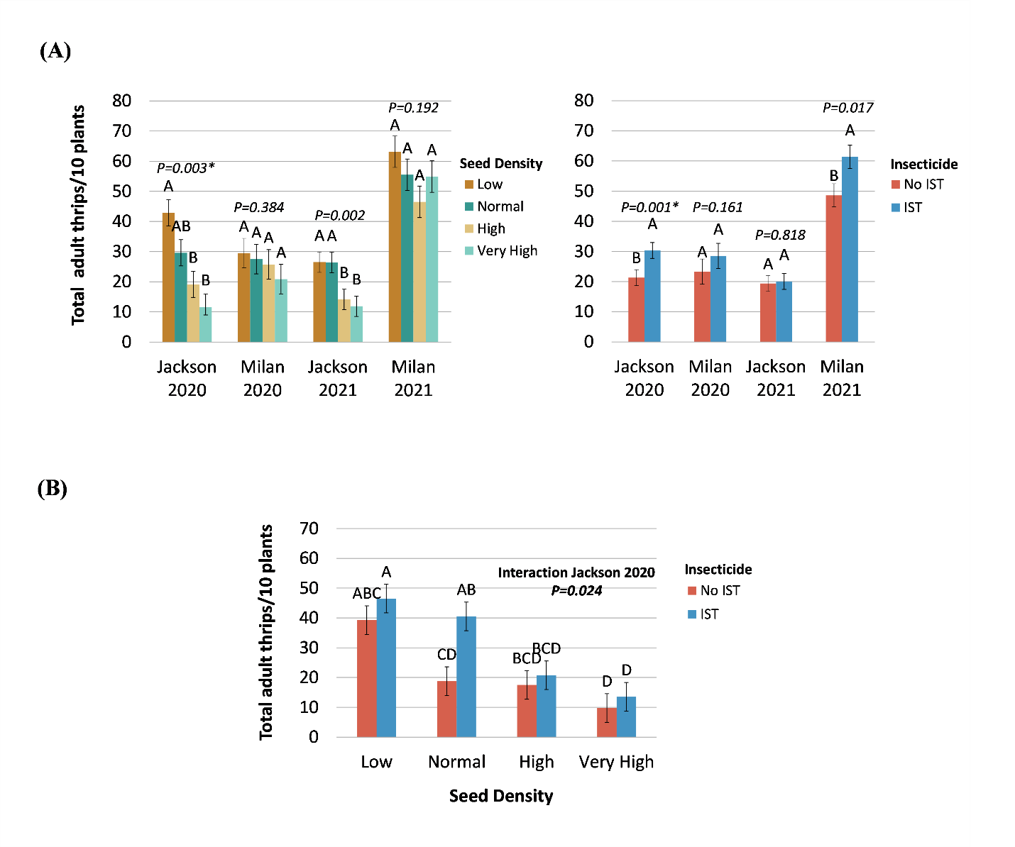
Figure 1. The average number of total adult thrips per ten plants for the plant density study showing (A) the main effects of seed density and insecticide seed treatment (IST) in each test (2020-2021: Jackson and Milan, TN), with an asterisk indicating an interaction (B) between seed density and insecticide seed treatment in the Jackson, TN 2020 test. Error bars represent 95% confidence intervals. Common letters above bars, within each test location, indicate treatments are not different (Tukey’s significant difference test, α=0.05).

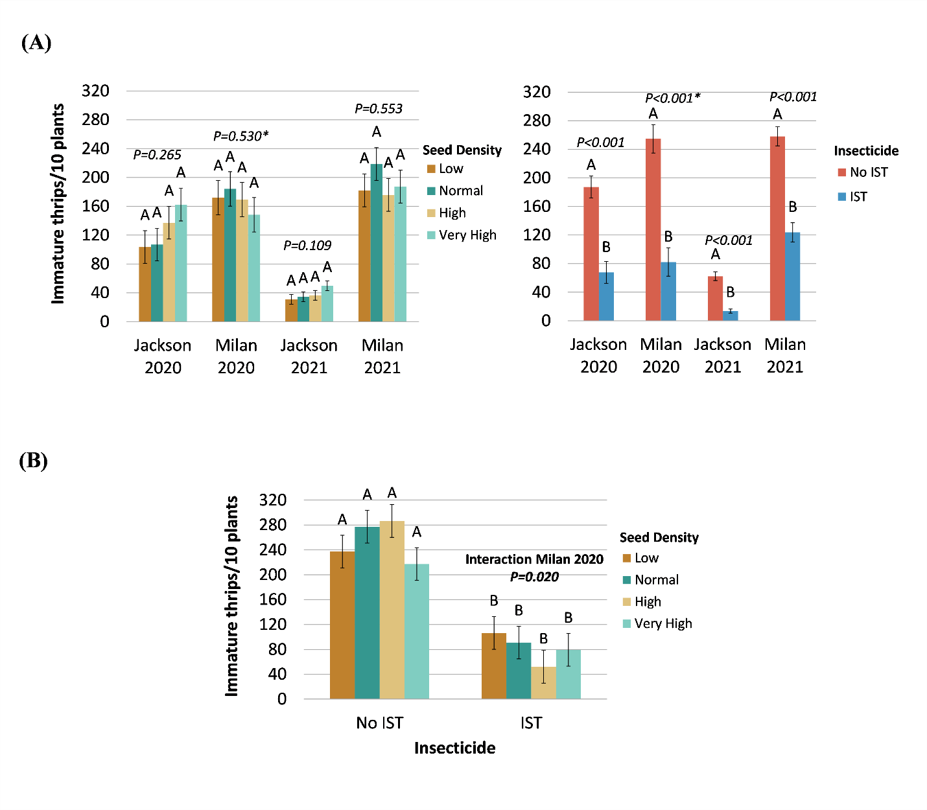
Figure 2. The average number of immature thrips per ten plants for the plant density study showing (A) the main effects of seed density and insecticide seed treatment (IST) in each test (2020-2021: Jackson and Milan, TN), with an asterisk indicating an interaction (B) between seed density and insecticide seed treatment in the Milan, TN 2020 test. Error bars represent 95% confidence intervals. Common letters above bars, within each test location, indicate treatments are not different (Tukey’s significant difference test, α=0.05).
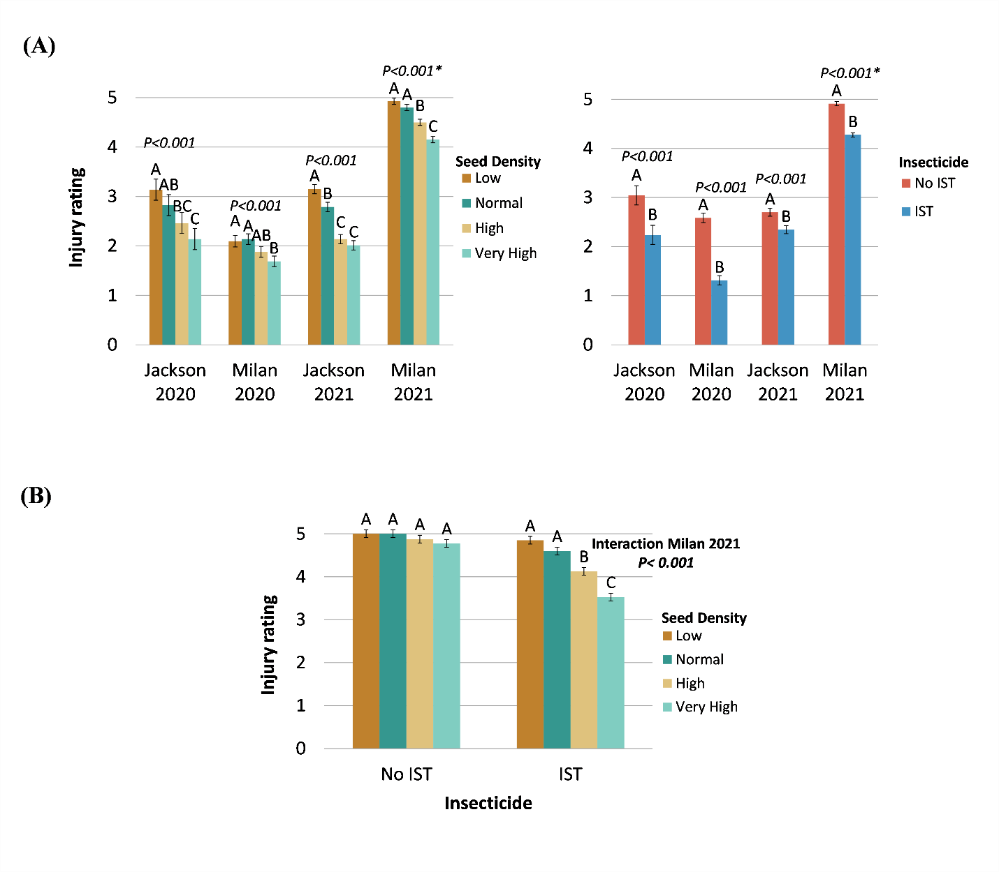
Figure 3. The average thrips injury ratings (0=no injury, 5= maximum injury) on two-leaf cotton for the plant density study showing (A) the main effects of seed density and insecticide seed treatment (IST) in each test (2020-2021: Jackson and Milan, TN), with an asterisk indicating an interaction (B) between seed density and insecticide seed treatment in the Milan, TN 2021 test. Error bars represent 95% confidence intervals. Common letters above bars, within each test location, indicate treatments are not different (Tukey’s significant difference test, α=0.05).
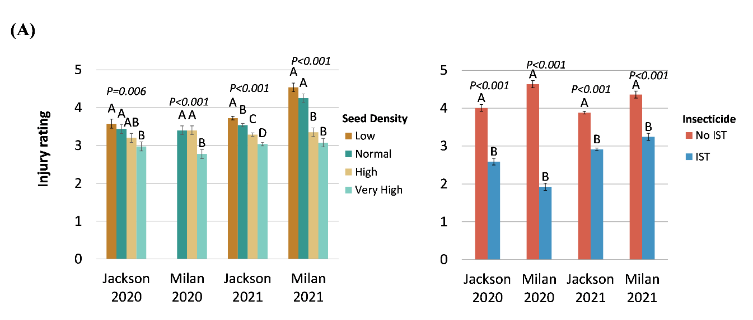
Figure 4. Effect of seed density and insecticide seed treatment (IST) on the average thrips injury ratings (0=no injury, 5= maximum injury) on four-leaf cotton in each test of the plant density study (2020-2021: Jackson and Milan, TN). Error bars represent 95% confidence intervals. Common letters above bars, within each test location, indicate treatments are not different (Tukey’s significant difference test, α=0.05).

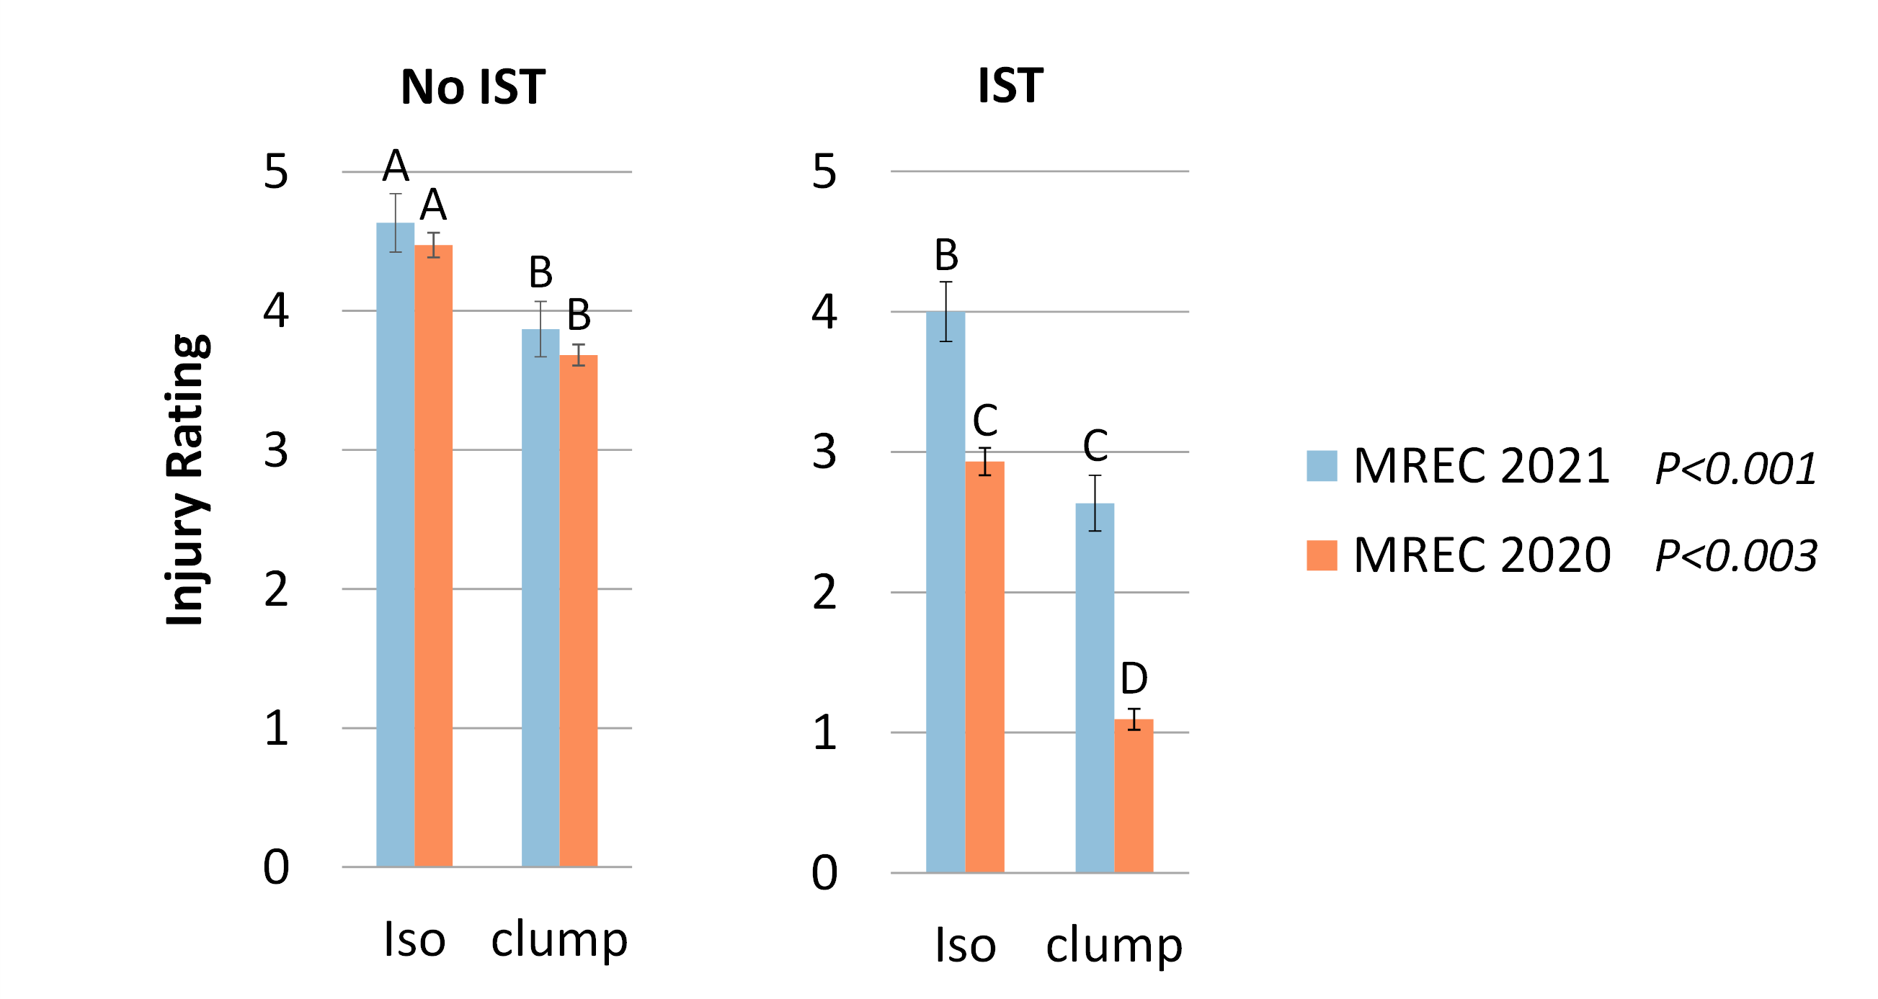
Figure 5. Effect of plant grouping (isolated versus clumped) and insecticide seed treatment (IST) on the average thrips injury ratings in the Milan, TN 2020 and 2021 density tests. Error bars represent 95% confidence intervals. Common letters above bars, within each test location, indicate treatments are not different (Tukey’s significant difference test, α=0.05).

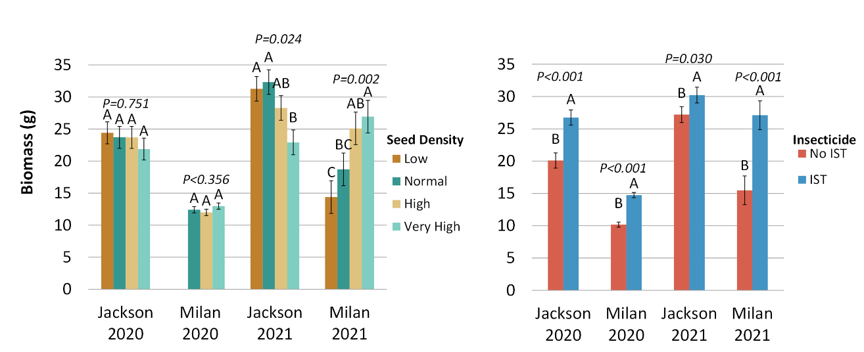
Figure 6. Effect of seed density and insecticide seed treatment (IST) on the average biomass (g) on four-leaf cotton in each test of the plant density study (2020-2021: Jackson and Milan, TN). Error bars represent 95% confidence intervals Common letters above bars, within each test location, indicate treatments are not different (Tukey’s significant difference test, α=0.05).

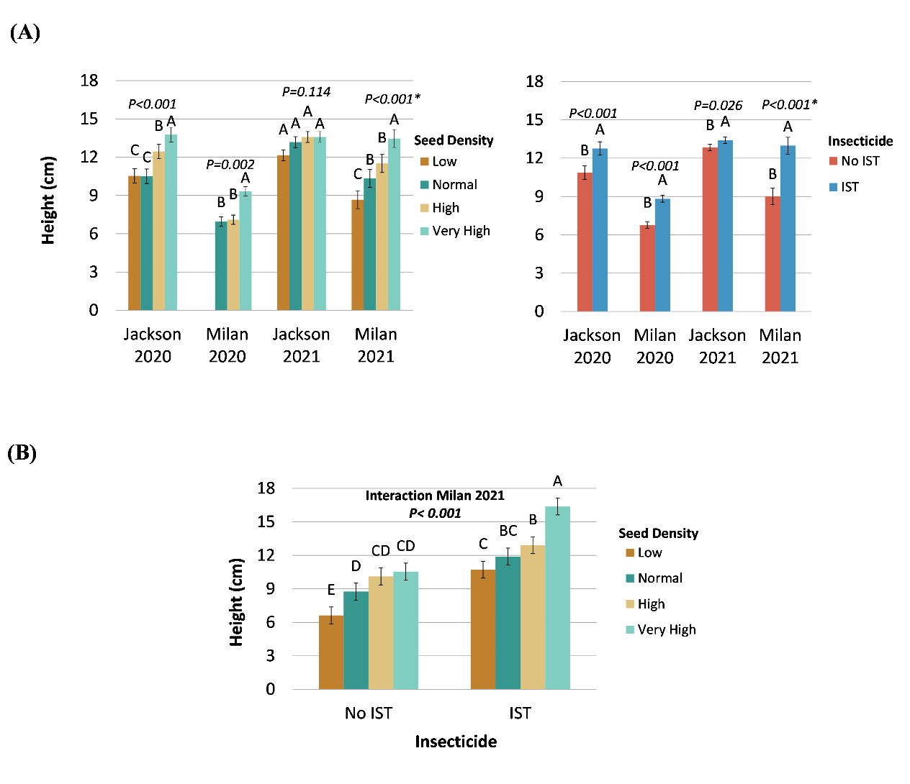
Figure 7. The average height (cm) of four-leaf cotton for the plant density study showing (A) the main effects of seed density and insecticide seed treatment (IST) in each test (2020-2021: Jackson and Milan, TN), with an asterisk indicating an interaction (B) between seed density and insecticide seed treatment in the Milan, TN 2021 test. Error bars represent 95% confidence intervals. Common letters above bars, within each test location, indicate treatments are not different (Tukey’s significant difference test, α=0.05).

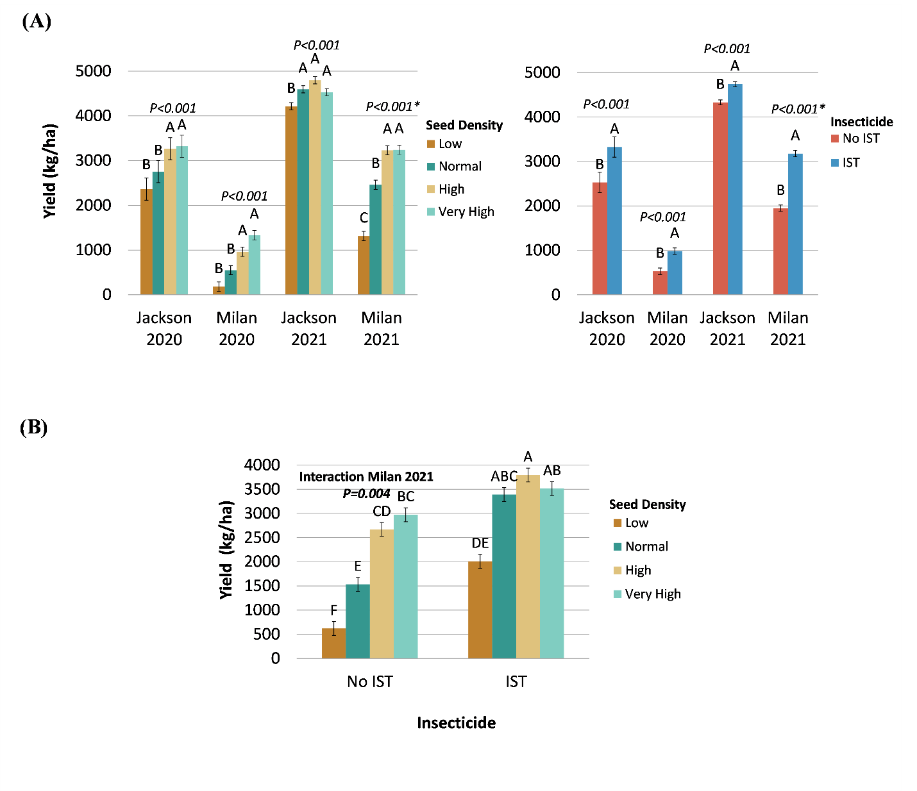
Figure 8. The average seed cotton yield (kg/ha) for the density study showing (A) the main effects of seed density and insecticide seed treatment (IST) in each test (2020-2021: Jackson and Milan, TN), with an asterisk indicating an interaction (B) between seed density and insecticide seed treatment in the Milan, TN 2021 test. Error bars represent 95% confidence intervals. Common letters above bars, within each test location, indicate treatments are not different (Tukey’s significant difference test, α=0.05).

Chapter III. Standardized Field Trials and Bioassays to Evaluate Resistance of Tobacco Thrips, Frankliniella fusca (Hinds), to Insecticides

Abstract

Foliar-applied insecticide treatments may be necessary to manage thrips in cotton (Gossypium hirsutum L.) under severe infestations or when at-planting insecticide seed treatments do not provide satisfactory protection. The most common foliar-applied insecticide is acephate. Field observations in Tennessee suggest that the performance of acephate has declined. Thus, the first objective was to perform leaf-dip bioassays to assess if tobacco thrips, Frankliniella fusca (Hinds), in cotton production regions have evolved resistance to foliar-applied insecticides. A second objective was to assess the performance of commonly applied foliar insecticides for managing thrips in standardized field trials in Arkansas, Tennessee, Mississippi, and Texas. For both objectives, several insecticides were evaluated including acephate, dicrotophos, dimethoate, lambda-cyhalothrin, imidacloprid, and spinetoram. Field trials and bioassays were completed from 2018 to 2021. Dose-response bioassays with acephate were performed on tobacco thrips field populations and a susceptible laboratory population. Bioassay results suggest that tobacco thrips have developed resistance to acephate and other organophosphate insecticides; however, this resistance seems to be most severe in Arkansas, Tennessee, and the Delta region of Mississippi. Resistance to other classes of insecticides were perhaps even more evident in these bioassays. The performance of these insecticides in field trials was variable, with tobacco thrips only showing consistent signs of resistance to lambda-cyhalothrin. However, it is evident that many populations of tobacco thrips are resistant to multiple classes of insecticides. Further research is needed to determine heritability and resistance mechanism(s).

Introduction

Upland cotton, Gossypium hirsutum L., is a major commodity grown in the southern U.S., and thrips can be found infesting cotton throughout this region. The most common species found in cotton include tobacco thrips, Frankliniella fusca (Hinds); flower thrips, Frankliniella tritici (Fitch); western flower thrips, Frankliniella occidentalis (Pergande); onion thrips, Thrips tabaci (Lindeman); and soybean thrips, Neohydatothrips variabilis (Beach) (Cook et al. 2003, Albeldaño et al. 2008, Stewart et al. 2013). Of these species, tobacco thrips is the most abundant in seedling cotton in the Mid-South (Arkansas, Tennessee, Missouri, Mississippi, Louisiana) and the majority of the southeast (Virginia, North Carolina, South Carolina, Georgia, Alabama, Florida) (Cook et al. 2003, Stewart et al. 2013).
Thrips feeding injury can cause plant mortality, stunted growth, delayed maturity, and yield loss (Gaines 1934, Dunham and Clark 1937, Watts 1937, Bourland et al. 1992, Faircloth et al. 1999, Cook et al. 2013). Seedlings are most susceptible to thrips injury from emergence to about the fourth true leaf stage (Stewart and Lentz 2010). Because thrips are early-season, consistent pests, most growers use a proactive approach to control them using at-planting insecticides which can be applied as a seed or in-furrow (liquid or granular) treatment (Cook et al. 2011). The insecticide seed treatments (IST) available include acephate (Orthene® 97; AMVAC Chemical Corporation, Los Angeles, CA), imidacloprid (Gaucho® 600, Bayer CropScience, Research Triangle Park, NC), thiamethoxam (Cruiser® 5FS, Syngenta Crop Protection, Greensboro, NC), and a pre-pack formulation that combines imidacloprid and thiodicarb (Aeris®, Bayer CropScience). Liquid in-furrow applications of acephate or imidacloprid are also options. Acephate is in the organophosphate (IRAC MoA group 1B) insecticide class. Imidacloprid and thiamethoxam are neonicotinoids (IRAC MoA group 4A).
Growers extensively adopted neonicotinoid seed treatments in the early 2000s. The primary at planting insecticide used to manage thrips before the introduction of neonicotinoids was aldicarb (Temik®, Bayer CropScience), a granular in-furrow carbamate insecticide (IRAC MoA group 1A). In 2010, aldicarb was voluntarily removed from the market because of its high toxicity to wildlife and humans and concerns about contamination of groundwater, but neonicotinoid seed treatments were already the most widely used at-planting thrips treatment. The primary seed treatments used were imidacloprid (Gaucho) and thiamethoxam (Cruiser) (Cook et al. 2020). After more than a decade of neonicotinoids being the primary thrips control method, decreased performance of this class of insecticide, particularly thiamethoxam, was observed in several Tennessee cotton fields during 2011 and 2012 (S. D. Stewart, personal observation). The efficacy of neonicotinoid seed treatments in Tennessee was assessed by Vineyard et al. (2017) in 2013 and 2014. Imidacloprid and aldicarb provided the greatest level of control in this study, while thiamethoxam was not different from the untreated control in terms of effects on plant vigor, crop maturity, or yield. Due to the limited protection provided by thiamethoxam, university Extension programs stopped recommending thiamethoxam for thrips control (Gore et al. 2014, Stewart 2014, Bogren et al. 2015, Hollis 2015). Researchers confirmed that the reduced efficacy of neonicotinoid seed treatments was due to tobacco thrips resistance to this insecticide class (Huseth et al. 2016 and 2018, Darnell-Crumpton et al. 2018).
Thrips resistance to neonicotinoids has caused growers to change their management strategies. A control tactic some growers have utilized is supplementing imidacloprid seed treatments with acephate as a seed treatment or liquid, in-furrow treatment (Cook et al. 2020). Aldicarb (AgLogicTM 15G, AgLogic Chemical LLC, Chapel Hill, NC) was recently reintroduced into the market as an alternative thrips insecticide, especially where nematodes are also an issue.
At-planting insecticide treatments may fail to provide adequate thrips control because of resistance to neonicotinoids, severe thrips pressure, or unfavorable growing conditions, so foliar-applied insecticide applications may be needed for optimal plant protection. Foliar applications have become more common because of resistance to neonicotinoid seed treatments (Cook et al. 2020). Recommended foliar-applied insecticide options include spinosyns (IRAC MoA group 5) and organophosphates such as acephate, dicrotophos, and dimethoate (Stewart et al. 2022). Multiple studies have evaluated the efficacy of foliar-applied insecticides for thrips control (Toews et al. 2012, Williams et al. 2014, Siebert et al. 2016, Huseth et al. 2017, D'Ambrosio et al. 2018, Cook et al. 2020, 2022). Pyrethroids (IRAC MoA group 3A) provide poor thrips control (Toews et al. 2012, Cook et al. 2020), and university Extension programs do not recommend this class of chemistry (Catchot 2020, Greene 2020). Where resistance to neonicotinoid seed treatments has been confirmed, it is expected foliar treatments made with this same mode of action will not provide adequate control. Indeed, research to confirm resistance to neonicotinoid insecticides was done with traditional dose response bioassays using treated leaf disks (Huseth et al. 2017).
For many years, acephate has been the primary foliar insecticide option to manage thrips due to its effectiveness and low cost (Stewart et al. 2020). However, a decline in the efficacy of acephate in Tennessee has been observed. From 2005 to 2019, thrips control with acephate declined, with greater than 90% control in 2005 to less than 40% control by 2018 (Stewart et al. 2020). In contrast, the performance of spinetoram did not change, albeit over a shorter period of time. The response of thrips populations to acephate has not been uniformly studied across the Mid-South, Southeast, and Texas cotton production regions. In this study, our goal was to better understand patterns of acephate resistance throughout the southern U.S. To do this, we combined laboratory-based bioassays with field screening studies to document differences in insecticide susceptibility across a broad geography. To estimate resistance status, dose-response bioassays were performed using acephate and other common insecticides on tobacco thrips populations collected from the Mid-South, Southeast, and Texas. The second objective was to evaluate the performance of foliar-applied insecticides through standardized field trials. Together, these results provide important context for changing sensitivity of tobacco thrips populations to common foliar insecticides used for early season management in cotton.

Materials and Methods

Thrips Collections. From 2018 through 2021, adult tobacco thrips populations were collected across a large geography in the southern U.S. to perform insecticide bioassays (Table 2). Field collected tobacco adult thrips were gathered from wild host plants, peanut (Arachis hypogaea L.), wheat (Triticum aestivum L.), or cotton (Table 2). Thrips were either collected with a sweep net or by gently beating plants into a white bucket or a white surface and aspirating them into a 1.5-ml microcentrifuge tube (No. 111558; Globe Scientific, Mahwah, NJ). The aspirators were made based on the design described by Darnell-Crumpton et al. (2018).
For comparison purposes, a tobacco thrips population from North Carolina State University, with known susceptibility to imidacloprid, thiamethoxam, acephate, (Darnell et al. 2018, Huseth et al. 2016, 2017), and presumably other insecticides, was included in the assays. This colony has been maintained on insecticide-free cabbage since 2012 at North Carolina State University. Mississippi State University also maintained a susceptible laboratory population that was originally sourced from the North Carolina State University colony. From 2018-2019, the susceptible colony maintained at Mississippi State University were tested in bioassays, and from 2020-2021, the susceptible colony maintained at North Carolina State University were tested.
Except for the Tennessee populations, thrips populations were prepared for shipping after collection by placing them in a sealable container with a fresh cabbage leaf or on the host from which the thrips were collected. A paper towel was sometimes placed in the container to reduce condensation. The thrips were shipped overnight to the West Tennessee Research and Education Center in Jackson, Tennessee in insulated coolers with ice packs within one to two days after collection. Upon arrival, tobacco thrips were transferred into sealable rearing containers (T808160B and L808 Berry Plastics, Evansville, Indiana). Holes were cut in the lids and bottom of the rearing buckets and covered with thrips-proof gauze (100-μm nylon mesh screen, Midwest Filter Corp., Highwood, IL) to allow ventilation. Populations were maintained on fresh cabbage leaves in an incubator at 27-29ºC, 60-70% relative humidity, and 14:10 L:D (hours of Light:Dark). Before the cabbage leaves were placed in the bucket, they were sterilized by soaking them in a one percent sodium hypochlorite solution for one minute. Then the leaves were rinsed with water and patted dry with a paper towel.
Discriminating Dose Bioassays. Generally, bioassays were performed on the submitted field populations in 2018, 2019, and 2021. In 2020, field-collected tobacco thrips were reared to the F1 generation. Rearing procedures were based on methods described by Darnell-Crumpton et al. (2018). Fresh cabbage leaves were placed in the buckets twice a week as a food source and oviposition substrate. Each time a new cabbage leaf was placed in the bucket, the old leaf was removed and placed in a new bucket. All the thrips were gently shaken off the leaf before being placed in the new bucket. The old buckets were discarded when only a few adults remained. When immature thrips hatched from the leaves, the leaves were replaced with a fresh leaf and allowed to grow to adults. Bioassays were done on the thrips approximately three days after adult eclosion. For the bioassays performed on the submitted field populations, thrips were kept in the incubator for three days after arrival before assays were performed to account for potential negative effects of shipping. The collection location, host, bioassay date, percent mortality in the water-check treatment, and generation the bioassays were done on for each population can be found in Table 2.
Five insecticides representing four classes were tested in the bioassays (Table 3). The bioassay diet from 2018 to 2020 consisted of leaf disks made from field-collected cotton leaves that had not been treated with insecticide. The cotton leaves were rinsed with water and patted dry before leaf disks were made. In 2021, the leaf disks were made from fresh cabbage leaves and washed and dried similarly. A size five cork borer (Humboldt, Elgin, IL) was used to make the leaf disks that were the same diameter as the 1.5-ml microcentrifuge tube. The disks were treated with the appropriate insecticide by dipping them in the solution for one second and then allowed to dry. Fresh insecticide dilutions were mixed each day that bioassays were performed at a concentration to simulate a foliar application volume of 93.5 L/ha (Table 3). No adjuvants were used, and a water-only check was included in each bioassay.
Eight thrips were aspirated into a microcentrifuge tube with a treated leaf disk, although this number occasionally varied between 6-10. Ten microcentrifuge tubes were used for each treatment, giving a total of approximately 80 thrips per insecticide dose. However, the total number of thrips tested varied somewhat depending upon the number of adults available. Also, some collections had too few individuals to test all insecticides, so only selected insecticides were tested. After 24 hours, the percent mortality was evaluated using a stereomicroscope. Thrips were classified as alive, dead, or moribund. Adults were considered moribund if they did not move greater than one body length when gently prodded. Moribund insects were considered as dead in the analysis. Abbott’s formula was used to correct the mortality for each insecticide treatment relative to the untreated control (Abbott 1925).
Dose-Response Bioassays with Acephate. Dose-response bioassays were done with acephate (Orthene 97) for three unselected Tennessee field populations (TN4, TN7U, and TN9), another Tennessee field population that was selected with acephate (TN6S), and the NC laboratory colony (NCLab3). The selected (TN6S) and unselected (TN7U) thrips were from the same original collection. The selected Tennessee population was adults exposed for 24 h to a cabbage leaf that was dipped into an acephate solution having 1.5 g of active ingredient/L of water. After the exposure period, the surviving thrips were given a fresh untreated cabbage leaf and reared to the next generation so that a dose-response bioassay could be performed on the selected generation. This pre-selection was done to eliminate susceptible individuals from the field population to compare the estimated resistance level of a selected population to an unselected population.
For each bioassay, a stock solution was made with acephate (Orthene 97) and diluted to obtain the desired concentration. Three to five concentrations between 0.7 and 23.4 grams of active ingredient/L were tested on each field-collected population, and six concentrations ranging from 0.05 to 5.8 grams/L were tested on the North Carolina laboratory population (NCLab3) (Fig. 9). No adjuvants were used, and a water-only check was included in each bioassay. The procedures for making and treating the leaf disks, aspirating thrips into microcentrifuge tubes, and evaluating the percent mortality were the same as described for the discriminating dose bioassays. Abbott’s formula was also used to correct each rate based on the check mortality (Abbott 1925).
Standardized Foliar-Applied Insecticide Field Trials. From 2018 to 2021, standardized, replicated field trials were done to evaluate the efficacy of multiple insecticides on thrips and plant injury. The locations for the tests included Tillar and Marianna, AR; Stoneville (Delta Region) and Starkville (Hill Region), MS; Jackson and Milan, TN; and Snook, TX. All tests were arranged in a randomized complete block design with four-row plots (0.97-1.02 m row centers, 9.4-12.2 m long) and four replicates. Fungicide only treated seed was used. Foliar insecticide applications were made at the first true leaf stage. In a few tests, thrips pressure was so severe that a second application was made, allowing treatment effects to be more evident. Ratings of thrips injury and thrips density were made by cooperating researchers, and data were selected from the last ratings date to evaluate treatment effects because this was generally when treatment differences were most evident. Treatments consisted of several classes of insecticides (Table 4). Application parameters, such as nozzle type and spacing, varied somewhat across test locations, but all applications were applied at a volume of 75-94 L/ha. The percent reduction in thrips injury from insecticide treatment was calculated relative to the injury observed in untreated plots, which was rated on a 0–5 scale, with 0 representing no injury and 5 representing extreme injury where almost all plants are dead (Kerns et al. 2019).
Five plants per plot were sampled, and an alcohol wash technique was used to estimate thrips numbers in these tests (Burris et al. 1989, Graham and Stewart 2018). The plants were cut below the cotyledons and placed in a container to be taken back to the laboratory. An alcohol wash solution was used to dislodge thrips from the plant, and a sieve (150 μm) was used to separate thrips from plant material. The sample was then placed under a stereomicroscope so thrips could be counted. The thrips were identified as either adults or immatures.
Statistical Analysis. Data for the discriminating dose bioassays were analyzed using GLIMMIX procedures in SAS version 9.4 (SAS Institute 2021), to perform a generalized linear mixed model analysis of variance. Each insecticide was analyzed separately across locations. Thrips population was treated as the fixed effect and year was random. Degrees of freedom were estimated using the containment method (SAS/STAT USER’s Guide 2019). Means were estimated using LSMEANS and separated using Tukey’s significant difference test (α=0.05). Thrips populations with a water-check mortality greater than 20% were excluded from the analysis. Dose-response bioassay data were analyzed in SAS using PROC PROBIT procedures with a log10 transformation to obtain LC₅₀ values and 95% fiducial limits. Resistance ratios were calculated by dividing the LC₅₀ of the field population by the laboratory susceptible colony from North Carolina. For the standardized field trials, the percent reduction in total thrips numbers, which was based on alcohol wash techniques, and injury was calculated for insecticide treatments relative to sample values in control plots that were not treated with insecticide. These data were analyzed using GLIMMIX procedures in SAS version 9.4 (SAS Institute 2021), to perform a generalized linear mixed model analysis of variance. The fixed effect was insecticide treatment, and the location was random. Degrees of freedom were estimated using the Satterthwaite’s formula (Satterthwaite 1946). Means were estimated using LSMEANS and separated using Tukey’s significant difference test (α=0.05).

Results

Discriminating Dose Bioassays. The percent mortality of tobacco thrips for acephate differed significantly by population (F=9.56; df=27, 237; P<0.001; Table 5). Assays done on tobacco thrips from the susceptible lab colony, two Texas, one Virginia, and four North Carolina populations had mortalities over 90%. One Virginia, Louisiana, Alabama, Mississippi-Hill, and two North Carolina populations had mortalities that ranged from 82-89%. One Mississippi-Hill population had a lower mortality at 76%. Populations from Arkansas, Tennessee, and one Mississippi-Delta population had mortalities that ranged from 46-68%, with one Tennessee population having a higher mortality of 76%.
The mortalities differed for bioassays done with dicrotophos on four Tennessee populations (48-74%), one Virginia population (83%), and the susceptible lab colony (92%) (F=5.13; df=5, 54; P<0.001; Table 5). Significant differences across locations were also found in assays with imidacloprid (F=22.67; df=6, 61; P<0.001; Table 5). The Tennessee populations had the lowest mortalities ranging from 27-43%. One bioassay was done on a Virginia population with a mortality of 57%, and the susceptible laboratory colony thrips had mortalities of 94% and greater.
Percent mortality also varied among populations for bioassays with lambda-cyhalothrin (F=217.09; df=8, 77; P<0.001; Table 5). All the field populations had less than 5% mortality, except the Texas population (50%). The susceptible laboratory colony had mortalities of 78% and greater. Although there were differences across locations in the bioassays with spinetoram (F=2.08; df=16, 140; P=0.013; Table 5) mortality for all populations was greater than 96%.
Dose-Response Bioassays with Acephate. LC₅₀ values, 95% fiducial limits, statistical parameters from the Probit analyses, and resistance ratios for acephate were determined for three Tennessee field populations and the North Carolina laboratory colony (Table 6). Dose-response curves and the raw means to create the curves are shown in Figure 9. The North Carolina laboratory colony had the lowest LC₅₀ (0.29 g of active ingredient/L). The Pearson goodness-of-fit statistic was poor for this analysis (P<0.001); however, the raw data points show close agreement with the dose-response regression curve (Fig. 9). For the adults of the Tennessee population (TN6S) which were selected with acephate the generation before testing, the percent mortality observed at the highest dose tested (53% at 23.4 g of active ingredient/L) was 80.7-fold greater than the North Carolina laboratory colony. The 2019 Jackson (TN4), 2019 Milan (TN7U), and 2021 Milan (TN9) populations had LC₅₀’s that were 4.7, 16.7, and 22.3-fold greater than the LC₅₀ of the North Carolina laboratory colony, respectively.
Standardized Foliar-Applied Insecticide Field Trials. The percent reduction in thrips injury and thrips numbers were calculated for insecticide treatments relative to sample values in plots that did not receive an insecticide treatment. The percent reduction in thrips injury and thrips numbers provided by foliar insecticides, averaged across years, is shown for individual test locations, and the distribution of these averages across all locations are shown as box-and-whisker plots in Figure 10. There were significant differences between treatments for thrips injury (P<0.004). The average percent decrease in thrips injury across all locations provided by foliar applications of acephate, dicrotophos, dimethoate, and spinetoram ranged from 26 to 35% (Fig. 10). There was a greater suppression of thrips injury with acephate in one Starkville, MS test (61%). Lambda-cyhalothrin reduced thrips injury on average by less than 13%, but a greater suppression of thrips injury was observed in three Texas tests (42, 43 and 61%). The average reduction in thrips numbers from acephate, dicrotophos, dimethoate, and spinetoram ranged from 47 to 66% (Fig. 10). On average, plots with lambda-cyhalothrin had significantly more thrips (11%) compared to the plots that did not receive an insecticide treatment (P<0.001). Spinetoram provided an average of 15-18% more control than the organophosphate treatments; however, differences among these treatments were not different.

Discussion

Overall, the objective of this research was to use laboratory-based insecticide bioassays in conjunction with field trials to evaluate the efficacy of currently available foliar insecticides across different cotton production regions and assess insecticide resistance in populations of tobacco thrips. There was considerable interest in assessing the efficacy of acephate because it is the most common foliar insecticide for managing thrips, and the performance of acephate has declined in Tennessee (Stewart et al. 2020). Limitations in time and with the number and size of submitted tobacco thrips populations did not allow screening of populations against all insecticides. Most bioassays were done on field-collected populations of tobacco thrips, so it can be presumed that populations were potentially heterogeneous mixtures of susceptible and resistant thrips. Also, the “health” of populations was potentially affected by the age of adults tested, the hosts from which they were collected, and handling, and this almost certainly introduced additional variability into the results for the assays done on the submitted field populations that were not kept in colony. However, there was clear evidence that insecticide resistance has developed in some populations of tobacco thrips, particularly in the upper Mid-South.
When averaging mortality from the discriminating dose bioassays for locations across years, there was reduced efficacy for acephate in field populations collected from Arkansas, Tennessee, and Mississippi (Stoneville) (≤76% mortality), and in some populations, less than 50% mortality was observed (Table 4). In comparison, field populations from Alabama, Louisiana, Virginia, and North Carolina were more susceptible (>82% mortality). Resistance ratios for acephate for three representative populations from Tennessee, relative to a known susceptible population, ranged from 4.7 to 22.3 (Table 6). A higher resistance ratio (≈ 80) was indicated for the Tennessee population that had been selected with acephate, indicating that this resistance is heritable.
In bioassays, there was a trend of lower mortality with dicrotophos when acephate also caused low mortality. Across locations, the reduction in thrips injury and thrips density caused by dimethoate in field trials were the same to those cause by acephate and dicrotophos. These observations suggest that tobacco thrips have developed cross resistance among organophosphate insecticides (Fig. 10). However, linear regression of mortality for the five populations that were tested with both acephate and dicrotophos did not show a significant correlation (F=4.05; df = 1,4; P=0.138; R²=0.575). Further testing is needed to validate the heritability of acephate or organophosphate resistance. Additionally, research is necessary to identify the mechanism of resistance. This resistance is likely metabolic in nature, partly because this resistance appears to be moderate and also because resistance to diazinon, an organophosphate, has been documented in western flower thrips (Zhoa 1994, Zhao 1995), and the mechanism of this resistance was either by metabolic detoxification or by a combination of metabolic detoxification and alteration of the acetylcholinesterase target site.
Our discriminating dose assay results showed reduced efficacy to imidacloprid in tobacco thrips populations relative to the susceptible population from North Carolina (Table 5). These results are congruent with findings by Huseth et al. (2016 and 2018) and Darnell-Crumpton et al. (2018), which document the widespread occurrence of tobacco thrips resistance to neonicotinoids. The agreement of imidacloprid resistance between these studies validates the assay method, which supports the above conclusion that resistance to acephate has also developed.
Lambda-cyhalothrin provides poor thrips control (Toews et al. 2012, Cook et al. 2020), and pyrethroid insecticides are not recommended to manage tobacco thrips in cotton (Catchot 2020, Greene 2020). Therefore, the low mortalities in bioassays of field populations from Tennessee, Mississippi (Stoneville), and Virginia were expected. The Texas population was more susceptible to lambda-cyhalothrin (Table 5), and this is consistent with the better control provided lambda-cyhalothrin in the field study (Fig. 10) and also consistent with previous observations in that geography (D. Kerns, personal observation). The mortality for the North Carolina laboratory colony was substantially higher than the field-collected populations. This suggests that tobacco thrips have evolved resistance to pyrethroid insecticides over a wide geography in the South, and presumably may be the first insecticide class to which tobacco thrips developed resistance. In fact, past field trials in the south in cotton showed that pyrethroids significantly reduced thrips numbers compared to untreated plots (Micinski 1984, Fitt and Teetes 1986, Ratchford et al. 1987, Reed and Grant 1987).
All thrips populations experienced high mortality in the bioassays with spinetoram (Table 5). Indeed, spinetoram was considered a positive control that was included, in part, to validate the quality of our assays. Tobacco thrips resistance to this class of insecticides was not expected because this class of insecticides, and spinetoram in particular, is relatively new and historically has not been used widely in field crops or for thrips control. Bioassay results would have predicted that field control with spinetoram would be markedly better than the other insecticides. Although spinetoram numerically reduced thrips numbers and injury more than other insecticide treatments, differences among insecticides were not statistically significant with the exception of lambda-cyhalothrin (Fig. 10). In general, when compared to bioassay results, there was less variation in the performance of foliar insecticide in the field trials performed from 2018 to 2021. The notable exception, as referenced above, was the better performance of lambda-cyhalothrin at the Texas location. Also, for all insecticide applications, the reduction of thrips injury, in particular, but also thrips density was not dramatic following the insecticide applications (Fig. 10). This is partly due to the migratory nature of tobacco thrips where re-infestation often occurs quickly (Layton and Reed 2014). Under continuous pest pressure, even more efficacious insecticides may not perform obviously better unless they provide longer residual control. Secondly, because preventative insecticide treatments were not used, the injury observed after foliar applications was almost certainly affected by thrips feeding that occurred before the applications.
Even when foliar insecticides were applied, substantial levels of thrips injury were still observed in some tests. While plants often compensate for early-season thrips injury, crop maturity can be delayed when growing conditions are not optimal and/or thrips densities are high, and yield may be negatively impacted (Cook et al. 2011). Delayed crop maturity can lead to the need for additional inputs such as insecticides and harvest aids, which increases production costs (Freeland et al. 2004, Parvin et al. 2005, Cook et al. 2011). Thus, an at-planting insecticide treatment for thrips is typically recommended in most regions of the southern U.S., with recommendations for making supplemental foliar applications in some circumstances. Reduced insecticide efficacy affects these recommendations.
Collectively, this study documented that resistance to acephate, and likely other organophosphate insecticides, has developed in tobacco thrips. This resistance appears primarily localized to the upper Mid-South, including West Tennessee and parts of the Delta cotton- growing areas of northern Mississippi and Arkansas (Table 5). Where resistance occurs, rotation to alternative chemistries such as spinetoram may be justified. However, more monitoring is needed to better define the geographic variability of resistance. The need for foliar-applied insecticide applications for thrips management is expected to be minimal with the introduction of ThryvOn™ (Bayer CropScience, Research Triangle Park, NC) because this new Bt trait provides substantial protection against thrips (Bachman et al. 2017, Graham and Stewart 2018, Akbar et al. 2019). However, it will be several years before cotton varieties with ThryvOn™ become widely planted, and the rate of adoption will be influenced by the cost of the technology. Thus, continued awareness and management of insecticide resistance in tobacco thrips is important.

Acknowledgements

Dr. Kennedy suggested the bioassay methods used in this study. I thank Drs. Anders Huseth, George Kennedy, Dominic Reisig, Sally Taylor, Sebe Brown, Tyler Towles, David Kerns, Gus Lorenz, Ben Thrash, Scott Graham, Whitney Crow, Jeff Gore, Angus Catchot, Don Cook, and Fred Musser and Mrs. Beverly Catchot for providing tobacco thrips populations. I also thank Dawson Kerns and Drs. Scott Graham and Clay Perkins for performing bioassays prior to 2020. This effort was partially support by Cotton Incorporated.

References

Abbott, W. S. 1925. A method of computing the effectiveness of an insecticide. J. Econ. Entomol. 18: 265-267.
Akbar, W., A. Gowda, J. E. Ahrens, J. W. Stelzer, R. S. Brown, S. L. Bollman, J. T. Greenplate, J. Gore, A. L. Catchot, G. Lorenz, S. D. Stewart, D. L. Kerns, J. K. Greene, M. D. Toews, D. A. Herbert, D. D. Reisig, G. A. Sword, P. C. Ellsworth, L. D. Godfrey, and T. L. Clark. 2019. First transgenic trait for control of plant bugs and thrips in cotton. Pest Manag. Sci. 75: 867-877.
Albeldaño, W. A., J. E. Slosser, and M. N. Parajulee. 2008. Identification of thrips species on cotton on the Texas Rolling Plains. Southwestern Entomol. 33: 43-51.
Bachman, P. M., A. Ahmad, J. E. Ahrens, W. Akbar, J. A. Baum, S. Brown, T. L. Clark, J. M. Fridley, A. Gowda, J. T. Greenplate, P. D. Jensen, G. M. Mueller, M. L. Odegaard, J. Tan, J. P. Uffman, and S. L. Levine. 2017. Characterization of the activity spectrum of MON 88702 and the plant-incorporated protectant Cry51Aa2.834_16. PLOS ONE 12: e0169409.
Bogren, R., K. M. Guidry, D. O. Stephenson, J. C. Stevens, Jr., S. Brown, and P. P. Price, III. 2015. Control costs, AgCenter experts tell farmers. LSU AgCenter News Archive 2015, Baton Rouge, LA. https://www.lsuagcenter.com/%20portals/communications/news news_archive/2015/february/headline_news/control-costs-agcenter-experts-tell-farmers.
Bourland, F. M., D. M. Oosterhuis, and N. P. Tugwell. 1992. Concept for monitoring the growth and development of cotton plants using main-stem node counts. J. Production Agricul. 5: 532-538.
Burris, E., K. J. Ratchford, A. M. Pavloff, D. J. Boquet, B. R. Williams, and R. L. Rogers. 1989. Thrips on seedling cotton: related problems and control. Louisiana Agricul. Exper. Stn. Bull. 911, LSU AgCenter, Baton Rouge, LA.
Catchot, A. 2020. 2020 Insect control guide for agronomic crops, pp. 2-125, Mississippi State University Ext. Pub. P2471. Missisipppi State University, Missisippi State, MS.
Cook, D., A. Herbert, D. S. Akin, and J. Reed. 2011. Biology, crop injury, and management of thrips (Thysanoptera: Thripidae) infesting cotton seedlings in the United States. J. Integr. Pest Manag. 2: 1-9.
Cook, D., B. Leonard, E. Burris, and J. Gore. 2013. Impact of thrips infesting cotton seedlings on cotton yield distribution and maturity. J. Cotton Sci. 17: 23-33.
Cook, D. R., C. T. Allen, E. Burris, B. L. Freeman, G. A. Herzog, G. L. Lentz, B. R. Lenoard, and J. T. Reed. 2003. A survey of thrips (Thysanoptera) species infesting cotton seedlings in Alabama, Arkansas, Georgia, Louisiana, Mississippi, and Tennessee. J. Entomol. Sci. 38: 669-681.
Cook, D. R., S. D. Stewart, J. Gore, G. M. Lorenz, A. L. Catchot, D. L. Kerns, S. Brown, G. Studebaker, N. Bateman, W. Crow, B. Thrash, and K. C. Allen. 2020. Managing thrips in Mid-South cotton, pp. 666-674. In Proc. Beltwide Cotton Conf., 8-10 Jan. 2020, New Orleans, LA. Nat. Cotton Counc., Memphis, TN.
Cook, D. R., S. D. Stewart, W. Crow, J. Gore, B. Thrash, G. M. Lorenz, A. L. Catchot, D. L. Kerns, S. Brown, G. Studebaker, T. Towles, N.S. Little, and N. Bateman. 2022. Thrips management in Mid-South cotton. In press Proc. Beltwide Cotton Conf., 4-6 Jan. 2022, San Antonio, TX. Nat. Cotton Counc., Memphis, TN.
D'Ambrosio, D. A., A. S. Huseth, and G. G. Kennedy. 2018. Evaluation of alternative mode of action insecticides in managing neonicotinoid-resistant Frankliniella fusca in cotton. Crop Prot. 113: 56-63.
Darnell-Crumpton, C., A. L. Catchot, D. R. Cook, J. Gore, D. M. Dodds, S. C. Morsello, and F. R. Musser. 2018. Neonicotinoid insecticide resistance in tobacco thrips (Thysanoptera: Thripidae) of Mississippi. J. Econ. Entomol. 111: 2824-2830.
Dunham, E. W., and J. C. Clark. 1937. Thrips damage to cotton. J. Econ. Entomol. 30: 855-857.
Faircloth, J., J. R. Bradley, and J. Van Duyn. 1999. The impacts of thrips on cotton productivity: what a difference a year makes, pp. 600-608. In Proc. Beltwide Cotton Conf., 3-7 Jan. 1999, Orlando, FL. Nat. Cotton Counc. Am., Memphis, TN.
Fitt, J. R., Jr., and G. L. Teetes. 1986. Chemical control of thrips and aphids on cotton, 1985. Insecticide and Acaricide Tests 11: 268-269.
Freeland, B. B., Jr., S. W. Martin, M. W. Ebelhar, and W. R. Meredith, Jr. 2004. Yield, quality, and economic impacts of 2002 harvest season rainfall in the Mississippi Delta, pp. 600-607. In Proc. Beltwide Cotton Conf., 5-9 Jan. 2004, San Antonio, TX. Nat. Cotton Counc. Am., Memphis, TN.
Gaines, J. C. 1934. A preliminary study of thrips on seedling cotton with special reference to the population, migration, and injury. J. Econ. Entomol. 27: 740-743.
Gore, J., A. L. Catchot, and D. Cook. 2014. Thrips management in cotton. Mississippi Crops. Mississippi State University Ext., Missisipppi State University, Missisippi State, MS. https://www.mississippi-crops.com/2014/05/16/thrips-management-in-cotton/.
Graham, S. H., and S. D. Stewart. 2018. Field study investigating Cry51Aa2.834_16 in cotton for control of thrips (Thysanoptera: Thripidae) and tarnished plant bugs (Hemiptera: Miridae). J. Econ. Entomol. 111: 2717-2726.
Greene, J. 2020. South Carolina cotton: thrips gain a head start in mid-April plantings. Clemson University. Blackville, SC. https://agfax.com/2020/05/08/south-carolina-cotton-thrips-gain-a-head-start-in-mid-april-plantings.
Hollis, P. 2015. Cotton growers saw thrips resistance in 2014. Southeast FarmPress. https://www.farmprogress.com/management/cotton-growers-saw-thrips-resistance-2014.
Huseth, A. S., D. A. D'Ambrosio, and G. G. Kennedy. 2017. Responses of neonicotinoid resistant and susceptible Frankliniella fusca life stages to multiple insecticide groups in cotton. Pest Manag. Sci. 73: 2118-2130.
Huseth, A. S., T. M. Chappell, A. Chitturi, A. L. Jacobson, and G. G. Kennedy. 2018. Insecticide resistance signals negative consequences of widespread neonicotinoid use on multiple field crops in the US cotton belt. Environ. Sci. Technol. 52: 2314-2322.
Huseth, A. S., T. M. Chappell, K. Langdon, S. C. Morsello, S. Martin, J. K. Greene, A. Herbert, A. L. Jacobson, F. P. Reay-Jones, T. Reed, D. D. Reisig, P. M. Roberts, R. Smith, and G. G. Kennedy. 2016. Frankliniella fusca resistance to neonicotinoid insecticides: an emerging challenge for cotton pest management in the eastern United States. Pest Manag. Sci. 72: 1934-1945.
Kerns, C. D., J. K. Greene, F. P. Reay-Jones, and W. C. Bridges Jr. 2019. Effects of planting date on thrips (Thysanoptera: Thripidae) in cotton. J. Econ. Entomol.112, 699-707.
Layton, B., and J. T. Reed. 2014. Biology and control of thrips on seedling cotton, Mississippi State University Ext. Serv. Pub. P2302. Missisipppi State University, Mississippi State, MS.
Micinski, S. 1984. Foliar applications for thrips control on cotton, 1983. Insecticide and Acaricide Tests 9: 272-273.
Parvin, D. W., S. W. Martin, F. J. Cooke, and B. B. Freeland, Jr. 2005. Economics and marketing, effect of harvest season rainfall on cotton. J. Cotton Sci. 9: 115-120.
Ratchford, K., J. B. Graves, A. M. Pavloff, and G. Burris. 1987. Efficacy of foliar insecticides on early season thrips and aphids and mid-season aphids in cotton, 1986. Insecticide and Acaricide Tests 12: 237-238.
Reed, J. T., and R. R. Grant. 1987. Evaluation of insecticides for early season thrips control in Mississippi, 1986. Insecticide and Acaricide Tests 12: 244-244.
SAS Institute. 2021. Programming Documentation for SAS® 9.4 and SAS® Viya® 3.5. SAS Institute, Cary, NC. https://documentation.sas.com/doc/en/pgmsascdc/9.4_3.5 /pgmsaswlcm/home.htm.
SAS/STAT USER’s Guide. 2019. The GLIMMIX Procedure. Containment Degrees of Freedom Approximation. https://documentation.sas.com/doc/en/pgmsascd c/9.4_3.3/statug/statug_glimmix_details38.htm.
Satterthwaite, F. E. 1946. An approximate distribution of estimates of variance components. Biometr. Bull., Vol. 2 No. 6: 110-114.
Siebert, M. W., S. Nolting, J. E. Dripps, L. C. Walton, D. R. Cook, S. Stewart, J. Gore, A. L. Catchot, G. Lorenz, B. R. Leonard, and A. Herbert. 2016. Efficacy of spinetoram against thrips (Thysanoptera: Thripidae) in seedling cotton, Gyssypium hirsutum L. J. Cotton Sci. 20: 309-319.
Stewart, S. D. 2014. Thinking ahead - thrips management in cotton. UTcrops News Blog, University of Tennessee Institute of Agricul. The University of Tennesse, Knoxville, TN. https://news.utcrops.com/2014/03/thinking-ahead-thrips-management-in-cotton/.
Stewart, S. D., and G. L. Lentz. 2010. Cotton insects: thrips, Pub. W026. University of Tennessee Ext. The University of Tennessee, Knoxville, TN.
Stewart, S. D., D. S. Akin, J. Reed, J. Bacheler, A. Catchot, D. Cook, J. Gore, J. Greene, A. Herbert, R. E. Jackson, D. L. Kerns, B. R. Leonard, G. M. Lorenz, S. Micinski, D. Reisig, P. Roberts, G. Studebaker, K. Tindall, and M. Toews. 2013. Survey of thrips species infesting cotton across the southern U.S. Cotton Belt. J. Cotton Sci. 17: 263-269.
Stewart, S.D., S. Brown, S. Steckel, M. Williams, A. McClure. 2022. Insect control recommendations for field crops cotton, soybean, field corn, sorghum, wheat and pasture, Pub. 1768. University of Tennessee Ext. The University of Tennessee, Knoxville, TN.
Stewart, S. D., S. Steckel, M. Williams, D. Kerns, C. Perkins, S. Graham, B. Catchot, A. Catchot, F. Musser, J. Gore, G. Lorenz, S. Brown, D. Kerns, G. Kennedy, A. Huseth, D. Reisig, and S. Taylor. 2020. Preformance of acephate against tobacco thrips and evidence of possible resistance, pp. 543-547. In Proc. Beltwide Cotton Conf., 8-10 Jan. 2020, Austin, TX. Natl. Cotton Counc. Am., Memphis TN.
Toews, M., P. Roberts, A. Herbert, S. Tubbs, G. Harris, R. Srinivasan, R. Smith, J. Greene, J. Bacheler, D. Reisig, and A. Herbert. 2012. Thrips management in seedling cotton with starter fertilizer and a single foliar application, pp. 1149-1152. In Proc. Beltwide Cotton Conf., 3-6 Jan. 2012, Orlando, FL. Natl. Cotton Counc. Am., Memphis, TN.
Vineyard, C. J., H. Kelly, L. Steckel, and S. Stewart. 2017. Potential interaction between pre-emergence herbicides and the efficacy of insecticide and fungicide seed treatments in cotton. J. Cotton Sci. 21:284–295.
Watts, J. G. 1937. Reduction of cotton yield by thrips. J. Econ. Entomol. 30: 860-863.
Williams, T. S., N. Jones, K. Emfinger, and D. Kerns. 2014. Efficacy of foliar insecticides towards thrips in cotton, 2013. Arthropod Manag. Tests 39: F52.
Zhao, G., W. Liu, J. M. Brown, and C. O. Knowles. 1995. Insecticide resistance in field and laboratory strains of western flower thrips (Thysanoptera: Thripidae). J. of Econ. Entomol. 88: 1164-1170.
Zhao, G. Y., W. Liu, and C. O. Knowles. 1994. Mechanisms associated with diazinon resistance in western flower thrips. Pesticide Biochemistry and Physiology 49: 13-23.

Appendix

Table 2. The collection location, host, generation tested, bioassay date, and percent water-check mortality for tobacco thrips populations tested in discriminating dose and dose response curve bioassays.
Population | Location | Host | Generation¹ | Bioassay | %Check
 |  |  |  | Date | Mortality
AL1 | Tallassee, AL | Cotton | F1 | 30-Jun-20 | 8.9
LA1 | St. Joseph, LA | Cotton | F1 | 23-Jun-20 | 17.9
AR1 | Marianna, AR | Cotton | F0 | 16-Jun-18 | 4.0
AR2 | Marianna, AR | Cotton | F1 | 23-Jun-20 | ---
AR3 | Tillar, AR | Cotton | F1 | 30-Jun-20 | 0.0
AR4 | Marianna, AR | Cotton | F1 | 21-Jun-21 | 31.5
MS1 | Starkville, MS | Cotton | F0 | 6-Jun-19 | 5.3
MS2 | Stoneville, MS | Cotton | F0 | 19-May-19 | 0.0
MS3 | Stoneville, MS | Cotton | F1 | 23-Jun-20 | 21.9
MS4 | Starkville, MS | Cotton | F1 | 8-Jul-20 | 6.3
MS5 | Stoneville, MS | Cotton | F0 | 21-Jun-21 | 32.3
MSLab1 | Lab Colony, MSU | Cabbage | >F10 | 23-Jun-18 | 1.4
MSLab2 | Lab Colony, MSU | Cabbage | >F10 | 10-Jun-19 | 2.2
NC1 | Lees Mill | Wheat | F0 | 22-May-19 | 9.6
NC1 | Township, NC
NC2 | Oconeechee | Wheat | F0 | 22-May-19 | 10.7
NC2 | Township, NC
NC3 | LaGrange, NC | Wild hosts | F1 | 16-Jun-20 | 21.3
NC4 | Fountain, NC | Wild hosts | F1 | 16-Jun-20 | 17.8
NC5 | Seaboard, NC | Wild hosts | F1 | 16-Jun-20 | 19.4
NC6 | Township 6-Upper | Wheat | F0 | 25-May-21 | 0.0
NC6 | Fishing Creek, NC
NC7 | North Whitakers | Wheat | F0 | 25-May-21 | 0.0
NC7 | Township, NC
NC8 | Plymouth, NC | Cotton | F1 | 17-Jul-21 | 2.6
Table 2 continued.
Population | Town | Host | Generation¹ | Bioassay | %Check
 |  |  |  | Date | Mortality
NCLab1 | Lab Colony, NCSU | Cabbage | >F10 | 12-Jun-20 | 2.6
NCLab2 | Lab Colony, NCSU | Cabbage | >F10 | 12-Aug-21 | 0.0
NCLab3 | Lab Colony, NCSU | Cabbage | >F10 | 21-Dec-21 | 13.2
TN1 | Jackson, TN | Wild hosts | F0 | 6-Jun-18 | ---
TN2 | Jackson, TN | Cotton | F0 | 16-Jun-18 | 4.1
TN3 | Jackson, TN | Wild hosts | F0 | 30-May-19 | 1.4
TN4 | Jackson, TN | Cotton | F0 | 4-Jun-19 | 4.6
TN5 | Milan, TN | Cotton | F0 | 6-Jun-19 | 7.0
TN6S | Milan, TN | Cotton | >F1 | 26-Jun-19 | 8.6
TN7U | Milan, TN | Cotton | >F1 | 26-Jun-19 | 0.0
TN8 | Milan, TN | Wild hosts | >F2 | 17-Jul-21 | 3.6
TN9 | Milan, TN | Wild hosts | >F2 | 21-Jul-21 | 2.3
TN10 | Milan, TN | Wild hosts | >F2 | 31-Jul-21 | 2.7
TN11 | Jackson, TN | Cotton | F0 | 4-Jun-21 | 6.2
TN12 | Milan, TN | Cotton | F0 | 4-Jun-21 | 5.6
TN13 | Jackson, TN | Cotton | F0 | 10-Jun-21 | 2.9
TX1 | Snook, TX | Cotton | F0 | 6-Jun-19 | 10.5
TX2 | Snook, TX | Wild hosts | F0 | 31-May-21 | 17.3
VA1 | Suffolk, VA | Peanut | F0 | 6-Jun-19 | 1.3
VA2 | Suffolk, VA | Peanut | F0 | 31-May-21 | 14.5
¹F0 = Submitted field population, F=generation of rearing in lab.

Table 3. Insecticides used in discriminating dose bioassays, showing concentrations of product and active ingredient used in bioassays, and the equivalent rate of product used per hectare.
Trade Name | Formulated Insecticide L⁻¹ | g Active L⁻¹ | Product ha⁻¹ | IRAC Class¹ | Manufacturer
Orthene 97 | Acephate,  3.00 g | 2.92 | 0.280 kg | 1B, Organophosphate | AMVAC  (Los Angeles, CA)
Radiant | Spinetoram, 0.586 ml | 0.070 | 0.055 L | 5, Spinosyn | Corteva Agriscience (Indianapolis, IN)
Bidrin | Dicrotophos  1.56 ml | 1.5 | 0.146 L | 1B, Organophosphate | AMVAC  (Los Angeles, CA)
Warrior II | Lambda-cyhalothrin,  0.780 ml | 0.195 | 0.073 L | 3A, Pyrethroid | Syngenta Crop Protection  (Greensboro, NC)
Admire Pro | Imidacloprid, 0.980 ml | 0.54 | 0.091 L | 4A, Neonicotinoid | Bayer CropScience  (Raleigh, NC)
¹Insecticide Resistance Action Committee (IRAC). https://irac-online.org/

Table 4. Insecticide treatments for regional thrips foliar-applied insecticide field trials.
Trade Name | Formulated Insecticide ha⁻¹ | kg Active ha⁻¹ | IRAC Class | Manufacturer
Orthene 97 | Acephate,  0.235 kg | 0.228 | 1B, Organophosphate | AMVAC  (Los Angeles, CA)
Radiant | Spinetoram,  0.110 L | 0.013 | 5,  Spinosyn | Corteva Agriscience (Indianapolis, IN)
Bidrin 8E | Dicrotophos,  0.234 L | 0.224 | 1B, Organophosphate | AMVAC  (Los Angeles, CA)
Karate Z | Lambda-cyhalothrin, 0.094 L | 0.023 | 3A,  Pyrethroid | Syngenta Crop  Protection  (Greensboro, NC)
Dimethoate 4EC | Dimethoate,  0.468 L | 0.224 | 1B, Organophosphate | Drexel Chemical Company  (Memphis, TN)

Table 5. Effect of location on percent mortality for discriminating dose bioassays. See Table 3 for insecticides and rates used.
Percent Average Mortality ± SE¹ in Leaf-Dip Bioassays
Population | Acephate | Dicrotophos | Imidacloprid | Lambda-cyhalothrin | Spinetoram
MSLab1 | 97.3±5.3a | . | . | . | .
MSLab2 | 94.0±5.9ab | . | . | . | .
NCLab1 | 92.4±5.3ab | 92.1±7.3a | 98.7±5.9a | 98.7±2.6a | 100.0±0.81ab
NCLab2 | 90.7±5.3ab | . | 93.8±6.2a | 78.0±2.6b | .
TX1 | 100.0±6.3a | . | . | . | .
TX2 | 93.2±5.3ab | . | . | 49.6±3.7c | 100.0±0.81ab
NC6 | 96.7±5.9ab | . | . | . | 100.0±1.04ab
NC4 | 96.5±5.3ab | . | . | . | .
NC8 | 94.0±5.0ab | . | . | 4.3±2.5d | 100.0±0.77a
NC7 | 92.6±5.5ab | . | . | . | .
NC2 | 83.5±6.3a-d | . | . | . | 100.0±0.96ab
NC1 | 83.3±6.3a-d | . | . | . | 100.0±0.96a
VA1 | 96.6±5.3ab | . | . | . | 100.0±0.81ab
VA2 | 82.3±3.7a-d | 82.7±7.3ab | 56.6±5.9b | 4.7±2.6d | 100.0±0.81a
LA1 | 89.4±6.3abc | . | . | . | .
AL1 | 87.7±6.8a-d | . | . | . | .
MS1 | 83.3±5.3a-d | . | . | . | 100.0±0.81ab
MS4 | 75.7±5.9a-f | . | . | . | .
MS2 | 68.3±5.3b-f | . | . | . | 100.0±0.81a
AR3 | 68.1±5.5b-f | . | . | . | .
AR1 | 57.1±5.3def | . | . | . | .
TN2 | 75.9±5.3a-e | . | . | . | 95.5±0.85b
TN12 | 67.5±5.3b-f | 64.1±7.3abc | 42.7±5.9bc | 1.8±2.6d | 100.0±0.81ab
TN5 | 59.0±5.3c-f | . | . | . | 98.7±0.81ab
TN3 | 58.9±5.3c-f | . | . | . | 98.3±0.81ab
TN11 | 51.0±5.3ef | 47.8±7.3c | 26.9±6.2c | 0.00±2.6d | 100.0±0.81ab
TN13 | 47.0±5.3f | 74.1±7.3abc | 42.5±5.9bc | 2.8±2.6d | 100.0±0.81ab
TN8 | 46.0±5.9f | . | . | . | 100.0±0.96ab
TN10 | . | . | 34.5±5.9bc | 0.00±2.6d | .
TN4 | . | 56.2±7.3bc | . | . | .
¹Standard error of the mean for pooled treatment effects.
Means within a column followed by a common letter are not significantly different (Tukey’s significant difference test α=0.05).
Table 6. LC50 values (g active ingredient /L) for acephate with 95% fiducial limits, slope, X² goodness of fit for the probit lines, and resistance ratios from three Tennessee field populations, a Tennessee population that was pre-selected with acephate, and the North Carolina laboratory susceptible population.
Population |  | Assay Date | Nª | Slope  (Log10 Dose) | LC₅₀ (95% FL)^{b} | X^{2c} | df | P>X^{2d} | RR (95% FL)^{e}
NCLab3 | 21-Dec-21 |  | 462 | 1.54 ±0.17 | 0.29 (0.20, 0.40) | 128.6 | 58 | <0.001 | ---
TN4 | 4-Jun-19 |  | 258 | 0.84 ± 0.18 | 1.36 (0.59, 2.17) | 49.28 | 38 | 0.104 | 4.69 (3.92, 4.73)
TN7U | 26-Jun-19 |  | 293 | 1.01 ± 0.16 | 4.85(3.37, 6.91) | 40.81 | 38 | 0.348 | 16.72 (15.24, 17.30)
TN9 | 21-Jul-21 |  | 279 | 1.59 ±0.24 | 6.47 (4.70, 8.55) | 48.69 | 36 | 0.077 | 22.31 (20.54, 22.62)
TN6S* | 26-Jun-19 |  | 152 | 0.47±0.28 | 23.50* | 50.83 | 19 | <0.001 | 81.03 *
ª Total number of tobacco thrips assayed.
^{b} LC₅₀ reported in grams of product per liter. Mortality was calculated based on the number of dead and moribund thrips.
^{c} Pearson Chi-Square Goodness-of-fit Statistic.
^{d} Pearson Chi-Square Goodness-of-fit Statistic P>X² (poor fit with P<0.10).
^{e} Resistance ratios were calculated by dividing the LC₅₀ for each field colony by the NC laboratory colony.
*Tennessee population selected at a rate of 1.5 g of active ingredient/L for 24 hours. Probit fit was not significant.

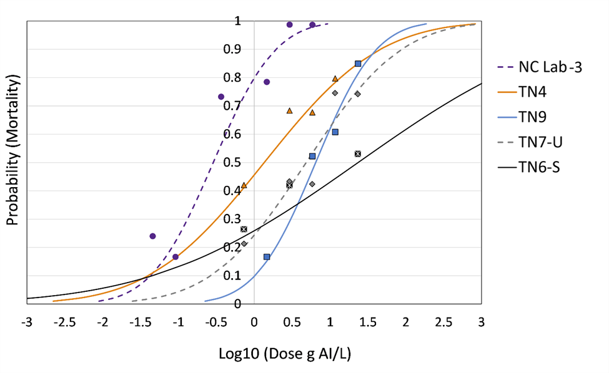
Figure 9. Predicted 24-h acephate (Orthene 97) mortality curves from probit analyses in grams of active ingredient (AI) per liter of three Tennessee tobacco thrips populations, an acephate-selected Tennessee population (TN6-S), and the North Carolina laboratory susceptible population. Uncorrected mean mortality data are represented by point markers.

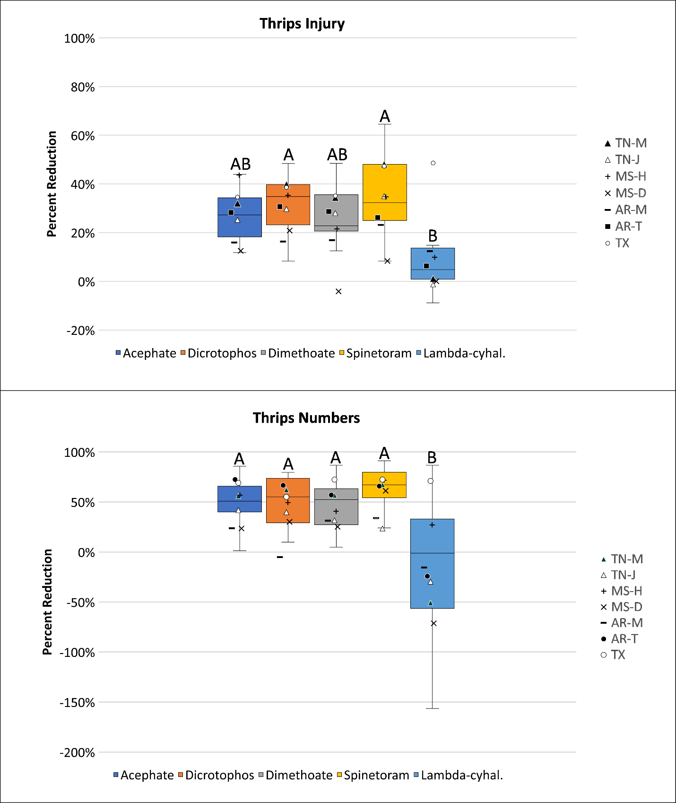
Figure 10. Distributions (box and whisker plots) of the average percent reduction of foliar insecticides based on thrips injury ratings (top) and total numbers of thrips (bottom) observed in all foliar insecticide tests. The boxes show the inclusive interquartile range, with the top and bottom of the box representing the upper and lower quartiles. The whiskers at the end show the highest and lowest values. Common letters above plots indicate mean values are not different (Tukey’s significant difference test, α=0.05). The points represent the average percent reduction in thrips injury (top) and percent reduction of thrips numbers (bottom) observed in foliar insecticides tests by location. The percent reduction in thrips injury and thrips numbers were calculated for insecticide treatments relative to sample values in plots that did not receive an insecticide treatment. Foliar insecticide test locations included: TN-M and TN-J (2 Trials Milan and 3 trials Jackson), MS-H and MS-D (2 trials each in Hills (Starkville) and Delta (Stoneville)), AR-M and AR-T (2 trials each in Marianna and Tillar), and TX (3 trials). See Table 4 for insecticides and rates used.

Conclusion

The results from the plant population study show that planting at low seeding rates or having low plant populations because of poor emergence can result in greater thrips damage. Results suggest that this increased injury is due to a higher concentration of adult thrips on a per plant in basis when plant populations are low. Additional data to evaluate the rate of oviposition on recently emerged seedlings may have helped explain why more thrips injury was observed where plants populations are lower. Even though increasing plant populations may not be practical, modifying seed spacing could be an economically feasible way to reduce thrips injury in cotton. Unfortunately, one test location test was lost in the seed spacing study. There were indications that using a hill-drop seed spacing approach might help reduce thrips injury, but results of this study were not conclusive.
An evaluation of insecticides that included organophosphates (acephate, dicrotophos, and dimethoate), a synthetic pyrethroid (lambda-cyhalothrin), a neonicotinoid (imidacloprid), and a spinosyn (spinetoram) showed strong evidence of insecticide resistance to acephate and other insecticides. This resistance to acephate appears to be worse in the upper Mid-South (Arkansas, Tennessee, and Mississippi (Delta Region)). Environmental conditions and thrips pressure were variable at each location, which made it difficult to definitively demonstrate resistance in field trials, except for lambda-cyhalothrin. However, using alternative chemistry (i.e., spinetoram) or increasing insecticide rates is justified where acephate resistance is documented. The need to make foliar insecticide applications for thrips management will decrease with the introduction of the new ThryvOn™ technology, but monitoring for tobacco thrips resistance will remain an important for at least the near future.

Appendix

Table S1. Effect of seed density and insecticide seed treatment (IST) on the average initial plant population per meter for each test of the plant density study (2020-2021: Jackson and Milan, TN).
Plants per meter
Main Effect |  | Treatments | Jackson 2020¹ | Milan 2020¹ | Jackson 2021² | Milan  2021³
Seed density |  | Low | 4.9d | 1.4c | 4.1d | 4.1d
 |  | Normal | 9.0c | 3.6c | 8.6c | 8.1c
 |  | High | 19.0b | 7.7b | 16.7b | 18.0b
 |  | Very High | 36.3a | 22.2a | 26.7a | 30.9a
Seed treatment |  | No IST | 15.3a | 7.3a | 11.3a | 11.2a
 |  | IST | 15.2a | 6.8a | 11.3a | 12.3a
Type III Tests of Fixed Effects
 | Effect |  |  | F-Value | df | P-Value
Jackson  2020 | seed density |  |  | 703.8 | 3,9 | <0.001
Jackson  2020 | seed treatment |  |  | 0.02 | 1,12 | 0.881
Jackson  2020 | seed density*seed treatment |  |  | 2.09 | 3,12 | 0.154
Milan  2020 | seed density |  |  | 47.44 | 3,24 | <0.001
Milan  2020 | seed treatment |  |  | 0.19 | 1,24 | 0.666
Milan  2020 | seed density*seed treatment |  |  | 0.99 | 3,24 | 0.415
Jackson  2021 | seed density |  |  | 150.0 | 3,24 | <0.001
Jackson  2021 | seed treatment |  |  | 0.00 | 1,24 | 0.997
Jackson  2021 | seed density*seed treatment |  |  | 1.71 | 3,24 | 0.191
Milan  2021 | seed density |  |  | 151.5 | 3,24 | <0.001
Milan  2021 | seed treatment |  |  | 1.70 | 1,24 | 0.204
Milan  2021 | seed density*seed treatment |  |  | 0.98 | 3,24 | 0.421
Means within a column followed by a common letter are not significantly different (Tukey’s significant difference test α=0.05).
¹Back-transformed (Bt) mean separation for square root.
²Back-transfomred (Bt) mean separation for log.
³Back-transfomred (Bt) mean separation for log10.

Table S2. Effect of seed spacing and insecticide seed treatment (IST) on the average number of plants per meter at the cotyledon and four-leaf stage for the test of the seed spacing study (2020-2021: Jackson and Milan, TN).
Plants per meter
Main Effect |  | Treatments | Cotyledon |  | SEM¹ |  | 4-Leaf |  | SEM
Seed spacing |  | Hill | 7.0b |  | 0.31 |  | 6.9b |  | 0.26
 |  | Single | 8.1a |  |  |  | 8.2a |  | 0.26
Seed treatment |  | No IST | 7.4a |  | 0.31 |  | 7.3b |  | 0.26
 |  | IST | 7.6a |  |  |  | 7.8a |  | 0.26
Type III Tests of Fixed Effects
 | Effect |  |  | F-Value |  | df |  | P-Value
Cotyledon | seed spacing |  |  | 23.24 |  | 1,9 |  | 0.001
Cotyledon | seed treatment |  |  | 1.18 |  | 1,9 |  | 0.305
Cotyledon | seed spacing*seed treatment |  |  | 0.01 |  | 1,9 |  | 0.920
4-Leaf | seed spacing |  |  | 76.21 |  | 1,9 |  | <0.001
4-Leaf | seed treatment |  |  | 11.69 |  | 1,9 |  | 0.008
4-Leaf | seed spacing*seed treatment |  |  | 0.08 |  | 1,9 |  | 0.780
¹Standard error of the mean, pooled across treatment effects.
Means within a column followed by a common letter are not significantly different (Tukey’s significant difference test α=0.05).

Table S3. Effect of seed density and insecticide seed treatment (IST) on the average number of total adult thrips per ten plants for each test of the plant density study (2020-2021: Jackson and Milan, TN).
Total Adult Thrips per 10 Plants
Main Effect |  | Treatments | Jackson 2020 | Milan 2020 | Jackson 2021 | Milan  2021
seed density |  | Low | 42.9a | 29.5a | 26.5a | 63.1a
 |  | Normal | 29.6ab | 27.5a | 26.4a | 55.5a
 |  | High | 19.1b | 25.8a | 14.1b | 46.5a
 |  | Very High | 11.6b | 20.9a | 11.9b | 54.9a
seed treatment |  | No IST | 21.3b | 23.3a | 19.4a | 48.6b
 |  | IST | 30.3a | 28.5a | 20.1a | 61.4a
seed density* seed treatment |  | Low No IST | 39.3abc | . | . | .
 |  | Low IST | 46.5a | . | . | .
 |  | Normal No IST | 18.8cd | . | . | .
 |  | Normal IST | 40.5ab | . | . | .
 |  | High No IST | 17.5bcd | . | . | .
 |  | High IST | 20.8bcd | . | . | .
 |  | Very High No IST | 9.8d | . | . | .
 |  | Very High IST | 13.5d | . | . | .
Type III Tests of Fixed Effects
Year | Effect |  |  | F-Value | df | P-Value
Jackson 2020 | seed density |  |  | 10.59 | 3,9 | 0.003
Jackson 2020 | seed treatment |  |  | 19.51 | 1,12 | <0.001
Jackson 2020 | seed density*seed treatment |  |  | 4.54 | 3,12 | 0.024
Milan  2020 | seed density |  |  | 1.07 | 3,21 | 0.384
Milan  2020 | seed treatment |  |  | 2.11 | 1,21 | 0.161
Milan  2020 | seed density*seed treatment |  |  | 0.44 | 3,21 | 0.727
Jackson 2021 | seed density |  |  | 7.02 | 3,21 | 0.002
Jackson 2021 | seed treatment |  |  | 0.05 | 1,21 | 0.818
Jackson 2021 | seed density*seed treatment |  |  | 0.14 | 3,21 | 0.935
Milan  2021 | seed density |  |  | 1.95 | 3,9 | 0.192
Milan  2021 | seed treatment |  |  | 7.71 | 1,12 | 0.017
Milan  2021 | seed density*seed treatment |  |  | 0.57 | 3,12 | 0.646
Means within a column followed by a common letter are not significantly different (Tukey’s significant difference test α=0.05).

Table S4. Effect of seed density and insecticide seed treatment (IST) on the average number of tobacco adult thrips per ten plants for each test of the plant density study (2020-2021: Jackson and Milan, TN).
Adult Tobacco Thrips per 10 Plants
Main Effect |  | Treatments | Jackson 2020 | Milan 2020 | Jackson 2021 | Milan  2021
seed density |  | Low | 36.4a | 22.4a | 23.6a | 58.0a
 |  | Normal | 24.0ab | 19.8a | 23.1a | 52.8a
 |  | High | 14.9bc | 17.4a | 11.9b | 44.4a
 |  | Very High | 8.89c | 15.4a | 10.5b | 50.9a
seed treatment |  | No IST | 17.8b | 18.13a | 17.4a | 46.1b
 |  | IST | 24.3a | 19.31a | 17.2a | 56.9a
Type III Tests of Fixed Effects
Year | Effect |  |  | F-Value | df | P-Value
Jackson 2020 | seed density |  |  | 15.34 | 3,9 | <0.001
Jackson 2020 | seed treatment |  |  | 11.73 | 1,12 | 0.005
Jackson 2020 | seed density*seed treatment |  |  | 2.43 | 3,12 | 0.116
Milan  2020 | seed density |  |  | 1.49 | 3,21 | 0.246
Milan  2020 | seed treatment |  |  | 0.23 | 1,21 | 0.637
Milan  2020 | seed density*seed treatment |  |  | 0.94 | 3,21 | 0.440
Jackson 2021 | seed density |  |  | 7.22 | 3,21 | 0.002
Jackson 2021 | seed treatment |  |  | 0.01 | 1,21 | 0.944
Jackson 2021 | seed density*seed treatment |  |  | 0.11 | 3,21 | 0.956
Milan  2021 | seed density |  |  | 1.41 | 3,12 | 0.288
Milan  2021 | seed treatment |  |  | 6.59 | 1,12 | 0.025
Milan  2021 | seed density*seed treatment |  |  | 0.67 | 3,12 | 0.589
Means within a column followed by a common letter are not significantly different. (Tukey’s significant difference test α=0.05).

Table S5. Effect of seed density and insecticide seed treatment (IST) on the average number of immature thrips per ten plants for each test of the plant density study (2020-2021: Jackson and Milan, TN).
Immature Thrips per 10 Plants
Main Effect |  | Treatments | Jackson 2020 | Milan  2020 | Jackson 2021 | Milan  2021
Seed density |  | Low | 103.5a | 171.9a | 31.0a | 182.0a
 |  | Normal | 106.9a | 184.1a | 34.6a | 218.6a
 |  | High | 137.1a | 169.3a | 36.5a | 175.8a
 |  | Very High | 162.3a | 148.3a | 49.6a | 187.3a
Seed treatment |  | No IST | 187.3a | 254.6a | 62.3a | 258.1a
 |  | IST | 67.6b | 82.2b | 13.6b | 123.8b
Seed density* Seed treatment |  | Low No IST | . | 237.3a | . | .
 |  | Low IST | . | 106.5b | . | .
 |  | Normal No IST | . | 277.3a | . | .
 |  | Normal IST | . | 91.0b | . | .
 |  | High No IST | . | 286.5a | . | .
 |  | High IST | . | 52.0b | . | .
 |  | Very High No IST | . | 217.3a | . | .
 |  | Very High IST | . | 79.3b | . | .
Type III Tests of Fixed Effects
Year | Effect |  |  | F-Value | df | P-Value
Jackson 2020 | seed density |  |  | 1.50 | 3,12 | 0.265
Jackson 2020 | seed treatment |  |  | 34.04 | 1,12 | <0.001
Jackson 2020 | seed density*seed treatment |  |  | 2.14 | 3,12 | 0.149
Milan  2020 | seed density |  |  | 0.79 | 3,9 | 0.530
Milan  2020 | seed treatment |  |  | 245.4 | 1,12 | <0.001
Milan  2020 | seed density*seed treatment |  |  | 4.79 | 3,12 | 0.020
Jackson 2021 | seed density |  |  | 2.28 | 3,21 | 0.109
Jackson 2021 | seed treatment |  |  | 81.92 | 1,21 | <0.001
Jackson 2021 | seed density*seed treatment |  |  | 1.61 | 3,21 | 0.218
Milan  2021 | seed density |  |  | 0.74 | 3,9 | 0.553
Milan  2021 | seed treatment |  |  | 155.2 | 1,12 | <0.001
Milan  2021 | seed density*seed treatment |  |  | 1.55 | 3,12 | 0.252
Means within a column followed by a common letter are not significantly different (Tukey’s significant difference test α=0.05).

Table S6. Effect of seed spacing and insecticide seed treatment (IST) on the average number of total adult thrips per ten plants for the test of the seed spacing study (Jackson, TN 2021).
Total Adult Thrips per 10 Plants
Main Effect |  | Treatments | Total Adults |  | SEM¹ | Immatures |  | SEM
Seed spacing |  | Hill | 13.6a |  | 2.56 | 30.8a |  | 3.94
 |  | Single | 15.9a |  | 2.56 | 31.8a |  | 3.94
Seed treatment |  | No IST | 16.9a |  | 2.56 | 44.3a |  | 3.94
 |  | IST | 12.6a |  | 2.56 | 18.3b |  | 3.94
Type III Tests of Fixed Effects
 | Effect |  |  | F-Value |  | df | P-Value
Total Adults | seed spacing |  |  | 0.67 |  | 1,9 | 0.444
Total Adults | seed treatment |  |  | 2.40 |  | 1,9 | 0.156
Total Adults | seed spacing*seed treatment |  |  | 0.13 |  | 1,9 | 0.724
Immatures | seed spacing |  |  | 0.04 |  | 1,9 | 0.839
Immatures | seed treatment |  |  | 29.75 |  | 1,9 | <0.001
Immatures | seed spacing*seed treatment |  |  | 0.00 |  | 1,9 | 1.000
¹Standard error of the mean, pooled across treatment effects.
Means within a column followed by a common letter are not significantly different (Tukey’s significant difference test α=0.05).

Table S7. Effect of seed density and insecticide seed treatment (IST) on the average thrips injury (0=no injury, 5= maximum injury) on two-leaf cotton for each test of the plant density study (2020-2021: Jackson and Milan, TN).
Thrips Injury on 2-Leaf Cotton
Main Effect |  | Treatments | Jackson 2020 | Milan 2020 | Jackson 2021 | Milan 2021
seed density |  | Low | 3.1a | 2.1a | 3.2a | 4.9a
 |  | Normal | 2.8ab | 2.1a | 2.8b | 4.8a
 |  | High | 2.5bc | 1.9ab | 2.1c | 4.5b
 |  | Very High | 2.1c | 1.7b | 2.0c | 4.2c
seed treatment |  | No IST | 3.0a | 2.6a | 2.7a | 4.9a
 |  | IST | 2.2b | 1.3b | 2.3b | 4.3b
seed density* seed treatment |  | Low No IST | . | . | . | 5.0a
 |  | Low IST | . | . | . | 4.9a
 |  | Normal No IST | . | . | . | 5.0a
 |  | Normal IST | . | . | . | 4.6a
 |  | High No IST | . | . | . | 4.9a
 |  | High IST | . | . | . | 4.1b
 |  | Very High No IST | . | . | . | 4.8a
 |  | Very High IST | . | . | . | 3.5c
Type III Tests of Fixed Effects
Year | Effect |  |  | F-Value | df | P-Value
Jackson 2020 | seed density |  |  | 12.66 | 3,21 | <0.001
Jackson 2020 | seed treatment |  |  | 43.66 | 1,21 | <0.001
Jackson 2020 | seed density*seed treatment |  |  | 0.44 | 3,21 | 0.725
Milan  2020 | seed density |  |  | 8.57 | 3,19 | <0.001
Milan  2020 | seed treatment |  |  | 304.8 | 1,19 | <0.001
Milan  2020 | seed density*seed treatment |  |  | 1.10 | 3,19 | 0.374
Jackson 2021 | seed density |  |  | 61.07 | 3,9 | <0.001
Jackson 2021 | seed treatment |  |  | 28.6 | 1,12 | <0.001
Jackson 2021 | seed density*seed treatment |  |  | 1.82 | 3,12 | 0.198
Milan  2021 | seed density |  |  | 29.37 | 3,24 | <0.001
Milan  2021 | seed treatment |  |  | 100.0 | 1,24 | <0.001
Milan  2021 | seed density*seed treatment |  |  | 14.99 | 3,24 | <0.001
Means within a column followed by a common letter are not significantly different (Tukey’s significant difference test α=0.05).

Table S8. Effect of seed density and insecticide seed treatment (IST) on the average thrips injury ratings on four-leaf cotton for each test of the plant density study (2020-2021: Jackson and Milan, TN).
Thrips Injury Ratings on 4-Leaf Cotton
Main Effect |  | Treatments | Jackson 2020 | Milan 2020 | Jackson 2021 | Milan 2021
seed density |  | Low | 3.6a | . | 3.7a | 4.5a
 |  | Normal | 3.4a | 3.7a | 3.5b | 4.3a
 |  | High | 3.2ab | 3.4a | 3.3c | 3.4b
 |  | Very High | 3.0b | 2.8b | 3.0d | 3.1b
seed treatment |  | No IST | 4.0a | 4.6a | 3.9a | 4.4a
 |  | IST | 2.6b | 1.9b | 2.9b | 3.2b
Type III Tests of Fixed Effects
Year | Effect |  |  | F-Value | df | P-Value
Jackson 2020 | seed density |  |  | 5.46 | 3,21 | 0.006
Jackson 2020 | seed treatment |  |  | 156.8 | 1,21 | <0.001
Jackson 2020 | seed density*seed treatment |  |  | 0.42 | 3,21 | 0.743
Milan  2020 | seed density |  |  | 15.29 | 2,18 | <0.001
Milan  2020 | seed treatment |  |  | 404.7 | 1,18 | <0.001
Milan  2020 | seed density*seed treatment |  |  | 2.88 | 2,18 | 0.082
Jackson 2021 | seed density |  |  | 46.77 | 3,21 | <0.001
Jackson 2021 | seed treatment |  |  | 490.3 | 1,21 | <0.001
Jackson 2021 | seed density*seed treatment |  |  | 1.65 | 3,21 | 0.208
Milan  2021 | seed density |  |  | 72.17 | 3,9 | <0.001
Milan  2021 | seed treatment |  |  | 225.1 | 1,12 | <0.001
Milan  2021 | seed density*seed treatment |  |  | 2.16 | 3,12 | 0.146
Means within a column followed by a common letter are not significantly different (Tukey’s significant difference test α=0.05).

Table S9. Effect of plant grouping and insecticide seed treatment (IST) on the average thrips injury for the Jackson, TN 2021 and Milan, TN 2021 plant density tests.
Plant Grouping Thrips Injury
Main Effect |  | Treatments | Milan 2020 |  |  | Milan 2021
plant group |  | Isolated | 3.7a |  |  | 4.3a
 |  | Clumped | 2.4b |  |  | 3.3b
seed treatment |  | No IST | 4.1a |  |  | 4.3a
 |  | IST | 2.0b |  |  | 3.3b
plant group* seed treatment |  | Isolated No IST | 4.5a |  |  | 4.6a
 |  | Clumped No IST | 3.7b |  |  | 3.9b
 |  | Isolated IST | 2.9c |  |  | 4.0b
 |  | Clumped IST | 1.1d |  |  | 2.6c
Type III Tests of Fixed Effects
Year | Effect |  |  | F-Value | df |  | P-Value
Milan 2020 | plant group |  |  | 1570.4 | 1,101.1 |  | <0.001
Milan 2020 | seed treatment |  |  | 639.3 | 1,101.0 |  | <0.001
Milan 2020 | plant group *seed treatment |  |  | 101.5 | 1,101.0 |  | <0.001
Milan 2021 | plant group |  |  | 93.27 | 1,122.1 |  | <0.001
Milan 2021 | seed treatment |  |  | 118.0 | 1,122.5 |  | <0.001
Milan 2021 | plant group *seed treatment |  |  | 9.28 | 1,122.6 |  | 0.003
Means within a column followed by a common letter are not significantly different (Tukey’s significant difference test α=0.05).

Table S10. Effect of seed spacing and insecticide seed treatment (IST) on the average thrips injury ratings done at the two-leaf, three-leaf, and four-leaf stage for the test of the seed spacing study (Jackson, TN 2021).
Thrips Injury Ratings on Scale a 0 (no injury) to 5 (maximum injury)
Main Effect |  | Treatments | 2-leaf | SEM¹ |  | 3-leaf |  | SEM | 4-leaf |  | SEM
Seed spacing |  | Hill | 2.6b | 0.08 |  | 3.6a |  | 0.05 | 3.5a |  | 0.03
 |  | Single | 2.8a |  |  | 3.6a |  | 0.05 | 3.5a |  | 0.03
Seed treatment |  | No IST | 2.9a | 0.08 |  | 3.9a |  | 0.05 | 3.8a |  | 0.03
 |  | IST | 2.5b |  |  | 3.3b |  | 0.05 | 3.2b |  | 0.03
Type III Tests of Fixed Effects
 | Effect |  |  |  | F-Value |  | df |  |  | P-Value
2-Leaf | seed spacing |  |  |  | 9.52 |  | 1,9 |  |  | 0.013
2-Leaf | seed treatment |  |  |  | 15.73 |  | 1,9 |  |  | 0.003
2-Leaf | seed spacing*seed treatment |  |  |  | 0.54 |  | 1,9 |  |  | 0.481
3-Leaf | seed spacing |  |  |  | 0.29 |  | 1,9 |  |  | 0.603
3-Leaf | seed treatment |  |  |  | 153.6 |  | 1,9 |  |  | <0.001
3-Leaf | seed spacing*seed treatment |  |  |  | 0.29 |  | 1,9 |  |  | 0.603
4-Leaf | seed spacing |  |  |  | 1.80 |  | 1,9 |  |  | 0.213
4-Leaf | seed treatment |  |  |  | 238.1 |  | 1,9 |  |  | <0.001
4-Leaf | seed spacing*seed treatment |  |  |  | 0.45 |  | 1,9 |  |  | 0.519
¹Standard error of the mean, pooled across treatment effects.
Means within a column followed by a common letter are not significantly different (Tukey’s s

Table S11. Effect of seed density and insecticide seed treatment (IST) on the average fraction green canopy cover from the Canopeo App for the Jackson, TN (2020 and 2021) and Milan, TN 2021 plant density tests.
Fractional Green Canopy Cover
Main Effect |  | Treatments | Jackson  2020 |  | Jackson  2021 |  | Milan  2021¹
seed density |  | Low | 0.5c |  | 1.4c |  | 0.2d
 |  | Normal | 1.1c |  | 3.0bc |  | 0.6c
 |  | High | 3.2b |  | 5.2ab |  | 3.3b
 |  | Very High | 6.1a |  | 6.1a |  | 10.6a
seed treatment |  | No IST | 1.5b |  | 3.0b |  | 0.8b
 |  | IST | 4.0a |  | 4.8a |  | 2.8a
seed density* seed treatment |  | Low No IST | 0.2d |  | 1.1c |  | .
 |  | Low IST | 0.8d |  | 1.6c |  | .
 |  | Normal No IST | 0.7d |  | 2.2c |  | .
 |  | Normal IST | 1.5cd |  | 3.8bc |  | .
 |  | High No IST | 1.5cd |  | 4.3bc |  | .
 |  | High IST | 4.8b |  | 6.1ab |  | .
 |  | Very High No IST | 3.4bc |  | 4.3bc |  | .
 |  | Very High IST | 8.8a |  | 7.9a |  | .
Type III Tests of Fixed Effects
Year | Effect |  |  | F-Value |  | df |  | P-Value
Jackson 2020 | seed density |  |  | 46.08 |  | 3,12 |  | <0.001
Jackson 2020 | seed treatment |  |  | 57.75 |  | 1,12 |  | <0.001
Jackson 2020 | seed density*seed treatment |  |  | 12.20 |  | 3,12 |  | <0.001
Jackson 2021 | seed density |  |  | 14.87 |  | 3,12 |  | 0.002
Jackson 2021 | seed treatment |  |  | 37.73 |  | 1,12 |  | <0.001
Jackson 2021 | seed density*seed treatment |  |  | 4.53 |  | 3,12 |  | 0.024
Milan  2021 | seed density |  |  | 105.4 |  | 3,12 |  | <0.001
Milan  2021 | seed treatment |  |  | 60.11 |  | 1,12 |  | <0.001
Milan  2021 | seed density*seed treatment |  |  | 2.87 |  | 3,12 |  | 0.081
¹Back-transformed (Bt) mean separation for log10.
Means within a column followed by a common letter are not significantly different (Tukey’s significant difference test α=0.05).

Table S12. Effect of seed density and insecticide seed treatment (IST) on the average biomass (g) of four-leaf cotton for each test of the plant density study (2020-2021: Jackson and Milan, TN).
Plant Biomass (g) of 4-Leaf Cotton
Main Effect |  | Treatments | Jackson 2020 | Milan 2020 | Jackson 2021 | Milan 2021
seed density |  | Low | 24.4a | . | 31.3a | 14.4c
 |  | Normal | 23.7a | 12.4a | 32.3a | 18.7bc
 |  | High | 23.7a | 12.0a | 28.3ab | 25.1ab
 |  | Very High | 21.9a | 13.0a | 22.9b | 26.9a
seed treatment |  | No IST | 20.1b | 10.2b | 27.2b | 15.5b
 |  | IST | 26.8a | 14.7a | 30.2a | 27.1a
Type III Tests of Fixed Effects
Year | Effect |  |  | F-Value | df | P-Value
Jackson 2020 | seed density |  |  | 0.41 | 3,9 | 0.751
Jackson 2020 | seed treatment |  |  | 18.47 | 1,12 | <0.001
Jackson 2020 | seed density*seed treatment |  |  | 0.10 | 3,12 | 0.957
Milan  2020 | seed density |  |  | 1.11 | 2,15 | 0.356
Milan  2020 | seed treatment |  |  | 69.68 | 1,15 | <0.001
Milan  2020 | seed density*seed treatment |  |  | 3.12 | 2,15 | 0.074
Jackson 2021 | seed density |  |  | 5.17 | 3,9 | 0.024
Jackson 2021 | seed treatment |  |  | 6.07 | 1,12 | 0.030
Jackson 2021 | seed density*seed treatment |  |  | 1.09 | 3,12 | 0.391
Milan  2021 | seed density |  |  | 11.81 | 3,9 | 0.002
Milan  2021 | seed treatment |  |  | 55.75 | 1,12 | <0.001
Milan  2021 | seed density*seed treatment |  |  | 1.27 | 3,12 | 0.328
Means within a column followed by a common letter are not significantly different (Tukey’s significant difference test α=0.05).

Table S13. Effect of seed density and insecticide seed treatment (IST) on the average height (cm) of four-leaf cotton for each test of the plant density study (2020-2021: Jackson and Milan, TN).
Plant Height (cm) of 4-Leaf Cotton
Main Effect |  | Treatments | Jackson 2020 | Milan 2020 | Jackson 2021 | Milan 2021
seed density |  | Low | 10.5c | . | 12.2a | 8.7c
 |  | Normal | 10.5c | 7.0b | 13.2a | 10.3b
 |  | High | 12.5b | 7.1b | 13.6a | 11.5b
 |  | Very High | 13.8a | 9.3a | 13.6a | 13.5a
seed treatment |  | No IST | 10.9b | 6.78b | 12.8b | 9.0b
 |  | IST | 12.8a | 8.8a | 13.4a | 13.0a
seed density* seed treatment |  | Low No IST | . | . | . | 6.6e
 |  | Low IST | . | . | . | 10.7c
 |  | Normal No IST | . | . | . | 8.8d
 |  | Normal IST | . | . | . | 11.9bc
 |  | High No IST | . | . | . | 10.1cd
 |  | High IST | . | . | . | 12.9b
 |  | Very High No IST | . | . | . | 10.6cd
 |  | Very High IST | . | . | . | 16.4a
Type III Tests of Fixed Effects
Year | Effect |  |  | F-Value | df | P-Value
Jackson 2020 | seed density |  |  | 25.49 | 3,21 | <0.001
Jackson 2020 | seed treatment |  |  | 36.11 | 1,21 | <0.001
Jackson 2020 | seed density*seed treatment |  |  | 1.99 | 3,21 | 0.147
Milan  2020 | seed density |  |  | 13.24 | 2,9 | 0.002
Milan  2020 | seed treatment |  |  | 43.91 | 1,9 | <0.001
Milan  2020 | seed density*seed treatment |  |  | 0.46 | 2,9 | 0.646
Jackson 2021 | seed density |  |  | 2.64 | 3,9 | 0.114
Jackson 2021 | seed treatment |  |  | 6.42 | 1,12 | 0.026
Jackson 2021 | seed density*seed treatment |  |  | 1.08 | 3,12 | 0.395
Milan  2021 | seed density |  |  | 33.71 | 3, 8.98 | <0.001
Milan  2021 | seed treatment |  |  | 204.08 | 1, 299 | <0.001
Milan  2021 | seed density*seed treatment |  |  | 5.96 | 3, 299 | <0.001
Means within a column followed by a common letter are not significantly different (Tukey’s significant difference test α=0.05).

Table S14. Effect of seed density and insecticide seed treatment (IST) on the average seed cotton yield (kg/ha) for each test of the plant density study (2020-2021: Jackson and Milan, TN).
Yield (kg/ha)
Main Effect |  | Treatments | Jackson 2020 | Milan  2020 | Jackson 2021 | Milan  2021
seed density |  | Low | 2364b | 183b | 4216b | 1315c
 |  | Normal | 2755b | 549b | 4594a | 2461b
 |  | High | 3267a | 961a | 4796a | 3231a
 |  | Very High | 3322a | 1333a | 4529a | 3241a
seed treatment |  | No IST | 2529b | 531b | 4328b | 1948b
 |  | IST | 3325a | 983a | 4740a | 3176a
seed density* seed treatment |  | Low No IST | . | . | . | 620f
 |  | Low IST | . | . | . | 2009de
 |  | Normal No IST | . | . | . | 1534e
 |  | Normal IST | . | . | . | 3388abc
 |  | High No IST | . | . | . | 2668cd
 |  | High IST | . | . | . | 3794a
 |  | Very High No IST | . | . | . | 2970bc
 |  | Very High IST | . | . | . | 3512ab
Type III Tests of Fixed Effects
Year | Effect |  |  | F-Value | df | P-Value
Jackson 2020 | seed density |  |  | 12.27 | 3,21 | <0.001
Jackson 2020 | seed treatment |  |  | 37.70 | 1,21 | <0.001
Jackson 2020 | seed density*seed treatment |  |  | 0.39 | 3,21 | 0.764
Milan  2020 | seed density |  |  | 23.28 | 3,24 | <0.001
Milan  2020 | seed treatment |  |  | 19.12 | 1,24 | <0.001
Milan  2020 | seed density*seed treatment |  |  | 2.78 | 3,24 | 0.063
Jackson 2021 | seed density |  |  | 9.04 | 3,24 | <0.001
Jackson 2021 | seed treatment |  |  | 26.58 | 1,24 | <0.001
Jackson 2021 | seed density*seed treatment |  |  | 2.12 | 3,24 | 0.124
Milan  2021 | seed density |  |  | 77.15 | 3,12 | <0.001
Milan  2021 | seed treatment |  |  | 151.11 | 1,12 | <0.001
Milan  2021 | seed density*seed treatment |  |  | 7.52 | 3,12 | 0.004
Means within a column followed by a common letter are not significantly different (Tukey’s significant difference test α=0.05).

Table S15. Effect of seed spacing and insecticide seed treatment (IST) on average seed cotton yield (kg/ha) for the test of the seed spacing study (Jackson, TN 2021).
Yield (kg/ha)
Main Effect | Treatments |  |  | Yield | SEM¹
Seed spacing | Hill |  |  | 4668a | 0.4
Seed spacing | Single |  |  | 4620a
Seed treatment | No IST |  |  | 4639a | 0.4
Seed treatment | IST |  |  | 4649a
Type III Tests of Fixed Effects
Effect |  | F-Value | df |  |  | P-Value
seed spacing |  | 0.82 | 1,9 |  |  | 0.388
seed treatment |  | 1.00 | 1,9 |  |  | 0.344
seed spacing*seed treatment |  | 0.19 | 1,9 |  |  | 0.670
¹Standard error of the mean, pooled across treatment effects.
Means within a column followed by a common letter are not significantly different (Tukey’s significant difference test α=0.05).

Vita

Jessica Krob was born in Wichita, Kansas. She developed an interest in agriculture when she moved to Northeast Arkansas and worked on a cotton farm. In 2020, she obtained a B.S. in Plant and Soil Science from Arkansas State University. She then pursued a M.S. in Entomology under Dr. Scott D. Stewart at the University of Tennessee in the Department of Entomology and Plant Pathology. She plans to obtain a Ph.D. in Entomology under Dr. Whitney Crow at Mississippi State University.

