DIVERSITY, TAXONOMY, AND SYSTEMATICS OF
CHANTERELLES AND ALLIES (CANTHARELLALES)

A Dissertation Presented for the
Doctor of Philosophy
Degree
The University of Tennessee, Knoxville

Rachel A. Swenie
August 2023

Copyright © 2023 by Rachel A. Swenie.
All rights reserved.

ACKNOWLEDGEMENTS

Thank you to my Ph.D. advisor, Dr. Brandon Matheny, for supporting and challenging me in equal measure. I have benefitted greatly from your mentorship, mycological expertise, and sense of humor.

Many thanks to my committee members, Drs. Liz Derryberry, Joe Williams, and Todd Reynolds, for providing suggestions and guidance on a variety of matters throughout my Ph.D.

I am grateful to my past and present lab mates, Marisol Sánchez-García, Hailee Korotkin, Brian Looney, Emma Harrower, Chance Noffsinger, and Django Grootmyers. Thank you for sharing your knowledge with me, and for your camaraderie in the field and lab.

I thank undergraduate researchers and lab technicians Alicia Hobbs and Noah Walker for contributing time and technical skills towards my research projects.

Warm acknowledgements to the Cumberland Mycological Society, the Asheville Mushroom Club, and the Wildacres Foray for organizing many fun and fruitful gatherings. I’m grateful for the connections I’ve made with individuals in these groups and the opportunities I’ve had to present my research findings to the broader southeastern mycological community.

Lastly, thank you Dan, Alex, Jenn, Anna, and my family for your unwavering support and encouragement.

ABSTRACT

The order Cantharellales is a lineage of approximately 1,000 fungal species that is sister to the rest of the mushroom-forming fungi (Agaricomycetes). Cantharellales species display a diverse array of morphologies and nutritional modes, from corticioid (crust-like) saprobes that decay dead wood, to biotrophic species that exist as parasites of plants, as well as mycorrhizal mushrooms that form mutualisms with forest trees. However, the evolutionary relationships among these lineages are poorly known.
Within the Cantharellales, I revised the taxonomy of the genus Hydnum (hedgehog mushrooms) in eastern North America by integrating morphological, ecological, and molecular phylogenetic data from modern and historical type collections. I found that sixteen Hydnum species occur in eastern North America alone, in contrast to the five species previously recognized, and all but one species is endemic to the region. I also conducted a systematic and floristic treatment of Cantharellus species (chanterelle mushrooms) from the southern Appalachian Mountains and found that while fruitbody macromorphology is highly variable within and across species, many Cantharellus species are identifiable by a combination of microscopic and ecological characteristics. I described one new species, C. vicinus, from east Tennessee and elevated another taxon to the species level. Furthermore, my results include the first report of the iconic European chanterelle C. cibarius from North America and suggest it may be conspecific with two previously described North American taxa.
To construct the first densely sampled multi-locus phylogeny of the Cantharellales, I developed a long-read, high-throughput sequencing method using the PacBio sequencing platform. This method produced clean sequences and allelic variants for multiple loci from hundreds of fresh and dried fungal specimens, cultures, and archival DNA extracts. Using this data, I measured intraspecific haplotype diversity to aid in species delimitation across the Cantharellales and found high levels of within-individual sequence divergence (up to 8.8%), particularly in corticioid Cantharellales with binucleate and multinucleate hyphae. I then combined PacBio and Sanger sequence data to generate the Cantharellales phylogeny, which supports four families in the order. Overall, rpb2 is the most suitable locus for species recognition within Cantharellales.

TABLE OF CONTENTS

INTRODUCTION 1
REFERENCES 3
CHAPTER I SIX NEW SPECIES AND REPORTS OF HYDNUM (CANTHARELLALES) FROM EASTERN NORTH AMERICA 5
Abstract 6
Introduction 6
Methods 7
Results 9
Taxonomy 10
Key to species of Hydnum in eastern North America 31
Acknowledgements 33
REFERENCES 34
APPENDIX 38
CHAPTER II NEW REPORTS, NEW SPECIES, AND HIGH DIVERSITY OF CANTHARELLUS IN THE SOUTHERN APPALACHIANS 50
Abstract 51
Introduction 51
Materials and Methods 53
Field collection 53
Microscopy 53
DNA extraction and sequencing 53
Taxon sampling and phylogenetic analyses 53
Network analysis 54
Taxonomy 54
Results 54
Taxonomy 56
Discussion 71
Key to Cantharellus in the southern Appalachians 73
Acknowledgements 74
REFERENCES 75
APPENDIX 80
CHAPTER III A PACBIO HIGH-THROUGHPUT MULTI-LOCUS SEQUENCING METHOD FOR FUNGAL SYSTEMATICS AND SPECIES DELIMITATION 95
Abstract 96
Introduction 96
Materials and Methods 98
Molecular analyses 98
Sequence data pipeline and analysis 99
Results 100
Discussion 100
Data Accessibility 102
Acknowledgements 102
REFERENCES 103
APPENDIX 106
CHAPTER IV A PHYLOGENETIC OVERVIEW OF THE CANTHARELLALES (CHANTERELLES AND ALLIES) 117
Abstract 118
Introduction 118
Materials and Methods 120
Taxon sampling 120
DNA extraction, gene sampling, and sequencing 120
DNA alignment and phylogenetic analyses 121
Molecular dating analysis 122
Results 122
Discussion 124
REFERENCES 127
APPENDIX 134
CONCLUSION 150
VITA 153

LIST OF TABLES

Table 1. Specimen data for sequences produced in this study. 46
Table 2. List of Cantharellus species within eastern North America, Mexico, and the Caribbean. 80
Table 3. Specimen data used in this study. New sequences produced for this study are in bold. 80
Table 4. Samples used in this study. 106
Table 5. Locus-specific primers and PCR conditions. 111
Table 6. Total number of attempted and successfully sequenced samples with mean number of sequence variants produced for each locus. 112
Table 7. Total number of attempted and successfully sequenced samples with mean number of sequence variants produced for each locus and maximum within-sample sequence variant divergence by taxonomic family. 112
Table 8. Previous classification schemes for Cantharellales. 134
Table 9. Accepted and former Cantharellales genera based on present and previous studies. 135
Table 10. Specimen data for sequences used in phylogenies. Sequences labeled “MLST” (PacBio) or “Sanger” are new to this study and were generated by that method. 136

LIST OF FIGURES

Figure 1. Global BI phylogeny of Hydnum. Species-level clades containing sequences from eastern United States and Canada are colored red. Posterior probabilities ≥0.95 are denoted with asterisks. 38
Figure 2. ML pruned phylogeny of North American species of Hydnum. Bootstrap support values ≥70% are shown above branches. Posterior probabilities ≥0.95 are shown with branches in bold. 39
Figure 3. Basidiomes of Hydnum species. A, B H. albidum 10640TJB (CORT 012029, epitype, photo T.J. Baroni) C H. alboaurantiacum RAS186 (TENN 073053, holotype, photo R.A. Swenie) D H. alboaurantiacum BPL876 (TENN 073003, photo B.P. Looney) E, F H. albomagnum RAS231 (TENN 073062, epitype, photo R.A. Swenie) G H. subtilior PBM4093 (TENN 073034, holotype, photo P.B. Matheny) H H. subtilior showing characteristic staining of context RAS180 (TENN 073050, photo R.A. Swenie). Scale bar: 20 mm. 41
Figure 4. Basidiomes of Hydnum species. A, B H. subolympicum RAS029 (TENN 070845, photo R.A. Swenie) C H. vagabundum CLO4985 (CSU 01477, holotype, photo C.L. Ovrebo) D H. vagabundum 10782TJB (CORT 014461, photo T. J. Baroni) E H. ferruginescens MH16005 (TENN 073549, holotype, photo M. Hopping) F H. ferruginescens RAS229 (TENN 073061, photo R.A. Swenie) G, H H. aerostatisporum RAS071 (TENN 073001, photo R.A. Swenie). Scale bar: 20 mm. 42
Figure 5. Basidiomes of Hydnum species. A H. canadense RAS100 (TENN 073010) B H. mulsicolor RAS023 (TENN 070321) C H. subconnatum RAS235 (TENN 073064, holotype) D H. subconnatum RAS169 (TENN 073048) E H. cuspidatum RAS246 (TENN 073086, holotype) F H. cuspidatum RAS150 (TENN 073037) G H. umbilicatum 10651TJB (CORT 012241, epitype) H H. umbilicatum RAS101 (TENN 073011). Photos A–F, H by R.A. Swenie; Photo G by T.J. Baroni. Scale bar: 20 mm. 43
﻿Figure 6. Basidiospores of Hydnum species. A H. albidum 9623TJB (CORT 014489) B H. alboaurantiacum TFB9833 (TENN 058812) C H. albomagnum PBM2512 (TENN 066858) D H. subtilior PBM3868 (TENN 067482) E H. subolympicum AJR14 (TENN 073004) F H. vagabundum 10782TJB (CORT 014461) G H. ferruginescens MH16005 (TENN 073549, holotype) H H. aerostatisporum MK9181403 I H. canadense RAS100 (TENN 073010) J H. mulsicolor MH16006 (TENN 073550) K H. quebecense JG003 (CORT 007330) L H. subconnatum RAS053 (TENN 070846) M H. cuspidatum BPL989 (TENN 073033) N H. umbilicatum 10651TJB (CORT 012241, epitype) O H. umbilicatum Peck (NYS-F-3258, holotype). Scale bar: 10 μm. 44
Figure 7. Holotype and basidiospores of Hydnum caespitosum. Scale bar: 5 μm. 45
Figure 8. Multilocus (28S + tef1 + rpb2) phylogeny of Cantharellus with pruned outgroup. A. Subgenus Cantharellus. B. Subgenera Parvocantharellus and Cinnabarinus. Sequences produced for this study are in bold. Bootstrap values ≥70 are shown on branches; an asterisk (*) indicates posterior probability ≥0.95. 87
Figure 9. Base map of tef1 nucleotide polymorphisms and gaps (–) across populations of Cantharellus camphoratus from Japan, USA– North Carolina (NC), and Canada–Newfoundland and Labrador (NL). Numerical position of polymorphisms within the DNA sequence and coding status (intron or exon) are denoted below each set of base pairs (bp). 88
Figure 10. Network analysis of (A) 28S sequences, (B) tef1 sequences, and (C) rpb2 sequences across specimens of Cantharellus camphoratus (in bold). Cantharellus formosus and C. versicolor S.C. Shao & P.G. Liu are outgroups. HT denotes holotype. 89
Figure 11. Network analysis of (A) 28S sequences, (B) tef1 sequences, and (C) rpb2 sequences across specimens in the Cantharellus cibarius complex (in bold). Cantharellus cascadensis and C. subalbidus are outgroups. HT denotes holotype; ET denotes epitype. 90
Figure 12. Network analysis of (A) 28S sequences, (B) tef1 sequences, and (C) rpb2 sequences, across specimens in the Cantharellus tenuithrix complex (in bold). Cantharellus pallens, C. anzutake W. Ogawa, N. Endo, M. Fukuda & A. Yamada, C. yunnanensis W.F. Chiu, and C. cibarius are outgroups. HT denotes holotype; ET denotes epitype. 91
Figure 13. Basidiomata of Cantharellus. A. C. altipes RAS084 (TENN-F-071461). B. C. altipes RAS639 (TENN-F-075384). C. C. betularum RAS631 (TENN-F-075393). D. C. camphoratus RAS614 (TENN-F-075387). E. C. camphoratus RAS661 (TENN-F-075389). F. C. enelensis (C. cibarius complex) RAS859 (TENN-F-075896). G. C. cibarius “white” CLC2018-2 (TENN-F-076274). H. C. flavolateritius RAS588 (TENN-F-076283). I. C. flavolateritius RAS590 (TENN-F-075271). Photos A–F, H, I by R. A. Swenie. Photo G by C. LaChance. Bars = 20 mm. 92
Figure 14. Basidiomata of Cantharellus. A. C. persicinus RAS841 (TENN-F-075884). B. C. tenuithrix PBM4292 (TENN-F-074854). C. C. flavus (C. tenuithrix complex) RAS464 (TENN-F-074949). D. C. velutinus (pink form) PBM4602 (TENN- F-075769). E. C. vicinus RAS426 (TENN-F-074935, holotype). F. C. vicinus RAS669 (TENN-F-075383). G. C. corallinus RAS629 (TENN- F-075397). H. C. intensissimus PBM4615 (TENN-F-075782, epitype). Photos A, C, E–G by R. A. Swenie; photos B, D, H by P. B. Matheny. Bars = 20 mm. 93
Figure 15. Cantharellus vicinus (holotype). A. Basidia. B. Spores. C. Pileipellis terminal hyphae. Bars = 5 μm. 94
Figure 16. Cantharellus intensissimus (epitype). A. Basidia. B. Spores. C. Pileipellis terminal hyphae. Bars = 5 μm. 94
Figure 17. The PacBio multi-locus long-read high throughput sequencing (HTS) workflow. 113
Figure 18. Intra-individual diversity of the tef1 locus across Craterellus. Sequences produced for this study are in bold text. Bootstrap support values are shown above branches. Within-sample sequence variant divergence up to 1.9% was detected among 11 sequence variants of tef1 in Craterellus ignicolor RAS589 (fruiting body isolate). 114
Figure 19. Intra-individual and intraspecific diversity of rpb2 across samples of Botryobasidium subcoronatum and B. simile (culture and fruiting body isolates). Sequences produced for this study are in bold text. Bootstrap support values ≥ 70 are denoted by an asterisk (*). Intraspecific sequence divergence in both species was greater than 5.5%. 115
Figure 20. Comparison of intra-individual genetic variation captured by Sanger sequencing vs. PacBio HTS for a single Hydnum sample (fruiting body isolate). A Sanger sequence (top row) is shown in comparison to six PacBio long-read HTS sequence variants (SV1–6) from the ITS locus. Nucleotide positions are presented above sequences. Sequence polymorphisms captured in the Sanger sequence are reflected in the long-read HTS sequence variants at positions 275 and 300, but the polymorphic site at position 235 and length heterogeneity at sites 360–71 are not captured by the Sanger sequence. 116
Figure 21. Two corticioid Cantharellales specimens containing non-target taxa. Fungal taxa detected varied by sequencing method and locus. 116
Figure 22. Morphological and ecological diversity among Cantharellales fungi. Clockwise from top left: the ectomycorrhizal edible mushroom Hydnum umbilicatum; corticioid (crust-like) teleomorph of the crop pathogen Rhizoctonia solani; an ectomycorrhizal coralloid Clavulina mushroom; the lichenized fungus Multiclavula mucida; the corticioid saprobe Botryobasidium rubiginosum; and the bulbil-forming lichenicolous Neoburgoa freyi. Photo of Rhizoctonia solani by Maria A. Kunetsova; photo of Neoburgoa freyi by Erich Zimmerman; all other photos by Rachel A. Swenie. 142
Figure 23. Multi-locus (18S, ITS, 28S, tef1, rpb2) phylogeny of the Cantharellales. Family designations are denoted in bold text with accepted families in blue. ML bootstrap values ≥ 70% are shown on branches. Clades strongly supported by UF bootstrap, SH, and aBayes metrics are indicated by bold branches. 143
Figure 24. 18S phylogeny of the Cantharellales. Family designations are denoted in bold text with accepted families in blue. ML bootstrap values ≥ 70% are shown on branches. Dotted line indicates a branch is displayed as half of full length. 144
Figure 25. ITS phylogeny of the Cantharellales. Family designations are denoted in bold text with accepted families in blue. ML bootstrap values ≥ 70% are shown on branches. 145
Figure 26. 28S phylogeny of the Cantharellales. Family designations are denoted in bold text with accepted families in blue. ML bootstrap values ≥ 70% are shown on branches. 146
Figure 27. tef1 phylogeny of the Cantharellales. Family designations are denoted in bold text with accepted families in blue. ML bootstrap values ≥ 70% are shown on branches. 147
Figure 28. rpb2 phylogeny of the Cantharellales. Family designations are denoted in bold text with accepted families in blue. Bootstrap values ≥ 70% are shown on branches. 148
Figure 29. Time-calibrated phylogeny of the Cantharellales showing clades containing biotrophic (ectomycorrhizal and lichenicolous) species. Mass-extinction events are indicated with shaded bars. 149

INTRODUCTION

Fungi are morphologically, ecologically, and functionally diverse organisms that comprise an estimated 2.2–3.8 million species worldwide. However, much of this diversity remains unrecognized; so far only 3–8% of fungal species have been named (Hawksworth & Lücking 2017). Species diversity is commonly underestimated even in mushroom-forming fungi, a group of particular importance to humans. Molecular sequencing techniques have led biologists to rethink traditional notions of what defines fungal species, since molecular species relationships are often at odds with traditional morphological species concepts.
The order Cantharellales exemplifies this dilemma. The order contains approximately 1,000 species and is sister to the rest of the mushroom-forming fungi (Agaricomycetes). Lineages within the Cantharellales are morphologically and ecologically diverse, including lichens that form symbioses with green algae, corticioid (crust-like) fungi that degrade dead organic carbon, pathogens that cause disease in agricultural crops, mutualists that inhabit orchid roots, species that grow on lichens, and tree-associated edible mushroom-forming fungi that are sold in markets worldwide (Moncalvo et al. 2006, Gónzalez et al. 2016, Lawrey et al. 2016, Oberwinkler et al. 2017, Olariaga et al. 2017). Despite recent advances in characterizing relationships across the fungal tree of life, evolutionary relationships in the Cantharellales remain poorly understood. From the handful of genomes that have been sequenced in the order, basic relationships have been inferred among the six named families in the order, but the genome-based phylogeny (https://mycocosm.jgi.doe.gov) has changed through time as genome sampling increases. A recent multi-gene systematic study supported combining three of these families into one broader family (Cao et al. 2021). One polyphyletic genus, Sistotrema, comprises five or more separate genera, four of which cannot be placed within existing families (Moncalvo et al. 2006). The polyphyletic genera Ceratobasidium and Rhizoctonia include important agricultural pathogens but have presented many challenges to delimiting species (Veldre et al. 2013, Gónzalez et al. 2016). Lichenicolous Cantharellales taxa are known solely from nuclear ribosomal DNA sequences, which do not resolve those species’ phylogenetic positions (Lawrey et al. 2016). To date, there is no densely sampled phylogeny of the Cantharellales that resolves these family and generic-level relationships. A comprehensive Cantharellales phylogeny will also enable better sequence-based identification of species and allow future macroevolutionary studies examining biogeography and drivers of diversification.
This dissertation research utilizes molecular systematics, taxonomy, type studies, and a novel high-throughput sequencing method to examine species diversity and evolution across the Cantharellales. First, I examine the taxonomy and systematics of two economically important groups within the Cantharellales, the edible mushroom genera Hydnum and Cantharellus, in eastern North America. Next, I develop a new sequencing method utilizing the long-read PacBio platform for generating multi-locus sequence data from an array of source materials, from fresh and dried specimens to cultures and archival DNA extracts. This method yields high-quality sequence data suitable for systematic analysis and allelic sequence variants useful for understanding intraspecific and intra-individual genetic variation. Lastly, I infer an evolutionary framework for the Cantharellales using single- and multi-locus phylogenies to evaluate family-level relationships and assess the utility of various loci for species recognition across the order.

REFERENCES

Cao, T., Hu, Y. P., Yu, J. R., Wei, T. Z., & Yuan, H. S. (2021). A phylogenetic overview of the Hydnaceae (Cantharellales, Basidiomycota) with new taxa from China. Studies in Mycology, 99, 100–121. https://doi.org/10.1016/j.simyco.2021.100121

Feng, B., Wang, X.-H., Ratkowsky, D., Gates, G., Lee, S. S., Grebenc, T., & Yang, Z. L. (2016). Multilocus phylogenetic analyses reveal unexpected abundant diversity and significant disjunct distribution pattern of the Hedgehog Mushrooms (Hydnum L.). Scientific Reports, 6(April), 25586. https://doi.org/10.1038/srep25586

Gónzalez, D., Rodriguez-Carres, M., Boekhout, T., Stalpers, J., Kuramae, E. E., Nakatani, A. K., Vilgalys, R., & Cubeta, M. A. (2016). Phylogenetic relationships of Rhizoctonia fungi within the Cantharellales. Fungal Biology, 120(4), 603–619. https://doi.org/10.1016/j.funbio.2016.01.012

Hawksworth, D. L., & Lücking, R. (2017). Fungal Diversity Revisited: 2.2 to 3.8 Million Species. Microbiol Spectrum, 5(4). https://doi.org/10.1128/microbiolspec.FUNK-0052-2016.

Lawrey, J. D., Zimmermann, E., Sikaroodi, M., & Diederich, P. (2016). Phylogenetic diversity of bulbil-forming lichenicolous fungi in Cantharellales including a new genus and species. The Bryologist, 119(4), 341–349. https://doi.org/10.1639/0007-2745-119.4.341

Martin, F., Kohler, A., Murat, C., Veneault-Fourrey, C., & Hibbett, D. S. (2016). Unearthing the roots of ectomycorrhizal symbioses. Nature Reviews Microbiology, 14(12), 760–773. https://doi.org/10.1038/nrmicro.2016.149

Moncalvo, J.-M., Nilsson, R. H., Koster, B., Dunham, S. M., Bernauer, T., Matheny, P. B., Porter, T. M., Margaritescu, S., Weiss, M., Garnica, S., Danell, E., Langer, G., Langer, E., Larsson, E., Larsson, K.-H., & Vilgalys, R. (2006). The cantharelloid clade: dealing with incongruent gene trees and phylogenetic reconstruction methods. Mycologia, 98(6), 937–948. https://doi.org/10.3852/mycologia.98.6.937

Oberwinkler, F., Cruz, D., & Suárez, J. P. (2017). Biogeography and Ecology of Tulasnellaceae. Ecol. Stud. 230: 237–271. https://doi.org/10.1007/978-3-319-56363-3

Olariaga, I., Moreno, G., Manjón, J. L., Salcedo, I., Hofstetter, V., Rodríguez, D., & Buyck, B. (2017). Cantharellus (Cantharellales, Basidiomycota) revisited in Europe through a multigene phylogeny. Fungal Diversity, 83(1), 263–292. https://doi.org/10.1007/s13225-016-0376-7

Pilz, D., Norvell, L., Danell, E., & Molina, R. (2003). Ecology and management of commercially harvested chanterelle mushrooms. Portland (OR): US Department of Agriculture, Forest Service, Pacific Northwest Research Station.

Veldre, V., Abarenkov, K., Bahram, M., Martos, F., Selosse, M. A., Tamm, H., Kõljalg, U., & Tedersoo, L. (2013). Evolution of nutritional modes of Ceratobasidiaceae (Cantharellales, Basidiomycota) as revealed from publicly available ITS sequences. Fungal Ecology, 6(4), 256–268. https://doi.org/10.1016/j.funeco.2013.03.004

CHAPTER I
SIX NEW SPECIES AND REPORTS OF HYDNUM (CANTHARELLALES) FROM EASTERN NORTH AMERICA

A version of this chapter was originally published by Rachel A. Swenie, Timothy J. Baroni, and P. Brandon Matheny:
Rachel A. Swenie, Timothy J. Baroni, P. Brandon Matheny. “Six new species and reports of Hydnum (Cantharellales) from eastern North America.” MycoKeys 42 (2018): 35–72.

R.A.S. and P.B.M. designed the study. All authors contributed specimens. R.A.S. conducted laboratory work and phylogenetic analyses. R.A.S. wrote the manuscript and all authors provided manuscript edits.

Abstract

Five species of Hydnum have been generally recognized from eastern North America based on morphological recognition: H. albidum, H. albomagnum, H. repandum and varieties, H. rufescens, and H. umbilicatum. Other unique North American species, such as H. caespitosum and H. washingtonianum, are either illegitimately named or considered synonymous with European taxa. Here, seventeen phylogenetic species of Hydnum are detected from eastern North America based on a molecular phylogenetic survey of ITS sequences from herbarium collections and GenBank data, including environmental sequences. Based on current distribution results, sixteen of these species appear endemic to North America. Of these, six species are described as new: H. alboaurantiacum, H. cuspidatum, H. ferruginescens, H. subconnatum, H. subtilior, and H. vagabundum. Geographic range extensions and taxonomic notes are provided for five additional species recently described as new from eastern North America. A new name, H. geminum, is proposed for H. caespitosum Banning ex Peck, non Valenti. Overall, species of Hydnum are best recognized by a combination of morphological and molecular phylogenetic analyses. Taxonomic descriptions are provided for seventeen species, including epitype designations for H. albidum, H. albomagnum, and H. umbilicatum, taxa described more than 100 years ago, and molecular annotation of the isotype of H. washingtonianum. Photographs and a key to eastern North American Hydnum species are presented.

Introduction

﻿Hydnum L: Fr (=Dentinum Gray) is a genus of ectomycorrhizal (ECM) mushroom-forming fungi found primarily in temperate forests of Asia, Australia, Europe, and North America. Until recently, only twelve species of Hydnum were commonly accepted world-wide. Initial phylogenetic studies of European Hydnum revealed higher than expected taxonomic diversity in the genus, with thirteen molecularly recognized clades masquerading under four morphologically-defined species names (Grebenc et al. 2009), which have since been described as new species (Olariaga et al. 2012, Vizzini et al. 2013, Niskanen et al. 2018). Following a global survey of diversity in the genus which estimated 31 species worldwide based on molecular phylogenetic analysis (Feng et al. 2016), additional taxonomic work in Europe and North America has raised the global species count to 34 (Buyck et al. 2017, Niskanen et al. 2018), which is estimated to be less than half of the total number of Hydnum species (Niskanen et al. 2018). This previously overlooked diversity may be due to morphological stasis in evolution of basidiome morphology and lack of attention to regional characterization of the Hydnum flora in locations outside Europe.
﻿ Hydnum, in its original Linnean concept, contained all species of mushroom-forming fungi with a spinose hymenophore (e.g., Fries 1821). Indeed, over 900 names have been attributed to the genus per Index Fungorum (www.indexfungorum.org). However, molecular phylogenetic analysis showed that the spinose hymenophore has evolved independently many times in distantly related taxa (Hibbett et al. 1997). As a consequence, most species formerly contained in Hydnum have been moved to other genera. Species of Hydnum in the contemporary sense (Donk 1956) and typified by H. repandum L.:Fr. are united by their smooth hyaline basidiospores, white to orange basidiomes, and stichic basidia, in which the meiotic spindle is vertically oriented (Donk 1933, Maas Geesteranus 1971, Restivo and Petersen 1976, Pine et al. 1999). Ecologically, Hydnum form ECM associations with a variety of vascular plant species including members of Pinaceae (Agerer et. al 1996), Myrtaceae (McNabb 1971), Fagales (McNabb 1971, Feng et. al 2016, Niskanen et al. 2018), Salicaceae (Niskanen et al. 2018), Malvaceae (Niskanen et al. 2018), and Dipterocarpaceae (Lee et al. 2002). The genus is distributed mostly in temperate areas, with a few reports from tropical and subtropical forests in southeast Asia (Lee et al. 2002, Feng et al. 2016) and the neotropics (Garibay-Orijel et al. 2006, Sarmiento and Fontecha 2013, Feng et al. 2016, Niskanen et al. 2018).
﻿ Previous analysis of global Hydnum diversity revealed the presence of six distinct
clades of Hydnum in eastern North America, only one of which also occurs on another continent (Feng et al. 2016). Currently, five species have been described from eastern North America: H. albidum Peck, H. albomagnum Banker, H. aerostatisporum Buyck, D.P. Lewis & V. Hofst., H. caespitosum Banning ex Peck (non Valenti), and H. umbilicatum Peck. Banker (1906) and Harrison and Grund (1987) recognized six species of Hydnum from across North America in their taxonomic treatments. Of those species that occur in eastern North America, four were described over one hundred years ago, and the application of those names has not been clarified in light of molecular phylogenetic analyses. Here, we resolve those species names by taxonomic revision of type ﻿specimens and DNA sequencing of contemporary collections, as well as document Hydnum species diversity and distribution in eastern North America. Seventeen species are treated here, of which six are described as new. A taxonomic key to species from eastern North America is included.

Methods

﻿Dried specimens of Hydnum were obtained from TENN, CORT, NYS, NY, WTU, and CSU. Herbarium abbreviations follow Thiers [continuously updated]. Additional collections were borrowed from the personal herbarium of Michael Kuo (Charleston, Illinois). Fresh Hydnum specimens were collected from localities in the eastern United States (North Carolina, Tennessee, Georgia, Florida, Virginia). Color documentation of fresh material follows Kornerup and Wanscher (1967; e.g., 5A2), Munsell Soil Color Charts (1954; e.g., 10YR 4/7), or Ridgway (1912; e.g., “Ochraceous-Tawny”). Macroscopic descriptions were taken from fresh material. In some instances, 5% KOH and 10% FeSO₄ were applied to pilei to test for macrochemical reactions.
Microscopic features were examined on a Nikon Eclipse 80i microscope from dried material rehydrated in 5% KOH and stained with Congo red or phloxine. Meas- urements and photographs were taken using a Nikon DS-Fi1 camera and Nikon NIS Elements 3.1 software. Basidiospores were measured from spore prints where available or spine tissue, and Q (quotient of basidiospore length to width) was calculated foreach spore. The number of spores measured for each species is represented as n=total number/number of specimens (e.g., n=20/3). Measurements in excess of two standard deviations are denoted in parentheses and averages in italics.
DNA extractions were performed using two methods. Fresh or dried material less
than five years old was extracted using an Extract-N-Amp Plant kit (Sigma-Aldrich, St. Louis, MO, USA). Older dried specimens were extracted using an HP Fungal DNA Extraction Kit (Omega Bio-Tek, Norcross, Georgia, USA). For specimens >50 years old, 10–20 mg ground tissue was incubated in extraction buffer at 65 °C for 72 hours prior to the first extraction step. The extraction was performed in a laminar flow hood to minimize contamination.
Primers ITS1F and ITS4 (Gardes and Bruns 1993, White et al. 1990) were used to amplify and sequence the nuclear rDNA internal transcribed spacer 1, 5.8S rRNA, and internal transcribed spacer 2 (hereafter, ITS). For older materials, we amplified and sequenced the two spacer regions separately following Ammirati et al. (2007) using primers ITS1F/ITS2 and 5.8SR/ITS4. Sequencing was performed on an Applied Biosystems 3730 Genetic Analyzer at the University of Tennessee Genomics Core. Sequence reads were assembled using Sequencher 5.0.1 (Gene Codes Corp., Ann Arbor, Michigan, USA).
GenBank sequences labeled as Hydnum, as well as closely matching environmental sequences, were downloaded. Sequences were visualized in AliView 1.20 (Larsson 2014) and aligned using MUSCLE 3.8.31 (Edgar 2004). Minor adjustments were made manually to the alignment. The GTR+I+GAMMA substitution model was ﻿selected as the best-fit model for Bayesian inference (BI) analysis in PartitionFinder 2.1.1 (Lanfear et al. 2016). BI analyses were performed using MrBayes 3.2.6 (Ronquist and Huelsenbeck 2003); the global analysis ran for 10 million generations with sampling every 1000th generation. Following global BI tree visualization, clades that did not contain sequences from eastern North America were pruned to form a second tree figure for easier graphical representation. Maximum Likelihood (ML) analysis was performed on the pruned dataset in RAxML 8.2.8 (Stamatakis 2014) using 1000 bootstraps under a GTRGAMMA model of nucleotide substitution following the RAxML user manual recommendation. BI analysis of the pruned data set ran for 5 million generations with sampling every 500th generation.
﻿The resulting phylogenies were visualized in FigTree v.1.4.3 (http://tree.bio.ed.ac.
uk/software/figtree/). Mislabeled sequences were omitted, as well as Hydnum from the southern hemisphere due to high levels of sequence divergence (Feng et al. 2016). Sistotrema alboluteum was chosen as an outgroup based on Feng et al. (2016). DNA alignments and tree files are available at TreeBase (submission 22888). Species are recognized here as monophyletic groups that differ in morphology, ecology, and/or geographic distribution.

Results

﻿119 ITS sequences were produced for this study (Table 1). For the BI analyses, the average standard deviation of split frequencies reached below 0.01 after 4 million generations (global phylogeny) and 2 million generations (pruned phylogeny), so the first 40% of sampled trees were discarded as the burn-in for each analysis. Posterior probabilities (PP) for each analysis were calculated from 12002 samples from two independent runs for both the global and pruned analyses. In each case the potential scale reduction factor (PSRF) convergence diagnostic reached a value of 1.0 for all parameters, indicative of sufficient sample size.
﻿The global phylogeny contained 397 sequences and 61 species-level clades. Species-level clades containing sequences from eastern United States and Canada are colored red in the global circle tree (Figure 1; all Figures are in Appendix). PP ≥ 0.95 for nodes of these clades are denoted with an asterisk. The pruned version of the global tree, including taxon tip labeling information, is shown in Figure 2. Four major clades of North American Hydnum were recovered, each with ML bootstrap support ≥ 70%. These are labeled by subgenus: Alba, Pallida, Hydnum, Rufescentia (Niskanen et al. 2018). A sister group relationship was recovered between subg. Hydnum and Rufescentia. In subg. Alba we recovered three monophyletic lineages that originate from eastern North America and correspond to phylogenetic species: H. alboaurantiacum sp. nov., H. albidum, and H. albomagnum. Subg. Pallida is represented by a single phylogenetic species from eastern North America: H. subtilior sp. nov. In subg. Hydnum three phylogenetic species from eastern North America were detected: H. vagabundum sp. nov., H. washingtonianum, and H. subolympicum. Subg. Rufescentia, centered around H. rufescens, contains the ﻿largest number of eastern North American phylogenetic species, including H. ferruginescens sp. nov., H. aerostatisporum, H. canadense, H. mulsicolor, Hydnum sp. AS30, H. subconnatum sp. nov., H. quebecense, H. cuspidatum sp. nov., and H. umbilicatum.
﻿We were unable to produce ITS sequences from the holotypes of the following
species: H. albidum, H. albomagnum, H. umbilicatum and H. caespitosum. As a result, we designated epitypes for three of those species – H. umbilicatum 10651TJB (CORT 012241), H. albidum 10640TJB (CORT 012029), and H. albomagnum RAS231 (TENN 073062), which are represented by ITS data. Each designated epitype was ﻿chosen based on morphological consistency and geographic proximity to sites containing holotypes. We were able to sequence partial ITS regions from two historical Peck collections labeled H. albidum, but based on morphology those specimens represent a separate, larger, white species that we describe here as H. vagabundum.
﻿A total of sixteen species-level monophyletic groups from eastern North America
were recovered, representing ten described and six undescribed species. One additional species, H. geminum, was not represented by any modern collections, and thus its phylogenetic position is unconfirmed. Below, taxonomic descriptions are presented for eastern North American species by subgenus. Of the recovered species, only one eastern North American Hydnum, H. mulsicolor, also occurs outside North America. This result is consistent with recent work that showed eastern North American clades of Hydnum are largely endemic (Feng et al. 2016, Niskanen et al. 2018).
﻿None of the species studied display a clear preference for tree host genus. Many occupy a wide geographic range within eastern North America, with three species (H. albidum, H. subtilior, H. vagabundum) also found in Central America. One species, H. washingtonianum, occurs in both eastern and western North America.
﻿Basidia in Hydnum were consistently suburniform, often undulating, and tapered
to a narrow pedicel. Basidium shape was not considered a diagnostic trait and thus omitted from taxonomic descriptions below. Basidiospores of Hydnum were inamyloid and acyanophilous (Hall and Stuntz 1971). Morphological variation across Hydnum was low compared to other genera, with few variable microscopic features. As a consequence, species varied by differences in basidiospore size and shape, number of sterigmata, and pileipellis elements. Several taxa in subg. Rufescentia were nearly morphologically indistinct from one another and could be identified in the field only by a combination of morphology and distribution/habitat data. Even so, ITS sequencing is necessary to confidently identify those species.

Taxonomy

﻿Hydnum subg. Alba Niskanen & Liimat., Mycologia 110(5): 896 (2018)

﻿Hydnum albidum Peck, Bulletin of the New York State Museum 1(2): 10 (1887) MycoBank Epitypification: MBT381859
GenBank: MH379883
Figures 3A, 3B, 6A

﻿= Hydnum repandum var. albidum (Peck) Bres., Iconographia Mycologica 21: 1045 (1932)
= Dentinum albidum (Peck) Snell, Mycologia 37: 51 (1945)
= Hydnum repandum f. albidum (Peck) Nikol., Flora Plantarum Cryptogamarum URSS. Fungi. Familia Hydnaceae 6(2): 306 (1961)

﻿Type: UNITED STATES. New York: Rensselaer County, Sandlake, ground in thin woods, Jul ca. 1886, C.H. Peck (holotype: NYS-F-134). Epitype: UNITED STATES. New York: Cortland County, Kennedy State Forest, Scutt Road (42.4685; -76.1656), on humus in forest with Quercus rubra, Fagus, Acer, 550 m, 30 Jul 2014, T.J. Baroni 10640TJB (CORT 012029).

﻿Description: Pileus 15–50 mm wide, round to reniform, convex to plano-convex or uplifted, disc sometimes shallowly depressed; surface glabrous, sometimes irregularly bumpy or mottled in appearance, bright white becoming cream or cream-peach (10YR 8/4), no reaction to KOH; margin entire and incurved when young, undulating in age. Spines 1–6 mm long, easily rubbing off, subdecurrent to decurrent, white to cream white (10YR 8/3). Stipe 15–45 × 5–15 mm, central or eccentric, equal to slightly enlarged or bulbous at the base, then tapering into ground, concolorous with the pileus, staining orange-ochre (5A4–5B7 or “Yellow Ochre”). Basal mycelium white when present. Context white to pale cream, staining slowly orange (5A6) after five mins. Odor mild at first, then pleasantly fruity like apricots when stored in foil. Taste mild, pleasant, or occasionally peppery.
﻿Basidiospores 4.5–5.2–6 μm × 3–4–4.5(5) μm, Q=(1.05)1.07–1.33–1.58(1.74) (n=72/5), subglobose to broadly ellipsoid, smooth, thin-walled, hyaline in KOH. Basidia 28–36(40) × 6–7(8) μm with 5–6(7) sterigmata. Pileipellis an interwoven cutis, hyphae smooth, cylindrical, thin-walled, mostly 3–6 μm wide. Clamp connections present.
﻿Distribution: Eastern Canada and U.S. and central Mexico – Nova Scotia, Ver-
mont, New York (type), Tennessee, North Carolina. Also Veracruz, Mexico (GenBank KC152123).
﻿Ecology: In hardwood and mixed woods with Betula, Quercus, Fagus, Tsuga, Pinus, Abies. June to early September.
﻿Other specimens examined: CANADA. Nova Scotia: Victoria County, Cape
North, Grey Glen Brook, Farm lot, with Abies, Betula, 80 m, 8 Sep 1973, R.H. Petersen TFB38198 (TENN 038198). UNITED STATES. New York: Cortland Co., Kennedy Forest, Scutt Hill Road, on humus under Quercus, Fagus, Acer, 550 m, 10 Aug 2003, T.J. Baroni 9623TJB (CORT 014489). North Carolina: Great Smoky Mountains National Park, Heintooga Round Bottom Road, top of road on embankment with Betula, Picea, 1525 m, 17 Aug 2017, R.A. Swenie RAS204 (TENN 071752). Great Smoky Mountains National Park, Heintooga Round Bottom Rd., on embankment with Betula, Quercus, Tsuga, 1525 m, 17 Aug 2017, R.A. Swenie RAS210 (TENN 073173). Tennessee: Great Smoky Mountains National Park, Ogle Place Nature Trail, near stream in soil among leaf litter with Tsuga, Betula, 670 m, 5 Jun 2016, R.A. Swenie RAS058 (TENN 072000). Great Smoky Mountains National Park, Schoolhouse Gap Trail, on embankment with Quercus, Pinus, Betula, 550 m, 8 Jul 2017, R.A. Swenie RAS158 (TENN 073041). Vermont: Windham County, Stratton Mountain Resort area, 650 m, 28 Jul 2017, T.J. Baroni 10788TJB (CORT 014475).
﻿Discussion: Hydnum albidum was originally described from New York by Peck (1887) and produces small white to cream-colored basidiomes with small subglobose to broadly elliptic basidiospores. In the protologue Peck distinguishes H. albidum from H. repandum by the smaller basidiomes and spores, as well as white coloration. In a later description Peck (1897) added that H. albidum is an edible but uncommon species
“uniformly colored in all its parts”. Of the two small white species of Hydnum that occur in eastern North America (Figures 3A–D), both H. albidum and H. alboaurantiacum have ﻿similarly small subglobose basdiospores (Figures 6A–B). However, H. alboaurantiacum quickly stains bright orange within minutes wherever handled, while H. albidum stains much less vividly brown-orange, sometimes only hours after handling. In addition, H. alboaurantiacum is only known from the southeastern US. While we were unable to successfully sequence DNA from the holotype of H. albidum, several collections from the region of the type locality are consistent with the morphology of the holotype of H. albidum, and one of these is designated as an epitype.
﻿In addition to the holotype, there are several other historical collections made by
Peck to which he applied the name H. albidum. Based on basidiospore measurements alone, it is clear three of the eight collections have much larger spores than H. albidum. We successfully sequenced partial ITS from two of those three collections, which matched modern specimens from Texas, New York, and Honduras belonging to a spe- cies more closely related to H. repandum (see discussion of H. vagabundum).
﻿Hydnum repandum var. album (Quél.) Rea is a European variety, the name of which has been widely applied in North America (Coker and Beers 1951, Smith et al. 1981, Harrison and Grund 1987, Roody 2003). The description of H. repandum var. album by Roody (2003) appears to refer to H. subtilior, while displaying a photo of what is perhaps H. albidum. However, the spores of H. albidum are smaller than the 7–8.5 × 5.5–7 μm listed by Roody (2003), Harrison and Grund (1987), Smith et al. (1981), and Coker and Beers (1951). Thus, the American concept of H. repandum var. album is best interpreted as H. subtilior, described below.

﻿Hydnum alboaurantiacum Swenie & Matheny, MycoKeys 42: 45 (2018)
MycoBank No: MB825492
GenBank: MH379955
Figures 3C, 3D, 6B

﻿Diagnosis: Most similar to Hydnum albidum but differs from it by the slightly stouter basidiomes that stain bright orange within minutes of handling. Differs from H. subtilior and H. vesterholtii by smaller basidiospores.
﻿Type: UNITED STATES. North Carolina: Great Smoky Mountains National
Park, Smokemont, Bradley Fork Trail (35.5634; -83.3092), scattered under Betula, Fagus, with Tsuga nearby, 28 Jul 2017, R.A. Swenie RAS186 (holotype: TENN 073053).
﻿Etymology: alboaurantiacum (L.) white-orange, referring to the coloration of the basidiomes, which stain bright orange.
﻿Description: Pileus 20–70 mm wide, irregularly round, convex, becoming shallowly convex to depressed, occasionally umbilicate; margin thin, wavy to lobed, incurved becoming decurved; surface matt, glabrous, pale to cream white (“Pale Ochraceous Buff”), quickly bruising orange (“Zinc Orange” or “Xanthine Orange”, 6A6-8). Spines 1–7 mm long, brittle in mass and breaking easily, adnate to subdecurrent, white to cream-orange (“Pale Ochraceous Buff” to “Light Ochraceous Buff”, 4A2–5A3). Stipe ﻿17–50 × 6–21 mm, central or eccentric, terete or clavate, concolorous with the pileus, easily bruising orange (5A2). Context thin, firm, cream white, staining orange (“Xanthine Orange” to “Mars Yellow”, 6A8 to 5B6–B7), especially in young specimens at base of stipe within five minutes when cut in half. Odor mild or sweet and fruity. Taste mild.
﻿Basidiospores 4–4.8–6(7) μm × 3–3.9–5(6) μm, Q=1.00–1.25–1.52(1.54) (n=44/6), globose to ellipsoid, smooth, hyaline in KOH. Basidia 36–42 × 4.5–7 μm with 5–7 sterigmata. Pileipellis an interwoven cutis, hyphae smooth, cylindrical, thin-walled, mostly 3–5 μm wide. Clamp connections present.
﻿Distribution: Southeastern U.S. – North Carolina (type), Tennessee, and West
Virginia (GenBank KU612600).
﻿Ecology: In mixed woods with Quercus, Tsuga, Pinus, Betula, Liriodendron, Fagus. May to August.
﻿Other specimens examined: UNITED STATES. North Carolina: Great Smoky
Mountains National Park, Deep Creek, Indian Creek, on soil in mixed woods, 610 m, 9 Jul 1974, J.H. Restivo JHR1459 (TENN 040599). Great Smoky Mountains Na- tional Park, Smokemont, Bradley Fork Trail, scattered under Betula, Fagus, Tsuga, 700 m, 28 Jul 2017, R.A. Swenie RAS186 (TENN 073053). Great Smoky Mountains National Park, Heintooga Round Bottom Road, scattered on embankment with Quercus, Betula, Tsuga, 1525 m, 17 Aug 2017, R.A. Swenie RAS208 (TENN 071751). Macon County, vicinity of Highlands, Glen Falls Trail, 1100 m, 14 Jul 2000, E.B. Lickey TFB9833 (TENN 058812). Transylvania County, Pisgah National Forest, Yellow Gap Road, 310 m, 18 Jul 2000, R.H. Petersen TFB9764 (TENN 058665). Duke Forest, scattered in mixed duff with Quercus, Pinus, 150 m, 25 May 2016, B.P. Looney BPL876 (TENN 073003). Blue Ridge Parkway, near mile marker 342, side of road on embankment, deciduous woodlot, 1225 m, 19 Aug 2016, J. Schieb RAS104 (TENN 073014). Buncombe County, Bent Creek Experimental Forest, near Boyd Branch Road, mossy acidic forest with Quercus alba, Q. rubra, Liriodendron tulipifera, Betula lenta, Tsuga canadensis, 670 m, 22 Aug 2016, M. Hopping MH16004 (TENN 073548). Tennessee: Great Smoky Mountains National Park, Cades Cove, Gregory Ridge Trail, 550 m, 18 Aug 2005, E.B. Lickey TFB12761 (TENN 061328). Great Smoky Mountains National Park, Maddron Bald Trail, on mossy soil with Tsuga, Quercus, Fagus, Pinus, 550 m, 4 Aug 2012, S.A. Trudell SAT1221712 (TENN 067355). Sevier County, University of Tennessee Biology Field Station, on mossy soil with Quercus, Tsuga, Pinus, 450 m, 27 Jul 2009, A.D. Wolfenbarger AW0119 (TENN 064272).
﻿Discussion: Hydnum alboaurantiacum has probably been mistaken for the closely
related H. albidum due to the initial pale white coloration and similar basidiospore size and shape. However, H. alboaurantiacum quickly stains bright rusty orange on all parts of the basidiomes where handled, whereas H. albidum slowly stains a lighter brown- orange hue. In addition, H. alboaurantiacum often displays a larger and more stout stature than H. albidum. The two species are readily distinguished as separate clades in Figure 2. Hydnum alboaurantiacum is known only from the southeastern US and appears derived from a grade of Central American taxa including the recently described H. zongolicense (Niskanen et al. 2018).

﻿Hydnum albomagnum Banker, Bulletin of the Torrey Botanical Club 28(4): 207 (1901) MycoBank Epitypification: MBT381860
GenBank: MH379943
Figures 3E, 3F, 6C

﻿= Dentinum albomagnum (Banker) Pouzar, Ceská Mykologie 10 (2): 76 (1956)

﻿Type: UNITED STATES. Alabama: Lee County, Auburn, Dec 1896, F.S. Earle (holo- type: NY 776138). Epitype: UNITED STATES. Tennessee: Big South Fork National River & Recreation Area, Bandy Creek area (36.4920; -84.6950), solitary on soil with Quercus, Pinus, 450 m, 23 Sep 2017, RAS231 (TENN 073062).
﻿Description: Pileus 60–110 mm wide, irregularly round, irregularly convex to
plano-convex or uplifted; surface dull, glabrous with adhering debris, uneven and sometimes pitted in places, cream white (4A4) with patches of cottony white, becoming light tan in age (10 YR 6/4); margin thin, wavy to slightly lobed, incurved when young then raised in age. Spines 1–6 mm long, brittle in mass, adnate to subdecurrent, white to cream white (4A3–5A3). Stipe 20–40 × 13–20 mm thick, central or eccentric, clavate, occasionally split in two towards the apex; surface smooth, concolorous with spines, if bruising then only very slightly an hour or more after handling (“Yellow-Ocher” to “Ochraceous-Tawny”). Context fleshy, white, unchanging when cut. Odor mild or slightly acidic at first, then pleasantly fruity like apricots when stored in foil. Taste mild.
﻿Basidiospores 5.5–6.2–7 μm × 3–3.8–5 μm, Q=1.24–1.66–2.07(2.17) (n=45/3), ellipsoid to broadly ellipsoid, smooth, thin-walled, hyaline in KOH. Basidia 38–46 × 5–6 μm with 4–5(6) sterigmata. Pileipellis a tightly interwoven cutis, hyphae smooth, cylindrical, thin-walled, mostly 2.5–5 μm wide. Clamp connections present.
﻿Distribution: Eastern U.S. – Massachusetts, North Carolina, Tennessee (epitype), and Alabama (holotype).
﻿Ecology: In hardwood and mixed woods with Quercus, Pinus. September to
December.
﻿Other specimens examined: UNITED STATES. Massachusetts: Worcester Coun-
ty, Rutland State Park, gregarious under litter layer along edge of road with Quercus, Pinus strobus, 260 m, 1 Nov 2003, P.B. Matheny PBM2512 (TENN 066858). North Carolina: Buncombe County, Black Mountain YMCA Blue Ridge Assembly, Wolfpit Loop, in leaf litter in broadleaf woods with Quercus, Acer, 900 m, 24 Sep 2015, B. Moerk NAMA 2015-050 (F C0305359F). Tennessee: Knox County, New Hopewell, on soil in mixed woods, 300 m, 2 Dec 1951, L.R. Hesler (TENN 020243).
﻿Discussion: The original description of Hydnum albomagnum by Banker (1901) was based solely on dried material. As mentioned in the protologue, this species has a shorter stipe and overall stouter appearance than other Hydnum. In addition, mature basidiomes are much larger than other whitish small-spored species. Hydnum albomagnum also has more strongly ellipsoid spores (Q values averaging 1.66) than ﻿other species. Historically, H. albomagnum has been less frequently collected than other pale species of Hydnum, perhaps because the basidiomes are often buried underneath layers of needle and leaf litter and thus overlooked. As basidiomes emerge from the ground, leaf litter remains stuck to the matt glabrous surface of the pileus, masking its appearance. This characteristic, along with the creamy white coloration, large basidiome size, and small ellipsoid spores, makes this one of the easier Hydnum species to identify. DNA sequencing of the type specimen of H. albomagnum was not successful; however, all modern collections reported under this species name have identical ITS sequences and match the morphology of the original species description. An epitype is chosen from Tennessee material, closest to the location of the holotype from Alabama.
﻿Collections that are likely H. alboaurantiacum (TENN 041525) and H. vagabundum (TENN 003140) have been misidentified as H. albomagnum, perhaps due to the larger white appearance of those specimens. However, those collections differ from H. albomagnum in spore dimensions and lack litter debris on the pileus, which persists even after drying in H. albomagnum.

﻿Hydnum subg. Pallida Niskanen & Liimat., Mycologia 110(5): 899 (2018)

﻿Hydnum subtilior Swenie & Matheny, MycoKeys 42: 48 (2018)
﻿MycoBank No: MB825493
GenBank: MH379913
Figures 3G, 3H, 6D

﻿= Hydnum repandum var. album (Quél.) Rea sensu Am. auct.

﻿Diagnosis: Hydnum subtilior is most closely related to European H. vesterholtii but differs from it based on ITS molecular data and geographic distribution in eastern North America.
﻿Type: UNITED STATES. Tennessee: Anderson County, Norris Dam State Park,
Clear Creek Trail (36.2124; -84.0681), scattered on soil along trail under Fagus, Carya, Quercus, 24 Jun 2017, P.B. Matheny PBM4093 (holotype: TENN 073034).
﻿Etymology: subtilior (L.) finer, more slender, in reference to the slim basidiomes.
﻿Description: Pileus 20–90 mm wide, round or occasionally reniform, convex becoming plano-convex to depressed, sometimes umbilicate; surface matt, glabrous, sometimes cracking into scales at the center, light cream yellow to cream orange buff (“Marguerite Yellow” to “Light Ochraceous Buff”, 4A3–A5 to 5A2–A4), yellow with KOH, negative with FeSO4; margin thin, entire, incurved when young then decurved and sometimes wavy in age, staining rusty orange-brown (“Ochraceous-Orange” to “Mars Yellow”, 6A5 to 5B6–B7). Spines 1–8 mm long, adnexed to decurrent, cream white to pale orange-cream (5A1–A2). Stipe 20–60 × 5–21 mm, central or eccentric, sometimes curving, equal or enlarging towards base, cream white or slightly lighter than pileus, staining rusty orange-brown (5B6-B8). Context spongy, cream white ﻿to pale orange-cream, slowly staining orange (5A4–6) throughout after five minutes where cut. Odor mild or sweet. Taste mild or pleasant.
﻿Basidiospores 7–8–9 μm × 5–6.3–7.5 μm, Q=1.07–1.27–1.52 (n=51/5), subglo-
bose to broadly ellipsoid, smooth, thin-walled, hyaline in KOH. Basidia 32–44 × 7–9 μm with 3–5(6) sterigmata. Pileipellis an interwoven cutis. Hyphae smooth, cylindri- cal, thin-walled, mostly 3–7 μm wide. Clamp connections present.
﻿Distribution: Eastern U.S. – Illinois, North Carolina, Tennessee (type), Georgia,
and Florida. Also Michoacán, Mexico (GenBank KY574324).
Ecology: In hardwoods under Quercus, Carya, Fagus, Carpinus or in mixed woods with these trees or Betula and conifers such as Tsuga or Pinus or less frequently Picea. June to August.
﻿Other specimens examined: UNITED STATES. Florida: Alachua County, San
Felasco Hammock Preserve State Park, Moonshine Sink Trail, in soil with deep layer of leaf litter, forest almost entirely Carya, 75 m, 23 Jul 2017, R.A. Swenie RAS180 (TENN 073050). Alachua County, Sweetwater Preserve off 16th Street entrance, mixed hardwood forest of Quercus, Carya, Carpinus and occasionally Pinus, 35 m, 6 Aug 2017, L. Kaminsky & G. LaPierre (FLAS 61253). Georgia: Putnam County, Rock Eagle 4-H Camp, with Quercus, Pinus, Carpinus, 200 m, 20 Jul 2017, R.A. Swenie RAS170 (TENN 073049). Illinois: Coles County, Lakeview Park, scattered under Quercus alba, Carya, 215 m, 8 Aug 2009, M. Kuo MK08080904. North Carolina: Great Smoky Mountains National Park, Big Creek, Baxter Creek Trail to Mt. Sterling, on soil under Tsuga, 500 m, 9 Aug 2012, P.B. Matheny PBM3868 (TENN 067482). Great Smoky Mountains National Park, Smokemont, Bradley Fork Trail, scattered under Betula, Fagus, Quercus, Tsuga, 700 m, 28 Jul 2017, R.A. Swenie RAS184 (TENN 073051). Great Smoky Mountains National Park, Heintooga Round Bottom Road, solitary with Betula, Picea, 1525 m, 17 Aug 2017, R.A. ﻿Swenie RAS207 (TENN 073057). Tennessee: Great Smoky Mountains National Park, Tremont, Middle Prong Trail, scattered singly in mixed woods next to river with Tsuga, Betula, 450 m, 14 Jul 2013, P.B. Matheny PBM3923 (TENN 071999). Great Smoky Moun- tains National Park, Cades Cove Road, 610 m, 31 Jul 2004, R.H. Petersen TFB12107 (TENN 060045). Great Smoky Mountains National Park, Elkmont, solitary under Quercus, Tsuga, 670 m, 4 Aug 2009, J.M. Birkebak JMB080409-09 (TENN 064273). Great Smoky Mountains National Park, Tremont Institute, Lagoon Trail, solitary under Tsuga, Carpinus, Betula, 450 m, 23 Jun 2017, R.A. Swenie RAS148 (TENN 073035). Great Smoky Mountains National Park, Greenbrier picnic area, solitary in riparian forest under Tsuga, Betula, 500 m, 28 Jul 2017, B.P. Looney BPL987 (TENN 073032). Anderson County, Norris Dam State Park, Clear Creek Trail, solitary in litter on slope under Quercus, ﻿Carya, Fagus, 275 m, 31 Aug 2009, A.J. Floden AJF2 (TENN 069607).
﻿Discussion: Hydnum subtilior is a common species in the southeastern U.S. found in deciduous and mixed forests with a variety of tree associates, often in deep layers of leaf litter. Environmental sequencing has recovered this species from Quercus root tips in central Mexico (García-Guzmán et al. 2017). The stipe is usually longer than the diameter of the pileus, and the overall coloration can range from light cream-yellow to peach or tan. The best diagnostic features for this species are the coloration and often elongated stature in combination with broadly ellipsoid spores averaging 8 × 6.3 μm. ﻿In addition, the context of fresh basidiomes stains orange throughout within five minutes when cut in half (Figure 3H).
﻿Earlier authors (Coker and Beers 1951, Smith et al. 1981, Harrison and Grund
1987, Roody 2003) referred to this species as H. repandum var. album, a taxon originally described from Europe.

﻿Hydnum subg. Hydnum L.

﻿Hydnum subolympicum Liimat., Niskanen, R.E. Baird & Voitk, Mycologia 110(5): 903 (2018)

﻿= Hydnum repandum sensu Coker & Beers, 1951

﻿Type: CANADA. Newfoundland and Labrador: Near Humber Village, trail to Barry’s Lookout (48.9860; -57.7600), mature secondary growth of Betula papyrifera and B. alleghaniensis, also with Cantharellus amethysteus, 2 Sept 2012, A. Voitk 12.09.02. av12 (holotype DAOM744368, isotype K(M)249002).
﻿Description: Pileus 80–130 mm wide, round, convex, becoming plano-convex;
surface dry, glabrous, dull reddish-orange when young (5 YR 5/6) then cream to peach or dull orange in age (5A2-3), sometimes cracking in age to reveal white color of flesh; margin incurved and entire, becoming wavy and decurved, staining ochre to rusty brown very slowly after handling (“Yellow Ochre” to 5B8). Spines 1–7 mm long, close, subdecurrent, cream-yellow to pinkish cream. Stipe 30–100 × 20–40 mm, central or eccentric, tapering downwards to a slightly bulbous base, texture firm, smooth, white or off-white, staining orange cream to rusty orange, then yellow-brown when handled (“Mars Yellow”, 10YR 5/8). Context white to cream, dry, firm, brittle, discoloration not observed. Odor mild or fruity and reminiscent of apricots. Taste mild or slowly bitter or peppery.
﻿Basidiospores 6–7.5–9 μm × 5–6.1–7 μm, Q=1.07–1.23–1.46 (n=38/3), subglo-
bose to broadly ellipsoid, smooth, hyaline in KOH. Basidia 36–42 × 6.5–8 μm with (3)4–5 sterigmata. Pileipellis an interwoven cutis, hyphae smooth, cylindrical, thin- walled, mostly 4–6 μm wide. Clamp connections present.
﻿Distribution: Eastern North America – Newfoundland and Labrador (type),
Quebec (GenBank No. KM406979), Maryland, Virginia, North Carolina, Tennessee, and Georgia.
﻿Ecology: In hardwood or mixed woods with Quercus, Betula. August to October.
﻿Other specimens examined: UNITED STATES. Georgia: White County, Unicoi
State Park, Unicoi to Helen Trail, hidden in soil embankment under roots, 460 m, 16 Jul 2017, R. Healy RAS168 (TENN 073047). Maryland: Harford County, Susquehanna State Park, 60 m, 9 Sep 2016, RAS118 (TENN 073021). North Carolina: Buncombe County, Bent Creek Experimental Forest, Boyd Branch, solitary in mature ﻿bottomland forest including Liriodendron tulipifera, 670 m, 19 Sep 2016, M. Hopping MH16009 (TENN 073551). Tennessee: Great Smoky Mountains National Park, Schoolhouse Gap Trail, solitary in mixed woods under Quercus, 490 m, 26 Oct 2013, A.J. Ramsey AJR14 (TENN 073004). Virginia: Grayson County, Mount Rogers National Recreation Area, Mt. Rogers Trail, scattered along trail in mixed hardwood forest with Betula, Quercus, 1225 m, 17 Aug 2015, R.A. Swenie RAS029 (TENN 070845).
﻿Discussion: This eastern North American species is phylogenetically allied with
H. repandum and relatives in subgenus Hydnum along with H. vagabundum sp. nov. (described below) and H. washingtonianum. It can be distinguished from European H. repandum mainly by the different geographic distribution (eastern North America). This species differs from H. vagabundum by the smooth yellow-peach pileus that tends to crack in age and mostly non-lobate pileus margin. In comparison to H. washingtonianum, H. subolympicum produces smaller spores. Because of the shape and coloration, basidiomes of H. subolympicum in the field can resemble large chanterelles from above. Like many other species of Hydnum, basidiomes of this species often possess the sweet apricot-like odor that is characteristic of chanterelles. In our experience, this species is a choice edible. Coker and Beers (1951) likely referred to this taxon under the name H. repandum.

﻿Hydnum vagabundum Swenie, Ovrebo & Matheny, sp. nov.
﻿MycoBank: MB825494
GenBank: MH379909
Figures 4B, 4C, 6F

﻿Diagnosis: Closely related to Hydnum subolympicum but differs from it by the paler, more lobate pileus and ITS sequence divergence.
Type: UNITED STATES. Texas: Newton County, State Highway 87 and County Road 3062 (30.7080; -93.8270), scattered in soil under Fagus, Pinus, Quercus, 29 Dec 2011, C.L. Ovrebo CLO4985 (holotype: TENN 074443).
Etymology: vagabundum (L.), wandering, roving about, in reference to the broad distribution of this species in North America.
﻿Description: Pileus 30–140 mm wide, round, convex, becoming plano-convex to
broadly depressed; margin incurved and often lobed when young, then decurved or straight and wavy in age; surface matted tomentose or glabrous and pitted-grooved to bumpy in areas, off-white with pale pinkish buff tones (5A2), sometimes with slight ochre hues (5C4–C5), staining ochre where bruised. Spines 1–12 mm long, shortest near the pileus margin, adnate to subdecurrent, concolorous with the pileus or slightly darker pinkish-orange (5A3). Stipe 20–60 × 10–30 mm, central or eccentric, equal or with a swollen base, surface smooth or soft matted-tomentose, white or concolorous with the pileus, pinkish tan in areas, slowly staining ochre where bruised. Context solid, white, discoloring slight ochre (5C4–C5) where cut in half. Odor not distinctive. Taste mild or sweet-nutty, then slowly slightly acidulous.
﻿Basidiospores 6.5–7.4–8.5 × 5–6.1–7.5 μm, Q=1.03–1.22–1.43(1.60) (n=97/4), subglobose to broadly ellipsoid, smooth, thin-walled, hyaline in KOH. Basidia 39–57 × 8–10.5 μm with (3)4–5 sterigmata. Pileipellis an interwoven cutis, hyphae smooth, cylindrical, thin-walled, mostly 3–7 μm wide. Clamp connections present.
﻿Distribution: Eastern U.S. and Central America – New York, Texas (type), Honduras (GenBank HM639267–HM639268).
﻿Ecology: In mixed woods with Fagus, Pinus, Quercus, Tsuga, Picea, Betula. May to December.
﻿Other specimens examined: UNITED STATES. New York: Bolton, Sand Lake,
August, C.H. Peck (NYS-D-7819). Rensselaer County, Burden Lake, 1 Sep, C.H. Peck (NYS-D-7820). Tompkins County, Hammond Hill State Forest, Red Man Run Rd., on humus in mixed woods with Tsuga, Fagus, Picea, Betula alleghaniensis, 520 m, 1 Sep 2017, T.J. Baroni 10782TJB (CORT 014461).
﻿Discussion: Hydnum vagabundum is a large whitish species in subgenus Hydnum. Two collections of this species at NYS from the late 1800s and early 1900s were misidentified as H. albidum by Peck but feature distinctly larger basidiospores than the holotype of H. albidum. In addition, basidiomes of this species are much larger and fleshier than those of H. albidum. Partial ITS sequences obtained from Peck’s specimens match two extant collections from New York and Texas, as well as GenBank sequences from western Honduras (HM639268, HM639267; Sarmiento and Fontecha 2013). In Honduras this species can be found in May and June, where it is a common edible (Sarmiento and Fontecha 2013). To date, H. vagabundum has the widest known range among the endemic eastern North American Hydnum species.
﻿Peck’s notes of what is described here as H. vagabundum indicate it as a “white,
edible Hydnum”. Another large whitish species, H. albomagnum, can be distinguished from H. vagabundum by the copious amount of leaf and needle debris that adheres to the pileus surface and smaller basidiospores.

﻿Hydnum washingtonianum Ellis & Everhart, Proc. Phila. Acad. 1894: 323 (1894)

﻿= Hydnum neorepandum Niskanen & Liimat., Mycologia 110(5): 901 (2018)

﻿Type: UNITED STATES. Washington: Kitsap County, Tracyton (47.6090; -122.6540), on ground in deep coniferous woods, 27 Dec 1893, A.M. Parker (holotype: NY 776185, isotype: WTU-F-14341).
﻿Description: Pileus up to 40 mm wide, subplane, slightly depressed, thin, irregular; surface glabrous, “subviscose”, wrinkled when dry, pale orange. Spines 3–5 mm long, terete, slender, acute, decurrent halfway down the stipe, pale yellow but nearly white when fresh. Stipe up to 40 × 5–10 mm, subcylindrical, tapering slightly towards the base, central or slightly eccentric, pale orange. Context fleshy.
﻿Basidiospores 7–7.7–8.5 μm × 6–6.8–7.5(8) μm, Q=1.04–1.13–1.22 (n=40/2), subglobose to broadly ellipsoid, smooth, thin-walled, hyaline in KOH. Basidia 31–41 × 7.5– 8.5 μm with 4 sterigmata. Pileipellis hyphae not reviving. Clamp connections present.
﻿Distribution: Western North America and eastern Canada – British Columbia,
Washington (type), California (GenBank GU180269, MG972632), and Newfoundland and Labrador.
Ecology: On ground in coniferous woods. December.
﻿Discussion: Hydnum washingtonianum, originally described from the Puget Sound region of Washington, is characterized by the pale orange pileus, yellowish decurrent spines, small globose basidiospores, and tough flesh. The species was considered synonymous with H. repandum by Maas Geesteranus (1964) and Hall and Stuntz (1971). However, we were able to produce a partial ITS sequence from the isotype (GenBank MH379846), which does not match European H. repandum sequences. Thus, we consider this species as an autonomous taxon with a mostly northern geographic distribution in North America. Phylogenetic analysis of the ITS sequence confirms this species from Washington, British Columbia, California, and Newfoundland and Labrador. Hydnum washingtonianum is associated with coniferous forests on both coasts, and one environmental sequence (GenBank GU180269) recovered this species on root tips of Pinus muricata in California.
﻿Hydnum neorepandum, a recently described species from Newfoundland and
Labrador (Niskanen et al. 2018), has an ITS sequence that differs by a single base pair from that of the isotype of Hydnum washingtonianum. The morphology of both protologues is also in agreement. Thus, we consider H. neorepandum a taxonomic synonym of H. washingtonianum.

﻿Hydnum subg. Rufescentia Niskanen & Liimat., Mycologia 110(5): 905 (2018)

﻿Hydnum ferruginescens Swenie & Matheny, sp. nov.
MycoBank: MB825495
GenBank: MH379905
Figures 3D, 5G

﻿Diagnosis: Most closely related to the Eurasian Hydnum magnorufescens but differs from it by somewhat smaller basidiospores, ITS sequence divergence, and geographic distribution in the southeastern U.S.
﻿Type: UNITED STATES. North Carolina: Buncombe County, Tanbark Ridge (35.6535; -82.4853), growing singly or conjoined in moss along trail with Pinus strobus, Quercus prinus, Kalmia latifolia, 915 m, 4 Sep 2016, M. Hopping MH16005 (holotype: TENN 073549).
﻿Etymology: ferruginescens (L.), becoming ferruginous or rust-colored, in reference to the overall coloration of this species.
﻿Description: Pileus 22–60 mm wide, round, convex, becoming depressed; margin incurved and entire when young, then irregularly lobed or degraded in age; surface dry, ﻿glabrous, tawny to fulvous (5YR 5/8 to 6/8), discoloring slightly darker when handled. Spines 1–4 mm long, shorter near the margin, adnate to subdecurrent, white to cream (5A2–A4), bruising orange. Stipe 15–40 × 5–12 mm, central or eccentric, equal or slightly wider at apex, texture smooth, white or cream, lightly bruising orange (7.5 YR 7/8, 5A6-7); thick white mycelial mat sometimes present at base of stipe. Context white, unchanging after 5 minutes where cut in half. Odor not distinctive. Taste not distinctive or mildly fruity.
﻿Basidiospores (5.5)6–6.9–8 μm × 5–6.3–7.5 μm, Q=1.01–1.09–1.22, (n=45/2), globose to subglobose, smooth, hyaline in KOH. Basidia 39–56 × 7.5–9 μm with (3)4–5 sterigmata. Pileipellis an interwoven cutis, hyphae smooth, cylindrical, thin- walled, mostly 5–7 μm wide. Clamp connections present.
﻿Distribution: Southeastern U.S. – North Carolina (type), Tennessee, Arkansas
(GenBank KX358033).
﻿Ecology: In mixed woods with Quercus, Pinus, Carya, Tsuga. September.
﻿Other specimens examined: UNITED STATES. Tennessee: Big South Fork National River & Recreation Area, West Bandy Trail, scattered along trail with Quercus, Carya, Pinus, Tsuga, 450 m, 23 Sep 2017, R.A. Swenie RAS229 (TENN 073061).
Discussion: Hydnum ferruginescens is known only from three occurrences in the southeastern U.S. This species is similar to H. magnorufescens, which has similarly sized basidiomes but slightly larger spores and is known from Europe and Asia.

﻿Hydnum aerostatisporum Buyck, Lewis & V. Hofstetter, Crypt. Mycologie, 38: 101–146 (2017)
Figures 3E, 3F, 5H

﻿= Hydnum subrufescens Niskanen & Liimat., Mycologia 110(5): 911 (2018)

﻿Type: UNITED STATES. Texas: Polk County, Big Thicket Natural Preserve, Big Sandy Creek Unit, Beaver Slide Trail (30.6150; -94.6700), 4 Jul 2014, Buyck 14.156 (PC0142475).
﻿Description: Pileus (20)30–100 mm wide, irregularly round or sometimes reniform, convex to plano-convex, becoming funnel-shaped in age, sometimes with slit or umbilicus forming over stipe, surface dry, glabrous, subzonate when young, then cracking to coarsely scurfy in age, bright to medium brownish orange (“Xanthine Orange” to “Orange Rufous”), paler when young (“Salmon-Orange”), often cracking in age to reveal lighter color of context (“Pale Pinkish Buff”); margin incurved and entire when young, then wavy, irregular or degraded in age, discoloring slightly darker after handling. Spines 1–9 mm long, close, mostly awl-shaped but occasionally spathulate, adnate to subdecurrent, buff to peach (“Light Buff” to “Pinkish Buff”). Stipe 25–80 × (3)7–25 mm, central or eccentric, equal or slight bulbous at base in younger specimens, smooth, often with white hazy or cottony patches overlaid on surface, cream white to pale orange in younger basidiomes, then darker tan orange with age, discoloring very slightly ﻿brownish orange when handled. Context cream to peach colored, firm, sometimes hollow with age, unchanging after 5 minutes when cut in half. Odor mild or sweet at first, then pleasantly fruity like apricots when stored in foil. Taste mild or weakly acrid.
Basidiospores 7–8.1–8.5 × 6–7–8 μm, Q=1.01–1.15–1.33 (n=38/3), mostly broadly ellipsoid, smooth, hyaline in KOH. Basidia 40–47 × 8–10 μm with (2)3–5 sterigmata. Pileipellis an interwoven cutis, hyphae smooth, cylindrical, thin-walled, mostly 4–6 μm wide. Clamp connections present.
Distribution: Eastern U.S. – Illinois, Texas (type), North Carolina, Tennessee,
Virginia, and Florida.
﻿Ecology: In hardwoods of Quercus, Carya, Ulmus or mixed woods including Betula, Picea, Tsuga. June to October.
﻿Specimens examined: UNITED STATES. Florida: Alachua County, Gainesville,
University of Florida Natural Area Teaching Laboratory, 30 m, 9 Sept 2016, A. I. Zuniga AIZ-021 (FLAS 60406). Alachua County, Gainesville, Possum Creek Park, in deep woods with Carya and some Quercus, soil rich and not sandy, 55 m, 9 Oct 2015, M.E. Smith MES1432 (FLAS 59996). Illinois: Coles County, Fox Ridge State Park, 230 m, 28 Sep 1996, M. Kuo MK09289621. Dewitt County, Weldon Springs State Recreation Area, gregarious under Carya with Quercus alba, Quercus rubra, Ulmus nearby, 215 m, 18 Aug 2014, M. Kuo MK09181403. North Carolina: Great Smoky Mountains National Park, Heintooga Round Bottom Road, scattered on mossy bank with Picea, Betula, other hardwoods, 1580 m, 24 Jul 2016, R.A. Swenie RAS071 (TENN 073001). Great Smoky Mountains National Park, Heintooga Round Bottom Road, solitary on embankment with Picea, Betula, 1525 m, 17 Aug 2017, R.A. Swenie RAS211 (TENN 073174). Great Smoky Mountains National Park, Cataloochee, Big Fork Ridge Trail, 1100 m, 18 Jun 2005, E.B. Lickey TFB12514 (TENN 060681). McDowell County, near Little Switzerland, with Tsuga, ca. 1000 m, 19 Aug 2016, A. Funston RAS107 (TENN 073017). Tennessee: Great Smoky Mountains National Park, Cades Cove Road, 1 mile before Schoolhouse Gap Rd, 610 m, 31 Jul 2004, R.H. Petersen TFB12108 (TENN 060046). Great Smoky Mountains National Park, Tremont River Trail, solitary on slope in mossy area in mixed woods with Tsuga and hardwoods, 450 m, 4 Jul 2017, B. Teresi & K. Hucks RAS157 ﻿(TENN 073040). Texas: Polk County, Big Thicket National Preserve, Beaverslide Trail, on ground in mixed woods, 30 m, 12 Jun 2017, R.L. Pastorino RLP61217D (TENN 073547). Virginia: Shenandoah National Park, Hogback Mountain, 600 m, 9 Sept 2016, RAS121 (TENN 073024).
﻿Discussion: Hydnum aerostatisporum is a commonly encountered species in the eastern U.S. It has been found primarily in hardwoods and mixed woods including conifers at high and low elevations on both sandy and non-sandy soils. The vibrant medium to dark orange pileus transitions from smooth in young specimens to conspicuously cracked and scurfy in age, often becoming funnel-shaped, occasionally with a hole or umbilicus. The stipe frequently becomes darker tan-orange in age, which is unusual in other medium-sized orange-pileate species of Hydnum. Basidiomes, particularly older specimens, often have patches of hazy white on the stipe surface.
﻿Hydnum aerostatisporum was recently re-described as a new species from Quebec
– H. subrufescens (Niskanen et al. 2018). The ITS sequence of the holotype of H. subrufescens differs from that of the holotype of the earlier described H. aerostatisporum by seven base pairs, but H. subrufescens does not form a well-supported monophyletic group in our phylogenetic analyses and recognition of H. subrufescens as a separate spe- cies would render H. aerostatisporum paraphyletic (Figure 2). The morphology of both is consistent, including the similarly sized globose to subglobose spores. For these reasons, we consider H. subrufescens a taxonomic synonym of H. aerostatisporum.

﻿Hydnum canadense Niskanen & Liimat., Mycologia 110(5): 908 (2018)
Figures 3G, 5I

﻿Type: CANADA. Newfoundland and Labrador: Near Grand Falls, south of the Exploits River, west of Hwy 360, south of Hwy 1, along a gravel road beside Moccasin Lake (48.9030; -55.5580), in conifer-dominated forest, 9 Sep 2009, K. Liimatainen & T. Niskanen 09-006 (holotype H7043727, isotype K(M)248978, isotype NY).
﻿Description: Pileus 12–25 mm wide, irregularly round to slightly reniform, convex to plano-convex, surface dry, glabrous, orange (“Zinc Orange” to “Xanthine Orange”), sometimes cracking in age near central depression; margin incurved and entire or slightly degraded. Spines 1–3 mm long, adnate, cream-colored, at times thick and somewhat flattened. Stipe 15–35 × 5–8 mm, central or eccentric, equal or widening at base, firm, smooth, white to cream, lightly staining ochre to medium brownish orange (“Mars Yellow” to “Orange Rufous”) where handled. Context not observed. Odor and taste mild.
Basidiospores 7–8–9(9.5) μm × 7–7.6–9 μm, Q=1.00–1.05–1.11, (n=38/1), globose to subglobose, smooth, hyaline in KOH. Basidia 38–46 × 7.5–9.5 μm with 3–5 sterigmata. Pileipellis an interwoven cutis, hyphae smooth, cylindrical, thin-walled, mostly 5–7 μm wide. Clamp connections present.
Distribution: Eastern North America – Newfoundland and Labrador (type, GenBank KX388681) and North Carolina.
Ecology: In conifer forest with Abies fraseri. August to September.
Specimen examined: UNITED STATES. North Carolina: Yancey County, Mount Mitchell State Park, in fir forest, 2000 m, 19 Aug 2016, R.A. Swenie RAS100 (TENN 073010).
﻿Discussion: Hydnum canadense is only known from high-elevation and higher latitude conifer forests in North Carolina and eastern Canada. The North Carolina collection was found among several basidiomes of H. umbilicatum. Hydnum canadense can be distinguished from H. umbilicatum by the 3–5 sterigmata (versus 2–4 sterigmata in H. umbilicatum) and ITS sequence divergence. Hydnum canadense differs from the closely related H. mulsicolor by the association with conifers and larger spore size. Another closely related species, H. submulsicolor, is morphologically indistinguishable from H. canadense according to Niskanen et al. (2018), and ITS sequencing is likely necessary to reliably differentiate it from H. canadense. The spores of the North Carolina collection of H. canadense reported here are more globose with a lower ﻿average Q value than that of the Newfoundland and Labrador collections reported by Niskanen et al. (2018).

﻿Hydnum mulsicolor Liimat. & Niskanen, Mycologia 110(5): 908 (2018)
Figures 3H, 5J

Type: SLOVENIA. Velike Lašče (45.8500; 14.6000): In forest of Picea abies, Fagus sylvatica, and Corylus avellana, GIS 1336 (holotype LJF1057).
﻿Description: Pileus 30–45 mm wide, round, convex when young, becoming
plano-convex to funnel-shaped; surface dry, glabrous or matted-tomentose, bright orange to tan (“Zinc Orange” to “Ochraceous-Tawny”) becoming subzonate towards margin, sometimes distinctly umbilicate at center; margin incurved at first, becoming decurved, wavy, and lightening in color. Spines 1–7mm long, decurrent, pinkish cream with white tips. Stipe 25–45 × 5–8 mm, central or eccentric, equal or enlarging downwards, texture firm, smooth, with aborted spines at stipe apex and some texturing below, cream white, sometimes with small white cottony patches, staining orange when handled, a dense mat of basal mycelium present at base. Context not observed. Odor mild or pleasant. Taste not distinctive.
﻿Basidiospores 6.5–7.7–8.5 μm × (5.5)6–7.1–8.5 μm, Q=1.00–1.08–1.19(1.24) (n=46/3), subglobose, smooth, hyaline in KOH. Basidia 52–60 × 7.5–9.5 μm with 3–4(5) sterigmata. Pileipellis an interwoven cutis, hyphae smooth, cylindrical, thin- walled, mostly 4–6 μm wide. Clamp connections present.
﻿Distribution: Eastern U.S. and Central Europe – Ohio, Virginia, North Carolina,
Tennessee (GenBank AJ547885, AJ547868, AJ783969), and Slovenia (type), Switzerland (GenBank KU612545, KX086216).
﻿Ecology: In deciduous or mixed forests with Quercus. July to September.
﻿Other specimens examined: UNITED STATES. North Carolina: Blue Ridge Park- way near Little Switzerland, deciduous woodlot with Quercus, 1100 m, 19 Aug 2016, M. Hopping RAS105 (TENN 073015). Blue Ridge Parkway near Little Switzerland, in mixed woods, 1100 m, 19 Aug 2016, D. Boes RAS108 (TENN 073018). Buncombe County, Tanbark Ridge, growing singly in mature acidic cove forest with Quercus and Acer, 915 m, 4 Sep 2016, M. Hopping MH16006 (TENN 073550). Tennessee: Great Smoky Mountains National Park, Cherokee Orchard, Bullhead Trail, on soil in mixed forest, 1340 m, 16 Jul 2015, R.A. Swenie RAS023 (TENN 070321). Virginia: Shenandoah National Park, milepost 21, 1000 m, 9 Sep 2016, RAS120 (TENN 073023).
﻿Discussion: Hydnum mulsicolor is the only species of Hydnum in eastern North America that is also known to occur in Europe based on ITS phylogenetic analysis. The basidiomes are small to medium-sized with strongly decurrent spines, and the pileus color ranges from strikingly orange to tan. Prominent basal mycelium is also present as a dense mat or as distinct rhizomorphs at the stipe base. In the eastern US, H. mulsicolor is often found with Quercus in mixed or hardwood forests. It is closely related to H. submulsicolor and H. canadense, both of which are known only from coniferous forests in eastern North America and have slightly larger spores than H. mulsicolor (Niskanen et al. 2018).

﻿Hydnum quebecense Niskanen & Liimat., Mycologia 110(5): 912 (2018)
Figure 5K

﻿Type: CANADA. Québec: Saint-Donat (46.3000; -74.2000), in conifer-dominated forest (Tsuga, Abies, Picea, Betula, and Populus), 5 Sep 2010, anonymous, T. Niskanen 10-064 (holotype H7043948, isotype K(M)248983, isotype NY).
﻿Description: Pileus 2–20 mm wide, round or sometimes irregularly so, convex, apex sometimes depressed or umbilicate, surface dry, tomentose or velutinous, tan orange-brown to warm reddish-brown; margin incurved, becoming decurved and wavy. Spines 1–2 mm long, adnate when young, subdecurrent with age, cream-white to peach. Stipe 15–45 × 3–10 mm, central, equal to subclavate, glabrous to minutely velutinous, cream white to very light buff orange, staining buff orange when handled. Context solid, cream to tan. Odor and taste mild.
Basidiospores 8–8.4–9.5 μm × 7–7.8–9 μm, Q=1.00–1.09–1.28 (n=19/2), globose to subglobose, smooth, hyaline in KOH. Basidia 40–51 × 7–8 μm with 2–3 sterigmata. Pileipellis an interwoven cutis, hyphae smooth, cylindrical, thin-walled, hyaline, mostly 5–8 μm wide. Clamp connections present.
﻿Distribution: Eastern U.S. and eastern Canada – New York, Quebec (type, GenBank KX388662).
Ecology: In moss, especially Sphagnum, under Fagus and Picea. July.
﻿Other specimens examined: UNITED STATES. New York: Hamilton County, Raquette Lake, Long Point, Blue Mountain Trail, in moss under Fagus grandifolia, 550 m, 25 Jul 2001, J. D’Apice 49JD (CORT 7367). Hamilton County, Raquette Lake, Sil- ver Beach Bog, in Sphagnum, 550 m, 22 Jul 1997, J. Guardino JG003 (CORT 7330). Hamilton County, Raquette Lake, Silver Beach Bog, in Sphagnum, 550 m, 23 Jul 1988, C. Nelson CN9 (CORT 7365). Hamilton County, Raquette Lake, Silver Beach Bog, in Sphagnum under Picea, 550 m, 26 July 1993, K. Hodge KH7 (CORT 7322).
﻿Discussion: This species is closely related to H. umbilicatum but is characterized
by the apparent habitat preference for Sphagnum bogs. The holotype from Québec (KX388662) was described among Sphagnum in association with conifers and northern hardwoods (mainly Picea, but also Tsuga, Abies, Betula, Populus).

Hydnum sp. AS 30

﻿Description: Pileus 20 mm wide, round, umbilicate, deep buff. Stipe less than 10mm long, central.
Basidiospores 6.5–7.2–8 μm × 6–6.9–7.5 μm, Q=1.00–1.05–1.1 (n=12/1), globose to subglobose, smooth, hyaline in KOH. Basidia 44–48 × 8–10.5 μm with (2) 3–4 sterigmata. Pileipellis an interwoven cutis, hyphae smooth, cylindrical, thin-walled, hyaline, mostly 5–7 μm wide. Clamp connections present.
Distribution: Eastern U.S. – New York.
Ecology: In Sphagnum, under Tsuga and Larix. July.
﻿Specimen examined: UNITED STATES. New York: Hamilton County, Raquette
Lake, Silver Beach Bog, Sphagnum substrate under Tsuga, Larix, 550 m, 28 Jul 1982, A. Sabol AS30 (CORT 007356).
Discussion: This species is known only from a single basidiome collected in New
York. The description is drawn from the original collection notes. It is closely related to H. subconnatum but differs from it by the smaller spore size, shorter stipe, and association with Sphagnum. It is recorded from the same locality and habitat as H. quebecense but differs from that species by ITS sequence and smaller spores. We refrain from describing the taxon as new until confirmed by additional collections and sequence data.

﻿Hydnum subconnatum Swenie & Matheny, sp. nov.
MycoBank: MB825496
GenBank: MH379930
Figures 4A, 5L

﻿Diagnosis: Closely related to Hydnum oregonense but differs from it by ITS sequence divergence and geographic distribution. Hydnum subconnatum is known only from the southeastern U.S.
﻿ Type: UNITED STATES. North Carolina: Yancey County, Carolina Hemlocks
Recreation Area, picnic area (35.8057; -82.2047), on soil growing in fused cluster and singly with Tsuga carolinensis, Quercus, Liriodendron, 840 m, 29 Sep 2017, R.A. Swenie RAS235 (holotype: TENN 073064).
Etymology. subconnatum (L.), born together, in reference to the fused stipe bases of multiple basidiomes.
﻿Description: Pileus 10–75 mm wide, more or less round, broadly convex to
plane, surface usually dry but sometimes slightly hygrophanous, glabrous, occasionally with shallow cracks or pits in age, sometimes umbilicate or with central depression, peach orange (6C8–6B7) to reddish-brown (“Cinnamon-Rufous”); margin incurved and entire, becoming eroded or split and sometimes wavy in age. Spines 1–8 mm long, shortest near margin, adnate to subdecurrent, white to pale orange (5A4, 6A3). Stipe 15–60 × 5–20(30) mm, central or eccentric, equal or widening to bulbous base, sometimes with up to four basidiomes fused together at base, texture smooth, white to dull tan, bruising orange-brown (6B8–7D7 or “Ochraceous- Buff”). Context fleshy, white to dull cream-brown, staining not observed. Odor mild or slightly sweet. Taste mild.
﻿Basidiospores 8.5–8.9–10 μm × 7.5–8.5–9.5(10) μm, Q= 1.00–1.05–1.14(1.20) (n=34/3), globose to subglobose, smooth, hyaline in KOH. Basidia 48–61 × 8.5–10.5 μm with 3–4 sterigmata. Pileipellis an interwoven cutis, hyphae smooth, cylindrical, thin-walled, mostly 4–6 μm wide. Clamp connections present.
﻿Distribution: Southeastern U.S. – North Carolina (type), Tennessee, and Georgia.
Ecology: In mixed woods with Quercus, Pinus, Tsuga, Fagus, Betula, Carya, Liriodendron. July to December.
﻿Other specimens examined: UNITED STATES. Georgia: Chatham County,
Wormsloe Plantation, in duff with Quercus, Pinus, 8 m, 26 Dec 1976, J.H. Restivo JHR40605 (TENN 040605). White County, Unicoi State Park, Unicoi to Helen Trail, solitary beside trail with Pinus and mixed hardwoods, 460 m, 16 Jul 2017, J.E. Uehling RAS165 (TENN 073026). White County, Unicoi State Park, Unicoi to Helen Trail, solitary beside trail with Pinus and mixed hardwoods, 460 m, 16 Jul 2017, R.A. Swenie RAS169 (TENN 073048). Tennessee: Great Smoky Mountains National Park, under Pinus, Tsuga, Quercus, Acer, Meig’s Creek Trail, 580 m, 30 Sep 2004, E.B. Lickey TFB12311 (TENN 060359). Great Smoky Mountains National Park, Cades Cove, scattered in mixed forest with Fagus, Quercus, Carya, Pinus, 520 m, 23 Nov 2013, R.A. Walter RAW18 (TENN 073005). Great Smoky Mountains National Park, Schoolhouse Gap Trail, scattered beneath Pinus, Tsuga, Quercus, Betula, 550 m, 26 Oct 2013, K.E. Rewcastle KER016 (TENN 073006). Great Smoky Mountains National Park, trail to Look Rock fire tower, some caespitose and forming a ring among Quercus litter on trail, 800 m, 17 Nov 2009, E.E. Austin EEA171109-1 (073744). Great Smoky Mountains National Park, Trillium Gap Trail, 9 Jul 2017, B.P. Looney BPL931 (TENN 073028). Big Ridge State Park, Ghost House Loop Trail, scattered to caespitose under Quercus, Fagus, Carya, Pinus virginiana, 320 m, 9 Nov 2015, R.A. Swenie RAS053 (TENN 070846).
﻿Discussion: Hydnum subconnatum is known from the southeastern U.S. in a range of low elevation mixed forests such as oak-pine or hemlock-pine mixed with oak and beech. All known specimens are reported under 1000 m elevation. Basidiomes can occur in caespitose clusters with the stipe bases and two or more pilei fused together. The pileus coloration is highly variable, however, ranging from deep orange to pale peach and fading to tan towards the margin, making this a difficult species to distinguish at a glance. Hydnum caespitosum Banning ex Peck (non H. caespitosum Valenti), described from Maryland, occurs “at roots of trees and near old stumps” and is much paler in coloration, depicted by Banning in her painting as a yellowish species. Furthermore, our examination of the holotype of H. caespitosum revealed that basidiospores are much smaller in that species than in Hydnum subconnatum. The new name H. geminum is proposed below for H. caespitosum Banning ex Peck.
﻿Specimens of H. subconnatum form a monophyletic group with support values <70% (ML) and <0.95 (BI). ITS sequence variation is relatively low (<1%) among sampled specimens of H. subconnatum, but the clade is highly dissimilar (8% sequence divergence) from Mexican taxa (Genbank KR135344-KR135345) that form a well- supported sister lineage.

﻿Hydnum cuspidatum Swenie & Matheny, sp. nov.
MycoBank: MB825497
GenBank: MH379944
Figures 4B, 5M

﻿Diagnosis: Closely related to Hydnum umbilicatum but differs from it by ITS sequence divergence as well as more elliptic basidiospores. Known so far in the southeastern and ﻿upper midwest United States. Differs from H. aerostatisporum by the smaller basidi- omes and slightly larger basidiospores.
﻿Type: UNITED STATES. Tennessee: Big South Fork National River & Recrea-
tion Area, John Litton Farm Trail (36.4960; -84.6700), on soil with Quercus, Tsuga, Pinus, 425 m, 29 Oct 2017, R.A. Swenie RAS246 (holotype: TENN 073068).
﻿Etymology: cuspidatum (L.), tapering to a fine, sharp point, in reference to the spines.
﻿Description: Pileus (11)15–50 mm wide, round to oval or irregular and reniform, convex when young, becoming plane or depressed, margin incurved and entire, becoming irregularly wavy or degraded; surface glabrous, sometimes floccose-scaly or scabrous near the umbilicus, dull orange to deep orange-brown (5A6–6B7–6D8, “Tawny” to “Mikado Brown”), olive-brown with KOH, at times faded in color towards the margin. Spines 1–8 mm long, shorter near the margin, adnate, pale buff, cream-orange, or tan-orange (7.5YR 8/4–8/6 or 5A3–A5). Stipe 15–50 × 3–10(12) mm, central or eccentric, equal or enlarged towards base, sometimes curved, texture smooth, buff to peach-brown (5A2–A3 to 5B6–C6), sometimes with hazy thin white patches especially towards apex, staining only very slightly light brown (10YR 7/4–7/6 or 5A–B7); cottony white basal mycelium often present. Context often hollow, flesh white to cream. Odor not distinctive or sweet and fruity. Taste not distinctive.
﻿Basidiospores (7)7.5–8.5–9.5(10.0) μm × 6–7.2–8.5 μm, Q=1.01–1.18–1.38(1.52) (n=99/6), subglobose to irregularly rounded-elliptic, smooth, thin-walled, hyaline in KOH. Basidia 39–56 × 7–9 μm with 3–4 sterigmata. Pileipellis an interwoven cutis, hyphae smooth, cylindrical, thin-walled, mostly 4–7 μm wide. Clamp connections present.
Distribution: Eastern U.S. – Michigan (KU612606, MG162266), North Carolina, Tennessee (type), and Georgia.
Ecology: In deciduous or mixed woods with Quercus, Pinus, Tsuga, Fagus, Betula, Carya, Carpinus, Picea. June to October.
﻿Other specimens examined: UNITED STATES. Georgia: White County, Unicoi State Park, Unicoi to Helen Trail, solitary with Pinus and mixed hardwoods, 460 m, 16 Jul 2017, R.A. Swenie RAS167 (TENN 073046). North Carolina: Blue Ridge Parkway near Little Switzerland, deciduous woodlot with Quercus and Rhododendron maximum, 1050 m, 19 Aug 2016, H. Hopping RAS106 (TENN 073016). McDowell County, Armstrong Creek, mixed woods, 450 m, 19 Aug 2016, J. Roberts RAS098 (TENN 073008). Great Smoky Mountains National Park, Big Creek Campground, under Tsuga, Carpinus, Betula, Fagus, Quercus, 525 m, 29 Jul 2017, B.P. Looney BPL989 (TENN 073033). Great Smoky Mountains National Park, Cataloochee Divide Trail, solitary with Quercus, Betula, Tsuga, 1525 m, 9 Sep 2017, RAS218 (TENN 073059). Great Smoky Mountains National Park, Balsam Mountain Road, 1525 m, 15 Aug 2005, E.B. Lickey TFB12725 (TENN 073033). Great Smoky Mountains National Park, Heintooga Round Bottom Road, scattered on embankment with Betula, Picea, 1525 m, 17 Aug 2017, R.A. Swenie RAS205 (TENN 073056). Tennessee: Great Smoky Mountains National Park, Tremont, Buckeye Trail, with Tsuga, Betula, 490 m, 23 Jun 2017, R.A. Swenie RAS151 (TENN 073038). Great Smoky Mountains National Park, Schoolhouse Gap Trail, scattered on embankment with Quercus, Betula, Pinus, 550 m, 18 Jul ﻿2017, R.A. Swenie RAS160 (TENN 073043). Anderson County, Oak Ridge, UT Arboretum, on soil in forest with Quercus, Carya, 300 m, 26 Oct 2009, J. Heggan JRH102609-3 (TENN 071998).
﻿Discussion: Hydnum cuspidatum is closely related to H. umbilicatum and is difficult to distinguish by morphology alone. As in H. umbilicatum, there is high variability in basidiome stature and color. The basidiospores of H. cuspidatum have a slightly higher Q value on average (1.18) than H. umbilicatum (1.06), otherwise phylogenetic analysis of ITS data is needed to distinguish the two species reliably. Hydnum cuspidatum occurs in deciduous or mixed forests in the midwest and southeastern U.S., where it can co-occur with H. umbilicatum. The ITS sequences of H. cuspidatum have relatively high intraspecific variation (up to 3%) compared to other North American Hydnum species. The lack of distinguishing morphological or ecological features deters further differentiation into separate taxa at this time.

﻿Hydnum umbilicatum Peck, Ann. Rep. N.Y. St. Mus. 54: 953 (1902)
MycoBank Epitypification: MBT381861
GenBank: MH379890
Figures 5C, 5D, 6N, 6O

﻿Type: UNITED STATES. New York: Rensselaer County, Sandlake, ground in thin woods, September, ca. 1901, C.H. Peck (holotype: NYS-F-3258). Epitype: UNITED STATES. New York: Cortland County, Lime Hollow Nature Center Tunison Aquatic Lab (42.5578; -76.2486), on humus in wet, boggy area with Tsuga, Betula alleghaniensis, 27 Aug 2014, T.J. Baroni 10651TJB (CORT 012241).
﻿Description: Pileus 15–70 mm wide, round, conico-campanulate to irregularly
convex, disc shallowly depressed to umbilicate; surface matt, glabrous or felty-fibrillose, orange-cream to orange-brown (5C6–8); margin entire and incurved when young to undulating in age, often paler in color than the rest of the pileus. Spines 1–8 mm long, aculeate, adnexed, fleshy pinkish to light orange (5A2–3). Stipe 20–80 × 4–15 mm, central or eccentric, equal to slightly enlarged downwards, glabrous or densely matted with fluffy fibrillose; white to peachy-pallid buff, staining ochre to medium brownish orange (“Mars Yellow” to “Orange Rufous”). Context white. Odor mild or pleasant. Taste mild, sometimes with nutty aftertaste.
﻿Basidiospores 7.5–8.4–9.5 μm × 7–8–9 μm, Q=1.00–1.06–1.18 (n=97/5), globose to subglobose, smooth, thin-walled, hyaline in KOH. Basidia 43–52 × 7.5–10 μm with (1)2–4 sterigmata. Pileipellis an interwoven cutis, hyphae smooth, cylindrical, thin-walled, mostly 4–8 μm wide. Clamp connections present.
﻿Distribution: Eastern North America – Michigan, Massachusetts, New York (type), Tennessee, North Carolina, Newfoundland and Labrador (GenBank KX388676), and Quebec (GenBank KX388675).
﻿Ecology: In coniferous or mixed woods with Tsuga, Pinus, Abies, Quercus, Betula, Fagus. July to November.
﻿Other specimens examined: UNITED STATES. Massachusetts: Worcester County, Rutland State Park, in arcs scattered singly or gregarious with Quercus, Pinus strobus, 260 m, 1 Nov 2003, P.B. Matheny PBM2511 (TENN 066875). Michigan: Marquette County, Big Bay, Alder Creek, 240 m, 2 Sep 1971, R.H. Petersen TFB36346 (TENN 036346). New York: Tompkins County, Ridgewood Reserve, 305 m, 13 Sep 2007, O. Akinyemi OA14 (CORT 008175). Tompkins County, Eames Bog, 325 m, 22 Sep 2011, B. Demo BD14 (CORT 007319). North Carolina: Transylvania County, Pisgah National Forest, Yellow Gap Road, under Quercus, 850 m, 18 Jul 2000, Jason TFB9766 (TENN 058667). Blue Ridge Parkway near Little Switzerland, coniferous woodlot, 1000 m, 19 Aug 2016, N. Byers RAS103 (TENN 073013). Yancey County, Carolina Hemlocks Recreation Area, picnic area under Tsuga carolinensis, Quercus, possibly Betula or Carpinus, 840 m, 29 Sep 2017, R.A. Swenie RAS234 (TENN 058667). Yancey County, Mount Mitchell State Park, Balsam Mountain trail, under Abies fraseri, 1920 m, 19 Aug 2016, R.A. Swenie RAS099 (TENN 073009). Yancey County, Mount Mitchell State Park, Balsam Mountain trail, under Abies fraseri, 1920 m, 19 Aug 2016, R.A. Swenie RAS101 ﻿(TENN 073011). Yancey County, Mount Mitchell State Park, Balsam Mountain trail, under Abies fraseri, 1920 m, 29 Sep 2017, R.A. Swenie RAS238 (TENN 073066). McDowell County, Armstrong Creek trail, under Quercus, Pinus, Liriodendron, 450 m, 30 Sept 2017, R.A. Swenie RAS239 (TENN 073067). Great Smoky Mountains National Park, Big Creek, Baxter Creek Trail, with Tsuga, Pinus, Quercus, 936 m, 25 Aug 2004, E.B. Lickey TFB12039 (TENN 060288). Tennessee: Great Smoky Mountains National Park, Maddron Bald Trail, scattered on soil and hardwood leaf litter with Tsuga, Quercus, Fagus, Pinus, 575 m, 29 Aug 2013, S.A. Trudell SAT1324109 (TENN 068871). Great Smoky Mountains National Park, Greenbrier, Injun Creek Trail, under Tsuga, 450 m, 18 Nov 2004, E.B. Lickey TFB12369 (TENN 060445). Great Smoky Mountains National Park, Cosby, Gabes Mountain Trail, with Tsuga and mixed hardwoods, 685 m, 16 Oct 2006, E.B. Lickey TFB13482 (TENN 061745). Big South Fork National River & Recreation Area, John Litton Farm Trail, scattered at base of dead Tsuga, in mixed woods with Tsuga, Quercus, Pinus, 425 m, 29 Oct 2017, R.A. Swenie RAS247 (TENN 073181).
﻿Discussion: Hydnum umbilicatum is widespread in eastern North America at low
and high elevations, mostly in conifer-dominated forests or mixed woods including conifers. The macromorphology can vary dramatically among basidiomes with some specimens displaying the namesake umbilicate pileus while others do not. The presence of an umbilicus is not a unifying taxonomic feature as its presence has been observed in several distantly related clades of Hydnum. Peck (1901) included a color plate illustration with his description depicting basidiomes with thin, convex, umbilicate pilei and slender stipes that are slightly longer than the diameter of the pileus. Unfortunately, we were unable to obtain DNA sequences from the type collection. However, in comparison to other closely related clades, specimens of H. umbilicatum have slightly larger globose to subglobose basidiospores averaging 8.4 × 8 μm with average Q values below 1.08, which closely matches our spore measurements of the holotype. In addition, Peck mentioned that “sometimes a definite line separates the paler margin from the more highly colored center of the pileus”, a trait that has been observed in several of the specimens of this species that cluster in a single ITS lineage.

﻿Species from eastern North America – Incertae sedis

Hydnum geminum Swenie & Matheny, nom. nov.
MycoBank MB825498
Figure 7

≡ ﻿Hydnum caespitosum Banning ex Peck, Rep. N.Y. St. Mus. 44: 74 (1891), non Valenti (1868)

﻿Type: UNITED STATES. Maryland: Carroll County, in clusters at the roots of trees and near old stumps, Aug–Sep, ca. 1880, M.E. Banning (holotype: NYS-F-3506).
Etymology: geminum (L.), twin, in reference to the clustered habit
Description: Pileus up to 40 mm wide, subconfluent, convex to expanded or sub-plane, subregular; surface appressed-fibrous, pale ochre, yellow, or dark flesh-colored. Spines short (<3 mm long), conical, acute, decurrent, pale ochre or light flesh color. Stipe up to 60 × 10 mm, united at the base, subcylindrical, subflexuous, floccose above, subglabrous below, whitish, staining yellow where bruised, solid. Context fleshy, white, turning yellow where cut. Taste mild.
Basidiospores 6–6.4–7 μm × 4.5–5.2–6 μm, Q=1.09–1.24–1.36 (n=12/1), broadly elliptic to subglobose, smooth, thin-walled, hyaline in KOH. Basidia not reviving, with 4–5 sterigmata. Pileipellis not observed. Clamp connections present.
Distribution: Eastern U.S. – Maryland (type).
Ecology: In clusters at the roots of trees and near old stumps, August to September.
﻿Discussion: The new binomial H. geminum is introduced to replace the illegitimate name H. caespitosum Banning ex Peck, which is a later homonym of H. caespitosum Valenti. The gross morphological description here is reproduced from Banker (1906) after reformatting for style, and measurements appear to be based on dried specimens. Peck’s protologue, Banning’s painting, and Banker’s notes depict a species best characterized by the overall yellowish color, short decurrent spines, flavescent or yellowing flesh, mild taste, and broadly elliptic to subglobose basidiospores that are mostly 6.5 × 5 μm in size. Although specimens of H. subconnatum (described above) may share the similar caespitose or clustered habit, it differs from H. geminum by the peach-orange to dark orange-brown pileus, longer non-decurrent spines, and a stipe that bruises orange-brown, not yellow. In addition, the basidiospores of H. subconnatum are larger than in H. geminum – 8.5–9.5 × 7.5–9 μm. Basidiomes of H. subtilior sometimes have an overall pale yellow tone and stain when bruised or cut in half, but basidiospores are smaller in H. geminum, and the overall basidiome stature of the holotype appears much stouter than in the generally slender H. subtilior. Upon examining the holotype of H. caespitosum, we found that basidiomes had very short spines (<1 mm) with very few spores and basidia. This aligns with Peck’s notes indicating he did not obtain spores and suggests the holotype consists of immature basidiomes. We have not yet recorded H. geminum in eastern North America. Banker (1906) refers to a collection made by Earle from Connecticut now housed at NCU (NCU- F-0012251). We have not re-examined this collection, but Banker describes it as somewhat darker than the type.

Key to species of Hydnum in eastern North America

﻿Note that the five species in couplet 17 are most reliably distinguished by phylogenetic analysis of ITS sequences.

1. Pileus ﻿white, cream, yellow, peach, pale orange, or light tan before handling 2
1’. Pileus ﻿darker than above, orange to tawny brown before handling 11

2. ﻿ Pileus mostly pale white to off-white or cream 3
2’. ﻿Pileus mostly with tones of yellow, peach, pale orange, or light tan 7

3. ﻿Pileus small to medium-sized, <60 mm wide at maturity 4
3’. ﻿Pileus larger than above, >60 mm wide at maturity 5

4. ﻿Basidiomes staining bright orange within two minutes of handling
H. alboaurantiacum
4.’ ﻿Basidiomes remaining white where handled or slowly staining orange-brown to ochre-brown after several minutes to hours H. albidum

5. Pileus with adhering litter debris H. albomagnum
5’. ﻿Pileus free of adhering debris 6

6. ﻿Basidiomes staining bright orange where handled, spores <7 μm long
H. alboaurantiacum
6’. ﻿ ﻿Basidiomes not staining bright orange where handled, spores mostly >7 μm long
H. vagabundum

7. ﻿Stipe >20 mm wide H. subolympicum
7’. ﻿Stipe <20 mm wide 8

8. ﻿Basidiospores mostly 4–6 × 3–5 μm H. alboaurantiacum
8’. ﻿Basidiospores larger than above, mostly 6–9 × 5–7.5 μm 9

9. ﻿Basidiospores mostly 6–7 × 5–6 μm H. geminum
9’. ﻿Basidiospores mostly 7–9 × 5.5–7.5 μm 10

10. ﻿Pileus light cream yellow to cream orange buff, known only from the southeastern U.S. and Mexico in deciduous or mixed woods H. subtilior
10’. ﻿Pileus pale orange, known only from eastern Canada and the western US in coniferous or mixed woods H. washingtonianum

11. ﻿Basidiomes caespitose H. subconnatum
11’. ﻿Basidiomes solitary or scattered 12

12. ﻿Spines decurrent H. mulsicolor
12’. ﻿Spines subdecurrent or adnate 13

13. ﻿Basidiospores mostly 5.5–7.5 × 5–7.5 μm H. ferruginescens
13’. ﻿Basidiospores larger than above, 6.5–10 × 6–9.5(10) μm 14

14. ﻿In Sphagnum in conifer-dominated woods 15
14’. ﻿On soil in deciduous, mixed, or coniferous woods 16

15. ﻿Basidiospores 6.5–8 × 6–7.5 μm H. sp. AS30
15’. ﻿Basidiospores larger than above, 8–9.5 × 7–9 μm H. quebecense

16. ﻿Basidiospores 8.5–10 × 7.5–9.5 μm, known only from the southeastern U.S. in mixed hardwoods under 900 m elevation H. subconnatum
16’. ﻿Basidiospores smaller than above, 7–9.5(10) × 6–9 μm, widespread or known only from northeastern North America in coniferous or mixed woods at various elevations 17

17. ﻿Known from mixed and hardwoods at all elevations, common and widespread in eastern U.S. (Gulf coast, southeast, midwest) H. aerostatisporum
17’. ﻿Known only from coniferous woods at low elevation in Québec H. submulsicolor
17″. ﻿Known only from coniferous woods at low elevation in northeastern Canada and high elevation in southeastern U.S. H. canadense
17‴.﻿ Known from coniferous, mixed forests, and hardwoods at various elevations in midwest and southeastern U.S. H. cuspidatum
17⁗. ﻿Known from coniferous and mixed woods at all elevations, common and widespread in eastern North America (southeast, northeast, Midwest) H. umbilicatum

Acknowledgements

﻿We thank TENN, NYS, NY, WTU, and CSU herbaria and staff for collection loans. We are grateful to Lorinda Leonardi at NYS for providing the image of Hydnum caespitosum. We thank Clark Ovrebo, Roy Halling, Mike Hopping, Michael Kuo, Ron Pastorino, Brian Looney, Steve Trudell, Matthew Smith and Laurel Kaminsky for sharing specimen ﻿photographs and information. We also thank Mary Berbee and Anna Bazzicalupo for sharing sequences of Hydnum washingtonianum. We are grateful for the assistance provided by the UT Genomics Core staff Joe May and Veronica Brown. We thank the members of the North American Mycological Association and Cumberland Mycological Society, as well as summer research interns at Tremont Institute who collected specimens. This material is based upon work supported by the National Science Foundation Graduate Research Fellowship under Grant No. 1452154. Additional research funding was provided by the Hesler Endowment Fund at the University of Tennessee. Field work was supported by an Appalachian Highlands Research Grant from the National Park Service.

REFERENCES

Agerer R, Kraigher H, Javornik B (1996) Identification of ectomycorrhizae of Hydnum rufescens on Norway spruce and the variability if the ITS region of H. rufescens and H. repandum (Basidiomycetes). Nova Hedwigia 63(1–2): 183–194.

Ammirati JF, Parker AD, Matheny PB (2007) Cleistocybe, a new genus of Agaricales. Mycoscience 48(5): 282–289. https://doi.org/10.1007/S10267-007-0365-5

Banker HJ (1906) A contribution to a revision of the North American Hydnaceae. Memoirs of the Torrey Botanical Club 12: 99–194. https://doi.org/10.5962/bhl.title.97394

Buyck B, Duhem B, Das K, Jayawardena RS, Niveiro N, Pereira OL, Prasher IB, Adhikari S, Albertó EO, Bulgakov TS, Castañeda-Ruiz RF, Hembrom ME, Hyde KD, Lewis DP, Michlig A, Nuytinck J, Parihar A, Popoff OF, Ramirez NA, Silva MD, Verma RK, Hofstetter V (2017) Fungal Biodiversity Profiles 21–30. Cryptogamie, Mycologie 38(1): 101–146. https://doi.org/10.7872/crym/v38.iss1.2017.101

Coker WC, Beers AH (1951) The stipitate hydnums of the eastern United States. The University of North Carolina Press, 15–21.

﻿Donk MA (1933) Revision der Niederlandischen Homobasidiomycetae-Aphyllophoraceae II. Mededelingen van de de Nederlandse Mycologische Vereeniging 22: 1–278.

Donk MA (1956) The Generic Names Proposed for Hymenomycetes V “Hydnaceae” (continuation). Taxon 5(4): 69–80. https://doi.org/10.2307/1217317

Edgar RC (2004) MUSCLE: multiple sequence alignment with high accuracy and high throughput. Nucleic Acids Research 32(5): 1792–1797. https://doi.org/10.1093/nar/gkh340

Feng B, Wang X-H, Ratkowsky D, Gates G, Lee SS, Grebenc T, Yang ZL (2016) Multilocus phylogenetic analyses reveal unexpected abundant diversity and significant disjunct distribution pattern of the Hedgehog Mushrooms (Hydnum L.). Scientific Reports 6(4): 1:11. https://doi.org/10.1038/srep25586

Fries EM (1821) Systema Mycologicum I, 397.

García-Guzmán OM, Garibay-Orijel R, Hernández E, Arellano-Torres E, Oyama K (2017) Worldwide meta-analysis of Quercus forests ectomycorrhizal fungal diversity reveals southwestern Mexico as a hotspot. Mycorrhiza 27: 811. https://doi.org/10.1007/s00572-017-0793-9

Gardes M, Bruns TD (1993) ITS primers with enhanced specificity for basidiomycetes – application to the identification of mycorrhizae and rusts. Molecular Ecology 2(2): 113–118. https://doi.org/10.1111/j.1365-294X.1993.tb00005.x

﻿Garibay-Orijel R, Cifuentes J, Estrada-Torres A, Caballero J (2006) People using macro-fungal diversity in Oaxaca, Mexico. Fungal Diversity 21: 41–67.

Grebenc T, Martín MP, Kraigher H (2009) Ribosomal ITS diversity among the European species of the genus Hydnum (Hydnaceae). Anales Del Jardín Botánico de Madrid 66S1: 121–132. https://doi.org/10.3989/ajbm.2221

Hall D, Stuntz DE (1971) Pileate Hydnaceae of the Puget Sound area. I. White-spored genera: Auriscalpium, Hericium, Dentinum and Phellodon. Mycologia 63: 937–1098. https://doi. org/10.1080/00275514.1971.12019214

Harrison KA, Grund DW (1987) Preliminary keys to the terrestrial stipitate Hydnums of North America. Mycotaxon 28: 419–426.

Hibbett DS, Pine EM, Langer E, Langer G, Donoghue MJ (1997) Evolution of gilled mushrooms and puffballs inferred from ribosomal DNA sequences. Proceedings of the National Academy of Sciences 94(22): 12002–12006. https://doi.org/10.1073/pnas.94.22.12002

Lanfear R, Frandsen PB, Wright AM, Senfeld T, Calcott B (2016) PartitionFinder 2: new methods for selecting partitioned models of evolution for molecular and morphological phylogenetic analyses. Molecular Biology and Evolution 34(3): 772–773. https://doi.org/10.1093/molbev/msw260

Larsson A (2014) AliView: a fast and lightweight alignment viewer and editor for large data sets. Bioinformatics 30(22): 3276–3278. https://doi.org/10.1093/bioinformatics/btu531

Lee SS, Watling R, Noraini-Sikin Y (2002) Ectomycorrhizal basidiomata fruiting in lowland forests of Peninsular Malaysia. Bois et Forêts des Tropiques 274: 33–43.

Maas Geesteranus RA (1964) Notes on Hydnums II. Persoonia 3(2): 155–192.

Maas Geesteranus RA (1971) Hydnaceous fungi of the eastern old world. Verhandelingen Der Koninklijke Nederlandse Akademie Van Wetenschappen, 1–75.

McNabb RFR (1971) Some new and revised taxa of New Zealand Basidiomycetes (Fungi). New Zealand Journal of Botany 9(2): 355–370. https://doi.org/10.1080/0028825X.1971.10429148

Niskanen T, Liimatainen K, Nuytinck J, Kirk P, Olariaga Ibarguren I, Garibay-Orijel R, Norvell L, Huhtinen S, Kytövuori I, Ruotsalainen J, Niemelä T, Ammirati JF, Tedersoo L (2018) Identifying and naming the currently known diversity of the genus Hydnum with an emphasis on European and North American taxa. Mycologia 110(5): 890–918. https://doi.org/10.1080/00 275514.2018.1477004

Olariaga I, Grebenc T, Salcedo I, Martín MP (2012) Two new species of Hydnum with ovoid basidiospores: H. ovoideisporum and H. vesterholtii. Mycologia 104(6): 1443–55. https:// doi.org/10.3852/11-378

Peck CH (1887) Descriptions of new species of New York fungi. Bulletin of the New York State Museum 1(2): 5–24.

Peck CH (1897) Report of the State Botanist (1896). Annual Report on the New York State Museum of Natural History 50: 77–159.

Peck, CH (1902) Report of the State Botanist (1901). Annual Report on the New York State Museum of Natural History, 54: 929–984.

Pine EM, Hibbett DS, Donoghue MJ (1999) Phylogenetic relationships of cantharelloid and clavaroid Homobasidiomycetes based on mitochondrial and nuclear rDNA sequences. Mycologia 91: 944–963. https://doi.org/10.2307/3761626

Restivo JH, Petersen RH (1976) Studies on Nuclear Division and Behavior within Basidia in Hydnum umbilicatum. Mycologia 68(3): 666–672. https://doi.org/10.1080/00275514.1976.12019951

﻿Ronquist F, Huelsenbeck JP (2003) MrBayes 3: Bayesian phylogenetic inference under mixed models. Bioinformatics 19(12): 1572–1574. https://doi.org/10.1093/bioinformatics/btg180

Roody WC (2001) Mushrooms of West Virginia and the Central Appalachians. University Press of Kentucky, 398.

Sarmiento E, Fontecha G (2013) Conocimiento tradicional de los hongos en el occidente de Honduras. Revista Ciencia Y Tecnología 13: 19–29. https://doi.org/10.5377/rct.v0i13.1710

Smith AH, Smith HV, Weber NS (1981) How to Know the Non-Gilled Mushrooms. Wm. C. Brown Publishers, 1-324.

Stamatakis A (2014) RAxML 8: a tool for phylogenetic analysis and post-analysis of large phylogenies. Bioinformatics 30: 1312–1313. https://doi.org/10.1093/bioinformatics/btu033

Vizzini A, Picillo B, Ercole E, Voyron S, Contu M (2013) Detecting the variability of Hydnum ovoideisporum (Agaricomycetes, Cantharellales) on the basis of Italian collections, and H. magnorufescens sp. nov. Mycosphere 4(1): 32–44. https://doi.org/10.5943/mycosphere/4/1/2

White TJ, Bruns TD, Lee S, Taylor JW (1990) Amplification and direct sequencing of fungal ribosomal RNA genes for phylogenetics. In: Innis MA, Gelfand DH, Sninsky JJ, White TJ (Eds) PCR protocols: A guide to the methods and applications. Academic Press, New York, 315–322. https://doi.org/10.1016/B978-0-12-372180-8.50042-1

APPENDIX

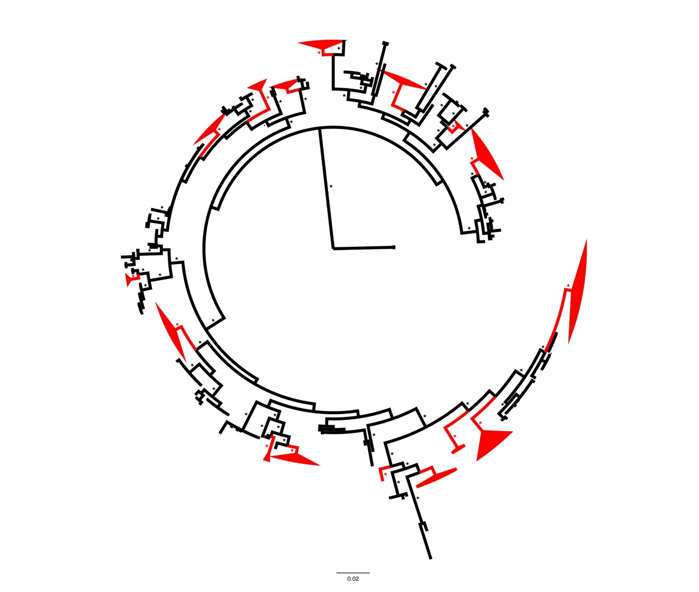
Figure 1. Global BI phylogeny of Hydnum. Species-level clades containing sequences from eastern United States and Canada are colored red. Posterior probabilities ≥0.95 are denoted with asterisks.

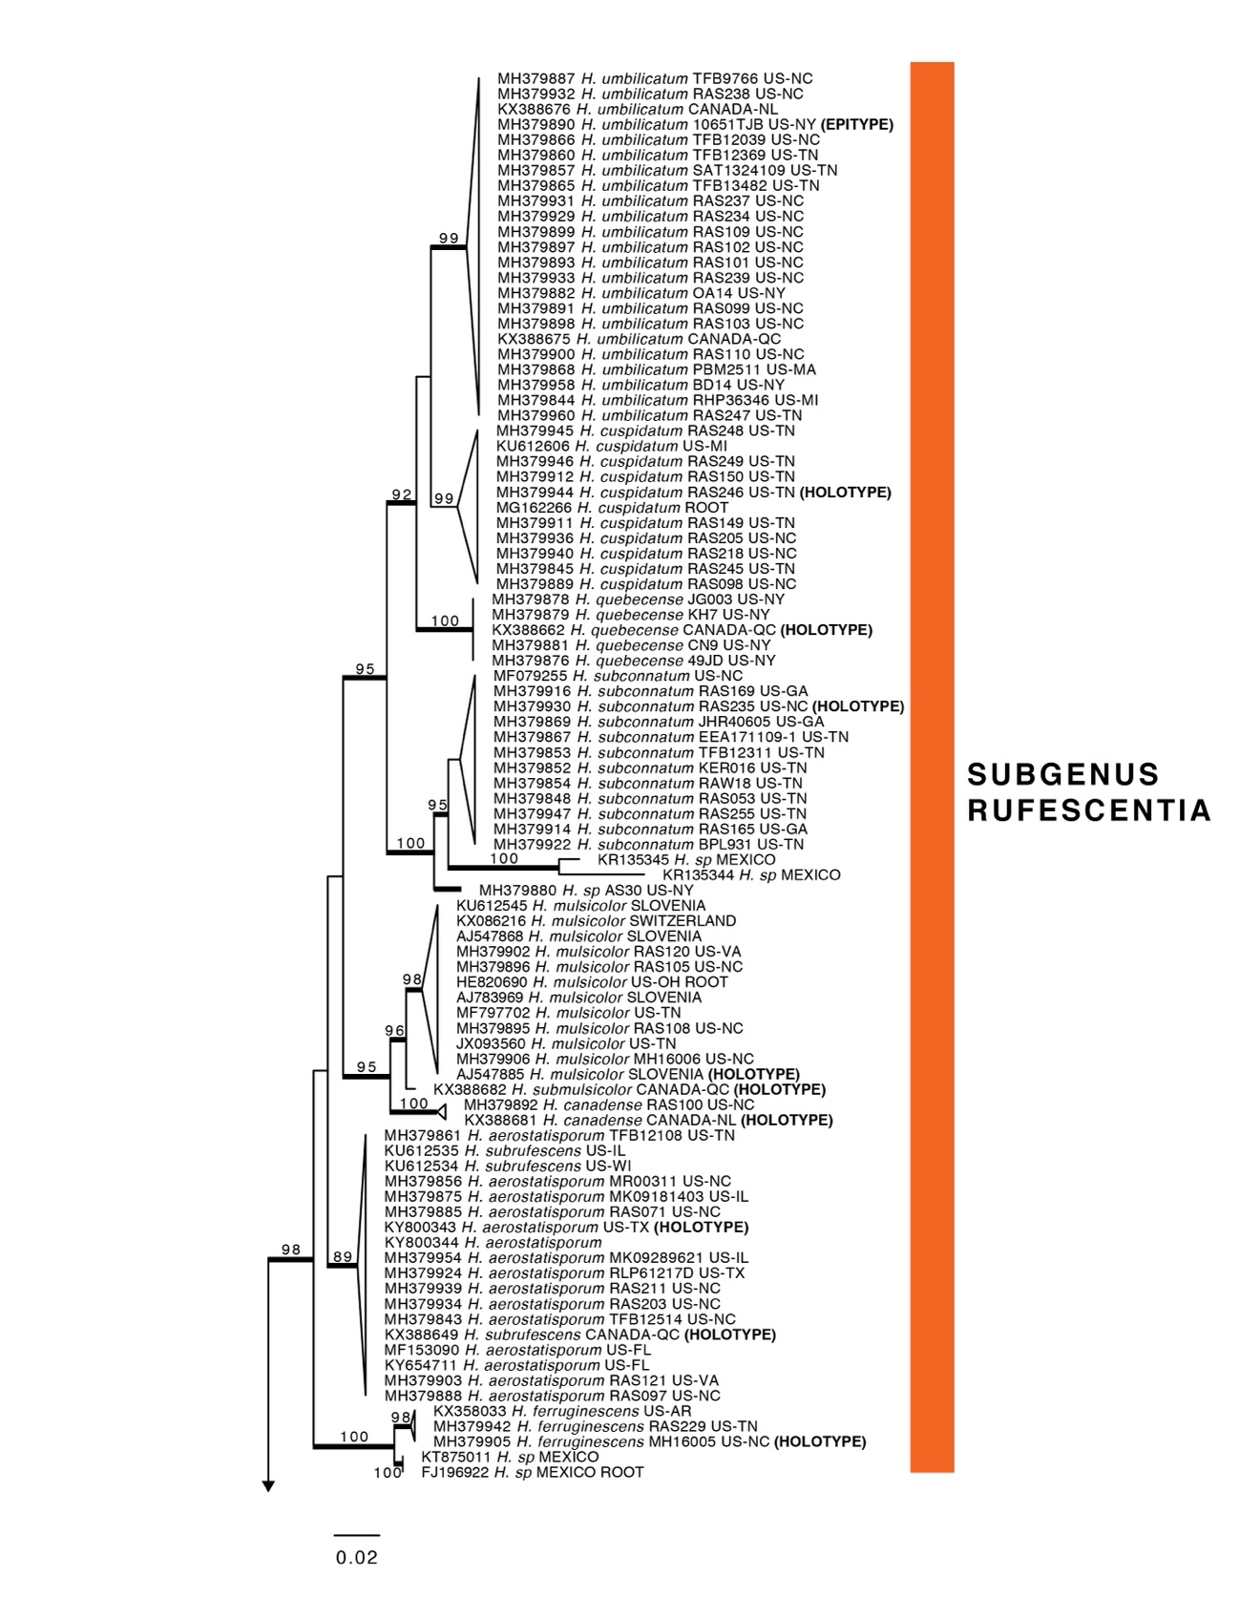
Figure 2. ML pruned phylogeny of North American species of Hydnum. Bootstrap support values ≥70% are shown above branches. Posterior probabilities ≥0.95 are shown with branches in bold.

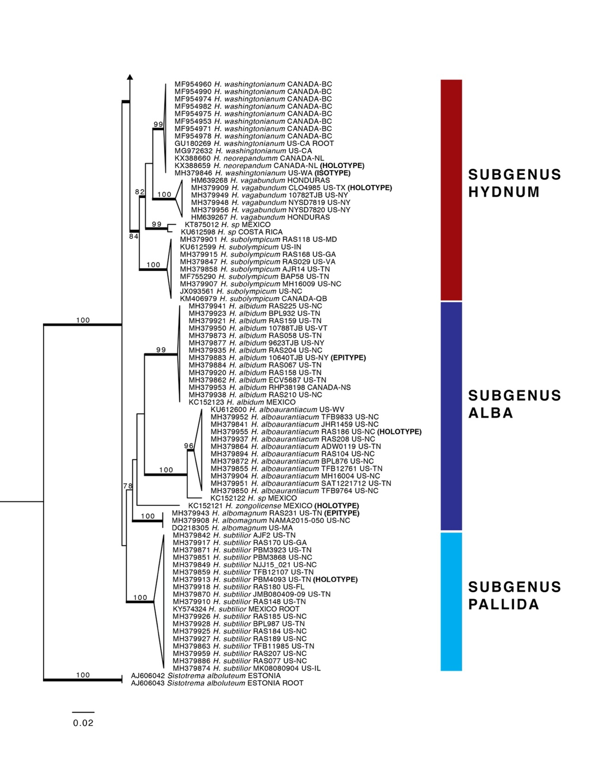
﻿Figure 2. Continued.

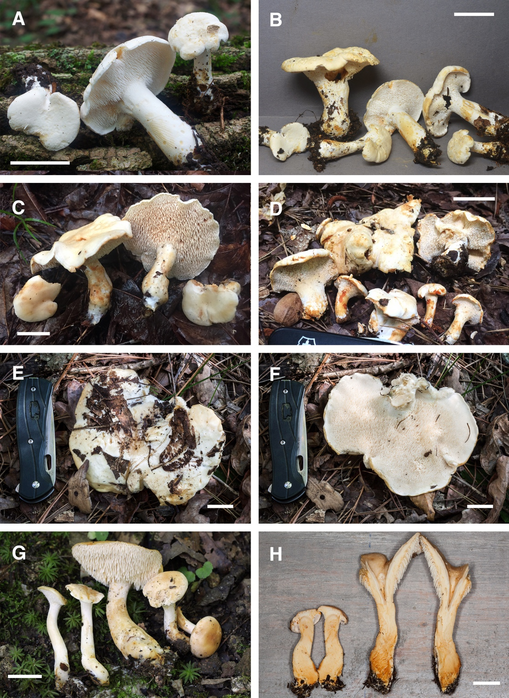
Figure 3. Basidiomes of Hydnum species. A, B H. albidum 10640TJB (CORT 012029, epitype, photo T.J. Baroni) C H. alboaurantiacum RAS186 (TENN 073053, holotype, photo R.A. Swenie) D H. alboaurantiacum BPL876 (TENN 073003, photo B.P. Looney) E, F H. albomagnum RAS231 (TENN 073062, epitype, photo R.A. Swenie) G H. subtilior PBM4093 (TENN 073034, holotype, photo P.B. Matheny) H H. subtilior showing characteristic staining of context RAS180 (TENN 073050, photo R.A. Swenie). Scale bar: 20 mm.

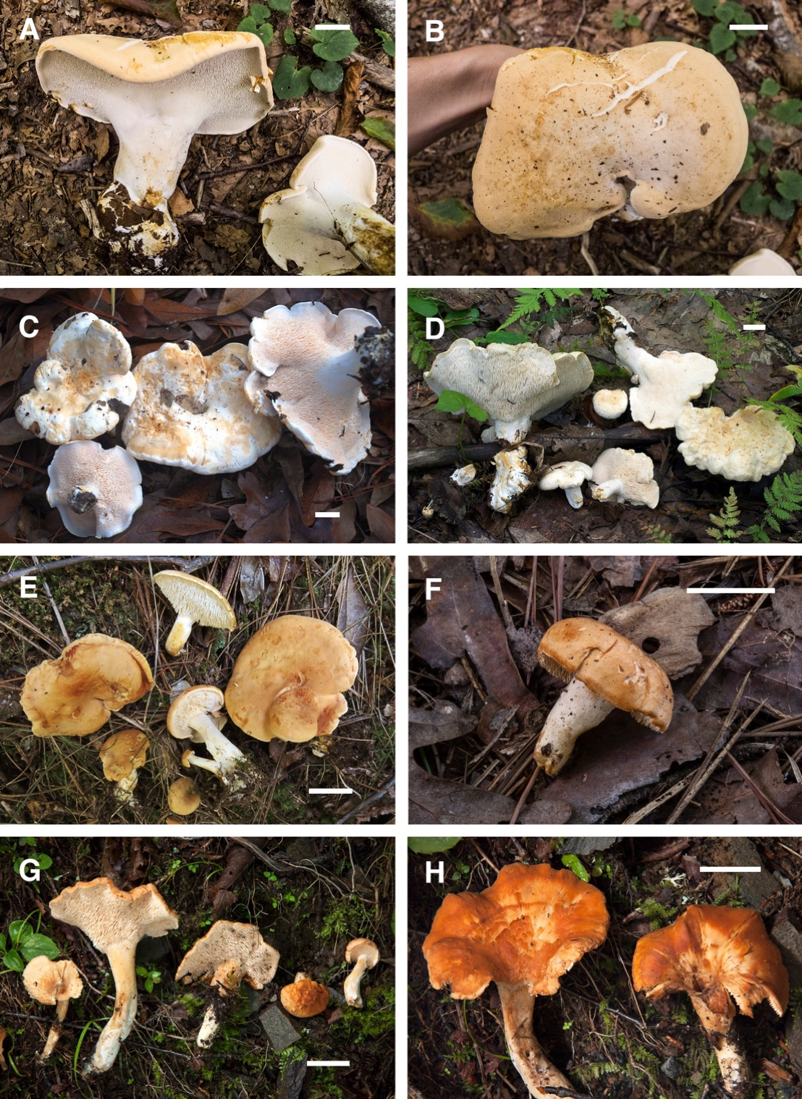
Figure 4. Basidiomes of Hydnum species. A, B H. subolympicum RAS029 (TENN 070845, photo R.A. Swenie) C H. vagabundum CLO4985 (CSU 01477, holotype, photo C.L. Ovrebo) D H. vagabundum 10782TJB (CORT 014461, photo T. J. Baroni) E H. ferruginescens MH16005 (TENN 073549, holotype, photo M. Hopping) F H. ferruginescens RAS229 (TENN 073061, photo R.A. Swenie) G, H H. aerostatisporum RAS071 (TENN 073001, photo R.A. Swenie). Scale bar: 20 mm.

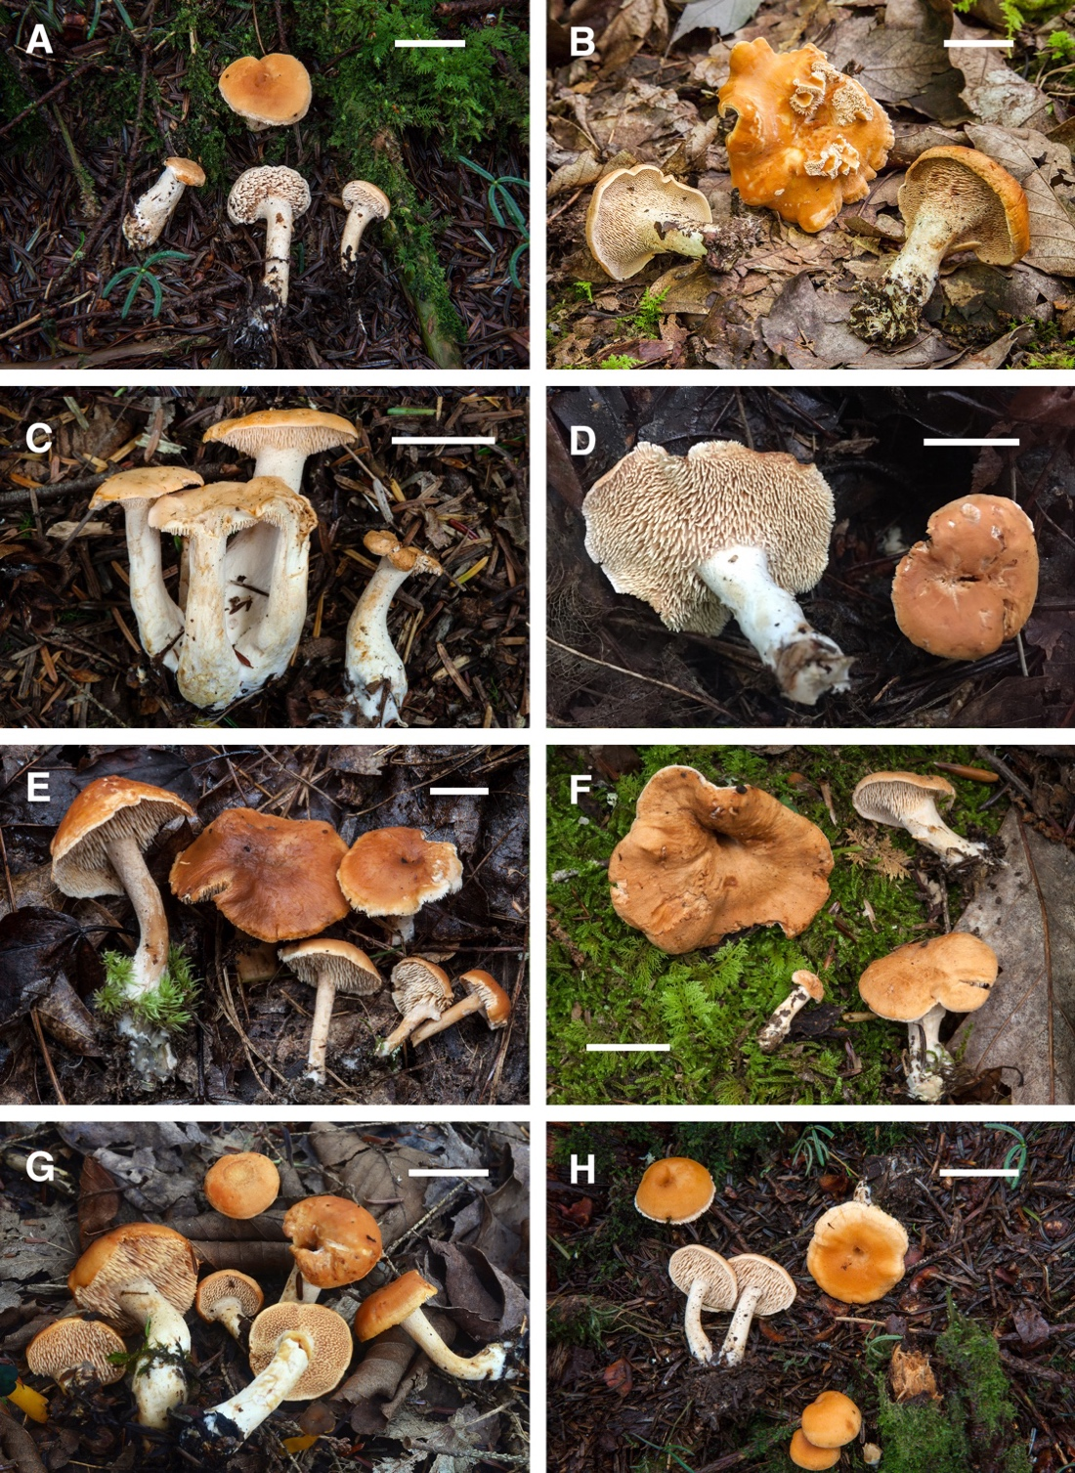
Figure 5. Basidiomes of Hydnum species. A H. canadense RAS100 (TENN 073010) B H. mulsicolor RAS023 (TENN 070321) C H. subconnatum RAS235 (TENN 073064, holotype) D H. subconnatum RAS169 (TENN 073048) E H. cuspidatum RAS246 (TENN 073086, holotype) F H. cuspidatum RAS150 (TENN 073037) G H. umbilicatum 10651TJB (CORT 012241, epitype) H H. umbilicatum RAS101 (TENN 073011). Photos A–F, H by R.A. Swenie; Photo G by T.J. Baroni. Scale bar: 20 mm.

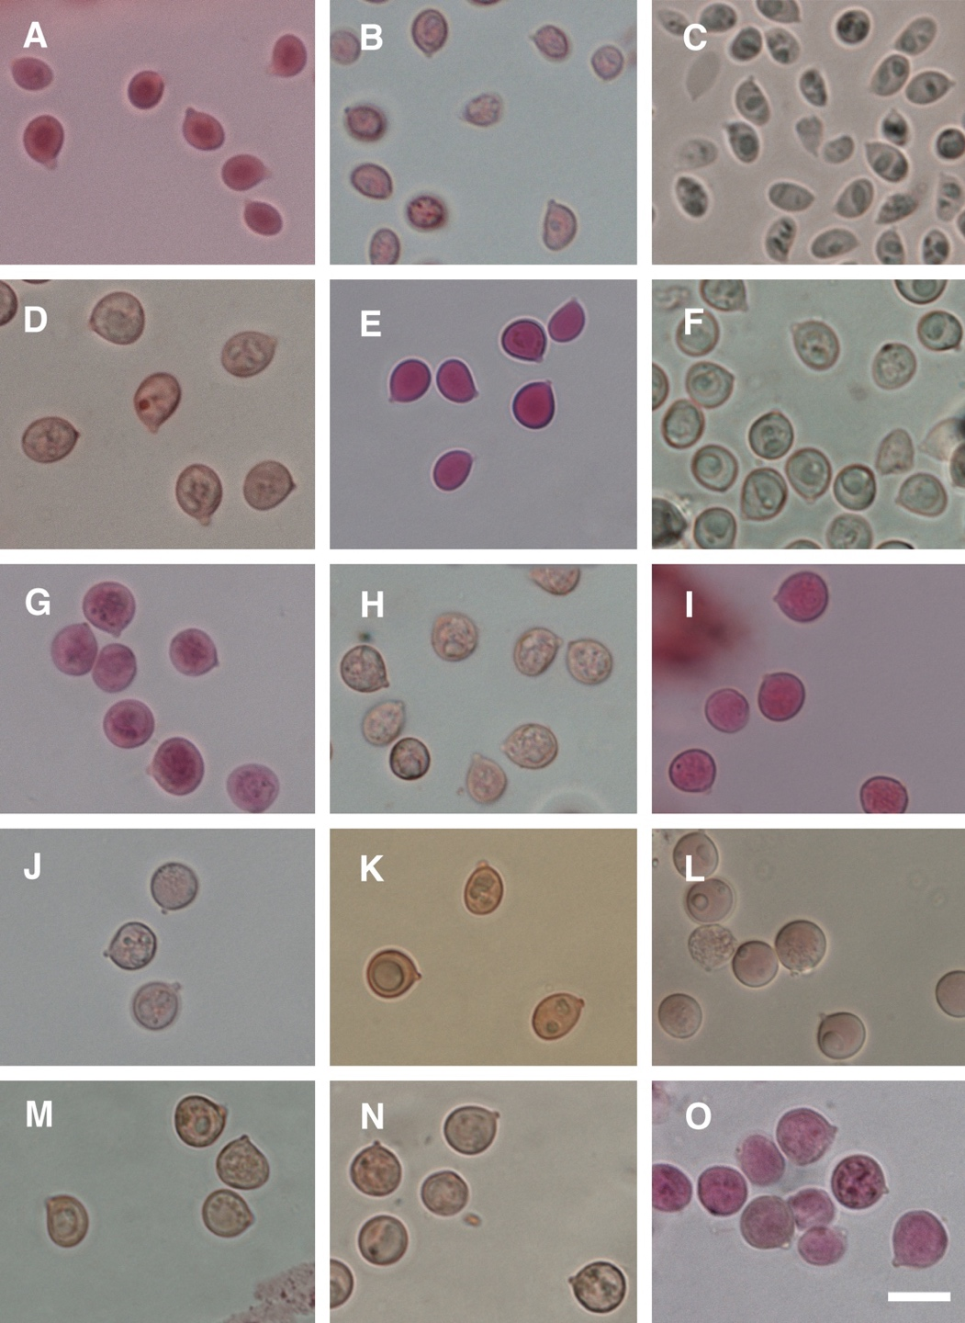
﻿Figure 6. Basidiospores of Hydnum species. A H. albidum 9623TJB (CORT 014489) B H. alboaurantiacum TFB9833 (TENN 058812) C H. albomagnum PBM2512 (TENN 066858) D H. subtilior PBM3868 (TENN 067482) E H. subolympicum AJR14 (TENN 073004) F H. vagabundum 10782TJB (CORT 014461) G H. ferruginescens MH16005 (TENN 073549, holotype) H H. aerostatisporum MK9181403 I H. canadense RAS100 (TENN 073010) J H. mulsicolor MH16006 (TENN 073550) K H. quebecense JG003 (CORT 007330) L H. subconnatum RAS053 (TENN 070846) M H. cuspidatum BPL989 (TENN 073033) N H. umbilicatum 10651TJB (CORT 012241, epitype) O H. umbilicatum Peck (NYS-F-3258, holotype). Scale bar: 10 μm.

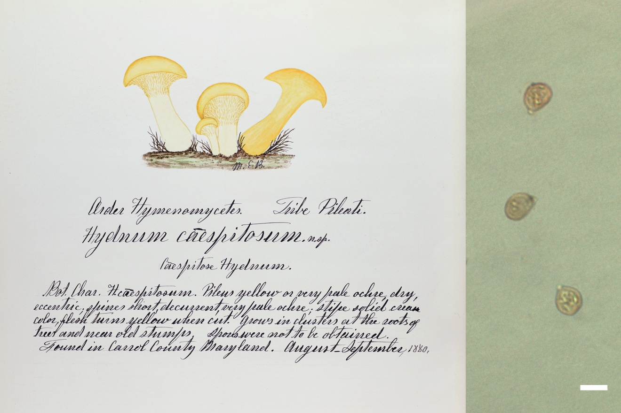
Figure 7. Holotype and basidiospores of Hydnum caespitosum. Scale bar: 5 μm.

Table 1. Specimen data for sequences produced in this study.

Table 1. Continued.

Table 1. Continued.

Table 1. Continued.

CHAPTER II
NEW REPORTS, NEW SPECIES, AND HIGH DIVERSITY OF CANTHARELLUS IN THE SOUTHERN APPALACHIANS
A version of this chapter was originally published by Rachel A. Swenie and P. Brandon Matheny:
Rachel A. Swenie, P. Brandon Matheny. “New reports, new species, and high diversity of Cantharellus in the southern Appalachians.” Mycologia (2023) 115(1):44–68.

R.A.S. and P.B.M. designed the study and conducted field work. R.A.S. conducted laboratory work and phylogenetic analyses. R.A.S. wrote the manuscript and P.B.M. provided manuscript edits.

Abstract
Chanterelles (genus Cantharellus) are among the most popular wild edible mushrooms worldwide. Efforts to understand chanterelle diversity have yielded numerous new species in recent years, particularly in eastern North America. We constructed a multilocus phylogeny including all described temperate species of Cantharellus and newly collected specimens from the eastern United States with an emphasis on southern Appalachia. We describe a new species, Cantharellus vicinus, an oak-associated chanterelle known only from lower-elevation areas in east Tennessee, based on phylogenetic and morphological data. Cantharellus vicinus is characterized by a compact stature, bright yellow hymenophore that turns salmon when mature, white stipe, and pale yellow pileus with a whitish bloom. The southeastern Cantharellus minor f. intensissimus is elevated to species level based on morphological and molecular evidence. The taxon is epitypified due to the sterile state of the holotype and ambiguity concerning application of the name. Evaluation of genetic diversity and gene conflict within Cantharellus camphoratus shows that it is a widespread species with populations in Atlantic Canada, the southeastern United States, and Japan. Similarly, C. cibarius and C. tenuithrix form complexes and may be more geographically widespread than previously thought. Additionally, we report the first known instances of Cantharellus betularum, C. corallinus, and C. altipes from the southern Appalachian Mountains.

Introduction

Chanterelles (genus Cantharellus Adans. ex Fr.) are among the most popular wild edible mushrooms in North America (Redhead et al. 1997) and likely account for over a billion dollars in commercial value each year worldwide (Pilz et al. 2003). For many years, European species of chanterelles such as Cantharellus cibarius Fr. were assumed to occur in North America. Researchers made efforts to distinguish additional North American taxa within C. cibarius, but the lack of diagnostic morphological characteristics made this a difficult task (Buyck and Hofstetter 2011; Petersen 1976, 1979). More recently, DNA sequencing has greatly expanded the number of recognized North American Cantharellus species by uncovering morphologically cryptic species that resemble European taxa but that are molecularly divergent (Arora and Dunham 2008; Buyck and Hofstetter 2011; Dunham et al. 2003). However, other studies have shown that some eastern North American chanterelle species are highly morphologically variable (e.g., C. velutinus Buyck & V. Hofst.), whereas other species are morphologically indistinguishable from related species (i.e., C. lateritius (Berk.) Singer and C. flavolateritius Buyck & V. Hofst.; see Buyck et al. 2016a), which can confound efforts to identify species reliably without sequence data.
At present, 25 Cantharellus species are recognized in eastern North America and four additional species are known from Mexico (Table 2; all Tables and Figures are located in the Appendix). Most of these were described over the past decade based on a combination of DNA sequence analysis and microscopic characteristics. Many species appear to be regional endemics, and previous molecular systematic studies revealed no Cantharellus species that are shared between Europe and southeastern North America (Buyck and Hofstetter 2011; Buyck et al. 2016b). The use of the standard internal transcribed spacer (ITS) fungal DNA barcode is discouraged for Cantharellus due to high levels of heterogeneity and length variation, particularly the ITS1 region, which ranges from 820 to 1100 bp in length (Feibelman et al. 1994). In its place, other gene regions such as the D1–D2 domains of nuc 28S rDNA (28S), a portion of translation elongation factor 1-alpha (tef1), and the most variable region of the second largest subunit of RNA polymerase II (rpb2) have been employed to identify and contribute to species recognition. Due to accelerated rates of molecular evolution at rDNA loci in Cantharellus, Moncalvo et al. (2006) recommended use of rpb2 and other protein- coding genes to resolve phylogenetic relationships among cantharelloid fungi.
Despite these recent advances in Cantharellus taxonomy and systematics, it is not clear how many species occur in the southern Appalachian region encompassing the southern Appalachian Mountains and surrounding areas of eastern Tennessee, western North Carolina, western Virginia, northwest South Carolina, and north- ern Georgia. We collected chanterelles over several field seasons in the eastern United States, with an emphasis on the southern Appalachians, to assess the taxonomic diversity in the region. To test hypotheses about species identities, we compiled the first multilocus phylogeny of all described Cantharellus species from the north temperate zone with molecular data. For clades with strongly supported gene conflict, we employed network analyses to measure genetic distances between closely related species at multiple loci. Network analyses have been used to visualize genetic conflict and delimit species in a variety of fungi from agarics to truffles, rusts, and Cordyceps-like fungi (Aime and McTaggart 2021; Cripps et al. 2019; Gazis et al. 2014; Orihara et al. 2021).
Here, we recognize Cantharellus species based on a combination of differences in morphology, ecology, phylogeny, and network analyses. As a result, we describe a new oak-associated chanterelle species discovered in Tennessee and provide taxonomic notes on additional Cantharellus species, including C. camphoratus R.H. Petersen, C. betularum Voitk & Thorn, C. altipes Buyck & V. Hofst., and C. corallinus Buyck & V. Hofst., reported for the first time from the southern Appalachians. We also recognize C. minor f. intensissimus R.H. Petersen at species rank based on morphological and phylogenetic data and compare this species with its well-known relative C. cinnabarinus (Schwein.) Schwein. Additionally, we discuss genetic diversity within C. cibarius and provide the first report of C. cibarius from eastern North America.

Materials and Methods

Field collection
A total of 45 specimens were collected from localities in Connecticut, New York, North Carolina, South Carolina, Tennessee, and Virginia from 2015 to 2021. Observations of gross morphology and spore prints were obtained from fresh specimens. Color notes were made using Munsell Soil Color Charts (1954, 2009) (i.e., 7.5 YR 4/2). Specimens were preserved using a food dehydrator and accessioned into TENN. Additional specimens were obtained from UWO. Herbarium codes follow Thiers (continuously updated).

Microscopy
Microscopic examinations were per- formed on sections of dried tissues rehydrated in 5% KOH and stained with Congo red (Largent et al. 1977). Measurements and photographs were taken using a Nikon Eclipse 80i microscope (Nikon, Tokyo, Japan), a Nikon DS-Fi1 camera, and Nikon NIS Elements 3.1 software. Basidiospores were measured from spore prints and reported with mean values in italics and measurements in excess of two standard deviations in parentheses. Q-values were calculated as basidiospore length divided by width. The number of spores measured for each species (n) is reported as total number of spores/number of specimens (e.g., n = 20/3).

DNA extraction and sequencing
Tissue samples were collected from specimens for DNA extraction using the Extract-N-Amp Plant kit (Sigma-Aldrich, St. Louis, Missouri). Primers were used in the following combinations to amplify and sequence the 28S, tef1, rpb2, and the second internal transcribed spacer region of nuc rDNA ITS1-5.8S-ITS2 (ITS2), respectively: LR0R/LR5 or LR0R/LR7 using LR5 as an internal sequence primer (Cubeta et al. 1991; Vilgalys and Hester 1990), tef1F/tef1R or 983 F/2218 R (Morehouse et al. 2003; Rehner and Buckley 2005), b6F/b7.1 R (Matheny 2005), and 5.8SR/ITS4 (White et al. 1990). Sequencing was performed on an Applied Biosystems 3730 Genetic Analyzer at the University of Tennessee Genomics Core, and sequence reads were assembled in Sequencher 5.0.1 (Gene Codes, Ann Arbor, Michigan).

Taxon sampling and phylogenetic analyses
Additional Cantharellus sequences for each locus were downloaded from GenBank, including all described species from subgenera Cantharellus, Parvocantharellus Eyssart. & Buyck, and Cinnabarinus Buyck & V. Hofst. These subgenera contain all described species from north temperate areas of the globe. Tropical species C. decolorans Eyssart. & Buyck and C. conspicuus Eyssart., Buyck & Verbeken in subgenus Cinnabarinus were omitted due to highly divergent sequences and long branch lengths. Type sequences were included for each species where available; for species with no available sequences from type material, vouchers with the most gene coverage were chosen to represent each species. All specimens and GenBank accession numbers are listed in Table 3. Sequences were aligned separately for each locus using MUSCLE in AliView 1.27 (Larsson 2014). Minor adjustments were made manually to each alignment, and, where applicable, primers were trimmed from the beginning and ends of sequences.
For phylogenetic analysis, we used partial sequences of 28S, tef1, and rpb2 following other multilocus studies in this genus (Buyck et al. 2013; Olariaga et al. 2017; Zhang et al. 2021). Cantharellus guyanensis Mont. from subgenus Afrocantharellus Buyck. & V. Hofst. was chosen as an outgroup since Afrocantharellus is sister to other subgenera of Cantharellus (Wilson et al. 2012). Four phylogenies were generated: a phylogeny for each separate locus plus a concatenated data set of all three loci after inspection for strongly supported intergene conflicts. Maximum likelihood (ML) analysis was conducted with RAxML 8.2.9 (Stamatakis 2014) with 1000 bootstrap replicates under the model GTR+GAMMA as recommended by the user manual. Bayesian inference (BI) analysis of the multilocus data set was run in MrBayes 3.2.7 (Ronquist et al. 2012) for 25 million generations, sampling trees and parameters every 2500 generations. Data were partitioned into seven subsets using the best-fit partition scheme found by PartitionFinder 2.1 (Lanfear et al. 2017) as follows: tef1 codon 1, GTR+I+G; rpb2 codon 1, GTR+I+G; rpb2 codon 2 and tef1 codon 2, GTR+I+G; rpb2 codon 3 and tef1 codon 3, GTR+G; tef1 intron, K80 +I+G; rpb2 intron, HKY+G; and 28S, GTR+I+G. To visualize the phylogenies, we used FigTree 1.4.4.

Network analysis
Phylogenetic network analysis was conducted to compare sequence divergence among clades with strongly supported gene conflict using SplitsTree 5.0.3 (Huson and Bryant 2006) with the options “NeighborNet” and “Uncorrected P.” The NeighborNet analysis is a distance-based method that represents genetic separation between nodes in the net- work. The split network models ambiguous signals within a data set, wherein parallel edges represent splits between taxa. The lengths of these edges correspond to branch lengths in a phylogenetic tree (Huson and Bryant 2006). For each clade, three networks were constructed, one for each locus (28S, tef1, rpb2).

Taxonomy
A typification section was included for each species with commentary to clarify type specimen details, which may be incomplete in the literature or lacking in associated GenBank accessions. Many GenBank accessions lack type designation status and/or are insufficiently labeled.

Results

A total of 100 new sequences were produced for this study (25 28S, 31 tef1, 40 rpb2, 4 ITS2; Table 3). For the BI analysis, after 10 million generations the standard deviation of split frequencies fell below 0.01; thus, the first 40% of the posterior distribution was discarded as burn-in, for a total of 12,002 trees sampled. Average effective sample size (ESS) values were >4000, and Potential Scale Reduction Factor (PSRF) was 1.0 for each parameter, indicating satisfactory mixing behavior and sampling from the posterior distribution. No strongly supported topological conflicts were found between the ML and BI analyses, and the ML topology is shown in Figure 8. The 28S data set contained 121 taxa and 1355 sites; the tef1 data set contained 120 taxa and 945 sites; the rpb2 data set contained 96 taxa and 1171 sites; and the 28S + tef1 + rpb2 data set (hereafter referred to as the combined data set) contained 152 taxa and 3471 sites.
Sequences of our collections mainly from the southern Appalachians were distributed in 11 different clades (Figure 8): the Cantharellus tenuithrix complex containing C. deceptivus Buyck, Justice & V. Hofst., C. flavus Foltz & T. J. Volk, C. phasmatis Foltz & T.J. Volk, and C. tenuithrix Buyck & V. Hofst.; the C. cibarius complex containing C. cibarius, C. enelensis Voitk et al., and C. roseocanus (Redhead, Norvell & Danell) Redhead, Norvell & Moncalvo; C. velutinus; C. altipes; C. camphoratus; Cantharellus sp. (described as new below); C. betularum; C. persicinus R.H. Petersen; C. flavolateritius; C. minor f. intensissimus R.H. Petersen (elevated to species rank below); and C. corallinus. However, strongly supported gene conflict was detected within the following clades: C. camphoratus, C. cibarius, and C. tenuithrix. The results of phylogenetic and network analyses for each of these clades are discussed separately below.
Specimens of Cantharellus “JPN sp. 2” from Japan differed from North American C. camphoratus by fewer than 1% of base pairs at each locus. The tef1 sequences from Japanese samples closely matched U.S. and Canadian samples (Figure 9). Shared polymorphisms among tef1 sequences showed that the Canadian sample 120922av02 from Newfoundland and Labrador had the highest genetic diversity. This result may be due to shared ancestral polymorphisms, but data from addi- tional loci would be necessary to test this hypothesis, as only 28S and tef1 sequences were available from the Japanese specimens. The results of our network analyses displayed these conflicting results at different loci (Figure 10). Because samples from Canada, USA, and Japan were closely allied at the tef1 and/or rpb2 loci and did not vary in their morphology and ecology, we considered these samples to be different populations of C. camphoratus.
Very low levels of genetic variation (<1%) were observed among specimens of C. cibarius, C. enelensis, and C. roseocanus (Figure 11). Apart from 28S, there was no clear geographic clustering of samples; for example, the tef1 sample RAS895 from New York differed from Canadian C. enelensis (VilneffE5) and German C. cibarius (AFTOL-607) by less than 1% similarity. The rpb2 sequence for RAS859 differed by one base pair from European C. cibarius specimens. The white U.S. cibarius-like specimen, CLC2018-2, differed from C. roseocanus DAOM220723 by a single base pair at the rpb2 locus. Gene histories revealed a similar pattern. Based on these results, C. cibarius appears to be a widespread species across the temperate Northern Hemisphere.
The C. tenuithrix clade included several poorly supported subclades. Most species within this complex lack multilocus sequence data from their holotype specimens. We assigned our field names using morphological species descriptions, but sequence results largely failed to support these morphological concepts. Whereas specimens were largely undifferentiated by 28S data, gene conflict was observed between tef1 and rpb2 gene networks (Figure 12) and phylogenies. Genetic differentiation was detected between European C. pallens and North American samples in the C. tenuithrix complex, and the ML analysis showed weak support for three North American clades: (i) C. deceptivus, (ii) C. tenuithrix, and (iii) C. flavus plus C. phasmatis. We assigned provisional species names to our samples based on their phylogenetic affinity to these taxa.

Taxonomy

Cantharellus subg. Cantharellus

Cantharellus altipes Buyck & V. Hofstetter, Fungal Diversity 49:39. 2011.
Figure 13A–B
Typification: USA. TEXAS: Montgomery County, Conroe (30.3, −95.45), 60 m, in Quercus-Pinus woods, 28 Jul 2007, Buyck 07.112 (holotype PC 0084080).
GenBank: tef1 = GQ914941.
Ecology and distribution: On soil in Quercus-Pinus forests in Gulf Coast states (Texas (type), Louisiana) and in northern hardwood forests with Fagus, Quercus, and Betula in the southern Appalachians (Tennessee, Virginia) at elevations reaching 1200–1300 m. Jul to Dec.
Specimens examined: USA. TENNESSEE: Sevier County, Great Smoky Mountains National Park, Trillium Gap Trail (35.670837, −83.438888), 1332 m, scattered under Betula alleghaniensis, Fagus, and Tsuga, 9 Aug 2020, R.A. Swenie RAS639 (TENN- F-075384); VIRGINIA: Grayson County, Mt. Rogers National Recreation Area, Mt. Rogers Trail (36.65942, −81.54085), 1220 m, scattered under Fagus and Quercus, 14 Aug 2016, R.A. Swenie RAS084 (TENN-F-071461).
Commentary: In addition to Texas oak-pine woods where the species was described, Cantharellus altipes also occurs in northern hardwood forests dominated by Fagus, Betula, and/or Quercus at moderate elevations in the southern Appalachians. Basidiomata of C. altipes generally have stipe lengths exceeding the pileus diameter, but pileus coloration is highly variable ranging from bright yellow to pale brownish yellow with a brown disc (Figure 13A–B). Stipe coloration also varies from pale cream to bright egg yellow, although the hymenophore is consistently pale cream-yellow. The large spore size (7.3–9.4–12 × 4.4–4.9–5.7 μm) combined with brown pileus tones can lead this species to be confused with C. betularum; however, C. altipes has somewhat smaller spores than C. betularum and is found in northern hardwood forests around 1200– 1300 m in elevation in the southern Appalachian Mountains, as opposed to C. betularum, which has spores averaging 10.4 × 5.6 μm and is known from high-elevation birch-spruce-fir habitat at 1800 m elevation.
There has been some confusion about the holotype designation for C. altipes. Collection BB 07.112, denoted as the holotype in the protolog, is represented only by a tef1 sequence (GQ914941). However, Buyck et al. (2013) later referred to BB 07.019 as the holotype of C. altipes. BB 07.019 is represented by 28S, tef1, and rpb2 sequences, and the tef1 sequence matches that of BB 07.112. Phylogenetic analysis showed that our specimens form a clade with the holotypes of C. altipes and C. septentrionalis A.H. Sm. Buyck et al. (2016b) discussed the possibility that these two taxa are synonymous. The binomial C. septentrionalis, which is the older name, has not been widely applied, and the holotype is represented by 28S sequence data only preventing a more thorough phylogenetic comparison between the two species. However, given what we know from contemporary collections of C. altipes, the phylogenetic affinity to C. septentrionalis, and variable macromorphology of C. altipes (Buyck and Hofstetter 2011; Figure 13A–B), sug- gests that the two species may indeed be synonymous. Additional sequence data from the type or collections from the type locality of C. septentrionalis in Michigan would help confirm or refute this.

Cantharellus betularum Voitk & Thorn, Persoonia 45:331. 2020.
Figure 13C
Typification: CANADA. NEWFOUNDLAND AND LABRADOR: Humber Village, trail to Barry’s Lookout (48.988, −057.792), 159 m, in leaf litter under Betula papyrifera, B. cordifolia, and B. alleghaniensis, 14 Sep 2013, Andrus Voitk 13.09.14.av01 (holotype DAOM 721702; isotype DAOM 734027). GenBank: 28S = KX592700.
Ecology and distribution: On soil under Betula, southeast Canada (type) and at high elevation (1800 m) in the southern Appalachians (North Carolina). Jul to Sep.
Specimens examined: CANADA. NEWFOUNDLAND AND LABRADOR: Humber Village, trail to Barry’s Lookout (48.988, −057.792), 159 m, in leaf litter under Betula papyrifera, B. cordifolia, and B. alleghaniensis, 24 Aug 2008, A. Voitk 11.08.12.av01 (DAOM 734022); ibid., 24 Aug 2008, M. Voitk 17.09.30.av01 (DAOM 984767). USA. NORTH CAROLINA: Swain County, Great Smoky Mountains National Park, Appalachian Trail (35.67990, −83.27344), 1800 m, scattered under Betula alleghaniensis, Abies fraseri, and Picea rubens, 25 Jul 2020, R.A. Swenie RAS631 (TENN-F-075393).
Commentary: Cantharellus betularum is a recently described North American species closely related to the European C. amethysteus (Quél.) Sacc. We collected C. betularum from a high-elevation (1768 m) spruce-fir-birch forest in the Great Smoky Mountains National Park in North Carolina and confirmed the identification using multiple loci (28S, tef1, rpb2). In addition, we generated rpb2 sequences from Canadian specimens cited in Thorn et al. (2020). Although rpb2 and tef1 sequences of C. betularum closely match Italian collections of C. amethysteus (99% sequence similarity), the two species form monophyletic sister clades strongly supported by the multilocus ML analysis. Thorn et al. (2020) reported that, unlike C. amethysteus, basidiomata of C. betularum do not always have violet scales on the pileus, and although the pileus of the young basidiomata we collected were minutely scaly and yellow-brown, no violet tones were noted. When young, C. betularum resembles C. camphoratus, a similarly brown-capped species that also occurs in high-elevation spruce-fir forests in the southern Appalachians. However, the spores of C. betularum are consistently larger than those of C. camphoratus, averaging 10.2 × 6.1 μm in C. betularum versus 9.1 × 5.2 μm in C. camphoratus based on measurements of sequenced specimens. Furthermore, C. betularum is found under Betula, whereas C. camphoratus occurs under Abies and Picea (Thorn et al. 2017). Another brownish to lilac-colored species, C. lewisii Buyck & V. Hofst., has much smaller spores and occurs in floodplain hardwood forests typically in Gulf Coast states. In our experience, C. betularum most closely resembles C. altipes in the field since C. altipes can occur in forests mixed with Betula and has brown tones at the center of the pileus. However, in the southeast, C. altipes is only known from northern hardwood habitat below 1400 m in elevation, and not the high-elevation spruce-fir-birch habitat at 1800 m where C. betularum was found. Additionally, C. betularum can be distinguished from C. altipes by the larger spore size (C. betularum: (7.7)8.7–10.4–14.3 × (3.9)4.6–5.6–7.1(7.7) μm; C. altipes: 7.3–9.4–12 × 4.4–4.9–5.7 μm). Thorn et al. (2020) also noted that C. betularum has distinctly shallow, blunted hymenial folds, which may be a useful identifying feature in the field. Still, genetic confirmation may be necessary to reliably distinguish C. betularum from other species.

Cantharellus camphoratus R.H. Petersen [as ‘comphoratus’], Nova Hedwigia 31:3. 1979.
Figure 13D–E
Typification: CANADA. NOVA SCOTIA: Kings County, Cape Split, Scots Bay (45.32, −64.45), 75 m, Picea and Abies with occasional Betula, only occasional parklands, mostly foggy and continually wet, 29 Aug 1973, R.H. Petersen (holotype TENN-F-038025 [!]). GenBank: 28S = KX896788.
Ecology and distribution: On acidic soils in coniferous woods under Abies and Picea or these trees mixed with Tsuga and Betula. Canada (holotype, Nova Scotia; Newfoundland and Labrador), northeastern United States (New York), southeastern United States (North Carolina), also Japan (Nagano, Gifu). Jul to Sep.
Specimens examined: USA. NEW YORK: Essex County, Northville Placid Trail (43.24733, −74.3118), 425 m, on acidic soil under Picea and Abies, 14 Aug 2021, R.A. Swenie RAS913 (TENN-F-075907); NORTH CAROLINA: Yancey County, Mount Mitchell State Park, Old Mitchell Trail (35.75143, −82.27356), 1890 m, scattered on acidic soil under Abies fraseri, Picea rubens, and Tsuga canadensis, 12 Jul 2019, P.B. Matheny PBM4274 (TENN-F-074836); ibid., 17 Jul 2020, R.A. Swenie RAS614 (TENN-F-075387); ibid., 21 Aug 2020, R.A. Swenie RAS659 (TENN-F-075388) and RAS661 (TENN-F-075389); ibid., 19 Sep 2020, P.B. Matheny PBM4501 (TENN-F-075373). CANADA. NEWFOUNDLAND AND LABRADOR: Newfoundland, Pasadena Ski Trails (48.996, −57.586), 90 m, on soil in mixed forest (Abies balsamea, Betula, Picea), 3 Sep 2012, A. Voitk 12.09.03.av17 (DAOM 734036); Newfoundland, Deer Lake (49.17, −57.43), 26 m, 13 Sep 2018, M. Voitk 18.09.13.av07 (UWO).
Commentary: Cantharellus camphoratus, originally described from Nova Scotia, has now been confirmed from the Adirondack Mountains in New York and high- elevation conifer forests in North Carolina. However, all basidiomata lacked the camphor odor and scaly pileus originally attributed to C. camphoratus (Petersen 1979). Petersen (1979) noted that a similar taxon without the camphor odor and scaly pileus also occurred in the southern Appalachians.
The tef1 sequences from U.S. collections most closely matched specimens from coniferous forests in Japan (3 bp differences; Figures 9, 10B). However, 28S and rpb2 sequences of our specimens closely matched the holotype and recent collections of C. camphoratus from Newfoundland and Labrador (Figures 10A, C). We hypothesize that Newfoundland (island), samples of which contain the greatest genetic diversity at the tef1 locus (Figure 9), may represent a refugium. Atlantic Canada is thought to have been a glacial refugium for some plant species (Brassard 1984; Tremblay and Schoen 1999). Cantharellus camphoratus features multiple tef1 alleles, from which the southeastern U.S. and Japanese populations may be derived, and that the variable gene history of the tef1 locus relative to 28S and rpb2 may be due to incomplete lineage sorting. If so, C. camphoratus has a wider disjunct range than most other chanterelle species in eastern North America. We recognize the Japanese specimens (“JPN2”/“sp. 2” in Ogawa et al. 2018) within C. camphoratus due to very low 28S and tef1 sequence divergence (<1%) from North American populations of C. camphoratus and due to similar ecology and morphology including spore size. Comparison of rpb2 sequences from Japanese specimens of C. camphoratus is needed to confirm this relationship. Further sampling of the western North American C. formosus Corner is also desirable to clarify its relationship to C. camphoratus. Results of the multigene analysis (Figure 8A) and tef1 phylogeny supported C. formosus as sister to C. camphoratus.
In contrast to the protologue, Thorn et al. (2017) noted that contemporary collections of C. camphoratus from Newfoundland and Labrador lacked the camphor odor and sometimes lacked scales on the pileus. However, two reliable field characteristics for C. camphoratus include the shallow blunt folds that may be merulioid when young and the golden pileus margin, both of which Petersen originally noted. In the field, C. camphoratus could be mistaken for C. betularum, which also has a brownish pileus and occurs in the southern Appalachian spruce-fir zone but associates with Betula alleghaniensis. The often merulioid hymenophore of C. camphoratus has also been noted in C. enelensis.
Our collections from North Carolina and New York are the first confirmed reports of C. camphoratus from the United States. In the southern Appalachians and in the Adirondacks, the species appears to prefer acidic soils under Picea and Abies.

Cantharellus cibarius Fr. complex
Figure 13F–G
Typification (Cantharellus cibarius): Bulliard, Herb.
France 2:pl. 62, 1781–1782, lectotype (icon.) designated by Eyssartier and Buyck (2000). SWEDEN. UPPLAND: Uppsala, Nåsten, under Picea abies, with Betula and Pinus, on acidic ground, 23 Jul 2005, A. Felipe & I. Olariaga (epitype BIO-Fungi 10986; isoepitype UPS F-575623). GenBank: ITS2 = KR677501; 28S = KR677539; tef1 = KX828823; rpb2 = KX828742.
Typification (Cantharellus roseocanus): CANADA. BRITISH COLUMBIA: Vancouver Island, Pacific Rim National Park, Wickaninnish Bay, Long Beach (49.05, −125.716667), 45 m, solitary to gregarious, often in small clusters, on bare or mossy or grassy needle beds in second-growth Picea stichensis without other tree associates or under Picea with Tsuga and/or Abies, 15 Sep 1995, S.A. Redhead (holotype DAOM 220723). GenBank: 28S = KX828810; tef1 = KX828837; rpb2 = KX828758.
Typification (Cantharellus enelensis): CANADA. NEWFOUNDLAND AND LABRADOR: Sandy Point (48.449269, −58.521503), 0.4 m, in moss or fruticose lichens on moist sandy soil under Picea glauca, 21 Aug 2013, Urve Voitk 13.08.21.av02 (holotype DAOM 721704; isotype DAOM 734041), GenBank: 28S = KX592712. USA. NEW YORK: Essex, Lake Pleasant, Northville Lake Placid Trail (43.73848, −74.46371), 640 m, on soil under Picea and Abies, 14 Aug 2021, R. A. Swenie RAS913 (TENN-F-075907).
Specimen examined (Cantharellus cibarius): USA. CONNECTICUT: Litchfield, Torrington (41.8, −73.1), 165 m, white color variant among yellow forms in mixed woods under Betula and Tsuga, 16 Aug 2018, C. LaChance CLC2018-2 (TENN-F-076274).
Commentary: In the past, most yellow chanterelle species in North America were referred to as C. cibarius before it was suggested, based on genetic analyses, that true C. cibarius did not occur in North America (Buyck and Hofstetter 2011). Indeed, both C. roseocanus and C. enelensis have been referred to as the western and eastern North American “cibarius,” respectively (Redhead 2012; Thorn et al. 2017). More recently, C. cibarius has been reported from Japan and northeast China (Ogawa et al. 2018; Shao et al. 2021). We have yet to observe C. cibarius in the southern Appalachians; however, two specimens collected from the northeastern United States (Connecticut and New York) clustered with European C. cibarius within a strongly supported monophyletic group with minimal genetic differentiation (Figure 8A). Our 28S phylogeny distinguished two groups within the C. cibarius clade: (i) European specimens including the epitype and (ii) North American species C. enelensis and C. roseocanus, although the latter clade was not well supported. One specimen from New York (RAS859) was allied with other North American species in that phylogeny. We provisionally interpreted RAS859 and AFTOL-607 from Germany as C. enelensis. The tef1 tree and network analysis (Figure 11B), however, showed that samples from Europe, Asia, and North America are poorly differentiated. Intergene conflicts were observed between the tef1 and rpb2 phylogenies and network analyses (SUPPLEMENTARY FIG. 3; FIG. 4C). Divergent gene histories could potentially be explained by low levels of ongoing gene flow among these populations. Alternatively, C. cibarius and C. enelensis may each be more widespread than previously thought with populations in both Europe and northern North America.
Olariaga et al. (2015, 2017) noted that basidiome color of C. cibarius is highly variable; a “typical” specimen has “an orange-yellow pileus, uniform-colored hymenophore and absence of marked staining upon bruising,” but entirely orange, entirely white, citrine yellow, or pink-coated specimens occasionally occur. Our specimen CLC2018-2, a white chanterelle growing among yellow specimens presumed to be the same species (Figure 13G), matches this concept of a highly variable C. cibarius. Such variation in basidiome color was also identified in the eastern North American counterpart to C. cibarius: Thorn et al. (2021) described C. enelensis f. acolodorus, an albino variant lacking the β-carotene responsible for the golden color of the typical yellow form of C. enelensis. Our phylogenetic analyses showed low genetic divergence and conflicting phylogenetic affinities among samples of C. cibarius, C. roseocanus, and C. enelensis. Therefore, we refer to these species as members of the C. cibarius complex, emphasizing a need for additional multilocus sampling from a broad geographic range to assess the extent of this iconic species. It is not clear from current data whether C. cibarius is a single widely distributed species, or whether the three currently described species in this complex can be reliably distinguished from one another with denser multilocus sampling.

Cantharellus flavolateritius Buyck & V. Hofst., Cryptog Mycol 37:372. 2016.
Figure 13H–I
Typification: USA. NORTH CAROLINA: Macon County, Highlands, south of Highlands Biological Station along Walking Stick Road (35.008283, −83.161300), 770 m, growing on side of dirt road, 21 Jun 2011, Jay Justice NC Canth-4 (holotype PC
0713852). GenBank: tef1 = KX857029.
Ecology and distribution: On soil in mixed woods including Pinus, Tsuga, Fagus, Carya, and Quercus, North Carolina (type), also Tennessee and Arkansas. May to Aug.
Specimens examined: USA. TENNESSEE: Blount County, Great Smoky Mountains National Park, Cades Cove near Elijah Oliver Place (35.602, −83.813), 366 m, on soil in mixed woods under Pinus and Tsuga, 7 Jul 2019, R.A. Swenie RAS463 (TENN-F-074947); Abrams Creek, Little Bottoms Trail (35.611, −83.923), 436 m, on soil under Pinus and hardwoods, 9 Jul 2020, R. A. Swenie RAS588 (TENN-F-076283); Abrams Creek, Little Bottoms Trail (35.613, −83.924), 436 m, on soil in mixed woods, 9 Jul 2020, R.A. Swenie RAS590 (TENN-F-075271); Cumberland County, Ozone Falls State Natural Area (35.88, −84.81), 610 m, 5 Aug 2019, A. Aromin RAS474 (TENN-F-074952); Union County, Big Ridge State Park, Lake Trail (36.2431, −83.9285), 335 m, on soil under Fagus, Carya, Quercus, and Pinus virginiana, 4 Jul 2019, P.B. Matheny PBM4264 (TENN- F-074817).
Commentary: Cantharellus flavolateritius was described recently from the southern Appalachians as an addition to a group of “smooth chanterelles.” Our sampling efforts suggest that this is a common species in oak-pine and oak-hickory forests of Tennessee and North Carolina but with a variable gross morphology. Basidiomata have a hymenophore that may be completely smooth or with shallow wrinkled folds and with hymenophore colors ranging from bright orange to yellow or nearly white. Similar variation is seen in the pileus color and texture ranging from orange to yellow and glabrous to velutinous or tomentose as in C. velutinus (e.g., PBM4264). However, C. velutinus has more distinctly and consistently lamellate folds, as well as a thicker pileus margin.
Cantharellus flavolateritius formed a strongly supported clade in our ML analysis but was poorly supported in the BI analysis (Figure 8A). Within-species sequence variation was largely confined to the 28S locus. Cantharellus lateritius is a closely related species, also described from North Carolina and recently epitypified from Texas (Buyck and Hofstetter 2011). According to Buyck et al. (2016a), C. lateritius is not morphologically distinguishable from C. flavolateritius, and the authors separated the two taxa based on tef1 divergence. Despite the availability of multilocus sequence data generated from the epitype of C. lateritius, we have not confirmed any collections of C. lateritius from the southern Appalachians. Based on our multilocus phylogeny (Figure 8A), C. lateritius and C. flavolateritius formed a poorly supported monophyletic group most closely related to two oak-associated chanterelle species described from Mexico with a smooth to rugulose hymenophore, C. furcatus Bandala, Montoya & Ramos and C. veraecrucis Bandala, Montoya & M. Herrera (Montoya et al. 2021).

Cantharellus persicinus R.H. Petersen, Nova Hedwigia 42:158. 1986.
Figure 14A
= Cantharellus spectaculus Foltz & T.J. Volk, Mycologia 105:458. 2013.
Typification (C. persicinus): USA. TENNESSEE: Blount County, Great Smoky Mountains National Park, Cades Cove, vicinity of picnic area (35.605556, −83.770556), 594 m, 12 Aug 1975, R.H. Petersen (holotype TENN-F-026086).
Typification (C. spectaculus): USA. WISCONSIN: La Crosse County, Hixon Forest Park, along the path parallel to Bliss Road, approximately halfway up the path on right side, associated with Quercus in Quercus-Carya mixed deciduous forest (43.8157, −91.2091), 250 m, 18 Jul 2010, Foltz C081, Collection CS001 (holotype C0171590F). GenBank: 28S = JX030421; tef1 = JX030414.
Ecology and distribution: Widely distributed in eastern North America (sequenced specimens from Wisconsin (type of C. spectaculus), Missouri, Tennessee (type of C. persicinus), North Carolina), on karst topography in oak-hickory forests with Quercus, Carya, and Fagus and in mixed forests on acidic soils. Jun to Sep.
Specimens examined: USA. TENNESSEE: Anderson County, Norris Dam State Park (36.24, −84.12), 400 m, scattered singly deep in leaf litter on soil on karst topography in hardwood forest of Quercus, Fagus, and Carya, 28 Jul 2013, P.B. Matheny PBM3933 (TENN- F-068446); Blount County, Great Smoky Mountains National Park, Schoolhouse Gap Trail (35.62696, −83.72645), 518 m, on soil in mixed woods, 17 Jul 2019, R.A Swenie RAS468 (TENN-F-075071); NORTH CAROLINA: Haywood County, Great Smoky Mountains National Park, Big Creek, Chestnut Branch Trail (35.7595, −83.1068), 500 m, in leaf litter on acidic soil under mixture of Pinus, Tsuga, Quercus, Betula, and Fagus, 16 Jul 2015, S.A. Trudell SAT1519702 (TENN- F-070322); Franklin County, Nantahala National Forest, Appalachian Trail above Rock Gap (35.093789, −83.522476), 1130 m, gregarious on acid soil in mixed forest with Tsuga, Quercus, Fagus, and Rhododendron, 30 Jul 2021, R.A. Swenie RAS841 (TENN-F-075884).
Commentary: Cantharellus persicinus can be recognized in the field due to the pink lamellar folds and slender habit. This species has a contrasting ochraceous buff to yellow-orange pileus that distinguishes it from pink forms of C. velutinus, which feature a peach-pink colored pileus and pink folds. The stipe is usually longer and thinner than other chanterelle species and is often buried in deep layers of leaf litter. These features, plus the very large spore size (9.5–12(14) × 5–7 μm) and 4-spored basidia, distinguish C. persicinus readily (Buyck et al. 2016c; Foltz et al. 2013; Petersen 1986). Buyck et al. (2016c) noted C. spectaculus is a later synonym of C. persicinus, a result reinforced by our phylogenetic analysis (Figure 8A). Thus, C. persicinus has a wide range in the eastern United States from Wisconsin south to Missouri and eastward to Tennessee and North Carolina.

Cantharellus tenuithrix Buyck & V. Hofst. complex
Figure 14B–C
Typification (Cantharellus tenuithrix): USA. TEXAS: Newton County, Sandridge, Country Road 4045 near Lewis’ Chapel (30.73, −93.766), 35 m, Pinus-Quercus woods on sandy soil, 28 Jul 2007, Buyck 07.125 (holotype PC 0084084). GenBank: ITS = JN944017; 28S = JN940600; tef1 = GQ914947; rpb2 = KF294712.
Typification (Cantharellus flavus): USA. WISCONSIN: La Crosse County, Hixon Forest Park, along the path running parallel to Bliss Road, approxi- mately halfway up the path when heading uphill, on right side (43.8157, −91.2091), 250 m, associated with Quercus in Quercus-Carya mixed deciduous forest, 18 Jul 2011, Foltz C066, Collection CF001 (holotype C0171585F). GenBank: 28S = JX030437.
Typification (Cantharellus phasmatis): USA. WISCONSIN: La Crosse County, Hixon Forest Park, along the path running parallel to Bliss Road (43.8157, −91.2091), 250 m, associated with Quercus in Quercus- Carya mixed deciduous forest, 18 Jul 2010, Foltz C073, Collection CP002 (holotype C0171588F). GenBank: 28S = JX030426.
Typification (Cantharellus deceptivus): USA. WISCONSIN: Vilas County, Lost Lake (45.96, −89.477), 488 m, under hardwood trees including Betula papyrifera and Populus grandidentata), 24 Jul 2010, 1074/Jay Justice JJ13/WI-CANT-1 (holotype PC 0142430). GenBank: 28 = KX896779; tef1 = KX857026.
Ecology and distribution: Widely distributed in east- ern North America (sequenced specimens from Wisconsin (types of C. deceptivus, C. flavus, and C. phasmatis), Missouri, North Carolina), Tennessee, Texas (type of C. tenuithrix), on karst topography and acidic soils in deciduous, coniferous, or mixed woods with Quercus, Pinus, Tsuga, Carya, Fagus, Betula, and Populus. Jun to Aug.
Specimens examined (Cantharellus deceptivus): USA. TENNESSEE: Sevier County, Great Smoky Mountains National Park, Elkmont, Little River Trail (35.6535, −83.579), 662 m, on soil in mixed woods, 3 Jun 2016, R.A. Swenie RAS056 (TENN-F-071459); NORTH CAROLINA: Swain County, Great Smoky Mountains National Park, Cherokee, Straight Fork Road (35.624, −83.2113), 610 m, on soil embankment in mixed woods with Tsuga and Quercus, 7 Jul 2019, R.A. Swenie RAS447 (TENN-F-074943).
Specimens examined (Cantharellus flavus): USA. TENNESSEE: Blount County, Great Smoky Mountains National Park, Cades Cove, Gregory Ridge Trail (35.561389, −83.844167), 610 m, on soil under Pinus rigida with Tsuga nearby, 17 Jul 2019, R.A. Swenie RAS464 (TENN-F-074949); near Tipton Place (35.601944, −83.813611), 366 m, on soil in mixed woods under conifers (Pinus, Tsuga), 3 Aug 2019, R.A. Swenie RAS473 (TENN-F-074951); Sevier County, Great Smoky Mountains National Park, Elkmont, first left off Elkmont Road by mulch pile (35.6638, −83.5889), 650 m, 2 Aug 2012, M.G. Wood MGW1115 (TENN- F-067243).
Specimens examined (Cantharellus tenuithrix): USA. NORTH CAROLINA: Monroe County, Cherokee National Forest, Wildcat Road (35.30823, −84.23233), 639 m, on soil on xeric ridge under Pinus, 5 Jul 2020, R. A. Swenie RAS584 (TENN-F-075272); TENNESSEE: Blount County, Great Smoky Mountains National Park, Cades Cove, Primitive Baptist Church (35.6020315, −83.8135083), 518 m, on soil in leaf litter under Pinus, Tsuga, and Quercus, 17 Jul 2019, P.B. Matheny PBM4292 (TENN-F-074854); Union County, Big Ridge State Park, Lake Trail (36.2431, −83.9285), 335 m, on soil under Fagus, Carya, Quercus, and Pinus virginiana, 4 Jul 2019, P.B. Matheny PBM4268 (TENN- F-074821).
Commentary: Four very closely related eastern North American species formed a strongly supported monophyletic group sister to European Cantharellus pallens (Figure 8A). The group contains C. deceptivus, C. flavus, C. phasmatis, and C. tenuithrix, all of which were described recently. However, topological placement of each species conflicted across individual gene phylogenies. Each of the North American species was separated by previous researchers based on morphology and genetic differences among ITS, 28S, and/or tef1 sequences (Buyck et al. 2016c; Foltz et al. 2013). However, based on our observations, the four species cannot be distinguished from one another reliably considering their ecology and morphology in the southern Appalachians. Cantharellus flavus, C. phasmatis, and C. deceptivus were all described from deciduous forests and C. tenuithrix from oak-pine forests. We failed to find any clear habitat preferences among the North American species. All were collected at lower elevations in the southern Appalachians below 700 m in coniferous or mixed conifer-hardwood forests on acidic soils and areas with karst topography. Efforts to distinguish the species based on morphology proved to be confounding. Hymenophore colors ranged from white to peach to yellow, sometimes within a single collection, and did not consistently correlate with different species in the complex.
Cantharellus pallens formed a distinct clade sister to the North American species in the multilocus phylogeny (Figure 8A). Phylogenetic and network analyses showed that European C. pallens is not distinguishable from members of the C. tenuithrix complex except at the rpb2 locus (Figure 12). However, since C. pallens formed a phylogenetic clade that does not contain any North American specimens, we considered C. pallens autonomous from the North American C. tenuithrix complex.
Cantharellus tenuithrix was originally described from Texas as the eastern North American sister taxon of C. cibarius, distinguishable by tef1 sequences and morphology (Buyck and Hofstetter 2011). The other three taxa in the tenuithrix complex, C. flavus, C. phasmatis, and C. deceptivus, were each described from the northern United States (Wisconsin) in 2013 and 2016 based on evaluation of very few collections and sequenced materials. The authors of C. flavus and C. phasmatis conducted phylogenetic analysis of the ITS, 28S, and tef1 gene regions. Hymenophore color was used to distinguish between C. flavus and C. phasmatis. It is now clear that within-species morphological variation in Cantharellus can be quite broad (see C. cibarius complex and C. flavolateritius discussed here, and Buyck et al. 2016a for examples in other Cantharellus species), and specimens within the tenuithrix complex appear to be no exception. Hymenophore color can change dramatically with age of the basidiome (Figure 14B). Cantharellus deceptivus, on the other hand, was described as a morphologically cryptic look-alike of C. phasmatis based on tef1 sequence divergence and a “less bright colored hymenophore” than C. tenuithrix or C. flavus (Buyck et al. 2016c). The holotype of C. deceptivus and another cited specimen formed a polytomy with other members of the tenuithrix complex in the tef1 phylogeny in Buyck et al. (2016c), and the authors noted that sequence difference between the species is minimal with >99.5% genetic similarity. Indeed, Buyck et al. (2016c) referred to these four species as a “complex.” In our BI multigene analysis, C. deceptivus, C. flavus, C. phasmatis, and C. tenuithrix also formed a polytomy, with poor support for each as an autonomous taxon. By contrast, we found that (i) C. tenuithrix, (ii) C. deceptivus, and (iii) C. flavus plus C. phasmatis formed three distinctive but weakly supported clades in our multilocus ML analysis (Figure 8A). Each formed strongly supported monophyletic clades in our rpb2-only ML analysis; however, rpb2 data are lacking for all holotypes except C. tenuithrix. Given these results, we assigned our specimens species names based on phyloge- netic affinity. However, since it is not possible to reliably distinguish these species in the field given their morphological plasticity and poorly supported phylogenetic placements, we are in agreement with Buyck et al. (2016c) who referred to this cluster of species as a complex.

Cantharellus velutinus Buyck & V. Hofst., Cryptog Mycol 37:372. 2016.
Figure 14D
Typification: USA. TEXAS: Tyler County, Big Thicket National Preserve, Beech Creek unit, along path running from the beginning of the trail near parking lot inside the Unit (30.72265, −94.224930), 55–70 m, 25 Jun 2014, Buyck, Lewis & Hofstetter, Buyck 1321/BB14.038 (holotype PC 0142227). GenBank: ITS2 = KX896774; 28S = KX896789; tef1 = KX857049.
Ecology and distribution: On soil on karst topography in hardwood forests under Quercus, Fagus, and Carya, and on acidic soils in Pinus-Quercus forests with sequenced specimens confirmed from southeastern states (Texas, Arkansas, Tennessee, Georgia, South Carolina, and West Virginia). Jun to Aug.
Specimens examined: USA. TENNESSEE: Anderson County, Norris Dam State Park, up slope between Clear Creek and Dyer Hollow Trails (36.2123, −84.0738), 305 m, in hardwood leaf litter on soil in oak-hickory forest under Fagus, Quercus, and Carya on karst topo- graphy, 14 Jul 2019, P.B. Matheny PBM4291 (TENN- F-074853); Warren County, Rock Island State Park (35.8085, −85.6415), 225 m, cespitose on soil, 13 Jul 2017, R.A. Swenie RAS456 (TENN-F-075070); SOUTH CAROLINA: Oconee County, Oconee State Park, Chestnut Branch Trail (34.872, −83.106), 549 m, scattered singly on acidic soil in Pinus-Quercus forest, 28 Jul 2021, P.B. Matheny PBM4602 (TENN-F-075769).
Commentary: We collected both yellow-orange and pink forms (Figure 14D) of C. velutinus in hardwood and oak- pine forests in the southern Appalachians. Both color variants have a whitish stipe, weak staining reaction when handled, and medium stature with a stipe longer than or equal to the pileus width. The tomentose to velutinous pileus is distinctive, but this feature was also observed among collections of C. flavolateritius. Nevertheless, C. velutinus is usually distinguishable from C. flavolateritius by the pale orange-yellow to pale pink hymenophore with narrow, blunt, lamellar folds. Collections of C. velutinus formed a strongly supported monophyletic group in all phylogenetic analyses, and the multilocus phylogeny suggested that C. velutinus is sister to the western U.S. species C. californicus.

Cantharellus vicinus Swenie & Matheny, sp. nov.
Figures 14E–F, 15
MycoBank MB843295
Typification: USA. TENNESSEE: Knox County, Knoxville, Post Oak Drive, lawn of private residence (35.75143, −82.27356), 300 m, gregarious under Quercus falcata on soil on karst topography, 4 Jul 2019, R.A. Swenie RAS426 (holotype TENN-F-074935). GenBank: ITS2 = OM654520; 28S = OM654523; tef1 = OM751842; rpb2 = OM687942.
Etymology: vicinus (Latin), neighbor, in reference to the occurrence in residential neighborhoods.
Diagnosis: A robust Quercus-associated species differing from Cantharellus iuventateviridis by sequence divergence, smaller basidiospore size, and pileus color. Differs from Cantharellus chicagoensis by sequence divergence and stipe color.
Pileus 20–100 mm wide, convex to plano-convex or shallowly depressed; surface glabrous, sometimes cracking with age; pale yellow (2.5 YR 8/6) to pale yellow-peach, often with a whitish bloom over the center; margin incurved to inrolled and irregularly lobate. Hymenophore with closely spaced folds that appear slightly wrinkled at first, becoming blunt but well-defined folds up to 3 mm deep, often forked and occasionally interconnected; vivid yellow to peach-yellow (10 YR 8/6–8/8), becoming salmon (7.5 YR 7/8), with pinkish or salmon tones upon drying. Stipe 20–60 × 15–50 mm, central, firm, stout, equal or tapering slightly toward the base; white to cream (10 YR 8/3), staining yellow-brown (10 YR 6/6) very slowly after handling or storage. Context white. Odor and taste mild.
Basidiospores (6)6.5–7.6–9 × 3.5–4.3–5 μm, Q = 1.5–1.8–2.2(2.4), n = 78/4, smooth, elliptic, hyaline. Pileipellis a cutis, terminal hyphae 25–55 × 4– 6 μm, with thickened walls. Basidia 50–84 × 5–8 μm, clavate/undulate with (3)4–6 sterigmata. Cystidia absent. Clamp connections present throughout. Spore print cream-white.
Ecology and distribution: Solitary to gregarious on soil under Quercus on karst topography in residential areas and hardwood forests, known only from Tennessee. Jul to Aug.
Additional specimens examined: USA. TENNESSEE: Knox County, Knoxville, Sharp’s Ridge Memorial Park (36.005, −83.940), 375 m, hardwood forest with Quercus on karst topography, 2 Jul 2020, R.A. Swenie RAS577 (TENN-F-075382); Knox County, Knoxville, Post Oak Dr, lawn of private residence (35.75143, −82.27356), 300 m, solitary under Quercus falcata on karst topography, 9 Jul 2020, R.A. Swenie RAS586 (TENN-F-075261); ibid., 30 Aug 2020, R.A. Swenie RAS669 (TENN- F-075383).
Commentary: Cantharellus vicinus is known from residential areas and urban hardwood forests under oak trees in Knoxville, Tennessee. The species formed a well-supported monophyletic group that appeared to be most closely related to two other Quercus-associated species from the eastern United States: C. chicagoensis Leacock et al. and C. iuventateviridis Buyck et al. Neither of these species has been recorded from the southern Appalachian region. Cantharellus chicagoensis and C. iuventateviridis are known only from the Midwest and Gulf Coast states, respectively. Both species have basidiomata with greenish tones at the pileus margin when immature (Buyck et al. 2016c; Leacock et al. 2016), a feature lacking from C. vicinus. Basidiomata of C. quercophilus, another Quercus-associated species known only from Gulf Coast states, are much smaller than those of C. vicinus and have a brown pileus (Buyck et al. 2010). Cantharellus vicinus is a relatively large, stout, fleshy chanterelle that grows slowly and persists through periods of dry weather, which may contribute to the sometimes cracked appearance of the pileus. Other distinctive features include the strongly inrolled pileus margin and hymenophore with crowded folds that turn orange or salmon-colored upon drying.

Cantharellus subg. Cinnabarinus

Cantharellus cinnabarinus (Schwein.) Schwein., Trans Am Phil Soc 4:153. 1834.
Typification: USA. TENNESSEE: Blount County, Great Smoky Mountains National Park, Cades Cove, Willie Myers (35.6, −83.8), 530 m, 14 Jul 2004, Buyck 04.263 (neotype PC 084092). GenBank: tef1 = GQ914983.
Ecology and distribution: On soil in mixed woods, possibly widespread throughout eastern North America, including reports from Mexico, the Bahamas, Puerto Rico, and observations as far south as Honduras. Jul to Aug.
Commentary: Samples of small red chanterelles analyzed in this study were collected from various localities within the Great Smoky Mountains National Park in North Carolina and Tennessee. Cantharellus cinnabarinus, originally described from Pennsylvania, was recently neotypified from Cades Cove on the Tennessee side of the Great Smoky Mountains National Park due to a lack of designated type material (Buyck et al. 2011). However, all samples of small red chanterelles sequenced during this study matched C. corallinus, not C. cinnabarinus. We therefore suspect that C. corallinus is more common than C. cinnabarinus in the southern Appalachians. The results of our phylogenetic analysis showed that samples from other studies originally labeled C. cinnabarinus (BB 07.053, GRSM77031) formed a clade sister to C. minor f. intensissimus, with the neotype of C. cinnabarinus sister to those two clades. As mentioned by Buyck et al. (2011), more specimens should be analyzed to determine the extent of genetic and species-level diversity within C. cinnabarinus. Other species of red chanterelles that may be confused for C. cinnabarinus include C. texensis Buyck & V. Hofst. in Texas and C. coccolobae Buyck, P.-A. Moreau & Courtec. Cantharellus texensis is known only from Texas and can be distinguished from C. cinnabarinus by longer spores and thin-walled pileipellis hyphae (Buyck et al. 2011). In contrast to Cantharellus cinnabarinus, Cantharellus coccolobae has larger spores and grows in association with Coccoloba in the Caribbean, Mexico, and southern Florida (Buyck et al. 2016d).

Cantharellus corallinus Buyck & V. Hofst., Cryptog Mycol 37:369. 2016.
Figure 14G
Typification: USA. MISSOURI: St. Louis County, Forest 44, conservation area (8.527267, −90.517017), 150 m, 16 Jul 2011, 1083/Jay Justice MO-Canth-2 (holotype PC 0713846). GenBank: 28S = KX896776; tef1 = KX857031.
Ecology and distribution: Scattered to gregarious on soil in leaf litter or among mosses in mixed hardwood-conifer forests including Quercus, Betula, Tsuga, Pinus, and Tilia in the southern Appalachians (Tennessee and North Carolina), Missouri (type), and Florida, with observations from Indiana, Pennsylvania, and New York. Jun to Aug.
Specimens examined: USA. NORTH CAROLINA: Swain County, Great Smoky Mountains National Park, Heintooga Round Bottom Road (35.573, −83.180), 915 m, scattered on soil under Betula, Quercus, and Tsuga, 7 Jul 2019, R.A. Swenie RAS445 (TENN- F-074944); Swain County, Great Smoky Mountains National Park, Hyatt Ridge Trail (35.5957, −83.2496), 1480 m, 24 Jul 2020, R.A. Swenie RAS629 (TENN-F-075397); TENNESSEE: Blount County, Great Smoky Mountains National Park, Schoolhouse Gap Trail (35.636, −83.736), 550 m, on soil under Tilia, Pinus, Quercus, Betula, and Tsuga, 17 Jul 2019, R.A. Swenie RAS466(TENN-F-074950).
Commentary: We obtained sequences of red chanterelle specimens collected from Tennessee and North Carolina and found that several collections assumed to be C. cinnabarinus matched sequence data for the holotype of C. corallinus, known previously only from Missouri (Buyck et al. 2016a). Whereas the authors of C. corallinus noted a mild taste, our collections had a delayed but distinctly peppery taste much like C. cinnabarinus. Based on our field observations, the stipe of C. corallinus tends to have more white coloration than C. cinnabarinus, often with distinct white patches extending from the base of the stipe upward, and the hymenophore of C. cinnabarinus is lamellate, whereas C. corallinus has a somewhat shallower set of blunt lamellate ridges.

Cantharellus intensissimus (R.H. Petersen) Swenie & Matheny, stat. nov.
Figures 14H, 16
MycoBank MB843297, MBT10006505
Basionym: Cantharellus minor Peck f. intensissima R. H. Petersen, Nowa Hedwigia 31:21. 1979.
Epitypification: USA. NORTH CAROLINA: Nantahala National Forest, Standing Indian Campground (35.073, −83.529), 1034 m, gregarious to singly on acidic soil under Tsuga, Pinus strobus, Quercus, Betula, and Rhododendron, 30 Jul 2021, P.B. Matheny PBM4615 (epitype TENN- F-075782), GenBank: ITS2 = OM964478, 28S = OM654545, rpb2 = OM6877975; TENNESSEE: Blount County, Great Smoky Mountains National Park, Cades Cove (35.6, −83.82), 540 m, 12 Aug 1975, R.H. Petersen (holotype TENN-F-027451 [!]).
Pileus 10–30 mm wide, broadly convex to plane, not perforated but with a depressed center; margin decurved, faintly striate, raised and lobed or scalloped with age, thin; surface dry, dull, smooth; orange throughout or with an orange-yellow margin; flesh thin, salmon-orange, not staining where bruised. Hymenophore lamellate, up to 3 mm deep, decurrent, distant, somewhat thick, narrow, densely anastomosed with interveins at least with age, orange to light orange or yellowish orange. Stipe 25–30 × 3–5 mm, equal, terete or somewhat compressed; dry, smooth; orange or a shade lighter toward or at the base, without any characteristic bruising pattern; flesh very tough, salmon-orange. Odor mild. Taste peppery.
Basidiospores 7–7.9–9 × 4–4.7–5.5 μm, Q = 1.4–1.7– 2, n = 40/2, smooth, elliptic, hyaline. Pileipellis a cutis, hyphae mostly cylindric and 4–10 μm wide, terminal cells with slightly thickened walls or thin-walled. Basidia clavate/undulate, 60–76 × 7–10 μm, with 4– 6(7) sterigmata. Cystidia absent. Clamp connections present throughout. Spore print not observed.
Ecology and distribution: Scattered to gregarious on acidic soils in leaf litter or among mosses in mixed Tsuga-Pinus forests including Quercus and Betula at mid- elevations in the southern Appalachians (Tennessee, North Carolina, South Carolina), also Texas. Jul to Aug.
Additional specimen examined: USA. SOUTH CAROLINA: Oconee County, Cherry Hill Recreation Area (34.932, −83.088), 732 m, gregarious on acidic oil and leaf litter on edge of Quercus-Pinus forest, 28 Jul 2021, P.B. Matheny PBM4601 (TENN-F-075768).
Commentary: We collected an unusual chanterelle resembling a bright orange Cantharellus cinnabarinus from acidic soils in mixed hardwood-conifer forests in North Carolina and South Carolina. The coloration of these specimens matched Cantharellus minor f. intensissimus, but the stature, deep and strongly anastomosing lamellar folds, upturned pileus margin with finely lobed edge, and peppery taste were all reminiscent of C. cinnabarinus and unlike C. minor Peck. Phylogenetic analysis (Figure 8B) also showed a close affinity with C. cinnabarinus rather than C. minor. One other sequence labeled Cantharellus f. intensissimus (BB 07.042) formed a clade with Cantharellus tabernen- sis Feib. & Cibula. As noted by the sequence authors, that specimen’s identity was first determined based on field habit and color but subsequently was found to be genetically identical to C. tabernensis (Buyck et al. 2011). We have identified a variant of C. tabernensis with salmon-colored folds (TENN-F-076652; sequence data not shown) that may account for this discrepancy.
The holotype specimen of C. minor f. intensissimus comprises dozens of basidiomata, all of which are sterile as noted by Eyssartier (2001) and reconfirmed by our examination of the collection. Buyck et al. (2011) noted that the presence of thick-walled cells in the pileipellis of the type contrasted with the large, thin-walled, pileipellis hyphal ends typical of C. minor. Indeed, we found the often-thickened walls of the terminal cells of the pileipellis and the stature of the dried fruitbodies of our specimens and the holotype of C. minor f. intensissimus more closely matched C. cinnabarinus than C. minor. Sequences from our collections of C. minor f. intensissimus formed a well-supported monophyletic group closely related to, but separate from, the neotype of C. cinnabarinus. Here, we elevate the forma intensissimus to the rank of species, reflecting its unique distinct phylogenetic position and combination of morphological characters. We epitypify the taxon because of the sterile status of the holotype and because the protolog did not provide a complete morphological description, features that fail to allow an unambiguous interpretation of the taxon.

Cantharellus subg. Parvocantharellus

Cantharellus appalachiensis R.H. Petersen, Svensk Bot Tidskr 65:402. 1971.
Typification: USA. TENNESSEE: Sevier County, Great Smoky Mountains National Park, LeConte Creek Trail (35.66, −83.45), 22 Jul 1968, RHP3433 (holotype TENN-F-033519).
Ecology and distribution: On soil under Quercus and Pinus, and in mixed woods, possibly widely distributed throughout eastern North America. Jun to Aug.
Specimens examined: USA. NORTH CAROLINA: Macon County, Nantahala National Forest, intersection of Glen Falls and Chinkapin Mountain trails (35.033123, −83.235678), 1063 m, gregarious on soil under Pinus, 29 Jul 2021, R.A. Swenie RAS837 (TENN-F-075880); TENNESSEE: Cumberland County, I-40 rest area between exits 324 and 325 (35.9092, −84.878), 549 m, scattered singly on soil under Quercus, 3 Aug 2019, P.B. Matheny PBM4310 (TENN-F-074872); Sevier County, Great Smoky Mountains National Park, Cherokee Orchard, Ogle Place nature trail (53.682852, −83.489795), 675 m, gregarious on soil in mixed forest near creek, 12 Jun 2017, R.A. Swenie RAS146 (TENN-F-071629).
Commentary: Cantharellus appalachiensis R.H. Petersen appears to be a common and distinctive species easily recognizable in the field by the dull brown stipe and pileus and contrasting buffy yellow lamellate hymenophore. Petersen and Ryvarden (1971) also noted a dull reddish reaction to 15% FeSO₄ on the stipe and pileus flesh. The extent of this species’ range outside of southern Appalachia remains to be confirmed. According to Lamoureux and Després (2004), the species occurs in Québec, but this has not been confirmed with sequence data. Shao et al. (2011) reported C. appalachiensis from China based on 28S sequence data. However, those 28S sequences more likely represent C. austrosinensis, a species recently described from China with 28S sequences identical to C. appalachiensis. Another brownish chanterelle that may be confused for C. appalachiensis in the southern United States is the closely related C. tabernensis, described from Mississippi, which has similarly sized spores to C. appalachiensis but differs by the brighter orange hymenophore and smaller stipe (Feibelman et al. 1996). Cantharellus tabernensis is more commonly encountered than C. appalachiensis in the southern Gulf Coast states (Buyck et al. 2010) and has not been reported from the southern Appalachians. The southern species C. quercophilus, which closely resembles C. appalachiensis morphologically, was described from oak habitat in Texas (Buyck et al. 2010) but has not been reported from the southern Appalachians. Sequences in our phylogeny obtained from GenBank include specimens from Tennessee, Missouri, and Texas; however, tef1 and rpb2 sequences across those specimens diverge up to 1.5%, indicating the need for closer examination of this species across its putative broad range.

Cantharellus minor Peck, Ann Rep Reg NY St Mus 23:122. 1872.
Typification: USA. NEW YORK: Greenbush (42.646, −74.444), 570 m, in open woods, Jul (holotype NYSf 1917).
Ecology and distribution: On soil in deciduous or mixed woods, widespread in eastern North America including observations from Mexico. Jun to Sep.
Specimens examined: USA. NORTH CAROLINA: Avery County, Linville, Tanawha Trail off Blue Ridge Parkway (36.1111, −81.8114), 1036 m, on soil in mixed woods with Tsuga and hardwoods, 28 Sep 2020, R.A. Swenie RAS718 (TENN-F-075543); Macon County, Highlands, Blue Valley Road (35.0064, −83.2156), 760 m, on sandy soil under Pinus strobus and Quercus, 8 Sep 2018, P.B. Matheny & R.A. Swenie RAS328 (TENN-F-074544); TENNESSEE: Sevier County, Great Smoky Mountains National Park, Cherokee Orchard, Bullhead Trail (35.6725, −83.49306), 805 m, 16 Jul 2015, P.B. Matheny PBM4044 (TENN-F-070648).
Commentary: Cantharellus minor is easily recognized in the field by the small slender stature, bright yellow to orange color, and distant lamellate folds. Cantharellus minor differs from C. intensissimus by the pileipellis with large, thin-walled, hyphal ends (Buyck et al. 2010) and lack of peppery taste. The species has not been studied in a molecular context across its putative broad geographic range, but Buyck et al. (2011) suggested one or more undescribed relatives in North America.

Discussion

This study fills previous gaps on the distribution and diversity of Cantharellus from eastern North America and in particular the southern Appalachians. Our multilocus phylogeny provides dense sampling of Cantharellus specimens from the southern Appalachians, a region rich in Cantharellus diversity. The genus has seen a flurry of recent taxonomic activity in eastern North America (Buyck et al. 2016a; Leacock et al. 2016; Thorn et al. 2020, 2017). Nevertheless, we found strong lines of evidence that support recognition of two new Cantharellus species, C. vicinus, sp. nov., and C. intensissimus, stat. nov. We also recorded range extensions for C. betularum and C. camphoratus in the United States and C. altipes and C. corallinus in the southern Appalachians. We recognize a total of 13 species, including one complex, in the southern Appalachians: C. appalachiensis, C. altipes, C. betularum, C. camphoratus, C. cinnabarinus, C. corallinus, C. flavolateritius, C. intensissimus, C. minor, C. persicinus, the C. tenuithrix complex (including C. flavus, C. deceptivus, and C. phasmatis), C. velutinus, and C. vicinus. Although some of these species appear to have broad geographic ranges spanning the eastern United States and southeastern Canada, we made no observations of four Cantharellus species described originally from Mexico (Table 2).
A combination of phylogenetic and network analyses show that C. cibarius and C. tenuithrix comprise complex mixtures of multiple species (referred to here as a “complex”), wherein multiple taxa previously described based on macromorphological differences and/or minor genetic differences at one or two loci comprise single well-supported monophyletic clades in our broader multilocus phylogenies and are not clearly differentiated at multiple loci in network analyses. Network analyses for these complexes (Figures 11, 12) show that these species are poorly distinguished from one another relative to outgroups. However, in the case of the C. tenuithrix complex, there is conflict between the topologies of the networks and clustering of taxa at the tef1 and rpb2 loci. It is also clear that there are large morphological differences across specimens within each of these complexes based on the constituent species’ descriptions and our field observations, and relying on morphology alone can easily mislead species identification.
Our analyses show that a few Cantharellus species in eastern North America have broad intercontinental distributions, viz., C. camphoratus (North America and Asia) and C. cibarius (North America, Europe, and Asia). Although C. cibarius was previously reported from Asia (Shao et al. 2021), our results support an even broader Holarctic distribution for the species including eastern and western North America. Still, species comprising the C. cibarius complex and C. tenuithrix complex require additional multilocus sampling from a wide geographic range to better evaluate species boundaries. Many sampling gaps remain across the north temperate zone, even across northern North America. Multilocus sequence data of specimens from these areas will paint a more complete picture of Cantharellus distributions within and across continents.
Species-level recognition of Cantharellus species may be challenging in the field due to large intraspecific variation in macromorphology within some species (e.g., C. velutinus in Buyck et al. 2016a), as well as convergent evolution resulting in morphologically similar yet molecularly divergent taxa (e.g., C. corallinus and C. cinnabarinus). We observed that several other species found in the southern Appalachians, such as C. altipes and C. flavolateritius, also display these trends. There are, however, several easily recognizable species with a unique combination of macroscopic traits, such as C. persicinus with the contrasting pink hymenophore and slender stature; still others are recognizable by their distinct habitat preferences in the southeastern United States (C. camphoratus, C. betularum). Furthermore, C. corallinus differs slightly from C. cinnabarinus by macromorphology and with practice the two can usually be distinguished in the field. In our experience, the two members of subgenus Parvocantharellus found in the southern Appalachians, C. minor and C. appalachiensis, are also common and easily identified in the field by their stature and coloration, although Buyck et al. (2011) suggested that each species may have one or more undescribed relatives. Field identification of Cantharellus species requires close study of macroscopic and microscopic characteristics and habitat information to narrow the potential list of candidate species for identification, but often DNA barcoding of tef1 and/or rpb2 is required for reliable identification.
Furthermore, we emphasize the importance of producing DNA sequences from at least three unlinked loci for phylogenetic analysis and new species discovery in Cantharellus, as a single gene can provide less than adequate results at the species level. Here, we used 28S, tef1, and rpb2 in our phylogenetic analyses since these loci are commonly employed in large-scale studies of Cantharellus (Buyck et al. 2013; Olariaga et al. 2017; Zhang et al. 2021). The 28S locus, however, generally lacks the necessary signal to distinguish Cantharellus species. Buyck and Hofstetter (2011) suggested that tef1 is the most appropriate locus to differentiate terminal taxa in Cantharellus, but our results show that tef1 alone does not reliably distinguish some species, such as those in the C. cibarius complex and C. tenuithrix complex (Figures 11, 12).
Due to reticulate gene histories and ancestral polymorphisms—exemplified here in the clades containing C. camphoratus, C. cibarius complex, and C. tenuithrix complex—a species may match samples of another species at one locus while diverging at other loci. Additionally, nucleotide polymorphisms occur regularly in both nuclear ribosomal and protein-coding loci, which can increase intraspecific sequence variability. For these reasons, sequence divergence between specimens at a single protein-coding locus is often insufficient evidence for a new species.
Our phylogenies suggest that reevaluation of genetic relationships is necessary across many parts of the Cantharellus tree of life going forward. Unresolved potential synonymies (e.g., C. altipes and C. septentrionalis A.H. Sm. & Morse) can be ameliorated with further type sequencing and multilocus sequencing of additional collections. Relying on tef1 as a barcode locus can mislead Cantharellus species identification, and a multilocus sequencing approach is necessary to help clarify species concepts and prevent future redescription of existing species.

Key to Cantharellus in the southern Appalachians

1. Basidiomata small, pileus ≤30 mm wide, stipe ≤5 mm thick; bright pink, red, or orange, taste peppery 2
1’. Basidiomata small or larger than above, some shade of yellow, yellow-orange, or brown; if small, then taste not peppery 4

2. ﻿ Basidiomata orange C. intensissimus
2’. ﻿Basidiomata pink or red 3

3. ﻿Stipe with patchy white areas, hymenophore some- what shallow with blunt lamellate ridges C. corallinus
3’. ﻿Stipe lacking patchy white areas, hymenophore lamellate C. cinnabarinus

4. ﻿Basidiomata small, pileus ≤30 mm wide, stipe ≤6 mm thick 5
4.’ ﻿Basidiomata larger than above 6

5. Pileus yellow to yellow-orange, hymenophore light yellow to yellow, spores 7.5–10 × 4.5–6 μm C. minor
5’. ﻿Pileus ochraceous buff to yellowish or yellow-orange, hymenophore pink or ochraceous buff, spores 9.5–12(14) × 5–7 μm C. persicinus

6. ﻿Pileus with brown tones 7
6’. ﻿Pileus yellow to orange throughout, lacking brown tones 10

7. ﻿Stipe brown; average spore length <9 μm C. appalachiensis
7’. ﻿Stipe cream, yellow, or orange; average spore length ≥ 9 μm 8

8. ﻿In conifer forests under Abies and Picea, spores 7.7– 9.1–11.2(12.1) × 3.9–5.0–6.7 μm C. camphoratus
8’. ﻿In hardwood or mixed forests under Betula, Fagus, and/or Quercus, average spore size longer than above 9

9. ﻿In northern hardwood forests under Fagus, Betula, and/or Quercus, stipe longer than pileus width at maturity, spores 7.3–9.4–12 × 4.4–4.9–5.7 μm C. altipes
9’. In northern hardwood or spruce-fir forests under Betula, stipe shorter or longer than pileus width at maturity, spores (7.7)8.7–10.4–14.3 × (3.9)4.6–5.6– 7.1(7.7) μm
C. betularum

10. ﻿Hymenophore mostly lacking distinct lamellar folds, partially to fully smooth
C. flavolateritius
10’. ﻿Hymenophore with distinct lamellar folds 11

11. ﻿Lamellar folds pink or ochraceous buff when fresh 12
11’. ﻿Lamellar folds white or yellow when fresh 13

12. ﻿Pileus and stipe ochraceous buff to yellowish or yellow-orange, habit slender, stipe ≤5 mm wide C. persicinus
12’. ﻿Pileus ochraceous salmon to pink, habit more robust than above, stipe >5 mm wide C. velutinus (pink form)

13. ﻿Lamellar folds turning dark orange or salmon-colored upon drying, pileus margin thick, basidiomata stout, in residential areas or urban forests under Quercus C. vicinus
13’. ﻿Lamellar folds not turning dark orange or salmon-colored upon drying, pileus margin thin, basidiomata stout or slender, under deciduous or coniferous trees 14

14. ﻿Pileus velutinous to hairy pubescent, yellow to orange-yellow, whitish bloom absent, lamellar folds pale orange-yellow, flesh staining weakly or strongly when handled, stipe white to buff, in deciduous forests C. velutinus (yellow-orange form)
14’. ﻿Pileus smooth, yellow, whitish bloom sometimes present, lamellar folds whitish or yellow, flesh staining or not when handled, stipe white to yellow, in deciduous or mixed forests C. tenuithrix complex

Acknowledgements

We thank Paul Super and the Great Smoky Mountains National Park for collection permit GRSM-2020-SCI-2452. We also thank Greg Thorn (UWO) and Carrie LaChance for providing specimens. We acknowledge Noah Walker and Django Grootmyers for laboratory assistance and Mary Grace Graddy for assisting with GenBank sequence submission. We thank Greg Thorn and two anonymous reviewers for their comments and suggestions on earlier versions of the manuscript.
This research was supported by the TENN Herbarium Hesler Fund Research Award and Breedlove, Dennis Fund Award to R.A.S., as well as a National Science Foundation Graduate Research Fellowship under grant no. 1452154 to R.A.S. and National Science Foundation DEB 2030779 to P.B.M.

REFERENCES

Aime MC, McTaggart AR. 2021. A higher-rank classification for rust fungi, with notes on genera. Fungal Systematics and Evolution. 7(1):21–47.

Arora D, Dunham SM. 2008. A new, commercially valuable chanterelle species, Cantharellus californicus sp. nov., associated with live oak in California, USA. Econ Bot. 62 (3):376–391.

Brassard GR. 1984. The Bryogeographical isolation of the Island of Newfoundland, Canada. Bryologist. 87(1):56–65.

Buyck B, Cruaud C, Couloux A, Hofstetter V. 2011. Cantharellus texensis sp. nov. from Texas, a southern lookalike of C. cinnabarinus revealed by tef-1 sequence data. Mycologia. 103(5):1037–1046.

Buyck B, Hofstetter V. 2011. The contribution of tef-1 sequences to species delimitation in the Cantharellus cibarius complex in the southeastern USA. Fungal Divers. 49(1):35–46.

Buyck B, Hofstetter V, Olariaga I. 2016b. Setting the record straight on North American Cantharellus. Cryptogam Mycol. 37(3):405–417.

Buyck B, Kauff F, Eyssartier G, Couloux A, Hofstetter V. 2013. A multilocus phylogeny for worldwide Cantharellus (Cantharellales, Agaricomycetidae). Fungal Divers. 64 (1):101–121.

Buyck B, Lewis DP, Eyssartier G, Hofstetter V. 2010. Cantharellus quercophilus sp. nov. and its comparison to other small, yellow or brown American chanterelles. Cryptogam Mycol. 31:17–33.

Buyck B, Moreau PA, Courtecuisse R, Kong A, Roy M, Hofstetter V. 2016d. Cantharellus coccolobae sp. nov. and Cantharellus garnieri, two tropical members of
Cantharellus subg. Cinnabarinus. Cryptogamie Mycologie. 37(3):391–403.

Buyck B, Olariaga I, Justice J, Lewis D, Roody W, Hofstetter V. 2016a. The dilemma of species recognition in the field when sequence data are not in phase with phenotypic variability. Cryptogam Mycol. 37(3):367–389.

Buyck B, Olariaga I, Looney B, Justice J, Hofstetter V. 2016c. Wisconsin Chanterelles revisited and first indications for very wide distributions of Cantharellus species in the United States East of the Rocky Mountains. Cryptogam Mycol. 37(3):345–366.

Cripps CL, Eberhardt U, Schütz N, Beker HJ, Evenson VS, Horak E. 2019. The genus Hebeloma in the rocky mountain alpine zone. MycoKeys. 46:1–54.

Cubeta MA, Echandi E, Abernathy T, Vilgalys R. 1991. Characterization of Anastomosis groups of Binucleate Rhizoctonia species using restriction analysis of an amplified ribosomal RNA Gene. Phytopathology. 81(11):1395–1400.

Dunham SM, O’Dell TE, Molina R. 2003. Analysis of nrDNA sequences and microsatellite allele frequencies reveals a cryptic chanterelle species Cantharellus cascadensis sp. nov. from the American Pacific Northwest. Mycol Res. 107(10):1163–1177.

Eyssartier G 2001. Vers une monographie du genre Cantharellus Adans.Fr. [doctoral dissertation]. Paris (France): National History Museum.

Eyssartier G, Buyck B. 2000. Le genre Cantharellus en Europe. Nomenclature et taxonomie. Bull. Soc. Mycol. France. 116:91–137.

Feibelman T, Bayman P, Cibula WG. 1994. Length variation in the internal transcribed spacer of ribosomal DNA in chanterelles. Mycol Res. 98(6):614–618.

Feibelman TP, Bennett JW, Cibula WG. 1996. Cantharellus tabernensis: a new species from the southeastern United States. Mycologia. 88(2):295–301.

Foltz MJ, Perez KE, Volk TJ. 2013. Molecular phylogeny and morphology reveal three new species of Cantharellus within 20 m of one another in western Wisconsin, USA. Mycologia. 105(2):447–461.

Gazis R, Skaltsas D, Chaverri P. 2014. Novel endophytic lineages of Tolypocladium provide new insights into the ecology and evolution of Cordyceps-like fungi. Mycologia. 106(6):1090–1110.

Huson DH, Bryant D. 2006. Application of phylogenetic networks in evolutionary studies. Mol Biol Evol. 23(2):254–67.

Lamoureux Y, Després J 2004. Clé des chanterelles du Québec. Poster. Éd. Cercle des mycologues de Montréal.

Lanfear R, Frandsen PB, Wright AM, Senfeld T, Calcott B. 2017. PartitionFinder 2: new methods for selecting parti- tioned models of evolution for molecular and morphologi- cal phylogenetic analyses. Mol Biol Evol. 34(3):772–773.

Largent DL, Johnson D, Watling R. 1977. How to identify mushrooms to genus III: microscopic features. Eureka (CA): Mad River Press Inc.

Larsson A. 2014. AliView: a fast and lightweight alignment viewer and editor for large datasets. Bioinformatics. 30 (22):3276–3278.

Leacock PR, Riddell J, Wilson AW, Zhang R, Ning C, Mueller GM. 2016. Cantharellus chicagoensis sp. nov. is supported by molecular and morphological analysis as a new yellow chanterelle in midwestern United States. Mycologia. 108(4):765–772.

Matheny PB. 2005. Improving phylogenetic inference of mushrooms with RPB1 and RPB2 nucleotide sequences (Inocybe; Agaricales). Mol Phylogenet Evol. 35(1):1–20.

Moncalvo J-M, Nilsson RH, Koster B, Dunham SM, Bernauer T, Matheny PB, Porter TM, Margaritescu S, Weiss M, Garnica S, et al. 2006. The cantharelloid clade: dealing with incongruent gene trees and phylogenetic reconstruction methods. Mycologia. 98(6):937–948.

Montoya L, Herrera M, Bandala VM, Ramos A. 2021. Two new species and a new record of yellow Cantharellus from tropical Quercus forests in eastern Mexico with the proposal of a new name for the replacement of Craterellus confluens. MycoKeys. 80:91–114.

Morehouse EA, James TY, Ganley ARD, Vilgalys R, Berger L, Murphy PJ, Longcore JE. 2003. Multilocus sequence typing suggests the chytrid pathogen of amphibians is a recently emerged clone. Mol Ecol. 12(2):395–403.

Ogawa W, Endo N, Fukuda M, Yamada A. 2018. Phylogenetic analyses of Japanese golden chanterelles and a new species description, Cantharellus anzutake sp. nov. Mycoscience. 59(2):153–165.

Olariaga I, Buyck B, Esteve-Raventós F, Hofstetter V, Manjón JL, Moreno G, Salcedo I. 2015. Assessing the taxonomic identity of white and orange specimens of Cantharellus: occasional colour variants or independent species? Cryptogam Mycol. 36(3):287–300.

Olariaga I, Moreno G, Manjón JL, Salcedo I, Hofstetter V, Rodríguez D, Buyck B. 2017. Cantharellus (Cantharellales, Basidiomycota) revisited in Europe through a multigene phylogeny. Fungal Divers. 83(1):263–292.

Orihara T, Healy R, Corrales A, Smith ME. 2021. Multilocus phylogenies reveal three new truffle-like taxa and the traces of interspecific hybridization in Octaviania (Boletaceae, Boletales). Boletaceae, Boletales IMA Fungus. 12(1):1–22.

Petersen RH. 1976. Notes on cantharelloid fungi. VII. The taxa described by Charles H. Peck. Mycologia. 68(2):304–326.
Petersen RH. 1979. Notes on cantharelloid fungi. IX. Illustrations of new or poorly understood taxa. Nova Hedwigia. 31:1–23.

Petersen RH. 1986. Notes on clavarioid fungi. XIX. Color illustrations of selected taxa, with comments on Cantharellus. Nowa Hedwigia. 42:151–160.

Petersen RH, Ryvarden L. 1971. Notes on cantharelloid fungi. IV. Two new species of Cantharellus. Svensk Bot Tidskr. 65:399–405.

Pilz D, Norvell L, Danell E, Molina R. 2003. Ecology and management of commercially harvested chanterelle mushrooms. Portland (OR): US Department of Agriculture, Forest Service, Pacific Northwest Research Station.

Redhead S. 2012. Nomenclatural novelties. Index Fungorum. 5:1. 2049–2375.

Redhead SA, Norvell LL, Danell E. 1997. Cantharellus formosus and the Pacific golden chanterelle harvest in western North America. Mycotaxon. 65:285–322.

Rehner S, Buckley E. 2005. A Beauveria phylogeny inferred from nuclear ITS and EF1-alpha sequences: evidence for cryptic diversification and links to Cordyceps teleomorphs. Mycologia. 97(1):84–98.

Ronquist F, Teslenko M, Van Der Mark P, Ayres DL, Darling A, Höhna S, Larget B, Liu L, Suchard MA, Huelsenbeck JP. 2012. MrBayes 3.2: efficient Bayesian phylogenetic inference and model choice across a large model space. Syst Biol. 61(3):539–542.

Shao SC, Liu PG, Wei TZ, Herrera M. 2021. New insights into the taxonomy of the genus Cantharellus in China: epityfication of C. yunnanensis W.F. Chiu and the first record of C. cibarius Fr. Cryptogam Mycol. 42(3):25–37.

Shao SC, Tian XF, Liu PG. 2011. Cantharellus in southwestern China: a new species and a new record. Mycotaxon. 116:437–446.

Stamatakis A. 2014. RAxML version 8: a tool for phylogenetic analysis and post-analysis of large phylogenies. Bioinformatics. 30(9):1312–1313.

Thiers BM. [continuously updated]. Index Herbariorum. https://sweetgum.nybg.org/science/ih/

Thorn RG, Banwell A, Kim JI, Lebeuf R, Voitk A. 2020. Cantharellus betularum. Persoonia. 45:330–331.

Thorn RG, Banwell A, Pham TH, Vidal NP, Manful CF, Nadeem M, Ivanov AG, Szyszka Mroz B, Bonneville MB, Hüner NPA, et al. 2021. Identification and analyses of the chemical composition of a naturally occurring albino mutant chanterelle. Sci Rep. 11(1):1–15.

Thorn RG, Kim JI, Lebeuf R, Voitk A. 2017. The golden chanterelles of Newfoundland and Labrador: a new species, a new record for North America, and a lost species rediscovered. Botany. 95(6):547–560.

Tremblay NO, Schoen DJ. 1999. Molecular phylogeography of Dryas integrifolia: glacial refugia and postglacial recolonization. Mol Ecol. 8(7):1187–1198.

Vilgalys R, Hester M. 1990. Rapid genetic identification and mapping of enzymatically amplified ribosomal DNA from several Cryptococcus species. J Bacteriol. 172(8):4238–4246.

White TJ, Bruns T, Lee S, Taylor JW. 1990. Amplification and direct sequencing of fungal ribosomal RNA genes for phylogenetics. In: Innis MA, Gelfand DH, Sninsky JJ, White TJ, editors. PCR protocols: a guide to methods and applications. New York: Academic Press, Inc; p. 315–322.

Wilson AW, Aime MC, Dierks J, Mueller GM, Henkel TW. 2012. Cantharellaceae of Guyana I: new species, combinations and distribution records of Craterellus and a synopsis of known taxa. Mycologia. 104(6):1466–1477.

Zhang M, Wang C, Buyck B, Deng W, Li T. 2021. Multigene phylogeny and morphology reveal unexpectedly high number of new species of Cantharellus subgenus Parvocantharellus. J Fungi. 7(11):919.

APPENDIX

Table 2. List of Cantharellus species within eastern North America, Mexico, and the Caribbean.

Table 3. Specimen data used in this study. New sequences produced for this study are in bold.
Species | Labeled name,  if different | Type status | Field number | Locality | LSU | tef1 | rpb2 | ITS
afrocibarius |  | Holotype | BB96.235 | Zambia | KF294668 | JX192993 | KF294746
alborufescens |  |  | AH44783 | France | KR677530 | KX828817 | KX828736
alborufescens |  |  | BB12.075 | Italy | KX929161 | KX907243 | KX907232
albovenosus |  | Holotype | 1690 | South Korea |  | KY271942
albus |  | Holotype | SPJian615 | China | MT782540 | MT776015 | MT776012
altipes |  |  | RAS084 | USA-Virginia | MF797657 |  | OM687954
altipes | amethysteus |  | RAS639 | USA-Tennessee |  | OM751854 | OM687955
altipes |  | Holotype | BB07.112 | USA-Texas |  | GQ914941
altipes |  |  | BB07.019 | USA-Texas | KF294627 | GQ914939 | KF294702
amethysteus |  | Neotype | AH44796 | Spain | KR677550 | KX828819 | KX828738
amethysteus |  |  | ﻿Estades10.454 | France | ﻿KX907214 | ﻿KX907237 | ﻿KX907226
amethysteus |  |  | ﻿BB07.284 | Slovakia | ﻿KF294639 | ﻿GQ914953 | ﻿KF294716
amethysteus |  |  | ﻿EC09.29 | Italy | ﻿KX907220 | ﻿KX907241 | ﻿KX907230
anzutake |  | Holotype | C84 | Japan | LC085415 | LC179800
appalachiensis |  |  | JJ-MO3 | USA-Missouri | KX857090 | KX857032 | KX856994
appalachiensis |  |  | BB07.123 | USA-Texas | KF294635 | GQ914979 | KF294711
appalachiensis |  |  | GRSM77088 | USA-Tennessee | DQ898690 |  | DQ898748
aurantinus |  | Holotype | GDGM46278 | China | MZ766517 | MZ766560
austrosinensis |  | Holotype | GDGM81249 | China | MZ605082 | MZ613983 | MZ614027
betularum |  | Holotype | 130914av01 | Canada-Newfoundland  and Labrador | KX592700
betularum |  | Paratype | 121003av01 | Canada-Newfoundland  and Labrador | KX592694 | KX592693
betularum |  | Paratype | 110812av01 | Canada-Newfoundland  and Labrador |  | OM751852 | OM687978
betularum |  | Paratype | 170930av01 | Canada-Newfoundland  and Labrador | OM654531 | OM751853 | OM687979
betularum | camphoratus |  | RAS631 | USA-North Carolina | OM654532 |  | OM687953 | OM654522
californicus |  | Holotype | OSC122878 | USA-California | KX828795 | KX828820 | KX828739
camphoratus |  |  | PBM4274 | USA-North Carolina |  | OM751845 | OM687946
camphoratus |  |  | RAS614 | USA-North Carolina | OM654527 | OM751846 | OM687947 | OM654521
camphoratus |  |  | RAS659 | USA-North Carolina | OM654528 |  | OM687948
camphoratus |  |  | RAS661 | USA-North Carolina | OM654529 |  | OM687949
camphoratus |  |  | 180913av07 | Canada-Newfoundland  and Labrador |  | OM751848 | OM687981
camphoratus |  |  | 120906av01 | Canada-Newfoundland  and Labrador | KX592734 | KX592735
camphoratus |  |  | 120903av17 | Canada-Newfoundland  and Labrador |  | OM751847 | OM687980
camphoratus |  |  | 120922av02 | Canada-Newfoundland  and Labrador | KX592737 | KX592738
Table 3. Continued.

Table 3. Continued.

camphoratus |  | Holotype | TENN38025 | Canada-Nova Scotia | KX896788
camphoratus |  |  | RAS913 | USA-New York |  |  | OM687950
camphoratus "JPN2" |  |  | C106 | Japan | LC085418 | LC085473
camphoratus "JPN2" |  |  | C88 | Japan |  | LC085472
cascadensis |  | Holotype | OSC75975 | USA-Oregon | AY041163
chicagoensis |  | Holotype | PRL8332 | USA-Illinois | KP639214 | KP639233
cibarius |  |  | ﻿GE07.025 | France | ﻿KF294658 | ﻿GQ914949 | ﻿KF294736
cibarius |  |  | AH44780 | Spain | ﻿KR677546 | ﻿KX828821 | ﻿KX828740
cibarius |  |  | WXH2580 | China |  | KM893847
cibarius |  |  | CLC2018-2 | USA-Connecticut | OM654547 |  | OM687977
cibarius |  | Epitype | ﻿BIOFungi10986 | Sweden | ﻿KR677539 | ﻿KX828823 | ﻿KX828742
cinnabarinus |  | Neotype | ﻿BB04.263 | USA-Tennessee |  | GQ914983
cinnabarinus |  |  | BB07.053 | USA-Texas | KF294630 | GQ914984 | KF294705
cinnabarinus |  |  | GRSM77031 | USA-Tennessee | DQ898692 |  | DQ898747
citrinus |  | Holotype | 1691 | South Korea |  | MW124385
coccolobae |  | Holotype | ﻿RC11-025 | Guadeloupe | KX857089 | KX857021 | KX856993
congolensis |  |  | ADK5214 | Democratic Republic  of Congo |  | KX834368 | KX834424
congolensis |  |  | BB98.058 | Tanzania | KF294673 | JX192996
corallinus |  | Holotype | JJ-MO2 | USA-Missouri | KX896776 | KX857031
corallinus | cinnabarinus |  | RAS445 | USA-North Carolina |  | OM751849
corallinus | cinnabarinus |  | RAS466 | USA-Tennessee |  | OM751850 | OM687951
corallinus | cinnabarinus |  | RAS629 | USA-North Carolina | OM654530 | OM751851 | OM687952
curvatus |  | Holotype | 1695 | South Korea |  | MW124390
cyphelloides |  | Holotype | TNS-F-61721 | Japan | LC047741
deceptivus |  | Holotype | JJ13-WI1 | USA-Wisconsin | KX896779 | KX857026
deceptivus | cibarius |  | MGW1162 | USA-Tennessee | MF797656
deceptivus | pallens |  | RAS056 | USA-Tennessee | MF797652 | OM751861 | OM687963
deceptivus |  |  | RAS447 | USA-Tennessee |  | OM751855 | OM687956
diminutivus |  |  | DS06.033 | Malaysia | KF294661 |  | KF294740
enelensis |  |  | AFTOL-607 | Germany |  | DQ059050 | DQ366285

Table 3. Continued.

enelensis | sp. |  | RAS859 | USA-New York | OM654546 | OM751872 | OM687976
enelensis |  | Isotype | 130821av02 | Canada-Newfoundland  and Labrador | KX592712
enelensis |  |  | VilneffE5 | Canada-Newfoundland  and Labrador | KX592719 | KX592720
ferruginascens |  |  | AH44782 | France | KR677526 | KX828826 | KX828747
ferruginascens |  |  | ICH453F | Iran | MH463326 | MH463328 | MH463327
fibrillosus |  | Holotype | ﻿PUN3957 | India | ﻿HM750917
fistulosus |  | Isotype | DT43 | Tanzania | KF294674 | JX192997
flavolateritius |  | Holotype | JJ-NC4 | USA-North Carolina |  | KX857029
flavolateritius |  |  | JJ-NC2 | USA-North Carolina | KX896783 | KX857027
flavolateritius | velutinus |  | PBM4264 | USA-Tennessee | OM654540
flavolateritius |  |  | RAS463 | USA-Tennessee | OM654536 | OM751864 | OM687966
flavolateritius |  |  | RAS474 | USA-Tennessee | OM654537 | OM751865 | OM687967
flavolateritius |  |  | RAS588 | USA-Tennessee | OM654539 | OM751867
flavolateritius |  |  | RAS590 | USA-Tennessee | OM654538 | OM751866 | OM687968
flavus |  | Holotype | C066 | USA-Wisconsin | JX030437
flavus |  |  | C067 | USA-Wisconsin |  | JX030416
flavus | cibarius |  | MGW1115 | USA-Tennessee | MF797653 | OM751859 | OM687960
flavus | deceptivus |  | RAS464 | USA-Tennessee |  | OM751857 | OM687958
flavus | deceptivus |  | RAS473 | USA-Tennessee | OM654533 | OM751858 | OM687959
formosus |  |  | SAR220712 | Canada-British  Columbia | KR677553 | KX828830 | KX828751
formosus |  |  | SAT1329820 | USA-Oregon |  | KX592751
friesii |  |  | ﻿GE07.077 | France | ﻿KF294659 |  | ﻿KF294737
furcatus |  | Holotype | Botteri6 | Mexico | MT371345
galbanus |  | Holotype | GDGM86249 | China | MZ766516 | MZ766568 | MZ766577
guyanensis |  |  | 1517 | Guyana | KX857095 | KX857061 | KX856999
hainanensis |  | Holotype | FHMU1931 | China | ﻿KY407524 | ﻿KY407536
intensissimus stat. nov. |  |  | PBM4601 | USA-South Carolina | OM654544 |  | OM687974
intensissimus stat. nov. |  | Epitype | PBM4615 | USA-North Carolina | OM654545 |  | OM687975 | OM964478
intensissimus stat. nov. | cinnabarinus |  | BB07.001 | USA-Texas | KF294624 | GQ914985 | KF294698
iuventateviridis |  | Holotype | BPL523 | USA-Mississippi | KX896780 | KX857047

koreanus |  | Holotype | 1696 | South Korea |  | MW124391
laevihymenius |  | Holotype | Yuan13902 | China | MW979521 | MW999419 | MW999454
lateritius |  | Epitype | BB07.025 | USA-Texas | KF294628 | GQ914957 | KF294703
lewisii |  | Holotype | BB07.003 | USA-Texas | JN940597 |  | KF294700
lilacinopruinatus |  |  | BB07.221 | Slovakia | ﻿KF294637 | ﻿GQ914951 | ﻿KF294714
luteolus |  | Holotype | GDGM60393 | China | MZ766515 | MZ766566 | MZ766575
luteovirens |  | Holotype | GDGM80672 | China | MZ605090 | MZ613992 | MZ614035
macrocarpus |  | Holotype | Zeng4050 | China | MT986061 | MT990634
minioalbus |  | Holotype | GDGM78901 | China | MZ605098 | MZ613999 | MZ614043
minor |  |  | BB07.057 | USA-Texas | KF294632 | JX192979 | KF294707
minor |  |  | BB07.002 | USA-Texas | KF294625 | JX192978 | KF294699
pallens |  |  | AH39124 | Morocco | KX828804 | KX828833 | KX828755
pallens |  |  | BB09.409 | Italy | KX907215 | KX857014 | KX929160
parvoflavus |  | Holotype | Montoya5423 | Mexico | MT371337 | MT449706
persicinus |  |  | JJ-MO4 | USA-Missouri | ﻿KX896790 | KX857033
persicinus |  |  | MH15001 | USA-North Carolina | ﻿KX896791 | KX857080
persicinus | spectaculus |  | PBM3933 | USA-Tennessee | OM654534 | OM751860 | OM687961
persicinus |  |  | RAS468 | USA-Tennessee | OM654543 | OM751871 | OM687972
persicinus |  |  | RAS841 | USA-North Carolina |  |  | OM687973
persicinus | spectaculus |  | SAT1519702 | USA-North Carolina | MF797701 |  | OM687962
phasmatis |  | Holotype | C073 | USA-Wisconsin | JX030426
phasmatis |  |  | C074 | USA-Wisconsin | JX030438 | JX030418
phloginus |  | Holotype | SSC98 | South Korea | KF801100 | KF801095
pseudoformosus |  | Holotype | SMR2009a | India | GU237071
quercophilus |  | Holotype | ﻿BB07.097 | USA-Texas | KF294644 | JX192981 | KF294721
romagnesianus |  |  | AH44218 | Spain | ﻿KX828807
romagnesianus |  |  | ﻿GE07.031 | France |  |  | ﻿KF294738
roseocanus |  | Holotype | DAOM220723 | Canada-British  Columbia | KX828810 | KX828837 | KX828758
roseofagetorum |  |  | AH44789 | Georgia | KX828812 | KX828839 | KX828760
Table 3. Continued.
septentrionalis |  | Holotype | Smith67052 | USA-Michigan | ﻿KX896785
sinominor |  | Holotype | GDGM80842 | China | MZ605107 | MZ614006 | MZ614050
spectaculus |  | Holotype | C081 | USA-Wisconsin | JX030421 | JX030414
subalbidus |  |  | OSC81782 | USA-Oregon | KX828814 | KX828841 | KX828762
subalbidus |  |  | BB13.014B | USA | KX896782 | KX857038
subamethysteus |  | Isotype | DS06.218 | Malaysia | KF294664 |  | KF294742
subcyanoxanthus |  | Holotype | BB00.1137 | Madagascar |  | JX192990 | KF294734
subminor |  | Holotype | Yuan13917 | China | MW979522 | MW999415 | MW999455
tabernensis |  |  | BB07.056 | USA-Texas |  | GQ914974 | KF294706
tabernensis |  |  | BB07.119 | USA-Texas | KF294634 | GQ914976 | KF294709
tabernensis | minor f.  intensissimus |  | BB07.042 | USA-Texas |  | GQ914973
tenuithrix |  | Holotype | BB07.125 | USA-Texas | JN940600 | GQ914947 | KF294712
tenuithrix | deceptivus |  | PBM4268 | USA-Tennessee |  | OM751862 | OM687964
tenuithrix | deceptivus |  | PBM4292 | USA-Tennessee |  | OM751856 | OM687957
tenuithrix |  |  | RAS584 | USA-North Carolina | OM654535 | OM751863 | OM687965
texensis |  | Holotype | ﻿BB07.018 | USA-Texas | ﻿KF294626 | ﻿GQ914988 | ﻿KF294701
vaginatus |  | Holotype | Hosaka07193 | China | HM594681
velutinus |  | Holotype | BB14.038 | USA-Texas | KX896789 | KX857049
velutinus | sp. |  | RAS456 | USA-Tennessee |  | OM751868 | OM687969
velutinus |  |  | PBM4291 | USA-Tennessee | OM654541 | OM751869 | OM687970
velutinus "pink" |  |  | PBM4602 | USA-South Carolina | OM654542 | OM751870 | OM687971
veraecrucis |  | Holotype | Bandala4505 | Mexico | MT371344 | MT449712
versicolor |  |  | Tian160 | China |  | KM893856
vicinus sp. nov. | deceptivus | Holotype | RAS426 | USA-Tennessee | OM654523 | OM751842 | OM687942 | OM654520
vicinus sp. nov. |  |  | RAS577 | USA-Tennessee | OM654524 | OM751843 | OM687943
vicinus sp. nov. |  |  | RAS586 | USA-Tennessee | OM654525 | OM751844 | OM687944
vicinus sp. nov. |  |  | RAS669 | USA-Tennessee | OM654526 |  | OM687945
violaceovinosus |  | Holotype | Corona648 | Mexico | MF616525 | MF616521
yunnanensis |  | Epitype | XieXD174 | China | KU720333 | KU720337
zangii |  |  | GDGM83171 | China | MZ605113 | MZ614012 | MZ614056
zangii |  |  | GDGM83228 | China | MZ605119 | MZ614018 | MZ614062
Table 3. Continued.
Figure 8. Multilocus (28S + tef1 + rpb2) phylogeny of Cantharellus with pruned outgroup. A. Subgenus Cantharellus. B. Subgenera Parvocantharellus and Cinnabarinus. Sequences produced for this study are in bold. Bootstrap values ≥70 are shown on branches; an asterisk (*) indicates posterior probability ≥0.95.

Figure 8. Continued.

Figure 9. Base map of tef1 nucleotide polymorphisms and gaps (–) across populations of Cantharellus camphoratus from Japan, USA– North Carolina (NC), and Canada–Newfoundland and Labrador (NL). Numerical position of polymorphisms within the DNA sequence and coding status (intron or exon) are denoted below each set of base pairs (bp).

Figure 10. Network analysis of (A) 28S sequences, (B) tef1 sequences, and (C) rpb2 sequences across specimens of Cantharellus camphoratus (in bold). Cantharellus formosus and C. versicolor S.C. Shao & P.G. Liu are outgroups. HT denotes holotype.

Figure 11. Network analysis of (A) 28S sequences, (B) tef1 sequences, and (C) rpb2 sequences across specimens in the Cantharellus cibarius complex (in bold). Cantharellus cascadensis and C. subalbidus are outgroups. HT denotes holotype; ET denotes epitype.

Figure 12. Network analysis of (A) 28S sequences, (B) tef1 sequences, and (C) rpb2 sequences, across specimens in the Cantharellus tenuithrix complex (in bold). Cantharellus pallens, C. anzutake W. Ogawa, N. Endo, M. Fukuda & A. Yamada, C. yunnanensis W.F. Chiu, and C. cibarius are outgroups. HT denotes holotype; ET denotes epitype.

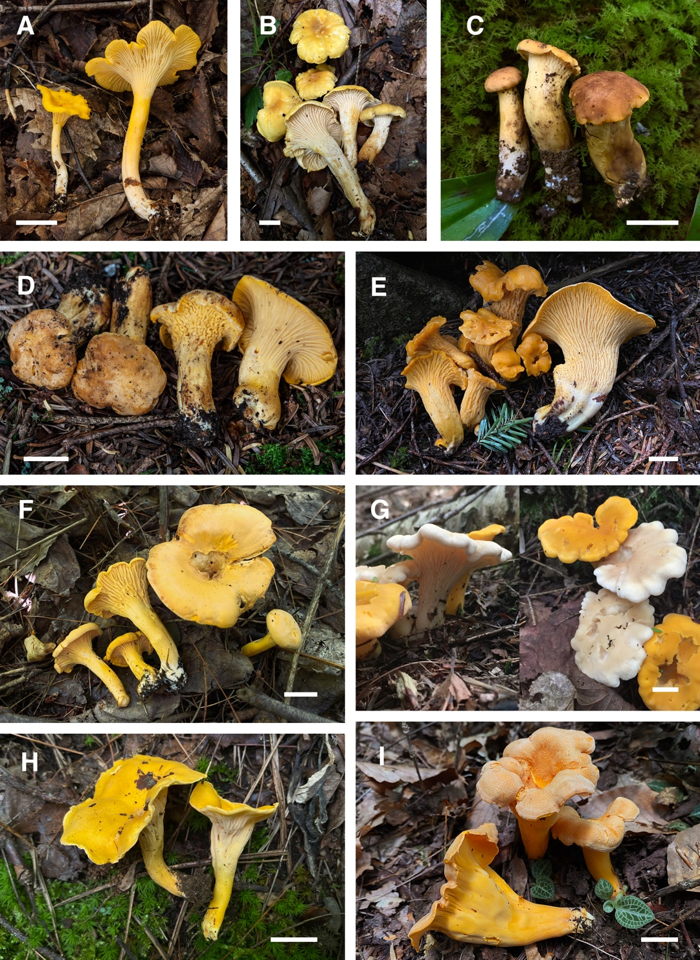
Figure 13. Basidiomata of Cantharellus. A. C. altipes RAS084 (TENN-F-071461). B. C. altipes RAS639 (TENN-F-075384). C. C. betularum RAS631 (TENN-F-075393). D. C. camphoratus RAS614 (TENN-F-075387). E. C. camphoratus RAS661 (TENN-F-075389). F. C. enelensis (C. cibarius complex) RAS859 (TENN-F-075896). G. C. cibarius “white” CLC2018-2 (TENN-F-076274). H. C. flavolateritius RAS588 (TENN-F-076283). I. C. flavolateritius RAS590 (TENN-F-075271). Photos A–F, H, I by R. A. Swenie. Photo G by C. LaChance. Bars = 20 mm.

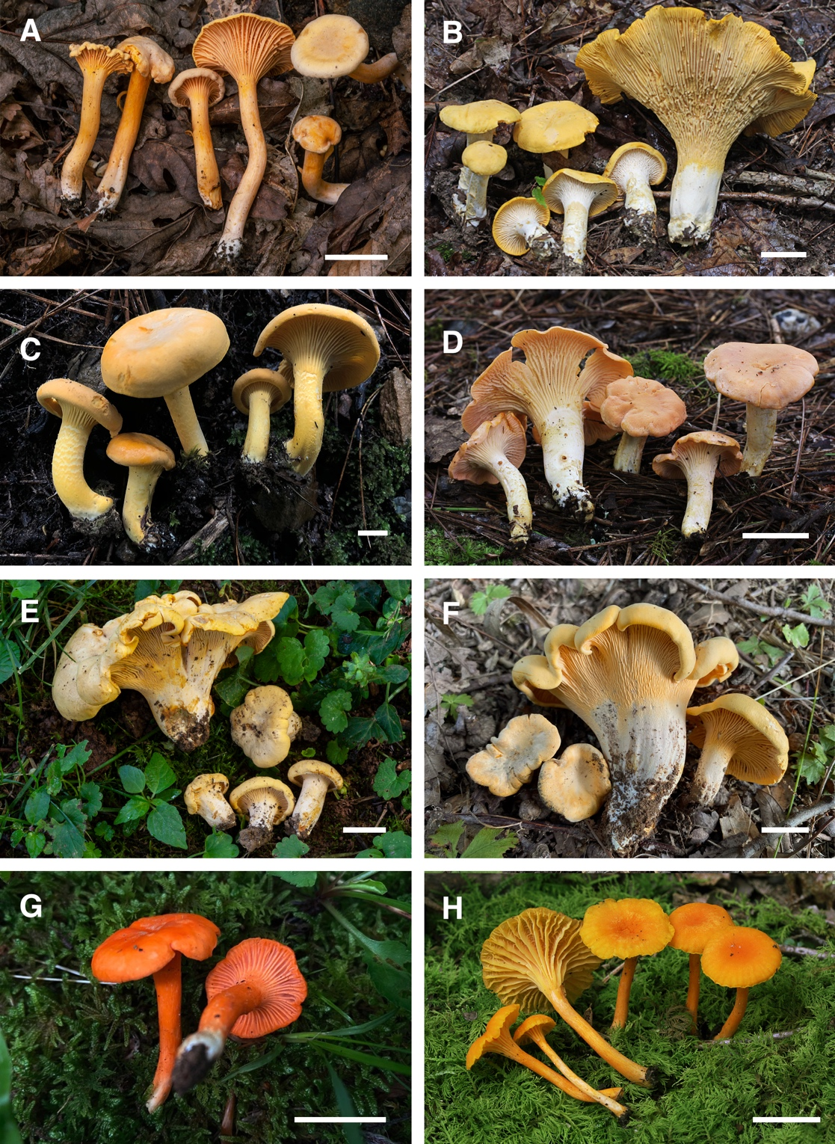
Figure 14. Basidiomata of Cantharellus. A. C. persicinus RAS841 (TENN-F-075884). B. C. tenuithrix PBM4292 (TENN-F-074854). C. C. flavus (C. tenuithrix complex) RAS464 (TENN-F-074949). D. C. velutinus (pink form) PBM4602 (TENN- F-075769). E. C. vicinus RAS426 (TENN-F-074935, holotype). F. C. vicinus RAS669 (TENN-F-075383). G. C. corallinus RAS629 (TENN- F-075397). H. C. intensissimus PBM4615 (TENN-F-075782, epitype). Photos A, C, E–G by R. A. Swenie; photos B, D, H by P. B. Matheny. Bars = 20 mm.

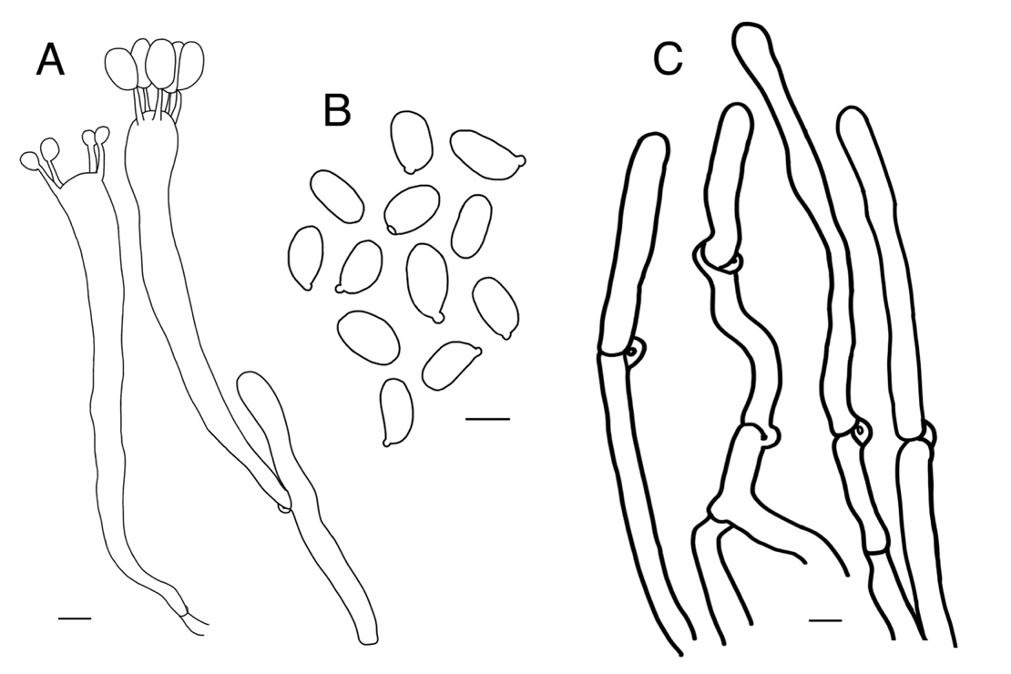
Figure 15. Cantharellus vicinus (holotype). A. Basidia. B. Spores. C. Pileipellis terminal hyphae. Bars = 5 μm.

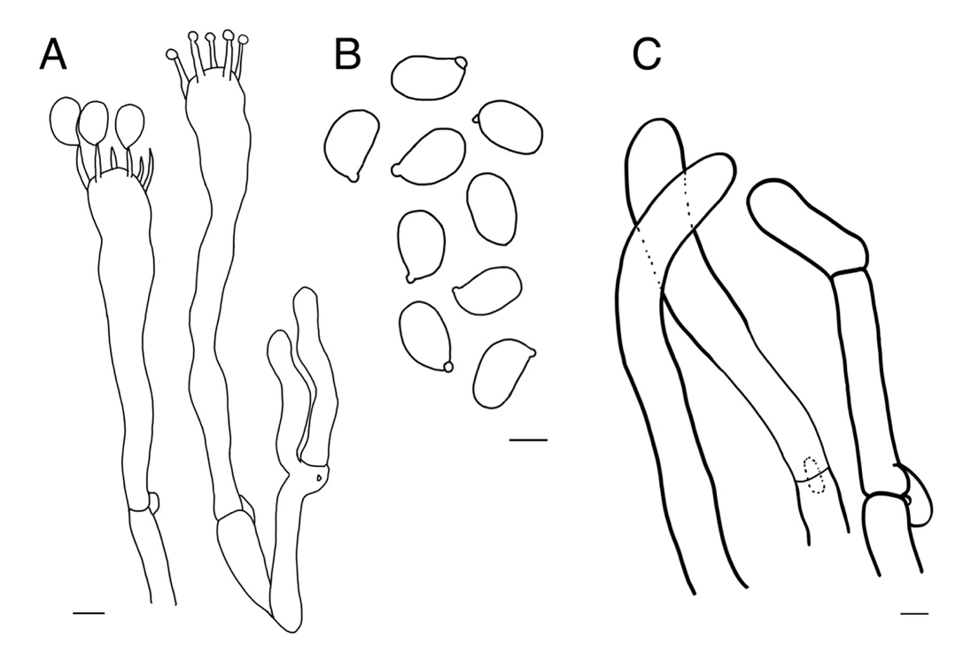
Figure 16. Cantharellus intensissimus (epitype). A. Basidia. B. Spores. C. Pileipellis terminal hyphae. Bars = 5 μm.

CHAPTER III
A PACBIO HIGH-THROUGHPUT MULTI-LOCUS
SEQUENCING METHOD FOR FUNGAL SYSTEMATICS AND SPECIES DELIMITATION

A version of this chapter has been submitted to Molecular Ecology Resources:
Rachel A. Swenie, Brian P. Looney, Yi-Hong Ke, J. Alejandro Rojas, Marc A. Cubeta, Gitta Langer, Rytas Vilgalys, and P. Brandon Matheny. “A PacBio high-throughput multi-locus sequencing method for fungal systematics and species delimitation.”

R.A.S. and P.B.M. designed the study; A.R., B.P.L., R.A.S., and R.V. developed the laboratory method; Y-H.K. and B.P.L. adapted and optimized the pipeline; R.A.S., M.A.C., G.E.L., and P.B.M. provided fungal specimens and culture isolates; R.A.S. and B.P.L. collected and analyzed data; R.A.S. wrote the manuscript and all authors provided edits.

Abstract
Multi-locus sequence data are widely used in fungal systematic and taxonomic studies to delimit species and infer evolutionary relationships. We developed and assessed the efficacy of a multi-locus pooled sequencing method using PacBio long-read high-throughput sequencing. Samples included fresh and dried voucher specimens, cultures, and archival DNA extracts of Agaricomycetes with an emphasis on the order Cantharellales. Of the 283 specimens sequenced, 93.6% successfully amplified at one or more loci with a mean of 3.3 loci amplified. Our method recovered multiple sequence variants representing alleles of rDNA loci and single copy protein coding genes rpb1, rpb2, and tef1. Within-sample genetic variation differed by locus and taxonomic group, with the greatest genetic divergence observed among sequence variants of rpb2 and tef1 from corticioid Cantharellales. Our method is a cost-effective approach for generating accurate multi-locus sequence data coupled with recovery of alleles from polymorphic samples and compound organisms. These results have important implications for understanding intra-individual genomic variation among genetic loci commonly used in species delimitation of fungi.

Introduction

High-throughput sequencing (HTS) methods have grown in popularity due to increased reliability and decreased cost. Single molecule sequencing, also referred to as “third generation” HTS, has been widely adopted in genome shotgun sequencing and transcriptome sequencing for generating accurate DNA sequences up to or exceeding 10 kb in length (Heather & Chain 2016). The PacBio Sequel third generation HTS platform has also shown promise for pooled barcoding of microbial soil samples and amplicon libraries (Bourne et al. 2018; Tedersoo et al. 2018; Runnel et al. 2022).
Multi-locus data from fungal specimens, conventionally produced by Sanger sequencing, are widely used in systematic and taxonomic studies. While Sanger sequencing remains popular due to accuracy and ease of use, it is a costly and time-consuming method for producing multi-locus data that is prone to generating heterogeneous reads when multiple alleles or contamination are present in a sample. Sanger sequencing is also limited to reads one kb or less in length (Heather & Chain 2016). An alternative technique is desirable to overcome these limitations and obtain multi-locus sequence data more efficiently and accurately.
PacBio sequencing has been shown to meet or exceed the success and fidelity of Sanger sequencing at a similar cost, and samples with allele length polymorphisms or field contamination often succeed with PacBio sequencing when Sanger sequencing has failed (Runnel et al. 2022). Isolating a single allele to avoid heterogeneity issues with Sanger sequencing is possible with the additional step of cloning prior to PCR, however this extra step obviously limits efficiency. With PacBio long-read HTS, individual sequence reads are generated from a single strand of DNA, circumventing the need for cloning and mitigating cloning bias issues. With adequate read depth, sequence variants within a dikaryon or diploid genome can also be recovered, providing insight into within-sample genetic diversity. The ribosomal DNA (rDNA) loci commonly used for barcoding fungi– 18S, ITS, and 28S– occur in tens to thousands of copies per nucleus depending on the fungal taxon (Lofgren et al. 2019). Intraspecific and intraindividual rDNA sequence variation in fungi may be due to hybridization and/or a lack of concerted evolution, a process that homogenizes rDNA copies (Hughes et al. 2013; Tremble et al. 2020). In heterokaryotic fungi with multinucleate cells, the divergent genomes of different nuclei can also contribute to intraspecific or intraindividual genetic variation (Paloi et al. 2022).
The occurrence of intra-genome variation in rDNA makes delimiting species based on rDNA sequences problematic for some fungal groups. This is exemplified in the Agaricomycete order Cantharellales. Within the Cantharellales, some genera are prone to long stretches of sequence length heterogeneity (especially Cantharellus and Tulasnella; Moncalvo et al. 2006), making rDNA loci inappropriate barcode markers for these taxa. Other multinucleate groups of fungi such as the form genus Rhizoctonia in the Ceratobasidiaceae present challenges at species delimitation and phylogenetic inference, arising from discordance among multiple loci due to nuclear divergence within individual genomes of multinucleate hyphae, hybridization, and incomplete lineage sorting (Gónzalez et al. 2006; Gónzalez et al. 2016; Paloi et al. 2022). Single molecule HTS is favorable in these circumstances by recovering all alleles present in a sample to elucidate both intra- and intergenomic variation.
We have developed and tested a method for rapid DNA extraction and cost-effective multi-locus PacBio HTS of fungal voucher specimens and cultures, employing a software pipeline to infer intra-individual allelic diversity across nuclear rDNA loci as well as single-copy genes. This method is adaptable for use with a wide variety of organisms and target loci. We amplified six loci commonly used in phylogenetic studies of fungi and detected high levels of intraspecific and intraindividual genetic diversity. Here we demonstrate the utility of this method for generating high-quality multi-locus data from a variety of sources, including voucher specimens, cultures, multi-species samples, and contaminated fruiting bodies (basidiomes).

Materials and Methods

Molecular analyses
A total of 283 specimens were sequenced across two PacBio Sequel runs (96 in the first run and 187 in the second run). All specimens belonged to the phylum Basidiomycota with an emphasis on the order Cantharellales (264 Cantharellales and 19 non-Cantharellales). The 283 specimens comprised 168 vouchered specimens at the University of Tennessee Herbarium and 115 culture isolates provided by M.A. Cubeta, G.E. Langer, and R.A. Swenie, and the Center for Forest Mycology Research culture collection (Table 4; all Tables and Figures are in Appendix).
DNA from cultures and recent herbarium specimens (< 5 years old) were extracted using an Extract-N-Amp Plant Kit (Sigma-Aldrich, St. Louis, MO, USA). Approximately 2–5 mg of culture tissue or hymenophore tissue (such as a piece of lamella) from basidiomata was suspended in 40 μL Extraction Solution and preserved at room temperature until subsequent DNA extraction. An additional 26 archival genomic DNA samples extracted 2–12 years prior via a standard extraction method, i.e. using an E.Z.N.A. HP Fungal DNA Kit (Omega Bio-Tek, Norcross, GA, USA) and stored at -20°C thereafter, were also included for subsequent PCR. In most cases, genomic DNA was diluted 1:10 with sterile double distilled H₂O before PCR amplification.
We targeted six loci commonly used in phylogenetic studies of fungi using the following locus-specific forward and reverse primers: NS1/SR2 for 18S (White et al. 1990; https://sites.duke.edu/vilgalyslab/rdna_primers_for_fungi/); ITS1F/ITS4 for ITS (White et al. 1990; Gardes & Bruns 1993); LR0R/LR7 for 28S (Vilgalys
& Hester 1990; https://sites.duke.edu/vilgalyslab/rdna_primers_for_fungi/); tef1F/tef1R and 983F/2218R for tef1 (Morehouse et al. 2003; Rehner & Buckley 2005); RPB1-Afor/ RPB1-Crev for conserved domains A–C of rpb1 (Matheny et al. 2002); bRPB2-6F/ bRPB2-7.1R (Matheny 2005) and newly designed Cantharellales-specific rpb2 primers Canthb6F and Canth7.1R for domains 6–7 of rpb2. Primer sequences and thermocycler conditions are listed in Table 1. A 20nt universal adapter sequence was added at the 5’ end of locus-specific primers (5′-CTGGAGCACGAGGACACTGA-3′ for forward primers; 5′-GCTGTCAACGATACGCTACG-3′ for reverse primers).
The first PCR step to amplify targeted loci was carried out in 25 μL volume reactions containing 5 μL 5X GoTaq Flexi Buffer, 1.5 μL MgCl₂, 0.5 μL for each 10 μM forward and reverse primer, 0.5 μL 10mM dNTPs, and 0.125–0.375 μL GoTaq G2 Hot Start Polymerase (with amount of GoTaq determined by the number of loci amplified in a reaction, 0.125 μL per locus), nuclease-free water to bring the volume to 24 μL, and 1 μL DNA. Up to 3 loci were simultaneously co-amplified. 18S, ITS, and 28S were co-amplified using ITS thermocycler conditions; rpb1 and rpb2 were co-amplified or amplified singly using RPB250 thermocycler conditions; and tef1 was amplified singly (Table 5). PCR product size was estimated by running 5 μL of PCR product for 40 minutes on a 2% agarose gel for 2- or 3-locus reactions, or a 1% agarose gel for 1-locus PCR reactions. Successful reactions were cleaned using 5 μL of PCR product and 2 μL ExoSAP-IT (Applied Biosystems, Waltham, MA, USA) in 0.2 mL PCR tubes. Cleaned PCR products were diluted 1:5 with nuclease-free water.
A second PCR barcoding step was carried out in 25 μL volume reactions containing 5 μL 5X GoTaq Flexi Buffer, 0.5 μL 10mM dNTPs, 0.25 μL GoTaq G2 Hot Start Polymerase, and 15.25 μL nuclease-free water, 1 μL of each 5 μM forward and reverse barcode primer, and 2 μL of the diluted cleaned PCR product using the following thermocycler conditions: an initial denaturation of 94°C for 30s, 35 cycles of 94°C for 30s, 50°C for 30s, and 72°C for 90s, and a final extension of 72°C for 10 min. A unique dual barcode was assigned to each specimen for the amplicons of all loci. Barcode primers contained a 5nt padding sequence, followed by a 16nt barcode sequence, followed by the same 20nt universal adapter included in locus-specific primers. Second step PCR products were visualized by running 5 μL of PCR product on a 2% agarose gel for 40 min.
All second PCR barcoding products were scored visually on a scale of 1–3 based on gel band intensity with 1 for weak bands and 3 for strong bands. Products without a visible band were discarded. Multiple DNA pools were created, each containing second step PCR products from 12–26 specimens. For each PCR product, 10 to 20 μL of was used: 20 μL for weak bands (score 1), 15 μL for medium bands (score 2), and 10 μL for strong bands (score 3). Each pool was cleaned individually using Mag-Bind TotalPure NGS Kit (Omega BioTek, Norcross, GA, USA) with a bead ratio of 0.7x and quantified using a Nanodrop One Spectrophotometer (Thermo Scientific, Waltham, MA, USA). Equimolar pooling was used to develop a final pooled library with a concentration between 1.7–1.9 μg. The final pooled library was sent to Duke University Center for Genomic and Computational Biology (GCB) for SMRTbellTM library preparation and PacBio Sequel sequencing on 1 SMRT cell.

Sequence data pipeline and analysis
Raw data in PacBio CCS fasta format was demultiplexed, quality filtered, corrected for PacBio sequencing error, and clustered by specimen and locus using a modified version of the purc pipeline (Rothfels et al. 2017). The purc pipeline (https://github.com/KeFungi/purc) output provides one fasta file per locus for each of the 283 specimens. Each fasta file contains sequence variants with a read depth of 4 or greater (labeled as “clusters” by the pipeline). Sequence variants were visualized in AliView 1.28 (Larsson 2014) and aligned using MUSCLE 3.8.31 (Edgar 2004). Locus-specific primers were trimmed from sequence ends as necessary, and identities were confirmed for all sequence variants using the BLASTn algorithm and comparison to the top 10 database matches on GenBank. For sequence variants from protein-coding loci with ambiguous BLASTn results, introns were removed, the sequence was translated into an amino acid sequence, and the BLASTp algorithm was used to compare the top 10 database matches on GenBank. The steps in the PacBio multi-locus long-read HTS workflow are summarized in Figure 1. Phylogenetic analysis for selected samples was conducted using RAxML 8.2.8 (Stamatakis 2014) under the GTRGAMMA model of nucleotide substitution for 1000 bootstraps.

Results

283 samples were subjected to PCR amplification across two PacBio runs (96 on run 1 and 187 on run 2). Of 283 samples, 265 (93.6%) amplified at one or more loci with 69.6% amplified at three or more loci (mean = 3.3 loci). 256 (90.5%) samples matched the expected taxonomic identity based on BLAST results; 42 samples contained sequences from the target taxon plus one or more non-target species; 13 samples yielded sequences that did not match the expected identity and were determined to be misidentified.
Overall, 886 sequence clusters (sequence variants) were recovered across all samples. Within each locus for each sample, the number of sequence variants ranged from 1 to 10 (mean = 1.69). 168 samples (63.4%) showed allelic diversity (> 1 sequence variant) at one or more loci. Sequence variant statistics by locus and taxonomic family are summarized in Table 2. Across 18S, ITS, and 28S rDNA regions, sequence variant diversity was consistently highest within the ITS with an average of 1.89 sequence variants per sample. Across the putatively single-copy protein-coding loci rpb1, rpb2, and tef1, intra-individual sample allelic diversity ranged from 0–5.5% (Table 7; Figures 18–19) and deleted or inserted exon positions within coding regions were observed (6.7% of rpb1 samples; 34.8% of rpb2 samples; 23.2% of tef1 samples).
A comparison of PacBio long-read HTS data to previously generated Sanger sequences from 170 samples for some of the same loci showed that the HTS sequences largely matched Sanger counterparts and often contained two complimentary sequence variants at sites that were polymorphic in the Sanger sequence. Occasionally HTS sequences contained other polymorphic sites not reflected in the Sanger sequence (Figure 20). PacBio long-read HTS produced high quality sequences for several samples where Sanger sequencing failed or produced unreadable sequences.
The 42 samples containing sequence data for more than two organisms (fungi or protists) were spread across taxonomic family and loci. In a few instances, it was not determined whether the additional organism was present in the DNA sample or whether it represented a PCR artifact. However, co-occurring organisms with a high sequence read depth or consistent presence across loci and/or samples were observed in 17 samples. For example, eight samples of Cantharellus extracted from fruiting bodies also yielded tef1, LSU, and/or ITS sequences of protists, while protist sequences were only detected in two other non-Cantharellus samples. Amplification of co-occurring organisms may be influenced by primer non-target specificity. An example of two corticioid samples containing multiple fungi recovered by HTS is presented in Figure 21.

Discussion

Our results demonstrate the utility of long-read HTS for generating multi-locus sequence data and understanding intra-individual and intraspecific genetic diversity. Of 283 samples in our study, 93.6% produced sequences from one or more loci, and 69.6% produced sequences from three or more loci. Sequence variation attributed to allelic diversity was common within Cantharellales and other Agaricomycetes, both within multi-copy rDNA loci and putatively single-copy loci rpb1, rpb2, and tef1, which are commonly used in phylogenetic studies (Tables 6 & 7). The purc pipeline preserves sequence variants for each specimen and locus (denoted as “clusters” in the output files For 18S, ITS, and 28S sequences we interpreted these sequence variants as copy variants within the the rDNA operon, as allelic haplotype variants for single-copy genes, or as non-functional gene duplications where a frameshift is present in an exon.
Our long-read multi-locus HTS approach is compatible with quick and traditional DNA extraction methods and suitable for cultures, fresh and dried specimens, environmental samples, and archival DNA extracts. Using multiplex PCR to simultaneously amplify multiple loci and pooling samples for PacBio long-read HTS (Chen et al. 2015; Barge et al. 2022) is a cost-effective method compared to Sanger sequencing, allowing sequencing of up to six loci from multiple samples. Our pooled barcoding approach to DNA sequencing is more economical than Sanger sequencing, especially as PacBio sequencing has increased in reliability and fidelity (Tedersoo et al. 2021; Runnel et al. 2022). Major strengths of the PacBio platform include the ability to sequence longer reads than the 1000 bp limit of Sanger, as well as adaptability to other robotic methods suitable for HTS. Since PacBio sequence reads are produced from single molecules, individual alleles (as sequence variants) are recovered, and samples with length heterogeneity produce high quality reads without the need for cloning (Figure 20). The relative ease of this method, along with the high-quality data obtained from polymorphic or contaminated samples suggests PacBio long-read HTS is a viable and cost-effective replacement for multi-locus Sanger sequencing, particularly when sequencing many samples.
PacBio HTS sequencing is flexible to custom primer design and locus choice. Success rates for PCR amplification were very high overall but varied by taxonomic group and locus (see Table 6). ). rDNA loci consistently amplified regardless of DNA source, while success in amplifying single-copy genes declined with age of specimens and DNA extracts. We did not detect issues of PacBio adapters or barcodes interfering with PCR amplification, but it is likely that some samples failed to amplify due to primer mismatch, particularly for rpb1, where fewer than 10% of attempted samples amplified. Optimization of PCR conditions is another important aspect of multiplex PCR. We hypothesize that lower read depth and fewer haplotypes recovered for 28S may be due in part to a non-optimal thermocycler DNA amplification protocol. Amplification of 28S separately from 18S and ITS using a more suitable thermocycler protocol is likely to yield greater numbers of reads. However, multiplexing several loci simultaneously produces savings in time and cost of PCR reagents, particularly dNTPs.
Understanding intra-allelic and intraspecific allele divergence is important for species delimitation and can also be informative for choosing OTU thresholds for analysis of environmental sequencing data. The purc pipeline corrects for PCR and PacBio sequence errors, removes chimeras, and groups reads from each allele into clusters (sequence variants) with a sequencing depth of four or more reads. The sequence variants are then grouped together by locus for each individual sample.
A particularly high level of intra-individual sequence variant diversity (up to 8.8%) was recovered in the Cantharellales families Botryobasidiaceae, Ceratobasidiaceae, and Tulasnellaceae (Table 7). Species in these families have primarily binucleate or multinucleate hyphae and many have anamorphic states (Langer 1994; Vilgalys & Cubeta, 1994; Arifin et al. 2021). In the Ceratobasidiaceae, species diversity was traditionally recognized using anastomosis groups based on hyphal fusion criteria (Vilgalys & Cubeta, 1994). Phylogenetic analyses of the Ceratobasidiaceae have reported incongruence across multiple gene loci, with non-monophyletic genera and mixed support for anastomosis groups (Gónzalez et al. 2006; Veldre et al. 2013; Gónzalez et al. 2016). Our results suggest genomic divergence across nuclei within an individual is often higher than expected, particularly for protein-coding loci (Figure 19). Therefore, characterizing intra-individual genetic diversity may be an important aspect of species delimitation in these fungi. Utilizing PacBio long-read HTS is one such method to assess genomic divergence within samples.
Our long-read HTS method can also detect non-target species present in a single sample, and therefore is useful for identifying compound organisms such as lichens, corticioid fungi, and contaminated samples, as other studies utilizing PacBio HTS have shown (Gueidan et al. 2019; Runnel et al. 2022). Of the 42 samples containing sequence data from two or more organisms, slightly more than half of these were from corticioid fungi (e.g., Figure 21), which are ecologically diverse and notoriously difficult to classify taxonomically. Several corticioid fungi also contained non-target protist or Ascomycota sequences, however the presence of these non-target sequences rarely hindered sequencing of the target. Thus, the PacBio long-read HTS method is an efficient and accurate sequencing approach for uncovering within-sample genetic diversity, from alleles to compound organisms.

Data Accessibility

Sequence data from this study is deposited in the NCBI Sequence Read Archive, BioProject PRJNA945373. All specimens are accessioned in herbaria at the University of Tennessee. Pipeline is available at https://github.com/KeFungi/purc. Pipeline is available at https://github.com/KeFungi/purc. Phylogenetic trees and sequence alignments are available at FigShare (DOI: 10.6084/m9.figshare.22795817).

Acknowledgements

This research was supported by a University of Tennessee Student Faculty Research Award to R.A.S. and P.B.M, ﻿an award from the Herbarium at the University of Tennessee to R.A.S, an NSF Graduate Research Fellowship (No. 1452154) to R.A.S., and NSF ARTS award to P.B.M. (DEB-2030779). We thank the Center for Forest Mycology Research for providing fungal culture isolates and James Lawrey, Matt Smith, and Karen Hughes for providing additional DNA extracts. We also gratefully acknowledge the assistance of Graham Alexander and the Duke University Sequencing and Genomic Technologies core facility.

REFERENCES

Arifin, A. R., May, T. W., & Linde, C. C. (2021). New species of Tulasnella associated with Australian terrestrial orchids in the Cryptostylidinae and Drakaeinae. Mycologia, 113(1), 212–230. https://doi.org/10.1080/00275514.2020.1813473

Barge, E. G., Leopold, D. R., Rojas, A., Vilgalys, R., & Busby, P. E. (2022). Phylogenetic conservatism of mycoparasitism and its contribution to pathogen antagonism. Molecular Ecology, 31(10), 3018–3030. https://doi.org/10.1111/mec.16436

Bourne, E. C., Bunk, B., Monaghan, M. T., Heeger, F., Spröer, C., Overmann, J., … Baschien, C. (2018). Long-read DNA metabarcoding of ribosomal RNA in the analysis of fungi from aquatic environments. Molecular Ecology Resources, 18(6), 1500–1514. https://doi.org/10.1111/1755-0998.12937

Chen, Y., Frazzitta, A. E., Litvintseva, A. P., Fang, C., Mitchell, T. G., Springer, D. J., ... & Perfect, J. R. (2015). Next generation multilocus sequence typing (NGMLST) and the analytical software program MLSTEZ enable efficient, cost-effective, high-throughput, multilocus sequencing typing. Fungal Genetics and Biology, 75, 64–71.

Edgar, R. C. (2004). MUSCLE: multiple sequence alignment with high accuracy and high throughput. Nucleic acids research, 32(5), 1792–1797.

Gardes, M., & Bruns, T. D. (1993). ITS primers with enhanced specificity for basidiomycetes‐application to the identification of mycorrhizae and rusts. Molecular Ecology, 2(2), 113–118.

González, D., Cubeta, M. A., & Vilgalys, R. (2006). Phylogenetic utility of indels within ribosomal DNA and β-tubulin sequences from fungi in the Rhizoctonia solani species complex. Molecular Phylogenetics and Evolution, 40(2), 459–470. https://doi.org/10.1016/j.ympev.2006.03.022

Gónzalez, D., Rodriguez-Carres, M., Boekhout, T., Stalpers, J., Kuramae, E. E., Nakatani, A. K., Vilgalys, R., Cubeta, M. A. (2016). Phylogenetic relationships of Rhizoctonia fungi within the Cantharellales. Fungal Biology, 120(4), 603–619. https://doi.org/10.1016/j.funbio.2016.01.012

Gueidan, C., Elix, J.A., McCarthy, P.M., Roux, C., Mallen-Cooper, M., Kantvilas, G. (2019). PacBio amplicon sequencing for metabarcoding of mixed DNA samples from lichen herbarium specimens. MycoKeys, 53, 73–91. https://doi.org/10.3897/mycokeys.53.34761

Heather, J. M., & Chain, B. (2016). The sequence of sequencers: The history of sequencing DNA. Genomics, 107(1), 1–8. https://doi.org/10.1016/j.ygeno.2015.11.003

Hughes, K. W., Petersen, R. H., Lodge, D. J., Bergemann, S. E., Baumgartner, K., Tulloss, R. E., … Cifuentes, J. (2013). Evolutionary consequences of putative intra-and interspecific hybridization in agaric fungi. Mycologia, 105(6), 1577–1594. https://doi.org/10.3852/13-041

Langer, G. (1994). Die gattung Botryobasidium Donk (Corticiaceae, Basidiomycetes). Gebrüder Borntraeger.

Larsson, A. (2014). AliView: a fast and lightweight alignment viewer and editor for large datasets. Bioinformatics, 30(22), 3276–3278.

Lofgren, L. A., Uehling, J. K., Branco, S., Bruns, T. D., Martin, F., & Kennedy, P. G. (2019). Genome‐based estimates of fungal rDNA copy number variation across phylogenetic scales and ecological lifestyles. Molecular Ecology, 28(4), 721–730.

Matheny, P. B., Liu, Y. J., Ammirati, J. F., & Hall, B. D. (2002). Using RPB1 sequences to improve phylogenetic inference among mushrooms (Inocybe, Agaricales). American Journal of Botany, 89(4), 688–698. https://doi.org/10.3732/ajb.89.4.688

Matheny, P. B. (2005). Improving phylogenetic inference of mushrooms with RPB1 and RPB2 nucleotide sequences (Inocybe; Agaricales). Molecular Phylogenetics and Evolution, 35(1), 1–20. https://doi.org/10.1016/j.ympev.2004.11.014

Moncalvo, J.-M., Nilsson, R. H., Koster, B., Dunham, S. M., Bernauer, T., Matheny, P. B., … Vilgalys, R. (2006). The cantharelloid clade: dealing with incongruent gene trees and phylogenetic reconstruction methods. Mycologia, 98(6), 937–948. https://doi.org/10.3852/mycologia.98.6.937

Morehouse, E. A., James, T. Y., Ganley, A. R., Vilgalys, R., Berger, L., Murphy, P. J., & Longcore, J. E. (2003). Multilocus sequence typing suggests the chytrid pathogen of amphibians is a recently emerged clone. Molecular Ecology, 12(2), 395–403. https://doi.org/10.1046/j.1365-294x.2003.01732.x

Paloi, S., Luangsa-ard, J. J., Mhuantong, W., Stadler, M., & Kobmoo, N. (2022). Intragenomic variation in nuclear ribosomal markers and its implication in species delimitation, identification and barcoding in fungi. Fungal Biology Reviews, 42, 1–33. https://doi.org/10.1016/j.fbr.2022.04.002

﻿Rehner, S. A., & Buckley, E. (2005). A Beauveria phylogeny inferred from nuclear ITS and EF1-alpha sequences: evidence for cryptic diversification and links to Cordyceps teleomorphs. Mycologia, 97(1), 84–98. https://doi.org/10.3852/mycologia.97.1.84

Rothfels, C. J., Pryer, K. M., & Li, F. W. (2017). Next‐generation polyploid phylogenetics: Rapid resolution of hybrid polyploid complexes using PacBio single‐molecule sequencing. New Phytologist, 213(1), 413–429. https://doi.org/10.1111/nph.14111

Runnel, K., Abarenkov, K., Copoț, O., Mikryukov, V., Kõljalg, U., Saar, I., & Tedersoo, L. (2022). DNA barcoding of fungal specimens using PacBio long-read high-throughput sequencing. Molecular Ecology Resources, 22(8), 2871–2879. https://doi.org/10.1111/1755-0998.13663

Stamatakis, A. (2014). RAxML version 8: a tool for phylogenetic analysis and post-analysis of large phylogenies. Bioinformatics, 30(9), 1312–1313.

Tedersoo, L., Tooming-Klunderud, A., & Anslan, S. (2018). PacBio metabarcoding of Fungi and other eukaryotes: errors, biases and perspectives. New Phytologist, 217(3), 1370–1385. https://doi.org/10.1111/nph.14776

Tedersoo, L., Albertsen, M., Anslan, S., & Callahan, B. (2021). Perspectives and benefits of high-throughput long-read sequencing in microbial ecology. Applied and Environmental Microbiology, 87(17), e00626-21.

Tremble, K., Suz, L. M., & Dentinger, B. T. M. (2020). Lost in translation: Population genomics and long-read sequencing reveals relaxation of concerted evolution of the ribosomal DNA cistron. Molecular Phylogenetics and Evolution, 148, 106804. https://doi.org/10.1016/j.ympev.2020.106804

Veldre, V., Abarenkov, K., Bahram, M., Martos, F., Selosse, M. A., Tamm, H., Kõljalg, U., & Tedersoo, L. (2013). Evolution of nutritional modes of Ceratobasidiaceae (Cantharellales, Basidiomycota) as revealed from publicly available ITS sequences. Fungal Ecology, 6(4), 256–268. https://doi.org/10.1016/j.funeco.2013.03.004

Vilgalys, R., & Hester, M. (1990). Rapid genetic identification and mapping of enzymatically amplified ribosomal DNA from several Cryptococcus species. Journal of Bacteriology, 172(8), 4238–4246.

Vilgalys, R., & Cubeta, M. A. (1994). Molecular systematics and population biology of Rhizoctonia. Annual Review of Phytopathology, 32(1), 135–155.

White, T. J., Bruns, T., Lee, S. J. W. T., & Taylor, J. (1990). Amplification and direct sequencing of fungal ribosomal RNA genes for phylogenetics. PCR protocols: a guide to methods and applications, 18(1), 315–322.

APPENDIX

Table 4. Samples used in this study.
Table 4. Continued.
Table 4. Continued.
Table 4. Continued.

Table 4. Continued.

Table 5. Locus-specific primers and PCR conditions.

Table 6. Total number of attempted and successfully sequenced samples with mean number of sequence variants produced for each locus.

Table 7. Total number of attempted and successfully sequenced samples with mean number of sequence variants produced for each locus and maximum within-sample sequence variant divergence by taxonomic family.

Figure 17. The PacBio multi-locus long-read high throughput sequencing (HTS) workflow.
Figure 18. Intra-individual diversity of the tef1 locus across Craterellus. Sequences produced for this study are in bold text. Bootstrap support values are shown above branches. Within-sample sequence variant divergence up to 1.9% was detected among 11 sequence variants of tef1 in Craterellus ignicolor RAS589 (fruiting body isolate).

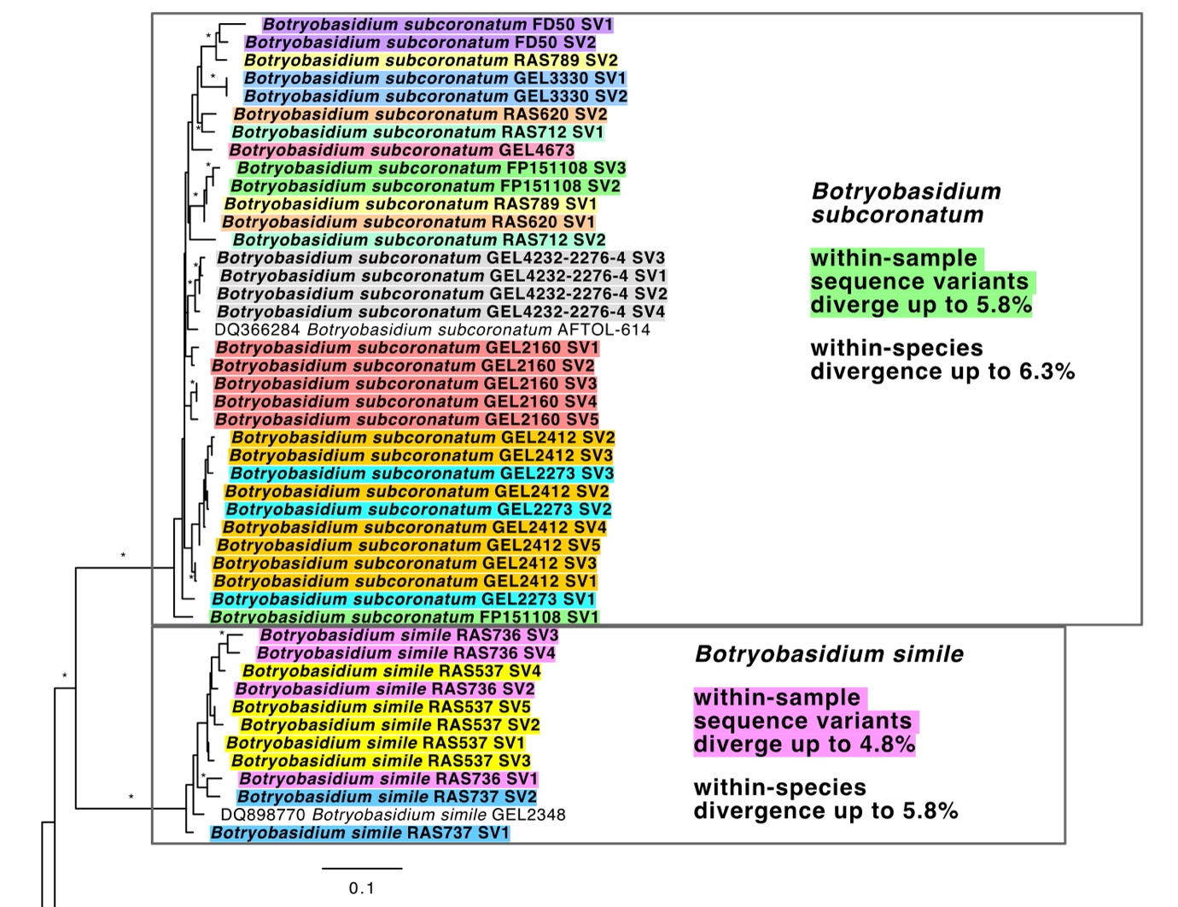
Figure 19. Intra-individual and intraspecific diversity of rpb2 across samples of Botryobasidium subcoronatum and B. simile (culture and fruiting body isolates). Sequences produced for this study are in bold text. Bootstrap support values ≥ 70 are denoted by an asterisk (*). Intraspecific sequence divergence in both species was greater than 5.5%.

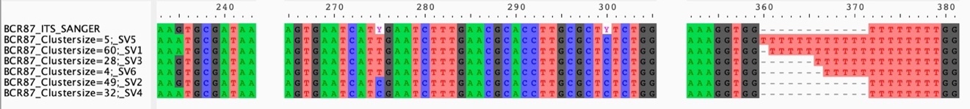
Figure 20. Comparison of intra-individual genetic variation captured by Sanger sequencing vs. PacBio HTS for a single Hydnum sample (fruiting body isolate). A Sanger sequence (top row) is shown in comparison to six PacBio long-read HTS sequence variants (SV1–6) from the ITS locus. Nucleotide positions are presented above sequences. Sequence polymorphisms captured in the Sanger sequence are reflected in the long-read HTS sequence variants at positions 275 and 300, but the polymorphic site at position 235 and length heterogeneity at sites 360–71 are not captured by the Sanger sequence.

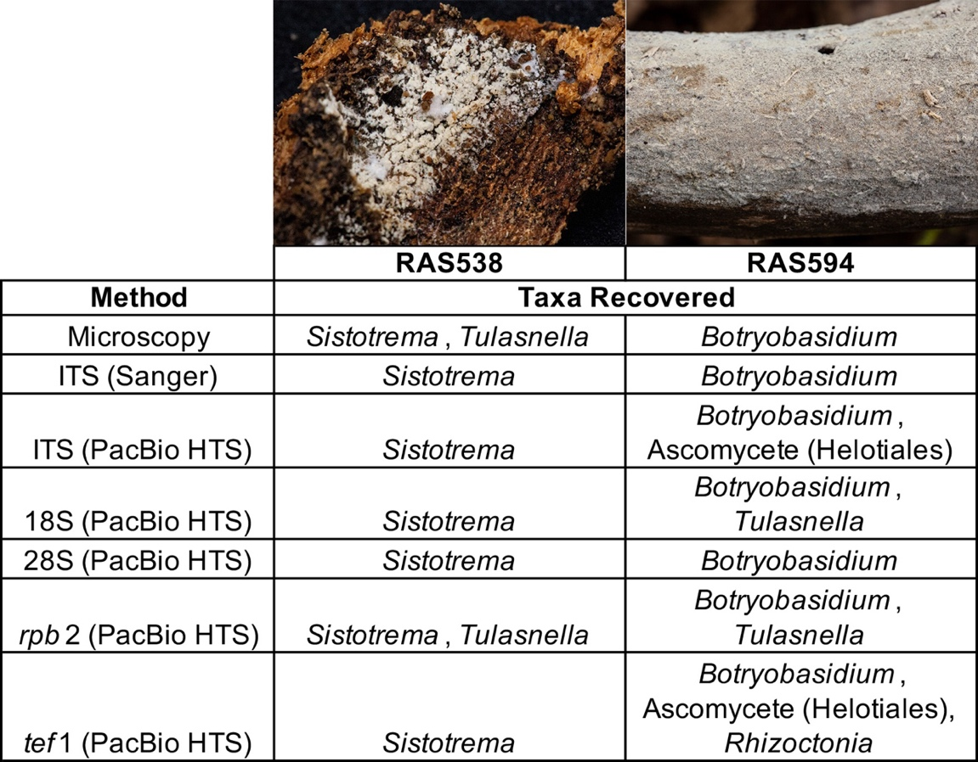
Figure 21. Two corticioid Cantharellales specimens containing non-target taxa. Fungal taxa detected varied by sequencing method and locus.

CHAPTER IV
A PHYLOGENETIC OVERVIEW OF THE CANTHARELLALES (CHANTERELLES AND ALLIES)

Abstract

The agaricomycete order Cantharellales contains approximately 1,000 species of fungi characterized by diverse morphological forms and nutritional strategies. Examples of these morphologies and ecological guilds include coralloid lichens that form symbioses with unicellular green algae, bulbil-forming lichenicolous species, corticioid free-living fungi that degrade dead organic carbon, pathogens that cause disease in agricultural crops, orchid root symbionts, and ectomycorrhizal mushroom-forming fungi. The order also includes popular edible mushrooms that are sold in markets worldwide. Despite recent advances to characterize relationships across the fungal tree of life, evolutionary relationships in the Cantharellales remain poorly understood. Here, I construct a multi-gene phylogeny of the Cantharellales using data generated from 323 specimens across the order to evaluate family-level relationships in the order. Four monophyletic families were recovered with strong measures of statistical support. These include Hydnaceae sensu lato, Tulasnellaceae, Botryobasidiaceae, and Ceratobasidiaceae. Across the order, three clades contain ectomycorrhizal fungi and seven clades contain lichenicolous forms. Seven different clades contained samples of the polyphyletic genus Sistotrema, six of which will require taxonomic reassignment to other genera. This study provides a framework for examining the evolution of form and function across this ecologically and morphologically diverse order of fungi.

Introduction

The Agaricomycetes, a class of predominantly mushroom-forming fungi, contains more than 20,000 described species that function in a variety of ecological roles as mutualists, pathogens, and decomposers in ecosystems throughout the globe (Hibbett et al. 2014). The Cantharellales is an order of mushroom-forming fungi that is sister to the rest of the Agaricomycetes (Varga et al. 2019; Sánchez-García et al. 2020). Members of the Cantharellales display a diverse array of morphologies and nutritional modes (Figure 22; all Tables and Figures are in Appendix), including popular ectomycorrhizal edible mushrooms such as the chanterelles and hedgehogs, corticioid (resupinate) saprobes that degrade dead wood, and destructive plant pathogens that cause blight on important crop plants such as peanuts, rice, and cucumbers (Anderson 1982; Moncalvo et al. 2006; Olariaga et al. 2017). Other species are lichenized, lichenicolous, or orchid symbionts (Lawrey et al. 2016; Oberwinkler et al. 2017).
The Cantharellales is an order of nearly 1,000 species (per indexfungorum.org). Seven families have been described within the order: Cantharellaceae, Clavulinaceae, Hydnaceae, Sistotremataceae, Botryobasidiaceae, Ceratobasidiaceae, and Tulasnellaceae. Early research into members of the order relied on basidiome, spore, and basidial morphology for classification. The diversity of basidiome and hymenophore morphologies across the Cantharellales meant stipitate members such as Cantharellus were categorized separately from corticoid Cantharellales like Sistotrema. Due to differing hymenophore types among stipitate Cantharellales, genera with gill-like (Cantharellus, Craterellus), coralloid (Clavulina, Multiclavula), and toothed (Hydnum) morphologies were thought to be distantly related. However, characteristics of the basidia were used to infer a potential relationship among diverse basidiome types. For example, Penancier (1961) noted members of the Cantharellaceae, Clavulinaceae, Hydnaceae, and Corticiaceae (including Sistotrema) shared the presence of stichic basidia, meiosporangia characterized by a longitudinally oriented meiotic spindle. Donk (1964) suggested the presence of stichic basidia was a potentially shared derived trait indicating a close relationship among those taxa. Despite this, Jülich (1981) segregated the genus Sistotrema into its own family, Sistotremaceae, within the order Sistotremales based on basidium shape and number of spores.
The remaining corticioid Cantharellales were initially considered “tulasnelloid fungi”. Later, the families Tulasnellaceae, Ceratobasidiaceae, and Botryobasidiaceae were recognized based on differences in basidium morphology and the presence or absence of repetitively germinating basidiospores (Juel 1897, Martin 1948, Donk 1956). However, taxonomists disagreed over how and whether these three families were closely related. The morphological classification developed by Rea (1922) segregated Tulasnella in its own order, Tulasnellales, based on its basidia with basally septate sterigmata. Oberwinkler (1982) retained Ceratobasidiaceae and Tulasnellaceae under Tulasnellales, while Botryobasidiaceae was considered distantly related. Jülich (1981) placed Ceratobasidiaceae and Botryobasidiaceae into the new orders Ceratobasidiales and Botryobasidiales, while noting a close relationship between Ceratobasidiales, Botryobasidiales, and Tulasnellales.
The earliest molecular phylogenetic studies referred to these various taxonomic groups as members of the “cantharelloid clade” (Pine et al. 1999; Binder et al. 2005; Moncalvo et al. 2006; Matheny et al. 2007). The families Cantharellaceae, Clavulinaceae, Hydnaceae, Botryobasidiaceae, Ceratobasidiaceae, and Tulasnellaceae have most commonly been recognized within the Cantharellales based on phylogenetic evidence (Moncalvo et al. 2006; Veldre et al. 2013; Diederich et al. 2014; Hibbett et al. 2014; Cao et al. 2021). A summary of classification schemes for Cantharellales is summarized in Table 8.
Today, as many as seven families have been recognized within the Cantharellales: Cantharellaceae, Clavulinaceae, Hydnaceae, Sistotremataceae, Botryobasidiaceae, Ceratobasidiaceae, and Tulasnellaceae. However, broader relationships among these families are unclear as studies have produced conflicting topologies, particularly regarding the positions of Botryobasidiaceae, Ceratobasidiaceae, and Tulasnellacae (Moncalvo et al. 2006; Veldre et al. 2013; Cao et al. 2021). The relatively few Cantharellales genomes that have been sequenced have done little to resolve family-level relationships, perhaps due to limited taxon sampling (Miyauchi et al. 2020; see also https://mycocosm.jgi.doe.gov/). One genus, Sistotrema, comprises five or more separate clades, three of which cannot be placed within existing families (Moncalvo et al. 2006). Several lichenicolous lineages in the Cantharellales have been recognized and described as unique genera but occupy unresolved positions in the order (Diederich et al. 2014; Lawrey et al. 2016; Diederich et al. 2022). To date, there is no densely sampled phylogeny of the Cantharellales that resolves these higher-level relationships and provides a robust internal framework to understand diversification and evolution of features within the group.
A phylogenetic framework can enable future studies of historical biogeography, species diversification, and evolutionary ecology. In particular, the Cantharellales is proportionally rich in ectomycorrhizal (ECM) species (Tedersoo et al. 2010). ECM fungi represent a major ecological guild that forms root symbioses with approximately 6,000 species of land plants and are critical to ecosystem health. The Cantharellales also contains a high number of lichenicolous lineages relative to other groups of mushroom-forming fungi (Diederich et al. 2022). Sánchez-García et al. (2020) suggested that the most recent common ancestor of the Cantharellales was a saprotroph, and the many corticioid Cantharellales lineages retained wood-decay capabilities. However, the order diverged before the origin of white rot capabilities in Agaricomycetes, and the mechanism of carbon degradation in these fungi has not yet been elucidated (Martin et al. 2016). In light of this, I constructed a multi-gene phylogeny of the Cantharellales to test the hypothesis that there are seven well-supported families in the order, and to enable future studies using phylogenetic comparative methods.

Materials and Methods

Taxon sampling
A literature search was conducted to compile a list of accepted genera within Cantharellales (Table 9). Samples were collected in the field, preserved, and accessioned at the University of Tennessee Herbarium (TENN). Cultures were attempted for samples of Botryobasidium, Sistotrema, and Tulasnella on malt extract or potato dextrose agar plates. Plates were incubated at 20–22° C. Additional samples comprised specimens from the University of Tennessee Herbarium, cultures from the Center for Forest Mycology Research, G. Langer (Northwest German Forest Research Institute), and M. Cubeta (North Carolina State University); and archival DNA isolates. A total of 223 Cantharellales specimens and one outgroup were selected for PacBio sequencing representing all seven families within the order. Sanger sequences from 24 collections were included to expand gene coverage and improve taxon sampling relative to estimated species diversity.

DNA extraction, gene sampling, and sequencing
Tissue samples were collected from specimens for DNA extraction using either an Extract-N-Amp Plant kit (Sigma-Aldrich, St. Louis, Missouri) for fresh or recently dried specimens < 5 years old and cultures. Older dried specimens > 5 years old were extracted using an HP Fungal DNA Extraction Kit (Omega Bio-Tek, Norcross, Georgia, USA). For specimens > 25 years, DNA was extracted using the method outlined for type specimen extraction in Swenie et al. (2018).
A gene sampling strategy was established that targeted five nuclear loci: 18S rDNA (18S), ITS1+5.8S+ITS2 (ITS), the 5’ end of 28S rDNA (28S), and portions of two nuclear protein-coding genes, rpb2 and tef1. These loci have been the most frequently used in previous phylogenetic studies of Cantharellales (Moncalvo et al. 2006; Lawrey et al. 2016; Olariaga et al. 2017; Cao et al. 2021). Select Cantharellales sequences were downloaded from GenBank if three or more loci were available from the same source sample. Additional Cantharellales sequences were obtained from and JGI MycoCosm (https://mycocosm.jgi.doe.gov/) targeting protein-coding sequence data from genomes. Additional sequences were included from holotypes and additional species within the lichenized, lichenicolous, corticioid, and aquatic genera Bergerella, Bulbilla, Burgoa, Bryoclavula, Membranomyces, Multiclavula, Minimedusa, Neoburgoa, Parmeliicida, and Rogersiomyces, regardless of number of loci available per sample, due to lack of representation of these lineages. Burgoa moriformis was excluded due to high 28S sequence divergence. All specimens and GenBank accession numbers are listed in Table 9.
For Sanger sequencing, primers were used in the following combinations to amplify and sequence the ITS, 28S, tef1, and rpb2 regions, respectively: ITS1F/ITS4, ITS1F/ITS2, or 5.8SR/ITS4 (White et al. 1990); LR0R/LR5 or LR0R/LR7 using LR5 as an internal sequence primer (Cubeta et al. 1991; Vilgalys and Hester 1990), tef1F/tef1R, 983F/2218R, or HEF1F/HEF1R (Morehouse et al. 2003; Rehner and Buckley 2005; Feng et al. 2016); and b6F/b7.1R (Matheny 2005). Sequencing was performed on an Applied Biosystems 3730 Genetic Analyzer at the University of Tennessee Genomics Core, and sequence reads were assembled in Sequencher 5.0.1 (Gene Codes, Ann Arbor, Michigan).
For PacBio high throughput multi-locus sequencing (MLST), methods are outlined in Chapter 3 of this dissertation. Briefly, multi-locus sequence data were generated for the 18S, ITS, 28S, tef1, and rpb2 regions using a multiplexed two-step PCR amplification and library preparation for sequencing on the PacBio Sequel platform using one SMRT cell. Samples were spread across two sequencing runs and the resulting sequence data were demultiplexed, error-corrected, sorted by locus, and clustered into sequence variants with a read depth of four or greater.

DNA alignment and phylogenetic analyses
Sequences were aligned separately for each of the five loci using MUSCLE in AliView 1.27 (Larsson 2014). Minor adjustments were made manually to each alignment, and primer sequences were trimmed from the beginning and ends of sequences where necessary. Maximum likelihood (ML) phylogenetic analysis was performed separately for each of the five individual loci using RAxML 8.2.9 (Stamatakis 2014) with 1000 bootstrap replicates under the GTR+GAMMA substitution model as recommended by the user manual. Dacrymyces ﻿sp. FPL8953 and Dacrymyces chrysospermus AMH013 (Dacrymycetes) served as outgroups due to the sister relationships between Dacrymycetes and Agaricomycetes. Holtermanniella wattica CBS 9496 (Tremellomycetes) was added as an additional outgroup as Tremellomycetes are sister to the clade containing Aagaricomycetes and Dacrymycetes. After inspecting the individual gene phylogenies for strongly supported intergene conflict and potential rogue taxa, the phylogenies were concatenated in SeaView, excluding the 18S and ITS rDNA loci for Cantharellus, Craterellus, and Tulasnella. Data were partitioned by locus and coding region and an additional ML analysis was performed on the five-locus concatenated alignment. IQ-TREE 2.2 was used to test model fit for the partitioned five-locus dataset, and an additional ultrafast (UF) 1000 bootstrap analysis was run along with the SH-aLRT (SH) and aBayes branch support tests (Nguyen et al. 2015; Hoang et al. 2018; Guindon et al. 2010; Anisimova et al. 2011). ML bootstrap proportions ≥70%, UF bootstraps ≥95%, SH-aLRT values ≥ 80%, and aBayes values ≥ 90% were considered evidence of strong support. FigTree 1.4.4 was used to visualize the phylogenies. Edits to the tree figures were made in Affinity Designer 1.10.6 (Serif Europe Ltd, United Kingdom).

Molecular dating analysis
The five-locus ML phylogeny was time calibrated by penalized likelihood in R 4.3.1 using the chronos function in ape (R Core Team 2023; Paradis & Schliep 2019). The node representing the most recent common ancestor of Cantharellales (Agaricomycetes) and Dacrymycetes was constrained to the Carboniferous period (299–359 Mya), an estimate supported by numerous previous studies (Floudas et al. 2012; Garnica et al. 2016; Varga et al. 2019; Sánchez-García et al. 2020; Miyachi et al. 2020).

Results

22 of the 25 accepted Cantharellales genera (Table 9) were represented by one or more sequences in the phylogenies. Sequences were not obtained from samples of Ingoldiella, and Sistotremella and Afrocantharellus were excluded due to high sequence divergence and limited gene sampling. Multiple studies have recovered Afrocantharellus as a sister clade to Cantharellus (Tibuhwa et al. 2012; Buyck et al. 2014; Shao et al. 2014). Cao et al. (2021) found Sistotremella occupied an uncertain phylogenetic position within the Hydnaceae.
The various single gene phylogenies contained 976 sequences from 323 samples (Table 9; sequence data are available in the NCBI Sequence Read Archive, BioProject PRJNA945373). Splicesomal introns of tef1 and rpb2 were retained if alignable across all taxa. One 410 bp insertion was excluded from 28S. The 18S alignment contained 223 sequences and 1228 sites; the ITS alignment 227 sequences and 1081 sites; the 28S alignment 209 sequences and 1570 sites; the tef1 alignment 112 sequences and 1370 sites; and the rpb2 alignment 211 sequences and 1177 sites. The five-locus concatenated alignment contained sequences from 303 samples and included 6426 sites.
The Cantharellales was recovered as a monophyletic group with strong statistical support across the multi-gene (Figure 23) and single-gene (Figures 24–28) phylogenies. The five-locus phylogeny supported four monophyletic families in the Cantharellales with high ML bootstrap values: Hydnaceae sensu lato (including the formerly recognized families Cantharellaceae, Clavulinaceae, and Hydnaceae sensu stricto), Tulasnellaceae, Botryobasidiaceae, and Ceratobasidiaceae. These results support the previous classifications of Hibbett et al. (2014) and Cao et al. (2021) (Table 8). Ceratobasidiaceae was strongly supported as sister to the rest of the order, and Botryobasidiaceae as sister to the clade containing Tulasnellaceae and Hydnaceae sensu lato. Tulasnellaceae and Hydnaceae were identified as sister groups in the five-locus phylogeny. Topologies varied across the single-gene phylogenies, but no strongly supported gene conflict was detected at nodes deeper than the genus level. Hydnaceae sensu lato received strong bootstrap support in the multi-gene analysis and the 18S, 28S, and tef1 phylogenies. Tulasnellaceae was poorly supported across all single-gene phylogenies except 18S, where it was sister to Cantharellus and Craterellus probably due to effects of long branch attraction. The 18S and ITS loci exhibited unusually high rates of change for Tulasnella, Cantharellus, and Craterellus, as noted previously (Feibelman et al. 1994; Moncalvo et al. 2006).
The family Botryobasidiaceae contained one genus, Botryobasidium, with several strongly supported subclades. Taxonomic revision would be required to determine whether the genus merits subdivision into additional genera. Similarly, the family Tulasnellaceae contained a single genus, Tulasnella, species of which were highly divergent including at low-copy protein-coding loci tef1 and rpb2. The genera Ceratobasidium, Rhizoctonia, and Thanatephorus were each polyphyletic. Species-level clades received strong support in a few instances, such as Ceratobasidium bulbillifaciens and C. oryzae-sativae, but some anastomosis groups of Rhizoctonia solani (i.e., AG-1, AG-4) were not monophyletic.
The multi-gene phylogeny recovered seven disparate clades of Sistotrema in the Hydnaceae sensu lato. Sistotrema sensu stricto, containing the ECM pileate-stipitate type species S. confluens and additional corticoid ECM Sistotrema taxa, was monophyletic. Sistotrema sensu stricto plus additional corticioid Sistotrema lineages formed a grade (paraphyletic group) giving rise to the ECM pileate-stipitate mushroom genus Hydnum. The lichenicolous bulbil-forming genus Neoburgoa formed a strongly supported sister group to Hydnum and Sistotrema sensu stricto. Together, these taxa were closely related to the lichenicolous Burgellopsis and saprotrophic Sistotrema raduloides. Burgellopsis, another lichenicolous bulbil-forming lineage, was represented by a single specimen that was weakly supported as sister to the aforementioned groups. The lichenicolous genus Minimedusa, previously considered closely related to Hydnum and Sistotrema sensu stricto (Lawrey et al. 2007), was found to be polyphyletic. Minimedusa polyspora (type) and M. obcoronata formed a strongly supported clade together, whereas Minimedusa pubescens formed a separate well supported sister clade with Sistotrema coronilla and S. adnatum. The sole member of the lichenized coral genus Bryoclavula, B. phycophila, was recovered as sister to Minimedusa, Sistotrema coronilla, and S. adnatum but with weak statistical support. A clade containing the lignicolous members of the bulbil-forming genus Burgoa and lignicolous corticioid species Sistotrema sernanderi, S. biggsiae, and S. eximum formed a clade sister to the rest of the Hydnaceae sensu lato with weak support.
Taxa classified in the family Clavulinaceae included the stipitate and mostly coralloid ECM Clavulina mushrooms, the corticioid ECM genus Membranomyces, three independent clades of saprotrophic Sistotrema, the aquatic lignicolous corticioid Rogersiomyces, lichenicolous genera Bulbilla, Burgella, and Parmeliicida, and the lichenized coralloid Multiclavula. Broader relationships across this group mostly received strong statistical support, excepting Clavulina, which was recovered as paraphyletic when ITS sequences of Membranomyces were included. Samples of Sistotrema brinkmanii formed a genetically diverse but monophyletic group sister to Clavulina, Membranomyces, and Sistotrema luteoviride. Burgella, Bulbilla, Rogersiomyces, and three unidentified Sistotrema samples formed a weakly-supported clade. Sister to the remainder of the Clavulinaceae was a clade containing Multiclavula and Parmeliicia.
The family Cantharellaceae contained the edible ectomycorrhizal chanterelle and trumpet mushrooms (Cantharellus and Craterellus, respectively). The sister relationship between these two genera was strongly supported across all phylogenetic analyses, as reported from previous studies (Moncalvo et al. 2006; Matheny et al. 2007; Wilson et al. 2012; Cao et al. 2021). Lichenicolous Cantharellales were also confined to the Hydnaceae sensu lato, except Ceratobasidium bulbillifaciens in the Ceratobasidiaceae.
The time-calibrated phylogeny (Figure 29) estimated the age of the Cantharellales at 324 Mya. Within the Hydnaceae sensu lato, the phylogeny suggests three potential transitions to an ECM nutritional mode were observed during the Mesozoic Era (252–66 Mya): one in the common ancestor of Clavulina and Membranomyces, one in the common ancestor of Hydnum and Sistotrema sensu stricto, and one in the common ancestor of Cantharellus and Craterellus (Figure 29). Two additional transitions to ECM habit occurred in the Ceratobasidiaceae (Veldre et al. 2013). Seven clades in the Cantharellales phylogeny contained lichenicolous taxa (Figure 29).

Discussion

This is the first contribution towards a densely-sampled phylogeny of the Cantharellales based on multi-gene sampling. The five-locus phylogeny strongly supports the recognition of four families within the order, rather than a classification of seven families. A more inclusive Hydnaceae (Hydnaceae sensu lato) is monophyletic across the multi-gene and protein-coding phylogenies with strong statistical support in the ML multi-gene and three of the five individual gene trees. The previously recognized families Cantharellaceae, Clavulinaceae, and Hydnum sensu stricto receive strong statistical support in the multi-gene tree but show weak bootstrap support and are polyphyletic within the individual gene trees. An alternative classification recognizing these three families would require erecting three additional families to accommodate the clades labeled incertae cedis in Figure 23, but weakly supported relationships along the backbone of Hydnaceae sensu lato and a lack of clear shared characteristics make this a less parsimonious option.
The family Hydnaceae sensu lato encompasses the largest number of genera and the widest variety of morphological and functional groups in the Cantharellales. Stichic basidia, in which the meiotic spindle is vertically oriented, may be a synapomorphy for this clade (Donk 1933, Pine et al. 1999). Stichic basidia have been confirmed in samples of the stipitate ECM genera Hydnum, Cantharellus, and Clavulina, as well as the lichenized stipitate genus Multiclavula, but have not been investigated in the remaining genera in the family, including lichenicolous and bulbil-forming lineages and the corticioid Sistotrema groups. The families Tulasnellaceae, Botryobasidiaceae, and Ceratobasidiaceae each form strongly supported monophyletic groups and can be distinguished from one another on the basis of morphological and ecological traits (Anderson 1982; Langer 1994; Oberwinkler et al. 2017). However, taxon sampling is limited at the genus level for all three families and does not include sequences from all Rhizoctonia anastomosis groups, or synonyms of Tulasnella such as Epulorhiza and Gloeotulasnella, which lack multi-locus data and have highly divergent rDNA sequences.
The protein-coding loci tef1 and rpb2 provide greater phylogenetic resolution than the more widely used nuclear rDNA loci (18S, ITS, and 28S) across the Cantharellales phylogeny, particularly at deeper nodes. These two loci are also useful for species-level recognition in some Hydnaceae genera such as Cantharellus (see Chapter 2 of this dissertation), Hydnum, and Clavulina. Use of these and other protein-coding gene markers is recommended in addition to rDNA loci for future systematic studies of the Cantharellales. The inclusion of ITS sequences of the corticioid ectomycorrhizal genus Membranomyces renders Clavulina paraphyletic; however, no other loci besides ITS are available from Membranomyces samples, so additional gene sampling is needed to confirm this result.
Species recognition within each of the largely corticoid families Tulasnellaceae, Ceratobasidiaceae, and Botryobasidiaceae will require further studies that incorporate intra-individual genetic variation into species delimitation (see Chapter 3 of this dissertation). Rhizoctonia and Thanatephorus are two non-monophyletic genera in the Ceratobasidiaceae. Several anastomosis groups in Rhizoctonia are also non-monophyletic, reflecting the need for further taxonomic work in this family. The Tulasnellaceae traditionally contained the genera Gloeotulasnella and Epulorhiza, which are now considered synonyms of Tulasnella (Roche et al. 2010). Similarly, the Botryobasidiaceae now contains a single genus, Botryobasidium. Botryohypochnus is considered a synonym of Botryobasidium (Langer 1994), and Botryobasidium was recommended for use over the asexual synonym Haplotrichum (Stalpers et al. 2021).
This is the first systematic study of the Cantharellales to include protein-coding sequences of lichenicolous taxa. While all lichenicolous genera other than Minimedusa are strongly supported as monophyletic, in some cases their broader placement within Hydnaceae sensu lato remains poorly resolved probably owing to limited gene sampling (i.e, Bergerella, Burgellopsis, Burgoa). The lichenicolous species Burgoa moriformis, represented by a single 28S sequence, was omitted due to its uncertain position on a long branch. It remains unclear whether this species is more closely related to species in the Tulasnellaceae as previously suggested (Diederich et al. 2022), or other species of Burgoa in Hydnaceae. Greater taxon sampling and sequencing of protein-coding genes from lichenicolous type species are expected to increase confidence in the phylogenetic position of these lichenicolous lineages.
Broadly recognized, the genus Sistotrema contains 125 species (based on data from Indexfungorum.org). Traditionally, corticioid or pileate-stipitate species possessing urniform basidia with 6–8 sterigmata, smooth spores, and a monomitic hyphal system with oily inclusions in the subicular hyphae were placed in Sistotrema (Eriksson et al. 1984). Later phylogenetic studies of Sistotrema species revealed the genus as polyphyletic (Larsson et al. 2004; Moncalvo et al. 2006). The dozens of Sistotrema samples included in this study were distributed across seven distantly related groups. Based on the five-locus phylogeny (Figure 23), Sistotrema sensu stricto is monophyletyic. Additional Sistotrema samples, some of which are ECM, plus Sistotrema sensu stricto form a grade giving rise to Hydnum. The other six independent Sistotrema lineages require taxonomic reassignment into other genera. Several lichenicolous Cantharellales form monophyletic groups containing Sistotrema species. For example, the genus Burgoa contains both saprotrophic and lichenicolous bulbil-forming species that have been suggested as anamorphic forms of the sexual species Sistotrema eximum and S. sernanderi (Lawrey et al. 2007). Sequences produced for this study of S. biggsiae match sequences of the type species Burgoa verzuoliana; like B. verzuoliana, S. biggsiae produces bulbils (Croan et al. 1999). Together, these samples form a strongly supported clade, including samples labeled S. eximum and S. sernanderi, suggesting several Sistotrema species outside of Sistotrema sensu stricto may be reassigned to the genus Burgoa. Similarly, three specimens sequenced for this study labeled S. oblongisporum and another labeled Sistotrema sp. form a strongly supported clade with two Burgella samples. The aquatic anamorphic genus Ingoldiella was later found to form a sexual state in culture which was described as S. hamatum (Nawawi & Webster 1982). However, the relationship of S. hamatum to other Sistotrema species remains unknown due to a lack of sequence data.
The dense species sampling presented here reveals a more complex picture of evolution of form and function in the Cantharellales than previous studies. The Cantharellales is shown to be an ancient group of fungi that diverged during the Carboniferous (Figure 29). The time-calibrated phylogeny suggests that early Cantharellales may have associated with progymnosperms (Lutzoni et al. 2018; Strullu-Derrien et al. 2018), and that most extant lineages in the order diverged after the Permian-Triassic extinction event. The evolution of ECM lineages may have coincided with the diversification of ECM conifers during the Mesozoic.
The evolution of lichenicolous forms, however, presents a more complex picture. While broader relationships across lichenicolous clades are not entirely clear, the topology suggests a hypothesis of multiple transitions to a lichenicolous habit in Cantharellales with subsequent transitions to other nutritional modes. While the clades containing lichenicolous Cantharellales vary in age between 50–250 Mya, this is considerably younger than the origin of ascolichens (Lutzoni et al. 2018).
Previous studies of agaricomycete diversification have considered lichenicolous fungi as parasitic corticioid forms, and other non-parasitic corticioid Cantharellales as saprotrophs. Yet, little is known about the functional ecology of lichenicolous and saprotrophic Cantharellales. Saprotrophic taxa in the order have a limited repertoire of lignocellulolytic enzymes and are thought to rely on decomposing low-lignin non-woody substrates (Martin et al. 2016). Additional research utilizing metabolomics and functional genomics is needed to understand whether all the presumed saprotrophic lineages in the Cantharellales are functionally similar.
The role of ECM symbiosis in the diversification of the Cantharellales remains unclear. While one recent study concluded that fruiting body form and not nutritional mode drove diversification in Agaricomycetes (Sánchez-García et al. 2020), multiple traits may underlie shifts in diversification rates (Caetano et al. 2018). Such dynamics have not been studied on a finer scale within the Cantharellales. Given the overwhelming species richness in the genera that produce stipitate basidiomes and function as ECM symbionts (Hydnum, Clavulina, Cantharellus, and Craterellus), I predict that the combination of stipitate basidiomes and ECM symbiosis promoted increased diversification in the Cantharellales. Future studies are planned to test this hypothesis using phylogenetic comparative methods.

REFERENCES

Anderson, N. A. (1982). The Genetics and Pathology of Rhizoctonia solani. Annual Review of Phytopathology, 20(1), 329–347. https://doi.org/10.1146/annurev.py.20.090182.001553

Anisimova, M., Gil, M., Dufayard, J. F., Dessimoz, C., & Gascuel, O. (2011). Survey of branch support methods demonstrates accuracy, power, and robustness of fast likelihood-based approximation schemes. Systematic Biology, 60(5), 685–699.

Binder, M., Hibbett, D. S., Larsson, K. H., Larsson, E., Langer, E., & Langer, G. (2005). The phylogenetic distribution of resupinate forms across the major clades of mushroom-forming fungi (Homobasidiomycetes). Systematics and Biodiversity, 3(2), 113–157. https://doi.org/10.1017/S1477200005001623

Buyck, B., Kauff, F., Eyssartier, G., Couloux, A., & Hofstetter, V. (2013). A multilocus phylogeny for worldwide Cantharellus (Cantharellales, Agaricomycetidae). Fungal Diversity, 64(1), 101–121. https://doi.org/10.1007/s13225-013-0272-3

Caetano, D. S., O’Meara, B. C., & Beaulieu, J. M. (2018). Hidden state models improve state-dependent diversification approaches, including biogeographical models. Evolution, 72(11), 2308–2324. https://doi.org/10.1111/evo.13602

Cao, T., Hu, Y. P., Yu, J. R., Wei, T. Z., & Yuan, H. S. (2021). A phylogenetic overview of the Hydnaceae (Cantharellales, Basidiomycota) with new taxa from China. Studies in Mycology, 99, 100–121. https://doi.org/10.1016/j.simyco.2021.100121

Corner, E. J. H. (1950). A monograph of Clavaria and allied genera. A monograph of Clavaria and allied genera.

Croan, S. C., Burdsall Jr, H. H., & Rentmeester, R. M. (1999). Preservation of tropical wood-inhabiting basidiomycetes. Mycologia, 91(5), 908–916.

Diederich, P., & Lawrey, J. D. (2007). New lichenicolous, muscicolous, corticolous and lignicolous taxa of Burgoa s. l. and Marchandiomyces s. l. (anamorphic Basidiomycota), a new genus for Omphalina foliacea, and a catalogue and a key to the non-lichenized, bulbilliferous basidiomycetes. Mycological Progress, 6(2), 61–80. https://doi.org/10.1007/s11557-007-0523-3

Diederich, P., Lawrey, J. D., Capdet, M., Pereira, S., Romero, A. I., Etayo, J., Flakus, A., Sikaroodi, M., & Ertz, D. (2014). New lichen-associated bulbil-forming species of Cantharellales (Basidiomycetes). Lichenologist, 46(3), 333–347. https://doi.org/10.1017/S0024282913000583

Diederich, P., Millanes, A. M., Wedin, M., & Lawrey, J. D. (2022). Flora of Lichenicolous Fungi, Volume 1.

Donk, M. A. (1933). Revision der niederländischen Homobasidiomycetae-Aphyllophoraceae. Mededelingen van het Botanisch Museum en Herbarium van de Rijksuniversiteit te Utrecht, 9(1), 1–278.
Donk, M. A. (1956). NOTES ON RESUPINATE HYMENOMYCETES-II* The tulasnelloid fungi. Reinwardtia, 3(3), 363–379.

Eriksson, J., Hjortstam, K., & Ryvarden, L. (1984). The Corticiaceae of North Europe, Vol. 7: Schizopora–Suillosporium. Fungiflora, Oslo.

Feibelman, T., Bayman, P., & Cibula, W. G. (1994). Length variation in the internal transcribed spacer of ribosomal DNA in chanterelles. Mycological Research, 98(6), 614–618. https://doi.org/10.1016/S0953-7562(09)80407-3

Feng, B., Wang, X.-H., Ratkowsky, D., Gates, G., Lee, S. S., Grebenc, T., & Yang, Z. L. (2016). Multilocus phylogenetic analyses reveal unexpected abundant diversity and significant disjunct distribution pattern of the Hedgehog Mushrooms (Hydnum L.). Scientific Reports, 6(April), 25586. https://doi.org/10.1038/srep25586

Floudas, D., Binder, M., Henrissat, B., Martínez, A. T., Otillar, R., Spatafora, J. W., Yadav, J. S., Coutinho, P. M., Vries, R. P. De, Ferreira, P., Findley, K., & Foster, B. (2012). The Paleozoic Origin of Enzymatic Lignin Decomposition Reconstructed from 31 Fungal Genomes. Science, 336(June), 1715–1719. https://doi.org/10.1126/science.1221748

Garnica, S., Riess, K., Schön, M. E., Oberwinkler, F., & Setaro, S. D. (2016). Divergence times and phylogenetic patterns of Sebacinales, a highly diverse and widespread fungal lineage. PLoS ONE, 11(3), 1–16. https://doi.org/10.1371/journal.pone.0149531

Gónzalez, D., Rodriguez-Carres, M., Boekhout, T., Stalpers, J., Kuramae, E. E., Nakatani, A. K., Vilgalys, R., & Cubeta, M. A. (2016). Phylogenetic relationships of Rhizoctonia fungi within the Cantharellales. Fungal Biology, 120(4), 603–619. https://doi.org/10.1016/j.funbio.2016.01.012

Guindon, S., Dufayard, J. F., Lefort, V., Anisimova, M., Hordijk, W., & Gascuel, O. (2010). New algorithms and methods to estimate maximum-likelihood phylogenies: assessing the performance of PhyML 3.0. Systematic Biology, 59(3), 307–321

Hawksworth, D. L., & Lücking, R. (2017). Fungal Diversity Revisited: 2.2 to 3.8 Million Species. Microbiol Spectrum, 5(4). https://doi.org/10.1128/microbiolspec.FUNK-0052-2016.

Hibbett, D. S., Bauer, R., Binder, M., Giachini, A. J., Hosaka, K., Justo, A., ... & Thorn, R. G. (2014). 14 Agaricomycetes. Systematics and Evolution: Part A, 373–429.

Hoang, D. T., Chernomor, O., Von Haeseler, A., Minh, B. Q., & Vinh, L. S. (2018). UFBoot2: improving the ultrafast bootstrap approximation. Molecular Biology and Evolution, 35(2), 518–522.

Juel, H.O. (1897). Muciporus und die Familie der Tulasnellaceen. Bihang till
Kongliga Svenska Vetenskaps-Akadernim Handlingar 23(III: 12). 1–29.

Jülich, W. (1981). Higher taxa of Basidiomycetes. Biblio. Mycol., 85.

Langer, G. (1994). Die gattung Botryobasidium Donk (Corticiaceae, Basidiomycetes). Gebrüder Borntraeger.

Larsson, K.-H., Larsson, E., & Kõljalg, U. (2004). High phylogenetic diversity among corticioid homobasidiomycetes. Mycological Research, 108(9), 983–1002. https://doi.org/10.1017/S0953756204000851

Larsson, K.-H. (2007). Re-thinking the classification of corticioid fungi. Mycological Research, 111(9), 1040–1063. https://doi.org/10.1016/j.mycres.2007.08.001

Lawrey, J. D., Binder, M., Diederich, P., Molina, M. C., Sikaroodi, M., & Ertz, D. (2007). Phylogenetic diversity of lichen-associated homobasidiomycetes. Molecular Phylogenetics and Evolution, 44(2), 778–789. https://doi.org/10.1016/j.ympev.2006.12.023

Lawrey, J. D., Zimmermann, E., Sikaroodi, M., & Diederich, P. (2016). Phylogenetic diversity of bulbil-forming lichenicolous fungi in Cantharellales including a new genus and species. The Bryologist, 119(4), 341–349. https://doi.org/10.1639/0007-2745-119.4.341

Lutzoni, F., Nowak, M. D., Alfaro, M. E., Reeb, V., Miadlikowska, J., Krug, M., Arnold, A. E., Lewis, L. A., Swofford, D. L., Hibbett, D., Hilu, K., James, T. Y., Quandt, D., & Magallón, S. (2018). Contemporaneous radiations of fungi and plants linked to symbiosis. Nature Communications, 9(1). https://doi.org/10.1038/s41467-018-07849-9

Matheny, P. B. (2005). Improving phylogenetic inference of mushrooms with RPB1 and RPB2 nucleotide sequences (Inocybe; Agaricales). Molecular Phylogenetics and Evolution, 35(1), 1–20. https://doi.org/10.1016/j.ympev.2004.11.014

Brandon Matheny, P., Wang, Z., Binder, M., Curtis, J. M., Lim, Y. W., Henrik Nilsson, R., Hughes, K. W., Hofstetter, V., Ammirati, J. F., & Schoch, C. L. (2007). Contributions of rpb2 and tef1 to the phylogeny of mushrooms and allies (Basidiomycota, Fungi). Molecular Phylogenetics and Evolution, 43(2), 430–451. https://doi.org/10.1016/j.ympev.2006.08.024

Martin, F., Kohler, A., Murat, C., Veneault-Fourrey, C., & Hibbett, D. S. (2016). Unearthing the roots of ectomycorrhizal symbioses. Nature Reviews Microbiology, 14(12), 760–773. https://doi.org/10.1038/nrmicro.2016.149

Martin, G. W. (1945). The classification of the Tremellales. Mycologia 37, 527–542.

Miyauchi, S., Kiss, E., Kuo, A., Drula, E., Kohler, A., Sánchez-García, M., ... & Martin, F. M. (2020). Large-scale genome sequencing of mycorrhizal fungi provides insights into the early evolution of symbiotic traits. Nature Communications, 11(1), 5125.

Moncalvo, J.-M., Nilsson, R. H., Koster, B., Dunham, S. M., Bernauer, T., Matheny, P. B., Porter, T. M., Margaritescu, S., Weiss, M., Garnica, S., Danell, E., Langer, G., Langer, E., Larsson, E., Larsson, K.-H., & Vilgalys, R. (2006). The cantharelloid clade: dealing with incongruent gene trees and phylogenetic reconstruction methods. Mycologia, 98(6), 937–948. https://doi.org/10.3852/mycologia.98.6.937

Morehouse, E. A., James, T. Y., Ganley, A. R., Vilgalys, R., Berger, L., Murphy, P. J., & Longcore, J. E. (2003). Multilocus sequence typing suggests the chytrid pathogen of amphibians is a recently emerged clone. Molecular Ecology, 12(2), 395–403. https://doi.org/10.1046/j.1365-294x.2003.01732.x

Nakasone, K.K. (2020). Boidinella gen. nov. (Cantharellales, Basidiomycota). Cryptogamie, Mycologie, 32(2), 191–197.

Nawawi, A., & Webster, J. (1982). Sistotrema hamatum sp. nov., the teleomorph of Ingoldiella hamata. Transactions of the British Mycological Society, 78(2), 287–291.

Nguyen, L. T., Schmidt, H. A., Von Haeseler, A., & Minh, B. Q. (2015). IQ-TREE: a fast and effective stochastic algorithm for estimating maximum-likelihood phylogenies. Molecular Biology and Evolution, 32(1), 268–274.

Oberwinkler, F. (1982). The significance of the morphology of the basidium in the phylogeny of basidiomycetes. In Basidium and basidiocarp: Evolution, cytology, function, and development (pp. 9–35). New York, NY: Springer New York.

Oberwinkler, F., Cruz, D., & Suárez, J. P. (2017). Biogeography and Ecology of Tulasnellaceae. Ecol. Stud. 230: 237–271. https://doi.org/10.1007/978-3-319-56363-3

Olariaga, I., Moreno, G., Manjón, J. L., Salcedo, I., Hofstetter, V., Rodríguez, D., & Buyck, B. (2017). Cantharellus (Cantharellales, Basidiomycota) revisited in Europe through a multigene phylogeny. Fungal Diversity, 83(1), 263–292. https://doi.org/10.1007/s13225-016-0376-7

Olariaga, I., Huhtinen, S., Læssøe, T., Petersen, J. H., & Hansen, K. (2020). Phylogenetic origins and family classification of typhuloid fungi, with emphasis on Ceratellopsis, Macrotyphula and Typhula (Basidiomycota). Studies in Mycology, 96, 155–184. https://doi.org/10.1016/j.simyco.2020.05.003

Paradis, E., & Schliep, K. (2019). ape 5.0: an environment for modern phylogenetics and evolutionary analyses in R. Bioinformatics, 35(3), 526–528.

Penancier, N. (1961). Recherches sur l'orientation des fuseaaux mitotiques dans la baside des Aphyllophorales. ﻿Trav. Lab. (La Jaysinia), 2, 57–71.

Pilz, D., Norvell, L., Danell, E., & Molina, R. (2003). Ecology and management of commercially harvested chanterelle mushrooms. Portland (OR): US Department of Agriculture, Forest Service, Pacific Northwest Research Station.

Pine, E. M., Hibbett, D. S., & Donoghue, M. J. (1999). Phylogenetic relationships of cantharelloid and clavaroid Homobasidiomycetes based on mitochondrial and nuclear rDNA sequences. Mycologia, 91(6), 944–963.

R Core Team (2013). R: A language and environment for statistical computing. R Foundation for Statistical Computing, Vienna, Austria. http://www.R-project.org/.

﻿Rea, C. (1922) British Basidiomycetae: a handbook of the larger British Fungi. Cambridge University Press.

Rehner, S. A., & Buckley, E. (2005). A Beauveria phylogeny inferred from nuclear ITS and EF1-alpha sequences: evidence for cryptic diversification and links to Cordyceps teleomorphs. Mycologia, 97(1), 84–98. https://doi.org/10.3852/mycologia.97.1.84

Roberts, P. (1998). Oliveonia and the origin of the holobasidiomycetes. Folia Cryptogamica Estonica, 33, 27–132.

Roche, S. A., Carter, R. J., Peakall, R., Smith, L. M., Whitehead, M. R., & Linde, C. C. (2010). A narrow group of monophyletic Tulasnella (Tulasnellaceae) symbiont lineages are associated with multiple species of Chiloglottis (Orchidaceae): Implications for orchid diversity. American Journal of Botany, 97(8), 1313–1327. https://doi.org/10.3732/ajb.1000049

Sánchez-García, M., & Matheny, P. B. (2016). Is the switch to an ectomycorrhizal state an evolutionary key innovation in mushroom-forming fungi? A case study in the Tricholomatineae (Agaricales). Evolution, 1–15. https://doi.org/10.1111/evo.13099

Sánchez-García, M., Ryberg, M., Khan, F. K., Varga, T., Nagy, L. G., & Hibbett, D. S. (2020). Fruiting body form, not nutritional mode, is the major driver of diversification in mushroom-forming fungi. Proceedings of the National Academy of Sciences of the United States of America, 117(51), 32528–32534. https://doi.org/10.1073/pnas.1922539117

Shao, S.-C., Buyck, B., Hofstetter, V., Tian, X.-F., Geng, Y.-H., Fu-Qiang, Y., & Liu, P.-G. (2014). Cantharellus hygrophorus, a New Species in Subgenus Afrocantharellus from Tropical Southwestern China. Cryptogamie, Mycologie, 35(3), 283–291. https://doi.org/10.7872/crym.v35.iss3.2014.283

Spirin, V., Volobuev, S., Viner, I., Miettinen, O., Vlasák, J., Schoutteten, N., ... & Larsson, K. H. (2021). On Sistotremastrum and similar-looking taxa (Trechisporales, Basidiomycota). Mycological Progress, 20, 453–476.

Stamatakis, A. (2014). RAxML version 8: a tool for phylogenetic analysis and post-analysis of large phylogenies. Bioinformatics, 30(9), 1312–1313.

Strullu-Derrien, C., Selosse, M. A., Kenrick, P., & Martin, F. M. (2018). The origin and evolution of mycorrhizal symbioses: From palaeomycology to phylogenomics. New Phytologist. https://doi.org/10.1111/nph.15076

Tedersoo, L., May, T. W., & Smith, M. E. (2010). Ectomycorrhizal lifestyle in fungi: Global diversity, distribution, and evolution of phylogenetic lineages. Mycorrhiza 20(4), 217–263. https://doi.org/10.1007/s00572-009-0274-x

Tedersoo, L., & Smith, M. E. (2013). Lineages of ectomycorrhizal fungi revisited: foraging strategies and novel lineages revealed by sequences from belowground. Fungal Biology Reviews, 27(3–4), 83-99.

Tibuhwa, D. D., Savić, S., Tibell, L., & Kivaisi, A. K. (2012). Afrocantharellus gen. stat. nov. is part of a rich diversity of African Cantharellaceae. IMA Fungus, 3(1), 25–38.

Varga, T., Krizsán, K., Földi, C., Dima, B., Sánchez-García, M., Sánchez-Ramírez, S., Szöllősi, G. J., Szarkándi, J. G., Papp, V., Albert, L., Andreopoulos, W., Angelini, C., Antonín, V., Barry, K. W., Bougher, N. L., Buchanan, P., Buyck, B., Bense, V., Catcheside, P., … Nagy, L. G. (2019). Megaphylogeny resolves global patterns of mushroom evolution. Nature Ecology and Evolution, 3(4), 668–678. https://doi.org/10.1038/s41559-019-0834-1

Veldre, V., Abarenkov, K., Bahram, M., Martos, F., Selosse, M. A., Tamm, H., Kõljalg, U., & Tedersoo, L. (2013). Evolution of nutritional modes of Ceratobasidiaceae (Cantharellales, Basidiomycota) as revealed from publicly available ITS sequences. Fungal Ecology, 6(4), 256–268. https://doi.org/10.1016/j.funeco.2013.03.004

Vilgalys, R., & Hester, M. (1990). Rapid genetic identification and mapping of enzymatically amplified ribosomal DNA from several Cryptococcus species. Journal of Bacteriology, 172(8), 4238–4246.

White, T. J., Bruns, T., Lee, S. J. W. T., & Taylor, J. (1990). Amplification and direct sequencing of fungal ribosomal RNA genes for phylogenetics. PCR protocols: a guide to methods and applications, 18(1), 315–322.

Wilson, A. W., Aime, M. C., Dierks, J., Mueller, G. M., & Henkel, T. W. (2012). Cantharellaceae of Guyana I: New species, combinations and distribution records of Craterellus and a synopsis of known taxa. Mycologia, 104(6), 1466–1477. https://doi.org/10.3852/11-412

Zamora, J. C., Pérez-Ortega, S., & Rico, V. J. (2014). Heteroacanthella ellipsospora sp. nov., the first lichenicolous basidiomycete with acanthoid basidia. Lichenologist, 46(1), 17–23. https://doi.org/10.1017/S0024282913000765

APPENDIX

Table 8. Previous classification schemes for Cantharellales.
Author | Orders recognized | Genera recognized | Notes
Julich (1981) | Botryobasidiales | Botryobasidiaceae
 |  | Botryohypochnaceae
 |  | Hypochnellaceae | Atheliales
 | Cantharellales | Clavulinaceae
 |  | Cantharellaceae
 |  | Craterellaceae
 |  | Hydnaceae
 | Ceratobasidiales | Ceratobasidiaceae
 |  | Cejpomycetaceae
 | Tulasnellales | Tulasnellaceae
Veldre et al. (2013) | Cantharellales | Botryobasidiaceae
 |  | Ceratobasidiaceae
 |  | "core group" | contains Cantharellaceae,
 |  |  | Clavulinaceae, Hydnaceae
 |  | Tulasnellaceae
Hibbett et al. (2014) | Cantharellales | Botryobasidiaceae
 |  | Ceratobasidiaceae
 |  | Hydnaceae | synonyms: Cantharellaceae,
 |  |  | Clavulinaceae, Sistotremataceae
 |  | Tulasnellaceae
Diederich et al. (2014) | Cantharellales | Botryobasidiaceae
 |  | Ceratobasidiaceae
 |  | Clavulinaceae
 |  | Hydnaceae
 |  | Tulasnellaceae
Cao et al. (2021) | Cantharellales | Botryobasidiaceae
 |  | Ceratobasidiaceae
 |  | Hydnaceae
 |  | Tulasnellaceae

Table 9. Accepted and former Cantharellales genera based on present and previous studies.
Table 10. Specimen data for sequences used in phylogenies. Sequences labeled “MLST” (PacBio) or “Sanger” are new to this study and were generated by that method.

Table 10. Continued.

Table 10. Continued.

Table 10. Continued.

Table 10. Continued.

Table 10. Continued.

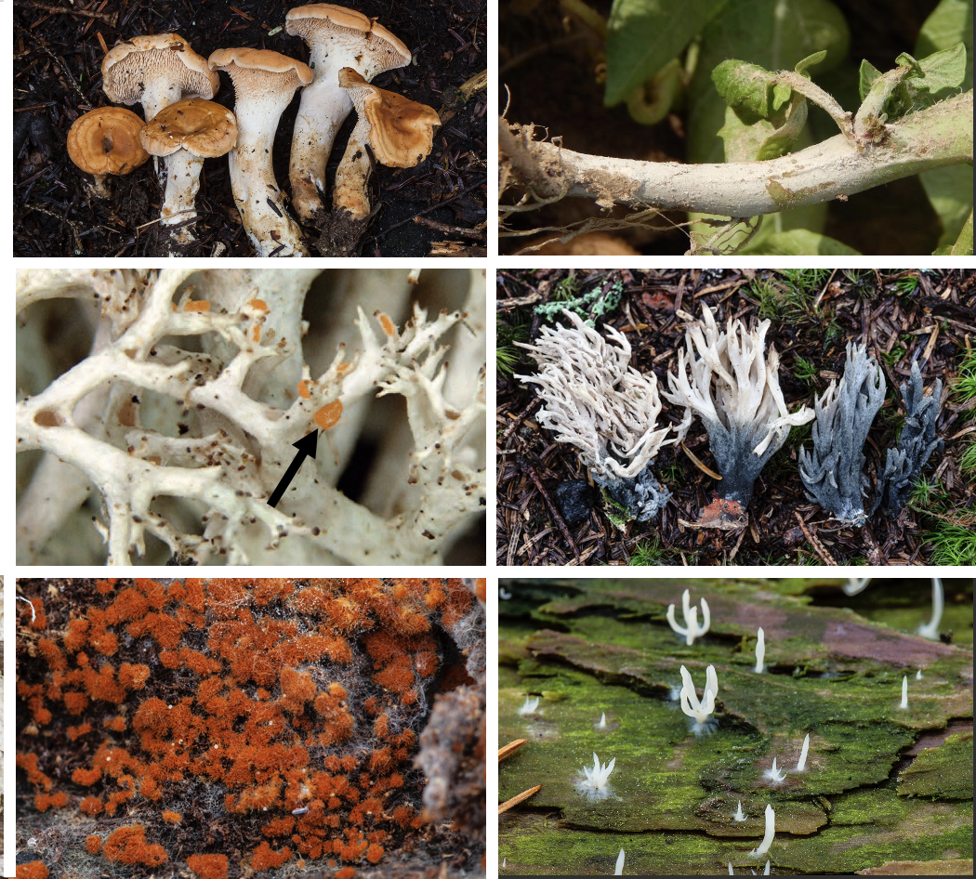
Figure 22. Morphological and ecological diversity among Cantharellales fungi. Clockwise from top left: the ectomycorrhizal edible mushroom Hydnum umbilicatum; corticioid (crust-like) teleomorph of the crop pathogen Rhizoctonia solani; an ectomycorrhizal coralloid Clavulina mushroom; the lichenized fungus Multiclavula mucida; the corticioid saprobe Botryobasidium rubiginosum; and the bulbil-forming lichenicolous Neoburgoa freyi. Photo of Rhizoctonia solani by Maria A. Kunetsova; photo of Neoburgoa freyi by Erich Zimmerman; all other photos by Rachel A. Swenie.

Figure 23. Multi-locus (18S, ITS, 28S, tef1, rpb2) phylogeny of the Cantharellales. Family designations are denoted in bold text with accepted families in blue. ML bootstrap values ≥ 70% are shown on branches. Clades strongly supported by UF bootstrap, SH, and aBayes metrics are indicated by bold branches.

Figure 24. 18S phylogeny of the Cantharellales. Family designations are denoted in bold text with accepted families in blue. ML bootstrap values ≥ 70% are shown on branches. Dotted line indicates a branch is displayed as half of full length.

Figure 25. ITS phylogeny of the Cantharellales. Family designations are denoted in bold text with accepted families in blue. ML bootstrap values ≥ 70% are shown on branches.

Figure 26. 28S phylogeny of the Cantharellales. Family designations are denoted in bold text with accepted families in blue. ML bootstrap values ≥ 70% are shown on branches.

Figure 27. tef1 phylogeny of the Cantharellales. Family designations are denoted in bold text with accepted families in blue. ML bootstrap values ≥ 70% are shown on branches.

Figure 28. rpb2 phylogeny of the Cantharellales. Family designations are denoted in bold text with accepted families in blue. Bootstrap values ≥ 70% are shown on branches.

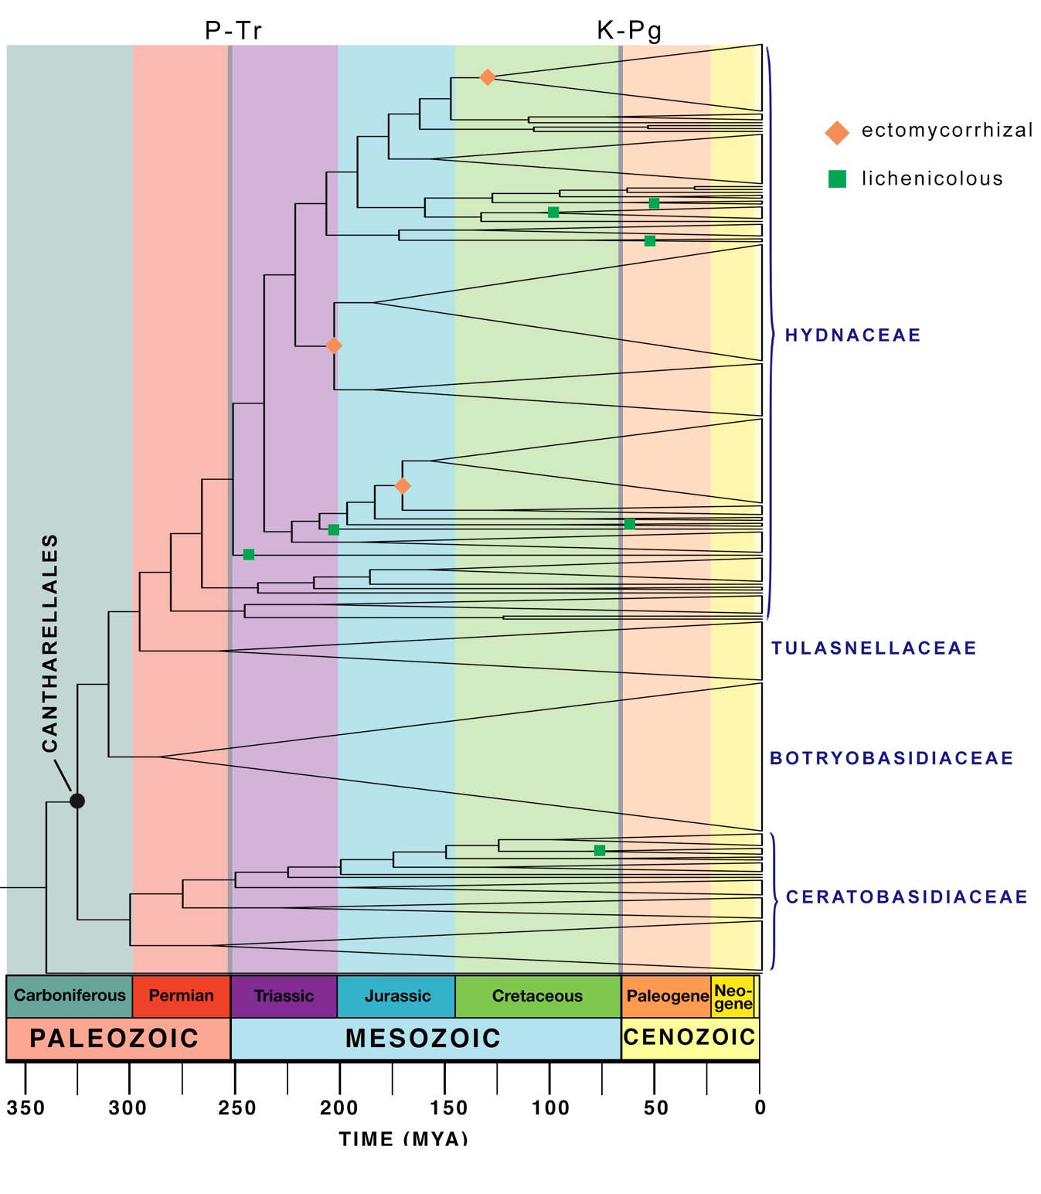
Figure 29. Time-calibrated phylogeny of the Cantharellales showing clades containing biotrophic (ectomycorrhizal and lichenicolous) species. Mass-extinction events are indicated with shaded bars.

CONCLUSION

This dissertation provides important contributions to understand fungal diversity, phylogenetic relationships, and evolution in the Cantharellales. Within the Cantharellales, I conducted systematic and taxonomic revision of two economically important genera of wild edible mushrooms in eastern North America: Hydnum, the hedgehog mushrooms, and Cantharellus, the chanterelle mushrooms. Hydnum was long thought to consist of very few globally-distributed species based on a morphological species concept, but species estimates based on molecular diversity have grossly exceeded that expectation. In eastern North America alone, I found evidence for sixteen species of Hydnum by integrating morphological, ecological, and molecular phylogenetic data from modern and historical type collections. In contrast to original concepts of Hydnum diversity, most Hydnum species are continental endemics (Feng et al. 2016). Indeed, only one eastern North American species, Hydnum mulsicolor, is shared between North America and Europe. Other more recent studies from China and Japan have revealed no Hydnum species that are shared between Asia and North America.
The chanterelle mushrooms (genus Cantharellus), in contrast, exhibit higher species diversity than Hydnum in eastern North America, with 27 described species. My research shows that while most chanterelle species in eastern North America appear to range widely across the region, a few exhibit intercontinental distribution patterns. Collections from the southern Appalachian Mountains revealed the first records of Cantharellus camphoratus, C. betularum, and C. cibarius from the United States. Cantharellus camphoratus is a fir- and hemlock-associated species with known populations in Atlantic Canada and the northeastern U.S., the highest elevations of the southern Appalachians, and montane Japan. I also show the iconic type species of the genus, Cantharellus cibarius, is not restricted to Europe as previously thought. Rather, C. cibarius appears to have a circumboreal distribution across Europe, Asia, and North America and may have been redescribed in North America as C. enelensis and C. roseocanus. Further multi-locus sampling of these and other eastern North American Cantharellus taxa is desirable to draw a clearer picture of species distributions.
Furthermore, I found multi-locus phylogenetic analysis is critical to species delimitation in Cantharellus. Gene conflict is abundant among Cantharellus species, and multi-locus analysis provides the most insight into species diversity among these morphologically variable fungi. Single-locus species identification has led to redescription of existing species; some cases, such as C. tenuithrix, are best referred to as complexes in the absence of additional multi-locus sampling from type materials. Nonetheless, novel unnamed Cantharellus species remain, even in a relatively well-studied region like North America. Based on micromorphology, ecology, and multi-locus phylogenetic analysis, I described one new species from oak habitat in Tennessee, C. vicinus, and elevated another species from the southern Appalachians to the species level, C. intensissimus. In total, I recognized 27 Cantharellus species in eastern North America, thirteen of which occur in the southern Appalachian Mountains.
Analyses of species diversity and distribution patterns provide insight into the historical biogeography and diversification processes that have shaped lineages. Knowledge of species diversity and their distributions is necessary to understand the wider ecological impacts of human use of these mushrooms. Across the Cantharellales more broadly, many unanswered questions remain concerning patterns and timing of diversification events. However, no well-supported phylogeny of the order exists to provide a framework for future biogeographic and ecological studies. Fungal genomics is still in its infancy and there exist draft genomes but no reference genomes for Cantharellales species. Most modern phylogenies are built from Sanger sequencing data, which is costly and time-consuming to produce.
To expedite the construction of a large-scale Cantharellales phylogeny, I developed a new method for generating multi-locus sequence data from a fungal specimens, cultures, and archival DNA extracts using the PacBio Sequel sequencing platform. PacBio high-throughput sequencing technology produces high-quality long reads from hundreds of samples, including heterogeneous and contaminated samples. Multiplexing loci together saves additional time and cost compared to traditional Sanger sequencing methods. Using this new method yielded clean sequences and allelic variants for multiple loci from hundreds of specimens representing all major lineages and ecological groups of Cantharellales. PacBio sequencing succeeded for many difficult samples where Sanger sequencing had failed, often due to length polymorphisms, corticioid compound organisms, or presence of protist contaminants. I recovered particularly high levels of within-sample sequence divergence in corticioid Cantharellales– up to 8.8% even in single-copy protein-coding loci. Many of these species have binucleate and multinucleate hyphae, which can be genetically divergent within a single individual. Species delimitation based on phylogenetic and morphological criteria has proved problematic in these groups and species limits remain unresolved. However, this PacBio sequencing method provides a promising path forward to characterizing individual and species-level genetic variation in these fungi.
Lastly, I combined PacBio, Sanger, and JGI genome sequence data to generate the first densely sampled multi-locus phylogeny of the Cantharellales. Single-gene phylogenies revealed the small subunit (18S) and internal transcribed spacer (ITS) nuclear ribosomal DNA loci contained considerable length heterogeneity in the genera Cantharellus, Craterellus, and Tulasnella, and were thus excluded from the multi-locus phylogenetic analysis. Overall, the multi-gene phylogeny supports recognition of four monophyletic families within the Cantharellales: Hydnaceae sensu lato, Botryobasidiaceae, Ceratobasidiaceae, and Tulasnellaceae. Stichic basidia may be a synapomorphy for the Hydnaceae, but this has not yet been investigated in the lichenicolous or saprobic corticioid members of in the family. Three independent transitions to an ECM nutritional mode are predicted within the Hydnaceae. Overall, rpb2 remains the most suitable locus for species recognition and phylogenetic inference across the Cantharellales, while acknowledging that multiple divergent copies of this gene may exist within a species.
There remain many outstanding questions about the evolution of nutritional modes and species diversification in the Cantharellales, such as: What is the nutritional mode of non-pathogenic and non-mycorrhizal Cantharellales species? Did acquisition of a stipitate morphology with an ECM nutritional mode drive species diversification? How did species diversity change across time and space? Further studies of diversification, biogeography, and functional ecology of the Cantharellales are warranted to understand the mechanisms and outcomes of evolution in this important group of Agaricomycetes.

VITA

Rachel A. Swenie was born in Illinois. She earned a Bachelor of Fine Arts in Photography from Columbia College Chicago and went on to found and run a mycology laboratory and mushroom farm at The Plant in the Back of the Yards neighborhood of Chicago. Keen to learn more about fungal diversity, Rachel returned to school to study biology and mycology. She conducted doctoral studies on systematics and taxonomy of chanterelle mushrooms and allies under the mentorship of Brandon Matheny and received her Ph.D. in Evolutionary Biology from the University of Tennessee, Knoxville in 2023. Rachel is an avid field mycologist and co-author of a forthcoming field guide to mushrooms of the southern Appalachian Mountains.

