pH-responsive hydrogels formed with shellac and zein acidified with glucono-δ-lactone

A Thesis Presented for the
Master of Science
Degree
The University of Tennessee, Knoxville

Javier Alfredo Aleman Martinez
December 2024

Copyright © 2024 by Javier Alfredo Aleman Martinez.
All rights reserved.

ACKNOWLEDGEMENTS
When I was searching for professional opportunities, Dr. Qixin Zhong gave me a chance to be part of his team and test all my ideas. I also appreciate him for being supportive and patient in the process of learning and applying knowledge. The curiosity and judgement learned from Dr. Zhong have made me a better professional. My professional internship made me realize how I have improved my judgement and scientific capabilities. I also want to thank my committee members Dr. Toni Wang and Dr. Tao Wu. I want to thank them for their patience and understanding. I want to thank Dr. Wang for letting me use her equipment and guide my ideas. I also want to thank Dr. Wu for always giving space for discussion whenever needed. Learning is a process, and I am glad these three professionals were part of my learning journey.
I also want to thank all the previous and current lab members including Surangna Jain, Bryan Castellanos, Kriza Calumba, Manik Roy, Shuang Ren, Md. Abdur Razzak, and Fatima Reyes. I want to thank Bryan Castellanos and Kriza Calumba for being supportive in my first months and path in the department. I also want to give a special thanks to Surangna Jain for her patience and guidance.
This work was supported by the University of Tennessee Institute of Agriculture and USDA National Institute of Food and Agriculture hatch project TEN00568.
ABSTRACT
Hydrogels with a continuous water phase and responsive to environmental conditions such as pH have unique applications. Shellac, a wax used in food coating, is a pH-responsive molecule soluble above pH 7 but insoluble in acidic conditions. The hypothesis of this thesis is that addition of zein in alkaline shellac solutions enables the formation of pH-responsive hydrogels after gradual and uniform acidification to slightly acidic pH enabled by hydrolysis of glucono-δ-lactone. In the first objective, the formation of zein-shellac hydrogels and physical properties of hydrogels were characterized. With 0.50-4.0% w/v zein supplemented to 4.0% w/v shellac at pH 12.0, dissolving 1.2% w/v glucono-δ-lactone lowered pH to 6.2-6.4 gradually during 8-h incubation at 22 °C and formed self-standing hydrogels. These hydrogels maintained their volume when immersed in phosphate buffer at pH 7.0, shrank at pH 6.0, but swelled or dissolved at pH 8.0. Small amplitude oscillatory tests were used to characterize rheological properties of hydrogels. These hydrogels showed a limit of linear viscoelastic regime of >1% strain, independent of zein concentration. A higher content of zein shortened the gelation time, and the storage modulus at 1 Hz was the highest (ca. 8,000 Pa) at 3.0% zein. Heating at 4-50 °C reduced the moduli, signifying hydrogen bonds in networks. In texture profile analysis, hydrogels had the highest hardness, adhesiveness, gumminess, and chewiness at 2.0-3.0% zein, while springiness and resilience were less dependent on zein concentration. The second objective was to investigate possible gelation mechanisms. Protein electrophoresis showed the grafting of multiple shellac to zein. Shrinking of hydrogels in 100-600 mM NaCl solutions at pH 7.0 indicates the insignificance of electrostatic attraction in gelation. Dissolving of hydrogels in 0.2-0.8% sodium dodecyl sulfate solutions and swelling of hydrogels in 1.0-4.0 M urea solutions at pH 7.0 unveil the major role of hydrophobic attraction bringing free shellac and shellac-grafted zein molecules in proximity to form hydrogen bonds and thus hydrogels. The significance of covalent bonding, hydrophobic attraction, and hydrogen bonds in hydrogel formation was confirmed in Fourier-transform infrared spectroscopy. These hydrogels with pH-responsiveness around pH 7.0 may find novel food and non-food applications.
Keywords: Zein, shellac, hydrogel, pH-shifting, pH-responsive, rheology

Table of Contents
Chapter One Introduction and Literature Review 1
1.1. Introduction 2
1.2. Molecular properties of zein 4
1.2.1. Structure of zein 4
1.2.2. Solubility of zein 4
1.3. Molecular structure and properties of shellac 6
1.3.1. Solubility of shellac 6
1.3.2. Shellac as a pH-responsive material 7
1.4. Improvement of dispersion stability of zein and shellac 7
1.4.1. Zein-surfactant complexes 7
1.4.2. Shellac-protein interactions 8
1.4.3. Zein-shellac interactions 9
1.5. Physical and chemical interactions of gels 9
1.5.1. Hydrophobic interactions (attractive force) 10
1.5.2. Hydrogen bonds (attractive force) 10
1.5.3. Covalent bonds (attractive force) 11
1.5.4. Electrostatic interactions (attractive or repulsive forces) 11
1.5.5. Steric interactions (repulsive force) 12
1.6. GDL-induced gelation 12
1.6.1. Acid-induced gelation of proteins 12
1.6.2. GDL role in protein gelation 13
1.7. Shellac-based gels 14
1.7.1. Techniques for preparing shellac-based gels 14
1.7.2. Rheological properties of shellac-based gels 15
1.8. Zein-based gels 16
1.8.1. Techniques for preparing zein-based gels 16
1.8.2. Rheological properties of zein-based gels 18
1.8.3. Texture properties of zein-based gels 20
1.9. pH-responsive hydrogels 20
1.9.1. Techniques for synthesis of pH-responsive hydrogels 21
1.9.2. Applications 22
2. Hypothesis and objectives 22
3. References 24
Chapter Two Materials and Methods 40
2.1. Chemicals and reagents 41
2.2. Formation of hydrogels 41
2.3. Swelling of gels at pH 6.0-8.0 41
2.4. Rheological analyses 42
2.4.1. Strain and frequency sweeps 42
2.4.2. Time sweep 42
2.4.3. Heating ramp 42
2.5. Texture profile analysis 43
2.6. Molecular interactions between zein and shellac 43
2.6.1. SDS-PAGE analysis 43
2.6.2. Zeta-potential and particle size analysis of dilute dispersions 43
2.6.3. Swelling of gels in NaCl, urea, and SDS solutions 44
2.6.4. Fourier-transformed infrared (FTIR) spectroscopy analysis 44
2.7. Statistical analysis 44
Chapter Three Results and Discussion 46
3.1. Visual assessment of gel formation 47
3.2. Swelling properties of hydrogels responding to pH 47
3.3. Rheological properties of gels 48
3.3.1. Strain and frequency sweep analyses 48
3.3.2. Time sweep analysis 48
3.3.3. Temperature sweep analysis of gels 49
3.4. Texture profile analysis of gels 50
3.5. Molecular interactions between zein and shellac in gel formation 51
3.5.1. SDS-PAGE analysis 51
3.5.2. Zeta potential, particle size analysis, and swelling 52
3.5.3. Interaction forces indirectly measured by swelling behavior 53
3.5.4. FTIR analysis 54
3.6. Possible gelation and pH-responsiveness mechanism 54
3.7. References 57
Chapter Four Conclusions and Future Work 63
Appendix 65
Vita 78

LIST OF TABLES
Table 1. Volume change% of gels prepared with 4.0% w/v shellac and 0.50-4.0% w/v zein after 12-h incubation at 22 °C in phosphate buffer adjusted to pH 6.0-8.0. 68
Table 2. Textural properties of gels prepared using 4.0% w/v shellac, 0.50-4.0% w/v zein, and 1.2% w/v of glucono-δ-lactone at pH 12.0 followed by 8-h incubation at 22 °C. 72

LIST OF FIGURES
Figure 1. Chemical structure of shellac monoester elaborated on ChemDraw software. 65
Figure 2. Appearance of 2.0 % w/v zein (ZN), 4.0% w/v shellac (SL), and mixtures with 0.50-4.0% w/v ZN and 4.0% w/v SL at pH 12.0 (A) and after addition of 1.2% w/v of glucono-δ-lactone and incubation at 22 °C for 8 h (B). Figure C shows pH changes of these samples. 66
Figure 3. Visual appearance of gels prepared using 4.0% w/v shellac (SL) and 0.50-4.0% w/v zein (ZN) immersed in phosphate buffer adjusted to pH 6.0, 6.5, 7.0, 7.5, and 8.0 at 22 °C for 0 and 12.0 h. 67
Figure 4. Strain sweep analysis at 1.0 Hz (A), frequency sweep at 0.10% strain magnitude (B-F), and the compiled tan(δ) (G) of samples with 4.0% w/v shellac (SL), 4.0% (B), 3.0% (C), 2.0% (D), 1.0% (E) or 0.5% (F) w/v zein (ZN), and 1.2% w/v glucono-δ-lactone at pH 12.0 incubated at 22 °C for 8 h without shearing before analysis. Data are averages of two independent replicates. 69
Figure 5. Storage modulus (Gʹ, black squares) and loss modulus (Gʺ, red circles) during 8-h time sweep at 22 °C, 0.10% strain magnitude, and 1.0 Hz for samples with 4.0% w/v shellac (SL), 4.0% (A), 3.0% (B), 2.0% (C), 1.0% (D) or 0.5% (F) w/v zein (ZN), and 1.2% w/v glucono-δ-lactone at pH 12.0. The gelation time (t_{gel}) shows the time when Gʹ begins to consistently surpass Gʺ. Rheological data are averages of two independent replicates. 70
Figure 6. Storage modules (Gʹ, black squares) and loss modulus (Gʺ, red circles) at 1.0 Hz and 0.10% strain magnitude for zein-shellac gels during heating from 4 to 50 °C. Samples with 4.0% w/v shellac (SL) and 4.0% (A), 3.0% (B), 2.0% (C), 1.0% (D) or 0.5% (F) w/v zein (ZN) at pH 12 were added with 1.2% w/v glucono-δ-lactone and were incubated at 22 °C for 8 h without shearing before the temperature sweep at 0.5°C/ min. Data are averages of two independent replicates. 71
Figure 7. SDS-PAGE analysis of 2.0% w/v zein only (lane 1), 4.0% w/v shellac only (lane 2), and 4.0% w/v shellac and 4.0% (lane 3), 3.0% (lane 4), 2.0% (lane 5), 1.0% (lane 6), or 0.5% (lane 7) w/v zein at pH 12.0 after adding 1.2% w/v of glucono-δ-lactone and 8-h incubation at 22 °C. 73
Figure 8. Zeta potential of dispersions with 2.0% w/v zein (ZN), 4.0% w/v shellac (SL), and mixtures of 4.0% w/v SL and 0.50-4.0% w/v ZN at pH 12.0 after 10-time dilution in deionized water and adjusting to pH 6.0-12.0 (A) and particle size distribution of these dispersions at pH 7.0 (B). 74
Figure 9. Visual appearance and volume change% of gels prepared with 4.0% w/v shellac and 0.50-4.0% w/v zein after immersing at 22 °C for 12 h in pH 7.0 phosphate buffer containing different concentrations of NaCl (A,D), SDS (B,E) or urea (C,F). 75
Figure 10. FTIR spectra of powders freeze-dried from dispersions with 2.0 % w/v zein (ZN), 4.0% w/v shellac (SL), and mixtures with 0.50-4.0% w/v ZN and 4.0% w/v SL at pH 12.0 after addition of 1.2 g of glucono-δ-lactone and incubation at 22 °C for 8 h. 76
Figure 11. Possible mechanism of forming of zein-shellac hydrogels as the hydrolysis of glucono-δ-lactone lowers pH to 6.2-6.4. 77

Chapter One
Introduction and Literature Review

1.1. Introduction
Gels, especially hydrogels with a continuous aqueous phase, are an important category of food products and provide important functional qualities such as mechanical strength, rheological characteristics, texture, and water retention capacity (Weiss, Salminen, Moll, & Schmitt, 2019). Proteins and polysaccharides are commonly used to form gels driven by a variety of mechanisms. In the case of pH and temperature-driven protein gels, the gelation typically involves protein denaturation and self-assembly, and the strength and structure of gel network are driven by the interplay of attractive and repulsive physical forces, as well as possible covalent bonding (Banerjee & Bhattacharya, 2012). Within hydrogel systems, pH-responsive hydrogels have gained interest due to their applications in drug delivery systems (Gupta et al., 2002). This class of hydrogels owe their pH-responsive swelling behavior to ionizable groups of the network forming components (Kocak et al., 2017). Therefore, the gelation of these hydrogels is profoundly affected by environmental conditions.
Water solubility is a prerequisite of forming protein hydrogels, and hydrogels are rarely formed from hydrophobic proteins. Among hydrophobic proteins, zein, prolamins in corn, is insoluble in water, but exhibits good solubility in aqueous ethanol mixtures (40-90% v/v) and alkaline solutions (Wang & Padua, 2010). Zein is well known for its application as surface coating in films and has been studied in nutraceutical delivery systems (Zhang et al., 2015). Zein can also form gel networks in aqueous ethanol solutions without (Zhong & Ikeda, 2012) or with (Gagliardi et al., 2020) evaporating ethanol. However, most food gels do not have the ethanol concentration need to form zein gels (Yuan et al., 2022). Other studies reported zein-polysaccharide complex hydrogels or emulsion gels (Wang et al., 2016). Besides polysaccharides, surfactants such as shellac and sodium dodecyl sulfate (SDS) can be adopted to bind with zein in diluted conditions (Mehta, 2010; Sun et al., 2017). However, there are currently no studies on hydrogels formed from mixtures containing surfactants and zein.
Shellac is a natural polymer classified as generally recognized as safe by the Food and Drug Administration (21 CFR 175.300). It is an amphiphilic resin composed of esterified aleuritic and cyclic terpene acids (Luo et al., 2016). Additionally, shellac has a pH-dependent solubility because its pKa between 6.9 and 7.5 makes it soluble above pH 7 but insoluble below about pH 7 (Limmatvapirat et al., 2007). Moreover, the significant portion of ionizable carboxylic groups in shellac enables its pH-responsiveness and controlled release of drugs in network structures (Barik et al., 2017). Shellac has previously been studied to strengthen soy protein hydrogels at pH 9 mediated by hydrophobic interactions and hydrogen bonding (Guo et al., 2023). Additionally, covalent bonding between ester groups of shellac and amino groups of proteins forms in alkaline conditions (Cagil, 2020; Wang et al., 2024). These physical and chemical characteristics of shellac are significant to the formation of pH-responsive hydrogels.
In this study, the aim was to fabricate pH-responsive hydrogels following a pH-shifting procedure by first dissolving shellac and zein at alkaline pH to possibly form covalent bonds and subsequently lowering pH to below the pKa of shellac (Wang et al., 2024). Instead of adopting strong acids like HCl, glucono-δ-lactone (GDL) was adopted to prevent the local precipitation during pH-shifting (Sun et al., 2018). The gradual hydrolysis of GDL uniformly lowers pH in the sample to possibly form ordered structures linking shellac-zein molecules to form hydrogel networks (Duran et al., 2019). The current chapter therefore reviews molecular properties of zein and shellac, interactions between shellac and proteins including zein, interactions involved in hydrogel formation, GDL-induced gelation, gels based on zein and shellac, and pH-responsive hydrogels.

1.2. Molecular properties of zein

1.2.1. Structure of zein
Zein, the primary storage protein of corn endosperm, is mainly composed of α-zein with two subunits having molecular weights of about 19 and 22 kDa (Li et al., 2012; Tatham et al., 1993; Xing et al., 2023). The scarcity of acidic and basic amino acids (Shukla & Cheryan, 2001) and the abundancy of hydrophobic amino acids are responsible for its hydrophobic nature (Gianazza et al., 1977). The secondary structure of α-zein is composed of 35-60% α-helices (Momany et al., 2006), and these α-helical segments (9-10) organized in an antiparallel configuration connected by glutamine residues and stabilized by hydrogen bonds further constitute its tertiary structure (Wang et al., 2008). In general, zein exhibits remarkable stability in its primary structure under various conditions such high pH, high temperature, and different concentrations of denaturants ((Selling et al., 2007).

1.2.2. Solubility of zein
Protein solubilization involves the sequential disruption of intermolecular forces such as hydrogen bonds and hydrophobic interactions. Hydrophobic amino acid residues such as leucine, proline and alanine add up to 43% of the total amino acid composition of zein (Gianazza et al., 1977). Therefore, zein is insoluble in water, and the aid of a polar organic solvent, highly alkaline or acidic conditions, or a surfactant is needed to dissolve zein (Li et al., 2012; Mehta, 2010; Pan & Zhong, 2016). Polar organic solvents used to form a binary solvent with water to dissolve zein include ethanol, methanol, and acetone (Manley & Evans, 1943). Particularly, α-zein can be well solubilized in 65-90% v/v aqueous ethanol (Li et al., 2012). However, these organic solvents are to be removed for certain applications.
Solubility of zein at highly basic or acidic solutions is enabled by its basic, acidic, and polar amino acids, including arginine (4), histidine (1), asparagine (4), and glutamine (21) (Shukla & Cheryan, 2001). In acidic conditions, zein acquires an overall positive charge, while it is overall negatively charged in alkaline conditions due to protonation and deprotonation of its amino acid residues; when the net charge becomes sufficient, zein becomes soluble in both alkaline and basic conditions (Qing et al., 2022).
Zein can interact with surfactants such as sodium dodecyl sulphate (SDS) through electrostatic and hydrophobic interactions (Mehta, 2010). The electrostatic attraction of ionic surfactants to oppositely charged amino acids of proteins and the hydrophobic interactions between the nonpolar sections of surfactants such as the alkyl chains and nonpolar amino acid residues of zein can improve stability (Ananthapadmanabhan, 2018). For SDS, the hydrophobic binding to nonpolar amino acid residues causes the unfolding of zein, and the attachment of SDS results in negative charges of complexes to enable the solubility and stability (Deo et al., 2003). Data based on absorbance and titration states that in a 1.5 g of SDS to 1 g of zein, 147 molecules can bind to a single zein molecule and complexes clusters are present rather than individual molecules based on light scattering data ((Ruso et al., 2004).

1.3. Molecular structure and properties of shellac
Shellac is a resin derived from lac bug (Laccifer lacca) and consists of a mixture of polyesters (Wang et al., 2004). Shellac has a low molecular weight of 1410-2417 Da (Li et al., 2020; Wang et al., 2024). Shellac’s chemical composition (Fig. 1) enables it to have distinctive solubility and behavior in different dispersed systems due to its pKa between 6.9 and 7.5(Limmatvapirat et al., 2007) making it soluble above pH 7 and insoluble below pH 7, i.e., pH responsive behavior (Yuan et al., 2021).

1.3.1. Solubility of shellac
Shellac is a resin composed of hydrophobic and hydrophilic sections and therefore is amphiphilic. The hydrophilic section is its carboxyl groups, while its hydrophobic section is due to its aliphatic chains of acids including aleuritic, jalaric, butolic and shellolic-epishellolic acids (Chen et al., 2024). Although shellac is an amphiphilic molecule, its major hydrophobic nature makes it insoluble in water and soluble in polar solvents such as alcohols, organic acids and ketones, as well as binary mixtures of these polar solvents and water (Gardner & Whitmore, 1929). Besides, the solubility of shellac in water is achieved in alkaline solutions of sodium carbonate after being heated to produce alkaline salts (Kamath & Mainkar, 1950). Although it may be stable in alkaline solutions, shellac has an aggregation behavior at pH <7 (Patel et al., 2013) as its pKa is between 6.9 and 7.5 (Limmatvapirat et al., 2007)

1.3.2. Shellac as a pH-responsive material
pH-responsive polymers contain acidic or basic groups such as carboxyl, amines, phosphate and sulfonic that change their structure and properties when exposed to different pH levels (Kocak et al., 2017). In the case of hydrogel systems, these ionizable groups may enable a pH-dependent swelling based on electrostatic interactions, with anionic hydrogels expanding above their pKa and cationic ones below their pKa (Gupta et al., 2002). One example of pH-responsive polymers is shellac, which has been utilized to control drug release based on pH (Cagil, 2020; Patel et al., 2011). This behavior is mainly associated to its considerable high content of carboxylic groups (Sharma et al., 1983), which lose protons at basic pH and accept them at low pH (Kocak et al., 2017). At low pH levels, like those present in the stomach (pH 1.2-3), it remains insoluble, while as pH increases in conditions such as the small intestine (pH 6.8-7.4), it may become soluble and release targeted drugs (Patel et al., 2011). Additionally, the combination of shellac with other compounds such as gelatin and plasticizers has been investigated to strengthen the stability and mechanical attributes of films (Soradech et al., 2017).

1.4. Improvement of dispersion stability of zein and shellac

1.4.1. Zein-surfactant complexes
Zein’s susceptibility to aggregate complicates its application in water at neutral pH, and therefore, different compounds such as surfactants have been used to overcome this limitation. The nature of the surfactant utilized may influence the solubilization and stability of zein. Anionic surfactants have the highest capacity to solubilize and stabilize zein, while zwitterionic and nonionic ones have a reduced impact (Lechuga et al., 2023; Shao et al., 2019).
An important parameter to measure the improvement of zein stability is particle size. Dai, Sun, et al. (2018) found that the complexes of zein and lecithin (a zwitterionic surfactant) to encapsulate curcumin at pH 4, had a reduction particle size as the concentration lecithin increased. The composite nanoparticles had a core of zein and curcumin bound by alkyl chains of lecithin via hydrophobic interactions, which enabled the nanoparticle stability at the increased lecithin content.
Nonionic surfactants can also help in the stabilization of zein. Tween 20 is a nonionic surfactant that, at a concentration of just 0.2 g/L, can hydrophobically (via its alkyl chains) interact with hydrophobic amino acids of zein to decrease particle size and enable stability at pH 4 (Wang et al., 2019). Similarly, Tween 80 improved physical stability of zein nanoparticles (Hu & McClements, 2014). The adsorption of polysorbates on zein nanoparticles forms a surface with polar groups of the surfactant to prevent nanoparticle aggregation due to hydrophobic attraction.
Anionic surfactants such as SDS interact hydrophobically with zein, unfolding the protein and solubilizing it as SDS concentration is increased (Deo et al., 2003). This occurs due to increased repulsion between charged headgroups of SDS at increased concentrations, which also leads to a greater unfolding of the protein. The drawback of this kind of synthetic surfactants is its potential toxicity (Newby et al., 2000)

1.4.2. Shellac-protein interactions
Shellac has been demonstrated to form different interactions with proteins that enable the formation of films, nanocapsules, and gel systems (Wang et al., 2020; Yang et al., 2018; Zhang et al., 2020). Due to its solubility limit in water, different techniques, such as antisolvent co-precipitation and pH-adjusting of aqueous solutions, have been applied to achieve interactions with other compounds and improved dispersibility in water (Chen et al., 2018).
Zeta potential analysis, provides valuable information about dispersions’ aggregation, and a magnitude of greater than 30 mV is considered a critical value for preventing colloidal particle aggregation (Hunter, 2013). H. Zhang et al. (2022) dispersed shellac pre-dissolved in ethanol to aqueous sodium caseinate solution. After evaporating ethanol, the zeta potential of the shellac-casein complexes was similar to that of sodium caseinate at pH 1.2 (gastric pH), suggesting the outer structure of complexes was sodium caseinate.
The pH-shifting process allows the solubilization of proteins at basic conditions leading to conformational changes in protein structure. Breakup of ester bonds in the oligomeric structure of shellac in basic conditions can allow covalent interactions between shellac monoesters and amino groups in proteins such as casein via a transacylation reaction to create covalent bonds between the two compounds (Guo et al., 2023; Wang et al., 2024). The covalent bonds enhance the stability of shellac at neutral pH. In another study, when implementing the pH-shifting process with 1% w/v rice protein and shellac, a decrease in zeta potential during the pH-shifting was associated to protein folding aided by hydrophilic groups of shellac (Wang et al., 2020).

1.4.3. Zein-shellac interactions
Zein and shellac mixtures can exhibit complex interactions and display unique properties as composite materials. In one study, zein and shellac were utilized to encapsulate curcumin in an antisolvent coprecipitation process (Sun et al., 2017). In the same study, shifts in amide I and amide II in the Fourier transform infrared (FTIR) spectra of zein and shellac revealed hydrogen bonding and hydrophobic interactions (Chen et al., 2018; Sun et al., 2017). The zeta potential and particle size value revealed compatibility and stability of the formed composite particles at pH 8. In another study, zein-shellac mixtures were used as delivery system for quercetin at pH 8 (Liu et al., 2024). In this study, the particle size of chitosan-zein-shellac nanoparticles displayed a size range from 200-250 nm above pH 5, mainly because zein and shellac carry a negative charge between pH 6-8, therefore improving the stability of the system. In a similar study, zein-shellac nanoparticles were developed to deliver alantolactone, a bioactive compound (Yu et al., 2023). The zeta potential displayed by the mixtures of the two compounds was below -30 mV in an aqueous ethanol solution (80% v/v). Based on this, stability demonstrated by zein-shellac mixtures especially near physiological pH (6-8) (Liu et al., 2024) may be utilized for different food and non-food applications.

1.5. Physical and chemical interactions of gels
The structural integrity and molecular associations of proteins during gelation can be interpreted through intermolecular interactions which have a crucial role in describing the protein behavior in aqueous solutions. The aggregation behavior of proteins is mediated by attractive and repulsive forces. One key aspect is described in the Derjaguin-Landau-Verwey-Overbreek (DLVO) theory. This theory proposes that the stability of colloidal systems is governed by the combination of two primary forces: van der Waals attraction (relative long-range forces) and electrostatic interactions arising from electrical double layer of particles (De Young et al., 1993). Besides DLVO forces, other non-DLVO forces affected by the surrounding solvent such as hydrophobic interactions, hydrogen bonds and steric repulsion are significant factors in protein stability (Molina-Bolıvar et al., 1999).

1.5.1. Hydrophobic interactions (attractive force)
Hydrophobic interactions have a crucial participation in protein gelation and conformational changes. The nonpolar amino acids of proteins try to minimize the contact with water, leading to protein aggregation (Kellis Jr et al., 1988). Several factors can enhance hydrophobic interactions, e.g., increasing temperature (Privalov, 1988). In the case of zein, the high proportion of hydrophobic amino acids can cause the entropy-driven aggregation that is influenced by temperatures (Bromberg, 1997). The hydrophobic interactions can be weakened by surfactants such as SDS and dodecyllethyldimethylammonium bromide (DDAB) through their binding on nonpolar aminoa acids of proteins (Mehta, 2010).

1.5.2. Hydrogen bonds (attractive force)
Hydrogen bonds are considered weaker interactions when compared to covalent bonds individually. In proteins, hydrogen bonds occur between partially electronegative atoms (O, N, and F) of amino acid residues to the hydrogen atoms covalently linked to another residue or compound which can facilitate protein gelation (Israelachvili, 2011). Intermolecular hydrogen bonds facilitate aggregation during gelation, while intramolecular hydrogen bonds are critical to protein structure and stability (Giteru et al., 2021). Hydrogen bonds play different roles in the secondary structure of proteins such as α-helices and β-sheets (Petukhov et al., 2004). This category of interactions can be weakened specially at increased temperatures due to increased thermal energy (Pace et al., 2014; Tang et al., 2002). Although hydrogen bonds contribute to protein stability, the overall polarity of protein amino acids plays the main role in protein solubilization and stability (Lazaridis et al., 1995).

1.5.3. Covalent bonds (attractive force)
Unlike non-covalent interactions, covalent bonds can play a major role in the structural integrity of proteins due to stronger and irreversible interactions. In the case of disulfide bonds, chain elongation is enhanced rather than acting as a network stabilizer (Clark & Lee-Tuffnell, 1998). Zein, which contains thiols groups within the amino acid cysteine, can form disulfide bonds between these cysteine residues (Esen, 1987). Disulfide bonds can enhance the process of gelation due to the increase in average molecular weight and chain length, therefore contributing to more extensive protein networks (Wang & Damodaran, 1990).
One nonenzymatic reaction for covalent bond formation is the transacylation reaction. This reaction can occur between casein (amino group) and propylene glycol alginate (PGA) with ester groups at alkaline conditions without Maillard reaction byproducts (Li & Zhong, 2021). After ester bonds of PGA are cleaved at alkaline conditions, the produced saturated carboxylate groups can rearrange to form covalent links with the amine groups of proteins which can stabilize the protein near its isoelectric point (Hadef et al., 2015; Li & Zhong, 2020).

1.5.4. Electrostatic interactions (attractive or repulsive forces)
Electrostatic interactions depending on the surface charge of proteins can behave as attractive or repulsive forces, being repulsive when their charges are the same type and attractive when they contain opposite charges (Bryant & McClements, 1998). These interactions also occur with permanent dipoles or ions and are affected by pH and ionic strength. In the case of zein, at alkaline pH where there is an increase in the deprotonation of side chain and terminal carboxyl groups and sulfhydryl group of cysteine, there is an increase in the electrostatic repulsion (Zhang et al., 2011). Near its isoelectric point of ~pH 6.2 (Dai, Zhan, et al., 2018), the net charge of zein is zero, and the weakened electrostatic repulsion causes the protein to aggregate. Ionic strength influences the electrostatic forces between charged molecules by screening their charges (Sanchez-Dominguez & Rodriguez-Abreu, 2016). Because of this, different physical properties such as gel strength can be altered through modifications in the ionic strength of a gel system (McGuffey & Foegeding, 2001).

1.5.5. Steric interactions (repulsive force)
Steric repulsion (excluded volume interaction) occurs when space occupied by certain molecule segments in a polymer becomes inaccessible by other molecules or segments resulting in the expansion of the polymer chain (Ikeda & Zhong, 2012). In protein gels, hydrophilic groups of molecules that attach to protein surfaces can also reduce hydrophobic protein-protein interactions (Matter et al., 2020). Low ionic strength may enable higher expansion of molecules therefore stronger steric repulsion (Belfort & Lee, 1991). This steric hindrance can inhibit gel formation or modify gel properties. Besides ionic strength, pH can affect steric interactions. Repulsive forces are reduced at pH values close to its pI due to a reduction in the charge density and therefore the expansion of charged structures (Belfort & Lee, 1991).

1.6. GDL-induced gelation

1.6.1. Acid-induced gelation of proteins
Protein gelation is a complex process that is influenced by external factors such as temperature, pH and solvent. Protein gels can be produced after solubilization at pH distant from its isoelectric point, followed by adjusting pH to be close to its isoelectric point (Mleko & Foegeding, 2000). These types of gels are called cold-set gels as their gelation behavior occurs due to screening of charges and not because of temperature shifting (Bryant & McClements, 1998). In one study with casein and whey protein, as the pH approached the isoelectric point, a change in surface charge induced an aggregation behavior and formation of gels (Vasbinder et al., 2004). Whey proteins themselves can also undergo unfolding when their hydrophobic sections are being exposed, inducing a self-assembly process due to intermolecular hydrophobic interactions (Britten & Giroux, 2001). For other proteins such as soy, acidification induces dissociation of glycinin subunits followed by association and formation of gels (Hermansson, 1986).

1.6.2. GDL role in protein gelation
GDL can gradually hydrolyze into gluconic acid when dissolved in water, which in turn slowly releases protons lowering the pH of polymer solutions to induce gelation (Duran et al., 2019; Grygorczyk & Corredig, 2013). Gradual acidification enables a gradual self-association process inducing gelation of hydrophilic and hydrophobic proteins (Wang et al., 2021). Increment amounts of GDL and temperature can also accelerate the release rate and acidification of proteins (Braga et al., 2006; De Kruif, 1997; Liu et al., 2023). During acidification, GDL can induce charge adjustment, and regarding soy protein, gluconic acid neutralizes the surface charges of the protein aggregates, promoting gelation (Liu et al., 2023). These shifts can be monitored through a time sweep experiment as GDL induces acidification. In this test, strain, frequency, and temperature are kept constant to describe a material evolution over time subjected to concurring reactions (Tunick, 2011).
Furthermore, when compared to acidification produced by HCl, the slower rate of acidification produced by GDL can prevent the heterogeneous aggregation of soy subunits (Grygorczyk & Corredig, 2013). This slow acidification translates into a controlled folding of proteins, specially hydrophobic proteins. In one study with soy protein isolates, GDL-induced gelation resulted in a more homogeneous gel structure when compared to being fermented by lactic acid bacteria (Grygorczyk & Corredig, 2013).

1.7. Shellac-based gels
According to Gao JiaNan et al. (2018), shellac dissolved at 5, 10, and 15 wt% in Na₂CO₃ solution can display viscoelastic behavior based on hydrophobic interactions between the polymer vesicles. Moreover, when GDL is used to adjust the pH of shellac-Na₂CO₃ solution, it can create nanosized vesicles that assemble into a hydrogel structure (Li et al., 2016). In contrast, gelation was not observed when shellac was solubilized in NaOH and pH was adjusted utilizing GDL at room temperature (Jain et al., 2023; A. Wang et al., 2022).

1.7.1. Techniques for preparing shellac-based gels
Shellac-based gels have received significant interest in recent years due to their unique properties and applications. Different functional groups found in shellac such as hydroxyl (-OH) and carboxyl (-COOH) facilitate interactions with other compounds through hydrogen bonding and electrostatic interactions (Pearnchob et al., 2004). The preparation of shellac-based composite gels involves mixtures with other compounds to form gels. One technique for gelation of shellac involves the dissolution of shellac at 6 wt% in rapeseed oil to form oleogels after being heated at 85 °C followed by cooling to room temperature (Patel & Dewettinck, 2015). In order to achieve this behavior, shellac must comply with olegelator properties such as attraction to oil and capability to self-assemble (Dassanayake et al., 2011). This capability of shellac to self-assembly may also enable it to create gel systems in aqueous media.
Another technique for shellac gel preparation involves its mixture with other compounds in a pH-shifting process. For instance, shellac can form gels when mixed with soy protein isolates in a co-folding process (Guo et al., 2023). It is worth mentioning that without shellac, soy protein isolates cannot gel in the same conditions. Mixtures of soy protein isolates and shellac were used at a total 12% w/w polymer concentration at different mass ratios. Both polymers were dispersed at pH 12 and then adjusted to pH 9, 8, and 7 followed by gelation at 4 °C. Similarly, shellac-chitosan gels can be fabricated after being dissolved in Na₂CO₃ solution followed by a pH shifting process using GDL (Ma et al., 2024). The limited research on shellac-based pH-shifting hydrogels is due to its predominantly hydrophobic nature, making shellac not a suitable alternative for hydrogel systems.

1.7.2. Rheological properties of shellac-based gels
Shellac-based gels can have different rheological properties under different conditions. One way of measuring gel strength is through frequency and strain sweep analyses. A strain sweep analysis applies a range of strains to a material at a constant frequency to determine its linear viscoelastic regime, whereas a frequency sweep is performed at a fixed strain in a range of frequencies to determine if a material displays viscoelastic properties and can be defined as a gel (Zhong & Daubert, 2013). The storage modulus (Gʹ) and loss modulus (Gʺ) can be tracked at different applied strains and frequencies (within the limit of linear viscoelastic region) to analyze the mechanical properties of gels (Zhong & Daubert, 2013). At low strains, gels display a linear viscoelastic behavior in which Gʹ and Gʺ remain relatively constant. However, at increasing strains, a reduction in Gʹ and Gʺ is attributed to a breakdown in the gel structure. Guo et al. (2023) determined that, for a total concentration of 12% w/w shellac and soy protein isolates, a lower concentration of shellac and a higher soy protein isolate concentration had higher Gʹ values (between 10000 and 20000 Pa) based on strain and frequency sweep analyses. The higher Gʹ values were related to increments in electrostatic attraction and hydrogen bonds between the two compounds. In another study of shellac-based oleogels, Patel et al. (2013) demonstrated that oleogels formed at shellac concentration as low as 2 wt% and increasing concentration of shellac led to higher Gʹ values (between 10000 and 30000 Pa based on a frequency sweep analysis. Patel and Dewettinck (2015) stated that in shellac-based oleogels, the gelation is triggered by the crystal-crystal interactions of shellac during gelation which can result in stronger gels at increasing shellac concentrations.

1.8. Zein-based gels

1.8.1. Techniques for preparing zein-based gels
Zein-based gels have recently gained interest across diverse areas owing to their versatile applications and biocompatibility. Two main techniques for zein-based gels are chemical crosslinking and solvent-antisolvent coprecipitation (Yuan et al., 2022). Chemical crosslinking can enable the formation of covalent bonds between zein and other compounds using enzymes (Glusac & Fishman, 2021). Recently, transglutaminase (TGase) was utilized to achieve a covalent bonded gel between the lysine residue of zein and pea protein (Zhao et al., 2023). Solutions were made at pH 12 in a total protein concentration of 5% (w/w) at different mass proportions of zein and pea protein followed by pH adjustment to 7 and addition of TGase to allow for gel formation. The existence covalent bonds between zein and pea protein was confirmed by the FT-IR spectra of the composite gels. The crosslinking between protein peptides occurs due to acyl transfer reaction occurring between lysine residues of proteins (Jiang & Zhao, 2011). In a similar study, J. Yan et al. (2021) developed an emulsion gel between zein and sodium alginate. Zein nanoparticles mixed with an alginate solution at pH 4 slowly formed gels after addition of corn oil, TGase, and Ca²⁺. A double crosslinking by TGase and Ca²⁺ ions enabled covalent bonds and egg-box mechanism of gelation, respectively. Besides covalent bonds induced by TGase, non-covalent bonds can be promoted by TGase by altering the hydrophobicity of self-assembled zein to induce tougher networks (Mattice & Marangoni, 2021). Besides TGase, other enzymes such as tyrosinase can help achieve gel-like emulsions between potato and zein proteins (Glusac et al., 2018). In this study, tyrosinase covalently linked 2% (w/v) of zein and 6.1% (w/v) of potato protein, creating stable gel-like emulsions with 40% olive oil.
Solvent-antisolvent precipitation gelation has been considered the most implemented method to achieve gel formation of zein. In this process, ethanol concentration is gradually reduced by adding water (antisolvent) which enhances hydrophobic interactions between zein and promotes self-aggregation (Nonthanum et al., 2012). In aqueous ethanol systems, zein can spontaneously form gel structures (Fu & Weller, 1999; Zhong & Ikeda, 2012). Zein (22-30% w/v) dissolved in different aqueous ethanol solutions (55-90% w/w ethanol-water), without ethanol evaporation, can self-assemble after 48 h (Zhong & Ikeda, 2012). In this study, it was demonstrated that parameters such as temperature, ethanol, and zein concentration affect the self-assembling behavior and mechanical properties of gels. In a similar study, zein (10-20% w/v) dissolved in water/ethanol mixture (35:65) were allowed to self-assemble after ethanol evaporation at 25 ± 2 °C for two hours (Gagliardi et al., 2020). The formed gels demonstrated good stability at 37°C and an elastic prominent behavior till reaching 50 °C. This viscoelastic behavior can be enhanced by other compounds such as PGA which can interact with zein during the self-assembly process (Liu et al. (2018). The produced zein-PGA composite gels improved the pH stability of zein gels and improved delivery of curcumin in acidic conditions. The hydrogen bonds created between zein and PGA enabled the creation of strong gels with improved sustained delivery of curcumin under simulated gastrointestinal conditions. Another method applying the solvent-antisolvent principle is the dissolution of zein at alkaline aqueous media followed by pH adjustment, as shown for gels formed exclusively at pH 3 for zein (2% w/v) and pectin (3% w/v) where both compounds can be attracted without precipitating (Kaushik et al., 2020).
Zein can also display characteristics as an oleogelator. Zein oleogels can be prepared to entrap oil utilizing the same solvent-antisolvent process mentioned previously. In the case of oleogels, oils such as oleic acid and sunflower oil can be incorporated to aqueous ethanol zein solutions before ethanol is removed (Keshanidokht et al., 2023; Tsung et al., 2020). Recent research based on ultra-small angle X-ray scattering (USAXS) demonstrated that zein molecules can organize into elongated fibers and spherical aggregates (Tsung et al., 2020). These oleogel systems can also be used as trans-fat replacers. In one study, the development of zein-stabilized oil-in-glycerol emulsion gels enriched with β-carotene demonstrated texture properties comparable to margarine (Chen et al., 2016; Sun et al., 2017).

1.8.2. Rheological properties of zein-based gels
Rheological behavior of zein-based gels can be affected by factors such as protein concentration and temperature (Gagliardi et al., 2020). Small-amplitude oscillation shear tests can be applied to study their viscoelastic behavior to elucidate the impact of external factors such as temperature. Gagliardi et al. (2020) found that zein gels prepared through solvent-antisolvent precipitation had a slight increase in Gʹ and Gʺ at 20-50 ℃ and a decreasing gel strength above 50 ℃. This same pattern was noted in a zein oleogel study, in which softer gels were obtained at increasing temperatures (Q. Wang et al., 2022). The effect of temperature can also be influenced by the type of oil utilized in the formation of zein gels. In a study, castor oil compared to sunflower oil had less protein network formation producing gels with less strength during heating (Zou et al., 2019).
Zein-based gels can exhibit complex rheological behaviors. In a study of zein gels formed with solvent-antisolvent principle, increasing zein concentration (15% and 20% w/v) enabled stronger gels and reduced the limit of linear viscoelastic regime (Gagliardi et al., 2020). Besides protein concentration, other parameters such as pH can produce zein gels with distinctive gel strength. In zein-pectin gels, pH can enable a sol-gel transition in a pH range between 2-3 (Kaushik et al., 2020). Above pH 3, the interaction forces existing between the two compounds are not sufficient to create the self-assembly needed for gelation. Additionally, zein-based gels often display frequency-dependent viscoelastic properties, in which both Gʹ and Gʺ have distinct behavior(Yuan et al., 2022). The frequency-dependency is affected by zein concentration, and at higher concentrations of zein, the abundant protein networks can have less dependence on the applied frequency (Gagliardi et al., 2020).
Within a frequency sweep analysis, the loss tangent (tan(δ), i.e., Gʺ/ Gʹ) also gives valuable information about the balance between the viscous and elastic components of a gel system(Zhong & Daubert, 2013). A tan(δ) value of <1 indicates a viscoelastic solid, while a tan(δ)value of >1 indicates a viscoelastic liquid. For example, at increasing frequencies, zein/tannic acid emulsion gels exhibited a decline in tan(δ) after 10 Hz (Zou, Yang, & Scholten, 2018). This behavior can be explained by the reduced particle hydrophobicity at the formed interphase reducing the association rate of particles (Zou, van Baalen, et al., 2018).

1.8.3. Texture properties of zein-based gels
Zein-based gels can exhibit different texture characteristics based on aspects such as concentration and interaction with other molecules. Several parameters such as hardness, cohesiveness (intermolecular forces), springiness (product recovery% after deformation) and chewiness (energy for mastication) can be derived from texture profile assessment of gels. For instance, Peng et al. (2024) established that zein-soy gels became harder when zein was incorporated. Although zein can contribute to hardness, excessive concentration can cause hardness and springiness reduction due to increased hydrophobicity in aqueous media (Zhao et al., 2023). The interaction with hydrophobic molecules such as β-carotene can influence the protein’s self-assembly and produce weaker gels (Lu et al., 2022). Zein emulsion gels can also be modulated by increasing zein concentration resulting in gels with increased hardness and cohesiveness, and the hardness increase can be related to increases in hydrogen and disulfide bonds that strength the protein network (Nephomnyshy et al., 2020).

1.9. pH-responsive hydrogels
pH-responsive polymers are unique materials that can alter their structure in response to changes in the surrounding pH, unlike conventional hydrophilic and hydrophobic polymers that maintain a fixed conformation (Dai et al., 2008). This kind of polymers have acidic (carboxylic, phosphoric acid) or basic (amine groups, imidazole) groups that gain (at low pH) or lose (at high pH) protons resulting in aggregation or solubilization behavior (Kocak et al., 2017). The swelling behavior of this kind of polymers depends on the nature, quantity, and distribution of the acidic and basic groups (Qiu & Park, 2001). Cationic (basic groups) hydrogels swell at low pH while collapse at high pH, anionic (acidic groups) hydrogels swell at high pH (above pK_{a}) and collapse at low pH, and the swelling of amphoteric hydrogels depends on the balance between acidic and basic groups which can induce aggregation at intermediate pH (Yang et al., 2022).

1.9.1. Techniques for synthesis of pH-responsive hydrogels
The primary fabrication of pH-responsive hydrogels encompasses three approaches: chemical bonding (free radical, grafting, and radiation polymerization), physical interactions (hydrogen bonds, hydrophobic attraction, and electrostatic interactions), and enzyme mediated linkage processes by the use of natural and synthetic polymers (Yang et al., 2022). The chemical crosslinking approach for hydrogel fabrication may enable robust structures through establishment of covalent bonds among various polymers chains (Yang et al., 2022). In the case of grafting polymers of chitosan and cellulose, the grafting is initiated by ammonium persulfate which enables active sites for covalent bonds formation between COOH groups of acrylic acid and NH₂ groups in chitosan (Essawy et al., 2016). This states the need for an initiator in the polymerization reaction under certain conditions. In the case of physically bonded hydrogels, the preparation process typically involves dissolving polymers in an appropriate solvent, adjusting of pH and allowing the system to equilibrate and swell or shrink in volume (Vegad et al., 2023). These can be formed from polymers having both hydrophilic and hydrophobic segments, which can self-assemble into hydrogels responding to pH changes (Ullah et al., 2015). For instance, hydrogen bonds are responsible of creating alginate hydrogels after an acidification process to induce self-assemble structures (J. Zhang et al., 2022). Another method is the use of polyelectrolytes such as chitosan, which forms hydrogels through electrostatic and hydrogen bonds when pH is adjusted (Bhattarai et al., 2010). Additionally, these gels can be further reinforced by incorporating additional crosslinking agents, like physically crosslinked by CaCl₂ in the case of sodium alginate microspheres (M. Yan et al., 2021).

1.9.2. Applications
pH-responsive hydrogels can have applications in pharmaceutical and food systems particularly in are of controlled release of targeted drugs and emulsions. These hydrogels can respond to varying pH conditions alongside the gastrointestinal tract, to protect pH-sensitive nutrients in the stomach for subsequent release in neutral or slightly alkaline conditions in the small intestine (Vegad et al., 2023). Applications in food systems include synthesis of Pickering emulsions {Ahmed, 2021 #255) and in food packaging in which they respond to pH changes caused by food spoilage, noticing consumers with visual indication (Yang et al., 2021). pH-responsive hydrogels can also have different biomedical applications. In the case of tissue engineering, these polymers can respond to cellular activities that alter local pH like in the case of wound healings (Das & Bal, 2024).

2. Hypothesis and objectives
The hypothesis of this thesis is that shellac and zein can be covalently linked at alkaline pH to form biopolymers and possibly pH-responsive hydrogels. To test the hypothesis, the first objective was to characterize physical properties of zein-shellac hydrogels as affected by zein concentration. Different incremental concentrations of zein (0.5, 1, 2, 3, and 4% w/v) with a constant 4% w/v shellac were dissolved at pH 12, and the solution pH was adjusted utilizing the same concentration of GDL to induce gel formation. To measure the effect of pH on gel volume change, gels were immersed in buffers adjusted to pH 6.0-8.0. Different rheological tests such as strain and frequency sweep were performed to measure gel strength. A time sweep and temperature sweep were performed to measure the evolution and behavior of gels at different temperatures and intervals. Additionally, a texture profile analysis was performed to evaluate the sensory mechanical properties of gels.
The second objective was to investigate possible gelation mechanisms by studying interactions between zein and shellac after the pH-shifting process. Different studies such as FT-IR, SDS-PAGE and zeta potential analysis were performed to address hydrogen, hydrophobic, covalent, and electrostatic interactions taking place in the already formed gels. Findings from both objectives were synthesized to propose a possible mechanism of gelation.

References
Ananthapadmanabhan, K. (2018). Protein-surfactant interactions. In Interactions of surfactants with polymers and proteins (pp. 319-366). Crc Press.
Banerjee, S., & Bhattacharya, S. (2012). Food gels: gelling process and new applications. Critical reviews in food science and nutrition, 52(4), 334-346.
Barik, A., Patnaik, T., Parhi, P., Swain, S., & Dey, R. (2017). Synthesis and characterization of new shellac–hydroxypropylmethylcellulose composite for pharmaceutical applications. Polymer Bulletin, 74, 3467-3485.
Belfort, G., & Lee, C.-S. (1991). Attractive and repulsive interactions between and within adsorbed ribonuclease A layers. Proceedings of the National Academy of Sciences, 88(20), 9146-9150.
Bhattarai, N., Gunn, J., & Zhang, M. (2010). Chitosan-based hydrogels for controlled, localized drug delivery. Advanced drug delivery reviews, 62(1), 83-99.
Braga, A., Menossi, M., & Cunha, R. (2006). The effect of the glucono-δ-lactone/caseinate ratio on sodium caseinate gelation. International Dairy Journal, 16(5), 389-398.
Britten, M., & Giroux, H. J. (2001). Acid-induced gelation of whey protein polymers: effects of pH and calcium concentration during polymerization. Food Hydrocolloids, 15(4-6), 609-617.
Bromberg, L. (1997). Zein− Poly (N-isopropylacrylamide) Conjugates. The Journal of Physical Chemistry B, 101(4), 504-507.
Bryant, C. M., & McClements, D. J. (1998). Molecular basis of protein functionality with special consideration of cold-set gels derived from heat-denatured whey. Trends in Food Science & Technology, 9(4), 143-151.
Cagil, E. M. (2020). Production and characterization of a new pH-responsive shellac system for controlled drug release. Journal of Molecular Structure, 1217, 128382.
Chen, S., Xu, C., Mao, L., Liu, F., Sun, C., Dai, L., & Gao, Y. (2018). Fabrication and characterization of binary composite nanoparticles between zein and shellac by anti-solvent co-precipitation. Food and Bioproducts Processing, 107, 88-96.
Chen, X.-W., Fu, S.-Y., Hou, J.-J., Guo, J., Wang, J.-M., & Yang, X.-Q. (2016). Zein based oil-in-glycerol emulgels enriched with β-carotene as margarine alternatives. Food Chemistry, 211, 836-844.
Chen, Y., Zhu, Z., Shi, K., Jiang, Z., Guan, C., Zhang, L., Yang, T., & Xie, F. (2024). Shellac-based materials: Structures, properties, and applications. International Journal of Biological Macromolecules, 135102.
Clark, A., & Lee-Tuffnell, C. (1998). Gelation of globular proteins. Functional properties of food macromolecules, 2, 77-142.
Dai, L., Sun, C., Wei, Y., Zhan, X., Mao, L., & Gao, Y. (2018). Formation and characterization of zein-propylene glycol alginate-surfactant ternary complexes: Effect of surfactant type. Food Chemistry, 258, 321-330.
Dai, L., Zhan, X., Wei, Y., Sun, C., Mao, L., McClements, D. J., & Gao, Y. (2018). Composite zein-propylene glycol alginate particles prepared using solvent evaporation: Characterization and application as Pickering emulsion stabilizers. Food Hydrocolloids, 85, 281-290.
Dai, S., Ravi, P., & Tam, K. C. (2008). pH-Responsive polymers: synthesis, properties and applications. Soft matter, 4(3), 435-449.
Das, I. J., & Bal, T. (2024). pH factors in chronic wound and pH-responsive polysaccharide-based hydrogel dressings. International Journal of Biological Macromolecules, 135118.
Dassanayake, L. S. K., Kodali, D. R., & Ueno, S. (2011). Formation of oleogels based on edible lipid materials. Current opinion in colloid & interface science, 16(5), 432-439.
De Kruif, C. (1997). Skim milk acidification. Journal of colloid and interface science, 185(1), 19-25.
De Young, L. R., Fink, A. L., & Dill, K. A. (1993). Aggregation of globular proteins. Accounts of chemical research, 26(12), 614-620.
Deo, N., Jockusch, S., Turro, N. J., & Somasundaran, P. (2003). Surfactant interactions with zein protein. Langmuir, 19(12), 5083-5088.
Duran, N. M., Spelzini, D., & Boeris, V. (2019). Characterization of acid–Induced gels of quinoa proteins and carrageenan. LWT, 108, 39-47.
Esen, A. (1987). A proposed nomenclature for the alcohol-soluble proteins (zeins) of maize (Zea mays L.). Journal of cereal science, 5(2), 117-128.
Essawy, H. A., Ghazy, M. B., Abd El-Hai, F., & Mohamed, M. F. (2016). Superabsorbent hydrogels via graft polymerization of acrylic acid from chitosan-cellulose hybrid and their potential in controlled release of soil nutrients. International Journal of Biological Macromolecules, 89, 144-151.
Fu, D., & Weller, C. L. (1999). Rheology of zein solutions in aqueous ethanol. Journal of agricultural and food chemistry, 47(5), 2103-2108.
Gagliardi, A., Froiio, F., Salvatici, M. C., Paolino, D., Fresta, M., & Cosco, D. (2020). Characterization and refinement of zein-based gels. Food Hydrocolloids, 101, 105555.
Gao JiaNan, G. J., Li Kun, L. K., Xu Juan, X. J., Zhang WenWen, Z. W., Ma JinJu, M. J., Liu LanXiang, L. L., Sun YanLin, S. Y., Zhang Hong, Z. H., & Li Kai, L. K. (2018). Unexpected rheological behavior of a hydrophobic associative shellac-based oligomeric food thickener. Journal of agricultural and food chemistry.
Gardner, W. H., & Whitmore, W. F. (1929). Nature and Constitution of Shellac I–Preliminary Investigation of the Action of Organic Solvents. Industrial & Engineering Chemistry, 21(3), 226-229.
Gianazza, E., Viglienghi, V., Righetti, P. G., Salamini, F., & Soave, C. (1977). Amino acid composition of zein molecular components. Phytochemistry, 16(3), 315-317.
Giteru, S. G., Ali, M. A., & Oey, I. (2021). Recent progress in understanding fundamental interactions and applications of zein. Food Hydrocolloids, 120, 106948.
Glusac, J., Davidesko-Vardi, I., Isaschar-Ovdat, S., Kukavica, B., & Fishman, A. (2018). Gel-like emulsions stabilized by tyrosinase-crosslinked potato and zein proteins. Food Hydrocolloids, 82, 53-63.
Glusac, J., & Fishman, A. (2021). Enzymatic and chemical modification of zein for food application. Trends in Food Science & Technology, 112, 507-517.
Grygorczyk, A., & Corredig, M. (2013). Acid induced gelation of soymilk, comparison between gels prepared with lactic acid bacteria and glucono-δ-lactone. Food Chemistry, 141(3), 1716-1721.
Guo, Y., Zhang, Z.-g., Cai, J., Li, W.-r., Chen, L.-y., & Wu, W.-c. (2023). Co-folding of soy protein isolates and shellac by structural interplays to induce hydrogels. Food Hydrocolloids, 139, 108527.
Gupta, P., Vermani, K., & Garg, S. (2002). Hydrogels: from controlled release to pH-responsive drug delivery. Drug discovery today, 7(10), 569-579.
Hadef, I., Rogé, B., & Edwards-Lévy, F. (2015). Serum albumin-alginate microparticles prepared by transacylation: Relationship between physicochemical, structural and functional properties. Biomacromolecules, 16(8), 2296-2307.
Hermansson, A.-M. (1986). Soy protein gelation. Journal of the American Oil Chemists Society, 63(5), 658-666.
Hu, K., & McClements, D. J. (2014). Fabrication of surfactant-stabilized zein nanoparticles: A pH modulated antisolvent precipitation method. Food Research International, 64, 329-335.
Hunter, R. J. (2013). Zeta potential in colloid science: principles and applications (Vol. 2). Academic press.
Ikeda, S., & Zhong, Q. (2012). Polymer and colloidal models describing structure-function relationships. Annual review of food science and technology, 3(1), 405-424.
Israelachvili, J. N. (2011). Intermolecular and surface forces. Academic press.
Jain, S., Lenaghan, S., Dia, V., & Zhong, Q. (2023). Co-delivery of curcumin and quercetin in shellac nanocapsules for the synergistic antioxidant properties and cytotoxicity against colon cancer cells. Food Chemistry, 428, 136744.
Jiang, S.-J., & Zhao, X.-H. (2011). Transglutaminase-induced cross-linking and glucosamine conjugation of casein and some functional properties of the modified product. International Dairy Journal, 21(4), 198-205.
Kamath, N., & Mainkar, V. (1950). Iodometric Determination of Acid Value of Lac. Analytical Chemistry, 22(5), 724-726.
Kaushik, P., Priyadarshini, E., Rawat, K., Rajamani, P., & Bohidar, H. (2020). pH responsive doxorubucin loaded zein nanoparticle crosslinked pectin hydrogel as effective site-specific anticancer substrates. International Journal of Biological Macromolecules, 152, 1027-1037.
Kellis Jr, J. T., Nyberg, K., S˘ ail, D. a., & Fersht, A. R. (1988). Contribution of hydrophobic interactions to protein stability. Nature, 333(6175), 784-786.
Keshanidokht, S., Kumar, S., Thulstrup, P. W., Via, M. A., Clausen, M. P., & Risbo, J. (2023). Thermo-responsive behavior of glycerol-plasticized oleogels stabilized by zein. Food Hydrocolloids, 139, 108582.
Kocak, G., Tuncer, C., & Bütün, V. (2017). pH-Responsive polymers. Polymer Chemistry, 8(1), 144-176.
Lazaridis, T., Archontis, G., & Karplus, M. (1995). Enthalpic contribution to protein stability: insights from atom-based calculations and statistical mechanics. Advances in protein chemistry, 47, 231-306.
Lechuga, M., Avila-Sierra, A., Lobato-Guarnido, I., García-López, A. I., Ríos, F., & Fernández-Serrano, M. (2023). Mitigating the skin irritation potential of mixtures of anionic and non-ionic surfactants by incorporating low-toxicity silica nanoparticles. Journal of Molecular Liquids, 383, 122021.
Li, K., Pan, Z., Guan, C., Zheng, H., Li, K., & Zhang, H. (2016). A tough self-assembled natural oligomer hydrogel based on nano-size vesicle cohesion. RSC advances, 6(40), 33547-33553.
Li, K., Tang, B., Zhang, W., Shi, Z., Tu, X., Li, K., Xu, J., Ma, J., Liu, L., & Zhang, H. (2020). Formation mechanism of bleaching damage for a biopolymer: differences between sodium hypochlorite and hydrogen peroxide bleaching methods for shellac. ACS omega, 5(35), 22551-22559.
Li, N., & Zhong, Q. (2020). Stable casein micelle dispersions at pH 4.5 enabled by propylene glycol alginate following a pH-cycle treatment. Carbohydrate polymers, 233, 115834.
Li, N., & Zhong, Q. (2021). Conjugation of α-, β-, and κ-caseins with propylene glycol alginate using a transacylation reaction as novel emulsifiers. Biomacromolecules, 22(10), 4395-4407.
Li, Y., Li, J., Xia, Q., Zhang, B., Wang, Q., & Huang, Q. (2012). Understanding the dissolution of α-zein in aqueous ethanol and acetic acid solutions. The Journal of Physical Chemistry B, 116(39), 12057-12064.
Limmatvapirat, S., Limmatvapirat, C., Puttipipatkhachorn, S., Nuntanid, J., & Luangtana-Anan, M. (2007). Enhanced enteric properties and stability of shellac films through composite salts formation. European Journal of Pharmaceutics and Biopharmaceutics, 67(3), 690-698.
Liu, F., Li, R., Mao, L., & Gao, Y. (2018). Ethanol-induced composite hydrogel based on propylene glycol alginate and zein: Formation, characterization and application. Food Chemistry, 255, 390-398.
Liu, J., Yu, H., Kong, J., Ge, X., Sun, Y., Mao, M., Wang, D. Y., & Wang, Y. (2024). Preparation, characterization, stability, and controlled release of chitosan-coated zein/shellac nanoparticles for the delivery of quercetin. Food Chemistry, 444, 138634.
Liu, X., Xu, J., Li, Y., Zhao, H., & Guo, S. (2023). Mechanism of the glucono-δ-lactone induced soymilk gelation: Enthalpy and entropy transformation in the cross-linking of protein molecules. Food Research International, 169, 112868.
Lu, Y., Ma, Y., Zhang, Y., Gao, Y., & Mao, L. (2022). Facile synthesis of zein-based emulsion gels with adjustable texture, rheology and stability by adding β-carotene in different phases. Food Hydrocolloids, 124, 107178.
Luo, Q., Li, K., Xu, J., Li, K., Zheng, H., Liu, L., Zhang, H., & Sun, Y. (2016). Novel biobased sodium shellac for wrapping disperse multiscale emulsion particles. Journal of agricultural and food chemistry, 64(49), 9374-9380.
Ma, J., Liu, Y., Xu, J., Chen, Y., Liu, L., & Zhang, H. (2024). An insect lac blanket-mimetic and degradable shellac hydrogel/chitosan packaging film with controllable gas permeation for fresh-cut vegetables preservation. International Journal of Biological Macromolecules, 133131.
Manley, R. H., & Evans, C. D. (1943). Binary solvents for zein. Industrial & Engineering Chemistry, 35(6), 661-665.
Matter, F., Luna, A. L., & Niederberger, M. (2020). From colloidal dispersions to aerogels: How to master nanoparticle gelation. Nano Today, 30, 100827.
Mattice, K. D., & Marangoni, A. G. (2021). Physical properties of zein networks treated with microbial transglutaminase. Food Chemistry, 338, 128010.
McGuffey, M. K., & Foegeding, E. A. (2001). Electrostatic effects on physical properties of particulate whey protein isolate gels. Journal of texture studies, 32(4), 285-305.
Mehta, S. (2010). Significant effect of polar head group of surfactants on the solubilization of Zein in mixed micellar (SDS–DDAB) media. Colloids and Surfaces B: biointerfaces, 81(1), 74-80.
Mleko, S., & Foegeding, E. (2000). pH induced aggregation and weak gel formation of whey protein polymers. Journal of Food Science, 65(1), 139-143.
Molina-Bolıvar, J., Galisteo-González, F., & Hidalgo-Alvarez, R. (1999). The role played by hydration forces in the stability of protein-coated particles: non-classical DLVO behaviour. Colloids and Surfaces B: biointerfaces, 14(1-4), 3-17.
Momany, F. A., Sessa, D. J., Lawton, J. W., Selling, G. W., Hamaker, S. A., & Willett, J. L. (2006). Structural characterization of α-zein. Journal of agricultural and food chemistry, 54(2), 543-547.
Nephomnyshy, I., Rosen-Kligvasser, J., & Davidovich-Pinhas, M. (2020). The development of a direct approach to formulate high oil content zein-based emulsion gels using moderate temperatures. Food Hydrocolloids, 101, 105528.
Newby, C. S., Barr, R. M., Greaves, M. W., & Mallet, A. I. (2000). Cytokine release and cytotoxicity in human keratinocytes and fibroblasts induced by phenols and sodium dodecyl sulfate. Journal of investigative dermatology, 115(2), 292-298.
Nonthanum, P., Lee, Y., & Padua, G. W. (2012). Effect of γ-zein on the rheological behavior of concentrated zein solutions. Journal of agricultural and food chemistry, 60(7), 1742-1747.
Pace, C. N., Fu, H., Lee Fryar, K., Landua, J., Trevino, S. R., Schell, D., Thurlkill, R. L., Imura, S., Scholtz, J. M., & Gajiwala, K. (2014). Contribution of hydrogen bonds to protein stability. Protein science, 23(5), 652-661.
Pan, K., & Zhong, Q. (2016). Low energy, organic solvent-free co-assembly of zein and caseinate to prepare stable dispersions. Food Hydrocolloids, 52, 600-606.
Patel, A., Heussen, P., Hazekamp, J., & Velikov, K. P. (2011). Stabilisation and controlled release of silibinin from pH responsive shellac colloidal particles. Soft matter, 7(18), 8549-8555.
Patel, A. R., & Dewettinck, K. (2015). Comparative evaluation of structured oil systems: Shellac oleogel, HPMC oleogel, and HIPE gel. European journal of lipid science and technology, 117(11), 1772-1781.
Patel, A. R., Schatteman, D., De Vos, W. H., Lesaffer, A., & Dewettinck, K. (2013). Preparation and rheological characterization of shellac oleogels and oleogel-based emulsions. Journal of colloid and interface science, 411, 114-121.
Pearnchob, N., Dashevsky, A., & Bodmeier, R. (2004). Improvement in the disintegration of shellac-coated soft gelatin capsules in simulated intestinal fluid. Journal of controlled release, 94(2-3), 313-321.
Peng, Y., Wu, Y., Shan, Z., Li, M., Wen, X., & Ni, Y. (2024). Effects of zein extractions on the structural properties of SPI-zein composite gels: Implications for gluten-free plant-based products. Food Chemistry, 452, 139562.
Petukhov, M., Rychkov, G., Firsov, L., & Serrano, L. (2004). H‐bonding in protein hydration revisited. Protein science, 13(8), 2120-2129.
Privalov, P. (1988). Hydrophobic interactions in proteins. In Protein structure and protein engineering (pp. 6-15). Springer.
Qing, R., Hao, S., Smorodina, E., Jin, D., Zalevsky, A., & Zhang, S. (2022). Protein design: From the aspect of water solubility and stability. Chemical Reviews, 122(18), 14085-14179.
Qiu, Y., & Park, K. (2001). Environment-sensitive hydrogels for drug delivery. Advanced drug delivery reviews, 53(3), 321-339.
Ruso, J. M., Deo, N., & Somasundaran, P. (2004). Complexation between dodecyl sulfate surfactant and zein protein in solution. Langmuir, 20(21), 8988-8991.
Sanchez-Dominguez, M., & Rodriguez-Abreu, C. (2016). Nanocolloids: A meeting point for scientists and technologists. Elsevier.
Selling, G. W., Hamaker, S. A., & Sessa, D. J. (2007). Effect of solvent and temperature on secondary and tertiary structure of zein by circular dichroism. Cereal chemistry, 84(3), 265-270.
Shao, P., Liu, Y., Ritzoulis, C., & Niu, B. (2019). Preparation of zein nanofibers with cinnamaldehyde encapsulated in surfactants at critical micelle concentration for active food packaging. Food Packaging and Shelf Life, 22, 100385.
Sharma, S., Shukla, S., & Vaid, D. (1983). Shellac-structure, characteristics & modification. Def. Sci. J, 33(3), 261-271.
Shukla, R., & Cheryan, M. (2001). Zein: the industrial protein from corn. Industrial crops and products, 13(3), 171-192.
Soradech, S., Nunthanid, J., Limmatvapirat, S., & Luangtana-anan, M. (2017). Utilization of shellac and gelatin composite film for coating to extend the shelf life of banana. Food Control, 73, 1310-1317.
Sun, C., Gao, Y., & Zhong, Q. (2018). Effects of acidification by glucono-delta-lactone or hydrochloric acid on structures of zein-caseinate nanocomplexes self-assembled during a pH cycle. Food Hydrocolloids, 82, 173-185.
Sun, C., Xu, C., Mao, L., Wang, D., Yang, J., & Gao, Y. (2017). Preparation, characterization and stability of curcumin-loaded zein-shellac composite colloidal particles. Food Chemistry, 228, 656-667.
Tang, X. C., Pikal, M. J., & Taylor, L. S. (2002). The effect of temperature on hydrogen bonding in crystalline and amorphous phases in dihydropyrine calcium channel blockers. Pharmaceutical research, 19, 484-490.
Tatham, A., Field, J., Morris, V., I'Anson, K., Cardle, L., Dufton, M., & Shewry, P. (1993). Solution conformational analysis of the alpha-zein proteins of maize. Journal of Biological Chemistry, 268(35), 26253-26259.
Tsung, K.-L., Ilavsky, J., & Padua, G. W. (2020). Formation and characterization of zein-based oleogels. Journal of agricultural and food chemistry, 68(46), 13276-13281.
Tunick, M. H. (2011). Small-strain dynamic rheology of food protein networks. Journal of agricultural and food chemistry, 59(5), 1481-1486.
Ullah, F., Othman, M. B. H., Javed, F., Ahmad, Z., & Akil, H. M. (2015). Classification, processing and application of hydrogels: A review. Materials Science and Engineering: C, 57, 414-433.
Vasbinder, A. J., van de Velde, F., & de Kruif, C. G. (2004). Gelation of casein-whey protein mixtures. Journal of Dairy Science, 87(5), 1167-1176.
Vegad, U., Patel, M., Khunt, D., Zupančič, O., Chauhan, S., & Paudel, A. (2023). pH stimuli-responsive hydrogels from non-cellulosic biopolymers for drug delivery. Frontiers in Bioengineering and Biotechnology, 11, 1270364.
Wang, A., Jain, S., Dia, V., Lenaghan, S. C., & Zhong, Q. (2022). Shellac micelles loaded with curcumin using a ph cycle to improve dispersibility, bioaccessibility, and potential for colon delivery. Journal of agricultural and food chemistry, 70(48), 15166-15177.
Wang, A., Lenaghan, S. C., & Zhong, Q. (2024). Structures and interactions forming stable shellac-casein nanocomplexes with a pH-cycle. International Journal of Biological Macromolecules, 267, 131585.
Wang, C. H., & Damodaran, S. (1990). Thermal gelation of globular proteins: weight-average molecular weight dependence of gel strength. Journal of agricultural and food chemistry, 38(5), 1157-1164.
Wang, L.-J., Yin, S.-W., Wu, L.-Y., Qi, J.-R., Guo, J., & Yang, X.-Q. (2016). Fabrication and characterization of Pickering emulsions and oil gels stabilized by highly charged zein/chitosan complex particles (ZCCPs). Food Chemistry, 213, 462-469.
Wang, L., Ishida, Y., Ohtani, H., Tsuge, S., & Nakayama, T. (2004). Characterization of natural resin shellac by reactive pyrolysis-gas chromatography Improvement of Forest Resources for Recyclable Forest Products,
Wang, Q., Rao, Z., Chen, Y., Lei, X., Zhao, J., Li, F., Lei, L., Zeng, K., & Ming, J. (2022). Characterization of responsive zein-based oleogels with tunable properties fabricated from emulsion-templated approach. Food Hydrocolloids, 133, 107972.
Wang, Q., Xian, W., Li, S., Liu, C., & Padua, G. W. (2008). Topography and biocompatibility of patterned hydrophobic/hydrophilic zein layers. Acta biomaterialia, 4(4), 844-851.
Wang, T., Yang, Y., Feng, W., Wang, R., & Chen, Z. (2020). Co-folding of hydrophobic rice proteins and shellac in hydrophilic binary microstructures for cellular uptake of apigenin. Food Chemistry, 309, 125695.
Wang, X., Huang, H., Chu, X., Han, Y., Li, M., Li, G., & Liu, X. (2019). Encapsulation and binding properties of curcumin in zein particles stabilized by Tween 20. Colloids and Surfaces A: Physicochemical and Engineering Aspects, 577, 274-280.
Wang, Y.-R., Yang, Q., Li-Sha, Y.-J., & Chen, H.-Q. (2021). Effects of thermal aggregation treatment on the structural, gelation properties and microstructure of phosphorylated rice glutelin gel. Journal of cereal science, 100, 103252.
Wang, Y., & Padua, G. W. (2010). Formation of zein microphases in ethanol− water. Langmuir, 26(15), 12897-12901.
Xing, J., Li, Z., Zhang, W., & Wang, P. (2023). The Composition, Structure, and Functionalities of Prolamins from Highland Barley. Molecules, 28(14), 5334.
Yan, J., Liang, X., Ma, C., McClements, D. J., Liu, X., & Liu, F. (2021). Design and characterization of double-cross-linked emulsion gels using mixed biopolymers: Zein and sodium alginate. Food Hydrocolloids, 113, 106473.
Yan, M., Chen, T., Zhang, S., Lu, T., & Sun, X. (2021). A core-shell structured alginate hydrogel beads with tunable thickness of carboxymethyl cellulose coating for pH responsive drug delivery. Journal of Biomaterials Science, Polymer Edition, 32(6), 763-778.
Yang, C., Wang, Y., Lu, L., Unsworth, L., & Chen, L. (2018). Oat protein-shellac beads: Superior protection and delivery carriers for sensitive bioactive compounds. Food Hydrocolloids, 77, 754-763.
Yang, J., Shen, M., Luo, Y., Wu, T., Chen, X., Wang, Y., & Xie, J. (2021). Advanced applications of chitosan-based hydrogels: From biosensors to intelligent food packaging system. Trends in Food Science & Technology, 110, 822-832.
Yang, Z., Chen, L., McClements, D. J., Qiu, C., Li, C., Zhang, Z., Miao, M., Tian, Y., Zhu, K., & Jin, Z. (2022). Stimulus-responsive hydrogels in food science: A review. Food Hydrocolloids, 124, 107218.
Yu, H., Ge, X., Kong, J., Sun, Y., Mao, M., Liu, J., Ye, J., Arora, A., Suppavorasatit, I., & Wang, Y. (2023). Development of alantolactone-loaded zein and shellac nanoparticles for controlled release in simulated gastrointestinal digestion. Journal of Food Engineering, 358, 111664.
Yuan, D., Huang, X., Meng, Q., Ma, J., Zhao, Y., Ke, Q., & Kou, X. (2022). Recent advances in the application of zein-based gels: A review. European Polymer Journal, 179, 111557.
Yuan, Y., He, N., Dong, L., Guo, Q., Zhang, X., Li, B., & Li, L. (2021). Multiscale shellac-based delivery systems: From macro-to nanoscale. ACS nano, 15(12), 18794-18821.
Zhang, B., Luo, Y., & Wang, Q. (2011). Effect of acid and base treatments on structural, rheological, and antioxidant properties of α-zein. Food Chemistry, 124(1), 210-220.
Zhang, H., Sun, X., Wang, J., Dong, M., Li, L., Bai, F., Xu, K., & Wang, L. (2022). Sodium caseinate decorating on shellac nanoparticles as a stabilizer for the encapsulation of quercetin. Food Chemistry, 395, 133580.
Zhang, J., Hurren, C., Lu, Z., & Wang, D. (2022). pH-sensitive alginate hydrogel for synergistic anti-infection. International Journal of Biological Macromolecules, 222, 1723-1733.
Zhang, Y., Cui, L., Che, X., Zhang, H., Shi, N., Li, C., Chen, Y., & Kong, W. (2015). Zein-based films and their usage for controlled delivery: Origin, classes and current landscape. Journal of controlled release, 206, 206-219.
Zhang, Y., Li, T., Zhang, H., Zhang, H., Chi, Y., Zhao, X., Li, H., & Wen, Y. (2020). Blending with shellac to improve water resistance of soybean protein isolate film. Journal of Food Process Engineering, 43(11), e13515.
Zhao, Y., Han, X., Hu, N., Zhao, C., Wu, Y., & Liu, J. (2023). Study on properties of TGase-induced pea protein–zein complex gels. Journal of Food Engineering, 354, 111578.
Zhong, Q., & Daubert, C. R. (2013). Food rheology. In Handbook of farm, dairy and food machinery engineering (pp. 403-426). Elsevier.
Zhong, Q., & Ikeda, S. (2012). Viscoelastic properties of concentrated aqueous ethanol suspensions of α-zein. Food Hydrocolloids, 28(1), 46-52.
Zou, Y., Thijssen, P.-P., Yang, X., & Scholten, E. (2019). The effect of oil type and solvent quality on the rheological behavior of zein stabilized oil-in-glycerol emulsion gels. Food Hydrocolloids, 91, 57-65.
Zou, Y., van Baalen, C., Yang, X., & Scholten, E. (2018). Tuning hydrophobicity of zein nanoparticles to control rheological behavior of Pickering emulsions. Food Hydrocolloids, 80, 130-140.
Zou, Y., Yang, X., & Scholten, E. (2018). Rheological behavior of emulsion gels stabilized by zein/tannic acid complex particles. Food Hydrocolloids, 77, 363-371.

Chapter Two
Materials and Methods

2.1. Chemicals and reagents
Zein (Z3625) powder was obtained from Sigma-Aldrich Corp (St Louis, MO, USA). SSB® 55 Pharma shellac flakes were purchased from Strover GmbH & Co (Bremen, Germany). GDL was purchased from Fisher Scientific (Pittsburgh, PA, USA). Supplies used in SDS-polyacrylamide gel electrophoresis (SDS-PAGE) were purchased from Bio-Rad Laboratories, Inc. (Hercules, CA). Unless noted otherwise, all other chemicals and reagents were of analytical grade and purchased from Sigma-Aldrich Corp. (St. Louis, MO, USA) or Fisher Scientific (Pittsburgh, PA, USA).

2.2. Formation of hydrogels
Mixtures containing 0-4.0% w/v zein and 4.0% w/v shellac were prepared according to a previous method with modifications (Sun et al., 2018). Ground shellac flakes and zein were dissolved in deionized (DI) water added with 4.4 mL of 2.0 M NaOH at 40 °C by stirring at 500 rpm for 45 min. The prepared solutions were then adjusted to pH 12.0 using 2.0 M NaOH. Finally, 1.2 g of GDL was added to the 100.0 mL solutions and mixed at 500 rpm for 5 min. The mixtures were used in the following characterizations. Separate mixtures were incubated at room temperature (RT, 22°C) for 8 h to form gels. A control sample with 2% w/v zein was prepared following the same procedures with 0.92%w/v GDL. The sample pH was monitored during the 8-h incubation at RT using a pH meter (Accumet AE150, Fisher Scientific, Pittsburgh, PA, USA). Three independent replicates were prepared for each formulation.

2.3. Swelling of gels at pH 6.0-8.0
The swelling responsiveness of gels at acidity below and above the gel pH was evaluated at pH 6.0-8.0 following a previously established methodology with some modifications (Minhas et al., 2013). Gels formed as above after 8-h RT incubation were cut into cylinders measuring 3.0 cm in diameter and 0.3 cm in height. Gel cylinders were then immersed into 5.0 mL of 50 mM phosphate buffer adjusted to pH 6.0, 6.5, 7.0, 7.5, and 8.0 utilizing 1.0 M NaOH or 1.0 M HCl. After incubation at RT for 12 h, samples were retrieved from the buffer to measure the volume utilizing a ruler. The volume change% was then calculated using eq. 1.
$Volume change\%=\frac{Final volume-Initial volume}{Initial volume}×100$ (1)

2.4. Rheological analyses

2.4.1. Strain and frequency sweeps
Strain and frequency sweep tests were performed in a stress-controlled Discovery Rheometer HR using a concentric cylinder system with a cup diameter of 30.4 mm and a bob with a diameter of 28.0 mm and length of 42.0 mm (TA Instruments, New Castle, DE, USA). The 20.0 mL mixture as prepared above was loaded in the concentric cylinder and equilibrated for 8 h at 22 °C without shearing. Subsequently, samples were subject to strain sweep tests at 22 °C in a strain magnitude range of 0.003-30% and an oscillatory frequency of 1.0 Hz. Separate samples were conducted for frequency sweeps at 22°C, 0.1-100 Hz, and 0.10% strain magnitude.

2.4.2. Time sweep
The evolution of storage (Gʹ) and loss (Gʺ) moduli during incubating the mixtures at 22 °C for 8 h was monitored using the above rheometer and concentric cylinder. The oscillatory shear strain magnitude was 0.10% and the frequency was 1.0 Hz.

2.4.3. Heating ramp
The mixtures were allowed to form gels in the concentric cylinder of the rheometer as described for the strain sweep test. After incubation for 8 h, the heating ramp was performed at 1.0 Hz and 0.10% strain magnitude from 4 to 50 °C at 0.5 °C/min.

2.5. Texture profile analysis
For the texture profile analysis, 20.0 mL of the mixtures prepared as above were placed in 50 mL beakers and allowed to form gels by incubation for 8 h at RT. Gels were cut into cylinder with a diameter of 3.0 cm and a height of 0.3 cm (Xiao & Zhong, 2017). A double compression test was performed using a TA. XT plus texture analyzer (New Castle, DE, USA) equipped with a P/25p probe with a diameter of 25 mm. The test parameters included a pretest speed of 2 mm/s, a test speed of 1 mm/s for 3 s, a post-test speed of 2 mm/s, 30% strain, and a trigger force of 5 g (Xiao & Zhong, 2017).

2.6. Molecular interactions between zein and shellac

2.6.1. SDS-PAGE analysis
SDS-PAGE was used to determine the presence of covalent bonding between shellac and zein. Mixtures prepared as above without incubation were diluted in the same volume of a loading buffer with 5% v/v β-mercaptoethanol and heated for 5 min in boiling water. Then, 12 μL of the solution was added to the wells of 4-20% Mini-Protean precast gels for electrophoresis at 200 V for 30 min (Li & Zhong, 2020). Gels were stained with Coomassie blue R-250 dye followed by destaining in a solution of DI water (65% v/v), methanol (25% v/v) and glacial acetic acid (10% v/v).

2.6.2. Zeta-potential and particle size analysis of dilute dispersions
The effect of pH on the aggregation of zein, shellac, and their mixtures during the pH shifting process was analyzed for zeta-potential. Dispersions with 2.0% w/v zein only, 4.0% w/v shellac only, and their mixtures with 0.50-4.0% w/v zein and 4.0% w/v shellac at pH 12.0 were prepared as above. The dispersions were diluted 10 times in DI water and were adjusted to pH 6.0-12.0 with 0.1 M HCl or 0.1 M NaOH. The zeta-potential was measured using a Zetasizer Nano-ZS series instrument (Malvern Instruments Ltd., Worcestershire, UTK). The particle size distributions of these samples at pH 7.0 were also measured using the same instrument.

2.6.3. Swelling of gels in NaCl, urea, and SDS solutions
To study gel structures as affected by electrostatic, hydrogen bonding, and hydrophobic interactions, a swelling analysis was performed based on a previous method with some modifications by incubating gels in NaCl, urea, and SDS solutions, respectively, without stirring (Can et al., 2003; Duran et al., 2019; Piculell et al., 1993). Gels prepared as above using 4.0% w/v zein and 4.0% w/v shellac after incubation at RT for 8 h were cut into cylinders with a diameter of 3.0 cm and a height of 0.3 cm. Then, the gel cylinders were immersed in 5.0 mL of NaCl (100, 300, and 600 mM), urea (1.0, 2.0, and 4.0 M), or SDS (0.2, 0.4, and 0.6% w/v) solutions that were adjusted to pH 7.0 with 0.1 M HCl or 0.1 M NaOH. The control solution was 5.0 mL of DI water adjusted to pH 7.0. After 12 h of incubation at RT, the gel cylinders were measured for volume change% as previously described.

2.6.4. Fourier-transformed infrared (FTIR) spectroscopy analysis
The zein-shellac mixture dispersions, 2.0% w/v zein solution, and 4.0% w/v shellac solution as prepared above were incubated at RT for 8 h, followed by freeze-drying in a bench top freeze dryer (Advantage Plus EL-85, VirTis, SP Scientific, Gardiner, NY, USA). The powders were then analyzed directly using a Spectrum Two FTIR instrument with a universal attenuated total reflection accessory (PerkinElmer Inc., Waltham, MA, USA) in the 600–4000 cm⁻¹ wavenumber range and a resolution of 4 cm⁻¹ with 64 scans for each sample.

2.7. Statistical analysis
Independent triplicates were conducted for all analyses, except for the rheological properties, which were analyzed for two independent replicates. The results were reported as mean ± standard deviations (SD). A one-way ANOVA test was conducted using the Origin Pro 2024 (OriginLab, Northhampton, MA, U.S.A) statistical software. A Tukey test was performed for means separation analysis with a confidence level of 95%.

Chapter Three
Results and Discussion

3.1. Visual assessment of gel formation
As shown in Fig 2A, dispersions with 2.0% w/v zein, 4.0% w/v shellac, and mixtures having 4.0% w/v shellac and 0.50-4.0% zein at pH 12.0 were visually homogeneous, indicating the solubility at alkaline conditions. This is expected because zein is soluble at pH ≥11 (Shukla & Cheryan, 2001) and shellac is soluble above about pH 7 (Limmatvapirat et al., 2004). Following the pH-shifting enabled by GDL after 8-h incubation at RT, the 4% shellac dispersion became turbid and viscous, the 2.0% zein dispersion showed precipitation and phase separation, while all dispersions with both shellac and zein formed self-standing gels (Fig. 2B). During the 8-h incubation, all treatments experienced a rapid drop in pH in the first 200 min, before showing a stable pH between 6.2 and 6.4 after about 300 min (Fig 2C). The hydrogel with a higher concentration of zein had higher pH, which can be attributed to the buffering effect of zein (Xia et al., 2022). The results signify the role of zein in forming hydrogels.

3.2. Swelling properties of hydrogels responding to pH
The pH-responsiveness of hydrogels was evaluated after immersion in buffers at pH 6-8, near the hydrogel pH (Fig. 2C). As shown visually in Fig 3 and quantitively in Table 1, the hydrogels shrank at pH 6.0 and 6.5 and maintained the volume at pH 7.0. At pH 7.5 and 8.0, the hydrogels with 0.50% and 1.0% zein grew in volume, and those with higher zein concentrations were dissolved at. Therefore, these hydrogels are pH-responsive. The rest of this work is focused on understanding physical properties of these hydrogels and the mechanisms of hydrogel formation.

3.3. Rheological properties of gels

3.3.1. Strain and frequency sweep analyses
Fig. 4A displays the Gʹ of zein-shellac hydrogels during the strain sweep. An increase in zein concentration up to 3.0% w/v resulted in an increase in Gʹ, while the hydrogel with 4.0% w/v zein had Gʹ smaller than that with 2.0% w/v zein, indicating the significance of zein for gelation and the weakening of gel strength by excessive zein. All hydrogels showed a limit of linear viscoelastic regime (LLVR) of higher than 1% strain, and there was no apparent difference in the LLVR as affected by zein concentration. These hydrogels are stronger than less than 200 Pa of Gʹ for hydrogels formed by first dissolving 15 and 20% in 65% aqueous ethanol followed by evaporating ethanol and incubation at RT for 2 h (Gagliardi et al., 2020). For subsequent small amplitude oscillatory tests, 0.10% strain magnitude was selected to ensure structural integrity during the oscillatory deformation (Ross‐Murphy, 1995).
Frequency sweep results are shown in Fig. 4B-F. All hydrogels had a greater Gʹ than Gʺ across the entire frequency range of 0.1-100 Hz. The moduli showed the frequency dependency, and the higher frequency dependency of Gʹ than Gʺ suggests the absence of structures that are permanently cross-linked (Raghavan et al., 1996). Additionally, the decreased tan(δ) (= Gʺ/Gʹ) at an increased frequency (Fig. 4G) indicates more solid-like properties of hydrogels at a faster deformation (Pereira et al., 2022).

3.3.2. Time sweep analysis
The evolution of hydrogel formation after addition of GDL using time sweep analyses (Bianco et al., 2022) is shown in Fig. 5. The moduli were small and unstable before showing steady growth and dominance of Gʹ over Gʺ. The point in time in which Gʹ exceeds Gʺ consistently was used to identify the sol-gel transition or gelation time (t_{gel}) (Yuliarti et al., 2017). The t_{gel} decreased with an increase in zein concentration, which is expected due to the increased volume fraction in colloidal dispersions facilitating network formation (Ikeda & Zhong, 2012). The shortened t_{gel} and increased moduli indicate that zein impacts hydrogel network formation. Furthermore, the hydrogel with a higher zein content has a higher pH (Fig. 2C) closer to the isoelectric point (pH 6.8) of zein (Cabra et al., 2005), and the strengthened hydrophobic interactions between zein favor network formation, decreasing t_{gel}. However, the hydrogel with 3% w/v zein had the strongest Gʹ (Fig. 4 and 5), suggesting there are other physical forces determining gel strength. For shellac, a higher pH closer to its pKa of 6.9-7.5 (Limmatvapirat et al., 2007) makes it more soluble and thus less hydrophobic. As a result, the hydrogel with 4% zein and a higher pH (Fig. 2C) overall can have weaker hydrophobic attraction between shellac and thus weaker gel strength than hydrogels with 3% and 2% zein (Fig. 4 and 5).

3.3.3. Temperature sweep analysis of gels
The evolution of Gʹ and Gʺ during heating hydrogels from 4 to 50 °C is shown in Fig. 6. All hydrogels showed consistent decreases in Gʹ during heating, while Gʺ initially maintained unchanged before showing continuous decreases at higher temperatures. Heating at this temperature range strengths hydrophobic interactions (Damodaran, 2008) but can break hydrogen bonds (Li et al., 2020). Results in Fig. 6 indicate the significance of hydrogen bonds to the network formation of hydrogels.
Moreover, samples with 1.0-4.0% w/v zein showed similar Gʹ and Gʺ in the middle temperature range before lower Gʹ and Gʺ upon further heating, while that with 0.50% w/v zein had similar Gʹ and Gʺ above about 32 °C. After testing, samples showed macroscopic phase separation in the sample cup, indicating the disruption of hydrogel network after heating to a set temperature causing different rheological properties from hydrogels. The phase separation during heating can be due to the increased thermal energy overcoming the strengthened hydrophobic interactions to separate attracting molecules, which is further favored by the reduced number of hydrogen bonds (Wei et al., 2020; Zou et al., 2019).

3.4. Texture profile analysis of gels
As noted in Table 2, the hardness of hydrogels initially showed a significant (P < 0.05) increase with zein concentration before showing insignificant differences (P > 0.05) at 2.0, 3.0, and 4.0% zein. The overall trend of hardness is similar to that of Gʹ (Fig. 4A). Compared to soy protein-shellac gels at 12.0% w/v of total biopolymer showing hardness of <25 g (Guo et al., 2023), zein-shellac hydrogels in the present study, with as little as 4.5% w/v of total biopolymer, are much harder. One significant difference between the two studies is that the soy protein-shellac gels had a much higher pH of 9.0 (Guo et al., 2023).
Cohesiveness, springiness, and resilience collectively reveal the ability of gels to maintain structural integrity, recover from applied force (deformation), and return to its original shape after a stress, respectively (Szczesniak, 2002). As observed in Table 2, zein-shellac hydrogels exhibited a maximum cohesiveness value of 0.55-0.66 (the 0.50% zein treatment) at 30% strain, and there was no apparent effect of zein concentration (P > 0.05). This parameter illustrates that internal bonds in hydrogels maintained integrity after a first applied compression (Paraskevopoulou & Kiosseoglou, 1997). The chewiness and gumminess values of hydrogels at 30% strain had a similar effect of zein concentration as the hardness. This means less energy is required for mastication of 0.50 and 1.0% zein hydrogels compared to those with 2.0, 3.0, and 4.0% (Szczesniak, 2002). The hardness and cohesiveness values of zein-shellac hydrogels are comparable to emulsion gels made of 4 wt% zein and 50 wt% oil with hardness of 7 N and cohesiveness 0.3 (Nephomnyshy et al., 2020).

3.5. Molecular interactions between zein and shellac in gel formation

3.5.1. SDS-PAGE analysis
As illustrated in Fig. 7, zein had two bands located at 25 and 22 kDa that is the characteristics of α-zein (Shukla & Cheryan, 2001), while shellac had a distinctive band located at the bottom of the gel, which was similar to that reported in previous studies with a molecular weight of 662 Da in the acid form after being solubilized in alkaline media (Dong & Zhong, 2019; Wang et al., 2024; Zhang et al., 2017). Except for the 4.0% zein sample showing a weak band at 22 kDa, bands corresponding to α-zein were invisible, and smearing zones above the zein bands were observed. The SDS-PAGE results indicate covalent bonding between zein and shellac, which was previously confirmed between the amino groups of soy proteins and casein and the ester groups of shellac via the transacylation reaction at alkaline pH (Guo et al., 2023; Wang et al., 2024). For α-zein, it has zero lysine, 2 histidine, and 2 arginine residues that would participate in nucleophilic attack during the transacylation reaction (Geraghty et al., 1981). In addition, the transacylation can occur between hydroxyl groups of proteins and ester groups of shellac (Li & Zhong, 2022), and there are thus numerous sites on zein available for forming covalent bonds with shellac. Shellac as prepared has a number-average molecular weight of 624 Da and a polydispersity index of 1.030 (Wang et al., 2024). The smearing zone above 25 kDa (Fig. 7) therefore suggests that there are multiple shellac molecules grafted on zein and the number of grafted shellac varies widely for each zein molecule.

3.5.2. Zeta potential, particle size analysis, and swelling
As shown in Fig. 8A, dispersions of zein, shellac, and their mixtures had a negative zeta potential with a magnitude greater than >30 mV in the pH range of 7.0-12.0, which is considered to be critical for preventing the aggregation of colloidal particles via electrostatic repulsion (Hunter, 2013). The zein-shellac mixtures had a more negative zeta-potential than shellac, which can be attributed to multiple shellac molecules grafted on zein (Fig. 7). This agrees with a study in which shellac was used to improve colloidal stability of zein near its isoelectric point (Sun, Xu, et al., 2017). In the pH 6.0-7.0 range where gelation occurred (Fig. 2C), zein had a zeta potential with a magnitude lower than 30 mV, while other dispersions still had a magnitude greater than 30 mV. The zeta-potential data suggests that, at sufficiently high enough concentrations, free shellac molecules and shellac grafted on zein can overcome electrostatic repulsion (Fig. 8A) at pH 6.2-6.4 (Fig. 2C) to form a network via hydrogen bonding (Fig. 6) and also possible hydrophobic interaction when shellac is less than 50% deprotonated at pH below its pKa of 6.9-7.5 (Limmatvapirat et al., 2007).
The particle size of dispersions was further evaluated at pH 7.0, in which zeta-potential was >30 mV in magnitude (Fig. 8A). As shown in Fig. 8B, dispersions with 0.50%, 1.0%, and 2.0% zein had broad size distributions, with some larger than zein and shellac control dispersions. The portion of particles bigger than zein was smaller for the mixtures with 3.0% and 4.0%, which can be due to the more evenly distributed shellac at a higher zein concentration. A previous study demonstrated the increase in particle size of zein-shellac composite nanoparticles prepared with anti-solvent precipitation, due to physical adsorption of excess shellac (Chen et al., 2018). Particle size results therefore suggest the possibility of composite zein-shellac particles with both chemically and physically bonded shellac.

3.5.3. Interaction forces indirectly measured by swelling behavior
Macroscopic swelling properties of gels at pH 7.0 as affected by different NaCl, SDS, and urea concentrations are shown in Fig. 9. An increase in NaCl concentration led to a greater reduction in the volume of the hydrogel (Fig. 9A,D). This volume reduction is due to a decrease in repulsive electrostatic forces (Fig. 8A) between network forming materials (Kokufuta et al., 1998), primarily shellac. Should there be electrostatic attraction, the weakened attraction would allow more freedom of molecules, leading to swelling of hydrogels. Therefore, electrostatic attraction is not significant to hydrogel formation.
As observed in Fig. 9B,E, an increased SDS concentration resulted in an increased extent of gel dissolution, signifying the role of hydrophobic interactions in hydrogel formation (Tuncaboylu et al., 2012). In contrast to the loss in volume responding to NaCl and SDS, increasing the urea concentration resulted in the increased gel swelling (Fig. 9C). In addition to disrupting hydrogen bonds between hydroxyl groups of shellac and causing zein unfolding (Patel et al., 2013), urea also weakens hydrophobic attraction between proteins (Li & Zhong, 2020; Schmid et al., 2017). The urea data suggests that, although weakened hydrogen bonding and hydrophobic attraction cause the hydrogel to swell at pH 7.0, the remaining hydrophobic attraction is still able to hold the hydrogel network together without disintegrating. Based on this set of analysis, hydrophobic interactions play the major role in forming hydrogels in the present study, while hydrogen bonding strengthened the hydrogel. Furthermore, because hydrogen bonds form only between polarizable groups while there is no preferential orientation of hydrophobic attraction (Walstra, 2002), hydrogen bonds are likely responsible for bridging free shellac molecules and those on zein when attracted close enough by hydrophobic interactions to form the three-dimensional network of hydrogels in the present study.

3.5.4. FTIR analysis
The FTIR spectra of zein, shellac, and their hydrogels are shown in Fig. 10. Stretching vibrations of shellac at 3315 cm⁻¹ and zein at 3288 cm⁻¹ were observed and can be attributed to -OH groups (Yuan et al., 2021). These peaks shifted to 3312, 3293, and 3300 cm⁻¹ for hydrogels prepared with 0.50, 2.0 and 4.0% zein, respectively, suggesting also the possible existence of hydrogen bonds between amide groups of zein and hydroxyl groups of shellac (Sun, Dai, & Gao, 2017).
As for zein, its amide I peak at 1652 cm⁻¹ and amide II peak at 1537 cm⁻¹ can be attributed to stretching vibrations of C=O and N-H, respectively (Chen et al., 2018). The amide I peak had no shift but reduced intensity when compared to the zein control. In the case of the amide II band, these peaks shifted to 1558, 1545, and 1546 cm⁻¹ in the hydrogels with 0.50, 1.0, and 4.0% zein, respectively. These shifts indicate hydrophobic interactions occurring between the hydrophobic amino acid residues of zein and carboxyl groups of shellac (Chen et al., 2018). For shellac, the peak at 1711 cm⁻¹ can be attributed to stretching vibration of the C=O groups (Yuan et al., 2021). The disappearance of this peak in hydrogels validated the previous SDS-PAGE results (Fig. 7) demonstrating the cleavage of ester bonds during the transacylation reaction to form covalent bonds between zein and shellac (Wang et al., 2024).

3.6. Possible gelation and pH-responsiveness mechanism
Taking the results together, several stages are responsible for hydrogel formation in this study (Fig. 11). Shellac is grafted on zein at varied numbers via the transacylation reaction while being co-dissolved in highly alkaline conditions (Fig. 7). While being gradually acidified due to hydrolysis of GDL, the carboxylate group of shellac becomes gradually protonated (Fig. 8A), and free shellac molecules and shellac-grafted zein molecules become more hydrophobic. During the 8-h incubation at RT, pH drops to 6.2-6.4 (Fig. 2C), below the pKa of 6.9-7.5 (Limmatvapirat et al., 2007), and the hydrophobic interaction bring molecules into close proximity to gradually form hydrogen bonds (Fig. 5) between hydroxyl and carboxyl groups of shellac to form a continuous network (Fig. 6, 7, and 8). Grafting on zein immobilizes shellac that can serve as initial sites for binding with free and grafted shellac to eventually form a network via hydrogen bonds, analogous to nuclei in ice crystallization but facilitated by hydrophobic attraction, strengthening the gel network (Fig. 4 and 5; Table 2). At an increased zein concentration, the network becomes more heterogeneous, weakening the network strength (Fig. 4 and 5; Table 2). The ordered hydrogen network makes hydrogels self-standing (Fig. 2) and having strong mechanical properties (Fig. 4, Table 2). However, these physical bonds are not permanent (Fig. 4) and can be easily disrupted by changes in environmental conditions such as temperature (Fig. 6), pH (Fig. 3, Table 1), ionic strength (Fig. 9), surfactants (Fig. 9), and hydrogen bond disrupters (Fig. 9).
The molecular characteristics of shellac enable the pH-responsiveness of hydrogels (Fig. 3, Table 1) formed at pH 6.2-6.4 (Fig. 1). At pH 6.0 and 6.5, the carboxylate groups of shellac are further protonated, as shown for the less negative zeta-potential (Fig 8A), and the strengthened hydrophobic interactions pull free shellac and shellac-grafted zein closer (Bryant & McClements, 1998), reducing the hydrogel volume. Although pH 7.0 is slightly above the hydrogel pH (Fig. 2C), the acidity is still around the pKa (6.9-7.5) of shellac (Limmatvapirat et al., 2007), resulting in no detectable volume change. At pH 7.5 and 8.0, shellac is highly soluble, and the swelling or dissolving of the hydrogels is expected. Dissolving of hydrogels at a high enough zein concentration (2% and above) suggests that the increased negative charges of zein above its isoelectric point of 6.8 (Shukla & Cheryan, 2001) and thus intramolecular repulsion cause the unfolding of zein to disrupt the initially formed structures (Bromberg, 1997; Wang et al., 2024).

References
Bianco, S., Panja, S., & Adams, D. J. (2022). Using rheology to understand transient and dynamic gels. Gels, 8(2), 132.
Bromberg, L. (1997). Zein− Poly (N-isopropylacrylamide) Conjugates. The Journal of Physical Chemistry B, 101(4), 504-507.
Bryant, C. M., & McClements, D. J. (1998). Molecular basis of protein functionality with special consideration of cold-set gels derived from heat-denatured whey. Trends in Food Science & Technology, 9(4), 143-151.
Cabra, V., Arreguin, R., Galvez, A., Quirasco, M., Vazquez-Duhalt, R., & Farres, A. (2005). Characterization of a 19 kDa α-zein of high purity. Journal of agricultural and food chemistry, 53(3), 725-729.
Can, H. K., Kavlak, S., Kırcı, B., & Güner, A. (2003). Swelling behavior of poly (N‐vinyl‐2‐pyrrolidone) and poly (N‐vinyl‐2‐pyrrolidone)/K2S2O8 hydrogels in α‐lactose solutions. Advances in Polymer Technology: Journal of the Polymer Processing Institute, 22(3), 252-259.
Chen, S., Xu, C., Mao, L., Liu, F., Sun, C., Dai, L., & Gao, Y. (2018). Fabrication and characterization of binary composite nanoparticles between zein and shellac by anti-solvent co-precipitation. Food and Bioproducts Processing, 107, 88-96.
Damodaran, S. (2008). Amino acids, peptides and proteins (Vol. 4).
Dong, L., & Zhong, Q. (2019). Dispersible biopolymer particles loaded with lactase as a potential delivery system to control lactose hydrolysis in milk. Journal of agricultural and food chemistry, 67(23), 6559-6568.
Duran, N. M., Spelzini, D., & Boeris, V. (2019). Characterization of acid–Induced gels of quinoa proteins and carrageenan. LWT, 108, 39-47.
Gagliardi, A., Froiio, F., Salvatici, M. C., Paolino, D., Fresta, M., & Cosco, D. (2020). Characterization and refinement of zein-based gels. Food Hydrocolloids, 101, 105555.
Geraghty, D., Peifer, M. A., Rubenstein, I., & Messing, J. (1981). The primary structure of a plant storage protein: zein. Nucleic acids research, 9(19), 5163-5174.
Guo, Y., Zhang, Z.-g., Cai, J., Li, W.-r., Chen, L.-y., & Wu, W.-c. (2023). Co-folding of soy protein isolates and shellac by structural interplays to induce hydrogels. Food Hydrocolloids, 139, 108527.
Hunter, R. J. (2013). Zeta potential in colloid science: principles and applications (Vol. 2). Academic press.
Ikeda, S., & Zhong, Q. (2012). Polymer and colloidal models describing structure-function relationships. Annual review of food science and technology, 3(1), 405-424.
Kokufuta, E., Suzuki, H., Yoshida, R., Yamada, K., Hirata, M., & Kaneko, F. (1998). Role of hydrogen bonding and hydrophobic interaction in the volume collapse of a poly (ethylenimine) gel. Langmuir, 14(4), 788-795.
Li, N., & Zhong, Q. (2020). Stable casein micelle dispersions at pH 4.5 enabled by propylene glycol alginate following a pH-cycle treatment. Carbohydrate polymers, 233, 115834.
Li, N., & Zhong, Q. (2022). Impacts of preparation conditions on the structure and emulsifying properties of casein-alginate conjugates produced by transacylation reaction. International Journal of Biological Macromolecules, 201, 242-253.
Li, X., Chen, L., Hua, Y., Chen, Y., Kong, X., & Zhang, C. (2020). Effect of preheating-induced denaturation during protein production on the structure and gelling properties of soybean proteins. Food Hydrocolloids, 105, 105846.
Limmatvapirat, S., Limmatvapirat, C., Luangtana-Anan, M., Nunthanid, J., Oguchi, T., Tozuka, Y., Yamamoto, K., & Puttipipatkhachorn, S. (2004). Modification of physicochemical and mechanical properties of shellac by partial hydrolysis. International journal of pharmaceutics, 278(1), 41-49.
Limmatvapirat, S., Limmatvapirat, C., Puttipipatkhachorn, S., Nuntanid, J., & Luangtana-Anan, M. (2007). Enhanced enteric properties and stability of shellac films through composite salts formation. European Journal of Pharmaceutics and Biopharmaceutics, 67(3), 690-698.
Minhas, M. U., Ahmad, M., Ali, L., & Sohail, M. (2013). Synthesis of chemically cross-linked polyvinyl alcohol-co-poly (methacrylic acid) hydrogels by copolymerization; a potential graft-polymeric carrier for oral delivery of 5-fluorouracil. DARU Journal of Pharmaceutical Sciences, 21, 1-9.
Nephomnyshy, I., Rosen-Kligvasser, J., & Davidovich-Pinhas, M. (2020). The development of a direct approach to formulate high oil content zein-based emulsion gels using moderate temperatures. Food Hydrocolloids, 101, 105528.
Paraskevopoulou, A., & Kiosseoglou, V. (1997). Texture profile analysis of heat‐formed gels and cakes prepared with low cholesterol egg yolk concentrates. Journal of Food Science, 62(1), 208-211.
Patel, B. K., Campanella, O. H., & Janaswamy, S. (2013). Impact of urea on the three-dimensional structure, viscoelastic and thermal behavior of iota-carrageenan. Carbohydrate polymers, 92(2), 1873-1879.
Pereira, K. A., Oliveira, P. F., Chaves, I., Pedroni, L. G., Oliveira, L. A., & Mansur, C. R. (2022). Rheological properties of nanocomposite hydrogels containing aluminum and zinc oxides with potential application for conformance control. Colloid and Polymer Science, 300(6), 609-624.
Piculell, L., Hourdet, D., & Iliopoulos, I. (1993). Swelling of polyacrylamide gels with pendant poly (ethylene oxide) chains in water and in ionic surfactant solutions. Langmuir, 9(11), 3324-3326.
Raghavan, S. R., Chen, L. A., McDowell, C., Khan, S. A., Hwang, R., & White, S. (1996). Rheological study of crosslinking and gelation in chlorobutyl elastomer systems. Polymer, 37(26), 5869-5875.
Ross‐Murphy, S. B. (1995). Rheological characterisation of gels 1. Journal of texture studies, 26(4), 391-400.
Schmid, M., Prinz, T. K., Stäbler, A., & Sängerlaub, S. (2017). Effect of sodium sulfite, sodium dodecyl sulfate, and urea on the molecular interactions and properties of whey protein isolate-based films. Frontiers in chemistry, 4, 49.
Shukla, R., & Cheryan, M. (2001). Zein: the industrial protein from corn. Industrial crops and products, 13(3), 171-192.
Sun, C., Dai, L., & Gao, Y. (2017). Formation and characterization of the binary complex between zein and propylene glycol alginate at neutral pH. Food Hydrocolloids, 64, 36-47.
Sun, C., Gao, Y., & Zhong, Q. (2018). Effects of acidification by glucono-delta-lactone or hydrochloric acid on structures of zein-caseinate nanocomplexes self-assembled during a pH cycle. Food Hydrocolloids, 82, 173-185.
Sun, C., Xu, C., Mao, L., Wang, D., Yang, J., & Gao, Y. (2017). Preparation, characterization and stability of curcumin-loaded zein-shellac composite colloidal particles. Food Chemistry, 228, 656-667.
Szczesniak, A. S. (2002). Texture is a sensory property. Food quality and preference, 13(4), 215-225.
Tuncaboylu, D. C., Argun, A., Sahin, M., Sari, M., & Okay, O. (2012). Structure optimization of self-healing hydrogels formed via hydrophobic interactions. Polymer, 53(24), 5513-5522.
Walstra, P. (2002). Physical Chemistry of Foods. CRC Press.
Wang, A., Lenaghan, S. C., & Zhong, Q. (2024). Structures and interactions forming stable shellac-casein nanocomplexes with a pH-cycle. International Journal of Biological Macromolecules, 267, 131585.
Wei, Y., Yao, J., Shao, Z., & Chen, X. (2020). Water-resistant zein-based adhesives. ACS Sustainable Chemistry & Engineering, 8(20), 7668-7679.
Xia, W., Zhu, L., Delahaije, R. J., Cheng, Z., Zhou, X., & Sagis, L. M. (2022). Acid-induced gels from soy and whey protein thermally-induced mixed aggregates: Rheology and microstructure. Food Hydrocolloids, 125, 107376.
Xiao, J., & Zhong, Q. (2017). Suppression of retrogradation of gelatinized rice starch by anti-listerial grass carp protein hydrolysate. Food Hydrocolloids, 72, 338-345.
Yuan, Y., Zhang, X., Pan, Z., Xue, Q., Wu, Y., Li, Y., Li, B., & Li, L. (2021). Improving the properties of chitosan films by incorporating shellac nanoparticles. Food Hydrocolloids, 110, 106164.
Yuliarti, O., Hoon, A. L. S., & Chong, S. Y. (2017). Influence of pH, pectin and Ca concentration on gelation properties of low-methoxyl pectin extracted from Cyclea barbata Miers. Food Structure, 11, 16-23.
Zhang, Y., Li, W.-Y., Lan, R., & Wang, J.-Y. (2017). Quality monitoring of porous zein scaffolds: a novel biomaterial. Engineering, 3(1), 130-135.
Zou, Y., Thijssen, P.-P., Yang, X., & Scholten, E. (2019). The effect of oil type and solvent quality on the rheological behavior of zein stabilized oil-in-glycerol emulsion gels. Food Hydrocolloids, 91, 57-65.

Chapter Four
Conclusions and Future Work

This study demonstrated an innovative method for the fabrication of hydrogels from two hydrophobic materials in zein and shellac utilizing GDL as a gradual acidulant. Inclusion of 0.50% or higher zein in alkaline 4.0% shellac facilitated hydrogel formation during gradual and uniform acidification from pH 12.0 to pH 6.2-6.4 due to hydrolysis of GDL. A shorter gelation time of gel treatments with a higher concentration of zein demonstrated the importance of protein-protein interactions for gel structure formation. Additionally, these hydrogels had high mechanical strengths as demonstrated for rheological properties and hardness in texture analysis. These hydrogels demonstrated significant responses to several environmental conditions, including temperature, pH, and ionic strength. The pH-responsive nature of shellac enabled the pH-responsiveness of hydrogels. Particularly, the volume change around pH 7.0 enabled by the solubility characteristics of shellac may allow unique applications of these hydrogels relevant to physiological conditions.
In terms of molecular mechanisms, the transacylation reaction enabled the covalent bonding between shellac and zein at alkaline conditions. Hydrophobic interactions played the major role to attract molecules to proximity during gradual protonation of carboxylate groups of shellac, and hydrogen bond formation between free shellac and shellac grafted on zein eventually led to network and hydrogel formation. Future work quantifying these molecular mechanisms, particularly molecular simulations, will further provide valuable scientific information to understand the viscoelastic properties of zein-shellac hydrogels and the impact of environmental conditions. Further characterization of environmental responsiveness and tuning these characteristics by alternating formulations can be used to identify food and non-food applications of these novel hydrogels.
Appendix

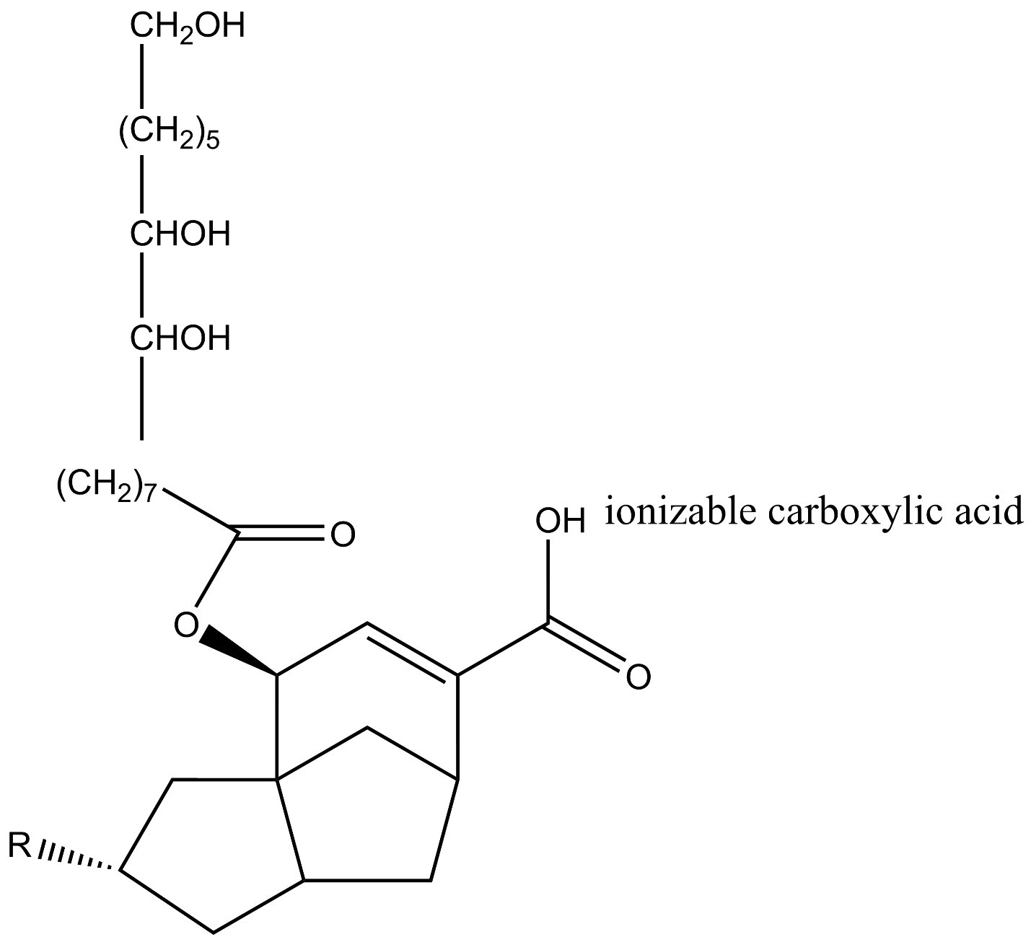
Figure 1. Chemical structure of shellac monoester elaborated on ChemDraw software.

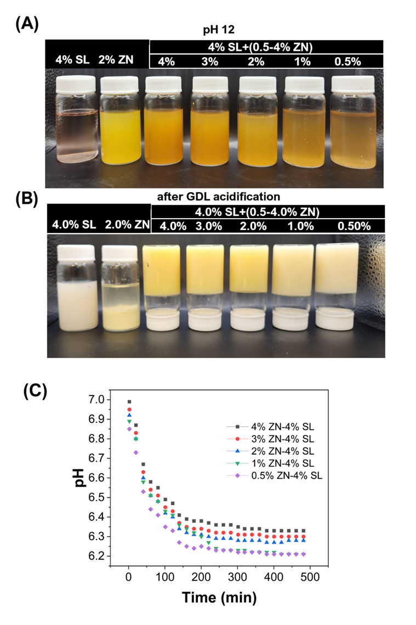
Figure 2 Appearance of 2.0 % w/v zein (ZN), 4.0% w/v shellac (SL), and mixtures with 0.50-4.0% w/v ZN and 4.0% w/v SL at pH 12.0 (A) and after addition of 1.2% w/v of glucono-δ-lactone and incubation at 22 °C for 8 h (B). Figure C shows pH changes of these samples.

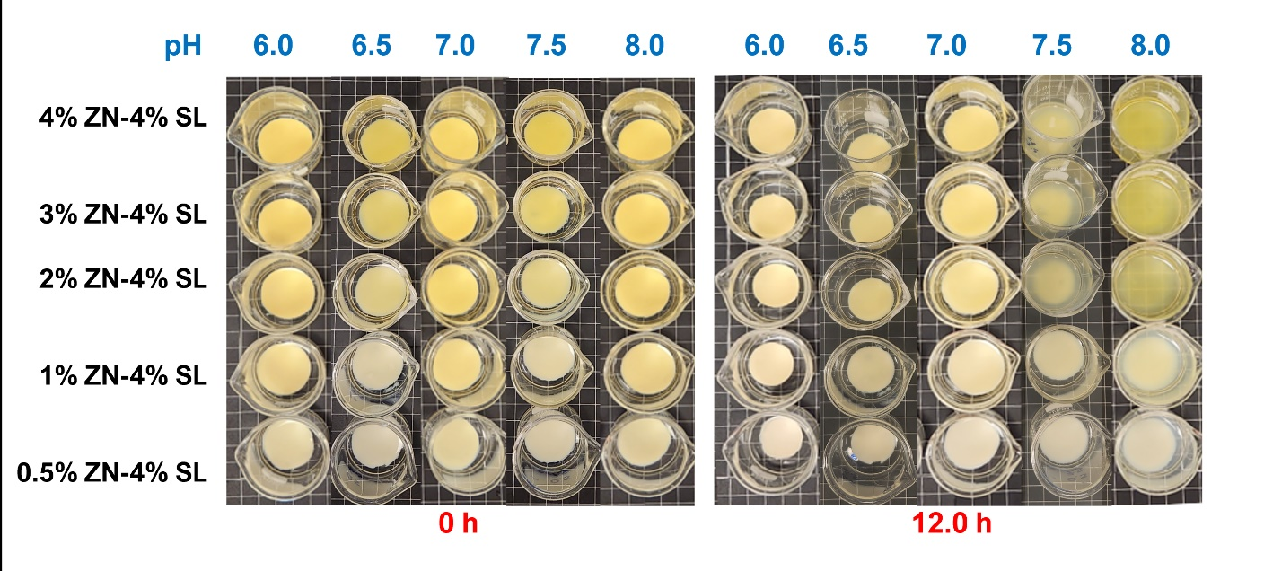
Figure 3. Visual appearance of gels prepared using 4.0% w/v shellac (SL) and 0.50-4.0% w/v zein (ZN) immersed in phosphate buffer adjusted to pH 6.0, 6.5, 7.0, 7.5, and 8.0 at 22 °C for 0 and 12.0 h.

Table 1. Volume change% of gels prepared with 4.0% w/v shellac and 0.50-4.0% w/v zein after 12-h incubation at 22 °C in phosphate buffer adjusted to pH 6.0-8.0.
Zein% | Volume change%
Zein% | pH 6.0 | pH 6.5 | pH 7.0 | pH 7.5 | pH 8.0
0.5 | -56.1±4.1ª | -6.4±6.4ª | 0 | 4.5±3.9ª | 11.44±4.04ª
1.0 | -52.4±2.2ª | -8.6±3.7ª | 0 | 8.3±2.7ª | 16.19±4.2ª
2.0 | -34±3.5^{b} | -10.8±3.7ª | 0 | dissolved | dissolved
3.0 | -28.9±7^{b} | -10.8±3.7ª | 0 | dissolved | dissolved
4.0 | -28.7±3.3^{b} | -14.9±3.5ª | 0 | dissolved | dissolved
*Numbers are mean ± SD (n = 3). Different superscript letters represent significant differences in mean values in the same column (P < 0.05).
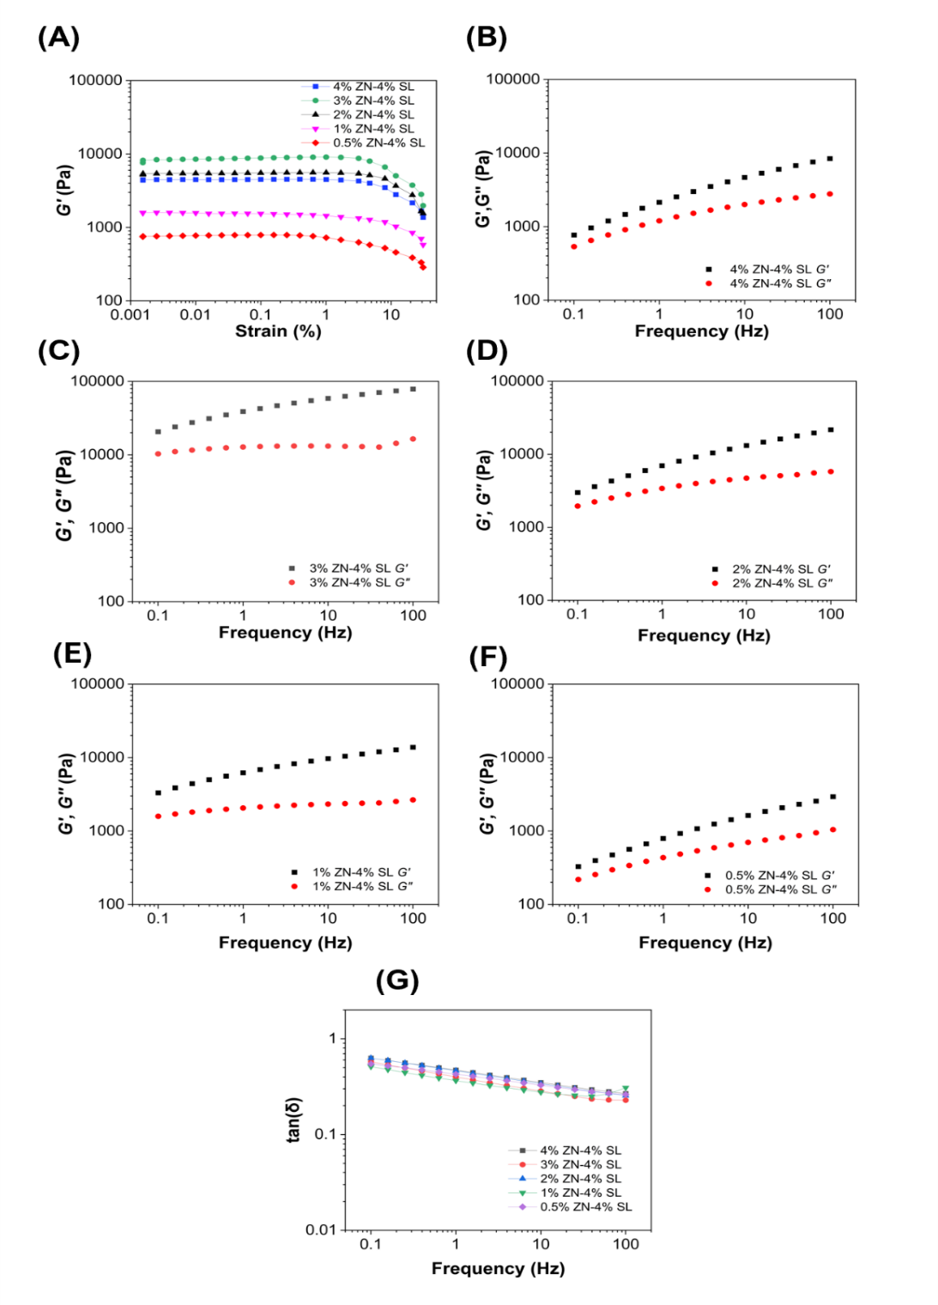
Figure 4 Strain sweep analysis at 1.0 Hz (A), frequency sweep at 0.10% strain magnitude (B-F), and the compiled tan(δ) (G) of samples with 4.0% w/v shellac (SL), 4.0% (B), 3.0% (C), 2.0% (D), 1.0% (E) or 0.5% (F) w/v zein (ZN), and 1.2% w/v glucono-δ-lactone at pH 12.0 incubated
at 22 °C for 8 h without shearing before analysis. Data are averages of two independent replicates.

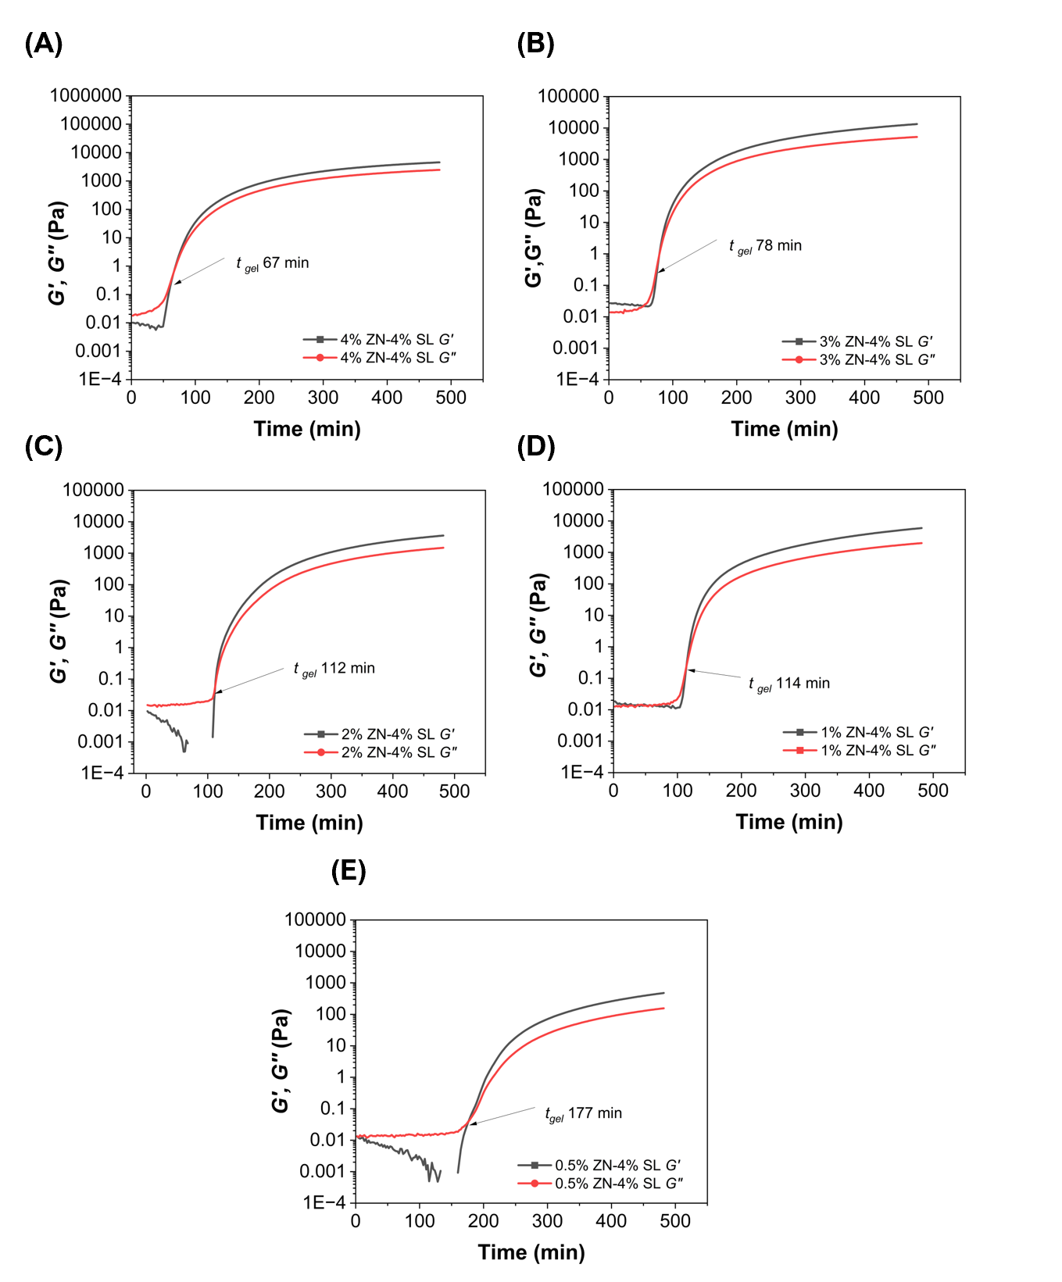
Figure 5 Storage modulus (Gʹ, black squares) and loss modulus (Gʺ, red circles) during 8-h time sweep at 22 °C, 0.10% strain magnitude, and 1.0 Hz for samples with 4.0% w/v shellac (SL), 4.0% (A), 3.0% (B), 2.0% (C), 1.0% (D) or 0.5% (F) w/v zein (ZN), and 1.2% w/v glucono-δ-
lactone at pH 12.0. The gelation time (t_{gel}) shows the time when Gʹ begins to consistently surpass Gʺ. Rheological data are averages of two independent replicates.
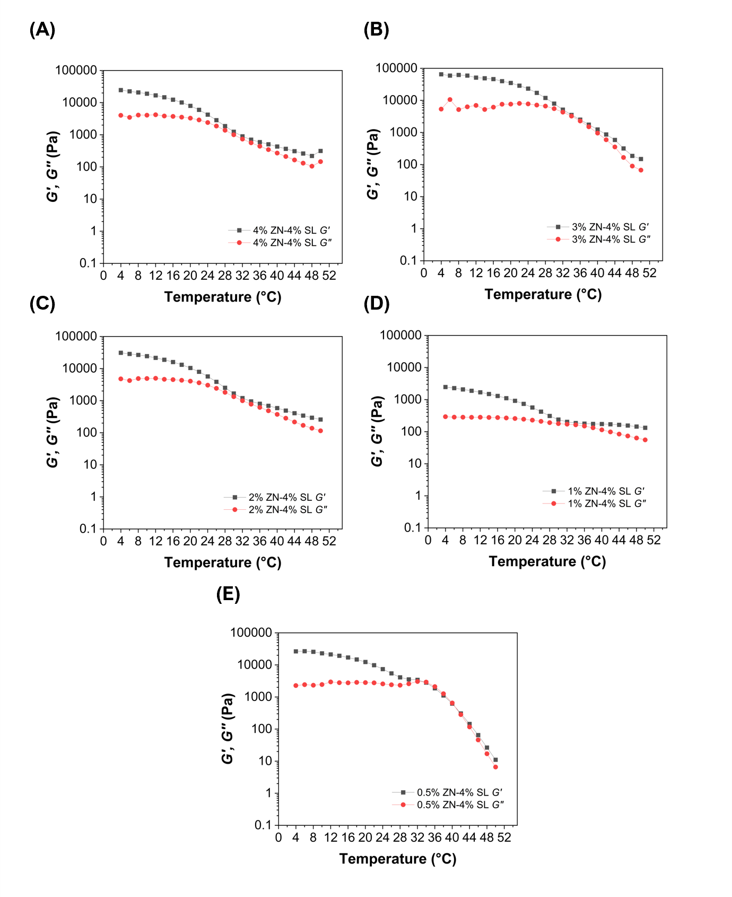
Figure 6 Storage modules (Gʹ, black squares) and loss modulus (Gʺ, red circles) at 1.0 Hz and 0.10% strain magnitude for zein-shellac gels during heating from 4 to 50 °C. Samples with 4.0% w/v shellac (SL) and 4.0% (A), 3.0% (B), 2.0% (C), 1.0% (D) or 0.5% (F) w/v zein (ZN) at pH 12 were added with 1.2% w/v glucono-δ-lactone and were incubated at 22 °C for 8 h without
shearing before the temperature sweep at 0.5°C/ min. Data are averages of two independent replicates.
Table 2. Textural properties of gels prepared using 4.0% w/v shellac, 0.50-4.0% w/v zein, and 1.2% w/v of glucono-δ-lactone at pH 12.0 followed by 8-h incubation at 22 °C.
Zein% | Hardness  (g) | Springiness | Adhesiveness  (g.sec⁻¹) | Cohesiveness | Gumminess (g) | Chewiness (g) | Resilience
0.50 | 155.9±17.5 ^{c} | 0.795±0.07 ª | -25.03±6.3 ª | 0.66±0.06 ª | 102.2±3.2 ^{b} | 81.4±9.5 ^{b} | 0.218±0.06 ª
1.0 | 435.2±36.12 ^{b} | 0.589±0.02 ^{b} | -36.67±6.1 ª | 0.55±0.02 ^{b} | 241.2±26.1 ^{b} | 142±13.9 ^{b} | 0.16±0.02 ª
2.0 | 852.06±92.31 ª | 0.575±0.02 ^{b} | -42±3.4 ª | 0.56±0.01 ^{ab} | 477.9±56.6 ª | 274.6±30 ª | 0.15±0.01 ª
3.0 | 806.85±102.66 ª | 0.63±0.07 ^{b} | -43.2±8.1 ª | 0.59±0.05 ^{ab} | 401.9±93.7 ª | 251.2±46 ª | 0.17±0.03 ª
4.0 | 776.4±84.3 ª | 0.69±0.03 ^{ab} | -36.6±12.7 ª | 0.6±0.03 ^{ab} | 409.6±35.3 ª | 280.4±21.5 ª | 0.15±0.01 ª
*Numbers are mean ± SD (n=3). Different superscript letters represent significant differences in mean values in the same column (P < 0.05).
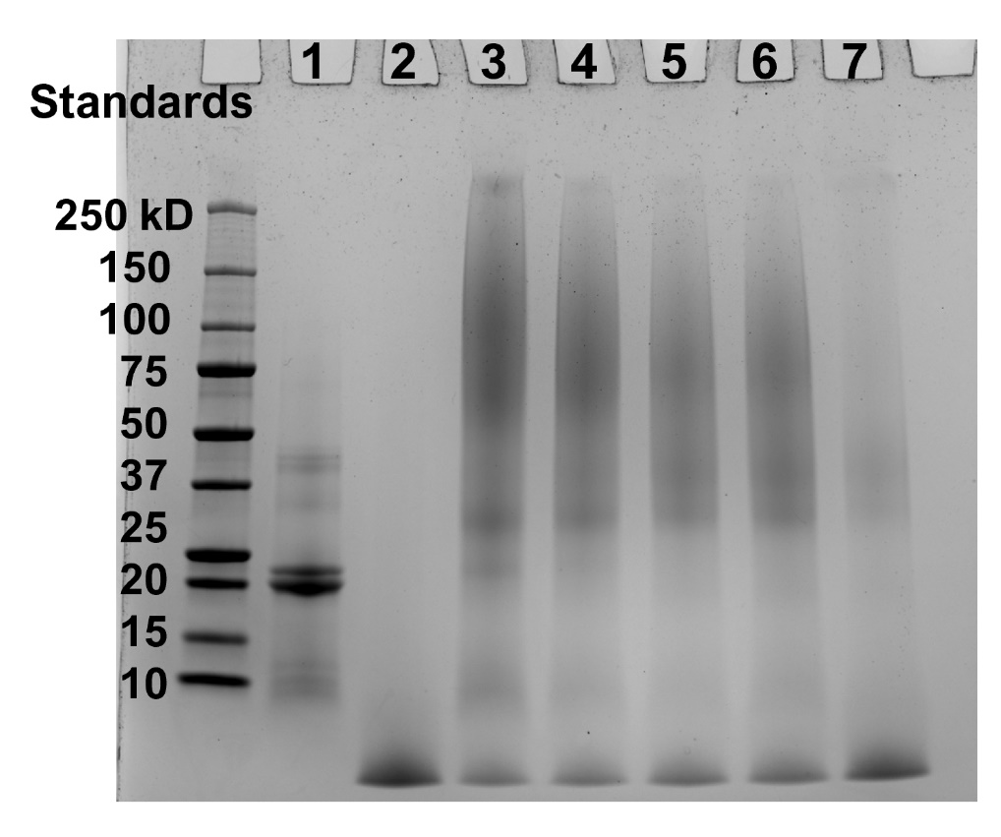
Figure 7 SDS-PAGE analysis of 2.0% w/v zein only (lane 1), 4.0% w/v shellac only (lane 2), and 4.0% w/v shellac and 4.0% (lane 3), 3.0% (lane 4), 2.0% (lane 5), 1.0% (lane 6), or
0.5%(lane 7) w/v zein at pH 12.0 after adding 1.2% w/v of glucono-δ-lactone and 8-h incubation at 22 °C.
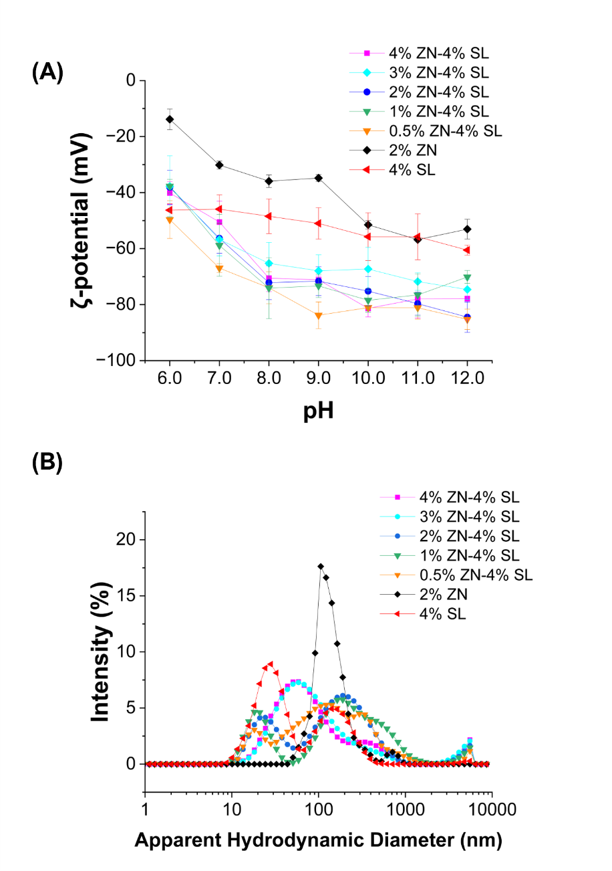
Figure 8 Zeta potential of dispersions with 2.0% w/v zein (ZN), 4.0% w/v shellac (SL), and mixtures of 4.0% w/v SL and 0.50-4.0% w/v ZN at pH 12.0 after 10-time dilution in deionized water and adjusting to pH 6.0-12.0 (A) and particle size distribution of these dispersions at pH 7.0 (B).

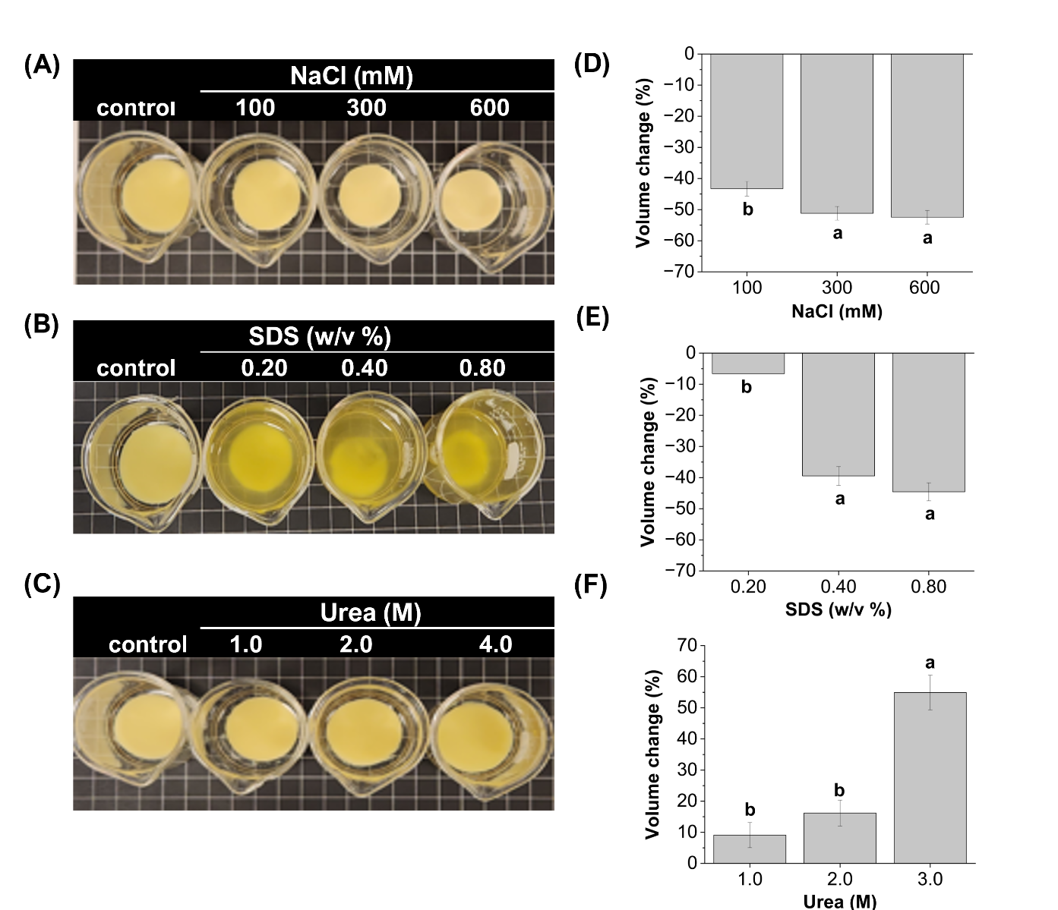
Figure 9 Visual appearance and volume change% of gels prepared with 4.0% w/v shellac and 0.50-4.0% w/v zein after immersing at 22 °C for 12 h in pH 7.0 phosphate buffer containing different concentrations of NaCl (A,D), SDS (B,E) or urea (C,F).

Figure 10 FTIR spectra of powders freeze-dried from dispersions with 2.0 % w/v zein (ZN), 4.0% w/v shellac (SL), and mixtures with 0.50-4.0% w/v ZN and 4.0% w/v SL at pH 12.0 after addition of 1.2 g of glucono-δ-lactone and incubation at 22 °C for 8 h.

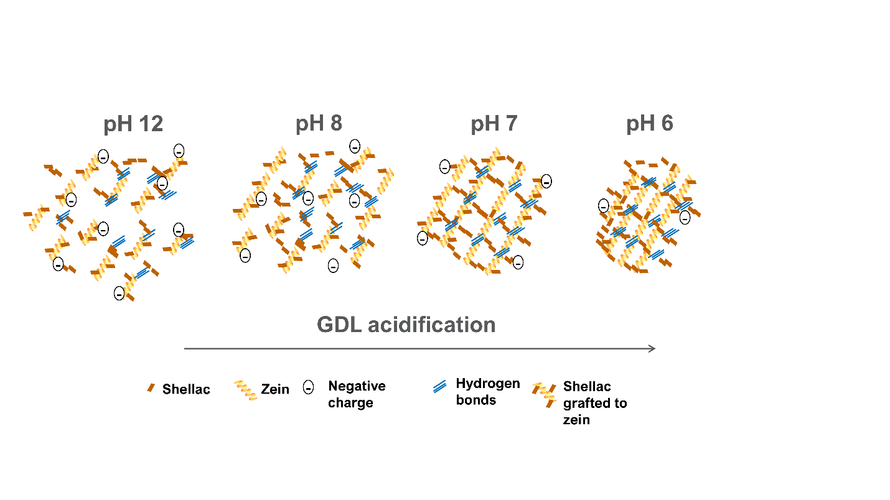
Figure 11 Possible mechanism of forming of zein-shellac hydrogels as the hydrolysis of glucono-δ-lactone lowers pH to 6.2-6.4.

Vita
Javier Aleman (originally from Lepaterique, Honduras) was born in Tegucigalpa, Honduras on June 14th, 1998. He moved with his mother to Tegucigalpa when he was 5 years old. He later studied at Zamorano University after receiving a presidential and Zamorano scholarship. He became the founder of the Art Club at Zamorano and became involved in the student senate. In his final year at Zamorano, he completed an internship at Texas Tech University, which made him view the United States of America as a place for professional growth. After graduating from Zamorano, he helped his father for two years in a small Latin store located in Pigeon Forge, Tennessee. His desire to continue his professional career was supported by Dr. Qixin Zhong after giving him an opportunity in his lab in 2023. In his two years as an MS student, Javier has gained support and different opportunities from his lab mates, professors, and wife (Ana Caceres) to achieve his goal of becoming a food scientist in the United States of America. He feels proud of representing his family, his country, and his alma mater.

