Analytical Techniques for the Analysis of Uranium Bearing Materials

A Dissertation Presented for the
Doctor of Philosophy
Degree
The University of Tennessee, Knoxville

Nathaniel Fletcher
July 2022

ACKNOWLEDGEMENTS

ABSTRACT

This is a sample Word document that can be used as a template in formatting your thesis/dissertation. It cannot exceed 350 words.

Table of Contents

List of Tables

List of Figures

Chapter One

Introduction

  - Nuclear Fuel Cycle

  - Uranium Ore Concentrates

  - Mass Spectrometry

  - Titrations

Chapter Two

Determining P, S, Br, and I content in uranium by triple quadrupole inductively coupled plasma mass spectrometry
This chapter was originally published in the Journal of Radioanalytical as shown below and is reproduced here with permission.
Fletcher, N. D.; Manard, B. T.; Metzger, S. C.; Ticknor, B. W.; Bostick, D. A.; Hexel, C. R. Determining P, S, Br, and I content in uranium by triple quadrupole inductively coupled plasma mass spectrometry. Journal of Radioanalytical and Nuclear Chemistry 2020, 324 (1), 395-402, Article. DOI: 10.1007/s10967-020-07057-0.

All experimental work and data analysis was performed by myself. experimental design as well as editing was performed by myself as well as Benjamin Manard, Shalina Metzger, Brian Ticknor, Debra Bostick, and Cole Hexel.

2.1 Abstract
The trace impurities of a uranium ore concentrate (UOC) can be examined to determine mine source, methods of production, and quality. This study presents a method to determine the concentration of halides and main group elements, specifically P, S, Br and I, utilizing triple quadrupole inductively coupled plasma - mass spectrometry. These analytes were measured in a uranium matrix to simulate a UOC sample. The concentrations determined with this method showed agreement with known values. Solutions with and without uranium were compared. A UOC certified reference material, CUP-2, was analyzed to further demonstrate the effectiveness of the method.
2.2 Introduction
Nuclear reactors supply over ten percent of the world’s energy needs ¹. Most nuclear reactors use uranium as the fissile material. One of the initial steps in the uranium nuclear fuel cycle is the production of a uranium ore concentrate (UOC) from various deposits (e.g. sandstone, lignite, and vein). Extraction of uranium from the mined material often results in high amounts of impurities within the final product, and analysis of these UOC impurities can be used in forensic and safeguard applications.
UOCs are produced by adding acids to mined and milled ore to leach out and concentrate uranium. The extraction method will vary depending on the type of mineral ². The impurities present in the UOC are dependent on both the production method and the geographic area from which the ore was mined ³. The geological location of the mined ore is important as different locations may have varying degrees of impurities present. Quantification of these impurities can help identify the original source of the UOC. The specific chemical and elemental signatures found in nuclear materials can provide information regarding the production history of the material through region specific trace element patterns, including rare earth elements and anions ⁴⁻⁶. Several studies have demonstrated that analysis of these can be used to identify a UOC to a specific origin ^{3, 7, 8}.
No single signature has been shown to uniquely determine the source of a given material, so it is often necessary to analyze multiple signatures as part of complete forensic analysis ⁸. The measurement of halides and main group elements, often present in UOCs as anions, can provide information regarding the process history ⁹. For example, Badaut et. al. found clear differences in anion concentrations when analyzing UOC samples from different geographical locations. The authors were able to determine which sample set originated in Beverley Mine (Australia) based on a low sulfate concentration, 15 µg mL⁻¹ versus 100 to 900 µg mL⁻¹ at other locations, as only one location in the study involved a process history that did not use large amounts of sulfate ⁵. Anion content was determined using ion chromatography (IC) with conductivity detection.
Several techniques have been used to measure the composition of UOCs ¹⁰. Handheld Raman spectrometers can be used as a screening method during the initial production. These systems determine the chemical form of uranium oxides as well as impurities with minimal sample preparation ¹¹. This method suffers in sensitivity. Fourier-transform infrared spectrometry (FTIR) has also been demonstrated for UOC analysis, identifying uranium oxides and some anionic species that fall in the mid IR range ¹². For example, sulfates and nitrates are often analyzed via FTIR due to their prominent bands at 1120 cm⁻¹ and 1384 cm⁻¹, respectively ². One drawback to FTIR is the reliance on a peak in the IR range which limits the applicability of the measurement. The most common methods for determining a multitude of trace elements in a UOC include inductively coupled plasma - mass spectrometry (ICP - MS) ^{13, 14} and inductively coupled plasma – optical emission spectroscopy ^{15, 16}. ICP – MS is a method of choice for many studies because it can analyze a wide range of elements at very low concentrations (ng mL⁻¹) ^{3, 8, 13, 17, 18}. Although halides are generally present in UOCs as salts or anions, they may be analyzed by ICP - MS if the ionization energy of the plasma is sufficient. In the case of sulphate and phosphate, the ICP - MS only detects S and P, but it is assumed that they originated as sulphate and phosphate ions.
The halides and some main group elements like F, Cl, P, S, Br, and I, typically present as anionic species, have unique properties that must be addressed for accurate or precise measurement when analyzing by ICP - MS. These elements are prone to volatility, spectral interferences, and sample carry-over effects. Some studies have minimized these issues by using a pyrohydrolysis method to extract the anions, IC to separate them, and conductivity detection for analysis ^{8, 19-21}. This method has been shown to be effective, but the detection limits are generally orders of magnitude lower when employing an ICP - MS. For example, Balcone-Boissard et. al. found that Br and I concentrations fell below detection limits when analyzing by conductivity detection but were measurable by ICP - MS ¹⁹. If utilizing this instrument, carry-over can be addressed by washing through a base such as tetra-methyl ammonium hydroxide (TMAH). TMAH can also address volatility issues by keeping the anion in solution ^{22, 23}.
This paper demonstrates a method to determine the content of specific halide and main group elements in a uranium matrix using a triple quadrupole (TQ) ICP - MS. The TQ removes spectral interferences by employing a reaction gas in the second quadrupole and eliminating the interference in the third quadrupole. Using this methodology individual analyte separation, such as IC, is not needed before analysis. Additionally, a hazardous alkaline solution like TMAH was not required when using extended wash times to minimize carry-over effects.
2.3 Experimental
2.3.1 Materials and Methods
All standards and samples were prepared in 2% nitric acid (HNO₃), diluted from a concentrated stock of Fisher Optima grade (Pittsburgh, PA, USA) using ASTM Type I water (18.2 MΩ·cm) produced by a Thermo Scientific Barnstead GenPure xCAD Plus Ultra-Pure water purification system (Waltham, MA, USA). Trace amounts of Fisher Optima grade hydrofluoric acid (HF) was used in the preparation of CUP-2 reference material.
Standards were prepared volumetrically by serial dilution from single element stocks (10 µg mL⁻¹) purchased from High Purity Standards (Charleston, SC, USA). Solutions were prepared fresh in HDPE containers. Quality control (QC) solutions were also prepared by serial dilution from a single element stock of iodide (100 µg mL⁻¹ I) and a multi-element stock containing P, S, and Br (100 µg mL⁻¹ PO₄, SO₄, and Br) (Multi Element IC Std 1 Solution A) purchased from High Purity Standards. External calibration was utilized for quantification with a 4-point calibration curve. P, Br and I had concentrations of 0, 1, 5, and 10 ng mL⁻¹ while S had concentrations of 0, 50, 75, and 100 ng mL⁻¹. The QC solution contained concentrations of 5 ng mL⁻¹ Br and I, 1.6 ng mL⁻¹ P, and 50 ng mL⁻¹ S. All solutions in the uranium matrix runs, including the blank, were analyzed in a uranium matrix of 50 µg mL⁻¹ that was prepared from a stock solution of uranium (High Purity Standards). Extended wash times of at least 10 minutes were performed with 2% HNO₃. Solutions were analyzed immediately after preparation to minimize losses due to volatility.
CUP-2 was prepared by weighing a 200 mg fraction of the dried UOC powder and adding 8M HNO₃ - 0.05M HF. The sample was microwave digested using a CEM (Mathews, NC, USA) Discover SP-D microwave. The dissolved UOC was diluted gravimetrically to approximately 10 mg UOC g solution⁻¹. The uranium concentration was determined using Davies-Gray titration, and the sample was subsequently diluted to a uranium concentration of 50 µg mL⁻¹ in 2% HNO₃ - 1 mM HF.
2.3.2 Instrumentation
A Thermo Scientific (Bremen, Germany) iCAP TQ ICP - MS was used for analyte measurement. The TQ has the ability to utilize ultrahigh purity (99.994%) gases within the reaction cell. Available reaction gases include oxygen, hydrogen, ammonia, and nitrogen (Airgas, Radnor, Pennsylvania). The optimized instrument parameters are listed in Table 1. A Peltier cooled quartz cyclonic spray chamber was used with a self-aspirating PFA 50 µL min⁻¹ nebulizer (ESI, Omaha, Nebraska, USA). The cyclonic spray chamber removes larger droplets from the aerosol, and the Peltier cooling system reduces the amount of solvent that enters the plasma, leading to reduction of interferences such as oxides and hydroxides. The constant temperature also helps reduce signal drift associated with environmental temperature changes ²⁴.
Table 1 Optimized TQ ICP - MS parameters
Plasma power (W) | 1550
Reaction gas flow (mL min⁻¹) | 0.338
Nebulizer gas flow (L min⁻¹) | 1.10
Cool gas flow (L min⁻¹) | 14.0
Spray chamber temperature (°C) | 2.70
CR entry lens (V) | -100
CR exit lens (V) | -160
D1 lens (V) | -200
D2 lens (V) | -83.9
Deflection entry lens (V) | -30.0
Extraction lens 2 (V) | -135
Focus lens (V) | 20.3
Pole bias | -1
Q1 entry lens (V) | -99
Q1 focus lens (V) | 0.76
Quad entry lens (V) | -25.2

2.4 Results and Discussion
2.4.1 Reaction-Gas Determination and Interferences
The analytes begin as anions in solution, but when they enter the plasma, the ionization energy is high enough to remove electrons converting them to cations despite their high electronegativities. Fluorine and chlorine were investigated, but their ionization potentials limited the formation of cations in the plasma. The difficulty in measuring these elements by ICP – MS with a sufficient detection limit has been demonstrated in another study ¹³. No further analysis of F or Cl was performed. The TQ ICP - MS can be used for on-mass or off-mass analysis as shown in Figure 1. On-mass analysis is when the mass detected is the same as the analyte mass set to pass through Q1, and the spectral interferences react with the collision cell gas so that Q3 will filter them out. For the case of off-mass analysis the analyte itself reacts with the gas in the collision cell so that the mass is shifted away from the spectral interferences, and Q3 filters out any mass other than that of the combined mass of the selected gas and the original analyte (Fig. 1). On-mass analysis was employed for ¹²⁷I⁺ and off-mass analysis was employed for ³¹P¹⁶O⁺, ³²S¹⁶O⁺, and ⁷⁹Br¹⁶O⁺.
Fig. 1 A diagram demonstrating the difference between on-mass and off-mass analysis using the TQ ICP - MS. Depicts spectral interferences passing through Q1 but not Q3 while the desired ion passes through to the detector. This is a pictorial display of both modes of operation, these modes can be performed sequentially.
The TQ ICP - MS utilized for this study incorporated four different reaction gases (hydrogen, helium, ammonia, and oxygen) employed as operating modes. Additionally, the kinetic energy discrimination (KED) mode uses a small amount of He in the collision cell to filter out unwanted spectral interferences based on their collision cross section. This requires a difference in size between the analyte and spectral interference rather than a difference in reactivity. The choice of collision cell gas for each ion depends on the thermochemistry and kinetics of the collisions that occur in the cell. For each ion, an ion exchange reaction with each gas can be proposed. For these reactions to occur, the enthalpy of formation of the reactants must be greater than that of the products. If this is not the case, then additional energy will be necessary for the reaction to proceed. This energy can originate from collisions that occur in the cell or by radio frequency ²⁵. If there is not enough energy to create a favorable reaction, then that reaction gas is not suitable for use with that ion. The best mode for each of the analytes was experimentally determined before method demonstration. Each species was analyzed via all modes, at 100 ng mL⁻¹ to determine ion transmission with the reaction gas. Single element solutions of the interfering ions were then injected at µg mL⁻¹ levels to determine spectral interference removal.
Phosphorus showed favorable response by either oxygen or KED mode. Both modes removed the spectral interferences listed in Table 2. The oxygen mode was chosen for P because it showed greater sensitivity (60x) than KED mode. For S, oxygen mode was the only mode that demonstrated the ability to resolve the spectral interferences by an off-mass shift (Table 2). Both oxygen and KED modes were evaluated for Br and showed favorable results. Upon analysis of single element interferences KED mode showed elevated Br counts due to an unresolved interference from Gd and Dy. For I, KED, oxygen, and helium were all investigated, all were able to eliminate spectral interferences (Table 2). The ion transmission was limited with KED having the least and helium having the greatest sensitivity. Oxygen provided half the sensitivity of helium for I analysis, but the number of counts were sufficient to make the measurements. Ultimately, oxygen mode was chosen for I as well. In this way all analytes studied utilized oxygen as the reaction gas in the collision cell. Using oxygen mode only kept analysis times down by limiting reaction gas equilibration times. These results were similar to the method developed by Balcaen et. al. which used oxygen as a reaction gas for off-mass analysis in organic matrices containing P and S, but Br and I were analyzed using charge transfer reactions instead of on-mass or off-mass analysis ²⁶. Oxygen mode was used for the remainder of the experiment.
Table 2 Selected spectral interferences for all analytes
Element | Interferences
³¹P | ¹H¹⁶O¹⁴N | ¹⁶O¹⁵N | ³H¹⁶O¹²C | ²H¹⁷O¹²C | ¹H¹⁸O¹²C | ¹²C¹⁹F
³¹P | ⁶³Cu⁺⁺ | ⁶²Ni⁺⁺ | ¹H³⁰Si
³²S | ¹⁶O¹⁶O | ¹H¹⁶O¹⁵N | ¹⁸O¹⁴N | ¹H³¹P | ¹²C²⁰Ne | ¹³C¹⁹F
³²S | ⁶⁵Cu⁺⁺ | ⁶⁴Ni⁺⁺ | ⁶⁴Zn⁺⁺
⁷⁹Br | ⁴⁰Ar³⁹K | ¹⁶O⁶³Cu | ¹⁴N⁶⁵Cu | ¹H⁷⁸Se | ¹²C⁶⁷Zn | ¹H⁶²Ni¹⁶O
⁷⁹Br | ⁶⁶Zn¹³C | ⁶⁴Zn¹⁵N | ¹⁵⁸Gd⁺⁺ | ¹⁵⁷Gd⁺⁺ | ¹⁵⁸Dy⁺⁺ | ¹H⁷⁸Kr
¹²⁷I | ¹¹⁵In¹²C | ⁸⁷Rb⁴⁰Ar | ¹²⁶Te¹H | ¹H¹¹⁰Pd¹⁶O | ¹¹¹Cd¹⁶O | ¹H¹¹⁰Cd¹⁶O
¹²⁷I | ⁸⁷Sr⁴⁰Ar | ¹¹³In¹⁴N | ¹¹⁵Sn¹²C | ¹¹⁴Cd¹³C | ²³⁸U¹⁶O⁺⁺ | ¹¹³Cd¹⁴N

2.4.2 Method Demonstration
For method demonstration the method was run on three separate days to determine accuracy and reproducibility. On each day the P, S, Br, and I were analyzed with and without a uranium matrix (50 µg mL⁻¹), three times per day, to investigate the magnitude of uranium ion count suppression. The High Purity Standards IC solutions were used as a quality control to demonstrate the effectiveness of the method. All reported uncertainties are represented as 2σ as determined from the triplicate daily data points from each experiment. The reported uncertainties for the 3 day average concentrations are expanded uncertainties calculated using the sum of the square. The components in the uncertainty model were the slope of the calibration curve, the concentration of the stock standards, and the measurement variability. All RSDs were calculated by multiplying the standard deviation by 100 and dividing by the average concentration of the analyte.
It was necessary to use a weighted average of the matrix blank to correct for change in sensitivity across the run. The matrix blank was analyzed before and after a run, and a linear correction was applied to the sample. Signal sensitivity in the QCs decreased by an average of 20% during the run. After the corrections were applied, the daily average concentrations of P showed reproducibility across the 3 days of experiments, ~ 2.7% RSD without a uranium matrix and ~ 2.9% with a uranium matrix (Fig. 2). The average concentration of P among the three days was 1.74 ± 0.18 ng mL⁻¹ when not in a uranium matrix and 1.64 ± 0.15 ng mL⁻¹ in a uranium matrix. In both cases the uncertainties overlap with the known value of 1.630 ± 0.016 ng mL⁻¹. The values for the three-day average concentrations show agreement with each other.

Fig. 2 Average daily concentration of P with three analysis per day. Solid line denotes known concentration and the dashed lines indicate uncertainty in the QC
Runs with and without a uranium matrix proved reproducible over three days with an average concentration of S measured at 50.1 ± 2.5 ng mL⁻¹ (~ 1.7% RSD) with no matrix and 47.4 ± 3.3 ng mL⁻¹ (~ 1.6% RSD) in a uranium matrix (Fig. 3). Both measured values show good recovery of the known concentration of 50.00 ± 0.50 ng mL⁻¹ within the uncertainty of the measurement at a 0.14% difference when not in a uranium matrix and a 5.4% difference in a matrix (Fig. 3). While there is a difference between solutions with and without a uranium matrix on the third day, this could be attributed to run to run variability of the method. The solutions show agreement with each other as the average concentrations fall within the uncertainties.

Fig. 3 Average daily concentration of S with three analysis per day. Solid line denotes known concentration and the dashed lines indicate uncertainty in the QC
For Br, the method demonstrated run to run reproducibility for solutions both with (~ 2.2% RSD) and without (~ 2.6% RSD) a uranium matrix. (Fig. 4). The three day average concentrations were 5.30 ± 0.30 and 5.15 ± 0.35 ng mL⁻¹, respectively. These values showed agreement with the known concentration of 5.00 ± 0.10 ng mL⁻¹ for both solutions not in a uranium matrix (3.0% different) and in a uranium matrix (5.7% different) as well as with each other. The agreement between the three day average concentrations indicates the method may be useful for the determination of Br in a uranium matrix.

Fig. 4 Average daily concentration of Br with three analysis per day. Solid line denotes known concentration and the dotted lines indicate uncertainty in the QC
Iodine was more difficult to analyze than the other species due to the carry-over and volatility effects. Initial 3 minute washout times were extended to 10 minutes to eliminate any carry-over effects from I. Issues with I carry-over has been previously reported ²⁷. While in an acid matrix it was necessary to run the sample immediately after preparation to avoid losing I to volatilization ²⁸. Since samples were analyzed within 10 minutes, more study is necessary to determine if I can be measured after microwave digestion. TMAH can be used to help keep iodine in solution, but at a pH above 8, uranium will precipitate out of solution ^{8, 29}. In the current method, the only added sample preparation for I is the addition of uranium to the blank and standards. This matrix matching step allows for the counts from the UO⁺⁺ interference at 127 amu to be accounted for, leaving only I⁺ counts.
After performing a blank subtraction, the method showed agreement with the known value of 5.00 ± 0.10 ng mL⁻¹ for average concentration of I both with (1.3% difference) and without (2.7% difference) a uranium matrix (Fig. 5). The method demonstrated run to run reproducibility with an RSD of ~ 2.2% when not in a uranium matrix and ~ 2.7% in a uranium matrix. An average three day concentration of 4.9 ± 1.1 ng mL⁻¹ for solutions with no matrix and 4.9 ± 1.4 ng mL⁻¹ with a uranium matrix was determined. The small difference between results with and without the matrix suggests that the method is suitable for analyzing I in UOCs with little sample preparation. Additionally, the method does not require the use of TMAH or other alkaline materials used in many other ICP - MS studies ³⁰.

Fig. 5 Average daily concentration of I with three analysis per day. Solid line denotes known concentration and the dotted lines indicate uncertainty in the QC
Limit of detection
The limit of detection for each analyte was calculated as both an instrument detection limit (IDL) and a method detection limit (MDL). The IDL was used to compare the results of the method with and without a uranium matrix while the MDL shows the effectiveness of the method for each species. The IDL was calculated using Eq. (1) where $σ_{B}$ is the standard deviation of the blank and m is the slope of the external calibration curve. The MDL was determined by propagating the IDL through the method preparation steps such that the uranium concentration was 50 µg mL⁻¹.
$IDL = \frac{3σ_{B}}{m}$ (1)
The IDLs of P, S, and Br were nearly identical whether the uranium matrix was present or not (Table 3). This supports the assertion that these analytes can be analyzed in a uranium matrix with little impact on the limit of quantification. The IDL of I was higher in a uranium matrix which would be expected due to the presence of the UO⁺⁺ interference (Table 2). While the IDL for I was higher than the other analytes, the method still demonstrated the ability to detect I in a uranium matrix at the concentrations utilized in this study (Fig. 5). The IDL for S was similar to that found in another study while the P and Br IDLs were two to three orders of magnitude lower than those found in the same study using IC and conductivity detection ⁵.
Table 3 LOD for the analytes with IDL (ng mL⁻¹) and MDL (µg g U⁻¹)
 | P | S | Br | I
No U IDL | 0.164 | 1.71 | 0.0736 | 0.00311
U IDL | 0.160 | 1.50 | 0.0640 | 0.235
U MDL | 3.20 | 30.0 | 1.28 | 4.70
The MDLs for P, Br, and I were similar while S was about one order of magnitude higher in concentration (Table 3). Sulfur had a higher MDL than the other analytes due to the higher background (50x counts) in the blank solutions. Sulfur values vary depending on the process in the formation of UOCs, and this element is a more valuable process indicator ³¹. Thus a high S blank, with the associated higher MDL, does not preclude a useful measurement of this species in UOC materials. Also, the higher MDL for S should not be an issue in analysis due to the generally high values of SO₄²⁻ in UOC ⁵. This is consistent with the results of an interlaboratory study, primarily utilizing sector field ICP - MS, where the average level of reported S in a UOC was nearly 6000 µg gU⁻¹ ¹³. The MDLs for P and S in the present work were similar to reported values from the interlaboratory study ¹³. No participants reported values for Br or Cl due to the difficulty in quantifying them by ICP – MS. This method was successful in quantifying Br and had a MDL that was the lowest of all analytes studied (Table 3).
2.4.3 CUP-2 Analysis
A certified reference material (CRM), CUP-2, was analyzed for anion content and the results were compared to the recommended values. CUP-2 is a UOC CRM that was jointly produced by the Canadian Certified Reference Materials Project and the Canadian Uranium Producers Metallurgical Committee. The CRM solution was diluted to a concentration of 50 µg U mL⁻¹, consistent with the uranium content used during method demonstration. The calibration standards were matrix matched in the same manner as was performed previously. CUP-2 was evaluated three times on three separate days so an average concentration value could be reported, and the reproducibility of the method for the CRM could be investigated. The CRM was analyzed for P, S, Br, and I, although there is no recommended value for Br or I.
The average P and S concentrations determined using the method described in this study show agreement with the provisionally recommended values for the CUP-2 CRM (Fig. 6). The average three day P concentration (410 ±45 µg g U⁻¹) was within 3.1% of the recommended value (397 µg g U⁻¹), and the S concentration (10700 ± 900 µg g U⁻¹) was within 0.89% of the recommended value (10607 µg g U⁻¹) (Fig. 6). This agreement suggests that the TQ ICP - MS method is suitable for detection of P and S in UOC materials. As mentioned previously, Br and I values are not available for CUP-2, because of the challenge of measuring the halides in material such as UOCs, but they were analyzed using the method developed in this study. No I was detected in CUP-2, nor has it been previously reported. This may be due several factors (e.g. extended storage time, volatility, and sample preparation). Further studies are required to determine if I could be detected in CUP-2 immediately after the sample was prepared. Bromine was detected utilizing this method with a three day average concentration of 21.7 ± 2.6 µg g U⁻¹. While there is no recommended value to compare this result to, the determined concentration is above the MDL of this study (Table 3). The use of the TQ and the method developed here may open the door for more routine analysis of these analytes in the future, allowing an evaluation of their value as signatures of the UOC source.

Fig. 6 Cup-2 data for P, S, and Br with a line indicating the recommended value
2.5 Conclusions
A method for analyzing P, S, Br, and I in a uranium matrix using a TQ ICP - MS is presented here. The instrument removed interferences that are common for the analytes in this study, and the results showed agreement between runs with and without a 50 μg mL⁻¹ uranium matrix for P, S, Br, and I. While the method may sacrifice precision on a multiple day analysis and stability issues in the acid matrix were observed for I, the average concentrations for all analytes agreed with known values. When analyzing the data for possible matrix effects, a comparison of the results with and without uranium shows that this method is suitable for accurate quantification of P, S, Br, and I when using matrix matching standards. When analyzing CUP-2, the experimentally determined concentrations for P and S agreed with the recommended values. This suggests that the method may be useful for those species and allows the possibility of Br and I analysis which have not traditionally been undertaken by ICP - MS in UOC materials in the past. The method allows for faster analysis times with less sample preparation, bypassing the use of chemical separations and alkaline washes.

Chapter Three
Determination of phosphorus and sulfur in uranium ore concentrates by triple quadrupole inductively coupled plasma mass spectrometry
This chapter was originally published in Talanta as shown below and is reproduced here with permission.
Fletcher, N. D.; Manard, B. T.; Bostick, D. A.; Bostick, W. D.; Metzger, S. C.; Ticknor, B. W.; Rogers, K. T.; Hexel, C. R. Determination of phosphorus and sulfur in uranium ore concentrates by triple quadrupole inductively coupled plasma mass spectrometry. Talanta 2021, 221. DOI: 10.1016/j.talanta.2020.121573.

All expermintal work and data analysis in this chapter was performed by myself. All expermintal design and editing was performed by myself as well as Benjamin Manard, Debra Bostick, William Bostick, Shalina Metzger, Brian Ticknor, Kayron Rogers, and Cole Hexel.
3.1 Abstract
The analysis of impurities in a uranium ore concentrate (UOC) could provide information regarding the source, production history, and potential intended use of the UOC. This study involves the analysis of UOC samples for phosphorus and sulfur. Concentrations were determined by triple quadrupole inductively coupled plasma – mass spectrometry and compared with results from a pyrohydrolysis method and previously reported results. The sulfur and phosphorus concentrations, determined by the mass spectrometer, were used to identify possible trends in the data, and the uncertainties were calculated using the Guide to Uncertainty Measurements workbench software. The triple quadrupole inductively coupled plasma - mass spectrometer method allows for the removal of interferences in the analysis of species that begin as anions. This method could not be performed with a traditional quadrupole instrument as the interferences could not be resolved. The newly developed method also allows for a high sample throughput as more than 25 samples were analyzed in every run.
3.2 Introduction
One of the first steps in the nuclear fuel cycle is the production of a uranium ore concentrate (UOC).⁴ UOCs are generated at a milling facility after the ore is mined, pulverized, and subsequentially leached of its uranium with acids. A solvent extraction method is then utilized to separate the uranium from the leachate prior to precipitation.¹⁰ The solid UOC can then be utilized for its intended purpose (e.g. production of material used as fuel for nuclear reactors or feed for enrichment processes). A wide range of processing methods, depending on the type of mineral, can be implemented to develop UOCs.^{2, 10, 32} The produced UOCs will contain impurities that are present from the mine or that were introduced during the processing of the ore. A thorough analysis of these trace element impurities can provide indications about the source, process history, and quality of the material.^{5, 6} The analysis of UOCs is commonly performed by inductively coupled plasma mass spectrometry or optical emission spectroscopy (ICP-MS/OES) due to the wide range of trace elements that can be determined at lower concentrations (ng mL⁻¹).^{14, 15, 18} Studies have demonstrated that the analysis of trace element patterns such as rare earth elements or anions can provide information on the processing history or the region the UOC originated in.^{7, 8} Halides and some main group elements are usually present as anions in UOCs, and the anion content can provide information about the production history of the material.⁹ Sulfate is especially common as many processing methods involve the use of sulfuric acid during leaching, resulting in high concentrations of sulfate.^{5, 13} The ³⁴S/³²S ratio has also been demonstrated as a viable signature for the identification of the source of the material, particularly if specific reagents (H₂SO₄) were used in the extraction and/or leaching processes.³¹ The isotopic signature of sulfur can be perturbed depending on the processing steps. Krajko et. al. demonstrated that leaching was the processing step that significantly impacted the sulfur values (³⁴S) by analyzing samples before and after leaching.³¹
One method for the determination of anions in a uranium matrix is total reflection X-ray fluorescence spectrometry.³³ This is a popular method because of the low sample amount requirement and the ability of the method to measure nonmetal and metals, but it is unable to measure some analytes such as phosphorus. Combustion IR has also been used to determine sulfate and other anion levels. This has been demonstrated in UOCs as wells as nuclear fuel.^{34, 35} Another method that has been widely applied for the analysis of anions in UOCs involves the use of pyrohydrolysis to extract the anions, ion chromatography (IC) for separation, and conductivity for detection.^{5, 19, 20} This extraction method has been previously reported for the separation of various anions, such as fluorine and chlorine, from nuclear material.³⁶
While pyrohydrolysis can be effective, it has been shown to be limited in the recovery of analytes such as sulfur or sulfate.²¹ Other studies have utilized ICP–MS to analyze trace elements including halides and main group elements due to the lower limits of detection provided for some analytes.^{22, 28} This was demonstrated by Balcone-Boissard et. al. when they determined that bromine and iodine levels in geochemical reference materials were below detection limits when measuring by IC with conductivity detection, but detection was possible by ICP–MS.¹⁹ While IC with conductivity detection actually measures anions, it should be noted that in ICP–MS the plasma has enough ionization energy to remove electrons from the anions so they are measured as cations.²⁵ In another study, Keegan et. al. developed a water leach method where a pulverized UOC sample was soaked in deionized water for 24 hours. The resulting solution was then filtered and the soluble anions were analyzed by IC and high resolution ICP–MS and sulfate was determined to be the predominate anion impurtity.⁸ As the processing history of those samples was known, the authors suggest the sulfate was linked to the production history.⁸
Halide and main group elements like phosphorus, sulfur, bromine, and iodine can be measured by ICP–MS, but they have properties that can make analysis difficult, such as volatility and spectral interferences. One study demonstrated the possibility of analyzing anions using high resolution ICP–MS to resolve the spectral interferences.³⁷ This study illustrated that at high mass resolution (m Δm⁻¹ 4000) the spectral interferences of S can be better resolved in comparison with a quadrupole that has a resolution of 300-400. In the case of the quadrupole the accuracy of the measurement was much lower due to unresolved interferences. They found that they could resolve ³²S from isobaric interferences ¹⁶O¹⁶O and ¹⁴N¹⁸O in uranium material with a limit of detection of 2 µg g U⁻¹.³⁷
Another possible method for the analysis of anions with spectral interferences is the use of a triple quadrupole (TQ) ICP–MS, as interferences can be removed prior to detection through the use of reaction gases in a collision cell.^{26, 38} While analysis of elements such as sulfur has shown to be unreliable using a single quadrupole ICP–MS, the TQ ICP–MS allows for the analysis to be performed on a quadrupole after the mass of the interferences or analyte has been shifted. This may provide a more rapid and cost effective form of analysis when compared to high resolution ICP–MS. In this study, 17 UOC samples from various mines around the world were analyzed. The sample series originated in locations where other samples have been collected and analyzed previously. Results from this study were compared to previously reported results when available. The UOC samples were analyzed using a TQ ICP–MS with a previously developed method to determine phosphorus, sulfur, bromine, and iodine content.³⁸ Concentrations determined by the TQ ICP–MS were compared to data obtained using a pyrohydrolysis extraction method and IC with conductivity detection. The phosphorus and sulfur content obtained by TQ ICP–MS was then used to identify possible trends in the data. Analysis of the uncertainties was performed to determine what aspects of the TQ ICP–MS method had the greatest impact on the overall uncertainties.
3.3 Experimental
3.3.1 Materials
Standards and samples were prepared using Fisher Optima grade (Pittsburgh, PA, USA) nitric acid (HNO₃). The HNO₃ was diluted from a stock with ASTM type 1 water (18.2 MΩ cm) from a Thermo Scientific Barnstead GenPure xCAD Plus Ultra-Pure water purification system (Waltham, MA, USA). Trace amounts of Fisher Optima grade hydrofluoric acid (HF) were utilized to aid in the dissolution of the samples. The Viognier and Feldspath certified reference materials (CRMs) were purchased from the Commission d’ETAblissement des Méthode d’Analyses (CETAMA). Feldspath is a UOC CRM with certified values determined for SO₄ and PO₄, and Viognier is a synthetic CRM with a certified value listed for P. CUP-2 is a reference material that was jointly produced by the Analytical Subcommittee of the Canadian Uranium Producers Metallurgical Committee and the Canadian Certified Reference Materials Project, and has recommended values for P and S. Viognier and Feldspath were analyzed by both the pyrohydrolysis and TQ ICP–MS methods while CUP-2 was analyzed by only the TQ ICP–MS method. All samples indicated in Table 1 were analyzed along with the CRMs.
Table 1 List of UOC samples and description of each
Sample | Country | Region | Phase
Mary Kathleen | Australia | Queensland | U₃O₈ Uranium Oxide
Radium Hill | Australia | South Australia | Na((UO₂)4O₂(OH)₅)(H₂O)₅ Metaschoepite-Na
Ranger Mine | Australia | Northern Territory | Na_{0.35}UO_{2.95}; Na₆U₇O₂₄ Sodium Uranium Oxide
South Alligator | Australia | Northern Territory | (UO2)₄O(OH)₆(H₂O)₅ Metaschoepite
Blind River | Canada | Elliot Lake, Ontario | Na₂U₃O₉ Sodium Uranium Oxide
Denison | Canada | Elliot Lake, Ontario | Na₂(UO₂)₂(Si₂O₅)₃ · 4H₂O  Sodium Uranyl Silicate Hydrate
Dyno Mine | Canada | Bancroft, Ontario | NH₃U₂O₆ · 3H₂O Ammonium Uranium Oxide Hydrate
Eldorado Uranium | Canada | Beaverlodge area Saskatchewan | (NH₄)₃((UO₂)₁₀O₁₀(OH))((UO₄)(H₂O)₂)(H₂O)₂  Ammonium Uranium Oxide Hydroxide Hydrate
Rabbit Lake | Canada | Saskatchewan | UO₄ · 2H₂O Metastudite
Faraday | Canada | Bancroft, Ontario | 2UO₃ · NH₃ · 3H₂O  Uranium Oxide Ammonia Hydrate
Madawaska Mine | Canada | Bancroft, Ontario | Na₆U₇O₂₄; Na₂O(UO₃H₂O); Na((UO₂)O(OH))  Sodium Uranium Oxides
Milliken Lake | Canada | Elliot Lake, Ontario | U₂(NH₃)O₆ · 3H₂O Uranium Amine Oxide Hydrate
North Span | Canada | Elliot Lake, Ontario | (UO₂)₄O(OH)₆(H₂O)₅ Metaschoepite
Rio Algom | Canada | Elliot Lake, Ontario | (NH₄)₂₍(UO₂)₂(SO₄)O₂) Zippeite
Stanleigh | Canada | Elliot Lake, Ontario | U₃(NH₃)O₉ · 5H₂O Uranium Amine Oxide Hydrate
Gunnar Mine | Canada | Beaverlodge area, Saskatchewan | U₃(NH₃)O₉ · 4H₂O Uranium Amine Oxide Hydrate
ESI USA | USA | Florida | U₃(NH₃)O₉ · 4H₂O Uranium Amine Oxide Hydrate

3.3.2 Pyrohydrolysis Method
The samples indicated in Table 1 were first weighed out, along with the Viognier and Feldspath QCs, in aliquots ≤ 0.5 g due to the small amount of sample available. The pyrohydrolysis system utilized for the extraction did not involve accelerants. Moisture saturated oxygen was passed over the sample in a furnace tube and the tube was heated to 800ºC. This extracts the anions as a volatile gas, which is then trapped and condensed into a distillate solution. The system utilized two gas scrubbers to trap the anions to ensure as much analyte as possible was recovered. Each trap contained 20 mL of a diluted carbonate buffer that can also be used as the eluent for IC. The stock was purchased from Thermo Fisher Scientific (Waltham, MA, USA) and diluted such that the solution contained 4.5 mM Na₂CO₃ and 0.8 mM NaHCO₃ at a pH of about 10.5. Each scrubber trap was held at ice water temperature.
The recovered distillate was analyzed by IC with conductivity detection using a Thermo Scientific IC System (Dionex ICS-1100). The separation column used was Dionex IonPac AS23. All standards were diluted from stocks purchased from Thermo Fisher Scientific. Solution ICC-200 was used for PO₄ and SO₄.
3.3.3 Triple Quadrupole Method
All samples were prepared by weighing out 300 mg of UOC powder. The CRMs analyzed in this study were UOC CRMs Viognier, Feldspath, and CUP-2. Samples and CRMs were dissolved in 8M HNO₃ at 120°C. Samples that were not dissolved after one week were digested using a CEM (Mathews, NC, USA) Discover SP-D microwave. The microwave was ramped to 225°C and held for 20 minutes at 260 PSI. Uranium content of the UOC samples and QCs was determined using a Thermo Scientific (Bremen, Germany) inductively coupled plasma – optical emission spectrometer (ICP-OES). The solutions were then diluted gravimetrically with 2% HNO₃ - 1 mM HF to 50 μg U mL⁻¹ solution.
The solutions were initially screened and then measured for P, S, Br, and I content periodically over a period of about three weeks to determine stability of the sample once in solution. Concentrations of the analytes were determined using a Thermo Scientific iCap TQ ICP–MS. All standards were prepared fresh daily, gravimetrically, using single elements stocks (10 µg mL⁻¹) purchased from High Purity Standards (Charleston, SC, USA). The calibration standards of P ranged from 5 to 700 ng g⁻¹, S ranged from 250 to 1600 ng g⁻¹, and Br and I ranged from 0.5 to 40 ng g⁻¹. Standards were matrix matched to the samples to have a uranium concentration of 50 μg g⁻¹ using a single element uranium standard (High Purity Standards, 1000 µg mL⁻¹). The method allowed for the analysis of more than 25 samples in a single run.
3.4 Results and Discussion
3.4.1 Quality Controls
The CRMs Feldspath, Viognier, and CUP-2 were analyzed as QCs by the TQ ICP–MS method in order to determine the accuracy of the method. The CRMs were also analyzed once by pyrohydrolysis. For the TQ ICP–MS method, since the QCs were dissolved multiple analysis, 9 times over a period of 18 days, of the same aliquot was performed. CUP-2 was analyzed to ensure the accuracy of the instrument as determination of P and S concentrations in CUP-2 has already been demonstrated.³⁸ Concentrations determined for P and S by TQ ICP–MS suggested the method was accurate as the expected value was generally within the uncertainty of the measurement (Fig. 1). The average concentration over the 18 days was close to the expected value with < 1% difference (Table 2).
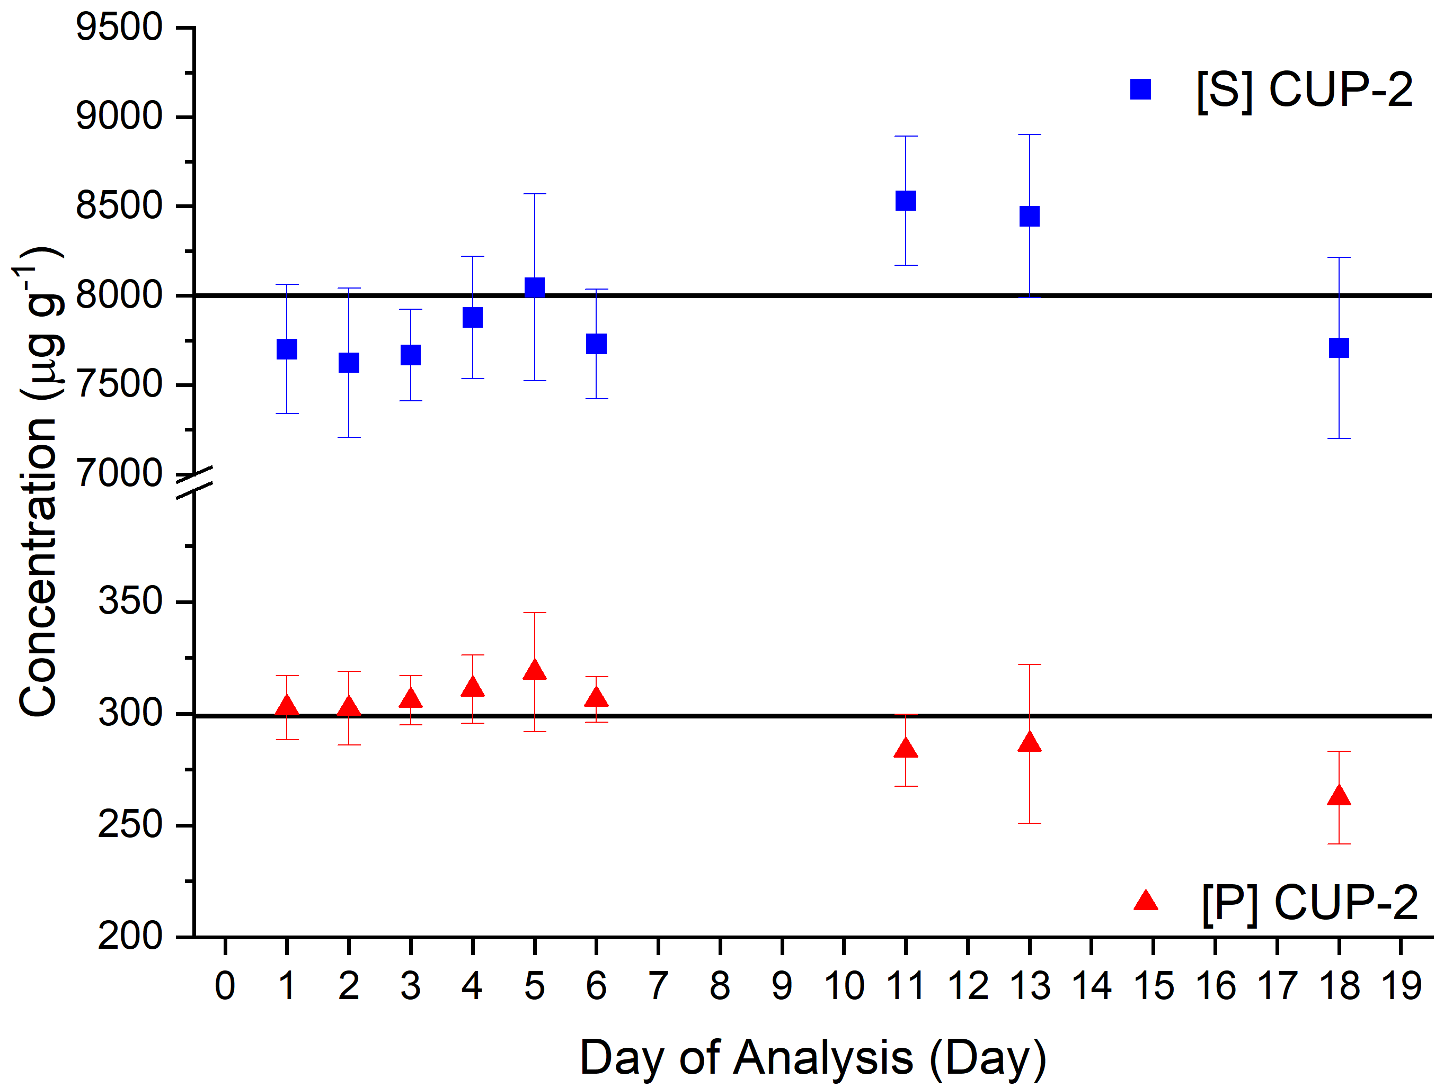
Fig. 1 Concentrations of CUP-2 for P and S over a period of 18 days with a line indicating expected value

Table 2 Average concentrations and expected values of the QCs for P and S (µg g⁻¹)
 | P (µg g⁻¹) |  |  |  |  | S (µg g⁻¹)
 |  | Expected | TQ ICP–MS |  | Expected |  | TQ ICP–MS
Feldspath |  | 51 ± 5.2 | 53 ± 4.2 |  | 5340 ± 330 |  | 4840 ± 340
Viognier |  | 43 ± 1.8 | 46 ± 4.1 |  | NA |  | ND
CUP-2 |  | 299 | 298 ± 23 |  | 8000 |  | 7930 ± 570

Duplicate analysis of Feldspath by the TQ ICP–MS was performed to demonstrate sample preparation reproducibility. Two aliquots were prepared for analysis in the same manner as the samples. The Br and I concentrations were both unreliable and varied greatly depending on the day. While the certified Feldspath value was for PO₄, this was converted to P by multiplying by the percentage of P in PO₄ so the certified value could be compared to results obtained by TQ ICP–MS. The duplicate analysis of Feldspath for P suggests that the method was reproducible among separate QC aliquots (Fig. 2). Given the demonstrated reproducibility among the two aliquots of QC, the average across all measurements was calculated and compared to the certified value for P (Table 2). The average P concentration showed good agreement with the expected value as it was within the uncertainty of the certificate with a 3.9% difference.
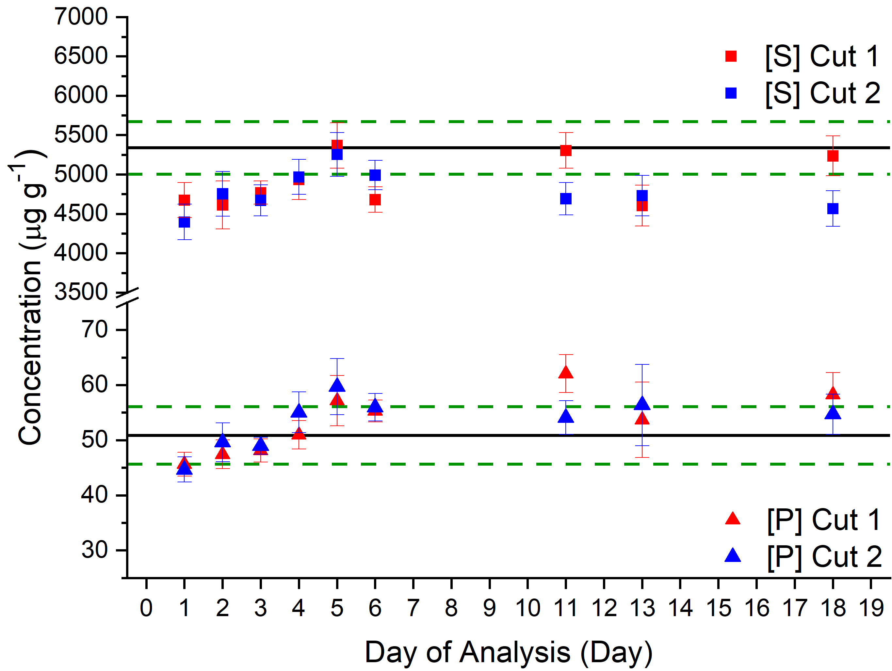Fig. 2 Concentration of P and S in two aliquots of Feldspath over 18 days with a solid line indicating certified value and dashed line indicating uncertainty given by the CRM

For the analysis of S in Feldspath a conversion of the certified SO₄ to S was performed by multiplying the value by the percentage of S in the molar mass of SO₄ so that a comparison between the certified value and values obtained by TQ ICP–MS could be made. Analysis of Feldspath for S also showed good reproducibility (Fig. 2). While the determined concentration on some days seemed to reach the expected value of 5340 µg g⁻¹ the data suggests the concentration in solution is less than the certified value (Fig. 2). Given the similarity among the separate aliquots, the average of all runs was again used to compare with the expected value. This resulted in a 9.4% difference (Table 2). The difference is not attributed to low ion transmission through the instrument due to the excellent agreement between the actual and certified values for S in the QC check CUP-2 (Table 2). One possible explanation for the lower than expected concentrations of S determined in Feldspath by TQ ICP–MS is a loss of S during dissolution of the sample. This could potentially be mitigated by performing the dissolution of the sample at a lower temperature to lessen the volatility.
Viognier showed similar results to the Feldspath in that the Br results were unreliable. The ICP–MS method did not detect any S, but this was expected as no S was added to the synthetic CRM. As was demonstrated in the Feldspath QC (Fig. 1) there is a slight increase in the P concentrations over the first 4 days, although this is less pronounced in Viognier 2 (Fig. 3). All the concentration values from the two aliquots were averaged, and a 7.0% difference from the expected value was determined (Table 2). The uncertainty of the average concentration of P contained the expected concentration which suggests accurate measurement of P in Viognier.
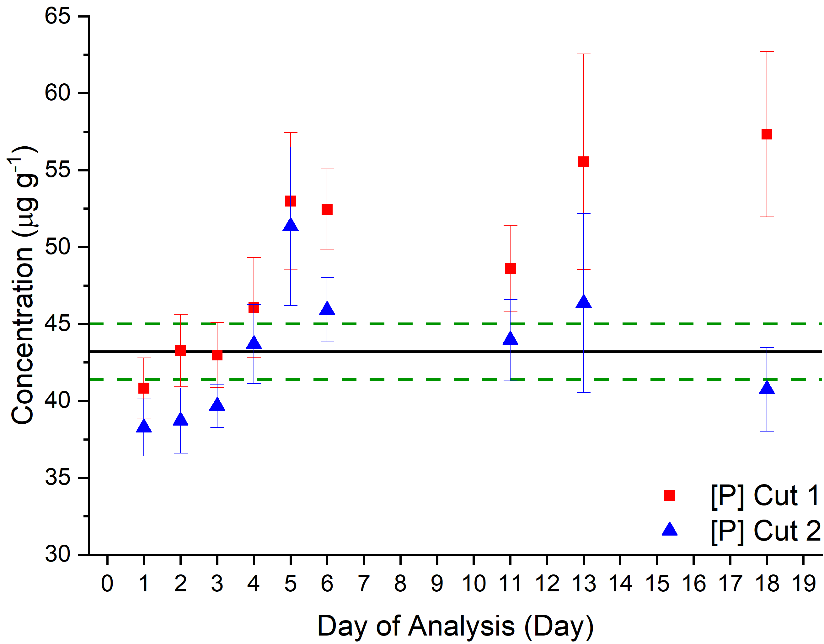
Fig. 3 Concentration of P in two aliquots of Viognier with a solid line indicating certified value and dashed lines indicating uncertainty given by the CRM

The pyrohydrolysis method was only able to detect SO₄ and concentrations were converted to S for comparison to the TQ ICP–MS method. The pyrohydrolysis technique determined a S concentration in the Feldspath QC of 1644 µg g⁻¹. This was much lower than the certified concentration of 5340 µg g⁻¹, and results in a 69% difference. For SO₄, poor recovery may be due to the conversion to the more volatile gasses. When examining the chromatograms, a peak attributed to SO₃ and SO₂ was identified. The SO₃ peak was also identified by IC after pyrohydrolysis on rock samples in a study performed by Shimizu et al.²¹ The increased volatility of the gases, especially SO₂, may result in an inability for the scrubbers to capture all of the S. This second peak was factored in to the reported S concentration. While the pyrohydrolysis method resulted in the detection of a portion of the SO₄, no PO₄ was detected. The lack of PO₄ recovery may have been due the formation of a uranium phosphate during processing.
3.4.2 UOC Samples
All samples were analyzed in the same manner as the QCs. The measured concentrations were compared to previously reported data. One of these studies was an interlaboratory report that analyzed the Springfields sample collection of UOCs for trace elements, including P and S for some of the samples analyzed in the study.³⁵ The ultimate goal of the interlaboratory study was to assist the International Atomic Energy Agency in developing the ability to determine the origin of UOCs from trace elements. Participating laboratories included the Los Alamos National Laboratory Atomic Weapons Establishment, , Lawrence Livermore National Laboratory, and the European Commission Karlsrhue. The Atomic Weapons Establishment reported P and S concentrations for some of the samples analyzed in the paper. They determined P concentrations by ICP–MS while S concentrations were determined by combustion IR. The S concentrations in this report were generally higher than what was determined in the pyrohydrolysis experiment, but lower than what was reported using the TQ ICP–MS method (Table 3). This may be due to a loss of S during the combustion of the sample in combustion IR.
Both the TQ ICP–MS and pyrohydrolysis methods were able to detect S in the UOC samples. As was demonstrated in the analysis of the CRM Feldspath, the recoveries using the TQ ICP–MS method were higher than the pyrohydrolysis method. The differences in S levels between the two methods varied greatly depending on the sample. For some samples the pyrohydrolysis method determined a S concentration that was 70% of what was determined by TQ ICP–MS, and for other samples the TQ ICP–MS determined a concentration that was over double what was determined by the pyrohydrolysis method (Table 3). This variability and lower S concentrations suggests that the pyrohydrolysis method was less effective in measuring S when compared to the TQ ICP–MS method. When comparing the TQ ICP–MS to results obtained in other studies there is little consensus on the S concentrations. In some cases, such as Ranger Mine, the concertation determined by the TQ ICP–MS was within the uncertainty of what was reported in another study, but the results were again generally higher from the TQ ICP–MS method (Table 3). The S concentration in Feldspath determined by the TQ ICP–MS were much closer to the certified value than the value reported by pyrohydrolysis. Given the result is closer to the expected value, the TQ ICP–MS data was utilized to identify any possible trends in S concentrations.
Table 3 Concentrations of S as determined by the TQ ICP–MS and pyrohydrolysis (µg g⁻¹)
Sample | TQ ICP–MS | Pyrohydrolysis* | Other references
Mary Kathleen | 17700 ± 1140 | 10093
Radium Hill | 2300 ± 150 | 1396.2
¥Ranger Mine | 2030 ± 180 | 810.74 | 1052 ± 572³
South Alligator | 5060 ± 290 | 1172.8 | 3344 ± 148³⁵
Blind River | 4790 ± 290 | 1234.8
Denison | 12600 ± 700 | 762.58
Dyno Mine | 958 ± 110 | 575.26 | 564^{39*}
Eldorado Uranium | 7370 ± 490 | 2852.3 | 5427^{39*}
Rabbit Lake | 1570 ± 120 | 1085.5 | 1165^{39*}
Faraday | 1810 ± 130 | 2644.4
Madawaska Mine | 2020 ± 150 | 1553.6 | 1636^{39*}
Milliken Lake | 10600 ± 730 | 3257.7
North Span | 12200 ± 750 | 2448.0
Rio Algom | 10900 ± 660 | 4131.9 | 6190 ± 1598³⁵
Stanleigh | 14900 ± 860 | 8795.9
Gunnar Mine | 1070 ± 96 | 682.43 | 705^{39*}
ESI USA | 21000 ± 1200 | 11823
¥ indicates that concentrations were converted to µg g U⁻¹* indicates that a value was originally reported as a concentration of SO₄ but was converted to a S concentration to compare with the TQ ICP–MS data
There were several trends or observations that could be identified when analyzing the TQ ICP–MS data for S. As mentioned previously, the TQ ICP–MS method did not detect any S in the Viognier QC which was expected as there was no S added to this CRM. Another observation was that Rio Algom had one of the higher S concentrations at 10900 ± 660 µg g⁻¹ (Table 3). This was expected as the phase of this UOC contained SO₄ (Table 1), although it is still much lower in concentration than some of the other samples. There are some samples that had much higher levels of S including ESI USA (19677 µg g⁻¹) and Mary Kathleen (17670 µg g⁻¹) (Table 3). This demonstrates that S has been shown to be more valuable as a process indicator. While Rio Algom contained S in the phase, other samples with no S in the phase had higher levels.³¹ This suggests that of the samples with higher levels of S, the analyte most likely originated from the leaching process, through the use of H₂SO₄ in the production of the UOC instead of the ore itself.
Similar to the S data, there was a wide range in P concentrations as determined by the TQ ICP–MS with values ranging from 23 ± 3.0 µg g⁻¹ (Mary Kathleen) to 4230 ± 250 µg g⁻¹ (Madawaska Mine) (Table 4). The ESI USA sample was much higher in P than the other samples with a concentration of 11600 ± 660 µg g⁻¹. Samples with higher levels of P are Dyno Mine, Faraday, and Madawska Mine which have a range of concentrations from 1202 ± 71 µg g⁻¹ to 4230 ± 250 µg g⁻¹ (Table 4) which originate in Bancroft, Ontario in Canada (Table 1). This region has been shown to have higher levels of P than other areas in Canada (Elliot Lake or Saskatchewn).⁸ The average P concentrations for the Eliot Lake samples are within the uncertainties previously reported, and all P concentrations reported by Keegan et. al. were determined by IC after a water leach extraction method.⁸ It is difficult to separate impacts from phase and location of the sample on P content. There seems to be little impact from morphology alone as Milliken Lake, Stanleigh, Gunnar Mine, and ESI USA were all uranium amine oxide hydrates, but their P concentrations varied from 265 ± 19 µg g⁻¹ to 11600 ± 660 µg g⁻¹. While the phase was the same, the locations of the samples varied, suggesting morphology may play a lesser role in contributing to the P content (Table 1 and 4). This method showed agreement with results obtained in other studies as the concentrations determined by TQ ICP–MS are similar to results obtained in other studies (table 4).

Table 4 Concentration of P in each sample as determined by the TQ ICP–MS (µg g⁻¹)
Sample | TQ ICP–MS | Other references
Mary Kathleen | 23 ± 3.0
Radium Hill | 201 ± 12
Ranger Mine | 119 ± 8.2
South Alligator | 533 ± 30 | 589 ± 29^{35*}
Blind River | 611 ± 38
Denison | 414 ± 23
Dyno Mine | 1202 ± 71 | 1140 ± 140⁸; 1046 ± 22^{35*}
Eldorado Uranium | 346 ± 22
Rabbit Lake | 87 ± 5.5
Faraday | 2050 ± 120 | 2190 ± 260⁸; 1600 ± 150^{35*}
Madawaska Mine | 4230 ± 250 | 4980 ± 600⁸; 3970 ± 254^{35*}
Milliken Lake | 265 ± 19
North Span | 244 ± 34
Rio Algom | 412 ± 24 | 488 ± 34^{35*}
Stanleigh | 556 ± 31
Gunnar Mine | 1100 ± 77 | 977 ± 15^{35*}
ESI USA | 11600 ± 660
*Indicates that the original data was converted from µg g U⁻¹ to µg g sample⁻¹ using the percentage of U in the sample.

3.4.3 Uncertainty
The Guide to the Expression of Uncertainty in Measurement (GUM) Workbench software was utilized to calculate the contributions of each step in the TQ ICP–MS method to the overall uncertainty using a representative sample, South Alligator. The GUM Workbench is commercial software that performs Taylor expansions to calculate the percentage of the uncertainty contributed by each variable. For both P and S, the main contribution to the uncertainty was from the slope of the calibration curve and the second highest contributing factor was the variability in the measurements (Fig. 5). The uncertainty of the slope was determined by calculating the relative standard error (RSE) of the calibration using equation 1 where $x_{c }$= calculated concentration of the standard, $x_{i}$ = measured concentration of the standard, $n$ = number of points in the calibration, and $p$ = the number of values in the fitting equation. For future measurements of P and S the uncertainty could be improved through a more accurate calibration curve. Once the samples were in solution, this study aimed to keep sample preparation analysis times down as much as possible. If preparation time were less of a concern isotope dilution mass spectrometry could be used instead of an external calibration to reduce uncertainties.¹⁴ The uncertainty in I concentrations came almost entirely from the variability in the measurements. This points to the unreliability of the I measurements. The Br data was also unreliable. This was most likely due to the use of acid washed labware in the method. The acid washed materials resulted in matrix blanks that were unusually high when compared to blanks analyzed using non-acid washed materials. In future Br analysis it may be necessary to use separate unleached materials.

Fig. 5 Variable contributions to the uncertainties in South Alligator of P (left) and S (right).

RSE $=100 × \sqrt{\left(\sum_{i=1}^{n}{{\left[\frac{x_{c }-x_{i} }{x_{i}}\right]}^{2}}\right)/\left(n-p\right)}$ (1)

3.5 Conclusions
The TQ ICP–MS and pyrohyrdolysis methods both allowed for the detection of S, but only the TQ ICP–MS allowed for the reliable detection of P in UOCs. The TQ ICP–MS method also allowed for much better recoveries of S than the pyrohydrolysis method as was demonstrated by both the Feldspath and UOC sample results. Both methods allow for the interference free detection of S, while the TQ ICP–MS method also allowed for interference free detection of P. More study is necessary to determine if Br or I can be detected in UOCs by these methods. The better recoveries and ability to measure P using the TQ ICP–MS method indicate this method performed better than pyrohydrolysis for the desired analytes. The concentrations of P and S determined by the TQ ICP–MS methods described here were in agreement with previously reported values providing an alternative method with shorter sample preparation times once they are in solution. The method also provides high sample throughput as more than 25 samples could be analyzed in a single run, and provides the ability to measure P and S by a quadrupole instead of high resolution ICP–MS.

Chapter Four
Method for the Separation of Hf-Lu, Rb-Sr, Nd-Sm, Pb and U in Uranium Ore Concentrates
All experimental work and data analysis was performed by myself. All experimental design and editing was performed by myself as well as Alex Zirakpirav, Benjamin Manard, and Cole Hexel.
4.1 Introduction
Radiogenic isotope ratio systems are commonly utlized in the fields of both geochemistry and nuclear forensics. These systems have been applied to geologic material for use as a radiogenic tracer as well as in geochronology.^{4, 40} Geochronolgy takes advantage of the relationship between parent and daughter atoms to determine an age of the material using the isotope ratio between the parent isotope and an isotope of the daughter.⁴¹ Some systems of interst in geochronology are the isotope ratios of ¹⁷⁶Lu/¹⁷⁷Hf, ⁸⁷Rb/⁸⁶Sr, and ¹⁴⁷Sm/¹⁴⁴Nd and how they relate to isotope ratios of the daughter such as ¹⁷⁶Hf/¹⁷⁷Hf, ⁸⁷Sr/⁸⁶Sr and ¹⁴³Nd/¹⁴⁴Nd respectively.⁴² While these systems can be used to determine age when related to the daughter , other isotope ratios, like the daughter isotope ratios mentioned previously, can be used as tracers by comparing to region specific ratios.^{40, 43, 44} Other systems include isotope ratios of individual elements such as Sm and Pb.⁴⁵⁻⁴⁷ These systems for radiogenic tracing have been applied to a wide array of geologic materials, and they have also been applied to nuclear material such as uranium ore concentrates (UOCs).
Regarding the Nd isotopic system in UOCs, Krajko et al. determined the ratio of ¹⁴³Nd/¹⁴⁴Nd by multicollector - inductively coupled plasma - mass spectromotry (MC-ICP-MS), and compared these results determine any trends in the data. They found that the ¹⁴³Nd/¹⁴⁴Nd isotope ratio varies widely in UOCs, but some deposit types, such as intrusive or quartz pebble conglomerate, have more specific ratios while other deposit types have greater variation.⁴⁵ Another study examined both the Pb and Sr isotope ratio systems in UOCs and found that there was extreme variation in the Pb isotope ratios.⁴⁸ This variation was most likely due to the inhomogeneity of the ore, as well as the contribution of natural Pb during the milling process. The ⁸⁷Sr/⁸⁶Sr ratio was found to vary less between replicate samples and demonstrated a relationship with the deposit type in some cases.⁴⁸ This study and others all demonstrate the need for analyzing multiple isotpic systems in the same sample to gain a better picture of the sample.⁴⁹
Before these isotope ratios can be determined, separations must be performed to isolate them from potential isoabaric interferences.⁵⁰ As such, it is important to separate Lu-Hf, Rb-Sr, and Sm-Nd, since each of these isotopic systems contains isobaric interferences such as ¹⁷⁶Hf and ¹⁷⁶Lu. Lead must be isolated from Hg due to isobaric interference at ²⁰⁴Pb and from Tl so that the ²⁰⁵Tl/²⁰³Tl can be used as an internal mass bias correction during analysis.⁵¹ Separation of U from the other elements is necessary because the great excess of U in UOCs would have a negative impact on transmission of the other analytes.⁵² The U content could also be used in U-Pb dating as well as to determine the grade (%U) of a UOC.^{44, 46} There have been many separation methods developed for the systems of interest mentioned previously, but few of these methods are concerned with the ability to analyze all of these elements in one sample.⁵³⁻⁵⁵
One such study concerned only with the separation of Hf and Lu utilized a cation resin, AG50W-x8, to isolate Lu and TEVA spec resin to separate Hf from the rare earth elements (REE).⁵³ The study also determined that the REE cut could be retained for separation of Nd and Sm using a di-(2-ethylhexyl)phophoric acid (HDEHP) extractant.⁵³ Another study developed a separation method that involved all elements of interest in this study, in addition to La, Ce and Th.⁵⁶ While this method does account for the elements of interest, it requires a multitude of columns and resins as well as the coupling and decoupling of some. Furthermore, it also requires complex solutions such as ascorbic acid. A simpler method was introduced by Yang et al. to separate Hf-Lu, Rb-Sr, and Nd-Sm. The HDEHP extractant Ln spec resin was first utilized to separate Hf and Lu. The other elements of interest for the study passed through this column and were loaded onto the cation exchange resin AG50W-X12 in order to separate Rb and Sr while the rest of the eluted matrix was loaded onto another Ln spec resin column to separate Nd and Sm.⁵⁷ While the method developed in the study was less complex, it did not include Pb or U, which are both elements of interest in the method proposed by the study described below.
The goal of this study was to develop a combined separation method for Hf, Lu, Rb, Sr, Nd, Sm, Pb and U. This was performed by adapting the Yang et al. separation method so that a similarly simple method could be implemented to include the separation of Pb and U along with Hf-Lu, Rb-Sr, and Nd-Sm using 2 mL polypropylene columns. Ideally, there would be few columns and the separation would be sequential with no aliquots taken for other columns to keep recoveries high. This can be especially important for cases such as Hf where the content in the UOC may be sample limiting.⁵⁸ After development and optimization of the method, elution profiles and column yields for each of the elements of interest were produced to determine the validity of the method. A UOC certified reference material (CRM) CUP-2 was then subjected to the separation. The isotope ratios of Hf, Sr, Pb, Nd and Sm were then determined and compared to reported values of CUP-2 where available.
4.2 Experimental
4.2.1 Materials and Reagents

All stock acid solutions were diluted using ASTM type I water (18.2 MΩ cm) from a Thermo Scientific (Waltham, MA, USA) Barnstead GenPure xCAD Plus Ultra-Pure water purification system. Samples and standards were prepared in 2% nitric acid (HNO₃) that was diluted from a Fisher chemical (Hampton, NH, USA) Optima grade stock. Various concentrations of hydrochloric acid (HCl) solutions were used as eluents in the columns all diluted from a Fisher ACS plus grade stock. Diluted solutions of Fisher Optima grade hydrofluoric acid (HF) and hydrogen peroxide (H₂O₂) were also utilized in the separation. Columns 1, 2 and 4 utilized individual prepacked polypropylene columns with 2 mL Ln spec resin and a 100-150 μm particle size purchased from Eichrom (Lisle, IL, USA). Column 3 used 2 mL of analytical grade Biorad (Hercules, CA, USA) AG 50W-X12 resin with a mesh size of 200-400 in a polypropylene column.
All samples and standards were prepared volumetrically from 1000 μg mL⁻¹ single element stocks of Hf, Lu, Pb, U, Ti, Zr, Yb, Nd, Sm, Rb, and Sr purchased from High Purity Standards (Charleston, SC, USA). Simulated samples were prepared such that they could be loaded onto column 1 with a 10 μg mL⁻¹ concentration for each analyte except for U, which was 50 μg mL⁻¹ to simulate a nuclear material sample. All acids were stored in teflon containers, and separation cuts were collected in polypropylene beakers. Each cut was dried down on a hot plate at 115 °C to remove the matrix and diluted with 2% HNO₃ for analysis, or with the solution required to load on the next column in the sequence. In addition to Hf, Lu, Ti, Rb, Sr, Nd, and Sm, Yb and Zr were also included in this study to ensure the method performed as expected during the optimization of this procedure. Adjustments were made to account for the specific circumstances of this study including differing sample load concentration, columns, and the additional separation of Pb and U.
4.2.2 Column1: Ln Resin
After the preconditioning of column 1 the sample was loaded in 1.5 M HCl to allow for the immediate elution of Pb, Rb, Sr, Sm and Nd. Additional 1.5 M HCl was then passed through the column to remove the desired analytes from the column. The Pb, Rb, Sr, Sm and Nd cut was evaporated on a hotplate and brought up in 1.5 mL of 2.5 M HCl to be loaded onto column 3 (Figure 1). The U, Hf, Zr, and Ti fraction was then stripped from the column using 2 M HF and dried down to be brought up in 4 M HCl + 0.5% H₂O₂ for column 2 (Figure 1). The remaining fraction of Yb-Lu was first eluted using 4 M HCl, but 6 M HCl was utilized as well to ensure complete removal from column 1. The Yb-Lu cut was dried down and diluted with 2% HNO₃ for analysis.
Figure 1. Flow chart demonstrating the developed separation method.

4.2.3 Column 2: Ln Resin
After the conditioning of column 2, the Ti, Hf, Zr, and U fraction obtained from column 1 was loaded onto the column in 4 M HCl + 0.5% H₂O₂ (Figure 1). Titanium was eluted immediately and additional 4 M HCl + 0.5% H₂O₂ was added to completely strip Ti from the resin. This was evaporated and brought up in 2% HNO₃ for analysis. Titanium was separated to eliminate possible impacts on the transmission of Hf during analysis.⁵⁴ The Hf-Zr fraction was then removed from the resin using 0.1 M HCl-0.29 M HF. The Hf-Zr cut was eluted with enough volume to allow for the stripping of Hf-Zr while the U fraction remained on the column. The U could then be eluted using 2 M HF. Both the Hf-Zr and U fractions were dried down and diluted with 2% HNO₃ for analysis.
4.2.4 Column 3: AG 50W-X12 Resin
After the conditioning of Column 3 with 2.5 M HCl, the Pb, Rb, Sr, Nd and Sm fraction that was collected in column 1 was loaded onto the column in 2.5 M HCl (Figure 1). This allowed for the immediate elution of Pb, and additional 2.5 M HCl was passed through the column to removal of any residual Pb. This was then evaporated and brought up in 2% HNO₃ for analysis. After the 2.5 M HCl, 5 M HCl was added to remove Rb and Sr sequentially. Each of these fractions were dried down and diluted in 2% HNO₃ for analysis. Following elution of Sr, the Nd and Sm fraction was eluted utilizing 6 M HCl. This was dried down and diluted with 0.14 M HCl for loading onto column 4 (Figure 1).
4.2.5 Column 4: Ln Resin
After conditioning the Ln spec resin with 0.14 M HCl, the Nd and Sm fraction collected from column 3 was loaded onto the column in 1.5 mL of 0.14 M HCl. No Nd or Sm was eluted upon addition. The concentration of the acid passed through the column was then increased to 0.2 M HCl to elute the Nd fraction. Samarium was then stripped from the column with 0.4 M HCl. Each of these fractions were evaporated and brought up in 2% HNO₃ for analysis.
4.2.6 Instrumentation
All results for the optimization, elution profiles, and column yields were obtained through external calibration. An Agilent Technologies 5110 inductively coupled plasma optical emission spectrometer (ICP-OES) (Santa Clara, CA, USA) was utilized during optimization of the method to quantify each analyte at the μg mL⁻¹ level. The ICP-OES used a quartz nebulizer and cyclonic spray chamber, and the wavelength at which each element was measured is listed in Table 1. A Thermo Scientific iCAP RQ-ICP-MS (Bremen, Germany) was then used to determine column yields and elution profiles for each analyte. The RQ-ICP-MS utilized a quartz cyclonic spray chamber with peltier cooling, and a PFA nebulizer to aid in the measurement of each m/z listed in Table 1.
Table 1. Each element analyzed listed with the wavelength and m/z monitored, as well as the cup configuration for those evaluated by MC-ICP-MS
 | ICP-OES | RQ-ICP-MS
Element | Wavelength (nm) | m/z
Hf | 277.336 | 178
Pb | 220.353 | 208
Sr | 216.596 | 88
Nd | 378.425 | 142
Sm | 442.434 | 152
U | 294.192 | 238
Lu | 261.541 | 175
Rb | 780.026 | 85
Ti | 308.804 | 48
Yb | 211.667 | 172
Zr | 267.865 | 90

4.3 Results and Discussion
4.3.1 Optimization
4.3.1.1 Column 1
Initially, column 1 was utilized to attempt to elute Pb, Ti, Lu-Yb, Hf-Zr, and U in individual cuts while eluting Rb, Sr, Sm, and Nd in another cut to be loaded onto the next column. This would have allowed for the separation to remain at only three columns and similar to the Yang et al. method. The first attempt to isolate Pb in column 1 in 1.5 M HCl showed 94 ± 0.93% recovery, but the Rb, Sr, Nd and Sm also eluted in this fraction. Since Pb eluted with the other analytes that were loaded onto column 3 in step 17 of the separation, adjustments to the column 3 procedure were required to account for the Pb separation (Table 2). The issue that required the most significant changes during the optimization of this method involved the separation of U, Hf, and Ti.
One study suggested utilizing dilute HCl-HF media to elute Hf in HDEHP such as Ln resin.⁵⁶ This did allow for the elution of Hf in the desired fraction, but 94 ± 0.52% of Ti was also recovered in this fraction. Lutetium eluted after this, but 17 ± 0.60% of the U was also recovered in this fraction which could have an impact on transmission when measured my ICP-MS. Given the difficulty in separating Hf from U and Ti without impacting the other elements, column 1 was split into two columns as is seen in Table 2. This allowed for the isolation of what was to be loaded on column 3, as well as separation of Lu from Hf and U. To start, only 5 mL of 2 M HF was utilized in step 5, but this resulted in poor separation of U as 88 ± 0.76% of Hf was recovered in the correct fraction, but 66 ± 0.56% of the U was in the Lu fraction (Table 2). This was addressed by increasing the volume of 2 M HF to 20 mL, resulting in a recovery of the U, Ti, and Hf in the desired fraction (step 5) which could be loaded onto Column 2.
4.3.1.2 Column 2
Given that the optimization of column 1 had already demonstrated Ti and Hf will elute together in dilute HCl-HF, and U, Hf and Ti will all elute in more concentrated HF. Titanium was first eluted using 4 M HCl with dilute H₂O₂. This allowed for the method to avoid the use of a more complex solution in the Ti separation such as ascorbic acid. The Hf could then be eluted separate from U using the 0.1 M HCl-0.29 M HF solution. Originally 10 mL was used to elute Hf. While no Hf was seen in other aliquots, only 89 ± 0.76% was recovered so this elution volume was adjusted to 15 mL to improve recovery. This resulted in a recovery of 94 ± 1.06%. The original volume used to elute U in step 13 was 5 mL, but this resulted in only a 5.6 ± 0.036% recovery. No U was seen in other fractions, indicating the remainder of the U was on the column. The volume in step 13 was then increased to 10 mL and 20 mL to demonstrate that U could be removed from the column. This resulted in a 7.4 ± 0.041% and 96 ± 0.58% recovery, respectively.
4.3.1.3 Column 3
After the optimization of column 1 it was clear that Pb would need to be loaded onto column 3 in addition to Rb, Sr, Nd and Sm. The first run of column 3 demonstrated that Pb could be eluted on the AG 50W-X12 resin using 2.5 M HCl. To ensure recovery of the Pb 9.5 mL of 2.5 M HCl was originally used to elute Pb including the sample load volume. While this did result in recovery of the Pb, 19 ± 0.38% of the Rb was also recovered in the Pb fraction. The amount of 2.5 M HCl used to elute Pb was adjusted to improve recoveries in the Rb fraction. Lowering the elution volume of the 2.5 M HCl to 6.5 mL allowed for recovery of Pb while also resulting in no recovery of Rb. Once the Pb recovery was established changes were also required to optimize the separation of Rb and Sr on the resin while also recovering enough Nd and Sm to load on the next column.
Initially, 4 mL of 5 M HCl was used in step 19 followed by 7 mL of 5 M HCl in step 20 (Table 2), but this led to many issues as about 3.5 ± 0.16% of the Sr was recovered in the Rb fraction. Also, about 25 ± 0.63% and 25 ± 0.17% of the Nd and Sm was recovered in the Sr fraction. While this does not result in any isobaric interferences, losing that level of Nd and Sm before loading on column 4 could have an impact on the ability to make reliable measurements in any sample with low levels of Nd and Sm. The volumes were adjusted to 3.5 mL and 5 mL for steps 19 and 20 respectively. This improved the separation between Sr and Nd-Sm as only 13 ± 0.32% of the Sr was found in the Nd-Sm fraction, but 11 ± 0.14% of the Rb was found in the Sr fraction. The volumes were then modified to 3 mL and 5.5 mL. This allowed for separation of Rb and Sr while minimizing the loss of Sr in the Nd-Sm cut to only 10 ± 0.64%, and the loss of Nd-Sm in the Sr cut to 2.6 ± 0.86% and 3.7 ± 0.83%, respectively.
4.3.1.4 Column 4
The optimization of column 4 was unique in that the most drastic changes made came in the conditioning and matrix eluting steps and not in the separation itself. Initially, the column was preconditioned with 4 mL of 0.25 M HCl. No matter what followed this step about 75% of the Nd and Sm would elute in the fraction after the sample was loaded. This was occurring because the 4 mL of preconditioning was not enough to adequately condition the column. To address this, the preconditioning and sample load concentrations were decreased to 0.14 M HCl and the volume of the preconditioning step was increased to 15 mL. This allowed for better conditioning of the column, and allowed for neither Nd or Sm to come off the column when the sample was loaded on. The volume of 0.2 M HCl used to elute Nd was also increased from 24 mL to 28 mL because 7.0 ± 0.062% of the Nd was eluting in the Sm fraction before this adjustment.
Table 2. The optimized separation method.
Step | Description | Acid | Volume (mL) | Collect
Column 1
1 | Prepare | 6 M HCl + 0.2 M HF | 60 | matrix
2 | Precondition | 1.5 M HCl | 20 | matrix
3 | Load sample | 1.5 M HCl | 5 | Pb, Rb, Sr, Nd, Sm
4 | Elute | 1.5 M HCl | 20 | Pb, Rb, Sr, Nd, Sm
5 | Elute | 2 M HF | 20 | U, Hf Zr, Ti
6 | Elute | 4 M HCl | 20 | Yb-Lu
7 | Elute | 6 M HCl | 20 | Residual Yb-Lu
Column 2
8 | Prepare | 6 M HCl + 0.2 M HF | 60 | matrix
9 | Precondition | 4 M HCl + 0.21 M H₂O₂ | 10 | matrix
10 | Load sample | 4 M HCl + 0.21 M H₂O₂ | 5 | Ti
11 | Elute | 4 M HCl + 0.21 M H₂O₂ | 20 | Ti
12 | Elute | 0.1 M HCl-0.29 M HF | 15 | Hf-Zr
13 | Elute | 2 M HF | 20 | U
Column 3
14 | Prepare | 6 M HCl | 25 | matrix
15 | Wash | H₂O | 5 | matrix
16 | Precondition | 2.5 M HCl | 4 | matrix
17 | Load sample | 2.5 M HCl | 1.5 | Pb
18 | Elute | 2.5 M HCl | 5 | Pb
19 | Elute | 5 M HCl | 3 | Rb
20 | Elute | 5 M HCl | 5.5 | Sr
21 | Elute | 6 M HCl | 20 | Nd, Sm
Column 4
22 | Prepare | 6 M HCl | 10 | matrix
23 | Wash | H₂O | 15 | matrix
24 | Precondition | 0.14 M HCl | 15 | matrix
25 | Load sample | 0.14 M HCl | 1.5 | matrix
26 | Elute | 0.14 M HCl | 10 | matrix
27 | Elute | 0.2 M HCl | 28 | Nd
28 | Elute | 0.4 M HCl | 16 | Sm

4.3.2 Elution Profiles
After initial optimization of the separation method using the ICP-OES, an ICP-MS was then used to aide in the development of elution profiles. The ICP-MS was necessary due to the heightened sensitivity to determine smaller differences in the amount of analyte eluted in each fraction. The elution profiles allowed for a better picture of the performance of the separation method. They were developed by collecting smaller repeated aliquots from each fraction. Each fraction was broken up into 2 mL cuts for columns 1, 2, and 4 while fractions for column 3 were broken up into 1 mL aliquots, except for the elution of Nd and Sm which was broken up into 2 mL cuts (Figure 1). The aliquots were then dried down and brought up in 2% HNO₃, such that the maximum concentration in any aliquot could by 20 ng mL⁻¹, for analysis by ICP-MS. The elution profiles were then produced by relating the percent recovery of each aliquot to the total volume passed through the column at that point.
The elution profile for column 1 (Figure 2a) demonstrated good separation in all the desired steps. In step 5, it appears that the Hf and U are almost separated if collection is stopped after 30 mL. While only about 3% of the U was found in the same aliquot as one with Hf the scale is important. For any UOC sample, about 1 mg of U will be loaded on the column and Hf in that sample will be at the ng level per gram of U. This indicates that even with only 3% of the U in this fraction, U will still be in significant excess over the Hf and further separation is necessary.
The elution profile of column 2 (Figure 2b) demonstrated clear separation among analytes of interest. Zirconium and Hf were expected to elute in the same fraction, and Zr should have no impact on the measurement of Hf.⁵⁷ As in column 2, the elution profile of column 3 (Figure 2c) demonstrated separation of elements that impact the measurement of the desired analyte. About 12% of the Sr does elute in the Nd-Sm fraction (Figure 2c). This should have no impact on the measurement of isotope ratios for Sr, Nd, or Sm. If a concentration for Sr is needed, then a cleaner separation of Sr and Nd-Sm may be necessary. The elution profile for column 4 (Figure 2d) indicated a clear separation of Nd and Sm. No Nd or Sm eluted before step 27 where Nd was the desired analyte (Table 2).

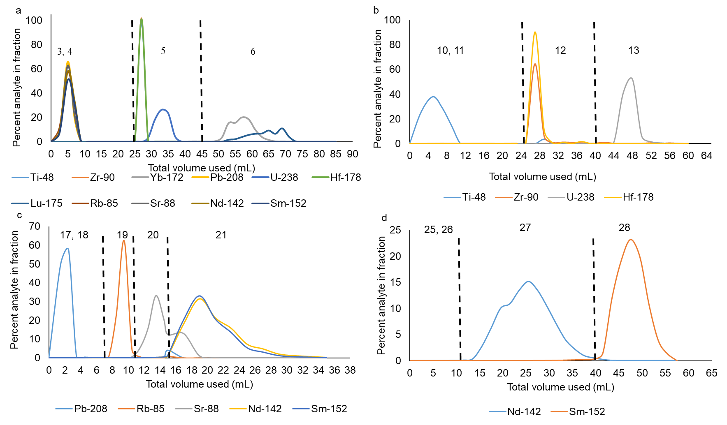
Figure 2. Elution profiles for each of the four columns with a-d representing columns 1-4, respectively. Step numbers from Table 2 are listed.
4.3.3 Column Yields
After the elution profiles were developed, column yields were obtained by running the complete separation method without breaking up each fraction into separate aliquots. This was repeated three times so that the column yields could be obtained in triplicate. Each fraction was dried down and diluted in 2% HNO₃ such that the concentration for each analyte should be 5 ng mL⁻¹. The yield was determined by dividing the actual amount of analyte eluted in ng by the expected amount of analyte.
The column yield for each element was determined to further validate the separation method (Figure 3). Separations were performed in triplicate to analyze the reproducibility of the method as well. The yields for column 1 (figure 3a) were all between 90 and 100% except Zr which was between 80 and 90%. Column 1 also demonstrated reproducibility as all three runs for each analyte were withing 10%. The yields for column 2 (Figure 3b) were excellent as well as all elements of interest were between 90 and 100%. This also showed excellent reproducibility with all runs for each analyte falling within 10%. Column 3 (Figure 3c) demonstrated yields again between 90 and 100% for Pb, Nd, and Sm. While those recoveries were all excellent, the recoveries for Rb and Sr were lower, 65-80% for Rb and 75-85% for Sr (Figure 3c). This is lower than the yields for the other analytes of interest, but this yield should be more than substantial for measuring isotope ratios of Sr. The reproducibility of column 3 varied slightly more than that of columns 1 or 2 as Rb ranged in recoveries by 17%. All other elements for column 3 fell in the 10% range. Column 4 (Figure 3b) demonstrated higher recoveries than column 3 did for Rb and Sr as the yields for Nd and Sm were both between 90 and 100%. The reproducibility of column 4 was excellent as Nd recoveries varied by only 3% while Sm varied by only 6%.
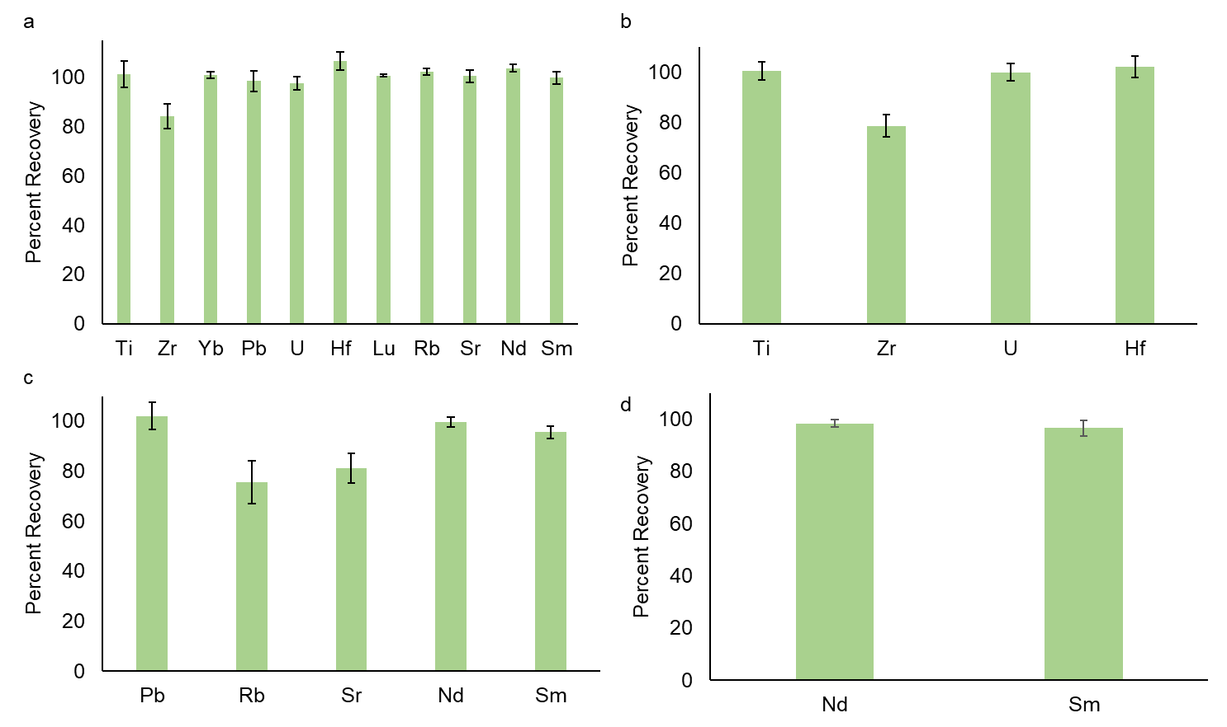
Figure 3. Column yields shown for each of the four columns with a-d representing columns 1-4 respectively.

4.4 Conclusions
Efficient separation techniques are required to accurately determine isotope ratios free of isobaric interferences that could result in inaccurate interference corrections. The developed separation method allows for the separation of Hf-Lu, Rb-Sr, Nd-Sm, Pb and U. Titanium was also separated from Hf as Ti may negatively impact the measurement of Hf by MC-ICP-MS. Separation is achieved through sequential application of Ln an AG resin. The separation uses a limited variety of acids and avoids the use of complex acids such as ascorbic acid or HCl or HNO₃ on their own. The optimized separation method demonstrated removal of isobaric interferences, and the determined column yields were high. A dissolved UOC CRM (CUP-2) was analyzed using the separation to determine the applicability of this method to high U samples. Uranium was included in this separation due to the impact the excess U can have on the measurement.

Chapter 5
Titrations for the determination of stability and dissociation constants of ligands in ionic liquid
In progress

Chapter 6
Summary and Outlook

References
(1) Chu, S.; Majumdar, A. Opportunities and challenges for a sustainable energy future. Nature 2012, 488 (7411), 294-303, Review. DOI: 10.1038/nature11475.
(2) Mayer, K.; Wallenius, M.; Varga, Z. Sample characteristics and nuclear forensic signatures. In The New Nuclear Forensics
Analysis of Nuclear Materials for Security Purposes Fedchenko, V. Ed.; Oxford University Press, 2015; pp 93-127.
(3) Keegan, E.; Richter, S.; Kelly, I.; Wong, H.; Gadd, P.; Kuehn, H.; Alonso-Munoz, A. The provenance of Australian uranium ore concentrates by elemental and isotopic analysis. Appl. Geochem. 2008, 23 (4), 765-777, Article. DOI: 10.1016/j.apgeochem.2007.12.004.
(4) Moody, K. J.; Grant, P. M.; Hutcheon, I. D. Nuclear Forensic Analysis; CRC Press
Taylor & Francis Group 2015.
(5) Badaut, V.; Wallenius, M.; Mayer, K. Anion analysis in uranium ore concentrates by ion chromatography. Journal of Radioanalytical and Nuclear Chemistry 2009, 280 (1), 57-61, Article. DOI: 10.1007/s10967-008-7404-3.
(6) Lin, M.; Zhao, Y. G.; Zhao, L. F.; Li, L. L.; Wang, F.; Zhu, L. C.; Hu, X. N.; Ning, W. Tracing origins of uranium ore concentrates (UOCs) by multidimensional statistical analysis of rare-earth impurities. Journal of Analytical Atomic Spectrometry 2015, 30 (2), 396-402, Article. DOI: 10.1039/c4ja00354c.
(7) Svedkauskaite-LeGore, J.; Rasmussen, G.; Abousahl, S.; van Belle, P. Investigation of the sample characteristics needed for the determination of the origin of uranium-bearing materials. J. Radioanal. Nucl. Chem. 2008, 278 (1), 201-209, Article. DOI: 10.1007/s10967-007-7215-y.
(8) Keegan, E.; Wallenius, M.; Mayer, K.; Varga, Z.; Rasmussen, G. Attribution of uranium ore concentrates using elemental and anionic data. Applied Geochemistry 2012, 27 (8), 1600-1609, Article. DOI: 10.1016/j.apgeochem.2012.05.009.
(9) Significance of Mineralogy in the Developments of Flowsheets flow sheets for Processing Uranium Ores; International Atomic Energy Agency, Vienna, 1980.
(10) Kristo, M. J.; Gaffney, A. M.; Marks, N.; Knight, K.; Cassata, W. S.; Hutcheon, I. D. Nuclear Forensic Science: Analysis of Nuclear Material Out of Regulatory Control. In Annual Review of Earth and Planetary Sciences, Vol 44, Jeanloz, R., Freeman, K. H. Eds.; Annual Review of Earth and Planetary Sciences, Vol. 44; Annual Reviews, 2016; pp 555-579.
(11) Su, Y. F.; Tonkyn, R. G.; Sweet, L. E.; Corbey, J. F.; Bryan, S. A.; Johnson, T. J. Characterization of Uranium Ore Concentrate Chemical Composition via Raman Spectroscopy. In 19th Meeting of the Chemical, Biological, Radiological, Nuclear, and Explosives (CBRNE) Sensing as part of the SPIE Defense and Commercial Sensing (DCS) Symposium, Orlando, FL, Apr 16-18, 2018; Spie-Int Soc Optical Engineering: BELLINGHAM, 2018; Vol. 10629. DOI: 10.1117/12.2304304. Pointurier, F.; Marie, O. Use of micro-Raman spectrometry coupled with scanning electron microscopy to determine the chemical form of uranium compounds in micrometer-size particles. J. Raman Spectrosc. 2013, 44 (12), 1753-1759, Article. DOI: 10.1002/jrs.4392. Lin, D. H. M.; Manara, D.; Varga, Z.; Berlizov, A.; Fanghanel, T.; Mayer, K. Applicability of Raman spectroscopy as a tool in nuclear forensics for analysis of uranium ore concentrates. Radiochim. Acta 2013, 101 (12), 779-784, Article. DOI: 10.1524/ract.2013.2110.
(12) Varga, Z.; Ozturk, B.; Meppen, M.; Mayer, K.; Wallenius, M.; Apostolidis, C. Characterization and classification of uranium ore concentrates (yellow cakes) using infrared spectrometry. Radiochim. Acta 2011, 99 (12), 807-813, Article. DOI: 10.1524/ract.2011.1886.
(13) Burger, S.; Boulyga, S. F.; Penkin, M. V.; Bostick, D.; Jovanovic, S.; Lindvall, R.; Rasmussen, G.; Riciputi, L. Quantifying multiple trace elements in uranium ore concentrates: an interlaboratory comparison. J. Radioanal. Nucl. Chem. 2014, 301 (3), 711-729, Article; Proceedings Paper. DOI: 10.1007/s10967-014-3224-9.
(14) Rogers, K. T.; Giaquinto, J.; Essex, R. M.; Metzger, S. C.; Ticknor, B. W.; Hexel, C. R. Trace impurity analysis in uranium oxide via hybrid quantification techniques-gravimetric standard addition and isotope dilution mass spectrometry. Journal of Radioanalytical and Nuclear Chemistry 2018, 318 (1), 685-694. DOI: 10.1007/s10967-018-6106-8.
(15) Manard, B. T.; Metzger, S. C.; Quarles, C. D.; Rogers, K. T.; Ticknor, B. W.; Bostick, D. A.; McBay, E. H.; Hexel, C. R. Evaluation and Specifications for In-Line Uranium Separations Using Inductively Coupled Plasma Optical Emission Spectroscopy (ICP-OES) Detection for Trace Elemental Analysis. Appl. Spectrosc. 2019, 73 (8), 927-935, Article. DOI: 10.1177/0003702819837650.
(16) Wylie, E. M.; Manard, B. T.; Quarles, C. D.; Meyers, L. A.; Xu, N. An automated micro-separation system for the chromatographic removal of uranium matrix for trace element analysis by ICP-OES. Talanta 2018, 189, 24-30, Article. DOI: 10.1016/j.talanta.2018.06.063.
(17) Khumalo, N.; Mathuthu, M. Determination of trace elements and lanthanide (REE) signatures in uranium mine products in South Africa by means of inductively coupled plasma mass spectrometry. J. Geochem. Explor. 2018, 186, 235-242, Article. DOI: 10.1016/j.gexplo.2017.12.012.
(18) Boulyga, S. F.; Cunningham, J. A.; Macsik, Z.; Hiess, J.; Penkin, M. V.; Walsh, S. J. Development, validation and verification of an ICP-MS procedure for a multi-element analysis of uranium ore concentrates. Journal of Analytical Atomic Spectrometry 2017, 32 (11), 2226-2237, Article. DOI: 10.1039/c7ja00180k. Varga, Z.; Katona, R.; Stefanka, Z.; Wallenius, M.; Mayer, K.; Nicholl, A. Determination of rare-earth elements in uranium-bearing materials by inductively coupled plasma mass spectrometry. Talanta 2010, 80 (5), 1744-1749, Article. DOI: 10.1016/j.talanta.2009.10.018.
(19) Balcone-Boissard, H.; Michel, A.; Villemant, B. Simultaneous Determination of Fluorine, Chlorine, Bromine and Iodine in Six Geochemical Reference Materials Using Pyrohydrolysis, Ion Chromatography and Inductively Coupled Plasma-Mass Spectrometry. Geostandards and Geoanalytical Research 2009, 33 (4), 477-485. DOI: 10.1111/j.1751-908X.2009.00018.x.
(20) Jeyakumar, S.; Mishra, V. G.; Das, M. K.; Raut, V. V.; Sawant, R. M.; Ramakumar, K. L. Study on the identification of organic and common anions in the pyrohydrolysis distillate of mixed uranium-plutonium carbide for the interference free determination of chlorine and fluorine by ion chromatography. Radiochimica Acta 2014, 102 (4), 291-302, Article. DOI: 10.1515/ract-2013-2131.
(21) Shimizu, K.; Suzuki, K.; Saitoh, M.; Konno, U.; Kawagucci, S.; Ueno, Y. Simultaneous determinations of fluorine, chlorine, and sulfur in rock samples by ion chromatography combined with pyrohydrolysis. Geochemical Journal 2015, 49 (1), 113-124, Article. DOI: 10.2343/geochemj.2.0338.
(22) Chai, J. Y.; Muramatsu, Y. Determination of bromine and iodine in twenty-three geochemical reference materials by ICP-MS. Geostand. Geoanal. Res. 2007, 31 (2), 143-150, Article. DOI: 10.1111/j.1751-908X.2007.00856.x.
(23) Oliveira, A. A.; Trevizan, L. C.; Nobrega, J. A. REVIEW: Iodine Determination by Inductively Coupled Plasma Spectrometry. Appl. Spectrosc. Rev. 2010, 45 (6), 447-473, Review. DOI: 10.1080/05704928.2010.502207.
(24) Thomas, R. Practical Guide to ICP-MS A Tutorial for Beginners; CRC Press Taylor & Francis Group, 2013.
(25) Tanner, S. D.; Baranov, V. I.; Bandura, D. R. Reaction cells and collision cells for ICP-MS: a tutorial review. Spectrochimica Acta Part B-Atomic Spectroscopy 2002, 57 (9), 1361-1452, Review. DOI: 10.1016/s0584-8547(02)00069-1.
(26) Balcaen, L.; Bolea-Fernandez, E.; Resano, M.; Vanhaecke, F. Inductively coupled plasma - Tandem mass spectrometry (ICP-MS/MS): A powerful and universal tool for the interference-free determination of (ultra) trace elements - A tutorial review. Analytica Chimica Acta 2015, 894, 7-19, Review. DOI: 10.1016/j.aca.2015.08.053.
(27) Haldimann, M.; Eastgate, A.; Zimmerli, B. Improved measurement of iodine in food samples using inductively coupled plasma isotope dilution mass spectrometry. Analyst 2000, 125 (11), 1977-1982, Article. DOI: 10.1039/b005879n.
(28) Todorov, T. I.; Gray, P. J. Analysis of iodine in food samples by inductively coupled plasma-mass spectrometry. Food Additives and Contaminants Part a-Chemistry Analysis Control Exposure & Risk Assessment 2016, 33 (2), 282-290, Article. DOI: 10.1080/19440049.2015.1131337.
(29) Schnetger, B.; Muramatsu, Y.; Yoshida, S. Iodine (and other halogens) in twenty six geological reference materials by ICP-MS and ion chromatography. Geostand. Newsl. 1998, 22 (2), 181-186, Article. DOI: 10.1111/j.1751-908X.1998.tb00690.x.
(30) Fecher, P. A.; Goldmann, I.; Nagengast, A. Determination of iodine in food samples by inductively coupled plasma mass spectrometry after alkaline extraction. J. Anal. At. Spectrom. 1998, 13 (9), 977-982, Article; Proceedings Paper. DOI: 10.1039/a801671b. Shah, M.; Wuilloud, R. G.; Kannamkumaratha, S. S.; Caruso, J. A. Iodine speciation studies in commercially available seaweed by coupling different chromatographic techniques with UV and ICP-MS detection. J. Anal. At. Spectrom. 2005, 20 (3), 176-182, Article. DOI: 10.1039/b415756g.
(31) Krajko, J.; Varga, Z.; Wallenius, M.; Mayer, K.; Konings, R. Investigation of sulphur isotope variation due to different processes applied during uranium ore concentrate production. J. Radioanal. Nucl. Chem. 2016, 309 (3), 1113-1121, Article. DOI: 10.1007/s10967-016-4733-5.
(32) Lerch, R. E.; Norman, R. E. NUCLEAR-FUEL CONVERSION AND FABRICATION CHEMISTRY. Radiochimica Acta 1984, 36 (1-2), 75-88, Article. Lunt, D.; Boshoff, P.; Boylettt, M.; El-Ansary, Z. Uranium extraction: the key process drivers. Journal of the South African Institute of Mining and Metallurgy 2007, 107 (7), 419-426.
(33) Dhara, S.; Misra, N. L.; Aggarwal, S. K. Determination of sulphur in uranium matrix by total reflection X-ray fluorescence spectrometry. Spectrochimica Acta Part B-Atomic Spectroscopy 2008, 63 (12), 1395-1398. DOI: 10.1016/j.sab.2008.10.033.
(34) Crewe, M. T. I.; Lopes, P. C.; Moura, S. C.; Sampaio, J. A. G.; Bustillos, O. V. Characterization of Hydrogen, Nitrogen, Oxygen, Carbon and Sulfur in Nuclear Fuel (UO₂) and Cladding Nuclear Rod Materials; Instituto de Pesquisas Energeticas e Nucleares, 05508-000 Sao Paulo, SP.
(35) Kinman, W. S.; Borg, L. E.; Kaye, P.; Mayer, K.; Varga, Z.; Wallenius, M. S. Interlaboratory Report on the Analysis Results and Metadata for the Springfields Uranium Ore Concentrate Sample Collection; LA-UR-16-24131.
(36) Jeyakumar, S.; Raut, V. V.; Ramakumar, K. L. Simultaneous determination of trace amounts of borate, chloride and fluoride in nuclear fuels employing ion chromatography (IC) after their extraction by pyrohydrolysis. Talanta 2008, 76 (5), 1246-1251, Article. DOI: 10.1016/j.talanta.2008.05.039.
(37) Golik, V. M.; Golik, S. V.; Trepachev, S. A.; Kuz'mina, N. V. Determination of B, Si, P, S, Cl, and Br in uranium materials by inductively coupled plasma mass spectrometry. Journal of Analytical Chemistry 2010, 65 (14), 1511-1516, Article. DOI: 10.1134/s106193481014011x.
(38) Fletcher, N.; Manard, B.; Metzger, S.; Ticknor, B.; Bostick, D.; Hexel, C. Determining P, S, Br, and I content in uranium by triple quadrupole inductively coupled plasma mass spectrometry. Manuscript in review, 2019.
(39) Han, S.-H.; Varga, Z.; Krajko, J.; Wallenius, M.; Song, K.; Mayer, K. Measurement of the Sulphur isotope ratio ( ³⁴ S / ³² S ) in uranium ore concentrates (yellow cakes) for origin assessment. Journal of Analytical Atomic Spectrometry 2013, 28, 1919-1925. DOI: 10.1039/C3JA50231G.
(40) Schaefer, B. Radiogenic Isotope Geochemistry: A Guide for Industry Professionals; University Printing House, 2016.
(41) Schmitz, M. D.; Kuiper, K. F. High-Precision Geochronology. Elements 2013, 9 (1), 25-30, Article. DOI: 10.2113/gselements.9.1.25.
(42) Boudin, A.; Deutsch, S. Geochronology: Recent Development in the Lutetium-176/Hafnium-176 Dating Method. Science 1970, 168 (3936), 1219-1220. Riley, G. H.; Compston, W. THEORETICAL AND TECHNICAL ASPECTS OF RB-SR GEOCHRONOLOGY. Geochim. Cosmochim. Acta 1962, 26 (DEC), 1255-1281, Article. DOI: 10.1016/0016-7037(62)90055-8. Lugmair, G. W.; Scheinin, N. B.; Marti, K. Sm-Nd age and history of Apollo 17 basalt 75075: Evidence for early differentiation of the lunar exterior Proc Lunar Sci: United States of America, 1975; Vol. 6, pp 1419-1429.
(43) Allegre, C. Isotope Geology; Cambridge University Press, 2008.
(44) Nebel-Jacobsen, Y.; Scherer, E. E.; Munker, C.; Mezger, K. Separation of U, Pb, Lu, and Hf from single zircons for combined U-Pb dating and Hf isotope measurements by TIMS and MC-ICPMS. Chemical Geology 2005, 220 (1-2), 105-120. DOI: 10.1016/j.chemgeo.2005.03.009.
(45) Krajko, J.; Varga, Z.; Wallenius, M.; Mayer, K. Development of a versatile sample preparation method and its application for rare-earth pattern and Nd isotope ratio analysis in nuclear forensics. J. Radioanal. Nucl. Chem. 2015, 304 (1), 177-181. DOI: 10.1007/s10967-014-3505-3.
(46) Shollenberger, Q. R.; Borg, L. E.; Ramon, E. C.; Sharp, M. A.; Brennecka, G. A. Samarium isotope compositions of uranium ore concentrates: A novel nuclear forensic signature. Talanta 2021, 221. DOI: 10.1016/j.talanta.2020.121431.
(47) White, W. M.; Albarede, F.; Telouk, P. High-precision analysis of Pb isotope ratios by multi-collector ICP-MS. Chemical Geology 2000, 167 (3-4), 257-270, Article. DOI: 10.1016/s0009-2541(99)00182-5.
(48) Varga, Z.; Wallenius, M.; Mayer, K.; Keegan, E.; Millett, S. Application of Lead and Strontium Isotope Ratio Measurements for the Origin Assessment of Uranium Ore Concentrates. Anal. Chem. 2009, 81 (20), 8327-8334. DOI: 10.1021/ac901100e.
(49) Aggarwal, J.; Habicht-Mauche, J.; Juarez, C. Application of heavy stable isotopes in forensic isotope geochemistry: A review. Appl. Geochem. 2008, 23 (9), 2658-2666. DOI: 10.1016/j.apgeochem.2008.05.016.
(50) Kleinhanns, I. C.; Kreissig, K.; Kamber, B. S.; Meisel, T.; Nagler, T. F.; Kramers, J. D. Combined chemical separation of Lu, Hf, Sm, Nd, and REEs from a single rock digest: Precise and accurate isotope Determinations of Lu-Hf and Sm-Nd using multicollector-ICPMS. Anal. Chem. 2002, 74 (1), 67-73. DOI: 10.1021/ac010705z.
(51) Chernyshev, I. V.; Chugaev, A. V.; Shatagin, K. N. High-precision Pb isotope analysis by multicollector-ICP-mass-spectrometry using Tl-205/Tl-203 normalization: Optimization and calibration of the method for the studies of Pb isotope variations. Geochemistry International 2007, 45 (11), 1065-1076. DOI: 10.1134/s0016702907110018.
(52) Manard, B. T.; Bostick, D. A.; Metzger, S. C.; Ticknor, B. W.; Zirakparvar, N. A.; Rogers, K. T.; Hexel, C. R. Rapid and automated separation of uranium ore concentrates for trace element analysis by inductively coupled plasma - optical emission spectroscopy/triple quadrupole mass spectrometry. Spectroc. Acta Pt. B-Atom. Spectr. 2021, 179. DOI: 10.1016/j.sab.2021.106097.
(53) Bizzarro, M.; Baker, J. A.; Ulfbeck, D. A new digestion and chemical separation technique for rapid and highly reproducible determination of Lu/Hf and Hf isotope ratios in geological materials by MC-ICP-MS. Geostand. Newsl. 2003, 27 (2), 133-145. DOI: 10.1111/j.1751-908X.2003.tb00641.x.
(54) BlichertToft, J.; Chauvel, C.; Albarede, F. Separation of Hf and Lu for high-precision isotope analysis of rock samples by magnetic sector multiple collector ICP-MS. Contributions to Mineralogy and Petrology 1997, 127 (3), 248-260. DOI: 10.1007/s004100050278.
(55) Li, C. F.; Guo, J. H.; Yang, Y. H.; Chu, Z. Y.; Wang, X. C. Single-step separation scheme and high-precision isotopic ratios analysis of Sr-Nd-Hf in silicate materials. J. Anal. At. Spectrom. 2014, 29 (8), 1467-1476. DOI: 10.1039/c3ja50384d.
(56) Pin, C.; Gannoun, A. Integrated Extraction Chromatographic Separation of the Lithophile Elements Involved in Long-Lived Radiogenic Isotope Systems (Rb-Sr, U-Th-Pb, Sm-Nd, La-Ce, and Lu-Hf) Useful in Geochemical and Environmental Sciences. Anal. Chem. 2017, 89 (4), 2411-2417. DOI: 10.1021/acs.analchem.6b04289.
(57) Yang, Y. H.; Zhang, H. F.; Chu, Z. Y.; Xie, L. W.; Wu, F. Y. Combined chemical separation of Lu, Hf, Rb, Sr, Sm and Nd from a single rock digest and precise and accurate isotope determinations of Lu-Hf, Rb-Sr and Sm-Nd isotope systems using Multi-Collector ICP-MS and TIMS. International Journal of Mass Spectrometry 2010, 290 (2-3), 120-126. DOI: 10.1016/j.ijms.2009.12.011.
(58) Kinman, W. S.; Borg, L. E.; Kaye, P.; Mayer, K.; Varga, Z.; Wallenius, M. S. Interlaboratory Report on the Analysis Results and Metadata for the Springfields Uranium Ore Concentrate Sample Collection; LA-UR-16-24131; Los Alamos National Laboratory, Los Alamos National Laboratory, 2016.

