Therapeutic Exercise Influences on Activity of the Multifidus Muscles in Horses

A Dissertation Presented for the

Doctor of Philosophy

Degree

The University of Tennessee, Knoxville

Tena Louise Ursini

May 2021

Copyright © 2021 by Tena Louise Ursini.
All rights reserved.

DEDICATION

This work is dedicated to all my family and friends who believed I could actually do this crazy thing, and who helped me over every hurdle along the way. To all the veterinarians, technicians, and assistants that made me into the person, veterinarian, and researcher I am today.

ACKNOWLEDGEMENTS

None of this work would have been possible without Dr. Steve Adair. His mentorship, support, and guidance were vital to the success of this project. In addition, my entire committee was essential in study design, planning, and publication.

Dr. Jim Richards and Dr. David Levine were pivotal in getting useful data extracted from the millions of crazy squiggly lines. Their guidance and support through the collection and processing of the electromyography signal were vital for the production of this dissertation.

I would like to thank Dr. Karen Shaw for her immense help and support through all the twists and turns of research as we ventured off into uncharted waters. Nora Young was incredible helping collect data an entire summer, fighting horses who were terrified of fly spray to stand still. Josh Bowlin, Emma Horn and Tyler Moore were always available and tolerated me asking them to jog “one more time” more times than I can count.

Dr. Stephen Kania and Kim Rutherford were essential in helping me keep all the deadlines and forms straight. I could have never survived without their guidance.

I would like to thank the University of Tennessee Large Animal Clinical Science Department for believing in me enough to provide me employment and faculty start-up funds to complete this work.

Lastly, I need to publicly thank my family and friends who provided support and understanding when I missed yet another social event. My husband was a rock star keeping the home fires burning on my pursuit for yet more letters of the alphabet to write after my name. Someday I hope to repay him for the sacrifices he made.

ABSTRACT

Back pain is a worldwide debilitating condition that affects humans and animals alike. Lower back pain in humans can be caused by a myriad of conditions, including idiopathic origin. Spinal stability is compromised during disease, and a lack of stability also contributes to pathologic spinal conditions. Regardless of species, the stability of the spine depends on bones, ligaments, tendons and muscles. Muscles provide the only active component that can counteract various loads applied to the body. There are several muscle groups that contribute to spinal mechanics. The erector spinae group are large superficial muscles the lie along each side of the spine and traverse its length. The erector spinae muscles are responsible for major trunk motion in all planes. Motion in the lumbar spine primarily consists of flexion and extension, but also partially contributes to lateral bending. The multifidus muscle group is deep to the erector spinae group and is responsible for postural maintenance of the spine. The multifidus also traverses the entire length of the spine, however its attachments are organized in small bundles or fascicles that only cross a few vertebral levels. Therefore, it is responsible for small finite movements to promote vertebral alignment. In humans, the multifidus is thought to be the main spinal stabilizer.

Spinal disease is associated with alterations in both the erector spinae and multifidus muscle groups. It has been difficult to determine if changes in the muscles alter stability and allow for disease, or if spinal disease induces pathology in the muscles. The majority of muscle changes consist of atrophy and or fat infiltration, both of which compromise the ability of the muscle to produce force.

Human physical therapy strategies have focused on stretching and strengthening both the erector spinae and multifidus muscle groups. These protocols have been extrapolated to quadruped animals without justification or knowledge of the biomechanical function of these muscle groups in quadrupeds.

Overall, we determined that the average and peak levels of activation of the multifidus muscle was increased on soft impressionable footing, while incorporating ground poles, and without the use of the tested training device, in trotting horses.

TABLE OF CONTENTS

CHAPTER 1: Introduction to Lower Back Pain 1
Abstract 2
Introduction 2
Comparative Spinal and Paraspinal Anatomy 3
Bony Anatomy 3
Joints 3
Ligaments 4
Paraspinal Muscles 5
Abdominal Muscles 7
Comparative Paraspinal Muscle Function in Normal Individuals 8
Changes in Paraspinal Musculature Associated with Back Pain 10
Physical Rehabilitation to Improve Function 13
Conclusion 14
References 15
Appendix 23
CHAPTER II: Multifidus Activation in Horses Trotting on Hard and Soft Surfaces 40
Abstract 41
Introduction 41
Methods 43
Results 45
Discussion 46
Conclusion 48
References 49
Appendix 52
CHAPTER III: Multifidus Activation in Horses Trotting During Therapeutic Exercise 53
Abstract 54
Introduction 55
Methods 56
Results 58
Discussion 60
Conclusion 62
References 63
Appendix 66
CHAPTER IV: Conclusions and Future Direction 69
Introduction 70
Conclusions 70
Future Research 71
References 72
VITA 75

LIST OF TABLES

Table 1.1 Mean (standard deviation) values for outcome measures on hard and soft surfaces. 52
Table 2.1: Means (standard deviation) and comparisons of normalized EMG outcome measures for all conditions 66
Table 2.2: Post hoc evaluation of training device without ground poles 67
Table 2.3: Post hoc evaluation of training device with ground poles 67
Table 2.4: Percent change in outcome measure means for each exercise condition in comparison to baseline 68

LIST OF FIGURES

Figure 1.1- Superior aspect of a human fourth thoracic vertebra… 23
Figure 1.2- Lateral aspect of fourth thoracic vertebra. 24
Figure 1.3- Human vertebral column 25
Figure 1.4- Ligamentous attachments of the human lumbar spine 26
Figure 1.5- Intervertebral disc structure. 27
Figure 1.6- Median section of the equine thoracolumbar spine. 28
Figure 1.7- Nuchal ligament in the horse.. 29
Figure 1.8- Lumbosacral junction, medial section.. 30
Figure 1.9- Human erector spinae muscle group. 31
Figure 1.10- Rotares muscle bundles in the human thoracic spine 32
Figure 1.11- Human multifidus muscle. 33
Figure 1.12- Superficial equine back muscles.. 34
Figure 1.13- Equine thoracolumbar junction.. 35
Figure 1.14- Equine multifidus insertions in lumbar spine 36
Figure 1.15- Human abdominal and lumbar musculature 37
Figure 1.16- Abdominal musculature in horses 38
Figure 1.17- "Bow and string" theory of equine back mechanics 39

LIST OF ABBREVIATIONS

1. ARV…………………………………………………………..average rectified value
2. EMG………………………………………………………………..electromyography
3. L5…………………………………………………………………………..fifth lumbar
4. LBP……………………………………………….…………………..lower back pain
5. MRI……………………………………………………magnetic resonance imaging
6. PE……………………………………………………………..peak enveloped value
7. T12……………………………………………...……………………..twelfth thoracic
8. T18……………………………………………….……………….eighteenth thoracic

CHAPTER 1: Introduction to Lower Back Pain

Abstract
According to the Global Burden of Disease 2010 study, lower back pain (LBP) has a global prevalence of 9.4% in humans with 80-85% of the population experiencing symptoms at some point in their lifetime [1, 2]. Of all conditions studied, LBP was found to cause more global disability than any other condition [1].
Back pain is also incredibly important in equine athletes, as it is known to contribute to poor performance [3, 4]. In mixed equine practices, back pain is reported in 13% of all cases and 47% of research clinics [5]. In reference to a chiropractic based equine practice, 94% of cases presented had back dysfunction or pain [6]. Diagnosing the cause of back pain is difficult in horses due to the multitude of causes [7] and inability to employ advanced imaging methods, such as magnetic resonance imaging (MRI) or computed tomography. Therefore, radiography and ultrasonography have become the main diagnostics used [4], both of which have limited sensitivity and specificity. Nuclear scintigraphy has been used in select cases but has limited capability of diagnosing soft tissue lesions [8]. Most back pain diagnoses are made based on exclusion of hind limb lameness, saddle fit incongruities, and clinical exam [4, 8, 9].
Regardless of the cause of LBP in humans, a variety of physical therapy protocols have been shown to improve pain and dysfunction [10-17]. Most protocols focus on increasing strength and fatigue resistance of the epaxial and abdominal muscles [10-12, 15, 17] as well as improving proprioception and balance control [10, 12, 14, 18].

Introduction
The Global Burden of Disease 2010 stud determined lower back pain (LBP) to have a global prevalence of 9.4% in humans with 80-85% of the population experiencing symptoms at some point in their lifetime [1, 2]. LBP caused the most global disability of any conditions studies, as defined by years lost to disability [1].

Back pain is equally important in equine athletes, as it contributes significantly to poor performance [3, 4]. In mixed equine practices, back pain is reported in 13% of all cases and 47% of research clinics [5]. In reference to a chiropractic based equine practice, 94% of cases presented had back dysfunction or pain [6]. Diagnosing the cause of back pain is difficult in horses due to the multitude of causes [7]. Therefore, extrapolation of principles from human studies has been employed. The following chapter will first discuss the basic comparative anatomy, comparative biomechanics, comparative changes that occur in conjunction with lower back pain and certain therapies currently used.

Comparative Spinal and Paraspinal Anatomy
The back consists of the bony spinal column, spinal ligaments, and paraspinal muscles and fascia. Structures of current clinical importance regarding the prevention and treatment of thoracolumbar lower back pain in humans and horses will be discussed further

Bony Anatomy
The spinal column is a continuous series of individual bones connected with complex linkages. Every vertebra has the same basic shape with a solid vertebral body, two vertebral pedicles extending posteriorly from the abaxial surfaces of the vertebral body, and posterior lamina connecting the two pedicles (Figure 1.1, 1.2) [19]. The posterior vertebral body, pedicles and laminae form the boundaries of the vertebral foramen, through which the spinal cord traverses [19]. The vertebral column has the primary function of protecting the spinal cord, the nerve roots and associated vasculature [19]. In general, humans have seven cervical vertebrae, twelve thoracic vertebrae, five lumbar vertebrae, and five fused sacral vertebrae [19] Figure 1.3. The overall shape of each vertebrae and its articulations is dependent on its location. Thoracic vertebrae allow for rotational and lateral bending and have articulations with the ribs [20]. Lumbar vertebrae are adapted to provide flexion and extension or movement within the sagittal plane [20]. Each vertebra has unique bony protuberances that correspond with ligament and muscular attachments. The spinous process resides between the laminae and extends posteriorly in bipeds. The transverse processes extend off each side of the vertebra at the junction of the pedicle and lamina [19].

The basic structure of each equine vertebrae is similar in design to humans; however, some shape changes are prevalent related to differing stresses placed upon the spine as a quadruped versus a biped.

Like humans, horses have seven cervical vertebrae, but eighteen thoracic and six lumbar vertebrae [21]. Thoracic vertebrae have especially prominent spinous processes, much longer than those in humans. Additionally, lumbar vertebrae have long horizontal transverse processes that develop synovial joints between each vertebra from the fifth vertebrae to the sacrum [21].

Joints
Between two individual vertebrae there are two articulations: synovial facet joints, and a cartilaginous disc between vertebral bodies. Thoracic vertebrae also have articulations with the ribs. Figure 1.4 [19].

Facet joints are true synovial structures complete with a fibrous capsule. Hyaline cartilage covers the bone of each superior and inferior facet. A synovial membrane lines the fibrous capsule and produces synovial fluid for lubrication [19]. Like other synovial joints within the body, facet joints are at risk of developing osteoarthritis. Remodeling of the bone at the joint capsule attachments can impinge upon the intervertebral foramina. Facet osteoarthritis is common in horses. Enthesophyte formation and enlargement of these joints can cause impingement of spinal nerves exiting the spinal foramina between vertebral bodies [22].

Intervertebral discs are the primary shock absorber between vertebrae in humans. The outer annulus fibrosis is a series of lamellae that form incomplete collars around the inner nucleus pulposus. The orientation of fibers within each lamellae layer changes based on the location within the disc. Posterior fibers can be predominantly vertical, which may predispose them to herniation into the spinal canal Figure 1.5 [19].

Intervertebral discs in horses are relatively thin and only contribute approximately 10% of the overall length of the spine [21]. Like humans, these discs have a peripheral annulus fibrosis and an inner nucleus pulposus, however the layers are much less distinct [21].

Ligaments
The anterior longitudinal ligament is a band of strong tissue that extends the entire length of the spinal column linking the anterior surfaces of the vertebral bodies. Fibers are found in three distinct levels with superficial fibers extending over three to four vertebral levels and deeper layers only extending from one vertebral body to the next. Fibers are known to extend and fuse with the superficial layers of bone, known as periosteum, as well as to the annulus fibrosis Figure 1.4 [19].

The posterior longitudinal ligament is a similar broad band of tissue that extends the length of the spinal cord on the posterior surface of vertebral bodies. Similarly, superficial fibers traverse several vertebral layers with deeper fibers traversing between two vertebrae. This ligament fuses with the annular fibrosis in adults as well as membranes associated with the epidural space Figure 1.4 [19].

The ligament flava connect adjacent laminae in the vertebral canal. Fibers in this structure are composed of mostly yellow elastic tissue and traverse from the anterior surface of one lamina to the posterior surface of the lamina below. The purpose of this ligament is to prevent separation of the laminae during spinal flexion and assist in returning to an erect upright posture Figure 1.4 [19].

The supraspinous ligament is a strong fibrous cord that connects the tips of spinous processes from the distal cervical to mid lumbar regions. It can be deficient in some people. Consistent with other spinal ligaments, superficial fibers cover several vertebrae and deeper fibers connect two to three vertebrae. Most of the ligament is continuous with tendons of muscles with midline attachments such as, semispinalis, longissimus, trapezius and latissimus dorsi Figure 1.4 [19].

Interspinous ligaments connect consecutive spinous processes, filling the gap between the ligamentum flava and supraspinous ligament. Dorsal fibers are continuous with tendons of longissimus thoracis Figure 1.4 [19].

The thoracolumbar fascia is a thick band of tissue that overlays all soft tissue structures of the thoracolumbar region. In humans is has three distinct layers. The posterior layer attaches to the lumbar spinous processes, crest of the sacrum and supraspinous ligaments. The middle layer attaches to the medial tips of the lumbar transverse processes, the intertransverse ligaments, iliac crest, and lower border of the 12th rib. The anterior layer attaches to the anterior surfaces of the lumbar transverse processes. The abdominal muscles insert upon the thoracolumbar fascia [19].

Horses have very similar ligamentous structures as described in humans Figure 1.6. In addition, horses possess a nuchal ligament, demonstrated by a strong band of elastic tissue that extends from the base of the skull to the cranial thoracic region where it blends with the supraspinous ligament [21]. This ligament also has a second portion that forms a sheet of elastic bundles that extend cranioventrally to connect the thick band to the spinous processes from the second cervical vertebrae to the third thoracic vertebrae Figure 1.7. The purpose of this ligament is to assist the horse in supporting the head and neck while still allowing the horse to graze [21].

At the equine lumbosacral junction, there is a wide gap between dorsal spinous processes. The supraspinous ligament is absent and the interspinous ligament is poorly developed in this region Figure 1.8 [5].

Paraspinal Muscles
The human back has several layers of muscles. Extrinsic muscles are superficial with truly intrinsic back muscles found in the deeper layers [19]. Extrinsic muscles mostly connect the axial skeleton to the thoracic limb. Focus will be placed on the musculature contained in the thoracic and lumbosacral regions.

The erector spinae muscle group is a large musculotendinous group that consists of three different muscles, spinalis, longissimus, and iliocostalis, each with three regional parts. Despite being one continuous muscle, the spinalis muscle is divided into three portions, capitus, cervicis, and thoracis. The spinalis thoracis is the most medial within the erector spinae muscle group. It originates from the spinous processes of the upper thoracic vertebrae and inserts on the spinous processes of the lower thoracic and first two lumbar vertebrae. On its lateral edge, the spinalis muscle blends with the longissimus thoracis Figure 1.9 [19].

The longissimus muscle contributes to the central portion of the erector spinae system. It is similarly divided into three parts: capitus, cervicis, and thoracis. Longissimus thoracis is the largest portion of erector spinae and is further divided into thoracic and lumbar portions. The thoracic portion of longissimus thoracis is composed of several groups of fascicles that originate from the thoracic transverse processes. Distally, the muscle fascicles coalesce into a wide fibrous aponeurosis that allow for multiple attachments. Fascicles have staggered insertions onto the lumbar spinous processes and their associated supraspinous ligament, sacral crest, and ilium [19]. The lumbar portion is covered by the aponeurosis of the thoracic segment. It originates from the posterior surface of the transverse processes of the five lumbar vertebrae and inserts in a similar staggered fashion via the lumbar intermuscular aproneurosis onto the ilium and dorsal sacroiliac ligament Figure 1.9 [19].

The iliocostalis is the most lateral component of the erector spinae system. It is also divided into three parts: cervicis, thoracis, and lumborum. Iliocostalis thoracis originates from the cervical thoracic transverse processes and ribs and inserts on the upper borders of the lower six ribs [19]. Iliocostalis lumborum is further divided into lumbar and thoracic parts. The thoracic portion originates from the lower eight ribs and inserts onto the medial end of the iliac crest. The lumbar portion originates from the tips of the first four lumbar transverse processes and inserts on the medial and dorsal portion of the iliac crest Figure 1.9 [19].

The spinotransverse group consists of the rotatores, multifidus, and semispinalis muscles [19]. The rotatores fascicles are small bundles that span one to two vertebral segments and traverse between the transverse process of one vertebra to the laminae and spinous processes of adjacent vertebrae Figure 1.10 [19].
The multifidus muscle lies lateral to the spinous processes and covers the laminae of each vertebrae, as well as the dorsal sacrum distally Figure 1.11 [19]. It has several distinct parts, originally described as cervicothoracic and lumbosacral segments [19]. Recent literature review has discovered that many researchers and anatomy atlases are inconsistent in the description of the multifidus in the lumbar region [23]. Despite anatomy texts describing the multifidus as a predominantly deep structure, half of the studies reviewed described it as a superficial structure [23], thus making it difficult to compare findings between research groups. Researchers such as Moseley et al. have claimed that the superficial fibers of the lumbar multifidus were responsible for spine orientation via electromyography (EMG) studies. However, the small muscle mass and thus low capacity to produce force, make this unlikely to other researchers [17]. Regardless, the multifidus muscle has garnered much attention across species due to pathology that develops concurrently with LBP, as will be further discussed later. The semispinalis muscle is divided into capital, cervical, and thoracic portions [19]. Fibers form small fascicles that originate from several levels of transverse processes and insert on transverse processes several levels distal [19].

Equine epaxial muscles are like those in humans. Main contributions are from the longissimus, spinalis, and iliocostalis muscles superficially as well as the multifidus muscle deeper Figure 1.12, 1.13 [24, 25].

The multifidus muscle in horses has 5 distinct fascicles each arising from a single spinous process and associated laminae. Each fascicle has an independent attachment with the most superficial fascicle crossing two to four intervertebral spaces, intermediate fascicles crossing two to four spaces, and the deepest fascicle crossing one space [26]. Each fascicle inserted on the mammillary process which lies dorsal to the articular facet and lateral to the spinous process Figure 1.14 [26]. The continuation of the multifidus muscle past the caudal lumbar region is referred to as the sacrocaudalis dorsalis muscle. The lateral aspect of the sacrocaudalis dorsalis muscle originates from the dorsal aspect of the fourth, fifth, or sixth lumbar vertebrae and blends into the supraspinous ligament and thoracolumbar fascia [26]. Caudal continuation of this muscle provides motor to the tail [27].

Abdominal Muscles
The transverse, internal oblique, external oblique, and rectus abdominus muscles overlap to form the anterior abdominal muscles in humans Figure 1.15 [19]. They have a variety of attachments, the most important for spinal stability being the thoracolumbar fascia. Fibers from each muscle run in separate directions, providing muscular support throughout full range of motion [28]. Contraction of the abdominal muscles increases tension within the thoracolumbar fascia, promoting trunk stiffness [28].

The abdominal musculature in horses is not vastly different than humans Figure 1.16. However, they have a vital role in supporting the weight of the abdominal contents, forces that are not present in humans [21]. The equine abdominal muscles insert onto the axial skeleton via a thick aponeurosis onto the prepubic tendon and thoracolumbar fascia [21].

Comparative Paraspinal Muscle Function in Normal Individuals
The theory of human spinal stability has evolved overtime to include both passive static positions and controlled movements [29]. The model driving the theory consists of three components: bone and ligaments, muscles, and neural control to coordinate muscle activity against the forces applied [30]. Bones and ligaments provide rigid passive stability; however, it is reported that human cadaver spines containing only vertebrae and ligaments collapse under a twenty-pound load [31, 32]. Muscles are essential to promote stiffness and stability [29]. Under normal conditions, it is believed that only 10% of maximal contraction is required to adequately stabilize spinal joints [29]. However, this need increases when instabilities are induced by disease. Muscular strength is important to combat forces from unpredictable activities, such as a fall or sudden load [29]. Additionally, endurance is also required during prolonged physical activities. Muscular strength and endurance are usually deficient in human patients with LBP [29, 33, 34]. Lastly, the entire system must be regulated and coordinated with neural control. Stiffness is maintained with intricate patterns of muscle activity that differ depending on the position of the joint and the load being applied [29].

The stiffness of the spine is dependent upon the forces of the back muscles [35]. The amount of force each muscle can produce is directly proportional to the number of parallel myofibers and the cross-sectional area [36]. Electromyography has determined that the superficial fibers within the multifidus appear to be responsible for controlling spine orientation, while deeper fibers contribute to intersegmental motion [37]. However, EMG only records muscle activity and is not a direct measure of muscle force [38]. Anatomically, the deep paraspinal muscles are difficult to reach for biomechanical analysis in vivo, thus researchers are required to use in vitro models or cadavers and mathematical modeling to simulate muscle forces [38].

Importantly, the stability of the lumbar spine increased during the most demanding tasks and decreased during periods of low muscular activity [39], potentially predisposing people to injury during light tasks of daily living. Large muscles such as the erector spinae group contribute the most to overall stiffness in humans [39] and appear to be the most important regarding total equilibrium and spinal stability [35]. This is mostly due to their larger cross-sectional areas, greater force producing ability, and longer lever arms. However, activation of the intrinsic deeper muscles such as the multifidus is required to maintain sagittal stability and equilibrium [35, 39]. The deep muscle groups, such as multifidus lie close to the center of rotation of the spine [40]. While being closer to center of rotation may seem a mechanical disadvantage due to a shorter lever arm, the muscles are also able to be shorter in length. Shorter muscles will have faster response times and contribute to the precise neuromuscular control required to maintain stability. Therefore, the deep multifidus muscle is believed to contribute mostly to posture while the erector spinae system is responsible for trunk extension and overall stiffness [28, 39].

As with any biological system, no one portion of the body works independently of another. Spinal stability is also thought to be contributed to by the abdominal muscles that insert onto the thoracolumbar fascia [28]. Contraction of the abdominal muscles occurs during limb movements, contributing to postural support [41]. With abdominal contraction, intra-abdominal pressure increases as well as tension of the thoracolumbar fascia, stiffening the trunk [28].

The most accepted biomechanical representation of the equine back is the bow and string theory Figure 1.17. The "bow" represents the spine and epaxial muscles, which is kept under tension by the "string" consisting of the sternum, and abdominal muscles [3]. Forces produced by the limbs try to bend or stretch the bow and thus the trunk must be developed to withstand these forces without injury.

In comparison to humans, there are far fewer kinematic studies and models developed for quadrupeds such as horses. Normal vertebral motion in horses has been noted [42-48] however there are few studies linking the muscle activity patterns with stride characteristics.

Preliminary findings of superficial epaxial muscles such as the longissimus have been reported. The longissimus dorsi muscle acts to stiffen the spine working both concentrically and eccentrically during thoracolumbar movement [49, 50]. While walking, the longissimus dorsi, showed one peak of activity during the stance phase of the ipsilateral limb [51]. As speed increased to the trot, there were two peaks, one for the push off phases of each hindlimb [52]. When the horse was asked to work on an incline, the duration and intensity increased with increased slope [53]. While walking in circles, horses show greater activation of the inside longissimus, with increasing activity as circles become smaller in diameter [54, 55]. Other studies have assessed motion of the entire back but have not linked spinal motion with muscle activity [42, 48]. Similarly, it has been determined that trunk muscle activity characteristics are significantly different in bipeds as compared to quadrupeds [56]. There are currently no studies published describing the EMG activity of the multifidus in horses.

Based on the motion recorded, it is believed that equine trunk muscles act to limit flexion and extension rather than induce movement [42]. Similar findings were concluded in dogs. When the epaxial muscle activity levels on EMG were linked with sagittal trunk kinematics and ground reaction forces, it was determined that the epaxial muscles only counteract the flexion of the spine in the sagittal plane, not in the vertical or horizontal planes [57]. Further study into the multifidus muscle in dogs showed bilateral activation patterns during symmetrical gaits [58] with increased activation during trotting as compared to walking [58, 59]. This also reinforced the function of the multifidus to stabilize the spine against lateral bending in the sagittal plane [58, 59].

Muscles are known to adapt their fiber types to counteract the types of loads applied [60]. Therefore, investigating the types of fibers within a muscle can provide indication to its function. There are three main muscle fiber types found in horses; type I, type IIA, and type IIX. Type I fibers are more adapted to postural functions, type IIX are designed for strength and power, and type IIA are a hybrid intermediate fiber [60]. In horses, the five separate bundles of the multifidus had varying muscle fiber types [27]. Only the middle bundle contained over fifty percent of type I fibers [27]. There was also a wide variation between breeds. Arabians had a higher proportion of type I fibers within the multifidus as compared to the more powerfully built quarter horses [27], implying that body type, predominant use, and conformation play an important role in paraspinal muscle function. When breeds were combined, the longissimus had the highest proportion of type IIX fibers, suggesting it plays a role in back strength and locomotion [27]. The sacrocaudalis dorsalis is thought to be a caudal extension of the multifidus muscle in horses [24, 26]. Post-mortem contraction velocity and force indicate that this muscle has several functions that were most dependent upon the location in relation to the spine, not the number vertebral segments the fascicle covered [25].

Changes in Paraspinal Musculature Associated with Back Pain
In humans, lower back pain (LBP) is defined as pain of the posterior trunk between the 12th rib and the lower gluteal folds [61]. LBP can be caused by a multitude of underlying conditions, including but not limited to intervertebral disc herniation, spinal stenosis, degenerative scoliosis, osteoarthritis of the facet joints, and idiopathic causes of lumbar paraspinal pain [62, 63].

Patients with disease causing LBP have been noted to have dysfunction, degeneration and or atrophy of paraspinal musculature [64-67]. People with non-specific LBP also show impairment in balance control and proprioceptive awareness [18]. Spinal stenosis induced multifidus atrophy was associated with greater dysfunction than stenotic patients without atrophy [64]. Additionally, the fat infiltration of multifidus and erector spinae noted on magnetic resonance imaging (MRI) in patients with nerve root compression repeatedly occurs on the symptomatic side just at the level of stenosis [68]. The multifidus was also noted to be atrophied at this level; however the erector spinae did not show an asymmetrical pattern [68]. Abnormalities on the side of disease were also repeatable in the instance of intervertebral disc degeneration, however, these also extended to vertebral levels above and below the diseased joint [69]. This was confirmed by others that discovered fatty infiltration was greater on the side of herniation and at one level below [70, 71]. Additionally, the degree of compressive disc herniation [72] and disability [73] was found to be directly correlated with the severity of fat infiltration. Ogon et al took this one step further and determined that the fat infiltration was deposited mostly intramyocellularly, or within the contractile myofiber itself [66]. Interestingly, in one study the multifidus cross sectional area was larger on the side of herniation [71], potentially indicating an inflammatory response and swelling of the muscle. Animal models have confirmed the pro-inflammatory response within the multifidus after intervertebral disc lesions, linking the degree of disease directly with increases in interleukin 1-beta, one of the most potent pro-inflammatory cytokines in the body [74]. Without a known cause of LBP, researchers have still commonly discovered fat infiltration and atrophy of the multifidus and erector spinae muscles on advanced imaging [75-80].
Morphologic changes such as atrophy and fat infiltration are not the only abnormalities recorded in the paraspinal muscles with spinal disease. Despite the cause of LBP researchers have found decreased muscular strength and endurance of lumbar musculature in patients experiencing LBP [33, 34, 81, 82]. Interestingly, patients with asymptomatic herniation of intervertebral discs did not show any significant differences in core muscle function or erector spinae and multifidus cross sectional area on MRI as compared to healthy age matched controls [83] therefore, disc displacement does not account for the entirety of muscular dysfunction.

Despite muscle abnormalities being associated with the presence of spinal disease and LBP, there have been conflicting reports on whether the reverse is always true [84-86]. One literature review found the cross-sectional area of the multifidus muscle to be predictive of LBP [85], however other researchers could not find any association with either the multifidus or erector spinae [86]. Kjaer et al showed adults with severe fatty infiltration to have higher odds of experiencing LBP either in the past or future [78]. Ranger et al has found paraspinal muscle cross sectional area to be predictive of disability but not the overall pain level [84]. Therefore, it is still impossible to determine if the pain originates from the abnormal spinal tissues, or if diseased and dysfunctioning tissue predisposes patients to pain. Despite this discrepancy, much attention has been focused on physical therapy and rehabilitation of these structures in patients with LBP.

As with many biological systems, it is difficult to determine if instability leads to overloading of tissues predisposing to injury [39], or if injured structures cause the instability. Likely both mechanisms are involved.

Causes of back pain in horses vary from poor management with ill-fitting tack and ineffective riding, soft tissue injuries, spondylosis, overriding dorsal spinous processes, vertebral injury or fracture, and lameness [3, 7, 9]. Overriding or impinged dorsal spinous processes is reportedly the most common cause of back pain in horses [87]. Despite radiographic findings of overriding or impinged dorsal spinous processes, clinical significance can be difficult to determine. Townsend reported that 83% of horses with normal thoracolumbar function and no evidence of back pain had overriding or impinged dorsal spinous processes found on necropsy [88]. Similarly, there were reportedly equal numbers of horses with overriding or impinged dorsal spinous processes in each of the symptomatic back pain and control groups [89].

In contrast to humans, intervertebral disc herniation is extremely rare in horses. Occasionally intervertebral discs can become dehydrated and the outer portion can become fragmented [21]. Calcification of the disc center is rare, and the clinical importance is unknown [21]. Central cleft formation with fibrillation was found in the first thoracic and lumbosacral discs on necropsy of normal horses [88], further complicating the clinical relevance of intervertebral disc degeneration in horses.

Radiographic evidence of osteoarthritis has been documented in the synovial facet joints of the thoracolumbar spine in horses presenting for back pain [90]. Usually two to five joints were affected, most commonly in the caudal thoracic and cranial lumbar spine [90]. Some horses had concurrent bony changes such as overriding dorsal spinous processes [90]. Since all horses within this group had evidence of back pain, it is impossible to determine if asymptomatic horses would have similar changes.

Spondylosis is extremely rare in horses, with 3% of all horses with back pain presenting with spondylosis lesions [91]. Additionally, only 33% of the lesions found had evidence of active bony change on nuclear scintigraphy, and 61% had other osseous lesions such as osteoarthritis and or overriding dorsal spinous processes [91]. Thus, spondylosis is a rare condition in horses, but may contribute to back pain.

It is currently impossible to MRI or CT the axial spine of horses. However, dogs are easily imaged. In contrast to horses but like humans, dogs have a high incidence of intervertebral disc disease and herniation [92]. The Dachshund breed is over-represented in cases and usually the herniated disc affects the spinal cord itself, not the nerve roots as is reported in humans [92]. Compared to non-compressive lesions, dogs with herniated discs did have decreased cross-sectional area of paraspinal musculature, however no asymmetries were present [92]. In contrast to humans, paravertebral muscle signal changes, associated with fat infiltration, were only seen in 7 % of dogs with acute intervertebral disc herniation [93]. Usually these were found extending caudally from the level of herniation, and most commonly in the thoracolumbar region [93]. Of the dogs that had unilateral muscle signal changes, most cases had contralateral disease [93]. This is in stark contrast to human findings already described.

Stubbs et al. investigated the relationship of osseous change with multifidus and sacrocaudalis dorsalis cross-sectional area as measured via transcutaneous ultrasound [94]. Measurements were taken bilaterally at five predetermined levels of the thoracolumbar spine of thoroughbred racehorses destined for euthanasia for reasons other than back pain, however 82% of horses used had evidence of back pain at study presentation [94]. After ultrasound measurements were obtained, horses were euthanized for spinal dissection. The paraspinal muscles were noted to have significant asymmetry in cross sectional areas at the same level of the pathology [94], however, ultrasound measurement locations were not determined based on the level of pathology. The side having the higher grade of disease was associated with smaller cross-sectional areas. Lesions graded as the greatest severity were associated with smaller cross-sectional areas [94].

Horses with back pain showed altered spinal movement in both experimental and clinical cases [95, 96]. When unilateral back pain was induced by injected lactic acid into the longissimus dorsi muscle, the caudal thoracic portion of the back was more extended, and horses tended to bend laterally away from the affected side [95]. After one week, horses still showed altered spinal mechanics compared to baseline, despite being asymptomatic for back pain [95]. Similarly, horses with clinical back pain showed decreased flexion and extension through the caudal thoracic and thoracolumbar regions as compared to asymptomatic horses [96]. There are currently no studies assessing paraspinal muscle function in horses with clinical back pain.

Physical Rehabilitation to Improve Function
Physical therapy has been a main treatment for LBP in humans. Current methodology focuses on both increasing strength and endurance of the epaxial and abdominal muscles [10-12, 15, 17] as well as improving proprioception and balance control [10, 12, 14]. Patients receiving general physical therapy had significantly greater improvement in both function and pain [13]. Four weeks of advanced core stabilizing exercises significantly improved pain and functional disability scores both after the treatment period and at a three month follow up in patients with idiopathic back pain [10]. Similar findings were discovered after proprioceptive neuromuscular facilitation training [10]. It is important to note that the control group in this study were not sedentary, as they were performing the general trunk strengthening exercises as is the current standard [10]. Both groups also showed improved function of the lumbar multifidus and transverse abdominal muscles [10]. Similar patients diagnosed with significant fat infiltration and atrophy were assigned to a high-resistance high-intensity exercise plan. After the ten-week program, patients showed significant improvements in pain levels and strength [11]. However, fat infiltration levels or muscle cross sectional area did not change on repeat MRI [11] implying that improvement may be due to retraining of other stabilizing musculature rather than rehabilitating the multifidus to normal function.

Traditionally, performing specific exercises on unstable surfaces such as impressionable balance pads has been popular in human physical therapy [17]. EMG activity is reportedly higher in trunk muscles when exercises are performed on unstable surfaces [17]. However, there have been no longitudinal studies showing any added benefit provided by exercising on unstable surfaces [17].
Evidence based physical rehabilitation programs are non-existent in equine medicine. Despite lacking and often conflicting biomechanics [56], human principles have been extrapolated for use in quadrupeds. Major focus has been placed on having horses stand on unstable impressionable foam pads while performing exercises. Additionally, core strengthening using dynamic mobilization exercises and training aids has been popular, again without biomechanical or EMG activity documentation.

Several groups have used dynamic mobilization exercises, consisting of baited stretches, to increase the cross-sectional area of epaxial muscles [97-99]. However, none of these exercises were performed in horses clinical for back pain. Nor was muscle activity or changes in spinal mechanics measured.

Similarly, horse enthusiasts are using more training aids to encourage hind limb engagement and core muscle activity. One device, known as the Pessoa system, has been shown to increase the cross-sectional area of the multifidus [100] in normal horses. However, this same apparatus is known to cause increased pressure on the dorsal spinous processes most associated with disease and pain [101], making its potential use in clinical cases limited. Another apparatus has been shown to decrease lateral bending and rotation of the thoracolumbar spine, interpreted as improved dynamic stability, after a four-week exercise program [102]. However, the study design did not include a control group. Thus, it cannot be determined if the effects were due to exercise alone without the training device.
Many specific exercise programs used in humans are impossible to implement due to poor compliance in horses.

Conclusion
As outlined, horses are different than humans in anatomy, biomechanics, causes and sequelae of back pain, and physical rehabilitation exercises available for use. Therefore, it is reasonably easy to conclude that human treatment principles should not be immediately adopted in equine sports medicine without further evidence of effects and efficacy. More investigation is required on the muscle activity of the epaxial and paraspinal musculature in horses both during normal activities and during current popular therapeutic exercises.

References
1. Hoy, D., et al., The global burden of low back pain: estimates from the Global Burden of Disease 2010 study. Annals of the Rheumatic Diseases, 2014. 73(6): p. 968-974.
2. Hoy, D., et al., Measuring the global burden of low back pain. Best Practice & Research in Clinical Rheumatology, 2010. 24(2): p. 155-165.
3. Jeffcott, L.B., BACK PROBLEMS IN THE HORSE - LOOK AT PAST, PRESENT AND FUTURE PROGRESS. Equine Veterinary Journal, 1979. 11(3): p. 129-136.
4. Riccio, B., et al., Two Multicenter Surveys on Equine Back-Pain 10 Years a Part. Frontiers in Veterinary Science, 2018. 5.
5. Jeffcott, L.B., DISORDERS OF THE THORACOLUMBAR SPINE OF THE HORSE - A SURVEY OF 443 CASES. Equine Veterinary Journal, 1980. 12(4): p. 197-210.
6. Haussler, K.K., Chiropractic evaluation and management. Veterinary Clinics of North America-Equine Practice, 1999. 15(1): p. 195-+.
7. Jeffcott, L.B., Symposium on back problems in the horse. (2) The diagnosis of diseases of the horse's back. Equine veterinary journal, 1975. 7(2): p. 69-78.
8. Burns, G., A. Dart, and L. Jeffcott, Clinical progress in the diagnosis of thoracolumbar problems inhorses. Equine Veterinary Education, 2018. 30(9): p. 477-485.
9. Greve, L., S. Dyson, and T. Pfau, Alterations in thoracolumbosacral movement when pain causing lameness has been improved by diagnostic analgesia. Veterinary Journal, 2017. 224: p. 55-63.
10. Areeudomwong, P. and V. Buttagat, Comparison of Core Stabilisation Exercise and Proprioceptive Neuromuscular Facilitation Training on Pain-related and Neuromuscular Response Outcomes for Chronic Low Back Pain: A Randomised Controlled Trial. The Malaysian journal of medical sciences : MJMS, 2019. 26(6): p. 77-89.
11. Berry, D.B., et al., The effect of high-intensity resistance exercise on lumbar musculature in patients with low back pain: a preliminary study. Bmc Musculoskeletal Disorders, 2019. 20.
12. Farragher, J.B., et al., Effects of lumbar extensor muscle strengthening and neuromuscular control retraining on disability in patients with chronic low back pain: a protocol for a randomised controlled trial. Bmj Open, 2019. 9(8).
13. Freburger, J.K., T.S. Carey, and G.M. Holmes, Effectiveness of physical therapy for the management of chronic spine disorders: A propensity score approach. Physical Therapy, 2006. 86(3): p. 381-394.
14. Hides, J.A., et al., Predicting a beneficial response to motor control training in patients with low back pain: a longitudinal cohort study. European Spine Journal, 2019. 28(11): p. 2462-2469.
15. Tagliaferri, S.D., et al., Randomized Trial of General Strength and Conditioning versus Motor Control and Manual Therapy for Chronic Low Back Pain on Physical and Self-Report Outcomes. Journal of Clinical Medicine, 2020. 9(6).
16. Whitman, J.M., et al., A comparison between two physical therapy treatment programs for patients with lumbar spinal stenosis - A randomized clinical trial. Spine, 2006. 31(22): p. 2541-2549.
17. Wirth, K., et al., Core Stability in Athletes: A Critical Analysis of Current Guidelines. Sports Medicine, 2017. 47(3): p. 401-414.
18. Hlaing, S.S., et al., Balance Control in Patients with Subacute Non-Specific Low Back Pain, with and without Lumbar Instability: A Cross-Sectional Study. Journal of Pain Research, 2020. 13: p. 795-803.
19. Standring, S., Gray's Anatomy : The Anatomical Basis of Clinical Practice. 41 ed. Gray's Anatomy. 2016: Elsevier Health Sciences.
20. Jacob, S., Atlas of human anatomy. 2002.
21. Dyce, K.M., W.O. Sack, and C.J.G. Wensing, Textbook of Veterinary Anatomy. 2009, Philadelphia: Elsevier.
22. Withers, J.M., et al., Radiographic anatomy of the articular process joints of the caudal cervical vertebrae in the horse on lateral and oblique projections. Equine Veterinary Journal, 2009. 41(9): p. 895-902.
23. Hofste, A., et al., Inconsistent descriptions of lumbar multifidus morphology: A scoping review. Bmc Musculoskeletal Disorders, 2020. 21(1).
24. Garcia Lineiro, J.A., et al., Structural and functional characteristics of the thoracolumbar multifidus muscle in horses. Journal of Anatomy, 2017. 230(3): p. 398-406.
25. Garcia Lineiro, J.A., et al., Parameters and functional analysis of the deep epaxial muscles in the thoracic, lumbar and sacral regions of the equine spine. Journal of Anatomy, 2018. 233(1): p. 55-63.
26. Stubbs, N.C., et al., Functional anatomy of the caudal thoracolumbar and lumbosacral spine in the horse. Equine Vet J Suppl, 2006. 38(36): p. 393-9.
27. Hyytiainen, H.K., et al., Muscle fibre type distribution of the thoracolumbar and hindlimb regions of horses: relating fibre type and functional role. Acta Veterinaria Scandinavica, 2014. 56(8): p. (27 January 2014)-(27 January 2014).
28. Ebenbichler, G.R., et al., Sensory-motor control of the lower back: implications for rehabilitation. Medicine and Science in Sports and Exercise, 2001. 33(11): p. 1889-1898.
29. Barr, K.P., M. Griggs, and T. Cadby, Lumbar stabilization - Core concepts and current literature, part 1. American Journal of Physical Medicine & Rehabilitation, 2005. 84(6): p. 473-480.
30. Panjabi, M.M., THE STABILIZING SYSTEM OF THE SPINE .1. FUNCTION, DYSFUNCTION, ADAPTATION, AND ENHANCEMENT. Journal of Spinal Disorders, 1992. 5(4): p. 383-389.
31. Crisco, J.J. and M.M. Panjabi, EULER STABILITY OF THE HUMAN LIGAMENTOUS LUMBAR SPINE .1. THEORY. Clinical Biomechanics, 1992. 7(1): p. 19-26.
32. Crisco, J.J., et al., EULER STABILITY OF THE HUMAN LIGAMENTOUS LUMBAR SPINE .2. EXPERIMENT. Clinical Biomechanics, 1992. 7(1): p. 27-32.
33. Beneck, G.J., L.L. Baker, and K. Kulig, Spectral analysis of EMG using intramuscular electrodes reveals non-linear fatigability characteristics in persons with chronic low back pain. Journal of Electromyography and Kinesiology, 2013. 23(1): p. 70-77.
34. Lee, S.-P., et al., Individuals With Recurrent Low Back Pain Exhibit Significant Changes in Paraspinal Muscle Strength After Intramuscular Fine Wire Electrode Insertion. Pm&R, 2020. 12(8): p. 775-782.
35. Bergmark, A., Stability of the lumbar spine. A study in mechanical engineering. Acta orthopaedica Scandinavica. Supplementum, 1989. 230: p. 1-54.
36. Whiting, W.C., and Zernicke, R.F., Biomechanics of Musculoskeletal Injury. 2nd ed. 2008, Champaign, IL: Human Kinetics.
37. Moseley, G.L., P.W. Hodges, and S.C. Gandevia, Deep and superficial fibers of the lumbar multifidus muscle are differentially active during voluntary arm movements. Spine, 2002. 27(2): p. E29-36.
38. Panjabi, M.M., Clinical spinal instability and low back pain. Journal of Electromyography and Kinesiology, 2003. 13(4): p. 371-379.
39. Cholewicki, J. and S.M. McGill, Mechanical stability of the in vivo lumbar spine: Implications for injury and chronic low back pain. Clinical Biomechanics, 1996. 11(1): p. 1-15.
40. Panjabi, M., et al., SPINAL STABILITY AND INTERSEGMENTAL MUSCLE FORCES - A BIOMECHANICAL MODEL. Spine, 1989. 14(2): p. 194-200.
41. Aruin, A.S. and M.L. Latash, DIRECTIONAL SPECIFICITY OF POSTURAL MUSCLES IN FEEDFORWARD POSTURAL REACTIONS DURING FAST VOLUNTARY ARM MOVEMENTS. Experimental Brain Research, 1995. 103(2): p. 323-332.
42. Audigie, F., et al., Kinematics of the equine back: flexion-extension movements in sound trotting horses. Equine veterinary journal. Supplement, 1999(30): p. 210-3.
43. Faber, M., et al., Basic three-dimensional kinematics of the vertebral column of horses trotting on a treadmill. American Journal of Veterinary Research, 2001. 62(5): p. 757-764.
44. Faber, M., et al., Basic three-dimensional kinematics of the vertebral column of horses walking on a treadmill. American Journal of Veterinary Research, 2000. 61(4): p. 399-406.
45. Haussler, K.K., et al., Segmental in vivo vertebral kinematics at the walk, trot and canter: a preliminary study. Equine veterinary journal. Supplement, 2001(33): p. 160-4.
46. Licka, T. and C. Peham, An objective method for evaluating the flexibility of the back of standing horses. Equine Veterinary Journal, 1998. 30(5): p. 412-415.
47. Pourcelot, P., et al., Kinematics of the equine back: a method to study the thoracolumbar flexion-extension movements at the trot. Veterinary Research, 1998. 29(6): p. 519-525.
48. Licka, T.F., et al., Evaluation of a signal-adapted filter for processing of periodic electromyography signals in horses walking on a treadmill. American journal of veterinary research., 2001. 62(11): p. 1687-1689.
49. Robert, C., et al., Effects of treadmill speed on the mechanics of the back in the trotting saddlehorse. Equine Veterinary Journal, 2001. 33(S33): p. 154-159.
50. Robert, C., et al., Effects of trotting speed on muscle activity and kinematics in saddlehorses. Equine Veterinary Journal, 2002. 34(S34): p. 295-301.
51. Licka, T., A. Frey, and C. Peham, Electromyographic activity of the longissimus dorsi muscles in horses when walking on a treadmill. Veterinary Journal, 2009. 180(1): p. 71-76.
52. Licka, T.F., C. Peham, and A. Frey, Electromyographic activity of the longissimus dorsi muscles in horses during trotting on a treadmill. American Journal of Veterinary Research, 2004. 65(2): p. 155-158.
53. Robert, C., J.P. Valette, and J.M. Denoix, The effects of treadmill inclination and speed on the activity of two hindlimb muscles in the trotting horse. Equine Veterinary Journal, 2000. 32(4): p. 312-317.
54. Cottriall, S., P. Ritruechai, and J.M. Wakeling, The effects of training aids on the longissimus dorsi in the equine back. Comparative Exercise Physiology, 2009. 5(3-4): p. 111.
55. Wakeling, J.M., et al., Effects of manipulative therapy on the longissimus dorsi in the equine back. Equine and Comparative Exercise Physiology, 2007. 3(03): p. 153-160.
56. Valentin, S. and T.F. Licka, Comparative need for spinal stabilisation between quadrupedal and bipedal locomotion. Comparative Exercise Physiology, 2015. 11(2): p. 95-105.
57. Ritter, D.A., et al., Epaxial muscle function in trotting dogs. Journal of Experimental Biology, 2001. 204(17): p. 3053-3064.
58. Schilling, N. and D.R. Carrier, Function of the epaxial muscles during trotting. Journal of Experimental Biology, 2009. 212(7): p. 1053-1063.
59. Schilling, N. and D.R. Carrier, Function of the epaxial muscles in walking, trotting and galloping dogs: implications for the evolution of epaxial muscle function in tetrapods. Journal of Experimental Biology, 2010. 213(9): p. 1490-1502.
60. Rivero, J.L.L., A scientific background for skeletal muscle conditioning in equine practice. Journal of Veterinary Medicine. Series A, 2007. 54(6): p. 321-332.
61. Kalichman, L., E. Carmeli, and E. Been, The association between imaging parameters of the paraspinal muscles, spinal degeneration, and low back pain. BioMed research international, 2017. 2017.
62. Creze, M., et al., Organization of the fascia and aponeurosis in the lumbar paraspinal compartment. Surgical and Radiologic Anatomy, 2018. 40(11): p. 1231-1242.
63. He, K., et al., The Implications of Paraspinal Muscle Atrophy in Low Back Pain, Thoracolumbar Pathology, and Clinical Outcomes After Spine Surgery: A Review of the Literature. Global Spine Journal, 2020. 10(5): p. 657-666.
64. Fortin, M., et al., Association between paraspinal muscle morphology, clinical symptoms and functional status in patients with lumbar spinal stenosis. European Spine Journal, 2017. 26(10): p. 2543-2551.
65. Hiyama, A., et al., The correlation analysis between sagittal alignment and cross-sectional area of paraspinal muscle in patients with lumbar spinal stenosis and degenerative spondylolisthesis. Bmc Musculoskeletal Disorders, 2019. 20.
66. Ogon, I., et al., Multifidus Muscles Lipid Content Is Associated with Intervertebral Disc Degeneration: A Quantitative Magnetic Resonance Imaging Study. Asian Spine Journal, 2019. 13(4): p. 601-607.
67. Sebro, R., et al., Assessment of trunk muscle density using CT and its association with degenerative disc and facet joint disease of the lumbar spine. Skeletal Radiology, 2016. 45(9): p. 1221-1226.
68. Shafaq, N., et al., Asymmetric Degeneration of Paravertebral Muscles in Patients With Degenerative Lumbar Scoliosis. Spine, 2012. 37(16): p. 1398-1406.
69. Ploumis, A., et al., Ipsilateral atrophy of paraspinal and psoas muscle in unilateral back pain patients with monosegmental degenerative disc disease. British journal of radiology, 2011. 84(1004): p. 709-713.
70. Cooley, J.R., et al., Relationships between paraspinal muscle morphology and neurocompressive conditions of the lumbar spine: a systematic review with meta-analysis. Bmc Musculoskeletal Disorders, 2018. 19.
71. Battié, M.C.P., et al., Is level- and side-specific multifidus asymmetry a marker for lumbar disc pathology? Spine Journal, The, 2012. 12(10): p. 932-939.
72. Faur, C., et al., Correlation between multifidus fatty atrophy and lumbar disc degeneration in low back pain. Bmc Musculoskeletal Disorders, 2019. 20(1).
73. Liu, Y., et al., Multifidus muscle fatty infiltration as an index of dysfunction in patients with single-segment degenerative lumbar spinal stenosis: A case-control study based on propensity score matching. Journal of Clinical Neuroscience, 2020. 75: p. 139-148.
74. James, G., et al., Dysregulation of the Inflammatory Mediators in the Multifidus Muscle After Spontaneous Intervertebral Disc Degeneration SPARC-null Mice is Ameliorated by Physical Activity. Spine, 2018. 43(20): p. E1184-E1194.
75. Wallwork, T.L., et al., The effect of chronic low back pain on size and contraction of the lumbar multifidus muscle. Manual Therapy, 2008. 14(5): p. 496-500.
76. Beneck, G.J. and K. Kulig, Multifidus Atrophy Is Localized and Bilateral in Active Persons With Chronic Unilateral Low Back Pain. Archives of Physical Medicine and Rehabilitation, 2012. 93(2): p. 300-306.
77. Goubert, D., et al., Lumbar muscle structure and function in chronic versus recurrent low back pain: a cross-sectional study. Spine Journal, 2017. 17(9): p. 1285-1296.
78. Kjaer, P., et al., Are MRI-defined fat infiltrations in the multifidus muscles associated with low back pain? Bmc Medicine, 2007. 5.
79. Lalkadamyali, H., et al., STIR Sequence for Depiction of Degenerative Changes in Posterior Stabilizing Elements in Patients with Lower Back Pain. American Journal of Roentgenology, 2008. 191(4): p. 973-979.
80. Yanik, B., B. Keyik, and I. Conkbayir, Fatty degeneration of multifidus muscle in patients with chronic low back pain and in asymptomatic volunteers: quantification with chemical shift magnetic resonance imaging. Skeletal Radiology, 2013. 42(6): p. 771-778.
81. da Silva, R.A., et al., Back muscle fatigue of younger and older adults with and without chronic low back pain using two protocols: A case-control study. Journal of Electromyography and Kinesiology, 2015. 25(6): p. 928-936.
82. Shirado, O., et al., CONCENTRIC AND ECCENTRIC STRENGTH OF TRUNK MUSCLES - INFLUENCE OF TEST POSTURES ON STRENGTH AND CHARACTERISTICS OF PATIENTS WITH CHRONIC LOW-BACK-PAIN. Archives of Physical Medicine and Rehabilitation, 1995. 76(7): p. 604-611.
83. Gwak, G.-t., et al., Comparison of MRI cross-sectional area and functions of core muscles among asymptomatic individuals with and without lumbar intervertebral disc degeneration. Bmc Musculoskeletal Disorders, 2019. 20(1).
84. Ranger, T.A., et al., Paraspinal muscle cross-sectional area predicts low back disability but not pain intensity. Spine Journal, 2019. 19(5): p. 862-868.
85. Ranger, T.A., et al., Are the size and composition of the paraspinal muscles associated with low back pain? A systematic review. Spine Journal, 2017. 17(11): p. 1729-1748.
86. Suri, P., A.L. Fry, and A.C. Gellhorn, Do Muscle Characteristics on Lumbar Spine Magnetic Resonance Imaging or Computed Tomography Predict Future Low Back Pain, Physical Function, or Performance? A Systematic Review. Pm&R, 2015. 7(12): p. 1269-1281.
87. Garcia-Lopez, J.M., Neck, Back, and Pelvic Pain in Sport Horses. Veterinary Clinics of North America-Equine Practice, 2018. 34(2): p. 235-+.
88. Townsend, H.G.G., et al., RELATIONSHIP BETWEEN SPINAL BIOMECHANICS AND PATHOLOGICAL-CHANGES IN THE EQUINE THORACOLUMBAR SPINE. Equine Veterinary Journal, 1986. 18(2): p. 107-112.
89. Cousty, M., et al., Location of radiological lesions of the thoracolumbar column in French trotters with and without signs of back pain. Veterinary Record, 2010. 166(2): p. 41-45.
90. Girodroux, M., S. Dyson, and R. Murray, Osteoarthritis of the thoracolumbar synovial intervertebral articulations: Clinical and radiographic features in 77 horses with poor performance and back pain. Equine Veterinary Journal, 2009. 41(2): p. 130-138.
91. Meehan, L., S. Dyson, and R. Murray, Radiographic and scintigraphic evaluation of spondylosis in the equine thoracolumbar spine: A retrospective study. Equine Veterinary Journal, 2009. 41(8): p. 800-807.
92. Bostrom, A.F., et al., Comparison of cross sectional area and fat infiltration of the epaxial muscles in dogs with and without spinal cord compression. Research in Veterinary Science, 2014. 97(3): p. 646-651.
93. Furtado, A.R.R., G.B. Cherubini, and O. Taeymans, Low-field magnetic resonance changes in the paravertebral musculature of dogs with acute intervertebral disc extrusion. Journal of Small Animal Practice, 2019. 60(6): p. 367-373.
94. Stubbs, N.C., et al., Osseous spinal pathology and epaxial muscle ultrasonography in Thoroughbred racehorses. Equine Veterinary Journal, 2010. 42(38): p. 654-661.
95. Wennerstrand, J., et al., Spinal kinematics in horses with induced back pain. Veterinary and Comparative Orthopaedics and Traumatology, 2009. 22(6): p. 448-454.
96. Wennerstrand, J., et al., Kinematic evaluation of the back in the sport horse with back pain. Equine Veterinary Journal, 2004. 36(8): p. 707-711.
97. Stubbs, N.C., et al., Dynamic mobilisation exercises increase cross sectional area of musculus multifidus. Equine Vet J, 2011. 43(5): p. 522-9.
98. de Oliveira, K., et al., Gymnastic Training and Dynamic Mobilization Exercises Improve Stride Quality and Increase Epaxial Muscle Size in Therapy Horses. Journal of Equine Veterinary Science, 2015. 35(11-12): p. 888-893.
99. Tabor, G. and J. Williams, Equine Rehabilitation: A Review of Trunk and Hind Limb Muscle Activity and Exercise Selection. Journal of Equine Veterinary Science, 2018. 60: p. 97-+.
100. Oliveira, K.d., et al., Biometry by ultrasonography of the epaxial and pelvic musculature in equines trained with Pessoa's rein. Ciencia Rural, 2014. 44(11): p. 2045-2051.
101. Mackechnie-Guire, R., et al., Local Back Pressure Caused by a Training Roller During Lunging With and Without a Pessoa Training Aid. Journal of Equine Veterinary Science, 2018. 67: p. 112-117.
102. Pfau, T., et al., Effect of a 4-week elastic resistance band training regimen on back kinematics in horses trotting in-hand and on the lunge. Equine Veterinary Journal, 2017. 49(6): p. 829-835.

Appendix
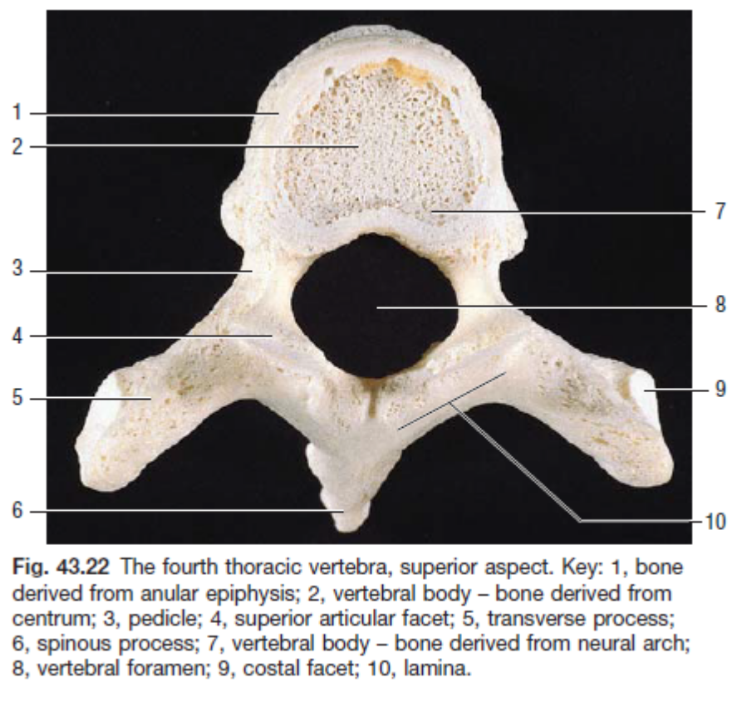

Figure 1.1- Superior aspect of a human fourth thoracic vertebra. Key of notable structures: 2- vertebral body 3- pedicle 4- superior articular facet 5- transverse process 6- spinous process 7- vertebral body 8- vertebral foramen 9- costal facet 10- lamina. Reproduced with permission from Gray’s Anatomy: The Anatomical Basis of Clinical Practice, 41st Edition, S. Stranding ed. Copyright Elsevier 2015.

Figure 2.2- Lateral aspect of fourth thoracic vertebra. Key of notable structures: 1- vertebral body, 3- superior articular facet, 4- transverse process, 6- pedicle, 7- inferior articular process, 8- spinous process. Reproduced with permission from Gray’s Anatomy: The Anatomical Basis of Clinical Practice, 41st Edition, S. Stranding ed. Copyright Elsevier 2015
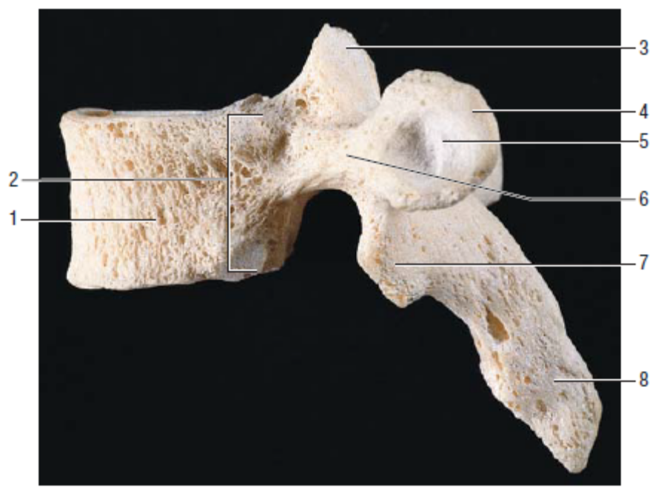

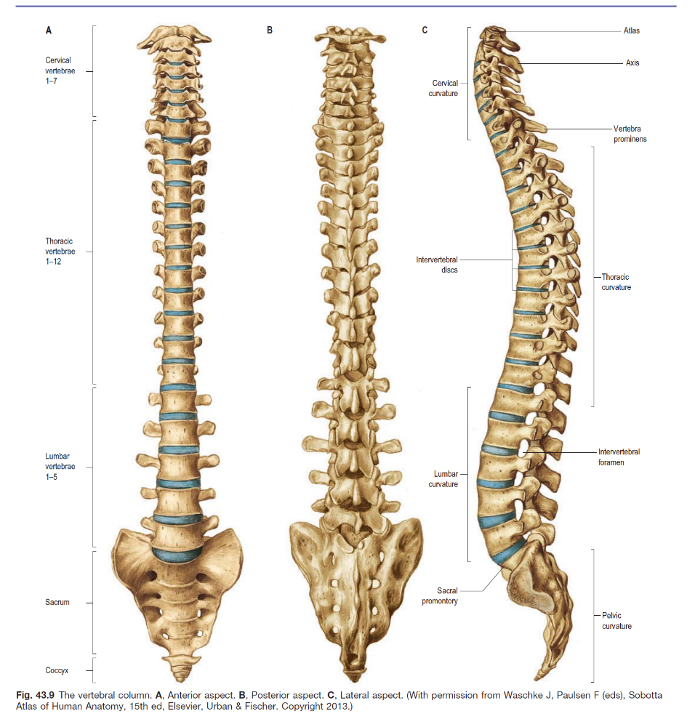

Figure 3.3- Human vertebral column, A- anterior aspect, B- posterior aspect, C- Lateral aspect. Reproduced with permission from Sobotta Atlas of Human Anatomy, 16th Edition, Paulsen and Waschke eds. Copyright Elsevier GmbH, Urban & Fisher, Munich 2018.
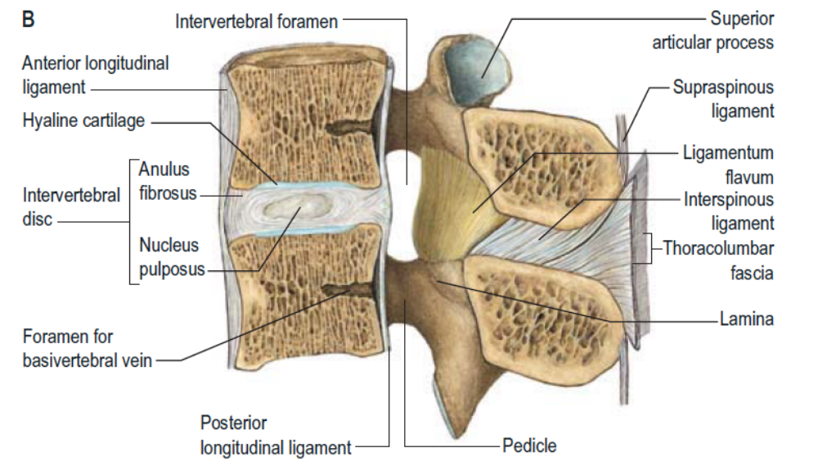
Figure 4.4- Ligamentous attachments of the human lumbar spine. Reproduced with permission from Sobotta Atlas of Human Anatomy, 16th Edition, Paulsen and Waschke eds. Copyright Elsevier GmbH, Urban & Fisher, Munich 2018.
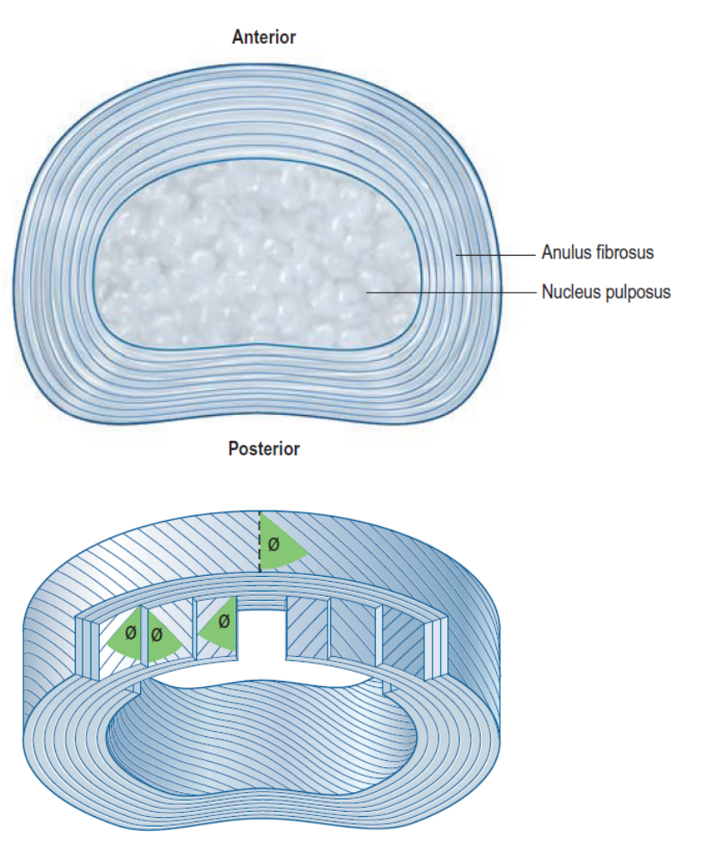
Figure 5.5- Intervertebral disc structure. The upper image depicts the annulus fibrosis and nucleus pulposus. The lower image shows the laminae of the annulus fibrosis demonstrating the changes in collagen fiber direction. Reproduced with permission from Clinical Anatomy of the Lumbar Spine and Sacrum, 3rd Edition, N Bogduk ed. Copyright Elsevier 1997.

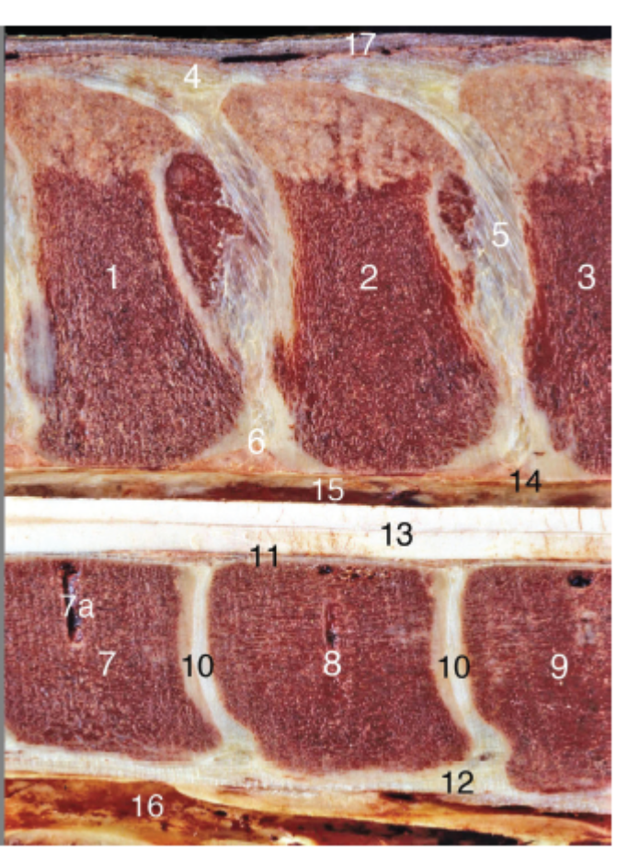
Figure 6.6- Median section of the equine thoracolumbar spine. Cranial is to the left. Key to notable structures: 1- spinal process of the seventeenth thoracic vertebra, 2- spinal process of the eighteenth thoracic vertebra, 3- spinal process of the first lumbar vertebrae, 4- supraspinal ligament, 5- interspinal ligament, 6- flavum ligament, 7- vertebral body of seventeenth thoracic vertebra, 8- vertebral body of eighteenth thoracic vertebrae, 9- vertebral body of the first lumbar vertebrae, 10- intervertebral discs, 11- dorsal longitudinal ligament, 12- ventral longitudinal ligament, 13- spinal cord. Reproduced with permission from Essentials of Clinical Anatomy of the Equine Locomotor System, 1st Edition, JM Denoix ed. Copyright Taylor and Francis Group, 2019.

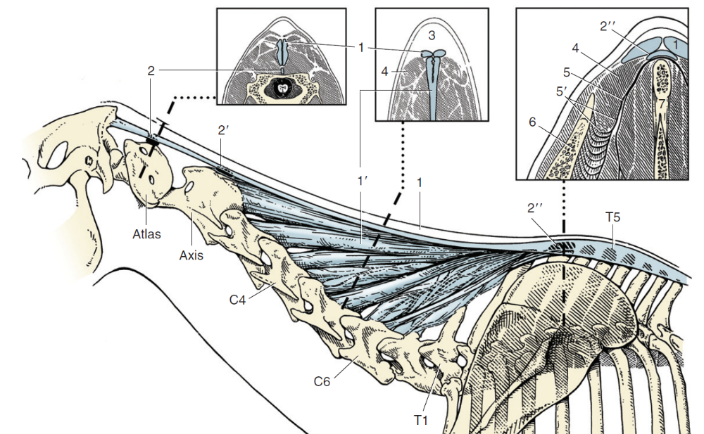
Figure 7.7- Nuchal ligament in the cervical and cranial thoracic portions of the horse. Key to notable structures: 1- Funicular portion of the nuchal ligament, 1'- laminar portion of nuchal ligament. Reproduced with permission from Textbook of Veterinary Anatomy, 3rd Edition, Dyce, Sack and Wensing eds. Copyright Elsevier 2009.

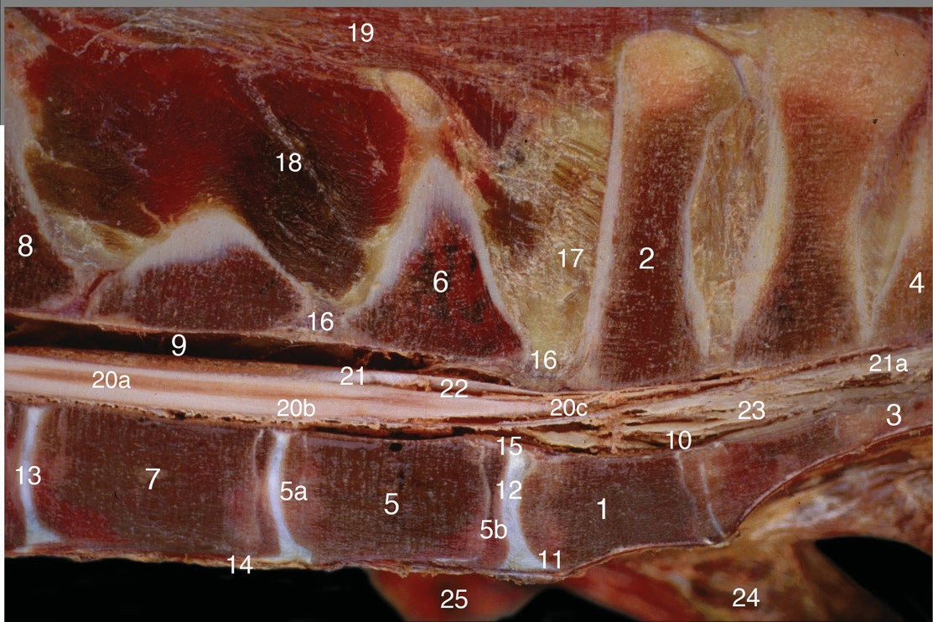
Figure 8.8- Lumbosacral junction, medial section. Key to notable structures: 1- body of first sacral vertebrae, 2- spinal process of first sacral vertebrae, 3- body of the third sacral vertebrae, 4- spinal process of third sacral vertebrae, 5- body of sixth lumbar vertebrae, 6- spinal process of sixth lumbar vertebrae, 7- body of fifth lumbar vertebrae, 8- spinal process of fourth lumbar vertebrae, 9- vertebral canal, 10- sacral canal, 12- lumbosacral intervertebral disc, 13- fourth lumbar intervertebral disc, 14- ventral longitudinal ligament, 15- dorsal longitudinal ligament, 16- flavum ligament, 17- interspinal ligament, 18- multifidus muscle, 19- erector spinae muscle, 20- spinal cord. Reproduced with permission from Essentials of Clinical Anatomy of the Equine Locomotor System, 1st Edition, JM Denoix ed. Copyright Taylor and Francis Group, 2019.

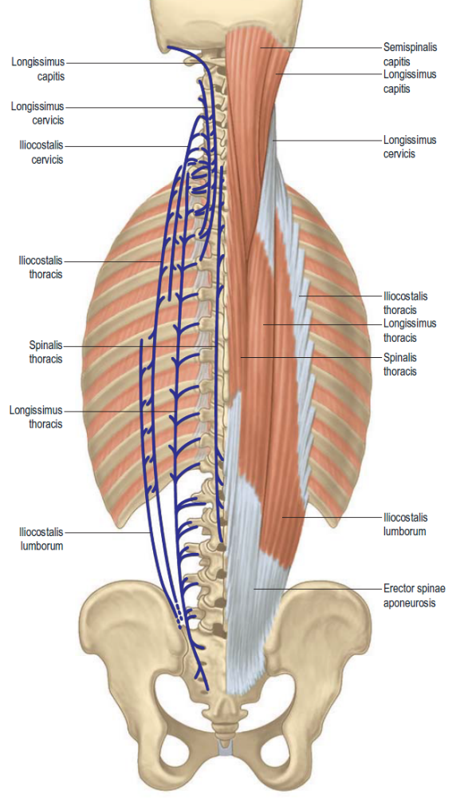
Figure 9.9- Human posterior back depicting the various parts of the erector spinae muscle group. Reproduced with permission from Gray’s Anatomy: The Anatomical Basis of Clinical Practice, 41st Edition, S. Stranding ed. Copyright Elsevier 2015

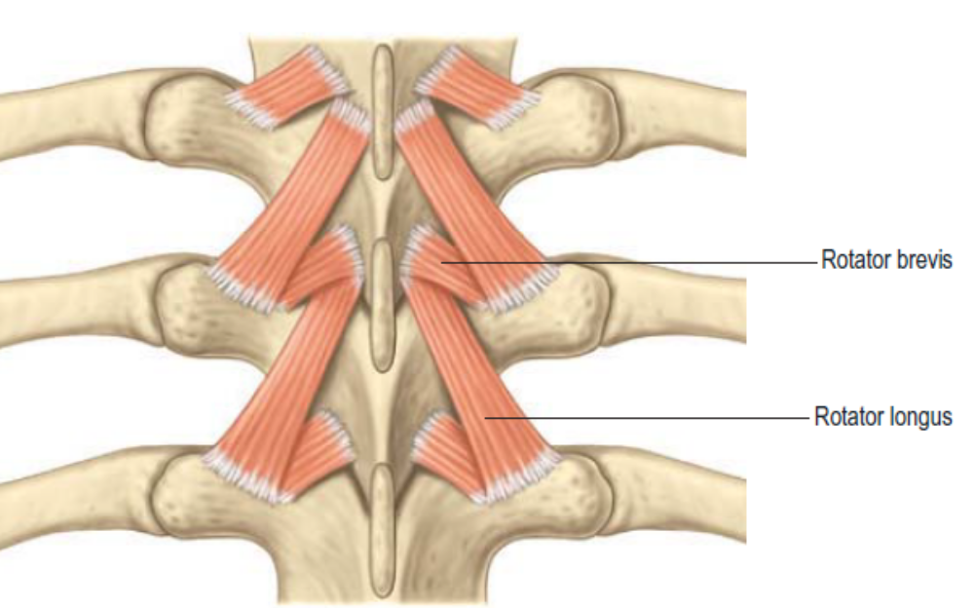
Figure 10.10- Rotares muscle bundles in the human thoracic spine (grays) Pending permission Benninghoff Anatomie 15th ed urban and Schwarzenberg 1994.

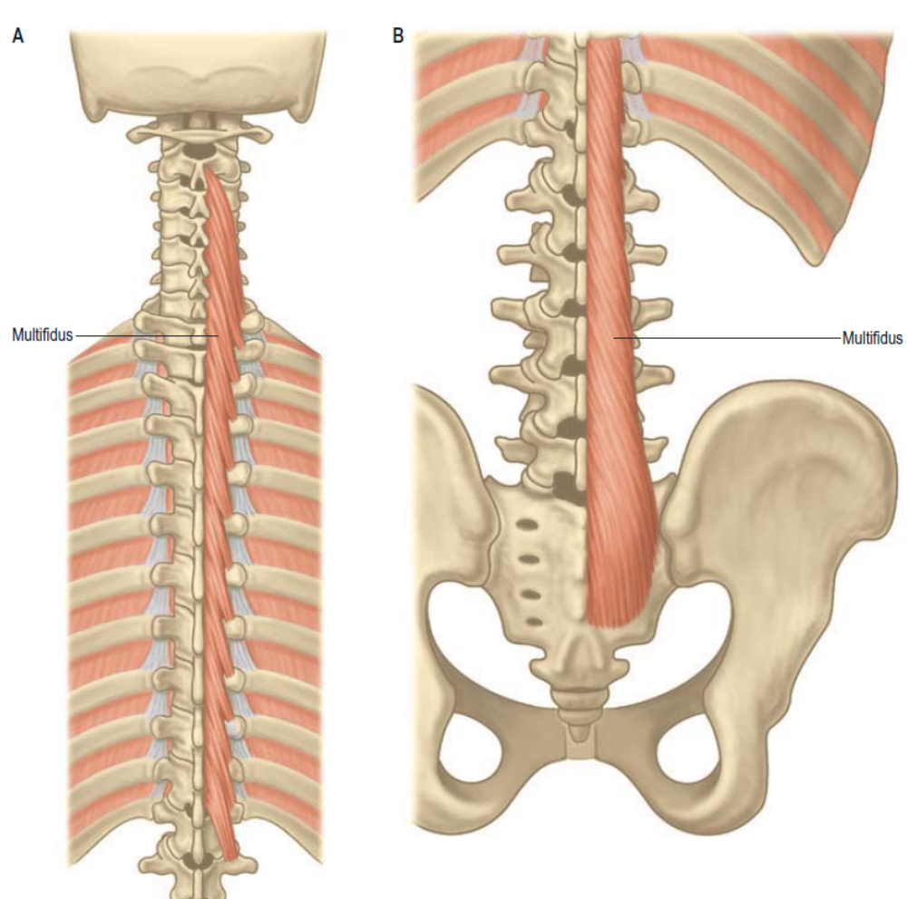
Figure 11.11- Human multifidus muscle. A- cervicothoracic portion, B- lumbosacral portion. Reproduced with permission from Gray’s Anatomy: The Anatomical Basis of Clinical Practice, 41st Edition, S. Stranding ed. Copyright Elsevier 2015.

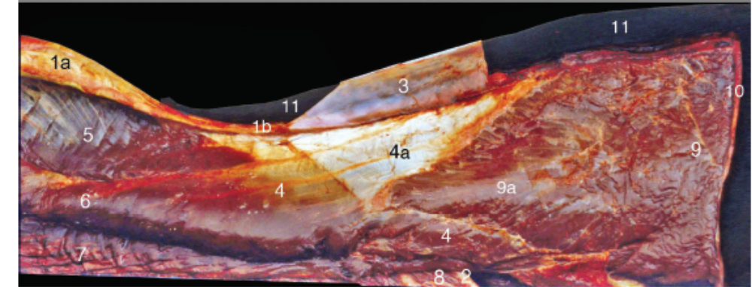
Figure 12.12- Dorsolateral aspect of dissected superficial equine back muscles. Cranial is to the left. Key to notable structures: 3- thoracolumbar fascia (reflected to the right side), 5- spinalis thoracis, 6- longissimus thoracis, 7- iliocostalis thoracis. Reproduced with permission from Essentials of Clinical Anatomy of the Equine Locomotor System, 1st Edition, JM Denoix ed. Copyright Taylor and Francis Group, 2019.

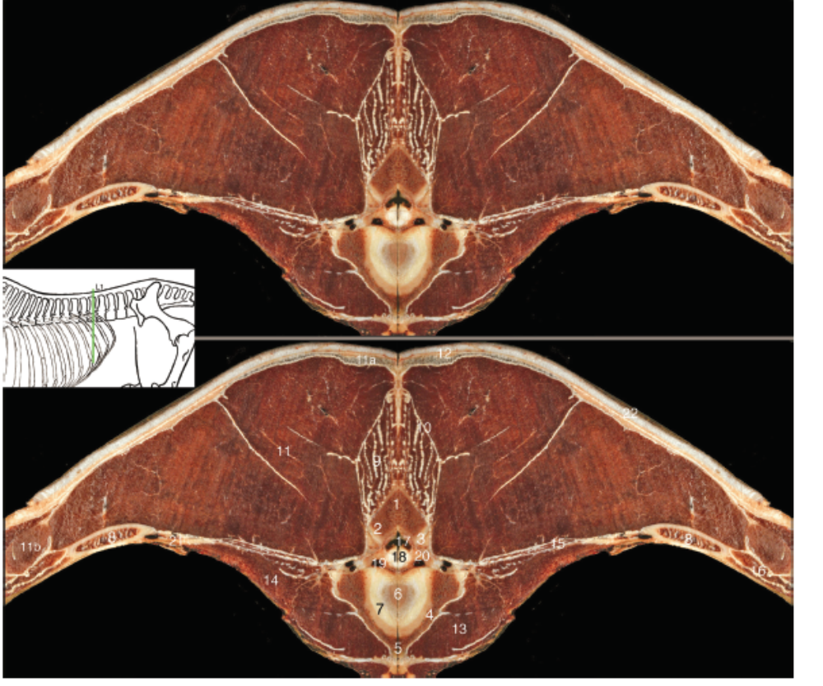
Figure 13.13- transverse section through the thoracolumbar junction. Key to notable structures: 9- multifidus muscle, 11- erector spinae muscle group. Reproduced with permission from Essentials of Clinical Anatomy of the Equine Locomotor System, 1st Edition, JM Denoix ed. Copyright Taylor and Francis Group, 2019.

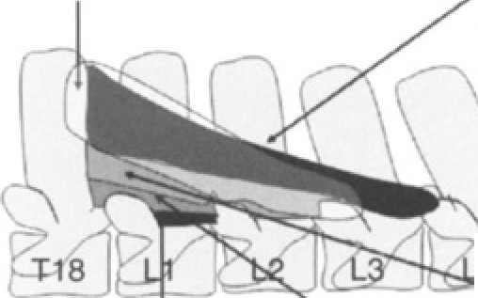

Figure 14.14- Lateral aspect of equine lumbar spine. The insertions of the five multifidus fascicles originating from the eighteenth vertebrae are diagramed. Reproduced under agreement with Wiley-Blackwell publisher. Stubbs, N.C., et al., Functional anatomy of the caudal thoracolumbar and lumbosacral spine in the horse. Equine Vet J Suppl, 2006. 38(36): p. 393-9.

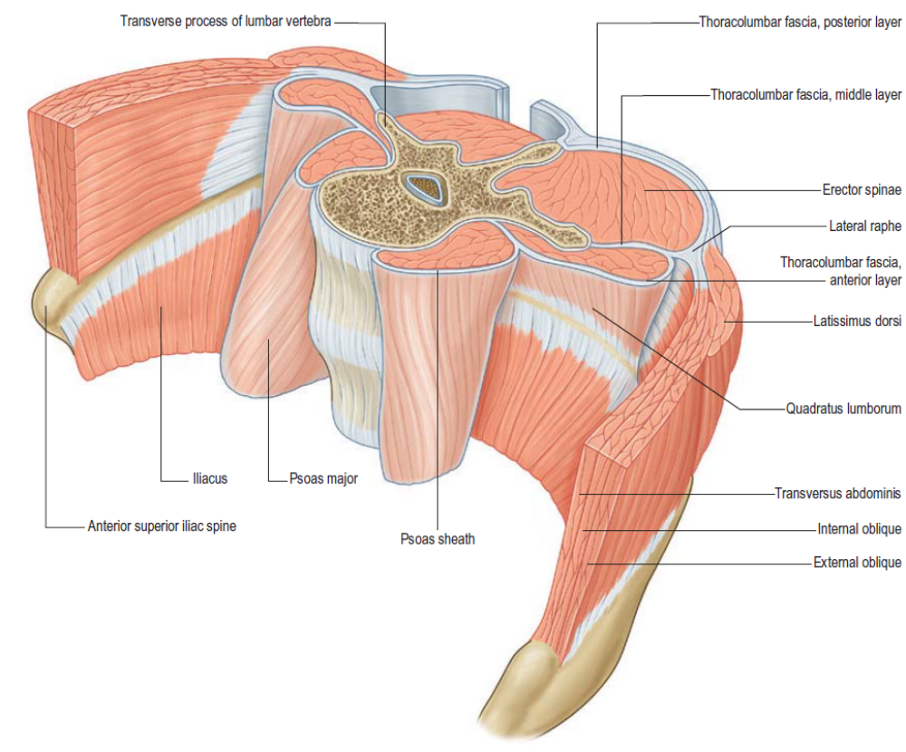
Figure 15.15- Human abdominal and lumbar musculature. Reproduced with permission from Gray’s Anatomy: The Anatomical Basis of Clinical Practice, 41st Edition, S. Stranding ed. Copyright Elsevier 2015

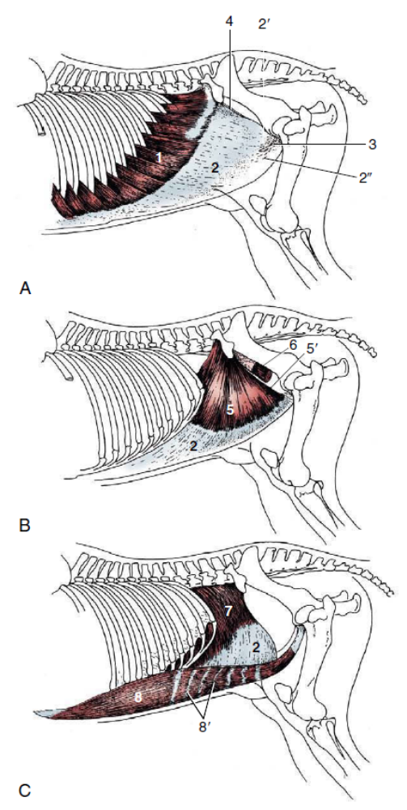

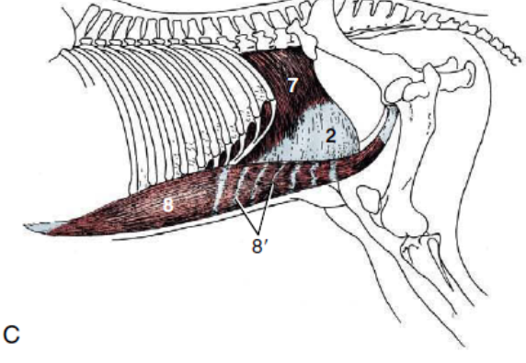

Figure 16.16- Abdominal musculature in horses. Cranial is to the left. A- superficial, B- middle, C- deep layers. Key for notable structures: 1- external abdominal oblique, 2- aponeurotic insertions, 5- internal abdominal oblique, 7- transverse abdominus, 8- rectus abdominus. Reproduced with permission from Textbook of Veterinary Anatomy, 3rd Edition, Dyce, Sack and Wensing eds. Copyright Elsevier 2009.

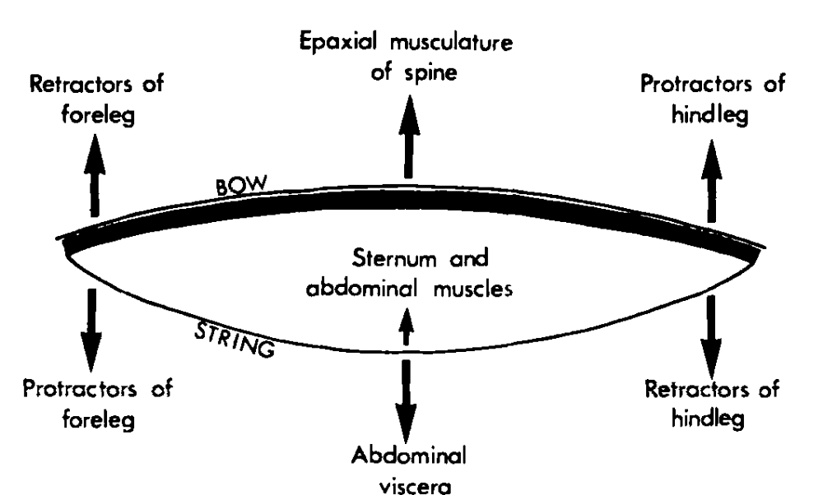
Figure 17.17- "Bow and string" theory depicting the forces acting upon the equine spine. Reproduced under agreement with Wiley-Blackwell publisher. Jeffcott, L.B., BACK PROBLEMS IN THE HORSE - LOOK AT PAST, PRESENT AND FUTURE PROGRESS. Equine Veterinary Journal, 1979. 11(3): p. 129-136

CHAPTER II:
Multifidus Activation in Horses Trotting on Hard and Soft Surfaces

Abstract
Equine sports medicine has recently developed an interest in core strengthening, with specific focus on the multifidus muscle. Currently, there are no publication related to the activity of the multifidus muscle in horses during normal activity such as trotting. Our objective was to use fine wire electromyography to measure the average work and peak activation performed by the multifidus in six different locations. We hypothesized that trotting on soft deformable arena footing would cause an increase in both muscle work and peak activation as compared to trotting on a hard surface.

Average muscle activation was significantly higher in soft footing as compared to the hard surface in the right cranial thoracic, right lumbar and left lumbar regions. The left cranial thoracic location showed significantly higher average activation on the hard surface. There was no significant difference in left or right caudal thoracic average activation. The peak activation was significantly higher on soft footing in the left caudal thoracic, left lumbar, right cranial thoracic, and right lumbar regions. There was no significant difference in left cranial thoracic or right caudal thoracic locations.

Specific limitations of this work include the inability to link the activation of the multifidus muscle to phase of stride. Additionally, the multifidus muscle is comprised of several fascicles that are not differentiable on ultrasound. While care was taken to implant each sensor at a similar location of each multifidus site, some electrodes may be in different fascicles than others. This work incorporates the use of four horses. Despite the ability to obtain statistically significant conclusions in most muscle locations, more changes may have been seen with a larger study population. Lastly, we were unable to standardize speed between trials. Horses were kept at their own natural pace and trotted by the same handler throughout the data collection process, thus limiting the effect of variation from different handlers.

In conclusion, trotting on a soft surface induced higher levels of muscle work and peak values in most multifidi locations as compared to trotting on a firm surface. Conditioning and exercise programs should not be performed solely on firm surfaces, as the multifidus may require the higher degree of activation for daily living.

Introduction
Core strength is of vital importance to maintain performance and prevent injury. Biomechanically, the horse back is thought to act as a "bow" consisting of the vertebral column, pelvis and associated musculature [1]. The bow is kept under tension by the "string" formed by the sternum and abdominal muscles [1]. Movement of the limbs produces forces the trunk must resist without injury.
In humans, the spine is believed to be actively stabilized mostly by activation of the multifidus and erector spinae muscle groups [2-4]. The multifidus muscle group lies on either side of the dorsal spinous process [5]. It has several fascicles that attach the mammillary process of one vertebra to the dorsal spinous process of another vertebra. Fascicles may span anywhere from one to four spinal segments, with longer fascicles lying more medially than shorter underlying fascicles [5]. In horses, the multifidus muscle is found in five distinct fascicles with a common cranial attachment with distinct and independent insertions caudally [6]. Each fascicle has bands that cross anywhere from one to four intervertebral discs [6]. Deeper bands connected fewer vertebral segments than more superficial bands, similar to what is seen in humans [5, 6]. Both humans and horses also have terminal insertions upon the sacrum [5, 6]. However, horses have a continuation of the multifidus referred to as the sacrocadualis dorsalis, that continues caudal and contributes to motor of the tail [6].

Humans with lower back pain have benefited from therapeutic exercise programs that incorporate trunk muscle strengthening and improving proprioception and balance control [7-12]. The incorporation of cross training on different surfaces has been increasingly popular. The concept driving these exercise programs resides on the thought that greater instability of the body-surface interface would induce greater challenges onto the neuromuscular system [13]. While increased trunk muscle activity has been reported in humans performing squats on balance discs [13], there are no longitudinal studies showing a significant benefit over exercising on stable surfaces [12]. Despite lacking scientific proof of benefit in humans, equine athletes are also being asked to perform exercises on various surfaces ranging from firm footing to soft arena sand.

Electromyography (EMG) is a technique that allows for the recording of myoelectric signals [14]. Muscles are composed of separate motor units composed of the alpha motor neuron, its axon, the motor end plate and the individual muscle fibers it controls [15]. EMG is specifically a recording of the electrical activity within each motor unit, referred to as the motor unit action potential [16]. There are two basic types of electrodes, indwelling and surface. Indwelling electrodes are implanted directly into the desired muscle of study. Surface electrodes are attached to the surface of the skin [16]. Indwelling fine wire electrodes show high specificity of measurement, they are not subject to crosstalk signals from other muscle groups, and they are the only option available for measuring the activity of deeper muscles [16] such as the multifidus.

Despite claims that the multifidus muscle is of great importance for spinal stability in horses, there are no reported studies investigating muscle activity in normal horses during basic exercise. The purpose of this study was to determine the activity level of the multifidus muscle in horses trotting on firm and soft surfaces. Our objectives were to use indwelling fine wire EMG electrodes to determine the average muscle activation and peak activation values of the multifidus muscle in three sites bilaterally. We hypothesized that the multifidus would show a greater amount of muscle work and higher peak activation when horses trotted on soft arena footing as compared to a hard asphalt surface.

Methods
Horses
Horses from the University of Tennessee Veterinary Research and Teaching herd were used. All horses were trotted in a straight line before recruitment into the study. Horses showing greater than a grade 2 lameness based on the American Association of Equine Practitioners lameness scale were excluded. Horses of gaited breeds were excluded unless they demonstrated a consistent two beat diagonal trot gait. This study was performed in accordance of the Association for Assessment and Accreditation of Laboratory Animal Care and United States Department of Agriculture guidelines with approval from the University of Tennessee Institutional Animal Care and Use Committee.

Fine-wire Electromyography
Muscle potentials from the multifidus muscle were collected using a telemetric unit (Myomotion; Noraxon USA, Scottsdale, USA) with a sampling frequency of 1500 Hz. The skin was clipped, shaved, and cleaned using chlorhexidine and isopropyl alcohol. Ultrasound was used to locate and identify each dorsal spinous process. The skin was desensitized with 1 ml mepivacaine per site taking care to remain superficial to the thoracolumbar fascia to prevent alterations in thoracolumbar muscle function as previously reported [17]. Ultrasound guidance was used to aseptically implement fine wire electrodes in the multifidus at the junction of the middle and deep third. Electrodes were placed at the level of the dorsal spinous process of the twelfth (T12) and eighteenth thoracic (T18) and fifth lumbar (L5) vertebrae bilaterally.

Exercises
EMG signals were collected with the horse trotting straight in hand on a hard asphalt and soft synthetic arena surface for a minimum of six repetitions of 15 consecutive strides. The head and neck were kept in a neutral position throughout each exercise. Video recordings were performed for all exercises which allowed for confirmation of the quality of the exercise. Exercises where horses stepped sideways or altered their head and neck position abruptly were excluded. All exercise repetitions for both conditions were performed on the same day and recorded with a high-speed camera (Ninox Video Capture 125) at a frame rate of 125 Hz synchronized to the telemetric unit.
Gait Cycle Validation
The gait cycle was linked to the activity of the longissimus dorsi muscle. Self-adhesive surface electrodes with an inter-electrode distance of 2 cm were adhered to clipped, shaved, and cleaned skin overlying the longissimus dorsi muscle at the level of the dorsal spinous process of the 16th vertebrae as previously described [18].

In addition to having surface EMG sensors in place, 9 mm spherical reflective markers were placed on the lateral aspect of each hoof at the level of the coronary band. Using motion analysis (Nexus, Vicon Motion Systems, Oxford, England) integrated and synchronized with the electromyographic signal from a telemetric system (Myomotion; Noraxon USA, Scottsdale, USA), the timing of the longissimus dorsi muscle activity in relation to the gait cycle was determined.
Kinematic data from both motion capture cameras and electromyography were collected using Nexus software and imported into Visual3D (C-Motion Inc., Germantown MD, USA) for further processing. Kinematic data were interpolated and low-pass filtered with a frequency cut off of 8 Hz. Gait cycle events of heel strike and toe off of each limb were labeled based on when makers reached a zero position in the vertical z-plane.

Exercise data processing
Motion artifact and noise from raw EMG signals were removed with a high-pass filter set at 40 Hz. These signals were then rectified and low pass filtered with a 15 Hz cut off frequency [19]. Using enveloped data, the onset and offset of muscle electrical activity within each of the five three-stride sections was labeled using Visual3D. Each of these activations were exported from Visual3D from the rectified and enveloped signals. The average rectified value and the maximum enveloped value were normalized to the maximum observed signal, i.e. the maximum observed EMG signal across all trot strides for each horse, as previously described [19]. The average rectified signal (ARV) during the activation was used as an indication of average "work-done" by the muscle [20, 21]. The peak value (PE) observed from the enveloped data represented the highest level of activation [20, 21].

Statistical Analysis
For each condition, the average rectified (average amount of muscle work) and maximum enveloped values (peak muscle activations) were calculated. The effect of the two surface conditions on the average amount of muscle work and peak muscle activation within each muscle section was assessed using an unpaired t-test across all observed gait cycles for all horses (SPSS version 27). Data was assessed using the Levene's test for equality of variances followed by the appropriate t-test for equality of means and results were reported using a 95% confidence interval and a significance level of p<0.05.

Results
Horses
One gelding and three mares aged 4 to 14 years of various breeds from the University of Tennessee Veterinary Research and Teaching herd were used. All horses were deemed to be a grade 2 or less baseline lameness in any limb based on the American Association of Equine Practitioners lameness scale. Additionally, all horses received oral phenylbutazone at a dose of 2.2 mg/kg twice daily starting at least 24 hours before data collection. All horses were visually sound during data collection as deemed by two authors experienced in assessing lameness.

Gait Cycle Validation
The left longissimus muscle was determined to have two isolated peaks of activation per single trot gait cycle. The first peak was associated with left front toe off. The second peak was associated with left hind toe off, consistent with previously reported work [18]. Using this data collected from the left longissimus muscle, the timing of three complete gait cycles was determined and extrapolated to the synchronized signal of the sensors implanted within multifidus muscle. Five three-stride segments were isolated from the data set within sections previously confirmed to be a quality exercise repetition based on the synchronized video recording.

Fine Wire Electromyography
The ARV was significantly higher in soft footing as compared to the hard surface in the right T12 (p<0.001), right L5 (p<0.001) and left L5 regions (p<0.001). The ARV was significantly higher on the hard surface in the left T12 region (p<0.001). There was no significant difference in left or right T18 locations. (Table 1.1). The table is located in the appendix for this chapter. The PE was significantly higher on soft footing in the left T18 (p=0.031), left L5 (p<0.001), right T12 (p<0.001) and right L5 (p<0.001) regions. There was no significant difference in left T12 or right T18 locations. (Table 1.1).

The clinical effect of the soft surface on muscle activation was estimated using the mean values for each muscle location and outcome parameter. It was determined that both lumbar regions had approximately double the ARV and PE values when horses trotted on soft footing as compared to the hard surface (Table 1.1). Also of note, the right T12 had an 87 and 95% increase in ARV and PE respectively on the soft surface. The left T12 showed a small decrease in both ARV and PE on the soft surface, but was not to a threshold to be considered clinically relevant.

Discussion
Our main purpose was to compare the muscle activity of the multifidus while horses were trotting on hard and soft surfaces. These exercises are common in all conditioning and exercise programs, regardless of the horse's intended use or purpose. This work is the first step in determining overall muscle activity of the multifidus muscle during a routine exercise, such as the trot.

We selected the multifidus muscle due to its theorized role as a spinal stabilizer in other quadrupeds [22-24]. The multifidus muscle has been emphasized in horses due to atrophy noted adjacent to areas of spinal disease post-mortem [25]. However, there have been no reports indicating the activation of the multifidus during motion in normal horses.

We found significant increases in either muscle work or maximum value in all muscle sections except right T18. Interestingly, left T12 was the only muscle location in which the softer footing induced an overall decrease in ARV and PE as compared to the hard, however only the ARV was found to be significantly different. This could be due to the left sided location of the handler when horses trot in hand. Despite not showing obvious changes in head or neck position, minute changes in position could have been missed, that may have contributed to altered muscle activation.

Human studies have shown significantly greater mean activation of the muscles responsible for ankle stabilization when people were asked to exercise on an unstable surface [26]. Additionally, an unstable surface increased activity of all trunk stabilizing muscles by 37-54% [27]. Other researchers confirmed these results on trunk muscles specifically in the lumbar [28], and abdominal musculature [29, 30].

Pinnington et al investigated the changes in surface EMG of the hamstrings, quadriceps, and tensor fascia latae muscles when runners were asked to perform in sand versus a firm wooden floor. Significant increases in average muscle activation as well as a calculated energy cost was observed in all muscles when running on sand [31]. Similar electromyographic studies assessing the effect of surface have not been reported in any muscle of the horse, to date.

Traditionally, most equine research on surface conditions has investigated the hoof-surface interaction [32, 33], or on the characteristics of the surface itself [34], with little to no interest in muscle activity. One equine study has been performed comparing trotting on firm sand to deeper unstable sand. It was found that the deeper sand resulted in decreased efficiency of pushoff, implying that propulsive muscles must require more force to propel forward [35], however, this was not confirmed with EMG. The same research group investigated the use of qualitative ultrasound and speed of sound measurements as a way of determining the force produced by a tendon [36]. When comparing two surfaces, the force produced by the superficial digital flexor tendon was greater in the surface that was softer and more easily deformed [36]. Since the force a tendon produces is directly related to the strength of muscle contraction, it can be believed that there was increased muscle activation in the softer surface.

Specific limitations of this work include the inability to link the activation of the multifidus muscle to phase of stride. However, this was not a primary objective of this study. Therefore, this study is limited regarding determination of the function of the multifidus during motion. Additionally, the multifidus muscle is comprised of several fascicles, each of different length. Care was taken to implant each sensor at a similar location of each multifidus site, at the junction of the middle and deep thirds. However, since the different fascicles are not ultrasonographically apparent, some sensors may be in different fascicles than others. While the anatomy is well documented [6, 37], the function of each fascicle has not yet been determined. Hyytiainen et al has shown variation of muscle fiber types between fascicles in horses as well as breeds [38]. Muscles have been documented to have altered fiber type, based on the forces and functions required [39]. Thus, there could be variation in EMG activity between fascicles. This work incorporates the use of four horses. Using all observations for every horse resulted in a calculated power of 1 at each muscle location for both ARV and PE. However, larger magnitudes of change could have become evident with more horses. Lastly, we were unable to standardize speed between trials, however, horses were maintained at their own natural pace for each exercise repetition and care was taken to prevent fatigue. This is similar to previous methods used [19, 40]. Additionally, each horse was maneuvered by the same handler throughout the study period, thus limiting the effect of variation from different handlers.

Future study should focus on integrating three-dimensional motion analysis with multifidus instrumentation to further explore the activity patterns during specific portions of the stride. Relating the EMG signal to stride characteristics and spinal motion would begin to define the role of the multifidus muscle in spinal stabilization in horses. If it is determined the multifidus contributes to spinal stability in a similar fashion as is seen in humans, further therapeutic exercise and rehabilitation methods should be investigated to maximize strength and function.

Conclusion
In conclusion, trotting on a soft surface induced higher levels of average muslve activation and peak activation values in most multifidi locations as compared to trotting on a firm surface, consistent with findings in humans [31] and implied conclusions in horses [35, 36]. Reconditioning programs should not be performed solely on firm footing, as the multifidus shows to have varied activation levels on the two densities of footing studied here.

References
1. Jeffcott, L.B., BACK PROBLEMS IN THE HORSE - LOOK AT PAST, PRESENT AND FUTURE PROGRESS. Equine Veterinary Journal, 1979. 11(3): p. 129-136.
2. Bergmark, A., Stability of the lumbar spine. A study in mechanical engineering. Acta orthopaedica Scandinavica. Supplementum, 1989. 230: p. 1-54.
3. Cholewicki, J. and S.M. McGill, Mechanical stability of the in vivo lumbar spine: Implications for injury and chronic low back pain. Clinical Biomechanics, 1996. 11(1): p. 1-15.
4. Ebenbichler, G.R., et al., Sensory-motor control of the lower back: implications for rehabilitation. Medicine and Science in Sports and Exercise, 2001. 33(11): p. 1889-1898.
5. Standring, S., Gray's Anatomy : The Anatomical Basis of Clinical Practice. 41 ed. Gray's Anatomy. 2016: Elsevier Health Sciences.
6. Stubbs, N.C., et al., Functional anatomy of the caudal thoracolumbar and lumbosacral spine in the horse. Equine Vet J Suppl, 2006. 38(36): p. 393-9.
7. Areeudomwong, P. and V. Buttagat, Comparison of Core Stabilisation Exercise and Proprioceptive Neuromuscular Facilitation Training on Pain-related and Neuromuscular Response Outcomes for Chronic Low Back Pain: A Randomised Controlled Trial. The Malaysian journal of medical sciences : MJMS, 2019. 26(6): p. 77-89.
8. Berry, D.B., et al., The effect of high-intensity resistance exercise on lumbar musculature in patients with low back pain: a preliminary study. Bmc Musculoskeletal Disorders, 2019. 20.
9. Farragher, J.B., et al., Effects of lumbar extensor muscle strengthening and neuromuscular control retraining on disability in patients with chronic low back pain: a protocol for a randomised controlled trial. Bmj Open, 2019. 9(8).
10. Hides, J.A., et al., Predicting a beneficial response to motor control training in patients with low back pain: a longitudinal cohort study. European Spine Journal, 2019. 28(11): p. 2462-2469.
11. Tagliaferri, S.D., et al., Randomized Trial of General Strength and Conditioning versus Motor Control and Manual Therapy for Chronic Low Back Pain on Physical and Self-Report Outcomes. Journal of Clinical Medicine, 2020. 9(6).
12. Wirth, K., et al., Core Stability in Athletes: A Critical Analysis of Current Guidelines. Sports Medicine, 2017. 47(3): p. 401-414.
13. Anderson, K. and D.G. Behm, Trunk Muscle Activity Increases With Unstable Squat Movements. Canadian journal of applied physiology, 2005. 30(1): p. 33-45.
14. Konrad, P., The abc of emg. A practical introduction to kinesiological electromyography, 2005. 1(2005): p. 30-5.
15. Wijnberg, I.D. and H. Franssen, The potential and limitations of quantitative electromyography in equine medicine. Veterinary Journal, 2016.
16. Williams, J.M., Electromyography in the Horse: A Useful Technology? Journal of Equine Veterinary Science, 2018. 60(C): p. 43-58.e2.
17. Roethlisberger-Holm, K., et al., Effect of local analgesia on movement of the equine back. Equine Vet J, 2006. 38(1): p. 65-9.
18. Licka, T.F., C. Peham, and A. Frey, Electromyographic activity of the longissimus dorsi muscles in horses during trotting on a treadmill. American Journal of Veterinary Research, 2004. 65(2): p. 155-158.
19. St. George, L., et al., Surface EMG signal normalisation and filtering improves sensitivity of equine gait analysis. Comparative exercise physiology, 2019. 15(3): p. 173-185.
20. Richards, J., et al., The effect of different decline angles on the biomechanics of double limb squats and the implications to clinical and training practice. Journal of human kinetics, 2016. 52(1): p. 125-138.
21. Richards, J., et al., A biomechanical investigation of a single-limb squat: implications for lower extremity rehabilitation exercise. Journal of athletic training, 2008. 43(5): p. 477-482.
22. Ritter, D.A., et al., Epaxial muscle function in trotting dogs. Journal of Experimental Biology, 2001. 204(17): p. 3053-3064.
23. Schilling, N. and D.R. Carrier, Function of the epaxial muscles during trotting. Journal of Experimental Biology, 2009. 212(7): p. 1053-1063.
24. Schilling, N. and D.R. Carrier, Function of the epaxial muscles in walking, trotting and galloping dogs: implications for the evolution of epaxial muscle function in tetrapods. Journal of Experimental Biology, 2010. 213(9): p. 1490-1502.
25. Stubbs, N.C., et al., Osseous spinal pathology and epaxial muscle ultrasonography in Thoroughbred racehorses. Equine Veterinary Journal, 2010. 42(38): p. 654-661.
26. Borreani, S., et al., Exercise intensity progression for exercises performed on unstable and stable platforms based on ankle muscle activation. Gait & posture, 2013. 39(1): p. 404-409.
27. Behm, D.G., et al., Trunk muscle electromyographic activity with unstable and unilateral exercises. Journal of Strength and Conditioning Research, 2005. 19(1): p. 193-201.
28. Imai, A., et al., Trunk Muscle Activity During Lumbar Stabilization Exercises on Both a Stable and Unstable Surface. Journal of Orthopaedic & Sports Physical Therapy, 2010. 40(6): p. 369-375.
29. Czaprowski, D., et al., Abdominal muscle EMG-activity during bridge exercises on stable and unstable surfaces. Physical Therapy in Sport, 2014. 15(3): p. 162-168.
30. Kim, M.-H. and J.-S. Oh, Effects of performing an abdominal hollowing exercise on trunk muscle activity during curl-up exercise on an unstable surface. Journal of Physical Therapy Science, 2015. 27(2): p. 501-503.
31. Pinnington, H.C., et al., Kinematic and electromyography analysis of submaximal differences running on a firm surface compared with soft, dry sand. European Journal of Applied Physiology, 2005. 94(3): p. 242-253.
32. Barstow, A., et al., Does 'hacking' surface type affect equine forelimb foot placement, movement symmetry or hoof impact deceleration during ridden walk and trot exercise? Equine Veterinary Journal, 2019. 51(1): p. 108-114.
33. Chateau, H., et al., Biomechanical analysis of hoof landing and stride parameters in harness trotter horses running on different tracks of a sand beach (from wet to dry) and on an asphalt road: Biomechanical analysis of hoof landing on sand. Equine veterinary journal, 2010. 42: p. 488-495.
34. Setterbo, J.J., et al., Dynamic properties of a dirt and a synthetic equine racetrack surface measured by a track‐testing device. Equine veterinary journal, 2013. 45(1): p. 25-30.
35. Crevier-Denoix, N., et al., Ground reaction force and kinematic analysis of limb loading on two different beach sand tracks in harness trotters. Equine Veterinary Journal, 2010. 42: p. 544-551.
36. Crevier-Denoix, N., et al., Influence of track surface on the equine superficial digital flexor tendon loading in two horses at high speed trot. Equine Veterinary Journal, 2009. 41(3): p. 257-261.
37. Garcia Lineiro, J.A., et al., Structural and functional characteristics of the thoracolumbar multifidus muscle in horses. Journal of Anatomy, 2017. 230(3): p. 398-406.
38. Hyytiainen, H.K., et al., Muscle fibre type distribution of the thoracolumbar and hindlimb regions of horses: relating fibre type and functional role. Acta Veterinaria Scandinavica, 2014. 56(8): p. (27 January 2014)-(27 January 2014).
39. Castejon-Riber, C., et al., Objectives, Principles, and Methods of Strength Training for Horses. Journal of Equine Veterinary Science, 2017. 56: p. 93-103.
40. St George, L., et al., Muscle Function and Kinematics during Submaximal Equine Jumping: What Can Objective Outcomes Tell Us About Athletic Performance Indicators? Animals, 2021. 11(2).

Appendix
Table 1.1 Mean (standard deviation) values for outcome measures on hard and soft surfaces.
Muscle | Oucome Measure | Hard Surface Mean (sd) | Soft Surface Mean (sd) | p value for equality of means (2-tailed) | Mean Difference | 95% Confidence Interval Lower | 95% Confidence Interval Upper | % soft of hard | % change
Left T12 | Average rectified | 0.5085 (0.19790) | 0.3782 (0.25258) | <0.001 | 0.13026 | 0.06696 | 0.19356 | 74.38 | -26%
Left T12 | Peak Envelope | 0.5360 (0.18427) | 0.4753 (0.33093) | 0.111 | 0.06074 | -0.01408 | 0.13556 | 88.68 | -21%
Left T18 | Average Rectified | 0.4136 (0.23571) | 0.4647 (0.31870) | 0.199 | -0.05109 | -0.1293 | 0.02712 | 112.35 | 12%
Left T18 | Peak Envelope | 0.4731 (0.24116) | 0.5717 (0.38510) | 0.031 | -0.09862 | -0.18833 | -0.00891 | 120.84 | 20%
Left L5 | Average Rectified | 0.1821 (0.20551) | 0.3608 (0.28953) | <0.001* | -0.17875 | -0.24877 | -0.10874 | 198.13 | 98%
Left L5 | Peak Envelope | 0.1397 (0.13674) | 0.3219 (0.32407) | <0.001* | -0.18214 | -0.25171 | -0.11257 | 230.42 | 130%
Right T12 | Average rectified | 0.3975 (0.21698) | 0.7763 (0.46244) | <0.001* | -0.37879 | -0.47978 | -0.2778 | 195.30 | 95%
Right T12 | Peak Envelope | 0.4576 (0.22127) | 0.8558 (0.49667) | <0.001* | -0.39826 | -0.50578 | -0.29074 | 187.02 | 87%
Right T18 | Average Rectified | 0.3159 (0.21123) | 0.2940 (0.26092) | 0.515 | 0.0219 | -0.04431 | 0.08812 | 93.07 | -7%
Right T18 | Peak Envelope | 0.3662 (0.22193) | 0.3887 (0.29459) | 0.542 | -0.02251 | -0.09528 | 0.05026 | 106.14 | 6%
Right L5 | Average Rectified | 0.1232 (0.13209) | 0.2435 (0.15558) | <0.001* | -0.12033 | -0.16058 | -0.08009 | 197.65 | 98%
Right L5 | Peak Envelope | 0.1003 (0.09209) | 0.1975 (0.14296) | <0.001* | -0.09713 | -0.1307 | -0.06356 | 196.91 | 96%
Bold* denotes significant differences between surfaces (p<0.05)

CHAPTER III:
Multifidus Activation in Horses Trotting During Therapeutic Exercise

Abstract
Thoracolumbar pain has been identified in both human and equine patients. Despite a variety of causes, physical therapy and conditioning programs have focused specifically on improving trunk and abdominal muscle function [1-5]. Equine exercise programs routinely incorporate ground poles and training devices for the similar goals of increasing spinal and core stability and strength [6-8]. The multifidus muscle has been an area of focus due to atrophy associated with disease [9]. To date, there have been no reports on the activity of the multifidus muscle in horses in relation to therapeutic exercises.

Our objectives were to use electromyography to determine the average work performed and peak muscle activity of the multifidus in horses trotting over ground poles and while wearing a resistance band-based training device. We hypothesized that ground poles and the training device would each increase average work performed and peak multifidus muscle activity.

Right and left cranial thoracic locations showed significant increased muscle work and peak activation when horses were trotted over ground poles versus without. There were significant interactions between the two conditions (with and without training device, and with and without ground poles) in all but the peak activity for left and right lumbar locations. The peak activation was significantly greater in horses trotting over poles in both lumbar regions, but there was no significant change in peak activation in either location due to the training device. Due to significant interactions unpaired t-tests were used to compare with and without the training device without ground poles and with and without the training device in combination with ground poles. When the influence of the training device was investigated without ground poles, left caudal thoracic muscle work and peak activity, and right lumbar muscle work were significantly lower when using the training device, as compared to without. When the training device was combined with trotting over ground poles, both left and right caudal thoracic regions showed significantly lower muscle work and peak activity when the device was used. There was no significant difference between with and without the device in either left or right lumbar muscle work.

In conclusion, implementing ground poles can be an effective strategy to increase the activation of the multifidus muscle, however, caution should be taken when incorporating the use of a resistance band training device as muscle work and peak activation were significantly reduced in most locations. Further study should be performed in regards to the training device to determine its effects on epaxial musculature.

Introduction
In humans, paraspinal musculature has been shown to contribute a substantial portion of overall spinal stability [10, 11]. The multifidus muscle has been specifically identified as a major contributor to spinal stabilization in humans [12]. Spinal instability has been correlated to injury, even under low stress movements of daily living [13]. Additionally, it has been hypothesized that a build-up of microtrauma could induce changes in neuromuscular control, thus predisposing spinal components to further injury [14].

Lower back pain (LBP) is defined as the pain of the posterior trunk between the 12th rib and the lower gluteal folds. [15]. A myriad of underlying conditions can cause LBP including but not limited to intervertebral disc herniation, spinal stenosis, degenerative scoliosis, osteoarthritis of the facet joints, and idiopathic causes [16, 17]. While horses can have similar symptoms of LBP as seen in humans, the underlying cause is not always as clear. Veterinary clinicians are limited in their ability to diagnose specific spinal lesions in horses due to their size and thus the impossibility to perform advanced diagnostic imaging. Regardless of the cause of LBP in humans, treatment relies heavily on physical therapy to improve trunk and abdominal muscle function [1-5], as well as proprioception and balance [1, 3, 18]. Similar principles have been implemented into equine therapeutic exercise programs with the use of ground poles and other training devices.

Ground poles are routinely used in equine exercise programs to improve proprioception, increase stride length, promote symmetry, and induce joint flexion [6, 7]. Brown et al has shown horses trotting over ground poles successfully clear the obstacle by lifting their limbs higher and increasing joint flexion across all joints [19]. There was significantly more joint flexion when trotting over poles as compared to flat ground [19]. It was concluded that trotting over poles would be effective to increase activation and strength of flexor muscles. During the stance phase, horses did not show significant increases in vertical ground reaction force or extension of the metacarpophalangeal and metatarsophalangeal joints [20]. Thus, the load placed upon each limb was like that traveling across flat ground [20]. To date, muscle activity has not been directly reported in horses trotting over ground poles.

Several types of training devices have been developed and used in equine exercise programs. Overall, the intention of each device is to promote abdominal lifting, engagement of the hind limbs, and spinal stability while strengthening the epaxial musculature [21]. One resistance band training device was determined to reduce mediolateral and rotational motion of the thoracolumbar spine [8]. The authors concluded that this decrease in thoracolumbar motion was due to increased dynamic stability [8]. If human modeling data is extrapolated, this would likely be due to increased muscle activity, since muscles contribute a large part to spinal stability [10, 11]. Muscle activity was not assessed in the aforementioned resistance band-based device [8]. Cottrail et al. described the activity of the longissimus dorsi muscle while using a different training device [21]. The longissimus dorsi muscle is a large epaxial muscle in horses thought to contribute to dynamic spinal stability [22]. Cottrall et al did not find any significant increase in longissimus dorsi activation with the use of the training device [21]. Therefore, if either of these training aids improve dynamic spinal stability, another mechanism or muscle is likely to be involved.

Electromyography (EMG) is the study of muscle activity by assessing the action potentials created by the motor unit [23]. The activity of deep musculature can be recorded using in-dwelling fine wire electrodes without the potential for cross-talk from other muscles [23]. The multifidus muscle can be imaged with routine ultrasonography [9, 24] in order to direct accurate and precise electrode placement.

Our objectives were to use electromyography to determine the average activation performed and peak muscle activity of the multifidus in horses trotting over ground poles and while wearing a resistance band-based training device. We hypothesized that ground poles and the training device would each increase average activation performed and peak multifidus muscle activity.

Methods
Horses
Four horses from the University of Tennessee Veterinary Research and Teaching herd were included. All horses were assessed for lameness by trotting in a straight line. Any horse with greater than a grade 2 lameness based on the American Association of Equine Practitioners lameness scale were excluded. Gaited horses and gaited breeds were excluded unless they maintained a consistent diagonal two beat trot gait. This study was performed in accordance of the Assessment and Accreditation of Laboratory Animal Care and United States Department of Agriculture guidelines with approval from the University of Tennessee Institutional Animal Care and Use Committee.

Gait Cycle Validation
The gait cycle was linked to the activity of the longissimus dorsi muscle. Self-adhesive surface electrodes with an inter-electrode distance of 2 cm were adhered to clipped, shaved, and cleaned skin overlying the longissimus dorsi muscle at the level of the dorsal spinous process of the 16th vertebrae as previously described [22].

In addition to having surface EMG sensors in place, 9 mm spherical reflective markers were placed on the lateral aspect of each hoof at the level of the coronary band. Using motion analysis (Nexus, Vicon Motion Systems, Oxford, England) integrated and synchronized with the electromyographic signal from a telemetric system (Myomotion; Noraxon USA, Scottsdale, USA), the timing of the longissimus dorsi muscle activity in relation to the gait cycle was determined.
Kinematic data from both motion capture cameras and electromyography were collected using Nexus software and imported into Visual3D (C-Motion Inc., Germantown MD, USA) for further processing. Kinematic data were interpolated and low-pass filtered with a frequency cut off of 8 Hz. Gait cycle events of heel strike and toe off of each hoof were labeled based on when makers reached a zero position in the vertical z-plane.

Fine-wire Electromyography
Muscle potentials from the multifidus muscle were collected using a telemetric unit (Myomotion; Noraxon USA, Scottsdale, USA) with a sampling frequency of 1500 Hz. The skin was clipped, shaved, and cleaned using chlorhexidine and isopropyl alcohol. Ultrasound was used to locate and identify each dorsal spinous process. The skin was desensitized with 1 ml mepivicaine per site taking care to remain superficial to the thoracolumbar fascia to prevent alterations in thoracolumbar muscle function as previously reported [25]. Ultrasound guidance was used to aseptically insert fine wire electrodes in the multifidus at the junction of the middle and deep third. Fine wire electrodes were placed at the level of the dorsal spinous process of the twelfth (T12) and eighteenth thoracic (T18) and fifth lumbar (L5) vertebrae bilaterally.

Exercises
EMG signals were collected with the horse trotting straight in hand on synthetic arena footing under four separate conditions: over a series of ground poles 10 cm in diameter, while wearing a therapeutic band-based training device (Equicore Concepts, East Lansing MI), while traveling over the series of ground poles while also wearing the training device, and trotting over the same arena surface without either ground poles or therapeutic band exercise device. Distance between poles was approximately one meter, dependent upon the height and natural stride length of each individual horse. Horses were acclimated to the resistance band training device for a minimum of three days before data collection. Tension of each of the resistance bands was set to 25% (the length of the elastic resistance band was made to be 75% of the measured distance between the attachment points). The authors find this degree of tension most clinically effective and is comparable to other studies [8]. The head and neck were maintained in a neutral position for every exercise. Video recording was synchronized to the telemetric system (Ninox Video Capture 125), to confirm the quality of each exercise. Horses had to perform between six and fifteen consecutive and consistent strides for each exercise to be deemed a quality repetition. A minimum of five quality repetitions of each exercise were recorded. All horses had complete data for all multifidus locations. However, the T12 electrodes had to be removed before equipping the training device, resulting in comparisons only at T18 and L5 for the resistance device.

Exercise data processing
Motion artifact and noise from raw EMG signals was removed with a high-pass filter set at 40 Hz. Whole signals were then rectified. Lastly, a low pass filter was implemented with a 15 Hz cut off frequency. Using enveloped data, the onset and offset of muscle electrical activity within each of the five three-stride sections was labeled using Visual3D. Each of these activations were exported from Visual3D from the rectified and enveloped signals. The average rectified value and the maximum enveloped value were normalized to the maximal reference voluntary contraction, represented by the maximum EMG outcome measure observed across all trot strides for each horse, as previously described (St George, 2019). The average rectified signal (ARV) during the activation was used as an indication of average "work-done" by the muscle [26, 27]. The peak value (PE) observed from the enveloped data represented the highest level of activation [26, 27].

Statistical Analysis
Statistical analysis of the data was performed using SPSS Version 27. The statistical analysis of the EMG measures included all observations across the two factors; with and without the training device and with and without ground poles. A two-factor univariate analysis of variance was used to test for differences between the two factors across all observations. Any interactions between the factors were further explored with unpaired t-tests.

Results
Horses
One gelding and three mares aged 4 to 14 years of various breeds from the University of Tennessee Veterinary Research and Teaching herd were utilized. All horses were deemed to be a grade 2 or less baseline lameness in any limb based on the American Association of Equine Practitioners lameness scale. All horses received oral phenylbutazone at a dose of 2.2 mg/kg twice daily started at least 24 hours before data collection. All horses were visually sound during data collection as deemed by two experienced lameness veterinarians.

Gait Cycle Validation
The left longissimus muscle was determined to have two isolated peaks of activation per single trotting gait cycle. The first peak was associated with left front toe off. The second peak was associated with left hind toe off, consistent with previously reported work [22]. Using the data collected from the left longissimus muscle, the timing of three complete gait cycles was determined and extrapolated to the synchronized signal of the sensors implanted within multifidus muscle. Five three-stride segments were isolated from the data sets previously confirmed to be a quality exercise repetition based on the synchronized video recording.

Fine Wire EMG
Right and left T12 locations showed strongly significant increased ARV and PE when horses were trotted over ground poles versus without (p<0.001) (Table 2.1). All tables are located in the appendix of this chapter.

There were significant interactions between the two conditions (with and without training device, and with and without ground poles) in all but the PE for left and right L5. The PE for both right (p=0.11) and left (P<0.001) L5 was significantly greater in horses trotting over poles vs no poles, but there was no significant change in PE in either location due to the training device (Table 2.1).
Due to the interactions between the training device and ground poles in all other outcome measures, one unpaired t-test compared with and without the training device without ground poles. Another unpaired t-test compared with and without the training device in combination with ground poles.

When the influence of the training device was investigated without ground poles, left T18 ARV (p= 0.002) and PE (p=0) and right L5 ARV (p=0) were significantly lower when using the training device, as compared to without (Table 2.2).
When the training device was combined with trotting over ground poles, both left and right T18 showed significantly lower ARV and PE when the device was used. There was no significant difference between with and without the device in either left or right L5 ARV (Table 2.3).

The clinical importance of muscle activation for each exercise and location were also calculated as a percentage of change as compared to the baseline condition of trotting over flat ground (Table 2.4). Ground poles cause a general increase in both PE and ARV at all locations. The highest magnitude of change was seen in both T12 locations with increases of approximately 40-50% in both ARV and PE. Left L5 exhibited increases in ARV and PE of 51 and 66% respectively. Left and right T18, and right L5 showed increases of 15-30%. The training device caused decreases in both ARV and PE in all locations except left L5. Of note were decreases of 21 and 23% in ARV and PE respectively at left T18. When the training device and ground poles were used in combination, larger decreases in ARV and PE were observed at left and right T18 locations. Left and right L5 both showed effects similar to that was seen with ground poles alone.

Discussion
The multifidus muscle has garnered much attention in the equine literature due to implied associations of atrophy with axial spine disease [9] like what is reported in humans [28-33]. Rehabilitation methods have focused on promoting hypertrophy of this structure [24, 34] however, muscle activity has never been directly measured. The work presented here is the first to document the overall muscle work and peak activity of the multifidus muscle in relation to specific therapeutic exercises and training devices.

We hypothesized that having horses trot over poles would increase the average muscle activation and peak activity of the multifidus as compared to trotting over the same surface without poles. This work supported that hypothesis in that both cranial thoracic regions showed significant increases in ARV and PE. Additionally, trotting over ground poles induced significantly more PE in left and right L5. Ground poles increased the ARV by 20-51% in comparison to trotting over the same surface without poles in all locations. Similarly, the PE increased by 15-66% across all multifidi locations measured.

We also hypothesized that when horses exercised wearing a resistance band-based training device the average and peak muscle activity would increase. Our findings did not support this hypothesis and actually resulted in significantly less ARV and PE in several locations. Other locations showed no significant change in ARV or PE when the device was used as compared to without it. Interestingly, the mean of each outcome parameter and muscle location except the ARV of left L5 was lower when the training device was used as compared to the same conditions without it. With a larger sample size, more locations could have reached statistical significance.

When the clinical effects were calculated based on a percentage of the baseline condition, each of the T18 locations showed the largest decrease in muscle activation when ground poles were used in conjunction with the training device. The L5 locations each had results lower, but more similar to that of horses trotting over ground poles without the device. Therefore, the use of both ground poles and the training device promoted further decrease in activity in the caudal thoracic regions, and maintained a similar muscle output as if the device was not used in the lumbar areas.

The overall decrease in average and peak muscle activity seen with the use of the training device was surprising. Clinically, horses do seem to engage their back and hindquarters when the device is used. Pfau et al. found that horses who were exercised in the training device had decreased roll, pitch, and mediolateral displacement of the thoracolumbar region [8]. They concluded the resistance band training device increased dynamic stability. However, our work implies that the decrease in motion is not due to increased multifidus activity. It is possible that the use of the training device activates other spinal stabilizers or abdominal or hind limb muscles. Similar studies have investigated the effects of a training device on the longissimus dorsi muscle, the main contributor of the epaxial muscle group in horses [21]. They discovered that the training device also significantly decreased the muscle activity [8]. Similar unpublished reductions in longissimus dorsi activity have been seen with the resistance band training device [35]. The training device may alter the timing of activation and while the overall muscle work or peak activation were unchanged, the muscle may be active during a different phase of stride, providing more stability during motion. To more precisely determine the function of the multifidus muscle during motion, more advanced motion analysis should be performed in conjunction with multifidus EMG recording. Additionally, the training device may require a more prolonged training regimen to change muscle activation.

Specific limitations of this work include the inability to make conclusions based on the timing of the multifidus muscle activation in reference to each phase of the stride. This was not a primary objective of this project, as we were interested in the overall muscle activity due to therapeutic interventions, not classifying the timing of contractions. As stated previously, the multifidus muscle has several fascicles of varying lengths [36, 37]. We took exceptional care to implant each sensor at a similar location and depth. However, the fascicles are not distinguishable on ultrasound, and therefore, some electrodes may be in different fascicles than others. While the anatomy is well documented [36, 37], the function of each fascicle has not yet been determined. Hyytiainen et al has shown variation of muscle fiber types between fascicles in horses as well as breeds [38]. Muscles have been documented to alter in fiber type, based on the forces and functions required [39]. Thus, there could be variation in EMG activity between fascicles. This work incorporates the use of four horses. Given the strongly significant results in some locations, we felt a sample size of four was adequate. Additionally, using all observations resulted in a calculated power of 1 at each muscle location and outcome measure. However, more changes could become evident with more horses. Lastly, velocity could not be standardized between trials, however, horses were kept at their own natural pace for each exercise repetition and care was taken to prevent fatigue. This is similar to other methods used [40, 41]. Additionally, each horse was maneuvered by the same handler throughout the study period, thus limiting the effect of variation from different handlers.

Conclusion
In conclusion, ground poles should be incorporated into every reconditioning and exercise plan focused on activating the multifidus muscle. However, caution should be used in regards to the resistance band training device tested, as both average and peak muscle activation were significantly lower in several locations. Further work should be performed to investigate the effects of the training device on other spinal stabilizing epaxial musculature and in conjunction with motion analysis.

References
1. Areeudomwong, P. and V. Buttagat, Comparison of Core Stabilisation Exercise and Proprioceptive Neuromuscular Facilitation Training on Pain-related and Neuromuscular Response Outcomes for Chronic Low Back Pain: A Randomised Controlled Trial. The Malaysian journal of medical sciences : MJMS, 2019. 26(6): p. 77-89.
2. Berry, D.B., et al., The effect of high-intensity resistance exercise on lumbar musculature in patients with low back pain: a preliminary study. Bmc Musculoskeletal Disorders, 2019. 20.
3. Farragher, J.B., et al., Effects of lumbar extensor muscle strengthening and neuromuscular control retraining on disability in patients with chronic low back pain: a protocol for a randomised controlled trial. Bmj Open, 2019. 9(8).
4. Tagliaferri, S.D., et al., Randomized Trial of General Strength and Conditioning versus Motor Control and Manual Therapy for Chronic Low Back Pain on Physical and Self-Report Outcomes. Journal of Clinical Medicine, 2020. 9(6).
5. Wirth, K., et al., Core Stability in Athletes: A Critical Analysis of Current Guidelines. Sports Medicine, 2017. 47(3): p. 401-414.
6. Frick, A. and B. Hethcote, Fitness in Motion: Keeping Your Equine's Zones at Peak Performance. G - Reference, Information and Interdisciplinary Subjects Series. 2007: Globe Pequot Press.
7. McGowan, C.M. and L. Goff, Animal physiotherapy : assessment, treatment, and rehabilitation of animals. Second edition. ed. 2016, Chichester, West Sussex ;: John Wiley & Sons Inc.
8. Pfau, T., et al., Effect of a 4-week elastic resistance band training regimen on back kinematics in horses trotting in-hand and on the lunge. Equine Veterinary Journal, 2017. 49(6): p. 829-835.
9. Stubbs, N.C., et al., Osseous spinal pathology and epaxial muscle ultrasonography in Thoroughbred racehorses. Equine Veterinary Journal, 2010. 42(38): p. 654-661.
10. Crisco, J.J. and M.M. Panjabi, EULER STABILITY OF THE HUMAN LIGAMENTOUS LUMBAR SPINE .1. THEORY. Clinical Biomechanics, 1992. 7(1): p. 19-26.
11. Crisco, J.J., et al., EULER STABILITY OF THE HUMAN LIGAMENTOUS LUMBAR SPINE .2. EXPERIMENT. Clinical Biomechanics, 1992. 7(1): p. 27-32.
12. Barr, K.P., M. Griggs, and T. Cadby, Lumbar stabilization - Core concepts and current literature, part 1. American Journal of Physical Medicine & Rehabilitation, 2005. 84(6): p. 473-480.
13. McGill, S.M., Low back stability: from formal description to issues for performance and rehabilitation. Exercise and sport sciences reviews, 2001. 29(1): p. 26-31.
14. Panjabi, M.M., A hypothesis of chronic back pain: ligament subfailure injuries lead to muscle control dysfunction. European spine journal, 2006. 15(5): p. 668-676.
15. Kalichman, L., E. Carmeli, and E. Been, The association between imaging parameters of the paraspinal muscles, spinal degeneration, and low back pain. BioMed research international, 2017. 2017.
16. Creze, M., et al., Organization of the fascia and aponeurosis in the lumbar paraspinal compartment. Surgical and Radiologic Anatomy, 2018. 40(11): p. 1231-1242.
17. He, K., et al., The Implications of Paraspinal Muscle Atrophy in Low Back Pain, Thoracolumbar Pathology, and Clinical Outcomes After Spine Surgery: A Review of the Literature. Global Spine Journal, 2020. 10(5): p. 657-666.
18. Hides, J.A., et al., Predicting a beneficial response to motor control training in patients with low back pain: a longitudinal cohort study. European Spine Journal, 2019. 28(11): p. 2462-2469.
19. Brown, S., et al., Swing phase kinematics of horses trotting over poles. Equine Vet J, 2015. 47(1): p. 107-12.
20. Clayton, H.M., N.C. Stubbs, and M. Lavagnino, Stance phase kinematics and kinetics of horses trotting over poles. Equine Vet J, 2015. 47(1): p. 113-8.
21. Cottriall, S., P. Ritruechai, and J.M. Wakeling, The effects of training aids on the longissimus dorsi in the equine back. Comparative Exercise Physiology, 2009. 5(3-4): p. 111.
22. Licka, T.F., C. Peham, and A. Frey, Electromyographic activity of the longissimus dorsi muscles in horses during trotting on a treadmill. American Journal of Veterinary Research, 2004. 65(2): p. 155-158.
23. Williams, J.M., Electromyography in the Horse: A Useful Technology? Journal of Equine Veterinary Science, 2018. 60(C): p. 43-58.e2.
24. Stubbs, N.C., et al., Dynamic mobilisation exercises increase cross sectional area of musculus multifidus. Equine Vet J, 2011. 43(5): p. 522-9.
25. Roethlisberger-Holm, K., et al., Effect of local analgesia on movement of the equine back. Equine Vet J, 2006. 38(1): p. 65-9.
26. Richards, J., et al., The effect of different decline angles on the biomechanics of double limb squats and the implications to clinical and training practice. Journal of human kinetics, 2016. 52(1): p. 125-138.
27. Richards, J., et al., A biomechanical investigation of a single-limb squat: implications for lower extremity rehabilitation exercise. Journal of athletic training, 2008. 43(5): p. 477-482.
28. Battié, M.C.P., et al., Is level- and side-specific multifidus asymmetry a marker for lumbar disc pathology? Spine Journal, The, 2012. 12(10): p. 932-939.
29. Cooley, J.R., et al., Relationships between paraspinal muscle morphology and neurocompressive conditions of the lumbar spine: a systematic review with meta-analysis. Bmc Musculoskeletal Disorders, 2018. 19.
30. Faur, C., et al., Correlation between multifidus fatty atrophy and lumbar disc degeneration in low back pain. Bmc Musculoskeletal Disorders, 2019. 20(1).
31. Fortin, M., et al., Association between paraspinal muscle morphology, clinical symptoms and functional status in patients with lumbar spinal stenosis. European Spine Journal, 2017. 26(10): p. 2543-2551.
32. Liu, Y., et al., Multifidus muscle fatty infiltration as an index of dysfunction in patients with single-segment degenerative lumbar spinal stenosis: A case-control study based on propensity score matching. Journal of Clinical Neuroscience, 2020. 75: p. 139-148.
33. Shafaq, N., et al., Asymmetric Degeneration of Paravertebral Muscles in Patients With Degenerative Lumbar Scoliosis. Spine, 2012. 37(16): p. 1398-1406.
34. Oliveira, K.d., et al., Biometry by ultrasonography of the epaxial and pelvic musculature in equines trained with Pessoa's rein. Ciencia Rural, 2014. 44(11): p. 2045-2051.
35. Shaw, K.L., Ursini, T. L. , Personal communication: Surface EMG in horses during therapeutic exercise, unpublished. 2021.
36. Garcia Lineiro, J.A., et al., Structural and functional characteristics of the thoracolumbar multifidus muscle in horses. Journal of Anatomy, 2017. 230(3): p. 398-406.
37. Stubbs, N.C., et al., Functional anatomy of the caudal thoracolumbar and lumbosacral spine in the horse. Equine Vet J Suppl, 2006. 38(36): p. 393-9.
38. Hyytiainen, H.K., et al., Muscle fibre type distribution of the thoracolumbar and hindlimb regions of horses: relating fibre type and functional role. Acta Veterinaria Scandinavica, 2014. 56(8): p. (27 January 2014)-(27 January 2014).
39. Castejon-Riber, C., et al., Objectives, Principles, and Methods of Strength Training for Horses. Journal of Equine Veterinary Science, 2017. 56: p. 93-103.
40. St George, L., et al., Muscle Function and Kinematics during Submaximal Equine Jumping: What Can Objective Outcomes Tell Us about Athletic Performance Indicators? Animals, 2021. 11(2).
41. St. George, L., et al., Surface EMG signal normalisation and filtering improves sensitivity of equine gait analysis. Comparative exercise physiology, 2019. 15(3): p. 173-185.g

Appendix

Table 2.1: Means (standard deviation) and comparisons of normalized EMG outcome measures for all conditions
 |  | Mean (sd) |  |  |  | Poles vs No Poles |  | Training device vs No Training device
Muscle | Outcome Measure | No Poles, No Training device | Poles, No Training device | Training device, No Poles | Training device, Poles | Mean difference (+/- 95% CI) | p value | Mean difference (+/- 95% CI) | p value | Interaction
Left T12 | Average rectified | 0.4434 (0.23556) | 0.6179 (0.26349) | n/a | n/a | 0.175 | <0.001 Ŧ | ̶
Left T12 | Peak Envelope | 0.5057 (0.26889) | 0.7236 (.26351) | n/a | n/a | 0.218 | <0.001 Ŧ
Left T18 | Average Rectified | 0.4391 (0.28076) | 0.5281 (0.30866) | 0.3472 (0.17994) | 0.2728 (0.16772) | 0.007 | 0.756 | -0.174 | <0.001 | <0.001*
Left T18 | Peak Envelope | 0.5224 (0.32428) | 0.6031 (0.33821) | 0.4016 (0.20246) | 0.3521 (0.18241) | 0.016 | 0.556 | -0.186 | <0.001 | 0.014*
Left L5 | Average Rectified | 0.2715 (0.26597) | 0.4090 (0.27310) | 0.3710 (0.22303) | 0.4334 (0.25320) | 0.1 | <0.001 | 0.062 | <0.001 | 0.005*
Left L5 | Peak Envelope | 0.2308 (0.26436) | 0.3821 (0.32181) | 0.2897 (0.15635) | 0.3657 (0.23664) | 0.114 | <0.001 Ŧ | 0.021 | 0.373 | 0.114
Right T12 | Average rectified | 0.5869 (0.40726) | 0.8426 (0.28228) | n/a | n/a | 0.256 | <0.001 Ŧ
Right T12 | Peak Envelope | 0.6567 (0.43235) | 0.9611 (0.35881) | n/a | n/a | 0.304 | <0.001 Ŧ
Right T18 | Average Rectified | 0.3049 (0.23703) | 0.3866 (0.32605) | 0.2687 (0.19079) | 0.2618 (0.15112) | 0.037 | 0.09 | -0.081 | <0.001 | 0.045*
Right T18 | Peak Envelope | 0.3775 (0.26039) | 0.4403 (0.35443) | 0.3421 (0.22136) | 0.3344 (0.19004) | 0.028 | 0.264 | -0.071 | 0.004 | 0.004*
Right L5 | Average Rectified | 0.1833 (0.15608) | 0.2347 (0.19312) | 0.1670 (0.11342) | 0.2006 (0.15582) | 0.042 | 0.004 | -0.025 | 0.087 | 0.001*
Right L5 | Peak Envelope | 0.1489 (0.12945) | 0.1801 (0.14016) | 0.1441 (0.09891) | 0.1789 (0.18250) | 0.033 | 0.011 Ŧ | -0.003 | 0.817 | 0.887
* denotes a significant interaction, conclusions were based on further post-hoc testing
Ŧ denotes significance (p<0.05)

Table 3.2: Post hoc evaluation of training device without ground poles
Muscle | Outcome Measure | No Training device Mean (sd) | Training device Mean (sd) | p for equality of means (2-tailed) | Mean difference | 95% CI (lower) | 95% CI (upper)
Left T18 | Average Rectified | 0.4647 (0.31870) | 0.3472 (0.17994) | 0.002 Ŧ | 0.11745 | 0.04516 | 0.18975
Left T18 | Peak Envelope | 0.5717 (0.38510) | 0.4016 (0.20246) | <0.001 Ŧ | 0.1701 | 0.08413 | 0.25607
Left L5 | Average Rectified | 0.3608 (0.28953) | 0.3710 (0.22303) | 0.78 | -0.0102 | -0.08227 | 0.06187
Right T18 | Average Rectified | 0.2940 (0.26092) | 0.2687 (0.19079) | 0.435 | 0.02528 | -0.0385 | 0.08906
Right T18 | Peak Envelope | 0.3887 (0.29459) | 0.3421 (0.22136) | 0.208 | 0.04658 | -0.02612 | 0.11929
Right L5 | Average Rectified | 0.2435 (0.15558) | 0.1670 (0.11342) | <0.001 Ŧ | 0.07647 | 0.03848 | 0.11446
Ŧ denotes significance (p<0.05)

Table 4.3: Post hoc evaluation of training device with ground poles
Muscle | Outcome Measure | No Training device Mean (sd) | Training device Mean (sd) | p for equality of means (2-tailed) | Mean difference | 95% CI (lower) | 95% CI (upper)
Left T18 | Average Rectified | 0.5281 (0.30866) | 0.2728 (0.16772) | <0.001 Ŧ | 0.25529 | 0.18589 | 0.32469
Left T18 | Peak Envelope | 0.6031 (0.33821) | 0.3521 (0.18241) | <0.001 Ŧ | 0.25098 | 0.17506 | 0.32689
Left L5 | Average Rectified | 0.4090 (0.27310) | 0.4334 (0.25320) | 0.514 | -0.02434 | -0.09778 | 0.0491
Right T18 | Average Rectified | 0.3866 (0.32605) | 0.2618 (0.15112) | <0.001 Ŧ | 0.1248 | 0.05375 | 0.19585
Right T18 | Peak Envelope | 0.4403 (0.35443) | 0.3344 (0.19004) | 0.009 Ŧ | 0.10588 | 0.02642 | 0.18533
Right L5 | Average Rectified | 0.2347 (0.19312) | 0.2006 (0.15582) | 0.171 | 0.03408 | -0.01487 | 0.08302
Ŧ denotes significance (p<0.05)

Table 5.4: Percent change in outcome measure means for each exercise condition in comparison to baseline
Muscle | Outcome Measure | No Poles, No Training device Mean (baseline) | Poles no Training device Mean | Poles No Training device % of baseline | % change | No Poles Training device Mean | No poles, Training device % of baseline | % change | Poles and Training device Mean | Poles and Training device % of baseline | % change
Left T12 | Average rectified | 0.4434 | 0.6179 | 139.35 | 39%
Left T12 | Peak Envelope | 0.5057 | 0.7236 | 143.09 | 43%
Left T18 | Average Rectified | 0.4391 | 0.5281 | 120.27 | 20% | 0.3472 | 79.07 | -21% | 0.2728 | 62.13 | -38%
Left T18 | Peak Envelope | 0.5224 | 0.6031 | 115.45 | 15% | 0.4016 | 76.88 | -23% | 0.3521 | 67.40 | -33%
Left L5 | Average Rectified | 0.2715 | 0.409 | 150.64 | 51% | 0.371 | 136.65 | 37% | 0.4334 | 159.63 | 60%
Left L5 | Peak Envelope | 0.2308 | 0.3821 | 165.55 | 66% | 0.2897 | 125.52 | 26% | 0.3657 | 158.45 | 58%
Right T12 | Average rectified | 0.5869 | 0.8426 | 143.57 | 44%
Right T12 | Peak Envelope | 0.6567 | 0.9611 | 146.35 | 46%
Right T18 | Average Rectified | 0.3049 | 0.3866 | 126.80 | 27% | 0.2687 | 88.13 | -12% | 0.2618 | 85.86 | -14%
Right T18 | Peak Envelope | 0.3775 | 0.4403 | 116.64 | 17% | 0.3421 | 90.62 | -9% | 0.3344 | 88.58 | -11%
Right L5 | Average Rectified | 0.1833 | 0.2347 | 128.04 | 28% | 0.167 | 91.11 | -9% | 0.2006 | 109.44 | 9%
Right L5 | Peak Envelope | 0.1489 | 0.1801 | 120.95 | 21% | 0.1441 | 96.78 | -3% | 0.1789 | 120.15 | 20%

CHAPTER IV: Conclusions and Future Direction

Introduction
The multifidus muscle has garnered much attention in equine exercise science, due to its contribution to spinal stability in humans [1-7]. Atrophy and asymmetry of the muscle has been reported in association with many spinal diseases in humans [8-13] and horses [14]. Exercise programs have focused on inducing hypertrophy of this muscle group [15, 16], however, the actual muscle activity has never been reported in association with therapeutic exercises in horses.

The aforementioned work was the first of its kind in determining the overall activity of the multifidus muscle while horses exercised. Fine-wire electromyography electrodes were successfully implanted into the multifidus muscle at several sites. The system and design used allowed for muscle activity assessment during various exercises. With refinement of the signal, several conclusions were able to be made about the alterations in muscle activity due to changes in conditions.

Conclusions
In regard to the effects of ground surface type, most equine research has focused on the hoof-surface interface and stride characteristics [17, 18]. A few studies have implied changes in muscle activity by assessing loading characteristics of the superficial digital flexor tendon [19, 20]. Human literature has reported increases in muscle activity in relation to exercise performed on more unstable surfaces [21-26] but similar reports cannot be found in equine literature. The results of Chapter II imply that exercises performed on the more unstable footing induces greater muscle work and peak activation in most portions of the multifidus.

Ground poles are routinely used in exercise programs to induce muscle activity [27, 28]. Horses trotting over poles do not show an increase in ground reaction forces in the support limb [29] making them acceptable for use in horses recovering from injury. In addition, horses are forced to flex all joints and lift their limbs higher to successfully navigate the ground poles [30]. The induced flexion has been implied to coincide with increased muscle activity, however, this has not previously been proven. Based on the results of Chapter III, ground poles do significantly increase the muscle work and peak activation of the multifidus muscle. Since ground poles do not induce added strain to tissues, but induce increased muscle activity, they should be considered for all rehabilitation plans focused on strengthening the multifidus muscle.

Training devices have been proposed to encourage horses to engage the core musculature and hindlimb musculature [31]. Exercise programs employing such devices have shown hypertrophy of the multifidus [15], and increased spinal stability [31], however, multifidus activity induced by a resistance band-based training device has not been reported. The results of Chapter III regarding the training device were not expected. Almost every muscle location showed decreases in average and peak muscle activity when the training device was in use. In several locations, this decrease was strongly significant. There were no locations where the training device induced significant increases in muscle activity which was unexpected.

In conclusion, muscle activity of deep muscles such as the multifidus was able to be measured using indwelling fine wire electrodes. No detrimental effects were seen in relation to horse comfort or motion in relation to the electrodes. Additionally, softer impressionable surfaces and ground poles should be considered in exercise plans focused on activating the multifidus muscle. Caution should be used when integrating the training device studied here due to the overall decrease in both average and peak muscle activity at almost every location measured.

Future Research
Future research should focus on determining the association of the multifidus muscle with spinal motion in horses. Literature is severely lacking, compared to human literature, in determining the function and role of the multifidus in horses. The work presented here is a starting point and allows for a repeatable model to assess the multifidus muscle during motion. Incorporating fine wire electromyography with other motion analysis systems such as 3-D motion capture or inertial motion units would be the next step to assess the biomechanical function of the multifidus.

Additionally, the commercially available training devices do appear to improve topline strength and function in clinical cases. More assessment should be done with indwelling, and surface electromyography as well as motion analysis to determine how these training devices may induce spinal stability. In addition to training devices, there are a myriad of other exercises such as underwater treadmill, swimming, jumping and incline work that should be investigated in relation to spinal stability and strengthening.

References
1. Barr, K.P., M. Griggs, and T. Cadby, Lumbar stabilization - Core concepts and current literature, part 1. American Journal of Physical Medicine & Rehabilitation, 2005. 84(6): p. 473-480.
2. Cholewicki, J. and S.M. McGill, Mechanical stability of the in vivo lumbar spine: Implications for injury and chronic low back pain. Clinical Biomechanics, 1996. 11(1): p. 1-15.
3. Ebenbichler, G.R., et al., Sensory-motor control of the lower back: implications for rehabilitation. Medicine and Science in Sports and Exercise, 2001. 33(11): p. 1889-1898.
4. Lee, S.-P., et al., Individuals With Recurrent Low Back Pain Exhibit Significant Changes in Paraspinal Muscle Strength After Intramuscular Fine Wire Electrode Insertion. Pm&R, 2020. 12(8): p. 775-782.
5. Moseley, G.L., P.W. Hodges, and S.C. Gandevia, Deep and superficial fibers of the lumbar multifidus muscle are differentially active during voluntary arm movements. Spine, 2002. 27(2): p. E29-36.
6. Panjabi, M., et al., SPINAL STABILITY AND INTERSEGMENTAL MUSCLE FORCES - A BIOMECHANICAL MODEL. Spine, 1989. 14(2): p. 194-200.
7. Panjabi, M.M., Clinical spinal instability and low back pain. Journal of Electromyography and Kinesiology, 2003. 13(4): p. 371-379.
8. Battié, M.C.P., et al., Is level- and side-specific multifidus asymmetry a marker for lumbar disc pathology? Spine Journal, The, 2012. 12(10): p. 932-939.
9. Cooley, J.R., et al., Relationships between paraspinal muscle morphology and neurocompressive conditions of the lumbar spine: a systematic review with meta-analysis. Bmc Musculoskeletal Disorders, 2018. 19.
10. Faur, C., et al., Correlation between multifidus fatty atrophy and lumbar disc degeneration in low back pain. Bmc Musculoskeletal Disorders, 2019. 20(1).
11. Fortin, M., et al., Association between paraspinal muscle morphology, clinical symptoms and functional status in patients with lumbar spinal stenosis. European Spine Journal, 2017. 26(10): p. 2543-2551.
12. Liu, Y., et al., Multifidus muscle fatty infiltration as an index of dysfunction in patients with single-segment degenerative lumbar spinal stenosis: A case-control study based on propensity score matching. Journal of Clinical Neuroscience, 2020. 75: p. 139-148.
13. Shafaq, N., et al., Asymmetric Degeneration of Paravertebral Muscles in Patients With Degenerative Lumbar Scoliosis. Spine, 2012. 37(16): p. 1398-1406.
14. Stubbs, N.C., et al., Osseous spinal pathology and epaxial muscle ultrasonography in Thoroughbred racehorses. Equine Veterinary Journal, 2010. 42(38): p. 654-661.
15. Oliveira, K.d., et al., Biometry by ultrasonography of the epaxial and pelvic musculature in equines trained with Pessoa's rein. Ciencia Rural, 2014. 44(11): p. 2045-2051.
16. Stubbs, N.C., et al., Dynamic mobilisation exercises increase cross sectional area of musculus multifidus. Equine Vet J, 2011. 43(5): p. 522-9.
17. Barstow, A., et al., Does 'hacking' surface type affect equine forelimb foot placement, movement symmetry or hoof impact deceleration during ridden walk and trot exercise? Equine Veterinary Journal, 2019. 51(1): p. 108-114.
18. Chateau, H., et al., Biomechanical analysis of hoof landing and stride parameters in harness trotter horses running on different tracks of a sand beach (from wet to dry) and on an asphalt road: Biomechanical analysis of hoof landing on sand. Equine veterinary journal, 2010. 42: p. 488-495.
19. Crevier-Denoix, N., et al., Influence of track surface on the equine superficial digital flexor tendon loading in two horses at high speed trot. Equine Veterinary Journal, 2009. 41(3): p. 257-261.
20. Crevier-Denoix, N., et al., Ground reaction force and kinematic analysis of limb loading on two different beach sand tracks in harness trotters. Equine Veterinary Journal, 2010. 42: p. 544-551.
21. Behm, D.G., et al., Trunk muscle electromyographic activity with unstable and unilateral exercises. Journal of Strength and Conditioning Research, 2005. 19(1): p. 193-201.
22. Borreani, S., et al., Exercise intensity progression for exercises performed on unstable and stable platforms based on ankle muscle activation. Gait & posture, 2013. 39(1): p. 404-409.
23. Czaprowski, D., et al., Abdominal muscle EMG-activity during bridge exercises on stable and unstable surfaces. Physical Therapy in Sport, 2014. 15(3): p. 162-168.
24. Imai, A., et al., Trunk Muscle Activity During Lumbar Stabilization Exercises on Both a Stable and Unstable Surface. Journal of Orthopaedic & Sports Physical Therapy, 2010. 40(6): p. 369-375.
25. Kim, M.-H. and J.-S. Oh, Effects of performing an abdominal hollowing exercise on trunk muscle activity during curl-up exercise on an unstable surface. Journal of Physical Therapy Science, 2015. 27(2): p. 501-503.
26. Pinnington, H.C., et al., Kinematic and electromyography analysis of submaximal differences running on a firm surface compared with soft, dry sand. European Journal of Applied Physiology, 2005. 94(3): p. 242-253.
27. Frick, A. and B. Hethcote, Fitness in Motion: Keeping Your Equine's Zones at Peak Performance. G - Reference, Information and Interdisciplinary Subjects Series. 2007: Globe Pequot Press.
28. McGowan, C.M. and L. Goff, Animal physiotherapy : assessment, treatment, and rehabilitation of animals. Second edition. ed. 2016, Chichester, West Sussex ;: John Wiley & Sons Inc.
29. Clayton, H.M., N.C. Stubbs, and M. Lavagnino, Stance phase kinematics and kinetics of horses trotting over poles. Equine Vet J, 2015. 47(1): p. 113-8.
30. Brown, S., et al., Swing phase kinematics of horses trotting over poles. Equine Vet J, 2015. 47(1): p. 107-12.
31. Pfau, T., et al., Effect of a 4-week elastic resistance band training regimen on back kinematics in horses trotting in-hand and on the lunge. Equine Veterinary Journal, 2017. 49(6): p. 829-835.

VITA

Tena L. Ursini was born in September 1986 in Palos Heights, IL. She attended Edwardsburg Public Schools in Edwardsburg, MI after her family moved to an 80-acre farm in Niles, MI. After graduating as class Salutatorian, Tena attended Michigan State University where she earned a Bachelor of Science degree in Animal Science in 2009. In May 2013, she graduated from the Michigan State University College of Veterinary Medicine as a Doctor of Veterinary Medicine. After veterinary school, Tena performed a one-year internship at Equine Sports Medicine and Surgery in Weatherford, TX. From June 2014 until June 2015, Tena performed a second internship at Rood and Riddle Equine Hospital in Lexington, KY. After completion of the second internship, Tena moved to Knoxville, TN and began a residency with an equine focus in Sports Medicine and Rehabilitation under the direction and mentorship of Dr. H. Steve Adair. During her residency, Tena was also enrolled in the Comparative and Experimental Medicine program in pursuit of a PhD, also under the mentorship of Dr. Adair.

During her time in graduate school, Tena had three publications, one as first author. Her previous work is not included in this dissertation, but did receive First Place Abstract at the American College of Veterinary Sports Medicine and Rehabilitation Special Session at the American College of Veterinary Surgeons Surgery Summit in 2018.Tena has also given numerous oral addresses at conferences hosted by the University of Tennessee Veterinary Medical Center and Comparative and Experimental Medicine Program. After successful completion of her residency, Tena passed her Certifying Board exam in 2019 and became a Boarded Specialist in the American College of Veterinary Sports Medicine and Rehabilitation.

