Title Here

A Thesis Presented for the
Doctorate of Philosophy
Degree
The University of Tennessee, Knoxville

Matthew R. Beach
XXXX 2013
ABSTRACT

This is a sample Word document that can be used as a template in formatting your thesis/dissertation. Your abstract must be 350 words or fewer. If you are using special characters, you’ll want to spell them out between square brackets after each time you use them (this is in the abstract only. It’s not necessary elsewhere in the document, although use of special characters in the title is prohibited.)
For our purposes a special character is any character which cannot be found on your typical English language keyboard. Because of how your abstract is used in the cataloging process, you will want to tell people how to interpret your special character in case the character itself gets garbled. So, if I wanted to use the µ [micro] character in my abstract, I would have to tell people how to interpret it. Since you’re the expert, you decide how to best interpret that character. It could be µ [micro] or µ [mu], whichever would make the most sense if the symbol itself cannot be replicated

TABLE OF CONTENTS

CHAPTER I Introduction and General Information 1
Heading 2 1
Heading 2 1
Galactic Cosmic Radiation 1
Particle Accelerators 1
Transport Models 1
Cross Section Databases 2
Heading 2 2
CHAPTER II Literature Review 3
Heading 2 3
Heading 3 3
Heading 3 3
Heading 3 3
CHAPTER III Materials and Methods 4
Experimental Setup 4
Run Descriptions 4
Detector Setup 5
Shadow Bar Setup 7
Beam Setup 7
Data Collection Walkthrough 7
Triggering Events 8
Background Spectra 8
Cross Section Calculations 9
Charged and Neutral Particle Discrimination 9
Ion Discrimination 10
Particle Identification 12
TOF Calculations 12
TOF to Energy Conversion 14
Cross Section Corrections 15
PDT Overlap Corrections 15
Reaction Cross Section Corrections 17
Limitations in Data 17
High-Energy PDT Plot Convergence 17
QDC Saturation 18
Superfluous PDT Lines 20
Coalescence Model Application 20
CHAPTER IV Results and Discussion 22
Heading 2 22
CHAPTER V Conclusions and Recommendations 23
LIST OF REFERENCES 24
APPENDIX 26
Vita 28

LIST OF TABLES

Table Page

Table 1. List of beam types and energies and the targets used with them. 4
Table 2. Description of the seven detector set positions. 6

LIST OF FIGURES

Figure 1. A view of the beam detecting scintillator (“trigger plastic”) and the beam exit. The trigger plastic is located approximately 5 cm downstream from the beam exit. The beam travels from right to left in the picture. The target materials were placed on the stand directly downstream from the beam scintillator. 5
Figure 2. A view of a thin plastic “veto” detector followed by a 5” liquid scintillator. 6
Figure 3. Schematic of the experimental setup. 6
Figure 4. A view of two shadow bars. 7
Figure 5. Histogram of energy deposition in a veto detector. 10
Figure 6. 2D plot of pulse height vs time-of-flight. 11
Figure 7. Histogram of time-of-flight values measured in one of the detector sets. 14
Figure 8. A pdt plot showing overlap points. 16
Figure 9. Plots showing corrected and uncorrected data. (a) shows protons and (b) shows deuterons. This data is taken from the same pdt plot. 16
Figure 10. Histogram of time-of-flight values measured in one of the detector sets. 18
Figure 11. An example pdt plot showing line saturation. 19
Figure 12. An example pdt plot showing an extraneous peaked line. 20

CHAPTER I
Introduction and General Information

Heading 2

The unique radiation present in space is difficult to reproduce experimentally, usually requiring the use of accelerators that focus on a specific isotope at a specific energy. This makes testing materials for space applications difficult. Computer codes are often employed in order to provide simulated results for new systems. However, the accuracy of these codes depends on the accuracy of the models used or the availability of cross section data.

Heading 2

Galactic Cosmic Radiation
The galactic cosmic radiation (GCR) spectrum is comprised of a wide variety of charged and neutral particles at a large range of energies. Of the charged particles, protons are the most prominent, composing ##% of the GCR spectrum. Shown below, in Figure ##, are the relative abundances of charged particles in the GCR spectrum as well as their relative dose contributions (which is a function of $Z^{2}$ of the particle.

Particle Accelerators
The high energies of the particles that make up the GCR spectrum require the use of particle accelerators for experiments that focus on GCR applications. Unfortunately, the limitations of these accelerators generally allow for the production of an incident radiation beam of only one ion at a specific energy. Because of this, the results of various runs apply to a very specific set of parameters.

In addition to the limitations imposed by the accelerators, heavy ions in the GCR energy regime can undergo a multitude of interactions which can complicate the data. At high energies, heavy ions can fragment into protons, neutrons, and lighter ions.

Transport Models
Transport codes such as PHITS and FLUKA can be utilized to simulate experiments focusing on GCR applications. They are useful tools due to the complexity and limitations of real experiments. However, these codes rely on experimental data in order to provide accurate results. Shown below in Figure ## are some experimental data compared to FLUKA calculations. In some areas, there is agreement between the data and calculations, but the agreements fall off in certain areas. The cause could be a variety of reasons. Building a large cross section database can help validate the models used in these codes to further improve the accuracy of the codes.

Some codes use the coalescence model to generate light ions from protons and neutrons. With this model, protons and neutrons can join together to form light ions under certain conditions. In order to properly test the model, proton and neutron spectra are needed as well as the spectra of the light ions one intends to produce. The coalescence model is an area of great uncertainty as there is a lack of data on the subject.

Cross Section Databases
There have been many experiments that generated light-ion production cross section data for several systems but, so far, there hasn’t been a set that encompasses neutrons, protons, and lighter ions for each system. The experiments described in this paper have previously been analyzed to produce neutron cross section data. This information will be reference, but not detailed, in this paper. These same data have been analyzed by the author to produce proton, deuteron, and triton cross section data on the same systems.

Heading 2

xxxxxxxxxxxxxxxxxxxxxxxxxxxxxxxxxxxxxxxxxxxxxxxxxxxxxxxxxxxxxxxxxxxxxxxxxxxxxx

CHAPTER II
Literature Review

xxxxxxxxxxxxxxxxxxxxxxxxxxxxxxxxxxxxxxxxxxxxxxxxxxxxxxxxxxxxxxxxxxxxxxxxxxxxxx

Heading 2

xxxxxxxxxxxxxxxxxxxxxxxxxxxxxxxxxxxxxxxxxxxxxxxxxxxxxxxxxxxxxxxxxxxxxxxxxxxxxx

Heading 3
xxxxxxxxxxxxxxxxxxxxxxxxxxxxxxxxxxxxxxxxxxxxxxxxxxxxxxxxxxxxxxxxxxxxxxxxxxxxxx

Heading 3
xxxxxxxxxxxxxxxxxxxxxxxxxxxxxxxxxxxxxxxxxxxxxxxxxxxxxxxxxxxxxxxxxxxxxxxxxxxxxx

Heading 3
xxxxxxxxxxxxxxxxxxxxxxxxxxxxxxxxxxxxxxxxxxxxxxxxxxxxxxxxxxxxxxxxxxxxxxxxxxxxxx

CHAPTER III
Materials and Methods

Experimental Setup

Run Descriptions
The experiment was set up at the Heavy-Ion Medical Accelerator in Chiba (HIMAC) facility in Japan. Several systems were run where each system is composed of a specific ion that is accelerated to a specific energy. Multiple targets were chosen to be used for each system. The targets included Al, Cu, Li, C, and Pb. The ions used in the experiment ranged from He to Xe at energies between 230 and 600 MeV/nucleon. A full description of the systems and targets can be seen below in Table 1.

Table 1. List of beam types and energies and the targets used with them.

Date (Month-Year) | Beam ion and energy (MeV/u) | Target type, thickness (cm) and areal density [(g/cm²)]
Date (Month-Year) | Beam ion and energy (MeV/u) | Al | Pb | Cu | C | Li
Apr 00 | C (290) | - | 0.2 [2.27] | 0.5 [4.48] | 1.0 [1.784] | -
Apr 00 | Ne (600) | - | 0.4 [4.54] | 0.5 [4.48] | 2.0 [3.568] | -
Apr 00 | Ne (400) | - | 0.2 [2.27] | 0.5 [4.48] | 1.0 [1.784] | -
Apr 01 | C (290) | - | 0.2 [2.27] | - | 1.0 [1.8] | -
May 01 | Si (600) | - | 0.4 [4.54] | 0.4 [3.584] | 1.0 [1.784] | -
May 01 | Ne (600) | 1.2 [3.24] | - | - | - | 5.28 [2.7984]
May 01 | Xe (400) | 0.095 [0.2565] | - | - | - | 0.9 [0.477]
Jan 02 | Fe (500) | 0.476 [1.2852] | - | - | - | 1.7 [0.901]
Jan 02 | Kr (400) | 0.2 [0.54] | 0.09 [1.0215] | 0.1 [0.896] | 0.3 [0.549] | 0.885 [0.46905]
June 02 | He (230) | 2 [5.4] | - | 0.6 [5.376] | - | -
June 02 | Xe (400) | 0.095 [0.2565] | 0.05 [0.5675] | 0.05 [0.448] | 0.15 [0.2676] | 0.9 [0.477]
June 02 | N (400) | - | - | 0.3 [2.688] | 1.0 [1.784] | -
Nov 02 | C (400) | 1.476 [3.9852] | 0.4 [4.54] | 0.5 [4.48] | 2.0 [3.568] | 5.6 [2.968]
Nov 02 | Ne (400) | 1.476 [3.9852] | - | - | - | 5.6 [2.968]

The densities for the targets are consistent throughout the experiment for all targets except for carbon. Most of the targets are square with dimensions of 10 cm by 10 cm. The lithium targets are circular with a 5.7 cm diameter.

Detector Setup
The experimental setup used 15 organic scintillators. One detector, the “trigger” detector, was placed at the beam exit window. The rest of the detectors were grouped into seven sets of two. Each detector set consisted of one 5” by 5” square, ¼” (6 mm) thick plastic scintillator directly in front of a 5” liquid scintillator. The plastic scintillators in each detector set are “veto” detectors. The trigger detector was a plastic 2” by 2” square scintillator that ranged in thickness from 0.1 to 0.5 mm depending on the beam type. The detector s can be seen below in Figures ## and ## and a schematic of the detector setup can be seen below in Figure ##.

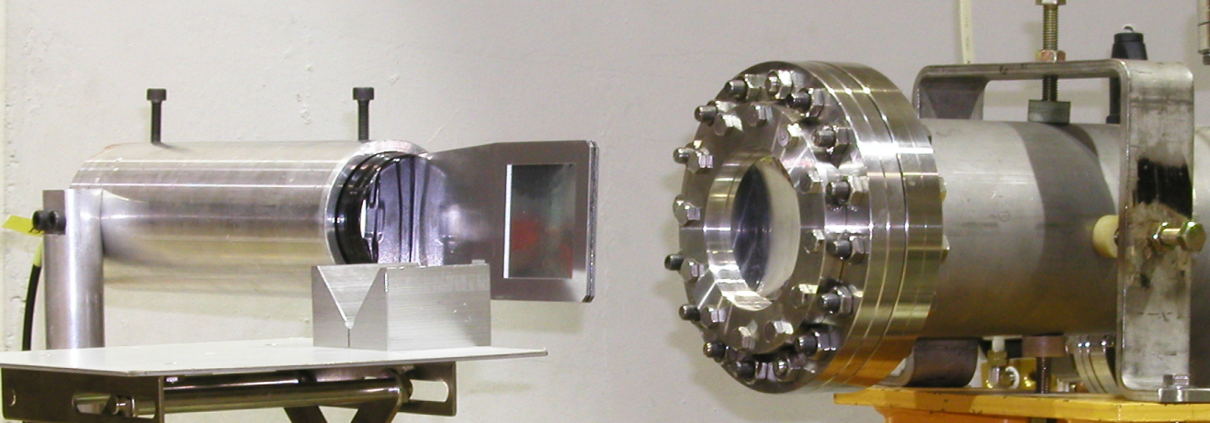

Figure 1. A view of the beam detecting scintillator (“trigger plastic”) and the beam exit. The trigger plastic is located approximately 5 cm downstream from the beam exit. The beam travels from right to left in the picture. The target materials were placed on the stand directly downstream from the beam scintillator.

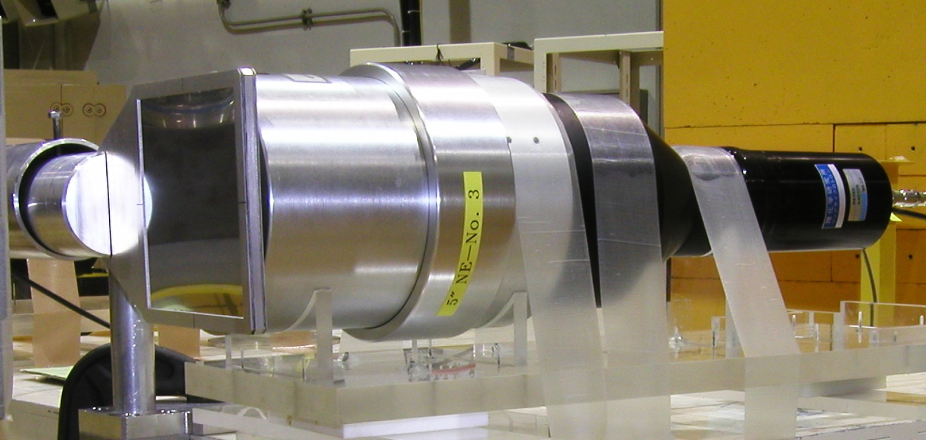
Figure 2. A view of a thin plastic “veto” detector followed by a 5” liquid scintillator.

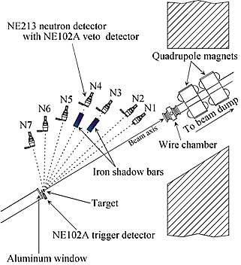

Figure 3. Schematic of the experimental setup.

The trigger detector was placed 5 cm downstream from the beam exit window followed by the targets, which were placed 19 cm downstream from the beam exit window. A 4 meter long, 30 cm diameter He-filled tube was also placed along the beam axis, downstream from the beam exit window (not shown in Figure ##). Finally, the beam dump was located 7 meters downstream.

The neutron and veto detector sets were arranged at various angles ranging from 5 to 80 degrees off of the beam axis. The centers of the scintillator cells were positioned between 306 cm and 506 cm from the center of the target (distances to the front faces of the detectors are 6 cm shorter, ranging from 300 to 500 cm). More detailed information about the detector setup can be seen below in Table ##.

Table 2. Description of the seven detector set positions.

Detector Set | Flight Path Length (cm) | Lab Angle (deg) | Solid Angle (mSr)
N1 | 506 | 5 | 0.494 ± 5.0%
N2 | 506 | 10 | 0.494 ± 5.0%
N3 | 456 | 20 | 0.608 ± 5.6%
N4 | 456 | 30 | 0.608 ± 5.6%
N5 | 406 | 40 | 0.767 ± 6.2%
N6 | 356 | 60 | 0.989 ± 7.1%
N7 | 306 | 80 | 1.35 ± 8.3%

Shadow Bar Setup
For background spectra, 1 to 3 shadow bars were included in the setup (depending on the system and run number). One shadow bar was composed of two solid iron blocks that were 15 cm by 15 cm square and 50 cm long. The other shadow bars were made by stacking 5 cm by 5 cm long iron bars together. The shadow bars are and were placed in front of the certain detectors to prevent ions originating from the direction of the target from interacting with the detectors directly behind the shadow bars. A picture of two shadow bars can be seen below in Figure ##.

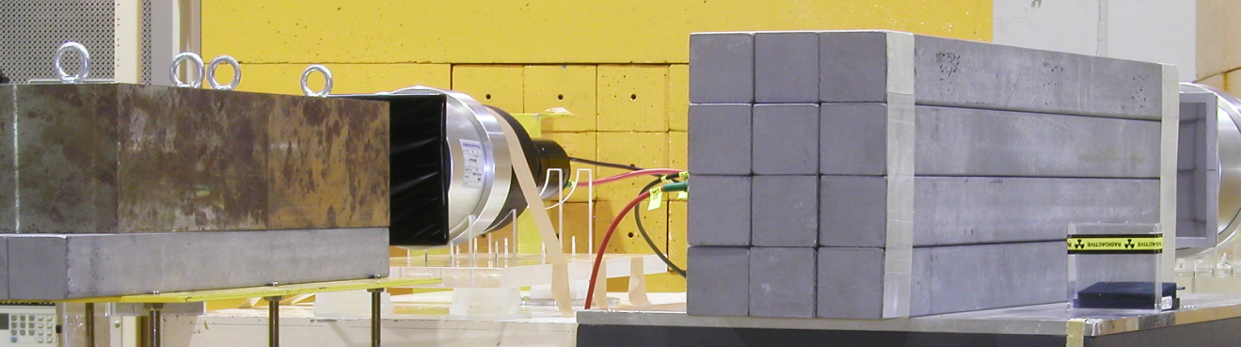
Figure 4. A view of two shadow bars.

Beam Setup
The beam was delivered to the target in pulses every 3.3 seconds. The duration of each pulse lasted between 0.5 and 1 second depending on the beam type. The average intensity of each pulse varied between 10⁴ and 10⁵ particles per pulse. The beam spot size on the target was a few millimeters in diameter and the beam spread was negligible compared to the divergence caused by coulomb scattering in the target and surrounding air.

Data Collection Walkthrough

This section describes the processes by which the particles are detected and the data is collected. Descriptions include how events are triggered and stopped, and how background spectra are created.

Triggering Events
When a beam particle exits the beam window, it first interacts with the trigger detector. The trigger detector sends out a delayed signal which triggers the end of an event (rather than the start of one). The beam particle then enters the target and has a chance to interact in a multitude of ways including fragmentation. Beam particles that undergo nuclear interactions expel fragments in all directions with many of them heading toward one of the seven detector sets. Heavier fragments are focused more toward the forward angles, whereas lighter ions are less constrained by their momentum and can be seen at broader angles. When one of the fragments interacts with a liquid scintillator, it signals the start of the event. Charge deposition and timing information are recorded for all detectors until the delayed timing signal from the trigger detector arrives to end the event.

The purpose for having the trigger detector signal the end of the event is to eliminate a multitude of events that register a beam particle in the trigger detector but no events in the downstream detectors. Relatively few of the beam particles create fragments that interact with one of the detector sets. It also helps prevent pileup issues involved with having large timing windows looking for a stop signal when none will actually show up.

Background Spectra
In order to measure background information, shadow bars were used in the setup. The shadow bars are placed in front of a specific detector set in order to block all fragments that originate from the target and travel directly to the detector. Therefore, events that are triggered by the detectors behind the shadow bars are treated as background noise.

For many of the target and beam combinations, there were four separate runs. Each run used a different shadow bar configuration in order to produce background spectra for every detector set. Most of the systems used the following configurations: (1) shadow bars in front of N1 and N2, (2) shadow bars in front of N3 and N4, (3) shadow bars in front of N5 and N6, and (4) shadow bars in front of N7. The Xe and Ne beam systems from May 2001 utilized only 5 of the 7 detector sets (omitting detector sets N4 and N6). The shadow bar configurations for these systems were the following: (1) shadow bars in front of N1 and N2, (2) shadow bars in front of N3 and N5, and (3) shadow bars in front of N7. The C beam system from April 2001 did not include the N7 detector set. The shadow bar configuration for this system was as follows: (1) shadow bars in front of N1 and N2, (2) shadow bars in front of N3 and N4, and (3) shadow bars in front of N5 and N6. The systems from November 2002 included all 7 detector sets, but used 3 different configurations instead of 4: (1) shadow bars in front of N1, N2, and N7, (2) shadow bars in front of N3 and N4, and (3) shadow bars in front of N5 and N6. Additional details for these runs can be seen above in Table 1.

For each system, a set of “blank target” runs were included using the same shadow bar configurations described above. This allows for the elimination of background caused by beam interactions in materials other than the target, such as the trigger detector, beam exit window, and air.

Cross Section Calculations

Charged and Neutral Particle Discrimination
Events are triggered when particles interact in one of the seven liquid scintillators. Events can be triggered by both charged and neutral particles. Discriminating between the two can be accomplished by observing the signals produced by the veto detectors (the plastic scintillators located directly in front of the liquid scintillators). Charged particles deposit a small fraction of their energy in these plastic scintillators whereas neutral particles generally pass through unimpeded. Since the scope of the analysis includes charged particles, but not neutral particles, events that contain veto detector signals above a certain threshold are kept and all others are ignored. A histogram of a typical veto detector output can be seen below in figure ##.

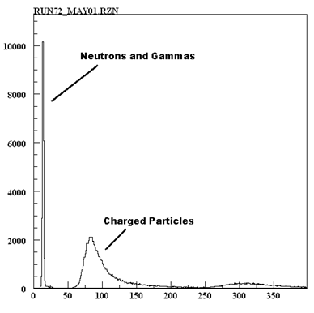
Figure 5. Histogram of energy deposition in a veto detector.

Ion Discrimination
After discarding events that were triggered by neutral particles, the events that remain are mostly those triggered by charged particles. Since the goal of the analysis is to calculate light ion production cross sections, it is necessary to identify the specific ions that triggered each event. The projectile and target may fragment into a variety of charged particles with different masses and kinetic energies, but given the experimental setup, only the lighter, more energetic ions will be able to reach the detectors before being absorbed in air. This can be accomplished by analyzing the measured time of flight of the particle and its associated energy deposition in a liquid scintillator. By producing two-dimensional pdt (proton-deutron-triton) plots of energy deposition vs time-of-flight, the different isotopes can be identified and separated. This can be observed in figure ## below.

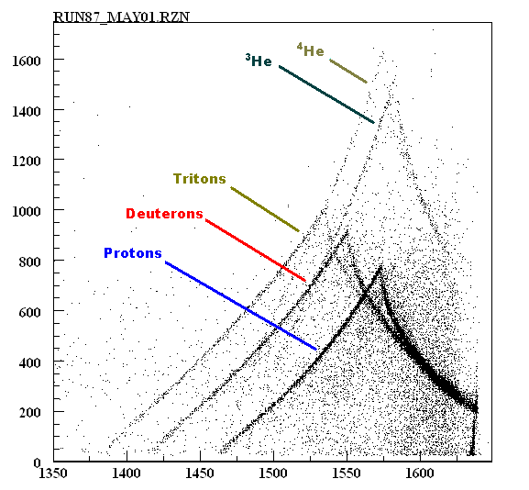
Figure 6. 2D plot of pulse height vs time-of-flight.

The interesting peaked lines can be explained by a few different phenomena. Different isotopes with similar time of flights will have similar velocities (with small deviations due to differing energy losses in air); however, the heavier ions will have higher energies and will deposit more energy in a detector. As time of flight decreases, the particle’s energy also increases, allowing for the deposition of more energy, assuming that the particle stops in the detector. This produces the upward sloping lines in the pdt plots. Since the detectors have a finite depth, this trend continues until a point where the particles are energetic enough to punch straight through the detector. At this point (the punchthrough point), a peak appears in the pdt plot, and the lines begin a downward sloping trend. This trend signifies a decrease in the energy deposition with decreased time-of-flights. In the energy regime that is detected in this experiment, higher energy particles have a lower linear-energy-transfer (LET) meaning they deposit less energy over a given distance. At energies past the punchthrough point, particles will pass through the same 5” of detector, but deposit less energy while doing so.

Particle Identification
The specific ions that produce each of the peaked lines in the pdt plots can be verified by comparing the measured punchthrough points to tabulated data. As described earlier, the punchthrough points occur when the ions are energetic enough completely range out in the 5” liquid scintillators. Energy dependent range values for protons incident on various target materials (including scintillating materials) are well known. Agreement between this tabulated data and the data in this experiment will verify the ions that were identified in the pdt plots.

The tabulated data provided by >>>>> contains range-energy data for protons only. However, this information can be used to estimate deuteron and triton energies where they range-out by using the following formula:

$R_{A}=R_{P}\left(\frac{M_{A}}{{Z_{A}}^{2}}\right)$ ( 1 )
Where $R_{A}$ is the range of particle with atomic number $A$, $R_{P}$ is the range of a proton, $Z$ is the charge, and $M_{A}$ is the mass of the particle with atomic number $A$. Equation 1 can be applied to ions with the same energy per nucleon. Since the goal is to find the energy at which deuterons and tritons stop at the edge of the liquid scintillators, $R_{A}$ has a value of 5” allowing for the evaluation of $R_{P}$. The calculated $R_{P}$ value is cross-referenced in the lookup tables to find the energy at which protons travel the full range of $R_{P}$. The listed energy is, therefore, the energy per nucleon at which the ion in question stops completely after travelling through 5” of liquid scintillating material.

TOF Calculations
In order to compare the experimental data with the tabulated data, the time-of-flight measurements need to be calibrated and converted into energy. The raw time-of-flight measurements are binned into histograms with channels widths of 0.25 ns. The time-of flight values associated with each channel number can be calculated by identifying the channel at which the prompt gamma rays pile up (prompt gammas refer to gamma rays produced by beam interactions in the target). All prompt gammas travel at the speed of light and will, therefore, have the same time-of-flight. Since gamma rays are neutral particles, calculating their time-of-flight is a straightforward process:

$TOF= \frac{d}{v}$ ( 2 )

Where $d$ is the flight distance and $v$ is the particle velocity.

After the gamma peak and associated time of flight have been identified, the time-of-flight can be calculated with the following formula:
$TOF\left(CH\right)=\left({CH}_{γ}-CH\right)*0.25+{TOF}_{γ}$ ( 3 )

Where ${CH}_{γ}$ is the channel number of the gamma peak, ${TOF}_{γ}$ is the time-of-flight for gammas, and $CH$ is the channel number in question. The result is a time-of-flight for the chosen channel number.

An example time-of-flight histogram is shown below in figure ##:
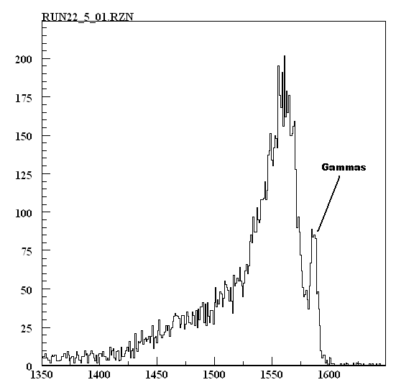
Figure 7. Histogram of time-of-flight values measured in one of the detector sets.

TOF to Energy Conversion
In order to generate double differential cross section data, the time-of-flight measurements need to be converted into energies at the points of particles’ production. This conversion is complicated with charged particles due to the slowing down mechanism they experience as they lose energy while traveling through a medium (referred to as stopping power). The stopping power depends on several factors including particle type, medium composition, and particle energy. The energy dependence of the stopping power typically necessitates the use of computer codes to help with calculations that involve charged particle motion. The code developed for this particular area of the analysis tracks particles from the point of production in the target to the point where the particles interact with the detectors. The code uses an iterative process that tracks changes in energy and time between several points from the target to the detector. The changes in energy are calculated using stopping power values obtained from NIST. The result of the calculation gives both a production energy and a final energy (energy of the particle when it reaches the detector) for every time-of-flight channel. This code can be seen in appendix ##.

Double differential cross sections for particle production can be calculated once the particle energy, angle, and intensity are known. Double differential cross sections are in units of b/(MeV-Sr) and integrating over all energies and angles will provide a total production cross section of that particle.

Particles are produced at a continuum of energies, but the nature of the data acquisition system (DAQ) discretizes the information into energy bins (or more precisely, time-of-flight bins which are later converted into energy bins). The data in these experiments are binned into channels with a 0.25 nanosecond window. The angular distribution is also a continuum, but detectors are discrete sizes with an angular resolution of that of detector itself. The experiment described in this paper uses seven detector setups, which means the double differential cross section can only be measured at seven different angles.

Increasing the size of the energy bins (and, even though this does not occur in this analysis, the angular bins) will worsen the resolution of the measurements, but the statistics will improve due to the increased count rate in each bin. Most of the measurements taken in these experiments were rebinned at lower energies in order to take advantage of this concept to increase statistical accuracy.

Cross Section Corrections

Once the cross sections are calculated, they need to be corrected for various effects in the experiment and in the analysis. These corrections include overlap adjustments, reaction cross section adjustments, and scattering adjustments. Each of these will be explained in more detail in the following sections.

PDT Overlap Corrections
As shown below in Figure ###, each of the isotope lines in the pdt plots overlap with a neighboring line at some point. When calculating a specific particle intensity, the count rates will be inflated at these overlap points due to the presence of counts from different particles. In order to adjust the data, two assumptions were made. First, the data is assumed to be continuous with no abrupt changes in magnitude throughout this energy regime. Second, the count rates at the overlap points consist solely of the particles in that overlap. This means that if half the particles in the p-d overlap are protons, then the other half will be deuterons.
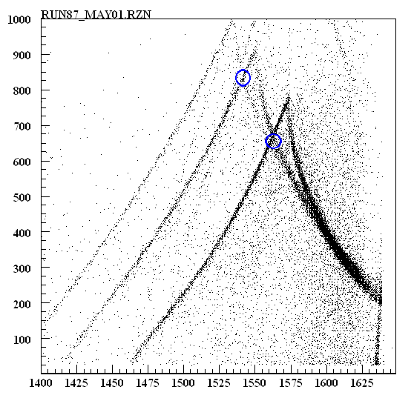
Figure 8. A pdt plot showing overlap points.

The overlap corrections are not calculated, but, rather, determined by graphical observations. The applied corrections attempt to deflate the data so that the resulting cross section plot looks continuous while also ensuring the second assumption is maintained, eg., if 30% of the counts are removed from protons in the p-t overlap, then 70% are removed from the tritons in the p-t overlap, ensuring a conservation of the total number of counts in the overlap region. An example correction can be seen below in Figure ###.

[Missing Figure]
Figure 9. Plots showing corrected and uncorrected data. (a) shows protons and (b) shows deuterons. This data is taken from the same pdt plot.

Reaction Cross Section Corrections
When the light ions travel toward a detector set, there is a chance that some will be absorbed in the target and surrounding air. The result is that some of the particles that should have interacted in the detectors were lost. This effectively lowers the calculated cross sections and should be corrected.
In order to correct for the particle loss due to absorption, one can apply the following equation:
$I=I_{0}e^{\left(-Nσ_{r}t\right)}$ ( 4 )
where $I$ is the intensity of particles at the end of the flight path, $I_{0}$ is the original intensity, $N$ is the atomic density of the medium that the particles are traveling through, $σ_{r}$ is the reaction cross section, and $t$ is the length of the flight path. Assuming an initial intensity of 1, the result is the ratio of particles that actually survive after travelling through path length $t$.

There is not an abundance of cross section data at the energy regimes for this experiment, so reaction cross section models must be employed in order to use this equation. The model used for this analysis is described in full in Tripathi [ref].

The difficulty equation # lies in the fact that the charged particles slow down when travelling through a medium and that the reaction cross sections are dependent on the energy of the particles. This problem is overcome by tracking particles over very short segments of the total path length so that the energy loss is very small. The equation is applied several times until the entire path length is compensated for. The code used for this process can be seen in Appendix ###.

Limitations in Data

Throughout many of the runs in this experiment, some phenomena arise that limit the scope of the data. The three phenomena described in this section are PDT convergence, QDC (charge to digital converter) saturation, and superfluous PDT lines. The first two limit the useable energy range when calculating cross sections. The third one, while not necessarily limiting the scope of the data, poses an interesting question as to the cause of the extra lines.

High-Energy PDT Plot Convergence
With every data set comes a phenomenon that limits the useable energy window for the cross section calculations. Each of the peaked lines in the pdt plots begin to merge together at lower time of flights, effectively preventing the discrimination between the different ions. This phenomenon can be seen in Fig. xxx with the red region (merged deuteron and triton lines) and the blue region (merged proton, deuteron, and triton lines). Corrections at this point are impractical as the trend in the data beyond the merging point is uncertain. Combining the information for each ion beyond the merging point into one set is possible, but the resulting cross section calculations would need to be in terms of flight time, as the energies would be different for each ion. However, double differential time-of-flight spectra have limited utility and are not considered here.
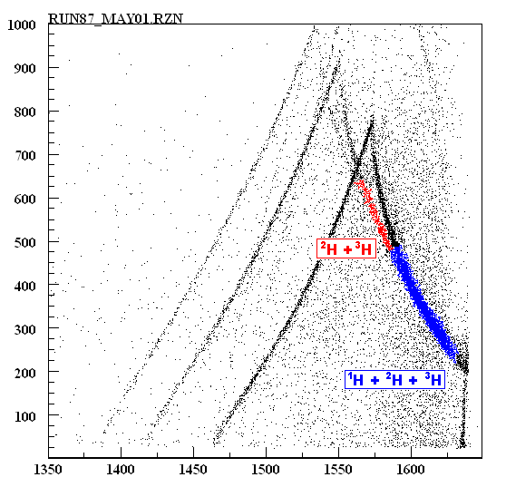
Figure 10. Histogram of time-of-flight values measured in one of the detector sets.

QDC Saturation
QDC (charge to digital converter) saturation issues arise in some of the earlier measured systems for this experiment. Since the original focus of the experiments was to observe neutron production, the detector gain settings weren’t optimal for charged particle analysis. As such, some charged light ion pulses saturated the QDC and had recorded QDC values at the maximum channel number, 2047. Some runs include two-dimenstional QDC vs TDC p-d-t plots where the peaked lines saturated at the top of the graph. This can be seen in Fig. xxx below by the horizontal line at a QDC value above channel 2000, extending across the entire range of TDC channel numbers. This limits the dynamic range of useable data because particle identification is not possible in the region of saturation.

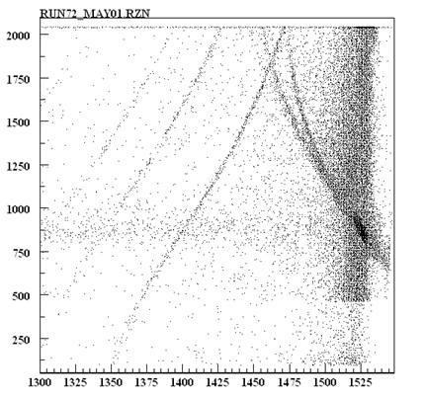
Figure 11. An example pdt plot showing line saturation.

Superfluous PDT Lines
Some of the later-run sets have extra particle lines that appear in the pdt plots. These lines behave much in the same way as the pdt lines. As of this writing, the appearance of the lines is unexplained, and it’s unsure whether the background subtraction can account for their presence or not. Luckily, the amount of counts in the extraneous line is low, and the overlap points tend to fall outside of the useable time of flight window caused by the merging phenomenon seen above in Figure ##.

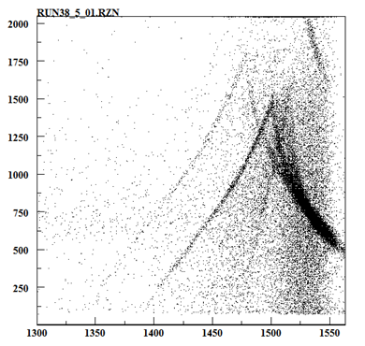
Figure 12. An example pdt plot showing an extraneous peaked line.

Coalescence Model Application

CHAPTER IV
Results and Discussion

Heading 2

xxxxxxxxxxxxxxxxxxxxxxxxxxxxxxxxxxxxxxxxxxxxxxxxxxxxxxxxxxxxxxxxxxxxxxxxxxxxxx

CHAPTER V
Conclusions and Recommendations

LIST OF REFERENCES

Citations go here…

APPENDIX
You’ll put appendix material here. This section is optional as well. You can place tables and figures in the appendix if you like. If you choose this option, you should indicate that tables and figures are in the appendix after the first mention in the text. You can place some tables/figures in the text and others in the appendix.

Vita

John X. Doe was born. He wrote a thesis. He graduated. This page really is required.

