Heritability and Genetic Gain of Seed Protein, Oil, and Yield among RIL of Soybean

A Thesis presented for the
Master of Science Degree
The University of Tennessee, Knoxville

Benjamin T. Wiggins
August 2012

DEDICATION
I dedicate this thesis to many people. To my parents Jerry and Katherine Wiggins for supporting me and encouraging me to live a good wholesome life, and for showing me how much an education is worth. To my Tennessee Tech Ag family: without the background I gained while my time there, graduate school would have been more difficult. To my church family, thank you for your support. To the memory of Mrs. Lisa Biggs- my mother, my friend, and a wonderful person who changed the world forever. And to my wife, Suzannah: we are about to start a new chapter of our lives, of which will be filled with more fun, laughter, tears, and joy than we have experienced in the past year and I cannot wait to get started with you.

ACKNOWLEDGEMENT

I would like to thank the faculty, staff and my fellow students here at the University of Tennessee that have aided in my research and class work as a graduate student and my friends and family for giving me the “encouragement” that I needed to pursue and obtain my graduate degree. I would like to extend a special thank you to my advisor Dr. Vince Pantalone for taking along not only myself as a graduate student but also accepting my wife into a position here as well, to my committee members Dr. Fred Allen and Dr. Dennis West who along with their guidance this degree is possible. I would also like to thank the soybean breeding team, Dr. Catherine Nyinyi, Deborah Landau-Ellis, Elizabeth Meyer, Ben Fallen, Chris Smallwood, Nicole Renworth-Tacey, Greg Allen, and my wife Suzannah Wiggins for helping me down the journey that is graduate school. A thank you is due to the staff at the East Tennessee Research and Education Center, the Highland Research and Education Center, the West Tennessee Research and Education Center, and the Research and Education Center at Milan for assisting me in my field experiment. I am thankful for my friends Kelly Barnett, the BESS kids, and the Vet Girls for helping release stress when needed and giving me a kick when it was deserved. I would like to thank my brothers, Matthew Wiggins, Daniel Wiggins, and Will Phillips, without your constant “attention” I would not be here. Most importantly, I would like to thank my wife, without her here I never would have made it. Lastly, I would like to thank the United Soybean Board, the TN Soybean Promotion Board, and the UTIA AG Research for their sponsorship of my research.
ABSTRACT
Soybean is a remarkable crop that is used in many aspects of our everyday lives. The seed protein is used primarily for livestock feed, though it is becoming more available as a meat substitute for human consumption. Soybean oil is used in many products such as plastics, foods, and industrial products. Seed yield is the major trait that is selected for in a breeding program. A population of 239 F₄ derived RIL from the cross of USG 5601T × U99-310255 was used to calculate heritability estimates by parent offspring regression and on an entry mean basis. This population was grown in 2009 as unreplicated F_{4:5} plant rows at the East Tennessee Research and Education Center (ETREC) in Knoxville, TN. In 2010, the F_{4:6} generation was grown as two replications with two locations, ETREC and Highland Rim Research and Education Center (HRREC) in Springfield, TN. In 2011, the F_{4:7} generation was grown at ETREC, HRREC, and at the Research and Education Center at Milan (RECMLN) in Milan, TN. Averaged over two years (2010 and 2011) and 5 environments exhibited a range of 1928.7 to 3033.6 kg ha⁻¹ with a mean of 2325.7 kg ha⁻¹for seed yield, 398.4 to 451.8 g kg⁻¹ with a mean of 426.8 g kg⁻¹ for seed protein concentration, and 201.1 to 224.6 g kg⁻¹ with a mean of 213.7 g kg⁻¹ seed oil concentration. On an entry mean basis, a heritability estimate of 0.85 for seed protein concentration was observed. However, a parent-offspring regression of F_{4:6} to F_{4:7} revealed an estimate of 0.43 (R²= 0.26). For seed oil concentration, heritability estimate on an entry mean basis was 0.78 and the parent-offspring regression was 0.11 (R²=0.01). Seed yield exhibited heritability estimates of 0.23 (R²=0.09) and 0.38 for parent-offspring regression and entry mean basis respectively. Genetic gains were calculated for all traits through selections for the top 5, 10, 15, and 20% of RILs for seed yield, seed protein, and seed oil concentration. Improvements in these traits were achieved singularly and could be selected for multiple traits when phenotypic correlations are considered.
TABLE OF CONTENTS
PART 1 1
Introduction 1
References 6
PART 2 7
Literature Review 7
References 16
PART 3 18
Heritability and Genetic Gain of RIL of Soybean from a cross of USG 5601T × U99-310255
18
Abstract: 19
Introduction 22
Materials and Methods 28
Results and Discussion 32
References 71
PART 4 72
Conclusions and Further Research 72
APPENDIX 75
VITA 83

LIST OF TABLES

Table 3.1 Observed seed yield means of selected F_{4:6} and F_{4:7} RILs, F_{4:7} population mean, realized genetic gain, predicted genetic gain, and realized heritability of seed yield for each selection intensity. 58
Table 3.2 Seed yield means for top 20% of F_{4:6} lines with mean seed yield for F_{4:7} generation and agronomic data. 59
Table 3.3 Observed seed oil concentration means of selected F_{4:6} and F_{4:7} RILs, F_{4:7} population mean, realized genetic gain, and predicted genetic gain, and realized heritability of seed oil concentration for each selection intensity. 62
Table 3.4 Seed oil concentration means for top 20% of F_{4:6} lines with mean seed oil concentration for F_{4:7} generation and agronomic data. 63
Table 3.5 Observed seed protein concentration means of selected F_{4:6} and F_{4:7} RILs, F_{4:7} population mean, realized genetic gain, and predicted genetic gain, and realized heritabilities of seed protein concentration for each selection intensity. 66
Table 3.6 Seed protein concentration means for top 20% of F_{4:6} lines with mean seed protein concentration for F_{4:7} generation and agronomic data. 67
Table 3.7 Correlations between seed oil concentration, seed protein concentration, and seed yield when average over two years and five locations. 70
Table A.1: Mean seed yield, oil, and protein concentration averaged over two years for a total of five locations along with agronomic data for a population of 239 RIL from the cross of USG 5601T × U99-310255. 76

LIST OF FIGURES

Fig. 3.1 Development of F4- derived RIL from the cross between USG 5601T and U99-310255. 41
Fig. 3.2: Frequency distribution of seed yield for F4:6 generation grown as replicated two row plots during 2011 in Knoxville, TN and Springfield, TN. 42
Fig. 3.3 Frequency distribution of seed yield for F_{4:7} generation grown as replicated two row plots during 2011 in Knoxville, TN, Springfield, TN, and Milan, TN. 43
Fig. 3.4 Frequency distribution of seed yield means averaged over two years and five locations for the F_{4:6} and F_{4:7} generations. 44
Fig. 3.5 Frequency distribution of seed oil concentration for F_{4:5} generation grown as unreplicated plant rows in Knoxville, TN in 2009. 45
Fig. 3.6 Frequency distribution of seed oil concentration means for F_{4:6} generation grown as replicated two row plots in Knoxville, TN and Springfield, TN in 2010. 46
Fig. 3.7 Frequency distribution of seed oil concentration means of F_{4:7} generation grown as replicated two row plots in Knoxville, TN, Springfield, TN, and Milan, TN in 2011. 47
Fig. 3.8 Frequency distribution of seed oil concentration means for the F_{4:6} and F_{4:7} generations averaged over two years and five environments. 48
Fig. 3.10 Frequency distribution of seed protein concentration means of the F_{4:6} generation grown as replicated two row plots in Knoxville, TN and Springfield, TN. 50
Fig. 3.11 Frequency distribution of seed protein concentration means of the F_{4:7} generation grown as replicated two row plots in Knoxville, TN, Springfield, TN, and Milan, TN in 2011. 51
Fig. 3.13 Parent-offspring regression for mean seed yield of the F4:6 and F4:7 generation. 53
Fig. 3.15 Parent-offspring regression for mean seed oil concentration of F4:6 and F4:7 generations. 55
Fig. 3.16 Parent-offspring regression for mean seed protein concentration of F_{4:5} and F_{4:6} generations. 56
Fig. 3.17 Parent-offspring regression for mean seed protein concentration of F_{4:6} and F_{4:7} generation. 57

PART 1

Introduction
The soybean [Glycine max (L) Merrill] is one of the world’s most important sources of protein and oil for an ever growing population. It is believed to have been domesticated as early as the 11th century B.C. in the Yellow River Basin area of China (Hymowitz and Newell, 1981). From there production expanded over much of China, Japan, and the rest of Asia in the following centuries. It was not until the 17th century that soybean was brought to Europe and not until the early 18th century that was it brought to the United States of America. Soybean was first introduced into the U.S. as a forage crop. At the onset of World War II, the U.S.’s soybean production acres began to grow so as to provide a biodiesel fuel alternative for the U.S. war efforts. This is when soybean became an important crop in the U.S. (Burton, 1997).
Soybean is a legume crop, meaning that it creates an environment that is home to symbiotic bacteria that fix atmospheric nitrogen and convert it to ammonia for the growing plant to manufacture amino acids, proteins, and nucleic acids. Thus the plant does not need to have supplemental nitrogen applied like corn (Zea maize), cotton (Gossypium hirsutum L.) or other non-legume crops. This ability has proven to be beneficial to production in the U.S. Soybean was predominately grown on ground that was less than favorable for other row crops due to either poor nutritive qualities of the soil or other environmental factors. In the last 50 years soybean has seen a production increase making it one of the staple crops for many farms across the U.S. (Burton, 1997).
Soybean is currently grown for a variety of reasons. Some are grown for direct human consumption (edamame) while the majority of soybeans are grown to sell on commodity markets. On these markets soybeans are sold and processed into soybean oil and soybean meal which are then used to create swine and poultry feed and a variety of different products from fuel, lubricants, and plastics to food additives, vegetable oil, and even a milk replacement product. Soybean is currently grown across the globe with the U.S., Brazil and China being the leading producers of soybeans in the world.
Recently in the U.S. a push has been made to be more environmentally friendly. One of the ways that has caused a boost to soybean production is the production of biodiesel. Biodiesel is a synthetic fuel that in the U.S. is produced predominately from the oil extracted from soybeans (Wittkop et al., 2009 and Acquaah, 2005). Many cities have started to make the transition to biodiesel powered public transportation so as to leave a smaller environmental footprint, providing a strong demand for soybean oil as biodiesel feedstock (Wittkop et al., 2009). For public use however, biodiesel is less viable since most of the personal vehicles that are used in the U.S. are not diesel powered. But, there are a few personal diesel powered cars and many commercial and government diesel trucks currently in use, with more models planned for the coming years (Freese, 2002). Another way that the public has influenced soybean production is the desire for a healthier vegetable oil. In recent years, soybean breeders have tried to improve the quality of the oil that has been produced from new cultivars. Consumers and producers of certain types of food have wanted an oil that is healthier and yet affordable for everyone involved. In this respect soybean breeders have made great advances in the composition of the oil that is produced from soybean. This has been accomplished by using different breeding strategies which include a wide variety of scientific tools including marker assisted selection (MAS) with single nucleotide polymorphism (SNP) markers, and other advancements in genomics research. These tools have become a great asset to many breeders, but breeders still rely on their knowledge of genetics and the calculations that assist in making selections. One important calculation is that of the heritability of a certain trait. Heritability is defined as the proportion of total variance that is genetic (Burton, 1987). Heritability is important because it aids the breeder in determining the amount of progress or genetic gain that can be made through certain breeding strategies. Wray and Visscher (2008) explain heritability as being how much of the variation is due to the genetic variation of the material relating between a parent and its offspring. A high heritability means the offspring have a greater chance of exhibiting an expression of the trait that is similar to that of the parents; whereas a low heritability shows a lower level of resemblance. Wray and Visscher (2008) go on to define the two types of heritability, broad and narrow sense heritability. They define broad sense heritability (typically denoted as H) as the proportion of phenotypic variation that is the result of the total genetic variation including both dominance and epitasis effects (H = σ²_{G}/σ²_{P}). Narrow sense heritability (typically denoted as h²) is the proportion of phenotypic variance that is the result of additive genetic variation (h² = σ²_{A}/σ²_{P}). The heritability for any trait can be calculated. One estimate of heritability is the entry mean basis which can be calculated by dividing the genetic variance (σ²_{g}) by the summation of the genetic variance (σ2g), the genotype by environment variance (σ²_{ge}) divided by the number of environments (e) that the experiment is conducted in, and the error variance divided by the product of the number of environments (e) and the number of replications (r) (Nyquist, 1991):

References
Acquaah, George. Principles of crop production: theory, techniques, and technology. 2nd ed. Upper Saddle River, NJ: Prentice Hall, 2005. 628-638.
Burton, J.W. 1987. Quantitative genetics: Results relevant to soybean breeding, in J. R. Wilcox Soybeans: Improvement, Production, and Uses pp. 211-242.
Burton, Joseph W. 1997. Soybean (Glycine max (L.) Merr.). Field Crop Research 53:171-186.
Freese, Charlie. “Fuel economy and torque benefits signal bright future for diesel power.” Ford Media.Ford, 02 Nov 2002. Web. 12 Jan 2011.
Hymowitz, T., and C.A. Newell. "Taxonomy of the Genus Glycine, Domestication and Uses of Soybeans." Economic Botany. 35.3 (1981): 272-288.
Nyquist, Wymen E. 1991. Estimation of heritability and prediction of selection response in plant populations, in Critical Review in Plant Science 10:3 pp. 235-322.
Wittkop, B., R.J. Snowdon, and W. Friedt. 2009. Status and perspectives of breeding for enhanced yield and quality of oilseed crops for Europe. Euphytica 170:131-140.
Wray, N. and Peter Visscher. 2008. Estimating trait heritability. Nature Education. 1:1

PART 2
Literature Review
Heritability estimates for different traits are of great interest to breeders. The heritability for a trait is currently one of the calculations that a breeder uses to aid in selection decisions. The higher a heritability, the greater the chance that the breeder will be able to make successful selections for targeted traits causing a genetic change in the trait of interest. Many studies have been done to determine the heritability for different traits of many crops. With respect to soybean, many heritability studies have been conducted on seed yield, protein concentration, and oil concentration. When looking at the heritability for any of these three traits, selections are usually done in a manner so as to increase as many traits as possible in order to provide the best quality of soybean while maintaining the acceptable levels of other traits.
Sebastion et al. (2010) evaluated whether context specific marker assisted selection (CSM) could be used to detect possible quantitative trait loci (QTL) for seed yield. In their experiment they had nine mother lines that they considered to be heterogeneous, allowing them to extract improved sub-lines from the populations. They proposed the idea that CSM could be used to identify (QTL) for seed yield, since a low heritability is known for seed yield. In the experiment these nine mother lines had a bulk sample of DNA fingerprint composed and one hundred polymorphic markers used to analyze the DNA for known QTL. Then they allowed the population to be advanced at two winter sites where 300 single plants where genotyped and allowed to self-pollinate. They then grew out these 300 single plants into plots and placed them according to their maturity. During that growing season, the individual genotypes where sampled again for DNA and analyzed for QTL. They found that by using CSM they could target QTL that seemed to be more prominent for a certain maturity group in a location where that maturity group is commonly grown.
Hartwig and Hinson (1972) looked at the correlation between seed yield, protein concentration and oil concentration. Crosses where made between ‘Bragg’, a high oil cultivar, and the lower yielding, high protein concentration line D60-7965. While wanting to maintain the higher seed yield and higher oil concentration of ‘Bragg’, but also to maintain the higher protein concentration of D60-7965, a series of backcrosses where made in order to develop two distinct populations. They used thirty six BC₁ F₅ lines and thirty six BC₂ F₄ lines for evaluation. Each of the thirty six lines from each population where divided into three distinct groups, a high, low, and a mid-level oil concentration. After analyzing the data it was shown that a high yielding, high protein concentration lines could be identified when a series of backcrosses were used, in this case two. They also indicated that though it was possible, it is difficult to accomplish. They showed a high negative correlation, -0.91, between oil concentration and protein concentration and a moderate negative correlation, -0.41, between yield and protein. When looking at the correlation between yield and oil though, a moderate positive correlation was found, 0.35.
Cober and Voldeng (2010) looked at a similar process to determine whether a backcross would increase the heritability of seed yield and protein concentration. They chose to create a population based upon the cross of AC Proteus by Maple Glen due to the high protein concentration of AC Proteus and the high yielding ability of Maple Glen. From those F₁ seeds, two backcrosses were made to create two distinct populations; one where Maple Glen was the female of the backcross and was carried on through the F₃ generation and one where the original cross was made and allowed to self-pollinate. Each of these was carried out to the F_{4:5} generation. At that generation lines were tested to estimate heritability of protein, oil, and seed yield. They found an inverse relationship between seed protein and oil (-0.84 for RIL, and -0.86 for the back cross population, P< 0.0001). This inverse relationship has been found in other experiments (Burton 1987), yet Cober and Voldeng showed that lines from their population could be used to increase both seed yield and protein concentration.
Karasu et al. (2009) looked at the heritability of seed yield and other agronomic traits. They chose five genotypes that are commonly produced in their area (the Southern Marmara Region of Turkey) and three additional experimental lines: Ataem-1, Ataem-2, A-3127, Corsoy, Hodgson-78, Mitchell, Sa-88, and Etae-8. Their experiment was designed in a randomized complete block (RCB) and was planted at two locations for two years. They showed that the genotype by environment interaction played a significant part in the phenotypic response of seed yield. They also suggested that an increase in seed yield would be possible but would be very small.
Bachlava et al. (2008) set out to estimate the heritability of oleate concentration and determine the correlations between oleate with other fatty acids along with agronomic traits. In that study, heritabilities for palmitic, stearic, oleic, linoleic, and linolenic fatty acids where calculated for three populations designated FAE, FAF, and FAS. The FAE population consisted of 721 F₅-derived lines from the cross of N98-4445A x Satelite. The FAF population consisted of 231 F₃-derived lines from the cross N97-3363-3 x PI423893. The FAS population had 231 F₃-derived lines from a cross of N98-4445A x PI423893. For the FAE population heritabilities for palmitic, stearic, oleic, linoleic, and linolenic fatty acids were estimated at 0.99, 0.94, 0.95, 0.95, and 0.94 respectively. Heritabilities for oil concentration and yield were estimated at 0.92 and 0.81, respectively. For the FAF population the heritability estimates were 0.96, 0.86, 0.96, 0.96, 0.98, and 0.94 for palmitic, stearic, oleic, linoleic, linolenic, and oil respectively. For the FAS population the heritability estimates were 0.82, 0.77, 0.88, 0.89, 0.97, and 0.81 for palmitic, stearic, oleic, linoleic, linolenic, and oil respectively. Bachlava et al. stated that with these high heritabilities, successful selections could be made as early as the F₃ generation and that it could be done on a limited number of environments. They also showed that as selections were made for higher oleate concentration this would reduce linoleate, linolenate, and palmitic acid concentration in soybean oil.
Lowman et al. (1990) looked at different experimental designs and how those designs affected the calculations that are used to determine the heritability of seed yield. They implemented their experiment to determine if a randomized complete block design (RCB) or an incomplete block (ICB) design would have a significant interaction upon the calculations of the variance components and the heritability of the two populations in their experiment. The two populations consisted of the first having forty-five F4:8 lines and the other population containing fifty F_{4:8} soybean lines. They showed that an ICB design would result in a greater precision and accuracy in estimating all of the variance components. They showed that when looking at all data through locations and years combined, the ICB design gave a greater accuracy for defining variance components due to better assignment of the blocking terms but that an RCB was adequate for most breeding programs.
Cherrak et al. (2003) sought to determine if the changes in concentration of the saturated fatty acid palmitic acid (16:0) and the polyunsaturated fatty acid linolenic acid (18:3) would improve oil quality. This was expected because low palmitic acid has shown increased health benefits for humans and a lower linolenic acid would provide a better flavor and stability to the oil of soybean seed. Palmitic acid and linolenic acid both showed moderately high heritabilities of 0.65 and 0.73. Cherrak et al. (2003) indicated that with heritabilities as high as this, successful selection could take place as early as the F₂ generation.
Panthee et al. (2006) looked for genomic regions that controlled amino acid composition in soybean hoping to improve the ability to select for an overall better amino acid composition for human and animal nutrition. They found a range of heritabilities from 0.13 for histidine to 0.67 for tyrosine. They also showed the heritability for protein to be 0.66 in a population consisting of F₆ derived plants from the cross N87-984-16 × TN93-99. At least one QTL was found for each of the amino acids in that population, though further research is needed to validate those markers across populations and environments.
Panthee et al. (2004) looked at β-conglycinin (7S) and glycinin (11S) concentration of soybean seed. Since glycinin contains more sulfur containing amino acids, it was a goal to detect quantitative trait loci (QTL) for this storage protein. They found significant differences (P<.05) among genotypes for glycinin and β-conglycinin, but the heritability estimate for β-conglycinin was small (0.30) and was estimated at zero for glycinin, suggesting genetic gains for altering protein subunits will be difficult to achieve. Three QTL’s for glycinin (Satt 461, Satt292, and Satt 156) were found on linkage group D2, I and L, and two QTL were found for conglycinin (Satt 461 and Satt 249) on linkage groups D2 and J. With the detection of these QTL, MAS could be made to select for an increased content of conglycinin or glycinin, but genetic gains would be difficult with low heritabilities.
Panthee et al. (2006) wanted to improve the availability of the sulfur containing amino acids methionine and cysteine. They proceeded to identify QTL for both methionine and cysteine concentration in soybean seed. The population contained 101 F₆ derived recombinant inbred lines (RIL) from a cross of N87-984-16 X TN93-99. A heritability of 0.14 and 0.57 for cysteine and methionine was found along with four molecular markers for cysteine and three molecular markers for methionine concentrations in soybean seed.
Scaboo et al. (2009) sought to confirm molecular markers for lowering seed phytate in soybean seed. These QTL, Satt237 and Satt527, where examined in two populations. One of the populations, 5601T × CX1834-1-2 showed heritabilities for yield, protein and oil concentration of 0.49, 0.95, and 0.95, respectively. They found high heritability estimates for seed phosphorous concentration (0.97 and 0.92 on an entry-mean and plot basis, respectively). They also showed that seed phytate was correlated with plant height, seed protein, and seed oil concentration, 0.26, -0.19, and 0.17, respectively. This suggests that it would be likely that as selection for lower seed phytate was made, a modest increase of seed protein could be anticipated. They further noted that phenotypic rather than molecular marker assisted selection was found to be more effective in lowering phytate levels and was more cost effective.
Panthee et al. (2005) estimated heritability using the entry mean equation by Nyquist (1991) to determine heritability. The REML estimation in PROC MIXED of SAS gave the appropriate variance components. Their population consisted of 101 F₆ derived recombinant inbred lines (RIL) from the cross N87-984-16 × TN93-99. The study was designed as a randomized complete block (RCB) design. They found that a moderate portion of the variation was due to the genetic component of the population (with entry mean basis heritability estimates of 0.66 for protein and 0.54 for oil). They also found a negative correlation between protein and oil concentration (-0.59, P<.001).
The negative correlation between seed oil and seed protein concentration is a concern for breeders wishing to increase both of these seed quality traits. If this correlation could be weakened or broken, or adequate population sizes could be developed for strategic selections, it would mean that breeders could advance two of the three major attributes that give soybean their value. If all three traits could be improved it would mean a higher value for soybeans for producers and processors.
The objectives for this study are as follows:
- Determine if a population of recombinant inbred lines (RIL) from the cross of USG 5601T x U99-310255 exhibits significant genetic variation for seed yield, seed protein concentration, and seed oil concentration.

- Compare heritability estimates from entry mean procedure with parent-offspring regression estimates for seed yield, seed protein concentration, and seed oil concentration from the F_{4:6} and the F_{4:7} lines from the cross of USG 5601T x U99-310255.

- Calculate genetic gain for selection intensities of the top 5, 10, 15, and 20% of RIL for seed yield, seed oil concentration, and seed protein concentration and compare them between the 2010 F_{4:6} and the 2011 F_{4:7} realized means.

References
Bachlava, Eleni, Joseph W. Burton, Cabell Brownie, Sanbao Wang, Jerome Auclair, and Andrea J. Cardinal. 2008. Heritability of oleic acid content in soybean seed oil and its genetic correlation with fatty acid and agronomic traits. Crop Sci. 48:1764-1772.
Burton, J.W. 1987. Quantitative genetics: Results relevant to soybean breeding, in J. R. Wilcox Soybeans: Improvement, Production, and Uses pp. 211-242.
Cherrak, C.M., V.R. Pantalone, E. J. Meyer, D.L. Ellis, S.L Melton, D.R. West, and J.R. Mount. 2003. Low-Palmitic, Low Linolenic Soybean Development. J. Am. Oil Chem Soc. 80, 6:539-543.
Cober, E.R. and H.D. Voldeng. 2000. Developing high-protein, high-yield soybean populations and lines. Crop Sci. 40:39-42.
Earwig, Edgar E. and Knell Hinson. 1972. Association between chemical composition of seed and seed yield of soybeans. Crop Sci. 12: 829-830.

Karasu, A., M. Oz, A.T. Gooey, and Z.M. Turin. 2009. Genotype by environment interactions, stability, and heritability of seed yield and certain agronomical traits in soybean (glycine max (l.) merr.) African Journal of Biotechnology 8-4: 580-590.
Lowman, G. Allan, Fred Allen, Robert Mclean, Vernon Reich, and Dennis West. 1990. Estimates of variance components and heritability for seed yield in two soybean populations from an incomplete vs. complete block design.
Nyquist, Wymen E. 1991. Estimation of heritability and prediction of selection response in plant populations, in Critical Review in Plant Science 10:3 pp. 235-322.
Panthee, D.R., V.R. Pantalone, D.R. West, A.M. Saxton, and C.E. Sams. 2005. Quantitative trait loci for seed protein and oil concentration, and seed size in soybean. Crop Sci. 45:2015-2022.
Panthee, D.R., P. Kwanyuen, C.E. Sams, D.R. West, A.M. Saxton, and V.R. Pantalone. 2004. Quantitative trait loci for β-Conglycinin and Glycinin fractions of soybean storage protein. JAOCS. 81, 11:1005 -1012.
Panthee, D.R., V.R. Pantalone, A.M Saxton, D.R. West, and C.E. Sams. Genomic regions associated with amino acid composition in soybean. 2006. Molecular Breeding 17: 79-89.
Panthee, D.R., V.R. Pantalone, C.E. Sams, A.M. Saxton, D.R. West, J.H. Orf, and A.S. Killam. 2006. Quantitative trait loci controlling sulfur containing amino acids, methionine and cysteine, in soybean seed. Theo Appl Genet. 112:546-553.
Scaboo, A.M., V.R. Pantalone, D.R. Walker, H.R. Boerma, D.R. West, F.R. Walker, and C.E. Sams. 2009. Confirmation of molecular markers and agronomic traits associated with seed phytate content in two soybean RIL populations. Crop Sci. 49:426-432.
Sebastian, S.A., L.G.Streit, P.A. Stephens, J.A. Thompson, B.R. Hedges, M.A. Fabrizius, J.F. Soper, D.H. Schmidt, T.L. Kallem, M.A. Hinds, L. Feng, and J.A. Hoeck. 2010. Context-specific marker-assisted selection for improved grain yield in elite soybean populations. Crop Sci. 50:1196-1206.

PART 3

Heritability and Genetic Gain of RIL of Soybean from a cross of USG 5601T × U99-310255

Abstract:
Soybean’s wide usage can be seen in the health food, fuel, livestock, and industrial businesses. This population of 239 RIL from the cross of USG 5601T × U99-310255 was developed to determine if significant variation was present in order to make selections for seed protein, oil, and yield. Heritability was calculated for seed protein, oil, and yield with estimates compared between that of an entry mean basis and parent-offspring regression. Genetic gain was calculated to examine if significant gain could be made by selecting the top 5, 10, 15, and 20% of each trait.
The F_{4:6} RIL had a seed yield range from 1061.4 to 2963.7 kg ha⁻¹ with a population mean of 1945.4 kg ha⁻¹ averaged over two environments in 2010. The F_{4:7} RIL exhibited a seed yield range from 1669.7 to 3417.4 kg ha⁻¹ with a population mean of 2494.1 kg ha⁻¹ when averaged over three environments in 2011. When averaged over two years (2010 and 2011) and five environments, seed yield ranged from 1928.7 to 3033.6 kg ha⁻¹ with a population mean seed yield of 2325.7 kg ha⁻¹. Heritability of seed yield on an entry mean basis was calculated to be 0.41 and 0.05 for the F_{4:6} and the F_{4:7} generation respectively. A parent offspring regression of the F_{4:6} lines upon the F_{4:7} lines produced a heritability for seed yield of 0.23 (R²= 0.09). Differing heritability estimates for seed yield are contributed by differences in the calculation equations between parent offspring regression slope and variance component ratio estimates used in the entry mean calculation. Moreover, a large genotypic by environmental interaction was observed in this experiment, which is a major component affecting heritability estimates. Genetic gain, calculated at 5, 10, 15, and 20% selection intensities, ranged from 152.3 to 203.7 kg ha⁻¹.
The F_{4:5} populations had a mean seed oil concentration of 216.5 g kg⁻¹ with a range of 198 to 235 g kg⁻¹. The F_{4:6} lines exhibited a mean seed oil concentration of 213.0 g kg⁻¹ with a range of 195 to 227 g kg⁻¹. The F_{4:7} lines had a mean seed oil concentration of 214.2 g kg⁻¹ with a range of 197 to 233 g kg⁻¹ When the F_{4:6} and F_{4:7} lines were averaged over years, a mean of 213.7 g kg⁻¹ with a range from 201.1 to 224.6 g kg⁻¹ was observed. The F_{4:6} population had an entry mean heritability estimate of 0.58 for seed oil concentration compared to a parent offspring regression of the F_{4:5} lines on the F_{4:6} where a heritability estimate of 0.34 (R²= 0.1) was calculated. The F_{4:7} population had an entry mean heritability estimate of 0.79 for seed oil concentration compared to the parent offspring regression of the F_{4:6} lines on the F_{4:7} lines, with heritability estimate of 0.11 (R²= 0.01). The differing heritability estimates were attributed to the large genotype by environmental interaction that was observed in this study and differences in the how the equations calculated heritability. Genetic gain for seed oil concentration was calculated using selection intensities of 5, 10, 15, and 20%. For each selection intensity, the realized mean seed oil concentration of specific F_{4:7} RIL selected as those from the upper tail at the F_{4:6} generation were within 7 g kg⁻¹ of the predicted mean.
The F_{4:5} plant rows had a mean seed protein concentration of 446.3 g kg⁻¹ with a range of 400 to 484 g kg⁻¹. The F_{4:6} lines averaged over two locations had mean seed protein concentration of 439.3 g kg⁻¹ with a range of 412 to 470 g kg⁻¹. The F_{4:7} population exhibited a seed protein concentration mean of 420.7 g kg⁻¹ with a range from 388.0 to 455.3 g kg⁻¹averaged over three locations. When averaged across two years (2010 and 2011), the population exhibited a mean seed protein concentration of 426.8 g kg⁻¹ with a range of 398.4 to 451.8 g kg⁻¹. Averaged over two years (five environments), the population of 239 RILs had a heritability estimate on an entry mean basis of 0.78. In the parent offspring regression of F_{4:5} plant row lines to the F_{4:6} lines, a heritability estimate of 0.43 was observed for seed protein concentration with R²= 0.26.The parent offspring regression of the F_{4:6} to the F_{4:7} lines exhibited a heritability estimate of 0.27 for seed protein with an R²= 0.08. A significant genotype by environmental interaction observed in the study may be a reason for differing heritability estimates of seed protein concentration.
With the genetic gain that was obtained through the selections for each trait, some lines excelled above that of the checks and parents in this population. 56U99-232 exhibited a mean seed yield almost 200 kg higher than that of USG 5601T and had the highest mean seed yield in this experiment, slightly higher than average levels of protein, and maintaining a respectable seed oil concentration. Further research into this line and others in this population could prove to be of value to breeding programs wishing to increase seed yield, oil and protein.

Introduction
Soybean is used in many products ranging from food products to makeup to plastics to fuel for cars. Soybean is so widely used because of its protein and oil concentration and quality. The oil produced from soybean is a versatile product, with many applications including cooking oil, inks, lubricants, and fuels; making it valuable in U.S.A. and global markets. Though protein concentration is primarily of concern in livestock feed, soybean has recently become popular in human diets in the Western Hemisphere in the form of tofu and other meat replacement options for those wishing to maintain a vegan or vegetarian diet or reduce their dietary consumption of meat. Meanwhile, the U.S. produces 35% of the world’s soybean crop, making it the top soybean producer world-wide. Therefore, the development of high yielding cultivars is the primary targeted goal in both private and public soybean breeding programs.
Seed Yield
With only 1.5 million square km (approximately 1%) of the world’s land being used for agriculture while the world population exceeds seven billion people, high yielding crop cultivars are becoming more and more important to producers.
Hamawaki et al. (2000) asked whether using an octuplet cross would provide a greater chance of increasing soybean seed yield. They used a total of 40 parents that consisted of exotic and commercial cultivars to produce 45 crosses. Heritabilities of seed yield ranged from 0 to 0.52. Hamawaki et al. estimated an expected genetic gain for seed yield that ranged from 0 to 22 % while having an observed genetic gain for seed yield that ranged from 0 to 113%. They stated that with wide range of variation along with the moderate heritability for seed yield, that some of the exotic lines in the eight-way cross could be used to improve lines for seed yield.
Weaver and Wilcox (1982) used 80 lines to determine if row spacing had an effect on seed yield heritability. They observed that in the narrow row spacing of 30 cm, heritability was significantly higher than that of the higher row spacing of 76 cm. The 30 cm spacing had a heritability ranging from 0.53 to 0.54 while the wider row spacing had a heritability ranging from 0.34 to 0.47. They suggested that with higher heritability obtained from narrower row spacing, if yield testing was limited to a single year, then narrower row spacing would be preferred.
Cicek et al. (2006) sought to determine the relationships between seed quality traits and agronomic characteristic that existed in a population of F₈ RILs from the cross of V71-370 x PI 407162. These parents were chosen due to V71-370 exhibiting high yielding characteristics and PI 407162 being a Glycine soja Seib. And Zucc. Accession that exhibited low sucrose. Cicek et al. (2006) carried out their experiment in 1999 in Warsaw, VA and at Blacksburg, VA. At the Warsaw location a range in seed yield of 51 to 404 grams per plot with a mean of 190.9 g was observed. While at the Blacksburg, VA location a range of 75 to 632 grams per plot with a mean of 307.9 g was observed. Cicek et al. (2006) determined the heritability on an entry mean basis for seed yield to be 0.62. Cicek et al. (2006) indicated that the moderately high heritability that was observed in their experiment along with the positive correlation that was exhibited between sucrose concentration and seed yield (r= 0.39) could provide an ability to select for both traits.
Seed Oil Concentration
Breeders have sought to increase the overall oil concentration in soybean to help meet market demand. One calculation that is valuable to breeders is the heritability of certain traits. The heritability of a trait represents the ability of an offspring to show similarities to that of the parents.
Several studies have shown varying heritability estimates for seed oil concentration. Burton and Brim (1981) indicated that oil can have a heritability that ranges from 0.51 to 0.95 depending on the population, meaning that the heritability of a trait is very dependent on the parents that are used in constructing a population. Li and Burton (2002) found similar ranges in the 32 populations in their study, where the heritability estimate for seed oil concentration ranged from 0.32 to 0.92. The higher the heritability estimate, the greater the likelihood that genetic gain will be realized for the trait. When Burton and Brim (1981) examined the heritability estimates for seed oil, the average heritability was found to be 0.62 across populations.
Pazdermik et al. (1996) looked at the different types of plots that could be used to select for seed protein and seed oil concentration. The study showed that seed oil concentration was not affected by the type of plot used whether it was a hill plot, multiple row plot, or single short row plot. For their population of recombinant inbred lines (RILs) the heritability of seed oil concentration was estimated to be 0.45, which is considered low for soybean. Pazdermik et al. (1996) indicated that only a small genetic gain for oil concentration was possible with their population. From a crop improvement standpoint, it would be preferable to use a population that would have a larger heritability when selecting for seed oil concentration.
Lee et al. (1996) used three populations to look for quantitative trait loci (QTLs) for seed protein and seed oil concentration. They found three new QTLs for seed oil concentration. The QTLs that where found were minor, explaining only 8-10% of total genetic variance that controlled seed oil concentration. In their population the heritability of seed oil concentration was estimated at 0.75.
Bachlava et al. (2008) studied three populations which all showed high estimates of heritability for seed oil concentration, 0.81, 0.94, and 0.98 in the respective populations designated as FAS, FAF, and FAE. The objective of their study was to examine the correlations between agronomic traits, oil concentration, and fatty acids, paying particular attention to oleic acid concentration. In the FAS population, seed oil concentration had low negative correlations between stearate (r= -0.30) and oleate fatty acid (r= -0.39). While seed oil concentration showed a low positive correlation between palmitate (r= 0.30) and linoleate fatty acid (r= 0.40). They also showed that in the FAS population there was no correlation between soybean seed oil and linolenate fatty acid. In the second population, FAF, there was no correlation between soybean seed oil concentration and either palmitate or stearate fatty acids. In the FAE population a low negative correlation was found between seed oil concentration and linolenate (r= -0.36). In the FAE population the other fatty acids as well as seed yield showed no correlation with soybean seed oil concentration.
Pantalone et al. (1996) estimated correlations between seed quality traits, agronomic traits, and fibrous root scores. In their study 46 randomly selected F₂ derived lines were used to determine the heritability of fibrous root score, seed protein, and seed oil concentration and genetic correlations among those traits. For their population they showed a heritability estimate of 0.83 for seed oil after conducting the study for two years at two locations in North Carolina. They found a moderate negative correlation between seed oil and seed protein. No significant correlation was found between seed oil concentration and seed yield. This suggested that it could be possible to select for high yielding lines while also selecting for high seed oil concentration but it would be challenging to increase protein concentration as well due to the negative correlation between oil and protein.
Seed Protein Concentration
Soybean breeders have set goals of achieving a higher seed protein concentration due to the demand and value of a high protein soybean meal. Heritability is important because it can provide guidance for a breeding strategy to alter plant characteristics.
Lee et al. (1996) conducted a study that assayed for quantitative trait loci (QTL) for seed protein and oil concentration that would be stable across populations and locations. The heritability for seed protein concentration in that study was found to be 0.83 for both populations. In the two populations, a total of five QTL for soybean seed protein were detected. However, those seed protein QTL were not stable across environments.
Li and Burton (2002) evaluated whether or not selecting for seed density could be used to select for soybean seed protein. The heritability of seed protein for the three populations used was estimated at 0.65, 0.78, and 0.82. The results further indicated a negative correlation between seed protein and seed oil concentration across their three populations (r= -0.71, -0.71, and -0.87 respectively). Seed protein and seed yield exhibited no correlation between populations one and three, while a high negative correlation was observed in population two. It was concluded that since populations two and three indicated a weak correlation between seed density and seed protein, making selections based on seed density would not be useful for selecting for improved seed protein concentration. A selection index was also formed from the results which could provide a method of selecting higher seed protein and oil concentration based on a seed weight and seed density.
Pazdernik et al. (1996) examined different plot types used in research to determine if type of plot had an effect on selecting for improved protein and oil concentration in soybeans. In that experiment hill plots, multiple row plots, and single row plots were compared. Using the same population in all three types of plots, heritability for seed protein was estimated to be 0.50. It was determined from this observation that seed protein was not greatly affected by plot type. It was determined for seed protein that single row plots would be suitable, but that more replication would provide a better depiction of the genotypic and phenotypic variance for each line being observed.
Jaureguy et al., (2011) evaluated heritability and correlations between food grade traits in soybean. They found that their population had a heritability of 0.86 for seed protein. Among seed quality traits seed size, sucrose, raffinose, and stachyose, the only traits that expressed any correlation with seed protein were seed size, which had a low negative correlation (r= -0.30, P< 0.001), and sucrose, which had a high negative correlation (r = -0.68, P < 0.05).
Pantalone et al. (1996) examined the relationship between fibrous root score, agronomic traits, and seed quality traits. They found that the population used in the study had a heritability of 0.84 for seed protein. The genetic correlations between seed protein and seed yield, seed oil, seed size, and root score were estimated. They found only the genetic correlation between root score and seed protein (r=0.42) was significant.
Materials and Methods
The population used in this experiment consisted of 239 F₄ derived recombinant inbred lines from the cross of USG 5601T x U99-310255. USG 5601T is a mid-group V maturity cultivar with white flowers, a determinate growth habit, and gray pubescence. USG 5601T was chosen for its high yield potential, combined with higher than average protein concentration. The line U99-310255 is of a late group III maturity, with gray pubescence, an indeterminate growth habit, and purple flowers. U99-310255 was chosen as a parent for its higher than average protein concentration combined with good oil concentration.
In 2006 the cross of USG 5601T × U99-310255 was made at the East Tennessee Research and Education Center (ETREC) at Knoxville, TN. From this cross, the F₁ seeds were sent to a winter site in Puerto Rico where they were allowed to self-pollinate. The F₂ seed were harvested from Puerto Rico and planted in May of 2007 at ETREC where it was allowed to self-pollinate. The F₃ seed were harvested from ETREC and grown at an overwintering site in Homestead, FL during the winter of 2007-2008 where the population was allowed to self-pollinate. The F₄ seed were planted at ETREC in 2008, and individual F₄ single plants were harvested using a stationary thresher. The F_{4:5} seed from each single plant were grown at ETREC as individual plant rows in the summer of 2009. The harvested F_{4:6} seed were planted at two locations ETREC in Knoxville, TN and the Highland Rim Research and Education Center (HRREC) in Springfield, TN in the summer of 2010. In the summer of 2011, the F_{4:7} seed were planted at HRREC, ETREC, and the Research and Education Center at Milan in Milan, TN (RECM) (Fig. 3.1).
Field Experiment
For the 2010 growing season, two replications of each entry were planted at two locations ETREC and HRREC. Entries consisted of 239 RILs of USG 5601T x U99-310255, the two parents, and the check lines 5002T, LD00-2817P, and IA 4004 grown in a randomized complete block design (RCBD). The plots were planted at 3.6 m plot lengths and end trimmed to a harvested plot length of 3.5 m with a row spacing of 0.76 m. Agronomic traits where measured in the field. Maturity was rated when 90% of the plants had reached R8 growth stage. Plant height was measured as the average row height from the base of the stem to the top of the plant at maturity. Lodging was scored at maturity with a score range from 1 (all plants erect) to 5 (all plants prostrate). Seed yield and moisture were measured with on-board calibrated instrumentation during plot harvest.
For the 2011 growing season, all entries described above were used, and a third replication was added along with a third location, MREC. The plot length was planted at 6.1 meters and end trimmed to 5 meters at all locations, row width was 0.76 m.
Seed Protein and Oil Concentration Measurement
Seed protein and oil concentration levels were obtained by using near infrared instrument (NIR 6500, Foss North America) using approximately 25 grams (g) of whole bean sample. The NIR was allowed to warm up for a minimum of two hours before being used. Diagnostics were run before allowing measurement of the samples. The room where the samples were measured was maintained at 20º C with 40% humidity to maintain a uniform environment for sample measurement.
Heritability
The phenotypic data for seed yield, protein concentration, and oil concentration were analyzed using the PROC MIXED procedure of SAS (SAS ver. 9.2, Cary, NC) software version 9.2 and REML to estimate the genotypic differences among the lines (SAS Institute Inc. Carry, NC). The blocking factors were location and replication. The heritability was calculated on an entry mean basis using the following formula (Nyquist, 1991):
$$h^{2}=\frac{σ_{g}^{2}}{σ_{g}^{2 } + \frac{σ_{ge}^{2}}{e} + \frac{σ^{2}}{r e} }$$

Where h² is the broad sense heritability, σ²_{g} is the genetic variance, σ²_{ge} is the genotype by environmental interaction variance, σ² is the overall error variance, e is the number of environments, and r is the number of replications for the experiment.
Parent-Offspring Regression
Nyquist (1991) indicated that parent offspring regression heritability is a regression line that estimates the linear fit of observations of the parental mean values to those of the offspring after selection. A common estimator of parent offspring regression for self-pollinating species is the regression of genotype means in one year on genotype means of the previous year (Nyquist, 1991). Parent-offspring regression heritability estimates were determined from the slope of the linear regression.
Genetic Gain
Genetic gain was estimated as described by Nyquist (1991):
R= HS= k (σ_{G}²/√σ_{P}²)
where R= genetic gain, k= selection intensity for a normal population, σ_{G}² = genetic variance, and σ_{P}² = phenotypic variance, H= heritability and S= selection differential. Genetic gain was also calculated as the difference between the original population mean and the population mean after a selection (Nyquist 1991):
µ₂ - µ₁ = R= ΔG
Where µ₂ = population mean after selection, µ₁ = original population mean, R= response to selection, and ΔG = genetic gain. For the purpose of this paper we chose selection intensities of the top 5, 10, 15, and 20% of the F_{4:6} RILs in 2010 and grew those selections along with the entire F_{4:7} population in 2011. We calculated realized genetic gain as the difference between the mean of the selected F_{4:7} (those specific genotypes that corresponded with those of the upper 5, 10, 15, and 20% from the F_{4:6} RIL) from the F_{4:7} population mean.
Results and Discussion
Population Variation
An objective of this study was to evaluate whether or not the cross of USG 5601T × U99-310255 could generate a population of recombinant inbred lines (RILs) that had significant variation for seed yield, seed oil, and seed protein concentration.

Seed Yield
This population exhibited a seed yield range for the F_{4:6} generation from 1061.4 to 2963.7 kg ha⁻¹ with a mean of 1945 kg ha⁻¹ when averaged over two environments in 2010 (Fig. 3.2). At the F_{4:7} generation when averaged over three environments in 2011 a range of 1670 to 3417 kg ha⁻¹ with a mean of 2494 kg ha⁻¹ was observed (Fig. 3.3). Seed yield averaged over those two years ranged from 1947 to 3034 kg ha⁻¹ with a mean seed yield of 2326 kg ha⁻¹ (Fig. 3.4) a very different range was observed by Bachlava et al. (2008) for their population of N98–4445A × Satelite, where seed yield ranged from 561 to 2126 kg ha⁻¹ with a mean of 1452 kg ha⁻¹. A narrower range was observed by Harrison et al. (1981) with a population of Dare × Forrest where a seed yield range of 3325 to 4231 kg ha⁻¹ with a mean of 3838 kg ha⁻¹ was observed. In our study variation for seed yield was significant (P< 0.001) causing significant genetic gain from an upper tail selection from the population.
Seed Oil Concentration
A wide range of values for seed oil was observed in this population. The seed oil concentration ranged from 198 to 235 g kg⁻¹ with a mean of 216.5 g kg⁻¹ and a normal distribution in the unreplicated F_{4:5} plant rows grown in 2009 at ETREC (Fig.3.5). In 2010 a similar range from 195 to 227 g kg⁻¹ was observed for the F_{4:6} RILs averaged over locations with a mean oil concentration of 213 g kg⁻¹ and showed a normal distribution (Fig. 3.6). In 2011, the population also exhibited a range similar to the two previous years. Averaged over the three locations in 2011, the population ranged from 197 to 233 g kg⁻¹ for seed oil concentration, with a mean of 214.2 g kg⁻¹ and a normal distribution (Fig. 3.7). The population averaged over the F_{4:6} and F_{4:7} generations had a similar range from 201.1 to 224.6 g kg⁻¹ with a mean of 213.7 g kg⁻¹ when averaged over years and locations (Fig. 3.8). The ranges for seed oil concentration that were observed in this study are slightly higher than those of Lee et al. (1996), from 182 to 203 g kg⁻¹, those of Pazdernik et al. (1996), 159 to 190 g kg⁻¹, and that of Pantalone et al. (1996), 171 to 200 g kg⁻¹. Transgressive segregants with oil values greater than either parent were evident in our study. This suggests that 5601T and U00-31025 have complementary loci for improving oil concentration.
Seed Protein Concentration
A broad range of seed protein concentration was evident when observing the F_{4:5} population which had a range of seed protein concentration from 400.6 to 484.4 g kg⁻¹ with a mean of 446.3 g kg⁻¹ (Fig. 3.9). In the F_{4:6} population, seed protein concentration ranged from 412.5 to 470.6 g kg⁻¹ with a population mean of 439.3 g kg⁻¹(Fig. 3.10). In the F_{4:7} population, the seed protein concentration ranged from 388.01 to 455.25 g kg⁻¹ with a population mean of 420.7 g kg⁻¹ (Fig. 3.11). Averaged over two years (five environments), the means of the F_{4:6} and the F_{4:7} lines had significant variation among genotype for seed protein concentration with a range from 398.35 to 451.79 g kg⁻¹ with a population mean of 426.8 g kg⁻¹ (Fig. 3.12).
With these ranges for seed yield, seed oil, and seed protein concentration we can infer that selections for seed yield, seed oil, and seed protein concentration could be used to produce improved cultivars.
Heritability
Another objective of this study was to determine heritability for seed yield, seed oil, and seed protein concentration on an entry mean basis and compare it to the heritability estimate calculated from a parent-offspring regression.
Seed Yield
Heritability was calculated for seed yield on an entry mean basis and by parent offspring regression according to Nyquist (1991). On an entry mean basis at the F_{4:6} generation, a heritability of 0.41 was estimated for seed yield. At the F_{4:7} generation heritability on an entry mean basis was estimated to be 0.05 for seed yield. When averaged over two years (2010 and 2011) at a total of five locations, a heritability of 0.38 was found on an entry mean basis. The heritability that was calculated for the F_{4:6} generation, 0.41, and the value estimated over the two year study, 0.38, was similar to those that have been previously reported (Li and Burton, 2002; Pantalone et al., 1996; and Bachlava et al., 2008). Parent offspring regression was used to estimate the heritability for this population by regressing the F_{4:6} generation genotype means upon the F_{4:7} generation genotype means. The regression estimated a heritability of 0.23 (R²= 0.09) (Fig. 3.13).
Seed Oil Concentration
The heritability of seed oil concentration for the population of 239 RILs was calculated in two ways, on an entry mean basis and by parent offspring regression (Nyquist 1991). For the F_{4:6} lines, the entry mean heritability estimate for seed oil concentration was moderate (0.58), while the F_{4:7} lines had a higher entry mean heritability estimate (0.79). Averaged over 2 years (2010- 2011) the entry mean heritability estimate of seed oil concentration was 0.65. These values are within the range reported by Lee et al. (1996) from 0.51 to 0.93. The parent offspring regression of F_{4:5} to F_{4:6} lines was estimated at 0.34 with an R² value of 0.18 for seed oil concentration (P<0.05) (Fig. 3.14). The parent offspring regression of F_{4:6} to F_{4:7} lines indicated a heritability estimate at 0.11 with an R² value of 0.01 (P<0.05) (Fig. 3.15). The parent offspring regression heritability estimates calculated in this study, were much less than that reported by Pazdernik et al. (1996) at 0.45 for their population.
Seed Protein Concentration
On an entry mean basis the F_{4:6} population heritability estimate for seed protein concentration (0.85) was similar to that of the F_{4:7} (0.81). Averaged over two years (2010 and 2011) the heritability estimate on an entry mean basis was 0.78. For the parent offspring regression of the F_{4:5} plant rows to F_{4:6} lines, a heritability of 0.43 was found with an R² value of 0.26 (Fig. 3.16). The parent offspring regression of F_{4:6} to the F_{4:7} lines indicated a heritability estimate of 0.28 with an R² value of .08 (Fig. 3.17).
The differing estimates for heritability for each trait from the entry mean estimation and the parent-offspring estimation were suggested by Nyquist (1991) when the parents and the offspring are not grown in the same year and location, heritability estimates from a parent-offspring regression could misrepresent the heritability of a trait.
Genetic Gain
Genetic gain is important for breeders to accomplish after selecting for traits. It provides an opportunity to release improved germplasm and new cultivars for further applied research to satisfy the demand by producers for high performing cultivars.
Seed Yield
Genetic gain was calculated for 5, 10, 15, and 20% selection intensities. The F_{4:6} lines showed a mean seed yield of 1945.3 kg ha⁻¹ in 2010 environments, while the F_{4:7} lines exhibited a mean seed yield of 2494.1 kg ha⁻¹ in 2011 environments where the environments proved to be more productive. For this study selection intensities of 5, 10, 15, and 20% were chosen to see if genetic gain could be made when selecting for seed yield. From the F_{4:6} lines the top 5% of lines exhibited a mean seed yield of 2731.9 kg ha⁻¹, the top 10% of lines exhibited a mean of 2604.6 kg ha⁻¹, the top 15% of lines exhibited a seed yield mean of 2526.5 kg ha⁻¹, and the top 20% of lines exhibited a mean of 2469.1 kg ha⁻¹. For the 5, 10, 15, and 20% selection intensities, when advanced to the F_{4:7} generation, a mean seed yield of 2650.0, 2694.8, 2666.8, 2643.4, kg ha⁻¹ was observed respectively. Realized genetic gain was calculated by subtracting the F_{4:7} population mean from the mean at each of the selection intensities (Table 3.1). This population has some lines that show promise for a soybean breeding program. For example, entry 56U99-244 showed high yielding characteristics at both the F_{4:6} (2874.6 kg ha⁻¹) and the F_{4:7} generation (2870.1 kg ha⁻¹) (Table 3.2). Most of the top 20% for yield would make good parental lines when selecting for soybean yield in a breeding program.
Seed Oil Concentration
For our population of F_{4:6} lines, a mean seed oil concentration of 213.0 g kg⁻¹ was observed and for the F_{4:7} lines a mean seed oil concentration of 214.2 g kg⁻¹ was observed. For this study we chose selection intensities of 5, 10, 15, and 20% to compare whether the realized means approached those expected after selection. For the 5% intensity, we found that the selected F_{4:6} lines had a mean of 224.2 g kg⁻¹; for the 10% intensity, the selected F_{4:6} lines had a mean seed oil concentration of 222.6 g kg⁻¹; for the 15% intensity, the selected F_{4:6} lines had a mean seed oil concentration of 221.4 g kg⁻¹; and for the 20% intensity the selected F_{4:6} lines had a mean seed oil concentration of 220.6 g kg⁻¹. After calculating the expected genetic gain for each selection intensity and comparing the predicted mean from the selection to that of the mean of the selected RIL observed in the F_{4:7} generation, although the realized genetic gain was not equal to that of the predicted, genetic gain was accomplished (Table 3.3)
Seed Protein Concentration
In the F_{4:6} population, a mean seed protein concentration of 439.3 g kg⁻¹ was observed, while in the F_{4:7} population a mean of seed protein concentration of 420.7 g kg⁻¹ was observed. For the 5% selection intensity, the seed protein concentration mean of the top 5% lines from the F_{4:6} was 464.7 g kg⁻¹; the top 10% exhibited a mean seed protein concentration of 460.7 g kg⁻¹. For the top 15% selection intensity at the F_{4:6} generation, a mean of 458.3 g kg⁻¹ was observed; for the 20% selection intensity at the F_{4:6} generation, a mean of seed protein concentration of 455.9 g kg⁻¹ was observed. After calculating the realized genetic gain (Table 3.5), a noticeable change of rank of genotypes for seed protein concentration became evident. This change in rank accounts for some of the significant genotype by environmental interaction that was observed in 2011.
Within this population, there are some lines that could prove to be valuable to a breeding program when selecting for increased seed protein concentration (Table 3.6). For example, entry 56U99-103 fell within the top 15% in the F_{4:6} generation (453.6 g kg⁻¹) and within the top 5% for the F_{4:7} generation (451.0 g kg⁻¹). Many of the entries within the top 20% of the F_{4:6} generation show promise, with the high broad sense heritability found for seed protein concentration within this population, selection for seed protein concentration is probable. Further research of these lines could provide breeding programs a source for establishing crosses to increase seed protein concentration.
From the results of this experiment, the 10% selection intensity would seem to be the intensity to choose, this is probably not the case. When selecting for a trait, it is normal that not all high producing genotypes could be selected from such a high intensity as a 5 or 10% selection intensity. This is due to a change in rank of genotypes which is common for a population to exhibit. The change in rank that was observed in this population could be due to the significant genotypic by environmental interaction that was observed.
Correlation
In this population of 239 RILs of the cross of USG 5601T x U99-310255, correlations between seed yield, seed protein concentration, and seed oil concentration were calculated with two year means (2010 and 2011) (Table 3.7). No significant relationship was found between seed protein concentration and seed yield. This is unusual because the correlation in most soybean populations is negative (Burton, 1987). However, some researchers have been able to overcome the typical negative correlation by the use of complementary parentage (Pantalone et al. 1996).We may have accomplished a similar opportunity in our population through the judicious choice of parents. Between seed yield and seed oil concentration a correlation of 0.30 was found. A correlation of -0.52 between seed oil and seed protein concentration was observed, which is considerably less challenging for selection of both traits than generally observed (Burton, 1987). Selecting for seed yield and seed protein concentration could be possible given the nonsignificant correlation observed in our population. Selecting for seed protein and seed oil concentration would be less probable given the correlations observed in this population, yet more likely than that typically encountered by breeders.

Cross of
USG 5601T x U99-310255
ETREC† summer 2006
Puerto Rico winter 2006-07
F₁ plants
ETREC summer 2007

F₂ population

F₃ population
Homestead, FL winter 2007-08
ETREC summer 2008
(threshed single F₄ plants)
F₄ population

F_{4:5} plant rows
ETREC summer 2009

F_{4:6} lines
ETREC and HRREC†† summer 2010
ETREC, HRREC, and RECM††† summer 2011
F_{4:7} lines
Fig. 3.1 Development of F4- derived RIL from the cross between USG 5601T and U99-310255.
† East Tennessee Research and Education Center in Knoxville, TN.
†† Highland Rim Research and Education Center in Springfield, TN.
††† Research and Education Center at Milan in Milan, TN.

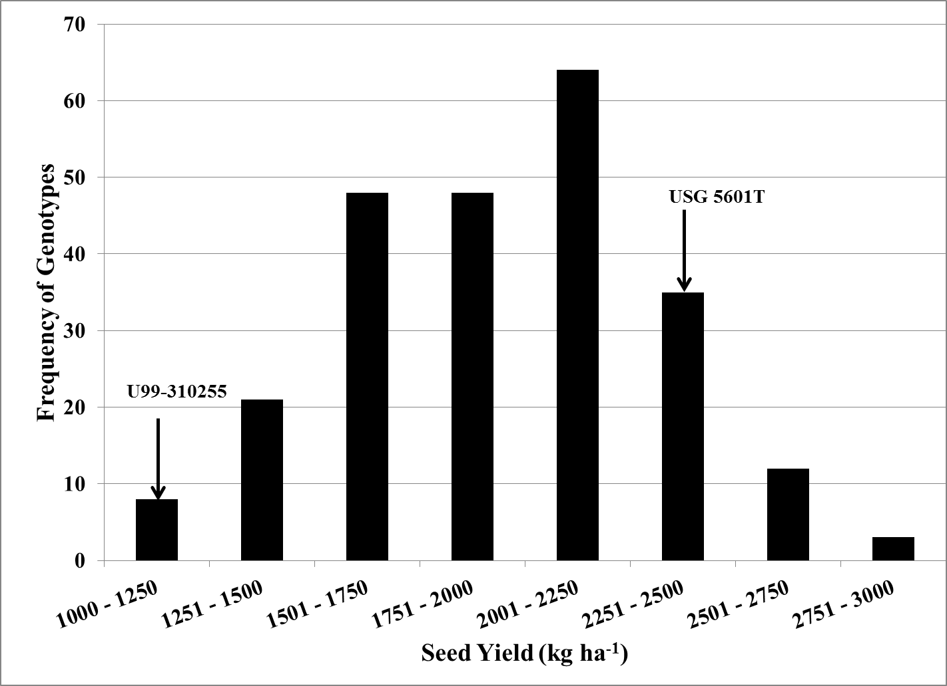
Fig. 3.2: Frequency distribution of seed yield for F4:6 generation grown as replicated two row plots during 2011 in Knoxville, TN and Springfield, TN.

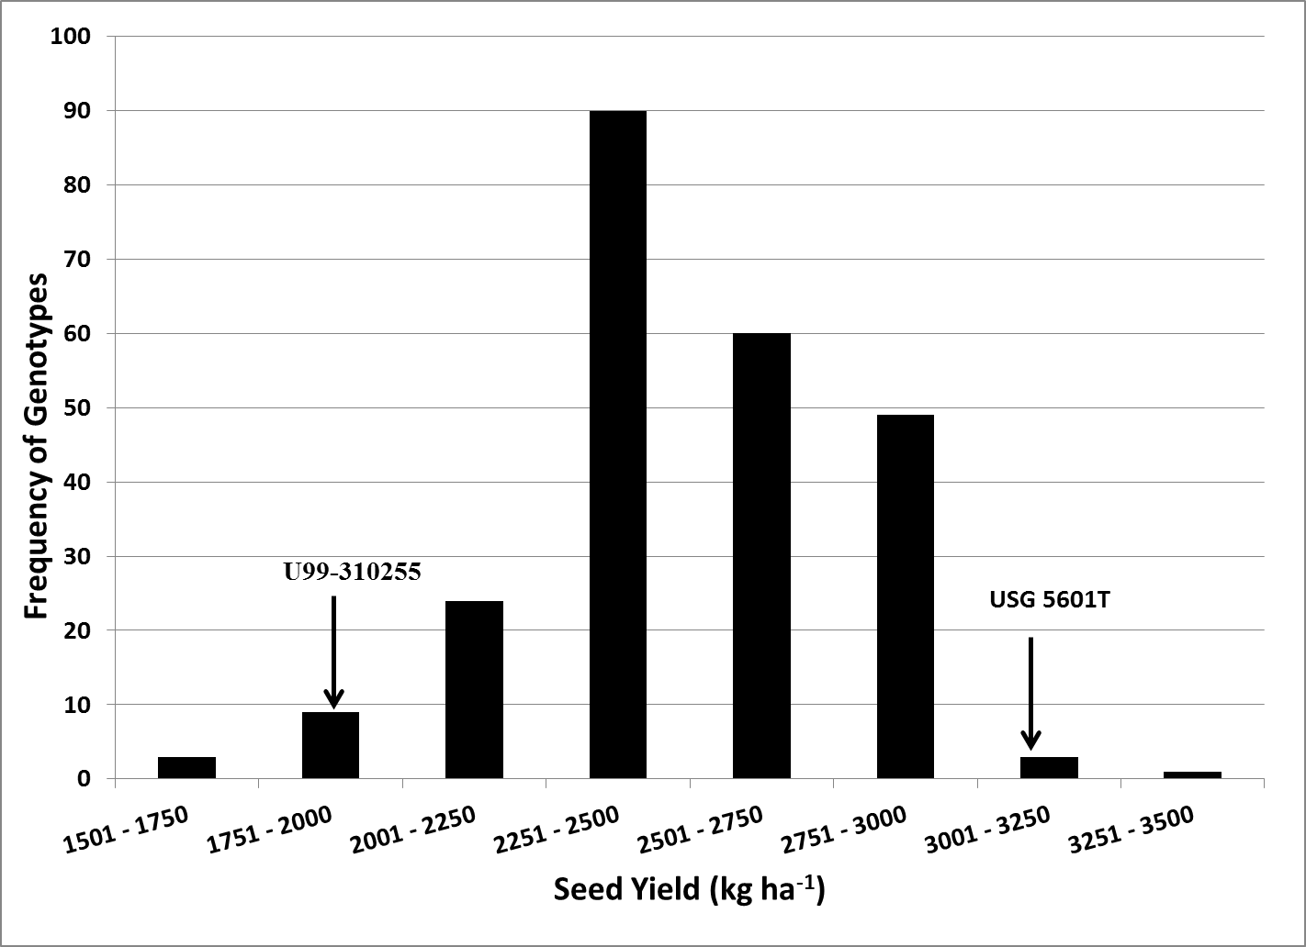
Fig. 3.3 Frequency distribution of seed yield for F_{4:7} generation grown as replicated two row plots during 2011 in Knoxville, TN, Springfield, TN, and Milan, TN.

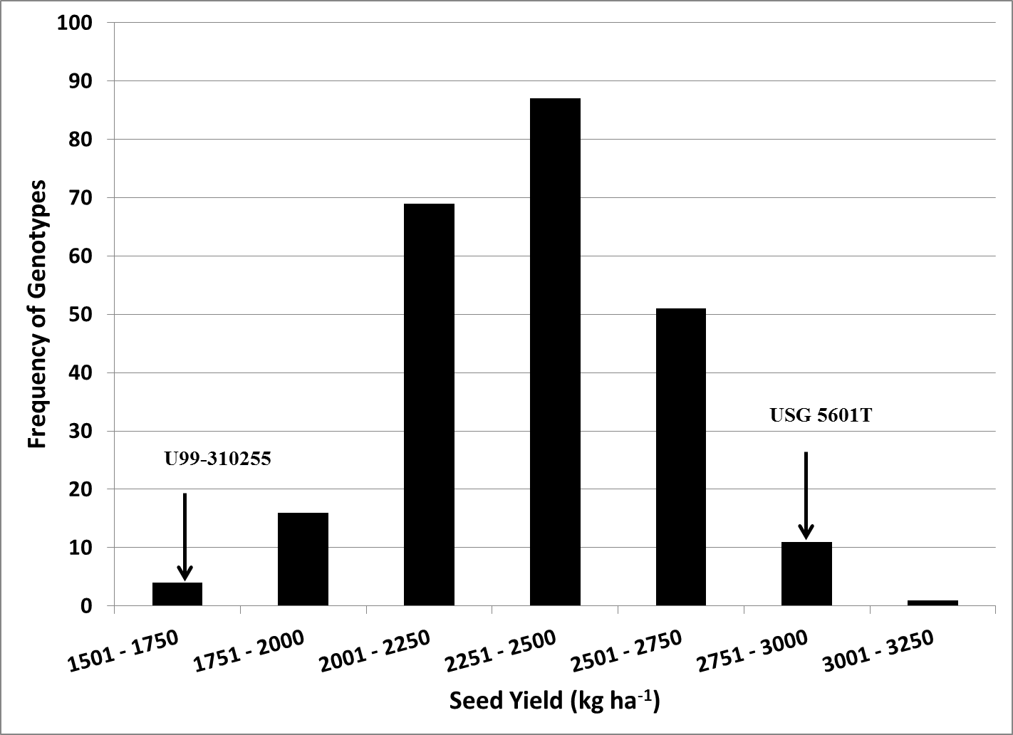
Fig. 3.4 Frequency distribution of seed yield means averaged over two years and five locations for the F_{4:6} and F_{4:7} generations.

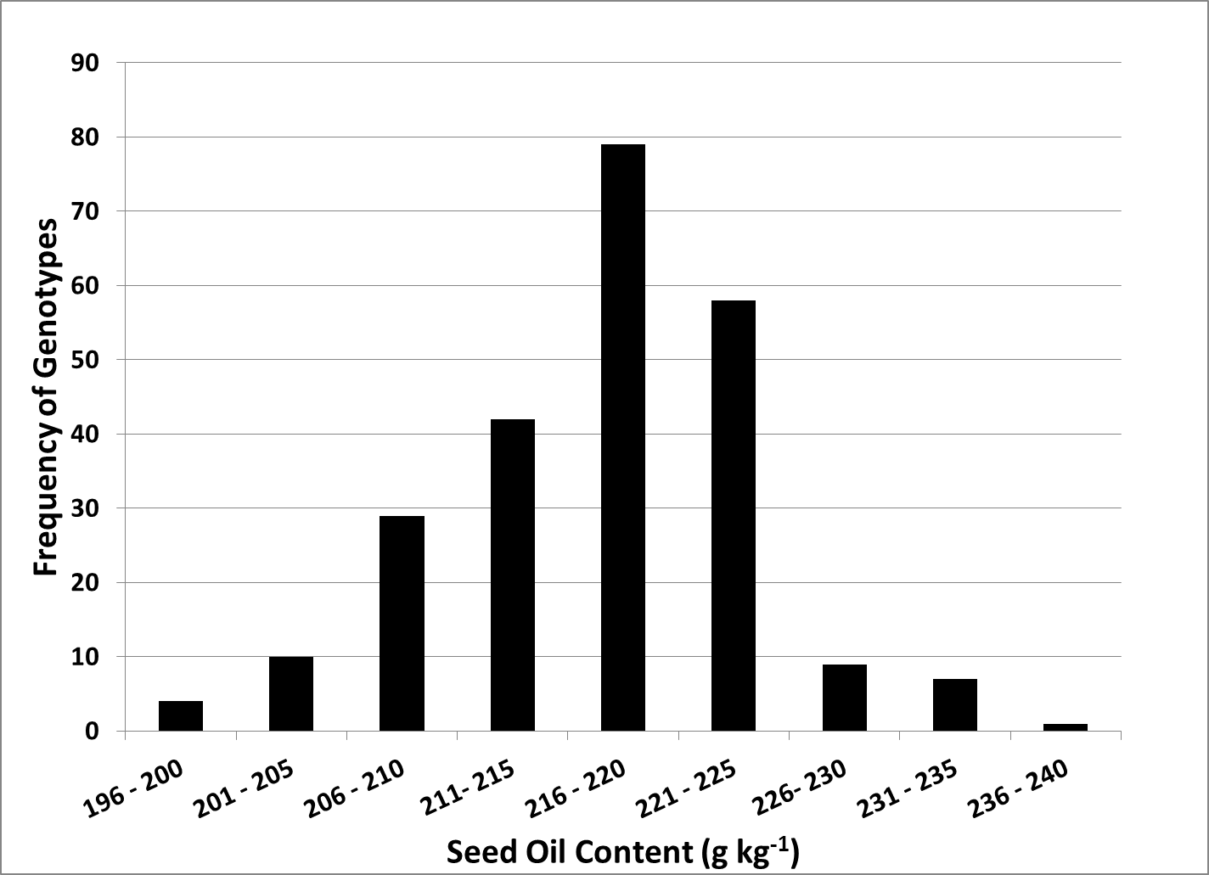
Fig. 3.5 Frequency distribution of seed oil concentration for F_{4:5} generation grown as unreplicated plant rows in Knoxville, TN in 2009.

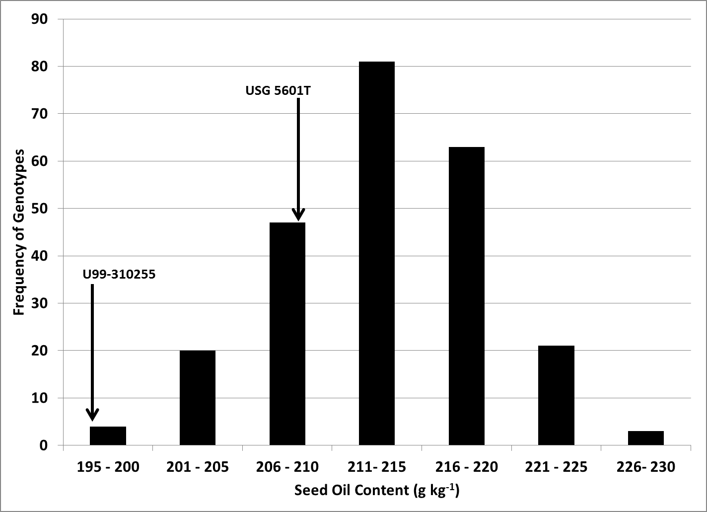
Fig. 3.6 Frequency distribution of seed oil concentration means for F_{4:6} generation grown as replicated two row plots in Knoxville, TN and Springfield, TN in 2010.

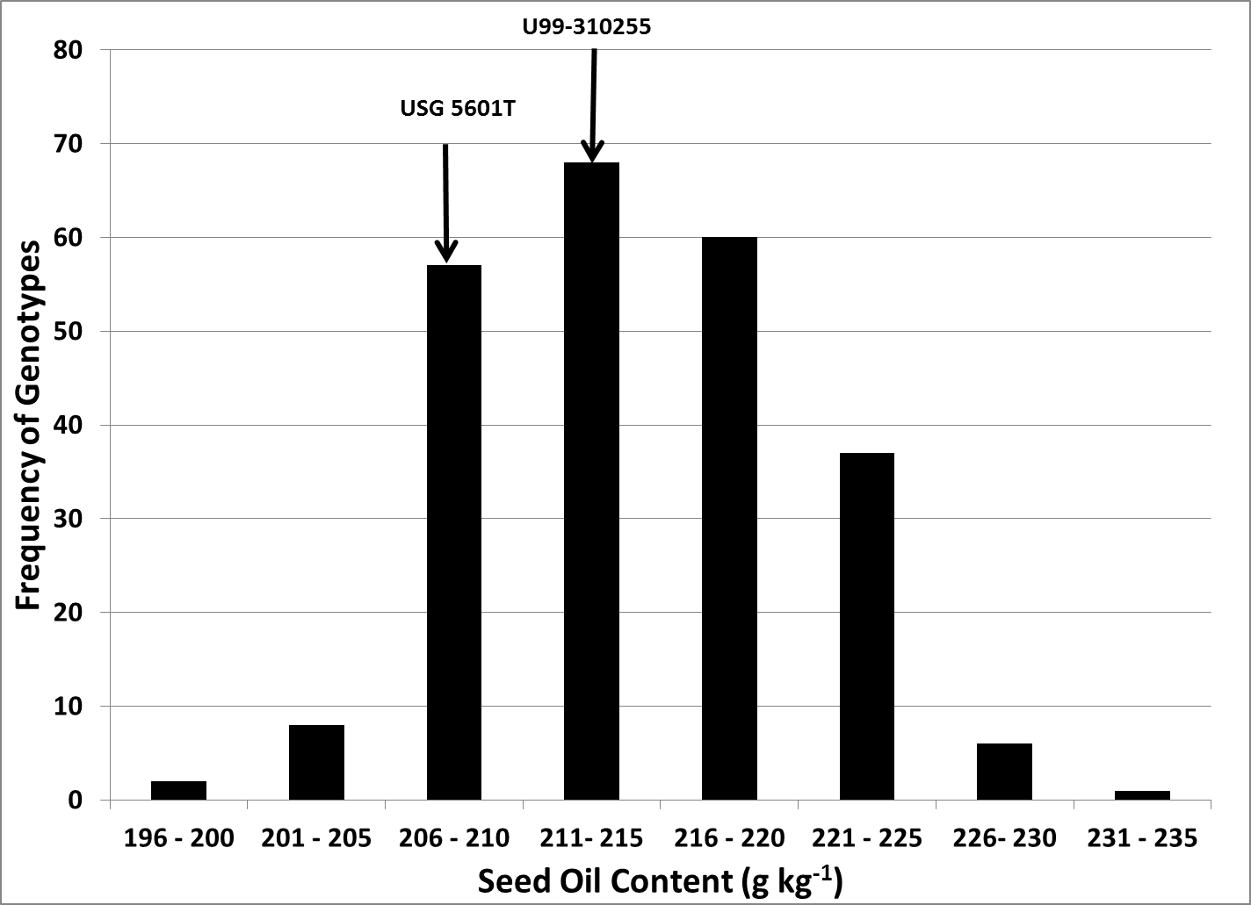
Fig. 3.7 Frequency distribution of seed oil concentration means of F_{4:7} generation grown as replicated two row plots in Knoxville, TN, Springfield, TN, and Milan, TN in 2011.

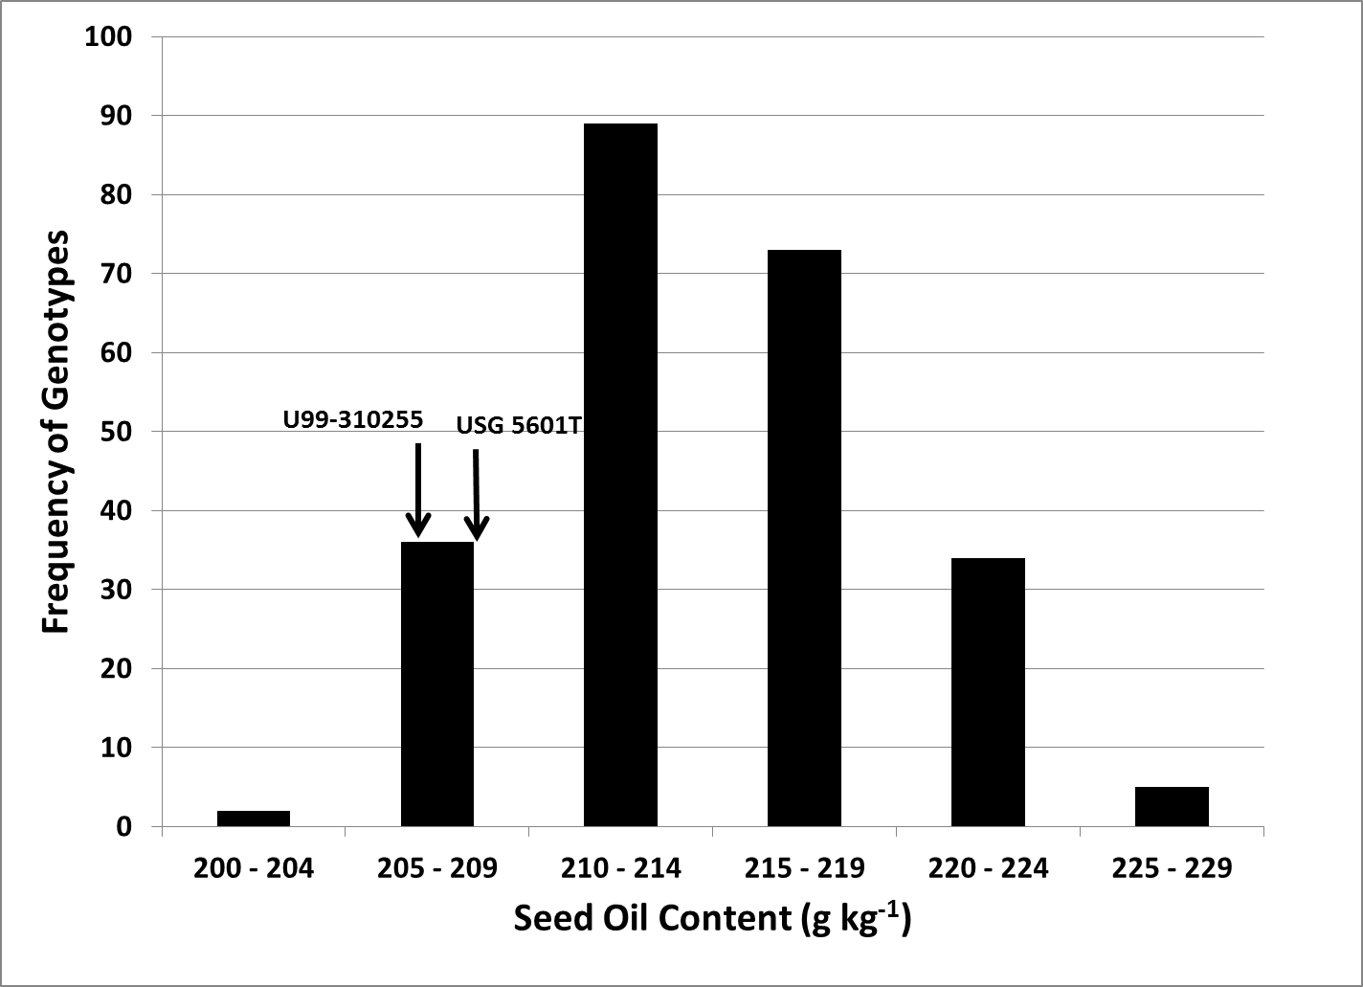
Fig. 3.8 Frequency distribution of seed oil concentration means for the F_{4:6} and F_{4:7} generations averaged over two years and five environments.

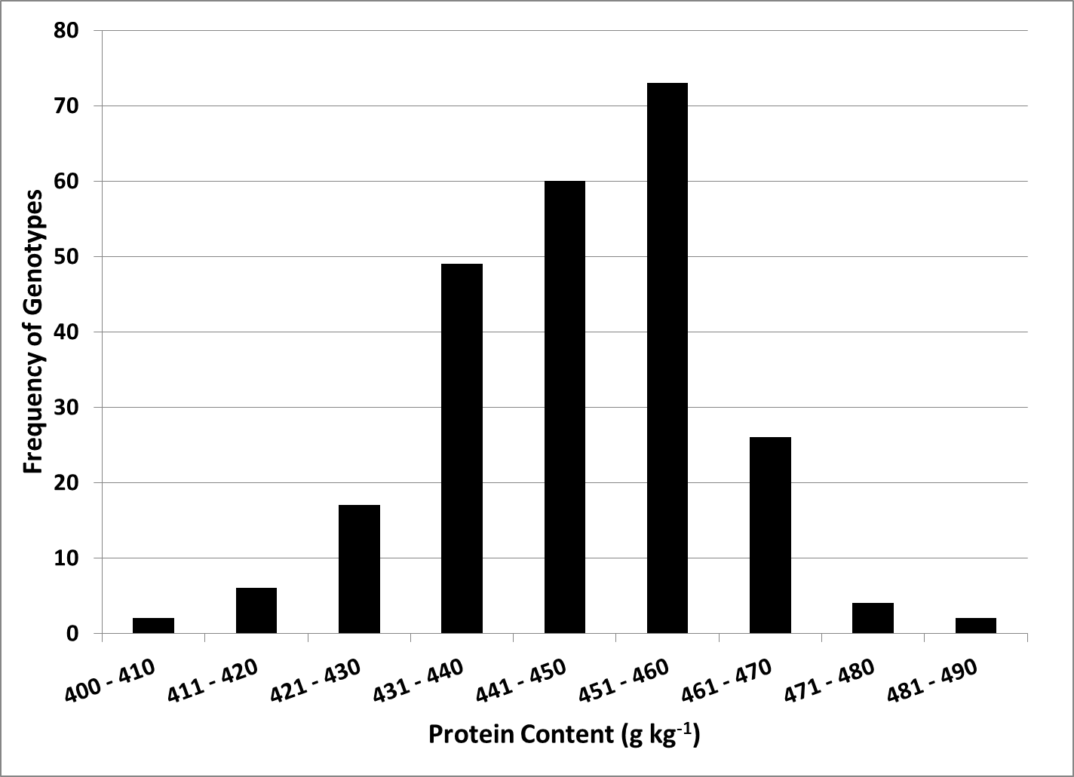
Fig. 3.9 Frequency distribution of seed protein concentration of the F4:5 generation grown as unreplicated plant rows in Knoxville, TN in 2009.

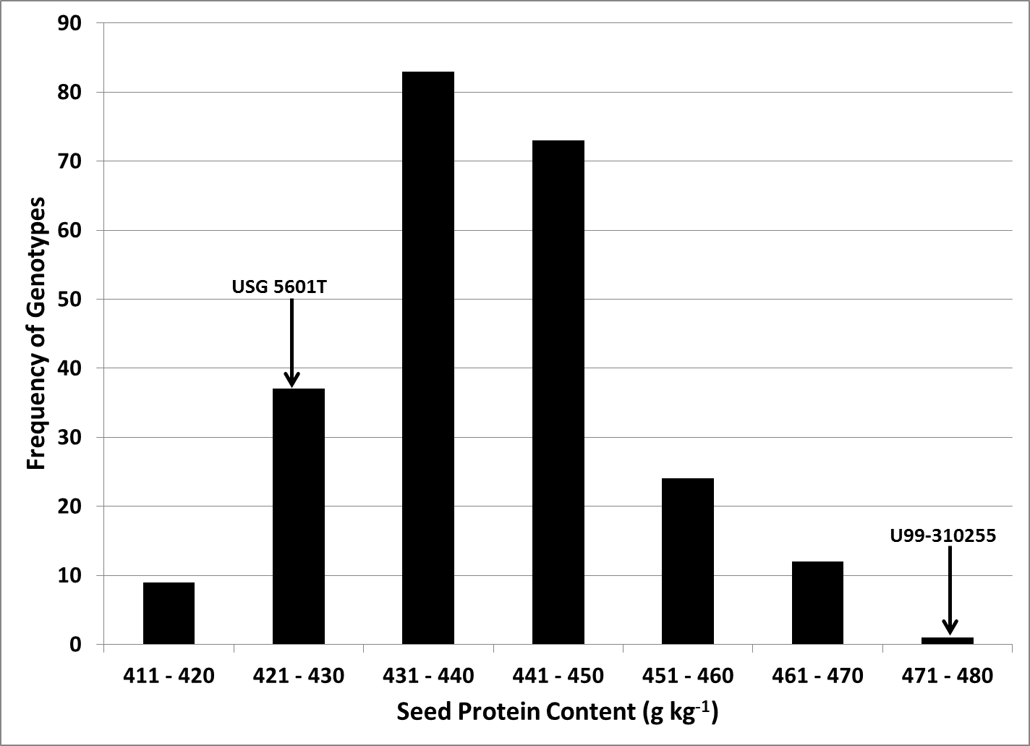
Fig. 3.10 Frequency distribution of seed protein concentration means of the F_{4:6} generation grown as replicated two row plots in Knoxville, TN and Springfield, TN.

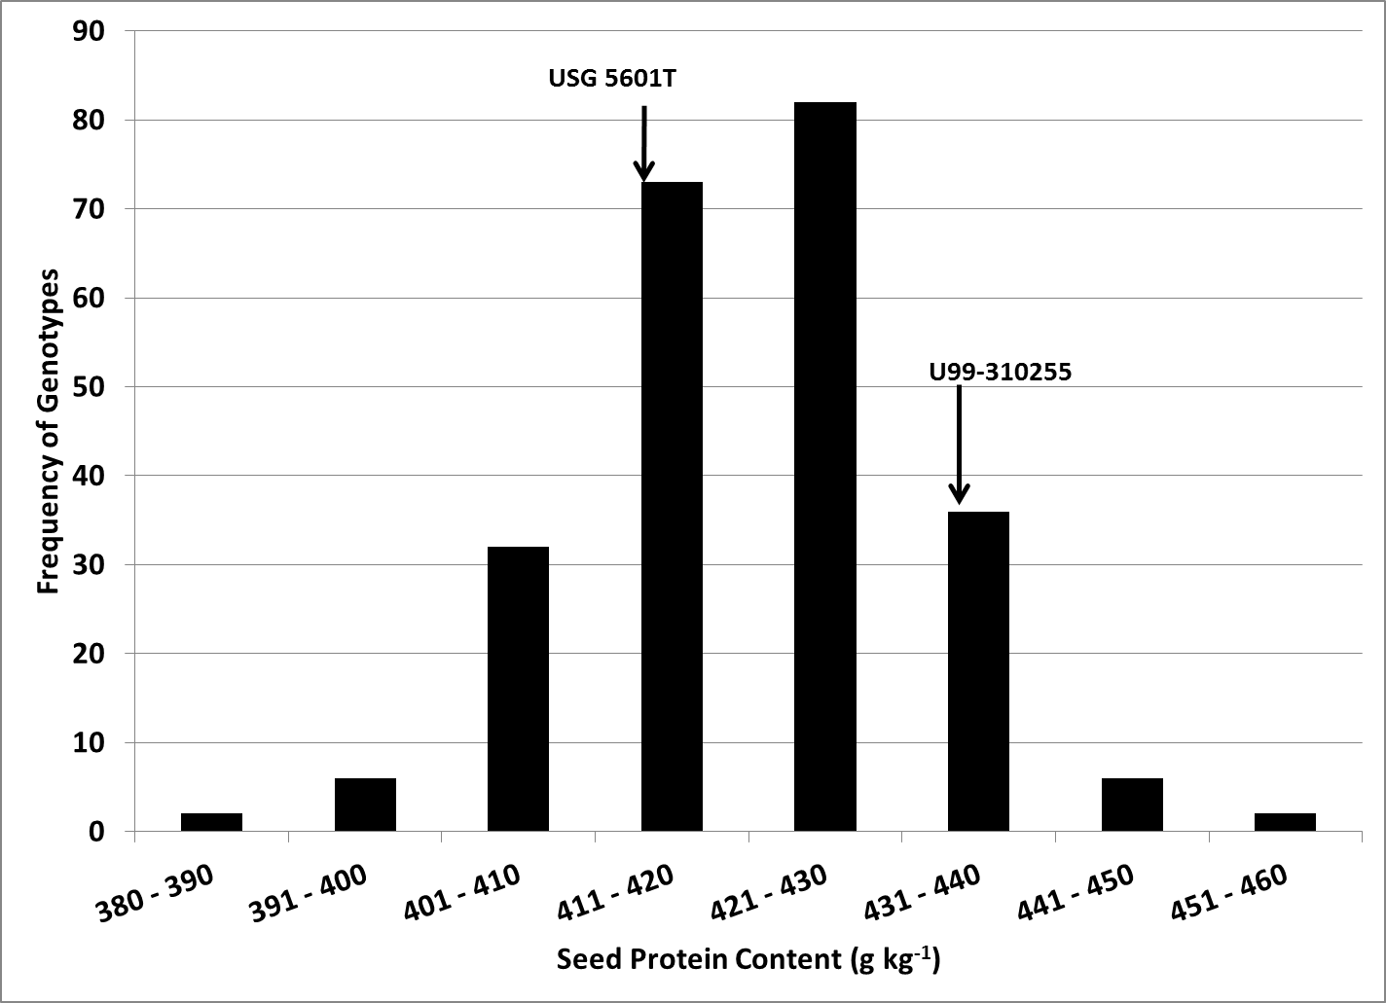
Fig. 3.11 Frequency distribution of seed protein concentration means of the F_{4:7} generation grown as replicated two row plots in Knoxville, TN, Springfield, TN, and Milan, TN in 2011.

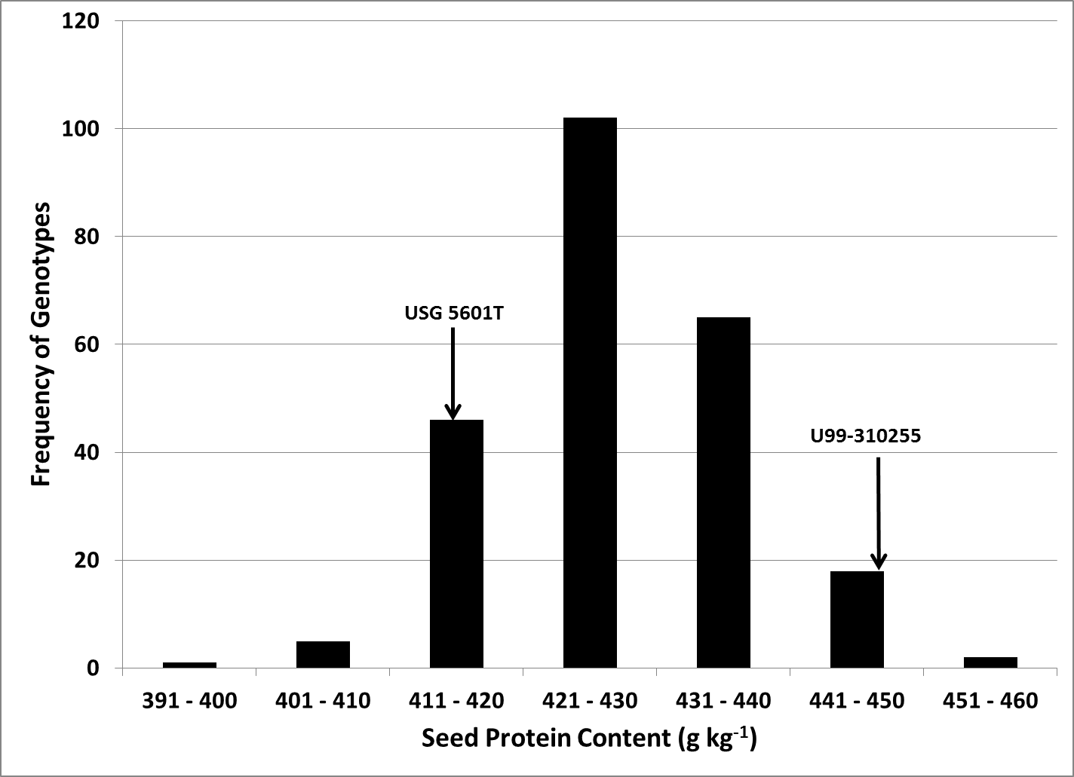
Fig. 3.12 Frequency distribution of seed protein concentration means for F_{4:6} and F_{4:7} generations averaged over two years and five locations.

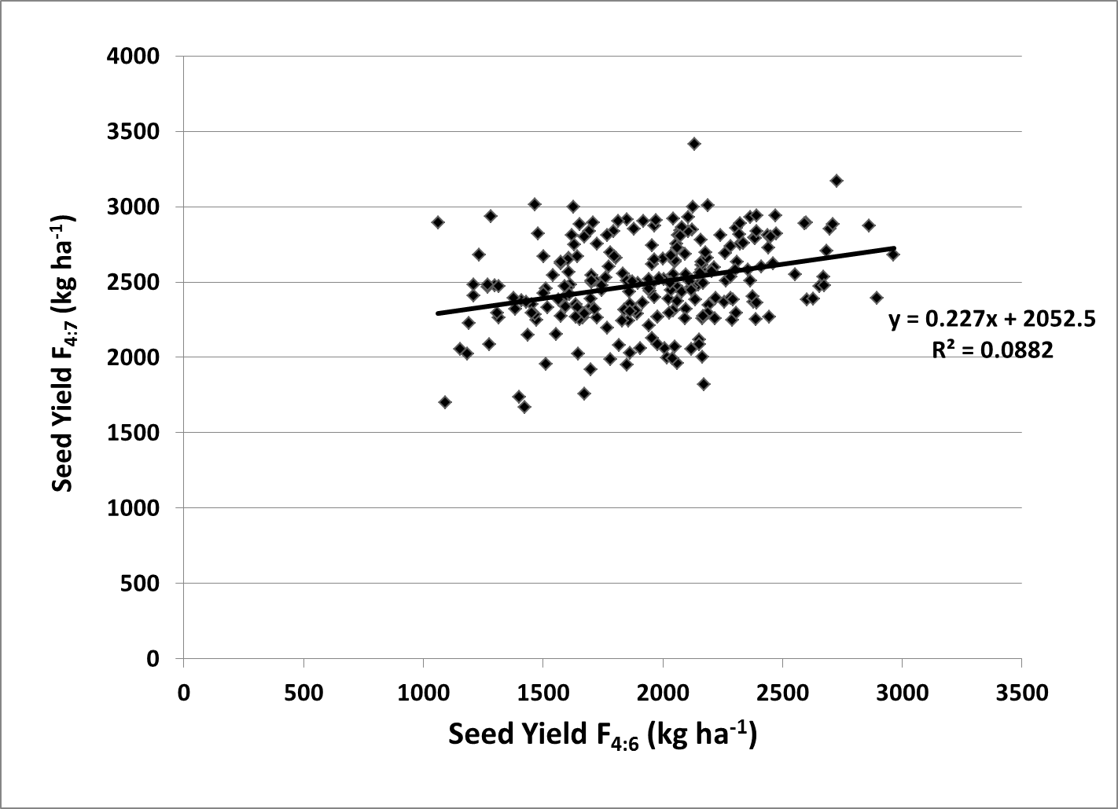
Fig. 3.13 Parent-offspring regression for mean seed yield of the F4:6 and F4:7 generation.

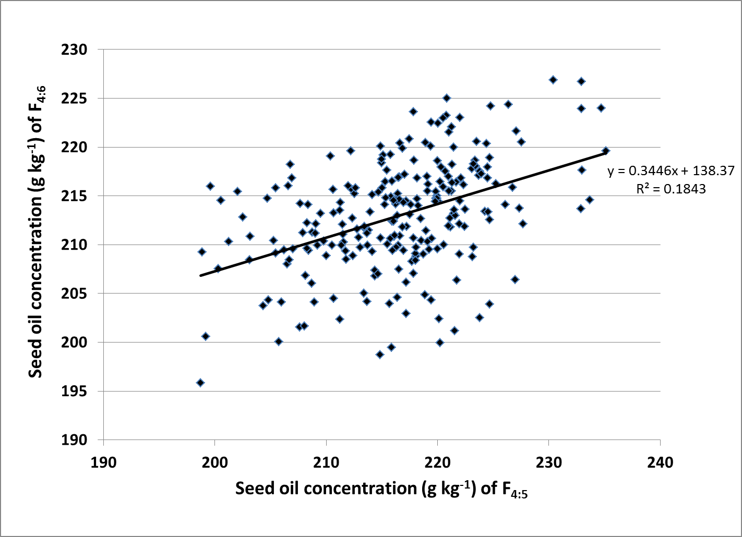
Fig. 3.14 Parent-offspring regression for mean seed oil concentration of F4:5 and F4:6 generations.

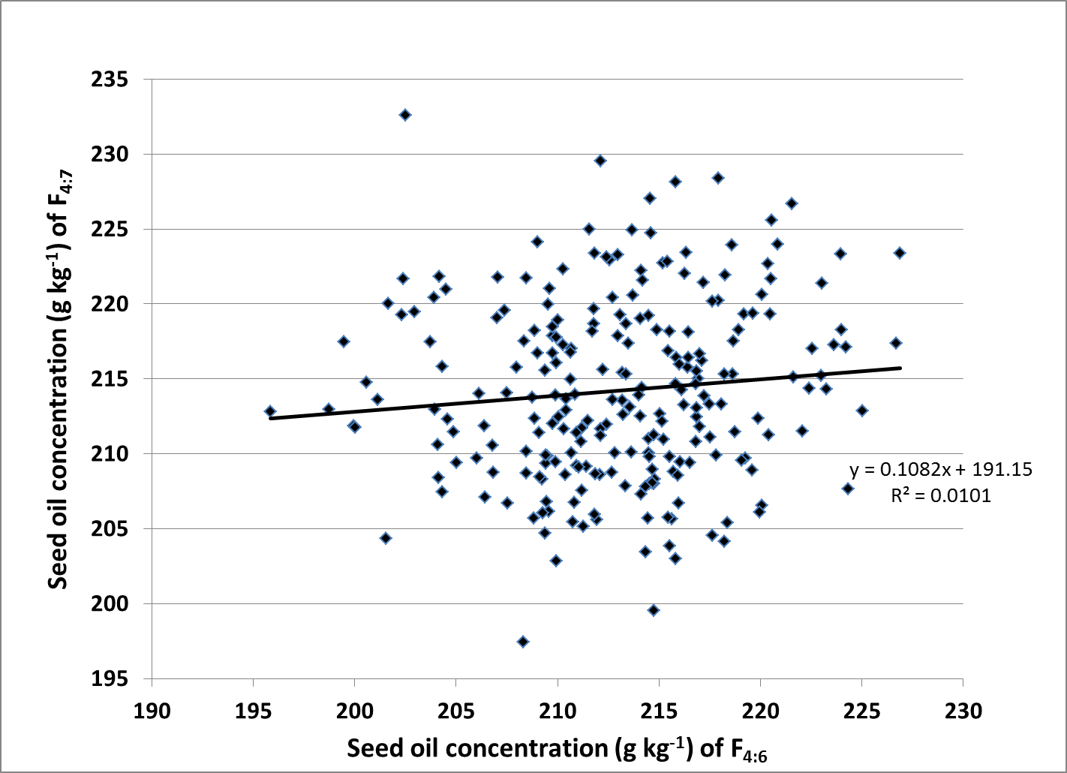
Fig. 3.15 Parent-offspring regression for mean seed oil concentration of F4:6 and F4:7 generations.

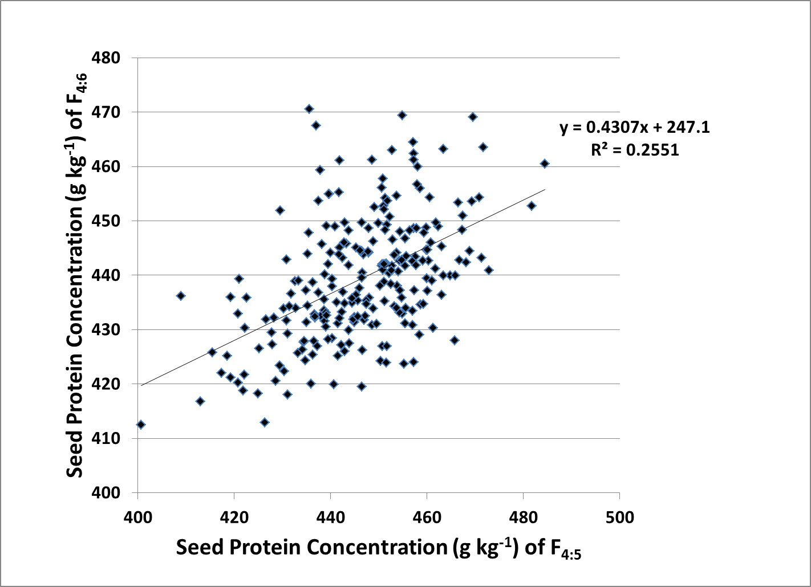
Fig. 3.16 Parent-offspring regression for mean seed protein concentration of F_{4:5} and F_{4:6} generations.

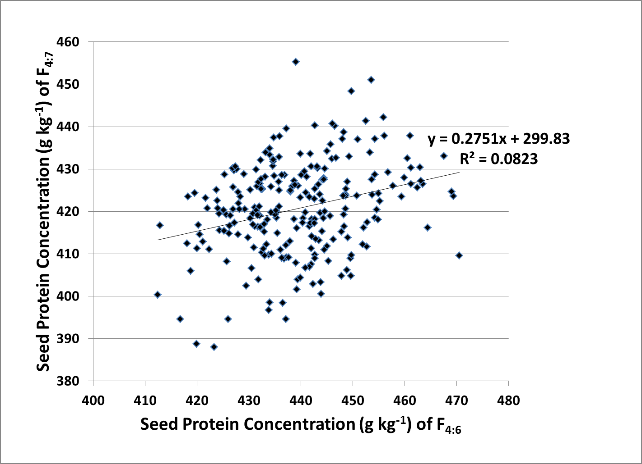
Fig. 3.17 Parent-offspring regression for mean seed protein concentration of F_{4:6} and F_{4:7} generation.

Table 3.1 Observed seed yield means of selected F_{4:6} and F_{4:7} RILs, F_{4:7} population mean, realized genetic gain, predicted genetic gain, and realized heritability of seed yield for each selection intensity.
Selection Intensity (%) | Observed Means of F_{4:6} Selected RILs | Observed Means of F_{4:7} Selected RILs | F_{4:7} Population Mean | Realized Genetic Gain | Predicted Genetic Gain | Realized Heritability
 |  | (kg ha⁻¹)
5 | 2731.9 | 2650.0 | 2491.1 | 158.9 | 313.7 | 0.90
10 | 2604.6 | 2694.8 | 2491.1 | 203.7 | 266.5 | 1.00
15 | 2526.5 | 2666.8 | 2491.1 | 175.7 | 236.0 | 1.24
20 | 2469.1 | 2643.4 | 2491.1 | 152.3 | 213.2 | 1.33

Table 3.2 Seed yield means for top 20% of F_{4:6} lines with mean seed yield for F_{4:7} generation and agronomic data.
Line | F_{4:6} Mean Seed Yield | F_{4:7} Mean Seed yield | Days to Maturity | Lodging Score | Height
 | kg ha⁻¹† |  |  |  | cm
56U99-021 | 2963.7 | 2678.3^{AN} | 114 | 1 | 69
56U99-071 | 2893.8 | 2393.4^{AN} | 110 | 2 | 64
56U99-244 | 2874.6 | 2870.1^{AC} | 114 | 2 | 71
56U99-232 | 2727.5 | 3169.6^{AA} | 113 | 2 | 82
56U99-223 | 2709.2 | 2885.3^{AB} | 116 | 2 | 65
56U99-107 | 2698.7 | 2851.7^{AC} | 111 | 2 | 52
56U99-006 | 2685.5 | 2705.6^{AN} | 112 | 2 | 58
56U99-075 | 2675.5 | 2479.1^{AN} | 111 | 2 | 55
56U99-027 | 2670.8 | 2536.1^{AN} | 111 | 2 | 52
56U99-014 | 2653.3 | 2471.1^{AN} | 110 | 2 | 72
56U99-170 | 2630.0 | 2386.9^{AN} | 112 | 2 | 75
56U99-052 | 2600.7 | 2382.8^{AN} | 111 | 2 | 69
56U99-125 | 2598.5 | 2894.7^{BB} | 115 | 2 | 52
56U99-133 | 2593.3 | 2888.0^{BB} | 111 | 2 | 70
56U99-051 | 2551.3 | 2550.5^{BN} | 106 | 2 | 60
56U99-029 | 2475.5 | 2820.2^{BD} | 111 | 2 | 59
56U99-239 | 2472.1 | 2940.8^{BA} | 119 | 2 | 69
56U99-035 | 2460.0 | 2621.3^{BN} | 114 | 2 | 68
56U99-225 | 2451.4 | 2802.1^{BN} | 103 | 2 | 67
56U99-099 | 2442.9 | 2269.5^{BN} | 112 | 2 | 61

Table 3.2
Line | F_{4:6} Mean Seed Yield | F_{4:7} Mean Seed yield | Days to Maturity | Lodging Score | Height
 | kg ha⁻¹† |  |  |  | cm
56U99-177 | 2442.4 | 2728.3^{BN} | 113 | 2 | 76
56U99-109 | 2436.5 | 2811.1^{BD} | 112 | 2 | 72
56U99-229 | 2410.2 | 2600.3^{BN} | 114 | 2 | 69
56U99-123 | 2393.6 | 2937.9^{BA} | 112 | 2 | 58
56U99-216 | 2390.9 | 2359.6^{CN} | 112 | 2 | 67
56U99-155 | 2390.4 | 2838.5^{CC} | 115 | 2 | 66
56U99-234 | 2388.7 | 2253.5^{CN} | 110 | 2 | 59
56U99-110 | 2385.5 | 2788.3^{CD} | 111 | 2 | 55
56U99-068 | 2382.0 | 2794.6^{CD} | 112 | 2 | 68
56U99-076 | 2380.2 | 2364.6^{CN} | 110 | 2 | 63
56U99-082 | 2374.4 | 2402.6^{CN} | 111 | 2 | 66
56U99-102 | 2366.9 | 2507.7^{CN} | 110 | 2 | 52
56U99-038 | 2366.7 | 2932.2^{CA} | 111 | 2 | 60
USG 5601T (P1) | 2359.5 | 3090.4 | 116 | 2 | 68
56U99-057 | 2354.9 | 2579.6^{CN} | 112 | 2 | 72
56U99-158 | 2337.3 | 2755.7^{CN} | 109 | 2 | 59
56U99-066 | 2323.5 | 2754.1^{CN} | 113 | 2 | 59
56U99-185 | 2322.1 | 2888.5^{DB} | 112 | 2 | 50
56U99-237 | 2319.1 | 2817.4^{DD} | 115 | 2 | 86
56U99-045 | 2305.8 | 2855.8^{DN} | 114 | 2 | 58

Table 3.2
Line | F_{4:6} Mean Seed Yield | F_{4:7} Mean Seed yield | Days to Maturity | Lodging Score | Height
 | kg ha⁻¹† |  |  |  | cm
56U99-164 | 2305.5 | 2294.6^{DN} | 112 | 2 | 55
56U99-032 | 2303.5 | 2582.3^{DN} | 113 | 2 | 73
56U99-243 | 2291.9 | 2380.5^{DN} | 112 | 2 | 78
56U99-023 | 2291.4 | 2247.5^{DN} | 111 | 2 | 72
56U99-171 | 2285.0 | 2533.7^{DN} | 111 | 2 | 47
56U99-127 | 2284.0 | 2395.0^{DN} | 107 | 2 | 56
56U99-025 | 2282.5 | 2736.3^{DN} | 112 | 2 | 58
56U99-136 | 2263.3 | 2510.3^{DN} | 112 | 2 | 52
U99-310255 (P2) | 1123.7 | 1898.5 | 92 | 3 | 71
†Superscript of A, B, C, and D represent top 5, 10, 15, and 20% of F_{4:6} (first superscript) and F_{4:7} (second superscript) seed yield. Superscript of N in either location means outside of top 20% for seed yield.
P1 and P2 designate female parent and male parent respectively.

Table 3.3 Observed seed oil concentration means of selected F_{4:6} and F_{4:7} RILs, F_{4:7} population mean, realized genetic gain, and predicted genetic gain, and realized heritability of seed oil concentration for each selection intensity.
Selection Intensity (%) | Observed Means of F_{4:6} Selected RILs | Observed Means of F_{4:7} Selected RILs | F_{4:7} Population Mean | Realized Genetic Gain | Predicted Genetic Gain | Realized Heritability
 | g kg⁻¹
5 | 224.2 | 217.1 | 214.2 | 2.9 | 6.7 | 0.37
10 | 222.6 | 217.7 | 214.2 | 3.5 | 5.7 | 0.49
15 | 221.4 | 216.6 | 214.2 | 2.4 | 5.0 | 0.43
20 | 220.6 | 216.0 | 214.2 | 1.8 | 4.5 | 0.39

Table 3.4 Seed oil concentration means for top 20% of F_{4:6} lines with mean seed oil concentration for F_{4:7} generation and agronomic data.
Line | F_{4:6} Mean Seed Oil Concentration | F_{4:7} Mean Seed Oil Concentration | Days to Maturity | Lodging Score | Height
 | g kg⁻¹† |  |  |  | cm
56U99-151 | 226.9 | 223.4^{AB} | 111 | 2 | 73
56U99-048 | 226.7 | 217.3^{AN} | 111 | 2 | 53
56U99-025 | 225.0 | 212.9^{AN} | 112 | 2 | 58
56U99-187 | 224.3 | 207.6^{AN} | 112 | 2 | 82
56U99-185 | 224.2 | 217.1^{AN} | 112 | 2 | 50
56U99-014 | 224.0 | 218.2^{AN} | 110 | 2 | 72
56U99-011 | 223.9 | 223.3^{AB} | 111 | 2 | 66
56U99-179 | 223.6 | 217.3^{AN} | 112 | 2 | 62
56U99-044 | 223.2 | 214.3^{AN} | 112 | 2 | 60
56U99-074 | 223.0 | 221.4^{AC} | 112 | 2 | 69
56U99-059 | 223.0 | 215.2^{AN} | 111 | 2 | 63
56U99-027 | 222.6 | 217.0^{AN} | 111 | 2 | 52
56U99-189 | 222.4 | 214.4^{BN} | 110 | 2 | 68
56U99-079 | 222.1 | 211.5^{BN} | 112 | 2 | 86
56U99-082 | 221.6 | 215.1^{BN} | 111 | 2 | 66
56U99-083 | 221.6 | 226.7^{BA} | 107 | 2 | 52
56U99-024 | 220.8 | 224.0^{BA} | 107 | 2 | 70
56U99-108 | 220.5 | 225.6^{BA} | 111 | 2 | 58
56U99-231 | 220.5 | 221.7^{BC} | 113 | 2 | 63
56U99-164 | 220.5 | 219.3^{BN} | 112 | 2 | 55
Table 3.4
Line | F_{4:6} Mean Seed Oil Concentration | F_{4:7} Mean Seed Oil Concentration | Days to Maturity | Lodging Score | Height
 | g kg⁻¹† |  |  |  | cm
56U99-118 | 220.4 | 211.3^{BN} | 110 | 2 | 77
56U99-159 | 220.4 | 222.7^{BC} | 111 | 2 | 75
56U99-160 | 220.1 | 220.6^{BD} | 106 | 1 | 46
56U99-168 | 220.1 | 206.5^{BN} | 113 | 2 | 82
56U99-177 | 220.0 | 206.1^{CN} | 113 | 2 | 76
56U99-241 | 219.9 | 212.3^{CN} | 116 | 2 | 88
56U99-144 | 219.6 | 219.4^{CN} | 112 | 2 | 66
56U99-041 | 219.6 | 208.9^{CN} | 111 | 2 | 62
56U99-229 | 219.3 | 209.7^{CN} | 114 | 2 | 69
56U99-022 | 219.2 | 219.3^{CN} | 111 | 2 | 68
56U99-244 | 219.1 | 209.6^{CN} | 114 | 2 | 71
56U99-070 | 218.9 | 218.3^{CN} | 106 | 2 | 61
56U99-095 | 218.7 | 211.4^{CN} | 115 | 2 | 69
56U99-065 | 218.6 | 217.5^{CN} | 106 | 2 | 66
56U99-157 | 218.6 | 215.3^{CN} | 111 | 2 | 64
56U99-131 | 218.6 | 223.9^{CB} | 111 | 2 | 54
56U99-035 | 218.4 | 205.4^{DN} | 114 | 2 | 68
56U99-072 | 218.3 | 221.9^{DC} | 107 | 2 | 69
56U99-137 | 218.2 | 204.1^{DN} | 115 | 2 | 52
56U99-234 | 218.2 | 215.3^{DN} | 110 | 2 | 59

Table 3.4
Line | F_{4:6} Mean Seed Oil Concentration | F_{4:7} Mean Seed Oil Concentration | Days to Maturity | Lodging Score | Height
 | g kg⁻¹† |  |  |  | cm
56U99-046 | 218.1 | 213.3^{DN} | 112 | 2 | 64
56U99-114 | 217.9 | 220.2^{DD} | 106 | 2 | 53
56U99-186 | 217.9 | 228.4^{DA} | 107 | 2 | 54
56U99-009 | 217.8 | 209.9^{DN} | 113 | 2 | 61
56U99-138 | 217.6 | 220.2^{DD} | 103 | 3 | 62
56U99-158 | 217.6 | 204.6^{DN} | 109 | 2 | 59
56U99-043 | 217.5 | 211.1^{DN} | 112 | 2 | 60
56U99-031 | 217.5 | 213.3^{DN} | 111 | 1 | 47
USG 5601T (P1) | 210.5 | 208.4 | 116 | 2 | 68
U99-310255 (P2) | 195.5 | 213.5 | 92 | 3 | 71
†Superscript of A, B, C, and D represent top 5, 10, 15, and 20% of F_{4:6} (first superscript) and F_{4:7} (second superscript) seed oil concentration. Superscript of N in either location infers outside of top 20% for seed oil concentration.
P1 and P2 designate female parent and male parent respectively.

Table 3.5 Observed seed protein concentration means of selected F_{4:6} and F_{4:7} RILs, F_{4:7} population mean, realized genetic gain, and predicted genetic gain, and realized heritabilities of seed protein concentration for each selection intensity.
Selection Intensity (%) | Observed Means of F_{4:6} Selected RILs | Observed Means of F_{4:7} Selected RILs | F_{4:7} Population Mean | Realized Genetic Gain | Predicted Genetic Gain | Realized Heritability
 | g kg⁻¹
5 | 464.7 | 425.9 | 420.7 | 5.2 | 19.6 | 0.53
10 | 460.7 | 426.8 | 420.7 | 6.1 | 16.7 | 0.58
15 | 458.1 | 427.0 | 420.7 | 6.3 | 14.8 | 0.65
20 | 455.9 | 425.0 | 420.7 | 4.3 | 13.4 | 0.86

Table 3.6 Seed protein concentration means for top 20% of F_{4:6} lines with mean seed protein concentration for F_{4:7} generation and agronomic data.
Line | F_{4:6} Mean Seed Protein Concentration | F_{4:7} Mean Seed Protein Concentration | Days to Maturity | Lodging Score | Height
 | g kg⁻¹† |  |  |  | cm
U99-310255 (P2) | 476.6 | 432.7 | 92 | 3 | 71
56U99-088 | 470.5 | 409.5^{AN} | 97 | 2 | 56
56U99-085 | 469.4 | 423.6^{AN} | 100 | 2 | 55
56U99-143 | 469.1 | 424.7^{AN} | 107 | 2 | 60
56U99-112 | 467.5 | 433.0^{AC} | 98 | 2 | 59
56U99-145 | 464.5 | 416.2^{AN} | 110 | 2 | 63
56U99-091 | 463.5 | 426.5^{AN} | 95 | 2 | 64
56U99-192 | 463.2 | 427.2^{AN} | 110 | 2 | 58
56U99-174 | 463.0 | 430.4^{AD} | 98 | 2 | 47
56U99-141 | 462.4 | 425.7^{AN} | 112 | 2 | 58
56U99-180 | 461.2 | 430.2^{AD} | 107 | 2 | 54
56U99-149 | 461.2 | 426.5^{AN} | 106 | 2 | 58
56U99-122 | 461.1 | 437.8^{AA} | 92 | 2 | 68
56U99-163 | 460.5 | 432.5^{BC} | 107 | 2 | 53
56U99-096 | 459.9 | 427.9^{BN} | 110 | 2 | 64
56U99-064 | 459.4 | 423.5^{BN} | 100 | 2 | 65
56U99-167 | 457.8 | 426.1^{BN} | 98 | 2 | 45
56U99-146 | 456.8 | 429.3^{BD} | 111 | 2 | 64
56U99-043 | 456.1 | 437.9^{BA} | 112 | 2 | 60

Table 3.6
Line | F_{4:6} Mean Seed Protein Concentration | F_{4:7} Mean Seed Protein Concentration | Days to Maturity | Lodging Score | Height
 | g kg⁻¹† |  |  |  | cm
56U99-019 | 455.9 | 442.2^{BA} | 113 | 2 | 58
56U99-073 | 455.2 | 422.4^{BN} | 97 | 2 | 57
56U99-178 | 455.0 | 424.3^{BN} | 104 | 2 | 67
56U99-204 | 454.9 | 418.0^{BN} | 103 | 2 | 61
56U99-173 | 454.6 | 420.4^{BN} | 104 | 2 | 48
56U99-076 | 454.3 | 428.7^{BN} | 110 | 2 | 63
56U99-016 | 454.3 | 437.1^{CB} | 115 | 2 | 60
56U99-132 | 454.2 | 418.5^{CN} | 103 | 1 | 47
56U99-240 | 453.7 | 423.9^{CN} | 103 | 2 | 55
56U99-184 | 453.7 | 427.5^{CN} | 111 | 2 | 52
56U99-103 | 453.6 | 451.0^{CA} | 112 | 2 | 65
56U99-111 | 453.3 | 433.9^{CB} | 111 | 2 | 62
56U99-117 | 452.8 | 417.4^{CN} | 107 | 2 | 64
56U99-072 | 452.7 | 411.7^{CN} | 107 | 2 | 69
56U99-009 | 452.5 | 441.4^{CA} | 113 | 2 | 61
56U99-090 | 452.1 | 416.2^{CN} | 103 | 2 | 52
56U99-205 | 451.9 | 412.2^{CN} | 106 | 2 | 52
56U99-139 | 450.9 | 437.0^{CB} | 111 | 2 | 50
56U99-070 | 450.8 | 423.7^{DN} | 106 | 2 | 61
56U99-214 | 449.7 | 409.7^{DN} | 106 | 2 | 47

Table 3.6
Line | F_{4:6} Mean Seed Protein Concentration | F_{4:7} Mean Seed Protein Concentration | Days to Maturity | Lodging Score | Height
 | g kg⁻¹† |  |  |  | cm
56U99-235 | 449.7 | 448.4^{DA} | 111 | 2 | 69
56U99-172 | 449.7 | 404.7^{DN} | 107 | 1 | 48
56U99-101 | 449.6 | 408.9^{DN} | 107 | 2 | 68
56U99-046 | 449.3 | 433.0^{DC} | 112 | 2 | 64
56U99-008 | 449.0 | 413.8^{DN} | 110 | 2 | 58
56U99-170 | 449.0 | 427.0^{DN} | 112 | 2 | 75
56U99-196 | 448.9 | 406.1^{DN} | 107 | 2 | 52
56U99-169 | 448.7 | 425.3^{DN} | 106 | 2 | 64
56U99-084 | 448.6 | 424.1^{DN} | 107 | 2 | 55
56U99-181 | 448.6 | 423.7^{DN} | 111 | 2 | 60
USG 5601T (P1) | 426.0 | 411.1 | 116 | 2 | 68
†Superscript of A, B, C, and D represent top 5, 10, 15, and 20% of F_{4:6} (first superscript) and F_{4:7} (second superscript) seed oil concentration. Superscript of N in either location infers outside of top 20% for seed oil concentration.
P1 and P2 designate female parent and male parent respectively.

Table 3.7 Correlations between seed oil concentration, seed protein concentration, and seed yield when average over two years and five locations.
 | Seed Yield | Seed Oil Concentration | Seed Protein Concentration
Seed Yield |  | 0.30† | 0.05††
Seed Oil Concentration |  |  | -0.52†
† Significant at P<0.01.
†† Non-significant.

References
Bachlava, Eleni, Joseph W. Burton, Cavell Brownie, Sanbao Wang, Jerome Auclair, and Andrea J. Cardinal. 2008. Heritability of oleic acid content in soybean seed oil and its genetic correlation with fatty acid and agronomic traits. Crop Sci. 48: 1764-1772.
Burton, J.W. and C.A. Brim. 1981. Recurrent selection in soybeans. III. Selection for increased percent oil in seeds. Crop Sci. 21:31-34.
Cicek, Mine S., Penyin Chen, M.A. Saghai Maroof, and Glenn R. Buss. 2006. Interrelationships amoung agronomic and seed quality traits in an interspecific soybean recombinant inbred population. Crop Sci. 46:1253-1259.
Hamawaki, Osvaldo, Natal Vello, and Claudinei Didone. 2000. Improvement in genetic characteristics and oil yield of selected soybean progenies from octuplet crosses. Genetics and Molecular Biology 23:4 855-864.
Jaureguy, Luciano M., Pengyin Chen, and Andrew M. Scaboo. 2011. Heritability and correlations among food-grade traits in soybean. Plant Breeding. 130:647-652.
Lee, S.H, M.A. Bailey, M.A.R. Mian, T.E. Carter, Jr., E.R. Shipe, D.A. Ashley, W.A. Parrott, R.S. Hussey, and H. R. Boerma. 1996. RFLP loci associated with soybean seed protein and oil content across populations and locations. Theor. Appl. Genet. 93:649-657.
Li, Hongxia and Joseph W. Burton. 2002. Selecting seed density to increase indirectly soybean seed protein concentration. Corp Sci. 42: 393-398.
Nyquist, Wymen E. 1991.Estimation of heritability and prediction of selection response in plant populations, in Critical Review in Plant Science 10:3 235-322.
Pantalone, Vincent R., Joseph W. Burton, and Thomas E. Carter, Jr. 1996. Soybean fibrous root heritability and genotypic correlations with agronomic and seed quality traits. Crop Sci. 36:1120:1125.
Pazdernik, D.L., L.L. Harmand, J.H. Orf, and F. Clotaire. 1996. Comparison of field methods for selection of protein and oil content in soybean. Can. J. Plant Sci. 46:721-725.
Weaver, D. B. and J. R. Wilcox. 1982. Heritabilities, gains from selection, and genetic correlations for characteristics of soybeans grown in two row spacings. Crop Sci. 22: 625-629.
"World Statistics." Soy Stats 2011. The American Soybean Association, 2011. Web. Verified: 14 Feb 2012. <http://www.soystats.com/2011/Default-frames.htm>.
PART 4
Conclusions and Further Research
Conclusions
This population of 239 RIL from the cross of USG 5601T × U99-310255 grown as F_{4:5}, F_{4:6,} and F_{4:7} in 2009, 2010, and 2011 respectively, showed a broad range of values for seed protein concentration, seed oil concentration, and seed yield. From these wide ranges, selections for the upper 5, 10, 15, and 20% tails proved to have entries that could be of value to soybean breeding programs.
Broad sense heritability estimates for seed oil concentration, seed protein concentration, and seed yield were calculated to be 0.65, 0.78, and 0.38 respectively when averaged over two years (2010 and 2011) and five locations. These estimates along with their correlations proved to be very insightful to the underlying genetic potential for the entries in this test. The correlations between these traits, though they are only for this population, suggest that simultaneous selections for increased seed yield and seed protein concentration should be possible. They also suggest that although a negative correlation between seed protein and seed oil concentration was observed, it is slightly lower than the correlation normally found
Genetic gain was achieved for seed protein concentration, seed oil concentration, and seed yield. Though some of the improvements did affect other traits, some entries showed promise if selection would be done for two traits, while providing an acceptable level for the other trait, as is the case when selecting for seed yield and protein concentration. Even more lines though showed improvement when selecting for only one trait, especially when selecting for seed oil concentration. Many of the entries produced means that were actually higher than both parents, meaning the parents had complimentary pairs of alleles that boosted the overall seed oil concentration levels.
Further Research
Further research in this population is warranted in that there are combinations of high producing lines with desirable combinations to producers and processors. With these higher levels of seed protein, seed oil, and seed yield a premium system could be put into effect for reaching target goals for seed oil and seed protein concentration. With the growing world population, more productivity per hectare is going to become the necessity in order for the world to maintain the current growth patterns. Higher values for seed protein and seed oil along with an increase in seed yield could provide the key to supplying the world with the demands of producers and processor of the future.

APPENDIX

Table A.1: Mean seed yield, oil, and protein concentration averaged over two years for a total of five locations along with agronomic data for a population of 239 RIL from the cross of USG 5601T × U99-310255.
Line | Yield | Oil | Protein | Percent Meal | Days to Maturity |  | Lodging Score |  | Height
 | kg ha⁻¹ | g kg⁻¹ |  |  |  |  |  | cm
56U99-232 | 3033.6 | 211.6 | 415.4 | 48.1 | 113 |  | 2 |  | 82
Dillon (CK) | 3011.6 | 204.8 | 406.4 | 46.8 | 120 |  | 2 |  | 65
TN08-109 (CK) | 2989.4 | 215.6 | 383.6 | 44.6 | 119 |  | 2 |  | 64
5002T (CK) | 2960.6 | 215.8 | 396.9 | 46.2 | 110 |  | 2 |  | 73
56U99-081 | 2903.5 | 204.2 | 436.6 | 50.2 | 115 |  | 2 |  | 82
56U99-244 | 2870.1 | 212.5 | 429.6 | 49.8 | 114 |  | 2 |  | 71
USG 5601T (P1) | 2865.5 | 209.0 | 415.7 | 48.1 | 116 |  | 2 |  | 68
56U99-223 | 2831.1 | 210.9 | 422.5 | 48.9 | 116 |  | 2 |  | 65
56U99-107 | 2804.6 | 207.0 | 424.1 | 48.9 | 111 |  | 2 |  | 52
56U99-125 | 2803.6 | 208.0 | 434.6 | 50.2 | 115 |  | 2 |  | 52
56U99-133 | 2797.3 | 211.8 | 419.6 | 48.6 | 111 |  | 2 |  | 70
56U99-239 | 2796.6 | 206.2 | 429.2 | 49.5 | 119 |  | 2 |  | 69
56U99-123 | 2770.4 | 213.8 | 421.0 | 48.9 | 112 |  | 2 |  | 58
56U99-021 | 2766.1 | 211.1 | 437.8 | 50.7 | 114 |  | 1 |  | 69
56U99-038 | 2758.2 | 209.7 | 434.2 | 50.2 | 111 |  | 2 |  | 60
56U99-221 | 2756.1 | 209.7 | 425.6 | 49.2 | 112 |  | 2 |  | 73
56U99-092 | 2729.2 | 212.3 | 430.1 | 49.9 | 112 |  | 2 |  | 71
Osage (CK) | 2716.2 | 203.0 | 429.9 | 49.4 | 117 |  | 2 |  | 72
56U99-185 | 2714.2 | 219.3 | 433.7 | 50.7 | 112 |  | 2 |  | 50
56U99-029 | 2714.1 | 209.6 | 423.7 | 49.0 | 111 |  | 2 |  | 59
56U99-109 | 2708.9 | 205.2 | 434.5 | 50.0 | 112 |  | 2 |  | 72
56U99-155 | 2700.6 | 211.6 | 427.7 | 49.6 | 115 |  | 2 |  | 66
56U99-006 | 2699.4 | 207.2 | 436.9 | 50.4 | 112 |  | 2 |  | 58
56U99-225 | 2694.2 | 216.2 | 422.7 | 49.2 | 103 |  | 2 |  | 67
56U99-045 | 2686.6 | 212.3 | 440.5 | 51.1 | 114 |  | 2 |  | 58
56U99-056 | 2678.3 | 212.7 | 417.1 | 48.4 | 111 |  | 2 |  | 71
56U99-231 | 2673.4 | 221.3 | 414.0 | 48.5 | 113 |  | 2 |  | 63
56U99-068 | 2667.7 | 209.5 | 424.6 | 49.1 | 112 |  | 2 |  | 68
56U99-110 | 2664.3 | 203.5 | 429.2 | 49.3 | 111 |  | 2 |  | 55
56U99-237 | 2651.3 | 211.3 | 418.4 | 48.5 | 115 |  | 2 |  | 86
56U99-041 | 2650.0 | 212.2 | 415.6 | 48.2 | 111 |  | 2 |  | 62
UA 4910 (CK) | 2648.3 | 217.8 | 399.6 | 46.6 | 107 |  | 2 |  | 69
56U99-177 | 2640.3 | 210.4 | 429.3 | 49.7 | 113 |  | 2 |  | 76
56U99-036 | 2636.4 | 211.5 | 422.9 | 49.0 | 112 |  | 2 |  | 73
56U99-158 | 2626.9 | 208.6 | 428.4 | 49.5 | 109 |  | 2 |  | 59
Table A.1
Line | Yield |  | Oil |  | Protein |  | Percent Meal |  | Days to Maturity |  |  | Lodging Score |  |  | Height
 | kg ha⁻¹ |  | g kg⁻¹ |  |  |  |  |  |  |  |  |  |  | cm
56U99-026 |  | 2624.0 |  | 210.0 |  | 432.1 |  | 50.0 |  | 111 |  |  | 2 |  |  | 80
56U99-132 |  | 2621.7 |  | 218.3 |  | 429.5 |  | 50.1 |  | 103 |  |  | 1 |  |  | 47
56U99-018 |  | 2603.8 |  | 216.4 |  | 414.5 |  | 48.3 |  | 111 |  |  | 2 |  |  | 75
56U99-222 |  | 2600.5 |  | 211.2 |  | 424.8 |  | 49.2 |  | 113 |  |  | 2 |  |  | 60
56U99-025 |  | 2596.6 |  | 216.9 |  | 422.6 |  | 49.3 |  | 112 |  |  | 2 |  |  | 58
56U99-208 |  | 2594.1 |  | 207.6 |  | 427.4 |  | 49.3 |  | 114 |  |  | 1 |  |  | 52
56U99-067 |  | 2588.9 |  | 212.8 |  | 425.0 |  | 49.3 |  | 110 |  |  | 2 |  |  | 78
56U99-179 |  | 2587.4 |  | 219.2 |  | 404.1 |  | 47.2 |  | 112 |  |  | 2 |  |  | 62
56U99-200 |  | 2581.0 |  | 208.2 |  | 421.8 |  | 48.7 |  | 111 |  |  | 2 |  |  | 75
56U99-241 |  | 2578.5 |  | 214.7 |  | 420.4 |  | 48.9 |  | 116 |  |  | 2 |  |  | 88
56U99-027 |  | 2577.6 |  | 218.9 |  | 429.1 |  | 50.1 |  | 111 |  |  | 2 |  |  | 52
56U99-035 |  | 2571.6 |  | 209.7 |  | 431.9 |  | 50.0 |  | 114 |  |  | 2 |  |  | 68
56U99-089 |  | 2557.3 |  | 210.7 |  | 430.7 |  | 49.9 |  | 113 |  |  | 2 |  |  | 65
56U99-203 |  | 2553.3 |  | 210.3 |  | 430.9 |  | 49.9 |  | 112 |  |  | 2 |  |  | 63
56U99-051 |  | 2550.7 |  | 211.4 |  | 432.7 |  | 50.1 |  | 106 |  |  | 2 |  |  | 60
56U99-071 |  | 2547.4 |  | 213.4 |  | 422.9 |  | 49.1 |  | 110 |  |  | 2 |  |  | 64
56U99-075 |  | 2544.6 |  | 208.6 |  | 423.9 |  | 49.0 |  | 111 |  |  | 2 |  |  | 55
56U99-229 |  | 2541.8 |  | 212.9 |  | 441.2 |  | 51.2 |  | 114 |  |  | 2 |  |  | 69
56U99-188 |  | 2540.1 |  | 217.4 |  | 431.3 |  | 50.3 |  | 103 |  |  | 1 |  |  | 45
56U99-129 |  | 2537.9 |  | 215.9 |  | 418.0 |  | 48.7 |  | 104 |  |  | 2 |  |  | 52
56U99-238 |  | 2537.4 |  | 209.8 |  | 421.3 |  | 48.7 |  | 112 |  |  | 2 |  |  | 85
56U99-019 |  | 2534.4 |  | 207.2 |  | 446.4 |  | 51.5 |  | 113 |  |  | 2 |  |  | 58
56U99-061 |  | 2530.6 |  | 209.6 |  | 424.8 |  | 49.1 |  | 115 |  |  | 2 |  |  | 71
56U99-014 |  | 2527.2 |  | 220.2 |  | 421.1 |  | 49.3 |  | 110 |  |  | 2 |  |  | 72
56U99-230 |  | 2523.9 |  | 207.8 |  | 429.7 |  | 49.6 |  | 113 |  |  | 2 |  |  | 74
56U99-104 |  | 2519.9 |  | 210.8 |  | 421.9 |  | 48.9 |  | 114 |  |  | 2 |  |  | 72
56U99-028 |  | 2514.4 |  | 206.1 |  | 428.3 |  | 49.4 |  | 112 |  |  | 2 |  |  | 68
56U99-032 |  | 2512.6 |  | 213.3 |  | 402.7 |  | 46.8 |  | 113 |  |  | 2 |  |  | 73
56U99-233 |  | 2511.6 |  | 209.8 |  | 424.2 |  | 49.1 |  | 111 |  |  | 2 |  |  | 66
56U99-057 |  | 2510.4 |  | 209.4 |  | 428.8 |  | 49.6 |  | 112 |  |  | 2 |  |  | 72
56U99-204 |  | 2509.0 |  | 221.5 |  | 429.4 |  | 50.3 |  | 103 |  |  | 2 |  |  | 61
56U99-046 |  | 2501.3 |  | 214.8 |  | 438.0 |  | 50.9 |  | 112 |  |  | 2 |  |  | 64
56U99-130 |  | 2487.5 |  | 210.1 |  | 428.9 |  | 49.6 |  | 113 |  |  | 1 |  |  | 48
56U99-176 |  | 2484.8 |  | 208.7 |  | 437.0 |  | 50.5 |  | 110 |  |  | 2 |  |  | 64
56U99-094 |  | 2481.9 |  | 214.8 |  | 417.9 |  | 48.6 |  | 104 |  |  | 2 |  |  | 64
56U99-054 |  | 2479.2 |  | 207.1 |  | 430.6 |  | 49.7 |  | 115 |  |  | 2 |  |  | 80
56U99-191 |  | 2478.3 |  | 213.9 |  | 414.0 |  | 48.1 |  | 111 |  |  | 2 |  |  | 69
56U99-128 |  | 2475.4 |  | 214.7 |  | 419.0 |  | 48.7 |  | 104 |  |  | 2 |  |  | 54
56U99-059 |  | 2472.7 |  | 217.6 |  | 414.1 |  | 48.3 |  | 111 |  |  | 2 |  |  | 63
Table A.1
Line | Yield |  | Oil |  | Protein |  | Percent Meal |  | Days to Maturity |  |  | Lodging Score |  |  | Height
 | kg ha⁻¹ |  | g kg⁻¹ |  |  |  |  |  |  |  |  |  |  | cm
56U99-168 |  | 2468.5 |  | 211.1 |  | 433.8 |  | 50.3 |  | 113 |  |  | 2 |  |  | 82
56U99-102 |  | 2464.4 |  | 214.0 |  | 418.1 |  | 48.6 |  | 110 |  |  | 2 |  |  | 52
56U99-170 |  | 2461.7 |  | 207.0 |  | 434.3 |  | 50.1 |  | 112 |  |  | 2 |  |  | 75
56U99-118 |  | 2458.8 |  | 214.1 |  | 430.3 |  | 50.0 |  | 110 |  |  | 2 |  |  | 77
56U99-171 |  | 2457.2 |  | 216.8 |  | 425.2 |  | 49.6 |  | 111 |  |  | 2 |  |  | 47
56U99-242 |  | 2453.0 |  | 213.7 |  | 421.3 |  | 48.9 |  | 112 |  |  | 1 |  |  | 52
56U99-037 |  | 2451.7 |  | 207.6 |  | 427.6 |  | 49.4 |  | 116 |  |  | 3 |  |  | 84
56U99-010 |  | 2451.3 |  | 213.4 |  | 431.6 |  | 50.1 |  | 106 |  |  | 2 |  |  | 58
56U99-052 |  | 2449.9 |  | 215.6 |  | 432.1 |  | 50.3 |  | 111 |  |  | 2 |  |  | 69
56U99-040 |  | 2445.5 |  | 209.4 |  | 430.2 |  | 49.7 |  | 111 |  |  | 2 |  |  | 65
56U99-097 |  | 2439.8 |  | 213.1 |  | 416.4 |  | 48.3 |  | 111 |  |  | 2 |  |  | 64
56U99-187 |  | 2436.8 |  | 212.8 |  | 429.1 |  | 49.8 |  | 112 |  |  | 2 |  |  | 82
56U99-227 |  | 2435.8 |  | 208.7 |  | 433.0 |  | 50.0 |  | 113 |  |  | 2 |  |  | 52
56U99-012 |  | 2434.8 |  | 212.7 |  | 430.0 |  | 49.9 |  | 111 |  |  | 2 |  |  | 60
56U99-136 |  | 2434.3 |  | 215.0 |  | 436.1 |  | 50.7 |  | 112 |  |  | 2 |  |  | 52
56U99-161 |  | 2425.6 |  | 218.4 |  | 427.2 |  | 49.9 |  | 104 |  |  | 2 |  |  | 68
56U99-137 |  | 2413.2 |  | 208.5 |  | 433.5 |  | 50.1 |  | 115 |  |  | 2 |  |  | 52
56U99-121 |  | 2412.5 |  | 209.4 |  | 441.6 |  | 51.1 |  | 112 |  |  | 2 |  |  | 75
56U99-044 |  | 2409.8 |  | 217.0 |  | 418.5 |  | 48.8 |  | 112 |  |  | 2 |  |  | 60
56U99-209 |  | 2409.1 |  | 214.7 |  | 420.7 |  | 48.9 |  | 107 |  |  | 2 |  |  | 76
56U99-224 |  | 2401.3 |  | 211.5 |  | 427.7 |  | 49.6 |  | 113 |  |  | 2 |  |  | 55
56U99-087 |  | 2397.3 |  | 212.2 |  | 428.2 |  | 49.7 |  | 112 |  |  | 2 |  |  | 69
56U99-082 |  | 2393.9 |  | 217.1 |  | 421.2 |  | 49.1 |  | 111 |  |  | 2 |  |  | 66
56U99-048 |  | 2391.7 |  | 220.5 |  | 433.1 |  | 50.7 |  | 111 |  |  | 2 |  |  | 53
56U99-138 |  | 2383.4 |  | 219.4 |  | 418.7 |  | 48.9 |  | 103 |  |  | 3 |  |  | 62
56U99-084 |  | 2382.0 |  | 213.6 |  | 431.6 |  | 50.1 |  | 107 |  |  | 2 |  |  | 55
56U99-020 |  | 2378.6 |  | 208.5 |  | 424.3 |  | 49.0 |  | 110 |  |  | 2 |  |  | 80
56U99-196 |  | 2376.2 |  | 217.6 |  | 419.3 |  | 48.9 |  | 107 |  |  | 2 |  |  | 52
56U99-216 |  | 2369.2 |  | 212.4 |  | 442.4 |  | 51.3 |  | 112 |  |  | 2 |  |  | 67
56U99-076 |  | 2368.5 |  | 214.3 |  | 437.2 |  | 50.8 |  | 110 |  |  | 2 |  |  | 63
56U99-127 |  | 2360.8 |  | 212.6 |  | 425.6 |  | 49.4 |  | 107 |  |  | 2 |  |  | 56
56U99-063 |  | 2359.4 |  | 213.5 |  | 420.6 |  | 48.8 |  | 110 |  |  | 2 |  |  | 64
56U99-031 |  | 2357.9 |  | 214.7 |  | 423.9 |  | 49.3 |  | 111 |  |  | 1 |  |  | 47
56U99-181 |  | 2357.1 |  | 209.1 |  | 432.7 |  | 50.0 |  | 111 |  |  | 2 |  |  | 60
56U99-101 |  | 2355.4 |  | 216.2 |  | 422.5 |  | 49.2 |  | 107 |  |  | 2 |  |  | 68
56U99-243 |  | 2353.2 |  | 211.3 |  | 421.6 |  | 48.8 |  | 112 |  |  | 2 |  |  | 78
56U99-086 |  | 2351.7 |  | 210.2 |  | 430.7 |  | 49.8 |  | 112 |  |  | 2 |  |  | 70
56U99-015 |  | 2346.2 |  | 209.9 |  | 422.0 |  | 48.8 |  | 111 |  |  | 2 |  |  | 71
56U99-043 |  | 2345.6 |  | 213.1 |  | 443.5 |  | 51.5 |  | 112 |  |  | 2 |  |  | 60
Table A.1
Line | Yield |  | Oil |  | Protein |  | Percent Meal |  | Days to Maturity |  |  | Lodging Score |  |  | Height
 | kg ha⁻¹ |  | g kg⁻¹ |  |  |  |  |  |  |  |  |  |  | cm
56U99-195 |  | 2343.8 |  | 219.5 |  | 418.2 |  | 48.9 |  | 111 |  |  | 2 |  |  | 61
56U99-069 |  | 2339.5 |  | 217.2 |  | 419.0 |  | 48.9 |  | 112 |  |  | 2 |  |  | 69
56U99-053 |  | 2333.2 |  | 214.8 |  | 432.9 |  | 50.3 |  | 112 |  |  | 2 |  |  | 70
56U99-124 |  | 2333.0 |  | 213.2 |  | 434.8 |  | 50.5 |  | 110 |  |  | 1 |  |  | 49
56U99-090 |  | 2328.7 |  | 215.1 |  | 427.2 |  | 49.7 |  | 103 |  |  | 2 |  |  | 52
56U99-194 |  | 2328.7 |  | 220.5 |  | 417.6 |  | 48.9 |  | 101 |  |  | 2 |  |  | 55
56U99-108 |  | 2325.6 |  | 223.9 |  | 411.5 |  | 48.3 |  | 111 |  |  | 2 |  |  | 58
56U99-099 |  | 2322.8 |  | 216.2 |  | 430.5 |  | 50.1 |  | 112 |  |  | 2 |  |  | 61
56U99-173 |  | 2320.1 |  | 214.6 |  | 430.9 |  | 50.1 |  | 104 |  |  | 2 |  |  | 48
56U99-078 |  | 2317.2 |  | 215.0 |  | 424.4 |  | 49.4 |  | 99 |  |  | 2 |  |  | 50
56U99-030 |  | 2310.5 |  | 209.7 |  | 428.6 |  | 49.6 |  | 114 |  |  | 2 |  |  | 78
56U99-139 |  | 2310.2 |  | 206.9 |  | 441.3 |  | 50.9 |  | 111 |  |  | 2 |  |  | 50
56U99-184 |  | 2308.6 |  | 211.7 |  | 436.2 |  | 50.6 |  | 111 |  |  | 2 |  |  | 52
56U99-017 |  | 2308.4 |  | 209.8 |  | 438.9 |  | 50.8 |  | 110 |  |  | 2 |  |  | 60
56U99-162 |  | 2307.6 |  | 210.9 |  | 424.5 |  | 49.2 |  | 112 |  |  | 2 |  |  | 58
56U99-151 |  | 2306.6 |  | 224.5 |  | 419.3 |  | 49.3 |  | 111 |  |  | 2 |  |  | 73
56U99-100 |  | 2305.9 |  | 214.7 |  | 434.4 |  | 50.5 |  | 113 |  |  | 2 |  |  | 71
56U99-011 |  | 2302.2 |  | 223.5 |  | 423.4 |  | 49.7 |  | 111 |  |  | 2 |  |  | 66
56U99-009 |  | 2300.0 |  | 212.3 |  | 444.8 |  | 51.6 |  | 113 |  |  | 2 |  |  | 61
56U99-164 |  | 2298.0 |  | 219.7 |  | 425.8 |  | 49.8 |  | 112 |  |  | 2 |  |  | 55
56U99-126 |  | 2296.5 |  | 209.2 |  | 429.3 |  | 49.6 |  | 110 |  |  | 2 |  |  | 55
56U99-234 |  | 2295.1 |  | 216.2 |  | 423.0 |  | 49.3 |  | 110 |  |  | 2 |  |  | 59
56U99-201 |  | 2293.3 |  | 210.2 |  | 442.2 |  | 51.2 |  | 110 |  |  | 2 |  |  | 63
56U99-093 |  | 2289.1 |  | 212.1 |  | 427.7 |  | 49.6 |  | 110 |  |  | 2 |  |  | 58
56U99-105 |  | 2286.3 |  | 220.7 |  | 412.7 |  | 48.3 |  | 110 |  |  | 1 |  |  | 46
56U99-049 |  | 2276.5 |  | 212.1 |  | 426.3 |  | 49.4 |  | 111 |  |  | 2 |  |  | 63
56U99-098 |  | 2275.1 |  | 211.6 |  | 415.8 |  | 48.2 |  | 106 |  |  | 2 |  |  | 58
56U99-156 |  | 2269.3 |  | 214.3 |  | 431.4 |  | 50.1 |  | 112 |  |  | 2 |  |  | 73
56U99-079 |  | 2266.8 |  | 214.8 |  | 429.7 |  | 50.0 |  | 112 |  |  | 2 |  |  | 86
56U99-047 |  | 2263.1 |  | 206.7 |  | 432.9 |  | 49.9 |  | 115 |  |  | 2 |  |  | 77
56U99-039 |  | 2263.1 |  | 216.5 |  | 428.4 |  | 49.9 |  | 111 |  |  | 2 |  |  | 56
56U99-023 |  | 2261.0 |  | 211.2 |  | 422.3 |  | 48.9 |  | 111 |  |  | 2 |  |  | 72
56U99-228 |  | 2259.4 |  | 213.3 |  | 424.5 |  | 49.3 |  | 112 |  |  | 2 |  |  | 61
56U99-236 |  | 2258.0 |  | 208.1 |  | 421.6 |  | 48.7 |  | 114 |  |  | 2 |  |  | 62
56U99-111 |  | 2253.4 |  | 212.0 |  | 439.9 |  | 51.0 |  | 111 |  |  | 2 |  |  | 62
56U99-215 |  | 2252.8 |  | 215.4 |  | 421.1 |  | 49.0 |  | 114 |  |  | 2 |  |  | 59
56U99-166 |  | 2250.0 |  | 211.2 |  | 430.1 |  | 49.8 |  | 113 |  |  | 2 |  |  | 61
56U99-154 |  | 2245.1 |  | 207.4 |  | 432.1 |  | 49.9 |  | 115 |  |  | 2 |  |  | 68
56U99-146 |  | 2237.2 |  | 208.4 |  | 438.4 |  | 50.6 |  | 111 |  |  | 2 |  |  | 64
Table A.1
Line | Yield |  | Oil |  | Protein |  | Percent Meal |  | Days to Maturity |  |  | Lodging Score |  |  | Height
 | kg ha⁻¹ |  | g kg⁻¹ |  |  |  |  |  |  |  |  |  |  | cm
56U99-217 |  | 2235.9 |  | 217.6 |  | 409.9 |  | 47.8 |  | 107 |  |  | 2 |  |  | 67
56U99-077 |  | 2231.2 |  | 217.3 |  | 418.5 |  | 48.8 |  | 110 |  |  | 2 |  |  | 49
56U99-220 |  | 2217.7 |  | 220.1 |  | 423.2 |  | 49.5 |  | 112 |  |  | 2 |  |  | 64
56U99-060 |  | 2214.6 |  | 211.3 |  | 428.4 |  | 49.6 |  | 107 |  |  | 2 |  |  | 62
56U99-202 |  | 2214.2 |  | 216.0 |  | 421.5 |  | 49.1 |  | 111 |  |  | 1 |  |  | 57
56U99-150 |  | 2211.6 |  | 215.0 |  | 423.0 |  | 49.2 |  | 110 |  |  | 2 |  |  | 67
56U99-207 |  | 2206.2 |  | 217.6 |  | 430.4 |  | 50.2 |  | 112 |  |  | 2 |  |  | 62
56U99-218 |  | 2200.7 |  | 215.8 |  | 415.7 |  | 48.4 |  | 106 |  |  | 2 |  |  | 54
56U99-178 |  | 2198.9 |  | 215.3 |  | 433.7 |  | 50.5 |  | 104 |  |  | 2 |  |  | 67
56U99-140 |  | 2197.9 |  | 210.7 |  | 432.7 |  | 50.1 |  | 112 |  |  | 2 |  |  | 66
56U99-122 |  | 2186.7 |  | 206.9 |  | 445.6 |  | 51.4 |  | 92 |  |  | 2 |  |  | 68
56U99-095 |  | 2185.9 |  | 213.9 |  | 421.8 |  | 49.0 |  | 115 |  |  | 2 |  |  | 69
LD00-2817P (CK) |  | 2181.5 |  | 224.1 |  | 392.7 |  | 46.1 |  | 107 |  |  | 2 |  |  | 69
56U99-206 |  | 2180.5 |  | 210.1 |  | 417.9 |  | 48.4 |  | 113 |  |  | 2 |  |  | 55
56U99-134 |  | 2179.9 |  | 221.1 |  | 411.1 |  | 48.1 |  | 106 |  |  | 2 |  |  | 65
56U99-034 |  | 2179.5 |  | 213.0 |  | 429.5 |  | 49.9 |  | 114 |  |  | 2 |  |  | 68
56U99-007 |  | 2178.6 |  | 214.7 |  | 425.7 |  | 49.5 |  | 111 |  |  | 2 |  |  | 72
56U99-219 |  | 2178.0 |  | 209.0 |  | 438.8 |  | 50.7 |  | 112 |  |  | 2 |  |  | 42
56U99-211 |  | 2173.0 |  | 215.9 |  | 418.6 |  | 48.7 |  | 110 |  |  | 2 |  |  | 64
56U99-183 |  | 2168.5 |  | 201.1 |  | 437.1 |  | 50.1 |  | 114 |  |  | 2 |  |  | 54
56U99-114 |  | 2168.2 |  | 219.5 |  | 427.6 |  | 50.0 |  | 106 |  |  | 2 |  |  | 53
56U99-199 |  | 2167.8 |  | 214.7 |  | 431.8 |  | 50.2 |  | 110 |  |  | 2 |  |  | 61
56U99-080 |  | 2166.8 |  | 216.0 |  | 418.6 |  | 48.7 |  | 111 |  |  | 2 |  |  | 66
56U99-050 |  | 2157.4 |  | 216.3 |  | 426.6 |  | 49.7 |  | 109 |  |  | 2 |  |  | 80
56U99-235 |  | 2156.3 |  | 207.2 |  | 448.8 |  | 51.8 |  | 111 |  |  | 2 |  |  | 69
56U99-175 |  | 2145.0 |  | 209.0 |  | 451.2 |  | 52.1 |  | 116 |  |  | 2 |  |  | 73
56U99-065 |  | 2142.5 |  | 217.9 |  | 423.1 |  | 49.4 |  | 106 |  |  | 2 |  |  | 66
IA 4004 (CK) |  | 2140.1 |  | 211.0 |  | 407.7 |  | 47.2 |  | 109 |  |  | 2 |  |  | 64
56U99-096 |  | 2132.9 |  | 207.9 |  | 439.6 |  | 50.7 |  | 110 |  |  | 2 |  |  | 64
56U99-055 |  | 2132.5 |  | 214.2 |  | 435.5 |  | 50.6 |  | 111 |  |  | 2 |  |  | 75
56U99-135 |  | 2128.4 |  | 220.2 |  | 398.3 |  | 46.6 |  | 110 |  |  | 2 |  |  | 56
56U99-152 |  | 2121.7 |  | 212.0 |  | 420.6 |  | 48.8 |  | 111 |  |  | 2 |  |  | 47
56U99-165 |  | 2116.9 |  | 220.1 |  | 413.2 |  | 48.3 |  | 111 |  |  | 2 |  |  | 65
56U99-169 |  | 2116.0 |  | 216.4 |  | 433.1 |  | 50.5 |  | 106 |  |  | 2 |  |  | 64
56U99-131 |  | 2113.6 |  | 222.2 |  | 413.9 |  | 48.5 |  | 111 |  |  | 2 |  |  | 54
56U99-172 |  | 2110.5 |  | 214.1 |  | 418.6 |  | 48.6 |  | 107 |  |  | 1 |  |  | 48
56U99-153 |  | 2107.2 |  | 220.3 |  | 426.8 |  | 49.9 |  | 112 |  |  | 2 |  |  | 65
56U99-182 |  | 2106.9 |  | 224.2 |  | 413.9 |  | 48.6 |  | 106 |  |  | 2 |  |  | 64
Table A.1
Line | Yield |  | Oil |  | Protein |  | Percent Meal |  | Days to Maturity |  |  | Lodging Score |  |  | Height
 | kg ha⁻¹ |  | g kg⁻¹ |  |  |  |  |  |  |  |  |  |  | cm
56U99-113 |  | 2100.4 |  | 216.5 |  | 427.1 |  | 49.8 |  | 106 |  |  | 2 |  |  | 68
56U99-142 |  | 2100.0 |  | 213.2 |  | 423.5 |  | 49.2 |  | 106 |  |  | 2 |  |  | 52
56U99-205 |  | 2081.7 |  | 222.5 |  | 425.5 |  | 49.9 |  | 106 |  |  | 2 |  |  | 52
56U99-193 |  | 2079.2 |  | 215.1 |  | 421.3 |  | 49.0 |  | 103 |  |  | 2 |  |  | 72
56U99-214 |  | 2079.0 |  | 219.6 |  | 423.0 |  | 49.5 |  | 106 |  |  | 2 |  |  | 47
56U99-016 |  | 2078.6 |  | 206.6 |  | 441.8 |  | 50.9 |  | 115 |  |  | 2 |  |  | 60
56U99-013 |  | 2078.1 |  | 219.5 |  | 422.0 |  | 49.3 |  | 110 |  |  | 2 |  |  | 63
56U99-157 | 2075.8 |  | 216.3 |  | 418.7 |  | 48.8 |  | 111 |  |  | 2 |  |  | 64
56U99-141 | 2075.5 |  | 207.8 |  | 437.9 |  | 50.6 |  | 112 |  |  | 2 |  |  | 58
56U99-070 | 2073.8 |  | 218.5 |  | 432.1 |  | 50.4 |  | 106 |  |  | 2 |  |  | 61
56U99-160 | 2073.6 |  | 220.4 |  | 421.2 |  | 49.3 |  | 106 |  |  | 1 |  |  | 46
56U99-072 | 2066.7 |  | 220.6 |  | 426.6 |  | 49.9 |  | 107 |  |  | 2 |  |  | 69
56U99-147 | 2065.3 |  | 214.4 |  | 417.8 |  | 48.6 |  | 106 |  |  | 2 |  |  | 73
56U99-008 | 2064.8 |  | 216.4 |  | 424.7 |  | 49.5 |  | 110 |  |  | 2 |  |  | 58
56U99-117 | 2057.3 |  | 207.1 |  | 429.2 |  | 49.5 |  | 107 |  |  | 2 |  |  | 64
56U99-167 | 2054.0 |  | 209.9 |  | 435.8 |  | 50.4 |  | 98 |  |  | 2 |  |  | 45
56U99-033 | 2053.8 |  | 216.2 |  | 426.8 |  | 49.7 |  | 106 |  |  | 2 |  |  | 62
56U99-022 | 2044.2 |  | 219.3 |  | 423.7 |  | 49.5 |  | 111 |  |  | 2 |  |  | 68
56U99-116 | 2040.3 |  | 217.4 |  | 410.4 |  | 47.9 |  | 103 |  |  | 2 |  |  | 64
56U99-210 | 2030.6 |  | 217.0 |  | 416.8 |  | 48.6 |  | 107 |  |  | 2 |  |  | 52
56U99-186 | 2010.7 |  | 224.6 |  | 421.8 |  | 49.6 |  | 107 |  |  | 2 |  |  | 54
56U99-064 | 2007.5 |  | 211.9 |  | 434.5 |  | 50.4 |  | 100 |  |  | 2 |  |  | 65
56U99-198 | 2004.8 |  | 218.9 |  | 411.6 |  | 48.1 |  | 106 |  |  | 2 |  |  | 45
56U99-058 | 2003.9 |  | 217.1 |  | 424.8 |  | 49.5 |  | 107 |  |  | 2 |  |  | 64
56U99-120 | 2001.5 |  | 215.8 |  | 421.1 |  | 49.0 |  | 111 |  |  | 2 |  |  | 62
56U99-189 | 1992.2 |  | 217.0 |  | 418.0 |  | 48.7 |  | 110 |  |  | 2 |  |  | 68
56U99-197 | 1989.9 |  | 215.8 |  | 427.0 |  | 49.7 |  | 103 |  |  | 3 |  |  | 59
56U99-180 | 1978.0 |  | 207.9 |  | 440.6 |  | 50.9 |  | 107 |  |  | 2 |  |  | 54
56U99-042 | 1971.4 |  | 212.7 |  | 427.6 |  | 49.6 |  | 111 |  |  | 2 |  |  | 64
56U99-106 | 1970.7 |  | 219.1 |  | 414.1 |  | 48.4 |  | 106 |  |  | 2 |  |  | 62
56U99-163 | 1931.0 |  | 214.9 |  | 441.8 |  | 51.4 |  | 107 |  |  | 2 |  |  | 53
56U99-024 | 1928.9 |  | 222.7 |  | 423.0 |  | 49.6 |  | 107 |  |  | 2 |  |  | 70
56U99-144 | 1928.6 |  | 219.5 |  | 426.0 |  | 49.8 |  | 112 |  |  | 2 |  |  | 66
56U99-159 | 1923.8 |  | 222.0 |  | 416.8 |  | 48.8 |  | 111 |  |  | 2 |  |  | 75
56U99-190 | 1918.4 |  | 216.4 |  | 410.2 |  | 47.8 |  | 110 |  |  | 2 |  |  | 54
56U99-226 | 1907.9 |  | 209.1 |  | 418.6 |  | 48.4 |  | 105 |  |  | 2 |  |  | 65
56U99-143 | 1849.8 |  | 212.9 |  | 442.4 |  | 51.3 |  | 107 |  |  | 2 |  |  | 60
56U99-145 | 1819.0 |  | 213.3 |  | 435.5 |  | 50.6 |  | 110 |  |  | 2 |  |  | 63
56U99-112 | 1817.4 |  | 209.5 |  | 444.5 |  | 51.4 |  | 98 |  |  | 2 |  |  | 59
Table A.1
Line | Yield | Oil | Protein | Percent Meal | Days to Maturity |  | Lodging Score |  | Height
 | kg ha⁻¹ | g kg⁻¹ |  |  |  |  |  | cm
56U99-115 | 1777.5 | 219.2 | 417.2 | 48.7 | 110 |  | 2 |  | 58
SED | 16.6 | 0.6 | 0.3

VITA

Benjamin Wiggins was born January 5, 1987 in Jackson, TN. He was raised in Friendship, TN and graduated from Crockett County High School in 2005. He attended Tennessee Technological University in Cookeville, TN.
Benjamin enrolled at the University of Tennessee in January 2010 as a graduate research assistant and plans to receive his Master of Science degree in May 2012. He has accepted a position with Pioneer Hi-Bred International as a Maize Product Development Intern in Algona, Iowa and plans to move on to a full time Senior Research Associate within the company.

