Effects of social dominance on perineuronal nets in medial prefrontal cortex and basolateral amygdala

A Thesis Presented for the
Master of Arts
Degree
The University of Tennessee, Knoxville

Anna F. Radford
August 2025
ABSTRACT
The medial prefrontal cortex contributes to many aspects of social behavior including the establishment and maintenance of dominance relationships. The development of dominance relationships also generates experience-dependent plasticity in cortical circuits controlling future social behavior and responses to stress. Perineuronal nets (PNN) are specialized extracellular structures that surround cortical neurons and contribute to experience-dependent neuroplasticity. Using a Syrian hamster model, we investigated whether the development of dominance relationships alters the expression of PNNs in the infralimbic (IL) and prelimbic (PL) regions of the ventral medial prefrontal cortex (vmPFC), as well as the basolateral amygdala (BLA). In addition, we tested whether status-dependent changes in PNN expression predicted changes in agonistic behavior. Female and male hamsters were paired with a weight-matched conspecific and exposed to daily dominance interactions for two weeks. Brains were collected after the final dominance interaction and PNN expression was measured throughout the rostral-caudal extent of the IL, PL, and BLA. While pairs of hamsters readily formed stable dominance relationships, pairs differed in their expression of PNNs particularly within the vmPFC of both males and females. Furthermore, PNN expression correlated most strongly with submissive behavior during the early phase of dominance encounters, indicating that the agonsistic behavior associated with the establishment of a subordinate status may best predict PNN expression within the vmPFC and BLA.
TABLE OF CONTENTS
Chapter One Introduction 1
Chapter Two Materials and Methods 6
Subjects 6
Social dominance encounters 6
Immunohistochemistry 9
Microscopy and quantification 10
Statistical analysis 11
Chapter Three Results 14
Social dominance behavior during dyadic encounters 14
Study 1: PNN expression in the vmPFC and BLA of dominant and subordinate males 16
Study 2: Status-dependent changes in PNN expression in males and females 19
Agonistic behavior during dominance relationships and PNN expression 20
Chapter Four Discussion 25
Significant Findings 25
Study 1 26
vmPFC role in dominance relationships 27
Study 2 29
Early vs late phases of agonistic behavior 31
Limitations 33
Conclusion 34
List of References 35
Appendix 45
Vita 48
LIST OF TABLES
Table 1. Criteria for Identifying PNNs 12

LIST OF FIGURES
Figure 1. Experimental design for Study 1 and Study 2 8
Figure 2. Distance-based redundancy analysis (db-RDA) 15
Figure 3. Perineuronal net expression in Study 1 17
Figure 4. Perineuronal net expression in Study 2 19
Figure 5. Principal component analysis of early phase agonistic behavior, late phase agonistic behavior, and PNN expression in the PL, IL, and BLA 20
Figure 6. Multiple regression analyses depicting significant associations between agonistic behavior and PNN expression in dominant and subordinate males …………. 22
Figure 7. Multiple regression analyses depicting significant associations between agonistic behavior and PNN expression in dominant and subordinate females ……….. 24
Supplemental Figure 1. Perineuronal net optical density in Study 2 ………………….. 44
Supplemental Figure 2. Agonistic behavior from Study 1 across all days of dominant-subordinate encounters. 44
Supplemental Figure 3. Agonistic behavior in Study 2 across all days of dominant- subordinate encounters .................................................................................................... 45

CHAPTER ONE

Introduction
Dominance relationships are a central component of social structure in a wide variety of animals (Milewski et al., 2022). Neuronal ensembles in the ventral medial prefrontal cortex (vmPFC) contribute to the regulation of social behavior and social decision making, including dominance interactions (Xing,et. al., 2022; Zhang, et. al., 2022). Mice that increase in dominance rank show greater immediate early gene expression in several limbic regions and the largest increases in neural activity occur within the prelimbic (PL) and infralimbic (IL) portions of the vmPFC (Williamson et al., 2019). Also, pyramidal neurons in the vmPFC show stronger excitatory synaptic inputs in dominant mice compared to subordinate mice (Wang et al., 2011). Zhou and colleagues showed that PL activation increased dominance status in mice by eliciting the initiation and maintenance of effortful behavior during a tube test competition (2017). Similarly, in rhesus monkeys, dominant and subordinate animals exhibit opposite patterns of vmPFC activity during social engagement and subordinates show greater vmPFC activity after achieving dominance over low-ranked conspecifics (Fujii et al., 2009). In humans, the vmPFC also plays an essential role in processing social status information and the position of others in a social network (Parkinson et al., 2017; Zerubavel et al., 2015). Altogether, these findings indicate that the vmPFC regulates the development of dominance relationships and drives to status-dependent changes in social behavior.
Experience-dependent changes in agonistic behavior are critical for the formation of a dominance hierarchy. The canonical view of the vmPFC is that it provides top-down, inhibitory control of aggressive behavior. This view is supported by findings that aggression-related psychopathologies are associated with dysfunction of the mPFC (Blair, 2010). In addition, pharmacological treatments that reduce aggression, such as selective serotonin reuptake inhibitors (SSRIs), increase mPFC activity (Siegel et al., 2007). While these findings from humans support the view that vmPFC activity inhibits aggression, evidence from animal models is mixed. In support of the canonical view, rearing adolescent rats in isolation leads to increased aggressive behavior and decreased cellular markers of neural activity within the vmPFC, such as c-Fos and Arc (Wall et al., 2012). Also, optogenetic stimulation of glutamatergic pyramidal cells in the vmPFC reduces aggression in mice, and optogenetic inhibition increases it (Takahashi et al., 2014). In contrast, the elevated aggression exhibited by rats socially isolated during adolescence has been associated with increased c-Fos immunoreactivity in both CaMKII-expressing and GABA-expressing neurons in the PL and IL (Biro et al., 2017). Further, optogenetic stimulation of vmPFC neurons projecting to the medial basal hypothalamus or the lateral hypothalamus increases the frequency and intensity of bites in a resident-intruder test, respectively (Biro et al., 2018). These findings suggest that while global activation of vmPFC neurons inhibits aggression, specific neural circuits within the vmPFC can stimulate aggression.
Experience-dependent plasticity in the cortical circuits that control agonistic behavior has the potential to alter other types of behavior, such as social anxiety and stress coping behavior. Levels of aggression reflect an individual’s capacity to control a social environment and dominant individuals display more active behavior while subordinates exhibit more passive behavior (De Boer and Koolhaas, 2003; Koolhaas et al., 1999). Rats and mice show positive correlations between trait aggressiveness and proactive coping styles in several tests for anxiety and depressive-like behavior. For example, animals high on aggressiveness show increased swimming in a forced swim test, increased exploration in an open field test, quicker emergence in a light/dark transition test, more time in the open arms of an elevated plus maze, increased burying of a shock probe, and reduced hypothalamic-pituitary-adrenal (HPA) axis reactivity (Benus et al., 1990.; De Boer and Koolhaas, 2003; de Kloet and Molendijk, 2016; Escorihuela et al., 1999). In contrast, low aggressive animals display passive coping responses, which are characterized by the opposite pattern of behavioral and neuroendocrine responses. In addition, rats exhibit individual variation in the way they cope with social defeat stress and their neuroendocrine stress response. Rats that resist social defeat and take longer to submit show less depressive-like behavior and reduced HPA-axis reactivity compared to rats who submit more quickly (Wood et al., 2010). Similarly, we have shown that dominant male hamsters exhibit a longer latency to submit during social defeat stress, reduced anxiety-like behavior following exposure to social defeat compared to subordinate animals, and greater stress-induced neural activity in PL and IL neurons projecting to the basolateral amygdala (BLA) (Cooper et al., 2023; Dulka et al., 2018; Morrison et al., 2014). Pharmacological inhibition of the vmPFC reinstates high levels of defeat-induced anxiety-like behavior in dominant hamsters (Morrison et al., 2013). Furthermore, chemogenetic activation of an IL-BLA pathway reduces defeat-induced anxiety in subordinate hamsters (Dulka et al., 2020). Altogether, these findings indicate that the acquisition of high social rank can increase proactive coping responses and activate vmPFC neural ensembles that reduce stress-related behavior.
A cellular structure that regulates experience-dependent neural plasticity in the cortex is perineuronal nets (PNN). PNNs consist of an extracellular matrix of chondroitin sulfate proteoglycans that surround neurons and regulate the development of synaptic connections (Fawcett et al., 2019). PNNs often surround parvalbumin (PV) neurons throughout the cortex and are specifically abundant in brain regions such as the BLA, vmPFC, piriform cortex, and hippocampus (Lensjø et al., 2017a). They were initially discovered to gate neural plasticity during developmental critical periods in the visual system (Pizzorusso, 2002). One study found that, after putting rats through 7, 15, or 35 days of chronic stress, PNN maturation slows down in both the medial prefrontal cortex and orbital prefrontal cortex while negatively affecting functions associated with those regions (de Araújo Costa Folha, et al., 2017). Similarly, chronic variable stress in adolescent rats reduces the number of mPFC neurons enwrapped by PNNs, increases anxiety-like behavior, and impairs spatial working memory (Folha et al., 2017). Furthermore, chronic unpredictable mild stress decreases the number of PNN cells in the PL in adult male rats (Yu et al., 2020), and removal of environmental enrichment leads to increased PNN expression in the BLA (Smail et al., 2023). While these studies suggest that gradual changes in PNN expression produce a stable pattern of synaptic connections, the expression of PNNs can also change rapidly to regulate neural plasticity. PNNs increase in the auditory cortex within the first 4 hours of fear conditioning, return to baseline levels 24 hours later, and their enzymatic degradation decreases the expression of conditioned fear (Banerjee et al., 2017). Similarly, the number of PNN enwrapped cells in the PL and IL decreases 1 hour following a single social defeat exposure (Shaughnessy et al., 2024). Altogether, these studies indicate that both chronic and acute stress can modulate PNN expression in the limbic system.
We proposed that PNNs may regulate neural plasticity in limbic circuits during the development of dominance relationships and contribute to status-dependent changes in social behavior. The goal of this study was to determine whether changes in agonistic behavior during the development of dominance relationships were associated with changes in the expression of PNNs in the IL, PL and BLA. We predicted that animals who achieve social dominance would show more PNNs within the IL, PL, and BLA compared to subordinate animals. Also, because we expected PNN expression to change gradually during the maintenance of dominance relationships, we predicted that PNN expression would correlate with agonistic behavior displayed during the final dominance interactions.

Chapter two

Materials and Methods
Subjects
This project used 51 male and 32 female Syrian hamsters (Mesocricetus auratus) that were 3-4 months old and weighed 130-150g. Animals came from our breeding colony, which was founded from hamsters purchased from Charles River Laboratories. All subjects were individually housed in polycarbonate cages (12cm x 27cm x 16 cm) with corncob bedding, cotton nesting material, and wire mesh tops for 7-10 days before the start of the experiment to let them scent mark their territory. Hamsters were kept on a 14:10 hour light/dark cycle to maintain their reproductive state, which has also been shown to maintain aggression (Landau, 1975). Subjects also received ad libitum access to food (Envigo Teklad rodent diet) and tap water. Subjects were handled daily for one week prior to dominant-subordinate encounters to habituate them to the stress of human handling. All behavioral procedures were conducted during the first three hours of the dark phase of their light cycle. All procedures followed the guidelines set by the National Institute of Health Guide for the Care and Use of Laboratory Animals and were approved by the Institutional Animal Care and Use Committee at the University of Tennessee at Knoxville.
Social dominance encounters
In Study 1, we were curious about the effects of social status on synaptic plasticity and used available tissue to explore this relationship. All tissue used came from male subjects that were weight-matched and randomly assigned to resident-intruder pairs for 14 daily social encounters to establish a dominant or subordinate status (Figure 1A). Encounters lasted 10 minutes before dominance status was established and were reduced to 5 minutes after a clear dominant and subordinate were identified. The stability of dominance relationships was confirmed by live observations. Dominant animals show chases and attacks while subordinates show avoids, flees, tail raises, and upright defensive postures. We used video files to quantify agonistic behavior and recorded the frequency and latency of attack, submit, and flank mark as described previously (Albers et al., 2002). To achieve inter-rater reliability observers reached 90% agreement on a subset of videos prior to quantification. We used 14 animals from multiple projects in Study 1, and animals were sacrificed, and brains were collected 60 minutes or 1-3 days after the last dominance encounter.
Based on the results found in study 1, we decided to strengthen our data analysis by conducting another study that included males, females, and no status controls. Animals in the no-status condition were matched with partners in a resident-intruder format but were separated from one another by a plexiglass barricade (Figure 1B). Females show a highly consistent 4-day estrous cycle, although aggression is inconsistent on days of estrus (Rosenhauer et al., 2017; Solomon et al., 2007; Wise, 1974). To prevent variation in aggression from disrupting the stability of dominance relationships we matched females according to their estrous cycle and did not perform dominance encounters on days of estrus. As a result, we paired females on diestrus I, diestrus II, and
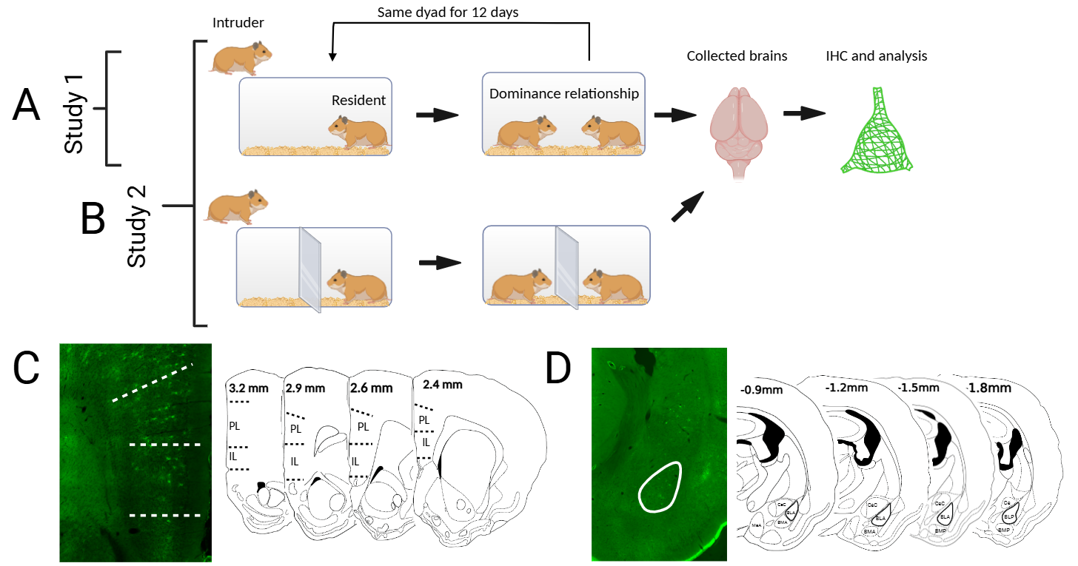
Figure 1. Experimental design for Study 1 and Study 2.
A) Diagram of experimental design for Study 1. Adult male hamsters were matched on age and weight and paired in daily dominance encounters for 12 consecutive days. Brains were collected 24-72 hours after the last encounter. Immunohistochemistry was performed to stain and quantify PNNs.
B) Diagram of experimental design for Study 2. Adult male hamsters were matched on age and weight, and dyads received 12 consecutive days of dominant-subordinate encounters. Adult female hamsters were matched on age, weight, and estrous cycle, and dyads received 14 days of dominant-subordinate encounters, skipping days of Estrus. Male and female no-status control animals followed a similar resident-intruder format with the addition of a perforated, plexiglass barrier placed between the animals for the entire encounter. Brains were collected 60 minutes after the last encounter, and immunohistochemistry was performed to stain and quantify PNNs.
C) Representative fluorescent microscope image of the prefrontal cortex with coronal atlas figures showing the areas of interest for quantifying PNNs in the prelimbic (PL) and infralimbic (IL) cortices.
D) Representative fluorescent microscope image of the amygdala with coronal atlas figures showing the areas of interest for quantifying PNNs in the basolateral (BLA).

proestrus, and they had 12 social encounters across 16 days. This resulted in 10 female dyads with strong and stable dominance relationships and 12 no-status control
females. Males were exposed to 14 consecutive social encounters to match the format used in Study 1. Because PNNs can change rapidly within hours of exposure to an acute stressor (Banerjee et al., 2017; Shaughnessy et al 2024), we sacrificed animals and collected brains 60 minutes after the last dominance encounter. Altogether, we tested 10 dominant females, 10 subordinate females, 12 no-status control females, 8 dominant males, 8 subordinate males, and 12 no-status control males in Study 2.
Immunohistochemistry
Subjects received an overdose of isoflurane and given an intracardial perfusion with ice-cold phosphate buffered saline (PB) and then 4% paraformaldehyde. Brains were post-fixed overnight in 4% paraformaldehyde and then transferred to a 30% sucrose solution. Brains were frozen and sectioned at 40 µm using a Leica microtome. Free floating sections were stored and sorted in three separate wells, which allowed for 120 µm between each analyzed tissue section so that cells encapsulated by PNNs were not counted more than once. To visualize PNNs, free-floating sections were blocked in 10% goat serum for 30 minutes and then incubated at room temperature for 24 hours in the primary antibody Lectin from Wisteria Floribunda (WFA, 1:500, Millipore Sigma, L1516) with 5% goat serum. The next day, sections were exposed to a 4-hour incubation with an Alexa Fluor 488 conjugate streptavidin (ThermoFisher Scientific, S32354) in 5% goat serum. Sections were rinsed in PB and diH2O, mounted on glass slides, and cover slipped with DAPI (Vectashield, Vector).
Microscopy and quantification
All images were collected on an Olympus BX51 epifluorescent microscope at 20x magnification and with a 300 x 300μm clip region. Brain regions were delineated in DAPI using defined boundaries according to a stereotaxic atlas for Syrian hamsters (Morin and Wood, 2001). Exposure time for each tissue section was calculated using a subsaturation threshold method for WFA expression in somatosensory or motor cortex at 20x magnification, which standardizes the quantification of high intensity PNNs (Lau et al., 2020). The subsaturation point was identified as the exposure time needed for saturation of the fluorescent signal of any encapsulated cell within the frame, and then decreasing the exposure time by one unit. The somatosensory and motor cortex were chosen as reference brain regions because these regions had the most intense fluorescent signal compared to other cortical regions. In Study 1, we performed a rostral to caudal analysis to identify regions within the vmPFC and BLA with the greatest PNN expression. Thus, three to four images were collected and averaged for each animal at each atlas figure within the IL, PL, and BLA. The IL and PL images were collected in cortical layers 2 and 3 as these layers had robust PNN expression with fully encapsulated neurons, whereas layers 4, 5, and 6 did not (Figure 1C; Figure 1D). Patterns of PNN expression in Study 1 were used to select regions of interest in Study 2, and PNNs were imaged using a similar procedure.
After images were collected, the files were uploaded to FIJI and then pipelined and analyzed using a macro installed into FIJI called Perineuronal net Intensity Program for the Standardization and Quantification of ECM Analysis (PIPSQUEAK) AI, version 5.0 beta 1.3. This software was developed to detect and quantify PNN-positive cells, intensity measures of PNN-positive cells, and area of pixel units of PNN expression (https://rewireneuro.com/). However, brain-region specific PNN optical intensity did not differ between statuses in Study 2 (p > 0.05; Supplemental Figure 1). Using a stringent criterion method, independent observers used the definitions in Table 1 to train the PIPSQUEAK model to count cells surrounded by PNNs. Two observers achieved 90% agreement before training the PIPSQUEAK algorithm, and observers monitored all semi-automated cell counts for false positives and false negatives. Observers were also blind to treatment conditions.
Statistical analysis
We analyzed agonistic behavior during dominance encounters using distance-based redundancy analysis (dbRDA) (Legendre and Legendre, 2012). This statistical approach allowed us to test for changes in agonistic behavior without running multiple ANOVAs and correlations for dominant and subordinate animals. Because dominants have a large number of zeroes for submissive behavior and subordinates have a large number of zeroes for aggressive behavior, we ran our model on a quantitative Jaccard (Ružička) dissimilarity matrix. This allowed us to calculate dissimilarity scores among the individuals and plot their agonistic behavior in multidimensional space. We used
Table 1. Criteria for Identifying PNNs
Criteria | Definitions
1 | PNNs need to exhibit a circular or pyramidal structure.
2 | PNN staining needs to be at least 1.5x brighter than ROI background.
3 | 70% of the WFA staining surrounding the soma needs to be above background or 50% of staining should be above background if at least one fiber is stained.
4 | Overlapping PNNs can be counted if the above criteria are met.

the vegan package (Oksanen, 2010) to carry out dbRDA models in males and females that tested male and females separately for whether agonistic behavior differed between dominants and subordinates. Also, we used residency condition (resident vs. intruder) as a covariate in the dbRDA models and statistical significance was assessed via 999 permutations of the data.
Using a general linear model, we also carried out a principal components analysis to test whether agonistic behavior during social dominance was associated with PNN expression. Following the PCA analyses, simple regression analyses were conducted to investigate whether dominance status or residency condition predicted the number of high-intensity PNN-positive cells in the BLA, IL, and PL. Multiple regression analyses were carried out to identify correlations between agonistic behavior and variance in the number of PNN+ cells across dominance status. These analyses allowed us to look at the parameter estimates and determine whether variance in PNN expression was due to dominance status or residency condition. If interactions were found for dominance status or residency condition within specific brain regions, we tested for effects of residency within each dominance status. We also conducted Tukey post hoc analyses using the multcomp package in R to identify pairwise differences among group means. The Tukey post hoc test was applied to the linear model fitted to our data, specifying a Tukey adjustment for multiple comparisons. This approach allowed us to control for Type I error while evaluating all pairwise group contrasts (dominant, subordinate and control subjects). Further, we calculated the rate (frequency/minute) of attacks, flees, and flank marks to account for variation in the duration of social encounters (5-10 minutes). All data were checked for kurtosis and skewness using the D’Agostino normality test from the fBasics package (D’Agostino and Pearson, 1973; D’Agostino and Rosman, 1974). Data were log-transformed to normalize distributions if there was significant skewness or kurtosis. Additionally, data were z-transformed into units of standard deviation. This allowed the data to be drawn from models of standard deviation because the measurement of the dependent variables (e.g. number of cells and time to submit) were measured in different units. If data sets had inflated zeros in their distribution, we ran regressions using a Poisson distribution. If data failed tests of normality on the Poisson distributions, a zero-inflated negative-binomial distribution was used. All calculations were performed in R v. 3.4.3 (R: The R Project for Statistical Computing)

Chapter Three

results
Social dominance behavior during dyadic encounters
Dominance relationships formed quickly such that female dyads took 1.0 (SD = 0) social encounters and male dyads took 1.142 (SD =0.363) social encounters for one animal to attack, the other to submit, and a clear winner and loser to emerge. We tested whether residents were significantly more likely to become dominant than expected by chance. In females, we found that 8 of 10 residents became dominant, while 2 of 10 intruders became dominant, which is not significantly different than the 50% expected by chance (𝜒²(1) = 1.98, p > 0.05). In males, we found that 14 of 22 residents became dominant, while 8 of 22 intruders became dominant, which is not significantly different than chance (𝜒²(1) = 0.83, p > 0.05).
We used a db-RDA model to examine the effects of dominance status and residency condition on agonistic behavior. In males, we found that dominance status explained a large proportion of variance in agonistic behavior (35.23%) and was a significant predictor of agonistic behavior in the dissimilarity matrix (F_{1,23} = 10.97, p< 0.0001; Figure 2A). In contrast, residency condition was not a significant predictor explaining variance in agonistic behavior (3.09%) (F_{1,23} = 1.17, p = 0.26). In females, we also found that dominance status explained a large proportion of variance in agonistic behavior (43.36%) and was a significant predictor of agonistic behavior in the dissimilarity matrix (F_{1,17} = 9.33, p< 0.001; Figure 2B). In contrast, residency condition was not a significant predictor
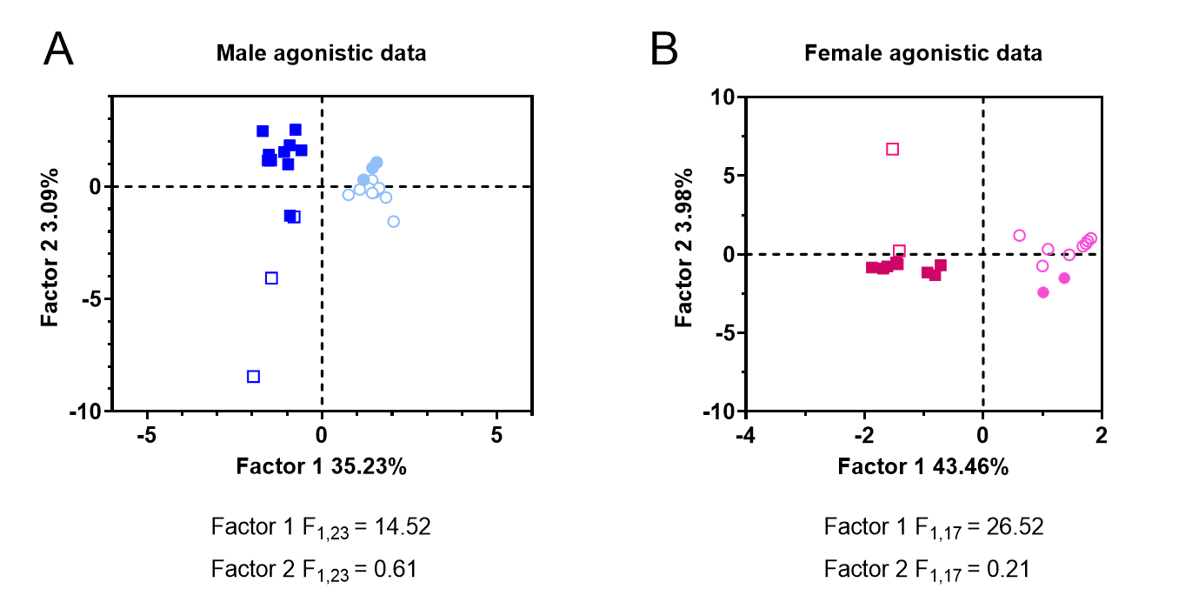Figure 2. Distance-based redundancy analysis (db-RDA) plots of dominance status and residency condition on agonistic behavior. Factor 1 (social dominance) clustered attacks and latency to submit in the negative direction and flees and latency to attack in the positive direction. Overall, this approach aggregated individual scores into two distinct clusters (i.e. dominants and subordinates). Factor 2 (residency condition) clustered flee rates in the positive direction and attack rates in the negative direction, although average latency to attack and average latency to submit did not contribute to Factor 2. 2A. Male agonistic behavior data. 2B. Female agonistic behavior data. (Filled square = dominant resident, empty square = dominant intruder, filled circle = subordinate resident, empty circle = subordinate intruder)

explaining variance in agonistic behavior (3.98%) (F_{1,17} = 1.28, p = 0.23). This is not surprising because we defined dominance status by the pattern of agonistic behavior and excluded animals that did not show a stable dominance relationship. Agonistic behavior from stable dominance relationships in Study 1 and Study 2 are shown in Supplemental Figure 2 and Supplemental Figure 3, respectively. When looking at the weighted sums of agonistic scores across each Factor, we found that Factor 1 (which represents dominance status) pulled attack rate, flank rate, and latency to submit in the negative direction and flee rate, flank latency, and latency to attack in the positive direction.
Interestingly, latency to submit during the last three dominance encounters had the highest weighted scores compared to latency to submit during the first three dominance encounters and other agonistic behavior, indicating that it had the greatest impact on Factor 1. This pattern is clearly visualized in a biplot for males in Study 1 and Study 2 (Figure 2A) and females in Study 2 (Figure 2B). As a result, dominants were clustered in a negative direction and subordinates in a positive direction. Factor 2 represents residency condition and it pulled flee rate in a positive direction and attack rate in a negative direction, while latencies to attack or submit did not contribute to Factor 2. As a result, dissimilarity scores clustered in a positive direction for residents and in a negative direction for intruders.
Altogether, these data indicate that dominants and subordinates differ in their patterns of agonistic behavior, and that residency condition did not significantly alter the aggressive behavior of dominants or the submissive behavior of subordinates. The pattern of agonistic behavior and formation of dominance relationships found here is similar to previous reports (Whitten et al., 2023).
Study 1: PNN expression in the vmPFC and BLA of dominant and subordinate males
We investigated whether dominance status and residency condition accounted for differences in PNN expression throughout the rostral-caudal extent of the BLA, PL, and IL. We found no significant effects of residency condition on PNN counts in these brain regions (p > .05), although we included it as a covariate in subsequent analyses. The number of PL cells encapsulated by PNNs significantly differed along the rostral-caudal axis (F_{3, 57} = 19.0, p < .001; Figure 3B), although no main effect of dominance status was found (p = .935; Figure 3A). Specifically, we found a significant linear trend, such that
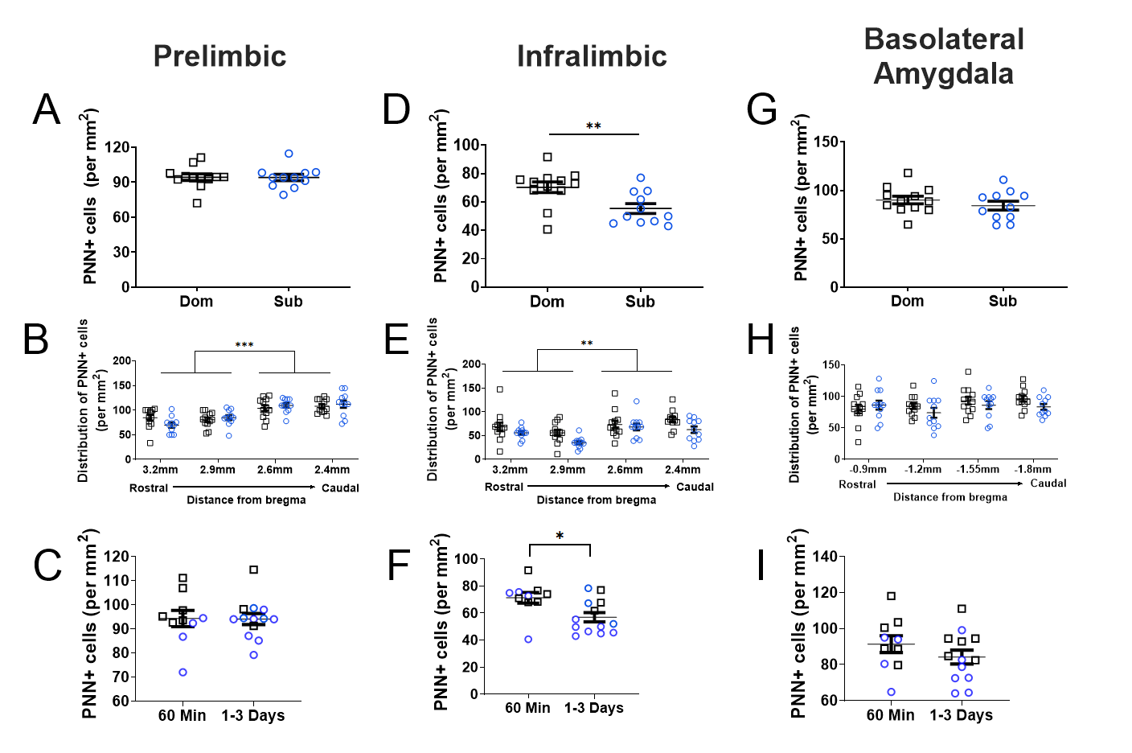
Figure 3. Perineuronal net expression in Study 1. PNN expression in the PL A) in dominant and subordinate males, B) across rostral to caudal subregions, and C) between animals perfused 60 minutes after their last dominance encounter and animals perfused 1-3 days after their last dominance encounter. PNN expression in the IL D) in dominant and subordinate males, E) across rostral to caudal subregions, and F) between animals perfused 60 minutes after their last dominance encounter and animals perfused 1-3 days after their last dominance encounter. PNN expression in the BLA G) in dominant and subordinate males, H) across rostral to caudal subregions, and I) between animals perfused 60 minutes after their last dominance encounter and animals perfused 1-3 days after their last dominance encounter. *** p < 0.001, **p < 0.01, *p ≤ 0.05 (Open black square=dominant male, open blue circle=subordinate male)

the density of PNN cells increased from rostral to caudal aspects of the PL (F_{1, 19} = 41.2, p < .001; Figure 3B).
Sphericity was violated in the IL (χ² (5) = 11.9, p = 0.036) and a Greenhouse-Geisser correction was used (ε = .775). Overall, subordinate males showed fewer PNN+ cells in the IL (M = 55.5, SEM = 3.64) compared to their dominant counterparts (M = 71.34, SEM = 3.52, F_{1, 19} = 9.83, p = .005, Figure 3D). Subordinates consistently showed lower PNN expression than dominants throughout the rostral-caudal extent of the IL. In addition, the number of PNN cells in the caudal IL was greater than in the rostral IL (F_{1, 19} = 5.20, p = .034; Figure 3E). The number of cells encapsulated by PNNs did not significantly differ along the rostral-caudal axis of the BLA (F_{3, 57} = 1.78, p = .161; Figure 3H). Similarly, there was no effect of dominance status on the number of PNN-encapsulated cells in the BLA (F_{1, 19} = .67, p = .424; Figure 3G).
Because brain tissue was used from studies that collected samples at multiple time points, we tested whether the interval between dominance encounter and brain collection altered PNN expression. We found that animals sacrificed 1-3 days after the final dominance encounter showed fewer PNN+ cells in the IL compared to animals sacrificed 1 hour after the final encounter (F_{1, 19} = 7.12, p = 0.02; b = 20.68, SE = 7.16, t = 2.89, p = 0.009). However, the interval between dominance encounters and brain collection did not alter PNN expression in the PL (F_{1, 19} = 0.01, p = 0.91) or BLA (F_{1, 19} = 1.28, p = 0.27).

Study 2: Status-dependent changes in PNN expression in males and females
Based on the findings in Experiment 1, we decided to investigate status-dependent differences in PNN expression 60 minutes after the last dominance encounter and within the caudal regions of the PL, IL, and BLA. Further, we included females to investigate sex-differences and a no status group to control for the effects of social experience. In females, dominance status significantly affects the density of PNN+ cells in the PL (F_{2,29} = 7.97, p = 0.001, 𝜂² = 0.354; Figure 4A). Specifically, subordinates had more PNN cells in the PL than dominants (t = 3.71, p = 0.002) and no status (t = 3.19, p = 0.009); dominant females did not differ from no status animals (t = -0.69, p = 0.77). No significant differences were found in the density of PNNs cells in the IL (F_{2,29} = 1.40, p = 0.26, 𝜂² = 0.019; Figure 4C) or BLA (F_{2,29} = 0.87, p = 0.28, 𝜂² = 0.088; Figure 4E).
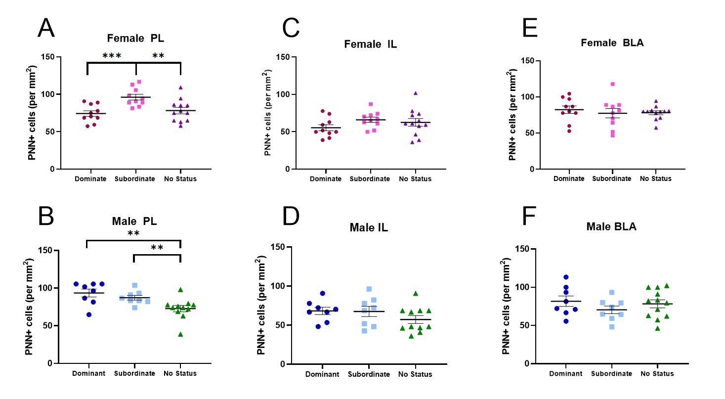 Figure 4. Perineuronal net expression in Study 2. The density of PNN cells for dominant, subordinate, and no-status females in the A) PL, C) IL, and E) BLA. The density of PNN cells for dominant, subordinate, and no-status males in the B) PL, D) IL, and F) BLA. *** p < 0.001, **p < 0.01 (Dark pink circle = dominant female, light pink square = subordinate female, purple triangle = no status control female, dark blue circle = dominant male, light blue square = subordinate male, green triangle = no status control male)
In males, there was a significant effect of dominance status on the density of PNN cells in the PL (F_{2,25} = 6.95, p = 0.003, 𝜂² = 0.357), Specifically, dominant and subordinate males showed a greater density of PNN cells in the PL compared to no status animals (dominants: t = 3.55, p = 0.004, subordinates: t = 2.48, p = 0.05; Figure 4B). However, dominants and subordinates did not differ from each other in PL PNN expression (t = -0.98, p = 0.60; Figure 4B). Further no significant differences were found in the expression of PNN cells in the IL (F_{2,25} = 1.48, p = 0.24, 𝜂² = 0.106) or BLA ( F_{2,25} = 0.87, p = 0.43, 𝜂² = 0.065; Figure 4D, Figure 4F).
Agonistic behavior during dominance relationships and PNN expression
Because we expected PNN expression to change during the development of dominance relationships, we tested whether agonistic behavior during dominance encounters predicted PNN expression in the PL, IL, and BLA. We hypothesized that PNN expression would be more closely associated with agonistic behavior during the late phase of dominance encounters (final 3 encounters) compared to the early phase (first 3 encounters).
We found that attack rates and latency to submit during the early and late phases of dominance relationships in male hamsters were heavily weighted on Factor 1 of a principal component analysis (Figure 5A). We ran multiple regression models to investigate if attack rates and latency to submit during the early and late phases of the dominance relationships were predictive of PNN counts in the PL, IL, and BLA. In addition, latency to attack and flee rates in the early and late phases of the dominance
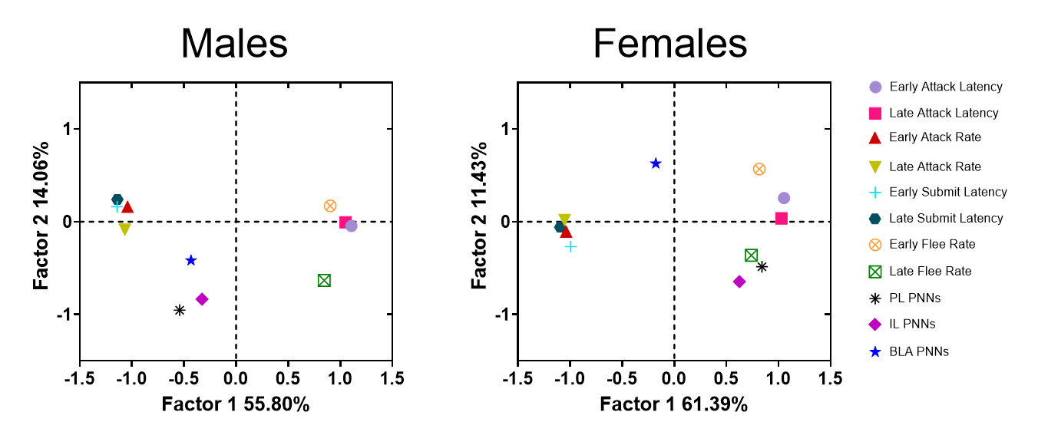Figure 5. Principal component analysis of early phase agonistic behavior, late phase agonistic behavior, and PNN expression in the PL, IL, and BLA. A) Males. B) Females.

relationships had strong loadings on Factor 1, although they were orthogonal to PNN counts (Figure 5A). Therefore, we ran a second multiple regression to see if latency to attack and flee rates during the early and late phases of dominance relationships predicted PNN expression in the PL, IL and BLA.
The rate of attack rates in dominant males during the late phase of dominant relationship was positively correlated with PNN expression in the PL (F_{1,12} = 6.19, p = 0.028, 𝜂² = 0.34; Figure 6A), but it was not during the early phase (F_{1,12} = 0.85, p = 0.38, 𝜂² = 0.067). The latency with which subordinates submitted during dominance encounters did not predict PNN expression in the PL during either the early phase or late phase (p > 0.05). The rate of flees in subordinate males was negatively associated with PNN expression in the PL during the early phase of dominance relationships (𝜒2(1) = 3.92, p = 0.047, 𝜂2 = 0.354), while flee rates during the late phase were not associated with PNN

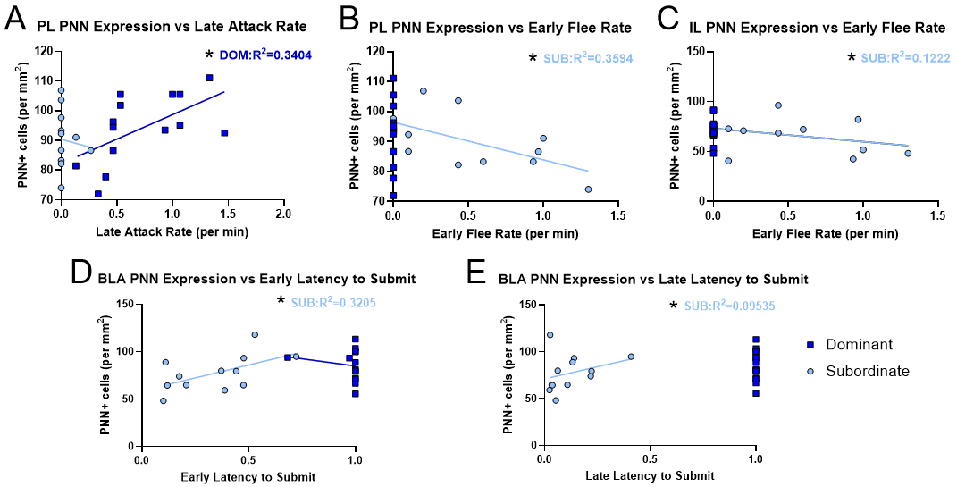

Figure 6. Multiple regression analyses depicting significant associations between agonistic behavior and PNN expression in dominant and subordinate males. A) PNN expression in the PL is positively associated with attack rate during the late phase of dominance encounters in dominants. B) PNN expression in the PL is negatively associated with flee rate during the early phase of dominance encounters in subordinates. C) PNN expression in the IL is negatively associated with flee rate during the early phase of dominance encounters in subordinates. D) PNN expression in the BLA is positively associated with latency to submit during the early phase of dominance encounters in subordinates. E) PNN expression in the BLA is positively associated with latency to submit during the late phase of dominance encounters in subordinates. (*p ≤ 0.05)

expression (𝜒2(1) = 3.28, p = 0.07, 𝜂2 = 0.313). Interestingly, the rate of flees in subordinate males during the early and late phases were not correlated with one another (F_{1,10} = 0.003, p = 0.95, 𝜂² = 0.003). Lastly, attack latency in dominant males did not predict PL PNN expression (F_{1,12} = 3.45, p = 0.08, 𝜂² = 0.223).
The rate of flees in subordinate males during the early phase of the dominance relationships was also negatively associated with PNN expression in the IL (𝜒²(1) = 5.96, p = 0.015, 𝜂² = 0.115; Figure 6C). However, flee rates in subordinates during the late phase of dominance relationships were not associated with IL PNN expression (𝜒²(1) =
2.778, p = 0.09, 𝜂² = 0.068). None of the other types of agonistic behavior predicted IL PNN expression in dominants or subordinates (p > 0.05).
PNN expression in the BLA was positively associated with latency to submit in subordinate males in the early phase (𝜒²(1) = 16.53, p < 0.01, 𝜂² = 0.325; Figure 6D) and late phase of dominance relationships (𝜒²(1) = 4.81, p = 0.028, 𝜂² = 0.097; Figure 6E). Interestingly, the latency with which subordinates submitted during the early and late phases of dominance relationships were not correlated. (𝜒²(1) = 0.28, p = 0.59, 𝜂² = 0.29). Lastly, none of the other agonistic behaviors were associated with BLA PNN expression in males (p > 0.05).
We performed similar analyses in female hamsters and found that aggressive behaviors (latency to attack indices and attack rates) were more heavily weighted on Factor 1 on a principal component analysis, while submissive behaviors (latency to submit indices and flee rates) were more heavily loaded on Factor 2 (Figure 5B). Therefore, we ran separate multiple regression analyses of aggressive and submissive behavior on PNN expression in PL, IL, and BLA.
PNN expression in the PL was negatively associated with flee rates in subordinate females during the early phase of dominance relationships (𝜒²(1) = 8.15, p = 0.02, 𝜂² = 0.505; Figure 7A), but not during the late phase (𝜒²(1) = 0.01, p = 0.89, 𝜂² = 0.002). Female subordinate flee rates during the early and late phases were not associated with one another (F_{1,8} = 0.18, p = 0.68, 𝜂² = 0.021). PNN expression in the IL was negatively associated with attack rates of dominants during the early phase (F_{1,8} = 10.25, p = 0.013, 𝜂² = 0.56; Figure 7B), but not during the late phase (F_{1,8} = 0.129, p = 0.73, 𝜂² = 0.016). Further, IL PNN expression was positively associated with latency to submit in subordinate females during the early phase of dominance relationship (F_{1,8} = 16.662, p = 0.004, 𝜂² = 0.676; Figure 7C), but not during the late phase (F_{1,8} = 0.04, p = 0.84, 𝜂² = 0.006). We found that neither aggressive nor submissive behavior in dominant or subordinate females predicted PNN expression in the BLA (p > 0.05).

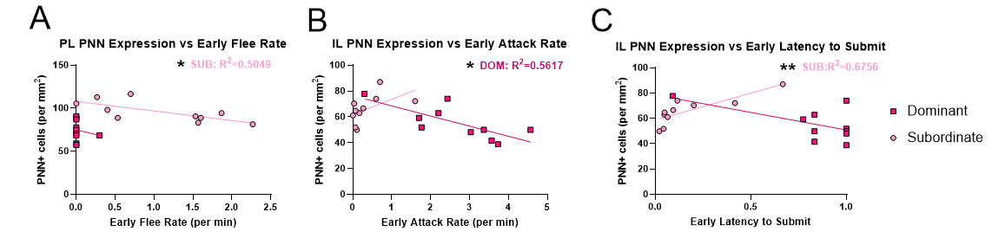Figure 7. Multiple regression analyses depicting significant associations between agonistic behavior and PNN expression in dominant and subordinate females during the early phase (first 3 days) of dominance encounters. A) PNN expression in the PL is negatively associated with flee rate in subordinates. B) PNN expression in the IL is negatively associated with attack rate in dominants. C) PNN expression in the IL is positively associated with latency to submit in subordinates. (**p < 0.01, *p < 0.05)

CHAPTER FOUR

Discussion
Significant Findings
In Study 1, a significant linear trend was discovered, displaying an increase in high-intensity PNN+ cells from rostral to caudal regions of the PL and IL. Furthermore, individuals perfused 60 minutes after their last dominance encounter showed a significant increase in high-intensity PNNs in the IL compared to individuals perfused 1-3 days after their last dominance encounter. Together, this suggests there is a higher gradient of PNNs within the caudal regions of the PFC compared to the rostral regions, and there may have been experience-dependent remodeling of PNNs that were time-dependent in the IL.
In Study 2, subordinate females had significantly more PNN+ cells in the PL compared to dominants and controls, suggesting that losing dominance encounters in females increases PNN expression in the PL. Dominant and subordinate males had more PNN+ cells in the PL compared to controls, indicating that social experience alone increases PNN expression in the PL. In the IL, dominant males had significantly more PNN expression compared to controls, suggesting that winning dominance encounters promotes neuroplasticity within the IL. During the late phase of dominance relationships, rate of attacks in dominant males predicts PNN expression in the PL, which is consistent with a role for neural ensembles in the PL mediating aggressive behavior. Because PNN expression correlates with patterns of aggression in the early phase, it may reflect a predisposition for agonistic behavior and alter the acquisition of a dominant status. For instance, rate of flees was negatively associated with PNN expression in the PL and IL of subordinate males and in the PL of subordinate females.
Study 1
This study focused on whether formation of a dominance relationship alters PNN expression in stress-sensitive brain regions and which aspects of dominance interactions are associated with PNN changes. We found that hamsters established stable dominance relationships after 2-3 days and following 2 weeks of social encounters, dominant animals had more IL neurons encapsulated by high-density PNNs compared to their subordinate counterparts. Regardless of social status, animals showed more PNN-positive cells in caudal regions of the IL and PL vmPFC than in rostral regions.
Although rostral and caudal IL neurons have largely similar connectivity, they do differ to some key projection targets. Rostral IL neurons project more robustly to the bed nucleus of stria terminalis, and central and basomedial amygdala, whereas caudal IL neurons project more robustly to the lateral septum and anterior hypothalamus (Vertes, 2004). As for the PL, rostral neurons project more to the entorhinal cortex, BLA, dorsal raphe nucleus, and ventrolateral periaqueductal gray while the caudal neurons project more to the lateral septum, anterior hypothalamus, mediodorsal thalamus, and dorsolateral periaqueductal gray (Vertes, 2004). Additionally, vmPFC regions differ in their role in active and passive coping, with the caudal PL modulating more active coping behaviors via its projections to the PAG (Johnson et al, 2022). Interestingly, aggressive behavior was positively associated with PNN changes in the PL, such that hamsters that attacked more often and more quickly showed greater PL PNN expression. Research suggests that higher PNN encapsulation of parvalbumin neurons in the mPFC is associated with aggressive interactions in socially isolated mice (Biro et al, 2023). In addition, the number of PNN-positive IL neurons was not associated with submissive behavior. These findings suggest that the aggressive behavior used to establish social dominance contributes to the increased density of mature PNNs in the vmPFC, which may support status-dependent differences in social behavior.
vmPFC role in dominance relationships
Dominance hierarchies have been shown to promote changes in neural plasticity and cause experience-related changes in social behavior. For example, in mouse colonies, increasing dominance rank is associated with elevated neural activity throughout the social behavior neural network with the largest increases in activity occurring within the prelimbic and infralimbic regions of the ventral medial prefrontal cortex (Williamson et al., 2019). Additionally, higher social ranking mice show greater excitatory synaptic input strength in the medial prefrontal cortex as compared to subordinates, and pharmacologically increasing synaptic efficacy in the PFC results in an increase in social rank while decreasing synaptic efficacy causes a decrease in social rank (Wang et al., 2011). Therefore, rising in social rank is correlated to an overall increase in PFC activity, while a drop in social rank is associated with decreased PFC activation. It has also been found that chronic stress, as modeled by those with subordinate social status, results in dendritic shrinkage in the mPFC and dendritic growth in the BLA (Davidson & McEwen, 2012). In other words, social status has an experience-dependent effect on the neural plasticity of animals undergoing stressful stimuli. Furthermore, the loss of social status has been linked to an increased risk for developing depression in humans or depression-like behaviors in animals, such as social avoidance and decreased pleasure-seeking (Nakajo et al., 2020). Thus, subordinate subjects that were once dominant experience detrimental changes in their agonistic behavior that result in mental and behavioral deficits as a result of losing, which is consistent with our own lab’s findings. Overall, it is evident that the development of dominance causes pivotal changes in synaptic plasticity and activation of vmPFC and BLA neurons.
In addition to neurophysiological changes, the development of a social rank also causes changes in stress vulnerability. For instance, dominant male and female mice show smaller deficits to chronic social defeat stress as compared to their subordinate counterparts, and male mice that have a history of winning display more positive stress outcomes in response to later stressors (LeClair et al., 2021). In humans, a high social status in a stable hierarchy improves stress responses and interview performance, due to greater feelings of control and lower testosterone reactivity (Knight & Mehta, 2016). Across species, developing a dominance status has been associated with stress resilience while developing a subordinate status has been associated with stress susceptibility, which is evident in our own lab’s research.
In previous studies, our lab has shown that dominant and subordinate hamsters exhibit differential stress-induced activity of vmPFC neurons. Dominants show elevated c-Fos immunoreactivity in vmPFC neurons that send projections to the BLA (Dulka et al., 2018) and the dorsal raphe nucleus (Grizzell et al., 2020). Further, the activity of vmPFC cells during social defeat stress contributes to a reduced conditioned defeat response in dominant hamsters, and muscimol injection into vmPFC prior to social defeat increases the conditioned defeat response to dominant, but not subordinate hamsters (Morrison et al., 2013). In addition, chemogenetic activation of an IL-BLA pathway reduces the conditioned defeat response of subordinate, but not dominant hamsters (Dulka et al., 2020). Altogether, these findings suggest a hypothesis in which the maintenance of dominance relationships generates widespread changes in PNN expression that supports aggressive behavior but also underlie status-dependent differences in other vmPFC pathways that regulate responses to social stress. Specifically, elevated PNN expression in the PL and IL might help maintain activity of pyramidal cells during social defeat stress and contribute to a reduced conditioned defeat response in dominants. This suggests that the development of social dominance leads to plasticity in neural circuits that can modulate stress vulnerability through PNNs.
Study 2
With the addition of females in Study 2, it is important to recognize that sex-differences are prevalent in rodent models of dominance hierarchies, conditioned fear, stress susceptibility, and PNN expression. Female hamsters depend more on the social context in which their social status is established and maintained as compared to males, possibly due to the high cost of losing territory if pups are present; females also display less stable dominance relationships than males, in which rank may switch within a dyad with each dominance encounter (Whitten et al., 2023). During fear conditioning, male rats show fear memory learning when conditioning events are spaced by one hour and one day, while females only show fear memory learning when conditioning events are spaced by one hour; thus, females do not show sustained fear conditioning over time (Cole & Parsons, 2023). This supports our own lab’s findings in which females do not show conditioned fear responses 24 hours after social defeat stress, while males typically show a robust conditioned defeat response. Furthermore, males and female hamsters have been reported to have significantly different PNNs within the hippocampal area CA1, BLA, and somatosensory cortex (Shaughnessy et al., 2024). Due to these sex-differences, explanations for PNN+ cellular expression patterns between males and females may differ within the same stress-sensitive brain-regions.
To begin, PNNs have been shown to increase the “evoked activity of fast-spiking neurons”, which could improve sensory transmission and regulate neural plasticity by promoting synaptic inhibition (Balmer, 2016). Another study found that PNNs normally work to increase PV+ cellular activity while PNN degradation results in reduced PV+ interneuron excitability (Nashawi et al., 2025). Therefore, the increased PNN+ cells present in the PL of subordinate females could be due to the increased neural transmission of fear-related memories due to the PL’s role in regulating negative emotional responses. As for males, both dominant and subordinate hamsters experience an increase in PNN+ cellular expression in the PL as compared to no status controls. Studies show conflicting evidence in the role of the PFC in dominant and subordinate male mice in various social rank-dependent experiments. In dominant mice, excitatory PFC neurons show increased synaptic strength compared to their subordinate cage-mates (Wang et al., 2011) while subordinate mice show greater neural activation in individual PFC neurons during social competition for a reward (Padilla-Coreano et al., 2022). In all, neuroplasticity changes within the PL may differentially modulate one’s stress response, resulting in increased PNNs seen in males. The observed differences in PNN expression, particularly within the PL, suggest that sex- and status-dependent mechanisms of neural plasticity may play a pivotal role in future stress resilience.
Early vs. late phases of agonistic behavior
By comparing agonistic behavior displayed during early and late phases of dominance encounters, we have revealed phase-specific associations with PNN expression across stress-sensitive brain regions. In dominant males, higher attack rates during the late phase of dominance encounters were significantly correlated with greater PNN expression in the PL, indicating that aggressive behavior that maintains hierarchy stability may drive neuroplasticity. Meanwhile, early phase aggression was not associated with PL PNN expression, suggesting that initial dominance encounters, when stability is at its lowest, is less likely to impact neuroplasticity in the PL. In subordinate males, early phase fleeing was negatively associated with PNN expression in the PL and IL, highlighting that an individual’s predisposition to submissive behavior may further suppress plasticity-related processes in the vmPFC. Yet, this relationship did not persist into the late phase, pointing to possible temporally-dependent neurophysiological and behavioral changes. Interestingly, PNN expression in the BLA was predicted by submission latency in subordinates, even though no significant changes in PNN expression were found across status. However, this may be attributed to the positive associations observed in both phases, though the submission latencies themselves were uncorrelated between early and late periods. These findings suggest that early behavioral responses are more pivotal in shaping PNN expression in the vmPFC of subordinates; whereas in dominants, PL PNN expression is more sensitive to late-phase aggression while the BLA integrates submissive behavior across time.
In females, subordinates that fled more during early phase dominance encounters had less PNN expression in the PL; however, this association did not maintain through the late phase, which indicates that losing dominance encounters early on in the development of a dyadic hierarchy may have a stronger influence on PL plasticity. It is important to note, though, that flee behaviors were not correlated across phases; therefore, female subordinates may adjust their behavioral strategies over time to avoid unnecessary aggression. In dominant females, higher attack rates during the early phase were associated with lower IL PNN expression, while no association was found during the late phase. Thus, aggression displayed early in the development of the animals’ dominance rank may suppress IL plasticity. On the other hand, subordinate females who were slower to submit during early encounters showed higher PNN expression in the IL, further highlighting the early phase as a critical window during which social behavior modulates neural adaptation in females. In contrast, no associations between behavior and PNN expression were observed in the BLA, suggesting that this region may not be as sensitive to agonistic behavior patterns. Overall, these findings emphasize the importance of early social interactions in shaping region-specific neural plasticity in females.
Limitations
As with any project, several limitations should be acknowledged. While it has been shown throughout the literature that PNNs preferentially encapsulate PV neurons, we did not perform immunohistochemistry to stain for PV; therefore, we cannot confirm whether PNN expression was limited to inhibitory cells within the vmPFC and BLA. Furthermore, the effects of social dominance on arginine-vasopressin V1a, oxytocin, and serotonin 1A receptor binding differ between sexes in several limbic brain regions (Grieb et al., 2021). Although social dominance alters how hamsters respond to acute social defeat stress, the effects of social dominance differ between male and female hamsters (Cooper et al., 2021). Another limitation is that we used a small clip region to image tissue sections at 20x magnification, which limited the amount of tissue quantified. Our AI software on FIJI and PIPSQUEAK streamlined assessing the images to account for reliability and fatigue issues that researchers can experience when manually counting cells. However, imaging a larger volume of tissue might better capture regional changes in PNN density. Lastly, our imaging procedure emphasized the quantification of high-intensity, mature PNNs (Lau et al., 2020). Thus, the parameters used for thresholding images may have underestimated low-intensity, immature PNNs and other studies might consider quantifying all PNN-positive cells above background.
Conclusion
This research highlights how experience-dependent plasticity is dependent on a multitude of factors, including sex, status, brain region, and patterns of dominant and submissive behavior. By identifying how early and late phases of agonistic behavior influence plasticity-related structures such as PNNs, this work provides a deeper understanding of how social hierarchies may result in biologically distinct markers of social status and stress vulnerability. Given that disruptions in social status and chronic stress are linked to anxiety, depression, and PTSD in humans, these findings help illuminate the biological mechanisms that may contribute to improving stress resilience.

LIST OF REFERENCES
Albers, H.E., Huhman, K.L., Meisel, R.L., 2002. 6 - Hormonal Basis of Social Conflict and Communication, in: Pfaff, D.W., Arnold, A.P., Fahrbach, S.E., Etgen, A.M., Rubin, R.T. (Eds.), Hormones, Brain and Behavior. Academic Press, San Diego, pp. 393–433. https://doi.org/10.1016/B978-012532104-4/50008-1
Balmer, T. S. 2016. Perineuronal Nets Enhance the Excitability of Fast-Spiking Neurons. eNeuro, 3(4), ENEURO.0112-16.2016. https://doi.org/10.1523/ENEURO.0112-16.2016
Banerjee, S.B., Gutzeit, V.A., Baman, J., Aoued, H.S., Doshi, N.K., Liu, R.C., Ressler, K.J., 2017. Perineuronal Nets in the Adult Sensory Cortex Are Necessary for Fear Learning. Neuron 95, 169-179.e3. https://doi.org/10.1016/j.neuron.2017.06.007
Benus, R., Bohus, B., Koolhaas, I.M., Oortmerssen, G.A.V., 1990. Elsevier BEHAVIOURAL STRATEGIES OF AGGRESSIVE AND NON-AGGRESSIVE MALE MICE IN ACTIVE SHOCK AVOIDANCE.
Bernstein, I.S., 1981. Dominance: The baby and the bathwater. Behavioral and Brain Sciences 4, 419–429. https://doi.org/10.1017/S0140525X00009614
Biro, L., Miskolczi, C., Szebik, H., Bruzsik, B., Varga, Z. K., Szente, L., Toth, M., Halasz, J., & Mikics, E. 2023. Post-weaning social isolation in male mice leads to abnormal aggression and disrupted network organization in the prefrontal cortex: Contribution of parvalbumin interneurons with or without perineuronal nets. Neurobiology of Stress, 25, 100546. https://doi.org/10.1016/j.ynstr.2023.100546
Biro, L., Sipos, E., Bruzsik, B., Farkas, I., Zelena, D., Balazsfi, D., Toth, M., Haller, J., 2018. Task Division within the Prefrontal Cortex: Distinct Neuron Populations Selectively Control Different Aspects of Aggressive Behavior via the Hypothalamus. J. Neurosci. 38, 4065–4075. https://doi.org/10.1523/JNEUROSCI.3234-17.2018
Biro, L., Toth, M., Sipos, E., Bruzsik, B., Tulogdi, A., Bendahan, S., Sandi, C., Haller, J., 2017. Structural and functional alterations in the prefrontal cortex after post-weaning social isolation: relationship with species-typical and deviant aggression. Brain Struct Funct 222, 1861–1875. https://doi.org/10.1007/s00429-016-1312-z
Blair, R.J.R., 2010. Psychopathy, frustration, and reactive aggression: The role of ventromedial prefrontal cortex. British Journal of Psychology 101, 383–399. https://doi.org/10.1348/000712609X418480
Cole, K. E., & Parsons, R. G. 2023. Sex difference in the facilitation of fear learning by prior fear conditioning. bioRxiv : the preprint server for biology, 2023.06.29.547102. https://doi.org/10.1101/2023.06.29.547102
Cooper, M.A., Clinard, C.T., Dulka, B.N., Grizzell, J.A., Loewen, A.L., Campbell, A.V., Adler, S.G., 2021. Gonadal steroid hormone receptors in the medial amygdala contribute to experience-dependent changes in stress vulnerability. Psychoneuroendocrinology 129, 105249. https://doi.org/10.1016/j.psyneuen.2021.105249
Cooper, M.A., Hooker, M.K., Whitten, C.J., Kelly, J.R., Jenkins, M.S., Mahometano, S.C., Scarbrough, M.C., 2023. Dominance status modulates activity in medial amygdala cells with projections to the bed nucleus of the stria terminalis. Behavioural Brain Research 453, 114628. https://doi.org/10.1016/j.bbr.2023.114628
D’Agostino, R., Pearson, E.S., 1973. Tests for departure from normality. Empirical results for the distributions of b2 and √b1. Biometrika 60, 613–622. https://doi.org/10.1093/biomet/60.3.613
D’Agostino, R.B., Rosman, B., 1974. The Power of Geary’s Test of Normality. Biometrika 61, 181–184. https://doi.org/10.2307/2334302
Davidson, R., McEwen, B. Social influences on neuroplasticity: stress and interventions to promote well-being. Nat Neurosci 15, 689–695 (2012).
De Boer, S.F., Koolhaas, J.M., 2003. Defensive burying in rodents: ethology, neurobiology and psychopharmacology. European Journal of Pharmacology, Animal Models of Anxiety Disorders 463, 145–161. https://doi.org/10.1016/S0014-2999(03)01278-0
de Araújo Costa Folha, O. A., Bahia, C. P., de Aguiar, G. P. S., Herculano, A. M., Coelho, N. L. G., de Sousa, M. B. C., Shiramizu, V. K. M., de Menezes Galvão, A. C., de Carvalho, W. A., & Pereira, A. 2017. Effect of chronic stress during adolescence in prefrontal cortex structure and function. Behavioural Brain Research, 326, 44–51. https://doi.org/10.1016/j.bbr.2017.02.033
de Kloet, E.R., Molendijk, M.L., 2016. Coping with the Forced Swim Stressor: Towards Understanding an Adaptive Mechanism [WWW Document]. Neural Plasticity. https://doi.org/10.1155/2016/6503162
Dulka, B.N., Bagatelas, E.D., Bress, K.S., Grizzell, J.A., Cannon, M.K., Whitten, C.J., Cooper, M.A., 2020. Chemogenetic activation of an infralimbic cortex to basolateral amygdala projection promotes resistance to acute social defeat stress. Scientific Reports 10, 1–13. https://doi.org/10.1038/s41598-020-63879-8
Dulka, B.N., Bress, K.S., Grizzell, J.A., Cooper, M.A., 2018. Social Dominance Modulates Stress-Induced Neural Activity in Medial Prefrontal Cortex Projections to the Basolateral Amygdala. Neuroscience 388, 274–283. https://doi.org/10.1016/j.neuroscience.2018.07.042
Escorihuela, R.M., Fernández-Teruel, A., Gil, L., Aguilar, R., Tobeña, A., Driscoll, P., 1999. Inbred Roman High- and Low-Avoidance Rats: Differences in Anxiety, Novelty-Seeking, and Shuttlebox Behaviors. Physiology & Behavior 67, 19–26. https://doi.org/10.1016/S0031-9384(99)00064-5
Fawcett, J.W., Oohashi, T., Pizzorusso, T., 2019. The roles of perineuronal nets and the perinodal extracellular matrix in neuronal function. Nature Reviews Neuroscience 20, 451–465. https://doi.org/10.1038/s41583-019-0196-3
Fujii, N., Hihara, S., Nagasaka, Y., Iriki, A., 2009. Social state representation in prefrontal cortex. Social Neuroscience 4, 73–84. https://doi.org/10.1080/17470910802046230
Grieb, Z.A., Ross, A.P., McCann, K.E., Lee, S., Welch, M., Gomez, M.G., Norvelle, A., Michopoulos, V., Huhman, K.L., Albers, H.E., 2021. Sex-dependent effects of social status on the regulation of arginine-vasopressin (AVP) V1a, oxytocin (OT), and serotonin (5-HT) 1A receptor binding and aggression in Syrian hamsters (Mesocricetus auratus). Hormones and Behavior 127, 104878. https://doi.org/10.1016/j.yhbeh.2020.104878
Grizzell, J.A., Clarity, T.T., Graham, N.B., Dulka, B.N., Cooper, M.A., 2020. Activity of a vmPFC-DRN Pathway Corresponds With Resistance to Acute Social Defeat Stress. Front. Neural Circuits 14. https://doi.org/10.3389/fncir.2020.00050
Johnson, S.B., Lingg, R.T., Skog, T.D., Hinz, D.C., Romig-Martin, S.A., Viau, V., Narayanan, N.S., Radley, J.J. 2020. Activity in a prefrontal-periaqueductal gray circuit overcomes behavioral and endocrine features of the passive coping stress response, Proc. Natl. Acad. Sci. U.S.A. 119 (44) e2210783119, https://doi.org/10.1073/pnas.2210783119.
Knight, E.L. & Mehta, P.H. 2017. Hierarchy stability moderates the effect of status on stress and performance in humans, Proc. Natl. Acad. Sci. U.S.A. 114 (1) 78-83, https://doi.org/10.1073/pnas.1609811114.
Koolhaas, J.M., Korte, S.M., De Boer, S.F., Van Der Vegt, B.J., Van Reenen, C.G., Hopster, H., De Jong, I.C., Ruis, M.A.W., Blokhuis, H.J., 1999. Coping styles in animals: current status in behavior and stress-physiology. Neuroscience & Biobehavioral Reviews 23, 925–935. https://doi.org/10.1016/S0149-7634(99)00026-3
Landau, I.T., 1975. Light-dark rhythms in aggressive behavior of the male golden hamster. Physiology & Behavior 14, 767–774. https://doi.org/10.1016/0031-9384(75)90068-2
Lau, B.Y.B., Layo, D.E., Emery, B., Everett, M., Kumar, A., Stevenson, P., Reynolds, K.G., Cherosky, A., Bowyer, S.-A.H., Roth, S., Fisher, D.G., McCord, R.P., Krishnan, K., 2020. Lateralized expression of cortical perineuronal nets during maternal experience is dependent on MECP2. eNeuro. https://doi.org/10.1523/ENEURO.0500-19.2020
LeClair, K.B., Chan, K.L., Kaster, M.P., Parise, L.F., Burnett, C.J., Russo, S.J. 2021. Individual history of winning and hierarchy landscape influence stress susceptibility in mice eLife 10:e71401. https://doi.org/10.7554/eLife.71401
Legendre, P., Legendre, L., 2012. Numerical Ecology. Elsevier.
Lensjø, K.K., Christensen, A.C., Tennøe, S., Fyhn, M., Hafting, T., 2017a. Differential Expression and Cell-Type Specificity of Perineuronal Nets in Hippocampus, Medial Entorhinal Cortex, and Visual Cortex Examined in the Rat and Mouse. eNeuro 4. https://doi.org/10.1523/ENEURO.0379-16.2017
Lensjø, K.K., Lepperød, M.E., Dick, G., Hafting, T., Fyhn, M., 2017b. Removal of Perineuronal Nets Unlocks Juvenile Plasticity Through Network Mechanisms of Decreased Inhibition and Increased Gamma Activity. J. Neurosci. 37, 1269–1283. https://doi.org/10.1523/JNEUROSCI.2504-16.2016
Milewski, T.M., Lee, W., Champagne, F.A., Curley, J.P., 2022. Behavioural and physiological plasticity in social hierarchies. Phil. Trans. R. Soc. B 377, 20200443. https://doi.org/10.1098/rstb.2020.0443
Morin, L.P. & Wood, R.I., 2001. stereotaxic atlas of the golden hamster brain. Academic.
Morrison, K.E., Bader, L.R., Clinard, C.T., Gerhard, D.M., Gross, S.E., Cooper, M.A., 2014. Maintenance of dominance status is necessary for resistance to social defeat stress in Syrian hamsters. Behavioural Brain Research 270, 277–286. https://doi.org/10.1016/j.bbr.2014.05.041
Morrison, K.E., Bader, L.R., McLaughlin, C.N., Cooper, M.A., 2013. Defeat-induced activation of the ventral medial prefrontal cortex is necessary for resistance to conditioned defeat. Behavioural Brain Research 243, 158–164. https://doi.org/10.1016/j.bbr.2013.01.006
Morrison, K.E., Curry, D.W., Cooper, M.A., 2012. Social status alters defeat-induced neural activation in Syrian hamsters. Neuroscience 210, 168–178. https://doi.org/10.1016/j.neuroscience.2012.03.002
Nakajo, H., Tsuboi, T., & Okamoto, H. (2020). The behavioral paradigm to induce repeated social defeats in zebrafish. Neuroscience research, 161, 24–32.
Nashawi, H., Foltz, C. T., Smail, M. A., Buesing, D. R., Herman, J. P., & Ulrich-Lai, Y. M. (2025). The impact of limited sucrose intake on perineuronal nets of parvalbumin interneurons in the basolateral amygdala: A potential role in stress resilience. Physiology & Behavior, 290, 114774. https://doi.org/10.1016/j.physbeh.2024.114774
Oksanen, J., 2010. Vegan : community ecology package. http://vegan.r-forge.r-project.org/.
Padilla-Coreano, N., Batra, K., Patarino, M. et al. Cortical ensembles orchestrate social competition through hypothalamic outputs. Nature 603, 667–671 (2022). https://doi.org/10.1038/s41586-022-04507-5
Parkinson, C., Kleinbaum, A.M., Wheatley, T., 2017. Spontaneous neural encoding of social network position. Nat Hum Behav 1, 1–7. https://doi.org/10.1038/s41562-017-0072
Pizzorusso, T., 2002. Reactivation of Ocular Dominance Plasticity in the Adult Visual Cortex. Science 298, 1248–1251. https://doi.org/10.1126/science.1072699
R: The R Project for Statistical Computing [WWW Document], n.d. URL https://www.r-project.org/ (accessed 7.5.23).
Rosenhauer, A.M., McCann, K.E., Norvelle, A., Huhman, K.L., 2017. An acute social defeat stressor in early puberty increases susceptibility to social defeat in adulthood. Hormones and Behavior 93, 31–38. https://doi.org/10.1016/j.yhbeh.2017.04.002
Shaughnessy, E. K., Horne, B. W., & Huhman, K. L. 2024. Perineuronal Nets in Syrian Hamsters: Anatomical Localization, Sex Differences, Diurnal Variation, and Response to Social Stress. Brain and Behavior, 14(12), e70189. https://doi.org/10.1002/brb3.70189
Siegel, A., Bhatt, S., Bhatt, R., Zalcman, S.S., 2007. The Neurobiological Bases for Development of Pharmacological Treatments of Aggressive Disorders. Curr Neuropharmacol 5, 135–147.
Solomon, M.B., Karom, M.C., Huhman, K.L., 2007. Sex and estrous cycle differences in the display of conditioned defeat in Syrian hamsters. Hormones and Behavior 52, 211–219. https://doi.org/10.1016/j.yhbeh.2007.04.007
Takahashi, A., Nagayasu, K., Nishitani, N., Kaneko, S., Koide, T., 2014. Control of Intermale Aggression by Medial Prefrontal Cortex Activation in the Mouse. PLOS ONE 9, e94657. https://doi.org/10.1371/journal.pone.0094657
Vertes, R.P., 2004. Differential projections of the infralimbic and prelimbic cortex in the rat. Synapse 51, 32–58. https://doi.org/10.1002/syn.10279
Wall, V.L., Fischer, E.K., Bland, S.T., 2012. Isolation rearing attenuates social interaction-induced expression of immediate early gene protein products in the medial prefrontal cortex of male and female rats. Physiology & Behavior 107, 440–450. https://doi.org/10.1016/j.physbeh.2012.09.002
Wang, F., Zhu, J., Zhu, H., Zhang, Q., Lin, Z., Hu, H., 2011. Bidirectional Control of Social Hierarchy by Synaptic Efficacy in Medial Prefrontal Cortex. Science 334, 693–697. https://doi.org/10.1126/science.1209951
Williamson, C.M., Klein, I.S., Lee, W., Curley, J.P., 2019. Immediate early gene activation throughout the brain is associated with dynamic changes in social context. Social Neuroscience 14, 253–265. https://doi.org/10.1080/17470919.2018.1479303
Wise, D.A., 1974. Aggression in the female golden hamster: Effects of reproductive state and social isolation. Hormones and Behavior 5, 235–250. https://doi.org/10.1016/0018-506X(74)90032-4
Wood, S.K., Walker, H.E., Valentino, R.J., Bhatnagar, S., 2010. Individual Differences in Reactivity to Social Stress Predict Susceptibility and Resilience to a Depressive Phenotype: Role of Corticotropin-Releasing Factor. Endocrinology 151, 1795–1805. https://doi.org/10.1210/en.2009-1026
Xing, B., Mack, N. R., Zhang, Y. X., McEachern, E. P., & Gao, W. J. 2022. Distinct Roles for Prefrontal Dopamine D1 and D2 Neurons in Social Hierarchy. The Journal of neuroscience : the official journal of the Society for Neuroscience, 42(2), 313–324. https://doi.org/10.1523/JNEUROSCI.0741-21.2021
Zhang, C., Zhu, H., Ni, Z., Xin, Q., Zhou, T., Wu, R., ... & Hu, H. 2022. Dynamics of a disinhibitory prefrontal microcircuit in controlling social competition. Neuron, 110(3), 516-531.
Zerubavel, N., Bearman, P.S., Weber, J., Ochsner, K.N., 2015. Neural mechanisms tracking popularity in real-world social networks. PNAS 112, 15072–15077. https://doi.org/10.1073/pnas.1511477112
Zhou, T., Zhu, H., Fan, Z., Wang, F., Chen, Y., Liang, H., Yang, Z., Zhang, L., Lin, L., Zhan, Y., Wang, Z., Hu, H., 2017. History of winning remodels thalamo-PFC circuit to reinforce social dominance. Science 357, 162–168. https://doi.org/10.1126/science.aak9726
                - Appendix
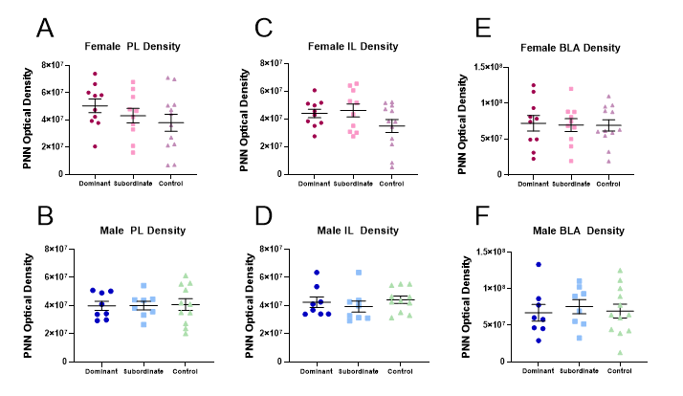
Supplemental Figure 1. Perineuronal net optical density in Study 2.
PNN optical density does not differ across dominant, subordinate, or control females in the A) PL, C) IL, or E) BLA. PNN optical density does not differ across dominant, subordinate, or control males in the B) PL, D) IL, or F) BLA.
(Dark pink circle=dominant female, light pink square=subordinate female, purple triangle=no status control female, dark blue circle=dominant male, light blue square=subordinate male, green triangle=no status control male)

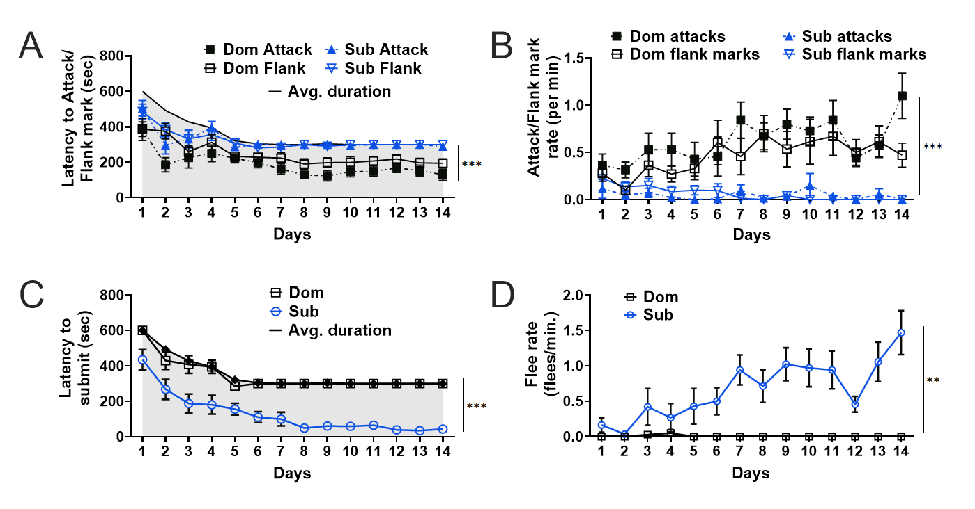
Supplemental Figure 2. Agonistic behavior from Study 1 across all days of dominant-subordinate encounters.
Supp. 2A Latency to attack and flank mark. Dominant males were quicker to attack and flank mark compared to subordinate males. (Filled grey line = average duration of encounters)
Supp. 2B. Rate of attacks and flank marks per minute. Dominant males show increased rates of attacks and flank marks compared to subordinate males.
Supp. 2C. Latency to submit. Subordinate males were quicker to submit than dominant males. (Filled grey line = average duration of encounters)
Supp. 2D. Rate of flees per minute. Subordinate males showed increased rates of fleeing compared to dominant males.

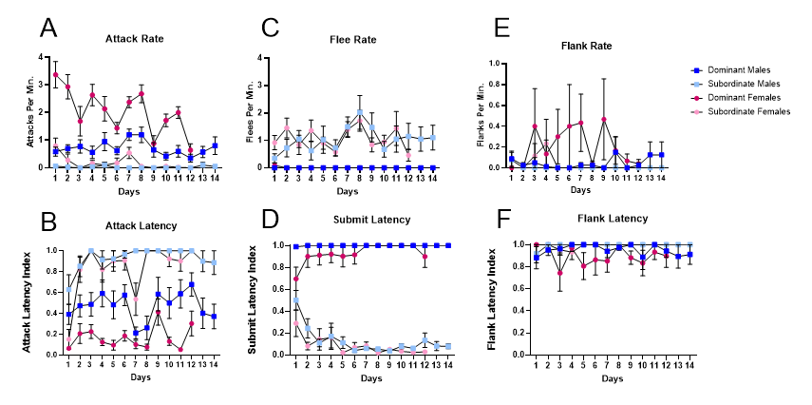
Supplemental Figure 3. Agonistic behavior in Study 2 across all days of dominant-subordinate encounters.
Supp. 3A. Rate of attacks per minute. Dominants have increased rates of attack compared to subordinates.
Supp. 3B. Attack latency index. Dominants are quicker to attack than subordinates.
Supp. 3C. Rate of flees per minute.Subordinates have increased rates of flee compared to dominants.
Supp. 3D. Submission latency index. Subordinates are quicker to submit than dominants.
Supp. 3E. Rate of flanks per minute. Dominants have increased rates of flank marking compared to subordinates.
Supp. 3F. Flank latency index. Dominants are quicker to flank mark than subordinates.

                - Vita
Anna F. Radford was born on March 14, 2000 in Lenoir City, Tennessee. She attended East Tennessee State University and earned her Bachelor of Science degree in 2022. She graduated Magna Cum Laude with a major in Biology and minors in Psychology and Microbiology. She is now pursuing a Ph.D. in Experimental Psychology with a focus in Neuroscience and Behavior at the University of Tennessee, Knoxville.

