Use of Vegetable Microparticles to Load Lipophilic Bioactive Compounds

A Dissertation presented for the
Doctor of Philosophy
Degree
The University of Tennessee, Knoxville

Inseob Choi
August 2021

Copyright © 2021 by Inseob Choi
All rights reserved.
ACKNOWLEDGEMENT
ABSTRACT
Lipophilic bioactive compounds (LBCs) have been gaining attention due to their therapeutic properties. Although, many delivery systems have been studied to encapsulate LBCs, increasing stability and bioaccessibility of the LBCs, most of delivery systems are rarely used in industry sectors due to expensive encapsulation techniques or ingredients used. Additionally, while a variety of encapsulating materials exist in nanoscale to achieve efficient encapsulation of LBCs, nanodimensional foods pose potential health risk, being subjected to toxicity test. In this dissertation, freeze-dried potato microparticles (FDPMs) and freeze-dried mushroom microparticles (FDMMs) were studied as encapsulating materials for three LBCs: resveratrol (RSV), curcumin (CCM), and quercetin (QCT). Matrices of both FDPMs and FDMMs demonstrated the potential of vegetable matrices as novel carrier materials, allowing high concentration of loading of LBCs due to porous structure of freeze-dried vegetables. In this study, the solution with high amount of RSV, CCM, and QCT was prepared by dissolving them in the binary solvent of ethanol and polyethylene glycol 400 (40:60 v/v). The studied LBCs displayed crystalline structure before their encapsulation, however, they existed in amorphous state after encapsulation. This altered structure of RSV increased ferric reducing power and bioaccessibility of RSV after encapsulation into FDPMs. Additionally, when CCM and QCT were encapsulated in FDMMs, the synergistic antioxidant activity of CCM and QCT was observed through DPPH scavenging assay. Furthermore, encapsulation of CCM and QCT into FDMMs significantly inhibited lipid oxidation of beef patties, indicated by significant low concentration of 2-thiobarbituric acid reactive substances in the patties. The encapsulation of RSV, CCM, and QCT into the vegetable-based microparticles may be used as ingredients for functional foods application.
Key words: vegetable matrix; lipophilic bioactive compound; diffusion; porosity; delivery system; antioxidant

TABLE OF CONTENTS
Chapter 1 Introduction and literature review 1
1.1 Abstract 2
1.2 Introduction 2
1.3 Lipophilic bioactive compounds 2
1.3.1 Resveratrol 2
1.3.1.1 Sources and isolation of probiotics 2
1.3.2. Curcumin 4
1.3.2.1 LAB probiotics 4
1.3.3 Quercetin 6
1.3.3.1 Alleviation of diarrhea symptoms 6
1.4. An overview of delivery system 6
1.4.1 Liposomes 6
1.4.2 Solid lipid nanoparticles 7
1.4.3 Molecular inclusion complexes 9
1.4.4 Safety and regulatory issues of nanoencapsulation 10
1.5 Encapsulation in vegetables 12
1.5.1 Vegetable matrices 12
1.5.2 Vacuum impregnation and osmotic dehydration 13
1.5.3 Porosity of vegetable matrices 14
1.9 Hypothesis and overview of dissertation research 15
References 16
Appendix 27
Chapter 2 Freeze-dried potato microparticles as a natural matrix to load resveratrol for enhanced bioaccessibility 28
2.1 Abstract 29
2.2 Introduction 29
2.3 Materials and methods 32
2.3.1 Materials 32
2.3.2 Preparation and characterization of freeze-dried potato microparticles 32
2.3.3 Encapsulation of resveratrol 33
2.3.4 Particle size of milled freeze-dried potato microparticles before and after encapsulation of resveratrol 33
2.3.5 Loading capacity of resveratrol 34
2.3.6 X-ray diffraction (XRD) 34
2.3.7 Scanning electron microscopy (SEM) 35
2.3.8 Differential scanning calorimetry (DSC) 35
2.3.9 Fourier-transform infrared spectroscopy (FTIR) 35
2.3.10 DPPH radical scavenging activity 35
2.3.11 Ferric reducing power 36
2.3.12 Photostability test 37
2.3.13 Thermal stability test 37
2.3.14 Release of resveratrol during simulated digestions 37
2.3.15 Statistical analysis 38
2.4 Results and discussions 39
2.4.1 Particle size, loading capacity, and storage stability 39
2.4.2 Physical state of resveratrol in freeze-dried potato microparticles 39
2.4.3 Morphology of resveratrol and freeze-dried potato microparticles before and after encapsulation 40
2.4.4 DSC analysis 41
2.4.5 FTIR analysis 42
2.4.6 Antioxidant activity analysis 42
2.4.7 Chemical stability of resveratrol 44
2.4.8 In vitro release of resveratrol during simulated gastrointestinal digestion 45
2.5 Conclusion 46
2.6 Acknowledgment 47
References 48
Appendix 55
Chapter 3 Co-encapsulation of curcumin and quercetin in freeze-dried mushroom microparticles for synergistic antioxidant activity 65
3.1 Abstract 66
3.2 Introduction 66
3.3 Materials and methods 66
3.3.1 Materials 66
3.3.2 Preparation of freeze-dried mushroom microparticles and determination of porosity 66
3.3.3 Loading of curcumin and quercetin into freeze-dried mushroom microparticles 67
3.3.4 Co-detection of curcumin and quercetin 67
3.3.5 Particle size of milled freeze-dried mushroom microparticles before and after loading the bioactive compounds 68
3.3.6 X-ray diffraction (XRD) 68
3.3.7 Scanning electron microscopy (SEM) 69
3.3.8 Differential scanning calorimetry (DSC) 69
3.3.9 Fourier-transform infrared spectroscopy (FTIR) 69
3.3.10 DPPH assay for synergistic antioxidant activity 70
3.3.11 Photostability test 71
3.3.12 Confocal laser scanning microscopy (CLSM) 71
3.3.13 Preparation of hamburger patties 72
3.3.14 TBARS test 72
3.3.15 Statistical analysis 73
3.4 Results and discussions 73
3.4.1 Particle size of freeze-dried mushroom microparticles and loading capacity of curcumin and quercetin in freeze-dried mushroom microparticles 73
3.4.2 Analysis of XRD 74
3.5 Conclusion 75
3.6 Acknowledgment 75
References 76
Chapter 4 Concluding remarks and future work 78
4.1 Conclusions 79
4.2 Future work 79
VITA 80

LIST OF TABLES

Table 1.1 Microorganisms. 39

LIST OF FIGURES
Figure 2.1 The diameter distribution of freeze-dried potato microparticles before and after loading resveratrol 55
Figure 2.2 XRD patterns of freeze-dried potato microparticles (FDPMs, A), FDPMs treated at encapsulation conditions (B), pristine resveratrol (C), physical mixture of FDPMs and pristine resveratrol (D), and resveratrol-loaded FDPMs (E) 56
Figure 2.3 SEM images of freeze-dried potato microparticles (FDPMs, A), FDPMs treated at encapsulation conditions (B), pristine resveratrol (C), physical mixture of FDPMs and pristine resveratrol (D), and resveratrol-loaded FDPMs (E) 59
Figure 2.4 DSC thermographs of freeze-dried potato microparticles (FDPMs, A), FDPMs treated at encapsulation conditions (B), pristine resveratrol (C), physical mixture of FDPMs and pristine resveratrol (D), and resveratrol-loaded FDPMs (E) 60
Figure 2.5 FTIR spectra of freeze-dried potato microparticles (FDPMs, A), FDPMs treated at encapsulation conditions (B), pristine resveratrol (C), physical mixture of FDPMs and pristine resveratrol (D), and resveratrol-loaded FDPMs (E) 61
Figure 2.6 DPPH radical scavenging activity (A) and ferric reducing power (B) of resveratrol (RSV), freeze-dried potato microparticles (FDPMs), physical mixture of RSV and FDPMs, and FDPMs loaded with RSV (RSV-FDPMs). Error bars are SD (n = 2). Different letters above columns in (B) indicate significant difference between mean values (p < 0.05) 62
Figure 2.7 Percentage of residual trans-resveratrol (RSV) in the pristine or encapsulated form during UV 253 nm irradiation for up to 60 min (A) or heating at 90 °C for up to 60 min (B). Error bars are SD (n = 2). Different letters above columns indicate significant difference between mean values in the same plot (p < 0.05) 63
Figure 2.8 The release profiles of pristine resveratrol (RSV), the physical mixture of pristine RSV and freeze-dried potato microparticles, and RSV loaded in freeze-dried potato microparticles during in vitro oral, gastric, and small intestinal digestions. Error bars are SD (n = 2) 64

Chapter 1 Introduction and literature review

1.1 Abstract
The use of live

1.2 Introduction
The use of live

1.3 Lipophilic bioactive compounds
One of the most widely accepted definition of probiotics is presented by an expert committee organized by the Food and Agriculture Organization (FAO).

1.3.1 Resveratrol
RSV (3,5,4`- trihydroxystilbene) is a naturally produced polyphenol phytoalexin in plants, such as grape as a response to environmental stress factors, including fungal infection, UV irradiation, and injury by insects and animals (Ndiaye et al., 2011; Neves et al., 2012). These stress factors promote the release of stilbene synthase enzyme, which is responsible for synthesizing RSV by acting on the precursor of RSV, i.e., phenylalanine (López-Hernández et al., 2007). RSV is hydrophobic with an octanol/water partition coefficient (K_{ow}) of 3.1, containing two benzene rings with three hydroxyl groups attached. Therefore, aqueous solubility of RSV is very low (<0.03 mg/mL), while it is slightly dissolved in dimethyl sulfoxide (DMSO) (16 mg/mL) and ethanol (50 mg/mL) (Soto‐Valdez et al., 2011). Although there are two geometric isomer forms of RSV, i.e., trans and cis, trans-RSV is more abundant and predominantly associated with therapeutic properties (Augustin et al., 2013). In general, the conversion of trans-RSV into cis-RSV occurs when exposed to UV light. For example, UV irradiation at 366 nm for 2 h induced 91% of isomerization from trans-RSV to cis-form (Trela & Waterhouse, 1996). Recent studies reported positive correlation between light intensity and the rate of cis-trans conversion of RSV until the ratio of cis-RSV and trans-RSV reached equilibrium around 2 h (Montsko et al., 2008; Silva et al., 2013). However, trans-RSV was stable without conversion into cis-form for more than 4 weeks when stored without light in the pH range of 1-7 (Trela & Waterhouse, 1996).
Therapeutic potential of RSV has attracted huge interest from researchers over the last decade (Fig. 1) as studies have revealed medicinal effects of RSV, including anticancer, anti-inflammatory, antioxidant, and cardioprotective properties (Abdelgawad et al., 2019; Das & Das, 2007; Hsieh & Wu, 2010). Since RSV has been known to have the effect as anticarcinogenic for three key phases: anti-initiation, anti-promotion, and anti-progression (Jang et al., 1997), anticancer properties of RSV on different human cancer cell lines have been reported (Fudhaili et al., 2019; Joe et al., 2002). However, comprehensive pharmacologic mechanism of RSV is still elusive, although recent researches have attempted to have better understanding of how RSV triggers cell cycle arrest and apoptosis (Kong et al., 2016; Singh et al., 2017; Wu et al., 2019). It is believed that anticancer property of RSV is attributed to its ability to regulate the level of reactive oxygen species (ROS), which induces downstream signaling cascades. The effect of oxidative stress-mediated signaling pathways is critical, affecting each stage of carcinogenesis (Gupta et al., 1999). In addition, ROS modifies phospholipids on plasma membrane, resulting in ensuing production of molecules that may interact with cellular proteins and DNA (Marnett, 2002). In in vivo study on Wistar rats, the supplementation of RSV (8 mg/kg) helped in the restoration of DNA damage caused by 1,2-dimethylhydrazine-induced oxidative stress, showing the role of RSV in quenching ROS (Sengottuvelan et al., 2009). This ROS-quenching ability of RSV is ascribable to its phenolic groups that can scavenge free radicals, such as hydroxy radical, superoxide anion, and lipid peroxyl radicals (Murias et al., 2005). Chronic RSV supplementation also has shown that cellular antioxidant activity is increased due to elevated levels of superoxide dismutase, various antioxidant enzymes, and other co-factors, such as β-carotene, glutathione, and vitamin E (Sengottuvelan et al., 2009).

1.3.1.1 Sources and isolation of probiotics
Fermented foods…

1.3.2 Curcumin
Curcumin, also known as diferuloylmethane, is a yellowish symmetric molecule with crystal structure found in the rhizome of Curcuma longa (i.e., turmeric) (Aggarwal et al., 2003; Araiza-Calahorra et al., 2018). Due to its relatively hydrophobic nature, curcumin, as RSV, is practically insoluble in aqueous solution with the partition coefficient (K_{ow}) of 3.2 (Jamwal, 2018). Although curcumin shows membrane permeability with its respectable lipophilic nature, it is also readily soluble in polar solvents, such as DMSO, methanol, and acetone (Araiza-Calahorra et al., 2018; Hussain et al., 2017). Curcumin is sensitive to various environmental factors, such as light, alkaline pH, elevated temperature, and oxygen (Kharat et al., 2017). When exposed to these conditions, three reactive functional sites (i.e., one diketone moiety and two phenolic groups) are readily oxidized by hydrogen abstraction (Priyadarsini, 2013). This leads to the formation of phenoxyl radicals, which are less reactive than peroxyl radicals, consequently resulting in reduced antioxidant property of curcumin (Priyadarsini, 2014). Generally, the degradation of curcumin in aqueous solution produces trans-6-(4’-hydroxy-3’methoxyphenyl)-2,4-dioxo-5-hexenal as a major product and ferulic acid, feruloylmethane, and vanillin as minor products (Schneider et al., 2015).
The health benefits of curcumin are little suspect as various therapeutic effects of curcumin have been demonstrated through in vitro and clinical studies (Ma et al., 2020; Noorafshan & Ashkani-Esfahani, 2013; Voulgaropoulou et al., 2019). Due to functional properties and pharmaceutical value of curcumin, it has been widely used as a natural colorant, a flavoring substance, and food preservative and antioxidant in many food and beverage products (Eybl et al., 2006; Wakte et al., 2011). Antioxidant property of curcumin is primary mechanism that explains most of therapeutic effects of curcumin on various health disease. It has been shown that oxidative stress indices in young male adults are significantly attenuated after oral supplementation of curcumin due to its antioxidant capacity (Roohi et al., 2017). Curcumin exerts its antioxidant capacity on free radicals via different mechanisms. First, curcumin shows “superb” scavenging activity for free radicals, such as hydrogen peroxide via proton donation from phenolic group (Ak & Gülçin, 2008). Also, it can promote the activation of glutathione peroxidase and superoxide dismutase, which are enzymes responsible for neutralizing free radicals (Marchiani et al., 2014). Lastly, curcumin inhibits ROS-producing enzymes, such as cyclooxygenase and lipoxygenase (Lin et al., 2007).

1.3.2.1 LAB probiotics
Lactobacillus is a genus of Gram-positive, non-spore-forming, catalase-negative, facultative anaerobic or microaerophilic, and rod-shaped bacterial species which are able to produce lactic acid as main metabolite of the fermentation.

1.3.3 Quercetin
In order to confer beneficial effects,

1.4. An overview of delivery system
To confer beneficial effects, a sufficient number of probiotic bacteria must be viable and functional once reached to the colon.

1.4.1 Liposomes
Liposome refers to the spherical vesicle with concentric lipid bilayers, and is among the first concepts for encapsulating RSV (Summerlin et al., 2015). Because liposomes comprise aqueous core surrounded by phospholipid bilayer, hydrophilic bioactive compounds can be carried within the aqueous core, while LBCs can be entrapped by phospholipid bilayer. Many studies have utilized liposome-based encapsulating system for RSV using different materials, such as soy lecithin, oleic acid, and egg yolk phosphatidylcholine (Caddeo et al., 2013; Huang et al., 2019; Pando et al., 2013). The diameter of liposomes varied (70-470 nm) depending on the preparation of liposomes, while generally high encapsulation efficiency of RSV was achieved around 80-90% (Balanč et al., 2016; Huang et al., 2019). Principally, liposomes are prepared using phosphatidyl choline with extrusion or sonication but various extra materials, such as cholesterol may be added to liposomal bilayers to achieve better stability of the vesicles (Lee et al., 2005). For example, low-methoxyl pectin was used to coat RSV-encapsulating liposome that resulted in superior system stability (Feng et al., 2020). Antioxidant property was also higher when curcumin-encapsulating liposomes were coated with Eudragit S100, which is a pH-sensitive polymer (De Leo et al., 2018). In addition, the physical stabilization of liposomes was achieved after co-encapsulation of RSV and curcumin due to the orientation of encapsulated materials, where curcumin was placed in hydrophobic core formed by bilayers, whereas RSV positioned themselves toward polar head groups of liposomes (Huang et al., 2019). However, low loading capacity of RSV in liposomes is the limiting factor because overloading causes the loss of structural integrity of liposomes due to limited available volume to encapsulate RSV within phospholipid bilayer (Chen et al., 2014).

1.4.2 Solid lipid nanoparticles
Solid lipid nanoparticles (SLNs) are colloidal carriers, in which lipid phase is fully solidified with nanodimension (10-1000 nm) (Mardhiah Adib et al., 2016). The concept of SLNs was initially developed in 1991 with the aim of providing physicochemical stability of, improving biocompatibility of, and protecting encapsulated material from degradation (Geszke-Moritz & Moritz, 2016). SLNs consist of lipid core enclosed by a surfactant, as a result, having the hydrophilic outermost layer with hydrophobic core. This structure enables SLNs to encapsulate LBCs, such as RSV into hydrophobic interior, although hydrophilic bioactive compounds can also be encapsulated into the particles (Souto & Müller, 2010). SLNs are usually prepared by fabricating O/W emulsions with high-shear homogenization, spray-drying, ultrasonication, solvent evaporation, and microemulsion-based methods (Lingayat et al., 2017). Main advantage of SLNs over other encapsulating techniques is that it is easier to scale-up and shows relatively high loading capacity compared to other encapsulating carriers (Mukherjee et al., 2009). Also, the use of organic solvents can be avoided, consequently mitigating possible toxicological risks associated with organic solvents (Parveen & Sahoo, 2008). In general, encapsulated LBCs are protected from chemical degradation as molecular diffusion is impeded by solidified lipid phase (Weiss et al., 2008). To achieve this, it is desired that LBCs are encapsulated within solid matrix once lipid crystallization is completed. Also, ongoing lipid crystallization often causes the expulsion of encapsulated LBCs (Mukherjee et al., 2009). The stability of and loading capacity of LBCs into formed SLNs are mainly depending on the type of lipids used as well as the characteristics of emulsifiers added to stabilize oil droplets (McClements et al., 2007). When SLNs are made of similar lipid molecules, such as tristearin, the molecules are capable of forming almost perfect crystals with few imperfections (Mukherjee et al., 2009). However, LBCs are usually encapsulated between fatty acid chains and within crystal imperfections, therefore, highly ordered crystalline state of lipids does not provide enough space for large amounts of loaded LBCs (Salminen et al., 2013). Accordingly, the use of lipids that have complex structure is recommended for high loading capacity of LBCs.
Most studies on encapsulating RSV in SLNs have done for non-food application (e.g., pharmaceutical industry), targeting specific diseases in a drug form (Gumireddy et al., 2019; Mohseni et al., 2019) Therefore, further studies on RSV-loaded SLNs are necessary for food application. A few researchers studied SLNs to encapsulate curcumin regarding food application (Ramalingam et al., 2016; Xue et al., 2018). The SLNs coated with food-grade chitosan were prepared using high shear homogenization and ultrasonication (Ramalingam et al., 2016). The study reported that both oral bioavailability and chemical stability of curcumin were increased significantly compared to those of non-encapsulated curcumin. Also, the combination of high-shear homogenization and ultrasonication showed the feasibility of large-scale production of SLNs for curcumin encapsulation (Ramalingam et al., 2016). As aforementioned, however, crystalline structure of SLNs leads to have low loading capacity of LBCs. For example, glyceryl behenate-based SLNs displayed encapsulation efficiency in the range of 3-37%, however, maximum loading for RSV was no more than 3% (Jose et al., 2014). Additionally, specific range of storage temperature for SLNs is required due to possible expulsion of LBCs resulted from crystallization process or polymorphic changes during storage (Yoon et al., 2013), which limits wide application of SLNs in food industry.

1.4.3 Molecular inclusion complexes
Molecular inclusion is the technique, in which “guest” molecule is accommodated into the cavity of “host” molecule using physical forces, such as van der Waals bonding (Nunes & Mercadante, 2007). While various factors, such as geometric compatibility and intermolecular interactions between host and guest molecules should be considered for the efficacy of inclusion process, cyclodextrins (CDs) are the most commonly used host molecules (Astray et al., 2009; Li & Yan, 2002). CDs are cyclic oligosaccharides that can be produced from starch by enzymatic modification (Kfoury et al., 2016). They consist of six (α-CDs), seven (β-CDs), or eight (γ-CDs) glucopyranose units, being β-CDs widely used for food application. These three types of CDs are found in the US Food and Drug Administration (FDA) “generally recognized as safe” (GRAS) list as food additives (FDA, 2020). The hydrophobic inner cavity of CDs allows the entrapment of LBCs forming “inclusion complex”, while hydrophilic exterior enables the complex to be dissolved in aqueous solutions (Astray et al., 2009; Brewster & Loftsson, 2007). The thermodynamic parameters for the inclusion process of bioactive compounds can be obtained from the following equation:
$$∆G=-RTlnK$$
where $∆G$ is the change of Gibbs free energy, $R$ is the gas constant (J/mol$∙$K), $T$ is the absolute temperature (K), and $K$ is the binding constant (mol⁻¹).
The $∆G$ values from inclusion complexation reaction were -19.14 kJ$∙$mol⁻¹ for RSV and -27.04 kJ$∙$mol⁻¹ for curcumin at 303 K, indicating that the inclusion process for both RSV and curcumin with CDs is spontaneous (Lu et al., 2009; Prabu & Mohamad, 2020). The water solubility of curcumin and RSV was greatly increased via inclusion complex formation with CDs, achieving around 10⁴ times higher water solubility for curcumin and even up to 7 $×$ 10⁵ folds higher for RSV (Ansari et al., 2011; F. Silva et al., 2014; Tønnesen et al., 2002). However, the decrease in the photostability of curcumin was observed when complexed with CDs (Karpkird et al., 2018; Tønnesen et al., 2002), whereas introducing RSV into CDs enhanced its photostability (Allan et al., 2009; Cheng et al., 2018). This instability of encapsulated material as well as their high cost of production and inability to target-controlled release limit the wide application of inclusion complexes.

1.4.4 Safety and regulatory issues of nanoencapsulation
The emergence of nanotechnology has allowed food and pharmaceutical researchers to adopt the application of nanotechnology into encapsulation. Despite a plethora of advantages of using nanoencapsulation, it has been facing safety, environmental, and therefore ethical concerns over the last few years owing to possible consequences of using nano-scale carriers on human health and the planet (Shishir et al., 2018). Therefore, the viewpoint on nanoencapsulation has been changing, concerning the potential risk to human health caused by nano-sized particles (Katouzian et al., 2017). Notwithstanding, details on the safety of nanoencapsulation have yet been explored, requiring extensive risk assessment and long-term toxicity in particular (He & Hwang, 2016).
Generally, nanoencapsulated substances or particles (NPs) can enter human body via skin permeation or oral consumption. As NPs are orally consumed, they may penetrate into various organs through connective tissues (Katouzian & Esfanjani, 2017). Detrimental effects, such as inflammatory bowel disease have been reported when NPs were accumulated in intestinal cells (Tetley, 2007). Also, the translocation of NPs aggregated in the intestine of rat and fish to the other organs was observed, resulting in inflammation responses (Jani et al., 1994; Zhang et al., 2007). The repercussion of inflammation response includes increased absorption rate of NPs. This may pose problems because the presence of NPs in intraepithelial zone inhibits the intake of foods with regular dimension owing to NPs’ large surface area and their exceptional reactivity (Fröhlich & Roblegg, 2012). Furthermore, when NPs enter the cells, they can modify the DNA in the cells, eventually manipulating normal functions of cells (Katouzian & Esfanjani, 2017). The accumulation of NPs in cells and organs in the long term poses significant cytotoxicity and immunological reactions, however, few studies have been conducted as for toxicity and absorption profile of food-based NPs, calling for encapsulation methods that are not solely based on nanotechnology.
Surface properties of NPs often matter regarding cytotoxicity. A study showed that negatively charged or neutral NPs possess less toxicity compared to positively charged ones (El Badawy et al., 2011). Therefore, modifying surface chemistry by adding different functional groups on or coating surface of NPs can be used to alter cell viability in animal and human bodies (He & Hwang, 2016; T. Silva et al., 2014). For example, cytotoxicity profiles of NPs were studied by MTT assay when added with human fibroblasts, and the result showed that polyethylene glycol-coated iron oxide NPs improve cell viability compared to the NPs without coating (Gupta & Wells, 2004).
Another issue regarding the application of NPs is the regulation. Currently, no legislation exists that is globally agreed on the use of NPs in food and pharmaceutical sector. While most countries do not provide regulation guidelines on the risk evaluation of nano-encapsulated materials, European Commission clearly defined nanomaterials as intentionally engineered material with one or more dimensions of the order of 100 nm or less, including structures or aggregates that may have the dimension above the order of 100 nm but maintain characteristics of nanoscale materials (Rauscher et al., 2014). According to the regulation (EU) no. 10/2011, NPs may possess toxicological properties, therefore, should be evaluated on a case-by-case basis (EFSA Panel on Food Contact Materials et al., 2020). Additionally, NPs must not be included in functional barrier because the migration of non-authorized substances from multi-layer may occur (Amenta et al., 2015). The FDA does not postulate elaborate guideline on NPs within food and drug matrix, however, it published “Draft Guidance for Industry”, which encompasses general safety and regulatory guidance on novel technologies in food industry (Duvall, 2012). The regulatory organizations in other countries also started to suggest that safety and hazard investigation should be conducted before the commercialization of food and beverages containing NPs (Katouzian et al., 2017).

1.5 Encapsulation in vegetables

1.5.1 Vegetable matrix
Vegetable tissues feature multi-phase system consisting of cells, capillaries, and pores (Gekas & Mavroudis, 1998). Mature vegetable tissues are classified as parenchyma, vascular, protecting, and supporting tissues, while edible portion of vegetables are mainly parenchyma cells (Alzamora et al., 2005). These parenchyma cells make up cell wall membrane and allow solvent molecules to pass through them easily (Torreggiani, 1993). It was reported that the size of pores in the walls of parenchyma is around 50 Å, allowing the crossing of small molecules, such as sugars and amino acids as well as small-sized proteins and polysaccharides (Carpita et al., 1979). However, not only wall pores but also intracellular spaces are also often referred as pores. Generally, intracellular spaces exist in parenchyma and account for about 20% of total volume of apple, 40% of mushroom, and 1% of potato (Alzamora et al., 2005). Changing intercellular spaces may allow easier passage of large molecules into matrix of vegetables. For example, senescence of apple enabled intracellular spaces to become enlarged, which allowed the passage of large molecules and even microbes (Ben-Arie et al., 1979).

1.5.2 Vacuum impregnation and osmotic dehydration
Vacuum impregnation (VI) and osmotic dehydration (OD) are two major food processing techniques to incorporate solutes into vegetable tissues for higher nutritional property of food matrix, which is based on diffusion without disrupting initial food matrix. Although these two techniques are often confused with each other, they are completely different. For VI, mechanically-induced difference in pressures is the driving force of the transfer of solutes that are dissolved or dispersed in a liquid phase into the porous structure of food system, while the transfer of water molecules in OD is caused by the difference in concentrations between the solution with solutes (e.g., ions and vitamins) and the intracellular liquid in vegetable matrix (Rydzak et al., 2017). OD occurs by immersing vegetable tissues in a hypertonic solution at atmospheric pressure (Shi & Le Maguer, 2002). As a consequence, water is partially removed from the vegetable tissue, travelling in the direction of concentration gradient (Raoult-Wack, 1994). However, leaching of nutrients from vegetable tissues occurs occasionally, resulting in the change in the composition of vegetables with altered nutritional profile (Ahmed et al., 2016). Furthermore, sugar or salt in hypertonic solutions may change organoleptic or functional properties of food matrix (Radziejewska-Kubzdela et al., 2014). The main goal of VI, however, is to transfer the external solution into the inside of food system applying vacuum, which allows the use of isotonic solution (Cháfer et al., 2003). The incorporation of external solution introduces desired solutes into intracellular spaces of plant system. This notably changes or improves various properties of foods, such as enhanced nutritional value (e.g., by enriching with bioactive compounds, micronutrients, and probiotics), extended shelf life (e.g., by decreasing pH), or modified sensory characteristics (e.g., by introducing sugar) (Allali et al., 2010; Derossi et al., 2013).

1.5.3 Porosity of vegetable matrices
It is assumed that the degree of food matrix impregnation considerably depends on porosity, the shape and dimension of pores as well as mechanical properties of vegetable tissues (Fito et al., 1996). In addition, porosity directly affects other physical properties of food, including mass diffusion coefficient and thermal diffusivity (Joardder et al., 2013). Therefore, modifying the structure (i.e., porosity) of vegetable matrix may be necessary to achieve desired impact of VI on the quality of final product. Drying is one of the factors that affect the porosity of final dried fruits and vegetables (Joardder et al., 2017). The glass transition theory has been introduced to expound the mechanism of collapse and shrinkage of matrix during the drying of fruits and vegetables. Based on this theory, shrinkage is negligible in food matrix if it is dried below the glass transition temperature (T_{g}) of the food, whereas significant shrinkage takes place when there is a huge difference in drying temperature and T_{g} of the food (Rahman, 2001). FD is usually performed at the temperature below T_{g}, where materials are in glassy state (Krokida et al., 1998). Therefore, shrinkage of vegetables during drying is insignificant, which results in higher porosity in the final product. However, vegetables are in rubbery state under conventional drying (e.g., hot-air drying and fluidized bed drying) with drying temperature above T_{g}, and considerable shrinkage of vegetables is observed. Therefore, dense and shriveled vegetables are produced after hot-air drying (Achanta & Okos, 1996).
In a previous study, the porosity of apple, banana, carrot, and potato was compared after the drying with five different methods (hot-air, vacuum, microwave, freeze, and osmotic drying) (Krokida & Maroulis, 1997). The result was clear that FD developed more porous structure (90% in porosity) in potato, than other drying methods, such as 70% for microwave drying, 30% for vacuum drying, and 20% for hot-air drying. The drying temperature (-35 °C for FD and 70 °C for vacuum and hot-air drying) partially explains the difference in porosity as T_{g} of potato starch is within 40-80 °C (Thiewes & Steeneken, 1997). The low porosity of vegetables after vacuum drying is not desired for encapsulation because it inhibits the incorporation of external solution into matrix. Also, rapid drying conditions, including vacuum and high temperature, promote rapid surface drying of vegetables and induce the formation of crust on the surface (Troncoso & Pedreschi, 2007). The difficulty of encapsulating bioactive compounds is increased with this impermeable crust formed. For example, the formation of impermeable layer of banana chips was accelerated when the proportion of hot-air drying was increased in the combination drying of hot-air and microwave (Mui et al., 2002). This indicates the importance of selecting appropriate drying method and drying condition to achieve desired encapsulation outcomes.

1.6 Hypothesis and overview of dissertation research
The overall hypothesis of this dissertation is that directly mixing a concentrated cell suspension (composed of 70-80% water) and dairy ingredient powders can be used to prepare powdered probiotics to enhance probiotic viability during storage and thermal treatment.

References
Abdelgawad, I. Y., Grant, M. K., & Zordoky, B. N. (2019). Leveraging the cardio-protective and anticancer properties of resveratrol in cardio-oncology. Nutrients, 11(3), 627.

Achanta, S., & Okos, M. R. (1996). Predicting the quality of dehydrated foods and biopolymers—research needs and opportunities. Drying Technology, 14(6), 1329-1368.

Aggarwal, B. B., Kumar, A., & Bharti, A. C. (2003). Anticancer potential of curcumin: preclinical and clinical studies. Anticancer research, 23(1/A), 363-398.

Ahmed, I., Qazi, I. M., & Jamal, S. (2016). Developments in osmotic dehydration technique for the preservation of fruits and vegetables. Innovative Food Science & Emerging Technologies, 34, 29-43.

Ak, T., & Gülçin, İ. (2008, 2008/07/10/). Antioxidant and radical scavenging properties of curcumin. Chemico-Biological Interactions, 174(1), 27-37. https://doi.org/https://doi.org/10.1016/j.cbi.2008.05.003

Allali, H., Marchal, L., & Vorobiev, E. (2010). Effects of vacuum impregnation and ohmic heating with citric acid on the behaviour of osmotic dehydration and structural changes of apple fruit. biosystems engineering, 106(1), 6-13.

Allan, K. E., Lenehan, C. E., & Ellis, A. V. (2009). UV light stability of α-cyclodextrin/resveratrol host–guest complexes and isomer stability at varying pH. Australian journal of chemistry, 62(8), 921-926.

Alzamora, S. M., Salvatori, D., Tapia, M. S., López-Malo, A., Welti-Chanes, J., & Fito, P. (2005). Novel functional foods from vegetable matrices impregnated with biologically active compounds. Journal of Food Engineering, 67(1-2), 205-214.

Amenta, V., Aschberger, K., Arena, M., Bouwmeester, H., Botelho Moniz, F., Brandhoff, P., Gottardo, S., Marvin, H. J. P., Mech, A., Quiros Pesudo, L., Rauscher, H., Schoonjans, R., Vettori, M. V., Weigel, S., & Peters, R. J. (2015, 2015/10/01/). Regulatory aspects of nanotechnology in the agri/feed/food sector in EU and non-EU countries. Regulatory Toxicology and Pharmacology, 73(1), 463-476. https://doi.org/https://doi.org/10.1016/j.yrtph.2015.06.016

Ansari, K. A., Vavia, P. R., Trotta, F., & Cavalli, R. (2011). Cyclodextrin-based nanosponges for delivery of resveratrol: in vitro characterisation, stability, cytotoxicity and permeation study. Aaps Pharmscitech, 12(1), 279-286.

Araiza-Calahorra, A., Akhtar, M., & Sarkar, A. (2018, 2018/01/01/). Recent advances in emulsion-based delivery approaches for curcumin: From encapsulation to bioaccessibility. Trends in Food Science & Technology, 71, 155-169. https://doi.org/https://doi.org/10.1016/j.tifs.2017.11.009

Astray, G., Gonzalez-Barreiro, C., Mejuto, J. C., Rial-Otero, R., & Simal-Gándara, J. (2009, 2009/10/01/). A review on the use of cyclodextrins in foods. Food Hydrocolloids, 23(7), 1631-1640. https://doi.org/https://doi.org/10.1016/j.foodhyd.2009.01.001

Augustin, M. A., Sanguansri, L., & Lockett, T. (2013). Nano- and micro-encapsulated systems for enhancing the delivery of resveratrol. Annals of the New York Academy of Sciences, 1290(1), 107-112. https://doi.org/https://doi.org/10.1111/nyas.12130

Balanč, B., Trifković, K., Đorđević, V., Marković, S., Pjanović, R., Nedović, V., & Bugarski, B. (2016). Novel resveratrol delivery systems based on alginate-sucrose and alginate-chitosan microbeads containing liposomes. Food Hydrocolloids, 61, 832-842.

Ben-Arie, R., Kislev, N., & Frenkel, C. (1979). Ultrastructural changes in the cell walls of ripening apple and pear fruit. Plant Physiology, 64(2), 197-202.

Brewster, M. E., & Loftsson, T. (2007, 2007/07/30/). Cyclodextrins as pharmaceutical solubilizers. Advanced Drug Delivery Reviews, 59(7), 645-666. https://doi.org/https://doi.org/10.1016/j.addr.2007.05.012

Caddeo, C., Manconi, M., Fadda, A. M., Lai, F., Lampis, S., Diez-Sales, O., & Sinico, C. (2013). Nanocarriers for antioxidant resveratrol: formulation approach, vesicle self-assembly and stability evaluation. Colloids and surfaces B: Biointerfaces, 111, 327-332.

Carpita, N., Sabularse, D., Montezinos, D., & Delmer, D. P. (1979). Determination of the pore size of cell walls of living plant cells. Science, 205(4411), 1144-1147.

Cháfer, M., González-Martı́nez, C., Chiralt, A., & Fito, P. (2003). Microstructure and vacuum impregnation response of citrus peels. Food Research International, 36(1), 35-41.

Chen, J., Lu, W.-L., Gu, W., Lu, S.-S., Chen, Z.-P., Cai, B.-C., & Yang, X.-X. (2014, 2014/04/01). Drug-in-cyclodextrin-in-liposomes: a promising delivery system for hydrophobic drugs. Expert Opinion on Drug Delivery, 11(4), 565-577. https://doi.org/10.1517/17425247.2014.884557

Cheng, J. G., Tian, B. R., Huang, Q., Ge, H. R., & Wang, Z. Z. (2018). Resveratrol functionalized carboxymethyl-β-cyclodextrin: synthesis, characterization, and photostability. Journal of Chemistry, 2018.

Das, S., & Das, D. K. (2007). Anti-inflammatory responses of resveratrol. Inflammation & Allergy-Drug Targets (Formerly Current Drug Targets-Inflammation & Allergy), 6(3), 168-173.

De Leo, V., Milano, F., Mancini, E., Comparelli, R., Giotta, L., Nacci, A., Longobardi, F., Garbetta, A., Agostiano, A., & Catucci, L. (2018). Encapsulation of curcumin-loaded liposomes for colonic drug delivery in a pH-responsive polymer cluster using a pH-driven and organic solvent-free process. Molecules, 23(4), 739.

Derossi, A., De Pilli, T., & Severini, C. (2013). Application of vacuum impregnation techniques to improve the pH reduction of vegetables: study on carrots and eggplants. Food and Bioprocess Technology, 6(11), 3217-3226.

Duvall, M. N. (2012). FDA regulation of nanotechnology. Washington, DC, USA: Beveridge & Diamond, PG.

EFSA Panel on Food Contact Materials, E., Aids, P., Silano, V., Barat Baviera, J. M., Bolognesi, C., Chesson, A., Cocconcelli, P. S., Crebelli, R., Gott, D. M., Grob, K., & Lambré, C. (2020). Review and priority setting for substances that are listed without a specific migration limit in Table 1 of Annex 1 of Regulation 10/2011 on plastic materials and articles intended to come into contact with food. EFSA Journal, 18(6), e06124.

El Badawy, A. M., Silva, R. G., Morris, B., Scheckel, K. G., Suidan, M. T., & Tolaymat, T. M. (2011, 2011/01/01). Surface Charge-Dependent Toxicity of Silver Nanoparticles. Environmental Science & Technology, 45(1), 283-287. https://doi.org/10.1021/es1034188

Eybl, V., Kotyzova, D., & Koutensky, J. (2006, 2006/08/15/). Comparative study of natural antioxidants – curcumin, resveratrol and melatonin – in cadmium-induced oxidative damage in mice. Toxicology, 225(2), 150-156. https://doi.org/https://doi.org/10.1016/j.tox.2006.05.011

FDA. (2020). GRAS Notice Inventory. Retrieved Nov 17 from https://www.cfsanappsexternal.fda.gov/scripts/fdcc/?set=GRASNotices

Feng, S., Sun, Y., Wang, P., Sun, P., Ritzoulis, C., & Shao, P. (2020). Co‐encapsulation of resveratrol and epigallocatechin gallate in low methoxyl pectin‐coated liposomes with great stability in orange juice. International Journal of Food Science & Technology, 55(5), 1872-1880.

Fito, P., Andrés, A., Chiralt, A., & Pardo, P. (1996). Coupling of hydrodynamic mechanism and deformation-relaxation phenomena during vacuum treatments in solid porous food-liquid systems. Journal of Food Engineering, 27(3), 229-240.

Fröhlich, E., & Roblegg, E. (2012, 2012/01/27/). Models for oral uptake of nanoparticles in consumer products. Toxicology, 291(1), 10-17. https://doi.org/https://doi.org/10.1016/j.tox.2011.11.004

Fudhaili, A., Yoon, N., Kang, S., Ryu, J., Jeong, J. Y., Lee, D. H., & Kang, S. S. (2019). Resveratrol epigenetically regulates the expression of zinc finger protein 36 in non‑small cell lung cancer cell lines. Oncology reports, 41(2), 1377-1386.

Gekas, V., & Mavroudis, N. (1998). Mass transfer properties of osmotic solutions. II. Diffusivities. International Journal of Food Properties, 1(2), 181-195.

Geszke-Moritz, M., & Moritz, M. (2016, 2016/11/01/). Solid lipid nanoparticles as attractive drug vehicles: Composition, properties and therapeutic strategies. Materials Science and Engineering: C, 68, 982-994. https://doi.org/https://doi.org/10.1016/j.msec.2016.05.119

Gumireddy, A., Christman, R., Kumari, D., Tiwari, A., North, E. J., & Chauhan, H. (2019). Preparation, characterization, and in vitro evaluation of Curcumin-and resveratrol-loaded solid lipid nanoparticles. AAPS PharmSciTech, 20(4), 145.

Gupta, A., Rosenberger, S. F., & Bowden, G. T. (1999). Increased ROS levels contribute to elevated transcription factor and MAP kinase activities in malignantly progressed mouse keratinocyte cell lines. Carcinogenesis, 20(11), 2063-2073.

Gupta, A. K., & Wells, S. (2004). Surface-Modified Superparamagnetic Nanoparticles for Drug Delivery: Preparation, Characterization, and Cytotoxicity Studies [Article]. IEEE Transactions on Nanobioscience, 3(1), 66-73. https://doi.org/10.1109/TNB.2003.820277

He, X., & Hwang, H.-M. (2016). Nanotechnology in food science: Functionality, applicability, and safety assessment. journal of food and drug analysis, 24(4), 671-681.

Hsieh, T. c., & Wu, J. M. (2010). Resveratrol: Biological and pharmaceutical properties as anticancer molecule. Biofactors, 36(5), 360-369.

Huang, M., Liang, C., Tan, C., Huang, S., Ying, R., Wang, Y., Wang, Z., & Zhang, Y. (2019). Liposome co-encapsulation as a strategy for the delivery of curcumin and resveratrol. Food & function, 10(10), 6447-6458.

Hussain, Z., Thu, H. E., Amjad, M. W., Hussain, F., Ahmed, T. A., & Khan, S. (2017, 2017/08/01/). Exploring recent developments to improve antioxidant, anti-inflammatory and antimicrobial efficacy of curcumin: A review of new trends and future perspectives. Materials Science and Engineering: C, 77, 1316-1326. https://doi.org/https://doi.org/10.1016/j.msec.2017.03.226

Jamwal, R. (2018, 2018/11/01/). Bioavailable curcumin formulations: A review of pharmacokinetic studies in healthy volunteers. Journal of Integrative Medicine, 16(6), 367-374. https://doi.org/https://doi.org/10.1016/j.joim.2018.07.001

Jang, M., Cai, L., Udeani, G. O., Slowing, K. V., Thomas, C. F., Beecher, C. W. W., Fong, H. H. S., Farnsworth, N. R., Kinghorn, A. D., Mehta, R. G., Moon, R. C., & Pezzuto, J. M. (1997). Cancer chemopreventive activity of resveratrol, a natural product derived from grapes [Article]. Science, 275(5297), 218-220. https://doi.org/10.1126/science.275.5297.218

Jani, P. U., McCarthy, D. E., & Florence, A. T. (1994, 1994/05/02/). Titanium dioxide (rutile) particle uptake from the rat GI tract and translocation to systemic organs after oral administration. International Journal of Pharmaceutics, 105(2), 157-168. https://doi.org/https://doi.org/10.1016/0378-5173(94)90461-8

Joardder, M. U., Kumar, C., & Karim, M. (2017). Food structure: Its formation and relationships with other properties. Critical reviews in food science and nutrition, 57(6), 1190-1205.

Joardder, M. U. H., Karim, A., & Kumar, C. (2013). Effect of moisture and temperature distribution on dried food microstructure and porosity. Proceedings of from model foods to food models: the DREAM project international conference,

Joe, A. K., Liu, H., Suzui, M., Vural, M. E., Xiao, D., & Weinstein, I. B. (2002). Resveratrol induces growth inhibition, S-phase arrest, apoptosis, and changes in biomarker expression in several human cancer cell lines. Clinical Cancer Research, 8(3), 893-903.

Jose, S., Anju, S. S., Cinu, T. A., Aleykutty, N. A., Thomas, S., & Souto, E. B. (2014, 2014/10/20/). In vivo pharmacokinetics and biodistribution of resveratrol-loaded solid lipid nanoparticles for brain delivery. International journal of pharmaceutics, 474(1), 6-13. https://doi.org/https://doi.org/10.1016/j.ijpharm.2014.08.003

Karpkird, T., Khunsakorn, R., Noptheeranuphap, C., & Midpanon, S. (2018). Inclusion complexes and photostability of UV filters and curcumin with beta-cyclodextrin polymers: effect on cross-linkers. Journal of Inclusion Phenomena and Macrocyclic Chemistry, 91(1-2), 37-45.

Katouzian, I., & Esfanjani, A. (2017). Release, Characterization and Safety of Nanoencapsulated Food Ingredients. In (pp. 401-453). https://doi.org/10.1016/B978-0-12-809740-3.00010-6

Katouzian, I., Faridi Esfanjani, A., Jafari, S. M., & Akhavan, S. (2017, 2017/10/01/). Formulation and application of a new generation of lipid nano-carriers for the food bioactive ingredients. Trends in Food Science & Technology, 68, 14-25. https://doi.org/https://doi.org/10.1016/j.tifs.2017.07.017

Kfoury, M., Hădărugă, N. G., Hădărugă, D. I., & Fourmentin, S. (2016). 4 - Cyclodextrins as encapsulation material for flavors and aroma. In A. M. Grumezescu (Ed.), Encapsulations (pp. 127-192). Academic Press. https://doi.org/https://doi.org/10.1016/B978-0-12-804307-3.00004-1

Kharat, M., Du, Z., Zhang, G., & McClements, D. J. (2017). Physical and chemical stability of curcumin in aqueous solutions and emulsions: impact of pH, temperature, and molecular environment. Journal of agricultural and food chemistry, 65(8), 1525-1532.

Kong, Y., Chen, G., Xu, Z., Yang, G., Li, B., Wu, X., Xiao, W., Xie, B., Hu, L., & Sun, X. (2016). Pterostilbene induces apoptosis and cell cycle arrest in diffuse large B-cell lymphoma cells. Scientific reports, 6, 37417.

Krokida, M., Karathanos, V., & Maroulis, Z. (1998). Effect of freeze-drying conditions on shrinkage and porosity of dehydrated agricultural products. Journal of Food Engineering, 35(4), 369-380.

Krokida, M., & Maroulis, Z. (1997). Effect of drying method on shrinkage and porosity. Drying Technology, 15(10), 2441-2458.

Lee, S. C., Lee, K. E., Kim, J. J., & Lim, S. H. (2005). The effect of cholesterol in the liposome bilayer on the stabilization of incorporated retinol [Article]. Journal of Liposome Research, 15(3-4), 157-166. https://doi.org/10.1080/08982100500364131

Li, J., & Yan, D. (2002). Preparation and Characterization of the Crystalline Inclusion Complex between β‐Cyclodextrin and Poly (neopentyl glycol). Macromolecular Chemistry and Physics, 203(1), 155-158.

Lin, Y. G., Kunnumakkara, A. B., Nair, A., Merritt, W. M., Han, L. Y., Armaiz-Pena, G. N., Kamat, A. A., Spannuth, W. A., Gershenson, D. M., & Lutgendorf, S. K. (2007). Curcumin inhibits tumor growth and angiogenesis in ovarian carcinoma by targeting the nuclear factor-κB pathway. Clinical Cancer Research, 13(11), 3423-3430.

Lingayat, V. J., Zarekar, N. S., & Shendge, R. S. (2017). Solid lipid nanoparticles: a review. Nanoscience and Nanotechnology Research, 2, 67-72.

López-Hernández, J., Paseiro-Losada, P., Sanches-Silva, A. T., & Lage-Yusty, M. A. (2007, 2007/09/01). Study of the changes of trans-resveratrol caused by ultraviolet light and determination of trans- and cis-resveratrol in Spanish white wines. European Food Research and Technology, 225(5), 789-796. https://doi.org/10.1007/s00217-006-0483-x

Lu, Z., Chen, R., Liu, H., Hu, Y., Cheng, B., & Zou, G. (2009). Study of the complexation of resveratrol with cyclodextrins by spectroscopy and molecular modeling. Journal of Inclusion Phenomena and Macrocyclic Chemistry, 63(3-4), 295-300.

Ma, C., Zhuang, Z., Su, Q., He, J., & Li, H. (2020). Curcumin Has Anti-Proliferative and Pro-Apoptotic Effects on Tongue Cancer in vitro: A Study with Bioinformatics Analysis and in vitro Experiments. Drug Design, Development and Therapy, 14, 509.

Marchiani, A., Rozzo, C., Fadda, A., Delogu, G., & Ruzza, P. (2014). Curcumin and curcumin-like molecules: from spice to drugs. Current medicinal chemistry, 21(2), 204-222.

Mardhiah Adib, Z., Ghanbarzadeh, S., Kouhsoltani, M., Yari Khosroshahi, A., & Hamishehkar, H. (2016, 2016/3/17). The Effect of Particle Size on the Deposition of Solid Lipid Nanoparticles in Different Skin Layers: A Histological Study. Adv Pharm Bull, 6(1), 31-36. https://doi.org/10.15171/apb.2016.06

Marnett, L. J. (2002, 2002/12/27/). Oxy radicals, lipid peroxidation and DNA damage. Toxicology, 181-182, 219-222. https://doi.org/https://doi.org/10.1016/S0300-483X(02)00448-1

McClements, D. J., Decker, E. A., & Weiss, J. (2007). Emulsion‐based delivery systems for lipophilic bioactive components. Journal of food science, 72(8), R109-R124.

Mohseni, R., ArabSadeghabadi, Z., Ziamajidi, N., Abbasalipourkabir, R., & RezaeiFarimani, A. (2019). Oral administration of resveratrol-loaded solid lipid nanoparticle improves insulin resistance through targeting expression of SNARE proteins in adipose and muscle tissue in rats with type 2 diabetes. Nanoscale research letters, 14(1), 227.

Montsko, G., Nikfardjam, M. S. P., Szabo, Z., Boddi, K., Lorand, T., Ohmacht, R., & Mark, L. (2008, 2008/04/30/). Determination of products derived from trans-resveratrol UV photoisomerisation by means of HPLC–APCI-MS. Journal of Photochemistry and Photobiology A: Chemistry, 196(1), 44-50. https://doi.org/https://doi.org/10.1016/j.jphotochem.2007.11.011

Mui, W. W., Durance, T. D., & Scaman, C. H. (2002). Flavor and texture of banana chips dried by combinations of hot air, vacuum, and microwave processing. Journal of agricultural and food chemistry, 50(7), 1883-1889.

Mukherjee, S., Ray, S., & Thakur, R. (2009). Solid lipid nanoparticles: a modern formulation approach in drug delivery system. Indian journal of pharmaceutical sciences, 71(4), 349.

Murias, M., Jäger, W., Handler, N., Erker, T., Horvath, Z., Szekeres, T., Nohl, H., & Gille, L. (2005, 2005/03/15/). Antioxidant, prooxidant and cytotoxic activity of hydroxylated resveratrol analogues: structure–activity relationship. Biochemical Pharmacology, 69(6), 903-912. https://doi.org/https://doi.org/10.1016/j.bcp.2004.12.001

Ndiaye, M., Kumar, R., & Ahmad, N. (2011). Resveratrol in cancer management: where are we and where we go from here? Annals of the New York Academy of Sciences, 1215(1), 144-149. https://doi.org/https://doi.org/10.1111/j.1749-6632.2010.05851.x

Neves, A. R., Lúcio, M., Lima, J. L. C., & Reis, S. (2012). Resveratrol in medicinal chemistry: A critical review of its pharmacokinetics, drug-delivery, and membrane interactions [Review]. Current Medicinal Chemistry, 19(11), 1663-1681. https://doi.org/10.2174/092986712799945085

Noorafshan, A., & Ashkani-Esfahani, S. (2013). A review of therapeutic effects of curcumin. Current pharmaceutical design, 19(11), 2032-2046.

Nunes, I. L., & Mercadante, A. Z. (2007). Encapsulation of lycopene using spray-drying and molecular inclusion processes. Brazilian Archives of Biology and Technology, 50(5), 893-900.

Pando, D., Caddeo, C., Manconi, M., Fadda, A. M., & Pazos, C. (2013). Nanodesign of olein vesicles for the topical delivery of the antioxidant resveratrol. Journal of Pharmacy and Pharmacology, 65(8), 1158-1167.

Parveen, S., & Sahoo, S. K. (2008, 2008/01/01). Polymeric nanoparticles for cancer therapy. Journal of Drug Targeting, 16(2), 108-123. https://doi.org/10.1080/10611860701794353

Prabu, S., & Mohamad, S. (2020). Curcumin/beta-cyclodextrin inclusion complex as a new “turn-off” fluorescent sensor system for sensitive recognition of mercury ion. Journal of Molecular Structure, 1204, 127528.

Priyadarsini, K. I. (2013). Chemical and structural features influencing the biological activity of curcumin. Current pharmaceutical design, 19(11), 2093-2100.

Priyadarsini, K. I. (2014). The chemistry of curcumin: from extraction to therapeutic agent. Molecules, 19(12), 20091-20112.

Radziejewska-Kubzdela, E., Biegańska-Marecik, R., & Kidoń, M. (2014). Applicability of vacuum impregnation to modify physico-chemical, sensory and nutritive characteristics of plant origin products—a review. International journal of molecular sciences, 15(9), 16577-16610.

Rahman, M. S. (2001). Toward prediction of porosity in foods during drying: a brief review. Drying Technology, 19(1), 1-13.

Ramalingam, P., Yoo, S. W., & Ko, Y. T. (2016, 2016/06/01/). Nanodelivery systems based on mucoadhesive polymer coated solid lipid nanoparticles to improve the oral intake of food curcumin. Food Research International, 84, 113-119. https://doi.org/https://doi.org/10.1016/j.foodres.2016.03.031

Raoult-Wack, A.-L. (1994). Recent advances in the osmotic dehydration of foods. Trends in Food Science & Technology, 5(8), 255-260.

Rauscher, H., Roebben, G., Sanfeliu, A. B., Emons, H., Gibson, N., Koeber, R., Linsinger, T., Rasmussen, K., Sintes, J. R., & Sokull-Klüttgen, B. (2014). Towards a review of the EC Recommendation for a definition of the term “nanomaterial”. Eur Union. doi, 10, 36237.

Roohi, B. N., Moradlou, A. N., & Bolboli, L. (2017). Influence of curcumin supplementation on exercise-induced oxidative stress. Asian J Sports Med, 8, e35776.

Rydzak, L., Sagan, A., Andrejko, D., Starek, A., Ślaska-Grzywna, B., Blicharz-Kania, A., Kobus, Z., & Natoniewski, M. (2017, 2017/11/01). Changes in Particle Size Distribution of Bran and Flour Obtained from Vacuum Impregnated and Infra-red Heated Wheat Grain. Food and Bioprocess Technology, 10(11), 1997-2004. https://doi.org/10.1007/s11947-017-1949-5

Salminen, H., Helgason, T., Kristinsson, B., Kristbergsson, K., & Weiss, J. (2013). Formation of solid shell nanoparticles with liquid ω-3 fatty acid core. Food chemistry, 141(3), 2934-2943.

Schneider, C., Gordon, O. N., Edwards, R. L., & Luis, P. B. (2015). Degradation of curcumin: from mechanism to biological implications. Journal of agricultural and food chemistry, 63(35), 7606-7614.

Sengottuvelan, M., Deeptha, K., & Nalini, N. (2009, 2009/10/07/). Resveratrol ameliorates DNA damage, prooxidant and antioxidant imbalance in 1,2-dimethylhydrazine induced rat colon carcinogenesis. Chemico-Biological Interactions, 181(2), 193-201. https://doi.org/https://doi.org/10.1016/j.cbi.2009.06.004

Shi, J., & Le Maguer, M. (2002). Osmotic dehydration of foods: mass transfer and modeling aspects. Food Reviews International, 18(4), 305-335.

Shishir, M. R. I., Xie, L., Sun, C., Zheng, X., & Chen, W. (2018). Advances in micro and nano-encapsulation of bioactive compounds using biopolymer and lipid-based transporters. Trends in Food Science & Technology, 78, 34-60.

Silva, C. G., Monteiro, J., Marques, R. R., Silva, A. M., Martínez, C., Canle, M., & Faria, J. L. (2013). Photochemical and photocatalytic degradation of trans-resveratrol. Photochemical & Photobiological Sciences, 12(4), 638-644.

Silva, F., Figueiras, A., Gallardo, E., Nerín, C., & Domingues, F. C. (2014, 2014/02/15/). Strategies to improve the solubility and stability of stilbene antioxidants: A comparative study between cyclodextrins and bile acids. Food Chemistry, 145, 115-125. https://doi.org/https://doi.org/10.1016/j.foodchem.2013.08.034

Silva, T., Pokhrel, L. R., Dubey, B., Tolaymat, T. M., Maier, K. J., & Liu, X. (2014, 2014/01/15/). Particle size, surface charge and concentration dependent ecotoxicity of three organo-coated silver nanoparticles: Comparison between general linear model-predicted and observed toxicity. Science of The Total Environment, 468-469, 968-976. https://doi.org/https://doi.org/10.1016/j.scitotenv.2013.09.006

Singh, S. K., Banerjee, S., Acosta, E. P., Lillard, J. W., & Singh, R. (2017). Resveratrol induces cell cycle arrest and apoptosis with docetaxel in prostate cancer cells via a p53/p21WAF1/CIP1 and p27KIP1 pathway. Oncotarget, 8(10), 17216.

Soto‐Valdez, H., Auras, R., & Peralta, E. (2011). Fabrication of poly (lactic acid) films with resveratrol and the diffusion of resveratrol into ethanol. Journal of Applied Polymer Science, 121(2), 970-978.

Souto, E. B., & Müller, R. H. (2010). Lipid nanoparticles: effect on bioavailability and pharmacokinetic changes. In Drug delivery (pp. 115-141). Springer.

Summerlin, N., Soo, E., Thakur, S., Qu, Z., Jambhrunkar, S., & Popat, A. (2015). Resveratrol nanoformulations: challenges and opportunities. International journal of pharmaceutics, 479(2), 282-290.

Tetley, T. D. (2007). Health effects of nanomaterials [Conference Paper]. Biochemical Society Transactions, 35(3), 527-531. https://doi.org/10.1042/BST0350527

Thiewes, H. J., & Steeneken, P. A. M. (1997, 1997/02/01/). The glass transition and the sub-Tg endotherm of amorphous and native potato starch at low moisture content. Carbohydrate Polymers, 32(2), 123-130. https://doi.org/https://doi.org/10.1016/S0144-8617(96)00133-6

Tønnesen, H. H., Másson, M., & Loftsson, T. (2002, 2002/09/05/). Studies of curcumin and curcuminoids. XXVII. Cyclodextrin complexation: solubility, chemical and photochemical stability. International Journal of Pharmaceutics, 244(1), 127-135. https://doi.org/https://doi.org/10.1016/S0378-5173(02)00323-X

Torreggiani, D. (1993). Osmotic dehydration in fruit and vegetable processing. Food Research International, 26(1), 59-68.

Trela, B. C., & Waterhouse, A. L. (1996). Resveratrol: isomeric molar absorptivities and stability. Journal of agricultural and food chemistry, 44(5), 1253-1257.

Troncoso, E., & Pedreschi, F. (2007). Modeling of textural changes during drying of potato slices. Journal of Food Engineering, 82(4), 577-584.

Voulgaropoulou, S., van Amelsvoort, T., Prickaerts, J., & Vingerhoets, C. (2019). The effect of curcumin on cognition in Alzheimer’s disease and healthy aging: A systematic review of pre-clinical and clinical studies. Brain Research, 1725, 146476.

Wakte, P. S., Sachin, B. S., Patil, A. A., Mohato, D. M., Band, T. H., & Shinde, D. B. (2011, 2011/05/19/). Optimization of microwave, ultra-sonic and supercritical carbon dioxide assisted extraction techniques for curcumin from Curcuma longa. Separation and Purification Technology, 79(1), 50-55. https://doi.org/https://doi.org/10.1016/j.seppur.2011.03.010

Weiss, J., Decker, E. A., McClements, D. J., Kristbergsson, K., Helgason, T., & Awad, T. (2008, 2008/06/01). Solid Lipid Nanoparticles as Delivery Systems for Bioactive Food Components. Food Biophysics, 3(2), 146-154. https://doi.org/10.1007/s11483-008-9065-8

Wu, H., Chen, L., Zhu, F., Han, X., Sun, L., & Chen, K. (2019). The cytotoxicity effect of resveratrol: Cell cycle arrest and induced apoptosis of breast Cancer 4T1 cells. Toxins, 11(12), 731.

Xue, J., Wang, T., Hu, Q., Zhou, M., & Luo, Y. (2018). Insight into natural biopolymer-emulsified solid lipid nanoparticles for encapsulation of curcumin: Effect of loading methods. Food Hydrocolloids, 79, 110-116.

Yoon, G., Park, J. W., & Yoon, I.-S. (2013). Solid lipid nanoparticles (SLNs) and nanostructured lipid carriers (NLCs): recent advances in drug delivery. Journal of Pharmaceutical Investigation, 43(5), 353-362.

Zhang, X., Sun, H., Zhang, Z., Niu, Q., Chen, Y., & Crittenden, J. C. (2007, 2007/02/01/). Enhanced bioaccumulation of cadmium in carp in the presence of titanium dioxide nanoparticles. Chemosphere, 67(1), 160-166. https://doi.org/https://doi.org/10.1016/j.chemosphere.2006.09.003

Appendix
Table 1.1 Microorganisms.

Chapter 2 Freeze-dried potato microparticles as a natural matrix to load resveratrol for enhanced bioaccessibility

2.1 Abstract
Resveratrol (RSV) is a natural polyphenol with many potential health benefits. However, RSV is lipophilic and susceptible to degradation, and strategies are to be studied to enable its distribution in food matrices, prevent its degradation during storage, and increase its bioaccessibility during digestion. In this study, the porous matrix of milled freeze-dried potato microparticles (FDPMs) was studied as a natural absorbent to load RSV. The binary solvent of ethanol and polyethylene glycol 400 (40:60 v/v) was used to dissolve 30% w/v RSV for diffusion into FDPMs. After evaporation of ethanol, the loading capacity was 112 mg RSV/g FDPMs and was maintained at 92.9% after 110-day ambient storage, the RSV stability under UV irradiation at 253 nm was improved, and the ferric reducing power was higher than the pristine RSV. The release of RSV in FDPMs was significantly higher than pristine RSV during simulated gastric and intestinal digestions. The increased reducing power and bioaccessibility were supported by the amorphous state of RSV in FDPMs. The present study illustrates the potential of porous vegetable microparticles as natural matrices to load lipophilic bioactive compounds.

2.2 Introduction
Resveratrol (RSV, 3,6,5’-trihydroxystilbene) is a polyphenol phytoalexin naturally produced in plants such as grapes.(R Neves et al., 2012) RSV has attracted much interest as many studies have revealed its medicinal effects, including anticancer, anti-inflammatory, antioxidant, and cardioprotective properties.(Abdelgawad et al., 2019; Das & Das, 2007; Hsieh & Wu, 2010) Although there are two geometric isomers, trans and cis, trans-RSV contributes predominantly to therapeutic properties of RSV.(Augustin et al., 2013) However, trans-RSV is susceptible to degradation under various environmental factors, such as light and extreme temperature. For example, the conversion of trans-RSV to cis-RSV occurs when exposed to UV irradiation.(Trela & Waterhouse, 1996) Additionally, RSV, containing two benzene rings with a total of three hydroxyl groups attached, has a very low water solubility (<0.03 mg/mL), and is moderately dissolved in dimethyl sulfoxide (16 mg/mL) and ethanol (50 mg/mL).(Soto‐Valdez et al., 2011) Although the oral administration of RSV is preferred as a preventive treatment, the low aqueous solubility and the vulnerability to degradation necessitate delivery systems to increase its stability and bioavailability.
Various delivery systems have been studied for RSV. Liposome-based encapsulating systems for RSV have been studied utilizing different materials, such as soy lecithin, oleic acid, and egg yolk phosphatidylcholine.(Caddeo et al., 2013; M. Huang et al., 2019; Pando et al., 2013) The diameter of liposomes varied (70-470 nm) depending on the preparation of liposomes, while high encapsulation efficiency of RSV (80-90%) was achieved.(Balanč et al., 2016; M. Huang et al., 2019) Molecular inclusion complexation in cyclodextrins is another commonly studied method that results in an increase in water solubility by as much as 10⁴ times.(Prabu & Mohamad, 2020; Silva et al., 2014) Although these methods have displayed successful encapsulation of RSV, the instability of encapsulated RSV, the high cost of production, and the inability to control the targeted release are some of the drawbacks limiting their practical applications.(Celli et al., 2015) Furthermore, most delivery systems have focused on developing nanoscale carriers, but most of these systems have not been studied for the toxicity.(He & Hwang, 2016)
To tackle the aforementioned issues, freeze-dried potato microparticles (FDPMs) were chosen as a natural food matrix to load RSV in this study. Potato, as one of the major staples in the world, may provide a novel low-cost and safe delivery option compared to nanoscale materials that are confronted with unanswered toxicity issues.(Borel & Sabliov, 2014) Because vegetable matrices have the tissues with internal pores wherein the biological fluid is contained, various external fluids containing probiotics or minerals have been introduced into different vegetables using diffusion without disrupting the original matrix.(Alzamora et al., 2005; Fito et al., 2001) To load RSV within potato, the porosity of potato is a critical factor because it affects the diffusion and loading of molecules through potato cells.(Li et al., 2021) Porosity refers to the ratio of void volume inside a material to the volume of the entire material.(Aprajeeta et al., 2015) Higher porosity of vegetables after various drying techniques has been reported as water within pores is vaporized.(Palzer et al., 2012; Ramos et al., 2003) The development of porous structures of potato was observed after vacuum, microwave, and freeze drying, resulting in the porosity of 31%, 78%, and 89%, respectively.(Krokida & Maroulis, 1997) Freeze-drying also avoids the phenomenon of case-hardening, which is the excessive drying of outer layers to often create undesirable textures.(Gulati & Datta, 2015)
The overall objective of this study was to develop and characterize FDPMs as a novel delivery system for RSV. The first task was to identify a solvent enabling dissolution of a high concentration of RSV, studied for a binary mixture with different volume fractions of ethanol and polyethylene glycol 400 (PEG400). After diffusion of the RSV solution in FDPMs and evaporation of ethanol, the structure and physicochemical properties of RSV-loaded FDPMs were characterized for the potential as a delivery system. FDPMs were prepared by milling freeze-dried potato cubes and had open pores. RSV-loaded FDPMs therefore may not have closed boundaries as in conventional encapsulation studies. Nevertheless, encapsulation and microcapsules are used here for simplicity of expression.

2.3 Materials and methods

2.3.1 Materials
RSV (98% purity) was obtained from Accela Chembino (San Diego, CA). Freeze-dried potato cubes of a dimension of 1 cm $×$ 1 cm $×$ 1 cm were a product of North Bay Trading (Brue, WI). Ethanol was purchased from Decon Labs (King of Prussia, PA). PEG400 and ferric chloride were supplied by Acros Organics (Fair Lawn, NJ). Bile salt, α-amylase from human saliva, pepsin, pancreatin, 2,2-diphenyl-1-picrylhydrazyl (DPPH), and trichloroacetic acid were the products of Sigma-Aldrich Corp. (St Louis, MO). Potassium ferricyanide and sodium phosphate (monobasic and dibasic) were purchased from MP Biomedicals, LLC (Santa Ana, CA). Methanol was obtained from Thermo Fisher Scientific Inc. (Pittsburgh, PA).

2.3.2 Preparation and characterization of freeze-dried potato microparticles
The freeze-dried potato cubes were milled using a 3383-L10 Wiley Mini Mill (Thomas Scientific, Swedesboro, NJ) equipped with a sieve of 30 mesh (0.595 mm). The porosity of FDPMs was determined to be 79.3 % based on mercury intrusion porosimetry (AutoPore V 9600, Micrometrics Instrument Corp., Norcross, GA) and had an average pore diameter of 2.94 μm.

2.3.3 Encapsulation of resveratrol
To obtain a high concentration of RSV in a solvent, the solubility of RSV in the mixture of ethanol and PEG400 with different volume ratios was first determined based on the visual inspection of solution clarity and stability as RSV concentration increased. RSV was dissolved at ~5% w/v in ethanol alone and ~25% w/v in PEG 400. The binary mixture with ethanol and PEG 400 at a volume ratio of 40:60 was able to dissolve 30% w/v RSV and was thus used to prepare the RSV solution for encapsulation. To encapsulate RSV, 0.5 g of FDPMs was immersed in 10 mL of the RSV solution and mixed on a magnetic stirrer (990 rpm) overnight for the diffusion of RSV solution in FDPMs. Then, FDPMs were separated from the suspension using a polyvinylidene fluoride (PVDF) membrane filter with a pore size of 0.45 μm (MilliporeSigma, Burlington, MA) and dried in a vacuum oven at 4,000 Pa under pressure to evaporate ethanol at 50 °C for 18 h. The dried FDPMs with RSV was stored in amber glass vials at 22 °C until before each experiment.

2.3.4 Particle size of milled freeze-dried potato microparticles before and after encapsulation of resveratrol
The size of milled FDPMs was determined using a laser diffraction particle size analyzer (PSA 1190, Anton Paar, Graz, Austria). Measurements were performed with the vibrator duty cycle of 56%, vibrator frequency of 44 Hz, and air pressure of 40,000 Pa at 22 °C.

2.3.5 Loading capacity of resveratrol
The dried RSV-loaded FDPMs were mixed with 10 mL of methanol for 4 h on a magnetic stirrer and centrifuged at 14,100 g for 30 min (Minispin Plus, Eppendorff, Hamburg, Germany). The supernatant was collected, diluted ten-folds using methanol, and filtered into amber vials using PVDF syringe filters with the pore size of 0.45 µm (MilliporeSigma, Burlington, MA) for HPLC analysis (Agilent 1100 Series). The mobile phase was the mixture of water and methanol (50:50 v/v) supplemented with 0.25% (v/v) acetic acid.(Zupančič et al., 2015) Each sample was eluted in an Eclipse Plus C18 column (4.6 $×$ 250 mm, 5 µm, Agilent, Santa Clara, CA), and RSV was detected at 306 nm using a UV-VIS detector. The injection volume was 20.0 µL, flow rate was 0.80 mL/min, and run time was 20.0 min. The area under the curve of the trans-RSV peak was used to determine RSV concentration. The standard curve was prepared from RSV solutions (10-50 μg/mL in methanol, R² = 0.9985). The loading capacity was calculated as follows:
Loading capacity (%) = $\frac{amount of RSV in FDPMs (g)}{amount of FDPMs (g)} ×100$ (1)

2.3.6 X-ray diffraction (XRD)
The XRD patterns of FDPMs, FDPMs after treatment at encapsulation conditions without RSV, pristine RSV, the physical mixture of FDPMs and RSV, and RSV-loaded FDPMS were determined. The Panalytical Empyrean diffractometer (Malvern Panalytical, Worcestershire, UK) was equipped with a Cu Kα (1.5406 Å) X-ray laser. The 2θ angle range was from 5° to 60° with a step size of 0.02626° and a scan speed of 0.1117°/s.

2.3.7 Scanning electron microscopy (SEM)
The morphology of powder samples was characterized using SEM. The samples were glued on a specimen stub and sputter-coated with palladium for 1 min. Images of samples were captured using a LEO 1525 SEM microscope (FIB/SEM Zeiss Auriga, Oberkochen, Germany).

2.3.8 Differential scanning calorimetry (DSC)
The thermal stability of samples was analyzed using a DSC system (DSC 250 Discovery, TA Instruments, New Castle, DE). Each sample (~ 5 mg) was weighed on an aluminum pan and then the pan was sealed with a hermetic pinhole lid. The samples were heated from 25 °C to 320 °C at a rate of 10 °C/min, with an empty pan being used as a reference.

2.3.9 Fourier-transform infrared spectroscopy (FTIR)
FTIR spectroscopy was used to analyze the chemical structure of samples. The attenuated total reflection (ATR)-FTIR spectra were generated with 64 scans in the range of 4000-400 cm⁻¹ using a PerkinElmer spectrum instrument (PerkinElmer, Waltham, MA) at a wavenumber resolution of 4 cm⁻¹.

2.3.10 DPPH radical scavenging activity
The DPPH assay was performed according to the reported procedure.(Molyneux, 2004) Samples were mixed in methanol for 4 h at RSV concentrations of 5, 10, 50, and 100 µg/mL. The supernatant (2 mL) was collected after centrifugation at 15,000 g for 30 min at 21 °C (Sorvall Legend Micro 21R, Thermo Fisher Scientific, Waltham, MA) and added to 2 mL of a DPPH solution (0.1 mM in methanol). After vortex-mixing for 10 s, samples were incubated for 30 min at 21 °C. Absorbance was read at 517 nm using a UV-vis spectrophotometer (Thermo Scientific, Waltham, MA), and the radical scavenging activity (i.e., reduction of the DPPH, Q) was calculated using the following equation:
$Q (\%)=100 (A_{0}-A_{C})/A_{0}$ (2)
where $A_{0}$ represents the absorbance of the control (methanol substituting for the test sample) and $A_{C}$ is the absorbance of a test sample.

2.3.11 Ferric reducing power
The ferric reducing potential of RSV samples was evaluated using a previously reported method with slight modification.(X. Huang et al., 2019) Standard ascorbic acid solutions were prepared with a concentration range of 0-154.4 mM. RSV sample (0.16 mg/mL) was mixed with a phosphate buffered saline (PBS, 2.5 mL, 0.2 M, pH 7.1) and a potassium ferricyanide solution (2.5 mL, 1% w/v). The solution mixtures were incubated at 50 °C for 20 min in a water bath. After cooling down in an iced water bath for 10 s, samples were acidified using trichloroacetic acid (2.5 mL, 10% w/v) and then centrifuged for 10 min at 3,000 g and 21 °C. The supernatant (0.1 mL) was mixed with deionized water (0.9 mL) and reacted with a ferric chloride solution (0.1 mL, 0.1% w/v) for 10 min. Absorbance was measured at 700 nm using the UV-vis spectrophotometer mentioned above. The reducing power of RSV samples was expressed in ascorbic acid equivalent (mM).

2.3.12 Photostability test
To study the photostability of RSV, samples were prepared by suspending 10 mg of RSV-loaded FDPMs in 10 mL of PBS (pH 7.0, 50 mM). The control was pristine RSV at a concentration comparable to that in FDPMs in the methanol-PBS mixture (1:99 v/v). The light-shielding effect of FDPMs was analyzed by comparing the extent of UV-induced isomerization of two sample sets. Samples were exposed for up to 1 h with the distance of 35 cm from a UV lamp (30 W, 253 nm). The samples were taken at certain time intervals (0, 5, 10, 30, and 60 min) and mixed with 10 mL methanol for 4 h at 22 °C. After centrifugation at 14,100 g for 30 min, the supernatant was filtered using the PVDF filter membrane of 0.45 μm pore size for HPLC analysis with the conditions described above.

2.3.13 Thermal stability test
Samples prepared in the same way as in the photostability test were contained within amber vials. The vials were placed in a water bath conditioned at 90 °C and were cooled immediately in an iced water bath after 0, 10, 20, 30, and 60 min of heating. Then, samples were mixed with 10 mL of methanol for 4 h before HPLC analysis following the above procedures.

2.3.14 Release of resveratrol during simulated digestions
Pristine RSV, the physical mixture of pristine RSV and FDPMs, and RSV-loaded FDPMs were mixed in 15 mL of PBS (5 mM, pH 7.0) at the RSV concentration of 1 mg/mL. Simulated digestions were performed following the previously described method.(X. Huang et al., 2019)
Oral phase. Because potato contains starch, oral phase was included in the in vitro digestion. Three units of α-amylase per mg of potato was added to a simulated saliva solution (PBS with 5 mM NaCl) that was used to suspend powder treatments corresponding to an RSV concentration of 1 mg/mL. Samples were incubated in a model C76 water bath shaker (New Brunswick Scientific, Edison, NJ) at 100 rpm and 37 °C for 5 min.
Gastric phase. After the oral phase digestion, 15 mL of a simulated gastric fluid (50 mM NaCl and 3.2 mg/mL pepsin, pH 1.2) was added to each sample. The mixture pH was adjusted to 2.7 using an NaOH solution (1.0 M), and samples were incubated in the above water bath shaker at 100 rpm and 37 °C for 120 min.
Intestinal phase. The pH of mixtures after the gastric phase digestion was adjusted to 7.0 using an NaOH solution (1.0 M). Then, 4 mL of a bile salt solution (12.5 mg/mL in PBS) and 2.5 mL of a pancreatic solution (8.0 mg/mL in PBS) were added, and samples were maintained in the 37 °C water bath shaker while being shaken at 130 rpm for 240 min.
Samples collected at pre-determined time points during simulated digestions were heated at 90 °C for 5 min to stop the reaction and then centrifuged at 14,100 g for 30 min. The supernatant was collected, diluted ten-folds using methanol, and filtered using 0.45 μm PVDF filter membranes for HPLC analysis as described above.

2.3.15 Statistical analysis
Mean values and standard deviations from at least two replicates were presented for antioxidant capacity, photostability, thermal stability, and bioaccessibility results. Statistical differences between mean values were determined from analysis of variance (ANOVA) with Tukey’s post-hoc test (α = 0.05) using SAS enterprise guide 7.1 (SAS Institute Inc, Cary, NC).

2.4 Results and discussion

2.4.1 Particle size, loading capacity, and storage stability
The size distribution of FDPMs before and after loading RSV is shown in Fig. 1. The volume-weighted mean particle diameter (D_{4, 3}) of milled FDPMs was 227.9 μm before loading RSV and significantly (p < 0.05) increased to 315.7 μm after loading RSV, probably due to the swelling effect of PEG400 on porous particles.(Guo et al., 2004) The loading capacity of RSV in FDPMs was 11.2±0.3% in freshly prepared samples and was 10.4±0.1% (92.9% retention) after 110-day of ambient storage in amber vials. Previous studies reported various loading capacity of RSV using different delivery systems. The RSV content in nanoparticles made of zein and pectin using antisolvent precipitation and electrostatic deposition was 6.2 – 10.2% (w/w) depending on the initial amount of RSV used.(Huang et al., 2017) Relatively low loading capacity of RSV was reported for spray drying studies, e.g., ~1.6% (w/w) using sodium alginate and carboxymethyl cellulose(Maria Leena et al., 2020) and 4.1% (w/w) using gum Arabic as the wall material.(Cardoso et al., 2019) The loading capacity was 3.1% after complexing RSV with cyclodextrin(Soo et al., 2016), whereas, the loading capacity was 56% for sonicated liposomes.(Isailović et al., 2013) The loading capacity of RSV in the present study is comparable to or better than studies utilizing scalable processes.

2.4.2 Physical state of resveratrol in freeze-dried potato microparticles
XRD pattern was analyzed to evaluate the reduction in crystallinity of RSV after encapsulation (Fig. 2). No distinct diffraction peaks were observed for both FDPMs and the FDPMs after treatment at encapsulation conditions, suggesting that the ethanol/PEG400 mixture solvent did not affect the crystallinity of FDPMs. The overall broad peak of FDPMs suggests that amorphous structures are the dominant structures in FDPMs,(Zhang et al., 2020) except for a minor peak at 2θ of around 16° that indicates the presence of minor crystalline regions in FDPMs. According to the vendor, freeze-dried potato cubes were blanched, which may explain the lack of distinct diffraction peaks expected for starch granules with amylopectin lamellar structures.(Keetels et al., 1996) Pristine RSV displayed several noticeable peaks at 2θ values of 6.6°, 16.3°, 19.1°, and 28.3°, which are similar to previously reported values,(Khan et al., 2019) indicating the crystalline structure of pristine RSV. These distinct characteristic peaks of RSV still appeared on the smooth XRD curve of FDPMs for the physical mixture of FDPMs and pristine RSV at the same ratio used in encapsulation. For FDPMs loaded with RSV, no sharp peak was observed, showing a pattern comparable to that of control FDPMs. The results suggest that RSV in FDPMs is in the amorphous state. This is notable because the crystallinity of lipophilic bioactive compounds results in low water solubility and aggregation during digestion;(McClements, 2015) whereas, amorphous structures might increase the bioaccessibility of RSV.(Shin et al., 2016)

2.4.3 Morphology of resveratrol and freeze-dried potato microparticles before and after encapsulation
The SEM images illustrated the porous external surface of FDPMs (Fig. 3A), even after the treatment with the ethanol/PEG400 binary solvent (Fig. 3B). However, pores on the outer surface of FDPMs were not easily identified after the encapsulation (Fig. 3E). In general, solutions can enter into a void of matrix more easily when the pore diameter is sufficiently big,(Pérez-Esteve et al., 2016) but the large pore size of encapsulating materials also promotes the leakage of entrapped compounds.(Zhang et al., 2016) The disappearance of apparent pores on FDPMs after encapsulation, therefore, may contribute to the protection of encapsulated RSV during storage and digestion. The pristine RSV had the rod-like crystal structure (Fig. 3C) that was also observed in its physical mixture with FDPMs (Fig. 3D). In contrast, no crystal structure of RSV was observed after encapsulation in FDPMs (Fig. 3E).

2.4.4 DSC analysis
DSC thermal profiles of RSV in its pristine and encapsulated forms are compared in Fig. 4. In thermograms of samples containing FDPMs, the first minor endothermic peak was noticed at around 53 °C and the second major endothermic peak was observed at around 130 °C. Two endothermic peaks were also observed for thermoplastic potato starch prepared by heating a mixture with potato starch, glycerol, and water at a mass ratio of 5:3:2.(Altayan et al., 2017) The first peak can be attributed to the gelatinization of starch,(Altayan et al., 2017) and the small peak area can be due to a small amount of moisture within FDPMs causing negligible gelatinization. The second major peak can be attributed to remaining starch granules and recrystallized starch after processes used to prepare freeze-dried potato cubes.(Altayan et al., 2017; Larsson & Eliasson, 1991) The thermogram of RSV (Fig. 4C) displayed a single endothermic peak with high intensity around 270 °C corresponding to the melting point of RSV.(Duarte et al., 2015) The sharp melting point in the thermogram is a typical characteristic of anhydrous crystalline substances. Therefore, the crystalline status of pristine RSV observed in DSC agrees with the XRD results (Fig. 2C). There was no shifting of this peak for the physical mixture of FDPMs and pristine RSV (Fig. 4D). However, this peak was absent in the thermogram of RSV-loaded FDPMs. Therefore, RSV became amorphous after being entrapped within FDPMs.(Karoyo et al., 2013)

2.4.5 FTIR analysis
The interaction between RSV and FDPMs was analyzed using FTIR in the range of 4000-400 cm⁻¹ (Fig. 5). The IR spectra between 3800 and 3000 cm⁻¹ indicate O-H stretching.(Kaczmarska et al., 2018) For FDPMs, the treatment by the ethanol/PEG400 mixture solvent increased the intensity of the peaks in the range of 3800 and 3000 cm⁻¹. The peak centered around 1080 cm⁻¹ represents C-H bending, and the intensity of this peak also increased after FDPMs were treated by the mixture solvent; whereas, the physical mixture of FDPMs and pristine RSV did not show significant changes in the peak intensity. The increased intensity at 2869 cm⁻¹ is due to vibration of the -CH₂- group, resulting from the presence of PEG400 in FDPMs.(Tan et al., 2016) The pristine RSV displayed several characteristic peaks, including C-C aromatic double bond stretching at 1605 cm⁻¹, C-C olefinic stretching at 1584 cm⁻¹, C-C ring stretching vibration at 1381 cm⁻¹, and trans olefinic band at 964 cm⁻¹.(Popova et al., 2014). These peaks were still observed for the physical mixture of FDPMs and the pristine RSV. However, most of these characteristic peaks of the pristine RSV shifted or disappeared after encapsulation, suggesting not only physical absorption but possible new interaction between RSV with PEG400 or FDPM components.

2.4.6 Antioxidant activity analysis
Resveratrol has an excellent activity scavenging various radicals.(R Neves et al., 2012) Therefore, the scavenging ability of encapsulated RSV was studied using the DPPH and ferric reducing power assays. DPPH is a nitrogen free radical with strong purple color, and its reduction by an antioxidant can be measured spectrophotometrically.(Holtz, 2009) The results of the DPPH assay are presented in Fig. 6A. The FDPMs did not exhibit any antioxidant activity, and the same was observed for FDPMs treated with the ethanol/PEG400 mixture solvent. RSV showed a DPPH scavenging capacity, which is congruent with previously reported data.(Duarte et al., 2015) In the studied concentration of RSV, 5-100 μg/mL, the reduced amount of DPPH increased with an increase in the RSV concentration. No significant difference in the DPPH scavenging capacity was observed among the pristine RSV, the pristine RSV in the physical mixture with FDPMs, and the encapsulated RSV. This can be due to the dissolution of RSV in the medium (methanol) used in the DPPH assay. The results in the present study are in agreement with a study after binding RSV with methyl-β-cyclodextrin,(Duarte et al., 2015) indicating that encapsulation had an insignificant impact on the DPPH scavenging capacity of RSV.
The phenolic hydroxyl groups of RSV can donate hydrogen atoms to other substances, providing RSV with reducing power. As the direct correlation between reducing power and the antioxidant capacity of compounds has been established,(Subramanian et al., 2013) the capability of reducing ferric ions by RSV in various forms was determined, shown in Fig. 6B. FDPMs alone did not show any reducing power, corresponding to ~0 mM ascorbic acid equivalent . The pristine RSV alone and that in the mixture with FDPMs had a comparable ferric reducing power of around 120 mM ascorbic acid equivalent. In comparison, RSV encapsulated in FDPMs displayed a significantly higher ferric reducing power. The reducing power of RSV after encapsulation in zein/pectin nanoparticles was slightly higher than that of the pristine RSV.(Huang et al., 2017) When quantified for solubility in PBS, the solubility of encapsulated RSV was approximately 2.5 times that of pristine RSV, corresponding to the increased reducing power of RSV after encapsulation.

2.4.7 Chemical stability of resveratrol
The UV irradiation initiates partial geometric isomerization of trans-RSV to cis-RSV, causing reductions in the biological activity of RSV.(Chen et al., 2007) Improving the UV stability of RSV, therefore, is important for practical applications.(Sessa et al., 2011) The residual amount of trans-RSV after UV irradiation is presented in Fig. 7A. The exposure to UV for a relatively short time, i.e., 5 min, was sufficient to significantly decrease the amount of trans-RSV in the pristine RSV solution; whereas, there was no decrease of trans-RSV content in the suspension with encapsulated RSV. The difference of the residual amount of trans-RSV between the two samples increased as the length of UV exposure was extended to 60 min. Compared with the pristine RSV, the encapsulated RSV showed an appreciably higher photostability, with no significance difference during the first 30 min of UV irradiation. After 60 min of UV exposure, the residual% of trans-RSV encapsulated in FDPMs decreased to 90.5%, while this number was 68.4% for the pristine RSV solution. The observed gradual isomerization of trans-RSV in the solution upon UV 253 nm irradiation agrees with a study quantifying isomerization at UV 260 nm.(Figueiras et al., 2011) The high UV stability of encapsulated trans-RSV suggests that RSV is present within FDPMs, and FDPMs effectively absorbs UV radiation to protect trans-RSV from isomerization. The residual trans-RSV in the solution after 60 min of UV irradiation in this study (68.4%) was higher than a reported value of ~30% after irradiation at 366 nm.(Xiong et al., 2018) The residual content of trans-RSV after irradiation at 366 nm for 100 min (9.4%) has been reported to be lower than that after 10 h of irradiation at 254 nm (37%).(Trela & Waterhouse, 1996)
The thermal stability of RSV was evaluated after heat treatment at 90 °C, which is a high enough temperature to induce thermal degradation of RSV.(Bancuta et al., 2018) Unlike the results from photostability test, thermal stability was similar for the pristine RSV and encapsulated RSV (Fig. 7B). This indicates that the encapsulation of RSV within FDPMs did not protect the thermal degradation of RSV. The possible explanation may be the release of encapsulated RSV, resulting from the structural changes of FDPMs during the thermal treatment. Heating FDPMs in water promotes swelling and possible destruction of potato starch granules, which in turn increases the number of parenchyma cells with high permeability(Dadmohammadi et al., 2020) and therefore the release of encapsulated RSV.(Wang et al., 2020) Our results contrast with the improved thermal stability of RSV after nanocomplexation with α-lactalbumin.(Liu et al., 2018)

2.4.8 In vitro release of resveratrol during simulated gastrointestinal digestion
To exert the biological effects of RSV, it is important to ensure that the encapsulated RSV is released in the intestines after oral consumption. Therefore, the release kinetics of RSV was characterized during simulated digestions by comparing the pristine RSV, a physical mixture of the pristine RSV and FDPMs, and RSV-loaded FDPMs. After the oral phase, there was no significant difference among the three treatments (Fig. 8). In both model gastric and intestinal fluids, the release% of RSV was the highest for the encapsulation treatment, which can be attributed to the increased RSV solubility after encapsulation, as mentioned previously. The improved solubility and bioaccessibility of RSV after encapsulation may result from the structural change of RSV from the crystalline to amorphous form.(Kanaujia et al., 2015) The increased surface area of amorphous RSV can also increase the solubility in mixed bile surfactant micelles, resulting in more complete release and increased bioaccessibility.(Davidov-Pardo et al., 2015; Maldonado-Valderrama et al., 2011; Peng et al., 2018) Furthermore, binding of RSV to hydrophobic patches of peptides may occur during digestion.(Yao et al., 2018) Because the proteases in GI fluids digest potato proteins,(X. Huang et al., 2019; Mäkinen et al., 2016) it is plausible that the formed peptides bind with RSV to increase its solubility, resulting in slightly higher bioaccessibility of RSV in the physical mixture of FDPMs and pristine RSV than the pristine RSV treatment.

2.5 Conclusion
To sum up, our study demonstrated that FDPMs can be used to load RSV via diffusion of the RSV solution with the binary solvent of ethanol/PEG400. The RSV encapsulated within FDPMs showed high stability with a decrease in retention by only 7% during the ambient storage for 110-day. Encapsulation in FDPMs improved the photostability of RSV but not the thermal stability. The XRD and DSC analyses demonstrated that RSV encapsulated in FDPMs had the amorphous structure. The amorphous structure of encapsulated RSV increased its water solubility, the ferric reducing power, and release% during in vitro digestions. Findings in the present study suggest the novel delivery system based on FDPMs may be used as safe and inexpensive ingredients to utilize lipophilic antioxidants such as RSV to improve food quality and bioaccessibility.

2.6 Acknowledgments
The authors are grateful to Dr. John Dunlap, Dr. Michael Koehler, Dr. Tong Wang, and Kendhl Seabright for allowing the use of instruments and assisting with experiments. Funding of this work was provided by the University of Tennessee Institute of Agriculture and USDA National Institute of Food and Agriculture hatch project TEN00568. Any opinions, findings, conclusions, or recommendations expressed in this publication are those of the author(s).

References
Abdelgawad, I. Y., Grant, M. K., & Zordoky, B. N. (2019). Leveraging the cardio-protective and anticancer properties of resveratrol in cardio-oncology. Nutrients, 11(3), 627.

Altayan, M. M., Al Darouich, T., & Karabet, F. (2017, 2017/12/01). On the Plasticization Process of Potato Starch: Preparation and Characterization. Food Biophysics, 12(4), 397-403. https://doi.org/10.1007/s11483-017-9495-2

Alzamora, S. M., Salvatori, D., Tapia, M. S., López-Malo, A., Welti-Chanes, J., & Fito, P. (2005). Novel functional foods from vegetable matrices impregnated with biologically active compounds. Journal of Food Engineering, 67(1-2), 205-214.

Aprajeeta, J., Gopirajah, R., & Anandharamakrishnan, C. (2015, 2015/01/01/). Shrinkage and porosity effects on heat and mass transfer during potato drying. Journal of Food Engineering, 144, 119-128. https://doi.org/https://doi.org/10.1016/j.jfoodeng.2014.08.004

Augustin, M. A., Sanguansri, L., & Lockett, T. (2013). Nano‐and micro‐encapsulated systems for enhancing the delivery of resveratrol. Annals of the New York Academy of Sciences, 1290(1), 107-112.

Balanč, B., Trifković, K., Đorđević, V., Marković, S., Pjanović, R., Nedović, V., & Bugarski, B. (2016). Novel resveratrol delivery systems based on alginate-sucrose and alginate-chitosan microbeads containing liposomes. Food Hydrocolloids, 61, 832-842.

Bancuta, O. R., Chilian, A., Bancuta, I., Setnescu, R., Setnescu, T., & Ion, R. M. (2018). Thermal characterization of resveratrol. Revista De Chimie, 69(6), 1346-1351.

Borel, T., & Sabliov, C. (2014). Nanodelivery of bioactive components for food applications: types of delivery systems, properties, and their effect on ADME profiles and toxicity of nanoparticles. Annual review of food science and technology, 5, 197-213.

Caddeo, C., Manconi, M., Fadda, A. M., Lai, F., Lampis, S., Diez-Sales, O., & Sinico, C. (2013). Nanocarriers for antioxidant resveratrol: formulation approach, vesicle self-assembly and stability evaluation. Colloids and surfaces B: Biointerfaces, 111, 327-332.

Cardoso, T., Gonçalves, A., Estevinho, B. N., & Rocha, F. (2019, 2019/10/01/). Potential food application of resveratrol microparticles: Characterization and controlled release studies. Powder Technology, 355, 593-601. https://doi.org/https://doi.org/10.1016/j.powtec.2019.07.079

Celli, G. B., Ghanem, A., & Brooks, M. S.-L. (2015). Bioactive encapsulated powders for functional foods—a review of methods and current limitations. Food and Bioprocess Technology, 8(9), 1825-1837.

Chen, X., He, H., Wang, G., Yang, B., Ren, W., Ma, L., & Yu, Q. (2007). Stereospecific determination of cis‐and trans‐resveratrol in rat plasma by HPLC: application to pharmacokinetic studies. Biomedical Chromatography, 21(3), 257-265.

Dadmohammadi, Y., Kantzas, A., Yu, X., & Datta, A. K. (2020, 2020/07/01/). Estimating permeability and porosity of plant tissues: Evolution from raw to the processed states of potato. Journal of Food Engineering, 277, 109912. https://doi.org/https://doi.org/10.1016/j.jfoodeng.2020.109912

Das, S., & Das, D. K. (2007). Anti-inflammatory responses of resveratrol. Inflammation & Allergy-Drug Targets (Formerly Current Drug Targets-Inflammation & Allergy)(Discontinued), 6(3), 168-173.

Davidov-Pardo, G., Pérez-Ciordia, S., Marı́n-Arroyo, M. a. R., & McClements, D. J. (2015, 2015/04/22). Improving Resveratrol Bioaccessibility Using Biopolymer Nanoparticles and Complexes: Impact of Protein–Carbohydrate Maillard Conjugation. Journal of Agricultural and Food Chemistry, 63(15), 3915-3923. https://doi.org/10.1021/acs.jafc.5b00777

Duarte, A., Martinho, A., Luís, Â., Figueiras, A., Oleastro, M., Domingues, F. C., & Silva, F. (2015, 2015/10/01/). Resveratrol encapsulation with methyl-β-cyclodextrin for antibacterial and antioxidant delivery applications. LWT - Food Science and Technology, 63(2), 1254-1260. https://doi.org/https://doi.org/10.1016/j.lwt.2015.04.004

Figueiras, T. S., Neves-Petersen, M. T., & Petersen, S. B. (2011, 2011/09/01). Activation Energy of Light Induced Isomerization of Resveratrol. Journal of Fluorescence, 21(5), 1897-1906. https://doi.org/10.1007/s10895-011-0886-3

Fito, P., Chiralt, A., Betoret, N., Gras, M., Cháfer, M., Martı́nez-Monzó, J., Andrés, A., & Vidal, D. (2001). Vacuum impregnation and osmotic dehydration in matrix engineering: Application in functional fresh food development. Journal of Food Engineering, 49(2-3), 175-183.

Gulati, T., & Datta, A. K. (2015). Mechanistic understanding of case-hardening and texture development during drying of food materials. Journal of Food Engineering, 166, 119-138.

Guo, W., Luo, G. S., & Wang, Y. J. (2004, 2004/03/15/). A new emulsion method to synthesize well-defined mesoporous particles. Journal of Colloid and Interface Science, 271(2), 400-406. https://doi.org/https://doi.org/10.1016/j.jcis.2003.08.056

He, X., & Hwang, H.-M. (2016). Nanotechnology in food science: Functionality, applicability, and safety assessment. journal of food and drug analysis, 24(4), 671-681.

Holtz, R. W. (2009). Chapter 13 - In Vitro Methods to Screen Materials for Anti-aging Effects. In N. Dayan (Ed.), Skin Aging Handbook (pp. 329-362). William Andrew Publishing. https://doi.org/https://doi.org/10.1016/B978-0-8155-1584-5.50017-X

Hsieh, T. c., & Wu, J. M. (2010). Resveratrol: Biological and pharmaceutical properties as anticancer molecule. Biofactors, 36(5), 360-369.

Huang, M., Liang, C., Tan, C., Huang, S., Ying, R., Wang, Y., Wang, Z., & Zhang, Y. (2019). Liposome co-encapsulation as a strategy for the delivery of curcumin and resveratrol. Food & function, 10(10), 6447-6458.

Huang, X., Dai, Y., Cai, J., Zhong, N., Xiao, H., McClements, D. J., & Hu, K. (2017, 2017/03/01/). Resveratrol encapsulation in core-shell biopolymer nanoparticles: Impact on antioxidant and anticancer activities. Food Hydrocolloids, 64, 157-165. https://doi.org/https://doi.org/10.1016/j.foodhyd.2016.10.029

Huang, X., Liu, Y., Zou, Y., Liang, X., Peng, Y., McClements, D. J., & Hu, K. (2019, 2019/08/01/). Encapsulation of resveratrol in zein/pectin core-shell nanoparticles: Stability, bioaccessibility, and antioxidant capacity after simulated gastrointestinal digestion. Food Hydrocolloids, 93, 261-269. https://doi.org/https://doi.org/10.1016/j.foodhyd.2019.02.039

Isailović, B. D., Kostić, I. T., Zvonar, A., Đorđević, V. B., Gašperlin, M., Nedović, V. A., & Bugarski, B. M. (2013, 2013/07/01/). Resveratrol loaded liposomes produced by different techniques. Innovative Food Science & Emerging Technologies, 19, 181-189. https://doi.org/https://doi.org/10.1016/j.ifset.2013.03.006

Kaczmarska, K., Grabowska, B., Spychaj, T., Zdanowicz, M., Sitarz, M., Bobrowski, A., & Cukrowicz, S. (2018). Effect of microwave treatment on structure of binders based on sodium carboxymethyl starch: FT-IR, FT-Raman and XRD investigations. Spectrochimica Acta Part A: Molecular and Biomolecular Spectroscopy, 199, 387-393.

Kanaujia, P., Poovizhi, P., Ng, W. K., & Tan, R. B. H. (2015, 2015/11/01/). Amorphous formulations for dissolution and bioavailability enhancement of poorly soluble APIs. Powder Technology, 285, 2-15. https://doi.org/https://doi.org/10.1016/j.powtec.2015.05.012

Karoyo, A. H., Sidhu, P., Wilson, L. D., & Hazendonk, P. (2013). Characterization and dynamic properties for the solid inclusion complexes of β-cyclodextrin and perfluorooctanoic acid. The Journal of Physical Chemistry B, 117(27), 8269-8282.

Keetels, C., Oostergetel, G., & Van Vliet, T. (1996). Recrystallization of amylopectin in concentrated starch gels. Carbohydrate Polymers, 30(1), 61-64.

Khan, M. A., Yue, C., Fang, Z., Hu, S., Cheng, H., Bakry, A. M., & Liang, L. (2019, 2019/10/01/). Alginate/chitosan-coated zein nanoparticles for the delivery of resveratrol. Journal of Food Engineering, 258, 45-53. https://doi.org/https://doi.org/10.1016/j.jfoodeng.2019.04.010

Krokida, M., & Maroulis, Z. (1997). Effect of drying method on shrinkage and porosity. Drying Technology, 15(10), 2441-2458.

Larsson, I., & Eliasson, A. C. (1991). Annealing of starch at an intermediate water content. Starch‐Stärke, 43(6), 227-231.

Li, H.-T., Chen, S.-Q., Bui, A. T., Xu, B., & Dhital, S. (2021, 2021/02/08/). Natural ‘capsule’ in food plants: cell wall porosity controls starch digestion and fermentation. Food Hydrocolloids, 106657. https://doi.org/https://doi.org/10.1016/j.foodhyd.2021.106657

Liu, Y., Fan, Y., Gao, L., Zhang, Y., & Yi, J. (2018). Enhanced pH and thermal stability, solubility and antioxidant activity of resveratrol by nanocomplexation with α-lactalbumin. Food & function, 9(9), 4781-4790.

Mäkinen, S., Streng, T., Larsen, L. B., Laine, A., & Pihlanto, A. (2016, 2016/08/01/). Angiotensin I-converting enzyme inhibitory and antihypertensive properties of potato and rapeseed protein-derived peptides. Journal of Functional Foods, 25, 160-173. https://doi.org/https://doi.org/10.1016/j.jff.2016.05.016

Maldonado-Valderrama, J., Wilde, P., Macierzanka, A., & Mackie, A. (2011, 2011/06/09/). The role of bile salts in digestion. Advances in Colloid and Interface Science, 165(1), 36-46. https://doi.org/https://doi.org/10.1016/j.cis.2010.12.002

Maria Leena, M., Gover Antoniraj, M., Moses, J. A., & Anandharamakrishnan, C. (2020, 2020/06/01/). Three fluid nozzle spray drying for co-encapsulation and controlled release of curcumin and resveratrol. Journal of Drug Delivery Science and Technology, 57, 101678. https://doi.org/https://doi.org/10.1016/j.jddst.2020.101678

McClements, D. J. (2015). Nanoscale nutrient delivery systems for food applications: improving bioactive dispersibility, stability, and bioavailability. Journal of Food Science, 80(7), N1602-N1611.

Molyneux, P. (2004). The use of the stable free radical diphenylpicrylhydrazyl (DPPH) for estimating antioxidant activity. Songklanakarin J. sci. technol, 26(2), 211-219.

Palzer, S., Dubois, C., & Gianfrancesco, A. (2012). Generation of product structures during drying of food products. Drying Technology, 30(1), 97-105.

Pando, D., Caddeo, C., Manconi, M., Fadda, A. M., & Pazos, C. (2013). Nanodesign of olein vesicles for the topical delivery of the antioxidant resveratrol. Journal of Pharmacy and Pharmacology, 65(8), 1158-1167.

Peng, S., Li, Z., Zou, L., Liu, W., Liu, C., & McClements, D. J. (2018). Improving curcumin solubility and bioavailability by encapsulation in saponin-coated curcumin nanoparticles prepared using a simple pH-driven loading method. Food & function, 9(3), 1829-1839.

Pérez-Esteve, É., Ruiz-Rico, M., de la Torre, C., Villaescusa, L. A., Sancenón, F., Marcos, M. D., Amorós, P., Martínez-Máñez, R., & Barat, J. M. (2016, 2016/04/01/). Encapsulation of folic acid in different silica porous supports: A comparative study. Food Chemistry, 196, 66-75. https://doi.org/https://doi.org/10.1016/j.foodchem.2015.09.017

Popova, M., Szegedi, A., Mavrodinova, V., Tušar, N. N., Mihály, J., Klébert, S., Benbassat, N., & Yoncheva, K. (2014). Preparation of resveratrol-loaded nanoporous silica materials with different structures. Journal of Solid State Chemistry, 219, 37-42.

Prabu, S., & Mohamad, S. (2020). Curcumin/beta-cyclodextrin inclusion complex as a new “turn-off” fluorescent sensor system for sensitive recognition of mercury ion. Journal of Molecular Structure, 1204, 127528.

R Neves, A., Lucio, M., LC Lima, J., & Reis, S. (2012). Resveratrol in medicinal chemistry: a critical review of its pharmacokinetics, drug-delivery, and membrane interactions. Current medicinal chemistry, 19(11), 1663-1681.

Ramos, I., Brandão, T. R., & Silva, C. (2003). Structural changes during air drying of fruits and vegetables. Food Science and Technology International, 9(3), 201-206.

Sessa, M., Tsao, R., Liu, R., Ferrari, G., & Donsì, F. (2011, 2011/12/14). Evaluation of the Stability and Antioxidant Activity of Nanoencapsulated Resveratrol during in Vitro Digestion. Journal of Agricultural and Food Chemistry, 59(23), 12352-12360. https://doi.org/10.1021/jf2031346

Shin, G. H., Li, J., Cho, J. H., Kim, J. T., & Park, H. J. (2016). Enhancement of Curcumin Solubility by Phase Change from Crystalline to Amorphous in Cur-TPGS Nanosuspension. Journal of Food Science, 81(2), N494-N501. https://doi.org/https://doi.org/10.1111/1750-3841.13208

Silva, F., Figueiras, A., Gallardo, E., Nerín, C., & Domingues, F. C. (2014, 2014/02/15/). Strategies to improve the solubility and stability of stilbene antioxidants: A comparative study between cyclodextrins and bile acids. Food Chemistry, 145, 115-125. https://doi.org/https://doi.org/10.1016/j.foodchem.2013.08.034

Soo, E., Thakur, S., Qu, Z., Jambhrunkar, S., Parekh, H. S., & Popat, A. (2016, 2016/01/15/). Enhancing delivery and cytotoxicity of resveratrol through a dual nanoencapsulation approach. Journal of Colloid and Interface Science, 462, 368-374. https://doi.org/https://doi.org/10.1016/j.jcis.2015.10.022

Soto‐Valdez, H., Auras, R., & Peralta, E. (2011). Fabrication of poly (lactic acid) films with resveratrol and the diffusion of resveratrol into ethanol. Journal of Applied Polymer Science, 121(2), 970-978.

Subramanian, R., Subbramaniyan, P., & Raj, V. (2013). Antioxidant activity of the stem bark of Shorea roxburghii and its silver reducing power. SpringerPlus, 2(1), 1-11.

Tan, B., Huang, Z., Yin, Z., Min, X., Liu, Y. g., Wu, X., & Fang, M. (2016). Preparation and thermal properties of shape-stabilized composite phase change materials based on polyethylene glycol and porous carbon prepared from potato. RSC advances, 6(19), 15821-15830.

Trela, B. C., & Waterhouse, A. L. (1996, 1996/01/01). Resveratrol: Isomeric Molar Absorptivities and Stability. Journal of Agricultural and Food Chemistry, 44(5), 1253-1257. https://doi.org/10.1021/jf9504576

Wang, S., Hu, X., Wang, Z., Bao, Q., Zhou, B., Li, T., & Li, S. (2020, 2020/06/01/). Preparation and characterization of highly lipophilic modified potato starch by ultrasound and freeze-thaw treatments. Ultrasonics Sonochemistry, 64, 105054. https://doi.org/https://doi.org/10.1016/j.ultsonch.2020.105054

Xiong, W., Ren, C., Li, J., & Li, B. (2018). Enhancing the photostability and bioaccessibility of resveratrol using ovalbumin–carboxymethylcellulose nanocomplexes and nanoparticles. Food & function, 9(7), 3788-3797.

Yao, K., Chen, W., Song, F., McClements, D. J., & Hu, K. (2018, 2018/06/01/). Tailoring zein nanoparticle functionality using biopolymer coatings: Impact on curcumin bioaccessibility and antioxidant capacity under simulated gastrointestinal conditions. Food Hydrocolloids, 79, 262-272. https://doi.org/https://doi.org/10.1016/j.foodhyd.2017.12.029

Zhang, K., Tian, Y., Liu, C., & Xue, W. (2020, 2020/03/23). Effects of temperature and shear on the structural, thermal and pasting properties of different potato flour. BMC Chemistry, 14(1), 20. https://doi.org/10.1186/s13065-020-00670-w

Zhang, Z., Zhang, R., Chen, L., & McClements, D. J. (2016, 2016/06/01/). Encapsulation of lactase (β-galactosidase) into κ-carrageenan-based hydrogel beads: Impact of environmental conditions on enzyme activity. Food Chemistry, 200, 69-75. https://doi.org/https://doi.org/10.1016/j.foodchem.2016.01.014

Zupančič, Š., Lavrič, Z., & Kristl, J. (2015). Stability and solubility of trans-resveratrol are strongly influenced by pH and temperature. European Journal of Pharmaceutics and Biopharmaceutics, 93, 196-204.

Appendix

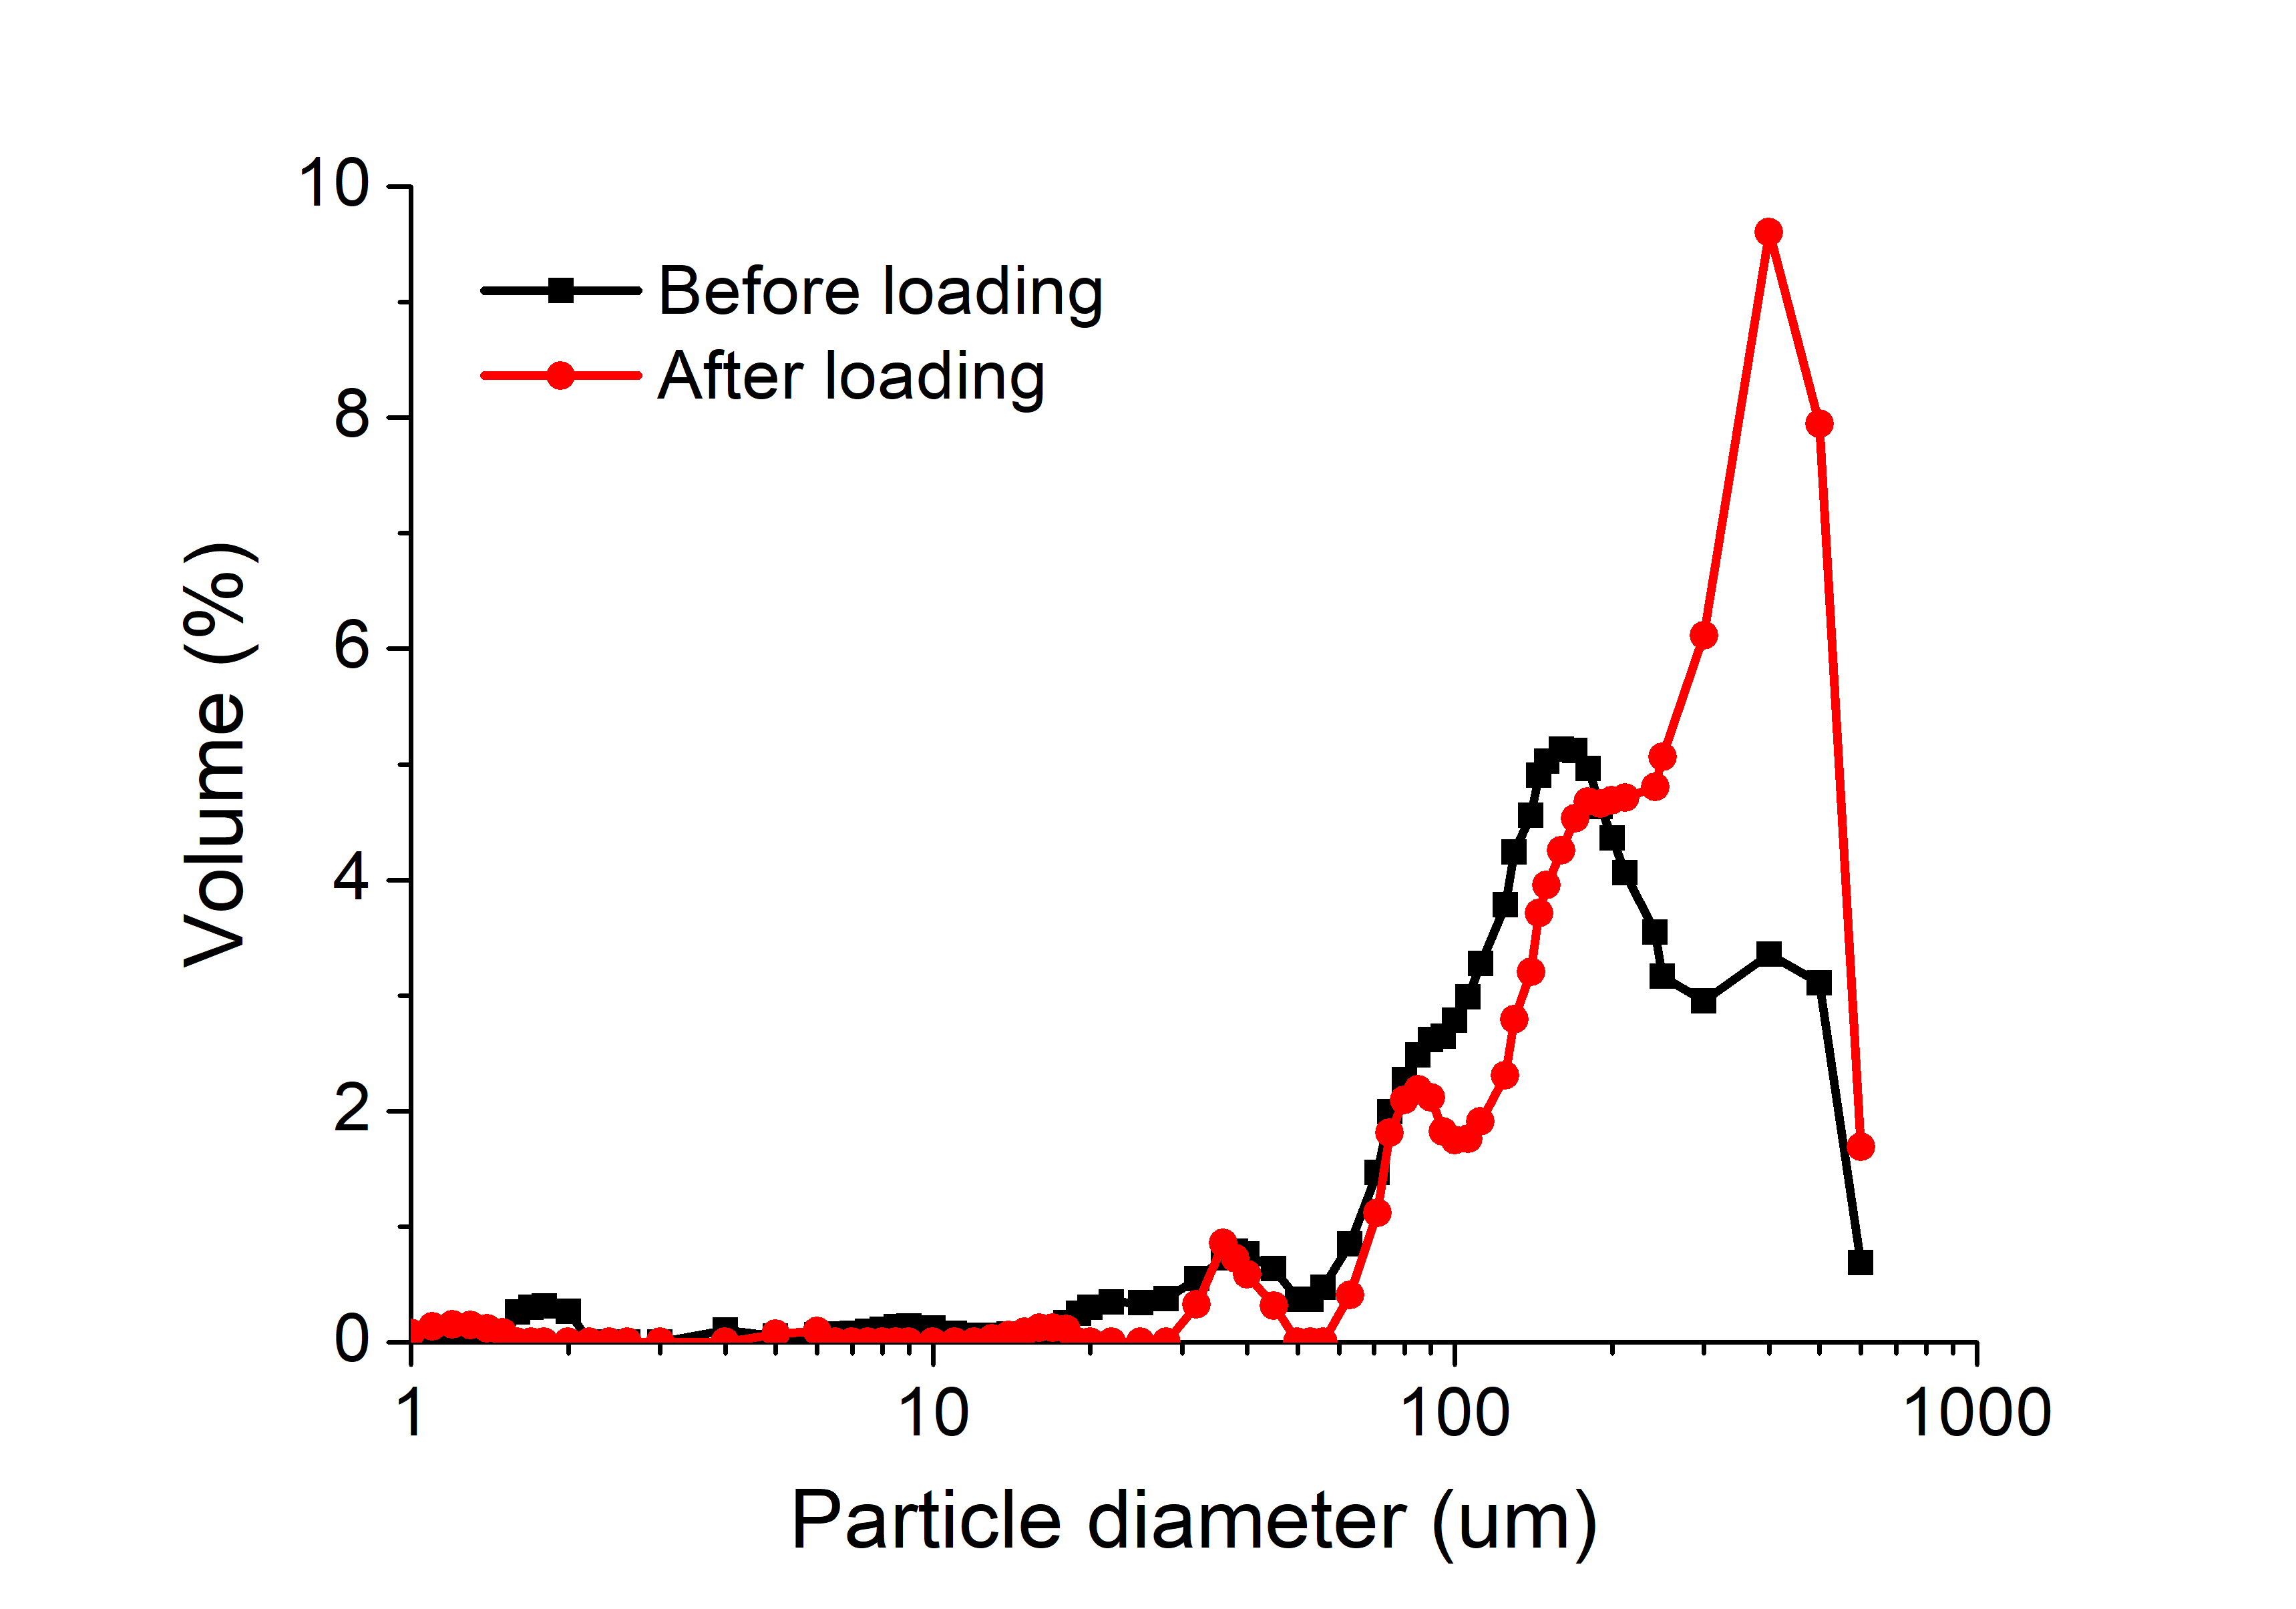Figure 2.1 The diameter distribution of freeze-dried potato microparticles before and after loading resveratrol.
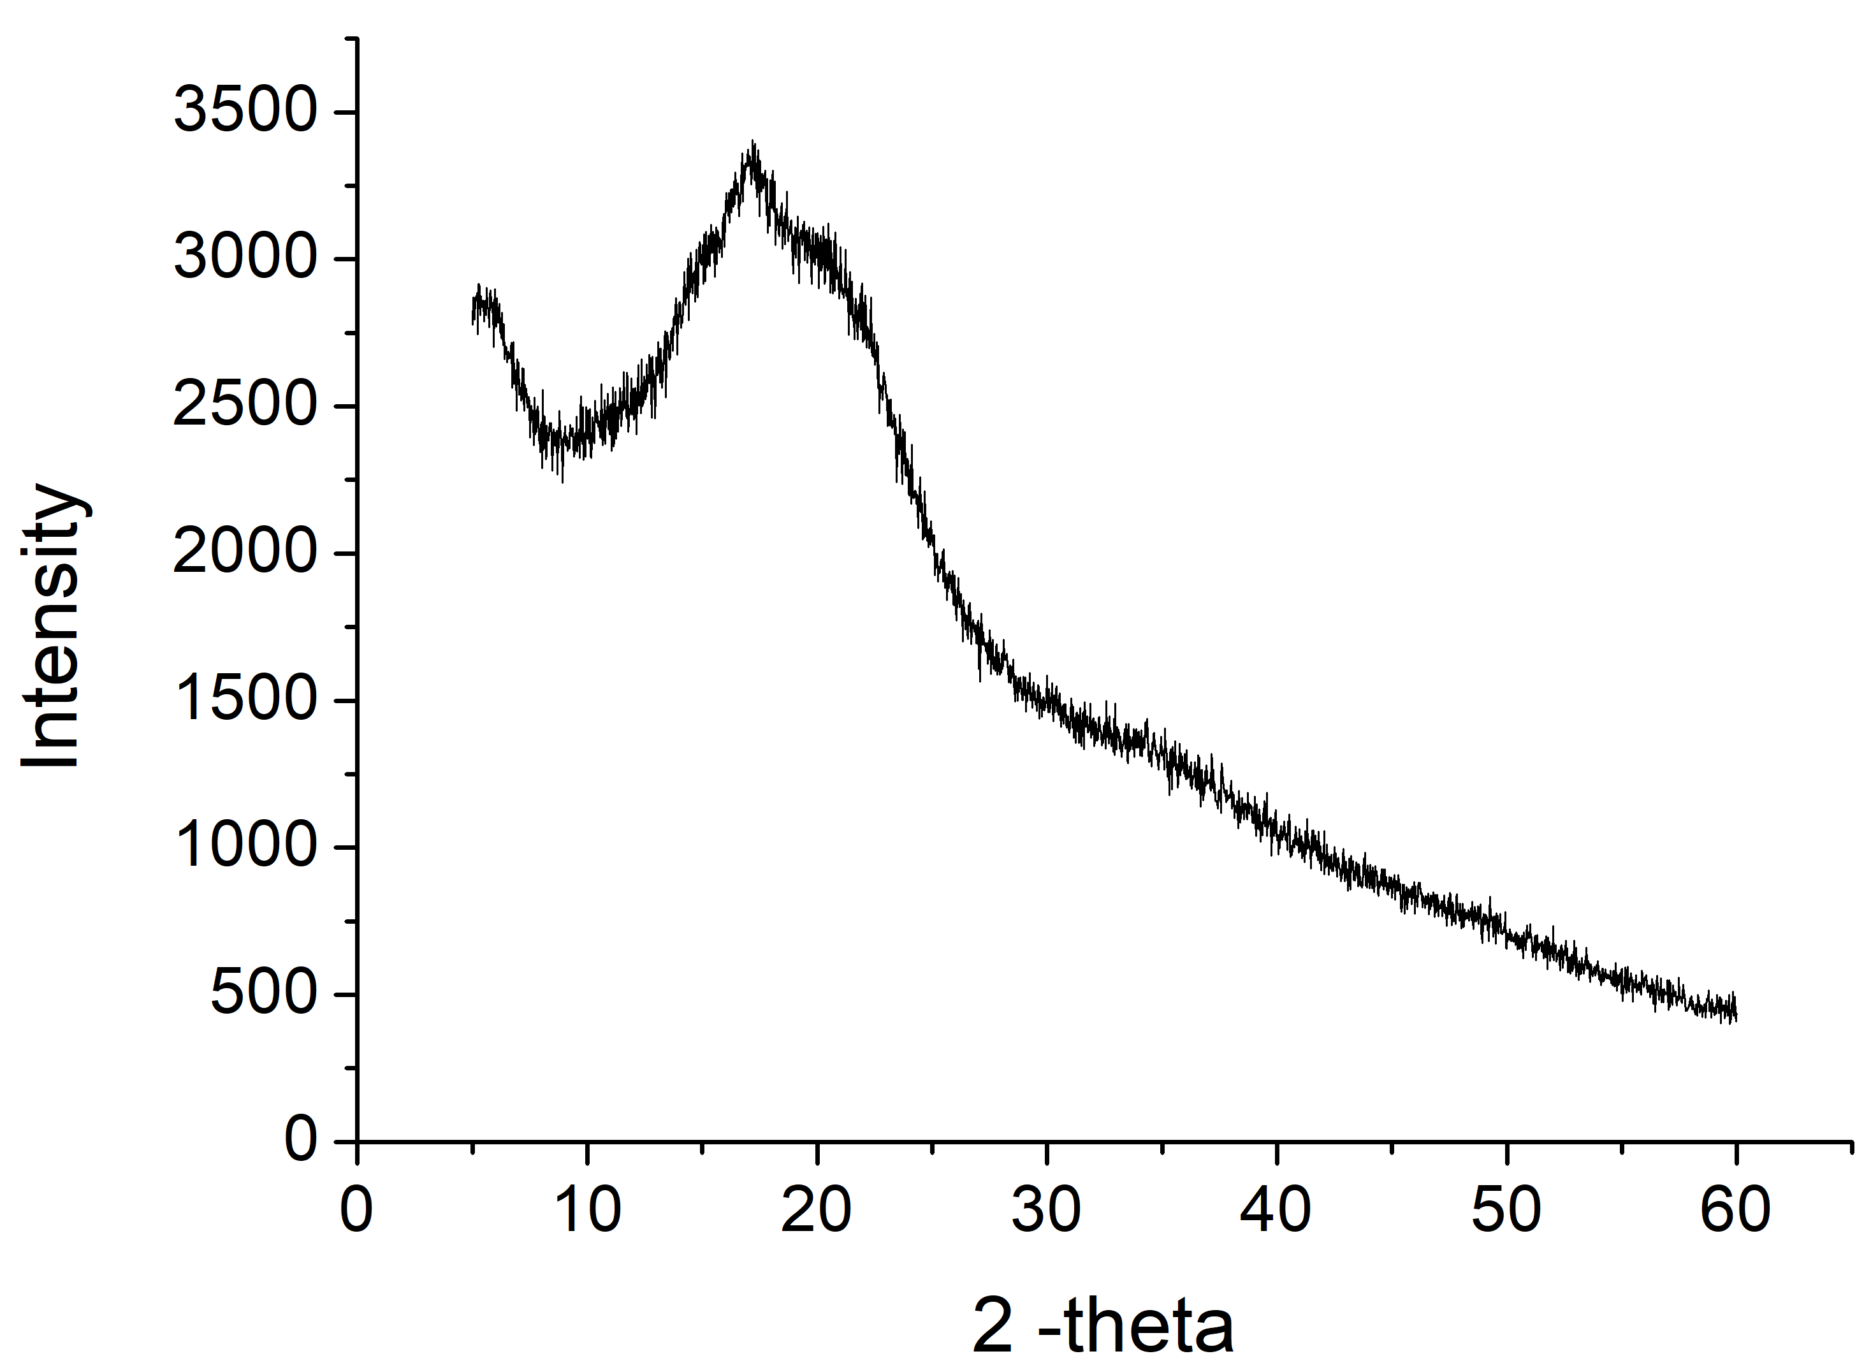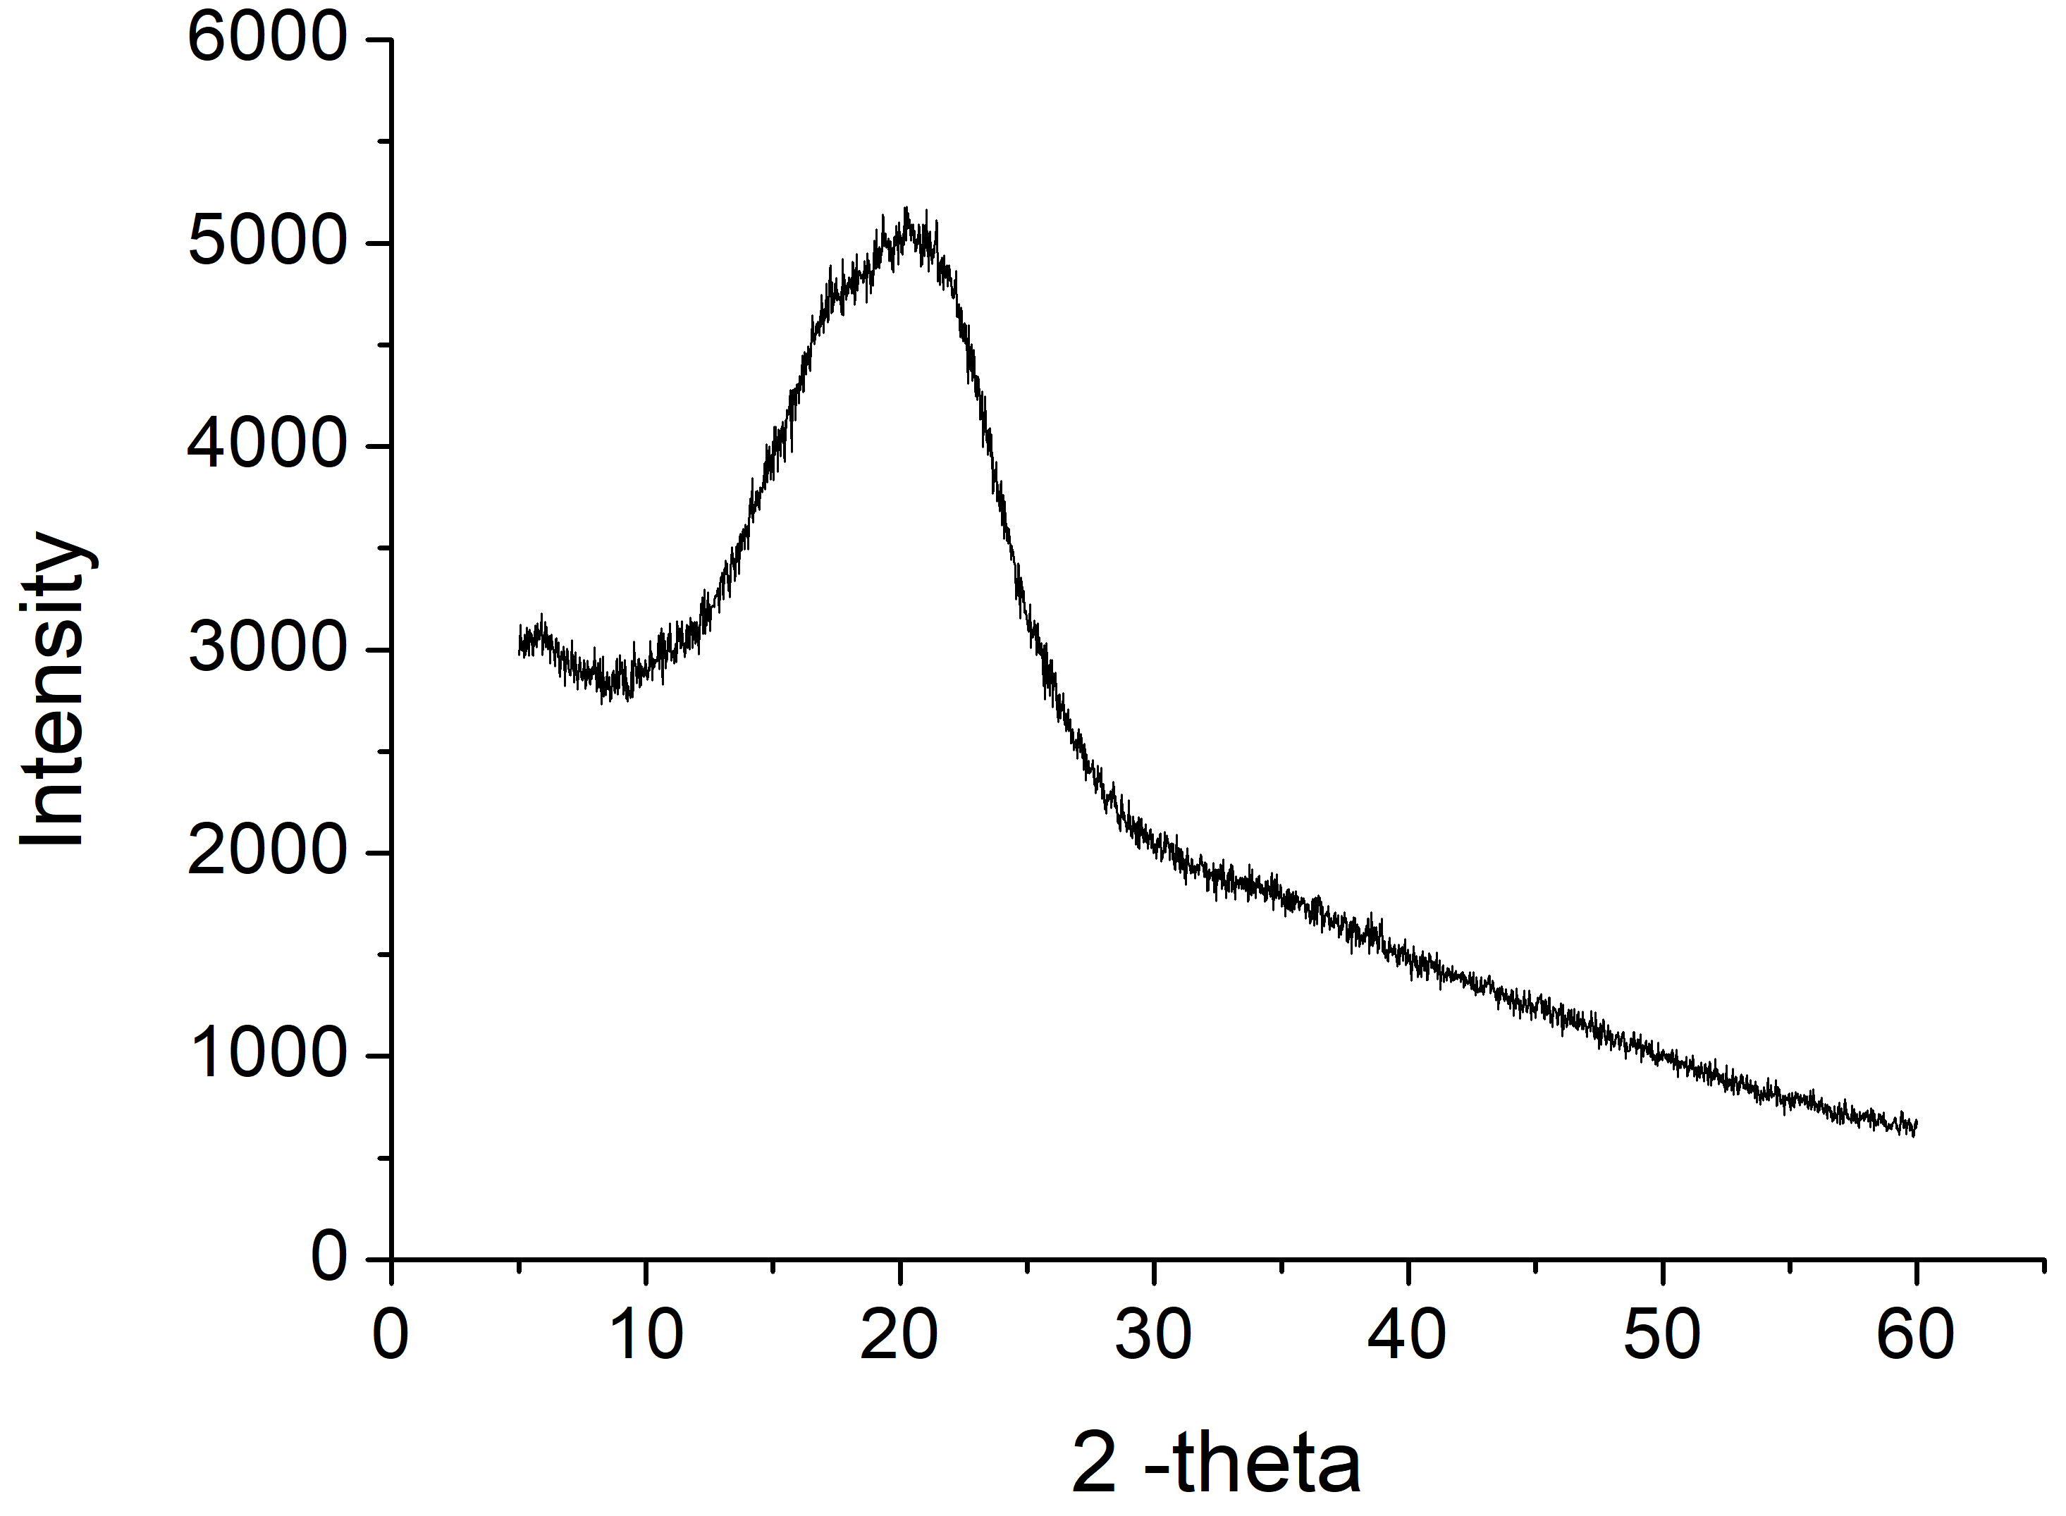
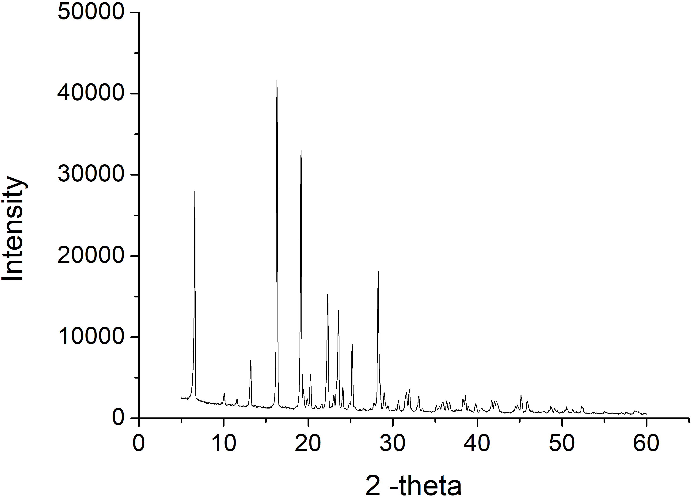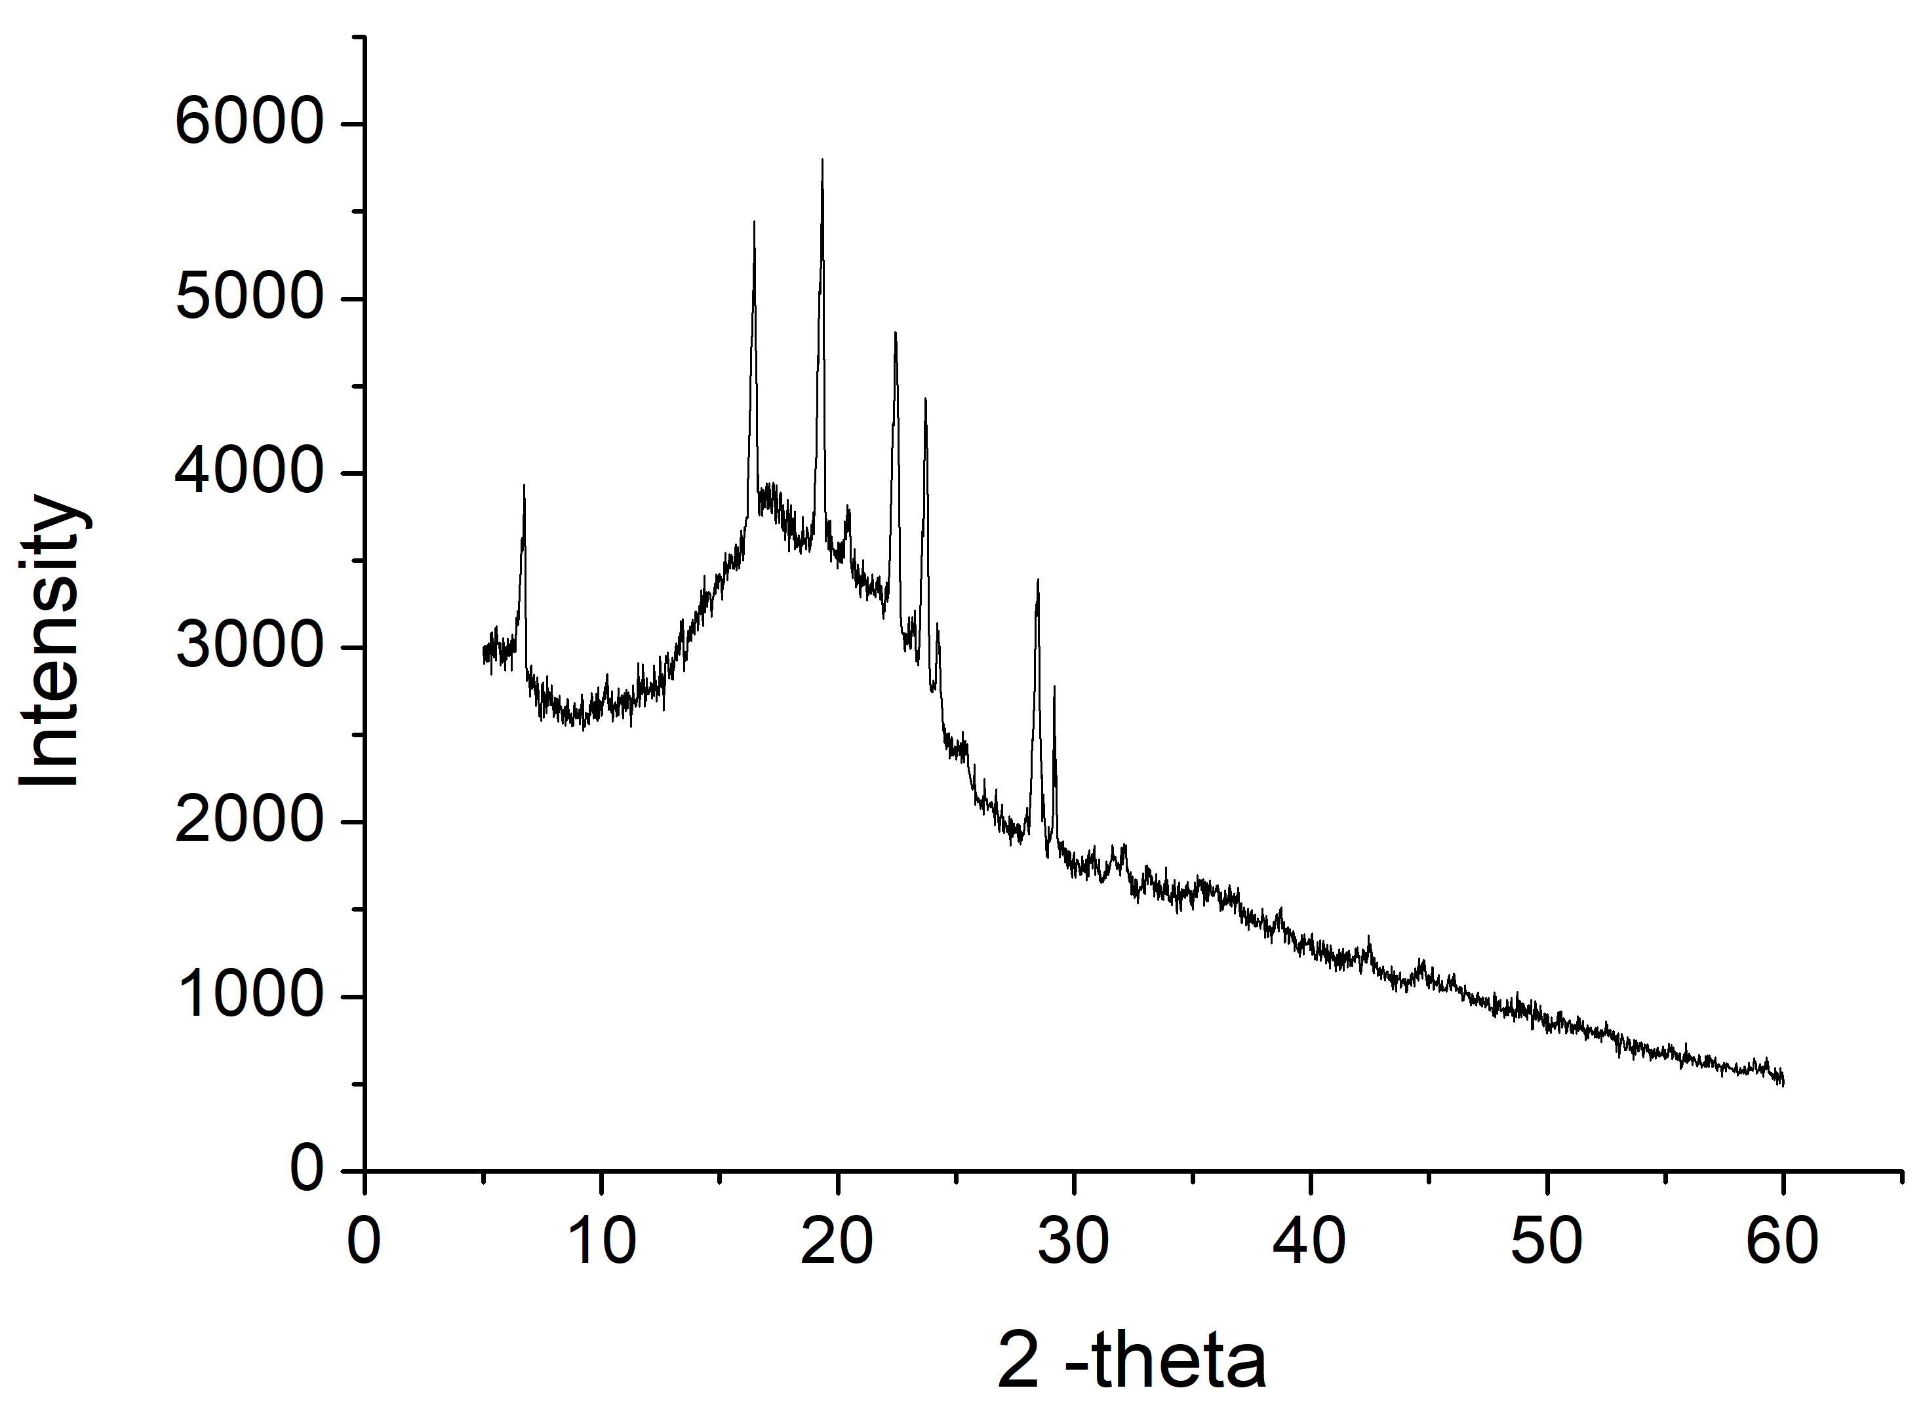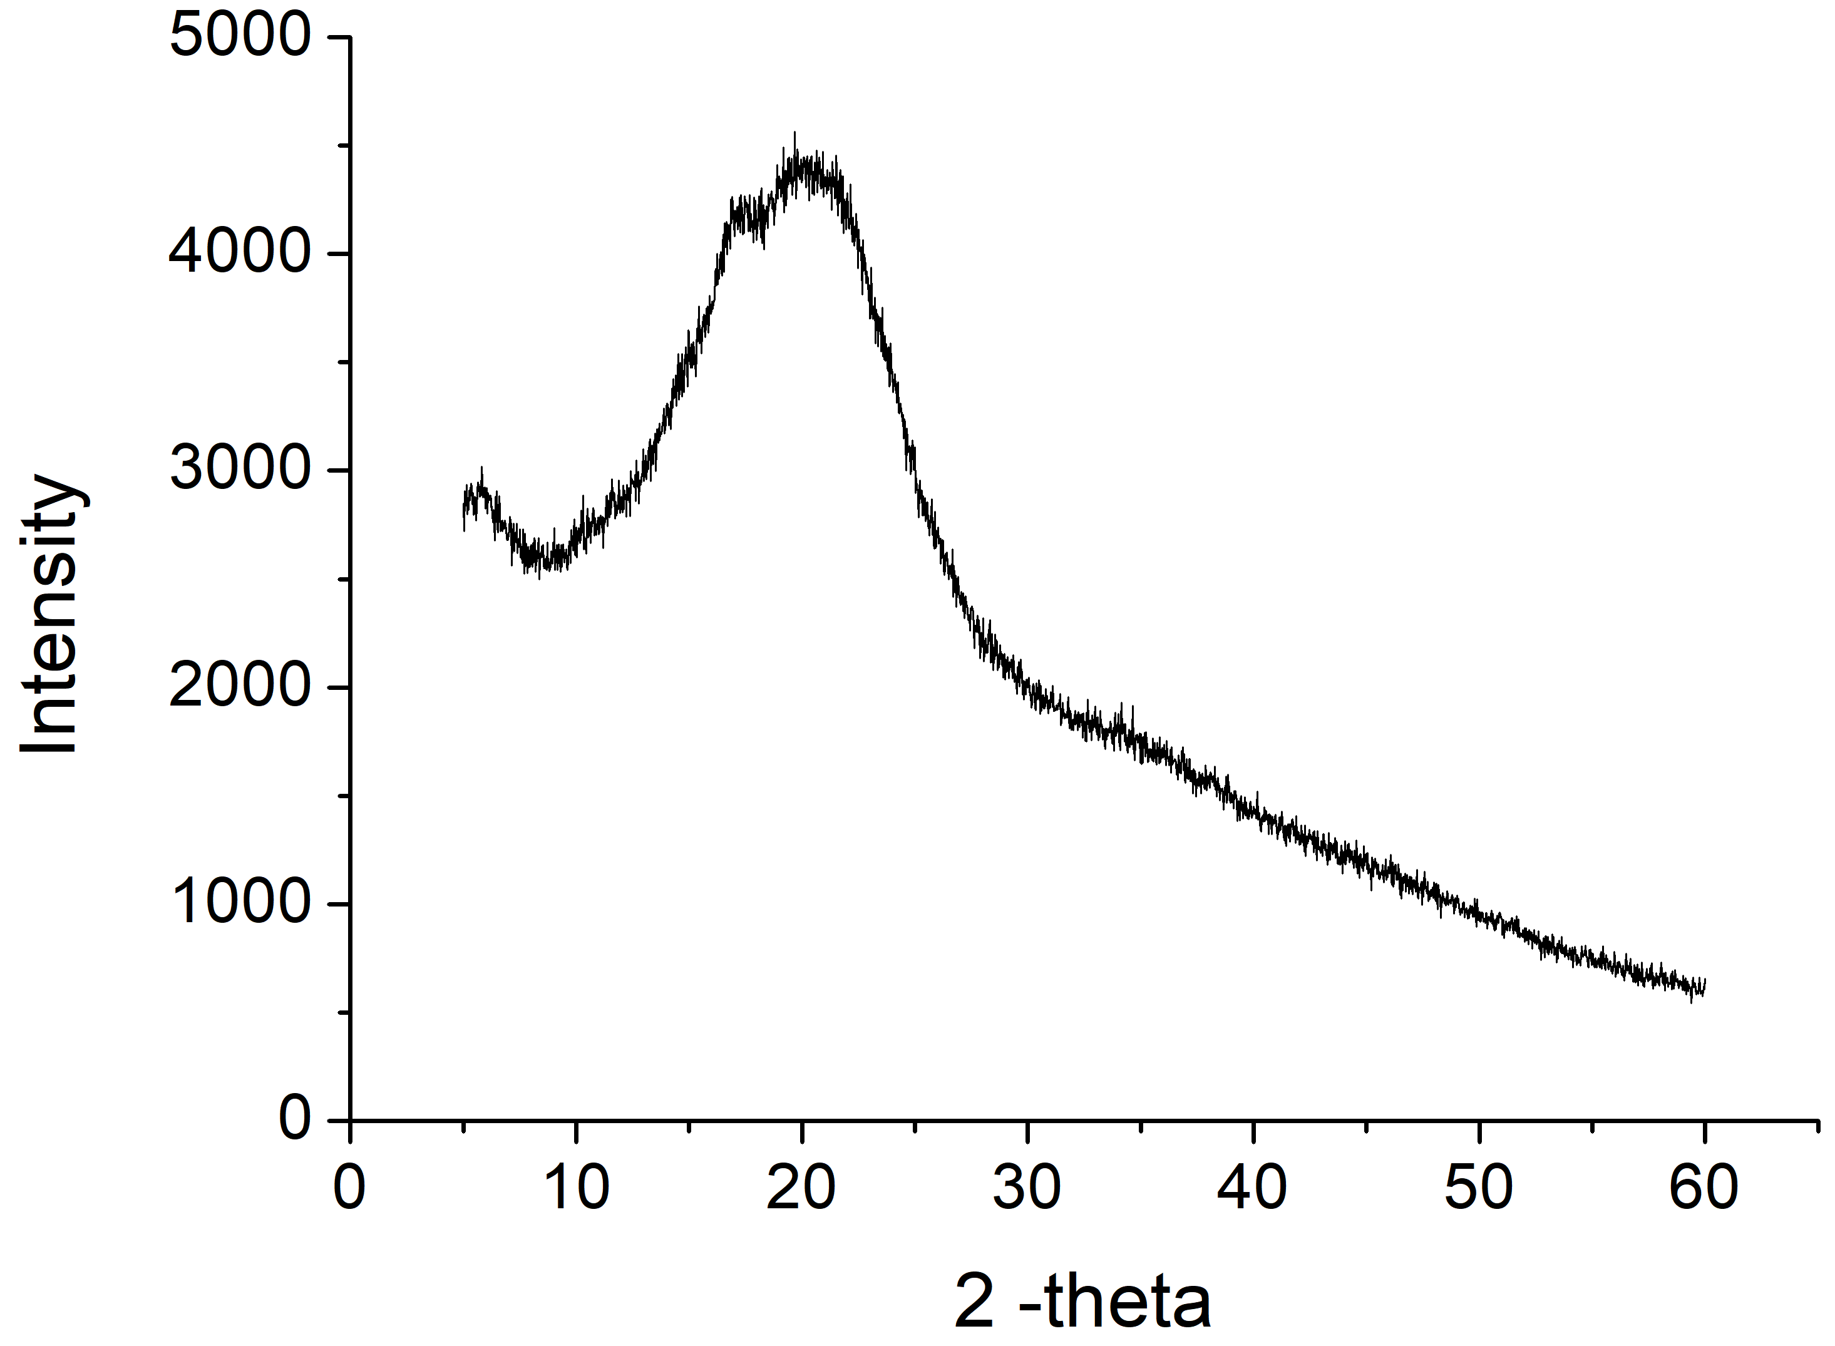

Figure 2.2 XRD patterns of freeze-dried potato microparticles (FDPMs, A), FDPMs treated at encapsulation conditions (B), pristine resveratrol (C), physical mixture of FDPMs and pristine resveratrol (D), and resveratrol-loaded FDPMs (E).

A
B
D
C
E

Figure 2.3 SEM images of freeze-dried potato microparticles (FDPMs, A), FDPMs treated at encapsulation conditions (B), pristine resveratrol (C), physical mixture of FDPMs and pristine resveratrol (D), and resveratrol-loaded FDPMs (E).
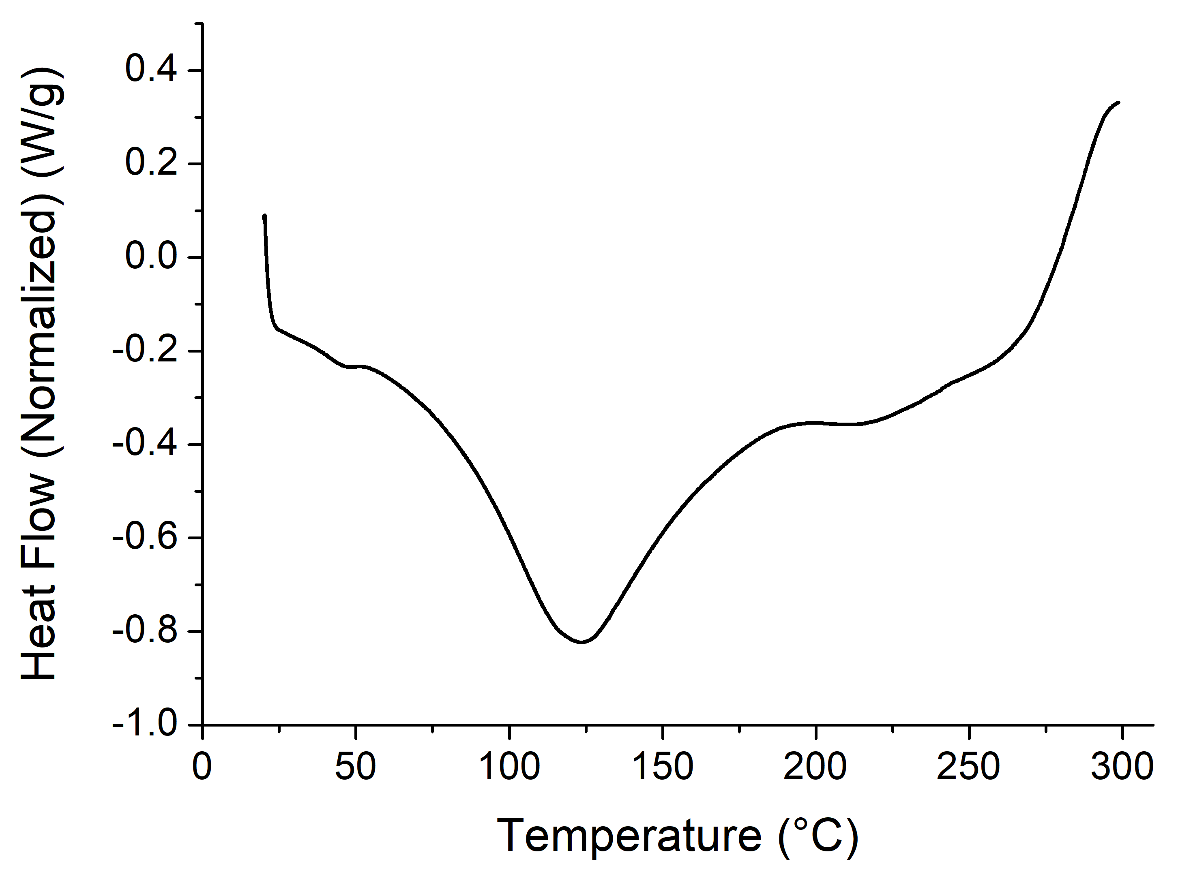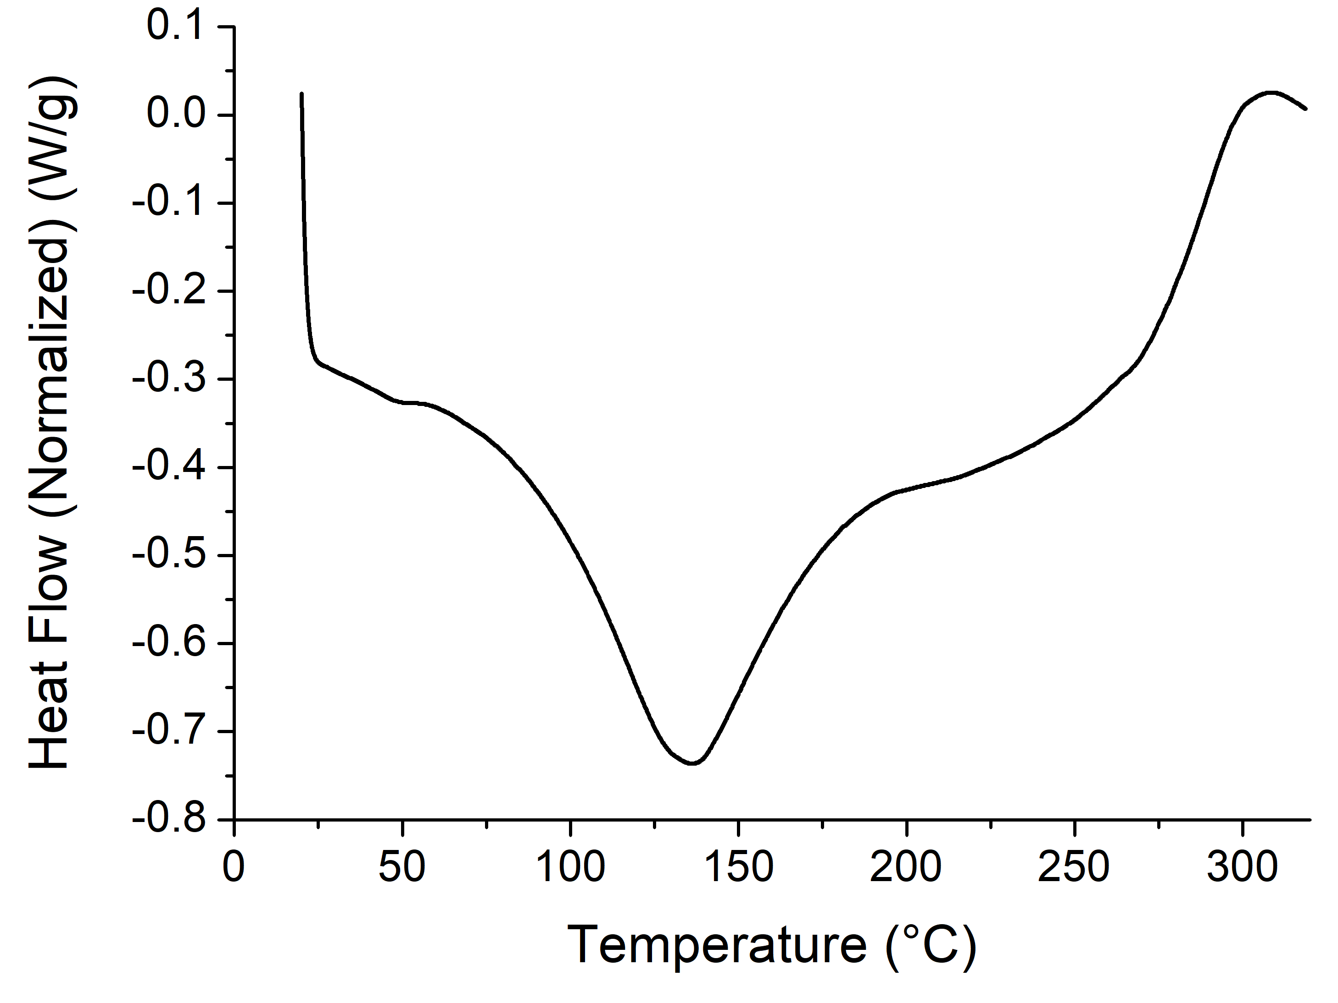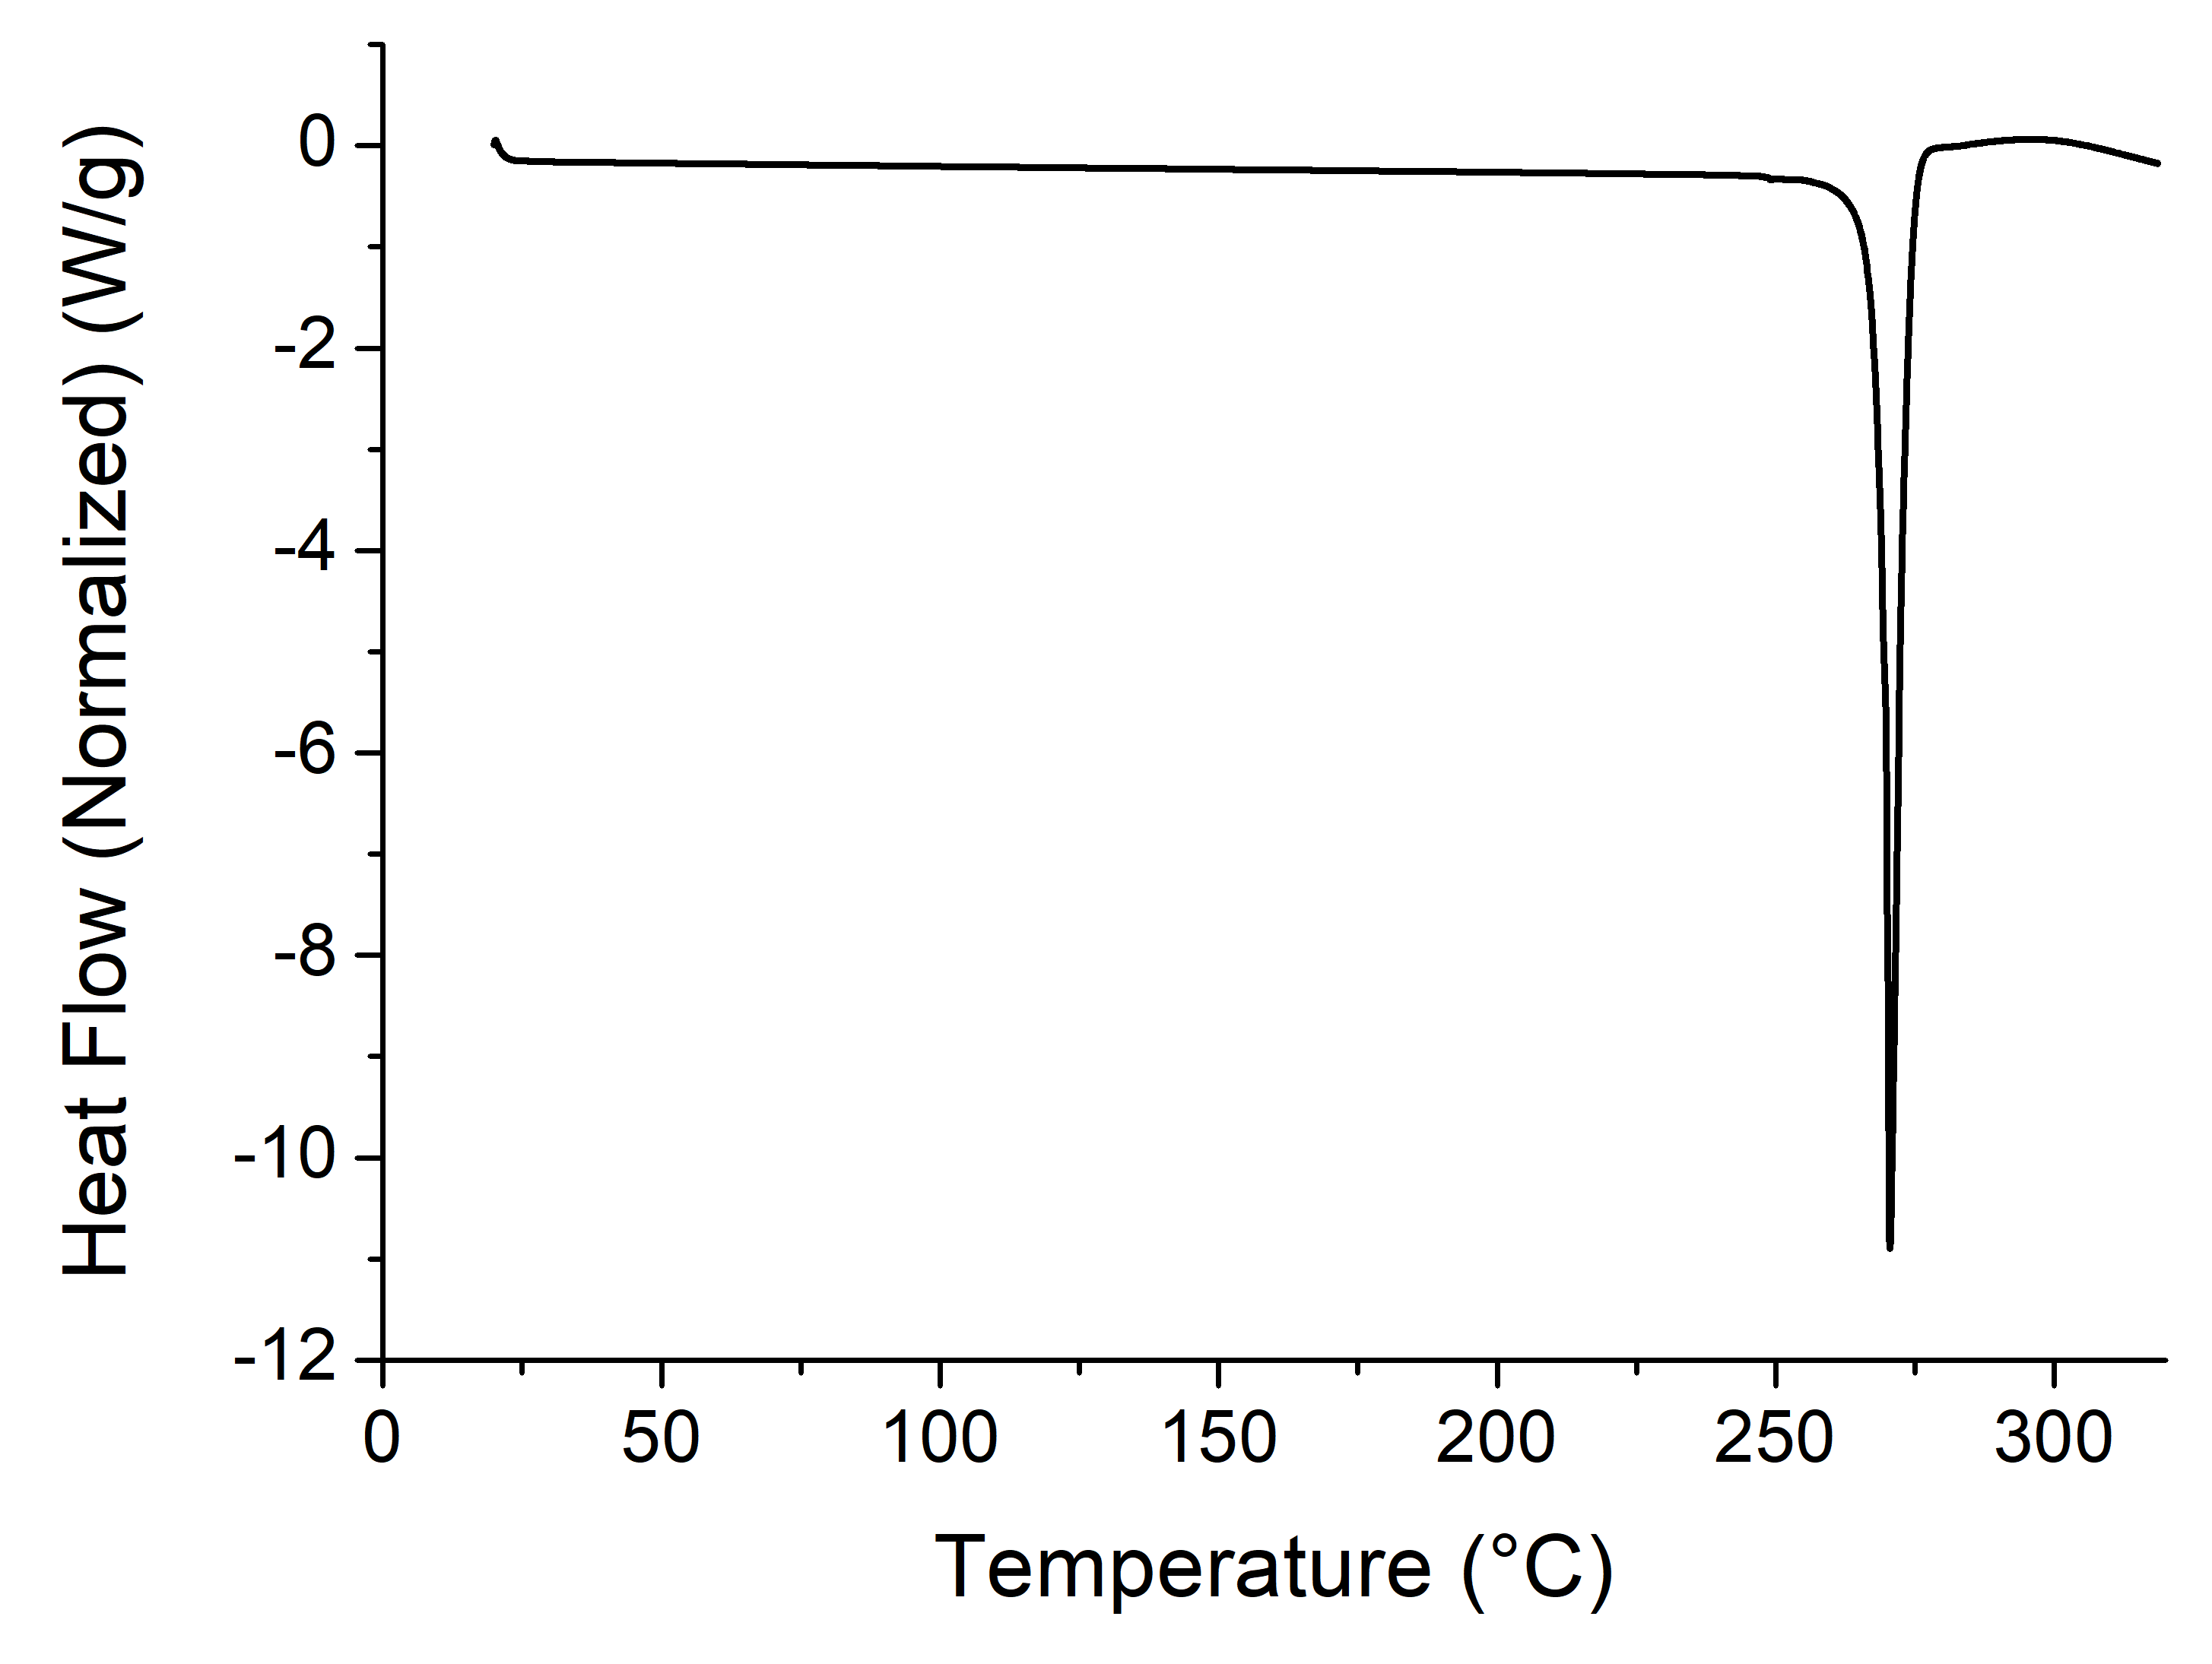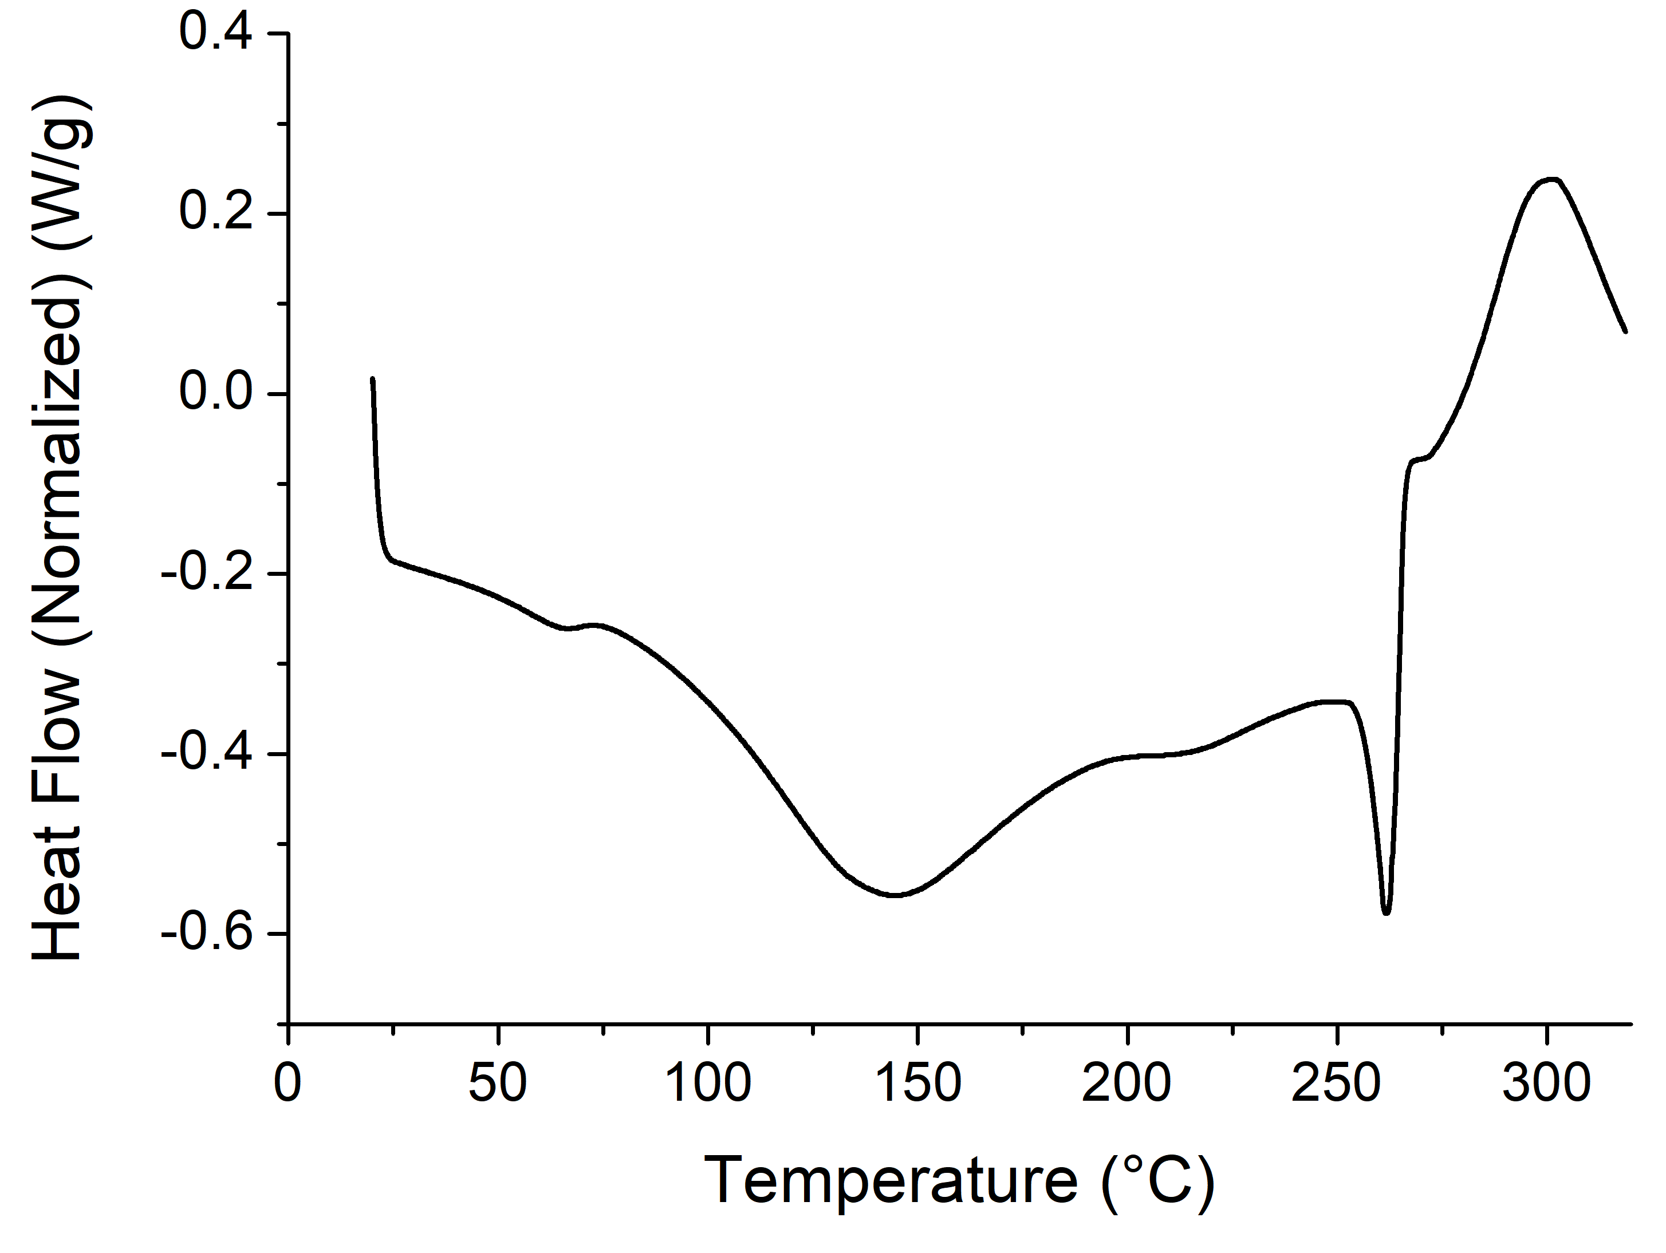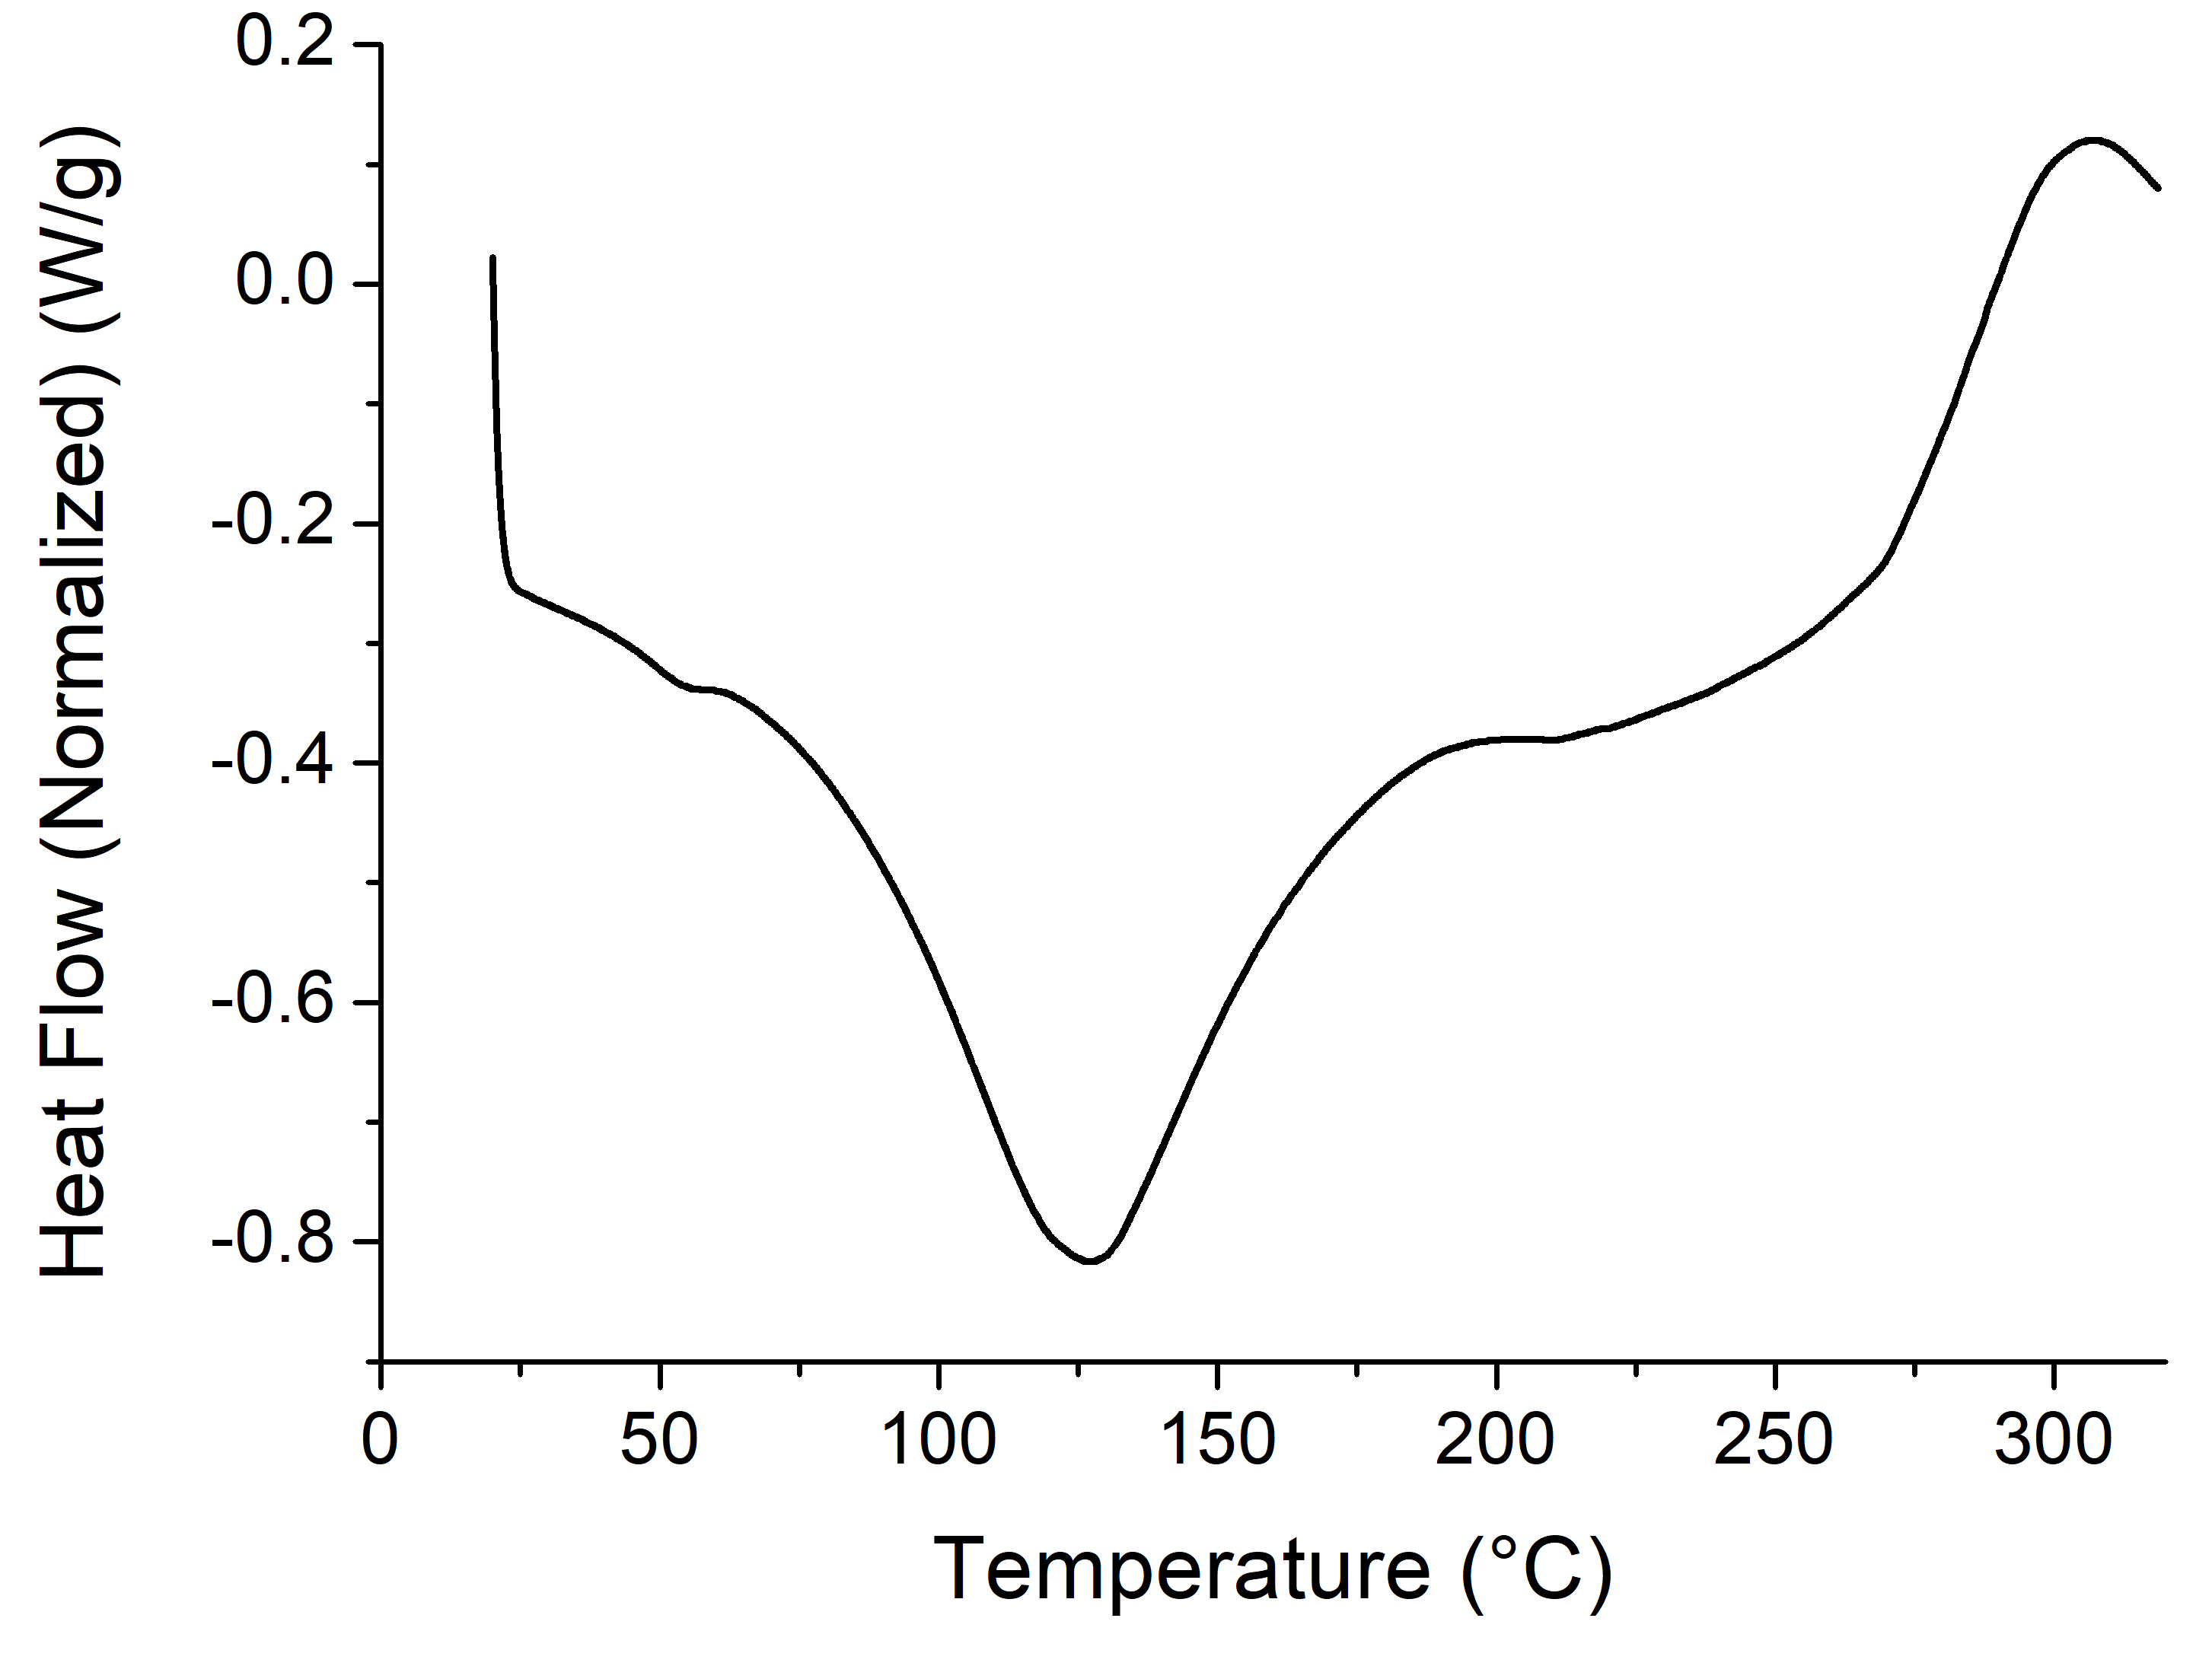
A
B
D
C
E

Figure 2.4 DSC thermographs of freeze-dried potato microparticles (FDPMs, A), FDPMs treated at encapsulation conditions (B), pristine resveratrol (C), physical mixture of FDPMs and pristine resveratrol (D), and resveratrol-loaded FDPMs (E)
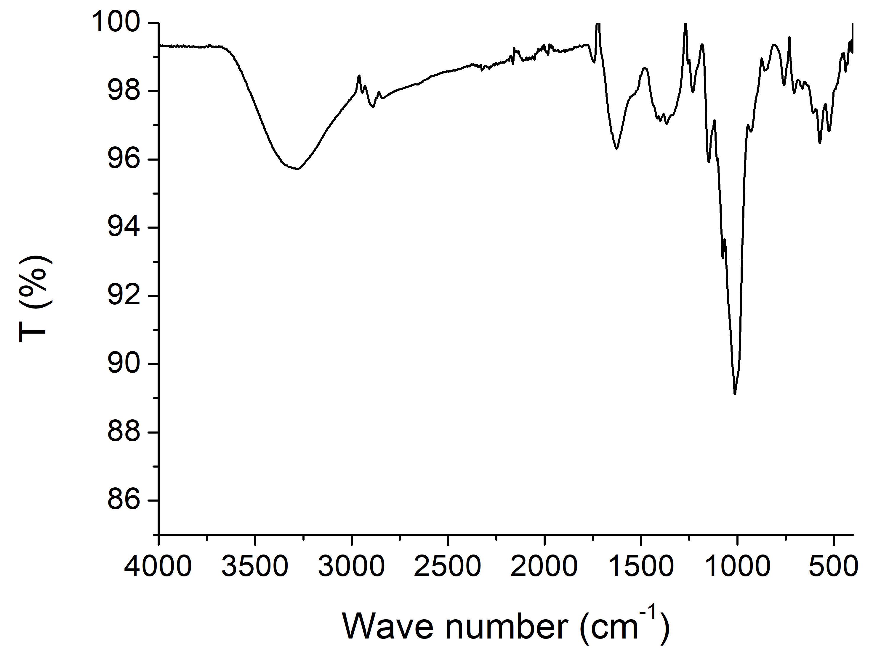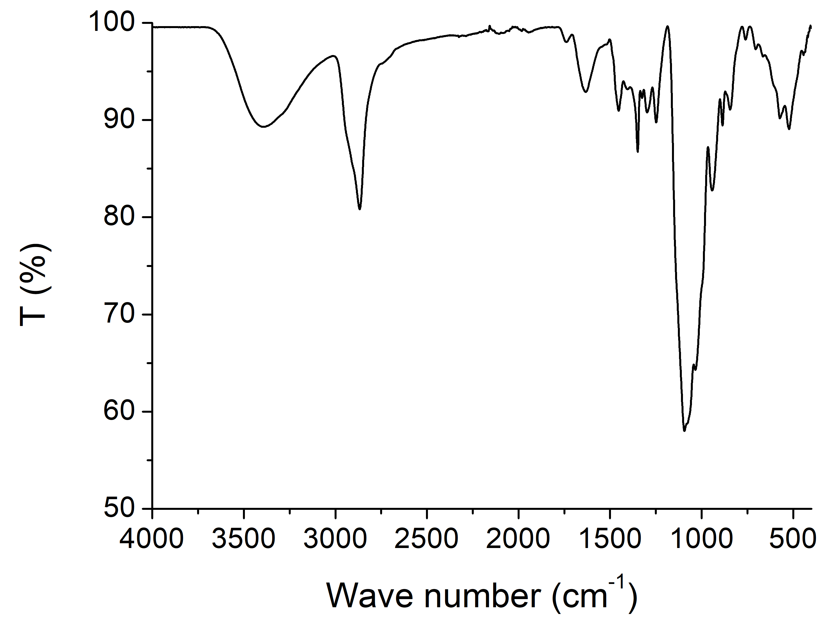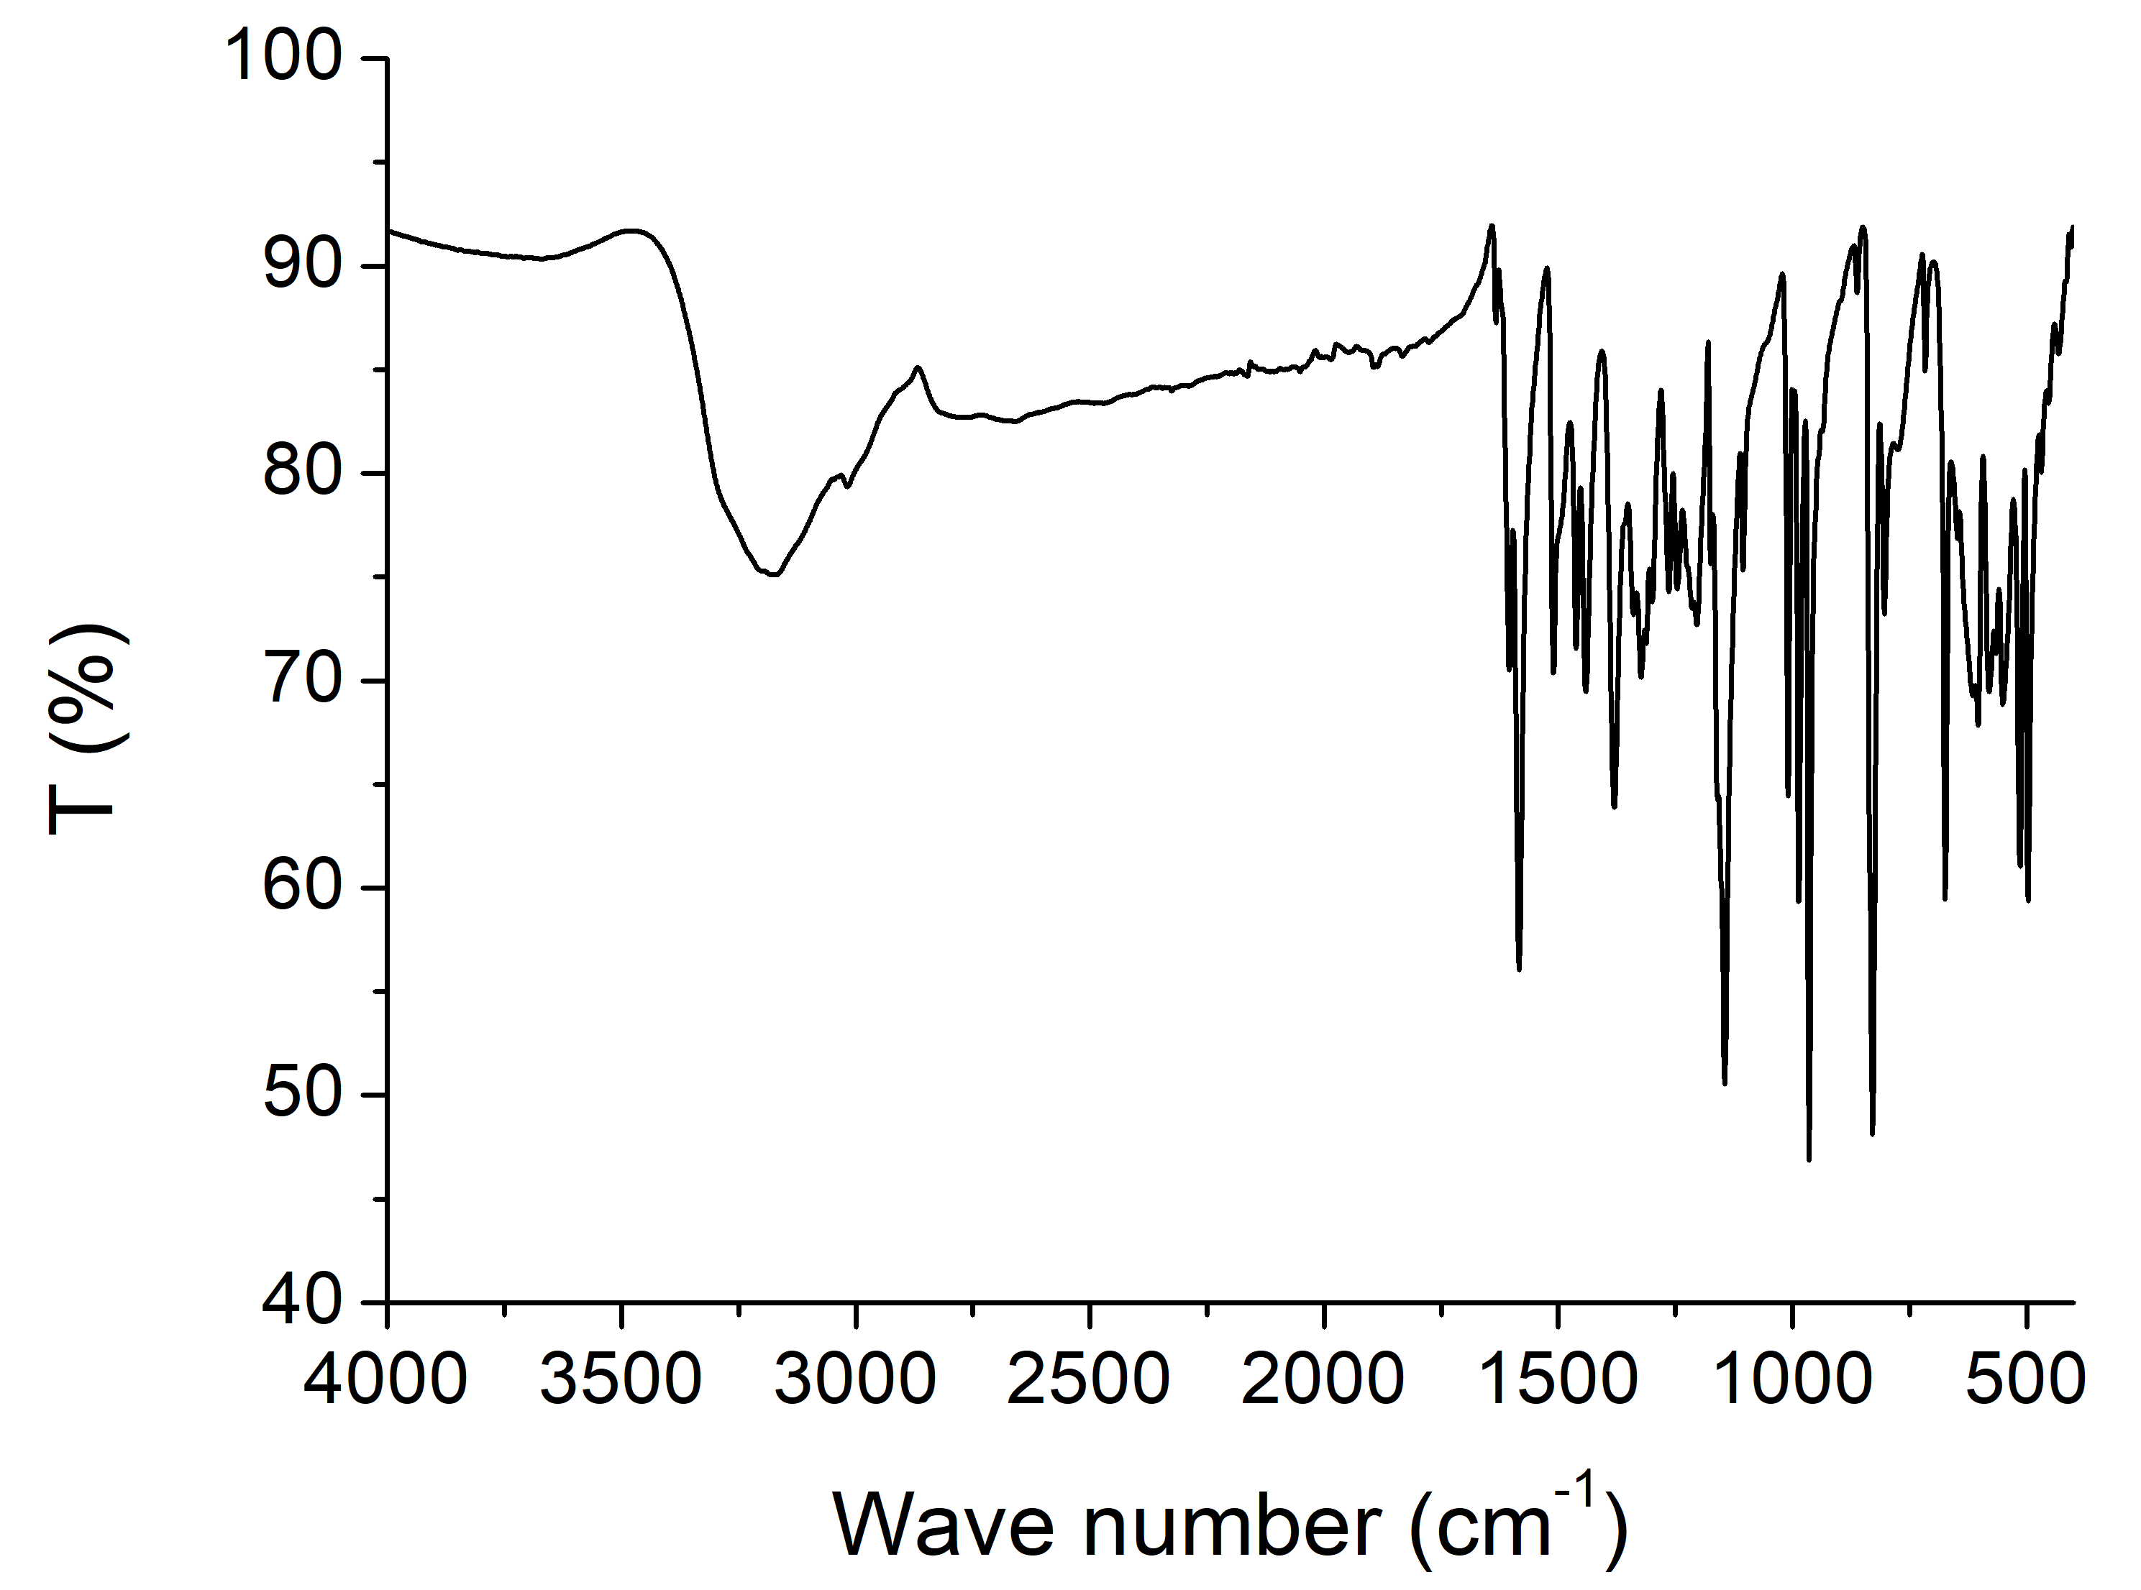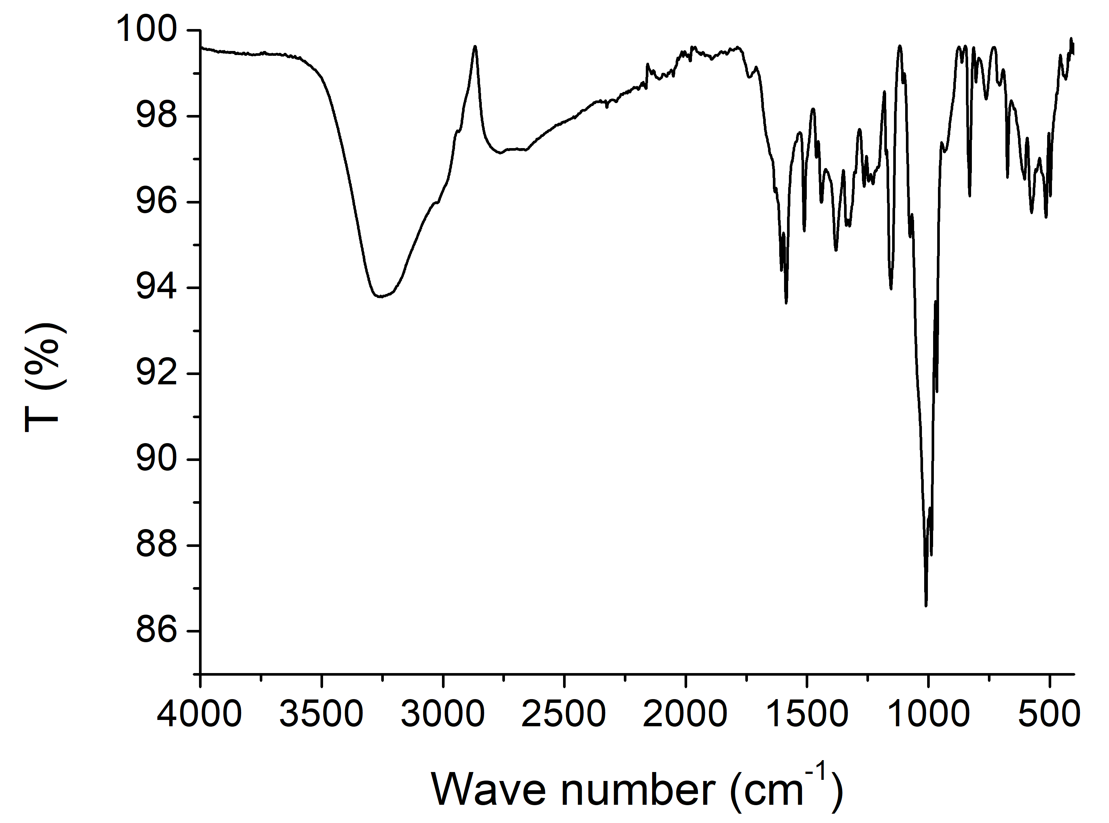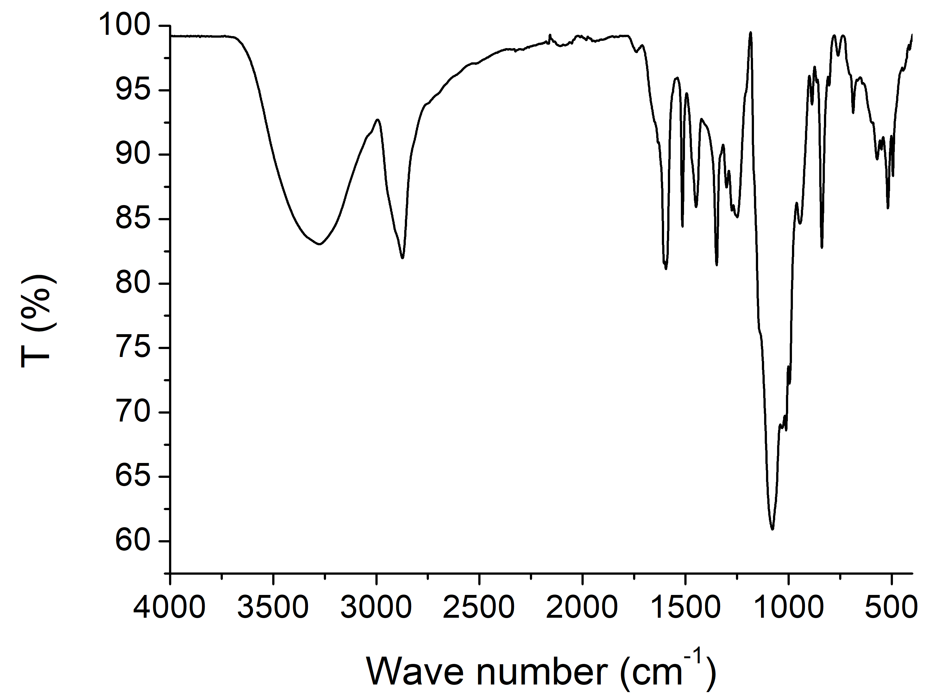
B
A
D
C
E

Figure 2.5 FTIR spectra of freeze-dried potato microparticles (FDPMs, A), FDPMs treated at encapsulation conditions (B), pristine resveratrol (C), physical mixture of FDPMs and pristine resveratrol (D), and resveratrol-loaded FDPMs (E)
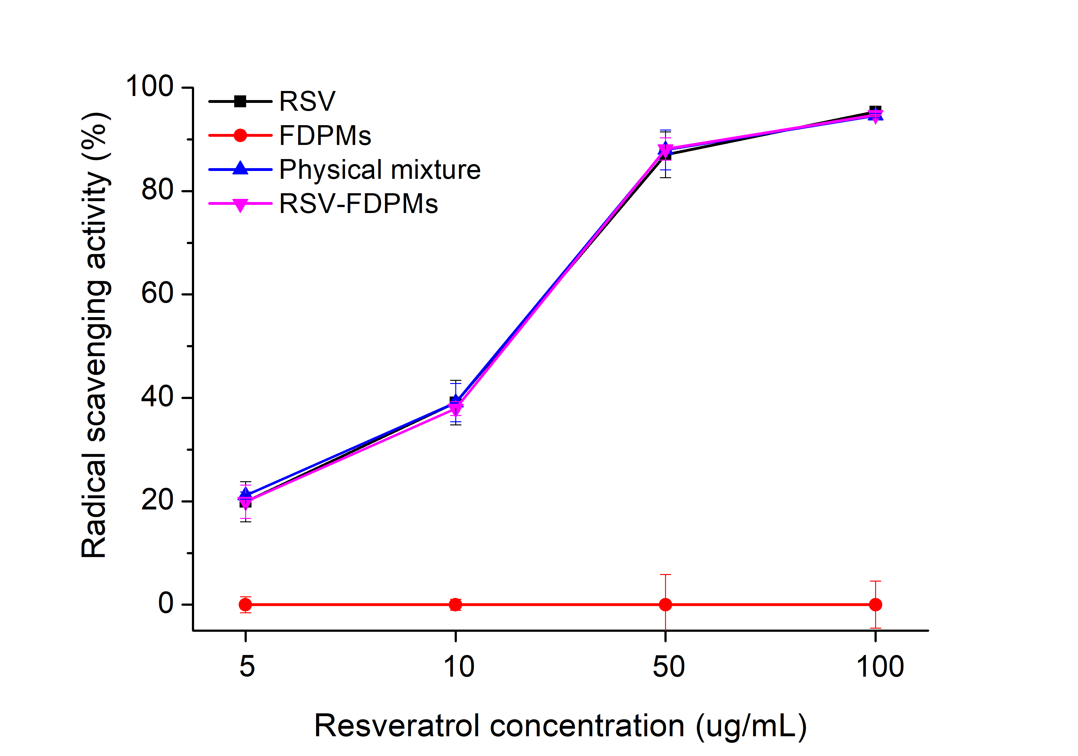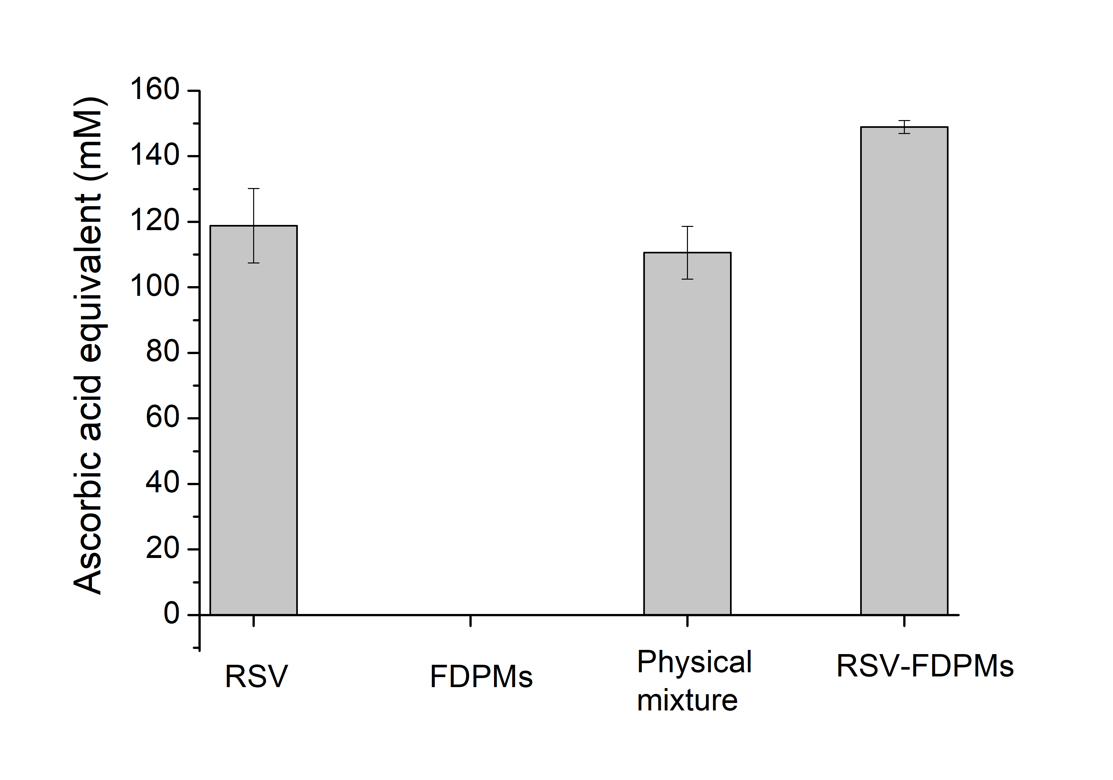
B
A
a
b
b
c

Figure 2.6 DPPH radical scavenging activity (A) and ferric reducing power (B) of resveratrol (RSV), freeze-dried potato microparticles (FDPMs), physical mixture of RSV and FDPMs, and FDPMs loaded with RSV (RSV-FDPMs). Error bars are SD (n = 2). Different letters above columns in (B) indicate significant difference between mean values (p < 0.05).
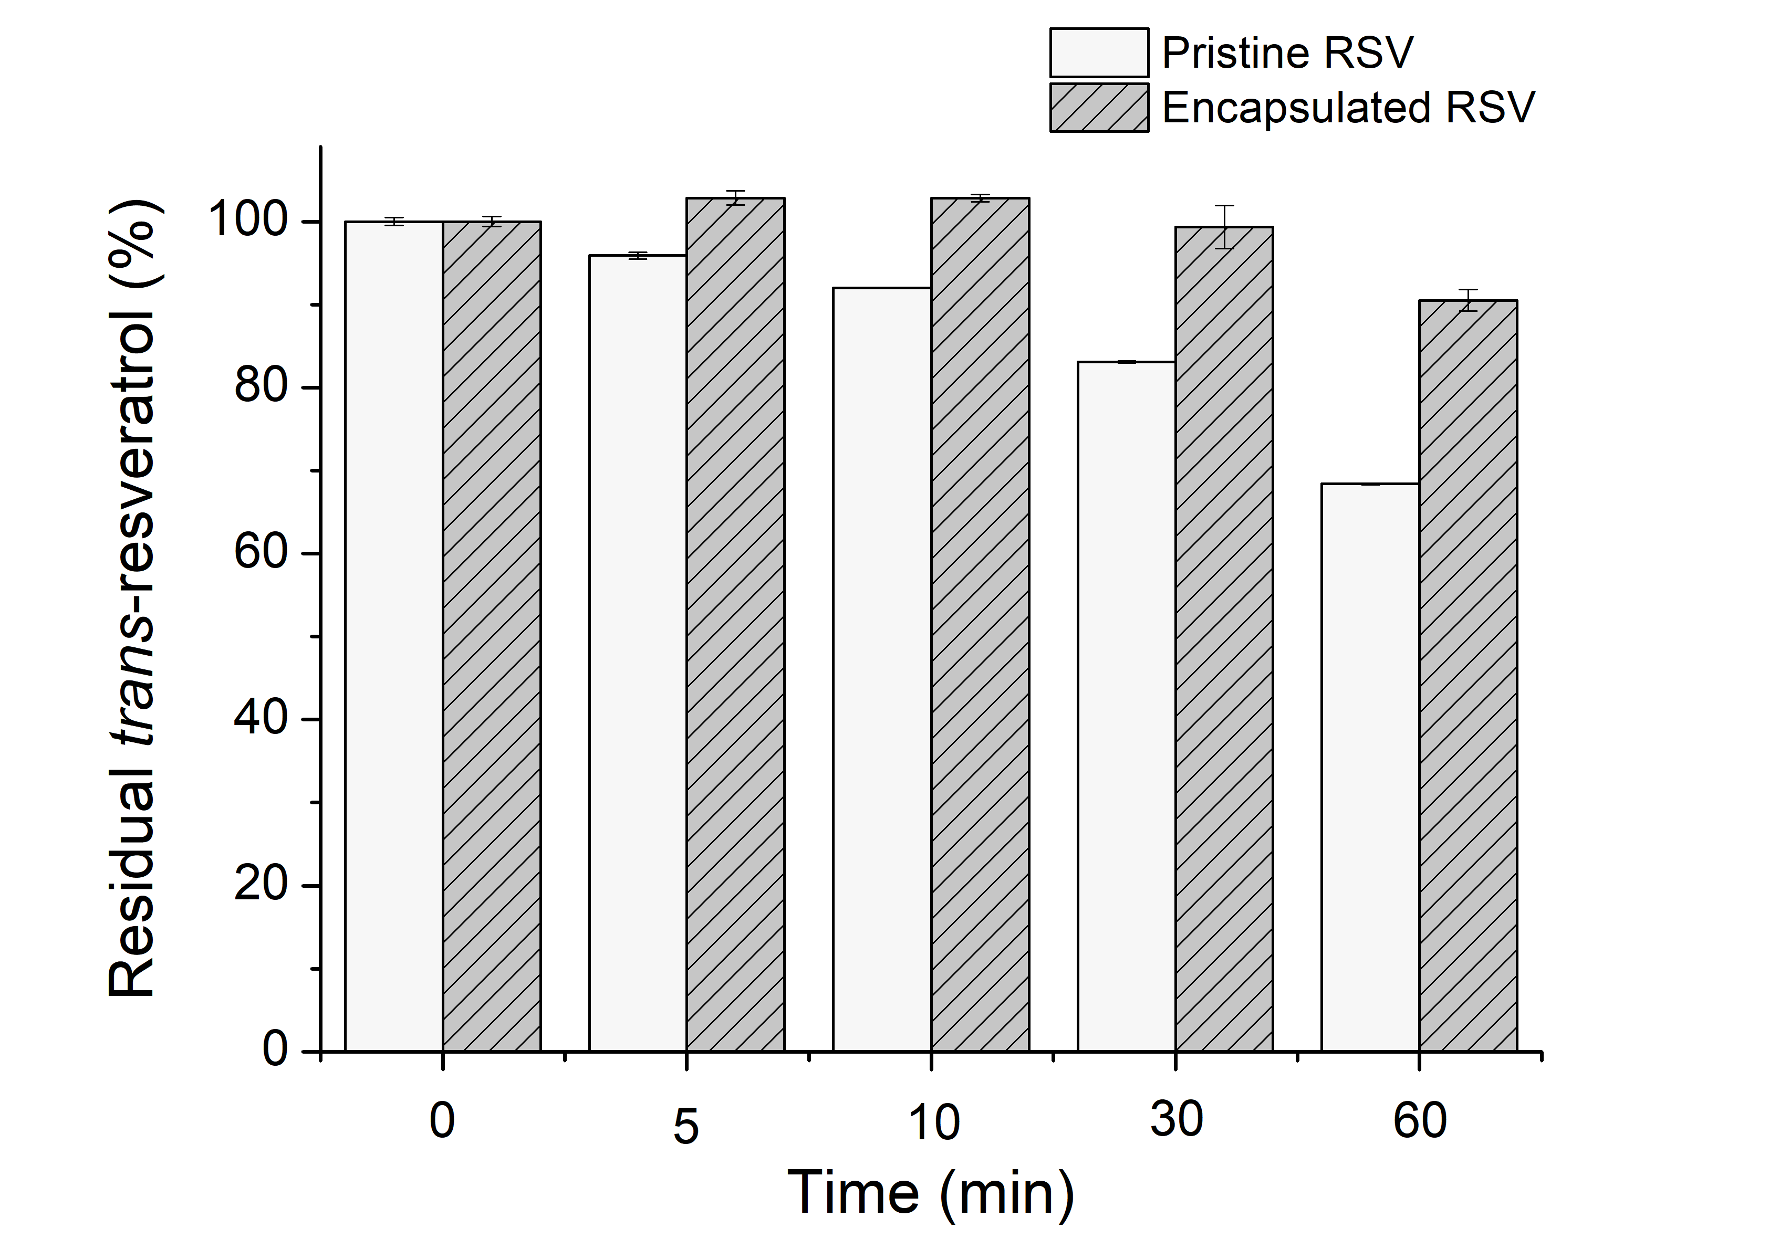
a
a
a
a
ab
bc
cd
d
e
f
B
A
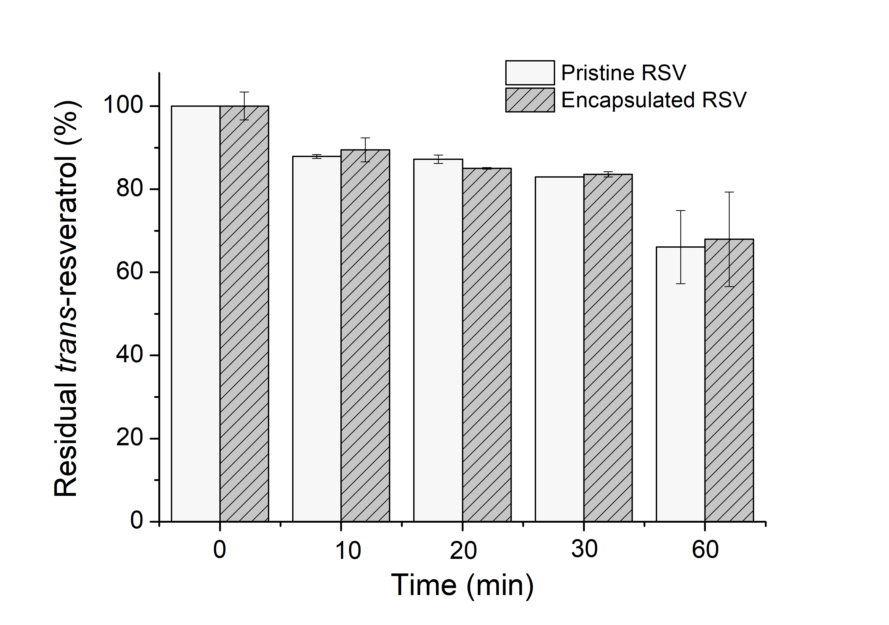
a
a
ab
abc
abc
abc
bc
c
a
a

Figure 2.7 Percentage of residual trans-resveratrol (RSV) in the pristine or encapsulated form during UV 253 nm irradiation for up to 60 min (A) or heating at 90 °C for up to 60 min (B). Error bars are SD (n = 2). Different letters above columns indicate significant difference between mean values in the same plot (p < 0.05).
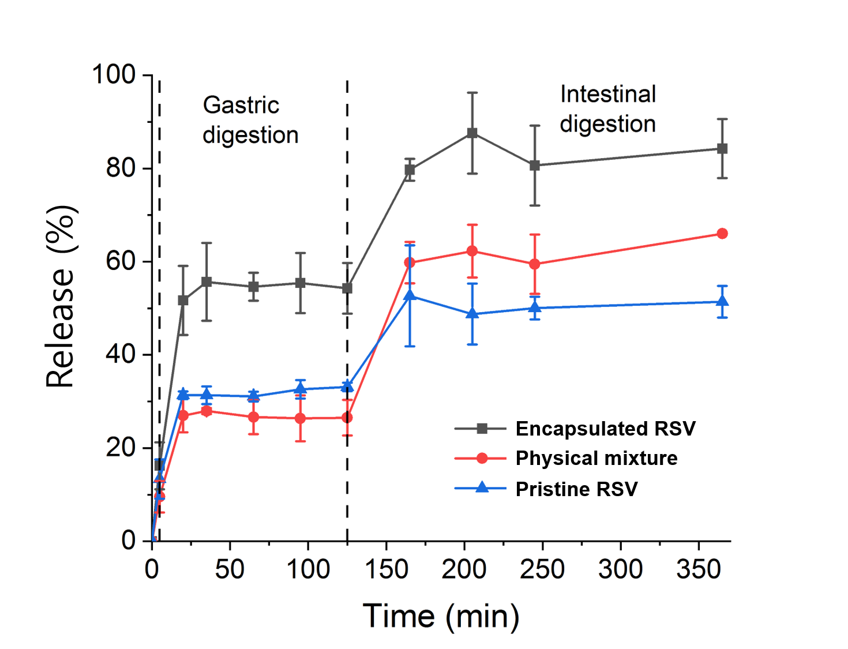

Figure 2.8 The release profiles of pristine resveratrol (RSV), the physical mixture of pristine RSV and freeze-dried potato microparticles, and RSV loaded in freeze-dried potato microparticles during in vitro oral, gastric, and small intestinal digestions. Error bars are SD (n = 2).

Chapter 3 Co-encapsulation of curcumin and quercetin in freeze-dried mushroom microparticles for synergistic antioxidant activity

3.1 Abstract
Curcumin (CCM) is …

3.2 Introduction
Mushroom…

3.3 Materials and methods

3.3.1 Materials
Freeze-dried mushroom slices (~0.2 cm of thickness) were obtained from North Bay Trading (Brue, WI). Curcumin with the purity of 95% was the product of Alfa Aesar (Haverhill, MA). Quercetin hydrate (95%), PEG400, and ferric chloride were purchased from Acros Organics (Fair Lawn, NJ). Ethanol (200 proof) was supplied by Decon Labs (King of Prussia, PA). Trichloroacetic acid (TCA), 1,1,3,3-tetraethoxypropane (TEP), 2-thiobarbituric acid (TBA), and 2,2-diphenyl-1-picrylhydrazyl (DPPH) were obtained from Sigma-Aldrich Corp. (St Louis, MO). Mono- and di-sodium phosphate and potassium ferricyanide were the product of MP Biomedicals, LLC (Santa Ana, CA). Acetonitrile, methanol, and phosphoric acid (85%) were from Fisher Scientific (Pittsburgh, PA). Fresh ground beef with 80% lean and 20% fat was purchased from local supermarket.

3.3.2 Preparation of freeze-dried mushroom microparticles and determination of porosity
FDMMs were prepared by milling freeze-dried mushroom slices through a sieve with mesh sizes of xx mm using a bench top mill (3383-L10 Wiley Mini Mill, Thomas Scientific, Swedesboro, NJ). The porosity of FDMMs was 82.7% with the average pore diameter of 4.62 μm determined by mercury intrusion porosimetry (AutoPore V 9600, Micrometrics Instrument Corp., Norcross, GA).

3.3.3 Loading of curcumin and quercetin into freeze-dried mushroom microparticles
CCM (8% w/v) and QCT (1.6% w/v) were dissolved in a binary solvent of ethanol and PEG400 (40:60 v/v) and stirred for 4 h on a magnetic stirrer at 990 rpm. The concentration of CCM was the maximal concentration that caused no precipitation from the solubility test in the binary solvent. The QCT concentration was chosen based on the CCM-QCT ratio that exhibited highest synergistic antioxidant activity from preliminary experiment. FDMMs (0.100 g) were added into 10 mL of CCM-QCT solution and separated from the solution by filtrating the solution through a 0.45 μm polyvinylidene fluoride (PVDF) membrane (MilliporeSigma, Burlington, MA). FDMMs obtained were dried at 50 °C in a vacuum oven under 4,000 Pa for 20 h to evaporate ethanol. The dried FDMMs were placed in a glass container and kept at 22 °C until each testing was conducted.

3.3.4 Co-detection of curcumin and quercetin
CCM-QCT-encapsulating FDMMs were suspended in 10 mL of methanol and stirred at 22 °C for 4 h. After centrifugation at 14,100 g for 30 min (Minispin Plus, Eppendorff, Hamburg, Germany), the supernatant was filtered through 13mm PTFE syringe filter with a 0.45 μm pore size (Agilent Technologies, Santa Clara, CA). Chromatographic separation was performed using a C18 column (4.6 $×$ 250 mm, 5 µm, Agilent Technologies, Santa Clara, CA) with HPLC system (Agilent 1100 Series) equipped with a UV-VIS detector. To detect curcumin and quercetin simultaneously, the mobile phase of acetonitrile and 1% v/v phosphoric acid (50:50 v/v) was operated in isocratic mode at a flow rate of 1.0 mL/min for 20 min at 22 °C. The detection wavelength was set at 425 nm for CCM and at 370 nm for QCT. The loading capacity was calculated according to following equation:
Loading capacity (%) = $\frac{amount of CCM or QCT in FDMMs (g)}{amount of FDMMs (g)} ×100$ (1)

3.3.5 Particle size of milled freeze-dried mushroom microparticles before and after loading the bioactive compounds
The size of milled FDMMs before and after loading curcumin and quercetin was compared by using laser diffraction technique with a particle size analyzer (PSA 1190, Anton Paar, Graz, Austria). The parameters for the dry powder were 56% for vibrator duty cycle, 44 Hz for vibrator frequency, and 40,000 Pa for air pressure. After 10 s of measurement time at 22 °C, particle size distribution was obtained based on Fraunhofer theory.

3.3.6 X-ray diffraction (XRD)
The XRD patterns of various samples were obtained using an X-ray diffractometer (The Panalytical Empyrean, Malvern Panalytical, Worcestershire, UK) equipped with a Cu Kα source at a wavelength of 1.5406 Å. Measurements were operated with a scan speed of 0.112°/s and a step size of 0.026°. The 2θ angle range was set from 5° to 60°.

3.3.7 Scanning electron microscopy (SEM)
The morphology of FDMMs, CCM, and QCT before and after encapsulation was studied using SEM. Samples in powder form were attached on an aluminum specimen stub by a carbon tape and gold-coated for 1 min with a sputter coater. Then, samples were observed with a LEO 1525 SEM microscope (FIB/SEM Zeiss Auriga, Oberkochen, Germany).

3.3.8 Differential scanning calorimetry (DSC)
The thermal stability of powder samples of different formulation was characterized by a DSC system (DSC 250 Discovery, TA Instruments, New Castle, DE). Approximately 5 mg of powder was weighed and transferred to an aluminum pan and an empty pan without powder sample was used as a reference. After the pan was tightly sealed by a hermetic lid with a pinhole, samples were heated from 30 °C to 340 °C at a rate of 10 °C/min. The flow rate of nitrogen as the transfer gas was 30 mL/min

3.3.9 Fourier-transform infrared spectroscopy (FTIR)
ATR-FTIR spectra of FDMMs, CCM, and QCT before and after encapsulation were obtained from a PerkinElmer spectrum instrument (PerkinElmer, Waltham, MA). The scanning region was from 4000 to 400 cm⁻¹ with 64 scans, and the wavenumber resolution was set at 4 cm⁻¹.

3.3.10 DPPH assay for synergistic antioxidant activity
The synergistic antioxidant effect of CCM and QCT was evaluated by DPPH assay following the principle described previously. (Molyneux, 2004) FDMMs, CCM, and QCT in pristine, mixture, or encapsulation system were prepared in methanol. The ratio of FDMMs to CCM to QCT was maintained for physically-mixed and encapsulated samples. Each sample (2 mL) was mixed with the same volume of methanol-based 0.1 mM DPPH solution for 10 s and incubated for 1 h in amber vials at 22 °C. The absorbance of reacted solution was observed at 517 nm using a UV-vis spectrophotometer (Thermo Scientific, Waltham, MA). The reduction of the DPPH, $Q_{exp}$ (%) (i.e., DPPH scavenging activity) was calculated using the following equation:
$Q_{exp} (\%)=100 (A_{0}-A_{C})/A_{0}$ (2)
where $A_{0}$ and $A_{C}$ are the absorbance of the control (methanol without test sample) and a test sample, respectively.
The synergistic effects (SE) can be defined as the ratio between the experimental antioxidant activity and the theoretical antioxidant activity.(Zanfini et al., 2010) Synergistic effect of CCM and QCT on DPPH scavenging activity was calculated using the following equation:
$SE=\frac{Q_{exp}}{Q_{theoretical}}$ (3)
where $Q_{theoretical}$ is $Q_{CCM}+Q_{QCT}-\frac{Q_{CCM}× Q_{QCT}}{100}$
CCM and QCT display synergistic action if $SE$ is greater than 1.

3.3.11 Photostability test
The chemical stability of curcumin and quercetin against UV-irradiation was studied. Briefly, CCM-QCT-loaded FDMMs or pristine CCM and QCT with comparable concentration to those in FDMMs were prepared by suspending them in 10 mL of PBS (pH 7.0, 50 mM). For pristine CCM and QCT samples, methanol was added into PBS (20% v/v). The photo-protective effect of FDMMs as encapsulating materials was studied by evaluating the residual concentration of pristine CCM and QCT before and after UV-irradiation. A UV lamp (30 W) with 253 nm was used for irradiation. Samples were irradiated while being stirred on a magnetic stirrer for 1 h at the distance of 35 cm from the lamp. Each sample was withdrawn at predetermined time intervals (i.e., 0, 5, 10, 30, and 60 min) and mixed with methanol (10 mL) for 4 h at 22 °C. The supernatant was collected after centrifugation of samples at 14,100 g for 30 min, filtered through PTFE syringe filter (0.45 μm pore size), and analyzed for HPLC using the parameters described above.

3.3.12 Confocal laser scanning microscopy (CLSM)
The distribution of encapsulated CCM and QCT in FDMMs was studied using a confocal laser scanning microscope (Leica TCS SP8, Leica Microsystems, Wetzlar, Germany) equipped with diode UV laser and argon ion laser. Due to natural fluorescence of curcumin at 488 nm and quercetin at 458 nm, no labelling was performed. To visualize FDMMs, CCM, and QCT, excitation wavelength was set as 405 nm, 488 nm, and 458 nm, respectively. Images were obtained at 10-fold magnification using LAS X software (Leica Microsystems, Wetzlar, Germany).

3.3.13 Preparation of hamburger patties
Hamburger patties (200 g) were prepared using ground beef according to the formulation presented in Table 1. The ingredients were mixed by a commercial blender for 1 min. After blending, patties were divided into duplicate samples (~ 90 g) and flattened to approximately 1 cm of thickness. Patties were cooked on an electric skillet at 180 °C until the internal temperature of patties reached 75 °C. Patties were cooled down at 22 °C in styrene foam tray and stored in Ziploc for 12 days at refrigerated temperature (~ 4 °C).

3.3.14 TBARS test
The lipid oxidation of the patties was evaluated by conducting TBARS analysis.(Sørensen & Jørgensen, 1996) Patties were cut into small chunks and homogenized with 20% TCA solution by a commercial blender (Hamilton Beach) for 1 h and by a microprocessor homogenizer (a model Cyclone I.Q., VirTis, Gardiner, NY) for 1 min at 30,000 rpm. Homogenized samples were filtered through PTFE filter (0.45 μm), and the filtrate (0.7 mL) was mixed with the same volume of 0.01 M TBA solution. After being heated for 30 min at 70 °C, samples were measured for the absorbance at 532 nm using the UV-VIS spectrophotometer. The absorbance was used to quantify TBARS that were expressed as mg of MDA per kg of hamburger patties. To prepare malondialdehyde (MDA) stock solution, 73.37 mg of TEP was dissolved in 10 mL of 0.1 M HCl and placed into a water bath for 5 min at 95 °C to convert TEP to MDA. The standard curve of MDA was established in the concentration range of 2.4 – 40 μg/mL.

3.3.15 Statistical analysis
Each measurement was done with at least two replicates. Mean and standard deviation were calculated for loading capacity, DPPH scavenging capacity, and photostability. Statistical analysis was conducted using SAS enterprise guide 7.1 (SAS Institute Inc, Cary, NC). Fisher’s least significant-difference (LSD) test with the analysis of variance (ANOVA) was used to determine the significant differences of mean values of treatment samples at the significance level of 0.05.

3.4 Results and discussion

3.4.1 Particle size of freeze-dried mushroom microparticles and loading capacity of curcumin and quercetin in freeze-dried mushroom microparticles
The particle size distribution of FDMMs (Figure 1) displayed that the number of FDMMs smaller than 50 μm slightly decreased after loading CCM and QCT, whereas more FDMMs in the range of 50 - 105 μm were observed after the loading. However, the De Brouckere mean diameter D [4, 3] of FDMMs from the particle size distribution was 161.9 $±$ 2.5 μm before loading CCM and QCT and 153.9 $±$ 6.5 μm after loading RSV without significant statistical difference (p > 0.05). This suggests that encapsulation of CCM and QCT can be achieved without affecting the original size of FDMMs. The loading capacity was 4.3% for CCM and 1.3% for QCT. The loading capacity of lipophilic bioactive compounds greatly depends on the composition of encapsulation materials. For example, a nanoparticle made of protein showed CCM loading capacity of 11.7%, whereas a same nanoparticle but prepared with lipid had only the loading capacity of 0.4%.(Zou et al., 2016) QCT is often dissolved in a solvent before being encapsulated. When QCT was dissolved in 100% ethanol for nanoformulation with cellulose nanofiber, loading capacity was 24.3%, however, the loading capacity was greatly enhanced to 74.2% by dissolving QCT in the mixture of water and ethanol (50:50 v/v).(Li et al., 2019) A study evaluated loading capacity of QCT in three different delivery system: solid lipid nanoparticles (SLN), nanostructured lipid carriers (NLC), and lipid nanoemulsions (LNE) with the reported loading capacity of 0.6%, 0.9%, and 0.9%, respectively.(Aditya et al., 2014) The method used in presented study demonstrated that scalable process can be used to load CCM and QCT into FDMMs, resulting in the loading capacity that is in the range of previously reported loading capacity values.

3.4.2 Analysis of XRD
All the samples exhibited their characteristic peaks in XRD curves shown in Fig. 2. FDMMs showed distinguished peaks at 9.6° and 21.1°. The cellular wall of mushroom has high amount of chitin, which can be converted into chitosan.(Ospina et al., 2015) Chitosan usually forms peaks around 9.6° and 21°(Vanaamudan et al., 2018) in which our FDMMs developed distinct peaks. This suggests that peaks observed from FDMMs are attributed to chitosan in FDMMs. The FDMMs treated at encapsulation condition without or with CCM and QCT still exhibited chitosan characteristic peaks but with reduced intensity. Similarly, reduced peak intensity from crystalline chitosan was observed when chiton was blended with PEG.(Parker et al., 2016) Pristine lipophilic bioactive compounds showed narrow crystallin peaks at 2θ of 8.9°, 14.5°, 17.3°, 18.2°, 24.6°, and 25.6° for CCM; 10.8°, 12.5°, and 27.4° for QCT that were comparable from previous studies of CCM and QCT crystallinity characterization.(Li et al., 2016; Sahoo et al., 2011) The sharp peaks from pristine CCM and QCT were maintained in the CCM-QCT mixture and CCM-QCT-FDMMs mixture, revealing same crystalline state of the bioactive compounds in the physical mixture form. However, CCM-QCT-loaded FDMMs did not exhibit diffraction peaks from the crystallinity of pristine CCM and QCT, indicating that the encapsulated compounds exist in amorphous state than crystalline state.

3.5 Conclusion

3.6 Acknowledgment

References
Aditya, N. P., Macedo, A. S., Doktorovova, S., Souto, E. B., Kim, S., Chang, P.-S., & Ko, S. (2014, 2014/11/01/). Development and evaluation of lipid nanocarriers for quercetin delivery: A comparative study of solid lipid nanoparticles (SLN), nanostructured lipid carriers (NLC), and lipid nanoemulsions (LNE). LWT - Food Science and Technology, 59(1), 115-121. https://doi.org/https://doi.org/10.1016/j.lwt.2014.04.058

Li, J., Shin, G. H., Lee, I. W., Chen, X., & Park, H. J. (2016, 2016/05/01/). Soluble starch formulated nanocomposite increases water solubility and stability of curcumin. Food Hydrocolloids, 56, 41-49. https://doi.org/https://doi.org/10.1016/j.foodhyd.2015.11.024

Li, X., Liu, Y., Yu, Y., Chen, W., Liu, Y., & Yu, H. (2019, 2019/03/01/). Nanoformulations of quercetin and cellulose nanofibers as healthcare supplements with sustained antioxidant activity. Carbohydrate Polymers, 207, 160-168. https://doi.org/https://doi.org/10.1016/j.carbpol.2018.11.084

Molyneux, P. (2004). The use of the stable free radical diphenylpicrylhydrazyl (DPPH) for estimating antioxidant activity. Songklanakarin J. sci. technol, 26(2), 211-219.

Ospina, N. M., Alvarez, S. P. O., Sierra, D. M. E., Vahos, D. F. R., Ocampo, P. A. Z., & Orozco, C. P. O. (2015). Isolation of chitosan from Ganoderma lucidum mushroom for biomedical applications. Journal of Materials Science: Materials in Medicine, 26(3), 135.

Parker, A. C., Rhodes, C., Jennings, J. A., Hittle, L., Shirtliff, M., Bumgardner, J. D., & Haggard, W. O. (2016). Preliminary evaluation of local drug delivery of amphotericin B and in vivo degradation of chitosan and polyethylene glycol blended sponges. Journal of Biomedical Materials Research Part B: Applied Biomaterials, 104(1), 78-87.

Sahoo, N., Kakran, M., Shaal, L., Li, L., Müller, R., Pal, M., & Tan, L. (2011). Preparation and characterization of quercetin nanocrystals. Journal of pharmaceutical sciences, 100(6), 2379-2390.

Sørensen, G., & Jørgensen, S. S. (1996). A critical examination of some experimental variables in the 2-thiobarbituric acid (TBA) test for lipid oxidation in meat products. Zeitschrift für Lebensmittel-Untersuchung und Forschung, 202(3), 205-210.

Vanaamudan, A., Sadhu, M., & Pamidimukkala, P. (2018, 2018/12/01/). Chitosan-Guar gum blend silver nanoparticle bionanocomposite with potential for catalytic degradation of dyes and catalytic reduction of nitrophenol. Journal of Molecular Liquids, 271, 202-208. https://doi.org/https://doi.org/10.1016/j.molliq.2018.08.136

Zanfini, A., Corbini, G., La Rosa, C., & Dreassi, E. (2010, 2010/01/01/). Antioxidant activity of tomato lipophilic extracts and interactions between carotenoids and α-tocopherol in synthetic mixtures. LWT - Food Science and Technology, 43(1), 67-72. https://doi.org/https://doi.org/10.1016/j.lwt.2009.06.011

Zou, L., Zheng, B., Zhang, R., Zhang, Z., Liu, W., Liu, C., Xiao, H., & McClements, D. J. (2016). Food-grade nanoparticles for encapsulation, protection and delivery of curcumin: comparison of lipid, protein, and phospholipid nanoparticles under simulated gastrointestinal conditions. Rsc Advances, 6(4), 3126-3136.

Chapter 4 Concluding remarks and future work

4.1 Conclusions
This dissertation demonstrated that…

4.2 Future work
The results presented in this dissertation conclude that…

Vita

