Computational Modeling of Membrane Nanotubes

A Thesis Presented for the
Master of Science
Degree
The University of Tennessee, Knoxville

Sina Mirzaeifard
December 2014

ACKNOWLEDGEMENTS

[This section will be filled up later]

ABSTRACT

Membrane nanotubes are long slender tubes that connect cells to each other and play a key role in transferring materials and information in cellular network. They consist of membrane with a bundle of actin filaments inside. This system is considered a semiflexible polymer confined in an elastic tube. Herein, we study the behavior of these tubes by analytical theory and computer simulation to find a better understanding. A polymer with helical wrappings inside of a hard tube is the case of study. With the help of analytical calculation we find global and local energy minima that yield a more likely state for the system. We also show that the presence of a bundle of polymers stabilizes the membrane against collapse and suggest a new scenario for the behavior of this bundle, which is circular cap configuration in addition to helical wrappings. We employ Monte Carlo technique in order to simulate and study membrane nanotubes at thermal equilibrium. We discuss several experiments in order to argue the stability of a membrane nanotube in different physical conditions.

TABLE OF CONTENTS

Chapter 1: Introduction 1
1.1. Biology background 1
1.2. Theoretical and computational framework 2
1.2.1. Semiflexible polymer 3
1.2.2. Membrane 3
1.2.3. Computer simulation 4
1.3. Review of previous work 4
1.4. Scheme perspective 6

Chapter 2: Problem formulation 7
2.1. Goals of our study 7
2.2. Simulation method 8
2.3. Measuring quantities for and membrane 9

Chapter 3: Results and discussion 10
3.1. Analytical calculations 10
3.2. Polymer behavior at equilibrium 15
3.3. Membrane behavior at equilibrium 19
3.4. Influence of fluidity on membrane 19
3.5. Membrane nanotubes 19

Chapter 4: Conclusions 20

List of references 21

VITA 23

LIST OF TABLES

[This section will be filled up later]

LIST OF FIGURES

[This section will be filled up later]

Introduction

Biology background

All living organisms are composed of one or more cells. A typical eukaryotic cell contains a variety of components like proteins, lipids, and organelles that are enclosed within a cell membrane. The function of a cell is governed by the physical interactions of such components, which are organized across multiple time- and length-scales. This project investigates the interaction between membranes and the actin cytoskeleton, two key components of eukaryotic cells, in cellular structures known as membrane nanotubes.^{1, 2}
The cell membrane consists of a thin lipid bilayer and associated protein molecules. The lipid molecules are mostly phospholipids, and their amphipathic character (i.e., they have hydrophilic and hydrophobic regions) drives the formation of a lipid bilayer with a thickness of about 5 nm. This lipid bilayer avoids free edges in order to minimize free energy, forming a closed and sealed configuration that helps the cell isolate and protect its interior parts from the external environment. This cell membrane is dynamic and mediates communication with the cell’s environment. The cell membrane is relatively impermeable and utilizes transmembrane proteins to transport material into and out of the cell.¹
The cytoskeleton consists of a network of filamentous proteins that supports cell shape and facilitates cell movement. The cytoskeleton in eukaryotic cells has three main filaments: actin filaments (also known as microfilaments), intermediate filaments, and microtubules. Actin filaments are responsible for shaping the cell’s surface and facilitating cell movement. Actin filaments are thin (5-9 nm) and dynamic polymers comprised of monomeric actin proteins. Actin filaments play many important roles in cells and can form two- and three- dimensional networks as well as linear bundles.¹
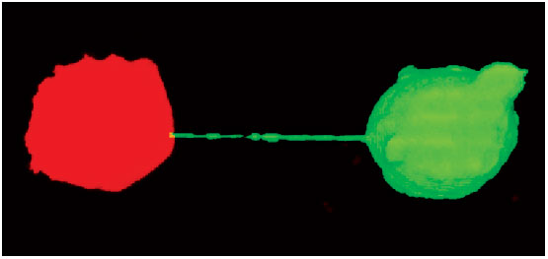
Recent experimental studies have found that many types of cells can physically link to each other over long distances by means of structures known as membrane nanotubes (e.g., see Fig. 1).²⁻⁶ Membrane nanotubes are long and slender tubes formed from the plasma membrane, and can vary in size, structure, and formation processes. It is speculated that cells use membrane nanotubes as a means of intercellular communication, and viruses can propagate from one cell to another by means of membrane nanotubes.^{5, 7, 8} Membrane nanotubes require the cytoskeleton for stability, and their length can extend over several hundred microns. Membrane nanotubes with a diameter less than 700 nm contain only actin and carry portions of plasma membrane between cells in both directions, whereas thicker membrane tubes contain both actin and microtubules and can carry components of the cytoplasm such as organelles and vesicles between cells.⁹ Two distinct processes can contribute to the formation of membrane nanotubes. In the first, an actin-driven protrusion extends from one cell to connect to a nearby cell, and in the second, cells adhere to each other while in close proximity, and a nanotube forms as they move apart. It is also feasible to observe the combination of these two processes (i.e., an actin-mediated protrusion extends from one cell to another and elongation of the nanotube occurs as the cells move apart).⁷
Figure 1 | Two T cells connected to each other by a membrane nanotube.⁴

Theoretical and computational framework

A small number of theoretical and computational studies have investigated long tubular extensions from cells.^{8, 10, 11} However, the physics of tubular membranes confined between two cells remains to be studied, and the recent discovery of membrane nanotubes may provide an interesting model system that can provide a greater understanding of membrane-cytoskeleton interactions.
We study membrane nanotubes using both analytical theory and computer simulations. On sufficiently long length scales, such as those relevant to membrane nanotubes, an actin filament can be modeled as a semiflexible polymer (also known as a worm-like chain). The polymer is represented as a continuous curve in which curvature is energetically unfavorable, with a term known as persistence length characterizing the polymer flexibility.¹² Membranes can also be modeled as continuous surfaces at sufficiently long length scales, with an energy that depends on bending rigidity ($κ$) and surface tension ($γ$) terms.¹³ The bending rigidity is a constant that parameterizes the energy associated with bending the membrane. Membranes can be characterized as fluid or polymerized, depending on the ability to resist in-plane shear.¹⁴ The continuum models of both polymers and membranes are amenable to computer simulation by describing them as discrete structures consisting of particles (nodes) connected by bonds (edges).
In this section, we introduce the continuum models of actin and membranes that form the theoretical basis for our work. We also outline the Monte Carlo computer simulation methods that allow us to explore properties of polymer-membrane systems at thermal equilibrium.

Semiflexible polymer

Actin filaments can be modeled as semiflexible polymers (worm-like chains) on length scales of interest in this study. The configuration of a polymer is mathematically parameterized by curve r(s) with inextensibility condition $\left|\frac{∂r\left(s\right)}{∂s}\right|=1$ (i.e., it has a unit tangent vector or velocity) and a total length of $l$ (called the contour length). The energy of such a polymer is given by
$E_{polymer}=\frac{l_{p}k_{B}T}{2}\int_{0}^{l}{ds{\left|\frac{∂^{2}r\left(s\right)}{∂s^{2}}\right|}^{2} }$,
where $l_{p}$ denotes the persistence length and $k_{B}T$ is the thermal energy. Here, persistence length is a function of the size of a bundle of actin, which is a small number of cross-linked actin filaments, and the term within the integral is the square of the local curvature. As a result, highly curved polymers have high energy while a completely straight polymer has zero curvature and consequently zero energy.

Membrane

We model the cell membrane as a thin tubular elastic membrane. The energy of a cylindrical membrane consists of surface tension and bending rigidity terms and can be written:
$E_{membrane}={ E}_{tension}{+ E}_{bending}=\left(2πRL\right)γ+\frac{κπL}{R}$ ,
where$R$ denotes the tube radius, $L$ denotes the tube length, $γ$ denotes surface tension, and $κ$ denotes membrane rigidity.

Computer simulation

While analytical calculation can provide much insight, it is often hard to generalize analytical results and to account for thermal fluctuations. Computer simulations allow exploration of equilibrium configurations. We use Monte Carlo methods to simulate discretized representations of both polymers and membranes in which particles are connected by edges to represent the objects. Particles (nodes) occupy different positions, are connected to each other by bonds (edges), and can change their positions randomly. The length between connected particles is constrained to a minimum and maximum length. The angles between bonds, which may vary during a simulation, are related to the curvature and hence, bending energy. Monte Carlo simulations are a well-known technique in statistical physics to sample configurations at thermal equilibrium. Typical simulation steps are as follows:
- Generate a trial configuration: Pick a vertex at random and move it by a random displacement.
$\vec{r_{i}}=\vec{r_{i}}+Δ\vec{x}$
- Test whether the new configuration is allowed by checking length constraint.
- If so, calculate the change in energy, $Δu=u_{trial }-u_{initial }$
- If $Δu≤0$, accept the trial move.
- If $Δu>0$, accept with probability $e^{-\frac{Δu}{k_{B}T}}$ (sampling according to canonical ensemble)
- If the trial move is not accepted, keep the previous configuration.
- Repeat
A single Monte Carlo step is completed after each particle attempts to move one time on average.

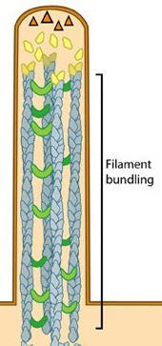
Review of previous work
Figure 2 | Sketch of filopodia by Faix et al. (2006)

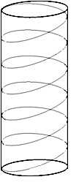
Previous work by other research groups has suggested approaches we can take to study membrane nanotubes. Work by Pronk et al. considered membrane protrusions known as filopodia, which are finger-like cellular projections with actin inside.¹³ They consider an ideal cylindrical tube with a helically wrapped polymer and use analytical calculations to investigate the energy of the system. The helix configuration of the polymer is described mathematically by
Figure 3 | Polymer with helical wrappings inside of a tube.
$r\left(s\right)=\left(\begin{matrix}R cos\left(2πns\right) \\ R sin\left(2πns\right) \\ s\sqrt{1-4n^{2}π^{2}R^{2}}\end{matrix}\right)$ ,
with $\left|\frac{∂^{2}r\left(s\right)}{∂s^{2}}\right|=4Rπ^{2}n^{2}$ and n the number of helix windings per unit contour length ($i.e., n=\frac{\# windings}{l}$). It can be shown that the total vertical length is:
$L=l\sqrt{1-{4n}^{2}π^{2}R^{2}}$, which allows us to write $\int_{0}^{l}{ds{\left(\frac{∂^{2}r\left(s\right)}{∂s^{2}}\right)}^{2}=}\frac{l}{R^{2}}{\left(1-\frac{L^{2}}{l^{2}}\right)}^{2}$, and thus,
$\frac{E_{polymer}}{k_{B}T}=\frac{l{ l}_{p}}{2R^{2}}{\left(1-\frac{L^{2}}{l^{2}}\right)}^{2}$.
Note that this equation holds only when the membrane length is less than the polymer length. There is no energy of confinement when the membrane is as long or longer than the polymer, since the polymer can fit in the tube without any curvature. Physically, the polymer energy should decrease as the membrane length increases since the polymer requires fewer windings to fit.
The total energy of the semiflexible polymer confined in an elastic tube is the summation of the polymer and membrane energies, $E=\frac{l_{p}k_{B}T}{2}\int_{0}^{l}{ds{\left(\frac{∂^{2}r\left(s\right)}{∂s^{2}}\right)}^{2} }+\left(\frac{πκ}{R}+2πγR\right)L$. The authors demonstrate that the presence of a bundle of actin in the system can stabilize a filopodium against collapse, which is the expected outcome when actin is not present.¹³ According to their results, a global energy minimum always occurs at a tube of zero length and infinite radius with a straight parallel polymer inside. However, in certain parameter regimes, a local energy minimum is possible at nonzero tube length and radius.
Recent work by Fosnaric et al. considered a single semiflexible polymer confined within a fluid vesicle.¹⁵ The authors use Monte Carlo (MC) computer simulations to study the effects of changing the persistence length of a polymer in a lipid vesicle. At equilibrium, interactions between the polymer and membrane result in the membrane forming a disk-like shape, which is in contrast with the spherical shape of an empty fluid membrane. Also, the polymer tends to adopt an ordered coil shape at equilibrium.¹⁵

Scheme perspective

Although recent studies have revealed insight into the structure, physical properties, and functions of membrane-actin systems, further research is needed to understand their behavior in a wide variety of situations. Membrane nanotubes provide a novel system in which to investigate interactions between the cell membrane and actin. As such, we use analytical theory and computer simulations to better understand actin filaments enclosed in membrane nanotubes. In this project, we begin by describing the theoretical framework and then introducing preliminary results. We demonstrate that a helical configuration is not the only likely configuration for a bundle of actin filaments in a tube and show that an alternative configuration is energetically favorable in a wide range of parameter space. We also employ Monte Carlo simulations to model a semiflexible polymer at thermal equilibrium. Common polymer quantities such as energy and end-to-end distance are calculated to study the polymer behavior in both confined and unconfined spatial regions. Confining a polymer in space gives insight into the effects of flexible membranes and allows us to estimate equilibration times for the simulations. To investigate flexible membranes, we use computer simulations of a discrete triangulated surface. We begin by studying the membrane without a polymer inside and investigate effects of various parameters and membrane shapes (e.g., spherical and cylindrical). We also consider a system in which a semiflexible polymer is placed inside of a membrane to model a membrane nanotube. We will conclude by giving a better understating of the physics and behavior of membrane nanotubes.

Problem formulation

Goals of our study

To gain insight into the behavior of membrane nanotubes, we will begin by studying polymers and membranes in isolation and then consider a polymer confined within a membrane. For our research purposes, we will model membrane nanotubes as an elastic cylindrical membrane with a semiflexible polymer inside.
We first seek to investigate the behavior of a semiflexible polymer without a membrane in various conditions. Our initial studies will confine a polymer in confined geometries such as hard cylinders. We will study polymer quantities such as end-to-end distance, radius of gyration, and energy, which will provide useful comparison for understanding effects of flexible membranes in subsequent simulations and will also allow us to estimate equilibration times of the simulations. We will study the effect of changing the initial configuration (e.g., helical, straight, and random in both confined and unconfined to geometries). Moreover, we will independently vary persistence length${ (l}_{p})$ and polymer length $\left(l\right)$ to investigate the effects on the system at equilibrium. Adding excluded volume between particles is another subject of interest, as it may change features of the polymer behavior. Performing the outlined tests will allow us to learn more about the polymer without complications from the membrane, and we can characterize how fixed and bounded geometries affect the polymer behavior.
We will follow a similar procedure for the membrane in isolation. We will study a cylindrical polymerized membrane with two cases governing the ends of the cylinder: free ends (the membrane can freely move in space) and fixed ends (the cylinder ends are confined to lateral movements only, which mimics an empty membrane nanotube confined between two cells). We will systematically change the bending rigidity ($κ$), the size of the cylinder (radius and length), the number of triangles, and the triangulation method. In addition to the polymerized membrane, we will incorporate membrane fluidity and redo the previous tests to investigate the effects of fluidity on the membrane. We will also consider other membrane shapes found in cell biology such as spherical vesicles.
We will conclude by simulating a polymer confined within a membrane tube, which represents our model of a membrane nanotube. We will study the interplay between the membrane and polymer, including the effects of thermal fluctuations. We seek to understand the influence of physical properties of the system such as persistence length, polymer length, bending rigidity, and membrane diameter. We will attempt to model biological conditions and to compare with experimental work to check for consistency. Our ultimate goal is to provide insight into the fascinating biology of membrane nanotubes by elucidating physical processes that govern their behavior.

Simulation method

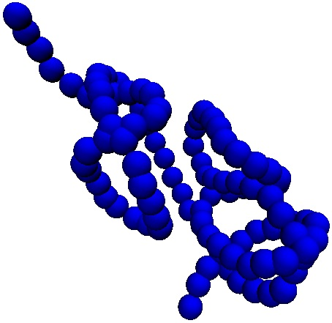
We employ Monte Carlo simulations to study a discrete model of a semiflexible polymer. The polymer consists of M vertices (nodes (r_{i})) connected by M-1 bonds (edges (E_{i})). The bond length can range from $l_{min}=1$ to$l_{max}=1.67$,¹⁵ and the total length of polymer is $l$ = $\sum_{i=1}^{M-1}{l_{E_{i}}}$. The energy of the polymer is given by $E_{polymer}=λ\sum_{j=1}^{M-2}{(1-\cos{θ_{j}})}$, where $θ$ denotes the angle between two successive bonds and $λ$ = $k_{B}T\left(\frac{ξ}{\overline{l}}\right)$, with $ξ$ the persistence length and $\overline{l}$ the average of the maximum and minimum bond lengths.
Figure 4 | A simulated polymer with M = 100 and$λ$ = 20 k_{B}T after 10⁵ Monte Carlo steps.
Baumgartner and Ho pioneered a model of a fluid membrane in which a randomly triangulated surface can break bonds between particles and create new bonds.¹⁶ Therefore, membrane particles can move throughout the membrane, in contrast with polymerized membranes, which have fixed internal connectivity.^{16, 17}
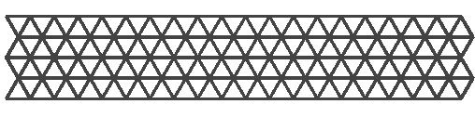
We also use Monte Carlo simulations to study discrete representations of membranes. We consider both fluid membranes and polymerized membranes. The membrane consists of N vertices that are connected by bonds forming a triangular mesh (see Fig. 6). Two connected vertices must be separated by an edge length between $l_{min}=1$ and$l_{max}=1.67$, and particles have excluded volume and cannot occupy the same space at a given time (i.e., particles are considered rigid spheres).¹⁵ The bending energy for these discrete, triangulated surfaces introduced by Nelson, Kantor, and Kardar, E = $λ\sum_{〈i, j〉}{\left(1-n_{i}.n_{j}\right)}$. The sum extends over all triangles sharing an edge, $λ$ depends on the bending rigidity, and n_{i} denotes a normal vector to a triangle.
Figure 5 | Triangulated surface sample described by 100 particles.
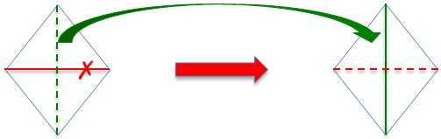
Fluid membranes incorporate an additional type of Monte Carlo move known as a bond flip. This mechanism provides fluidity for the membrane, allowing each vertex to escape its original neighbors. In this model, during each Monte Carlo step, N bonds are randomly chosen to be cut and replaced by new bonds (see Fig.7). New bonds must satisfy the bond length constraint and each particle must have at least 3 bonds to other particles to prevent either bonds or triangles from “dangling”.^{19, 20}
Figure 6 | Cutting and creating bonds in the bond flip mechanism.
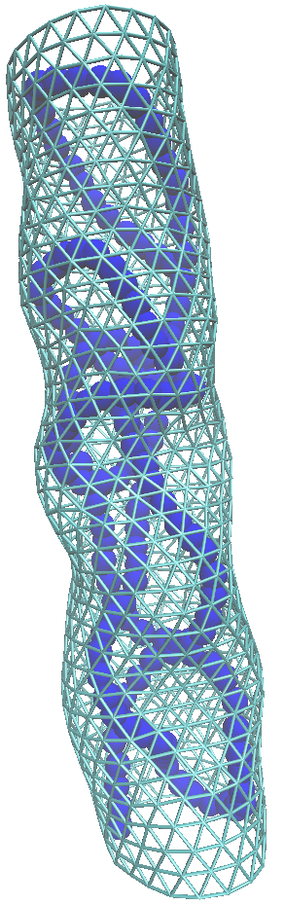
Figure 7 | A simulated polymerized membrane nanotube consists of 840 particles with a polymer inside including 160 particles after 10⁴ Monte Carlo steps.

Measuring quantities for and membrane

We calculate quantities such as energy, end-to-end distance, and radius of gyration to investigate the behavior of the polymer in different conditions. End-to-end distance ($\vec{r_{e}}$) is the distance between the first ($\vec{r_{1}}$) and last particles ($\vec{r_{M}}$) (i.e.,$\vec{r_{e}}=\vec{r_{M}}-\vec{r_{1}}$). The radius of gyration is given by ${R_{g}}^{2}=\frac{1}{{2M}^{2}}\sum_{i, j}{{\left(r_{i}-r_{j}\right)}^{2}}$. For radius of gyration and energy data, the correlation function, which is $C_{E}\left(τ\right)=\frac{1}{T_{max}-τ}\sum_{t (MCS)=0}^{T_{max}-τ}{\tilde{E}\left(t\right) \tilde{E}\left(t+τ\right) }(\left[\tilde{E}\left(t\right)=E\left(t\right)-〈E〉\right]$) is applied to measure how correlated two sequent configurations are once system is equilibrated. Specific heat is another quantity of interest to discern phase transition regimes, which is calculated by $C=\frac{1}{N}\left[〈E^{2}〉-{〈E〉}^{2}\right]$.¹⁹

Results and discussion

Analytical calculations

In analytical theory, we employ the previously mentioned formula, which is $E=\frac{l_{p}k_{B}T}{2}\int_{0}^{l}{ds{\left(\frac{∂^{2}r\left(s\right)}{∂s^{2}}\right)}^{2} }+\left(\frac{πκ}{R}+2πγR\right)L$, to calculate the energy of the system.
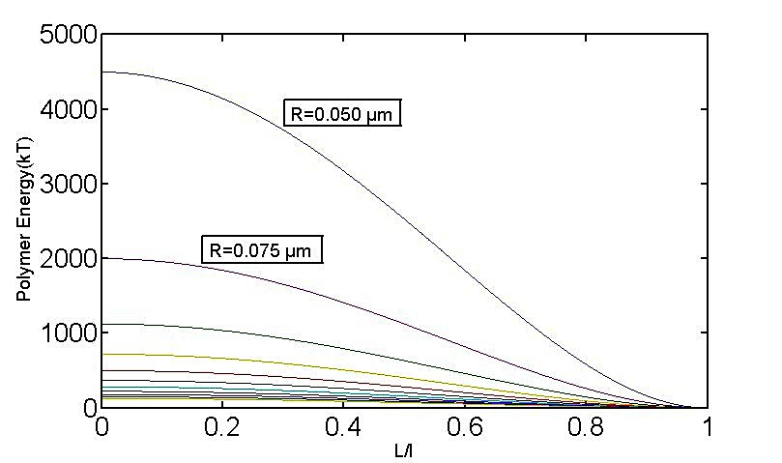
Note that the polymer part of this equation holds only when the membrane length is less than the polymer length. Physically, the polymer energy should decrease as the membrane length increases, with no energy of confinement when the membrane is longer than to polymer (if the membrane length is equal to or greater than the polymer length, the polymer can fit in the tube without any curvature).
Figure 8 | For polymers longer than a membrane, decrease in polymer energy occurs with increase in radius or length of the membrane.
Each polymer configuration in different physically possible conditions yields exclusive results. This stability argument encourages us to analytically investigate more likely and energetically favorable polymer configurations for such a system at equilibrium.
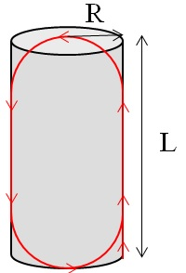
Although a helical configuration has been assumed for many biopolymers such as ds-DNA and actin filaments,¹⁸ one can find other well-behaved configurations. We consider an alternative conformation for the polymer in a tubular membrane, which we call the circular cap configuration. The polymer in this configuration follows the length of the membrane tube without curvature and turns at the top and bottom of the membrane by making semicircles (see Fig. 3). Therefore, the polymer contributes to the energy only in the cap areas. We have shown by analytical and computational methods that this is an energetically favorable configuration in some ranges of membrane radii and length. The shape of a circularly wrapped polymer at its turning points can be described by
Figure 9 | Polymer with circular cap shape movement inside of a tube.
$r\left(s\right)=\left(\begin{matrix}R cos\left(αs\right) \\ R sin\left(αs\right)\end{matrix}\right)$ ,
The inextensibility condition, $\left|\frac{∂r\left(s\right)}{∂s}\right|=1$, allows us to find $α=\frac{1}{R}$ $.$ If we have a polymer with n turns (semicircles), the energy associated with the polymer is $\frac{nπl_{p}}{2R}$. One can calculate the number of turns using:
$$l=\left(L-R\right)+πR+\left(L-2R\right)+πR+…=\left(L-R\right)+nπR+\left(n-1\right)\left(L-2R\right)$$
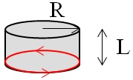
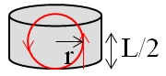
Neglecting the last uncompleted turn so that n is an integer, we have n = $\left\lfloor \frac{l-R}{πR+L-2R}\right\rfloor$.
Figure 10 | Polymer winding in horizontal direction in tube in case L<2R.
Figure 11 | Polymer winding in longitudinal direction in tube in case L<2R.
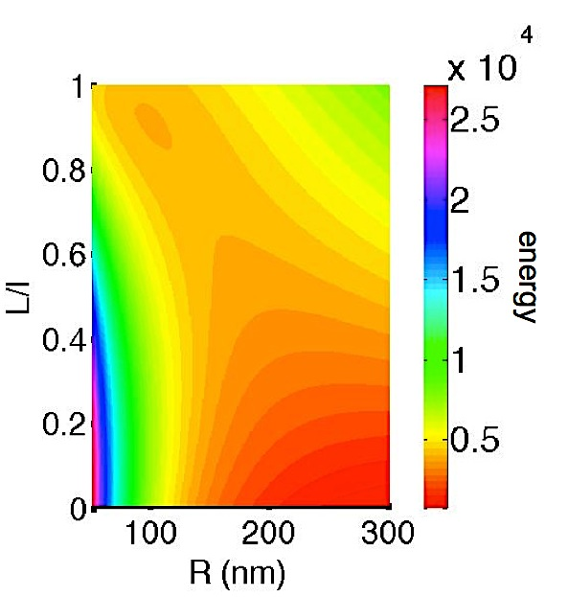
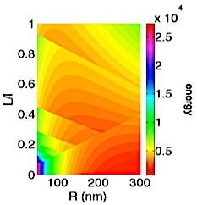
This past scenario only holds for L>2R. For cases in which L<2R, we consider two other cases: (i) Winding in the horizontal direction without any growth in the vertical direction that gives $n=\frac{l}{πR}$ (see Fig. 4) and (ii) winding in the vertical direction with a smaller radius (see Fig. 5). In case (ii), the new radius for polymer winding is $\frac{L}{2}$, giving $n=\frac{2l-L}{πL}$. It obviously implies that when L approaches 0, the energy associated with polymer tends to infinity.
Figure 12 | Surface plot of a filopodia (membrane with helical (a) and circular cap (b) polymer inside) energy per radius and unit length. Darker shades stand for lower energy values.
Here, the polymer energy (like helical scenario) is zero when the polymer length is less than or equal to the membrane length.
If we calculate the total energy of filopodia with given physical properties for a typical cell parameters ($κ=40 k_{B}T, γ=0.0025\frac{k_{B}T}{{nm}^{2}}, lp = 15 µm$), the global minimal energy that represents the most likely condition varies from helical to circularly wrapped case. As shown in figure 7, this minimum for a polymer with helical configuration occurs at the largest radius (R=300 nm) and shortest membrane length (ideally L=0 nm). In addition to global energy minimum, a local energy minimum exists at a radius and length ratio equal to 100 nm and 0.9 approximately that stabilizes filopodium against collapse. The membrane energy contribution (bending rigidity and surface tension) dominates polymer energy. A circular cap shape polymer with wrappings in vertical direction when L<2R has a minimum energy happening at a narrow range of membrane lengths and radii (L≈411 nm, R≈156 nm). Polymer considerably contributes in the system total energy in contrast with the helical case.
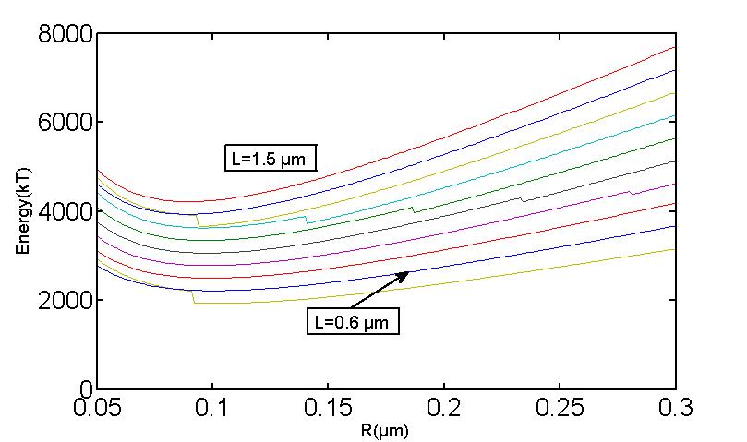
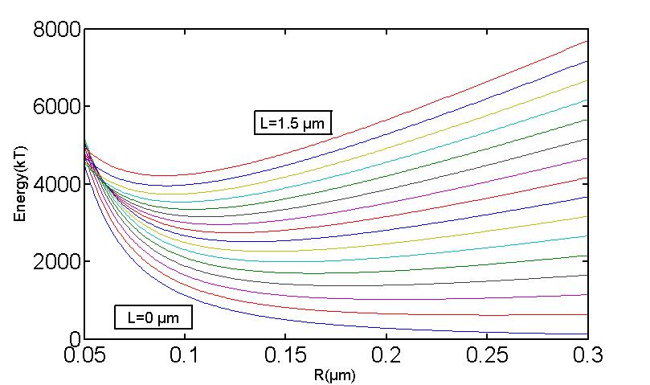
Generally, there are two approaches to find the local and global energies and as a result, membrane radius, considering the polymer contribution. When the polymer length is shorter than the membrane length, there is no contribution to the energy by the polymer. In this case, after taking the derivative of total energy with respect to R, for both helical and circular cap shapes, the global minimum in energy occurs when we have only contributions of bending rigidity and surface tension as introduced earlier. But when we are in the regime of the polymer length larger than membrane length, the previous minimum no longer exists and the analytical method doesn’t lead us an explicit solution. For filopodia, we apply numerical method to find a range of radius, around R≈100 nm for both helical and circular cap shapes that minimize the energy in a range of membrane lengths. If we now calculate the radius of an empty tube, which is given by only considering two surface tension and bending rigidity terms that leads to the equation: ${\left(\frac{∂E}{∂R}\right)}_{L}=-\frac{κπL}{R^{2}}+2πγL=0⟹R=\sqrt{\frac{κ}{2γ}}$ , the radius will be equal to 89.44 nm. Since a bundle of polymers trigger radial forces, an empty tube finds a smaller radius to stabilize the system.
Figure 13 | Energy plot per membrane radius for circular cap (left) and helical (right) shape polymers. Red circles show a range of radii (R≈100 nm) that provide lower energies for different membrane lengths (increasing from the down to up).
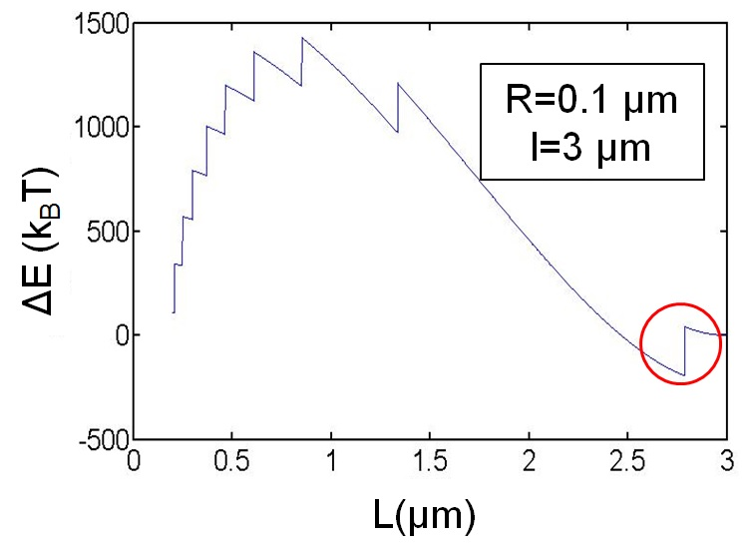
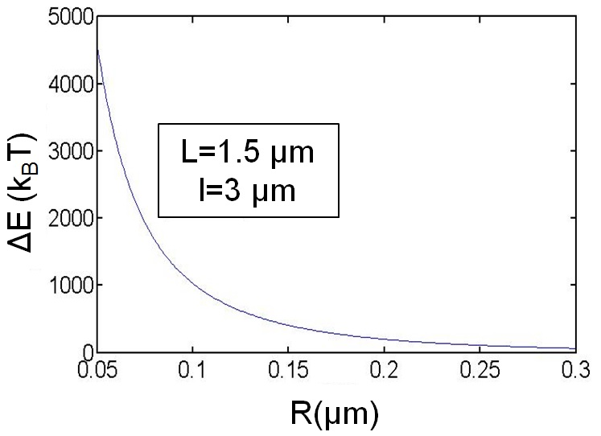
We considered helical and circularly cap polymer configurations and compare the energy difference $ΔE$ = E_{helix} – E_{cap}. For $l≤L, ΔE=0$, since there is no energy associated with polymer in both cases. Figure 4 shows that actin in an elastic tube is more energetically favored in a circular cap shape than in a helical shape for much of parameter space. If we increase the membrane radius, the likelihood of circular cap shape behavior for a bundle decreases as $ΔE$ approaches zero. However, the helical shape is energetically favorable in a small region where the polymer length is close to that of the membrane. In addition to this region, if we consider the case when L<2R, A bundle with helical configuration exist more likely than circular cap configuration with wrappings in horizontal or vertical direction.
Figure 14 | a) Energy difference as a function of membrane length with fixed radius and polymer length. The red circle shows the small range of L over which the helical polymer provides lower energy than the circular one. The stepwise behavior is due to employing a floor function for the circular case. b) Energy difference as a function of membrane radius with fixed membrane and polymer lengths. As R increases, the difference vanishes.

For a case which the polymer winds in the horizontal direction, as L increases, the energy of the polymer with helical shape decreases while the energy associated with the polymer with circular cap shape does not change (see Fig. 5 a). On the contrary, increasing membrane radius leads to zero $ΔE$ (see Fig. 5 b). Changing the polymer length results a more complicated interpretation. As the polymer length increases, the polymer with helical shape matches with the horizontal windings case. So, the $ΔE$ is being reduced whereas in the first region L/l is nearly zero, consequently, the energy of helical case approximately remains constant (close to zero) while increasing length of polymer cause energy increase in the horizontal windings shape (see Fig. 5 c).
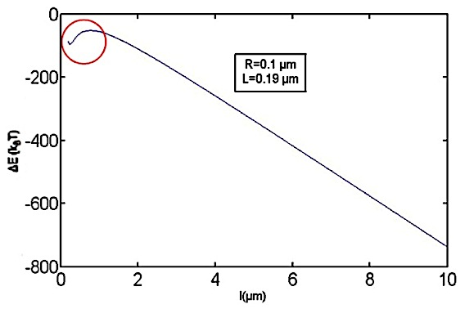
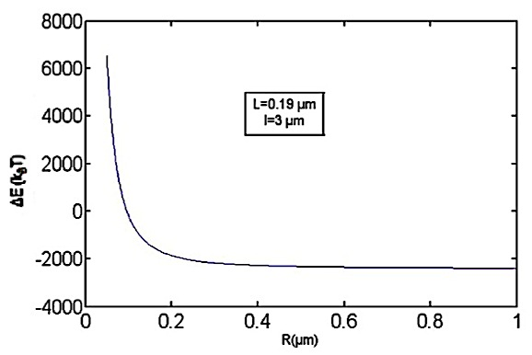
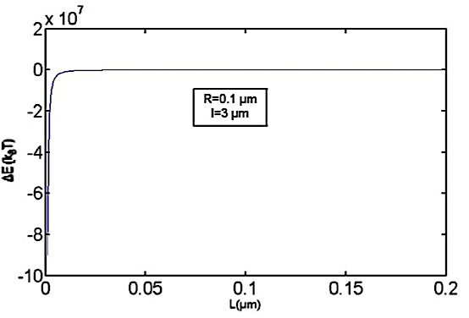
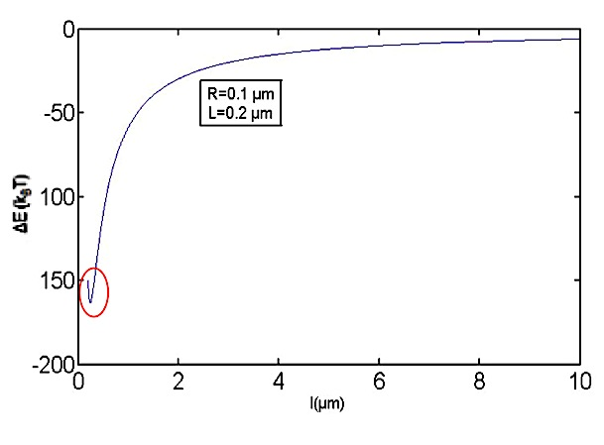
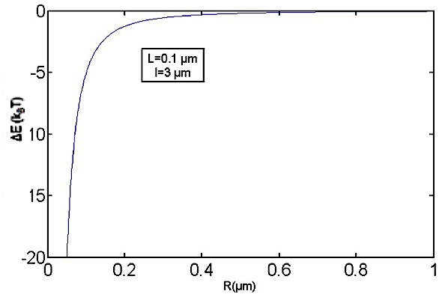
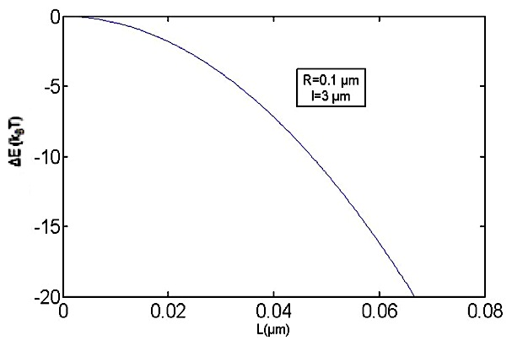
In another case of vertical wrappings for polymer, as L increases $ΔE$ decreases. For a region around L=0, a significant difference can be observed due to the large number of windings (see Fig. 6 d). If one extends radius size, $ΔE$ decreases to approach a constant value (the energy of the circular cap shape) because of quadratic energy reduction for helix without any change in circle (see Fig. 6 e). Moreover, as polymer length increases, $ΔE$ decreases due to a significant number of windings for the circular cap shape. A short region may be seen that $ΔE$ increases for the same reason as mentioned for the length change of a polymer with horizontal wrapping (see Fig. 6 f). Due to greater $ΔE$ for this case in different conditions, one can find membrane tubes with polymer windings in the horizontal direction for circular cap shape case when L<2R. However a polymer seems to hardly have a short length in comparison with its radius, particularly for the first process of nanotubes formation (protrusion from one cell to another cell), helical shape holds stability conditions better for the system.
Figure 15 | a,d) Energy difference as a function of membrane length with fixed radius and polymer length. b,e) Energy difference as a function of membrane radius with fixed membrane and polymer lengths. c,f) Energy difference as a function of polymer length with fixed radius and length membrane. Red area shows the region for polymer length that energy difference behaves reversely.

Polymer behavior at equilibrium

We systematically change the persistence length of an unconfined polymer and proceed the simulations until 10⁸ Monte Carlo Sweeps (represents the average number each node moves one time) in order to allow the system to reach seeming equilibrium since starting with straight and random configurations yield a fluctuation around a similar value in the process of calculation of different quantities.
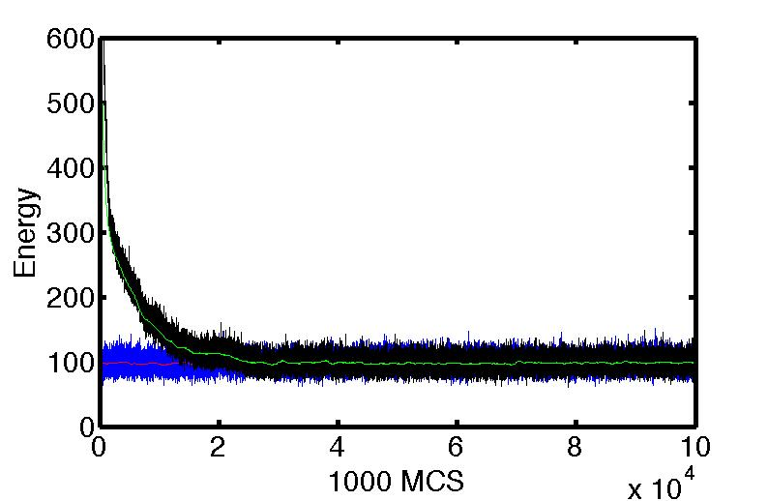
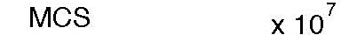
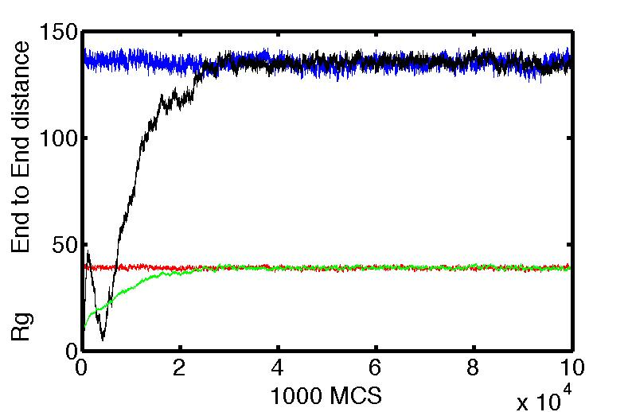
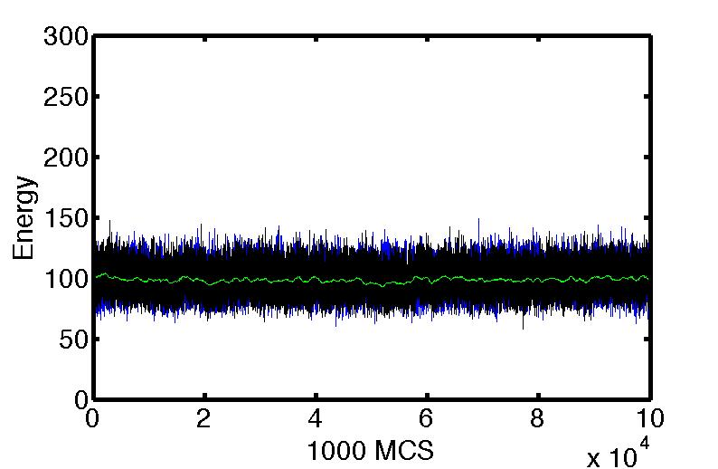
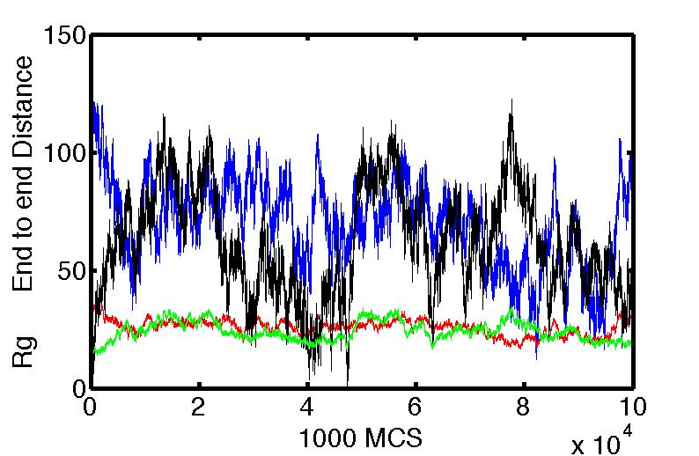
Following figures indicate that as persistence length increases, the polymer tends to reach untied (straight-like) configuration more rapidly (if the polymer starts running from a random configuration) due to energy contribution and the number of accepted moves also decreases, consequently, polymers with greater persistence lengths, which show less flexibility in their behaviors, require more MCS (i.e., Monte Carlo Steps) to equilibrate.

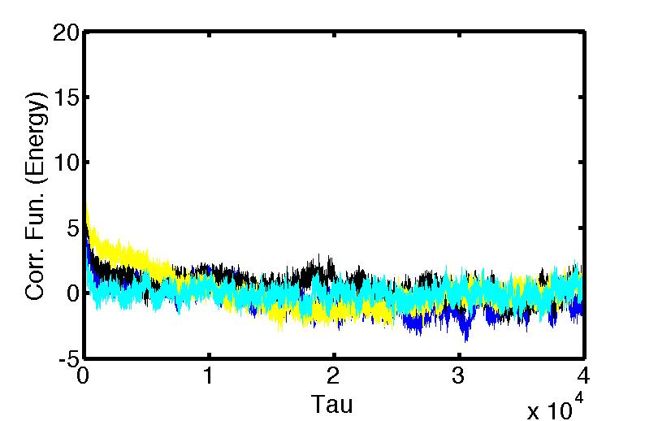
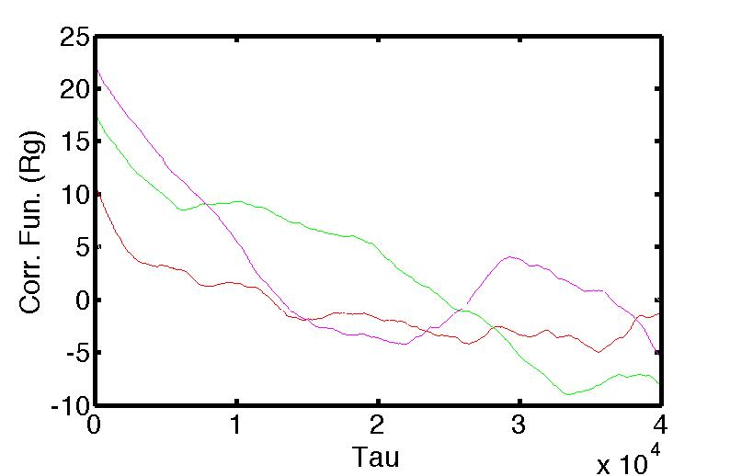
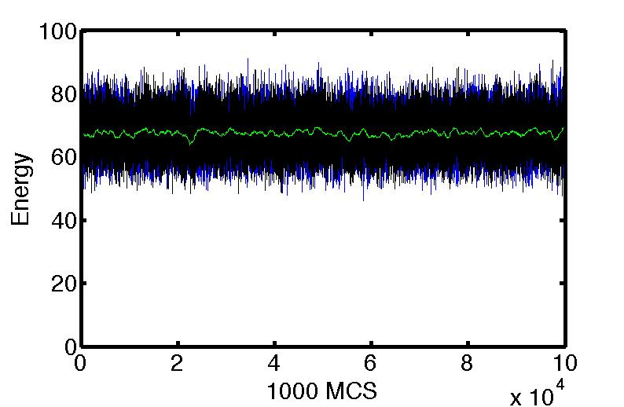
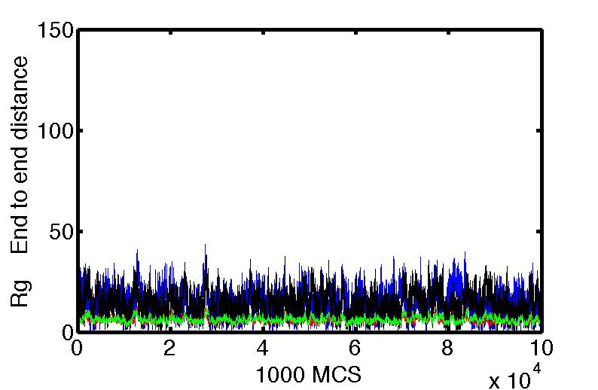
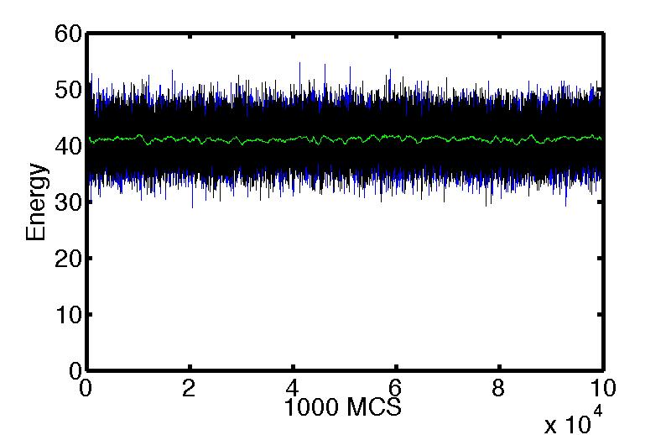
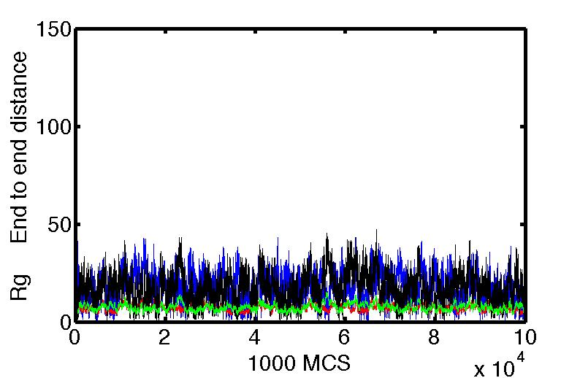
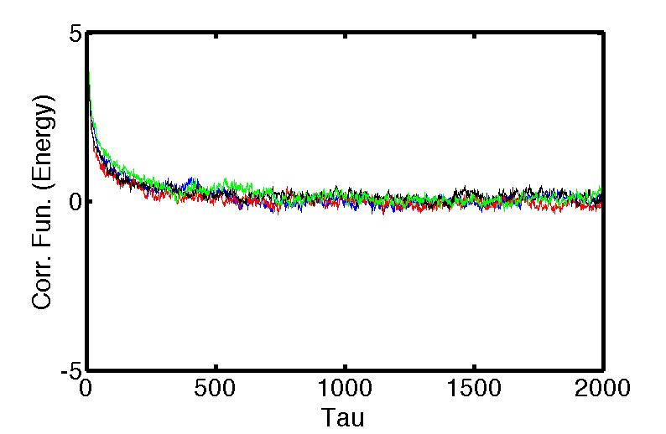
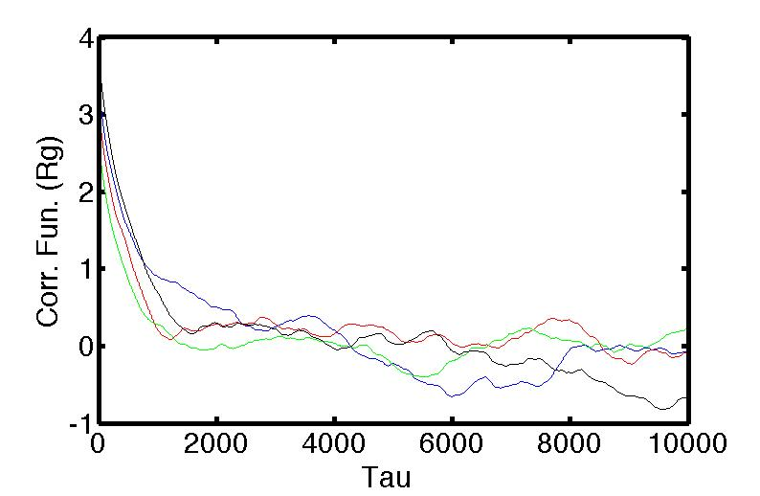
We calculate correlation functions for energy and radius of gyration data associated with polymers with $λ$ = 1 and 20. Relaxation time data differs from trajectory to trajectory for energy correlation function (see Fig. 7 a and 8 a). Correlation function for radius of gyration does not yield any reliable data (see Fig. 7 b and 8 b). These results show that either polymer has not yet been equilibrated or more data (multiple trajectories) are demanded in order to find more precise average.
Figure 17 | Correlation function plots of energy (a) and radius of gyration (b) for polymers with random initial configurations and $λ$ = 20
Figure 16 | polymers with random initial configurations are shown in black and green. Polymers with ideally straight initial configurations are shown in blue and red. a,b) Energy, end-to-end distance, and radius of gyration plots of two polymers with $λ$ = 1000. Averaged number of accepted moves is 22%. c,d) Energy, end-to-end distance, and radius of gyration plots of two polymers with $λ$ = 20. Averaged number of accepted moves is 73%. e,f) Energy, end-to-end distance, and radius of gyration plots of two polymers with $λ$ = 1. Averaged number of accepted moves is 87%. g,f) Energy, end-to-end distance, and radius of gyration plots of two polymers with $λ$ = 0.5. Averaged number of accepted moves is 88%.
Figure 18 | Correlation function plots of energy (a) and radius of gyration (b) for polymers with random initial configurations and$λ$ = 1
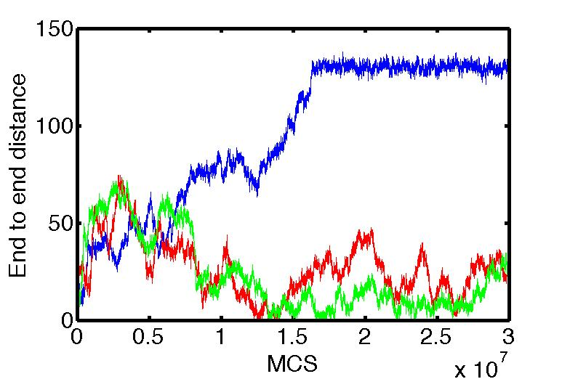
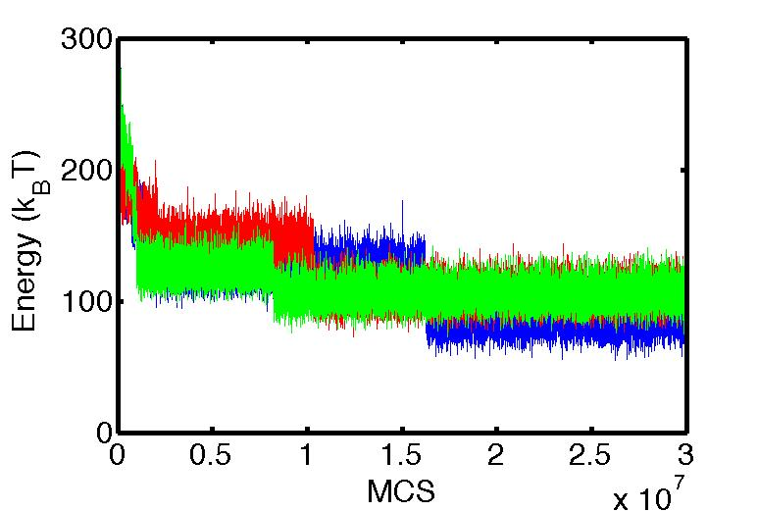
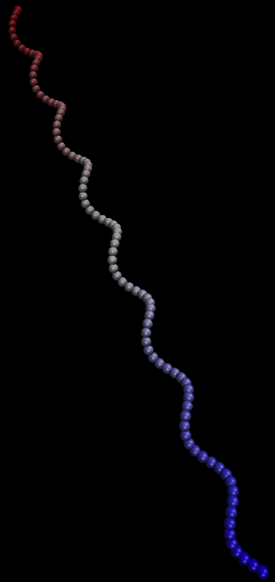
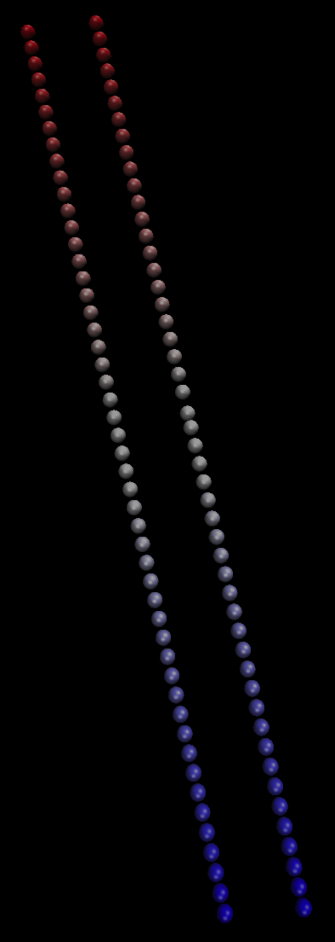
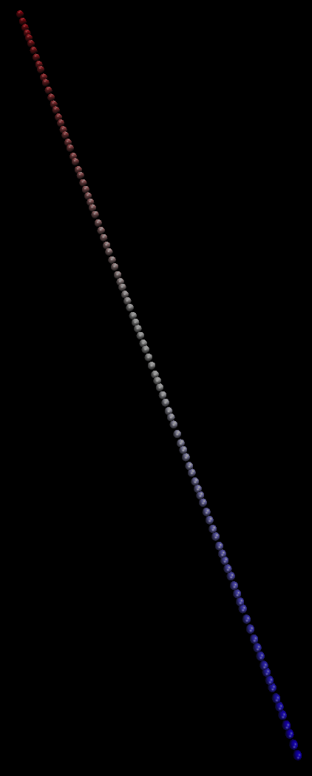
Polymer behavior in a hard tube, which is the confined geometry we study here, is slightly different and significantly dependent on the tube radius and magnitude of $λ$. In this case of study, polymers provide useful comparisons for understanding effects of flexible membranes and estimating equilibrium time for individual polymers. Three different starting configurations: linear, helical, and jagged (see Fig. 9) for $λ$ = 20 and radius = 2 are evaluated. In jagged initial configuration case, energy level jumps might be observed due to existence of untied loops (i.e., stuck polymers in kinked configurations) in different trajectories even though they started form the same state (see Fig. 10). In contrast with jagged case, helical and linear initial configurations are considered more energetically favorable than jagged shape. Hence, the polymers reach a higher and similar energy state, presumably equilibrated (see Fig. 11). The number of rejected moves for all cases dramatically increases as the tube radius decreases. For instance, if radius changes from 2 to 0.2, the number of rejected moves approximately increases about 30 times.
Figure 20 | Results show energy and end-to-end distance plots for three distinct trajectories starting with the same jagged configuration.
Figure 19 | Different initial configurations for polymers: linear, helical, jagged (from left to right)
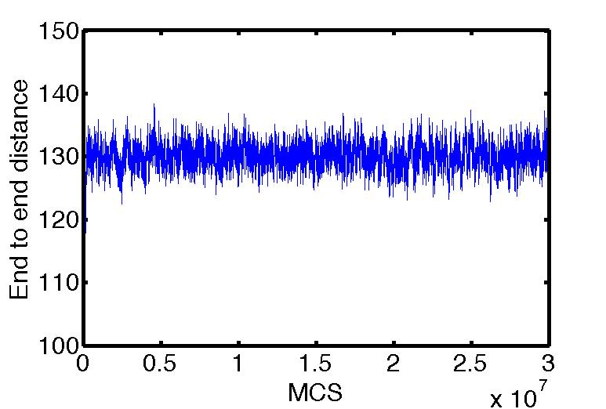
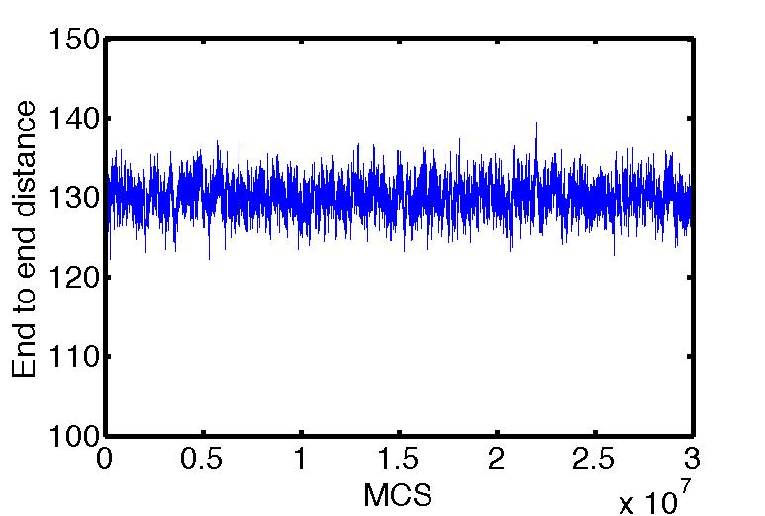
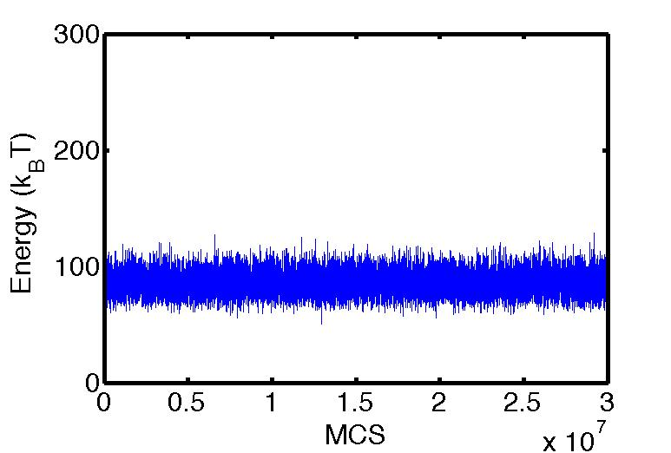
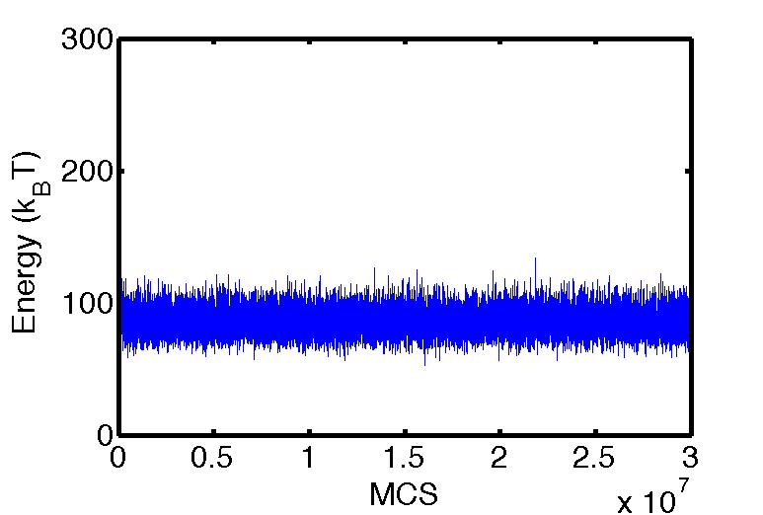
Figure 21 | Results show energy and end-to-end distance plots for two individual polymers (single trajectory for each) starting with linear (above) and helical (below) configurations.

Membrane behavior at equilibrium

[This section will be filled up later]

Influence of fluidity on membrane

[This section will be filled up later]

Membrane nanotubes

[This section will be filled up later]

Conclusions

[This section will be filled up later]

List of references

- B. Alberts, A. Johnson, J. Lewis, M. Raff, K. Roberts, and P. Walter (2002) "Molecular biology of the cell" 4th ed., Garland Science, New York
- A. Rustom, R. Saffrich, I. Markovic, P. Walther, H. Gerdes (2004) "Nanotubular Highways for intercellular Organelle Transport" Science 303
- A. Chauveau, A. Aucher, Ph. Eissmann, E. Vivier, and D. M. Davis (2010) "Membrane nanotubes facilitate long-distance interactions between natural killer cells and target cells" PNAS 107
- S. Sowinski, C. Jolly, O. Berninghausen, M. A. Purbhoo, A. Chauveau, K. Köhler, S. Oddos, Ph. Eissmann, F. M. Brodsky, C. Hopkins, B. Önfelt, Q. Sattentau, and D. M. Davis (2008) "Membrane nanotubes physically connect t cells over long distances presenting a novel route for HIV-1 transmission" Nature Cell Biology 10
- B. Onfelt, S. Nedvetzki, K. Yanagi, and D. M. Davis (2004) "Membrane Nanotubes Connect Immune Cells" The journal of immunology 173
- Y. Li, R. Lipowsky, and R. Dimova (2011) "Membrane nanotubes induced by aqueous phase separation and stabilized by spontaneous curvature" PNAS 108
- D. M. Davis, and S. Sowinski (2008) "Membrane nanotubes: dynamic long-distance connections between animal cells" Molecular Cell Biology 9
- A. Saric, and A. Cacciuto (2012) "Mechanism of Membrane Tube Formation Induced by Adhesive Nanocomponents" PRL 109
- B. Onfelt, S. Nedvetzki, R. K. P. Benninger, M. A. Purbhoo, S. Sowinski, A. N. Hume, M. C. Seabra, M. A. A. Neil, P. M. W. French, and D. M. Davis (2006) "Structurally Distinct Membrane Nanotubes between Human Macrophages Support Long-Distance Vesicular Traffic or Surfing of Bacteria" The journal of immunology 177
- I. Derényi, F. Julicher, and J. Prost (2002) "Formation and Interaction of Membrane Tubes" PRL 88
- G. Koster, A. Cacciuto, I. Derényi, D. Frenkel, and M. Dogterom (2005) "Force Barriers for Membrane Tube Formation" PRL 94
- J. Kierfeld, K. Baczynski, P. Gutjahr, T. Kuhne, and R. Lipowsky (2010) "Modelling semiflexible polymers: shape analysis, buckling instabilities, and force generation" Soft Matter 6
- S. Pronk, P. L. Geissler, and D. A. Fletcher (2008) "Limits of Filopodium Stability" PRL 100
- R. Lipowsky (1994) "Stacks and bunches of fluid membranes" J. Phys.: Condens. Matter 6
- M. Fosnaric, A. Iglic, D. M. Kroll, and S. May (2013) "Monte Carlo simulations of a polymer confined within a fluid vesicle" Soft Matter 9
- J. S. Ho, and A. Baumgartner (1990) "Simulations of Fluid Self-Avoiding Membranes" Europhys. Lett. 12
- A. Baumgartner, and J. S. Ho (1990) "Crumpling of Fluid Vesicles" J. Phys. Rev. A 41
- Z. Yang, D. Zhang, L. Zhang, Ch. Hongping, Ateeq-ur-Rehman, and H. Liang (2011) "Local coil–helix transition of semiflexible polymers confined in spheres" Soft Matter 7
- D. M. Kroll, and G. Gompper (1992) "The Conformation of Fluid Membranes: Monte Carlo Simulations" Science 255
- H. Noguchi (2009) "Membrane Simulation Models from Nanometer to Micrometer Scale" Journal of the Physical Society of Japan 78

VITA

[This section will be filled up later]

