Field of Forgotten Dreams: The Role of Memorial Myopia in Representing Black Baseball History in Birmingham, Alabama

A Thesis Presented for the
Master of Science
Degree
The University of Tennessee, Knoxville

Micah J. Ortiz
May 2025
Dedication
For my family, friends, and loved ones.
"Baseball is a game, yes. It is also a business. But what it most truly is, is disguised combat. For all its gentility, it's almost leisurely pace, baseball is violence under wraps”
~ Willie Mays

Acknowledgements
To my advisor Dr. Derek H. Alderman and Dr. Tracey Norrell, thank you for pushing me to be better. Both Dr. Alderman and Dr. Norrell has been a tremendous resource, advocate, and mentor. I am appreciative of the experience and their mentorship in every aspect of my academic career, along with my own personal growth. I am forever thankful for this experience and both of your gratitude and leadership.
Along with Dr. Alderman and Dr. Norrell, my other committee member, Dr. Ron Kalafsky (University of Tennessee, Knoxville), I wish to express gratitude and appreciation for your unwavering support. My entire academic career at UTK has been a great experience thanks to you and the guidance you have shown me.
To my parents Kristi and Joel, thank you for pushing me to be a better human and showing that even a South Dakota boy can succeed far away from his roots. I constantly look up to you and find myself growing into the man you always thought I would be. From the phone calls and texts, picking me up from the airport, and even the hotel bookings, thank you both. I would not be where I am without you.
Further acknowledgement goes to my friends back home, elsewhere, and right here in Knoxville: Sawyer, Jimmy, Gabe, Kiah, Katie, Bosten, Morgan, Margaret, Dominick, Alex, Caroline, the Seths’, Tate, Hannah, and to everyone else I have the fortune to call a friend - thank you.

Abstract
Baseball in Birmingham, Alabama, has a long and troubled past regarding racial tension, although my thesis finds that those tensions do not appear fully interpreted and memorialized in the city’s two major Black baseball heritage sites - historic Rickwood Field and the Negro Southern League Museum. Until recently, the history of the Negro Leagues of Baseball was largely under-valued and written out of contemporary baseball memory and record books. Still, an ongoing effort to carry out a more inclusive and critical discussion of Black baseball and the social inequalities that formed and defined it have allowed sites like Birmingham’s Rickwood Field and the Negro Southern Leagues Museum to move to the forefront of sports-related tourism. My research carries out a critical reading of the depiction of the history of race, racism, and civil rights struggle during the Jim Crow era of segregation, examining the extent to which these themes are apparent, missing, or obscured through the sites’ markers, exhibits, artifacts, and wider spatial arrangement. In analyzing Rickwood and the Negro Leagues Museum of Birmingham as places of sports memory, I examine concepts of spatial narratives, conditional storytelling, and the ongoing racial politics memorialization process. My central argument is that the preserved ballpark and baseball-related museum, while they should be ideal places for understanding how sport and society are often intertwined through politics and racial segregation, perpetuate a “memorial myopia” that blurs our ability to fully see and understand the reality of prejudice and segregation in baseball and Birmingham specifically. Through ethnographic analysis, my research highlights how baseball history in Birmingham, Alabama is curated, remembered, and retold, providing a framework for understanding how sports can both challenge and reinforce societal norms.
Keywords: myopia, memory, sports geographies, Birmingham, and baseball

Table of Contents

Chapter 1 – Toward A Sports Geography of Race and Memory 1
Introduction 1
Disclosure on the Inclusion of the Journal Article 2
Intellectual Merit 3
Baseball as an Institution 3
Seething Presence and the Agency of Objects 4

Chapter 2: Research Article 6
Introduction 6
Baseball and Segregation 6
Memory and Place 7
Memorial Myopia 8

Background to the Study 9
Bridging Memory Studies and Sports Geographies 9
Incorporating Race and Black Baseball History in Memory Studies 11
Birmingham as a Key Battleground in Civil Rights and Racialization 13
Research Need and Questions 15

Research Findings 18
Rickwood Field 18
America’s Oldest Ballpark: Rickwood Field as a Place of Memory 18
Rickwood Tour 20
Birmingham Negro Southern League Museum 30
Narrative Mapping and Storytelling at the Negro Southern League Museum 30
Museums as Racial Myopia 37
Memorial Entrepreneur 37
Blurriness and Memory 39
Cultural Impacts of Baseball in Birmingham 40

Conclusion 41
Birmingham Memory 41
Furthering Myopia 42

Chapter 3: Implications and Future Research 44
Introduction 44
Public Memory 45
Implications 46
Future Research and Conclusions 47

Bibliography 49

Vita 52

List of Figures

Figure 1.1 23

Figure 1.2 24

Figure 1.3 27

Figure 1.4 30

Figure 2.1 33

Figure 2.2 34

Chapter 1: Toward A Sports Geography of Race and Memory

Introduction
Baseball has long been a cornerstone of American popular sports culture, providing millions of players and fans a powerful platform to express cultural identity and influence the broader history of sports in the United States. As an institution of culture, baseball has become the focus of the human/cultural geographic study of sport as a cultural and social institution that both shapes and is shaped by wider values, identities, and inequalities. Baseball has given the world and the discipline of geography a unique but often neglected laboratory for examining the formation of economic, cultural, and political relations and spaces. As the game grew from its early conception in the late-19th century to the early-20th century, the sport has long faced challenges not only in realizing racial equality and integration but also challenges in how to remember these issues, most especially, yet not unique too, in the American South.
While literature in sports geography has existed for several decades and often focused on geographic patterns in athletic competition, fandom, hooliganism, and cultural advocacy amongst athletes and fans, there has been a noticeable gap in understanding how sports and sports geography contribute to public memory and memory studies. As this paper will discuss, Bale (2002) offers the subfield of geography the opportunity to explore sports under the principles of globalization, cultural diffusion, and geographic memories. This thesis aims to fill this gap by providing a comprehensive analysis of the role of sports in shaping public memory, while boosting the claims of other geographic literature of spatial analysis processes in sites of memory. Notwithstanding Bale’s major contributions, the development of a critical approach to the study of race and memory in sports geography is still severely lacking (see Alderman and Inwood 2016).

This thesis is inspired to attack the groundwork that Hoeslcher and Alderman (2004), Rhoden (2008), Janson and Koch (2016), and others have established – that sports are more than a game, and how we remember sports moments in history is directly related to contemporary performance of memory. The Birmingham Negro Southern League Museum (BNSLM) and Rickwood Field in Birmingham, Alabama will be under the spotlight of public memory as they portray fandom, memorabilia, and athletic achievement that may blur the reality of history.
The central focus of this thesis is to unravel the concept of 'myopia in memorials' and its critical blurring of histories of racism and civil rights struggle at specific sites of public memory in Birmingham, Alabama. The term' myopia' is borrowed from William Rhoden’s (2008) book Forty-Million Dollar Slaves, where it is used to discuss the blurring of the Negro Leagues and its perception of what success looks like. In this thesis, 'myopia in memorials' refers to the strategic positioning of sites of memory and their objects to blur the reality of prejudice and segregation in Birmingham, particularly in relation to the Negro Leagues and Rickwood Field.

Disclosure on the Inclusion of the Journal Article
This thesis is presented to the University of Tennessee, Knoxville under the “Use of Journal Articles” format. The title, “Field of Forgotten Dreams: The Role of Memorial Myopia in Representing Black Baseball History in Spatial and Memory Reconstruction in Birmingham, Alabama’s” will be open for publication consideration upon the defense of this thesis. This is a thesis compiled of three chapters, Chapters 1 and 3 are “bookends” meant to help build and support the findings of Chapter 2, the research article. Chapters 1 and 3 likely will not be under the journal submission process in the future, although sections of them may be used to help establish the intellectual merit of the research article.

Intellectual Merit
This thesis project originates from a desire to explore sports memory and examine the places established to celebrate sports history. It focuses on the connection between these sites of memory and the processes of memory building and forgetting. These processes are essential to understanding public memory and its relationship to societal power (Hoelscher and Alderman, 2004). As I will discuss further, memory studies highlight the importance of place-based identities and public memory in the processes of re-remembering and, consequently, re-forgetting. Museum curators play a crucial role in shaping specific narratives related to these spaces, which can alter contemporary memory using objects and narrative techniques.

Baseball as an Institution
This thesis focuses on the theme of baseball and its memory. As discussed later, Jackie Robinson’s breaking of the color barrier is often misinterpreted. Traditional narratives portray Jackie Robinson as a Black athlete who stoically endured racism and was able to ‘ignore’ the tragedies and hardships he faced during his time with the Brooklyn/Los Angeles Dodgers organization. This rhetoric is far from accurate because it overshadows his memory of social activism alongside other Black athletes. Sports fandom is deeply intertwined with the politics of place-based identities and is essential for ideas of belonging within specific communities. Often overlooked in baseball history is Birmingham’s historic Rickwood Field, which is tied to the Ku Klux Klan and hosted rallies for the Klan (Barra 2010).
These memories interact to reinforce baseball's traditional cultural narratives. The Klan’s presence at Rickwood Field does not justify the absence of a commemorative plaque within the ballpark’s self-guided tour; however, this history cannot be erased; it may remain hidden in academic literature and the city’s archives. The role of societal power and public memory is critical, as cities and city councils overseeing memorial projects can elevate certain memories while obscuring others.

Seething Presence and the Agency of Objects
Curators of museums and other memory sites propose narratives about the past to the visiting public, but they also shape the public’s relationship with the past by what they don’t say or leave out or obscure. Avery Gordon (2008, 8) introduces the concept of “seething presence” to highlight the relationships that form between what is said and not said at places of memory, suggesting that the past can exert a “ghostly haunting” that challenges taken-for-granted realities and their complex ties to present life. “The ghost is not merely a dead or missing person, but a social figure, and investigating it can lead to that dense site where history and subjectivity shape social life” (Gordon 2008, 8). As I will argue later in this thesis, museums or memorial sites focused on remembrance can be seen as hallowed grounds that despite their iconic status are the sites of haunting and absent presence. Rickwood Field in Birmingham, Alabama is home to a site marketed and memorialized as foundational to baseball history in the city and the nation. However, it harbors a contested and not fully discussed history of racial discrimination and antiracist resistance that I explore through the concept of “memorial myopia” and the fact that the objects, signage, and very landscape deployed at the Negro League Southern Museum and Rickwood Field embody a living, breathing, seething presence of under-discussed histories that can challenge public memory.
This discussion of places of baseball memory being sites of seething presence allows us to discuss the agency of objects or the difference they make in shaping people’s experiences at these places of memory (Dittmer and Waterton 2014). Emerging from the work of archaeologists, geographers, memory study scholars, and ethnographers, the narrative of objects possessing agency is crucial to how we understand the memorialization process and specifically how museums and other historical sites operate and project commemorative messages forward by relying upon the authority of artifacts. This perspective posits that humans are “intentional” in their creation and placement of objects (Hodder 2003). By pairing Gordon’s ghostly hauntings and the seething presence with the agency of objects/artifacts, we can draw connections to museums and their ability to produce a myopia. Objects and artifacts at places of memory are used to bring certain memories and interpretations of the past in clear focus and, at that same moment, other visions of the past are blurred. Traditionally, museums are designed to evoke specific emotions to narrate their stories in full, and the arrangement of objects/artifacts/exhibits during tours is strategically planned. As I argue later, the positioning of critical race topics related to segregation and race in Birmingham is often concealed at both memory sites examined in this study. As the hauntings of the seething presence accompany us during tours, we lack full clarity regarding the authentic narrative of Black baseball in the American South, which stifles the ability of seething presence and object agency to foster meaningful storytelling about race and place.

Chapter 2: Research Article

Introduction

Baseball and Segregation
Born from racial contention and segregated practice (Lanctot 2004), the Negro Leagues of baseball offered the ability for Black ballplayers and team owners to create a league of their own as they lived with and against Jim Crow segregation (Rhoden 2006). What they offered to the sport of baseball, was quintessential in creating an avenue for Black self-determination and success. A league of their own, for their own, by their own - was seen as a pivotal step in creating a form of equity amongst minorities in America. Negro League teams were established in nearly every major city in the Midwest and East Coast and led to a formidable expansion in baseball history. Introducing legendary players like Satchel Paige, Josh Gibson, Jackie Robinson, and others, became crucial in understanding that baseball is now a racialized sport. It is more than a game; it is now politics. The politics of civil rights in the early-to-mid 20th century in the United States led for professional sports teams to undergo vast change amidst a growing popularity in sport and athlete advocacy. A counter to this advocacy of social justices began from city councils and local governments to install laws to limit the involvement of African Americans and other minorities in white athletics. It is more than a game as it involves something more complex than just sports. It is a hidden violence between league commissioners, team owners, ballplayers, and fans. A violence in a game that moves at a leisurely pace but is filled with the politics of social advocacy and sports integration. A generation of athletes being more than the athlete; cases in Birmingham, AL, Los Angeles California in the 1960s, are prime examples of understanding the voices of the Black athlete and the politics of sport and sports memory. As I will argue later, how we remember this era of professional baseball is fundamental in how we frame race conversations in sport, and baseball history particularly.
My work is set in Birmingham, Alabama, home to one of the most established and respected baseball communities, particularly for its ties to the Negro Leagues. Birmingham is a key site for the playing of baseball—historically and now—as well as the production of public memory and heritage tourism experiences related to Black baseball. The interpretation and promotion of sites of memory like Rickwood Field, the oldest ballpark in America, and the Negro Southern League Museum, located in downtown Birmingham next to the new minor league field of the Birmingham Barons, are key coordinates in the city’s celebration of Black baseball and the places that led to the establishment and bravado of American baseball history.

Memory and Place
This paper offers a critical reading of how the history of Negro Leagues is selectively remembered, obscured or blurred at Rickwood Field and the Negro Southern League Museum, drawing from three visits to each site in October, November, and December 2025 - and a critical reading of the many texts, artifacts, and designed spaces of these places of Black baseball memory and tourism.
In seeking to understand how Rickwood Field and the Negro Southern League Museum represent Black baseball and the vital relationship between race and sport in America, I offer evidence that each institution, while significant, has its limitations in fully engaging with this essential memory-work. Specifically, I offer the analytical concept of myopia to characterize the way Rickwood and the Southern League Museum curate and interpret memory of the Negro Leagues. Myopia, at its most basic level, refers to nearsightedness. Objects that are closer to your eyes appear clearer while objects that are further away look blurry. While often represented as a medical term, myopia, I wish to extend it to memory studies, with a little help from Rhoden (2006) in Forty-Million Dollar Slaves (Rhoden 2006).
Just as someone with myopia sees objects clearly only when they're close, museums and other places of memory that adopt a myopic perspective tend to highlight specific, often more comfortable or convenient aspects of history, while overlooking broader, more complex narratives. This selective focus can distort the full understanding of the past, much like how nearsightedness limits one’s ability to see things at a distance. Memory places and institutions with this limited interpretive vision risk presenting a skewed version of history that doesn’t fully engage with all the important, sometimes challenging, aspects of the past.

Memorial Myopia
My analysis of the commemorative messages transmitted through Rickwood Field and The Southern Negro League Museum suggest a “memorial myopia” at work. These places of memory make clear the up-front history of Black baseball players, events, and contributions of the past but often fail to bring into focus the broader struggles over race and civil rights at work in the Negro Leagues and baseball player lives. Such commemorative nearsightedness is problematic anytime and anywhere, but especially so in Birmingham—a southern city so strongly identified with anti-Black violence and the Civil Rights Movement. As I illustrate in this paper, this myopia is carried out through a variety of memorial forms—from signage and interpretive panels to the objects put on display and even the narrative paths in which visitors are encouraged to follow.
This work hopes to make significant contributions to the study of sports geographies, which has long been pursued by geographers but holds a marginalized place in the field relative to the importance of sport within American society and across other nations. Some of this neglect is because traditional sports geography—which has concerned itself with the mapping and description of patterns of sports participation and fandom. Only until relatively recently has sports geographies engaged in discussions of social power, identity, and inequality. Addressing issues of race and the Black experience remain an under-developed a void this paper hopes to full somewhat. My paper also seeks to make important contributions to memory studies—an interdisciplinary field devoted to understanding how societies commemorate or memorialize their past and use various places (including museums and preserved sites), institutions, practices, and objects to carry out what is always selective remembering, and by extension a forgetting or occlusion/obscuring of history. While memory studies are greatly informed by critical social and cultural theory, including critical understandings of race, sports have not necessarily held a central place in that body of work and my work hopes to counter that tendency.

Background to the Study

Bridging Memory Studies and Sports Geographies
Memory studies serve as a great foundation in the discipline of geography. As we begin to unravel the concept of memorial myopia, we must understand that sports provide unique elements that can’t be quantified through traditional analysis. As sports geography grows as a discipline, we begin to understand further that sports are consumed through media understanding. The usage of sports as a ‘spectacle’ allows for us as viewers to imagine, or reimagine, place through cultural elements and narrative based mediums (Wise 2020). While the sub-discipline of sports geography is still growing, the earlier and most cited works of Sports Geography by John Bale (2002) lay out the growing field as informative and accessible to geographic inquiries like globalization, diffusion, and geographic imaginaries or memories. This is an important effort categorized by numerous scholars to accord the field into more prestige. Intellectuals in the past have discerned this sub-discipline to overwhelming dismiss the text produced for the spectacle of sport (Hern 2013: 8) (Janson and Koch 2016).
What this sub-discipline of sports geography offers to the field of memory studies and geographical thought processes, is a unique study of critical geographies and memory geographies. The term “critical human geographies” has its genesis in the works of late 20th century Marxist scholars (Duncan and Ley 1982). Yet, the term that other geographies have used to build the sub-discipline of critical sports geography (Janson and Koch 2016) rely on the definition of “critical human geography” from Lawrence Berg (2010) as “a diverse set of ideas and practices linked by a shared commitment to a broadly conceived emancipatory politics, progressive social change, and the use of a range of critical sociogeographic theories” (Berg 2010). A field en masse in sports geographies allows for contemporary thought to flood the mainstream knowledge and counter ideas of sport as an intellectual afterthought.
Building upon previous knowledges, I begin to take the stance of our scholar forefathers and continue to press on the idea of critical sports geography serving as fundamental in memory studies. Museums and memorials have made decisions, whether consciously or not, that benefit the visitor paying homage to the museum’s collections. The way that museums or sites of memory are designed to push to a broader narrative. In memory studies, scholars have defined this term as conditional storytelling (Hanna et. al 2024). Breaking the mold from the “seething presence” (Gordon 2008) and other ethnographers, allows us to recognize that the inanimate objects in the sites of memory have agency. Not that they are living and breathing as you and me are, but that the object, existing in the space of memory are designed to complete a story that may be different than conventional memory. Those innate objects are curated to be seen when appropriate, and to be moved past when more appropriate.
What we get when we combine the disciplines and sub-disciplines of geography, memory studies, and critical sports geography are examples of researchers being able to bridge the gaps between knowledges and build an example of how sports, and sports memory, affect cultural memory. What I will offer later is an example of this; how we choose to remember sports history has a distinct correlation to how we remember societies’ past. Cities, states, and countries use their memory, or re-memory of eras in the past as public relations to rebrand or forget periods of time that may not showcase the best of humanity. Sports and sports memory are key to this act of remembering as it allows for social advocacy in the past to narrate a better and more just society in the present and future.

Incorporating Race and Black Baseball History in Memory Studies
Using Rhoden’s (2008) dilemma of myopia in the Negro Leagues as a source of inspiration, we can further our analysis and understand how museums are motives for memory (Rhoden 2008; 99). While the initial use from, as previously allured too, focuses on the dilemma of myopia in racial capitalism for the Negro Leagues. Rhoden, points out the narrow focuses of success amongst Black athletes in team organizations (99-101). While in a critique that can be partial to blame for the death of the Negro National Leagues in the 1950s, the creation of Black owned businesses was in retaliation to Jim Crow laws and de facto segregation – “Segregation forced African Americans into a spirit of interdependence that celebrated the particle of existence that mainstream society attacked: their humanity” (Rhoden 2008; 99).
Continuing Rhoden’s usage of myopia, the lack of social and historical awareness amongst athletes and businesses can exist in the form of museums. The disconnection between athletes and social activity is a prominent discussion on why the Negro Leagues existed. Rhoden uses this term to display the disconnect and understanding racial capitalism as an effect for self-promotion instead of collective action (Rhoden 2008; 115).
The story of baseball is a narrative that Americans, of a certain generation, can especially relate too. An era of triumph in the 1870s led to the sport being an accomplished part of society. As time progressed, so did the growth of America’s pastime. The game followed population shifts from the city, then to the suburb, the game followed with. The game became as American as apple pie, it represented the American ideals and values of personal freedom and a deep burning need for competition (Sullivan 1998). Yet, the sport, as a reflection of a prejudiced society, remained a powerful force of hatred and dismay for non-white persons.
The power of a business is a continued presence in western culture. As capitalism begins to enter its late stages in the post-WWII era competitive individualism dominates. As Sullivan (1998) presents, the very central theory that leads us to myopia in the museum; Adam Smith, “told us that we need not be bothered by considerations of the greater good” (Sullivan 1998, 169). While this is a loose interpretation and commentary of capitalism regarding one’s own gain, it can play a large role in understanding the emphasis of race and identity in organized sports.
Competition is deemed to be an inherently good thing in relation to salaries, sport, job hunting, and other facets of American individualized life. This section will unpack the myth of sport and competition as it relates to the individuality of Black persons. As the game grew, the talent pool soon followed. General Managers would divvy out thousands of dollars to scout talent, when the best players were under the noses and overlooked because of their color of their skin. Sullivan argues that these injustices lead to a minimizing of Major League achievement, especially during the proposed “Golden Age” of baseball in the 1920s (Sullivan 1998, 170).
While this article mostly argues that the sensibility or reasoning of ball club owners and their willful ignorance to Black ballplayers, it enables further conversation on what myopia fully entails to memory studies.
While the content matter of race and its discussion with sport can be vast at times, it is seemingly lacking in rich content matter that involves discourse centered around remembering/memory. While other research journals and books discuss the nature of Black ballplayers being outcasted or treated differently, they seldom to ask how the Black experience is collectively remembered in baseball. Myopia in museums shapes the nearsightedness of how we remember struggle through the memorial curator’s perspective. Achievement, race, and sports as form of public memory processes provides a contestation between the power of social memorialization and the lived experiences in reality.

Birmingham as a Key Battleground in Civil Rights and Racialization
Memory has been used as a vehicle for ruling class. As reiterated numerous times throughout this paper and other memory scholarship, how we remember is directly tied to how we forget. How society is collectively remembering is based on the representatives of the ruling class (Hoelscher and Alderman 2004). These memory processes are also locations for contest between potential rivaling groups dedicated to the act of memory. Alabama, as a state, has been a hotspot for memory reconstruction and memory contest as sites of the Nathan Bedford Forrest memorial at his cemetery (Hoelscher and Alderman 2004) (Carney 2001). This is an area of deep contestation and allows for the sport and place to have a unique mingling of deeper contextual meanings regarding racial justice. Finally, beginning to understand these processes in Birmingham exhibits a greater root of contest as to what makes Birmingham such an interesting area of research.
Birmingham, as a city with a vast history of social injustices, allows for the BNSLM and Rickwood Field to exist in a unique microcosm of a city that has a deeply rooted history in hate, and an attempt to rebrand into something greater than it once was. In Charles Connerly’s “The Most Segregated City in America” (Connerly 2005) and Bobby Wilson’s “Race and Place in Birmingham: The Civil Rights and Neighborhood Movements” (Wilson 2000) allows for Birmingham’s tainted history to be examined. The city itself is chosen to be the notable site of baseball memory including holding games like the Rickwood classic in memoriam of the Negro Leagues and how far America has come since the era of Jim Crow.
Continuing the legacy outlined by Connerly (2005) and Wilson (2000), Bond and Rapson (2024) begin to outline memory and memory processes in the Magic City. Their opening argument is the institution of racial capitalism in the cityscape of Birmingham in relation to environmental racism. The American South exemplifies this through its mobilization of inequitable labor with ties to the steel industry.
Furthering the topic of racial capitalism, we must understand the memorial landscape of the South as a memorial landscape. The South employs a “dual heritage” (Upton 2015, 17), in which white history is pushed to the forefront of memory processes and Black history is “treated as incidental to the historical logic of whiteness” (Upton 2015, 17) (Bond and Rapson 2024). This is a chief element of memory as the curators of memory control are exclusive to ones’ deemed status in society through capitalist means. These very same curators, while they can acknowledge Black history, may only recognize the “exceptional figures” (Bond and Rapson 2024). These “exceptional figures”, that will be referenced later: Satchel Paige, Jackie Robinson, Reggie Jackson, etc. all become foundational in the Black baseball experience.
The Black athlete had a myth of supposed entitlement. Jackie Robinson, as historically portrayed and remembered, falsely, was the quiet man in the face of racism. Yet, as we know it now, Robinson garnered more than adequate attention and conversation on race and identity. Briefly pivoting from Birmingham, the 1968 Summer Olympic games served as an excellent opportunity to boycott in support of Black athlete’s demand for social justices. Backed from athletes and activists such as Lou Alcindor (Kareem Adul-Jabbar), Martin Luther King Jr., and Jackie Robinson himself (Robinson 1967). Putting the identity of being Black in America first, and sports second was at the forefront of some athletes in the civil rights era. While it would be unfair to state all athletes of this era participating in activism, it is important to note that Jackie Robinson most especially was an athlete that encompassed the voice of baseball and activism. A ballplayer, that is remembered at the BNSLM and honored with its own exhibit.
What I offer, and what the city of Birmingham especially offers – is a take that the Negro Leagues of baseball, are being remembered in a unique manner. What this thesis will accomplish is an ethnographic methodology that positions the BNSLM and Rickwood Field under a spotlight and seeks to understand myopia in museum. How we remember is just as important as remembering in itself.

Research Need and Questions
Players of the Negro League found home in cities like Birmingham, Kansas City, Atlanta, Chicago, and Baltimore. Yet, the presence of Black baseball in Birmingham made it the site of preservation the of Rickwood Field and the construction of the Negro Southern League Museum. These places of memory became prevalent in the local culture and greater baseball identity. According to museum founder, and executive director for the Center of Negro League Baseball Research (CNLBR), Dr. Layton Revel, the importance of this museum in Birmingham, was its connection to many Negro League players who still refer to this region in the American south as home. Upon entry to the museum, you are greeted with a video playing in the first exhibit that states exactly why the building was chosen and why Birmingham is important. Under the “Meet the Researchers” tab on the BNSLM website, Dr. Layton Revel lays out his research focuses as:
- He wrote the story line for the museum. According to the story line that Dr. Revel wrote, the Negro Southern League Museum tells the history of Black baseball in America through the eyes of Birmingham, Alabama. This concept is truly unique and provides museum visitors with valuable insight into the history of Negro League baseball.
- Virtually all of the artifacts that are displayed in the museum are on loan from Dr. Revel and the Center for Negro League baseball Research’s Museum collection. Their museum collection of Negro League baseball artifacts is the largest in the world.
- Revel also put together a research team that is specifically focused on Negro League research that is directly related to the museum. The research team is constantly doing research to further the body of knowledge of Black baseball in the South. In addition, they work on new exhibits and projects related to educating the general public on Black baseball history.
- Revel and the Center for Negro League Baseball Research also constructed an online research center that is specifically related to the museum. The research team downloads new and updated information to the website on a regular basis.
In carrying out an interpretation of what historical narratives about race and racism are made clear or blurred at Rickwood Field and the Birmingham Negro Southern League Museum, my thesis is informed by:
- A critical reading of sports geographies that recognizes how the sport shapes and is shaped by wider social relations, including racial inequalities;
- A critical reading of the role of sports in public commemoration and the production of marketable places of memory;
- A critical reading of the contested place that race and racism can have sports-related memory-making;
- A critical understanding of the kind of conditional and selective storytelling that occurs at sports-related museums and historical sites when taking on difficult topics such as race;
- A critical understanding the agency of inanimate artifacts and sports memorabilia within sites of memory and the difference these objects have in storytelling
A critical understanding of the difficulty that America has in truly talking about histories of racism and how a memorial myopia about race can be perpetuated even in places so closely identified with retelling the history of Black civil rights struggles. Different museums and memorials can serve multiple purposes. While these institutions have the appearance of trading in full, objective historical fact, they are masters at displaying half-truths. The story of Black baseball in Birmingham cannot exist without discussing race. My research is focused on the geography of memory and its relationship with discussing race, without discussing its role of segregation and racism.

Research Findings

Rickwood Field

America’s Oldest Ballpark: Rickwood Field as a Place of Memory
Tucked away in Birmingham, AL, the oldest professional baseball park lies asleep. The history of the Negro Leagues of Baseball was long forgotten or discarded in terms of contemporary baseball memory, but with an ongoing mission to rejuvenate and assimilate a broader baseball history has allowed for sites like Rickwood Field to blossom again. On May 29th, 2024 – Major League Baseball (MLB), officially announced an incorporation of Negro League statistics into their record books. This allows for more than 2300 players from the years of 1920-1948 to be included in the memorialization process. Stories of grandeur have now been given an opportunity for new light. Names like Josh Gibson, Satchel Paige, “Cool Papa” Bell, and Luis Tiant Sr. are now officially immortalized in the record book; yet their lives and baseball success can lack substance through spoken or written narratives. Baseball purists have long struggled with identification and glorification of these leagues, but Rickwood Field stands the test the time of racial segregation and an era of Jim Crow. The ballpark as a form of memory is an important tool to understand how sport and society often are intertwined through politics and racial segregation. How many areas or sites of the Negro Leagues mentioned on the website or at the site? What is the ballpark doing to help support or suppress that memory of Negro League players and segregation and racial violence?
Visiting the site in Birmingham provided key contexts to the emphasis on perseverance and differences through sport. The main gate at Rickwood features a pink sign that features language memorializing the start of the women’s suffrage in 1915 in Birmingham. I quickly learned that this site is not just a ballpark that featured Negro Leagues and its players, it is a site of revolution. The goal of this research is to provide a narrative approach to memory studies and the understanding of the spatial narratives of the past to tell a story upon the present. In a return to the ballpark in the summer of 2024, Mr. October Reggie Jackson relayed a harsh memory that this era of segregation and racial biases displayed is still an important element of the story of baseball and American society. Jackson, played at the ballpark as a part of the A’s farm system for the aptly named Birmingham A’s. During his return he discussed what it was like being a Black man in the south during this era of extreme racial tension and oppression. He stated his treatment was no different than other Black men during his time playing in Birmingham. “The racism when I played here, the difficulty of going through different places where we traveled, fortunately I had a manager and players on the team that helped me go through it,” said Jackson. “But I wouldn’t wish it on anybody” (MLB.com). It was an era of silence and suppression, even when complaining and fighting was on the forefront of the minds of these minority players.
Rickwood Field is now a memorial, a comment created from Reggie Jackson stuck out with me, and helped fuel my research analysis of a spatial narrative. He further states that playing here was not a moral win or a ‘conquering’. It was something he never would want to do again. He and his Black teammates would walk into restaurants, and they would get slurs thrown at them and told that they cannot eat there. The hotel wouldn’t allow Jackson and his other teammates to stay. He further stated, “Had it not been for my white friends, had it not been for a white manager [John McNamara] and [Joe] Rudi, [Rollie] Fingers and [Dave] Duncan and Lee Meyers, I would have never made it,” said Jackson. “I was too physically violent; I was ready to physically fight someone. I would have gotten killed here, because I would have beat someone’s ass and you would have saw me in an oak tree somewhere” (MLB.com) This was not a new or startling revelation, as signs along the self-guided tour featured the clubhouse where players would change and prepare for the game, yet, minority players would not be allowed in the clubhouse and forced to either change outside or in the bus before stepping foot into the arena. The website for Rickwood Field, as of October 2024, references Negro League players 21 times with links to disparate material (books, merchandise available for purchase). In contrast, references to the Negro Leagues at the physical ballpark occurs approximately 4 times in major areas and themes for the guided tour.

Rickwood Tour
The Rickwood Field itself, now turned into a museum/memorial, once was the premier space for baseball in the American south. The ballpark and team, constructed and owned by Birmingham native Rick Woodward, became home to the Birmingham Coal Barons and provided for ‘something more than sports’ attitude towards the city. Upon the park’s official grand opening, the city closed business and opened to the Barons as baseball fever swept the nation in the early 1910s (RickWood.com). The ballpark was initially constructed with the all-white Barons team, but with the overflowing crowds attending the Negro League Black Barons games, an opportunity for Woodward to expand his business and use of the park was born.
In Baseball in Birmingham, a book written by Clarence Watkins (2003), serves as an important reminder that Negro Leagues was a form of cultural commodification. Pictures of most players were unidentifiable and had the players rarely promoted in the early 1920s. Later, graphics/posters were hung around town promoting those like ‘Cool Papa’ Bell and Josh Gibson (Watkins 2003). Images of baseball provide an opportunity for photographic journals or memorials to exist with new context today. Rick Woodward might have allowed for Negro National Leagues and the Southern Negro League to exist in his space, but that doesn’t make him an ally or an advocate. He saw a commodification of the sport he loved and capitalized on economic output (Barra 2003). The stadium became a rental home, for the Black Barons as they played games when the Coal Barons were out of town. Black ball became the site of passion and baseball for the Black residents of Birmingham every other Sunday in the early 1920s. 15,000 fans ‘flooded’ the iconic gates of Rickwood Field for games. In Rickwood Field: A Century of America’s Oldest Ballpark by Allen Barra (2003), stated that during the Black Baron games, the usual “Negro Bleachers” in right field were now the “white bleachers” and usually filled up.
This became an era of contest between competing narratives. Barra references how individuals were “happy” (Barra 2003) to be standing next to one another, whereas Reggie Jackson offered his opinion on the matter and the horrible and disgusting acts he endured (MLB.com). This is what I noticed first upon arrival of the memorial that is now Rickwood Field. A self-guided brochure was offered and off I went on the tour. The first stop was the main entrance that allowed is accompanied by a framed plaque (pictured figure 1.1), that is in honor of Birmingham’s first Women’s Suffrage movement in 1915 outside the front gate (figure 1.2).
The sign accompanies more than just a memorial, but rather a demarcation of the revolution that Rickwood Field may stand for. Something, larger than baseball. That is, for the most part, the main narrative held at Rickwood Field. While some of the game’s greatest white players of all time like Ty Cobb, Ted Williams, Mickey Mantle, and the Great Bambino Babe Ruth all stepped foot and played games at the iconic Birmingham ballpark, the site means more and holds more than just historic sentiment. Tours become a form of mobile storytelling.

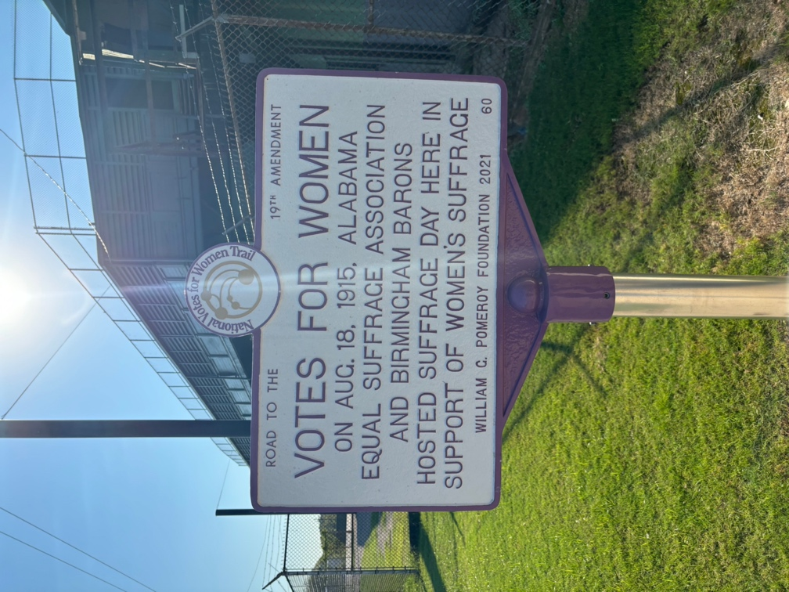

(Figure 1.1)

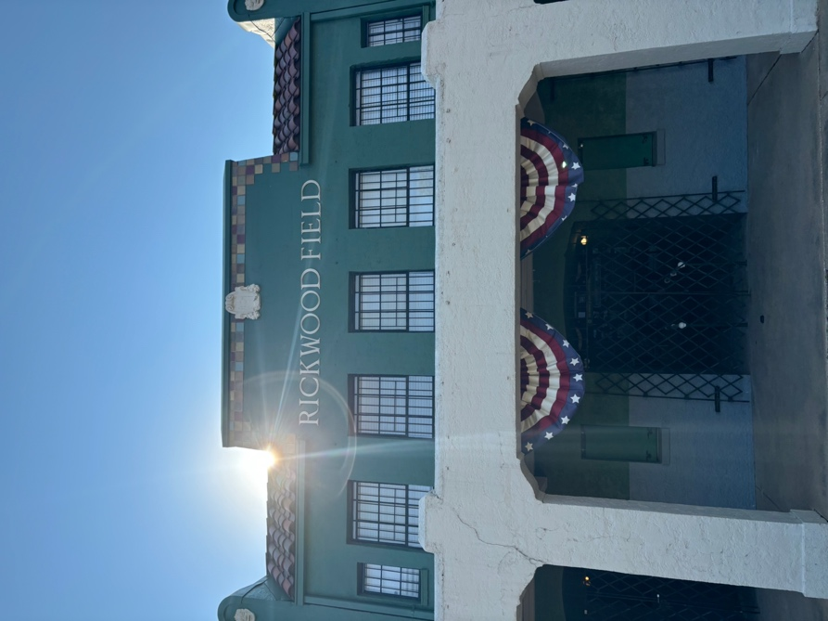

(Figure 1.2)

It is very intentional that the main gates of Rickwood Field feature the Votes for Women campaign hosted by the Birmingham Barons in support for Women’s Suffrage in 1915. It is one of the first things you see upon entry to the ballpark. This research is inspired by the mobile storytelling of Hanna et al (2024) and the story of Monticello/Thomas Jefferson’s home. They create a narrative through the space we walk. “A museum’s historical message is never as tightly controlled as a researcher or tourist may assume—even if it is delivered through a closely scripted guided tour. Touring a museum is a form of conditional storytelling that emerges through interactions between tour guides and visitors” (Hanna et al, 2024, 341). The spatial design of the tour itself is important to understanding the story of professional baseball in Birmingham. The main gate featuring the Pink Suffrage sign, then the tickets area, followed by the Breezeway Photos area – where until somewhat recently through the “Friends of Rickwood” have put up pictures and memorials of Black Barons legends.
As mentioned, prior, the tour of the ballpark references Negro Leagues and its players approximately four times in major areas of visibility. However, the tour is very designed – whether intentional or unintentional - to showcase the history of America’s oldest ballpark. But if you read between the lines and focus on the plaques and understand the history of southern segregation, you will begin to uncover a story in greater detail. A newly constructed exhibit for Alabama native Willie Mays is enshrined and that is where the history in the tour starts to become unraveled. It isn’t explicit by any means, even as plaques and memorials of Negro League greats are upheld. Pictured in Figure 1.2 is the clubhouse plaque where it states that the area was segregated for players with different color. “Negro League Legends like Willie Mays, Satchel Paige, and Josh Gibson were not allowed to use the clubhouses and often changed on the bus or before arrival to Rickwood Field.” That quote comes directly under text discussing who played at this historic venue like Babe Ruth and Ted Williams, but they were not subject to the same treatment and harassment like other players due to the privilege of the White color of their skin.
The success of America’s Oldest Ballpark is through spatial storytelling. The conditional nature of the guided areas mostly focuses on the history of the park and the legends who played, with subtle inclinations or references to a truer racialized history of the ballpark. What it failed to do was understand the all-encompassing past. No reference inside the park was made to the owner’s connection to the Ku Klux Klan and its rallies inside the stadium (Barra, 2010). The field was a place of revolution for Black empowerment and agency, yet it lives in the shadows of a more segregated version of the past that Birmingham is trying to forget.
What I discovered upon the visit was further understanding that memorials are not perfect in terms of memory. The ballpark was not exclusively a ballpark for Negro League players and games, thus might not have warranted more attention from a national lens on the topic of segregation and mistreatment in the American South. Yet, in the earlier mentioned interview by MLB on Fox on the return to Rickwood for the Willie Mays memorial, Reggie Jackson laid out with explicit language his true feelings on his return. In what was supposed to be a memory of life for Mays quickly turned into the uncovering of old wounds from Jackson and providing an uncomfortable conversation for the MLB on Fox hosts. What Jackson provides is an authentic and genuine reaction that I found to be absent from the site of memory at Rickwood Field. References of the past were made, but the truth is not in full focus. A myopia is perpetuated. In the scholarship of memory and creation of memory, you intentionally curate the past, to remember – which allows for us to have a subsequent creation of forgetting through obscuring.

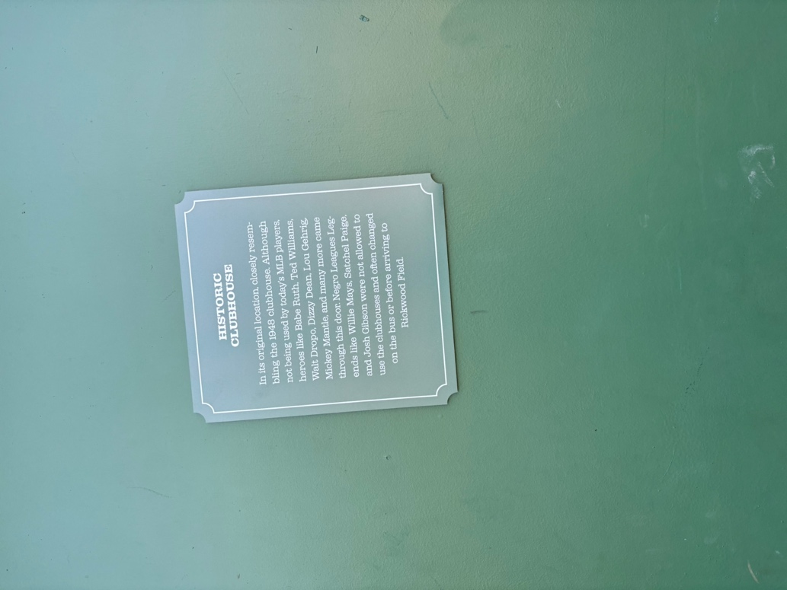

(Figure 1.3)

As the possibility of research allows for resources like the Negro League Baseball memorial at Rickwood Field to exist, it also presents possible limitations that if given more time, would allow for further explanation. Tours at the site were limited to self-guided tours during the offseason and would only encompass what is precured by the information the self-guided brochure or the plaques are encounters (Figure 1.4).
Pictured in Figure 1.4 is the pamphlet detailing each of the stops a visitor may engage during the tour of Rickwood Field. These stops constitute the spatial narrative of Rickwood Field, the configuring of historical stories within certain spaces and in a prescribed order or flow. Listing the route in order, you visit the main entrance at stop number one. These designated touring stops are designed to invoke the seething presence (Avery Gordon 2008). You are supposed to feel the past, feel the ghost and its hauntings at Rickwood Field. The three main areas where the tour mentions race and racism is stop #3 “Breezeway Photographs.” At this stop is a wall filled with pictures of baseball legends including Negro Leaguers and the Black Barons. The Black Barons were put on display long after the field was in use for the Negro Southern League by the Friends of Rickwood. This was an area of intense social prejudice and as stop #3 is labeled, this particular area of the ballpark was meant for the privileged man, and not people of color. The other main areas are at stops #14 and #17. These are demarcations of the past and Rickwood Fields long history tied with racism. The “Home and Visitor Dugouts” as it is near the locker rooms on the venue. As history has told us, post-integration years still did not allow for Black players to be in the changing rooms with their white teammates. These dugouts accompany a legendary essence that is still being haunted with the reality of extreme racism and abuse. The last area is stop #17 near the reserve bleachers that existed to keep the people of color away from the mix of white ballpark goers. The “Arrow Shirt Sign” was active in the era of Jim Crow and was designed to keep Black ballpark goers away from the white attendees. This offers a more clear and impactful stop near the end of the tour that is meant to promote goers that this history of racism is not so distant.
Given further possibilities of research I would go to the Negro Southern League (NSL) Museum in Birmingham, AL and use an emphasis of conditional storytelling outlined by Hanna et al (2024), and the elements of auto-ethnography of research. The key themes of current research focus on the elements of conditional storytelling, what tours/self-guided tours outline for what you are supposed to see, and what becomes hidden or observed. No reference of the Klan presence was made aware of at the grounds of Rickwood Field, and only recently has the iconic field became a site of Negro League memorial. Given the context of future research, paying a visit to the NSL Museum would serve future research wonders given a concerted emphasis from baseball historians on the life of the Negro Leagues. Legends like Josh Gibson, Satchel Paige, Jackie Robinson, all played a fundamental role in the game of baseball but were often disregarded in terms ‘legitimacy’ from historians or purists wanting to keep baseball the way they found it. In ways, Rickwood Field provides a troubled past that leads to uncomfortable, yet important, conversations on race and racism – it also provides context given suppression and endurance; all for the love of the game.

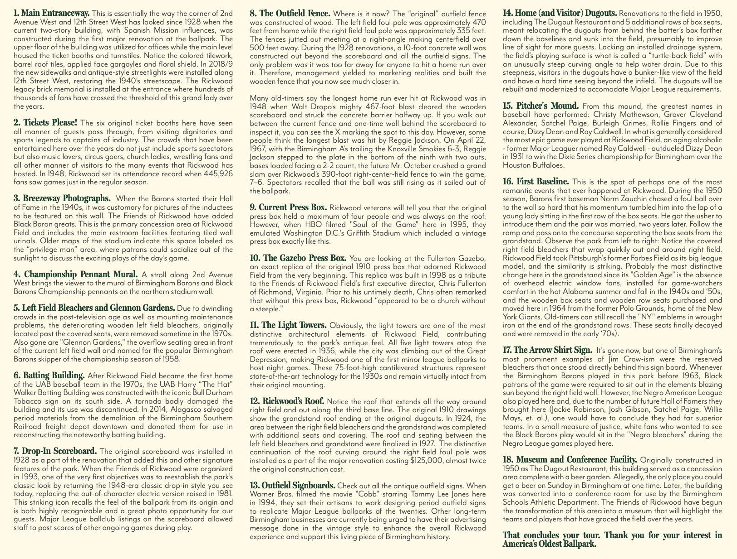

(Figure 1.4)

Birmingham Negro Southern League Museum
The goals of museum curator Dr. Layton Revel, and others, is focused on the collection of baseball artifacts and memorabilia, using these objects for educator purposes. However, is the museum itself providing commentary or critical theory on social justice issues or an oral history, similar to Reggie Jackson’s commentary upon his return to Rickwood Field in June 2024? Memory scholars have long been interested in the ideas of conditional storytelling (Hanna et. al 2024). Museums, or memory sites – like Rickwood Field – provide a place for memoriam and a story. Touring a museum is a form of conditional storytelling that emerges through interactions between tour guides and visitors” (Hanna et al, 2024). The spatial design of both tours are itself just important to understanding the story of professional baseball in Birmingham, AL.

Narrative Mapping and Storytelling at the Negro Southern League Museum
As stated in the introduction, the Birmingham Negro Southern League Museum (BNSLM), was originally designed and constructed to offer a space for Negro League baseball to succeed. Their mission statement: “The mission of the Negro Southern League Museum is to present the history of African-American baseball in an unsurpassed manner by maintaining a world-class facility that recognizes the League’s impact on Birmingham, Alabama and the world of professional baseball. This understanding, along with the acknowledgement of the players’ ability to inspire people of all races and transcend barriers, establishes a blueprint for the Museum to evoke a broad sense of community and create unparalleled cultural and educational experiences that acknowledge the past, embrace the present, and frame the future” (BirminghamNSLM.org).
The goals of my research are to seek out the elements of critical theory at the BNSLM. What Rickwood Field is great at, is telling the story of baseball history. This is a ballpark that the greats of yesteryear were stepping on these hallowed grounds. It markets itself as a place of progress and resistance. Rickwood Field will be discussed later in depth, building off of previous writings, and how it is a site of contention and misconception. Yet, the BNSLM is a site that is specifically designed and curated to promote and preserve the history of the Negro Leagues, through artifact collection, museum and exhibit creation, and educational deliverables. Figure 2.1 is the outline of the BNSLM and its designated routes.
Upon first visiting the BNSLM, you are greeted with an engraved map on the flooring that has the host cities of the Negro Southern League, operated from 1920 to 1951. You are then greeted with a quote from the “Home Run King” Hank Aaron that states, “"On the field, Blacks have been able to be super giants," he once stated. "But, once our playing days are over, this is the end of it and we go back to the back of the bus again" (Figure 2.2).
The designed routes featured in Figure 2.1 are key baseball themes meant to take visitors through the bodily and emplaced process of remembering. Remembering what the Negro Leagues are. Starting in the “Dugout”, you are greeted with the video from Dr. Layton Revel detailing his mission statement with his infatuation with the Negro Leagues, and why
Birmingham needed this museum as his friend once playing, and that Birmingham is home to a lot of retired Negro Leaguers. Also, featured in the “Dugout” is signed baseballs alphabetized from A-Z, are Negro League ballplayers who played in Birmingham, featuring many names such as Charley Pride.

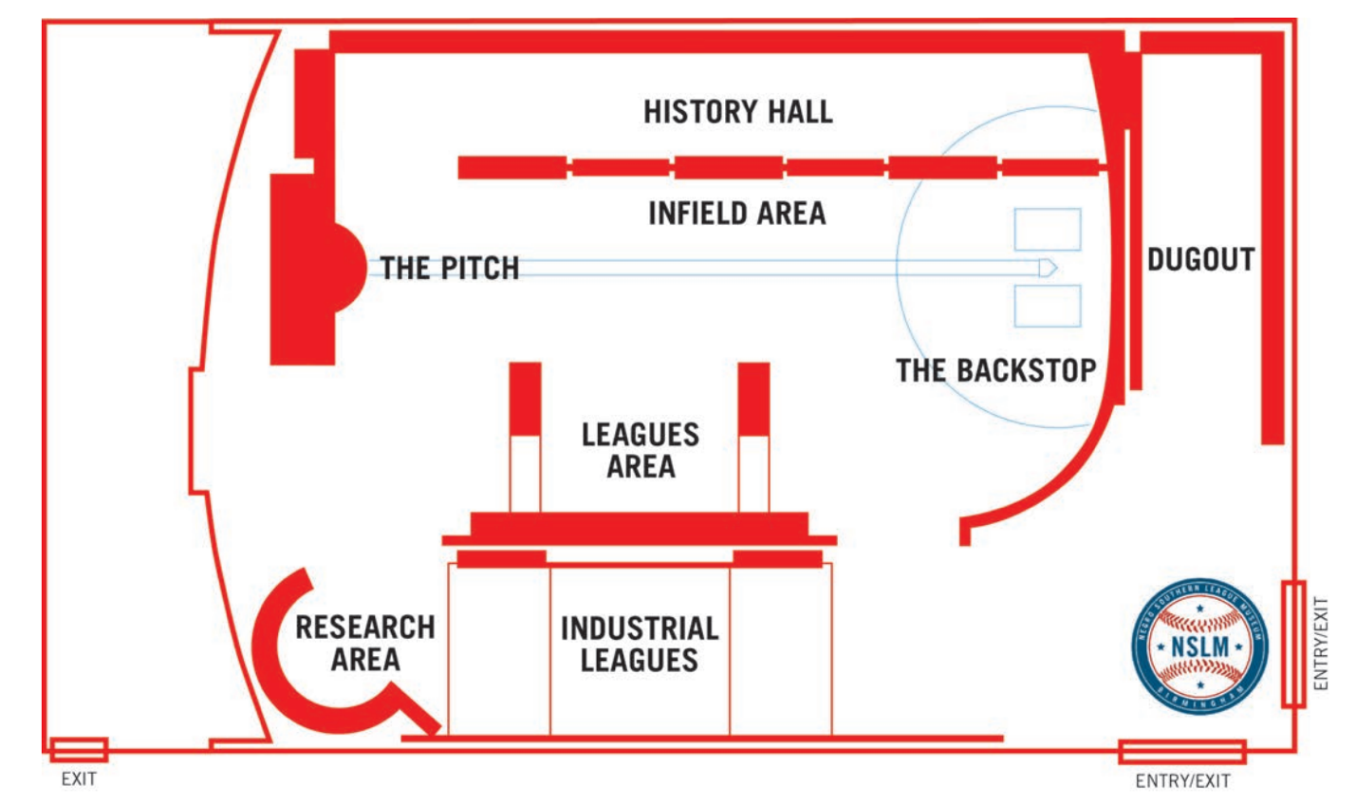
(Figure 2.1)

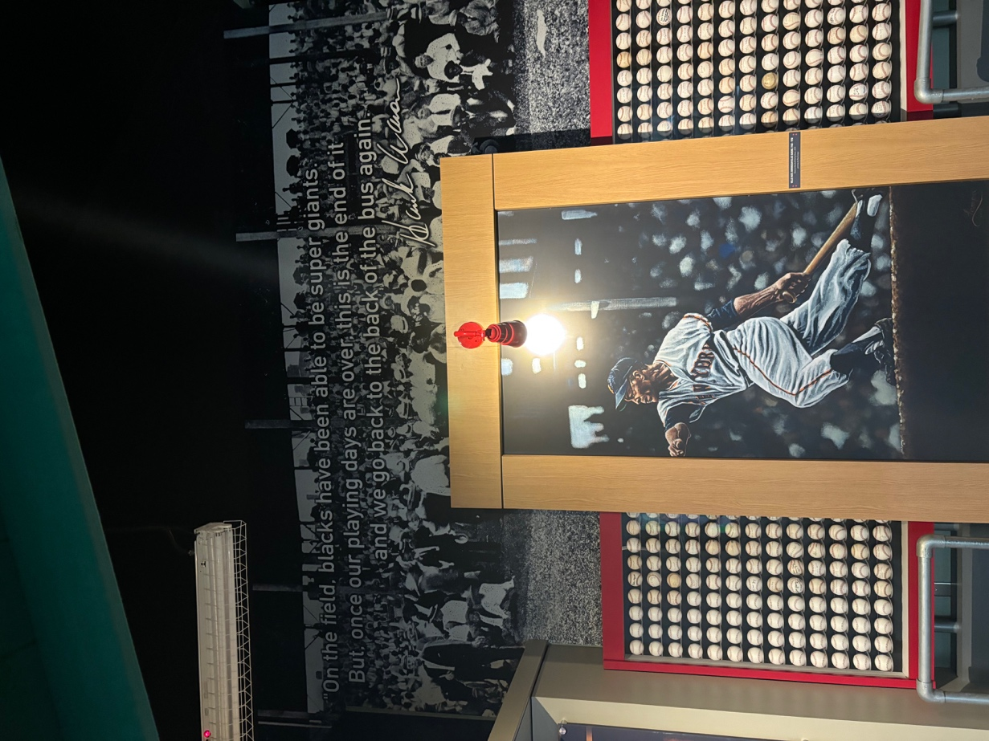

(Figure 2.2)

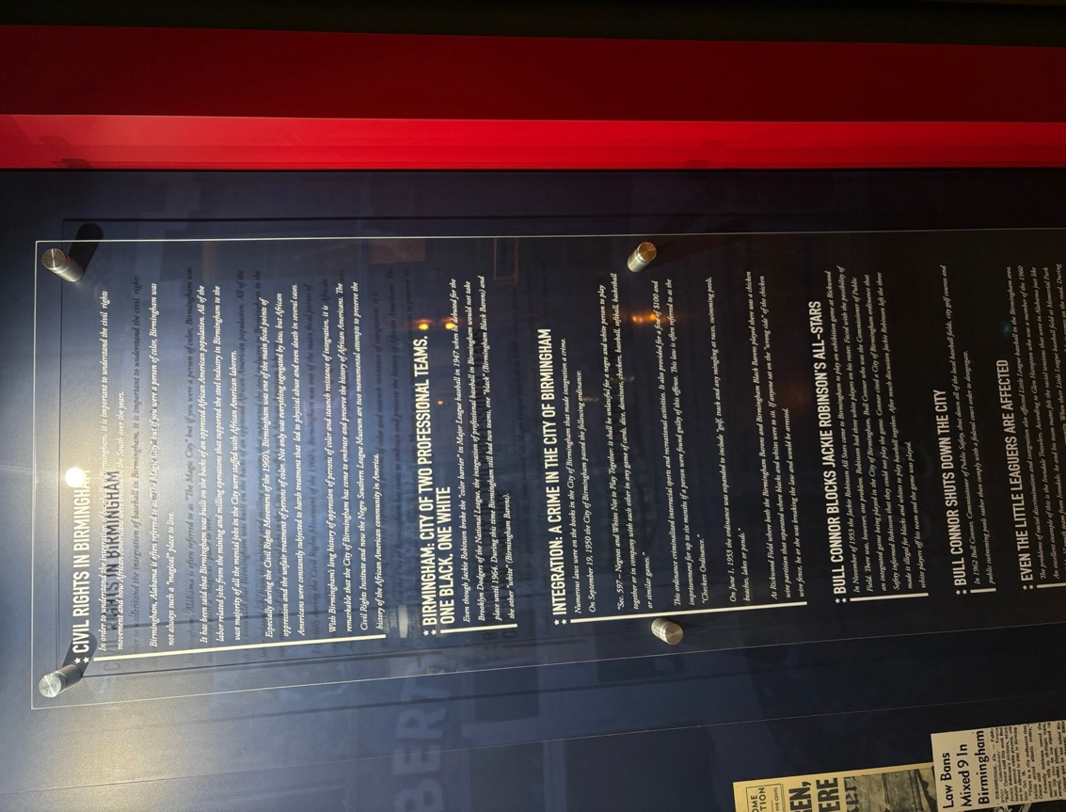

(Figure 2.3)

Next, you are guided to “History Hall” where you are subjected to looking at many of game-worn clothing and newspaper clippings that outline the early origins of the Negro Leagues. Per one exhibit in “History Hall” titled “’64 Birmingham Barons Integrate the Southern League” where the focus of racism is on display. They focus on the story of facing verbal abuse at both and away games as racial tensions were high the entire 1964 season. This is one of the few elements of the BNSLM referencing race while acknowledging that racism did exist but not stating anything more than the abuse and suffering the Black ballplayers went through.
Following “History Hall” the next stop on the tour, is into the open room of the “Infield Area”, “The Pitch”, and “The Backstop”. Where we find race/racism most prominently discussed is in the very far back corner where the “Infield Area” and “The Backstop” begins. Figure 2.3 features the text that is on display that discusses the situations of the racial prejudice that Black people underwent in Birmingham. This display features no commentary from ballplayers who experienced this harsh reality, and no commentary about Bull Connor rising to fame.
In Figure 2.3, the plaque displays the title of “Bull Connor Shuts Down the City”. Bull Connor gained fame in Birmingham as the City Commissioner and his harsh ruling in favor of strict segregation laws. Under Bull Connor’s leadership as City Commissioner, installing the Checkers act that ensured that persons of color couldn’t interact with white people under the umbrella of sporting events. While sites existing in Birmingham also fail to demonstrate is Bull Connor’s rise to Birmingham popularity came through the radio and being the sports broadcaster to the Birmingham (white) Barons (Connerly 2005). Baseball is never just a sport; it is a sport existing in extreme violence and politics that adhere to a society of suppression and oppression. His name is on display at the BNSLM and the Birmingham Civil Rights Institute numerous times, but how he gained local fame for being a baseball commentator is absent. Bull Connor represented the white consensus of memory. Baseball in Birmingham was successful for both the Negro Leagues and the white leagues, but the two could not exist in one league as long as Bull Connor was in charge.
Preceding the “Infield Area” is “The Pitch” and “The Backstop”, an interactive exhibit that features simulated pitches from Negro League legend, Satchel Paige. This exhibit is designed for the purpose to see big league pitching, up close and personal. “The Backstop” is where the museum attendee stands, and experiences Paige’s simulated pitching. This is an exhibit that is proudly boasted from Dr. Revel as it provides an experience that no other baseball museum can provide. You are experiencing history up close and personal. Followed by “The Pitch” is more memorabilia from Satchel Paige’s baseball career, but little is available about his off the field personality and achievements.
The last three areas are the “League Areas”, “Research Center”, and the “Industrial Leagues”. These last three areas may not necessarily stand out from a lens of critical commentary as the “Research Center” provides access to Revel’s Center for Negro League Baseball Research (CNLBR), where they provide appropriate supplemental materials for individuals to learn about the history of the Negro Leagues. These supplemental materials are PDFs created from the CNLBR that tells the stories of Negro Leaguers and their baseball achievement. The final two exhibits “League Areas” and “Industrial Leagues” mostly provide memorabilia and game-worn jerseys of ballplayers from Birmingham, and highlights the origins of the Industrial Leagues in Birmingham when steel and mining companies would host ballgames for its employees to play in.

Museums as Racial Myopia
Nearsightedness in museums and memorialization is an untapped field in memory studies and sports memory studies. What I have found through observation, oral histories, and conditional storytelling inside the site of memory is a much harsher version of memory. I have detected and identified a pattern of collective racial myopia among common sites of memory in Birmingham at the BNSLM and Rickwood Field. Whether consciously or not, patterns of nearsightedness seem to engage in baseball history as a common factor instead of baseball history as a form of segregation and Jim Crow.
As previously mentioned, museum director Dr. Layton Revel, became nearly the sole proprietary of Negro League memorabilia. According to Revel and his long-time business partner, Dan Creed, they are proud to boast that this is the museum of the Negro Leagues. While the official museum of the Negro Leagues is located in Kansas City, MO and is designed to have conversations and evoke intense emotions surrounding race and racial history in the United States – the BNSLM is largely designed to showcase Revel and Creed’s collection of memorabilia.

Memorial Entrepreneur
What this collection of sports memorabilia at the BNSLM from both Revel and Creed’s personal collections – “on loan” per the Center for Negro League Baseball Research (CNLBR) – provides a unique outlook on remembering the history of baseball. How Creed and Revel obtain these sports memorabilia is one thing, they are not shy to boast about. In Dwyer and Alderman’s (2008) work, the term “memorial entrepreneurs” is used to describe these individuals or groups. Who now shapes how the public interacts or remembers the past by financial or personal gain. Memorial entrepreneurship helps explain the phenomena as the BNSLM at an attempt to change the narrative and perception of history through commercial contexts. While the BNSLM doesn’t charge admission, it does involve a shaping of public memory that does not seem to engage in greater critical race theory or conversation about Birmingham’s racial history. Yet, in conversation with Revel about my research, he offered suggestions and the opportunity for future discussion as he believes that his museum was the perfect site to engage in conversations about race and the history of Jim Crow and Civil Rights in Birmingham. Yet his enthusiasm in conversation did not seem to match the reality of his site of memory. Furthermore, the business associate to Revel, Dan Creed, is a salesman, and this may influence his background on promotion of the museum. While the museum has an extensive collection of historic baseball memorabilia, whether that collection does not necessarily lead toward a greater conversation of race, baseball, and race and baseball in Birmingham, Alabama.
Yet, it is important to discuss what Dr. Layton Revel excels at in his historical collection and preservation of Black baseball in Birmingham and that is the overall number of artifacts on display. As Dan Creed and Dr. Revel proudly boast it is the overall materials they have collected over the decades. What started as a passion project for shear collection of memorabilia was able to donate (albeit to his own museum) these items to try to help preserve elements of harsh history in Birmingham. We cannot fathom what would happen if these items failed to exist in this space. The BNSLM offers the city of Birmingham an opportunity to continue having these conversations of race and equality while acknowledging the hardships of the past. However, the problems of good intentions fall at the doorstep of reality. Birmingham offers more sites of memory like the Civil Rights Institute, right next door to the 16th Street Baptist church, that begins to tell the story of the harsh reality of racism in Birmingham. The BCRI offers an excellent memory reconstruction of what Birmingham used to be. Magic City, failed to deliver magic to people of color, and instead offered nothing short of a nightmare.

Blurriness and Memory
As alluded earlier, how we choose to remember is just as important as remembering itself. Birmingham as the city of both of our sites of memory are held; is no stranger to racial tension and violence. Once nicknamed “Bombingham” due to its prominent history of dynamite explosions targeting African Americans in traditional white spaces, the city was filled with a culture of hate and called “America’s Most Segregated City” (Connerly 2005). Most notably of such bombings, was the 16th Street Baptist Church Bombing in 1963. In an act of terrorism, the Ku Klux Klan killed four young girls outside a well-known and highly attended, predominantly, Black, Baptist church. That infamous and tragic day in Birmingham civil rights history has no mention in the BNSLM.
Context and understanding the objects on display having agency are important. A museum that prides itself on the history of Black Baseball, results in the shortcomings it wishes to wash away. The museum contains no content or information on “Bombingham” and no interviews/oral histories that mention if those ballplayers that played in the Negro Southern League for the Birmingham Black Barons attended the very same church that was a victim to those heinous acts in 1963 including Rev. Bill Greason, a then retired, Negro League pitcher who was a pastor and attendee of the 16th street Baptist Church.
This discussion of myopia in museums is important when we move forward and understand the collective organization and activism that African Americans performed in cities like Birmingham. As stated earlier, one of the museums strongest features is its overall massive collection of baseball artifacts that relate to the Negro Leagues. Yet the past becomes blurry around the edges as the museum neglects to speak on greater social justice issues regarding the history of Black ballplayers in Birmingham. While the museum might attempt to create a celebration of accomplishment in the sport and integration into the then all-white Major League Baseball; but taking a step back and realizing that this site of memorialization is heavily skewed in favor of one man’s interpretation of Black baseball could further be of the utmost benefit to creating and re-remembering.
How we situate ourselves in the present shapes how we remember the past. Those processes are unique when it comes to social structures parallel to social justice conversations today. “What is defined as memorable is socially mediated and the result of commemorative work and decisions of individuals and groups—from artists, tour guides, and community activists to government officials, museum curators, business leaders—who as ‘memorial entrepreneurs’ influence how the public views, senses, and debates the past” (Naef 2019) (Alderman 2022). While the BNSLM isn’t undergoing extreme exhibit changes, it can still serve as a model for the past to be translated into new life.

Cultural Impacts of Baseball in Birmingham
While publicly accessed data and oral histories of Black ballplayers may be limited in some capacity, the Birmingham Civil Rights Institute (BCRI) does a good job of maintaining and interpreting some athletic artifacts in their site of memory, while providing an authentic and interactive experience to have a more accurate remembering. The BCRI, opened for business in 1992, is a unique site of memory as you are able to partially re-live the experiences of segregation and Jim Crow. Museum attendees are enabled to feel, listen, and look at the “institutional discourse” experienced between people of color in Birmingham, AL as they begin a re-remembering as they view themselves in places of history (Gallagher 1999). This is an important distinction into the notion of how we imagine ourselves in the present, effects how we remember the past (Alderman and Inwood 2013). Where the BCRI is effective, and where the BNSLM and Rickwood Field is falling short, is the experience of interactivity. The BNSLM most especially doesn’t allow for ourselves to look back into time. It offers a one-of-a-kind experience on facing one of baseball’s greatest pitchers Satchel Paige, at a interactive simulation, but the particular exhibit offers as Satchel’s story through artifacts and baseball memorabilia, but not his social justice efforts and experiences travelling across the American South and the Black Power movement (Spivey 2012).

Conclusion

Birmingham Memory
What the BNSLM and Rickwood exemplifies is an effort, whether consciously or not, to promote its brand towards a greater audience. The BNSLM is a great collection of baseball artifacts that present a story of Black baseball supposedly in its totality. A generic request of an appreciation of a different brand that made the sport American’s love possible is the marketing attempt that the BNSLM especially employs. What they neglect is an expansion into the re-remembering processes.
Birmingham situates itself in the possibility of a city undergoing a re-brand, an effect to show the city has moved past its history of racism and embrace its diversity. As a product of this re-branding, the BNSLM and Rickwood Field are believed to be this attempt to represent the city as something greater than a negative history. Rickwood Field, despite hosting numerous Klan rallies in the 20th century, it is the product of being the oldest ballpark in all America. Despite having a contested history, is home to the business of the Birmingham Black Barons of the Negro Southern League and led to an avenue for Black baseball and success. This contention had led to the birth of myopia in museums. How we view and remember different sites of memory is correlated to how we view and imagine ourselves in the present. What sites like the BNSLM and Rickwood Field are coming short, is the lived experience and understanding that the product of Black baseball could only have ever existed through racial discrimination and segregation.

Furthering Myopia
As the city moves past its tumultuous past, certain forms of memory get pushed to the side and ‘blurred.’ The Birmingham Negro Southern League is not innocent in the memory process of racial capitalism amongst its contributors and curators. As discussed extensively, the Birmingham experience is centered around previous prestige of the Magic City, labor, and promotion of sport. As we move forward, we must continue critiquing the remembrance processes. The national media has perpetuated the notion that you can make the Black athlete famous yet not hear from their Black experience. These sites of memory are powerful in shaping narratives through reconstruction as the Negro Southern League was exclusively Black owned and operated.
As Layton Revel and the BNSLM and CNLBR exist in their own right, the nature of entrepreneurship and its portrayal of Black baseball in Birmingham runs the risk of reducing the reality of Black baseball into a fiction of segregation being a separate story. The BNSLM, while expertly crafted and filled with historic memorabilia, neglects a more critical and substantive story. As I write and ponder about how we remember and explore the narrative processes of conditional storytelling in sites of memory, I begin to recall the oral history that Mr. October, Reggie Jackson stated. His hardship and racial perseverance in relation to Birmingham is powerful and reigns true. While the BNSLM is a museum mostly dedicated to the Negro Southern League, it is a memory that proudly boasts other artifacts that relate outside of Birmingham. I now begin to think about its relationship with the Civil Rights Institute and the memory of the 16th street Baptist Church Bombings. More research and critical theory can be applied to the BNSLM to explore the path of Black activism through the lens of Black ballplayers.

Chapter 3: Implications and Future Research

Introduction
Black activism occupies its own realm of remembrance and collective action that challenges the mainstream narrative. As the involvement of Black athletes in activism continues to grow, unraveling a history of competing narratives becomes crucial in our discussions. We must explore the Black athlete's space and existence. While minority baseball players had a ‘league of their own,’ they were thrust into the limelight of integration into white athletics, which subjected them to intense feelings of hatred and dissonance from peers, competitors, and viewers. The 1968 Olympic Games Boycott was a key moment in sparking conversation about the injustices faced by the Black and minority communities during the Civil Rights Era. A prominent figure in this movement was UCLA basketball star Lew Alcindor (Kareem Abdul-Jabbar), who began to recognize the many injustices faced by Black athletes in predominantly white sports environments (Smith 2009). This led to a barrage of slurs and commentary criticizing Abdul-Jabbar’s perceived lack of patriotism, a problematic belief on the part of the American public that one could not be part of the nation and at the same time expect more of it in protecting people’s rights. In a notable interview on NBC’s Today Show in 1968, he remarked that America was a place he lived, but not one he claimed (Smith 2009). This idea resonates with the sentiments of Branch Rickey, owner of the Brooklyn/LA Dodgers, in his pursuit to assimilate players from the Negro Leagues into Major League Baseball. While Rickey recognized the financial opportunity in hiring Jackie Robinson as a skilled player and a chance to win, he also understood the challenges Robinson would encounter.

Public Memory
I present all of this as a broader examination of the blurring of memory. Branch Rickey is less memorable (as he should be) in comparison to Jackie Robinson breaking the color barrier, but even less so in the realm of public memory than Branch Rickey is Andrew “Rube” Foster. Rube Foster, once a pitcher himself, was first an elder in the Methodist Episcopal Church while also being a prominent ballplayer in the early 1900s (Hill 2015). Using his influence, he played a crucial role in founding a Black-owned and operated baseball league, which was significant in terms of Black activism in the church and society. Despite passing away in 1930, many years before Jackie Robinson broke the color barrier, Rube is mainly remembered for being the first to understand the importance of continuing the legacy of Black athletes in activism as a means to challenge the predominantly white spaces of athletics.
As we reflect on who the dominant society considers important, an equally important process of forgetting has resulted in the memorial myopia visible at the Birmingham Negro Southern League Museum and Rickwood Field. Rube Foster has a small exhibit at the museum, but his message of creating a universe for Black presence and acceptance being nurtured and celebrated (Rhoden 2006) is completely absent. Foster had staying power for the Negro Leagues and turned down being included into semi-professional white leagues because “all he had to do was keep on developing Negro baseball… and the time would come when the white leagues would have to admit us” (Rhoden 2006). What Birmingham’s Negro League Southern Museum and Rickwood Field represent are significant sites of memory that highlight the agency and existence of minorities, though they do not adequately address the suppression experienced by minorities living in the most segregated city in the United States. Birmingham, as we know, has a contentious past that it may be trying to escape. The founder of the BNSLM and head researcher of the CNLBR, Layton Revel, was commissioned by the city itself to create a site of public memory focused on Birmingham’s Black baseball history. However, this site lacks the very history that has shaped the Magic City since the early 20th century—a history marked by hate, segregation, and the silencing of Black voices and identities. Furthermore, Rickwood Field and the Negro League Museum could strive to offer a focused, a deeper, and a more nuanced perspective on race and memory. The narrative remains incomplete without acknowledging the suppressed voices within the processes of public memory.

Implications
Implications from this thesis includes the use of qualitative analysis in the realm of ethnography. As human and cultural geographies have often exceled in ethnographic research. As the origins of ethnography lie in anthropology (Hammersley 2006) yet, this area of research has allowed for me to negotiate a more up-close approach and understand that inanimate possess exhibits, signs, and objects agency and the curators of the inanimate objects are a part of the relational storytelling. Ethnography has allowed me to approach others as social scientists and community sourced engagement through oral histories posted online. While my research may not meet the requirements of ethnography to anthropologists, it does meet the requirements of geography as it helps to examine the relationship building amongst the community and can help underline certain social justice issues.
Furthering this notion, ethnography in geography helps to serve as a foundational step in reconstructing the past or restructuring the pasts relationship with the present. Memories serve as a key purpose to our imaginaries, and as we dive into our imagination, we must understand what has taken place (Truc 2011). This work laid out has entrusted researchers with understanding place instead of history as a blank canvas. Ethnography has pushed the cutting-edge of the academy to an understanding of the field as more than just work, and data as more than just statistics. Collection and its mapping processes has exposed geography’s need for something stronger in critical human geography and memory studies to help examine history and its relationship to our present and future. Birmingham’s NLSM and Rickwood Field are insightful indicators of a nostalgia driven industry that our imagination and experiences can help reflect a pseudo-reality.

Future Research and Conclusions
Future research centered on this project could explore numerous avenues related to the memory of baseball in Birmingham, Alabama, and across the United States. As referenced earlier, the oral history provided by “Mr. October,” Reggie Jackson, at the Major League Baseball (MLB) reunion game at Rickwood Field held in the summer of 2024 seemed to surprise both producers and on-air talent from MLB on Fox, as it clearly highlighted traumatic memories of racism that Rickwood and its affiliates have been obscuring. Further examination could focus on how other museums in other communities that commemorate baseball address race. The Negro Leagues Baseball Museum in Kansas City, MO, is considered the primary source of Negro League preservation in America. Further research could pose questions centered around the relationship, interactions, and differences/similarities in storytelling between the Kansas City museum and Birmingham’s Negro League Southern Museum. Do they engage with each other through their storytelling and artifact collections? Who loans the artifacts to the Kansas City museum? How is race addressed at the Kansas City site relative to what we clearly see (or not) in Birmingham, and what narrative are the positioned objects attempting to convey? Most central to this thesis, to what extent does the Kansas City Museum perpetuate a “memorial myopia” to the same degree and in the same ways as in Birmingham? How does the geographic placement of each museum—one in the Midwest and one in the Deep Southeast—affect how the story of race and baseball is told (or obscured)?
Questions like those above help outline the cultural shift of memory from comforting public consensus to a more reality- and experience-based understanding of America’s past. I recount parts of the narrative of sports in my section on the 1968 Olympics and the significant political activism of figures like Kareem Abdul-Jabbar, but they are often more remembered for their titles as activists rather than the substance of their messages. Black baseball in Birmingham struggles to amplify the voices in “America’s Most Segregated City.” Birmingham carries the heavy title of brutality during America’s civil rights era, and the preservation of collective Black struggle and sacrifice is often blurred from public view in an effort to “move past” the tragedies of a violent racial history. Openly discussing the role of these painful histories in creating and shaping America’s pastime has always been important, but they are especially needed now given the cultural and political moment we find ourselves as a radical conservative backlash threatens to stifle meaningful discussions of racism and social justice in the nation. Given that public schools and universities are being limited in what they can teach, there is an even greater demand that sites of public memory—preserved structures, memorials, and museums—do not perpetuate a myopia that not only damages our understanding of the lived historical experiences of discrimination and self-determination of Black athletes but also compromise the ability of white America to empathize and reckon with those racialized legacies.

Bibliography
Alderman, Derek H. "Commemorative place naming: To name place, to claim the past, to repair futures." The politics of place naming: Naming the world 29 (2022).
Alderman, Derek H., and Joshua FJ Inwood. "Landscapes of memory and socially just futures." The Wiley‐Blackwell Companion to Cultural Geography (2013): 186-197.
Barra, Allen. Rickwood Field: A Century in America’s Oldest Ballpark. W.W. Norton and Company. New York. 2010.
Benjamin, Stefanie. Performing a Different Narrative: Museum Theater and the Memory-Work of Producing and Managing Slavery Heritage at Southern Plantation Museums. International Journal of Heritage Studies, vol. 24 no. 3, pp. 270-282, 2018.
Berg, L. (2010). Critical Human Geography. In Encyclopedia of Geography, ed. B.
Warf. London: Sage, 617–22.
Bond, Lucy, and Jessica Rapson. "Memory In the “Magic City”: The Naturalisation of Racial Capitalism and Environmental Racism at Heritage Sites in and Around Birmingham, Alabama." Memory Studies Review 1, no. 1 (2024): 56-75.
Carney, Court. "The Contested Image of Nathan Bedford Forrest." The Journal of Southern History 67, no. 3 (2001): 601-630.
Connerly, Charles E. "The Most Segregated City in America: City Planning and Civil Rights in Birmingham, 1920–1980." University of Virginia Press. 2005.
Duncan, James, and David Ley. "Structural Marxism and human geography: a critical assessment." Annals of the Association of American Geographers 72, no. 1 (1982): 30-59.
Dwyer, Owen & Alderman, Derek. (2008). Civil Rights Memorials and the Geography of Memory.
Gallagher, Victoria J. "Memory and reconciliation in the Birmingham civil rights institute." Rhetoric & Public Affairs 2, no. 2 (1999): 303-320.
Hammersley, Martyn. "Ethnography: problems and prospects." Ethnography and education 1, no. 1 (2006): 3-14.
Hanna, S. P., Potter, A. E., & Alderman, D. H. (2024). Mapping narratives on historical tours. In The Routledge Handbook of Cartographic Humanities (pp. 339-347). Routledge.
Hern, M. (2013). One Game at a Time: Why Sports Matter. Oakland: AK Press.
Hill, Russell. (2015) "Preparing the Way and Opening the Door: Texas, Rube Foster, and the Integration of Baseball." Intersect: Perspectives in Texas Public History, 19-26.
Hodder, Ian; 2003. “The “social” in Archaeological Theory: An Historical and Contemporary Perspective,” in A Companion to Social Archaeology. Lynn Meskell and Robert Pruecel. Malden MA: Blackwell, 23-42.
Hoelscher, Steven, and Derek H. Alderman. "Memory and place: geographies of a critical relationship." Social & Cultural Geography 5, no. 3 (2004): 347-355.
Jansson, David, and Natalie Koch. "Toward a critical geography of sport: space, power, and social justice." In Critical Geographies of Sport, pp. 253-268. Routledge, 2016.
MLB.com. "Reggie Jackson Discusses Racism at Rickwood Field Game." MLB, June 20, 2024. https://www.mlb.com/news/reggie-jackson-discusses-racism-at-rickwood-field-game.
Naef, P. 2019. Memorial Entrepreneurs in post-conflict tourism. In Tourism and Hospitality in Conflict Ridden Destinations. Routledge.
Jackie Robinson, “Mixed Emotions Over Boycott Of Olympics,” New York Amsterdam News (1962-), December 16, 1967.
Simons, Williams. “Jackie Robinson and the American Mind: Journalistic Perceptions of the Reintegration of Baseball". Journal of Sport History, vol 12., no. 1, pp. 39-64. 1985.
Smith, John Matthew. "" It's Not Really My Country": Lew Alcindor and the Revolt of the Black Athlete." Journal of Sport History (2009): 223-244.
Spivey, Donald. If You Were Only White: The Life of Leroy" Satchel" Paige. University of Missouri Press, 2012.
Sullivan, Neil J. "Baseball and race: the limits of competition." The journal of Negro history 83, no. 3 (1998): 168-177.
Truc, Gérôme. "Memory of places and places of memory: for a Halbwachsian socio-ethnography of collective memory." International Social Science Journal 62 (2011).
Upton, Dell. "Architecture in everyday life." New Literary History 33, no. 4 (2002): 707-723.
Watkins, Clarence. Baseball in Birmingham. Charleston, SC: Arcadia Publishing, 2003.
Waterton, Emma, and Jason Dittmer. "The museum as assemblage: Bringing forth affect at the Australian War Memorial." Museum Management and Curatorship 29, no. 2 (2014): 122-139.
Wilson, Bobby M.. “Race and Place in Birmingham: The Civil Rights and Neighborhood Movements.” (2000).
Wise, Nicholas, and Geoffery Z. Kohe. "Sports geography: New approaches, perspectives and directions." Sport in Society 23, no. 1 (2020): 1-10.

Vita
Micah J. Ortiz is from Sturgis, South Dakota and acknowledges the land it occupies as the ancestral, traditional, and contemporary of the Oceti Sakowin (Sioux). His thesis was advised by Dr. Derek Alderman, Dr. Tracey Norrell, and Dr. Ronald Kalafsky in the Department of Geography at the University of Tennessee, Knoxville graduating in May 2025 with his Master of Science. Micah Ortiz earned his B.S. in Social Science Education from Black Hills State University in May 2023, graduating Magna Cum Laude.

Dr. Layton Revel, is based out of Dallas, TX and works as a physicians review assistant and leads a vocational rehabilitation program in the Dallas area.

