The Evaluation of Two Prenatal Yoga Programs

A Thesis Presented for the
Master of Science
Degree
University of Tennessee, Knoxville

Doree Lynn Gardner

August 2014
Dedication

This thesis is dedicated to Taylor, for all his continuing love and support. Together we can achieve anything!

Acknowledgements

Foremost, I would like to express my sincere gratitude to my advisor Dr. Dawn Coe for her constant support throughout my Masters degree. Your guidance, motivation, enthusiasm, and knowledge were an inspiration to me throughout this entire process. From the day I came to visit Tennessee, to graduation, you have been a constant source of kindness and support. I truly appreciate all the countless hours you have spent teaching and mentoring me.
I would also like to thank Dr. Dixie Thompson and Dr. Katie Kavanagh for serving on my thesis committee. Dr. Thompson, you have been a constant beacon of knowledge and inspiration for me. Thank you for your advice and suggestions throughout this whole process. You have taught me so much about being both a student and a researcher and I have genuinely enjoyed learning from you. Dr. Kavanagh, you opened my eyes to the world of maternal and fetal health, and I will be forever grateful. You genuinely care about each and every one of your students. Your guidance and advice has been instrumental in my growth personally and as a graduate student. Thank you for being an excellent example of a great educator, for your constant encouragement, and for providing me with many new ideas.
I would like to acknowledge Dr. Stacy Hunter and Pure Action Inc. for funding my research endeavors at the University of Tennessee. Dr. Hunter, thank you for being so patient with me throughout the process and teaching me so much about writing and the world of research. I would also like to thank my undergraduate research assistants, Hannah Alexander and Caroline Holland for all their help throughout data collection.
A very special thanks goes out to my undergraduate mentor at Arizona State, Dr. Wayne Willis, without whose motivation, encouragement, and pure love of science, I would not have considered a graduate career in Kinesiology. Dr. Willis truly made a difference in my life. It was under his tutelage that I developed a focus and became interested in physiology. It was through his persistence, understanding and kindness that I completed my undergraduate degree and was encouraged to apply for graduate school. I doubt I will ever be able to convey my appreciation fully, but I will be eternally grateful for his guidance.
I would also like to thank my parents, Carter and Donna, for the love and support they have provided me through my entire life. You both have taught me so much about love, life, and perseverance. Mom, you really have made everything possible for me. Thank you for always supporting me, no matter what, and for being such a great role model of a strong, intelligent, and independent woman. Dad, you have been my compass. Thank you for teaching me the values of hard work and patience. You taught me from a young age to question everything and to always strive to keep learning. I love you both so much.
Finally, I would like to thank Taylor. You were always there to cheer me up and stood by me through the good times and bad.

Abstract

Purpose: To determine the energy expenditure and feasibility of two different DVD-based prenatal yoga programs (static yoga practice and vinyasa practice). Methods: Participants were 25 women in their second trimester (13-28 weeks) who were screened for pregnancy-related risk factors. The two DVDs used were “Prenatal Yoga with Shiva Rea” (DVD A) which is a static yoga practice, and “Jennifer Wolfes Prenatal Vinyasa Yoga” (DVD B) which is a flow yoga practice. Both DVDs were approximately 50-55 minutes, and included three phases (warm up, main, cool down). Each subject completed both prenatal DVD routines approximately two weeks apart. The energy expenditure (VO₂, METs, and Kcals) was measured using the Viasys Jaeger Oxycon Mobile system. Enjoyment and feasibility were measured using an adapted version of the PACES questionnaire. Results: DVD B had significantly greater average total energy expenditure than DVD A (p<0.001). There was a significant interaction between phase, type of yoga, and VO₂, F(3,21)= 61.15, p<.001. DVD B had significantly greater average total bout heart rate (HR) than DVD A (p<0.001). There was a significant interaction between phase, type of yoga, and HR, F(1,16)=10.318, p=0.005. There were no differences between yoga DVD program type for feasibility (p=0.397) or enjoyment (p=0.886). The rating of perceived exertion (RPE) was significantly higher for DVD B compared to DVD A (14.12 vs. 11, p<0.001). Conclusion: The energy expenditure of “vinyasa” style prenatal yoga (DVD B) was significantly higher than standard prenatal yoga. Additionally, both DVDs were found to be equally enjoyable and feasible. These results provide data regarding energy expenditure and can be useful in providing options for activity during pregnancy.

Table of Contents

CHAPTER 1: INTRODUCTION…………………………………………………………………................ 1
CHAPTER 2: REVIEW OF LITURATURE…………………………………………………………….. 4
INTRODUCTION……………………………………………………………………………………….. 4
HISTORY OF PHYSICAL ACTIVITY DURING PREGNANCY AND RECOMMENDATIONS………………………………………………………………………………. 5
BENEFITS OF PHYSICAL ACTIVITY DURING PREGNANCY………………………….. 7
Healthy Body Weight…………………………………………………………………….. 8
Prevention of Pregnancy Induced Complications……………………………. 8
Relief of Pregnancy Related Discomforts……………………………………… 10
Ease of Labor and Delivery………………………….………………………………. 10
Psychological Benefits…………………………………………………………………..10
YOGA………………………………………………………………………………………………………11
Metabolic Response to Hatha Yoga……………………………………………….. 12
Health Benefits of Yoga…………………………………………………………………15
PRENATAL YOGA…………………………………………………………………………………….18
Prenatal Yoga and Mental Health………………………………………………….. 19
Prenatal Yoga and Pregnancy Related Disorders…………………………… 21
Limitations to Current Prenatal Yoga Research and Future
Directions…………………………………………………………………………………… 21
CONCLUSION…………………………………………………………………………………………. 23
CHAPTER 3: MANUSCRIPT……………………………………………………………………………… 25
ABSTRACT…………………………………………………………………………………………….. 25
INTRODUCTION…………………………………………………………………………………….. 26
METHODS……………………………………………………………………………………………… 28
RESULTS…………………………………………………………………………………………………32
DISCUSSION…………………………………………………………………………………………… 36
REFERENCES…………………………………………………………………………………………………….41
APPENDICES……………………………………………………………………………………………………. 48
APPENDIX A: INFORMED CONSENT……………………………………………………….. 49
APPENDIX B: INSTITUTIONAL REVIEW BOARD CONSENT………………………. 53
APPENDIX C: ACTIVITY LOG…………………………………………………………………… 55
APPENDIX D: QUESTIONAIRES……………………………………………………………….. 57
APPENDIX E: RECRUITMENT FLYER AND EMAIL……………………………………. 60
APPENDIX F: BORG SCALE……………………………………………………………………… 63
APPENDIX G: CONFIDENTIALITY AGREEMENT………………………………………..65
APPENDIX H: YOGA DVDS………………………………………………………………………. 67
APPENDIX I: PARMEDX FOR PREGNANCY………………………………………………. 69
APPENDIX J: CONTRAINDICATIONS TO PHYSICAL ACTIVITY DURING PREGNANCY……………………………………………………………………………………………71
VITA………………………………………………………………………………………………………………….73

List of Tables

TABLE 1. Participant characteristics………………………………………………………………… 33
TABLE 2. DVD Phase length………………………………………………………………………………33
TABLE 3. Mean VO₂, MET value, and caloric expenditure (Kcal/day)…………………..34
TABLE 4. Mean heart rate (bpm)……………………………………………………………………….34
TABLE 5. Feasibility, enjoyment (PACES), rate of perceived exertion (RPE), and usage for each type of yoga……………………………………………………………………………….34

List of Figures

FIGURE 1. VO₂ values for each phase and each DVD program……………………………… 35
FIGURE 2. Heart rate values for each phase and each DVD program……………………. 35

CHAPTER 1

INTRODUCTION

Exercise during pregnancy provides many health benefits for the mother and the fetus¹⁻³. These benefits include reduced risk for maternal complications such as preeclampsia and gestational diabetes mellitus (GDM) and reduced fetal complications such as unfavorable fetal birth weight, hyperinsulinemia, and hypoglycemia^{2,4,5}. The 2008 Physical Activity Guidelines for Americans recommends that during pregnancy women should engage in at least 150 minutes of moderate-to-vigorous intensity physical activity per week⁶. However, recent research suggests that only about 23% of pregnant women engage in the recommended amount of physical activity^{7,8}. Pregnancy is associated with a decline in the frequency and duration of physical activity⁷. Inactivity during pregnancy is cause for concern because pregnant women who do not engage in exercise forgo numerous health benefits⁷.
The type of exercise most beneficial during pregnancy is still unclear; however, many pregnant women turn to less strenuous forms of physical activity during gestation such as walking, water aerobics, and yoga¹. A possible reason for yoga’s growing popularity in the pregnant population may be health benefits associated with the practice in reducing stress, anxiety, insomnia, depression, back pain, and relief of muscular tension or pain⁹. Prenatal yoga practice has also been correlated to more favorable birth outcomes¹⁰. Limited research has focused on yoga during pregnancy despite the popularity of prenatal yoga programs and classes¹¹.
Despite prenatal yoga’s growing popularity¹² and the evidence supporting both the psychological and physical benefits, there is a lack of research in this area. Specifically, research investigating the energy expenditure and feasibility of prenatal yoga programs have yet to be reported. The lack of literature may explain the hesitance of some health professionals to recommend prenatal yoga for general well being during pregnancy. In fact, the American College of Obstetricians and Gynecologists (ACOG) does not even mention the word yoga in their committee opinion entitled “Exercise during Pregnancy and the Postpartum Period”¹. Pregnancy is an important time in women’s lives that may promote decreased physical activity¹³. For many women, being physically active during pregnancy is compromised by the physical and psychological demands that occur during this time¹³. Most commonly, women report barriers to physical activity during pregnancy due to physical limitations, restrictions, and lack of time¹³. Researchers have identified that low impact and less strenuous exercise options may be more feasible for women during pregnancy⁷. Yoga may be attractive as an alternative to traditional aerobic and strength training programs because it requires little space, virtually no equipment, has limited harmful side effects, and with its focus on relaxation, body awareness, and meditation provides a qualitatively different exercise experience which may be perceived as less strenuous and more pleasurable¹⁴. At this point, no studies have reported the energy expenditure or feasibility of prenatal yoga, leaving a fundamental gap in the research on this topic. Therefore, the purpose of this research study is to investigate both the energy expenditure and the feasibility of two different DVD-based prenatal yoga programs.
Objectives:

The current study has two main objectives:

1. Investigate the energy expenditure of two DVD prenatal yoga routines.

2. Determine the feasibility (defined by use and enjoyment) of two different DVD-based prenatal yoga programs.

Hypothesis: There will be differences in energy expenditure between the two types of DVD based yoga programs.

CHAPTER 2

REVIEW OF LITERATURE

INTRODUCTION

Pregnancy is often a time when women take steps to improve their lifestyle habits in order to provide the healthiest environment for the fetus. Decades of scientific evidence have demonstrated that physical activity during pregnancy is not only safe, but also beneficial for both women and their developing fetus^{1,7,15-20}. The 2008 Physical Activity Guidelines for Americans state: “Unless a women has medical reasons to avoid physical activity during pregnancy, she can begin or continue moderate-intensity aerobic physical activity during her pregnancy and after the baby is born”⁶. Furthermore, the American College of Obstetricians and Gynecologists Committee Opinion on Exercise During Pregnancy and the Postpartum Period, updated in 2009, states: “In the absence of either medical or obstetric complications, 30 minutes or more of moderate exercise a day on most, if not all, days of the week is recommended for pregnant women, and pregnant women should be encouraged to engage in regular, moderate intensity physical activity to continue to derive the same associated health benefits during their pregnancies as they did prior to pregnancy”²¹. These guidelines are clear that women should stay active during pregnancy; however, a majority of women do not meet the recommended levels of physical activity before and during pregnancy¹⁶. This may be due to reported barriers to physical activity during pregnancy such as rapid physical changes and lack of feasibility of more traditional physical activities used before pregnancy¹³. Further research is needed on benefits of more non-traditional physical activity programs such as yoga.
The purpose of this literature review is to provide a detailed description of physical activity trends during pregnancy, benefits of physical activity during pregnancy, and specifically current research on prenatal yoga.

HISTORY OF PHYSICAL ACTIVITY DURING PREGNANCY AND RECOMMENDATIONS
In 1985, the American College of Obstetricians and Gynecologists (ACOG) released a bulletin regarding exercise and pregnancy advising women to reduce physical activity during pregnancy¹. The bulletin suggested that maximum heart rate during pregnancy should not exceed 140 beats per minute and women should not take part in strenuous exercise for more than 15 minutes¹. This advice was based on concerns that exercise could have negative effects on the mother and the fetus due to increased stress hormones, increased core temperature during embryogenesis, biomechanical stress and increased risk of maternal musculoskeletal injury due to changes in posture and ligament laxity, and by shunting the transport of oxygen and nutrients to maternal skeletal muscles rather than to the developing fetus^{4,22}. These recommendations were mostly based on expert opinion due to the lack of scientific research of exercise during pregnancy available at that time⁴.
Following the original ACOG physical activity guidelines in 1985, research over the next decade focused on safety and the potential benefits of physical activity performed during the gestational period. Results from these studies showed that any effects of physical activity on the mother and the fetus were likely to be beneficial, and not harmful as previously thought⁴. Specifically, retrospective studies of women who participated in leisure time physical activity throughout their pregnancies were less likely to develop pregnancy-related disorders such as preeclampsia, gestational diabetes, and gestational hypertension¹⁹. In 1994 ACOG revised the bulletin no longer recommending that women reduce physical activity during pregnancy and removing limitations and prohibitions regarding exercise during pregnancy; however, they still recommended that women avoid exercising to exhaustion²³. In 2002, the current ACOG Committee Opinion #267 was released encouraging women without any contraindications to engage in at least 30 minutes of moderate intensity physical activity on most, if not all days of the week to continue to derive the health benefits of activity during their pregnancy²¹. In 2003 the Society of Obstetricians and Gynaecologists of Canada and the Canadian Society for Exercise Physiology released joint recommendations stating “all women without contraindications should be encouraged to participate in aerobic and strength conditioning exercises as part of a healthy lifestyle during their pregnancy”²². The Office of Disease Prevention and Health Promotion, within the U.S. Department of Health and Human Services, led the development of the first ever “Physical Activity Guidelines for Americans” in 2008. These guidelines complement the “Dietary Guidelines for Americans” as well as other national health promotion and disease prevention efforts, and include a section recommending physical activity specifications to pregnant women⁶. The guidelines specify that healthy pregnant women who are not already doing vigorous intensity exercise, should get at least 150 minutes of moderate intensity aerobic activity per week.
With the high prevalence of overweight and obesity in America, it is important that all people participate in physical activity²⁴⁻²⁶. This is also true for pregnant women. Many women wish to continue to pursue an active lifestyle during pregnancy, while the pregnancy itself may provide the motivation for more sedentary women to begin an exercise program for the sake of improved health and fitness²⁰. Although for many years physician groups advised against exercise during pregnancy, today, American physician groups encourage women with uncomplicated pregnancies to follow the current Physical Activity Guidelines for Americans: at least 30 minutes of moderate physical activity on most, if not all days of the week⁶.

BENEFITS OF PHYSICAL ACTIVITY DURING PREGNANCY
There is evidence that suggests that exercise positively affects pregnancy, labor, and pregnancy outcomes. For example, research has shown that women who are physically active during their pregnancies have decreased risk for conditions such as preeclampsia and gestational diabetes, faster labors, decreased excessive gestational weight gain, and decreased anxiety^{4,20,24,27}. Additionally, women who exercise during pregnancy are more likely to continue to exercise postpartum²⁸. Furthermore, with the mother’s health choices during pregnancy having an enormous impact on the health of the growing baby, it is crucial for the mother to be proactive with her health habits especially during this time.
Healthy Body Weight
Maintaining a healthy body weight and avoiding excess fat accumulation are frequently stated goals of women who choose to exercise during pregnancy²⁹. Excessive gestational weight gain is a public health concern in many developed nations³⁰. Women who gain excessive weight during pregnancy are more likely to develop gestational diabetes mellitus, deliver a baby by cesarean section, become obese postpartum, and put their child at risk of childhood overweight or obesity^{24,30}. Research has shown that overall, weight and fat gain was significantly lower in a group of experienced exercisers who were active both before and during their pregnancies compared to a control group of previously active women who quit exercising before or during early pregnancy³¹. Additionally, objectively measured walking is significantly associated with reduced risk of excessive gestational weight gain in both the 2nd and 3rd trimesters³⁰.

Prevention of Pregnancy Induced Complications
Gestational Diabetes Mellitus (GDM) is defined by the American Diabetes Association as a form of glucose intolerance first diagnosed during pregnancy³². As obesity rates have increased, so has the prevalence of GDM with approximately 10% of all pregnant women developing this condition^{33,34}. GDM is one of the most common complications of pregnancy and is associated with a substantially elevated risk of adverse health outcomes for both mothers and offspring³⁵. Physical activity has been shown to be effective in preventing and managing GDM³⁵. The responsible mechanisms are that glucose tolerance and insulin sensitivity is improved, while muscle and liver glycogen storage is enhanced, thus reducing the incidence of hyperglycemia and hypoglycemia³⁶. Higher levels of physical activity before and during early pregnancy are associated with significantly decreased risk for developing GDM³⁵. Furthermore, physical activity can be used as an adjunctive therapy for women with GDM as a way to control blood glucose levels without the use of pharmacological intervention³⁷.
Preeclampsia is characterized by hypertension and protein in the urine after 20 weeks of pregnancy¹⁵. It is the leading cause of perinatal morbidity and mortality in the developed world, and to date, the only means of treating the disease is by inducing delivery^{15,38}. The incidence of preeclampsia has risen to 3-6% in the past 20 years³⁸, and will likely keep climbing as a result of the obesity epidemic and incidence of hypertension³⁹. The impact of exercise on reducing the risk of preeclampsia has long been debated; therefore, ACOG has yet to support the prescription of exercise training to women at risk for developing the disease¹⁵. There is, however, a significant body of research that supports the protective roles of physical activity against preeclampsia³⁸. Epidemiological and clinical studies have shown that the rate of pregnancy-induced hypertension and preeclampsia may be lowered in women who engage in regular physical activity ^{18,19,38}. Most studies investigating the impact of physical activity in early pregnancy have demonstrated a significant decrease in preeclampsia risk compared with sedentary women^{15,18,19,38}. Conversely, some studies have shown no protective role, or a non-significant decreased risk of preeclampsia with physical activity during pregnancy; however, this may be attributable to the small number of cases, or the short evaluation period^{15,40,41}.

Relief of Pregnancy Related Discomforts
Some evidence supports that exercise may assist with many of the discomforts of a normal pregnancy. Women who are physically active have reported decreased incidence of constipation, improved bladder control, decreased incidence of varicose veins, improved sleep, less heartburn, and fewer leg cramps⁴². Additionally, women who are regularly physically active before and during pregnancy experience less pelvic girdle and low back pain^{43,44}.

Ease of Labor and Delivery
There is substantial evidence that suggests that physical activity may make pregnancy more comfortable, shorten labor, and reduce the need for obstetric interventions³. Compared with sedentary women, well-conditioned pregnant women were found to have significantly shorter labors, less need for obstetric intervention, and fewer signs of fetal compromise^{3,45}. Consistent maternal exercise is also correlated with decreased requests for anesthetic and decreased perceived exertion during labor⁴⁶.

Psychological Benefits
Physical activity provides numerous psychological benefits as well as physiological benefits²⁰. Although few studies have investigated the effect of physical activity interventions on mental health during pregnancy, available evidence supports a beneficial effect²⁰. Moderate physical activity during the third trimester has been associated with lower depression scores at six-week postpartum checkups²⁷. Furthermore, postpartum exercise interventions have been shown effective in reducing symptoms of depression⁴⁷.

YOGA
Yoga is an ancient mind-body practice that originated in India and is becoming increasingly recognized and used in developed nations as a health practice^{48,49}. The word yoga comes from the Sanskrit word “yug”, which directly translates as “to unite”; more broadly, it means to work towards a more unified experience of the self and improved health⁴⁸. The physical practice of yoga postures (asanas) was originally intended to prepare the body for meditation; however, the practice of the postures has become synonymous with “yoga” in the Western world⁵⁰. Traditionally, the practice of postures is one of eight different branches of the yoga framework: bhakti (devotion), karma (service), raja (meditation), mantra (chanting), laya (abstract thought), tantra (ritual), vedanta (philosophy), and hatha (physical)^{50,51}.
Hatha yoga is the most common form of yoga practiced in North America⁵⁰. Specifically, hatha yoga uses a combination of postures to enhance strength, flexibility, balance, and mind-body coordination⁵². Additionally, meditation and breathing exercises (pranayama) are practiced to focus and calm the mind while developing self-awareness⁵⁰. Hatha yoga involves participants to hold and move between a series of static postures. Main classifications of the different types of postures are standing, forward bends, backward bends, twists, balancing, inversions, and restoratives^{50,53}. These postures require focused effort in completing the poses, controlling the body, and breathing at a steady rate⁵⁰. Generally, a yoga pose requires isometric muscle contractions to stabilize the body in the posture. Depending on the style of yoga, the posture may be held for 30 seconds to several minutes⁵⁴. The styles of hatha yoga are characterized by the rate at which the postures are performed, temperature and environment of the class, emphasis on body awareness, alignment, and breathing, physical intensity, and difficulty level of the postures selected⁵⁰. Some of the many forms of hatha yoga popular in the United States are Hatha flow, Iyengar, restorative, Vinyasa, Bikram or “hot yoga”, Ashtanga, and Kundalini⁵⁴. To meet the particular needs of the wide variety of individuals that practice yoga the use of props (straps and blocks) and posture modifications enables those of most functional abilities to practice yoga⁵⁰. For the sake of this review, the term “yoga” will refer to Hatha yoga.

Metabolic Response to Hatha Yoga
Unlike other traditional modes of physical activity, yoga is a hybrid form of activity that combines stretching, isometric muscle contractions, breathing exercises, and meditation. Despite yoga being an ancient practice, scientific research investigating the effects of this type of physical activity is relatively new. Although some studies have shown that yoga demonstrates significant musculoskeletal and metabolic health benefits, the degree to which the physical activity component of the yoga may have contributed to these benefits has received very little attention⁴⁹. Few studies have attempted to quantify the metabolic costs of yoga compared to more traditional forms of physical activity. Of the few studies that have investigated the intensity of yoga, most reported the average energy cost to be in the low to moderate range based on percentage of maximal heart rate and oxygen consumption (VO₂)¹⁴.
Two studies that investigated intensity of individual static Hatha yoga postures found that the postures elicited a light metabolic response correlating to less than three METs^{55,56}. These two studies suggest that the intensity of Hatha yoga postures may not be vigorous enough to be considered adequate for increasing aerobic capacity according to the American College of Sports Medicine (ACSM) guidelines (e.g. 50 to 85% of maximum oxygen uptake reserve)^{55,57,58}. Another study that investigated the metabolic response of a standard 30 minute Hatha yoga routine compared the yoga to sitting in chair and walking on the treadmill at a moderate pace (3.5 mph)⁵⁷. This study found that the intensity of Hatha yoga was lower than walking on the treadmill at 3.5 mph at approximately 57% of maximum heart rate (MHR). The average MET value for the hatha yoga session was reported to be 2.17 METs, the average MET value for the treadmill walk was 4.62, and the average MET value for the resting in the chair was reported as 1.03 METs⁵⁷.
Furthermore, this study demonstrated the variability in metabolic responses of static yoga postures versus flow yoga postures done in the sun salutation series. The sun salutation is a continuous flow of floor and standing postures, which results in an initial rise followed by sustained elevated heart rate and VO₂, whereas static postures are performed intermittently with rest postures in between. Therefore, on average, heart rate and VO₂ responses are higher during the flow portion or sun salutation than during the other static postures⁵⁴. The flow type postures executed during the portion of the routine that included the sun salutation series resulted in an average heart rate equivalent of 67% MHR, whereas the static yoga postures resulted in an average of 56% MHR⁵⁷. Another study demonstrated that 32 mintues of Iyengar style hatha yoga, limited to only standing postures, required approximately 4 METs or 34% VO₂ max. The MET value demonstrated in the study is categorized as “moderate intensity” which would fall into the basic guidelines for physical activity as recommended by “Physical Activity Guidelines for Americans;” however, this is still lower than the recommended ACSM guidelines for increasing aerobic capacitiy⁵⁷.
The structure of yoga classes that is unique to this type of physical activity may greatly affect the measured intensity. Typical yoga sessions include postures held from 30 seconds to one minute with frequent breaks in between consisting of resting postures lying in the supine position⁵⁴. Therefore, when the intensity across the entire session is averaged, it includes the intensity of these frequent rest postures called “savasanas” or corpse pose. A study investigating the acute physiological responses to hatha yoga postures in advanced practitioners reported the range of responses various yoga postures elicit⁵⁹. The type of posture and duration of the posture significantly determines the physiologic responses such as heart rate, VO₂, and blood pressure⁵⁹. There is a large difference in energy expenditure between common hatha yoga postures and savasana (rest posture)⁵⁴. For example, warrior III, a common standing yoga posture, elicits a VO2 of 14.6 mL/kg/min or 4 METs, whereas a common rest posture, savasana, elicits a VO₂ of 3.6 mL/kg/min or 1 MET^{54,59}. The researchers also reported that the physiological responses were significantly greater in standing postures and inversions versus supine and seated asanas⁵⁹.

Health Benefits of Yoga
Yoga programs have been rapidly gaining popularity as a form of exercise and a means of enhancing general health in the United States. In 2008, 15 million Americans reported that they practiced yoga¹¹. Furthermore, yoga is perceived as a way to develop and maintain a healthy mind and body. Currently, the majority of scientific research investigating yoga emphasizes the mental health benefits, however, there is also growing body of literature that supports the psychological and physiological health benefits of yoga^{49,60,61}. The potential health benefits of yoga range from stress reduction, to improved fitness and management of chronic conditions⁶².
Research has shown that yoga can be effective at alleviating depressive symptoms and improving quality of life for those diagnosed with a depressive disorder^{63,64}. Compared to sedentary controls, yoga interventions show effectiveness in treating depression⁶⁴. Yoga has also been shown to decrease perceived stress and anxiety^{65,66}. Current research on yoga for posttraumatic stress disorder (PTSD) suggests a possible role of yoga in managing PTSD⁶⁷. After a natural disaster, yoga practice was reported to significantly reduce symptoms of PTSD, self-rated symptoms of stress (fear, anxiety, disturbed sleep, and sadness), and respiration rate⁶⁸. Similarly, yoga interventions were able to improve symptoms of PTSD in persons exposed to combat or terrorism⁶⁷. The mechanisms by which yoga elicits favorable mental health changes are not completely understood, however, there has been an attempt to explore electrophysiological markers and neurotransmitters, such as gamma-amino-butyric acid (GABA), cortisol, and serotonin, which were found to change with yoga^{69,70}. Research studies have found that yoga interventions increase GABA and seratonin levels in the brain, while decreasing cortisol. Following a 60-min yoga posture session, a 34% increase in thalamic GABA levels has been shown in experienced yoga practitioners and a 15% increase in novices with 12 weeks of yoga posture training. There is also evidence that yoga promotes a reduction in sympathetic activation, enhancement of cardio-vagal function, and a shift in autonomic nervous system balance from primarily sympathetic to parasympathetic⁷¹. The autonomic nervous system plays a central role in stress response. Specifically, overly stressed individuals tend to have decreased parasympathetic nervous system activity (PNS) and increased sympathetic nervous system activity (SNS). The therapeutic effects of yoga can be understood in part through its direct effects on the autonomic nervous system and indirect effects on the GABA system⁷². Evidence suggests that yoga interventions increase parasympathetic nervous system activation, restoring optimal homeostasis to the autonomic nervous system⁷².
The efficacy of yoga to induce favorable psychological and physiological health outcomes has been shown in healthy and clinical populations⁶². The unique combination of flexibility, strength, and motor control demands qualify yoga as a exercise to improve overall fitness⁵⁰. Yoga postures are beneficial for maintaining and increasing flexibility, balance, and muscular strength and endurance⁵⁰. Furthermore, yoga can help reduce risk factors for chronic diseases such as hypertension and inflammation^{50,62,73}. In one intervention study, yoga resulted in reductions in body mass, systolic blood pressure, insulin concentrations, and triglycerides in individuals with at least one metabolic syndrome risk factor when performed twice per week for a 3-month period⁷⁴. Another more traditional form of Hatha yoga, Iyengar yoga, has also been shown to reduce 24-hour blood pressures in pre-hypertensive and stage-I hypertensive individuals⁷⁵. Furthermore, research investigating yoga and inflammation has shown that advanced yoga practitioners have significantly lower baseline levels of inflammatory cytokines such as interleukin 6 (IL-6) and C-reactive protein (CRP)⁷⁶. An 8-week Hatha yoga intervention consisting of 3, 70-minute sessions per week reduced the pro-inflammatory cytokines IL-6 and CRP while increasing extracellular antioxidant superoxide dismutase in chronic heart failure patients⁷⁷. Most recently, a randomized control trial investigating yoga’s impact on inflammation in breast cancer survivors reported that 12 weeks of 90-minute yoga sessions, twice per week, resulted in significantly lower pro-inflammatory cytokines, specifically interleukin-6, tumor necrosis factor alpha, and interleukin-1 beta⁷⁸.
Although not well established, studies investigating glucose metabolism and insulin have shown yoga to produce favorable outcomes for both lowering fasting blood glucose in individuals with type 2 diabetes, and increasing insulin sensitivity⁶². Researchers at Harvard found that eight weeks of daily yoga significantly improved sleep quality for people with insomnia, whereas another study found that twice-weekly yoga sessions helped breast cancer survivors sleep better and feel less fatigued^{79,80}. Recently, studies have revealed yoga induced physiological changes at the cellular level. One study found that yoga practice results in changes in gene expression that boosts immunity at the cellular level⁸¹. Yoga interventions have also been found to significantly decrease inflammatory cytokines in clinical and healthy populations^{61,81}.

PRENATAL YOGA
Yoga is perceived as a way to develop and maintain a healthy mind and body, and because of its low-impact and relaxing nature it has been gaining popularity as a mode of exercise during pregnancy⁸². A possible reason for yoga’s growing popularity in the pregnant population may be health benefits associated with the practice in reducing stress, anxiety, insomnia, depression, back pain, and relief of muscular tension or pain^{9,10,73,83,84}. Yoga is also an attainable way to stay fit during pregnancy because almost any yoga pose can be easily modified to fit the pregnant woman’s needs and abilities⁸². However, little is known about the potential benefits and metabolic consequences of yoga among the pregnant population.
Pregnancy is a time when physiological and biomechanical changes occur rapidly as the body adapts to support the growing fetus⁴. This is especially true in the third trimester when the weight of the baby almost doubles, adding additional strain on the low back, pelvic floor, and diaphragm²⁹. Common complaints during this time include low back pain, lower extremity edema, urinary incontinence, and heartburn. In addition to the physiological stressors during this time, psychological stressors are often heightened; as there is a need to manage the various physical, emotional, mental, and pain states that arise throughout the stages of pregnancy and labor⁴. Yoga may be effective in the reduction of negative symptoms associated with pregnancy and birth⁴⁹. Given its growing popularity, it is important to evaluate its effects on the maternal experience and to investigate gaps in the literature and direction for future research.

Prenatal Yoga and Mental Health
Much of the limited prenatal yoga research focuses on mental health or psychological benefits of prenatal yoga practice during pregnancy. Researchers in India evaluated the effects of prenatal yoga on the quality of life and interpersonal relationships of 102 healthy pregnant women compared to standard antenatal exercises⁸⁵. The program went from the 20th to 36th weeks of gestation and encompassed lectures, postures (asanas), breathing exercises (pranayama), and meditation. The yoga group had significantly greater improvements on the World Health Organization Quality of Life Inventory and Fundamental Interpersonal Relationships Orientation questionnaire. Specifically, the women in the yoga group reported significantly lower anxiety, depression, and stress when compared to the control group. The authors suggest that yoga may be a cost-effective and non-invasive way to improve mood and quality of life during pregnancy⁸⁵. Another study used a similar 16-18 week yoga program to investigate maternal stress during pregnancy⁷³. A control group that received standard prenatal exercises was used. Stress was measured via questionnaire, and also objectively via heart rate variability. Self-reported perceived stress scores and heart rate variability both decreased significantly in the yoga group compared with the control group⁷³. Specifically, perceived stress decreased by 31. 6% in the yoga group with significantly lower heart rate variability, whereas the perceived stress increased by 6.6% in the control group⁷³. Additional studies have found yoga programs during pregnancy to significantly reduce maternal feelings of anxiety and depression^{83,84}. An 8-week prenatal yoga intervention that included 59 pregnant women reported decreased anxiety both subjectively via questionnaire, and physiologically via cortisol levels⁸⁴. Another similar prenatal yoga intervention used three questionnaires, the pregnancy experiences questionnaire, the state trait anxiety inventory, and the hospital anxiety depression questionnaire, to evaluate yoga’s impact on anxiety and depression. Compared to a control group, the yoga group reported 15.6% less anxiety and 30.7% less depression compared to 13.7% anxiety increase and 3.5% depression increase in the control group⁸³,

Prenatal Yoga and Pregnancy Related Discomforts
Research in Taiwan examined the effects of a 12-14 week prenatal yoga program during the 26th to 40th weeks of pregnancy on discomfort and childbirth self-efficacy, when compared to standard prenatal education⁹. The yoga group reported less discomfort in the 38-40th week of gestation and higher self-efficacy in both the active and second stages of labor⁹. Additionally, a similar 12-week prenatal yoga intervention in Thailand found that the yoga program resulted in higher maternal comfort at three different assessment points during labor, lower self-reported maternal labor pain scores, and significantly shorter labor times, when compared to a control group⁸⁶. No differences were found in the number of women with induced labors, or newborn APGAR scores⁸⁶. Another prenatal yoga intervention study found that women in the yoga experimental group reported higher levels of comfort during labor and two hours post labor¹⁰. The experimental group was also found to have shorter duration of the first stage of labor, as well as total time of labor¹⁰

Limitations to Current Prenatal Yoga Research and Future Directions
Most of the literature investigating prenatal yoga to date has been conducted in Asian countries (India, Taiwan, Thailand), where yoga is more culturally accepted and common⁸². Thus, the results may not be applicable to other areas of the world where yoga is less prominent. Studies in different cultural settings are necessary to better evaluate the feasibility of yoga as a form of prenatal exercise⁸². Also, studies use a variety of yoga styles, so it is difficult to make comparisons between them. Despite yoga’s growing popularity, there are limited numbers of randomized, controlled yoga studies using objective quantitative outcome measures and those studies often have small numbers of subjects^{75,87,88}. Yoga interventions studies need to focus on larger participant samples, validated and reliable assessment instruments, specify inclusion and exclusion criteria, and use sound methodology that is accurately reported. This would improve the usability of the study results and promote growth in the area of yoga research.
It is vital for prenatal yoga programs moving forward that the energy expenditure and feasibility of yoga programs be investigated to open the door for further research in this area. The feasibility of yoga intervention programs has been investigated in a variety of populations, however there is currently no standard protocol or validated questionnaire for assessing feasibility. The dictionary definition of feasibility is “the degree something is capable of being easily or conveniently done”. Previous studies investigating feasibility of yoga programs most often assess feasibility by measuring multiple factors such as program adherence, enjoyment, likeability, and feasibility of the programs^{57,87,89,90}. A recent study found that a 12-week yoga intervention study was found to be both effective and feasible in reducing falls and improving mobility in the elderly⁸⁷. Additionally, yoga interventions have been found feasible for individuals with arthritis, chronic obstructive pulmonary disease, breast cancer survivors, veterans with posttraumatic stress disorder, and young adults with intellectual disabilities^{58,89,90}. However, the feasibility of yoga programs in the pregnant population has not yet been evaluated. Feasibility of programs is especially important during times of high stress and transition such as pregnancy¹³. Because many women report an increase of barriers to physical activity during pregnancy, it is important that potential exercise programs be both enjoyable and feasible for the participants¹³. For this reason, both the energy expenditure and feasibility of prenatal yoga programs should be evaluated.

CONCLUSION
The importance of physical activity during pregnancy has been established, and current guidelines recommend that pregnant women participate in 150 minutes of moderate physical activity per week⁶. Pregnancy is associated with a decline in exercise frequency and duration⁷. Inactivity during pregnancy is cause for concern because prenatal women who do not engage in exercise forgo numerous health benefits⁸. The type of exercise most beneficial during pregnancy is still unclear; however, many pregnant women may turn to less strenuous forms of physical activity during gestation such as water aerobics, yoga, and walking⁷. Yoga programs have been rapidly gaining popularity as a form of exercise and a means of enhancing general health in the United States. Furthermore, yoga is perceived as a way to develop and maintain a healthy mind and body, and because of its low-impact and relaxing nature it has been gaining popularity as a mode of exercise during pregnancy⁸². Research supports that consistent exercise during pregnancy increases numerous health benefits for both the mother and the baby^{4,5,8}. Specifically, a few studies have highlighted the benefits of prenatal yoga practice for the pregnant population, however, this research is very limited, and therefore further research in this area is needed⁸². With popularity of prenatal yoga programs on the rise, it is important that there be research quantifying the metabolic and physiological parameters of prenatal yoga.

Chapter 3

MANUSCRIPT

ABSTRACT

Purpose: To determine the energy expenditure and feasibility of two different DVD-based prenatal yoga programs (static yoga practice and vinyasa practice). Methods: Participants were 25 women in their second trimester (13-28 weeks) who were screened for pregnancy-related risk factors. The two DVDs used were “Prenatal Yoga with Shiva Rea” (DVD A) which is a static yoga practice, and “Jennifer Wolfes Prenatal Vinyasa Yoga” (DVD B) which is a flow yoga practice. Both DVDs were approximately 50-55 minutes, and included three phases (warm up, main, cool down). Each subject completed both prenatal DVD routines approximately two weeks apart. The energy expenditure (VO₂, METs, and Kcals) was measured using the Viasys Jaeger Oxycon Mobile system. Enjoyment and feasibility were measured using an adapted version of the PACES questionnaire. Results: DVD B had significantly greater average total energy expenditure than DVD A (p<0.001). There was a significant interaction between phase, type of yoga, and VO₂, F(3,21)= 61.15, p<.001. DVD B had significantly greater average total bout heart rate (HR) than DVD A (p<0.001). There was a significant interaction between phase, type of yoga, and HR, F(1,16)=10.318, p=0.005. There were no differences between yoga DVD program type for feasibility (p=0.397) or enjoyment (p=0.886). The rating of perceived exertion (RPE) was significantly higher for DVD B compared to DVD A (14.12 vs. 11, p<0.001). Conclusion: The energy expenditure of “vinyasa” style prenatal yoga (DVD B) was significantly higher than standard prenatal yoga. Additionally, both DVDs were found to be equally enjoyable and feasible. These results provide data regarding energy expenditure and can be useful in providing options for activity during pregnancy.

INTRODUCTION

Exercise during pregnancy provides many health benefits for the mother and the fetus¹⁻³. These benefits include reduced risk for maternal complications such as preeclampsia and gestational diabetes mellitus (GDM) and reduced fetal complications such as unfavorable fetal birth weight, hyperinsulinemia, and hypoglycemia^{2,4,5}. The 2008 Physical Activity Guidelines for Americans recommends that during pregnancy women should engage in at least 150 minutes of moderate-to-vigorous intensity physical activity per week⁶. However, recent research suggests that only about 23% of pregnant women engage in the recommended amount of physical activity^{7,8}. Pregnancy is associated with a decline in the frequency and duration of physical activity⁷. Inactivity during pregnancy is cause for concern because pregnant women who do not engage in exercise forgo numerous health benefits⁷.
The type of exercise most beneficial during pregnancy is still unclear; however, many pregnant women turn to less strenuous forms of physical activity during gestation such as walking, water aerobics, and yoga¹. Yoga is perceived as a way to develop and maintain a healthy mind and body, and because of its low impact and modifiable nature, yoga is a plausible exercise for pregnant women⁸².

Pregnancy is an important time in women’s lives that may encourage decreased physical activity levels¹³. For many women, being physically active during pregnancy is compromised by the physical and psychological demands that occur during this time¹³. Most commonly, women report barriers to physical activity during pregnancy due to physical limitations, medical restrictions, and lack of time¹³. Researchers have identified that low impact and less strenuous exercise options may be more feasible for women during pregnancy⁷. Yoga may be attractive as an alternative to traditional aerobic and strength training programs because it requires little space, virtually no equipment, has limited harmful side effects, and with its focus on relaxation, body awareness, and meditation provides a qualitatively different exercise experience which may be perceived as less strenuous and more pleasurable¹⁴.
Despite prenatal yoga’s popularity and the evidence supporting both the psychological and physical benefits, scientific research in this area is scarce. It is important for prenatal programs moving forward that the energy expenditure during the yoga practice be investigated in order to open the door for further research in this area. The energy expenditure during yoga practice in non-pregnant individuals has been investigated; however, prenatal energy expenditure has yet to be reported. Furthermore, because many women report increased barriers to physical activity during pregnancy, it is important that potential exercise programs be both enjoyable and feasible for participants¹³. Feasibility is defined by the ease and convenience that a task can be completed. For the purposes of this study, feasibility was evaluated based on rated enjoyment, perceived feasibility, and DVD usage. The lack of prenatal yoga research leaves a fundamental gap in the research on this topic. Therefore, the purpose of this research study is to investigate both the energy expenditure and the feasibility of two different DVD-based prenatal yoga programs.
METHODS
Participants
Twenty-five pregnant women in their second trimester (13-28 weeks) participated in the current study. Participants were recruited from the Knoxville area by word of mouth, flyers, internet postings, and emails. All participants were at least 18 years of age, between 13 and 28 weeks gestation, had physician approval to participate in the study, and were inexperienced yoga practitioners. Participants were excluded from the study if these criteria were not met or if they had one or more contraindications for exercise, as outlined by the American College of Obstetricians and Gynecology. Each participant provided informed consent (Appendix A) prior to participating in the study. The University of Tennessee Institutional Review Board approved the protocol (Appendix B).

Protocol
Participants reported to the laboratory on three separate occasions, with approximately two weeks between each visit. Using a randomized design, participants completed two DVD-based prenatal yoga programs “Shiva Rea’s Prenatal Yoga” (DVD A) and “Prenatal Vinyasa Yoga & Short Forms” (DVD B). DVD A is a standard Hatha yoga practice where static postures are performed separated by frequent rest breaks. DVD B is a vinyasa or yoga flow based practice where postures are synchronized with breathing which turn static postures into a dynamic flow. Each of these routines was performed on a separate visit. Energy expenditure was assessed while the participant performed the routines contained on each yoga DVD. After completion of visit 1, the participants had a two-week period to practice the yoga DVDs on their own. During this two-week period, the participants recorded any structured physical activity and prenatal yoga DVD usage on an activity log (Appendix C). After the two-week period, when the participants returned for visit 2, they completed a questionnaire (Appendix D) to determine the feasibility of practicing the yoga DVDs at home.

Visit 1
Each participant’s height and weight was measured. Participants were fitted with mask coving the mouth and nose, the Oxycon portable metabolic unit, and a Polar heart rate monitor . The Oxycon Mobile respiratory gas exchange analysis system (CareFusion, Inc.) was used to determine values of oxygen consumption and energy expenditure during the sessions. This portable system weighs approximately two pounds and is worn on the participant’s chest using a fitted vest. The polar heart rate monitor is a strap placed around the participant’s chest, just below the breast tissue, that determines heart rate during the session. Energy expenditure during ten minutes of rest and the entire yoga session was assessed. Table 2 outlines the specific phase lengths for each DVD. The participant was asked to rate their perceived exertion (RPE) using the Borg Scale (6-20) four times throughout the yoga session. After the initial visit, the participant was sent home with the yoga DVD and an activity log (Appendix C) for two weeks. The participant was instructed to record any structured physical activity on the log, including prenatal DVD usage. After the two-week period (at Visit #2), the participant completed assessment questionnaires of enjoyment and feasibility (Appendix D) after each of these activities.

Visit 2
Upon returning for visit two, the participant completed assessment questionnaires of enjoyment (PACES) and feasibility. Explicit instructions were given to the participant instructing them to fill out the questionnaires relative to the specific yoga DVD that was evaluated during visit one and the two-week period. The procedures were held consistent between visit one and visit two. Each participant’s weight was measured again. As in Visit #1, the participants were fitted with the portable metabolic unit and a heart rate monitor. Another 10-minute resting period was conducted. The participant performed the alternate prenatal yoga program DVD. After completing the prenatal yoga program, filled out the enjoyment and feasibility questionnaires. The participant was once again sent home with the DVD for two weeks. After the two weeks the participant returned to the lab to complete the final questionnaires and return the activity logs.

Questionnaires
An adapted version of the PACES questionnaire was used to measure enjoyment of the yoga DVDs. The participants were given direct instruction to fill out the questionnaire for each specific DVD. The measure was scored from 7-35, with a higher score indicating greater enjoyment. Perceived feasibility questions created for the purpose of this study were scored from 2-10, with a lower score indicating higher rated feasibility.

Statistical Analyses
Descriptive statistics are reported as mean + standard deviation. Energy expenditure was expressed as VO_{2,} METS, and Kcals. These values were derived from breath by breath data averaged over 30-second intervals. Heart rate (bpm) was also averaged over 30-second intervals. Total bout energy expenditure and heart rate were determined by averaging the data over all four phases of the yoga routine. . Paired t-tests were used to examine total bout differences (VO₂, METs, and Kcals) and enjoyment, feasibility and usage (number of times the yoga DVD was performed) between the two different yoga DVD types. Repeated measures ANOVA was used to compare interactions for energy expenditure (VO2, METs, and Kcals) and heart rate between the type of yoga DVD and the phase (rest, warm up, main, cool down). All data were analyzed using SPSS version 17.0 (SPSS, Inc., Chicago IL). An alpha level of 0.05 was used to indicate statistical significance for all analyses.

RESULTS
Participant characteristics are shown in Table 1. DVD phase lengths are shown in Table 2. The results of the repeated measures ANOVA indicated that there was a significant interaction between phase and type of yoga for energy expenditure (VO₂, METs, and Kcal) F(3,21)= 61.15, p<0.001. To examine this interaction, the energy expenditure during the different types of yoga were compared at each individual phase using paired samples t-test (Table 3). For all phases, except rest, DVD B had significantly higher average energy expenditure (p<0.001). Figure 1 illustrates the average VO₂ values for each phase (rest, warm up, main, cool down) for DVD A and DVD B. The results of the paired samples t-test for VO₂ indicated that DVD B had a significantly higher average VO₂ for the total bout (9.30 + 1.13 vs. 6.50 + 1.01 ml•kg⁻¹•min⁻¹), t(23)= -14.76, p< 0.001. All phases were significantly greater than rest.
For both DVDs, the average total bout heart rate was compared using paired samples t-tests. The results of the paired samples t-test for heart rate indicated that DVD B had a significantly higher average heart rate for the total bout (115 + 13.3 vs. 100 + 9.8 bpm), t(23)= -8.80, p<0.001. The results of the repeated measures ANOVA indicated that there was a significant interaction between phase, type of yoga, and heart rate, F(1,16)=10.318, p=0.005. To examine this interaction, the heart rates during the different types of yoga were compared at each individual phase using paired samples t-tests (Table 4). DVD B had significantly higher heart rates during the main portion of the yoga workout and during the cool down (p<0.001), however, there were not significant differences in heart rate between the two programs during the rest and warm up (Table 4). Figure 2 illustrates the average heart rates during each phase (rest, warm up, main, cool down) for DVD A and DVD B.
Additionally, the feasibility, enjoyment, and RPE were compared for each DVD yoga program using paired samples t-tests (Table 5). The RPE was significantly higher for DVD B compared to DVD A (14.12 vs. 11, p<0.001). No significant differences were found for either yoga DVD program type for feasibility (p=0.397) or enjoyment (p=0.886). DVD usage was significantly higher for DVD B versus DVD A. Over the two week period where the women used the DVDs at home, DVD B had an average usage of 1.5 times, whereas DVD A had an average reported usage of 0.59.

Table 1. Participant characteristics (N=25)
Variable | Mean + SD | Range
Age (y) | 29.76 + 2.33 | 21 – 37
Gestational Age (wk) | 21.86 + 4.94 | 13 – 28
Weight (kg) | 70.25+ 9.96 | 54.36 – 92.72
Height (m) | 1.66 + 0.06 | 1.52 – 1.80

Table 2. DVD phase length
Phase | DVD A time (minutes) | DVD A time (minutes)
Warm up | 7 | 7
Main | 40 | 35
Cool down | 5 | 4
Total bout | 52 | 46

Table 3. Mean VO₂ (ml•kg⁻¹•min⁻¹) MET value, and caloric expenditure (Kcal/day) at each phase (rest, warm up, main, cool down, and total bout) for each yoga type (DVD A and DVD B).
Phase | DVD A  VO₂ | DVD B  VO₂ | DVD A  MET | DVD B  MET | DVD A  Kcal | DVD B  Kcal | Sig. (p)
Rest | 3.57 + 0.54 | 3.55 + 0.47 | 1.02 + 0.29 | 1.01 + 0.29 | 1795 + 302 | 1770 + 255 | 0.730
Warm up | 6.20 + 0.97 | 7.01 + 0.86 | 1.77 + 0.51 | 2.00 + 0.57 | 3119 + 581 | 3431 + 483 | <0.001
Main | 6.84 + 1.09 | 10.08 + 1.23 | 1.95 + 0.55 | 2.88 + 0.82 | 3424 + 596 | 5055 + 632 | <0.001
Cool down | 5.31 + 1.24 | 7.50 + 1.02 | 1.52 + 0.43 | 2.14 + 0.61 | 2662 + 646 | 3731 + 490 | <0.001
Total bout | 6.50 +1.01 | 9.30 + 1.13 | 1.86 + 0.53 | 2.66 + 0.76 | 3267 + 546 | 4656 + 577 | <0.001

Table 4. Mean heart rate (beats per minute) at each phase for each type of yoga.
Phase | DVD A | DVD B | Sig. (p)
Rest | 84 + 9.84 | 81 + 11.22 | 0.211
Warm up | 98 + 10.72 | 99 + 10.57 | 0.716
Main | 100 + 11.24 | 118 + 15.89 | <0.001
Cool down | 91 + 14.50 | 102 + 13.58 | <0.001
Total bout | 100 + 9.75 | 115 + 13.32 | <0.001

Table 5. Feasibility, Enjoyment (PACES), Rate of Perceived Exertion (RPE), and Usage for each type of yoga.
Variable | DVD A | DVD B | Sig. (p)
RPE  (6-20 scale) | 11 + 2.08 | 14.12 + 1.45 | <0.001
Feasibility  (scored 2-10) | 3.28 + 1.90 | 3.80 + 2.16 | 0.397
PACES  (scored 7-35) | 29.52 + 5.29 | 29.76 + 5.27 | 0.886
DVD use  (# of times used) | 0.59 + 0.96 | 1.50 + 1.57 | <0.05

Figure 1. VO₂ values for each phase and each DVD program.
* p<0.005

Figure 2. Heart rate values for each phase and each DVD program.
*p<0.005

DISCUSSION
Many women experience discomforts during pregnancy, which may act as barriers and contribute to the decline in physical activity during pregnancy. Research suggests that participating in prenatal yoga can relieve many pregnancy related discomforts, sleep disturbances, and perceived stress^{9,10}. The current study is the first to examine the energy expenditure and feasibility of prenatal yoga. The primary finding of this study is that vinyasa style prenatal yoga (DVD B) has higher energy expenditure, expressed as VO₂, METs, and Kcal, than standard prenatal yoga (DVD A). The current study showed no difference in rated enjoyment or feasibility between the two yoga programs; however, based on activity logs the vinyasa-based program (DVD B) was used approximately three times as frequently at home compared to DVD A (1.50 vs. 0.59).
The current study showed that the vinyasa-based prenatal practice (DVD B) had a higher VO₂ and heart rate compared to the practice that used static postures followed by rest periods (DVD A). Previous Hatha yoga research has shown that vinyasa or “flow” yoga typically has higher energy expenditure than static yoga postures⁵⁹. Typically, vinyasa yoga is a continuous flow of standing and floor postures that results in a sustained elevated heart rate and VO₂. This is in contrast to typical static yoga practice that consists of a posture held for 30 seconds to one minute, followed by rest postures⁵⁴. Therefore, when the entire yoga session is averaged, the low intensity of the frequent rest postures may contribute to the differences in average energy expenditure and heart rate values when comparing the two types of yoga. The RPE was higher in DVD B when compared to DVD A. This compares favorably with DVD B having higher oxygen consumption (VO₂) and heart rate. Given that vinyasa type yoga requires greater energy expenditure and is quantified to have greater intensity, it would be expected that the RPE would be higher with DVD B.
The feasibility of yoga intervention programs have been shown in various populations; however, the current study was the first to investigate the feasibility of yoga programs in the pregnant population^{58,87}. Vinyasa-type yoga tends to have greater intensity and be rated as more difficult when compared to static based yoga programs⁵⁹. For novice yoga practitioners, static yoga programs may be perceived as more feasible and less difficult. Since vinyasa-type yoga tends to result in greater energy expenditure and intensity, this type of yoga may have great appeal to more fit individuals. The current study showed no difference in rated enjoyment or feasibility between the two yoga programs; however, based on activity logs the vinyasa-based program (DVD B) was used three times as frequently at home compared to DVD A. This may be due to the nature of the program differences. DVD B had higher energy expenditure and RPE, therefore, because DVD B was more intense, it may have been perceived as a more effective use of time.
The 2008 Physical Activity Guidelines for Americans recommend that pregnant women who are not already doing vigorous-intensity activity should get at least 150 minutes of moderate intensity aerobic activity per week during pregnancy and the postpartum period⁶. The current study showed that energy expenditure was greater for all phases of the yoga programs compared to rested. On average the total bout VO₂ was 6.50 ml•kg⁻¹•min⁻¹ for DVD A and 9.30 ml•kg⁻¹•min⁻¹ for DVD B, correlating to 1.8 and 2.6 METs, respectively, according to MET value. Light intensity activities are defined as 1.1 to 2.9 METs, where as moderate intensity activities are defined as 3.0 to 5.9 METs. Therefore, both yoga programs used fall into the light intensity metabolic equivalent category, although DVD B was on the high end of light intensity. The reported RPE value for DVD B was 14, which in terms of perceived exertion categorizes this DVD in the moderate intensity range. RPE is a subjective measure used to assess intensity, however, previous research has suggested that the RPE system may not always be an accurate prediction of heart rates during pregnancy⁹¹. Even though these yoga programs do not fall into the recommended intensity relative to MET values, there are still benefits to this type of exercise training. Previous research supports that yoga practice has positive effects on other components of physical fitness and health such as, flexibility, muscle strength, and mental health variables^{61,62}. Additionally, women who may not be able to exercise at a moderate intensity can participate in lower intensity practices such as yoga and still see health benefits⁹². Furthermore, yoga is a mind body practice that incorporates multiple integrated elements such as relaxation techniques, postures, breath control, and meditation. The relative interaction of these elements on health outcomes is unknown. Therefore, yoga may convey health benefits that are unrelated or only partially related to the physical activity component of the practice.
The current study has several strengths and limitations. A notable strength was that the VO₂ was objectively measured using indirect calorimetry, a valid and reliable technique. Furthermore, two popular types of yoga programs were investigated. The fact that a DVD-based yoga routine was used is also strength, given that in many other studies where the class is instructed in person, there is room for error in the variety of instruction and differences in the classes from day-to-day which can affect the study results. Additionally, activity logs were used during the study to prevent recall bias. Limitations of the current study include the short time frame of the study. The sample only included participants were in their second trimester (13 to 28 weeks gestation). Therefore, our findings may not be applicable to pregnant women in all stages of their pregnancy.
The main objective of this study was to assess the energy expenditure of two DVD-based yoga programs “Prenatal Yoga with Shiva Rea” (DVD A) and “Prenatal yoga Vinyasa” (DVD B). Results show that the vinyasa-based yoga program (DVD B) had a higher energy expenditure than DVD A. Overall, both of the DVDs were rated as feasible prenatal yoga programs. Pregnancy is a time that is correlated with a decline in physical activity, therefore research investigating the feasibility of programs for this population is important. Furthermore, no studies to date have investigated the energy expenditure of prenatal yoga leaving a fundamental gap in the literature. Further research needs to be done investigating the long-term effects of prenatal yoga programs and health outcomes during pregnancy, labor, and delivery.

REFERENCES

1. American College of Obstetricians and Gynecologists. Exercise during pregnancy and the postnatal period. Washington DC: ACOG; 1985.
2. Stafne SN, Salvesen KA, Romundstad PR, Eggebo TM, Carlsen SM, Morkved S. Regular exercise during pregnancy to prevent gestational diabetes: a randomized controlled trial. Obstetrics and gynecology. Jan 2012;119(1):29-36.
3. Sternfeld B, Quesenberry CP, Eskenazi B, Newman L. Exercise during pregnancy and pregnancy outcome. Medicine and science in sports and exercise. 1995;27:634-640.
4. Stafne SN. Exercise During Pregnancy. National Center for Fetal Medicine: Department of Public Health and General Practice, Norwegian University of Science and Technology; 2012.
5. Lewis B, Avery M, Jennings E, Sherwood N, Martinson B, Crain AL. The effect of exercise during pregnancy on maternal outcomes: Practical Implications for practice. Am J Lifestyle Med. 2008;5:441-455.
6. U.S. Department of Health and Human Services. Physical Actvity Guidelines for Amercians. Chapter 7: Additional considerations for some adults. 2008.
7. Gaston A, Cramp A. Exercise during pregnancy: A review of patterns and determinants. Journal of Science and Medicine in Sport. 2011;14(4):299-305.
8. Mudd LM, Owe KM, Mottola MF, Pivarnik JM. Health benefits of physical activity during pregnancy: an international perspective. Medicine and science in sports and exercise. Feb 2013;45(2):268-277.
9. Sun YC, Hung YC, Chang Y, Kuo SC. Effects of a prenatal yoga programme on the discomforts of pregnancy and maternal childbirth self-efficacy in Taiwan. Midwifery. Dec 2010;26(6):e31-36.
10. S N. Efficacy of yoga on pregnancy outcome. Journal Alternative and Complementary Medicine. 2005;11(2):237-244.
11. Vitello P. Hindu group stirs a debate over yoga's soul. The New York Times2010.
12. Wang S-M, DeZinno P, Fermo L, et al. Complementary and alternative medicine for low-back pain in pregnancy- a cross-sectional survey. The Journal of Alternative and Complementary Medicine. 2005;11(3):459-464.
13. Symons Downs D, Hausenblas HA. Women's exercise beliefs and behaviors during their pregnancy and postpartum. Journal of midwifery & women's health. Mar-Apr 2004;49(2):138-144.
14. Hagins M, Moore W, Rundle A. Does practicing hatha yoga satisfy recommendations for intensity of physical activity which improves and maintains health and cardiovascular fitness? BMC complementary and alternative medicine. 2007;7:40.
15. Genest DS, Falcao S, Gutkowska J, Lavoie JL. Impact of exercise training on preeclampsia: potential preventive mechanisms. Hypertension. Nov 2012;60(5):1104-1109.
16. Joy E, Mottola M, Chambliss H. Integrating exercise is medicine into the care of pregnant women. Current sports medicine reports. 2013;12(4):245-247.
17. Impact of physical activity during pregnancy and postpartum on chronic disease risk. Medicine and science in sports and exercise. May 2006;38(5):989-1006.
18. Magnus P, Trogstad L, Owe KM, Olsen SF, Nystad W. Recreational physical activity and the risk of preeclampsia: a prospective cohort of Norwegian women. American journal of epidemiology. 2008;168:952-957.
19. Marcoux S, Brisson J, Fabia J. The effect of leisure time physical activity on the risk of pre-eclampsia and gestational hypertension. Journal of epidemiology and community health. 1989;43:147-152.
20. Pivarnik JM, Chambliss H, Clapp JF, et al. Impact of physical activity during pregnancy and postpartum on chronic disease risk. Medicine and science in sports and exercise. May 2006;38(5):989-1006.
21. Gynecolegists ACoOa. Committee opinion# 267: exercise during pregnancy and the postpartum period. Obstetrics & Gynecology. 2002;99(1):171-173.
22. Davies GA, L.A. W, Mottola MF, C M. Joint SOGC/CSEP Clinical practice guideline: exercise in pregnancy and the postpartum period. Can J Appl Physiol. 2003;28:330-341.
23. Gynecologists ACoOa. Exercise during pregancy and the postpartum period. ACOG Technical bulletin #189. 1994;Washington: ACOG.
24. Brenda R, Charles S. Excess pregnancy weight gain and long-term obesity: one decade later. The American College of Obstetricians and Gynecologists. 2002;100(245-52).
25. Chu SY, Callaghan WM, Kim SY, et al. Maternal obesity and risk of gestational diabetes mellitus. Diabetes care. Aug 2007;30(8):2070-2076.
26. Flegal KM, Carroll MD, Ogden CL, Johnson CL. Prevalence and trends in obesity among US adults, 1999-2000. JAMA : the journal of the American Medical Association. 2002;288(14):1723-1727.
27. Nordhagen I, Sundgot-Borgen J. Physical activity among pregnant women in relation to pregnancy-related complaints and score of depression. Tidsskrift for den Norske laegeforening : tidsskrift for praktisk medicin, ny raekke. 2002;122:470-474.
28. Sterfield B. Physical activity and pregnancy outcome: review and recommendations. Sports Med. 1997;23:33-37.
29. Hammer R, Perkins J, Parr R. Exercise during the childbearing year. Journal of Perinatal Education. 2000;9(1):1-14.
30. Jiang H, Qian X, Li M, et al. Can physical activity reduce excessive gestational weight gain? Findings from a Chinese urban pregnant women cohort study. The international journal of behavioral nutrition and physical activity. 2012;9:12.
31. Clapp JF, Little K. Effect of recreational exercise on pregnancy weight gain and subcutaneous fat deposition. Medicine and Science in Sport and Exercise. 1995;27:170-177.
32. Association AD. Diagnosis and classification of diabetes mellitus. Diabetes care. 2012;35(1):64-71.
33. Ferrara A. Increasing prevalence of gestational diabetes mellitus: a public health perspective. Diabetes care. 2007;30(2):141-146.
34. Flegal KM, Carroll MD, Kit B, Ogden CL. Prevalence of obesity and trends in the distributions of body mass index among US adults. JAMA : the journal of the American Medical Association. 2012;307(5):491-497.
35. Tobias DK, Zhang C, van Dam RM, Bowers K, Hu FB. Physical activity before and during pregnancy and risk of gestational diabetes mellitus: a meta-analysis. Diabetes care. Jan 2011;34(1):223-229.
36. Bung P, Artal R, Khodiguian N, Kjos S. Exercise in gestational diabetes: an optional theraputic approach? Diabetes. 1991;40:182-185.
37. Coe DP, Conger SA, Kendrick JM, et al. Effect of walking on glucose levels in women with gestational diabetes mellitus: University of Tennessee, Knoxville; 2014.
38. Rudra C, Williams MA, Lee I-M, Miller RS, Sorensen TK. Percieved exertion during prepregnancy physical activity and preeclampsia risk. Medicine and science in sports and exercise. 2005;37:1836-1841.
39. O'Brien T, Ray J, Chan W. Maternal body mass index and the risk of preeclampsia: a systematic overview. Epidemiology. 2003;14:368-374.
40. Rudra C, Sorensen TK, Luthy DA, Williams A. A prospective analysis of recreational physical activity and preeclampsia risk. Medicine and science in sports and exercise. 2008;40:1581-1588.
41. Vollebregt K, Wolf H, Boer K, van der Wal MF, Vrijkotte TG, Bonsel G. Does physical activity in leisure time early in pregnancy reduce the indidence of preeclampsia or gestational hypertension? Acta obstetricia et gynecologica Scandinavica. 2010;89:261-267.
42. Wolfe L. Exercise Testing and Prescription for Special Cases. Theoretical Basis and Practical Application. 2nd ed. ed: Philadelphia: Lea & Febiger; 1993.
43. Morkved S, Salvesen K, Schei B, Lyndersen S, Bo K. Does group training during pregnancy prevent lumbopelvic pain? A randomized clinical trial. Acta obstetricia et gynecologica Scandinavica. 2007;86(276-82).
44. Dewey KG, McCrory M. Effects of dieting and physical activity on pregnancy and lactation. The American journal of clinical nutrition. 1994;59:S446-452.
45. Clapp JF. The course of labor after endurance exercise during pregnancy. American journal of obstetrics and gynecology. 1990;163(1799-805).
46. Rice P, Fort I. The relationship of maternal exercise on labor, delivery, and health of the newborn. J Sports Med Phys Fitness. 1991;31:95-99.
47. Armstrong K, Edwards H. The effects of exercise and social support on mothers reporting depressive symptoms: a pilot randomized controlled trial. Int J Mental Health Nurs. 2003;12:130-138.
48. Salmon P, Lush E, Jablonski C, Sephton S. Yoga and mindfulness: clinical aspects of an ancient mind/body practice. Cognitive and Behavioral Practice. 2009;16(1):59-72.
49. Field T. Yoga clinical research review. Complementary therapies in clinical practice. 2011;17:1-8.
50. Roland KP, Jakobi JM, Jones GR. Does yoga engender fitness in older adults? A critical review. Journal of Aging and Physical Activity. 2011;19:62-79.
51. Choundry B. Bikram Yoga. New York: Harper Collins; 2007.
52. Smith C, Hancock H, Blake-Mortimer J, Eckert K. A randomised comparative trial of yoga and relaxation to reduce stress and anxiety. Complementary Therapies in Medicine. 2007;15:77-83.
53. Morone N, Greco C. Mind-body interventions for chronic pain in older adults: A structured review. Pain Medicine. 2007;8:359-375.
54. Hunter SD. Hatha yoga and arterial stiffness and reactivity, The University of Texas at Austin; 2011.
55. Rai L, Ram K, Kant U, Madan S, Sharma S. Energy expenditure and ventilatory respones during siddhasana- A Yogic Seated Posture. Indian journal of physiology and pharmacology. 1993;38(1):29-33.
56. Rai L, Ram K. Energy Expenditure and ventilatory responses during virasana- a yogic standing posture. Indian journal of physiology and pharmacology. 1993;37(1):45-50.
57. Clay C, Lloyd L, Walker J, Sharp K, Pankey R. The metabolic cost of hatha yoga. Journal of Strength and Condiioning Research. 2005;19(3):604-610.
58. Hawkins B, Stegall J, Weber M, Ryan JB. The influence of a yoga exercise program for young adults with intellectual disabilites. International Journal of Yoga. 2012;5(2):151-156.
59. Blank S. Physiological responses to Iyengar Yoga performed by trained practitioners. Journal of Exercise Physiology 2006.
60. Hunter SD, Dhindsha M, Cunningham E, Tarumi T, Alkatan M, Tanaka H. Improvements in glucose tolerance with Bikram yoga in older obese adults: A pilot study. Journal of Bodywork and Movement Therapies. 2013;in press.
61. Pullen PR, Thompson WR, Benardot D, et al. Benefits of yoga for African American heart failure patients. Medicine and science in sports and exercise. Apr 2010;42(4):651-657.
62. Bussing A, Michalsen A, Khalsa SB, Telles S, Sherman KJ. Effects of yoga on mental and physical health: a short summary of reviews. Evidence-based complementary and alternative medicine : eCAM. 2012;2012:2-8.
63. Pilkington K, Kirkwood G, Rampes H, Richardson J. Yoga for depression: the research evidence. Journal of affective disorders. 2005;89:13-24.
64. Uebelacker LA, Epstein-Lubow G, Gaudiano B, Tremont G, Battle C, Miller I. Hatha yoga for depression: critical review of the evidence for efficacy, plausible mechanisms of action, and directions for future research. Journal of Psychiatric Practice. 2010;16(1):22-33.
65. Chong C, Tsunaka M, Tsang H, Chan E, Cheung W. Effects of yoga on stress managment in healthy adults: a systematic review. Alternative Therapies in Health and Medicine. 2011;17(1):32-38.
66. Saeed S, Antonacci D, Bloch R. Exercise, yoga, and meditation for depressive and anxiety disorders. American family physician. 2010;81(8):981-987.
67. Telles S, Singh N, Balkrishna A. Managing mental health disorders resulting from trauma through yoga: a review. Depression Research and Treatment. 2012.
68. Telles S, Naveen K, Dash M. Yoga reduces symptoms of distress in tsunami survivors in the Andaman Islands. Evidence-based complementary and alternative medicine : eCAM. 2007;4(4):503-503.
69. Brown R, Gerbarg P. Sudarshan Kriya yogic breathing in the treatment of stress, anxiety, and depression: part I- neurophysiologic model. Journal of Alternative and Complementary Medicine. 2005;11(1):189-201.
70. Murthy P, Gangadhar B, Janakiramaiah N, Subbakrishna D. Normalization of P300 amplitude following treatment in dysthymia. Biological Psychiatry. 1997;42(8):740-743.
71. Innes K, Bourguignon C, Taylor A. Risk indices associated with the insulin resistance syndrome, cardiovascular disease, and possible protection with yoga: a systematic review. journal of the American Board of Family Practice. 2005;18(6):491-519.
72. Streeter CC, Gerbarg PL, Saper RB, Ciraulo DA, Brown RP. Effects of yoga on the autonomic nervous system, gamma-aminobutyric-acid, and allostasis in epilepsy, depression, and post-traumatic stress disorder. Medical hypotheses. May 2012;78(5):571-579.
73. Satyapriya M, Nagendra HR, Nagarathna R, Padmalatha V. Effect of integrated yoga on stress and heart rate variability in pregnant women. International journal of gynaecology and obstetrics: the official organ of the International Federation of Gynaecology and Obstetrics. Mar 2009;104(3):218-222.
74. Yang K, Bernardo L, Sereika S, Conroy M, Balk J, Burke L. Utilization of 3-month yoga program for adults at high risk for type 2 diabetes: A Pilot Study. Evidence-based complementary and alternative medicine : eCAM. 2009.
75. Cohen D, Bloedon L, Rothman R, et al. Iyengar Yoga versus enhanced usual care on blood pressure in patients with prehypertension to stage I hypertension: a randomized controlled trial. Evidence-based complementary and alternative medicine : eCAM. 2009.
76. Kiecolt-Glaser J, Christian L, Preston H, et al. Stress, Inflammation, and Yoga Practice. Psychosom Med. 2010;72(113-121).
77. Pullen PR, Nagamia SH, Mehta PK, et al. Effects of Yoga on Inflammation and Exercise Capacity in Patients with Chronic Heart Failure. J Card Fail. 2008;14:407-413.
78. Kiecolt-Glaser J, Bennett J, Andridge R, Peng J. Randomized controlled trial of yoga in women with breast cancer undergoing radiotherapy. Journal Clinical Oncology. 2014;32(10).
79. Khalsa SBS. Treatment of chronic insomnia with yoga: a preliminary study with sleep wake diaries. Applied Psychophysiology and Biofeedback. 2004;29(4):269-278.
80. Bower JE, Garet D, Sternlieb B, et al. Yoga for persistent fatigue in breast cancer survivors: a randomized controlled trial. Cancer. Aug 1 2012;118(15):3766-3775.
81. Qu S, Olafsrud SM, Meza-Zepeda LA, Saatcioglu F. Rapid gene expression changes in peripheral blood lymphocytes upon practice of a comprehensive yoga program. PloS one. 2013;8(4):e61910.
82. Babbar S, Parks-Savage AC, Chauhan SP. Yoga during pregnancy: a review. American journal of perinatology. Jun 2012;29(6):459-464.
83. Satyapriya M, Nagarathna R, Padmalatha V, Nagendra HR. Effect of integrated yoga on anxiety, depression & well being in normal pregnancy. Complementary therapies in clinical practice. Nov 2013;19(4):230-236.
84. Newham JJ, Wittkowski A, Hurley J, Aplin JD, Westwood M. Effects of antenatal yoga on maternal anxiety and depression: a randomized controlled trial. Depression and anxiety. Apr 30 2014.
85. Rakhshani A, Maharana S, Raghuram N, Nagendra HR, Venkatram P. Effects of integrated yoga on quality of life and interpersonal relationship of pregnant women. Quality of life research : an international journal of quality of life aspects of treatment, care and rehabilitation. Dec 2010;19(10):1447-1455.
86. Chuntharapat S, Petpichetchian W, Hatthakit U. Yoga during pregnancy: effects on maternal comfort, labor pain and birth outcomes. Complementary therapies in clinical practice. May 2008;14(2):105-115.
87. Tiedemann A, O'Rourke S, Sesto R, Sherrington C. A 12-week Iyengar yoga program improved balance and mobility in older community-dwelling people: a pilot randomized controlled trial. The Journals of Gerontrology. 2013;68(9):1068-1075.
88. Tekur P, Singphow C, Nagendra R, Raghuran N. Effect of short-term intensive yoga program on pain, functional disability, and spinal flexibilty in chronic low back pain: a randomized control study. The Journal of Alternative and Complementary Medicine. 2008;14(6):637-644.
89. Donesky-Cuenco D, Nguyen H, Paul S, Carrieri-Kohlman V. Yoga therapy decreased dyspnea-related distress and improves functional performance in people with chronic obstructive pulmonary disease: A pilot study. The journal of Alternative and Complementary Medicine. 2010;15(3):225-234.
90. Haaz S. Examining the safety, feasibility, and efficacy of yoga for persons with arthritis, The Johns Hopkins University; 2010.
91. O'Neill M, Cooper K, Boyce E, Hunyor S. Accuracy of Borg's ratings of percieved exertion in the prediction of heart rates during pregnancy. British journal of sports medicine. 1992;26(2):121-124.
92. Fletcher G, Balady G, Blair S, et al. Statement on exercise: benefits and recommendations for physical activity programs for all Americans. Circulation. 1996;94:857862.

APPENDICES

Appendix A: Informed Consent

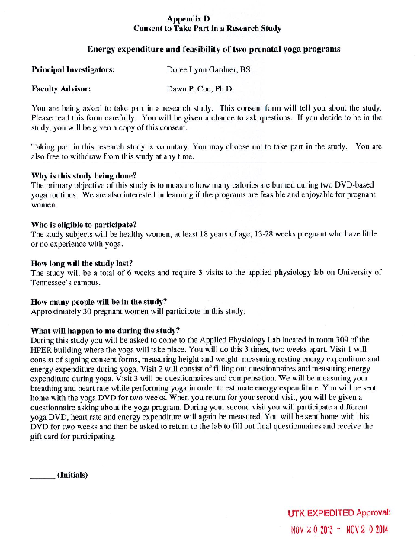



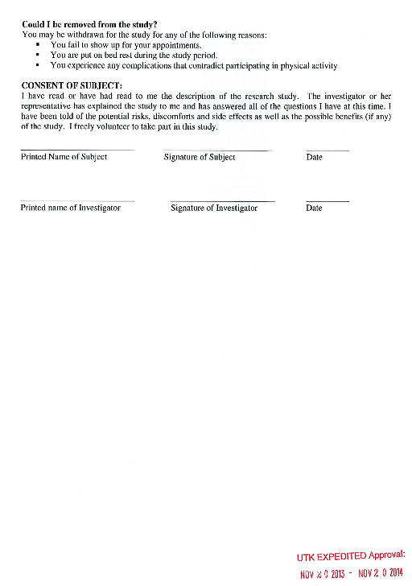

Appendix B: Institutional Review Board Consent

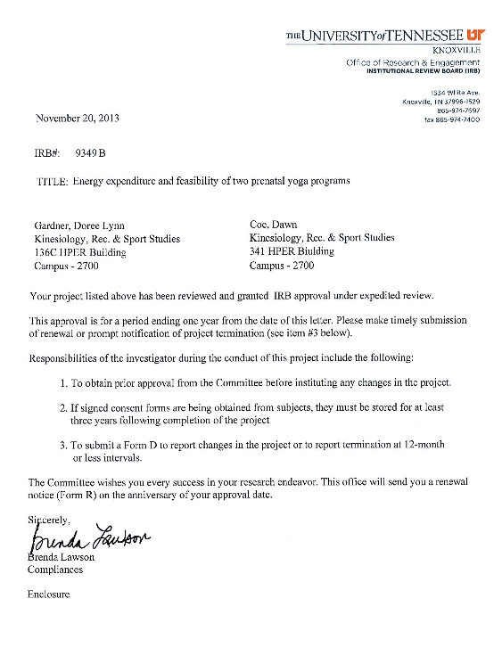

Appendix C: Activity Log

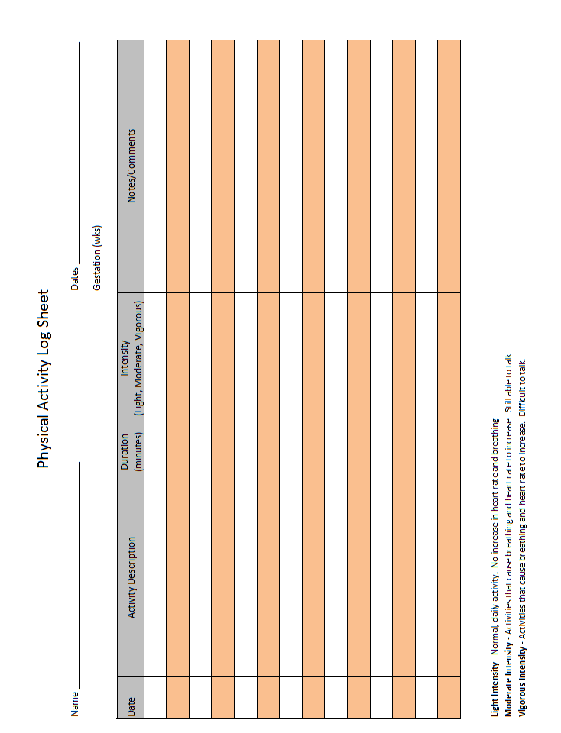

Appendix D: Enjoyment and Feasibility of Physical Activity Questionnaires

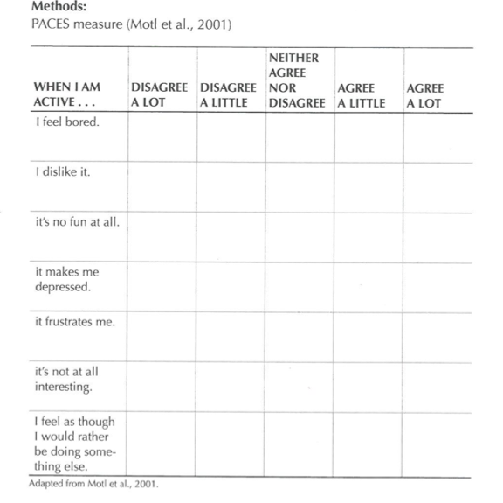

 | Disagree a lot | Disagree A little | Neither agree nor disagree | Agree A little | Agree A lot
I feel that this yoga program is a feasible activity that I can do at home
I would want to do this DVD based yoga program on my own

Appendix E: Recruitment flyer and email

Department of Kinesiology, Recreation, and Sport Studies



Pregnant Women Needed for a Research Study
Energy Expenditure and Feasibility of Two Prenatal Yoga Programs

The purpose of this study is investigate the energy expenditure and feasibility of two different DVD based prenatal yoga programs

If you choose to take part, you will come to the Applied Physiology Lab on University of Tennessee campus on three separate occasions. Visits #1 and 2 will last about 1 hour and 45 minutes and visit #3 will last 20 minutes. We will measure your breathing and heart rate as you perform yoga. To be able to take part in this study you must be between 13 and 28 weeks gestation of a healthy pregnancy as documented by your physician.

Completion of study will be compensated with a gift card

Please contact Doree Lynn Gardner if interested
dgardne7@utk.edu
865-974-5091


Subject line: Seeking pregnant women for prenatal yoga research

The Applied Physiology Lab at University of Tennessee is looking for women between 13 and 28 weeks gestation of a healthy pregnancy. The purpose of this study is investigate the energy expenditure and feasibility of two different DVD based prenatal yoga programs
If you choose to take part, you will come to the Applied Physiology Lab on University of Tennessee campus on three separate occasions. Visits #1 and 2 will last about 1 hour and 45 minutes and visit #3 will last 20 minutes. We will measure your breathing and heart rate as you perform yoga. To be able to take part in this study you must be between 13 and 28 weeks gestation of a healthy pregnancy as documented by your physician.

Completion of this study will be compensated with a gift card

If you are interested in participating or have any questions about the study, please email Doree at dgardne7@utk.edu.

Thank you.

Appendix F: Borg Scale

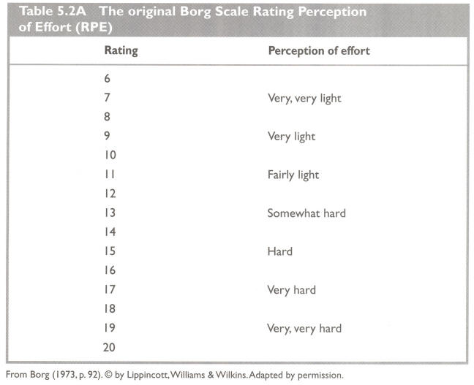

Appendix G: Confidentiality Agreement

Research Team Member’s Pledge of Confidentiality

“Energy Expenditure and Feasibility of Two Prenatal Yoga Programs”

As a member of this project’s research team, I understand that I will be involved in the collection and analysis of sensitive data. The information obtained during data collection was provided by research participants who participated in this project on good faith that their data would remain strictly confidential. I understand that I have a responsibility to honor this confidentially agreement. I hereby agree not to share any information with anyone except the primary researcher of this project or other members of this research team. Any violation of this agreement would constitute a serious breach of ethical standards, and I pledge not to do so.

___________________________________ ________________

Research Team Member (Printed Name) Date

___________________________________

Research Team Member (Signature)

Appendix H: Yoga DVDs





Appendix I: PAR-MEDX for pregnancy

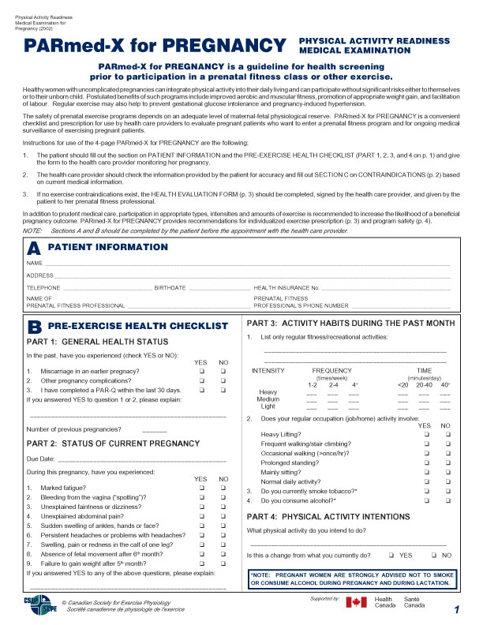

Appendix J: Contraindications for Exercise during Pregnancy

RISK FACTORS:
Contraindications for Exercising During Pregnancy*
Relative
• Severe anemia
• Unevaluated maternal cardiac dysrhythmia
• Chronic bronchitis
• Poorly controlled type I diabetes
• Extreme morbid obesity
• Extreme underweight [Body mass index (BMI) <12]
• History of extremely sedentary lifestyle
• Intrauterine growth restriction in current pregnancy
• Poorly controlled hypertension
• Orthopedic limitations
• Poorly controlled seizure disorder
• Poorly controlled hyperthyroidism
• Heavy smoker
Absolute
• Hemodynamically significant heart disease
• Restrictive lung disease
• Incompetent cervix / cerclage
• Multiple gestation at risk for premature labor
• Persistent second or third trimester bleeding
• Placenta previa after 26 wk of gestation
• Premature labor during the current pregnancy
• Ruptured membranes
• Preeclampsia / pregnancy-induced hypertension
*American College of Obstetricians and Gynecologists. Exercise during pregnancy and the postpartum period. ACOG Committee Opinion No. 267. Obstet Gynecol 2002;99:171–173.

VITA

Doree Lynn Gardner was born on January 4th, 1989 in Sioux City, Iowa to Carter and Donna Gardner. In May of 2007, she graduated from East High School in Sioux City, Iowa. She began her undergraduate education at Arizona State University in Tempe, Arizona in the fall of 2007. At Arizona State, Doree was actively involved in extra curricular and volunteer activities, President of her sorority Kappa Kappa Gamma, and a group fitness instructor at the Student Recreation Center. In 2010, Doree completed an international research internship at The University College Dublin, where she was introduced to working in academia. Upon returning to the United States, she started an undergraduate research assistantship with Dr. Wayne Willis at Arizona State University’s Center for Metabolic Biology, which was an exciting and challenging experience that pushed her into continuing her education and research endeavors. She obtained her Bachelor in Science degree from Arizona State in 2012. Doree accepted a graduate teaching assistantship at the University of Tennessee, Knoxville and began her course work in the fall of 2012. Doree graduated from the University of Tennessee with a Master of Science degree in August 2014. She plans to continue her education in the field of Women’s Health.

