Development of a Glucose Bioreporter Using the Yeast Saccharomyces cerevisiae
Hunter Tipton
University of Tennessee-Knoxville

Abstract:
Biofuel producers rely on yeast in order to ferment glucose produced from plant biomass into ethanol. In order to determine the efficiency of this procedure, there is a need for efficiently and economically determining the concentration of glucose in a given solution. This experiment attempts to utilize the lux operon to produce a constitutively active light producing strain of yeast. This serves as a toxicity reporter in glucose solutions as well as an indicator as to whether or not a particular strain of yeast is capable of acting as a glucose bioreporter. This was be done by ligating the constitutively active GPD promoter into pUAIB, and then transforming this plasmid and pUTK404 into S. cerevisiae W303. Similarly, another strain had pUTK404 and pUTK401 transformed into it for the same purpose. Only the yeast strain containing pUTK404 and pUTK401 was effectively in producing light. While multiple potential reasons exist for the failure of the pUGPDAIB and pUTK404 strain to produce light, the most likely reason is an unintended interruption of the luxA or luxB genes during the ligation process.

Introduction
In order to keep up with the growing consumption of fossil fuels, the market for bio-fuels is ever growing. Not only are bio-fuels a renewable resource, but they also can decrease dependency on foreign fuel sources (Sun 2002). Therefore, research in biofuel production is a high-interest field in the world today.
Ethanol is currently the most consumed biofuel in the global market. Its production is based on the fermentation of simple sugars derived from organic products such as corn or sugarcane, commonly with the use of the yeast Saccharomyces cerevisiae as a fermenter. When using yeast, the organic material must be broken down into glucose prior to fermentation (Sun 2002). Therefore, having a reliable method to measure the quantity of glucose in a solution is useful in determining the efficiency of ethanol production from a known biomass.
One such method is utilizing the lux operon to convey light production capabilities to yeast cells and then putting it under the control of a glucose sensitive promoter. In this way, light would be produced at levels relative to the glucose concentration in a solution. One such group of promoters is the Hexose Transporter Protein promoters. The Hexose Transporter Protein genes are under the control of various promoters that are sensitive to variable levels of glucose. Depending on the desired response, different promoters can be chosen for use. For example, HXT1 is sensitive to high glucose concentrations due to the fact that it has a low affinity for glucose. Conversely, HXT6 and HXT7 are induced by low concentrations of glucose, indicating that they have high affinities for glucose molecules. There are 17 HXT promoters in all, giving way to a large number of options in building a glucose sensitive strain of yeast (Ozcan 1999).
In order to derive meaningful data from a yeast bioreporter, a standard must be established as a mean of comparison. Therefore, before a glucose sensitive strain can be built, it is necessary to first construct a constitutively active strain. A constitutively active bioreporter utilizing the lux operon is often useful for detecting the toxicity of a sample (Min 2003). For example, since a constitutive strain should produce bioluminescence all the time, a reduction in bioluminescence may be a result of toxins in a sample killing or inhibiting the light-producing cells. This can be identified by submitting constitutively active cells to the same tests in order to determine if they still emit light under identical circumstances. If not, it can be determined that something in the sample is inhibiting light production and therefore affecting results.
The goal in this experiment is to develop a yeast bioreporter that constitutively emits light. This will be done by ligating the gene promoter GPD into the plasmid pUAIB, which contains the genes luxA and luxB that encode for the light producing enzyme luciferase. This plasmid will be constitutively activated when transformed into S. cerevisiae along with the plasmid pUTK404. pUTK404 contains luxC, luxD, and luxE which encodes for the necessary aldehyde substrate for luciferase function (Watanabe 1993). A second constitutively active strain will then be created using the plasmid pUTK401, also containing luxA and luxB, in place of pUGPDAIB .

Methods
Creation of the Plasmid pUGPDAIB
In order to maintain a fresh culture of E. coli containing the target plasmid pUAIB, a single E. coli colony containing pUAIB was streaked on fresh LB plates that contained ampicillin at 100 ug/ml. Then, 4 ml of LB broth with ampicillin at 100 ug/ml was inoculated with E. coli containing pUAIB for a later miniprep. In order to amplify the GPD promoter gene sequence and to add PstI and XbaI restriction sites to the ends, the following volumes of the given reagents were then added to a set of 16 PCR tubes which were then PCR amplified via a Touchdown protocol :
Reagent | Volume Pipetted to Tubes 1-15 | Volume Pipetted to Tube 16  (-control)
Water | 22.7 µl | 23 µl
GPDFPstI F Primer | 1 µl | 1 µl
GPDRXbaI R Primer | 1 µl | 1 µl
Template DNA | 0.3 µl (50 ng) | 0 µl

The Touchdown protocol consists of the following cycles:
Temperature (ºC) | Time (min) | Cycle repetitions
95 | 5 | 1
95  60  72 | .5  .75  1 | 35
72 | 10 | 1

The PCR products were gel electrophoresed for 45 minutes in a 1% agarose gel at 100 V in order to determine if the correct sized bands had been amplified. A gel extraction was then performed and DNA was quantified via nanodrop.
A miniprep was then conducted on the E. coli containing pUAIB culture in order to isolate the plasmid. First, the culture was pelleted by centrifuging for five minutes at 13,000 x g in a 1.5 ml microcentrifuge tube. This was performed multiple times, decanting each time and adding more broth culture until all 4 ml of culture had been pelleted in a single centrifuge tube. Then, the solution was decanted and 250 µl of Cell Resuspension Solution was added and vortexed in order to resuspend the pellet. 250 µl of Cell Lysis Solution was then added and the tube was inverted eight times to lyse the cells. 350 µl of Neutralization solution was then added to the solution, and the tube was inverted eight times to mix to precipitate proteins. The solution was then centrifuged at 16,000 x g for 10 minutes at room temperature. A spin column was then inserted into a collection tube, and the cleared lysate was pipetted into the spin column. The spin column and collection tube were then centrifuged at 16,000 x g for 1 minute at room temperature, and the flowthrough was discarded. 750 µl of wash solution was then added to clean the DNA, and the spin column and collection tube were again centrifuged at top speed for 1 minute. This step was then repeated with 250 µl of wash solution. The solution was then centrifuged at top speed for 2 minutes at room temperature. The spin column was then transferred to a 1.5 ml microcentrifuge tube, and 50 µl of warm nuclease-free water was added to the spin column to elute the DNA. This was then centrifuged at 16,000 x g for 1 minute, and the resulting flowthrough containing pUAIB was quantified using the nanodrop and stored at -20 ºC for later use.
The DNA was then ligated into the vector pCR2.1 by combining the following reagents into a microcentrifuge tube and allowing them to incubate for 15 minutes at room temp:
Reagent | Volume (in µl)
Water | 3
Salt solution | 1
GPD-PCR solution | 2
pCR2.1 Vector | 1

2 µl of the ligated product was then added to 50 ul of competent E. coli cells. In order to transform the cells, they were placed into a 42 ºC water bath for 30 seconds. Then, 250 µl of SOC medium was then added to the cells, and they were incubated for 1 hour at 37 ºC. 100µl of cells were then spread over one LB/Amp plate, and 50 µl were then spread over another. These plates were then left to incubate at 37ºC overnight.
Blue/White screening indicated successful ligation and transformation in white colonies. One of these colonies was inoculated into 4 ml LB/Amp broth and was incubated in a 37ºC shaking water bath overnight. These colonies were miniprepped via the previous protocol and stored at -20 ºC.

A digest of GPD in pCR2.1 and of pUAIB was then run by placing the following volumes of reagents into microcentrifuge tubes and allowing them to incubate at 37 ºC overnight:
Reagent | GPD-Invitrogen Vector Digest | pUAIB Digest
10X buffer H | 3.5 µl | 3.5 µl
10XBSA | 3.5 µl | 3.5 µl
Water | 10 µl | 2 µl
PstI (10U/µl) | 3 µl | 3 µl
XbaI (12U/µl) | 3 µl | 3 µl
Template DNA | 12 µl | 20 µl

A gel electrophoresis was then run on the digests to confirm correct digestion, and then the GPD and AIB gel bands were extracted and quantified.

A ligation protocol of GDP into pUAIB was carried out, using the following reagents:
Regeants | GPD:pUAIB (volumes in µl) | pUAIB only (volumes in µl)
Water | 3.5 | 6.5
10X buffer | 1.5 | 1.5
T4 DNA Ligase | 2 | 2
pUAIB | 5 | 5
GPD Insert | 3 | 0

3 µl of each of these two ligations were transformed into 50 ul of competent E. coli cells. First, they were incubated for 15 minutes on ice. Then, they were heat shocked for 30 seconds at 42 ºC. 250 µl of SOC were then added to each group of cells. They were then allowed to shake sideways for 1 hour in the 37 ºC incubator to properly aerate the cells. 100 µl of the GPD:pUAIB mix was spread onto two plates, and 100 µl of the pUAIB mix was spread onto a third plate. All three plates were incubated at 37 ºC overnight. Six colonies were then selected from the pUGPDAIB plate and were cultured in roughly 5 ml of LB broth each, in six tubes, at 37 ºC overnight. Each of the six clones was then miniprepped and their DNA quantified.

The six clones were then PCR amplified with GPD F/R and luxA F/R primers to confirm the presence of both GPD and lux genes, with the reagents being added as follows:
Reagent | Tubes 1-6 (clones 1-6) | Tube 7 pUTK420 (+control) | Tube 8  (-control) | Tubes 9-14 (clones 1-6) | Tube 15 pUTK420  (+ control) | Tube 16  (-control)
Water | 22.5 µl | 22.5 µl | 23 µl | 22.5 µl | 22.5 µl | 23 µl
Forward primer | 1 µl GPD F | 1 µl GPDF | 1 µl GPDF | 1 µl luxAF | 1 µl luxAF | 1 µl luxAF
Reverse primer | 1 µl GPDR | 1 µl GPDR | 1 µl GPDR | 1 µl luxAR | 1 µl luxAF | 1 µl luxAF
template | .5 µl | .5 µl | 0 µl | .5 µl | .5 µl | 0 µl

The PCR was run by TD65 protocol. The PCR product was then gel electrophoresed and analyzed to confirm the presence of GPD and luxA in the plasmid (Figure 1).

Figure 1. PCR amplified samples of pUGPDAIB ligation product
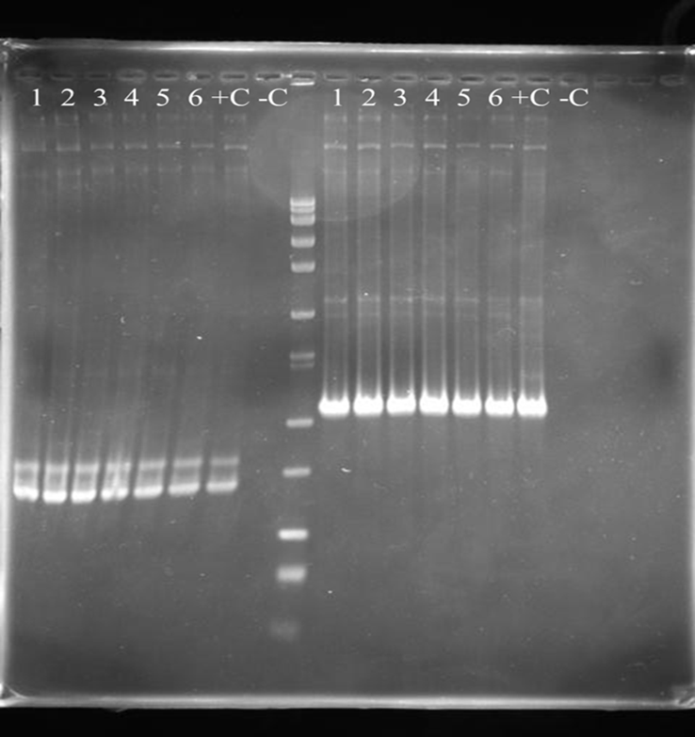
GPD gene sequences
luxA gene sequences
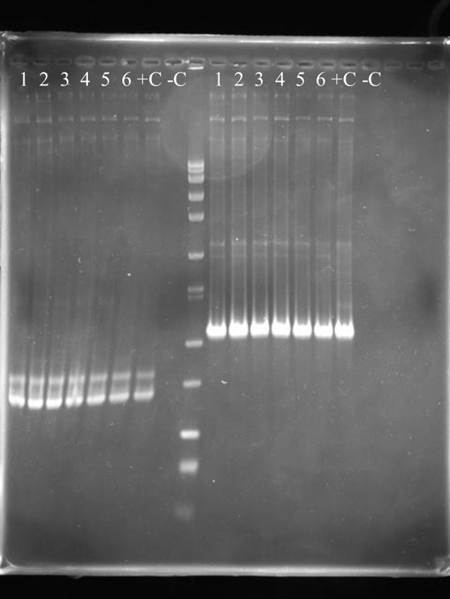
In order to confirm the ligation of GPD into pUAIB, a gel electrophoresis was performed on the PCR product of the ligated plasmid. Amplified GPD gene sequences (left) and luxA gene sequences (right) from the engineered plasmid pUGPDAIB appear in the gel corresponding to their appropriate band lengths.

Transformation of pUGPDAIB/pUTK401 and pUTK404 into S. cervisiae W303

S. cerevisiae W303 cells were grown in YPD broth at 28 ºC to an O.D₆₀₀ of 1-1.5. Cells were made competent with a Lithium Acetate protocol. After the cells were made competent, pUGPDAIB and pUTK404 were transformed into the cells via electroporation. 100 µl of cells were then plated onto four plates. These plates were grown at 28ºC for three days and then observed for growth.
A PCR was then performed on 14 of the colonies grown from these plates to confirm whether the cells contained the plasmids pUGPDAIB and pUTK404, using the following reagents:
Reagents | Colonies 1-14 | pUTK404 (+control) | -control
Water | 23 µl | 23 µl | 23 µl
luxC-F | 1 µl | 1 µl | 1 µl
LuxC-R | 1 µl | 1 µl | 1 µl
Template | Small amount of cells (enough to seal pipette tip) | .5 µl pUTK404 solution | 0 µl pUTK404 solution

A gel was then run to confirm the presence of luxC in the colonies, as seen in Figure 2.

Figure 2. PCR amplified samples of pUTK404 from S. cerevisiae transformation
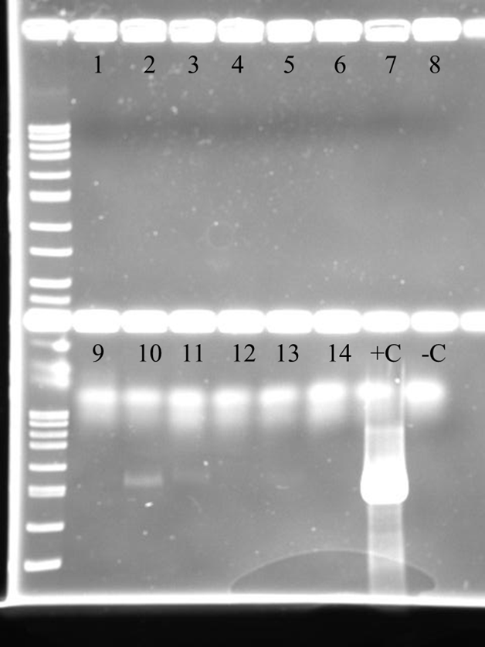
In order to confirm the presence of pUTK404 after transformation into S. cerevisiae W303, PCR products from the resulting colonies were run on a 1% agarose gel. Colonies 10 and 11 were the only colonies that contained the plasmid.

An identical procedure was performed using luxA F/R primers to check for the presence of pUGPDAIB. Upon finding none, colonies 10 and 11 were streaked onto YMM -leu, -ura, +trp plates and again checked for pUTK404 using the previous procedure. Upon finding no colonies with pUTK404, the transformation protocol was attempted three more times, checking for pUTK404 and pUGPDAIB each time.
Upon yielding no results, the transformation method was switched to a heat shock method. Cultures were grown overnight at 30º C in YMM -leu, +ura, +trp. The next morning the cultures were diluted toOD₆₀₀ 0.1 O.D. and grown for 4 hours. The cultures were then centrifuged at 4000 rpm for two minutes and decanted. The pellet was then washed with 25 ml of sterile H₂O, centrifuged at 4000 rpm for two minutes, decanted, and resuspended in .5 ml of LiAc/TE buffer. The solution was then transferred to a 1.5 ml microcentrifuge tube and pelleted at 13,000 rpm for one minute and decanted. The pellet was then resuspended in in 225 ul of LiAc/TE buffer via vortexing. 50 ul aliquots were then separated for each transformation. 5 ul of 2 ug/nl of single stranded herring sperm carrier DNA and 1 ug each of pUTK404 and pUGPDAIB were added to each aliquot. 300 ul of LiAc/TE/PEG solution was then added to each aliquot and vortexed. These were then incubated for 30 minutes at 30ºC. They were then incubated at 42ºC for 15 minutes. After incubation, the aliquots were then centrifuged for one minute at 8000 rpm. Each aliquot was then decanted, and 200 ul of ddH₂O was added. The resulting solutions were then plated on YMM -,-,+ plates and grown for three days at 28ºC. The resulting colonies were then PCR amplified and gel electrophoresed in the same manner as outlined above. The first transformation was unsuccessful therefore this procedure was repeated four times. Upon completing the final try, all colonies were cultured in YMM -,-,+ broth for one hour and tested for light production.
Upon receiving no positive data to confirm that this strain is capable of transformation and light production, the procedure was repeated using pUTK401 instead of pUTK404. After transformation, the resulting colonies were grown in YMM -,-,+ broth for one hour and then measured for optical density. They were then tested for light production. A scatterplot was then constructed for light production vs. optical density in order to determine if cell counts were responsible for varied levels of light production, as seen in Figure 3.

Figure 3. Light Production vs. Optical Density for pUTK404 and pUTK401 Transformed Colonies
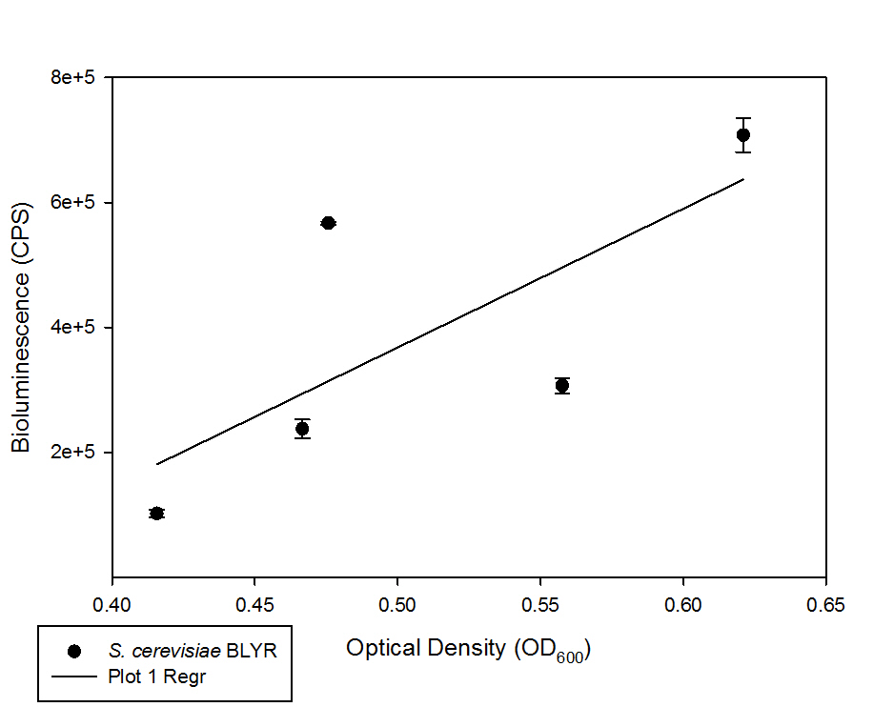
In order to determine whether cell counts were responsible for varied levels of light production in the transformed colonies, the optical densities of each culture were recorded. These densities were then compared to the counts per second values. There was no strong correlation.

Discussion
As seen in Figure 1, GPD and luxA gel bands were isolated from the DNA miniprepped from the transformed E. coli colonies. Therefore the ligation of GPD into the plasmid pUAIB was successful in forming pUGPDAIB. However, upon transforming pUGPDAIB and pUTK404 into Saccharomyces cerevisiae W303 and then subsequently gel electrophoresing the luxA F/R and luxC F/R products, the results were not definitive. Figure 2, a test for the luxC PCR product, shows faint bands of the appropriate size for luxC in colonies 10 and 11. This indicates that these colonies contained pUTK404. However, after streaking these colonies and testing them again, the plasmid was not detected in either sample. Similarly, pUGPDAIB was not found in any of the colonies tested.
Despite several attempts to transform these plasmids using both electroporation and heat shock methods, the results were consistently negative for each plasmid. Upon attempting to transform pUTK404 and pUTK401, a plasmid similar in function to pUGPDAIB, the results were positive after the first try, proving that light production is possible in the yeast strain S. cerevisiae W303. This can be seen in Figure 3, where four of the five transformed colonies have light production levels that exceed the 20,000 counts-per-second threshold for a constitutively activated lux operon in S. cerevisiae. Similarly, it can determined that the high light levels are not simply a product of high optical densities due to the fact that Figure 3 shows counts-per-second near 6e+5, a number high above the threshold, at a relatively low O.D₆₀₀.
There are several explanations for why light production could not be achieved after transforming pUTK404 and pUGPDAIB. Given that the transformation of pUTK404 and pUTK401 worked on the first attempt, it is unlikely that human error in the transformation methods accounts for the lack of light production. Gel electrophoresis indicated that the necessary lux genes were not found in any of our colonies, therefore indicating that neither of the two plasmids was ever transformed into the yeast. However, colonies grew on the leucine and uracil deficient media. Since the two plasmids jointly convey leucine and uracil production capabilities to the yeast, cells could only grow on this media if they had received the plasmids. Since cells were able to grow, it is possible that simply too many cells were used in the PCR technique. This could overload the PCR with inhibitors, therefore giving false negative results.
However, if the plasmids were transformed into the cell, the cells should have produced light regardless of what the gel electrophoresis images showed. It is possible that this is due to an error in ligating the GPD sequence into the plasmid pUAIB. One such potential error would be an interruption in an unwanted area of the plasmid, particularly the luxA or luxB gene sequences. Another potential error could be a backwards ligation of the GPD promoter into the plasmid. This would yield no transcription from the lux genes.

Future Directions
In order to achieve more accurate results, it is necessary to attempt to ligate GPD into pUAIB again to ensure that the promoter is inserted correctly and that the plasmid is correctly engineered correctly. Sequencing the promotor in the plasmid would confirm whether it had been inserted correctly. In addition, when checking for the presence of pUGPDAIB in a colony, fewer cells should be used in order to ensure that the polymerase chain reaction occurs correctly.
Once a strain is produced with pUGPDAIB, work can then begin on a glucose sensitive strain. In the same manner as before, HXT promoters can be ligated in front of pUAIB, putting luxA and luxB under the control of variable glucose levels in a solution. In order to encompass a large spectrum of glucose concentrations, HXT1, HXT2, HXT3, and HXT4 will be used as the glucose sensitive promoters in four separate bioreporters. HXT1, HXT2, HXT3, and HXT4 exhibit different levels of activity based on glucose levels (Ozcan 1995). This allows for the utilization of each bioreporter at different expected glucose concentrations, and also allows for cross checking of a concentration through the use of multiple bioreporters in one sample.

Works Cited
Min, J, C H. Pham, and M B. Gu. "Specific responses of bacterial cells to dioxins." Environmental Toxicology and Chemistry22.2 (2003): 233-38. Web. 26 Apr. 2013.
Ozcan, Sabire, and Mark Johnston. "Function and Regulation of Yeast Hexose Transporters." Microbiology and Molecular Biology Reviews 63.3 (1999): 554-69. Web. 26 Apr. 2013.
Sun, Ye, and Jiayang Cheng. "Hydrolysis of lignocellulosic materials for ethanol production: a review." Bioresource Technology83.1 (2002): 1-11. Web. 25 Apr. 2013.
Watanabe, Haruo, Toshiyuki Nagoshi, and Humio Inaba. "Luminescence of a bacterial luciferase intermediate by reaction with H2O2: the evolutionary origin of luciferase and source of endogenous light emission." Biochimica et Biophysica Acta (BBA) - Bioenergetics 1141.2-3 (1993): 297-302. Web. 26 Apr. 2013.

