THE STEEL TOWER:
A 21st CENTURY TALL BUILDING

A Thesis Presented for the
Master of Architecture
Degree
The University of Tennessee, Knoxville

Peter Guldenshuh Duke
May 2013

Copyright © 2013 by Peter G. Duke
All rights reserved.

ACKNOWLEDGEMENTS

I am t thankful to my thesis committee and especially Marleen Davis. Thank you for the confidence and patience throughout the entire process.
ABSTRACT

This paper outlines the need for a new mixed use high-rise project for the commercial business district of Pittsburgh, Pennsylvania. The proposed tower combines commercial, laboratory, residential, and tourist program into one tower of roughly 1.5 million square feet.
As the new world headquarters for US Steel, the facility is sited and developed strategically in Pittsburgh's Golden Triangle. Its prominent location in the heart of downtown seeks to take advantage of the public transit in an effort to curb extraneous individual travel while further enriching the downtown experience. The building's height, orientation, and grounding are developed to relate to external environmental factors. As a site specific high-rise, emphasis is placed on view corridor and skyline composition. Furthermore, its dominant vertical orientation creates an urban landmark and a viewing platform available for public use.
The steel mega-structure uses a highly articulated diagrid in an effort to minimize material while emphasizing an organized loading strategy. The innovative structuring concept works as a dialogue for steel's future involvement in 21st century high rise building construction.
By combining sheer height and size with an innovative structural system, the Steel Tower seeks to become the tall building among many in Pittsburgh, PA.

TABLE OF CONTENTS

CHAPTER I: A Call for Tall Buildings 1
CHAPTER II: Pittsburgh's Case 3
CHAPTER III: Competing Options 7
CHAPTER IV: The Necessity of Location 11
CHAPTER V: Siting the Tower 15
CHAPTER VI: Programming the Tower 25
CHAPTER VII: Structuring the Tower 29
CHAPTER VIII: Design Development 32
CHAPTER IX: Architectural Experience 39
LIST OF REFERENCES 43
VITA 46

LIST OF FIGURES

Figure 1. Skyline. 3
Figure 2. Local Situation. 4
Figure 3. US Steel Tower. 5
Figure 4. Downtown Pittsburgh. 5
Figure 5. Prospective Sites. 8
Figure 6. John Deere Headquarters. 9
Figure 7. ALCOA Headquarters. 10
Figure 8. Pittsburgh-1900. 12
Figure 9. Seven Preliminary Sites. 15
Figure 10. Skyline Massing Study. 17
Figure 11. Skyline Regulations. 18
Figure 12. Figure Ground/Height. 19
Figure 13. Influencial Conditions. 20
Figure 14. Transit Conditions. 21
Figure 15. Wood Street Facades. 22
Figure 16. Photomontage Panoramas. 23
Figure 17. The Granite Building. 24
Figure 18. Massing Program. 27
Figure 19. Core Program. 27
Figure 20. Swiss Re Building. 30
Figure 21. Diagrid Forces. 31
Figure 22. Diagrid Reduction. 31
Figure 23. Entry and Context. 33
Figure 24. Eatery Level. 34
Figure 25. Upper Levels. 36
Figure 26. Design Sections. 37
Figure 27. Birdseye View. 40
Figure 28. Night Vista. 41

CHAPTER I

A Call for Tall Buildings

Citizens take pride in their city's skyline. A skyline represents a particular region's collective wealth, industry, and culture over time. Within a city, an individual skyscraper acts as a beacon. It can be a billboard and usually becomes a vertical landmark. Collections of these mega-structures indicate an essential core, obvious coalition of centralized planning, and strong influences from free market forces. A single tower, however, can be world renowned and lauded for its structural achievements or aesthetic identity. The construction of a skyscraper and its addition to the skyline can be seen as a pure expression of human will through self-assertion and dominance over the landscape. (Denk, 2007) High-rises are decidedly charged pieces of architecture. Construction on this scale has the unrivaled ability to positively affect citizens' perception of place.
At this junction, the need for ever-taller buildings becomes more relevant. Plainly said, the advantage of building tall has always been increased urban density. The true function of this building type is clearly derived by maximizing floor area over a minimal site by means of vertical stacking. However, only when a tall building overcomes its mono-functionality as a series of commercial floor plates and embodies itself as a vertical street, will it increase both urban density and urban vibrancy.
Too often these hulking behemoths overtake historical plots or turn inwardly thereby neglecting the street on which they stand. Typically commercial in scope, tall buildings tend to become over-populated by day and desolate by night. It is imperative to recognize the form's inherent faults, smartly resolve its shortcomings, and emphasize the themes that make the skyscraper great. High-rises are sculpture. They are art on the largest scale known to man and they have a definite purpose.
Cities are consistently seeking vibrancy and density within their downtown core. Favorable density creates walk-able streets, centralized distribution of goods and services, and limits exterior sprawl. In an ever effort to mitigate the effects of an outwardly growing city population, buildings have necessarily grown in height. Every expanding city finds itself in a quandary as the only realistic way to expand is upward. Spreading outward into new districts or the hinterlands is only a viable option for so long. Eventually, the shear distance of travel eliminates all sense of community and walk-ability.
Overall, the necessity of a skyscraper can be distilled into an insistence in sustainability. It is essential to compact people into a tight area. This density is more gentle on the planet. It relieves Earth of all the deleterious effects and associated energy costs stemming from long distance travel. Furthermore, an increase in density within the existing urban network allows the countryside to return to a more natural and healthy state. Beyond its strengths born from economy and ecology, high-rises positively serve a number of social, cultural, and civic interests.

CHAPTER II

Pittsburgh's Case
Pittsburgh, Pennsylvania's skyline has long been a subject of my specific fascination. Once the seat of the third most corporate headquarters in America, Pittsburgh's high-rise density remains particularly great among American cities. (Carnegie, 2013) Furthermore, its situation in northern Appalachia afford visitors access to the city's many hills and rivers for an array of interesting scenery and prominent vantage points. Many of these vantage points deliver especially stunning vistas of the skylines' density and natural contours (Figure 1, 2)

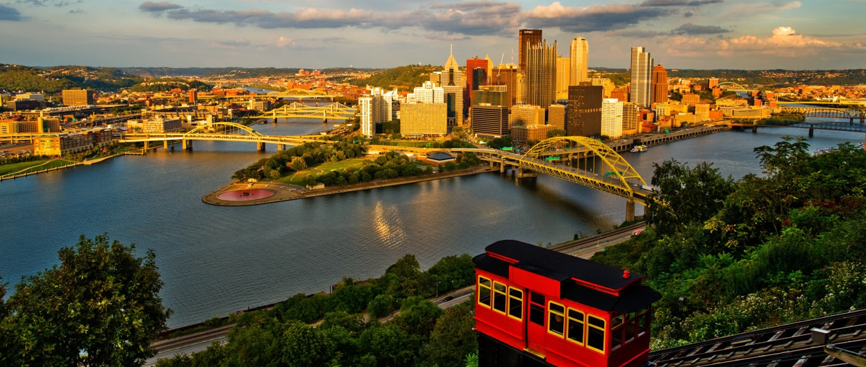
Figure 1. Pittsburgh as seen from Mount Washington (Vito Palmesano)

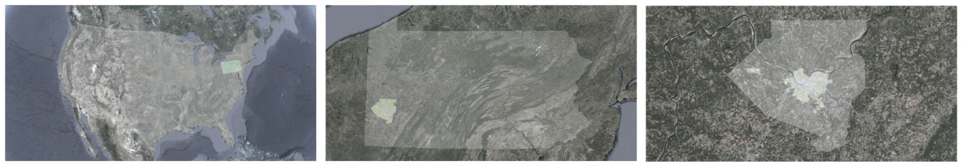
Figure 2. Pittsburgh's situation within US, Pennsylvania, and Allegheny County.

The tallest of all the Pittsburgh towers is the 2.3 million sq. foot, 841 foot tall US Steel Tower (Figure 3). The tower's dominance over the city represents steel's role as the foremost industry within the city for over a hundred years following Andrew Carnegie's founding of the Edgar Thompson Steel Works in 1875. This dominance finally and abruptly ended as America's domestic steel industry collapsed in the late 1970's. Since then, Pittsburgh has diversified its economy toward financial services, healthcare, education, technology and robotics but the steel industry remains prominent. Recently, a new wave of downtown construction once again has the Steel City's built environment morphing and evolving.

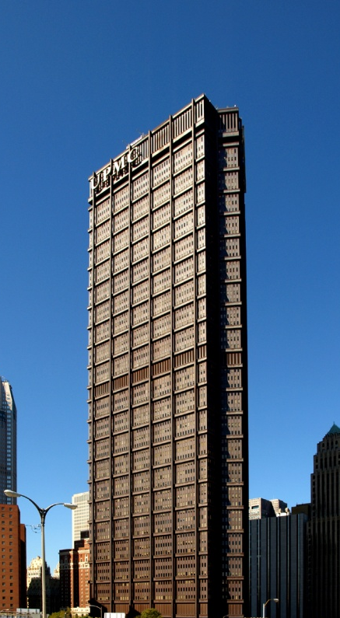 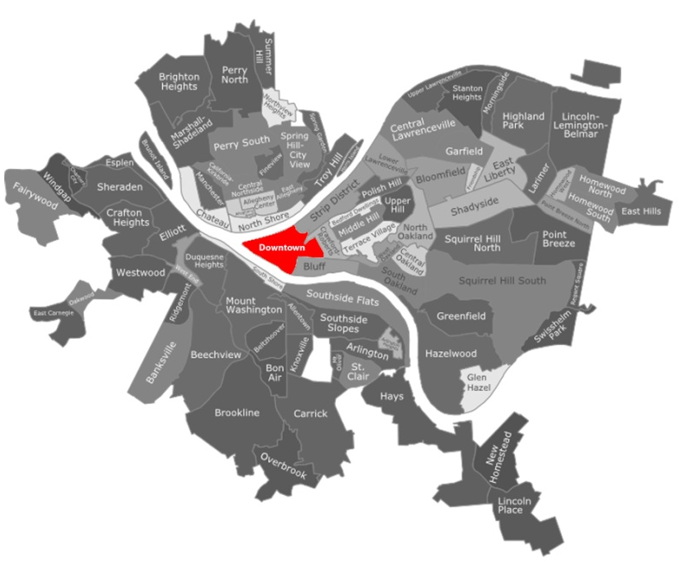
Figure 3. US Steel Tower Figure 4. Downtown Pittsburgh (red)
(CTBUH)

US Steel is slated to leave their headquarters within their namesake tower in 2017 when their lease will expire. The current building has housed the majority of US Steel's Pittsburgh operation since its construction finished in 1971. As such, the company is in the market for 800,000 to 1 million square feet to accommodate not only the 1,800 workers currently working in the U.S. Steel Tower, but other employees working around the Pittsburgh metro region. (Belko, 2012)
While the siting of this new headquarters remains unknown and under closely guarded supervision, it is imperative that US Steel's main office remain downtown in Pittsburgh's central business district(CBD) as a vertically oriented major building. (Figure 4) US Steel, the company that provided the structural material necessary for tall buildings of past and present, the company that grew Pittsburgh from a frontier town to a leading city, the company that continues to be one of the largest employers in western Pennsylvania, deserves a grand gesture on a large scale. US Steel's new hub of operation must remain downtown. It must be among the other leading business headquarters of the city where it can act as a beacon for Pittsburgh's citizenry and a billboard for its product.
A tower for a company rooted in the development of a structural product inherently calls for precise and thoughtful formal expression of such a product. According to many architectural historians, theorists, and architects including Mies van der Rohe and Le Corbusier steel is the definer of a skyscraper. (Beedle, 2007) At any rate, a building designed specifically of steel for a steel company remains a short sighted endeavor. Colossal buildings require colossal foundations, and the foundation for a proposal as massive as a skyscraper must consider far more than material and client. Throughout this paper I seek to expose, question, and finally prove that a steel framed tall building is the correct solution for US Steel's new corporate headquarters in Pittsburgh, Pennsylvania.

CHAPTER III

Competing Options

US Steel has many options for a new corporate headquarters at its disposal. While the company is understandably keeping its future intentions a private matter, several sites have been considered front runners in the selection process. Late reports indicate mutual interests among three distinct locations. As highlighted in Figure 5, the sites from west to east are the Findlay region, the central business district, and the Strip District. (Belko, 2012) The CBD, locally referred to as the Golden Triangle, and literally represented in gold, is home to the company's current headquarters. Findlay, represented in blue, is the neighborhood surrounding the airport and is significantly west of the city. The strip district, depicted in red, directly adjoins the CBD, but has historically been Pittsburgh's produce, meat-packing, and warehouse district (Figure 5).

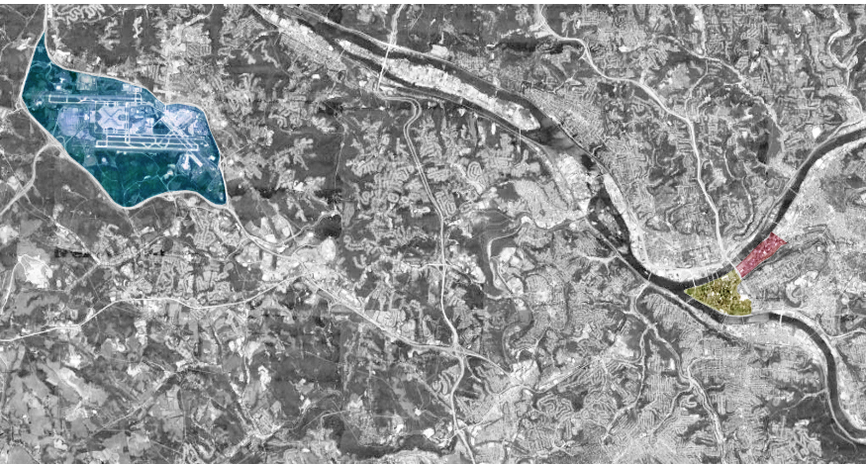

Figure 5. Prospective sites for new U.S. Steel Headquarters (Google Earth)
West to East: Pittsburgh International Airport and Findlay Neighborhood (Blue), Central Business District (Gold), Strip District (Red)

In addition to their site considerations, U.S. Steel is also investigating several building typologies. If electing to remain in the CBD, the company would undoubtedly pursue another tall building, as that is the only option for such a large square footage requirement in the densely built region. The other two sites allow for more opportunities to sprawl.
The company's interest in the Findlay region stems from its proximity to the airport directly adjacent to the proposed development location. A large, international business like US Steel will always need the capability of convenient, rapid travel. Today, the connection between the airport and the CBD leaves significant room for desired improvement. While the commute is merely a fifteen minute drive, the only alternative method of transportation is the shuttle service provided by Port Authority Transit. As such, one can obviously see the advantages of locating a multi-national corporation close to the airport for convenience alone.
Furthermore, the region has significant land-holdings selling for relatively nominal prices when compared to other districts of the city. One such holding currently being discussed is the 116 acre parcel off McClaren Road currently owned by District Judge Anthony Saveikis.(Belko, 2012) Such a large tract immediately implies a large, sprawling complex which would certainly be of a less expensive construction method. Here too, parking would logically be provided upon the selected site. (Figure 6)

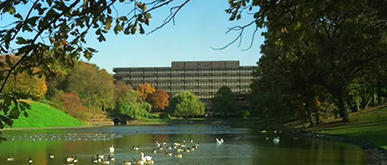

Figure 6. Example of a park-like HQ - John Deere's headquarters in Moline, IL
(John Deere)

The Strip District affords many advantages for building too. Even though it is located immediately adjacent to the Golden Triangle, real estate prices are significantly lower. While acreage is harder to come by than out towards the airport, a 37 acre tract owned by the Buncher Company could be slated for redevelopment. Currently, US Steel leases space for its transportation, engineering, and environmental groups on a Buncher owned building in the Strip District. One could perceive some logic behind a transition to move all operations into a campus like setting (Figure 7). This setting would have the added advantage of allowing for cross-pollination between departments and facilitating a more streamlined work-flow (Belko, 2012).

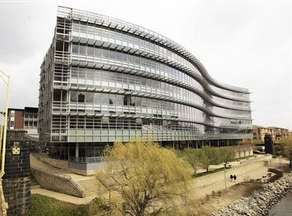
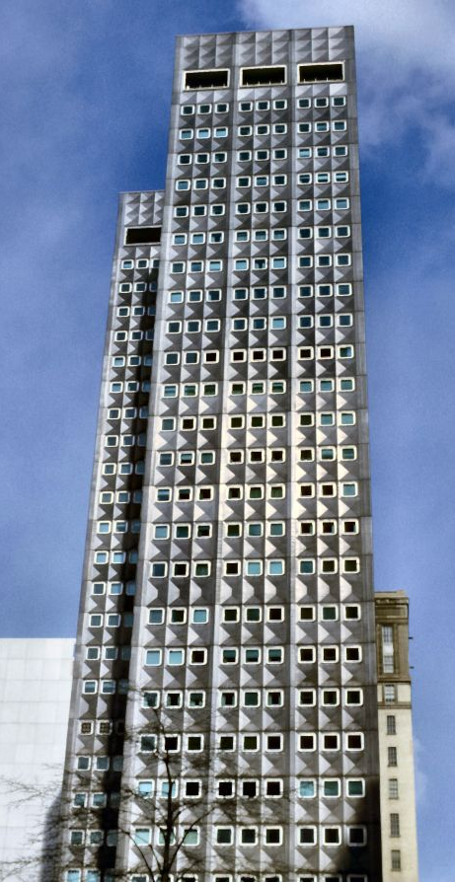
Figure 7. The old ALCOA headquarters in CBD Pittsburgh (left) moved across the Allegheny River for a modern campus (right) (France Metallurgie/ALCOA)

CHAPTER IV

The NEcessity of Location

Appalachia's highest concentration of jobs per square mile remains in Pittsburgh's Golden Triangle for a reason. Initially, the confluence of the Monongahela and Allegheny Rivers was seen as a strategic outpost for colonial era armies and militias. The French's establishment of Fort Duquesne in 1754, followed by its sacking and renaming by the British as Fort Pitt foreshadowed the site's strategic location for the oncoming centuries.
After Fort Pitt grew out of the area now defined as Point State Park and into the boundaries of the current CBD, more forces would cause the area to expand. Ship building naturally found a niche for explorers headed west. The city grew in size with populations robust enough to establish a university, a continually running newspaper, and a strong pre-steel industrial base. (Toker, 2007) Local coal discoveries in Coal Hill, now called Mt. Washington, further spurred industry and the population exponentially rose. Finally, the discovery of the regions rich iron reserves ignited an industrial boon (Figure 8).
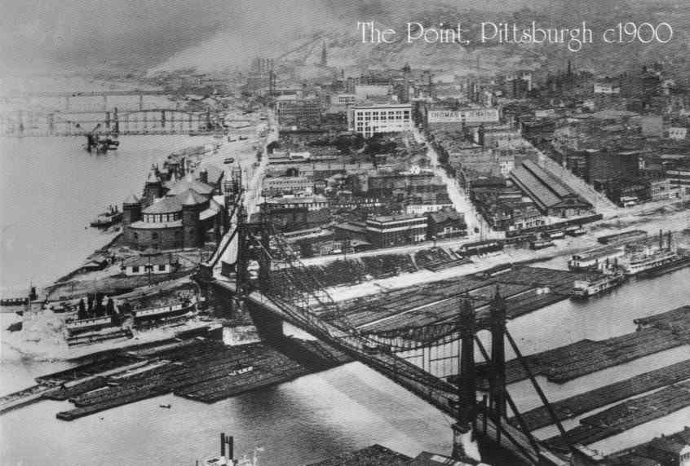
Figure 8. 1900 postcard from Mt. Washington (Heinz History Center)

From the beginning, the downtown triangle has been the place of established business, commerce, and finance. The CBD grew steadily since the time of the first forts. Its street grid was established early on and, being the oldest part of town, grew upward just as the other regions grew outward. Being the center of the region, it has always received the most attention and money. Scores of bridges and tunnels rapidly link the CBD to its constituent neighborhoods. The convenience afforded by these connections allowed the downtown to grow into a force and although pocked by distinct neighborhoods and seemingly un-traversable land and water, Pittsburgh naturally radiates outwardly from the Golden Triangle. (Figure 4).
Having always been the most convenient, centralized location of the city, the Golden Triangle grew tall and dense to accommodate business interests looking for such convenience. Like most American constructing tall buildings at the dawn of the 20th century, Pittsburgh's high-rises were built solely for business interests. Even so, the city center still functions smoothly today. Multi-modal transportation allows commuters to easily enter the city, work, and exit the city quickly. Workers may enter by automobile, subway, bus, or street car on designated routs that all terminated in the city center. Its location minimizes transit for the most making it the location of the greatest good. No other location allows for, or could handle such a daily flux of population. No other location minimizes commuter time for all with its strategic central location. No other location works for business quite like a downtown.
Not only is the CBD the appropriate place to locate a large business because of convenience, it is also the most logical spot for future business endeavors. In an age of ever-growing sensitivities toward energy consciousness and sustainability, ignoring an opportunity to build within the pre-existing urban fabric is simply an irresolvable issue. Locating such a large complex outside the central business district for immediate and minor cost savings is totally short sighted.
Cost of sprawl is related to the expansion of the city. The predominant pattern of land development in the second half of the twentieth century was fiscally inefficient because it increased the cost of operating and maintaining utility services. The high cost of maintaining infrastructure for sprawling developments hurts taxpayers and contributes to the fiscal crisis that many local governments face. The cost to provide public infrastructure and services for a given community in new sprawling development is higher than to service the same community in a "smart growth" or infill development. The cost of building and servicing infrastructure for new sprawling and "leapfrog" development (i.e., built away from urban areas) is ultimately subsidized by the entire community. Clearly, sprawl costs more and compact developments are desirable for the local governments and taxpayers. This inherently encourages the construction of high-rise buildings or agglomeration. In some situations where land costs are low, as in smaller cities, sprawling may be justified if the new high-rise development is perceived to be non-profitable because of anticipated high vacancy rate. (Beedle 2007)

CHAPTER V

Siting the Tower

Establishing the Golden Triangle as the logical place for a new, vertically oriented headquarters presents a gambit of further placement considerations. The majority of the CBD plots effectively contribute to the overall well-being and vibrancy of the region. In an effort to strategically determine the best location for a new tower, the only sites for consideration are underutilized or vacant.
Fulfilling these blighted conditions, seven potential sites are located within the Golden Triangle. Each parcel necessarily meets certain requirements regarding size and functionality. After determining the plots, individual analysis of each site is undertaken in an effort to discover the best potential option through objective analysis. (Figure 9)

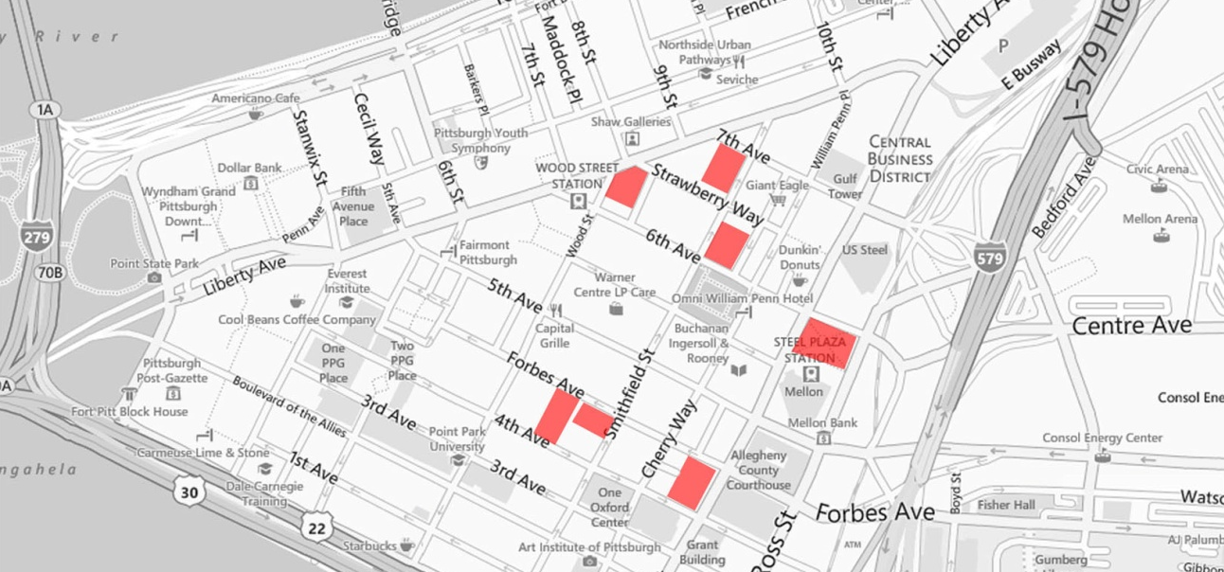
Figure 9. Locations of the seven preliminary sites
A visual impact analysis generates the information necessary to carry out the procedure. The basic footprint stretches the furthest dimensions of each individual site and represents the absolute maximum building extent. The dimensions dictate the length of an extrusion representing a basic high-rise form and its corresponding visual impact within the skyline. For instance, a 1.5 million square foot tower on a 200'x200' foot lot calculates as follows:

200' x 200' = 40,000 square feet. (Each floor plate can be determined this large)
1,500,000 sq.ft./40,000 sq.ft. = 37.5 floor plates (38 rounded up = number of stories)
38 stories x 15 feet per story = 570 feet needed for extrusion towards sky

Each plot is determined this way and exported to Google Earth for three dimensional visualization. It should be noted that these extrusions represent the minimum height necessary to fulfill a 1.5 million square foot program as they represent repeated and unbroken floor stacking without a setback. At any rate, the analysis proves helpful towards setting up a dialogue with potential sites and existing structures. (Figure 10)

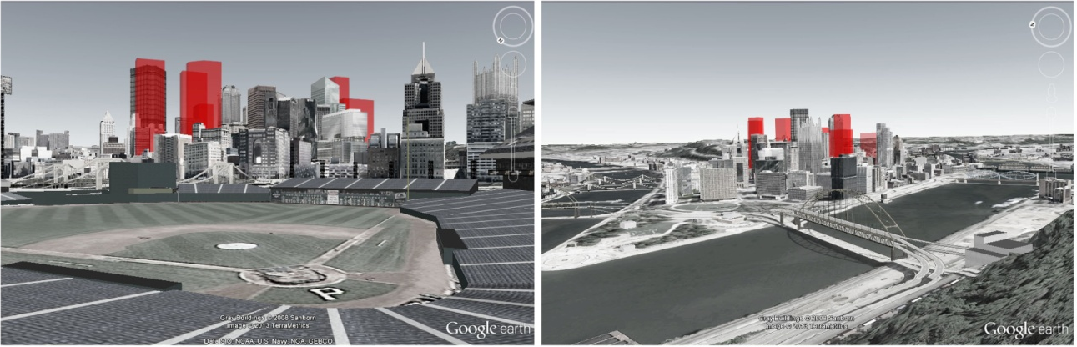

Figure 10. All seven study massing models extruded upwards within the CBD

The previous method reveals little more than a basic understanding of the intended massing. In an effort to further investigate the future design's impact at a city-wide scale, another investigation dove into the existing profile of the Pittsburgh skyline. As it currently exists, the tall buildings of the CBD taper towards the river from a high-point dictated by the extant US Steel Building. This visual clarity creates an organized and functional composition. Notably, the largest buildings exist toward the center of the golden triangle, able to collect light and views above their surrounding neighbors. As the built environment approaches the rivers, the building height decreases accomplishing two things. First, the lowering of height creates a more human scale for the parks that abut the river. Additionally, the tapering maximizes light penetration within the downtown core, effectively reducing blocked views, diminishing reflected and glaring light, and discouraging dark urban-canyons. (Figure 11)
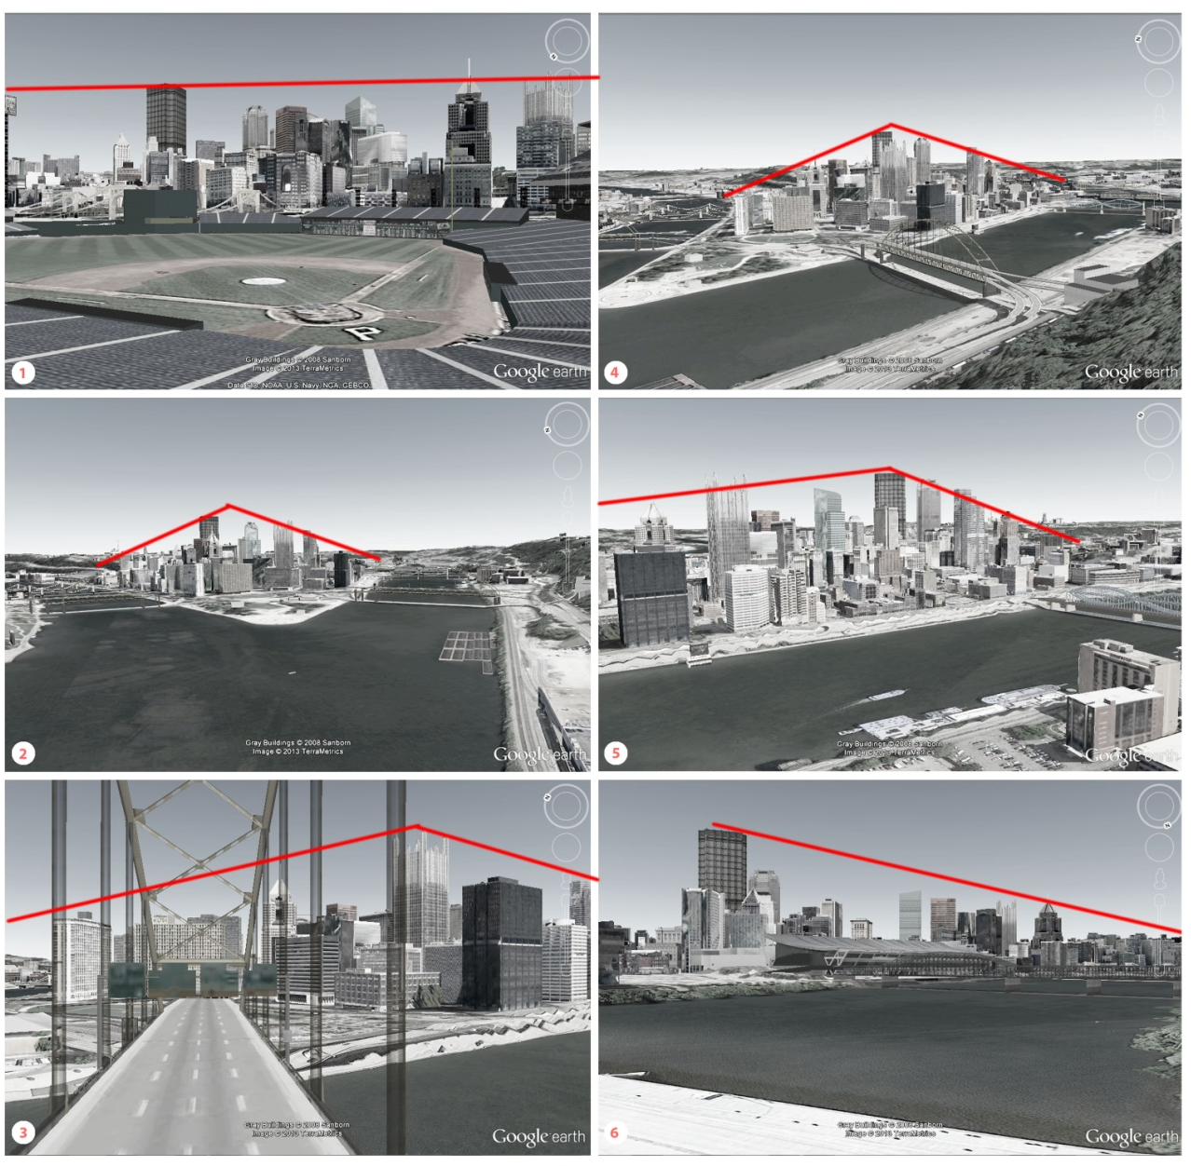
Figure 11. Regulating lines dictate the taper in buildings' height across the CBD

The combination of analysis techniques eliminates a majority of the pre-selected sites based on visual merit and compositional strength alone. Alas, several sites prove to positively integrate into the existing skyline justifying further refinement. This next approach focuses on localizing existing structures, ease of access, proximity to public transportation, and unique site conditions.
A height analysis based on a typical figure-ground study reinforces a number of obvious truths while exposing further levels of nuance. The figure-ground studies, operating at three different heights, illustrate potential viewing corridors and available natural light. By recognizing the height and impact of neighboring structures, a careful understanding of visual impact is further understood. (Figure 12) .

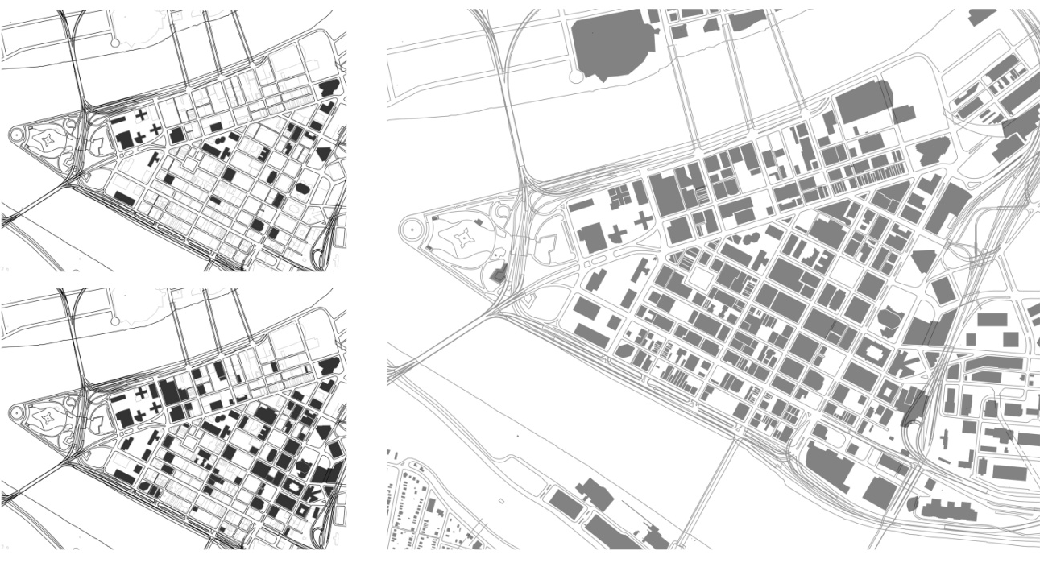
Figure 12. Figure ground at different heights - top left -350', bottom left - 125'

The next round of analysis focuses on local infrastructure. Locations of primary arteries, block orientations, and downtown green space further target one acceptable site. Priority is given to a site that locates itself on a primary road and on a knuckle-block that links the two block datums of downtown. At this time, proximity to green space is avoidable. A later discussion about program will further elucidate this idea. (Figure 13)

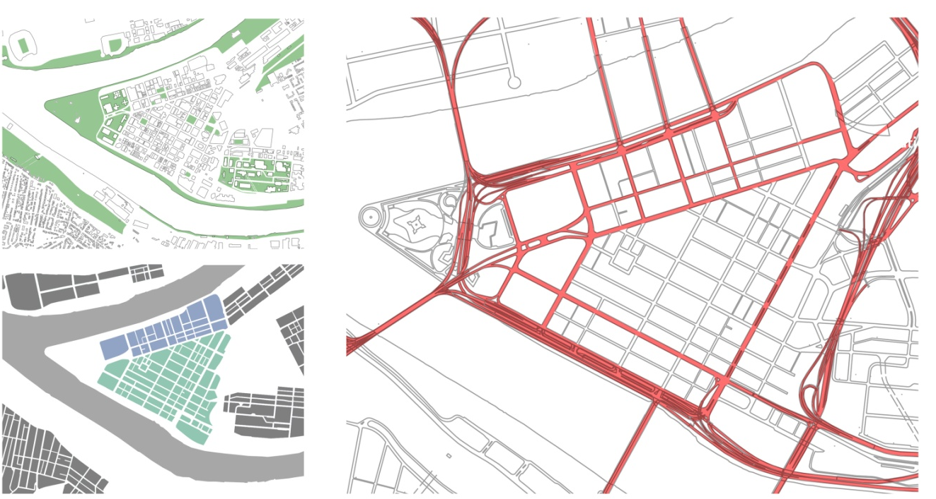
Figure 13. Green space, block datum, and major downtown arteries diagrammed

Finally, influence from major public transit hubs dictate the final site selection. Access to the city's extensive bus network is greatest on Liberty Avenue where nearly all of the bus routes terminate. Additionally, the location of the subway's Wood Street Station on Liberty Avenue further localizes the search. Lastly, Pittsburgh's high-speed bus corridors all route closely to the selected site. The convergence of Liberty Avenue, Sixth Street, and Wood Avenue proves to be a prime place for future urban development. As noted earlier, this site has fallen into severe underutilization and is primed for extensive development according to extensive analysis. (Figure 14)

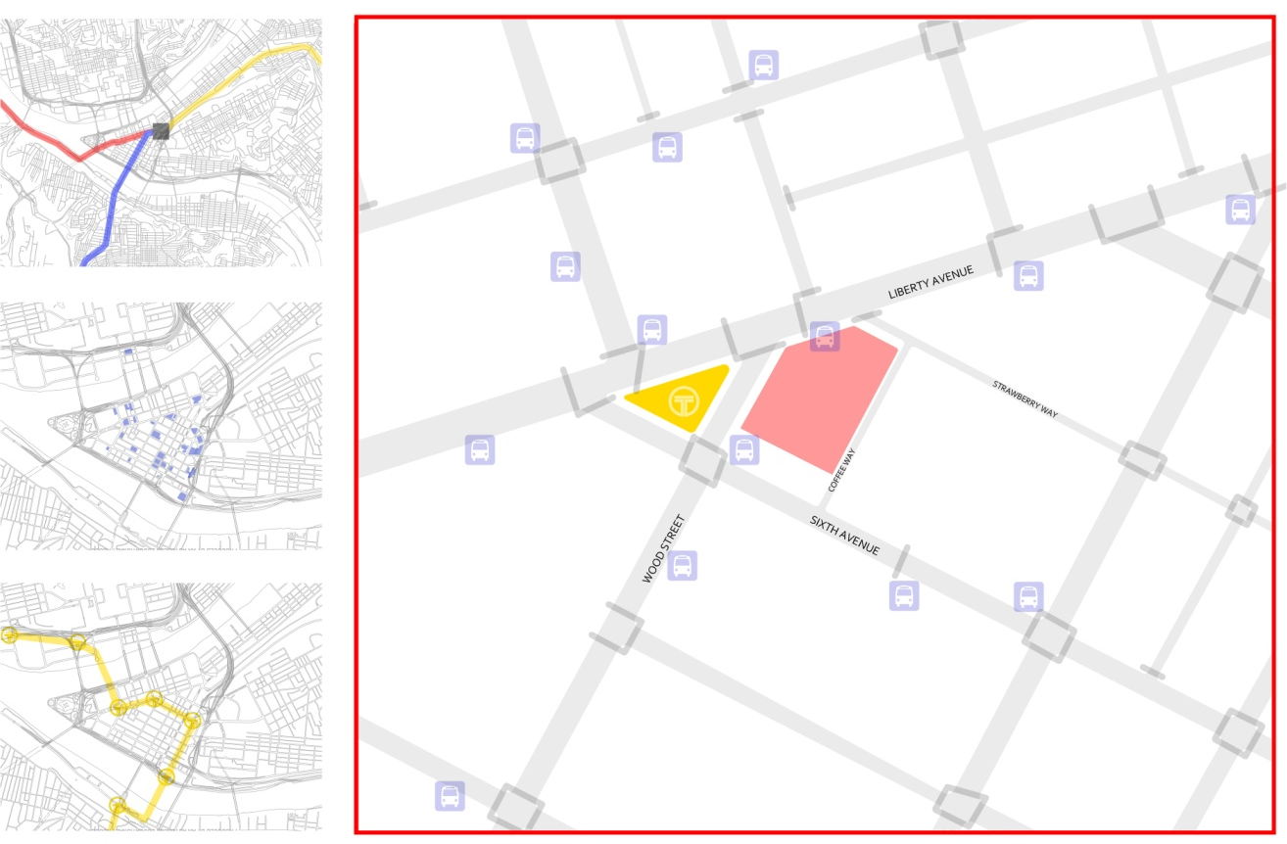

Figure 14. Influential conditions - top left - rapid bus corridors, middle left - parking, bottom left - subway routes and stations, right - the selected site(red) with bus stops(blue) and subway station (yellow)

The selected site requires the demolition of five existing buildings on the irregular-pentagon shaped block between Liberty Avenue, Wood Street, and Sixth Avenue. One building shall remain - the Granite Building. The Granite Building, formerly known as the German National Bank building was built by Bickel and Brennan in 1889. It is listed on Pittsburgh's Register for Historic Places and is a handsome nine story building on the corner of Sixth Avenue and Wood Street. The other five buildings are of varying height, program, and states of disrepair. (Figure 15,16,17)

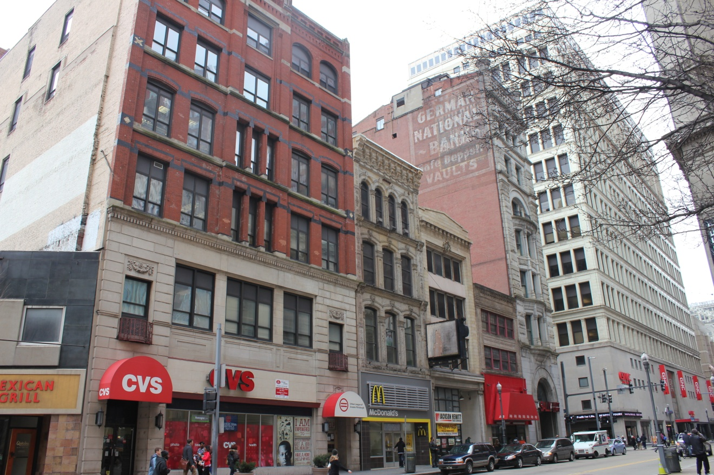

Figure 16. Facades of four of the five to-be-demolished buildings
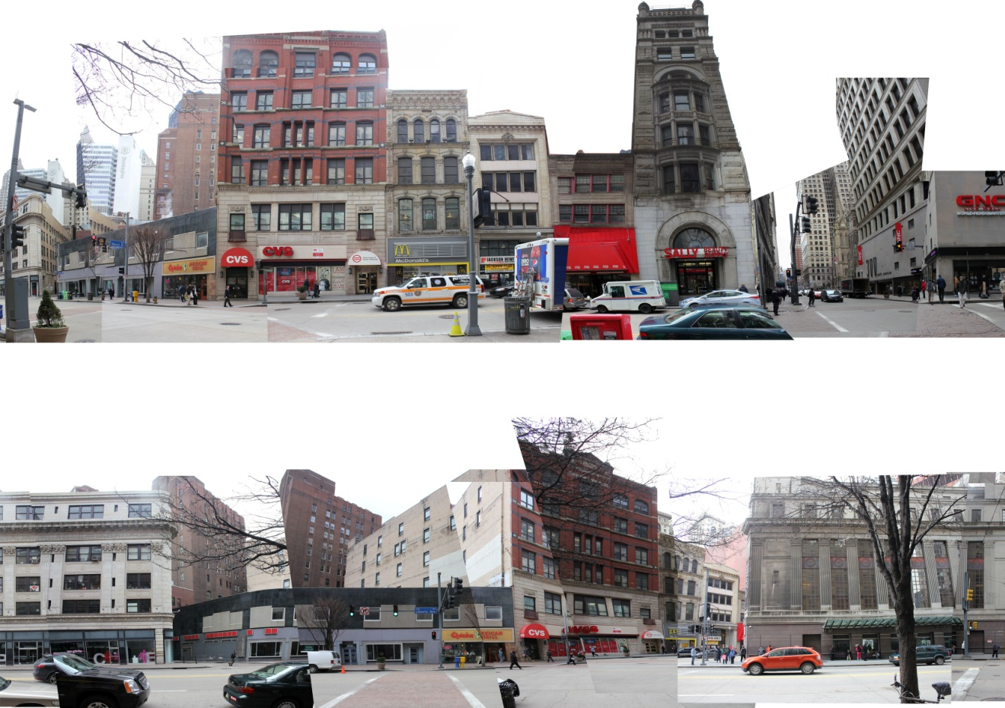

Figure 16. Photomontage-panorama top - Wood Street, bottom - Liberty Avenue
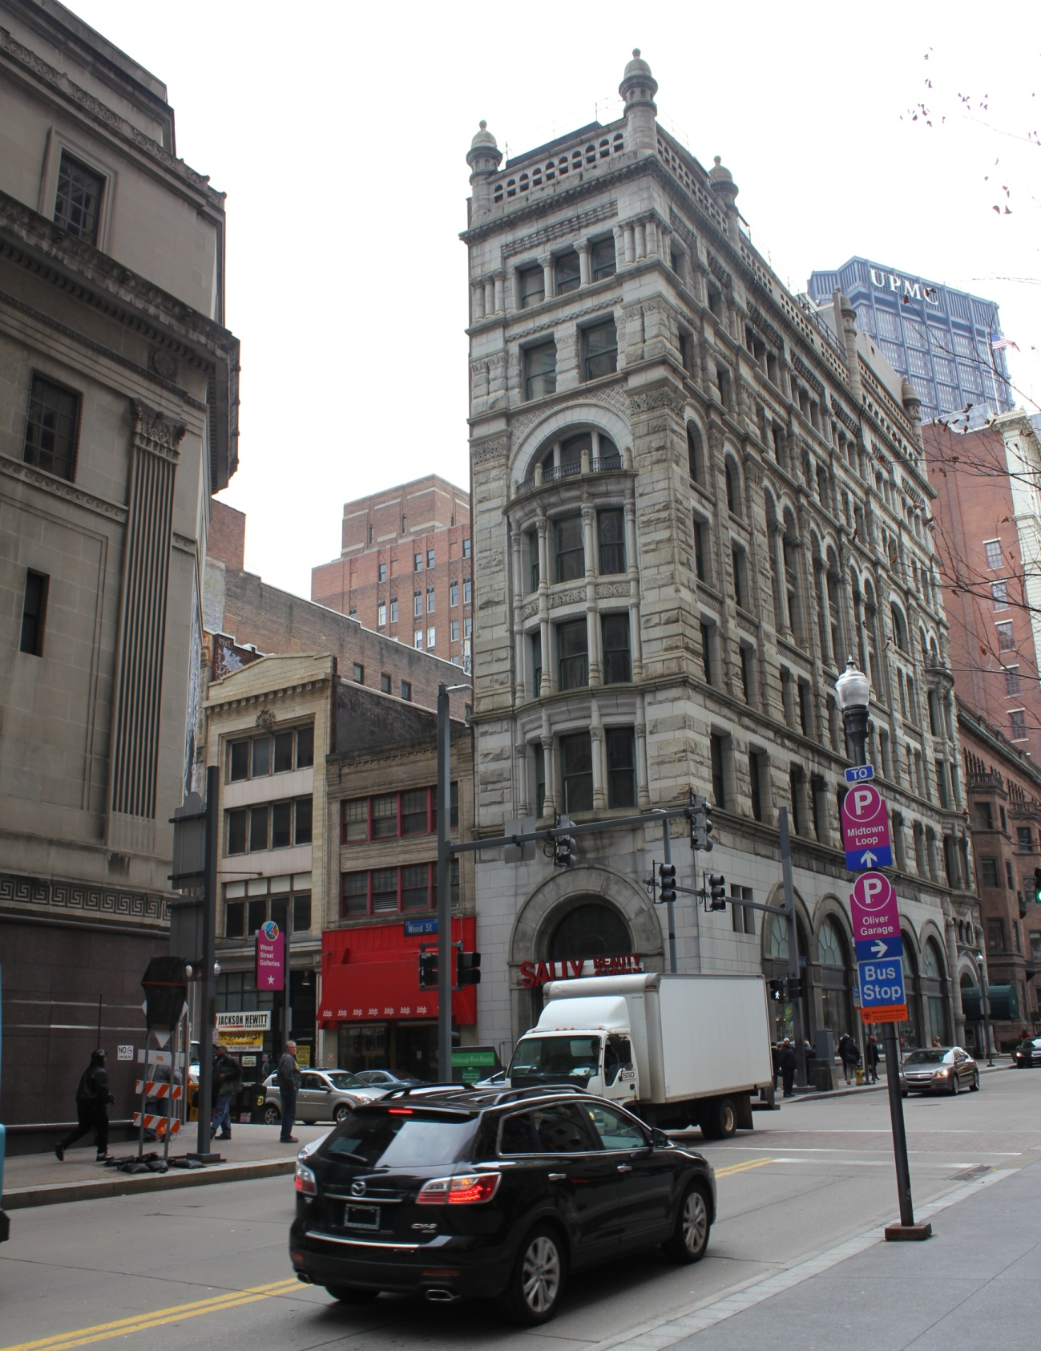

Figure 17. The Granite Building (1889) - slated to remain on the proposed block

CHAPTER VI

Programming the Tower

The new tower design will accommodate all one million square feet necessary for US Steel's new corporate office. (Belko, 2012) This office space is unique in scope as it is home both to the administrative business professionals and researchers/engineers. As such, accommodations are made adjusting the building's use to suit two far ranging work environments. Small scale laboratory space is also accounted for inside the building. Deployment of such spaces requires much different sizes, spacing, and code requirements, but such varied program offers exciting potentials for visual demarcation within a primarily vertical office building.
Additionally, one hundred thousand square feet of supplementary office space is developed in an effort to attract other companies to the downtown core and ease the existing demand for class A office space. Currently demand for such class A office space is at an all-time high within the CBD of Pittsburgh. (Colliers, 2013) Furthermore, an allocation three hundred thousand square feet as rentable condos and apartments add to the thriving community downtown. This addition should further the exciting trend as more people are craving downtown real-estate of their own.
The floor level presents itself as a challenging opportunity for program development. While the CBD remains the destination for commuting workers and visitors interested in culturally minded activities, the downtown has been unable to deliver many of the expected attractions. As it currently stands, the CBD is a place to work and sometimes shop, but hardly a place to hang-out or enjoy the scenery. As such, the proposed building activates the street with civic-minded space and affords access to the pinnacle of the tower's observation deck. Currently, Pittsburgh is remarkably absent such a space. (Figure 18)
The design of the tower integrates a seven story base before the tower projects through. It is here that the public has an opportunity to enter, rise and overlook the working-lab space. The opportunity to oversee the work of US Steel in a controlled environment creates a link between the citizenry and the city's past manufacturing heritage. The working-lab features huge pieces of machinery acting as sculpture at the street level encouraging public interaction.
Resting on the raised plinth that roofs the working-lab is the servery, working kitchen, and indoor/outdoor eating space. This program avails to the office workers. Accessible by elevator and stair this space is a casual environment linking US Steel employees across disciplines. Furthermore, the outdoor seating arrangement creates a raised pocket park, both lessening the urban heat island effect and providing much desired green space. The dislocation from the ground indicates a more private nature and rewards employees of the tower with a grand, raised platform from which to view the city.
The majority of the tower is fitted for an office arrangement. Separated only by a band of mechanical space, the roughly one million square feet of office program is seen as place for interactions between departments. Each floor plan is linked to those above and below. This configuration initiates physical activity and dialogue via an open lobby zone permeating the entire office complex.
Lifted off the office blocks, the residential units are raised to a lofty height to provide stunning aerial views and ample light. These units are designed as luxury apartments and are accordingly some of the most expensive units in the city. Above even the residential region, the observation deck allows visitors to view their city from a dynamic height.

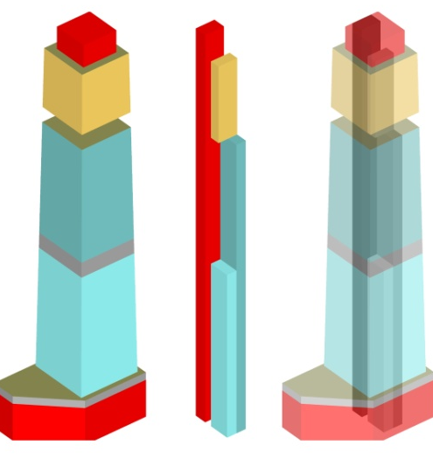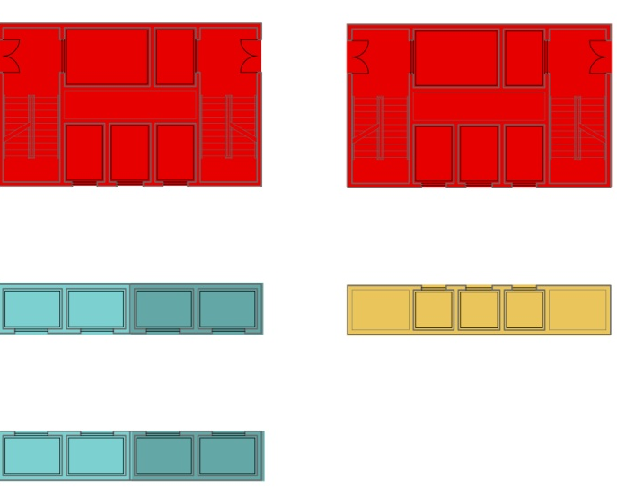

Figure 18. Program layouts Figure 19. Elevator program

Bridging multiple distinct program elements accomplishes several goals. It links Pittsburghers' with their city. It locates living units downtown, thus relieving some of the public transportation overload. Furthermore, locating expensive rental units downtown mitigates extraordinary construction costs and provides a revenue stream for the city. Finally it becomes “the chief symbol of an urban collective… a civic emblem.” (Attoe, 1981) People view the skyline as the symbol of their city, their region, and sometimes their way of life. This can all be accomplished through a mixing of people and place within one urban situation.
Connecting all these uniquely programmed elements in a vertical fashion has traditionally been the work of single stop elevators. The new US Steel tower minimizes the size foot-print of the vertical cores by zoning each elevator for a particular region. (Figure 19) For instance, one core serves the entirety of the building, acting as an emergency core. One core serves the office environment but only distributes workers every three floors in an effort to promote cross-pollination, physical activity, and speed of delivery. Finally, a sky-lobby allows for interchange at height in an effort to reduce core footprint, and provide a junction of public and private space. (Wells, 2005)

CHAPTER VII

Structuring the Tower

Today, the majority of steel used in construction is recycled. Steel is itself a renewable material. It is the material that permitted the construction of the first tall buildings. Over time, as many high-rises were subsequently torn down, their skeletons were harvested, recycled, and used for the next generation of super tall buildings. The percentage of recycled steel continues to rise in new construction and currently surpasses 85% of all used construction grade steel. (Ali, 1989) U.S. Steel has a legacy to celebrate knowing much of its steel was the first manufactured generation. Although it may not oversee the production of the vast quantities of new product it once did, a high percentage of any steel in any modern building across the world was originally manufactured by the huge Pittsburgh conglomerate.
Sustainable building design is the future of construction practice across the world. Recycled materials are just the beginning of any future design. Realistically, even massive buildings need to limit the amount of material input even if the material is recycled. As a structural system, metal supports have already undergone a massive overhaul in technology and implementation. Beginning with cast and wrought iron ferrous structure evolved into steel, then high strength steel, and continues today with additives and alloys making the product stronger and more durable. These improvements consistently reduce the total amount of structural product necessary for any new construction. Interestingly though, new techniques in structural design and engineering have further reduced the amount of steel necessary to erect tall structures. Innovative processes brought forward by Buckminster Fuller three-quarters of a century ago and theorized a century before that by Vladimir Shukhov are finding their way into our modern skyscrapers. (Ingenhoven, 2007) New processes are helping to create unique forms while eliminating excess materials. (Figure 20)
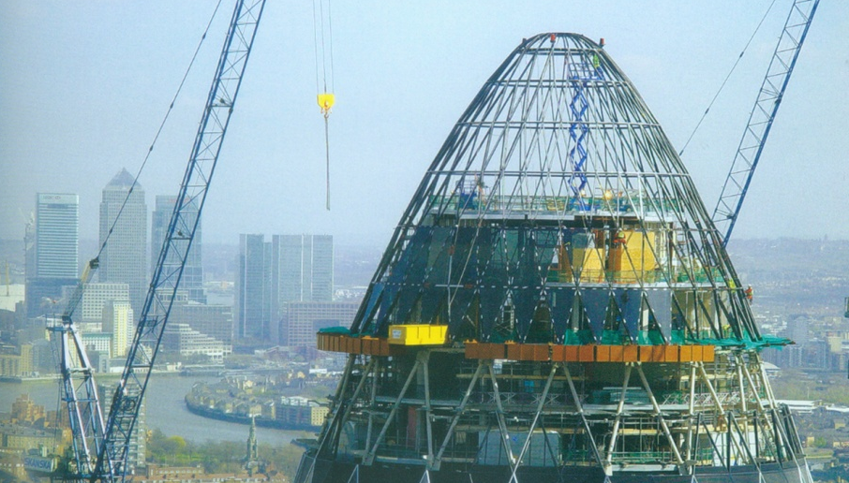
Figure 20. Swiss Re building in London by Sir Norman Foster and Parteners
The base unit of a diagrid is composed of interconnected support beams that form a diagonal grid. Diagrids work in plane and are resistant to axial forces when vertical. The diagonal geometry, with angles of less than 45 degrees in the direction of predominant loading, enhances the unit stiffness resistance to bending moments by increasing cross-bracing resistance, which is far more efficient than an orthogonal grid. (Moussavi, 2009) The distribution of loads along the diagonal lattice embeds the diagrid base unit with an optical affect of lightness and crystallinity that remains consistent within any space it defines. (Figure 21)
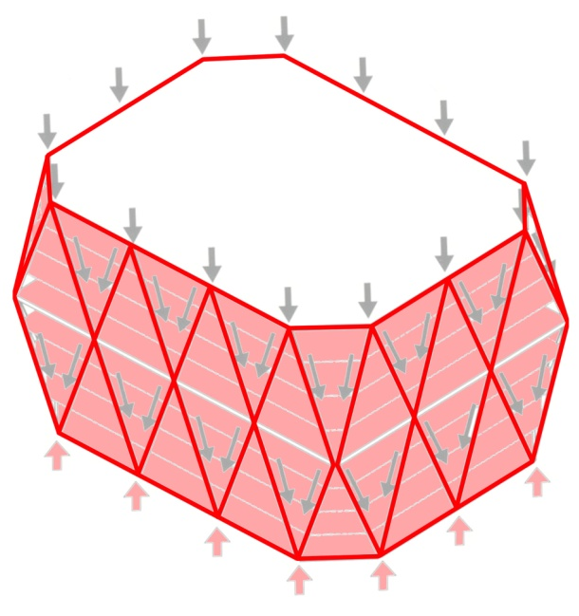 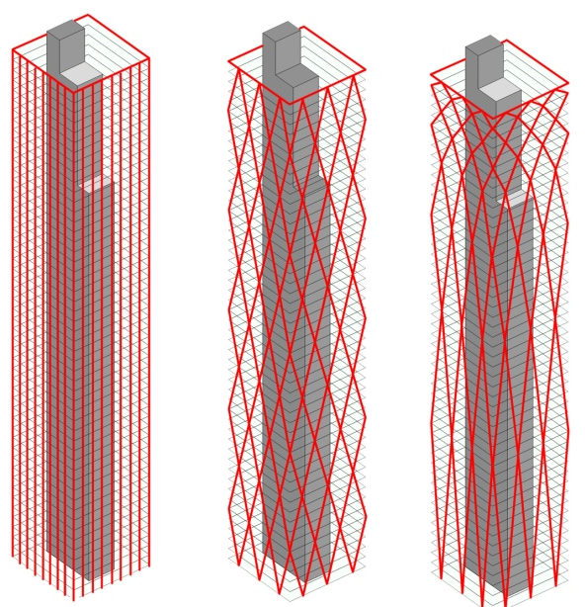
Figure 21. Diagrid loading diagram Figure 22. Structural reduction
To further enhance the diagrid, an emphasis is placed on limiting the structural members. By varying the diagrid's height-to-width ratio over the course of elevation, the structure is more capable of countering the vertical loading at the bottom and lateral loading at the top. By progressively containing fewer stories as the diagrid repeats vertically, the structure can be more massive and sparse at the bottom of the tower while more intricate and filigree towards the top. (Moussavi, 2009) Additionally, the diminishing the tessalation leads to the visual effect of finiteness and completion. (Figure 22)

CHAPTER VIII

Design Development

While initially slotted at just over six hundred feet in height, the structural, aesthetic, and massing strategies determine an appropriate height at just over eight hundred feet. Such height makes the tower the second tallest in Pittsburgh's CBD. Its increase in height can mainly be attributed to a desirable stepping-back in accordance with vertical rise. The step-back allows for separation from neighbors and a lessened cast shadow below. It also creates an iconic and more structurally stable form.
The ground floor plan is easily distinguishable as three programmatic entities. (Figure 23) Directly adjoining the Granite Building on Wood Street, the entry space is served by the vertical core and an easily accessible escalator for transportation within the lower observation space. Flanking the entry space is the large, open laboratory space separated only by a monumental glass curtain. Abutting the alley is the third major program space: the loading dock. This area receives a back-of-house treatment and operates as part of the functional nerve center for the entire structure. On the ground floor, the entire plot is utilized in an effort to both draw in pedestrian traffic and maximize floor space for grand laboratory and entry spaces.
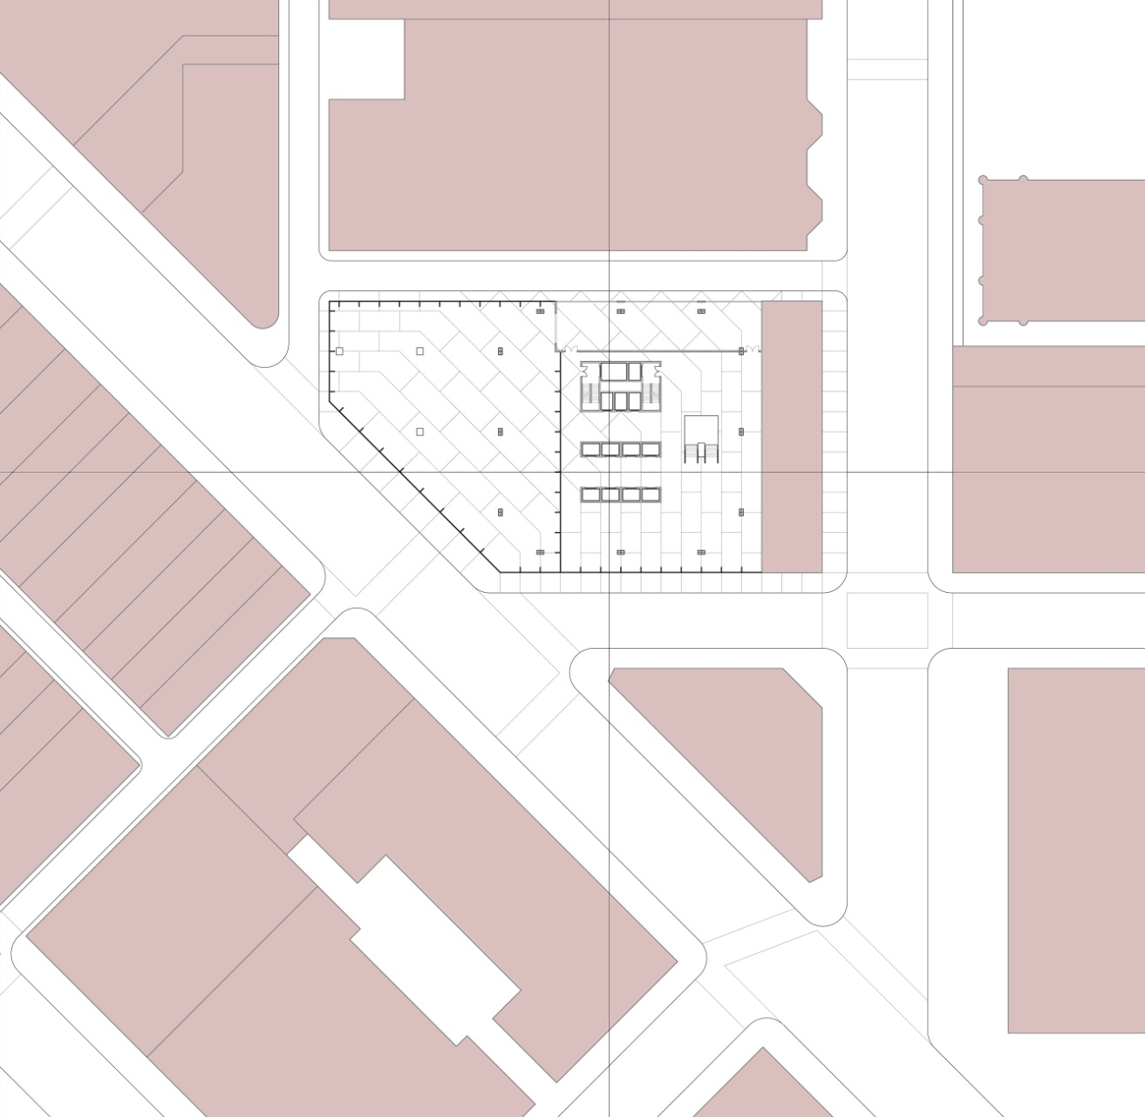
Figure 23. Site ground Plan

The entire base portion of the structure is surrounded by a monumental glass fin wall which allows for an easy reading of the tower's structural diagrid as it extends to the ground. The glass works doubly as a completely transparent skin utilized for its potential as a minimal barrier thus drawing pedestrians inside.
Standing above the lobby space, the indoor/outdoor eating deck aims to serve interested US Steel employees during the lunch hour. (Figure 24) Specific accommodations are made for kitchen/cafeteria staff, serving areas, and a variety of eating set-ups. Once again surrounded by fin glass, the cafeteria takes on an open-air vibe in an effort to promote well-being and worker happiness.

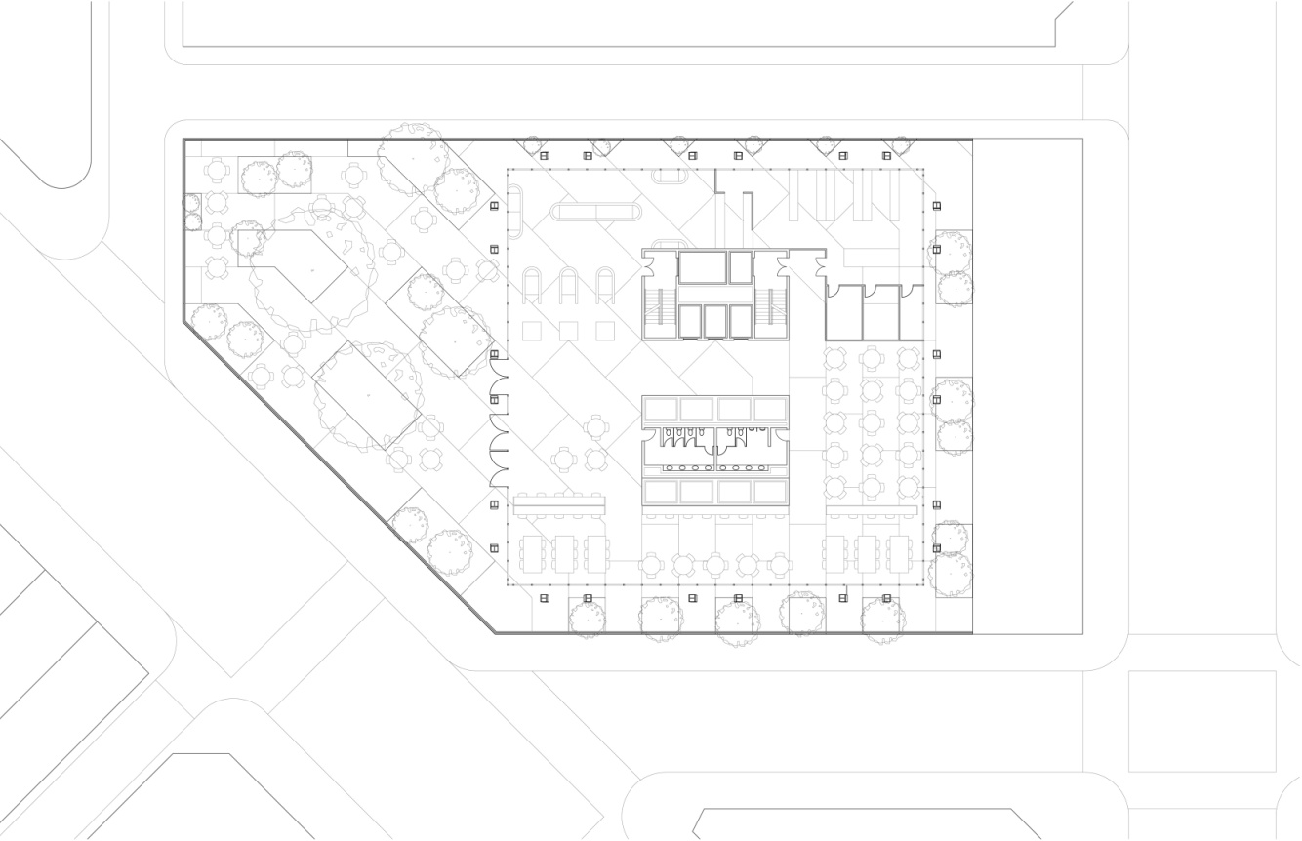
Figure 24. 7th Floor Plan - Indoor/Outdoor Cafeteria

Rising ever skyward, a number of programs constitute the tower portion. Office spaces are designed to accommodate a multitude of working environments. Special focus and attention is paid to integrating highly public and highly private work environments across a standardized floor plate. Access to light and ventilation is readily accessible. A collaborative working environment is emphasized by connecting floors through shared lobby space. (Figure 25,26) Developed as three floor packages, just one elevator bank serves each node. From here, employees are encouraged to rise or descend one floor to reach their destination. In addition to promoting increased face-time with colleagues, this system shortens arrival time and fosters an open air policy. In this sense, every business floor is essentially three floors, psychologically opening-up the working environment.

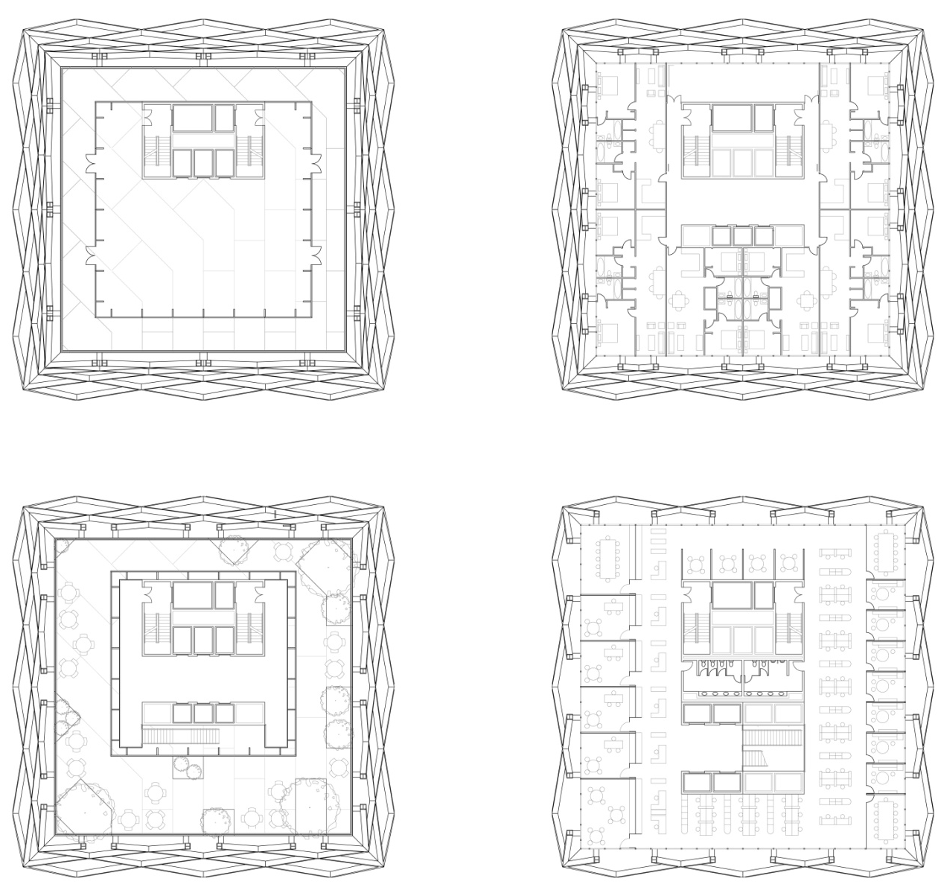
Figure 25. Several floor plans. Bottom right - typical office layout, Bottom left - sky lobby, Top right - typical residential layout, Top left - observation deck

Separating the residential portion of the structure from the office program, the sky lobby functions on multiple levels. The multi-leveled space acts as a filter whereby separating the public from the residents well off the ground. This set up also works as an elevator interchange, where some shafts end and others begin. This rationale allows the lifts to be more localized consequently serving their occupants more quickly and efficiently. As an additional feature, the sky lobby is surrounded by an occupiable green roof. This sky garden rises above the 545 foot pinnacle of the immediately proximal K&L Gates center and becomes a visual marker in the skyline. (Figure 25,26,27)

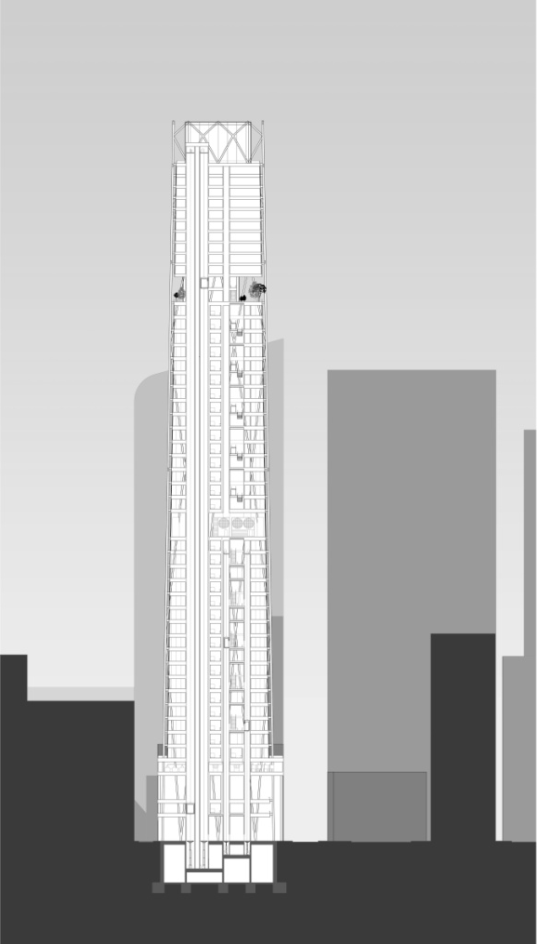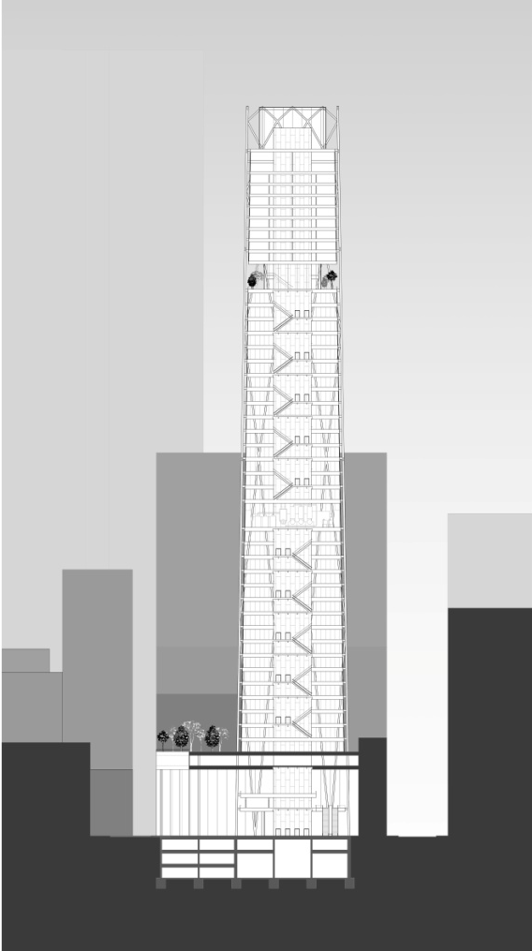

Figure 26. Design sections showing relation to urban context. Left - emphasizing vertical circulation, Right - emphasizing program interchange

Capping the tower are the residential and observation deck portions of the building. Each are located high in the sky to give unrivaled vistas of the region. The series of one thousand square foot apartments are laid out in a flexible plan and capable of re-arrangement for larger and grander layouts. The observation deck affords panoramic views of the surrounding city and landscape from the safety and enclosure of a highly articulated glass box (Figure 25, 26)

CHAPTER IX

Architectural Experience

As the second largest building in Pittsburgh, and perhaps the most visible, the proposed high-rise will command visual attention throughout the surrounding landscape. In addition, the new tower will function as both office and observation platform which necessitates a specific handling of exterior aesthetics. Above all, the expression of steel remains particularly important and is deployed smartly and delicately. (Figure 27)
Separating the surrounding structural diagrid shell from the interior spaces immediately resolves many issues. By doing so, the essential structure is put on direct display as an exterior wrapper. As a snaking, intertwined sculptural entity, it supports the entire high-rise. Additionally, the separation leaves room for the insertion of a primary solar shield to block the harsh sunlight.
Set immediately behind the primary diagrid structure, but still outside of the building envelope, the solar shield of perforated metal addresses several issues. First, it blocks much of the unwanted direct light and diffuses it for more apt interior use. By deflecting the direct light, the solar shield is capable of reducing the solar gains which constitute the majority of high-rise buildings' energy expenditures. (Moe, 2008) In the winter, this system operates in reverse and ostensibly operates as a jacket reflecting escaping heat back towards the building.
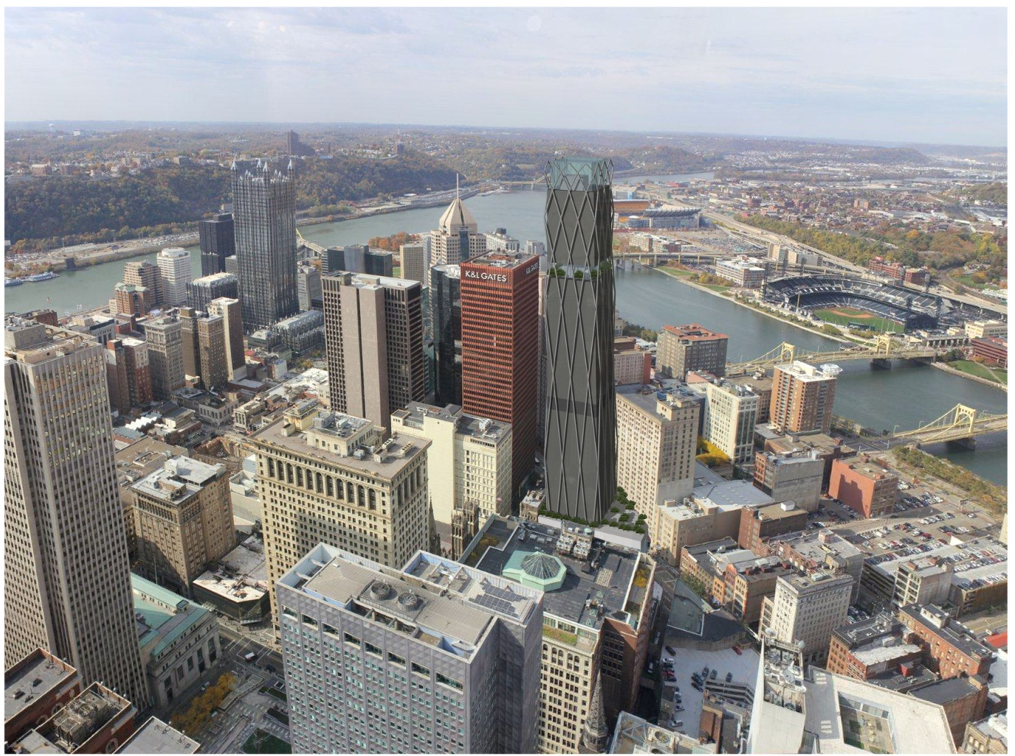

Figure 27. Aerial view of the new Steel Tower taken from 59th floor of US Steel Tower

Also attaching directly to the building's structural diagrid is the programmable lighting system. This system shines outwardly as not to affect or distract occupants/workers inside. It is further developed to attract and beckon outsiders to the structure. The environmentally responsible LED tracks along the exterior surface of the building express the unique structuring at night. (Figure 28)
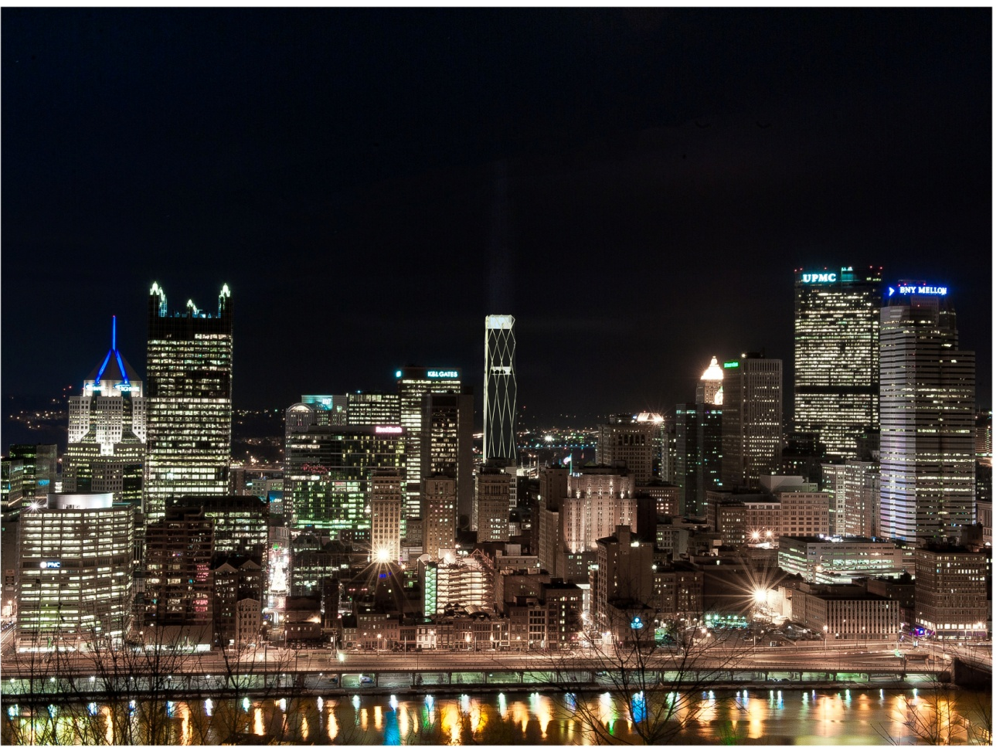

Figure 28. Night view of the new US Steel Building (center/back) from Mt. Washington

The total effect of the building is meant to inspire the next generation of tall building designs. The configuration is meant to push the structural capacities of steel and thereby enlighten the public to its inherent material capabilities. Throughout recent history, architects have sought smart deployment and expression of the structurally marvelous material. The city of Pittsburgh and US Steel deserve such an expression on a grand scale. By combining sheer size with an innovative structural system, the Steel Tower seeks to become the tall building in Pittsburgh, PA.

LIST OF REFERENCES

Ali, M. M. "Structural System and Material Selection for a 40-story Building in Chicago," Proceedings of International Conference on High-rise Buildings, Nanjing, China, March, 1989.

Ali, M. M. "The Skyscraper: Epitome of Human Aspirations," Proceedings of the 7th World Congress on Tall Buildings and Urban Habitat: Renewing the Urban Landscapes. New York, NY: ASCE, October, 2005.

Attoe, W. Skylines: Understanding and Molding Urban Silhouettes, New York, NY: John Wiley, 1981.

Beedle, L.S. "The Reporter Calls," CTBUH Review Journal, Vol. 1, No. 1, reprinted in Catalyst for Skyscraper Revolution: Lynn S. Beedle-A Legend in His Lifetime, M.M. Ali, ed., 2004, Chicago, IL: Council on Tall Buildings and Urban Habitat, 2000.

Beedle, Lynn S., Mir M. Ali, and Paul J. Armstrong. The Skyscraper and the City: Design, Technology, and Innovation. Lewiston: Edwin Mellen, 2007.

Belko, Mark. "Strip, Findlay Considered for U.S. Steel Headquarters." Pittsburgh Post-Gazette 11 Sept. 2012:

Carnegie Mellon University, "EPP GRADUATE FAQ - The Pittsburgh Setting." Engineering and Public Policy. N.p., n.d. Web. Apr. 2013.

Codella, F.L. and McArthur, A.J. "Architecture of Tall Buildings," Planning and Design of Tall Buildings: Proceedings of ASCE-IABSE International Conference, New York, NY, Vol. 1a, No. 1-8, 1973.

"Colliers International." Pittsburgh | Pittsburgh | Colliers International. N.p., n.d. Web. Apr. 2013.

Denk, Ellen, "The Origins of the High-Rise Building." Detail Sept. 2007: 935+.
Foster, Norman, and David Jenkins. Catalogue Foster and Partners. München [u.a.: Prestel, 2005.

Foster, Norman, and David Jenkins. Foster 40: Themes - Projects. Munich [u.a.: Prestel, 2007.

Goldberger, P. The Skyscraper, New York, NY: Alfred A Knopf, 1981.

Gonçalves, Joana Carla Soares., and Érica Mitie. Umakoshi. The Environmental Performance of Tall Buildings. Washington, DC: Earthscan, 2010.

Huxtable, A.L. The Tall Building Artistically Considered; The Search for a Skyscraper Style,New York, NY: Pantheon, 1984.

Ingenhoven, Christoph, "Typological Aspects of High-Rise Buildings." Detail Sept. 2007: 956+.
Kaltenbrunner, Robert. "Icons of Progress - High-Rise Buildings, Their Motivation, Aesthetics and Effects." Detail Sept. 2007: 928+.

Kavanagh, T.C. "Environmental System,"Planning and Design of Tall Buildings, Proceedings of Conference, Bethlehem, PA, Lehigh University, August 1972, Vol. Ia, New York, NY: American Society of Civil Engineers, 1972.

Lynch, K., 1960. The Image of the City, Cambridge, MA: MIT Press

MacMillian, A. and Metzstein, I. "Amenity and Aesthetics of Tall Buildings," Planning and Design of Tall Buildings, Proceedings of Conference, Bethlehem, PA, Lehigh University, August 1972, Vol. Ia, New York, NY: American Society of Civil Engineers, 1974.

Farshid Moussavi: The Function of Form. Barcelon: Actar, 2009. Print.

Moe, Kiel. Integrated Design in Contemporary Architecture. New York, NY: Princeton Architectural, 2008.

Naisbitt, J. Megatrends. New York, NY: Warner Books, 1984.

Reichel, Alexander. Building with Steel: Details, Principles, Examples. Basel: Birkhauser, 2007.

Sullivan, Louis H. "The Tall Office Building Artistically Considered." Lippincott's Magazine, March 1896.

Toker, Franklin. Buildings of Pittsburgh. Chicago: Society of Architectural Historians, 2007.

Wells, Matthew. Skyscrapers Structure and Design. New Haven: Yale UP, 2005.

Wood, Antony. Best Tall Buildings 2009: CTBUH International Award Winning Projects. New York: Routledge, 2010.

Yeang, Ken. Service Cores. Chichester, West Sussex: Wiley-Academy, 2000.

Vita

Peter Guldenshuh Duke was born in Harrisburg, Pennsylvania on August 6, 1987. He is the son of David Charles Duke and Nina Guldenshuh Duke. After completing his work at Cedar Cliff High School, he matriculated to the University of Pittsburgh where he majored in Architectural Studies in 2010. For the next three years Peter pursued his Masters of Architecture at the University of Tennessee where he graduated in the spring of 2013.

