Advancing Established Natural White Oak (Quercus alba.) Reproduction Through a Midstory Removal

A Thesis Presented for the
Master of Science
Degree
The University of Tennessee Knoxville

Canaan Jeffrey Dugger
August 2023

Acknowledgments

I would first like to show my most sincere gratitude towards Dr. Wayne Clatterbuck and the numerous opportunities, resources, and mentorship he has provided me with through the years of working with him. I feel fortunate as well as privileged to have worked on such a meaningful project with a great and knowledgeable advisor.
Thank you to my committee members Dr. David Buckley and Dr. Adam Taylor for being such great resources and mentors, both in my time as an undergraduate as well as a graduate student. Both have had profound and lasting positive influences on my academic and personal life.
Thanks to Dr. Kevin Hoyt and the wonderful staff at the UT Arboretum at Oak Ridge for being flexible and accommodating with my schedule as well as allowing me to conduct a multiple year study on their grounds.
To even begin to try and express all the gratitude and appreciation I have for all of the wonderful friends and family I am fortunate to have in my life, would become a list far too long for this section. For all those that take the time to read this, you know who you are, and I thank you for everything you do for me.
To Mom and Dad, thank you for always granting me the freedom for following my passions, supporting me all along the way, as well as providing me with so many essential lessons, skills, and values through the years. I love and respect you both for all that you have done for me.
Lastly, I want to give my appreciation and recognition to my wonderful partner, Tara Skiba. If it wasn’t for all of her selfless time and patience, she has so generously given me over the years, from always listening and supporting me to all the delectable cooking she provided me and in addition to helping me collect field data each season, and walking me through the rigorous world of R, there would be no way I could have made it this far without her. Thank you for everything Tara. I look forward to what the future holds for the two of us.

Abstract

In recent decades, there has been an alarming decline in white oak (Quercus alba.) regeneration and recruitment occurring within eastern forests. Historically, the frequency and the intensity of anthropogenic disturbances was dynamic over the landscape. However, over just the last century a major compositional shift has occurred from this change in disturbance regimes. Eastern forests are now promoting the regeneration of mesic species that obstruct white oaks’ ability to compete successfully and establish in the upper canopy.
The majority of successful white oak regeneration and recruitment is now occurring on the average to more xeric sites. Limited studies have been conducted that assess the effects of a midstory removal on the growth and abundance of advanced white oak reproduction that resulted from a mast acorn crop season. This study was conducted at the Oak Ridge Forest Resources Research and Education Center (FRREC) over two complete growing seasons. A previous season’s mast acorn crop, resulting in the forest floor being carpeted with advanced white oak reproduction, was utilized by applying a midstory removal to enhance white oak seedlings. This study aims to investigate the effects of increased intermediate light conditions on reproduction, growth, and abundance of white oak seedlings and competitor species.
Data were analyzed in R. The results indicate a positive response from white oak seedlings receiving the midstory removal treatment on the plot and subplot level. Changes in white oak seedling height classes on the plot level were observed following each growing season as well as from the first to last year. There was also significant differences observed between treatments on the subplot level in percent height and root collar diameter (RCD) growth following each growing season and from the first to last year. In addition, there were differences in ranges of percent height growth and percent light received between the two treatments. This study provides additional information to the existing literature of silviculture, evaluates the immediate effects of a midstory release cut on growth and abundance of advance reproduction that resulted from a bumper acorn crop season, and provides guidelines for advancing established natural white oak reproduction.

Table of Contents

Chapter 1: Introduction 1
Objectives 4
Chapter 2: Review of Literature 5
The history and influence of disturbance 5
Biology and Ecology of White Oak 9
Principles of white oak silviculture 12
Chapter 3: Materials and Methods 17
Study site 17
Study installation and design 18
Data collection 24
Data analysis 26
Chapter 4: Results 28
Study analysis 28
Response of white oak 31
Response of maple 37
Photosynthetically active radiation (PAR) 42
Chapter 5: Discussion 49
Response of white oak 49
Response of Maple 53
Photosynthetically active radiation (PAR) 55
Management implications 57
Chapter 6: Conclusions 60
References 62
Vita 75

List of tables

Table 1: DBH classes and total tree species removed in midstory release cut by plot location. 23
Table 2: Total number of tagged control and release subplot seedlings across years, with maple and white oak seedling totals. 30
Table 3: Average subplot height and RCD by treatment and year regardless of species. 32
Table 4: Total number of tagged subplot white oak seedlings by treatment and year. 33
Table 5: Raw number of white oak seedlings by plot level height class with percent total for each year and treatment 35
Table 6: White oak subplot seedling average percent height and RCD growth by treatment and by year 36
Table 7: Average height and RCD of subplot white oak seedlings with a minimum and maximum range of total measurements taken by treatment and year. 38
Table 8: Total number of tagged subplot maple seedlings by treatment and year. 39
Table 9: Raw number of maple seedlings by plot level height class with percent total for each year and treatment 40
Table 10: Maple subplot seedling average percent height and RCD growth by treatment and by year 43
Table 11: Average height and RCD of subplot maple seedlings with a minimum and maximum range of total measurements taken by treatment and year. 44

List of Figures
Figure 1: Acres of white oak forests and respective age classes. 3
Figure 2: Advanced white oak reproduction abundance for plot placement and installation. 19
Figure 3: Schematic for plot outline and subplot placement system as well as location and direction of ceptometer measurements. 20
Figure 4: Map of FRREC with release plot locations in red and control plot locations in blue. 21
Figure 5: White oak and maple seedlings with attached aluminum tags. 25
Figure 6: Plot level abundance by treatment and year for white oak and maple, and Miscellaneous species. 29
Figure 7: Box and whisker plot comparing control and release white oak seedlings average height growth across all years. 41
Figure 8: Box and whisker plot comparing control and release maple seedlings average height growth across all years. 45
Figure 9: Scatterplot of control and release white oak seedling height growth in response to percent light received. 46
Figure 10: Scatterplot of control and release maple seedling height growth in response to percent light received. 48

Chapter 1: Introduction

White oak (Quercus alba) is a keystone species within our eastern forest ecosystems and is involved directly in many critical ecological processes. White oaks provide a myriad of benefits, including hard mast and habitat for wildlife species, valuable lumber to society, and vital ecosystem services such as soil stabilization, air purification, and the sequestration of carbon (Cavender-Bares 2016). Oaks (Quercus spp.) support and create interactions with more forms of life than any other tree genus in North America (Tallamy 2021). Oak ecosystems spread across 114 million acres (Loftis et. al. 1993) which makes up over half of eastern forest composition (Dey 2014a). However, white oak currently faces numerous competitive pressures that have hindered its ability to successfully regenerate and recruit into the upper canopy.
These pressures brought on by local competitive species could effectively threaten future representation of white oak within the eastern forest ecosystems. Due to the vast shifts from historically frequent disturbance regimes over the last century, forest microclimates have been drastically transformed to foster many of the major shade-tolerant oak competitor species such as maple (Acer spp.), American beech (Fagus grandifolia), and flowering dogwood (Cornus florida). Without the occurrence of intermediate and frequent disturbances, these shade-tolerant species have created dense midstory canopies which obstruct sufficient levels of diffuse light from reaching the forest floor. This in turn has effectively reduced the overall competitiveness of white oak regeneration across much of its historically dominated sites. When ample sunlight does reach the forest floor following a larger disturbance event, shade-intolerant species such as yellow poplar (Liriodendron tulipifera), black cherry (Prunus serotina), and sweetgum (Liquidambar styraciflua) often respond much quicker and outcompete the slower growing white oak seedling (Ashton & Kelty 2018). If this trend continues, over time it would lead to the loss of seed sources as well as a substantial decline in white oak stocking which would certainly cause severe harm to both local ecosystems and economies.
The upfront investment of time and money associated with successful white oak management prove to be a challenging barrier, especially for private landowners. Currently, about 80% of the eastern oak forests are privately held (McShea 2007). Butler (2008) reported that only one in five acres of family forest land in the East is owned by someone who has a written forest management plan, two in five acres is owned by someone who has received forest management advice. The coordination and cooperation of landowners with natural resource professionals is crucial for the future of white oaks forests since the majority of it occurs on privately owned land within the eastern United States.
White oak has evolved to possess a variety of physiological adaptations in response to disturbance as well as competitive pressures. These adaptions should be utilized in order to implement successful silvicultural treatments. Decades of scientific studies have documented that with adequate quantities of advance reproduction is necessary to regenerate oak (Sander 1972, Loftis 1990, Clatterbuck 2019). A midstory release can be a practical option to recruit seedlings into the forests future upper canopy (Hackworth et. al. 2020). By providing suitable levels of diffuse light to the forest floor, seedling competitiveness should increase. However, serious actions and long-term commitments must be instigated by landowners and natural resource professionals. Current stocking trends suggest that there are currently insufficient amounts of younger white oak to replace the older cohorts that will eventually die off or be harvested (Figure 1). This has led scientists, landowners, and natural resource professionals to ask: What will the future of white oak representation look like in our forests?

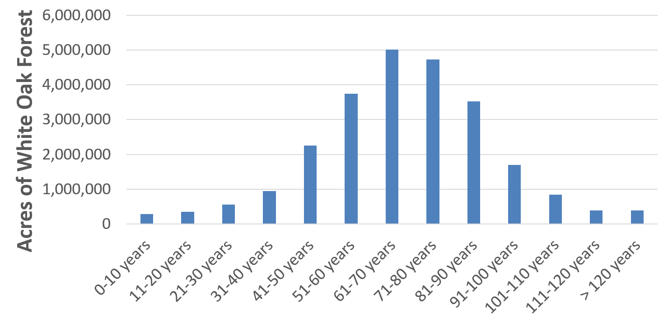
Figure 1: Acres of white oak forests and respective age classes (White oak Initiative. Restoring sustainability for white oak and upland oak: An assessment and conservation plan. p. 64. https://www.whiteoakinitiative.org/assessment-conservation-plan) (2023).

Objectives

The three objectives of the study are as follows:

- To examine the effects of a mid-story removal treatment on the growth and abundance of advance white oak reproduction resulting from a bumper acorn crop.

- To examine the effects of a midstory removal on the growth and abundance of white oak competitor species.

- To examine the relationship of increased diffuse light created by a midstory removal treatment to the growth of advanced white oak reproduction and competitor species.

Chapter 2: Review of Literature

The history and influence of disturbance

To understand the current ecological constraints white oak faces, one must recognize the long history and influence that disturbance has had on developing the composition of eastern forests. This study refers to white oak as Quercus alba while oak refers to Quercus spp.
In the last 18,000 years, many shifts in species assemblages have occurred within eastern North America due to climatic, biotic, and abiotic factors (Abrams 1992). However, in just the last 350 years, the landscape and composition of forests have undergone a near complete transformation (Whitney 1994, Foster et. al. 1998). Prior to European settlement, white oak was one of the dominant tree species across a diverse range of landscapes and sites (Abrams 2003). Palaeoecological and dendrochronological studies reveal oak dominance began during the early Holocene epoch when warmer and drier periods promoted the regular occurrence of fire (Abrams 1992). Throughout the rise in Native Americans populations, the incorporation of fire as a management tool for clearing agricultural land, creating game trails, reducing insects and pests as well as driving game from the forest is apparent (Whitney 1994, Mann 2005).
Historical documents also indicate that Native American ignitions far outnumbered natural causes in most locations (Gleason 1913, DeVivo 1991). There is a myriad of biotic and abiotic stimuli, as well as physiological adaptions, that allowed oak to maintain their dominance in eastern forests through the centuries. However, fire was a contributor for the creation and maintenance of pre-settlement oak forests (Abrams 1992). Dey (2014a) described fire as the matrix or the background disturbance that favored the development of oak reproduction. Humans have also dramatically shaped and developed forest composition with fire over many centuries (Nowacki & Abrams 2008). Towards the end of Native American cultural presence, fire interval ranged from every two years or less in southern areas to 50-100 years in the Northeast, at low to medium severities (Wright & Bailey 1982, Frost 1998, Guyette et. al. 2006).
A majority of pre-settlement animals, vegetation, and tree species were adapted and maintained by these recurrent lower intensity fires. Oak, pine (Pinus spp.), and many hardwoods species dominance on the landscape is attributed to the open conditions created by the recurrence of understory fires (Nowacki & Abrams 2008). Fire was further promoted by the accumulation of decay resistant and highly flammable woody debris from fire tolerant tree species to understory fuel loads (Varner et. al. 2016). Frequent lower intensity fires, followed by extended fire free periods, was substantial for opposing understory competition and allowing oak to recruit into upper canopy positions and resist fire damage (Dey 2014a). Once European settlers arrived, fire remained present on the landscape but at a more intense and frequent occurrence than previously (Guyette et al. 2002, Stambaugh et. al. 2007, Arthur et al. 2012).
As populations increased, the reliance on forests for their wood products grew exponentially. Colonials brought new technology that could clear forests quickly for agriculture as well as supply wood to the emerging timber, coal, and iron markets (Dey 2014a). Disturbance events quickly became more recurrent, widespread and at higher intensities than before (Pyne 1982, Williams 1989, Whitney 1994). Massive timber operations, livestock grazing, the continued practice of burning to clear land, catastrophic wildfires, the loss of the dominant American chestnut (Castanea dentata) through introduced disease, the eradication of many wild game species and the fencing of domestic animals, which relied heavily on acorns and seedlings as a food source, created open environments that continued to be conducive to oak regeneration (Clark 1993, Dickson 1992, Abrams 2003, Ellsworth & McComb 2003, Rooney & Waller 2003, Dey 2014a). Through these larger and more frequent disturbances, fire sensitive and shade tolerant species were routinely kept in check. These open environments maintained conditions and resources for oak reproduction to resprout vigorously after a disturbance, develop extensive root systems, and successfully compete by persisting longer than other species could.
This ability to tolerate various disturbance events and regenerate accordingly, promoted their success on the landscape during this time (Cavender-Bares 2016). Many of today’s mature oak forests resulted directly from these dramatic changes to forest disturbance frequency and scale, that occurred in the late 19th and early 20th centuries (Dey 2014a). However, compared to other eastern oak species, white oak saw very little recruitment during the turn of the 20th century, due to their slow growth and recovery from frequent disturbance events as well as their highly sought-after wood products (Whitney & Davis 1986, Nowacki et. al. 1990, Whitney 1994, Abrams & Ruffner 1995, Abrams & McCay 1996). Intensive land management and open grazing all began to slowly cease during the 1920’s, in addition to many policies being put in place for fire suppression efforts. These extreme shifts away from disturbance and the open conditions they created, as well as the turn towards fossil fuels as the primary energy source, would have unanticipated ecological consequences that can be directly observed today (Nowacki & Abrams 2008).
With a sudden “cut-off” of disturbance, succession was able to proceed further than it historically had, allowing major white oak competitors to now regenerate and compete successfully. The once open canopy forests began to close and become dominated by mesic shade-tolerant and fire-sensitive species (Nowacki & Abrams 2008). Over time a self-reinforcing loop of mesophication began with closing forest canopies and the ensuing creation of moist, cool, and shaded understory conditions that were no longer conducive to fire and white oaks (Nowacki & Abrams 2008, Kreye et. al. 2013, Alexander & Arthur 2014, Varner et. al. 2015). For much of the 20th century, selective harvesting (high grading) and single tree selection were the leading methods used in forestry harvesting operations (McGee 1972, Clark 1993). It did not become apparent until around the 1960s that these past methods favored shade tolerant species like maple and American beech in the absence of fire (Dey 2014a). Also, complete harvesting techniques such as clearcutting began to show proclivity for promoting both shade tolerant species like maple and American beech as well as sun loving and prolific seeding shade intolerant species such as yellow poplar and black cherry (Lorimer 1984, Clark 1993).
In the following decades, fire suppression and reduced disturbance on the landscape led to the successful invasion of shade-tolerant species in the majority of eastern forest understories (Elliot et. al. 1997, Weigel & Parker 1997, Morrissey et. al. 2010). The regeneration and subsequent accumulation of advanced reproduction of white oak has become nearly absent in these shaded environments. Although white oak is still dominant and maintains the largest range of the eastern oak species, maple has had the largest increase in species frequency on present day white oak sites (Abrams 2003, Dey 2014a). This “super generalist” has low resource requirements and competes successfully in a wide range of conditions making it especially problematic for white oak regeneration (Abrams 1998). Significant white oak recruitment has not materialized in the last century, and white oak individuals currently face strong competition on all but the average to more xeric sites where the majority of their success is now found (Abrams 2003). However, even on these average and more xeric sites, white oak is still having to compete heavily against the shade tolerant and heavy seeding maple species. White oak is failing to hold its dominance on both the intermediate and higher quality sites it once occupied (Carvell 1979). Without direct intervention and the practical management of sufficient accumulation of advanced white reproduction, stocking will continue to decrease in the decades to come (Dey 2014a).
Of the eastern upland oak species, white oak has received considerably less research attention especially on the average to poorer quality sites (Smith 1993). Natural resource professionals have continued to investigate regenerating white oak with varied success (Fei et. al. 2011, Nowacki & Abrams 2008). Regenerating and sustaining white oak onto the landscape is now a major objective for forest management in the eastern United States. If the application of intermediate disturbance as a tool for managing forest composition continues to be disregarded, white oak will eventually be replaced. Forest diversity will suffer greatly and both regional ecosystems and economies will be negatively affected. Further research in the disciplines of forest science, ecology, and silviculture will be necessary to promote successful regeneration and recruitment of white oak in future forests.

Biology and Ecology of White Oak

White oak possesses a collection of adaptations and strategies which have allowed it to be successful for centuries, over a broad range of sites within eastern forests, for centuries. White oak is a long-lived tree that has been recorded as old as 600 years as well as can survive and be successful over an extensive range of climatic conditions and soils (Rogers 1990). The most frequent soil association for white oak is with the Alfisol and Ultisol orders (Rogers 1990). Though white oak has historically been associated with frequent but lower intensity understory burning, in the absence of fire, white oak is a transitional to latter successional species on a majority of sites (Abrams 2003). White oak has the ability to produce tyloses which help compartmentalize injuries from fires, sprouts robustly following a disturbance event, and is amongst the deepest-rooted tree species in the eastern United States (Abrams 2003).
Seedlings can have 10 times more biomass located underground than in its above ground leaves after just one year of growth (Tallamy 2021). White oak has developed remarkable adaptations for drought and fire but not for competing in low light conditions underneath a closed forest canopy (Crow 1988, Burns & Honkala 1990, Abrams 2003). Optimal white oak growth is rarely achieved with anything less than 10 to 20% of full sunlight reaching the understory (Phares 1971, Gottschalk 1994, Guo et. al. 2001) White oak is, generally, regarded as an intermediate shade tolerant species, with most of the tolerance occurring at the younger stages of growth and regressing in tolerance as it becomes larger (Rogers 1990). However, seedlings, saplings, and even pole size white oak have been reported to persist under the forest canopy for up to 90 years (Rogers 1990). White oak typically becomes dominant in the forest due to its longevity and perseverance under the canopy as well as having the ability to respond proactively after a disturbance event compared to many of its competitors.
The aptitude to persist is a key theme for white oak management. The three primary methods for regeneration of white oak are advanced reproduction, seedling sprouts and stump sprouts (Johnson et. al. 1992). Any type of seedling that exists before a disturbance event or harvest is defined as being advance reproduction and the growth of this reproduction into the overstory is called recruitment (Dey 2014b). The accumulation of white oak seedlings in the understory is often taller and more abundant than other oak species reproduction (Rogers 1990). Historically, this accumulation of reproduction was supported by reductions in mid- and understory canopies through disturbance events like fire and drought (Rogers 1990, Dey 2014b).
The deep tap root that is formed as a juvenile seedling is maintained through maturity and allows for a long-term survival stratagem with the capability to repeatedly sprout and buildup advanced reproduction over many years (Rogers 1990, Abrams 2003). White oak has been shown to have slower height growth compared to other species and will establish large root systems as a tactic against recurring shoot dieback (Crow 1988, Abrams 1992). Yellow poplar, maple, black walnut (Juglans nigra), and white ash (Fraxinus americana) have all been shown to have faster shoot growth rates than white oak while with only hickory and American beech having slower shoot growth rates (Gingrich 1967). Depending on specific site productivity, the most common tree species found growing with white oak are yellow poplar, hickory (Carya spp.), maple, shortleaf pine, eastern white pine (Pinus strobus), sweetgum, American beech as well as other oak species (Rogers 1990). Initial floristics directly controls future forest competition in eastern forests (Egler 1954, Loftis 2004, Johnson et. al. 2019). In addition, the climatic and physiographic conditions of a site will also strongly dictate the interactions of the species present (Larsen & Johnson 1998).
The development of seed banks in the forest soil over multiple years from species like yellow poplar, maple, and black cherry can be especially problematic for the regeneration and recruitment success of white oak seedlings (Dey 2014b). The ability to produce abundant acorn crops periodically is an essential feature white oak maintains between the ages of 50 to 200 years. Successful regeneration of white oak relies largely on suitable levels of light that lead to the survival and long-term accumulation of advanced reproduction (Larsen & Johnson 1998). A large acorn mast or “bumper” crop event for white oak typically occurs every 4-10 years, ranging from 10,000 to 500,000 acorns per hectare, but several years can pass with no acorn production (Rogers 1990). White oak is a periodic seed producer, and it is estimated that in its life span, a single tree can drop up to 3 million acorns (Tallamy 2021).
Many animals, such as squirrels (Sciurus spp.) and blue jays (Cyanocitta cristata), play an important role in the dispersal acorns far from the tree of origin, which can give white oak a distinctive advantage by spreading its acorns away from immediate sources of competition around seed source origin (Steele & Smallwood 2002). A single blue jay is estimated to disperse up to 4,500 acorns every fall season and plant over 3,000 trees in its lifetime (Tallamy 2021). White oak acorns that are not eaten or dispersed, will germinate upon hitting the forest floor in the fall, fueled by reserves in the cotyledons (Dey 2014b). However, in the first year, white oak juvenile seedlings tend to be poor competitors due to their slow height growth caused by the allocation of carbon for root development (Larsen & Johnson 1998, Johnson et. al. 2019). In order to effectively manage for white oak, natural resource professionals and landowners should utilize its adaptations to drought, fire, and intermediate light conditions to their management strategies. In addition to having the foresight and long-term commitment, managers need to leverage the aspects of favorable site conditions, limited amounts of competition present, accumulation of established advanced reproduction as well as utilizing the occurrence of bumper acorn crops in order to effectively manage for white oak.

Principles of white oak silviculture

Over the last century, a significant basis of knowledge has been contributed to the fields of oak ecology and silviculture (Sander et. al. 1976, Hicks 1998, Johnson et al. 2019, Ashton & Kelty 2018). However, there are currently limited studies specifically examining the intricacies of a midstory release and subsequent treatments on average to xeric sites containing advanced white oak reproduction resulting from a bumper acorn crop. Though there are central themes and management strategies shared between all of the oak species, silviculture should not be reduced to encompass all oaks. Species will grow where they can successfully compete and tolerate local environmental conditions, not always where they grow best, so the true challenge exists in determining the response of white oak to a specific environment (Clatterbuck 2019). White oak exists in a complex forest system where multiple species, all with distinctive strategies and adaptions for survival, compete for resources over an array of site conditions.
Understory microclimates are known to be directly influenced by stand structure and composition (Brown & Parker 1994, Breshears et. al. 1998) which only further complicates the process of culturing and managing for white oak. With a recent surge in advocacy from groups such as the White Oak Initiative (2021), more investigation towards the processes of regeneration and recruitment for management and conservation are being taken to ensure white oaks are maintained within our forests. One of the central principles involved with white oak silviculture is the manipulation of diffuse light received. This single variable can directly determine seedling success or failure on a site. Several studies have indicated that a range of 15 to 40% diffuse light is ideal for developing competitive white oak seedlings (Dillaway & Stringer 2006, Brose & Rebbeck 2017).
High rates of advanced reproduction mortality are most often associated with shaded understories, browsing, and competition from either shade-tolerant or shade-intolerant species. The application of a midstory removal treatment increases the amount of diffuse light to the forest floor to a level which is ideal for stimulating white oak seedling growth over shade-tolerant species while maintaining enough shade to deter the rapid growth of shade-intolerant species (Dey & Hartman 2005). This increase in light transmittance allows white oak to build up biomass and carbohydrates belowground in root systems prior to any above ground response (Dillaway et. al. 2007). As more light is provided from the decrease in midstory canopy density, both the growth and abundance of large advance reproduction increases (Johnson 1992, Larsen et. al. 1997). Currently, with the absence of repeated disturbances on the landscape as well as appropriate management practices, fewer sites are providing the suitable light conditions that inhibit the accumulation of vigorous white oak reproduction (Blizzard et. al. 2013, Johnson et. al. 2019, Sander 1979). White oak is presently better suited for competing and dominating future stands on the more average to xeric sites (Blizzard et. al 2013, Dey 2014b).
Another significant principle of white oak silviculture is the presence and accumulation of advanced reproduction. Rarely is oak planted with success in the eastern United States forests (Johnson 1984, Johnson & Zimmer 1985, Johnson et. al. 1986). The majority of oak silviculture research has been focused on the establishment, development, and maintenance of vigorous advanced reproduction (Dey 2014b). Following a harvest or disturbance event, the regeneration potential of white oak is largely determined by the previous dominant overstory species (Dey 2014b). The abundance of advanced reproduction in the understory is positively associated with an overstory consisting of large, >25 centimeter diameter at breast height (DBH) seed-bearing age trees (Fei & Steiner 2008, Johnson 1992).
Furthermore, the competitiveness of a seedling or sapling following a harvest or disturbance event is directly related to its prior seedling size (Loftis 1990, Dey 1991, Johnson et. al. 2019). In order to accomplish successful regeneration and recruitment of white oak, it is commonly recommended to have 100 to 200 large advance reproduction seedlings of >130 cm in height to achieve 40 to 60 mature trees per 0.4 hectare (Sander 1972, Sander et. al. 1976, Clatterbuck & Hodges 1988, Stringer 2016). The sufficient use of site evaluations and preparations as well as the application of appropriate silvicultural prescriptions and competition control can make an immense difference for having a successful outcome when regenerating and recruiting white oak. In general, oaks entail a much greater complex application of pre-harvest treatments than any other eastern hardwood species (Larsen & Johnson 1998). A midstory removal is the first step, in a series of prescriptions, that aim to culture white oak advanced reproduction into the future overstory.
The positive effects of a midstory removal can last several years and the overstory that is preserved aims to prevent the regeneration of competing species (Parrott et. al. 2012). A shelterwood cut can then be initiated once seedlings reach an acceptable abundance and height from the increase of light provided from the prior midstory release. A study by Hackworth et al. (2020) showed the combination of a midstory removal followed by a shelterwood enhanced white oak seedling growth, establishment and produced larger, more abundant white oak seedlings. In addition, controlling competing vegetation before, during, and after these prescriptions is paramount to maintaining vigorous and competitive advanced reproduction.
Fire can have the potential to be an advantageous tool when it is used both appropriately and judiciously at lower intensities. It has the ability to prepare a site for the next good acorn crop, clear litter layers that hinder seedling germination, destroy seed sources of competitors, and increase light availability through the reduction of mid- and upper canopies layers (Larsen & Johnson 1998). The development and maintenance of advanced white oak reproduction goes hand in hand with understanding the influence of varying canopy densities, species life histories, site productivities, and the competitive strategies of individual species (Larsen & Johnson 1998). “Windows of opportunity” should therefore be employed to encourage the processes which yield advance reproduction and its eventual recruitment (Sander 1984, Oliver & Larson 1996). The additional use of inventories of current forest overstories as well as predictive modeling can be an excellent strategy for determining future compositions as well as developing suitable silvicultural prescriptions (Dey et. al. 1996, Brose 2008, Vickers et. al. 2011).

Chapter 3: Materials and Methods

Study site

This study was initiated in the summer of 2020 across the grounds of the Oak Ridge Forest Resources Research and Education Center (FRREC) following a large bumper acorn crop which had occurred in a previous season. Though this prior bumper acorn season contributed to the substantially high abundance of white oak seedlings observed throughout this study, there was sparse amounts of various woody seedlings including white oak and maple preceding the initiation of this study. This two-age forest’s upper canopy was primarily dominated by white oak across the study. The DBH of overstory white oaks ranged from 51 to 90 centimeters and heights ranged from 26 to 37 meters. Basal area ranged from a minimum of 6.5 to a maximum of 7.8 square meters per hectare across all sites. The codominant and intermediate canopy classes were composed of various oak species of both white and red oak families, hickory, shortleaf pine, American beech, maple, as well as yellow poplar. The midstory was predominantly comprised of pole size maple, American beech, eastern red bud (Cercis canadensis) black cherry, dogwood, sourwood (Oxydendrum arboretum), sweetgum and blackgum (Nyssa sylvatica). In addition to the substantial amounts of white oak advanced reproduction, there were also seedlings present of species such as maple, hickory, dogwood, oak, sassafras (Sassafras albidum), American beech, sweetgum, yellow poplar, black cherry, pine, American holly (Ilex opaca), black gum, eastern red bud, umbrella magnolia (Magnolia tripetala), locust (Robinia spp.) and elm (Ulmus spp.). However, these species were far less abundant compared to white oak and maple.
Estimated ground coverage in these closed canopy stands was sparse, less than 20%, consisting of Japanese stilt grass (Microstegium vimineum), Virginia creeper (Parthenocissus quinquefolia), grapevine (Vitis rotundifolia), Christmas fern (Polystichum acrostichoides), poison ivy (Toxicodendron radicans), little brown jug (Hexastylis arifolia), American ginseng (Panax quinquefolius), may apple (Podophyllum peltatum), green brier (Smilax rotundifolia) and blood root (Sanguinaria canadensis). Heavy leaf litter, rocky topsoil and coarse woody debris were all present on the forest floor. Soils were largely composed of well drained Fullerton-Pailo complex with varying slopes ranging from five to thirty-five percent (Soil Survey Staff 2023). All plot location sites were homogenous in their soil profiles, vegetation and tree species compositions, abundance of white oak advance reproduction and site productivities.

Study installation and design

Plot installation occurred during the summer of 2020 and were subjectively located in areas that had a large proportion of white reproduction (Figure 2). Plots were installed prior to receiving the designation of control or release treatment. Plots were installed by using a 2-meter by 2-meter polyvinyl chloride (PVC) pipe square outline and permanently marked with four 1-meter PVC pipes driven into each of the four corners. A grid system (Figure 3) was used for consistent placement of a 0.5-meter by 0.5-meter square PVC pipe subplot within each plot. The number of plots varied between each treatment location.
Three to four plots were installed at each of the release treatment locations while one to four plots were installed at control locations. Each plot always contained two subplots within it. A total of 26 plots and 52 subplots were installed across the FRREC (Figure 4). Thirteen of these plots received the release treatment while the remaining thirteen served as controls. A total of 26 subplots, two per plot, received a release treatment while the remaining 26 were control.

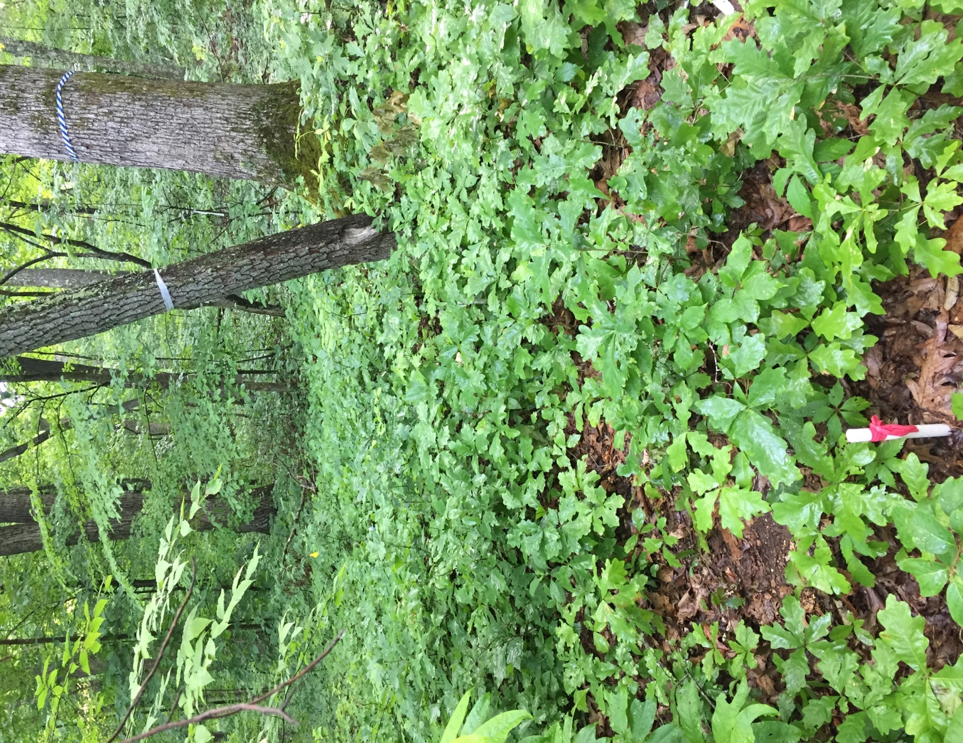
Figure 2: Advanced white oak reproduction abundance for plot placement and installation (Summer 2020).

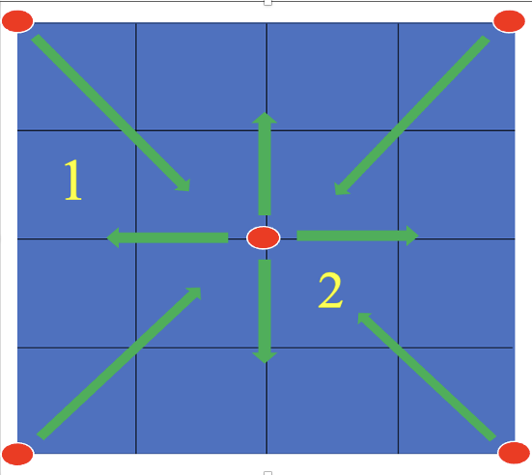
Figure 3: Schematic for plot (2 meter by 2 meter) outline and subplot (0.5 meter by 0.5 meter) placement system as well as location and direction of ceptometer measurements.

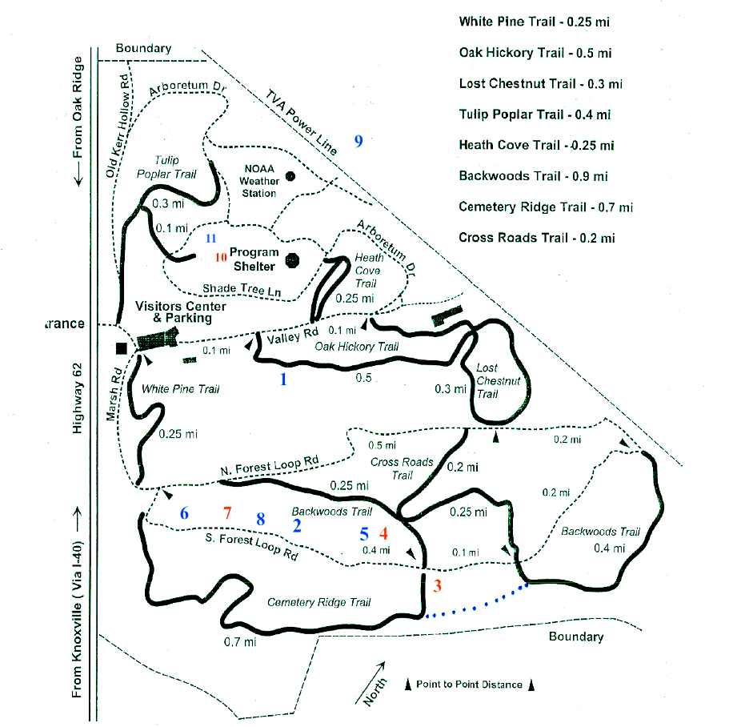
Figure 4: Map of FRREC with release plot locations in red and control plot locations in blue.

The total area representing all 26 plots was 104 meters squared while the subplots had a total area of 13 meters squared across the study. A permanent metal T-post was driven into the bottom left corner of every plot and marked with a coordinating color for future study measurements. Each area where plots were located was marked with GPS coordinates. Four release plot locations received a midstory removal treatment during July 2020 that averaged .04 to .08 hectares in area per location. All trees 18 centimeters or less in diameter, regardless of species, was removed and stumps were treated with a 50% glyphosate solution to deter sprouting (Table 1).
Trees 20 centimeters and greater were also felled or girdled by cutting with 50% glyphosate applied on the stump or girdle. Species that produce copious amounts of seed annually such as maple, American beech, yellow poplar, and black cherry were treated. Only 11 trees were twenty centimeters or greater in diameter across the four release treatment locations. The only trees that were retained on the release areas were dominant or codominant white oak, which would provide future seed source as well as cast some shade on seedlings. One to four white oak trees were kept on each plot location. These remaining white oaks were not uniformly distributed across the release locations. The basal area remained and ranged between 6.5 to 7.8 square meters per hectare in both the release and control treatments suggesting that the midstory release did not remove overstory basal area.

Data collection

Growth and light measurements were taken in June to July during the first year of the study and served as a baseline in order to compare over the two complete growing seasons (2021 & 2022). Woody species were counted within each plot.
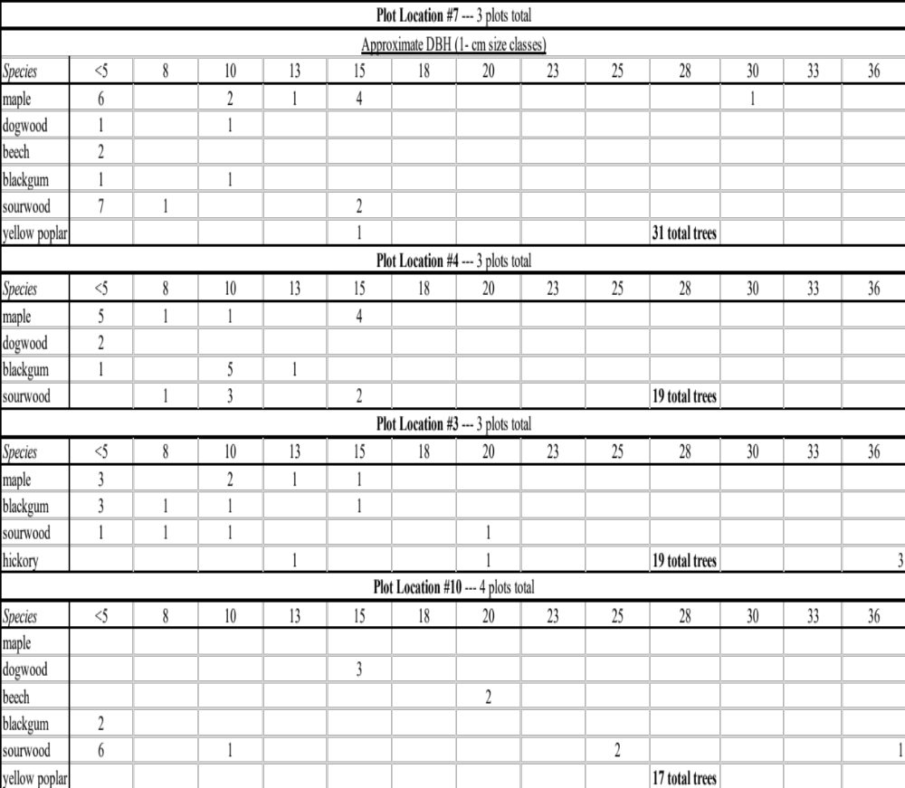
Table 1: DBH classes and total tree species removed in midstory release cut by plot location (2020).

A 2-meter PVC pipe was employed to divide the plot into sections for a more accurate seedling species count. Seedlings within the plot were further categorized into <30.5, 30.5-70, 70-91.4, and 91.4-122 centimeter height classes at the time of count for each year. Since non-woody ground vegetation composed an estimated <5% of the ground coverage, this vegetation was not measured while the remaining woody seedlings were categorized as miscellaneous.
An aluminum tag, with a unique identifier, was attached with galvanized wire at the base of each seedling that fell within the two subplots (Figure 5). Seedling heights were measured from the ground to the apical bud using a meter stick. Digital calipers were used to measure RCD where the base of the seedling stem met the soil. These measurements were taken prior to the application of the release treatment in June-July of 2020 and were repeated at the end of the next two growing seasons in September-October. Subplot species with missing tags were assumed to be either missing or dead and removed from the data.
An AccuPAR model LP-80 ceptometer was implemented to collect photosynthetically active radiation (PAR) measurements on control and release plots. These measurements were taken twice a year from 2020 to 2022 during July through August on two overcast free days with the exception of control plot location 11 which were not installed until the fall following the summer release cut.
The ceptometer was calibrated prior to the start of each year’s data collection and light measurements were taken at sternum height (one meter) above the ground during solar noon from 12:00 to 2:00 p.m. eastern time. Prior to taking measurements at each plot location, a baseline PAR reading was taken consistently in an exposed, open area of full sunlight at the FRREC adjacent to plots. A total of eight light readings were taken on each plot to order to ensure consistency over the two days.
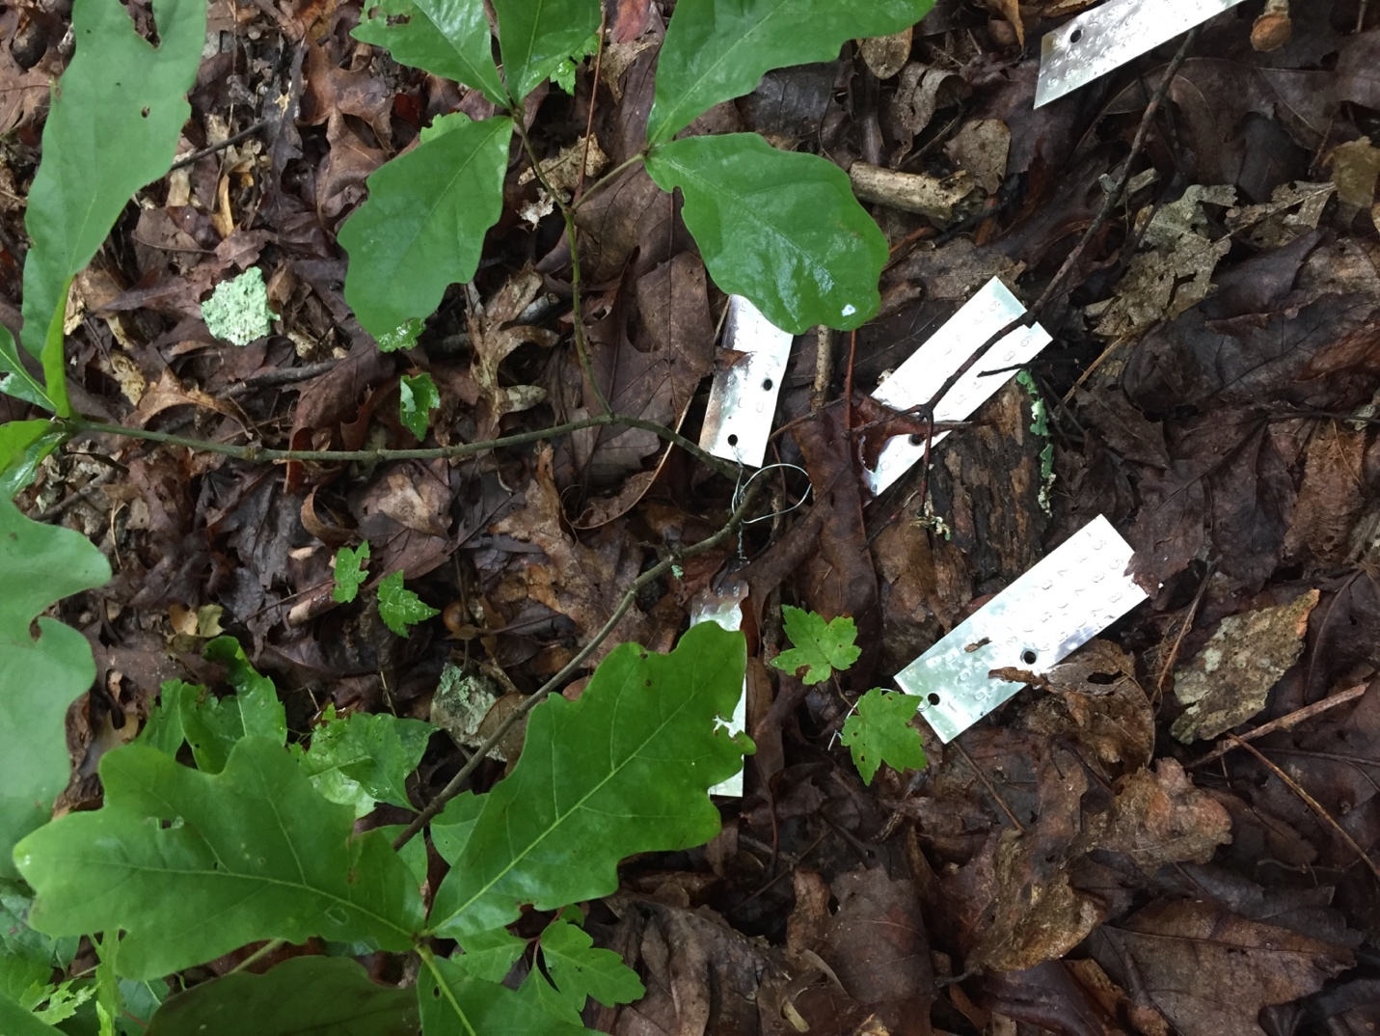
Figure 5: White oak and maple seedlings with attached aluminum tags.

Four of these PAR measurements were taken from plot center facing outward. The remaining four measurements were taken from each corner facing inward to the plot center. Figure 2 also illustrates the procedure for directing ceptometer measurements on plots. An average age for white oak was determined by coring 1-2 dominant overstory trees around each plot location with an increment borer and counting the rings. The same white oaks were also measured for their heights using a SUUNTO clinometer as well as their DBH using a diameter tape.

Data analysis

Data were entered and organized within Excel before entering into R. An alpha value of 0.05 was set for all analyses performed. Data were analyzed between the two complete growing seasons as well as between the first years baseline measurements and last year. White oak, sugar maple (Acer saccharum), and red maple (Acer Rubrum) were the most common species in abundance and growth. These species were directly compared and analyzed. The remaining miscellaneous woody species were only considered for comparisons of abundance.
In order to examine the subplot level effects of the midstory release, a Wilcoxon test was implemented to compare average height and RCD between treatments within each growing season as well as the first to the last year, regardless of species. In addition, the average percent height and RCD growth of white oak and maple seedlings was compared between treatments by growing season as well as the first to last year. Seedlings that were missing a tag or otherwise dead, were removed from the data set across all years for analysis involving average percent growth but not for comparisons of average measurements. A p value less than .05 indicated a statistically significant difference.
A chi-square test of independence compared plot level proportional abundance between white oak and maple seedlings by treatment and growing season as well as from the first year to the last. Proportional changes in white oak and maple seedling height classes between control and release treatments by growing seasons and from first to last year was also analyzed on the plot level. A p value greater than 0.05 indicated proportions were statistically similar.
Finally, a scatterplot was used to reference average percentage of height growth in response to average percentage of light received for white oak and maple seedlings between treatments over the two growing seasons.

Chapter 4: Results

Study analysis

White oaks average age was 122 years across our study sites with an average height and DBH of 30.5 meters and 60 cm, respectively. The site index is estimated to be 21 meters at 50 years (Soil Survey Staff 2023). White oaks comprised >70% of the total seedlings in the control and release plots initially (2020), maples 18% and miscellaneous species 8% (Figure 6). Red maple and sugar maple were grouped together into a maple category for the analyses. Through subsamples, red maple composed approximately 70% and sugar maple 30% of the maple category.
All other woody seedlings were categorized into a miscellaneous species classification. Only the white oak and maple categories were considered in this research. The other miscellaneous species did not have enough seedlings by species to provide a meaningful comparison. A total of 782 seedlings were tagged across 52 subplots during the summer of 2020: 320 in control and 462 in release (Table 2). In the fall of 2021, there were 609 tagged seedlings: 275 in control and 334 in release. By the end of the growing season, in the fall of 2022, there was a total of 524 tagged woody seedlings remaining: 245 in control and 312 in release.
A total of 4,801 seedlings were counted across all 26 plots in the summer of 2020 (Figure 6). Of these, 1,942 were in control treatment and 2,859 were in release treatment. There were 3,765 seedlings counted in 2021: 1,529 in control and 2,236 in release. By the conclusion of this study, in the fall of 2022, there were 4,074 seedlings counted: 1,523 in control and 2,551 in release.

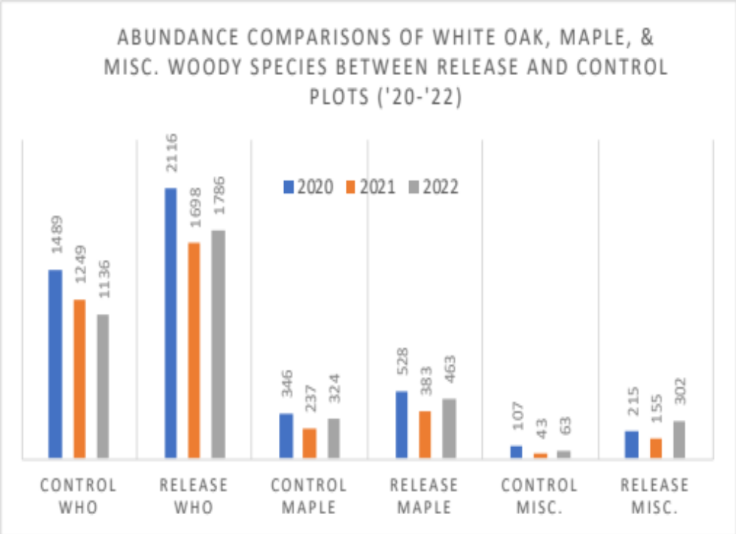
Figure 6: Plot level abundance by treatment and year for white oak and maple. Miscellaneous species consisted of chestnut oak, black cherry, hickory, sassafras, beech, northern red oak, black oak, black gum, dogwood, sweetgum, elm spp., locust spp., and sourwood.

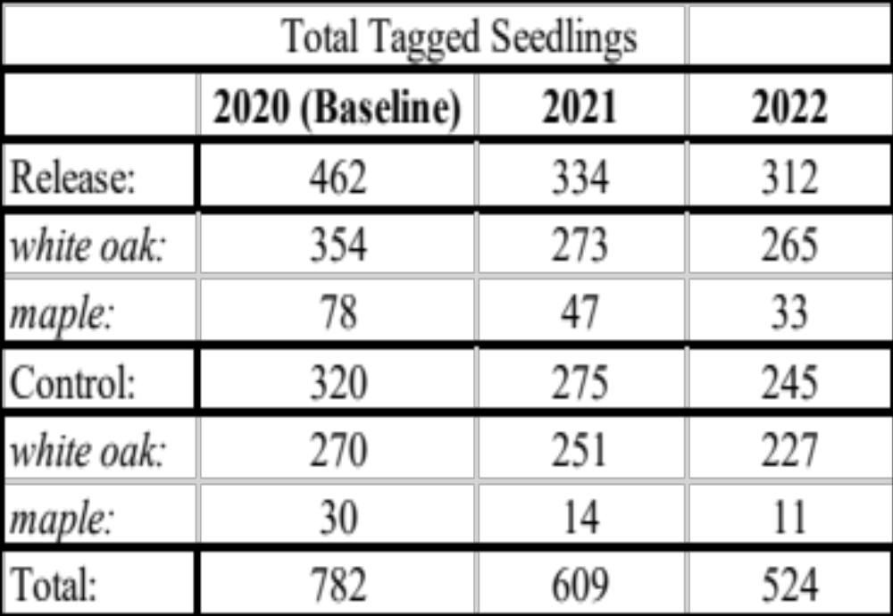

Table 2: Total number of tagged control and release subplot seedlings across years, with maple and white oak seedling totals (remaining number represents miscellaneous woody species).

After one complete growing season, 2020-2021, average height and RCD in control (p=1.721e-11, 0.0007406, respectively) and release (p=<2.2e-16, <2.2e-16, respectively) treatment subplot groups, regardless of species, were significantly different from one another (Table 3). After the second complete growing season, 2021-2022, height and RCD averages in control (p=0.0002103, <2.2e-16, respectively) and release (p=6.071e-9, 9.376e-14, respectively) subplots were statistically different, regardless of treatment or species. When comparing control and release subplots from the first base year to the last year, regardless of species, both average height (p < 2.2e-16) and RCD (< 2.2e-16) were different from one another. Therefore, statistically significant differences were present in both average height and RCD after each growing season as well as from the first to last year, regardless of treatment or species.
Proportions of plot level white oak and maple abundance are similar between control and release after each growing season (Figure 6). Control treatments in 2021 and 2022 showed differences on the plot level in white oak and maple abundance (p= 1.973e-0.5) but no differences were found for release treatment plots in those same years. Overall, the proportions of abundance in control treatment plots have statistically different proportions from one another across all years (p=8.707e-0.5) while release treatment plots were not proportionally similar.

Response of white oak

There was a total of 624 white oak seedlings tagged at the start of this study in the summer of 2020; 270 of these were in control treatment and the remaining 354 were in release treatment. In the fall of 2021, a total of 524 were tagged: 251 control and 273 release. At the conclusion of this study, in the fall of 2022, there were 492: 227 control and 265 release (Table 4).
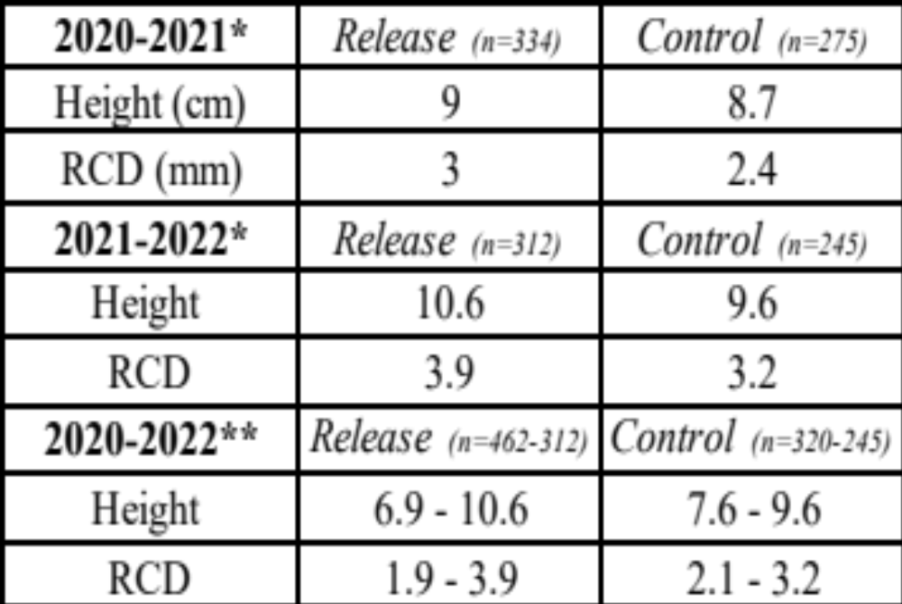
Table 3: Average subplot height and RCD by treatment and year regardless of species (* indicates p < 0.05; statistically significant difference between treatments, ** indicates significant difference from base year to last).

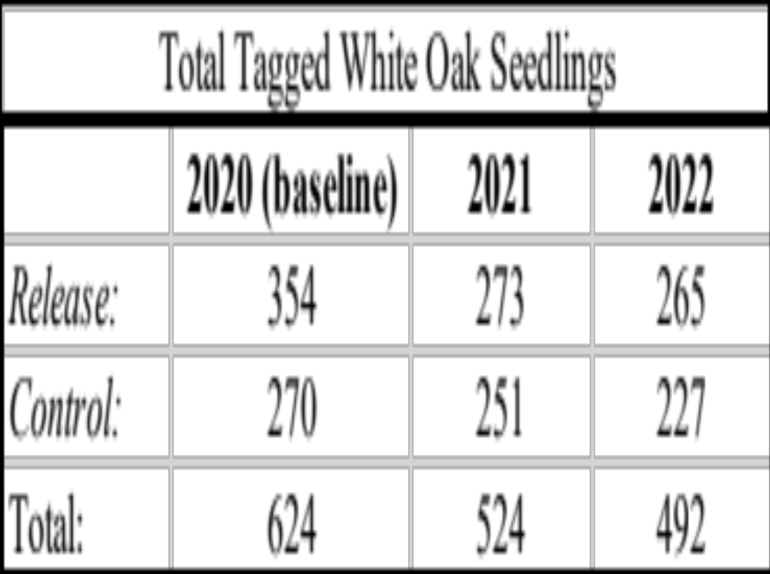
Table 4: Total number of tagged subplot white oak seedlings by treatment and year.

The midstory removal treatment had observed proportional changes in white oak seedlings that advanced into the taller height classes on the plot level over the two complete growing seasons as well as from the first to last year (Table 5). From 2020-2021 (p=3.563e-08) and 2021-2022 (p=1.075e-12) release treatment height classes did not show similar distribution proportions and were significantly different from one another. This same trend was also observed in the first (p=0.01119) and second (p=0.003077) complete growing season in control treatment plots. Changes in height class distributions between the first base year and last year were also not shown to be proportionally similar in control (p=9.698e-08) or release (2.2e-16) treatment plots. Changes in plot level height classes were shown to be proportionally similar between release and control treatments in 2021 but were not in 2022 (p=2.835e-06).
The midstory release treatment also appeared to affect the average percent growth of white oak height and RCD on the subplot level following each growing season as well as from the first to last year of this study (Table 6). When comparing control to release subplot level treatments between 2020-2021 (p=7.532e-11), 2021-2022 (p=1.089e-09), and 2020-2022 (<2.2e-16), the percent height growth of white oak seedlings had statistically significant differences between them all. Similar effects were also observed between release and control treatments after each growing season (p=<2.2e-16, 0.02236) as well as from the first to last year (p=1.425e-11), on the percent growth of RCD. When each growing season was directly compared to one another, average percent changes of white oak RCD growth were statistically different in both release and control subplot treatments (p=1.976e-08, 1.351e-15). These same statistically significant differences were also observed in white oak average precent height growth between the two growing seasons for both release and control subplot treatments (p=3.797e-07, 0.0001923).
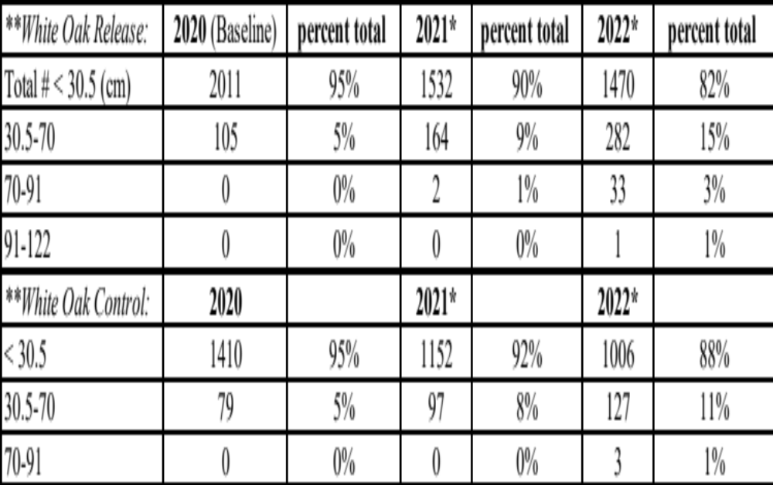
Table 5: Raw number of white oak seedlings by plot level height class with percent total for each year and treatment (* indicates p -value >0.05; statistically significant proportional difference in height class after one growing season, ** indicates treatment shows significant difference from base year to last

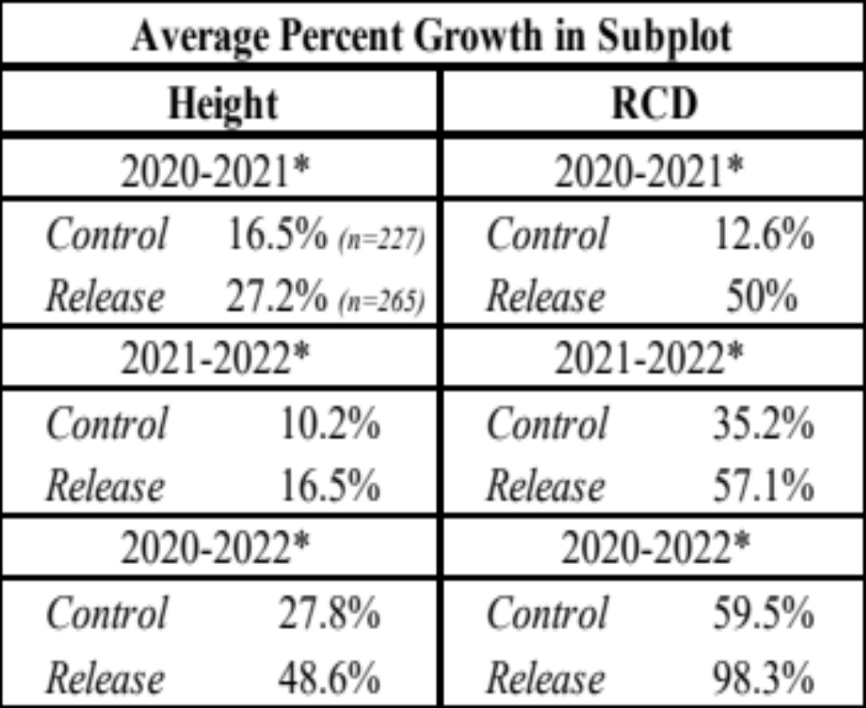
Table 6: White oak subplot seedling average percent height and RCD growth by treatment and by year (* indicates p<0.05; significant seedling percent growth difference between treatments.)

Table 7 expresses the average height and RCD for subplot white oak seedlings by treatment for each year. Though not significant, figure 7 presents a boxplot for percent height growth of subplot white oak seedling for both growing seasons. Release height growth ranged from 10 to 35% with a median of 22% while control plots ranged from 3 to 20% with a median of 12%.

Response of maple

There was a total of 108 maples tagged in the summer of 2020, 30 in control subplots and 78 in release subplots. In 2021 there were 61 total: 14 control and 47 release. By the end of the growing season in 2022 there were a total of 44 maple left across all 52 subplots: 11 control and 33 release (Table 8).
Maple was also observed to experience changes in population distributions within height classes from the midstory removal treatment (Table 9). Maple receiving the release treatment had statistically significant changes in population distributions of height classes between 2020-2021 (p=0.02853) and 2021-2022 (p=0.004424) on the plot level. No significant difference in proportional changes of control height classes was observed when comparing 2020 to 2022. However, there was a significant change in release treatment height classes from 2020 to 2022 (p=1.383e-07). Control maple did not see any significant changes in proportions in height class distributions after each growing season or from the first to last year. There were also no proportional differences in maple height class populations when comparing control to release treatments in both 2021 and 2022.

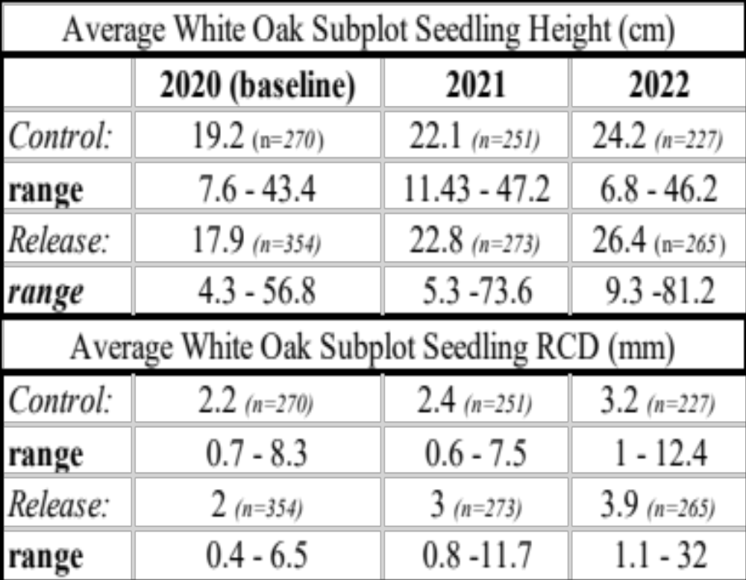
Table 7: Average height and RCD of subplot white oak seedlings with a minimum and maximum range of total measurements taken by treatment and year.

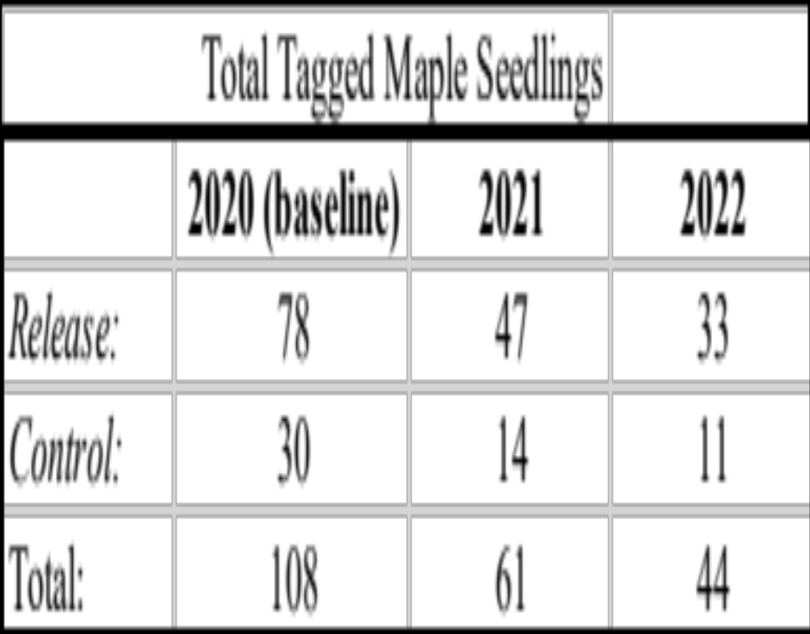
Table 8: Total number of tagged subplot maple seedlings by treatment and year.

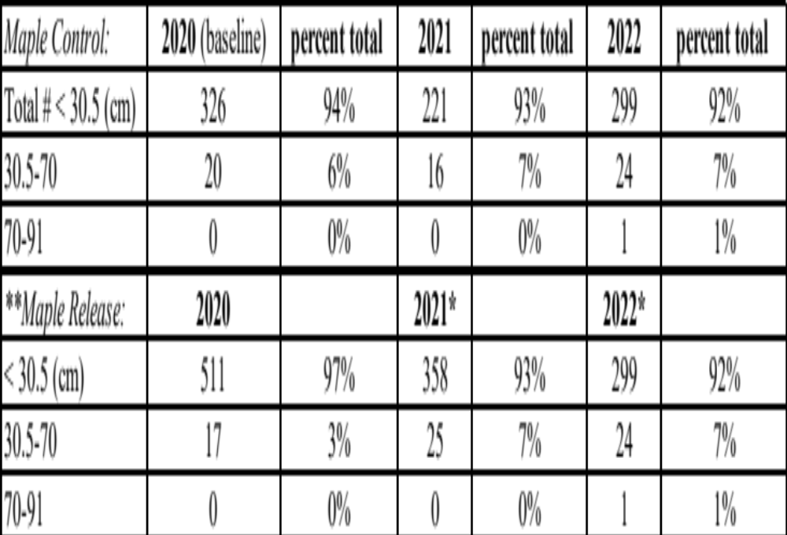
Table 9: Raw number of maple seedlings by plot level height class with percent total for each year and treatment (* indicates p -value >0.05; statistically significant proportional difference in height class after growing season, ** indicates treatment shows significant difference from base year to last.

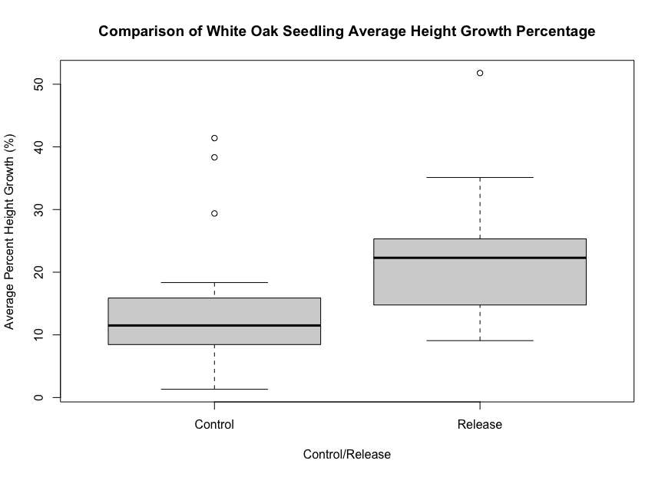
Figure 7: Box and whisker plot comparing control and release white oak seedlings average height growth across all years (n=530 release, 454 control).

No significant differences were observed when average percent height and RCD growth was compared between control or release treatments over the two complete growing seasons as well as the first to last year (Table 10). However, when comparing the first growing season to the second, there were significant differences in release treatment height (p=0.001537) and RCD (0.001954). Table 11 expresses the average height and RCD growth of maple seedlings for each treatment and year. Figure 8 presents a boxplot for percent height growth of subplot maple seedling heights across both growing seasons. Maple release seedlings height growth percentages ranged from 5 to 100% with a median of 25% while control ranged from 0 to 30% with a median of 20%.

Photosynthetically active radiation (PAR)

Light was not found to be a significant predictor of white oak seedling height in either control or release treatment groups. Figure 9 depicts, but not statistically significant, the range of percent height growth and percent received for both control and release treatments. White oak seedlings in the release treatment had a much wider range of 3 to 47% light received and 9 to 52% height growth compared to the 2 to 19% light received and 3 to 43% by the control group. The majority of control seedlings can be observed clustering within the 3 to 10% light received and 2 to 42% percent height growth range while release seedlings can be observed clustering within the 5 to 20% light received and 10 to 30% percent height growth.

Table 10: Maple subplot seedling average percent height and RCD growth by treatment and by year (* indicates p<0.05; significant seedling percent growth difference between two growing season treatments.)

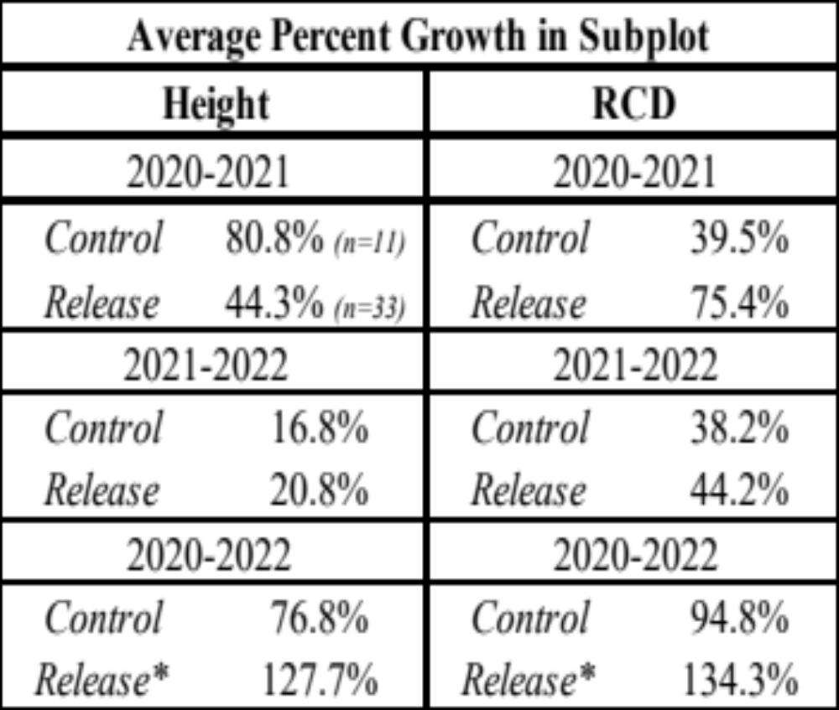

Table 11: Average height and RCD of subplot maple seedlings with a minimum and maximum range of total measurements taken by treatment and year.
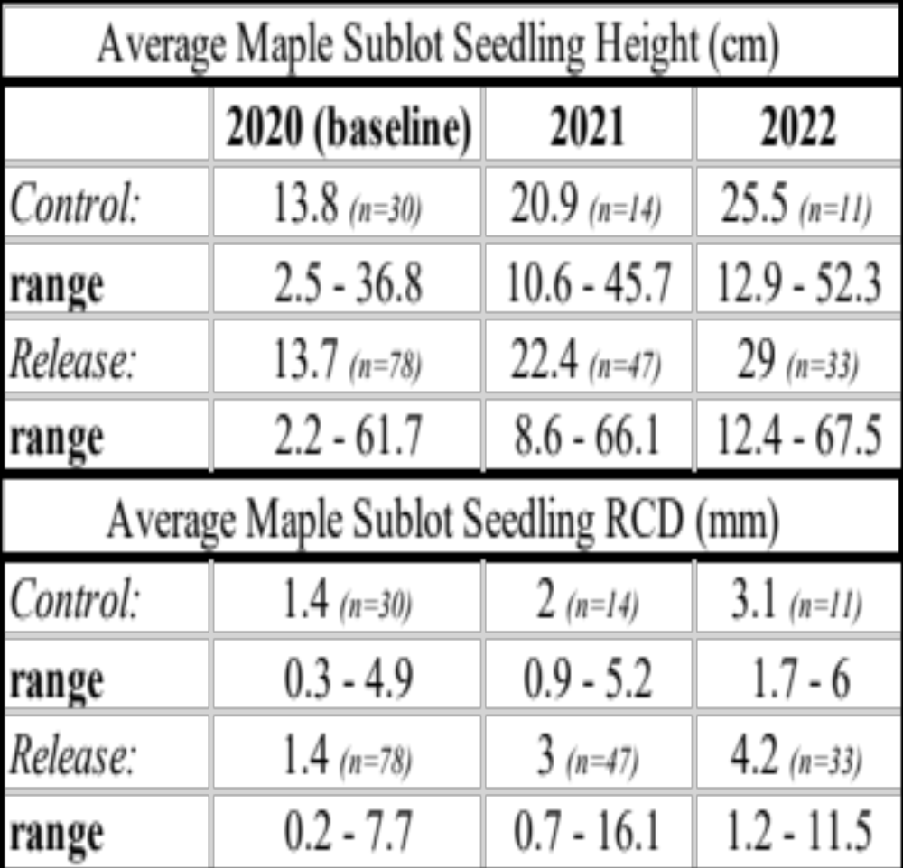

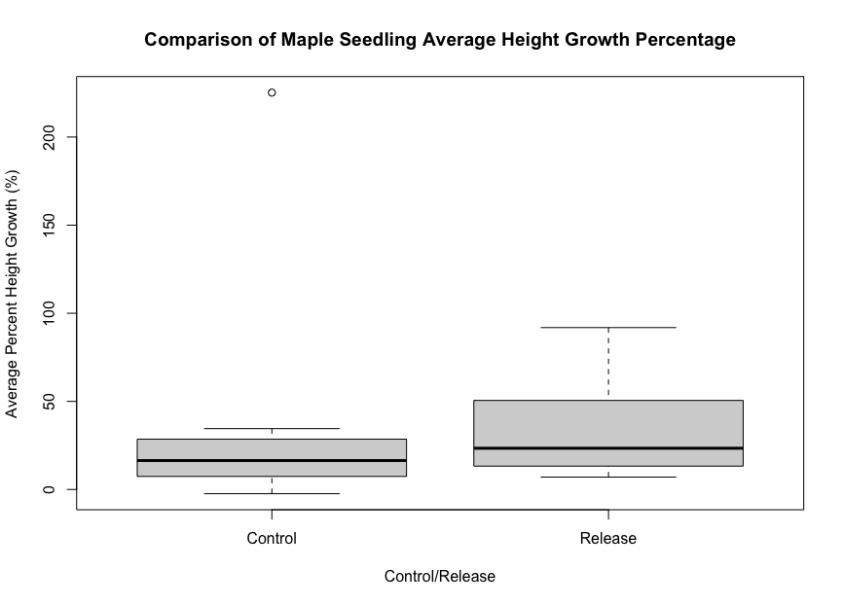
Figure 8: Box and whisker plot comparing control and release maple seedlings average height growth across all years (n=66 release, 22 control).

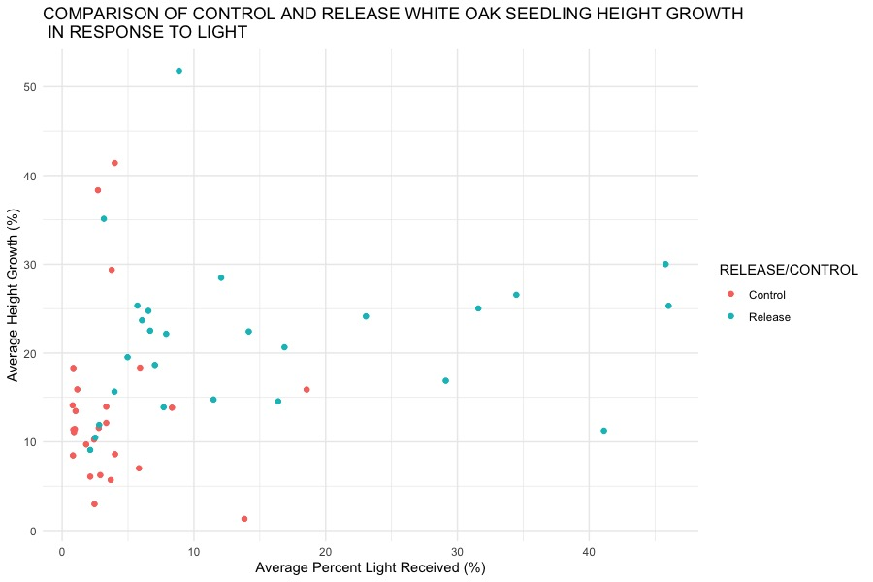

Figure 9: Scatterplot of control and release white oak seedling height growth in response to percent light received (each point represents average height growth of the two subplots for each plot and the plot PAR average of four center plot measurements on one date in 2021 and 2022, n=52; 26 control and 26 release).

The relationship between percent height growth and light received was also not found to be statistically significant in both treatment groups for maple seedlings. Figure 10 shows the range of percent height growth and percent light received for maple seedlings after two growing seasons. No significant statistical relationship were indicated comparing control and release treatments. Maple seedlings receiving release had a wider range of light percentage received and height growth compared to the control. The outliers observed were likely plots where maple seedlings were present, taller, and older than the seedlings that regenerated after the bumper acorn crop year when the study was established.
Release maple seedlings light received ranged from 3 to 52% while height growth ranged from 10 to 95%. Control seedling had a range of 2 to 7% light received and 0 to 225% average height growth. The majority of the data points for both maple treatment groups are clustered in the bottom left within the 2 to 8% light received and 0 to 45% height growth range. The majority of the data points for both maple treatment groups are clustered in the bottom left within the 2 to 8% light received and 0 to 45% height growth range.

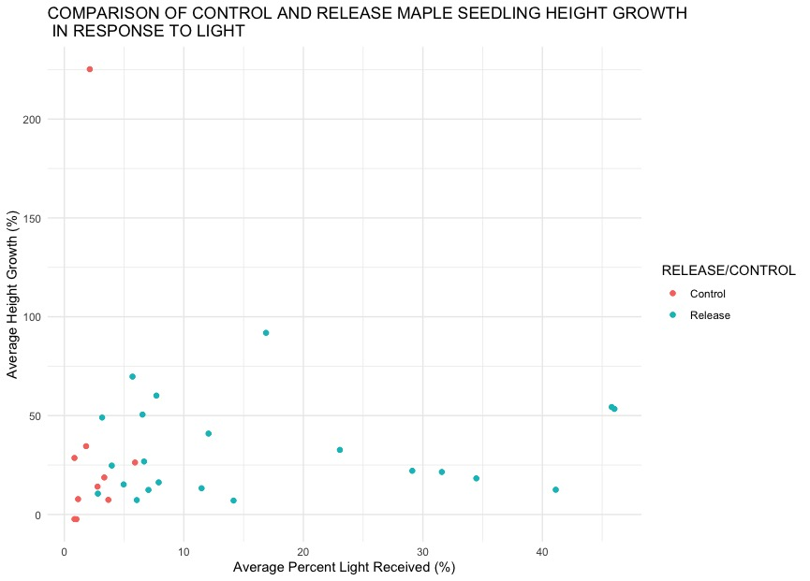
Figure 10: Scatterplot of control and release maple seedling height growth in response to percent light received (each point represents average height growth of the two subplots for each plot and the plot PAR average of four center plot measurements on one date in 2021 and 2022, n=52; 26 control and 26 release).

Chapter 5: Discussion

Response of white oak

The results of this study support the existing literature which suggests, with adequate accumulation of advanced white oak reproduction, a midstory removal treatment can provide a positive stimulus on abundance, vigor, and growth of seedlings (Lorimer et al. 1994, Lockhart et al. 2000, Dillaway et al. 2007, Motsinger et al. 2010). When observing abundance on both the plot and subplot level, regardless of treatment, white oak held an advantage across the duration of this study over its only major competitor, maple (Figure 6). This was likely attributed to a previous substantially large bumper acorn crop season. There was also a considerable amount of white oak seedlings present in the control plots but in less abundance compared to the release. Furthermore, there was 312% more white oak seedlings present in both release and control plots, when compared to maple, in 2020. By 2022 there was 271% more white oak between both treatment plots compared to maple. In addition, white oak represented 478% more of the tagged seedlings within release and control subplots compared to maple in the first base year and 1,018% more in the last growing season (Table 2).
This elevated level of abundance on both the plot and subplot level is a positive indicator that white oak is in a position to maintain its current advantage over local competitors. Future bumper acorn crops will continually add to the overall accumulation of white oak advanced reproduction. If these levels of white oak abundance in this study continue to increase or are maintained, unimpeded by competition, the sheer quantity of established white oak seedlings is on track to meet the existing recommendations of Sander (1972), Sander et. al. (1976), Clatterbuck & Hodges (1988) and Stringer (2016) who suggested having 100 to 200 large seedlings per 0.4 hectare to yield 40 to 60 mature trees in the future.
There was a clear difference present between white oak and maple seedling abundance observed on the plot and subplot levels. The method for plot placement likely caused discrepancies in reported abundance as well. The placement and installation of plots followed the “subjective without preconceived bias” approach described by Mueller-Dombois and Ellenburg 1974 and Pfister and Arno (1980), and Clatterbuck (1996) in which the placement of our plots were subjectively chosen to sample the homogenous landscapes, compositions, and canopy structures present in our study area. This approach allowed areas with abundant white oak advanced reproduction to be sampled and to determine how they would respond to a midstory release. Basal area range measured before and after midstory release and in control treatment were similar suggesting the midstory release did not create any large gaps in the overhead canopy.
It is important to also recognize the strong intraspecific competition is occurring with the forest floor being carpeted with advance white oak reproduction (Figure 2). Usually, density of oak saplings is much lower than seedlings, which indicate a bottleneck occurring between these stages due to competition (Crow 1988, Nowacki et. al. 1990). Even when white oak is ample in both the overstory and understory, the absence of saplings in the midstory prevents the potential of ingrowth of white oak into the overstory (Signell et. al. 2005, Dey 2014b, and Clatterbuck 2019). A study conducted by Beck (1970) demonstrated that woody and herbaceous competition following an overstory removal cut was not detrimental for the first couple years but within five growing seasons red oak seedlings were overtopped. A midstory removal or crop tree release could be an effective method to slowly introduce the transmittance of diffuse light through the canopy with minimal encouragement of woody and herbaceous competitors.
Maple abundance and growth has been observed to quickly catch up to white oak seedlings in response to increasing levels of diffuse light created by a midstory removal. Hartman et. al. (2005) demonstrated that maple with high abundance overtopped oak in as little as 10 years under a shelterwood system. A study in Kentucky evaluating responses of oak and competitors to a midstory removal reported that red maple had a mean 6-year relative height growth of 459% over other oak species and made up 55% of seedlings in release treatment plots (Craig et. al. 2014). Little information is available from the literature on the influence of bumper acorn crops on the success of a midstory release treatment for the growth of white oak advance reproduction and associated competitors. This study provides an opportunity to understand more on the processes involved with successfully culturing large quantities of established white oak reproduction resulting from a bumper acorn crop on average productivity sites.
For two complete growing seasons since a midstory release, significant shifts in height class distributions of white oak seedlings were observed which suggests a positive response to the midstory removal treatment (Table 5). All plots that received the release treatment had greater relative proportions in the taller height classes after the conclusion of each growing season. Control plots also had increasing height class distribution shifts after each growing season; however, it was less than the release. This is likely due to white oaks intermediate shade tolerance allowing it to maintain height growth even in lower light levels.
Following the first complete growing season, control and release white oak seedlings had 363% more in the <30.5 cm height class range and 537% more in 30.5-70 cm range than maple seedlings (Tables 5 & 9). After the last growing season there were 314% more white oak seedlings that were in <30.5 centimeter range, 752% more in the 30.5-70 centimeter range, and 1700% more in the 70-91 centimeter range than maple seedlings. There were only four white oak seedlings in the 91-122 cm height class range in 2022 and zero maple. These results are in accordance with the recommendations of (Sander 1972) that states successful oak management can be achieved with an abundance of white oak seedlings with heights greater than 130 cm. After two complete growing seasons no white oak seedlings were in this recommended 130 cm height class. However, if height growth continues at this rate, the recommended 130 cm height class could be achieved in a few years.
In terms of growth on the subplot level, the percent mean height and RCD growth of release white oak seedlings were observed to have a significant response to the increased diffuse light levels created by the midstory removal (Table 6). White oak seedlings substantially increased in height following the first growing season. This same trend continued into the second growing season and can be clearly seen when comparing base year white oak release seedlings average height at the end of the second growing season (Table 7). In comparison, control seedlings were slightly taller the first year prior to the midstory treatment but release seedlings were similar in height to the control seedlings after one growing season and surpassed the control during the next growing season.
The average size of white oak seedling RCD was greater in subplots receiving the release treatment (Table 7). Release and control sizes were almost identical in the first baseline year. However, seedlings receiving the release treatment grew substantially more than the control following both growing seasons. In addition, there was a significant difference in percent RCD growth of white oak seedlings receiving the release treatment in the first growing season. Percent growth for the RCD of control seedlings in the second growing season was greater but not from the first base year to the end of the second growing season (Table 6).
There are limited studies investigating RCD and its influences on successful management. However, white oak seedlings have a judicious growth strategy when allocating resources below ground during the first year prior to above ground response (Dillaway et. al. 2007). In this study as well as a study by (Parrot et. al. 2012), greater ground line diameters were observed in release treated seedlings. Previous research reports that a midstory removal has direct positive influences on both height and RCD growth, vigor, and abundance of upland oak species for up to 10 years following the treatment (Loftis 1990b, Lockhart et al. 2000, Lhotka and Loewenstein 2013, Frank et al. 2018, Miller et al. 2018).

Response of Maple

Maple was the primary competitor of white oak across this study on both the plot and subplot level, regardless of treatment. However white oak advance reproduction outnumbered maple advance reproduction by a ratio of roughly 4:1 (Figure 6). Maple was not represented on every plot and subplot. In addition, the majority of white oak seedlings established with the bumper acorn crop, while maple, especially the larger ones, probably were established prior to this bumper crop. This could explain the outliers that were observed within the data. Craig et. al. (2014), indicated that with increased diffuse light levels provided by a midstory removal, the growth and competitiveness of red maple was also enhanced.
This study has similar results with the maple component; however, white oak was able to maintain its abundance throughout both growing seasons regardless of treatment. On both the plot and subplot level there were considerably more white oak seedlings present. This is in contrast with many other studies that have resulted in maple becoming the primary dominant species in growth and abundance following increased light created by a midstory removal (Hackworth 2020, Lhotka & Loewenstein 2013, Parrot et. al. 2012, Stringer 2016). Maple also showed positive responses to the increased diffuse light levels with observed changes in height class distributions after each growing season as well as from the first to last year (Table 9). The only statistically significant change in height classes were observed in plots receiving the release treatment.
In addition, only one seedling was recorded in both control and release plots within the 70 to 91 cm height range during 2022 and no other taller seedlings were recorded. The percent growth of height and RCD compared between the two growing seasons as well as from the first base year to the last, regardless of treatment was not found to be significant for maple seedlings (Table 10). In addition, maple seedling percent height and RCD growth were only statistically significant when comparing the first growing season to the end of the second growing season. These greater growth rates could have been attributed to the lower sample sizes for maple seedlings which were more variable within the data. Additionally, maple seedlings have smaller average height and RCD in both treatments groups compared to white oak seedlings in the first base year (Tables 7 & 11). After one complete growing season, maple within the release treated subplots was similar to release white oak height and RCD but not in the control.
Following the last complete growing season, maple seedling height and RCD surpassed control and release white oak seedlings (Table 7 & 11). Gottschalk (1994) suggested that maple has a higher plasticity and positive response to altered light conditions. Maple allocates carbon to their root systems at a much lower rate compared to white oak seedlings, which could explain why they were able to respond faster in height growth within this study (Abrams 1998). Maple has become one of the most abundant and widespread species in the eastern United States due to its “super generalist” ability which has allowed it to compete successfully in a wide variety of forest settings (Abrams 1998). Unless further competition control is implemented or there is enough abundance of advanced white oak seedlings present, maple will continue to be a major competitor to white oak even on the poorer quality sites where many other more mesic species cannot compete.

Photosynthetically active radiation (PAR)

The relationship of percent height growth in response to percent light received was observed between treatments for white oak seedlings on the subplot level over two growing seasons (Figure 9). These positive effects associated with a midstory removal are reliant on the treatments capability to increase the levels of diffuse light to the understory which generally results in 10-20% of full sunlight (Brose and Rebbeck 2017, Schweitzer and Dey 2017, Miller et. al. 2017). While we expected to find a height increase for white oak seedlings with midstory removal, the amount of light received was 10 to 20% compared to >30% suggested by Gardiner & Hodges (1998) and Gottschalk (1983, 1985, 1994) to achieve greater growth gains. Corresponding height growth of white oak reproduction at these lower light levels is hypothesized to be less than at the 20 to 30% sunlight received in other studies (Dillaway & Stringer 2006, Gottschalk 1994, Guo et. al. 2001, Jarvis 1964, Phares 1971).
Most research (Miller et. al. 2004, Dillaway & Stringer 2016, Gottschalk 1994, Dey & Parker 1996, Lhotka, and Lowenstein 2009, Motsinger et. al. 2010, Parrot et. al. 2012) have suggested that a typical unaltered hardwood stands generally range anywhere from 1 to 8% full sunlight reaching the forest understory. In this study, percent light received, and percent height growth showed a relationship between treatments in white oak seedlings (Figure 9). Release white oak seedlings were observed to have higher ranges in both percent light received, and percent height growth compared to the control. Our findings indicate height growth at 10 to 20% understory light received. Dillaway & Stringer (2006) also reported that white oak advance reproduction can tolerate and find success with slightly lower diffuse light levels of <20%.
There was also a relationship observed between maple seedling treatments for percent height growth and percent light received (Figure 10). The majority of the percent light received, and percent height growth was clustered in a smaller range compared to white oak (Figure 9) However, maple seedlings had a larger height growth percentage range compared to white oak seedlings but in contrast were represented in 20 fewer subplots potentially due to fewer regeneration sources present.
This study was limited to only capturing two complete growing seasons of light and growth data which likely did not give a complete representation of the relationships between percent height growth in response to light received. Similar studies investigating midstory removal and light conducted by Blankenship & Arthur (2006), Parrot et. al. (2012), Craig et. al. (2014) and Schweitzer et. al. (2017) all have longer durations of time spanning 5 to 10 growing seasons. Several factors potentially hindered data collection accuracy. One involved possible light measurement error taken by the ceptometer. Though this could have been caused by calibration issues, Baldocchi & Collineau (1994) reported that it is often problematic to characterize diffuse light availability under canopies due to the vast spatiotemporal heterogeneity.
Also, as mentioned previously, light was not a criterion for placement of plots, and we believe this caused possible issues with obtaining consistent light readings. This method of placement likely created variability in the amount of diffuse light received by seedlings on the forest floor since dominant white oak seed trees were retained on release sites. Plots that were installed near these crowns likely received more shade than plots outside the influence of the crowns and thus caused an incomplete picture of PAR being received. Though seedlings were not aged, there were white oak and maple seedlings probably existing prior to the initiation of this study and before the initial bumper acorn crop season. This would explain the outliers observed in (Figures 9 & 10).

Management implications

Advance reproduction is essential to regenerate oak species (Sanders 1972, Loftis 1990, Clatterbuck 2019). Though oaks can regenerate by seed or by stump sprouts too (Rogers 1990), the characteristic slow growth of newly germinated acorns and subsequent seedlings is often exceeded by faster growing species suppressing oak. In addition, although sprouting occurs for cut stumps or smaller trees, sprouting ability progressively diminishes with large trees and stumps which are typically the trees that are cut during a timber harvest (McGee 1978). Oak regeneration from advance reproduction is insufficient unless advance reproduction of sufficient size and number are present with the timber harvest (Loftis 1990, Clatterbuck 2019). Most stands that are harvested have closed canopies that do not allow sufficient diffuse light to the forest floor to establish and develop advance reproduction prior to the harvest.
Oak advance reproduction commonly follows a bumper acorn crop, when number of acorns exceeds predation, which can occur sporadically once every 4 to 10 years (Rogers 1990). These seedlings are small (<30 cm tall) under closed canopies and are outgrown by faster growing species once released. Thus, measures must be taken to develop larger size of advanced seedlings so they can gain a head start and compete with faster growing seedlings once the overstory is removed (Loftis 1990). One of those measures is midstory removal that allows the amount of sunlight to encourage growth of intermediate light tolerant oaks while discouraging growth of both intolerant and shade tolerant species. Thus, regeneration of oak is a process rather than an event when it comes to establishing and developing advance reproduction (Clatterbuck 2019).
An event assumes that oak reproduction will miraculously appear in both sufficient size and abundance following a harvest without any pre-conditions being met and be able to successfully compete with other species. This sort of event rarely occurs with the slow growth associated with oaks and the increasingly competitive mesic forests. Advance reproduction of oaks with sufficient size and abundance must be adequately cultured prior to the harvest of oaks if oaks are expected to be a future component of the next stand. A series of incomplete disturbances should be applied over time in order to create the intermediate light conditions that white oak seedlings utilize for competitive success. A midstory removal as a preliminary step in a shelterwood, has been advocated by Loftis (1990) for enhancing understory light conditions that encourage the development of advance oak reproduction.
Fire as a tool for controlling competition as well as increasing understory diffuse light levels has also been suggested to be beneficial for pre- and post-midstory removal treatments (Sander 1971, Abrams 1992, Hartman et. al. 2005). However, research conducted on the Cumberland Plateau, observed burning would top kill maple preliminarily, but maple would resprout with a greater response than oaks post treatment (Blankenship & Arthur 2006, Alexander et. al. 2008, Green et. al. 2010). These studies did not have any treatment to the midstories prior to the application of fire. In addition, burning is not a panacea for regenerating oak and often will give varied results. Research conducted by Lorimer et. al. (1990), Dey et. al. (2008), and Parrot et. al. (2012) have reported that the underplanting of oak seedlings to enhance the pool of advance reproduction size, vigor, and abundance can be a successful management option.
The evaluation of site conditions should not be overlooked. These conditions can directly influence the competitive success of white oak and local competitors in response to an intermediate disturbance such as a midstory removal. Loftis (1990) has suggested the final harvest be implemented 10 years following a midstory removal treatment, however the exact timing will ultimately be contingent on the particular conditions of the site, silvics of the competing species as well as the various environmental influences. If the regeneration mechanisms of white oak as well as the numerous assemblies of species present are not understood or leveraged suitably, success of recruiting white oak seedlings will likely be limited. In summary, to ensure that white oak will effectively regenerate and become a component of the next stand, there must be a sufficient amount of advance reproduction present, a gradient of intermediate light must be available to promote white oak and discourage both the shade tolerant and shade intolerant competitor species, and the appropriate timing of a series of intermediate operations or disturbance to maintain light conditions must be applied.

Chapter 6: Conclusions

The overall response of white oak seedling growth indicates that there was a positive influence from the increase in diffuse light levels through the canopy created by the midstory removal treatment. In contrast to many other similar studies (Parrot et. al. 2012, Dillaway & Stringer 2006, Dillaway et. al. 2007) investigating the effects of a midstory removal, competitor species abundance was limited comparatively and did not appear to have serious effects on the competitive success of white oak seedlings after two growing seasons. This suggests that with an abundant accumulation of advanced seedlings provided from a large bumper acorn crop season, white oak can be competitive and find success on average productivity upland sites when diffuse light levels are increased to support increased height growth. Intraspecific competition among the numerous white oak seedlings can also have positive and negative effects on seedling growth.
This study was limited to only two complete growing seasons and was conducted on a much smaller scale compared to many other similar studies. There were light measurement irregularities due to possible ceptometer calibration issues. The placement of plots and the distance of plots to crowns of overstory trees may have contributed to the variability in light measurements between plots, even though the overhead canopy stayed intact during the midstory removal.
However, the research provides a valuable opportunity to understand the preliminary processes involved with bumper acorn crop advance reproduction and the influences that a subsequent midstory removal can have over its recruitment success. White oak was observed to have a positive response in both abundance and growth following the midstory removal treatment. Maple growth was also observed to have a positive response to the increased light levels in the release treatments. In this study, white oak seedling abundance overcompensates the number of maple seedlings by a ratio of 4:1. The overall response of maple growth was greater than white oak and will likely necessitate some form of competition control in the future if a crop tree release or shelterwood harvest is the objective.
Alternatively, the overabundance of white oak advance reproduction may not only discourage the growth of the smaller maple component of this study but influence growth among adjacent white oak stems because of their overabundance. The midstory release treatment was observed to show a relationship in percent height growth in response to percent light received compared to the control over both growing seasons. This same difference was also observed between treatments and growing seasons for maple seedlings. However, many of the maple present at the plot locations were established prior to the bumper acorn crop season. In addition, maple was only present on a fraction of the plots and subplots. Future studies should investigate both the longer-term growth effects of increased light on large accumulation of bumper acorn advanced white oak reproduction and competitor species as well as the influence of competition within larger pools of established advanced white oak reproduction.

References

Abrams, Marc D. Fire and the development of oak forests. BioScience 42.5 (1992): 346-353.
Abrams, Marc D., and Charles M. Ruffner. Physiographic analysis of witness-tree distribution (1765–1798) and present forest cover through north central Pennsylvania. Canadian Journal of Forest Research 25.4 (1995): 659-668.
Abrams, Marc D., and Deanna M. McCay. Vegetation–site relationships of witness trees (1780–1856) in the pre-settlement forests of eastern West Virginia." Canadian Journal of Forest Research 26.2 (1996): 217-224.
Abrams, Marc D. The red maple paradox. BioScience 48.5 (1998): 355-364.
Abrams, Marc D. Where has all the white oak gone? BioScience 53.10 (2003): 927-939.
Alexander, Heather D., Arthur, M. A., Loftis, D. L., and Green, S. R. Survival and growth of upland oak and co-occurring competitor seedlings following single and repeated prescribed fires. Forest Ecology and Management 256.5 (2008): 1021-1030.
Alexander, Heather D., and Mary A. Arthur. Increasing red maple leaf litter alters decomposition rates and nitrogen cycling in historically oak-dominated forests of the eastern US. Ecosystems 17.8 (2014): 1371-1383.
Arthur, Mary A., Alexander H.D., Dey, D. C., Schweitzer, C. J., and Loftis, D. L. Refining the oak‐fire hypothesis for management of oak-dominated forests of the eastern United States. Journal of Forestry 110.5 (2012): 257-266.
Ashton, Mark S., and Matthew J. Kelty. The Practice of Silviculture: Applied Forest Ecology. John Wiley & Sons, 2018.
Baldocchi, Dennis, and Serge Collineau. The physical nature of solar radiation in heterogeneous canopies: spatial and temporal attributes. Exploitation of Environmental Heterogeneity by Plants. Ecophysiological Processes Above‐and Belowground (1994): 21-71.
Beck, Donald E. Effect of competition on survival and height growth of red oak seedlings. Vol. 56. US Department of Agriculture, Forest Service, Southeastern Forest Experiment Station, 1970.
Blankenship, B. A., and M. A. Arthur. Stand structure over 9 years in burned and fire-excluded oak stands on the Cumberland Plateau, Kentucky. Forest Ecology and Management 225.1-3 (2006): 134-145.
Blizzard, Elizabeth M., Kabrick, J. M., Dey, D. C., Larsen, D. R., Pallardy, S. G., Gwaze, D. P., and Guldin, J. M. Light, canopy closure, and overstory retention in upland Ozark forests. In: Guldin, James M., ed. 2013. Proceedings of the 15th biennial southern silvicultural research conference. e-Gen. Tech. Rep. SRS-GTR-175. Asheville, NC: US Department of Agriculture, Forest Service, Southern Research Station. 73-79. 2013.
Breshears, David D., Nyhan, J. W., Heil, C. E., and Wilcox, B. P. Effects of woody plants on microclimate in a semiarid woodland: soil temperature and evaporation in canopy and intercanopy patches. International Journal of Plant Sciences 159.6 (1998): 1010-1017.
Brose, Patrick. H., Gottschalk, K. W., Horsely, S. B., Knoop, P. D., Kochenderfer, J. N., McGuinness, B. J., and Stout, S. L. Prescribing regeneration treatments for mixed-oak forests in the Mid-Atlantic region. USDA For Serv. Gen Tech Rep NRS-33, Newtown Road, PA 100 (2008).
Brose, Patrick H., and Joanne Rebbeck. A comparison of the survival and development of the seedlings of four upland oak species grown in four different understory light environments. Journal of Forestry 115.3 (2017): 159-166.
Brown, Martin J., and Geoffrey G. Parker. Canopy light transmittance in a chronosequence of mixed-species deciduous forests. Canadian Journal of Forest Research 24.8 (1994): 1694-1703.
Burns, Russell M., and B. H. Honkala. Summary of tree characteristics. Silvics of North America 2. Agriculture Handbook 654. U.S. Department of Agriculture, Forest Service, Washington, D.C. (1990): 846-849.
Butler, Brett J. Family Forest owners of the United States, 2006. Gen. Tech. Rep. NRS-27. Newtown Square, PA: US Department of Agriculture, Forest Service, Northern Research Station. (2008): p. 27-72.
Carvell, Kenneth L. Factors affecting the abundance, vigor, and growth response of understory oak seedlings. Regenerating oaks in upland hardwood forests (1979): 22-23.
Cavender-Bares, Jeannine. Diversity, distribution, and ecosystem services of the North American oaks. International Oaks 27 (2016): 37-48.
Clark, F. Bryan. An historical perspective of oak regeneration. Oak regeneration: Serious problems, practical recommendations. USDA For. Serv., Gen. Tech. Rep. SE-84, Southeastern Forest Experiment Station, Asheville, NC, 1993.
Clatterbuck, Wayne K., and John D. Hodges. Development of cherrybark oak and sweet gum in mixed, even-aged bottomland stands in central Mississippi, USA. Canadian Journal of Forest Research 18.1 (1988): 12-18.
Clatterbuck, Wayne K. A community classification system for forest evaluation: Development, validation, and extrapolation. Global to Local: Ecological Land Classification: Thunderbay, Ontario, Canada, August 14–17, 1994 (1996): 299-321.
Clatterbuck, Wayne K. What do we know about oaks? Keystones of oak silviculture. e-Gen. Tech. Rep. SRS-237. Asheville, NC: US Department of Agriculture Forest Service, Southern Research Station (2019): 3-12.
Craig, Jared M., John M. Lhotka, and Jeffrey W. Stringer. Evaluating initial responses of natural and underplanted oak reproduction and a shade-tolerant competitor to midstory removal. Forest Science 60.6 (2014): 1164-1171.
Crow, Thomas R. Reproductive mode and mechanisms for self-replacement of northern red oak (Quercus rubra)-a review. Forest science 34.1 (1988): 19-40.
DeVivo, Michael S. Indian use of fire and land clearance in the southern Appalachians. Fire and the Environment: Ecological and Cultural Perspectives: Proceedings of an International Symposium, Knoxville, Tennessee, March 20-24, 1990.Gen. Tech. Rep. SE-69 Southeastern Forest Experiment Station (1991): 306-310.
Dey, Daniel C. A comprehensive Ozark regenerator. Columbia, MO: University of Missouri. 283 p. Diss. Ph. D. dissertation, 1991.
Dey, Daniel C., Paul S. Johnson, and H. E. Garrett. Modeling the regeneration of oak stands in the Missouri Ozark Highlands. Canadian Journal of Forest Research 26.4 (1996): 573-583.
Dey, Daniel C., and George Hartman. Returning fire to Ozark Highland Forest ecosystems: effects on advance regeneration. Forest Ecology and Management 217.1 (2005): 37-53.
Dey, Daniel C., Gary W. Miller, and John M. Kabrick. Sustaining northern red oak forests: managing oak from regeneration to canopy dominance in mature stands. United States Department of Agriculture Forest Service General Technical Report PNW 733 (2008): 91.
Dey, Daniel C. Sustaining oak forests in eastern North America: regeneration and recruitment, the pillars of sustainability. Forest Science 60.5 (2014a): 926-942.
Dey, Daniel C. Oak regeneration ecology and dynamics. Gen. Tech. Rep. SRS-199. Asheville, NC: US Department of Agriculture Forest Service, Southern Research Station. (2014b): 3-11.
Dickson, James G., ed. The Wild Turkey: Biology and Management. Stackpole Books, 1992.
Dillaway, Dylan, and Jeff Stringer. Effects of shade on the growth of natural and artificially established white oak (Quercus alba L.) regeneration. 15th Central Hardwood Forest Conference. 2006.
Dillaway, Dylan N., Jeffrey W. Stringer, and Lynne K. Rieske. Light availability influences root carbohydrates, and potentially vigor, in white oak advance regeneration. Forest Ecology and management 250.3 (2007): 227-233.
Egler, Frank E. Vegetation science concepts I. Initial floristic composition, a factor in old-field vegetation development with 2 figs. Vegetation 4.6 (1954): 412-417.
Elliott, Katherine J., Boring, L. R., Swank, W. T., and Haines, B.R. Successional changes in plant species diversity and composition after clearcutting a southern Appalachian watershed. Forest Ecology and Management 92.1-3 (1997): 67-85.
Ellsworth, Joshua W., and Brenda C. McComb. Potential effects of passenger pigeon flocks on the structure and composition of pre-settlement forests of eastern North America. Conservation Biology 17.6 (2003): 1548-1558.
Fei, Songlin, and Kim C. Steiner. Relationships between advance oak regeneration and biotic and abiotic factors. Tree Physiology 28.7 (2008): 1111-1119.
Fei, Songlin, Kong, N., Steiner, K. C., Moser, W.K., and Steiner, E. B. Change in oak abundance in the eastern United States from 1980 to 2008. Forest Ecology and Management 262.8 (2011): 1370-1377.
Foster, David R., Glenn Motzkin, and Benjamin Slater. Land-use history as long-term broad-scale disturbance: regional forest dynamics in central New England. Ecosystems 1.1 (1998): 96-119.
Frank, Graham S., Ronald A. Rathfon, and Michael R. Saunders. Ten-year responses of underplanted northern red oak to silvicultural treatments, herbivore exclusion, and fertilization. Forests 9.9 (2018): 571.
Frost, Cecil C. Pre-settlement fire frequency regimes of the United States: a first approximation. Fire in ecosystem management: shifting the paradigm from suppression to prescription. Tall Timbers Fire Ecology Conference Proceedings. Vol. 20. 1998.
Gardiner, Emile S., and John D. Hodges. Growth and biomass distribution of cherrybark oak (Quercus pagoda Raf.) seedlings as influenced by light availability. Forest Ecology and Management 108.1-2 (1998): 127-134.
Gingrich, Samuel F. Measuring and evaluating stocking and stand density in upland hardwood forests in the Central States. Forest Science 13.1 (1967): 38-53.
Gleason, Henry Allan. The relation of forest distribution and prairie fires in the Middle West. Torreya 13.8 (1913): 173-181.
Gottschalk, Kurt W. Effects of shading on growth and development of northern red oak, black oak, black cherry, and red maple seedlings. II. Biomass partitioning and prediction. (1983).
Gottschalk, Kurt W. Effects of shading on growth and development of northern red oak, black oak, black cherry, and red maple seedlings. I. Height, diameter, and root/shoot ratio. (1985).
Gottschalk, Kurt W. Shade, leaf growth and crown development of Quercus rubra, Quercus velutina, Prunus serotina and Acer rubrum seedlings. Tree Physiology 14.7-8-9 (1994): 735-749.
Green, Stephanie R., Mary A. Arthur, and Beth A. Blankenship. Oak and red maple seedling survival and growth following periodic prescribed fire on xeric ridgetops on the Cumberland Plateau. Forest Ecology and Management 259.12 (2010): 2256-2266.
Guo, Yanfei, Michael G. Shelton, and Brian R. Lockhart. Effects of light regimes on the growth of cherrybark oak seedlings. Forest Science 47.2 (2001): 270-277.
Guyette, Richard P., Rose-Marie Muzika, and Daniel C. Dey. Dynamics of an anthropogenic fire regime. Ecosystems 5.5 (2002): 472-486.
Guyette, Richard P., et al. Fire scars reveal variability and dynamics of eastern fire regimes. In: Dickinson, Matthew B., ed. 2006. Fire in eastern oak forests: delivering science to land managers, proceedings of a conference; 2005 November 15-17; Columbus, OH. Gen. Tech. Rep. NRS-P-1. Newtown Square, PA: U.S. Department of Agriculture, Forest Service, Northern Research Station (2006): 20-39.
Hackworth, Zachary J., John M. Lhotka, and Jeffrey W. Stringer. Midstory removal facilitates growth but reduces competitiveness of oak reproduction prior to and after shelterwood establishment cutting. Forest Science 66.3 (2020): 371-381.
Hartman, Jason P., David S. Buckley, and Terry L. Sharik. Differential success of oak and red maple regeneration in oak and pine stands on intermediate-quality sites in northern Lower Michigan. Forest ecology and management 216.1-3 (2005): 77-90.
Hicks, Ray R. Ecology and Management of Central Hardwood Forests. John Wiley & Sons, 1998.
Jarvis, Paul G. The adaptability to light intensity of seedlings of Quercus petraea (Matt.) Liebl. The Journal of Ecology (1964): 545-571.
Johnson, Paul S. Responses of planted northern red oak to three overstory treatments. Canadian Journal of Forest Research 14.4 (1984): 536-542.
Johnson, Paul S., Dale C. D., Davidson, K. R., and Law, J. R. Planting northern red oak in the Missouri Ozarks: a prescription. Northern Journal of Applied Forestry 3.2 (1986): 66-68.
Johnson, Paul S. Oak overstory reproduction relations in two xeric ecosystems in Michigan. Forest Ecology and Management 48.3-4 (1992): 233-248.
Johnson Paul S., Shifley, S. R., Rogers, R., Dey, D. C., and Kabrick, J. M. The Ecology and Silviculture of Oaks. Cabi, 2019.
Johnson, Roger B., and William J. Zimmer. A more powerful test for dispersion using distance measurements. Ecology 66.5 (1985): 1669-1675.
Kreye, Jesse K., Varner, J. M., Hiers, J. K., and Mola, J. Toward a mechanism for eastern North American forest mesophication: differential litter drying across 17 species. Ecological Applications 23.8 (2013): 1976-1986.
Larsen, David R., and Paul S. Johnson. Linking the ecology of natural oak regeneration to silviculture. Forest Ecology and Management 106.1 (1998): 1-7.
Larsen, David R., Monte A. Metzger, and Paul S. Johnson. Oak regeneration and overstory density in the Missouri Ozarks. Canadian Journal of Forest Research 27.6 (1997): 869-875
Lhotka, John M., and Edward F. Loewenstein. Development of three underplanted hardwood species 7 years following midstory removal. Southern Journal of Applied Forestry 37.2 (2013): 81-90.
Lockhart, Brian R., John D. Hodges, and Emile S. Gardiner. Response of advance cherrybark oak reproduction to midstory removal and shoot clipping. Southern Journal of Applied Forestry 24.1 (2000): 45-50.
Loftis, David L. Predicting post-harvest performance of advance red oak reproduction in the southern Appalachians. Forest Science 36.4 (1990): 908-916.
Loftis, David L. Upland oak regeneration and management. In: Spetich, M. A., Gen Tech. Rep. SRS-73, Asheville, N.C.: U.S. Department of Forest Service, Southern Research Station (2004): 163-167.
Lorimer, Craig G. Development of the red maple understory in northeastern oak forests. Forest Science 30.1 (1984): 3-22.
Lorimer, Craig G., Jonathan W. Chapman, and William D. Lambert. Tall understory vegetation as a factor in the poor development of oak seedlings beneath mature stands. Journal of Ecology (1994): 227-237.
Mann, Charles C. 1491: New Revelations of the Americas Before Columbus. Alfred A Knopf Incorporated, 2005.
McGee, Charles E. From a defective hardwood stand to multiple use opportunity. Journal of Forestry 70.11 (1972): 700-704.
McGee, Charles E. Size and age of tree affect white oak stump sprouting. Vol. 239. Department of Agriculture, Forest Service, Southern Forest Experiment Station, 1978.
McShea, William J., et al. Forestry matters: decline of oaks will impact wildlife in hardwood forests. The Journal of Wildlife Management 71.5 (2007): 1717-1728.
Miller, Gary W., James N. Kochenerfer, and Kurt W. Gottschalk. Effect of pre-harvest shade control and fencing on northern red oak seedling development in the central Appalachians. Gen. Tech. Rep. SRS-73. Asheville, NC: US Department of Agriculture, Forest Service, Southern Research Station. (2004): 182-189
Miller, Gary W., Patrick H. Brose, and Kurt W. Gottschalk. Advanced oak seedling development as influenced by shelterwood treatments, competition control, deer fencing, and prescribed fire. Journal of Forestry 115.3 (2017): 179-189.
Motsinger, Jonathan R., et al. Effect of midstory and understory removal on the establishment and development of natural and artificial pin oak advance reproduction in bottomland forests. New Forests 39 (2010): 195-213.
Morrissey, Robert C., Jacobs, D. F., Seifert, J. R., and Kershaw, J. A. Overstory species composition of naturally regenerated clearcuts in an ecological classification framework. Plant Ecology 208.1 (2010): 21-34.
Mueller-Dombois, Dieter, and Heinz Ellenberg. Aims and methods of vegetation ecology. John Wiley & Sons, New York (1974): 547.
Nowacki, Gregory J., and Marc D. Abrams. The demise of fire and “mesophication” of forests in the eastern United States. BioScience 58.2 (2008): 123-138.
Nowacki, Gregory J., Marc D. Abrams, and Craig G. Lorimer. Composition, structure, and historical development of northern red oak stands along an edaphic gradient in north-central Wisconsin. Forest Science 36.2 (1990): 276-292.
Oliver, Chadwick Dearing, and Bruce C. Larson. Forest Stand Dynamics. (1996): 153-162.
Parrott, David L., Lhotka, J. M., Stringer, J. W., and Dillaway, D. N. Seven-year effects of midstory removal on natural and underplanted oak reproduction. Northern Journal of Applied Forestry 29.4 (2012): 182-190.
Phares, Robert E. Growth of red oak (Quercus rubra L.) seedlings in relation to light and nutrients. Ecology 52.4 (1971): 669-672.
Pyne, Stephen J. Fire in America: A Cultural History of Wildland and Rural Fire. University of Washington Press, 2017.
Rogers, Robert. Quercus alba L. White oak. Silvics of North America 2. Agriculture Handbook 654. U.S. Department of Agriculture, Forest Service, Washington, D.C. (1990): 605-613.
Rooney, Thomas P., and Donald M. Waller. Direct and indirect effects of white-tailed deer in forest ecosystems Forest Ecology and Management 181.1-2 (2003): 165-176.
Sander, Ivan L. Height growth of new oak sprouts depends on size of advance reproduction. Journal of Forestry 69.11 (1971): 809-811.
Sander, Ivan L. Size of oak advance reproduction: key to growth following harvest cutting. US Forest Serv Res Pap NC (1972).
Sander, Ivan L., Paul S. Johnson, and Richard Franklin Watt. A guide for evaluating the adequacy of oak advance reproduction. No. 23. US Department of Agriculture, Forest Service, North Central Forest Experiment Station, 1976.
Sander, Ivan L. Regenerating oaks with the shelterwood system. In: Holt, Harvey A.; Fischer, Burnell C., eds. Proceedings, regenerating oaks in upland hardwood forests, the 1979 John S. Wright Forestry Conference. Purdue University: (1979): 54-60.
Sander, Ivan L., Paul S. Johnson, and Robert Rogers. Evaluating oak advance reproduction in the Missouri Ozarks. Research Paper NC-251. US Department of Agriculture, Forest Service, North Central Forest Experiment Station, St. Paul, MN 16 (1984).
Schweitzer, Callie J., Dey, D. C., Kabrick, J. M., Knapp, B. O., Larsen, D. R., Shiftley, S.R., and Steltzer, H. E. Midstory shelterwood to promote natural Quercus reproduction on the Mid-Cumberland Plateau, Alabama: Status 4 years after final harvest. Proceedings of the 20th central hardwood forest conference. General Technical Report NRS-P-167. Columbia, MO: US Department of Agriculture, Forest Service, Northern Research Station. 2017.
Signell, Stephen A., Abrams, M. D., Hovis, J. C., and Henry, S. W. Impact of multiple fires on stand structure and tree regeneration in central Appalachian oak forests. Forest Ecology and Management 218.1-3 (2005): 146-158.
Smith, David Wm. Oak regeneration: the scope of the problem. Oak regeneration: Serious problems, practical recommendations. USDA For. Serv., Gen. Tech. Rep. SE-84, Southeastern Research Station, Asheville, NC, 1993.
Soil Survey Staff. Natural Resources Conservation Service, United States Department of Agriculture. Official Soil Series Descriptions. (https://websoilsurvey.nrcs.usda.gov/app/WebSoilSurvey.aspx) Accessed (April 23, 2023).
Stambaugh, Michael C., Richard P. Guyette, and Daniel C. Dey. What fire frequency is appropriate for shortleaf pine regeneration and survival? In: Kabrick, John M.; Dey, Daniel C.; Gwaze, David, eds. Shortleaf pine restoration and ecology in the Ozarks: proceedings of a symposium; 2006 November 7-9; Springfield, MO. Gen. Tech. Rep. NRS-P-15. Newtown Square, PA: US Department of Agriculture, Forest Service, Northern Research Station (2007): 121-128.
Steele, Michael A., and Smallwood, P., Terzaghi, W. B., Carlson, J. E., Contreras, T., & McEuen, A Oak dispersal syndromes: do red and white oaks exhibit different dispersal strategies? Upland Oak Ecology Symposium. 2002.
Stringer, Jeffrey W. Oak regeneration challenges. Managing Oak Forests in the Eastern United States. CRC Press (2016): 80-91.
Tallamy, Douglas W. The nature of Oaks: the rich ecology of our most essential native trees. Timber Press, 2021.
Varner, J. Morgan, Kane, J. M., Kreye, J. K., and Engber, E. The flammability of forest and woodland litter: a synthesis. Current Forestry Reports 1.2 (2015): 91-99
Varner, J. Morgan, Kane, J. M., Hiers, J. K., Kreye, J. K., and Veldman, J. W. Suites of fire-adapted traits of oaks in the southeastern USA: multiple strategies for persistence. Fire Ecology 12.2 (2016): 48-64.
Vickers, Lance A., Fox, T. R., Loftis, D. L., and Boucugnani, D. A. Predicting Forest regeneration in the Central Appalachians using the REGEN expert system. Journal of sustainable forestry 30.8 (2011): 790-822.
Weigel, Dale R., and George R. Parker. Tree regeneration response to the group selection method in southern Indiana. Northern Journal of Applied Forestry 14.2 (1997): 90-94.
Whitney, Gordon G., and William C. Davis. from primitive woods to cultivated woodlots: Thoreau and the forest history of Concord, Massachusetts. Journal of Forest History 30.2 (1986): 70-81.
Whitney, Gordon G. From coastal wilderness to fruited plain: a history of environmental change in temperate North America from 1500 to the present. Cambridge University Press, 1996.
White Oak Initiative. Restoring sustainability for white oak and upland oak: An assessment and conservation plan. p. 64. (https://www.whiteoakinitiative.org/assessment-conservation-plan) 2023.
Williams, Michael. Americans and their forests: a historical geography. Cambridge University Press, 1992.
Wright, Henry A., and Arthur W. Bailey. Fire ecology: United States and southern Canada. John Wiley & Sons, 1982.

Vita

Canaan Dugger was born in Nashville, Tennessee in 1997. He was raised in Franklin, Tennessee and developed a passion for the outdoors by growing up camping, hiking, and exploring the local creeks with his dogs.
After graduating High School, Canaan attended Columbia State Community College before moving to Knoxville, Tennessee to finish his prerequisite classes at Pellissippi State Community College. During this time, he discovered the forestry major and began his undergraduate degree at The University of Tennessee Knoxville focusing on restoration and conservation forestry.
As an undergraduate Canaan worked at the Center for Renewable Carbon doing various lab work before holding an internship with UTK Extension in the Summer of 2020. During this summer, Canaan started a project, that would later become his master’s thesis project, on natural white oak regeneration. He graduated in May of 2021 with a B.S. in Forestry and a minor in wildlife management.
In the fall semester 2021, Canaan accepted a position as a graduate teaching assistant and continued working on his previous extension project. He helped teach both dendrology and principles of silviculture labs while continuing his research and writing his thesis.
His future career goals include working for the state of Tennessee as an area forester and continuing to focus on the topics of white oak silviculture and stand development ecology.

