Identification of key factors in texture aversion and acceptance

A Dissertation Presented for the

Doctor of Philosophy

Degree

The University of Tennessee, Knoxville

Robert Pellegrino

August 2020

ACKNOWLEDGEMENTS

Thank you to my friends, family, and stained t-shirts that have supported me throughout my long-term career as a poor student. I probably owe you all a lot money, time, and Tidying.

Abstract

All five senses contribute to the experience of eating, giving feedback on whether to continue or stop the process of consumption. Sensory feedback loops help the consumer modulate food ingestion by determining nutritional value and possible hazards. Texture is one sense integral to the eating process that may lead to a food being accepted or rejected. However, which specific oral textural features contribute to overall acceptance and rejection of a food is not well understood. In our first study, we used three different cultures, Poland, U.S.A., and Singapore, to explore common texture features in food. Our results show that all three cultures were twice as likely to mention texture combinations (multiple textures) with a texture contrast when describing foods, they liked, in comparison to foods they disliked. However, the western countries did not prefer extremely diverse texture combinations unlike the Asian country. In a second study, we measured the motivations and sensory attributes that lead to food rejection and specific texture qualities within rejected foods. Our results demonstrate unpleasant sensory attributes represents the largest reason people reject to eat a food with 94% of individuals rejecting a food due to its texture, a rate comparable to flavor-based rejection. This may be due to the mere number of aversive texture terms (outpacing liked terms) and the same food may be rejected due to a single or combination of texture terms. However, individual differences exist with touch sensitivity increasing motivations to reject and influencing the relationship primary eating senses (including texture) have with rejection as well as clusters of individuals rejecting foods due to different texture types (e.g. brittleness/elasticity or hardness/fat content). Together, these studies show the complexity of oral textures in food perception which influence adult’s food choice.

Table of Contents

INTRODUCTION 1
The Multisensory Experience of Eating 1
Food Acceptance and Rejection 2
Complexity of Food Texture 4
Tactile/Texture Sensitivity 6
CHAPTER I Texture Contrasts and Combinations Across Cultures 9
Abstract 10
Introduction 11
Materials and Methods 13
Results 16
Discussion 20
Conclusion 22
CHAPTER II Aversive Textures and Their Role in Food Rejection 23
Abstract 24
Introduction 25
Materials and Methods 26
Results 30
Discussion 36
CONCLUSION 41
REFERENCES 43
VITA 56

List of Tables

Table 1. Classification of textural characteristics by 3 main classes (mechanical, geometric, & other) 12
Table 2. Demographic summary of participants. 14
Table 3. List of popular texture terms used for liked and disliked foods. 17
Table 4. Demographic summary of participants. 27
Table 5. Pairwise odds ratios for foods being rejected due to its sensory attribute sorted by largest difference (according to Z-score). 32
Table 6. Aversive texture types across all subjects and clustered groups. 36

List of Figures

Figure 1. Simplified diagram of the multisensory processing in food perception. 2
Figure 2. Information processing of a bee encountering a stimulus (e.g. flower). 5
Figure 3. Depiction of theories to explain the relationship between appreciation and perceived complexity of a stimuli over experience 6
Figure 4. Word clouds of popular texture terms between food likings and among populations 18
Figure 5. Frequency of texture contrasts and combinations mentioned for liked and disliked foods among populations 19
Figure 6. Frequency of texture characteristics mentioned for liked and disliked foods among populations 19
Figure 7. Motivations to reject food for the lower and upper quartiles of touch sensitivity 31
Figure 8. Probablity of a food to be rejected due to its unpleasant sensory attribute 32
Figure 9. The proportion of people who reject foods by sensory attribute. 33
Figure 10. Correspondence analysis plot of foods rejected due to their textures 34
Figure 11. Top 6 most rejected food due to its texture and frequency of top aversive texture terms. 35

INTRODUCTION

The Multisensory Experience of Eating

To incorporate enough information to detail reality individuals typically take a multisensory approach. In this approach, physical stimuli characteristics are detected through the sensory systems (vision, audition, touch, smell and taste) and then integrated together to form a representative object which then guides behavior (Stein & Stanford, 2008). Complimentary information from different sensory systems has many behavioral benefits such as faster response times, and improved detection and accuracy (Murray et al., 2016). However, multisensory integration is seamless and efficient, not requiring attention and assuming patterns from sensory input based off past experiences to lessen the cognitive burden. For instance, seeing the world in pixels, each with their own set of oscillations (sound) and plume of odorants (smell) would be over stimulating and provide too much information (e.g. pixels near each other are redundant) requiring lots of processing, leading to slow decision making. Instead, in a Bayesian way, the mind creates reality off perceptual inference via bottom-up proximal sensing and top-down updating through perceptual learning (Friston, 2005). Similarly, all five senses contribute to the experience of eating, giving continual input that drives top-down influence on the hedonic value of the meal and, if acceptable, the actions needed to consume it (Auvray & Spence, 2008). Within a food there are abstract representations that bind multiple senses (Figure 1). For instance, flavor seamlessly binds odor and taste into one perceptual object so tightly that individuals often refer to flavor taking place in the mouth although smell is signaled in the nose (a phenomena called odor referral) (Lim & Johnson, 2012). Another set of senses involved in eating often considered one object is the texture of the food.
Texture is defined as “all the mechanical, geometrical and surface attributes of a product perceptible by means of mechanical, tactile and, where appropriate, visual and auditory receptors” (ISO 11036:1994, Sensory analysis — Methodology — Texture profile, 1994). Food texture starts with the eyes, moves to the hands and then delivered to the mouth. As mastication begins the food fractures releasing trapped aromas and creating a reverberation throughout the oral cavity that is heard via bone conductance. Through a feedback loop of sensory and motor actions the movement of the jaw and tongue, along with lubrication from saliva, manipulate the texture of the food to make it safe for ingestion.

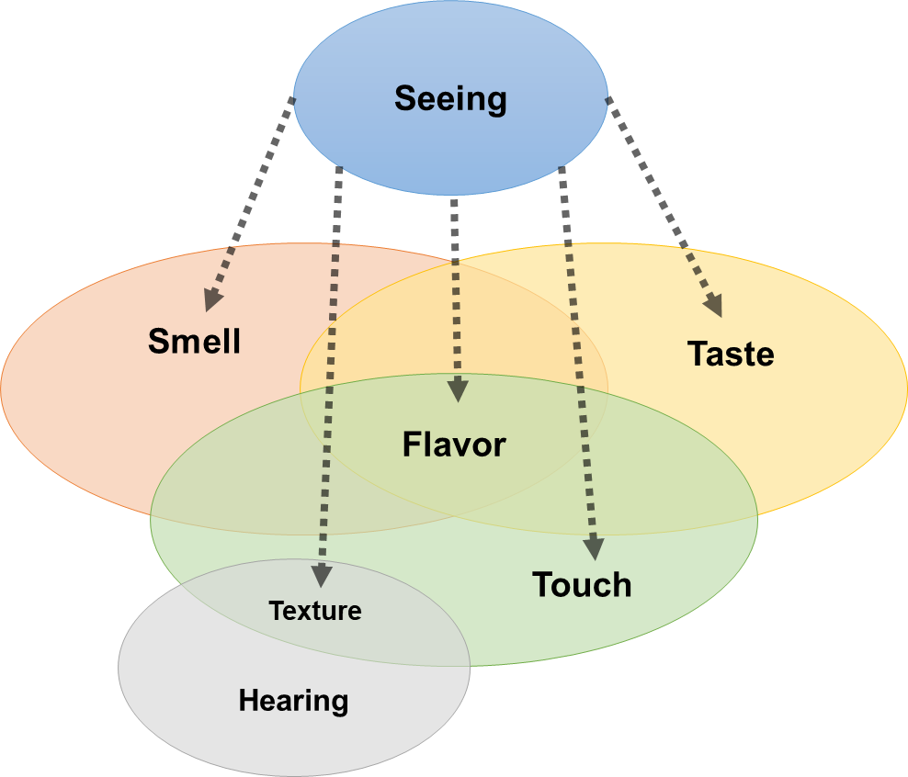
Figure 1. Simplified diagram of the multisensory processing in food perception.

Food Acceptance and Rejection
To assess a consumers appeal to food, behavioral or subjective questionnaires may be used alone or in combination. Behavioral assessments and questionnaires have both shown that positive sensory appeal and health outcomes are important motivators for the development and maintenance of food acceptance. Behavioral acceptance testing is a common practice in sensory science in which participants, soloed in booths, use a rating scale to express their liking or disliking of several foods during consumption. Typically, a 9-point hedonic scale (“extremely like” to “extremely dislike”) is used to determine liking while alternative approaches can be used in combination to gain more insight into drivers of liking such as intensity scales, just-about-right (JAR) scales or descriptive techniques (e.g. open-ended or check-all-that-apply (CATA) (Lawless & Heymann, 2010). Additionally, preference or noticeable hedonic differences between samples, either liked or disliked can be obtained through alternative-forced choice procedures; however, preference and liking should not be confused as someone may have a preference for similarly disliked foods that are not acceptable (Lawless & Heymann, 2010). For instance, the consumer rejection threshold (CRT) uses paired comparison (2-alternitive forced choice, 2-AFC) to determine a critical point where preference is altered (Prescott et al., 2005); however, recent research shows this method does not represent rejection but compromised acceptance (Filho et al., 2015). Hedonic methods have therefore been developed to pinpoint the shift from acceptance to rejection (Filho et al., 2018).
For a more generalized understanding of individual food preferences, questionnaires are typically used. In the past, valid and reliable physiological scales like the Food Choices Questionnaire (FCQ; (Steptoe et al., 1995)) and Food Motivation Scale (Martins & Pliner, 1998) have been used to measure motives of food acceptance. Alternatively, attitudes towards food characteristics may be accessed through open-ended responses about a variety of foods (Luckett & Seo, 2015; Pellegrino, Hummel, et al., 2020; Szczesniak, 1971). Nevertheless, enjoyable sensory attributes have consistently been rated as the largest motivator, followed by health factors, for food acceptance and choice (Martins & Pliner, 1998; Pellegrino, Hummel, et al., 2020; Steptoe et al., 1995; Szczesniak, 1971). Consequently, the notions of lower sensory appeal is a leading cause to reject a food (Martins & Pliner, 2005). In 1987, Rozin and Fallon defined three specific motivations for rejecting a food: 1) sensory-affective 2) anticipated consequences and 3) ideational (Rozin & Fallon, 1987). Sensory-affective represents the belief that the food has negative sensory properties such as an unpleasant flavor/taste, texture, aroma, sound or appearance. Anticipated consequences relate to physical (e.g. health) or social harm (e.g. class status) that may result from ingestion or choice of a food, while ideation comes from knowledge of the origin or nature of the food (e.g. eating insects in western cultures). Texture has persistently been shown to be a prominent food characteristic determining food acceptability (Luckett & Seo, 2015; Szczesniak, 1971), and texture is often mentioned as a reason people won’t eat a certain food (Cardello, 1996; Szczesniak, 1972; Surmacka Szczesniak, 2002).
Exogenous factors obtained through perceptual learning also modify behaviors. Culture represents a major influence in food preferences and liking (Prescott & Bell, 1995; Rozin & Vollmecke, 1986) through political and economic influences (Rozin, 1988). As foods become established in cultures and emphasized through cuisines, the characteristics of those food may be liked more and more through exposure (Pliner, 1982). In fact, the question “What is your culture or ethnic group?” may be the best and fastest way to determine the food preferences of an individual according to Rozin and Vollmecke (1986). For instance, preference for prominent flavor food attributes such as taste (Pellegrino et al., 2018; Prescott, 1998; Sorokowska et al., 2017) and smell (Ayabe-Kanamura et al., 1998; Pangborn et al., 1988) have all been shown to be influenced by culture.

Complexity of Food Texture
Aristotle, in his Book Beta of the De anima, taught that there are five senses (aísthēsis): sight, hearing, smell, taste, and touch – each communicating a signal across some medium for a sensory organ to display a representative object (Heller-Roazen, 2007). Earlier, it was discussed that there is an interplay of communicational signals from different sensory organs called multisensory processing; however, within each sense there are several signals creating a complex and diverse pattern to be interpreted by the receiver. For instance, color, lines, and contrast are all visual signals while several odorants create one odor. These designs of signal or arrangement of features in a stimulus can be complex. To complicate things further, an object can be defined by this multitude of signals as well as its aesthetics judged by the receiver (Chatterjee & Vartanian, 2016). In other words, when an individual encounters a stimulus they do not simply reflexively respond, but rather build meaning by extracting and transforming the information gathered. Extraction through perception can be approximated with information theories (many based on the information theory developed by Claude Shannon (Shannon, 1948)); however, all information has bias that must be accounted for with systems other than sensory (Renoult & Mendelson, 2019). Complexity of a stimulus must account not only for perception, but also evaluation considered by the cognitive and emotional systems (Wyer et al., 1999). These systems interact with each other, such as perception influences cognition leading to changes in preference (Figure 2). In this sense, complexity is a collative and dynamic property. Using this framework one can extrapolate into reasons individuals may prefer simple and complex stimuli. For instance, looking at information theory of perception alone would predict individuals always preferring simple, familiar stimuli as it would be processed more efficiently; however, it has been shown in the visual (Bornstein, 1989) and tactile domains (Jakesch & Carbon, 2012) that individuals like complex stimuli (for its arousal) and overexposure can lead to boredom.

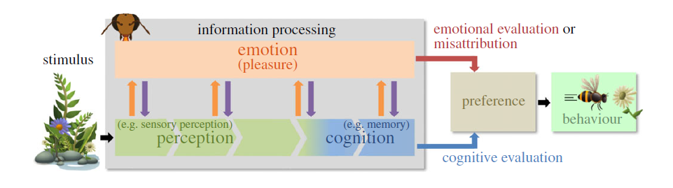
Figure 2. Information processing of a bee encountering a stimulus (e.g. flower). Figure obtained from (Renoult & Mendelson, 2019).

Many foods have complex features both in perception and aesthetic evaluation (Köster & Mojet, 2016). Currently, there are many theories explaining how complexity affects liking over time (Figure 3). Based on a recent review, there is no consensus on the hedonic relationship of complexity in food (Palczak et al., 2019); however, it likely resembles an inverted-U curve similar to arousal and liking (Berlyne et al., 1965; Mielby et al., 2013). Depending on the food different types of complexity may emerge and as mentioned before, food complexity is dynamic as prior exposure plays a role in shaping the level perceived and enjoyed. For instance, liquids such as wines may be discussed strictly in terms of complex flavors and experts may find and enjoy more complexity than novice drinkers (Spence & Wang, 2018b). In addition to complex flavor, solid food stuff may also present textural complexity. Complex textures come from the combination of several senses signaled and their continual change over time (Szczeniak & Kahn, 1984), and complexity has been noted as a feature of most palatable foods (Hyde & Witherly, 1993). For instance, audition is an inherent part, along with touch, of several textures such as crispness (Vickers & Bourne, 1976), in such, that modifying the sound modifies the crispness (Zampini & Spence, 2004). When biting into a baguette, the initial crispness is contrasted with softness of the inner crumb of the bread and these contrasting textures change from hard to soft or soft to sticky as the eating process continues. For more complex stimuli, there may be large texture combinations coexisting and dynamically changing during the chewing process (Tang et al., 2017). Along with perception, cognitive processes must engage in sensory-motor feedback loops to not choke and decide when it is safe to swallow (Shupe, Wilson, et al., 2018). Additionally, emotional processes outside of pleasure such as disgust may be present with certain or unexpected textures such as slimy, mushy, and sticky (Kushner, 2011; Saluja & Stevenson, 2019). Increased textural complexity leads to more descriptors with higher intensity ratings using static (Larsen et al., 2016) and temporal measures (Tang et al., 2017). Additionally, several researchers have found textural complexity to enhance satiation (Larsen et al., 2016). However, current experimental evidence for textural complexity have emphasized the physical complexity rather than the aesthetics.

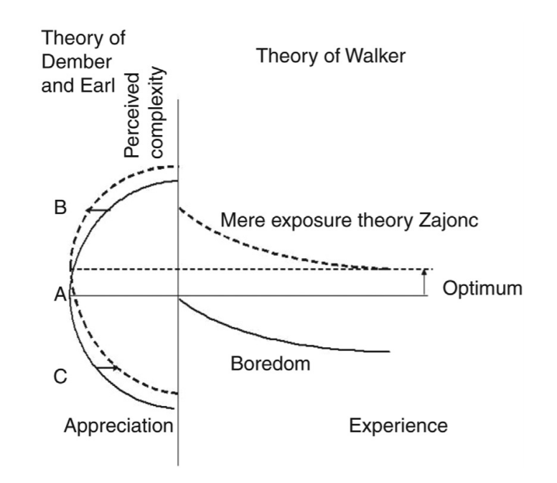
Figure 3. Depiction of theories to explain the relationship between appreciation and perceived complexity of a stimuli over experience. Figure obtained from (E. P. Köster & Mojet, 2007).

Tactile/Texture Sensitivity
An unmistakable and pervasive characteristic of our species is individual differences within and across populations, and it is for this reason we amass large samples to measure a phenomena. Through observations of physical structures many individual differences are apparent from the height of an individual to the number of freckles present and eye size or color. Individual differences are vast, not only on the external profile of an individual, but also their internal makeup. For instance, from a random sample of people there will be many variations in the size and shape of organs as well as their placement within the body (Bergman, 1988). Muscle placement differences or absence lead to unrepresented internal emotions to outside receivers. For instance, the corrugator supercili, an important facial muscle to determine valance or emotions such as happy and angry, is absent in 20% of the population (Neta et al., 2009; Tassinary et al., 1989). More specific to sensory, differences in physiological functioning have long been documented under the umbrella term individual response stereotypy and includes somatic, autonomic and brain differences with stereotypy referring to the reliability of the individuals’ differing response over time (Ayres, 1964; Lacey, 1959; Lacey et al., 1953; Lacey & Lacey, 1958; Malmo & Shagass, 1949).
Response differences may come in the form of sensitivities to a specific sensory stimulus or generalized to a broader range, and may refer to hypersensitivity (i.e., over-responsiveness) or hyposensitivity (i.e., under-responsiveness). Atypical sensory processing has been associated with several clinical conditions such as Tourette’s (Belluscio et al., 2011), migraines (Schwedt, 2013), and autism spectrum disorder (Cermak et al., 2010), but may also affect healthy adults to a lesser extent (Robertson & Simmons, 2013; Tavassoli et al., 2014). Importantly, there are several distinctions between different sensory sensitivities within atypical sensory processing: behavioral sensory sensitivity, neural sensory sensitivity, and subjective sensory sensitivity. Subjective sensory sensitivity accounts for most of the work done in this field and are self-reported individual differences through psychological scales. Behavioral sensory sensitivity, on the other hand, are individual differences in the ability to discriminate or detect sensory stimuli while neural sensory sensitivity are excitation differences among receptors and/or across neural networks to a given stimulus. An open question in the field of individual differences is how do these measures of sensitivity relate to each other (Ward, 2019).
Using functional magnetic resonance imaging (fMRI) it has been shown that individuals with subjective hypersensitivity have an increase brain activity to a stimulus compared to those rating themselves less sensitive (Green et al., 2013, 2015). However, these subjective to neural sensitivity studies are relating general sensitivity to a specific stimulus. More importantly, it is less known if this activity is related to increased noise or signal. If the increased activity is signal then an increase in behavioral sensitivity should follow, but if the activity is noise then a decrease in behavior should be reflected. Neural activity balancing signal and noise can be shown in the following simple equation (Zhaoping, 2006):

$$O=K\left(S\right)+N_{a}$$

In this equation, O represents the response output (e.g. neuronal population) while S refers to the signal and K() the encoding function (e.g., what is done with the signal). N_{a} refers to the background noise (non-specific, spontaneous neural activity). Importantly, this framework of sensitivity ignores the possibility of stochastic resonance (McDonnell & Abbott, 2009) in which noise in some circumstances increases signal leading to increases in behavioral sensitivity (Simmons et al., 2009). Similarly, a refined noise parameter can be added to the equation above termed multiplicative noise (N_{m}) (O’Hare & Hibbard, 2016). This new framework can be summed up in the following equation:

$$O=K\left(S\right)∙(1+N_{m})+N_{a}$$

Recently, this equation has been used to describe a range of possible relationships between subjective, neural and behavioral sensitivity (Ward, 2019). However, this framework has been rooted in atypical populations rather than sensitivity differences in neurotropic individuals and has focused on general sensory sensitivities rather than more specific ones. Specific sensitives’ have been shown in both clinical (Frenzel et al., 2012; Moshourab et al., 2017) and non-clinical groups (Coulthard & Sahota, 2016; Nederkoorn et al., 2015, 2019; Shupe et al., 2019). For instance, deaf individuals show a decrease in tactile sensitivity (Moshourab et al., 2017) with more pronounce neural responses to tactile stimuli (Güdücü et al., 2019), and this may be due to cross-modal reorganization (Glick & Sharma, 2017). Additionally, the decrease in behavioral tactile sensitivity with age has been explained through a decreased neural response (Bangcuyo & Simons, 2017; Calhoun et al., 1992; Shupe, Resmondo, et al., 2018; Thornbury & Mistretta, 1981). Many relationships between subjective, neural, and subjective sensitivities remain unexplored for specific sensory modalities including touch. Additionally, other exogenous and endogenous factors most likely affect these relationships such as attention through prioritization, stimuli salience, and emotion (Ward & Del Rio, 2019).

CHAPTER I
Texture Contrasts and Combinations Across Cultures
A version of this chapter is published in Journal of Texture Studies by Robert Pellegrino, Bobby K. Cheon, Ciarán G. Forde, Anna Oleszkiewicz, Michal Pieniak, Curtis R. Luckett:

Abstract
Texture has long been considered an important attribute for food acceptance. However, which specific textural characteristics contribute to overall acceptance of a food is not well understood. It has been suggested that texture contrasts and combinations are a universal feature in giving foods a desirable texture, yet this notion is largely based upon anecdotal data. This study uses multiple survey research methods to assess the importance of texture contrast and combinations across cultures (Poland, U.S.A., and Singapore). Participants (N = 288) completed a survey that included overt measures of food texture contrast importance as well as free response questions regarding texture. The overall importance of texture for food liking was not different across the populations. However, the participants from Singapore and Poland gave more importance to a desirable food having multiple textures than the U.S.A. cohort. When looking at free responses, participants were twice as likely to mention combinations (multiple textures) with a texture contrast when describing foods they liked, in comparison to foods they disliked. This was observed across all three cultures. However, the type and quantity of texture terms used within combinations were different among cultures. For instance, Singaporeans enjoyed more texturally diverse food combinations than the other two cultures. These findings highlight the importance of texture contrasts and combinations in three distinct cultures.

Introduction
Texture is the material property that arises from the combination of structural, mechanical, and surface properties of foods which are detected through the senses of vision, hearing, and touch. In other words, texture is the way food and drink feel in one's mouth. Textures play an important role in food acceptance, with a majority of individuals giving it high importance in comparison to other characteristics of food (Luckett & Seo, 2015; Szczesniak, 1971; Szczesniak & Kahn, 1971). The importance of texture to palatability has been reported to be universal across populations (Rohm, 1990). Additionally, texture has been shown to be more important than flavor in the rejection of some foods for adults and children alike (A. V Cardello, 1996; Alina S. Szczesniak, 1972).
Texture perception often begins with the eyes but is centered on tactile sensations from within the oral cavity. The movement of the jaw and tongue, along with lubrication from saliva, manipulate the texture to make it safe for ingestion. Throughout the manipulation step, the texture of the food changes dynamically. Nomenclature for describing textural qualities was first developed in the 1960s (Szczeniak, 1963). The terms classified were designed to be simple in wording to relate fundamental, measurable properties with perceptual experience. Specifically, texture terms were classified into three main classes of characteristics and subsequent primary or secondary properties (see Table 1). Three main classes of characteristics were defined: mechanical, geometrical and other. Mechanical characteristics included texture properties that relate to applied stress (e.g., hardness, elasticity). Geometrical characteristics have properties related to structure and appearance (e.g., particle size and shape) while other characteristics included mouthfeel properties that do not fall into the first two categories (e.g., moisture and fat content). However, as mentioned by Szczesniak and later Guinard and Mazzucchelli (1996), some terms are more complex and may fit across categories or be context‐specific like juiciness (Guinard & Mazzucchelli, 1996). Studies on consumer attitudes toward food attributes show that texture terms, such as crisp/crispy, crunch/crunchy, creamy and juicy, are very commonly reported by consumers (Luckett & Seo, 2015; Szczesniak & Kahn, 1971). Furthermore, in similar cross‐cultural studies, overlap and differences in texture terms frequently used for foods among several populations have been shown (Lawless et al., 1997; Nishinari et al., 2008; Rohm, 1990). A list for 54 English texture terms for foods and their equivalent term in 22 languages has also been compiled (Drake, 1989). Culturally specific foods and styles of cooking change the types of textures experienced and may emphasize or deemphasize texture attributes. For instance, many Asian dishes incorporate cooked cartilage which is primarily a texturized food that lacks flavor. This may help explain why the Japanese have over 400 texture terms (Hayakawa et al., 2013; Yoshikawa et al., 1970). As mentioned, most cross‐cultural research in texture has examined types of terms and their salience among populations while ignoring texture combinations present within a food.

Table 1. Classification of textural characteristics by 3 main classes (mechanical, geometric, & other)ª
Mechanical characteristics
Primary | Secondary | Examples
Hardness |  | Soft, firm, hard
Cohesiveness | Brittleness | Crumbly, crunchy, brittle
 | Chewiness | Tender, chewy, tough
 | Gumminess | Short, mealy, pasty, gummy
Viscosity |  | Thin, viscous
Elasticity |  | Plastic, elastic
Adhesiveness |  | Sticky, tacky, gooey
Geometric characteristics
Primary |  | Examples
Particle size and shape |  | Gritty, grainy, course
Particle shape and orientation |  | Fibrous, cellular, crystalline
Other characteristics
Primary | Secondary | Examples
Moisture content |  | Dry, moist, wet, watery
Fat content | Oiliness | Oily
 | Greasiness | Greasy
ªAdapted from Szczeniak (1963) by Guinard & Mazzuchelli (1996)

There are several ways in which a food can contain multiple textures, many of which are not mutually exclusive. In order to better understand a multitextured food, this study looks to further classify multiple textured foods based upon previous descriptions. In the simplest form, a food can statically possess multiple textures (i.e., chewy cheese and the crispy crust of pizza). As mentioned previously, foods can possess different texture types which manifest temporally during the eating process. So, a food which contains a singular texture in the static state can be perceived to have multiple textures dynamically, for example chocolate moving from a hard texture upon the first bite to a smooth texture prior to swallowing. A change in texture and other flavor properties has been discussed as a key for high palatability of food (Hyde & Witherly, 1993). Different textures may also be classified depending on the energy required to process or manipulate them during consumption, and texture changes may move between two similar energy requirements or one having higher or lower (contrasting) energy needs than the other (Szczeniak & Kahn, 1984). For instance, when biting into a baguette, one may perceive contrasting textures from the hard exterior to the soft interior, or a high energy to low energy texture change. However, after bolus formation one may perceive both soft and moist textures concurrently, both of which require a low level of oral processing energy. Foods that are reported to have texture characteristics that require contrasting energy needs to process orally are deemed to have a texture contrast. Conversely, a food with multiple textures of the same oral processing energy requirements only contains a texture combination. More plainly a contrast always involves a texture combination, but a texture combination does not always imply a contrast is present.
The current study was designed to look at cross‐cultural differences of liked and disliked textures among three different populations: (a) North American (U.S.A, N = 124), (b) European (Poland, N = 73), and Asian (Singapore, N = 91). The survey sites were chosen to provide a broad perspective towards texture contrasts across three highly populated continents. Individuals from each population were asked to rate the importance of texture and foods having multiple textures. They were then asked to describe textures for their most liked and disliked foods. An online survey was used to collect responses and a coding schema based on an established texture classification system was used to analyze results. Building on previous work, we anticipate universal liking for texture and multiple textures within food; however, cultural shifts in types of textures mentioned for liked and disliked foods are expected.

Materials and Methods

Participants
A total of 288 individuals with an age ranging from 18 to 77 years old (mean [M] = 30.24, SD = 11.91) participated in the study. Participants in the U.S.A. and Poland were recruited from the general population, while Singaporean participants were recruited from a student population. Thus, data was gathered from populations on three separate continents, Europe, Asia, and North America (see Table 2).

Table 2. Demographic summary of participants.
Sex | Country |  | N | Min | Max | Mean | SD
Men | All Men | Age | 125 | 18.0 | 70.0 | 28.5 | 10.4
 |  | BMI | 125 | 17.3 | 46.9 | 23.9 | 5.0
 | Poland | Age | 50 | 18.0 | 57.0 | 28.2 | 8.2
 |  | BMI | 50 | 17.3 | 38.3 | 21.9 | 3.7
 | Singapore | Age | 40 | 21.0 | 30.0 | 23.8 | 1.9
 |  | BMI | 40 | 18.6 | 30.0 | 22.7 | 2.5
 | U.S.A. | Age | 35 | 19.0 | 70.0 | 34.3 | 15.2
 |  | BMI | 35 | 17.8 | 46.9 | 28.3 | 6.0
Woman | All Women | Age | 163 | 18.0 | 77.0 | 31.4 | 12.7
 |  | BMI | 163 | 18.2 | 46.8 | 24.7 | 6.8
 | Poland | Age | 23 | 18.0 | 52.0 | 28.4 | 8.4
 |  | BMI | 23 | 18.7 | 31.6 | 25.3 | 3.4
 | Singapore | Age | 51 | 21.0 | 26.0 | 21.8 | 1.1
 |  | BMI | 51 | 12.3 | 26.7 | 20.4 | 2.6
 | U.S.A. | Age | 89 | 20.0 | 77.0 | 37.7 | 13.4
 |  | BMI | 89 | 18.2 | 46.8 | 27.0 | 7.9

Survey
A separate online survey was deployed for each participating population. The survey was presented in English for Singapore and U.S.A., while the Polish authors translated and presented their questions in Polish. The survey began with a general definition for texture (adapted from Szczesniak (2002))
“Texture is the sensation from the structural, mechanical, and surface properties of the foods detected through the senses of vision, hearing, and touch. In other words, texture is the way food and drink feel in your mouth”.

Next, participants were asked to use a 7‐point category scale to assess (a) texture's importance to food liking (“Not Important at All” to “Extremely Important”) and (b) level of agreement to the enjoyment of multiple textures (“Extremely Disagree” to” Extremely Agree”).
- In general, how important is texture to your liking of a food?
- For a food to be enjoyable, it must have multiple textures.
After ratings, the participants were asked to specify their most liked and disliked food or dish. They were then asked to list three texture qualities that make them like or dislike the food or dish. The supplemental text boxes were not mandatory in case the food/dish did not have three liked or disliked texture characteristics. Additionally, the participants were asked for their gender, age, nationality, native language, height, and weight.

Statistical Analysis
Only individuals claiming nationality that matched the corresponding population of interest was analyzed. Analysis was completed in SAS 9.4 (SAS Institute, Inc., Cary, NC). The rating of texture importance and level of agreement to the enjoyment of multiple textures were analyzed through a one‐way ANCOVA with population as the predictive factor. Age and BMI were used as cofactors in these models.
The frequency of common liked and disliked texture terms was quantified for each population and the frequency of those popular terms (>5 mentions) was compared. A Fisher's exact test was used and post hoc comparisons among populations were Bonferroni corrected. Significant terms that may be due to language (especially Polish) were verified by a native Polish speaking author.
Texture quality terms were categorized into an established classification system for texture types (Guinard & Mazzucchelli, 1996; Szczeniak, 1963) (Table 1). Specifically, the class of texture characteristic (mechanical, geometric and other) and the subsequent primary and secondary characteristics were recorded in separate columns for each texture term. Next, three texture variables were calculated from the coded categories: texture contrast, texture classes, and texture combinations. A texture contrast was defined as a food being described by an active and passive texture (e.g., hard/crispy and soft/moist). A passive texture needs a low amount of energy to process the food (moist, soft) while an active texture needs a high amount of energy to process (Szczesniak & Kahn, 1984). Texture contrast was a binary variable (0 or 1)—either there was or there was not a contrast between two or more textures for a food. Texture combinations represented the number of different primary or secondary characteristics for a food. Texture classes represented the number of different classes of texture characteristics (mechanical, geometric and other), providing a measure of the diversity in texture terms used. Texture combinations and classes were continuous variables with a range from 0 to 3. Texture contrasts and combinations have been described in previous literature (Szczesniak & Kahn, 1984). For texture combination and class variables, a mixed effects model was used in which liked and disliked terms were used as the within variables and population as the between participants variable. A binomial mixed regression model was used to measure contrast differences within liked foods and among populations. For all three models, age and BMI were set as covariates.

Results
There were no differences in the importance of texture to food liking among populations (F 2, 269 = 1.62, p = .20, d = 0.17), with each rating food texture relatively important for liking: U.S.A. (Mean ± SD = 5.14 ± 1.51), Poland (5.12 ± 1.31), and Singapore (5.35 ± 1.25). However, the U.S.A. population (3.42 ± 1.53) put less importance on foods having multiple textures in order to be enjoyed compared to Polish (4.26 ± 1.75) and Singapore (4.39 ± 1.32) populations (F 2, 273 = 10.12, p < .001, d = 0.53).
Differences among popular terms (>5 mentions) across populations within liking are marked in Table 3 (for a list frequency for all terms, see Table S1). Soft was widely listed when describing liked foods and was either the first or second most popular descriptor for liked foods across all populations. Smooth , crispy , and crunchy were also commonly used to describe liked foods. Across populations there was less similarity in the terms to describe disliked foods.

A visualization of popular texture terms for liked and disliked foods are shown in Figure 4. Populations used different popular terms for liked and disliked foods (χ 2 = 154.10, p < .001 and χ 2 = 204.733, p < .001, respectively) foods. As shown in Figure 5, more texture combinations and texture contrasts were mentioned for liked foods compared to disliked foods (F_{(1, 271)} = 12.73, p < .001, d = 0.26 and F_{(1, 419)} = 63.01, p < .001, OR = 2.68, d = 0.55, respectively), and this was independent of culture (F_{(2, 269)} = 2.05, p = .13 and F_{(2, 419)} = 2.56, p = .08, respectively). However, an interaction between population and food liking was observed for texture characteristics (F_{(2, 271)} = 7.56, p < .001, d = 0.38; Figure 6). The Singapore population mentioned more texture characteristics for liked compared to disliked foods while the opposite trend was shown for U.S.A. and Polish populations. There were no other significant effects (p > .05).

Table 3. List of popular texture terms used for liked and disliked foods. All values are expressed as a percentage of total texture responses. Terms in the same row that do not share a letter are significantly different from each other (p > 0.05)
Liked Foods |  |  |  | Disliked Foods
Terms | Polish | Singapore | U.S.A. | Terms | Polish | Singapore | U.S.A.
chewy | 1.88 b | 9.35 a | 7.24 a | chewy | 6.85 | 4.00 | 4.10
creamy | 1.88 b | 3.27 ab | 7.24 a | crunchy | 0 b | 5.71 a | 1.87 ab
crispy | 13.75 | 7.01 | 8.62 | dry | 4.79 | 3.43 | 2.61
crunchy | 0.63 c | 7.01 b | 18.62 a | fatty | 4.11 a | 0 b | 0.37 b
elastic | 4.38 a | 0 b | 0 b | grainy | 0.68 | 0.57 | 4.10
firm | 5.63 a | 0.47 b | 4.14 a | gritty | 0 b | 0 b | 3.73 a
hard | 0.00 | 1.87 | 2.41 | hard | 0 b | 13.14 a | 1.87 b
juicy | 1.25 | 3.27 | 2.07 | lumpy | 2.74 | 1.14 | 1.87
layered | 3.13 a | 0 b | 0.34 ab | mushy | 2.74 a | 8 ab | 13.06 a
melty | 2.50 | 0.93 | 2.41 | rough | 0.68 b | 8 a | 1.49 b
moist | 4.38 | 3.27 | 2.41 | rubbery | 2.74 | 1.14 | 1.87
rough | 0.63 ab | 4.67 a | 0.69 b | slimy | 0 b | 9.14 a | 12.31 a
smooth | 5.63 b | 16.36 a | 9.66 ab | slippery | 5.48 | 1.14 | 1.49
soft | 18.75 | 19.16 | 13.10 | soft | 4.79 | 8.57 | 3.73
springy | 4.38 a | 0.47 ab | 0 b | squishy | 2.74 | 2.86 | 3.73
tender | 6.88 | 5.14 | 5.52 | sticky | 10.27 a | 4 ab | 2.24 b
- | - | - | - | stringy | 6.85 a | 0 b | 2.99 ab
- | - | - | - | tough | 10.27 | 3.43 | 4.48
- | - | - | - | watery | 4.79 | 2.86 | 1.87
Note : All values are expressed as a percentage of total texture responses. Terms in the same row that do not share a letter are significantly different from each other (p > .05)

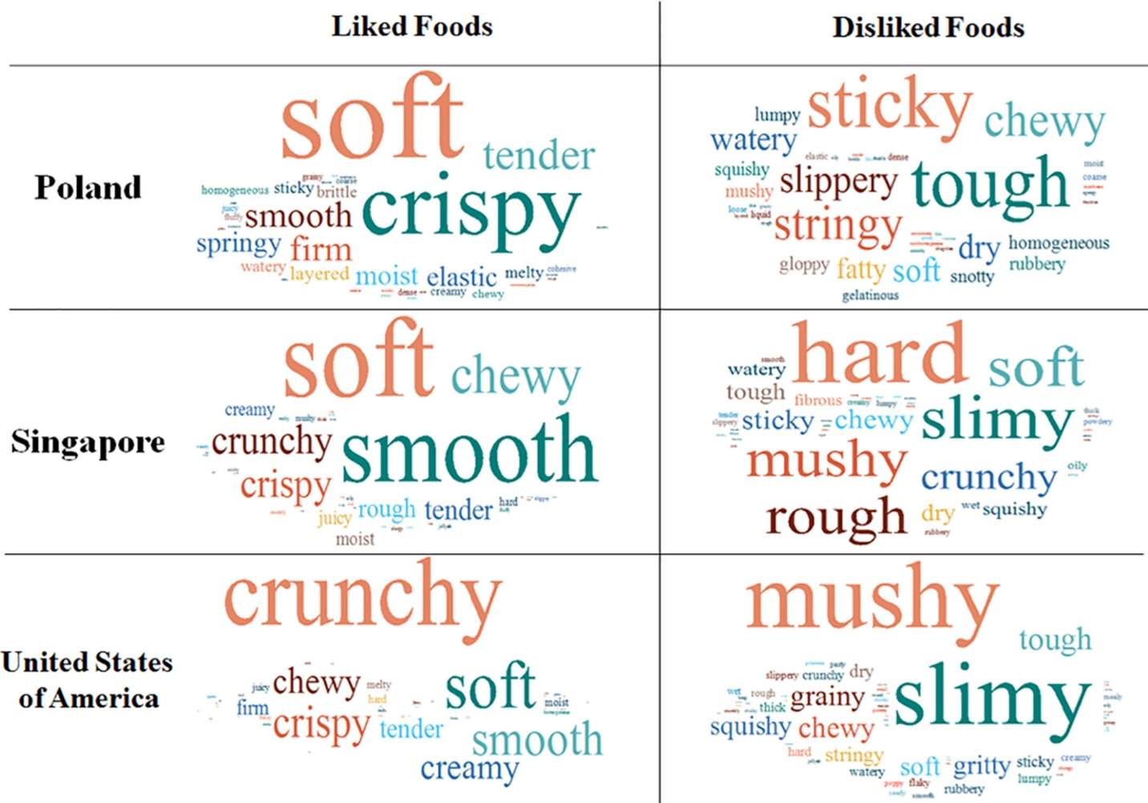
Figure 4. Word clouds of popular texture terms between food likings and among populations. Larger words represent a greater frequency of use within a population for liked or disliked foods.

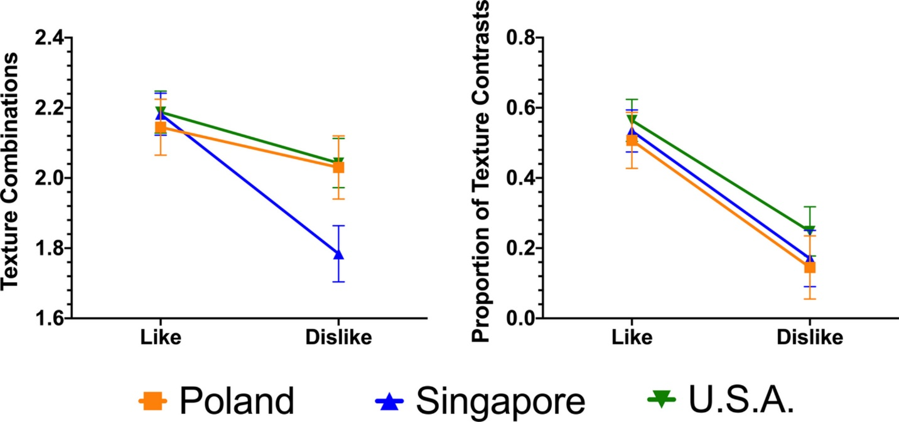
Figure 5. Frequency of texture contrasts and combinations mentioned for liked and disliked foods among populations.

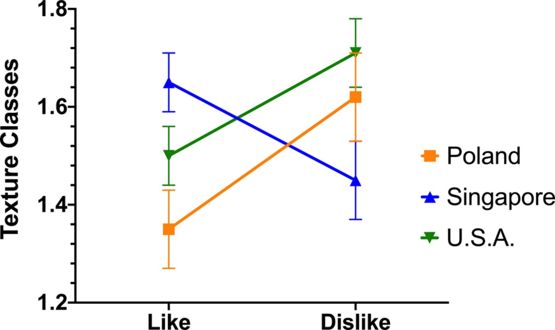
Figure 6. Frequency of texture characteristics mentioned for liked and disliked foods among populations. An interaction among population and food liking exists (p < .001). From liked to disliked foods, the Asian population decreased their mention of texture characteristics while an increase was noticed for Poland and U.S.A

Discussion
The classification of texture may fall under its main class of characteristics and subsequent primary and secondary properties as defined by Szczesniak (1963). In this study, we examined these notions and defining mechanisms across populations to consider the consistency and cultural specificity of consumer attitudes towards texture contrasts and combinations across three distinct cultures.
As expected, texture in foods is important with all populations in the study reporting similarly high levels of importance. Texture is universally recognized as integral to making foods enjoyable to eat. Two similarly designed surveys asking individuals to openly report food attributes that contribute to the liking of several (30+) types of foods showed texture as the most frequently mentioned attribute followed by flavor (Luckett & Seo, 2015; Szczesniak & Kahn, 1971). Given the dynamic nature of texture changes during consumption, individual texture attributes are often not perceived in isolation, but accompanied by other textures. The importance of multiple textures to food appreciation was confirmed across the populations in the current study. In particular, the North American (U.S.A.) population rated the importance for foods having multiple textures to be less important for food pleasantness than the other two populations, even when controlling for age and BMI.
The presence of multiple textures happens during initial evaluation and during mastication as the texture typically shifts from high to low energy. Thus, at any stage, there may be different combinations of textures and they may or may not be contrasting. We show that all individuals, irrelevant of culture, report more combinations and contrasts in liked foods/dishes compared to disliked foods/dishes. Therefore, although the U.S.A. population were found to place less importance on foods having multiple textures, these textures were still present among the most palatable foods. Similarly, Szczesniak and Kahn (1984) were the first to point out the importance of texture contrasts and combinations for a US population stating the “polarity between stimulating/energetic (i.e., firm, crisp) and passive/soothing (i.e., soft, creamy) texture characteristics form the foundation of many highly desirable texture combinations” (Szczesniak & Kahn, 1984). In this paper, they describe four scenarios incorporating texture combinations and contrasts to increase enjoyment: (a) within a meal, (b) on the plate, (c) within a multiphase food, and (d) within a uniphase food during consumption. Whereas within meal texture combinations may demonstrate low to high energy shifts in texture (e.g., soup to meat), most answers to our survey dealt with contrasts of varying combinations for the multiphase or uniphase foods (e.g., steak being crispy then tender or smooth).
The textures within combinations and contrasts were not the same across cultures with many different texture terms being reported for liked and disliked foods (Figure 1). Past studies have examined texture term usage across populations with differences being demonstrated between and within cultures, consumers, and experts (Blancher et al., 2007; Cardello et al., 1982; Drake, 1989; Lawless et al., 1997; Nishinari et al., 2008). For instance, it has been shown that English speakers use far less texture terms (~70) (Drake, 1989; Szczesniak & Kleyn, 1963) than those from Japan (~400) (Hayakawa et al., 2013; Yoshikawa et al., 1970), as the Japanese language includes many more onomatopoeic words for descriptions (e.g., fizz, crackle) (Hanada, 2020). In our study, we focused on collecting an unrestrained consumer lexicon for liked and dislike foods. Interestingly, collapsing across cultures, 22 more disliked texture terms were mentioned than liked terms (Table S1)—a finding supporting the view that texture is often more salient when unpleasant (Szczesniak, 2002). Additionally, it has been stated that while flavor drives food liking, texture is often the food attribute responsible for food rejection (Cardello, 1996).
One cross‐cultural study, like ours, categorized each term by its main class of characteristics and showed that cultures similarly use more mechanical and geometrical terms (Nishinari et al., 2008). This notion may be true for our study as well; however, we asked a different question, “how does the number of main class of texture characteristics within a liked and disliked food combination culturally differ?” Here, we found differences across populations. The Asian (Singapore) population showed more main classes of characteristics within a liked than a disliked combination of textures. The opposite trend was found in the European (Polish) and North American populations. In this regard, foods with texture attributes representing distinct texture classes (i.e., mechanical, geometrical, other) tended to be aversive for the two Western cultures but were reported as more palatable for the Asian population in our survey. This may reflect differences in the breadth of texture awareness across the three different cultures and future studies are needed to describe these differences in more detail and across a wider geographical population. It is important to note, however, that Singapore has a very diverse population near distinct styles of cuisine across east Asia including influence from western cultures. Therefore, individuals in this environment are accustomed to many types of foods with varying texture.

Limitations
This study provides the consumer attitudes towards texture across three unique populations; however, the authors made some methodological concessions to complete this study. The study was distributed online, meaning no actual food was consumed and the participants were not strictly controlled in the construction of their responses. Along these lines questions and survey instructions could have interpreted differently. Specifically, the respondents could have interpreted multiple textures differently. Additionally, the Singaporean population were university students. While the authors controlled for age in the statistical analyses, other sociocultural factors could be unique to the student population. Lastly, the Polish population was administered the survey in Polish, while the other populations completed the survey in English. There is a possibility that the available vocabulary for texture descriptors is different across the languages (i.e., Polish and English) used in this study.

Conclusion
This study highlights that texture combinations and contrasts are an important factor for texture acceptance across three cross‐cultural populations. The importance of texture combinations and contrasts was stable across populations, though textures with attributes from multiple main texture classes were associated with greater palatability in Asia and having multiple textures was found to be less important for food liking in the other two populations.

CHAPTER II
Aversive Textures and Their Role in Food Rejection
A version of this chapter is published in Journal of Texture Studies by Robert Pellegrino, Curtis R. Luckett:

Abstract

Texture is a prominent feature in foods and consequently can be the reason a food is accepted or rejected. However, other sensory attributes, such as flavor/taste, aroma, sound and appearance may also lead to the rejection of food and motivations other than unpleasantness exist in unacceptance. To date, these motivations for food rejection have been studied in isolation and their relationships with psychological factors have not been tested. This study measured reasons people reject a food and probed into the specifics of texture rejection. A large U.S. sample (N=473) was asked to rate their motivations for rejecting a food, list foods that were disliked due to unpleasant sensory attributes, specify the unpleasant sensory attribute(s), and complete an assessment of general touch sensitivity. Results showed 94% of individuals reject a food due to its texture, a rate comparable to flavor-based rejection. Looking at the number of foods being rejected, flavor was the most common food attribute, followed by texture and then aroma. From a linguistic standpoint, aversive textures encompass a large vocabulary, larger than liked textures, and the same food may be rejected due to a single or combination of texture terms. Viscosity (e.g. slimy) and hardness (e.g. mushy) are the most common aversive texture types, but through cluster analysis subsets of individuals were identified that are more aversive to other textures. This study emphasizes the role of aversive textures in food rejection and provides many avenues for future investigations.

Introduction
Texture is defined as “all the mechanical, geometrical and surface attributes of a product perceptible by means of mechanical, tactile and, where appropriate, visual and auditory receptors” (International Standards Organization, 1994), and is a prominent food characteristic determining food acceptability (Luckett & Seo, 2015; Pellegrino et al., 2020; Szczesniak, 1971). Texture is often mentioned as a reason people won’t eat a certain food (Cardello, 1996; Szczesniak, 1972; Szczesniak, 2002), and prior research points to the possibility that the use of disliked texture terms may outweigh liked ones (Pellegrino, Cheon, et al., 2020). When looking for overarching texture characteristics related to food acceptability, several complex issues arise. For example, textures are food dependent meaning that the same texture may be liked or disliked when present in different foods (Cardello, 1996). Additionally, foods typically contain several textures and the combinations of those texture characteristics are important for acceptance, a finding that shows some cultural dependence (Pellegrino et al. 2020). For these reasons and possibly others, food rejection due to texture has not been empirically investigated nor compared to other common sensory attributes (e.g. flavor/taste, aroma). Complicating matters even further, the unpleasantness of a sensory property represents one of the reasons people will reject to eat a food.
Rozin and Fallon (1987) defined three motivations for rejecting a food: 1) sensory-affective 2) anticipated consequences and 3) ideational (Rozin & Fallon, 1987), and motivations have been shown change depending on the food (Martins & Pliner, 2005). Sensory-affective represents the belief that the food has negative sensory properties such as an unpleasant flavor/taste, texture, aroma, sound or appearance. Anticipated consequences relate to physical (e.g. health) or social harm (e.g. class status) that may result from ingestion or choice of a food, while ideation comes from knowledge of the origin or nature of the food (e.g. eating insects in western cultures). In relation to texture, the greasiness of a slice of pizza may hold long-term health consequences or the sharp, jagged nature of a chip may motivate someone to not eat it due to the potential of physical harm. This concept is best illustrated in children, who tend to not eat hard textures as it may impose a choking hazard (Wardle & Cooke, 2008). Unfamiliar textures are also avoided, such as those outside personal experience or cultural norms (Szczesniak, 2002). This relationship between texture and food rejection may explain why food neophobia and texture dislike tend to be correlated in children and adults (Coulthard & Sahota, 2016). In fact, many of these motivations to reject food have been exclusively studied in children, as picky-eating can lead to malnutrition (Cooke et al., 2003; Falciglia et al., 2000). The focus on food rejection in children has led to a gap in the literature about the fundamentals of texture rejection. Conversely, from testing with children an additional factor in food rejection has been uncovered, touch sensitivity (Nederkoorn et al., 2015). More specifically, children with higher touch sensitivity (measured by playing) were found to reject foods more frequently. It has been suggested a similar relationship may be present for adults (Nederkoorn et al., 2019).
The current study sampled a large population across the United States (N = 473) to access motivations and sensory traits leading to food rejection in adults. Specifics of texture rejection were further explored measuring frequencies of texture terms and rejection relationships with food context and touch sensitivity. Additionally, this study was designed to quantify the frequency of texture-based food rejection. Based on past research, we hypothesize sensory attributes to dominate consumer reasoning for food rejection and texture to be the primary food attribute listed for food rejection. Additionally, we hypothesize a large, diverse lexicon of texture terms for disliked foods.

Materials and Methods

Participants
Survey responses were collected through Prolific (www.prolific.co) using Qualtrics software (Provo, UT). The survey was distributed to individuals who were native English speakers, born in and currently reside in the U.S.A, and reported no dietary restrictions. Of the 505 participants who initiated the survey, 473 (93.7%) were included in the analysis as the excluded participants failed one of the two catch questions (n = 15) or reported they had smell dysfunction (n = 6), had dentures (n = 6), or were diabetic (n = 5). Participants were compensated $1.79 for completing the survey. Overall, the majority of participants had at least a high school degree (99.9%), and 89% had completed at least some college. The average self-reported BMI was 27.34 (SD 7.83); and 4.1% were underweight (BMI 18.5 or less), 42.4% were normal weight (BMI between 18.5 and 24.9), 26.8% were overweight (BMI between 25.0 and 29.9), and 26.8% were obese (BMI 30 or more). Details on the demographics of the participants can be seen in Table 4.

Table 4. Demographic summary of participants.
 |  | N | BMI
Age Cat | (Males, Females) |  |  | Mean ± SD | Range
18-24 | 104 (67, 36) |  |  | 25.19 ± 6.42 | 16.13 - 51.49
25-34 | 219 (115, 102) |  |  | 27.59 ± 8.12 | 16.14 - 69.94
35-44 | 86 (48, 38) |  |  | 28.93 ± 8.59 | 13.35 - 58.31
45-54 | 27 (10, 17) |  |  | 28 ± 8.82 | 20.01 - 57.87
55-64 | 27 (9, 18) |  |  | 27.88 ± 6.06 | 21.45 - 48.11
65+ | 10 (5, 5) |  |  | 27.7 ± 6.49 | 15.79 - 39.22
Education
Less than high school degree | 5 (3, 1) |  |  | 25.49 ± 6.69 | 18.4 - 33.47
High School Degree | 189 (107, 82) |  |  | 28.36 ± 9.41 | 13.35 - 69.94
College degree | 221 (117, 102) |  |  | 27 ± 6.73 | 15.79 - 59.06
Graduate Degree | 58 (27, 31) |  |  | 25.45 ± 5.4 | 15.64 - 39.22
*N counts do not include individuals (N=3) that specified Other for gender

Survey Design
The survey was designed to determine the frequency that individuals reject food due to sensory attributes while ascertaining the types of foods commonly rejected for its texture. After demographic information was obtained (age, gender, education, height, weight), additional questions related to the initial exclusion criteria (e.g. native language) was collected to validate screening tool. First, motivations behind food rejections were explored. Three motivations, set by Rozin and Fallon (1987), were given (and defined) and then rated for their involvement in the rejection of food: 1) Unpleasantness of the sensory attributes (e.g. appearance, sound, texture/mouthfeel, taste/flavor and aroma), 2) Anticipation of consequences (or harm) after eating, either short term (e.g. upset stomach) or long term (e.g. cancer), and 3) Other factors such as consuming nontraditional (e.g. insects) or religiously-restricted (e.g. pork for Muslims) foods (Rozin & Fallon, 1987). Next, participants were asked to list all foods that they reject to eat due to its sensory attributes. On the same page, and prior to the question, a list 5 sensory attributes and definitions were given: 1) Aroma: the smell of the food before you eat it (e.g. smell of baked bread), 2) Texture: the way a food feels in your hands or mouth (e.g. rough, crispy), 3) Flavor/taste: the distinctive taste of the food (e.g. sweet, fruity), 4) Sound: the noise of the food (e.g. sound of sizzling meat), and 5) Appearance: the way the food looks (e.g. color, shape). On the following page all foods mentioned were listed and individuals were asked to check-all-that-apply for which sensory attribute(s) made them not eat this food. A listing of all sensory attributes defined earlier were available. Lastly, the next page repopulated foods that were checked for ‘texture’ as a sensory attribute contributing to the rejection of the food. For each of these foods, participants were asked to describe the texture(s) that were unpleasant in this food. After all food-related questions were answered, the participants filled out the touch sensitivity subscale of the Sensory Perception Quotient (SPQ) which was developed for adults with and without autism (Tavassoli et al., 2014). This scale had 9 statements (e.g. I notice the weight and pressure of a hat on my head) which were rated on a six-point scale (Strongly Disagree, 1; Strongly Agree, 6).

Statistical Analysis
The SPQ touch sensitivity subscale (Tavassoli et al., 2014) was summed to a composite score and showed good reliability (Cronbach’s α = 0.71), along with a normal distribution (W = 0.99). A linear mixed effects model was used to understand motivation differences for individuals with higher touch sensitivities. In this model, the motivations were used as the within variables and composite touch sensitivity score as continuous variable for each participant. The interaction between these terms was also included in the model.
Next, several questions dealing with the frequencies at which sensory attributes are rejected were explored. The first question tested was “Which unpleasant sensory attribute was mentioned the most as a reason to reject a food and how does this change with touch sensitivity?” To answer this question, a mixed effects logistic model was built. In this model, foods (N=358) were nested within subjects (N=473) and each food had a binary rejection outcome for a particular sensory attribute (e.g. rejected for texture and flavor, but not sound, appearance, and aroma). Additionally, the touch sensitivity of the subject was included as well as its cross-level interaction with the sensory attribute. However, for textures, anecdotally, a more common response of food aversion is “there is ‘a’ food I won’t eat due to its texture.” This tests a different notion than the previous question, it asks “How many people reject a food due to a sensory attribute?” To answer this question, foods were collapsed within individuals and each sensory attribute was made binary (mentioned or not mentioned as a reason to reject one or more of the foods listed). This resulted in different frequencies than the previous question. Cochran’s Q Test was used to measure differences across sensory attributes with post-hoc testing utilizing false-discovery rate (FDR)-adjusted Wilcoxon sign test (Cochran, 1954). Lastly, overall touch sensitivity was regressed against all demographic factors (age, sex, education, and BMI) simultaneously using a linear model without interactions. Three individuals identified their sex as “other” and were not included in the demographic analysis.
The texture-specific section of the survey was analyzed next to understand how people use aversive texture terms in relation to foods. Due to the diversity of what can constitute a texture attribute, texture terms are often indexed into classes which are related to different aspects of texture. For example, mechanical attributes are a texture class concerned with reactions to stress (e.g. hardness, brittleness) while the geometrical and surface attributes are related to food size/shape/arrangement (e.g. porous, gritty) or moisture level/fat content of the food (e.g. moist, greasy), respectively (Guinard & Mazzucchelli, 1996; Szczeniak, 1963). All texture quality terms were categorized into an established classification system for texture types (Guinard & Mazzucchelli, 1996; Szczeniak, 1963) (Table 1). As the number of texture terms that describe disliked food was very large, only the texture terms and foods with a count of at least 20 were plotted against each other using correspondence analysis (CA). Next, cluster analysis techniques were used to classify individuals into groups of similar disliked textures. Foods were collapsed within individuals and the texture term types were summed. The texture terms were analyzed using principle component analysis (PCA) without a weighted outcome of sensitivity. Texture term types were reduced into seven principal components (PCs) using PCA. The PCs explained 71% of the texture term usage. Individuals were then classified into four groups using self-organizing maps (SOMs) cluster analysis based on their texture term usage PCs (CCC = 1.65). Non-parametric Kruskal-Wallis rank tests were done for each texture type from the classification (Table 1), with the clustered groups as the main factor and post-hoc comparisons among groups were done using the Wilcoxon method. Demographics and touch sensitivity differences were also analyzed using a one-way ANOVA.
The analysis was conducted in R, with mixed effects models being implemented using lme4 (Bates et al., 2014). Age, sex, education, and BMI were controlled for in all mixed effects models. Maximal random effects model structures were fitted first and then reduced depending on convergence. Significance was estimated using the Satterthwaite method (Satterthwaite et al., 2013) implemented by lmerTest (Kuznetsova et al., 2017) while Tukey HSD post-hoc tests were done on estimated marginal means with emmeans (Lenth et al., 2018). In all cases a statistical significance was defined as p < 0.05. All data and analysis code is available at: https://osf.io/t4smk/.

Results
The unpleasantness of sensory attributes was the largest motivation to reject a food followed by anticipated consequences and then ideational factors (F2,934 = 15.04, p < 0.001). Motivations did not show a relationship with the sensitivity of touch (F2,934 = 0.28, p = 0.76) as all motivations increased with increased touch sensitivity (B = 0.034, SE = 0.008, z = 4.32, p < 0.001; Figure 7).
Two questions were examined next. First, what is the most frequent sensory attribute that motivates rejection? Flavor was found to be the most frequent sensory attribute followed by texture and then aroma, appearance and sound (F4, 12330 = 334.97, p < 0.001; Figure 8).
All sensory attributes were significantly different from each other (p < 0.001) with the smallest difference between aroma and appearance followed by flavor and texture. The largest difference was between flavor and aroma (Z = 21.72). For instance, people were 72% more likely to mention flavor than texture while people were 9 times more likely to not eat a food due to its flavor when compared to aroma (Table 5). Touch sensitivity had a positive relationship with flavor (B = 0.09, SE = 0.04, z = 2.16, p = 0.03) and texture (B = 0.08, SE = 0.04, z = 2.04, p = 0.04), trended with aroma (p = 0.06), and had no relationship with appearance (p = 0.09) and sound (p > 0.05). Here, an increase in touch sensitivity increased the number of foods rejected due to flavor, texture and aroma. BMI increased positivity with the number of foods rejected (p = 0.01); however, no other demographics held predictive value (p > 0.05). Modeling sensitivity alone against demographics, an increase in BMI decreased touch sensitivity [F1, 416 = 10.55, p = 0.001]. There was a trend for women [F1, 416 = 3.76, p = 0.05] and higher education [F7, 416 = 1.99, p = 0.05] being more touch sensitive.
Next, the question “How many people reject a food due to an unpleasant sensory attribute?” was examined. A similar trend to the previous questions was shown. Flavor and texture were the most common sensory attributes contributing to rejection followed by aroma, appearance and sound (Q = 937.21, p < 0.001); however, there was no difference between flavor and texture (p = 0.89). Here, around 94% of people reject a food due to its flavor and texture (Figure 9).

Figure 7. Motivations to reject food for the lower and upper quartiles of touch sensitivity

Figure 8. Probablity of a food to be rejected due to its unpleasant sensory attribute.

Table 5. Pairwise odds ratios for foods being rejected due to its sensory attribute sorted by largest difference (according to Z-score).
Comparisons | Odds Ratio (OR) | Standard Error (SE) | |Z| | p
Flavor / Aroma | 9 | 0.886 | 22.319 | <.0001
Flavor / Appearance | 14.71 | 1.861 | 21.246 | <.0001
Texture / Appearance | 5.59 | 0.514 | 18.757 | <.0001
Flavor / Sound | 495.63 | 180.173 | 17.072 | <.0001
Texture / Aroma | 188.54 | 65.294 | 15.129 | <.0001
Texture / Sound | 3.42 | 0.296 | 14.253 | <.0001
Aroma / Sound | 55.06 | 19.169 | 11.514 | <.0001
Appearance / Sound | 33.7 | 11.598 | 10.221 | <.0001
Texture / Flavor | 0.38 | 0.047 | 7.867 | <.0001
Aroma / Appearance | 1.63 | 0.142 | 5.658 | <.0001

A total of 445 individuals rejected foods due to their texture. The next section of the survey was used to understand what texture people find aversive. When asked what textures led to the rejection of the food, individuals used 115 unique texture terms. Different textures led to the rejection of different foods (Figure 10).
Mushrooms were the most disliked food due to its texture (e.g. slimy), followed by beans (e.g. mushy) and tomatoes (e.g. slimy); however, these foods (and others) were rejected for a variety of textures, not just one (Figure 11).

Classifying textures into their types, mechanical features of the food make up the majority of the texture aversions with hardness (e.g. mushy) and viscosity (e.g. slimy) as leading causes. When clustering individuals by texture types, smaller groups have a heightened dislike toward specific textures while the majority (or largest cluster) are broad in their texture aversion (Table 6). For instance, the smaller groups A, B, and D contain individuals with a high aversion to gumminess, elasticity, and oiliness/greasiness, respectively. There were no differences in demographics nor touch sensitivity across groups (p > 0.05).

Figure 9. The proportion of people who reject foods by sensory attribute.
Figure 10. Correspondence analysis plot of foods rejected due to their textures
Figure 11. Top 6 most rejected food due to its texture and frequency of top aversive texture terms.

Table 6. Aversive texture types across all subjects and clustered groups.
 |  | All Subjects  N = 435 | Clusters (% of N)
Mechanical characteristics |  | Sum (%) | A (7%) | B (21%) | C (66%) | D (6%)
Primary | Secondary
Hardness |  | 407 (24%) | 14.6% c | 22.1% bc | 25.5% b | 33.8% a
Cohesiveness | Brittleness | 176 (10.5%) | 8.3% bc | 14.1% a | 10.2% b | 3.8% c
 | Chewiness | 140 (8.4%) | 7.0% a | 6.9% a | 8.9% a | 10.8% a
 | Gumminess | 38 (2.3%) | 24.2% a | 0.0% b | 0.0% b | 0.0% b
Viscosity |  | 346 (20.7%) | 13.4% bc | 8.8% c | 29.2% a | 15.9% b
Elasticity |  | 114 (6.8%) | 3.8% b | 19.8% a | 0.8% c | 4.5% b
Adhesiveness |  | 45 (2.7%) | 2.5% ab | 5.1% a | 1.4% b | 3.2% ab
Geometric characteristics
Class
Particle size and shape |  | 211 (12.6%) | 12.1% a | 13.1% a | 14.0% a | 3.8% b
Particle shape and orientation |  | 61 (3.6%) | 5.1% ab | 7.2% a | 1.8% c | 1.9% bc
Other characteristics
Primary | Secondary
Moisture content |  | 103 (6.2%) | 6.4% ab | 2.9% b | 8.2% a | 3.8% ab
Fat content | Oiliness/Greasiness | 33 (2.0%) | 2.5% b | 0.0% c | 0.0% c | 18.5% a
*Letters represent significant difference (p < 0.05) between clusters for a texture type. Bold represents a defining feature of the cluster.

Discussion
Texture plays a pivotal role in the enjoyment of food; therefore, the presence of an aversive texture should contribute to the rejection of a food. In this study, we used a cascading survey method to explore the role texture has in food avoidance. Our results demonstrate unpleasantness of sensory attributes as the leading reason to reject food with texture being one of the most frequently disliked attributes. Additionally, all motivations to reject a food increase as an individual becomes more sensitive to touch. When considering only sensory-related motivations, an increased touch sensitivity is not specific to increased texture dislike, but generalizes to smell and taste dislikes as well. Ninety-four percent of individuals in our survey said they reject a food for an unpleasant texture, the same rate as which an unpleasant flavor is responsible for food rejection. However, as mentioned earlier, it is important to realize textures are not well defined by a singular descriptor, unlike flavor where many flavor notes are typically assigned a one-word descriptor. Unpleasant textures encompass a vast vocabulary and the same food may be rejected due to a single or combination of texture terms.
Positive sensory appeal and health outcomes are important motivators for the development and maintenance of food acceptance. Consequently, on the negative end of these acceptance motivators are reasons to reject a food like unpleasant sensory effects and anticipated consequences while a third motivator is ideational factors (Rozin & Fallon, 1987). Enjoyable sensory attributes have consistently been rated as the largest motivator, followed by health factors, for food acceptance and choice (Luckett & Seo, 2015; Martins & Pliner, 1998; Steptoe et al., 1995; Szczesniak, 1971). This seems to be true for the avoidance of food as well (Martins & Pliner, 2005). Individuals reported unpleasantness of sensory attributes as the main motivator to reject food, followed by anticipated consequence and ideational factors. Meanwhile, all motives increased independent from one another when individuals were sensitive to touch. Thus, sensitivity to touch does not only influence the likelihood that food is rejected due to sensory characteristics, but sensitivity to touch generally increases all motives to reject or avoid a food. Moreover, increasing sensitivity to touch does correspond to an increased avoidance and rejection of foods.
An increase in touch sensitivity has been associated with increased picky eating and less food intake in children (Cermak et al., 2010; Farrow & Coulthard, 2012; Ghanizadeh, 2013; Nederkoorn et al., 2015; Smith et al., 2005) and adults (Nederkoorn et al., 2019). In our study, we extend these findings by showing the increased rejection of foods with touch sensitivity was not specific to texture, but generalizes to aroma and flavor properties of the disliked food. For instance, an unpleasant flavor was the most frequent reason to avoid a food, followed by texture and aroma. The frequency at which individuals rejected a food for these reasons increased with increased touch sensitivity. The rate at which individuals rejected food for appearance and sound of the food were not influenced by touch sensitivity. The senses of touch, taste and smell play a prominent role in flavor perception, and interestingly, are the last checkpoint before foods are ingested (Rozin & Fallon, 1987). In this way, these senses help guide choice behavior towards pleasurable, safe foods. Therefore, an individual with a heightened sense may use touch, taste, and smell more frequently to reject more foods than someone without such sensitivity. ‘Generalized sensory sensitivity’ has been shown before in autistic individuals and leads to more rejected foods (Cermak et al., 2010).
Texture, like flavor, should be considered as a primary deterrent of food intake as 94% of adults reported it as a reason to reject a food. Indeed, texture underlies reasons people eat and do not eat a food, and this may be due to its abundance and complexity in a single food. There are several types of textures present in one food and these textures come to attention temporally throughout the eating process. For instance, the hardness of a baguette may be the dominant texture during the beginning of a chewing cycle while softness is more present towards the end. In fact, these texture contrasts, from high to low energy states, are an enjoyable feature in foods and the lack of them leads to avoidance (Pellegrino et al., 2019). This complexity of texture broadens when you consider the context-dependency many textures have with the food. Our study clearly shows that depending on the food, a texture may be accepted or rejected. For instance, crunchy and crispy, for a US population, are among the most liked textures (Luckett & Seo, 2015). However, they are also leading causes of rejection when present in certain foods like onions. Complexity from the interplay of texture combinations and contextual-dependency needs much more investigation as much of the research into food attribute complexity has focused on flavor (Spence & Wang, 2018a). Most descriptors of flavor are objected-based (Iatropoulos et al., 2018), and pertain to the food, while texture terms encompass a vast vocabulary typically made up of adjectives. For instance, it has been shown that English speakers use around 70 texture descriptors (Drake, 1989; Szczesniak & Kleyn, 1963) for liked food. This study, along with our previous work, show disliked terms to be even larger (115 and 93; (Pellegrino et al., 2019)). These findings lend support to the adage that while flavor drives liking, texture is often the food attribute responsible for rejection (Cardello, 1996).
The development of these texture aversions is still unclear. Most related research has focused on texture aversion in children (Cooke et al., 2003; Falciglia et al., 2000), and there is strong evidence of comparable food preferences between adults and their children (Coulthard & Sahota, 2016; Guidetti & Cavazza, 2008). Speculating, texture aversions may be developed in childhood based off parents’ preferences and persist into adulthood – creating a generational cycle. Our results specify dominant texture attributes to consider when exploring if such cycle were to be explored in future longitudinal studies. Slimy and mushy, the dominant aversive textures, were characterized by mechanical properties, viscosity and hardness. Additionally, soft and slimy may provoke a sense of disgust as it may indicate microbial growth and pathogen presence (Saluja & Stevenson, 2019). For adults, mushy may be perceived as temporally uninteresting, having no dynamic contrast throughout the eating process which leads to dislike (Pellegrino et al. 2019). From previous reports it was expected that sticky would also be a frequently listed aversive texture, however that was not the case (Saluja & Stevenson, 2019; Skolnick 2013). This may be related to the association between sticky and sweetness (a pleasurable taste), as mono and di-saccharides are common sources of stickiness in human food. Further research should seek to characterize the effect of associated tastes on the hedonic value of texture attributes.
The current research provides several new avenues of research that warrant further investigations. In our study, we showed a possible ‘generalized sensory sensitivity’ with increased touch sensitivity increasing all motivations to reject a food along with non-specific unpleasant sensory properties. Does the increase of food rejection due to physical touch sensitivity, measured by dynamic (e.g. tactile play) or acuity assessments, generalize across senses instead of being specific to texture? Moreover, does sensitivity transfer over to emotional constructs such as disgust which has been tied to texture aversion (Saluja & Stevenson, 2019). Lastly, as shown in the results, many of the foods rejected by adults were unprocessed, low-calorie foods (e.g. mushrooms, tomatoes). Picky eating towards unprocessed food due to textures may lead to increased weight (Hall et al., 2019), and these bad habits may help create unwarranted preferences of children and adults alike. Future studies should directly address the relationship between texture-based food aversion and obesity.

Limitations
While this study is a step forward in our understanding of texture aversions, certain factors make it important to continue addressing the issue. Firstly, these participants of this study were not representative of the U.S.A. population. Along those lines, as mentioned earlier, culture can play a key role in food texture preferences (Pellegrino et al., 2019). This study was only performed on English-speaking citizens of the U.S.A. and may not be generalizable to other cultures. Future studies should seek to look across cultures using a representative sample to comprehensively address the role in texture aversion if food rejection.
Also, food sensory experiences have been described as subconscious and implicit to many individuals (Köster, 2003). There is the possibility some of our participants rationalized their subconscious food attitudes when explicitly asked about them in our survey. However, the effects of rationalization tend to be small and there is little evidence that rationalization is pervasive (Stafford, 2020). Furthermore, our participants were only asked about the specifics of their texture aversion if they reported a texture-based food aversion, limiting the possible effects of rationalization.

CONCLUSION
Texture, along with flavor, is a prominent food characteristic that leads individuals to accept or reject a food. Texture is a component of all foods bound in multiple sensory signals and has several unique features making it complex. In two studies, we explored the complexity of like and disliked textures through open-ended, experimental questionnaires and several coding schemas for analysis. The results show a diversity of features which explains the appeal and rejection of texture in foods as well as individual differences within the oral texture domain.
In our first study, we queried three different cultures (two western and one eastern) on a food they liked and disliked – probing into the specifics of what texture led them to that decision. Using a unique coding schema based off instrumental texture classification, three types of textural features were derived: contrasting textures, combinations of textures, and diversity range for texture combinations. The results show a combination of textures within a food increases its appeal, but only to a point for some western cultures. If this combinational code of diverse textures equates to complexity than there might be cultural shifts in Berlyne’s inverted-U shaped curve representing the relationship between complexity and liking. Secondly, all cultures enjoyed multiple textures, especially when they were contrasting or statically shifting from a high to low energy. In other words, all cultures enjoyed a change in texture with each bites if they were expected. This feature of texture most likely increases engagement and arousal during mastication. Future research should look at texture contrasts when they are in violation of expectation and how this modifies behavior. Additionally, a quantitative measure of acceptable high to low changes in energy per bite could and should be measured instrumentally to develop more palatable foods. Is there an optimal expected contrast energy difference that leads to a more pleasurable eating experience and will this optimal texture in a food enhance satiety (like complexity)? These questions are still unanswered, but future work in food texture should address them.
In the second study, we showed that texture plays a pivotal role in food aversions. This had been shown in children, but had not been explored in adults. Texture was the reason people refused to a food at the same level as flavor. To date, most interventions to divert food aversions are within children and concentrate on flavor rather than texture. There is strong evidence of comparable food preferences between adults and their children and parents have a large influence on the diet of their child through mere exposure in their own diet. Thus, a critical step to broaden the diet of a child is through their parents. Additionally, preferences created during childhood persist into adulthood creating a generational cycle. So, to address picky eating in children we need to better identify adult motivations for texture aversions so interventions can be designed. In our study, we showed there are several types of aversive textures present in one food, with many of these foods being unprocessed, healthy foods. Lastly, individual differences, measured by subjective sensitivity, led to higher motivations to reject a food and as well as higher number of self-reported foods to reject when related to primary eating senses (e.g. smell, taste, and touch).

List of REFERENCES

Auvray, M., & Spence, C. (2008). The multisensory perception of flavor. Consciousness and Cognition, 17(3), 1016–1031. https://doi.org/10.1016/j.concog.2007.06.005
Ayabe-Kanamura, S., Schicker, I., Laska, M., Hudson, R., Distel, H., Kobayakawa, T., & Saito, S. (1998). Differences in Perception of Everyday Odors: A Japanese-German Cross-cultural Study. Chemical Senses, 23(1), 31–38. https://doi.org/10.1093/chemse/23.1.31
Ayres, A. J. (1964). Tactile Functions. Their Relation To Hyperactive And Perceptual Motor Behavior. The American Journal of Occupational Therapy: Official Publication of the American Occupational Therapy Association, 18, 6–11.
Bangcuyo, R. G., & Simons, C. T. (2017). Lingual tactile sensitivity: Effect of age group, sex, and fungiform papillae density. Experimental Brain Research, 235(9), 1–10. https://doi.org/10.1007/s00221-017-5003-7
Bates, D., Mächler, M., Bolker, B., & Walker, S. (2014). Fitting Linear Mixed-Effects Models using lme4. ArXiv:1406.5823 [Stat]. http://arxiv.org/abs/1406.5823
Belluscio, B. A., Jin, L., Watters, V., Lee, T. H., & Hallett, M. (2011). Sensory sensitivity to external stimuli in Tourette syndrome patients. Movement Disorders, 26(14), 2538–2543. https://doi.org/10.1002/mds.23977
Bergman, R. A. (1988). Compendium of human anatomic variation: Text, atlas, and world literature. Urban & Schwarzenberg.
Berlyne, D. E., Borsa, D. M., Craw, M. A., Gelman, R. S., & Mandell, E. E. (1965). Effects of stimulus complexity and induced arousal on paired-associate learning. Journal of Verbal Learning and Verbal Behavior, 4(4), 291–299. https://doi.org/10.1016/S0022-5371(65)80033-0
Blancher, G., Chollet, S., Kesteloot, R., Hoang, D. N., Cuvelier, G., & Sieffermann, J.-M. (2007). French and Vietnamese: How do they describe texture characteristics of the same food? A case study with jellies. Food Quality and Preference, 18(3), 560–575. https://doi.org/10.1016/J.FOODQUAL.2006.07.006
Bornstein, R. (1989). Exposure and Affect: Overview and Meta-Analysis of Research, 1968–1987. Psychological Bulletin, 106(2), 265–289.
Calhoun, K. H., Gibson, B., Hartley, L., Minton, J., & Hokanson, J. A. (1992). Age-related changes in oral sensation. In The Laryngoscope (Vol. 102). https://doi.org/10.1288/00005537-199202000-00001
Cardello, A. V. (1996). The role of the human senses in food behavior. In Texture. Cereal foods world (USA) (p. II). http://agris.fao.org/agris-search/search.do?recordID=US9620352
Cardello, Armand V., Maller, O., Kapsalis, J. G., Segars, R. A., Sawyer, F. M., Murphy, C., & Moskowitz, H. R. (1982). Perception of Texture by Trained and Consumer Panelists. Journal of Food Science, 47(4), 1186–1197. https://doi.org/10.1111/j.1365-2621.1982.tb07646.x
Cermak, S. A., Curtin, C., & Bandini, L. G. (2010). Food Selectivity and Sensory Sensitivity in Children with Autism Spectrum Disorders. Journal of the American Dietetic Association, 110(2), 238–246. https://doi.org/10.1016/J.JADA.2009.10.032
Chatterjee, A., & Vartanian, O. (2016). Neuroscience of aesthetics. Annals of the New York Academy of Sciences, 1369(1), 172–194. https://doi.org/10.1111/nyas.13035
Cochran, W. G. (1954). Some Methods for Strengthening the Common χ2 Tests. Biometrics, 10(4), 417–451. JSTOR. https://doi.org/10.2307/3001616
Cooke, L., Wardle, J., & Gibson, E. L. (2003). Relationship between parental report of food neophobia and everyday food consumption in 2-6-year-old children. Appetite, 41(2), 205–6. https://doi.org/10.1016/s0195-6663(03)00048-5
Coulthard, H., & Sahota, S. (2016). Food neophobia and enjoyment of tactile play: Associations between preschool children and their parents. Appetite, 97, 155–159. https://doi.org/10.1016/J.APPET.2015.11.028
Drake, B. (1989). Sensory Textural/Rheological Properties?A Polyglot List. Journal of Texture Studies, 20(1), 1–27. https://doi.org/10.1111/j.1745-4603.1989.tb00417.x
Falciglia, G. A., Couch, S. C., Gribble, L. S., Pabst, S. M., & Frank, R. (2000). Food Neophobia in Childhood Affects Dietary Variety. Journal of the American Dietetic Association, 100(12), 1474–1481. https://doi.org/10.1016/S0002-8223(00)00412-0
Farrow, C. V., & Coulthard, H. (2012). Relationships between sensory sensitivity, anxiety and selective eating in children. Appetite, 58(3), 842–846. https://doi.org/10.1016/J.APPET.2012.01.017
Filho, T. L., Lucia, S. M. D., Minim, L. A., Silva, R. de C. dos S. N. da, & Minim, V. P. R. (2018). Validation of the hedonic threshold methodology in determining the hedonic rejection threshold. Journal of Sensory Studies, 33(1), e12313. https://doi.org/10.1111/joss.12313
Frenzel, H., Bohlender, J., Pinsker, K., Wohlleben, B., Tank, J., Lechner, S. G., Schiska, D., Jaijo, T., Rüschendorf, F., Saar, K., Jordan, J., Millán, J. M., Gross, M., & Lewin, G. R. (2012). A Genetic Basis for Mechanosensory Traits in Humans. PLOS Biology, 10(5), e1001318. https://doi.org/10.1371/journal.pbio.1001318
Friston, K. (2005). A theory of cortical responses. Philosophical Transactions of the Royal Society B: Biological Sciences, 360(1456), 815–836. https://doi.org/10.1098/rstb.2005.1622
Ghanizadeh, A. (2013). Parents reported oral sensory sensitivity processing and food preference in ADHD. Journal of Psychiatric and Mental Health Nursing, 20(5), 426–432. https://doi.org/10.1111/j.1365-2850.2011.01830.x
Glick, H., & Sharma, A. (2017). Cross-modal plasticity in developmental and age-related hearing loss: Clinical implications. Hearing Research, 343, 191–201. https://doi.org/10.1016/j.heares.2016.08.012
Green, S. A., Hernandez, L., Tottenham, N., Krasileva, K., Bookheimer, S. Y., & Dapretto, M. (2015). Neurobiology of Sensory Overresponsivity in Youth With Autism Spectrum Disorders. JAMA Psychiatry, 72(8), 778–786. https://doi.org/10.1001/jamapsychiatry.2015.0737
Green, S. A., Rudie, J. D., Colich, N. L., Wood, J. J., Shirinyan, D., Hernandez, L., Tottenham, N., Dapretto, M., & Bookheimer, S. Y. (2013). Overreactive Brain Responses to Sensory Stimuli in Youth With Autism Spectrum Disorders. Journal of the American Academy of Child & Adolescent Psychiatry, 52(11), 1158–1172. https://doi.org/10.1016/j.jaac.2013.08.004
Güdücü, Ç., Ergönül, İ., Öniz, A., İkiz, A. Ö., & Özgören, M. (2019). Deaf adolescents have bigger responses for somatosensory and visual stimulations. Neuroscience Letters, 707, 134283. https://doi.org/10.1016/j.neulet.2019.134283
Guinard, J. X., & Mazzucchelli, R. (1996). The sensory perception of texture and mouthfeel. Trends in Food Science and Technology, 7(7), 213–219. https://doi.org/10.1016/0924-2244(96)10025-X
Hall, K. D., Ayuketah, A., Brychta, R., Cai, H., Cassimatis, T., Chen, K. Y., Chung, S. T., Costa, E., Courville, A., Darcey, V., Fletcher, L. A., Forde, C. G., Gharib, A. M., Guo, J., Howard, R., Joseph, P. V., McGehee, S., Ouwerkerk, R., Raisinger, K., … Zhou, M. (2019). Ultra-Processed Diets Cause Excess Calorie Intake and Weight Gain: An Inpatient Randomized Controlled Trial of Ad Libitum Food Intake. Cell Metabolism, 30(1), 67–77.e3. https://doi.org/10.1016/J.CMET.2019.05.008
Hanada, M. (2020). Food-texture dimensions expressed by Japanese onomatopoeic words. Journal of Texture Studies, 51(3), 398–411. https://doi.org/10.1111/jtxs.12499
Hayakawa, F., Kazami, Y., Nishinari, K., Ioku, K., Akuzawa, S., Yamano, Y., Baba, Y., & Kohyama, K. (2013). Classification of Japanese Texture Terms. Journal of Texture Studies, 44(2), 140–159. https://doi.org/10.1111/jtxs.12006
Heller-Roazen, D. (2007). The Inner Touch: Archaeology of a Sensation. Zone Books.
Hyde, R. J., & Witherly, S. A. (1993). Dynamic contrast: A sensory contribution to palatability. In Appetite (Vol. 21). https://doi.org/10.1006/appe.1993.1032
Iatropoulos, G., Herman, P., Lansner, A., Karlgren, J., Larsson, M., & Olofsson, J. K. (2018). The language of smell: Connecting linguistic and psychophysical properties of odor descriptors. Cognition, 178, 37–49. https://doi.org/10.1016/J.COGNITION.2018.05.007
International Standards Organization. (1994). ISO 11036:1994, Sensory analysis—Methodology—Texture profile. International Standards Organization. https://www.iso.org/obp/ui/#iso:std:iso:11036:ed-1:v1:en
Jakesch, M., & Carbon, C.-C. (2012). The Mere Exposure Effect in the Domain of Haptics. PLOS ONE, 7(2), e31215. https://doi.org/10.1371/journal.pone.0031215
Köster, E. P., & Mojet, J. (2007). 11—Boredom and the reasons why some new food products fail. In H. MacFie (Ed.), Consumer-Led Food Product Development (pp. 262–280). Woodhead Publishing. https://doi.org/10.1533/9781845693381.2.262
Köster, E. P., & Mojet, J. (2016). 12 - Familiarity, monotony, or variety: The role of flavor complexity in food intake. In P. Etiévant, E. Guichard, C. Salles, & A. Voilley (Eds.), Flavor (pp. 277–291). Woodhead Publishing. https://doi.org/10.1016/B978-0-08-100295-7.00013-X
Köster, Egon Peter. (2003). The psychology of food choice: Some often encountered fallacies. Food Quality and Preference, 14(5), 359–373. https://doi.org/10.1016/S0950-3293(03)00017-X
Kushner, L. H. (2011). Food for thought: The role of texture in the disgust response. https://search.proquest.com/openview/749c790d436dd2143f693009efb396de/1?pq-origsite=gscholar&cbl=18750&diss=y
Kuznetsova, A., Brockhoff, P. B., & Christensen, R. H. B. (2017). lmerTest Package: Tests in Linear Mixed Effects Models. Journal of Statistical Software, 82(13). https://doi.org/10.18637/jss.v082.i13
Lacey, J. I. (1959). Psychophysiological approaches to the evaluation of psychotherapeutic process and outcome. In Research in psychotherapy (pp. 160–208). American Psychological Association. https://doi.org/10.1037/10036-010
Lacey, J. I., Bateman, D. E., & Vanlehn, R. (1953). Autonomic response specificity; an experimental study. Psychosomatic Medicine, 15, 8–21. https://doi.org/10.1097/00006842-195301000-00002
Lacey, J. I., & Lacey, B. C. (1958). Verification and Extension of the Principle of Autonomic Response-Stereotypy. The American Journal of Psychology, 71(1), 50–73. JSTOR. https://doi.org/10.2307/1419197
Larsen, DanaÃ© S., James, B. J., Tang, J., Ferguson, L., & Morgenstern, M. P. (2016). Textural Complexity is a Food Property—Shown Using Model Foods. International Journal of Food Properties. https://agris.fao.org/agris-search/search.do?recordID=US201700155392
Larsen, Danaé S., Tang, J., Ferguson, L. R., & James, B. J. (2016). Increased textural complexity in food enhances satiation. Appetite, 105, 189–194. https://doi.org/10.1016/j.appet.2016.05.029
Lawless, H. T., & Heymann, H. (2010). Acceptance Testing. In Sensory Evaluation of Food. Springer International Publishing. https://doi.org/10.1007/978-1-4419-6488-5_14
Lawless, H. T., & Heymann, H. (2010). Preference Testing. In Sensory Evaluation of Food. Springer International Publishing. https://doi.org/10.1007/978-1-4419-6488-5_13
Lawless, H., Vanne, M., & Tuorila, H. (1997). Categorization of English and Finnish Texture Terms Among Consumers and Food Professionals. Journal of Texture Studies, 28(6), 687–708. https://doi.org/10.1111/j.1745-4603.1997.tb00147.x
Lenth, R., Singmann, H., Love, J., Buerkner, P., & Herve, M. (2018). Emmeans: Estimated marginal means, aka least-squares means. R Package Version, 1(1), 3.
Lim, J., & Johnson, M. B. (2012). The role of congruency in retronasal odor referral to the mouth. Chemical Senses, 37(6), 515–522. https://doi.org/10.1093/chemse/bjs003
Lima Filho, T., Minim, V. P. R., Silva, R. de C. dos S. N. da, Della Lucia, S. M., & Minim, L. A. (2015). Methodology for determination of two new sensory thresholds: Compromised acceptance threshold and rejection threshold. Food Research International, 76, 561–566. https://doi.org/10.1016/j.foodres.2015.07.037
Luckett, C. R., & Seo, H.-S. (2015). Consumer Attitudes Toward Texture and Other Food Attributes. Journal of Texture Studies, 46(1), 46–57. https://doi.org/10.1111/jtxs.12110
Malmo, R. B., & Shagass, C. (1949). Physiologic study of symptom mechanisms in psychiatric patients under stress. Psychosomatic Medicine, 11, 25–29. https://doi.org/10.1097/00006842-194901000-00004
Martins, Y., & Pliner, P. (2005). Human food choices: An examination of the factors underlying acceptance/rejection of novel and familiar animal and nonanimal foods. Appetite, 45(3), 214–224. https://doi.org/10.1016/j.appet.2005.08.002
Martins, Yolanda, & Pliner, P. (1998). The Development of the Food Motivation Scale. Appetite, 30(1), 94. https://doi.org/10.1006/appe.1997.0127
McDonnell, M. D., & Abbott, D. (2009). What Is Stochastic Resonance? Definitions, Misconceptions, Debates, and Its Relevance to Biology. PLOS Computational Biology, 5(5), e1000348. https://doi.org/10.1371/journal.pcbi.1000348
Mielby, L. H., Jensen, S., Edelenbos, M., & Thybo, A. K. (2013). An Approach to Measuring Adolescents’ Perception of Complexity for Pictures of Fruit and Vegetable Mixes. Journal of Sensory Studies, 28(1), 66–75. https://doi.org/10.1111/joss.12024
Moshourab, R., Bégay, V., Wetzel, C., Walcher, J., Middleton, S., Gross, M., & Lewin, G. R. (2017). Congenital deafness is associated with specific somatosensory deficits in adolescents. Scientific Reports, 7. https://doi.org/10.1038/s41598-017-04074-0
Murray, M. M., Lewkowicz, D. J., Amedi, A., & Wallace, M. T. (2016). Multisensory Processes: A Balancing Act across the Lifespan. Trends in Neurosciences, 39(8), 567–579. https://doi.org/10.1016/j.tins.2016.05.003
Nederkoorn, C., Houben, K., & Havermans, R. C. (2019). Taste the texture. The relation between subjective tactile sensitivity, mouthfeel and picky eating in young adults. Appetite, 136, 58–61. https://doi.org/10.1016/J.APPET.2019.01.015
Nederkoorn, C., Jansen, A., & Havermans, R. C. (2015). Feel your food. The influence of tactile sensitivity on picky eating in children. Appetite, 84, 7–10. https://doi.org/10.1016/J.APPET.2014.09.014
Neta, M., Norris, C. J., & Whalen, P. J. (2009). Corrugator Muscle Responses Are Associated With Individual Differences in Positivity-Negativity Bias. Emotion (Washington, D.C.), 9(5), 640–648. https://doi.org/10.1037/a0016819
Nishinari, K., Hayakawa, F., Xia, C., Huang, L., Meullenet, J., & Sieffermann, J. (2008). Comparative Study Of Texture Terms: English, French, Japanese And Chinese. Journal of Texture Studies, 39(5), 530–568. https://doi.org/10.1111/j.1745-4603.2008.00157.x
O’Hare, L., & Hibbard, P. B. (2016). Visual processing in migraine. Cephalalgia, 36(11), 1057–1076. https://doi.org/10.1177/0333102415618952
Palczak, J., Blumenthal, D., Rogeaux, M., & Delarue, J. (2019). Sensory complexity and its influence on hedonic responses: A systematic review of applications in food and beverages. Food Quality and Preference, 71, 66–75. https://doi.org/10.1016/j.foodqual.2018.06.002
Pangborn, R. M., Guinard, J.-X., & Davis, R. G. (1988). Regional aroma preferences. Food Quality and Preference, 1(1), 11–19. https://doi.org/10.1016/0950-3293(88)90003-1
Pellegrino, R., Cheon, B. K., Forde, C. G., Oleszkiewicz, A., Pieniak, M., & Luckett, C. R. (2020). The contribution of texture contrasts and combinations to food acceptance across cultures. Journal of Texture Studies, 51(2), 225–231. https://doi.org/10.1111/jtxs.12494
Pellegrino, R., Hummel, T., Emrich, R., Chandra, R., Turner, J., Trone, T., Dorminy, C., & Luckett, C. R. (2020). Cultural determinants of food attitudes in anosmic patients. Appetite, 147, 104563. https://doi.org/10.1016/J.APPET.2019.104563
Pellegrino, R., Sorokowska, A., Marczak, M., Niemczyk, A., Butovskaya, M., Huanca, T., & Sorokowski, P. (2018). Mapping sweetness preference across the lifespan for culturally different societies. Journal of Environmental Psychology, 58, 72–76. https://doi.org/10.1016/j.jenvp.2018.07.012
Pliner, P. (1982). The Effects of Mere Exposure on Liking for Edible Substances. Appetite, 3(3), 283–290. https://doi.org/10.1016/S0195-6663(82)80026-3
Prescott, J. (1998). Comparisons of taste perceptions and preferences of Japanese and Australian consumers: Overview and implications for cross-cultural sensory research. Food Quality and Preference, 9(6), 393–402. https://doi.org/10.1016/S0950-3293(98)00021-4
Prescott, J., & Bell, G. (1995). Cross-cultural determinants of food acceptability: Recent research on sensory perceptions and preferences. Trends in Food Science & Technology, 6(6), 201–205. https://doi.org/10.1016/S0924-2244(00)89055-X
Prescott, J., Norris, L., Kunst, M., & Kim, S. (2005). Estimating a “consumer rejection threshold” for cork taint in white wine. Food Quality and Preference, 16(4), 345–349. https://doi.org/10.1016/j.foodqual.2004.05.010
Renoult, J. P., & Mendelson, T. C. (2019). Processing bias: Extending sensory drive to include efficacy and efficiency in information processing. Proceedings of the Royal Society B: Biological Sciences, 286(1900), 20190165. https://doi.org/10.1098/rspb.2019.0165
Robertson, A. E., & Simmons, D. R. (2013). The relationship between sensory sensitivity and autistic traits in the general population. Journal of Autism and Developmental Disorders, 43(4), 775–784. https://doi.org/10.1007/s10803-012-1608-7
Rohm, H. (1990). Consumer Awareness Of Food Texture In Austria. Journal of Texture Studies, 21(3), 363–374. https://doi.org/10.1111/j.1745-4603.1990.tb00485.x
Rozin, P. (1988). Cultural approaches to human food preferences. https://agris.fao.org/agris-search/search.do?recordID=US8873146
Rozin, P., & Vollmecke, T. A. (1986). Food likes and dislikes. Annual Review of Nutrition, 6, 433–456. https://doi.org/10.1146/annurev.nu.06.070186.002245
Rozin, Paul, & Fallon, A. E. (1987). A perspective on disgust. Psychological Review, 94(1), 23–41. https://doi.org/10.1037/0033-295X.94.1.23
Saluja, S., & Stevenson, R. J. (2019). Perceptual and cognitive determinants of tactile disgust. Quarterly Journal of Experimental Psychology, 72(11), 2705–2716. https://doi.org/10.1177/1747021819862500
Satterthwaite, T. D., Elliott, M. A., Gerraty, R. T., Ruparel, K., Loughead, J., Calkins, M. E., Eickhoff, S. B., Hakonarson, H., Gur, R. C., Gur, R. E., & Wolf, D. H. (2013). An improved framework for confound regression and filtering for control of motion artifact in the preprocessing of resting-state functional connectivity data. NeuroImage, 64, 240–256. https://doi.org/10.1016/j.neuroimage.2012.08.052
Schwedt, T. J. (2013). Multisensory Integration in Migraine. Current Opinion in Neurology, 26(3), 248–253. https://doi.org/10.1097/WCO.0b013e328360edb1
Shannon, C. E. (1948). A mathematical theory of communication. The Bell System Technical Journal, 27(3), 379–423. https://doi.org/10.1002/j.1538-7305.1948.tb01338.x
Shupe, G. E., Resmondo, Z. N., & Luckett, C. R. (2018). Characterization of oral tactile sensitivity and masticatory performance across adulthood. Journal of Texture Studies, 49(6), 560–568. https://doi.org/10.1111/jtxs.12364
Shupe, G. E., Wilson, A., & Luckett, C. R. (2018). The Effect of Oral Tactile Sensitivity on Texture Perception and Mastication Behavior in Humans. BioRxiv, 466342. https://doi.org/10.1101/466342
Shupe, G. E., Wilson, A., & Luckett, C. R. (2019). The effect of oral tactile sensitivity on texture perception and mastication behavior. Journal of Texture Studies, 50(4), 285–294. https://doi.org/10.1111/jtxs.12451
Simmons, D. R., Robertson, A. E., McKay, L. S., Toal, E., McAleer, P., & Pollick, F. E. (2009). Vision in autism spectrum disorders. Vision Research, 49(22), 2705–2739. https://doi.org/10.1016/j.visres.2009.08.005
Smith, A. M., Roux, S., Naidoo, N. T. (Raj), & Venter, D. J. L. (2005). Food choices of tactile defensive children. Nutrition, 21(1), 14–19. https://doi.org/10.1016/J.NUT.2004.09.004
Sorokowska, A., Pellegrino, R., Butovskaya, M., Marczak, M., Niemczyk, A., Huanca, T., & Sorokowski, P. (2017). Dietary customs and food availability shape the preferences for basic tastes: A cross-cultural study among Polish, Tsimane’ and Hadza societies. Appetite, 116, 291–296. https://doi.org/10.1016/j.appet.2017.05.015
Spence, C., & Wang, Q. J. (2018a). On the Meaning(s) of Perceived Complexity in the Chemical Senses. Chemical Senses, 43(7), 451–461. https://doi.org/10.1093/chemse/bjy047
Spence, C., & Wang, Q. J. (2018b). What does the term ‘complexity’ mean in the world of wine? International Journal of Gastronomy and Food Science, 14, 45–54. https://doi.org/10.1016/j.ijgfs.2018.10.002
Stafford, T. (2020). Evidence for the rationalisation phenomenon is exaggerated. Behavioral and Brain Sciences, 43. https://doi.org/10.1017/S0140525X19002085
Stein, B. E., & Stanford, T. R. (2008). Multisensory integration: Current issues from the perspective of the single neuron. Nature Reviews. Neuroscience, 9(4), 255–266. https://doi.org/10.1038/nrn2331
Steptoe, A., Pollard, T. M., & Wardle, J. (1995). Development of a Measure of the Motives Underlying the Selection of Food: The Food Choice Questionnaire. Appetite, 25(3), 267–284. https://doi.org/10.1006/appe.1995.0061
Szczeniak, A. S. (1963). Classification of Textural Characteristics. Journal of Food Science, 28(4), 385–389. https://doi.org/10.1111/j.1365-2621.1963.tb00215.x
Szczeniak, A. S., & Kahn, E. L. (1984). Texture Contrasts and Combinations: A Valued Consumer Attribute. Journal of Texture Studies, 15(3), 285–301. https://doi.org/10.1111/j.1745-4603.1984.tb00385.x
Szczesniak, A. S. (1971). Consumer Awareness Of Texture And Of Other Food Attributes, II. Journal of Texture Studies, 2(2), 196–206. https://doi.org/10.1111/j.1745-4603.1971.tb00581.x
Szczesniak, Alina S. (1972). Consumer awareness of and attitudes to food texture ii. Children and teenagers. Journal of Texture Studies, 3(2), 206–217. https://doi.org/10.1111/j.1745-4603.1972.tb00624.x
Szczesniak, Alina S., & Kahn, E. L. (1971). Consumer Awareness Of And Attitudes To Food Texture. Journal of Texture Studies, 2(3), 280–295. https://doi.org/10.1111/j.1745-4603.1971.tb01005.x
Szczesniak, Alina Surmacka. (2002). Texture is a sensory property. 13, 215–225.
Tang, J., Larsen, D. S., Ferguson, L., & James, B. J. (2017). Textural Complexity Model Foods Assessed with Instrumental and Sensory Measurements. Journal of Texture Studies, 48(1), 9–22. https://doi.org/10.1111/jtxs.12188
Tassinary, L. G., Cacioppo, J. T., & Geen, T. R. (1989). A Psychometric Study of Surface Electrode Placements for Facial Electromyographic Recording: I. The Brow and Cheek Muscle Regions. Psychophysiology, 26(1), 1–16. https://doi.org/10.1111/j.1469-8986.1989.tb03125.x
Tavassoli, T., Hoekstra, R. A., & Baron-Cohen, S. (2014). The Sensory Perception Quotient (SPQ): Development and validation of a new sensory questionnaire for adults with and without autism. Molecular Autism, 5(1), 1–10. https://doi.org/10.1186/2040-2392-5-29
Thornbury, J. M., & Mistretta, C. M. (1981). Tactile sensitivity as a function of age. Journals of Gerontology, 36(1), 34–39.
Vickers, Z., & Bourne, M. C. (1976). A Psychoacoustical Theory of Crispness. Journal of Food Science, 41(5), 1158–1164. https://doi.org/10.1111/j.1365-2621.1976.tb14407.x
Ward, J. (2019). Individual differences in sensory sensitivity: A synthesizing framework and evidence from normal variation and developmental conditions. Cognitive Neuroscience, 10(3), 139–157. https://doi.org/10.1080/17588928.2018.1557131
Ward, J., & Del Rio, M. (2019). The mechanisms of sensory sensitivity: A response to commentaries on Ward (2019). Cognitive Neuroscience, 1–4. https://doi.org/10.1080/17588928.2019.1697223
Wardle, J., & Cooke, L. (2008). Genetic and environmental determinants of children’s food preferences. British Journal of Nutrition, 99(S1), S15–S21. https://doi.org/10.1017/S000711450889246X
Wyer, R. S., Clore, G. L., & Isbell, L. M. (1999). Affect and Information Processing. In M. P. Zanna (Ed.), Advances in Experimental Social Psychology (Vol. 31, pp. 1–77). Academic Press. https://doi.org/10.1016/S0065-2601(08)60271-3
Yoshikawa, S., Nishimaru, S., Tashiro, T., & Yoshida, M. (1970). Collection and classification of words for description of food texture: Collection of words. Journal of Texture Studies, 1, 437–442.
Zampini, M., & Spence, C. (2004). The role of auditory cues in modulating the perceived crispness and staleness of potato chips. Journal of Sensory Studies, 19(5), 347–363. https://doi.org/10.1111/j.1745-459x.2004.080403.x
Zhaoping, L. (2006). Theoretical understanding of the early visual processes by data compression and data selection. Network: Computation in Neural Systems, 17(4), 301–334. https://doi.org/10.1080/09548980600931995

VITA
Robert Pellegrino Jr. was born in Orlando, FL in 1987 to Robert and Lynn Pellegrino. Robert has one older sister, Nicole, and a younger cat named Frankie. The family moved to Hot Springs, AR where Robert grew up and attended school. He graduated from Lake Hamilton School in 2005. Robert graduated with a Bachelor’s degree from Arkansas Tech University in May of 2009 and joined the WalMart Corporation. He worked as network engineer for two years and business analyst for another two years before pursuing a Master Degree in Food Science at University of Arkansas in 2012. Obtaining his Master Degree in 2015, Robert left the USA to purse a Doctorate of Medical Research at the Technical University of Dresden in the Department of Otorhinolaryngology. Upon return, and after a few other gigs, he began a Doctorate of Philosophy in Food Science with a minor in Statistics in Summer 2017.

