Improvements to Solanum tuberosum cv. ‘Desireé’ cell suspension culture and Nicotiana tabacum cv. ‘Petit Havana’ shoot induction.

A Thesis Presented for the
Master of Science
Degree
The University of Tennessee, Knoxville

Jessica Slade Layton
December 2020

Copyright © 2020 by Jessica Slade Layton
All rights reserved.

ACKNOWLEDGEMENTS
I would like to extend my deepest gratitude to Dr. Charles Neal Stewart Jr. for allowing me the opportunity to purse my master’s degree within the breadth of his research. It was his guidance, the guidance of my esteemed committee and the constant support of the many wonderful researchers and staff of the Stewart Lab that led to the completion of this work. Finally, I would like to thank the Department of Plant Sciences at the University of Tennessee, Knoxville for allowing me to pursue my degree and the support of their faculty towards its completion.

ABSTRACT
Since the 1980s, progress in biotechnology has harnessed the incredible potential of plant biology. Plants have been engineered to be pest and herbicide resistant, enhance stress tolerance, and produce pharmaceutical proteins. Despite these feats of genetic engineering, plant tissue culture remains a limiting factor for future research. Unfortunately, the pressure to quickly innovate and produce novel products has pushed aside research to optimize tissue culture and exploring underlying molecular mechanisms for improved culture conditions. Efficient tissue culture methods are limited to a few plant taxa and are sometimes described in an oversimplified manner under the assumption they are facile to replicate. As a result, nuances of methodology, that are difficult to quantify, remain undescribed; introducing limitations in reproducibility across differing laboratory environments. Two such examples of overlooked plant tissue culture tools are potato cell suspension culture and rose bengal [4,5,6,7-tetrachloro-2',4',5',7'-tetraiodofluorescein (RB)]. Potato cell suspension cultures, although prevalent in literature, remain relatively uncharacterized. RB is a red, xanthene dye that produces reactive oxygen species (ROS) under light conditions. RB, although supported by literature as a promising tool in plant ROS research, is distinctly unexplored in plant tissue culture. To address this dearth in scientific literature, potato cell suspension culture was optimized and the effects of RB on tobacco plant regeneration were characterized. Potato cell suspension optimization established that Solanum tuberosum cv. ‘Desireé’ friable callus induction is dependent on auxin, internodal callus is more productive, producing between 2.9- and 4.8-fold more biomass, on solid media than leaf callus, leaf callus sourced cell suspension culture are about 1.2-fold more productive than internodal counterparts and that the optimized culture produced by this work is highly replicable. The effect of RB on tobacco shoot regeneration was evaluated and the results demonstrated shoot induction was enhanced between 1.7- and 2.2-fold at concentrations of 10-30 mg/L, inhibited at concentrations of 80-100 mg/L and decreased between 3.9- and 9.4-fold at sub-lethal concentrations of 50-70 mg/L. Overall, statistically significant improvements to and valuable insights on the replicability of potato cell suspension as well as the ability to utilize RB as a tool in plant tissue culture were elucidated.
Table of Contents
Chapter One Introduction 1
Background 2
Potato cell suspension culture 3
Rose bengal and reactive oxygen species 4
Scope of research 7
References 8
Chapter Two: Optimization and characterization of Solanum tuberosum cv. ‘Desireé’ cell suspension culture 12
Abstract 13
Introduction 14
Materials and Methods 16
Plant material 16
Callus induction 16
Cell suspension cultures 17
Statistical analysis 18
Results 19
Callus induction 19
Verification of cell sedimentation method using cell culture flasks 21
Cell suspension culture growth 22
Suspension culture variablity 23
Discussion 25
References 31
Chapter Three: Rose bengal mediated singlet oxygen treatment elicits enhanced shoot induction in Nicotiana tabacum cv. ‘Petit Havana’ tissue culture. 34
Abstract 35
Introduction 36
Materials and Methods 38
Plant material 38
Shoot induction 39
Statistical analysis 40
Results 40
Shoot induction and explant biomass 40
Effect of light intensity on shoot induction and explant biomass 41
Phenotype 42
Discussion 43
Conclusion 46
References 48
Chapter 4: Conclusions and reccomendations 52
Appendix 54
Vita 69

LIST OF TABLES
Table 1: Comprehensive media list for callus induction of potato leaf and internodal tissue. Most plant growth hormone (PGH) concentrations were extracted from literature. Concentrations labeled as “unpublished” were included to explore major PGH variations between cited concentrations for callus induction in the ‘Desireé’ cultivar.. 55
Table 2: Potato tissue response to media treatment after 5 total weeks of incubation. All plates were subcultured to fresh media after 3 weeks of incubation. Data related to callus phenotype, texture and color, was collected. Additionally, data on the percentage of explants producing callus, roots and shoots was compiled. Each data point represents four total biological replicates (plates of tissue culture; two containing leaf explants and two internodal explants) averaged together for each media (n=4). PCI 8, 9, 12 and 13 (bolded and underlined) demonstrated desirable callus phenotype, friable and uniformly colored (single color throughout), for cell suspension culture initiation and were carried forward for quantitative biomass analysis. Percentage data (callus, root and shoot induction) was statistically analyzed using Kruskal-Wallis non-parametric test (Kruskal-Wallis) accompanied by Dwass, Steel, Critchlow-Fligner pairwise two-sided multiple comparison (DSCF) post-hoc analysis (p<0.05). Callus induction (p<0.0001), root induction (p=0.0002) and shoot induction (p<0.0001) data sets were determined to have statistically significantly differences among means (Kruskal-Wallis); however, DSCF analysis revealed no statistical significances between pairwise comparisons of callus, root or shoot induction data across all media types (p>0.05). 57
LIST OF FIGURES
Figure 1: Cell sedimentation method utilized for measuring potato cell suspension culture growth over time. Aliquots of 5 ml pack cell volume (PCV) were suspended in 50 ml of fresh liquid media and transferred to plastic, cell culture flasks. Flasks were held in an upright position and shaken at 80-100 rpm (a). Sedimentation (mm), or cells precipitated after culture settling, were measured as a metric of growth. For consistent imaging across experiments, an in/cm ruler was fastened to a foam apparatus with a back background (b). Green-yellow cell suspension callus (c) , allowed to settle for 2-5 min, was imaged next to the ruler and the images reference to determine the level of sedimentation in mm. Sedimentation of each flask was measured daily or every other day to quantify cell suspension culture growth over time without disturbing the culture (d). 56
Figure 2: Callus induction, quantified by callus weight (mg) of potato internodal and leaf tissue explants incubated on a control, PCI 8, 9, 12 or 13 (Table 1) media for 6 weeks. Data represents 9 biological replications, plates, each containing 9 technical replications, leaf explants (n=9). Every plate was subcultured to fresh media after 3 weeks incubation. Error bars represent standard error and letters represent statistical groupings according to the ANOVA Fisher LSD test (p<0.05) where same letters signify no statistical differences. 59
Figure 3: Verification of methodology utilizing plastic cell culture flasks and cell precipitation level after settling, cell sedimentation, as a metric of cell suspension growth. Cell suspension callus sedimentation (mm), defined as height of callus precipitated in the bottom of cell culture flasks after settling, and fresh weight (g) were compared over the course of 7 days to demonstrate correlation between these values overtime. Data represents three biological replicates, defined as a single mass of subcultured cells grown within the same 250 ml Erlenmeyer flask (n=3). Callus was separated into 5 individual plastic cell culture flasks (aliquots of 5 ml pack cell volume) and images/weight data collected every other day. Upon data collection, a single flask was sacrificed for weighing. Callus was removed from plastic culture flask, drained of media via vacuum filtration and fresh weight weighed (g). Sedimentation (mm) was measured as described in Figure 1. Error bars represent standard error and letters represent statistical groupings according to the ANOVA Fisher LSD test (p<0.05) where same letters signify no statistical differences. 60
Figure 4: Cell suspension growth of cultures sourced from leaf (L) and internodal (I) callus initiated on PCI 8 and 9 (Table 1), quantified using the cell sedimentation (mm) method demonstrated in Figure 1. Data was collected from two experiments, a and b, exploring the four best performing callus from Figure 3 exhibiting desirable phenotypes; friable, uniformly colored and differentiated (lacking prolific root formation) callus (refer to Table 2). Graph a lacks data from the internodal callus sourced suspension culture grown in PCI 8 due to inability to initiate at the time of experimentation. Graph b depicts data exploring the missing cell suspension culture compared to the intermodally sourced suspension grown in PCI9. Leaf callus sourced suspensions were omitted in experiment b since these cultures performed better overall than the internodal sourced culture. Data represents 6 biological replicates, defined as a single mass of subcultured cells grown within the same 250 ml Erlenmeyer flask, separated into 3 technical replicates (n=6). Error bars represent standard error and letters represent statistical groupings according to the ANOVA Fisher LSD test (p<0.05) where same letters signify no statistical differences. 61
Figure 5: Cell sedimentation (mm) data of two, independent, leaf derived cell suspension cultures of potato demonstrating similarity of growth habit across individual cultures. Source cultures from a and b were independently initiated from callus grown on separate tissue culture plates. All cultures were maintained using identical methodology. Graphs a and b each depict 6 biological replications and 3 technical replications (n=6); 18 total flasks, derived from 6 pre-grown, 500 ml suspension cultures, grown together for 7 days and sedimentation (mm), defined as height of callus precipitated in the bottom of cell culture flasks after settling, measured as a metric of growth. Error bars represent standard error and letters represent statistical groupings according to the ANOVA Fisher LSD test (p<0.05) where same letters signify no statistical differences. 62
Figure 6: Cell composition and phenotype of two independently initiated, leaf callus derived, cell suspension cultures of potato demonstrating phenotypic variability between replicates. Each suspension culture was initiated and maintained using identical methodology. Phenotypes depicted in 1a-1d and 2a-2d characterize cultures utilized for growth analysis in Figure 5, graphs a and b, respectively. Both cultures were consistently comprised of three cell types, regardless of age: 1) globular, totipotent cells (1b and 2b), 2) elongated, chained cells (1c and 2c) and 3) enlarged globular cells (1d and 2d). Differences in cell distribution between cultures can be observed in images 1a and 2a. Culture 1 contained less callus masses, resulting in a more homogenous cell distribution whereas culture 2 contained more dense masses of cells resulting in more sparse and clumpy distribution. 63
Figure 7: Tissue culture and data collection of tobacco 1 cm leaf disks plated on shoot induction media supplemented with rose bengal (RB). Explants were incubated on shoot induction media, subcultured to fresh media after 3 weeks and shoot production, per explant, data collected after an additional 3 weeks. Shoots of various sizes were separated from the main explant and manually counted. Compound microscope images c. and d. demonstrate the smallest shoots collected and e. represent examples of large shoots separated from explants. 64
Figure 8: Combined analysis of average shoot production (a) and total explant biomass (b) per 1 cm leaf disks explants of tobacco after 6 weeks on shoot induction media of two experiments treated under differing light intensities (Figures 9 and 10). Explants were incubated on shoot induction media supplemented with varying concentrations of rose bengal (10-100 mg/L) and subcultured once at 3 weeks. An average initial weight of explants, prior to plating on shoot induction media, is included to demonstrate that increases in biomass are a result of treatment rather than initial explant size. The experimental design was RCBD with subsampling; 15 total replicates per treatment group, distributed in petri dishes, each containing 6 - 1 cm leaf disk explant subsamples (n=15). Error bars represent standard error and letters represent statistical groupings according to the ANOVA Fisher LSD test (p<0.05) where same letters signify no statistical differences. 65
Figure 9: Average shoot production (a) and total explant biomass (b) per 1 cm leaf disks explants of tobacco after 6 weeks on shoot induction media under a light intensity of 85 μmol m⁻² s⁻². Explants were incubated on shoot induction media supplemented with varying concentrations of rose bengal (10-100 mg/L) and subcultured once at 3 weeks. An average initial weight of explants, prior to plating on shoot induction media, is included to demonstrate that increases in biomass are a result of treatment rather than initial explant size. The experimental design was CRD with subsampling; 9 replicates per treatment group, distributed in petri dishes, each containing 6 - 1 cm leaf disk explant subsamples (n=9). Error bars represent standard error and letters represent statistical groupings according to the ANOVA Fisher LSD test (p<0.05) where same letters signify no statistical differences. 66
Figure 10: Average shoot production (a) and total explant biomass (b) per 1 cm leaf disks explants of tobacco after 6 weeks on shoot induction media under a light intensity of 90 μmol m⁻² s⁻². Explants were incubated on shoot induction media supplemented with varying concentrations of rose bengal (10-100 mg/L) and subcultured once at 3 weeks. An average initial weight of explants, prior to plating on shoot induction media, is included to demonstrate that increases in biomass are a result of treatment rather than initial explant size. The experimental design was CRD with subsampling; 6 replicates per treatment group, distributed in petri dishes, each containing 6 - 1 cm leaf disk explant subsamples (n=6). Error bars represent standard error and letters represent statistical groupings according to the ANOVA Fisher LSD test (p<0.05) where same letters signify no statistical differences. 67
Figure 11: Shoots and callus of explants incubated on shoot induction media without rose bengal treatment (control) and with rose bengal treatment (RB). Shoot phenotype across all treatments was consistent; however, callus proliferation and shoot differentiation differed between control explants and those treated with RB. Control explants exhibited large masses of undifferentiated tissue with fewer differentiated shoots. Explants treated with RB demonstrated low quantities of undifferentiated tissue and high quantities of small differentiated shoots. These observations align with the findings in Figure 10. 68

CHAPTER ONE
Introduction

Background
Tissue culture is an invaluable tool utilized in all fields of research within plant biology. Although routinely performed, the technology remains dynamic; always developing and improving to expand the repertoire of plant species or tools available. Unfortunately, with the focus of plant biology shifting towards innovative advancements in plant biotechnology, such as engineering pest or herbicide resistance, the finetuning of plant tissue culture is often overlooked in favor of established methods utilized in well characterized plant species. Although effective, this methodology limits the progress of future research; especially when attempting to translate results across organisms.
Replicating results across plant species or cultivars is often challenging due to nuanced variation of plant physiology. For example, if a study was performed in tobacco, the media used to grow tobacco in culture cannot inherently be translated directly to potato and produce the same results due to differences of plant growth hormone sensitivity, macro-micronutrient balancing, tissue receptibility towards sterilizing, etc. As a result, it is imperative to evaluate the efficacy of the tissue culture practice being utilized to ensure that unwarranted and uncontrollable variation, such as semi-clonal variation or eliciting of environmental stress responses, is not potentially affecting the data and its subsequent replicability in future studies. Furthermore, when limitations present themselves in plant tissue culture, new methods or chemicals must be explored in order to either overcome those constraints or to increase our understanding about physiological mechanisms behind them. Unfortunately, problems of tissue culture remain an integral part of plant biological research and are often unidentified until a study is either being reproduced from literature in a different lab environment or employing a new approach entirely. At the time of this research, two such problems presented themselves in our lab and revealed major gaps in the literature concerning potato cell suspension cultures and the response of plant tissue to rose bengal under routinely utilized culture conditions.
Potato cell suspension culture
Cell suspension cultures are useful tools in plant biology by providing a source of rapidly dividing, uniform plant cells [Santos et al., 2016]. They can be utilized for isolating protoplasts, exploring plant pathogen or stress response, regenerating whole plants, and producing commercially important products by serving as bioreactors. As a result, plant cell suspensions have been widely developed and maintained for research across many plant species such as tobacco [Sasbe et al., 2000; Smith et al., 2002; Santos, 2016], rice [Ohira et al., 1973], Medicago [Pires et al., 2012], and soybean [Li et al., 1997; Smith et al 2002]. In potato, cell suspension culture served as a vital tool for exploring the effects of water stress on the vacuole [Fricke and Pahlich, 1990], biosynthesis of galactan [Geshi et al., 2000], somatic embryogenesis [Kaur et al., 2018], plant regeneration [Lan, 1977], study of viroid replication in potato [Mühlbach et al., 1983], water stress response studies [Sabbah and Tal, 1990], accumulation and biosynthesis of phytoalexins [Brindle et al., 1983; Brindle et al., 1988], among others. Despite their prevalence in potato research, these cultures remain poorly characterized and often vary greatly between studies in methodology or media composition. In fact, only a single study has been published concerning the optimizing of potato cell suspension culture. Sajid and Aftab presented work toward the development of an efficient method for initiating potato cell culture in 2016; however, no efforts were made to characterize aspects of the culture that might affect future reproducibility such as growth kinetics or suspension cell phenotype [Sajid and Aftab, 2016]. Although it is not uncommon for potato cell suspensions to differ in media composition due to tissue source type, there is distinct lack of information presented on growth habit, cell type composition and variability between independently initiated cultures. As a result, a need exists for a study that optimizes a replicable potato cell suspension, characterizing the methodology from callus induction through culture initiation, whilst presenting data on the resulting growth habit and cell composition of the culture itself. Such a study would 1) provide a reliable cell suspension for future studies, 2) present guidelines on how to optimize future cultures of potato and what kind of phenotypic parameters to expect while doing so, and 3) ultimately fill a gap in literature concerning a well utilized tool of plant biology.
Rose bengal and reactive oxygen species
Rose bengal [4,5,6,7-tetrachloro-2',4',5',7'-tetraiodofluorescein (RB)] is a red, xanthene class dye that produces singlet oxygen (O₂⁻) when exposed to light. This chemical is most utilized in medical research for detecting damaged epithelium cells in the eye [Duvall and Kershner, 2006; Argüeso et al., 2006]. It also serves as a useful antimicrobial agent against gram-positive bacteria [Wen et al., 2017] and as an antifungal agent [Kramer and Pady, 1961; Durkee et al., 2020]. Despite its prevalence in medical research, early studies exploring the effects of RB treatment on plant tissue only demonstrated lethality resulting from the oxidative stress elicited by the dye. When pea leaves and flax cotyledons were treated with RB and exposed to light, symptoms of oxidative damage such as decreased chlorophyll and carotenoid content, rapid chlorophyll loss and increased chlorosis were present suggesting that the chemical was overtaxing endogenous reactive oxygen species (ROS) remediation mechanisms [Percival and Dodge, 1983; Knox and Dodge, 1984]. Following these results, RB was utilized to induce oxidative stress in Arabidopsis cell suspension resulting in a programmed cell death response dependent on the presence of chloroplasts [Gutiérrez et al., 2014], to induce salicylic acid biosynthesis and subsequent systemic resistance associated with abiotic stress [Enyedi, 1999], and to demonstrate that singlet oxygen produced from the chemical did not elicit the same response in artemisinin production as salicylic acid and methyl jasmonate associated single oxygen bursts [Guo et al., 2010]. These studies represent the only research directly involving the use of RB in plants and their results suggest that the application of this chemical is limited to producing oxidative stress. Despite these limitations, the stark differences in response to RB sourced singlet oxygen and endogenous singlet oxygen bursts suggests that this chemical may yet have potential in future plant ROS research.
ROS are a unique class of highly reactive molecules that play a role in intracellular signaling and energy transfer in plant and animal cells alike. Initially, ROS were recognized as sources of oxidative stress; eliciting cellular damage such as lipid peroxidation, DNA and RNA damage, or protein denaturation. In more recent research, however, they have been elucidated to play vital roles in plant stress response, hormone signaling, meristem differentiation, cell maintenance, organelle and cell signaling, as well as redox signaling [Waszczak et al., 2018]. Although these roles have been identified, plant ROS research is still a relatively new field and the tools available for its exploration are limited. Interestingly, research in the green alga Chlamydomonas reinhardtii, and the subsequent use of the findings in tobacco, revitalize the possibility of using RB as a tool in plant tissue culture for exploring the role of ROS in plant physiology. Oxidative stress induced by exogenous treatment of RB specifically upregulated GPXH/GPX5, a glutathione peroxide (GPX) gene homolog [Ledford et al., 2007; Fischer et al., 2005; Fisher et al., 2009]. When this gene was overexpressed in tobacco, conferred resistance to similar oxidative stress, induced by high light conditions, was observed when expression was targeted to the chloroplast and/or cytoplasm [Yoshimura et al., 2004]. Furthermore, a similar tolerance response was observed when green algae was pretreated with sub-lethal levels of RB which resulted in transient acclimation to lethal singlet oxygen stress [Ledford et al., 2007]. Although the singlet oxygen treatment utilized in tobacco was not sourced from RB, the ability of GPXH/GPX5 to confer similar oxidative stress resistance in a higher plant suggests that GPX proteins from green algae function similarly to those in plants. It is, therefore, reasonable to hypothesize that RB may elicit similar response in plant tissue as is observed in green algae and could potentially serve as a useful tool in plant ROS research. However, before this avenue can be explored, an understanding of how RB affects plant tissue in culture is necessary. The current literature only explores the lethal nature of RB in plant tissue. As a result, there is a need to explore the effect of various concentrations of RB, specifically sub-lethal or non-lethal concentrations, to evaluate the feasibility of using this chemical as a tool for plant ROS research. This type of study would not only explore the ability for the singlet oxygen generator to be utilized in exploring plant ROS, but would also elucidate the ability to utilize RB as a selectable agent since there is a documented gene that confers resistance to a similar type of oxidative damage [Yoshimura et al., 2004], induced by exposure to high light, in tobacco.

Scope of research
The goal of the research presented in this thesis was to explore improvements in tissue culture through two poorly defined areas of plant biological research; potato cell suspension culture and the effects of RB on plant tissue. The objectives of this research were to 1) optimize and fully characterize a cell suspension culture of potato and 2) evaluate the feasibility of utilizing RB as a tool for plant biological research under tissue culture conditions.

References
- Argüeso, P., Tisdale, A., Spurr-Michaud, S., Sumiyoshi, M. and Gipson, I.K. Mucin characteristics of human corneal-limbal epithelial cells that exclude the rose bengal anionic dye. Investigative Ophthalmology and Visual Science, 47(1), 113-119 (2006).
- Brindle, P. A., Kuhn, P. J. and Threlfall, D. R. Accumulation of phytoalexins in potato-cell suspension cultures. Phytochemistry, 22(12), 2719-2721 (1983).
- Brindle, P. A., Kuhn, P. J. and Threlfall, D. R. Biosynthesis and metabolism of sesquiterpenoid phytoalexins and triterpenoids in potato cell suspension cultures. Phytochemistry, 27(1), 133-150 (1988).
- Durkee, H., Arboleda, A., Aguilar, M.C., Martinez, J.D., Alawa, K.A., Relhan, N., Maestre-Mesa, J., Amescua, G., Miller, D. and Parel, J. Rose bengal photodynamic antimicrobial therapy to inhibit Pseudomonas aeruginosa keratitis isolates. Lasers in Medical Science, 35, 861-866 (2020).
- Duvall, B., & Kershner, R.M. Ophthalmic Medications and Pharmacology. Thorofare, NJ: Slack (2006).
- Enyedi, A.J. Induction of salicylic acid biosynthesis and systemic acquired resistance using the active oxygen species generator rose bengal. Plant Physiology, 154, 106-112 (1999).
- Fischer, B.B., Krierger-Liszkay, A. and Eggen, R.I.L. Oxidative stress induced by the photosensitizers neutral red (type I) or rose bengal (type II) in the light causes different molecular responses in Chlamydomonas reinhardtii. Plant Science, 168, 747-759 (2005).
- Fischer, B.B., Dayer, R., Schwarzenback, Y., Lemaire, S.D., Behra, R., Liedtke, A. and Eggen, R.I.L. Function and regulation of the glutathione peroxidase homologous gene GPXH/GPX5 in Chlamydomonas reinhardtii. Plant Molecular Biology, 71, 569-583 (2009).
- Fricke, W. and Pahlich, E. The effect of water stress on the vacuole-extravacuole compartmentation of proline in potato cell suspension cultures. Physiologia Plantarum, 78, 374-378 (1990).
- Geshi, N., Jorgensen, B., Scheller, H. V. and Ulvskov, P. In vitro biosynthesis of 1,4-β-galactan attached to rhamnogalacturonan I. Planta, 210, 622-629 (2000).
- Guo, X., Yang, X., Yang, R. and Zeng, Q. Salicylic acid and methyl jasmonate but not rose bengal enhance artemisinin production through invoking burst of endogenous singlet oxygen. Plant Science, 178, 390-397 (2010).
- Gutiérrez, J., González-Pérez, S., García-García, F., Daly, C.T., Lorenzo, Ó. Revuelta, J.L, McCabe, P.F. and Arellano, J.B. Programmed cell death activated by rose bengal in Arabidopsis thaliana cell suspension cultures requires functional chloroplasts. Journal of Experimental Botany, 65(12), 3081-3095 (2014).
- Kaur, A., Reddy, M. S. and Kumar, A. Direct somatic embryogenesis of potato [Solanum tuberosum (L.)] cultivar ‘Kufri Chipsona 2’. Plant Cell, Tissue and Organ Culture, 134, 457-466 (2018).
- Knox, J.P. and Dodge, A.D. Photodynamic damage to plant leaf tissue by rose bengal. Plant Science Letters, 37, 3-7 (1984).
- Kramer, C.L. and Pady, S.M. Inhibition of growth of fungi on rose bengal media by light. Transactions of the Kansas Academy of Science, 64 (2), 110-116 (1961).
- Lan, S. Regeneration of plantlets from single cells in potatoes. American Potato Journal, 54, 575-580 (1977).
- Ledford, H. K., Chin, B. L. and Niyogi, K. K. Acclimation to singlet oxygen stress in Chlamydomonas reinhardtii. Eukaryotic Cell, 6, 919-930 (2007).
- Li, J., Hegeman, C. E., Hanlon, R. W., Lacy, G. H., Denbow, D. M. and Grabau, E. A. Secretion of active recombinant phytase from soybean cell-suspension cultures. Plant Physiology, 114, 1103-1111 (1997).
- Mühlbach, H. P., Faustmann, O. and Sänger, H. Conditions for optimal growth of a PSTV-infected potato cell suspension and detection of viroid-complementary longer-than-unit-length RNA in these cells. Plant Molecular Biology, 2, 239-247 (1983).
- Ohira, K., Oijima, K. and Fujiwara, A. Studies on the nutrition of rice cell culture I. A simple, defined medium for rapid growth in suspension culture. Plant and Cell Physiology, 14, 1113-1121 (1973).
- Percival, M.P. and Dodge, D. Photodynamic effects of rose bengal on senescent flax cotyledons. Journal of Experimental Botany, 34(138), 47-54 (1983).
- Pires, A. S., Rosa, S., Castanheira, S., Fevereiro, P. and Abrances, R. Expression of recombinant human erythropoietin in suspension cell cultures of Arabidopsis, tobacco and Medicago. Plant Cell Tissue Organ Culture, 110, 171-181 (2012).
- Sabbah, S. and Tal, M. Development of callus and suspension cultures of potato resistant to NaCl and mannitol and their response to stress. Plant Cell, Tissue and Organ Culture, 21, 119-128 (1990).
- Sajid, Z. A. and Aftab, F. An efficient method for the establishment of cell suspension culture in Potato (Solanum tuberosum L.). Pakistan Journal of Botany, 48(5), 1993-1997 (2016).
- Santos, R.B., Abranches, R., Fishcer, R., Sack, M., and Holland, T. Putting the spotlight back on plant cell suspension cultures. Frontiers in Plant Science, 7, Article 297 (2016).
- Sasabe, M., Takeuchi, K., Kamoun, S., Ichinose, Y., Govers, F., Toyoda, K., Shiraishi, T. and Yamada, T. Independent pathways leading to apoptotic cell death, oxidative burst and defense gene expression in response to elicitin in tobacco cell suspension culture. European Journal of Biochemistry, 267, 5005-5013 (2000).
- Smith, M.L., Mason, H.S. and Shuler, M.L. Hepatitis B surface antigen (HBsAg) expression in plant cell culture: Kinetics of antigen accumulation in batch culture and its intracellular form. Biotechnology and Bioengineering, 80(7), 812-822 (2002).
- Waszczak, C., Carmody, M. and Kangasjärvi J. Reactive oxygen species in plant signaling. Annual Review of Plant Biology, 69, 209-236 (2018).
- Wen, X., Zhang, Z., Szewczyk, G., El-Hussein, A., Huang, Y., Sarna, T. and Hamblin M.R. Potassium iodide potentiates antimicrobial photodynamic inactivation mediated by rose bengal in in-vitro and in-vivo studies. Antimicrobial Agents and Chemotherapy, 61(7), e00467–17 (2017).
- Yoshimura, K., Miyao, K., Gaber, A., Takeda, T., Kanaboshi, H., Miyasaka, H. and Shigeoka, S. Enhancement of stress tolerance in transgenic tobacco plants overexpressing Chlamydomonas glutathione peroxidase in chloroplasts or cytosol. The Plant Journal, 37, 21-33 (2004).
CHAPTER TWO
Optimization and characterization of Solanum tuberosum cv. ‘Desireé’ cell suspension culture.

Abstract
Cell suspension culture is a prevalent tool utilized in plant biological research of potato; however, it often remains poorly described and varies greatly among studies. To date, potato cell suspension cultures have been inadequately characterized and evaluated for replicability. This study optimizes a rapidly dividing, light-grown, replicable cell suspension culture of Solanum tuberosum cv. ‘Desireé’ (potato) and presents detailed methodology, with supporting data, on callus phenotype, callus biomass, cell suspension growth over the course of 7 days (the time between subculture) and cell suspension culture variability between independently initiated cultures. Friable and uniformly colored ‘Desireé’ callus induction was observed on media supplemented with solely auxin and callus grown on media supplemented with 4 mg/L 2,4-D (PCI 9) resulted in the best performing cell suspension culture. Interestingly, callus grown from internodal explants on this media produced 3.4-fold more than leaf explants; however, leaf callus sourced cultures grew about 1.3-fold more callus per day, after 2 days of growth, than the internodal counterpart. PCI 9 leaf cultures were demonstrated to be phenotypically reproducible across independently initiated cultures; however, a 1.3-fold difference in growth was observed between identical cultures. Overall, the data presented in this study addresses major gaps in the characterization of and provides a more facile and simplified methodology for evaluating the growth kinetics of potato cell suspension culture as well as presents an optimized cell culture of ‘Desireé’ potato.

Introduction
Cell suspension cultures serve as invaluable sources of rapidly dividing plant tissue in many different plant species. Simply put, these cultures are composed of plant callus or a population of single plant cells suspended and grown in liquid media under light or dark conditions. Cell suspension cultures grow more rapidly than many other sources of plant tissue, such as callus on solid media or whole plants, and can be readily scaled up or down in biomass for use in various experimental designs. They provide sources of disease free, sterile tissue that can be subsequently regenerated into plants, be a source of protoplasts for rapid vector expression assays and provide tissue for in-vitro expression or metabolomic research. Despite their versatility and prevalence in plant biology research, these cultures are often poorly described and rarely optimized. This is especially true of potato cell suspension cultures. Although potato represents the third most agronomically important food crop in the world and suspension cultures are frequently utilized for potato research, there is a distinct lack of comprehensive research exploring the optimization, growth habit, cell phenotype and variability of cell cultures [Potato Facts and Figures, 2017].
Potato cell suspensions have been utilized for numerous studies since the early 1970s. They have provided a valuable source of tissue for plant regeneration, evaluation of pathogen response and in-vitro biosynthesis related to potato. Plantlet and whole plant regeneration have been reported in multiple potato cell suspension cultures; representing a valuable tool for mass propagation of potato from disease free tissue [Torabi et al., 2008; Lam, 1977; Tavazza et al., 1988]. Similar cultures were utilized to study potato spindle tuber virus replication [Mühlbach et al., 1983], alkalinization defense mechanisms related to pathogen infection [Moroz et al., 2017], accumulation of phytoalexins in response to fungal pathogens [Brindle et al., 1983], and relationships between sesquiterpenoid phytoalexin and terpenoid production in response to incompatible and compatible races of Phytophthora infestans [Brindle et al., 1988]. Furthermore, potato cell suspension cultures have been used to evaluate ethylene production related to endogenous monoamines [Dai et al., 1993] and galactan biosynthesis in microsomal membranes [Geshi et al., 2000]. Interestingly, the suspension cultures represented in each of these works, although similar in growth condition, vary greatly in methodology. Some variation in media and tissue source is to be expected simply due to cultivar nuances or target tissue of the study; however, there appear to be unnecessary and unexplained variations such as plant growth regulator concentrations or light conditions. Additionally, few studies provide additional information outside media composition, ambient growth conditions and subculture frequency. An exception to this was a study performed by Sajid and Aftab in 2016; however, the study did not characterize growth habit of the developed cell suspension culture or clearly define cell phenotype [Sajid and Aftab, 2016]. Overall, each study appears to develop a culture of their own or select previously described cultures from similar studies as a means to an end. Although this methodology has yielded invaluable scientific progress in potato research, it also invites unnecessary and inexplicable variation that has the potential to inhibit progress, reliability and ultimately reproducibility of future research.
To address this void of information, a thorough investigation was performed on callus phenotype, callus biomass, and cell suspension culture growth, phenotype and variability of potato cell suspension culture. In this document, I describe the methodology involved in optimizing a rapidly dividing, reproducible cell suspension culture of potato and discuss supporting data that addresses gaps currently present in the literature.
Materials and methods
Plant material:
Sterile potato tissue was nodally propagated into fresh MS-reg [4.33 g/L MS salts, 25 g/L sucrose, 100 mg/L myo-inositol, 0.17 g/L NaH₂PO₄, 0.44 g/L CaCl₂H₄O₂, 0.4 mg/L Thiamine HCl, 5 ml/L “complete vitamin stock” (40 mg glycine, 10 mg nicotinic acid, 10 mg pyridoxine HCl, 10 mg thiamine HCl in 100 ml DI H₂O stored at 4°C), pH 5.8, 2 g gelzan and 1 ml/L MS vitamins] PTL-100CTM culture vessels with vented lids [PhytoTech Labs: Closure, PTL-100CTM, Vented (Product ID: C2110)]. All plant tissue was grown under a 16/8-hour day/night light cycle (~100 μmol m⁻² s⁻²) at room temperature (approximately 25°C). Plants were propagated monthly to fresh media.
Callus induction:
Sterile leaf and internodal explants were harvested from 4-week-old plants in culture. Leaf explants were cut into 1 cm squares and internodal explants into 0.5-1 cm segments. All explant types were placed on respective callus induction media (Table 1) and incubated for at least 6 weeks. Explants were subcultured every 2-3 weeks to fresh media and explant tissue was removed from callus as it developed. Once all explants had been removed, callus was grown independently and subcultured every 2-3 weeks to fresh media. Callus should be kept no longer than 6 months after callus induction.

Cell suspension cultures:
Culture initiation and maintenance:
After 6 weeks of callus induction, 2 grams of green, friable callus was used to inoculate 20 ml of respective liquid, callus induction media (Table 1; liquid media was made without gelzan), in a 125 ml Erlenmeyer flask. Cultures were grown at 120-140 rpm for 7 days and filtered through a 425 µm sieve into a sterile petri-dish. Filtered cells were then transferred to a new, 125 ml flask and allowed to settle for 2-5 minutes. After settling, 15 ml of liquid media was removed, without disturbing precipitated cells at the bottom of the flask, and replaced with fresh media. Cultures then grew an additional 7 days. Next, 30 ml of fresh liquid media was added to the flask and allowed to grow for 7 more days. At this point, the suspension cultures were growing well and were maintained every 5-7 days by sub-culturing approximately 20 ml of fine suspension culture into 30 ml fresh media (could be scaled up or down when necessary). The filtering method described above was repeated monthly, as needed, to maintain fine, loosely aggregated cultures. Cell suspension cultures should be kept no longer than 6 months after initiation.
Growth experiment methodology:
Select cell suspension cultures were evaluated for growth using a cell sedimentation method developed in this study. Prior to a growth experiment, 100 ml cell suspension cultures, 40 ml aliquots of cell suspension cells and 60 ml fresh media, were grown in 250 ml Erlenmeyer flasks for 1-2 weeks (media was removed and replenished every 7 days) until a desired packed cell volume (PCV) of suspension callus was collected. These initial cultures served as biological replicates during experimentation. The large culture was then separated into 5 ml PCV aliquots (technical replicates), all media removed and then resuspended into fresh media to a total volume of 50 ml (this process was performed in 50 ml centrifuge tubes). These new 50 ml cultures were poured into sterile, plastic cell culture flasks (Figure 1a) and grown for 7 days at 100 rpm on an orbital shaker. It was essential that the cultures were gently agitated as not to splash the cell suspension callus out of the liquid media. If this occurred, callus would quickly adhere to the sides of the culture flask and jeopardize the ability to accurately measure the growth of the culture via cell sedimentation (callus precipitation at the bottom of the flask after settling for 2-5 minutes). Additionally, all replicates for each growth experiment were performed in a single location at the same time to ensure accurate comparisons. Cultures were removed from the orbital shaker daily or every other day to settle and measure cell sedimentation. Cell sedimentation was measured by taking images of the settled cultures next to an in/cm ruler fastened to a foam apparatus (Figure 1b). Images were analyzed using ImageJ [Rueden et al., 2017] to acquire accurate measurements for height of precipitated callus, cell sedimentation, at the bottom of the flask in mm.
Statistical analysis:
Tissue response, callus induction and cell suspension culture growth experiments were designed using a completely randomized design. The tissue response experiment was conducted with 4 biological replications and data analyzed using Kruskal-Wallis non-parametric test (Kruskal-Wallis) accompanied by Dwass, Steel, Critchlow-Fligner pairwise two-sided multiple comparison (DSCF) post-hoc analysis (p<0.05) to determine if differences among means were statistically significant [SAS 9.4, Cary, N.C, U.S.A]. Quantitative callus induction experiments were conducted with 9 biological replicates containing 9 technical replicates and cell suspension experiments with 3-6 biological replications and 3-5 technical replicates. Mixed model analysis of variance (ANOVA) and Fisher’s least significant difference (Fisher LSD) test were performed on data to determine significant differences among means (p< 0.05) [SAS 9.4, Cary, N.C, U.S.A]. Additionally, log transformation was performed on all callus induction and cell suspension datasets to conform to normal distribution.
Results
Callus induction:
Callus, of leaf and internodal explants, was induced on all media described in Table 1 to evaluate the type of callus produced. Light growing condition was selected due to more rapid callus induction and proliferation. Callus typically initiated within 3-4 weeks and proliferated between 5-6 weeks. Upon proliferation, cell suspension culture initiation was feasible with multiple plates of tissue culture for each individual culture. Callus phenotype was defined by color and texture (friable or not friable). All media, except PCI 7, produced callus on every explant and root induction was observed on explants plated on PCI 1, 3, 8, 9, 11, 12 and 13 (Table 2). Non-friable, brown callus formed on all media supplemented with BAP (6-benzylaminopurine) accompanied by an auxin, regardless the ratio of auxin to cytokinin. Green, non-friable callus was observed when media was supplemented with zeatin riboside and IAA (indole acetic acid). Friable, green or yellow callus formed on media supplemented with 4-5 mg/L of total auxin. When explants were incubated on media containing 1 mg/L of 2, 4-D (2,4-dichlorophenoxyacetic acid), a non-friable, yellow phenotype was observed. These results suggest that media containing solely auxin (4-5 mg/L total supplemented auxin), either 2,4-D, a combination of 2, 4-D and p-chlorophenoxyacetic acid, NAA (1-naphthaleneacetic acid), or a combination of NAA and IBA (indole-3-butyric acid), induced friable, uniformly colored callus. Unfortunately, due to high concentrations of auxin, root proliferation accompanied callus induction among these media; however, selection of undifferentiated tissue and subsequent sub-culturing to fresh media typically resulted in callus culture free of root production. Although all of these media (Table 1) are represented or derived from represented media in the literature for potato, friable callus production in ‘Desireé’ cultivar was only detected on media solely supplemented with auxin rather than the expected mixture of auxin and cytokinin plant growth hormones. It is also important to identify that minimalistic basal media was selected for all variations and only hormone concentrations were extracted from the literature in this study. Any other chemical components that were described in the cited literature that may have led to the success of callus induction was not considered to reduce possible variation. As a result, this study does not discredit any hormone concentrations cited but rather optimizes a minimalistic approach for the purposes of future work and the study presented here.
Media that produced friable, uniformly colored callus, PCI 8, 9, 12 and 13, were selected for quantitative biomass analysis to determine which would be used for cell suspension cultures (Table 2). This phenotype was deemed desirable because 1) friable callus easily releases cells from aggregates when place in liquid media and 2) uniformly colored callus is indicative of consistent cell type thus reducing variability of subsequent cell cultures. Quantitative analysis of callus biomass after 6 weeks of incubation on callus induction media PCI 8, 9, 12 and 13 demonstrated that internodal explants produced anywhere from 2.9- to 4.8-fold more callus than their leaf counterparts (Figure 2). Internodal explants produced 4.8-, 3.4-, 3.4- and 2.9-fold more callus than leaf callus on PCI 8, 9, 12 and 13, respectively. PCI 8 and PCI 9 resulted in the highest biomass among internodal explants whereas PCI 9 and 13 resulted in the highest biomass among leaf explants. These results indicate that internodal callus, specifically those initiated on PCI 8 and 9, would provide the best source of rapidly dividing callus for cell suspension culture. Despite this, neither the viability nor productivity of a cell culture derived from leaf or internode could be predicted at this point in the study due to a distinct lack of phenotypic differences between callus types. As a result, it was decided to create cell suspension cultures from leaf and internodal callus initiated on the most productive media observed in the internodal subset; PCI 8 and 9.
Verification of cell sedimentation method using plastic cell culture flasks:
The method utilized for all growth experiments throughout this work (refer to Growth experiment methodology), specifically the use of plastic cell culture flasks designed for animal cell cultures, has not yet been reported in the literature to track the growth of plant cell suspension cultures. As a result, a small experiment was performed to verify the viability of the method by comparing cell sedimentation levels with fresh weight of cell suspension callus over the course of 7 days; the time frame utilized for each growth experiment performed for this study. Three biological replicates were prepared, as previously described, and grown to 20 ml PCV callus. Biological replicates were separated into 5 – 5 ml PCV aliquots and distributed into 5 individual plastic cell culture flasks (technical replicates). On day 0, a single technical replicate was imaged, and subsequently sacrificed for recording fresh weight of the cell suspension callus. Fresh weight was collected by pouring an entire 50 ml culture into a 250 ml vacuum filtration apparatus (Figure 3) and removing all liquid from the suspended callus. Callus was then weighed, in an enclosed scale, and fresh weight recorded in grams. This method was repeated for the remaining technical replicates on days 1, 3, 5 and 7. The data from this experiment, demonstrated in Figure 3, substantiate that the cell sedimentation values utilized to represent cell suspension growth correlate significantly with the increase in fresh weight over the same time frame.
Cell suspension culture growth:
Although the results of quantitative analysis of callus biomass suggested that internodal callus produces 2.9- to 4.8-fold more callus than leaf callus on solid media within 6 weeks, the results of cell suspension culture growth experiments suggest that it may not serve as the best source of callus for cell suspension (Figure 4). Cell suspension cultures were initiated with internodal and leaf callus grown on PCI 8 and PCI 9 media. Cultures initiated with leaf sourced callus produced about 1.2-fold more precipitated callus than the internodal sourced cultures at the time of subculture (7 days of growth). The cell suspension culture sourced from leaf callus initiated on PCI 9 (PCI9-L) outperformed all cultures on days 3, 4, 5, and 6 demonstrating an average of 1.3-, 1.5-, 1.3-, and 1.1-fold increased callus production, respectively.
The results of these experiments demonstrated that leaf callus was, on average, a better source of callus for potato cell suspension cultures and produced more biomass over the course of 7 days of growth. Although all cultures created were viable, rapidly dividing and healthy sources of potato tissue, the slight nuances and statistically significant differences in growth habit described here demonstrate how variable these cultures can be; even grown under identical conditions. Theoretically, as long as a single cell suspension culture is selected for experimentation, any variations between tissue and media should be consistent across all data and inherently not affect the conclusions derived thereof. However, when methodology is not well defined and tissue sources vary across different studies, it becomes difficult to make distinct conclusions across datasets. This also introduces variation between studies that may limit reproducibility and effectively affect future research if not carefully taken into consideration.
Suspension culture variability:
PCI9-L was selected as the optimized culture, based on the findings of cell suspension culture growth experiments (PCI9-L produced 1.3-fold more callus than all other cultures on days 2-6), and was evaluated for variability during culture replication. Two, independently initiated PCI9-L cultures, cell suspension cultures initiated from separate batches of callus induced at different times, were evaluated for growth over the course of 7 days and cell phenotype observed. Growth analysis of these cultures demonstrated similar but variable growth habit (Figure 5). Culture A demonstrated a slightly more rapid growth rate; producing an average of 1.3-fold more callus per day, than culture B, after day 2 (Figure 5a). Despite this difference in growth, culture B contained the same type of cells observed in culture A (Figure 6). Culture A, however, contained fewer cell aggregates, observed and recognized as dense clusters of cells at which light could not penetrate nor permit view of individual cells within the cluster, which likely contributed to the higher growth rate (Figure 6, 1a). The results of these experiments demonstrated a growth variability of 1.3-fold between independently initiated potato cell suspension cultures of PCI9-L. Phenotypic data demonstrate identical cell types between cultures A and B and ultimately suggest that this culture is highly replicable despite differences in growth habit.
Although the cell phenotypic data suggest that PCI9-L is a replicable culture, the presence of a 1.3-fold difference in growth between otherwise identical cultures emphasizes the importance of characterizing cultures independently despite identical tissue source, initiation methodology and growth conditions. It is necessary to identify that the 1.3-fold difference observed between PCI9-L and PCI9-I, in the dataset represented by Figure 4a, does not correlate with the fold difference in growth observed between culture A and B in Figure 5. The PCI9-L suspension initiated in Figure 5b, culture B, was initiated at the same time as the PCI9-I suspension in Figure 4b. During this batch of cultures, PCI9-L grew an average 1.4-fold more than the PCI9-I culture initiated at the same time; a result consistent with the data presented in Figure 4a. Additionally, even though the phenotype of PCI9-I was not considered in this study, all cultures created during this batch were only filtered once and experiments performed quickly after initiation. The cultures in Figure 4a were older and had been filter 2-3 times to maintain low aggregation. Although not specifically addressed by the data presented here, the differing levels of aggregation phenotypically observed between cultures A and B (Figure 6) likely contributed to the differences observed in growth habit between cultures. Aggregates typically diminish cell growth within cell suspension cultures due to the fact that the cells restricted within are not in direct contact with nutrient rich media, limiting in their ability to actively divide, and are prevented from being released into the surrounding liquid media. Therefore, aggregation was also likely the cause of the 1.5-fold decrease of growth in PCI9-I cultures presented in Figure 4b compared to those in Figure 4a. Overall, these results emphasizes the importance of filtering cell suspension cultures to encourage higher biomass output and of characterizing growth kinetics of independently initiated cultures to account for growth variability between otherwise identical cultures.
Discussion
The methodology, detailed characterization and subsequently optimized potato cell suspension culture presented in this work represent growth kinetic and cell characterization data left previously undescribed in potato literature. The data presented here fill gaps currently present in the literature concerning culture growth kinetics, cell phenotype and variation between cultures that could contribute to future reproducibility. In summary, the findings of this work demonstrate that potato friable callus induction, of the ‘Desireé’ cultivar, was observed on media solely supplemented with auxin rather than an expected auxin and cytokinin combination, internodal callus of this cultivar is more productive, producing between 2.9- and 4.8-fold more callus, on solid media than leaf callus, leaf callus sourced cell suspension culture are about 1.2-fold more productive than their internodal counterparts and that the optimized culture produced by this work demonstrated a 1.3-fold difference in growth habit and contained identical cell types between independently initiated cell suspension cultures. Within this data, important contributions to the literature are as follows; 1) the results of optimizing a potato cell suspension culture, PCI9-L , presented data unrepresented in the literature and provided additional insight to ‘Desireé’ cell suspension culture not explored by Sajid and Aftab in 2016, and a streamlined cell sedimentation method was developed that 2) provides a facile alternative to routinely performed fresh/dry weight methodology and 3) simplifies the represented cell sedimentation methodology previously described in the literature.
In 2016, Sajid and Aftab published the most detailed characterization of a potato cell suspension culture, to date, using a dark grown, internodal callus (grown on a media similar to PCI9 described in Table 1) derived culture of the cultivar ‘Desireé’ [Sajid and Aftab, 2016]. The optimized culture developed in this study, PCI9-L, added to their work by presenting previously undescribed growth kinetics, cell type characteristics and variability of growth between independently initiated cell suspension cultures of ‘Desireé’ potato; filling distinct gaps of information unrepresented in potato literature. Additionally, this work also introduced new information regarding callus induction as well as the effect of tissue source type on culture growth that may prove useful in future potato cell suspension culture works. The development and optimization of PCI9-L presents data on growth kinetics of potato cell suspension culture by characterizing the growth of 4 distinct cell suspension cultures further than what is currently represented in the literature. Interestingly, this analysis also highlighted unexpected differences between internodal and leaf callus sourced potato cell suspension cultures, resulting in a 1.2-fold difference in growth of otherwise identical cultures. In contrast, the internodal callus proved more productive on solid media than its leaf counterparts; exhibiting an average 3.6-fold difference in growth. This result demonstrates important nuances of growth between callus and cell suspension culture not previously addressed. Although callus may grow faster on solid media, that does not mean the productivity of that callus will translate to liquid culture; especially in potato. Furthermore, the results of this work suggest that under light conditions, potato callus initiated and proliferated faster than what was previously reported under dark grown conditions. In Sajid and Aftab’s work, callus required 8 weeks to grow prior to initiation of a cell suspension [Sajid and Aftab, 2016] whereas, in this study, cell suspension culture initiation was feasible by 6 weeks. It is important to note that a larger quantity of callus, 2 g verses 0.5 g [Sajid and Aftab, 2016], was selected to initiate cell suspension cultures in this work; however, that was not due to requirement but rather preference to ensure that a cell suspension culture would initiate upon the first attempt. The PCI9-L culture required less maintained to initiate and to maintain that what was described by Sajid and Aftab; 7 day growth intervals between refreshing media and a single filtering event during initiation verses 3-5 day growth intervals and two filtering events [Sajid and Aftab, 2016]. Lastly, the phenotype and growth variability of PCI9-L was fully characterized and presented. Results demonstrated phenotypic consistency; however, a 1.3-fold difference in growth habit was observed across independently initiated, but otherwise identical, cultures.
In addition to providing an optimized and phenotypically replicable potato cell suspension culture, the cell sedimentation method developed for this study, using plastic cell culture flasks for characterizing cell suspension growth, provides a facile alternative to popular fresh or dry weight methodology present in the literature. The routinely utilized method is to grow aliquots of a single biological replicate in separate flasks, one designated for each day, and to sacrifice a flask to measure fresh or dry weight daily to produce a growth curve for the suspension as a whole [Sultana et al., 2019; Mustafa et al., 2011; Leone et al., 1994]. Although this method is a true and tried way to characterize growth kinetics in cell suspension culture, is not necessarily efficient nor accurate in doing so on a well-defined, biological replicate level and introduces room for error during data collection. Each flask, an aliquot of suspension isolated within a single environment, is technically in and of itself a single biological replicate. As a result, it would be preferred to evaluate growth on a flask level where the cells are left undisturbed to grow for the duration of the growth characterization experiment rather than disturb an aliquot, isolated within its own environment, to represent a growth point of an entire culture batch (a general population of cell suspension culture initiated from a single source of callus). In this study, I defined biological replications in a similar way as previously described using the fresh/dry weight method to ensure enough data was present to make a substantial conclusion. In future works, however, each individual flask, of which I refer to as technical replicates, can be considered as biological replications due to the nature of a single flask-based environment. Furthermore, error can easily be introduced at the initial steps of the fresh/dry weight methodology if the amount of callus being aliquoted is not carefully normalized across all flasks chosen to represent daily values of growth; carrying that error forward to the weight values collected thereafter. Using the sedimentation methodology, any error in the amount of initial cell suspension callus used can be imaged on day 0 and subsequently normalized, if necessary, during data analysis. If the protocol described here is utilized, the initial volume of cells will be very accurate; as was the case for each growth experiment performed for this study. Even with normalization of the callus inputted into each flask using the fresh/dry weight methodology, the downstream processing of the samples requires immensely more labor and time compared to a cell sedimentation method whilst providing equally as accurate, if not less accurate due to questionable biological replicate definition, data on culture growth kinetics. Overall, the sedimentation method requires less manual labor and leaves less room for error than that fresh/dry weight methods resulting in faster and more facile data collection.
Concerning cell sedimentation methodology currently utilized in the literature to characterize cell culture kinetics, the method detailed in this work also improves and simplifies the process for more facile data collection. In a general protocol published on plant cell suspension culture establishment and characterization, a closed, 250 ml Erlenmeyer flask system was developed where sedimentation was measured on a metal apparatus that positioned the flask at a 60° angle to measure precipitated callus [Mustafa et al., 2011]. Although this method is viable and efficient in tracking cell suspension growth, volume calibration was required to predict the volume of callus precipitated after settling [Mustafa et al., 2011]. My method utilized plastic culture flasks, which come etched with accurately labeled volume in ml, that have flat bottoms to ensure that cell suspension callus is evenly distributed after settling and required no additional calibration to take accurate cell sedimentation measurements. In simplifying the process, future work characterizing potato cell suspension culture, and possibly those of other plant species, can be facilely scaled up or be utilized routinely to determine key information during the growth phase that could contribute to development of technology such as cryopreservation or bioreactor plant cell systems.
Overall, the data produced by this work addresses major gaps in and builds upon the present potato cell suspension culture literature through detailed optimization and subsequent characterization of a ‘Desireé’ potato cell suspension culture. It highlights important nuances of potato callus on sold media verses liquid media as well as demonstrates the variability of cell suspension culture growth between independently initiated, but otherwise identical, cultures; information important to consider when developing cell suspension cultures of potato for future works. This research also provides a facile alternative to plant cell culture growth characterization methodology present in the literature and offers an optimized cell suspension culture of the potato cultivar ‘Desireé’.

References
- Abd Elaleem, K. G., Modawi, R.S. and Khalafalla, M. M. Effect of plant growth regulators on callus induction and plant regeneration in tuber segment culture of potato (Solanum tuberosum L.) cultivar Diamant. African Journal of Biotechnology, 8(11), 2529-2534 (2009).
- Al-Hussaini, Z. A., Yousif, SH. A. and AL-Ajeely, S. A. Effect of different medium on callus induction and regeneration in potato cultivars. International Journal of Current Microbiology and Applied Sciences, 4(5), 856-865 (2015).
- Bendif, H., Adouni, K. and Boudeiniba, M. The effect of growth regulators and explants on callus induction in four cultivars of potato (Solanum tuberosum L.). Journal of Bioresources Valorization, 2(1), 34-41 (2017).
- Brindle, P.A, Kuhn, P.J. and Threlfall, D.R. Biosynthesis and metabolism of sesquiterpenoid phytoalexins and triterpenoids in potato cell suspension cultures. Phytochemistry, 27(1), 133-150 (1988).
- Brindle, P.A., Kuhn, P.J. and Threlfall, D.R. Accumulation of phytoalexins in potato-cell suspension cultures. Phytochemistry, 22(12), 2719-2721 (1983).
- Dai, Y., Michaels, P.J. and Flores, H.E. Stimulation of ethylene production by catecholamines and phenylethylamine in potato cell suspension cultures. Plant Growth Regulation, 12, 219-222 (1993).
- Geshi, N., Jørgensen, B., Scheller, H.V. and Ulvskov, P. In vitro biosynthesis of 1,4-β-galactan attached to rhamnogalacturonan I. Planta, 210, 622-629 (2000).
- Lam, S. Regeneration of plantlets from single cells in potatoes. American Potato Journal, 54, 575-580 (1977).
- Leone, A., Costa, A., Tucci, M. and Grillo, S. Adaptation verses shock response to polyethylene glycol-induced low water potential in cultured potato cells. Physiologia Plantarum, 92, 21-30 (1994).
- Moroz, N., Fritch, K.R., Marcec, M.J., Tripathi, D., Smertenko, A. and Tanaka, K. Extracellular alkalinization as a defense response in potato cells. Frontiers in Plant Science, 8, 32 (2017).
- Mühlbach, H. Faustmann, O. and Sänger, H.L. Conditions for optimal growth of a PSTV-infected potato cell suspension and detection of viroid-complementary longer-than-unit-length RNA in these cells. Plant Molecular Biology, 2, 239-247 (1983).
- Mustafa, N.R., Winter, W., Iren, F. and Verpoorte, R. Initiation, growth and cryopreservation of plant cell suspension cultures. Nature Protocols, 6(6), 715-742 (2011).
- Potato Facts and Figures. Retrieved October 10, 2020, from https://cipotato.org/potato/potato-facts-and-figures/ (2017).
- Rueden, C. T., Schindelin, J., Hiner, M.C., DeZonia, B.E., Walter, A.E., Arena, E.T. and Eliceiri, K.W. ImageJ2: ImageJ for the next generation of scientific image data. BMC Bioinformatics, 18, 529 (2017).
- Sajid, Z. A. and Aftab, F. An efficient method for the establishment of cell suspension cultures in Potato (Solanum tuberosum L.). Pakistan. Journal of Botany, 48(5), 1993-1997 (2016).
- Shirin, F., Hossain, M., Kabir, M. F., Roy, M. and Sarker, S.R. Callus induction and plant regeneration from internodal and leaf explants of four potato (Solanum tuberosum L.) cultivars. World Journal of Agricultural Sciences, 3(1), 1-6 (2007).
- Sultana, M. S., Frazier, T. P., Millwood, R. J., Lenaghan, S. C. and Stewart, C. N. Development and validation of a novel and robust cell culture system in soybean (Glycine max (L.) Merr.) for promoter screening. Plant Cell Reports, 38, 1329-1345 (2019).
- Tavazza, R., Ordás, R.J. and Ancora, G. Procedure for the regeneration of plants from cell suspension protoplasts of tetraploid potato (Solanum tuberosum L.) cv. ‘Desireé’. Plant Sciences, 58, 223-230 (1988).
- Torabi, F., Majad, A. and Ehsanpour A.A. Plant regeneration from cell suspension culture of potato (Solanum tuberosum L.). Pakistan Journal of Biological Sciences, 11(5)¸778-782 (2008).

CHAPTER THREE
Rose bengal-mediated singlet oxygen treatment elicits enhanced shoot induction in Nicotiana tabacum cv. ‘Petit Havana’ tissue culture.
Abstract
Identification of novel tools for exploring plant biology can often be challenging. Technological limitations in plant research, such as growing plants in tissue culture or elucidated underlying molecular mechanisms behind gene expression or environmental response, limit the scope of research being conducted to few plant species and present major challenges towards translating research to novel specimens. As a result, it has become imperative to explore new avenues towards overcoming challenges in plant biology. In this study we evaluate the feasibility of utilizing rose bengal (RB), a xanthene dye that under light conditions produces reactive oxygen species (ROS), in plant biological research. Although limited research has been performed exploring the effect of RB on plant tissue, previous works suggest that RB may serve as a potential selectable agent or a promising tool for ROS research in higher plants. To explore these potential uses of RB in plant research, RB was supplemented into tobacco regeneration media at varying concentrations and the effects on shoot induction were tracked over the course of 6 weeks. Interestingly, RB elicited a hormesis effect on tobacco shoot regeneration. Shoot induction was enhanced between 1.7- and 2.2-fold at concentrations of 10-30 mg/L and inhibited at concentrations of 80-100 mg/L. Sub-lethal levels of RB were defined as 50-70 mg/L where shoot induction decreased between 3.9- and 9.4-fold compared to the control. The enhancement of shoot induction at non-lethal concentrations of RB was completely unexpected and was speculated to be caused by downregulation of WUSCHEL in response to downstream signaling in response to non-lethal O₂⁻ radical stress. The results of this work suggest that RB could serve as a potential selectable agent, tool for plant ROS research and a potential enhancer of plant organogenesis.
Introduction
Rose bengal [4,5,6,7-tetrachloro-2',4',5',7'-tetraiodofluorescein (RB)] is a xanthene class, red, photosensitizing dye that produces singlet oxygen (O₂⁻ radicals) in response to light exposure [Ludviková et al., 2016]. This chemical is mostly utilized in medical research to detect damaged epithelium cells of the eye [Duvall and Kershner, 2006; Argüeso et al., 2006]. However, due to its ability to produce reactive oxygen species (ROS), it has interesting potential to be utilized in plant biological research. ROS have traditionally been associated with oxidative stress resulting in cellular damage, such as lipid peroxidation, DNA and RNA damage, or protein denaturation. To date, RB has only been reported to induce oxidative damage or elicit stress responses in plant tissue when exposed to light [Knox and Dodge, 1984; Percival and Dodge, 1983; Gutiérrez et al., 2014]. Under light conditions, RB treatment of flax cotyledons resulted in decreased chlorophyll content, increased chlorosis and decreased carotenoid content suggesting oxidative damage over time [Percival and Dodge, 1983]. Treatment of pea leaves evoked a similar response, resulting in rapid chlorophyll loss [Knox and Dodge, 1984]. These responses of plant tissue to RB treatment were speculated to be caused by overtaxing reactive oxygen species (ROS) remediation mechanisms in the cell [Percival and Dodge, 1983; Knox and Dodge, 1984]. Unfortunately, the subsequent research conducted was limited by these initial results and RB has since only been utilized as an elicitor of programed cell death or stress response in plant tissue [Gutiérrez et al., 2014; Enyedi 1999; Guo et al., 2010].
Although ROS are a well reported source of cellular damage, they are also natural byproducts of cellular processes and serve vital roles in metabolic signaling. ROS have been suggested to be involved in phytohormone balancing during seed dormancy [Choudhary et al. 2020; Singh et al., 2016; Diaz-Vivancos et al., 2013], inducing upregulation of ROS scavenging enzymes [ Diaz-Vivancos et al., 2013; Singh et al., 2016], cell growth and cell elongation [Choudhary et al., 2020]. Exogenous application of ROS has been successfully used to support novel mechanisms of ROS signaling such as involvement in desiccation tolerance rescue in Cargana korshinskii seeds [Peng et al., 2017] or phytohormone balancing between abscisic acid (ABA) and gibberellins (GAs) during seed germination [Kumar et al., 2015]. Although unexplored in plant tissue, exogenous treatment of RB has demonstrated promising results in another photosynthetic organism, Chlamydomonas reinhardtii, green algae, that has the potential to be translated to higher plants. Oxidative stress induced by exogenous treatment of RB in green algae specifically upregulated GPXH/GPX5, a glutathione peroxide (GPX) gene homolog, and conferred transient resistance to lethal oxidative stress [Ledford et al., 2007; Fischer et al., 2005; Fisher et al., 2009]. When this gene was overexpressed in tobacco, conferred resistance to similar oxidative stress, induced by high light conditions, was observed when expression was targeted to the chloroplast and/or cytoplasm [Yoshimura et al., 2004]. Unfortunately, the current literature does not explore similarities between green algae and plant tissue gene expression related to RB treatment; however, the fact that a GPX from green algae conferred similar resistance to oxidative stress in a higher plant suggests that GPX function similarly in both organisms. It may also then be reasonable to believe that RB would elicit similar responses in plant tissue as is observed in green algae. Specifically, green algae were able to withstand sub-lethal treatment of RB [Ledford et al., 2007; Fischer et al., 2005; Fisher et al., 2009]. This characteristic is essential in for future plant ROS research with RB; if the tissue cannot survive treatment, subsequent analysis of gene expression or phenotypic changes in response to O₂⁻ radical treatment would be severely inhibited.
Although RB has potential to serve as either a selectable agent or as a tool to explore the effects of O₂⁻ radical treatment on plant tissue, there is a genuine need for understanding how this chemical interacts with plant tissue under tissue culture conditions; research that is currently unrepresented in the literature. To assess the viability of utilizing RB as a selection agent or a tool for ROS research in plant biology, I explored the effects of RB concentration on plant regeneration of Nicotiana tabacum cv. ‘Petit Havana’ (tobacco). In this work, I describe the effects of RB, at concentrations of 0-100 mg/L, on plant regeneration, represented by shoot production, of tobacco and discuss the implications that the results have on utilizing this chemical as a tool for future plant biology research.
Materials and methods
Plant Material:
Tobacco seed sterilization:
Nicotiana tabacum cv. ‘Petit Havana’ (tobacco) seed was aliquoted into 1.5 ml Eppendorf tubes to the 50-100 μl line. It is suggested that during the seed sterilization procedure, only prepare 2-4 tubes of sterile seed at a time; excessive workload could potentially expose the seed to lethal amounts of time in the bleach-tween20 solution resulting in decreased germination rates. Seeds were rinsed with 1 ml 70% EtOH for 1 minute with shaking. EtOH was removed and 1 ml of 10% bleach with 0.1% tween20 was added. Tubes were placed on a vortex mixer and gently shaken for 6 minutes. Bleach-tween solution was quickly removed, and seeds rinsed with 1 ml sterile DI-H₂O three times; shaking for 1 minute at each rinse. Seeds were air dried in a flow hood for 24 hours for long term storage and then plated on TSG (tobacco seed germination) plates (4.33 g/L MS basal salt, 1 ml/L 10x MS vitamin solution, 30 g/L sucrose, pH 5.8, 2 g/L gelzan). Germinated tobacco seedlings were transferred to PTL-100CTM culture vessels [Phytotech Labs: Closure, PTL-100CTM (Product ID: C2101)] containing TSG to be maintained for 4-8 weeks. After this time frame, or after explant harvest, plants were discarded.
Growth conditions:
All plant tissue was grown under a 16/8-hour day/night light cycle (~100 μmol m⁻² s⁻²) in culture vessels or tall petri-dishes unless defined otherwise.
Shoot induction:
Culture conditions:
Leaf explants were harvested from 4-8-week-old, sterile tobacco plants in culture vessels and cut into 1 cm (diameter) circles. Explants were plated on standard, tall petri-dishes (100 mm x 25 mm) containing RMOP (regeneration media of plants: 4.33g MS basal salts, 1 ml/L MS vitamin solution, 100 mg/L myo-inositol, 1 mg/L Thiamine HCL, pH 5.8, 2 g/L Gelzan) [Svab et al., 1990]. Media was supplemented with 0-100 mg/L RB. Each plate was given 6 explants; a single petri-dish containing 6 explants was considered a biological replicate and each explant represented a subsample. Shoot induction was performed for a total of 6 weeks; all plates were subcultured once at 3 weeks of incubation.

Data Collection:
After 6 weeks of shoot induction, shoots were counted manually by hand, using forceps. Shoots were counted if differentiated leaves and an apical meristem were visible to the naked eye (Figure 7). This method was selected because this type of result could be quantifiable during routine tissue culture.
Statistical analysis:
Shoot induction experiments were performed using a completely randomized design with subsampling. Experiments contained 6-9 biological replicates each with 6 subsamples. When a combined analysis of all replicates (15 biological replications) was performed across two experiments, the experimental design was evaluated as a completely randomized block design. Blocks were defined by light level. Mixed model analysis of variance (ANOVA) and Fisher’s least significant difference (Fisher LSD) test were performed on data to determine significant differences among means (p < 0.05) [SAS 9.4, Cary, N.C, U.S.A]. Additionally, log transformation was performed on all datasets to conform to normal distribution.
Results
Shoot induction and explant biomass:
A previously undescribed hormesis effect on shoot induction was observed when tobacco leaf explants where incubated on shoot organogenesis media supplemented with RB. When shoots were induced on tobacco leaf tissue in the presence of RB at 10-30 mg/L, there was a statistically significant increase in the number of shoots produced per leaf explant (Figure 8). A 1.7-, 2.2- and 1.7-fold increase in shoot production from the control was observed when media was supplemented with 10, 20 and 30 mg/L RB, respectively. At 40 mg/L, shoot induction was comparable to the control (0 mg/L RB) and at concentrations of 50 mg/L, or greater, shoot production was severely or completely inhibited. Among the sublethal concentrations of RB, a 3.9-, 3.9- and 9.4-fold decrease in shoot production from the control was observed when media was supplemented with 50, 60 and 70 mg/L RB respectively. These concentrations were determined to be sublethal because, although they significantly limited shoot production, they did not compromise tissue viability and allowed subsequent plant regeneration. Interestingly, biomass per explant did not follow the hormesis trend observed in shoot induction. Instead, explants exhibiting higher shoot production weighed significantly less than the control. Overall, biomass gradually decreased with increasing concentration of RB.
Effect of light intensity on shoot induction and explant biomass:
Radical oxygen production from RB is solely light dependent. As a result, it was expected that differences in light intensity would have an effect on the relationship between RB concentration and shoot induction. Due to the photosensitizing nature of RB, small incremental differences in light intensity were selected. There was a major concern that increasing light levels too drastically would make the RB treatment more lethal. Therefore, two general tissue culture areas were selected, with an average of a 5 μmol m⁻² s⁻² difference between them, to evaluate how light intensity would affect shoot induction of tobacco treated with RB. Interestingly, the general hormesis trend, observed in Figure 8, was consistent with increasing light intensity. At a light intensity of 85 μmol m⁻² s⁻² (Figure 9), shoot induction across all concentrations of RB was lower than shoot production observed at 90 μmol m⁻² s⁻² (Figure 10). Additionally, at a higher light intensity, shoot production at 40 mg/L RB was statistically higher than the control; a result different than that observed across all experiments (Figure 8) and at a lower light intensity (Figure 9). Interestingly, biomass data showed little response of control samples (0 mg/L RB) to changes in light intensity. Samples incubated with RB, however, demonstrated lower biomass at a higher light intensity (Figure 9 and 10). Despite these observations, no conclusions can be made without broader analysis of the effects of light intensity combined with RB treatment on tobacco shoot induction from leaf tissue. It is possible that increasing light intensity may result in more rapid degradation of RB that could either increase the intensity of O₂⁻ radicle stress over a shorter interval of time or decrease intensity of stress due to less RB being present in the media over the course of the three week incubation before subculturing explants to fresh media. Until further research is conducted, the effects of light intensity on the RB treatment of tobacco leaf tissue cannot be elucidated.
Phenotype:
Shoot phenotype was generally consistent across all concentrations of RB; however, explants exhibiting higher shoot production demonstrated distinct differences in the types of tissue present at time of data collection. Control samples, that produced higher biomass, displayed high amounts of undifferentiated, callus tissue accompanied by fewer differentiated, large shoots (Figure 11). The presence of larger quantities of undifferentiated tissue in the control group likely contributed to the distinct differences in biomass observed during data collection (Figures 8-10). All explants treated with RB exhibited little to no quantities of undifferentiated, callus tissue. At concentrations of 10-30 mg/L RB, explants developed distinct and numerous, smaller shoots accompanied by low amounts of callus tissue (Figure 11). At higher concentrations of RB, this same phenotype was present until shoot induction could no longer be observed. Overall, these differences in phenotypes between explants treated without and with RB align with the shoot induction data presented in Figures 8-10.
Discussion
Although biomass differences in the data can be explained by the observed phenotypic differences demonstrated in Figure 11, the beneficial effects of RB on shoot induction at concentrations of 10-30 mg/L suggest that the O₂⁻ radical stress elicited by the chemical may be affecting the tissue on a molecular level. It has been reported that two subspecies of ROS, O₂⁻ radicals and hydrogen peroxide (H₂O₂) play an antagonist role in SAM development. O₂⁻ and H₂O₂ are responsible for the regulation of WUSCHEL (WUS), a transcription factor involved in stem cell fate of plants, in the SAM; O₂⁻ up regulates WUS expression promoting cell maintenance whereas H₂O₂ downregulates WUS and promotes cell differentiation [Choudhary et al., 2020]. Since RB is well characterized to produce specific ROS, O₂⁻ radicals, it is feasible to predict that this is affecting the regulation of shoot apical meristem (SAM) development at non-lethal concentrations such as is observed at 10-30 mg/L. Interestingly, this implication would inherently challenge the current literature exploring the roles of ROS in meristematic development. Treatment with RB mediated O₂⁻ radicals during shoot induction of tobacco appears to promote cell differentiation, rather than cell maintenance, resulting in higher shoot production of tobacco leaf tissue. At a glance, this result seemingly contradicts what is presented in the literature; however, the upregulation of GPXH/GPX5 in Chlamydomonas observed in response to this same treatment suggests otherwise. GPX proteins are well characterized enzymes that are responsible for the remediation of H₂O₂, not O₂⁻, into alcohols and oxygen [Eshdat et al., 1997]. The specific upregulation of a GPX homolog in Chlamydomonas suggest that RB treatment is eliciting the production of H₂O₂ downstream of the initial treatment of O₂⁻ radicals sourced from exposing the chemical to light. This would also explain why overexpression of GPXH/GPX5 was successful at conferring resistance to high light conditions in tobacco [Yoshimura et al., 2004]. High light stress leads to overproduction of O₂⁻ radicals from the photosystem II reaction center, eliciting a similar type of ROS stress as RB [Niyogi, 1999]. Furthermore, H₂O₂ production downstream of O₂⁻ radical stress has been reported in Chlamydomonas reinhardtii [Chang et al., 2013]. H₂O₂ production was reported to increase in response to very high light conditions and lead to increased biosynthesis of carotenoids of which decreased the effects of O₂⁻ related damage [Chang et al., 2013]. Although further research would be required to verify this pathway in plants, this increase of H₂O₂ production in response to O₂⁻ radical stress would explain the upregulation of GPX proteins in Chlamydomonas. The results of this study, combined with the similarity in conferred resistance to high light stress observed across Chlamydomonas and tobacco through upregulation of and overexpression of GPXH/GPX5, lead me to conclude that it is very likely that O₂⁻ radical stress also results in production of H₂O₂ in tobacco leaf tissue. Under this theory, at concentrations of 10-30 mg/L RB, of which enhanced shoot induction of tobacco leaves in this study, the ROS damage from O₂⁻ radical stress is not lethal nor over tax the endogenous ROS remediating machinery (GPX proteins for example) but may still increase production of H₂O₂. The presence of endogenous H₂O₂ could then respectively signal WUS to encourage SAM differentiation at varying levels. Additionally, in encouraging SAM differentiation, production of undifferentiated callus would be discouraged and shoot production would be favored from the tissue, ultimately resulting in higher production of shoots without necessarily increasing biomass.
Although an increase of shoot organogenesis from tobacco leaf tissue was observed and concentrations of 10-30 mg/L RB appeared seemingly beneficial in this study, it is important to note that RB has been elucidated as an elicitor of programed cell death and mutagenic homologous recombination in Arabidopsis [Gutiérrez et al., 2014; Kovalchuk et al., 2003]. In Arabidopsis cell suspension culture, photooxidative stress was observed at a concentration of 0.5 μM [Gutiérrez et al., 2014] whereas in whole plants, mutagenic homologous recombination occurred at concentrations above 0.2 μM [Kovalchuk et al., 2003]. The “beneficial” concentrations defined in this study, 10, 20 and 30 mg/L, represent molar concentrations of 9.7, 19 and 29 μM, respectively, and all lie above the threshold of inducing detrimental effects to plant tissue previously described in Arabidopsis. Interestingly, Kovalchuk et al. reported that pre-treating with concentrations of 0.05-0.2 μM RB resulted in decreased homologous recombination when treated with a DNA-damaging agent (MMS) whilst having minimal effects on the genome stability of Arabidopsis [Kovalchuk et al., 2003]. It is therefore possible that the concentration thresholds of detrimental effects to plant tissue differ between plant species and this study supports the idea that tobacco is more tolerant to RB treatment than Arabidopsis. Whatever the case may be, it is important to take into consideration the effects of RB treatment on plant genome stability whilst exploring the use of RB as a selectable agent; especially at concentrations that are significantly higher than what is known to elicit mutagenic homologous recombination (greater than 0.2 μM) [Kovalchuk et al., 2003]. As for the concentrations at which RB elicited improved shoot induction in this work, elucidation of the detrimental effects of RB on the tobacco genome, or those of other desired plant species, would be necessary before utilizing this chemical as an enhancer of shoot induction or a selectable agent in plant tissue culture.
Conclusion
Overall, further genomic expression and molecular research on the effects of RB treatment in plant tissue are required to make any definitive conclusions related to the mechanism by which RB improves shoot induction. Although the data presented here are limited, they suggest that RB is a viable agent for ROS research in plant tissue under tissue culture conditions; plant leaf explants can be treated with RB supplemented into media and subcultured under a normal tissue culture schedule (subculturing explants into fresh media every 2-3 weeks). Additionally, treatment of tobacco leaf tissue with a range of RB 0-100 mg/L, under tissue culture conditions, has revealed a novel hormesis effect on shoot induction; benefitting shoot production at 10-30 mg/L, showing sub-lethal effects (decreasing, but not eliminating, shoot induction compared to the control) at 50-70 mg/L and completely inhibiting shoot induction of tobacco leaf tissue at 80-100 mg/L. The hormesis associated with shoot induction also invites the idea of utilizing RB as a tissue culture enhancer of shoot organogenesis from or selectable agent for plant leaf tissue. RB treatment at 10-30 mg/L statistically enhanced shoot production in tobacco. At concentrations of 50-70 mg/L, shoot production was severely decreased but tissue remained viable enough to permit shoot regeneration; a result desirable of a selectable agent. Ultimately, the results of this work present valuable insight into the effect of RB on plant tissue in culture. They suggest that this chemical has the potential to 1) improve tissue culture through increasing shoot production in leaf tissue, 2) serve as a selectable agent of plant tissue and 3) invoke non-lethal, specific ROS stress in plant leaf tissue that could be further investigated to elucidate the effects of ROS production and ROS signaling in higher plants. Despite these potential uses, caution should be taken when utilizing this oxidative agent for regeneration of whole plants as it has shown to interrupt genomic stability at concentrations above 0.2 μM in Arabidopsis [Kovalchuk et al., 2003].

References
- Argüeso, P., Tisdale, A., Spurr-Michaud, S., Sumiyoshi, M. and Gipson, I.K. Mucin characteristics of human corneal-limbal epithelial cells that exclude the rose bengal anionic dye. Investigative Ophthalmology and Visual Science, 47(1), 113-119 (2006).
- Chang, H., Kang, C. and Lee, K. Hydrogen peroxide production protects Chlamydomonas reinhardtii against light-induced cell death by preventing singlet oxygen accumulation through enhanced carotenoid synthesis. Journal of Plant Physiology, 170(11), 976-986 (2013).
- Choudhary, A., Kumar, A. and Kaur, N. ROS and oxidative burst: Roots in plant development. Plant Diversity, 42, 33-43 (2020).
- Diaz-Vivancos, P., Barba-Espín, G. and Hernández, J.A. Elucidating hormonal/ROS networks during germination: insights and perspectives. Plant Cell Reports, 32, 1491-1502 (2013).
- Duvall, B., & Kershner, R.M. Ophthalmic Medications and Pharmacology. Thorofare, NJ: Slack (2006).
- Enyedi, A.J. Induction of salicylic acid biosynthesis and systemic acquired resistance using the active oxygen species generator rose bengal. Plant Physiology, 154, 106-112 (1999).
- Eshdat, Y., Holland, D., Faltin, Z. and Ben-Hayyim, G. Plant glutathione peroxidases. Physiologia Plantarum, 100, 234-240 (1997).
- Fischer, B.B., Dayer, R., Schwarzenback, Y., Lemaire, S.D., Behra, R., Liedtke, A. and Eggen, R.I.L. Function and regulation of the glutathione peroxidase homologous gene GPXH/GPX5 in Chlamydomonas reinhardtii. Plant Molecular Biology, 71, 569-583 (2009).
- Fischer, B.B., Krierger-Liszkay, A. and Eggen, R.I.L. Oxidative stress induced by the photosensitizers neutral red (type I) or rose bengal (type II) in the light causes different molecular responses in Chlamydomonas reinhardtii. Plant Science, 168, 747-759 (2005).
- Guo, X., Yang, X., Yang, R. and Zeng, Q. Salicylic acid and methyl jasmonate but not rose bengal enhance artemisinin production through invoking burst of endogenous singlet oxygen. Plant Science, 178, 390-397 (2010).
- Gutiérrez, J., González-Pérez, S., García-García, F., Daly, C.T., Lorenzo, Ó. Revuelta, J.L, McCabe, P.F. and Arellano, J.B. Programmed cell death activated by rose bengal in Arabidopsis thaliana cell suspension cultures requires functional chloroplasts. Journal of Experimental Botany, 65(12), 3081-3095 (2014).
- Gutiérrez, J., González-Pérez, S., García-García, F., Daly, C.T., Lorenzo, Ó. Revuelta, J.L, McCabe, P.F. and Arellano, J.B. Programmed cell death activated by rose bengal in Arabidopsis thaliana cell suspension cultures requires functional chloroplasts. Journal of Experimental Botany, 65(12), 3081-3095 (2014).
- Kovalchuk, I., Filkows, J., Smith, K. and Kovalchuk, O. Reactive oxygen species stimulate homologous recombination in plants. Plant, Cell and Environment, 26, 1531-1539 (2003).
- Knox, J.P. and Dodge, A.D. Photodynamic damage to plant leaf tissue by rose bengal. Plant Science Letters, 37, 3-7 (1984).
- Kumar, S.P.J., Prasad, S.R., Banerjee, R. and Thammineni, C. Seed birth to death: dual functions of reactive oxygen species in seed physiology. Annals of Botany, 116(4), 663-668 (2015).
- Ledford, H. K., Chin, B. L. and Niyogi, K. K. Acclimation to singlet oxygen stress in Chlamydomonas reinhardtii. Eukaryotic Cell, 6, 919-930 (2007).
- Ludvíková, L., Friš, P., Heger, D., Šebej, P., Wirz, J. and Klán, P. Photochemistry of rose bengal in water and acetonitrile: a comprehensive kinetic analysis. Physical Chemistry Chemical Physics, 18(24), 16266-16273 (2016).
- Niyogi, K.K. Photoprotection revisited: Genetic and molecular approaches. Annual Review of Plant Physiology and Plant Molecular Biology, 50, 33-359 (1999).
- Peng, L., Lang, S., Wang, Y., Pritchard, H.W. and Wang, X. Modulating role of ROS in re-establishing desiccation tolerance in germinating seeds of Caragana korshinskii Kom. Journal of Experimental Botany, 28(13): 3585-3601 (2017).
- Percival, M.P. and Dodge, D. Photodynamic effects of rose bengal on senescent flax cotyledons. Journal of Experimental Botany, 34(138), 47-54 (1983).
- Singh, R., Singh, S., Parihar, P., Mishra, R.K., Tripathi, D.K., Singh, V.P., Chauhan, D.K. and Prasad, S.M. Reactive oxygen species (ROS): Beneficial companions of plants’ development process. Frontiers in Plant Science., 7, 1-19 (2016).
- Svab, Z., Hajdukiewicz, P. and Maliga, P. Stable transformation of plastids in higher plants. Proceedings of the National Academy of Sciences of the United States of America, 87(21), 8526-8530 (1990).
- Yoshimura, K., Miyao, K., Gaber, A., Takeda, T., Kanaboshi, H., Miyasaka, H. and Shigeoka, S. Enhancement of stress tolerance in transgenic tobacco plants overexpressing Chlamydomonas glutathione peroxidase in chloroplasts or cytosol. The Plant Journal, 37, 21-33 (2004).

CHAPTER FOUR
Conclusions and recommendations

The goal of the research presented in this thesis was to improve specific aspects of tissue culture in potato and tobacco. Cell suspension culture was optimized, fully characterized and supporting methodology presented to fill a current gap in potato literature. The resulting data demonstrate a statistically significant improvement in growth habit from the literature of, provide useful insight towards the variability of and provide useful guidelines for future research in potato cell suspension culture. In tobacco, rose bengal (RB) was elucidated to be a useful tool for ROS research in plants, a potential selectable agent and as an enhancer of shoot induction. Although the enhancement of plant regeneration was not suggested by the literature review, it presented itself as a unique and novel method to improve tissue culture in tobacco. Unfortunately, tobacco regeneration is not an aspect of plant research that needed improvement; however, the results suggest that this chemical may lead to improvements in the tissue culture of other plant species. Additionally, if the theories presented in Chapter 3 are verified by further research, RB would have the potential to become an invaluable tool in overcoming recalcitrance in plant tissue culture. It is recommended that if RB is implemented into tissue culture of other plant species, take care to optimize the concentrations of treatment. The effects of ROS differ greatly between plant species/cultivars and it should be assumed that plants other than tobacco have the potential to be more sensitive or more resilient to ROS treatment. As a result, initial lethal results may not fully represent the potential of using RB in future research. Overall, the results of this thesis demonstrate improvements in potato and tobacco tissue culture that provide valuable insight for future work in potato cell suspension cultures and plant ROS research.

APPENDIX
Table 1: Comprehensive media list for callus induction of potato leaf and internodal tissue. Most plant growth hormone (PGH) concentrations were extracted from literature. Concentrations labeled as “unpublished” were included to explore major PGH variations between cited concentrations for callus induction in the ‘Desireé’ cultivar.
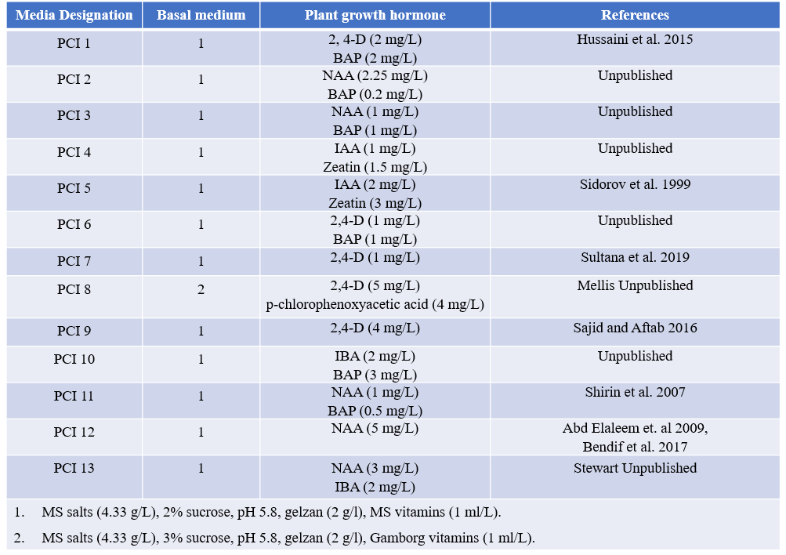
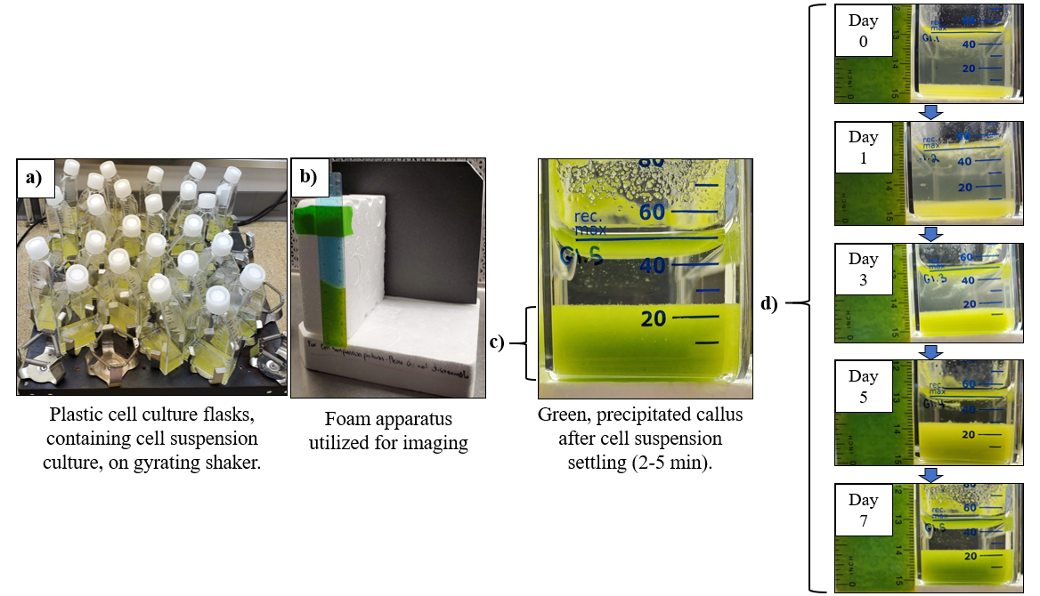
Figure 1: Cell sedimentation method utilized for measuring potato cell suspension culture growth over time. Aliquots of 5 ml pack cell volume (PCV) were suspended in 50 ml of fresh liquid media and transferred to plastic, cell culture flasks. Flasks were held in an upright position and shaken at 80-100 rpm (a). Sedimentation (mm), or cells precipitated after culture settling, were measured as a metric of growth. For consistent imaging across experiments, an in/cm ruler was fastened to a foam apparatus with a back background (b). Green-yellow cell suspension callus (c) , allowed to settle for 2-5 min, was imaged next to the ruler and the images reference to determine the level of sedimentation in mm. Sedimentation of each flask was measured daily or every other day to quantify cell suspension culture growth over time without disturbing the culture (d).

Table 2: Potato tissue response to media treatment after 5 total weeks of incubation. All plates were subcultured to fresh media after 3 weeks of incubation. Data related to callus phenotype, texture and color was collected. Additionally, data on the percentage of explants producing callus, roots and shoots was compiled. Each data point represents four total biological replicates (plates of tissue culture; two containing leaf explants and two internodal explants) averaged together for each media (n=4). PCI 8, 9, 12 and 13 (bolded and underlined) demonstrated desirable callus phenotype, friable and uniformly colored (single color throughout), for cell suspension culture initiation and were carried forward for quantitative biomass analysis. Percentage data (callus, root and shoot induction) was statistically analyzed using Kruskal-Wallis non-parametric test (Kruskal-Wallis) accompanied by Dwass, Steel, Critchlow-Fligner pairwise two-sided multiple comparison (DSCF) post-hoc analysis (p<0.05). Callus induction (p<0.0001), root induction (p=0.0002) and shoot induction (p<0.0001) data sets were determined to have statistically significantly differences among means (Kruskal-Wallis); however, DSCF analysis revealed no statistical significances between pairwise comparisons of callus, root or shoot induction data across all media types (p>0.05).

Table 2: Potato tissue response to media treatment after 5 total weeks of incubation.
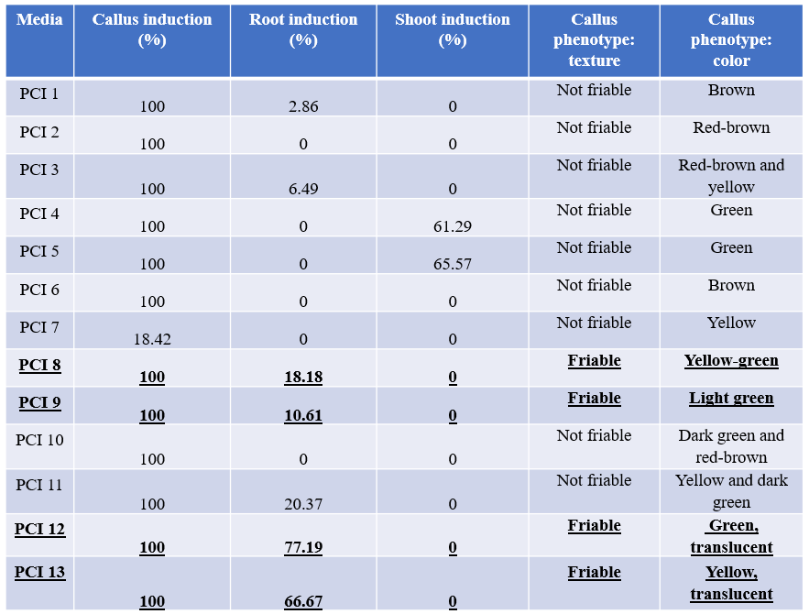
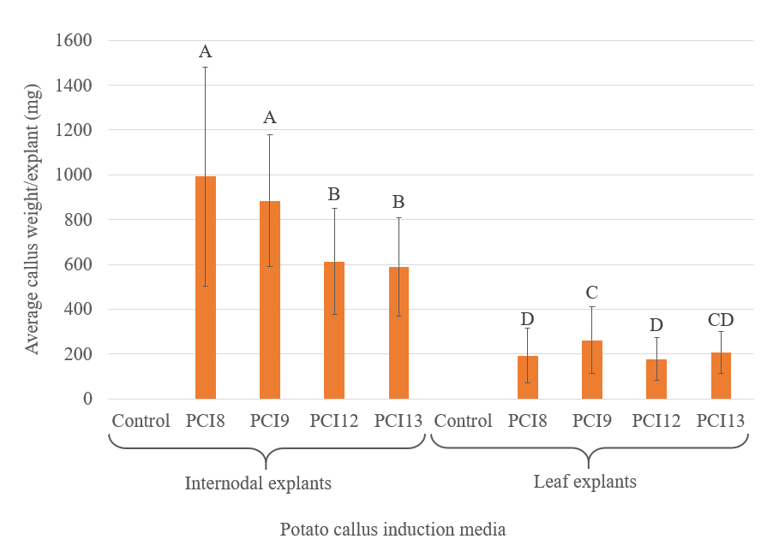
Figure 2: Callus induction, quantified by callus weight (mg) of potato internodal and leaf tissue explants incubated on a control, PCI 8, 9, 12 or 13 (Table 1) media for 6 weeks. Data represents 9 biological replications, plates, each containing 9 technical replications, leaf explants (n=9). Every plate was subcultured to fresh media after 3 weeks incubation. Error bars represent standard error and letters represent statistical groupings according to the ANOVA Fisher LSD test (p<0.05) where same letters signify no statistical differences.

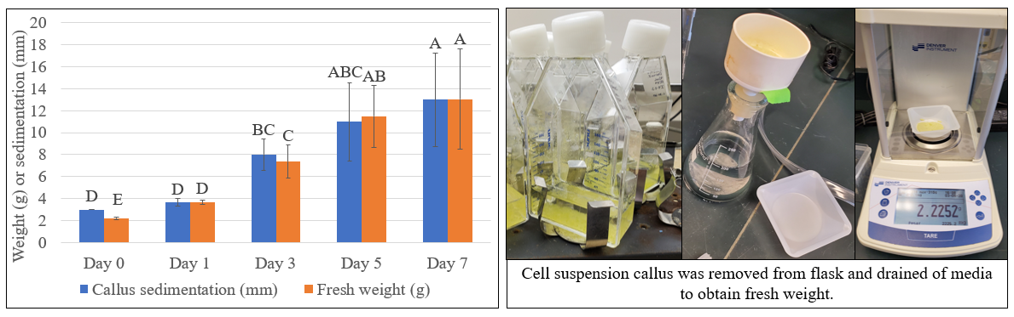
Figure 3: Verification of methodology utilizing plastic cell culture flasks and cell precipitation level after settling, cell sedimentation, as a metric of cell suspension growth. Cell suspension callus sedimentation (mm), defined as height of callus precipitated in the bottom of cell culture flasks after settling, and fresh weight (g) were compared over the course of 7 days to demonstrate correlation between these values overtime. Data represents three biological replicates, defined as a single mass of subcultured cells grown within the same 250 ml Erlenmeyer flask (n=3). Callus was separated into 5 individual plastic cell culture flasks (aliquots of 5 ml pack cell volume) and images/weight data collected every other day. Upon data collection, a single flask was sacrificed for weighing. Callus was removed from plastic culture flask, drained of media via vacuum filtration and fresh weight weighed (g). Sedimentation (mm) was measured as described in Figure 1. Error bars represent standard error and letters represent statistical groupings according to the ANOVA Fisher LSD test (p<0.05) where same letters signify no statistical differences.
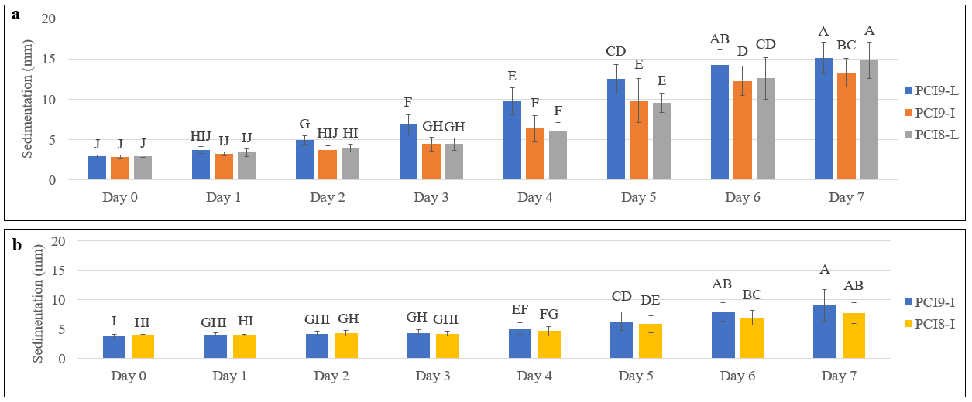
Figure 4: Cell suspension growth of cultures sourced from leaf (L) and internodal (I) callus initiated on PCI 8 and 9 (Table 1), quantified using the cell sedimentation (mm) method demonstrated in Figure 1. Data was collected from two experiments, a and b, exploring the four best performing callus from Figure 3 exhibiting desirable phenotypes; friable, uniformly colored and differentiated (lacking prolific root formation) callus (refer to Table 2). Graph a lacks data from the internodal callus sourced suspension culture grown in PCI 8 due to inability to initiate at the time of experimentation. Graph b depicts data exploring the missing cell suspension culture compared to the intermodally sourced suspension grown in PCI9. Leaf callus sourced suspensions were omitted in experiment b since these cultures performed better overall than the internodal sourced culture. Data represents 6 biological replicates, defined as a single mass of subcultured cells grown within the same 250 ml Erlenmeyer flask, separated into 3 technical replicates (n=6). Error bars represent standard error and letters represent statistical groupings according to the ANOVA Fisher LSD test (p<0.05) where same letters signify no statistical differences.
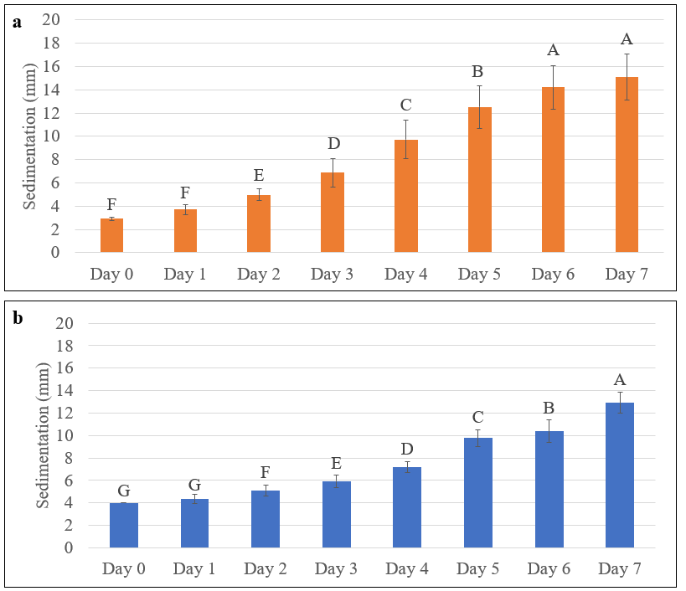
Figure 5: Cell sedimentation (mm) data of two, independent, leaf derived cell suspension cultures of potato demonstrating similarity of growth habit across individual cultures. Source cultures from a and b were independently initiated from callus grown on separate tissue culture plates. All cultures were maintained using identical methodology. Graphs a and b each depict 6 biological replications and 3 technical replications (n=6); 18 total flasks, derived from 6 pre-grown, 500 ml suspension cultures, grown together for 7 days and sedimentation (mm), defined as height of callus precipitated in the bottom of cell culture flasks after settling, measured as a metric of growth. Error bars represent standard error and letters represent statistical groupings according to the ANOVA Fisher LSD test (p<0.05) where same letters signify no statistical differences.
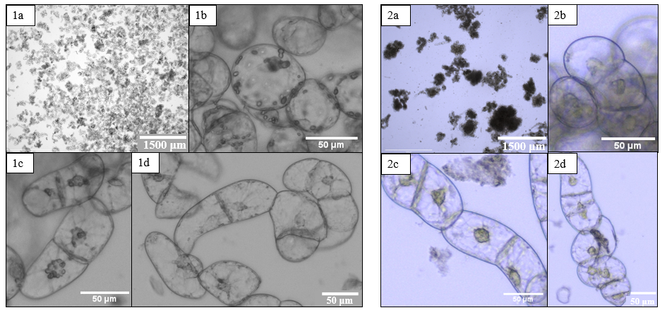
Figure 6: Cell composition and phenotype of two independently initiated, leaf callus derived, cell suspension cultures of potato demonstrating phenotypic variability between replicates. Each suspension culture was initiated and maintained using identical methodology. Phenotypes depicted in 1a-1d and 2a-2d characterize cultures utilized for growth analysis in Figure 5, graphs a and b, respectively. Both cultures were consistently comprised of three cell types, regardless of age: 1) globular, totipotent cells (1b and 2b), 2) elongated, chained cells (1c and 2c) and 3) enlarged globular cells (1d and 2d). Differences in cell distribution between cultures can be observed in images 1a and 2a. Culture 1 contained less callus masses, resulting in a more homogenous cell distribution whereas culture 2 contained more dense masses of cells resulting in more sparse and clumpy distribution.
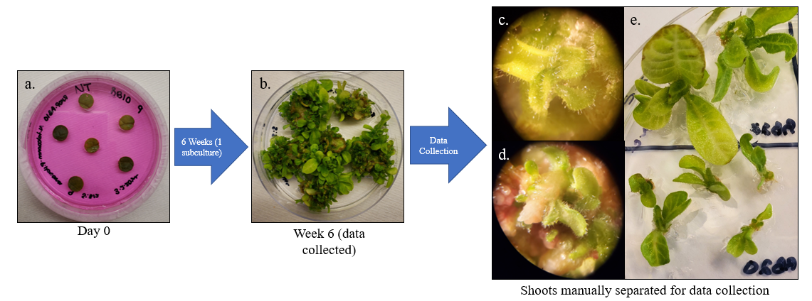
Figure 7: Tissue culture and data collection of tobacco 1 cm leaf disks plated on shoot induction media supplemented with rose bengal (RB). Explants were incubated on shoot induction media, subcultured to fresh media after 3 weeks and shoot production, per explant, data collected after an additional 3 weeks. Shoots of various sizes were separated from the main explant and manually counted. Compound microscope images c. and d. demonstrate the smallest shoots collected and e. represent examples of large shoots separated from explants.

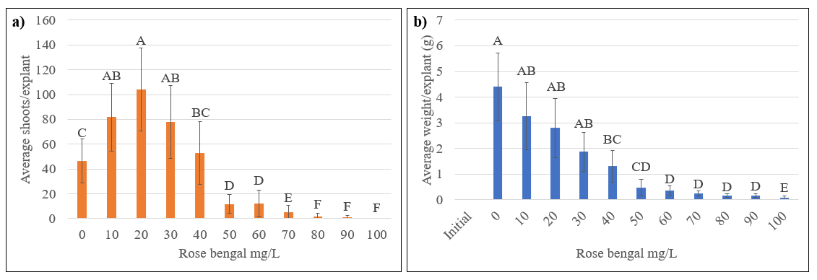
Figure 8: Combined analysis of average shoot production (a) and biomass (b) per 1 cm leaf disks explants of tobacco after 6 weeks on shoot induction media of two experiments treated under differing light intensities (Figures 9 and 10). Explants were incubated on shoot induction media supplemented with varying concentrations of rose bengal (10-100 mg/L) and subcultured once at 3 weeks. An average initial weight of explants, prior to plating on shoot induction media, is included to demonstrate that increases in biomass are a result of treatment rather than initial explant size. The experimental design was RCBD with subsampling; 15 total replicates per treatment group, distributed in petri dishes, each containing 6 - 1 cm leaf disk explant subsamples (n=15). Error bars represent standard error and letters represent statistical groupings according to the ANOVA Fisher LSD test (p<0.05) where same letters signify no statistical differences.

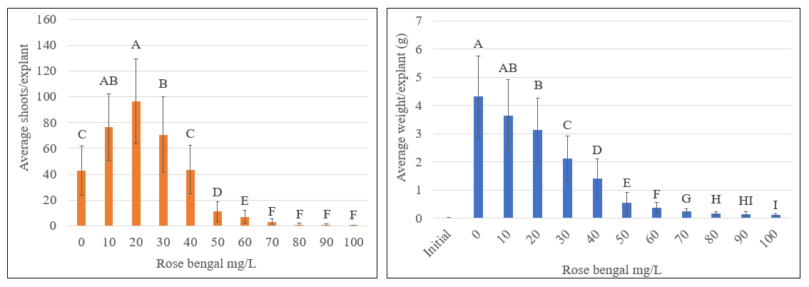
Figure 9: Average shoot production (a) and total explant biomass (b) per 1 cm leaf disks explants of tobacco after 6 weeks on shoot induction media under a light intensity of 85 μmol m⁻² s⁻². Explants were incubated on shoot induction media supplemented with varying concentrations of rose bengal (10-100 mg/L) and subcultured once at 3 weeks. An average initial weight of explants, prior to plating on shoot induction media, is included to demonstrate that increases in biomass are a result of treatment rather than initial explant size. The experimental design was CRD with subsampling; 9 replicates per treatment group, distributed in petri dishes, each containing 6 - 1 cm leaf disk explant subsamples (n=9). Error bars represent standard error and letters represent statistical groupings according to the ANOVA Fisher LSD test (p<0.05) where same letters signify no statistical differences.

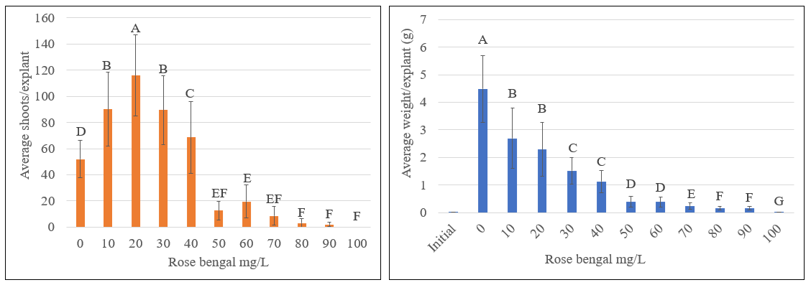
Figure 10: Average shoot production (a) and total explant biomass (b) per 1 cm leaf disks explants of tobacco after 6 weeks on shoot induction media under a light intensity of 90 μmol m⁻² s⁻². Explants were incubated on shoot induction media supplemented with varying concentrations of rose bengal (10-100 mg/L) and subcultured once at 3 weeks. An average initial weight of explants, prior to plating on shoot induction media, is included to demonstrate that increases in biomass are a result of treatment rather than initial explant size. The experimental design was CRD with subsampling; 6 replicates per treatment group, distributed in petri dishes, each containing 6 - 1 cm leaf disk explant subsamples (n=6). Error bars represent standard error and letters represent statistical groupings according to the ANOVA Fisher LSD test (p<0.05) where same letters signify no statistical differences.
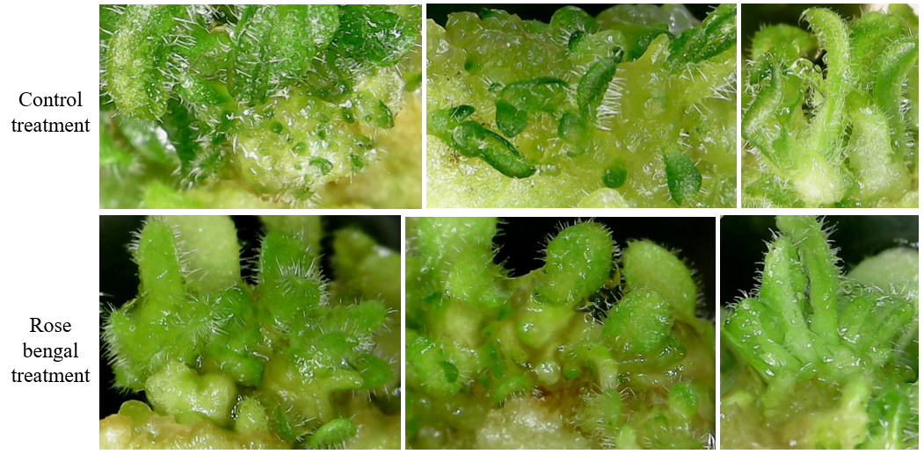
Figure 11: Shoots and callus of explants incubated on shoot induction media without rose bengal treatment (control) and with rose bengal treatment (RB). Shoot phenotype across all treatments was consistent; however, callus proliferation and shoot differentiation differed between control explants and those treated with RB. Control explants exhibited large masses of undifferentiated tissue with fewer differentiated shoots. Explants treated with RB demonstrated low quantities of undifferentiated tissue and high quantities of small differentiated shoots. These observations align with the findings in Figure 10.

VITA
Jessica S. Layton was born in 1996 in Knoxville, Tennessee, USA. She graduated with her Bachelor of Science in Plant Science from the University of Tennessee, Knoxville in 2018. Currently, she is pursuing her Master of Plant Sciences degree from the same university. She is making progress towards improving plant tissue culture through the optimization of potato cell suspension culture and improving shoot induction in tobacco.

