Modeling Feral Cat Population Dynamics in Knox County, TN

Lindsay E. Lee¹, Nick Robl², Alice M. Bugman³, An T.N. Nguyen⁴, Bridgid Lammers⁵, Teresa L. Fisher⁶, Heidi Weimer⁷, Suzanne Lenhart¹ and John C. New, Jr.⁶

¹Department of Mathematics, University of Tennessee, Knoxville
²College of Veterinary Medicine, University of Wisconsin, Madison
³Veterinary Specialty Center, Buffalo Grove, IL
⁴National Institute for Mathematical and Biological Synthesis, University of Tennessee, Knoxville
⁵Carolina Veterinary Specialist, Charlotte, NC
⁶College of Veterinary Medicine, University of Tennessee, Knoxville
⁷Young Williams Animal Center, Knoxville, TN

Abstract
Feral cats (Felis catus) are recognized as a problem internationally due to their negative impact on wildlife and potential to spread infectious disease to people and other animals. Trap-neuter-return (TNR) programs are employed in many areas to control feral cat populations as a humane method, and this approach is used on a limited basis in Knox County, Tennessee. Despite the frequent use of TNR as a strategy, its effectiveness remains controversial. The objective of this mathematical model is to predict the impact of selected strategies on the population of feral cats. The model with three age classes predicts the population over a period of 5 years in one month time steps. TNR rates are varied to investigate the effects of targeting spay/neuter programs seasonally, and such targeting predicts a measurable decline in feral cat population growth over a five year period. Targeting TNR intervention at adult females during the time prior to mating season in highly populated feral colonies may further decrease the population. These results suggest a more efficacious strategy than non-targeted TNR programs.

Keywords: feral cats, discrete population model, control interventions

Correspondence should be sent to Suzanne Lenhart, Department of Mathematics, University of Tennessee, 1403 Circle Drive, 227 Ayres Hall, Knoxville, TN 37996-1320. Email: lenhart@math.utk.edu

Modeling Feral Cat Population Dynamics in Knox County, TN
Introduction
Worldwide, feral domestic cats are considered a nuisance species. However, there is debate over the terminology in regards to feral cats (Slater, 2004). For the purpose of this paper, we define them as unowned domestic cats living in the wild with a natural fear of humans. Their characteristic evasive behavior and lack of socialization distinguishes them from free-roaming pet cats (Levy & Crawford, 2004). The feral cat population has expanded dramatically due to their ability to breed prolifically, which humans promote through subsidization. It is estimated that there are approximately 80 million owned pet cats and 80-90 million feral cats in the United States (Centonze & Levy, 2002; Andersen, Martin & Roemer, 2004). These numbers imply an important problem in the United States (Nutter, Levine & Stoskopf, 2004; Centonze & Levy, 2002) and worldwide (Andersen et al., 2004; Natoli, Schmid, Say & Pontier, 2007; Robertson, 2008; Gunther, Finkler & Terkel, 2011).
The expanding feral cat population poses numerous problems. From a public health perspective, feral cats have the ability to transmit infectious diseases and parasites both intraspecifically (e.g. FIV, FeLV) and zoonotically (e.g. rabies, Toxoplasma gondii) (Levy & Crawford, 2004; Danner, Farmer, Hess, Stephens & Banko, 2010; Littnan, Steward, Yochem & Braun, 2007; Brown, 2011). Feral cats are problematic for conservation in their ability to prey on endemic wildlife including small mammals, reptiles, and amphibians, and they have contributed to the decline and extinction of some bird species (Patronek, 1998; Crooks & Soulé, 1999; Woods, McDonald & Harris, 2003; Nogales et al., 2004; Winter, 2004; van Heezik, Smyth, Adams & Gordon, 2010; Danner et al., 2010). Animal welfare groups are concerned with the urban feral cat population both in regards to quality of life of the cats (Centonze & Levy; 2002) and vulnerability to people who consider them a nuisance and resort to poisoning and hunting as a means of removal. Feral cats can also pose risks to motorists when they are present along major roadways as well as serving as a nuisance through the spraying behaviors of males or female vocalizations when in estrus.
Several strategies are employed to address feral cat populations; the most common of which is the trap-neuter-return (TNR) strategy. TNR involves the capture of feral individuals followed by neutering/spaying and tagging altered cats by ear-tipping, after which the cats are returned to the location in which they were trapped. TNR programs also often include vaccinations and flea/tick treatments. Once returned, the altered cats become a part of a managed colony. Managed colonies are monitored for new cats entering the colony through birth and immigration and exiting the colony via death and emigration. Feral cat colony managers subsidize the colonies with food and water and when possible, take sick or injured animals for veterinary care. TNR is a preferred method of population control by some because of its potential to control populations both humanely and in a cost-effective manner (Levy & Crawford, 2004; Loyd & De Vore 2010). While returning the cats does not directly address some of the issues related to wildlife predation, public health, and human interests, altered cats tend to roam less and have less objectionable behavior than before their surgery (Robertson, 2008). Thus, they may be less likely to encounter wildlife, wander onto highways, or spread disease through sexual contact or aggression. Despite the frequent use of TNR programs, data demonstrating the success of this strategy in reducing populations is limited. One study indicates that a 75% TNR rate or 50% trap-euthanize (TE) rate is required to decrease the feral cat population (Andersen, et al. 2004). At lower intervention rates, the population growth is predicted to persist though at a reduced rate. In a more recent model, population decrease was similar across all intervention strategies (TE, TNR, and a 50:50 combination) when immigration was assumed to be 0% into a colony; immigration rates of 25% or greater predicted only TE at a rate of 75% could decrease the population whereas TNR and a 50:50 combination could not (Schmidt, Swannack, Lopez & Slater, 2009). Two models (Loyd et al. 2010; Lohr et al. 2010) compared management options of TNR and TE and showed the TNR with volunteers and small cat populations would be more cost effective. In this study, the effectiveness of the current TNR program in Knox County, Tennessee, is evaluated with a discrete mathematical model incorporating both seasonal and age-specific population parameters. The model assesses the potential for altering the current program to target feral cats seasonally (i.e., immediately prior to mating season) in order to improve effectiveness and optimize economic benefits.
Methods
Formulation of the Model
We used data on feral cats in Knox County from two confidential sources. Both sources contain a substantial sample size, and both give similar results based on selected descriptive statistics (Table 1).
Table 1 placed here
We constructed a discrete mathematical model for females in a single feral cat colony with monthly time steps to account for variations in population parameters that occur monthly (e.g., birth rate) as well as other variables such as death rate and potential for adoption. The population is divided into five age and spay classes; the classes included intact neonatal (N), an intact juvenile (J), spayed juveniles (JS), intact adults (A), and spayed adults (AS) (Figure 1).
Figure 1 placed here
These differed in the following parameters: death rate, potential to be spayed, ability to reproduce, possibility of emigration or immigration, and potential for adoption (Table 2).
Table 2 placed here
Monthly birth rates and the addition of neonates and spay classes to the model incorporate an additional level of detail relative to previous studies that utilize yearly time steps and fewer age groups (Andersen et al., 2004; Budke & Slater, 2009). The model includes only female cats, as is consistent with similar population models (Budke & Slater, 2009; Andersen et al., 2004).
The neonatal class (N) consists of individuals from birth to two months of age (spanning two time steps). Their high mortality, inability to leave the colony through emigration, and the fact that they are too young to be spayed (spayed individuals must be greater than 1.5 pounds, which is not reached until about two months of age) distinguishes these individuals from the other groups. Since they cannot be spayed, they cannot be adopted. Neonatal individuals do not reproduce.
The juvenile class (J) includes individuals from three to seven months of age. At the juvenile stage, individuals are old enough to be spayed but too young to give birth, although toward the end of this class, some individuals may be pregnant. Juveniles experience lower death rates relative to neonates, but higher death rates than adults. Since the model assumes only spayed individuals can be adopted, an adoption rate is not included for the intact juvenile class.
Individuals in the juvenile spay class (JS) are spayed individuals from four to seven months old. They experience a small decrease in mortality relative to intact juveniles and a decrease in emigration rates. Since they have been reproductively altered, the model incorporates an adoption rate for this group. The length of this age class does not include the third month because the earliest a cat can be spayed is when they become a juvenile in the third month. If a cat is spayed at the earliest possible time, it will not transition into the juvenile spayed class until the fourth month.
Individuals within the adult class (A) include cats from eight months to five years of age. All individuals are considered to have died by age five, which is a relatively conservative estimate as most studies of feral cats have found that individuals rarely live beyond three years (Jessup, 2004). Constituents of this class experience the highest birth rate and a lower mortality rate than all previous classes. They can emigrate and be spayed, but cannot be adopted by our assumptions.
The adult spay class (AS) includes spayed individuals from eight months to five years old that have been spayed. Some of these individuals will be JS cats that transition into the AS class. Cats in this class experience the lowest mortality rate because spayed individuals tend to live longer than intact individuals due to the decreased potential for aggression and territoriality. Spayed adults experience a decreased rate of emigration for the same reason.
To summarize, the model is based on the following assumptions:
- The model is for female feral cats only;
- Each litter contains 50% female and 50% male cats;
- Spayed female cats do not immigrate or emigrate; they only leave the colony through death or adoption;
- Only spayed cats are adopted;
- Neonatal cats neither immigrate nor emigrate;
- No feral cat will survive beyond 5 years.
The equations of the model are given below, with t representing the time step.

The following parameters are accounted for in the model: birth, death and disappearance, spaying, immigration, abandonment, and adoption. Birth is a seasonal parameter for this model. Spaying is calculated as either seasonal or non-seasonal. All other values are non-seasonal. Each parameter has a different value depending on the age/spay class.
Death and disappearance, adoption, immigration, and spaying rates are each percentages of the current population. The percentage of cats that die, disappear, or are adopted is no longer counted in the model for the next time steps. These parameters are used to create terms that, when multiplied by the number of cats in a specific age class at the current time step, calculate the number of cats who survive, are not adopted, and who stay in the population at the next time step. In the non-spayed age classes, the spayed parameter is treated the same way because if a cat gets spayed, it leaves the non-spayed age classes in a similar fashion. In the spayed age classes, only spayed cats are counted, so the spayed parameter itself is multiplied by the survival term and terms for cats that stay in the population. Abandonment is not a percentage; it is an integer value representing the number of cats that enter the population. It is added instead of multiplied.
The transition in age uses fractions to account for the length of the age class in terms of time steps. For instance, in the N equation (Eq. 1), ½ is multiplied by the survival term and then by the N population at the current time step t. The N age class is 2 time steps long, so at each time step, half of the N cats will move on to the J age class, and the other half will stay for one more time step. The same is true for the other age classes. The J age class is 5 time steps long, so in the J equation (Eq. 2), it is assumed that at any given time t, 4/5 of the J cats will stay in the J age class for the next time step, and 1/5 will transition to the A age class.
The model begins in January with a colony with unrestricted breeding of initially 25 intact female cats distributed across age classes at ratios extracted from data source 1 (Table 1) for the specific month of January. Table 3 shows this distribution.
Table 3 placed here
Parameters
We calculated parameters from a combination of two confidential data sets and values found in the literature where specific local data were unavailable. Both data sets included the following information: date of spay or neuter surgery, sex, age, pregnancy status, and number of feti if the cat was pregnant. Records from data set 1 included monthly information from 2007-2011 for 1075 feral female cats. Because it included data for every month of the year, it is the basis for our estimates of monthly birth rates. Data set 2 included information collected between 2006-2011 for 560 female feral cats and was used to calculate adoption rates.
Monthly birth rates were calculated from data set 1. We divided the number of pregnant cats that were spayed each month by the total number of cats captured during that month to determine a monthly pregnancy rate. At the time of surgery, the number of feti from pregnant cats was counted which resulted in an average of 4.27 feti per pregnant cat. This average is similar to those reported by others. Nutter et al. (2004) reported that the number of feti present during gestation can differ from the number of kittens present at birth by as much as 25% (i.e., 3 kittens born for every 4 feti present during gestation). Consequently, we decreased the birth estimate by 25%, or 3.20 kittens/pregnant female. Since the model only reflects females, we divided the number of kittens per pregnant female in half to account for an approximate 50:50 sex ratio. Thus, a pregnant female will produce on average 1.6 female cats per litter in our model. We multiplied the average number of female cats produced per litter by the monthly pregnancy rate to generate a monthly birth rate. As an approximation, the monthly birth rate comes from shifting the monthly pregnancy forward by one month. The average gestation length is 65.3 days (Musters, de Gier, Kooistra & Okkens, 2011). Our data showed that births only occur within the months March-November.
Data for death rates of feral cats were unavailable from the Knox County data sources. Thus, we used values derived from the literature (Nutter et al., 2004; Danner et al., 2010). Because death is so difficult to differentiate from emigration, we include natural death and emigration in one parameter.
In reference to neonatal and juvenile individuals, Nutter et al. (2004) reported that out of a population of 169 cats, 81 had died or disappeared within 100 days (or 3.33 months) of birth. We assumed this rate was the same for male and female cats of this age. Thus, we calculated the total death rate over the first 100 days to be 81/169 (or 0.48), from which we determined an average monthly survival rate (1-death rate) of 0.822 (calculated from (1-0.48)^{1/3.33}), from which a monthly death rate of 0.18 is deduced. For the model, we rounded this parameter slightly upward to 0.19 for our Neonatal age class (months 1 and 2) because we assume that deaths in the first 100 days are distributed more heavily within the first two months.
Nutter et al. (2004) reports further death and disappearance rates from 100 to 180 days post-birth. According to their data, 127 of 169 cats were dead or disappeared before 6 months. Subtracting the deaths and disappearances from the first 100 days gives 46/169 cats died or disappeared between 100 days and 6 months. This gives 0.727 survival between 100 days (3.33 months) and 6 months, meaning 0.888 monthly survival in this time (0.727^(1/(8/3))). The monthly death rate is 0.112, which for our model we also rounded slightly upward to 0.12 to account for the fact that our juvenile age class contains cats younger than 100 days.
Danner et al. (2010) reported annual survival rates for adult female feral cats (≥1yr) as 0.759 per year. We converted this value to a monthly survival rate of 0.977 (0.759= monthly rate¹²). Since our model considers adult cats to be those individuals greater than seven months old, we adjusted the monthly adult survival rate given by Danner et al. (2010) by rounding up to account for a slightly decreased average monthly survival rate for adults when the smaller monthly survival rates for months eight through eleven were incorporated.
We used data from Gunther et al. (2011) to estimate death rates for spayed animals. Upon spaying, survival rates tend to change as a result of decreased aggressive interactions and decreased disease transmission (Courchamp, Yoccoz, Artois & Pontier, 1998; Finkler, Gunther & Terkel, 2011). Gunther et al. (2011) found that in a population of unaltered cats, the survival rate for the first six months was 32%, a value similar to that found by Izawa and Ono (1986). The survival rate in a population of altered individuals was 76% (death rate 24%). We converted this value for cats in a group of altered individuals to a monthly value and used it as the JS monthly death rate. The ratio of this number to the J death rate was approximately 1/(2.67). We could not find any literature data on the survival of adult spayed cats, so we used the ratio of the JS death rate to the J death rate to calculate the AS death rate. We assumed that the death rate ratio between JS and J remains consistent for the AS and A classes. The A death rate multiplied by this ratio yields our AS death rate.
Because of lack of data locally or in the literature on euthanasia rates, we did not include it in our model. Scott, Levy & Crawford (2002) described a county in Florida in which cats are captured by their caretakers and brought into a shelter, much like Knox County. They give a euthanasia rate of 0.4% over 40 months, so excluding a euthanasia parameter does not compromise the realistic nature of our results.
In our model, only J and A cats can enter a population through abandonment and immigration. We predict young cats are less likely to enter a feral colony because they are seen as more desirable pets, and they are too young to migrate on their own. Abandonment (i.e, by owners) is treated as value added to an age class at a given time step. Immigration is treated as a percentage of the population of the age class at a given time step.
While we know abandonment and immigration occur, the magnitude is unknown locally and is not reported in the literature. According to Schmidt et al. (2009), when immigration rates cannot be found, immigration is approximated to be a percentage of the maximum available niche-space. Studies also have run simulations at different arbitrary immigration and abandonment rates to compare the outputs of the various scenarios (Schmidt et al., 2009, Loyd & DeVore, 2012; Lohr, Cox, & Lepczyk, 2013). Our model uses the same values as Lohr et al. (2013) for abandonment. Entry into the population is calculated from a percentage of the initial population of the given age class. Our low, medium, and high levels of abandonment are 1%, 5%, and 10% of the initial population, respectively. Our model uses the same values as Loyd et al. (2012) for immigration, with low, medium, and high levels of female immigration being monthly percentages of 0.345, 0.745, and 0.885, respectively.
In our model, only JS and AS cats will be adopted. We calculated adoption rates based on values acquired from data set 2 from Knox County (Table 4).
Table 4 placed here
In TNR programs, prior to a cat’s release to its original location, the tip of the left ear is removed so that they may be easily identified and recaptures can be avoided. These tipped cats are considered too wild to be able to successfully interact with humans as pets. Individuals that are adopted do not have an ear tip removed because they are less adverse to human interaction. We used the percentages of cats in each age group who did not have their ear tipped to calculate the monthly adoption rates. Adoption rates include only spayed individuals because intact cats are not adopted. Thus, the neonatal group does not include this variable since individuals in this group are too young to be spayed. The adoption rates are assumed to be non-seasonal.
The spay rate represents the intervention in our simulation to see what effects different values have on the population growth of the colony. We do not know the current spay rates of feral cats in Knox County, so cannot compare the current situation to the scenarios run with our model.
Simulation Results
Using different intervention (i.e., spay rate) scenarios, we focused first on differences between spaying cats throughout the year versus spaying cats only during the months in which our data show there are no births: December, January, and February. At the initial time, all of the below scenarios depict colonies of 25 intact female cats. We show the case with no immigration and abandonment and the case with the most immigration and abandonment possible that could still lead to zero population growth in each scenario. The most possible immigration is the “high” level, and the most possible abandonment that could still lead to zero population growth is the “low” level. In all scenarios, population stabilization was impossible within 5 years if abandonment was above the low level.
Figure 2 displays the population growth with annual spay rates of 0% for both the juvenile and adult classes given no immigration with no abandonment (blue) and high immigration with low abandonment (red). There is a dramatic increase from the initial population of 25 intact female cats to a total population of over 1000 in each case. While this number is likely exaggerated given that our model does not account for carrying capacities of these colonies, this number does show how quickly a feral cat colony can expand.
Figure 2 placed here
Simulation of non-seasonally targeted TNR strategy. Figure 3 shows population stabilization in five years when both juveniles and adults are spayed at 62% over the year when there is no immigration and no abandonment and 74% when there is high immigration and low abandonment. With cats entering the population through means other than birth, it requires more surgeries to achieve zero population growth, and at the end of five years, the population is higher.
Figure 3 placed here
Figure 4 show population growth over 5 years if 100% of juveniles are spayed throughout the year and 0% of the adults are spayed. The blue line shows this scenario with no immigration and no abandonment, and the red line shows this scenario with high immigration and low abandonment. The population decreases after about 2 years with this age-specific intervention when there is no immigration and no abandonment. For both scenarios, it is impossible to stabilize the population with any intervention of less than 100% spaying of juveniles and no spaying of adults.
Figure 4 placed here
Simulation of seasonally targeted TNR strategy. Figure 5 shows the population growth resulting from seasonal targeting (i.e., spaying only during December, January, and February) of both juveniles and adults. The blue line shows a spay percentage of 55% for both the juvenile and adult age classes with no immigration and no abandonment, and the red line shows a spay percentage of 70% for both classes with high immigration and low abandonment.
Figure 5 placed here
Figure 6 shows population growth with seasonal (December, January, February only) spaying of only adults at 70% during the three targeted months over 5 years with no immigration and no abandonment (blue) and spaying of only adults during this time at 90% with high immigration and low abandonment (red).
Figure 6 placed here
Discussion
In contrast to the model proposed by Andersen et al. (2004), our model incorporates monthly shifts in birth rates as well as additional age classes. These details allow us to assess the effects of seasonal intervention on the cat population. The present model predicts that the feral cat population may be controlled (i.e. stabilized) within five years at a constant monthly spay rate of 62% during the year if there is no immigration or abandonment. At spay rates greater than 62%, the population declines. This value is slightly less than those values predicted by similar studies: 71% in Budke & Slater (2009) and 75% in Andersen et al. (2004). (removed sentence here) If we assume the population has a high level of immigration and low level of abandonment, a 74% spay rate is required to stabilize the population. When the survival rates for sub-adults during the first year of life are multiplied, they yield only an approximate 25% survival rate of feral cats over the course of the first year of life. This is lower than the survival rates used by others for the first year (Budke & Slater, 2009; Andersen et al., 2004). Despite the difference in values used to construct the model, a 75% death rate within the first year of life is reasonable in comparison with other studies (Nutter et al., 2004; Warner, 1985). It is likely that survival rate through the first year changes logarithmically rather than linearly; however these data were unavailable.
In contrast to a constant monthly spay rate, seasonally targeting spays just prior to the breeding season (December-February) requires only a 55% spay rate if we assume there is no immigration and no abandonment. If we assume high immigration and low abandonment, a 70% spay rate is necessary. While these values increase the number of individuals that must be spayed within the three months of such a program, they reduce the total number of spays required annually to achieve population stability. According to our model, spaying at 62% non-seasonally in a closed colony will require approximately 91 total spays over 5 years, and the final population at the end of that time spay will be approximately 63 cats, starting at initial time with a population of 25 female cats. The results indicate that spaying at 55% of the total population over the three months of December, January, and February in the same colony will stabilize the population before 5 years. At the end of that period, the population will be approximately 61 cats and will require overall about 79 spays. A similar pattern is seen in a colony with high immigration and low abandonment. A non-seasonal spay rate of 74% requires a total of 115 spays over five years with an end population of 69 cats. A seasonal spay rate of 70% requires 96 surgeries and results in an end population of 61 cats.
The present model suggests that targeting spays seasonally allows for fewer total spays to be performed throughout the year with a smaller total population at the end of 5 years. This results from a significant decrease in birth rates early in the year (March - May) such that fewer kittens are present throughout the rest of the year that would require spaying. Furthermore, the seasonal targeting of spays reduces the number of unnecessary spays that would be performed on cats that would die later between the time of being spayed and the reproductive season. For example, in a TNR program maintaining a consistent monthly spay rate, a kitten born in May would be two months old in July and could be spayed at that time, but then could die shortly after, before it reached reproductive capability. Thus, the time and money invested in that individual would be unnecessary for controlling the population. Since it is more likely for a cat to die within the first year of life, it would be more efficient to wait until just before the reproductive season to invest the time and money to spay the cat. Although seasonally targeting spays may require a greater input of personnel and economic resources during the three-month target period, the cost over the entire year would actually be less and yield better results.
Consistent with previous studies, the present model highlights the possible benefits of targeting juveniles for intervention if spaying is conducted without seasonal targeting. Budke & Slater (2009) report that a spay program targeting juveniles and adults requires a 70% spay rate to yield population decline, whereas a program neglecting juveniles requires a spay rate of 91% to halt population growth. Our model indicates that if 100% of only juveniles are spayed, there will be a significant decrease in population before 2 years. Over 5 years, this method requires about 102 total spays and results in a final population of about 33 in a population with no immigration or abandonment. Spaying 100% of juveniles in a colony with high immigration and low abandonment requires 177 spays and results in a final population of 82 cats. No other spay percentage for juveniles only produced a population stabilization or decline. However, when seasonally targeting spays, our model shows that spaying adults is more important to population stabilization and decline. In a colony without immigration or abandonment, spaying only adults seasonally at 70% requires about 62 total spays over 5 years and results in population stabilization over that time frame with a final population of 50. In a colony with high immigration and low abandonment, a spay rate of 90% results in population stabilization with 70 spay surgeries and a final population of 43 cats. If colony managers are able to seasonally target their adults at 100%, there is an immediate dramatic decline. This scenario requires only about 25 spays and results in a final population after 5 years of about 5 cats if cats only come into the population through birth. According to our model, this is the ideal spay scenario, though in reality it may be difficult to achieve as adult cats are more difficult to capture than juveniles because they are more adverse to people. Though fewer spays will need to be conducted, more resources may have to be spent in the actual capture of the cats.
It is also important to note that with feral cat population control programs extending over several years, it may be most effective to invest more resources earlier in the program as these costs decrease with time as the population declines. In other words, if it is possible to achieve the desired spay rate of 62% in the first year to initiate a population decline, the following year, when the population decreases, there will be fewer individuals left to spay such that the 62% rate will include fewer cats and therefore cost less than the same rate the previous year. It is especially important to invest resources early if spaying is conducted above the rates required to stabilize the population because the difference in cost between each year is much greater than if spaying is conducted at a rate that slows population growth to 0%.
While it is difficult to achieve a spay rate of 62% across all of Knox County, we intend our model to apply more specifically to managed feral cat colonies wherein the manager knows the individuals in the colony and makes an active effort to trap individuals so that cats may be spayed. For managed colonies, there is evidence that spay rates well over 62% may be achievable (UT College of Veterinary Medicine (UTCVM) unpublished data). Thus, it is possible to achieve a declining population within a managed colony, although that is assuming no immigration from surrounding colonies. In order to achieve a declining population for the entire county, it may be necessary to develop new methodologies for improving trapping rates, improving spay rates, or developing alternative contraceptive methods that are more efficient.
If we assume that our parameters remain realistic over the long term, then eigenvalue analysis of the underlying matrix model shows that the populations do, in fact, approach stabilization or decrease in the given scenarios. For the scenarios in which we conclude that the population of the colony approaches stabilization at the end of five years, the dominant eigenvalue is approximately 0.96 or less, demonstrating that over the long term, the population of the colony does gradually decrease. Though it is not realistic to assume that parameters such as adoption and birth rates remain the same for long periods of time, this eigenvalue analysis does support our conclusions.
While the model provides a basis on which to predict population growth and control measures, we recognize several limitations in the data. At present, significant data on migration of cats between colonies and abandonment of cats into feral colonies are unavailable and would likely require extensive radio tracking or GPS collars to collect. Our model takes migration and abandonment into account by running different scenarios at various rates, which may not accurately reflect real-life scenarios. Spaying cats has the effect of increasing lifespan of both the spayed individual and other members of the group (Gunther et al., 2011); however, data describing the differences between the two groups are unavailable. Gunther et al. (2011) suggest that a spayed cat may live perhaps two or three times as long as an intact cat due to fewer deaths related to trauma or disease.
Future research will include using new data collected from individual colonies in Knox County to calculate migration rates. We would also like to improve the accuracy of our parameters, especially death rates, with more complete data and calculate the average euthanasia rate of feral cats in Knox County. Eventually, this could lead to the building of a multi-colony model to simulate the implementation of spatial spay targeting. We hypothesize that targeting the colonies with the highest number of cats will produce the greatest drop in population growth.
The recent work by McCarthy, Levine & Reed (2013) used a stochastic agent-based model to compare trap-vasectomy-hysterectomy strategy with the strategies of lethal control and of trap-neuter-release. Although their work showed the advantages of the use of vasectomy or hysterectomy as control methods, this method has not been thoroughly investigated
(Medes-de-Almeida, Faria & Landau-Remy, 2006; Kendall, 1979). In future work, our model could be extended to include this alternative strategy.
Conclusion
Overpopulation of feral cats creates conservation, sanitation, public health, and animal health issues in many areas of the world. The most widely accepted method to control population growth is trap-neuter-release (TNR). This is the method currently implemented by Knox County, TN, but its effectiveness is questioned with their current spay rates.
While we do not know the actual spay rate in Knox County currently, this model may be used to predict the effectiveness of spaying under several scenarios. Controlling the feral cat population in Knox County under the current non-seasonally targeted approach requires at least a 62% yearly spay rate. As this rate may be difficult to achieve, it may be more effective to target spays seasonally, before the reproductive season, so that fewer spays are required to achieve the same effect. With seasonal targeting of spays, the minimum rate required to achieve population stability or decline is reduced to 55% and requires fewer total spays. Consequently, it may be more reasonable economically to employ a seasonal spay methodology.

Acknowledgements: This work was partially supported through participation in the
Research Experiences for Undergraduates and Veterinary Students summer program at the
National Institute for Mathematical and Biological Synthesis, sponsored by the National Science
Foundation, the U.S. Department of Homeland Security, and the U.S. Department of Agriculture through NSF Award EF-0832858, with additional support from the University of Tennessee,
Knoxville. This work was also supported by the Companion Animal Initiative of Tennessee, and
the University of Tennessee College of Veterinary Medicine. We also acknowledge assistance
from Young-Williams Animal Center, Knoxville, Tennessee. Lenhart is partially supported by
the UT Center for Business and Economic Research.
References
Andersen, M. C., Martin, B. J., & Roemer, G. W. (2004). Use of matrix population models to estimate the efficacy of euthanasia versus trap-neuter-return for management of free-roaming cats. Journal of the American Veterinary Medical Association, 225, 1871-1876.
Brown, C. M. (31 May 2011). Compendium of animal rabies prevention and control, 2011. National Association of State Public Health Veterinarians, Inc. http://www.health.state.ny.us/diseases/communicable/zoonoses/rabies/docs/2011_compendium_animal_rabies_prevention_control
Budke, C. M. & Slater, M. R. (2009). Utilization of Matrix Population Models to Assess a 3-Year Single Treatment Nonsurgical Contraception Program Versus Surgical Sterilization in Feral Cat Populations. Journal of Applied Animal Welfare Science, 9(12), 277-292.
Centonze, L. A., & Levy, J. K (2002). Characteristics of free-roaming cats and their caretakers. Journal of the American Veterinary Medical Association, 220, 1627-1633.
Courchamp, F., Yoccoz, N. G., Artois, M., & Pontier, D. (1998). At-risk individuals in Feline Immunodeficiency Virus epidemiology: evidence from a multivariate approach in a natural population of domestic cats (Felis catus). Epidemiology & Infection, 121, 227-236.
Crooks, K. R. & Soulé, M. E. (1999). Mesopredator release and avifaunal extinctions in a fragmented system. Nature, 400, 563-566.
Danner, R. M., Farmer, C., Hess, S. C., Stephens, R. M., & Banko, P. C. (2010). Survival of Feral Cats, Felis catus (Carnivora: Felidae), on Mauna Kea, Hawai’i, Based on Tooth Cementum Lines. Pacific Science, 64, 381-389.
Finkler, H., Gunther, I., & Terkel, J. (2011). Behavioral differences between urban feeding groups of neutered and sexually intact free-roaming cats following a trap-neuter-return procedure. Journal of the American Veterinary Medical Association, 238(9), 1141–1149.
Gunther, I., Finkler, H., & Terkel, J. (2011). Demographic differences between urban feeding groups of neutered and sexually intact free-roaming cats following a trap-neuter-return procedure. Journal of the American Veterinary Medical Association, 238, 1134-1140.
Izawa, M. and Ono, Y. (1986) Mother-offspring relationship in the feral cat population. J. Mammalogical Soc. Japan, 11: 27-34.
Jessup, D. A. (2004). The welfare of feral cats and wildlife. Journal of the American Veterinary Medical Association, 225, 1377-1383.
Kendall, T.R. (1979). Cat population control; vasectomize dominant males. California Veterinarian, 33(7), 9–12.
Levy, J. K. & Crawford, P. C. (2004). Humane strategies for controlling feral cat populations. Journal of the American Veterinary Medical Association, 225, 1354-1360.
Littnan, C. L., Stewart, B. S., Yochem, P. K., & Braun, R. (2007). Survey for selected pathogens and evaluation of disease risk factors for endangered Hawaiian monk seals in the main Hawaiian Islands. Ecohealth, 3, 232-244.
Lohr, C. A., Cox, L. J., & Lepczyk, C. A. (2013). Costs and Benefits of Trap-Neuter-Release and Euthanasia for Removal of Urban Cats in Oahu, Hawaii. Conservation Biology, 27, 64-73.
Loyd, K. A. T. & DeVore, J. L. (2010). An Evaluation of Feral Cat Management Options Using a Decision Analysis Network, Ecology and Society, 15(4), 1-10.
Loyd, K. A. T. & DeVore, J. L. (2012). Feral Cat Population Dynamics under Alternative Management Strategies. Preprint.
McCarthy, R. J., Levine, S. H. & Reed, J. M. (2013). Estimation of effectiveness of three methods of feral cat population control by use of a simulation model. Journal of the American Veterinary Medical Association, 243(4), 502-511.

Mendes-de-Almeida F., Faria M. C. F., Landau-Remy G., Branco, A. S., Barata, P., Chame, M. Salim Pereira, M. J., & Labarthe, N. (2006). The impact of hysterectomy in an urban colony of domestic cats (Felis catus Linnaeus, 1758). International Journal of Applied Research in Veterinary Medicine, 4(2), 134–141.
Musters, J., de Gier, J., & Kooistra, H. S., & Okkens, A. C. (2011). Questionnaire-based survey of parturition in the queen. Theriogenology, 75(9), 1596-1601.
Natoli, E., Schmid, M., Say, L., & Pontier, D. (2007). Male reproductive success in a social group of urban feral cats. (Felis catus L.). Ethology, 113(3), 283-289.
Nogales M., Martin A., Tershy B. R., Donlan, C. J., Veitch, D., Puerta, N., Wood, B., & Alonso, J. (2004). A review of feral cat eradication on islands. Conservation Biology, 18(2), 310-319.
Nutter, F. B., Levine, J. F., & Stoskopf, M. K. (2004). Reproductive capacity of free-roaming domestic cats and kitten survival rate. Journal of the American Veterinary Medical Association, 225,1399-1402.
Patronek, G. J. (1998). Free-roaming and feral cats - their impact on wildlife and human beings. Journal of the American Veterinary Medical Association, 212, 218-226.
Robertson, S. A. (2008). A review of feral cat control. Journal of Feline Medicine and Surgery, 10, 366-375.
Schmidt, P. M., Swannack, T. M., Lopez, R. R., & Slater, M. R. (2009). Evaluation of euthanasia and trap-neuter-return (TNR) programs in managing free-roaming cat populations. Wildlife Research, 36(2), 117-125.
Scott, K. C., Levy, J. K., & Crawford, P. C. (2002). Characteristics of free-roaming cats evaluated in a trap-neuter-return program. Journal of the American Veterinary Medical Association, 221, 1136-1138.
Slater, M. R. (2004). Understanding issues and solutions for unowned, free-roaming cat populations. Journal of the American Veterinary Medical Association, 225, 1350-1354.
University of Tennessee College of Veterinary Medicine, Companion Animal Initiative of Tennessee, confidential data.
van Heezik, Y., Smyth, A., Adams, A., & Gordon, J. (2010). Do domestic cats impose an unsustainable harvest on urban bird populations? Biological Conservation, 143(1), 121-130.
Warner, R. E. (1985). Demography and movements of free-ranging domestic cats in rural Illinois. Journal of Wildlife Management, 49, 340-346.
Winter, L. (2004). Trap-neuter-release programs: the reality and the impacts. Journal of the American Veterinary Medical Association, 225, 1369-1376.
Woods, M., McDonald, R. A., & Harris, S. (2003). Predation of wildlife by domestic cats Felis catus in Great Britain. Mammal Review, 33, 174-188.
TABLE 1. Comparison of the two data sets.
 | Data source 1 | Data source 2
Sample size | 1074 | 560
Time frame | 2007-2011 | 2006-2011
Ratio male/female | 49/51 | 41/59
Proportion of pregnancy/all female | 19% | 15%
Seasonal peak of pregnancy | March | March
Most frequent age of pregnancy | 1-3 years | >2 years
Average feti/litter | 4.27 | 4.06
Percentage kittens/all feral cats | 28% | 32%
Seasonal peak of kittens | May-June | May-June

TABLE 2. Parameters for each age class.
Age class | Death | Birth rate | Spay | Migration | Adoption
N | X
J | X |  | X | X
JS | X |  |  |  | X
A | X | X | X | X
AS | X |  |  |  | X

TABLE 3. Distribution of cats across age classes in the month of January based on data source 1.
Age class | Percentage of total population in January
Neonatal (N) | 0%
Juvenile (J) | 16.67%
Adult (A) | 83.33%

TABLE 4. Adoption percentages per age class.
Age group | Number of cats adopted | Number of total cats | Percentage
2-7 mo. (JS) | 33 | 179 | 18.4%
7+ mo. (AS) | 32 | 379 | 8.4%

RESULTS TABLE
Table A.1. Seasonal average feti/litter for adult feral cats (6months-5years) (Private source)
Month | Number of litter | Number of feti | Number of adult female | Average feti per adult female | Average feti per adult female (adjusted)
Jan | 0 | 0 |  | 0.00 | 0.00
Feb | 9 | 35 | 45 | 0.78 | 0.00
Mar | 37 | 157 | 71 | 2.21 | 0.58
Apr | 21 | 83 | 39 | 2.13 | 1.66
May | 11 | 46 | 29 | 1.59 | 1.60
June | 12 | 58 | 56 | 1.04 | 1.19
July | 9 | 46 | 30 | 1.53 | 0.78
Aug | 8 | 36 | 33 | 1.09 | 1.15
Sep | 3 | 12 | 19 | 0.63 | 0.82
Oct | 2 | 9 | 23 | 0.39 | 0.47
Nov | 0 | 0 |  | 0.00 | 0.29
Dec | 0 | 0 |  | 0.00 | 0.00

Spaying at a rate of 0% for both J and A with given (emigration, abandonment) levels, starting with 25 female cats (check code to make sure outputted values are correct, did not put them here yet)
 | End of Y1 | End of Y2 | End of Y3 | End of Y4 | End of Y5
(none, none) | 64.6 | 132.8 | 273.0 | 561.2 | 1153.5
(high, low) | 76.1 | 178.1 | 407.2 | 921.3 | 2074.9

Non-seasonal. Both J and A spayed at given rate, which provides population stabilization after 5 years with given (emigration, abandonment) levels (starting with 25 female cats)
 |  | End of Y1 | End of Y2 | End of Y3 | End of Y4 | End of Y5 | Total
62 (none, none) | Annual surgeries | 20.5828 | 19.6832 | 18.3151 | 17.0426 | 15.8585 | 91.48230
 | Intact end of year | 32.1336 | 29.8982 | 27.8209 | 25.8880 | 24.0893
 | Spayed end of year | 15.5956 | 26.7085 | 33.3934 | 37.0614 | 38.6849
 | Pop end each year | 47.7292 | 56.6067 | 61.2143 | 62.9494 | 62.7742
74 (high, low) | Annual surgeries | 27.5759 | 24.9669 | 22.4544 | 20.5799 | 19.1809 | 114.7580
 | Intact end of year | 30.3389 | 26.9605 | 24.4408 | 22.5604 | 21.1571
 | Spayed end of year | 20.9208 | 34.7265 | 42.3626 | 46.2030 | 47.7663
 | Pop end each year | 51.2597 | 61.6870 | 66.8034 | 68.7634 | 68.9234
Non-seasonal, only J spayed at given rate, A at 0, which provides population stabilization at the end of 5 years with given (emigration, abandonment) levels (starting with 25 female cats)
 |  | End of Y1 | End of Y2 | End of Y3 | End of Y4 | End of Y5 | Total
100 (none, none) | Annual surgeries | 43.3264 | 27.0396 | 16.2729 | 9.7933 | 5.8938 | 102.3261
 | Intact end of year | 21.6925 | 13.0551 | 7.8568 | 4.7283 | 2.8456
 | Spayed end of year | 32.7006 | 43.1926 | 42.4508 | 37.0859 | 30.4090
 | Pop end each year | 54.3931 | 56.2477 | 50.3076 | 41.8142 | 33.2546
100 (high, low) | Annual surgeries | 48.5325 | 39.9680 | 33.3643 | 28.9469 | 25.9919 | 176.8036
 | Intact end of year | 27.1690 | 22.1838 | 18.8488 | 16.6178 | 15.1255
 | Spayed end of year | 36.5895 | 55.7549 | 64.1976 | 66.8046 | 66.4168
 | Pop end each year | 63.7585 | 77.9387 | 83.0464 | 83.4224 | 81.5423

Seasonal. Both J and A spayed at given rate, which provides population stabilization after 5 years with given (emigration, abandonment) levels (starting with 25 female cats)
 |  | End of Y1 | End of Y2 | End of Y3 | End of Y4 | End of Y5 | Total
55 (none, none) | Annual surgeries | 16.7424 | 16.4974 | 15.8719 | 15.2713 | 14.6935 | 79.07656
 | Intact end of year | 37.9491 | 36.5074 | 35.1260 | 33.7969 | 32.5180
 | Spayed end of year | 7.0189 | 16.4546 | 22.6222 | 26.5270 | 28.8613
 | Pop end each year | 44.9680 | 52.9620 | 57.7482 | 60.3239 | 61.3793
70 (high, low) | Annual surgeries | 23.1408 | 20.6953 | 18.6857 | 17.2406 | 16.2008 | 95.96321
 | Intact end of year | 37.2609 | 33.2548 | 30.3766 | 28.3055 | 26.8153
 | Spayed end of year | 9.5743 | 21.6642 | 28.5448 | 32.2325 | 34.0005
 | Pop end each year | 46.8352 | 54.9190 | 58.9214 | 60.5380 | 60.8158

Seasonal, only A spayed at given rate, J at 0, which provides population stabilization at the end of 5 years with given (emigration, abandonment) levels (starting with 25 female cats)
 |  | End of Y1 | End of Y2 | End of Y3 | End of Y4 | End of Y5 | Total
70 (none, none) | Annual surgeries | 16.5289 | 12.1045 | 11.6094 | 11.1304 | 10.6712 | 62.04446
 | Intact end of year | 31.8491 | 30.5434 | 29.2832 | 28.0749 | 26.9165
 | Spayed end of year | 8.3343 | 14.7874 | 18.9508 | 21.5159 | 22.9748
 | Pop end each year | 40.1834 | 45.3308 | 48.2340 | 49.5908 | 49.8913
90 (high, low) | Annual surgeries | 23.4614 | 12.9692 | 11.8617 | 11.1190 | 10.6235 | 70.03481
 | Intact end of year | 25.1704 | 22.6075 | 20.8853 | 19.7363 | 18.9696
 | Spayed end of year | 12.1362 | 18.3866 | 21.8086 | 23.5585 | 24.3521
 | Pop end each year | 37.3066 | 40.9941 | 42.6939 | 43.2948 | 43.3217

Figure Captions
- Compartment representation of the discrete mathematical model.
- Population growth with non-seasonal spaying of 0% for both J and A age classes. Red is high immigration and low abandonment. Blue is no immigration and no abandonment.
- Population growth with non-seasonal spaying of 62% for both J and A age classes with no immigration and no abandonment (blue) and 74% for both J and A age classes with high immigration and low abandonment (red).
- Population growth with non-seasonal spaying at 100% for J cats and 0% for adult cats over 5 years with no immigration and no abandonment (blue) and high immigration and low abandonment (red).
- Population growth with seasonal spaying at 55% for both J and A cats over 5 years with no immigration and no abandonment (blue) and seasonal spaying of 70% for both J and A with high immigration and low abandonment (red).
- Population growth with seasonal spaying at 70% for adults only with no immigration and no abandonment (blue) and seasonal spaying of 90% for adults only with high immigration and low abandonment (red).

Figure 1. Compartment representation of the discrete mathematical model.

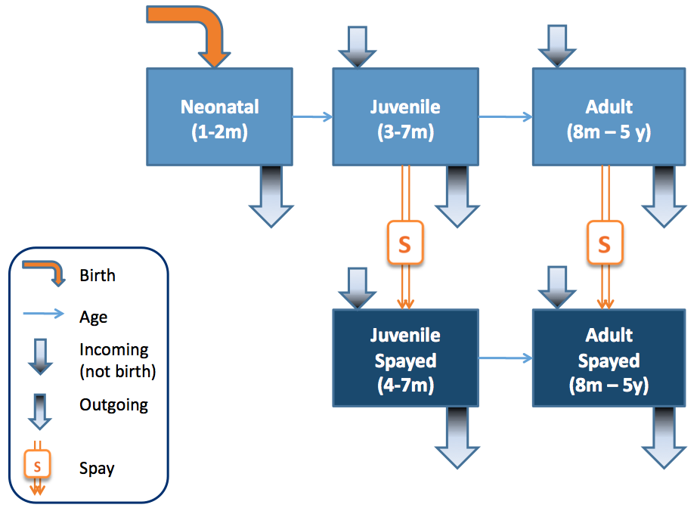

Figure 2. Population growth with non-seasonal spaying of 0% for both J and A age classes. Red is high immigration and low abandonment. Blue is no immigration and no abandonment.
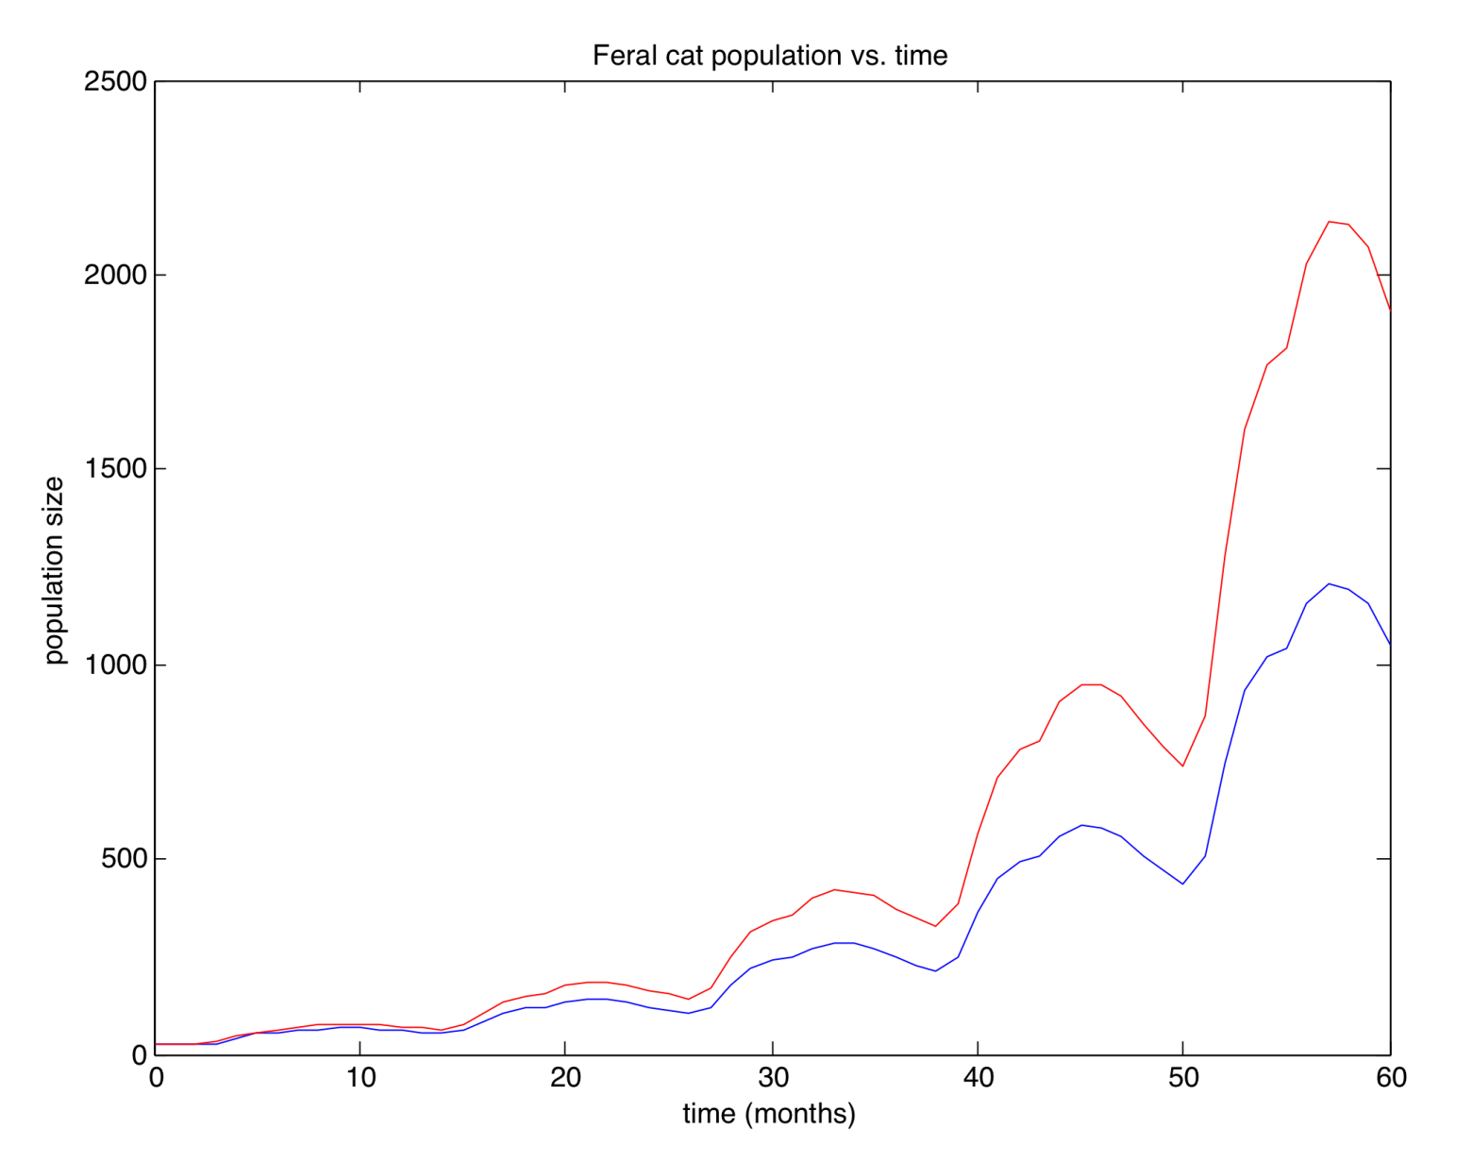

Figure 3. Population growth with non-seasonal spaying of 62% for both J and A age classes with no immigration and no abandonment (blue) and 74% for both J and A age classes with high immigration and low abandonment (red).
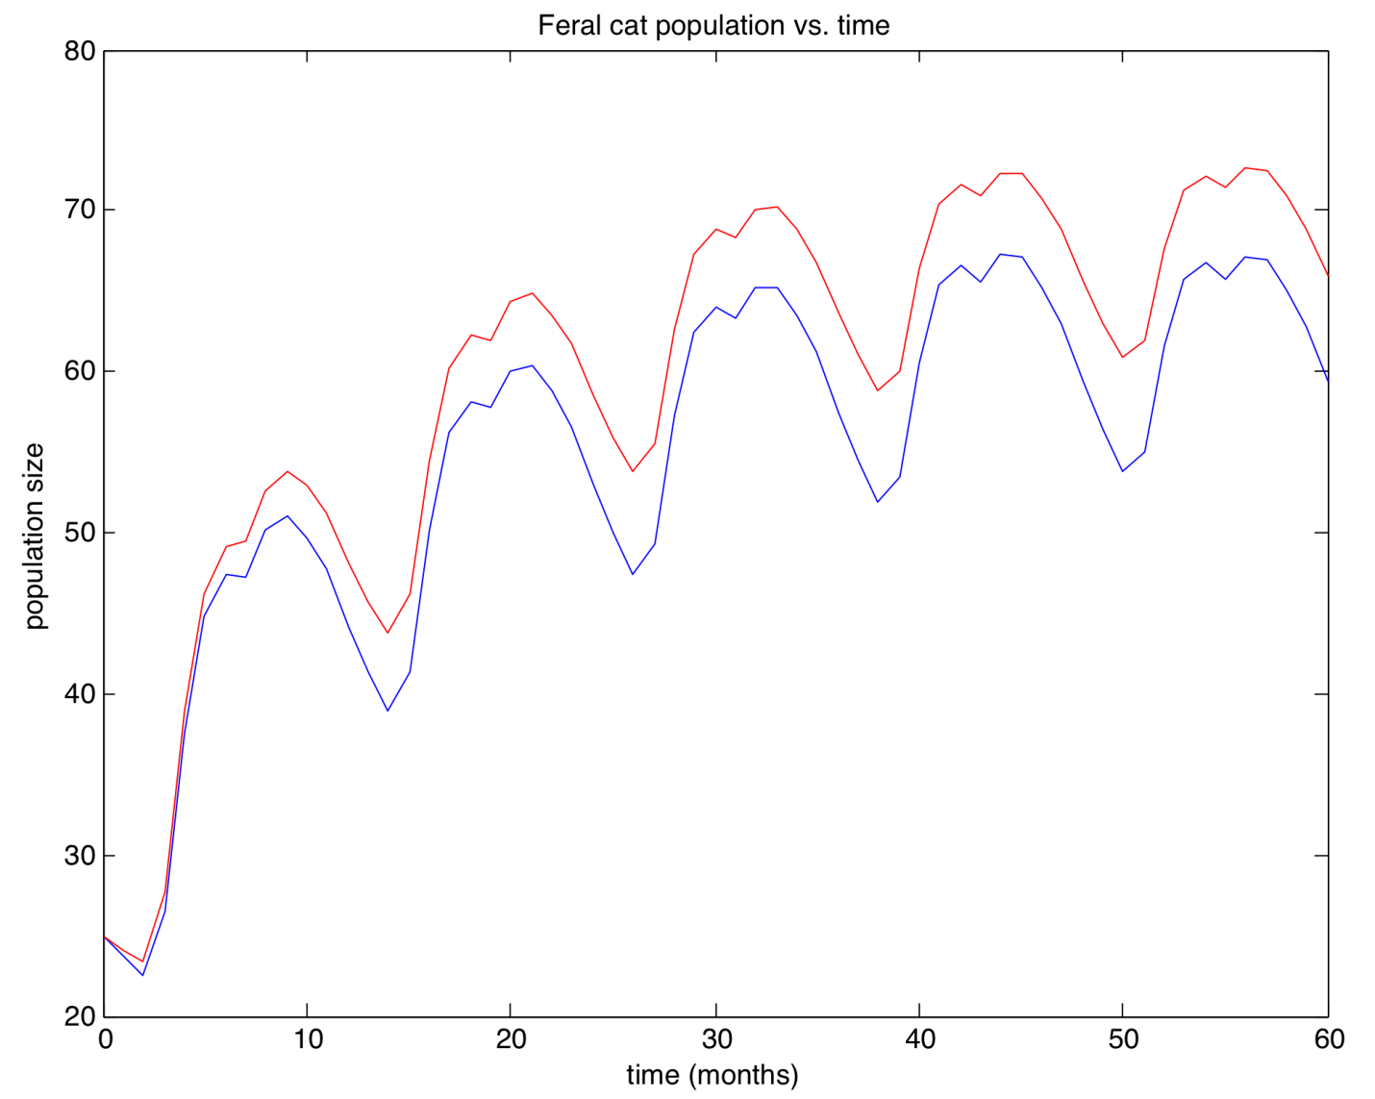
Figure 4. Population growth with non-seasonal spaying at 100% for J cats and 0% for adult cats over 5 years with no immigration and no abandonment (blue) and high immigration and low abandonment (red).
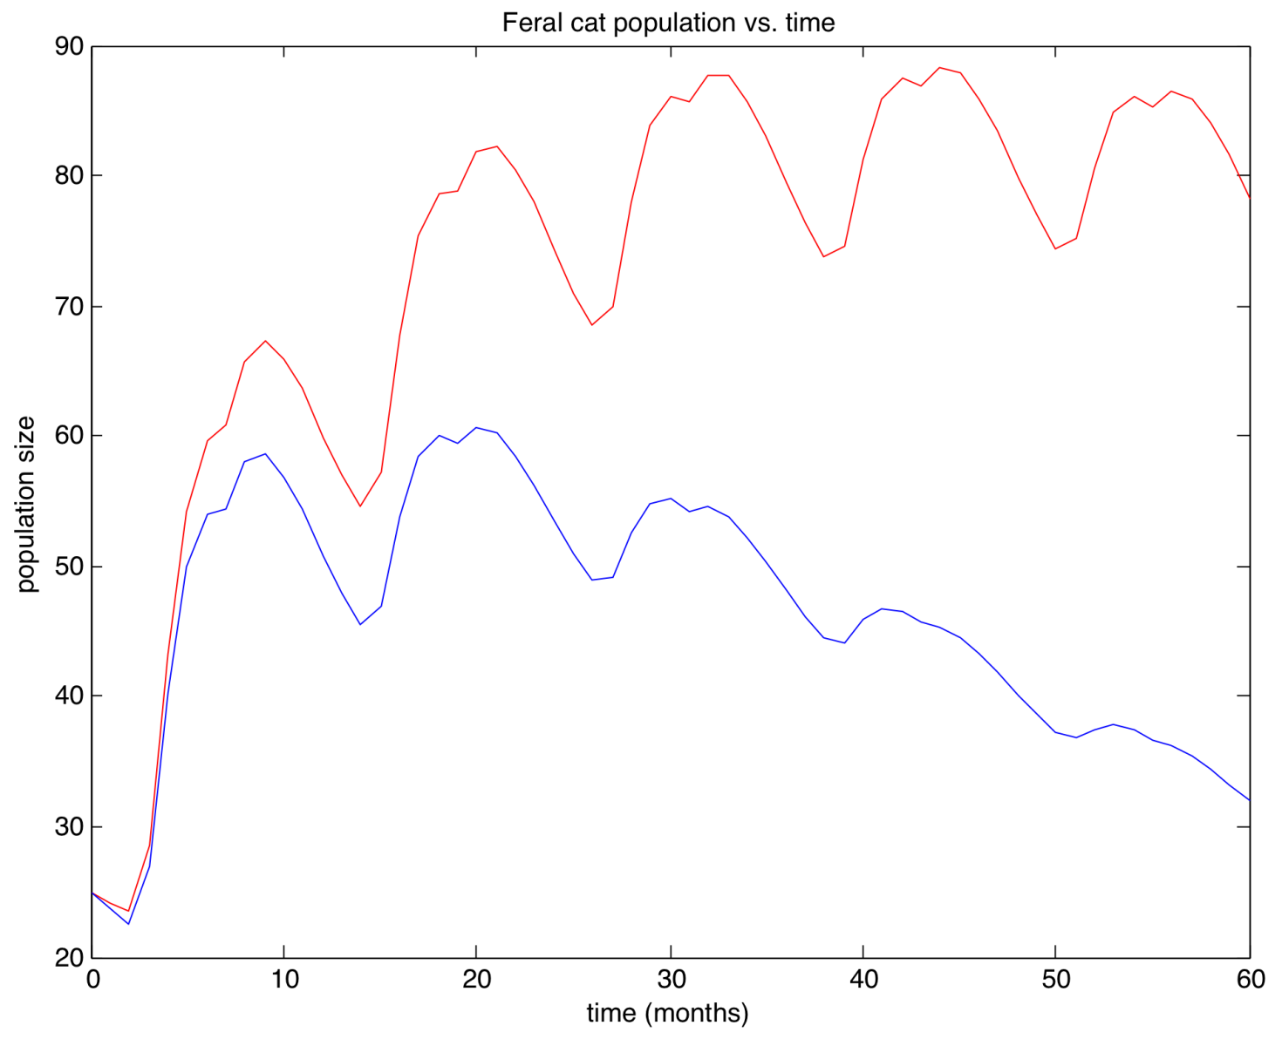
Figure 5. Population growth with seasonal spaying at 55% for both J and A cats over 5 years with no immigration and no abandonment (blue) and seasonal spaying of 70% for both J and A with high immigration and low abandonment (red)
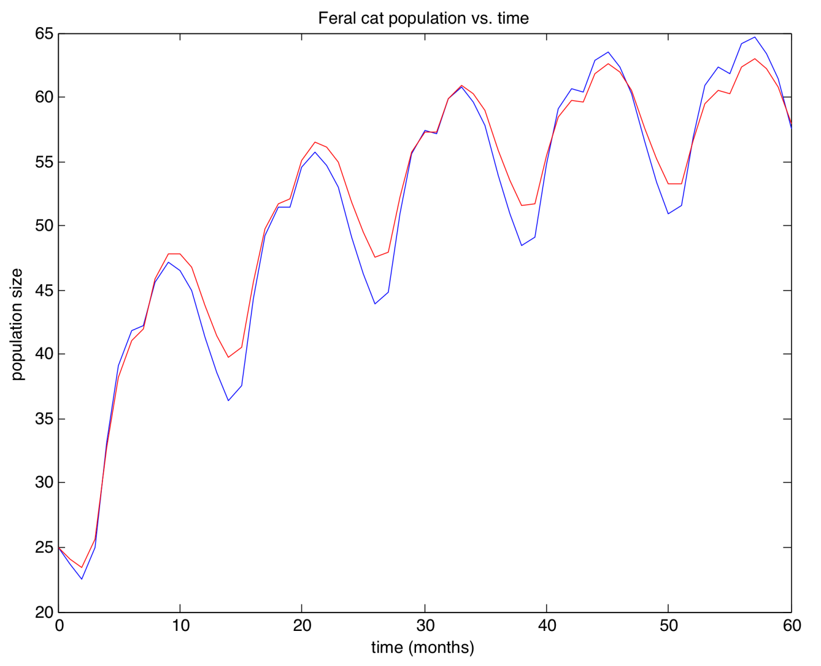
Figure 6. Population growth with seasonal spaying at 70% for adults only with no immigration and no abandonment (blue) and seasonal spaying of 90% for adults only with high immigration and low abandonment (red).
