Physicochemical Properties and Functionality of Pardina Lentil, Navy Bean, Garbanzo Bean, and Split Pea Starches

Jenna Laughlin
Philipus Pangloli
Vermont Dia

Department of Food Science, the University of Tennessee, Knoxville

Abstract
As alternative protein sources become increasingly popular in diets across the globe, starches from the commonly used protein sources can be left over after protein extraction. In addition to this, it is becoming more difficult to fulfill demand for other commonly used starches due to climate change and supply chain constraints. Finding starch substitutes can be beneficial for preventing waste from alternative protein production and for maintaining the needs of the food industry in a sustainable manner. The objective of this study was to characterize the physicochemical properties of starch from navy beans, lentils, garbanzo beans (chickpeas), and yellow split peas. Moreover, the effect of phosphorylation on the functionality of isolated starches was evaluated. The degree of phosphorylation was unable to be determined due to some errors while testing, so phosphorylated results were included but no comparisons were made between the phosphorylated and unmodified samples. To test for the properties of the starches, first the starch was extracted from the dried pulses, then microscopy, solubility, swelling, water retention capacity, least gelation concentration, and gelatinization and melting point tests were performed. Unmodified split pea and navy bean starches appeared slightly larger than lentil and garbanzo starches under the contrast microscope. All samples had similar gelatinization temperatures near 80° C both in DSC and hot stage microscope tests. Lentil and garbanzo starches had a least gelation concentration of 0.4% while the split pea and navy bean starches had a least gelation concentration of 0.8%. Though the effect of phosphorylation could not be established, the unmodified starches have many possible uses in both the food industry and other industries. Legumes are a sustainable source of nutrition that has the potential to be a highly effective starch replacement or substitute in the future of the food science industry.

- Introduction
Legumes are edible seeds that provide essential vitamins and nutrients in our diet. They are high in protein and carbohydrates in the form of starch. This starch is composed of two molecules, amylose and amylopectin. Both are polysaccharides consisting of D-glucose monomers joined together by glycosidic bonds and can be found in various food sources.¹ Starches are often used in foods such as gels, jellies, and sauces to enhance textural properties, due to their gelling and stabilizing characteristics.² They also can be used to improve the sensory qualities of certain foods, acting as thickeners, fat substitutes, and emulsifiers. Legumes are an inexpensive, sustainable source of protein, complex carbohydrates, and starches.³ They may even be the future of sustainable diets and alternate protein consumption due to their desirable properties and inherent health benefits.⁴
Because legumes are good sources of proteins, they are often used in the alternative protein industry. As a result of legume protein extraction, a starch that is cheap and readily available remains.⁵ These starches have properties that make them desirable for the aforementioned purposes. The legumes used in the following tests include navy beans, yellow split peas, garbanzo beans, and lentils. According to a study led by Semin Ozge Keskin of the Kocaeli University Food Processing Department, navy beans are made up of 28.2-43.4% amylose, garbanzo beans are 23.0-35.24% amylose, and lentils are generally 23.5-38% amylose.⁶ Split peas were not mentioned in the study, but for the purposes of this study, it can be assumed their amylose content falls within a similar range as the other three legume starches. The three samples present very similar experimental amylose content, and each is a good source of protein, dietary fiber, and starch carbohydrates.⁷ Each legume mentioned can also be classified as a commonly consumed household ingredient. Lentils and garbanzo beans are particularly popular in Mediterranean diets with an array of different uses. Lentils and garbanzo beans are also now becoming more popular gluten free substitutes and are particularly desirable as a pasta base due to their protein content being higher than typical wheat-based pasta.
Testing to characterize the properties of the four starches can determine how suitable they would be as alternatives or replacements to other common starches in the food industry.⁸ It also can determine what characteristics these starches have that might be used outside of the food industry for other practical applications. The properties of these various legume starches can also be indicative of other food uses they have outside of replacing the predominant starches currently on the market.
The objective of this study was to determine properties of legume starches and suggest potential applications of these starches based on their potentially desirable properties. The tests performed to characterize the properties of these starches were phosphorylation, swelling, solubility, water retention capacity, least gelation concentration, microscopy, and differential scanning calorimetry (gelatinization and melting point).

- Materials and Methods
Samples
Dried Pardina (brown) lentils, garbanzo beans, yellow split peas, and navy beans were used for the project. The starch from each sample was extracted separately and that was used for the duration of the project.
2.1 Starch Extraction
For each sample, the starch extraction procedure was the same except for the amount of dried legume used. The first starch extracted was from the Garbanzo beans. To start, 200g of dried garbanzos were soaked in a 0.1% NaHSO₃ solution overnight. This was done in triplicate. After soaking, each 200g portion of garbanzos was drained and blended with 500 mL of deionized (DI) water. This mixture was drained through 4 layers of cheesecloth. The solid portion was preserved for other experiments and the liquid was collected and passed through a 100 and 200 mesh sieve. The final liquid considered the garbanzo “milk” was transferred to 250 mL centrifuge tubes. This was initially centrifuged at 5000 x g for 20 minutes but did not appear to extract all the starch. Centrifugation was repeated at 2500 x g for 20 minutes and again at 10000 x g for 20 minutes. The supernatant was discarded after this, and precipitate was mixed with 100 mL of a 0.2% NaOH solution. This was centrifuged again at 10000 x g for 20 minutes and the previous procedure was repeated once. After discarding the second NaOH supernatant, the precipitate was mixed with 100 mL of DI water and centrifuged at 10000 x g for 20 minutes. The water mixture and centrifugation were repeated 2 more times. The final precipitate after the last centrifugation was collected into 50 mL centrifuge tubes and freeze-dried resulting in garbanzo starch.
The next three samples were the split peas, navy beans, and brown lentils. For these, essentially the same procedure was performed that was used for garbanzo beans with a few minor changes. Instead of 200 g of sample used, 400 g of sample was weighed in triplicate for each of the other three legumes. The dried 400g samples were soaked in 2 liters of 0.1% NaHSO₃ solution overnight then drained and blended with 1 liter of DI water. The samples were filtered using the same 4 layers of cheesecloth and 100 and 200 mesh sieves. The resulting liquid of each sample was placed in 250 mL centrifuge tubes then centrifuged at 10000 x g for 20 minutes. The same rinsing procedure with NaOH and DI water was performed, and all samples were also transferred to 50 mL centrifuge tubes for freeze-drying after the last centrifugation.
2.2 Phosphorylation
Ten grams of each sample was weighed then suspended in 500 mL of DI water. While stirring, 200 mg of sodium tripolyphosphate was added and allowed to continue stirring until it dissolved. The samples (all with a pH close to 10) were adjusted down to pH 8.5 with 1 N HCl. The suspensions were transferred to separate centrifuge tubes and placed in a 45° shaking water bath for 90 minutes. After removal from the shaking water bath, the suspensions were placed in an ice bath for 10 minutes to stop the reaction. The pH of each of these samples was adjusted down to 5.4 with 1 N HCl. These were then centrifuged for 10 minutes at 8000 x g at 4° C. After centrifugation, the supernatant was discarded, and remaining precipitate was washed with 100 mL of DI water and centrifuged again with the same settings. The washing and centrifugation were repeated 3 more times to equate to 4 total washes and 5 total centrifugations. The precipitate of each sample was transferred to separate 50 mL centrifuge tubes and freeze-dried to produce the phosphorylated starch.
2.3 Microscopy
Two types of microscopies were performed on each sample. The first was a contrast microscope and the second was a polarized light microscope which also is a hot stage microscope that was used to determine gelatinization point. For both microscopes, a small pinch of sample was placed on a slide with a small drop of DI water.
For the contrast microscope, images were taken at 400x magnification. Each legume and its phosphorylated starch had images repeated in duplicate. For the polarized light microscope/hot stage microscope, images were taken at 5° intervals as the temperature was increased from 25° C until gelatinization. The temperature was set to increase 5° every minute. The maximum temperature was set to be 90° C, but most samples were stopped and cooled around ~80° C. This was performed in duplicate with each starch and its phosphorylated counterpart.
2.4 Solubility, swelling, and water retention capacity
This procedure was performed once for each starch and phosphorylated starch. A water bath was pre-heated to 90° C. Six 15 mL centrifuge tubes were weighed, and weight was recorded. Approximately 100 mg of sample was added to each tube and weight was recorded. Five mL of DI water was added to each tube, and they were vortexed before being placed in the pre-heated shaking water bath. The tubes were in the shaking water bath for 30 minutes and vortexed every five minutes before being removed and allowed to cool. The tubes were centrifuged at 1000 x g for 20 minutes at room temperature. The supernatant was drained into pre-weighed aluminum dishes and placed in a 110° oven overnight. The tubes with precipitate were weighed then placed at a 45° angle for 10 minutes allowing excess supernatant to drain. After draining the tubes were weighed again. All weights recorded were used to calculate the solubility, swelling, and water retention capacity.
Solubility = $\frac{[\left(W4-W3\right)*100]}{W2}$
Swelling = $\frac{[\left(W5-W1\right)*100]}{W2}$
Water retention capacity = (W5-W6)
**W1 = weight of 15 mL centrifuge tube and lid (g), W2 = weight of sample, tube, and lid (g), W3 = weight of aluminum dishes (g), W4 = weight dried aluminum dishes (g), W5 = tube, lid, and sediment, W6 = tube, lid, and sediment after draining
2.5 Least gelation concentration
Five concentrations of starch were prepared in five 15 mL centrifuge tubes based on Table 1.0. After adding starch and DI water, the samples were vortexed and placed in a boiling water bath. The samples were vortexed constantly until the suspension appeared to have completely gelatinized. Once removed from the boiling water bath, samples were placed directly into an ice bath for 10 minutes. The tubes were then left in the refrigerator overnight and flipped upside down the next morning to determine the least gelation concentration based on which concentrations had gel stay at the top of the tube.
Concentration | Sample Amount (mg) | DI water amount (mL)
0.4% | 200 | 5
0.8% | 400 | 5
1.6% | 800 | 5
2.4% | 1200 | 5
3.2% | 1600 | 5
Table 1.0 - least gelation concentration experiment sample and water amounts
2.6 Differential scanning calorimetry (DSC)
Hermetic aluminum pans were placed on a scale and approximately 4 mg of each starch sample were weighed into separate pans. Six microliters of DI water were added, and the weight of the combined sample and water was recorded for each. The hermetic lid was placed on the pan and was sealed prior to being placed on an orbital shaker. The pans stayed on the shaker for approximately 60 minutes prior to running the DSC. Three samples were tested for both lentil starch and phosphorylated starch. A reference pan was used while running DSC and it contained no sample or water, just an empty sealed pan. The DSC was run for both the starch samples and the phosphorylated starch samples in duplicate, and data for the melting point, gelatinization point and enthalpy were recorded.

- Results
3.1 Microscopy
Under the contrast microscope, the two starches that appeared the largest were the navy bean and split pea starches. The garbanzo and lentil starches appeared to have similar sizes but slightly smaller than the other two legumes. All had similar shapes and a similar fracture-like appearance on some of the granules. The phosphorylated starches appeared to be slightly more fractured, but the sizes of the phosphorylated starches were not noticeably different from the unmodified starch. The images were taken at 400x magnification and 200x magnification. The observations were the same for both magnifications.
The hot stage/polarized light microscope was primarily used to determine the visual gelatinization point of the starches. It was possible to tell when starches had gelatinized based on when the notable “cross” on each granule had disappeared. Though a perfectly accurate temperature could not be recorded, a temperature range was estimated for each starch and phosphorylated starch. The temperatures for all starches ranged from 70 to 85° Celsius. Across all starches, phosphorylation appeared to have a minor effect on the gelatinization temperature, lowering it slightly for each.
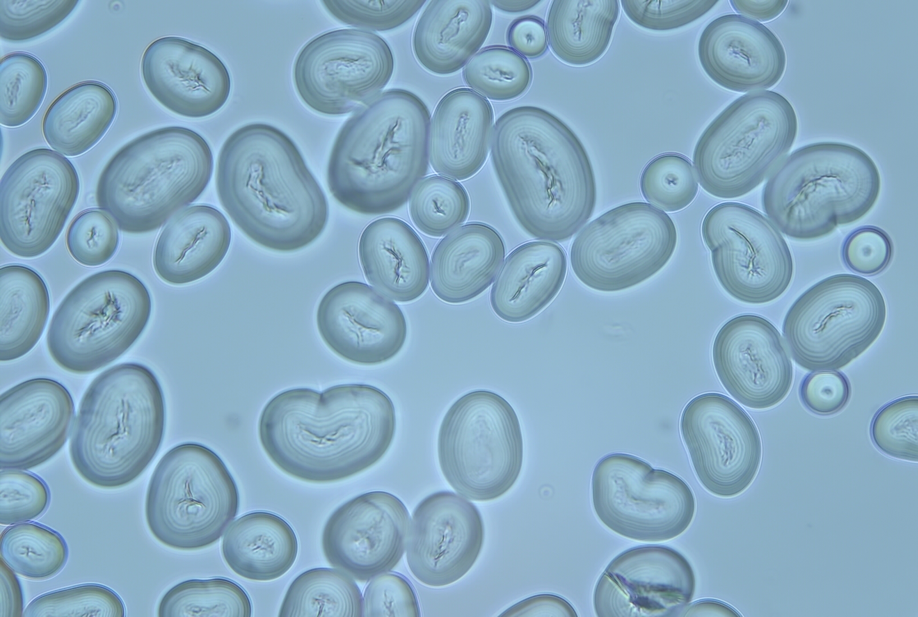
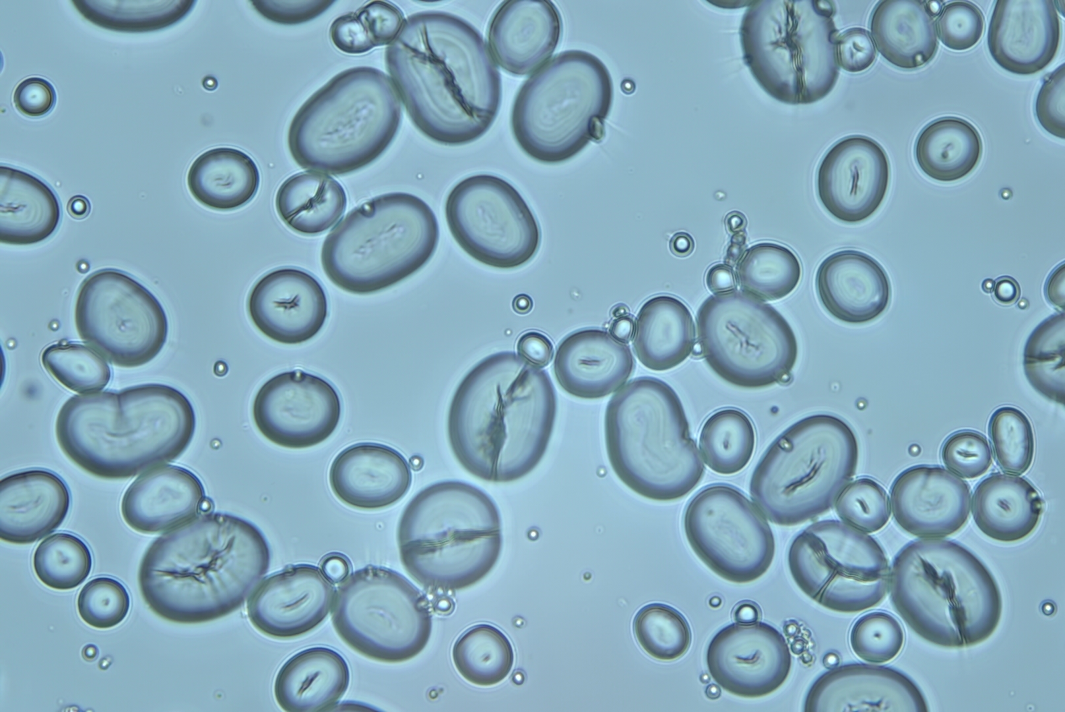
Figure 1.0 - Left: Navy bean starch under contrast microscope (400x); Right - Phosphorylated navy bean starch under contrast microscope (400x)

3.2 Effect of phosphorylation on swelling, water retention capacity, and solubility
The navy bean starch had an average solubility of 0.283 from 6 samples while the phosphorylated navy bean had an average solubility of 0.238. The difference in these values is low enough that it can be concluded that phosphorylation did not impact the solubility of navy bean starch. The average water retention capacity of navy bean starch was 0.012. The phosphorylated navy bean starch was just slightly higher with an average of 0.022. Again, because the values are already so small, these slight differences are almost negligible. The swelling value for navy bean starch averaged to be 19.53 and for phosphorylated navy bean starch the average was 21.60. There was a slightly higher average swelling value, but not significantly.
Garbanzo starch had an average solubility of 0.193. The phosphorylated garbanzo starch average solubility was 0.237. The values are just slightly different, but not notably. The phosphorylated garbanzo starch average was 0.01, a little lower than the unmodified garbanzo starch’s average value of 0.07. Average swelling values were close with the unmodified starch at 21.32 and the phosphorylated starch at 23.56. The phosphorylation did not seem to have any effect on these values for garbanzo starch, although the degree of phosphorylation could have been too low to be able to detect a change.
The lentil starch values seemed to follow the pattern of the other two starches. The solubility average was 0.190 while the phosphorylated solubility average was 0.189. These averages are so close that it is certain there is no effect from phosphorylation on lentil starch solubility. The water retention capacity values were similar too. The unmodified starch had an average of 0.08 and the phosphorylated average was 0.03. The swelling average value for lentil starch was 19.96 and the phosphorylated average was 22.00.
Yellow split pea starch displayed an average solubility of 0.29, higher than any of the other legume’s values. The phosphorylated starch also had the highest average value compared to both unmodified and phosphorylated starches at 0.33. The water retention capacity returned followed a similar trend as the other starches with the unmodified average value being 0.27 and the phosphorylated average value being 0.047. The split pea starch swelling values were 18.33 and 17.27 for unmodified and phosphorylated respectively.
The values for each individual legume’s two starches were all very similar. None had a difference high enough to draw interest or concern. Each test showed very similar results for all starches and phosphorylated starches as well. Though there are some miniscule differences in other properties, each of these starches appears to behave almost the same.
Swelling, Solubility, Water Retention Capacity averages
Sample | Solubility | Swelling | WRC
Navy Bean | 0.283 | 19.52 | 0.012
P-navy bean | 0.238 | 21.597 | 0.022
Lentil | 0.1903 | 19.963 | 0.077
P-lentil | 0.1887 | 22.004 | 0.03
Split pea | 0.285 | 18.327 | 0.0267
P-split pea | 0.3315 | 17.2682 | 0.0467
Garbanzo | 0.193 | 21.31 | 0.07
P-garbanzo | 0.237 | 23.56 | 0.01
Table 2.0: Swelling, water retention capacity, and solubility average values. The P- denotes phosphorylated form of that starch.

3.3 Effect of phosphorylation on least gelation concentration
The least gelation concentration (LGC) was the same for each starch and phosphorylated starch except for one sample. The phosphorylated navy bean starch had a lower LGC than the unaltered navy bean starch, and this could be due to a number of factors. More repetition would help eliminate any uncertainty about this test and allow the results to be more precise. None of the samples had an LGC higher than 0.8%. Other than the navy bean and phosphorylated navy bean starches, there does not appear to be much or any effect of phosphorylation on the gelation of these starches.
Least Gelation Concentration
Sample | LGC
Lentil | 0.4%
Phosphorylated lentil | 0.4%
Split pea | 0.8%
Phosphorylated split pea | 0.8%
Navy bean | 0.8%
Phosphorylated navy bean | 0.4%
Garbanzo | 0.4%
Phosphorylated garbanzo | 0.4%
Table 2.1: Least gelation concentration of the various samples

3.4 Differential scanning calorimetry
In tables 2.2 and 2.3, the gelatinization and melting point data are presented. The garbanzo starch was tested multiple times so the average values of all the tests are shown. The results of the garbanzo starch tests were all outliers compared to the phosphorylated garbanzo and all other samples. It is unclear why this occurred because all samples were prepared exactly the same and tested at the same time. It would make sense to repeat the test for all samples but particularly the garbanzo as the values were unexpected and do not seem compatible with all other data collected. It is plausible to assume that phosphorylation may have had a minor impact on the melting point values, but overall, the data was fairly consistent (disregarding garbanzo).
The ending gelatinization temperature can be compared to the gelatinization temperatures observed in the hot stage microscope test. The hot stage microscope data was less precise and accurate than the DSC data, but overall, all samples appear to follow a similar trend. The DSC produced a high gelatinization endpoint of ~81°C and a low close to 70 °C. This is a narrower range compared to the visual data from the microscope which was to be expected. The navy bean, lentil, and split pea starches and their phosphorylated starches displayed similar properties both in gelatinization end point and melting point. Both the unmodified and phosphorylated garbanzo samples had values that were deviant enough to cause some suspicion, meaning that they could have been contaminated or the machinery could have malfunctioned when it was testing those. Before using or analyzing the data as a whole, all DSC tests with garbanzo and phosphorylated garbanzo should be repeated with newly prepared samples.
Gelatinization
Sample | Initial (°C) | Onset (°C) | Peak (°C) | End (°C) | Enthalpy (J/g)
Navy bean | 50.08 | 57.46 | 71.25 | 80.15 | 1.6043
P-navy bean | 54.39 | 59.49 | 87.24 | 80.46 | 1.8037
Lentil | 59.37 | 65.74 | 72.32 | 80.78 | 1.6621
P-lentil | 56.06 | 61.77 | 68.65 | 77.85 | 1.9685
Split pea | 54.67 | 60.77 | 68.6 | 79.84 | 1.9236
P-split pea | 53.56 | 59.59 | 66.81 | 79.45 | 1.9714
Garbanzo* | 60.99 | 61.84 | 66.48 | 71.24 | 0.80328
P-garbanzo | 55.75 | 57.78 | 62.64 | 70.62 | 1.8651
Table 2.2. Differential scanning calorimetry data for gelatinization points. The P- denotes phosphorylated form of that starch.

Melting Point
Sample | Initial (°C) | Onset (°C) | Peak (°C) | End (°C) | Enthalpy (J/g)
Navy bean | 134.79 | 137.68 | 137.73 | 141.9 | 5.0477
P-navy bean | 134.85 | 136.25 | 136.25 | 138.98 | 2.294
Lentil | 132.11 | 132.67 | 132.67 | 136.07 | 3.4965
P-lentil | 134.8 | 135.87 | 136.45 | 140.15 | 4.4255
Split pea | 132.67 | 133.45 | 133.42 | 136.67 | 3.5237
P-split pea | 135.89 | 137.28 | 137.28 | 140.85 | 5.1176
Garbanzo* | 99.41 | 100.39 | 105.52 | 130.7 | 578.97
P-garbanzo | 130.73 | 130.92 | 130.96 | 132.73 | 1.7333
Table 2.3. Differential scanning calorimetry data for melting points. The P- denotes phosphorylated form of that starch.

- Discussion
This study intended to characterize the properties of unmodified starch as well as phosphorylated starch and then discuss their differences and subsequent functionalities. The phosphorylation of the samples was performed without issue; however, the degree of phosphorylation was unable to be determined likely due to low yield of phosphorylated product. The data from the “phosphorylated” starch was presented in the results section, however it is unclear if the degree to which it was phosphorylated was significant or negligible. While it would be useful to understand the effects of phosphorylation and applications corresponding to that, the potential functions discussed here will focus on the data collected from the unmodified starch samples. In the future, different phosphorylation tests could be conducted to determine further uses and to understand how the degree of phosphorylation has a role in impacting the properties of starches.
Three of the most commonly used food starches are potato, cassava, and corn. These have widespread applications throughout the food industry and elsewhere, however they differ both from each other and from the legume starches tested in a few ways. The first of which is gelatinization temperature. In a study done by Abdullah et al, a DSC analysis was performed on potato, corn, and cassava starches to determine gelatinization point.⁹ Potato starch had the lowest gelatinization temperature, followed by cassava, then corn. Interestingly, this study displayed gelatinization temperatures for all three samples in between 62 and 69$°$ C. This differs almost greater than 10$°$ from the average gelatinization temperatures of the legume starches. Unmodified split pea, lentil, and navy bean starch gelatinization temperatures were within ±1$°$ of 80$°$ C. These varying gelatinization temperatures can be indicative of how starches will behave in potential food products. Gelatinization occurs prior to gelation, and it is the process of starch granules heating, swelling, and bursting. This can both thicken and solidify the liquid. Gelation is the step that follows when the gel cools and the polymers will bond to solidify the substance further.¹⁰ The amount of amylose present in a starch can affect how it gels, so a higher amount will result in easier gelling. In the future, it would be beneficial to perform gelatinization and least gelation concentration tests on other plant starches to compare to the experimental samples. This would help estimate the amylose content of each and the potential for their applications in food products.
Though legumes have a slightly lower overall starch content than the current most widely used food starch sources mentioned, they should be strongly considered as an option to be made more commonplace and commercially available to meet growing demands for non-meat protein sources, due to their affordability, versatility, and sustainable impact.^{5, 11} The desire for non-meat protein sources has roots in ethical reasonings, personal beliefs, sustainability, and accessibility. A major benefit to using legume-based starches is the lessened environmental impact. Legumes are a sustainable alternative to meat and other similarly used protein and carbohydrate rich foods.¹² Legumes are also desirable for their variability and genetic manipulability.¹¹ They can be modified to resist extreme climate conditions.⁷ Due to climate change and other economic issues, more commonly used starches such as potato and corn are becoming more expensive, and it is increasingly challenging to satisfy the current demand. Since legumes are already increasing in popularity with the alternative protein industry, the leftover starch from protein extraction could be used as opposed to being wasted.⁶ The opportunity to use every component of a legume should not be overlooked or ignored. Because they are a sustainable option that can be modified for use based on climate changes, they have the potential to be able to feed the world and preserve the environment. Moreover, they are desirable as protein alternatives rapidly growing in popularity and overall, a nutritious and versatile food product. All these qualities and benefits make legumes an enticing resource that should be investigated thoroughly.

- Conclusion
Popularizing the use of alternative starches and legume starches in particular has many benefits. Characterizing the various physicochemical properties of these starches will be helpful for determining the best applications for use in the food industry or elsewhere. Testing the differences in unmodified and phosphorylated starches would also be beneficial to determine impact of chemical modification. It is possible that phosphorylation could improve the existing qualities of unmodified starches, however this can only be confirmed with further research. The unmodified starch alone displayed characteristics that are different from current starches readily available, but their properties are beneficial and make it a desirable alternative for future use in the food industry.

- Sources
1. Wani, I.A., Sogi, D.S., Hamdani, A.M., Gani, A., Bhat, N.A. and Shah, A. (2016), Isolation, composition, and physicochemical properties of starch from legumes: A review. Starch - Stärke, 68: 834-845. https://doi.org/10.1002/star.201600007
2. Dyck, J. (2019, July 11). Starch. Retrieved from https://www.usapulses.org/technical-manual/chapter-6-non-traditional-application/starch
3. Crosby, Guy. “Ask the Expert: Legumes and Resistant Starch.” The Nutrition Source, Harvard University, 28 Oct. 2019, https://www.hsph.harvard.edu/nutritionsource/2015/11/16/ask-the-expert-legumes-and-resistant-starch/
4. Junior, J. F., & De Francisco, A. (2020, March). Cereals & Grains Association. Retrieved December 6, 2021, from https://www.cerealsgrains.org/publications/cfw/2020/March-April/Pages/CFW-65-2-0018.aspx
5. Oyeyinka, S. A., Singh, S., & Amonsou, E. O. (2021). A review on structural, digestibility and physicochemical properties of legume starch-lipid complexes. Food chemistry, 349, 129165. https://doi.org/10.1016/j.foodchem.2021.129165
6. Keskin, S. O., Ali, T. M., Ahmed, J., Shaikh, M., Siddiq, M., & Uebersax, M. A. (2021). Physico-chemical and functional properties of legume protein, starch, and dietary fiber—A review. Legume Science, e117. https://doi.org/10.1002/leg3.117
7. Calles, Teodardo. (2016). The International Year of Pulses: what are they and why are they important. Agriculture for Development. 26. 40-42.
8. Santana, Á. L., & Meireles, M. A. A. (2014). New starches are the trend for industry applications: a review. Food and public health, 4(5), 229-241.
9. A H D Abdullah et al. Physical and chemical properties of corn, cassava, and potato starches. 2018 IOP Conf. Ser.: Earth Environ. Sci. 160 012003
10. Fennema’s Food Chemistry. 4th edition. Edited by: S. Damodaran, K. Parkin and O. Fennema. 2008. CRC Press. Taylor and Francis Book.
11. Fernando, S. (2021), Pulse protein ingredient modification. J Sci Food Agric. https://doi.org/10.1002/jsfa.11548
12. Stagnari, F., Maggio, A., Galieni, A. et al. Multiple benefits of legumes for agriculture sustainability: an overview. Chem. Biol. Technol. Agric. 4, 2 (2017).

