Investigation of Zyflamend on AMPK signaling and potential interactions of its components

A Dissertation Presented for the
Doctor of Philosophy Degree

The University of Tennessee, Knoxville

YI ZHAO

December 2014
Copyright ©2014 by Yi Zhao
All rights reserved.

ACKNOWLEDGEMENTS

I want to pay my sincere gratitude to all those who helped me complete my Ph.D. degree in Nutrition Science. I would like to thank my academic advisor Dr. Jay Whelan for his support and guidance in my graduate studies and professional career. He always supports me for every single experiment that I am interested in. He always cheers me up when I felt disappointed about my experimental results. He gave me many opportunities to attend national and international conferences, and moreover, he always generously supported me when I meet difficulties in my life. I feel so lucky and grateful to have Dr. Whelan as my Ph.D advisor.
I would like to thank my committee members, Dr. Guoxun Chen, Dr. Seung Baek, and Dr. Michael McEntee. Dr. Chen provided many suggestions on molecular technology and unlimited lab supplies. Without him, I could not have finished my project. Dr. Baek hosted a great seminar which gave me many chances to interact with outstanding scholars from all over the world. Dr. McEntee was always so friendly and encouraged me when I felt confused about the comprehensive exam.
I would like to thank Dr. Jason Collier and Dr. Susan Burke, for their help on setting up the NF-κB luciferase system. I also would like to thank Dr. Dallas Donohoe, for his help on experiments involving fatty acid oxidation. The completion of this work would not be possible without help from these professors.
Colleagues and collaborators were also important for me to complete my project. I would like to thank Dr. E-chu Huang, for training me on multiple laboratory techniques. She was not only a labmate, but was also one of my best friends in the USA. Without her, my life in the USA would have been gray and boring. I would also like to thank Amber Macdonald who helped me culture cells when I was struggling with my dissertation.
This work was financially supported by the Tennessee Agricultural Experiment Station (JW) and U.S. Department of Agriculture.
At the end, I have to thank my family. I’d like to thank my parents who always love, support and encourage me under any circumstances. I am grateful to my mother who helped me take care of my newborn baby. I greatly appreciate my father for suggestions about Traditional Chinese Medicine, who helped me identify the combinations used in this study, (based on the 1028 possible combinations in Zyflamend) when evaluating the synergistic effect of herbs. I have to thank my husband, Xie Xie, who always consoled me and gave me a hand when confronted with all kinds of difficulties. He is the second best father (the first is my dad) and the best baby-sitter in the world. Finally, I have to thank my little angle, Iris. She is a priceless treasure and the most important part of my life. I hope she will be proud of me when she has a chance to read my dissertation.
Without all of your support, this would not be possible. Thank you all!

ABSTRACT

The reductionist approach contributes greatly to our understanding of anticancer properties of phytonutrients, but in vitro studies demand concentrations that are 100-1000 times higher than achievable in humans, producing results with little physiologic relevance, resulting in disappointing outcomes in clinical trials. However, maintaining these bioactives in the presence of other compounds originally derived from the food/extract of origin may synergistically lower the bioactive dose so translatability becomes feasible. The first objective of this study was to determine if bioefficacy of phytonutrients can be enhanced when used in combination at doses that are ineffective when used in isolation. In this project, proliferation of CWR22Rv1cells, HEK293 cells and expression of NF-κB was evaluated and synergy were assessed when treated with turmeric, Chinese goldthread and their bioactives in isolation or in combination. Bioactives were not as potent as their extracts of origin. Combinations of herbal extracts and/or their isolated bioactives lowered effective concentrations and may account for why foods/plant extracts are more likely to be beneficial against cancer compared with isolated components.
Turmeric and Chinese goldthread are two major components of a polyherbal mixture, Zyflamend which have been show anti-prostate cancer (PCa) effects via multiple mechanisms. Here, we showed that Zyflamend regulated fatty acid metabolism by inhibiting synthesis and enhancing oxidation in prostate cancer cells, suggesting AMP-activated protein kinase (AMPK), the master energy sensor of cells, as a potential target. In castrate resistant PCa cells, Zyflamend activated AMPK, and in turn, regulated known downstream targets of AMPK, such as mammalian target of rapamycin complex 1 (mTORC1) and the phosphorylation of acetyl CoA carboxylase (ACC). The anti-proliferative effects of Zyflamend could be mimicked by AMPK activation and attenuated by AMPK inhibition. Thus, we concluded that AMPK activation contributes to the anti-PCa effect of Zyflamend. These novel results, along with those published previously, provide a more complete picture of how this polyherbal mixture may complement conventional treatments based on its multiple mechanisms of action.

TABLE OF CONTENTS

Chapter I INTRODUCTION 13
1.1 Prostate cancer 13
1.1.1 Progression of prostate cancer 13
1.1.2 Prostate cancer treatment 14
1.2 Herbs and PCa treatment 15
1.2.1 Epidemiology of Prostate Cancer 15
1.2.2 Diet and Prostate Cancer 16
1.2.3 Mechanisms of phytochemical action 17
1.2.4 Turmeric and cancer 18
1.2.5 Chinese goldthread and cancer 22
1.3 Disappointed results of clinical trials using pure phytochemicals 24
1.3.1 Low bioavailability of phytochemicals 25
1.3.2 Interactions among phytochemicals 27
1.4 Traditional Chinese Medicine (TCM) and cancer 30
1.5 Evaluation of synergy 30
1.6 Cell models for prostate cancer research 31
1.7 Zyflamend 33
1.7.1 Quality control of Zyflamend 33
1.7.2 Zyflamend and its anti-cancer effects in pre-clinical and clinical studies 34
1.8 Metabolic alternation in cancer 35
1.8.1 Increased macronutrients synthesis 35
1.8.2 Reduction of β-oxidation 38
1.9 Crosstalk between AKT/mTOR and SREBP1/FASN pathways in prostate cancer 39
1.10 AMP-activated protein kinase 40
1.10.1 Structure of AMP-activated protein kinase 40
1.10.2 AMP-activated protein kinase maintains energy homeostasis of cells 40
1.10.3 AMPK is a target for drugs and natural products with effects on cancer 41
1.11 Summary 42
Chapter II TURMERIC AND CHINESE GOLDTHREAD SYNERGISTICALLY INHIBIT PROSTATE CANCER CELL PROLIFERATION AND NF-KB SIGNALING 61
Abstract 61
2.1 Introduction 62
2.2 Materials and Methods 66
2.2.1 Experimental design 66
2.2.2 Chemicals 66
2.2.3 Cell Culture 67
2.2.4 Cell Proliferation 67
2.2.5 Transfection and luciferase assay 67
2.2.6 Assessment of Synergistic, Additive or Antagonistic Effects of Combinations of Herbal Extracts and/or Phytochemicals 68
2.2.7 Statistical analysis 69
2.3 Results 69
2.3.1 Cell proliferation 69
2.3.2 Comparisons of Chinese goldthread with berberine, and turmeric with curcumin on cell proliferation 70
2.3.3 Intra-herbal comparisons of companion phytonutrients (berberine with coptisine, curcumin with ar-turmerone) on cell proliferation 71
2.3.4 Inter-herbal comparison of the extracts of Chinese goldthread with turmeric on cell proliferation 73
2.3.5 Inter-herbal comparison of phytonutrients (berberine with curcumin) 74
2.3.6 TNFα-stimulated NF-κB expression 75
2.3.7 Comparisons of turmeric with curcumin on TNFα-stimulated NF-κB expression 75
2.3.8 Intra-herbal comparisons of companion phytonutrients (curcumin with ar-turmerone) on TNFα-stimulated NF-κB expression 76
2.3.9 Inter-herbal comparison of the extracts of Chinese goldthread with turmeric on TNFα-stimulated NF-κB expression 76
2.3.10 Inter-herbal comparison of phytonutrients (coptisine with curcumin) on TNFα-stimulated NF-κB expression 77
2.4 Discussions 78
2.5 Conclusions 83
Chapter III ZYFLAMEND, A POLYHERBAL MIXTURE, INHIBITS LIPOGENSIS AND MTORC1 SIGNALING VIA ACTIVATION OF AMPK 97
Abstract 97
3.1 Introduction 98
3.2 Materials and Methods 100
3.2.1 Zyflamend 100
3.2.2 Cell Culture 100
3.2.3 Cell Proliferation 101
3.2.4 Down regulation of AMPKα1/2 by small interfering RNA 101
3.2.5 Western blotting 102
3.2.6 Acetyl-Coenzyme A assay 102
3.2.7 Construction of recombinant adenovirus 103
3.2.8 RNA isolation and quantitative Real Time-PCR 103
3.2.9 Extracellular Flux Analysis 104
3.2.10 Statistical analysis 105
3.3 Results 105
3.3.1 Zyflamend inhibited de novo fatty acid synthesis in CWR22Rv1 cells 105
3.3.2 Zyflamend increased fatty acid oxidation in CWR22Rv1 cells 105
3.3.3 Zyflamend regulates AMPK phosphorylation in CWR22Rv1 and PC3 prostate cancer cell lines 106
3.3.4 Zyflamend regulates downstream targets of AMPK 106
3.3.5 Zyflamend decreased CWR22Rv1 cell viability, in part, through the activation of AMPK 107
3.4 Discussions 108
LIST OF REFERENCES 122
VITA 142

LIST OF TABLES

Table I.1 Cellular and molecular mechnisms of turmeric 44
Table I.2 In vitro antiproliferative effects of berberine, curcumin, coptisine and ar-turmerone in a variety of cell lines based on IC₅₀ concentrations (µM) 45
Table I.3 Effect of oral dosing of curcumin from a single dose (g) to 24 weeks treatment (g/d) on maximum serum/plasma concentrations (nM) of curcumin and its metabolic derivatives 47
Table I.4 Synergistic effect among phytochemicals from different herbs 48
Table I.5 Specifications for active ingredients and excipients in Zyflamend [144] 49
Table II.1 Dose-effect relationships of berberine and coptisine (from Chinese goldthread), curcumin and ar-turmerone (from turmeric), Chinese goldthread and turmeric and their combinations using their IC₅₀ values or using ratios corresponding to relative amounts in their native extracts on proliferation of CWR22Rv1 cells. 84
Table II.2 Dose-effect relationships of berberine and coptisine (from Chinese goldthread), curcumin and ar-turmerone (from turmeric), Chinese goldthread and turmeric and their combinations using their IC₅₀ values or using ratios corresponding to relative amounts in their native extracts on proliferation of HEK293 cells. 85
Table II.3 Dose-effect relationships of curcumin and ar-turmerone (from turmeric), curcumin (from turmeric) and coptisine (from Chinese goldthread), and Chinese goldthread and turmeric and their combinations using their IC₅₀ values or using ratios corresponding to relative amounts in their native extracts on NF-κB promoter activity using transfected HEK293 cells. 86
Table II.4 Dose-effect relationships of Chinese goldthread, turmeric, berberine, coptisine, curcumin and ar-turmerone and their combinations on proliferation of CWR22Rv1 and HEK293 cells and NF-κB Promoter Activity. 87

LIST OF FIGURES
Figure I.1 Progression of prostate cancer. 50
Figure I.2 Classification of dietary phytochemicals. Adapted from Ref [19] 51
Figure I.3 Mechanisms of anti-carcinogenesis actions of phytochemicals, redrawn from Ref. [56]. 52
Figure I.4 Mechanisms of curcumin on gene expression, redrawn from Ref [63]. 53
Figure I.5 Molecular targets of resveratrol, redrawn from Ref [96]. 54
Figure I.6 Digestion and absorption of polyphenols. 55
Figure I.7 Mechanisms of synergistic effect among phytochemicals. Redrawn from ref [118]. 56
Figure I.8 Mechanisms of goldthread and turmeric anti-cancer effect in TCM. 57
Figure I.9 Theroic basis of Chou-Talalay method, with author’s permission. 58
Figure I.10 Metabolism alternations in cancer cells. 59
Figure I.11 AMPK signaling pathways. 60
Figure II.1 Experimental design. 90
Figure II.2 The effects of berberine, coptisine, curcumin, ar-turmerone, Chinese goldthread and turmeric on cell proliferation. 91
Figure II.3 The comparison of berberine and curcumin on cell proliferation compared to their herbal extracts of origin, Chinese goldthread and turmeric, respectively, in CWR22Rv1 cells and HEK293 cells. 92
Figure II.4 The effects of berberine, coptisine, curcumin, ar-turmerone, Chinese goldthread and turmeric on inhibition of TNFα-stimulated NF-κB transcriptional activity in HEK293 cells. 93
Figure II.5 The effects of curcumin and turmeric on inhibition of TNFα-stimulated NF-κB transcriptional activity. 94
Figure II.6 The effects of individual herbs versus their combination on cell proliferation. 95
Figure II.7 Combination of herbal extracts may inhibit NF-κB in CWR22Rv1 cells. 96
Figure III.1 Regulation of SREBP-1c and FASN expression by Zyflamend in CWR22Rv1 cells. 113
Figure III.2 Effects of Zyflamend on fatty acid oxidation. 114
Figure III.3 The effects of Zyflamend on phosphorylation of AMPKα in CWR22Rv1 and PC3 prostate cancer cell lines. 115
Figure III.4 Regulation of downstream targets of AMPK by ±Zyflamend in CWR22Rv1 cells. 116
Figure III.5 Regulation of downstream targets of AMPK by AICAR in CWR22Rv1 cells and Zyflamend (Zyf) in PC3 cells. 117
Figure III.6 The effects of partial knockdown of AMPKα1/2 on phosphorylation of ACC and raptor in the presence or absence of Zyflamend. 118
Figure III.7 The effects on modulating AMPK activity on cell viability with the AMPK inhibitor compound C and overexpression of AMPKα1/2 subunits in the presence or absence of Zyflamend in CWR22Rv1 cells. 119
Figure III.8 Zyflamend may activate AMPK partially via activation of LKB1. 120
Figure III.9 Berberine and curcumin activate AMPK and downstream targets. 121

INTRODUCTION

Prostate cancer
Prostate cancer (PCa) is the most common internal malignancy diagnosed in men and the second highest cause of cancer death in males in the United States[1].

Progression of prostate cancer
Development of prostate cancer can be characterized by several clinical stages (Figure I.1) [2, 3]. It is widely accepted that prostatic intraepithelial neoplasia (PIN) is an initial step in the progression towards PCa [4, 5]. Notably, due to the strong association between high-grade PIN (HGPIN) and PCa, it is recognized as the precursor of PCa [6-8]. Progression of PCa is a slow process and it takes up to 10 years to manifest the disease from PIN [7, 9]. To evaluate the prognosis and progression of PCa, two parameters are commonly utilized. One is the Gleason grade, which is an evaluation system for biopsy results. The other one is prostate specific antigen (PSA), a protein produced by prostate epithelial cells. Time dependent elevation of PSA is a sign for cancer progression [9]. PCa is considered ‘low grade’ when the Gleason score is between 2 and 6 [10], along with a low blood PSA level. Gleason score and PSA levels increase with tumor progression. Tumors with a Gleason score of ≥7 behave in a more aggressive manner and more readily metastasizes to secondary sites, such as bone and lymph nodes. PCa with Gleason scores higher than 7 can be categorized as an advanced form prostate cancer (Ad PCa).
Androgens play an important role in prostate cancer progression. Advanced prostate cancer can be further distinguished based on hormone dependence. In early phases of advanced PCa, there is a dependence on the presence of androgens (androgen-dependent growth) for promotion. In the absence of androgens, (referred to as androgen deprivation therapy, ADT), most tumors regress as indicated by a drop in PSA levels. However, overtime almost all androgen dependent tumors transition to an androgen-independent type (castration resistant), typically within ~ 3-5 years. This stage is more likely to lead to a more terminal stage of PCa. The growth of the tumor in this phase is remarkably aggressive and is difficult to treat because of the location of the tumor (i.e., bone). Inevitably death occurs within one or two years (Figure I.1). [3, 9, 11, 12]

Prostate cancer treatment
Different kinds of strategies were generated to prevent or treat PCa. Due to the slow progression of the disease, the 5-year survival rates are 100% if diagnosed early, unless the disease progress to castrate resistant form. Therefore, diagnosis for early stage PCa is essential and critical for treatment and management. Besides traditional diagnosis methods like biopsy and the PSA test, a variety of new biomarkers are also used, including prostate health index (PHI, the score combining all types of PSA), RNA markers (PCA3, TMPRSS2-ETS, PTEN, etc.), circulating tumor cells (CTC), etc. [13, 14].
With regards to advanced forms of PCa, it is important to generate treatment strategies to prolong the life and increase survival, particularly following ADT [2, 9, 15]. ADT is the first line of care against Ad PCa [16]. The clinical practice guideline published by the American Society of Clinical Oncology recommends continuous ADT to both androgen dependent and independent Ad PCa [15]. It was first reported by Huggins and Hodges seventy years ago that suppressing serum androgen levels has dramatic clinical effects in men with Ad PCa [17]. ADT could be achieved by either surgical castration (orchiectomy) or pharmacologic castration. Despite the low physical morbidity of orchiectomy, it is becoming less common to utilize this treatment in Ad PCa due to the psychological impact [16]. Pharmacologic castration can be achieved by inhibition of androgen receptor (AR) signaling, which includes suppression of luteinizing hormone-releasing hormone (LnRH antagonist), inhibition of androgen biosynthesis and inhibition of AR (AR antagonism) [18].
Although ADT is wildly used in treatment of Ad PCa and clearly shows benefit in improving quality of life in patients, there is no evidence showing a survival benefit of ADT for metastatic PCa [16]. Thus, it is important to generate new treatment strategies to prolong life and increase the survival rates of Ad PCa patients.

Herbs and PCa treatment
Prostate carcinogenesis is a long and multi-step process that normally takes 2-3 decades to progress from its precancerous condition, thus providing a large window of opportunity to prevent or slow the disease process. As a result, PCa cancer is a gold model to investigate chemopreventive agents owing to the prevalence of the disease and its slow progression [13]. Among chemopreventive agents from natural sources, botanicals and herbs are receiving an increasing amount of attentions due to their low adverse effects and potential anti-cancer properties. These natural products are gaining interest from patients as forms of complementary and alternative medicines during cancer treatment [14].

Epidemiology of Prostate Cancer
Epidemiological research indicates that race is an important risk factor in the development of PCa. As reported by the American Cancer Society, the latest Cancer Statistics show that African Americans have the highest incidence and death rates. Comparatively, these rates are much lower in Asian Americans, which have 3 times lower incidence rates and 5 times lower death rates than African Americans [1]. The diet of African Americans tends to contain more deep fried meat and lower amounts of fresh fruits and vegetables [21]. Worldwide ~ 2/3 cases of PCa are found in developed countries and cultures with a typical Western-style diet [22]. For example, PCa cases in India are about 35 times fewer than in the United States [23]. Interestingly, the same ethnic groups living in different regions also have different PCa incidence rates. Japanese living in the United States have higher PCa incidence rates compared with those living in Japan [24]. The PCa incidence rate of first generation Japanese immigrants is ~4 times higher than people from their hometown and this rate is almost the same as US-born residents [25].

Diet and Prostate Cancer
One explanation for these data is that the components of diet, such as fruits, vegetables, spices, and herbs may influence the initiation and progression of PCa. A meta-analysis of case-control and cohort studies indicated that high adherence to the Mediterranean diet, rich in fruits and vegetables significantly reduced the risk of PCa by ~4% [19]. In a 2 year US cohort study, 43,268 US males completed detailed food frequency questionnaires which included flavonoid-rich foods (tea, fruits, vegetables, soy, et al.). The total amount of flavonoids was calculated and an inverse trend of flavonoid intake and high-grade PCa was observed [20]. Similarly, in the Netherlands Cohort study spanning 17 years, involving 58,279 subjects, detailed dietary intakes were collected by questionnaires and dietary flavonoid intake and black tea consumption were associated with a significant reduction in the risk of Ad PCa [21]. Similar results were found in a study of 250 Chinese PCa patients and 500 controls, where green vegetables and green tea were inversely associated with the risk of PCa [22].

Mechanisms of phytochemical action
Pre-clinical studies using phytochemicals contribute greatly to our understanding of their mechanism of action. Phytochemicals, the non-essential nutrients found in fruits, vegetables and herbs, are commonly responsible for color and aroma of plants. Phytochemicals can be divided into 5 groups and the phenolics are the most important part of phytochemicals from our diet (Figure I.2) [23]. Although different phytochemicals have a variety of targets to interrupt cancer initiation and progression, there are several common mechanisms of actions [24-26] (Figure I.3):
1. Preventing DNA-damage by scavenging reactive oxygen species (ROS) and procarcinogenic molecules [27, 28].
2. Influencing epigenetics (methylation status of DNA and histone) by targeting the activity of various factors influencing epigenetics, such as DNA methyltransferase (DNMT), histone deacetylase (HDAC), etc. [29, 30].
3. Altering mitogen-activated protein kinases (MAPKs) cascades, targeting extracellular-signal-regulated kinase (ERK) [31-33], JUN N-terminal kinase (JNK) and p38 or phosphoinositide-3-kinase (PI3K) and protein kinase B (PKB).
4. Modifying activity of several transcription factors, such as activator protein-1 (AP-1) and nuclear factor-κB (NF-κB), androgen receptor (particularly PCa), thus modifying the expression of cancer-related factors, such as COX-2 [34], IL-6, IL-8, VEGF, PSA, etc.
5. Increasing cell cycle arrest by modulating key molecules involved in control of the cell cycle, such as cyclin D, p21, etc. [35].
6. Increasing apoptosis by targeting caspase 3 and the Bcl-2 family [27, 36, 37].
These mechanisms are not separate from each other, but stimulate and support each other to form positive feedback loops, thus helping cancer cells to increase their ability to proliferate, resist cell death, and promote invasion and metastasis. Due to the interaction among multiple pathways, drugs targeting single genes result in resistance to therapy, sooner or later [38]. Moreover, it is common for targeted drugs to have serious side effects [29]. For these reasons, utilizing herbs and phytochemicals are playing a more important role in cancer prevention and treatment due to the low potential for side-effects and multiple targeting characteristics. Two herbs that interest to us are turmeric and Chinese goldthread and their major bioactive compounds.

Turmeric and cancer
Turmeric (Curcuma longa) has been wildly used to color and flavor foods worldwide for thousands of years. In Southeast Asian cuisine, turmeric rhizome, normally abbreviated as turmeric, is the predominant intergradient of curry powder. In the West, it is predominantly used in pickles, mustard and other kinds of sauces. Besides use in the diet, turmeric is used medicinally in Traditional Chinese and Indian Medicine. This spice is used to treat colic, toothaches, chest pains as an anti-inflammatory agent. It is also used to heal wounds and protect lining of the stomach. Moreover, turmeric is also used in the treatment of jaundice and to support liver function. Most importantly, turmeric is typically used in cancer treatment in Traditional Chinese medicine due to the anti-‘blood stasis’ effect [39, 40]. As a promising natural product in ancient medicine, an increasing number of researches have begun to clarify the cellular and molecular mechanisms of the action of turmeric.

In vitro studies
In cell-based studies, turmeric has been shown to have anti-oxidant and anti-mutagenic activities [41-46] (Table I.1) which may contribute to cancer prevention. It inhibits proliferation and induces apoptosis by regulating multiple molecular targets and pathways, including the inhibition of NF-κB and STAT3 [47], inhibition of PGE₂ release [48], and the increase of G2/M cell cycle arrest [49]. These functions explain, at least a part, why turmeric has been shown to suppress cancer progression and metastasis [40, 47-53] (Table I.1). Turmeric’s anti-cancer effects have been shown to be applicable to many types of cancer (Table I.1). As summarized in Table I.1, oral and topical application of turmeric significantly inhibits tumorigenesis [44, 54-57]. At the molecular level, oral doses of turmeric decrease the activity of proinflammatory pathways (i.e., NF-κB, PGE2, COX-2, NO) [56], increases apoptosis (i.e., Bcl2) [56] and increase cell cycle arrest (i.e., p21, p53 and cyclin D) [58].

In vivo studies
Chronic myeloid leukemia (CML) is characterized by elevated levels of nitric oxide (NO). In patients with CML, cotreatment of turmeric (5 g t.i.d. for 6 weeks) with chemotherapy (imatinib) resulted in lower levels of NO compared with imatinib alone. No significant side effects were found from the addition of turmeric at a dose of 15 g/day [59]. These studies suggest efficacy of turmeric on cancer related biomarkers with no reported side effects. However, to obtain stronger evidence and clarify the molecular mechanism regarding the anti-cancer effect of turmeric, randomized, placebo-controlled, double blind clinical trials are required.

Phytochemicals in turmeric
Phytochemicals in turmeric can be roughly categorized into two groups. Curcuminoids account for about 3% to 5% of the dry weight of turmeric, and contributes to its yellow color [60]. The most common curcuminoid in turmeric is curcumin. The other group is the essential oil which is responsible for the aromatic taste and smell of turmeric. Dried turmeric normally yields 1.5%-5% essential oil and the most abundant compound is ar-turmerone [40].

Curcumin and prostate cancer
Curcumin, o-methoxyphenol derivative, is the most widely studied bioactive compound in turmeric. Its anti-PCa effects have been extensively studied. In cell based studies, curcumin decreases cell viability of both androgen-dependent (LNCaP) and androgen-independent (PC3) PCa cells with an IC₅₀ value of ~30 µM [61]. It can interfere with growth factor signaling pathways by down-regulating epidermal growth factor-receptor (EGF-R) [62] and androgen receptor [63, 64]. Curcumin also induces cell cycle arrest and apoptosis of PCa cells by inhibiting NF-κB and AP-1[64], down-regulating c-Jun [63] and cyclin D [65]. Epigenetic modification is also a target. Gene chip results indicated that curcumin changed the transcription level of over 100 genes by >4-fold in androgen dependent (LNCaP) PCa cells and about 40 genes in androgen independent (C4-2B) PCa cells [66]. The potential mechanism for epigenetic modification is illustrated in Figure I.4 [67]. Treating LNCaP PCa cells with 5 µM curcumin for 24 hr decreased total HDAC activity and methylation of histone 3 at the promoter regions of targeted tumor suppressor genes like Neurog1 which is commonly hypermethylated and silenced in PCa cells [68]. Curcumin may also prevent PCa. Curcumin prevents malignant transformation of prostate epithelial cells induced by TCDD, a highly toxic pro-carcinogenic molecule [69]. Curcumin inhibits the elevation of cytochrome P450 by decreasing nuclear levels of arylhydrocarbon receptor (AhR) and AhR nuclear translocator (ARNT), protecting DNA damage from TCDD treatment, and thus preventing malignant transformation. In addition, the Hedgehog signaling pathway was also been shown to be inhibited by curcumin in PCa both in vitro and in vivo [70].
Preclinical xenograft models of PCa support results from cell culture studies. Using a LNCaP xenograft model, nude mice were treated with diets containing 2% curcumin (w/w) for up to 6 weeks. Curcumin inhibited proliferation, induced apoptosis and inhibited angiogenesis in vivo [71]. Using DU-145 cells in a xenograft animal model, curcumin significantly decreased the tumor volume and induced apoptosis by increasing caspase-3 activity and inhibited metastasis through inhibiting MMP activity [72]. Although numerous studies show preclinical efficacy of curcumin, most clinical studies are limited to phase I trials to clarify the safety and bioavailability of curcumin. Single high oral doses (up to 12 g) of curcumin are well tolerated by healthy volunteers [73]. In addition, orally doses up to 8 mg/day for 3 months did not show any toxicity [74]. In spite of the high tolerance of curcumin, poor systemic bioavailability restricts it from being a proven clinical treatment. Unfortunately, even at oral doses up to 12 g, serum levels have been limited to concentrations in the low nM range [73]. This low bioavailability may be due to poor solubility, rapid metabolism, and short half-life [13].

Turmerone and cancer
Curcumin is not the only bioactive compound in turmeric. Thus far, there are about 235 compounds identified in this botanical [75]. One important component of curcumin free turmeric (CFT) is turmeric oil, with ar-turmerone being its most abundant compound (31%) [76]. Although its effect on inhibiting proliferation is not as potent as curcumin, ar-turmerone can still decrease viability of DU-145 PCa cell by ~10% after 72 hr treatment at a concentration of 100 µM [77]. This compound also shows anti-oxidant, anti-inflammatory and anti-carcinogenic effect in other cell models. Sera et al reported that ar-turmerone suppressed inflammatory cytokines interferone (IFN)-γ and IL-2 in CD4 T cells [78]. It decreased the expression of COX-2 and MMP-9 by interrupting NF-κB, PI3K/Akt, and ERK 1/2 pathways, and inhibited invasion, migration, and colony formation of MDA-MB-231 (breast cancer) cells [79]. In vivo studies or clinical trials have yet to be conducted to test its anti-carcinogenic effect and clinical application of ar-turmerone requires further investigation.

Chinese goldthread and cancer
Chinese goldthread (CG) (Coptis chinensis) has been used as an herbal medicine in Asia for over 2000 years and it is still commonly used in Chinese medicine. In TCM, CG is wildly used to remove damp-heat which roughly translates to inflammation in modern medicine [80]. It is the most important ingredient of many famous anti-inflammatory Chinese compound formulae such as Sanhuang Xieyin decoction and Huanglian Jiedu decoction [81, 82]. Because inflammation is an important hallmark of cancer [38], CG is appealing for its potential anti-carcinogenic effect. It has been used in studies involving many cancer types such as breast, colon, liver, pancreatic and neuroblastoma [80, 83, 84]. DNA microarray data indicate that CG can modify 27 genes of pancreatic cancer [85]. CG can also inhibit NF-κB activity and its translocation stimulated by TNF-α in human keratinocyte [86]. Feeding rabbits CG at a dose of 0.14 g/kg can decrease serum IL-6 level, which may in part, explain the anti-inflammatory effect [87]. More studies are needed to clarify the mechanisms of anti-inflammatory and anti-cancer effects of CG.

Berberine and prostate cancer
There are more than 8 kinds of isoquinolin alkaloids identified from CG [88]. Berberine is considered the most active component and its anti-inflammatory and anti-carcinogenic effect has been widely studied [80, 89, 90]. Berberine significantly decreases the viability of multiple PCa cell lines, including LNCaP, CWR22Rv1, PC3, C4-2B and DU-145 with IC₅₀ values in the range of 50-100 µM [91, 92]. To decrease cell viability, berberine increases G1 arrest by decreasing cyclin D1/D2/E, decreasing activity of CDK2/4/6, increasing p21/p27 and binding of CDK with p21/p27 [91]. G2/M cell cycle arrest is also induced by exposure of 50 µM berberine for 24 hr [93], and berberine increases PCa cell apoptosis by generating ROS and increasing the activity of caspase-3 [91, 94, 95]. Androgen receptor is also regulated by berberine. It is reported that 100 µM berberine significantly reduces the expression of androgen receptor and PSA concentration in LNCaP and CWR22Rv1 cells after 24 hr treatment [92]. Berberine also significantly suppresses the growth of PCa cell in animal model [96]. Although the anti-cancer effects of berberine are encouraging in cell culture and animal models, clinical studies have not yielded any positive results. One reason may be its low bioavailability. For example, the mean maximum plasma concentration in 20 healthy volunteers given an oral dose of 400 mg of berberine was only ~ 0.4 ng/ml (1.2 nM), a concentration dramatically lower than those used in vitro (50-100 µM) [97].

Coptisine and cancer
Besides berberine, another phytochemical in CG, coptisine, also shows potential as an anti-cancer compound. It has been reported that coptisine inhibits the proliferation of hepatoma and leukemia cell lines with IC₅₀ values varying from 0.6-14.1 µg/mL (1.8-44 µM) [84]. It may also suppress as adhesion, migration and invasion of breast cancer cells via down-regulation of MMP-2 [98]. There are no reported studies involving coptisine in PCa.

Disappointed results of clinical trials using pure phytochemicals
In vitro studies using pure phytochemicals derived from natural products help to clarify potential mechanisms of their anti-cancer effects; and although epidemiological studies clearly show a relationship between diet and cancer, results from clinical trials using phytonutrients are disappointing [99].
Using resveratrol as an example, more than 1000 papers about resveratrol have been published in PubMed every year since 2010 and a multitude of molecular targets were found in preclinical studies (Figure I.5) [100]. These encouraging data suggest that resveratrol has been identified as a ‘potential’ chemopreventive agent for cancer with identifiable mechanisms of action. However, it is difficult to translate these results to humans. In a phase I randomized, double-blind study, 6 patients with colorectal cancer and hepatic metastasis were equally divided into control and experimental groups, where the experimental group was given 5 g resveratrol daily for 10-21 days. Resveratrol had no effect on circulating PGE₂ and VEGF levels. In addition, resveratrol had no effects on well-known cancer-related biomarkers in liver tissue, such as IGF-1, Ki-67, p-Akt, p-GSK3, p-ERK, p-JNK, β-catenin, and Bcl-2 [101].

Low bioavailability of phytochemicals
One explanation is low bioavailability of phytochemicals, in general. Concentrations used in vitro are much higher than physiological concentrations achievable in humans. Using the phytonutrients used in this dissertation, Table I.2 and Table I.3 summarize this point where the mean IC₅₀ concentrations of a variety of phytochemicals observed in a variety of cancer cell lines are 41 µM, 21 µM, >243 µM and 29 µM for: berberine, curcumin, ar-turmerone and coptisine, respectively. This is in dramatic contrast to humans provided gram quantifies of oral doses, where the serum/plasma concentrations are in the nM range (Table I.3).

Digestion, absorption and excretion of phytochemicals
Bioavailability of phytochemicals is related to the digestion, absorption, transportation and excretion. In botanicals, polyphenols, are the most abundant phytochemicals Typically are associated with endoplasmic reticulum, accumulated in vacuoles as conjugated forms, or linked to the cell walls via ester bonds. Most polyphenols are released from food matrices in the stomach or small intestines after intake. It has been reported that ~80% of flavonoids, a member of polyphenol family, are ingested as glycosides and removal of these sugar moieties are required prior to uptake by enterocytes. The free forms are taken up by enterocytes through passive diffusion, facilitated or active transport. Most of the polyphenols are re-conjugated in the form of glucuronides, sulfates or methylated prior to reaching the apical side of enterocyte. They can be resecreted back into the lumen of the gut. After entering the bloodstream, they are bound to albumin or lipoprotein particles, such as LDL and HDL. The majority of polyphenols prefer to circulate bound to proteins. LDL and HDL prefer to incorporate apolar polyphenols. Further phase I/II metabolism of polyphenols and their conjugated forms occur in liver. Polar polyphenols are typically excreted via kidney while the majority of apolar compounds are excreted via the bile [102] (Figure I.6).

Low oral bioavailability of phytochemicals
Several reasons may contribute to the low oral bioavailability of phytochemicals.
1. Apolar polyphenols, such as flavonoids and isoflavonoids, need to be mixed with bile salts in small intestine for absorption due to their poor solubility in aqueous, which significantly dampens their bioaccessiblity [103].
2. Most polyphenols, except for those with low molecular weights, require cell surface transporters for absorption, although not all transporters have been identified. [104].
3. Following absorption by enterocytes, most polyphenolics are quickly conjugated before they reach the apical side. This metabolic step may facilitate re-secretion of the derivatives of polyphenols back into the lumen of the gut, enhance degradation and/or result in their accumulation in the cells [104].
4. Tissue distribution is also important for bioavailability of phytochemicals. For example, curcumin could only be detected in liver and kidney tissues after an oral dose of 400 mg [105].

Interactions among phytochemicals
Besides low bioavailability, interactions among phytochemicals and other nutrients may also contribute to the differential effects observed between phytochemicals and foods in which they are found [102]. For example, β-carotene is rich in fruits and vegetables. High intake of fruits and vegetables rich in β-carotene is inversely related to the risk of lung cancer [106]. It is reasonable to hypothesize that supplementation of β-carotene could decrease the incidence of lung cancer. However, in a randomized, double-blind, placebo-controlled trial involving 29,133 male smokers in Finland (over 5-8 years), β-carotene supplementation significantly increased the incidence of lung cancer [107]. This result was recapitulated in another study, which showed that combination of β-carotene and vitamin A increased the incidence of lung cancer by about 28% [108]. It has been suggested that compared its anti-oxidant effect in fruits and vegetable, β-carotene in isolation may shift to a pro-oxidant when used at high doses [109].
These data suggest that the effects of isolated phytochemicals may have effects that are divergent from the natural products from which they are derived. As suggested by Todd et al “The role of nutrition in cancer is more complicated than originally thought. Any potential benefits derived from dietary sources are likely to be due to a combination of factors rather than single components acting in isolation” [110]. Dietary sources like botanicals contain many phytochemicals and these phytochemicals may interact synergistically. For example, phytochemicals in cranberries include flavonol glycosides, anthocyanins, proanthocyanidins and pheonolic acids with synergistic effects against multiple cancer cell lines [111]. Similarly, pomegranate fractions act synergistically when suppressing PCa cell growth [112]; and the efficacy of ginger extract (GE), with a mix of 4 other most abundant bioactives, was more potent than the individual components in a PCa xenograft model. It was suggested that the higher bioavailability of the phytochemicals in GE extract may have contributed to this effect [113]. Some of these effects can be summarized in Table I.4 and illustrated in Figure I.7.

Synergy and phytochemicals
Synergy can be explained by the following:
1. The bioavailability of phytochemicals may be enhanced by other phytochemicals from the same natural product. For example, turmeric exhibits superior cytotoxicity compared with curcumin in multiple cancer cell lines including pancreatic, colon, and breast [47, 51]. The combination of turmeric oil and curcumin can increase the bioavailability of curcumin by ~ 7-8 fold [114]. Poly E, a multi polyphenolic combination from green tea is more potent in inhibiting tumor growth compared with EGCG, the most wildly studied phytochemical extracted from green tea [115-117]. Poly E could inhibit lung tumorignenesis in mice where EGCG had no effect [118]. Regarding bioavailability, the levels of EGCG were higher in human plasm samples when taken orally as the Poly E mixture compared with EGCG alone [119]. Similarly, EC, another phytochemical in green tea, can enhance the cell incorporation of EGCG in lung cancer cells [120]. Phytochemicals from different herbs appear to have the same interaction. In a phase I clinical trial, 6 healthy man were divided into two groups (n=3/group) and provide oral doses of curcumin with or without piperine. Plasma from the combination group showed that combination of 2 g curcumin ( from turmeric) and 5 mg of piperine (from black pepper) can double the bioavailability of curcumin compared with curcumin alone [121].
2. Phytochemicals from the same herb or different herbs may have “synergistic multi-target effects”, meaning the phytochemicals affect multiple targets, and therefore cooperate synergistically (Figure I.7) [122]. For example, the anti-inflammatory properties of Chinese goldthread (CG) are more potent than berberine, where CG inhibited nuclear translocation of NF-κB, but berberine had no effect [86]. Similarly, phytochemicals from different herbs may also synergistically. EGCG (from green tea), genistein (from soy) and quercetin (fruits, vegetables, grains) can synergistically decrease the viability of PCa cells. Different molecular targets have been identified for each phytochemical. For example, EGCG was found to decrease androgen receptor expression; genistein could increase p53, NADPH dehydrogenase and quinone 1 (NQO1); and quercetin could decrease both AR and increase NQO1. When these phytochemicals were used in combination, all the molecular targets (AR, p53, NQO1) were affected in a synergistic manner [123].
3. One phytochemical may eliminate or neutralize the adverse effects of another phytochemical when used in combination. Although, at this time no direct evidence proves this hypothesis, this is commonly believed to be the rationale, in part, for the formulation of traditional Chinese herbals. More work is needed to verify this hypothesis [122].

Traditional Chinese Medicine (TCM) and cancer
Cancer is among the most common disease in the world. In Asia, it is common to use TCM as a complementary and alternative therapy to improve the quality of a cancer patient’s life [39]. In TCM, cancer can be explained by ‘damp-heat’ and ‘blood stasis’ [39]. Damp-heat can be interpreted as long term inflammation in relationship to Western medicine [80], and blood stasis refers to the poor blood circulation, erythrocyte aggregation, exudation and hemorrhage [124]. Damp-heat and blood stasis is believed to interact with each other, thus promoting the development and metastasis of cancer. Herbal medicine is an important part of TCM. Chinese goldthread is one of the most common herbs used to remove damp-heat in TCM, accounting for anti-inflammatory effect of CG [80]. Turmeric is typically used as a blood-activating and stasis-resolving medicine in cancer therapy [39, 124] (Figure I.8). Their combination is believed to act synergistically based on TCM. However, this effect has yet to be verified.

Evaluation of synergy
To quantitate synergistic effects, several mathematic methods have been developed. Of these, ‘Chou-Talalay’ is a commonly used method to measure the synergistic effects of chemopreventive compounds [125]. Over 40 papers using Chou-Talalay have been published since 2013, with synergistic effects of chemoprevention drugs tested in multiple cancer cell lines (i.e., prostate, lung, ovarian, and breast carcinoma) [126-131]. Chou-Talalay is based on the median-effect equation and the theoretical basis of this method is illustrated in Figure I.9. The Chou-Talalay analysis utilizes two outcomes to differentiate synergy, antagonism or additive effects. One is the combination index (CI). If the CI is <1, the effect of the combination is synergistic, and the greater difference from “1” the greater the synergy. If the CI is = 1, the effect is additive, and if it is > 1, there is antagonism. The other is Dose Reduction Index (DRI), which tells us to what extent one compound can enhance the effectiveness of another compound at a given ratio and concentration, that is , how many fold the effective concentration of each compound may be reduced compared with the concentration of the compound in isolation [132]. CompuSyn® is the software developed by Chou et al. (2005) which utilizes the Chou-Talalay method. This software can spontaneously generate dose dependent curves of each drug and their combinations, and calculate CI and DRI. The handbook of this software provides detailed experimental design for testing synergistic effects of different cancer chemoprevention drugs. Thus, CoumpuSyn® can be used to evaluate the synergistic effects individual phytochemicals or combinations of herbal extracts from which they are derived.

Cell models for prostate cancer research
Cell models are commonly used to investigate the mechanisms of phytochemicals because they are easy to handle and manipulate, and because of their homogeneity, reproducibility, availability and variety. Most cancer cell lines were generated from aggressive and metastatic tumors [133]. Generally, there are two kinds of cell lines as models related to advanced PCa (Ad PCa), androgen-dependent (LNCaP, CWR22) and those that are androgen-independent (PC3, DU-145, CWR22Rv1). Due to the complexity of tumors in vivo, it is critical to choose an appropriate cell model based on objectives of each study. With regards to advanced forms of PCa, it is important to generate treatment strategies to prolong the life and increase survival, particularly following ADT. For this reason, we believe androgen-independent cell lines are better choices than androgen-dependent ones. In addition, cell models need to represent the basic characters of the diseases of interest. There are two important components associated with androgen-independent PCa. One is prostate specific antigen (PSA) which is used as a biomarker for monitoring the recurrence and progression of Ad PCa. The other one involves the mutation of the androgen receptor. Typically androgen receptor expression is detectable in PCa tissues that are castrate resistant, whereby the growth does not require the presence of androgens [134, 135]. Moreover, it is common to observe mutations in the androgen receptor, a characteristic of the hormone refractory phenotype in Ad PCa [136]. PC3 and DU-145 are two commonly used androgen-independent PCa cell lines; however, neither produces PSA nor expresses androgen receptor, while CWR22Rv1 PCa cells process both characteristics. As such, CWR22Rv1 cells are commonly selected as a model for castrate-resistant PCa.
CWR22Rv1 is a cell line derived from relapsed CWR22 PCa cells [137]. This cell line produces PSA and can survive in medium with or without androgen. The androgen receptor expressed by CWR22Rv1 cell has two isoforms. One isoform has a mutation on DNA binding site and the other one mutated in the ligand binding domain. These two types of androgen receptor are constitutively activated when these cells are cultured in medium without androgens [138]. As such, CWR22Rv1cells are used as a cell model when studying Ad PCa following ADT.
To explore the interaction of phytochemicals, we also used a cell line (HEK293 cells) commonly used as a tool for expression vectors [139]. This cell lines was originally derived from human embryonic kidney cells and was developed in in Alex van der Eb’s laboratory in early 70s [140]. Because they are easy to handle and transfect, HEK293 cells are commonly used in cell biology research for these reasons. One important use of this cell line is transfection of a luciferase reporter by Lipofectamin® to test the transcriptional activity of targeting genes [141]. HEK293 is also used as a vector for the propagation of adenovirus.

Zyflamend
Zyflamend is a combination of the extracts of ten commonly used herbs ((holy basil (Ocimum sanctum), turmeric (Curcuma longa), ginger (Zingiber officinale), green tea (Camellia sinensis), rosemary (Rosmarinus officinalis), hu zhang (Polygonum cuspidatum), barberry (Berberis vulgaris), oregano (Origanum vulgare), baikal skullcap (Scutellaria baicalensis), and Chinese goldthread (Coptis chinensis)) (Table I.5) [142, 143]. The extracts are blended with beeswax and extra virgin olive oil and encapsulated in bovine spongiform encephalopathy (BSE) free gelatin (data provided by the manufacturer). This product has been on the market in 10 countries and regions for over 10 years and no serious adverse events have been reported. Many of the herbs in Zyflamend have been used for thousands of years. Rosemary, turmeric, ginger and oregano are “generally recognized as Safe” (GRAS) (21 CFR 182.10 and 182.20) when used in food.

Quality control of Zyflamend
Zyflamend delivers herbs in a concentrated form not as isolated phytochemicals. Manufacturing of Zyflamend fully complies with Good Manufacturing Practices (GMP) as mandated in 21 CFR § 111 by the Food and Drug Administration (FDA). Fourier transform infrared spectroscopy (FTIR) is used by suppliers for verification of the herbal components to confirm the identity of the raw materials. The raw materials from each supplier are also verified by independent laboratories using a variety of analytical approaches, such as high performance liquid chromatography (HPLC), thin layer chromatography (TLC) and mass spectrometry (MS). Heavy metals, pesticides, and microbes are also targets analyzed for by both supplier and a third party laboratories. For quality control purposes, select bioactive compounds in each extract must be maintained within certain ranges, as summarized in Table 5.

Zyflamend and its anti-cancer effects in pre-clinical and clinical studies
Many of the bioactive phytochemicals found in the extracts of botanicals (i.e., curcumin, berberine, EGCG, resveratrol, baicalein, etc.) have been shown to be effective anti-cancer agents in vitro and many of their mechanisms of action have been elucidated [13, 24, 70, 144, 145]. Therefore, it is logical to think that the combination of these bioactives could have synergistic or additive effect for prostate cancer treatment. Zyflamend has been reported to improve the outcome of HG-PIN (a commonly accepted precursor of PCa) with no serious adverse events or toxicities reported when taken orally up to 18 months [146, 147]. It one study, 48% of subjects diagnosed with HG-PIN had a 25 to 50% decrease in PSA levels and a reduction of NF-κB in HGPIN following 18 months of Zyflamend treatment [146]. In preclinical models, more systematic studies have been conducted investigating its potential mechanisms of action, with PCa being a common target. In a murine xenograft models fed Zyflamend at human equivalent doses, it inhibited growth of tumors derived from androgen dependent and independent PCa cells. When Zyflamend was couple with hormone ablation (ADT), regression of tumor size accelerated, along with PSA levels compared with ADT alone. At the molecular level, Zyflamend has been shown to decrease the protein levels of androgen receptor and a variety of HDAC [148]. Zyflamend treatment has been shown to reduce cell viability in PrEC, RWPE-1, LNCaP, CWR22Rv1 and PC3 cell lines [143, 149-151]. In LNCaP cells, it decreased PSA secretion and the activity of COX-1and COX-2, reduced the expression and protein stability of androgen receptor, and increased expression of p21 [149, 152]. In CWR22Rv1 cells, Zyflamend reduced expression of androgen receptor, IGF-1R, class I and II HDACs, elevated CBP/p300, p21 and p27 [143, 150]. In PC3 cells, Zyflamend has also been shown to inhibit the arachidonic acid pathway by targeting 5-LOX and 12-LOX [151]. Zyflamend also has anticancer properties in other experimental cancer models, i.e., bone, skin, mouth, pancreas and kidney [153-157], and multiple molecular targets have been identified. For example, the NF-κB activation and downstream signaling of NF-κB are modulated by Zyflamend in bone cancer [142, 153]. In pancreatic cancer, Zyflamend inhibited the activity of NF-κB, COX-2, VEGF, etc.[157]. Moreover, Zyflamend inhibited melanoma cell growth, migration, and expression of iNOS and COX-2, and induced cell apoptosis [154].

Metabolic alternation in cancer
Limitless replication is one important hallmark of cancer [158]. To support this characteristic, a large number of metabolic alterations happen in cancer cells and a major one is a shift from catabolic to anabolic metabolism (Figure I.10) [159], including increased macronutrients synthesis [160, 161] and reduced β-oxidation [162].

Increased macronutrients synthesis
To support the growth of rapidly proliferating cells, there is an increased need for macronutrients including proteins, nucleic acids and fatty acids. For example, protein turnover is ~2 fold higher in lung cancer patients than in healthy controls [160]. Protein turnover in malnourished cancer patients is more than 30% higher than in non-cancer patients [161]. Furthermore, deregulation of protein synthesis is related to transformation of cancer cells [163]. Similarly, DNA synthesis is also commonly elevated in cancer cells. Thymidylate synthase, essential for DNA synthesis, is elevated in multiple human cancers [164].
Increase of de novo fatty acid synthesis is another characteristic of cancer cells. Normal cells prefer to use exogenous lipids to synthesize new structural lipids, whereas de novo fatty acid synthesis is primarily found in lipogenic tissues (liver and adipose tissue) and is highly dependent on nutritional status[165]. However, in cancer cells this pathway is upregulated and these cells are less responsive to dietary changes. The activity of fatty acid synthase (FASN), a key enzyme involved in de novo fatty acid synthesis, is overexpressed in majority of human malignancies such as prostate, breast, colorectum, stomach and lung [166, 167].

Elevation of protein synthesis in PCa
The elevation of protein synthesis in PCa is generally due, in part, to the upregulation of mammalian target of rapamycin (mTOR), which is induced by PI3K-Akt-mTOR pathway (Figure I.11). This pathway is initiated by the binding of ligands to growth factor receptors, such as platelet derived growth factor (PDGF), insulin-like growth factor (IGF), epidermal growth factor (EGF), etc. Following receptor activation, PI3K is recruited and activated by phosphorylation, and in turn phosphorylates phosphatidylinositol-4, 5-diphosphate (PIP2) to generate phosphatidylinositol-3, 4, 5-triphosphate (PIP3). Activated PIP3 can bind to phosphoinositide-dependent protein kinase 1 (PDK1) which activates Akt (also known as protein kinase B, PKB) by phosphorylation. p-Akt can then activate one of its major downstream targets, mTOR, increasing protein synthesis and promoting cell growth and proliferation. Akt can also activate androgen receptor in the absence of androgens, and this is believed to be involved in the relapse of CRPC [168] (Figure I.11). It is reported that this pathway is up-regulated in about a half of PCa [168]. Activation of Akt by detecting phosphorylated Akt (p-Akt) at pS473 can be found in almost all PIN and invasive PCa samples [169-171]. Moreover, the level of p-Akt is positively related with Gleason grades and PSA level [172-174].
The activity PI3K can be inhibited by phosphatase and tensin homolog (PTEN) which convert PIP3 back to PIP2. Mutation/deletion of PTEN, which encodes PTEN, can be found in ~30% of primary PCa and in ~60% of metastatic PCa. Moreover, copy loss of PTEN is more frequently found in CRPC [169].
mTOR, one of the central regulators of cell growth, responds to both nutrients and growth factors [175]. There are two kinds of signaling complexes involving mTOR, mTORC1 and mTORC2, which have distinct compositions and functions. mTORC1 is involved in regulating cell growth, angiogenesis and metabolism [176]. There are 4 subunits contained in mTORC1 complex, regulatory associated protein of mTOR (raptor), PRAS40, GβL and mTOR. Within these subunits, raptor acts like a ‘scaffold’ protein, and plays a critical role in recruiting substrates of mTORC1, such as 4EBP1 and ribosomal S6 kinase (S6K) [177]. GβL stabilizes the combination of mTOR and raptor, acting as a positive regulator of the activity of mTORC1 complex [178]. Activated mTORC1 complex can remove 4EBP1 from translation initiation factor eIF4E and activate S6K by phosphorylation, which promote translation of a number of cell growth regulators (i.e. cyclin D) and biogenesis of ribosome [179, 180]. As the result of mTORC1 complex, protein synthesis is elevated and tumor genesis is enhanced.

Elevation of de novo fatty acid synthesis in PCa
The key enzymes involved in de novo fatty acid synthesis are ATP citrate lyase (ACLY), acetyl-CoA carboxylase (ACC) and FASN. At the beginning of this process, citrate is exported from mitochondrial and is converted to acetyl-CoA by ACLY. ACC then converts acetyl-CoA to malonyl-CoA and its carbon skeleton is used by FASN to produce palmitate. Among these enzymes, ACC is the rate-limiting step for fatty acid synthesis and FASN is the committed step that is commonly up-regulated in both primary and advanced forms of PCa. There is a positive relationship between FASN level and PCa progression and metastases [181, 182]. Interestingly, the transcription of ACLY, ACC and FASN can be regulated by the same transcriptional regulator, sterol response element binding protein-1c (SREBP-1c) [183, 184]. It has been reported that SREBP-1c is positively correlated with PCa progression [185]. Besides increasing transcription [182, 186], up-regulating FASN can also be achieved by increasing gene copy number [187] and increasing protein stabilization [188] in PCa.

Reduction of β-oxidation
Increase of de novo fatty acid synthesis also impairs the rate of β-oxidation. Carnitine palmitoyl transferase-1 (CPT-1) is the rate-limiting enzyme that transfers long-chain fatty acids from the cytosol to the mitochondria for oxidation. The activity of CPT-1 can be inhibited by malonyl-CoA, which is commonly elevated in cancer cells due to the over-activation of ACC [189]. It has been reported that CPT-1 is commonly deregulated in multiple experimental and clinical cancer models, impairing β-oxidation in cancer cells (Figure I.11) [162].

Crosstalk between AKT/mTOR and SREBP1/FASN pathways in prostate cancer
Elevation of protein synthesis and de novo fatty acid synthesis are not independent. mTOR and FASN pathways can support and stimulate each other, thus promote cancer progression and metastasis (Figure I.11). Newly synthesized fatty acids tend to partition into lipid rafts [190], which provide platforms for protein-protein interaction, thus activating signaling cascades like PI3K [191]. Moreover, FASN pathway can also be up-regulated by Akt-mTOR pathway via multiple mechanisms.
1. mTORC1 can directly induce the translation of ACC and FASN with no change in their mRNA level [192].
2. mTORC1 can stimulate FASN pathway by increasing the expression of SREBP-1 and accumulating mature SREBP-1 in cells[193].
3. Akt can up-regulating SREBP-1 through activating androgen receptor. In PCa, androgen receptor is an important regulator for SREBP-1 expression. In addition, AKT can activate androgen receptor in the absence of its ligand, which plays an important role in CRPC.
4. Akt can directly phosphorylate ACLY, increasing its activity [194].
High levels of FASN in PCa are correlated with the phosphorylation and nuclear accumulation of Akt [171].
Several specific inhibitors of mTORC1 or FASN have been shown promising preclinical results. However, systematic use of these inhibitors in the clinic is hampered due to the emergence of survival feedback loops and severe side effects [195, 196]. For example, rapamycin, an mTORC1 inhibitor can induce the activities of PI3K and Akt [197-199], and enhance lipogenesis by inducing FASN [200]. FASN inhibition results in unwarranted weight loss and thus was precluded from clinical use

AMP-activated protein kinase

Structure of AMP-activated protein kinase
AMP-activated protein kinase (AMPK) is one of the central regulators of cellular and organismal metabolism in eukaryotes. In human, AMPK exists as an obligate heterotrimer, containing a catalytic subunit (α) and two regulatory subunits (β and γ). The activity of AMPK complex can be enhanced by more than 100 fold when Thr172 of the α subunit is phosphorylated by upstream kinases. There are two major kinase that activate AMPK, liver kinase B1 (LKB1) and Ca²⁺/CaM-dependent protein kinase kinase β (CaMKKβ). Increased AMP/ATP or ADP/ATP ratio can stimulate the phosphorylation of AMPK provided by LKB1. AMP or ADP can directly bind to the γ subunit of AMPK, thus promoting phosphorylation and inhibiting dephosphorylation. Besides responding to AMP/ADP, AMPK can also be activated by CaMKKβ responding to the increase of intracellular level of Ca²⁺. [201, 202]

AMP-activated protein kinase maintains energy homeostasis of cells
Once activated, AMPK can turn on ATP-generating pathways and turn off ATP-consuming pathways [184, 203], thus switching the metabolic states from anabolism to catabolism. Modulations by AMPK can be achieved in an acute manner via phosphorylation of metabolic enzymes and in a chronic manner via modifying the transcription levels of these enzymes. AMPK inhibits the activity of mTORC1 by directly phosphorylating raptor (regulatory associated protein of mTORC1) [204], thus inhibiting protein synthesis. AMPK can also inhibit lipogenesis via down-regulating activity of ACC/ FASN pathway. ACC can be inhibited by AMPK via directly phosphorylation. Inhibition of ACC could increase the level of acetyl-CoA and decrease the level malonyl-CoA, which in turn increases the activity of CPT-1, thus increasing β-oxidation. AMPK can also inhibit the expression of FASN by down-regulating the transcriptional regulator, SREBP-1c [183, 184, 205-207]. (Figure I.11)

AMPK is a target for drugs and natural products with effects on cancer
AMPK is commonly deregulated in metabolic syndrome [208], which is associated with increased risk of high grade PCa [184, 209]. In addition, Akt pathway is commonly over-activated in Ad PCa due to the nonfunctional PTEN, thus inhibiting the activity of AMPK [169, 210]. Moreover, inactivation of AMPK increases proliferation, migration and invasion of androgen-independent PCa cells. With inactivation of AMPK, the expression of several oncogenes such as IGF1 and IGF1R are upregulated, whereas several cancer suppressor genes such as p53 and p21 are downregulated [211]. Altogether, these findings indicate that AMPK may play a role in PCa progression and metastasis and activation of AMPK is a potential strategy for PCa treatment.
Multiple AMPK activators have shown anti-PCa properties in epidemiologic and pre-clinical studies [206, 212-215]. Metformin, a mainstream therapeutic drug for type II diabetes, reduces the risk of PCa in Caucasians by 44% and this anti-cancer effect is partly attributed to AMPK activation [207]. Metformin can increase AMP/ATP ratio in cells via impairing respiratory chain, thus activating AMPK [196]. Another AMPK activator, Aminoimidazole-4-carboxamide-1-β-D-ribofuranoside (AICAR) also shows anti-PCa effects in both androgen-dependent and independent PCa cells [211, 212]. AICAR mimics the molecular structure of AMP, thus directly activating AMPK by binding to γ subunit. Some mechanisms of anti-PCa actions of AICAR have been elucidated. As an AMPK activator, AICAR inhibits activity of both mTORC1/S6K and ACC/FASN pathways, thus inhibiting protein and fatty acid synthesis in Ad PCa cells [211, 212].
AMPK is also a target of multiple phytochemicals such as curcumin, berberine, resveratrol, and EGCG [196, 201], which may contribute to the anti-cancer action of these bioactive compounds. These phytochemicals indirectly activate AMPK via different mechanisms. For example, Curcumin can activate LKB1, and EGCG can activate CaMKKβ, the upstream kinases of AMPK [196, 216]; berberine can increase AMP/ATP via inhibiting mitochondrial function [217]; and resveratrol can inhibit ATP synthesis and increase activity of LKB1 [196, 201]. All of these phytochemicals are components of Zyflamend, and this it is logical to hypothesize that AMPK is a target of Zyflamend.

Summary
In summary, it seems intuitive that combination of bioactives in botanicals is far more effective than an individual bioactive in isolation. However, there is no systematically approach to evaluate the synergistic actions in complex mixture such as Zyflamend. To address this issue, we picked two wildly used herbs (turmeric and Chinese goldthread) from Zyflamend and determined if synergy could explain the enhanced effect of (a) the combination of herbs over isolated bioactives derived from those herbs, (b) the combination of bioactives over isolated bioactives derived from the same herb (companion compounds), (c) the combination of herbs over individual herbs, (d) the combination of bioactives from different herbs over the isolated bioactives, and (e) whether these synergistic effects on proliferation can apply at the molecular level.
There are always concerns regarding reproducibility and quality control of herbal mixtures due to the complex components of these products. The quality control in the preparation of these extracts has been described in detail elsewhere [148]. Assurance of that quality control has been verified by the corroborative reproducible results generated at different times, with different lots, in multiple laboratories, under different circumstances, using similar and different cell lines with similar concentrations [143, 146-157, 218]. Previously generated results suggested that multiple pathways may be involved in mechanisms of Zyflamend action. Preliminary evidence from our laboratory demonstrating that Zyflamend down regulates SREBP-1c and FASN transcription and increases fatty acid oxidation suggests it may be regulating AMPK, a new discovery related to this blend of bioactives. Therefore, the objective of this study was to determine if Zyflamend could modulate AMPK activation and its downstream targets, biomarkers of fatty acid synthesis and mTORC1 signaling. These novel results, along with those published previously, can provide a more complete picture as to how blends of natural products may complement conventional treatments as a result of multiple mechanisms of action.

Table I.1 Cellular and molecular mechnisms of turmeric
Cell type | Dose, duration | Molecular target | conclusion
Tumor prevention
Anti-oxidant
In vitro assay | -, 30 min | - | Exhibited anti-oxidant activity in in vitro assays [41, 42]
Renal epithelial | 100 µg/ml, 3 h | - | Inhibited lipid degradation and peroxidation caused by H₂O₂ [43]
Anti-mutagenic
S. typhimurium | - |  | Exhibited anti-mutagenic activity against direct mutagens [44]
S. typhimurium | 2 mg/plate, 48 h |  | Exhibited anti-mutagenic activity against environmental mutagens [45]
Beef patties | 0.2%, 10 min | Heterocyclic amines (HCAs) | Inhibited mutagen (HCAs) generation during cooking process [46]
Cancer suppression
Decrease cell viability
Chinese Hamster Ovary/lymphocyte | 0.4 mg/ml, 30 min | - | Inhibited the growth both cell lines [50]
Pancreatic carcinoma | IC₅₀: 1-1.22 µg/ml, 72 h | NF-κB, STAT3 | Exhibited superior cytotoxicity compared to curcumin and synergistically enhanced effects of gemcitabine [51]
Multiple cancer | 25-100 µg/ml, up to 48 h | NF-κB, STAT3  Bax, DR4, DR5 | Exhibited anti-proliferative activities and induced apoptosis; more potent than curcumin; and enhanced effects of chemotherapeutic agents [47, 52]
Leukemia/liver carcinoma | IC₅₀: 0.92-15.2 µg/ml, - | TNF-alpha, PGE2 | Exhibited anti-inflammatory activity against oxidative stimulus [48, 53]
Colon carcinoma | 50-500 µg/ml, 72 h | Caspase-8, 9, 3, cyclin B1, CDK1 | Exhibited apoptosis induction and G2/M cell cycle arrest activities [49]

Table I.2 In vitro antiproliferative effects of berberine, curcumin, coptisine and ar-turmerone in a variety of cell lines based on IC₅₀ concentrations (µM)
Berberine [219] |  | Curcumin |  |  | ar-Turmerone |  |  | Coptisine
Cell Line | IC₅₀ (µM) | Cell Line | IC₅₀(µM) | Ref | Cell Line | IC₅₀ (µM) | Ref | Cell Line | IC₅₀ (µM) | Ref
HeLa | 20 | KBM-5 | 3.8 | [220] | MDA-MB-231 | >100 | [221] | MDA-MB-231 | 78 | [222]
L1210 | 10 | Jurkat | 4.3 | [220] |  | 50 | [79] | HeLa | 35 | [223]
A431 | 75 | U266 | 7.6 | [220] |  | >462 | [224] | MDA-MB-468 | 63 | [222]
DU145 | 100 | A549 | 17 | [220] | MCF-7 | >100 | [221] | HepG2 | 203 | [225]
U937 | 15 | U87 | 15 | [226] |  | >50 | [79] |  | 3.5 | [84]
MCF7 | 20 | T98G | 31 | [226] |  | >462 | [224] | Hep3B | 5.4 | [84]
CL1-5 | 7.5 | PC3 | 32 | [227] | HepG2 | >100 | [221] | SK-Hep1 | 1.4 | [84]
Colo205 | 80 | LNCaP | 53 | [228] |  | 300 | [229] | PLC/PRF/5 | 6.6 | [84]
C6 | 10 | DU145 | 30 | [72] |  | >432 | [224] | K562 | 7.2 | [84]
U-87 | 20 | MCF-7 | 20 | [230] | Hep3B | 564 | [229] | U937 | 1.5 | [84]
VSMC | 200 | MCF7/LCC2 | 20 | [230] | Huh-7 | 472 | [229] | Raji | 0.6 | [84]
B16 | 3 | MCF7/LCC9 | 20 | [230] | U937 | 185 | [231] | P3H1 | 11 | [84]
RPMI 8226 | 5 | Mean | 21 |  | K562 | 185 | [232] | LoVo | 2.7 | [233]
MDA-MB-231 | 25 |  |  |  | L1210 | 116 | [232] | LoVo/Dx | 12.5 | [233]
NPC-HK1 | 200 |  |  |  | U937 | 111 | [232] | HT29 | 1.5 | [233]
EAC | 2 |  |  |  | RB1-2H3 | 162 | [232] | Mean | 29
YES-6 | 3 |  |  |  | Mean | >243
NIH-3T3 | 30
A7r5 | 23
Table I.2 Continued
HepG2 | 39
Hep3B | 45
Sk-Hepl | 10
PLC/PRF/5 | 40
K562 | 43
U937 | 28
P3H1 | 24
Berberine [219] |  | Curcumin |  |  | ar-Turmerone |  |  | Coptisine
Raji | 1.8
L929 | 120
Mean | 41

Table I.3 Effect of oral dosing of curcumin from a single dose (g) to 24 weeks treatment (g/d) on maximum serum/plasma concentrations (nM) of curcumin and its metabolic derivatives
Ref | Dose (g) | Curcumin (nM)  (underivatized) | Total Curcumoids (nM)  (curcumin +derivatives)
LC or GC Mass Sepctral Analysis
[234] | 0.45 | nd
 | 1.8 | nd
 | 368 | nd-11 | 35.8
[235] | 4 | 21 | 149
[236] | 0.03 | 4.9
HPLC-UV Detection
[73] | 2 | nd
[74] | 4 | nd
 | 6 | nd
 | 8 | nd
 | 10 | 137
 | 12 | 157
 | 4 | 510
 | 6 | 630
 | 8 | 1770
[237] | 0.45 | <3 | <3
 | 1.8 | <3 | <3
 | 3.6 | <3 | <3
[238] | 0.036 | nd | nd
 | 0.072 | nd | nd
 | 0.108 | nd | nd
 | 0.144 | nd | nd
 | 0.18 | nd | nd
[121] | 2 | nd
[239] | 12 | nd

Table I.4 Synergistic effect among phytochemicals from different herbs
models | Phytochemicals | Doses, duration | conclusion
In vitro assay | Curcumin +resveratrol | 5 µM each, 3 min | Exhibited synergistic effects on antioxidant activities [240]
Cell lines
Breast cancer | Curcumin +carnosic acid | 4 µg/mL each, 24 hr | Synergistically decreased viability of multiple BCa cell lines [241]
 | Curcumin + DHA | < 50 µM | Synergistically decreased viability of SK-BR-3 cell [242]
 | Curcumin + emodin | N/A | Synergistically decreased cell viability [243]
 | EGCG, resveratrol, γ-tocotrienol | 10 µM each | Synergistically decreased NQO1, additively suppress cell proliferation, reduce cyclin D1 and Bcl-2 [244]
 | 6 phytochemicals cocktail | < 10 mM | Synergistically decreased cell viability and affected multiple molecular targets [245]
Oral epithelial | Curcumin + EGCG | N/A | Synergistically decreased viability of malignant epithelial cells [246]
Prostate cancer | EGCG, genistein, curcumin | 2.5 µM each | Synergistically decreased viability of CWR22Rv1 cells in 10% FBS medium [123]
Human trial | Curcumin +piperine | 1500+15 mg/d, 28 d | Bioavailability of curcumin was enhanced by piperine [121, 247]
mice | Curcumin +resveratrol | 5 µM each, 10 week | Bioavailability of curcumin was enhanced by resveratrol [248]

Table I.5 Specifications for active ingredients and excipients in Zyflamend [148]
Botanical | Part used | Method of extraction | Marker/component specifications
Rosemary  (Rosmarinus officinalis) | Leaf | Supercritical CO₂ | Diterpene phenols (22%–24%), Essential oils (3%–5%)
Rosemary  (Rosmarinus officinalis) |  | Water and alcohol | Diterpene phenols (24%–26%)
Ginger  (Zingiber officinale) | Rhizome | Supercritical CO₂ | Pungent compounds (24–35%), Zingiberene (≥8%)
Ginger  (Zingiber officinale) |  | Water and alcohol | Pungent compounds≥3%
Turmeric  (Curcuma longa) | Rhizome | Water and alcohol | Curcuminoids (≥11%)
Turmeric  (Curcuma longa) |  | Supercritical CO₂, water | Curcumin (≥0.5%), Total essential oil with α- and  β-turmerone (70%–90%)
Holy Basil  (Ocimum sanctum) | Leaves | Water and alcohol | Ursolic acid (2%–3%)
Green tea  (Camellia sinensis) | Leaves | Water | Polyphenols (≥45%)
Hu zhang  (Polygonum cuspidatum) | Radix &  Rhizome | Water and alcohol | Resveratrol (≥8%)
Chinese goldthread  (Coptis chinensis) | Root | Water and alcohol | Berberine (≥6%)
Barberry  (Berberis vulgaris) | Root bark | Water and alcohol | Berberine (≥6%)
Oregano,  (Origanum vulgare) | Leaf | Supercritical CO₂, water | Essential oils (8%–12%), Phenolic antioxidants (≥4.5%)
Baikal skullcap  (Scutellaria baicalensis) | Root | Water and alcohol | Baicalin (≥17%), Baicalein (≥1.5%), Wogonin (≥0.4%)

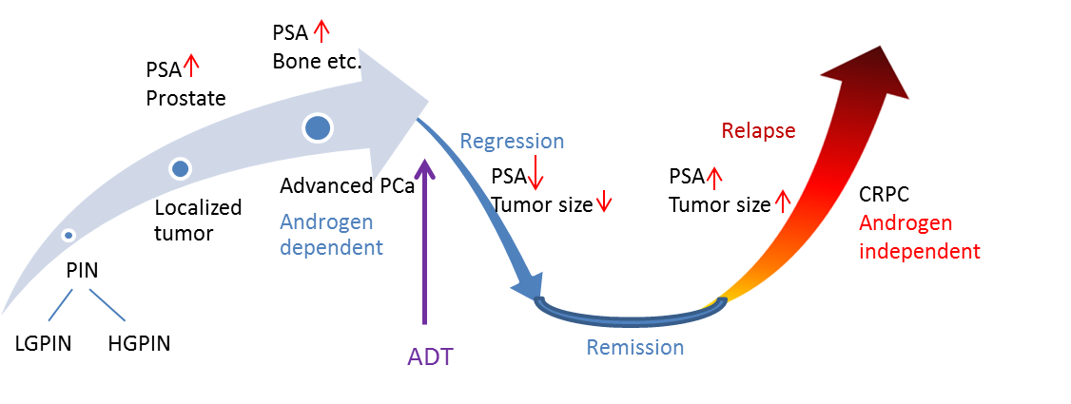
Figure I.1 Progression of prostate cancer.
Abbreviations: PIN, prostatic intraepithelial neoplasia; LGPIN, low-grade prostatic intraepithelial neoplasia; HGPIN, high-grade prostatic intraepithelial neoplasia; PSA, prostate specific antigen; PCa, prostate cancer; ADT, androgen deprivation therapy; CRPC, castrate resistant prostate cancer.

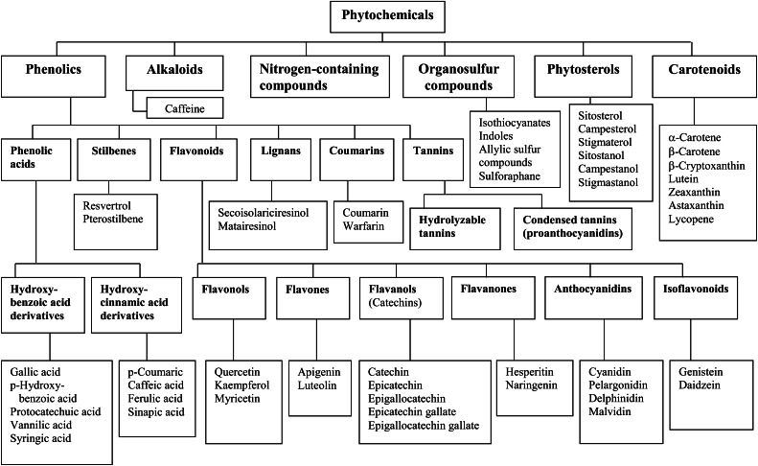
Figure I.2 Classification of dietary phytochemicals. Adapted from Ref [23]

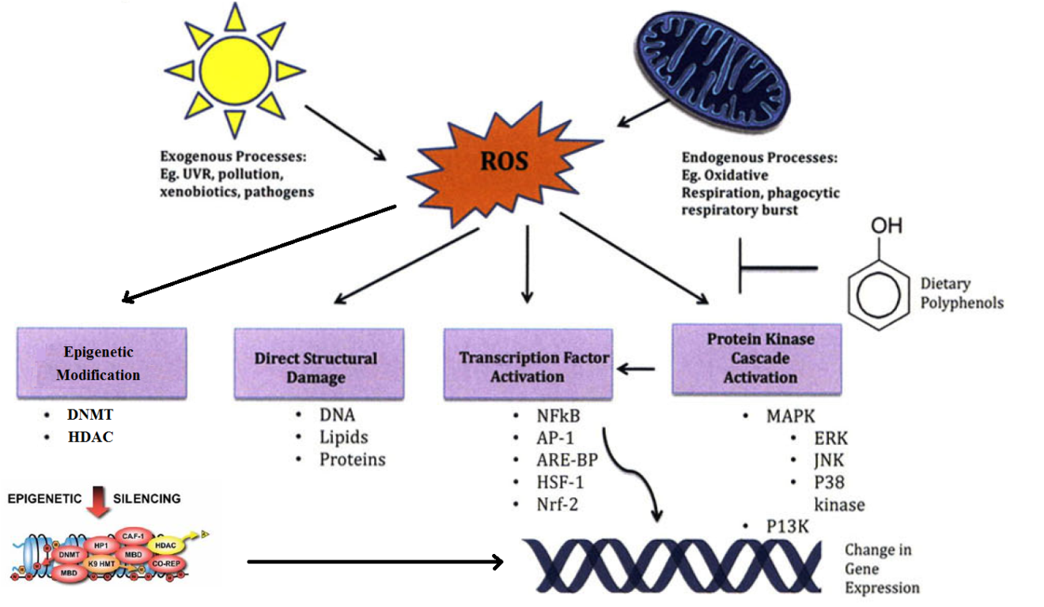
Figure I.3 Mechanisms of anti-carcinogenesis actions of phytochemicals, redrawn from Ref. [60].

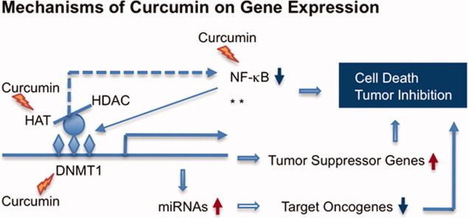
Figure I.4 Mechanisms of curcumin on gene expression, redrawn from Ref [67].

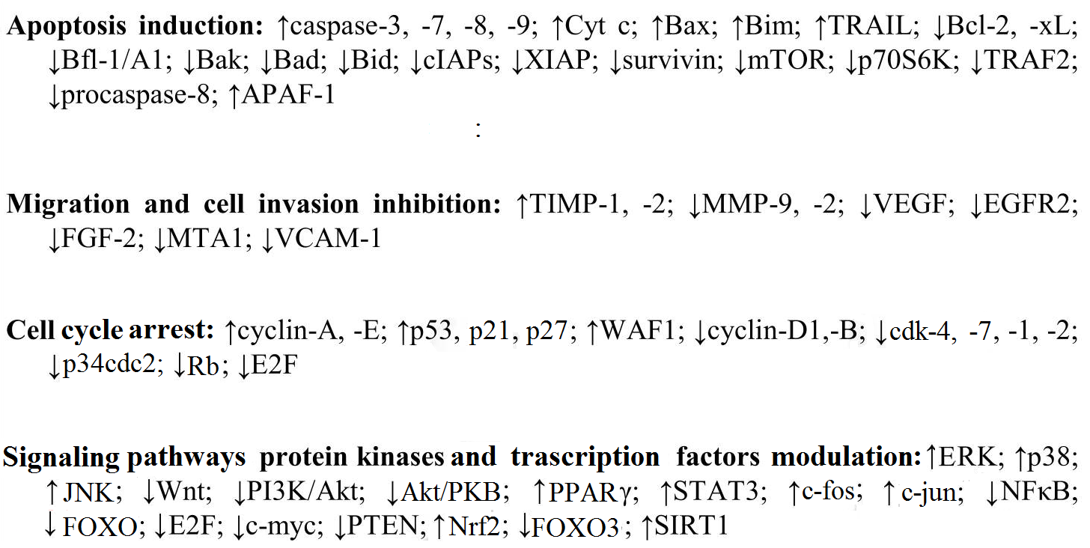
Figure I.5 Molecular targets of resveratrol, redrawn from Ref [100].

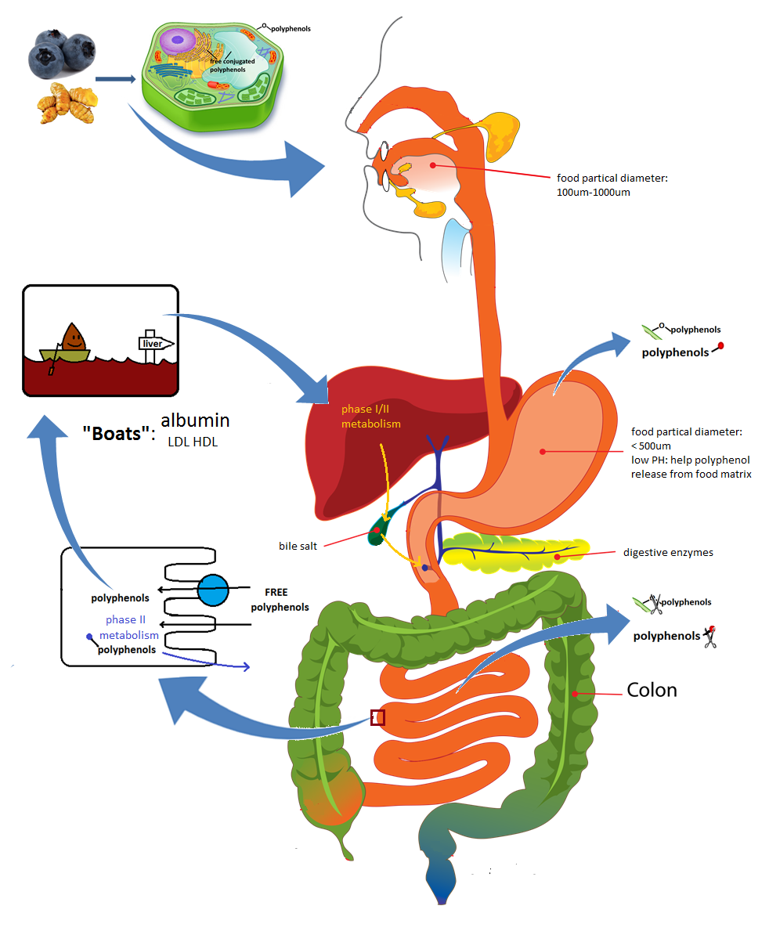
Figure I.6 Digestion and absorption of polyphenols.

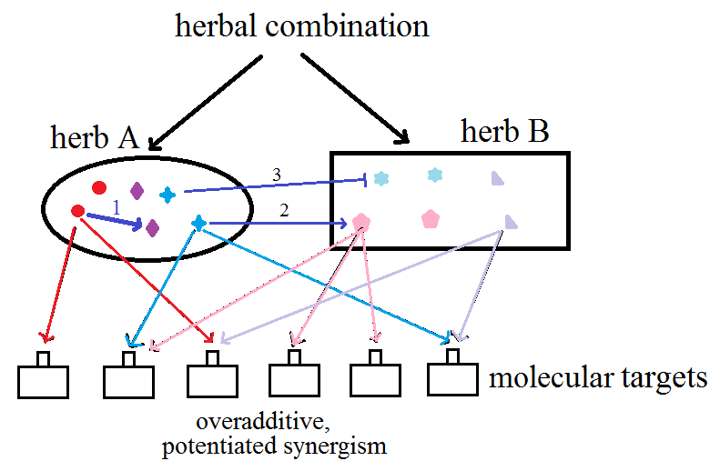
Figure I.7 Mechanisms of synergistic effect among phytochemicals. Redrawn from ref [122].

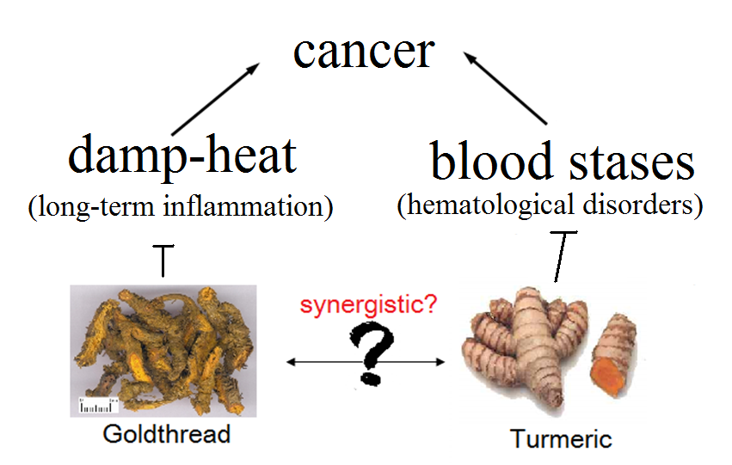
Figure I.8 Mechanisms of goldthread and turmeric anti-cancer effect in TCM.

Figure I.9 Theroic basis of Chou-Talalay method, with author’s permission.

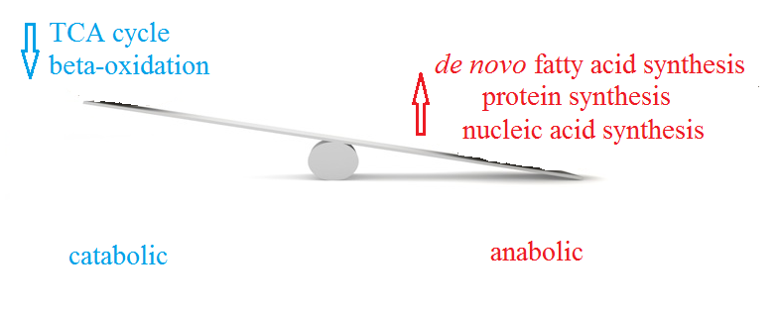
Figure I.10 Metabolism alternations in cancer cells.

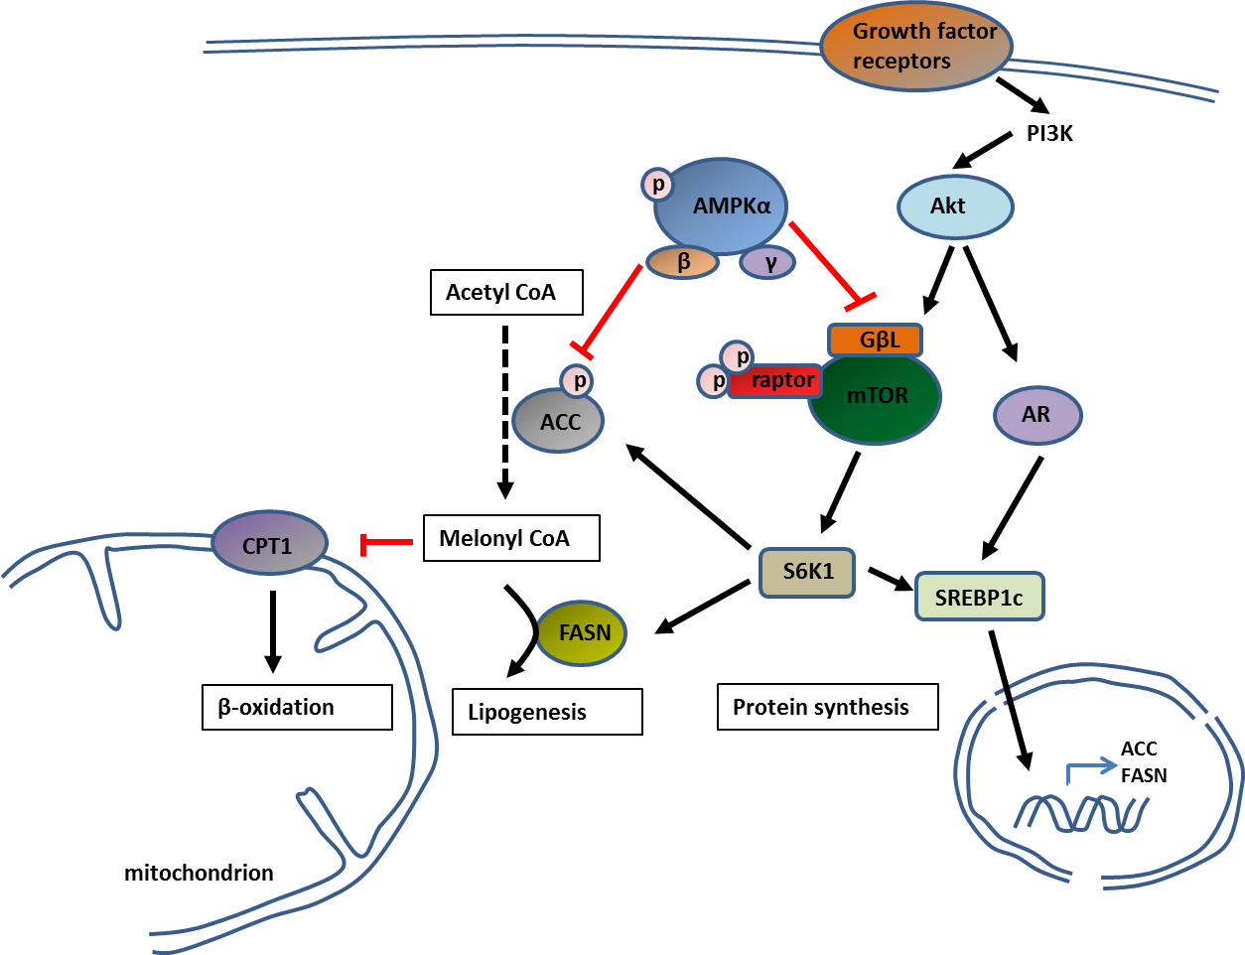
Figure I.11 AMPK signaling pathways.

TURMERIC AND CHINESE GOLDTHREAD SYNERGISTICALLY INHIBIT PROSTATE CANCER CELL PROLIFERATION AND NF-KB SIGNALING

Abstract
Pre-clinical studies using bioactive compounds from botanicals appear to offer some protection against cancer. Research using single bioactives contributes greatly to our understanding of their mechanism of action, but in vitro studies demand concentrations that are higher than achievable in humans (µM), producing results with questionable physiologic relevance. However, maintaining these bioactives in the presence of other compounds originally derived from the food or extract of origin may synergistically lower the bioactive dose so translatability becomes feasible. The objective of this study was to determine if bio-efficacy of phytonutrients can be enhanced when used in combination even at doses that are ineffective for any compound when used in isolation. The anti-proliferative and molecular effects of herbs (turmeric and Chinese goldthread) and their bioactives (curcumin and ar-turmerone, berberine and coptisine, respectively) were determined in isolation and in combination. Using CWR22Rv1 and HEK293 cells, cell proliferation (as assessed by the MTT assay) and NF-κB promoter activity (using a luciferase reporter construct) were evaluated and synergy of action was assessed by the Chou-Talalay method utilizing CompuSyn® software. Turmeric and Chinese goldthread act synergistically (combination index<1) when inhibiting cell proliferation with all cell lines tested. The synergy of action of combinations of companion bioactives from the same herb (i.e., curcumin/ar-turmerone and berberine/coptisine) and bioactives from different herbs (i.e., curcumin/berberine) help to explain why turmeric and Chinese goldthread are more effective than their major bioactives in isolation. At the molecule level, curcumin+ar-turmerone and curcumin+coptisine synergistically attenuated TNFα-stimulated NF-κB promoter activity. Even compounds with poor efficacy become more biologically active in the presence of companion compounds. Importantly, the effects of combining any two bioactives or herbal extracts were highly synergistic at concentrations approaching physiological significance (nanomolar). These results suggest that bioactives in combination (as plant extracts or isolated compounds) are highly synergistic at the cellular and molecular level at physiologically relevant concentrations. These data help to explain why complex mixtures of botanicals may be more efficacious than their bioactives in isolation.

Introduction
Research exploring the use of natural products, such as botanicals, herbs, herbal extracts, and their isolated bioactives are becoming increasingly appealing because of their potential efficacy in attenuating growth and viability of cancer cells with few observed side effects in humans when these agents are taken orally. The combination of multiple botanicals may prove to be more efficacious as compared with their use in isolation. These effects may be related to the fact that when bioactives are used in combination their synergy could reduce the concentration needed for effectiveness to one that is physiologic. For example, polyherbal mixtures can be quite effective in inhibiting cancer cell proliferation when individual herbal extracts have no effect (Figure II.6). Furthermore, in vitro studies demand concentrations (often in the 20-100 µM range) [30, 89] that are several orders of magnitude higher than nM doses achievable in humans. The difference between these effects seen in vitro using micromolar concentrations when compared with the nanomolar concentrations measured in human raises the issue of the translational relevance of some of the in vitro studies, which likely accounts for at least part of the disappointing outcomes in clinical trials [99]. Tables I.2 and I.3 summarize this point where the mean IC₅₀ concentrations observed in a variety of cancer cell lines are 41 µM, 21 µM, >243 µM and 29 µM for the bioactives berberine, curcumin, ar-turmerone and coptisine, respectively, while the serum/plasma concentrations in humans provided oral doses of curcumin are in the nanomolar range. With one exception, the serum/plasma levels of curcumin are <200 nM at doses as high as 12 g (Table I.3). Maintaining an individual bioactive in the presence of other bioactive compounds (originally derived from the food or extract of origin) may turn isolated compounds that have weak bioactivity to those that have substantially more activity at lower doses. This would make translation to humans more feasible. For instance, the World Cancer Research Fund/American Institute for Cancer Research reports that consumption of individual nutrients could in some instances result in vastly different outcomes when compared with their foods of origin [249]. This concept of the importance of the complex source versus isolated nutrients is echoed by the American Cancer Society [250]. Importantly, this concept can be equally applied to combinations of foods or botanicals.
To investigate the synergistic action of botanicals, we used CWR22Rv1 and HEK293 cells. CWR22Rv1 cells are an in vitro model of castrate-resistant prostate cancer (PCa) [137] and complement our research investigating the effects of a mixture of bioactive botanicals on in vitro and in vivo models of castrate-resistant PCa [143, 148, 150]. The HEK293 cell line is a transformed human embryonic kidney cell that is widely used as a tool for expression vectors [139]. In this case, HEK293 cells were transfected with a recombinant plasmid expressing a luciferase gene under the control of a multimerized NF-κB responsive-promoter stimulated with TNFα [251].
In Traditional Chinese Medicine [252], Chinese goldthread and turmeric are used in combination to treat a variety of diseases, among them cancer. Cancer has been explained as a combination of damp-heat and blood stasis where the anti-cancer effects of Chinese goldthread and turmeric can be explained as damp-heat removing [80, 89] and blood stasis improving [80], respectively. The use of Chinese goldthread and turmeric complement our previous studies involving a polyherbal mixture containing these two herbal extracts [143, 148, 150].
While Chinese goldthread (Coptis chinensis) has been tested in a number of cancers [84, 253-255], very little is known about its impact on PCa. Instead, berberine, the major bioactive phytochemical in Chinese goldthread (estimated to be ~6% [88, 256]) has been preferentially studied and has been found to inhibit cell growth at concentrations of 30 µM to 100 µM in androgen-dependent and androgen-independent PCa cells [44, 47, 48]. A minor constituent in this herb is coptisine (ratio of berberine to coptisine is approximately 5:1) [256]; however, this compound and the potential synergy between these compounds has yet to be tested.
Turmeric (Curcuma longa) is a plant commonly found in Asia from the ginger family. Like Chinese goldthread, extracts of turmeric are not typically used in studies; instead curcumin, one of its primary ingredients known for its anticancer properties, is the primary target of investigation [257, 258]. Curcumin is the major curcuminoid in turmeric at a level of ~5-6% [40, 259]. The molecular targets of curcumin are extensive (as reviewed elsewhere [257, 260]). For example, curcumin has been shown to modify those targets involved in inflammation, apoptosis, angiogenesis, metastasis and the expression of transcription factors, various receptors, growth factors and a variety of protein kinases. However, curcumin inhibits androgen-dependent and androgen-independent PCa cell growth at concentrations of 40 µM to 100 µM [261]. While the diversity of compounds in turmeric is extensive [40, 76], a less commonly studied one is ar-turmerone from the sesquiterpenes (ratio of curcumin to ar-turmerone in turmeric is approximately 4:1) [262, 263], with reported IC₅₀ values in a variety of cancer cell lines of >243 µM [79, 221, 224, 229, 232]; however, ar-turmerone has not been studied in PCa. Similarly, the potential synergy between these compounds has yet to be tested.
The objective of this study was to build upon the concept that the combination of bioactives in botanicals is far more effective than an individual bioactive in isolation. While this seems intuitive, a systematic approach yielding solid experimental evidence has yet to be fully explored. To address this issue, we determined if synergy could explain the enhanced effect of (a) the combination of herbs over isolated bioactives derived from those herbs, (b) the combination of bioactives over isolated bioactives derived from the same herb (companion compounds), (c) the combination of herbs over individual herbs, (d) the combination of bioactives from different herbs over the isolated bioactives, and (e) whether these synergistic effects on proliferation can apply at the molecular level. NF-κB expression was chosen as the molecular target because of its link in castrate-resistant PCa [264, 265] and because it has been previously identified as a target of bioactive phytonutrients and natural products [266, 267].

Materials and Methods

Experimental design
The experimental design for testing synergistic interactions is presented in Figure II.1. The comparisons made in this study included the combinations of herbs (inter-interactions), comparison of the herb to its major bioactive (i.e., Chinese goldthread versus berberine and turmeric versus curcumin), combinations of bioactives from the same herb (intra-interaction) and combinations of bioactives from different herbs (inter-interactions).

Chemicals
The herbal extracts of Chinese goldthread (Coptis chinensis) and turmeric (Curcuma longa) were provided by New Chapter (Brattleboro, VT). Fourier transform infrared spectroscopy was used to independently identify the raw materials and they were further verified by independent laboratories using a variety of analytical approaches (i.e., high performance and thin layer chromatographies and mass spectrometry) (as described previously) [148]. Quality control was determined by ranges of select bioactives, such as curcuminoids in turmeric and berberine in Chinese goldthread. Berberine (98% purity) was purchased from MP Biomedicals (Solon, OH), curcumin (98% purity) from Fischer Scientific (Pittsburgh, PA), coptisine (98% purity) from Quality Phytochemicals (Edison, NJ), and ar-turmerone (90% purity) from Sigma-Aldrich (St. Louis, MO). All substances were dissolved in dimethyl sulfoxide (DMSO) (Sigma-Aldrich, St. Louis, MO) to varied stock concentrations. RPMI 1640 cell culture media (Invitrogen, Grand Island, NY), supplemented with 0.5% fetal bovine serum (FBS, Invitrogen, Grand Island, NY) was used to dilute each stock solution to the required final concentrations.

Cell Culture
For the experimental treatments, CWR22Rv1 cells (American Type Culture Collection, Rockville, MD), a human-derived castrate-resistant PCa line, were grown in RPMI 1640 media supplemented with 10% FBS under an atmosphere of 5% CO₂ at 37°C. Prior to the experiments the level of FBS was reduced to 0.5%. HEK293 cells (ATCC, Rockville, MD), a human embryonic kidney cell line, were grown in DMEM media supplemented with 10%FBS under an atmosphere of 5% CO₂ at 37°C.

Cell Proliferation
Cell growth and proliferation inhibition studies were performed using standard 96 well plates and analyzed with the MTT [3-(4, 5-dimethylthiazol-2-yl)-2, 5-diphenyltetrazolium bromide] (Chalbiochem, Darmstadt, Germany) assay following the manufacturer’s instructions. CW22Rv1 cells were plated at a density of 2×10⁴ cells per well. After 24 hours, the FBS concentration in the cell culture media was reduced to 0.5% FBS and the cells were incubated overnight prior to the addition of the herbal extracts or phytochemicals. HEK293 cells were plated at a density of 1×10⁴ cells per well. After 24 hours, the cells were incubated with herbal extracts or phytochemicals. After 48 hr incubation, cell viability and proliferation were measured via the MTT assay. Briefly, medium was replaced by 100µl of 0.5mg/ml MTT and cells were incubated for 4 hr at 37°C. Intracellular formazan crystals were solubilized with 100 µl isopropanol/0.04 N HCl. Absorbance was read at 540 nm on a SpectraCount microplate photometer (Perkin Elmer Inc, Waltham, MA).

Transfection and luciferase assay
The multimerized NF- κB promoter luciferase vector has been described elsewhere [11]. Transient transfection of luciferase reporter constructs into HEK293 cells was achieved using Lipofectamine® 2000 (Life technologies, Grand Island, NY) following manufacturer’s instructions. Briefly, HEK293 cells were plated at a density of 1.5×10⁴ cells per well in 96 well plates. After 24 hours, 4 ng/well plasmid was transfected with 0.32 μl/well Lipofectamine® 2000. After incubating overnight, transfection medium was removed and cells were incubated with herbal extracts or phytochemicals in 0.5% FBS supplemented DMEM medium for 1 hour. After incubation, HEK293 cells with luciferase reporter were stimulated by 5 ng/ml TNF-α for 4 hours. Whole cell lysate was achieved by 20 μl passive lysis buffer (Promega, Madison, WI) and 10 μl was used for luciferase activity measurement by using the Luciferase Assay Reagent (Promega, Madison, WI). Luciferase activity was detected using the GloMax plate reading luminometer and normalized to total cellular protein concentration per well using the BCA assay (Thermo Scientific, Rockford, IL) following manufacturer’s instruction.

Assessment of Synergistic, Additive or Antagonistic Effects of Combinations of Herbal Extracts and/or Phytochemicals
To calculate the effects of compounds or herbs in combination, IC₅₀ values were determined for each ingredient. For the experiments with the combination of herbal extracts, turmeric and Chinese goldthread were combined at a concentration equivalent to their IC₅₀ values followed by serial dilutions to generate a dose response. For the experiments that combined individual bioactive phytochemicals from different herbal extracts (berberine and curcumin), they were combined at concentrations equivalent to their IC₅₀ values, followed by serial dilutions to generate a dose response. For the experiments that combined individual bioactive phytochemicals from the same herbal extract (i.e., berberine and coptisine, curcumin and ar-turmerone), they were combined at concentrations equivalent to their IC₅₀ values or based on their relative ratios in their respective herbal extracts followed by serial dilutions to generate dose responses.
Assessment of synergistic, additive or antagonistic effects of combinations was determined using the Chou-Talalay method [132]. This method is derived from mass-action law principles as described in detail elsewhere [125]. The combination index (CI) and dose-reduction index (DRI) were used to differentiate synergy, antagonism and additive effects for combinations of components. CI and DRI were generated for all treatments with CompuSyn® 1.0 (Combo Syn, Paramus, NJ) according to the manufacturer’s instructions. CompuSyn® 1.0 software uses an algorithm based on the Chou-Talalay method to simulate the interaction of 2 or more compounds. Briefly, concentrations and corresponding effect levels for all data points were input to generate a complete report of analytical results. CI is a parameter that indicates whether the interaction of two compounds is synergistic, additive, or antagonistic [additive (CI = 1); synergistic (CI < 1); antagonistic (CI > 1)]. DRI is a parameter that indicates the degree to which the concentration of a compound can be reduced when used in combination with another compound to maintain an equivalent effect. The use of CI and DRI provide numerical assessments of not only whether there is synergy, but the extent of that synergy and synergy at particular doses [132].

Statistical analysis
The results were presented as mean ± SEM and were analyzed by two-tailed student’s T-test. Differences were considered significant at p<0.05.

Results

Cell proliferation
Dose response curves were generated for all bioactives tested in each cell type. All the bioactives and their extracts of origin reduced cell proliferation in a dose dependent manner (Figure. II.2). IC₅₀ values of bioactives were used, in part, to determine the synergistic effect between different bioactives.

Comparisons of Chinese goldthread with berberine, and turmeric with curcumin on cell proliferation
Dose-response curves were generated for Chinese goldthread, berberine, turmeric and curcumin and their effectiveness inhibiting cell proliferation were compared based on the relative amounts of the phytonutrients in the herbal extract (i.e., the amount of berberine in Chinese goldthread and the amount of curcumin in turmeric). Proliferation of CWR22Rv1cells and HEK293 cells was reduced in dose-dependent manners with Chinese goldthread and berberine (Figure. II.2). Following normalization based on the relative amount of berberine in Chinese goldthread, there was a shift to the left in the IC₅₀ value, from 30 µM for berberine to 19 µM in CWR22Rv1 cells and from 30 µM for berberine to 11 µM in HEK293 cells (Figure. II.3). Cell proliferation was also reduced in dose-dependent manners with turmeric and curcumin (Figure. II.2). Following normalization based on the relative amount of curcumin in turmeric, there was a shift to the left of the IC₅₀ value from 22 µM for curcumin to 9.5 µM for turmeric in CWR22Rv1 cells and from 11 µM for curcumin to 4 µM for turmeric in HEK293 cells (Figure. II.3). These results collectively infer that other compounds within the original herbal extracts (companion compounds) may be acting in concert (i.e., synergism) with each of the bioactive phytonutrients. To explore this possibility, we investigated the effects of combining companion phytonutrients from Chinese goldthread (i.e., berberine with coptisine) and turmeric (i.e., curcumin with ar-turmerone).

Intra-herbal comparisons of companion phytonutrients (berberine with coptisine, curcumin with ar-turmerone) on cell proliferation
Berberine and coptisine are two bioactive phytonutrients found in Chinese goldthread (companion phytonutrients) and their synergy could help explain, in part, the enhanced effectiveness of Chinese goldthread when compared with berberine in isolation. Berberine and coptisine reduced the proliferation of CW22Rv1 cells in dose-dependent manners with IC₅₀ values of 30 µM and 85 µM, respectively (Figure II.2). In a similar manner, the proliferation of HEK293 cells was reduced by berberine and coptisine with IC₅₀ values of 30 µM and 70 µM, respectively (Figure II.2). To determine the effects on proliferation with the combination, cells were treated with berberine plus coptisine with serial dilutions starting with concentrations equivalent to their IC₅₀ values (30 µM:85 µM for CWR22Rv1, 30 µM:70 µM for HEK293) and reducing these to nanomolar concentrations while maintaining the same ratio. The combination of berberine plus coptisine reduced cell proliferation in a dose-dependent manner and the minimum effective doses were determined for both single phytochemicals and their combinations (Tables II.1 and II.2). CI and DRI values were generated for minimum effective doses by CompuSyn® 1.0, respectively. The combination of berberine plus coptisine reduce the minimum effective doses from µM level to nM level in CWR22Rv1 cells (7.5 µM for berberine, 21 µM for coptisine, and 0.24 µM+0.66 µM for their combination) and was highly synergistic in inhibiting cell growth at this level (CI equal to 0.05), with the DRIs being 52 and 37 when combined at the lowest concentrations (0.24 µM+0.66 µM). This means the addition of berberine to coptisine or coptisine to berberine reduced the effective doses 52 and 37 fold, respectively, compared with each alone. In a similar manner, the combination of berberine plus coptisine also reduced the minimum effective doses significantly in HEK293 cells (15 µM for berberine, 17.5 µM for coptisine, and 3.75 µM+8.75 µM for combination) and was highly synergistic in inhibiting cell growth at this level (CI equal to 0.42 with the DRIs being 3.2 and 32).
Curcumin and ar-turmerone (two bioactive phytonutrients found in turmeric) reduced the proliferation of CW22Rv1 cells in dose-dependent manners with IC₅₀ values of 22 µM and 150 µM, respectively (Table II.1). In a similar manner, the proliferation of HEK293 cells was reduced by curcumin and ar-turmerone with IC₅₀ values of 11 µM and 200 µM, respectively (Table II.2). To determine the effects on proliferation with the combination, cells were treated with curcumin plus ar-turmerone with serial dilutions starting with concentrations equivalent to their IC₅₀ values (22 µM:150 µM for CWR22Rv1, 11 µM:200 µM for HEK293) and reducing these to nanomolar concentrations while maintaining the same ratio (Tables II.1 and II.2). The dose-response curves with the combination of curcumin plus ar-turmerone reduced cell proliferation in a dose-dependent manner. The combination of curcumin plus ar-turmerone reduced the minimum effective doses in CWR22Rv1 cells (5.5 µM for curcumin, 9.4 µM for ar-turmerone, and 0.17 µM +1.2 µM for their combination) and was highly synergistic in inhibiting cell growth at this level (CI equal to 0.09 with the DRIs being 37 and 16). In a similar manner, the combination of curcumin plus ar-turmerone also reduced the minimum effective doses significantly in HEK293 cells (11 µM for curcumin, 200 µM for ar-turmerone, 0.69 µM+25 µM for their combination) and was highly synergistic in inhibiting cell growth at this level (CI equal to 0.45 with the DRIs being 14 and 2.6).
While it is standard practice to use the ratio of the IC₅₀ values to evaluate synergy, the ratio of these bioactive phytonutrients from their respective herbal extracts are different. For example, the ratio of berberine to coptisine in Chinese goldthread is ~5:1, and curcumin to ar-turmerone is ~4:1. As such, synergy was also assessed at more “natural” ratios (Tables II.1 and II.2). For CWR22Rv1 cells, the combination of berberine and coptisine was highly synergistic in inhibiting cell growth at minimum effective concentrations (0.469 µM+0.094 µM) where the CI was 0.16, respectively. The DRI values at these concentrations were 6.8 and 14.6 for berberine and coptisine, respectively. Similarly, using HEK293 cells, the combination of berberine and coptisine in a 5:1 ratio was highly synergistic in inhibiting cell growth in minimum effective concentrations (1.88 µM+0.38 µM) where the CI was 0.10, respectively. The DRI values at these concentrations were 11 and 109 for berberine and coptisine, respectively.
Using CWR22Rv1 cells, the combination of curcumin plus ar-turmerone were also highly synergistic in inhibiting cell growth at concentrations as low as 0.344 µM+0.086 µM, respectively (Table II.1), where the CI was 0.06. The DRI values at these concentrations were 17.6 and 187 for curcumin and ar-turmerone, respectively. Using HEK293 cells, the combination of curcumin and ar-turmerone was synergistic in inhibiting cell growth at minimum effective concentrations of 11 µM+2.75 µM, respectively, where the CI was 0.64 (Table II.2). The DRI values at these concentrations were 2.4 and 3.8 for curcumin and ar-turmerone, respectively.

Inter-herbal comparison of the extracts of Chinese goldthread with turmeric on cell proliferation
The extracts of Chinese goldthread and turmeric reduced the proliferation of CWR22Rv1 and HEK293 cells in dose-dependent manners (IC₅₀ values for CWR22Rv1 cells were 130 µg/ml and 65 µg/ml, for HEK293 cells were 80 µg/ml and 30µg/ml, respectively) (Figure II.2). To determine the effects on proliferation with the combination, cells were treated with Chinese goldthread plus turmeric with serial dilutions starting with combined concentrations equivalent to their IC₅₀ values (130 µg/ml:65 µg/ml for CWR22Rv1 cells and 80 µg/ml:30 µg/ml for HEK293 cells) and going as low as ≤1 µg/ml (maintaining the same ratio). The combination of Chinese goldthread plus turmeric qualitatively reduced cell proliferation in a dose-dependent manner for both cell lines (Tables II.1 and II.2). CI and DRI values were generated at minimum effective concentrations. For CWR22Rv1 cells, the minimum effective concentration was more than 100 times lower than their respective IC₅₀ values (1.103 µg/ml+0.508 µg/ml, respectively). The combination of Chinese goldthread and turmeric were highly synergistic in inhibiting cell growth at these doses, where the CI was 0.04, respectively. The DRI values at the minimum effective concentrations were 51.6 and 52.1 for Chinese goldthread and turmeric, respectively. Using HEK293 cells, the minimum effective concentrations were significantly reduced to 10 µg/ml+3.75 µg/ml. The combination was highly synergistic at these doses, where the CI was 0.29. The DRI values at the minimum effective concentrations were 6.8 and 6.8, respectively.

Inter-herbal comparison of phytonutrients (berberine with curcumin)
To explain, in part, the synergism between Chinese goldthread and turmeric, isolated bioactive compounds from each herb (i.e., berberine and curcumin) were evaluated for synergy. To determine the effects on proliferation with the combination, cells were treated with berberine plus curcumin with serial dilutions starting with concentrations equivalent to their IC₅₀ values (30 µM:22 µM for CWR22Rv1 cells and 30 µM:11 µM for HEK293 cells) and reducing these to nanomolar concentrations while maintaining the same ratio. The combination of berberine plus curcumin reduced cell proliferation in a dose-dependent manner for both cell lines (Tables II.1 and II.2). CI and DRI values were generated for minimum effective concentrations. For CWR22Rv1 cells, the combination of berberine and curcumin was highly synergistic in inhibiting cell growth at these levels (CI equal to 0.08, respectively), with the DRIs being 23.5 and 23.7 when combined at the minimum effective concentrations (0.235 µM+0.172 µM) (Table II.1). Similar results were observed with HEK293 cells (Table II.2). The combination of berberine and curcumin was highly synergistic in inhibiting cell growth at these levels (CI equal to 0.32), with the DRIs being 5.3 and 7.5 when combined at the minimum effective concentrations (3.75 µM+1.38 µM).

TNFα-stimulated NF-κB expression
Dose response curves were generated for all bioactives and extracts tested in HEK293 cells. All the bioactives and their extracts of origin, except berberine and Chinese goldthread, reduced NF-κB expression in a dose dependent manner (Figure II.4). IC₅₀ values of bioactives were used, in part, to determine the synergistic effect between different bioactives.

Comparisons of turmeric with curcumin on TNFα-stimulated NF-κB expression
Dose-response curves were generated for turmeric and curcumin and their effectiveness inhibiting NF-κB expression were compared based on the relative amounts of the phytonutrients in the herbal extract (i.e., the amount of curcumin in turmeric). NF-κB expression was reduced in dose-dependent manners with turmeric and curcumin (Figure II.4). Following normalization based on the relative amount of curcumin in turmeric, there was a shift to the left in the IC₅₀ value, from 20 µM for curcumin to 10 µM (Figure II.5). These results collectively infer that companion compounds in turmeric may be acting synergistically with curcumin. To explore this possibility, we investigated the effects of combining the companion ar-turmerone with curcumin.

Intra-herbal comparisons of companion phytonutrients (curcumin with ar-turmerone) on TNFα-stimulated NF-κB expression
Curcumin and ar-turmerone (two bioactive phytonutrients found in turmeric) reduced the NF-κB expression in dose-dependent manners with IC₅₀ values of 20 µM and 275 µM, respectively (Figure II.4). To determine the effects on NF-κB expression with the combination, cells were treated with curcumin plus ar-turmerone with serial dilutions starting with concentrations equivalent to their IC₅₀ values (20 µM:275 µM) and reducing these to nanomolar concentrations while maintaining the same ratio (Table II.3). The dose-response curves with the combination of curcumin plus ar-turmerone reduced NF-κB expression in a dose-dependent manner. The combination of curcumin plus ar-turmerone reduced the minimum effective concentrations of 20 µM for curcumin and 275 µM for ar-turmerone to 0.16 µM+2.15 µM for their combination, respectively (Table II.3). The combination was highly synergistic in inhibiting NF-κB expression (CI equal to 0.01 with the DRIs being 109 and 311), In a similar manner, the combination of curcumin plus ar-turmerone in a ratio based on relative amounts in turmeric (ratio of 4:1; Table II.3) also reduced the minimum effective doses significantly from 20 µM for curcumin and 275 µM for ar-turmerone to 0.63 µM+0.16 µM for their combination, respectively. This effect was also highly synergistic in inhibiting NF-κB expression at these concentrations (CI equal to 0.04 with the DRIs being 23 and 3563).

Inter-herbal comparison of the extracts of Chinese goldthread with turmeric on TNFα-stimulated NF-κB expression
The extract of Chinese goldthread did not reduce NF-κB expression using concentrations up to 400 µg/ml (Figure II.4B). In contrast, turmeric reduced the NF-κB expression in a dose-dependent manner (IC₅₀ value was 70 µg/ml) (Figure II.4B). To determine the effects on NF-κB expression with the combination, cells were treated with 200 µg/ml Chinese goldthread plus progressive dilutions of turmeric beginning at 70 µg/ml. The combination of Chinese goldthread plus turmeric reduced the minimum effective dose of turmeric from 70 µg/ml to 8.75 µg/ml with the combination (Table II.3). CI and DRI values were not generated due to the lack of a dose-response curve for Chinese goldthread.

Inter-herbal comparison of phytonutrients (coptisine with curcumin) on TNFα-stimulated NF-κB expression
Berberine, just like Chinese goldthread, did not reduce NF-κB transcriptional activity using concentrations up to 100 µM (Figure II.4A). In an effort to explain, in part, the inter-herbal synergism between Chinese goldthread and turmeric, coptisine from Chinese goldthread and curcumin from turmeric were evaluated for synergy (Table II.3). To determine the effects on NF-κB expression with the combination, cells were treated with curcumin plus coptisine with serial dilutions from concentrations equivalent to their IC₅₀ values (20 µM:80 µM) to nanomolar concentrations while maintaining the same ratio. The combination of curcumin plus coptisine reduced NF-κB expression in a dose-dependent manner. CI and DRI values were generated for minimum effective concentrations. The combination of curcumin and coptisine was highly synergistic in inhibiting NF-κB expression at these levels, where the CI was equal to 0.03, and the DRIs being 70 and 42 when combined at the minimum effective concentrations (0.31 µM+1.25 µM) (Table II.3).

Discussions
It has been proposed that traditional medicines from various cultures (i.e., Traditional Chinese Medicine) provide effective remedies due to their combinations of herbals, but there is a challenge in establishing a rationale for their superior therapeutic value compared with using isolated bioactives [122] . There is growing evidence that the benefits of combinations of essential and non-essential nutritives lie in their synergy and multiple targets of action [110]. This concept is presented in several reviews describing the lack of concordance between observational studies of bioactives compared with the foods from which the bioactives are derived (i.e., the impact of β-carotene versus foods that contain β-carotene on the risk of lung cancer) [99, 110].
The mechanisms of the anticancer effects of berberine, curcumin and their herbs from which they are derived have been extensively studied, where they have been shown to modulate cancer cells to induce cell-cycle arrest, cellular apoptosis and inhibition of cell invasion and metastasis. Multiple signaling pathways are known to be affected (including cyclin D, caspase-3, NF-κB, PI3 kinase, TNF-α, COX-2, MMP-9, etc.) and are well-documented [40, 80, 89, 92, 257, 258, 268-270]. Thus, it is not necessary for us to duplicate these mechanistic studies. The aim of this paper was not to revisit the established mechanisms of the anticancer effects of these bioactives, but to assess the synergistic effect between bioactives and compare them to the herbs from which they are derived.
It has been suggested that synergy of polyherbals is related to their multiple targets of action, their coordinated impact on bioavailability, and their collective ability to minimize/neutralize adverse side effects [122]. Furthermore, while many bioactives from botanicals have the same targets [271], it is not always clear whether the mechanisms modifying these targets are similar. Because of our ability to demonstrate the combinations used in this study function synergistically (and not additively), these data suggest while some mechanisms may overlap, others involve biological convergence (modifying a biological outcome, such as cell proliferation, via several pathways) and biochemical convergence (modifying a biochemical pathway, such as NF-κB expression, via several mechanisms).
Also important is the concept that the combination of compounds could sufficiently lower the effective dose/concentration when compared with the individual compounds, and similarly, the ability of the combination of herbs to lower the effective dose/concentration when compared with individual herbs or individual bioactives derived from the herbs. If this effective dose/concentration can be sufficiently lowered, there is a better chance that it could have biological meaning, i.e., shifting the effective levels from micromolar to nanomolar concentrations. For most underivatized bioactive phytonutrients, their effective concentrations on cells in culture are typically between 20-100 µM (see Table I.2) [30], while the total plasma/serum concentrations (derivatized and underivatized) are typically two to three orders of magnitude lower following oral dosing (see Tables I.2 and I.3) [114, 272, 273].
Investigations in the chemopreventative effects of phytonutrients are not new, but confirming the concept that effectiveness of the botanicals from which these phytonutrients are derived, particularly through dose-reduction, may be superior because the synergy of action has been poorly explored. To quantitate this kind of interaction, we used the Chou-Talalay method of analysis [125]. This method can differentiate between synergy, additive effects and antagonism of combinations of agents. It is based on the use of a constant ratio of components through a variety of concentrations (i.e., serial dilutions) while monitoring a single end point (in our case cell proliferation or promoter activation). This computerized model establishes the CI (combination index) to determine the type of interaction, and the DRI (dose-reduction index) represents the magnitude of the dose reduction as a result of the combination for a given dose.
These data are typically generated using ratios of the IC₅₀ values from dose-response curves generated for each individual agent and are presented in each of the tables. Data can also be generated, and was presented in the tables, using concentrations that approach physiological relevance where cell growth was still significantly inhibited. The DRI is important at physiologically relevant concentrations (those plasma/serum concentrations following an oral dose) to establish potential therapeutic value. Because individual phytonutrients within the same botanical (what we refer to as “companion compounds”) exist in ratios that may be different from the IC₅₀ values, we also ran a parallel set of experiments using those ratios for biological relevance. For example, the IC₅₀ values for berberine and coptisine are 30 µM and 85 $µ$M, respectively, for a ratio of 1:2.8, but in Chinese goldthread these two compounds exist in a ratio closer to 5:1. The DRI can tell us to what extent one compound can enhance the effectiveness of another compound at a given ratio and dose compared with the compound alone [132].
This study systematically demonstrates that the enhanced effects of herbal extracts compared with individual bioactives found in those extracts may be explained by the synergy of action of the companion compounds found within that extract. When the extract of turmeric was compared with curcumin and the extract of Chinese goldthread compared with berberine, the dose response curves shifted to the left suggesting companion compounds within the extracts could be responsible for this shift by acting in synergy. This was confirmed by establishing the synergy (CI values <1) between companion bioactives from the same extract (i.e., curcumin plus ar-turmerone from turmeric, and berberine plus coptisine from Chinese goldthread).
In addition, this study further supports the concept that the synergy observed by combining two different herbal extracts could, in part, be explained by their synergistic action and due, in part, to the synergistic action of the combination of individual bioactives uniquely derived from these different sources. This is easily illustrated by comparing our previous results with our current results on the ability of Chinese goldthread and turmeric to inhibit proliferation of CWR22Rv1 cells (Figure II.6). Chinese goldthread and turmeric, when isolated from a polyherbal mixture, were unable to inhibit cell proliferation at doses of 4.1 μg/ml and 11.3 μg/ml, respectively, while our current data demonstrates inhibition of proliferation was observed at doses as low as 1.1 μg/ml and 0.5 μg/ml, respectively, when used in combination (Table II.3). It is believed that this synergistic effect is due, in part, to the combinations of bioactives unique to each of the extracts. When berberine (from Chinese goldthread) was combined with curcumin (from turmeric), the CI value demonstrated strong synergism. This supports the concept of improved effectiveness with targeted combinations of botanicals.
Our previous studies investigated the mechanisms of a polyherbal mixture containing Chinese goldthread and turmeric on the inhibition of castrate-resistant PCa in vitro and in vivo [143, 148, 150]. These inhibitory effects also included mechanisms involving TNFα-induced cell proliferation (Figure II.7). TNFα signals through NF-κB. As a follow-up, this study helps to better define the actions of two of the components in the polyherbal mixture, Chinese goldthread and turmeric, on this signaling pathway. Turmeric and curcumin inhibited NF-κB promoter activity, but Chinese goldthread and berberine were ineffective. Similar to our results, curcumin has been reported by others to inhibit NF-κB expression at similar concentrations observed in this study (~20 µM) [274-279]. In contrast, Chinese goldthread and berberine did not inhibit NF-κB expression in this study, and others report similar results with berberine [280, 281]. Interestingly, coptisine, a component of Chinese goldthread, inhibited NF-κB expression, but these levels were much higher (IC₅₀ =70 µM) than what could be achieved as a component of Chinese Goldthread, partially explaining why Chinese goldthread was ineffective. Interestingly, when curcumin was used in combination with the least active bioactives (i.e., coptisine and ar-turmerone), curcumin enhanced their effectiveness 32 and 3563 fold, respectively. In addition, an ineffective Chinese goldthread lowered the minimum effective dose of turmeric 8 fold (a CI value could not be determined due to the lack of a dose response with Chinese goldthread).
Importantly, these data suggest that even when bioactives appear to have little or no activity, they may still act synergistically with other bioactives when used in combination, underscoring the concepts of biological and biochemical convergence. In addition, our data demonstrate that these actions of synergy may be concentration dependent. The use of concentrations higher than the IC₅₀ values (i.e., IC₉₀) for the combinations can act in a synergistic manner; however, many times this is not the case. In many instances, the CI values are >1 (antagonism) at concentrations higher than the IC₅₀ value, but <1 (synergy) for concentrations lower than the IC₅₀, (see Table II.4), underscoring the importance of concentrations used in studies.

Conclusions
In summary, most of today’s cancers are influenced by our environment, particularly by the botanicals we eat (i.e., herbs, fruits, vegetables). The major source of bioactive phytonutrients is from these foods. To understand the impact of their consumption, our objective was to investigate the concept that the combination of bioactives in botanicals is potentially far more effective than an individual bioactive in isolation. Our data is proof-of-principle that combinations of companion bioactives from the same source and bioactives from different sources act synergistically, providing some evidence that combinations found in botanicals (and foods) have advantages over isolated bioactives. Even compounds with poor efficacy can become more biologically active in the presence of companion compounds. These advantages translate into effective doses those are more physiologic.

Table II.1 Dose-effect relationships of berberine and coptisine (from Chinese goldthread), curcumin and ar-turmerone (from turmeric), Chinese goldthread and turmeric and their combinations using their IC₅₀ values or using ratios corresponding to relative amounts in their native extracts on proliferation of CWR22Rv1 cells.
Isolated compounds and combinations | Minimum Effective Dose (µM)ª | IC₅₀  (µM) | Combination Index (CI) | Dose Reduction Index (DRI)
Berberine | 7.5 | 30
Coptisine | 21 | 85
Ber + Cop  (ratio = 1 : 2.8)^{b} | 0.24 + 0.66 |  | 0.05 | Berberine: 52  Coptisine: 37
Ber + Cop  (ratio = 5 : 1)^{c} | 0.47 + 0.09 |  | 0.16 | Berberine: 7  Coptisine: 15
Curcumin | 5.5 | 22
ar-turmerone | 9.4 | 150
Cur + ar-tur  (ratio = 1 : 6.8)^{b} | 0.17 + 1.2 |  | 0.09 | Curcumin: 37  ar-turmerone: 16
Cur + ar-tur  (ratio = 4 : 1)^{d} | 0.34 + 0.09 |  | 0.06 | Curcumin: 18  ar-turmerone: 187
Berberine | 7.5 | 30
Curcumin | 5.5 | 22
Ber + Cur  (ratio = 1.4 : 1)^{b} | 0.24 + 0.17 |  | 0.16 | Berberine: 24  Curcumin: 24
Isolated herbal extracts and combinations | Minimum Effective Dose (µg/ml)ª | IC₅₀  (µg/ml) | Combination Index (CI) | Dose Reduction Index (DRI)
Chinese Goldthread | 65 | 130 µg/ml
Turmeric | 35 | 65 µg/ml
Chinese GT + Tur  (ratio = 2 : 1)^{b} | 1.10 + 0.51 |  | 0.14 | Chinese GT: 52  Turmeric: 52
ªConcentration derived from the dose-response curves where growth inhibition was significantly inhibited (p<0.05). ^{b}Ratio based on IC₅₀ values. ^{c}Ratio based on relative amounts in Chinese goldthread. ^{d}Ratio based on relative amounts in turmeric.

Table II.2 Dose-effect relationships of berberine and coptisine (from Chinese goldthread), curcumin and ar-turmerone (from turmeric), Chinese goldthread and turmeric and their combinations using their IC₅₀ values or using ratios corresponding to relative amounts in their native extracts on proliferation of HEK293 cells.
Isolated compounds and combinations | Minimum Effective Dose (µM)ª | IC₅₀  (µM) | Combination Index (CI) | Dose Reduction Index (DRI)
Berberine | 15 | 30
Coptisine | 18 | 70
Ber + Cop  (ratio = 1 : 2.3)^{b} | 3.75 + 8.75 |  | 0.42 | Berberine: 5.2  Coptisine: 4.5
Ber + Cop  (ratio = 5 : 1)^{c} | 1.88 + 0.38 |  | 0.10 | Berberine: 11  Coptisine: 109
Curcumin | 11 | 11
ar-turmerone | 200 | 400
Cur + ar-tur  (ratio = 1 : 36)^{b} | 0.69 + 25 |  | 0.45 | Curcumin: 15  ar-turmerone: 2.6
Cur + ar-tur  (ratio = 4 : 1)^{d} | 11 + 2.75 |  | 0.64 | Curcumin: 2.8  ar-turmerone: 1.4
Berberine | 15 | 30
Curcumin | 11 | 11
Ber + Cur  (ratio = 2.7 : 1)^{b} | 3.75+1.83 |  | 0.32 | Berberine: 5.3  Curcumin: 7.5
Isolated herbal extracts and combinations | Minimum Effective Dose (µg/ml)ª | IC₅₀  (µg/ml) | Combination Index (CI) | Dose Reduction Index (DRI)
Chinese Goldthread | 40 | 80 µg/ml
Turmeric | 30 | 40 µg/ml
Chinese GT + Tur  (ratio = 2 : 1)^{b} | 10 + 3.75 |  | 0.29 | Chinese GT: 6.8  Turmeric: 6.8
ªConcentration derived from the dose-response curves where growth inhibition was significantly inhibited (p<0.05). ^{b}Ratio based on IC₅₀ values. ^{c}Ratio based on relative amounts in Chinese goldthread. ^{d}Ratio based on relative amounts in turmeric.

Table II.3 Dose-effect relationships of curcumin and ar-turmerone (from turmeric), curcumin (from turmeric) and coptisine (from Chinese goldthread), and Chinese goldthread and turmeric and their combinations using their IC₅₀ values or using ratios corresponding to relative amounts in their native extracts on NF-κB promoter activity using transfected HEK293 cells.
Isolated compounds and combinations | Minimum Effective Dose (µM)ª | IC₅₀  (µM) | Combination Index (CI) | Dose Reduction Index (DRI)
Curcumin | 20 | 20
ar-turmerone | 275 | 275
Cur + ar-tur  (ratio = 1 : 14)^{b} | 0.16+2.15 |  | 0.01 | Curcumin: 109  ar-turmerone: 311
Cur + ar-tur  (ratio = 4 : 1)^{c} | 0.63+0.16 |  | 0.04 | Curcumin: 23  ar-turmerone: 3563
Curcumin | 20 | 20
Coptisine | 80 | 80
Cur+Cop  (Ratio=1:4)^{b} | 0.31+1.25 |  | 0.03 | Curcumin: 70  Coptisine: 42
Isolated herbal extracts and combinations | Minimum Effective Dose (µg/ml)a | IC50  (µg/ml) | Combination Index (CI) | Dose Reduction Index (DRI)
Chinese goldthread | - | -
Turmeric | 70 | 70
Chinese goldthread +turmeric | 200+8.75 |  | - | -  -
ªConcentration derived from the dose-response curves where NF-κB expression was significantly inhibited (p<0.05). ^{b}Ratio based on IC₅₀ values. ^{c}Ratio based on relative amounts in turmeric. Abbreviations: Cur, curcumin; ar-tur, ar-tumerone; Cop, coptisine; Chinese GT, Chinese Goldthread; Tur, turmeric.

Table II.4 Dose-effect relationships of Chinese goldthread, turmeric, berberine, coptisine, curcumin and ar-turmerone and their combinations on proliferation of CWR22Rv1 and HEK293 cells and NF-κB Promoter Activity.
Compounds / combinations | Dm (µM) | m | r | CI  IC₂₅ | CI  IC₅₀ | CI  IC₇₅ | CI  IC₉₀ | DRI- IC₂₅ | DRI- IC₅₀ | DRI- IC₇₅ | DRI- IC₉₀ | DRI- IC₂₅ | DRI- IC₅₀ | DRI-  IC₇₅ | DRI-  IC₉₀
Inhibition of Proliferation using CWR22Rv1 Cells |  |  |  |  |  |  |  | Ber | Ber | Ber | Ber | Cop | Cop | Cop | Cop
Berberine | 23.1 | 1.7 | 0.9
Coptisine | 96.7 | 0.8 | 0.9
Ber:Cop (1: 2.8)ª | 27.2 | 0.6 | 0.8 | 0.2 | 0.5 | 1.5 | 4.7 | 11.8 | 3.3 | 0.9 | 0.1 | 8.4 | 4.8 | 2.7 | 1.6
Ber:Cop (5: 1)^{b} | 25.3 | 1.2 | 0.9 | 0.8 | 0.9 | 1.2 | 1.6 | 1.4 | 1.1 | 0.8 | 0.6 | 14.5 | 22.9 | 36.3 | 57.3
Inhibition of Proliferation using CWR22Rv1 Cells |  |  |  |  |  |  |  | Cur | Cur | Cur | Cur | ar-T | ar-T | ar-T | ar-T
Curcumin | 11.4 | 2.1 | 0.9
ar-turmerone | 328.3 | 0.4 | 0.9
Cur:arT (1: 6.8)ª | 13.8 | 1.2 | 0.7 | 0.3 | 0.2 | 0.2 | 0.4 | 10.0 | 6.4 | 4.1 | 2.7 | 6.0 | 27.3 | 124 | 564
Cur:arT (4: 1)^{b} | 4.4 | 1.0 | 0.8 | 0.2 | 0.3 | 0.6 | 1.1 | 6.1 | 3.2 | 1.7 | 0.9 | 99.4 | 371 | 1386 | 5173
Inhibition of Proliferation using CWR22Rv1 Cells |  |  |  |  |  |  |  | Ber | Ber | Ber | Ber | Cur | Cur | Cur | Cur
Berberine | 23.1 | 1.7 | 0.9
Curcumin | 11.4 | 2.1 | 0.9
Ber:Cur (1.4: 1)ª | 13.8 | 1.2 | 0.7 | 0.5 | 0.6 | 0.7 | 0.9 | 4.8 | 4.3 | 3.9 | 3.5 | 3.9 | 2.9 | 2.1 | 1.6
Inhibition of Proliferation using CWR22Rv1 Cells |  |  |  |  |  |  |  | CG | CG | CG | CG | Tur | Tur | Tur | Tur
Chinese goldthread | 106 | 1.6 | 0.9
Table II.4. Continued
Compounds / combinations | Dm (µM) | m | r | CI  IC₂₅ | CI  IC₅₀ | CI  IC₇₅ | CI  IC₉₀ | DRI- IC₂₅ | DRI- IC₅₀ | DRI- IC₇₅ | DRI- IC₉₀ | DRI- IC₂₅ | DRI- IC₅₀ | DRI-  IC₇₅ | DRI-  IC₉₀
Turmeric | 49.6 | 1.8 | 0.8
Chinese GT: Tur (2: 1)ª | 87.5 | 0.6 | 0.8 | 0.3 | 1.1 | 3.7 | 12 | 5.7 | 1.8 | 0.6 | 0.2 | 5.8 | 1.7 | 0.5 | 0.2
Inhibition of Proliferation using HEK293 Cells |  |  |  |  |  |  |  | Ber | Ber | Ber | Ber | Cop | Cop | Cop | Cop
Berberine | 42.9 | 2.6 | 0.9
Coptisine | 81.9 | 2.8 | 0.9
Ber:Cop (1: 2.3)ª | 51.2 | 2.0 | 0.9 | 0.7 | 0.8 | 0.9 | 1.0 | 3.2 | 2.8 | 2.5 | 2.2 | 2.7 | 2.3 | 2.0 | 1.7
Ber:Cop (5: 1)^{b} | 33.3 | 1.0 | 0.9 | 0.3 | 0.7 | 1.5 | 3.0 | 3.2 | 1.5 | 0.8 | 0.4 | 31.3 | 14.8 | 7.0 | 3.3
Inhibition of Proliferation using HEK2931 Cells |  |  |  |  |  |  |  | Cur | Cur | Cur | Cur | ar-T | ar-T | ar-T | ar-T
Curcumin | 17.3 | 3.2 | 0.9
ar-turmerone | 400.6 | 1.0 | 0.9
Cur:arT (1: 6.8)ª | 100.3 | 1.3 | 0.9 | 0.4 | 0.4 | 0.4 | 0.6 | 10.6 | 6.4 | 4.0 | 2.4 | 3.1 | 4.1 | 5.5 | 2.4
Cur:arT (4: 1)^{b} | 11.1 | 1.5 | 0.8 | 0.4 | 0.5 | 0.8 | 1.1 | 2.9 | 1.9 | 1.3 | 0.9 | 122 | 180 | 267 | 395
Inhibition of Proliferation using HEK2931 Cells |  |  |  |  |  |  |  | Ber | Ber | Ber | Ber | Cur | Cur | Cur | Cur
Berberine | 37.8 | 2.6 | 0.9
Curcumin | 17.2 | 3.2 | 0.9
Ber:Cur (1.4: 1)ª | 18.0 | 1.9 | 0.9 | 0.5 | 0.6 | 0.8 | 0.9 | 3.3 | 2.9 | 2.5 | 2.1 | 4.5 | 3.6 | 2.8 | 2.2
Inhibition of Proliferation using HEK2931 Cells |  |  |  |  |  |  |  | Ber | Ber | Ber | Ber | Cur | Cur | Cur | Cur
Table II.4. Continued
Chinese goldthread | 152 | 2.3 | 0.9
Compounds / combinations | Dm (µM) | m | r | CI  IC₂₅ | CI  IC₅₀ | CI  IC₇₅ | CI  IC₉₀ | DRI- IC₂₅ | DRI- IC₅₀ | DRI- IC₇₅ | DRI- IC₉₀ | DRI- IC₂₅ | DRI- IC₅₀ | DRI-  IC₇₅ | DRI-  IC₉₀
Turmeric | 49.3 | 2.9 | 0.8
Chinese GT: Tur (2: 1)ª | 73.7 | 2.6 | 0.9 | 0.8 | 0.8 | 0.8 | 0.8 | 2.7 | 2.8 | 3.0 | 3.1 | 2.6 | 2.5 | 2.4 | 2.3
NF-κB Promoter Activity using Transfected HEK293 Cells |  |  |  |  |  |  |  | CG | CG | CG | CG | Tur | Tur | Tur | Tur
Curcumin | 35.0 | 1.3 | 0.5
ar-turmerone | 1418 | 1.3 | 0.5
Cur:arT (1: 14)ª | - | - | - | - | - | - | - | - | - | - | - | - | - | - | -
Cur:arT (4: 1)^{b} | 43 | 0.8 | 0.4 | 0.6 | 0.9 | 1.7 | 2.9 | 1.8 | 1.0 | 0.6 | 0.3 | 273 | 166 | 101 | 61
NF-κB Promoter Activity using Transfected HEK293 Cells |  |  |  |  |  |  |  | Cur | Cur | Cur | Cur | Cop | Cop | Cop | Cop
Curcumin | 35.0 | 1.3 | 0.5
Coptisine | 90.3 | 1.1 | 0.6
Cur: Cop (1: 4)ª | 16.2 | 0.7 | 0.8 | 0.1 | 0.2 | 0.4 | 0.7 | 20.5 | 10.8 | 5.7 | 3.0 | 11.6 | 7.0 | 4.2 | 2.5
D_{m}: median-effect dose (concentration which inhibits cell growth by 50%). m: shape of the dose-effect curves, where m=1, hyperbolic; m>1, sigmoidal; and m<1, flat sigmoidal, respectively. r: linear correlation coefficient of the median-effect plot (indicates conformity of data). ªRatio based on IC₅₀ values. ^{b}Ratio based on relative amounts in Chinese goldthread.
Abbreviations: ar-T, ar-turmerone; Ber, berberine; CG, Chinese goldthread; CI, combination index; Cop, coptisine; Cur: curcumin; DRI, dose reduction index.

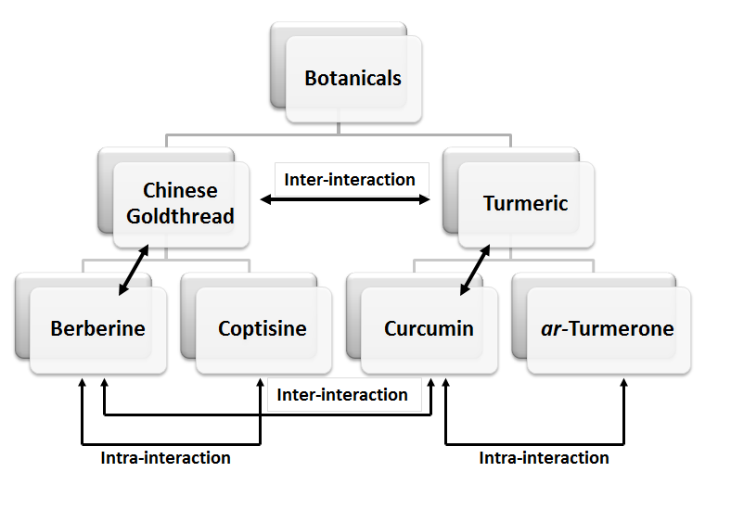
Figure II.1 Experimental design.
Comparisons were made between herbs and their major bioactives, among combinations of herbs (inter-interaction of herbs) and combinations of bioactives from the same herb (intra-interaction of isolated bioactives) or different herbs (inter-interactions of isolated bioactives).

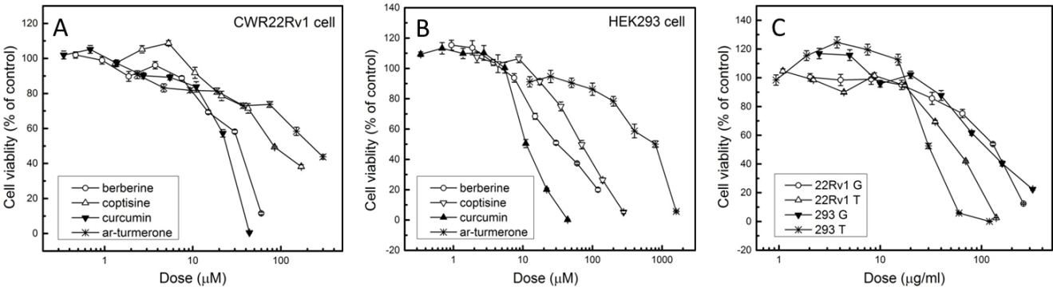
Figure II.2 The effects of berberine, coptisine, curcumin, ar-turmerone, Chinese goldthread and turmeric on cell proliferation.
Dose-response curves for cell proliferation were generated with berberine, coptisine, curcumin, ar-turmerone using (A) CWR22Rv1 cells and (B) HEK293 cells. (C) Dose-response curves for cell proliferation were also generated with the herbal extracts of Chinese goldthread and turmeric for both cell lines. IC50 values of bioactives and herb extracts were generated from these curves.

Figure II.3 The comparison of berberine and curcumin on cell proliferation compared to their herbal extracts of origin, Chinese goldthread and turmeric, respectively, in CWR22Rv1 cells and HEK293 cells.
Following normalization based on the relative amount of berberine in Chinese goldthread and curcumin in turmeric, dose-response curves were compared between Chinese goldthread and berberine in (A) CWR22Rv1 cells and (C) HEK293 cells, and between turmeric and curcumin in (B) CWR22Rv1 cells and (D) HEK293 cells. Compared to individual compounds, herbal extracts had a more pronounced effect on reducing cell proliferation compared to their isolated bioactives (shifts in IC₅₀ values to the left).

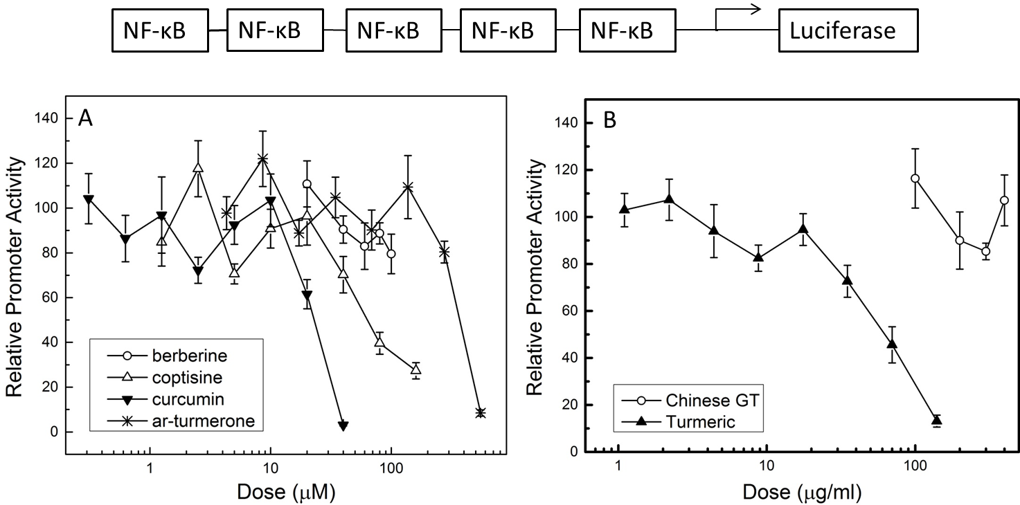
Figure II.4 The effects of berberine, coptisine, curcumin, ar-turmerone, Chinese goldthread and turmeric on inhibition of TNFα-stimulated NF-κB expression in HEK293 cells.
Dose-response curves were generated with (A) berberine, coptisine, curcumin, ar-turmerone) and (B) Chinese goldthread and turmeric. IC50 values of the bioactives and turmeric were generated from these curves.

Figure II.5 The effects of curcumin and turmeric on inhibition of TNFα-stimulated NF-κB expression.
HEK 293 cells were treated with serial dilutions of either curcumin or turmeric and inhibition of TNFα-stimulated NF-κB expression was determined. Following normalization based on the relative amount of curcumin in turmeric, dose-response curves were compared between turmeric.

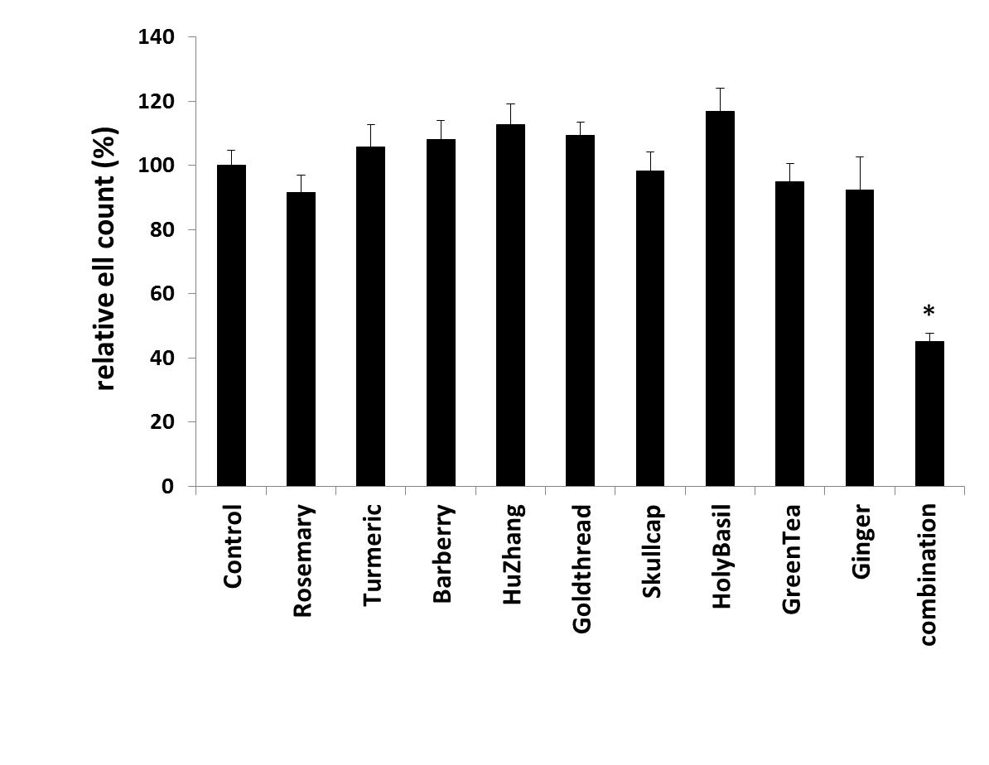
Figure II.6 The effects of individual herbs versus their combination on cell proliferation.
CWR22Rv1 cells were treated with individual herbal extracts (10.2 µg/ml ginger, 15.4 µg/ml rosemary, 11.3 µg/ml turmeric, 4.1 µg/ml Chinese goldthread, 10.2 µg/ml holy basil, 8.2 µg/ml hu zhang, 4.1 µg/ml barberry, 10.2 µg/ml green tea, 2.0 µg/ml Baikal skullcap or a combination equivalent to amounts used individually (76 ug/ml) for 48 hr and cell viability was measured by MTT assay (see “Methods” section of the paper). For more details of the mixture see references 7-9. Treatment with individual herbal extracts did not significantly affect cell viability, whereas their combination significantly reduced cell viability. Data is presented as means±SD (n=8). Bars with an asterisk (*) are significantly different from the non-treated Control at p<0.05.

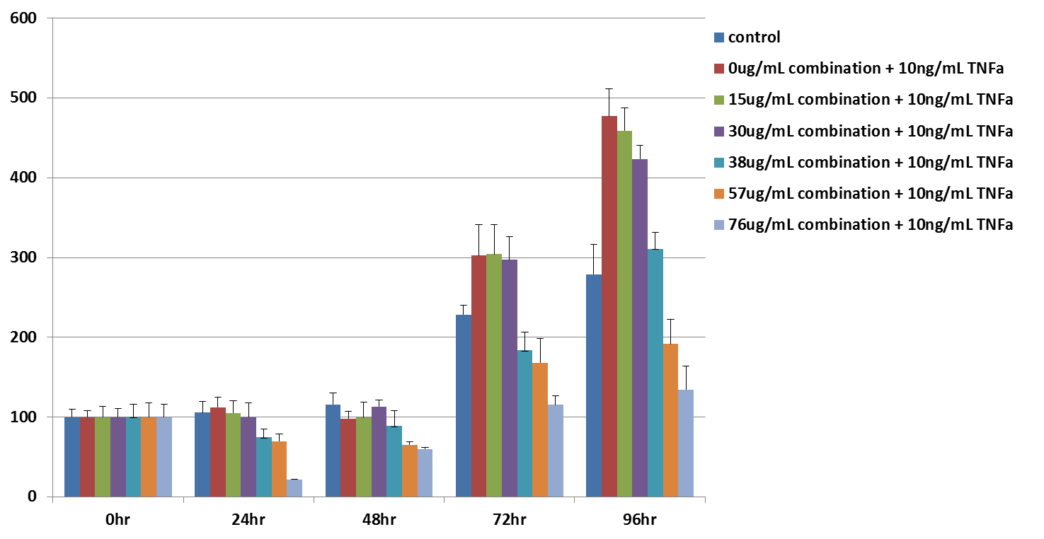
Figure II.7 Combination of herbal extracts may inhibit NF-κB in CWR22Rv1 cells.
CWR22Rv1 cells were treated with a combination of herbal extracts (10.2 µg/ml ginger, 15.4 µg/ml rosemary, 11.3 µg/ml turmeric, 4.1 µg/ml Chinese goldthread, 10.2 µg/ml holy basil, 8.2 µg/ml hu zhang, 4.1 µg/ml barberry, 10.2 µg/ml green tea, 2.0 µg/ml baikal skullcap with increasing combined concentrations (0, 15, 30, 38, 57, 76 ug/ml) with or without TNF-α (10 ng/ml) for 0, 24, 48, 72, and 96 hr. For more details of the herbal mixture see references 7-9. Cell viability was measured by MTT assay (see “Methods” section of the paper). TNF-α had a progressive effect on cell proliferation over time and this effect was attenuated in the presence of herbal mixture in a dose-dependent manner. Data is presented as means±SD (n=8).

ZYFLAMEND, A POLYHERBAL MIXTURE, INHIBITS LIPOGENSIS AND MTORC1 SIGNALING VIA ACTIVATION OF AMPK

Abstract
An extensive body of literature demonstrates that Zyflamend, a polyherbal mixture inhibits tumor growth at human doses. This complex mixture has been show anti-prostate cancer (PCa) effects via multiple mechanisms. Reprogramming of metabolic pathways is a common feature of castrate resistant PCa (CRPC). Our preliminary data showed that Zyflamend regulated fatty acid metabolism by inhibiting synthesis and enhancing oxidation in CRPC cells, suggesting AMP-activated protein kinase (AMPK), the master energy sensor of cells, as a potential target. The objective of this study was to determine if the growth inhibitory effects of Zyflamend toward CRPC growth involves regulation of AMPK and downstream signaling. In castrate resistant PCa cells, Zyflamend activated AMPK, and in turn, regulated known downstream targets of AMPK, such as mammalian target of rapamycin complex 1 (mTORC1) and the phosphorylation of acetyl CoA carboxylase (ACC). The AMPK pathway regulatory effects and anti-proliferative effects of Zyflamend could be mimicked by AMPK activation and attenuated by AMPK inhibition. Thus, we concluded that AMPK activation contributes to the anti-PCa effect of Zyflamend. These novel results, along with those published previously, provide a more complete picture of how this polyherbal mixture may complement conventional treatments based on its multiple mechanisms of action.

Introduction
The National Center for Complementary and Alternative Medicine (NCCAM) defines complementary medicine as “using a non-mainstream approach together with conventional medicine” in the treatment of a condition or disease (http://nccam.nih.gov/health/whatiscam). It has been estimated that as much as 25% of individuals diagnosed with prostate cancer use some form of complementary therapy [282], with Zyflamend being among the choices [283].
Zyflamend® (New Chapter, Brattleboro, VT) is a blend of 10 herbal extracts (ginger, rosemary, turmeric, Chinese goldthread, holy basil, hu zhang, barberry, oregano, green tea and basil skullcap) formulated based on their antioxidant and potentially anti-inflammatory properties. To date, there have been 14 research articles investigating the anti-cancer effects of this blend, covering in vitro, preclinical and clinical studies involving the prostate, bone, skin, kidney, breast and pancreas [143, 146-157, 218], with prostate being the predominant focus. It has been reported that a number of its constituents act synergistically such that physiological doses are possible [284] and multiple mechanisms of action have been linked in a variety of cancer cell lines by down regulating the androgen receptor [143, 148, 152], insulin-like growth factor-1R [148, 150], class I and II HDACs [143, 148], COX-1 and COX-2 activities [149, 154, 157], 12-LOX and Rb protein phosphorylation [151], and the up regulation of tumor suppressor genes such as p21 and p27 [143, 149]. Zyflamend has also been shown to modulate NF-κB activation [153, 157], iNOS [154], apoptotic pathways [154, 156, 157], and aryl hydrocarbon receptor expression [218]. It is believed that it is the combination of bioactives that accounts for modulation of multiple pathways at relatively low doses (as described in references [148, 284]).
AMPK is a master energy sensor in cells and responds to changes in the ratio of AMP:ATP such that when this ratio increases it responds by increasing ATP-generating pathways (i.e., β-oxidation) and concomitantly decreasing anabolic pathways such as lipogenesis and protein synthesis [203]. Upregulation of AMPK activity inhibits acetyl CoA carboxylase (ACC) activity and down regulates the expression of fatty acid synthase (FASN) and the transcription factor sterol regulatory element binding protein-1c (SREBP-1c), key regulators of lipogenesis. AMPK also targets mTORC1, a complex of proteins comprised of mammalian target of rapamycin (mTOR), regulatory associated protein of mTOR (raptor), GβL (also known as mLST8) and PRAS40 [176]. This complex promotes protein synthesis and is negatively regulated by AMPK in part via the phosphorylation of raptor. Raptor acts as a scaffolding protein for downstream targets of the mTOR complex such as ribosomal S6 kinase (S6K) [176]. Recently, AMPK has been shown to be a potentially important target in the treatment of prostate cancer [205, 206, 212-214].
Recent research using Zyflamend in androgen dependent and castrate-resistant prostate cancer cell lines suggest multiple pathways may be involved in its synergistic mechanism of action [143, 148, 284]. Preliminary evidence from our laboratory demonstrating that Zyflamend down regulates SREBP-1c and FASN transcription and increases fatty acid oxidation suggests it may be regulating AMPK, a new discovery related to this blend of bioactives. Therefore, the objective of this study was to determine if Zyflamend could modulate AMPK activation and its downstream targets, biomarkers of fatty acid synthesis and mTORC1 signaling. These novel results, along with those published previously, can provide a more complete picture as to how blends of natural products may complement conventional treatments as a result of multiple mechanisms of action.

Materials and Methods

Zyflamend
Zyflamend® (New Chapter, Brattleboro, VT) is derived from the extracts of ten different commonly consumed herbs (w/w): holy basil (Ocimum sanctum 12.8%), turmeric (Curcuma longa 14.1%), ginger (Zingiber officinale 12.8%), green tea (Camellia sinensis 12.8%), rosemary (Rosmarinus officinalis 19.2%), hu zhang (Polygonum cuspidatum 10.2%), barberry (Berberis vulgaris 5.1%), oregano (Origanum vulgare 5.1%), baikal skullcap (Scutellaria baicalensis 2.5%), and Chinese goldthread (Coptis chinensis 5.1%). Detailed description and characterization of the preparation of Zyflamend and quality assurance of the mixture has been described previously in detail [148].

Cell Culture
Human prostate cancer cell lines, CWR22Rv1 and PC3 cells (American Type Culture Collection, Rockville, MD), were initially grown in RPMI 1640 media supplemented with 10% fetal bovine serum (FBS) under an atmosphere of 5% CO₂ at 37°C. For the experimental treatment, CWR22Rv1 and PC3 cells were then cultured in RPMI 1640 supplemented with 0.5% FBS containing 200 µg/mL Zyflamend reconstituted in dimethyl sulfoxide (DMSO) for cell proliferation assay, mRNA extraction, protein isolation and acetyl-CoA measurement. FBS at a concentration of 0.5% represents an androgen depleted environment. Dose response curves and time course experiments were performed previously [143]. HEK293 cells (American Type Culture Collection, Rockville, MD) were grown in DMEM media supplemented with 10% FBS under an atmosphere of 5% CO₂ at 37°C.

Cell Proliferation
Cell growth and proliferation inhibition studies were performed using standard 96 well plates and analyzed with the MTT [3-(4, 5-dimethylthiazol-2-yl)-2, 5-diphenyltetrazolium bromide] (Chalbiochem, Darmstadt, Germany) assay following the manufacturer’s instructions. CWR22Rv1 cells were plated at a density of 2×10⁴ cells per well. After 24 hr, the FBS concentration in the cell culture media was reduced to 0.5% FBS and the cells were incubated overnight prior to the addition of the Zyflamend (200 μg/mL), AICAR (100 μM), Compound C (5 μM) or recombined adenovirus. After 48 hr incubation, cell viability and proliferation were measured via the MTT assay. Briefly, medium was replaced by 100 µl of 0.5 mg/ml MTT and cells were incubated for 4 hr at 37°C. Intracellular formation crystals were solubilized with 100 µl isopropanol/0.04 N HCl. Absorbance was read at 540 nm on a SpectraCount microplate photometer (Perkin Elmer Inc, Waltham, MA).

Down regulation of AMPKα1/2 by small interfering RNA
CWR22Rv1 cells (2×10⁵ cells per well in 6-well plates, in transfection medium (sc-36868, Santa Cruz Biotechnology, Dallas, TX) were transfected with 80 pmols of siRNA for AMPKα1/2 (sc-29673, Santa Cruz Biotechnology, Dallas, TX) and a scrambled control siRNA (Control siRNA-A, sc-37007, Santa Cruz Biotechnology, Dallas, TX) using transfection reagent (sc-29528, Santa Cruz Biotechnology, Dallas, TX) as described by the manufacturer. Six hr post transfection cells were cultured with RPMI 1640 media containing 10% FBS overnight. After recovery, media was replaced with 0.5% FBS media containing vehicle or Zyflamend (200 μg/mL) for 30 min at 37°C. The total protein was harvested for Western blot.

Western blotting
Cells were lysed in RIPA cell lysis buffer (Cell Signaling Technology, Danver, MA). Protein quantification was performed using BCA protein assay kit (Pierce Biotechnology, Rockford, IL). Equal amount of protein (20 µg) were fractioned by 8% SDS-PAGE and transferred to a polyvinylidine diflouride (PVDF) membrane by electroblotting. Membranes were blocked by 5% bovine serum albumin (BSA) (Santa Cruz Biotechnology, Dallas, TX) in 0.1% Tris-buffered saline-Tween-20 (TBST) for 1 hr at room temperature and incubated in TBST containing primary antibodies overnight at 4°C. Membranes were incubated with anti-mouse or anti-rabbit secondary antibody conjugate with horseradish peroxidase (HRP) (Cell Signaling Technology, Danver, MA). Protein expression was detected with Pierce ECL Western Blotting detection system and membranes were exposed to Hyperfilm Film (GE Healthcare, Piscataway, NJ) Antibodies of p-AMPKα (p172), AMPKα, p-ACC, ACC, p-Raptor, Raptor, GβL, p-S6K, S6K (Cell Signaling Technology, Danver, MA) were used to detect target protein level. β-actin (Santa Cruz Biotechnology, Dallas, TX) was used as the control.

Acetyl-Coenzyme A assay
Acetyl-CoA was assayed using an acetyl-coenzyme A assay kit (Sigma-Aldrich, St. Louis, MO) according to the manufacturer’s instructions. The number of CWR22Rv1 cells was counted before trypsin and collection. Cells were homogenized in 400 µL acetyol CoA assay buffer and samples were deproteinized by adding 800 µL ice-cold 8% PCA. The resulting supernatant was neutralized by adding 3M KHCO₃. Standards were quantified on a 0.2-1 nmol scale and 50 µL of sample was added to each well. The plate was read on a GloMax® Microplate Reader (Promega, Madison, WI) and results were normalized to cell number.

Construction of recombinant adenovirus
Plasmids containing cDNA of constitutively activated AMPKα1 or AMPKα2 subunits were provided by Dr. Jian Yang (University of Alabama). AMPK cDNA was inserted to pACCMV plasmid and cotransfected with pJM17 into HEK293 cells by Lipofectamine 2000™ transfection reagent (Invitrogen, Carlsbad, CA) following the manufacturer’s instruction. Recombinant virus termed ad-CMV-ampkα1/α2 were produced and purified. Virus containing the bacterial β-galactosidase gene (ad-CMV-βGal) was provided by Dr. Guoxun Chen (University of Tennessee-Knoxville) and used as control. Overexpression was verified by western blot.

RNA isolation and quantitative Real Time-PCR
Total RNA was isolated from CW22Rv1 cells using Trizol® reagent (Invitrogen, Carlsbad, CA) following the manufacturer’s instructions. Contaminating DNA was removed from RNA samples using Turbo DNA freeTM kit (Ambion, Austin, TX). Concentration of total RNA was measured using NanoDrop 1000TM (Thermo Scientific, Wilmintion, DE) Complementary DNA (cDNA) was reverse-transcripted from RNA samples using TaqMan® reagent kit (Applied Biosystems, Carlsbad, CA) following the manufacturer’s instructions. Briefly, RNA (2 µg) was mixed with MultiScribeTM Reverse Transcriptase, RNase Inhibitor, dNTP Mixture, random hexamers, RT buffer, MgCl₂ solution and incubated 10 min at 25°C, 30 min at 48°C, 5 min at 95°C and then stored at 4 °C. cDNA samples were used for quantitative RT-PCR using ABI Prism® 7300 Real-Time PCR System (Applied Biosystems, Carlsbad, CA). cDNA (0.7 µl) was used as a template for RT-PCR with 2.5 µM primer sets. PCR reactions were performed with standard thermocycle program: 1 min at 94°C, followed by 30 cycles of (15 sec at 94°C; 30 sec at 50°C; 2 min at 72°C) followed by 5 min at 72°C. Each sample was in triplicated and normalized with 36B4. Primers for RT-PCR are listed below:
SREBP1c, F: 5’-GCCATGGATTGCACTTT-3’, R: 5’-CAAGAGAGGAGCTCAATG-3’ FASN, F: 5’-CGCTCGGCATGGCTATCT-3’, R: 5’-CTCGTTGAAGAACGCATCCA-3’ 36B4, F: 5’-TGCATCAGTACCCCATTCTATCA-3’, R: 5’-AAGGTGTAATCCGTCTCCACAGA-3’. The relative amounts of all mRNAs were calculated using the comparative CT method as previously described with 36B4 as the invariant control [143].

Extracellular Flux Analysis
The rate of change of dissolved oxygen surrounding the monolayer of CWR22Rv1 cells was measured by XF24 Flux Analyzer (Seahorse Bioscience) following the manufacture’s protocol. Briefly, all assays were conducted using a seeding density of 60,000 cells/well in 500 µL of RPMI 1640 (10% FBS) in a ploy-D-lysine-coated XF24-will microplate (Seahorse Bioscience, Billerica, MA). After culturing cells in CO₂ incubator for 24 hr, cell medium was changed to Krebs-Henseleit Buffer (KHB, 111 mM NaCl, 4.7 mM KCl, 1.25 mM CaCl₂, 2mM MgSO₄, 1.2 mM NaH₂PO₄, PH 7.2) supplemented with 2.5 mM glucose, 0.5 mM carnitine and 25mM HEPES and incubate in 37°C non-CO₂ incubator for 1 hr. Then assays were placed in the analyzer and the oxygen consumption rate (OCR) could be detected by the fluorescent probes that contain oxygen sensors. Each measure cycle contain mix and analysts for 3 min, quiescent for 2 min and acquisition for 3 min. In this study, Zyflamend (200 µg/mL) or the controls (DMSO, Olive oil and AICAR) were injected first and OCR was measured for 3 cycles; BSA-Palmitate or BSA (87.5 µL, Seahorse Bioscience) were injected secondly and OCR was collected for 6 cycles; Etomoxir was injected thirdly and OCR was collected for 3 cycles.

Statistical analysis
The results were presented as mean ± SD. For two group comparisons, the data was analyzed by two-tailed Student’s T-test. For multiple comparisons, the results were analyzed by an ANOVA followed by Tukey’s post hoc analysis when appropriate. Differences were considered significant at p<0.05.

Results

Zyflamend inhibited de novo fatty acid synthesis in CWR22Rv1 cells
In preliminary experiments using CWR22Rv1 cells, Zyflamend treatment (24 hr) significantly decreased mRNA levels of SREBP-1c, the major transcriptional regulator of enzymes in lipogenic pathway by ~60% (Figure III.1A). It also decreased mRNA level of fatty acid synthase (FASN) by ~ 50% (Figure III.1A). Consistently, protein level of FASN was decreased by about 10% (Figure III.1B).

Zyflamend increased fatty acid oxidation in CWR22Rv1 cells
De novo lipogenesis is a necessary component in mediating cellular proliferation in cancer cells [285], one that is in opposition with fatty acid oxidation. Because fatty acid synthesis, in part, regulates fatty acid oxidation, we determined if cellular β-oxidation was increased in the presence of Zyflamend. CWR22Rv1 cells were treated in the presence or absence of Zyflamend using a Seahorse FX24 analyzer. Zyflamend increased fatty acid oxidation 6 fold as compared with control (olive oil) (Figure III.2A). As a positive control, we treated CWR22Rv1 cells with and without AICAR, which is known to activate AMPK, thus stimulating fatty acid oxidation. AICAR treatment increased fatty acid oxidation 4 fold compared to control (DMSO) (Figure III.2B).

Zyflamend regulates AMPK phosphorylation in CWR22Rv1 and PC3 prostate cancer cell lines
In CWR22Rv1 cells, phosphorylation of AMPKα (T172) was increased by Zyflamend (200 µg/ml) ~3.5 fold after 30 min treatment (Figure III.3A, B). Similarly, Zyflamend increased phosphorylation of AMPKα (T172) by ~2 fold in PC3 cells. (Figure III.3C, D).

Zyflamend regulates downstream targets of AMPK
ACC and mTORC1 complex are two major downstream targets of AMPK. In CWR22Rv1 cells, Zyflamend (200 µg/ml) increased phosphorylation of ACC ~2 fold after 30 min treatment (Figure III.4A, B). The cellular level of acetyl CoA significantly increased by about 1.5 fold after 24 hr treatment of Zyflamend (Figure III.4C).
Regarding mTORC1 complex which includes raptor and GβL [286], Zyflamend treatment increased phosphorylation of raptor ~4 fold after 30 min treatment (Figure 22A, B). Phosphorylation of S6K, a downstream biomarker for activity of mTORC1 complex, was reduced in a time dependent manner (0.5–3 hr) with Zyflamend treatment (Figure III.4A, B). In the presence of Zyflamend, GβL protein levels decreased in a time dependent manner (Figure III.4A, B). Increases in the phosphorylation of ACC and raptor were recapitulated in CWR22Rv1 cells following treatment with the positive control AICAR (Figure III.5A, B) and in PC3 cells following treatment with Zyflamend (Figure III.5C, D).
To confirm that Zyflamend increased phosphorylation of ACC and raptor by increasing the activity of AMPK, we knocked down AMPKα1/2 subunit by siRNA. Transit knockdown by siRNA transfection resulted in a 50% reduction of AMPKα protein levels (Figure III.6A, B). Concomitantly, phosphorylation of ACC and raptor was decreased by about 50% after AMPKα knockdown. The addition of Zyflamend treatment attenuated the effects of siRNA knockdown of AMPKα1/2 on phosphorylation of ACC and raptor (Figure III.6A, C, D).

Zyflamend decreased CWR22Rv1 cell viability, in part, through the activation of AMPK
Inhibiting AMPK activity by compound C modestly enhanced CWR22Rv1 cell viability after 48 hr treatment (Figure III.7A). Zyflamend decreased cell viability and this effect was attenuated with the concomitant treatment of compound C (Figure III.7A).
To mimic the effect of Zyflamend’s induction of phosphorylation of AMPKα, cells were treated with AICAR, a known AMPK activator. AICAR (100 µM) treatment decreased cell viability by about 20% after 48 hr treatment. Treatment with AICAR plus Zyflamend resulted in an additional reduction in cell viability (~30%) (Figure III.7C).
Overexpression of AMPKα1/2 subunits (as confirmed by western blot, Figure III.7B) inhibited cell viability in CWR22Rv1 cells by 40% (Figure III.7C), and this effect was augmented in the presence of Zyflamend.

Discussions
Zyflamend is a commercial product comprised of the extracts of ten herbs. Its original formulation almost 2 decades ago was based on those herbs that had antioxidant and anti-inflammatory properties. Its subsequent use as a complementary therapy and experimental investigations in an assortment of cancer models has drawn attention by a variety of laboratories interested in the role of natural products in health and disease [143, 146-157, 218].
There are always concerns regarding reproducibility and quality control of commercial products. The quality control in the preparation of these extracts has been described in detail elsewhere [148]. Assurance of that quality control has been verified by the corroborative reproducible results generated at different times, with different lots, in multiple laboratories, under different circumstances, using similar and different cell lines with similar concentrations [143, 146-157, 218]. The best combinations of extracts within this formulation have not been systematically determined because it would be infeasible to reproduce the results from 1028 possible combinations. However, recent evidence using biologic and molecular endpoints suggests that the condominium of compounds found in individual extracts is synergistically more efficacious than isolated bioactives derived from those extracts and that the combinations of extracts are synergistically more efficacious than the extracts used individually [284]. These combinations are more likely to have bioactivity at concentrations that would be more physiologically relevant [284]. Furthermore, the use of well-defined extracts in testing mechanisms of action provides evidence more related to how people eat (viz. people eat foods with their complexity of bioactives, not purified compounds from those foods). As such, generating mechanisms of action using well-defined combinations should further the understanding of the food-health relationship.
In our laboratory, we have been studying the effects of Zyflamend on preclinical models of castrate-resistant prostate cancer [143, 148, 150] using cell lines derived from the CWR22 lineage [287, 288]. We focus our attention on this lineage because the androgen dependent CWR22 cells can relapse into the androgen-insensitive CWR22R cell line in vivo following androgen deprivation [288, 289]. These cells, unlike the androgen independent PC3 cell line, have a functional androgen receptor and produce prostate specific antigen, common characteristics in human castrate-resistant prostate cancer.
Our experience using Zyflamend and those of others [143, 146-157, 218] reveal diverse mechanisms of action, possibly explaining its robust effects using in vivo models of tumorigenesis at oral doses that mimic human intakes [148, 157]. To further investigate this diversity of action, the objective of this study was to follow up on our preliminary evidence that Zyflamend also inhibits lipogenesis by down regulating SREBP-1c and FASN expression and enhancing fatty acid oxidation. To support the rapid proliferation of cancer cells, upregulation of de novo fatty acid synthesis is commonly found in solid tumors, including prostate, and this metabolic shift supporting anabolic processes can be the result of dysregulation of AMPK [205, 206]. Therefore, we logically investigated the effect of Zyflamend on AMPK activation as determined by modulation of its well-accepted downstream targets involved in lipogenesis and mTORC1 signaling.
AMPK is a multimeric protein consisting of a catalytic subunit (α) and two regulatory subunits (β and γ) [203]. Activation of AMPK involves the phosphorylation of Thr172 of the α subunit. Activation of this kinase increases catabolic pathways such as fatty acid oxidation, and inhibits anabolic pathways such a lipogenesis and protein synthesis [290]. Regulation of AMPK has become an important target for cancer treatment. AMPK activators, such as MT63-78, metformin and AICAR, have been shown to be inhibitors of prostate cancer in a variety of preclinical models [206, 212].
Zyflamend increased AMPK activity by increasing phosphorylation of Thr172 of the catalytic subunit, resulting in inhibition of fatty acid synthesis, in part, via the phosphorylation of ACC. Importantly, de novo phospholipid biosynthesis has been shown to be a primary target for fatty acids from this pathway [206]. These results are consistent with previous studies investigating AMPK activation using a variety of prostate cancer cell lines, where multiple AMPK activators increased phosphorylation of AMPK, ACC, raptor, and inhibited phosphorylation of S6K [206]. Furthermore, our results demonstrating increases in fatty acid oxidation are also consistent with AMPK activation as determined by C¹⁴-CO₂ production using in vivo and in vitro models of prostate cancer [206]. Collectively, these results suggest that Zyflamend was causing a shift in anabolic and catabolic processes.
Recapitulation of AMPK activation was demonstrated via the inhibition of mTORC1 signaling, and our results are similar to those of others who used a variety of tools to activate AMPK [206, 212]. Knock down and over-expression experiments and the use of AICAR and compound c confirmed Zyflamend’s role in regulating AMPK activation and its downstream signaling.
In an effort to determine how Zyflamend was regulating AMPK, we ran some preliminary experiments using inhibitors of LKB1 and CaMKKβ, kinases known to be involved in the phosphorylation of Thr172 [203] (Figure III.8). Zyflamend increased the phosphorylation of LKB1 and AMPK. Inhibiting LKB1 with radicicol reduced basal levels of p-AMPKα and appeared to attenuate the ability of Zyflamend to fully phosphorylate AMPKα. The CaMKKβ inhibitor STO-609 could also inhibit the phosphorylation of AMPK, but Zyflamend was able to fully rescue AMPK phosphorylation in the presence of STO-609, suggesting the increase in AMPK phosphorylation is mediated in part via LKB1. Follow up experiments are needed to fully explore this mechanism. Furthermore, we previously reported that Zyflamend was a potent inhibitor of the expression of PSA [148] and androgen receptor [148, 150], along with increases in p21 expression [143], and recent data have strongly suggested that these results may also be linked to AMPK activation [206]. Castrate resistant forms of the disease coordinately involve activation of the androgen receptor in the absence of androgens coupled with higher expression of lipogenic genes compared with prostate cancer cells that are androgen-dependent [185, 206, 291].
Bioactives from natural products found in Zyflamend, such as resveratrol, berberine, curcumin, epigallocatechin gallate, etc, have been shown to be potential activators of AMPK [201]; however, the levels needed are in the range of 10-100 μM , or 3-4 orders of magnitude higher than physiologically possible [284, 292-296]. In order to identify components within Zyflamend that could account for these results (at least in part), we investigated the effects of berberine and curcumin, compounds in Chinese goldthread and turmeric, respectively (Figure III.9). Each compound in isolation and in combination increased AMPK activation; results not all that different from our earlier findings with the inhibition of NF-κB activation and cell proliferation in the same experimental model [284].
In summary, Zyflamend is a polyherbal mixture whose components have been shown to act synergistically against cancer in a variety of models. It has been clearly established that activation of AMPK can inhibit mTORC1 signaling, the expressions of androgen receptor, p21, SREBP-1c and FASN, ACC activity, and increase fatty acid oxidation. Zyflamend also replicates these same effects. In addition to inhibiting the expression of androgen receptor and p21, the results presented here also suggest that it coordinately up regulates AMPK activation as evidenced by inhibition of mTORC1 signaling, the expressions of SREBP-1c, FASN, and ACC activity, with increases in fatty acid oxidation. Based on these results and those previously published in other cancer models, combinations of natural products, such as those found in Zyflamend, should be considered for complementary therapy due to their potential multiple mechanisms of action.

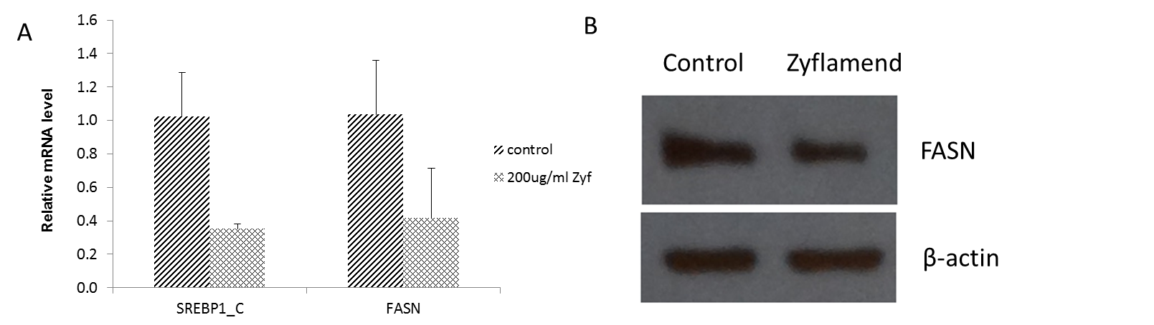
Figure III.1 Regulation of SREBP-1c and FASN expression by Zyflamend in CWR22Rv1 cells.
(A) mRNA levels of SREBP1c and FASN from CWR22Rv1 cells treated in the presence or absence of Zyflamend (200 µg/ml). Data is presented as mean±SD, n=3. Group comparisons, Zyflamend versus control,* p<0.05. (B) Western blot for FASN from CWR22Rv1 cells treated in the presence or absence of Zyflamend (200 µg/ml).

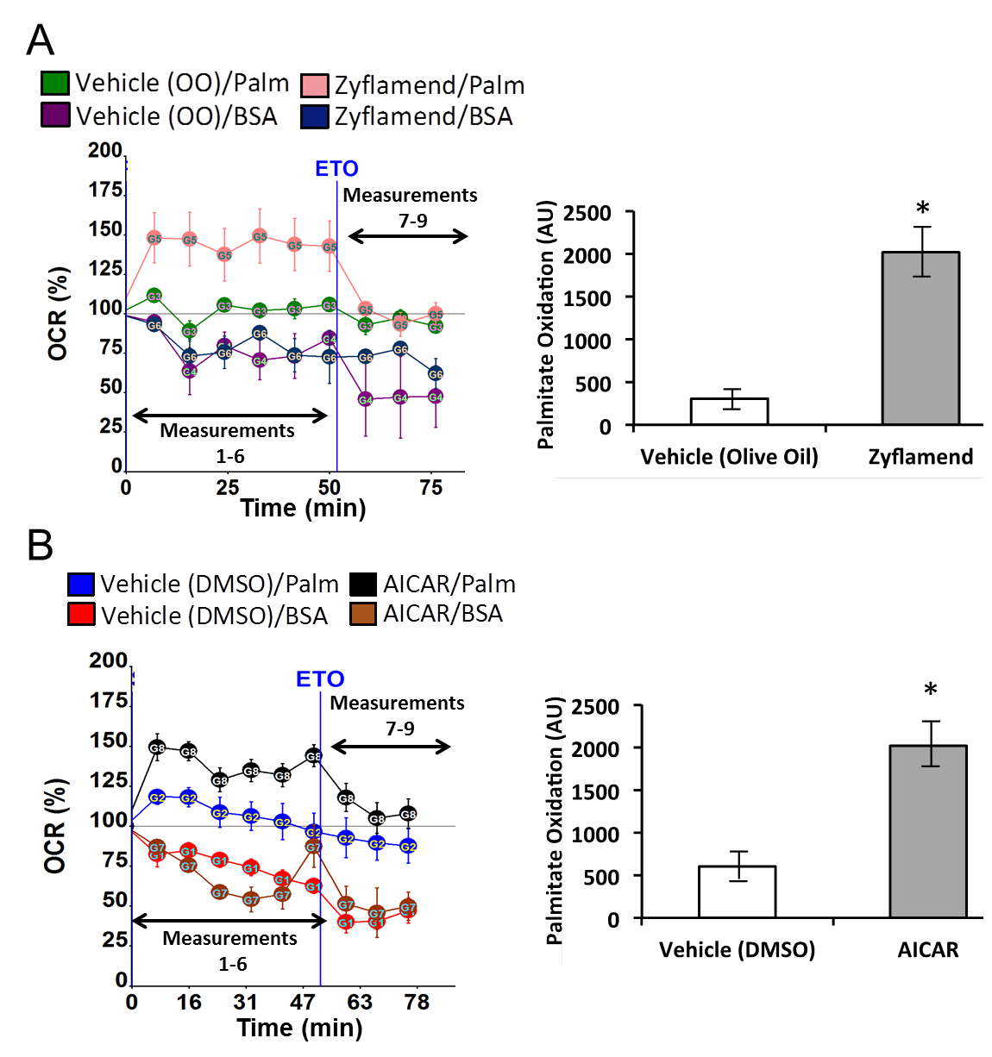
Figure III.2 Effects of Zyflamend on fatty acid oxidation.
(A) Percent change in oxygen consumption rate (OCR) relative to baseline in CWR22Rv1 cells that were pre-treated with vehicle (olive oil) or Zyflamend (200 µg/ml). BSA or palmitate was injected at time point 0. Etomoxir (ETO) was injected at 55 minutes. Palmitate oxidation (right panel) was determined by subtracting the OCR measurements before and after etomoxir injection. The resultant OCR from the BSA group is then subtracted from the resultant OCR from the palmitate group to get the relative palmitate oxidation that is expressed in arbitrary units (AU). (B) Percent change in oxygen consumption rate (OCR) relative to baseline in CWR22Rv1 cells that were pre-treated with vehicle (DMSO) or AICAR (100 µM). BSA or palmitate was injected at time point 0. Etomoxir (ETO) was injected at 55 minutes. Palmitate oxidation was determined as before (right panel). For palmitate oxidation measurements data points represent the average OCR (%) over 3-5 replicates per condition. Error bars are +/- SEM. Significant differences indicated (*, p < 0.05)
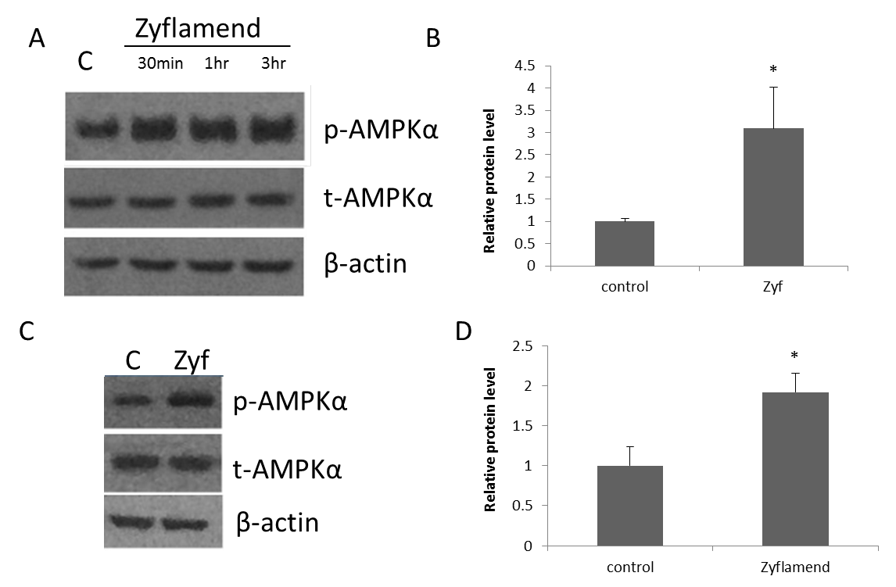
Figure III.3 The effects of Zyflamend on phosphorylation of AMPKα in CWR22Rv1 and PC3 prostate cancer cell lines.
(A, B) Protein levels of p-AMPKα were determined in CWR22Rv1 cells treated ± Zyflamend (200 µg/ml, 0-3 hr). Data is presented in (B) for the 30 min time point. (C, D) Protein levels of p-AMPKα were determined in PC3 cells treated ± Zyflamend (200 µg/ml, 30 min). Data is presented as mean±SD, n=3. Group comparisons, Zyflamend versus control, * p<0.05

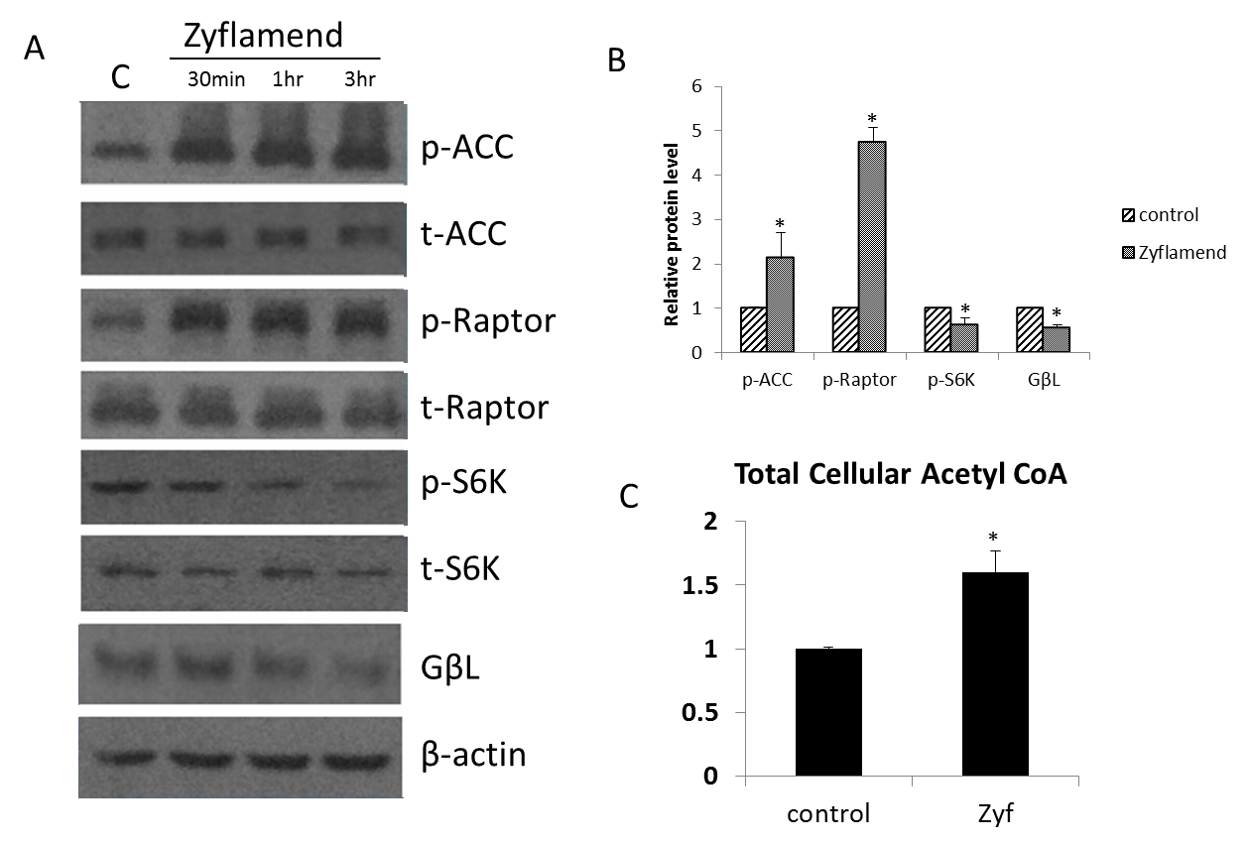
Figure III.4 Regulation of downstream targets of AMPK by ±Zyflamend in CWR22Rv1 cells.
(A, B) The effects of Zyflamend treatment (0.5–3 hr) on phosphorylation of ACC, raptor and S6K and protein levels of GβL. Data is presented as mean±SD, n=3. Group comparisons, Zyflamend versus control, * p<0.05. (C) Effects of Zyflamend on total cellular levels of acetyl CoA. Data is presented as mean±SD, n=3. Group comparisons, Zyflamend versus control, * p<0.05.

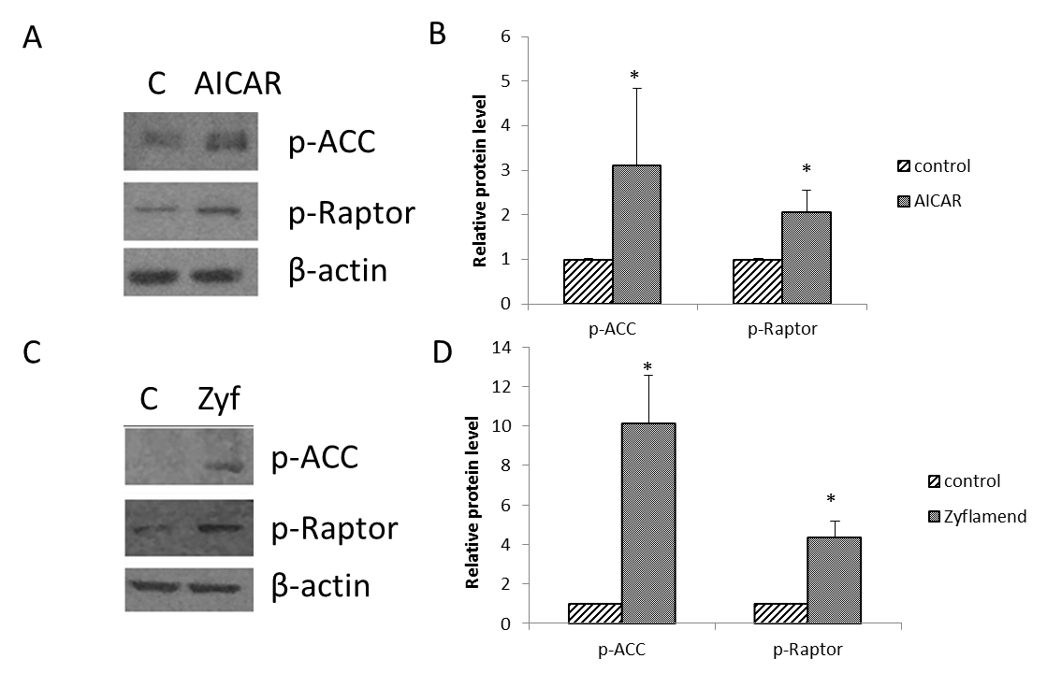
Figure III.5 Regulation of downstream targets of AMPK by AICAR in CWR22Rv1 cells and Zyflamend (Zyf) in PC3 cells.
(A, B) The effects of AICAR (positive control) on phosphorylation of ACC and raptor in CWR22Rv1 cells. (C, D) The effects of Zyflamend on phosphorylation of ACC and raptor in PC3 cells. Data is presented as mean±SD, n=3. Group comparisons, AICAR or Zyflamend versus control,* p<0.05

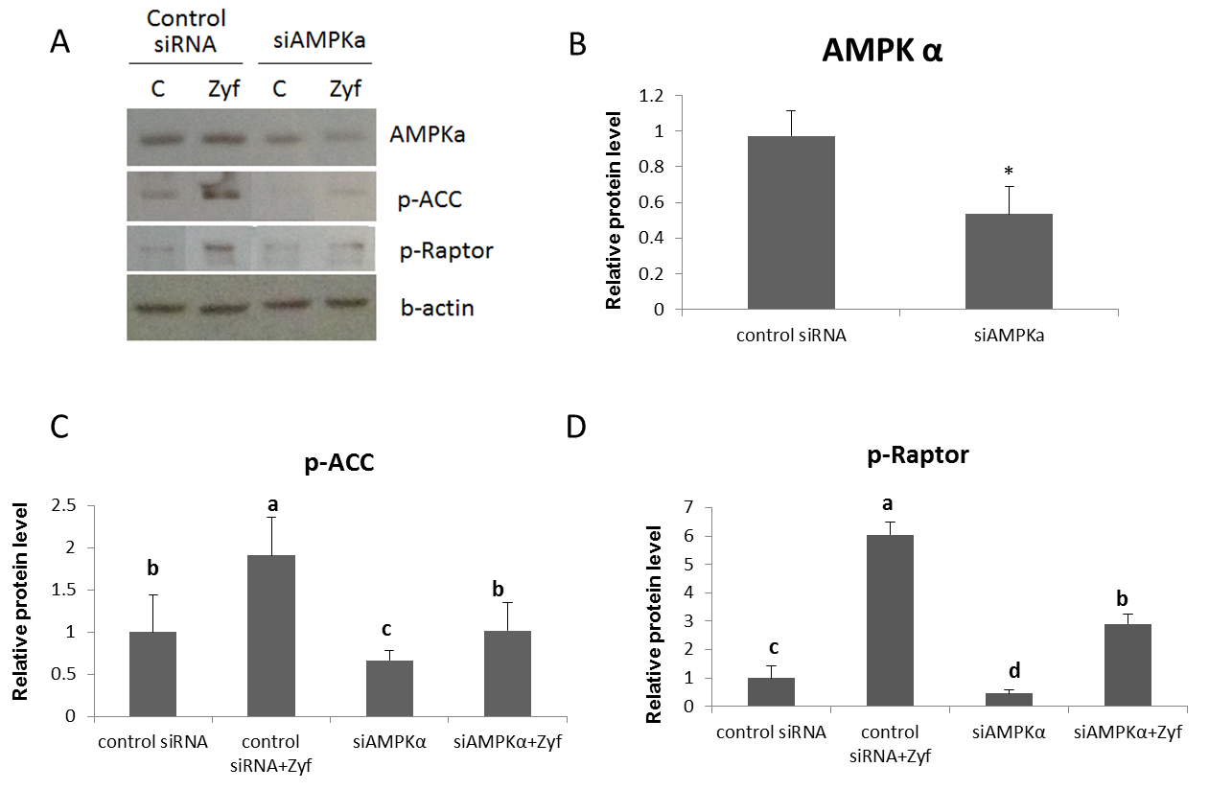
Figure III.6 The effects of partial knockdown of AMPKα1/2 on phosphorylation of ACC and raptor in the presence or absence of Zyflamend.
(A, C, D) Western blot of p-ACC and p-raptor following knockdown of AMPKα1/2 in the presence or absence of Zyflamend. Data is presented as mean±SD, n=3. ^{a,b,c,d}Bars with different letters within each figure are significantly different at p< 0.05; (B) Group comparison, siAMPKα versus control,* p<0.05.

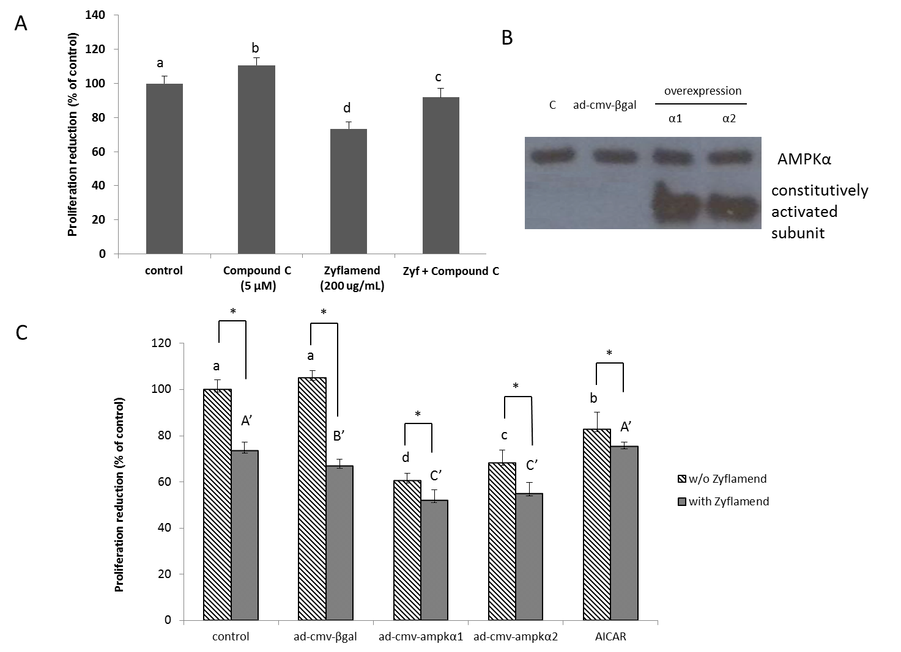
Figure III.7 The effects on modulating AMPK activity on cell viability with the AMPK inhibitor compound C and overexpression of AMPKα1/2 subunits in the presence or absence of Zyflamend in CWR22Rv1 cells.
(A) The effects of cell viability following treatment with compound C, in the presence or absence of Zyflamend. Data is presented as mean±SD, n=8. ^{a,b,c,d} Bars with different letters are significantly different at p< 0.05. (B) Overexpression by adenovirus as confirmed by western blot. (C) The effects of overexpression of AMPKα1/2 subunits on cell viability in the presence or absence of Zyflamend. Data is presented as mean±SD, n=8. Bars with different letters (^{a,b,c,d} or ^{A’,B’,C’}) are significantly different at p<0.05. Within group comparisons ±Zyflamend, * p<0.05.

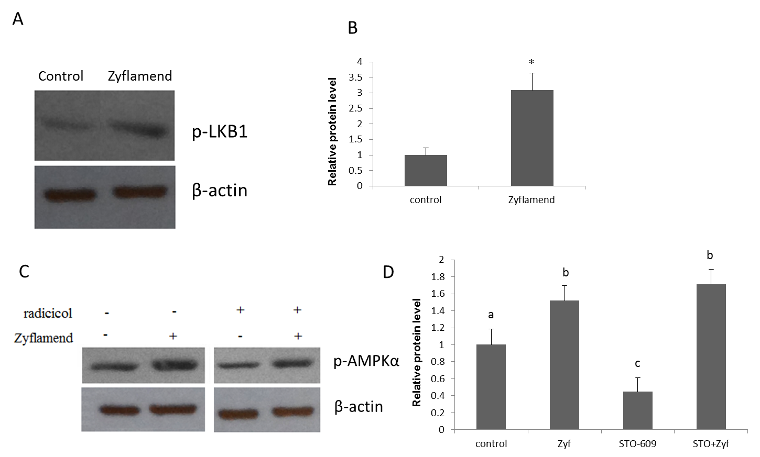
Figure III.8 Zyflamend may activate AMPK partially via activation of LKB1.
(A, B) Western blot of p-LKB1 following treatment of Zyflamend in CWR22Rv1 cells. Group comparison, Zyflamend versus control,* p<0.05. (C) Western blot of p-AMPKα following treatment of radicicol (LKB1 inhibitor) (D) The effects of STO-609 (CaMKKβ inhibitor) on phosphorylation of AMPKα in the presence or absence of Zyflamend. Data is presented as mean±SD, n=3. ^{a,b,c} Bars with different letters are significantly different at p< 0.05.

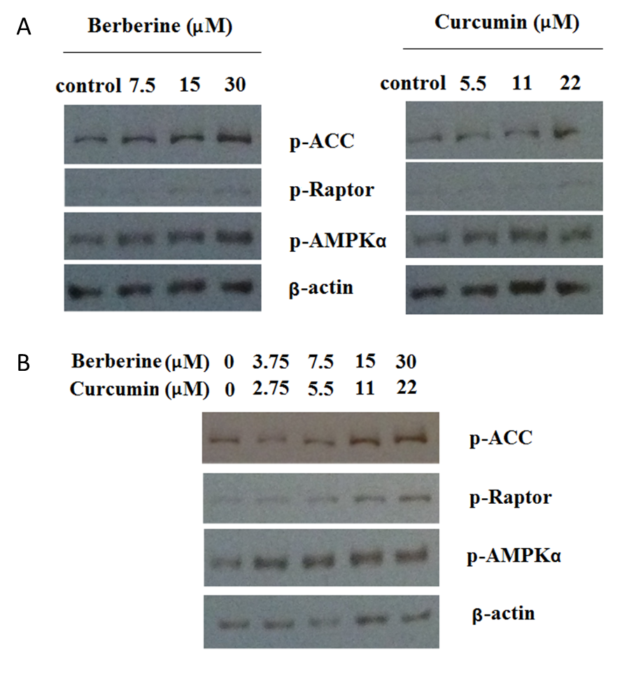
Figure III.9 Berberine and curcumin activate AMPK and downstream targets.
(A) Western blot of p-ACC, p-raptor and p-AMPKα following treatment of berberine or curcumin in CWR22Rv1 cells. (B) Western blot of p-ACC, p-Raptor and p-AMPKα following treatment of combination of berberine and curcumin in CWR22Rv1 cells.

LIST OF REFERENCES

[1] R. Siegel, J. Ma, Z. Zou, and A. Jemal, "Cancer statistics, 2014", CA Cancer J Clin, 2014, 64(1), pp. 9-29.
[2] D. L. Suzman and E. S. Antonarakis, "Castration-resistant prostate cancer: latest evidence and therapeutic implications", Ther Adv Med Oncol, 2014, 6(4), pp. 167-79.
[3] H. I. Scher and G. Heller, "Clinical states in prostate cancer: toward a dynamic model of disease progression", Urology, 2000, 55(3), pp. 323-7.
[4] W. A. Sakr, D. J. Grignon, G. P. Haas, L. K. Heilbrun, J. E. Pontes, and J. D. Crissman, "Age and racial distribution of prostatic intraepithelial neoplasia", Eur Urol, 1996, 30(2), pp. 138-44.
[5] W. A. Sakr, "Prostatic intraepithelial neoplasia: A marker for high-risk groups and a potential target for chemoprevention", Eur Urol, 1999, 35(5-6), pp. 474-8.
[6] J. Bastaros, J. Placer, A. Celma, J. Planas, and J. Morote, "Current significance of the finding of high grade prostatic intraepithelial neoplasia in the prostate biopsy", Actas Urol Esp, 2014, 38(4), pp. 270-5.
[7] D. G. Bostwick, "Prostatic intraepithelial neoplasia (PIN): current concepts", J Cell Biochem Suppl, 1992, 16H, pp. 10-9.
[8] L. Cheng, A. Lopez-Beltran, R. Mazzucchelli, R. Montironi, and M. Scarpelli, "Mechanisms of Disease: high-grade prostatic intraepithelial neoplasia and other proposed preneoplastic lesions in the prostate", Nature Clinical Practice Urology, 2007, 4, pp. 321+, p. 321.
[9] H. I. Scher, "Prostate carcinoma: defining therapeutic objectives and improving overall outcomes", Cancer, 2003, 97(3 Suppl), pp. 758-71.
[10] D. M. Berman and J. I. Epstein, "When is prostate cancer really cancer?", Urol Clin North Am, 2014, 41(2), pp. 339-46.
[11] H. Grönberg, "Prostate cancer epidemiology", The Lancet, 2003, 361(9360), pp. 859-864.
[12] A. So, A. Hurtado-Coll, and M. Gleave, "Androgens and prostate cancer", World Journal of Urology, 2003, 21(5), pp. 325-337.
[13] D. Nambiar and R. P. Singh, "Advances in prostate cancer chemoprevention: a translational perspective", Nutr Cancer, 2013, 65 Suppl 1, pp. 12-25.
[14] G. Seifert, P. Mansky, and A. Längler, "Introduction", in Integrative Pediatric Oncology, A. Längler, P. J. Mansky, and G. Seifert, Editors, 2012, Springer Berlin Heidelberg, pp. 1-4.
[15] E. Basch, D. A. Loblaw, T. K. Oliver, M. Carducci, R. C. Chen, J. N. Frame, K. Garrels, S. Hotte, M. W. Kattan, D. Raghavan, F. Saad, M. E. Taplin, C. Walker-Dilks, J. Williams, E. Winquist, T. Wootton, R. B. Rumble, S. B. Dusetzina, and K. S. Virgo, "Systemic Therapy in Men With Metastatic Castration-Resistant Prostate Cancer: American Society of Clinical Oncology and Cancer Care Ontario Clinical Practice Guideline", J Clin Oncol, 2014.
[16] N. Sharifi, J. L. Gulley, and W. L. Dahut, "ANdrogen deprivation therapy for prostate cancer", JAMA, 2005, 294(2), pp. 238-244.
[17] C. Huggins, R. E. Stevens, Jr, and C. V. Hodges, "Studies on prostatic cancer: Ii. the effects of castration on advanced carcinoma of the prostate gland", Archives of Surgery, 1941, 43(2), pp. 209-223.
[18] "New trends in androgen deprivation therapy: Summary of key research presented at AUA 2014", Can Urol Assoc J, 2014, 8(7-8 Suppl 4), pp. S134-6.
[19] L. Schwingshackl and G. Hoffmann, "Adherence to Mediterranean diet and risk of cancer: a systematic review and meta-analysis of observational studies", Int J Cancer, 2014, 135(8), pp. 1884-97.
[20] Y. Wang, V. L. Stevens, R. Shah, J. J. Peterson, J. T. Dwyer, S. M. Gapstur, and M. L. McCullough, "Dietary flavonoid and proanthocyanidin intakes and prostate cancer risk in a prospective cohort of US men", Am J Epidemiol, 2014, 179(8), pp. 974-86.
[21] M. S. Geybels, B. A. Verhage, I. C. Arts, F. J. van Schooten, R. A. Goldbohm, and P. A. van den Brandt, "Dietary flavonoid intake, black tea consumption, and risk of overall and advanced stage prostate cancer", Am J Epidemiol, 2013, 177(12), pp. 1388-98.
[22] M. L. Li, J. Lin, J. G. Hou, L. Xu, X. G. Cui, X. X. Xu, Y. W. Yu, X. Han, G. M. Wang, J. M. Guo, D. F. Xu, T. C. Thompson, G. W. Cao, and H. W. Zhang, "Environmental and Psycho-social Factors Related to Prostate Cancer Risk in the Chinese Population: a Case-control Study", Biomed Environ Sci, 2014, 27(9), pp. 707-17.
[23] R. H. Liu, "Health-promoting components of fruits and vegetables in the diet", Adv Nutr, 2013, 4(3), pp. 384s-92s.
[24] A. Bommareddy, W. Eggleston, S. Prelewicz, A. Antal, Z. Witczak, D. F. McCune, and A. L. Vanwert, "Chemoprevention of prostate cancer by major dietary phytochemicals", Anticancer Res, 2013, 33(10), pp. 4163-74.
[25] S. C. Thomasset, D. P. Berry, G. Garcea, T. Marczylo, W. P. Steward, and A. J. Gescher, "Dietary polyphenolic phytochemicals--promising cancer chemopreventive agents in humans? A review of their clinical properties", Int J Cancer, 2007, 120(3), pp. 451-8.
[26] M. M. Manson, B. E. Foreman, L. M. Howells, and E. P. Moiseeva, "Determining the efficacy of dietary phytochemicals in cancer prevention", Biochem Soc Trans, 2007, 35(Pt 5), pp. 1358-63.
[27] M. M. Manson, "Cancer prevention -- the potential for diet to modulate molecular signalling", Trends Mol Med, 2003, 9(1), pp. 11-8.
[28] A. Kale, S. Gawande, and S. Kotwal, "Cancer phytotherapeutics: role for flavonoids at the cellular level", Phytother Res, 2008, 22(5), pp. 567-77.
[29] W. Vanden Berghe, "Epigenetic impact of dietary polyphenols in cancer chemoprevention: lifelong remodeling of our epigenomes", Pharmacol Res, 2012, 65(6), pp. 565-76.
[30] A. Link, F. Balaguer, and A. Goel, "Cancer chemoprevention by dietary polyphenols: promising role for epigenetics", Biochem Pharmacol, 2010, 80(12), pp. 1771-92.
[31] D. S. Albrecht, E. A. Clubbs, M. Ferruzzi, and J. A. Bomser, "Epigallocatechin-3-gallate (EGCG) inhibits PC-3 prostate cancer cell proliferation via MEK-independent ERK1/2 activation", Chem Biol Interact, 2008, 171(1), pp. 89-95.
[32] X. Wang, E. A. Clubbs, and J. A. Bomser, "Genistein modulates prostate epithelial cell proliferation via estrogen- and extracellular signal-regulated kinase-dependent pathways", J Nutr Biochem, 2006, 17(3), pp. 204-10.
[33] E. A. Clubbs and J. A. Bomser, "Glycitein activates extracellular signal-regulated kinase via vascular endothelial growth factor receptor signaling in nontumorigenic (RWPE-1) prostate epithelial cells", J Nutr Biochem, 2007, 18(8), pp. 525-32.
[34] T. Dorai and B. B. Aggarwal, "Role of chemopreventive agents in cancer therapy", Cancer Lett, 2004, 215(2), pp. 129-40.
[35] T. E. Hedlund, W. U. Johannes, and G. J. Miller, "Soy isoflavonoid equol modulates the growth of benign and malignant prostatic epithelial cells in vitro", Prostate, 2003, 54(1), pp. 68-78.
[36] Y.-J. Surh, "Cancer chemoprevention with dietary phytochemicals", Nat Rev Cancer, 2003, 3(10), pp. 768-780.
[37] T. E. Hedlund, A. van Bokhoven, W. U. Johannes, S. K. Nordeen, and L. G. Ogden, "Prostatic fluid concentrations of isoflavonoids in soy consumers are sufficient to inhibit growth of benign and malignant prostatic epithelial cells in vitro", Prostate, 2006, 66(5), pp. 557-66.
[38] D. Hanahan and Robert A. Weinberg, "Hallmarks of Cancer: The Next Generation", Cell, 144(5), pp. 646-674.
[39] L. Lao, L. Xu, and S. Xu, "Traditional Chinese Medicine", in Integrative Pediatric Oncology, A. Längler, P. J. Mansky, and G. Seifert, Editors, 2012, Springer Berlin Heidelberg, pp. 125-135.
[40] S. C. Gupta, B. Sung, J. H. Kim, S. Prasad, S. Li, and B. B. Aggarwal, "Multitargeting by turmeric, the golden spice: From kitchen to clinic", Mol Nutr Food Res, 2013, 57(9), pp. 1510-28.
[41] S. W. Qader, M. A. Abdulla, L. S. Chua, N. Najim, M. M. Zain, and S. Hamdan, "Antioxidant, total phenolic content and cytotoxicity evaluation of selected Malaysian plants", Molecules, 2011, 16(4), pp. 3433-43.
[42] A. Betancor-Fernandez, A. Perez-Galvez, H. Sies, and W. Stahl, "Screening pharmaceutical preparations containing extracts of turmeric rhizome, artichoke leaf, devil's claw root and garlic or salmon oil for antioxidant capacity", J Pharm Pharmacol, 2003, 55(7), pp. 981-6.
[43] H. H. P. Cohly, A. Taylor, M. F. Angel, and A. K. Salahudeen, "Effect of Turmeric, Turmerin and Curcumin on H2O2-Induced Renal Epithelial (LLC-PK1) Cell Injury", Free Radical Biology and Medicine, 1998, 24(1), pp. 49-54.
[44] M. A. Azuine, J. J. Kayal, and S. V. Bhide, "Protective role of aqueous turmeric extract against mutagenicity of direct-acting carcinogens as well as benzo [alpha] pyrene-induced genotoxicity and carcinogenicity", J Cancer Res Clin Oncol, 1992, 118(6), pp. 447-52.
[45] R. Kuttan, G. Kuttan, S. Joseph, T. A. Ajith, M. Mohan, and R. C. Srimal, "Antimutagenicity of herbal detoxification formula Smoke Shield against environmental mutagens", J Exp Clin Cancer Res, 2004, 23(1), pp. 61-8.
[46] K. Puangsombat, W. Jirapakkul, and J. S. Smith, "Inhibitory activity of Asian spices on heterocyclic amines formation in cooked beef patties", J Food Sci, 2011, 76(8), pp. T174-80.
[47] J. H. Kim, S. C. Gupta, B. Park, V. R. Yadav, and B. B. Aggarwal, "Turmeric (Curcuma longa) inhibits inflammatory nuclear factor (NF)-kappaB and NF-kappaB-regulated gene products and induces death receptors leading to suppressed proliferation, induced chemosensitization, and suppressed osteoclastogenesis", Mol Nutr Food Res, 2012, 56(3), pp. 454-65.
[48] L. Menghini, S. Genovese, F. Epifano, B. Tirillini, C. Ferrante, and L. Leporini, "Antiproliferative, protective and antioxidant effects of artichoke, dandelion, turmeric and rosemary extracts and their formulation", Int J Immunopathol Pharmacol, 2010, 23(2), pp. 601-10.
[49] B. Hu, K. P. Shen, H. M. An, Y. Wu, and Q. Du, "Aqueous extract of Curcuma aromatica induces apoptosis and G2/M arrest in human colon carcinoma LS-174-T cells independent of p53", Cancer Biother Radiopharm, 2011, 26(1), pp. 97-104.
[50] R. Kuttan, P. Bhanumathy, K. Nirmala, and M. C. George, "Potential anticancer activity of turmeric (Curcuma longa)", Cancer Lett, 1985, 29(2), pp. 197-202.
[51] C. Ramachandran, A. P. Resek, E. Escalon, A. Aviram, and S. J. Melnick, "Potentiation of gemcitabine by Turmeric Force in pancreatic cancer cell lines", Oncol Rep, 2010, 23(6), pp. 1529-35.
[52] S. N. A. Malek, G. S. Lee, S. L. Hong, H. Yaacob, N. A. Wahab, J.-F. Faizal Weber, and S. A. A. Shah, "Phytochemical and Cytotoxic Investigations of Curcuma mangga Rhizomes", Molecules, 2011, 16(6), pp. 4539-4548.
[53] R. C. Lantz, G. J. Chen, A. M. Solyom, S. D. Jolad, and B. N. Timmermann, "The effect of turmeric extracts on inflammatory mediator production", Phytomedicine, 2005, 12(6-7), pp. 445-52.
[54] R. Thapliyal, K. N. Naresh, K. V. Rao, and G. B. Maru, "Inhibition of nitrosodiethylamine-induced hepatocarcinogenesis by dietary turmeric in rats", Toxicol Lett, 2003, 139(1), pp. 45-54.
[55] K. B. Soni, M. Lahiri, P. Chackradeo, S. V. Bhide, and R. Kuttan, "Protective effect of food additives on aflatoxin-induced mutagenicity and hepatocarcinogenicity", Cancer Lett, 1997, 115(2), pp. 129-33.
[56] R. Garg, A. Ingle, and G. Maru, "Dietary turmeric modulates DMBA-induced p21ras, MAP kinases and AP-1/NF-kappaB pathway to alter cellular responses during hamster buccal pouch carcinogenesis", Toxicol Appl Pharmacol, 2008, 232(3), pp. 428-39.
[57] K. Krishnaswamy, V. K. Goud, B. Sesikeran, M. A. Mukundan, and T. P. Krishna, "Retardation of experimental tumorigenesis and reduction in dna adducts by turmeric and curcumin", Nutr Cancer, 1998, 30(2), pp. 163-166.
[58] J. Kim, H. L. Ha, H. B. Moon, Y. W. Lee, C. K. Cho, H. S. Yoo, and D. Y. Yu, "Chemopreventive effect of Curcuma longa Linn on liver pathology in HBx transgenic mice", Integr Cancer Ther, 2011, 10(2), pp. 168-77.
[59] V. S. Ghalaut, L. Sangwan, K. Dahiya, P. S. Ghalaut, R. Dhankhar, and R. Saharan, "Effect of imatinib therapy with and without turmeric powder on nitric oxide levels in chronic myeloid leukemia", J Oncol Pharm Pract, 2012, 18(2), pp. 186-90.
[60] A. Krausz, H. Gunn, and A. Friedman, "The basic science of natural ingredients", Journal of Drugs in Dermatology, 2014, 13, pp. 937+, p. 937.
[61] T. Dorai, N. Gehani, and A. Katz, "Therapeutic potential of curcumin in human prostate cancer-I. curcumin induces apoptosis in both androgen-dependent and androgen-independent prostate cancer cells", Prostate Cancer Prostatic Dis, 2000, 3(2), pp. 84-93.
[62] T. Dorai, N. Gehani, and A. Katz, "Therapeutic potential of curcumin in human prostate cancer. II. Curcumin inhibits tyrosine kinase activity of epidermal growth factor receptor and depletes the protein", Mol Urol, 2000, 4(1), pp. 1-6.
[63] H. Guo, Y. M. Xu, Z. Q. Ye, J. H. Yu, and X. Y. Hu, "Curcumin induces cell cycle arrest and apoptosis of prostate cancer cells by regulating the expression of IkappaBalpha, c-Jun and androgen receptor", Pharmazie, 2013, 68(6), pp. 431-4.
[64] K. Nakamura, Y. Yasunaga, T. Segawa, D. Ko, J. W. Moul, S. Srivastava, and J. S. Rhim, "Curcumin down-regulates AR gene expression and activation in prostate cancer cell lines", Int J Oncol, 2002, 21(4), pp. 825-30.
[65] A. B. Kunnumakkara, P. Anand, and B. B. Aggarwal, "Curcumin inhibits proliferation, invasion, angiogenesis and metastasis of different cancers through interaction with multiple cell signaling proteins", Cancer Lett, 2008, 269(2), pp. 199-225.
[66] R. L. Thangapazham, S. Shaheduzzaman, K. H. Kim, N. Passi, A. Tadese, M. Vahey, A. Dobi, S. Srivastava, and R. K. Maheshwari, "Androgen responsive and refractory prostate cancer cells exhibit distinct curcumin regulated transcriptome", Cancer Biol Ther, 2008, 7(9), pp. 1427-35.
[67] S. Fu and R. Kurzrock, "Development of curcumin as an epigenetic agent", Cancer, 2010, 116(20), pp. 4670-6.
[68] L. Shu, T. O. Khor, J. H. Lee, S. S. Boyanapalli, Y. Huang, T. Y. Wu, C. L. Saw, K. L. Cheung, and A. N. Kong, "Epigenetic CpG demethylation of the promoter and reactivation of the expression of Neurog1 by curcumin in prostate LNCaP cells", Aaps j, 2011, 13(4), pp. 606-14.
[69] H. Choi, Y. S. Chun, Y. J. Shin, S. K. Ye, M. S. Kim, and J. W. Park, "Curcumin attenuates cytochrome P450 induction in response to 2,3,7,8-tetrachlorodibenzo-p-dioxin by ROS-dependently degrading AhR and ARNT", Cancer Sci, 2008, 99(12), pp. 2518-24.
[70] A. Slusarz, N. S. Shenouda, M. S. Sakla, S. K. Drenkhahn, A. S. Narula, R. S. MacDonald, C. L. Besch-Williford, and D. B. Lubahn, "Common botanical compounds inhibit the hedgehog signaling pathway in prostate cancer", Cancer Res, 2010, 70(8), pp. 3382-90.
[71] T. Dorai, Y. C. Cao, B. Dorai, R. Buttyan, and A. E. Katz, "Therapeutic potential of curcumin in human prostate cancer. III. Curcumin inhibits proliferation, induces apoptosis, and inhibits angiogenesis of LNCaP prostate cancer cells in vivo", Prostate, 2001, 47(4), pp. 293-303.
[72] J. H. Hong, K. S. Ahn, E. Bae, S. S. Jeon, and H. Y. Choi, "The effects of curcumin on the invasiveness of prostate cancer in vitro and in vivo", Prostate Cancer Prostatic Dis, 2006, 9(2), pp. 147-52.
[73] C. D. Lao, M. T. t. Ruffin, D. Normolle, D. D. Heath, S. I. Murray, J. M. Bailey, M. E. Boggs, J. Crowell, C. L. Rock, and D. E. Brenner, "Dose escalation of a curcuminoid formulation", BMC Complement Altern Med, 2006, 6, pp. 10.
[74] A. L. Cheng, C. H. Hsu, J. K. Lin, M. M. Hsu, Y. F. Ho, T. S. Shen, J. Y. Ko, J. T. Lin, B. R. Lin, W. Ming-Shiang, H. S. Yu, S. H. Jee, G. S. Chen, T. M. Chen, C. A. Chen, M. K. Lai, Y. S. Pu, M. H. Pan, Y. J. Wang, C. C. Tsai, and C. Y. Hsieh, "Phase I clinical trial of curcumin, a chemopreventive agent, in patients with high-risk or pre-malignant lesions", Anticancer Res, 2001, 21(4b), pp. 2895-900.
[75] S. Li, W. Yuan, G. Deng, P. Wang, P. Yang, and B. B. Aggarwal, "Chemical composition and product quality control of turmeric (Curcuma longa L.)".
[76] G. Singh, I. P. Kapoor, P. Singh, C. S. de Heluani, M. P. de Lampasona, and C. A. Catalan, "Comparative study of chemical composition and antioxidant activity of fresh and dry rhizomes of turmeric (Curcuma longa Linn.)", Food Chem Toxicol, 2010, 48(4), pp. 1026-31.
[77] S. K. Sandur, M. K. Pandey, B. Sung, K. S. Ahn, A. Murakami, G. Sethi, P. Limtrakul, V. Badmaev, and B. B. Aggarwal, "Curcumin, demethoxycurcumin, bisdemethoxycurcumin, tetrahydrocurcumin and turmerones differentially regulate anti-inflammatory and anti-proliferative responses through a ROS-independent mechanism", Carcinogenesis, 2007, 28(8), pp. 1765-73.
[78] S. Oh, A. R. Han, H. R. Park, E. J. Jang, H. K. Kim, M. G. Jeong, H. Song, G. H. Park, E. K. Seo, and E. S. Hwang, "Suppression of Inflammatory cytokine production by ar-Turmerone isolated from Curcuma phaeocaulis", Chem Biodivers, 2014, 11(7), pp. 1034-41.
[79] S. Y. Park, Y. H. Kim, Y. Kim, and S. J. Lee, "Aromatic-turmerone attenuates invasion and expression of MMP-9 and COX-2 through inhibition of NF-kappaB activation in TPA-induced breast cancer cells", J Cell Biochem, 2012, 113(12), pp. 3653-62.
[80] J. Tang, Y. Feng, S. Tsao, N. Wang, R. Curtain, and Y. Wang, "Berberine and Coptidis rhizoma as novel antineoplastic agents: a review of traditional use and biomedical investigations", Journal of ethnopharmacology, 2009, 126(1), pp. 5-17.
[81] B. J. Kim, H. Kim, G. S. Lee, I. So, and S. J. Kim, "Effects of San-Huang-Xie-Xin-tang, a traditional Chinese prescription for clearing away heat and toxin, on the pacemaker activities of interstitial cells of Cajal from the murine small intestine", J Ethnopharmacol, 2014, 155(1), pp. 744-52.
[82] G. H. Yue, S. Y. Zhuo, M. Xia, Z. Zhang, Y. W. Gao, and Y. Luo, "Effect of huanglian jiedu decoction on thoracic aorta gene expression in spontaneous hypertensive rats", Evid Based Complement Alternat Med, 2014, 2014, pp. 565784.
[83] T. Friedemann, B. Otto, K. Klatschke, U. Schumacher, Y. Tao, A. K. Leung, T. Efferth, and S. Schroder, "Coptis chinensis Franch. exhibits neuroprotective properties against oxidative stress in human neuroblastoma cells", J Ethnopharmacol, 2014, 155(1), pp. 607-15.
[84] C. C. Lin, L. T. Ng, F. F. Hsu, D. E. Shieh, and L. C. Chiang, "Cytotoxic effects of Coptis chinensis and Epimedium sagittatum extracts and their major constituents (berberine, coptisine and icariin) on hepatoma and leukaemia cell growth", Clin Exp Pharmacol Physiol, 2004, 31(1-2), pp. 65-9.
[85] N. Iizuka, M. Oka, K. Yamamoto, A. Tangoku, K. Miyamoto, T. Miyamoto, S. Uchimura, Y. Hamamoto, and K. Okita, "Identification of common or distinct genes related to antitumor activities of a medicinal herb and its major component by oligonucleotide microarray", Int J Cancer, 2003, 107(4), pp. 666-72.
[86] R. Enk, R. Ehehalt, J. E. Graham, A. Bierhaus, A. Remppis, and H. J. Greten, "Differential effect of Rhizoma coptidis and its main alkaloid compound berberine on TNF-alpha induced NFkappaB translocation in human keratinocytes", J Ethnopharmacol, 2007, 109(1), pp. 170-5.
[87] M. Xue, H. J. Yin, C. F. Wu, X. J. Ma, C. Y. Guo, Y. Huang, D. Z. Shi, and K. J. Chen, "Effect of Chinese drugs for activating blood circulation and detoxifying on indices of thrombosis, inflammatory reaction, and tissue damage in a rabbit model of toxin-heat and blood stasis syndrome", Chin J Integr Med, 2013, 19(1), pp. 42-7.
[88] J. Chen, F. Wang, J. Liu, F. S. Lee, X. Wang, and H. Yang, "Analysis of alkaloids in Coptis chinensis Franch by accelerated solvent extraction combined with ultra performance liquid chromatographic analysis with photodiode array and tandem mass spectrometry detections", Anal Chim Acta, 2008, 613(2), pp. 184-95.
[89] Y. Sun, K. Xun, Y. Wang, and X. Chen, "A systematic review of the anticancer properties of berberine, a natural product from Chinese herbs", Anticancer Drugs, 2009, 20(9), pp. 757-69.
[90] P. R. Vuddanda, S. Chakraborty, and S. Singh, "Berberine: a potential phytochemical with multispectrum therapeutic activities", Expert Opin Investig Drugs, 2010, 19(10), pp. 1297-307.
[91] S. K. Mantena, S. D. Sharma, and S. K. Katiyar, "Berberine, a natural product, induces G1-phase cell cycle arrest and caspase-3-dependent apoptosis in human prostate carcinoma cells", Mol Cancer Ther, 2006, 5(2), pp. 296-308.
[92] J. Li, B. Cao, X. Liu, X. Fu, Z. Xiong, L. Chen, O. Sartor, Y. Dong, and H. Zhang, "Berberine suppresses androgen receptor signaling in prostate cancer", Mol Cancer Ther, 2011, 10(8), pp. 1346-56.
[93] Y. Wang, Q. Liu, Z. Liu, B. Li, Z. Sun, H. Zhou, X. Zhang, Y. Gong, and C. Shao, "Berberine, a genotoxic alkaloid, induces ATM-Chk1 mediated G2 arrest in prostate cancer cells", Mutat Res, 2012, 734(1-2), pp. 20-9.
[94] S. M. Meeran, S. Katiyar, and S. K. Katiyar, "Berberine-induced apoptosis in human prostate cancer cells is initiated by reactive oxygen species generation", Toxicol Appl Pharmacol, 2008, 229(1), pp. 33-43.
[95] L. Y. Zhang, Y. L. Wu, X. H. Gao, and F. Guo, "Mitochondrial protein cyclophilin-D-mediated programmed necrosis attributes to berberine-induced cytotoxicity in cultured prostate cancer cells", Biochem Biophys Res Commun, 2014, 450(1), pp. 697-703.
[96] M. S. Choi, J. H. Oh, S. M. Kim, H. Y. Jung, H. S. Yoo, Y. M. Lee, D. C. Moon, S. B. Han, and J. T. Hong, "Berberine inhibits p53-dependent cell growth through induction of apoptosis of prostate cancer cells", Int J Oncol, 2009, 34(5), pp. 1221-30.
[97] W. Hua, L. Ding, Y. Chen, B. Gong, J. He, and G. Xu, "Determination of berberine in human plasma by liquid chromatography-electrospray ionization-mass spectrometry", J Pharm Biomed Anal, 2007, 44(4), pp. 931-7.
[98] J. Li, D. M. Qiu, S. H. Chen, S. P. Cao, and X. L. Xia, "Suppression of human breast cancer cell metastasis by coptisine in vitro", Asian Pac J Cancer Prev, 2014, 15(14), pp. 5747-51.
[99] F. L. Meyskens, Jr. and E. Szabo, "Diet and cancer: the disconnect between epidemiology and randomized clinical trials", Cancer Epidemiol Biomarkers Prev, 2005, 14(6), pp. 1366-9.
[100] J. Tomé-Carneiro, M. Larrosa, A. González-Sarrías, F. A. Tomás-Barberán, M. T. García-Conesa, and J. C. Espín, "Resveratrol and clinical trials: the crossroad from in vitro studies to human evidence", Current pharmaceutical design, 2013, 19(34), pp. 6064.
[101] L. M. Howells, D. P. Berry, P. J. Elliott, E. W. Jacobson, E. Hoffmann, B. Hegarty, K. Brown, W. P. Steward, and A. J. Gescher, "Phase I randomized, double-blind pilot study of micronized resveratrol (SRT501) in patients with hepatic metastases--safety, pharmacokinetics, and pharmacodynamics", Cancer Prev Res (Phila), 2011, 4(9), pp. 1419-25.
[102] T. Bohn, "Dietary factors affecting polyphenol bioavailability", Nutr Rev, 2014, 72(7), pp. 429-52.
[103] K. R. Walsh, Y. C. Zhang, Y. Vodovotz, S. J. Schwartz, and M. L. Failla, "Stability and Bioaccessibility of Isoflavones from Soy Bread during In Vitro Digestion", J Agric Food Chem, 2003, 51(16), pp. 4603-4609.
[104] B. Wahlang, Y. B. Pawar, and A. K. Bansal, "Identification of permeability-related hurdles in oral delivery of curcumin using the Caco-2 cell model", European Journal of Pharmaceutics and Biopharmaceutics, 2011, 77(2), pp. 275-282.
[105] V. Ravindranath and N. Chandrasekhara, "Absorption and tissue distribution of curcumin in rats", Toxicology, 1980, 16(3), pp. 259-265.
[106] L. B. Sansbury, K. Wanke, P. S. Albert, L. Kahle, A. Schatzkin, and E. Lanza, "The effect of strict adherence to a high-fiber, high-fruit and -vegetable, and low-fat eating pattern on adenoma recurrence", Am J Epidemiol, 2009, 170(5), pp. 576-84.
[107] "The effect of vitamin E and beta carotene on the incidence of lung cancer and other cancers in male smokers. The Alpha-Tocopherol, Beta Carotene Cancer Prevention Study Group", N Engl J Med, 1994, 330(15), pp. 1029-35.
[108] G. S. Omenn, G. E. Goodman, M. D. Thornquist, J. Balmes, M. R. Cullen, A. Glass, J. P. Keogh, F. L. Meyskens, B. Valanis, J. H. Williams, S. Barnhart, and S. Hammar, "Effects of a combination of beta carotene and vitamin A on lung cancer and cardiovascular disease", N Engl J Med, 1996, 334(18), pp. 1150-5.
[109] P. Palozza, "Prooxidant actions of carotenoids in biologic systems", Nutr Rev, 1998, 56(9), pp. 257-65.
[110] T. M. Gibson, L. M. Ferrucci, J. A. Tangrea, and A. Schatzkin, "Epidemiological and clinical studies of nutrition", Semin Oncol, 2010, 37(3), pp. 282-96.
[111] N. P. Seeram, L. S. Adams, M. L. Hardy, and D. Heber, "Total cranberry extract versus its phytochemical constituents: antiproliferative and synergistic effects against human tumor cell lines", J Agric Food Chem, 2004, 52(9), pp. 2512-7.
[112] E. P. Lansky, W. Jiang, H. Mo, L. Bravo, P. Froom, W. Yu, N. M. Harris, I. Neeman, and M. J. Campbell, "Possible synergistic prostate cancer suppression by anatomically discrete pomegranate fractions", Invest New Drugs, 2005, 23(1), pp. 11-20.
[113] S. R. Gundala, R. Mukkavilli, C. Yang, P. Yadav, V. Tandon, S. Vangala, S. Prakash, and R. Aneja, "Enterohepatic recirculation of bioactive ginger phytochemicals is associated with enhanced tumor growth-inhibitory activity of ginger extract", Carcinogenesis, 2014, 35(6), pp. 1320-9.
[114] P. Anand, A. B. Kunnumakkara, R. A. Newman, and B. B. Aggarwal, "Bioavailability of curcumin: problems and promises", Mol Pharm, 2007, 4(6), pp. 807-18.
[115] A. M. Bode and Z. Dong, "Epigallocatechin 3-gallate and green tea catechins: United they work, divided they fail", Cancer Prev Res (Phila), 2009, 2(6), pp. 514-7.
[116] M. Shimizu, A. Deguchi, J. T. Lim, H. Moriwaki, L. Kopelovich, and I. B. Weinstein, "(-)-Epigallocatechin gallate and polyphenon E inhibit growth and activation of the epidermal growth factor receptor and human epidermal growth factor receptor-2 signaling pathways in human colon cancer cells", Clin Cancer Res, 2005, 11(7), pp. 2735-46.
[117] H. Fu, J. He, F. Mei, Q. Zhang, Y. Hara, S. Ryota, R. A. Lubet, R. Chen, D. R. Chen, and M. You, "Lung cancer inhibitory effect of epigallocatechin-3-gallate is dependent on its presence in a complex mixture (polyphenon E)", Cancer Prev Res (Phila), 2009, 2(6), pp. 531-7.
[118] Q. Zhang, H. Fu, J. Pan, J. He, S. Ryota, Y. Hara, Y. Wang, R. A. Lubet, and M. You, "Effect of dietary Polyphenon E and EGCG on lung tumorigenesis in A/J Mice", Pharm Res, 2010, 27(6), pp. 1066-71.
[119] H. H. Chow, I. A. Hakim, D. R. Vining, J. A. Crowell, J. Ranger-Moore, W. M. Chew, C. A. Celaya, S. R. Rodney, Y. Hara, and D. S. Alberts, "Effects of dosing condition on the oral bioavailability of green tea catechins after single-dose administration of Polyphenon E in healthy individuals", Clin Cancer Res, 2005, 11(12), pp. 4627-33.
[120] M. Suganuma, S. Okabe, Y. Kai, N. Sueoka, E. Sueoka, and H. Fujiki, "Synergistic effects of (--)-epigallocatechin gallate with (--)-epicatechin, sulindac, or tamoxifen on cancer-preventive activity in the human lung cancer cell line PC-9", Cancer Res, 1999, 59(1), pp. 44-7.
[121] G. Shoba, D. Joy, T. Joseph, M. Majeed, R. Rajendran, and P. S. Srinivas, "Influence of piperine on the pharmacokinetics of curcumin in animals and human volunteers", Planta Med, 1998, 64(4), pp. 353-6.
[122] H. Wagner and G. Ulrich-Merzenich, "Synergy research: approaching a new generation of phytopharmaceuticals", Phytomedicine, 2009, 16(2-3), pp. 97-110.
[123] T. C. Hsieh and J. M. Wu, "Targeting CWR22Rv1 prostate cancer cell proliferation and gene expression by combinations of the phytochemicals EGCG, genistein and quercetin", Anticancer Res, 2009, 29(10), pp. 4025-32.
[124] Y.-f. Qian and X.-j. Wang, "Effects of Blood-Activating and Stasis-Resolving Drugs on Tumor Formation and Metastasis", Journal of Traditional Chinese Medicine, 2009, 29(4), pp. 301-310.
[125] T. C. Chou, "Theoretical basis, experimental design, and computerized simulation of synergism and antagonism in drug combination studies", Pharmacol Rev, 2006, 58(3), pp. 621-81.
[126] C. M. Bolyard, J. Y. Yoo, P. Y. Wang, U. Saini, K. S. Rath, T. P. Cripe, J. Zhang, K. Selvendiran, and B. Kaur, "Doxorubicin synergizes with 34.5ENVE to enhance antitumor efficacy against metastatic ovarian cancer", Clin Cancer Res, 2014.
[127] A. R. Hamid, G. W. Verhaegh, F. P. Smit, C. van Rijt-van de Westerlo, I. Armandari, A. Brandt, F. C. Sweep, J. P. Sedelaar, and J. A. Schalken, "Dutasteride and enzalutamide synergistically suppress prostate tumor cell proliferation", J Urol, 2014.
[128] W. Xu, W. W. Ma, and H. H. Zeng, "Synergistic Effect of Ethaselen and Selenite Treatment against A549 Human Non-small Cell Lung Cancer Cells", Asian Pac J Cancer Prev, 2014, 15(17), pp. 7129-35.
[129] P. Ethiraj, K. Veerappan, B. Doraisami, and S. Sivapatham, "Synergistic anti-carcinogenic effect of interferon-beta with cisplatin on human breast adenocarcinoma MDA MB231 cells", Int Immunopharmacol, 2014, 23(1), pp. 222-228.
[130] N. Grabinski and F. Ewald, "Ibrutinib (Imbruvica) potently inhibits ErbB receptor phosphorylation and cell viability of ErbB2-positive breast cancer cells", Invest New Drugs, 2014.
[131] J. K. Dermawan, K. Gurova, J. Pink, A. Dowlati, S. De, G. Narla, N. Sharma, and G. R. Stark, "Quinacrine Overcomes Resistance to Erlotinib by Inhibiting FACT, NF-kappaB, and Cell-Cycle Progression in Non-Small Cell Lung Cancer", Mol Cancer Ther, 2014, 13(9), pp. 2203-14.
[132] T. C. Chou, "Drug combination studies and their synergy quantification using the Chou-Talalay method", Cancer Res, 2010, 70(2), pp. 440-6.
[133] D. Ferreira, F. Adega, and R. Chaves, "The Importance of Cancer Cell Lines as in vitro Models in Cancer Methylome Analysis and Anticancer Drugs Testing". Oncogenomics and Cancer Proteomics - Novel Approaches in Biomarkers Discovery and Therapeutic Targets in Cancer, 2013.
[134] M. V. Sadi, P. C. Walsh, and E. R. Barrack, "Immunohistochemical study of androgen receptors in metastatic prostate cancer. Comparison of receptor content and response to hormonal therapy", Cancer, 1991, 67(12), pp. 3057-64.
[135] P. Koivisto, T. Visakorpi, and O. P. Kallioniemi, "Androgen receptor gene amplification: a novel molecular mechanism for endocrine therapy resistance in human prostate cancer", Scand J Clin Lab Invest Suppl, 1996, 226, pp. 57-63.
[136] J. P. Gaddipati, D. G. McLeod, H. B. Heidenberg, I. A. Sesterhenn, M. J. Finger, J. W. Moul, and S. Srivastava, "Frequent detection of codon 877 mutation in the androgen receptor gene in advanced prostate cancers", Cancer Res, 1994, 54(11), pp. 2861-4.
[137] R. M. Sramkoski, T. G. Pretlow, 2nd, J. M. Giaconia, T. P. Pretlow, S. Schwartz, M. S. Sy, S. R. Marengo, J. S. Rhim, D. Zhang, and J. W. Jacobberger, "A new human prostate carcinoma cell line, 22Rv1", In Vitro Cell Dev Biol Anim, 1999, 35(7), pp. 403-9.
[138] C. G. Tepper, D. L. Boucher, P. E. Ryan, A. H. Ma, L. Xia, L. F. Lee, T. G. Pretlow, and H. J. Kung, "Characterization of a novel androgen receptor mutation in a relapsed CWR22 prostate cancer xenograft and cell line", Cancer Res, 2002, 62(22), pp. 6606-14.
[139] P. Thomas and T. G. Smart, "HEK293 cell line: a vehicle for the expression of recombinant proteins", J Pharmacol Toxicol Methods, 2005, 51(3), pp. 187-200.
[140] F. L. Graham, J. Smiley, W. C. Russell, and R. Nairn, "Characteristics of a human cell line transformed by DNA from human adenovirus type 5", J Gen Virol, 1977, 36(1), pp. 59-74.
[141] A. H. Guo, X. W. Gong, W. H. Kan, Q. H. Qin, P. Deng, J. Z. Wang, and Y. Jiang, "Regulation of inducible nitricoxide synthase gene transcription by p38 mitogen-activated protein kinase in human embryonic kidney 293 cells", Di Yi Jun Yi Da Xue Xue Bao, 2003, 23(3), pp. 206-9.
[142] C. C. Rosenbaum, D. P. O'Mathuna, M. Chavez, and K. Shields, "Antioxidants and antiinflammatory dietary supplements for osteoarthritis and rheumatoid arthritis", Altern Ther Health Med, 2010, 16(2), pp. 32-40.
[143] E. C. Huang, Y. Zhao, G. Chen, S. J. Baek, M. F. McEntee, S. Minkin, J. P. Biggerstaff, and J. Whelan, "Zyflamend, a polyherbal mixture, down regulates class I and class II histone deacetylases and increases p21 levels in castrate-resistant prostate cancer cells", BMC Complement Altern Med, 2014, 14, pp. 68.
[144] M. F. McCarty, J. Hejazi, and R. Rastmanesh, "Beyond Androgen Deprivation: Ancillary Integrative Strategies for Targeting the Androgen Receptor Addiction of Prostate Cancer", Integr Cancer Ther, 2014.
[145] R. Miocinovic, N. P. McCabe, R. W. Keck, J. Jankun, J. A. Hampton, and S. H. Selman, "In vivo and in vitro effect of baicalein on human prostate cancer cells", Int J Oncol, 2005, 26(1), pp. 241-6.
[146] J. L. Capodice, P. Gorroochurn, A. S. Cammack, G. Eric, J. M. McKiernan, M. C. Benson, B. A. Stone, and A. E. Katz, "Zyflamend in men with high-grade prostatic intraepithelial neoplasia: results of a phase I clinical trial", J Soc Integr Oncol, 2009, 7(2), pp. 43-51.
[147] S. Rafailov, S. Cammack, B. A. Stone, and A. E. Katz, "The role of Zyflamend, an herbal anti-inflammatory, as a potential chemopreventive agent against prostate cancer: a case report", Integr Cancer Ther, 2007, 6(1), pp. 74-6.
[148] E. C. Huang, M. F. McEntee, and J. Whelan, "Zyflamend, a combination of herbal extracts, attenuates tumor growth in murine xenograft models of prostate cancer", Nutr Cancer, 2012, 64(5), pp. 749-60.
[149] D. L. Bemis, J. L. Capodice, A. G. Anastasiadis, A. E. Katz, and R. Buttyan, "Zyflamend, a unique herbal preparation with nonselective COX inhibitory activity, induces apoptosis of prostate cancer cells that lack COX-2 expression", Nutr Cancer, 2005, 52(2), pp. 202-12.
[150] E. C. Huang, G. Chen, S. J. Baek, M. F. McEntee, J. J. Collier, S. Minkin, J. Biggerstaff, and J. Whelan, "Zyflamend reduces the expression of androgen receptor in a model of castrate-resistant prostate cancer", Nutr Cancer, 2011, 63(8), pp. 1287-96.
[151] P. Yang, C. Cartwright, D. Chan, M. Vijjeswarapu, J. Ding, and R. A. Newman, "Zyflamend-mediated inhibition of human prostate cancer PC3 cell proliferation: effects on 12-LOX and Rb protein phosphorylation", Cancer Biol Ther, 2007, 6(2), pp. 228-36.
[152] J. Yan, B. Xie, J. L. Capodice, and A. E. Katz, "Zyflamend inhibits the expression and function of androgen receptor and acts synergistically with bicalutimide to inhibit prostate cancer cell growth", Prostate, 2012, 72(3), pp. 244-52.
[153] S. K. Sandur, K. S. Ahn, H. Ichikawa, G. Sethi, S. Shishodia, R. A. Newman, and B. B. Aggarwal, "Zyflamend, a polyherbal preparation, inhibits invasion, suppresses osteoclastogenesis, and potentiates apoptosis through down-regulation of NF-kappa B activation and NF-kappa B-regulated gene products", Nutr Cancer, 2007, 57(1), pp. 78-87.
[154] S. Ekmekcioglu, C. Chattopadhyay, U. Akar, A. Gabisi, Jr., R. A. Newman, and E. A. Grimm, "Zyflamend mediates therapeutic induction of autophagy to apoptosis in melanoma cells", Nutr Cancer, 2011, 63(6), pp. 940-9.
[155] P. Yang, Z. Sun, D. Chan, C. A. Cartwright, M. Vijjeswarapu, J. Ding, X. Chen, and R. A. Newman, "Zyflamend reduces LTB4 formation and prevents oral carcinogenesis in a 7,12-dimethylbenz[alpha]anthracene (DMBA)-induced hamster cheek pouch model", Carcinogenesis, 2008, 29(11), pp. 2182-9.
[156] J. H. Kim, B. Park, S. C. Gupta, R. Kannappan, B. Sung, and B. B. Aggarwal, "Zyflamend sensitizes tumor cells to TRAIL-induced apoptosis through up-regulation of death receptors and down-regulation of survival proteins: role of ROS-dependent CCAAT/enhancer-binding protein-homologous protein pathway", Antioxid Redox Signal, 2012, 16(5), pp. 413-27.
[157] A. B. Kunnumakkara, B. Sung, J. Ravindran, P. Diagaradjane, A. Deorukhkar, S. Dey, C. Koca, Z. Tong, J. G. Gelovani, S. Guha, S. Krishnan, and B. B. Aggarwal, "Zyflamend suppresses growth and sensitizes human pancreatic tumors to gemcitabine in an orthotopic mouse model through modulation of multiple targets", Int J Cancer, 2012, 131(3), pp. E292-303.
[158] D. Hanahan and R. A. Weinberg, "The hallmarks of cancer", Cell, 2000, 100(1), pp. 57-70.
[159] G. Peluso, R. Nicolai, E. Reda, P. Benatti, A. Barbarisi, and M. Calvani, "Cancer and anticancer therapy-induced modifications on metabolism mediated by carnitine system", Journal of Cellular Physiology, 2000, 182(3), pp. 339-350.
[160] D. Heber, R. T. Chlebowski, D. E. Ishibashi, J. N. Herrold, and J. B. Block, "Abnormalities in glucose and protein metabolism in noncachectic lung cancer patients", Cancer Res, 1982, 42(11), pp. 4815-9.
[161] M. Jeevanandam, G. D. Horowitz, S. F. Lowry, and M. F. Brennan, "Cancer cachexia and protein metabolism", Lancet, 1984, 1(8392), pp. 1423-6.
[162] C. Prip-Buus, A. C. Bouthillier-Voisin, C. Kohl, F. Demaugre, J. Girard, and J. P. Pegorier, "Evidence for an impaired long-chain fatty acid oxidation and ketogenesis in Fao hepatoma cells", Eur J Biochem, 1992, 209(1), pp. 291-8.
[163] M. J. Clemens, "Targets and mechanisms for the regulation of translation in malignant transformation", Oncogene, 2004, 23(18), pp. 3180-8.
[164] D. Voeller, L. Rahman, and M. Zajac-Kaye, "Elevated levels of thymidylate synthase linked to neoplastic transformation of mammalian cells", Cell Cycle, 2004, 3(8), pp. 1005-7.
[165] H. S. Sul and D. Wang, "Nutritional and hormonal regulation of enzymes in fat synthesis: studies of fatty acid synthase and mitochondrial glycerol-3-phosphate acyltransferase gene transcription", Annu Rev Nutr, 1998, 18, pp. 331-51.
[166] J. A. Menendez and R. Lupu, "Fatty acid synthase-catalyzed de novo fatty acid biosynthesis: from anabolic-energy-storage pathway in normal tissues to jack-of-all-trades in cancer cells", Arch Immunol Ther Exp (Warsz), 2004, 52(6), pp. 414-426.
[167] T. Mashima, H. Seimiya, and T. Tsuruo, "De novo fatty-acid synthesis and related pathways as molecular targets for cancer therapy", Br J Cancer, 2009, 100(9), pp. 1369-1372.
[168] S. Phin, M. Moore, and P. D. Cotter, "Genomic rearrangements of PTEN in prostate cancer", Frontiers in Oncology, 2013, 3.
[169] P. K. Majumder and W. R. Sellers, "Akt-regulated pathways in prostate cancer", Oncogene, 2005, 24(50), pp. 7465-74.
[170] M. Sun, G. Wang, J. E. Paciga, R. I. Feldman, Z. Q. Yuan, X. L. Ma, S. A. Shelley, R. Jove, P. N. Tsichlis, S. V. Nicosia, and J. Q. Cheng, "AKT1/PKBalpha kinase is frequently elevated in human cancers and its constitutive activation is required for oncogenic transformation in NIH3T3 cells", Am J Pathol, 2001, 159(2), pp. 431-7.
[171] T. Van de Sande, T. Roskams, E. Lerut, S. Joniau, H. Van Poppel, G. Verhoeven, and J. V. Swinnen, "High-level expression of fatty acid synthase in human prostate cancer tissues is linked to activation and nuclear localization of Akt/PKB", J Pathol, 2005, 206(2), pp. 214-9.
[172] Y. Liao, R. Grobholz, U. Abel, L. Trojan, M. S. Michel, P. Angel, and D. Mayer, "Increase of AKT/PKB expression correlates with gleason pattern in human prostate cancer", Int J Cancer, 2003, 107(4), pp. 676-80.
[173] S. N. Malik, M. Brattain, P. M. Ghosh, D. A. Troyer, T. Prihoda, R. Bedolla, and J. I. Kreisberg, "Immunohistochemical demonstration of phospho-Akt in high Gleason grade prostate cancer", Clin Cancer Res, 2002, 8(4), pp. 1168-71.
[174] J. I. Kreisberg, S. N. Malik, T. J. Prihoda, R. G. Bedolla, D. A. Troyer, S. Kreisberg, and P. M. Ghosh, "Phosphorylation of Akt (Ser473) is an excellent predictor of poor clinical outcome in prostate cancer", Cancer Res, 2004, 64(15), pp. 5232-6.
[175] S. Wullschleger, R. Loewith, and M. N. Hall, "TOR signaling in growth and metabolism", Cell, 2006, 124(3), pp. 471-84.
[176] R. J. Shaw, "LKB1 and AMP-activated protein kinase control of mTOR signalling and growth", Acta Physiol (Oxf), 2009, 196(1), pp. 65-80.
[177] H. Nojima, C. Tokunaga, S. Eguchi, N. Oshiro, S. Hidayat, K. Yoshino, K. Hara, N. Tanaka, J. Avruch, and K. Yonezawa, "The mammalian target of rapamycin (mTOR) partner, raptor, binds the mTOR substrates p70 S6 kinase and 4E-BP1 through their TOR signaling (TOS) motif", J Biol Chem, 2003, 278(18), pp. 15461-4.
[178] D. H. Kim, D. D. Sarbassov, S. M. Ali, R. R. Latek, K. V. Guntur, H. Erdjument-Bromage, P. Tempst, and D. M. Sabatini, "GbetaL, a positive regulator of the rapamycin-sensitive pathway required for the nutrient-sensitive interaction between raptor and mTOR", Mol Cell, 2003, 11(4), pp. 895-904.
[179] D. A. Guertin and D. M. Sabatini, "Defining the role of mTOR in cancer", Cancer Cell, 2007, 12(1), pp. 9-22.
[180] M. K. Holz, B. A. Ballif, S. P. Gygi, and J. Blenis, "mTOR and S6K1 mediate assembly of the translation preinitiation complex through dynamic protein interchange and ordered phosphorylation events", Cell, 2005, 123(4), pp. 569-80.
[181] J. V. Swinnen, F. Vanderhoydonc, A. A. Elgamal, M. Eelen, I. Vercaeren, S. Joniau, H. Van Poppel, L. Baert, K. Goossens, W. Heyns, and G. Verhoeven, "Selective activation of the fatty acid synthesis pathway in human prostate cancer", International Journal of Cancer, 2000, 88(2), pp. 176-179.
[182] J. V. Swinnen, T. Roskams, S. Joniau, H. Van Poppel, R. Oyen, L. Baert, W. Heyns, and G. Verhoeven, "Overexpression of fatty acid synthase is an early and common event in the development of prostate cancer", Int J Cancer, 2002, 98(1), pp. 19-22.
[183] J. Suburu and Y. Q. Chen, "Lipids and prostate cancer", Prostaglandins Other Lipid Mediat, 2012, 98(1-2), pp. 1-10.
[184] G. Zadra, C. Photopoulos, and M. Loda, "The fat side of prostate cancer", Biochim Biophys Acta, 2013, 1831(10), pp. 1518-32.
[185] S. L. Ettinger, R. Sobel, T. G. Whitmore, M. Akbari, D. R. Bradley, M. E. Gleave, and C. C. Nelson, "Dysregulation of sterol response element-binding proteins and downstream effectors in prostate cancer during progression to androgen independence", Cancer Res, 2004, 64(6), pp. 2212-21.
[186] J. V. Swinnen, H. Heemers, L. Deboel, F. Foufelle, W. Heyns, and G. Verhoeven, "Stimulation of tumor-associated fatty acid synthase expression by growth factor activation of the sterol regulatory element-binding protein pathway", Oncogene, 2000, 19(45), pp. 5173-81.
[187] U. S. Shah, R. Dhir, S. M. Gollin, U. R. Chandran, D. Lewis, M. Acquafondata, and B. R. Pflug, "Fatty acid synthase gene overexpression and copy number gain in prostate adenocarcinoma", Hum Pathol, 2006, 37(4), pp. 401-9.
[188] E. Graner, D. Tang, S. Rossi, A. Baron, T. Migita, L. J. Weinstein, M. Lechpammer, D. Huesken, J. Zimmermann, S. Signoretti, and M. Loda, "The isopeptidase USP2a regulates the stability of fatty acid synthase in prostate cancer", Cancer Cell, 2004, 5(3), pp. 253-61.
[189] Y. Shi and P. Burn, "Lipid metabolic enzymes: emerging drug targets for the treatment of obesity", Nat Rev Drug Discov, 2004, 3(8), pp. 695-710.
[190] J. V. Swinnen, P. P. Van Veldhoven, L. Timmermans, E. De Schrijver, K. Brusselmans, F. Vanderhoydonc, T. Van de Sande, H. Heemers, W. Heyns, and G. Verhoeven, "Fatty acid synthase drives the synthesis of phospholipids partitioning into detergent-resistant membrane microdomains", Biochem Biophys Res Commun, 2003, 302(4), pp. 898-903.
[191] K. Simons and D. Toomre, "Lipid rafts and signal transduction", Nat Rev Mol Cell Biol, 2000, 1(1), pp. 31-9.
[192] S. Yoon, M. Y. Lee, S. W. Park, J. S. Moon, Y. K. Koh, Y. H. Ahn, B. W. Park, and K. S. Kim, "Up-regulation of acetyl-CoA carboxylase alpha and fatty acid synthase by human epidermal growth factor receptor 2 at the translational level in breast cancer cells", J Biol Chem, 2007, 282(36), pp. 26122-31.
[193] T. Porstmann, C. R. Santos, B. Griffiths, M. Cully, M. Wu, S. Leevers, J. R. Griffiths, Y. L. Chung, and A. Schulze, "SREBP activity is regulated by mTORC1 and contributes to Akt-dependent cell growth", Cell Metab, 2008, 8(3), pp. 224-36.
[194] D. C. Berwick, I. Hers, K. J. Heesom, S. K. Moule, and J. M. Tavare, "The identification of ATP-citrate lyase as a protein kinase B (Akt) substrate in primary adipocytes", J Biol Chem, 2002, 277(37), pp. 33895-900.
[195] H. Zhou, Y. Luo, and S. Huang, "Updates of mTOR inhibitors", Anticancer Agents Med Chem, 2010, 10(7), pp. 571-81.
[196] G. Zadra, C. Priolo, A. Patnaik, and M. Loda, "New strategies in prostate cancer: targeting lipogenic pathways and the energy sensor AMPK", Clin Cancer Res, 2010, 16(13), pp. 3322-8.
[197] K. E. O'Reilly, F. Rojo, Q. B. She, D. Solit, G. B. Mills, D. Smith, H. Lane, F. Hofmann, D. J. Hicklin, D. L. Ludwig, J. Baselga, and N. Rosen, "mTOR inhibition induces upstream receptor tyrosine kinase signaling and activates Akt", Cancer Res, 2006, 66(3), pp. 1500-8.
[198] A. Carracedo, L. Ma, J. Teruya-Feldstein, F. Rojo, L. Salmena, A. Alimonti, A. Egia, A. T. Sasaki, G. Thomas, S. C. Kozma, A. Papa, C. Nardella, L. C. Cantley, J. Baselga, and P. P. Pandolfi, "Inhibition of mTORC1 leads to MAPK pathway activation through a PI3K-dependent feedback loop in human cancer", J Clin Invest, 2008, 118(9), pp. 3065-74.
[199] V. S. Rodrik-Outmezguine, S. Chandarlapaty, N. C. Pagano, P. I. Poulikakos, M. Scaltriti, E. Moskatel, J. Baselga, S. Guichard, and N. Rosen, "mTOR kinase inhibition causes feedback-dependent biphasic regulation of AKT signaling", Cancer Discov, 2011, 1(3), pp. 248-59.
[200] J. A. Menendez and R. Lupu, "Fatty acid synthase and the lipogenic phenotype in cancer pathogenesis", Nat Rev Cancer, 2007, 7(10), pp. 763-77.
[201] D. G. Hardie, "AMPK: a target for drugs and natural products with effects on both diabetes and cancer", Diabetes, 2013, 62(7), pp. 2164-72.
[202] D. G. Hardie, "AMP-activated/SNF1 protein kinases: conserved guardians of cellular energy", Nat Rev Mol Cell Biol, 2007, 8(10), pp. 774-85.
[203] D. G. Hardie, F. A. Ross, and S. A. Hawley, "AMPK: a nutrient and energy sensor that maintains energy homeostasis", Nat Rev Mol Cell Biol, 2012, 13(4), pp. 251-62.
[204] D. G. Hardie, "AMPK and Raptor: matching cell growth to energy supply", Mol Cell, 2008, 30(3), pp. 263-5.
[205] R. Flavin, G. Zadra, and M. Loda, "Metabolic alterations and targeted therapies in prostate cancer", J Pathol, 2011, 223(2), pp. 283-94.
[206] G. Zadra, C. Photopoulos, S. Tyekucheva, P. Heidari, Q. P. Weng, G. Fedele, H. Liu, N. Scaglia, C. Priolo, E. Sicinska, U. Mahmood, S. Signoretti, N. Birnberg, and M. Loda, "A novel direct activator of AMPK inhibits prostate cancer growth by blocking lipogenesis", EMBO Mol Med, 2014, 6(4), pp. 519-38.
[207] G. Zhou, R. Myers, Y. Li, Y. Chen, X. Shen, J. Fenyk-Melody, M. Wu, J. Ventre, T. Doebber, N. Fujii, N. Musi, M. F. Hirshman, L. J. Goodyear, and D. E. Moller, "Role of AMP-activated protein kinase in mechanism of metformin action", J Clin Invest, 2001, 108(8), pp. 1167-1174.
[208] Z. Luo, A. K. Saha, X. Xiang, and N. B. Ruderman, "AMPK, the metabolic syndrome and cancer", Trends Pharmacol Sci, 2005, 26(2), pp. 69-76.
[209] B. Grundmark, H. Garmo, M. Loda, C. Busch, L. Holmberg, and B. Zethelius, "The metabolic syndrome and the risk of prostate cancer under competing risks of death from other causes", Cancer Epidemiol Biomarkers Prev, 2010, 19(8), pp. 2088-96.
[210] A. Hahn-Windgassen, V. Nogueira, C.-C. Chen, J. E. Skeen, N. Sonenberg, and N. Hay, "Akt activates the mammalian target of rapamycin by regulating cellular ATP level and AMPK activity", Journal of Biological Chemistry, 2005, 280(37), pp. 32081-32089.
[211] J. Zhou, W. Huang, R. Tao, S. Ibaragi, F. Lan, Y. Ido, X. Wu, Y. O. Alekseyev, M. E. Lenburg, G. F. Hu, and Z. Luo, "Inactivation of AMPK alters gene expression and promotes growth of prostate cancer cells", Oncogene, 2009, 28(18), pp. 1993-2002.
[212] X. Xiang, A. K. Saha, R. Wen, N. B. Ruderman, and Z. Luo, "AMP-activated protein kinase activators can inhibit the growth of prostate cancer cells by multiple mechanisms", Biochem Biophys Res Commun, 2004, 321(1), pp. 161-7.
[213] M. Zakikhani, R. J. Dowling, N. Sonenberg, and M. N. Pollak, "The effects of adiponectin and metformin on prostate and colon neoplasia involve activation of AMP-activated protein kinase", Cancer Prev Res (Phila), 2008, 1(5), pp. 369-75.
[214] J. Wright and J. Stanford, "Metformin use and prostate cancer in Caucasian men: results from a population-based case–control study", Cancer Causes & Control, 2009, 20(9), pp. 1617-1622.
[215] V. C. Lin, Y. C. Tsai, J. N. Lin, L. L. Fan, M. H. Pan, C. T. Ho, J. Y. Wu, and T. D. Way, "Activation of AMPK by pterostilbene suppresses lipogenesis and cell-cycle progression in p53 positive and negative human prostate cancer cells", J Agric Food Chem, 2012, 60(25), pp. 6399-407.
[216] L. X. Na, Y. L. Zhang, Y. Li, L. Y. Liu, R. Li, T. Kong, and C. H. Sun, "Curcumin improves insulin resistance in skeletal muscle of rats", Nutrition, Metabolism and Cardiovascular Diseases, 2011, 21(7), pp. 526-533.
[217] N. Turner, J. Y. Li, A. Gosby, S. W. To, Z. Cheng, H. Miyoshi, M. M. Taketo, G. J. Cooney, E. W. Kraegen, D. E. James, L. H. Hu, J. Li, and J. M. Ye, "Berberine and its more biologically available derivative, dihydroberberine, inhibit mitochondrial respiratory complex I: a mechanism for the action of berberine to activate AMP-activated protein kinase and improve insulin action", Diabetes, 2008, 57(5), pp. 1414-8.
[218] A. Mohebati, J. B. Guttenplan, A. Kochhar, Z. L. Zhao, W. Kosinska, K. Subbaramaiah, and A. J. Dannenberg, "Carnosol, a constituent of Zyflamend, inhibits aryl hydrocarbon receptor-mediated activation of CYP1A1 and CYP1B1 transcription and mutagenesis", Cancer Prev Res (Phila), 2012, 5(4), pp. 593-602.
[219] L. M. Howells, E. P. Moiseeva, C. P. Neal, B. E. Foreman, C. K. Andreadi, Y. Y. Sun, E. A. Hudson, and M. M. Manson, "Predicting the physiological relevance of in vitro cancer preventive activities of phytochemicals", Acta Pharmacol Sin, 2007, 28(9), pp. 1274-304.
[220] A. Pal, B. Sung, B. A. Bhanu Prasad, P. T. Schuber, Jr., S. Prasad, B. B. Aggarwal, and W. G. Bornmann, "Curcumin glucuronides: assessing the proliferative activity against human cell lines", Bioorg Med Chem, 2014, 22(1), pp. 435-9.
[221] X. Lin, S. Ji, X. Qiao, H. Hu, N. Chen, Y. Dong, Y. Huang, D. Guo, P. Tu, and M. Ye, "Density functional theory calculations in stereochemical determination of terpecurcumins J-W, cytotoxic terpene-conjugated curcuminoids from Curcuma longa L", J Org Chem, 2013, 78(23), pp. 11835-48.
[222] A. Refaat, S. Abdelhamed, H. Yagita, H. Inoue, S. Yokoyama, Y. Hayakawa, and I. Saiki, "Berberine enhances tumor necrosis factor-related apoptosis-inducing ligand-mediated apoptosis in breast cancer", Oncol Lett, 2013, 6(3), pp. 840-844.
[223] H. Tanabe, H. Suzuki, A. Nagatsu, H. Mizukami, Y. Ogihara, and M. Inoue, "Selective inhibition of vascular smooth muscle cell proliferation by coptisine isolated from Coptis rhizoma, one of the crude drugs composing Kampo medicines Unsei-in", Phytomedicine, 2006, 13(5), pp. 334-42.
[224] G. G. Yue, B. C. Chan, P. M. Hon, M. Y. Lee, K. P. Fung, P. C. Leung, and C. B. Lau, "Evaluation of in vitro anti-proliferative and immunomodulatory activities of compounds isolated from Curcuma longa", Food Chem Toxicol, 2010, 48(8-9), pp. 2011-20.
[225] J. Yi, X. Ye, D. Wang, K. He, Y. Yang, X. Liu, and X. Li, "Safety evaluation of main alkaloids from Rhizoma Coptidis", J Ethnopharmacol, 2013, 145(1), pp. 303-10.
[226] W. Z. Du, Y. Feng, X. F. Wang, X. Y. Piao, Y. Q. Cui, L. C. Chen, X. H. Lei, X. Sun, X. Liu, H. B. Wang, X. F. Li, D. B. Yang, Y. Sun, Z. F. Zhao, T. Jiang, Y. L. Li, and C. L. Jiang, "Curcumin suppresses malignant glioma cells growth and induces apoptosis by inhibition of SHH/GLI1 signaling pathway in vitro and vivo", CNS Neurosci Ther, 2013, 19(12), pp. 926-36.
[227] C. M. Hung, Y. H. Su, H. Y. Lin, J. N. Lin, L. C. Liu, C. T. Ho, and T. D. Way, "Demethoxycurcumin modulates prostate cancer cell proliferation via AMPK-induced down-regulation of HSP70 and EGFR", J Agric Food Chem, 2012, 60(34), pp. 8427-34.
[228] K. H. Tsui, T. H. Feng, C. M. Lin, P. L. Chang, and H. H. Juang, "Curcumin blocks the activation of androgen and interlukin-6 on prostate-specific antigen expression in human prostatic carcinoma cells", J Androl, 2008, 29(6), pp. 661-8.
[229] S. B. Cheng, L. C. Wu, Y. C. Hsieh, C. H. Wu, Y. J. Chan, L. H. Chang, C. M. Chang, S. L. Hsu, C. L. Teng, and C. C. Wu, "Supercritical carbon dioxide extraction of aromatic turmerone from Curcuma longa Linn. induces apoptosis through reactive oxygen species-triggered intrinsic and extrinsic pathways in human hepatocellular carcinoma HepG2 cells", J Agric Food Chem, 2012, 60(38), pp. 9620-30.
[230] M. Jiang, O. Huang, X. Zhang, Z. Xie, A. Shen, H. Liu, M. Geng, and K. Shen, "Curcumin Induces Cell Death and Restores Tamoxifen Sensitivity in the Antiestrogen-Resistant Breast Cancer Cell Lines MCF-7/LCC2 and MCF-7/LCC9", Molecules, 2013, 18(1), pp. 701-720.
[231] Y. Lee, "Activation of apoptotic protein in U937 cells by a component of turmeric oil", BMB Rep, 2009, 42(2), pp. 96-100.
[232] M. Ji, J. Choi, J. Lee, and Y. Lee, "Induction of apoptosis by ar-turmerone on various cell lines", Int J Mol Med, 2004, 14(2), pp. 253-6.
[233] M. L. Colombo, C. Bugatti, A. Mossa, N. Pescalli, L. Piazzoni, G. Pezzoni, E. Menta, S. Spinelli, F. Johnson, R. C. Gupta, and L. Dasaradhi, "Cytotoxicity evaluation of natural coptisine and synthesis of coptisine from berberine", Farmaco, 2001, 56(5-7), pp. 403-9.
[234] R. A. Sharma, S. A. Euden, S. L. Platton, D. N. Cooke, A. Shafayat, H. R. Hewitt, T. H. Marczylo, B. Morgan, D. Hemingway, S. M. Plummer, M. Pirmohamed, A. J. Gescher, and W. P. Steward, "Phase I clinical trial of oral curcumin: biomarkers of systemic activity and compliance", Clin Cancer Res, 2004, 10(20), pp. 6847-54.
[235] J. M. Ringman, S. A. Frautschy, E. Teng, A. N. Begum, J. Bardens, M. Beigi, K. H. Gylys, V. Badmaev, D. D. Heath, L. G. Apostolova, V. Porter, Z. Vanek, G. A. Marshall, G. Hellemann, C. Sugar, D. L. Masterman, T. J. Montine, J. L. Cummings, and G. M. Cole, "Oral curcumin for Alzheimer's disease: tolerability and efficacy in a 24-week randomized, double blind, placebo-controlled study", Alzheimers Res Ther, 2012, 4(5), pp. 43.
[236] H. Sasaki, Y. Sunagawa, K. Takahashi, A. Imaizumi, H. Fukuda, T. Hashimoto, H. Wada, Y. Katanasaka, H. Kakeya, M. Fujita, K. Hasegawa, and T. Morimoto, "Innovative preparation of curcumin for improved oral bioavailability", Biol Pharm Bull, 2011, 34(5), pp. 660-5.
[237] G. Garcea, D. J. Jones, R. Singh, A. R. Dennison, P. B. Farmer, R. A. Sharma, W. P. Steward, A. J. Gescher, and D. P. Berry, "Detection of curcumin and its metabolites in hepatic tissue and portal blood of patients following oral administration", Br J Cancer, 2004, 90(5), pp. 1011-5.
[238] R. A. Sharma, H. R. McLelland, K. A. Hill, C. R. Ireson, S. A. Euden, M. M. Manson, M. Pirmohamed, L. J. Marnett, A. J. Gescher, and W. P. Steward, "Pharmacodynamic and pharmacokinetic study of oral Curcuma extract in patients with colorectal cancer", Clin Cancer Res, 2001, 7(7), pp. 1894-900.
[239] U. Klickovic, D. Doberer, G. Gouya, S. Aschauer, S. Weisshaar, A. Storka, M. Bilban, and M. Wolzt, "Human Pharmacokinetics of High Dose Oral Curcumin and Its Effect on Heme Oxygenase-1 Expression in Healthy Male Subjects", BioMed Research International, 2014, 2014, pp. 7, p. 458592.
[240] N. Aftab and A. Vieira, "Antioxidant activities of curcumin and combinations of this curcuminoid with other phytochemicals", Phytother Res, 2010, 24(4), pp. 500-2.
[241] L. S. Einbond, H. A. Wu, R. Kashiwazaki, K. He, M. Roller, T. Su, X. Wang, and S. Goldsberry, "Carnosic acid inhibits the growth of ER-negative human breast cancer cells and synergizes with curcumin", Fitoterapia, 2012, 83(7), pp. 1160-8.
[242] J. D. Altenburg, A. A. Bieberich, C. Terry, K. A. Harvey, J. F. Vanhorn, Z. Xu, V. Jo Davisson, and R. A. Siddiqui, "A synergistic antiproliferation effect of curcumin and docosahexaenoic acid in SK-BR-3 breast cancer cells: unique signaling not explained by the effects of either compound alone", BMC Cancer, 2011, 11, pp. 149.
[243] J. Guo, W. Li, H. Shi, X. Xie, L. Li, H. Tang, M. Wu, Y. Kong, L. Yang, J. Gao, P. Liu, W. Wei, and X. Xie, "Synergistic effects of curcumin with emodin against the proliferation and invasion of breast cancer cells through upregulation of miR-34a", Mol Cell Biochem, 2013, 382(1-2), pp. 103-11.
[244] T. C. Hsieh and J. M. Wu, "Suppression of cell proliferation and gene expression by combinatorial synergy of EGCG, resveratrol and gamma-tocotrienol in estrogen receptor-positive MCF-7 breast cancer cells", Int J Oncol, 2008, 33(4), pp. 851-9.
[245] A. Ouhtit, R. L. Gaur, M. Abdraboh, S. K. Ireland, P. N. Rao, S. G. Raj, H. Al-Riyami, S. Shanmuganathan, I. Gupta, S. N. Murthy, A. Hollenbach, and M. H. Raj, "Simultaneous inhibition of cell-cycle, proliferation, survival, metastatic pathways and induction of apoptosis in breast cancer cells by a phytochemical super-cocktail: genes that underpin its mode of action", J Cancer, 2013, 4(9), pp. 703-15.
[246] A. Khafif, S. P. Schantz, T. C. Chou, D. Edelstein, and P. G. Sacks, "Quantitation of chemopreventive synergism between (-)-epigallocatechin-3-gallate and curcumin in normal, premalignant and malignant human oral epithelial cells", Carcinogenesis, 1998, 19(3), pp. 419-24.
[247] Y. Panahi, M. Ghanei, A. Hajhashemi, and A. Sahebkar, "Effects of Curcuminoids-Piperine Combination on Systemic Oxidative Stress, Clinical Symptoms and Quality of Life in Subjects with Chronic Pulmonary Complications Due to Sulfur Mustard: A Randomized Controlled Trial", Journal of Dietary Supplements, 0(0), pp. null.
[248] N. K. Narayanan, D. Nargi, C. Randolph, and B. A. Narayanan, "Liposome encapsulation of curcumin and resveratrol in combination reduces prostate cancer incidence in PTEN knockout mice", Int J Cancer, 2009, 125(1), pp. 1-8.
[249] P. Veer and E. Kampman, "Food, nutrition, physical activity and the prevention of cancer: a global perspective", Washington, DC: World Cancer Research Fund/American Institute for Cancer Research, 2007.
[250] L. H. Kushi, C. Doyle, M. McCullough, C. L. Rock, W. Demark‐Wahnefried, E. V. Bandera, S. Gapstur, A. V. Patel, K. Andrews, and T. Gansler, "American Cancer Society guidelines on nutrition and physical activity for cancer prevention", CA Cancer J Clin, 2012, 62(1), pp. 30-67.
[251] S. J. Burke and J. J. Collier, "The gene encoding cyclooxygenase-2 is regulated by IL-1beta and prostaglandins in 832/13 rat insulinoma cells", Cell Immunol, 2011, 271(2), pp. 379-84.
[252] R. A. Collins, "A ten-year audit of traditional Chinese medicine and other natural product research published in the Chinese Medical Journal (2000-2009)", Chin Med J (Engl), 2011, 124(9), pp. 1401-8.
[253] J. Liu, C. He, K. Zhou, J. Wang, and J. X. Kang, "Coptis extracts enhance the anticancer effect of estrogen receptor antagonists on human breast cancer cells", Biochem Biophys Res Commun, 2009, 378(2), pp. 174-8.
[254] H. Wang, F. Zhang, F. Ye, Y. Ma, and D. Y. Zhang, "The effect of coptis chinensis on the signaling network in the squamous carcinoma cells", Front Biosci (Elite Ed), 2011, 3, pp. 326-40.
[255] K. K. Auyeung and J. K. Ko, "Coptis chinensis inhibits hepatocellular carcinoma cell growth through nonsteroidal anti-inflammatory drug-activated gene activation", Int J Mol Med, 2009, 24(4), pp. 571-7.
[256] S. Kamath, M. Skeels, and A. Pai, "Significant differences in alkaloid content of Coptis chinensis (Huanglian), from its related American species", Chin Med, 2009, 4, pp. 17.
[257] M. Schaffer, P. M. Schaffer, J. Zidan, and G. Bar Sela, "Curcuma as a functional food in the control of cancer and inflammation", Curr Opin Clin Nutr Metab Care, 2011, 14(6), pp. 588-97.
[258] R. Wilken, M. S. Veena, M. B. Wang, and E. S. Srivatsan, "Curcumin: A review of anti-cancer properties and therapeutic activity in head and neck squamous cell carcinoma", Mol Cancer, 2011, 10, pp. 12.
[259] O. N. Pozharitskaya, S. A. Ivanova, A. N. Shikov, and V. G. Makarov, "Separation and free radical-scavenging activity of major curcuminoids of Curcuma longa using HPTLC-DPPH method", Phytochem Anal, 2008, 19(3), pp. 236-43.
[260] T. Das, G. Sa, B. Saha, and K. Das, "Multifocal signal modulation therapy of cancer: ancient weapon, modern targets", Mol Cell Biochem, 2010, 336(1-2), pp. 85-95.
[261] M. H. Teiten, F. Gaascht, M. Cronauer, E. Henry, M. Dicato, and M. Diederich, "Anti-proliferative potential of curcumin in androgen-dependent prostate cancer cells occurs through modulation of the Wingless signaling pathway", Int J Oncol, 2011, 38(3), pp. 603-11.
[262] R. Priya, A. Prathapan, K. G. Raghu, and A. N. Menon, "Chemical composition and in vitro antioxidative potential of essential oil isolated from Curcuma longa L. leaves", Asian Pacific Journal of Tropical Biomedicine, 2012, 2(2, Supplement), pp. S695-S699.
[263] J. A. Duke, "Handbook of phytochemical constituents of GRAS herbs and other economic plants: Herbal Reference Library", 2000: CRC.
[264] R. J. Jin, Y. Lho, L. Connelly, Y. Wang, X. Yu, L. Saint Jean, T. C. Case, K. Ellwood-Yen, C. L. Sawyers, N. A. Bhowmick, T. S. Blackwell, F. E. Yull, and R. J. Matusik, "The nuclear factor-kappaB pathway controls the progression of prostate cancer to androgen-independent growth", Cancer Res, 2008, 68(16), pp. 6762-9.
[265] N. Nadiminty, W. Lou, M. Sun, J. Chen, J. Yue, H. J. Kung, C. P. Evans, Q. Zhou, and A. C. Gao, "Aberrant activation of the androgen receptor by NF-kappaB2/p52 in prostate cancer cells", Cancer Res, 2010, 70(8), pp. 3309-19.
[266] S. C. Gupta, C. Sundaram, S. Reuter, and B. B. Aggarwal, "Inhibiting NF-kappaB activation by small molecules as a therapeutic strategy", Biochim Biophys Acta, 2010, 1799(10-12), pp. 775-87.
[267] B. B. Aggarwal and S. Shishodia, "Suppression of the nuclear factor-kappaB activation pathway by spice-derived phytochemicals: reasoning for seasoning", Ann N Y Acad Sci, 2004, 1030, pp. 434-41.
[268] J. K. Lin, "Molecular targets of curcumin", Adv Exp Med Biol, 2007, 595, pp. 227-43.
[269] S. Yu, G. Shen, T. O. Khor, J. H. Kim, and A. N. Kong, "Curcumin inhibits Akt/mammalian target of rapamycin signaling through protein phosphatase-dependent mechanism", Mol Cancer Ther, 2008, 7(9), pp. 2609-20.
[270] C. S. Beevers, L. Chen, L. Liu, Y. Luo, N. J. Webster, and S. Huang, "Curcumin disrupts the Mammalian target of rapamycin-raptor complex", Cancer Res, 2009, 69(3), pp. 1000-8.
[271] M. M. Manson, "Inhibition of survival signalling by dietary polyphenols and indole-3-carbinol", Eur J Cancer, 2005, 41(13), pp. 1842-53.
[272] S. M. Zick, Z. Djuric, M. T. Ruffin, A. J. Litzinger, D. P. Normolle, S. Alrawi, M. R. Feng, and D. E. Brenner, "Pharmacokinetics of 6-gingerol, 8-gingerol, 10-gingerol, and 6-shogaol and conjugate metabolites in healthy human subjects", Cancer Epidemiol Biomarkers Prev, 2008, 17(8), pp. 1930-6.
[273] D. Del Rio, G. Borges, and A. Crozier, "Berry flavonoids and phenolics: bioavailability and evidence of protective effects", Br J Nutr, 2010, 104 Suppl 3, pp. S67-90.
[274] S. W. Oh, J. Y. Cha, J. E. Jung, B. C. Chang, H. J. Kwon, B. R. Lee, and D. Y. Kim, "Curcumin attenuates allergic airway inflammation and hyper-responsiveness in mice through NF-kappaB inhibition", J Ethnopharmacol, 2011, 136(3), pp. 414-21.
[275] J. H. Lim and T. K. Kwon, "Curcumin inhibits phorbol myristate acetate (PMA)-induced MCP-1 expression by inhibiting ERK and NF-kappaB transcriptional activity", Food Chem Toxicol, 2010, 48(1), pp. 47-52.
[276] W. S. Jeong, I. W. Kim, R. Hu, and A. N. Kong, "Modulatory properties of various natural chemopreventive agents on the activation of NF-kappaB signaling pathway", Pharm Res, 2004, 21(4), pp. 661-70.
[277] Y. E. Marin, B. A. Wall, S. Wang, J. Namkoong, J. J. Martino, J. Suh, H. J. Lee, A. B. Rabson, C. S. Yang, S. Chen, and J. H. Ryu, "Curcumin downregulates the constitutive activity of NF-kappaB and induces apoptosis in novel mouse melanoma cells", Melanoma Res, 2007, 17(5), pp. 274-83.
[278] D. Chen, M. Nie, M. W. Fan, and Z. Bian, "Anti-inflammatory activity of curcumin in macrophages stimulated by lipopolysaccharides from Porphyromonas gingivalis", Pharmacology, 2008, 82(4), pp. 264-9.
[279] P. Hu, P. Huang, and M. W. Chen, "Curcumin attenuates cyclooxygenase-2 expression via inhibition of the NF-kappaB pathway in lipopolysaccharide-stimulated human gingival fibroblasts", Cell Biol Int, 2013, 37(5), pp. 443-8.
[280] Z. Dvorak, R. Vrzal, P. Maurel, and J. Ulrichova, "Differential effects of selected natural compounds with anti-inflammatory activity on the glucocorticoid receptor and NF-kappaB in HeLa cells", Chem Biol Interact, 2006, 159(2), pp. 117-28.
[281] M. Cao, P. Wang, C. Sun, W. He, and F. Wang, "Amelioration of IFN-gamma and TNF-alpha-induced intestinal epithelial barrier dysfunction by berberine via suppression of MLCK-MLC phosphorylation signaling pathway", PLoS One, 2013, 8(5), pp. e61944.
[282] S. Wilkinson, S. Farrelly, J. Low, A. Chakraborty, R. Williams, and S. Wilkinson, "The use of complementary therapy by men with prostate cancer in the UK", Eur J Cancer Care (Engl), 2008, 17(5), pp. 492-9.
[283] Y. Philippou, M. Hadjipavlou, S. Khan, and A. Rane, "Complementary and alternative medicine (CAM) in prostate and bladder cancer", BJU Int, 2013, 112(8), pp. 1073-9.
[284] Y. Zhao, J. J. Collier, E.-C. Huang, and J. Whelan, "Turmeric and Chinese goldthread synergistically inhibit prostate cancer cell proliferation and NF-kB signaling", Functional Foods in Health and Disease, 2014, 4(7), pp. 312-339.
[285] M. G. Vander Heiden, L. C. Cantley, and C. B. Thompson, "Understanding the Warburg effect: the metabolic requirements of cell proliferation", Science, 2009, 324(5930), pp. 1029-33.
[286] D.-H. Kim, D. D. Sarbassov, S. M. Ali, R. R. Latek, K. V. P. Guntur, H. Erdjument-Bromage, P. Tempst, and D. M. Sabatini, "GβL, a Positive Regulator of the Rapamycin-Sensitive Pathway Required for the Nutrient-Sensitive Interaction between Raptor and mTOR", Mol Cell, 11(4), pp. 895-904.
[287] T. G. Pretlow, S. R. Wolman, M. A. Micale, R. J. Pelley, E. D. Kursh, M. I. Resnick, D. R. Bodner, J. W. Jacobberger, C. M. Delmoro, J. M. Giaconia, and et al., "Xenografts of primary human prostatic carcinoma", J Natl Cancer Inst, 1993, 85(5), pp. 394-8.
[288] M. Nagabhushan, C. M. Miller, T. P. Pretlow, J. M. Giaconia, N. L. Edgehouse, S. Schwartz, H. J. Kung, R. W. de Vere White, P. H. Gumerlock, M. I. Resnick, S. B. Amini, and T. G. Pretlow, "CWR22: the first human prostate cancer xenograft with strongly androgen-dependent and relapsed strains both in vivo and in soft agar", Cancer Res, 1996, 56(13), pp. 3042-6.
[289] M. F. McEntee, C. Ziegler, D. Reel, K. Tomer, A. Shoieb, M. Ray, X. Li, N. Neilsen, F. B. Lih, D. O'Rourke, and J. Whelan, "Dietary n-3 polyunsaturated fatty acids enhance hormone ablation therapy in androgen-dependent prostate cancer", Am J Pathol, 2008, 173(1), pp. 229-41.
[290] D. G. Hardie, F. A. Ross, and S. A. Hawley, "AMP-activated protein kinase: a target for drugs both ancient and modern", Chem Biol, 2012, 19(10), pp. 1222-36.
[291] J. V. Swinnen, W. Ulrix, W. Heyns, and G. Verhoeven, "Coordinate regulation of lipogenic gene expression by androgens: evidence for a cascade mechanism involving sterol regulatory element binding proteins", Proc Natl Acad Sci U S A, 1997, 94(24), pp. 12975-80.
[292] J.-T. Hwang, J. Ha, I.-J. Park, S.-K. Lee, H. W. Baik, Y. M. Kim, and O. J. Park, "Apoptotic effect of EGCG in HT-29 colon cancer cells via AMPK signal pathway", Cancer Lett, 2007, 247(1), pp. 115-121.
[293] D. M. Breen, T. Sanli, A. Giacca, and E. Tsiani, "Stimulation of muscle cell glucose uptake by resveratrol through sirtuins and AMPK", Biochem Biophys Res Commun, 2008, 374(1), pp. 117-22.
[294] G. Suchankova, L. E. Nelson, Z. Gerhart-Hines, M. Kelly, M. S. Gauthier, A. K. Saha, Y. Ido, P. Puigserver, and N. B. Ruderman, "Concurrent regulation of AMP-activated protein kinase and SIRT1 in mammalian cells", Biochem Biophys Res Commun, 2009, 378(4), pp. 836-41.
[295] W. Pan, H. Yang, C. Cao, X. Song, B. Wallin, R. Kivlin, S. Lu, G. Hu, W. Di, and Y. Wan, "AMPK mediates curcumin-induced cell death in CaOV3 ovarian cancer cells", Oncol Rep, 2008, 20(6), pp. 1553-9.
[296] K. W. Liang, S. C. Yin, C. T. Ting, S. J. Lin, C. M. Hsueh, C. Y. Chen, and S. L. Hsu, "Berberine inhibits platelet-derived growth factor-induced growth and migration partly through an AMPK-dependent pathway in vascular smooth muscle cells", Eur J Pharmacol, 2008, 590(1-3), pp. 343-54.

VITA
Yi Zhao was born and grown up in Xinxiang, China. In June 2008, she obtained a Bachelor of Science degree in Biology at Wuhan University. She started her graduate study at the University of Tennessee-Knoxville in January 2009. In December 2014, she graduated from the University of Tennessee with Doctor of Philosophy degree in Nutrition Science (concentrated in herbal mixture and prostate cancer).

