GIS-Based Streambank Video Mapping to Determine Erosion Susceptible Areas

A Thesis Presented for the
Master of Science
Degree
University of Tennessee, Knoxville

Brett Allen Connell
May 2012

Abstract
According to the U.S. Environmental Protection Agency, excess sediment is a significant cause of water quality impairment for rivers (USEPA, 2009). Therefore, determining the areas of river where streambank erosion is the highest should provide valuable information. Considering the amount of funds being spent on river restoration and storm flow retention, there needs to be a more efficient method to document annual conditions, on a watershed scale. Traditional streambank survey methods are limited in total characterized area, time consuming, environmentally intrusive, and expensive. This project describes the development of a Bank Erosion Susceptibility Index (BESI) to map landscape scale, streambank erosion susceptibility. The Streambank Video Mapping System (SVMS) equipped kayak provides georeferenced video footage correlated with Global Positioning Systems (GPS), for Geographic Information Systems (GIS) mapping applications. BESI was then applied to the video with erosion susceptibility scores being displayed within ArcGIS. Parameters being assessed while watching georeferenced video include bank angle, bank height to bankfull ratio, surface protection, and riparian diversity. A 7.7 km reach of the New River (TN) was mapped and determined to be 78% low, 21% moderate, and only 1% high scores of erosion susceptibility. A 7.6 km reach of Beaver Creek was mapped with 81% low, 18% moderate, and 1% high scores of erosion susceptibility. Physical field measurements were compared to video assessment showing an average of -1.4 percent error at 38 sites. Additional analysis showed a 3.5 BESI score standard error value, relating to viewer subjectivity between five people applying the BESI. Through this method, field time, cost, and environmental impact will all be reduced, with the most erosion-susceptible areas being highlighted for further documentation or restoration efforts.

Acknowledgements
Of the many individuals that deserve recognition for this research, I would like to thank my academic advisor, Dr. Paul Ayers, for his exceptional mentorship and guidance over the past two years. Thanks to my committee members Dr. Raymond Albright and Dr. Andrea Ludwig for their detailed critiques and recommendations for thesis material. Special thanks go to Ken Swinson for his Excel expertise and hard work in the field.
I credit my academic success and ambition to my mother and father, Karen and Ed, for their unconditional support, guidance, and love. Both of my brothers Ryan and Ed for being everything big brothers should be. And finally, I would like to recognize Justin Robinson and Alan Ward of the Utah Division of Natural Resources, and John Erhart for being the positive encouragement I needed to pursue a master’s degree.

Contents

Abstract ii
Acknowledgements iii
List of Figures vi
List of Tables viii
Chapter 1: Introduction 1
Chapter 2: Literature Review 2
2.1 Factors that Influence Streambank Erosion 2
2.2 Erosion Indices 4
2.3 Habitat Assessment 10
2.4 Video Mapping Research 12
2.5 Summary of Literature 14
Chapter 3: Justification and Objectives 16
3.1 Project Justification 16
3.2 Project Objectives 17
Chapter 4: Bank Erosion Susceptibility Index Development 18
4.1 Introduction 18
4.3 Bank Height to Bankfull Height Ratio 20
4.4 Surface Protection 23
4.5 Riparian Diversity 24
Chapter 5: Equipment 26
5.1 Streambank Video Mapping System 26
Chapter 6: Study Areas 30
6.1 New River 30
6.2 Beaver Creek 30
Chapter 7: Results 32
7.1 New River 34
7.2 Beaver Creek 37
7.3 Reach Comparison 41
Chapter 8: Bank Measurement and Validation Methods 42
8.1 Introduction 42
8.2 Field Measurements 42
8.3.1 New River Field Measurement Methods 45
8.3.2 New River Field Measurement Results 46
8.4.1 Beaver Creek Field Measurement Methods 49
8.4.2 Beaver Creek Field Measurement Results 50
8.5 Viewer Comparison 53
8.5.1 New River Viewer Comparison 53
8.5.2 Beaver Creek Viewer Comparison 55
8.6 Discussion 59
Chapter 9: Conclusions 63
Chapter 10: Recommendations 65
10.1 Recommendations for SVMS Data Collection Process 65
10.2 Recommendations Related to Data Analysis 66
References 67
Appendix A 71
Appendix B 76
Vita 80

List of Figures

Figure 1: Photo from New River (TN) showing: 20
Figure 2: Cross Section Showing Bank Height, Bankfull Height, and Depth. (http://www.ohioamphibians.com/monitoring/Stream-dwelling/Site.html, assessed March 2012) 21
Figure 3: Detailed Picture of Bank Height to Bankfull Ratio (Creech, 2011). 22
Figure 4: Camera Calibration Chart. 22
Figure 5: Photo from New River (TN) showing: 23
Figure 6: Photo from New River (TN) showing: 25
Figure 7: Streambank Video Mapping System. 26
Figure 8: Contour GPS Video Camera (http://contour.com/products/contour-gps, accessed January, 2012). 27
Figure 9: The Hull Mountable Depth Sonar. Cruzpro Model ATU120ST (http://www.cruzpro.co.nz/active.html, accessed on January 2012). 28
Figure 10: The NMEA 0183 multiplexer used to combine the two distance sensors, depth data and GPS data into a single data string (http://nolandeng.com/nm42.php, accessed January 2012). 29
Figure 11: Opti-logic RS-100 (http://www.opti-logic.com/industrial_rangefinders.htm, accessed January 2012). 29
Figure 12: Map showing both the New River and Beaver Creek in east Tennessee 31
Figure 13: USGS Gage for New River (TN). 32
Figure 14: New River Left Bank Erosion Susceptibility Index Score surveyed December 3, 2011. 34
Figure 15: New River Right Bank Erosion Susceptibility Index Score surveyed December 3, 2011. 35
Figure 16: Comparison of New River Left and Right Bank by Distance and Rating. 35
Figure 17: New River Percentages and Distance. 36
Figure 18: New River Left and Right Bank Combined Bank Erosion Susceptibility Index Score surveyed December 3, 2011. 36
Figure 19: Beaver Creek Left Bank Erosion Susceptibility Index Score surveyed September 8, 2011. 37
Figure 20: Beaver Creek Right Bank Erosion Susceptibility Index Score surveyed September 8, 2011. Figure 21 location inside red circle. 38
Figure 21: Beaver Creek site receiving a Bank Erosion Susceptibility Index score of 28. 38
Figure 22: Comparison of Beaver Creek Left and Right Bank by Distance and Bank Erosion Susceptibility Index Rating. 39
Figure 23: Beaver Creek Percentages and Distance of Bank Erosion Susceptibility Rating. 39
Figure 24: Beaver Creek Left and Right Bank Combined Bank Erosion Susceptibility Index Score surveyed September 8, 2011. 40
Figure 25: New River and Beaver Creek Streambank Health Trend Line Comparison. 41
Figure 26: Inclinometer used to take bank angle measurements in the field. 43
Figure 27: New River (TN) Surface Protection Field Measurements. 44
Figure 28: Beaver Creek (TN) Bank Height Field Measurement. 44
Figure 29: New River (TN) Bank Height Field Measurement. 45
Figure 30: Beaver Creek Site # 3. 47
Figure 31: New River Bank Erosion Susceptibility Index Score Comparison with 1:1 Line. 48
Figure 32: Bank Erosion Susceptibility Index Score Comparison of Viewer vs. Field Measurements. 48
Figure 33: Beaver Creek graph used for stratified random site selection. 49
Figure 34: Average Bank Erosion Susceptibility Index Score Comparison between Control Ratings. 51
Figure 35: Individual Field vs. Video Bank Erosion Susceptibility Index Score at Nine Control Sites (a), and High, Medium, and Low Site Averages (b). 51
Figure 36: Beaver Creek River Left Bank Erosion Susceptibility Index Scores. 52
Figure 37: Average of New River Bank Erosion Susceptibility Index Scores. 55
Figure 38: Average of Beaver Creek (TN) Random Scores. 57
Figure 39: Beaver Creek (TN) High Control Average. 57
Figure 40: Beaver Creek (TN) Medium Control Average. 58
Figure 41: Beaver Creek (TN) Low Control Average. 58
Figure 42: Viewer Bank Erosion Susceptibility Index Score Sheet. 78
Figure 43: Bank Angle = 2.45, Bank Height = 3-6, Surface Protection = 2.45, Riparian Diversity = 2.45. 79
Figure 44: Bank Angle = 9, Bank Height = 6-9, Surface Protection = 6.95, Riparian Diversity = 6.95. 79

List of Tables

Table 1: Streambank Erosion and Habitat Assessment Comparison. 5
Table 2: Bank Erosion Hazard Index (Rosgen, 2001). 6
Table 3: Bank Erosion Susceptibility Index (BESI). 19
Table 4: Bank Erosion Susceptibility Index (BESI) Rating Guide. 33
Table 5: Individual Bank Erosion Susceptibility Index Scores for All 20 Random Sites on the New River (TN). 46
Table 6: Individual Bank Erosion Susceptibility Scores for the stratified random sites on Beaver Creek (TN). 50
Table 7: New River Individual Sites with Field Measurement, Viewer Average, Percent Error, and Standard Deviation Between All Viewers. 54
Table 8: Beaver Creek Individual Sites with Field Measurement, Viewer Average, Percent Error, and Standard Deviation Between All Viewers. 56
Table 9: Individual Sites with Field Measurement, Viewer Average, Percent Error, and Standard Deviation between All Viewers. 61
Table 10: Author vs. Additional Viewers to Figure Coefficient of Variation. 62
Table 11: Coefficient of Variation After Removal of Site 3. 62
Table 12: VTR Times for Bank Erosion Susceptibility Index Application. 78

Chapter 1: Introduction

Streambank erosion does occur naturally and is a major, beneficial part of the sediment/hydrologic cycle. Without the input of streambank material, the formation of stream channel features such as point bars, pools, riffles, or runs, would be impossible. Too much erosion and sediment, however, often proves detrimental for any type of system. Excessive suspended sediment will lead to many adverse effects, such as higher water temperatures, lower dissolved oxygen, clogged fish gills, and smothering of eggs and other aquatic insects (Wilber, 2001). Land-use changes related to agriculture, forestry, mining, and urban development may substantially increase the amount of sediment entering United States streams (Hart, 2006). The clearing of vegetation and increased impervious surface in watersheds result in higher peak flows, leading to channel enlargement through bed and bank erosion (Foster, 2010). With the annual increase in streambank restoration efforts, as well as more land development, the need to map and monitor streambank erosion on a large scale is increasing every day.
In 2010, further research and development on large scale, habitat mapping was performed in the Obed Wild and Scenic River in Tennessee (Candlish, 2010). The Under Water Video Mapping System (UVMS) was used to record riverine morphological characteristics below the water surface. The video was then combined GPS data for upload into ArcGIS. A UVMS database with mesoscale habitat resolution of an entire watershed can then be used to locate optimum habitat for any type of species. This same principle should be able to be applied to streambank assessment, to determine high areas of erodibility.

Chapter 2: Literature Review

2.1 Factors that Influence Streambank Erosion
Erosion is the process in which wind, water, and ice remove particles from the surrounding landscape (Pidwirny, 2006). The three primary processes of erosion involve detachment, transport, and deposition (Walling, 1999). Wind, water, and ice are the mediums primarily responsible for transport. Finally, the process of erosion stops when the particles are deposited out of the transporting medium and settle on a surface. Simon (1989) reported lateral bank erosion rates from the Forked Deer River system in West Tennessee representing a bank erosion contribution of 82 percent, with 18 percent contributed by bed degradation. The size, geometry, and structure of streambanks, along with the properties of all the bank material, the hydraulics of flow in the channel, and climatic conditions, all play a role in determining the erodibility of streambanks (Thorne and Tovey, 1981). Streambank angle and presence of protective vegetative cover will be the focus of this section.
Angle of the streambank was one of the first parameters to be used as an indicator in determining bank stability. Pfankuch (1975) used bank angle as one of several factors to evaluate the stability of mountain streams in Montana. Pfankuch (1975) and other researchers (e.g., Platts, 1987; Rosgen, 2001) interested in streambank stability have traditionally measured the angle of the bank as a whole. Specifically, one streambank angle is measured from the bottom of the bank to the top of the bank. Foster (2010) suggests that the association between bank angle and erosion is weakest where banks are gently sloped, and becomes stronger as banks steepen. Due to gravitational forces, an obvious assumption is that streambank particles are more likely to be detached from steeper slopes and deposited on gentler slopes (Foster, 2010).
Foster (2010) studied the relationship between streambank angles while using the erosion pin method to take measurements on the Little River in Tennessee. Erosion pins are a common and inexpensive tool used in monitoring of bank erosion (Gordon, 1992). Bank angle was discussed in many research papers in relation to erosion and is an important indicator of streambank erosion (Platts, 1987; Rosgen, 2001; Pfankuch, 1975; Gordon, 1992; Lawler, 1993). The repeated erosion pin survey methods is the most conventional method used to directly estimate streambank erosion and deposition rates at a site (Lawler, 1993). Bank profile surveys are usually performed at fixed transect sites show the evolution of aggradation and degradation within a channel. They are also performed at intervals to show similarities within a stream reach but commonly only document bank angle as an indicator for stability. The low number and wide spacing of cross-sections is a problem in statistical sampling due to the need for extrapolation (Gordon, 1992).
Wynn (2006) focused on the presence and abundance of vegetation in relation to streambank erosion. This study showed that riparian vegetation statistically had multiple significant effects on soil erodibility. To evaluate the effects of vegetation on stream bank soil erodibility and critical shear stress, the upper and lower banks at each site were tested in situ using a multiangle submerged jet test device (Wynn, 2006). Three tests were conducted on both the upper and lower bank at each site, the data were analyzed following the procedures of Hanson and Cook (1997), and the results were averaged to produce two sets of Kd (soil erodibility) and τc (soil critical shear stress) for each site. Herbaceous riparian vegetation increases the cohesion of streambanks through root reinforcement of bank soils. Quantifying the effects of riparian vegetation on the soil cohesion and stability of streambanks will improve predictions of how riparian vegetation may influence the geomorphology of streams (Micheli, and Kirchner, 2002).
Euro-Americans have altered the landscape to meet the needs of a growing industrialized culture (Foster 2010). Agriculture, forestry, mining, and urban development have substantially increased the amount of sediment entering our nations streams (Hart, 2006). In most watersheds, the relationship between erosion caused by land-use changes and increased sediment is likely to be significant (Walling, 1999). Hart (2006) reported that sub-watersheds consisting of a forested land cover in the Little River watershed had lower concentrations of total suspended solids (TSS) than drainage areas classified as either agriculture or urban.

2.2 Erosion Indices
Due to the numerous factors that influence erosion, an index is used so that a select number of parameters can be individually scored and then added for a total score. The main difference between the following indices is that five of them focus on the actual streambank, while the rest are more of an overall habitat quality index. Table 1 lines up five different erosion indices along with six different habitat quality indices. Common with most indices are values associated with a certain grade of a predetermined parameter. One major difference amongst all indices is whether to weight certain parameters or not. One given parameter may or may not have as much influence as another, and is therefore adjusted to compensate before being summed into a final score. For instance, Table 1displays the overlapping of assessments and also shows a trend from left to right as methods become more focused on habitat in instead of just erosion.

Table 1: Streambank Erosion and Habitat Assessment Comparison.
BEHI (Bank Erosion Hazard Index) developed by Rosgen (2001), USDOT (United States Department of Transportation) developed by Henderson )2006), EPIN (Erosion Potential Index Number) was developed by the Genesee/Finger Lakes Regional Planning Council (1998), SEI (Streambank Erosion Inventory) was developed by the Michigan Department of Environmental Quality (2001), BEPI (Bank Erosion Potential Index) was developed by The Wisconsin Division of Natural Resources (2010), QHEI (Qualitative Habitat Evaluation Index) was developed by Rankin (1989), RBP (Rapid Bio-assessment Protocol) developed by Barbour for the USEPA (1999), SVAP (Streambank Visual Assessment Protocol), RGA (Rapid Geomorphic Assessment) was developed by Simon (2006), SCA (Stream Corridor Assessment) developed by the Maryland Department of Natural Resources (2003). PIBO (PACFISH/INFISH Biological Opinion) developed by the USDA Forest Service.

The Bank Erosion Hazard Index (BEHI) developed by Rosgen (2001) is part of a bigger, total river assessment/ classification that is widely used throughout academia and governmental agencies. The BEHI (Rosgen, 2001) focuses on just the erodibility of the actual bank and is one of the most widely accepted methods today. Erodibility is the resisting force and function of the bank properties, such as vegetation and bank angle. The five parameters that feed into the BEHI (Table 2 )to calculate the index are the 1) ratio of bank height to bank full height, 2) root depth, which is measured as a percentage of bank full height, 3) root density percentage, 4) surface protection percentage, and 5) bank angle in degrees. Each parameter is separated into six possible scores; very low, low, moderate, high, very high, and extreme. After combining all five parameters scores, the final BEHI score will range from 5 – 50 with higher numbers indicating a higher bank erosion hazard. The BEHI method is very in-depth and proven to be accurate in the prediction of soil erosion (Rosgen, 2001).

Table 2: Bank Erosion Hazard Index (Rosgen, 2001).
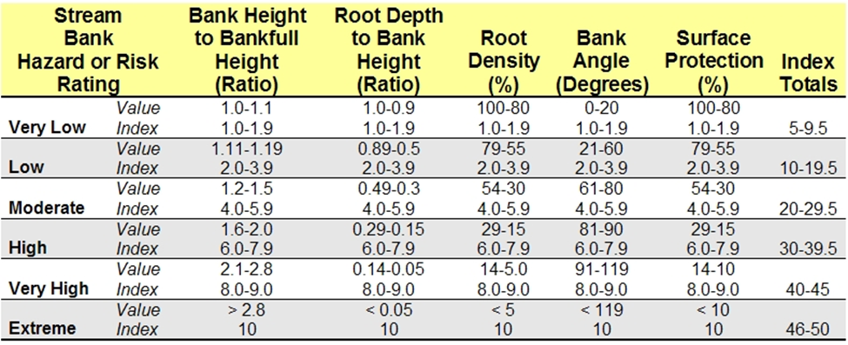

The BEHI has also been used to estimate annual sediment loads from streambank erosion in a study done by Van Eps (2004). A total of 36 miles was surveyed on both foot and canoe with an average of three miles per day. There were 192 total sites where a bank profile assessment was performed throughout the West Fork White River watershed. Within the 36 miles there were also 8 reaches that had erosion toe pins installed and surveyed for various combinations of BEHI and NBSS (Near Bank Shear Stress). These sites were surveyed twice over a one year period to determine annual lateral erosion rates. Models were made and proven comparable to other methods of sediment load calculation. Due to the non-continuous streambank erosion measurements, extrapolation was used to fill in the blanks between survey sites.
Creech (2011) differentiated, and then combined the concepts of erodibility x erosivity to produce and overall streambank erosion measurement. Additionally, bank material such as sand and stratification of bank material are considered into the overall erodibility score. Erosivity is the driving force of water dealing with hydraulics and the function of Near Bank Shear Stress (NBSS). The seven different properties then measured to determine NBSS are 1) channel patterns, 2) ratio of curvature to bankfull width, 3) ratio of pool slope to average water surface slope, 4) ratio of pool slope to riffle slope, 5) ratio of near-bank maximum depth to bankfull mean depth, 6) ratio of near-bank shear stress to bankfull shear stress, and 7) Velocity profiles / Isovels / Velocity gradient (Creech, 2011). The final step involves erosion pins and bank profile measurements. All this information combined then displays regional curves for very low, to extreme BEHI values which are then used to measure sediment rates, prioritize restoration and supplement other ongoing projects.
There are 13 indicators identified for the stability assessment method used by the United States Department of Transportation (USDOT). Henderson (2006) discusses the overlapping parameters of habitat assessment and erosion indices. Each of the 13 parameters used in this index are equally weighted due to previous test results to see if different weights would actually have an impact. Parameters included watershed characteristics, flow habit, channel pattern, entrenchment, bed material, bar development, obstructions, bank material, bank slope, vegetative protection, bank cutting, mass wasting, and upstream distance to bridge. Assessing stream channel stability at bridges and culverts was the main point for the assessment.
The Genesee/Finger Lakes Regional Planning Council (1998) developed a method to determine streambank erosion potential using four different parameters. Erosion Potential Index Number (EPIN) was the sum of the scores of bottom material value (rock, gravel, or soil bottom), side slope condition value (stable, moderate erosion, eroded), vegetative condition value (good, moderate, or poor), and (average velocity x River Miles). In less than one year, 221 different sites were assessed with great results showing which streams had a higher erosion potential. Although non-continuous, it was evident that having less parameters and covering a greater distance had its advantage in large scale mapping projects.
A Streambank Erosion Inventory (SEI) was developed by the Michigan Department of Environmental Quality (2001) and focused on inventorying new erosion sites and assessing the stabilization work that had been completed on erosion sites previously. During each site visit information was collected relevant to site accessibility, condition of the bank, percent of vegetative cover, apparent cause of the erosion, bank slope, length and height, river conditions, soil types, and recommended treatments. Viewing a system in its larger-scale (landscape) context helps managers to define key variables and constraints that shape site-scale problems (Seelbach, 1997).
The Wisconsin Division of Natural Resources (2010) uses the Bank Erosion Potential Index (BEPI). Bank materials, bank height / bankfull height, bank slope, stratification, vegetation, and location of thalweg are the individual parameters that make up the index. Noted on the index is “The BEPI Worksheet is adapted from Rosgen, David L.”
Not shown in Table 1 is the Bank Stability and Toe Erosion Model (BSTEM), developed by Simon et al. (2003). This assessment predicts streambank retreat due to both fluvial erosion and geotechnical failure. This method is the most in-depth and complex method of computing erosion potential being used today. As a result, training and data collection to use BSTEM appropriately is higher in both cost and time compared to other methods. Parameters assessed are geometry, top of bank toe, bank layer thickness, flow parameters, bank material, and hydraulic data are all needed to run the program. The Factor of Safety outputs are failure width, failure volume, sediment loading and constituent load. Information output from BSTEM is very valuable but comes with a price of intensive field work and data entry.
Disadvantages of traditional erosion assessments include time intensive field surveys by biologists trained in habitat identification, and the uncertainty of extrapolating data to represent an entire riverine ecosystem (McConkey, 2009). In summary, similarities between the majority of erosion surveys are the high costs, and the limited length of stream actually sampled. Randomly selected reaches, often limited by accessibility, are assumed to represent the stream as a whole with data then being extrapolated. An advantage of indices is the countless available assessments with each one catering to each state or organization’s needs. New indices can be made by anyone as well but should go through a process of validation to be relevant.

2.3 Habitat Assessment
Indicators for quantifying and estimating potential erosion can also be found within the many available stream habitat assessments. Numerous water chemistry, instream features, and riparian factors all combine together give an overall habitat assessment score. Numerous indices are currently available that quantify the many different combinations of factors into a comparative index, for which there is no standard method. To say that one assessment is always better than the rest would be impossible to prove.
The Qualitative Habitat Evaluation Index (QHEI) developed by Rankin (1989) is an overall stream health indicator. The QHEI is an intensive and time consuming method that takes the entire stream into consideration. Substrate, in stream cover, channel morphology, riparian/erosion, pool/riffle, and gradient, are all scored and given a QHEI number. No chemical measurements are made and the scores are weighted so that substrate, instream cover, and morphology account for 60% of the total score. Riparian zone and bank erosion however only account for 10% of the total score. The remaining 30% account for pool, riffle, and run quality within the reach.
Barbour (1999) developed the Rapid Bioassessment Protocol (RBP) with the EPA. The RBP integrates several biological population measurements, along with functional habitat parameters. Sampling reaches are divided into high gradient or low gradient streams, while physical habitat assessment parameters are adjusted accordingly. All parameters are evaluated and rated on a numerical scale of 0 to 20, with higher values indicating better habitat. The ratings are then totaled and compared to reference reach scores to provide a final habitat ranking. The ten parameters measured are epifaunal substrate/available cover, embeddedness, velocity/depth combinations, sediment deposition, channel flow status, channel alteration, frequency of riffles and/or frequency of bends (sinuosity), bank stability, bank vegetative protection, and riparian vegetative zone width. The actual habitat assessment process involves rating these 10 parameters as optimal, suboptimal, marginal or poor (Barbour, 1999).
The Stream Visual Assessment Protocol (SVAP) is an introductory level, assessment method for people who are unfamiliar with stream assessments. The protocol was developed as a tool to qualitatively characterize stream ecological conditions and to help facilitate the work of NRCS (2003) personnel who work with riparian landowners. Participation by the landowner in making assessments is encouraged. By participating, the landowner learns about stream processes, signs of impairment, and effects of land use activities on ecological health and integrity. The parameters used in the SVAP include channel condition, hydrologic alteration, riparian zone, bank stability, water appearance, and several other factors using a numeric value, quantitatively describing the rating from poor to excellent.
The Rapid Geomorphic Assessment (RGA), developed by Simon (2006) while working for the National Sedimentation Laboratory, evaluates stream stability by assessing primary bed material, degree of channel incision, degree of channel constriction, Simon's Channel Evolution Model, and several other factors. Each of these assessment protocols utilizes a series of questions that asks the investigator to determine the level of function of various habitat parameters by selecting from a series of possible answers (Simon, 2006). The parameters within the habitat assessment indices that relate to streambank erosion are vegetative protection, riparian protection zone, bank stability, and erosion.
The Maryland Department of Natural Resources (2003) developed the Stream Corridor Assessment Survey (SCA), a very in-depth and well explained habitat assessment that has been adopted by several other states and organizations as a standard. Instream cover, embeddedness, channel alteration, sediment deposition, velocity and depth combinations, channel flow status, bank vegetative protection, condition of banks, and riparian width are the habitat parameters used in this 68 page manual. Accurate illustrations on maps were emphasized as well as properly labeling to ensure easy locating in the future.
By far the most in depth habitat sampling protocol is the PACFISH/INFISH Biological Opinion (PIBO) used by the Fish and Aquatic Ecology Unit of the USDA Forest Service. Within each reach surveyed, there are 20 transects that have two different indices applied. First the stream channel attributes listed in Table 1 are measured, but also including water chemistry and macro invertebrates. Then an extremely detailed vegetation parameters index is applied to the riparian area. One of the objectives of PIBO is to determine if specific Designated Management Area practices related to livestock grazing are maintaining or restoring riparian vegetation structure and function.

2.4 Video Mapping Research
A significant step in the field of habitat assessment is the ability to rapidly map landscape scale areas with GPS and video imagery. Using a sit-on-top kayak outfitted with above and underwater video cameras, depth sonar, and GPS, every second of video was fixed to a GPS location. Fiscor (2005) mapped the optimum habitat for five endangered mussel species using the canoe based UVMS (Underwater Video Mapping System) in the Big South Fork River (TN). Physical bedform features were first georeferenced and then queried within ArcGIS for habitat suitability. Each mussel species was assigned specific habitat suitability scores ranging from optimal, suboptimal, marginal, and not-suitable which were based on pool-riffle-run, substrate, embeddedness, and water depth. A previous inventory of Big South Fork endangered mussels habitats (Bakaletz, 1991) was compared to the predicted areas using the habitat suitability model. A total of nine mussel sites, suitable for the five endangered species, were mapped within three river reaches of this study. The UVMS method indicated optimal, suboptimal, or marginal, mussel habitat in the vicinity of eight out of nine areas (Fiscor, 2005). Fiscor was able to map over 27 km of stream in less than 11 hours, on three different trips.
Rogers (2008) created a kayak-based UVMS map of Abrams Creek in the Great Smokey Mountains National Park (TN). Results were compared to traditional techniques, as well as a control method, where all particles within a randomly placed plastic frame were counted and measured. All three methods of UVMS data collection (thalweg, proportional, and zig-zag) were statistically compared for consistency to the frame method. Conclusions indicated that there were no statistically significant differences between measurements of particle size, diameter size class, and percent distribution among the UVMS method, pebble count method, and a control (PVC frame placed underwater) at α=0.15 (Rogers, 2008). Advantages of the UVMS method include less field time, minimal streambed disturbance, convenience of post-field processing, and capacity to obtain digitally stored data that can be geo-referenced for use in GIS (Rogers, 2008).
Candlish (2010) documented additional mussel and fish habitat that were under the Threatened and Endangered list with the kayak based, UVMS system on 47 miles of river at the Obed Wild and Scenic River (TN). Extensive analysis was performed to identify the most suitable habitat for each fish species and then queried in ArcGIS to show the optimum habitat within the Obed River. Large amounts of habitat were found for the threatened and endangered fish species, with mussel habitat being both limited, and far apart. The Under Water Video Mapping System (UVMS) has mapped over 200 miles and proved valuable in identifying ecologically valuable areas to locate both fish and mussel species (Candlish, 2010).
Creating river habitat maps with geo-referenced video is an emerging concept that shows great promise for a variety of reasons. Large, landscape-scale maps have been created and have attributed greatly to watershed management and monitoring. Attributes such as depth, and PRR (pool, riffle, and run) are assigned to each GPS point and habitat maps are made within ArcGIS. Information from this can be used for threatened and endangered species potential location or re-introduction. McConkey (2009) assessed over 80 miles of the Big South Fork in one summer which would have taken years to do through any other type of habitat assessment.

2.5 Summary of Literature
Streambank erosion and habitat assessment methodologies have been criticized that identical approaches commonly yield different results within the same section of stream, increasing the variation among data (Roper et al., 2002). Other critiques indicate that there are inconsistencies in the proper protocol, lack of consistent training in this scientific niche, and difficulties in using stream attributes to detect change caused by management activity or human induced stream impacts (Candlish, 2009). Previous research has identified bank angle, bank height, surface protection, riparian diversity, and velocity as being important in determining potential streambank erosion. Traditional erosion surveying techniques that require physical measurements have been shown to be time consuming, costly, and very intrusive to the aquatic environment. Erosion indices have been developed and are widely accepted for predicting erosion. The disadvantage comes in time and money spent gathering the information, as well as the amount of stream bank that can be surveyed.
An appropriate technique is needed to assess larger distances of streambank, in a shorter amount of time, and at an affordable cost. Satellite based and aerial photos are able to cover large areas, however do not provide sufficient enough detail for streambank erosion assessment The field of using GPS based video mapping for landscape scale maps is proving to be beneficial and growing. Based on literature, an opportunity exists to document large sections of streambank, and assess erosion susceptibility. Foster (2010) stated that in selecting individual monitoring sites on each tributary, accessibility was a key factor. The studied streams are wadable and monitored banks are located in close proximity to roads (Foster, 2010). In most cases, the studied banks were chosen to be representative of banks on the tributaries and streambank erosion appeared typical for the watershed (Harden et al., 2009).
With the Underwater Video Mapping System, accessibility was only an issue at put in and take out. By floating down the river, there was no trespassing, no riparian or substrate disturbance and no need for a representative reach because the whole river was just mapped. If something was missed during the survey, a digital video record was available for verification.

Chapter 3: Justification and Objectives

3.1 Project Justification
With sediment being the primary stream pollutant in US Rivers (USEPA, 2009), determining the areas of river where erosion is the highest should provide valuable information for watershed management and restoration. Methods of streambank monitoring have been improving in terms of accuracy and effectiveness when measuring the health of stream banks. There are numerous methods being used to predict and document streambank erosion, with each focusing on several different combinations of parameters. There is however, a need to combine these proven parameters for an overall erosion susceptibility value. As improvements in methods continue, a few important factors seem to remain as limitations.
Determining the length of streambank to assess in order to get a representative sample, and the validity of a representative sample in itself, is an issue. The ability to re-assess the same site, by other evaluators at a later time, as well as the need for a year by year archive also seems to have been ignored. The final, ignored aspect of current streambank assessments is the impact of the survey method itself, and the detrimental effects towards river mechanics, chemistry, biology, and habitat. Time and funding will always be an influence and may also be the reason for many of the isolated, non-continuous river assessments done in the past. There is a great need for watershed scale, erosion susceptibility mapping techniques. With the amount of financial investment on river restoration and storm flow retention, there needs to be a better way to document progress on a large scale.
With the Under Water Mapping System (UVMS) already proven useful in large-scale river habitat mapping throughout Tennessee, preliminary shoreline mapping on Lake Loudon has displayed even more promise in video mapping technology (Connell, 2011). Video was assessed and each second of shoreline was given an erosion susceptibility score out of 100 points. Rapid identification and location of high erosion areas on Lake Loudon became obvious and are a main driving force for applying the technique for streambank erosion mapping.

3.2 Project Objectives
The objective of this study was to develop a modified Bank Erosion Hazard Index to apply the UVMS technique and map landscape scale, streambank erosion susceptibility. Specific objectives include,
1) creation of a suitable index based on already proven parameters for predicting streambank erosion through the assessment of video,
2) development of Streambank Video Mapping System (SVMS) equipment to focus on measuring georeferenced streambank erosion indicators,
3) characterization of large scale reaches and identification of highly erosive areas to target restoration and/or more in-depth documentation through the use of ArcGIS, and
4) validation of both the field measurements and the consistency of video interpretation between viewers.

Chapter 4: Bank Erosion Susceptibility Index Development

4.1 Introduction
The Bank Erosion Susceptibility Index (BESI) method was primarily based on the Bank Erosion Hazard Index (BEHI) (Rosgen, 2001) and focuses on four attributes that can be easily seen from video. Several other erosion models and habitat assessments were evaluated and considered. The four parameters assessed by video analysis were bank angle, bank height, surface protection, and riparian diversity. More parameters and any combination thereof could be used, but for the purpose of this research four was determined to be sufficient. Water velocity and cut bank height were highly considered, but reflecting the BEHI as closely as possible seemed the most credible route.
The original six scores of the BEHI, 1.5, 3, 5, 7, 8.5, 10 relate to very low, low, moderate, high, very high, and extreme erosion susceptibility. To increase accuracy and reduce subjectivity, the number of possible scores for each BESI parameter was reduced from six to four. Low and very low were combined as well as very high and extreme in all of the parameters for consistency. The related values were then averaged to reflect the original BEHI (Rosgen, 2001) as closely as possible. Table 3 shows the BESI score sheet for bank angle, bank height, surface protection, and riparian diversity. Scores for each streambank location range from 9.8 - 36 for each side of the stream.
Table 3: Bank Erosion Susceptibility Index (BESI).

4.2 Bank Angle
Bank Angle (degrees) is a parameter that is affected by bankfull flow and measured from the waterline up to bank height. More associated with erosion indices as opposed to habitat assessments, bank angle was in six of the previously reviewed methods including the BEHI. Very high bank angles (>90°) can be seen in Figure 1 which relates to mass failure are also useful at predicting more erosion. Bank angles were grouped as, 0-60, 61-80, 81-90, and greater than 90 degrees. The corresponding scores for each angle range were 2.45, 4.95, 6.95, and 9.
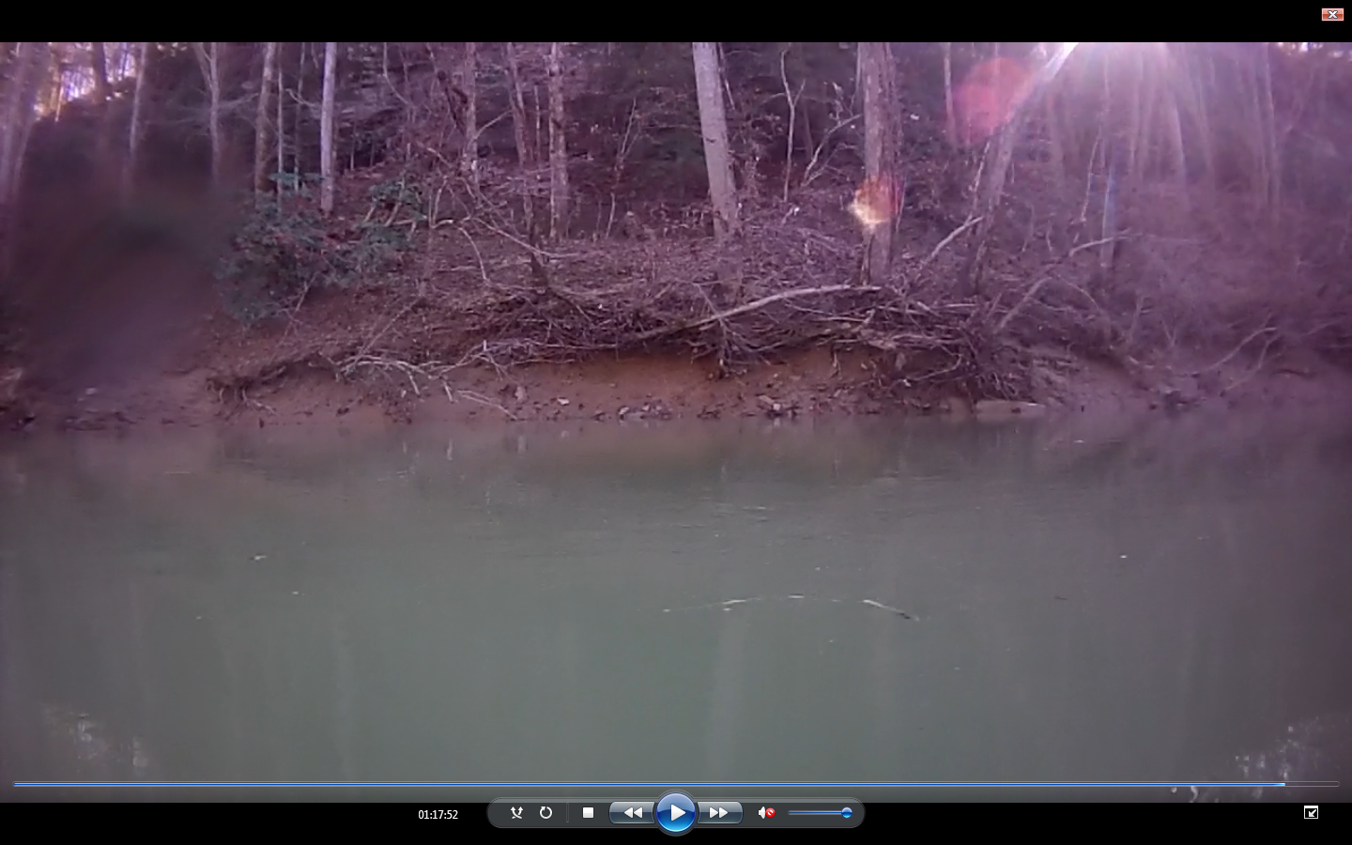
2.5 m height
Centerline
Figure 1: Photo from New River (TN) showing:
Bank Angle = 9, Bank Height = 7.5 ft, Surface Protection = 6.95, Riparian Diversity = 6.95.

4.3 Bank Height to Bankfull Height Ratio
The ratio of bank height to bankfull height was included in BESI due to the importance that was placed on it by Rosgen (2001). Bankfull height, also known as the ordinary high water mark, is illustrated in Figure 2 and was a constant height in this project throughout the entire reach. Figure 2 and Figure 3 were useful field references, but did not eliminate the subjectivity already present in determining bank height and bankfull height.
Bank height to bankfull height ratio was determined by visual assessment with the calibrated lines on the screen (Figure 1, Figure 5, and Figure 6), in addition to the depth and distance data discussed in section 5.1. Distance from the streambank enabled use of the camera calibration chart (Figure 4) to give an estimate of the actual bank height. Cut banks were the easiest to measure while this section was the most susceptible for a subjective assessment.
Focus of the measurements was from the water surface to bank height. Bank height measurements were grouped as follows, 0-1, 1-3, 3-6, 6-9, 9-12, 12-18, and >18 ft. The corresponding scores were 0.5, 2, 4.5, 7.5, 10.5, 15, and 18. After each GPS point was assigned a bank height, bankfull height, and depth, the following formula: (Bank Height + Depth / Bankfull + Depth) was used to figure the ratio value. Ratio measurements of 1.0-1.19, 1.2-1.5, 1.6-2, >2.1, had the corresponding “Ratio Value” for each bank height group of 2.45, 4.95, 6.95, and 9.

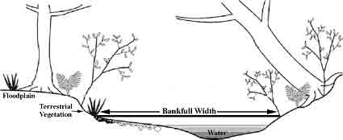
Depth

Bank Height
Bank Height
Figure 2: Cross Section Showing Bank Height, Bankfull Height, and Depth. (http://www.ohioamphibians.com/monitoring/Stream-dwelling/Site.html, assessed March 2012)

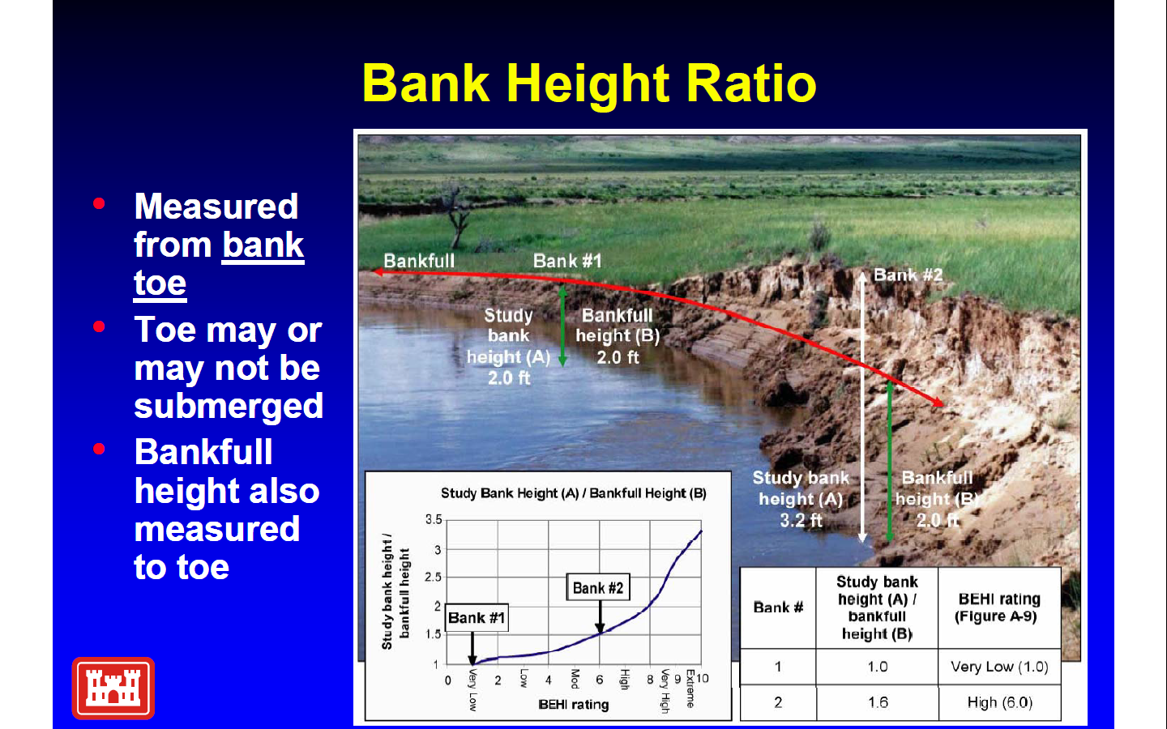
Figure 3: Detailed Picture of Bank Height to Bankfull Ratio (Creech, 2011).

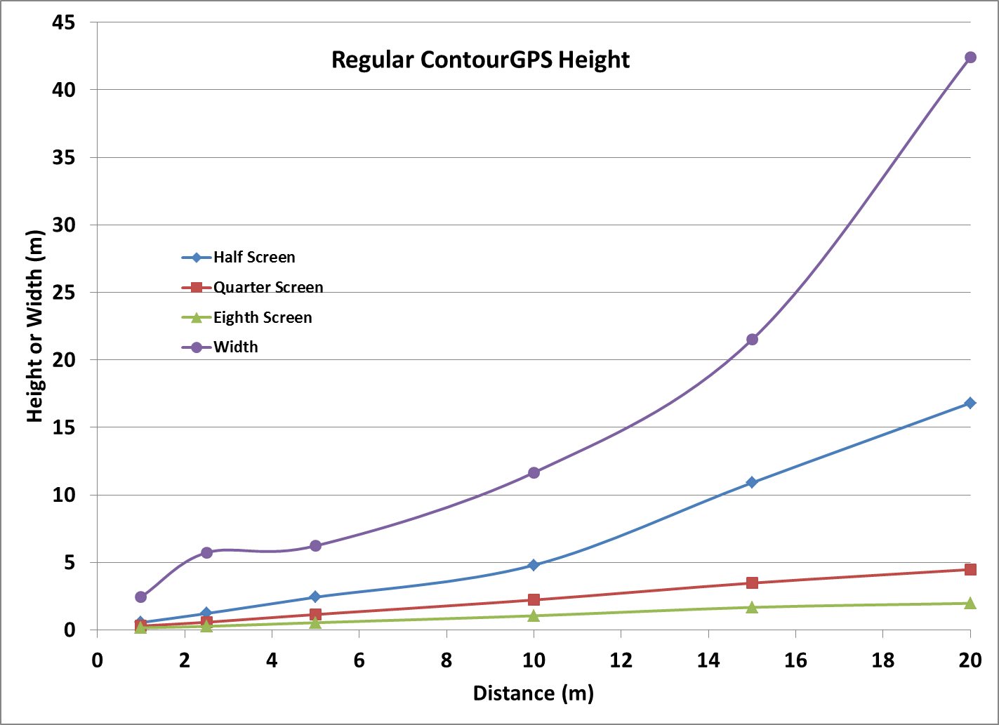
Figure 4: Camera Calibration Chart.

4.4 Surface Protection
Surface protection is a visual assessment, of the percentage of bank covered from erosive forces by grasses, rocks, roots, plants, trees both alive and dead. Figure 5 is a great example of moderate surface protection. There is plenty of exposed soil, but also a small amount of cover provided by trees, logs and roots. Of the 11 assessments displayed in Table 1, ten of them use surface protection as an indicator of erodibility. This parameter was divided into four sections while still reflecting the BEHI with the higher percentages relating to better surface protection. Ranges for surface protection are 100-56, 55-30, 29-15, <14, with the associated point scores of 2.45, 4.95, 6.95, and 9.

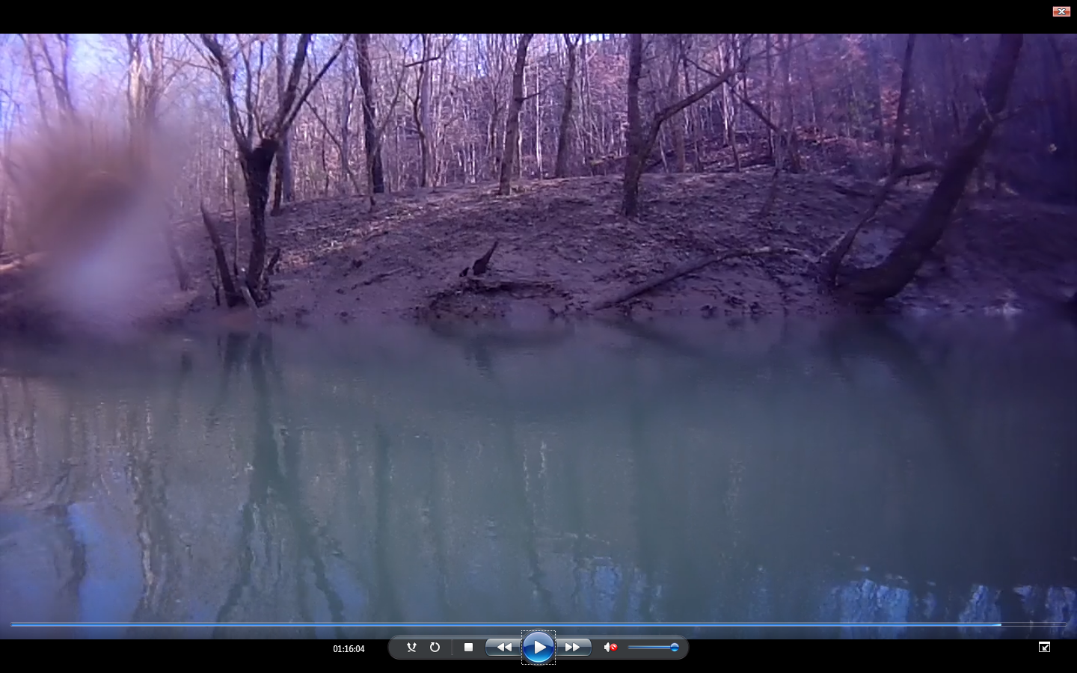
4.0 m height
Centerline
Figure 5: Photo from New River (TN) showing:
Bank Angle = 2.45, Bank Height = 10.5 ft, Surface Protection = 6.95, Riparian Diversity = 6.95.

4.5 Riparian Diversity
Root depth and root density are both part of the BEHI (Rosgen, 2001) which is impossible to detect from video. Using a substitute parameter named riparian diversity, a score was determined that reflects a similar score produced in the BEHI. Diversity, as well as riparian width, comes into play while determining the score for this parameter. Figure 6 shows several sizes of trees and brush which made this an area of optimal riparian diversity.
Optimal- Surrounding area consists of several sizes of trees, shrubs, and grasses of all sizes. High diversity indicates very high root depth and density. BESI score = 2.45.
Sub-Optimal- Surrounding area consists of less quantity and a low diversity trees with some understory and grasses. Sub-Optimal diversity indicates good root depth and density. BESI score = 4.95.
Marginal- Surrounding area consists of a few trees and no riparian width, with a few shrubs and grass. Marginal diversity indicates moderate root depth and density. BESI score = 6.95.
Poor- Surrounding area consists of short grass or bare soil. Very low diversity indicates poor root depth and density. BESI score = 9.

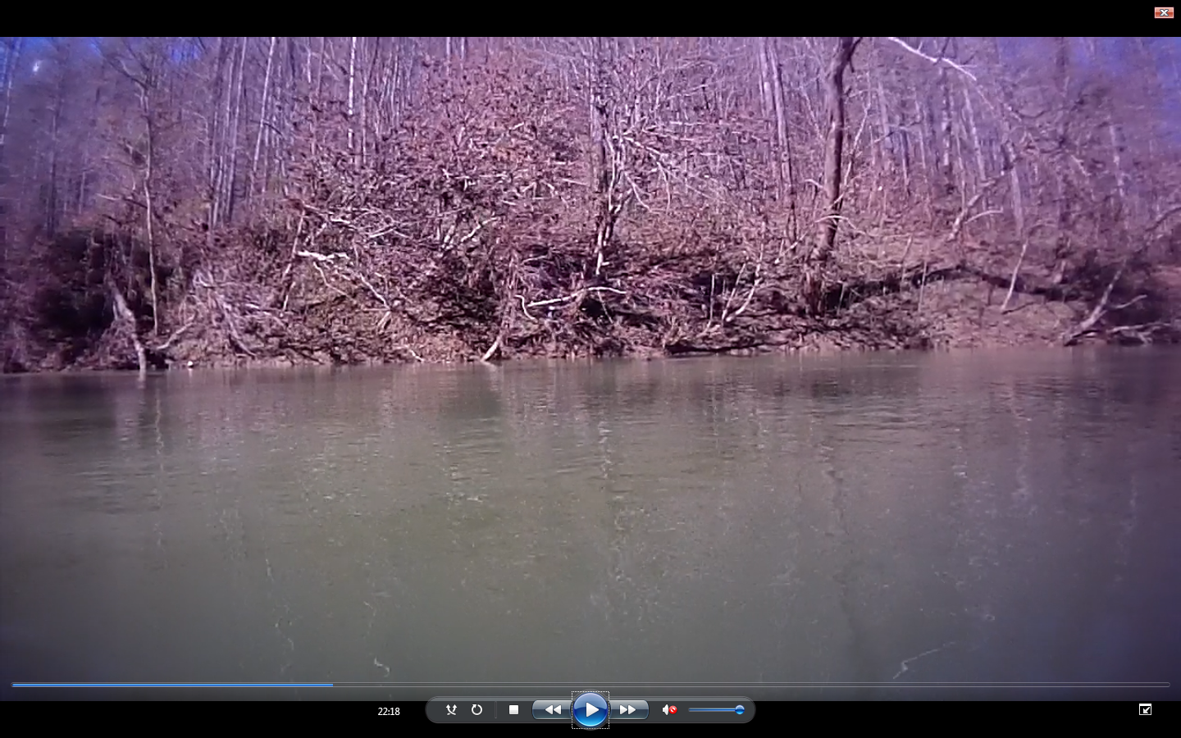
2.0 m height
Centerline
Figure 6: Photo from New River (TN) showing:
Bank Angle = 2.45, Bank Height = 4.5 ft, Surface Protection = 2.45, Riparian Diversity = 2.45.

Chapter 5: Equipment

5.1 Streambank Video Mapping System
The Streambank Video Mapping System (SVMS, Figure 7) consists of a Tarpon 100 sit-on-top kayak, up to three Contour GPS video cameras, a depth sensor, a NMEA multiplexer, two distance sensors, and a Trimble GPS unit. The Trimble 132 (1Hz) was used for sub meter GPS accuracy that was then recorded onto a flash drive along with two distance measurements and depth output data so that each point will have the associated Coordinated Universal Time (UTC) and location.

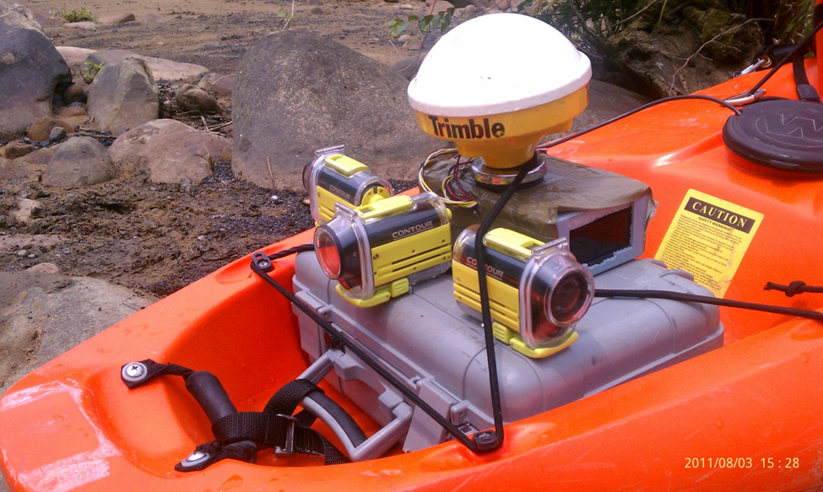
Figure 7: Streambank Video Mapping System.

The Contour GPS camera (Figure 8), uses the Neo-6 GPS module with three different video resolutions and two frame rates which can be used in any combination depending on the application (http://contour.com/products/contour-gps, accessed January, 2012). A water-proof case and a 135° wide angle lens enabled the Streambank Video Mapping System to capture continuous miles of high definition, streambank footage. The “Contour 720p” (1280 x 720 @30 fps) settings used in this project enabled us to capture up to 1 hour and 50 minutes of video before having to pull over and replace the batteries. For every 30 minutes of video, 2 GB of memory was used on a micro SD card. Depending on the length of stream being sampled, up to a 32 GB micro SD card could be used to increase storage capacity for a higher video quality and frame rate. A built-in omni-directional microphone could also be utilized if verbal field notes need to be taken when pen and paper are not available.

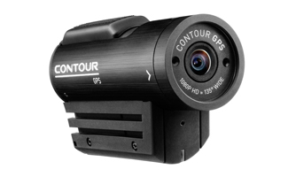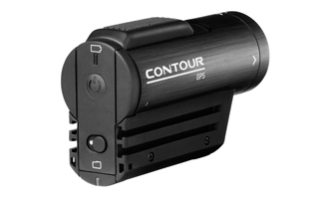
Figure 8: Contour GPS Video Camera (http://contour.com/products/contour-gps, accessed January, 2012).

The CruzPro ATU120ST (Figure 9) shallow water depth sonar provided 3 mm resolution between bottom of stream and bottom of kayak (http://www.cruzpro.co.nz/active.html, accessed on January 2012). Additionally, this sonar transducer was calibrated specifically for this research, set to read a range of depth from 15 cm – 13 m (Candlish, 2010). The depth sensor provided a 1 Hz output that coincided with the Trimble output rate and presented its depth readings in NMEA 0183 data string format. Data sentences were then imported through the NMEA multiplexer (Figure 10) in the following $SDDBT structure: $SDDBT, 00.00, f, 00.00, M, 00.00, F*CS. The number before ‘f’ gave depths in feet, while ‘M’ stands for meters.
The two distance sensors being used were the Opti-logic RS-100 (Figure 11) running at 10 Hz with a range of 100 yds. Width readings were exported with the same GPS location in the following $DDIST structure: $DDIST 1, 2.24,M. The number “1” stands for sensor #1 (of 2) while the only distance units are measured in meters. With 10 distance measurements being exported per second, a pivot table was used in excel to take an average and give one value per GPS point.

Figure 9: The Hull Mountable Depth Sonar. Cruzpro Model ATU120ST (http://www.cruzpro.co.nz/active.html, accessed on January 2012).
Figure 10: The NMEA 0183 multiplexer used to combine the two distance sensors, depth data and GPS data into a single data string (http://nolandeng.com/nm42.php, accessed January 2012).

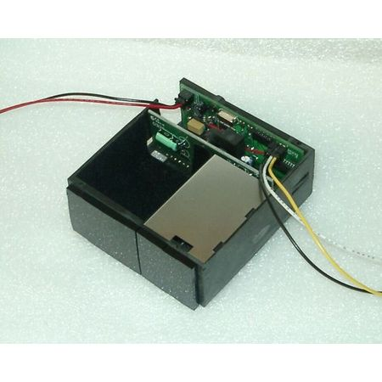
Figure 11: Opti-logic RS-100 (http://www.opti-logic.com/industrial_rangefinders.htm, accessed January 2012).

Chapter 6: Study Areas

6.1 New River
The New River (Figure 12) which flows into the Big South Fork National Forest (BISO) was first kayaked on July 27, 2011 with the Streambank Video Mapping System (SVMS). This first survey was the “leaf on” survey, which was later compared to the “leaf off” survey, to help determine the optimum time to document the streambank. With a flow of approximately 500 cubic feet per second (14.1 m³/s), SVMS equipped kayaks were put in at the River Road Bridge (36.38926 deg. N, 84.48787 deg. W) directly South of Huntsville, TN, (Figure 14) and surveyed a mostly flat water section of the New River. Approximately 7.7 kilometers of each streambank was documented until the Low Gap Road Bridge (36.38429 deg. N, -84.52813 deg. W) just before the park boundary. Video was captured and matched with corresponding GPS, width and depth data. The “leaf off” survey took place on December 3, 2011 with a flow of approximately 900 cubic feet per second (25.5 m³/s) where 1 hour and 20 minutes of video was captured. The same section was documented with the SVMS and will serve as a comparison while applying the four parameters of BESI.

6.2 Beaver Creek
Beaver Creek (Figure 12), located 15 miles outside of Knoxville, TN was assessed with the SVMS on September 8, 2011. Beaver Creek was a tributary of the Clinch River and drains a watershed area of 224 square km (86.5 square miles) between Copper Ridge and Black Oak Ridge. Flows were approximately 500 cfs (14.1 m³/s) which was higher than preferred, but still possible due to only needing video of the streambank. Kayaks were put in at the Solway Bridge (35.96475 deg. N, 84.17852 deg. W) and then documented 7.6 kilometers of streambank (Figure 19) until paddling into the flat water of Melton Hill Reservoir. The total time of video recorded was 1 hour and 5 minutes. Leaf off comparison was not necessary due to close proximity and high quality footage of the streambank survey.

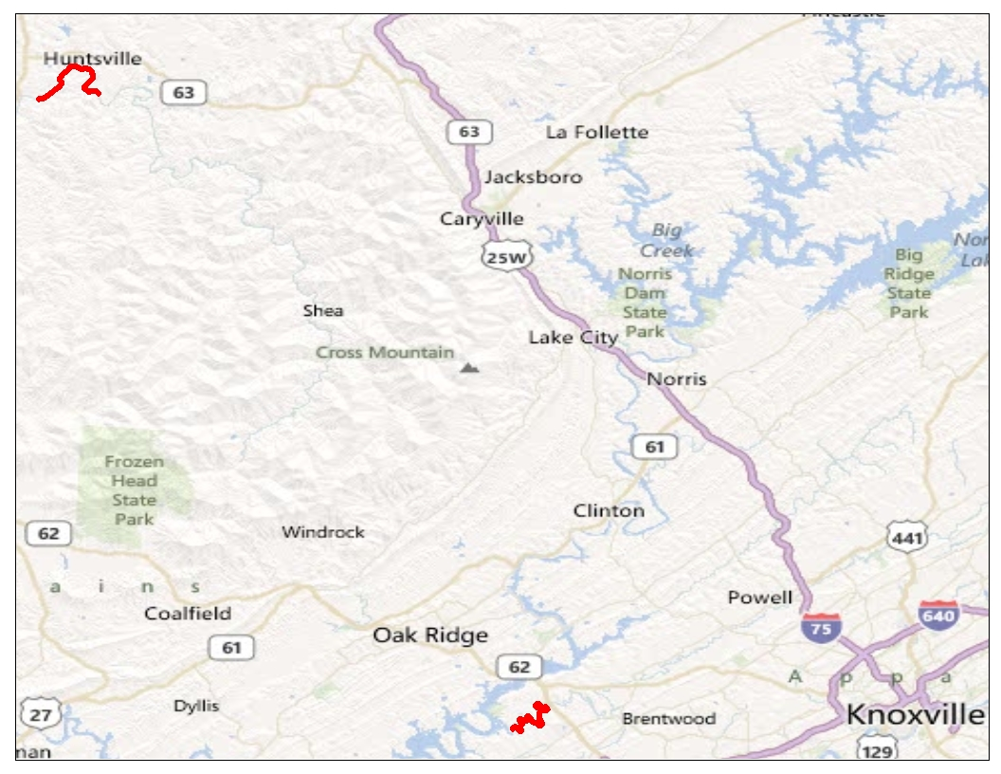
Beaver Creek Site
New River Site
Figure 12: Map showing both the New River and Beaver Creek in east Tennessee

Chapter 7: Results

The Bank Erosion Susceptibility Index (BESI) was applied to the video captured while using the Streambank Video Mapping system (SVMS) on the New River and Beaver Creek. Planning kayak trips involved using the USGS 03408500 NEW RIVER AT NEW RIVER, TN gage page (http://waterdata.usgs.gov/usa/nwis/uv?03408500) to check flows for safety and desired flow rates. The extremely varying rates of flow are displayed in Figure 13 with the greatest peak happening just days before the “leaf off” survey. Hours of planning, resources and driving would have been wasted had flows not have been monitored.

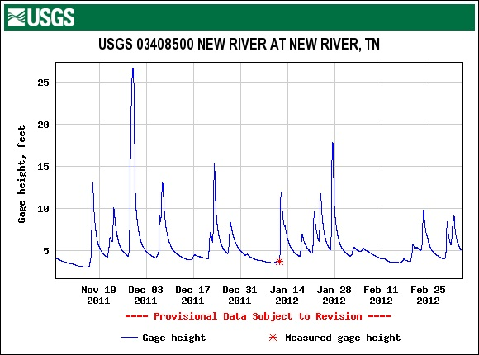
Figure 13: USGS Gage for New River (TN).

After successful surveys, the video was assessed using methods described in Chapter Four. Assessing bank angle, bank height, surface protection, and riparian diversity, one parameter at a time, proved most accurate with the fast forward button being used often. Small anomalies (less than 5 sec.) were ignored considering the purpose of this research. BESI score sheets were filled out with the table summed BESI results then being loaded into ArcGIS (2011). The BEHI (Rosgen, 2001) has six levels of streambank hazard rating of very low, low, moderate, high, very high, and extreme associated with an index range of 5-50. BEHI values were modified proportionally to BESI values with 4 ratings of low, moderate, high, and very high, at intervals of 18.5, 24.4, and 30.2, and a range of 9.8-36 (Table 4). Again, BEHI very low and low categories combined for a BESI low rating, and BEHI high and very high categories combined for an extreme rating. Areas of high erosion susceptibility are made obvious while using thematic mapping within ArcGIS. Appendix A has 16 maps thematically mapping each of the four BESI parameters for each side of the river.

Table 4: Bank Erosion Susceptibility Index (BESI) Rating Guide.
Erosion Susceptibility Rating | BESI Score
Low | < 18.5
Moderate | 18.5 – 24.4
High | 24.5 – 30.2
Very High | 30.1 – 36

7.1 New River
BESI scores did not reach a very high rating for New River and had a high score of 25. Figure 14 has an arrow pointing to the beginning of a high erosion susceptibility reach which encompasses the high 25 score. Total distance of shoreline that was rated high was 136 meters (Figure 16). Results showed 78% (Figure 17) of the new river received a rating of low and 21% at moderate. This left 1% at high which would be good locations to further investigate for possible restoration. Patterns that relate to shape of the river and areas of high erosion susceptibility are not noticeable. Average BESI score for the entire reach was 15.25, giving it a low erosion susceptibility score. Figure 18 is thematically mapped with BESI scores of both the left and right streambank scores combined further showing that the second half of New River is at a higher rating of erosion susceptibility.
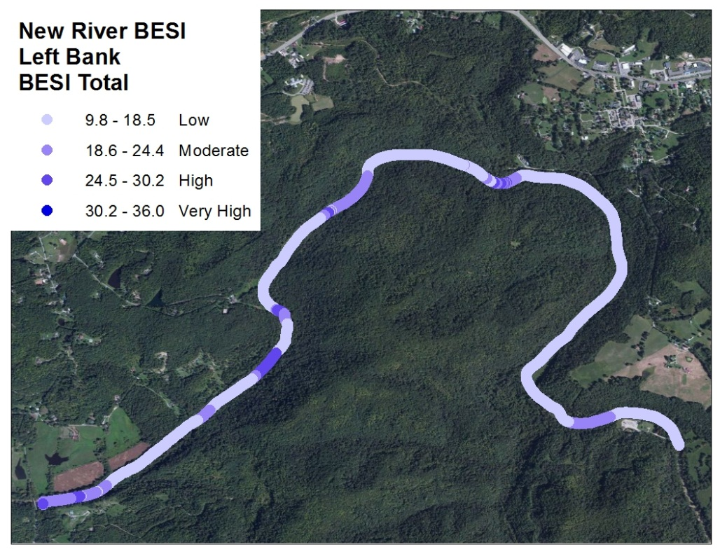
Flow
Huntsville, TN
36.38429 deg. N, 84.52813 deg. W
36.38926 deg. N 84.48787 deg. W
Figure 14: New River Left Bank Erosion Susceptibility Index Score surveyed December 3, 2011.

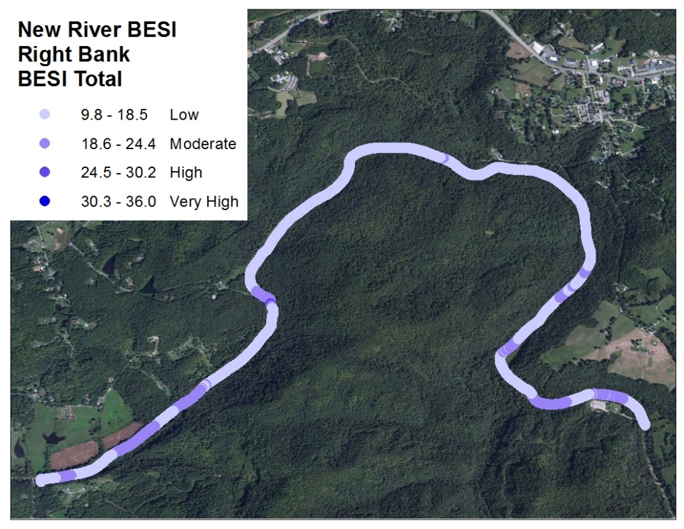
Flow
Figure 15: New River Right Bank Erosion Susceptibility Index Score surveyed December 3, 2011.

Figure 16: Comparison of New River Left and Right Bank by Distance and Rating.

Figure 17: New River Percentages and Distance.

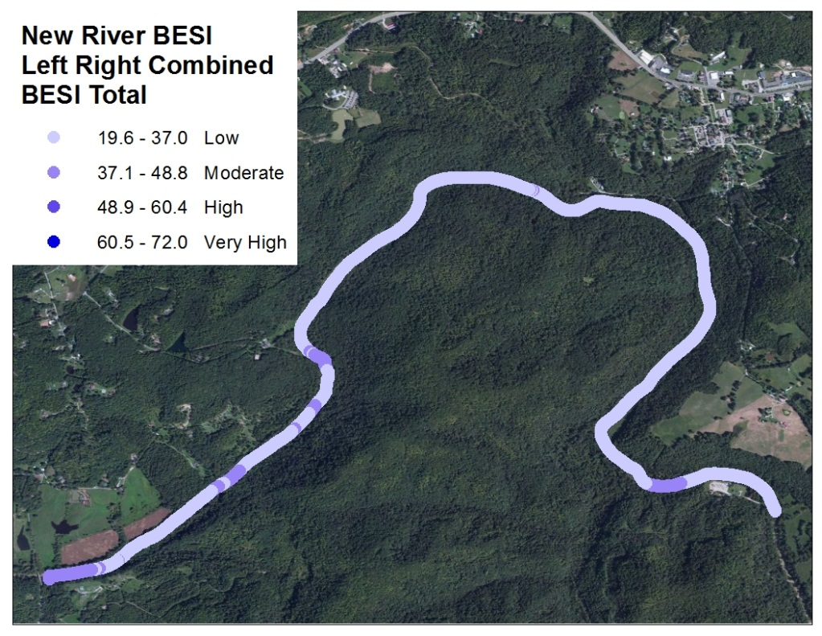
Flow
Figure 18: New River Left and Right Bank Combined Bank Erosion Susceptibility Index Score surveyed December 3, 2011.

7.2 Beaver Creek
The highest erosion susceptibility score for Beaver Creek circled in Figure 20, and shown in Figure 21, was two BESI score points away from reaching the very high category. The 1% portion rated high would be the areas in most need of attention and has a total length of 190 meters (Figure 22). With 81 % low, 18% moderate (Figure 23), and an average BESI score of 14, Beaver Creek received an overall low erosion susceptibility score. Figure 24 is thematically mapped with BESI scores of both the left and right streambank scores combined.

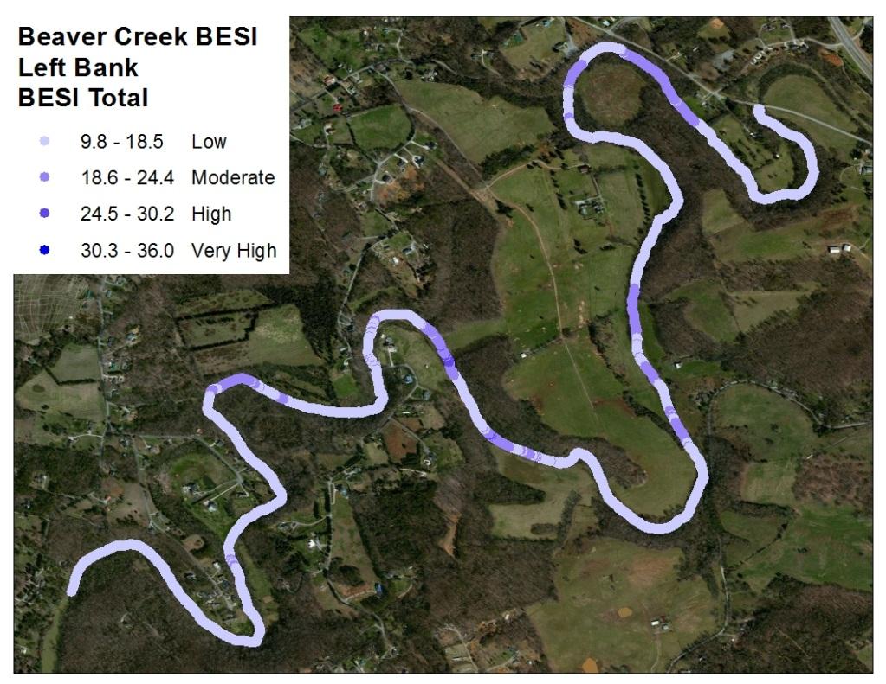
Flow
35.94912 deg. N 84.20076 deg. W
35.96475 deg. N 84.17852 deg. W
Figure 19: Beaver Creek Left Bank Erosion Susceptibility Index Score surveyed September 8, 2011.

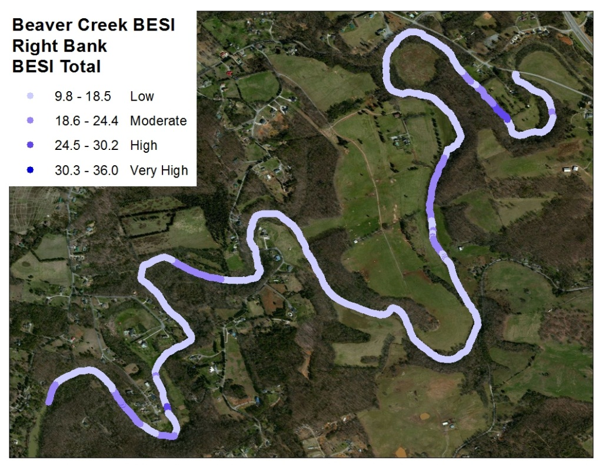
Flow
Figure 20: Beaver Creek Right Bank Erosion Susceptibility Index Score surveyed September 8, 2011. Figure 21 location inside red circle.

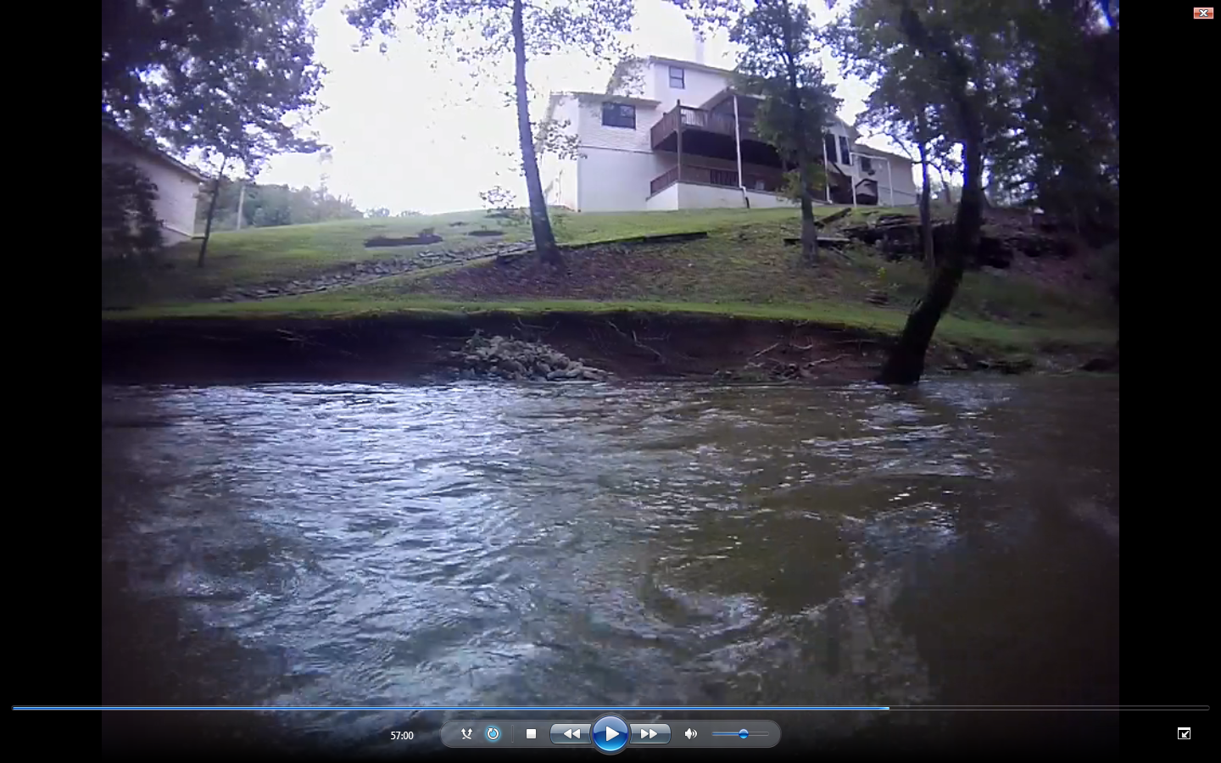
Figure 21: Beaver Creek site receiving a Bank Erosion Susceptibility Index score of 28.

Figure 22: Comparison of Beaver Creek Left and Right Bank by Distance and Bank Erosion Susceptibility Index Rating.

Figure 23: Beaver Creek Percentages and Distance of Bank Erosion Susceptibility Rating.

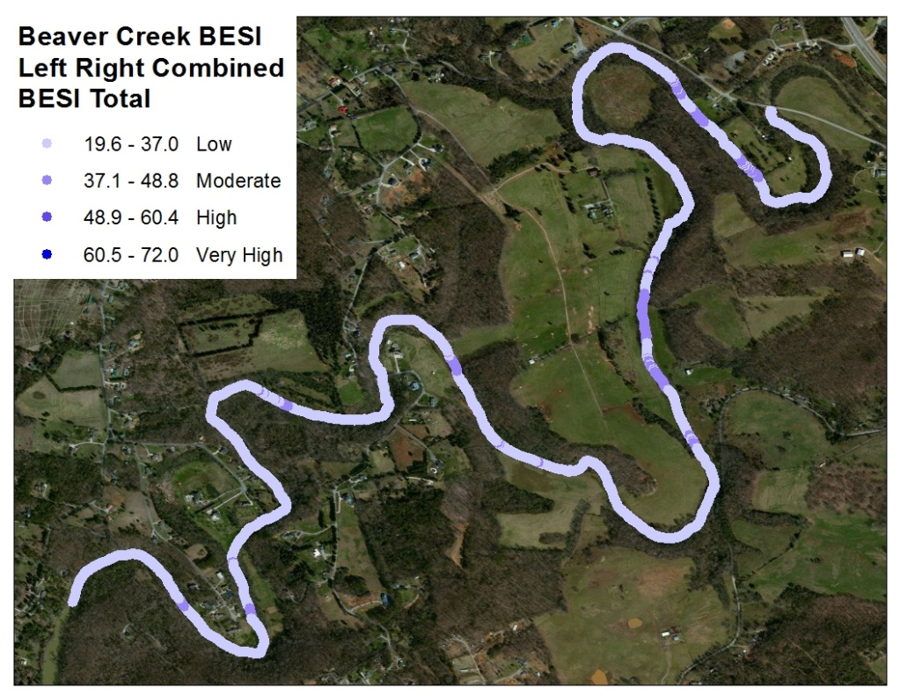
Flow
Figure 24: Beaver Creek Left and Right Bank Combined Bank Erosion Susceptibility Index Score surveyed September 8, 2011.

7.3 Reach Comparison
Using maps in ArcGIS can help prioritize the areas needing restoration and increase the cost effectiveness. By plotting the percent distance associated with both left and right BESI Scores, a river health trend line can be illustrated. This can be used to compare between rivers (Figure 25 ) as well as showing annual trends of the same river, to see if river health is improving or declining. Beaver Creek was showing higher BESI scores however having a longer distance of lower BESI scores. If funds were available for restoration, Beaver Creek shows a greater need for improvement.

Low
Moderate
High
Figure 25: New River and Beaver Creek Streambank Health Trend Line Comparison.

Chapter 8: Bank Measurement and Validation Methods

8.1 Introduction
Video interpretation and assessments made are subjective observations of the author. Assessments by even the most credible of people are limited until there is a validation process to ensure the accuracy and consistency of the results. To check for both accuracy and consistency, two different types of validation were performed. On site, physical measurements of the Bamk Erosion Susceptibility Index (BESI) parameters were compared to the author’s video assessment results to check for accuracy. For consistency, results from the five viewers were compared to each other to see the percent error between individual viewers.

8.2 Field Measurements
Field measurements of BESI took place on February 16, 2012 for the New River and February 23, 2012 for Beaver Creek. The New River was approximately 350 cfs (9.9 m³/s) and both the left and right banks of 10 completely random locations were manually measured for bank angle, bank height, surface protection, and riparian diversity. Beaver Creek was at 350 cfs (9.9 m³/s) on February 23, where both left and right banks of all 9 locations were manually measured for bank angle, bank height, surface protection, and riparian diversity.
To measure bank angle, an inclinometer (Figure 26) was used three times on each bank, with the average being used for the final validation score. Percent surface protection was scored using a measuring tape stretched from the water to bank height (Figure 27). That distance was divided by 20 to then used as the increment. Every increment received a score of either “protected” or “unprotected”, with the number of “protected” spots being multiplied by 20 for a final surface protection score. Riparian diversity was assessed by estimating the number and density of tree and plant species as well as taking the actual visible root density into consideration. Bank height was measured using a stadia rod (Figure 28), and when needed, measuring tape and a level were also used (Figure 29).

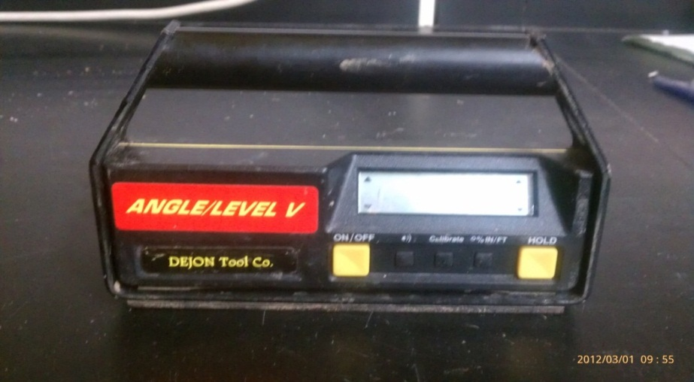
Figure 26: Inclinometer used to take bank angle measurements in the field.

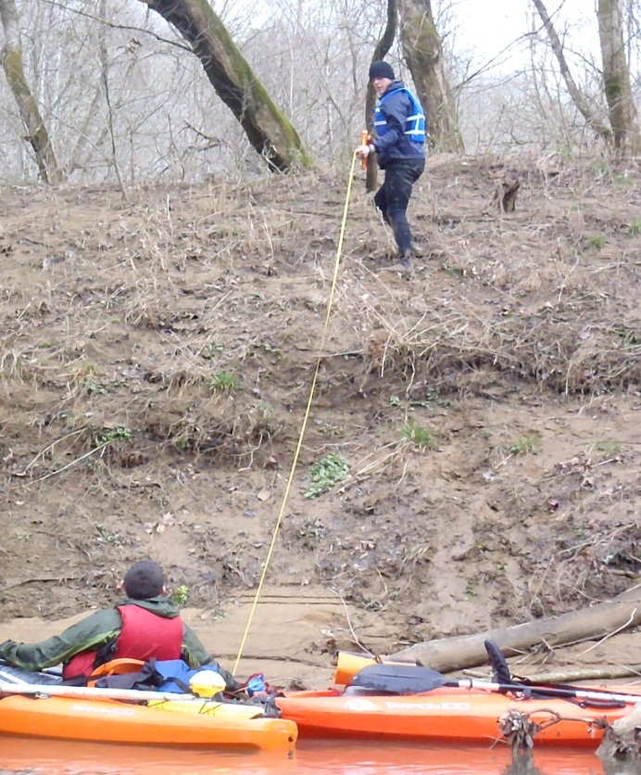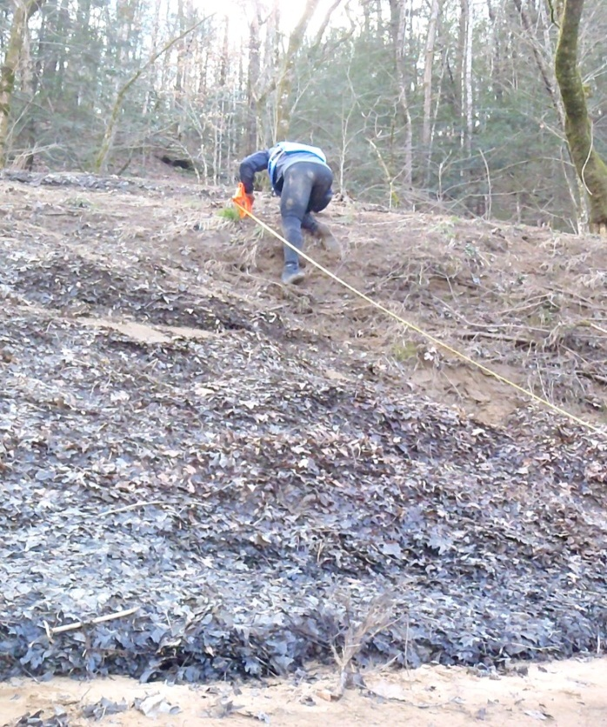
Figure 27: New River (TN) Surface Protection Field Measurements.

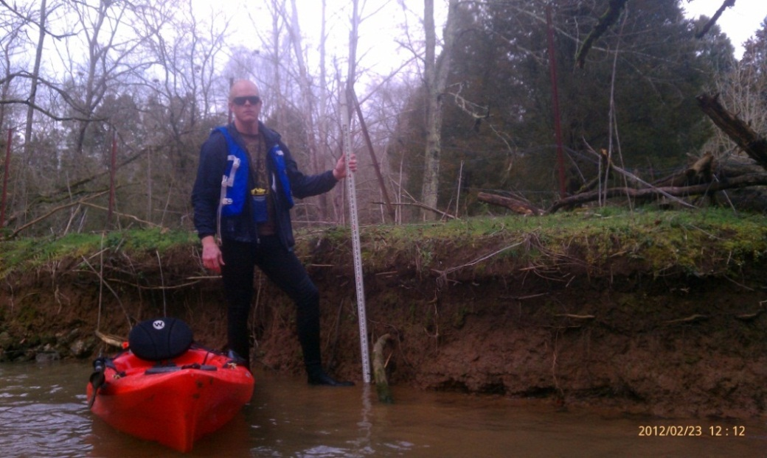
Figure 28: Beaver Creek (TN) Bank Height Field Measurement.

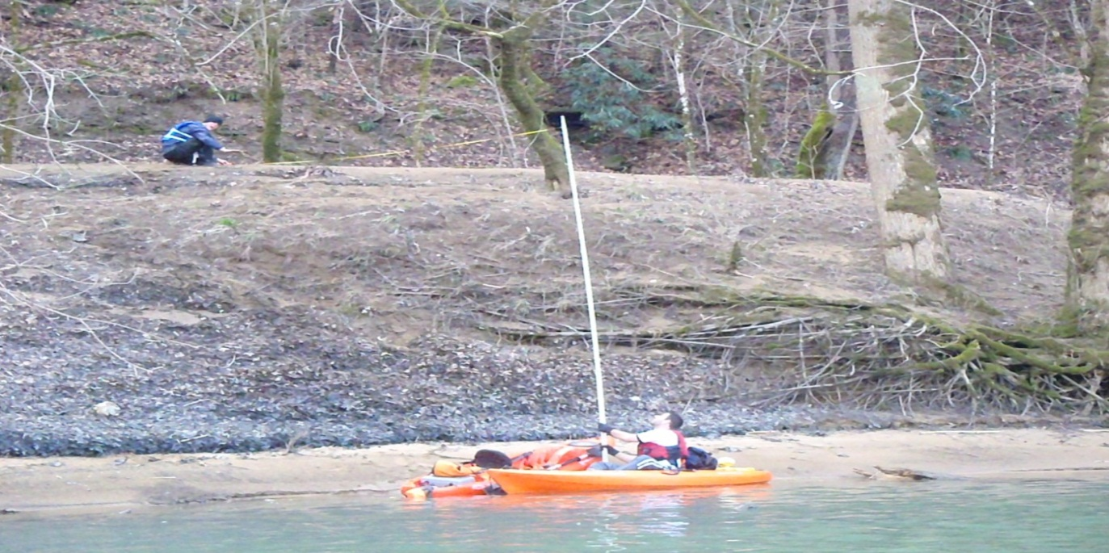
Figure 29: New River (TN) Bank Height Field Measurement.

8.3.1 New River Field Measurement Methods
Field validation was performed on New River to check for accuracy and consistency in all four parameters of BESI. New River field validation differed from Beaver Creek only in the fact that all locations, both left and right bank were completely random. All possible UTC times were loaded into a random number generator (www.random.org) which chose the 10 locations, with each side of the river (20 total) being assessed. Due to the incised profile of the New River, measurement of both surface protection (Figure 27) and bank height (Figure 29) proved time consuming. Measuring parameters on both river left and river right, at each location took approximately 25 minutes.

8.3.2 New River Field Measurement Results
Results for individual sites from both the author and field measurements are in Table 5. A strong variance in the results was New River, site #3 (Figure 30). In the field notes during validation of New River it was stated, “Random sample location is not representative of area”. This made the validation measurements much higher in BEHI values and resulted in a very high standard deviation. Depending on how precise video interpretation needs to be, viewing can take anywhere from three to six hours, per hour of video using the BESI method. Focusing on parameters that lasted more than 5 seconds of video was the standard for this project. Out of the 20 sites sampled, site #3 (Figure 31 and Figure 32) being the greatest outlier shows great value in the SVMS sampling method.

Table 5: Individual Bank Erosion Susceptibility Index Scores for All 20 Random Sites on the New River (TN).
Bank Angle (BA), Surface Protection (SP), Riparian Diversity (RD), Ratio Value (RV)

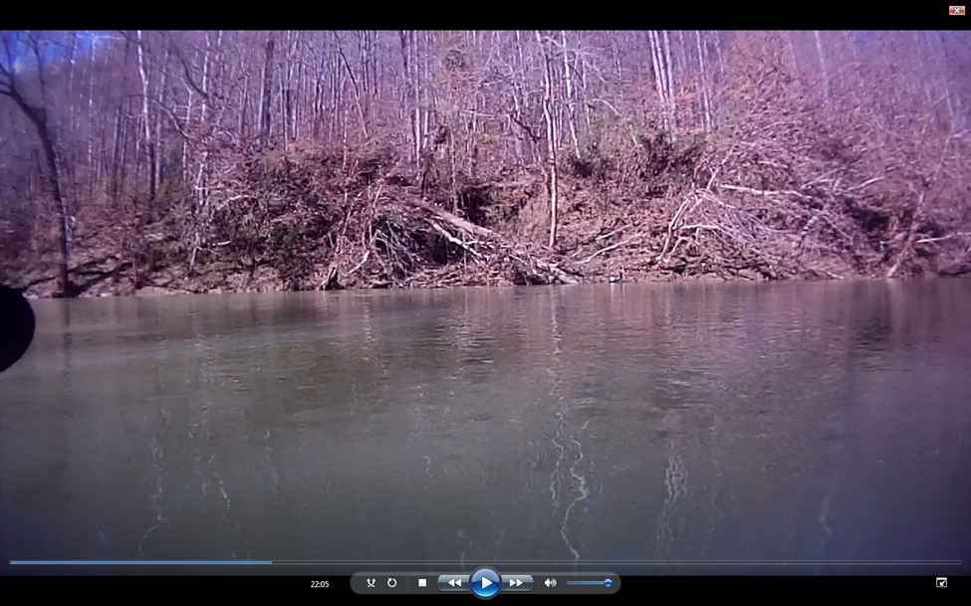
Figure 30: Beaver Creek Site # 3.

Figure 31: New River Bank Erosion Susceptibility Index Score Comparison with 1:1 Line.
Red arrow pointing out site #3.

Figure 32: Bank Erosion Susceptibility Index Score Comparison of Viewer vs. Field Measurements.
Red arrow pointing out error for site #3.

8.4.1 Beaver Creek Field Measurement Methods
Field validation was performed on Beaver Creek to check for accuracy and consistency in all four parameters of BESI. The right side video of Beaver Creek was first assessed by the author (identified as “Viewer”) with a BESI score being assigned to each GPS point. Scores were displayed and points were chosen in a stratified random method, from the graph made in excel (Figure 33). Field measurements of these nine individual control sites were performed on Beaver Creek to check for accuracy. Three different, high, medium, and low BESI score locations were located and physically measured for all the BESI parameters. Scores of the actual sites were not known during field measurements to ensure an unbiased measurement. The other side of the river at each point was also physically measured which will serve as random points. Beaver Creek had a total of 18 sampled points, nine of which were random.

Site 7
Site 6
Site 5
Site 2
Site 3
Site 8
Site 4
Site 9
Site 1
Figure 33: Beaver Creek graph used for stratified random site selection.

8.4.2 Beaver Creek Field Measurement Results
The results of the video and field measurements are shown in Table 6 for the control sites. Positive result trends exist for all three levels of the control BESI scores which can be seen. Figure 34 compares results when all three control values are averaged for the field measurements and author. Overall consistency was very high with video interpretation results being extremely comparable to the validation scores. The decision to have a control came about due to the lack of riparian diversity of New River and concern of small variability. Figure 35a displays individual values compared in a 1:1 ratio next to Figure 35b which is the averages of each rating level. Although a smaller range, results for the nine sites on left bank followed the 1:1 ratio line as well (Figure 36). On average the viewer score was lower than the actual field measurement.

Table 6: Individual Bank Erosion Susceptibility Scores for the stratified random sites on Beaver Creek (TN).
Bank Angle (BA), Surface Protection (SP), Riparian Diversity (RD), Ratio Value (RV)
.

Figure 34: Average Bank Erosion Susceptibility Index Score Comparison between Control Ratings.

a)
b)
Figure 35: Individual Field vs. Video Bank Erosion Susceptibility Index Score at Nine Control Sites (a), and High, Medium, and Low Site Averages (b).

Figure 36: Beaver Creek River Left Bank Erosion Susceptibility Index Scores.

8.5 Viewer Comparison
The final step to validate BESI scores was to check for consistency between viewers. Five people assessing the same video and all determining a different score would show inconsistency. Viewer comparison involved five different people of varying subject matter expertise, who assessed 38 individual sites from two different rivers, to compare viewer subjectivity while applying the BESI technique. The BESI viewer scoring packet (Appendix B) was given along with VTR (Video Time Recorded) times and explanation of the scoring with pictures relating to possible scores. Video interpretations were first performed by the author (viewer) and then by four others from mixed expertise (viewer avg.). Scores for the author were taken directly from the continuous assessment of both reaches while the additional viewers went to the exact time of video to make the assessment.

8.5.1 New River Viewer Comparison
Table 7 has separated each parameter by bank angle (BA), surface protection (SP), riparian diversity (RD), ratio value (RV) and total. For each parameter, actual field measurements, average values of the five viewers, percent error between those two values, and then a standard deviation between all of the five viewers is displayed. Percent error average for all 20 New River locations was -10.35 indicating that the viewer’s video assessment was on average, just below the actual field measurement. This trend is also visible in Figure 37. Overestimating bank angle was compensated by underestimating the bank height to bankfull height ratio value. Riparian diversity was the most accurately assessed parameter for New River. Average standard deviation between all 5 viewers was 1.58 or less for each individual site and 3.81 for the BESI score total. Figure 37 differs from Table 7 in that viewer average does not include the authors (viewer) score. This shows how the viewer is closer to the actual measurement but sometimes the viewer average was closer.

Table 7: New River Individual Sites with Field Measurement, Viewer Average, Percent Error, and Standard Deviation Between All Viewers.
Bank Angle (BA), Surface Protection (SP), Riparian Diversity (RD), Ratio Value (RV)

Figure 37: Average of New River Bank Erosion Susceptibility Index Scores.

8.5.2 Beaver Creek Viewer Comparison
When taking the average of all the viewers, percent error was higher for both bank angle and percent surface protection (Table 8). In most cases of high error, there was an over estimate which relates to the difficulties of visually assessing any angle, let alone bank angle. Estimates of bank angle made while in the field prior to measurement even proved to be higher than the actual. It became apparent that further training was needed to approximate bank angle from video interpretation. Riparian diversity, ratio value, and most importantly BESI total, all had comparatively low percent error. Standard deviations between the viewers were all low with the BESI total at 3.1. Considering the range of 9.8-36 with four variables, these results are satisfactory. Figure 38 displays the average of the nine random river left sites associated with the control river right. Individual graphs were made for high, medium, and low (Figure 39-Figure 41) and further enforce the accuracy of the BESI visual assessment. Figure 38- Figure 41differ from Table 8 in that viewer average does not include the authors (viewer) score.

Table 8: Beaver Creek Individual Sites with Field Measurement, Viewer Average, Percent Error, and Standard Deviation Between All Viewers.
Bank Angle (BA), Surface Protection (SP), Riparian Diversity (RD), Ratio Value (RV)

Figure 38: Average of Beaver Creek (TN) Random Scores.

Figure 39: Beaver Creek (TN) High Control Average.

Figure 40: Beaver Creek (TN) Medium Control Average.

Figure 41: Beaver Creek (TN) Low Control Average.

8.6 Discussion
The method of having control locations to increase the range of scores during validation resulted in highly acceptable results. Rather than having random samples grouped together, the broad range showed how accurate the BESI is at assessing streambank erosion susceptibility. The complete random samples on New River still came back with positive results but just with a smaller range.
When combining results from both Beaver Creek and New River for a total of 38 sites (Table 9), results are very satisfactory. Percent error was highest for bank angle (26.6) as expected but with a .96 standard deviation, meaning that viewer variability was low. Average percent error of -2.14 for BESI total was a highly acceptable showing on average the validity of the streambank video mapping system for determining the the bank erosion susceptibility index.
After performing the viewer comparison, primary viewer scores had more percent error than the other 4 viewers average. Average percent error of the author is -4.9 vs. average of the four additional at -1.46 (Table 10). Even though percent errors in this case were low, results do show that the more viewers there are, the better when trying to compensate for error. Additionally, the primary viewer was the main surveyor in the field taking the validation measurements, which have been proven in the past to have some level of variability (Roper, 2002).
A coefficient of variation of 24.5% for all viewers combined indicates that video interpretation is mostly within that amount of error of the actual field measurement (Table 10). For example, a location with a field score of 30 could have a BESI score ranging from 22.5-36. A location with a field score of 13 could have a BESI score ranging from 9.8-16.25. The smaller the BESI score, the less amount of error, also meaning that the higher the BESI score is, the more amount of possible error. These ranges are still sufficient results for identifying areas of high streambank erosion susceptibility. Table 11 has been created to show an even smaller coefficient of variation after the removal site # 3 discussed in section 8.3.2. Considering these results, video interpretation of streambank attributes proved acceptable. This research further supports Rogers (2008) findings of accurate video assessment of underwater substrate size.

Table 9: Individual Sites with Field Measurement, Viewer Average, Percent Error, and Standard Deviation between All Viewers.
Bank Angle (BA), Surface Protection (SP), Riparian Diversity (RD), Ratio Value (RV)

Table 10: Author vs. Additional Viewers to Figure Coefficient of Variation.

Table 11: Coefficient of Variation After Removal of Site 3.

Chapter 9: Conclusions

The objective of this project was to develop a Bank Erosion Susceptibility Index (BESI) to map landscape scale, streambank erosion susceptibility. Previous video mapping research used underwater technology on a customized kayak to conduct landscape-scale habitat mapping. This technology was then retrofitted to put the focus of video on the streambank and survey erosion susceptibility. This system proved its ability to acquire continuous, clear video of each streambank, which was georeferenced with both channel width and depth data, for further analysis.
Bank erosion susceptibility maps for New River and Beaver Creek were developed and validated utilizing the GPS-enhanced Streambank Video Mapping System (SVMS). The SVMS developed for this research consisted of a Tarpon 100 sit-on-top kayak, two Contour GPS video cameras, a depth sensor, a NMEA multiplexer, two distance sensors, and a Trimble GPS unit Depending on flow rates, the SVMS surveyed up to 5 km of per hour while capturing continuous, high definition streambank video and physical river characteristics. Up to 1 hour and 50 minutes of continuous video survey can be performed with the Contour camera before needing to exchange batteries.
Literature review indicated the Bank Erosion Hazard Index (BEHI) developed by Rosgen (2001) was the most commonly used, and reasonable index to emulate. Based on the BEHI, video-based database attributes were quantified into four streambank parameters for accurately locating sites of high erodibility. The four descriptors include: bank angle, bank height/bankfull ratio, surface protection, and riparian diversity. This project exhibited the SVMS as a reliable monitoring tool for acquiring georeferenced streambank video to view these attributes.
Surveys on two river reaches were conducted to apply and validate the Bank Erosion Susceptibility Index (BESI). The BESI was constructed to quantitatively delimit streambank erosion susceptibility ranges (ranging from 9.8-36) into four categories. Sequentially they are: low, moderate, high, and extreme. New River had 7.7 km of streambank mapped with 78% low, 21% moderate, and only 1% high scores of erosion susceptibility. New River had 20 random locations chosen to compare both the accuracy of the author and the consistency of four additional viewers. Beaver Creek had 7.6 km of streambank surveyed while using the SVMS. After applying the BESI to Beaver Creek, river right video, three different high, medium, and low locations were found and physically measured to compare the accuracy of video assessment. Validation showed acceptable results in each individual BESI parameter, and more importantly with the BESI total score. Beaver Creek showed 81% low, 18% moderate, and 1% high scores of erosion susceptibility.
In addition to comparing results of the author to actual field measurements, four additional people assessed the same locations in order to measure viewer variability. Results from all 38 showed an average standard deviation of 3.47 for BESI total, and less than 1.38 for the four individual parameters. BESI total, average percent error value for the author was -4.90 with the additional viewers having a -1.46 average percent error value. To characterize the measure of dispersion, an average coefficient of variation of 24.5% was found between the field measurements and video interpretation.
The SVMS and BESI served to be a valuable form of landscape-scale, erosion susceptibility mapping. Compared to traditional erosion assessments which tend be costly, inefficient, environmentally intrusive, and inaccurate due to extrapolation, the SVMS surveys more streambank, in less time, without laying a foot on any living thing or private property.

Chapter 10: Recommendations

10.1 Recommendations for SVMS Data Collection Process
Visibility of the streambank was the biggest limiting factor while on the New River during the “leaf on” survey. Ideal distance from the streambank for optimum video quality was approximately 7 m. When a survey is performed again during the lush summer months, on a river similar in size to the New River, using two kayaks would prove very beneficial. Each kayak would be positioned not in the thalweg, but as close to 7 meters distance from opposing banks, while having each kayak with only one camera and acquiring a depth closer toe depth. This method would prove beneficial even during a “leaf off” survey due to shade from optimum riparian diversity.
Kayaking through riffles would sometimes splash water onto the Contour camera. Visibility would be affected until the lens either dried off or another kayaker came to wipe the moisture off. A 12” ruler with dry cloth secured on the end could even be used by the person paddling the kayak. Rain-x is another idea that has yet to be tried out.
Referring back to Creech (2011) and the concept of erodibility and erosivity, several more measurements are possible while utilizing the SVMS. Erosivity encompasses the property of river hydraulics and function of Near Bank Shear Stress (NBSS). River radius of curvature ratio would utilize the river width sensors and turning radius (from GPS track log) resulting in a factor of erosivity. Velocity can be estimated by video assessment (pool, riffle, run) and also calculated using the width and depth sensors to figure an area of cross section then related to river flow rate. Overall slope can be determined if GPS elevation accuracies are sufficient.

10.2 Recommendations Related to Data Analysis
Additional viewers need not only more practice watching video to make assessments, but field experience as well. Subject matter experts would be the best to review video, however this may add to the final cost for larger and more complex projects. More training and guidance to make sure all possible viewers will be making accurate and consistent assessments. Sections of river greater than 10 km will require multiple people to do the video assessment in regards to time and mental fatigue of people watching the video. For any length of video, each attribute should be assessed by the same viewer from start to finish to maintain consistency.
While initially reviewing video of the “leaf on” survey, it was obvious that applying the BEHI would prove inaccurate for streambanks with significant vegetative overlays. It was decided to do an additional survey in the winter with less foliage on the streambank and more visibility. “Leaf on” scores were compared to the leaf off scores to check if BESI measurements could be determined through the thick, very shaded understory. All results showed no relationship between viewer assessment and validation. Distance from shore proved to be the biggest restraint from reliable assessments during the “leaf on” survey. Beaver Creek was a much smaller stream where floating the middle proved feasible for accurate assessments. The foliage was not a hindrance and the assessments proved to be highly accurate.
With the final score ratings giving no locations on either river a very high rating, modifying the scale may be necessary in order for very high erosion susceptibility areas to receive the appropriate rating. Beaver Creek especially, had many locations of bad agriculture practice and improper landscaping that were obvious causes of very high streambank erosion.

References

ArcGIS. (http://www.esri.com/software/arcgis/arcgis10/index.html, accessed on January 2011).
Bakaletz, S. 1991. Mussel survey of the Big South Fork River and Recreation Area. MS Thesis Cookeville, TN: Tennessee Technological University, Department of Biology.
Barbour, M.T., J. Gerritsen, B.D. Snyder, and J.B. Stribling, 1999. Rapid Bioassessment
Protocols for Use in Streams and Wadeable Rivers: Periphyton, Benthic Macroinvertebrates and Fish, Second Edition. EPA 841-B-99-002. U.S. Environmental Protection Agency. Office of Water. Washington, D.C.

Candlish, J.R. 2010. Aquatic Habitat Mapping of the Obed Wild and Scenic River (OBRI) for Threatened and Endangered Species Habitat Delineation. MS Thesis. Knoxville, TN: The University of Tennessee, Department of Biosystems Engineering.
Connell, B. 2011. Streambank Shoreline Video Mapping System (SSVMS) To Determine Erosion Susceptible Areas. Seminar Presentation. Knoxville, TN: The University of Tennessee, Department of Biosystems Engineering.
Creech, C. 2011. Managing and Understanding Sediments in Your Watershed. United States Army Corps of Engineers, Detroit District. (http://www.glc.org/tributary/documents/sedimentcourse/cleveland/D107_BankErosion_Creech, accessed on January 2012)
CruzPro. 2009. Operations manual for Cruzpro ATU120ST high resolution shallow water NMEA 0183 active depth transducer. Henderson, New Zealand.
Cruzpro Model ATU120ST (http://www.cruzpro.co.nz/active.html, accessed on January 2012).
Fiscor, A.J. 2005. Mussel Habitat Mapping in the Big South Fork River and Recreation Area (BISO). MS Thesis. Knoxville, TN: The University of Tennessee, Department of Biosystems Engineering.
Foster, R.F. 2010. The relationships of streambank angles and shapes to streambank erosion rates in the Little River watershed, TN. MS Thesis. Knoxville, TN: The University of Tennessee. Department of Geography.

Genesee/Finger Lakes Regional Planning Council. 1998. Seneca Lake WMP: Chapter 7L-1; Sources of Pollution, Streambank Erosion.

Gordon, N.D. 1992. Stream Hydrology, An Introduction for Ecologists, West Sussex, UK. 1992. 526 pp. ISBN 0--471-93084-9.

Hanson G.J. and K.R. Cook, 1997. Development of excess shear stress parameters for circular jet testing. ASAE Paper No. 97–2227, American Society of Agricultural Engineers: St. Joseph, MI.

Hart, H. 2006. Effect of Land Use on Total Suspended Solids and Turbidity in the Little
River Watershed, Blount County, Tennessee. MS Thesis, University of Tennessee.

Henderson, G.L. 2006. Assessing Stream Channel Stability at Bridges in Physiographic Regions. Office of Infrastructure Research and Development. McLean, VA.

Lawler, D.M. 1993. The measurement of river bank erosion and lateral channel
change - A review Earth Surface Processes and Landforms, 18(9): 777-821.

Micheli, E. R. and J.W. Kirchner, 2002. Effects of wet meadow riparian vegetation on streambank erosion. 2. Measurements of vegetated bank strength and consequences for failure mechanics. Earth Surf. Process. Landforms, 27: 687–697. doi: 10.1002/esp.340

McConkey, J.B. 2009. Georeferenced Riverine Habitat mapping in the Big South Fork National River and Recreation Area. MS Thesis. Knoxville, TN: The University of Tennessee, Department of Biosystems Engineering.

MDEQ. 2001. Michigan Department of Environmental Quality, Streambank Erosion Inventory (SEI).

MDNR. 2001. Maryland Division of Natural Resources, Stream Corridor Assessment Survey (SCA).

Noland Engineering. (http://nolandeng.com/nm42.php, accessed January 2012).

NRCS. 1998. Stream Visual Assessment Protocol, Natural Resource Conservation Service, National Water and Climate Center Technical Note 99-1.USDA, Washington, D.C.

Opti-logic RS-100 (http://www.opti-logic.com/industrial_rangefinders.htm, accessed January 2012).

Pidwirny, M. 2006. Erosion and Deposition. In Fundimentals of Physical Geography. Accessed from http://www.physicalgeography.net/fundamentals/10w.html, April 2011.

Pfankuch, D.J. 1975. Stream reach inventory and channel stability evaluation. U.S.Department of Agriculture Forest Service. Region 1. Missoula, Montana.David L.

Platts, W.S. 1987. Methods for evaluating riparian habitats with applications to management. U.S. Department of Agriculture, Forest Service, Intermountain Research Station, General Technical Report INT-221. Ogden, UT.

Random Number Generator. (http://www.random.org/, accessed January 2012)

Rankin, E.T. 1989. The Qualitative Habitat Evaluation Index (QHEI): Rational, methods, and application. Columbus, OH: Environmental Protection Agency.
Rogers, J.S. 2008. Comparison of underwater video mapping and pebble count measurements in determining stream channel substrate. MS Thesis. Knoxville: University of Tennessee, Department of Wildlife and Fisheries.
Roper, B.B. 2002. An Evaluation of physical stream habitat attributes used to monitor streams: Journal of the American Water Resources Association. Vol 38, No.6.
Rosgen, D.L. 1996. Applied River Morphology. Wildland Hydrology, Pagosa Springs , CO: 353pp.
Seelbach, P.W. 1997. Overview of the Michigan Rivers Inventory (MRI) Project. Michigan Department of Natural Resources.
Simon, A. 1989. Gradation Processes and Channel Evolution in Modified West Tennessee Streams. U.S. Geological Survey Professional paper 1470, 93 pp.
Simon, A., E. Langendoen, R. Bingner, R.R. Wells, A. Heins, N. Jokay, and I. Jaramillo. 2003. Lake Tahoe Framework Implementation Study: Sediment Loadings and Channel Erosion. USDA-ARS National Sedimentation Laboratory Research Report No. 39, pp. 375. BSTEM.
Simon, A. 2006. Disturbance, stream incision, and channel evolution: The roles of excess transport capacity and boundary materials in controlling channel response.” Geomorphology 79: 361-383.

Thorne, C.R and N.K. Tovey. 1981. Stability of composite river banks. Earth Surface Processes and Landforms, 6, 469-484.

USEPA. 2009. National Water Quality Inventory: Report to Congress 2004 Reporting Cycle, United States Environmental Protection Agency; Office of Water, Washington DC.

Van Eps, M.A. 2004. Using a bank erosion hazard index (BEHI) to estimate annual sediment loads from streambank erosion in the west fork White River Watershed. Arkansas Department of Environmental Quality.

Walling, D.E. 1999. Linking land use, erosion, and sediment yields in river basins. Hydrobiologia, 40, 223-240.

WDNR. 2010. Wisconsin Division of Natural Resources, Bank Erosion Potential Index (BEPI).

Wilber D.H. and Douglas G. Clarke. 2001. Biological Effects of Suspended Sediments: A Review of Suspended Sediment Impacts on Fish and Shellfish with Relation to Dredging Activities in Estuaries. North American Journal of Fisheries Management. Vol. 21, Issue 4.

Wynn, T.M. 2004. The Effects of Vegetation on Streambank Erosion. PhD thesis, Blacksburg, Va, Virginia Tech, Department of Biological Systems Engineering.
Wynn, T.M. and S. Mostaghimi. 2006. Effects of riparian vegetation on stream bank subaerial processes in southwestern Virginia, USA. Earth Surface Processes and Landforms, 31(4): 399-413.

Appendix A

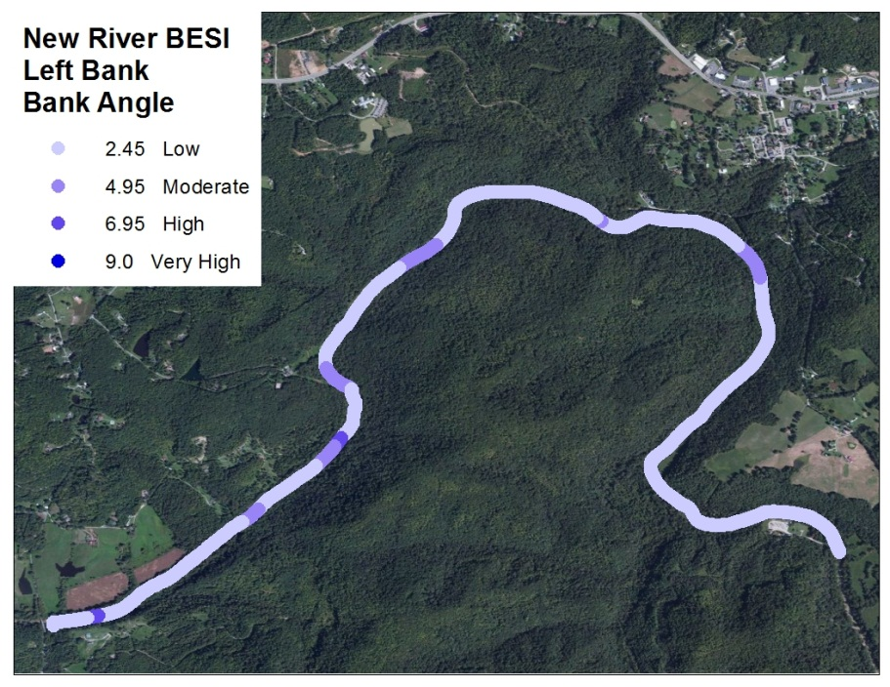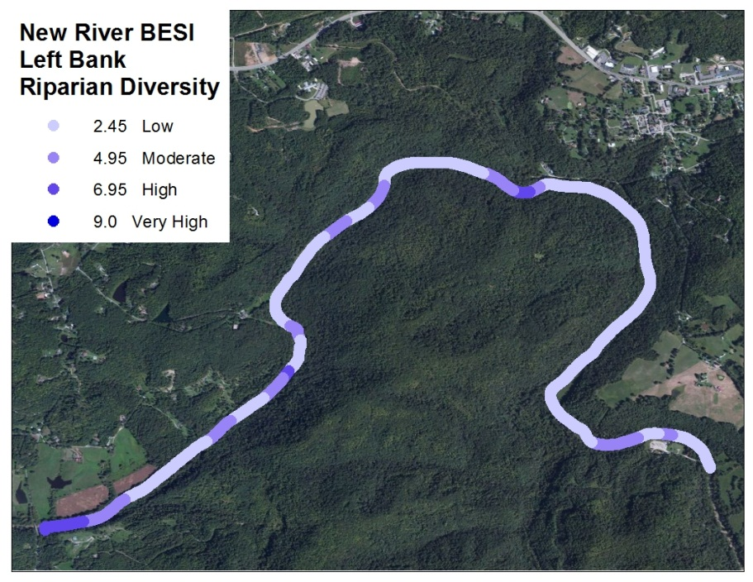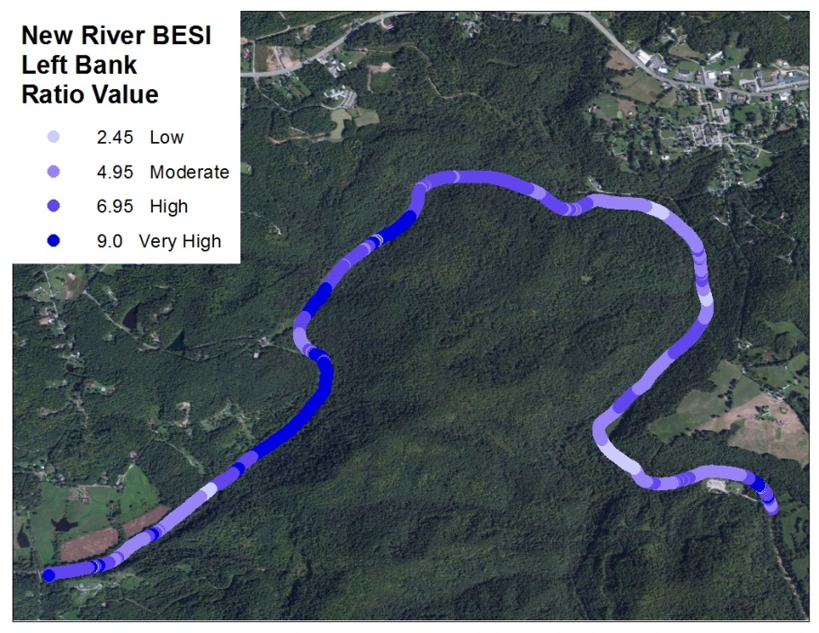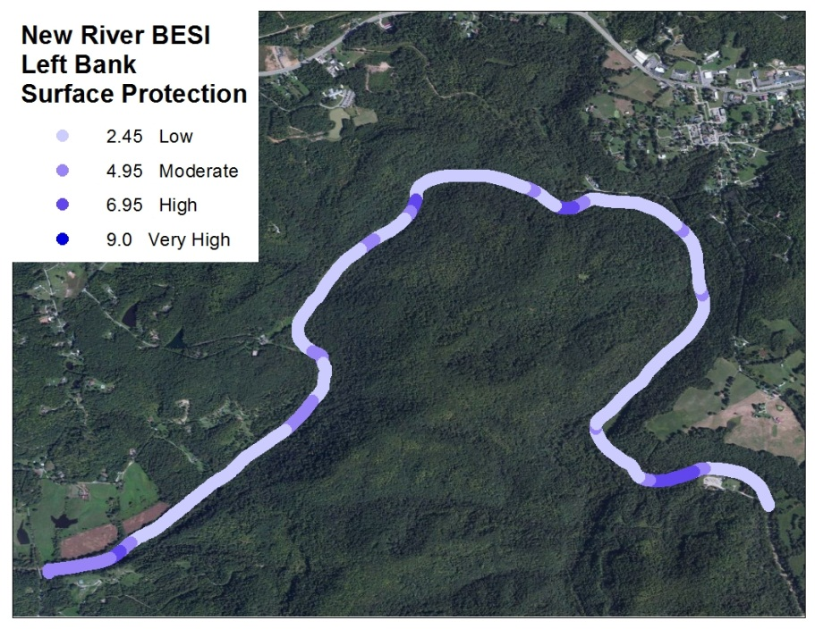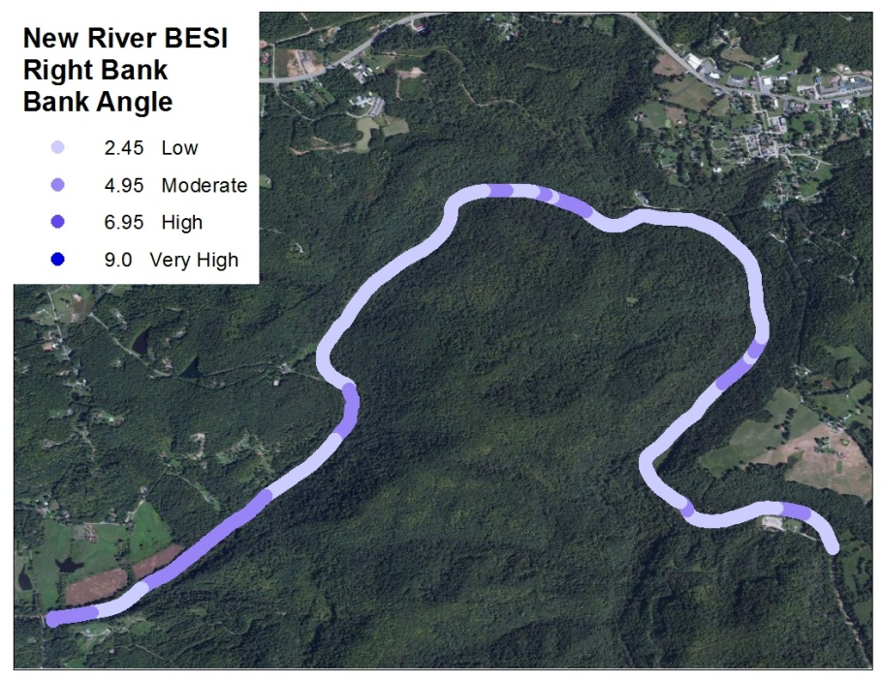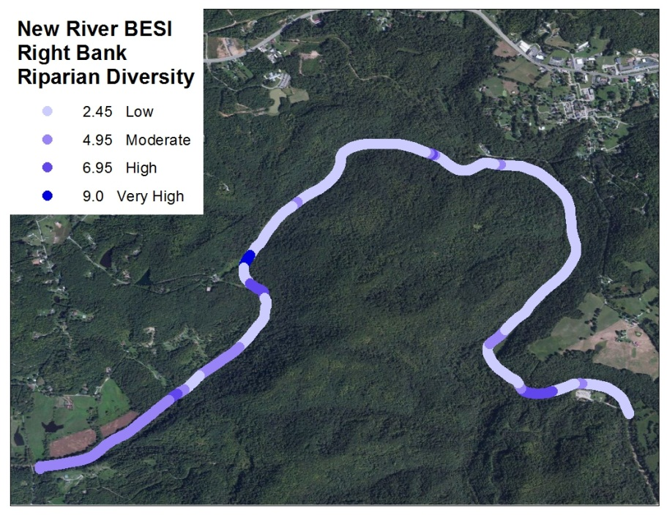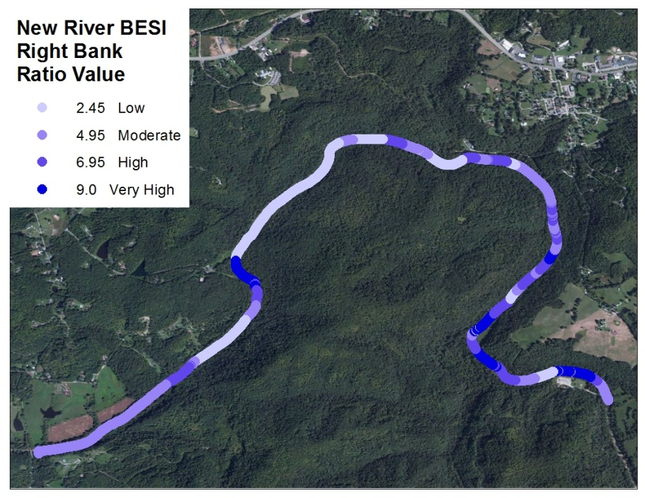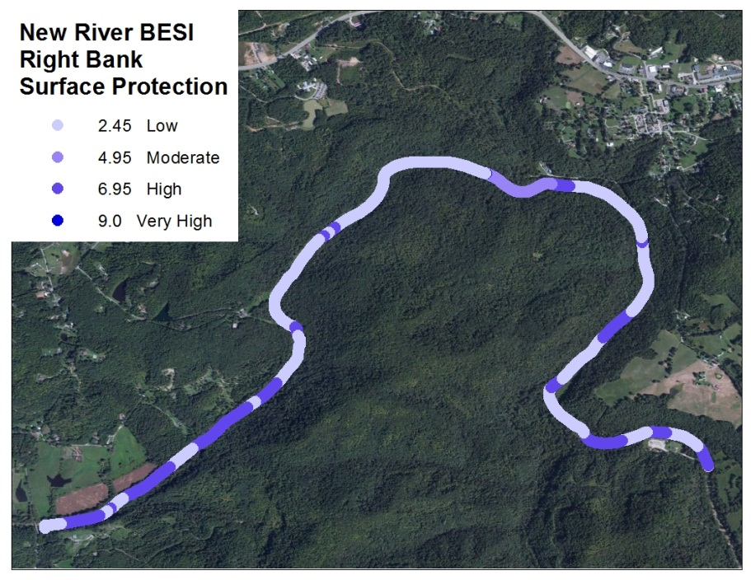

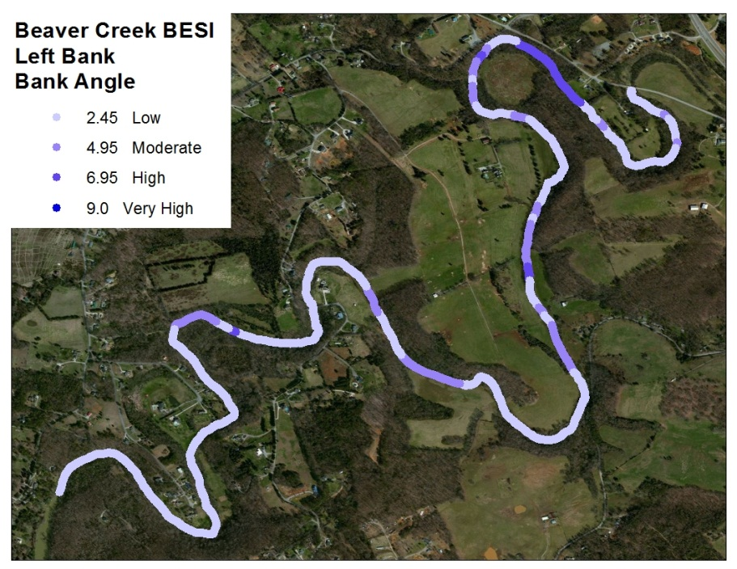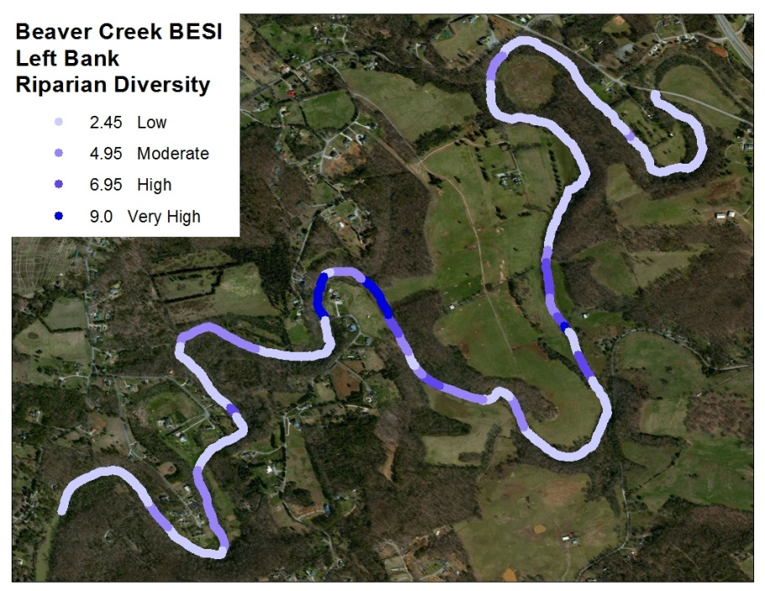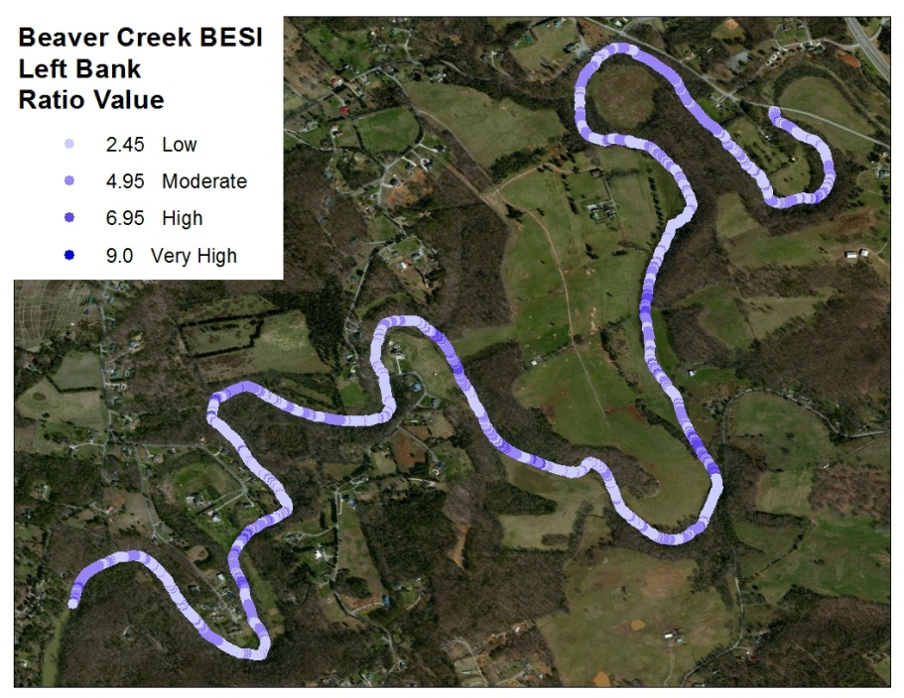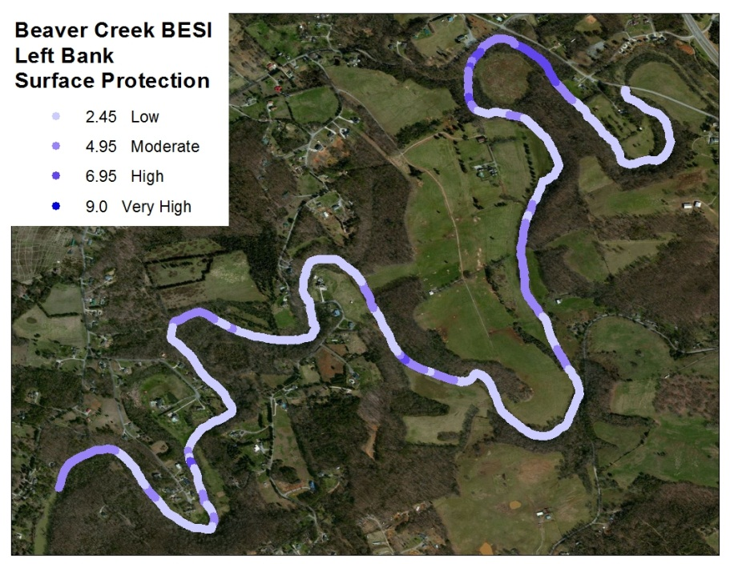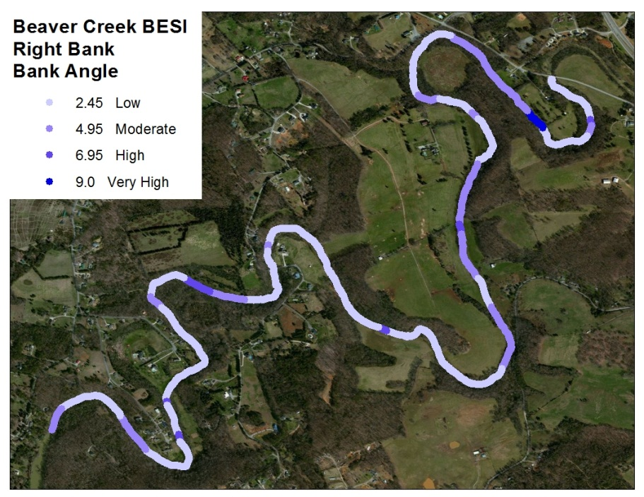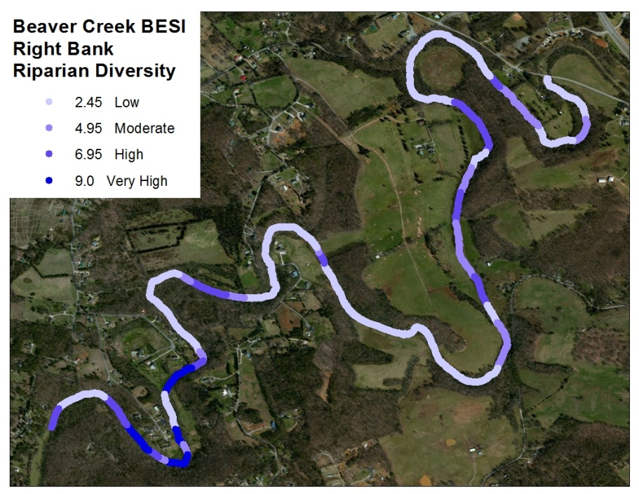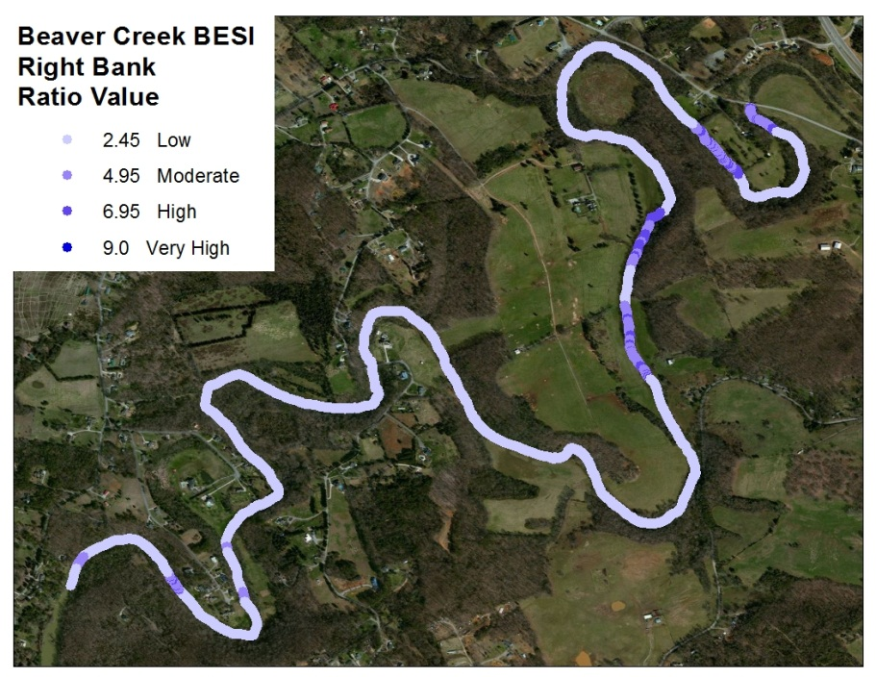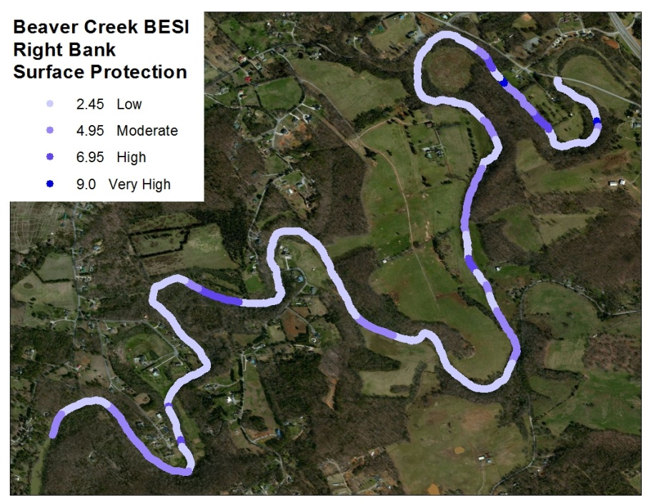

Appendix B

Given to additional viewers to instruct and assist with training for video assessment
Bank Angle
Bank angles will be grouped as, 0-60, 61-80, 81-90, >90 deg. The corresponding scores for each angle group received are of 2.45,4.95, 6.95, and 9.
Bank Height to Bankfull Ratio
Bank height to bankfull ratio (m) is determined by using visual assessment and the calibrated lines on the screen while reviewing the video. Cut banks will be the easiest to measure while this section will be the most susceptible to subjectivity. Focus of the measurement will be from the water surface to bank height. Measurement values in feet will be, 0-1, 1-3, 3-6, 6-9, 9-12, 12-18, >18.
Surface Protection
Surface protection is a visual assessment of the amount of bank protected from erosive forces by grasses, plants, trees both alive and dead. Surface protection (%) was divided into four sections which relate to how much soil was exposed to moving water directly on the stream bank (water level to bank height). Ranges for surface protection are 100-56, 55-30, 29-15, <14. The associated points are 2.45,4.95, 6.95, and 9.
Riparian Diversity
Root depth and root density are both part of the BEHI (Rosgen, 2001) which would prove to be impossible to measure from video. Using riparian diversity, a score was determined that reflects the same score produced in the BEHI. Diversity, as well as riparian width, comes into play while determining the score for this parameter.
Optimal- Surrounding area consists of several sizes of trees, shrubs, and grasses of all sizes. High diversity indicates very high root depth and density. BESI score = 2.45
Sub-Optimal- Surrounding area consists of low diversity trees with some understory and grasses. Indicates good root depth and density. BESI score = 4.95
Marginal- Surrounding area consists of a few trees and no riparian width, with a few shrubs and grass. Indicates moderate root depth and density. BESI score = 6.95
Poor- Surrounding area consists of short grass or bare soil. Indicates poor root depth and density. BESI score = 9

Figure 42: Viewer Bank Erosion Susceptibility Index Score Sheet.

Table 12: VTR Times for Bank Erosion Susceptibility Index Application.
Figure 43: Bank Angle = 2.45, Bank Height = 3-6, Surface Protection = 2.45, Riparian Diversity = 2.45.
Figure 44: Bank Angle = 9, Bank Height = 6-9, Surface Protection = 6.95, Riparian Diversity = 6.95.

Vita
Brett Connell graduated from Hocking College with and Associates Degree in Fisheries Management and Aquaculture before continuing on for a B.S. in Environmental Science from the University of Toledo. Summer internships for the Forest Service in Montana one summer and Idaho Fish and Game the next gave him the fisheries experience needed to take on a job with the US Army Corps of Engineers at McNary Dam, OR. Feeling like a security guard for fish and wanting to see more of the west, he took a fisheries technician job for Utah Division of Natural Resources and found his passion in streambank restoration. During this time, Brett got accepted to the graduate school at the University of Tennessee at Knoxville with an interest from Paul Ayers in the Department of Biosystems Engineering and Soil Sciences.

