BG-4, a novel bioactive peptide from Momordica charantia, inhibits lipopolysaccharide-induced inflammation in THP-1 human macrophages
Lynsey D Jones, Philipus Pangloli, Hari B Krishnan, Vermont P Dia
Department of Food Science and Technology
College of Agricultural Sciences and Natural Resources
University of Tennessee, Knoxville, USA

Abstract
Chronic inflammation has been associated with the development of multiple malignancies including neurodegenerative diseases like Parkinson’s and Alzheimer’s Disease and cancer. Using naturally occurring compounds with anti-inflammatory effects is an attractive way to prevent diseases associated with inflammation. BG-4 is a novel peptide isolated from the seeds of bitter melon (Momordica charantia) with potent trypsin inhibitory activity. The objective of this research is to evaluate the capability of BG-4 to inhibit lipopolysaccharide(LPS)-induced inflammation in THP-1 human macrophages. THP-1 human macrophages were pre-treated with different concentrations of BG-4 for 8 h and challenged with LPS for 16 h. The anti-inflammatory effects were evaluated by measuring the secretion of pro-inflammatory cytokines IL-1β, IL-6 and TNF-α compared to untreated THP-1 macrophages. The mechanism of action was explored using the NF-κB signaling pathway. BG-4 pre-treatment of 50 µg/mL reduced production of IL-6 by 88.4% and TNF-α by 50.7%. BG-4 also decreased the nuclear translocation of p65 NF-κB subunit as measured by immunofluorescence microscopy and western blot. Our data indicates the potential of BG-4 to prevent diseases associated with aberrant and uncontrolled inflammation.

1. Introduction
Momordica charantia, also known as bitter gourd (BG) or bitter melon, is a perennial plant belonging to the the Cucurbitaceae or cucurbit family. It is cultivated throughout the world and has traditionally been used in folk medicine. Pre-clinical studies have shown that M. charantia can be especially effective against type II diabetes. In the indigenous populations of Asia, South America, and Africa where this treatment is popular, plant-based medicine is the most cost-effective way to treat diabetes and other related diseases. [1] Recent studies have also shown the capability of BG to affect different processes in carcinogenesis. An extract from BG inhibited ovarian cancer tumorigenicity in vitro and in vivo by activating the AMPK signaling pathway. [2] In addition, two ribosome-inactivating proteins isolated from BG called α-momorcharin and momordica anti human immunodeficiency virus protein arrested cell cycle and induced apoptosis in lung cancer cells.[3] Recently, a novel peptide from BG with strong trypsin inhibitory properties was identified and named BG-4. The peptide was isolated from the seeds of the gourd by a simple 70% aqueous ethanol extraction [4] (Figure 1A). BG-4 caused the strong trypsin inhibitory activity of the extract as increasing purity of the extract led to increased trypsin inhibition. In addition, purified BG-4 was at least 8 times more potent in inhibiting trypsin activity than the purified soybean trypsin inhibitor (Figure 1B). Trypsin inhibitors have historically been shown to interrupt different stages of carcinogenesis. In recent studies, ulinistatin, a type of urinary trypsin inhibitor, suppressed proliferation and motility of gastric cancer cells [5] and reduced resistance of liver cancer cells to chemotherapeutic agent epirubicin by promoting apoptosis and inhibiting NF-κB signaling. [6] In addition food derived trypsin inhibitors have shown anticancer activities including Bowman-Birk and Kunitz trypsin inhibitors from soybean [7], buckwheat trypsin inhibitor [8], and other legumes trypsin inhibitors[9]. BG-4 demonstrated the capability of BG-4 to cause cytotoxicity and promote apoptosis in HT-29 and HCT-116 human colon cancer cells[4].
THP-1 cells have been commonly used as an in vitro model of human monocyte and macrophages in studies on inflammatory diseases [10]. Sharif et al. [11] showed that THP-1 cells treated with LPS responded with a change in expression of a number of inflammation-related genes (IL-1β, IL-6, IL-8, IL-10 and TNF-α). In addition, exposure of THP-1 monocytes to LPS results in activation of the NF-κB transcription factor, which arranges a gene expression program leading to the activation of inflammation, cell proliferation, differentiation, migration and cell survival, which are mediated through the release of chemokines and cytokines [11, 12] These previous studies on the potential beneficial role of trypsin inhibitors in cancer chemoprevention and therapy and the previous study identifying BG-4 as a peptide to promote apoptosis in human colon cancer cells serve as the scientific premise to study BG-4 as a means to inhibit LPS induced inflammation in THP-1 human macrophages.
2. Materials and Methods
2.1 Materials
THP-1 cells were obtained from the American Type Culture Collection (Manasas, VA, USA). BG-4 was isolated and purified from bitter gourd seeds as previously reported [4]. All chemicals were purchased from VWR (Radnor, PA, USA), Fisher Scientific (Atlanta, GA, USA), or Bio-Rad (Hercules, CA, USA) unless stated otherwise.
2.2 Cell Culture
THP-1 cells were differentiated from monocytes to macrophages using phorbol 12-myristate 13-acetate (PMA) as the differentiation agent. THP-1 was cultured using Roswell Park Memorial Institute-1640 media (RPMI 1640) (ATCC) containing 10% fetal bovine serum, 1% penicillin-streptomycin, 1% sodium pyruvate, and 50 µM beta-mercaptoethanol (to prevent cross-linking of Fc receptors on the cell by the antibody in serum and therefore avoiding damaging cell function) and incubated at 37ºC in 5%CO₂/95% air. PMA was added at a concentration of 162 nM to promote differentiation of THP-1 cells into macrophages as previously described by Furundzija et al [13] with some modifications. Macrophage differentiation was allowed for 24 h and it was determined by cell morphology and total adhesion to the plate. After differentiation, THP-1 cells were pre-treated with non-cytotoxic doses of BG-4 ranging from 6.25 to 50 ppm for 8 hours and the cells were challenged with 1 µg/mL LPS from Escherichia coli O55:B5 for 16 hours. Afterwards the cell spent medium was collected and analyzed for TNF-α and IL-6 secretion as measures of pro-inflammatory effects of LPS.
2.3 Whole Cell Lysate Harvesting
To obtain the whole cell lysate, a RIPA lysis buffer-protease inhibitor cocktail mix was prepared. One hundred µL of lysis buffer was added to each well of a 6-well plate and the plate was incubated at 4 °C for 5 min. Using a cell scraper, the plates were scraped and the cell lysates were transferred into pre-chilled 1.5-mL microfuge tubes and vortexed for 5 min in a cold room. They were then centrifuged at 14,000 x g for 10 min at 4ºC. The supernatant was collected and the pellet discarded. The protein concentration of the supernatant was measured using Bradford Assay. To the remaining supernatant, equal volumes of Laemmli buffer with β-mercaptoethanol were added and boiled for 5 min. Cell lysates were stored at -20 until analysis by Western Blot.
2.4 Separation of Cytosolic and Nuclear Fractions
In a similar fashion to the harvesting of the whole cell lysate, to separate the cytosolic and nuclear fractions cells were washed with ice-cold PBS 2x. Using a cell scraper, the cells were then scraped with 500 µL ice-cold PBS and centrifuged for 5 min at 1000 x g at 4ºC. The supernatant was then discarded. One hundred µL of lysis buffer containing 0.01M DTT and protease inhibitors was added and the cells were re-suspended by gently pipetting the suspension. The cells were then incubated on ice for 15 min to allow to swell. After which, 20 µL of 10% Triton X100 was added and vortexed vigorously for 10 seconds. They were then centrifuged immediately for 1 min at 14,000 x g. The supernatant (cytosolic fraction) was then discarded. To the pellet, 50 µL of extraction buffer containing 0.01 M DTT and protease inhibitors was and vortex mixed in a cold room (4ºC) at high speed for 30 min. They were then centrifuged for 5 min at 21,000 x g at 4 °C. The supernatant (nuclear fraction) was transferred to a pre-chilled microfuge tube. The protein concentrations were determined using Bradford Assay. To the remaining fraction, equal volumes of Laemmli buffer with β-mercaptoethanol were added and boiled for 5 min. All boiled fractions were stored at -20ºC until analysis.
2.4 ELISA
The Human IL-6 and TNF-α MAX™ Deluxe Set from Bio-Legend (San Diego, CA, USA) was used for ELISA testing. All reconstitutions and preparations were done as indicated on the instruction sheet from the manufacturer. On Day 1, 100 µL of diluted Capture Antibody solution were added to each well and the plate was sealed and incubated overnight between 2ºC and 8ºC. On Day 2 the plate (each well) was washed 4 times with wash buffer and 200 µL 1X Assay Diluent A was added to each well to block the plate. It was then sealed and incubated at room temperature for an hour while on a plate shaker. After washing 4 more times with wash buffer, 100 µL of either standard dilutions or diluted samples was added to each well. The plate was sealed and incubated at room temperature for 2 hours with shaking. The plate was washed 4 more times and 100 µL detection antibody solution was added and the plate was incubated with shaking for another hour at room temperature. After washing the plate 4X, 100 µL diluted Avidin-HRP solution was added to each well and the plate was sealed and incubated for 30 min with shaking at room temperature. The plate was then washed 5X with soaking for 30 sec-1 min per wash and 100 µL of substrate solution was added and the plate incubated in the dark for 20 min. The reaction was stopped by adding 100 µL of 2 M H₂SO₄ to each well and the absorbance read at 450 nm on a Cambrex ELX 808 microplate reader (Biotek Instruments, Winooski VT, USA). The concentration of IL-6 and TNF-α was calculated from the generated standard curve.
2.5 SDS-PAGE and Western Blot
Frozen samples were thawed at room temperature and vortexed for about 3 seconds. A 1X Tris/glycine SDS buffer was prepared (100 mL 10X Tris/glycine SDS buffer (161-0732, Biorad) + 900 mL deionized water). The gel cassette was placed in the electrode assembly and the frame was clamped. The center was filled with running buffer to ensure no leaks. After placing the assembly into the electrophoresis tank, the tank was filled with running buffer and the wells were loaded with 5 µL Precision Plus Protein Dual Color Standard (molecular weight standard) and samples with pre-determined volume based on equal protein loading were loaded. Protein separation was run at 200V for 30-35 min. The gels were then pre-equilibrated in ice-cold blotting buffer and proteins were transferred to PVDF membrane (GE Healthcare Life Sciences, Pittsburgh PA) at 110 V for 1 h at 4 °C. The blots were blocked with 5% non-fat dry milk for 1 h at room temperature, washed three times with TBS containing 0.1% Tween 20 (TBST) for 5 min and incubated with primary antibody overnight at 4 °C at 1:1000 dilution. The blots were washed with TBST five times for 5 min and incubated with secondary antibody at 1:5000 dilution for 2 h at room temperature. After washing with TBST, the blots were imaged with C-Digit Blot scanner (Li-Cor Biosciences, Lincoln, NE) using WesternSure ECL Substrate (Li-Cor Biosciences, Lincoln, NE). The intensity of bands was quantified using Image Studio Software (Li-Cor Biosciences, Lincoln, NE, USA).
2.6 Intracellular Reactive Oxygen Species
For fluorescence microscopy, the THP-1 cells were seeded and treated as appropriate and the cells were then washed with PBS twice. One-mL of 10 µM 2′,7′-dichlorofluorescein diacetate was added to cover the whole surface of the cells. After incubation at 37 ºC for 30 min in the carbon dioxide incubator, the stain solution was removed and washed with PBS twice. The cells were overlaid with 50% glycerol and imaged using the Invitrogen EVOS FL auto cell imaging system (ThermoFisher Scientific, Waltham MA).
For fluorescence spectroscopy cells were seeded the same way and washed with PBS 2X. Cells were dislodged from the plate by adding 200 µL of trypsin-EDTA solution and incubated at 37 °C for 5 min. After incubation, 800 µL of complete medium with 10% FBS was added to inactivate trypsin and then centrifuged at 1000 x g for 5 min and the supernatant discarded. One mL of PBS was added to carefully re-suspend the cells and then centrifuged. Tye cells were re-suspended in 500 µL of PBS containing 10 µM 2′,7′-dichlorofluorescein diacetate and incubated at 37ºC for 30 min in the carbon dioxide incubator. After vortex mixing, 200 µL of the suspension (in duplicate) was plated in a 96-well black plate. Fluorescence intensity was read at 485 nm/528 nm on a Synergy microplate reader (BioTek, Winooski, VT, USA).

2.7 Immunofluorescence (p-STAT3 and p-65)
Cells were treated per protocol, growth medium removed, and washed with PBS 2x. Cells were fixed with 500 µL of 4% paraformaldehyde at room temperature for 15 min. After washing the cells 3x (5 min each time) with PBS, 500 µL of 0.1% Triton X100 was added and then incubated for 10 min at room temperature. Cells were washed as before and 5% BSA was added to each well (500 µL) and incubated for 1 hour at room temperature (blocking step). Cells were washed as before and 200 µL of diluted primary antibody were added to each well and incubated at 4ºC overnight. Cells were washed as before and 200 µL of diluted secondary antibody was added and incubate for 2 hours at room temperature in the dark. The cells were washed and 2 drops of the mounting medium with DAPI was added. The cells cured for 24 hours at room temperature in the dark and were then imaged using a fluorescence microscope. The primary antibodies were p65 (1-mL 5% BSA, 4-mL PBS and 25 µL p-65 antibody) and c-Jun (1-mL 5% BSA, 4-mL PBS and 25 µL p-STAT3 antibody. Vortexed prior to use). The secondary antibody was Alexa-Fluor 488-conjugated anti-rabbit (2-mL 5%BSA, 8-mL PBS and 10 µL goat antirabbit Alexa-Fluor 488 conjugate).

2.8 Statistical Analysis
Data were analyzed using analysis of variance utilizing the proc GLM procedure of Statistical Analysis System software version 9.4. Means were separated using Tukey’s posthoc analysis at P < 0.05.

3. Results and Discussion
3.1 BG-4 Pre-treatment reduced the secretion of pro-inflammatory cytokines
Macrophages respond to LPS by expressing many inflammatory cytokines. The pathway occurs as follows: LPS binds to LPS-binding protein and is delivered to the cell surface receptor CD14. LPS is then transferred to the transmembrane signaling receptor TLR4 and protein MD2. Other intracellular signaling pathways are activated by LPS stimulation including the NF-κB pathway[14].
As shown in Figure 2A, LPS-treatment led to increased TNF-α secretion by THP-1 cells from 33.2 pg/mL to 1164.3 pg/mL. The increased secretion of TNF-α induced by LPS was dose-dependently reduced by BG-4 pre-treatment. At a concentration of 6.25 ppm, BG-4 significantly reduced TNF-α secretion by 16.2% and at 50 ppm, BG-4 reduced TNF-α secretion by 50.7%. Figure 2B shows the effect of LPS and BG-4 treatment on IL-6 secretion by THP-1 macrophages. LPS treatment led to a significant increase in IL-6 secretion by THP-1 macrophages compared to untreated cells (13.8 vs 466.5 pg/mL). BG-4 treatment starting at 12.5 ppm dose-dependently reduced IL-6 secretion induced by LPS in THP-1 macrophages reaching 88.4% reduction at 50 ppm. Previous reports have shown the cancer promoting effects of pro-inflammatory cytokines TNF-α and IL-6. For instance, analysis of different colonic polyps has shown an increased TNF-α expression in serrated adenoma and hyperplastic polyps as compared to normal colonic mucosa [15] while factors that can increase the risk of CRC such as high fat diet have shown to upregulate TNFα secretion promoting formation of colonic adenoma in vivo [16]. In addition, chronic ethanol feeding increased gene expression of pro-inflammatory cytokines IL-1α, IL-6 and TNF-α at a precancerous stage in chemically-induced colonic tumorigenesis in mice [17]. Our study indicated that BG-4 pre-treatment for 8 hours reduced TNF-α and IL-6 secretion by THP-1 macrophages when challenged by LPS.
3.2 Western Blot analysis of p-ERK ½ and p-STAT3
We then analyzed proteins associated with overproduction of pro-inflammatory cytokines. More specifically, we measured the phosphorylation of extracellular regulated kinase ½ (p-ERK ½) and signal transducer and activator of transcription 3 (pSTAT-3) (Figure 3a). The negative control shows a very low expression as seen in the Western Blot in Figure 3b. Overall BG-4 expression of p-ERK 1/2 and p-STAT3 but only p-ERK ½ reached statistical significance.
3.3 Intracellular Reactive Oxygen Species
We then tested the capability of BG-4 to reduce production of intracellular reactive oxygen species in LPS-induced THP-1 macrophages. Intracellular reactive oxygen species was measured by staining THP-1 macrophages with 2′,7′-dichlorodihydrofluorescein diacetate (H₂DCFDA) which becomes the highly green fluorescent 2′,7′-dichlorofluorescein upon oxidation. As shown in Figure 4, LPS treatment led to increased green fluorescence by THP-1 cells (Figure 4A, top panel at 4x magnification, scale bar 1000 µm and bottom panel at 20 x magnification, scale bar at 200 µm) which was validated by a fluorescence spectrophotometry experiment (Figure 4B). Pre-treatment of BG-4 for 8 hours prior to LPS induction led to a dose-dependent green fluorescence indicating the capability of BG-4 to reduce production of intracellular reactive oxygen species induced by LPS in THP-1 macrophages.

3.4 Analysis of p65 subunit of NF-κB transcription factor
To further explain the anti-inflammatory effect of BG-4 using PMA-differentiated THP-1 macrophages, the expression of nuclear-factor of kappa B (NF-κB) p65 unit was measured using immunofluorescence microscopy and western blotting of THP-1 nuclear lysates. As shown in Figure 5A, untreated THP-1 macrophages showed cytoplasmic localization of p65 unit (green). Upon treatment of 1 µg/mL LPS, strong nuclear staining of p65 unit can be seen indicating translocation of p65 from the cytoplasm into the nucleus (blue) of THP-1 macrophages. On the other hand, pre-treatment of THP-1 macrophages with 50 ppm BG-4 for 8 h prior to LPS-stimulation led to reduced p65 nuclear staining suggesting inhibition of p65 translocation from the cytoplasm into the nucleus of the cells. This was further verified by western blotting of the nuclear fraction of THP-1 macrophages indicating reduced expression of NF-κB p65 subunit in BG-4 pre-treated THP-1 macrophages prior to LPS stimulation as compared to THP-1 macrophages that were stimulated with LPS alone (Figure 5B). NF-κB is an essential transcription factor regulating various signaling pathways one of which is the expression of different genes and proteins involved in inflammation. The canonical NF-κB signaling involves the heterodimeric protein p50-p65 which is activated upon treatment of LPS. The p50 subunit helped in DNA binding while the p65 subunit is important in activating the transcriptional activity of NF-κB [18].Previous reports have shown the association of NF-κB signaling in playing an essential role in inflammation and innate immunity. For instance, NF-κB is increasingly recognized as a crucial player in many steps of cancer initiation and progression. During these latter processes, NF-κB works with multiple other signaling molecules and pathways to mediate crosstalk by other transcription factors such as STAT3 and p53. These transcription factors either directly interact with NF-κB subunits or affect NF-κB target genes [19]. Our data showed the capability of BG-4 to attenuate LPS-induced NF-κB signaling supporting our hypothesis that BG-4 can have an anti-inflammatory effect against THP-1 macrophages. To further elucidate the mechanism by which BG-4 can be used as a chemopreventive agent against THP-1 cells, activation of signal transducer and activator of transcription 3 (STAT3) was measured by immunofluorescence utilizing antibody specific to phosphorylated form of STAT3. As shown in Figure 6, untreated THP-1 macrophages have very low expression of p-STAT3 while LPS treatment led to increased green staining of THP-1 macrophages indicative of increased activation of STAT3 through phosphorylation. Pre-treatment of THP-1 macrophages with 25 and 50 ppm BG-4 for 8 h prior to LPS treatment reduced the green fluorescence staining showing the capability of BG-4 to prevent phosphorylation of STAT3. Activation of STAT3 signaling has been implicated as the central mechanism in the development, progression, and maintenance of many human tumors. It has also been validated as an anti-cancer target as it is involved in the critical functions of cell differentiation and immune responses [20].

4. Conclusion
Our data show the capability of BG-4 to reduce LPS-induced inflammation in THP-1 human macrophages by reducing the secretion of pro-inflammatory cytokines IL-6 and TNF-α. In addition, BG-4 pre-treatment led to reduced nuclear translocation of p65 subunit of NF-κB and phosphorylation of STAT3. Figure 7 shows the proposed mechanism of action for preventing inflammation. LPS treatment of THP-1 macrophages leads to phosphorylation of ERK which activates the translocation of p-65 to the nucleus. This leads to the production of reactive oxygen species and maturation of pro-inflammatory cytokines that can lead to chronic inflammation. Our results showed that BG-4 pre-treatment inhibited phosphorylation of extracellular regulated kinase leading to reduced translocation of p65 to the nucleus and reduction of reactive oxygen species. This leads to a reduction of pro-inflammatory cytokines IL-6 and TNF-alpha which can possibly explain the chemopreventive effect of BG-4 against chronic inflammation.

Acknowledgements
The University of Tennessee Chancellor’s Honors Program for an Honors Undergraduate Research Grant.

References
1. Joseph B, J.D., Antidiabetic effects of Momordica charantia (bitter melon) and its medicinal potency. Asian Pacific Journal of Tropical Disease, 2013. 3(2): p. 93-102.
2. Yung, M.M., et al., Bitter Melon (Momordica charantia) Extract Inhibits Tumorigenicity and Overcomes Cisplatin-Resistance in Ovarian Cancer Cells Through Targeting AMPK Signaling Cascade. Integr Cancer Ther, 2016. 15(3): p. 376-89.
3. Fan, X., et al., Alpha-MMC and MAP30, two ribosome-inactivating proteins extracted from Momordica charantia, induce cell cycle arrest and apoptosis in A549 human lung carcinoma cells. Mol Med Rep, 2015. 11(5): p. 3553-8.
4. Dia, V.P. and H.B. Krishnan, BG-4, a novel anticancer peptide from bitter gourd (Momordica charantia), promotes apoptosis in human colon cancer cells. Sci Rep, 2016. 6: p. 33532.
5. Wang, J., et al., Suppressive effects on cell proliferation and motility in gastric cancer SGC-7901 cells by introducing ulinastatin in vitro. Anticancer Drugs, 2016. 27(7): p. 651-9.
6. Song, B., et al., Ulinastatin reduces the resistance of liver cancer cells to epirubicin by inhibiting autophagy. PLoS One, 2015. 10(3): p. e0120694.
7. Dia, V.P., et al., Bowman-Birk and Kunitz protease inhibitors among antinutrients and bioactives modified by germination and hydrolysis in Brazilian soybean cultivar BRS 133. J Agric Food Chem, 2012. 60(32): p. 7886-94.
8. Oparin, P.B., et al., Buckwheat trypsin inhibitor with helical hairpin structure belongs to a new family of plant defence peptides. Biochem J, 2012. 446(1): p. 69-77.
9. Wati, R.K., et al., Trypsin inhibitor from 3 legume seeds: fractionation and proteolytic inhibition study. J Food Sci, 2010. 75(3): p. C223-8.
10. Sakamoto, H., et al., Biomechanical strain induces class a scavenger receptor expression in human monocyte/macrophages and THP-1 cells: a potential mechanism of increased atherosclerosis in hypertension. Circulation, 2001. 104(1): p. 109-14.
11. Sharif, O., et al., Transcriptional profiling of the LPS induced NF-kappaB response in macrophages. BMC Immunol, 2007. 8: p. 1.
12. Chanput, W., et al., Transcription profiles of LPS-stimulated THP-1 monocytes and macrophages: a tool to study inflammation modulating effects of food-derived compounds. Food Funct, 2010. 1(3): p. 254-61.
13. Furundzija, V., et al., IGF-1 increases macrophage motility via PKC/p38-dependent alphavbeta3-integrin inside-out signaling. Biochem Biophys Res Commun, 2010. 394(3): p. 786-91.
14. Guha, M. and N. Mackman, LPS induction of gene expression in human monocytes. Cell Signal, 2001. 13(2): p. 85-94.
15. Szylberg, L., et al., Expression of COX-2, IL-1beta, TNF-alpha and IL-4 in epithelium of serrated adenoma, adenoma and hyperplastic polyp. Arch Med Sci, 2016. 12(1): p. 172-8.
16. Zhu, Q.C., et al., Effect of a high-fat diet in development of colonic adenoma in an animal model. World J Gastroenterol, 2014. 20(25): p. 8119-29.
17. Shukla, P.K., et al., Chronic ethanol feeding promotes azoxymethane and dextran sulfate sodium-induced colonic tumorigenesis potentially by enhancing mucosal inflammation. BMC Cancer, 2016. 16: p. 189.
18. Oeckinghaus, A. and S. Ghosh, The NF-kappaB family of transcription factors and its regulation. Cold Spring Harb Perspect Biol, 2009. 1(4): p. a000034.
19. Hoesel, B. and J.A. Schmid, The complexity of NF-kappaB signaling in inflammation and cancer. Mol Cancer, 2013. 12: p. 86.
20. Johnston, P.A. and J.R. Grandis, STAT3 signaling: anticancer strategies and challenges. Mol Interv, 2011. 11(1): p. 18-26.

Figure 1. Electrophoresis profile and trypsin inhibitory activity of aqueous and ethanolic extracts from Momordica charantia. A) SDS-PAGE profile of different Momordica charantia extracts indicates that increasing ethanol concentrations (0 to 70% in 10% increment, lanes 1 to 8) in the extraction medium led to isolation and purification of a novel peptide termed BG-4. B) Trypsin inhibitory activity of Momordica charantia extracts is associated with the degree of BG-4 purity. Increasing BG-4 purity led to increased capability of the extract to inhibit trypsin, the purified BG-4 peptide from 70% ethanol extraction (lane 8) is 8.6 times more effective in inhibiting trypsin

- B)
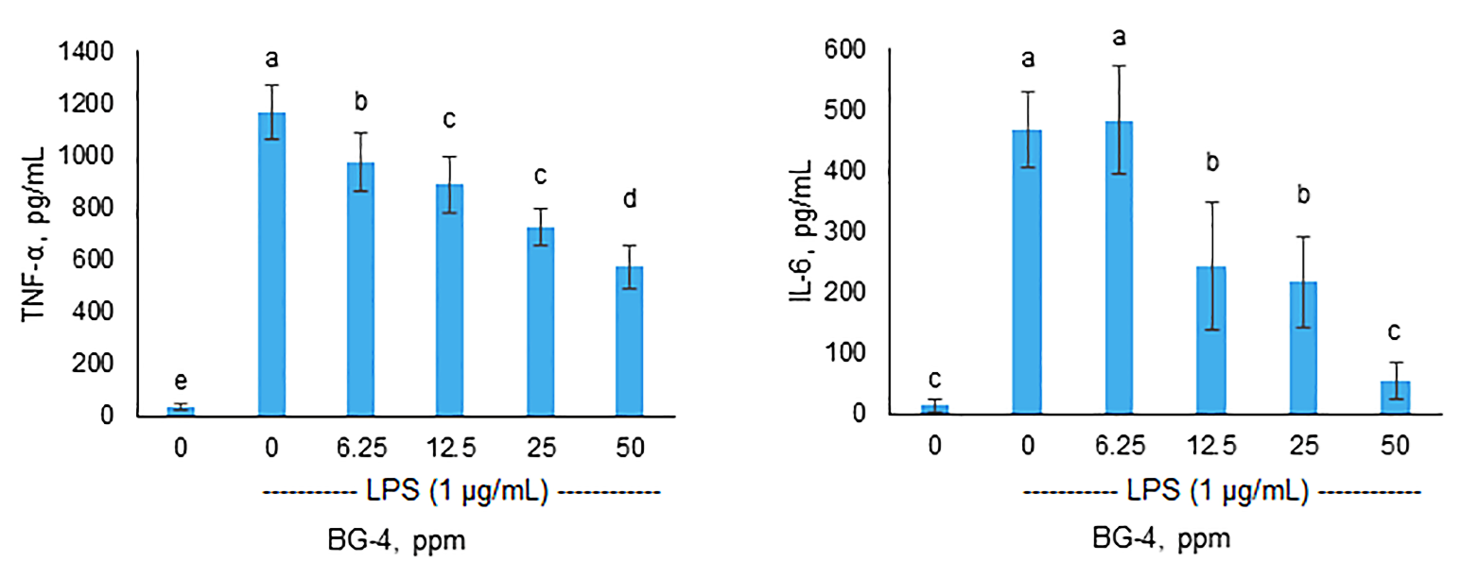
Figure 2. BG-4 pre-treatment reduced the secretion of pro-inflammatory cytokines TNF-α and IL-6 in LPS-induced THP-1 macrophages. A) BG-4 dose dependently reduced TNF-α secretion in LPS-induced THP-1 macrophages, 50 ppm BG-4 reduced TNF-α secretion by 50.7%. B) BG-4 starting at 12.5 ppm dose-dependently reduced IL-6 secretion in LPS-induced THP-1 macrophages, 50 ppm BG-4 reduced IL-6 secretion by 88.4%. Bars with different letter are significantly different from each other (P < 0.05, n > 8).

A)
- + + + LPS (1 µg/mL)
 p-ERK ½ (42-44 kDa) ERK ½
p-STAT3 (80 kDa)
STAT3 (80 kDa)
Actin (41 kDa)
0 0 25 50 BG-4 (µg/mL)
- + + + LPS (1 µg/mL)
A)

B)

Figure 3 Negative control shows very low expression as seen in the Western Blot
-Overall BG-4 significantly blocked the expression of p-ERK but not p-STAT3

A)

B)
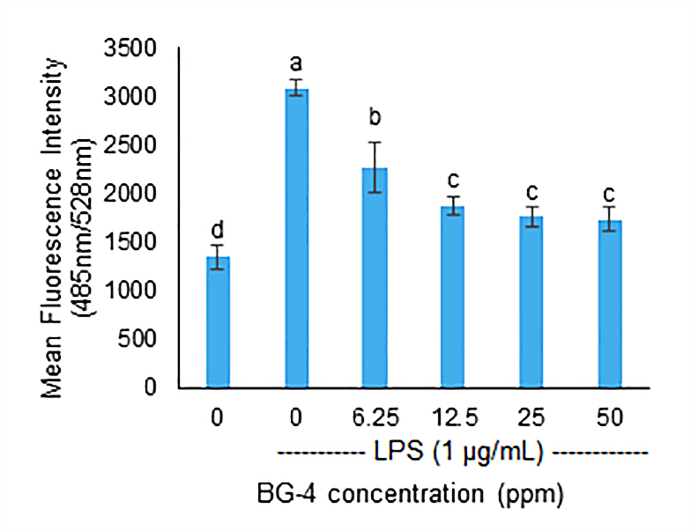
Figure 4. BG-4 pre-treatment reduced intracellular reactive oxygen species production in LPS-induced THP-1 macrophages. A) Images of THP-1 cells stained with H₂DCFDA. Upper panel shows THP-1 cells at 4x magnification (scale bar is 1000 µm) while lower panel shows THP-1 cells at 20x magnification (scale bar is 200 µm). The green fluorescence indicates the degree of intracellular reactive oxygen generation and as shown BG-4 dose-dependently reduce green fluorescence. B) The reduction in green fluorescence was validated by quantitative fluorescence spectrophotometry experiment indicating that BG-4 starting at 6.25 ppm dose-dependently reduce intracellular reactive oxygen. Bars with different letter are significantly different from each other (P < 0.05, n > 5).

A)
B)
Figure 5. BG-4 pre-treatment reduced the expression of NF-κB p65 subunit in the nucleus of PMA-differentiated THP-1 macrophages. A) Immunofluorescence staining of p65 in THP-1 macrophages.

Figure 6. BG-4 pre-treatment reduced activation of signal transducer and activator of transcription 3 (STAT3) Immunofluorescence experiments were performed in two independent replicates and 6 random fields were photographed for each replicate (scale bar is 100 µm).

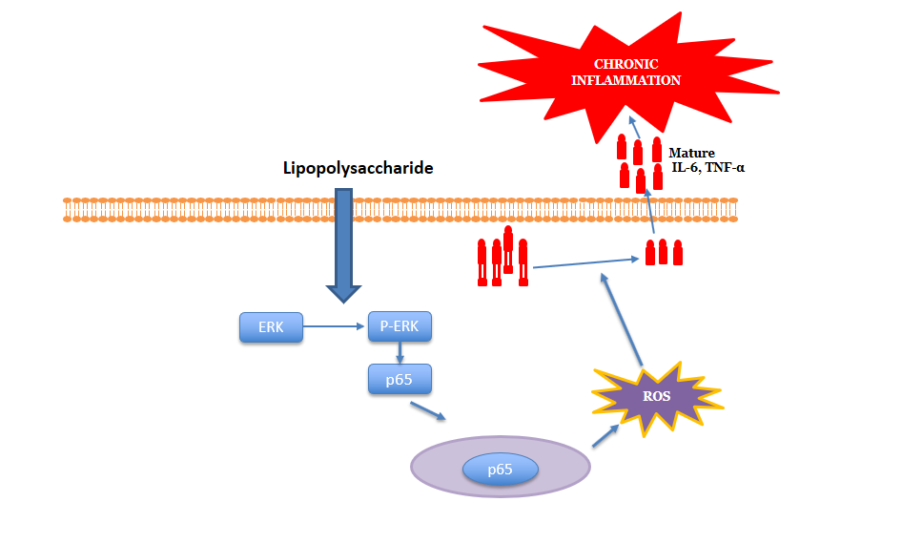
Figure 7. Proposed mechanism of action of inflammation prevention by BG-4.

