A Comprehensive Street Tree and Soil Study along Roadways in Oak Ridge, Tennessee

A Thesis Presented for the
Master of Science
Degree
The University of Tennessee, Knoxville

Thomas Murphy Turnbull
August 2014

Acknowledgements
Firstly, I would like to thank my major professor Dr. Sharon Jean-Philippe for her support, guidance, and example of diligence she provided throughout my time at the University of Tennessee. I am not only grateful for the financial support, but also the patience and willingness she displayed guiding me through all aspects of my graduate education. I also would like to thank my committee: Dr. David S. Buckley, Dr. Sean Schaeffer, Dr. Eric Wiseman, and Dr. Ray Albright. Your encouragement and valuable input was vital to my completion of this thesis.
I also would like to thank Dr. Essington for allowing me to use his soil chemistry lab, as well as Melanie Stewart, Galina Melnichinko and Dr. Leticia Sonon for analyzing my numerous soil extracts. Many thanks are also due to those who helped me with field and lab work: Benjamin Reichert, Thomas Jennings, Christine Sullivan, and Brandon James.
Lastly, I would like to thank my family. Their encouragement and support these past two years have been most valuable in running this race. Most of all, I would like to thank my wife, Caroline. Her love, support, patience, and constant encouragement have been the foundation for me completing this work.

Abstract
In the early 1940s, during the early stages of the Manhatttan Project (WWII), rural communities in Anderson County, Tennessee were rapidly converted into laboratory facilities and the city of Oak Ridge. The environment that became Oak Ridge not only experienced pollutants from the laboratory activities, but also alterations from the land-use change from rural to urban. Therefore, a study was conducted to determine the impacts of land-use change from rural to urban on (1) street tree diversity and performance; and (2) the biological, chemical and physical properties, and nutrient dynamics of street tree ecosystem soils. There were a total of 607 street trees, composed of 37 different species, on the five main roadways in Oak Ridge, Tennessee The street tree inventory revealed that the street tree ecosystems in Oak Ridge had a high relative abundance of Acer rubrum (21.91%)) and Pyrus calleryana (19.93 %). Chemical, rather than physical, soil and site properties in street tree ecosystems had the greatest impact on street tree performance. Also, the street tree ecosystem soils were significantly different from Knox County rural forest soils biologically, chemically, and physically. Soils in Oak Ridge differed street by street in their biological, chemical, and physical properties but were not influenced by traffic rates. There were also differences in soil microbial biomass carbon (MBC) during the winter on streets based on their diversity of trees; however, the most diverse street was among the lowest in soil microbial biomass. Seasonally, the winter proved to not only have greater amounts of soil microbial biomass carbon and nitrogen (MBN), but significantly less extractable organic carbon (EOC) and nitrogen (EON) and total labile carbon (TLC) than the spring. Overall, this study provided insights into the post urbanization impacts on the street trees, soils, sites, and nutrient dynamics within street tree ecosystems of Oak Ridge.

Table of Contents
Chapter 1: Introduction 1
Urbanization and Land Use Change 1
Soil Environments 3
Natural and Urban Forest Soils 3
Soil Biogeochemical Cycling 6
Seasonality 10
Tree Diversity 11
Importance of Tree Diversity in Natural and Urban Forests 11
Street Tree Ecosystems 13
Statement of Problem 14
Objectives and Hypotheses 15
Chapter 2: Materials and Methods 18
Site Description 18
Street Tree Inventory 20
Street Tree Study Sites and Condition Assessments 20
Tree Diversity Sampling Scheme 23
Soil Sampling and Methodology 23
Oak Ridge Traffic and Stream Data 25
Basic Soil Analyses 25
Cation Exchange Capacity (CEC) – Na Saturation Method pH 7 28
Soil Bulk Density 29
Hydroflouric Acid Microwave Digestion 31
Chloroform Fumigation Extraction “slurry” Method (sCFE) 32
Knox County Forest and Soil Data 34
Statistical Analyses 34
Chapter 3: Results 36
Street Tree Inventory 36
Street Tree Soil and Site Characteristics 36
Street Tree Soil Differences by Street 44
Street Tree Soil vs. Forest Soil 45
Street Tree Diversity and Soil Microbial Biomass 48
Urban Soil Seasonal Variation 48
Street Tree Performance Assessment 48
Chapter 4: Discussion 56
Objective 1: Impacts of Land-use Change on Street Tree Diversity and Performance 56
Hypothesis 1: Rural Forests will have Higher H’ than Street Tree Ecosystems 56
Hypothesis 2: Soil and Site Physical Properties will have Greatest Impact on Street Trees 57
Objective 2: Impacts of Land-use Change on the Site and Soil Biological, Chemical and Physical Properties, and Nutrient Dynamics within Street Tree Ecosystems 60
Hypothesis 1: Higher AADT will have Higher Heavy Metals and lower Soil Microbial Biomass 63
Hypothesis 2: Streets with Higher H’ will have Greater Soil Microbial Biomass 65
Hypothesis 3: Street Tree Ecosystems will Lose C and N from Winter to Spring 66
Chapter 5: Conclusion 69
References 71
Appendix 81
Vita 117
List of Tables
Table 1. Method for calculating cumulative tree condition scores 22
Table 2. Street tree species abundance 37
Table 3. Soil biological, chemical, and physical soil and site properties in Oak Ridge 42
Table 4. Soil chemical properties in Oak Ridge street tree soils 43
Table 5. MANOVA results for soil biological, chemical, and physical properties between streets 46
Table 6. ANOVA results for comparison in rural forest soils and street tree ecosystem soils 47
Table 7. Significant correlations from Pearson’s Correlation of tree condition scores and annual twig elongation 53
Table A. 1. Oak Ridge Turnpike inventory 87
Table A. 2. Rutgers Avenue inventory 103
Table A. 3. Illinois Avenue inventory 104
Table A. 4. Lafayette Avenue inventory 108
Table A. 5. Tulane Avenue inventory 114

List of Figures
Figure 1. Oak Ridge, Tennessee 19
Figure 2. Five Main Streets: Oak Ridge, Tennessee 21
Figure 3. Random Sampling for Street Tree Diversity 24
Figure 4. Oak Ridge: Study Street Trees and Streams 26
Figure 5. Soil samples for gravimetric soil moisture 27
Figure 6. Bulk Density Sampling Scheme 30
Figure 7. Diameter distribution of the total five street inventory 38
Figure 8. Street tree conditions. 39
Figure 9. Pyrus calleryana and Acer rubrum, and their relative abundances on each street. 40
Figure 10. Diversity indices by location. 41
Figure 11. ANCOVA results for differences in microbial biomass between streets based on diversity 49
Figure 12. ANOVA results in seasonal differences in street tree ecosystem soil carbon pools... 50
Figure 13. ANOVA results in seasonal differences in street tree ecosystem soil nitrogen pools. 51
Figure 14. Score plot of first two components and street tree genera. 54
Figure 15. Score plot of first two components and street tree conditions 55
Figure A. 1. Boxplots of log transformed seasonal microbial biomass nitrogen 82
Figure A. 2. Boxplots of log transformed seasonal microbial biomass carbon 83
Figure A. 3. Resulting eigenvalues from principal components analysis 84
Figure A. 4. Biplot of first two principal components with street tree genera and variable loadings 85
Figure A. 5. Biplot of first two principal components with street tree conditions and variable loadings 86

Chapter 1: Introduction

Urbanization and Land Use Change

Urbanization has been defined as the movement of a population to a central location, which leads to the global expansion of cities (Clark, 1998; Mcdonald et al., 2008). Across the globe, urbanization is occurring whether it is a product of the global economy or the child of Imperialism, “involving the extension of authority and control of one state or people over another”. Presently, this global urbanization has produced over 300 cities with at least 1,000,000 inhabitants and 14 megacities that house at least 10,000,000 people (Pickett et. al. 2011). Furthermore, many cities in industrialized nations are growing in such a way that urban land is increasing because of the desire to live in suburban areas rather than live in the traditional compact city (Pickett et. al. 2011). Urban areas now are not only considered as the dense city, but also larger plots of land in more of a suburban setting. Due to the conversion of more lands for urban use, urban land is on the increase.
The urbanization phenomenon is prevalent in the United States. Currently, almost 80% of the United States population is considered urban (Pickett et al. 2011). Numerous social and biological factors have actively influenced the growth of the United States population such as high immigration, fertility, and life expectancy rates; which directly affects the growth of cities (Nowak and Walton, 2005). Population growth rates have been found to increase the U.S. population by about 1% per year, which projects an increase of 250 million people by 2050 (Heimlich and Anderson, 2001; Nowak and Walton, 2005). The Industrial Revolution (~1877-1900) initially caused much of the large city development in the United States; however, after WWII more people owned cars which resulted in the expansion of urban land due to the desire to live in suburban areas and commute to the city for work (Heimlich and Anderson, 2001).The action of spreading outwards of a city to the outskirts with lower housing densities is known as urban sprawl (Coison et al., 2013). From the period of 1960-1990, this urban expansion claimed more than 100 million acres in the United States each year (Heimlich and Anderson, 2001). By the year 2050, urban land in the United States is projected to encompass a total area larger than the state of Montana (Nowak and Walton, 2005).
During the settlement of the United States, towns were erected along waterways for transportation purposes and the surrounding land was farmed which was the basis of most economies (Miller, 1997). Land-use change to urban can be traced back to surplus products being produced that can sustain the lives of non-agricultural people (Childe, 1950). The Industrial Revolution simply allowed for more products to be produced, thus encouraging the growth of pre-existing towns which was not possible in pre-industrial society (Sjoberg, 1960). Also, transportation of people and goods became more efficient due to advances such as the steam engine and automobile (Miller, 1997). As populations grew in these towns, the city boundaries and economies grew; thus claiming more land in order to sustain the population. Land-use change from forest, agriculture, or rural land to urban requires drastic alterations in the environment. In order for cities to develop, land must first be converted from its previous land-use to conditions suitable for urban infrastructure. The pre-existing vegetation must be cleared and the ground must be stabilized to sustain buildings. Therefore, conversion to urban land alters not only the vegetation of the area being converted, but also the soil. Furthermore, the vegetation and soil in areas that were converted from rural to urban face many environmental stressors including increased temperatures, particulate matter from car exhaust and construction activities, stormwater runoff, compacted soils, and the presence of impervious surfaces.

Soil Environments
Natural and Urban Forest Soils
The importance of soils in all ecosystems (especially forests) has been known for a long time. In the first century B.C., Virgil wrote in his Georgics: “Nor indeed can all soils bear things. By riversides willows grow, and alders in thick swamps, barren mountain-ashes on rocky hills; on the sea myrtle thickets flourish. So diverse are the native lands of trees (Wilde 1958).” Virgil obviously saw that there was a connection between the land and soil type with the growth of different tree species. Forest soil composition is instrumental to the entire makeup of the forest ecosystem by providing nourishment to the numerous inhabitants. Soils not only provide nutrients, but also control the water in the ecosystem; recycle waste; and provide habitat to organisms from microbes to mammals (Brady and Weil 2002). The composition of forest stands are influenced by the soil as well as tree morphology, growth rate, wood quality, reproductive vigor, disease resistance, and the ability for trees to withstand environmental conditions (Wilde 1958). Soils are composed of factors that enable those traits to be taken on by trees and also determine which species can grow in those areas, as Virgil noticed over 2000 years ago. Soil conditions for adequate plant growth contain around 20-30% air, 20-30% water, 5% organic material, 45% mineral matter, and ultimately the loam should be about half solid and half pore space (Brady and Weil 2002).
Soil profiles are made up of distinct horizons that are layered according to the amount of weathering that has occurred. Each horizon contributes factors to the soil that determine what can and cannot grow there. The uppermost horizon, the O horizon, contains organic material from detritus that gets broken down and utilized by the decomposers and the A horizon (topsoil) is where that matter accumulates beneath and contains minerals (Brady and Weil 2002). The B horizon contains iron and aluminum oxides as well as carbonates. Beneath that lies the C horizon which contains the parent material (Brady and Weil 2002). Each horizon contributes to the composition, health and overall function of that soil. Soil organic carbon (SOC) is an indicator of soil quality. SOC is composed from leaf litter, plant roots, and organisms that are found in the soil (Kimble et al., 2003). The ability for forests to sequester carbon is compromised when disturbances like clear cutting, thinning, acid rain, and land-use change occur (Kimble et al., 2003).
The process of converting land from forested to urban areas, results in an interesting soil mosaic due to the removal of topsoil, compaction of existing soil, and introduction of soil. Land conversion produces soil patches of different profiles including natural soil profiles, partially disturbed soils, and covered soils (Kimble et al., 2003). Due to the variability of urban soil, successful establishment of landscape or street trees requires knowledge of the soil composition at the desired planting site. The removal of topsoil (graded soil) and soil compaction (bulk density greater than 1.6 Mg/m³) are two issues that arise in urban soils. The first step in assessing urban forest quality is determining which of the four criteria it meets: 1) Not graded and not compacted, 2) Not graded but compacted, 3) Graded but compacted, or 4) Graded and compacted (Craul 1999). Although tree roots are strong and persistent, growth in compacted and graded soils are not in the least bit ideal. A lack of understanding on urban soil profiles could be the catalyst of many failed planting attempts.
When forested or rural land is converted to urban land, topsoil is removed and the soil horizons become disturbed; consequently, the ability for the soil to function in recycling and storing carbon is hindered. Land use change from rural to urban has been found to foster higher soil bulk densities, decreased soil carbon, and increased heavy metal concentrations in soil (Scharenbroch et al., 2005; Chen et al., 2013; Pouyat and McDonnell, 1991; Li et al., 2014). Microbial biomass carbon (MBC) also has been found to decrease after soil disturbances; however, urban soils have been found to exhibit both higher and lower concentrations when compared to rural or undisturbed soils (Silveira et al., 2010; Yuangen et al., 2006; Kaye et al., 2005). Microbial biomass nitrogen has been found to be significantly lower in urban environments when compared to rural forested environments which could be an indicator of less nutrients being cycled to the vegetation (Zhao et al., 2012). Natural forest soils also have lower bulk densities; whereas urban soils typically have higher bulk densities, reduced aeration, water infiltration, and root growth (Brady and Weil 2002). Management practices such as backfilling and excavation are the disturbance events that result in both vertical and lateral changes in the soil horizon (Kimble et al., 2003).
Another factor that soils in urban areas face is a phenomenon known as the urban heat island (UHI) effect. The UHI effect is an increase in surface temperature within defined city centers. The main contributing factors to the UHI is the lack of vegetative cover, resulting in reduced rates in evapotranspiration (i.e. cooling of the microclimate), and heat storage by urban structures (Kimble et al., 2003).The soil’s temperature increases along with the rest of the urban ecosystem. The increase in soil temperature can have significant effects on the microbial activity that occurs in the soils and on the overall productivity of the soil (Kimble et al., 2003). Furthermore, the presence of impervious surfaces has been found to increase pH, alter soil nutrient dynamics, accumulate heavy metals and impact the soil water (Cekstere and Osvalde, 2013; Trammell et al, 2011; Lemaire and Rossignol, 1999).

Soil Biogeochemical Cycling
The biogeochemical cycling in soils refers to the physical, chemical, and biological properties found in soil and the interactions between those factors (Curtis and Sloan, 2005; Totsche et al., 2009). The various functions of those three factors influence each other as well as the entire soil ecosystem (Totsche et al., 2009). Therefore, the pedosphere relies on multiple interactions with both biotic and abiotic environmental factors. One challenge that faces urban soil profiles (other than compaction) is the influx of chemicals from pollutants. Around 90% of persistent organic pollutants (POPs) and other harmful by-products are accumulated in the soil environment: as a result of the presence of pollutants, the soil includes them in its various biogeochemical interfaces (Totsche et al., 2009). Pollutants are likely going to be present in urban soil no matter the precautions; however, the soil’s biogeochemical interface does function in the degradation of these compounds and therefore should be protected at great length. Without proper degradation and cycling, we could face problems such as polluted aquifers. Driving the degradation and cycling of these pollutants, as well as nutrients, are microorganisms that are found in the soil (Totsche et al., 2009).
Due to urban development, urban soils vary in their horizonation as well as soil forming processes. The disturbances that take place in urban development lead to the incorporation of new material (construction debris, foreign fill soil, etc.) in the existing soil, which ultimately affects the various cycles and processes that occur in soil (Pouyat and Effland, 1999). Compared to rural or forest soils, following land use change, urban soils tend to have more heavy metals such as lead, cobalt, and nickel, higher concentrations of SOC, salt, and more acidic solutions; all of which affect soil cycles (Kimble et al., 2003). The high SOC in the urban soils however, is likely from SOC decay rather than the input of organic material from net primary production (Kimble et al., 2003). Therefore, the SOC in urban soils is primarily residual from the urban development process rather than from litter. Furthermore, the leaf litter that is found in urban areas has been found to be more acidic and contain higher heavy metals than that of natural forests or rural areas from the amount of pollution form both wet and dry deposition; thereby, making urban soils and their cycling distinct from natural soils (Berg and McClaugherty, 2008; Lovett et al., 2000; Johnson and Hale, 2004). Overall, whether from direct soil changes from urban development and direct anthropogenic inputs or the chemically altered litter in urban areas, the properties of urban soils are largely impacted by humans. Thus, the cycling of nutrients in urban environments and their soils varies greatly from natural forests, rural areas, and the soils that are found there.
Time is essential for the soils in newly urbanized areas to biologically, chemically, and physically develop and function. Urban soils that were more recently subject to urban development, have been found to be more compacted; contain less soil organic matter; and have lower microbial biomass carbon than urban soils that experienced land conversion to urban longer ago (Scharenbroch et al., 2005). The soil organic matter (SOM) in recently disturbed urban soils has been found to be dominated by litter compounds and low amounts of fulvic acid (Beyer et al., 1995). Fulvic acids are found in SOM and also act as a soil pH buffer, impede the mobility of metal ions, and increase soil biological activity (Plaza et al., 2002; Senesi and Loffredo, 2005). In order for pollutants and other toxic substances to become bound in the soil, time is needed in order for humification to occur and SOM to accumulate (Beyer et al., 1995). Soil amendments, such as compost, aid in the humification process and stimulate the formation of SOM (Beyer et al, 1995). However, the addition of inputs such as herbicides, pollution from automobiles, and decreased soil aeration from compaction deter the formation of SOM; therefore, impeding the evolution of microbial communities that function in nutrient turnover (Beyer et al., 1995).
Soil microbes are soil dwelling organisms such as bacteria, fungi, protozoans, and actinomycetes that play vital roles in the health of soils. One kilogram of soil can contain 10¹³ prokaryotes and 10⁵ nematodes, which demonstrated the abundance of life that can be found in the soil (Curtis and Sloan, 2005). Microbes not only inhabit soil micro- and macro-aggregates, but also, due to their growth patterns (i.e. colonies), help form and structure aggregates (Totsche et al., 2009). Soil microorganisms play a key role in plant productivity by partitioning resources and altering nutrient supply rates (Van Der Heijden, 2008). Most notably, microbes control the cycling of C and N which are essential to the flora and fauna of natural forest ecosystems (Zak et al., 2003). In a typical forest ecosystem, the amount of microbes found in the soil is limited by the amount of carbon available from litter, root death, and rhizodeposits or root exudates (Grayston et al., 1996). Due to this, soil microbial biomass is greater in the rhizosphere because of the abundance of carbon. Fall et al. (2012) found that as distance from trees and depth of soil decreased, so did the amount of soil microbes. Soil microbes have been found to also function in soil formation, groundwater quality maintenance, and contaminant degradation (Fierer et al., 2003). The ecosystem services that soil microbes offer are of great importance not only to forest health, but also the health of the human population.
Soil microorganisms help drive the degradation of pollutants. The rates in which these pollutants degrade depend on the chemical structure of the pollutants as well as the structure and catabolic activity (the breaking down of molecules) of the resident microbial community (Reid et al., 2000). Pollutants also serve as nutrients for micro-organisms. This may be due to the co-evolution soil micro-flora and compounds that contain structures similar analogous to those found in pollutants (Tostche et al., 2009). Soil microbes not only are able to break down many harmful pollutants, but have the ability to utilize them for their benefit. In an urban setting, where pollutants are plentiful, the soil conditions have been found to favor microbes that degrade pollutants (Beyer et al., 1995). Urban soils have been found to have high amounts of hydrophobic carbon units from pollutants, thereby influencing the selection of soil microorganisms that are specialized to use those compounds as food sources (Beyer et al., 1995). We know little about these organisms because they are rather difficult to study (Fierer et al., 2003). Consequently, this opens the door to endless opportunities in soil microbial research.
The cycling of carbon and nitrogen in urban forests has the same framework as a natural forest but more variable inputs and dynamics due to the land-use change to urban and ongoing anthropogenic inputs in these areas (Brown et al., 2005). Urban soils also experience high fluxes of nitrite (N₂O) which is likely influenced by over fertilization of residential lawns, thereby resulting in N lost to the atmosphere after mineralization has occurred (Lorenz and Lal, 2009). Other inputs into the soil environment from construction activies, fossil fuel combustion, sewage sludge and other wastes can alter biogeochemical carbon and nitrogen cycling by drastically increasing or decreasing the pH of the soil (Bridges, 1991). Fossil fuel combustion from factories and automobiles produces large amounts of carbon-dioxide (CO₂) and reactive nitrogen, which ultimately becomes incorporated into the nutrient cycling in urban soils and the urban forest vegetation (Zhu et. al, 2004). Pouyat and Turechek (2001) found that net N-mineralization was greater in urban soils when compared to rural soils, which likely is due to elevated soil temperatures in urban forest soils from the urban heat island effect. Therefore, although plant available nitrogen has the potential to be efficiently produced in urban soils, there is also great potential for nitrogen losses.
The increased soil temperatures in urban soils, along with poor quality leaf litter and non-native earthworms, have also been found to promote greater amounts of recalcitrant carbon in urban as opposed to more rural soils which ultimately leads to slower decomposition of organic matter (Groffman et al, 1995). Even though there are many direct anthropogenic effects (waste dumping and fertilization) and indirect effects (atmospheric deposition and poor litter quality) carbon and nitrogen is still being cycled nonetheless. Characterizing the dynamics of carbon and nitrogen in urban soils however is difficult because of the amount of different inputs and the variability of each urban soil environment. A better understanding of spatial and temporal relations of urban soils and their carbon and nitrogen dynamics needs to be further investigated (Scharenbroch et al., 2005).
Seasonality
Nitrogen is an essential nutrient for plants. It is a major component in amino acids, nucleic acids, and chlorophyll (Brady and Weil, 2002). Nitrogen also prompts root growth and nutrient uptake (Brady and Weil, 2002). The dominant forms of nitrogen that plant roots take up are Ammonium NH₄⁺ and Nitrate NO₃⁻ ions (Brady and Weil, 2002). These forms of nitrogen are made available to plants by mineralization, or nitrification. Soil microbes govern this process by either fixing atmospheric nitrogen (N₂) or decomposing plant material that contains Organic N and transforming those forms of nitrogen into plant available forms (Sylvia et al., 2005). Soil microbes also have the ability to make nitrogen unavailable to plants by converting inorganic N to organic N through immobilization. This process temporarily makes nitrogen unavailable to plants, but can be beneficial to ecosystems by preventing nitrogen losses through leaching (Sylvia et al., 2005). Nitrate, which is an available form of nitrogen, is easily leached from the soil environment when there are excess amounts and can contaminate drinking water as well as cause eutrophication to occur (Sylvia et al., 2005). The soil microbial biomass, therefore, can function not only as a mediator, but also a sink for nitrogen.
In forests, a phenomenon known as the “vernal dam” has been found to occur, where in the spring, maximum nutrient losses can occur and understory plant species serve as the sinks for nutrients (Tessier and Raynal, 2003). The native understory vegetation, particulary early spring vernals, prevent nitrates from leaching out of the forest, and store the nitrogen momentarily until that vegetation can become a source of nitrogen for other sinks, such as trees. Zak et al. (1990) found that soil microbes not only exhibit this vernal dam ability, but can be the most substantial nitrogen sink in a forest before canopy development. In areas that lack understory vegetation, such as street tree ecosystems, the soil microbial biomass may be the key player in nitrogen retention during periods when losses are high. Since urban soils have been found to be both nitrogen limited as well as nitrogen saturated, knowledge about how nitrogen moves through the system and is lost or stored by the microbes is crucial in determining the potential nitrogen availability for the urban vegetation (Scharenbroch and Lloyd, 2004).
Tree Diversity
Importance of Tree Diversity in Natural and Urban Forests
Tree diversity is an important characteristic in determining the overall health and stability of a forest ecosystem. According to McLaughlin and Percy (1999), the health of a forest is determined by its ability to increase or maintain productivity while resisting biotic and abiotic stressors. These various stressors include invasive pests, invasive plants, air pollution, wildfires, and global climate change. Diversity of a forest stand is beneficial to the overall forest ecosystem. For example, if one tree species gets impacted by a pest or disease, another species may be able to fill the niche of the original species. In the early 1900s, the chestnut blight (Cryphonectria parasitica) was introduced from Asia and devastated the Eastern United States’ forests, killing nearly 3.5 billion American chestnuts by 1940 (Roane et al., 1986). American chestnuts provided forage for wildlife, habitat, and was also the most valuable tree for lumber. Oak species then were able to replace the gaps left by dead chestnuts; therefore, filling the niches that the chestnuts held (Woods and Shanks, 1959). Without sufficient diversity in Eastern forests, the impacts of losing the chestnuts would have been even more deleterious. Forest mono-cultures are at risk of mass mortality in the event of disease or infestation. Diversity in natural and urban forests is a buffer when tree losses from catastrophic events occur (Raupp et al., 2006).
Tree diversity is imperative to a healthy urban forest community. Miller and Miller (1991) suggest that no more than 10% of a single species should be planted in order to maintain a diverse urban forest. Urban tree diversity became a serious consideration after the Dutch elm disease (a fungal disease introduced to the U.S. in the early 1930s) decimated populations of elm trees. Elms were commonly used as street trees because they are large, fast growing, drought tolerant, and able to adapt to a variety of soil conditions (Raupp et al., 2006). The widespread use of elms in American cities led to large scale tree removals that left not only city streets devoid of trees but also municipality budgets that were stretched for money (Sinclair and Campana, 1978). The importance of street tree diversity is even greater with the amount of invasive pests such as Emerald Ash Borer, Thousand Cankers Disease, Asian long-horned beetle, Southern Pine Beetle, and other pest and diseases that plague our urban trees. In Ohio communities alone, the Emerald Ash Borer could result in the removal and treatments of ash trees that would cost an estimated $1.0-4.2 billion (Sydnor et al., 2007). If diversity were more carefully considered, the cost would be significantly less for those communities facing potential mass tree mortality. When urban tree populations experience mass mortality the monetary value is not the only resource jeopardized; the ecosystem services like nutrient cycling, storm water control, pollutant removal, and atmospheric cooling are also impacted.
Street Tree Ecoystems
Urban trees (street trees, park trees, residential trees, etc.) face a host of environmental stressors such as pests, diseases, harsh climatic conditions, and poor soil qualities (Miller, 1997). Trees in more natural or rural settings are still exposed to many environmental factors such as pests or climatic conditions, but urban trees must be able to withstand natural stressors as well as issues associated more closely with an urban environment (Miller, 1997). Urban development as well as ongoing construction can have profound effects on the urban forest. Street trees are any trees that are growing within the public right-of-way (Miller, 1997). The proximity of street trees to construction activities has been found to greatly impact the survival of street trees. These construction sites alter urban soils through compaction, chemical contamination, water saturation or depravation, and altered nutrient cycles; all of which can impact the ability for trees to thrive (Day et al., 2010; Tomiczek, 2003; Nielson et al., 2007). Hauer et al. (1994) found 5% greater mortality of street trees adjacent to construction activities, and also that there was a significant positive correlation between street tree conditions and tree lawn widths (the area in which street trees are growing). Impervious surfaces play a large role in the ecosystem processes in an urban environment (Nowak and Greenfield, 2012). Most notably, impervious surfaces increase local temperature, thereby creating an urban heat island (UHI) that affects the hydrology, pollutant emissions, and ozone production (Heisler and Brazel, 2010; U.S. EPA, 1983; National Research Council, 2008). The hydrological impacts on street trees range from excessive amounts of water to being completely devoid of water. Street trees that are planted in poorly drained soils are at risk of oxygen deficiencies due to the flooding of the root zone (Saebo et al., 2003). On the other hand, Nielson et al. (2007) suggests that street tree planting pits can be totally depleted of soil water during the growing season due to poor water retention in tree pit soils. The lack of water available to street trees is also due to the size of a planting pit, rainfall interception by buildings, other impervious surfaces, the actual tree, and increased rates of evapotranspiration from the heat island (Lemaire and Rossignol, 1999; Tomiczek, 2003). It has also been found that the street trees closer to impervious surfaces such as roadways could be growing in soils that have variable pH’s, nutrient imbalance, as well as excess sodium and chlorine from de-icing salts, all of which could potentially impede tree growth (Cekstere and Osvalde, 2013). Human selection plays a large role in what street trees species grow in a city; however, the harsh environment that street trees must tolerate could be the factor that shapes the overall composition and diversity of street tree ecosystems by selecting for tree species that better tolerate the urban environment.
Statement of Problem
In 1942, during WWII, laboratories were built in East Tennessee for the purpose of developing the uranium bomb (DOE, 2013). The rural forests and farmland that were in that area were rapidly converted into laboratory facilities and the city of Oak Ridge (Resen, 2010). The environment that became Oak Ridge not only experienced the pressures that come with land-use change from rural to urban, but also the inputs of excess heavy metals and toxic chemical wastes from the laboratory activities. Pollutants from the laboratories have also been found in streams that are adjacent to roadways within the city itself; therefore, the trees and soils that are in close proximity to the highly polluted streams may be impacted by the wastes from the laboratory facilities (Jean-Philippe et al., 2011). Since the environment has gone through so much disturbance and change, it is important to determine how the vegetation and soils have been impacted by the land-use change.
Street trees are exposed to many stressors within cities. Knowledge about the diversity of street tree ecosystems and the performance of street trees in Oak Ridge could help determine how resilient the street tree ecosystems are to current pressures within the city, as well as the potential threats posed by pests and disease. Furthermore, knowledge about the soils within the street tree ecosystems could offer insight as to how street tree ecosystems have been impacted by land-use change from rural to urban in their biological, chemical, and physical properties as well as nutrient cycling.
Objectives and Hypotheses
The overarching aim of this study was to determine the impacts of land-use change on street trees as well as the soils and sites in which they grow. A field study was done in Oak Ridge and Knox County, Tennessee in order to address two objectives under the overarching aim. The first objective was to determine the impacts of land-use change from rural to urban on street tree diversity and performance in street tree ecosystems. Two hypotheses were tested under this objective.
- Rural forested sites will have greater tree diversity than street tree ecosystems.
The planting of non-native trees in the urban landscape has been found to both increase tree diversity as well as decrease tree diversity. However, the Southern Appalachains are known for their high diversity in tree species. Therefore, it was expected that tree diversity in Oak Ridge, Tennessee street tree ecosystems would be lower than rural forested sites in Knox County, Tennessee, whose forests are indicative of the forests that were in the Oak Ridge area prior to development.
- Soil bulk density, soil moisture, and street tree distance to impervious surface will have a greater impact on street tree performance than microbial biomass carbon (MBC), microbial biomass nitrogen (MBN), cation exchange capacity (CEC), and elemental concentrations.
Land-use change from rural to urban results in compacted soils, altered soil water relations, and the presence of impervious surfaces. Soil bulk density, soil moisture, and impervious are physical parameters of a street tree ecosystem that can have immediate impacts on street trees when they are planted. Tree root penetration and nutrient acquisition is limited in compacted soils. Excessive soil moisture can deplete the rhizosphere of oxygen and a lack of soil moisture can create drought conditions that impede nutrient transport and photosynthesis in trees. Also, the presence of impervious surfaces in street tree ecosystems can limit the amount of available sunlight, expose trees to intense heat, and confine street trees overall growing space.
The second objective was to determine the impacts of land-use change from rural to urban on the site characteristics, soil biological, chemical and physical properties, and nutrient dynamics within street tree ecosystems. Rural forest soil biological, chemical and physical properties from Knox County, Tennessee were compared to soils from street tree ecosystems in Oak Ridge, Tennessee to first determine that street tree ecosystem soils were distinct from rural forest soils. Three hypotheses were tested under this objective.
- Streets with higher Annual Average Daily Traffic (AADT) will have higher heavy metals, higher bulk densities, and lower MBC and MBN than streets with lower AADT.
The amount of human activity in a central location makes the urban environment distinct from rural areas. Similarly, varying traffic rates, may play a role in creating distinct soils in street tree ecosystems of different roadways. Fuel combustion, particulate matter from car exhaust, and decay from automotive waste has been found to contribute to the amount of heavy metals in soils. Ongoing construction activities and the presence of impervious surfaces can result in compacted soils. Furthermore, disturbances from construction, heavy metal accumulation, and high bulk densities can inhibit soil microbial activity and result in lower soil microbial biomass.
- Streets with greater tree diversity will have higher MBC and MBN than less diverse streets.
It has been found that sites with greater tree diversity can have higher levels of soil microbial biomass than less diverse sites. However, this interaction has not been researched in an urban environment, much less street tree ecosystems. Despite the land-use having been changed from rural to urban and the ongoing disturbances that occur along roadsides; it was predicted that street tree ecosystems that have are higher in tree diversity will have higher soil microbial biomass than less diverse street tree ecosystems.
- Street tree ecosystems will experience losses in C and N during the transition from winter to spring due to the lack of native understory vegetation.
In rural forests, organic matter is decomposed by microorganisms where organic forms of C and N are rendered immobile. Due to the removal of topsoil, organic matter, and the lack of native understory vegetation it is hypothesized that levels of C and N in street tree ecosystem soils will indicate nutrient losses from winter to spring.

Chapter 2: Materials and Methods
Site Description
Oak Ridge, Tennessee is located in Anderson county of East Tennessee, USA (Figure 1). The city covers around 220.80 km² with a population of approximately 29,351 people (US Census Bureau, 2012). Oak Ridge has an annual average precipitation of 129.31 cm and the growing season for the area spans 220 days (NOAA; Tennessee Climatological Service). The streets that were used as the study sites were determined by the City of Oak Ridge Recreation & Parks Department. The streets that were selected were the five main streets that intersect the city: Illinois Avenue 3.09 km (SW-NW), Rutgers Avenue 1.50 km (S-N), Tulane Avenue 0.80 km (S-N), Lafayette Avenue 2.40 km (S-N), and Oak Ridge Turnpike 9.25 km (SW-NE). The beginnings of each of the streets are found at the following coordinates: Illinois Avenue (-84 14.686, 36 0.11), Rutgers Avenue (-84 15.073, 36 0.332), Tulane Avenue (-84 15.416, 36 0.429), Lafayette Avenue (-84 14.534, 36 0.196), and Oak Ridge Turnpike (-84 12.419, 36 2.996). All roadways had two traffic lanes with the exception of Illinois Avenue, which had three lanes of traffic from its inteserction with Lafayette to its intersection with Tulane before it decreased to two lanes. Along these five streets, the street trees were inventoried and random plots were generated for soil sampling (Figure 2). The dominant forest cover type in Anderson County is oak-hickory (Renewable Resources Evaluation Research Work Unit, 1982). The general soil environment found in the city of Oak Ridge is Collegedale-Gladeville-Rock Outcrop (USDA, 1981). Along the inventoried thoroughfares; the dominant soil types are Collegedale clays. Other soil types are Collegedale-rock outcrops, Upshur Variant silt clay loam, Hamblen silt loam, and Capshaw silt loam; however, the Collegedale clays are most abundant along the study sites (USDA, 1981). The five streets intersect the city’s various industrial establishments and
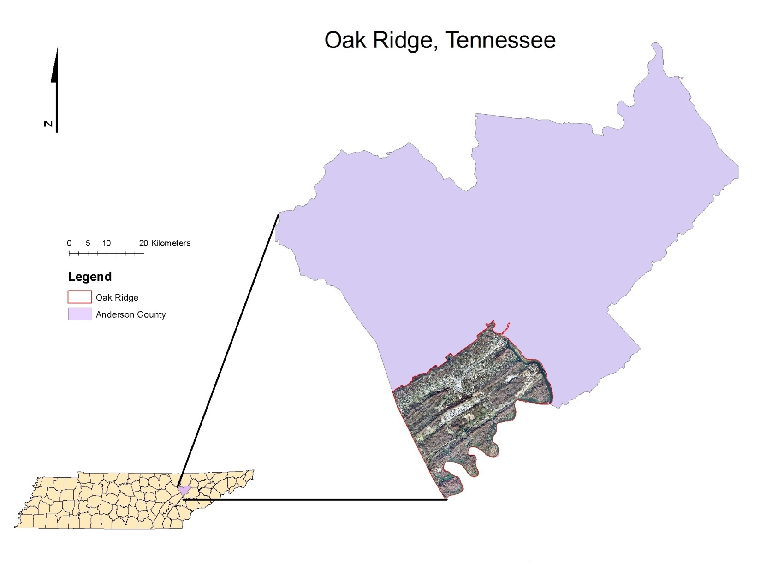
Figure 1. The city of Oak Ridge, Tennessee in Anderson County.

residential areas. Illinois, Tulane, Rutgers, and Oak Ridge Turnpike are characterized mainly by the many business establishments lining their edges. Lafayette Avenue also has industrial areas, but proportionally contains more residential areas than the other streets.
Street Tree Inventory
A general street tree inventory was conducted for the five main streets. All live trees, dead trees, and stumps that were within the public right-of-way were included in the total inventory. The stumps and dead trees were included in the inventory for the Oak Ridge Recreation & Parks Department to utilize at their own discretion in future management. Species name, diameter at breast height (dbh), geographic coordinates, and tree condition (good, fair, poor, dead) were recorded for each street tree that had a dbh of 2.54 cm or greater. A Garmin etrex 20 hand-held GPS was used with the mark waypoint feature to assign each tree and stump with latitudinal and longitudinal coordinates
Street Tree Study Sites and Condition Assessments
To assess the health of The City of Oak Ridge street tree ecosystems a 25% (152 street trees) random sample of live trees was selected from the total street tree inventory. Each of the 152 street trees was treated as a separate study plot. However, the sample size decreased to 136 street trees due to the removal of trees for maintenance or development purposes. The percentage of street trees from the random sample compared to the total amount of street trees along each street was 32 % for Illinois, 42 % for Rutgers, 15% for Tulane, 25 % for Lafayette, and 23 % for ORTP. The distance of each street tree to the nearest impervious surface was measured in order to determine the confinement of each planting space. To assess tree condition, Scharenbroch and Catania (2012) cumulative score ranking for different tree characteristics were adopted (Table 1). In order to measure annual twig elongation, the average length of the previous year’s growth for
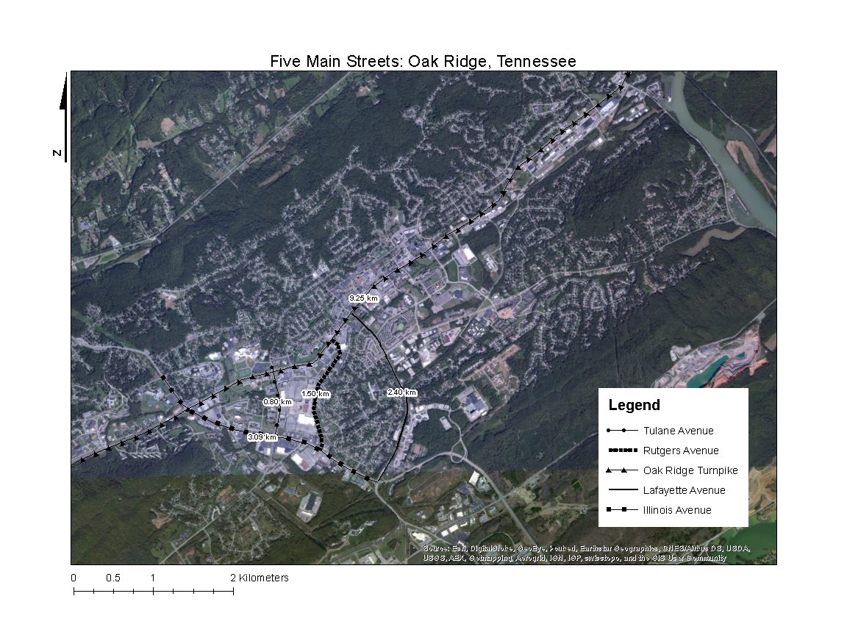
Figure 2. Oak Ridge, Tennessee street trees on the five main roadways.

four twigs (one for each cardinal direction) was used for each study street tree When the canopy was too high to reach measurable twigs, a pole saw was used to cut twigs for those measurements. The crown width of each sample tree was also measured for another tree condition variable. Live crown ratio (LCR), expressed as a percentage (%), was also determined for each of the sample street trees to be used as an additional condition variable. A three person consensus was used for determining tree score, tree crown width, and LCR.
Tree Diversity Sampling Scheme
Shannon’s diversity index was calculated for the total inventory, as well as each street, and Knox County sites. Shannon’s diversity index is determined by the following equation:
s
H = ∑ - (P_{i} * ln P_{i})
i=1

whereas Pi = is the relative abundance of each tree species found at each site, S = number of tree species found, and ∑ = sum of tree species 1 to species S (Shannon and Weaver, 1949). For the Oak Ridge street tree diversity calculations, five 100 m long transects were randomly generated along each street. Based on the random transects, all of the trees that were perpendicular to or bisected by each transect were used in the diversity calculations (Figure 3). Diversity was calculated for the Knox County sites based on all trees within the 0.04 ha plot.
Soil Sampling and Methodology
To assess seasonal variation in street tree ecosystem soils, soil samples were taken both in the winter of 2013 (2/25/2013-3/15/2013) and spring of 2013 (5/9/2013-5/28/2013) within the drip line of each study street tree. Six 2.5 cm diameter soil cores 20-30 cm deep were taken randomly; from which a composite sample was produced for each study plot. Soil samples then
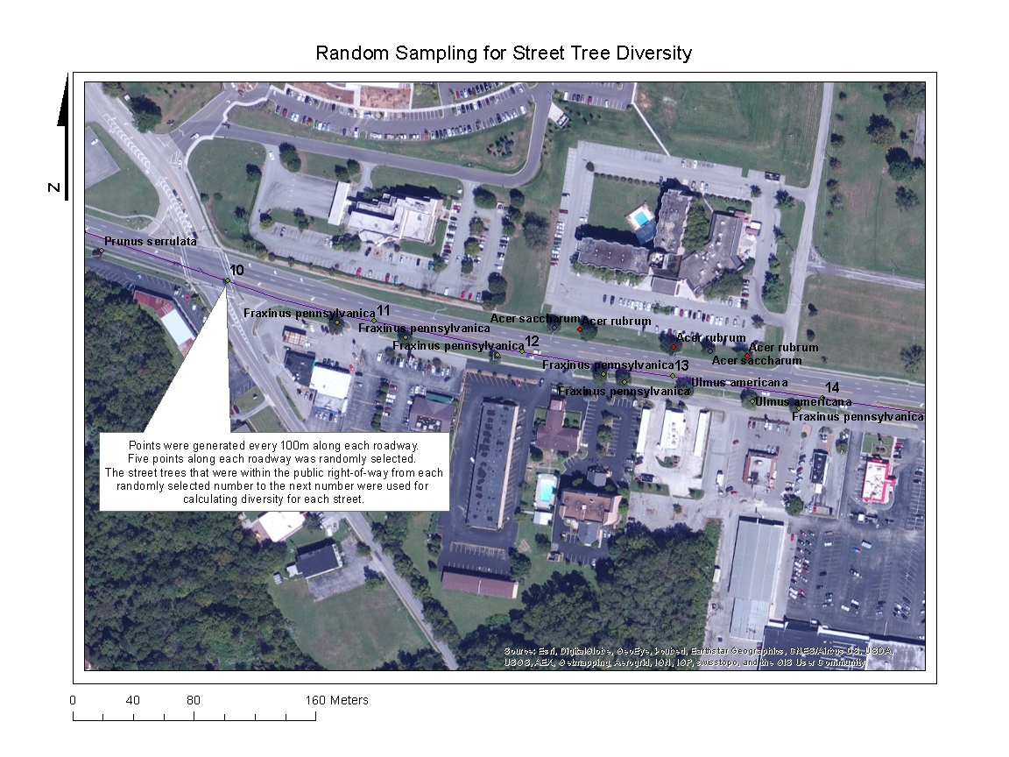
Figure 3. Street tree diversity sampling scheme.
were bagged, labeled and stored at -80˚C until analyzed. Subsamples were taken from composite soil sample for all soil analyses.
Oak Ridge Traffic and Stream Data
In order to determine which streets had the most traffic, traffic rates needed to be determined for each street. Traffic rates, measured as cars per day, where obtained through traffic records from the Tennessee Department of Transportation 2011 report for Oak Ridge East Anderson County (TDOT, 2011).
Distance from street tree to the nearest stream was determined by using the points collected by the Garmin etrex 20 during the inventory at each street tree, ArcMap 10, and stream vector data from the USGS National Hydrography Dataset (ESRI, 2011; USDA/NRCS, 2012). To determine the distance of each street tree to the nearest stream, the Join function was used in ArcMap to join the streams polyline shapefile to the street tree inventory point shapefile. Joining the two shapefiles by location resulted in a point shapefile with the street tree attributes as well as the attributes of the closest stream and the distance of each tree to that stream (Figure 4).
Basic Soil Analyses
All soil samples were first sieved with a 2 mm sieve. Gravimetric soil moisture (GSM) was done in triplicates at 10 g. The soil was first weighed into tin weigh pans and then placed in a drying oven for 24 hours at 105˚C (Figure 5). After drying, the subsamples were then weighed again and the percent water loss was then calculated by using the following equation:
GSM = (Weight of soil (g) – Average dry weight (g)) / Average dry weight (g) * 100
The 1:1 method was used to measure pH. From the sieved soil sample, 10 grams were weighed out and placed into a 50 ml centrifuge tube. After that, 10 ml of de-ionized water was poured into the tube with the soil. The tubes was then stirred vigorously with a vortex mixer and
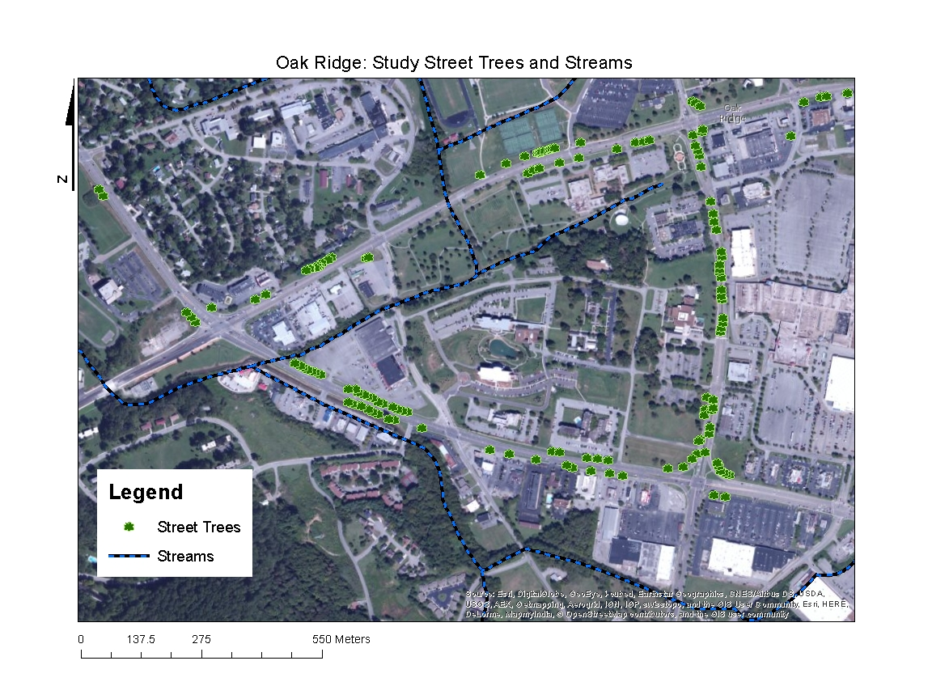
Figure 4. Map of Oak Ridge, TN and the study street trees with streams from the USGS Hydrography Dataset. Distance from tree to nearest stream was determined by joining the tree and stream layers.

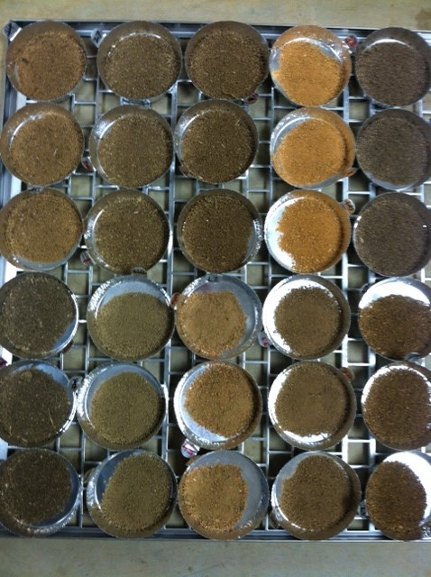
Figure 5. Soil samples in trays ready to load into the oven for gravimetric soil moisture measurements. Note the variation in soil color among different street tree sites.
allowed to settle for for thirty minutes. The pH measurement was then determined with an electrode by using a Fischer Accumet excel XL25. Before measurements were taken, the machine was calibrated at pH 10, pH 7, and pH 4. The H+ concentration (–log10) of each measurement was used for all statistical tests and then transformed back for reporting.
Cation Exchange Capacity (CEC)-Na Saturation Method pH 7
To measure cation exchange capacity of each soil sample, Chapman (1965) Na saturation method was adopted. Sodium acetate (NaOAc) was prepared by placing 136 g of NaOAc into a 1 L beaker and dissolved into 800 ml of deionized water. The solution was buffered with 10% acetic acid until the pH read 7.0. The solution was transferred to a 1 L volumetric flask and brought to volume (1 L) with deionized water. To prepare the ammonium acetate (NH₄Oac) solution, 77.08 g of NH₄Oac was placed into a 1 L beaker and dissolved into 800 milliliters of deionized water. Afterwards, the solution was transferred to a 1 L volumetric flask and brought to volume (1 L) with deionized water.
Five grams of soil were weighed into 50 ml centrifuge tubes. To each sample, 30 ml of the pH 7 1M NaOAc solution was added. The tubes were capped and placed on a shaker for 5 minutes. After shaking, the tubes were transferred to a centrifuge where they were centrifuged at 4000 rpm (rotations per minute) for 4 minutes. The tubes were removed and the clear supernatant was discarded. Thirty ml of pH 7 1M NaOAc was added again to each tube. The tubes were capped and the soil was stirred using a vortex mixer. Next, the tubes were set on the shaker for 5 minutes and transferred again to the centrifuge for the same rate and time as the previous step. The tubes were removed from the centrifuge and the supernatant was discarded. This step was repeated two more times. Samples were then centrifuged and washed three times with 30 ml of 95% ethanol in each tube. Following each wash, the ethanol was discarded. Thirty ml of 1 M NH₄Oac added was added to each tube. Tubes were capped and stirred with a vortex mixer until the soil was re-suspended. The samples were placed on a shaker for 5 minutes and centrifuged for 4 minutes at 4000 rpm. The clear supernatant was decanted into 100 ml volumetric flasks. This step was repeated three times. Lasly, the volumetric flasks were then brought to volume with pH 7 1M NH₄Oac and stored in 15 ml centrifuge tubes in a refrigerator until ICP analysis.
Soil Bulk Density
A bulk density method for gravelly soils was used to determine the bulk density of each street tree planting, n = 65 (Figure 5) (Blake 1965). Street tree plantings were designated by areas that contained street trees and were bound by impervious surfaces (Figure 6). The street tree plantings that were sampled for bulk density had to contain at least one of the street trees from the random 25 %. Samples were taken in September of 2013 at each planting that had at least one of the random study trees. First, a garden trowel was used to carefully dig a hole approximately three inches in diameter. The soil from that hole was transferred to a one gallon plastic bag and labeled. The hole was lined with a plastic sheet and carefully filled with water until the water reached the same level as the ground. After the hole was filled, the plastic sheet was gathered by the corners and the water was carefully poured into a large plastic beaker. The water was poured into a 500 ml graduated cylinder and the volume was recorded.
The soil sample was brought back to the lab were plant material was first removed. Each sample was weighed and the soil fresh weight was then recorded. Each sample was passed through a 2 mm sieve and the sieved fresh weight was recorded. From the sieved sample, three subsamples of each sample were weighed into tin weigh pans at 10.00 g. The subsamples were then placed into a drying oven for 24 hours at 100˚C. The dry weights of each subsample were recorded and averaged. From that average the gravimetric soil moisture was calculated, resulting in a
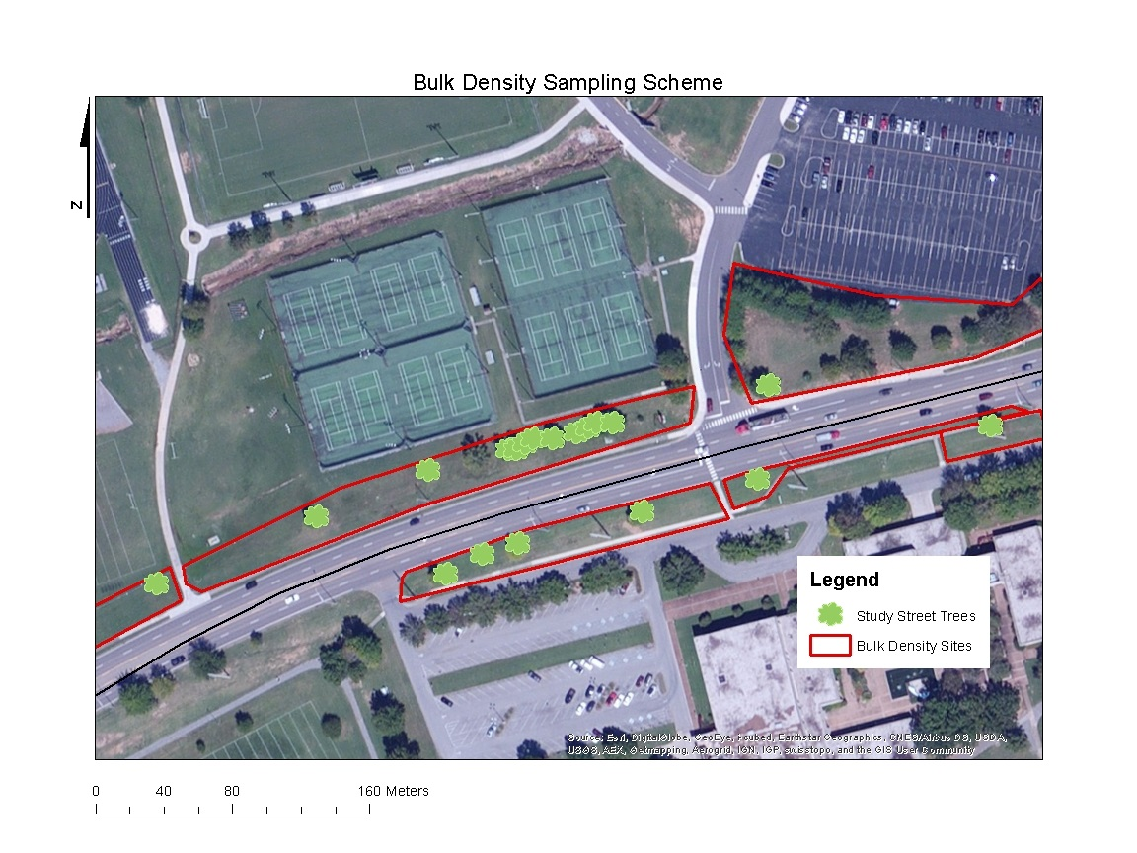
Figure 6. Bulk density samples were taken at plantings with sample trees that were bound by impervious surfaces. A total of 65 sites were sampled.

percentage. The gravimetric soil moisture percentage was used to determine the dry weight of the total fresh weight and the sieved fresh weight, therefore giving the total dry weight each soil sample. The total dry weights were then used to calculate the bulk densities of each sample. This was done by dividing each total dry weight (g) by the volume (cm³) of each hole.
Hydroflouric Acid Microwave Digestion
A hydroflouric acid microwave digestion developed by Nadkarni (1984) was used to measure total elemental concentrations. Each soil sample was done in triplicate. For each sample, 0.2 grams of air dried sieved soil was weighed out into polyallomar centrifuge tubes with caps. Then, 2 ml of reagent grade hydroflouric acid (HF) was added to each sample and allowed to sit in fume hood overnight (at least 16 hours). Next, 5 ml of aqua-regia (3:1:1 mixture of reagent grade hydrochloric acid (HCL), reagent grade nitric acid, and deionized water) was added to each sample and mixed with a vortex. The tubes (12-18) were then placed in a Tappen 800 watt microwave oven for 3 minutes at 80% power with two beakers of deionized water present in the microwave. The tubes were then removed from the microwave and allowed to cool. Approximately 1 gram of reagent grade boric acid was then added to each sample and mixed with a vortex. Tubes were then returned to the microwave for 10 minutes at 20% power. Tubes were mixed with a vortex while still warm in order to dissolve as much boric acid as possible. After the tubes were cool, they then were rinsed into 100 ml volumetric flasks with deionized water and then brought to volume. Flasks were then parafilmed and inverted to insure proper mixing. The solution was then filtered through Whatman No. 1 paper into 15 ml centrifuge tubes (around 13-15 ml). The samples were then stored in a refrigerator until the ICP analysis.

Chloroform Fumigation Extraction “slurry” Method (sCFE
Soil microbial biomass Carbon and Nitrogen was determined by using an adaptation of the Chloroform Fumigation Extraction “slurry” Method (sCFE) proposed by Fierer (2003).
From each soil sample, two 5 g subsamples of sieved soil were weighed out into 250ml Pyrex No.1395 glass bottles, one fumigated (with chloroform) and one un-fumigated (without chloroform). 40ml of 2 M KCl were added to each sample. To one sample 0.5 ml of ethanol-free chloroform was added. Both the chloroform exposed and control samples were sealed with chloroform resistant screw caps and placed on orbital shaker for 4 hours at 150 rev/min. Following shaking, the slurry was allowed to settle for 10 minutes, and 20 – 30 ml of extract from the top was decanted. By decanting only the top portion, the chloroform that concentrated at the bottom of the bottle was avoided. The extracts were then filtered through Whatman No. 1 filter paper using glass funnels in 50 ml Erlenmeyer flasks. Extracts were bubbled with air through rubber tubes using glass tips for 30 minutes. Extracts were then transferred to 50ml Falcon tubes and frozen until analysis. Samples then were thawed and transferred to glass tubes. A standard curve was made then the bottles were sent to be analyzed for total carbon (TC) and total nitrogen (TN).
From each extract, total carbon (TC) and total nitrogen (TN) were determined. TC was analyzed by a TOC-VCPH SHIMADZU analyzer with a 0.1ppm detection limit. The machine first flushed 150 ml/min of carrier gas (purified air) through a TC combustion tube which was heated to 680˚C. After the injection, the TC in the sample was then oxidized and decomposed into the form of carbon dioxide. The carrier gas along with the products of the combustion were then cooled and dehumidified. The products were then passed through a non-dispersive infrared detector (NDIR) sample cell that detects carbon dioxide. The NDIR analog signal then peaks and the data processor calculated the peak area detected. The TC concentration was then determined by relating the measured peak to the calibration curve made by a known, predetermined TC standard solution. Microbial biomass carbon (MBC) was calculated by the following equation: Microbial C – EC/kEC, whereas, the chloroform-labile pool (EC) is the difference between the fumigated and non-fumigated extracts and kEC is the soil-specific constant at 0.45 (Beck et al, 1997). Extractable organic carbon (EOC), was measured from the non-chloroform exposed extracts and total labile carbon (TLC) was determined by add MBC and EOC (MBC + EOC = TLC). All three measurements (MBC, EOC, and TLC) were used to test hypothesis three under the second objective.
Total nitrogen (TN), was determined by using a TNM-1 SHIMADZU analyzer with a 0.1ppm detection limit. Again, carrier gas was used to flow into a combustion tube at a rate of 150 ml/min and then heated to 720˚C with the use of a catalyst. After thermal decomposition had taken place, the TN was measured from the nitrogen monoxide product which was detected by the chemiluminescence detector. A standard calibration curve was used to determine the TN by expressing the measured peak and the standard curve peak as a ratio. Microbial biomass N was then determined by the following equation: Microbial N = EN/kEN. The EN represents the difference between the fumigated and non-fumigated extracts, and the kEN is the soil specific constant estimated at 0.54 (Brookes et al., 1985). Extractable organic nitrogen (EON), was measured from the non-chloroform exposed extracts and total labile nitrogen (TLN) was determined by add MBN and EON (MBN + EON = TLN). All three measurements (MBN, EON, and TLN) were used to test hypothesis three under the second objective.
Winter extracts were analyzed for carbon and nitrogen by the University of Tennessee’s Biosystems Engineering and Soil Sciences department. The extracts from the spring soil samples were analyzed for carbon and nitrogen at the University of Georgia Agricultural and Environmental Services Laboratories.
Knox County Forest and Soil Data
Twenty random 0.04 ha plots were generated in forested areas of Knox County, Tennessee. All trees within the 0.04 ha plots that were greater than 2.54 cm dbh were identified, measured for dbh, and used for calculating Shannon’s diversity index for each plot. The mean diversity of all the plots was used to compare the Knox County tree diversity to the mean diversity of the streets in Oak Ridge.
Soil samples were taken within each of the Knox County plots for the winter and spring of 2013. Each sample was a composite that consisted of six cores taken randomly within each plot at depths of 20 - 30 cm. The same soil analyses were done on the Knox County soils that were conducted on the Oak Ridge soils.
Statistical Analyses
A Pearson’s two-tailed correlation coefficient in SPSS 21 was used to determine what soil biological, chemical and physical properties were correlated with microbial biomass carbon (MBC) and microbial biomass nitrogen (MBN) in the urban soils at street tree planting locations (IBM Corp. Released 2012). A Principal Components Analysis (PCA) in JMP Pro 10.0.2 was used to determine the soil properties that were the most heavily characterizing the urban soil of Oak Ridge, Tennessee (JMP®, Version Pro 10.0.2).
Multivariate Analysis of Variance (MANOVA) using SPSS 21 was used to measure the variance of different means of dependent variables (elemental concentrations, total C, total known N, soil pH, bulk density, soil microbial biomass MBC and MBN, and soil water content) between the five streets. A one-way Analysis of Variance (ANOVA) using JMP Pro was used to determine the differences between seasons in MBC, MBN, soil water content, and pH. A log10 transformation was used for the MBC and MBN data in order to satisfy the ANOVA assumption of normality (Figure A. 1-2). The log10 transformed means were then reverted to its original state by raising it as an exponent over ten: 10^^{log10} (MBC or MBN). Microbial biomass differences between streets based on the Shannon’s Diversity Index values were determined by an Analysis of Covariance (ANCOVA) in SPSS 21 using distance of tree to impervious surface as a covariate. ANOVA was also used in JMP Pro 10.0.2 to determine the biological, chemical, and physical differences between the Oak Ridge urban soil and Knox County forest soils. Levenne’s test for unequal variance was done for all ANOVA’s in order to meet ANOVA assumptions. All variables with standard deviation within five fold of each other were also considered to have met the equal variance assumption.
A Pearson’s two tailed correlation coefficient and the principal components from the PCA was used to investigate which urban environmental stressors were likely influencing street tree conditions and growth. Urban environmental stressors, elemental concentrations, soil pH, bulk density, soil microbial biomass MBC and MBN, soil water content, tree distance from impervious surface, and distance from closest stream were independent variables that were tested for their influences on the dependent variables, tree condition score and growth.

Chapter 3: Results
Street Tree Inventory
The number of street trees that were inventoried along the five main thoroughfares in Oak Ridge was 607, with 37 different species (Table 2). The diameters ranged from 5.08 cm to 93.98 cm and the average diameter of the street trees was 30.3 cm (Figure 7). The general street tree conditions showed 52% (313 trees) as good, 30% (185 trees) fair, 16% (96 trees) poor, and 2% (13 trees) dead (Figure 8). The street tree ecosystems, as a whole, were dominated by Acer rubrum (21.91%) and Pyrus calleryana (19.93 %) (Table 2). Street by street, Illinois, Oak Ridge Turnpike (ORTP), and Rutgers’ street tree ecosytems were composed of > 10% Pyrus calleryana; whereas, > 10% Acer rubrum was on all streets but Illinois (Figure 9). The average street tree diversity index for the five streets was H’ = 1.39 (Figure 10). Oak Ridge Turnpike had 339 street trees with Acer rubrum > Pyrus calleryana > Ilex xattenuata, the most abundant species, and a diversity index of H’ = 1.81. Rutgers had 19 street trees, with Gymnocladus dioicus > Acer rubrum > Liquidambar styraciflua the most abundant species, and a diversity index of H’ = 1.12. Illinois had 74 street trees, with Pyrus calleryana > Fraxinus pennsylvanica > Acer rubrum > Quercus phellos, the most abundant species, and the highest diversity index of H’ = 1.85. Lafayette had 128 street trees, with Acer rubrum > Pinus strobus > Acer saccharum, the most abundant species, and a diversity index of H’ = 1.43. Tulane had 47 street trees and was the least diverse, with Pyrus calleryana > Prunus serrulata > Fraxinus pennsylvanica, the most abundant species, and a diversity index of H’ = 0.75.
Street Tree Soil and Site Characteristics
Tables 3 and 4 describe the physical, biological, chemical properties of the sampled soils and sites that were analyzed along the five main streets in Oak Ridge.

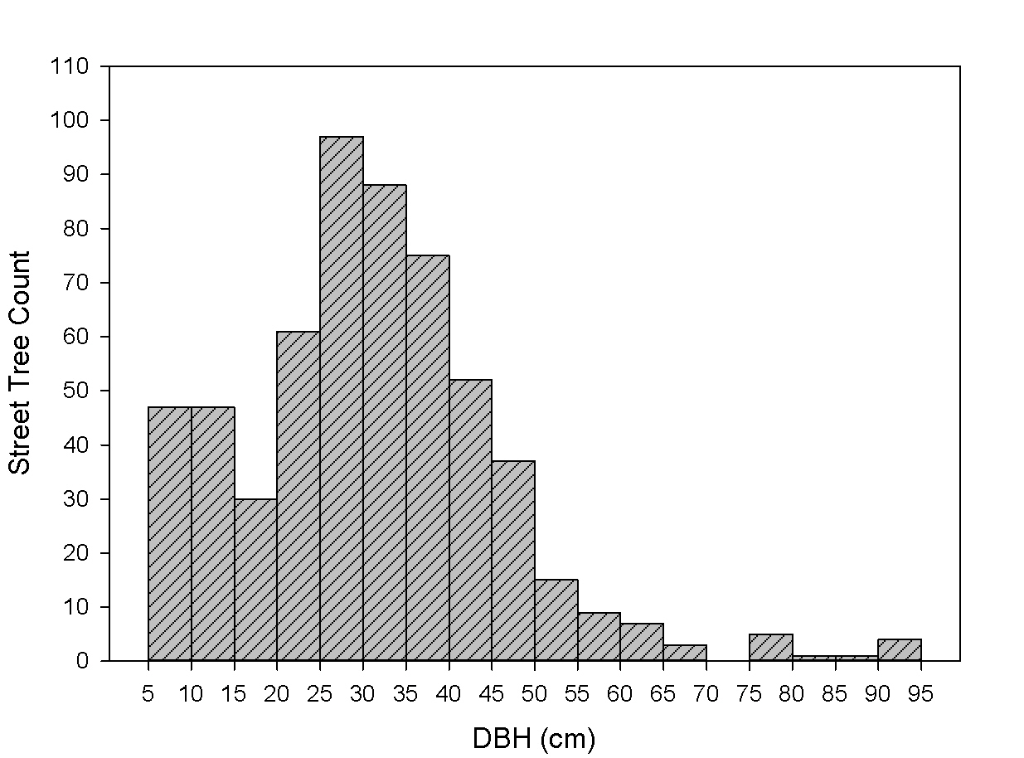
Figure 7. Diameter distribution of the total five street inventory.

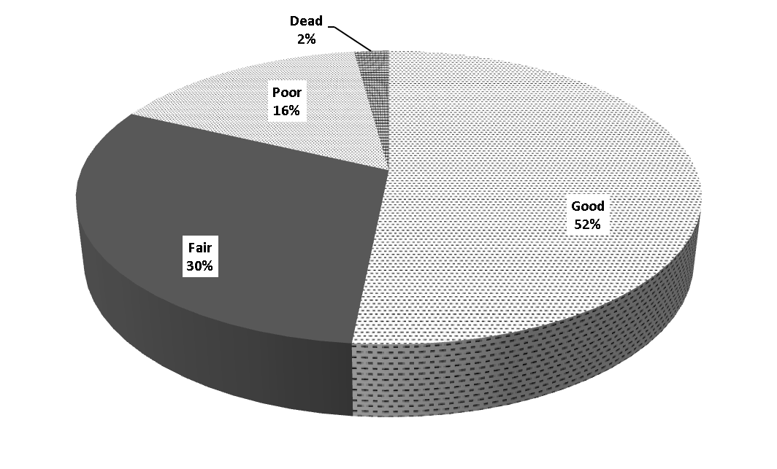
Figure 8. Street tree conditions (good, fair, poor, dead) determined for the total street tree inventory of the five main thoroughfares in Oak Ridge, Tennessee.

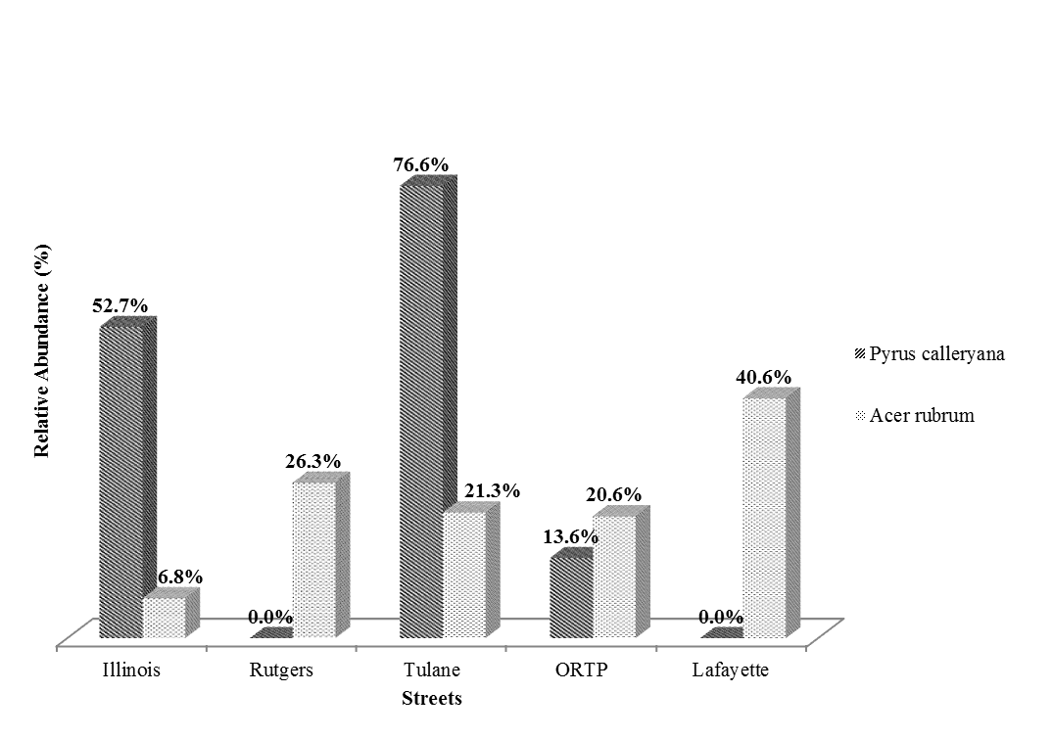
Figure 9. The two most abundant Oak Ridge street tree species, Pyrus calleryana and Acer rubrum, and their relative abundances on each street in 2012.

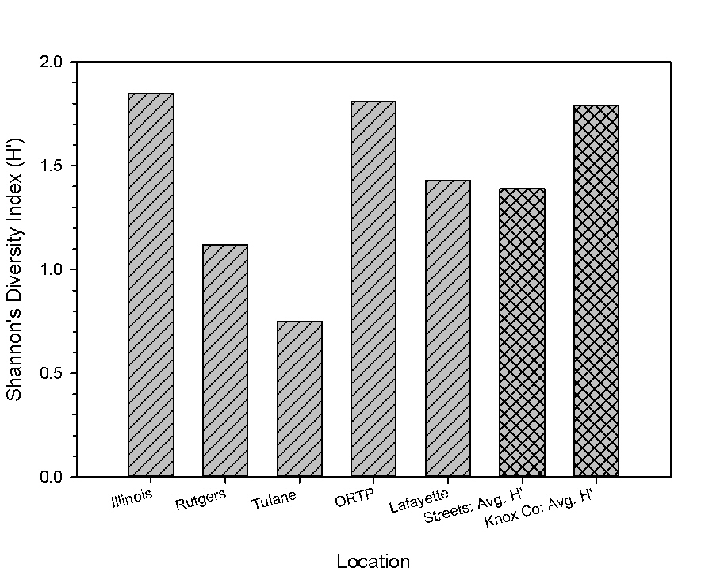
Figure 10. The diversity indices (H’) were Illinois 1.85, Rutgers 1.12, Tulane 0.75, ORTP 1.81, Lafayette 1.43, Total (5 street inventory) 1.39, Knox Co. (area forests) 1.79.

The Pearson’s two-tailed correlation matrix revealed several significant correlations between street tree soil biological, chemical and physical properties and site characteristics. Tree distance from impervious surface was significantly (p<0.05) negatively correlated with Ca, Co, Mn P, S, Sr, Zn, Pb, winter microbial biomass nitrogen (wMBN), and winter microbial biomass carbon (wMBC). Distance from impervious surface was also significantly (p<0.05) positively correlated to K. Tree distance to the closest stream was significantly (p<0.05) negatively correlated with tree distance from impervious surface, wMBN, bulk density, and Zn. Significant (p<0.05) positive correlations were found with winter gravimetric soil moisture (wGSM) and wMBN, wMBC, Ca, and Cr; whereas, wGSM was found to be significantly (p<0.05) positively correlated with Ba, Ti, and tree crown width. Significant (p<0.05) positive correlations were found between wMBN and wGSM, Mg, Ni, P, S, Sr, and Zn. The wMBC was found to be significantly (p<0.05) positively correlated to wGSM, Ca, Cr, Mg, Ni, S, Sr, Zn, and Pb; as well as negatively significantly correlated with Ba. Tree condition scores were significantly (p<0.05) positively correlated with Ca, tree diameter, live crown ratios (LCR); likewise, tree condition scores were significantly (p<0.05) negatively correlated with As.
Street Tree Soil Differences by Streets
Multivariate Analysis of Variance (MANOVA) was run to compare mean differences between street tree soils’ biological, physical and chemical properties (Table 5). Illinois and Lafayette significantly (p < 0.05) differed from ORTP in MBC and MBN differed significantly (p < 0.05) on ORTP and Lafayette. Streets differed in chemical and physical composition between bulk density, wGSM, distance of tree from impervious surface, three macronutrients (K, P and S) and three micronutrients (Fe, Mn, and Zn) (Table 5). The only heavy metal that differed significantly between streets was Zn. Even though there was no significant difference between the busiest street (Illinois) and the least busy street (Tulane), the second busiest street (ORTP) did have significantly more Zn in the street tree planting soil than Lafayette. The wMBC and wMBN proved to not be lower on busier streets than less busy streets even though there were significant differences found between the streets. When comparing Illinois to Tulane for both wMBC and wMBN, both instances revealed no significant differences in microbial biomass.
Street Tree Soil and Forest Soil
The results from ICP total elemental analyses from street tree soils in Oak Ridge and from Knox County forests from Jean-Philippe at al., (unpublished data) revealed that Oak Ridge had both significantly higher and lower concentrations of macro- and micronutrients than Knox County (Prob>F = <.05*).Oak Ridge’s street tree soil nutrients that were higher in concentration (mg kg⁻¹) than Knox County forest soils were Cu, S, Zn, Mg, and Na (Table 6). When compared to street tree soils Mn (Prob>F = 0.05*) was lower in concentration (Table 6). Concentrations of Pb in the soil on both sites also showed a difference. Oak Ridge had significantly higher mean concentrations of Pb than Knox County (Table 6). The microbial biomass was found to significantly differ between the forested plots and the street tree ecosystem soils. Mean spring microbial biomass carbon (spMBC) in Oak Ridge was significantly lower than Knox County forest’s soil (Table 6). The wMBC did not significantly differ by location. Oak Ridge’s was significantly higher than the Knox County soils. The spring microbial biomass nitrogen (spMBN) sample in Oak Ridge had a mean concentration of 7.61ug g⁻¹ and the Knox sample had a mean of 9.70 ug g⁻¹; however, there was no difference detected by the ANOVA (Table 6). Other soil characteristics that differed were bulk density and cation exchange capacity (CEC). Overall, significantly higher bulk densities and higher CEC were found in the Oak Ridge street tree ecosystem soil than the Knox County forest soil (Table 6).

Street Tree Diversity and Soil Microbial Biomass
ANCOVA test, controlling for tree distance to impervious surface, found only wMBC to be significantly different between streets based on their Shannon’s Diversity H’, (Prob>F = <.05*) where ORTP (H’ = 1.81), was found to have significantly higher mean wMBC than Illinois (H’ = 1.85) and Lafayette (H’= 1.43) (Figure 11).
Urban Soil Seasonal Variation
One-way ANOVA tests for each seasonal variable showed multiple differences between the two seasons (Prob > F = < .05*) (Figures 12 and 13). Overall, the winter season had significantly higher MBC and MBN. The MBC in the winter had a mean of 54.20 ug g⁻¹ while the street tree soil in the spring had a mean MBC of 38.69 ug g⁻¹. The wMBN had a mean of 9.81 ug g⁻¹ and a spMBN of 7.61 ug g⁻¹. Extractable organic carbon (EOC) and total labile carbon (TLC) were both significantly higher in the spring than the winter. EOC had mean spring concentration of 186.83 ug g⁻¹ and the winter had a concentration of 50.65 ug g⁻¹. TLC in the spring was at a mean concentration of 225.81 ug g⁻¹. Extractable organic nitrogen (EON) differed significantly between the two seasons with a mean concentration of 20.30 ug g⁻¹ in the spring and 17.86 ug g⁻¹ in the winter. Total labile nitrogen (TLN) did not differ seasonally. The GSM in the winter was also significantly higher than the spring with means of 29.63 % water and 23.08 %. There was no difference found between the seasons in soil pH.
Street Tree Performance Assessments
Tree condition score was not significantly correlated to physical or biological properties measured (p < 0.05). The physical soil properties and planting site characteristics (tree distance
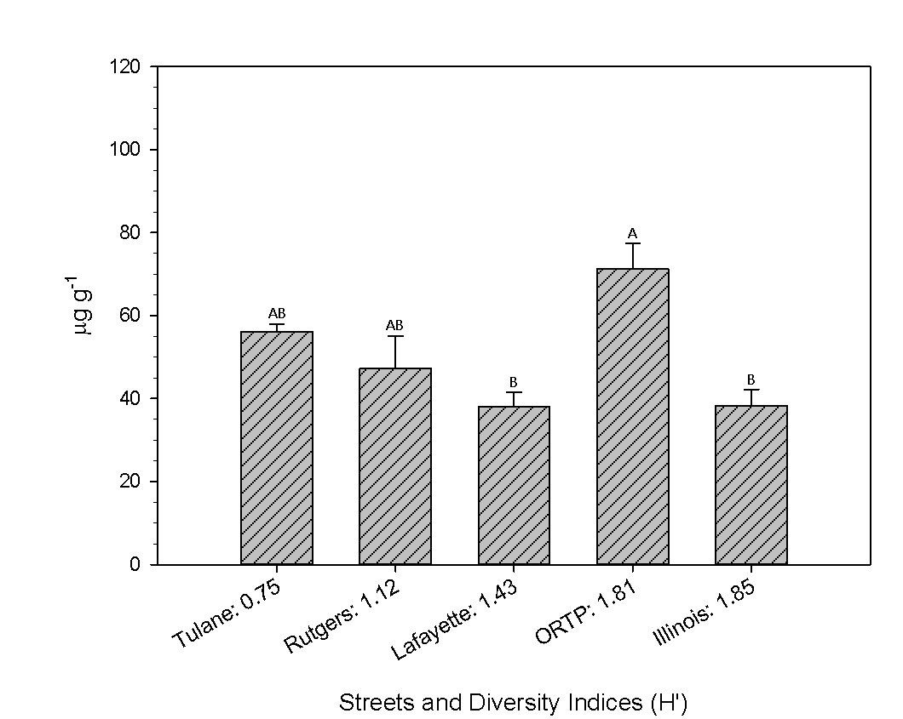
Figure 11. ANCOVA results, controlling for tree distance to impervious surface. Different letters indicate significant difference at the 0.05 level.

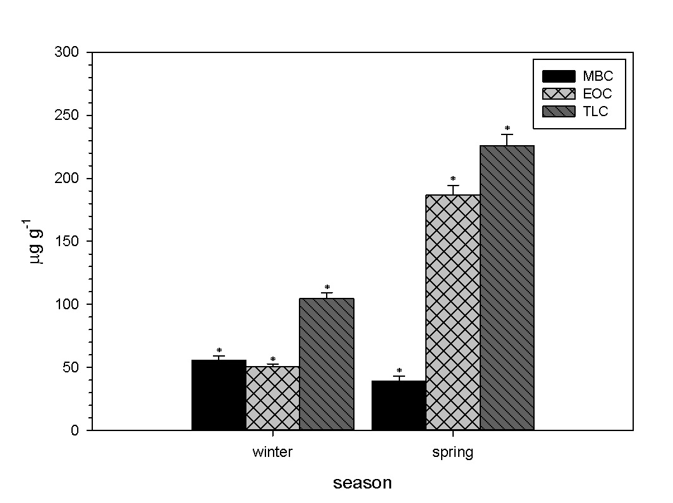
Figure 12. ANOVA results in seasonal differences in street tree ecosystem soil carbon pools. Bars represent mean concentrations with standard errors. *Significant difference at the 0.05 level.

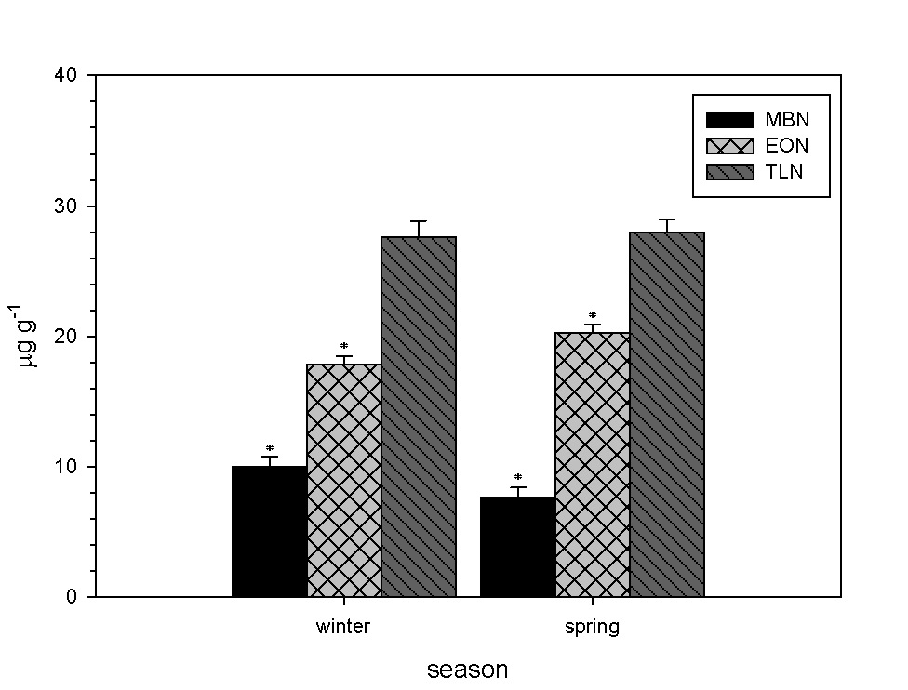
Figure 13. ANOVA results in seasonal differences in street tree ecosystem soil nitrogen pools. Bars represent mean concentrations with standard errors. *Significant difference at the 0.05 level.
to impervious surface and tree distance to closest stream) were found to have no correlation to street tree performance. However, street tree condition score was significantly positively and negatively correlated to Ca and As, respectively (Table 7). Annual twig elongation (growth) was significantly and positively correlated with Ca as well as spring gravimetric soil moisture (spGSM) (Table 7). Despite the lack of correlation between site properties and tree condition and growth, there were high concentrations of heavy metals other than As found in the street tree soils (Table 4).
Principal component analysis (PCA) produced a total of thirty-five components (Figure A. 3). The first eleven components accounted for over seventy-three percent of the variance among the variable (Figure A. 3). The eleven components were then used as variables for Pearson’s Correlation with tree condition score and tree growth. None of the principal components were significantly correlated to tree score or growth. The biplot of the first two components, however, show that the data was heavily loaded on by several elements, wMBC, wMBN, and distance to impervious surface (Figure 14). Also, the score plots represented by general condition show more poor trees grouped closer to the origin and extending into quadrats 1 and 3 (Figures 15).

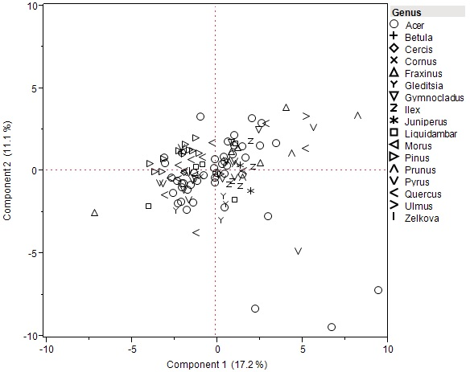
Figure 14. Score plot of first two components and street tree genera represented by symbols.
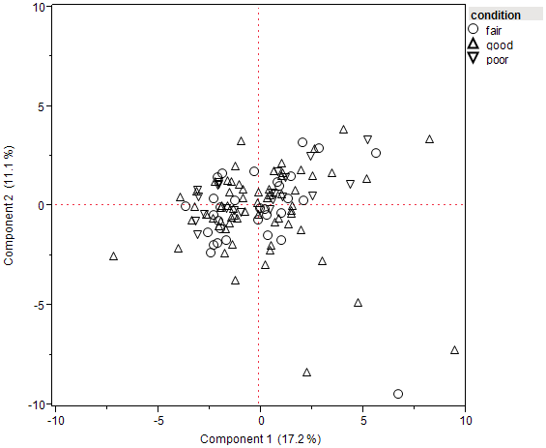
Figure 15. Score plot of first two components with street conditions represented by symbols.

Chapter 4: Discussion
Objective 1: Impacts of Land-use Change on Street Tree Diversity and Performance
Hypothesis 1: Rural Forests will have Higher H’ than Street Tree Ecosystems
The hypothesis that higher H’ would be found in rural forests was supported. The higher tree diversity found in Knox County forested sites than Oak Ridge street tree ecosystems is likely a result of the amount of non-native trees such as Acer buergerianum, Ilex attenuata, and Pyrus calleryana, as well as large amounts of preferred native trees such as Acer rubrum, Pinus strobus, and Acer saccharum that were intentionally planted. Some of the street trees that were likely naturally recruited such as Juglans nigra, Morus rubra, and Juniperus virginiana. It has been found that city parks tend to resemble the natural area forests in their composition rather than streets tree populations (Welch, 1994). Likewise, Jim and Liu (2001), found that communities of roadside trees were the least diverse forests when comparing them to parks and institutional (university campus) forests. Since diversity has been found to increase overall forest productivity and act as a safety net for pest or disease epidemics, tree diversity in the urban forest would only increase the benefits to the overall ecosystem (Belote et al., 2011; Raupp, 2006). The current pests that pose threats to the Oak Ridge urban forest are Emerald Ash Borer (Agriligus planepinus, EAB) which is decimating ash (Fraxinus) populations and Thousand Cankers Disease (TCD) which targets walnut (Juglans) species. The current status of Oak Ridge’s street trees seems to be in fairly good standing if one or both of these pests should hit since the street tree ecosystems are comprised of only 2.31% Fraxinus pennsylvanica and 0.33% Juglans nigra (Table 2). However, if the tree diversity was higher in Oak Ridge, herbivory from EAB and the walnut twig beetle (the vector for TCD) could be deterred and result in healthier street tree ecosystems (Jactel and Brockerhoff, 2007).
Not only are the street tree ecosystems in Oak Ridge less diverse than in Knox County rural forests, but the species composition within the street tree ecosystems lacks evenness. According to the 10:20:30 rule, a street tree population should not be composed of more than 10% of a single species, 20% of a single genus, or 30% of a single family (Subburayalu and Sydnor, 2012). Judging by the 10:20:30 guideline, Oak Ridge street tree ecosystems’ diversity falls short of that accepted diversity parameter. The guideline was created to prevent widespread destruction in the event of disease outbreak. The street tree inventory of the five main thoroughfares revealed a composition of being nearly 22% Acer rubrum and 20% Pyrus calleryana; therefore, should disease or pests strike one of those two species, the Oak Ridge urban forest could potentially experience drastic losses in ecosystem services. The overabundance of Pyrus calleryana also presents an existing problem without pests or disease. Pyrus calleryana “Bradford”, which is common in Oak Ridge as well as other cities, is known to have poor branch attachments due to crotch formations; thereby making these trees susceptible to branch loss, splitting from wind or storm damage, and an overall shorter lifespan (Dirr, 1990).
Hypothesis 2: Soil and Site Physical Properties will have Greatest Impact on Street Trees
The hypothesis that soil and site physical properties will have the greatest impact on street trees was not supported. The negative correlation with As and tree condition could be an indication that increased amounts of As in Oak Ridge urban soil could harmful to the street trees. Arsenic has been found to inhibit root elongation and could therefore be influencing tree performance (Song et al., 2006). The positive correlation between tree condition and growth with Ca indicate that the street trees tend to have better performance and growth on sites with higher amounts of Ca. Street trees that are receiving higher amounts of Ca could be in better condition and growing more because Ca is vital for the synthesis of cell walls in plants and cell membrane stabilization (Eklund and Eliasson, 1990; Fromm, 2010). The positive correlation with growth and spGSM could be an insight that some street trees in Oak Ridge during the spring had limited water available in their root zones; therefore, growth may have been limited to trees that had less soil moisture at their planting sites. Water availability to street tree is an issue that not only faces urban forest managers, but has also been thoroughly investigated. Excess water as well as drought can have detrimental impacts on urban tree performance (Saebo et al., 2003; Nielson et al., 2007). The positive correlation with tree growth and spGSM in Oak Ridge’s soils may suggest that lack of water may be an issue for the street tree ecosystems. Although these correlations do not indicate causation, this does open doors for more research and possible management directives to be taken. Oak Ridge in particular, may benefit by selecting street trees to plant for drier sites that are more drought tolerant (Whitlow et al., 1992). Also, further investigation of soil chemicals on tree physiological properties would offer greater insight to the impacts of urban soils on tree growth and condition.
The interactions between site properties with tree condition and growth were further investigated by using a Principal Components Analysis (PCA). Eleven principal components, with eigenvalues over one, accounted for over seventy-three percent of the variance within the data. Since it took eleven components to explain seventy-three percent of the variance within the data, it is apparent that the street tree ecosystem soil in Oak Ridge is variable in its characteristics (Figure A. 3). In Oak Ridge, the soil and site characteristics that greatly influenced the variance of the data were the winter microbial biomass concentration, distance to impervious surface, and multiple soil chemical concentrations (Al, Fe, P, Cr, Zn, Sr, S, and Ca) (Figure 14). When plotting the sample plots by tree score on the first two component axes, there were no apparent groupings based on better tree performance or worse tree performance. However, when looking at the initial inventory condition assessment the good and fair trees can be seen deviating further from the origin; whereas the poor condition trees hold a linear grouping closer to the origin (Figure 15). Also, in Quadrat 1 of Figures 14 and 15, there are heaving loadings from Al, Fe, Cd, Co, P and Cu (Figures A. 4 and 5). The score plot that that has the general conditions (Figure 15) of each tree depicts multiple poor condition street trees (Ulmus, Prunus, Gymnocladus, and Fraxinus) (Figure 14) in Quadrat 1 which had heavy loadings in Al, Fe, Cd, Co, P and Cu. Therefore, Ulmus, Prunus, Gymnocladus, and Fraxinus species may be impacted by varying amounts of Al, Fe, Cd, Co, P, and Cu in Oak Ridge street tree ecosystems. Likewise, there were several poor condition trees (Quercus, Pinus, and Acer) that were plotted in Quadrat 4 which was heavily influenced by the distance to impervious surface (Figures 14 and 15) (Figures A. 4 and 5). This could mean that many of the trees that are performing well along Oak Ridge’s roadways are more tolerant of the variance in soil chemical as well as biological properties. A similar study by Scharenbroch and Catania (2012) that used the same tree score method, found that soil texture and pH correlated with tree conditions while tree growth was correlated to wet-aggregate stability, bulk density, pH, soil organic matter (SOM), and particulate organic matter (POM). Their findings seemed to imply that the physical properties of soils impacted the tree conditions and growth. Whereas, Cekestere and Osvalde (2013) found that street and park trees that were in poorer condition were growing in soils that were high in Na, Cl, and Mg; and low in K, Fe, Cu, B. Therefore, chemical concentrations in the latter study were moreover what weighed the heaviest on the ability of street trees to perform.

Objective 2: Impacts of Land-use Change on the Site and Soil Biological, Chemical and Physical Properties, and Nutrient Dynamics within Street Tree Ecosystems
The soil analyses indicated that urbanization has impacted Oak Ridge’s urban soil biologically, chemically, and physically. The initial correlation matrix showed that there were many soil and site characteristics that were correlated with one another. The correlation matrix also resulted in multiple significant correlations between distance to impervious surfaces, such as concrete, and several soil properties. The pH of Oak Ridge’s street tree soil was not among the variables that correlated with distance to impervious surface; whereas pH has been found in other areas to increase the closer the distance to roadways (Trammell et al., 2011). Trammell et al. (2011) also found that Cd, Cu, Cr, Ni, Zn, and Pb all decreased as distance to interstate increased. This same trend was found in Oak Ridge with Ca, Co, Mn, P, Pb, Sr, S, and Zn. The analyte, K, was the only element that had increasing concentrations as distances to impervious surfaces increased. One reason this trend could be more pronounced in Oak Ridge than the study conducted by Trammell et al. (2011) is that the soil samples for Oak Ridge were taken within the center of the city rather than in forests along the urban interstates. Therefore, Oak Ridge’s urban soils could be subject to more direct anthropogenic inputs. In urban areas, Ca often originates from building materials such as concrete which is incorporated into the soil formation (Orsini et al., 1986). Therefore, it makes sense that Oak Ridge’s street tree soils exhibit the pattern of having higher concentrations of Ca closer to roadways. Furthermore, since Ca can promote alkalinization, the more acidic soils that were found closer to impervious surfaces suggest that there may be inputs, such as fertilizers, that are preventing the soils from being more alkaline (Cekstere and Osvalde, 2013). Fertilizers could also explain the higher concentrations of P closer to impervious surfaces. Pouyat et al (2007) proposed that the P and K found in Baltimore, Maryland urban soils were likely from lawn fertilizers. K, however, had an opposite trend than P in regards to the impervious surfaces in Oak Ridge.
The higher amounts of Zn closer to roadways could be from dust of deteriorated vehicle parts, such as tires, that contain Zn (Cekstere and Osvalde, 2013). Some motor fuels have anti-knock agents that contain Mn; thereby, offering a possible explanation for the higher Mn concentrations found closer to the roadways in Oak Ridge (Zayed et al., 1999). Furthermore, decades of Pb based fuels being used for decades within the city likely caused the street tree ecosystem soils to have greater Pb concentrations than the rural forest soils (Mielke and Reagan, 1998). Both wMBC and wMBN were significantly and negatively correlated with distance to impervious surface. This result could be showing the potential of impervious surface to promote more soil microbial biomass. A soil pH near neutral (6-7) is optimal for most soil microbes; therefore, the higher pH and microbial biomass found closer to impervious surfaces could mean that alkaline adapted microbes, such as some cyanobacteria, are more prevalent closer to roadways than other microbes (Sylvia et al., 2005). Further investigation of microbial ecology in street tree soil would provide better understanding for the types of microbes and their functions along roadways.
The impact of urbanization on Oak Ridge’s urban soil is also evident when comparing the biological, chemical, and physical properties of Oak Ridge’s street tree ecosystem soils to soils found in Knox County, Tennessee forests. The Ca and Mg concentrations in Oak Ridge soils where higher than the soils of Knox County forested sites. Accumulation of these elements in urban soil has been attributed to dust from construction activities (Cekestere and Osvalde, 2013). Therefore, anthropogenic activities play a role in chemically influencing the soil composition in urban areas. The higher concentrations of Cu and Zn in Oak Ridge’s soils when compared to the Knox County soils could be from the more concentrated automobile activity within the city. Copper and Zinc both have been found to be linked to tire deterioration and dust from brake pad usage (Zanders, 2005). When comparing Mn and Na between Oak Ridge and Knox County soils, the forest soils of Knox County exhibited higher mean concentrations. Oak Ridge also had significantly higher amounts of Pb in its urban soil compared to Knox County’s forest soil. Cities have been found to contain high concentrations of Pb in their soil because of the amount of anthropogenic activities such as coal combustion, old forms of gasoline used, mining, and other industrial activities concentrated in one area (Huang and Ao, 2010; Hu et al., 2014). Since Oak Ridge had such a rapid development as well as ongoing fuel combustion from their laboratories, higher Pb concentrations were to be expected. The CEC was significantly greater in Oak Ridge’s street tree soils than Knox County’s forest soils, indicating that the street tree soils are able to more efficiciently allocate base cations to the vegetation. The difference is CEC could be due to the fact that the Oak Ridge street tree ecosystem soils were more clayey than the Knox County forest soils and also had less organic matter built up from leaf litter. The spMBC was significantly higher in Knox County while the wMBN was signicantly greater in Oak Ridge. Soil microbial biomass has been found to be lower in cities when compared to more rural areas, which is likely due to reduced amounts of litter as well as lower quality litter (Groffman et al., 1995; Pouyat et al., 2002). The higher wMBN in Oak Ridge could indicate that the microbes are storing more organic nitrogen in the spring before mineralizing it for plant uptake in order to decrease the amount of nitrogen losses. Significantly lower N mineralization rates have been found in urban soil A horizons compared to rural soils; however, urban soils have also been found to have increased nitrification rates when compared to rural soils (White and McDonnel, 1988; Zhu and Carreiro, 1999). Bulk density was also higher in Oak Ridge than in Knox County. Higher bulk densities are generally expected to be found in cities rather than in rural areas. Roadsides also receive high amounts of use from vehicles, to foot traffic, and construction. Forest soils are not subject to the same exertion of force from the surface; therefore lower bulk densities in a forest setting should be lower than along roadways. Also, the accumulation of organic matter (OM) in forests promotes more microbial activity, porosity, and water infiltration rates; which in turn allows for lower bulk densities. In cities, the OM (i.e. leaves and woody debris) is usually removed for aesthetic purposes; therefore, OM is not allowed to accumulate and allevieate compacted areas.
Hypothesis 1: Higher AADT will have Higher Heavy Metals and lower Soil Microbial Biomass
The hypothesis that higher AADT will have higher heavy metals and lower soil microbial biomass was not supported. The impacts of urbanization on the street tree ecosystem soils in Oak Ridge can be seen in the properties and the distribution of the soils along roadways. Firstly, the soils along the roadways biologically, chemically, and physically differed between certain streets (Table 5). Those differences in soil composition demonstrate that urban soils are heterogeneous in their distribution due to anthropogenic influences such as construction, soil sealing from impervious surfaces, fill soil, and pollutants (Vasenev et al., 2013; L. Yang et al., 2014). Both wMBC and wMBN were significantly higher along ORTP than Lafayette. Lafayette had significantly less soil moisture (wGSM) than ORTP, so it could also be that the amount of soil moisture along Lafayette in the winter could be the factor that is preventing higher amounts of microbial biomass. Another factor that could have driven the lower microbial biomass along Lafayette is the abundance of Eastern white pine (Pinus strobus) which constitutes 36% of the species found on that street. Bauhus et al. (1998) found that microbial biomass nitrogen was significantly less under conifers when compared to broadleaf deciduous trees; therefore, the Eastern white pines along Lafayette could be suppressing the soil microbial community. The wMBC was also significantly higher in soils along ORTP than Illinois. Illinois also had significantly less wGSM than ORTP; therefore, the higher amount of soil moisture along ORTP soils could likely be the reason for more microbial biomass. The second busiest road is ORTP; therefore, it seems that higher traffic rates on ORTP did not negatively impact the microbial biomass. It is likely that other factors such as water, vegetation, impervious surfaces, and direct soil disturbances have a greater impact on the soil microbial community than the amount of traffic a roadway receives. The distance of trees to impervious surface was lowest on Tulane and almost the same as ORTP. The three largest and busiest streets (Illinois, ORTP, and Lafayette) had the highest bulk densities, but statistically only Illinois was significantly higher than Rutgers. The higher bulk densities along Illinois could be because it receives more traffic than Rutgers and also has had a more recent history of construction activities. From a hydrological perspective, the wGSM was significantly higher along ORTP and Rutgers. Trees growing along those roadways could be getting sufficient water or in some cases too much water.
Chemically, certain the streets differed significantly from each other in Fe, K, Mn, P, S, and Zn concentrations. Although Zn did not differ between Illinois and Tulane (busiest and least busy street), a significant difference was found between ORTP (21077 cars/day) and Lafayette (17160 cars/day) (Table 5). Overall, ORTP is more intensely developed than Lafayette, Rutgers, and Tulane. Sources for Zn have been found to be decaying automobile parts (especially tire debris), municipal sludges, and atmospheric deposition (Smolders and Degryse, 2002; Schrader, 1992; Olid et al., 2010). It is likely that the amount of development on ORTP and the amount automobile debris could be the reason for the higher concentrations of Zn than in street tree ecosystem soils along Lafayette. Again with Mn, the same trend can be found, ORTP is significantly higher than Lafayette. Another study that investigated soil properties and traffic densities along interstates also found that the amount of traffic did not explain variation in soil characteristics (Trammell et al., 2011). Pouyat et al. (1991) found that soils closer to the city exhibit higher concentrations heavy metals than soils further away. This could be a characteristic of Oak Ridge’s soil environment, that instead heavier traffic rates being the culprits of high elemental concentration could be the proximity of the soils to the more developed center of the city. Lafayette runs along the outer border of Oak Ridge and has not been as developed by large businesses, stores, or facilities; therefore, allowing less accumulation of trace metals from anthropogenic sources. The differences found in K, P, and S concentration are likely from areas getting more fertilizers for lawn care purposes. ORTP and Lafayette still differed significantly for analytes K and P; therefore, soils along roadways that are more intensely developed could be subject to higher nutrient concentrations. S, although not statistically significant, demonstrated the trend of ORTP having higher concentration than Lafayette as well. Overall, the impacts of urbanization on the roadside soil environment determine by two factors; impervious surfaces altering soil properties and processes, and the location of the roadways in the city rather than the amount of traffic.
Hypothesis 2: Streets with Higher H’ will have Greater Soil Microbial Biomass
Overall, the hypothesis that streets with higher H’ will have greater soil microbial biomass was not supported. Oak Ridge Turpike (ORTP) not only was one of the most diverse streets (H’ = 1.81), but it also the most soil winter microbial biomass carbon (wMBC) (71.26 ug g⁻¹). Despite ORTP having signifantly higher wMBC than both Illinois and Lafayette, there was no significant difference detected between ORTP and the least diverse street, Tulane. Furthermore, the most diverse street, Illinois (H’ = 1.85), only had a mean wMBC of 38.33 ug g⁻¹. The abundance of Pinus along Lafayette (H’ = 1.43), which had the lowest wMBC, could be a greater influence in the wMBC the actual street tree diversity. Plant diversity has been found to increase microbial biomass in natural forests but this possible interaction has not been found in the urban forest (Zak et al. 2003). The diversity of leaf litter mixtures has also been found to increase soil microbial biomass as well as function. The removal of leaf litter from many roadside tree plantings could be the reason that this relationship has been neglected. Since the soil samples in Oak Ridge were primarily taken underneath individual trees, this could mean that the tree species rather than stands or litter mixtures are increasing the soil microbial biomass along Oak Ridge’s roadways. Root exudates, organic substrates released from roots, are known to differ between plant species and also increase soil microbial within the rhizosphere (Curl and Truelove, 1986; Grayston et al., 1996). Therefore it is possible that root exudation of individual street trees or species is driving the differences of soil microbial biomass found in Oak Ridge street tree ecosystems.
Hypothesis 3: Street Tree Ecosystems will Lose C and N from Winter to Spring
The hypothesis that street tree ecpsystems will lose C and N from winter to spring was not supported. The winter soil samples showed higher concentrations of MBC and MBN than the spring as well as significantly lower concentrations of EOC, TLC, and EON. Ros et al. (2009) found that EON was significantly higher in the spring than the winter season which was due to increased soil moisture and temperature that promoted soil microbial activity. The higher EON in the spring in Oak Ridge, along with the significantly less MBN in the spring, shows that the as the seasons changes the soi microbes were immobilizing soil nutrients into labile organic matter. Both EOC and TLC were significantly greater in the spring which also shows that the MBC was immobilizing nutrients into labile organic matter. These results demonstrate that even though the microbes were acting as a souce for soil nutrients, they were allocating them into temporary immobilized pools of labile C and N. Ectomycorrhizae and some plants are able to utilize labile organic nutrients from the soil organic matter (SOM) such as EON, EOC, and TLN (Van Der Heijerdan, 2008). Since the soil samples were taken before the street trees’ buds broke, the soil nutrients may have been held immobile long enough in their different organic forms in order to be allocated to the tree roots rather than lost to the environment.
The winter also had wetter soils than the spring, indicated by the significant difference in GSM. Soil moisture and temperature is known to be essential for soil microorganisms and their functioning (Sylvia et al., 2005). Therefore, it makes sense that the season with the most soil moisture would harbor the most MBC and MBN. A study conducted on forest soils in a mixed oak ecosystem in India found that the soil microbial biomass (C & N) was not only higher in the wetter months, but that the winter season had lower soil microbial biomass (C & N) than the spring months (Devi and Yadava, 2006). However, since the spring soil were dryer than the winter soils in Oak Ridge, then the soil microbial biomass seemed to have been impacted by the lack of moisture. The lack of precipitation during the spring sample period in Oak Ridge could have been the factor that led to less MBC and MBN. Devi and Yadava (2006) also suggest that the higher microbial N in the wetter periods could be a mechanism for conserving nutrients during times when losses are likely. Also, the decrease in MBN during from winter to spring could mean that the microbes are not acting as a sink for nutrients. Tessier and Raynal (2003) had a similar finding; the microbes were acting as a source and the understory vegetation was an N sink during the change from winter to spring when nutrient losses are high. In the case of Oak Ridge’s urban forest, this could mean that nutrients are being lost (leached out or volatolized) since there is little to no understory along the street tree plantings. The SOM in Oak Ridge street tree ecosystem soils acted as a temporary sink for the soil nutrients until the trees were ready to have nutrients allocated to them. Therefore, the labile organic C and N served as an alternative sink in the street tree ecosystems since they lack native understory plant species. The predominant vegetation along the roadsides, other than the street trees, is turfgrass. Lawns have been found to exhibit greater N retention than forests; therefore, in order to fully understand the nutrient losses and storage from winter to spring, the C and N in the grass that constitutes the understory of the roadsides must also be tested (Raciti et al., 2008).

Chapter 5: Conclusion
In determining the impacts of land-use change from rural to urban on street tree diversity, it was found that rural forests were more diverse than street tree ecosystems. The diversity of the Oak Ridge street tree ecosystems was notably lower than that of Knox County rural forested sites. There also is evident unevenness in the species composition of the street tree ecosystems which was evident by the amount of Acer rubrum and Pyrus calleryana that were found along the streets. When looking at the impacts of the land-use change on street tree performance soil and site physical properties such as bulk density, soil moisture, and street tree distance to impervious surface did not have the greatest impacts on tree performance. Instead, chemical properties of street tree ecosystem soils had the greatest impact on street tree performance. Although spGSM was correlated with twig elongation and tree distance from impervious surface seemed to be impacting street tree conditions in the PCA, the impact of chemical properties on performance outweighed those of physical properties.
When determining the impacts of land-use change from rural to urban on soil and site biological, chemical, and physical properties within street tree ecosystems it was found that Oak Ridge street tree ecosystems differed biologically, chemically, and physically, and nutrient dynamics from Knox County rural forest soils. Busier streets did not seem to harbor greater amounts of heavy metals than less busy streets. Likewise, the amount of traffic did not seem to inhibit the soil microbial biomass; instead the busiest street had the highest amount of soil microbial biomass. Bulk density also was not higher along street that received more traffic. Proximity to the center could be a greater factor than the actual amount of heavy metals and microbes than the traffic density of the street. Also, more management such as lawn fertilization along certain roadways could be a greater influence than traffic amounts.
Streets with greater street tree diversity overall did not harbor more soil microbial biomass. The most diverse street, Illinois, was one of the lowest streets in wMBC. There were differences found between two other less diverse streets and ORTP, the second most diverse street. However, this finding does not fully support a relationship between street tree diversity and soil microbial biomass. These findings do show that specific street tree species in abundance could influence the soil microbial biomass rather than total tree diversity. The seasonal variation of C and N within street tree ecosystems indicated that even though there is a lack of native understory plants, street tree ecosystems are not experiencing significant nutrient losses from winter to spring. Even though MBC and MBN were significantly less in the spring than the winter, the higher levels of EOC, TLC, and EON in the early spring shows that the nutrients are being temporarily immobilized into labile forms of C and N that likely will be a nutrient source for the street trees.

References

Bauhus, J., Pare, D., Cote, L., 1998. Effects of tree species, stand age and soil type on soil microbial biomass and its activity in a southern boreal forest. Soil Biology and Biochemistry, 30(8): 1077-1089.
Beck, T., R. G. Joergensen, E. Kandeler, F. Makeschin, E. Nuss, H. R. Oberholzer, and S. Scheu. 1997. An inter-laboratory comparison of ten different ways of measuring soil microbial biomass C. Soil Biology and Biochemistry, 29(7):1023-1032.
Belote, R.T., Prisley, S., Jones, R.H., Fitzpatrick, M., de Beurs, K., 2011. Forest productivity and tree diversity relationships depend on ecological context within mid-Atlantic and Appalachian forests (USA). Forest Ecology and Management, 261: 1315-1324.
Berg, B., McClaughtery, C., 2007. Litter decomposition rate is dependent on litter Mn concentrations. Biogeochemistry, 82: 29-39.
Beyer, L., Blume, H., Elsner, D., Willnow, A., 1995. Soil organic matter composition and microbial activity in urban soils. The Science of the Total Environment, 168: 267-278.
Blake, G. R., 1965. Bulk Density in Methods of Soil Analysis. Agronomy, No. 9, Part 1, C. A. Black, pp374-390.
Brady, Nyle C., Weil, Ray R., 2002. The Nature and Properties of Soils, Thirteenth Edition. Prentice Hill: New Jersey, pp1-28, 140-146.
Bridges, E. M., 1991. Waste materials in urban soils. In: Bullock P, Gregory PJ, editors. Soils in the urban environment. Oxford, U.K.: Blackwell Scientific Publications; 1991. pp28-46.
Brookes, P. C., A. Landman, G. Pruden, and D. S. Jenkinson. 1985. Chloroform fumigation and the release of soil nitrogen: a rapid direct extraction method to measure microbial biomass nitrogen in soil. Soil Biology and Biochemistry, 17:837-842.
Brown, D. G., Johnson, K.M., Loveland, T.R., Theobald, D.M., 2005. Rural land-use trends in the conterminous United States, 1950–2000. Ecological Applications, 15:1851–63.
Cekstere, G., Osvalde, A., 2013. A study of chemical characteristics of soil in relation to street trees status in Riga (Latvia). Urban Forestry and Urban Greening, 12: 69-78.
Chapman, H.D., 1965. Cation-exchange capacity. P. 891-901. In C.A Black et al. (eds.) Methods of soil analysis. Part 2. Chemical and microbiological properties. Agronomy, No. 9. ASA, Madison, WI.
Chen, Y., Day, S.D., Wick, A.F., Strahm, B.D., Wiseman, P.E., Daniels, W.L., 2013. Changes in soil carbon pools and microbial biomass from urban land development and subsequent post-development soil rehabilitation. Soil Biology and Biogeochemistry, 66:38-44.
Childe, V.G., 1950. The urban revolution. Tennessee Planning Review, 21: 3-17.
Clark, David, 1998. Interdependent urbanization in an urban world: an historical overview. The Geographical Journal, 168(1): 85-95.
Coison, T., Oueslati, Walid, Salanie, J., 2013 Urban sprawl occurrence under spatially varying agricultural amenities. Regional Science and Urban Economics (2013), doi: 10.1016/j.regsciurbeco.2013.11.001.
Craul, Phillip J., 1999. Urban Soils: Applications and Practices. John Wiley & Sons, Inc: New York, p10.
Curl, E.A., Truelove, B., 1986. The Rhizosphere. Springer, New York, pp1-288.
Curtis, T. P. and W. T. Sloan, 2005. Exploring microbial diversity – A vast below. Science 309: 1331–1333.
Day, S.D., Wiseman, P.E., Dickinson, S.B., Harris, J.R., 2010. Tree root ecology in the urban environment and implications for a sustainable rhizosphere. Arboriculture and Urban Forestry, 36(5): 193-205.
Dirr, M.A., 1990. Manual of woody landscape plants. Stipes, Champaign, IL. pp 674-683.
Devi, N.B, Yadava, P.S., 2006. Seasonal dynamics in soil microbial biomass C, N, and P in a mixed-oak forest ecosystem of Manipur, North-east India. Applied Soil Ecology, 31:220-227.
DOE, 2013. http://www.y12.doe.gov/about/history/. Y-12 History. 14 January 2013.
Eklund, L., Eliasson, L., 1990. Effectsa of calcium ion concentration on cell wall sysnthesis. Journal of Experimental Botany, 41: 863 – 867.
ESRI, 2011. ArcGIS Desktop: Release 10. Redlands, CA: Environmental Systems Research Institute.
Fall, D., Diouf, D., Zoubeirou, A. M., Bakhoum, N., Faye, A., Sall, S. N., 2012. Effect of distance and depth on microbial biomass and mineral nitrogen content under Acacia Senegal (L.) Willd. trees. Journal of Environmental Management, 95: S260-S264.
Fierer. 2003. Stress Ecology and the Dynamics of Microbial Communities and Processes in Soil. University of California, 226pp.
Fierer, N., J.P. Schimel, P.A. Holden, 2003. Variations in microbial community composition through two soil depth profiles. Soil Biology & Biochemistry, 35: 167–176.
Fromm, J., 2010. Wood formation of trees in relation to potassium and calcium nutrition. Tree Physiology, 30: 1140 – 1147.
Grayston, S. J., Vaughan, D., and D. Jones, 1996. Rhizosphere carbon flow in trees, in comparison with annual plants: the importance of root exudation and its impact on microbial activity and nutrient availability. Applied Soil Ecology, 5: 29-56.
Groffman, P. M., Pouyat, R. V., McDonnell, M. J., Pickett, S. T. A., and Zipperer W. C., 1995. “Carbon pools and trace gas fluxes in urban forest soils”, in R. Lal, J. Kimble, E. Levine, and B. A. Stewart (eds.). Advances in Soil Science: Soil Management and Greenhouse Effect, 1995, pp147-158.
Heimlich, R. E., Anderson, W. D., 2001. Development at the urban fringe and beyond: impacts on agriculture and rural land. Economic research service. USDA. Agricultural Economic Report no. 803.
Heisler, G. M., Brazel, A. J., 2010. The urban physical environment: temperature and urban heat islands. In: Aitkenhead-Peterson, J., Volder, A. (eds.), Urban Ecosystem Ecology (Agronomy Monograph). Soil Science Society of America, Madison, WI, pp29-56.
Hauer, R.J., Miller, R.W., Ouimet, D.M., 1994. Street tree decline and construction damage. Journal of Arboriculture, 20: 94–97.
Huang, W.H., Ao, W.H., 2010. The lead content in Chinese coals and their environmental impact. Geochimica Cosmochimica Acta 74: A431.
Hu, X., Sun, Y., Ding, Z., Zhang, Y., Wu, J., Lian, H., Wang, T., 2014. Lead contamination and transfer in urban environmental compartments analyzed by lead levels and isotopic compositions. Environmental Pollution, 187: 42-48.
IBM Corp. Released 2012. IBM SPSS Statistics for Windows, Version 21.0. Armonk, NY: IBM Corp.
Jactel, H., Brockerhoff, B.G., 2007. Tree diversity reduces herbivory by forest insects. Ecology Letters, 10: 835-848.
Jean-Philippe, S.R., Franklin, J.A., Buckley, D.S., Hughes, K.A., 2011. The effectof mercury contamination on trees and their mychorrizal fungi. Environmental Pollution, 159(10): 2733-2739.
Jean-Philippe, S.R., Reichert, B.L., Turnbull, T., Schaeffer, S., and Thompson-Adkins, M.M. (unpublished data). Woody vegetation and soil microbial nitrogen and carbon along an urban-to-rural gradient.

Jim, C. Y., Liu, H. T., 2001. Species diversity of three major urban forest types in Guangzhou City, China. Forest Ecology and Management, 146: 99-114.
JMP®, Version Pro 10.0.2. SAS Institute Inc., Cary, NC, 1989-2007.
Johnson, D., Hale, B., 2004. White birch (Betula papyrifera Marshall) foliar litter decomposition in relation to trace metal atmospheric inputs at metal contaminated and uncontaminated sites near Sudbury, Ontario and Rouyn-Noranda, Quebec, Canada. Environmental Pollution, 127: 65-72.
Kaye, J.P., McCulley, R.L., Burke, I.C., 2005. Carbon fluxes, nitrogen cycling, and soil microbial communities in adjacent urban, native and agricultural ecosystems. Global Change Biology, 11: 575-587.
Kimble, J.M., Heath, Linda S., Birdsey, Richard A., Lal, R., 2003. The Potential of U.S. Forest Soils to Sequester Carbon and Mitigate the Greenhouse Effect. Lewis Publishers: New York, pp1-11, 94-121, 351-356.
Lemaire, F., Rossignol, J. P., 1999. Stress factors related to urban soils. Acta Horticulture, 496: 347-352.
Li, L., Holm, P.E., Marcussen, H., Hansen, H.C.B., 2014. Release of cadmium, copper and lead from urban soils of Copenhagen. Environmental Pollution, 187: 90-97.
Lorenz, K., and Lal, R., 2009. Biogeochemical C and N cycles. Environmental International, 35: 1-8.
Lovett, G.M., Traynor, M.M., Pouyat, R.V., Carreiro, M.M., Zhu, W., Baxter, J.W., 2000. Atmospheric deposition to oak forests along an urban-rural gradient. Environmental Science and Technology, 34: 4294-4300.
L. Yang, L. Yuan, P. Kui, W., Songtao, 2014. Nutrients and heavy metals in urban soils under different green space types in Anji, China. Catena, 115: 39-46.
Mcdonald, R. I., Kareiva, P., Forman, R. T. T., 2008. The implications of current and future urbanization for global protected areas and biodiversity conservation. Biological Conservation, 141: 1698-1703.
McLaughlin, S.B., Percy, K., 1999. Forest health in North America: some perspectives on actual and potential roles of climate and air pollution. Water, Air, and Soil Pollution, 116: 151-197.
Mielke, H.W., Reagan, P.L., 1998. Soil is an important pathway of human lead exposure. Environmental Health Perspectives, 106(1): 217 – 229.
Miller, R. H., and R. W. Miller, 1991. Planting and survival of selected street tree taxa. Journal of Arboriculture, 17: 185-191.
Miller, R. W., 1997. Urban Forestry: Planning and Managing Urban Greenspaces, second edition. Waveland Press. Long Grove, IL. pp105-235.
Nadkarni, R. A., 1984. Applications of Microwave Oven Sample Dissolution in Analysis. Analytical Chemistry, 56: 2233-2237.
National Research Council, Committee on Hydrologic Impacts of Forest Management, 2008. Hydrologic effects of a changing forest landscape. The National Academies Press, Washington, DC.
Nielson, C. N., Buhler, O., Kristoffersen, P., 2007. Soil water dynamics and growth of street and park trees. Arboriculture & Urban Forestry, 33(4): 231-245.
NOAA. “Oak Ridge Climate Normals and Records.” 19 July 2013. Web. 7 July 2014. http://www.srh.noaa.gov/mrx/?n=oqtclimate
Nowak, D. J., and E. J. Greenfield, 2012. Tree and impervious cover change in U.S. cities. Urban Forestry & Urban Greening, 11: 21-30.
Nowak, D. J., Walton, J. T., 2005. Projected urban growth (200-2050) and its estimated impact on the US Forest Service. Journal of Forestry, December: 383-389.
Olid, C., Garcia-Orellana, J., Martinez-Cortizas, A., Masque, P., Peiteado-Varela, E., Sanchez-Cabeza, J., 2010. Multiple site study of recent atmospheric metal (Pb, Zn and Cu) deposition in the NW Iberian Peninsula using peat cores. Science of the Total Environment, 408: 5540-5549.
Orsini, C.Q., Tabacniks, M.H., Artaxo, P., Andrade, M.F., Kerr, A.S., 1986.Characteristics of fine and coarse particles of natural and urban aerosols of Brazil. Atmospheric Environment, 20: 2259 – 2269.
Pickett, S.T.A., Cadenasso, M.L., Grove, J.M., Boone, C.G., Groffman, P.M., Irwin, E., Kaushal, S.S., Marshall, V., McGrath, B.P., Nilon, C.H., Pouyat, R.V., Szlavecz, K., Troy, A., Warren, P. 2011. Urban ecological systems: scientific foundations and a decade of progress. Journal of Environmental Management, 92: 331-362.
Plaza C, Senesi N, García-Gil J C, Brunetti G, D’Orazio V, Polo A. 2002. Effects of pig slurry application on soils and soil humic acids. Journal of Agricultural and Food Chemistry, 50: 4867-4874.
Pouyat, R.V. and Effland, W.R., 1999. The investigation and classification of humanly modified soils in the Baltimore Ecosystem Study, in Classification, Correlation, and Management of Anthropogenic Soils. Kimble, J.M., Ahrens, R.J., Bryant, R.B., Eds., USDA Natural Resource Conservation Service, National Soil Survey Center, Lincoln, NE, pp141-154.
Pouyat, R., Groffman, P., Yesilonis, I., Hernandez L., 2002. Soil carbon pools and fluxes in urban ecosystems. Environmental Pollution, 116: S107-S118.
Pouyat, R.V., McDonnell, M.J., 1991. Heavy metal accumulations in forest soils along an urban-rural gradient in Southeastern New York, USA. Water, Air, and Soil Pollution, 57-58: 797-807.
Pouyat, R. V., and Turechek, W. W., 2001. Short- and long-term effects of site factors on net N-mineralization and nitrification rates along an urban-rural gradient. Urban Ecosystems, 5: 159-178.
Pouyat, R.V., Yesilonis, I.D., Russell-Anelli, J., Neerchal, N.K., 2007. Soil chemical and physical properties that differentiate urban land-use and cover types. Soil and Water Management and Conservation, 71(3): 1010-1019.
Raciti, S.M., Groffman, P.M., Fahey, T.J., 2008. Nitrogen retention in urban lawns and forests. Ecological Applications, 18(7): 1615-1626.
Raupp, M. J., Cumming, A. B., Raupp, E. C., 2006. Street tree diversity in Eastern North America and its potential for tree loss to exotic borers. Arboriculture and Urban Forestry, 32(6): 297-304.
Reid, B. J., Jones, K. C., Semple, K. T., 2000. Bioavailability of persistent organic pollutants in soils and sediments-a perspective on mechanisms, consequences and assessment. Environmental Pollution, 108, 103-112.
Renewable Resources Evaluation Research Work Unit, 1982. Forest statistics for East Tennessee counties. USDA Forest Service, Southern Research Station, Resource Bulletin SO-87: 4-6.
Resen, W., 2010. The secret city: Oak Ridge, Tennessee. The Observer News. www.theobservernews.com.
Roane, M. K., Griffin, G. J., Elkins, J. R., 1986. Chestnut blight, other Endothia diseases, and the genus Endothia. American Phytopathological Society Monograph Series, pp1-53.
Ros, G.H., Hoffland, E., Kissel, C.V., Temminghoff, E.J.M., 2009. Extracable and dissolved soil organic nitrogen – a quantitative assessment. Soil Biology and Biochemistry, 41: 1029-1039.
Saebo, A., Benedikz, T., Randrup, T. B., 2003. Selection of trees for urban forestry in Nordic countries. Urban Forestry and Urban Greening, 2: 101-114.
Scharenbroch and Catania, 2012. Soil quality attributes as indicators of urban tree performance. Arboriculture and Urban Forestry, 38(5): 214-228.
Scharenbroch, B. C., Lloyd, J. E., 2004. Aliterature review of nitrogen availability indices foruse in urban landscapes. Journal of Arboriculture, 30: 214-230.
Scharenbroch, B.C., Lloyd, J. E., Johnson-Maynard, J. L., 2005. Distinguishing urban soils with physical, chemical, and biological properties. Pedobiologia, 49: 283-296.
Schrader, S., 1992. Energy-dispersive X-ray microanalysis of the calciferous glands of Lumbricus terrestris L. (Oligochaeta) contaminated with heavy metals. Soil Biology and Biochemistry, 24: 1755-1759.
Senesi N, Loffredo E. 2005. Metal ion complexation by soil humic substances. In: Sparks D L, Tabatabai M A, eds., Chemical Processes in Soil. Soil Science Society of America. Madison, WI. pp563-618.
Shannon, C.E., Weaver, W., 1949. The mathematical theory of communication. The University of Illinois Press, Urbana: 1-117.
Silveira, M.L., Comerford, N.B., Reddy, K.R., Prenger, J., DeBusk, W.F., 2010. Influence of military land uses on soil carbon dynamics in forest ecosystems of Georgia, USA. Ecological Indicators, 10(4): 905-909.
Sinclair, W. A., Campana, R. J., 1978. Dutch elm disease: perspectives after 60 years. Northeast Regional Research Publication, 8(5): 1-52.
Sjoberg, G., 1960. The pre-industrial city. Dubque, IA: Free Press.
Smolders, E., Degryse, F., 2002. Fate and effect of zinc from tire debris in soil. Environmental Science and Technology, Sept 1; 36(17): 3706-3710.
Song, J., Zhao, F.J., McGrath, S.P., Luo, Y.M., 2006. Influence of soil properties and aging on arsenic phytotoxicity. Environmental Toxicology and Chemistry, 25(6): 1663-1670.
Subburayalu, S., Sydnor, T. D., 2012. Assessing street tree diversity in four Ohio communities using the weighted Simpson index. Landscape and Urban Planning, 106(1): 44-50.
Sydnor, T.D., Bumgardner, M., Todd, A., 2007. The potential economic impacts of emerald ash borer (Agrilus planipennis) on Ohio, U.S., communities. Arboriculture and Urban Forestry, 33(1): 48-54.
Sylvia, David M., Hartel, Peter G., Fuhrmann, Jeffry J., Zuberer, David A., 2005. Principles and applications of soil microbiology, 2nd edition. Prentice Hall. Upper Saddle River, New Jersey. 14: 355-356.
TDOT, 2011. 2011 Traffic Map, Oak Ridge East Anderson County Tennessee. Tennessee Department of Transportation Long Range and Project Planning Divisions, U.S. Department of Transportation Federal Highway Administration.
Tennessee Climatological Services. “Climate data for Tennessee.” Web. 7 July 2014. https://ag.tennessee.edu/climate/Pages/climatedataTN.aspx
Tessier, Jack T., Raynal, Dudley J., 2003. Vernal nitrogen and phosphorus retention by forest understory vegetation and soil microbes. Plant and Soil, 256: 443-453.
Tomiczek, C., 2003. The phytomedical situation of plants under urban conditions, pp21-22. In Mitteilungen aus der Biologischen Bundesanstalt fur Land- und Forstwirtschaft 394. Balder, H., Strauch, K. H., and Backhaus, G. F., Eds. Biologische Bundesanstalt fur Land- und Forstwirtschaft, Braunshweig.
Totsche, K. U., Rennert, T., Gerzabek, M. H., Kogel-Knabner, I., Smalla, K., Spiteller, M., 2009. Biogeochemical interfaces in soil: the interdisciplinary challenge for soil science. Journal of Plant Nutrition and Soil Science, 173: 88-99.
Trammell, T.L.E., Schneid, B.P., Carreiro, M.M., 2011. Forest soils adjacent to urban interstates: soil physical and chemical properties, heavy metals, disturbance legacies, and relationships with woody vegetation. Urban Ecosystem, 14: 525-552.
USDA/NRCS - National Geospatial Center of Excellence, 2012. National Hydrography Dataset (NHD) - 24k. nnhd24kli_l_tn001.shp.
USDA, 1981. Soil Survey of Anderson County, Tennessee. USDA Soil Conservation Service and Tennessee Agricultural Experiment Station.
U.S. Environmental Protection Agency, 1983. Resuls of nationwide urban runoff program: volume 1-final report. U.S. Environmental Protection Agency, Water Planning Division, Washington, DC. NTIS Accession Number: PB84-185552.
Van Der Heijerdan, M.G.A., Bardgett, R. D., Van Straalen, N. M., 2008. The unseen majority: soil microbes as drivers of plant diversity and productivity in terrestrial ecosystems. Ecology Letters, 11: 296-310.
Vasenev, V.I., Stoorvogel, J.J., Vasenev, I.I., 2013. Urban soil organic carbon and its spatial heterogeneity in comparison with natural and agricultural areas in the Moscow region. Catena, 107: 96-102.
Welch, J. M., 1994. Street and park trees of Boston: a comparison of urban forest structure. Landscape and Urban Planning, 29: 131-143.
White, C.S., McDonnell, M.J., 1988. Nitrogen cycling processes and soil characteristics in an urban versus rural forest. Biogeochemistry, 5: 243-262.
Whitlow, T.H., Bassuk, N.L., Reichert, D.L., 1992. A 3-Year Study of Water Relations of Urban Street Trees. Ournal of Applied Ecology, 29(2): 436-450.
Wilde, S.A., 1958. Forest Soils: Their Properties and how they relate to Silviculture. The Ronald Press Co: New York, pp4, 9.
Woods, F. W., Shanks, R. E., 1959. Natural replacement of chestnut by other species in the Great Smoky Mountains National Park. Ecology, 40(3): 349-361.
Yuangen, Y., Campbell, C.D., Clark, L., Cameron, C.M., Paterson, E., 2006. Microbial indicators of heavy metal contamination in urban and rural soils. Chemosphere, 63: 1942-1952.
Zak, D. R.; Groffman, P. M.; Pregitzer, K. S.; Christensen, S.; Tiedje, J. M., 1990. The vernal dam: plant-microbe competition for nitrogen in northern hardwood forests. Ecology, 19(2): 651-656.
Zak, D. R.; Holmes, W. E.; White, D. C.; Peacock, A. D.; Tilman, D., (2003). Plant diversity: Soil microbial communities and ecosystem function, Are there any links? Ecology, 84(4): 2042-2050.
Zanders, J.M., 2005. Road sediment: characterization and implications for the performance of vegetated strips for treating road run-off. Science of the Total Environment, 339: 41-47.
Zayed, J., Pitre, J., Rivard, M., Loranger, S., 1999. Evaluation of pollutant emissions related to the use of MMT in gasoline. Water, Air, and Soil Pollution, 109: 137-145.
Zhao, D., Li, F., Wang, R., 2012. The effects of different urban land use patterns on soil microbial biomass nitrogen and enzyme activities in urban are of Beijing, China. Acta Ecologia Sinica, 32: 144-149.
Zhu, W.-X., Carreiro, M.M., 1999. Chemoautotrophic nitrification in acidic forest soils along an urban-to-rural transect. Soil Biology and Biochemistry, 31: 1091-1100.
Zhu, W.X., Dillard, N.D., Grimm, N.B., 2004. Urban nitrogen biogeochemistry: status and processes in green retention basins. Biogeochemistry, 71:177-196.

Appendix

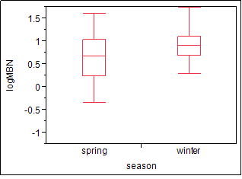
Figure A. 1. Boxplot showing the significant difference in microbial biomass nitrogen (MBN) between winter and spring. ANOVA revealed that winter had significantly higher MBN than the spring sample.

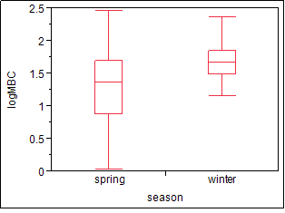

Figure A. 2. Boxplot showing the significant difference in microbial biomass carbon (MBC) between winter and spring. ANOVA revealed that winter had significantly higher mean MBC than the spring sample.
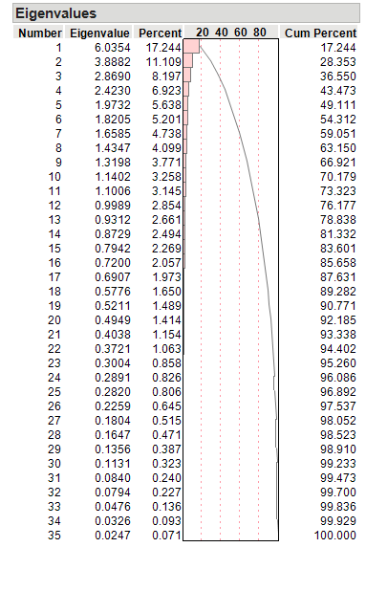

Figure A. 3. Resulting eigenvalues from the principal components analysis (PCA) showing the percent of variance each component accounted for with all of the soil and site data.

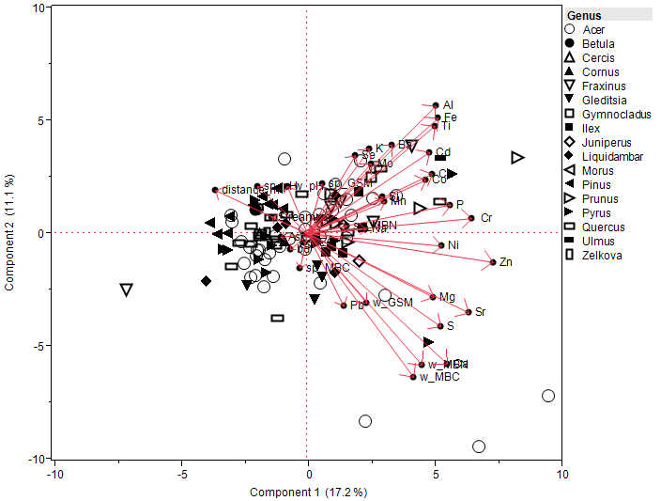
Figure A. 4. Biplot of first two components and the resulting eigenvalues plotted with each variable's loading indicated by arrows. Street tree genus is represented by symbols.
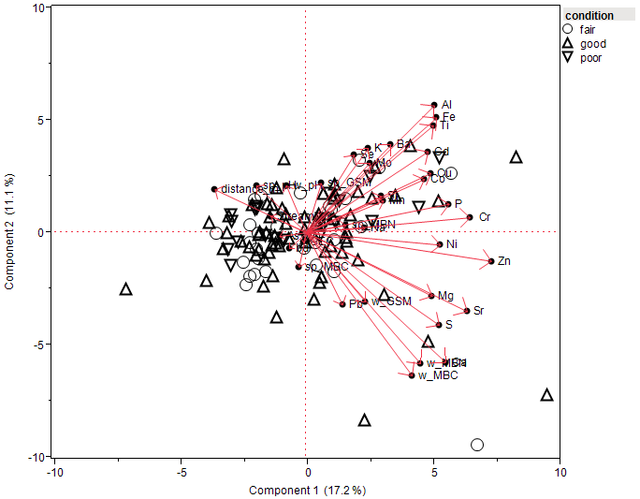
Figure A. 5. Biplot of first two components and the resulting eigenvalues plotted with each variable's loading indicated by arrows. Street conditions are represented by symbols.

Table A. 1. Oak Ridge Turnpike Oak Ridge, TN
Species Scientific Name | Species Common Name | (-) Longitude | Latitude | Diameter (in) | Condition
Pyrus calleryana | Bradford Pear | 084 16.121 | 36 00.652 | 17 | fair
Pyrus calleryana | Bradford Pear | 084 16.105 | 36 00.658 | 16 | fair
Pyrus calleryana | Bradford Pear | 084 15.777 | 36 00.801 | 11 | poor
Quercus palustris | Pin Oak | 084 15.737 | 36 00.814 | 11 | fair
Quercus palustris | Pin Oak | 084 15.709 | 36 00.823 | 6 | good
Liquidambar styraciflua | Sweet Gum | 084 15.695 | 36 00.826 | 16 | fair
Quercus palustris | Pin Oak | 084 15.689 | 36 00.827 | 11 | good
Quercus palustris | Pin Oak | 084 15.687 | 36 00.827 | 11 | good
Quercus palustris | Pin Oak | 084 15.685 | 36 00.828 | 7 | good
Quercus palustris | Pin Oak | 084 15.683 | 36 00.829 | 7 | good
Quercus palustris | Pin Oak | 084 15.678 | 36 00.829 | 11 | fair
Quercus palustris | Pin Oak | 084 15.672 | 36 00.830 | 6 | good
Quercus palustris | Pin Oak | 084 15.669 | 36 00.831 | 12 | fair
Quercus palustris | Pin Oak | 084 15.667 | 36 00.832 | 16 | good
Quercus palustris | Pin Oak | 084 15.663 | 36 00.832 | 6 | good
Quercus palustris | Pin Oak | 084 15.624 | 36 00.839 | 14 | good
Pinus Strobus | White Pine | 084 16.005 | 36 00.702 | 20 | good
n/a | Stump | 084 16.010 | 36 00.700 | n/a | n/a
Pinus strobus | White Pine | 084 16.020 | 36 00.696 | 19 | good
Pinus strobus | White Pine | 084 16.022 | 36 00.022 | 16 | good
Pinus strobus | White Pine | 084 16.024 | 36 00.692 | 15 | good
Pinus strobus | White Pine | 084 16.026 | 36 00.691 | 15 | good
Pinus strobus | White Pine | 084 16.027 | 36 00.692 | 22 | good
Table A. 1. Continued
Species Scientific Name | Species Common Name | (-) Longitude | Latitude | Diameter (in) | Condition
Pinus strobus | White Pine | 084 16.030 | 36 00.690 | 16 | good
Pinus strobus | White Pine | 084 16.037 | 36 00.689 | 19 | good
Pinus strobus | White Pine | 084 16.038 | 36 00.689 | 21 | poor
Pinus strobus | White Pine | 084 16.043 | 36 00.687 | 16 | good
Pinus strobus | White Pine | 084 16.044 | 36 00.687 | 19 | good
Prunus serrulata | Cherry | 084 16.952 | 36 00.701 | 11 | poor
Prunus serrulata | Cherry | 084 15.948 | 36 00.702 | 9 | poor
Quercus palustris | Pin Oak | 084 15.705 | 36 00.802 | 9 | good
n/a | Stump | 084 15.696 | 36 00.806 | n/a | n/a
Quercus palustris | Pin Oak | 084 15.687 | 36 00.808 | 10 | good
Quercus palustris | Pin Oak | 084 15.656 | 36 00.814 | 8 | good
Quercus palustris | Pin Oak | 084 15.627 | 36 00.820 | 5 | poor
Quercus palustris | Pin Oak | 084 15.569 | 36 00.830 | 14 | fair
Quercus palustris | Pin Oak | 084 15.541 | 36 00.837 | 14 | good
Quercus palustris | Pin Oak | 084 15.528 | 36 00.838 | 16 | good
Quercus palustris | Pin Oak | 084 15.519 | 36 00.840 | 12 | good
Quercus palustris | Pin Oak | 084 15.305 | 36 00.842 | 10 | good
Prunus serrulata | Cherry | 084 15.284 | 36 00.884 | 10 | good
Prunus serrulata | Cherry | 084 15.258 | 36 00.889 | 11 | good
Prunus serrulata | Cherry | 084 15.250 | 36 00.890 | 10 | good
Acer buergerianum | Trident Maple | 084 15.217 | 36 00.894 | 13 | good
Acer buergerianum | Trident Maple | 084 15.212 | 36 00894 | 11 | good
Pyrus calleryana | Bradford Pear | 084 15.178 | 36 00.897 | 14 | good
Table A. 1. Continued
Species Scientific Name | Species Common Name | (-) Longitude | Latitude | Diameter (in) | Condition
Pyrus calleryana | Bradford Pear | 084 15.171 | 36 00.897 | 13 | good
Pyrus calleryana | Bradford Pear | 084 15.166 | 36 00.897 | 16 | fair
Gleditsia triacanthos inermis | Thornless Honeylocust | 084 15.116 | 36 00.912 | 5 | fair
Gleditsia triacanthos inermis | Thornless Honeylocust | 084 15.062 | 36 00.954 | 9 | fair
Gleditsia triacanthos inermis | Thornless Honeylocust | 084 15.053 | 36 00.964 | 10 | fair
Gleditsia triacanthos inermis | Thornless Honeylocust | 084 15.036 | 36 00.981 | 11 | fair
Acer saccharum | Sugar Maple | 084 14.945 | 36 01.110 | 11 | good
Acer saccharum | Sugar Maple | 084 14.930 | 36 01.124 | 9 | good
Acer saccharum | Sugar Maple | 084 14.896 | 36 01.160 | 17 | good
Acer saccharum | Sugar Maple | 084 14.887 | 36 01.170 | 17 | good
Acer saccharum | Sugar Maple | 084 14.878 | 36 01.179 | 18 | fair
Acer saccharum | Sugar Maple | 084 14.871 | 36 01.189 | 10 | fair
Acer saccharum | Sugar Maple | 084 14.862 | 36 01.198 | 14 | good
Acer saccharum | Sugar Maple | 084 14.855 | 36 01.206 | 11 | good
Acer saccharum | Sugar Maple | 084 14.832 | 36 01.234 | 5 | poor
Acer saccharum | Sugar Maple | 084 14.825 | 36 01.241 | 7 | good
Acer buergerianum | Trident Maple | 084 14.722 | 36 01.335 | 11 | good
Acer buergerianum | Trident Maple | 084 14.718 | 36 01.341 | 9 | good
Acer buergerianum | Trident Maple | 084 14.713 | 36 01.344 | 9 | good
Acer buergerianum | Trident Maple | 084 14.703 | 36 01.352 | 5 | good
Acer buergerianum | Trident Maple | 084 14.700 | 36 01.355 | 11 | good
Acer buergerianum | Trident Maple | 084 14.695 | 36 01.360 | 9 | good
Table A. 1. Continued
Species Scientific Name | Species Common Name | (-) Longitude | Latitude | Diameter (in) | Condition
Pyrus calleryana | Bradford Pear | 084 14.675 | 36 01.381 | 12 | fair
Pyrus calleryana | Bradford Pear | 084 14.669 | 36 01.385 | 12 | poor
Acer buergerianum | Trident Maple | 084 14.655 | 36 01.376 | 13 | fair
Prunus serrulata | Cherry | 084 14.686 | 36 01.347 | 14 | good
Prunus serrulata | Cherry | 084 14.691 | 36 01.343 | 14 | good
Acer buergerianum | Trident Maple | 084 14.706 | 36 01.329 | 7 | good
Acer buergerianum | Trident Maple | 084 14.708 | 36 01.327 | 13 | good
Acer buergerianum | Trident Maple | 084 14.713 | 36 01.322 | 10 | good
Prunus serrulata | Cherry | 084 14.723 | 36 01.311 | 10 | good
Acer saccharum | Sugar Maple | 084 14.846 | 36 01.186 | 10 | fair
Acer saccharinum | Silver Maple | 084 14.849 | 36 01.179 | 8 | poor
Acer saccharinum | Silver Maple | 084 14.899 | 36 01.126 | 13 | poor
Acer saccharinum | Silver Maple | 084 14.904 | 36 01.119 | 15 | poor
Acer saccharum | Sugar Maple | 084 14.919 | 36 01.105 | 4 | fair
n/a | Stump | 084 14.923 | 36 01.100 | n/a | n/a
Acer saccharinum | Silver Maple | 084 14.930 | 36 01.093 | 14 | fair
Acer saccharinum | Silver Maple | 084 14.935 | 36 01.085 | 14 | poor
Acer saccharinum | Silver Maple | 084 14.940 | 36 01.077 | 17 | poor
Acer buergerianum | Trident Maple | 084 14.603 | 36 01.424 | 8 | fair
Acer buergerianum | Trident Maple | 084 14.597 | 36 01.426 | 12 | good
Gleditsia triacanthos inermis | Thornless Honeylocust | 084 14.593 | 36 01.429 | 11 | fair
Gleditsia triacanthos inermis | Thornless Honeylocust | 084 14.582 | 36 01.434 | 15 | good
Table A. 1. Continued
Species Scientific Name | Species Common Name | (-) Longitude | Latitude | Diameter (in) | Condition
Gleditsia triacanthos inermis | Thornless Honeylocust | 084 14.533 | 36 01.461 | 9 | fair
Gleditsia triacanthos inermis | Thornless Honeylocust | 084 14.519 | 36 01.470 | 10 | good
Acer negundo | Boxelder | 084 14.420 | 36 01.520 | 8 | fair
Ginkgo biloba | Ginkgo | 084 14.415 | 36 01.523 | 12 | good
Ginkgo biloba | Ginkgo | 084 14.409 | 36 01.526 | 12 | good
Ginkgo biloba | Ginkgo | 084 14.398 | 36 01.529 | 15 | fair
Ginkgo biloba | Ginkgo | 084 14.394 | 36 01.532 | 20 | good
Acer platanoides | Norway Maple | 084 14.273 | 36 01.589 | 18 | fair
n/a | Stump | 084 14.265 | 36 01.592 | n/a | n/a
Juniperus virginiana | E Red Cedar | 084 14.264 | 36 01.593 | 5 | fair
Acer rubrum | Red Maple | 084 14.240 | 36 01.607 | 14 | fair
Acer rubrum | Red Maple | 084 14.218 | 36 01.617 | 13 | fair
Acer rubrum | Red Maple | 084 14.161 | 36 01.651 | 5 | fair
Acer rubrum | Red Maple | 084 14.125 | 36 01.668 | 4 | good
Pyrus calleryana | Bradford Pear | 084 14.006 | 36 01.742 | 17 | fair
Pyrus calleryana | Bradford Pear | 084 13.995 | 36 01.746 | 13 | fair
Pyrus calleryana | Bradford Pear | 084 13.985 | 36 01.753 | 13 | fair
Pyrus calleryana | Bradford Pear | 084 13.976 | 36 01.757 | 13 | fair
Pyrus calleryana | Bradford Pear | 084 13.965 | 36 01.763 | 14 | fair
Pyrus calleryana | Bradford Pear | 084 13.954 | 36 01.769 | multistem | fair
Pyrus calleryana | Bradford Pear | 084 13.953 | 36 01.769 | multistem | fair
Pyrus calleryana | Bradford Pear | 084 13.951 | 36 01.770 | 12 | fair
Acer rubrum | Red Maple | 084 13.887 | 36 01.801 | 11 | good
Table A. 1. Continued
Species Scientific Name | Species Common Name | (-) Longitude | Latitude | Diameter (in) | Condition
Acer rubrum | Red Maple | 084 13.881 | 36 01.803 | 10 | fair
n/a | Stump | 084 13.873 | 36 01.806 | n/a | n/a
n/a | Stump | 084 13.869 | 36 01.808 | n/a | n/a
Acer saccharum | Sugar Maple | 084 13.846 | 36 01.817 | 15 | fair
Acer buergerianum | Trident Maple | 084 13.845 | 36 01.821 | 14 | good
Acer buergerianum | Trident Maple | 084 13.840 | 36 01.823 | 11 | good
Acer buergerianum | Trident Maple | 084 13.834 | 36 01.826 | 11 | good
Acer buergerianum | Trident Maple | 084 13.826 | 36 01.829 | 10 | good
Acer buergerianum | Trident Maple | 084 13.821 | 36 01.823 | 16 | good
Acer saccharinum | Silver Maple | 084 13.809 | 36 01.838 | 13 | poor
Picea abies | Norway Spruce | 084 13.802 | 36 01.540 | 10 | fair
Pyrus calleryana | Bradford Pear | 084 13.769 | 36 01.865 | 18 | poor
n/a | Stump | 084 13.755 | 36 01.863 | n/a | n/a
Pyrus calleryana | Bradford Pear | 084 13.754 | 36 01.864 | 32 | fair
Pyrus calleryana | Bradford Pear | 084 13.733 | 36 01.875 | 18 | fair
Pyrus calleryana | Bradford Pear | 084 13.666 | 36 01.918 | 12 | poor
Acer buergerianum | Trident Maple | 084 13.662 | 36 01.921 | 10 | good
Acer buergerianum | Trident Maple | 084 13.656 | 36 01.925 | 8 | good
Acer buergerianum | Trident Maple | 084 13.650 | 36 01.929 | 9 | good
Pyrus calleryana | Bradford Pear | 084 13.645 | 36 01.932 | 13 | fair
Pyrus calleryana | Bradford Pear | 084 13.640 | 36 01.936 | 13 | fair
Pyrus calleryana | Bradford Pear | 084 13.634 | 36 01.940 | 13 | fair
Pyrus calleryana | Bradford Pear | 084 13.629 | 36 01.944 | 13 | fair
Table A. 1. Continued
Species Scientific Name | Species Common Name | (-) Longitude | Latitude | Diameter (in) | Condition
Pyrus calleryana | Bradford Pear | 084 13.622 | 36 01.947 | 15 | fair
Acer buergerianum | Trident Maple | 084 13.611 | 36 01.955 | 10 | fair
Acer buergerianum | Trident Maple | 084 13.604 | 36 01.957 | 13 | fair
Acer buergerianum | Trident Maple | 084 13.601 | 36 01.959 | 13 | fair
Pyrus calleryana | Bradford Pear | 084 13.542 | 36 01.996 | 14 | good
Acer buergerianum | Trident Maple | 084 13.507 | 36 02.069 | 15 | good
Acer buergerianum | Trident Maple | 084 13.517 | 36 02.055 | 8 | fair
Pyrus calleryana | Bradford Pear | 084 13.582 | 36 01.990 | 11 | good
Pyrus calleryana | Bradford Pear | 084 13.590 | 36 01.984 | 13 | good
Pyrus calleryana | Bradford Pear | 084 13.590 | 36 01.984 | 13 | fair
Pyrus calleryana | Bradford Pear | 084 13.591 | 36 01.984 | 12 | fair
Pyrus calleryana | Bradford Pear | 084 13.602 | 36 01.982 | 15 | good
Pyrus calleryana | Bradford Pear | 084 13.846 | 36 01.832 | 14 | good
Pyrus calleryana | Bradford Pear | 084 13.861 | 36 01.824 | 10 | good
Acer negundo | Boxelder | 084 13.989 | 36 01.769 | multistem | fair
Acer negundo | Boxelder | 084 14.041 | 36 01.741 | 31 | fair
Juniperus virginiana | E Red Cedar | 084 14.056 | 36 01.731 | 21 | good
Acer negundo | Boxelder | 084 14.069 | 36 01.724 | 9 | fair
Juglans nigra | black walnut | 084 14.067 | 36 01.724 | 8 | fair
Morus rubra | red mulberry | 084 14.066 | 36 01.725 | 5 | fair
Juglans nigra | black walnut | 084 14.074 | 36 01.721 | 8 | poor
Celtis occidentalis | hackberry | 084 14.076 | 36 01.721 | 17 | fair
Acer rubrum | Red Maple | 084 14.169 | 36 01.667 | 9 | good
Table A. 1. Continued
Species Scientific Name | Species Common Name | (-) Longitude | Latitude | Diameter (in) | Condition
Acer rubrum | Red Maple | 084 14.176 | 36 01.664 | 15 | good
Acer rubrum | Red Maple | 084 14.185 | 36 01.659 | 16 | good
Acer rubrum | Red Maple | 084 14.192 | 36 01.654 | 8 | fair
Acer rubrum | Red Maple | 084 14.203 | 36 01.649 | 18 | fair
Acer rubrum | Red Maple | 084 14.211 | 36 01.647 | 14 | good
Quercus falcata | S Red Oak | 084 14.223 | 36 01.635 | 37 | good
Liquidambar styraciflua | Sweet Gum | 084 14.230 | 36 01.629 | 15 | good
Liquidambar styraciflua | Sweet Gum | 084 14.236 | 36 01.626 | 24 | good
Quercus palustris | Pin Oak | 084 14.242 | 36 01.623 | 37 | good
Acer rubrum | Red Maple | 084 14.232 | 36 01.618 | 8 | fair
Acer rubrum | Red Maple | 084 14.306 | 36 01.580 | 10 | poor
Liquidambar styraciflua | Sweet Gum | 084 14.402 | 36 01.547 | 26 | fair
Liquidambar styraciflua | Sweet Gum | 084 14.408 | 36 01.544 | 19 | good
Liquidambar styraciflua | Sweet Gum | 084 14.417 | 36 01.540 | 19 | good
Liquidambar styraciflua | Sweet Gum | 084 14.426 | 36 01.536 | 24 | good
Phellodendron amurense | amur corktree | 084 14.434 | 36 01.533 | 15 | poor
Liquidambar styraciflua | Sweet Gum | 084 14.445 | 36 01.528 | 23 | good
Phellodendron amurense | amur corktree | 084 14.447 | 36 01.527 | 10 | poor
Liquidambar styraciflua | Sweet Gum | 084 14.451 | 36 01.524 | 26 | good
Liquidambar styraciflua | Sweet Gum | 084 14.523 | 36 01.491 | 22 | fair
Juniperus chinensis | blue point juniper | 084 14.523 | 36 01.489 | 16 | fair
Quercus nigra | water oak | 084 14.531 | 36 01.487 | 37 | good
Quercus nigra | water oak | 084 14.535 | 36 01.483 | 34 | good
 |  |  |  | 14 | fair
Table A. 1. Continued
Species Scientific Name | Species Common Name | (-) Longitude | Latitude | Diameter (in) | Condition
Quercus nigra | water oak | 084 14.547 | 36 01.477 | 37 | good
Cornus florida | dogwood | 084 14.561 | 36 01.469 | 10 | poor
Acer saccharum | Sugar Maple | 084 14.566 | 36 01.468 | 12 | fair
Picea pungens | Colorado Blue Spruce | 084 14.578 | 36 01.461 | 5 | fair
Acer rubrum | Red Maple | 084 14.584 | 36 01.458 | 8 | fair
Acer rubrum | Red Maple | 084 14.591 | 36 01.452 | 17 | good
Acer rubrum | Red Maple | 084 14.596 | 36 01.449 | 13 | fair
Acer rubrum | Red Maple | 084 14.600 | 36 01.447 | 18 | good
Acer rubrum | Red Maple | 084 14.615 | 36 01.437 | 30 | good
Magnolia grandiflora | Southern Mag | 084 14.617 | 36 01.434 | 8 | good
Acer rubrum | Red Maple | 084 14.621 | 36 01.432 | 16 | good
Acer rubrum | Red Maple | 084 14.627 | 36 01.427 | 14 | good
Acer rubrum | Red Maple | 084 14.640 | 36 01.417 | 21 | good
Acer rubrum | Red Maple | 084 14.650 | 36 01.408 | 15 | good
Acer rubrum | Red Maple | 084 14.654 | 36 01.405 | 13 | good
Ilex xattenuata | Foster Holly | 084 13.723 | 36 01.893 | 4 | good
Ilex xattenuata | Foster Holly | 084 13.712 | 36 01.899 | 3 | fair
Ilex xattenuata | Foster Holly | 084 13.691 | 36 01.912 | 4 | good
Ilex xattenuata | Foster Holly | 084 13.678 | 36 01.919 | 4 | good
Pyrus calleryana | Bradford Pear | 084 13.469 | 36 02.094 | 15 | good
Pyrus calleryana | Bradford Pear | 084 13.453 | 36 02.116 | 16 | dead
Pyrus calleryana | Bradford Pear | 084 13.430 | 36 02.141 | 13 | dead
Pyrus calleryana | Bradford Pear | 084 13.430 | 36 02.151 | 15 | dead
Table A. 1. Continued
Species Scientific Name | Species Common Name | (-) Longitude | Latitude | Diameter (in) | Condition
Ilex xattenuata | Foster Holly | 084 13.427 | 36 02.170 | 16 | good
Ilex xattenuata | Foster Holly | 084 13.426 | 36 02.172 | 16 | good
Ilex xattenuata | Foster Holly | 084 13.426 | 36 02.171 | 17 | good
Ilex xattenuata | Foster Holly | 084 13.418 | 36 02.182 | 4 | good
Acer buergerianum | Trident Maple | 084 13.483 | 36 02.171 | 15 | good
Acer buergerianum | Trident Maple | 084 13.491 | 36 02.092 | 15 | good
Acer buergerianum | Trident Maple | 084 13.492 | 36 02.082 | 15 | good
Zelkova serrata | Zelkova | 084 13.323 | 36 02.243 | 18 | good
Zelkova serrata | Zelkova | 084 13.311 | 36 02.245 | 15 | good
Zelkova serrata | Zelkova | 084 13.293 | 36 02.264 | 13 | good
Zelkova serrata | Zelkova | 084 13.277 | 36 02.273 | 10 | good
Zelkova serrata | Zelkova | 084 13.260 | 36 02.283 | 11 | good
Zelkova serrata | Zelkova | 084 13.244 | 36 02.293 | 13 | good
Zelkova serrata | Zelkova | 084 13.232 | 36 02.297 | 14 | good
Pinus strobus | White Pine | 084 13.211 | 36 02.309 | 21 | fair
Celtis occidentalis | hackberry | 084 13.205 | 36 02.314 | 15 | fair
Pinus strobus | White Pine | 084 13.205 | 36 02.314 | 15 | fair
n/a | Stump | 084 13.202 | 36 02.317 | n/a | n/a
Juniperus virginiana | E Red Cedar | 084 13.202 | 36 02.317 | 8 | good
Acer rubrum | Red Maple | 084 13.195 | 36 02.322 | 5 | good
Acer platanoides | norway maple | 084 13.189 | 36 02.326 | 5 | fair
Acer rubrum | Red Maple | 084 13.183 | 36 02.329 | 6 | poor
n/a | Stump | 084 13.179 | 36 02.333 | n/a | n/a
Table A. 1. Continued
Species Scientific Name | Species Common Name | (-) Longitude | Latitude | Diameter (in) | Condition
Ilex xattenuata | Foster Holly | 084 13.191 | 36 02.342 | 5 | good
Ilex xattenuata | Foster Holly | 084 13.196 | 36 02.339 | 4 | good
Ilex xattenuata | Foster Holly | 084 13.202 | 36 02.335 | 5 | good
Ilex xattenuata | Foster Holly | 084 13.208 | 36 02.332 | 4 | good
Ilex xattenuata | Foster Holly | 084 13.213 | 36 02.329 | 6 | good
Ilex xattenuata | Foster Holly | 084 13.218 | 36 02.326 | 5 | good
Ilex xattenuata | Foster Holly | 084 13.224 | 36 02.324 | 6 | good
Acer rubrum | Red Maple | 084 13.239 | 36 02.316 | 12 | good
Acer rubrum | Red Maple | 084 13.260 | 36 02.301 | 10 | fair
Acer rubrum | Red Maple | 084 13.272 | 36 02.296 | multistem | good
Acer rubrum | Red Maple | 084 13.284 | 36 02.289 | 8 | good
Acer rubrum | Red Maple | 084 13.294 | 36 02.281 | 8 | fair
Acer buergerianum | Trident Maple | 084 13.304 | 36 02.278 | 9 | good
Acer rubrum | Red Maple | 084 13.317 | 36 02.269 | 5 | fair
Acer rubrum | Red Maple | 084 13.329 | 36 02.263 | 8 | poor
Acer rubrum | Red Maple | 084 13.338 | 36 02.257 | 7 | good
Acer buergerianum | Trident Maple | 084 13.350 | 36 02.250 | 12 | good
Acer buergerianum | Trident Maple | 084 13.362 | 36 02.242 | 10 | good
Pinus strobus | White Pine | 084 13.174 | 36 02.333 | 24 | fair
Acer rubrum | Red Maple | 084 13.167 | 36 02.337 | 5 | good
Acer rubrum | Red Maple | 084 13.162 | 36 02.342 | 8 | good
Ilex xattenuata | Foster Holly | 084 13.158 | 36 02.354 | 6 | good
Acer rubrum | Red Maple | 084 13.147 | 36 02.353 | 4 | good
Table A. 1. Continued
Species Scientific Name | Species Common Name | (-) Longitude | Latitude | Diameter (in) | Condition
Acer saccharum | Sugar Maple | 084 13.052 | 36 02.419 | 9 | good
Acer rubrum | Red Maple | 084 13.046 | 36 02.423 | 10 | good
Acer rubrum | Red Maple | 084 13.038 | 36 02.428 | 7 | fair
Ilex xattenuata | Foster Holly | 084 13.031 | 36 02.435 | 8 | fair
Ilex xattenuata | Foster Holly | 084 13.027 | 36 02.437 | 5 | good
Acer buergerianum | Trident Maple | 084 13.037 | 36 02.446 | 9 | good
Prunus serrulata | Cherry | 084 13.071 | 36 02.428 | multistem | dead
Acer buergerianum | Trident Maple | 084 13.091 | 36 02.411 | 10 | good
Acer rubrum | Red Maple | 084 13.101 | 36 02.403 | 8 | good
Ilex xattenuata | Foster Holly | 084 13.121 | 36 02.392 | 5 | good
Species Scientific Name | Species Common Name | (-) Longitude | Latitude | Diameter (in) | Condition
Ilex xattenuata | Foster Holly | 084 13.122 | 36 02.389 | 8 | good
Ilex xattenuata | Foster Holly | 084 13.127 | 36 02.387 | 8 | good
Ilex xattenuata | Foster Holly | 084 13.132 | 36 02.383 | 6 | good
Ilex xattenuata | Foster Holly | 084 13.148 | 36 02.371 | 7 | good
Acer rubrum | Red Maple | 084 13.159 | 36 02.363 | multistem | fair
Acer rubrum | Red Maple | 084 13.170 | 36 02.357 | 7 | good
Acer rubrum | Red Maple | 084 13.180 | 36 02.350 | 8 | good
Ilex xattenuata | Foster Holly | 084 12.813 | 36 02.569 | 12 | good
Acer rubrum | Red Maple | 084 12.900 | 36 02.527 | 5 | good
Acer rubrum | Red Maple | 084 12.924 | 36 02.513 | 4 | poor
Acer rubrum | Red Maple | 084 12.933 | 36 02.507 | 4 | good
Acer rubrum | Red Maple | 084 12.941 | 36 02.504 | 5 | good
Table A. 1. Continued
Species Scientific Name | Species Common Name | (-) Longitude | Latitude | Diameter (in) | Condition
Acer rubrum | Red Maple | 084 12.949 | 36 02.499 | 7 | poor
Acer rubrum | Red Maple | 084 12.955 | 36 02.497 | 5 | good
n/a | Stump | 084 12.958 | 36 02.495 | n/a | n/a
Pyrus calleryana | Bradford Pear | 084 12.962 | 36 02.494 | 14 | fair
Pyrus calleryana | Bradford Pear | 084 12.975 | 36 02.487 | 18 | poor
Pyrus calleryana | Bradford Pear | 084 12.983 | 36 02.483 | 19 | poor
Pyrus calleryana | Bradford Pear | 084 13.007 | 36 02.471 | 15 | poor
Acer rubrum | Red Maple | 084 12.970 | 36 02.471 | 9 | good
Acer rubrum | Red Maple | 084 12.962 | 36 02.474 | 7 | good
Ilex xattenuata | Foster Holly | 084 12.957 | 36 02.427 | 4 | fair
Ilex xattenuata | Foster Holly | 084 12.950 | 36 02.479 | 4 | fair
Pyrus calleryana | Bradford Pear | 084 14.681 | 36 01.374 | 4 | fair
Acer platanoides | norway maple | 084 12.935 | 36 02.488 | 8 | good
Ilex xattenuata | Foster Holly | 084 12.950 | 36 02.487 | 16 | fair
Ilex xattenuata | Foster Holly | 084 12.949 | 36 02.489 | 10 | good
Ilex xattenuata | Foster Holly | 084 12.927 | 36 02.501 | 19 | good
Ilex xattenuata | Foster Holly | 084 12.912 | 36 02.509 | 5 | good
Ilex xattenuata | Foster Holly | 084 12.896 | 36 02.517 | 20 | good
Ilex xattenuata | Foster Holly | 084 12.895 | 36 02.518 | 17 | good
Ilex xattenuata | Foster Holly | 084 12.896 | 36 02.518 | 19 | good
Pyrus calleryana | Bradford Pear | 084 12.895 | 36 02.511 | 12 | fair
Acer rubrum | Red Maple | 084 12.774 | 36 02.582 | 9 | good
Acer rubrum | Red Maple | 084 12.770 | 36 02.584 | 11 | good
Table A. 1. Continued
Species Scientific Name | Species Common Name | (-) Longitude | Latitude | Diameter (in) | Condition
Pyrus calleryana | Bradford Pear | 084 12.740 | 36 02.598 | 17 | good
Ilex xattenuata | Foster Holly | 084 12.693 | 36 02.630 | 10 | good
Ilex xattenuata | Foster Holly | 084 12.685 | 36 02.636 | 10 | fair
Acer rubrum | Red Maple | 084 12.672 | 36 02.644 | 6 | fair
Acer rubrum | Red Maple | 084 12.656 | 36 02.654 | 5 | poor
Acer rubrum | Red Maple | 084 12.650 | 36 02.658 | 11 | good
Ilex xattenuata | Foster Holly | 084 12.631 | 36 02.670 | 6 | good
Acer saccharum | Sugar Maple | 084 12.624 | 36 02.674 | 6 | good
Acer rubrum | Red Maple | 084 12.618 | 36 02.678 | 7 | good
Acer rubrum | Red Maple | 084 12.610 | 36 02.683 | 11 | good
Acer rubrum | Red Maple | 084 12.604 | 36 02.687 | 12 | fair
Pyrus calleryana | Bradford Pear | 084 12.581 | 36 02.701 | 14 | fair
Pyrus calleryana | Bradford Pear | 084 12.577 | 36 02.704 | 17 | fair
Ilex xattenuata | Foster Holly | 084 12.678 | 36 02.649 | 11 | good
Ilex xattenuata | Foster Holly | 084 12.430 | 36 02.989 | 4 | good
Acer rubrum | Red Maple | 084 16.978 | 36 00.333 | 2 | poor
Betula nigra | river birch | 084 16.981 | 36 00.329 | multistem | poor
Quercus phellos | Willow Oak | 084 16.986 | 36 00.331 | 2 | fair
Acer saccharum | Sugar Maple | 084 16.989 | 36 00.328 | 2 | poor
Acer rubrum | Red Maple | 084 16.993 | 36 00.328 | 2 | poor
Quercus rubra | N Red Oak | 084 16.996 | 36 00.325 | 2 | poor
Betula nigra | river birch | 084 17.001 | 36 00.326 | multistem | poor
Table A. 1. Continued
Species Scientific Name | Species Common Name | (-) Longitude | Latitude | Diameter (in) | Condition
Acer saccharum | Sugar Maple | 084 17.017 | 36 00.321 | 2 | good
Betula nigra | river birch | 084 17.018 | 36 00.319 | multistem | poor
n/a | Stump | 084 17.024 | 36 00.319 | n/a | n/a
Acer rubrum | Red Maple | 084 17.027 | 36 00.315 | 2 | dead
Acer rubrum | Red Maple | 084 17.032 | 36 00.316 | 2 | dead
Betula nigra | river birch | 084 17.034 | 36 00.314 | multistem | poor
Acer rubrum | Red Maple | 084 17.041 | 36 00.312 | 2 | poor
Acer rubrum | Red Maple | 084 17.046 | 36 00.312 | 2 | dead
Quercus phellos | Willow Oak | 084 17.047 | 36 00.309 | 2 | fair
Acer saccharum | Sugar Maple | 084 17.055 | 36 00.309 | 2 | poor
Betula nigra | river birch | 084 17.058 | 36 00.304 | multistem | poor
Quercus phellos | Willow Oak | 084 17.063 | 36 00.306 | 2 | good
Acer saccharum | Sugar Maple | 084 17.065 | 36 00.303 | 2 | poor
Acer saccharum | Sugar Maple | 084 17.118 | 36 00.285 | 2 | poor
Acer rubrum | Red Maple | 084 17.071 | 36 00.305 | 2 | poor
Quercus rubra | N Red Oak | 084 17.073 | 36 00.301 | 2 | fair
Betula nigra | river birch | 084 17.078 | 36 00.302 | multistem | poor
Acer rubrum | Red Maple | 084 17.081 | 36 00.298 | 2 | dead
Quercus rubra | N Red Oak | 084 17.085 | 36 00.298 | 2 | poor
Quercus phellos | Willow Oak | 084 17.088 | 36 00.295 | 2 | fair
Acer saccharum | Sugar Maple | 084 17.092 | 36 00.296 | 2 | fair
Betula nigra | river birch | 084 17.094 | 36 00.294 | multistem | poor
Quercus phellos | Willow Oak | 084 17.100 | 36 00.294 | 2 | good
Table A. 1. Continued
Species Scientific Name | Species Common Name | (-) Longitude | Latitude | Diameter (in) | Condition
Acer rubrum | Red Maple | 084 17.108 | 36 00.291 | 2 | poor
Quercus rubra | N Red Oak | 084 17.109 | 36 00.288 | 2 | poor
Quercus rubra | N Red Oak | 084 17.124 | 36 00.285 | 2 | poor
Betula nigra | river birch | 084 17.126 | 36 00.282 | multistem | poor
Acer saccharum | Sugar Maple | 084 17.131 | 36 00.283 | 2 | poor
Acer rubrum | Red Maple | 084 12.946 | 36 02.501 | 4 | fair
Quercus phellos | Willow Oak | 084 17.012 | 36 00.320 | 2 | fair
Acer rubrum | Red Maple | 084 12.760 | 36 02.591
Table A. 2. Rutgers Avenue Oak Ridge, TN
Species Scientific Name | Species Common Name | (-) Longitude | Latitude | Diameter (in) | Condition
Acer saccharinum | Silver Maple | 084 14.932 | 36 01.054 | 10 | fair
Gymnocladus dioicus | Coffee Tree | 084 14.923 | 36 01.005 | 13 | poor
Cercis canadensis | Red Bud | 084 14.930 | 36 01.004 | 9 | fair
Gymnocladus dioicus | Coffee Tree | 084 14.932 | 36 01.001 | 10 | poor
Gymnocladus dioicus | Coffee Tree | 084 14.925 | 36 01.000 | 14 | good
Acer saccharum | Sugar Maple | 084 14.923 | 36 01.000 | 6 | good
Gymnocladus dioicus | Coffee Tree | 084 14.931 | 36 00.999 | 12 | good
Gymnocladus dioicus | Coffee Tree | 084 14.926 | 36 00.997 | 14 | good
Gymnocladus dioicus | Coffee Tree | 084 14.925 | 36 00.994 | 17 | fair
Acer rubrum | Red Maple | 084 14.921 | 36 00.974 | 8 | good
Acer rubrum | Red Maple | 084 14.942 | 36 00.939 | 13 | good
Acer rubrum | Red Maple | 084 15.013 | 36 00.862 | 10 | fair
Acer rubrum | Red Maple | 084 15.035 | 36 00.839 | 10 | good
Acer rubrum | Red Maple | 084 15.045 | 36 00.828 | 7 | good
Liquidambar styraciflua | Sweet Gum | 084 15.083 | 36 00.791 | 10 | good
Liquidambar styraciflua | Sweet Gum | 084 15.083 | 36 00.791 | 8 | fair
Liquidambar styraciflua | Sweet Gum | 084 15.083 | 36 00.789 | 8 | good
Liquidambar styraciflua | Sweet Gum | 084 15.092 | 36 00.769 | 10 | good
Fraxinus pennsylvanica | Green Ash | 084 15.103 | 36 00.745 | 17 | good

Table A. 3. Illinois Avenue Oak Ridge, TN
Species Scientific Name | Species Common Name | (-) Longitude | Latitude | Diameter (in) | Condition
Pyrus calleryana | Bradford Pear | 084 14.631 | 36 00.114 | 15 | good
Pyrus calleryana | Bradford Pear | 084 14.644 | 36 00.121 | 13 | good
Pyrus calleryana | Bradford Pear | 084 14.662 | 36 00.130 | 15 | good
Pyrus calleryana | Bradford Pear | 084 14.678 | 36 00.134 | 14 | good
Pyrus calleryana | Bradford Pear | 084 14.718 | 36 00.131 | 8 | fair
Pyrus calleryana | Bradford Pear | 084 14.735 | 36 00.138 | 12 | good
Pyrus calleryana | Bradford Pear | 084 14.745 | 36 00.162 | 13 | good
Pyrus calleryana | Bradford Pear | 084 15.431 | 36 00.401 | 18 | good
Pyrus calleryana | Bradford Pear | 084 15.414 | 36 00.399 | 13 | fair
Platanus occidentalis | Sycamore | 084 14.879 | 36 00.195 | 30 | good
Pyrus calleryana | Bradford Pear | 084 14.732 | 36 00.132 | 11 | good
Pyrus calleryana | Bradford Pear | 084 14.718 | 36 00.122 | 11 | good
Pyrus calleryana | Bradford Pear | 084 14.715 | 36 00.119 | 11 | good
Pyrus calleryana | Bradford Pear | 084 14.713 | 36 00.116 | 8 | fair
Cercis canadensis | Red Bud | 084 14.711 | 36 00.118 | multistem | poor
Fraxinus pennsylvanica | Green Ash | 084 14.712 | 36 00.112 | 5 | poor
Cercis canadensis | Red Bud | 084 14.710 | 36 00.102 | 4 | poor
Cercis canadensis | Red Bud | 084 14.708 | 36 00.103 | multistem | fair
Fraxinus pennsylvanica | Green Ash | 084 14.695 | 36 00.104 | multistem | poor
Fraxinus pennsylvanica | Green Ash | 084 14.695 | 36 00.104 | multistem | poor
Fraxinus pennsylvanica | Green Ash | 084 14.695 | 36 00.104 | multistem | poor
Quercus phellos | Willow Oak | 084 14.689 | 36 00.106 | 11 | fair
Quercus phellos | Willow Oak | 084 14.686 | 36 00.110 | 15 | poor
Table A. 3. Continued
Species Scientific Name | Species Common Name | (-) Longitude | Latitude | Diameter (in) | Condition
Quercus phellos | Willow Oak | 084 14.680 | 36 00.102 | n/a | dead
Quercus rubra | Northern Red Oak | 084 14.669 | 36 00.099 | 12 | fair
Quercus phellos | Willow Oak | 084 14.658 | 36 00.099 | 13 | poor
Quercus rubra | Northern Red Oak | 084 14.655 | 36 00.091 | 14 | fair
Quercus rubra | Northern Red Oak | 084 14.665 | 36 00.085 | 8 | poor
Quercus phellos | Willow Oak | 084 14.670 | 36 00.090 | 14 | fair
Fraxinus pennsylvanica | Green Ash | 084 15.569 | 36 00.427 | 11 | fair
Ulmus americana | American Elm | 084 15.589 | 36 00.430 | 21 | poor
Ulmus americana | American Elm | 084 15.617 | 36 00.434 | 16 | poor-girdled
Fraxinus pennsylvanica | Green Ash | 084 15.645 | 36 00.438 | 18 | poor
Fraxinus pennsylvanica | Green Ash | 084 15.654 | 36 00.441 | 17 | fair
Fraxinus pennsylvanica | Green Ash | 084 15.700 | 36 00.449 | 10 | fair
Fraxinus pennsylvanica | Green Ash | 084 15.740 | 36 00.456 | 13 | good
Fraxinus pennsylvanica | Green Ash | 084 15.770 | 36 00.462 | 17 | poor-split
Prunus serrulata | Cherry | 084 15.872 | 36 00.490 | 17 | poor-dead
n/a | Stump | 084 15.914 | 36 00.501 | n/a | n/a
Platanus occidentalis | Sycamore | 084 15.922 | 36 00.502 | 30 | good
Pyrus calleryana | Bradford Pear | 084 15.938 | 36 00.508 | 10 | fair
Pyrus calleryana | Bradford Pear | 084 15.947 | 36 00.511 | 12 | poor
Pyrus calleryana | Bradford Pear | 084 15.953 | 36 00.514 | 14 | poor
Pyrus calleryana | Bradford Pear | 084 15.968 | 36 00.519 | 14 | poor
n/a | Stump | 084 15.963 | 36 00.518 | n/a | n/a
Pyrus calleryana | Bradford Pear | 084 15.977 | 36 00.522 | 10 | poor
Table A. 3. Continued
Species Scientific Name | Species Common Name | (-) Longitude | Latitude | Diameter (in) | Condition
n/a | Stump | 084 16.213 | 36 00.626 | n/a | n/a
n/a | Stump | 084 16.219 | 36 00.632 | n/a | n/a
n/a | Stump | 084 16.226 | 36 00.638 | n/a | n/a
Acer saccharum | Sugar Maple | 084 16.350 | 36 00.783 | 7 | good
Acer rubrum | Red Maple | 084 16.356 | 36 00.791 | 8 | good
Acer saccharum | Sugar Maple | 084 15.477 | 36 00.437 | 16 | good
Acer rubrum | Red Maple | 084 15.500 | 36 00.435 | 18 | fair
Pyrus calleryana | Bradford Pear | 084 15.894 | 36 00.510 | 14 | poor
Pyrus calleryana | Bradford Pear | 084 15.901 | 36 00.511 | 11 | fair
Pyrus calleryana | Bradford Pear | 084 15.909 | 36 00.514 | 11 | fair
Pyrus calleryana | Bradford Pear | 084 15.916 | 36 00.517 | 8 | fair
Pyrus calleryana | Bradford Pear | 084 15.931 | 36 00.521 | 11 | poor
Pyrus calleryana | Bradford Pear | 084 15.938 | 36 00.523 | 15 | good
Pyrus calleryana | Bradford Pear | 084 15.946 | 36 00.528 | 10 | fair
Pyrus calleryana | Bradford Pear | 084 15.954 | 36 00.530 | 14 | fair
Pyrus calleryana | Bradford Pear | 084 15.959 | 36 00.532 | 12 | fair
Pyrus calleryana | Bradford Pear | 084 15.968 | 36 00.535 | 12 | fair
Pyrus calleryana | Bradford Pear | 084 15.972 | 36 00.539 | 12 | good
Pyrus calleryana | Bradford Pear | 084 15.983 | 36 00.540 | 14 | poor
Pyrus calleryana | Bradford Pear | 084 16.024 | 36 00.558 | 17 | fair
Pyrus calleryana | Bradford Pear | 084 16.033 | 36 00.561 | 14 | fair
Pyrus calleryana | Bradford Pear | 084 16.037 | 36 00.562 | 13 | good
Pyrus calleryana | Bradford Pear | 084 16.044 | 36 00.564 | 13 | good
Table A. 3. Continued
Species Scientific Name | Species Common Name | (-) Longitude | Latitude | Diameter (in) | Condition
Pyrus calleryana | Bradford Pear | 084 16.055 | 36 00.570 | 13 | fair
Pyrus calleryana | Bradford Pear | 084 16.063 | 36 00.573 | 10 | fair
Pyrus calleryana | Bradford Pear | 084 16.188 | 36 00.643 | 19 | good
Acer saccharum | Sugar Maple | 084 15.675 | 36 00.458 | 18 | good
Acer rubrum | Red Maple | 084 15.664 | 36 00.457 | 21 | good
Acer rubrum | Red Maple | 084 15.623 | 36 00.450 | 27 | good
Acer saccharum | Sugar Maple | 084 15.607 | 36 00.448 | 13 | good
Acer rubrum | Red Maple | 084 15.591 | 36 00.446 | 17 | good
Pyrus calleryana | Bradford Pear | 084 16.051 | 36 00.567 | 13 | fair
Pyrus calleryana | Bradford Pear | 084 15.983 | 36 00.524 | 10 | poor

Table A. 4. Lafayette Oak Ridge, TN
Species Scientific Name | Species Common Name | (-) Longitude | Latitude | Diameter (in) | Condition
Pinus strobus | White Pine | 084 14.417 | 36 00.380 | 20 | fair
Pinus strobus | White Pine | 084 14.413 | 36 00.377 | 25 | fair
Pinus strobus | White Pine | 084 14.413 | 36 00.374 | 25 | fair
Pinus strobus | White Pine | 084 14.417 | 36 00.366 | 19 | good
Pinus strobus | White Pine | 084 14.417 | 36 00.360 | 18 | good
Pinus strobus | White Pine | 084 14.420 | 36 00.357 | 24 | good
Pinus strobus | White Pine | 084 14.422 | 36 00.354 | 20 | good
Pinus strobus | White Pine | 084 14.425 | 36 00.352 | 18 | good
Pinus strobus | White Pine | 084 14.426 | 36 00.348 | 22 | good
Pinus strobus | White Pine | 084 14.430 | 36 00.336 | 24 | good
Pinus strobus | White Pine | 084 14.432 | 36 00.333 | 15 | good
Pinus strobus | White Pine | 084 14.432 | 36 00.330 | 17 | good
Pinus strobus | White Pine | 084 14.432 | 36 00.324 | 12 | good
Pinus strobus | White Pine | 084 14.433 | 36 00.322 | 11 | fair
Acer platanoides | norway maple | 084 14.438 | 36 00.317 | multistem | dead
Pinus strobus | White Pine | 084 14.442 | 36 00.298 | 13 | good
Pinus strobus | White Pine | 084 14.443 | 36 00.296 | 15 | good
Pinus strobus | White Pine | 084 14.448 | 36 00.286 | 10 | good
Pinus virginiana | Virginia Pine | 084 14.399 | 36 00.406 | multistem | poor
Acer rubrum | Red Maple | 084 14.331 | 36 00.574 | 9 | good
Acer rubrum | Red Maple | 084 14.332 | 36 00.577 | 4 | good
Acer rubrum | Red Maple | 084 14.334 | 36 00.580 | 3 | fair
Acer rubrum | Red Maple | 084 14.334 | 36 00.582 | 2 | poor
Table A. 4. Continued
Species Scientific Name | Species Common Name | (-) Longitude | Latitude | Diameter (in) | Condition
Acer rubrum | Red Maple | 084 14.330 | 36 00.585 | 5 | good
Acer rubrum | Red Maple | 084 14.333 | 36 00.586 | 3 | fair
Acer rubrum | Red Maple | 084 14.331 | 36 00.588 | 3 | poor
Acer rubrum | Red Maple | 084 14.329 | 36 00.591 | 4 | good
Acer rubrum | Red Maple | 084 14.328 | 36 00.595 | 3 | poor
Acer rubrum | Red Maple | 084 14.328 | 36 00.599 | 3 | poor
Acer rubrum | Red Maple | 084 14.332 | 36 00.604 | 3 | fair
Acer rubrum | Red Maple | 084 14.332 | 36 00.609 | 3 | poor
Acer rubrum | Red Maple | 084 14.333 | 36 00.612 | 3 | poor
Acer rubrum | Red Maple | 084 14.333 | 36 00.616 | 3 | good
Acer rubrum | Red Maple | 084 14.329 | 36 00.619 | 4 | fair
Acer rubrum | Red Maple | 084 14.333 | 36 00.620 | 3 | good
Acer rubrum | Red Maple | 084 14.330 | 36 00.623 | 4 | good
Acer rubrum | Red Maple | 084 14.332 | 36 00.623 | 5 | good
Acer rubrum | Red Maple | 084 14.330 | 36 00.629 | 4 | good
Acer rubrum | Red Maple | 084 14.333 | 36 00.633 | 2 | dead
Pinus virginiana | Virginia Pine | 084 14.335 | 36 00.633 | 15 | good
Acer platanoides | norway maple | 084 14.496 | 36 00.220 | 11 | poor
Pinus strobus | White Pine | 084 14.494 | 36 00.227 | 10 | good
Pinus strobus | White Pine | 084 14.486 | 36 00.235 | 8 | good
Platanus occidentalis | Sycamore | 084 14.485 | 36 00.236 | 31 | good
Acer rubrum | Red Maple | 084 14.391 | 36 00.487 | 3 | poor
Acer rubrum | Red Maple | 084 14.388 | 36 00.493 | 2 | fair
Table A. 4. Continued
Species Scientific Name | Species Common Name | (-) Longitude | Latitude | Diameter (in) | Condition
Acer rubrum | Red Maple | 084 14.382 | 36 00.506 | 2 | poor
Acer rubrum | Red Maple | 084 14.380 | 36 00.512 | 3 | good
Acer rubrum | Red Maple | 084 14.377 | 36 00.518 | 2 | fair
Acer rubrum | Red Maple | 084 14.374 | 36 00.524 | 3 | good
Pinus strobus | White Pine | 084 14.340 | 36 00.557 | 11 | good
Pinus strobus | White Pine | 084 14.342 | 36 00.553 | 13 | good
Pinus strobus | White Pine | 084 14.343 | 36 00.549 | 12 | dead
Pinus strobus | White Pine | 084 14.345 | 36 00.546 | 17 | good
Liquidambar styraciflua | Sweet Gum | 084 14.352 | 36 00.531 | 21 | fair
Pinus strobus | White Pine | 084 14.355 | 36 00.521 | 18 | fair
Pinus strobus | White Pine | 084 14.362 | 36 00.501 | 14 | fair
Pinus strobus | White Pine | 084 14.363 | 36 00.500 | 17 | good
Pinus strobus | White Pine | 084 14.367 | 36 00.496 | 18 | fair
Pinus strobus | White Pine | 084 14.367 | 36 00.493 | 22 | good
n/a | Stump | 084 14.368 | 36 00.488 | n/a | n/a
Pinus strobus | White Pine | 084 14.371 | 36 00.483 | 23 | fair
Pinus strobus | White Pine | 084 14.371 | 36 00.480 | 23 | fair
n/a | Stump | 084 14.376 | 36 00.469 | n/a | n/a
n/a | Stump | 084 14.376 | 36 00.466 | n/a | n/a
Pinus strobus | White Pine | 084 14.378 | 36 00.461 | 19 | good
Acer rubrum | Red Maple | 084 14.380 | 36 00.456 | multistem | fair
Pinus strobus | White Pine | 084 14.382 | 36 00.452 | 12 | fair
Acer rubrum | Red Maple | 084 14.460 | 36 00.852 | 6 | good
Table A. 4. Continued
Species Scientific Name | Species Common Name | (-) Longitude | Latitude | Diameter (in) | Condition
Pinus strobus | White Pine | 084 14.389 | 36 00.437 | 20 | good
Pinus strobus | White Pine | 084 14.404 | 36 00.400 | 15 | good
Pinus strobus | White Pine | 084 14.403 | 36 00.395 | 18 | good
Pinus strobus | White Pine | 084 14.406 | 36 00.391 | 16 | good
n/a | Stump | 084 14.409 | 36 00.389 | n/a | n/a
Pinus strobus | White Pine | 084 14.410 | 36 00.384 | 20 | good
Acer rubrum | Red Maple | 084 14.481 | 36 00.261 | 10 | good
Acer platanoides | norway maple | 084 14.477 | 36 00.268 | multistem | poor
Acer rubrum | Red Maple | 084 14.469 | 36 00.279 | 11 | good
Acer platanoides | norway maple | 084 14.465 | 36 00.287 | 16 | good
Acer saccharum | Sugar Maple | 084 14.461 | 36 00.293 | 11 | good
Acer rubrum | Red Maple | 084 14.454 | 36 00.306 | 11 | good
Acer rubrum | Red Maple | 084 14.448 | 36 00.317 | 9 | good
Acer platanoides | norway maple | 084 14.446 | 36 00.321 | 18 | fair
Acer platanoides | norway maple | 084 14.444 | 36 00.328 | 15 | fair
Acer saccharum | Sugar Maple | 084 14.442 | 36 00.333 | 9 | good
Acer rubrum | Red Maple | 084 14.437 | 36 00.346 | 7 | good
Acer saccharum | Sugar Maple | 084 14.434 | 36 00.353 | 15 | good
Acer rubrum | Red Maple | 084 14.432 | 36 00.362 | 18 | good
Acer saccharum | Sugar Maple | 084 14.421 | 36 00.383 | 12 | good
Acer rubrum | Red Maple | 084 14.420 | 36 00.390 | 16 | good
Acer rubrum | Red Maple | 084 14.415 | 36 00.774 | 11 | good
n/a | Stump | 084 14.419 | 36 00.782 | n/a | n/a
Table A. 4. Continued
Species Scientific Name | Species Common Name | (-) Longitude | Latitude | Diameter (in) | Condition
Acer platanoides | norway maple | 084 14.392 | 36 00.459 | 16 | fair
Acer saccharum | Sugar Maple | 084 14.388 | 36 00.466 | 11 | good
Pinus strobus | White Pine | 084 14.387 | 36 00.443 | 17 | good
Acer rubrum | Red Maple | 084 14.386 | 36 00.472 | 10 | good
Acer saccharum | Sugar Maple | 084 14.384 | 36 00.477 | 10 | good
Acer platanoides | norway maple | 084 14.382 | 36 00.484 | 19 | poor
Acer rubrum | Red Maple | 084 14.378 | 36 00.494 | 11 | good
Acer platanoides | norway maple | 084 14.374 | 36 00.504 | 19 | fair
Acer platanoides | norway maple | 084 14.370 | 36 00.514 | 20 | fair
Acer platanoides | norway maple | 084 14.363 | 36 00.530 | 14 | poor
Acer rubrum | Red Maple | 084 14.360 | 36 00.539 | 18 | good
Liquidambar styraciflua | Sweet Gum | 084 14.357 | 36 00.547 | 19 | good
Acer saccharum | Sugar Maple | 084 14.347 | 36 00.611 | 14 | good
Acer negundo | Boxelder | 084 14.529 | 36 00.202 | 18 | fair
Acer saccharum | Sugar Maple | 084 14.534 | 36 00.196 | 23 | good
Koelreuteria paniculata | goldenrain tree | 084 14.567 | 36 00.120 | 11 | fair
Koelreuteria paniculata | goldenrain tree | 084 14.565 | 36 00.115 | multistem | poor
Acer rubrum | Red Maple | 084 14.642 | 36 01.127 | 9 | good
Acer rubrum | Red Maple | 084 14.648 | 36 01.131 | 13 | good
Acer saccharum | Sugar Maple | 084 14.664 | 36 01.144 | 13 | good
Acer rubrum | Red Maple | 084 14.671 | 36 01.149 | 11 | good
Acer rubrum | Red Maple | 084 14.713 | 36 01.182 | 13 | good
Acer saccharum | Sugar Maple | 084 14.415 | 36 00.400 | 13 | good
Table A. 4. Continued
Species Scientific Name | Species Common Name | (-) Longitude | Latitude | Diameter (in) | Condition
Acer saccharum | Sugar Maple | 084 14.733 | 36 01.198 | 12 | good
Acer saccharum | Sugar Maple | 084 14.722 | 36 01.187 | 23 | fair
Acer saccharum | Sugar Maple | 084 14.724 | 36 01.192 | 12 | good
Acer saccharum | Sugar Maple | 084 14.729 | 36 01.195 | 18 | good
Acer rubrum | Red Maple | 084 14.743 | 36 01.203 | 14 | good
Acer negundo | Boxelder | 084 14.755 | 36 01.214 | 17 | fair
Acer platanoides | norway maple | 084 14.412 | 36 00.407 | 17 | good
Acer rubrum | Red Maple | 084 14.407 | 36 00.418 | 11 | good
Acer rubrum | Red Maple | 084 14.430 | 36 00.799 | 11 | good
Pinus strobus | White Pine | 084 14.384 | 36 00.447
Acer rubrum | Red Maple | 084 14.439 | 36 00.817 | 13 | good
Acer rubrum | Red Maple | 084 14.455 | 36 00.845 | 7 | good
Acer rubrum | Red Maple | 084 14.384 | 36 00.498 | 2 | poor
Acer rubrum | Red Maple | 084 14.480 | 36 00.890 | 11 | good
Acer saccharum | Sugar Maple | 084 14.391 | 36 00.729 | 8 | good
Acer rubrum | Red Maple | 084 14.381 | 36 00.716 | 17 | good
Acer saccharum | Sugar Maple | 084 14.377 | 36 00.708 | 10 | good
Acer rubrum | Red Maple | 084 14.373 | 36 00.700 | 10 | good

Table A. 5. Tulane Avenue Oak Ridge, TN
Species Scientific Name | Species Common Name | (-) Longitude | Latitude | Diameter (in) | Condition
Pyrus calleryana | Bradford Pear | 084 15.442 | 36 00.806 | 17 | good
Pyrus calleryana | Bradford Pear | 084 15.444 | 36 00.820 | 15 | good
Pyrus calleryana | Bradford Pear | 084 15.446 | 36 00.826 | 15 | good
Pyrus calleryana | Bradford Pear | 084 15.450 | 36 00.832 | 12 | fair
Pyrus calleryana | Bradford Pear | 084 15.453 | 36 00.845 | 17 | fair
Prunus serrulata | Cherry | 084 15.440 | 36 00.849 | 15 | poor
Prunus serrulata | Cherry | 084 15.438 | 36 00.852 | 9 | poor
Prunus serrulata | Cherry | 084 15.467 | 36 00.848 | 17 | good
Pyrus calleryana | Bradford Pear | 084 15.439 | 36 00.522 | 12 | good
Pyrus calleryana | Bradford Pear | 084 15.442 | 36 00.507 | 11 | good
Pyrus calleryana | Bradford Pear | 084 15.444 | 36 00.500 | 9 | poor
Pyrus calleryana | Bradford Pear | 084 15.450 | 36 00.470 | 13 | good
Pyrus calleryana | Bradford Pear | 084 15.453 | 36 00.468 | 10 | poor
Acer rubrum | Red Maple | 084 15.456 | 36 00.452 | 11 | fair
Acer saccharum | Sugar Maple | 084 15.463 | 36 00.446 | 8 | fair
Fraxinus pennsylvanica | Green Ash | 084 15.453 | 36 00.887 | 7 | good
Fraxinus pennsylvanica | Green Ash | 084 15.449 | 36 00.885 | 7 | good
Fraxinus pennsylvanica | Green Ash | 084 15.441 | 36 00.881 | 5 | fair
Pyrus calleryana | Bradford Pear | 084 15.407 | 36 00.426 | 16 | fair
Prunus serrulata | Cherry | 084 15.412 | 36 00.427 | multistem | fair
Pyrus calleryana | Bradford Pear | 084 15.416 | 36 00.429 | 15 | good
Prunus serrulata | Cherry | 084 15.420 | 36 00.431 | multistem | fair
Pyrus calleryana | Bradford Pear | 084 15.423 | 36 00.437 | 18 | poor
Table A. 5. Continued
Species Scientific Name | Species Common Name | (-) Longitude | Latitude | Diameter (in) | Condition
Prunus serrulata | Cherry | 084 15.425 | 36 00.441 | multistem | poor
Pyrus calleryana | Bradford Pear | 084 15.443 | 36 00.454 | 16 | fair
Pyrus calleryana | Bradford Pear | 084 15.437 | 36 00.477 | 12 | poor
Pyrus calleryana | Bradford Pear | 084 15.435 | 36 00.485 | 12 | fair
Pyrus calleryana | Bradford Pear | 084 15.432 | 36 00.506 | 13 | fair
Pyrus calleryana | Bradford Pear | 084 15.430 | 36 00.509 | 13 | good
Pyrus calleryana | Bradford Pear | 084 15.429 | 36 00.519 | 14 | fair
Pyrus calleryana | Bradford Pear | 084 15.417 | 36 00.602 | 13 | good
Pyrus calleryana | Bradford Pear | 084 15.415 | 36 00.607 | 11 | fair
Pyrus calleryana | Bradford Pear | 084 15.413 | 36 00.613 | 12 | fair
Pyrus calleryana | Bradford Pear | 084 15.413 | 36 00.619 | 14 | fair
Pyrus calleryana | Bradford Pear | 084 15.413 | 36 00.642 | 9 | fair
Pyrus calleryana | Bradford Pear | 084 15.414 | 36 00.646 | 10 | fair
Pyrus calleryana | Bradford Pear | 084 15.414 | 36 00.654 | 12 | fair
Pyrus calleryana | Bradford Pear | 084 15.414 | 36 00.669 | 13 | fair
Pyrus calleryana | Bradford Pear | 084 15.416 | 36 00.676 | 9 | fair
Pyrus calleryana | Bradford Pear | 084 15.416 | 36 00.679 | 10 | fair
Pyrus calleryana | Bradford Pear | 084 15.416 | 36 00.685 | 12 | fair
Pyrus calleryana | Bradford Pear | 084 15.412 | 36 00.695 | 12 | fair
Pyrus calleryana | Bradford Pear | 084 15.413 | 36 00.701 | 12 | fair
Pyrus calleryana | Bradford Pear | 084 15.420 | 36 00.728 | 13 | fair
Pyrus calleryana | Bradford Pear | 084 15.423 | 36 00.738 | 13 | fair
Pyrus calleryana | Bradford Pear | 084 15.425 | 36 00.748 | 14 | fair
Table A. 5. Continued
Species Scientific Name | Species Common Name | (-) Longitude | Latitude | Diameter (in) | Condition
Pyrus calleryana | Bradford Pear | 084 15.428 | 36 00.763 | 15 | fair

Vita
Thomas Turnbull was born in 1989 in the city of Richmond, Virginia. He grew up in Bristol, Tennessee where he graduated from Tennessee High School in 2008. He then began his undergraduate studies at Carson-Newman University, where he studied biology while playing on the football team. In May 2012 he received his Bachelor of Arts degree in Biology and decided to pursue a graduate education in Forestry.
In the fall of 2012, Thomas began his Master’s in Forestry under Dr. Sharon Jean-Philippe. His thesis research was focused on studying street tree performance and soil properties along roadways in Oak Ridge, Tennessee.

