Cultural Sensitivity:
Importance, Competencies, and Public Relations Implications

Sarah Lutz
Honors Thesis
Spring 2017
Introduction
The purpose of this thesis is to illustrate the importance of cultural sensitivity and competencies in business communication, specifically in the field of public relations, so that public relations professionals can work at their most effective levels in today’s intercultural business environment. Culture is directly related and contingent upon communication, and communication is an integral part of public relations. Cultural sensitivity is a necessary effort that one makes to become culturally competent. Once an individual recognizes the importance of cultural sensitivity, he or she can become culturally competent through the development of specific skills related to cultural competency. The skills needed to be culturally competent are expanded upon in this thesis.

What is culture?
“Culture may be understood as a consortium of communication (or a bundle of messages) that a given people have in common: their shared experiences, shared perceptions, and values, shared consciousness” (Macdonald, 1991). These values, experiences, and communications are “guidelines about what things mean, what is important, and what should be done” (Schmidt, Conaway, Easton, & Wardrope, 2007). Culture guides the actions of individuals and groups. Consequently, it is necessary to understand different cultures when wanting to foster good relationships between cultures.
To ensure a positive and understanding relationship between individuals, each person must realize that there are multiple layers to culture. Some layers are easily seen and others are only recognized when a person has become consciously aware of the main elements of his culture and the new culture.
As shown in the Layers of Culture figure by Parissa Haghirian, a professor of cross-cultural management and communication, culture is best described through three main concepts: values, attitudes, and behavior. Each of these aspects of culture “signify culture and allow us to differentiate from other cultures” (Haghirian, 2012). Behavior is a highly visible aspect of culture and it is also linked to artifacts and symbols (also known as aesthetic concepts), language, and rituals. Values and attitudes are not visible to individuals outside the culture, and they are not easily understood by outside cultures.

Figure 1: Layers of Culture
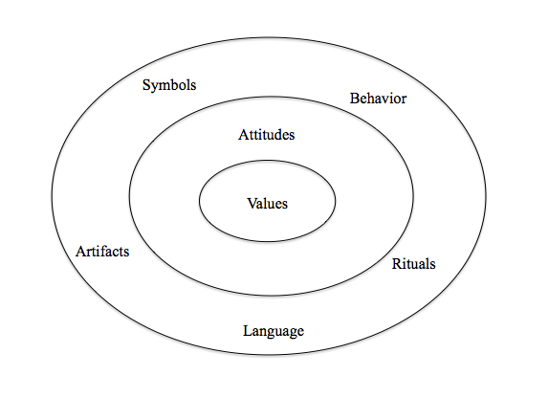

Values make up societal guidelines and define priorities within a culture. “Our values are developed throughout our lives and are influenced by a variety of elements within our societies” (Rudd & Lawson, 2007). Two main elements of culture are institutions and aesthetic components, which heavily influence a culture and an individual’s values. Common institutions in cultures such as family, education, and religion vary in importance and influence depending on the culture. The recognition of the influence of the aesthetic component is especially important during nonverbal communication within a culture. “Aesthetic components of a culture give it its appreciation for beauty and other things pleasing to the cognitive and affective senses of an individual” (Rudd & Lawson, 2007). Aesthetic components consist of the definition and relevance of certain styles, designs, symbols, and colors.
Similar to values, culture has a strong influence on attitude and is a difficult concept to fully understand. Attitudes express how an individual acts and reacts to certain situations, objects and individuals. “[Attitudes] can be best expressed with the phrases. ‘It is better to’ or ‘I should’ or ‘I’d rather’” (Haghirian, 2012). Attitudes are guided by the values of a culture and then shown through behavior.
The different types of elements within a culture can be described as “tools” adopted depending on the cultural norms. A common analogy is that the human mind is similar to a toolbox, and no matter the cultural background, humans have access to the same tools. The difference is, that the culture an individual grew up in has the ability to influence which “tools” are most often used (Norenzayan & Heine, 2005). Though an individual may be partial to using a specific set of tools, he has the capability to use more than just the tools he is accustomed to using. The conscious effort to try applying the “tools” that people from other cultures use most often demonstrates cultural sensitivity.

What is cultural sensitivity?
Having knowledge and understanding of what defines culture is the first step in becoming more culturally sensitive. “The most popular [concept of culture] is the iceberg model, in which we can see that only some aspects of culture are visible to us and many more are hidden. Like an iceberg where we can only see the top reaching out of the water, culture only shows us a few visible aspects and hides most of it under the seas (or in our case in societies that we visit or encounter)” (Haghirian, 2012). Cultural sensitivity is the effort an individual makes to see beyond the tip of the iceberg and try to understand the aspects of culture that are hidden, but make up the base and the majority of the culture.
A quote by R. L. Stevenson (Bannon et al., 2003) sums up how one must approach a new culture and individuals with different backgrounds and values. “There are no foreign lands; only the traveler is foreign.” There is nothing foreign, nor weird about a new culture, because in actuality you are the “foreign” or “weird” artifice in comparison to the culture. Through this thought process, a person becomes aware of his own culture, the elements that define it, and the elements within the new culture.
"As you learn to know a culture for yourself, you revise and enrich your own model of how the people in it feel, think and behave, and why they go on that way. Then you are ready to decide how best to channel your own feelings, modify your own thinking and adapt your own behavior to fit" (Bannon et al., 2003). The most difficult part of being culturally sensitive is shifting one’s own thoughts and actions, to best present and align oneself to others (Feng, 2009). After learning about one’s own culture, a person can take that knowledge and compare his culture to another. Becoming culturally aware of one’s own cultural norms and of other’s cultural norms is the initial step toward understanding the differences among cultures and being able to use one’s understanding to better communicate and interact within a new culture (Gundling, Hogan, & Cvitkovich, 2011). With a deeper understanding of both cultures, an individual can recognize the differences and the similarities between the cultures and readjust his thoughts and actions to better understand the new culture and communicate with the individuals from that culture.
There are six stages of cultural sensitivity outlined by Milton J. Bennett. Bennett’s Stages of Cultural sensitivity define the developmental process of an individual’s integration into a different culture. Each stage provides a deeper understanding of one’s experiences, thoughts, and actions while adapting to another culture. The six stages include: denial, defense, minimization, acceptance, adaption, and integration (Bennett, 1986). Though each stage can be reached, not everyone is able to complete the process and integrate into the culture.
Denial, the first stage, is being oblivious to cultural differences. While in this stage, one is ignorant to cultural differences and may not realize cultural differences even exist between the individual’s own culture and the new culture. Common misconceptions in this stage include thinking the different culture will be extremely similar to one’s own culture, including the language, conceptions of time, or social behaviors. Usually, people in this stage have not undergone intercultural experiences before. “Since difference has not been encountered, meaning (categories) has not been created for such phenomena” (Bennett, 1986). This causes individuals to think “one’s own world view is unchallenged as central to all reality” (Bennett, 1986).
The defense stage is the ethnocentric view that one’s culture is better, an “us and them” mentality. “[Individuals in a new culture] feel ‘under siege’ by people that they stereotype in simplistic and negative ways, protecting themselves with a hardened boundary between themselves and the ‘others’” (Bennett, 1986). Negative stereotypes imposed by the individual consume the cultural image of the different culture. These negative assumptions hinder the individual from experiencing and understanding the true aspects of the culture (Hammer, Bennett, & Wiseman, 2003).
The third stage, minimization is the act of acknowledging differences in culture, but underrating the importance of the differences. The individual has adopted an understanding that “deep down we are all alike, either physically/physiologically or spiritually/philosophically” (Bennett, 1986). This is the first stage where the individual will begin to make cultural adaptions, but the commonalities assumed are still ethnocentric. One sees too much similarity between the two cultures and thinks one’s personal values are universal, “since everyone is essentially like us, it is sufficient in cross-cultural situations to ‘just be yourself’” (Bennett, 1986).
The acceptance stage requires a perspective shift, while still retaining one’s personal values. The individual finally understands that the cultural differences and experiences are dependent on the cultural context and not universal. It is important to note that acceptance does not mean a permanent alteration of values or agreement but an acceptance of different cultural views (Hammer et al., 2003).
Adaption, the fifth stage, is the ability to function in a bicultural capacity. Meaning, one is able to look at differences based on one’s own culture and then see the differences based on other cultural perceptions. “People at Adaptation can engage in empathy—the ability to take perspective or shift frame of reference vis-à-vis other cultures” (Hammer et al., 2003). This adaption shift consists of two aspects, cognitive adaption and behavioral adaption. Cognitive adaption is the ability to think with both cultures in mind and behavioral adaption is taking action with the appropriate cultural norms in consideration.
The final stage is integration. It is reached when one is able to effortlessly shift between multiple cultures and evaluate norms based on both culture’s views. This entails that an individual changes from being ethnocentrism oriented, the belief that an individual’s culture is superior to other cultures, to polycentrism oriented. Integration occurs when an individual “intentionally makes a significant, sustained effort to become fully competent in new cultures” (Bennett, 1986).
Just knowing the seven stages of cultural sensitivity is not enough to become culturally sensitive or competent. An individual must make an effort and dedicate the time to understand, reach and progress through each stage. To become culturally sensitive takes time and a willingness to learn about and understand one’s own culture and learn about and understand the surrounding culture or cultures. The process of purposefully learning and understanding is called cultural sensitivity training.
Cultural Sensitivity Training
Cultural sensitivity training is necessary to advance through the stages of cultural sensitivity, to better relations between culturally different individuals and to propel a business into a global market. The goal of training is to become cognitively aware of and have an understanding of differences between cultures. “Cognitive awareness and understanding of cultural values and norms is key to meeting the challenges of intercultural interactions.” This emphasizes the necessity of going beyond the simple foundational elements of an individual culture in cultural sensitivity training; “…one must be able to assimilate the knowledge of one culture with another (or several others) in order to determine the most effective way to interact and communicate” (Rudd & Lawson, 2007). Attaining cognitive awareness and an understanding of cultures can be accomplished through the study and comparison of cultures.
Although there are many techniques used in cultural sensitivity training programs, there are two essential points agreed upon: “the commitment to improving internal and external cross-cultural communications must become part of the company’s culture and apply to everyone equally, from the CEO down” and that “many existing programs offer little more than etiquette training—such as whether you should bow or shake hands—while failing to address deeper issues that impact communications” (Chebium, 2015). The program needs to ensure that the training addresses how to understand and remedy issues, and that it is not just a quick lesson about surface-level differences. The knowledge of a culture is only helpful if it can be put into context (Bannon et al., 2003).

Importance of cultural sensitivity in business communication
Many cultures have subcultures within them and a business is an example of a subculture. The business’s culture will be a combination of the overall area’s culture and the business’s goals and mission. The business uses the overlying culture to guide the organization’s behaviors. “Culture underlines all interactions, including business interactions. Business interactions involve two levels of culture, the individual cultures of the people involved in the interaction and the organizational culture of the business involved. Culture influences most areas of business…” (Rudd & Lawson, 2007). Not only does becoming intercultural sensitive make the business more influential and people-oriented, but it also gives the organization a competitive advantage (Walker, Walker, & Schmitz 2003).
Businesses no longer stay in a single culture, because the world is “shrinking” and businesses are now part of the global business model. Becoming interculturally sensitive improves the business’s likelihood of accomplishing its business goals (Bannon et al., 2003). “However, in an increasingly global environment, remaining isolated from other cultures becomes impossible. Once we start crossing over and interacting with people from other cultures, communication becomes more challenging” (Rudd & Lawson, 2007). Businesses realize the expansion of the market and have to act accordingly to train employees on intercultural sensitivity.
As part of training employees to become culturally sensitive and competent, knowledge and an understanding of culture is imperative. When attempting to understand a new culture, one must have a basic outline, a base model, as a point of reference to build upon with more knowledge and experience. That base model is cultural knowledge and without it, there would be nothing to build upon, so no future understanding can be achieved. “Once you have started to build your model of a culture, you can augment and enrich it by asking questions of it, challenging it, and thinking laterally” (Bannon et al., 2003).
Becoming interculturally sensitive prepares an individual for the expected and unexpected, which makes the person a better employee and a better global citizen. To better understand oneself and others, an individual must be willing to invite the unexpected and be ready to learn. Though there will be similarities between individuals, there will be many differences. One must be open to new information and new experiences when learning about a different culture. To invite the unexpected simply means to push away preconceived notions. Humans “literally see what we expect to see” (Gundling et al., 2011). So, intercultural sensitivity training is necessary to prepare oneself to see and understand the unexpected.
A comprehensive study done in 1990 on the effectiveness and impact of cross-cultural training indicated a positive correlation between cross-cultural training and “development of greater feelings of well-being and self-confidence”, “self-reported measures of relationship skills” and “development of appropriate perceptions relative to members of another culture” (Black & Mendenhall, 1990).
The realm of business is expanding globally, and consequently, business communication is becoming essential. Communication professionals, especially public relations professionals, are expected to deliver “more effective tailored contents for multicultural interlocutors,” promote a deeper understanding between a business and its publics, increase employment, become more inclusive and welcoming to multicultural staff talents through “fertile dialogue and innovation”, improve social involvement and corporate reputation and expand market shares in diversity segments of stakeholders (Ravazzani, 2006). The expansion of business expectations to include a global scale illustrates the need for cultural sensitivity in business communication. Business communication professionals need to become competent in diversity and cultural issues to become an active and integral part of the global business environment (Toth, 2016).

What are the skills needed to be culturally competent?
There are many variations to what skills are specifically needed to become interculturally sensitive. The seven skills that are common themes in becoming interculturally sensitive are that the individual must have an open attitude, be self-aware, have an understanding of the cultures language, nonverbal behavior, silent languages, values, and Hofstede’s cultural dimensions which affect thinking and decision-making processes.
Open attitude
An open attitude is about developing a global mindset. The requirements to achieve this open mindset are to challenge assumptions, avoid quick judgments, tolerate ambiguity and complexity, exercise patience, and pursue learning (Walker et al., 2003). An individual must be willing to learn, try and experience new things. “While the cognitive component of an intercultural interaction is important, the affective component is also necessary for effective and successful intercultural interactions. Affective understanding requires an experiential approach to learning” (Rudd & Lawson, 2007). Through this experiential and “conscious attention to normally subconscious processes” approach, the person can develop a better understanding of other cultures (Rudd and Lawson, 2007).
Self-awareness
Understanding one’s own culture has been referenced numerous times, but the importance of self-awareness cannot be stressed enough. Intercultural sensitivity education should include self-awareness building, because cultural understanding of similarities and differences are referenced to a person’s home culture (Hånberg & Ödterdahl, 2009). There are many questions one must ask himself when improving self-awareness, such as “What are my cultural values, beliefs and attitudes?,” “How are these elements of my culture reflected in my behavior?” and “How adaptable and tolerant am I?” (Walker et al., 2003). By continuously asking oneself these questions, an individual will become more self-aware and therefore more culturally sensitive towards differing cultures.
Language
The verbal languages of cultures create an obvious divide and can make understanding and communication between cultures impossible. Even being able to speak a second language does not aid in understanding as much as being a native speaker. “Having the ability to communicate [with language] during a business transaction may help in meeting the immediate business objective, it does not add to the cognitive knowledge and understanding of another culture” (Rudd & Lawson, 2007). Just because two individuals can speak the same language does not mean they fully understand each other. Other elements of the culture, such as underlying meaning and nonverbal communication, can occur and accidentally be ignored or wrongly assumed. Even if a person speaks the language as a second language, having an interpreter or translator can be helpful to fully understand and better communicate with individuals from other cultures.
Nonverbal Behaviors
Nonverbal behavior comprises 80-90 percent of a culture’s communication, which are commonly taken for granted subconsciously (Hall & Hall, 1987). Because of the subconscious nature of nonverbal language, understanding becomes increasingly difficult (Alder & Graham, 1989). Nonverbal behavior communicates the context of a situation. Consequently, a situation’s context can be interpreted numerous ways because of the differences in nonverbal behaviors across cultures.
According to Edward T. Hall, when dealing with nonverbal behavior, cultures vary from high to low context on a continuum (1976). Depending on where the culture falls along the continuum, defines the importance of nonverbal behavior within that culture. A culture that is high context communicates in ways that rely heavily on context in conversation; meaning the cultures uses nonverbal communication consistently. “Not only are the words important in high-context communication, but also important is the situation and environment in which the communication takes place” (Rudd & Lawson, 2007). In conversations, many things may not be spoken, but implied. An individual in the high context culture, whether that individual is a part of that culture or new to the culture, is expected to pick up on and understand these implied messages. A culture that falls on the continuum as low context communicates more explicitly and directly (Hall, 1976). Low context cultures focus on the exact words of the communication, rather than looking into a deeper context. So, nonverbal behaviors are relevant, but not as essential to understanding to communication within a culture.
The difficulty with a culture’s contextual ranking is when two individuals with different levels of context importance try to communicate without an understanding of the other’s importance of context. It is imperative to successful communication to have an understanding of the context of a culture and an understanding of what certain nonverbal behaviors mean.
Silent languages
There are five silent languages Hall established through his research: time, space, material things, friendships, and agreements (Hall, 1976). These five languages are not openly discussed within a culture, but are a part of the communication styles of the individuals of a culture.
Time. The language of time is an abstract influence on the communication and actions of individuals; “time is not something we continuously think about in terms of its meaning; we think about it in terms of its effects on our lives, usually in a subconscious manner” (Rudd & Lawson, 2007). Hall separated the way a culture views time into monochronic and polychronic orientations (Hall, 1976). These two forms of viewing time relate to the culture’s structural representation of time in terms of planning and scheduling.
Cultures that are interpreted to be more monochronic view time as structured and purposive (Kaufman-Scarborough & Lindquist, 1999). Monochronic cultures are more task-oriented and punctual, where the clock decides when a task or situation is begun and finished (Rudd & Lawson, 2007). Time is seen as separable, and therefore can be scheduled around a single task or activity, with complete focus on that specific task (Nonis, Teng, & Ford, 2005). Polychronic cultures view time as continuous and smooth (Kaufman‐Scarborough & Lindquist, 1999).
Polychronic cultures focus on the importance of the individuals involved in a task or situation and “concentrate more on the completion of human transactions than meeting schedules” (Nonis et al., 2005). Each culture has a distinct view of time, which creates difficulty when approaching tasks and schedules with different cultures (Hall & Hall, 1987). But, an individual can take comfort in realizing there is a varying degree of both monochronic and polychronic characteristics within a culture, depending on the task and the individuals involved with the task (Rudd & Lawson, 2007). So, understanding the influence of time on one’s own culture and the different culture is an important concept when trying to create successful communication between cultures.
Space. The language of space is the special relationship individuals have between each other, i.e. the physical space between humans. What is considered appropriate space and inappropriate space is heavily influenced by culture (Silver, 2013). Depending on the context of the interactions between individuals, whether it is a personal or business interaction, decides the accepted physical space. Greetings and introductions, such as handshakes, are common invitations into an individual’s personal space (Hall, 1976). In Western cultures, there is an understood distance between handshakes and introductions. Non-western cultures, including Middle Eastern cultures, perceive personal space to be limited and will interact with others with only a few inches of personal space (Rudd & Lawson, 2007). Privacy is also interpreted as personal space, which is heavily dictated by the culture’s view of privacy. Cultures with a more individualistic view will expect privacy to be respected in relation to personal space. Whereas, collectivistic cultures, which emphasize the needs and goals of the group as a whole over the needs and goals of an individual, will have a more open perception of personal space, allowing the physical distance between individuals to be smaller (Rudd & Lawson, 2007).
Material Things. The silent language of material things offers a visible display of what a culture believes is important. This language is used when “assessing individuals from that culture,” such as by the clothes an individual wears, the house a person owns, or the car he drives (Rudd & Lawson, 2007). The language of material things can also be seen through the level of individualism and collectivism of a culture. Cultures that are more individualistic will hold material things in greater importance than collectivistic cultures. These assessments of individuals occur at a subconscious level and it is critical in maintaining cultural sensitivity to be aware of one’s own material assessments when communicating and interacting with individuals of differing cultural backgrounds.
Friendship. Friendship is another silent language and can be often overlooked in importance because of its misunderstood nature. Friendships are essentially how a culture values relationships with others (Rudd & Lawson, 2007). Again, individualism and collectivism play an integral role in understanding a culture’s importance of relationships. For collectivistic cultures, friendship equates to trust, which is a necessary factor when communicating and conducting business with individuals. More individualistic cultures separate friendship and business, but positive, more formal relationships are still necessary when communicating with individuals in individualistic cultures.
Agreement. Lastly, the silent language of agreements plays an important role in becoming culturally sensitive, especially in the communication and business world. Agreement is a language highly dependent on other silent languages, such as friendship and the ability to trust the individuals involved. The ability to trust the individuals is a direct correlation to how a culture views the responsibility of individuals involved in the agreement (Rudd & Lawson, 2007). So, in a more collective culture the responsibility is seen as personal, which makes the agreement personal, versus an individualistic culture seeing the agreement as formal and not a personal matter.
The five silent languages require a deeper level of knowledge and understanding of a culture because they are not typically discussed. This greater level of understanding results in a better grasp of cultural sensitivity and the ability to apply cultural sensitivity in relation to communicating and working with other cultures.
Values
Values provide the foundation for a culture and an individual’s communication and behavioral guidelines (Rudd & Lawson, 2007). Values define societal priorities and accepted behaviors, and “are so deeply embedded in our psyche that we do not question them at all” (Haghirian, 2012). Values are influenced by numerous elements in society. As mentioned, institutions and aesthetic components can summarize the majority of those elements and “the values and norms of an institution will reflect the values and norms of the culture within which it operates.” Examples of institutions that are prominent within most societies are family, educational systems, and religion (Rudd & Lawson, 2007).
Institutions within a culture also vary depending on the culture referenced. The definition of family may include just the immediate family, like in Western cultures, as opposed to Asian and Latin European cultures’ definition of family that also includes grandparents. Education systems influence the cultural development of a country in relation to the control of the educational system. If education is controlled at a national level, then the educational curriculum will be the same across the culture, but if the education system is separated within a culture, such as the United States’ decision to control curriculum at a state level, then the curriculum will vary across the culture (Rudd & Lawson, 2007). Religion also has many moral implications within a culture, specifically on the basis of explaining what is considered right and wrong. This can influence an individual from one culture on his outlook towards communication and interaction with an individual from a differing culture.
The aesthetic component is also important when trying to understand culture, especially the nonverbal language of a culture. Many aspects of cultural appreciation of beauty are not stated aloud, but understood subconsciously (Rudd & Lawson, 2007). Beauty can be seen in art, music, color, scenery, dance, and more; which is important to understand when trying to communicate or discuss an event or business deal, because what one culture may value for its beauty, another may find offensive. With an understanding of a culture’s values, an individual can relate his own values to the values of the differing culture and realize the importance of certain aspects of the culture.
Hofstede’s cultural dimensions
The thinking and decision-making process of a culture can be explained by the knowledge and understanding of a culture’s cultural dimensions. Geert Hofstede, a Dutch social psychologist, conducted a comprehensive study on how values are influenced by culture. His work focused on workplace values, but his research had a greater scale of influence in understanding cultural similarities and differences. Through his work, he developed the cultural dimensions theory, which identified five dimensions of national culture (Hofstede, 2001). The five dimensions are: power distance, individualism/collectivism, masculinity/femininity, uncertainty avoidance and long-term/short-term orientation. For each category, a country receives a numerical rank and score compared to other countries. These categories are reflective of how a culture dictates the country’s interactions with the culture and the rest of the world. They are the building blocks of the country’s culture and examples of each category can be seen in routine, daily actions of a country’s citizens or in large-scale country interests. Depicted in the Hofstede Table, used by Michael L. Kent to further understand the influence of Hofstede’s dimensions on international communication, are the countries on Hofstede’s cultural dimensions scale (Kent, 2011).

Figure 2: Hofstede Table
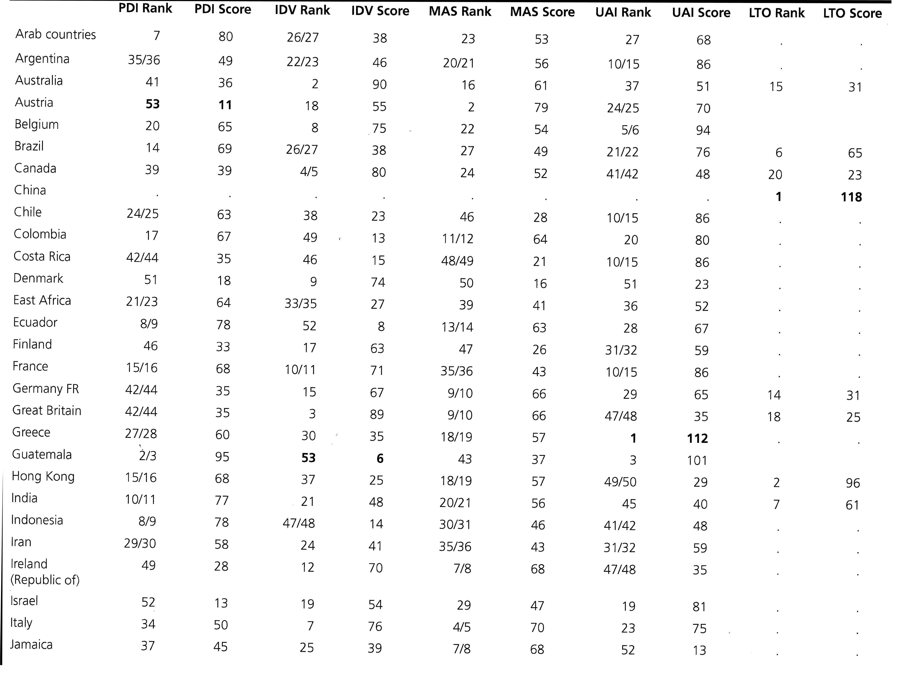
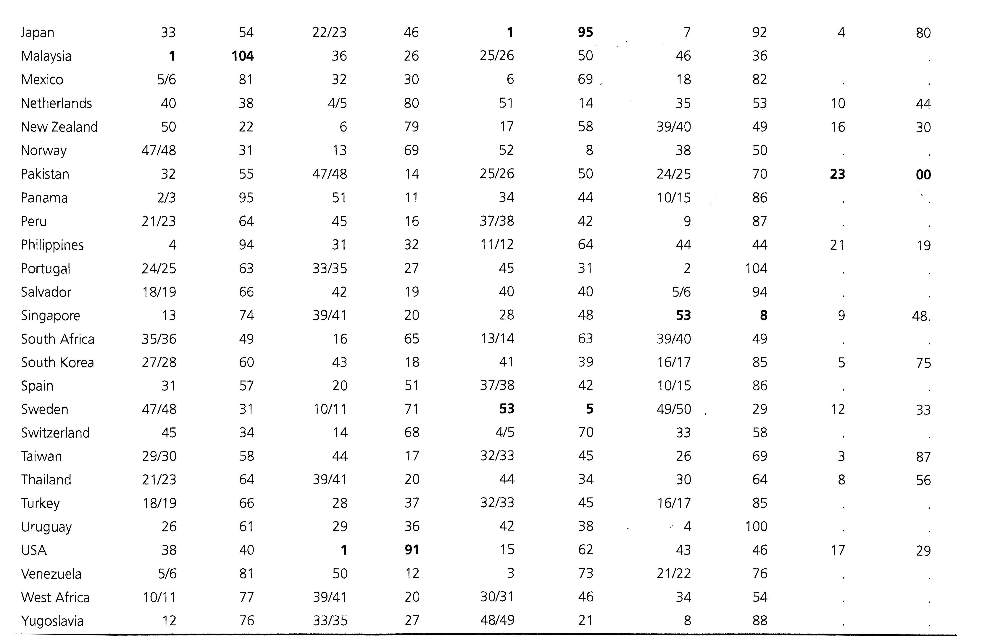
The first category, power distance index (PDI), measures the “perceived distance” between individuals of different stature. More specifically, it measures the closeness of individuals from different power statuses or statures and the individuals’ willingness to accept the “distance”. The higher the score a culture receives, the more of an understood hierarchical system there is in place within that culture and the individuals of that culture accept the hierarchy without further justification. In lower power distance cultures, “people strive to equalize the distribution of power and demand justification for inequalities of power” (Geert Hofstede, n.d.).
The next category is individualism/collectivism (IDV). Individualism measures the country’s emphasis on individualistic ideals versus collectivistic ideals, or a focus on a person’s best interest versus society’s best interest. A low score means the country is more community oriented and a high score means a country is individual-focused. In a high scoring, individualistic culture there is a “loosely-knit social framework” where people assume responsibility for themselves and their immediate family (Geert Hofstede, n.d.). In a low scoring, collectivistic culture there is a tight-knit social framework where people “can expect their relatives or members of a particular group to look after them in exchange for unquestioning loyalty” (Geert Hofstede, n.d.).
The masculinity dimension (MAS) measures a country’s focus on power and assertiveness and role distributions. A low score, femininity, means the country prefers “cooperation, modesty, caring for the weak and quality of life” (Geert Hofstede, n.d.). A high masculinity score would mean the country cares more about achievement, assertiveness, and materialistic success. For role distribution, feminine cultures would have less gender segregation relating to work and family roles. Whereas, in a masculine culture the women would find their role within the family or in traditionally female working positions and the men would work outside the home (Kent, 2011).
The uncertainty avoidance index score (UAI) reflects the country’s tolerance for uncertainty and ambiguity. A country with a high score would have a low tolerance for uncertainty and ambiguity. This means that the country’s people are more likely to get stressed and concerned about an unplanned occurrence and the individuals of that culture try to control and be prepared for the future. A country with a low score in uncertainty avoidance means that country does well with unplanned occurrences and exhibit a more “let it happen” approach to the future.
Long-term/short-term orientation (LTO) is Hofstede’s fifth cultural dimension, which “refers to issues of thrift, perseverance, and the desire for orderly relationships with others” (Kent, 2011). A culture with a long-term orientation will base current decisions on outcomes in the future and not just what is best for the present. Cultures with a more short-term orientation will focus on present interactions and make decisions regarding the immediate repercussions.
A better indication of how a culture thinks and makes decisions comes from the understanding of Hofstede’s cultural dimensions. Being able to not only know where a culture lands on the cultural dimension scale but also interpret what the score and ranking mean in relation to one’s own culture’s dimensions will provide a guide on how to best communicate interculturally.

Implications of cultural sensitivity for public relations
Being a public relations professional is being an “educated global citizen” (Starck & Kruckeberg, 2004). Public relations has become dependent on an understanding of intercultural relations. Organizations expect public relations practitioners to be culturally competent and “public relations often follows multinational organizations as they enter new markets” (Culbertson & Chen, 2009). Public relations professionals are seen as “cultural intermediaries” with a goal of creating common identities between products, issues, and consumers (Curtin & Gaither, 2007).
Why a public relations professional has to be culturally sensitive and competent is understandable because “communication and culture are inseparable ” (Smith, 1966). Therefore, it is the duty of public relations professionals to be culturally competent, because culture is communication and communication is public relations (Sriramesh & White, 1992). “Communication and collaboration are the essence of modern public relations," and the collaboration between multiple cultures is a priority when advancing in today’s global business world (Vercic, Grunig, & Grunig, 1996).
To become an educated global citizen, an individual must be culturally sensitive and culturally competent. Cultural competency is a necessary attribute of a successful communicator in the public relations field. Competency allows “the practitioner to become the proactive custodian of intercultural communication within their organisations, rather than a passive supplier of communication tasks, carried out under the umbrella of public relations. As such, the practitioner can play a greater role in developing strategic communication that allows for cultural meaning to take a central role in the development of relationships with stakeholders from diverse backgrounds” (Fitch & Desai, 2012).
As discussed, becoming culturally competent does not occur from basic knowledge of a culture, but from an understanding of both an individual’s culture and understanding of the differing culture. There is a difference between knowledge of a culture and an understanding of a culture. An understanding is a deeper level of knowledge that allows one to put cultural knowledge into practice. Knowledge alone lets you avoid cultural blunders, but understanding culture allows an individual to use the knowledge and understanding of a culture to communicate in a way that is respectful, understanding and beneficial to all individuals involved (Culbertson & Chen, 2009). Training to become competent involves more than just a curriculum of facts and references, but also opportunities for experience.
For public relations, “culture provided the meaning for the various forms of communication behaviors, such as spoken language or nonverbal gestures, as well as the rules and norms that governed when and how these behaviors should be used” (Zaharna, 2000). With the guidance and understanding of culture, public relations professionals can better structure and interpret messages for diverse cultures. Language, nonverbal behaviors, and silent languages are especially important in communication for public relations practitioners, specifically spoken and written communication, including press conferences, interviews, press releases, and copywriting. Because there are so many factors that go into communication, such as language (traditional or slang), the importance of who is speaking, the context, nonverbal cues, and the reader engagement, the target culture must be understood (Payne, n.d.).
In relation to understanding a culture’s values, a public relations practitioner must be able to apply the knowledge of values in culture-specific terms and situation-specific terms. Depending on a culture’s values, introducing a new product or campaign will need a different approach (culture-specific) compared to a public relations effort of crisis management (situation-specific) (Freitag, 2002). The values a culture holds guides societal priorities and accepted behaviors and therefore need to be treated with importance when communicating in the public relations field.
For pubic relations professionals, understanding the thinking and decision-making process of cultures is essential to effective intercultural communication. The knowledge and ability to use Hall’s context cultures and Hofstede’s cultural dimensions allow a public relations professional to “approach an international assignment with a greater appreciation for the nuances of campaign message design” (Freitag, 2002).
By applying the knowledge and understanding of a culture, public relations professionals can communicate in a way that is “understandable, meaningful and memorable to audiences around the globe,” which is a main objective in communication (Creedon & Al-Khaja, 2005). To better understand and successfully communicate with that culture, public relations practitioners must be able to critically analyze the messages, events, and situations presented by multiple cultures and provide multiple points of view (Creedon & Al-Khaja, 2005). By becoming culturally sensitive and competent, public relations practitioners will be able to analyze cultures and provide multiple cultural viewpoints. Public relations professionals “must embrace what is intrinsic to holistic and communal societies” because there is “a growing need for experts in relationship building, negotiation, and communal traits. If practitioners supposedly skilled in communication cannot assume these roles, they will miss an opportunity to help guide future economic and social growth” (Culbertson & Chen, 2009).

Conclusion
Cultural sensitivity and cultural competency are essential to be a successful public relations practitioner in today’s intercultural and interrelated global business environment. This thesis addresses the definitions of culture and cultural sensitivity and how they relate to business communication. From the discussion, one can see how culture influences communication on an individual and business level. Consequently, this influence proves to be important, especially in the field of public relations. This demonstrates a need for public relations professionals to be culturally sensitive and culturally competent. A public relation practitioner can become culturally competent through the knowledge and understanding of different cultures and by practicing cultural sensitivity skills, including an open attitude, self-awareness, an understanding of a culture’s language, nonverbal behaviors, silent languages, values, and cultural dimensions that affect thinking and decision-making processes. By applying these components of competency, the individual will gain experience in being culturally sensitive and be a culturally competent public relations practitioner.

References
Adler, N. J., & Graham, J. L. (1989). Cross-cultural interaction: The international comparison fallacy? Journal of International Business Studies, 20(3), 515-537. Retrieved March 26, 2017, from https://www.jstor.org/stable/155189?seq=1#page_scan_tab_contents.
Bannon, G., Guy, V., Al-Omari, J., Reed, B., Pooley, R., & White, N. (2003). Cross-cultural communication: the essential guide to international business (J. Mattock, Ed.). London: Kogan Page.
Bennett, M. J. (1986). A developmental approach to training for intercultural sensitivity. International Journal of Intercultural Relations,10(2), 179-196. doi:10.1016/0147-1767(86)90005-2
Black, J. S., & Mendenhall, M. (1990). Cross-cultural training effectiveness: A review and a theoretical framework for future research. Academy of Management Review, 15(1), 113-136. doi:10.5465/amr.1990.11591834
Chebium, R. (2015, January 07). How to create an effective cross-cultural training program. Society for Human Resource Management. Retrieved February 26, 2017, from https://www.shrm.org/hr-today/news/hr-magazine/pages/010215-cross-cultural-training.aspx
Creedon, P., & Al-Khaja, M. (2005). Public relations and globalization: Building a case for cultural competency in public relations education. Public Relations Review,31(3), 344-354. doi:10.1016/j.pubrev.2005.05.021
Culbertson, H. M., & Chen, N. (2009). International public relations: a comparative analysis. New York: Routledge, Taylor & Francis Group.
Curtin, P. A., & Gaither, T. K. (2007). International public relations: negotiating culture, identity, and power. Thousand Oaks, CA: SAGE Publications.
Feng, A. (2009). Becoming interculturally competent through education and training (M. Byram & M. Fleming, Eds.). Tonawanda, NY: Multilingual Matters.
Fitch, K., & Desai, R. (2012). Developing global practitioners. Journal of International Communication,18(1), 63-78. doi:10.1080/13216597.2012.662169
Freitag, A. R. (2002). Ascending cultural competence potential: An assessment and profile of U.S. public relations practitioners' preparation for international assignments. Journal of Public Relations Research,14(3), 207-227. doi:10.1207/s1532754xjprr1403_3
Geert Hofstede. (n.d.). Retrieved March 5, 2017, from https://geert-hofstede.com/national-culture.html
Gundling, E., Hogan, T., & Cvitkovich, K. (2011). What is global leadership?: 10 key behaviors that define great global leaders. Boston, MA: Intercultural Press/Nicholas Brealey Pub.
Haghirian, P. (2012). Successful cross-cultural management: a guide for international managers. New York: Business Expert Press.
Hall, E. T. (1976). Beyond culture. New York: Anchor Books.
Hall, E. T., & Hall, M. R. (1987). Hidden differences: doing business with the Japanese. New York: Anchor Press/Doubleday.
Hammer, M. R., Bennett, M. J., & Wiseman, R. (2003). Measuring intercultural sensitivity: The intercultural development inventory. International Journal of Intercultural Relations,27(4), 421-443. doi:10.1016/s0147-1767(03)00032-4
Hånberg, C., & Österdahl, G. (2009). Cross-cultural training of expatriates - DiVA portal. Retrieved February 23, 2017, from http://www.diva-portal.org/smash/get/diva2:227437/FULLTEXT02
Hofstede, G. (2001). Culture's consequences: comparing values, behaviors, institutions, and organizations across nations (2nd ed.). Thousand Oaks, CA: Sage Publ.
Kaufman‐Scarborough, C., & Lindquist, J. D. (1999). Time management and polychronicity. Journal of Managerial Psychology,14(3/4), 288-312. doi:10.1108/02683949910263819
Kent, M. L. (2011). Public relations writing: a rhetorical approach. Boston: Allyn & Bacon.
Macdonald, G. F. (1991). What is culture? Journal of Museum Education, 16(1), 9-12. doi:10.1080/10598650.1991.11510161
Nonis, S., Teng, J., & Ford, C. (2005). A cross-cultural investigation of time management practices and job outcomes. International Journal of Intercultural Relations,29(4), 409-428. doi:10.1016/j.ijintrel.2005.05.002
Norenzayan, A., & Heine, S. J. (2005). Psychological universals: What are they and how can we know? Psychological Bulletin, 131(5), 763-784. doi:10.1037/0033-2909.131.5.763
Payne, N. (n.d.). Public relations across cultures: Building international communication bridges. Retrieved April 4, 2017, from http://aboutpublicrelations.net/ucpayne.htm
Ravazzani, S. (2006, November). “Communicating for diversity, with diversity, in diversity”: Main implications and summary of the contents [Scholarly project]. In Http://www.instituteforpr.org/. Retrieved April 3, 2017, from http://www.instituteforpr.org/wp-content/uploads/Ravazzani_Diversity_Summit.pdf
Rudd, J. E., & Lawson, D. (2007). Communicating in global business negotiations a geocentric approach. Los Angeles: Sage Publications.
Schmidt, W. V., Conaway, R. N., Easton, S. S., & Wardrope, W. J. (2007). Communicating globally: intercultural communication and international business. Los Angeles: SAGE Publications.
Silver, J. (2013). Personal space: Exploring human proxemics. Retrieved March 27, 2017, from http://search.alexanderstreet.com.proxy.lib.utk.edu:90/view/work/3190367
Smith, A. G. (1966). Communication and Culture. NY: Holt, Rinehart and Winston.
Sriramesh, K. and White, J. (1992). "Societal culture and public relations." In J. E. Grunig (Ed.), Excellence in public relation and communication management. Hillsdale, NJ: Lawrence Erlbaum Associates, pp. 597-614.
Starck, K., & Kruckeberg, D. (2004). Ethical obligations of public relations in an era of globalisation. Journal of Communication Management,8(1), 29-40. doi:10.1108/13632540410807529
Toth, E. L. (2016, January 21). Diversity and public relations practice. Retrieved April 3, 2017, from http://www.instituteforpr.org/diversity-and-pr-practice/
Vercic, D, Grunig, L. and Grunig, J.E. (1996). "Global and specific principles of public relations: Evidence from Slovenia," in H. Culbertson and N. Chen (Eds.), International public relations: A comparative analysis. Mahwah, NJ: Lawrence Erlbaum
Walker, D. M., Walker, T., & Schmitz, J. (2003). Doing business internationally: the guide to cross-cultural success, second edition. New York: McGraw-Hill.
Zaharna, R. S. (2000). Intercultural communication and international public relations: Exploring parallels. Communication Quarterly,48(1), 85-100. doi:10.1080/01463370009385582

