Generalizing across gender during early word learning: Evidence from a statistical learning paradigm
Madison Newsom
Chancellor Honor’s Program
University of Tennessee

Abstract
Before children can speak, they can track the likelihood that two syllables co-occur to pull words out of a continuous stream of speech. Previous research with 17-month-olds has suggested that words that have high co-occurrence statistics (i.e., high transitional probability, HTP) make better object labels than words with low transitional probability (LTP). Here we test whether infants can generalize the patterns tracked in a continuous stream of speech to a speaker of a different gender. Infants were familiarized with an Italian corpus produced by a female speaker, that contains both HTP and LTP words. Following familiarization, infants were trained to pair HTP words with novel objects. The HTP words used during test were either produced by a novel male speaker (Experiment 1) or the same female speaker as during familiarization (Experiment 2). If infants recognize the HTP words when produced by a novel speaker, they should readily learn to map these words onto novel objects. Although the ability to generalize across speakers and genders is an important ability during early language acquisition, infants failed to map the HTP word to novel objects in both Experiment 1 and 2. Limitations of the current study are discussed.
Keywords: statistical learning, transitional probability, generalization, gender

Introduction
The majority of speech that infants hear is continuous with limited reliable acoustic cues to indicate word boundaries (Cole & Jakimik, 1980). This presents infants with the challenge of finding individual words in a speech stream, but previous research has shown that they use multiple strategies to surmount this obstacle. Research has shown that one strategy infants employ is called statistical learning (SL), where they are able to track the likelihood that two syllables co-occur, referred to as transitionally probability (TP) between syllables, in continuous speech.
TP is much higher within words than across word boundaries. This can be modeled in the phrase “pretty baby;” the TP in pre/ty and ba/by (or within word TP) is much more robust than TP of ty/ba (between words). Research has demonstrated that infants, as young as 8 months old, are able to track these statistics between syllables to discover word boundaries in continuous artificial speech (Saffran, Aslin, & Newport, 1996). Research has also shown that infants are able to these same types of regularizes in natural speech (Pelucchi, Hay, & Saffran, 2009). Further, Hay, Pelucchi, Estes, and Saffran (2011) demonstrate that words that contain high TP (HTP) make better object labels for 17-month-olds than those with low TP (LTP), showing that word learning may be influenced by SL. However, little is known about how infants represent these newly segmented words.
In their natural language learning environments, infants receive diverse language input by numerous speakers. Speakers differ in, among other things, their anatomical vocal cord structure, accent, and pitch. These properties that differ across speakers are referred to as indexical properties. Therefore, indexical specificity analyzes variation between these properties (Mulak, Bonn, Chládková, Aslin, & Escudero, 2017). Previous research has shown that infants are able to generalize and successfully learn across these indexical changes. At 10.5 months, infants recognize words of their native language across a change in gender in fluent speech (Houston & Jusczyk, 2000). Research has also indicated that infants at 11- and 17-month-olds are able to generalize across gender between familiarization and test when presented with an artificial language (Graf Estes, 2012).
In the current study, we test whether 17-month-olds are able to generalize across indexical features when segmenting words from natural Italian speech. While infants are sensitive to speaker characteristics from an early age (Mulak et al., 2017), they should come to ignore these same characteristics during word learning, as these types of indexical features do not affect the meaning of words (e.g., /dog/ produced by a female voice means the same thing as /dog/ produced by a male voice). Similar to Hay et al. 2011, Experiment 1 examines infants’ representations of newly segmented words across a change in gender. Experiment 2 sought out to ensure that infants were tracking TP information in our corpus.

Experiment 1
Introduction
To test infants’ representation of the indexical features of newly segmented words, we familiarized 17-month-olds to a naturally spoken Italian corpus produced by a female speaker. Following familiarization, infants participated in a word learning task where a male speaker produced the HTP words from the corpus instead of the female speaker from familiarization.

Method
Participants
Twenty 17-month-old (mean age 17.42 months, range: 16.95-17.95 months) infants participated in Experiment 1. These monolingual infants were born full-term and had fewer than 4 ear infections in the last 12 months. All infants were free of any history of hearing or vision problems, corrected or uncorrected, according to parental report. They were also evenly distributed and counterbalanced between conditions. Participants were recruited from the Child Development Research Group database maintained at the University of Tennessee Knoxville. Data was excluded from 34 infants due to experimental error (14), fussiness (13), parent exclusion (3), excess ear infections (2), or failure to pay attention (2).

Stimuli
The familiarization corpus consisted of a naturally produced Italian speech stream used by Hay and colleagues (Hay et al., 2011). It was composed of 12 grammatically correct Italian sentences as well as four embedded trochaic target words (fuga, melo, bici, and casa). These target words occurred six times in the corpora. Two words were HTP (TP=1.0) because their syllables always co-occurred, and two were LTP (TP=.33) because their syllables also occurred in other words. The corpus was repeated three times and presented each HTP target word 18 times in total. A native female Italian speaker produced 2 counterbalanced corpora (Languages A and B) in infant-directed speech, where the HTP and LTP target words were switched. This insured that any differential learning was not due to any idiosyncrasies in individual target words. In the current study, we used a different female Italian speaker than previous studies. Each familiarization corpus lasted approximately 2 min 30 s.

Procedure
Here, we replicated the procedures used by Hay and colleagues (Hay et al., 2011). Infants sat on a parent’s lap in a sound proof booth 1m from a television screen. Participants were first shown a lively, silent cartoon as one of two Italian corpora of a native Italian female speaker (either Language A or B) played in the background. Language A (136 seconds) and Language B (144 seconds) were counterbalanced between participants using the Habit program.
Immediately following the familiarization, infants were trained and tested on two novel label-object pairings produced by a novel male speaker using the Switch Paradigm. Labels were the HTP words from the corpus. Infants were habituated to two novel label-object pairs. On each trial infants saw one object and heard the corresponding label. Object-label presentations continued until infants showed a 50% decrease in looking from the first to the last 3 training trials, or after 25 trials. At test, infants were presented with both Same trials, in which the object-label pairing from habituation was maintained, and Switch trials, in which original object-label pairs were violated (i.e., Object A with Label B and vice versa). There were 4 Same and 4 Switch trials counterbalanced across 8 testing orders and a total of 8 test trials. The dependent variable was difference in looking time between the Switch and Same trials. If infants learn the object-label parings, they should look longer on Switch trials than on Same trials.
An observer controlled Habit by holding down a key while the infant gazed at the monitor that displayed the object and released the key when they looked away. The observer was blind because they did not know which object-labels the infants were being presented with during habituation or test trials.
Each participant’s parents completed a general information questionnaire and a MacArther Communicative Development Inventory for Infants (MCDI; Fenson, Dale, Reznick, Bates, Thal, & Pethick, 1994) vocabulary survey.

Figure 1: Visual stimuli presented in training and testing phases

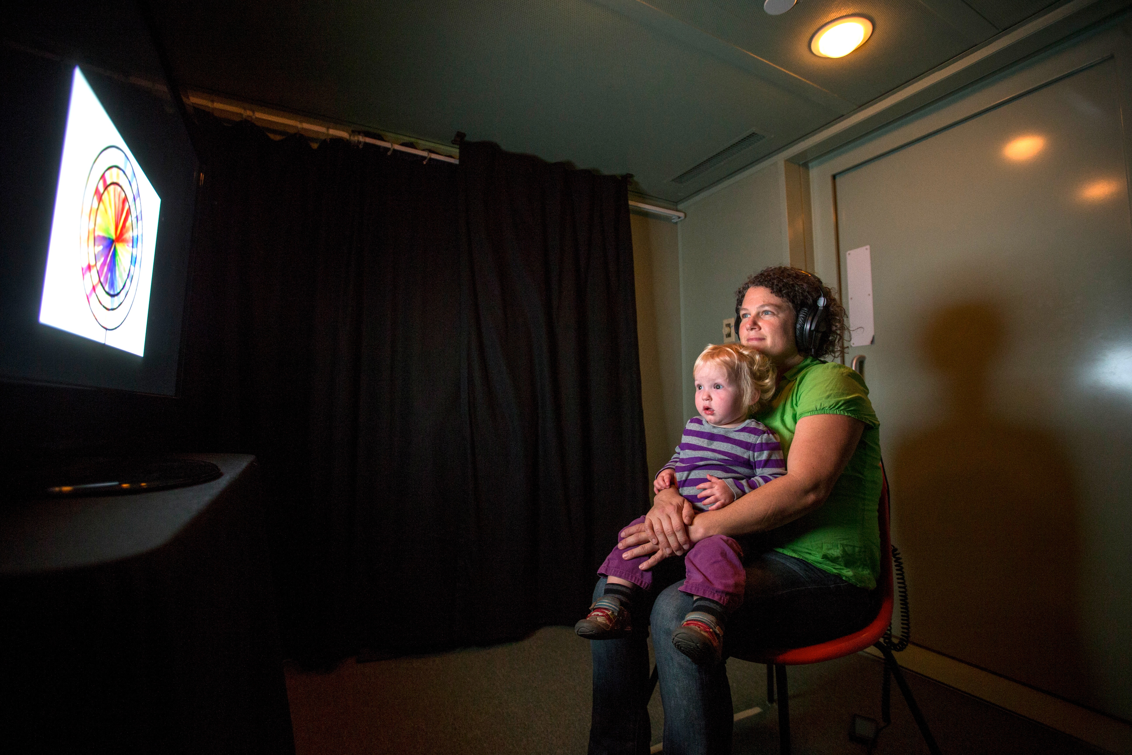

Figure 2: Parent and child participating in the soundproof booth

Results and Discussion
A paired t-test revealed that infants did not look significantly longer on Switch (mean = 7.49 sec, SD =3.30) than on Same trials (mean= 7.36 seconds), t(19)=.105, p=.917, suggesting that they did not learn the label-object pairings.

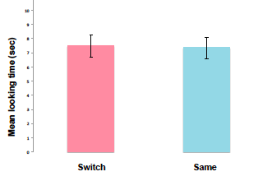

Figure 3: Mean looking time on Switch and Same trials for
Experiment 1. Error bar represent standard error of the mean.

At 17 months, infants may have a difficult time recognizing the words in training (male voice) as being the same as the words that they pulled out of continuous speech (female voice). Alternatively, infants may have failed to segment the HTP words from the speech stream.

Experiment 2
Introduction
Experiment 2 was designed to ensure that failure to learn in Experiment 1 was due to an inability to generalize across speaker gender and not a failure to track TP information in the new corpus. To that end, we set out to replicate Hay et al. 2011 with the same corpus used in Experiment 1, keeping the speaker constant between familiarization and word-learning phases.

Methods
Participants
Nineteen 17-month-old monolingual English-learning infants (mean age 17.42 months, range: 16.95-17.95 months) participated in this experiment. These infants had the same exclusion criteria as Experiment 1. Data was not included from 21 infants due to fussiness (13), parent exclusion (2), excess ear infections (3), hearing or vision problems (1), prematurity (1) or failure to pay attention (1).

Procedure
The procedure was identical to Experiment 1, with the following exception: the same native female Italian speaker who produced the familiarization corpus also produced the words used in the word-learning phase.

Results and Discussion
Surprisingly, a paired t-test for Experiment 2 revealed infants did not look significantly longer on Switch (mean = 9.72 sec, SD =3.60) than on Same trials (mean= 9.35 seconds), t(18)=.467, p= .646, suggesting that they again did not learn the label-object pairings. We were unable to replicate the basic findings from Hay et al. 2011.

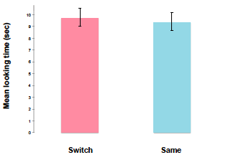
Figure 4: Mean looking time on Switch and Same trials for
Experiment 2. Error bar represent standard error of the mean.

General Discussion
In both Experiments 1 and 2, infants failed to map the HTP words to novel objects. We were unable to replicate previous work by Hay et al. (2011) and Graf Estes and colleagues (Graf Estes, 2012). This limits our ability to draw any meaningful conclusions about infants’ ability to generalize across speaker gender. These findings do not follow from previous research. For example, Houston & Jusczyk (2000) found that infants at as young as 10.5 months olds are able to recognize words despite a change in gender in their native language in fluent speech. Graf Estes (2012) also discovered that 11 and 17 months infants generalize across a gender change with an artificial language. From these studies, it would follow that infants at 17 months of age could also recognize and succeed in word learning despite a change in gender. Thus, we do not fully understand the specific processes of how infants represent indexical (speaker) information in words that are newly segmented from natural speech. The reasons for our failure to replicate previous work remain unclear; however, one contributing factor may involve the participants’ language proficiency.
While is no vocabulary size data available from the infants in Hay et al. (2011), over 25% of infants from both of our experiments scored below the 10th percentile for vocabulary size. We collected these vocabulary sizes from the MCDI parental reports. For a point of reference, children between 18-24 months old are typically categorized as late talkers if they score at or below the 10th percentile in these types of measures (Ellis, 2013). In Experiment 1, 5 infants from the sample of 20 had vocabulary sizes lower than the 10th percentile, seen below in Figure 5.
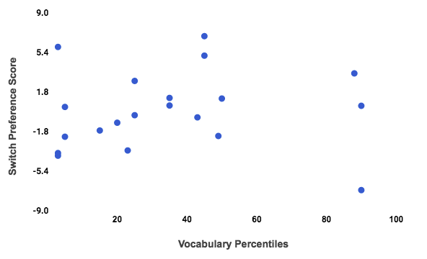

Figure 5: Switch preference score and vocabulary percentiles of participants
from MCDI reports from Experiment 1.

In our second experiment, 9 infants out of our sample of 19 had vocabulary percentiles lower than the 10th percentile, as well. In total, 14 of our 39 infants from both experiments (35.90 %) would be categorized as late talkers.
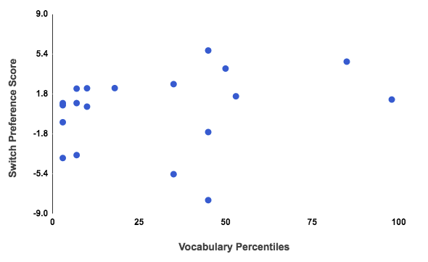
Figure 5: Switch preference and vocabulary percentiles of participants from
MCDI reports from Experiment 2.

Although vocabulary size and performance were not correlated in our sample, it is possible that infants with lower vocabulary size could be having a difficult time learning to map words from continuous speech even with support of the statistics.
A limitation of this study could be our narrow sample size. Since we only used data from 20 babies for Experiment 1 and 19 babies for Experiment 2, potential correlations could be ambiguous among this limited amount of infants. A larger sample size could reveal more patterns in our data that were not as clear in the sample sizes.
Further work will be necessary to identify how infants are representing these statistically defined words. One way this representation could be studied is to investigate the ability to generalize across gender in infants from homes with a significant amount of linguistic variability (i.e., many different speakers) and compare them to infants that do not have substantial input variability. Since previous research has shown that variability in language input gives infants greater sensitivity in learning language (Plante, Ogilvie, Vance, Aguilar, Dailey, Meyers, & Burton, 2014), it would follow that infants with enhanced variability in their language exposure would generalize across a change in gender and segment words significantly better than those with lesser variability in their homes. Supplementary research has the potential to further specify the exact processes of how infants representing statistically defined words and acquire language.

Acknowledgements
This work was supported by a grant to JFH (1R01HD083312) from NICHD. We would like to extend a warm thank you to all participating families and every member of the Infant Language and Perceptual Learning Lab at the University of Tennessee, Knoxville.

Appendix
Language 2A
Spesso Lisa capita in fuga nella casa dove giaci gracile e tesa.
Se cadi con la bici prima del bivio del melo cavo ti do dieci bigoli e una biro.
Gli amici della cavia Bida poggiano le bici in bilico presso il melo per difesa dalla biscia.
Sovente carico la spesa nel vicinato dopo una fuga con la bici nuova.
Carola si è esibita in una fuga verso il melo perché offesa dagli amici scortesi.
Se vai a casa in bici ti debiliti ma cali e non sei più obesa.
Dietro la casa del capo ho sprecato i ceci sotto al melo ombroso.
Se cuci subito sulla divisa bigia il distintivo col melo vado in casa a dormire.
Teresa si abitua alla fuga da casa con la vecchia bici senza luci posteriori.
Taci sulla fuga di Marisa con il caro lattaio.
Il bel melo sta tra la casa dei Greci e la chiesa arcana dove hai giocato con le bilie.
I soci della ditta Musa si danno alla fuga con la bici della maglia rosa.
Language 2B
Roméro fu coinvolto in una futile fuga in bici verso il profumo del mélo ombroso.
Il collega di Paolo Fusi trovò la bici per la fuga presso la casa del molo.
La maga tiene in casa almeno un fuco, uno squalo e una tartaruga del Nilo.
Il fuco procede parallelo alla casa sulla riga tracciata dalla cometa.
Il gattone Refuso medita sul mélo presso casa ascoltando una fuga di Verdi.
Il fu Medo Rossi ruppe la braga nella bici il mese scorso durante la gara.
Giga ogni mese paga con zelo l’affitto per la casa con il melo in fiore.
meco prega il cielo che ogni fuga da casa termini sotto melo ombroso.
Il delfino beluga si dimena tutto solo nella fuga verso il Nilo azzurro.
Un pezzo di filo si è infilato nella bici appoggiata al melo dietro la méscita.
Vi fu un tempo in cui la bici in lega non temeva il gelo del rifugio della Futa.
La strega del melo fu vista in fuga sulla bici con un chilo di rametti.

References
Cole, R. A., & Jakimik, J. (1980). How are syllables used to recognize words?. The Journal of the Acoustical Society of America, 67(3), 965-970.
Hay, J. F., Pelucchi, B., Estes, K. G., & Saffran, J. R. (2011). Linking sounds to meanings: Infant statistical learning in a natural language. Cognitive Psychology, 63(2), 93-106.
Houston, D. M., and Jusczyk, P. W. (2000). The role of talker-specific information in word segmentation by infants. Journal of Experimental Psychology: Human Perception and Performance, 26(5), 1570-158.
Ellis, E. M. (2013). Lexical and Cognitive Processing in Early Language Delay (Doctoral dissertation, San Diego State University).
Fenson, L., Dale, P. S., Reznick, J. S., Bates, E., Thal, D. J., & Pethick, S. J. (1994). Variability in early communicative development. Monographs of the Society for Research in Child Development, 59, 1–173
Graf Estes, K. (2012). Infants generalize representations of statistically segmented words. Frontiers in Psychology, 3, 447.
Mulak, K. E., Bonn, C. D., Chládková, K., Aslin, R. N., & Escudero, P. (2017). Indexical and linguistic processing by 12-month-olds: Discrimination of speaker, accent and vowel differences. PloS one, 12(5).
Plante, E., Ogilvie, T., Vance, R., Aguilar, J. M., Dailey, N. S., Meyers, C., & Burton, R. (2014). Variability in the language input to children enhances learning in a treatment context. American Journal of Speech-Language Pathology, 23(4), 530-545.
Pelucchi, B., Hay, J. F., & Saffran, J. R. (2009). Statistical Learning in a Natural Language by 8-Month-Old Infants. Child Development, 80(3), 674-685.
Saffran, J. R., Aslin, R. N., & Newport, E. L. (1996). Statistical Learning By 8-Month Old Infants. Science, 274(5294), 1926-1928.

