To the Graduate Council:

I am submitting herewith a thesis written by Brent Steven Pilon entitled “Stormwater Best Management Practices: Improvement and Evaluation”. I have examined the final electronic copy of this thesis for form and content and recommend that it be accepted in partial fulfillment of the requirements for the degree of Master of Science, with a major in Biosystems Engineering.

John S. Tyner, Major Professor

We have read this thesis and
recommend its acceptance:

Daniel C. Yoder

John R. Buchanan

Accepted for the Council:
Carolyn R. Hodges
Vice Provost and Dean of the Graduate School

(Original signatures are on file with official student records.)

Stormwater Best Management Practices:
Improvement and Evaluation

A Thesis
Presented for the
Master of Science
Degree
The University of Tennessee, Knoxville

Brent Steven Pilon
December 2010

Copyright © 2010 by Brent S. Pilon
All rights reserved.

ACKNOWLEDGEMENTS
I would like to thank my major professor, Dr. John Tyner, and my committee members, Dr. Daniel Yoder and Dr. John Buchanan, for their guidance in the completion of this thesis. I would like to thank Wesley Wright for his guidance in many aspects of this work and his assistance in data logger programming. I would also like to thank Dr. Stacy Worley and David Smith for helping me to assemble and program the hydrograph generator control system. I would like to thank Craig Waggoner for his assistance in the fabrication shop. I would like to thank Galina Melnichenko, Melanie Stewart, and Robert Raley for helping me with chemical and sediment samples analysis. I would like to thank Boone Hillenbrand, Alex McLemore, and Lori Gibson for helping me install and test the solid state skimmer. Finally, I would like to thank Mr. George Williams at the Alcoa City Center for providing use of the facility for pervious concrete water quality testing.

ABSTRACT
Each of the studies conducted herein is related to best management practices for stormwater pollutant removal. This thesis is divided into two chapters. Chapter One details the development and functionality of a novel stormwater detention pond outlet, the solid state skimmer. The device is a perforated riser having no moving parts that is capable of draining detention ponds primarily from the topmost orifices. We found that such a device is capable of reducing effluent turbidity and sediment concentrations compared to a traditional riser outlet. Chapter Two describes a water quality monitoring study performed that shows a pervious concrete detention system can remove stormwater pollutants from parking lot runoff. The stormwater flowed across asphalt paving before infiltrating into the pervious concrete and an aggregate sub-base below. We sampled the runoff before it entered the pervious and after it passed through the detention system and found significant decreases in several pollutants.

TABLE OF CONTENTS

Chapter Page

FORWARD Error! Bookmark not defined.
TABLE OF CONTENTS v
CHAPTER ONE: THE SOLID STATE SKIMMER 1
Abstract 2
Introduction 3
Literature Review 3
Hypothesis 5
Flow Modeling 7
Design Concept 7
The Orifice Equation 9
Full Flow 9
Partial Flow 9
Continuous Riser Discharge 11
Flow Models 13
Analytical Flow Equations 13
Orifice Placement 16
Numerical Flow Equations 18
Methods 20
Test Apparatus 20
Model Validations 21
Design Storm 22
Sediment Load 23
Sediment Retention Tests 24
Laboratory Analysis 26
Statistical Analysis 27
Results 28
Validation 28
Analytical Model 28
Traditional Riser and SSS 29
Sample Analysis 31
Turbidity 31
Total Solids 34
Particle Size Analysis 35
Conclusions 36
List of References Error! Bookmark not defined.
CHAPTER TWO: A PERVIOUS CONCRETE WATER QUALITY STUDY 40
Abstract 41
Introduction 42
Permeable Pavements 42
Surface Water Impairment 42
Permeable Pavement Studies 45
Hypothesis 46
Methods 48
Sample Collection 49
Sample Analysis 51
pH 51
Turbidity 52
Total Suspended Solids 52
Anions 52
Chemical Oxygen Demand 53
Metals 53
Polycyclic Aromatic Hydrocarbons 53
Statistical Analysis 54
Results 55
pH 55
Turbidity 56
Total Suspended Solids 57
Chloride 58
Nitrite and Nitrate 59
Sulfate 61
Chemical Oxygen Demand 62
Metals 63
Polycyclic Aromatic Hydrocarbons 64
Conclusions 65
References 66
APPENDIX 70
Vita 72

LIST OF FIGURES

Figure Page

Figure 1.1. The Solid State Skimmer 7
Figure 1.2. Comparison of Bottommost Orifice Heads 8
Figure 1.3. Partially Flowing Orifices 10
Figure 1.4. Continuous Riser Flow Regimes 12
Figure 1.5. The Gamma Distribution 15
Figure 1.6. The SSS and the Traditional Riser Installed 21
Figure 1.7. NRCS Design Storm Hydrograph 23
Figure 1.9. Analytical Model Validation 28
Figure 1.10. Traditional Riser and SSS Validation 29
Figure 1.11. Traditional Riser and SSS Discharges 30
Figure 1.12. Tests 1-4 Turbidity Results 31
Figure 1.13. Turbidity Results from Individual Tests 32
Figure 1.13 cont’d. Turbidity Results from Individual Tests 33
Figure 1.14. Tests 1-4 Total Solids Results 34
Figure 1.15. Particle Size Analysis 35
Figure 2.1.The Alcoa City Center Site (© Google) 48
Figure 2.2. Cross Section of the Alcoa Pervious Pavement Site 49
Figure 2.3. Sampling Apparatus Installed at Site 50
Figure 2.4. Mean pH Values from Five Storm Events 55
Figure 2.5. Mean Turbidity Values from Four Storm Events (Sept #1 unavailable) 56
Figure 2.6. Mean TSS Concentrations from Three Storm Events (Sept #1 and Sept #2 omitted) 57
Figure 2.7. Mean Chloride Concentrations from Five Storm Events 58
Figure 2.8. Mean Nitrite Concentrations from Five Storm Events Error! Bookmark not defined.
Figure 2.10. Mean Sulfate Concentrations from Five Storm Events 61
Figure 2.11. Mean COD Concentrations (Sept #1 and Sept #2 unavailable) 62
Figure 2.12. Mean Zinc Concentrations from Three Storm Events (April and June unavailable) 63
Figure 2.13. Mean PAH Concentrations from Four Storm Events (Sept #2 omitted) 64

CHAPTER ONE: THE SOLID STATE SKIMMER

Abstract
Sediment laden runoff is a leading pollutant in many watersheds, so best management practices such as stormwater basins have been developed to help mitigate the impacts of sediment. Stormwater basins, which either temporarily or permanently store runoff, are typically drained by perforated risers and, more recently, by floating skimmers. Whereas a traditional riser drains mostly from its lower orifices because of the higher heads that exist at greater depths, floating skimmers can drain the cleaner water at the uppermost basin elevations, thereby allowing for increased sediment retention. However, floating skimmers can be more difficult to install and more prone to failure, which inhibits their wide adoption. We have developed a solid state skimmer (SSS) that is simple in design, is installed in the same manner as a traditional riser, and requires no modification of an existing basin. The SSS is comprised of two concentric vertical risers that form a chamber allowing the lower orifices to become submerged. This yields a situation such that the majority of flow occurs through the uppermost orifices, allowing for better sediment retention. Results from a field scale experiment indicate that the SSS can provide an 8.5% mass increase in sediment retained and a 10.4% decrease in turbidity compared to a traditional riser.

Introduction

Literature Review
According to the National Water Quality Inventory: 2004 Report to Congress, prepared under sections 305(b) and 303(d) of the Clean Water Act, at least 9% of the stream miles and 7% of the lake acres assessed were impaired by sediment and turbidity. Stormwater is a leading contributor to this impairment and can transport soluble pollutants and pollutants adsorbed to sediments (US EPA, 2009). It is beneficial to prevent this transport and to facilitate the remediation of these pollutants before they contaminate surface waters.

To decrease the negative impacts of stormwater on surface waters, the US EPA has developed a manual of best management practices (BMPs) which includes structures such as detention ponds and sediment basins. Detention ponds have outlets designed primarily to attenuate peak stormwater discharges and to subsequently allow sediment to settle. Whereas detention ponds are designed to completely release treated runoff, sediment basins have a permanent pool of water for retaining settled sediment. Dry detention ponds and sediment basins, hereafter referred to collectively as stormwater basins, are traditionally one of the most widely used stormwater best management practices for attenuating urban runoff and reducing sediment discharge (US EPA, 2006). Therefore, if an effective, yet simple means were developed to increase the efficiency of these basins, this could be a valuable contribution to the reduction of sediment output from urban surfaces.

The traditional perforated riser (a single standpipe having an arrangement of orifices) is the outlet prescribed by the US EPA (2006) for controlling the discharge from stormwater basins. Risers were first used to discharge runoff from agricultural terraces in the 1940s by the USDA SCS in Iowa. These first risers were mounted flush to the ground and drained to conduit below grade (Phillips, 1969). The concept of using above-grade perforated risers to attenuate peak outflows by temporarily storing runoff above grade prior to discharging it was first utilized in the 1960s by USDA SCS engineers in Iowa. Using a riser outlet decreased the peak flow rate from a terrace such that smaller subsurface piping could be used which was more cost effective than earlier systems that had very little storage and, subsequently, required larger pipes to carry the peak discharges (Beasley, 1972). Riser intakes were later used to drain beef feedlots, and orifices of 1.59 cm (5/8 in) diameter or greater provided good flow control and did not readily clog with suspended solids or floating debris (Linderman et al., 1976).

The perforated riser is simple to construct and install. It provides precise control over the outflow rates from a basin and serves as its own overflow device since water can spill into the top when flood conditions exist. However, no matter the orifice configuration or spacing, the highest head is always acting on the lowest, most submerged orifices. As a basin fills, the head on the bottom orifices increases, causing more discharge to occur from the bottom of the basin where sediment is being deposited. In response to this problem, several outlet devices have been designed that either lengthen the flow path to the bottommost orifices of a riser or bring an outlet orifice to the surface of the basin.

One device designed to increase the flow path length to the outlet orifices is an outlet structure patented by Simpson et al. (2009). It consists of a vertical perforated riser surrounded by overlapping, concentric non-perforated riser baffles. The design aims to provide increased retention of both floatable pollutants and settled sediments while regulating discharge from the basin. The arrangement of the baffles is such that floating liquids or debris do not have a direct path to any of the outlet orifices at any basin stage, increasing their retention. However, since the baffles are designed not to affect the actual flow characteristics of the outlet riser, the greatest head is still at the bottom of the riser in the vicinity of deposited sediments. All materials suspended in, and not floating on top of, the fluid are still discharged through a riser whose bottommost orifices will always have the greatest head driving the discharge. Although Simpson et al. acknowledge that reducing flow from the bottom orifices is essential to sediment retention, increasing the flow path length to the bottom orifices does not minimize the heads on those orifices.

Faircloth, Jr. (1998) patented a floating skimmer outlet having a single orifice which is held at a fixed depth slightly below the surface of a basin and is connected to the basin outlet via a flexible hose. The orifice is subjected to a constant head, setting a constant flow rate from the skimmer regardless of the stage within the basin. Although having a constant outflow simplifies the routing calculations, skimmer basins must be made relatively large to detain larger storm events because they do not drain faster as they fill, or more complicated systems can be installed having multiple skimmers at different resting depths. The floating skimmer has several rotating parts that can be damaged by suspended or deposited sediments. When one considers the muddy, gritty environment in which these devices operate, this is not ideal since all of the many systems comprising the skimmer must work in unison for the skimmer to operate correctly. The orifice assembly must be free to rotate as the water level increases, or the discharge rate will be incorrect. The pivoting debris guards must be free to move, or the single orifice could become clogged. Finally, the skimmer assembly must be free to raise and lower on the flexible hose attached at its base. If the skimmer becomes lodged in the muddy bottom of the basin, a large increase in flow rate could cause untreated runoff to exit the basin. In addition, a second outlet must be provided as an emergency spillway; one option recommended by Faircloth is to use a riser.

Jarrett (2001) provides the results of eight studies conducted on two full-scale experimental sediment basins having volumes of 140 m³ and 50 m³. Each study introduced a 100 m³ hydrograph carrying 454 kg of sediment (Hagerstown silt loam “A” horizon) into a basin for various drainage rates, basin depths, and outlet configurations. Traditional riser outlets were reported to have an 82.0% mean sediment retention efficiency while floating skimmer outlets were reported to have an 89.5% mean sediment retention efficiency meaning that basins having floating skimmer outlets retained about 9.1% more sediment than those equipped with traditional riser outlets.

Hypothesis
The floating skimmer represents the state of the art for top-draining basin outlets and is the only commercially available alternative to the perforated riser outlet. However, even Faircloth recommends that a riser be installed as an emergency spillway device in conjunction with the floating skimmer. It appears that because of its simplicity and robust design, the basin outlet riser will continue to be a relevant technology. Developing a device that removes water from near the surface like a floating skimmer, has no moving parts, provides a variable flow rate as a function of depth, and acts as an integrated emergency spillway would be a large improvement on basin discharge outlets. We hypothesize that a “skimming riser” capable of automatically decreasing the head on its lower orifices as a basin fills will retain more sediment than a traditional riser outlet due to removal of more water from nearer the surface. The objectives of this study were to design and build such a skimming riser using engineering and flow modeling techniques, to validate our flow models, and to test the device’s sediment retention capability against a traditional riser outlet.

Flow Modeling

Design Concept
The solid state skimmer (SSS) (patent pending) consists of two concentric perforated risers: an inlet riser in contact with the water in the basin and an outlet riser in contact with the free-air at the basin outlet. The risers are separated by a gap forming a chamber. Water must flow into the chamber through orifices in the inlet riser and out of the chamber through orifices in the outlet riser before exiting the basin outlet. The configuration of the orifices causes the chamber to partially fill when flowing, creating a submerged condition on the lower inlet riser orifices. This causes the head on the submerged orifices to be the delta head between the basin stage and the chamber stage as opposed to only that of the basin stage. Figure 1.1 shows a schematic of a SSS in a basin where quantity and length of the dark blue flow lines represent the cross sectional area and velocity, respectively, of the flow jets emitted by each orifice.
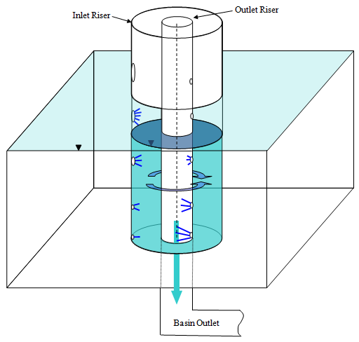

Figure 1.1. Schematic of the Solid State Skimmer showing the two risers and the relative flow rates of the orifices
The SSS is designed such that as the basin stage increases, the delta head between the basin and the riser chamber remains small, causing more inlet riser orifices to become submerged and the discharge rate of those submerged orifices to decrease. Consequently, this requires an increase in the size of the upper inlet orifices with increasing stage to accommodate the need for increased flow. At lower basin stages, the chamber drains, and the lower orifices can contribute more flow. This creates a situation where the majority of flow always discharges from the uppermost flowing orifices. By properly configuring the orifices on each of the risers, the lower submerged orifices of the SSS inlet riser could experience centimeters of head when the lower orifices of a traditional riser would be subjected to a meter of head (Figure 1.2).

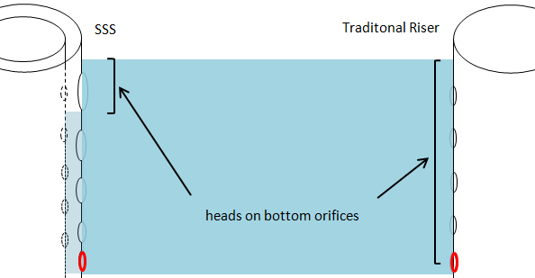
Figure 1.2. Comparison of the heads on bottommost orifice of the SSS and the traditional riser

The Orifice Equation

Full Flow
The orifice equation describes the flow rate, Q, from a single orifice flowing full as a function of the head such that
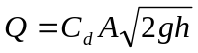 (1)
where C_{d} is a discharge coefficient typically given as 0.61 for square shoulder orifices, A is the orifice cross-sectional area, g is the gravitational constant, and h is the height of water above the center of the orifice (Finnemore, 2002). Based on this relationship, the lower an orifice is located on a riser, the greater the flow from that orifice and the greater the potential outflow of sediment as it settles through the water column. In order to decrease the amount of flow from the lower orifices, one must reduce the head acting on them, especially when the basin is full. As described above, the chamber of water formed between the two risers of the SSS serves to submerge the lower inlet orifices at increasing basin depths such that the flow from a submerged inlet orifice is driven by the delta head and not the total basin head. This requires that the orifice equation be written for a submerged orifice as
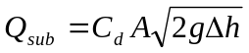 (2)
where Q_{sub} is the flow from a submerged orifice and Δh is the delta head acting on the center of the submerged orifice (Finnemore, 2002).

Partial Flow
When modeling the flow from a perforated riser, there are times where an orifice will be flowing partially full. For the case of a partially flowing orifice we searched for a weir equation of the form
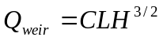 (3)
where Q_{weir} is the flow from a weir, C = 3.1 is a discharge coefficient for sharp crested weirs, L is the weir length, and H is the height of water above the weir invert (Haan, 1994). However, no definition of an L value for a circular weir was found in the literature, so we defined a partially-flowing-orifice weir length, L_{part}, with a piecewise function such that, as illustrated by Figure 1.3
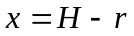 (4)
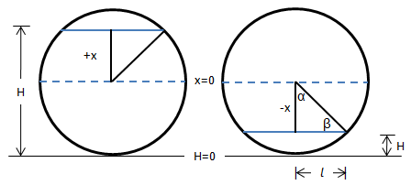
Figure 1.3. Partially flowing orifices flow regimes where H is the height of water above the orifice invert depth

where x is the distance from the water surface to the center of the orifice, H is the water elevation above the partially flowing orifice invert elevation, and r is the orifice radius. The angle α is described as
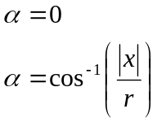 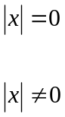 (5)
and β is an angle described as
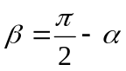 (6)
such that the water surface half length, Ɩ, is described as
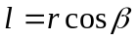 (7)
and the equation for the partially-flowing-orifice weir length is given by
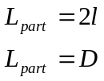 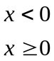 (8)
where D is the orifice diameter. Using Eq. 1 for full flow and substituting Eq. 8 into Eq. 3 for partial flow, the discharge from a single non-submerged orifice, Q(z), at a given basin stage, z, can be modeled as
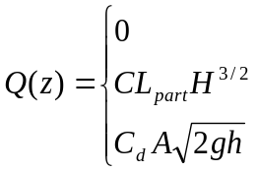 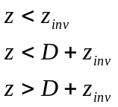 (9)
where z_{inv} is the orifice invert elevation. This equation was independently and concurrently derived and modeled by Brandes et al. (2010).

Continuous Riser Discharge
Figure 1.4 illustrates the possible flow regimes of the traditional riser and SSS where h is the basin stage and y is the chamber stage such that the delta head, Δh, is given by
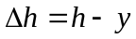 (10)
The traditional riser discharges to free air no matter the basin stage since it drains directly to the basin outlet. There are three, potentially simultaneously occurring, flow cases for the SSS: Case 1 when the inlet riser orifices discharge to the chamber freely, Case 2 when the inlet riser orifices discharge to the chamber submerged, and Case 3 when the outlet riser orifices discharge to the basin outlet freely. Case 3 can be described by the same form of equation describing flow from the traditional riser. The general orifice equation for continuous riser discharge, QC, is given by
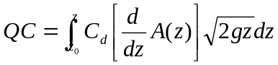 (11)
where A(z) describes the continuous orifice distribution, A, as a function of z (McEnroe, 1988). The limits of integration define the vertical interval over which the cumulative outflow is calculated.

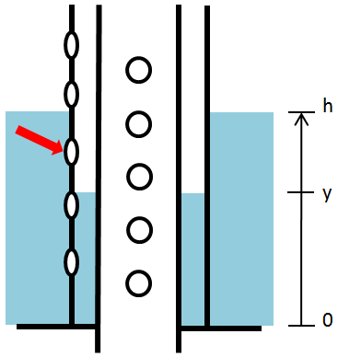
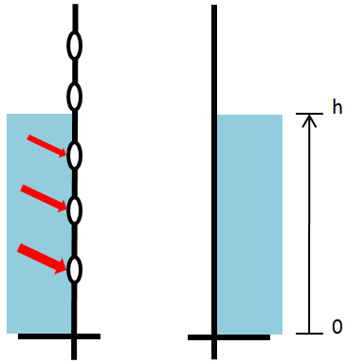

(a) Traditional riser discharge
(b) Case 1 SSS inlet riser discharge

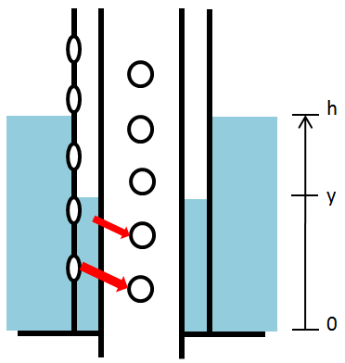
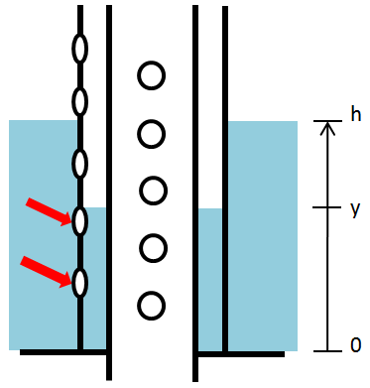

(c) Case 2 SSS inlet riser discharge
(d) Case 3 SSS outlet riser discharge

Figure 1.4. Continuous flow regimes for the SSS and the traditional riser

Flow Models

Analytical Flow Equations
Closed form analytical equations can be used to describe the flow from the traditional riser and the SSS using a limited number of parameters. Whereas numerical equations require that the flow must be calculated for each individual orifice, the following discussion will describe a method for approximating the flow from a riser having a series of orifices as the flow from a single equivalent opening. This method will be shown to provide a simpler, more direct means for determining riser outlet flow.
Traditional Riser
To model a discharge curve for the traditional riser, a 120 cm (4 ft) tall riser was divided into twelve 10 cm vertical intervals having one 1.59 cm (5/8 in) orifice each. The constant orifice spacing lead to a linear A(z) function given by
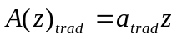 (12)
where a_{trad} is a parameter that describes the effective width of the orifice distribution as a function of z. This width distribution is analogous to an equivalent weir geometry for the continuous area distribution. For this situation, a_{trad} was found to be 0.1979 by dividing the cumulative orifice area by the total height. Continuous flow is found by substituting Eq. 12 into Eq. 11
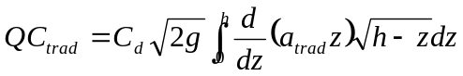 (13)
where integrating between 0 and h gives the expression
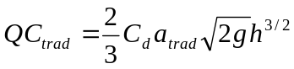 (14)
Solid State Skimmer
The SSS flow model was designed such that the overall stage-discharge curve would match the traditional riser stage-discharge curve, allowing for an unbiased sediment retention comparison. As described earlier, the SSS discharge can be characterized by three flow regimes: Case 1,Case 2, and Case 3. The two SSS risers are in series such that
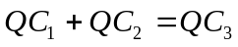 (15)
where
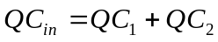 (16)
and
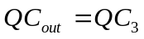 (17)
where the subscripts 1, 2, and 3 describe the respective flow cases.

Because the SSS inlet riser orifices must increase in size with increasing basin stage, the cumulative area distribution, A(z), can be described by the polynomial
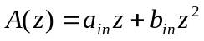 (18)
where a_{in} and b_{in} are parameters that describe the effective width of the orifice distribution as a function of z.

Inlet Riser
By substituting Equation 18 into Eq. 11, we can model Case 1 as
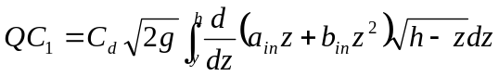 (19)
where integrating between y and h gives
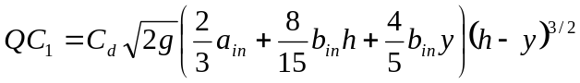 (20)
Likewise, we can model Case 2 as
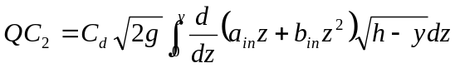 (21)
where integrating between 0 and y gives
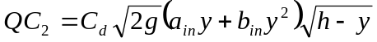 (22)
and QC₁, and QC₂ are functions of both the basin and chamber heads as shown in Figure 4. Therefore, to solve for a_{in} and b_{in}, it was necessary to define the head-Δh curve as a function of basin head.

We prepared a desired head-Δh curve using a gamma (γ) statistical distribution function
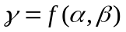 (23)
where α is a parameter describing how sharply the curve peaks, and β is a parameter describing the location of the peak with respect to the x-axis. Taking the x-axis as basin head and the y-axis as Δh, the parameters can be set to give a curve that provides a larger Δh with lower basin heads (more lower inlet orifices flowing) and a smaller delta head with greater basin heads (mostly top inlet orifices flowing). Setting α = 2.2 and β = 1.1 gave a reasonable curve for the 120 cm tall risers (Figure 1.5).

Using the gamma distribution as an initial approximation of Δh, we solved for QC_{in} and minimized the sum of the error between the SSS inlet and traditional riser flows
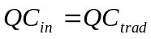 (24)
by iteratively optimizing the parameters resulting in a_{in} = 0.0423 and b_{in} = 0.0055. We further
Figure 1.5. A gamma distribution used to approximate the delta head as a function of basin head
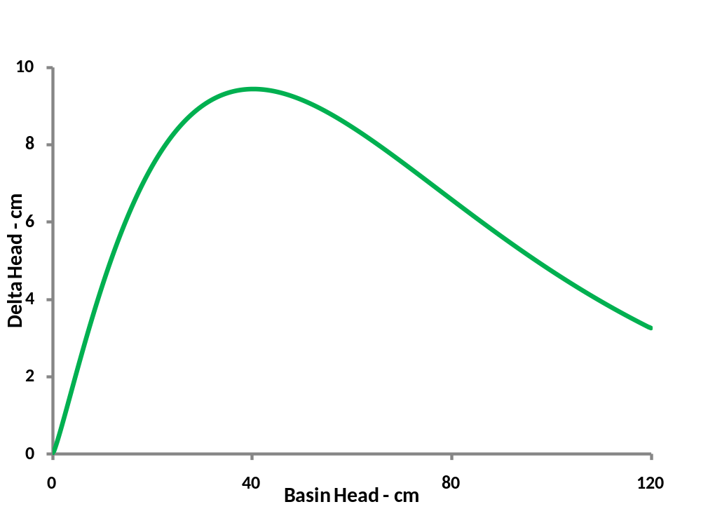

minimized the error by optimizing the Δh at each stage interval. The sum of the errors could be minimized, but not eliminated, since the traditional riser and SSS flow distributions are functions of different area distribution curves (polynomial versus linear) and different heads (Δh versus h).

Outlet Riser
For the orifices in the outlet riser, the gamma curve was utilized again to relate h to y. The SSS outlet orifices are uniformly distributed, as is the case for the traditional riser, such that
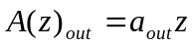 (25)
where a_{out} is a parameter that describes the effective orifice width distribution as a function of z. Substituting Eq. 25 into Eq. 11 yields the equation for Case 3
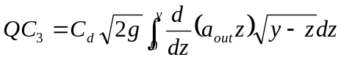 (26)
where y is the chamber depth. Integrating between 0 and y gives
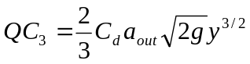 (27)
The total error between QC_{in} and QC_{out} was minimized by iteratively optimizing such that a_{out} = 0.2251.

Orifice Placement
Traditional Riser
The area of each orifice represents an area that corresponds to a vertical interval on the riser given by Eq. 12 that is larger than the orifice diameter. Therefore, each orifice must be placed in a location that best distributes its discrete area within the vertical interval to provide the truest approximation of the analytical solution. The optimum location is at the centroid of the vertical interval, given by
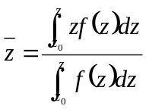 (28)
where is a vertical centroid and f(z) is any function (Stewart, 2003). Substituting Eq. 22 gives

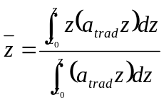 (29)
and integrating gives the centroid of the area function for a given vertical riser interval
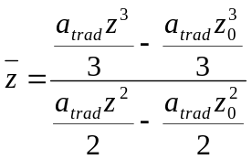 (30)
Solid State Skimmer
Inlet Riser
To minimize the physical differences between the traditional riser and the SSS, the bottommost SSS inlet orifice was made the same diameter and positioned at the same height as the bottommost traditional riser orifice. Placing the orifice at this location meant that an area equal to the orifice area was attributed to an elevation given by Eq. 18. Each subsequent orifice placed on the riser consumed more of the cumulative area until the available area was exhausted and a total of twelve orifices (arbitrarily selected to match the number of traditional riser orifices) were placed. The diameters of the eleven remaining orifices were chosen based on standard hole-saw diameters (1.9 cm [0.75 in], 3.2 cm [1.25 in], and 3.8 cm [1.5 in]) to simplify the fabrication of the riser. Starting at the bottom of the riser and moving upward, orifices having these diameters were added to the riser. Smaller orifices were placed at the base of the riser, with larger orifices at the top. Following a procedure similar to the traditional riser, and substituting Eq. 18 into Eq. 28, the optimum location of each orifice at the centroid of each outlet riser vertical interval is given by
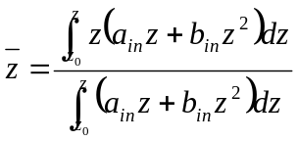 (31)
such that integrating with respect to the height bounds of each vertical interval gives
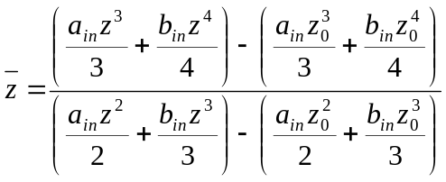 (32)
Outlet Riser
To further minimize the differences between the traditional riser and the SSS, the twelve outlet riser orifices were made the same diameter as the traditional riser orifices. However, the orifice center elevations were shifted down relative to the traditional riser orifices, since the chamber depth is always less than the basin depth. Following a similar procedure to that for the SS inlet and traditional risers, and substituting Eq. 25 into Eq. 28, the optimum location of each orifice at the centroid of each outlet riser vertical interval is given by
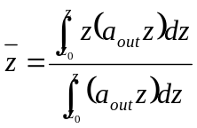 (33)
and integrating gives
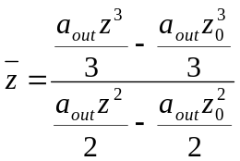 (34)

Numerical Flow Equations
Traditional Riser
Though not necessary for its design, the traditional riser discharge was also modeled numerically such that the total flow as a function of basin stage, Q(z)_{trad}, is given by
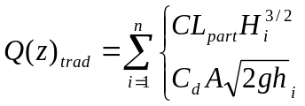 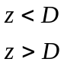 (35)
where n is the number of orifices contributing flow, H_{i} is the height of water above the invert of a partially flowing orifice, h_{i} is the height of water above a fully flowing orifice, and n is the number of orifices. The numerical solution is based on the physical size and placement of the orifices, not the continuous distribution that the analytical model assumes. It was used to validate the analytical solution and to provide a means for validating the flow characteristics of the fabricated traditional riser.
Solid State Skimmer
Once again, though not necessary for its design, we calculated the numerical stage discharge curve for the SSS using the calculated orifice diameters and locations such that
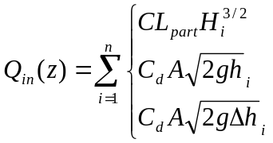 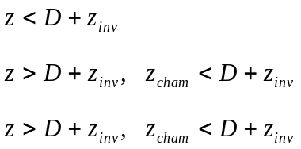 (36)
and
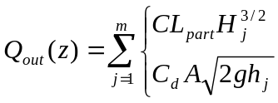 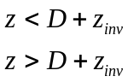 (37)
where H is the differential head for a partially flowing inlet riser orifice, h is the head on a fully flowing inlet orifice, n is the number of inlet orifices, i, m is the number of outlet orifices, j, and z_{cham} is the chamber elevation. Eq. 36 and Eq. 37 were used as a means to validate the analytical solution and to more accurately model the performance of the fabricated SSS.

By optimizing y, we equalized the SSS inlet and outlet stage-discharge curves on a 0.01 m increment over the 1.2 m riser height. By iteratively solving the numerical stage-discharge relationships, Eq. 36 and Eq. 37, for all twelve orifices on each SSS riser at each h increment simultaneously, we minimized an error term
 (38)
such that the flow from the SSS inlet and outlet risers was equalized at each basin h and both y(h) and Δh(h) were optimized in terms of the configuration of the physical system.

Methods

Test Apparatus
The basin for the field scale test consisted of a commercially available above-ground swimming pool, nominally 4.6 m (15 ft) diameter by 1.2 m (4 ft) deep with a volume of 19,000 L (5000 gal). We developed a stage-storage relationship for the basin and found that the volume was well represented by approximating the area of the pool as an ellipse having major and minor chords of 4.4 m and 4.3 m, respectively. We developed a stage-storage curve for the basin for the elliptical area, A_{E}
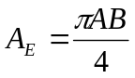 (39)
where A is the major chord and B is the minor chord of the ellipse (Stewart, 2003).

We graded a site for the basin behind the Biosystems Engineering and Soil Science Hydraulics Lab. Figure 1.6 shows a schematic of the field experiment apparatus. Then we dug two trenches to accommodate the schedule 40 PVC subsurface drainage conduit for each of the two outlets. The drainage conduit for each riser consisted of a 25.4 cm (10 in) elbow leading to a coupler and then a 7.6 cm (3 in) drain pipe. The drain pipes discharged to a nearby pit previously constructed for another experiment. Next, the pool was installed on the graded site above the drainage conduit. A hole was cut in the pool floor at each coupler to accept the traditional riser and the SSS. The traditional riser consisted of a single 25.4 cm (10 in) diameter schedule 40 PVC pipe. The SSS required that two risers be installed in one coupler so we fabricated a PVC base ring with two concentric grooves to accept the 25.4 cm (10 in) inlet riser and the 15.2 cm (6 in) outlet riser. The ring created the chamber floor and had a 15.2 cm hole in its center to allow outflow from the outlet riser to the subsurface conduit. The risers were secured into the couplers using rubber gasket compound to create a water-tight seal. The holes in the pool floor were sealed by packing bentonite clay around the base of the risers and securing a plastic apron to the risers on top of the bentonite. Weights were used to create additional sealing around the perimeter of the plastic aprons.

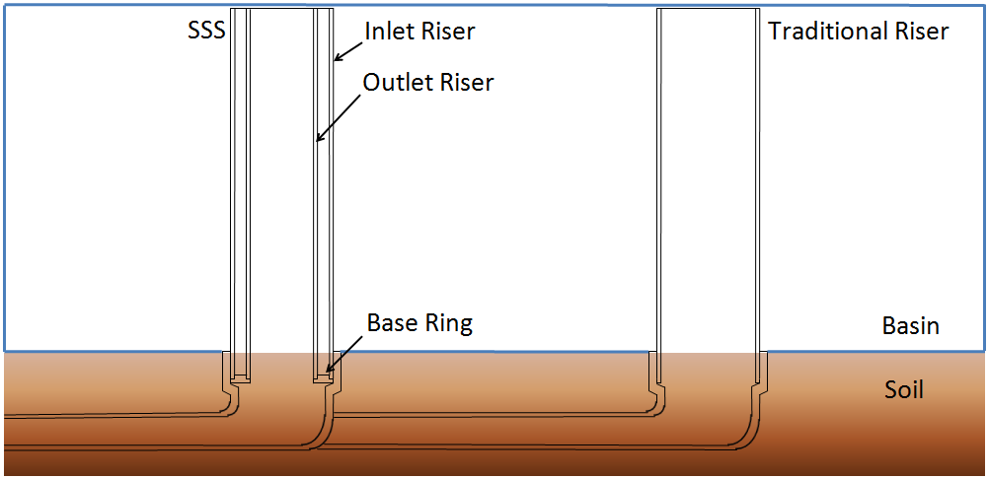
Figure 1.6. The SSS and the traditional riser as installed in the swimming pool basin. The outlets below the soil surface at a sample collection point

Model Validations
The traditional riser and the SSS analytical flow models, Eqs. 14, 20, and 22, were validated using the respective numerical flow models, Eqs. 35-37 as truth. The overall error between the analytical and numerical modelss was determined. Basin drawdown tests were then conducted to validate that the traditional riser and the SSS performed as designed by the analytical flow models, Eqs. 14, 20, and 22. The traditional riser model was validated to demonstrate that it could predict the stage-discharge curve for a basin. The SSS model was validated to demonstrate that its stage-discharge curve matched that of the traditional riser and that it could provide an accurate h-Δh curve. We performed a separate drawdown experiment for both the traditional riser and the SSS, taking stage measurements over the course of the events at recorded times. From these stage measurements and the basin area, we found the discharge rate, Q_{meas}, at any stage from
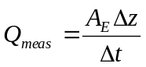 (40)
where Δz is the change in basin elevation and Δt is the elapsed time. It was important to design a SSS whose discharge curve matched that of a target traditional riser so that a meaningful sediment retention comparison could be made.

Design Storm
In order to set the inflow rate, we used the National Resources Conservation Service (NRCS) unit hydrograph method 2 year, 24 hour rainfall distribution storm, which for Knoxville has a rainfall depth of 8.3 cm (3.25 in) (Haan, 1994). The storm flow, Q(t), for the NRCS dimensionless unit hydrograph is defined as
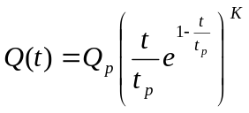 (41)
where Q_{p} is the peak storm flow, t is the elapsed storm time, t_{p} is time to reach peak flow, and K = 3.77 is a fit parameter for the NRCS dimensionless unit hydrograph (Haan, 1994). We then created a model to rout a preliminary storm with guesses for Q_{p} and t_{p} through the basin using a continuity equation
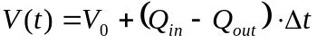 (42)
where V(t) is basin storage at time t, V₀ is previous basin storage, Q_{in} is the storm inflow, and Q_{out} is the basin outflow, and Δt = 0.01 h is a time increment. The storm routing exercise predicted whether the traditional riser and the SSS would allow the basin to fill and drain in about 8 hours so that the full outflow event could be sampled in one workday. Although we used a 24 hour design storm, the hydrograph trailed to zero flow at 8 hours. After several iterations, we determined that the values of the hydrograph parameters Q_{p} = 0.0102 m³/s and t_{p} = 1 hr would allow the basin to fill and drain in the allotted time. With these parameters set, the total design storm volume was 45,000 L (12,000 gal) (Figure 1.7).

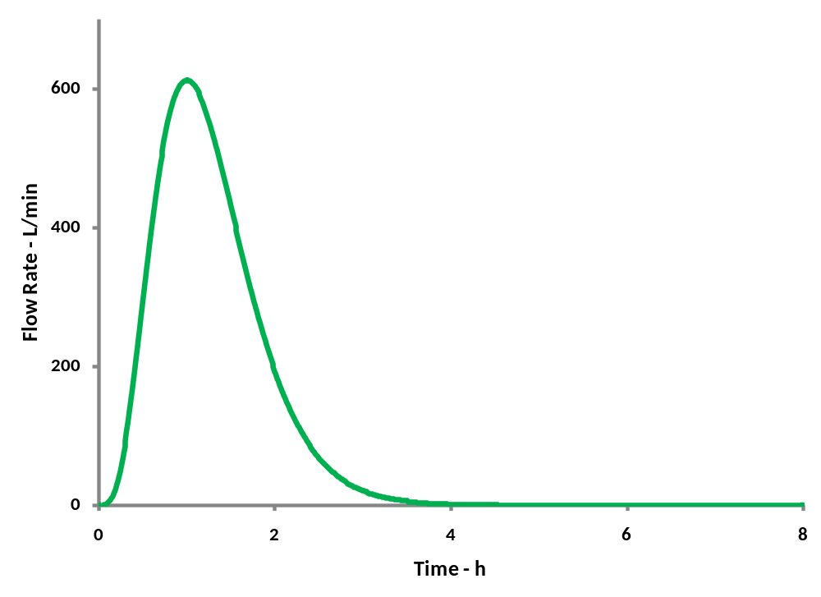
Figure 1.7. NRCS design storm hydrograph for a 2 yr, 24 hr rainfall distribution in Knoxville, TN

The hydraulics lab is equipped with tanks from which water can be pumped at a desired flow rate using a computer controlled flow control valve, creating a device termed the “hydrograph generator” (Yoder et al., 1998). Using a hydrograph generator device for measuring time varying flows in conjunction with the control valve, we were able to pump the design storm hydrograph to the basin. The hydrograph generator consists of a precision cut V-notch weir mounted in a vertical column with a pressure transducer on the inlet side. The device was recalibrated for the range up to our peak flow rate, or about 570 L/min (150 gpm).

Sediment Load
Because we pumped our hydrograph to the basin, the watershed of the experiment is not a physical area, but rather a theoretical watershed area, A_{w}
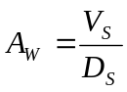 (43)
where V_{S} is the storm volume and D_{S} is the storm depth assuming 100% runoff. The resulting design storm area of 587 m² (0.145 ac) was used to determine the amount of sediment eroded by the design storm..

To calculate the mass of soil eroded from our theoretical watershed, we used this area and the revised universal soil loss equation (RUSLE):
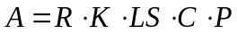 (44)
where A is the annual average soil loss per unit area, R is the erosivity factor, K is the erodibility factor, LS is the slope length factor, C is the cover factor, and P is the conservation support practice factor (Haan, 1994). For the purpose of simplifying the calculation, the time of concentration was assumed to be zero. We determined the soil eroded by one storm event, A_{S}, from our theoretical watershed using
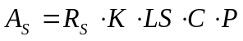 (45)
where, based on our 2 year, 24 hour design storm for Knoxville, TN, R_{S} = 698 MJ·mm/ha·hr·storm (Haan, 1994). K = 0.0316 tonne·ha·hr/ha·MJ·mm for a sandy clay loam (determined by a particle size analysis from a prior experiment) and assuming the theoretical watershed to be a square and taking its diagonal as the critical length, LS = 0.14 assuming a 1% slope (Haan, 1994). Finally, we assumed C = 0.8 and P = 1. Based on this, the soil eroded from a theoretical watershed by one occurrence of our design storm is 145 kg, dry basis and 159 kg taking into account a measured moisture content of 9.8%

Sediment Retention Tests
Four tests were conducted by routing the design storm hydrograph and associated sediment through the basin to compare the sediment retention efficiencies of the traditional riser and the SSS (Figure 1.8). The tests were designed to provide a side by side comparison of the traditional riser and the SSS such that they had the same flow properties and were subjected to the same set of conditions within each test. An electronic control system used the reading from a pressure transducer on the hydrograph generator to control the needle valve and set the flow according to the storm hydrograph.

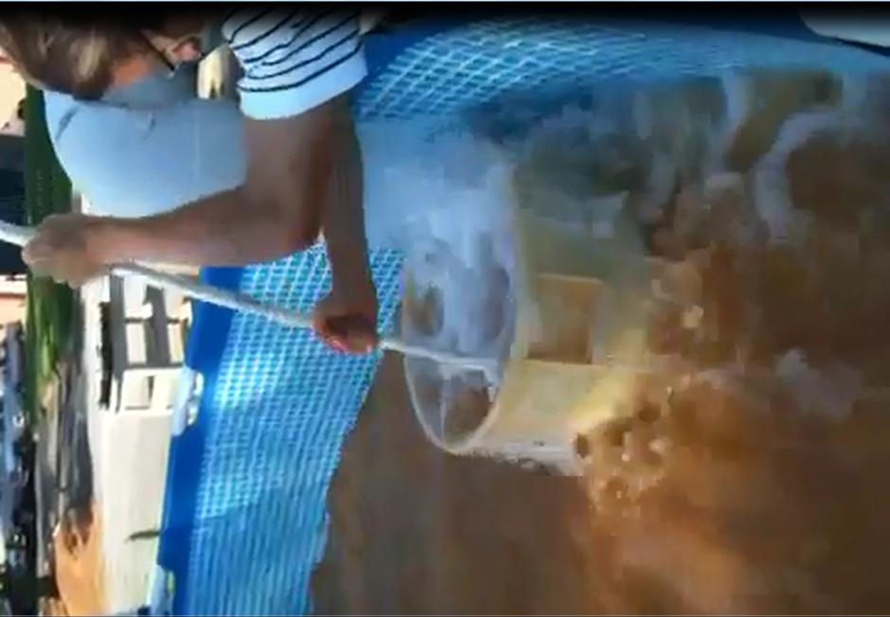
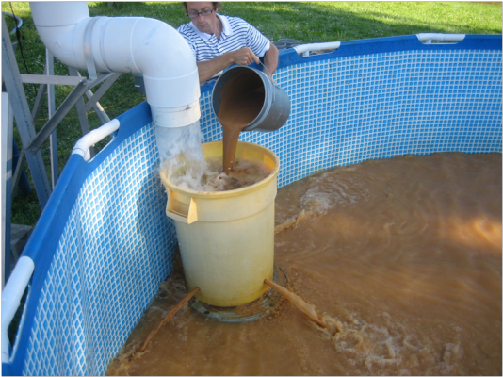

2
1

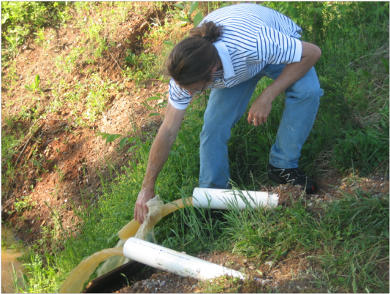
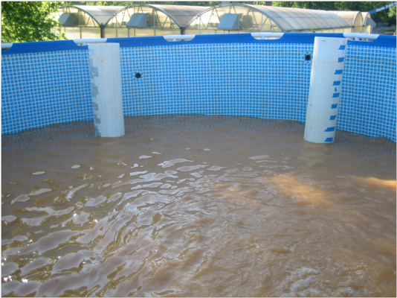

4
3

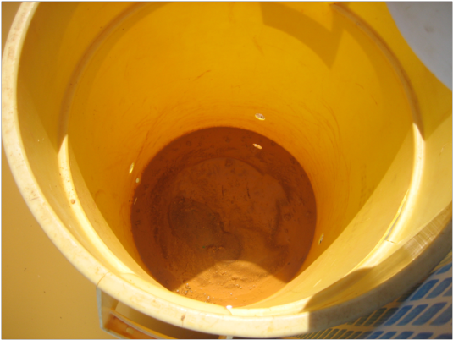
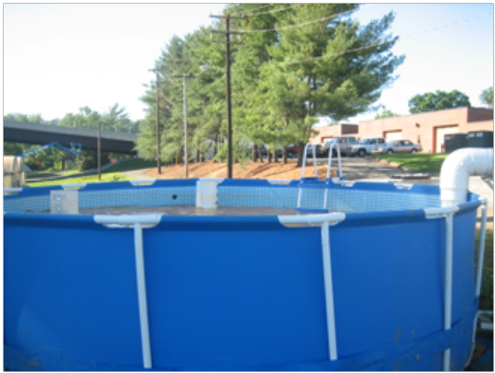

6
5

Figure 1.8. The Sediment Retention Test: (1) adding the sediment, (2) ensuring the sediment is dispersed, (3) filling the basin, (4) collecting effluent samples, (5) draining the basin, and (6) noting that only coarse sand remains in the trashcan.

Soil was prepared for the tests by placing 8.8 kg on a wet basis into one of 18 buckets, adding 6 L of water and mixing with a drill paint mixer bit for 1 minute at least 12 hours before testing. Then, just prior to the test, all the buckets were mixed again using the drill. Soil was added on an inflow volume basis at 8.8 kg per 2600 L (700 gal) of inflow. The inflow was directed straight down into a 130 L (35 gal) trashcan with three 2.54 cm (1 in) holes drilled in its base to further agitate the soil before discharging it to the basin. The contents of the can were periodically agitated with a length of pipe to ensure that any smaller particles were suspended and flushed into the basin. At the end of each test, there was about 10 kg of the coarsest sand left in the trash can. It is thought that this remainder is insignificant as sand too heavy to be moved by the intense turbulence in the trash can would almost surely have settled within the basin. Twenty-eight paired effluent samples were collected from the outlets of the two systems on an outflow volume basis using 300 mL glass bottles. The first twenty samples were collected every 1,890 L (500 gal) of outflow, and the last eight were collected every 945 L (250 gal) of outflow as the hydrograph tailed off.

Laboratory Analysis
Turbidity was measured for each of the twenty-eight samples collected from each of the four tests using a Monitek CST06825 Model 21 Nephelometer optical turbidity meter. Six composite measurements were also made using samples 1-4, 5-8, 9-12, 13-16, 17-20, and 21-28 from each test such that each composite represented a volume of 7,570 L (2000 gal). Total suspended solids were measured from the composite samples. Using a vacuum suction apparatus, the composite samples were filtered through 45 μm glass filters, dried in a 105°C oven, and weighed to determine the sediment concentrations. Particle size analysis was performed on a sample of the fresh soil and on a 125 mL subsample from each of the composite samples using a Beckman Coulter LS 13 320 Universal Liquid Module to show the particle sizes retained by the traditional riser and the SSS. The soil was not dispersed in order to measure particles as they would naturally be detached by erosion. As such, some of the particles measured as silt or clay may actually by aggregates of smaller particles likely having lower densities and settling velocities than the actual particles themselves.

Statistical Analysis
Statistics were performed on the sediment retention data to show if the SSS significantly increased the sediment retained in the basin. Using SAS v9.2, the experiment was a random block design concerning the turbidity measurements, and a random block design with sampling with regards to the suspended solids and particle size analyses since the data originated from composite samples.

Results

Validation

Analytical Model
The numerical models (Eqs. 35 and 37) were used to validate the analytical models (Eqs. 14, 20, 22, and 27) as shown in Figure 1.9. The peaks in the SSS inlet numerical model indicate the physical locations of each orifice which are not shown by the continuous analytical curve because it represents the discontinuous orifices as a continuous equivalent opening. The peaks are pronounced on the SSS inlet numerical curve because the flow is a function of the Δh. For the case when the water level is rising and is at a given orifice, the Δh is at a local minimum. It reaches a local maximum just before it reaches the invert of the next orifice.
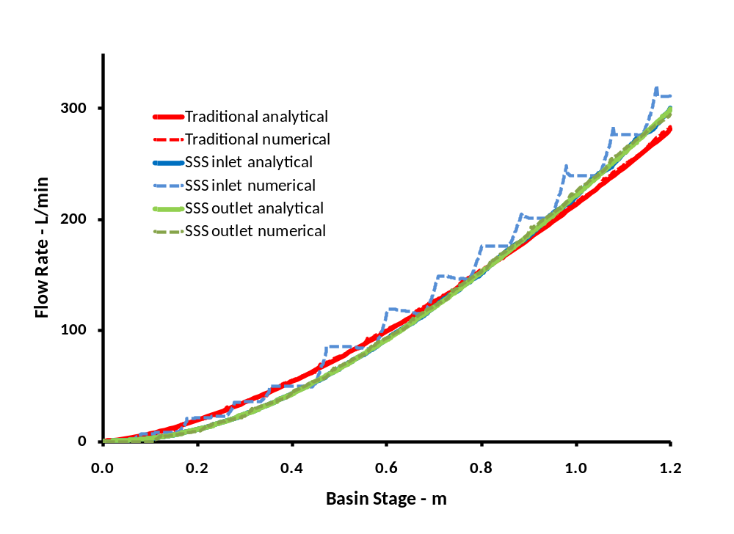

Figure 1.9. Validation of the new analytical models against the numerical models (truth). Each riser pipe was evaluated independently causing the differences in the flow rates to be more apparent.

Traditional Riser and SSS
The results comparing actual measured flows to the analytical model predictions are shown in Figure 1.10. The models matched the measured data well such that the numerical h-Δh curve reveals discrete peaks and troughs caused by the orifice placements. The flow measurements also tracked the models well. The skimmer model validation proved that we could match the conventional stage discharge curve, which was our goal in order to compare sediment retention for the two systems under identical flow conditions. It also proved that we could control the differential head curve for a full scale skimmer riser system.
Figure 1.10. Traditional Riser and SSS Validation. The “trad” and “sss” subscripts denote the traditional and SSS outlets, respectively.
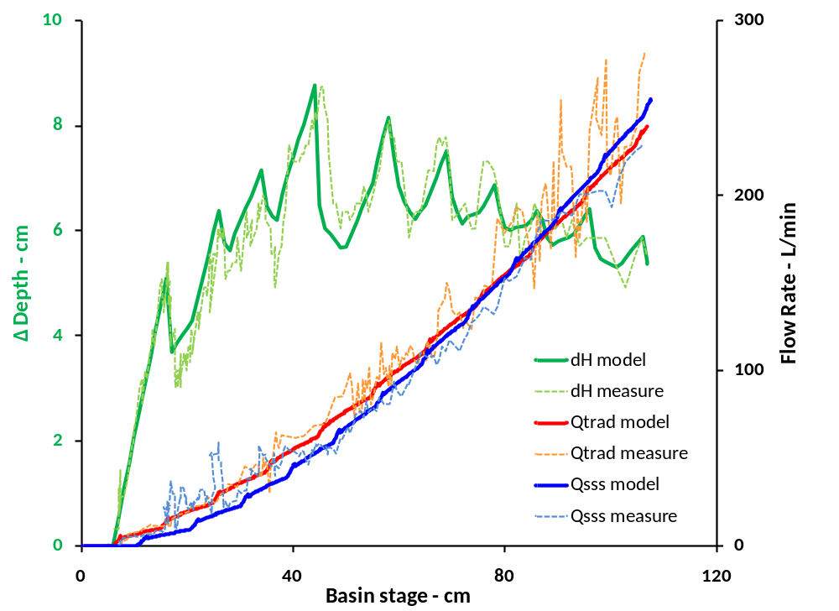

As shown in Figure 1.11 for analytical model flow rates, the SSS drains much of the water in a basin from the topmost elevations where the cleanest water is located. At the maximum basin depth of 3.5 ft, the top SSS inlet orifice is handling more than 5 times the flow rate of the bottommost traditional riser orifice, and the bottom SSS inlet orifice is flowing at only 1/5 the rate of the bottommost traditional riser orifice. Although the SSS does not completely shut off the bottommost orifices, the results show that the SSS should increase sediment retention compared to the traditional riser. In order to test these calculated results, three analyses were performed to characterize the sediment retention efficiency of the two outlets: turbidity, total solids, and particle size.

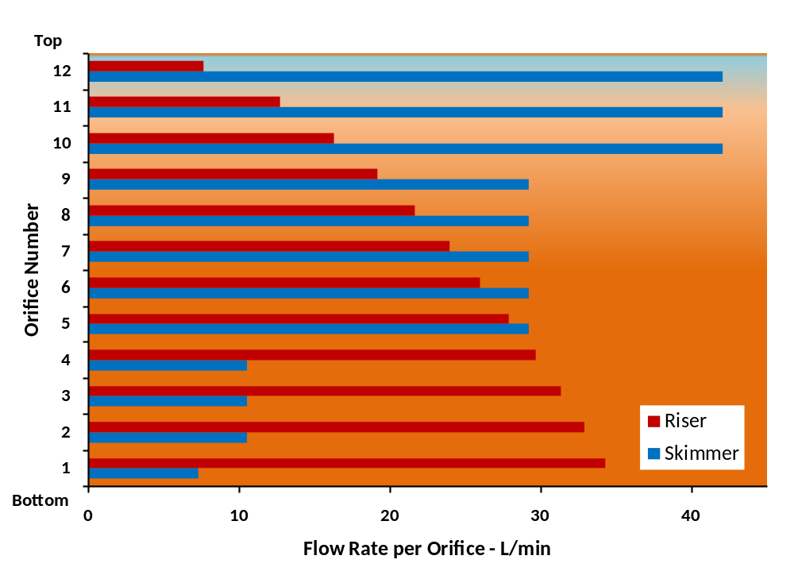
Figure 1.11. Traditional riser and SSS discharges as calculated by the numerical models. Note that the flow from the bottom orifice of the traditional riser is about 5 times that of the the flow from the bottom SSS orifice.

Sample Analysis

Turbidity
The SSS provided a 10.8% decrease in turbidity values compared to the readings from the traditional riser (p = 0.0642). The results of four test runs are shown in Figure 1.12, and the time series values of the flow-weighted composite samples for each run are shown in Figure 1.13.

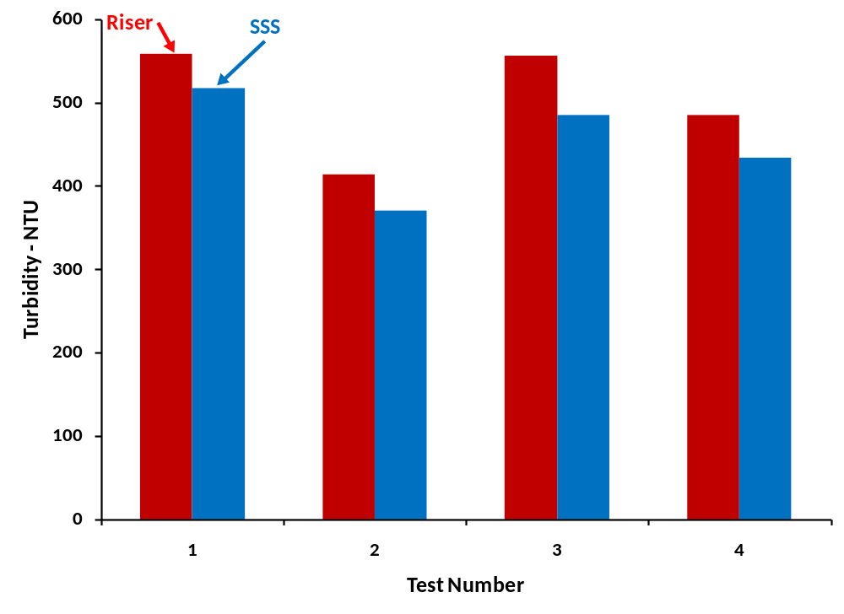
Figure 1.12. Turbidity results from each of the four tests. The SSS provided a 10.8% in effluent turbidity.

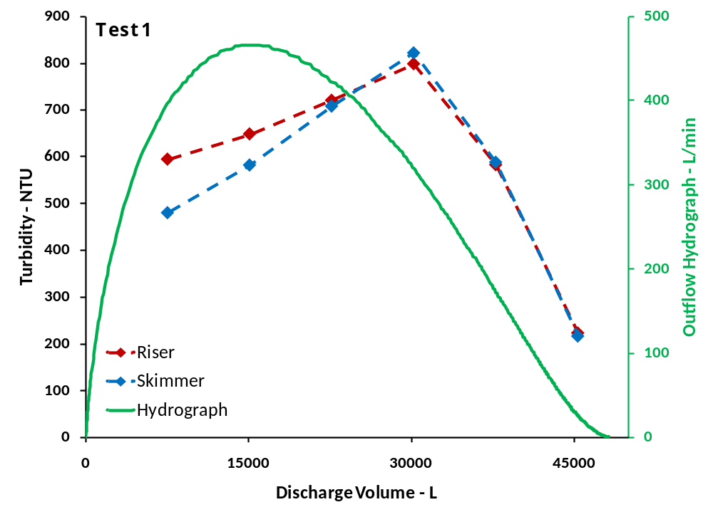

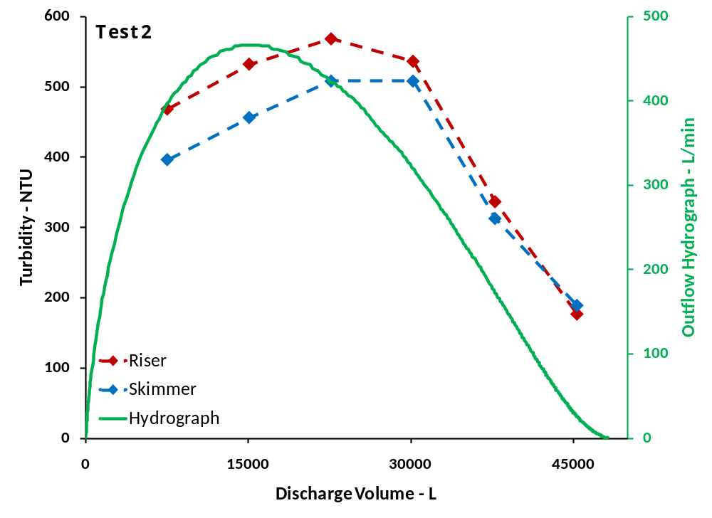
Figure 1.13. Turbidity results from test 1 and 2 are shown for the composite samples. The inflow hydrograph is shown relative to the discharge volume.

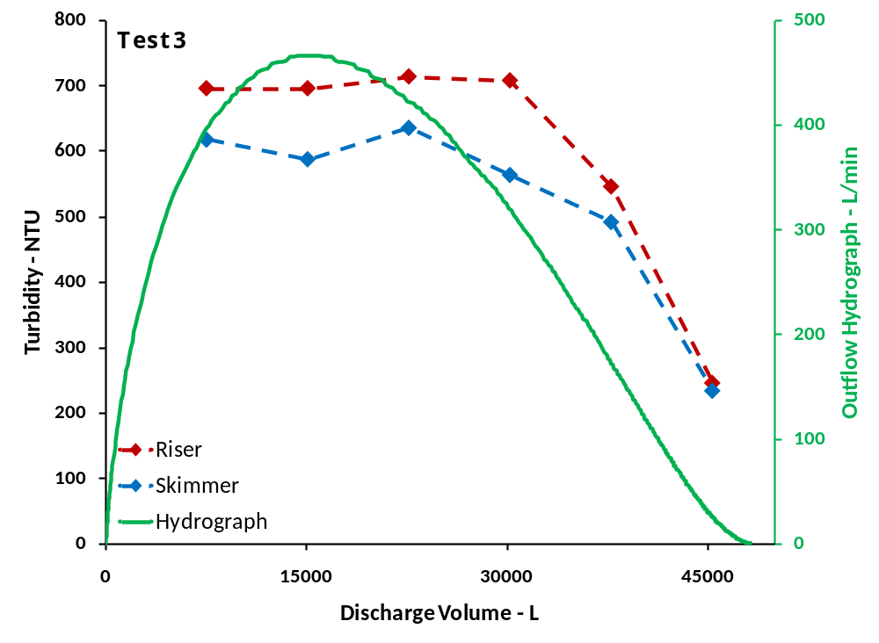

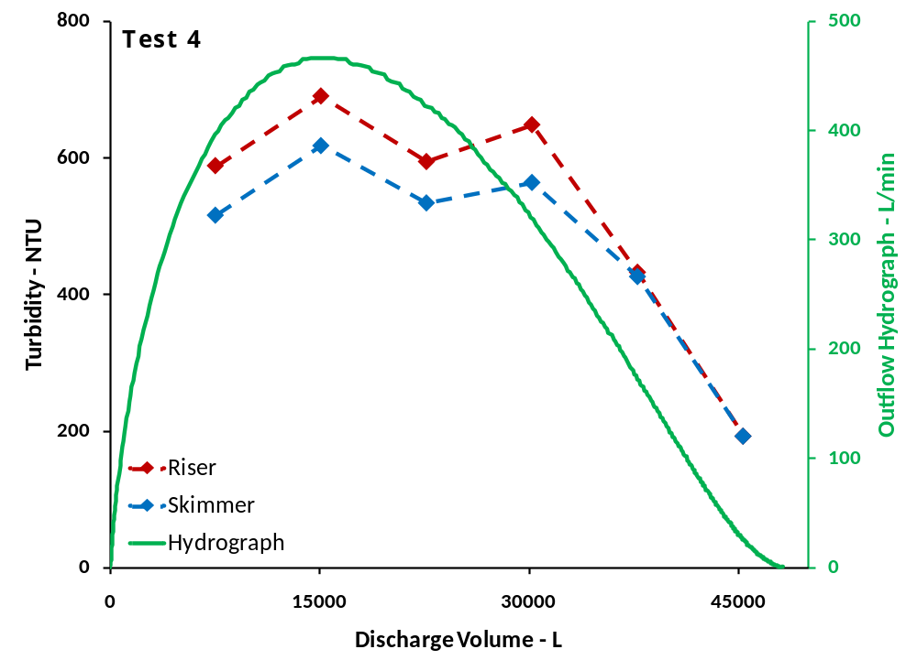

Figure 1.13 cont’d. Turbidity results from test 3 and 4 are shown for the composite samples. The inflow hydrograph is shown relative to the discharge volume.

Total Solids
Figure 1.14 shows the total sediment retained by the traditional riser and the SSS for each of the four tests. Averaging the results from the four tests, the SSS retained 8.5% more sediment by mass than the traditional riser (p = 0.4592). Although these results are statistically insignificant, they still show an increase in retained sediment on par with the 9.1% sediment increase of the Faircloth floating skimmer (Jarrett, 2001)

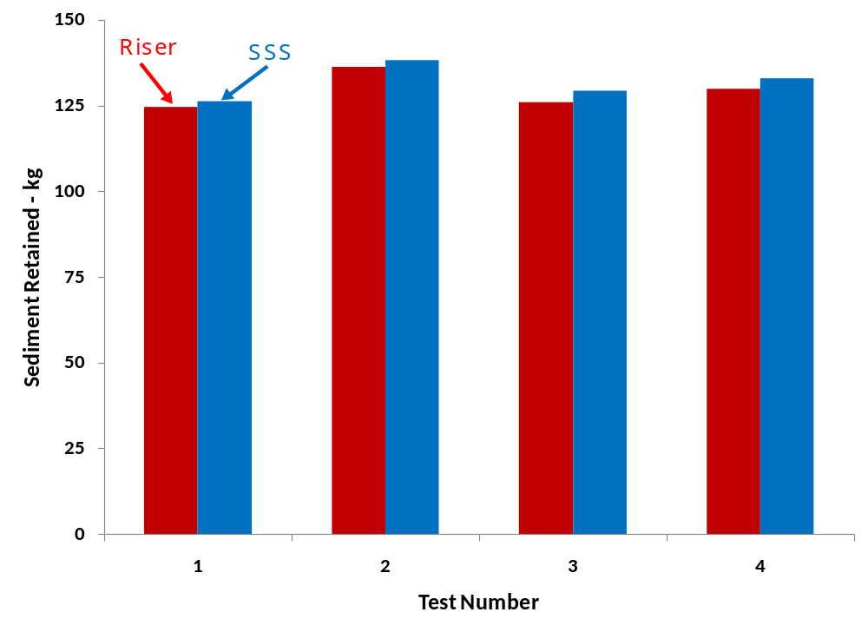
Figure 1.14. Total suspended solids from each of the four tests. The SSS retained 8.5% more sediment than the traditional riser.

Particle Size Analysis
The raw soil of the experiment was a sandy loam consisting of 44% sand, 45% silt, and 11% clay where the USDA limit for sand is >50 μm and for clay is <2 μm (Hillel, 1998). Both the traditional riser and the SSS effluents contained very little sand relative to the raw soil which one would expect due to the relatively high energy required to keep sand suspended (Figure 1.15). There was also relatively little clay in the effluents as a percentage since a large fraction remained suspended in the basin, and clay does not readily settle regardless of the outlet used.

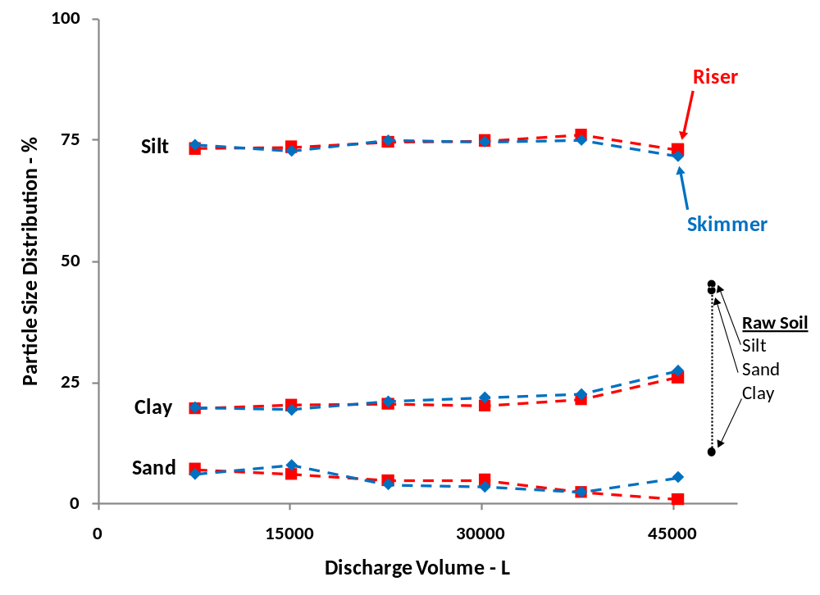
Figure 1.15. Particle size distributions shown for each of the composite samples and the raw soil used in the experiment.

Conclusions
We modeled, built, validated, and tested a SSS device that performs on par with the floating skimmer retaining on the order of 10% more sediment by mass than a traditional perforated riser outlet. This proves the hypothesis that the SSS increases sediment retention by automatically decreasing the heads on the lowers orifices, thereby decreasing the outflow from the portion of the basin holding the highest sediment concentrations. Although our test basin was smaller than a typical full scale basin in the field, the comparison between the two outlets is still valid on a relative basis.

Our analytical model, capable of characterizing the orifice area distribution of a SSS with just three area fitting parameters and two delta head fitting parameters, was shown to provide a suitable approximation of the discrete orifice distribution. The flow from an SSS can be predicted using the three equations describing the three flow cases instead of having to numerically solve the flow for each individual orifice. This property of the analytical model greatly simplifies the design calculations.

This research was performed for one design storm, one soil type, and one set of outlet orifice configurations. The experiment was designed within the constraints of the materials, dimensions, and capacities of the apparatus used. Further tests should be conducted to determine the orifice configurations that maximize sediment retention for various basin configurations. Although we designed the SSS of this experiment to match the stage-discharge relationship of a traditional riser, an SSS could be designed for optimum sediment retention. The SSS should also be evaluated in a stormwater basin to determine its efficacy under field conditions. A field installation would also uncover any potential long term maintenance issues. Also, software should be developed that allows a user to design a SSS for site-specific commercial applications.

List of References

Beasley, R.P. 1972. Erosion and Sediment Pollution Control. Ames: Iowa State
University Press.

Brandes, D., W.T. Barlow, and B. Hendrickson. 2010. An experimental study of stage-discharge
relationships for thick-walled concrete orifices. ASCE World Environmental and Water
Resources Congress: Challenges of Change.

Faircloth Jr., J.W. 1998. Water skimming apparatus for the control of sediment
pollution. Patent No.: US 5,820,751 A.

Finnemore, E.J. and J.B. Franzini. 2002. Fluid Mechanics with Engineering
Applications, 10th Ed. Boston: McGraw-Hill.

Haan, C.T., B.J. Barfield, and J.C. Hayes. 1994. Design hydrology and sedimentology
for small catchments. San Diego: Academic Press, Inc.

Hillel, D. 1998. Environmental soil physics. San Diego: Academic Press, Inc.

Jarrett, A.R. 2001. Designing sedimentation basins for better sediment capture. Soil
Erosion Research for the 21st Century. ASAE: 701P0007.

Linderman, C.L., N.P. Swanson, and L.N. Mielke. 1976. Riser intake design for settling
basins. Transactions of the ASAE: 894-896.

McEnroe, B.M., J.M. Steichen, and R.M. Shweiger. 1988. Hydraulics of perforated
riser inlets for underground-outlet terraces. Transactions of the ASAE 31(4): 1082-1085.

Phillips, R.L. 1969. Tile outlet terraces – history and development. Transactions of the
ASAE: 517-518.

Simpson, T.S., G. Coppola, and R. Borrego. 2009. Drainage management systems and
methods. Patent No.: US 7,556,158, B2.

Stewart, James. 2003. Early transcendentals: calculus, 5th Ed. Belmont: Brooke/Cole-Thomson
Learning.

United States Environmental Protection Agency (US EPA). 2006. Dry Detention Ponds.
Stormwater Menu of BMPs. http://cfpub.epa.gov/npdes/stormwater/menuofbmps.
Accessed Dec. 2009.

United States Environmental Protection Agency. 2006. Sediment Basins and Rock
Dams. Stormwater Menu of BMPs. http://cfpub.epa.gov/npdes/stormwater/menuofbmps.
Accessed Dec. 2009.

United States Environmental Protection Agency. 2009. National water quality inventory: 2004
report to congress. Office of Water: EPA 841-R-08-001.

Yoder, D.C., J.B. Wilkerson, J.R. Buchanan, K.J. Hurley, and R.E. Yoder. 1998.
Development and evaluation of a device to control time varying flows. Transactions of the ASAE 41(2): 325-332.

CHAPTER TWO: A PERVIOUS CONCRETE WATER QUALITY STUDY

Abstract
Stormwater is a leading source of pollutants which, when transported to surface waters, has the potential to damage aquatic habitat, decrease reservoir capacity, and contaminate drinking water. Permeable pavements have been developed that allow stormwater to infiltrate into storage below the pavements, thereby reducing runoff volumes and peak flow rates to receiving waters. Infiltrating stormwater also introduces the potential for pollutant remediation by means of physical and biological processes that occur within the pavement storage and the soil below. We monitored the water quality at a site having asphalt drives and parking adjacent to pervious concrete parking to evaluate whether a pervious concrete detention system can remove stormwater pollutants from parking lot runoff. The stormwater flowed across asphalt paving before infiltrating into the pervious concrete and the aggregate sub-base below. We sampled the runoff before it entered the pervious concrete and after it passed through the pervious concrete detention system and found significant decreases in pH, total suspended solids, chloride, chemical oxygen demand, chloride, and polycyclic aromatic hydrocarbon compared to untreated asphalt runoff.

Introduction

Permeable Pavements
Pavements are the most common structures built by man, occupying twice the area of buildings, such that two-thirds of the precipitation that falls on impervious surfaces in urban watersheds falls on pavements (Hun-Dorris, 2005). Imperviousness alters the natural hydrology of a water shed such that runoff volumes increase and infiltration into the soil decreases. These increased volumes reach receiving waters as high-energy, concentrated flows that erode stream banks and scour stream beds, leading to increased sediment transport. Decreased infiltration also interferes with groundwater recharge, especially in drought conditions (NRC, 2008). To address the negative impacts of impervious paved surfaces, permeable pavements such as open-joint paving blocks, pervious asphalt, and pervious concrete are being installed such that water and air can pass through them. Tennis et al. (2004) indicate that pervious concrete enables more efficient land usage compared to traditional collection, conveyance, and detention stormwater infrastructure because of its ability to serve as both a pavement and a runoff storage structure. Pervious concrete typically has 20% voids and can infiltrate 12 m/hr or 200 L/min/m². These pavements provide temporary storage of runoff in a manner similar to above ground detention basins and thus can reduce total runoff and peak flow rates.

Surface Water Impairment
Urbanization increases impervious surfaces such as streets, driveways, parking lots and sidewalks on which pollutants such as fertilizers, oils, salts, debris, and sediment rest until a precipitation event washes them into storm drains. Stormwater transports these untreated pollutants to surface waters which can result in fish kills, habitat destruction, loss of aesthetic value, and drinking water contamination (US EPA, 2005). Despite the fact that the quality of the nation’s surface waters has increased dramatically since the passage of the Clean Water Act and the National Pollutant Discharge Elimination System permitting program, many impaired water bodies still exist. According to the most recent National Water Quality Inventory (US EPA, 2009b), prepared under sections 305(b) and 303(d) of the Clean Water Act, at least 9% of the stream miles and 7% of the lake acres assessed were impaired by sediment and turbidity. At least 7% of the stream miles and 9% of the lake acres assessed were impaired by oxygen enrichment or depletion, and at least 6% of the stream miles and 7% of the lake acres assessed were impaired by metals. Stormwater is listed as a leading contributor to this impairment because it transports both soluble pollutants and pollutants adsorbed to sediments.

Pervious concrete systems can address the issue of pollutant delivery in two ways. If the system is designed for detention (temporary storage in a stone sub-basin), the sediment has a better chance of settling out than if it were directly transported offsite by a traditional storm drain outlet due to the decreased flow rate through the stone. If the system is designed for retention, all the stormwater infiltrates into the soil such that there is no runoff, and no pollutants are conveyed directly to surface waters. Pervious pavements also have the potential to improve water quality by removing pollutants carried by stormwater through mechanisms similar to those that occur in the soil. Sandy soils will allow more runoff to infiltrate but clay soils with higher cation exchange capacities will capture more pollutants (US EPA, 2009c).
Pitt et al. (1995) investigated the origins and amounts of toxic pollutants in urban stormwater and found that runoff from vehicle service and parking areas had relatively high levels of suspended solids, metals, and hydrocarbons compared to runoff from roofs, streets, and landscaped areas. Sartor et al. (1974) found that stormwater contains higher levels of solids, chemical oxygen demand, and other pollutants compared to rainwater. Legret and Pagotto (1999) measured pollutant concentrations from a major rural highway and found high levels of suspended solids, chemical oxygen demand, metals, and hydrocarbons.
The US EPA (1999) Stormwater Best Management Practice Report shows pervious pavement removals efficiencies for solids, nitrogen, and metals to be from 65% to 100%. Infiltration best management practices such as permeable pavement retention systems are considered to be 100% effective at removing pollutants since none of the discharge discharges to surface waters. Infiltration should provide significant pollutant removal such that as water infiltrates the underlying soil layers, pollutants can adsorb to the soil matrix or be biodegraded by microorganisms. However, there is concern regarding the mobility of metals and hydrocarbons in soils especially in coastal areas having very sandy soils with large infiltration rates and potentially insufficient contact time for breakdown or adsorption of contaminants.
Although there is concern that the use of pervious pavements could result in groundwater contamination due to increased infiltration rates, there are two specific cases where this could potentially be a problem. The first is a case is a brownfield where a toxic residue remains from a previous land use. The other is where the soil is so sandy or gravelly that it acts as a conduit for untreated runoff to the groundwater. Almost any other soil has enough capacity to filter out the hydrocarbons and fine particles transporting metals. Infiltration will always offer greater opportunity for stormwater remediation compared to direct conveyance to surface waters, and unless a community in a watershed is entirely dependent on shallow aquifers for their water supply, it offers the best alternative for polluted stormwater.

The porosity of the pervious pavements provides a media on which pollutants such as metals can be immobilized due to the high surface area encountered by runoff as it infiltrates. Because the environment within the pavement is aerated and periodically moistened, an ecosystem similar to that of a natural soil exists in the pavement such that hydrocarbons can be immobilized and degraded within the pavement. As long as automobiles continue to be manufactured as they are today, pollutants will continue to be deposited onto paved surfaces. These can either accumulate in surface waters or in pavements and soils where they can be immobilized and treated (Hun-Dorris, 2005).

Motto (1970) showed decreases in soil lead concentrations with both increasing soil depth near highways and increasing distances from highways. Lagerwerff (1970) showed decreases in lead and zinc concentrations in roadside soils with increasing distance from traffic and increasing soil depth. Chow (1970) and Milberg (1980) measured soil lead concentrations at various depths alongside highways and found decreasing concentrations with increasing depth. Bioremediation is a known phenomenon used especially in the fields of contaminated land remediation and oil spill cleanup. Pratt et al. (1999) measured the ability of pervious pavements to support microbial populations capable of degrading hydrocarbons using a laboratory pervious pavement system simulation. They showed that with increased microbial populations (chemical oxygen demand levels) there were decreases in effluent oil and grease levels such that only 2% of the oil applied to the system was recovered in the effluent. These studies demonstrate the mechanisms by which pervious pavements can treat infiltrated pollutants in manners similar to those of native soils.

Permeable Pavement Studies
Two permeable interlocking concrete paver (PICP) sites were monitored for water quality in North Carolina. At a site in Goldsboro installed over a loamy sand soil, runoff pollutant concentrations from an asphalt pavement were compared to the discharge concentrations of an adjacent permeable pavement consisting of 8 cm thick pavers placed over 8 cm of No. 72 gravel and 20 cm of No. 57 gravel. The PICP discharge yielded significant decreases in total Kjeldahl nitrogen, ammonium, total phosphorus, and zinc when compared to the asphalt runoff over 14 storm events. These results showed no significant changes in either nitrate, nitrite, or total suspended solids. The Goldsboro study site was a paired watershed rather than a comparison of inflow versus outflow such that pollutant loadings in the asphalt runoff could not be assumed to be equal to loadings of water infiltrating the PICPs. A similar site in Swansboro installed over a sandy soil yielded no runoff from 16 storm events (Bean et al., 2007).

In another study, the quality of pervious asphalt discharge from thirty rainfall events was compared to discharge from a nearby catchment drained by a traditional separate system over a period of four years at a site in France (Legret et al., 1996). The pervious discharge showed lower concentrations of total suspended solids, lead, and zinc. The research also showed that metals were more concentrated in the pavement itself than at the geotextile membrane separating the underlying soils from the stone sub base, and metals concentrations were even lower in the underlying soil. Legret and Colandini (1999) compared the pollutant concentrations from a pervious asphalt pavement and a reference catchment draining the adjacent streets, sidewalks, and rooftops. They found reduced suspended solids, lead, and zinc concentrations from the pervious asphalt. Pagotto et al. (2000) monitored discharge from a French highway before and after the traditional asphalt road course was replaced by pervious asphalt and compared the water quality of the runoff. The pervious pavement yielded decreases in total suspended solids, lead, zinc and hydrocarbons.

Booth and Leavitt (1999) found that compared to runoff from a traditional asphalt pavement, the discharge from an adjacent permeable paver lot had reduced concentrations of zinc over three storm events. In a follow up study at the same site, Brattebo and Booth (2003) monitored the paver discharge after six years of daily parking usage and compared discharge pollutant concentration to traditional asphalt runoff. They found decreases in zinc and hydrocarbons in the paver discharge.

Rushton (2001) compared pollutant concentrations from traditional asphalt and concrete pavements to a permeable pavement in Florida. She found decreases in suspended solids, nitrate, lead, and zinc between the asphalt and the permeable pavement but no apparent differences between the traditional concrete and the permeable pavement. Gilbert and Clausen (2006) compared the quality of runoff from asphalt, permeable paver, and crushed stone driveways in Connecticut. They found the highest concentrations of total suspended solids, nitrate, lead and zinc in the runoff from asphalt drives. Total suspended solids and zinc levels were much lower for the pavers than for the stone drives.

Hypothesis
There is limited research involving a direct comparison of surface runoff and pervious concrete discharge collected along a single flow path, as most of the previous studies are either before and after comparisons or side-by-side paired studies. The former requires and assumption that no other factors change over time, while the latter assumes identical influent concentrations. The proposed research intends to evaluate the quality of stormwater samples collected at the surface and below the aggregate base of a pervious concrete detention system. We hypothesize that the increased detention time and lower flow rates in the aggregate sub-base, along with its biological and chemical properties, will allow for remediation of stormwater runoff. The objective of this research is to collect stormwater samples from in-line impervious and pervious systems and compare their contaminant levels in order to evaluate whether significant reductions of pollutants occur due to infiltration though pervious concrete.

Methods
Site Layout
The monitoring study was conducted at the Alcoa City Center in Alcoa, TN (Figure 2.1). The site consists of asphalt drives and parking (red in figure) adjacent to a row of pervious concrete parking (green in figure) having detention storage beneath it on the down-gradient portion of the lot. The lot is sloped such that the majority of the runoff from the asphalt infiltrates through the pervious concrete and is temporarily stored in a stone aggregate reservoir (40% porosity) before exiting through a 38 cm diameter perforated French drain (Figure 2.2). The water that exits the drain enters a vault and then discharges to the city stormwater lines via a secondary outlet pipe leading from the vault. Some of the asphalt runoff also drains directly to the city stormwater system via grates located at both the north and south drives. The concrete was poured about ten years ago and has since become partially clogged with fines, though it still infiltrates stormwater but at a reduced flow rate.
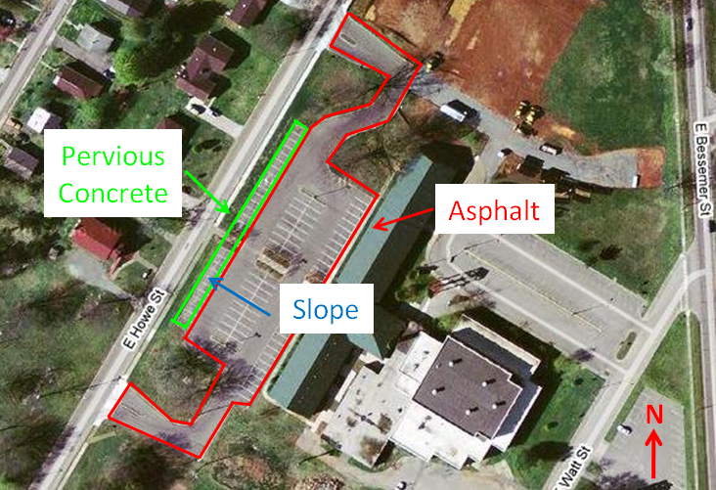

Figure 2.1.The Alcoa City Center Site (© Google)

Figure 2.2. Schematic Cross Section of the Alcoa Pervious Pavement Site
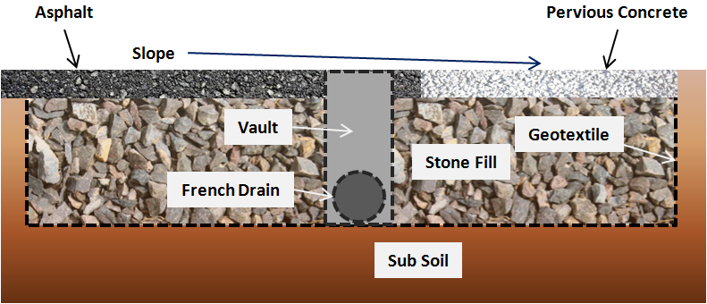

Sample Collection
We installed two solar powered sampling stations adjacent to the parking area to collect samples of the untreated asphalt runoff and the treated pervious concrete discharge (Figure 2.3). Float switches were installed in both the runoff collection box and the outlet end of the French drain. The switches were used to communicate to Campbell Scientific data loggers unique to each sampling location. The loggers were programmed to check for a pulse every fifteen minutes until the presence of water was detected by a closing of the float switch. The data loggers then checked every five minutes while water was present and commanded ISCO flow-weighted samplers programmed to collect three samples in each of 24 bottles (semi-discrete sampling), such that a six hour discharge event could be sampled. The controllers would then direct the samplers to stop collecting samples when the water level receded below the level of the float switch. A Texas Electronics tipping bucket rain gauge connected to the surface data logger recorded the precipitation depth every fifteen minutes.

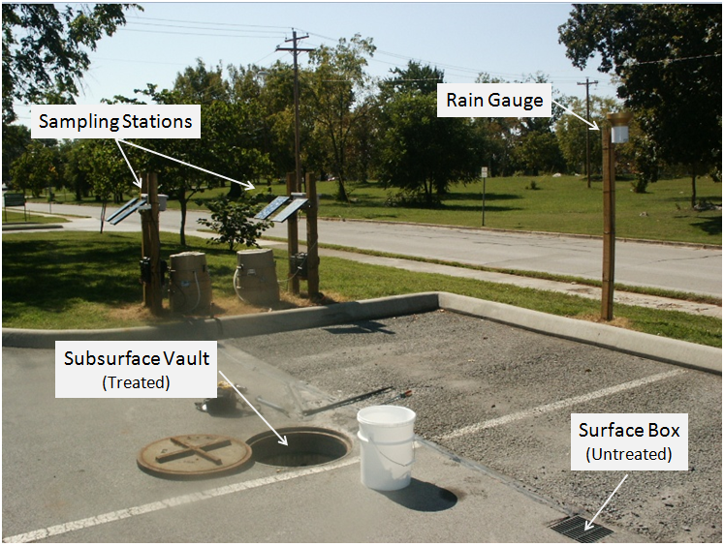
Figure 2.3. Sampling Apparatus Installed at Site

Sample Analysis
After rainfall events, we collected the samples from the ISCO units and transported them to the Department of Biosystems Engineering and Soil Science Water Quality Laboratory at the University of Tennessee. Immediately after returning to the lab, we refrigerated the samples at 0°C until they could be analyzed. Sampling and measurement of stormwater took place from April through September 2009 for five storm events following installation of the sampling system. Both untreated and treated stormwater samples were analyzed for pH, turbidity, total suspended solids, chemical oxygen demand (COD), chloride, nitrite, nitrate, and sulfate, lead and zinc, and polycyclic aromatic hydrocarbons (PAHs).

Because only concentration measurements and not runoff volume analyses were made, mass transport calculations were not made for any of the pollutants. This study only compared the pollutant concentrations of the surface runoff to the pollutant concentrations in the final site discharge stream. It is likely that some of the stormwater that infiltrated the pervious concrete detention system was lost to the subsoil, potentially causing the discharge pollutant concentrations to increase. This would lead to under estimation of the pervious concrete pollutant removal capacity such that they system may actually remove more pollutants than those shown in this study.

pH
Stormwater having a highly acidic or basic pH can render surface waters uninhabitable by aquatic life and unsuitable for human recreation or consumption without treatment. We measured the pH of the discharges from the Alcoa site to evaluate how treatment by pervious concrete changes the stormwater pH. The pH was measured using an Orion 525A probe meter. Each stormwater sample was shaken and placed on a magnetic stirring plate on medium speed. The pH probe was then rinsed with deionized water and placed in the sample as the bottle was being stirred. When the sample was sufficiently mixed, the meter readout indicated a steady value, and the reading was made. The probe was rinsed with deionized water between readings.

Turbidity
Turbidity is a measure of the cloudiness of a liquid. Highly turbid water blocks sunlight that would normally reach greater depths and the organisms living at those depths. It can also harm the aesthetic appeal of a water body and render it undesirable for human consumption. Turbidity can be a function of the suspended solids content of stormwater, though it can also be affected by the presence of dissolved solids. It is often used as an indicator for the presence of disease causing microorganisms (US EPA, 2009a). Turbidity was measured using a Monitek CST06825 Model 21 Nephelometer. This turbidity meter measures the scatter of a light source shined through a sample caused by particles in the water. Each sample was shaken, and then a subsample was collected and placed in a vial which was analyzed in the meter.

Total Suspended Solids
Total Suspended Solids (TSS) were measured according to Standard Method 2540 D by filtering a known subsample volume through a 45 micron glass filter disc using a vacuum suction apparatus. The filters were weighed before they were used. Following filtration, they were dried at 105°C and then weighed again. The TSS concentrations were obtained by finding the difference in solids mass divided by the volume of sample filtered.

Anions
Chloride occurs in natural waters on the order of about 100 mg/L unless they are brackish or saline. It can accumulate in stormwater from industrial discharges, fertilizers, and road salting. Chloride is not reactive such that it does not form insoluble precipitates or adsorb to mineral or organic surfaces (Fetter, 1999). Rainwater contains dissolved nitrate and ammonia. In soil and groundwater, microorganisms oxidize and reduce nitrogen species. Under oxidizing conditions, ammonia is converted to nitrite, which is then converted to nitrate. Nitrite is very reactive and is readily converted to nitrate such that little nitrite is found in the environment (Fetter, 1999). The maximum contaminant levels for nitrate and nitrite are 10 mg/L and 1 mg/L , respectively. Both of these compounds are toxic to infants if consumed and can cause death at high concentrations (US EPA, 2009a). Chloride, nitrite, nitrate, and sulfate concentrations were measured according to EPA Method 300.1 using a Dionex DX-100 Ion Chromatograph (IC). Known volumes of the TSS filtration effluent were placed in vials and analyzed in the IC. Fluka brand IC standard solutions were used to calibrate the IC prior to sampling.

Chemical Oxygen Demand
COD is a measure of the organic content of a stormwater sample. It indicates the amount of oxygen from a water body that is required to degrade the organic matter in the sample that would have otherwise been used for natural processes in the water body. COD was measured according to Standard Method 5220 D. A subsample was collected from each sample bottle and then digested in a vial of potassium dichromate and sulfuric acid in a 150°C heating rack for one hour. Next, the digestion vials were removed from the heat, cooled, and inserted into a Hach DR/2010 Spectrophotometer. The COD was then recorded as a function of the colorimetric value.

Metals
Metals are cations and most have limited mobility in soil because of cation exchange or sorption to mineral surfaces. They are mobile in groundwater only if the pH is such that soluble ions can exist and the soil has low cation exchange capacity. They can also be mobile if attached to a mobile colloid. Acidic, sandy soils with low organic and clay content facilitate metals mobility. In a pH range from 8 to 11, there can be less than 100 μg/L of zinc. For soils having a pH greater than 4.6, lead sorption increases (Fetter, 1999). Lead and zinc concentrations were measured with a Spectro CIROS ICP-OES inductively coupled plasma (ICP) mass spectrometer (MS) using commercially available standards.

Polycyclic Aromatic Hydrocarbons
Hydrocarbons dissolved in stormwater can adsorb to solid surfaces through what is called the hydrophobic effect. When dissolved in water, these compounds tend to be attracted to substances less polar than water. More often than not, these substances are organic solids rather than mineral surfaces. Aromatic hydrocarbons undergo biological degradation under aerobic conditions (Fetter, 1999). PAHs were measured via a multistep process following Standard Method 3510C, separatory funnel liquid-liquid extraction, and Standard Method 8270D, semivolatile organic compounds by gas chromatography mass spectrometry. A suite of 16 PAHs typically found in used motor oil were analyzed using Restek 8270 Calibration Mix #5.

The extraction process consisted of removing the water from five, 800 mL composite samples per event, two of the treated and two of the untreated samples and one using the standard solution. Sixty mL of methylene chloride solvent was added to each sample flask and the standard flask. The flasks were shaken once every 10 minutes for a total of three repetitions to distribute the solvent throughout. The solvent was then drawn from the flask into a separate container. The flasks were then brought to a pH of less than two using sulfuric acid, 60 ml of methylene chloride were added, the flasks were shaken, and the extraction was repeated. Finally, the extraction was repeated after bringing the pH above 10 using sodium hydroxide.

The desiccation process consisted of filtering the extracted methylene chloride solution through a column containing granular sulfate and recapturing it in an airtight flask. The evaporation/condensation process entailed placing the methylene chloride solutions into a 60°C bath and boiling off most of the methylene chloride until a concentrated sample was left in the bottom of the flasks. These samples were bottled in vials and analyzed with a Shimadzu GCMS-QP20105/GC-2010 gas chromatograph spectrometer.

Statistical Analysis
SAS v9.2 was used to compare the pollutant concentrations between the treated and untreated samples. Because the treated samples were taken from the outflow stream of the entire pervious concrete area, they were not directly paired to a given untreated sample taken from the surface runoff box, and the experiment was analyzed as a completely randomized design using the analysis of variation univariate procedure. Significance was set at α = 0.05. In the event that a data distribution was non-normal, a log transformation was performed or in the worst case of the PAH data, a rank transformation was required.

Results
Samples from five storm events spanning a period of six months, April to September 2009, were analyzed. In some instances, a given storm event did not provide enough sample for analyses of all the constituents to be conducted. These are labeled as “unavailable” when applicable in Figures 2.4-2.13. The pervious concrete detention system significantly reduced the concentrations of TSS, chloride, COD, and PAHs. Nitrite was nearly significantly reduced (0.05 < p < 0.1) while nitrate was nearly significantly increased. Sulfate concentrations were significantly higher for the pervious concrete discharge than for the asphalt runoff.

pH
The runoff for the five storm events tended to be neutral to acidic in contrast to the discharge from the pervious concrete which was slightly basic (p < 0.01) (Figure 2.4). Given that the stone fill beneath the concrete was limestone native to the region, it follows that the stormwater could become basic after passing through it. Pratt (1999) also showed that acidic rain water (pH=6.5) can become basic (pH=8.0) after passing through limestone aggregate.
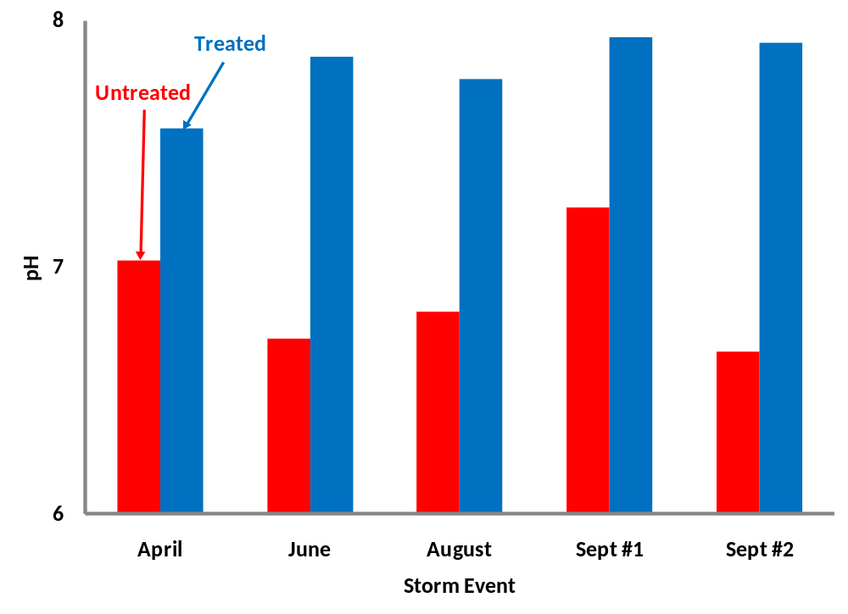
Figure 2.4. Mean pH Values from Five Storm Events

Turbidity
Generally, the turbidity of the pervious discharge was less than that of the asphalt runoff, but the difference was not significant (p = 0.60) (Figure 2.5). This is to be expected since both the concrete and the stone fill have large surface areas with which to trap mineral and biological pollutants that lead to high turbidity. Although there is no evidence suggesting it, the discharge spike seen Sept #2 might be explained by the sloughing of biological material from the concrete or aggregate substrate as described in Pratt et al. (1999).

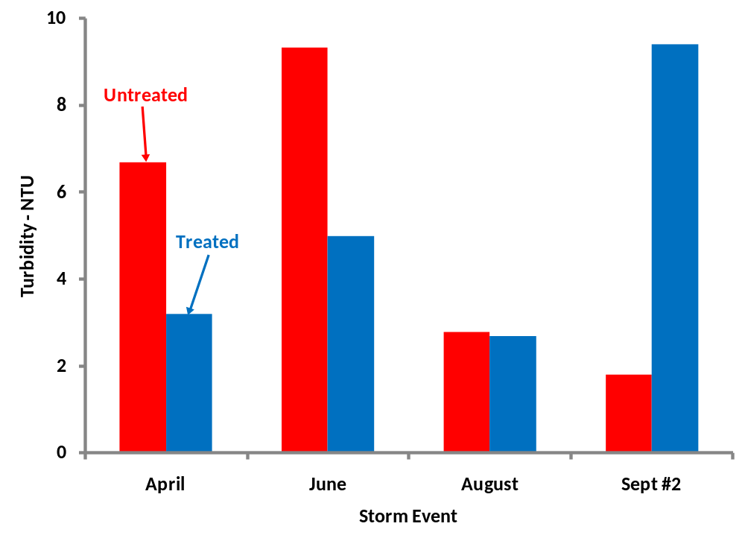
Figure 2.5. Mean Turbidity Values from Four Storm Events (Sept #1 unavailable)

Total Suspended Solids
Total suspended solids were reduced in the treated discharge in all instances that they were present in the asphalt runoff (Figure 2.6). This is due to the same properties of the concrete system that allow it to filter turbidity causing particles. The September storms’ TSS levels were extremely low (10⁻⁵ mg/L) such that they were omitted from the statistical analysis. Even though the turbidity for the September #2 storm was particularly high for the pervious concrete discharge, this may be due to dissolved solids not captured by the filter disc or biological solids incinerated during heating. When suspended solids are present, their removal by the pervious concrete detention system is significant (p = 0.02).

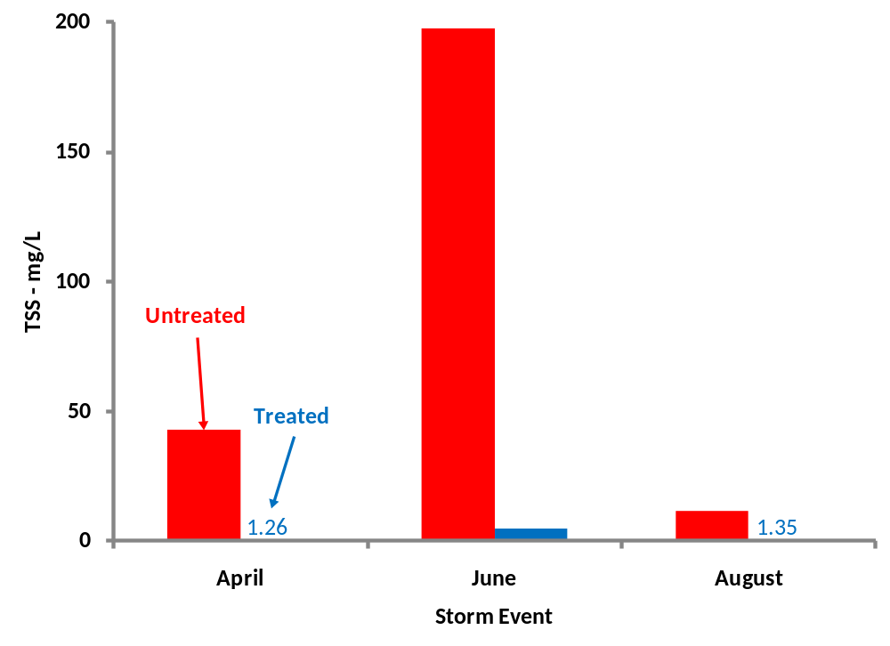
Figure 2.6. Mean TSS Concentrations from Three Storm Events (Sept #1 and Sept #2 omitted)

Chloride
Chloride concentrations were significantly reduced by the pervious concrete system (p = 0.04) (Figure 2.7). Although chloride ions tend to be nonreactive, the dissolution of the limestone (calcium carbonate) aggregate and the subsequent release of calcium ions may have provided reaction sites for the chloride ions.

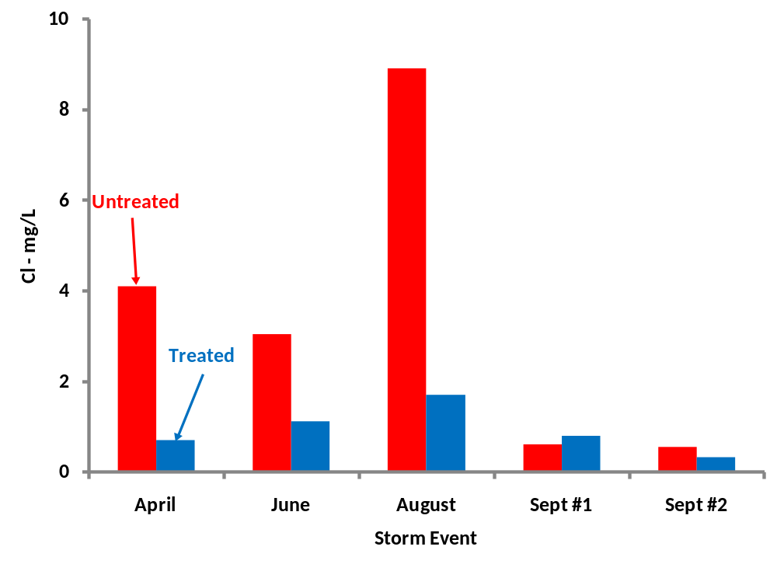

Figure 2.7. Mean Chloride Concentrations from Five Storm Events

Nitrite and Nitrate
Nitrite is a byproduct of nitrification of ammonia in rainwater and readily reacts to form nitrate under aerobic conditions. It was nearly significantly (p = 0.08) reduced by the pervious concrete detention system by conversion to nitrate, which increased in the concrete discharge to a similar degree (p = 0.09) as verified by the differences in concentration shown in Figures 2.8 and 2.9. However, for the September storm untreated samples, the nitrite may have converted to nitrate in the time between when the samples were collected and capped before being transported to the lab.

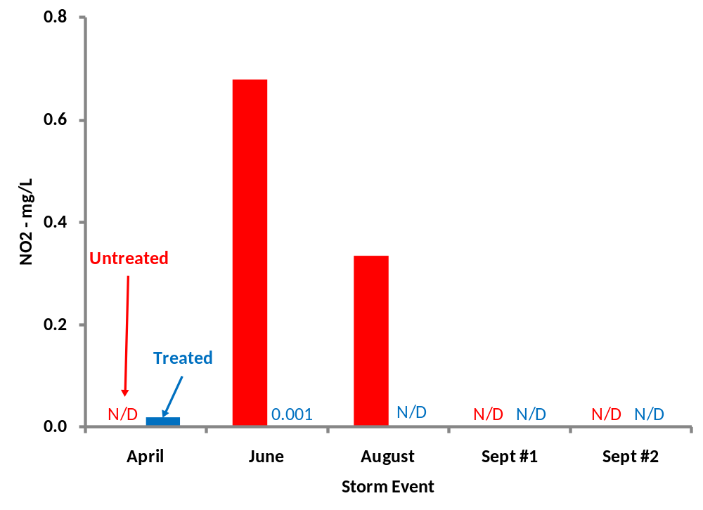
Figure 2.8. Mean Nitrite Concentrations from Five Storm Events

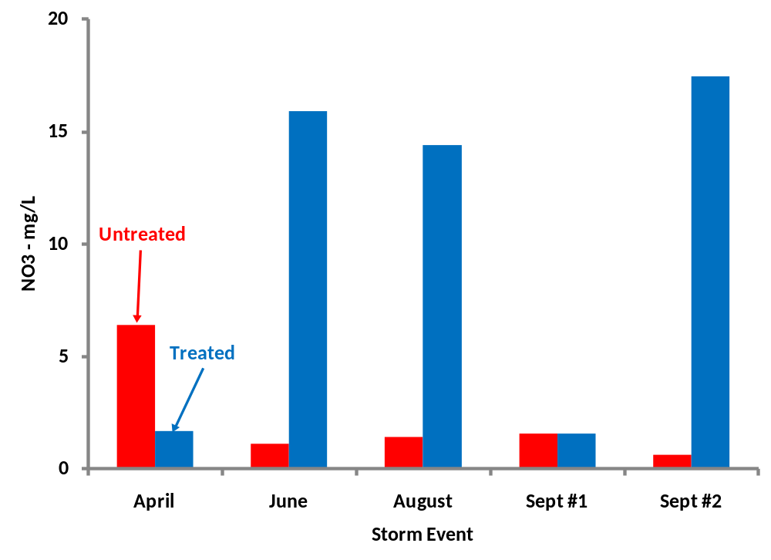

Figure 2.9. Mean Nitrate Concentrations from Five Storm Events

Sulfate
Pervious concrete discharge sulfate concentrations were significantly higher than those for the asphalt runoff (p < 0.01) (Figure 2.10). The sulfate concentrations were variable, being higher for the asphalt runoff in some storms and higher for the pervious concrete discharge in others. In some instances sulfur freed from the degradation of hydrocarbons might react to form sulfate.

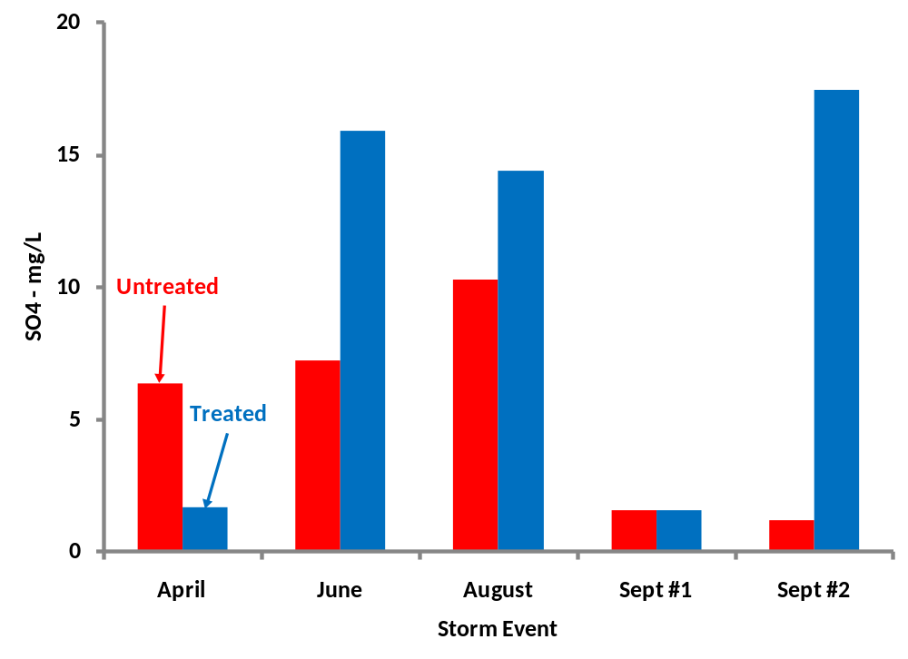

Figure 2.10. Mean Sulfate Concentrations from Five Storm Events

Chemical Oxygen Demand
COD in the pervious discharge was generally less than that of the concentration in the untreated runoff ( p = 0.03) (Figure 2.11). COD detects the presence of organic solids which can be immobilized within the concrete or aggregate

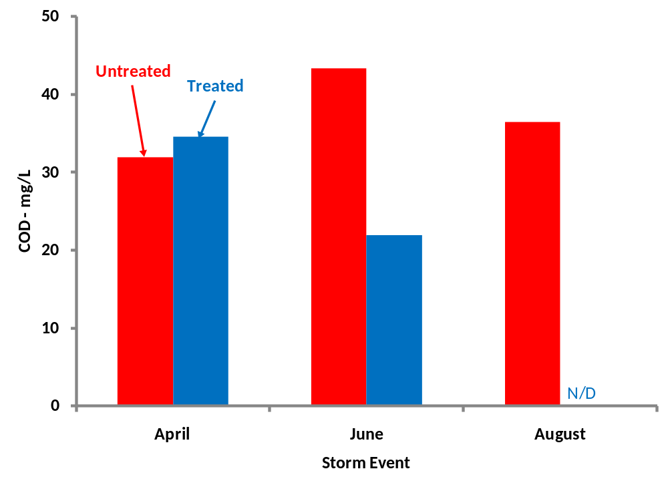

Figure 2.11. Mean COD Concentrations (Sept #1 and Sept #2 unavailable)

Metals
Lead was below the detection limits of the Spectro CIROS ICP-OES ICP MS for all storm events, for both treatments. The zinc concentrations of the pervious discharge were not significantly lower than those of the asphalt runoff (p = 0.34) (Figure 2.12).

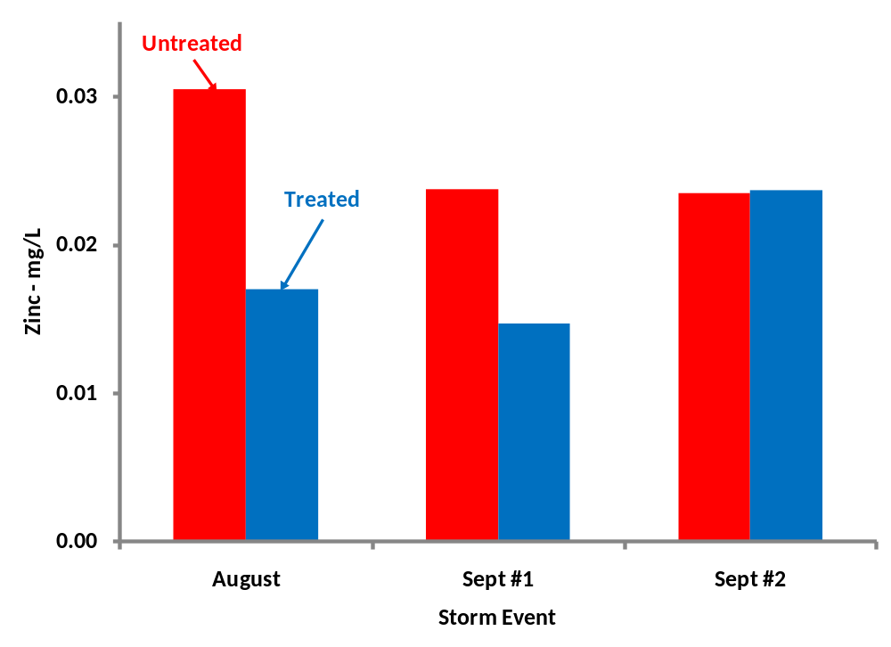
Figure 2.12. Mean Zinc Concentrations from Three Storm Events (April and June unavailable)

Polycyclic Aromatic Hydrocarbons
The concentrations of hydrocarbons were significantly lower (p < 0.01) for the pervious discharge than for the asphalt runoff (Figure 2.13). The September #2 storm had atypically high runoff and discharge concentrations near 25 μg/L. it is possible that a vehicle leaked a large quantity of oil or some other fluid prior to this storm event, causing a spike in hydrocarbons.

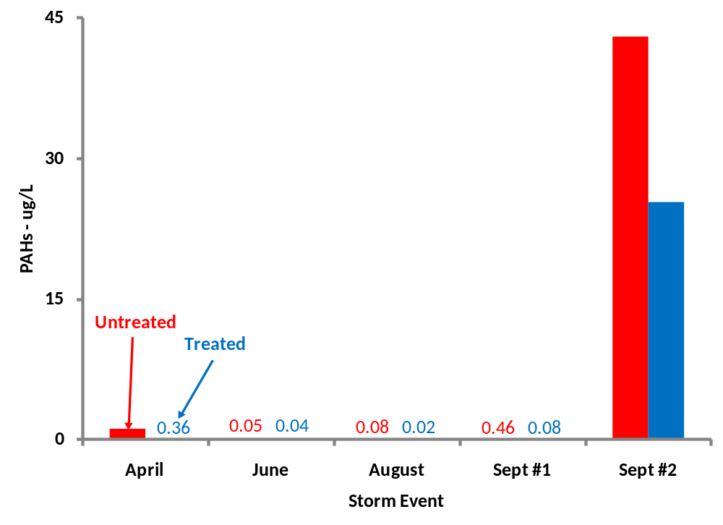

Figure 2.13. Mean PAH Concentrations from Four Storm Events (Sept #2 omitted)

Conclusions
Although pervious pavements serve primarily to reduce runoff volumes and peak flow rates by temporarily storing stormwater, this research has shown that a pervious concrete detention system is also capable of removing stormwater pollutants. We found that the pervious concrete paving at the Alcoa City Center significantly (p < 0.05) reduced the TSS, COD, chloride, sulfate, and PAH concentrations compared to untreated asphalt runoff. It also nearly significantly decreased nitrite concentrations. There were increased nitrate and sulfate concentrations in the pervious concrete discharge. These results validate our hypothesis that pervious concrete can reduce runoff pollutant loadings.

The results of this project may lead to a wider acceptance of pervious concrete as an alternative to established best management practices (i.e. detention basins that reduce valuable land area) for the purpose of improving the quality of stormwater being discharged to surface waters. This will allow developers to incorporate mandatory elements such as parking lots into their stormwater management plans and to save their clients money while helping the environment.

List of References

Bean, E.Z., W.F. Hunt., and D.A. Bidelspach. 2007. Evaluation of four permeable pavement
sites in eastern North Carolina for runoff reduction and water quality impacts. ASCE: Journal of Irrigation and Drainage Engineering Nov/Dec: 583-592.

Booth, D.B. and J. Leavitt. 1999. Field evaluation of permeable pavement systems for improved
stormwater management. APA Journal Sum: 314-325.

Brattebo, B.O. and D.B. Booth. 2003. Long-term stormwater quantity and quality performance
of permeable pavement systems. Water Research 37: 4369-4376.

Brown, H.J. 2008. Pervious Concrete Research Compilation: Past, Present, and Future. RMC
Research and Education Foundation.

Chow, T.J. 1970. Lead accumulation in roadside soil and grass. Nature 225: 295-296.

Fetter, C.W. 1999. Contaminant hydrogeology, 2nd Ed. Long Grove: Waveland Press, Inc.

Gilbert, J.K. and J.C. Clausen. 2006. Stormwater runoff quality and quantity from asphalt, paver,
and crushed stone driveways in Connecticut. Water Research 40: 826-832.

Hun-Dorris, T. 2005. Advances in porous pavement. Stormwater Mar/Apr.

Lagerwerff, J.V. and A.W. Specht. 1970. Contamination of roadside soil and vegetation with
cadmium, nickel, lead and zinc. Environmental Science and Technology 4(7): 583-586.

Legret, M., V. Colandini, and C. Le Marc. 1996. Effects of porous pavement with reservoir
structure on the quality of runoff water and soil. Science of the Total Environment 189/190: 335-340.

Legret, M. and C. Pagotto. 1999. Evaluation of pollutant loadings in the runoff waters from a
major rural highway. Science of the Total Environment 235: 143-150.

Legret, M. and V. Colandini. 1999. Effects of a porous pavement with reservoir structure on
runoff water: water quality and fate of heavy metals. Wat. Sci. Tech. 9(2): 111-117.

Milberg, R.P., J.V. Lagerwerff, D.L. Brower, and G.T. Biersdorf. 1980. Soil lead accumulation
alongside a newly constructed roadway. J. Environ. Quality 9: 6-8.

Motto, H.L., R.H. Daines, D.M. Chilko, and C.K. Motto. 1970. Lead in soils and plants: its
relationship to traffic volume and proximity to highways. Environmental Science and Technology 4(3): 231-237.

National Research Council (NRC). 2008. Urban Stormwater Management in the United States. Washington, D.C.: National Academies Press.

Pagotto, C., M. Legret, and P. Le Cloirec. 2000. Comparison of the hydraulic behavior and the
quality of highway runoff water according to the type of pavement. Wat. Res. 34(18): 4446-4454.

Tennis, P.D., M.L. Leming, and D.J. Akers. 2004. Pervious Concrete Pavements. Portland
Cement Association.

Pitt, R., R. Field, M. Lalor, and M. Brown. 1995. Urban stormwater toxic pollutants: assessment,
sources, and treatability. Water Environment Research 67(3):260-275.

Pratt, C.J. 1999. Use of permeable, reservoir pavement constructions for stormwater treatment
and storage for re-use. Wat. Sci Tech. 39(5): 145-151.

Pratt, C.J., A.P. Newman, and P.C. Bond. 1999. Mineral oil bio-degradation within a permeable
pavement: long term observations. Wat. Sci. Tech. 39(2): 103-109.

Rushton, B.T. 2001. Low-impact parking lot design reduces runoff and pollutant loads. J. Wat.
Res. Pln. Mgmt. May/Jun: 172-179.

Sartor. J.D., G.B. Boyd, and F.J. Argady. 1974. Water pollution aspects of street surface
contaminants. Journal Water Pollution Control Federation 46(3): 458-467.

United States Environmental Protection Agency. 1999. Preliminary Data Summary of Urban
Storm Water Best Management Practices. Office of Water.

United States Environmental Protection Agency. 2005. Stormwater Phase II Final Rule. Office
of Water.

United States Environmental Protection Agency. 2009a. National Primary Drinking Water
Regulations.

United States Environmental Protection Agency. 2009b. National Water Quality Inventory:
Report to Congress. Office of Water.

United States Environmental Protection Agency. 2009c. Pervious Concrete Pavement. National
Pollutant Discharge Elimination System.

APPENDIX

Vita
Bent Pilon was born in Orange, California December 13, 1984. He lived in Murfreesboro, Tennessee from 1987 until he graduated from Blackman High School in 2003 and has lived in Knoxville for the past 7 years while attending the University of Tennessee. He graduated with a B.S. in Biosystems Engineering with a minor in Environmental Engineering in August of 2008 and will graduate with a M.S. in Biosystems Engineering in December 2010.

