Rapid Molecular Detection and Population Genetics of Pityophthorus juglandis, a Vector of Thousand Cankers Disease in Juglans spp.

A Thesis Presented for the
Master of Science
Degree
The University of Tennessee, Knoxville

Emel Oren
December 2016

Copyright © 2016 by Emel Oren
All rights reserved.

ACKNOWLEDGEMENTS

I would like to express my sincere gratitude to my major professor, Dr. Denita Hadziabdic, for her guidance and encouragement during my graduate studies here at the University of Tennessee.
I would like to thank my committee members, Dr. William Klingeman, Dr. Paris Lambdin and Dr. Kevin Moulton for their help and valuable suggestions. It was my true pleasure to get to know and work with you.
My deepest thanks to Dr. Romina Gazis and Sarah Boggess for their mentorship and invaluable guidance. Special thanks to Angel Chaffin and Laura Poplawski for their help during extracting DNA.
Special thanks to my labmates, Tyler Edwards and Chris Wyman for their help, guidance, and friendship, above all reviewing my thesis.
I am also very thankful to numerous collaborators who collected beetle specimens and wood samples throughout the eastern and western United States with Italy and made this project possible.
Special thanks to Qunkang Cheng helping me for statistical analysis.
Thanks to everyone in the department of Entomology and Plant Pathology, my fellow graduate students, and everyone who made my graduate life interesting. It has been a true pleasure working with all of you.
Most importantly, I would like to thank my family: my mom, Selma, my dad, Feyzullah, and my sister, Ikbal for their support throughout all these years and letting me to follow my dreams.

ABSTRACT
Thousand Cankers Disease (TCD) is a disease complex involving the fungal pathogen Geosmithia morbida, an insect vector Pityophthorus juglandis, and the hosts, Juglans spp. and Pterocarya spp. Signs and symptoms of TCD include crown thinning due to branch dieback, yellowing and wilting of the leaves, appearance of epicormic shoots, numerous entrance/exit holes, gallery formation by P. juglandis, and the development of small, dark brown cankers underneath the bark. TCD originally described from the western United States, has now expanded to the eastern US and northwestern Italy. The disease complex is often difficult to diagnose due to the absence of symptoms or signs on the bark surface. Furthermore, disease symptoms can be confused with the impact of other abiotic or biotic agents. As a result, rapid molecular detection of TCD is necessary to improve our detection methods and prevent massive die-offs of this important trees. However, we have limited knowledge regarding genetic diversity of TCD complex members. Therefore, understanding population dynamics, gene flow, and spread of this disease is important in combating future outbreaks and potential large scale epidemics. In this study, we focused on two objectives: 1) developing rapid molecular detection protocol for TCD, and 2) evaluation of genetic diversity, spatial structure, and distribution of P. juglandis from populations in the United States and Europe using microsatellites. Using previously developed species specific microsatellite loci for G. morbida and P. juglandis, our results provided a successful protocol with a high degree of sensitivity and outlined evidence that rapid molecular detection of TCD is feasible, effective, and time efficient. For population studies, P. juglandis specimens (n=839) from 40 subpopulations across northwestern and southwestern US, eastern US, and Italy were genotyped at 12 highly polymorphic P. juglandis microsatellite loci. Our results indicated high genetic diversity, presence of population structure, and limited gene flow among these groups. Also, high levels of genetic diversity across all groups were explained by human mediated movement of infested plant material from multiple sources, multiple times. This supports an earlier hypothesis that the disease has been established in these areas for a longer period of time than previously expected.

TABLE OF CONTENTS
Chapter 1. Rapid Molecular Detection of Thousand Cankers Disease 1
Abstract 2
Introduction 2
Collection of Walnut Branches 8
Materials and Methods 8
Sampling Process 8
Lesion-directed Sampling 8
Feature-directed Sampling 9
DNA Extraction and PCR 10
Analysis of Amplification 10
Statistical Analysis 10
Results 11
Discussion 14
References 19
Chapter 2. Evaluating genetic diversity, spatial structure and distribution of Pityophthorus juglandis from populations in the United States and south Europe using microsatellites 25
Abstract 26
Introduction 27
Materials and Methods 33
Specimen Collection 33
DNA Isolation 34
Data Analyses 35
Results 37
Discussion 40
References 45
Appendix 52
Vita 96

LIST OF TABLE
Table 1. Pearson’s Chi-square test with Yates’ continuity correction comparisons of molecular detection efficiencies among drill cores taken at sites where Geosmithia morbida (Gm) and Pityophthorus juglandis (Pj) are known to occur. Presented data was quantified across collection locations and sample type, whether lesion-directed or feature-directed on walnut branch sections. 53

Table 2. Pearson’s chi-square test with Yates’ continuity correction comparison of molecular detection efficiencies in any of the drilled samples (per tree) could yield a confirmation that a sample (tree) is positive for a TCD complex member 54

Table 3. Logistic mixed model outcomes observed by region and among drill core samples 55

Table 4. Pityophthorus juglandis populations used to evaluate genetic diversity, spatial structure and distribution of the beetle in the US and Italy. 57

Table 5. Genbank accession numbers, primer sequences, number of alleles, and allelic ranges (bp) of twelve microsatellite loci 59

Table 6. Diversity measures across 839 Pityophthorus juglandis individuals from 40 different subpopulations using twelve microsatellite loci. 60

Table 7. Diversity measures, fixation indices and gene flow calculations across 839 Pityophthorus juglandis from 40 different subpopulations using twelve microsatellite loci. 62

Table 8. Diversity measures across 839 Pityophthorus juglandis individuals from 4 geographical regions using twelve microsatellite loci. 63

Table 9. Diversity measures, fixation indices and gene flow calculations across 839 Pityophthorus juglandis from 4 geographical regions using twelve microsatellite loci. 64

Table 10. Diversity measures across 839 Pityophthorus juglandis individuals from 2 genetic clusters using twelve microsatellite loci. 65

Table 11. Diversity measures, fixation indices and gene flow calculations across 839 Pityophthorus juglandis from 2 genetic clusters using twelve microsatellite loci. 66

Table 12. Pairwise population differentiation (Fst) of Pityophthorus juglandis from four geographic regions using twelve microsatellite loci. 67

Table 13. Pairwise gene flow (Nm) values for 839 Pityophthorus juglandis individuals from four geographic regions using twelve microsatellite loci. 68
Table 14. Analysis of molecular variance (AMOVA) for 839 Pityophthorus juglandis individuals across twelve microsatellite loci. 69

Table 15. Bottleneck determination by sign tests for 839 Pityophthorus juglandis individuals grouped by the four geographic regions using twelve microsatellite loci. 70

LIST OF FIGURES
Figure 1. Thousand Cankers Disease symptoms on Juglans nigra trees.The symptoms include yellowing of the leaves, crown and branch dieback and formation of epicormic shoots. Image provided by Dr. Đenita Hadžiabdić 71

Figure 2. Pityophthorus juglandis galleries in the phloem (upper image) and exit holes (lower image in Juglans regia branches (arrows). Adult P. juglandis create entrance and emergence holes the size of a pinhead (0.64-0.75 mm) with galleries approximately 2.5 to 5 cm long. Images provided by Dr. Đenita Hadžiabdić. 72

Figure 3. Geosmithia morbida induced elliptical cankers underneath Juglans nigra branches. Individual cankers (upper image) can coalesce and form large necrotic lesions underneath the bark (lower image) thus girdling the branch and resulting in rapid tree mortality. The cankers are visible only after the outer bark is removed. Images provided by Dr. Đenita Hadžiabdić - Guerry. 73

Figure 4. The native range of Juglans nigra (green shading). The map courtesy of USDA- NRCS Plant Database. 74

Figure 5. Geosmithia morbida. Cream colored to tan colonies of Geosmithia morbida grown on half strength potato dextrose agar (PDA) (left image). Conidia and conidiophore of G. morbida (right image). Images provided by Dr. Đenita Hadžiabdić and Tyler Edwards. 75

Figure 6. Mixed cultures collected from infested Juglans spp. galleries. Geosmithia morbida is slow growing pathogen that is often outcompeted by other faster growing fungi. Images provided by Dr. Romina Gazis. 76

Figure 7. Pityophthorus juglandis.The body length is less than 2 mm (A); the pronotal asperities from the middle to the anterior margin form two or more well-defined concentric rows; anterior margin of pronotum with more than 12 asperities (B); apex of elytra evenly rounded (C). Images courtesy of Steven Valley. 77

Figure 8. Mixed cultures from Pityophthorus juglandis colonized galleries. Detection methods of Geosmithia morbida is difficult due to other fungi that can grow faster and outcompete slow growing G. morbida. Image provided by Dr. Romina Gazis. 78

Figure 9. Three geographical locations used in rapid molecular detection study. The samples were collected from either within (California, Tennessee) or outside (Missouri) the current distribution of Thousand Cankers Disease. 79

Figure 10. Drilling of Juglans spp. branches to obtain wood shavings used for DNA isolation. Drilling potential cankers for DNA isolation and molecular confirmation of presence/absence of Thousand Cankers Disease. 80

Figure 11. Batches of walnut drill shavings were collected into 1.5 ml safe-lock microcentrifuge tubes (left); solutions of isolated DNA were used for PCR amplification (right). 81

Figure 12. Thousand Cankers Disease molecular confirmation. Gel image of positive control (Geosmithia morbida) (circle) and negative control (water) based on 25 base pairs marker; electropherogram from Tennessee walnut shavings amplified with Geosmithia specific microsatellite locus, GS004. 82

Figure 13. Molecular detection of Thousand Cankers Disease complex member(s) percentage of positive drill samples from both feature-directed (n=400) and lesion-directed (n=800) samples from California, Missouri, and Tennessee. 83

Figure 14. Molecular detection outcomes among 40 Juglans nigra and J. hindsii samples from California, Missouri (control) and Tennessee. 84

Figure 15. Molecular detection of Thousand Cankers Disease complex member(s) among positive trees for all samples and both drilling methods (A), among positive trees for all samples using lesion-directed drillings (B), and among positive trees for all samples using feature-directed drillings (C). 87

Figure 16. Canker areas under bark. Elliptical cankers in walnut phloem caused by Geosmithia morbida are visible only after the outer bark is removed. Image provided by Dr. William Klingeman. 88

Figure 17. Thousand Cankers Disease distributions and quarantines areas as of April 15, 2015.Map courtesy Minnesota Department of Agriculture. 89

Figure 18. Pityophthorus juglandis. Comparison of morphological characters of male (A) and female (B) WTB. Arrows indicate the degree of pubescence on the male and female frons; the apex, which occurs before the midpoint on the anterior half of the pronotum of males and females; and granules on the male elytral declivity (C). Image provided by S. M Hishinuma, UC Davis and A. D. Graves, USDA Forest Service from (Seybold et al. 2013). 90

Figure 19. Geosmithia morbida. Four weeks old colonies of G. morbida grown on half strength potato dextrose agar (PDA) (A); conidia and conidiophore (B). Images provided by Dr. Romina Gazis – Seregina (A), Dr. Đenita Hadžiabdić Guerry (B). 91

Figure 20. Placing the trap about 2.5 to 4.5 m from the main stem of suspect walnut tree, 1.5 to 3 m from the live branches of that tree’s crown and hang the trap on a 3 m pole. Image provided by Dr. Đenita Hadžiabdić. 92

Figure 21. Maximum ΔK at K = 2 estimated using Evanno’s methodfor 839 Pityophthorus juglandis individuals using 12 SSRs. 93

Figure 22. Structure bar graph representing 2 and 3 genetic clusters of 839 Pityophthorus juglandis individuals from three geographic regions (northwestern, southwestern, and eastern US, and Italy) using twelve microsatellite loci. 94

Figure 23. The model-based clustering results produced by TESS indicated the presence of three genetic clusters based on the lowest DIC value. Above map shows US subpopulations, below map shows Italy subpopulations. 95

Chapter 1. Rapid Molecular Detection of Thousand Cankers Disease

Abstract
The Thousand Cankers Disease (TCD) complex involves Juglans spp. and Pterocarya spp., fungal pathogen, Geosmithia morbida, and vector, (Pityophthorus juglandis). TCD originally described from the western United States (US), has now expanded to the eastern US and northwestern Italy. The disease complex is often difficult to diagnose due to the absence of symptoms or signs on the bark surface. Furthermore, disease symptoms can be confused with the impact of other abiotic or biotic agents. Thus, there is a critical need for rapid TCD detection using molecular tools. Using previously developed species specific microsatellite loci for G. morbida and P. juglandis, we developed a rapid molecular detection protocol for TCD complex. A total of 120 Juglans bolts were collected from three geographical locations, either within (California, Tennessee) or outside (Missouri) the current distribution of TCD. Forty bolts were collected from each location. A total of 1600 drill cores were taken, and shavings from these cores were used for DNA extraction. Following PCR amplification, DNA samples were analyzed with a QIAxcel capillary electrophoresis system. Data were analyzed using the program R and the interclass correlation coefficient was used for power calculations. Molecular detection outcomes among all sampled trees demonstrated that California samples had the highest rate of TCD complex member detection (85%, n=34) compared to trees from Tennessee (37.5%, n=15). Our results provided a successful protocol with high degree of sensitivity and outlined evidence that rapid molecular detection of TCD is feasible, effective, and time efficient.

Introduction
In the past two decades, widespread mortality of Juglans nigra L. in the United States was a result of the devastating disease identified as Thousand Cankers Disease (TCD) (Grant et al. 2011; Kolarik et al. 2011). The disease complex involves most walnut species (Juglans spp. L), and three species of wingnut (Pterocarya spp. Nutt. ex Moq.) trees (Juglandaceae) as a host, fungal pathogen Geosmithia morbida M. Kolarik, E. Freeland, C. Utley, & N. Tisserat (Ascomycota: Hypocreales: Bionectriaceae) and insect vector Pityophthorus juglandis Blackman (Coleoptera: Curculionidae: Scolytinae), the walnut twig beetle (Kolarik et al. 2011; Tisserat et al. 2011; Freeland 2012; Seybold et al. 2012; Serdani et al. 2013; Utley et al. 2013; Hishinuma et al. 2016). Even though the severe decline of Juglans spp. was observed in the early 1990s in the western US (Tisserat et al. 2009; Zerillo et al. 2014), it was not until 2011 that the fungal symbiont, G. morbida, was identified and described (Kolarik et al. 2011).
Symptoms of TCD include crown thinning due to branch dieback, yellowing and wilting of the leaves (flagging), appearance of epicormic shoots (Fig. 1), numerous entrance/exit holes and gallery formation by P. juglandis (Fig. 2), and development of small, dark brown cankers underneath the bark (Fig. 3) (Kolarik et al. 2011; Tisserat et al. 2011). The disease was eventually named Thousand Cankers Disease after formation of a large number of coalescing cankers around galleries and exit holes that ultimately girdle the tree and prevent the flow of water and nutrients (Tisserat et al. 2009; Zerillo et al. 2014). Geosmithia morbida conidia surrounding bark beetle galleries can be dispersed by wind, water, and insect vector. The most efficient movement is by an insect vector (Kolarik et al. 2008). Walnut tree die-off is observed three to four years after the initial disease symptoms are detected (Kolarik et al. 2011; Hadziabdic et al. 2014). This is particularly troubling since the wood is highly prized for woodworking, gunstocks, ornamental and high-quality timber characteristics (Goodell 1984), as well as a food source for forest animals (Hadziabdic et al. 2014). The estimated current value of standing J. nigra in the U.S. is $568 billion (Hadziabdic et al. 2014; USDA-FS-PPQ 2015); in Tennessee alone, the value of black walnut is around $1.37 billion in urban areas and $1. 47 billion in forest areas (Haun et al. 2010), making it an important species from both an environmental and economic perspective.
In 2010 TCD was discovered in Knoxville, Tennessee, resulting in the first report of this disease complex in the native range of J. nigra (Fig. 4) (Grant et al. 2011), threating the highly valuable native timber stands in the eastern U.S. (Newton et al. 2009; Seybold et al. 2012). All Juglans spp. are susceptible to disease pressures, however, G. morbida fungal colonization was most severe in the native J. nigra trees (Utley et al. 2013). Currently, TCD has spread to seven eastern U.S. states – Indiana, Maryland, North Carolina, Ohio, Pennsylvania, Tennessee and Virginia- (Grant et al. 2011; Fisher et al. 2013; Hadziabdic et al. 2014) and northwestern Italy, which is the native range of J. regia L. (Montecchio and Faccoli 2014). It has been hypothesized that that the movement of the pathogen and vector might be human-assisted, particularly for recent Italian introductions (Haun et al. 2010; Hadziabdic et al. 2014; Zerillo et al. 2014; Rugman-Jones et al. 2015). The primary suspected method for the spread of TCD is the transportation of logs and firewoods from infested areas (Hansen et al. 2011).
Geosmithia morbida is the first phytopathogenic species reported in this genus, although Geosmithia spp. have not been considered important plant pathogens (Kolarik et al. 2011). Geosmithia morbida is different from other Geosmithia spp. because of its inability to grow on Czapek-Dox Agar (CDA), its thermotolerance (Freeland 2012), and the monilioid or atypically branched base of the conidiophores (Kolarik et al. 2011). Fungal colonies on half strength potato dextrose agar (PDA) are cream-colored to tan and tan to yellow-tan on the reverse side of the petri dish with cylindrical to ellipsoid conidia that can form in chains (Fig. 5). Morphological confirmation of the species can be challenging since there is no specific medium for obtaining pure G. morbida cultures. Also, the pathogen is slow-growing in culture and often is outcompeted with other, faster-growing fungi (Fig. 6). Even though Penicillium spp. and Geosmithia spp. conidia are not related, conidiophore morphology of G. morbida is similar in appearance to Penicillium spp. and can often be confused with the latter (USDA-FS-PPQ 2015), making diagnostic efforts more challenging. Geosmithia morbida is morphologically homogeneous, but genetically variable (Kolarik et al. 2011) with high haploid genetic diversity (Hadziabdic et al. 2014; Zerillo et al. 2014).
The TCD vector, P. juglandis, is a small, ̴2 mm long, phloem feeding insect (Kolarik et al. 2011), yellowish to reddish brown, and thought to be native to the southwestern US (Arizona, California, New Mexico) and northern Mexico (Chihuahua) (Fig. 7) (Blackman 1928; Bright 1981; Wood S.L. and D.E. 1992; LaBonte and Rabaglia 2012; Seybold et al. 2013). During the winter, P. juglandis can live as both larvae and adults within the galleries of Juglans spp. In the eastern US, adults resume activity by late April and most fly to branches to mate and initiate new tunnels for egg galleries. Some may remain in the trunk and expand overwintering tunnels (Nix 2013). There are generally two overlapping generations per season in Colorado, while in Tennessee that number is unclear (Nix 2013). Recent findings by Rugman-Jones et al. (2015) revealed high levels of genetic diversity and evidence of two genetic lineages among P. juglandis in the US, suggesting the evidence of two morphologically indistinguishable species.
TCD galleries often contain diverse fungal communities. McDermott – Kubeczko (2016) indicated that fungal communities on J. nigra branches include Aspergillus and Penicillium species, which are plurivorous fungi. Also, Fusarium solani isolates that were recovered from TCD infested branches can cause large necrotic areas on inoculated J. nigra (Tisserat et al. 2009; Montecchio et al. 2015), but the effect on the development of TCD is still ambiguous (Ploetz et al. 2013). Even though, we do not know how F. solani pathogencity affects the development of TCD, it was found to commingle with G. morbida, suggesting that two phytopathogen system may be colonizing aggressively in dead or dying phloem in already weakened trees (Ploetz et al. 2013; McDermott-Kubeczko 2016).
The disease is often difficult to identify because the bark surface may not exhibit any TCD symptoms or can be confused with drought damage (Hadziabdic et al. 2014; USDA-FS-PPQ 2015). Recent research findings from the US Forest Service Forest Inventory and Analysis inspections acknowledged that J. nigra resources in the eastern US were threatened by the TCD infestations across the native range (Randolph et al. 2013). They observed that less than 5% of evaluated trees were affected by TCD, based on tree crown conditions (Randolph et al. 2013). However, initial tree starvation and canker development may appear long before crown die-back is apparent, making disease confirmation complicated. The authors concluded that lack of evidence of TCD confirmation may be superficial due to inability of the monitoring system to confirm disease presence based solely on current crown dieback (Randolph et al. 2013). In the past years, we have observed a large number of new epicormics shoots formations on initially heavily infested TCD trees in the eastern US (Hadziabdic, personal communication). Currently, we have limited knowledge of the ability of these “recovered” trees to survive another TCD attack or prevent further mortality caused by other opportunistic or aggressive diseases.
Morphological confirmation of TCD can be challenging, time-consuming, and often unreliable due to competition with faster-growing fungi (Fig. 8). Plant disease diagnosis based on symptoms is rarely used as a single method of confirmation due to its limitations. Molecular techniques can provide valuable tools in this process and can be applied for simultaneous detection and identification of plant pathogens (Silva et al. 2016). Also, diversity of the myriad of fungal species that are associated with Juglans spp. may cause lesions similar to those of G. morbida, making traditional identification challenging and time consuming (McDermott-Kubeczko 2016). Currently, disease management is unavailable, and no pesticide or control methods exist to prevent the spread of TCD. Thus, the economic, social, and environmental consequences of further TCD epidemics could be devastating (Hadziabdic et al. 2014). As a result, rapid molecular detection of TCD is necessary to prevent massive die-offs of this important tree.
PCR has become the gold standard for early detection in many fields such as agriculture, forestry, as well as, human and animal health (Versalovic and Lupski 2002; Lamarche et al. 2015). This is because it is sensitive enough to detect minute amounts of DNA from the target organism even when the material is heterogeneous. Furthermore, molecular methods eliminate the labor time to isolate the pathogen (Cawkwell et al. 1993; Hamelin et al. 2000; Lamarche et al. 2015; Silva et al. 2016). To reduce the time needed for disease confirmation using traditional culturing methods, this study objective was to utilize species-specific microsatellite loci developed for G. morbida (Hadziabdic et al. 2012) and P. juglandis (Hadziabdic et al. 2015) to develop a rapid molecular detection protocol for TCD.

Collection of Walnut Branches

Materials and Methods
A total of 120 Juglans spp. bolts were collected from three geographical locations, either within (California, Tennessee) or outside (Missouri) the current distribution of TCD (Fig. 9). Forty bolts were collected from each location. Two different types of drilling were used to obtain wood shavings from sampled branches: lesion-directed (n=1200) and feature-directed (n=400). A total of 1600 drill cores were taken (Fig. 10), and shavings from these cores were used for DNA extraction (Fig. 11).

Sampling Process

Lesion-directed Sampling
For lesion directed sampling, bark was removed from each bolt using a scalpel to expose cankers and phloem discoloration. Preliminary observations have revealed a broad diversity in discoloration of phloem tissues that ranges across tan, dark brown hues and in some instances almost black colored tissues that can be associated with G. morbida-induced lesions. Ten cankers were identified, and drill shavings were collected into 1.5 ml safe-lock microcentrifuge tubes. Drill bits (7/64 inch- 0.28 cm diameter) were heat sterilized using a bead sterilizer (Steri 350, Fisher Scientific, Pittsburgh, PA) between each drilling point to prevent cross-contamination. A total of 10 lesion-directed samples were taken from each collected bolt (per each location n=400, total n=1200). Using a sterile drill bit (7/64 inch- 0.28 cm diameter), a small end of a bottomless tube (microfunnel) was placed against the exposed, marked cankers. The sterilized drill bit was placed through the microfunnel, and drilled through the wood to collect the shavings containing canker and/or beetle parts. Shavings collected in microfunnel were transferred into a labeled 1.5 ml safe-lock microcentrifuge tubes. The process was repeated until ~ 150 mg of drill shavings were collected. Samples were stored at -20°C until used for DNA extraction.

Feature-directed Sampling
In addition to lesion-directed sampling, a subset of five samples was taken as feature-directed cores. These samples were included to emulate field collected samples in which a walnut branch section could be examined for the presence of the TCD complex members without having any evidence of pathogen or vector presence. Consequently, feature directed samples were taken adjacent to lenticels, secondary branch unions, bark furrows, and various other bark wound sites without bark removal. Five different feature-directed drill shavings were collected into 1.5 ml safe-lock microcentrifuge tubes. Drill bits (7/64 inch- 0.28 cm diameter) were heat sterilized using a bead sterilizer (Steri 350, Fisher Scientific, Pittsburgh, PA) between each drilling point to prevent cross-contamination. A total of five feature-directed samples were taken from each collected bolt (per locations n=200, total n=400), except for Missouri control branches. Using a sterile drill bit (7/64 inch- 0.28 cm diameter), a small end of a bottomless tube (microfunnel) was placed against the exposed, marked cankers. The sterilized drill bit was placed through the microfunnel, and drilled through the wood to collect the shavings. Shavings collected in the microfunnel were transferred into a labeled 1.5 ml safe-lock microcentrifuge tubes. The process was repeated until ~ 150 mg of drill shavings were collected. Samples were stored at -20°C until used for DNA extraction.

DNA Extraction and PCR
DNA was extracted using a QIAamp Fast DNA Stool Mini Kit or DNA Stool Mini Kit (QIAGEN, Germantown, MD, USA), according to the manufacturer’s protocol. PCR amplifications were performed using P. juglandis-specific microsatellite locus (WTB 192) (Hadziabdic et al. 2015) as well as using G. morbida- specific microsatellite locus (GS 004) (Hadziabdic et al. 2012). PCR amplification was performed in 11 μl reactions containing 1 μL DNA (undiluted), 4 μl Go-Taq G2 Hot Start Colorless Master Mix (Promega, Madison, WI, USA), 1 μL of 10 μM of each primer, 0.5 μl DMSO and 3.5 μL of sterile water. Both positive and negative control samples were included for additional confirmation and accuracy of results (Fig 12). PCR amplification was performed in a 96-well plate, using an Eppendorf Mastercycler pro Thermocycler (Eppendorf AG, Hamburg, Germany) with an initial denaturation step of 2 min at 95°C, followed by 30 cycles of 95°C for 30 s, 55°C for 45 s, 70°C for 1 min, and a final extension at 70°C for 1 min.

Analysis of Amplification
Following PCR amplification, DNA samples were analyzed via a QIAxcel Capillary Electrophoresis System (QIAgen, Valencia, CA, USA) using a 25 base pair DNA size marker. With the QIAxcel system, data are automatically generated and exported using QIAxcel ScreenGel software. The software facilitates rapid data interpretation and provides flexibility with data in which results are displayed in both electropherogram and gel image view (Fig. 12).

Statistical Analysis
Data were analyzed with R software (R-CoreTeam 2014) using lme4 (Bates et al. 2015), lmerTest (Kuznetsova et al. 2016), lsmeans (Lenth 2016), fmsb (Nakazawa 2015), and ggplot2 (Wickham and Chang 2016) packages. Interclass correlation coefficient, as described by Zou (Zou 2012) was used for to calculate power analysis. Pearson’s chi-square test (α= 0.05) with Yates’ continuity correction was performed to discern the predictive capability of the tested drilling protocols for the ability to detect the pathogen, G. morbida (Gm) and/or the beetle, P. juglandis (Pj). A logistic mixed model analysis also assessed the consistency of results across locations and within sample type, as well as interaction between these factors. Data analyses included a total of 1600 observation with the following six variables: location (CA, MO, TN), tree number (1-40), drill number (n=10 lesion-directed samples and n=5 for feature-directed samples per tree branch), presence or absence of the G. morbida specific marker GS004, presence or absence of P. juglandis specific marker WTB192, and the different drill types (lesion-directed or feature-directed).

Results
Molecular confirmation was based on positive results from DNA amplification of drilled bark samples and provided an effective and efficient method of diagnosing G. morbida and P. juglandis using the species-specific molecular markers. Pearson’s Chi-square test with Yates’ continuity correction was performed to examine the efficacy of these markers in rapidly detecting TCD using both lesion- and feature-directed drilling methods. The relation between these two variables was significant for all samples, Χ² (df=1, n=1600) = 14.11, P ˂ 0.001 (Table 1). When the two drilling methods were analyzed separately, both lesion-directed (X² [df=1, n=1200] = 14.24, P ˂ 0.001) and feature-directed (X² [df=1, n=400] = 11.16, P ˂ 0.01) drilling procedures were competent means to detect Gm and or Pj (Table 1). Effect of collection was also assessed for both drilling methods, regarding efficacy in rapidly detecting disease across the different geographical regions (Table 1). Only the California samples yielded an ability to detect either Gm or Pj using both lesion-directed and feature-directed drilling methods [X² (df=1, n=400) = 6.68 P ˂ 0.001, X² (df=1, n=200) = 5.99, P ˂ 0.01, respectively] (Table 1). By contrast, neither drilling method was highly effective at detecting Gm or Pj for the samples taken in Tennessee (Table 1). Another Pearson’s Chi-square test with Yates’ continuity correction was performed to determine the probability that any of the 10 lesion-directed or 5 feature-directed drill cores, within each of 40 trees per location, could confirm that a tree is positive for any of the TCD complex member (either Gm or Pj presence) which was examined under the following conditions: presence of Gm only, presence of Pj only, or joint confirmation of both Gm and Pj within a sample (Table 2). When drill sampling outcomes were pooled, both lesion-directed and feature-directed drilling methods were effective in detecting a TCD complex member in the California and Tennessee locations (X² [df=1, n=200] = 12.11, P ˂ 0.001) (Table 2). When the two drilling methods were analyzed separately, both lesion-directed (X² [df=1, n=120] = 7.69, P = 0.005) and feature-directed (X² [df=1, n=80] = 6.79, P = 0.009) drilling methods were efficient molecular means of detecting TCD complex members (Table 2). However, only California samples yielded similar capabilities for both lesion-directed and feature-directed drilling (X²[df=1, n=40] = 5.06, P = 0.02) to detect a TCD complex members (Table 2).
The logistic mixed model statistics revealed that lesion-directed drilling was almost 13 times more likely to yield a positive confirmation of G. morbida from the California-sourced J. hindsii trees than was observed among the Tennessee J. nigra samples (Table 3, Figs. 13 and 14). In addition, among California J. hindsii trees sampled, the Gm-specific marker confirmed the presence of the pathogen, in other words returned a “positive” detection outcome, about seven times more efficiently using lesion-directed sampling than was achieved by for feature-directed sampling (Table 3) (Fig. 13).
Molecular detection outcomes among all sampled trees (n=120) across the three different locations (n=40 trees/location), demonstrated that California samples had the highest rate of TCD complex member detection compared to trees from Tennessee (Fig. 14). The validity of the sampling techniques molecular markers is supported control location (Missouri) (Fig 14) by negative for detections presence of both pathogen and the beetle in all examined samples (Figs. 15). Geosmithia morbida was detected among 21 California trees, whereas in Tennessee, only 12 trees revealed presence of the pathogen (Fig. 14). Pityophthorus juglandis beetle DNA was detected exclusively from just two California trees and one Tennessee tree (Fig. 14). However, 11 California trees and two Tennessee trees were confirmed to have both the pathogen and the beetle among drill samples (Fig. 14). In summary, 37.5 percent (n=15) of sampled J. nigra trees in Tennessee and 85 percent (n=34) of sampled J. hindsii trees in California were confirmed to have either for Gm or Pj, thus infestation by at least one of the TCD complex members (Fig. 15A). When data was partitioned based on the two drilling methods, 30 percent (n=12) of J. nigra trees and 80 percent (n=32) of J. hindsii trees in Tennessee and California respectively, were confirmed for presence of either Gm or Pj using lesion-directed method (Fig. 15B); 15 percent (n=6) of J. nigra trees in Tennessee; and 37.5 percent (n=15) of J. hindsii trees in California were confirmed for presence of either Gm or Pj using feature-directed method (Fig. 15C).

Discussion
Molecular detection methods can enhance our ability to detect microbial pathogens rapidly and more efficiently across a number of scientific fields including agriculture, forestry, as well as human and animal health (Versalovic and Lupski 2002; Lamarche et al. 2015). In this study demonstrate a successful protocol that achieves molecular confirmation of a high degree of sensitivity evidence indicates that rapid molecular detection of TCD is feasible, effective, and time efficient. However, it is still very challenging to properly monitor, identify, and detect microorganisms associated with disease outbreaks to prevent further epidemics across wide geographical areas. The number of successful breakthroughs provided insight into the need to quickly identify these devastating diseases. Audy et al. (1996) developed a quick PCR-based procedure for rapid detection of the casual agents of bean common blight Xanthomonas campestris pv. phaseoli and bean halo blight, Pseudomonas syringae pv. phaseolicola, in bean seed. Cawkwell et al. (1993)developed a rapid molecular technique for detecting allele loss in colorectal tumour samples using microsatellite loci. Versalovic and Lupski (2002)used nucleic acid amplification techniques to detect Chlamydia trachomatis. Their methodology was further improved to detect other Chlamydia and Mycoplasma species (Versalovic and Lupski 2002).
Two TCD phytopathogenic systems, G. morbida and F. solani, in combination with the insect vector, P. juglandis, can result in formation of coalescing cankers that can girdle branches or twigs, prevent the flow of nutrients, and eventually cause tree mortality over time (Tisserat et al. 2011; Ploetz et al. 2013; Hadziabdic et al. 2014; Montecchio et al. 2015). Our ability to obtain pure G. morbida culture can take days to weeks in time, particularly from samples obtained in the eastern US region. This is due to a number of factors including lack of G. morbida specific medium, slow growing nature of the pathogen, and ability to be outcompeted by other, faster growing fungi (Kolarik et al. 2011; Hadziabdic et al. 2014). For those reasons, rapid molecular detection is needed to establish quarantine and buffer areas and mitigate further disease epidemics. Although instituting quarantines can be effective, it has not prevented TCD to spread across US and Europe. As a result, Canadian national plant protection organizations developed a real-time PCR based detection methods for 10 of the most unwanted alien forest pathogens in Canada, which includes G. morbida (Lamarche et al. 2015). Their methods were based on the Taq-Man technology using β-tubulin gene and represent a powerful tool to prevent introduction and establishment of potentially invasive species (Lamarche et al. 2015). Their research findings, however, didn’t focus on the insect vector or isolating from the infested tree branches, which makes the detection more challenging and cumbersome. The same method was used to detect the dogwood anthracnose pathogen (Discula destructiva) (Miller et al. 2016). Even though D. destructiva is a slow growing fungus like G. morbida, molecular detection method was successful in identifying the fungus from both dried herbarium and fresh Cornus spp. samples (Miller et al. 2016).
DNA extraction and PCR amplification are reproducible, allowing for analysis of extremely heterogeneous environments such as infested branch samples to be used for molecular confirmation of various pathogens (Vainio and Hantula 2000; Pennanen et al. 2001; Mumford et al. 2006). The PCR assay described which here was specific to G. morbida and P. juglandis. PCR protocols using species specific markers that can detect and identify target DNA in heterogeneous samples. We used two different approaches to ascertain this: (1) we tested the G. morbida specific primer (GS004) against several common type? contaminants of TCD galleries; and (2) we conducted simultaneous fungal isolations and PCR assays from two different Tennessee branches. These approaches confirmed that cross-transferability off? is not an issue for the G. morbida primer (GS004) used in this study, thus eliminating the possibility of false negatives in any given sample. In our preliminary studies, cross-transferability of P. juglandis microsatellites was present and the studies are ongoing ???to elucidate species involved. In addition to that?, we tested three different DNA polymerase enzyme in this study: AmpliTaq Gold DNA polymerase (Applied Biosystems, Foster City, CA, U.S.A.), KOD Hot Start DNA polymerase (Millipore, Billerica, Massachusetts, U.S.A.), and Go-Taq G2 Hot Start Colorless Master Mix (Promega, Madison, WI, USA). All tested enzymes were succseful in detection of the pathogen and/or vector from the heterogeneous samples ( shavings) but GoTaq produced the most reliable products and was therefore used in further analyses.
Our results indicated that 34 out of 40 trees from California were positive for the presence of either G. morbida or P. juglandis using both lesion-directed and feature-directed samples, whereas 15 out of 40 Tennessee trees were positive. Our results further revealed that lesion-directed drilling was almost 13 times more likely to yield a positive confirmation of the pathogen from the California-sourced J. hindsii trees when compared to J. nigra trees in Tennessee. According to Utley et al. (2013) Juglans spp. response to G. morbida inoculations was different indicating higher susceptibility of canker development in J. nigra when compared to J. hindsii. However, disease pressures are higher in CA and the specimens of P. juglandis populations is considerably higher than in Tennessee for the past few years. The Gm-specific marker was about seven times more efficient in detecting lesion-directed sample in comparison to feature-directed sample for overall. The lack of detection confirmation from Tennessee is not necessarily due to the inability of the technology to detect Gm and/or Pj. Trees collected from Tennessee locations were collected in areas in which disease was present, but not every single tree was currently exhibiting signs and symptoms of TCD. California samples were taken from a single location in Yolo County, CA which has a high density of TCD complex members, whereas Tennessee samples were taken from seven different TCD confirmed counties across a larger geographical area in east Tenneesee. The other likely explanation for higher disease detection from California could be the contribution of ecological variance such as mistletoe and drought in California (Utley et al. 2013). In a recent study by McDermott-Kubeczko (2016) similar observations to mine were noted – trees confirmed for the presence of G. morbida had crowns that appeared healthy. Furthermore, our preliminary studies from the eastern US indicated that tree strata and location of the branch on a suspected tree may play a role in infection process and can result in the presence or absence of cankers.
Molecular techniques also can be utilized in detecting the pathogens from asymptomatic plants (Llop et al. 2000). To simulate that, we examined feature-directed drilling methods which were taken without bark removal or identification of potential cankers. Our results using this method indicated that 15% of J. nigra trees in Tennessee and 37.5% of J. hindsii trees in California contained Gm or Pj using this method. The success of feature-directed drilling method is not as robust as direct-drilling method, but nonetheless, even feature-directed drilling is able to potentially detect the presence of TCD complex members. For both drilling methods, molecular confirmation of Pj was less successful when compared to Gm. We hypothesized that the presence of other potential vectors involved in dissemination of the role Gm can play in molecular detection of P. juglandis. To date, G. morbida has been associated with P. juglandis only, but weevil Stenomimus pallidus and two ambrosia beetle species Xylosandrus crassiusculus Motschulsky and Xyleborinus saxeseni Ratzeburg (Juzwik et al. 2015; Juzwik et al. 2016) have been identified as TCD vectors. Our preliminary data indicated that other ambrosia beetles are associated with G. morbida, however, the work is currently ongoing to elucidate this finding (Chahal unpublished data). Another likely explanation for the limited detection rate of P. juglandis could be explained by the low quality of DNA in a drilled shaving sample (Silva et al. 2016), which could be below the detection limit of the P. juglandis specific primer.
In a conclusion, the PCR-based method used in this study provided an efficient, sensitive and cost-effective tool for rapid molecular detection of TCD complex members. Disease confirmation time can be reduced from weeks to a single day using minute amounts of DNA from either pathogen and/or vector mixed with other environmental material including plant host and other potential vectors. Using species specific microsatellite loci, we were able to confirm the presence of the pathogen and insect vector alone or in combination with each other. This method can be utilized and replicated in other labs and reinforce quarantine issues in cases when disease symptoms are not appearant. This methodology could be utilized for other similar invasive species and prevent further spread of introduced pathogens that could result in significant environmental, social and economical damage.

References
Thousand Cankers Disease. Maryland Department of Agriculture.

Bates D, Mächler M, Bolker B, Walker S. 2015. Fitting linear mixed-effects models using lme4. J Stat Softw 67: 1-48.

Blackman MW. 1928. The genus Pityophthorus Eichhoff in North America: a revisional study of the Pityophthori, with descriptions of two new genera and seventy-one new species. Bulletin New York State College of Forestry: 5-183.

Bright DE. 1981. Taxonomic monograph of the genus Pityophthorus Eichhoff in North and Central America (Coleoptera, Scolytidae). Mem Entomol Soc Can 113: 1-&.

Cawkwell L, Bell SM, Lewis FA, Dixon MF, Taylor GR, Quirke P. 1993. Rapid Detection of Allele Loss in Colorectal Tumors Using Microsatellites and Fluorescent DNA Technology. British Journal of Cancer 67: 1262-1267.

Fisher JR, Makcann DP, Taylor NJ. 2013. Geosmithia morbida, thousand cankers disease of black walnut pathogen, was found for the first time in southwestern Ohio. Vol 2015, Plant Health Progress.

Freeland E. 2012. Intraspecific variability of Geosmithia morbida the causal agent of thousand cankers disease, and effects of temperature, isolate and host family (Juglans nigra) on canker development. In Department of Bioagricultural Sciences and Pest Management, Vol M.S. Colorado State University, Fort Collins, Colorado.

Goodell E. 1984. Walnuts for the Northeast. Arnoldia.

Grant JF, Windham MT, Haun WG, Wiggins GJ, Lambdin PL. 2011. Initial assessment of thousand cankers disease on black walnut, Juglans nigra, in Eastern Tennessee. Forests 2: 741-748.

Hadziabdic D, Vito LM, Windham MT, Pscheidt JW, Trigiano RN, Kolarik M. 2014. Genetic differentiation and spatial structure of Geosmithia morbida, the causal agent of thousand cankers disease in black walnut (Juglans nigra). Curr Genet 60: 75-87.

Hadziabdic D, Wadl PA, Staton ME, Klingeman WE, Moulton JK, Pscheidt JW, Wiggins GJ, Grant JF, Lambdin PL, Windham MT et al. 2015. Development of microsatellite loci in Pityophthorus juglandis, a vector of thousand cankers disease in Juglans spp. Conserv Genet Resour 7: 431-433.

Hadziabdic D, Wadl PA, Vito LM, Boggess SL, Scheffler BE, Windham MT, Trigiano RN. 2012. Development and characterization of sixteen microsatellite loci for Geosmithia morbida, the causal agent of thousand canker disease in black walnut (Juglans nigra). Conserv Genet Resour 4: 287-289.
Hamelin RC, Bourassa M, Rail J, Dusabenyagasani M, Jacobi V, Laflamme G. 2000. PCR detection of Gremmeniella abietina, the causal agent of Scleroderris canker of pine. Mycological Research 104: 527-532.

Hansen M, Bush E, Day E, Griffin G, Dart N. 2011. Walnut thousand cankers disease alert. Virginia Cooperative Extension.

Haun G, Powell S, Strohmeier C, Kirksey J. 2010. State of Tennessee thousand cankers disease action plan. Tennesseee Department of Agriculture.

Hishinuma SM, Dallara PL, Yaghmour MA, Zerillo MM, Parker CM, Roubtsova TV, Nguyen TL, Tisserat NA, Bostock RM, Flint ML et al. 2016. Wingnut (Juglandaceae) as a new generic host for Pityophthorus juglandis (Coleoptera: Curculionidae) and the thousand cankers disease pathogen, Geosmithia morbida (Ascomycota: Hypocreales). Canadian Entomologist 148: 83-91.

Juzwik J, Banik MT, Reed SE, English JT, Ginzel MD. 2015. Geosmithia morbida found on weevil species Stenominus pallidus in Indiana. Plant Health Progress 16: 7-10.

Juzwik OJ, McDermott-Kubeczko M, Stewart TJ, Ginzel MD. 2016. First Report of Geosmithia morbida on Ambrosia Beetles Emerged From Thousand Cankers-diseased Juglans nigra in Ohio. Plant Dis 100: 1238-1238.

Kolarik M, Freeland E, Utley C, Tisserat N. 2011. Geosmithia morbida sp. nov., a new phytopathogenic species living in symbiosis with the walnut twig beetle (Pityophthorus juglandis) on Juglans in USA. Mycologia 103: 325-332.

Kolarik M, Kubatova A, Hulcr J, Pazoutova S. 2008. Geosmithia fungi are highly diverse and consistent bark beetles associates: Evidence from their community structure in temperate Europe. Microbial Ecology 55:65-80.

Kuznetsova A, B. BP, B. CRH. 2016. Package ‘lmerTest’. R package version: 2-19.
LaBonte JR, Rabaglia RJ. 2012. A screening aid for the identification of the walnut twig beetle, Pityophthorus juglandis Blackman. Vol 2015.

Lamarche J, Potvin A, Pelletier G, Stewart D, Feau N, Alayon DI, Dale AL, Coelho A, Uzunovic A, Bilodeau GJ et al. 2015. Molecular detection of 10 of the most unwanted alien forest pathogens in Canada using real-time PCR. PloS one 10: e0134265.

Lenth R. 2016. Package ‘lsmeans’.

Llop P, Bonaterra A, Peñalver J, López MM. 2000. Development of a Highly Sensitive Nested-PCR Procedure Using a Single Closed Tube for Detection of Erwinia amylovorain Asymptomatic Plant Material. Applied and Environmental Microbiology 66: 2071-2078.
McDermott-Kubeczko M. 2016. Fungi isolated from black walnut branches in Indiana and Tennessee urban areas. University of Minnesota.

Miller S, Masuya H, Zhang J, Walsh E, Zhang N. 2016. Real-Time PCR Detection of Dogwood Anthracnose Fungus in Historical Herbarium Specimens from Asia. PloS one 11: e0154030.

Montecchio L, Faccoli M. 2014. First record of thousand cankers disease Geosmithia morbida and Walnut Twig Beetle Pityophthorus juglandis on Juglans nigra in Europe. Plant Dis 98: 696-696.

Montecchio L, Faccoli M, Short DPG, Fanchin G, Geiser DM, Kasson MT. 2015. First Report of Fusarium solani Phylogenetic Species 25 Associated With Early Stages of Thousand Cankers Disease on Juglans nigra and Juglans regia in Italy. Plant Dis 99: 1183-1183.

Mumford R, Boonham N, Tomlinson J, Barker I. 2006. Advances in molecular phytodiagnostics–new solutions for old problems. Eur J Plant Pathol 116: 1-19.

Nakazawa M. 2015. Package ‘fmsb’.

Newton L, Fowler G, Neeley AD, Schall RA. 2009. Geosmithia sp. and Pityophthorus juglandis Blackman movement from the Western into the Eastern United States. Vol 2015. United States Department of Agriculture Animal and Plant Health Inspection Service.

Nix KA. 2013. The life history and control of Pityophthorus juglandis Blackman on Juglans nigra L. in Eastern Tennessee. In Entomology and Plant Pathology, Vol MS, p. 93. University of Tennessee, Knoxville, TN.

Pennanen T, Paavolainen L, Hantula J. 2001. Rapid PCR-based method for the direct analysis of fungal communities in complex environmental samples. Soil Biol Biochem 33: 697-699.

Ploetz RC, Hulcr J, Wingfield MJ, de Beer ZW. 2013. Destructive Tree Diseases Associated with Ambrosia and Bark Beetles: Black Swan Events in Tree Pathology? Plant Dis 97: 856-872.

R-CoreTeam. 2014. R: a language and environment for statistical computing. R Foundation for Statistical Computing.

Randolph KC, Rose AK, Oswalt CM, Brown MJ. 2013. Status of black walnut (Juglans nigra L.) in the Eastern United States in light of the discovery of thousand cankers disease. Castanea 78: 2-14.

Rugman-Jones PF, Seybold SJ, Graves AD, Stouthamer R. 2015. Phylogeography of the walnut twig beetle, Pityophthorus juglandis, the vector of thousand cankers disease in North American walnut trees. PloS one 10: e0118264.
Serdani M, Vlach JJ, Wallis KL, Zerillo M, McCleary T, Tisserat N. 2013. First report of Geosmithia morbida and Pityophthorus juglandis causing thousand cankers disease in butternut. Plant Health Progress doi 10.

Seybold S, Haugen D, O’Brien J, Graves A. 2013. Thousand cankers disease. USDA Forest Service, Northeastern Area State and Private Forestry Pest Alert. NA-PR-02-10, originally published May 2010, reprinted Aug. 2010, Oct. 2011, and Feb. 2013. Available: http://na.fs.fed.us/pubs/palerts/cankers_disease/thousand_cankers_disease_screen_res.pdf.

Seybold SJ, Coleman TW, Dallara PL, Dart NL, Graves AD, Pederson LA, Spichiger SE. 2012. Recent collecting reveals new state records and geographic extremes in the distribution of the walnut twig beetle, Pityophthorus juglandis Blackman (Coleoptera: Scolytidae), in the United States. Pan-Pac Entomol 88: 277-280.

Silva CFd, Uesugi CH, Blum LEB, Marques ASdA, Ferreira MÁdSV. 2016. Molecular detection of Erwinia psidii in guava plants under greenhouse and field conditions. Ciência Rural 46: 1528-1534.

Tisserat N, Cranshaw W, Leatherman D, Utley C, Alexander K. 2009. Black walnut mortality in Colorado caused by the walnut twig beetle and thousand cankers disease. Phytopathology 99: S128-S128.

Tisserat N, Cranshaw W, Putnam ML, Pscheidt J, Leslie CA, Murray M, Hoffman J, Barkley Y, Alexander K, Seybold SJ. 2011. Thousand cankers disease is widespread in black walnut in the Western United States. In Plant Health Progress Online publication doi, Vol 2015.

USDA-FS-PPQ. 2015. Thousand Cankers Disease Survey Guidelines.

Utley C, Nguyen T, Roubtsova T, Coggeshall M, Ford TM, Grauke LJ, Graves AD, Leslie CA, McKenna J, Woeste K et al. 2013. Susceptibility of Walnut and Hickory species to Geosmithia morbida. Plant Dis 97: 601-607.

Vainio EJ, Hantula J. 2000. Direct analysis of wood-inhabiting fungi using denaturing gradient gel electrophoresis of amplified ribosomal DNA. Mycological Research 104: 927-936.

Versalovic J, Lupski JR. 2002. Molecular detection and genotyping of pathogens: more accurate and rapid answers. Trends Microbiol 10: S15-21.

Wickham H, Chang W. 2016. Toolbox. In ggplot2: Elegant Graphics for Data Analysis, doi:10.1007/978-3-319-24277-4_3, pp. 33-74. Springer International Publishing, Cham.

Wood S.L., D.E. B. 1992. A catalog of Scolytidae and Platypodidae (Coleoptera), part 2, taxonomic index. Great Basin Naturalist Memoirs B: 1-1005.
Zerillo MM, J. IC, Woeste K, Graves AD, Hartel C, Pscheidt JW, Tonos J, Broders K, Cranshaw W, Seybold SJ et al. 2014. Population structure of Geosmithia morbida, the causal agent of thousand cankers disease of walnut trees in the United States. PloS one 9: e112847.

Zou GY. 2012. Sample size formulas for estimating intraclass correlation coefficients with precision and assurance. Stat Med 31: 3972-3981.

Chapter 2. Evaluating genetic diversity, spatial structure and distribution of Pityophthorus juglandis from populations in the United States and south Europe using microsatellites

Abstract
Thousand Cankers Disease (TCD) involves the canker producing fungal pathogen Geosmithia morbida, an insect vector Pityophthorus juglandis, and the plant hosts, Juglans spp. L. and Pterocarya spp. Disease is manifested by canopy thinning due to branch die-back, canker formation, and numerous entrance and exit holes caused by the insect vector. Although the disease has caused significant mortality among native and non-native populations, we have limited knowledge regarding genetic diversity of the TCD complex members. Broad-scale studies of genetic structure and diversity are indicative of the recent evolutionary history of a species. In this study we have estimated current levels of genetic diversity and population structure for P. juglandis across different geographical regions. P. juglandis specimens from 40 subpopulations across northwestern US, southwestern US, Eastern US, and Italy were genotyped at 12 highly polymorphic P. juglandis specific microsatellite loci. Our results indicated high genetic diversity, presence of population structure, and limited gene flow among these groups. Our results suggested that high levels of genetic diversity across all groups could be explained by human mediated movement of infested plant material from multiple sources on multiple occasions. This supports earlier hypothesis that disease has been established in these areas for a longer period of time than previously expected.

Introduction
Thousand Cankers Disease (TCD) is a disease complex involving canker producing fungal pathogen Geosmithia morbida, an insect vector Pityophthorus juglandis (walnut twig beetle), and the plant hosts, Juglans spp. L. and Pterocarya spp. Nutt. Ex Moq. (Tisserat et al. 2009; Kolarik et al. 2011; Utley et al. 2013; Hishinuma et al. 2016). Disease signs and symptoms include: canopy thinning due to branch die-back, discoloration of the leaves, numerous entrance and exit holes caused by P. juglandis, and the formation of small lesions underneath the bark (Kolarik et al. 2011; Tisserat et al. 2011) (Fig. 16). After the initial disease symptoms are detected, tree die-off is observed within three to four years (Kolarik et al. 2011; Hadziabdic et al. 2014). This rapid rate of mortality is a result of the movement, feeding, and tunnel formation by the vector, P. juglandis, followed by G. morbida canker development (Tisserat et al. 2009; Kolarik et al. 2011; Utley et al. 2013; Hadziabdic et al. 2014). Even though TCD has caused significant mortality among native and non-native populations, the disease origin, spread, and overall etiology is still largely unknown (USDA-FS-PPQ 2015). Thousand Cankers Disease is often considered one of the black swan events that can be rare, unpredictable in its epidemiology, and can have extremely negative consequences with significant economic and environmental impacts on native species, and the conservation of biodiversity (Taleb 2010; Ploetz et al. 2013).
Although the fungal symbiont assocaited with TCD, G. morbida, was identified in the late 2000s and documented in 2011 (Kolarik et al. 2011), the first impacts of the disease associated with P. juglandis damage in J. nigra trees (black walnut) was documented in Colorado in the early 2000s (Tisserat et al. 2009). The first record of J. nigra mortality, however, occurred in Utah in the mid-1990s, followed by tree mortalities in Oregon in 1997, and in New Mexico in 2001 (Tisserat et al. 2011). Currently, TCD is present in most of the Western US states, including Idaho (2003), Washington (2008), California (2008), and Nevada (2011) (USDA-FS 2002; Cranshaw 2011) (Fig. 17). In 2010, TCD was discovered in Knoxville, Tennessee. This discovery resulted in the first report of this disease complex in the native range of J. nigra (Grant et al. 2011), threatening the highly valuable native timber stands in the Eastern US. TCD has spread to seven Eastern US states to date (Grant et al. 2011; Fisher 2013; Hadziabdic et al. 2014) and to southern Europe (native range of J. regia L.) (Montecchio and Faccoli 2014).
Recent estimates from the US Forest Service Forest Inventory and Analysis (FIA) indicates that TCD may have been present in the native range for at least ten years before the first disease discovery in the Eastern US (Randolph et al. 2013). Although their data indicated that 306 million live black walnut trees existed in the eastern US forests, they found no evidence of TCD decline, based on crown condition and mortality rates (Randolph et al. 2013). The authors concluded, however, that lack of TCD presence could be due to the inability of the inventory and monitoring system to detect its observed presence in the Eastern US (Hadziabdic, personal communication). Even though P. juglandis was collected in 2004 and 2005 from dying J. nigra trees, it was recorded as a secondary pest because it had never been described as an important agent that aids in causing tree mortality (Tisserat et al. 2009). In 2009 and 2011, however, rapid mortality of J. nigra trees were recorded as the result of the movement and feeding by P. juglandis in the galleries of the phloem, followed by pathogen canker development near those galleries (Tisserat et al. 2009; Kolarik et al. 2011). It is highly probable that relatively high populations of P. juglandis are required before TCD can cause severe decline or mortality (Seybold et al. 2013).
Pityophthorus juglandis is a small (~ 2 mm long), phloem-feeding insect (Seybold et al. 2016) that is yellowish to reddish brown in color, and native to the southwestern US (Arizona, California, New Mexico) and northern Mexico (Chihuahua) (Blackman 1928; LaBonte and Rabaglia 2012). Males P. juglandis appear similar to females with the exceptions of a tuft of fine short blonde setae on the front of the head and more coarsely punctured elytra (Nix 2013). Males also have distinct granules on both the suture and lateral convexities on the elytra (Blackman 1928). Pityophthorus juglandis has a steep declivity in the elytra and 4 to 6 concentric rows of asperities on the pronotum that are usually broken and overlap at the median line (Blackman 1928; Bright 1981; Tisserat et al. 2009). In addition, the punctures on the elytra are in rows (Blackman 1928) (Fig. 18).
Seybold et al. (2012) discovered that P. juglandis flight activity peaks at temperatures between 23°C-24°C and cease flying in temperatures below 17°C-18°C. Larvae feed for 1-1.5 months under the bark, and they become pupae at the end of the tunnel. There are usually two overlapping generations per season in Colorado, and three in Tennessee (Klingeman, personal communication). Nix’s (2013) investigation of the life history of P. juglandis revealed that egg and immature (larva and pupa) development occur within galleries dug by the females at the interface of the bark and cambial tissue consisting of entrance tunnels and brood chambers. Larvae produce tunnels perpendicular to the gallery of adult females. The last larval instar expands the end of the gallery before pupation. During the winter, P. juglandis can live as larvae and adults within the galleries of Juglans spp. Adults resume activity by late April where most fly to branches to mate and initiate new tunnels for egg galleries. Some may remain in the trunk and expand overwintering tunnels (Nix 2013).
The fungal agent of TCD was the first phytopathogenic fungus in the Geosmithia genus (Tisserat et al. 2009) and can be found in various habitats associated with bark and ambrosia beetles (Kolarik et al. 2007; Kolarik et al. 2008; Kolarik and Kirkendall 2010) (Fig. 19). When it is associated with the insect vector, P. juglandis, the result can be devastating (Ploetz et al. 2013). Geosmithia morbida M. Kolařík, E. Freeland, C. Utley, & N. Tisserat (Ascomycota: Hypocreales: Bionectriaceae) causes a multitude of cankers that have been known to coalesce and girdle branch or twigs (Leslie et al. 2010), thus the name of thousand cankers disease (Tisserat et al. 2009; Zerillo et al. 2014). In the past few years, progress has been made to investigate the spatial structure and genetic diversity of G. morbida using molecular tools. Kolařík et al. (2011) demonstrated that G. morbida is genetically variable but morphologically and ecologically homogenous. Using both single nucleotide polymorphisms (SNPs) from three genomic regions and microsatellite loci, Hadziabdic et al. (2014) and Zerillo et al. (2014) provided evidence of high haploid genetic diversity and significant differentiation among genetic clusters that corresponded to different geographical regions. They lacked evidence of sexual reproduction or genetic recombination in any population. Both Zerillo et al. (2014) and Hadziabdic et al. (2014) indicated that G. morbida was likely introduced to different regions several times and from several sources. The large number of haplotypes and the genetic complexity of G. morbida provided the plausible hypothesis that the pathogen evolved in association with at least one Juglans spp. and its insect vector, P. juglandis, long before the first reports of the disease were made (Hadziabdic et al. 2014; Zerillo et al. 2014).
Even though Juglans spp. are the primary TCD host, a recent study by Hishinuma et al. (2016) provided evidence that Pterocarya spp., Pterocarya fraxinifolia Spach, Pterocarya rhoifolia Siebold and Zuccarini, and Pterocarya stenoptera de Candolle (Juglandaceae) might also serve as TCD hosts. Out of 16 Juglans spp. that are native to the Americas (Stone et al. 2009; Rugman-Jones et al. 2015), only six are found in the US. These six include: J. californica S. Watson (southern California black walnut), J. cinerea L. (butternut), J. hindsii Jeps. (northern California black walnut), J. major Torr. (Arizona walnut), J. microcarpa Berl. (little walnut), and J. nigra L. (Utley et al. 2013). Utley et al. (2013) study revealed that susceptibility to G. morbida inoculations differed among Juglans spp. Juglans nigra was the determined to be the most susceptible to G. morbida, while J. major, the southwestern US native host, resulted in smaller and more superficial cankers (Utley et al. 2013). Their findings also confirmed that three closely related species (Carya illinoinensis, C. aquatica, and C. ovate), that are important both economically and ecologically, were unaffected by G. morbida inoculations (Utley et al. 2013).
Eastern US native J. nigra, wood is highly prized for woodworking and gunstocks, as well as for its ornamental and high-quality timber characteristics (Goodell 1984). Moreover, walnuts are a crucial food source for animals, especially squirrels (Vander Wall 2001). The trees are also important for shade, aesthetics, and wildlife forage in urban areas (Randolph et al. 2013). Currently, the estimated value of standing J. nigra in the US is $568 billion (Hadziabdic et al. 2014; USDA-FS-PPQ 2015). The wood, lumber, and logs are exported to over 45 countries (Utley et al. 2013), making it an important species from both an environmental and economic perspective. Although limited research is available regarding Pterocarya spp. across a wider geographical range of TCD distribution, the potential further spread of P. juglandis beyond Europe and into Asia, could be devastating for the conservation of native Juglans and Pterocarya species in those regions.
Even though progress has been made in understanding the biology and life cycle of P. juglandis (McDonald and Linde 2002; Stefansson et al. 2012; Nix 2013; Hadziabdic et al. 2014), the knowledge regarding the biology of this species group is still limited (Rugman-Jones et al. 2015), and genetic diversity and spatial distribution are still poorly understood. Recent findings by Rugman-Jones et al. (2015) indicated high levels of genetic diversity and evidence of two genetic lineages among P. juglandis in the US, suggesting the evidence of two morphologically indistinguishable species. According to their research, two major haplotypes of a single lineage are responsible for the spread of the P. juglandis range (Rugman-Jones et al. 2015). Understanding genetic structure and spatial distribution of P. juglandis populations can provide an insight into the species evolutionary potential and explain what populations provide the highest risk and largest mortality rates for Juglans spp. Disease management is currently unavailable, and no pesticide or other control methods exist to prevent the spread of TCD.
In this study, we investigated spatial structure and genetic diversity of the P. juglandis subpopulations in relation to their geographical distribution across the US and Europe using previously developed microsatellite loci (Hadziabdic et al. 2015). In the span of the past two decades, P. juglandis has expended its range from its native distribution to the northwestern and eastern US and Europe (Kolarik et al. 2011; Tisserat et al. 2011; Seybold et al. 2012; Hadziabdic et al. 2014; Montecchio and Faccoli 2014; Rugman-Jones et al. 2015). We hypothesized that the recent geographic range expansion of state is due to human mediated movement associated with multiple introductions, as seen with the fungal symbiont, G. morbida (Hadziabdic et al. 2014; Zerillo et al. 2014). Therefore, the objective of this study was to assess the genetic diversity, differentiation, and spatial structure of P. juglandis subpopulations across the US and Italy, which is the genetic material that we were able to obtain. In particular, we addressed the following questions: (1) How much genetic diversity exists in these geographically fragmented subpopulations? (2) How is genetic diversity spatially structured across the entire species distribution range? and (3) Is there any evidence of gene flow among these subpopulations? Some understanding regarding the interactions between the host, pathogen, and vector, as well as, their origin and distribution, can provide an insight into the best management practices and potentially prevent further global spread of TCD.

Materials and Methods

Specimen Collection
Pityophthorus juglandis were collected from individual Juglans spp. across wide geographical area in the US and Italy during 2014, 2015 and 2016, where TCD has been reported (Table 4). Trapping methodology described by Seybold et al. (2013) was utilized for specimen collection, which were stored in 70% ethanol until it was used for the population study (Fig. 20). Briefly, multiple funnel traps were baited with lures containing aggregation pheromone produced by males. Captured insects were collected into a trap cup, containing ~250 ml of alcohol free, low toxicity antifreeze (RV & Marine Antifreeze, SPLASH, Saint Paul, MN, USA) to pressure the insects. Lures were replaced approximately every 2 to 3 months and traps were checked every 14 days in TN or until enough specimens were collected from the collection sites (USDA-FS-PPQ 2015). Pityophthorus juglandis adults were transferred from the collection cup into a leak proof vial containing 70% ethanol. City, county, state, coordinates, collector, and tree host were recorded. Collected samples were identified morphologically using a P. juglandis identification guide (Seybold et al. 2013) and confirmed by Dr. William Klingeman. Across Tennessee field sites in 2015, trapping of Pityophthorus juglandis started at the beginning of May and ended in the middle of October. For 2016, trapping started in late May and ended at the beginning of August due to low P. juglandis activity. Shipment of infested material and/or P. juglandis were in accordance with USDA issued permits (P526P-14-04158, P526P-15-03500 and P526P-14-04158).

DNA Isolation
Prior to DNA isolation, P. juglandis specimens were placed in a Petri dish containing distilled water for 15 mins and then placed onto filter paper to allow the evaporation of residual ethanol. Samples were then placed in 2 ml conical screw-cap microcentrifuge tubes (Fisherbrand, Pittsburgh, PA, USA) containing 2.3 mm diameter Zirconia/Silica beads (BioSpec Products, Bartlesville, OK, USA). Samples were placed in a Bead Mill 24 homogenizer (Fisher Scientific, Pittsburgh, PA, USA) with speed 5 m/s for 30 seconds with 2 cycles and a 3 min wait between cycles. DNA was extracted using Thermo Scientific MagJET Genomic DNA Kit (Fisher Scientific, Pittsburgh, PA, USA), according to the modified manufacturer’s protocol. Modifications included additional 20 µl of proteinase K/sample prior to overnight incubation at 56°C in a digital dry bath/heating block (Fisher Scientific, Pittsburgh, PA, USA). Additionally, elution buffer was heated at 70°C and added twice (45 µl/each elution) with 5 mins incubation at room temperature between elutions. The eluted sample was centrifuged for 1 min at 8000 rpm each time, resulting in final DNA volume of 90 µl/each specimen.
PCR amplifications were performed using 12 P. juglandis-specific microsatellite loci (Hadziabdic et al. 2015) (Table 5). PCR amplification was performed in 11 μl reactions containing 1 μL of DNA (undiluted), 4 μl of Go-Taq G2 Hot Start Colorless Master Mix (Promega, Madison, WI, USA), 1 μL of 10 μM of each primer, 0.5 μl of DMSO and 3.5 μL of sterile water. PCR amplification was performed in 96-well plates, using an Eppendorf Mastercycler Pro Thermocycler (Eppendorf AG, Hamburg, Germany) with an initial denaturation step of 2 min at 95°C, followed by 30 cycles of 95°C for 30 secs, 55°C for 45 secs, 70°C for 60 secs, and a final extension at 70°C for 1 min.
Following amplification, DNA samples were analyzed via a QIAxcel Advanced Capillary Electrophoresis System (QIAgen, Valencia, CA, USA) using an internal 25 base pair DNA size marker. With the QIAxcel Advanced system, data are automatically generated and exported using QIAxcel Advanced ScreenGel software. This software facilitates rapid data interpretation, and provides flexibility with data in which results are displayed in both an electropherogram and a gel image view. Both positive and negative control samples were included for additional confirmation and accuracy of results. After analyzing all individuals using 12 polymorphic P. juglandis specific microsatellite loci, individuals that failed to amplify across at least 6 microsatellite loci were removed from further analyses.

Data Analyses
The program FLEXIBIN (Amos et al. 2007) was used for automated binning of allelic data by converting raw allele lengths into allele classes. The programs GenAlEx 6.5 (Peakall and Smouse 2012) and R software (R-CoreTeam 2016) were used for computation of the standard measures of genetic diversity among P. juglandis subpopulations.
The population structure of P. juglandis subpopulations was investigated using two different Bayesian-based clustering methods, STRUCTURE and TESS (Pritchard et al. 2000; Caye et al. 2016). To infer the number of P. juglandis subpopulations across a wide geographical area, program STRUCTURE version 2.3.4 (Pritchard and Donnelly 2001; Hubisz et al. 2009) was utilized using twenty independent runs for each K value between K = 1-10 and an initial burn-in of 200,000 iterations, followed by 600,000 Markov chain Monte Carl (MCMC) steps. In addition, an admixture model with correlated allele frequencies, which assumes no prior information of origin of these populations, was selected. Appropriate number of clusters was evaluated using Evanno’s method (Evanno et al. 2005) and visualized in STRUCTURE HARVESTER (Earl and VonHoldt 2012) and POPHELPER (Francis 2016). The second Bayesian-based approach utilized TESS3 in R (newest version available at https://github.com/BioShock38/TESS3_encho_sen) using 10,000 iterations with 20 replicates for each K value between K = 1-10. The program can estimate spatial population structure and evaluate ancestry coefficients using algorithms that are based on least-squares optimization as well as geographically constrained non-negative matrix factorization (Caye et al. 2016). The optimal number of ancestral populations was determined using the deviance information criterion (Caye et al. 2016) and data was plotted and visualized in R.
Genetic differentiation was calculated using analysis of molecular variance (AMOVA) in ARLEQUIN v. 3.5.2.2 (Excoffier and Lischer 2010) and three different analyses were performed. The first analysis grouped all samples into one hierarchical group. Subsequent analyses grouped individuals based on their STRUCTURE and geographical assignments. The significances of variance components for each hierarchical comparison were assessed using a 10,000 permutations and the 95% confidence interval.
The program Bottleneck 1.2 (Piry et al. 1999) was used to test if P. juglandis subpopulations have undergone recent bottleneck (excess in gene diversity) or population expansion (deficit in gene diversity). We grouped P. juglandis subpopulations into 4 geographical regions (northwestern US, southwestern US, eastern US and Italy). Both Sign and Wilcoxon tests were used to detect any significant excess or deficit in gene diversity (Cornuet and Luikart 1996) under the infinite allele model (IAM), stepwise mutation model (SMM), and two-phase mutation models (TPM) using default settings. Lastly, correlation between genetic and geographic distance was evaluated using the program R and statistical significance was evaluated using a Mantel test with 1,000 permutations.

Results
Discrete population structures were detailed among WTB, taken high genetic diversity and differentiation among P. juglandis individuals from subpopulations across eastern and western US, and Italy. For this study, a total of 1007 Pityophthorus juglandis across 40 regional different subpopulations were analyzed using twelve microsatellite loci (Hadziabdic et al. 2015). After removing samples that did not amplify across a number of loci or amplifications failed entirely, a total of 839 individuals remained and were then used in subsequent data analyses. Genetic diversity (He) across all P. juglandis individuals and each population was high (0.60), with values ranging from 0.49 in Italian subpopulation IT3 (Sandrigo, Vicenza, IT) to 0.67 in Oregon subpopulations OR8 and OR9 (Mossier and The Dalles, Wasco Co., OR) (Table 6). The mean number of alleles (Na) across all loci and subpopulations was 4.85 (Table 6). Allelic richness across 40 subpopulations was 2.44, ranging from 2.17 in the Indiana subpopulation to 4.59 in Sandrigo, Vicenza, Italy (IT3) subpopulation (Table 6). The total number of alleles across all loci was 164, with an average of 14 alleles per locus (alleles ranged from 9-20) (Table 7). Shannon’s diversity index across 40 subpopulations was 1.15 and ranged from 0.87 (IT3) to 1.42 (OR8) (Table 6). The presence of private alleles, (an allele found in only one population) was observed across all loci, and across 13 out of 40 subpopulations (Table 6). The Pityophthorus juglandis subpopulation from Walnut Creek Center, Yavapai County, Arizona (AZ) had the highest number of private alleles when compared to other subpopulations (Table 6). Our data further indicated that populations from the western US had a higher occurrence and number of private alleles when compared to populations from the eastern US (Table 6).
Two groups based on clusters identified by STRUCTURE when we further partitioned data into four geographical regions (northwestern, southwestern, and eastern US, and Italy). Our results indicated high genetic diversity across 4 regions (He=0.69) and two genetic clusters (He=0.70) (Tables 8 and 10). The northwestern US partition resulted in the highest gene diversity, but highest allelic richness was observed in the southwestern US subpopulation (Table 8). Similar to our previous findings, southwestern and northwestern US subpopulations had the highest number of private alleles (42% and 39% respectively), when compared to the eastern US and Italy (Table 8). For all data sets, a significant amount of inbreeding was observed across all subpopulations (Fis = 0.65, 0.68 and 0.69 for 40 subpopulations, 4 geographical regions and two genetic clusters, respectively) (Tables 7, 9 and 11).
The proportion of genetic diversity attributed to population differentiation across 40 subpopulations was high across all loci (Fst=0.20), ranging from 0.10 (WTB19) to 0.33 (WTB 130) (Table 7) with limited gene flow (Nm=1.18), ranging from 0.52 (WTB130) to 1.44 (WTB16) (Table 7). When data was partitioned into 4 geographical locations and two genetic clusters, we observed a slightly different pattern of lower population differentiation and increased gene flow (Fst=0.07, Nm=4.36 and Fst=0.06, Nm=11.42, respectively) (Tables 9 and 11).
Pairwise population differentiation (Fst) across 40 subpopulations of P. juglandis ranged from 0.013 to 0.245. The lowest genetic differentiation was found among two Tennessee subpopulations (TN5 and TN6) (Fst=0.01), whereas the largest differentiation was observed between CO2 and IT3 subpopulations (Fst=0.25) (data not presented). When data was partitioned across 4 geographical locations, genetic differentiation among the groups was very limited ranging from 0.01 between northwestern and Eastern US subpopulations to 0.07 between Italy and the southwestern US (Table 12). In addition, gene flow was present among all four geographic regions, but the highest values were observed among northwestern and Eastern US subpopulations (Nm=20.29) (Table 13).
Two genetic clusters (ΔK = 2) were detected using program STRUCTURE with Evanno’s method (Evanno et al. 2005) (Fig. 21). Twenty runs of the same k, used for STRUCTURE analysis, produced highly consistent individual assignment probabilities. Clusters identified using STRUCTURE may suggest the presence of two coexisting lineages with Italian ancestry and potential divergence of those lineages in North America. The two clusters included southwestern US subpopulations (AZ, NM and CO) as one group and northwestern US, eastern US and Italy subpopulations as the second group (Figure 22). The model-based clustering results produced by TESS indicated the presence of three genetic clusters based on the lowest DIC value (Figure 23) that corresponds well to geographical regions (Figure 23).
The analysis of molecular variance (AMOVA) was performed using three different hierarchical analyses in which subpopulations were: i) combined in one hierarchical group across all subpopulations (839 individuals across 49 subpopulations), ii) grouped based on two clusters identified by STRUCTURE iii) combined into four geographical groups: northwestern US, southwestern US, eastern US, and Italy. Using AMOVA, most of the genetic variation between the 40 subpopulations was explained by individual beetle variation rather than divergence across 40 subpopulations, 84.08 % and 15.92 % (F_{ST} = 0.16, P < 0.01), respectively (Table 14). Similarly, data were analyzed using 2 inferred genetic clusters, most of variation was individually based (87.36%); only 12.64% of variation was attributed to differentiation among two genetic clusters (F_{ST} = 0.13, P < 0.01) (Table 14). Similarly, when P. juglandis individuals were grouped based on four geographical regions, only 6.71% of variation was among the groups, 10.95% among populations within the groups and 82.35% within the populations (F_{CT} = 0.07, F_{SC} = 0.12, F_{ST} = 0.18, P < 0.01) (Table 14).
Since TCD newly distributed to eastern US, population bottleneck or expansion was tested using 4 geographical regions across all P. juglandis individuals. Two different tests, Sign and Wilcoxon were utilized to detect the presence of significant deficit or excess in gene diversity. In northwestern and eastern US groups, our results indicated a significant excess in gene diversity under IAM model, but also a significant deficit under SMM model indicating both population bottleneck and expansion (Table 15). However, mode-shift indicator followed normal L-shaped distribution, which is expected under mutation-drift equilibrium.

Discussion
This study is one of the most comprising of its kind regarding the sample size (1007 P. juglandis specimens, 41 populations in 10 U.S.A. states with two Italy cities) and the number of loci (12 microsatellites) and found high genetic diversity, limited gene flow, and an admixture between subpopulations.
Our results indicate that a high level of genetic diversity was maintained at different parts of US and Italy, this leads to having random mating (Rivas et al. 2004). Nevertheless, our result indicated that high inbreeding coefficient (F_{IS} = 0.65, P = 0). In a recent study morphologically indistinguishable two walnut twig beetle lineages were found and if the two lineages did interbreed freely, we would expect complete mixing of nuclear genotypes (Rugman-Jones et al. 2015). This might explain why our data had admixture structure and high inbreeding coefficient. Private alleles were usually rare in the population in which they were detected (Kalinowski 2004). Large populations are expected to have more private allelic richness than small ones (Kalinowski 2004). Therefore, western populations, more individuals, tended to have more private alleles per locus than Eastern ones and Italy ones. Especially Arizona subpopulation had the highest number of private alleles because of the population size.
Bayesian clustering analyses among 41 subpopulations of Pityophthorus juglandis individuals reflect the history of the recent spread and support our hypothesis of multiple introductions of vector insect. Separation among the clusters is not complete due to a high level of connectivity with each other. The current WTB outbreak and range expansion throughout Eastern U.S.A. have been described as originating from multiple sources within southwestern/western USA (NM/AZ) (Rugman-Jones et al. 2015). In this study, we found no evidence of a headquarter for the recent expansion, although the level of connectivity among Eastern and Western sites with Italy population graph suggests multiple sources of subpopulations. High levels of genetic diversity are usually typical of an organism’s native area (Rugman-Jones et al. 2015). However, our findings neglect the origin of the beetle; it was thought to be New Mexico or Arizona since the first discovery place of the beetle (Blackman 1928). P. juglandis distribution is not continuous within the geographic range they inhabit (Seybold et al. 2012), which can provide an insight into a speculative form of disease spread in the Eastern USA. This controversial issue can be explained by several major factors including the presence of susceptible host species (Juglans spp.) and human-mediated movement of firewood, barked wood products, and mulch from infested locations (Seybold et al. 2012; Utley et al. 2013; Rugman-Jones et al. 2015).
Analysis of molecular variance showed genetic structuring and some level of restricted gene flow among populations. According to AMOVA analyses, the four clusters have infrequent gene flow. Thus it is tempting to hypothesized that the natural barriers present in the study area may deter or limit gene flow (Allendorf and Luikart 2007; Tang et al. 2016). By this, 780 of the 820 pairwise estimated F_{ST} values were significantly different from zero (data not shown), indicating also limited gene flow between populations. Such a result similar to those obtained for other insect pests, such as Acanthoscelides obtectus Say (Alvarez et al. 2005), Callosobruchus maculatus (Kebe et al. 2016), or Tecia solanivora Povolny (Torres-Leguizamon et al. 2011).
We should have some barrier to explain limited gene flow (Gayathri Samarasekera et al. 2012).The major factor limiting the gene flow between populations is geographic isolation. Our AMOVAs based on West, East U.S.A, and Italy identified a non-negligible percentage of variance. However, we also identified Italy individuals and Washington individuals formed a cluster. So, long-distance dispersion might be associated to seed marketing and exchange, also agrees with the observations of Tuda et al. (2014) at the global scale and with the presence of international trading agreements (Tuda et al. 2014). Therefore, it is expected that human-mediated processes such as seed-trading networks and pest control strategies are strongly country based, such a result is a strong indication of human-mediated processes shaping the genetic structure of this pest. However, previous studies have reported the long-distance dispersal events of bark beetles by atmospheric winds (Furniss and Furniss 1972; Safranyik et al. 1992; Jackson et al. 2008; Westfall and Ebata 2008). Human-assisted movement of infested bark, wood with bark (i.e. round wood, processing residues, firewood) and plants for planting can easily contribute to the spread of thousand cankers disease over long distances and across geographical barriers. This could explain the presence of a US strain (Montecchio and Faccoli 2014) in the first European outbreak located in north Italy a few kilometers from a sawmill importing walnut logs from north America. Human-assisted movement of infested bark, wood with bark (i.e. round wood, processing residues, firewood) and plants for planting can easily contribute to the spread of thousand cankers disease over long distances and across geographical barriers.
Species-specific associations between insect herbivores (or parasites) and their host plant may promote lock-step responses to landscape-level changes (Nason et al. 2002). Generally speaking, differentiation of plant-insect herbivore species pairs should be largely driven by factors affecting the host distribution, given that an asymmetry of interdependence exists (the plant can survive without its insect herbivore, but not vice versa)(Nason et al. 2002).
Juglans spp. are native to neither Colorado nor Oregon, but J. nigra have been planted as street trees in Oregon and Colorado. It is unknown how the P. juglandis were introduced to these areas, it might be an accidental introduction or human-mediated movement of wood products (Rugman-Jones et al. 2015). Another reason of host-shift might be a plant volatile, 3-carene, that acts as a primary attractant of the beetle vector (Lu et al. 2011).

References

Allendorf F, Luikart G. 2007. Units of conservation. Conservation and the genetics of populations: 380-420.

Alvarez N, Mckey D, HOSSAERT‐MCKEY M, Born C, Mercier L, Benrey B. 2005. Ancient and recent evolutionary history of the bruchid beetle, Acanthoscelides obtectus Say, a cosmopolitan pest of beans. Molecular ecology 14: 1015-1024.

Amos W, Hoffman J, Frodsham A, Zhang L, Best S, Hill A. 2007. Automated binning of microsatellite alleles: problems and solutions. Molecular Ecology Notes 7: 10-14.

Blackman MW. 1928. The genus Pityophthorus Eichhoff in North America: a revisional study of the Pityophthori, with descriptions of two new genera and seventy-one new species. Bulletin New York State College of Forestry: 5-183.

Bright DE. 1981. Taxonomic monograph of the genus Pityophthorus Eichhoff in North and Central America (Coleoptera, Scolytidae). Mem Entomol Soc Can 113: 1-&.

Caye K, Deist TM, Martins H, Michel O, Francois O. 2016. TESS3: fast inference of spatial population structure and genome scans for selection. Mol Ecol Resour 16: 540-548.

Cornuet JM, Luikart G. 1996. Description and power analysis of two tests for detecting recent population bottlenecks from allele frequency data. Genetics 144: 2001-2014.

Cranshaw W. 2011. Recently Recognized Range Extensions of the Walnut Twig Beetle, Pityophthorus Juglandis Blackman (Coleoptera: Curculionidae: Scolytinae), in the Western United States. Coleopterists Bulletin 65: 48-49.

Earl DA, VonHoldt BM. 2012. STRUCTURE HARVESTER: a website and program for visualizing STRUCTURE output and implementing the Evanno method. Conserv Genet Resour 4: 359-361.

Evanno G, Regnaut S, Goudet J. 2005. Detecting the number of clusters of individuals using the software STRUCTURE: a simulation study. Mol Ecol 14: 2611-2620.

Excoffier L, Lischer HE. 2010. Arlequin suite ver 3.5: a new series of programs to perform population genetics analyses under Linux and Windows. Mol Ecol Resour 10: 564-567.

Fisher JRM, D.P. Taylor, N. J. 2013. Geosmithia morbida, Thousand Canker Disease of Black Walnut Pathogen, was found for the first time in southwestern Ohio. Vol 2015, Plant Health Progress.

Francis R. 2016. pophelper: an r package and web app to analyse and visualize population structure. Molecular ecology resources.
Furniss MM, Furniss RL. 1972. Scolytids (Coleoptera) on snowfields above timberline in Oregon and Washington. The Canadian Entomologist 104: 1471-1478.

Gayathri Samarasekera GD, Bartell NV, Lindgren BS, Cooke JE, Davis CS, James PM, Coltman DW, Mock KE, Murray BW. 2012. Spatial genetic structure of the mountain pine beetle (Dendroctonus ponderosae) outbreak in western Canada: historical patterns and contemporary dispersal. Mol Ecol 21: 2931-2948.

Goodell E. 1984. Walnuts for the Northeast. Arnoldia.

Grant JF, Windham MT, Haun WG, Wiggins GJ, Lambdin PL. 2011. Initial assessment of thousand cankers disease on black walnut, Juglans nigra, in Eastern Tennessee. Forests 2: 741-748.

Hadziabdic D, Vito LM, Windham MT, Pscheidt JW, Trigiano RN, Kolarik M. 2014. Genetic differentiation and spatial structure of Geosmithia morbida, the causal agent of thousand cankers disease in black walnut (Juglans nigra). Curr Genet 60: 75-87.

Hadziabdic D, Wadl PA, Staton ME, Klingeman WE, Moulton JK, Pscheidt JW, Wiggins GJ, Grant JF, Lambdin PL, Windham MT et al. 2015. Development of microsatellite loci in Pityophthorus juglandis, a vector of thousand cankers disease in Juglans spp. Conserv Genet Resour 7: 431-433.

Hishinuma SM, Dallara PL, Yaghmour MA, Zerillo MM, Parker CM, Roubtsova TV, Nguyen TL, Tisserat NA, Bostock RM, Flint ML et al. 2016. Wingnut (Juglandaceae) as a new generic host for Pityophthorus juglandis (Coleoptera: Curculionidae) and the thousand cankers disease pathogen, Geosmithia morbida (Ascomycota: Hypocreales). Canadian Entomologist 148: 83-91.

Hubisz MJ, Falush D, Stephens M, Pritchard JK. 2009. Inferring weak population structure with the assistance of sample group information. Molecular ecology resources 9: 1322-1332.

Jackson PL, Straussfogel D, Lindgren BS, Mitchell S, Murphy B. 2008. Radar observation and aerial capture of mountain pine beetle, Dendroctonus ponderosae Hopk.(Coleoptera: Scolytidae) in flight above the forest canopy. Canadian Journal of Forest Research 38: 2313-2327.

Kalinowski ST. 2004. Counting alleles with rarefaction: Private alleles and hierarchical sampling designs. Conservation Genetics 5: 539-543.

Kebe K, Alvarez N, Espindola A, Justy F, Olivieri I, Sembene M. 2016. Insights into the genetic structure of the cowpea pest Callosobruchus maculatus in Africa. Journal of Pest Science 89: 449-458.
Kolarik M, A. , Kubatova JH, Pazoutova S. 2008. Geosmithia fungi are highly diverse and consistent bark beetles associates: Evidence from their community structure in temperate Europe. Microbial Ecology 55:65-80.

Kolarik M, Freeland E, Utley C, Tisserat N. 2011. Geosmithia morbida sp. nov., a new phytopathogenic species living in symbiosis with the walnut twig beetle (Pityophthorus juglandis) on Juglans in USA. Mycologia 103: 325-332.

Kolarik M, Kirkendall LR. 2010. Evidence for a new lineage of primary ambrosia fungi in Geosmithia Pitt (Ascomycota: Hypocreales). Fungal Biology 114: 676-689.

Kolarik M, Kostovcik M, Pazoutova S. 2007. Host range and diversity of the genus Geosmithia (Ascomycota : Hypocreales) living in association with bark beetles in the Mediterranean area. Mycological Research 111: 1298-1310.

LaBonte JR, Rabaglia RJ. 2012. A Screening Aid for the Identification of the Walnut Twig Beetle, Pityophthorus juglandis Blackman. Vol 2015.

Leslie CA, Seybold SJ, Graves AD, Cranshaw W, Tisserat N. 2010. Potential Impacts of Thousand Cankers Disease on Commercial Walnut Production and Walnut Germplasm Conservation. In Vi International Walnut Symposium, Vol 861 (ed. DL McNeil), pp. 431-434.

Lu M, Wingfield MJ, Gillette N, Sun J-H. 2011. Do novel genotypes drive the success of an invasive bark beetle–fungus complex? Implications for potential reinvasion. Ecology 92: 2013-2019.

McDonald BA, Linde C. 2002. Pathogen population genetics, evolutionary potential, and durable resistance. Annual Review of Phytopathology 40: 349-379.

Montecchio L, Faccoli M. 2014. First record of thousand cankers disease Geosmithia morbida and Walnut Twig Beetle Pityophthorus juglandis on Juglans nigra in Europe. Plant Dis 98: 696-696.

Nason JD, Hamrick J, Fleming TH. 2002. Historical vicariance and postglacial colonization effects on the evolution of genetic structure in Lophocereus, a Sonoran Desert columnar cactus. Evolution 56: 2214-2226.

Nix KA. 2013. The life history and control of Pityophthorus juglandis Blackman on Juglans nigra L. in Eastern Tennessee. In Entomology and Plant Pathology, Vol MS, p. 93. University of Tennessee, Knoxville, TN.

Peakall R, Smouse PE. 2012. GenAlEx 6.5: genetic analysis in Excel. Population genetic software for teaching and research—an update. Bioinformatics 28: 2537-2539.
Piry S, Luikart G, Cornuet JM. 1999. BOTTLENECK: A computer program for detecting recent reductions in the effective population size using allele frequency data. J Hered 90: 502-503.

Ploetz RC, Hulcr J, Wingfield MJ, de Beer ZW. 2013. Destructive Tree Diseases Associated with Ambrosia and Bark Beetles: Black Swan Events in Tree Pathology? Plant Dis 97: 856-872.
Pritchard JK, Donnelly P. 2001. Case-control studies of association in structured or admixed populations. Theoretical Population Biology 60: 227-237.

Pritchard JK, Stephens M, Donnelly P. 2000. Inference of population structure using multilocus genotype data. Genetics 155: 945-959.

R-CoreTeam. 2016. R: A language and environment for statistical computing. . R Foundation for Statistical Computing.

Randolph KC, Rose AK, Oswalt CM, Brown MJ. 2013. Status of black walnut (Juglans nigra L.) in the eastern United States in light of the discovery of thousand cankers disease. Castanea 78: 2-14.

Rivas GG, Zapater MF, Abadie C, Carlier J. 2004. Founder effects and stochastic dispersal at the continental scale of the fungal pathogen of bananas Mycosphaerella fijiensis. Molecular Ecology 13: 471-482.

Rugman-Jones PF, Seybold SJ, Graves AD, Stouthamer R. 2015. Phylogeography of the walnut twig beetle, Pityophthorus juglandis, the vector of thousand cankers disease in North American walnut trees. PloS one 10: e0118264.

Safranyik L, Linton D, Silversides R, McMullen L. 1992. Dispersal of released mountain pine beetles under the canopy of a mature lodgepole pine stand. Journal of Applied Entomology 113: 441-450.

Seybold SJ, Coleman TW, Dallara PL, Dart NL, Graves AD, Pederson LA, Spichiger SE. 2012. Recent collecting reveals new state records and geographic extremes in the distribution of the walnut twig beetle, Pityophthorus juglandis Blackman (Coleoptera: Scolytidae), in the United States. Pan-Pac Entomol 88: 277-280.

Seybold SJ, Dallara PL, Hishinuma SM, Flint ML. 2013. Detecting and identifying the walnut twig beetle: Monitoring guidelines for the invasive vector of thousand cankers disease of walnut. UC IPM Program, University of California Agriculture and Natural Resources.

Seybold SJ, Penrose RL, Graves AD. 2016. Invasive Bark and Ambrosia Beetles in California Mediterranean Forest Ecosystems. In Insects and Diseases of Mediterranean Forest Systems, pp. 583-662. Springer.
Stefansson TS, Serenius M, Hallsson JH. 2012. The genetic diversity of Icelandic populations of two barley leaf pathogens, Rhynchosporium commune and Pyrenophora teres. European Journal of Plant Pathology 134: 167-180.

Stone DE, Oh S-H, Tripp EA, Manos PS. 2009. Natural history, distribution, phylogenetic relationships, and conservation of Central American black walnuts (Juglans sect. Rhysocaryon) 1. The Journal of the Torrey Botanical Society 136: 1-25.

Taleb NN. 2010. The black swan: The impact of the highly improbable. Random house, New York.

Tang XT, Zheng FS, Qin J, Lu MX, Du YZ. 2016. Genetic Structure of Water Chestnut Beetle: Providing Evidence for Origin of Water Chestnut. PloS one 11: e0159557.

Tisserat N, Cranshaw W, Leatherman D, Utley C, Alexander K. 2009. Black walnut mortality in Colorado caused by the walnut twig beetle and thousand cankers disease. In Phytopathology, Vol 99, pp. S128-S128.

Tisserat N, Cranshaw W, Putnam ML, Pscheidt J, Leslie CA, Murray M, Hoffman J, Barkley Y, Alexander K, Seybold SJ. 2011. Thousand cankers disease is widespread in black walnut in the Western United States. In Plant Health Progress Online publication doi, Vol 2015.

Torres-Leguizamon M, Dupas S, Dardón D, Gómez Y, Niño L, Carnero A, Padilla A, Merlin I, Fossoud A, Zeddam J-L. 2011. Inferring native range and invasion scenarios with mitochondrial DNA: the case of T. solanivora successive north–south step-wise introductions across Central and South America. Biological Invasions 13: 1505-1519.

Tuda M, Kagoshima K, Toquenaga Y, Arnqvist G, Alvarez N. 2014. Global Genetic Differentiation in a Cosmopolitan Pest of Stored Beans: Effects of Geography.

USDA-FS-PPQ. 2015. Thousand Cankers Disease Survey Guidelines.

USDA-FS. 2002. Forest Insect and Disease Conditions of the Southwestern Region, 2001. Forestry and Forest Health Publication R3-02-01, Southwestern Region, USDA Forest Service, Albuquerque, NM.

Utley C, Nguyen T, Roubtsova T, Coggeshall M, Ford TM, Grauke LJ, Graves AD, Leslie CA, McKenna J, Woeste K et al. 2013. Susceptibility of Walnut and Hickory species to Geosmithia morbida. Plant Dis 97: 601-607.

Vander Wall SB. 2001. The evolutionary ecology of nut dispersal. The Botanical Review 67: 74-117.

Westfall J, Ebata T. 2008. Summary of Forest Health Conditions in British Columbia—2007. British Columbia Ministry of Forests. Forest Practices Branch, Victoria, BC: 81.

Zerillo MM, J. IC, Woeste K, Graves AD, Hartel C, Pscheidt JW, Tonos J, Broders K, Cranshaw W, Seybold SJ et al. 2014. Population structure of Geosmithia morbida, the causal agent of thousand cankers disease of walnut trees in the United States. PloS one 9: e112847.

Appendix

Table 1. Pearson’s Chi-square test with Yates’ continuity correction comparisons of molecular detection efficiencies among drill cores taken at sites where Geosmithia morbida (Gm) and Pityophthorus juglandis (Pj) are known to occur. Presented data was quantified across collection locations and sample type, whether lesion-directed or feature-directed on walnut branch sections.
Location Sample Type N^{A} Pj⁽⁻⁾/Gm⁽⁻⁾ Pj⁽ ⁽⁺⁾/Gm⁽⁻⁾ Pj⁽ ⁽⁻⁾/Gm⁽⁺⁾ Pj⁽ ⁽⁺⁾/Gm⁽⁺⁾ Χ² (df=1)^{B} P-value

CA, TN LD&FD^{C} 1600 1420 28 141 11 14.11 < 0.001
CA, TN LD 1200 1065 4 126 5 14.24 < 0.001
CA, TN FD 400 355 24 15 6 11.16 < 0.001

CA LD&FD 600 449 23 117 11 1.96 NS^{D}
TN LD&FD 600 571 5 24 0 6.50 NS
CA LD 400 287 1 107 5 6.68 < 0.001
CA FD 200 162 22 10 6 5.99 < 0.01
TN LD 400 378 3 19 0 <0.0001 NS
TN FD 200 193 2 5 0 <0.0001 NS

^{A} Number of individuals.
^{B} Pearson’s chi-square test (α= 0.05) with Yates’ continuity correction.
^{C} LD = lesion-directed drill sampling; FD = feature-directed drill sampling.
^{D}NS = not statistically significant.

Table 2. Pearson’s chi-square test with Yates’ continuity correction comparison of molecular detection efficiencies in any of the drilled samples (per tree) could yield a confirmation that a sample (tree) is positive for a TCD complex member [e.g., either pathogen, Geosmithia morbida (Gm) or beetle, Pityophthorus juglandis (Pj) presence]. Data are quantified across collection locations and sample type, whether from lesion-directed or feature-directed sampling of walnut branches.

Location Sample Type N^{A} Pj⁽⁻⁾/Gm⁽⁻⁾ Pj⁽ ⁽⁺⁾/Gm⁽⁻⁾ Pj⁽ ⁽⁻⁾/Gm⁽⁺⁾ Pj⁽ ⁽⁺⁾/Gm⁽⁺⁾ Χ² (df=1)^{B} P-value

Combined thousand cankers disease-infested localities^{C}
CA, TN LD & FD ^{D} 200 135 7 45 13 12.11 < 0.001
CA, TN LD 120 76 1 36 7 7.68 0.005
CA, TN FD 80 59 6 9 6 6.79 0.009

Among trees ^{E}
CA LD or FD 40 25 4 5 6 5.05 0.02
TN LD or FD 40 34 2 4 0 < 0.0001 NS^{F}

^{A} Number of individuals.
^{B} Pearson’s chi-square test (α= 0.05) with Yates’ continuity correction.
^{C} Tallied observations across 10 lesion-directed or 5 feature-directed drill cores per tree.
^{D} LD = lesion-directed drill sampling; FD = feature-directed drill sampling
^{E} Tallied observations, irrespective of lesion-directed or feature-directed drilling effort, noted within 40 branch samples (each serving as a single-tree representative).
^{F} NS = not statistically significant.

Table 3. Logistic mixed model outcomes observed by region and among drill core samples taken from California and Tennessee (Thousand Cankers Disease infested sites), and MO (un-infested, control) locations.

Location Sample Type N^{A} LS Mean Estimate^{B} Lower 95% CI Upper 95% CI Contrast Estimate P-value

Analysis of All (Combined) Sampling Methods
CA LD & FD^{C} 600 -2.28 -2.82 -1.76
TN LD & FD 600 -4.23 -5.00 -3.45
MO FD 400 NA NA NA
CA vs TN 1.94^{D} < 0.001
LD vs FD -1.92 < 0.001

Analysis of Each Sampling Method
CA LD 400 -1.33 -1.88 -0.77
TN LD 400 -3.89 -4.71 -3.06
MO FDE 400 -20.86 -61.96 20.25
CA FD 200 -3.25 -4.10 -2.40
TN FD 200 -4.57 -5.74 -3.40
MO LD NA NA NA NA
CA, LD vs TN, LD 2.55 < 0.001
CA, LD vs CA, FD 1.92 < 0.001
CA, LD vs TN, FD 3.24 < 0.001
CA, FD vs TN, FD 0.64 NS (0.85)^{F}
CA, FD vs TN, FD 1.32 NS (0.37)
TN, LD vs TN, FD 0.68 NS (0.90)

^{A} Number of individuals.
^{B} Values are given in logit (not the response) scale.
^{C} LD = lesion-directed drill sampling; FD = feature-directed drill sampling.
^{D} Detection recovery probabilities are calculated from contrast estimates of comparisons reported. Thus, compared with samples taken in Tennessee, the California drill core samples were 6.96 times more likely to yield a positive detection of Geosmithia morbida or Pityophthorus juglandis (e.g., where exponential log [1.94] = 6.96).
^{E} Because no disease symptoms were present among Missouri samples, drilling was directed toward most-likely features observed on the bark surface. No other drilling was performed for these samples.
^{F} NS = not statistically significant.

Table 4. Pityophthorus juglandis populations used to evaluate genetic diversity, spatial structure and distribution of the beetle in the US and Italy.

Population Code | Sample Site* | Host | Latitude | Longitude | Collection Date | Collector**
AZ | Walnut Creek Center, Yavapai Co., AZ | J. major | 34.923553 | -112.843744 | 2016 | RC
CO1 | Fort Collins, Larimer Co., CO | J. nigra | 40.57775 | -105.08141 | 2013 | DH
CO2 | Laporte, Larimer Co., CO | J. nigra | 40.630604 | -105.14609 | 2013 | DH
IN | Brookville, Franklin Co., IN | J. nigra | 39.386535 | -85.05253 | 2015 | TS
IT1 | Sandrigo, Vicenza, IT | J. regia | 45.636754 | 11.591358 | 2014 | MF
IT2 | Thiene, Vicenza, IT | J. regia | 45.667146 | 11.50568 | 2014 | MF
IT3 | Sandrigo, Vicenza, IT | J. regia | 45.650623 | 11.599902 | 2014 | MF
IT4 | Bressanvido, Vicenza, IT | J. regia | 45.659338 | 11.650444 | 2014 | MF
IT5 | Dueville, Vicenza, IT | J. regia | 45.61096 | 11.50117 | 2014 | MF
IT6 | Castelfranco Veneto, Treviso, IT | J. regia | 45.66061 | 11.89805 | 2014 | MF
NM1 | Reserve, Catron Co., NM | J. major | 33.704656 | -108.75905 | 2016 | TD
NM2 | Reserve, Catron co., NM | J. major | 33.713348 | -108.75808 | 2016 | TD
NV1 | Reno, Washoe Co., NV | J. nigra | 39.523995 | -119.79693 | 2015 | SJ
NV2 | Sparks, Washoe Co., NV | J. nigra | 39.529725 | -119.77642 | 2015 | SJ
NV3 | Sparks, Washoe Co., NV | J. nigra | 39.527867 | -119.77747 | 2015 | SJ
OH | Hamilton, Butler Co., OH | J. nigra | 39.413994 | -84.608295 | 2013 | WK
OR1 | Barlow, Clackamas Co., OR | J. nigra | 45.250833 | -122.72361 | 2013 | JP
OR2 | Corvallis, Benton Co., OR | J. nigra | 44.591389 | -123.21833 | 2013 | JP
OR3 | Corvallis, Benton Co., OR | J. nigra | 44.591389 | -123.21833 | 2013 | JP
OR4 | Sauvie Island, Multnomah Co, OR | J. nigra | 45.703611 | -122.79111 | 2013 | JP
OR5 | Medford, Jackson Co., OR | J. nigra | 42.406389 | -122.94 | 2013 | JP
OR6 | Salem, Marion Co. OR | J. nigra | 44.943611 | -123.00861 | 2013 | JP
OR7 | Eugene, Lane Co. OR | J. nigra | 44.072222 | -123.12111 | 2013 | JP
OR8 | Mosier, Wasco Co., OR | J. nigra | 45.676667 | -121.40333 | 2013 | JP
OR9 | The Dalles, Wasco Co., OR | J. nigra | 45.654722 | -121.21611 | 2013 | JP
Table 4. Continued.

PA1 | Doylestown, Bucks Co., PA | J. nigra | 40.35011325 | -75.127792 | 2014 | PS
PA2 | Doylestown, Bucks Co., PA | J. nigra | 40.351433 | -75.128374 | 2014 | PS
TN1 | Spring City, Rhea Co., TN | J. nigra | 35.6956 | -84.85745 | 2015 | EÖ
TN2 | Hinton, Knox Co., TN | J. nigra | 35.971833 | -83.992056 | 2014 | WK
TN3 | Warrior Trail, Knox Co., TN | J. nigra | 35.82225 | -84.146638 | 2015 | WK
TN4 | Church, Knox Co., TN | J. nigra | 35.9765 | -84.001944 | 2015 | WK
TN5 | Murphy Rd., Knox Co., TN | J. nigra | 36.0539167 | -83.876194 | 2015 | WK
TN6 | Burkhart Rd., Knox Co., TN | J. nigra | 36.0742222 | -83.856472 | 2015 | WK
TN7 | Lakeshore Park, Knox Co., TN | J. nigra | 35.9253611 | -83.991778 | 2012 | WK
TN8_9 | Pearson Springs Park, Blount Co., TN | J. nigra | 35.73753 | -83.97828 | 2012 | WK
TN10 | Sandy Springs Park, Blount Co., TN | J. nigra | 35.74028 | -83.97561 | 2012 | WK
TN11 | UT Farm Rd., Blount Co., TN | J. nigra | 35.84025 | -83.94997 | 2014 | WK
TN12 | Marion Co., TN | J. nigra | 35.25626 | -85.44903 | 2015 | EÖ
TN13 | Dayton, Rhea Co., TN | J. nigra | 35.4866 | -85.02054 | 2015 | EÖ
WA | Walla Walla, Walla Walla Co., WA | J. nigra | 46.01722 | -118.2955 | 2016 | MG
*Sample site includes location, county and state information.
**Collectors: Royce Carlson (RC), Denita Hadziabdic (DH), Tyler Stewart (TS), Massimo Faccoli (MF), Tracy Drummond (TD), Jeff Knight (JK), William Klingeman (WK), Jay Pscheidt (JP), Paul Smith (PS), Emel Ören (EÖ), Matthew Ginzel (MG).

Table 5. Genbank accession numbers, primer sequences, number of alleles, and allelic ranges (bp) of twelve microsatellite loci used to assess genetic diversity of Pityophthorus juglandis individuals.

Locus | Repeat Motif | Primer sequences (5'- 3') | Allele size range (bp) | Alleles | Genebank accession number
WTB01 | (TG)₈ | F: CTAAGGCGTTCTAGGTGCTGAT R: AGACCGAAGTAGCCAGACAAAG | 402 - 415 | 10 | KP091439
WTB9 | (AT)₈ | F: CATTTCGGTTTCGCCTCAAGTT R: TCCCAAATCCGGACTTTAAGGG | 372 - 379 | 9 | KP091442
WTB13 | (AT)₁₀ | F: GCACGCACATTCACACGTAATA R: AGAACATTTCGTGCATCTTGCA | 353 - 362 | 9 | KP091445
WTB14 | (AC)₁₀ | F: GCCAAAAGTTTAAGTGCTCGCT R: TACACACGCACACATTCACAAC | 356 - 366 | 10 | KP091446
WTB15 | (AC)₈ | F: GGCTTTCACCTTTCTGCCAAAT R: TTCACATGGCTTCAGACCACTT | 350 - 378 | 8 | KP091447
WTB16 | (AG)₈ | F: AGTGCACTTTGGCTTGTTTTCA R: CCCAGTTCACCCTTCAAGAAGA | 352 - 365 | 10 | KP091448
WTB19 | (AG)₈ | F: CCCCAGGAACCTTGATCAAGAA R: CCTGAACGTGTTCGAATTGTCA | 334 - 371 | 14 | KP091449
WTB128 | (CAG)₇ | F: TAAAGGGGCGCAGAATAGTGC R: AAGAAAGAGGAGCCATGACAGG | 380 - 389 | 6 | KP091450
WTB130 | (TAA)₈ | F: GCGACTAAATTGAATAAATCCGACC R: CTCCATATGCGGACTACACGAA | 282 - 292 | 6 | KP091451
WTB189 | (AACA)₆ | F: AAAGGGAGACGACGTTCGATAG R: GTTAAAAACGATGCCGCTTTCA | 134 - 142 | 7 | KP091453
WTB191 | (ACCA)₇ | F: ACGAGAAGCCCATGAACTGG R: TTTTGTCCATCAAATGTCCGGC | 223 - 240 | 10 | KP091455
WTB192 | (AAAT)₆ | F: ATTTTAGCAGCAACATCGAGGC R: TATGAAGGTCGGTTGCATCACA | 268 - 277 | 7 | KP091456
All loci Ta (°C) is 55.

Table 6. Diversity measures across 839 Pityophthorus juglandis individuals from 40 different subpopulations using twelve microsatellite loci.
Population Code | Nª | Na^{b} | Ar^{c} | I^{d} | H_{o}^{e} | H_{e}^{f} | Pa^{g}
northwestern US
NV1 | 15 | 4.00 | 2.28 | 1.04 | 0.18 | 0.56 | 0
NV2 | 5 | 3.00 | 2.33 | 0.91 | 0.21 | 0.53 | 0
NV3 | 19 | 4.75 | 2.54 | 1.26 | 0.15 | 0.66 | 0
OR1 | 8 | 3.25 | 2.31 | 1.00 | 0.14 | 0.57 | 0
OR2 | 26 | 5.58 | 2.53 | 1.31 | 0.19 | 0.66 | 1
OR3 | 24 | 5.17 | 2.38 | 1.18 | 0.15 | 0.61 | 2
OR4 | 7 | 3.83 | 2.46 | 1.10 | 0.21 | 0.58 | 0
OR5 | 26 | 5.25 | 2.51 | 1.28 | 0.23 | 0.66 | 0
OR6 | 26 | 5.08 | 2.28 | 1.11 | 0.20 | 0.57 | 2
OR7 | 14 | 3.83 | 2.29 | 1.02 | 0.14 | 0.56 | 0
OR8 | 30 | 6.83 | 2.59 | 1.42 | 0.30 | 0.67 | 4
OR9 | 6 | 4.50 | 2.75 | 1.30 | 0.33 | 0.67 | 0
WA | 37 | 6.08 | 2.50 | 1.30 | 0.25 | 0.65 | 3
southwestern US
AZ | 48 | 5.92 | 2.31 | 1.17 | 0.16 | 0.57 | 5
CO1 | 29 | 5.50 | 2.42 | 1.23 | 0.27 | 0.60 | 3
CO2 | 7 | 3.42 | 2.27 | 0.97 | 0.25 | 0.53 | 2
NM1 | 30 | 6.00 | 2.51 | 1.31 | 0.29 | 0.62 | 4
NM2 | 30 | 6.42 | 2.45 | 1.30 | 0.24 | 0.61 | 0
eastern US
IN | 24 | 4.42 | 2.17 | 1.00 | 0.24 | 0.53 | 0
OH | 29 | 5.00 | 2.33 | 1.15 | 0.13 | 0.58 | 0
PA1 | 26 | 4.75 | 2.26 | 1.07 | 0.20 | 0.55 | 0
PA2 | 26 | 5.00 | 2.26 | 1.10 | 0.21 | 0.56 | 0
TN1 | 16 | 4.17 | 2.27 | 1.03 | 0.19 | 0.56 | 0
TN2 | 29 | 5.92 | 2.42 | 1.25 | 0.15 | 0.62 | 0
TN3 | 30 | 5.33 | 2.37 | 1.18 | 0.20 | 0.61 | 1
TN4 | 15 | 4.33 | 2.43 | 1.16 | 0.11 | 0.62 | 0
TN5 | 22 | 5.00 | 2.27 | 1.10 | 0.17 | 0.55 | 1
TN6 | 29 | 5.00 | 2.23 | 1.08 | 0.18 | 0.54 | 0
TN7 | 29 | 5.83 | 2.38 | 1.21 | 0.22 | 0.60 | 0
TN8_9 | 31 | 6.00 | 2.52 | 1.33 | 0.18 | 0.65 | 1
TN10 | 29 | 6.17 | 2.56 | 1.36 | 0.22 | 0.66 | 0
TN11 | 27 | 5.67 | 2.50 | 1.31 | 0.17 | 0.64 | 0
Table 6. Continued.
TN12 | 14 | 4.83 | 2.28 | 1.08 | 0.27 | 0.55 | 0
TN13 | 8 | 4.08 | 2.51 | 1.12 | 0.17 | 0.60 | 0
Italy
IT1 | 10 | 3.42 | 2.22 | 0.96 | 0.20 | 0.54 | 0
IT2 | 11 | 4.50 | 2.42 | 1.15 | 0.27 | 0.59 | 0
IT3 | 7 | 2.92 | 4.59 | 0.87 | 0.12 | 0.49 | 0
IT4 | 10 | 4.00 | 2.33 | 1.10 | 0.28 | 0.57 | 0
IT5 | 13 | 4.67 | 2.40 | 1.16 | 0.32 | 0.58 | 0
IT6 | 17 | 4.75 | 2.33 | 1.12 | 0.26 | 0.57 | 1
Total Mean | 21 | 4.85 | 2.44 | 1.15 | 0.21 | 0.6 | 0.75
Nª – number of P. juglandis individuals
Na^{b} – mean number of different alleles
Ar^{c} – allelic richness
I^{d} – Shannon’s information index
H_{o}^{e} – observed heterozygosity
H_{e}^{f} – expected heterozygosity
Pa^{g}– number of private alleles in each population

Table 7. Diversity measures, fixation indices and gene flow calculations across 839 Pityophthorus juglandis from 40 different subpopulations using twelve microsatellite loci.
Locus | Nª | H_{o}^{b} | H_{e}^{c} | F_{IS}^{d} | F_{ST}^{e} | Nm^{f}
WTB1 | 13 | 0.23 | 0.61 | 0.62 | 0.15 | 1.40
WTB9 | 10 | 0.10 | 0.53 | 0.81 | 0.16 | 1.37
WTB13 | 15 | 0.25 | 0.58 | 0.58 | 0.22 | 0.89
WTB14 | 11 | 0.18 | 0.58 | 0.68 | 0.14 | 1.50
WTB15 | 20 | 0.23 | 0.53 | 0.56 | 0.28 | 0.63
WTB16 | 16 | 0.12 | 0.62 | 0.81 | 0.15 | 1.44
WTB19 | 18 | 0.36 | 0.71 | 0.50 | 0.10 | 2.30
WTB128 | 13 | 0.09 | 0.54 | 0.84 | 0.31 | 0.56
WTB130 | 9 | 0.09 | 0.49 | 0.82 | 0.33 | 0.52
WTB189 | 11 | 0.24 | 0.60 | 0.60 | 0.21 | 0.96
WTB191 | 15 | 0.25 | 0.72 | 0.65 | 0.16 | 1.36
WTB192 | 13 | 0.37 | 0.60 | 0.38 | 0.17 | 1.19
Total Mean | 14 | 0.21 | 0.60 | 0.65 | 0.20 | 1.18
Nª – number of alleles observed at each locus
H_{o}^{b} – observed heterozygosity
H_{e}^{c}– expected heterozygosity
F_{IS}^{d} - inbreeding coefficient
F_{ST}^{e}- the variance among subpopulations relative to the total variance
N_{m}^{f} – the number of migrant individuals entering a population each generation

Table 8. Diversity measures across 839 Pityophthorus juglandis individuals from 4 geographical regions using twelve microsatellite loci.
Population Code | Nª | Na^{b} | Ar^{c} | I^{d} | H_{o}^{e} | H_{e}^{f} | Pa^{g}
northwestern US | 243 | 10.33 | 8.17 | 1.57 | 0.22 | 0.73 | 16
southwestern US | 144 | 10.67 | 8.21 | 1.62 | 0.22 | 0.71 | 17
eastern US | 384 | 10.17 | 7.68 | 1.47 | 0.19 | 0.68 | 7
Italy | 68 | 6.92 | 6.76 | 1.30 | 0.26 | 0.63 | 1
Total Mean | 210 | 9.52 | 7.90 | 1.49 | 0.22 | 0.69 | 10.25
Nª – number of P. juglandis individuals
Na^{b} – mean number of different alleles
Ar^{c} – allelic richness
I^{d} – Shannon’s information index
H_{o}^{e} – observed heterozygosity
H_{e}^{f} – expected heterozygosity
Pa^{g}– number of private alleles in each population

Table 9. Diversity measures, fixation indices and gene flow calculations across 839 Pityophthorus juglandis from 4 geographical regions using twelve microsatellite loci.
Locus | Nª | H_{o}^{b} | H_{e}^{c} | F_{IS}^{d} | F_{ST}^{e} | Nm^{f}
WTB1 | 13 | 0.24 | 0.69 | 0.65 | 0.05 | 4.40
WTB9 | 10 | 0.10 | 0.53 | 0.82 | 0.05 | 4.83
WTB13 | 15 | 0.24 | 0.64 | 0.62 | 0.13 | 1.70
WTB14 | 11 | 0.19 | 0.67 | 0.72 | 0.05 | 4.77
WTB15 | 20 | 0.21 | 0.66 | 0.68 | 0.16 | 1.32
WTB16 | 16 | 0.14 | 0.70 | 0.80 | 0.04 | 6.07
WTB19 | 18 | 0.42 | 0.78 | 0.46 | 0.03 | 8.45
WTB128 | 13 | 0.11 | 0.74 | 0.86 | 0.09 | 2.68
WTB130 | 9 | 0.08 | 0.63 | 0.87 | 0.13 | 1.66
WTB189 | 11 | 0.29 | 0.73 | 0.61 | 0.06 | 4.13
WTB191 | 15 | 0.26 | 0.79 | 0.67 | 0.04 | 6.39
WTB192 | 13 | 0.39 | 0.70 | 0.45 | 0.04 | 5.95
Total Mean | 14 | 0.22 | 0.69 | 0.68 | 0.07 | 4.36
Nª – number of alleles observed at each locus
H_{o}^{b} – observed heterozygosity
H_{e}^{c}– expected heterozygosity
F_{IS}^{d} - inbreeding coefficient
F_{ST}^{e}- the variance among subpopulations relative to the total variance
N_{m}^{f} – the number of migrant individuals entering a population each generation

Table 10. Diversity measures across 839 Pityophthorus juglandis individuals from 2 genetic clusters using twelve microsatellite loci.
Cluster | Nª | Na^{b} | Ar^{c} | I^{d} | H_{o}^{e} | H_{e}^{f} | Pa^{g}
Cluster1 | 612 | 11.83 | 10.16 | 1.51 | 0.20 | 0.70 | 30
Cluster2 | 227 | 11.16 | 11.06 | 1.58 | 0.25 | 0.71 | 22
Total Mean | 420 | 11.50 | 10.61 | 1.55 | 0.22 | 0.70 | 26
Nª – number of P. juglandis individuals
Na^{b} – mean number of different alleles
Ar^{c} – allelic richness
I^{d} – Shannon’s information index
H_{o}^{e} – observed heterozygosity
H_{e}^{f} – expected heterozygosity
Pa^{g}– number of private alleles in each population

Table 11Diversity measures, fixation indices and gene flow calculations across 839 Pityophthorus juglandis from 2 genetic clusters using twelve microsatellite loci.
Locus | Nª | H_{o}^{b} | H_{e}^{c} | F_{IS}^{d} | F_{ST}^{e} | Nm^{f}
WTB1 | 13 | 0.26 | 0.75 | 0.65 | 0.01 | 37.26
WTB9 | 10 | 0.09 | 0.59 | 0.84 | 0.01 | 31.82
WTB13 | 15 | 0.22 | 0.63 | 0.66 | 0.12 | 1.87
WTB14 | 11 | 0.18 | 0.67 | 0.74 | 0.04 | 5.77
WTB15 | 20 | 0.23 | 0.69 | 0.67 | 0.15 | 1.36
WTB16 | 16 | 0.15 | 0.69 | 0.79 | 0.03 | 8.36
WTB19 | 18 | 0.43 | 0.78 | 0.44 | 0.04 | 5.40
WTB128 | 13 | 0.10 | 0.67 | 0.85 | 0.17 | 1.18
WTB130 | 9 | 0.09 | 0.74 | 0.88 | 0.01 | 20.44
WTB189 | 11 | 0.30 | 0.75 | 0.60 | 0.05 | 5.17
WTB191 | 15 | 0.27 | 0.81 | 0.67 | 0.02 | 12.29
WTB192 | 13 | 0.34 | 0.68 | 0.51 | 0.04 | 6.10
Total Mean | 14 | 0.22 | 0.70 | 0.69 | 0.06 | 11.42
Nª – number of alleles observed at each locus
H_{o}^{b} – observed heterozygosity
H_{e}^{c}– expected heterozygosity
F_{IS}^{d} - inbreeding coefficient
F_{ST}^{e}- the variance among subpopulations relative to the total variance
N_{m}^{f} – the number of migrant individuals entering a population each generation

Table 12. Pairwise population differentiation (Fst) of Pityophthorus juglandis from four geographic regions using twelve microsatellite loci.
 | northwestern US | southwestern US | eastern US | Italy
northwestern US | 0
southwestern US | 0.051 | 0
eastern US | 0.012 | 0.061 | 0
Italy | 0.049 | 0.069 | 0.055 | 0

Table 13. Pairwise gene flow (Nm) values for 839 Pityophthorus juglandis individuals from four geographic regions using twelve microsatellite loci.
 | northwestern US | southwestern US | eastern US | Italy
northwestern US | 0
southwestern US | 4.683 | 0
eastern US | 20.292 | 3.856 | 0
Italy | 4.832 | 3.368 | 4.255 | 0

Table 14. Analysis of molecular variance (AMOVA) for 839 Pityophthorus juglandis individuals across twelve microsatellite loci. Three analyses were conducted: the first included all subpopulations as a one hierarchical group (i), based two clusters identified by STRUCRURE (ii), and based four geographic regions – northwestern US, southwestern US, eastern US, and Italy (iii).

Variance partition | Degrees of freedom | Sum of squares | Variance component | % Variation | P value | F-statistics
(i)
Among populations | 39 | 519.23 | 0.28 Va | 15.92 | P ˂ 0.01
Within populations | 1638 | 2451.76 | 1.50 Vb | 84.08 | P ˂ 0.01 | F_{ST} = 0.16
Total | 1677 | 2970.99 | 1.78
(ii)
Among populations | 1 | 162.33 | 0.24 Va | 12.64 | P ˂ 0.01
Within populations | 1676 | 2808.66 | 1.68 Vb | 87.36 | P ˂ 0.01 | F_{ST} = 0.13
Total | 1677 | 2970.99 | 1.92
(iii)
Among groups | 3 | 169.96 | 0.12 Va | 6.71 | P ˂ 0.01 | F_{CT} = 0.07
Among populations within groups | 36 | 349.28 | 0.20 Vb | 10.95 | P ˂ 0.01 | F_{SC} = 0.12
Within populations | 1638 | 2451.76 | 1.50 Vc | 82.35 | P ˂ 0.01 | F_{ST} = 0.18
Total | 1677 | 2970.99 | 1.81
The analysis included all individuals across 40 populations as one hierarchical group and partitioning populations into two groups identified by the program STRUCTURE.
F_{ST} – the variance among subpopulations relative to the total variance
F_{IS} – individual inbreeding coefficient
F_{IT} – deviating from Hardy-Weinberg proportions in the total population
F_{SC} – the variance among subpopulations within groups
F_{CT} – the variance among groups relative to the total variance

Table 15. Bottleneck determination by sign tests for 839 Pityophthorus juglandis individuals grouped by the four geographic regions using twelve microsatellite loci.

Mutation modelsª
Region | I.A.M. (P value) | T.P.M. (P value) | S.M.M. (P value)
northwestern US | 1/11^{b} (0.02) | 7/5 (NS) | 12/0 (< 0.01)
southwestern US | 3/9 (NS) | 6/6 (NS) | 12/0 (< 0.01)
eastern US | 1/11 (0.02) | 6/6 (NS) | 12/0 (< 0.01)
Italy | 3/9 (NS) | 6/6 (NS) | 10/2 (< 0.01)
ª I.A.M. = infinite allele model; T.P.M. = two-phase mutation models; S.M.M. = stepwise mutation model
^{b} Number of loci in deficit (population expansion)/excess (population bottleneck)

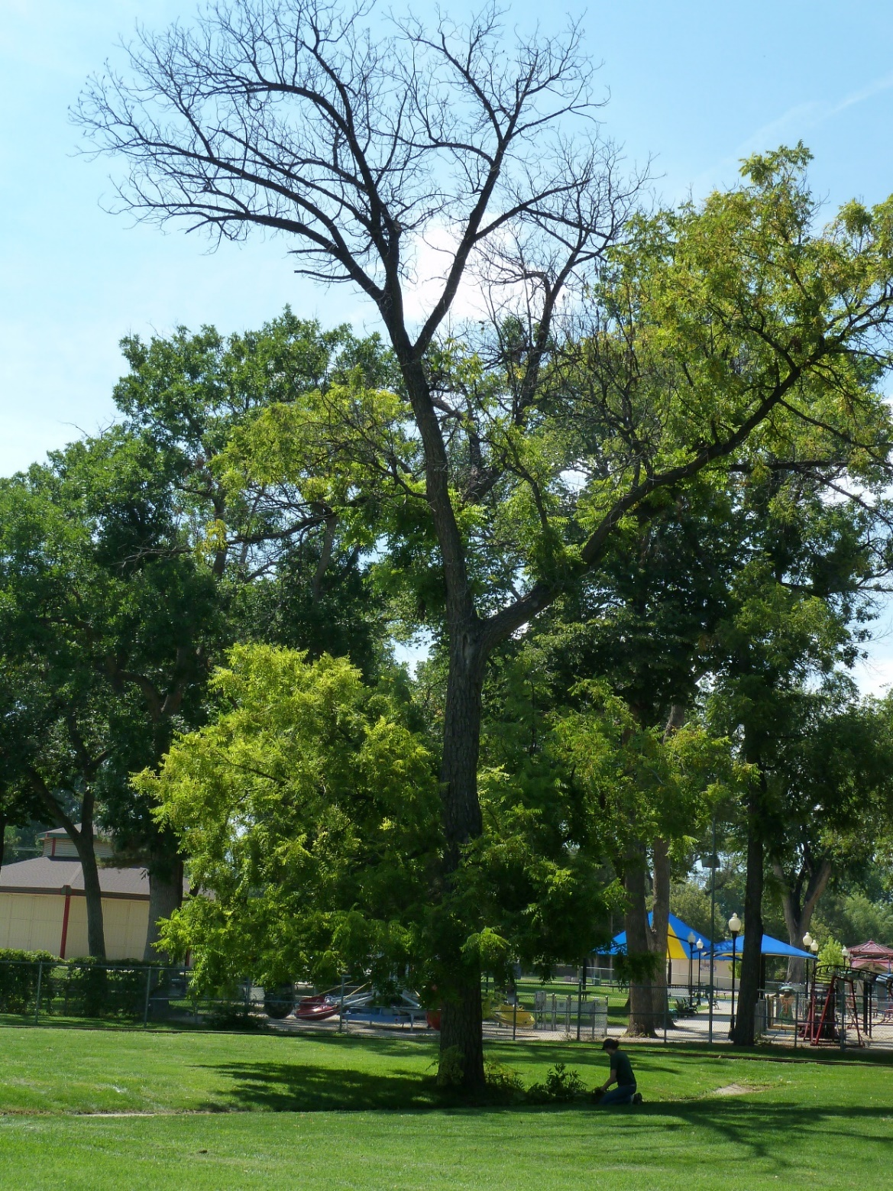
Figure 1. Thousand Cankers Disease symptoms on Juglans nigra trees.The symptoms include yellowing of the leaves, crown and branch dieback and formation of epicormic shoots. Image provided by Dr. Đenita Hadžiabdić

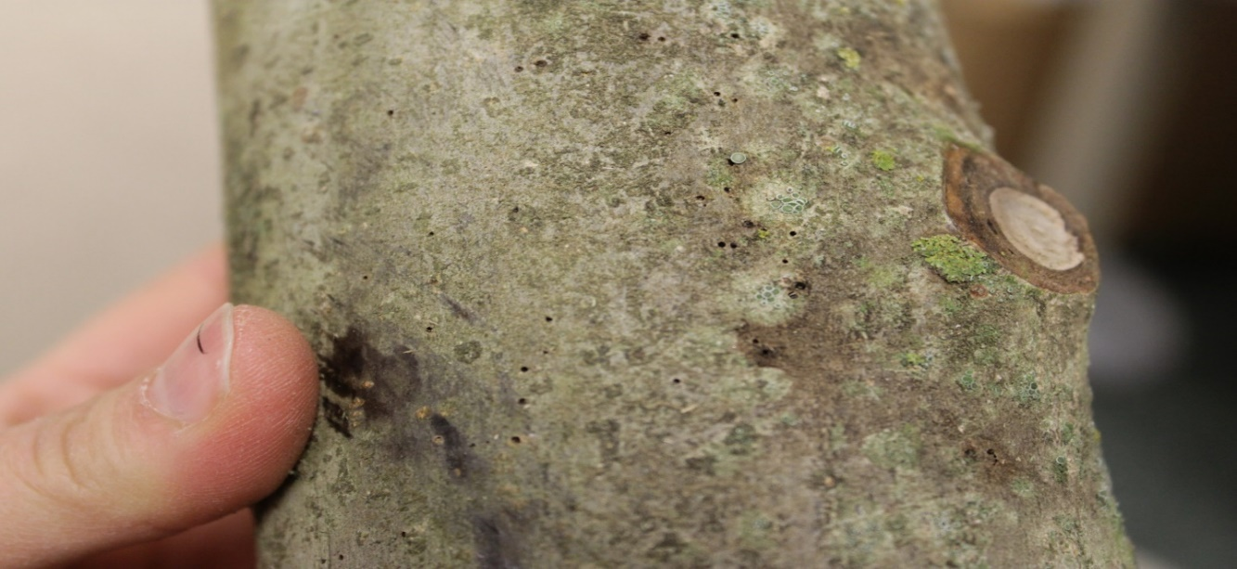
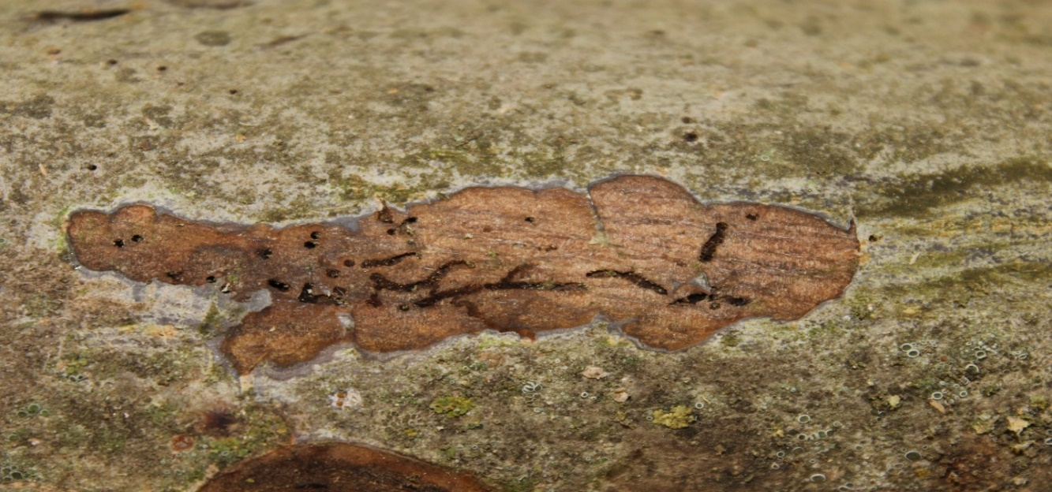

Figure 2. Pityophthorus juglandis galleries in the phloem (upper image) and exit holes (lower image in Juglans regia branches (arrows). Adult P. juglandis create entrance and emergence holes the size of a pinhead (0.64-0.75 mm) with galleries approximately 2.5 to 5 cm long. Images provided by Dr. Đenita Hadžiabdić.

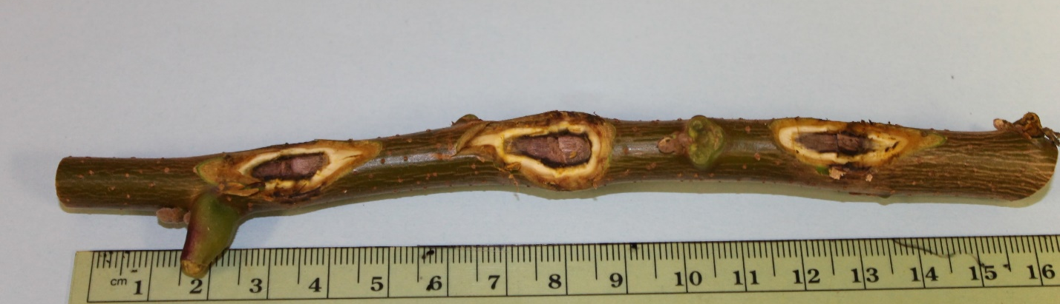
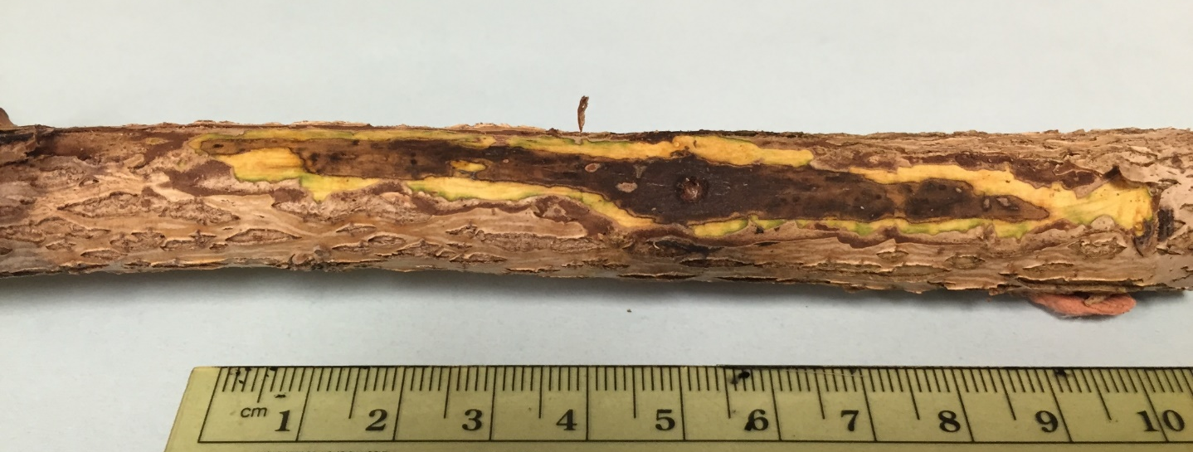 Figure 3. Geosmithia morbida induced elliptical cankers underneath Juglans nigra branches. Individual cankers (upper image) can coalesce and form large necrotic lesions underneath the bark (lower image) thus girdling the branch and resulting in rapid tree mortality. The cankers are visible only after the outer bark is removed. Images provided by Dr. Đenita Hadžiabdić - Guerry.

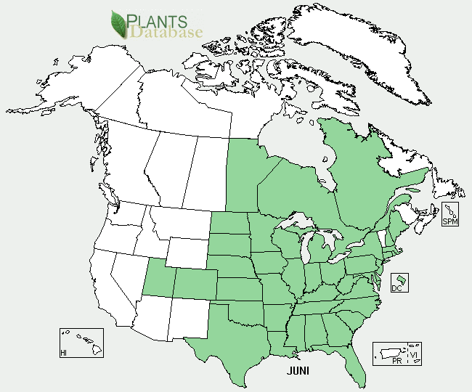
Figure 4. The native range of Juglans nigra (green shading). The map courtesy of USDA- NRCS Plant Database.

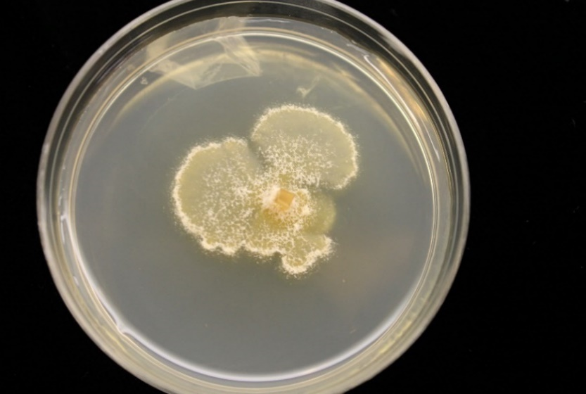
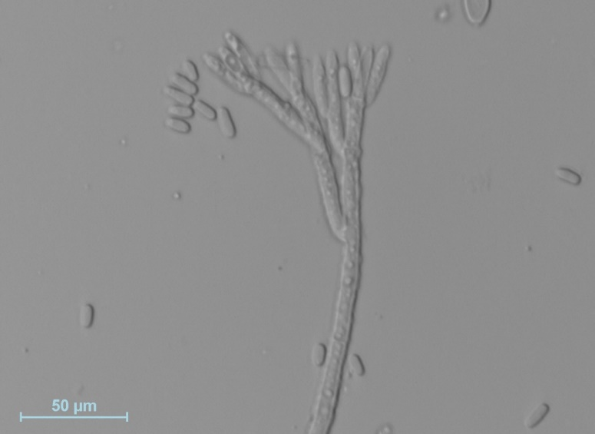

Figure 5. Geosmithia morbida. Cream colored to tan colonies of Geosmithia morbida grown on half strength potato dextrose agar (PDA) (left image). Conidia and conidiophore of G. morbida (right image). Images provided by Dr. Đenita Hadžiabdić and Tyler Edwards.

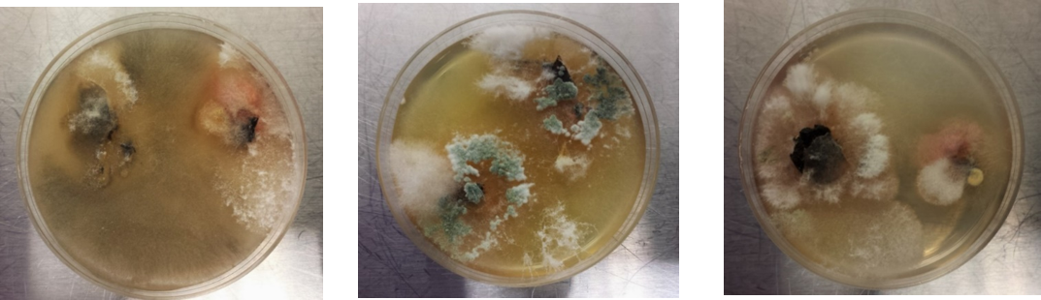
Figure 6. Mixed cultures collected from infested Juglans spp. galleries. Geosmithia morbida is slow growing pathogen that is often outcompeted by other faster growing fungi. Images provided by Dr. Romina Gazis.

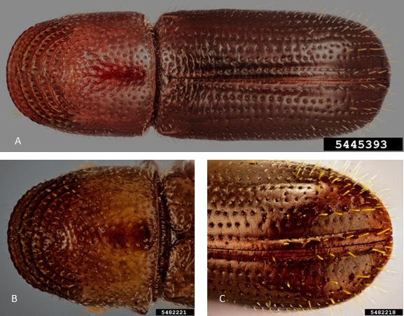
Figure 7. Pityophthorus juglandis.The body length is less than 2 mm (A); the pronotal asperities from the middle to the anterior margin form two or more well-defined concentric rows; anterior margin of pronotum with more than 12 asperities (B); apex of elytra evenly rounded (C). Images courtesy of Steven Valley.

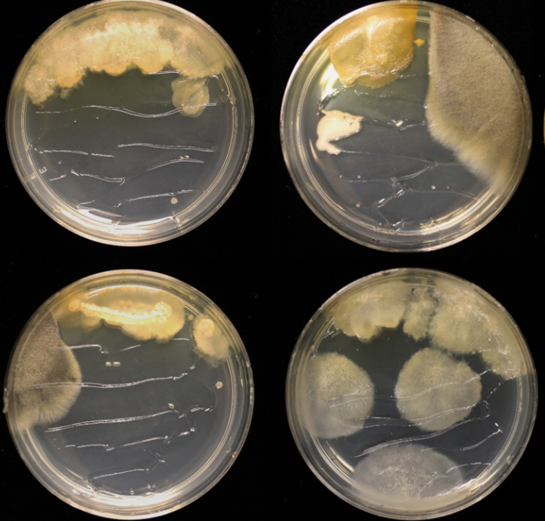
Figure 8. Mixed cultures from Pityophthorus juglandis colonized galleries. Detection methods of Geosmithia morbida is difficult due to other fungi that can grow faster and outcompete slow growing G. morbida. Image provided by Dr. Romina Gazis.
Figure 9. Three geographical locations used in rapid molecular detection study. The samples were collected from either within (California, Tennessee) or outside (Missouri) the current distribution of Thousand Cankers Disease.
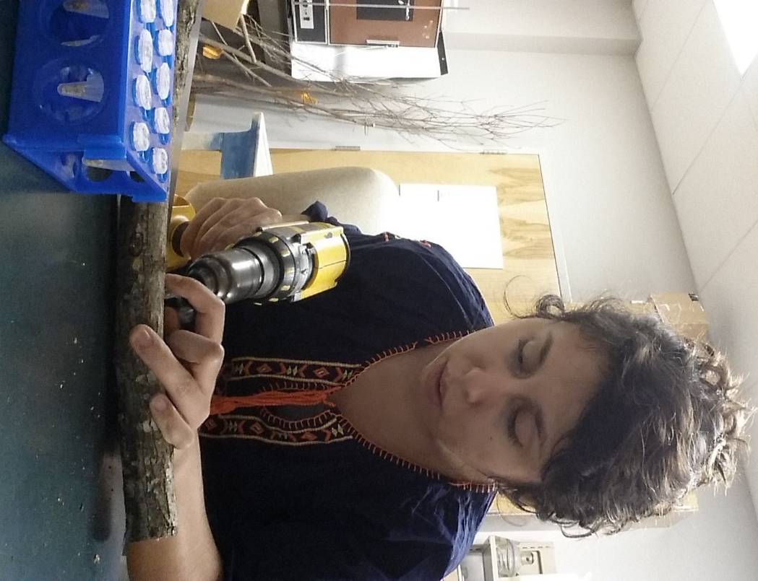
Figure 10. Drilling of Juglans spp. branches to obtain wood shavings used for DNA isolation. Drilling potential cankers for DNA isolation and molecular confirmation of presence/absence of Thousand Cankers Disease.
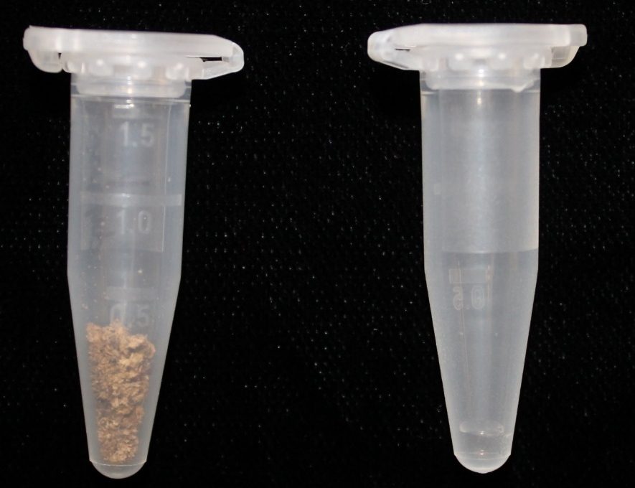
Figure 11. Batches of walnut drill shavings were collected into 1.5 ml safe-lock microcentrifuge tubes (left); solutions of isolated DNA were used for PCR amplification (right).

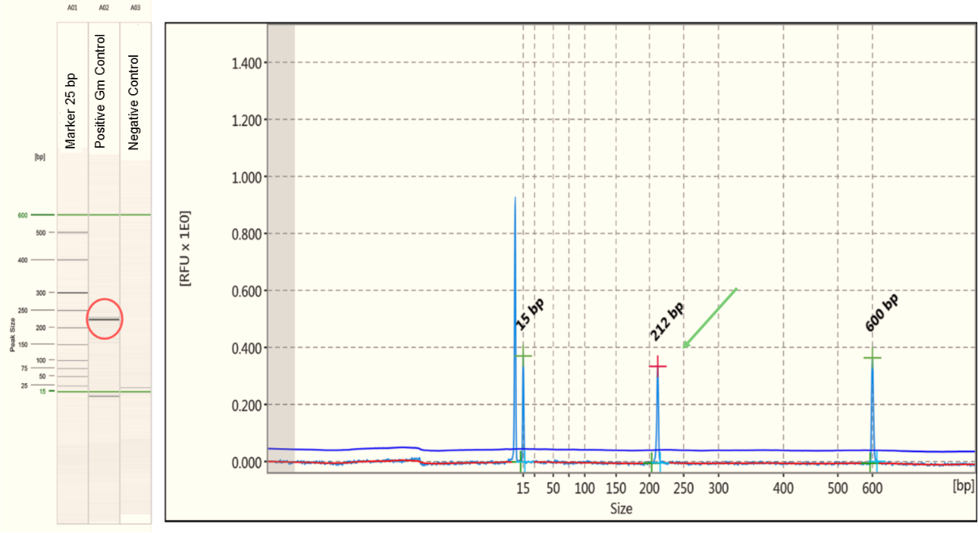
Figure 12. Thousand Cankers Disease molecular confirmation. Gel image of positive control (Geosmithia morbida) (circle) and negative control (water) based on 25 base pairs marker; electropherogram from Tennessee walnut shavings amplified with Geosmithia specific microsatellite locus, GS004.

Figure 13. Molecular detection of Thousand Cankers Disease complex member(s) percentage of positive drill samples from both feature-directed (n=400) and lesion-directed (n=800) samples from California, Missouri, and Tennessee.

Figure 14. Molecular detection outcomes among 40 Juglans nigra and J. hindsii samples from California, Missouri (control) and Tennessee.

A
B
C
Figure 15. Molecular detection of Thousand Cankers Disease complex member(s) among positive trees for all samples and both drilling methods (A), among positive trees for all samples using lesion-directed drillings (B), and among positive trees for all samples using feature-directed drillings (C).

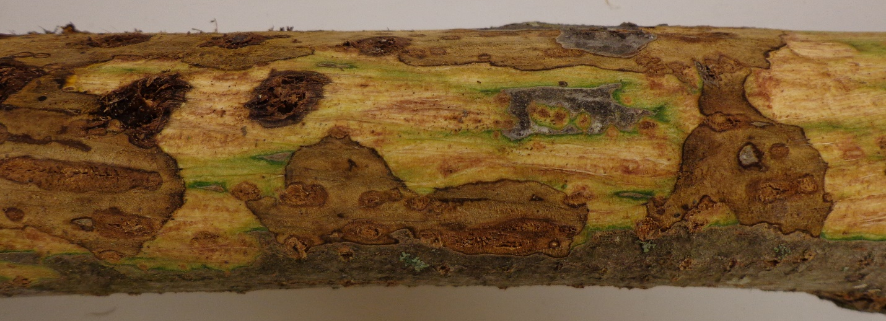
Figure 16. Canker areas under bark. Elliptical cankers in walnut phloem caused by Geosmithia morbida are visible only after the outer bark is removed. Image provided by Dr. William Klingeman.

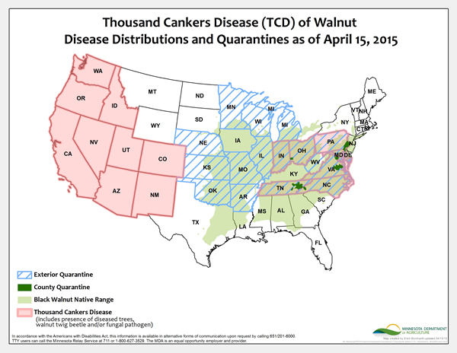
Figure 17. Thousand Cankers Disease distributions and quarantines areas as of April 15, 2015.Map courtesy Minnesota Department of Agriculture.

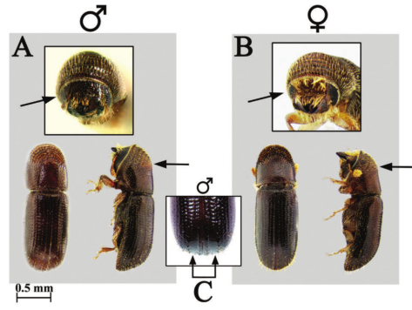
Figure 18. Pityophthorus juglandis. Comparison of morphological characters of male (A) and female (B) WTB. Arrows indicate the degree of pubescence on the male and female frons; the apex, which occurs before the midpoint on the anterior half of the pronotum of males and females; and granules on the male elytral declivity (C). Image provided by S. M Hishinuma, UC Davis and A. D. Graves, USDA Forest Service from (Seybold et al. 2013).


Figure 19. Geosmithia morbida. Four weeks old colonies of G. morbida grown on half strength potato dextrose agar (PDA) (A); conidia and conidiophore (B). Images provided by Dr. Romina Gazis – Seregina (A), Dr. Đenita Hadžiabdić Guerry (B).

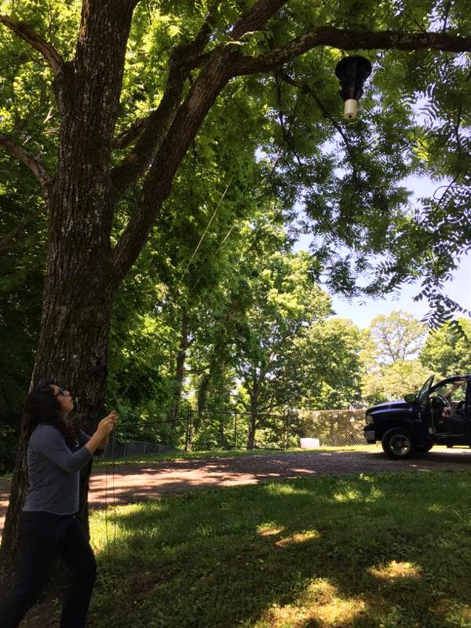
Figure 20. Placing the trap about 2.5 to 4.5 m from the main stem of suspect walnut tree, 1.5 to 3 m from the live branches of that tree’s crown and hang the trap on a 3 m pole. Image provided by Dr. Đenita Hadžiabdić.

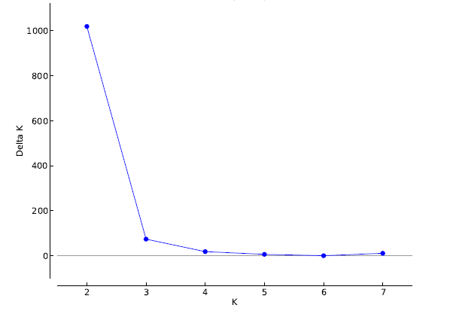
Figure 21. Maximum ΔK at K = 2 estimated using Evanno’s methodfor 839 Pityophthorus juglandis individuals using 12 SSRs.

Figure 22. Structure bar graph representing 2 and 3 genetic clusters of 839 Pityophthorus juglandis individuals from three geographic regions (northwestern, southwestern, and eastern US, and Italy) using twelve microsatellite loci.

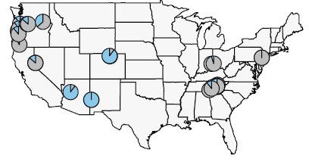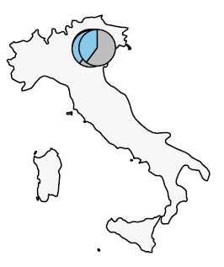

Figure 23. The model-based clustering results produced by TESS indicated the presence of three genetic clusters based on the lowest DIC value. Above map shows US subpopulations, below map shows Italy subpopulations.

Vita
Emel Oren was born in Mugla, Turkey, to the parents of Selma and Feyzullah. She is first of two daughters. She attended Emirbeyazit Primary School and continued to Mugla Anatolian High School in Mugla. After graduation she headed to Aydin, little northwest of Mugla, Adnan Menderes University where she was introduced to Agricultural Engineering program, major in plant protection. After completing her undergraduate, she got a fellowship for United States Master. She started English Language Institute in University of Delaware, Newark, Delaware. After she started her master with Dr. Denita Hadziabdic as her first student in University of Tennessee, Knoxville. During the master education, she got two 2nd places in student paper competition and student poster competition, Tennessee Entomological Society and southern Chapter of International Society of Arboriculture. Emel graduated with a Master of Science degree in Entomology and Plant Pathology in December, 2016.

