The Evolution of PET Throughout Heterogeneous Glycolysis and the Repolymerization of Oligomers

Kendra M. Day

Dr. Mark Dadmun and Shelby Watson-Sanders
Dr. Nemykin

CHEM 408: Honors: Research in Chemistry

May 3, 2025

Acknowledgments
I would like to express my sincere gratitude to my mentor, Dr. Mark Dadmun, for his consistent guidance and support throughout all my academic endeavors. His knowledge, vision, and willingness to help have been instrumental in meeting my research goals and completing my thesis. From taking me in as a freshman to sending me off as a senior, Dr. Dadmun has been pivotal in my choice to pursue polymer science moving forward, and I am immensely grateful.
Likewise, I am extremely thankful to my graduate student mentor, Shelby Watson-Sanders, for her unwavering encouragement and dedication to my success. She has put countless hours toward this project, and I could not have accumulated, analyzed, or presented my results without her. I have learned countless skills from her in the past 2.5 years, and I am so thankful for her positivity, critical thinking, and friendship.
I wish to acknowledge my thesis committee for the time and effort they have dedicated to reviewing my materials and bettering my work. I could not have done it without their guidance and careful consideration. Alongside my committee, I wish to thank the staff at the University of Tennessee, Knoxville for their assistance and for countless opportunities to share and improve.
I am thankful to our collaborators at the National Renewable Energy Laboratory for their contribution to our data. We could not have drawn such thorough conclusions without their aid and expertise. I also wish to acknowledge the generous financial support we received from the National Science Foundation for this project. Without them, I could not have accessed the materials or equipment necessary to complete the project.
Finally, I wish to thank my loved ones for their continuous support and encouragement throughout my academic career and scientific pursuits. They have heard about my research more times than anyone, and I wouldn’t be here without them.
Table of Contents
1. Abstract 4
2. Introduction 5
3. Experimental 9
3.1. Flake Formation 9
3.2. Glycolysis Reaction 11
3.3. Repolymerization 12
3.4. Time Evolution of PET oligomer Repolymerization 13
3.5. Mechanical Testing of Repolymerized PET Samples Formed by Melting 13
3.6. Mechanical Testing of Repolymerized PET Samples Formed by Solvent Casting 14
3.7. Swelling Experiments 15
3.8. PET Structural Analysis 15
4. Results and Discussion 17
References 36

Abstract
Polyethylene Terephthalate (PET) is one of the most common plastics and is often mechanically recycled on an industrial scale, making it a prime material for chemical recycling. However, it is energy and cost-intensive to convert PET to monomer. Thus, our research seeks to simplify the recycling process by producing PET oligomers from consumer waste and reincorporating them into new materials. We seek to elucidate the evolution of chain structure during PET depolymerization to demonstrate the impact of particle size and thus particle surface area on reaction intermediates throughout depolymerization and repolymerization. These experiments follow the decrease in molecular weight (M_{n}), decrease in dispersity (Đ), and increase in percent crystallinity of depolymerized PET flakes of varying lengths (4 mm, 18 mm, or 44 mm). Our interpretation of chain evolution envisions ethylene glycol (EG) diffusing into the polymer flake to first react with amorphous polymer. Our results indicate that the diffusion of EG into the smallest dimension of the polymer flake, its thickness (0.3 mm), governs the heterogeneous reaction rather than being controlled by the overall particle size or particle surface area. Furthermore, we seek to understand chain evolution to access and control the structure of oligomer intermediates, which we repolymerize through annealing to achieve molecular weights and tensile strengths similar to virgin PET. Ultimately, our results illustrate that intermediates can be repolymerized and used to produce value-added materials through less energy-intensive methods than depolymerization to monomers.

Introduction
Plastic demand and production are rapidly increasing, but plastic waste is poorly managed. In the past 15 years, about half of all plastics have been produced, with production expected to reach 900-1100 megatons by 2050.¹ Estimates suggest that only around 9% of plastic waste is recycled while around 30% is mismanaged or leaked into the environment.² Therefore, current recycling trends cannot sustain long-term increases in demand and production. Efforts to reduce plastic utilization or replace plastic packaging have induced higher carbon dioxide emissions, more solid waste, and higher energy and water consumption.² Developing sustainable recycling methods is necessary to combat environmental pollution and the impact on marine life of plastic waste. Once they reach the environment, plastics can persist for hundreds of years and degrade into life-threatening microplastic or nanoplastic particles.³ Polyethylene terephthalate (PET) is one of the most commonly discarded plastics, with PET bottles being the most frequent item found in modern waste streams.^{4,5} Many companies have taken to mechanically recycling PET, which can degrade the polymer and reduce its performance with repeated implementation.⁶⁻⁸ However, recycling efforts demonstrate the viability of PET as a material for chemical recycling. Chemical recycling can maintain and enhance materials’ mechanical and physical properties, allowing plastics to undergo a closed-loop lifecycle where raw materials are replenished without downcycling, disposal, or landfilling. The widespread adoption of chemical recycling would reduce the production of volatile organic compounds, greenhouse gases, and mutagenic or carcinogenic byproducts caused by incineration.³ By successfully recycling PET bottles, there is potential to decrease global plastic pollution by over 10% while providing methods to chemically recycle all PET consumer products.⁴
Chemical recycling begins by converting polymer waste into small molecules using heat or chemical depolymerization.⁹ PET can depolymerized through glycolysis, pyrolysis, hydrolysis, methanolysis, enzymatic degradation, and more reactions.¹⁰ As PET's most common depolymerization method, alcoholysis reactions such as glycolysis, ethanolysis, and methanolysis utilize an alcohol reactant to depolymerize PET. These reactions depend heavily on the design and efficacy of the catalyst used.¹⁰ As a result, several authors have investigated catalysts with varying effectiveness and environmental impacts. Carvalho, Muniz, and Rubira propose the hydrolysis of consumer PET waste using sulfuric acid.¹¹ While effective in producing crystalline oligomers, sulfuric acid is corrosive, toxic, and potentially harmful to the environment and living organisms. Similarly, Mohammadi, Bouldo, and Enayati incorporate microwave irradiation in the depolymerization reaction to produce higher-order oligomers in the depolymerization of PET.¹² Producing 100% oligomers in only 5 minutes, this reaction utilizes a carcinogenic and environmentally toxic catalyst, antimony(III) oxide.¹² Both Cao et al. and Wei et al. employed alcoholysis reactions with zinc-based catalysts, using oxygen vacancy-rich Fe/ZnO nanosheets and zinc acetate, respectively, as catalysts.^{10,13} In addition to the potential of zinc to harm aquatic life, the catalyst workup completed by Cao et al. required temperatures of 350-500$℃$.¹⁰ Wang et al. achieved a depolymerization process free of catalysts using a twin-screw extruder with BHET as an alcoholysis agent.¹⁴ This process rapidly depolymerizes PET into oligomers but requires heating the material to 290 $℃$.¹⁴ For these reasons, alcoholysis reactions have found great potency in depolymerizing PET to controlled-weight oligomers. However, many alcoholysis reactions require environmentally unfriendly catalysts or harsh reaction conditions that make them less economically feasible and industrially relevant.
Glycolysis is the most common PET depolymerization mechanism due to its low cost, commercial viability, and mild conditions.^{13,15} Through glycolysis, PET can be depolymerized with ethylene glycol and an environmentally green catalyst, triazabicyclodecene: methanesulfonic acid (TBD:MSA).¹⁶ TBD:MSA is thermally robust with high depolymerization efficiency and enhanced recyclability compared to other catalyst systems used in alcoholysis.¹⁷
The heterogeneous glycolysis of PET is often characterized as occurring at the surface of the PET flakes, which leads to the reaction rate being dependent on the particle's surface area. If accurate, glycolysis would transpire through interfacial collisions of the glycol with the surface of a PET particle, where small pieces of monomer and oligomer are broken off the polymer surface. We seek to interrogate this assumption by examining how flake size impacts the depolymerization rate of PET by glycolysis and the dependence of the reaction rate on the diffusion of ethylene glycol into the amorphous sections of the semi-crystalline PET flakes. Additionally, our group has studied the heterogeneous glycolysis reaction to elucidate the evolution of the structure of reaction intermediates that enables the isolation of oligomers through less energy-intensive methods than depolymerization to monomers.¹⁸

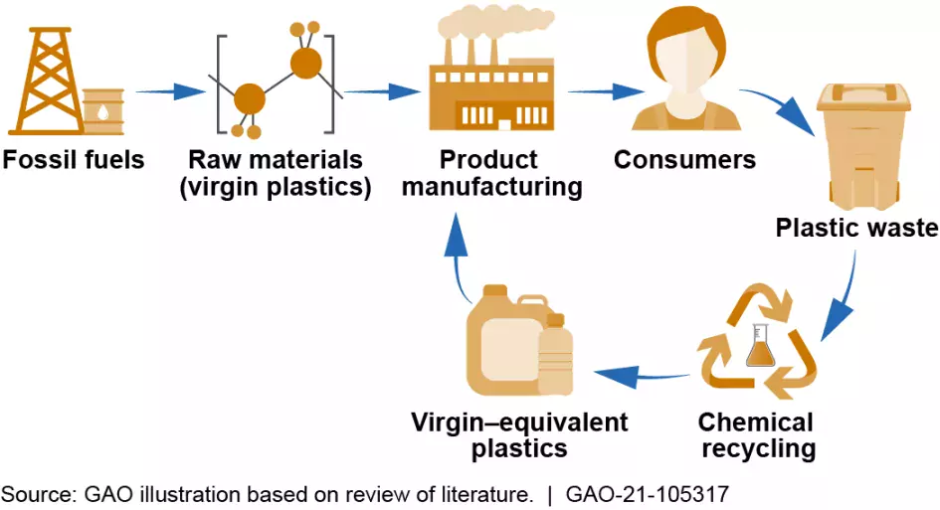
Figure 1: Lifecycle of plastics derived from fossil fuels with the utilization of chemical recycling, adapted from Reference 19.

The repolymerization of PET from oligomers or monomers allows for its utilization in closed-loop recycling, which may produce value-added materials that have greater economic or functional value than the original product. Breaking down PET polymers into monomers or oligomers by glycolysis results in an increase in the number of hydroxyl end groups of the PET chain. Annealing these oligomers at elevated temperatures provides pathways for these hydroxyl end groups to react and repolymerize the oligomer to new polymer chains. The success of the repolymerization of oligomers can be evaluated through a mechanical analysis of the resulting material, with higher tensile strength indicating a more useful plastic.
Therefore, our group has focused on repolymerizing PET through annealing without degradation or the diminishment of mechanical properties. Using less harsh reaction conditions, more environmentally safe chemicals, and scalable methodologies, these studies seek to achieve the closed-loop chemical recycling of PET for use in value-added products. Our research addresses the impact of particle size, depolymerization time, and annealing time on the mechanical properties of the re-polymerized PET. In these studies, PET flakes were produced from consumer waste Coca-Cola bottles and cut into pieces with equal widths and thicknesses but varying lengths (4 mm, 8 mm, 18 mm, 28 mm, 44 mm), altering their surface areas. Using differential scanning calorimetry (DSC), nuclear magnetic resonance (NMR) spectroscopy, and gel permeation chromatography (GPC), we determined the flakes’ crystallinity, dispersity, molecular weight, and number of alcohol end groups throughout the depolymerization. After understanding this evolution of polymer chains, the oligomers were repolymerized and formed into sheets for Instron testing and comparison to virgin PET. These experiments demonstrate the impact of depolymerization and annealing times on the successful repolymerization of PET. Through these methodologies, consumer PET was chemically recycled and mechanically analyzed to mitigate the issue of abundant plastic waste in the environment and landfills.

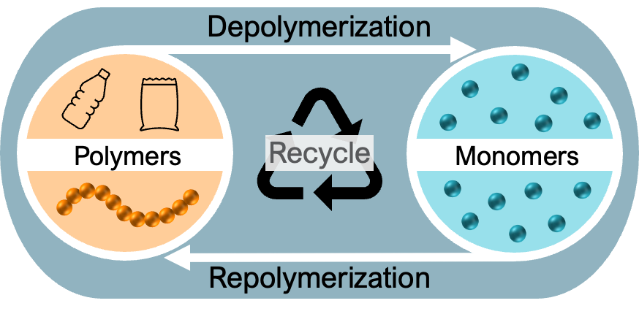
Figure 2: Recycling process showing the depolymerization of polymers into monomers and the subsequent repolymerization of monomers back into polymers, adapted from Reference 20.

Experimental

Flake Formation

PET Coke bottles were washed and dried before being spiraled with a razor blade apparatus that controls for the width of the plastic strips. The spiraled plastic was then cut into flakes with various lengths using scissors. After all flakes were cut, 20-30 flakes of each length were precisely measured and used to determine the average length of all flakes of that size. Flakes were produced with nominal lengths of 4, 8, 18, 28, and 44 mm. Figure 3 shows the 44, 18, and 4 mm flakes along with a diagram designating the width, length, and thickness of a flake. Figure 4 shows the measured PET flake lengths and the average length for each labeled flake size.
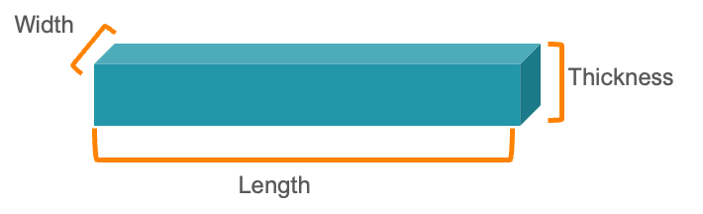
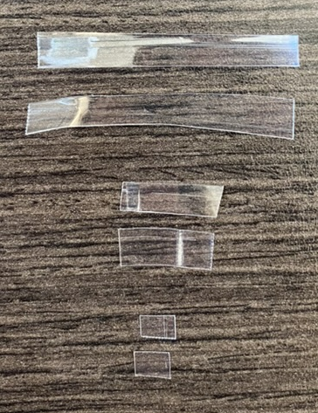
Figure 3: Image showing 44, 18, and 4 mm flakes from top to bottom (left), along with a diagram showing how the width, length, and thickness were measured for each flake (right).

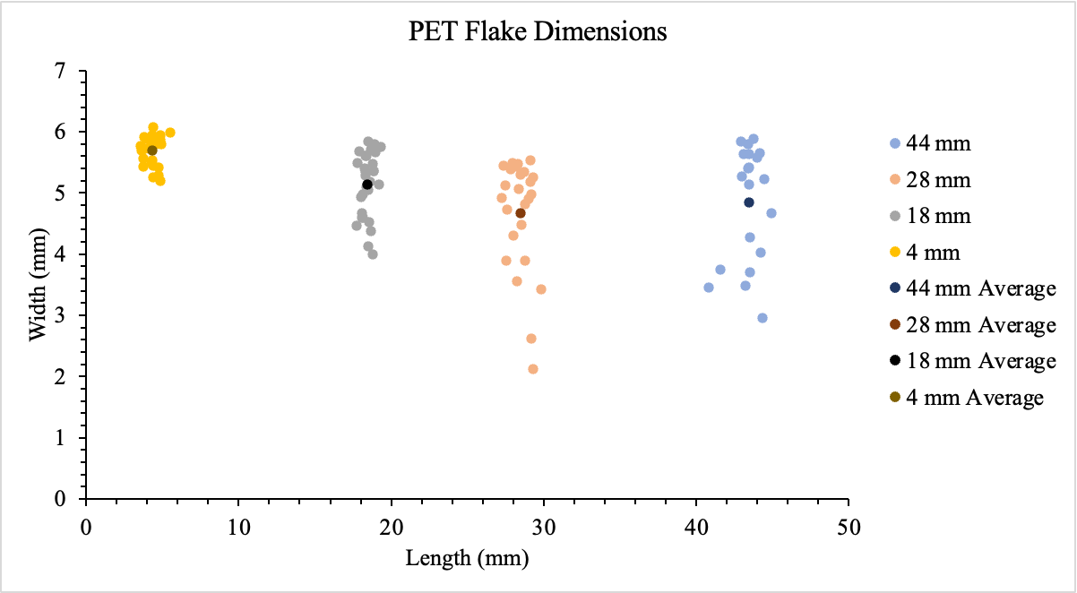
Figure 4: Graph depicting measured flake lengths and calculated average flake lengths (dark dot) for flakes labeled 44, 28, 18, and 4 mm.

Glycolysis Reaction
The salt organocatalyst was prepared in a glovebox by mixing triazabicyclodecene (TBD) (>98%, Tokyo Chemical Industry) and methanesulfonic acid (MSA) (>99%, Tokyo Chemical Industry) at molar ratios to acid to base (1:1) at 80 ºC for 15 minutes. Ethylene glycol (EG) (Oakwood Chemical and Sigma-Aldrich Chemicals), salt catalyst, and PET (20:0.5:1 molar ratio) were placed in a reaction vial in a Labconco glovebox before being transported to an oil bath. Scheme 1 exemplifies this reaction. The reaction mixture was stirred in an oil bath at 180 °C, where samples were removed in 15-minute intervals. Figure 5 shows the arrangement of reaction vials in an oil bath for depolymerization.

Scheme 1: Reaction scheme for the depolymerization of PET into oligomers using a TBD:MSA catalyst and ethylene glycol.
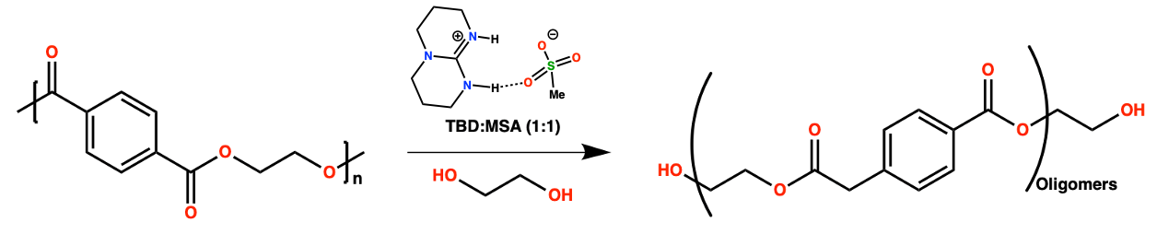

After the allotted time, the samples were removed from the oil bath, and water was added to stop the depolymerization reaction and stirred for 5-10 minutes. The water, ethylene glycol, and soluble products were decanted from the PET solids, adding more water. The solid flakes were washed for 5-10 minutes before the water was poured off. The flakes were then allowed to dry at 60 °C overnight. For the scaled-up reactions, the procedure was repeated with the same molar ratio of reactants. The reactions were completed under nitrogen using a round bottom flask with a sidearm.

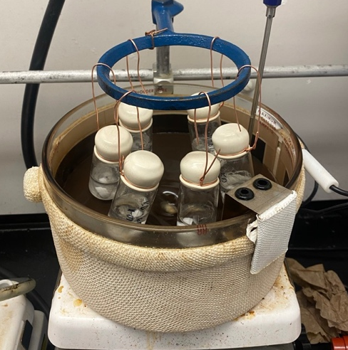
Figure 5: Oil bath setup for the depolymerization of PET via glycolysis in 1-gram portions.

Repolymerization
Oligomers from 8mm samples that had been depolymerized for 60 and 105 minutes were annealed for 13 hours at 240 °C to allow for repolymerization in a Thermo Fisher Scientific Lindberg Blue M vacuum oven. The repolymerized samples and virgin PET were separately dissolved in hexafluoroisopropanol (HFIP) (Oakwood Chemical). The dissolved PET was precipitated in methanol ($≥$99.8%, Fisher Chemical) to remove impurities. The setup can be seen in Figure 6. The precipitate was collected using a Buchner funnel, and the solid was allowed to dry overnight. The precipitate was then blended in a Nutri Bullet blender and vacuum-dried in a Stabil-Therm Blue M oven for 4 hours at 200-220 °C.

Time Evolution of PET oligomer Repolymerization
10 g PET samples that had been depolymerized for 120 minutes were distributed among 12 vials. Vials 1-9 were annealed in a vacuum oven to anneal at 240 °C for increments of 6 hours ranging from 6 hours to 54 hours. Vials 10-12 were used for nuclear magnetic resonance (NMR) analysis, viscosity testing, and future comparison.

Mechanical Testing of Repolymerized PET Samples Formed by Melting
Repolymerized PET was removed from the vacuum and taken to a hot plate heated to 280°C. Kapton film was placed on the hot plate, and an oval of precipitate was poured on the film (Fig. 6). The precipitate was melted in the air for 30 seconds before a second piece of Kapton was placed on the solid and topped with a metal disk. The solid was melted under the disk for 1-2 minutes before being flipped, melted for an additional 0.5-1.5 minutes, and removed from the hot plate. Upon removal, the sheet was placed onto the hot piece of metal to slowly cool to room temperature. The sheets were then cut into dog bones using a Carver Model C Laboratory Press and a sharp dog bone cutter. The mechanical properties of the dog bones were analyzed using an Instron 5965.

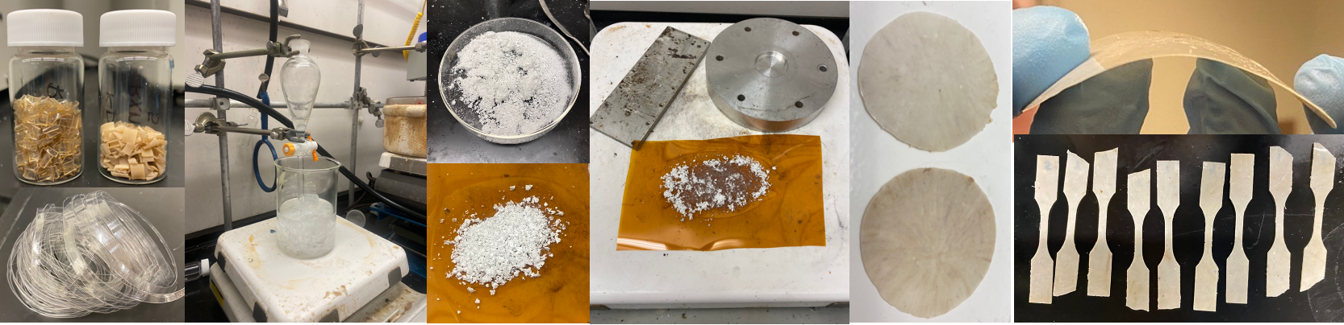
Figure 6: Images showing the depolymerized and virgin PET, the precipitation in methanol setup, the blended material, the melting setup on the hot plate, the melted virgin PET sheets, and virgin PET dog bones.

Mechanical Testing of Repolymerized PET Samples Formed by Solvent Casting
0.5 g PET samples that had been depolymerized for 120 minutes and repolymerized for 26 hours were dissolved in about 3 mL of HFIP. Excess HFIP was removed using rotary evaporation to produce a solution with a syrup consistency. The solution was poured onto a level, clean metal sheet. As shown in Figure 7, a film of the concentrated PET solution was formed by doctor blading using a 6 mil film casting knife from BYK, creating an even film that is 10 mm wide. This film was covered with a piece of aluminum foil to prevent particulates from sticking to the surface as it dried. After fully air-drying, the sheet was removed from the metal and dried in a vacuum oven at 70 $℃$ for 8 hours. The sheets were then cut into dog bones using a Carver Model C Laboratory Press and a sharp dog bone mold. The mechanical properties of the materials were tested using an Instron 5965.

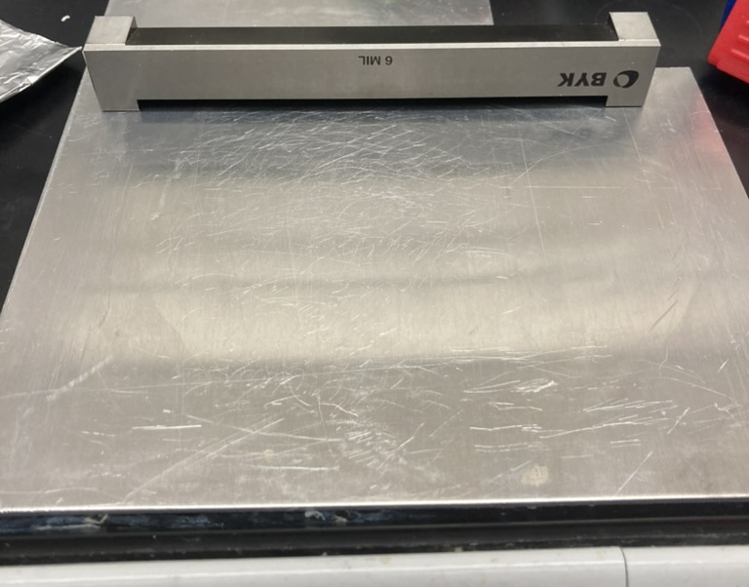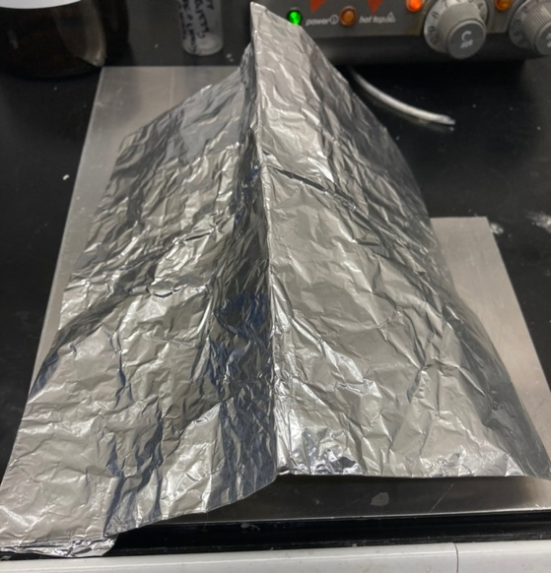
Figure 7: Images of the solvent casting setup. Left: metal sheet and solvent leveler. Right: cast sheet covered with aluminum foil to prevent particulate contamination.

Swelling Experiments
0.5 g of PET flakes were placed in a vial with a 30-mole ratio of EG:PET. The number of flakes in each vial was recorded, as it varied with flake size. The vials were placed in an oil bath at 180$℃$ for 30, 60, 90, and 120 minutes to swell. After being removed from the oil bath, the EG was poured off, and the PET flakes were dabbed with filter paper to remove residual solvent. The flakes were weighed and placed on a hot plate to dry at 60 $℃$. Using Equations 1 and 2, the swelling percentage by mass and the normalized swelling per flake was calculated.

$\frac{Final Mass of Flakes-Initial Mass of Flakes}{Initial Mass of Flakes }*100$ Eqn. 1
$\frac{Final Mass of Flakes-Initial Mass of Flakes}{Number of Flakes}$ Eqn. 2

PET Structural Analysis
PET samples for NMR analysis were dissolved in HFIP using 20 mg of PET in 1 mL of HFIP. The PET: HFIP mixture was agitated for 5 days before 50 microliters of the mixtures were mixed with 800 microliters of deuterated chloroform (CDCl₃) (99.8%, Thermo Scientific). NMR analysis was conducted with a Jeol 400YH spectrometer, where the spectra were analyzed to determine the number average molecular weight of virgin, depolymerized, and repolymerized PET. Equation 3 introduces how molecular weight can be determined from the NMR analysis of the end groups that are present. The variable "A" in Equation 3 denotes the integral of a peak. The "H" value denotes the number of protons that the peak represents, while the "n" value represents how many repeat units in the polymer there are of that designated peak. The molecular weight can be determined from NMR because there is only one -OH end group in a polymer chain and is not repeated throughout the chain; therefore "nx" can be determined for a peak representing a proton sequence that is repeated throughout the chain. Figure 8 shows three peaks and corresponding hydrogen atoms in PET that are used during NMR end-group analysis.
$\frac{\left(\frac{Ax}{Ay}\right)Hyny}{Hx}=nx$ Eqn. 3
The viscosity average molecular weight of the PET samples was also determined by measuring the intrinsic viscosity of the PET samples, while differential scanning calorimetry (DSC) was used to determine the percent crystallinity of the PET samples. In the viscosity measurements, 150 mg of PET was dissolved in HFIP for testing on a Schott Viscometer. In the DSC experiments, 3-5 mg of PET was used for crystallinity analysis on a TA Instruments Q 2000 DSC.¹⁸ Gel-permeation chromatography (GPC) analysis was also completed on the depolymerized PET samples with help from our collaborators at the National Renewable Energy Laboratory (NREL). The Fourier-transform infrared spectroscopy (FTIR) spectra of the solvent-cast sheets of virgin PET and repolymerized PET before and after drying at 70$℃$ in the vacuum oven using a Thermo-Scientific Nicolet iS50 FT-IR Spectrometer.

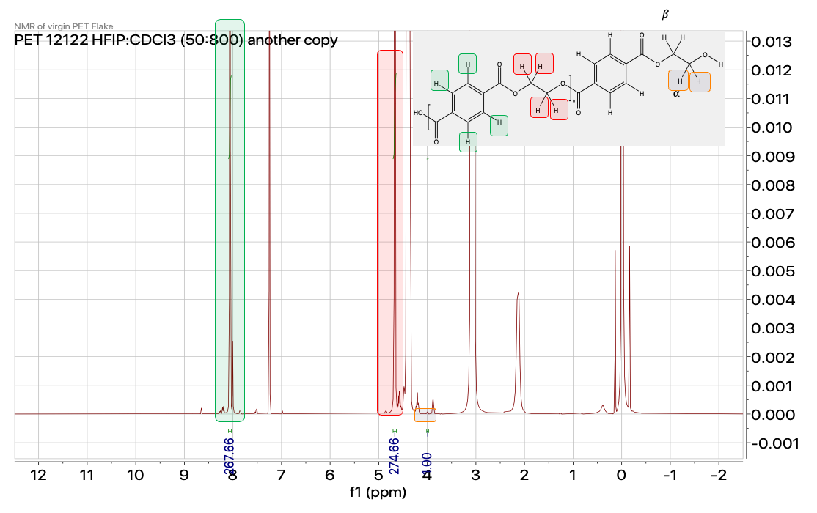
Figure 8: ¹H NMR spectrum and chemical structure of virgin PET. The hydrogen atoms and corresponding peaks utilized for end group analysis are highlighted.

Results and Discussion

The heterogeneous depolymerization of PET via glycolysis with a TBD:MSA catalyst cleaves PET to produce monomers, dimers, and oligomers which have 1-2 alcohol end groups per chain (Scheme 2). The current experiment seeks to discard small molecules such as monomers and dimers, i.e., bis(hydroxyethyl) terephthalate (BHET), to focus on repolymerizing low molecular weight oligomers into value-maintained or value-added materials. Furthermore, the experiment seeks to correlate depolymerization and repolymerization conditions to the properties of the reaction products to consistently produce low-molecular-weight oligomers upon depolymerization and high-molecular-weight chains upon repolymerization. A goal of these studies is therefore to produce oligomers that can consistently reform PET chains with similar molecular weights and mechanical properties to virgin PET.

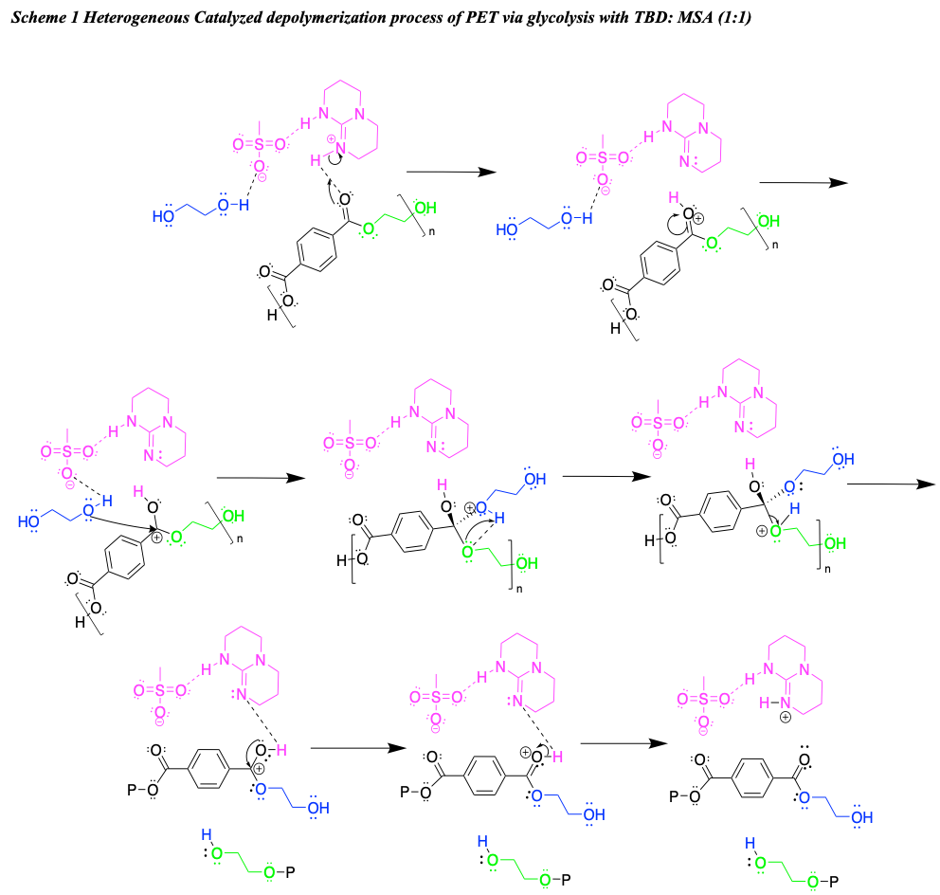
Scheme 2: Heterogeneous depolymerization process of PET via glycolysis catalyzed with TBD: MSA (1:1)., where P represents the polymer chain.

Impact of Flake Size on the Evolution of Chain Structure During PET Glycolysis.
Several trends were observed throughout the depolymerization of PET flakes with differing lengths. Figure 9 shows the change in percent crystallinity of 44 mm PET flakes (blue) and 8 mm PET flakes (green) with depolymerization time, as well as 8 mm PET flakes with annealing time at 180 °C, i.e the reaction temperature (yellow). It is observed that the depolymerized PET samples with different surface areas have similar increases in percent crystallinity with reaction time, while the PET flakes that are annealed at 180 °C without catalyst have lower crystallinities than the sample annealed at 180 °C with catalyst. This difference in percent crystallinity is attributed to the reaction playing a role in the increase in bulk crystallinity. Figure 10 shows the change in dispersity of the 44 mm (blue), 18 mm (orange), and 4 mm (purple) flakes with glycolysis time. This shows that the dispersity of the PET from all flake sizes decreases with reaction time, demonstrating that the oligomers are becoming more uniform in chain length with reaction time. Despite having drastically different surface areas, 44 mm and 8 mm particles showed similar increases in percent crystallinity (Fig. 9), decreases in dispersity (Fig. 10), and decreases in molecular weight (Figs. 11 and 12). The DSC results show that the percent crystallinity increases as a function of depolymerization time, but flakes with different lengths maintain similar crystallinity throughout the reaction, especially at low reaction times.

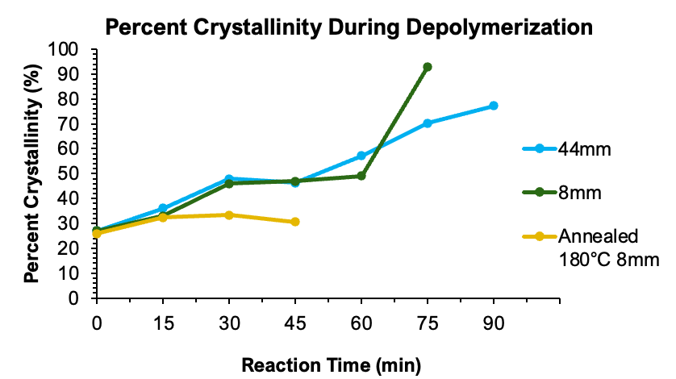
Figure 9: Changes to percent crystallinity for depolymerized oligomers as a function of glycolysis reaction time for the shown flake lengths.

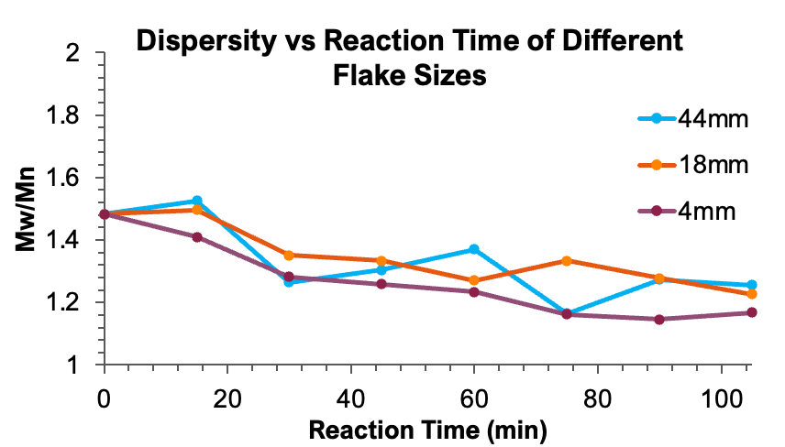
Figure 10: Changes to dispersity index for flakes of different flake lengths as a function of reaction time.

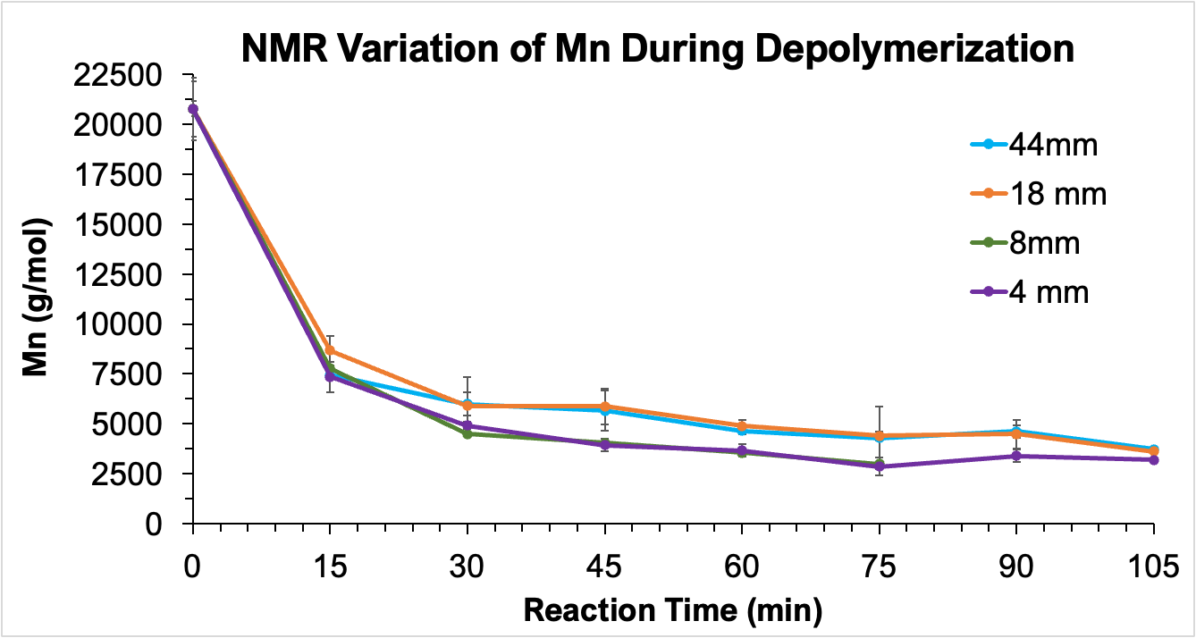
Figure 11: Variation in chain molecular weights throughout the depolymerization reaction for flakes of different lengths as determined by ¹H NMR spectroscopy.

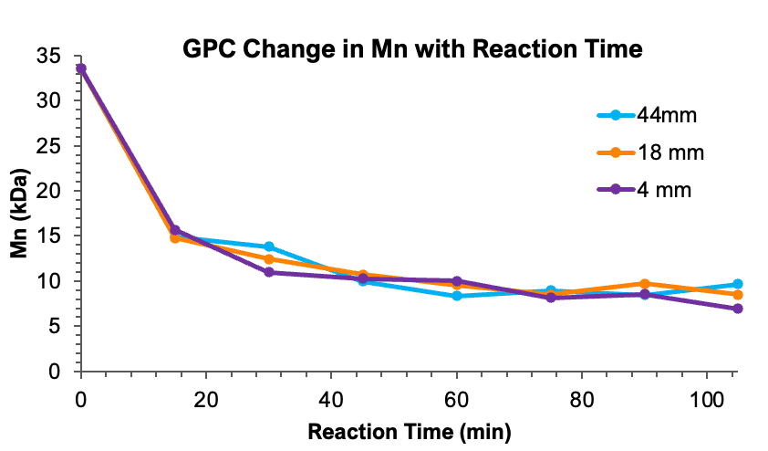
Figure 12: Changes in chain molecular weight with reaction time for different flake lengths as determined by GPC analysis.

Figure 13 shows an increase in the percent crystallinity of both 8 mm and 44 mm flakes as a function of reaction time, with extremely similar values. Additionally, this plot shows that both flake sizes undergo similar decreases in molecular weight with reaction time. Interestingly, the ¹H NMR spectroscopy shows that the progression of chain molecular weight does not vary with particle size. We interpret this data to indicate that the diffusion of EG into the smallest dimension of the polymer flake, its thickness (0.3 mm), governs the heterogeneous reaction, rather than being controlled by the overall particle size or particle surface area.

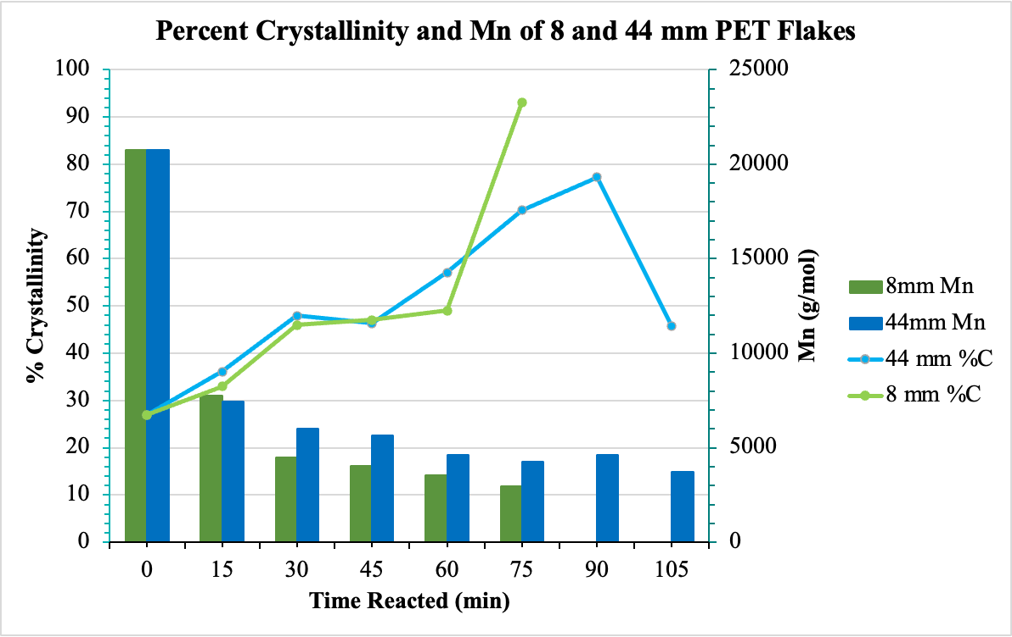
Figure 13: Plots of the percent crystallinity and number average molecular weight of the 8 and 44 mm PET flakes throughout depolymerization.

Figure 14 depicts our interpretation of chain evolution during glycolysis. In this process, ethylene glycol diffuses into the polymer flake to first react with amorphous polymer while being bound by the crystalline phase. The chain scission of the amorphous ties chains lowers the dispersity of the depolymerized intermediates. Figure 15 shows the change in flake appearance as a function of increasing depolymerization time from 15 to 90 minutes. Flakes reacted for extended periods become opaque, brittle, and powdery compared to the transparent and pliable starting material. The change in appearance is consistent with amorphous polymer being removed from the flakes to leave behind crystalline sections with visibly diminished mechanical properties. Thus, chain scission occurring in the amorphous portions of semi-crystalline flakes allows for the production of useful oligomer intermediates with hydroxyl end groups that may react during repolymerization.

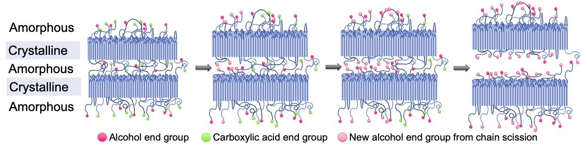
Figure 14: The cutting of amorphous tie chains and the production of alcohol end groups from chain scission.¹⁸

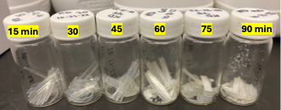
Figure 15: The change in flake appearance and structure with depolymerization time from 15 to 90 minutes reacted.

The number of alcohol end groups increases throughout the reaction as amorphous tie chains are being cut (Fig. 14). However, the molecular weights calculated using end group analysis with ¹H NMR assume that the molecules have one -OH end group. Since this assumption is not correct as the depolymerization proceeds, the molecular weight calculated with ¹H NMR and GPC analyses differ. The number of alcohol end groups per chain can be anywhere between 1 and 2 as the reaction proceeds, and thus comparison of the NMR M_{n} and GPC M_{n} provides a pathway to determine the number of -OH end groups per chain. Figure 16 outlines the procedure to determine the average number of hydroxyl end groups per chain during the depolymerization of PET. The lines were produced by calculating the M_{n} of the PET oligomer that emerges at each reaction time as a function of the number of -OH end groups per chain (between 1 and 2) using the NMR data and Equation 3. The triangles show the number average molecular weight of each PET oligomer as determined by GPC, where the x-axis of each triangle provides the number of alcohol end groups. The number of alcohol end groups is indicative of the completion of the depolymerization reaction, since new alcohol end groups are generated from amorphous chain scission.¹⁸ The number of -OH end groups per chain increases from 1 to 2 as the depolymerization reaction proceeds.¹⁸ In combination with achieving lower molecular weights, the number of hydroxyl end groups present informed our decision to optimally depolymerize PET for 120 minutes before repolymerization.
Figure 17 depicts the change in -OH end groups with depolymerization time for flakes of different lengths. Despite altering the flake length from 4mm to 44mm, the increase in alcohol end groups with reaction time remains relatively consistent. Smaller flakes tend to reach a greater number of alcohol end groups with less reaction time, indicating that they initially have more available amorphous polymer and less area for diffusion to occur. As a result, 8 mm flakes were chosen for studying repolymerization to remain on the smaller side of the length spectrum while avoiding the possible decrease of alcohol end groups at high reaction times.

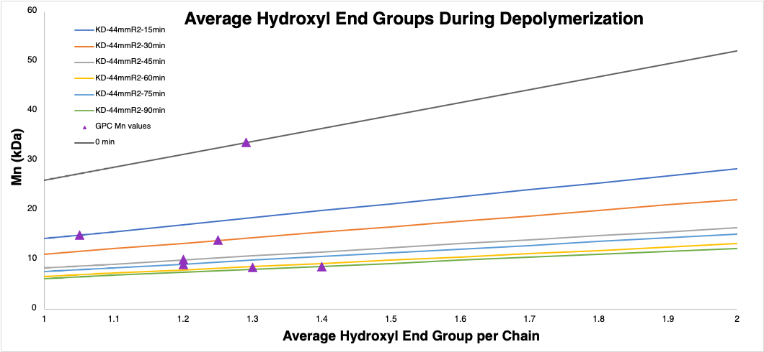
Figure 16: Average number of hydroxyl end groups per chain throughout the depolymerization from theoretical ¹H NMR calculations with Equation 3 (lines) and experimental GPC analysis (triangles). The overlap of the purple diamonds and line denotes the true number of -OH end groups on each depolymerization reaction product.

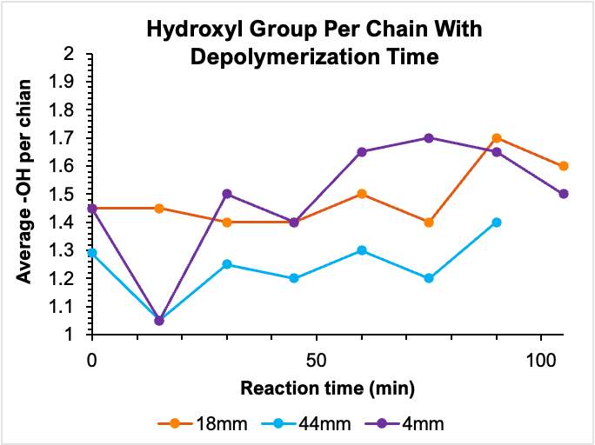
Figure 17: Change in the number of hydroxyl end groups throughout the reaction for flakes of different lengths.

Repolymerization of PET
Figure 18 shows the viscosity molecular weights (M_{v}) achieved by repolymerizing PET reported as a percentage of that found with virgin PET. Samples that were annealed for 26 hours exhibited the highest M_{v}, making them most closely comparable to virgin material. Before the 26-hour mark, samples did not fully repolymerize, with some hydroxyl end groups not undergoing transesterification to become longer polymer chains. However, past 26 hours, the chains began to degrade, causing them to break down and have lower molecular weights. Consequently, the repolymerization time chosen to examine the properties of the depolymerized PET oligomers is 26 hours.
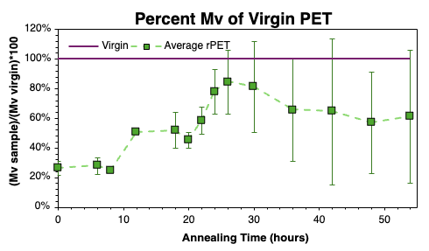
Figure 18: Percent viscosity molecular weight of virgin PET achieved by repolymerized samples based on annealing from 0 to 54 hours.

Unmodified, depolymerized, and repolymerized PET sheets were produced via melting on a hot plate. In general, these trials produced brittle sheets with frequent irregularities caused by excess water or solvent in the material, uneven hot plate temperatures, and the formation of small air pockets while melting. Some of the unmodified PET sheets were cut into dog bones for tensile testing, where the stress-strain curve is presented in Figure 19. The average tensile strength achieved in this study for virgin PET matched those in literature, showing that the methodology is plausible. Although this method served as a point of comparison, it was not easily reproducible when studying the depolymerized or repolymerized materials. Therefore, a solvent-casting method to create the PET samples was developed and employed.

Figure 19: Tensile strength of virgin PET dog bones from PET that has undergone dissolution in HFIP, precipitation in methanol, and melting on a hot plate. Tensile strength was obtained using an Instron and is reported from an average of nine samples.

The amount of solvent in the solvent-cast film was examined by FTIR, where Figure 20 compares the FTIR spectra of a solvent-cast sheet of PET before and after drying in a vacuum oven at 70 $℃$ overnight. The spectrum of the sample prior to drying shows a clear alcohol peak around 3500 cm⁻¹ that corresponds to the hydroxyl group present in HFIP. This indicates that the HFIP is not fully evaporated when the sheet is removed from the plate immediately after air drying. The spectra for HFIP and the reaction without drying show many similar peaks. The disappearance of these peaks in the vacuum-dried sample shows that the excess solvent is successfully removed. As a result, vacuum drying was completed on all solvent-cast sheets, which were then used in the tensile test experiments.

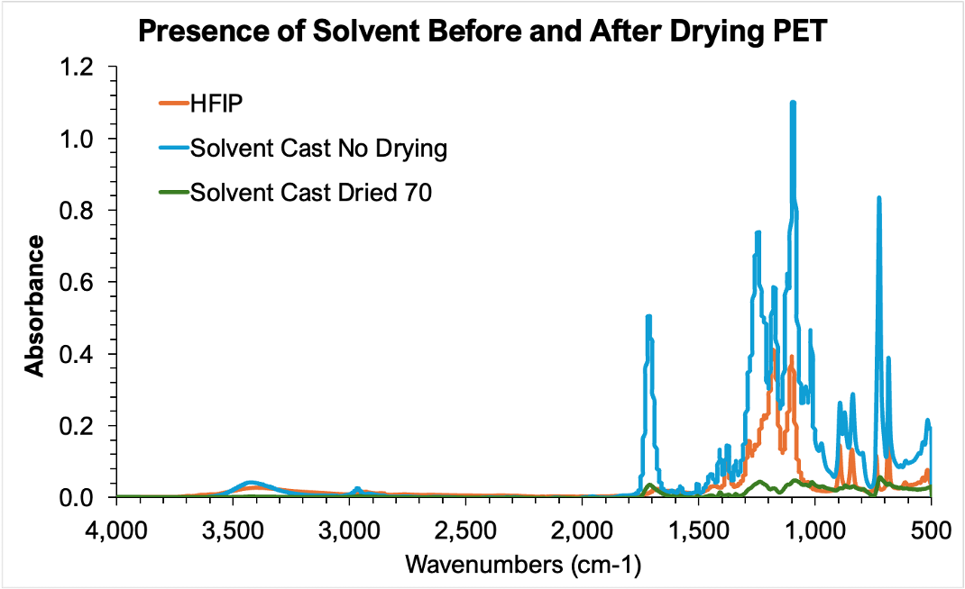
Figure 20: FTIR spectra for solvent cast dog bones of depolymerized (120 min) and repolymerized (25 hr) PET before and after drying at 70$℃$ overnight, with a comparison to HFIP.

Figure 21 shows the stress-strain curves of the dog bones of the depolymerized, repolymerized, and virgin PET that were produced via solvent casting. The graph includes curves from before and after vacuum drying, showing decreased elongation without HFIP. The inclusion of solvent in the sample before vacuum drying allows the material to withstand greater tensile strain, acting as a plasticizer and causing a greater elongation at break. However, drying the material increases the ultimate tensile stress of both repolymerized and virgin PET. The solvent casting approach provides a clear method to determine the tensile strengths of repolymerized PET.

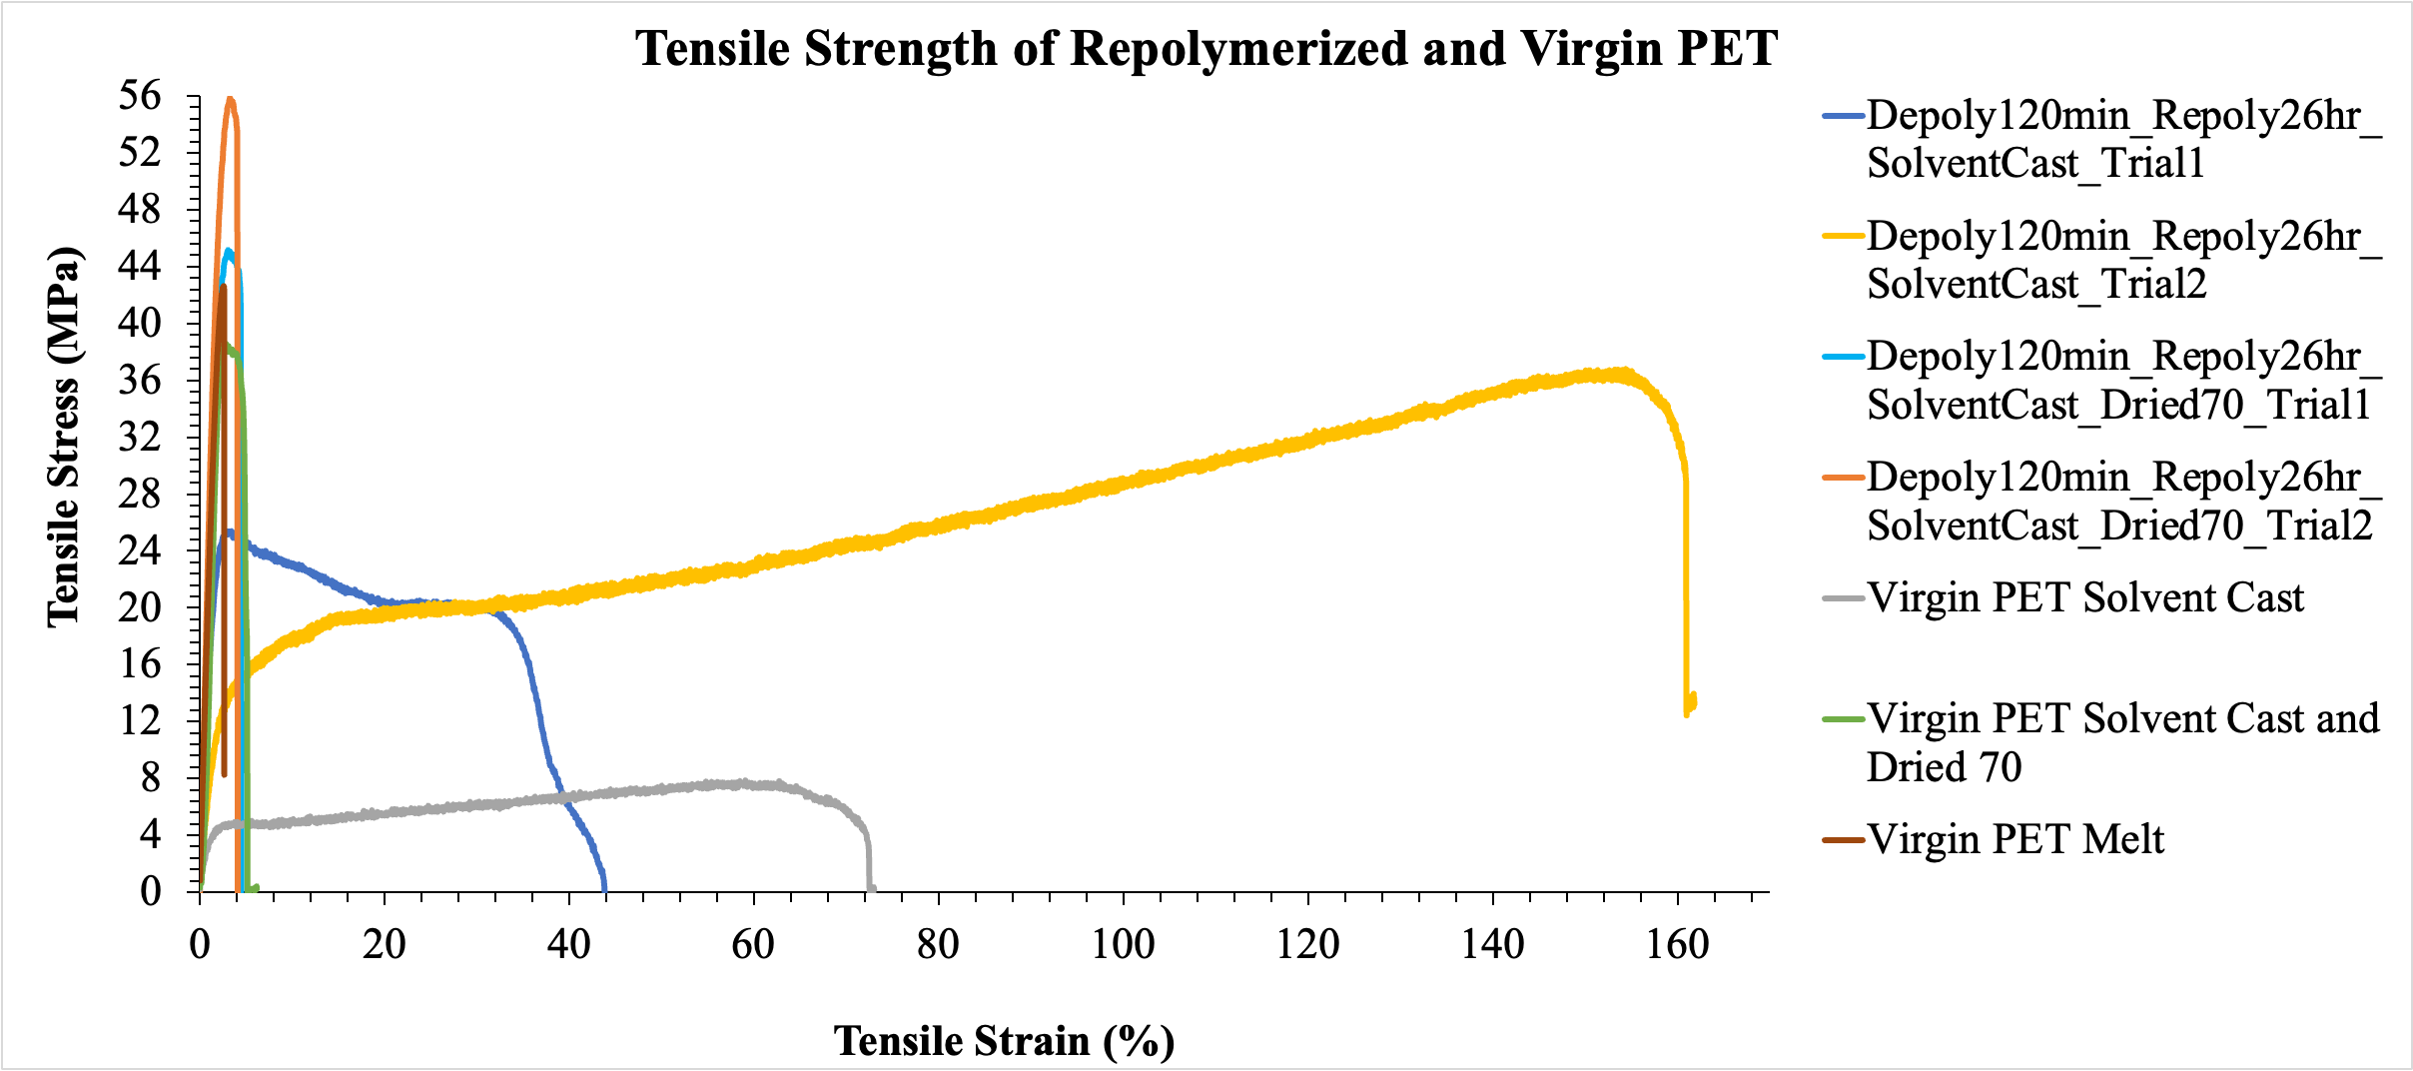
Figure 21: Comparison of the tensile strengths achieved by virgin PET in the melt method, virgin PET in the solvent cast method, virgin PET through solvent casting with drying at 70$℃$, depolymerized (120 min) and repolymerized (26 hr) PET through solvent casting without drying, and depolymerized (120 min) and repolymerized (26 hr) PET through solvent casting with drying at 70$℃$.

Figure 22 shows the comparison of the stress-strain behavior between virgin and repolymerized PET after vacuum drying. While the solvent cast and vacuum-dried virgin PET exhibit a slightly higher elongation, the repolymerized materials achieve higher ultimate tensile stress. From all dried samples tested, virgin PET produced an average tensile strength of 31.2 MPa, while the PET formed from the two depolymerized and repolymerized reactions produced averages of 32.7 and 39.4 MPa. Therefore, these repolymerized materials reach similar molecular weights and tensile strengths to virgin PET, showing a circular depolymerization-repolymerization process with significant potential in producing economically similar materials. Interestingly, these properties are similar but slightly greater than those of the virgin PET that is formed by melt pressing.

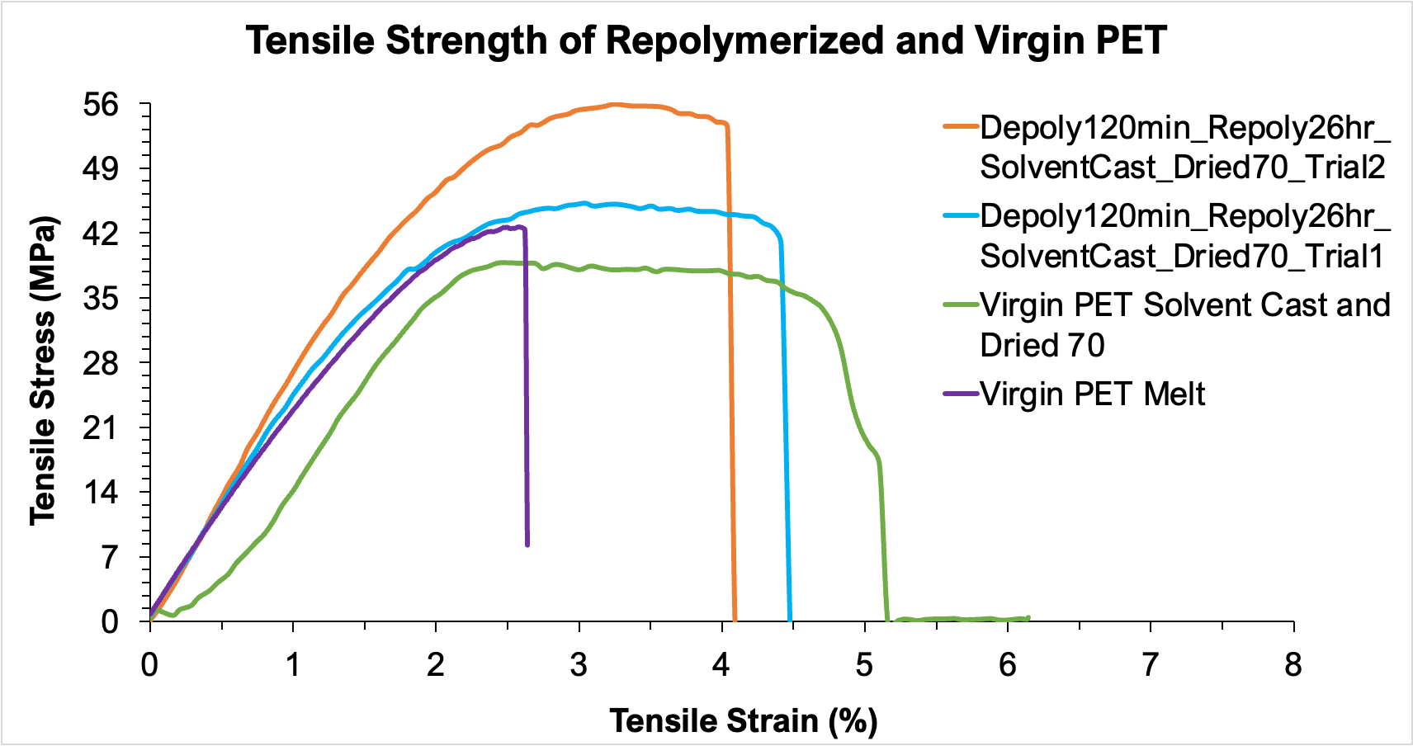
Figure 22: Tensile strengths achieved by melted virgin PET, solvent cast, and dried virgin PET, and depolymerized (120 min) and repolymerized (26 hr) solvent cast and dried PET.

Role of Ethylene Glycol Diffusion in the PET Depolymerization Reaction
Figure 23 shows the swelling of virgin PET with EG for the flakes of different lengths as a function of time without a catalyst. Initially, smaller flakes experience greater swelling than larger flakes due to their higher surface area-to-volume ratio. This higher surface-area-to-volume ratio results in a shorter diffusion path and more available amorphous chains for EG diffusion. Larger flakes have a higher EG capacity, so with increased reaction time, their swelling converges with short and medium flakes. Figure 24 shows the normalized average swelling per flake of unmodified PET in EG. Since the volume of the flakes decreases faster than their surface area with flake size, smaller flakes have a much smaller amount of amorphous polymer to hold EG than longer flakes. Moving from a 44 mm to a 4 mm length decreases the flake’s surface area by approximately a factor of 9 while its volume decreases by a factor of 11. Although larger flakes require more time to fully swell, they have the potential to swell more than smaller flakes due to a much greater volume of amorphous polymer. These results suggest that the rate of depolymerization for PET is initially dependent on the diffusion of EG into the amorphous portion of the polymer flake. In the first 30 minutes of the reaction, all flake lengths show similar diffusion rates, indicating a lack of dependency on particle size. Additionally, the first 30 minutes of the reaction shows the greatest decrease in molecular weight, consistent with the importance of EG diffusion at the beginning of the reaction. These results support the conclusion that glycolysis depends more on the diffusion of EG into the flakes’ constant thickness than their surface areas.

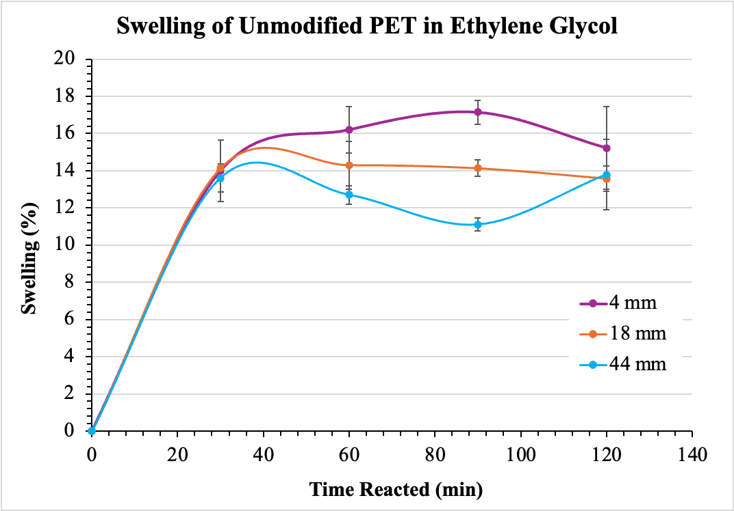
Figure 23: Graph depicting the swelling percent by mass of virgin PET reacted in ethylene glycol based on flake length and reaction time.

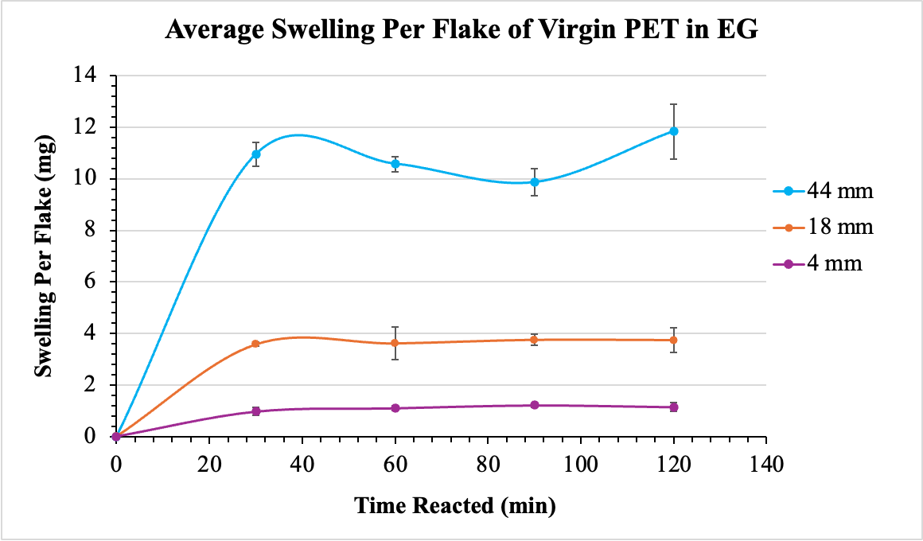
Figure 24: Graph depicting the average swelling per flake of virgin PET in ethylene glycol based on flake length and reaction time.

Finally, Figure 25 illustrates the average percent weight change and change in M_{n} for three samples of 28 mm PET as a function of depolymerization time. In general, samples with lower molecular weights after depolymerization are more opaque and brittle, with lower dry weights. These samples are mostly crystalline, and the decrease in dry weight can be attributed to a loss of amorphous tie chains. The dry weight of the samples initially increases as the flakes swell with EG, and it remains relatively constant as the flakes lose amorphous sections while taking on EG. The dry weight decreases as the amount of amorphous polymer discarded outweighs the EG swollen into the flakes. The molecular weight of the polymer decreases more consistently, indicating that changes to dry weight are caused by swelling in the early stages of depolymerization. The depolymerization rate and initial swelling of the flakes are therefore dependent more on the diffusion of EG into the flakes than their surface areas.

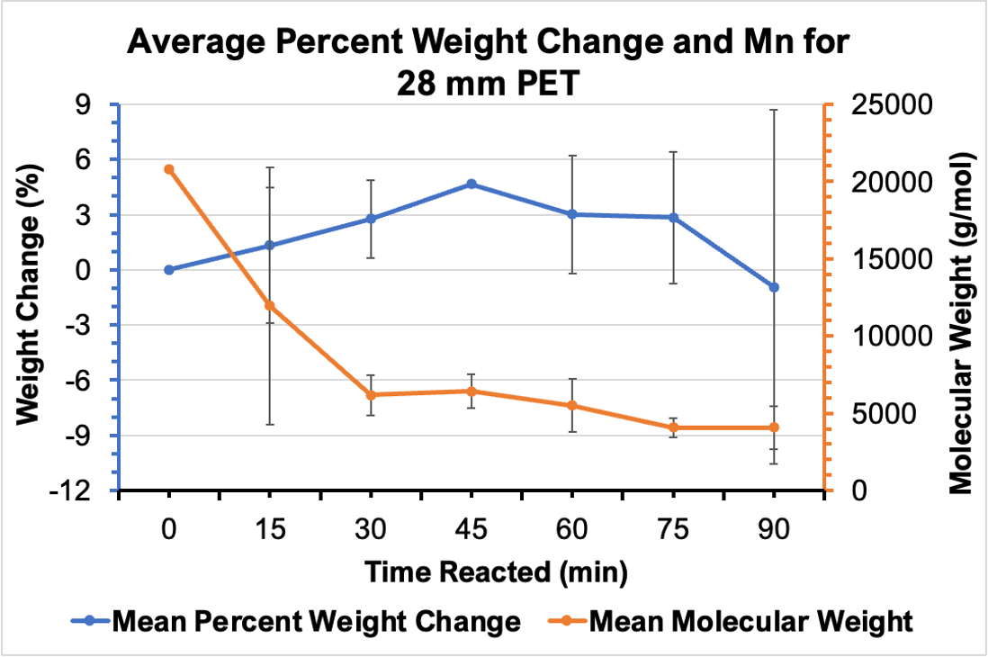
Figure 25: Average percent weight change and molecular weight across three samples of 28 mm PET as a function of depolymerization time.

Understanding the process of PET depolymerization and the impact of flake dimensions on chain evolution offers insight into accessing and controlling the structure of oligomer intermediates. While changes to particle size alter the overall surface area, they do not change the progression of chain M_{n} during the depolymerization. Therefore, these results indicate that the rate of glycolysis depends more on the rate of EG diffusion into the smallest dimension of the flake, which remained constant throughout all these experiments. During depolymerization, flakes of different lengths experience similar changes in properties and chain structures, showing almost no dependency on surface area.
After chain scission produces PET oligomers, depolymerized samples can undergo solid-state repolymerization by annealing at 240 °C, producing repolymerized PET that can be compared to virgin PET. Our results illustrate that repolymerized materials attain properties that are very similar to that of virgin PET, and therefore can then be used to produce value-added products through less energy-intensive methods than depolymerization to monomer. Future studies will focus on the impact of annealing before depolymerization on the rate of glycolysis and the repolymerized product’s mechanical properties. Furthermore, we seek to compare the crystallinity of the unmodified, depolymerized, and repolymerized materials.

- Conclusion
The size of PET flakes can be tuned to access useful oligomers in a heterogeneous glycolysis reaction resulting in less energy-intensive methods than depolymerization to monomer. Increasing flake size produces oligomers with similar percent crystallinity and chain length as produced with shorter flakes. Therefore, we deduce that glycolysis is controlled more by the diffusion of ethylene glycol into the smallest dimension (thickness) of the polymer flake than by particle size or the flake’s surface area. Swelling experiments show that both larger and smaller flakes retain similar amounts of ethylene glycol, highlighting that diffusion is not dependent on surface area but on the smallest dimension of the flake.
Depolymerization intermediates can be repolymerized by annealing oligomers at 240 °C for 24 hours to produce PET with an M_{v} that is comparable to virgin PET. Below this time, PET chains are left unreacted, and above this time the chains begin to degrade. The PET that is formed by repolymerizing oligomers that emerge from the depolymerization can be evaluated based on their mechanical properties using a solvent casting approach to create thin films rather than melting. In solvent casting, the leftover solvent in the sheet must be removed by vacuum drying to prevent the plasticization of PET. Oligomers that have been de- and repolymerized can achieve similar molecular weights and tensile strengths to virgin PET. These results illustrate that consumer waste can be chemically re/upcycled without the removal of additives or the addition of functional groups. The results of this study are applicable in combatting pollution and the environmental hazards of increased plastic demand and waste.

Acknowledgment
This work was supported by the National Science Foundation, Polymers program, Division of Materials Research (DMR- 2104982).

References

(1) Dokl, M.; Copot, A.; Krajnc, D.; Fan, Y. V.; Vujanović, A.; Aviso, K. B.; Tan, R. R.; Kravanja, Z.; Čuček, L. Global projections of plastic use, end-of-life fate and potential changes in consumption, reduction, recycling and replacement with bioplastics to 2050. Sustainable Production and Consumption 2024, 51, 498-518.
(2) Billiet, S.; Trenor, S. R. 100th Anniversary of Macromolecular Science Viewpoint: Needs for Plastics Packaging Circularity. ACS Macro Letters 2020, 9, 1376-1390.
(3) Schade, A.; Melzer, M.; Zimmermann, S.; Schwarz, T.; Stoewe, K.; Kuhn, H. Plastic Waste Recycling─A Chemical Recycling Perspective. ACS Sustainable Chemistry & Engineering 2024, 12, 12270-12288.
(4) Brand Audit Report 2023. Break Free From Plastic: 2024.
(5) Brand Audit Report 2018-2022. Break Free From Plastic: 2022.
(6) Park, S. H.; Kim, S. H. Poly (ethylene terephthalate) recycling for high value added textiles. Fashion and Textiles 2014, 1, 1.
(7) Our Technology: Mechanical Recycling Aloxe Holding B.V., 2025.
(8) Mechanical and molecular recycling. Eastman Chemical Company 2025.
(9) Clark, R. A.; Shaver, M. P. Depolymerization within a Circular Plastics System Chemical Reviews 2024, 124, 2617-2650.
(10) Cao, J.; Liang, H.; Yang, J.; Zhu, Z.; Deng, J.; Li, X.; Elimelech, M.; Lu, X. Depolymerization mechanisms and closed-loop assessment in polyester waste recycling. Nature Communications 2024, 15, 6266.
(11) de Carvalho, G. M.; Muniz, E. C.; Rubira, A. F. Hydrolysis of post-consume poly(ethylene terephthalate) with sulfuric acid and product characterization by WAXD, 13C NMR and DSC. Polymer Degradation and Stability 2006, 91, 1326-1332.
(12) Mohammadi, S.; Bouldo, M. G.; Enayati, M. Controlled Glycolysis of Poly(ethylene terephthalate) to Oligomers under Microwave Irradiation Using Antimony(III) Oxide. ACS Applied Polymer Materials 2023, 5, 6574-6584.
(13) Wei, X.; Zheng, W.; Chen, X.; Qiu, J.; Sun, W.; Xi, Z.; Zhao, L. Chemical upcycling of poly(ethylene terephthalate) with binary mixed alcohols toward value-added copolyester by depolymerization and repolymerization strategy. Chemical Engineering Science 2024, 294, 120103.
(14) Wang, H.; Wei, X.; Zheng, W.; Tang, H.; Xi, Z.; Sun, W.; Zhao, L. Controlled depolymerization of polyethylene terephthalate based on twin-screw extruder and repolymerization of the depolymerized products. Chemical Engineering Science 2025, 307, 121341.
(15) Liu, P.; Zheng, Y.; Yuan, Y.; Han, Y.; Su, T.; Qi, Q. Upcycling of PET oligomers from chemical recycling processes to PHA by microbial co-cultivation. Waste Management 2023, 172, 51-59.
(16) Dove, A. P. Organic Catalysis for Ring-Opening Polymerization ACS Macro Letters 2012, 1, 1409-1412.
(17) Kim, J. G.; Lee, G. S.; Lee, A. Triazabicyclodecene: A versatile catalyst for polymer synthesis. Journal of Polymer Science 2024, 62, 42-91.
(18) Watson-Sanders, S.; Dadmun, M. More Efficient Chemical Recycling of Poly(Ethylene Terephthalate) by Intercepting Intermediates. ChemSusChem 2024, 17, e202301698.
(19) Can Chemical Recycling Reduce Plastic Pollution? U.S. Government Accountability Office, 2021.
(20) Liu, Y.; Lu, X.-B. Emerging Trends in Closed-Loop Recycling Polymers: Monomer Design and Catalytic Bulk Depolymerization. Chemistry – A European Journal 2023, 29, e202203635.

