From Foraging to Food Production on the Southern Cumberland Plateau of Alabama and Tennessee, U.S.A.

A Dissertation Presented for the
Doctor of Philosophy
Degree
The University of Tennessee, Knoxville.

Stephen Byrnes Carmody
December 2014

Dedication

To Braden and Maddie.

Acknowledgements
I would first like to thank my committee; Jan F. Simek, David G. Anderson, Gary D. Crites, Kandace D. Hollenbach, and Sally P. Horn. Without their thoughtful encouragement, unwavering support, and dedication to my success this day would not have arrived so soon. They were each an incredible role model of success, teacher, and friend, throughout this long journey.
I also owe an incredible debt of gratitude to Sarah C. Sherwood. Not only did Sarah provide me with the opportunity to work with her fieldschool but she also allowed me to return year after year. Our discussions in the field and in the laboratory helped form the basis of my dissertation research. She taught me to be a better field archaeologist, researcher, and scholar. Her friendship and encouragement were instrumental to my success.
I would also like to thank all of the fieldschool students and volunteers that helped to excavate the Michaels and Uzzelles Shelter. Their hard work in the field made my research possible. Their good-spirit made hours in the field and lab enjoyable. Also, their assistance in snake-wrangling activities helped ensure my survival.
I thank the Anthropology faculty at the University of Tennessee who were not officially on my dissertation committee. Their doors were always open for questions and they were certainly helpful throughout the entire process. I want to thank Thad Bissett for his help with statistics, GIS, and all other computer-related problems. And also Sierra Bow who sense of humor and friendship eased the pain of long days in the office and also the field. While there are far too many graduate students to list by name I thank all of you who were supportive and encouraging along the way.
I could not have even started this journey had it not been for the love and support of my parents, Glyn Ann and Fred Carmody. Your encouragement to begin this process was only exceeded by your support to finish. I could not have done this without you. I love you both and am grateful for all that you have done for me. I also want to thank Laura, Rebecca, Amy, Rick, and James. You have loved and supported me through every decision I have made in life. That support has made the difficult decisions easier and the easy ones more trivial.
Last but certainly not least I have to thank my beautiful wife Lydia and my two precious children, Braden and Madeleine. You have tolerated my mess, work-filled nights and weekends, and caffeine-fueled days, never complaining about bags of dirt, piles of books, and stacks of papers. Your patience, understanding, and love kept me focused throughout this journey and made me feel completion was possible when it seemed it was not. While words cannot describe how much I love you I hope to show you each and every day through my actions.

Abstract
Research involving the origin of plant domestication remains as important today as ever. While early anthropologists viewed plant domestication as a necessary precondition for cultural development, more recent ethnographic studies have shown that agriculture was a much more labor intensive subsistence practice than hunting and gathering, leading many to question the reasons behind the prehistoric transition. Today, research and advances in technology have provided conclusive evidence to include the Eastern Woodlands of North America as one of the eight global centers of indigenous plant domestication. Although the timing of domestication and the plants involved in early horticultural systems are well understood, several questions remain unanswered.
Today, most models suggest that initial plant domestication occurred either in the heavily populated river valleys, or in the surrounding uplands that were also frequented by prehistoric groups. To test these models, I analyzed plant assemblages from five sites containing Archaic through Woodland period deposits, the time periods preceding, following, and during which initial plant domestication occurred. The sites were selected for their geographic position and proximity to each other. Found within a 20-mile radius of one another, Michaels Shelter and Uzzelles Shelter are located in the uplands of the southern Cumberland Plateau, Widows Creek and Mussel Beach are located in the Tennessee River Valley, and Russell Cave is situated approximately halfway between the upland and river valley sites.
My results from analyzing the plant remains from these five sites show that the conditions that favored early plant domestication in floodplain settings across the region were also present in upland settings. These factors include rich soils, highly disturbed landscapes, and the frequent reoccupation of sites in areas where plant food resources naturally occurred and were encountered on the landscape. All of these factors contributed to initial plant domestication in both the upland and floodplain environments across the Eastern Woodlands. Additionally, through the application of the diet breadth and central place foraging models, I explain how individual decision-making processes in small scale societies, and not geographical location, resulted in the cultivation and domestication of indigenous plants.

Table of Contents
Chapter 1: Introduction 1
Chapter 2: The Origins of Agriculture 8
Early Approaches 8
Newer Archaeology Approaches 11
Post-Processual Approaches 16
Evolutionary Approaches 19
Chapter 3: The Physical and Cultural Landscape of the Southern Cumberland Plateau 24
Physiography 24
Soils of the Cumberland Plateau 26
Forests of the Cumberland Plateau 32
Fauna of the Cumberland Plateau 38
Changing Plant and Animal Communities during the Holocene 45
Cultural Environment of the Southern Cumberland Plateau 48
The Archaic Period (11,500 – 3,200 cal yr BP) 49
Early Archaic Period (11,500 – 8,900 cal yr BP) 50
Middle Archaic period (8,900 – 5,800 cal yr BP) 52
Late Archaic period (5,800 – 3,800 cal yr BP) 54
Gulf Formational Stage of the Middle Tennessee Valley 57
Woodland Period (3,200 – 1,020 cal yr BP) 58
Early Woodland period (3,200 – 2,225 cal yr BP) 58
Middle Woodland Period (2,225 – 1,725 cal yr BP) 61
Late Woodland Period (1,725 – 1,020 cal yr BP) 68
Chapter 4: The Sites 72
The Michaels Shelter (40FR276) 72
The Uzzelles Shelter (40FR267) 79
Previous Research: Lithic Analysis 82
Ceramic Analysis 86
The Mussel Beach Site (40MI70) 88
Previous Research: Lithic Analyses 94
Ceramics Analyses 98
Faunal Analysis 99
Botanical Analysis 109
General Site Interpretation 127
Widows Creek (1JA305) 131
Previous Analysis: Faunal Remains 134
Bone Tools 143
Human Skeletal Remains 150
Ceramic Analysis 153
Geoarchaological Analysis 162
General Site Interpretation Based on Artifact Analysis 166
Russell Cave (1JA181) 167
Previous Research: Ceramic Analysis 169
Lithic Analysis 173
Bone Artifacts 181
Human Skeletal Remains 182
Vertebrate Remains 182
Invertebrate Remains 184
Botanical Analysis 191
General Site Interpretations of Russell Cave 193
Summary 194
Chapter 5: Paleoethnobotanical Methods and Datasets 196
Preservation and Recovery of Plant Remains 196
The Samples 199
Michaels Shelter (40FR267) 199
Uzzelles Shelter (40FR267) 202
Mussel Beach (40MI70) 205
The Widows Creek Site (1JA305) 207
The Russell Cave Site (1JA181) 208
Laboratory Methods 212
Quantitative Analysis 212
Chapter 6: Results 217
The Michael’s Shelter 219
The Uzzelles Shelter 229
The Mussel Beach Site 240
The Widows Creek Site 246
The Russell Cave Site 259
Chapter 7: The Plants 271
Nuts 274
Acorn (Quercus spp.) 274
Black Walnut (Juglans nigra) 277
Hickory (Carya spp.) 278
Edible Seeds/Crops 280
Amaranth (Amaranthus sp.) 280
Giant Ragweed (Ambrosia trifida) 289
Gourds (Cucurbita pepo ssp.ovifera) 290
Bottle Gourd (Lagenaria siceraria) 292
Knotweed (Polygonum sp.) 294
Maize (Zea mays) 295
Maygrass (Phalaris caroliniana) 298
Sumpweed (Iva annua) 301
Sunflower (Helianthus annuus) 303
Fruits 306
Blackberry/Raspberry (Rubus spp.) 306
Black Cherry (Prunus serotina) 306
Blueberry (Vaccinium spp.) 307
Hackberry (Celtis occidentalis) 308
Hawthorn (Crataegus spp.) 308
Honey Locust (Gleditsia triacanthos) 309
Red Mulberry (Morus rubra) 310
Persimmon (Diospyros virginiaia) 311
Sumac (Rhus spp.) 312
Wild Grapes (Vitis spp.) 312
Greens 313
Miscellaneous Taxa 313
Bedstraw (Galium spp.) 313
American Sycamore (Platanus occidentalis) 315
Southern Magnolia (Magnolia grandiflora) 316
Giant River Cane (Arundinaria gigantea) 316
Chapter 8: The Models 318
Diet Breadth Model 318
Central Place Foraging Model 330
Conclusions 335
Chapter 9: Discussion 350
The Floodplain Sites 351
The Mussel Beach Site 352
The Widows Creek Site 355
The Upland Sites 361
The Michaels Shelter Site 364
The Uzzelles Shelter Site 364
Russell Cave 369
Summary 371
Land Management Practices and the Formation of Gardens 373
Gardens and Gender 377
Chapter 10: Conclusion 381
Changing Relationships between People 381
Changing Relationships with Plants 383
Changing Relationships with the Landscape 384
Concluding Thoughts 385
Work Cited 389
Appendices 431
Appendix A 432
Appendix B 436
Appendix C 440
Appendix D 444
Vita 448

List of Tables
Table 3.1: Soils from the Uplands of the Cumberland Plateau. 28
Table 3.2: Soils of the Colluvial Lands of the Cumberland Plateau. 29
Table 3.3: Soils from the Terraces and Benches of the Cumberland Plateau. 30
Table 3.4: Soils from the River Bottoms of the Cumberland Plateau. 31
Table 3.5: Plant Communities by Landscape Position on the Cumberland Plateau. 34
Table 3.6: Major Community Types Identified in the Mixed Mesophytic Forest Region. 37
Table 3.7: Common Amphibian, Bird, and Mammal Species of the Mixed Mesophytic Forest. 39
Table 3.8: Bivalves Found in the Tennessee River System’s. 40
Table 3.9: Gastropods Found in the Tennessee River Systems. 41
Table 3.10: Fishes Found in the Tennessee River Systems. 42
Table 3.10 (cont.): Fishes Found in the Tennessee River Systems. 43
Table 3.10 (cont): Fishes Found in the Tennessee River Systems. 44
Table 3.11: Turtle Species Found in the Tennessee River Systems. 45
Table 4.1: AMS Radiocarbon Dates from Michaels Shelter. 78
Table 4.2: Radiocarbon Ages from the Uzzelles Shelter. 81
Table 4.3. Diagnostic Projectile Point Distribution from the Uzzelles Shelter. 85
Table 4.4: Pottery Recovered from the Uzzelles Shelter. 86
Table 4.5: Summary of Temporal Components from the Mussel Beach Site. 90
Table 4.6: Radicarbon Dates from Sites from the Mussel Beach Site. 92
Table 4.6(cont): Radicarbon Dates from Sites from the Mussel Beach Site. 93
Table 4.7: Lithic Tools Recovered from the Mussel Beach Site. 95
Table 4.8: Summary of Sample Vessels Analysis from the Mussel Beach Site. 99
Table 4.9: Inferred Ceramic Chronology from Mussel Beach Site. 100
Table 4.10: Vertebrate Assemblage from Mussel Beach Site by Time Period. 101
Table 4.11: Vertebrate Remains Recovered from the Mussel Beach Site. 102
Table 4.11(cont): Vertebrate Remains Recovered from the Mussel Beach Site. 103
Table 4.12. Identified Freshwater Mussel by Component from the Mussel Beach Site. 104
Table 4.13. Combined NISP and Weights for all Invertebrates from the Mussel Beach site. 104
Table 4.14: Fully Sorted Paleoethnobotanical Samples Analyzed from the Mussel Beach Site. 111
Table 4.14 (cont.): Fully Sorted Paleoethnobotanical Samples Analyzed from the Mussel Beach Site. 112
Table 4.14 (cont.): Fully Sorted Paleoethnobotanical Samples Analyzed from the Mussel Beach Site. 113
Table 4.14 (cont.): Fully Sorted Paleoethnobotanical Samples Analyzed from Mussel Beach Site. 114
Table 4.15: Scanned Paleoethnobotanical Samples from the Mussel Beach Site. 115
Table 4.15 (cont.): Scanned Paleoethnobotanical Samples from the Mussel Beach Site. 116
Table 4.15(cont.): Scanned Paleoethnobotanical Samples from the Mussel Beach Site. 117
Table 4.15(cont.): Scanned Paleoethnobotanical Samples from the Mussel Beach Site. 118
Table 4.15(cont.): Scanned Paleoethnobotanical Samples from the Mussel Beach Site. 119
Table 4.15(cont.): Scanned Paleoethnobotanical Samples from the Mussel Beach Site. 120
Table: 4:16 Taxa Identified from Mussel Beach Site. 121
Table 4.16 (cont.): Taxa Identified from Mussel Beach Site. 122
Table 4.17: Taxa Identified from Late Archaic I Samples from the Mussel Beach Site. 123
Table 4.18: Taxa Identified from Late Archaic II Samples from the Mussel Beach Site. 123
Table 4.19: Taxa Identified from Late Archaic III Samples from the Mussel Beach Site. 124
Table 4.20: Taxa Identified from Middle Woodland samples from the Mussel Beach Site. 125
Table 4.20(cont.): Taxa Identified from Middle Woodland samples from the Mussel Beach Site. 126
Table 4.21: Taxa Identified from Late Woodland samples at the Mussel Beach Site. 127
Table 4.23: Unionacean Species Identified from the Widows Creek Site. 138
Table 4.23(cont.): Unionacean Species Identified from the Widows Creek Site. 139
Table 4.24: Density of Fresh Water Mussels From the Widows Creek Site 141
Table 4.25: Vertebrate Remains Recovered from the Widows Creek Site. 142
Table 4.26: Distribution of Bone Tools from the Widows Creek Site. 144
Table 4.27: Raw Material Types by Temporal Component at Widows Creek Site. 147
Table 4.28: Primary Manufacturing Evidence on Modified Bone by Temporal Component. 147
Table 4.29: Manufacturing Stage of Modified Bone by Temporal Component. 148
Table 4.30: Morphological Categories of Modified Bones by Temporal Component. 149
Table 4.31: Cultural Affiliation, Age, and Sex of Burials from Widows Creek. 151
Table 4.32: Grave Goods Associated with Burials from Widows Creek Site. 154
Table 4:33: Ceramic Types Identified by Level from 60R100. 155
Table 4:34: Ceramic Types Identified by Level from 50R100. 156
Table 4:35: Ceramic Types by Level from 50R200. 157
Table 4.36: Pottery types recovered from features at the Widows Creek Site. 159
Table 4.36(cont): Pottery Types Recovered from Features at the Widows Creek Site. 160
Table 4:37: Radiocarbon Dates from the Russell Cave Site. 170
Table 4.38: Breakdown of Ceramic Surface Treatments by Level from the Russell Cave Site. 171
Table 4.39: Stamped Patterns on Ceramics Found by Level from the Russell Cave site. 171
Table 4.40: Ceramic Chronology Based on the 1962 NPS Excavations. 172
Table 4.41: Typed Projectile Points from the 1962 NPS Russell Cave Excavations. 174
Table 4.41(cont.): Typed Projectile Points from the 1962 NPS Russell Cave Excavations. 175
Table 4.41(cont.): Typed Projectile Points from the 1962 NPS Russell Cave Excavations. 176
Table 4.42: Distribution of Unifacial Tools from the 1962 Russell Cave Excavation. 179
Table 4.43: Distribution of Bifacial Tools from the 1962 Russell Cave Excavation. 180
Table 4.44: Distribution of Groundstone Artifacts from the 1962 Russell Cave Excavation. 180
Table 4.45: Distribution of Bone Tools from the 1962 Russell Cave Excavation. 181
Table 4.46: Human Skeletal Remains Recovered from Russell Cave. 182
Table 4.47: Mammalian Remains Recovered from 1962 NPS Russell Cave Excavation. 185
Table 4.48: Avian Remains Recovered During the 1962 Russell Cave Excavation. 186
Table 4.49: Amphibian and Reptile Remains Recovered from the 1962 Russell Cave Excavation. 187
Table 4.50: Fish Remains Recovered from the 1962 Russell Cave Excavation. 188
Table 4.51: Mollusk Remains Recovered from the 1962 Russell Cave Excavation. 190
Table 5.1: Paleoethnobotanical Samples Analyzed from the Michaels Shelter 200
Table 5.1(cont.): Paleoethnobotanical Samples Analyzed from the Michaels Shelter. 201
Table 5.2: Paleoethnobotanical Samples Analyzed from the Uzzelles Shelter. 204
Table 5.3: Paleoethnobotanical Samples Analyzed from the Mussel Beach Site. 206
Table 5.4: Paleoethnobotanical Samples Analyzed from the Widows Creek Site. 207
Table 5.4(cont.): Paleoethnobotanical Samples Analyzed from the Widows Creek Site. 208
Table 5.5: Paleoethnobotanical Samples Analyzed from the Russell Cave Site. 211
Table 6.1: Identified Plant Remains from the Five Research Sites. 218
Table 6.2: Identified Plant Remains from the Michaels Shelter. 220
Table 6.2(cont): Identified Plant Remains from the Michaels Shelter. 221
Table 6.3: Ubiquity of Plant Remains Recovered from the Michaels Shelter. 226
Table 6.4: Plant Remains Identified from the Uzzelles Shelter. 230
Table 6.4(cont.): Plant Remains Identified from the Uzzelles Shelter 231
Table 6.4(cont.): Plant Remains Identified from the Uzzelles Shelter. 232
Table 6.4(cont.): Plant Remains Identified from the Uzzelles Shelter. 233
Table 6.4(cont.): Plant Remains Identified from the Uzzelles Shelter. 234
Table 6.5: Ubiquity of Plant Remains from the Uzzelles Shelter. 235
Table 6.6: Plant Remains Identified from the Mussel Beach Site. 242
Table 6.6(cont.): Plant Remains Identified from the Mussel Beach Site. 243
Table 6.6(cont.): Plant Remains Identified from Mussel Beach site. 244
Table 6.6(cont.): Plant Remains Identified from Mussel Beach site. 245
Table 6.7: Identified Plant Materials Recovered from the Widows Creek site. 249
Table 6.7 (cont.): Plant Remains Identified from the Widows Creek Site. 250
Table 6.7(cont.): Plant Remains Identified from the Widows Creek Site. 251
Table 6.7(cont.): Plant Remains Identified from the Widows Creek Site. 252
Table 6.7(cont.): Plant Remains Identified from the Widows Creek Site. 253
Table 6.7(cont.): Plant Remains Identified from the Widows Creek Site. 254
Table 6.8: Ubiquity of Plant Remains Recovered from the Widows Creek Site. 255
Table 6.9: Identified Plant Remains from the Russell Cave Site. 261
Table 6.9 (cont.): Identified Plant Remains from the Russell Cave Site. 262
Table 6.9 (cont.): Identified Plant Remains from the Russell Cave Site. 263
Table 6.9(cont.): Identified Plant Remains from the Russell Cave Site. 264
Table 6.9(cont): Identified Plant Remains from the Russell Cave Site. 265
Table 6.10: Ubiquity of Plant Remains Recovered from the Russell Cave Site. 266
Table 7.1: Seasonality of Plant Remains Recovered from the Five Research Sites. 272
Table 7.1(cont.): Seasonality of Plant Remains Recovered from the Five Research Sites. 273
Table 8.1: Post-Encounter Return Rates Calculated for Plant Resources Recovered from the Five Research Sites. 323
Table 8.2: Diet Breadth from the Widows Creek Site. 324
Table 8.3: Diet Breadth from Mussel Beach Site Test Units. 327
Table 8.4: Diet Breadth from the Mussel Beach Site Features. 328
Table 8.5: Diet Breadth from the Russell Cave Site. 329
Table 8.6: Diet Breadth from the Michaels Shelter Site. 330
Table 8.7: Diet Breadth from the Uzzelles Shelter. 330
Table 8:8: Costs Associated with Travel (1 km) Along Various Slope Angles. 332
Table 8.9: Roundtrip Cost Associated with Carrying One 15-kg Load Along Slopes. 334
Table 8.10: Effective Foraging Radii for the Five Research Sites. 336
Table 8.10(cont.): Effective Foraging Radii for the Five Research Sites. 337
Table 8.11: Return Rates for Crops Based on Yields from Wild Stands. 347
Table 8.12: Estimated Return Rates for Crops Placed Within A 1-km Radius of Sites. 348
Table 9.1: Seasonality Implied from the Mussel Beach Site Features and Test Units. 353
Table 9.2: Seasonality Implied from the Widows Creek Site Plant Assemblage. 354
Table 9.3: Seasonality Implied from the Michaels Shelter Plant Assemblage. 363
Table 9.4: Seasonality Implied from the Uzzelles Shelter Plant Assemblage. 363
Table 9.5: Seasonality Implied from the Russell Cave Site Plant Assemblage. 368
Table A.1: Detailed Data from the Michaels Shelter Column Samples 432
Table A.1(cont): Detailed Data from Michaels Shelter Column Samples 433
Table A.2: Artifactual Data from Michaels Shelter Paleoethnobotanical Column Samples 434
Table A.2(cont.): Artifactual Data from Michaels Shelter Paleoethnobotanical Column Samples 435
Table B.1. Detailed Data for Russell Cave Paleoethnobotanical Samples 436
Table B.1 (cont.): Detailed Data for Russell Cave Paleoethnobotanical Samples 437
Table B.2: Artifactual Data for Russell Cave Paleoethnobotanical Samples 438
Table B.2 (cont): Artifactual Data for Russell Cave Paleoethnobotanical Samples. 439
Table C.1. Detailed Data from Uzzelles Shelter Paleoethnobotanical Samples. 440
Table C.1 (cont.): Detailed Data from Uzzelles Shelter Paleoethnobotanical Samples. 441
Table C.2: Artifactual Data from Uzzelles Shelter Paleoethnobotanical Samples. 442
Table C.2 (cont.): Artifactual Data from Uzzelles Shelter Paleoethnobotanical Samples. 443
Table D.1: Detailed Data from Widows Creek Paleoethnobotanical Samples. 444
Table D.1 (cont.): Detailed Data from Widows Creek Paleoethnobotanical Samples. 445
Table D.2. Artifactual Data from Widows Creek Paleoethnobotanical Samples. 446
Table D.2 (cont.): Artifactual Data from Widows Creek Paleoethnobotanical Samples. 447

List of Figures
Figure 1.1: Study Area in South Central Tennessee and Northeastern Alabama, U.S.A. 5
Figure 3.1: Stratigraphic sequence of the Cumberland Plateau in the Sewanee area. 26
Figure 3.2: Mean July temperatures for the Southeastern United Stated, after Viau et al. 2006. 47
Figure 4.1: Plan view site map following 2011 excavation and clean up efforts. 73
Figure 4.2: Image showing cleaned floor and north and east profiles following the 2012 excavation. Image courtesy Sherwood et al. 2012. 74
Figure 4.3: (Left) Image of excavations along north wall and (right) post excavation photo showing exposed prepared rock surface along the north wall. 75
Figure 4.4: Image showing the location of test units from 2011 and 2013 excavations from the Michael’s Shelter. 77
Figure 4.5: Plan view map of the Uzzelles Site. 79
Figure 4.6: South profile from the Uzzelles Shelter showing location of middens and float column 2. 82
Figure 4.7: Incidence of diagnostic projectile points from Uzzelles Shelter. 84
Figure 4.8: Location of the Mussel Beach site in the Tennessee River Valley. 89
Figure 4.9: Plan view of initial excavation including trenches, midden areas, and features. 91
Figure 4.10: Arial view of the Widows Creek site. 132
Figure 4.11: Plan view of Widows Creek site showing location of excavation trenches. 133
Figure 4.12: Image shows profile of Trench 1 and the assigned cultural deposits. 133
Figure 4.13: Radiocarbon dates from the Widows Creek site. Red line indicates break in occupation at the site. 161
Figure 4.14: Figure shows locations of columns samples used for geoarchaeological analysis. 162
Figure 4.15: Laboratory data from Trench 1, BL 40 - 41. 163
Figure 4.16: Laboratory analysis from Trench 2, BL 40 - 41 R90. 164
Figure 5.1: Image shows float column 1 from Michaels Shelter. 200
Figure 5.2: Plan view of Uzzelles Shelter excavation units. 202
Figure 5.3: Profile photos of Float Columns 2 (left) and Float Column3 (right). 203
Figure 5.4: Image showing 1956-58 excavations and test units from the Russell Cave Site. 210
Figure 5.5: Image of boxplot showing the comparison of data from three sites. 215
Figure 6.1: Boxplot showing the density of plant materials recovered through time at the Michaels Shelter. Note that the y-axis is scaled logarithmically. 227
Figure 6.2: Boxplots displaying the density of wood, hickory, acorn, and fruits from the Michaels Shelter site. Note that the y-axes are scaled logarithmically. 228
Figure 6.3: Boxplots displaying the relative density of wood, hickory, acorn, and fruits from the Michaels Shelter site. Note that the y-axes are scaled logarithmically. 229
Figure 6.4: Boxplot showing changes in density of plant materials through time at Uzzelles Shelter. Note that the Y-axis is scaled logarithmically. 236
Figure 6.5: Boxplots displaying the density of wood, hickory, acorn, and edible seeds from Uzzelles Shelter. Note that the y-axes are scaled logarithmically. 238
Figure 6.6: Boxplots displaying the relative density of wood, hickory, acorn, and edible seeds from Uzzelles Shelter. Note that the y-axes are scaled logarithmically. 239
Figure 6.7: Boxplots showing the relative densities of wood, hickory, acorn, and black walnut from the Widows Creek site. E represents Early Archaic through Late Archaic deposits, D represents Late Archaic deposits, C represents Early Woodland deposits, B represents Late Woodland deposits, and A represents Terminal Woodland deposits. Note that the y-axes are scaled logarithmically. 256
Figure 6.8: Boxplots showing the relative densities of edible seeds and fruits from the Widows Creek site. E represents Early Archaic through Late Archaic deposits, D represents Late Archaic deposits, C represents Early Woodland deposits, B represents Late Woodland deposits, and A represents Terminal Woodland deposits. Note that the y-axes are scaled logarithmically. 257
Figure 6.9: Boxplots showing the relative densities of chenopods, maygrass, and little barley from the Widows Creek site. E represents Early Archaic through Late Archaic deposits, D represents Late Archaic deposits, C represents Early Woodland deposits, B represents Late Woodland deposits, and A represents Terminal Woodland deposits. Note that the y-axes are scaled logarithmically. 258
Figure 6.10: Boxplots displaying the relative density of wood, hickory, acorn, and black walnut from the Russell Cave site. E represents Early Archaic deposits, D represents Middle Archaic deposits, C represents Late Archaic deposits, B represents Early Woodland deposits, and A represents mixed Woodland period. Note that the y-axes are scaled logarithmically. 268
Figure 6.11: Boxplots displaying the relative density of fruits, edible seeds, maygrass, and chenopods from the Russell Cave site. E represents Early Archaic deposits, D represents Middle Archaic deposits, C represents Late Archaic deposits, B represents Early Woodland deposits, and E represents mixed Woodland period. Note that the y-axes are scaled logarithmically. 269
Figure 8.1: Algorithum used to calculate return rate (kcal) of plant food resources identified in this research. 320
Figure 8.3: Image showing the effective foraging radius of different resources recovered from the Mussel Beach site. 338
Figure 8.4: Images shows the effective foraging radius for reseources recovered from the Widows Creek site. 339
Figure 8.5: Images shows the effective foraging radius for resources recovered from the Russell Cave site. 340
Figure 8.6: Images showing the effective foragaing radius for resources recovered from the Michalels Shelter. 341
Figure 8.7: Image shows the effective foraging radius for resources recovered from the Uzzelles Shelter. 342
Figure 9.1: Soils in the vicinity of the Mussel Beach site and surrounding areas. 359
Figure 9.2: Soils found in the area surrounding the Widows Creek site. 360
Figure 9.3: Soil profiles for the Uzzelles and Michaels Shelter. 366
Figure 9.4: Scaled slope profiles for the Michaels and Uzzelles Shelters. 367
Figure 9.5: Soils from around the Russell Cave site. 371

Chapter 1: Introduction
The origin of agriculture is viewed as one of the most significant and consequential transitions in human history – one that involved the domestication of plant species and long-term changes in the structure and organization of societies, initiating a new relationship between individuals and the natural environment. The analysis of plant materials recovered from numerous archaeological sites across eastern North America has established the region as one of only eight independent centers for indigenous plant domestication worldwide, where agriculture arose independently of influences or diffusion from other areas. Though decades of research have established the earliest dates for domesticated seed crops, questions about the actual domestication process remain unresolved.
As early as the 1920s, large amounts of plant materials recovered during excavations of rockshelters in Arkansas led analysts like Melvin Gilmore, W.E. Safford, and Volney Jones to conclude that caches of seeds were being stored for later planting (Funkhouser and Webb 1930:252; Gilmore 1931; Jones 1936; Linton 1924:349; Webb and Funkhouser 1936:114; Yarnell 1994:8). Similar finds in rockshelters and caves in Kentucky led Jones (1936) to conclude that Chenopodium seeds represented an earlier domestication event separate from maize in the eastern North American region (Jones 1936:148; Webb and Funkhouser 1932; Yarnell 1994:8). Based on the precedence of domesticated Chenopodium, and the recovery of larger-sized giant ragweed, sunflower, and sumpweed achenes from upland shelters, Jones suggested that these plants had also been domesticated (Jones 1936:151). Jones also noted the similarity between the collections from the Ozarks and Kentucky and their stratigraphic relationship to ceramics and corn, which led him to believe that these plants were “brought into cultivation” prior to and independent of crops from other areas (Jones 1936:162). Over the past 50 years, advances in technology and methodologies have provided conclusive evidence to substantiate the claims of these early archaeologists and establish eastern North America as one of the best-documented centers of domestication worldwide (Smith 1994:175).
Today, the earliest evidence for plant domestication comes from seven Late Archaic period (5,000 – 3,400 cal yr BP) archaeological sites (Smith 2011). Based on morphological variability that occurred as a result of human interaction, the fruits and seeds of goosefoot (Chenopodium berlandieri) from Riverton in Illinois, Newt Kash and Cloudsplitter in Kentucky, and Marble Bluff in Arkansas, sumpweed (Iva annua var. macrocarpa) from the Napoleon Hollow site in the lower Illinois River valley of Illinois, pepo gourds (Cucurbita pepo spp.ovifera) from the Phillips Spring site in Missouri, and sunflower (Helianthus annuus var. macrocarpus) from the Hayes site along the Duck River in central Tennessee provide the earliest evidence of domestication in these plants (Cowan 1985b:207; Gremillion 2004:216; Price 2009:6427; Smith 1985a, 2011; Smith and Yarnell 2009:6561). Maygrass (Phalaris caroliniana), knotweed (Polygonum erectum), little barley (Hordeum pusillum), and giant ragweed (Ambrosia trifida) lack the morphological markers commonly associated with domestication, but occur in such large quantities with other species that do show such characteristics that they are considered to have been intentionally planted (Cowan 1985a:207; Gremillion 2004:216; Smith and Yarnell 2009:6562). These native plants were part of the initial farming systems established in the river valleys and uplands of eastern North America. While the earliest dates for domesticated plants are commonly accepted, many questions remain unanswered about this process. Of these questions, perhaps the most controversial involves the ecological setting of domestication.
The recovery of early domesticates from both riverine and upland sites has fueled an ongoing discussion regarding the specific geographical context of initial plant domestication. Those who support a river valley context point to the fact that, presently, the earliest evidence of each of the four indigenous domesticates comes from river valley settings. Smith’s Floodplain Weed Theory (1987) suggested that cultivation and subsequent domestication of seed crops was the result of intensified relationships between people and plant populations that shared floodplain habitats. People favored these habitats for repeated occupations based on the presence and concentrations of food resources provided by these environments.
Conversely, the position of upland rockshelters as key places in this discussion became evident as early as 1877, when E. B. Andrews excavated small bags of chenopod seeds from Ash Cave in Hocking County, Ohio (Andrews 1877:50). Today, proponents of an upland model suggest that domestication was not restricted to floodplains, but instead could have developed in locations with “little alluvial soils and few aquatic resources” (Gremillion 2004:493), where anthropogenic habitat disturbances were commonplace for other reasons (Fritz 1997; Gardner 1997; Gremillion 2004; Munson 1986; Watson 1985). They suggest that well-preserved plant remains recovered from dry rockshelters indicated that the initial domestication of floodplain colonizers, such as Cucurbita gourds, marshelder, and chenopod, could have occurred in fertile, upland soils (Gremillion et al. 2008). In particular, the management of hickory trees by prehistoric groups in the uplands (Gardner 1997, Munson 1986) would have created conditions similar to those described in river valleys by Smith (1987).
These various theories point to a variety of causal and geographic conditions in the process of plant domestication. Clearly, while the end products of domestication have been agreed upon, the process remains contested. In this dissertation, I address the controversy surrounding the geographic location of initial plant domestication in the Eastern Woodlands and hypothesize that initial plant domestication was not dependent on a specific ecological context, but rather was the result of decisions made by individuals, informed by their knowledge of the local environment. To test this hypothesis, as well as the applicability of the current models, I analyzed plant assemblages from five sites. These sites lie within a 20-mile radius of each other, situated on the southern Cumberland Plateau and the adjacent Tennessee River Valley (Figure 1.1). They span the uplands and lowlands, the two competing geographic areas argued to have been the original loci for plant domestication. Michaels Shelter and Uzzelles Shelter represent upland sites similar to Cloudsplitter, Marble Bluff, and Newt Kash; that is, other upland sites where early domesticates have been recovered. Mussel Beach and Widows Creek represent riverine environments and are similar to Hayes, Napoleon Hollow, Phillip Springs, and Riverton, riverine sites with evidence for early plant domestication. Russell Cave is located in Doran’s Cove, approximately halfway between the uplands of the Southern Cumberland Plateau and the Tennessee River Valley. Not only are these sites ideally located on the landscape to address the questions regarding the process and location of plant domestication, but their occupational sequences also span the appropriate time periods, the Archaic through the Woodland periods.
In the end, I provide a new interpretation by factoring in geography, plant use prior to, during, and after initial plant domestication, and gender and the gendered division of labor, to explore how decision-making processes by prehistoric groups resulted in plant domestication.
Figure 1.1: Study Area in South Central Tennessee and Northeastern Alabama, U.S.A.

Following chapters of this dissertation are structured as follows. In Chapter Two, I discuss the history of studies of the origin of agriculture, including current models. I also discuss the progression of theoretical thought on the subject through time, culminating in my decision to use human behavioral ecology, and specifically the diet breadth and central place foraging models.
In Chapter Three, I discuss the geography and geology of the study area as well as the flora and fauna as each of these factors played a role in decisions to use each of these landscapes for initial plant domestication. I also discuss the prehistory of the region by exploring previous archaeological research in the project region with a focus on those key sites relevant to the topic.
Chapter Four provides detailed descriptions of the five sites included in this research. The discussion includes histories of previous archaeological excavations, highlighting artifact and site interpretations from those earlier studies.
In Chapter Five, I detail the samples analyzed in this study. This includes a discussion of the contexts from which the samples were recovered and also the techniques used to recover and process the samples. I also describe the laboratory methods I used to analyze each sample.
In Chapter Six, I present the results of my analysis of the five plant assemblages. This analysis created a baseline of plant use from upland and river valley context prior to, during, and after initial plant domestication. I then discuss changes in plant use from each site and compare those trends to those observed in the data from the other sites, in the end exploring general trends seen in the data across the larger project area. Comparison of the assemblages provided a better understanding of plant use, how it varied across geographic region, and how it was affected by initial plant domestication.
A discussion of the habitat, seasonality, periodicity, and nutritional aspects of the different plant taxa recovered from each of the five sites is the focus of Chapter Seven. This chapter also includes a discussion concerning how prehistoric groups collected and processed the plant food resources identified from the sites. Each of these factors would have played a significant role in prehistoric groups’ decision to incorporate or exclude resources from their diets, and would have influenced site use.
In Chapter Eight, I apply the data analyzed in Chapter Six to the diet breadth and central place foraging models. Through this application, I explore how costs associated with the collection, processing, and travel would have affected return rates for the resources identified at each site. I also explore how each site’s geographic position would have also played a role in resource selection and site function. Trends in the data help explain how sites were used through the transition from foraging to food production in the region and how that transition affected landscape use and site function.
In Chapter Nine I pull together the results from the analysis outlined in Chapter Six, the specifics of each plant food resource discussed in Chapter Seven, and the application of the models in Chapter Eight to discuss what factors led to the domestication of indigenous plants in the Eastern Woodlands.
Based on the discussion outlined in Chapter Nine, I offer my conclusions in Chapter Ten. Using the findings of this research, I explain why I believe prehistoric groups made skillful and deliberate decisions resulting in plant domestication in the defined project region, and across the larger Eastern Woodlands. My interpretation includes plant habitat and nutritional values; the physical environment including topography, geology, and soils; and gender and gender relations. This discussion is embedded within the explanation of how plant domestication altered both the physical and cultural landscape.

Chapter 2: The Origins of Agriculture
The shift to food production marks a major shift in human subsistence behavior. Despite the extensive amounts of research and theoretical literature devoted to this topic, no one general model has been widely accepted. The realization that hunter-gatherers, even in marginal environments, spent only a few hours each day involved in food procurement activities, while those in farming communities spent much more time in labor-intensive and time-consuming food production activities, led researchers to question why groups made this transition. Historically, the transition has been attributed to exogenous factors, those which are controlled by natural forces over which humans had little control, or by endogenous factors that reflect changes made within groups that result from decisions and choices humans made (Price and Gebauer 1995:4). Commonly cited explanations for the shift to food production by hunter-gatherers include individual invention, cultural evolution, demographic pressure, environmental conditions or change, evolutionary relationships between humans and plants, ecological and evolutionary factors, and socioeconomic competition (Bender 1978; Binford 1968; Boserup 1965; Braidwood 1963; Childe 1936, 1952; Cohen 1977a, 1977b; Harris 1977, 1989; Hayden 1972, 1986, 1990, 1992, 1995; Morgan 1877, 1881; Rindos 1984; Westropp 1872; Wright 1968, 1977). Questions regarding the transition to food production have long been of great interest in archaeology and have changed through the 19th and 20th century based on available data and new technologies, and alongside emerging theoretical perspectives.

Early Approaches
The earliest theories for the origins of agriculture were based on the idea of cultural evolution or universal cultural progression. In his 1836 work, Ledetraad til nordisk Oldkyndighed (Guidelines on Nordic Antiquarianism), C.J. Thomsen devised a Three Age System to classify artifacts based on a chronological sequence of artifact production. He suggested that, over the course of time, individuals and groups passed through stages of technological development that were reflected in the manufacture of tools made of stone, bronze, or iron. He suggested that groups would not use stone if bronze were available, and would not use bronze if iron were available, and hypothesized that technological development proceeded in similar stages from primitive to more advanced. He labeled these stages the Stone Age, Bronze Age, and Iron Age (Daniel and Renfrew 1988:38). This system was later revised and the Stone Age divided into the Old Stone Age, or the Paleolithic, and the New Stone Age, or the Neolithic, which was associated with the earliest farming and the herding of domestic livestock (Barker 2006:4). Ideas regarding technological development continued to evolve in the 19th century. Hodder Westropp suggested that “every race must pass through the necessary transitional stages before it can arrive at a higher development” (1872:3). Contemporary Victorian prehistorians and scholars, including Lewis Henry Morgan (1881) and Nilsson (1868), accepted this idea of universal cultural progress with similar stages of developments and their descriptions; all agreeing that farming was an enormous leap forward in which humans used culture to control nature.
During the first half of the twentieth century, V. Gordon Childe, renowned Old World scholar and prehistorian, addressed the origin of agriculture using a Marxist approach. In his 1936 work Man Makes Himself, Childe (1936:1) claimed that great skepticism surrounded the Victorian notions of progress that had previously been accepted as fact. He then described the process he termed the “Neolithic Revolution” as man’s gradual attempt to control nature at the end of the last Ice Age, culminating in control over food supplies that allowed individuals to “plant, cultivate, and improve by selecting edible grasses, roots, and trees” (Childe 1936:66-67). Childe believed that this led to the cultivation of rice, wheat, barley, millet, maize, sweet potatoes, and yams, crops that supported large modern populations and were responsible for the rise of early civilizations (1936).
Childe developed his Oasis Hypothesis, which suggested that people, plants, and animals would have clustered together in areas near water resources, which forced people to domesticate both plants and animals as a successful solution to the competition for resources. He believed that the process began on the “shore of a shrunken lake” in Cairo or in Northern Europe (Childe 1936:70). As greater and longer droughts devastated an already dry region, sandy deserts were occasionally broken by oases (Childe 1936:77). People and animals were then forced to these oases in search of water, creating disturbed habitats where crops then flourished. Although Childe mainly refers to the domestication of animals, he does mention that plant domestication preceded animal domestication, occurring somewhere along the Nile River Valley, or in Palestine (Childe 1936:69-75). Desiccation provided the stimulus for incipient food production. As populations were forced to live in close proximity along the banks of rivers, streams, and near springs, intensive explorations for food resulted in a symbiosis between people and animals, resulting in domestication (Childe 1951:23-25). While Childe was unconvinced of his oasis theory towards the end of his career, his work provided a stark contrast to the ideas proposed by the Victorians of the past and helped shape future research into the origins of agriculture (Barker 2006:14).
While Childe popularized the idea of the role of desiccation in the spread of agriculture, he was not the first to suggest this. Pumpelly (1904) proposed a similar theory prior to Childe, stating that groups were separated due to regional desiccation. As habitable lands receded, populations of plants, animals, and people were forced to live in close proximity around oases. Populations then began to use native plants and animals to support themselves (Pumpelly1904:65). He believed that these acquisitions, along with “the knowledge of copper and lead and the art of spinning, the domestication of animals, agriculture, and probably the art of painting pottery” were then spread from the oasis to other parts of the world, after the domestication of the horse (Pumpelly1904:66).

Newer Archaeology Approaches
While Childe and his contemporaries focused most of their efforts on the timing of the transition to agriculture, publication of the first radiocarbon dates by Libby (coincidently around the time of Childe’s death) revolutionized archaeology by allowing archaeologists to focus less on the timing of specific events and more on questions of “how” and “why.” The advent of radiocarbon dating, new techniques for recreating past environments, and zooarchaeology and archaeobotany, all helped redefine studies into the origins of agriculture in the 1950s and 1960s (Barker 2006:17).
Specifically, in the 1940s and 1950s, Robert Braidwood and his team of researchers set out to identify the earliest food-producing economies in the Near East for his Iraq-Jarmo project. Pollen analysis from the region suggested that it was warmer and wetter in the early Holocene, Braidwood aimed and managed to disprove Childe’s Oasis Theory. Braidwood’s team focused on the water-rich hills surrounding the Tigris and Euphrates rivers in what became termed the “hilly flanks of the Fertile Crescent,” suggesting that if modern sheep and wheat were upland species, they would have retreated to the hills in response to postglacial desiccation instead of migrating to the lowland oases (Braidwood 1963). While Braidwood had expected to find that climate played a major role in the transition to food production, he discovered that the transition occurred much later than the Pleistocene-Holocene transition. This led him to conclude that the reasons had to be cultural, suggesting that as technology and knowledge of their surrounding environment became more sophisticated, and groups realized the potential of the plants and animals and exploited that potential through domestication (Barker 2006:25; Braidwood 1963; Watson 1995:25).
Comparable studies were undertaken in North America by Richard MacNeish and the Tehuacan Archaeological Botanical Project. The Tehuacan Valley provided an ideal setting for the study because food remains and human coprolites were well preserved in these arid conditions (Callen 1969:240). Maize pollen (Zea mays), along with the remains of gourds (Cucurbita mixta) and avocado (Persea americana) were recovered from sites and dated between 7,000-5,000 B.C. Evidence for domesticated maize, beans, gourds and other squashes, and chilies were recovered from the later Coxcotlan phase dated between ca. 5,000 -3,400 BC, the period when groups were believed to have relied more on farming than hunting and gathering for the first time (Barker 2006:22; MacNeish 1964:34). Evidence from MacNeish’s Tehuacan Archaeological Botanical Project and from other sites in the region led to the conclusion that there were multiple origins of domestication in the New World. These multiple domestication events were the result of a long experimental processes by groups that were not yet committed to farming, and that a Neolithic Revolution, as proposed by Childe, did not occur in the New World. MacNeish concluded that it took almost 6,000 years for the traits characteristic of such events to evolve into a single complex (Barker 2006:23; MacNeish 1964:37).
The 1960s also witnessed major changes in archaeological philosophy with the advent of New Archaeology, whose proponents thought the discipline should become more like the sciences in terms of theory and methodology and less like the humanities. They argued that the past could be reconstructed in terms of systems of economic and social behaviors and the processes of change in these systems (Barker 2006:26). Whereas previously, diffusion and migration models had been used to explain culture change, New Archaeology sought to explain culture as an adaptive system, and culture change as a result of either external forces, such as the environment, technological advances, or internal forces like population pressure. The interest in long-term site histories and multi-regional projects such as those conducted at Tehuacan and Jarmo integrated survey with excavation and environmental archaeology. This approach led to a focus on subsistence practices and change, and eventually to a focus on the origins of agriculture (Barker 2006:26). Lewis Binford and Kent Flannery were both influential in these studies.
In 1968, Lewis Binford observed that groups of modern-day hunter-gatherers living in areas with marginal resources rarely starve, spend few hours daily engaged in food collecting, spend more time involved in leisure activities, and only engage in labor-intensive agricultural practices when absolutely necessary (Gebauer and Price 1992:2). He believed that, in the Pleistocene, an increase in human population upset the balance between food resources and people, leading to domestication as a means to support larger populations. Binford argued that population pressure, or a population density too high to be supported by the hunter-gatherer lifestyle, was the basic stimulus to agriculture (Binford 1968:328). He argued that rising sea-levels at the end of the last glaciation created favorable shoreline environments that encouraged groups to become more sedentary. These populations grew rapidly, forcing others to interior areas, encroaching into territories belonging to hunter-gatherer populations. In these areas, or marginal zones of overpopulation, Binford believed agriculture emerged as a means to produce more food (Barker 2006:27; Binford 1968). As opposed to previous models, Binford suggested that agriculture was the result of a complex interrelationship between environmental change, population pressure, and changes in foraging practices and settlement patterns (Barker 2006:27).
Kent Flannery accepted Binford’s thesis that the environmental changes that occurred at the Pleistocene–Holocene transition led to intensification of plant use and eventually the origins of agriculture, but he argued that it would have been those people in more marginal areas, and not in the resource rich zones, who would have been forced to intensify food procurement efforts (Barker 2006:28). In 1969, Flannery (1969:77) discussed the origin of agriculture in the Near East, beginning with what he termed the “broad spectrum revolution.” He described this as a broadening of the subsistence base by populations during the Upper Paleolithic period, including the incorporation of greater amounts of marine resources such as waterfowl, snails, and plants, a trend that continued until approximately 6,000 B.C. He felt that this broadening of the diet and of exploitation strategies laid the groundwork for the first domestications to take place. Flannery saw this expansion of the diet as a direct response to increasing populations whose densities exceeded the carrying capacities of the land. This set the stage for domestication to occur in less favorable areas outside of the natural range of wild plants where people tried to artificially produce stands as dense as those found in their natural habitats (Flannery 1969:79-81).
In 1977, Mark Cohen expanded upon the ideas initially proposed by both Binford and Flannery, suggesting that population pressure led to the intensification of subsistence regimes. Cohen (1977a, 1977b:7) argued that rising sea levels fell short of explaining the world-wide emergence of agriculture because the irregularity of global coastlines would have resulted in geographically specific adaptations to each region. Instead, he argued that population growth and pressures contributed to the growth and spread of agricultural economies, and that this growth and spread did not occur independently of natural and cultural factors, but attributed its worldwide parallelism to continuous population growth and pressures. As a result of this continuous population growth, agriculture was adopted as an adjustment that human populations were forced to make in response to their increasing numbers. Cohen stated that, as populations grew, the most easily obtained foods were quickly depleted, requiring populations to either move to less populated areas or to exploit more labor-intensive resources. However, as all possible lands were occupied, groups resorted to using even more resources like the small seeds that were eventually domesticated in eastern North America, leading to more time-consuming subsistence strategies and food production (Cohen 1977b:14).
Cohen based his theory on six central principles (Cohen 1977b:15-16). First, he believed that agriculture occurred not as a single unified concept, but as an accumulation of techniques that were employed to expand the range of particular resources. This was important because he used previously employed techniques and showed continuity in subsistence patterns with no conceptual break, suggesting earlier groups had the technology but not the necessity for agriculture. The second principle was that agriculture was not as easy as hunting and gathering, and did not provide a more secure food base or a more nutritious diet. The third principle stated that human populations had grown throughout their histories, encroaching on their resource bases and new territories, resulting in a need for new and adaptive strategies. Fourth, he proposed that hunter-gatherer groups had no mechanisms for population control and the type of population expansion witnessed prior to the adoption of agriculture necessitated a change in subsistence practices. The fifth principle suggested that the parallelism seen worldwide leading up to the adoption of agriculture demanded a common explanatory factor. The sixth and final proposition stated that the adoption of agriculture worldwide was only one of a suite of ecological adaptations made in response to continuous worldwide population growth.

Post-Processual Approaches
The rise of post-processual archaeology during the 1980s provided a critique to the models presented in the prior two decades. Advocates believed that interpretations needed to be more socially oriented, that is, not removing domestication and production from social life (Denham 2007:9). They suggested that the decision to intensify resource production or farming was more likely the result of cultural needs and aspirations and less about population pressures and environmental fluctuations.
Barbara Bender suggested that too much weight had been placed on stress models and believed that social roles and obligations may have provided internal pressures that resulted in the need to increase economic production (Bender 1978:209). Believing that the household was the basic unit of production in hunter-gatherer groups, she proposed that these groups produced domesticated plants for direct use or for reciprocal use between households (Bender 1978:209). Because individual units are parts of a larger structure of kinship, these surpluses could be used to maintain stability by other more successful members when failure occurred at any level within that structure. She further suggested that these surpluses were generated to cover social obligations that included material outflows related to marriages, ceremony, and trade alliances (Bender 1978:210). Increased production became important to maintaining these social, political, and economic networks.
Tim Ingold argued that agriculture should be viewed as “human’s involvement in establishing the conditions for growth” (Ingold 1996:21, 2000:86). He challenged the traditional view of agriculture, suggesting that the domestication of plants and animals should be viewed as “the counterpart of the self-domestication of humanity in the process of civilization” (Ingold 2000:77). He believed that the idea of domestication wrongly implied that individuals domesticated plants and animals based on a preconceived or deliberate end result, and that less emphasis should be placed on phenotypic and genotypic variation and refocused to the “conditions of growth.” By suggesting that domesticated plants were grown and not made, he undermined the most fundamental of Western dichotomies: that between culture and nature (Denham 2007:10). He stated that humans and the environment “grow together in a single, continuous field of relationships” (Ingold 2000:87). This idea was a clear departure from many of the ideas presented in the past.
Dismissing both major and minor climate fluctuations as a driving force behind the transition to food production, Brian Hayden suggested that competitive feasting among complex hunter-gather groups living in resource-rich environments was the driving force behind food production. He believed that the shift to food production should be coincident with the development of social inequality and explored these occurrences in the Eastern Woodlands and Mesoamerica.
Hayden (1972, 1986, 1990, 1992:12, 2001) suggested that hunter-gatherers used their resources to control population levels as opposed to being at the mercy of out-of-control population growth. He claimed that the nature of resource fluctuations required food sharing and the formation of inter-group alliances to assist in times of food shortages. The importance of food sharing and the vulnerability of certain resources to overexploitation led to claims of private ownership and competition for economic resources. Under the conditions of limited and fluctuating resources, competition is maladaptive, whereas sharing and reciprocal relationships have a positive value (Hayden 1986:178). Competition can be seen within groups through evidence of social stratification and seen between groups by evidence of warfare (Hayden 1986:181). Extra time or labor invested in food production under this system would only be wasted on those who did not participate in these activities under a system of obligatory food sharing. Food production should only occur, then, in a situation where food sharing is no longer necessary for survival, which would require these resources to be reliable, abundant, and not likely at risk for overexploitation. Competitive feasts with hierarchical socioeconomic rivalries, emerging in areas with resource abundance, could have been employed by ambitious individuals to gain control over labor and loyalties. Control over labor in this type of system is the goal and is displayed as a symbol of power. Competitive feasting can be witnessed by the presence of highly desirable foods that are labor intensive to produce (Hayden 1992:13). Competitive behaviors increase when these resources can be used to control people’s standards of living, especially when these resources are in great demand. These foods could be converted into status items and then manipulated, resulting in individuals engaging in this competitive status and wealth accumulation (Hayden 1986:183).
As opposed to demographic theories, Hayden’s competitive feasting model suggested that domestication should occur in resource-rich areas; and that the first domesticates should have been items suitable for feasting and not staples. He believed these items would have been intoxicants, condiments, containers, or carbohydrate-rich resources that were considered prestige items. Furthermore, evidence for feasting, rituals, and domestication should occur among complex hunter-gatherer groups that are semi-sedentary with evidence for status items, regional exchange networks, and socioeconomic inequality (Hayden 1992:13, 1995:282). Unlike stress models that assume that hunter-gatherers turned to the more labor-intensive practices of food production as a last resort, after all other resources had been exhausted, Hayden’s socioeconomic model suggests that it is when people begin to “fight with food” for power that people turn to labor-intensive practices to develop prestige commodities ( Hayden 1995:282).

Evolutionary Approaches
A focus on Darwinian or evolutionary models of plant domestication also emerged during the 1980s (Rindos 1984). David Rindos (1984:141, 2007:41) suggested that food production evolved as the result of a mutualistic relationship between plants and humans that was “neither inevitable nor desirable, but merely happened.” Rindos did not specifically address why agricultural systems developed worldwide after the Pleistocene, but focused more on the co-evolutionary mechanisms that occurred between people and plants during the domestication process (Watson 1995:30). He defined this as “an evolutionary process in which the establishment of a symbiotic relationship between organisms, increasing the fitness of all involved, brings about the changes in the traits of the organisms” (Rindos 1984:99). Rindos (1984) did not state that the domestication process would have been ecologically specific to the regions where it occurred. He defined three stages of the domestication continuum: (1) incidental domestication, defined as the unintentional process by humans of dispersing and protecting wild plants, resulting in morphological changes; (2) specialized domestication, resulting from the creation of anthropogenic locales as humans impact their local environments and the influence of plants and humans on each other is intense; and (3) agricultural domestication, which he defined as the culmination of the co-evolutionary process, resulting in plants that are adapted to humanly created environments (Rindos 1985:139). The major contribution of his work was to embed the concept of domestication within a framework of co-evolution (Harris 1989:14).
Bruce D. Smith (1987) proposed his Floodplain Weed Theory, also a co-evolutionary approach, to explain the domestication of sunflower, gourds, chenopod, and marshelder in eastern North America between 4,500 and 3,500 years ago (Smith 1995a:193). The theory comprised six elements, which included the work of previous scholars like Edgar Anderson, Jack Harlan and J.M.J de Wet. His theory suggested that prior to 7,000 B.P., hunter-gatherer groups exploited a great diversity of plant and animal resources, including marshelder (Iva annua), goosefoot (Chenopodium berlandieri), and pepo gourds (Cucurbita pepo), that grew in disturbed open habitats of river valleys. These three were attractive resources based on their abundance and potential harvests. After 7,000 B.P., groups revisited these same river valleys in response to environmental changes that made these areas more resource rich, particularly through conditions that encouraged and increased shellfish populations. These sites were occupied more permanently throughout the growing season, creating a new habitat that was anthropogenic, open, and continually disturbed, similar to the natural habitats of these plants. As a result they became a major component of these new floodplain plant communities (Smith 1995a:203, 1995b:20).
In 1989 David R. Harris presented a model similar to that of Rindos, but took a more ecological approach. It was evolutionary in the sense that it viewed the emergence of agriculture as the result of selection working on cultural and biological variation, but ecological in that the analytical target was the relation between plants and people (Harris 2007:27). His model differed from those previously presented in that it was not unidirectional or deterministic, nor did it attempt to answer why past populations shifted to a reliance on cultivated crops from wild plant foods. Instead, it showed a series of exploitation activities and accompanying ecological effects as a result of a positive relationship between the input of energy per unit of exploited land and the energy output in terms of the caloric value of the harvested and processed plants. The model did not explain if this relationship was a function of population density, environmental factors, or socio-demographic factors (Harris 1989:18, 2007:32). Harris stated that as human activities in plant food procurement evolved through time, hunter-gatherer strategies were progressively replaced. Harvesting, planting and sowing, land clearance, drainage, and storage techniques were incorporated and elaborated upon, culminating in agricultural production (Harris 1989:18). Along this continuum or gradient, interaction between people and plants became closer, and energy per unit of land input increased along with modifications to natural ecosystems, resulting in domesticated forms of plants that had become reliant on human assistance for survival.
More recently, foraging models developed by human behavioral ecologists have been used to address this transition (Foley 1985; Keegan 1986:92; Winterhalder and Goland 1993, 1997; Winterhalder and Kennett 2006). What separated these models from alternative approaches are their small scale application, which focused on the individual or small group, as opposed to larger, long-term, society-level responses to external pressures or variables like population growth, climate change, and technological innovation (Smith 2006:289; Winterhalder and Goland 1997:126). They did not specify what caused the independent variables to change, but offered the opportunity to explore how these influences may have affected resource selection (Winterhalder and Goland 1997:124-5; Winterhalder and Kennett 2006:13). Foraging theory demonstrated considerable potential to be adapted to various systems of human subsistence including foraging, farming, or mixed economies that rely on a combination of the two (Winterhalder and Kennett 2006:17).
Within human behavioral ecology, great attention is paid to the role of the environment, which has been defined as everything that impinges upon an individual’s ability to survive and reproduce, and is considered to be the arena in which individuals “live, reproduce and die” (Winterhalder and Smith 1992:8). While the effects of the physical and cultural environment are a major focus, the distinguishing characteristic of this approach is its use of formal models to explore fitness-related benefits and costs of behavioral alternatives to socio-ecological factors (Cannon and Broughton 2010:2). While anthropologists and archaeologists have long had interest in these human-environment interrelationships, this approach allows for more methodologically rigorous and theoretically sound investigations into these issues through the identification of measurable variables used to test assumptions and through the specification of parameters thought to affect the costs and benefits of behavioral alternatives (Cannon and Broughton 2010:2). Two of these models, the diet breadth and central place foraging, explained in greater detail in Chapter Eight, were used in this study to examine plant domestication in the region.
By harvesting, storing, and planting seeds of selected crops, prehistoric populations created new plants that relied on human intervention for their survival. New plants species could be moved from their native ranges into areas being occupied by these groups. The addition of these resources into prehistoric groups’ subsistence regimes, where wild plant food resources were still being exploited, would have affected those previously established food procurement systems. Analysis of travel costs to these stands of new plants will help explain how resource selection was affected by the introduction of domesticates and cultigens into these systems. The analysis of travel costs from both upland and lowland sites should aid in our understanding of how this process might have played out in these different environments, possibly making it more favorable in one area than in the other.
Based on the assumptions of the diet breadth and central place foraging models, I hypothesize that initial plant domestication was not dependent on a specific ecological context, i.e., uplands or lowlands, as suggested by previous researchers (Rindos 1984; Smith 1987). Rather, I believe that initial plant domestication was the result of decisions made by individuals, informed by their knowledge of the local environment including the seasonal availability of plant food resources and how that corresponded to the timing and scheduling of foraging activities. Knowledge of the physical landscape and the specific habitats of plants would have allowed groups to move plants outside of their native ranges if necessary to produce an increase in storable food resources in specific areas on the landscape that they occupied heavily at certain times of the year. This would have allowed groups to increase harvest yields while decreasing processing and transportation costs, making these plants more valuable to groups. Analysis of the plant materials from the five sites included in this study will allow me to test this hypothesis.

Chapter 3: The Physical and Cultural Landscape of the Southern Cumberland Plateau
The southern Cumberland Plateau provides an ideal landscape for exploring early horticultural societies in the Eastern Woodlands. The proximity of the uplands of the Cumberland Plateau to the Tennessee River Valley below provides a stark contrast and allows for a comparison of the two landscapes. Though all of the defined study area lies within the Cumberland Plateau physiographic region as defined by Fenneman (1938), the physical landscapes are highly variable, ranging from the sandstone-capped uplands of the Cumberland Plateau to the limestone bluffs and slopes that descend into the Tennessee River Valley in Northern Alabama. Prehistorically, the floral and faunal communities were as diverse as the landscape itself, providing a multitude of resources and environments for prehistoric populations to exploit. In this chapter, I describe the physical setting of the research area, including the physiography, the soils, and the modern flora and fauna of the Cumberland Plateau province. I then discuss how climate change through the Holocene transformed the plant and animal communities. I conclude with a discussion of the cultural landscape of the region and discuss how prehistoric populations were not only directly affected by changing conditions on the landscape but were also agents of change themselves. I use these environmental and cultural exchanges to explore how populations were impacted and how that influence led to the origin of food production.

Physiography
The Cumberland Plateau is the southernmost section of the Appalachian Plateau province, extending from southern Kentucky to the Gulf Coastal Plain in Alabama (Fenneman 1938:284; Miller 1974:3). It is a broad upland that stands approximately 1,000 feet above the Highland Rim to the west and the Ridge and Valley of east Tennessee (Amick and Rollins 1937:22; Ashley 1911:188; Safford and Kilbrew 1900:20). The Eastern Cumberland Escarpment, or Walden’s Ridge, marks the entire southeastern limit of the Plateau (Wilson and Stearns 1958:1294). It is fairly even, with a drop-off of about 1,000 feet (Ashley 1911:189; Hayes 1896:317; Nelson 1916:157). The more irregular escarpment on the western border has been formed by approximately 180 million years of differential lowering between the limestone surface of the Highland Rim and the sandstone capped Cumberland Plateau (Anthony and Granger 2004:45; Glenn 1915:49; Nelson 1926:157). Though the plateau is mainly flat to slightly rolling, there are mountains that rise above the basic level of the plateau, several deep gorges, and two prominent valleys—the Sequatchie in the south and the Elk in the north (Ashley 1911:188; Miller 1974:3). The Sequatchie Valley runs approximately 60 miles north-south and bisects the southern half of the plateau in Tennessee into two parallel but uneven arms. Through time, erosion from the Tennessee River and its tributaries has resulted in the formation of the modern Sequatchie Valley.
The topography of the Cumberland Plateau is maintained by the slow weathering and erosion of layers of sandstone and conglomerates (Knoll and Potter 1998:144). The upper portion is made up of Pennsylvanian-aged clastic sedimentary rocks including shale, siltstone, sandstone, and conglomerates (Figure 3.1). This portion is made up of the Gizzard Group, the oldest of which is the Raccoon Mountain Formation. The Raccoon Mountain Formation is overlain by the Warren Point Sandstone, which is topped by the Signal Point Shale. The Crab Orchard group is made up of the Sewanee Conglomerate that is overlain by the Whitwell Shale. The lower portion of the Plateau is comprised of Mississippian-aged limestone, dolomites, and shales. The chemical weathering of these rocks has resulted in the slopes and benches that define its topography (Hayes 1896:315; Knoll and Potter 1998:144; Wilson and Stearns 1958:1284). The lower or Mississippian section is comprised of the Monteagle Limestone formation, which is overlain by the Hartselle Formation, Bangor Limestone, and Pennington Formation (Knoll and Potter 1998:146).

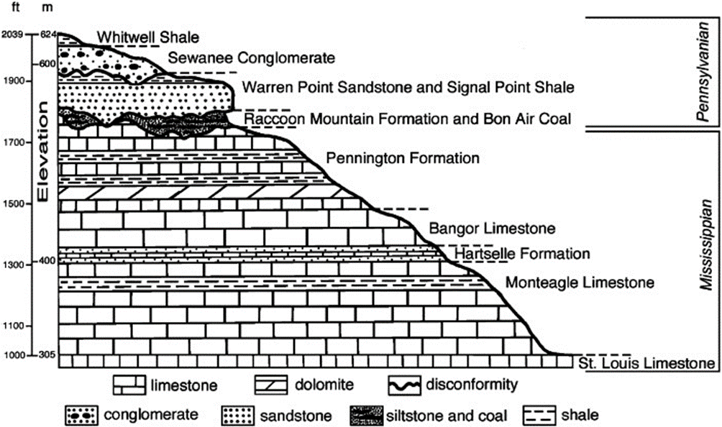
Figure 3.1: Stratigraphic sequence of the Cumberland Plateau in the Sewanee area (from Knoll and Potter 1998).

Soils of the Cumberland Plateau
The soils of the Cumberland Plateau are as diverse as the topography and are greatly influenced by the underlying geology, as well as age, climate, vegetation, and slope (Fox 1941; Hinkle et al. 1993:208). These factors vary greatly across the region, resulting in a diversity of soil types in the uplands, terraces, colluvial areas, and bottomlands.
The soils of the uplands have developed from the weathering of underlying parent materials that include limestone, sandstones, and unconsolidated silts (Table.3.1) (Fox 1941:7). These soils are normally classified as soils of limestone valley uplands or sandstone plateaus (Fox 1941:24). The soils that formed over sandstone, shale, and interbedded shale and limestone are usually shallow and low in fertility. Those formed over high-grade limestone are usually considered high in natural fertility (Fox 1941:25; Hinkle et al. 1993:209). Multiple soil series are recognized (Table 3.1).
Colluvial soils occupy sloping fans and benches at the base of long and steep slopes (Table 3.2) (Elder et al. 1958; Fox et al. 1958:7; Swenson et al. 1954). They have formed from parent materials that washed off of or fell from the adjacent slopes. They are found in drainages, at the base of upland slopes, and on small alluvial-colluvial fans. Multiple soil series are recognized (Table 3.2).
Old alluvial soils that occur in stream terraces or benches represent old floodplains left behind by streams as they cut their way down to lower levels. In many cases, these soils are similar to the older soils of the uplands. Differences in these soils series are based on age and drainage (Table 3.3).
The nearly level bottomlands soils are developed from materials deposited by streams (Table 3.4). These are mainly younger soils because the parent materials have not been in place long enough to have developed well-defined soils. Soil series recognized are identified in Table 3.4.
Table 3.1: Soils from the Uplands of the Cumberland Plateau.
Soils | Parent Material | Drainage | Relief | Slope |  | Acid |  | Organic Matter |  | Plant Nutrients
Muskinghum | Acid sandstone | Excessively drained | Undulating to hilly | 12—60% |  | Strong |  | Low |  | Low
Hartsells | Acid sandstone | Well drained | Nearly level to rolling | 5—12% |  | Strong |  | Low |  | Low
Linker | Acid sandstone | Well drained | Nearly level to rolling | 5—12% |  | Strong |  | Low |  | Low
Crossville | Acid sandstone | Well drained | Nearly level to rolling | 5—12% |  | Strong |  | Low |  | Low
Talbott | Argillaceous limestone | Well drained | Undulating to rolling | 5—12% |  | Medium to Strong |  | Low |  | Moderate
Colbert | Argillaceous limestone | Moderately well drained | Undulating to rolling | 5—12% |  | Medium |  | Low |  | Moderate
Bodine | Cherty limestone | Excessively drained | Undulating to hilly | 25—60% |  | Strong |  | Low |  | Low
Dellrose | Cherty limestone | Excessively drained | Undulating to hilly | 25—60% |  | Medium to Strong |  | Moderate |  | Moderate
Baxter | Cherty limestone | Well drained | Undulating to hilly | 25—60% |  | Strong |  | Low |  | Low
Clarksville | Cherty limestone | Excessively drained | Undulating to hilly | 25—60% |  | Strong |  | Low |  | Low
Fullerton | Cherty limestone | Excessively drained | Undulating to hilly | 12—25% |  | Medium to Strong |  | Moderate |  | Moderate
Bolton | High grade limestone | Well drained | Undulating to hilly | 5—25% |  | Medium |  | High |  | High
Decatur | High grade limestone | Well drained | Undulating to hilly | 2—25 % |  | Medium to Strong |  | Relatively high |  | Relatively high
Dewey | High grade limestone | Well drained | Undulating to hilly | 2—25 % |  | Medium to Strong |  | Relatively high |  | Relatively high
Armuchee | Limestone and shale | Excessively drained | Hilly to steep | 25—60 % |  | Medium |  | Low |  | Low
Tellico | Sandstone and limestone | Moderately well drained | Undulating to rolling | 12—25% |  | Medium to Strong |  | Low |  | Low
Mimosa | Phosphatic limestone | Well drained | Undulating to hilly | 12—25 % |  | Strong |  | Low |  | Low
Enders | Shale and sandstone | Moderately well drained | Undulating to rolling | 2—5 % |  | Medium to Strong |  | Low |  | Low
Pottsville | Shale and sandstone | Poorly drained | Hilly | 12—20 % |  | Medium to Strong |  | Low |  | Low
Mountainview | Unconsolidated Silts | Well drained | Nearly level to rolling | 2—12 % |  | Strong |  | Low |  | Low
Dickson | Unconsolidated Silts | Moderately well drained | Nearly level to rolling | 5—12 % |  | Strong |  | Low |  | Low
Lawrence | Unconsolidated Silts | Imperfectly drained | Nearly level | 0—3 % |  | Strong |  | Low |  | Low
Guthrie | Unconsolidated Silts | Poorly drained | Nearly level | 0—3 % |  | Strong |  | Low |  | Low
Moderate internal drainage provides optimum conditions for crop growth
Table compiled from Elder et al. 1958, Fox et al. 1958, and Swenson et al. 1954.

Table 3.2: Soils of the Colluvial Lands of the Cumberland Plateau.
Soils | Parent Material | Internal Drainage | Relief | Slope | Acid | Organic Materials | Plant Nutrients
Swaim | Argillaceous limestone | Moderate | Gently sloping | 2—12% | Medium | Moderate | Moderate
Hollywood | Argillaceous limestone | Poorly drained | Gently sloping to level | 2—7 % | Neutral | High | Moderate
Hermitage | Cherty limestone | Moderate | Sloping to level | 2—5 % | Medium to Strong | High | High
Greendale | Cherty limestone | Moderate | Gently sloping | 2—7 % | Medium to Strong | Moderate | Moderate
Pace | Cherty limestone | Well drained | Undulating to hilly | 2—25 % | Strong | Low | Low
Minvale | Cherty limestone | Well drained | Undulating to hilly | 5—12 % | Medium | Moderate | Moderate
Abernathy | Limestone | Moderate | Sloping to level | 0—4 % | Medium | Moderate | Moderate
Ooltewah | Limestone | Poorly drained | Nearly level | 0—5 % | Medium to Strong | Moderate | High
Guthrie | Limestone | Poorly drained | Nearly level | 0—3 % | Strong | Low | Low
Emory | Limestone | Well drained | Gently sloping | 2—7 % | Medium | High | High
Barbourville | Sandstone and shale | Moderate | Sloping to level | 2—7 % | Medium to Strong | High | Moderate
Cotaco | Sandstone and shale | Poorly drained | Sloping to level | 0—2 % | Strong | Low | Low
Allen | Sandstone w/ limestone and shale | Moderate | Undulating to hilly | 2—25 % | Strong | Low | Low
Jefferson | Sandstone w/ limestone and shale | Moderate | Undulating to hilly | 5—25 % | Strong | Low | Low
Moderate internal drainage provides optimum conditions for crop growth
Table compiled from Elder et al. 1958, Fox et al. 1958, and Swenson et al. 1954.

Table 3.3: Soils from the Terraces and Benches of the Cumberland Plateau.
Soils | Parent Material | Internal Drainage | Relief | Slope |  | Acid |  |  | Organic Material | Plant Nutrients
Cumberland | Limestone | Well drained | Undulating to hilly | 2—5% |  | Strong |  |  | High | High
Etowah | Limestone | Well drained | Nearly level to rolling | 2—5 % |  | Strong |  |  | High | High
Humphreys | Limestone | Well drained | Nearly level | 1—5 % |  | Medium to Strong |  |  | Medium | Medium
Wolftever | Limestone | Moderately well drained | Nearly level to undulating | 2—5 % |  | Medium to strong |  |  | Moderate | Moderate
Capshaw | Limestone | Moderately well drained | Nearly level to undulating | 2—5 % |  | Medium to Strong |  |  | Low | Low
Taft | Limestone | Imperfectly drained | Nearly level | 0—3 % |  | Medium to Strong |  |  | Low | Low
Robertsville | Limestone | Poorly drained | Nearly Level | 0—3 % |  | Strong |  |  | Low | Low
Tupelo | Limestone | Poorly drained | Nearly level to undulating | 2—5 % |  | Strong |  |  | Low | Low
Waynesboro | Sandstone | Well drained | Undulating to hilly | 2—12 % |  | Medium to Strong |  |  | Moderate | Moderate
Nolichucky | Sandstone | Well drained | Nearly level | 2—5 % |  | Strong |  |  | Low | Low
Holston | Sandstone | Well drained | Nearly Level | 2—15 % |  | Strong |  |  | Low | Low
Tyler | Sandstone | Imperfectly drained | Nearly Level | 0—3 % |  | Strong |  |  | Low | Low
Purdy | Sandstone | Poorly drained | Nearly level | 0—3 % |  | Strong |  |  | Low | Low
Monongahela | Sandstone | Poorly drained | Nearly Level | 0—3 % |  | Strong |  |  | Low | Low
Sequatchie | Sandstone | Well drained | Nearly level to undulating | 2—5 % |  | Medium to Strong |  |  | Moderate | Moderate
Whitwell | Sandstone | Moderately well drained | Nearly level | 1—5 % |  | Medium to Strong |  |  | Moderate | Moderate
Moderate internal drainage provides optimum conditions for crop growth
Table compiled from Elder et al. 1958, Fox et al. 1958, and Swenson et al. 1954.

Table 3.4: Soils from the River Bottoms of the Cumberland Plateau.
Soils | Parent Material | Internal Drainage | Relief | Slope | Acid | Organic Matter | Plant Nutrients
Ennis | Cherty limestone | Well drained | Nearly level | 0—3 % | Medium to Strong | Medium |  | Medium
Dunning | Cherty limestone | Imperfectly drained | Nearly level | 0—3 % | Slightly | High |  | Medium
Lobelville | Cherty limestone | Imperfectly drained | Nearly level | 0—3 % | Strong | Low |  | Low
Melvin | Cherty limestone | Poorly drained | Nearly level | 0—3 % | Medium | Moderate |  | Moderate
Bruno | Limestone | Excessively drained | Nearly level | 0—3 % | Medium to Strong | Low |  | Low
Huntington | Limestone | Moderately well drained | Nearly level | 0—3 % | Neutral | High |  | High
Egam | Limestone | Moderately well drained | Nearly level | 0—3 % | Medium | Medium |  | High
Lindside | Limestone | Imperfectly drained | Nearly level | 0—3 % | Medium | High |  | High
Staser | Mixed sandstone, shale, and limestone | Well drained | Nearly level | 0—12 % | Slightly | High |  | High
Hamblen | Mixed sandstone, shale, and limestone | Imperfectly drained | Nearly level | 0—2 % | Medium to Strong | Moderate |  | Moderate
Sturkie | Mixed sandstone, shale, and limestone | Well drained | Nearly level | 0—4 % | Medium to Strong | Moderate |  | Moderate
Prader | Mixed sandstone, shale, and limestone | Poorly drained | Nearly level | 0—2 % | Neutral | Moderate |  | Moderate
Pope | Sandstone | Moderately well drained | Nearly level | 0—2 % | Strong | Low |  | Low
Philo | Sandstone | Well drained | Nearly level | 0—2 % | Strong | Low |  | Low
Atkins | Sandstone | Poorly drained | Nearly level | 0—3 % | Very Strong | Low |  | Low
Moderate internal drainage provides optimum conditions for crop growth
Table compiled from Elder et al. 1958, Fox et al. 1958, and Swenson et al. 1954.

Forests of the Cumberland Plateau
The great diversity found on the physical landscape is also witnessed in the forest communities. While the forests of the Cumberland Plateau are classified as Mixed Mesophytic Forests (Bailey 1976; Braun 2001:87), there is great variation within that category from north to south. These forests are characterized by high biodiversity at the community level and are some of the most biologically rich systems not only in the United States, but also worldwide (Hinkle et al. 1993:203). The boundaries of the forests to the east are somewhat indistinct and overlap the adjacent Ridge and Valley Province. To the west, the Mixed Mesophytic Forests are delimited by the western escarpment of the Cumberland Plateau (Braun 2001:39). As defined by Braun (1950:40), the dominant trees of the arboreal layer are: beech (Fagus grandifolia), tulip tree (Lirodendron tulipifera), basswood (Tilia heterophylla, T. heterophylla var. michauxii, T. floridana, T. neglecta), sugar maple (Acer saccharum, A. saccharum var. nigra, A. saccharum var. rugelii), chestnut (Castanea dentata), sweet buckeye (Aesculus octandra), red oak (Quercus borealis var. maxima), white oak (Quercus alba), hemlock (Tsuga canadensis), and silverbell (Halesia monticola). Local or less abundant species that occur in Mixed Mesophytic Forests include: birch (Betula lutea var. allegheniensis, B. lenta), black cherry (Prunus serotina), cucumber tree (Magnolia acuminata), white ash (Fraxinus americana, including var. biltmoreana), and red maple (Acer rubrum). Other species including black gum (Nyssa sylvatica), black walnut (Juglans nigra), and two species of hickory (Carya ovata and Carya cordiformis) are found in large numbers within these forests but are never abundant (Braun 2001:40—41). These lists are not exclusive, nor are each of the species found in every area of the region.
Trees of the lower layers that never reach the canopy are also important features of the Mixed Mesophytic Forests. They include dogwood (Cornus florida), magnolias (Magnolia tripetala, Magnolia macrophylla, and Magnolia fraseri), sourwood (Oxydendrum arboreum), striped maple (Acer pensylvanicum), redbud (Cercis canadensis), ironwood or blue beech (Carpinus caroliniana), hop-hornbeam (Ostrya virginiana), holly (Ilex opaca), and serviceberry (Amelanchier arborea). The shrubs Lindera benzoin, Hamamelis virginiana, Asimina triloba, Hydrangea arborescens, and Cornus alterniflolia are also abundant. Other species of variable abundance include Viburnum acerifolium, Ribes cynosbati, Pyrularia pubera, Stewartia ovata (S. pentagyna), Sambucus canadensis, Euonymus americanus, E. atropurpureus, Clethra acuminata, and Aralia spinosa (Braun 1950:43).
Due to the dissected nature of the Plateau, the Western Escarpment from northern Tennessee into Alabama is described by Braun as the Cliff Section (Braun 2001:113). Forests here are primarily mixed oak, oak-hickory, and oak-pine communities. The predominant species found in the region are oak (Quercus alba, Q. montana, Q. coccinea, Q. falcata, Q. stellata, Q.borealis var. maxima), hickory (Carya glabra, C. tomentosa), black gum (Nyssa sylvatica), sourwood (Oxydendrum arboretum), persimmon (Diospyros virginiana), flowering dogwood (Cornus florida), pine (Pinus echinata, P. virginiana), and other xeric species (Braun 2001:113).

Table 3.5: Plant Communities by Landscape Position on the Cumberland Plateau.
Landscape Position | Uplands | Ravine
Floodplain terrace | Red maple-river birch-holly | River birch
Streamside slope | Hemlock | Hemlock (lower slopes)
 |  | White pines (upper draws)
Poorly drained swales | Red maple | N/A
 | Red maple-white oak-black gum
Lower slopes | White oak | White oak-northern red oak
 |  | Beech-tulip tree
 |  | Tulip tree-shagbark
 |  | Hickory-northern red oak
Middle to upper slope | Chestnut oak (rocky slopes) | N/A
Middle to lower slope | N/A | Beech
 |  | Northern red oak-sugar maple
 |  | Sugar maple-white basswood-ash-buckeye
Broad ridges and upper slope | Mixed oak | N/A
 | Scarlet oak
 | Short leaf pine-white oak
Middle slope | Post oak-scarlet oak | Sugar maple-white oak
Narrow ridges | Black jack oaks (shallow soils) | N/A
Narrow ridges to cliff edges | Virginia pine | N/A
Upper slopes | N/A | Mixed oak
 |  | Chestnut oak
Data compiled from Hinkle 1978, 1989.

Because of the great diversity in substrate and topography in the Cliff Section (Braun 2001), Hinkle (1978, 1989) conducted a more recent analysis of those forest communities. He provided detailed descriptions of 331 circular forest plots (0.04 ha.) in selected stands of the Cumberland Plateau and of 231 plots in ravines and gorges of the Plateau. Twelve community types were identified based on the dominant species within each plot (Table 3.5). Hinkle concluded, contrary to Braun’s assertion, that the designation oak-hickory forest should not be applied to the upland Cumberland Plateau communities because hickory trees would have played little importance, as their frequencies were low. However, hickories would have been of greater importance in the middle and lower slopes related to lower occurrences of fire (Hinkle 1989:128). He claimed that many of the species that would make up a Mixed Mesophytic forest were absent from the upland area, namely maples (Acer saccharum), birch (Betula lenta and Betula lutea), hornbeam (Carpinus caroliniana), bitternut hickory (Carya cordiformis), yellowwood (Cladrastis kentukea), black walnut (Juglans nigra), magnolia (Magnolia acuminate), chinkapin oak (Quercus muehlenbergii), basswood (Tilia heterophylla), and elm (Ulmus americana). He also noted that two species of oaks, Quercus imbricaria and Quercus marilandica, are more appropriately mixed oak forests species. Ravine forests types were much more similar to those defined by Braun (2001) (Hinkle 1989:128).
The forests of the Tennessee Valley and Cumberland Plateau regions in Jackson County, Alabama, are as diverse as those on the upland Plateau in neighboring Tennessee and are described as the southern district of the Cliff section by Braun (2001). On the heavily dissected Cumberland Plateau of Northern Alabama, the underlying sandstone makes for rather poor soils. These forests have been classified as Oak-Hickory-Pine Forests and are dominated by pines (Pinus taeda, P. echinata, and P. virginiana) and oaks, which primarily occupy the dry uplands (Quercus coccinea, Q. alba, Q. stellata, and Q. falcata), rocky gorges (Quercus borealis and Q. montana), and stream beds (Quercus nigra) (Harper 1943:90; Hinkle et al. 1993:206). These forests also include red maple (Acer rubrum), sweet gum (Liquidambar styraciflua), beech, (Fagus grandifolia), black gum (Nyssa silvatica), birch (Betula nigra), hemlock (Tsuga canadensis) and several species of hickories (Carya spp.) (Harper 1943:92). At the southern limits of the Cumberland Plateau physiographic province, south of the Tennessee River, the forests take on a different composition as a result of the underlying Mississippian-aged Tuscumbia limestone. The forests of the limestone slopes are made up of cedar (Juniperus virginiana), shagbark hickory (Carya ovata), silver maple (Acer saccharinum), redbud (Cercis canadensis), and wild plum (Prunus americana) (Harper 1943:78). The forests of the valley bottoms and along creeks and streams are different from those on the fertile limestone slopes. These forests are composed mainly of elms (Ulmus spp.), sycamore (Platanus occidentalis), hackberry (Celtis occidentalis), river birch (Betula nigra), honey locust (Gleditsia triacanthos), black willow (Salix nigra), and ironwood (Carpinus caroliniana) (Harper 1943:78).
Several studies have addressed the forest composition of the Mixed Mesophytic Forest region as defined by Braun (2001). Table 3.6 demonstrates the incredible variability that exists across a region as large and diverse, topographically and environmentally, as the Cumberland Plateau physiographic region.

Table 3.6: Major Community Types Identified in the Mixed Mesophytic Forest Region.
Mixed Mesophytic | Mixed to Dry Forests
Beech | White pine
Beech-tulip | White pine-chestnut oak
Beech-white oak-sugar maple | White pine-white oak-chestnut oak
Tulip | White oak
Tulip-shagbark hickory-northern red oak | White oak-beech
Sugar maple-basswood-white ash-buckeye | White oak-chestnut oak
Sugar maple-northern red oak | White oak-chinquapin oak
Sugar maple-shagbark hickory-white oak | White oak-hickory
Sugar maple-white oak | White oak-northern red oak
White ash-sugar maple | White oak-scarlet oak
White basswood-sugar maple-buckeye | White oak-virginia pine
Northern red oak | Chestnut oak
Northern red oak-chestnut oak-white oak | Chestnut oak-northern red oak
Northern red oak-sugar maple | Chestnut oak-white oak
 | Chestnut oak-white oak-beech
Pine Forests
Virginia pine | Dry Oak Forests
Shortleaf pine-white oak | Blackjack oak
Virginia pine-white oak | Mixed oak
Shortleaf pine | Post oak-scarlet oak
Virginia pine-white oak-blackjack oak | Scarlet oak
Virginia pine-white pine
 | Swamp Forests to Wet Swales
Streamside | Red maple
River birch | Red maple-river birch-holly
Tulip-sweet gum | Red maple-black gum
 | Red maple-white oak-black gum
Table generated from Hinkle et al. (1993).

Fauna of the Cumberland Plateau
The diversity of fauna in the Mixed Mesophytic Forests reflects the diversity found in the topography and forest communities of the region. These forests support the richest and most abundant amphibian fauna, avifauna, and mammalian fauna of all southeastern upland forest communities, influenced by the abundance and amount of moisture (Hinkle et al. 1993:225). The dominance of mast-bearing trees supports communities of large mammals that most likely reached higher population densities prior to the chestnut blight fungus and European colonization. This blight, by killing chestnut trees that had been a major source of mast, affected large mammal populations once common on the Plateau, such as elk, cougars, black bear, and white-tailed deer. Wild turkey, extinct Carolina parakeet, and extinct passenger pigeons are examples of bird species that were also negatively affected by European colonization (Table 3.7) (Ganier 1933:44).
The riverine environments of the Southern Cumberland Plateau are as rich and diverse as the forests. They provide an ideal environment for several different species of mollusks, fishes, and turtles, as well as the larger mammals found in other forests regions. The Tennessee River and its tributaries also provide habitat for several aquatic species. Thirty nine species of pelecypods (bivalves) (Table 3.8) and thirty species of gastropods (Table 3.9) have been identified in the rivers and streams of East Tennessee (Hickman 1937:8). Along with mollusk’s, 166 native species of fish have been identified in the Tennessee River system. Some of the larger species such as gar, catfish, bass, and drum, would have provided important food resources for prehistoric groups (Table 3.10) (Kuhne 1939). Twelve species of turtle also have been identified in East Tennessee (Table 3.11) (Carr 1952). Waterfowl are also frequent occupants of these riverine environments (Ganier 1933).
Table 3.7: Common Amphibian, Bird, and Mammal Species of the Mixed Mesophytic Forest.
Amphibian | Bird | Mammal
Green Salamander | Cerulean warbler | White-footed mouse
Coal skink | Kentucky warbler | Short-tailed shrew
Worm snake | Acadian flycatcher | Smoky shrew
Copperhead | Summer tanager | Eastern chipmunk
Black racer | Yellow-throated vireo | Flying squirrel
Black rat snake | Parula warbler | Gray squirrel
Cave salamander | Black and white warbler | Eastern woodrat
Ring-necked snake | Worm eating warbler | Red bat
Red-spotted newt | Ovenbird | Opossum
Slimy salamander | Black-throated green warbler | Hairy-tailed mole
Five-lined skink | Canadian warbler | Little brown bat
Garter snake | Rose-beaked grosbeak | Eastern pipistrelle
Fowler's toad | Dark-eyed junco | Big brown bat
American toad | Turkey | Gray fox
Gray treefrog | Ruffed goose | Raccoon
Spring peeper | Bobwhite | Striped skunk
Mountain chorus frog | Morning dove | White-tailed deer
Eastern box turtle | Wood thrust | Black bear
Wood frog | Carolina wren | Bobcat
Table after Hinkle et al. 1993.

Table 3.8: Bivalves Found in the Tennessee River System’s.
Family | Genus | Species | Common Name
Unionidae | Fusconaia | pilaris
 |  | pilaris lesueriana
 |  | cor
 |  | cuneolus
 |  | barnesiana
 |  | edgariana
 | Quadrula | cyclindrica
 |  | pustulosa | Pimple-back
 |  | metanevra | Monkey-face
 | Cycloainas | tuberculata | Purple pimple-back
 | Amblema | costata | Three-ridge
 | Pleurobema | cordatum | Rough or Pyramid pigtoe / Ring pink
 |  | cordatum pyramidatum | Rough or Pyramid pigtoe / Ring pink
 | Obovaria | retusa | Ring pink
 | Lasmigona | costata | Fluted shell
 | Cyprogenia | irrorata
 | Eliptio | dilatatus | Spoike, Lady-finger
 | Actiononaias | carinata | Muckett
 | Ptychobranchus | fasciolare
 |  | subtena
 | Dromus | dromus | Dromedary pearlmussel
 | Dysnomia | capsaeformis
 |  | triquetra
 |  | brevidens
 |  | torulosa
 |  | lenoir
 | Ligumia | recta latissima | Black sand shell
 | Lampsilis | ovata | Pocketbook
 |  | ovata ventricosa | Pocketbook
 |  | orbiculata | Pocketbook
 | Leptodea | fragilia | Fragile paper shell
 |  | leptodon
 | Proptera | alata | Pink Heel-splitter
 | Plethobasus | cyphyus | Bullhead
 | Alasmidonta | marginata | Nigger-toe
 | Micromya | nebulosa
 |  | vanuxemensis
 | Medionidus | conradicus
Spaeridae | Pisidium | abditum
Table after Hickman 1937.

Table 3.9: Gastropods Found in the Tennessee River Systems.
Family | Genus | Species | Family | Genus | Species
Viviparidae | Campeloma | rufum | Ancylidae | Ferrisia | fusca
 |  | ponderosum | Helicidae | Polygyra | rugeli
Pleuroceridae | Pleurocera | moniliferum |  |  | denotata
 |  | gradatum |  |  | thyroides
 |  | filum |  |  | elevata
 | Goniobasis | adusta |  |  | inflecta
 | Anculosa | subglobosa |  |  | appressa
 |  | subglobosa tintinnulum |  |  | stenotrema
 |  | subglobosa gibbosa |  |  | tridentata
 |  | tintinnabulum |  |  | spinosa
 |  | ornata |  |  | albolabris
 |  | praerosa |  |  | fraudlenta
 | Io | fluvialis |  |  | andrewsae
 |  | fluvialis lyttonensis |  |  | clausa
 |  | fluvialis paulensis |  |  | mithcelliana
 |  | fluvialis angitremoides |  |  | plicata
 |  | fluvialis nolichuckyensis | Endodontidae | Discus | patulus
 |  | fluvialis loudonensis |  | Anguispira | alternata
 |  | recta |  |  | a. crassa
 |  | spinosa | Zonitidae | Omphalina | cuprea
 | Lithasia | geniculata |  | Vitrea | capsella
 |  | verrucosa |  |  | petrophila
 |  | obovata |  | Retinella | indentata
 | Eurycaelon | anthonyi |  | Ventridens | gularis
Lymnaeidae | Lymnaea | desidiosa |  |  | accerus
 | Psuedosuccinea | columella |  |  | suppressus
Planorbidae | Heliosoma | trivolvis |  | Mesomphix | perlaevis
 | Gyraulus | parvus | Haplotrematidae | Haplotroma | concavum
Physidae | Physella | heterostrpha
 |  | gyrina
Table after Hickman 1937.

Table 3.10: Fishes Found in the Tennessee River Systems.
Genus | Species | Common Name | Genus | Species | Common Name
Acipenser | fulvencens | Lake Sturgeon | Ictalurus | lacustris | Channel catfish
Scaphirhynchus | platorynchus | Shovel nosed sturgeon |  | furcatus | Blue catfish
Lepisosteus | osseus | Long-nosed gar | Pilodictis | olivaris | Mud catfish
 | productus | Spotted gar | Ameiurus | nebulosus | Brown bullhead
 | paltostomus | Short-nosed gar |  | natalis | Yellow bullhead
 | spathula | Alligator gar |  | melas | Black bullhead
Amia | calva | Bowfin | Umbra | limi | Mud minnow
Amphiodon | alosiodes | Moon-eye |  | pygmaea
Hiodon | tergisus | Moon-eye | Esox | vermiculatus | Mud pickerel
 | selenops | Moon-eye |  | niger | Eastern pickerel
Alosa | ohiensis | Ohio shad |  | masquinongy | Ohio muskellunge
Pomolobus | chrysochloris | Blue herring | Esoc | lucius | Northern pike
Dorosoma | cepedianum | Gizzard shad | Anguilla | bostoniensis | Amercian freshwater eel
Salvelinus | frontinalis | Brook trout | Fundulus | dispar | Star-headed topminnow
Salmo | gairdnerii | Rainbow trout |  | notatus | Black-banded topminnow
 | trutta | Brown trout |  | chrysotus | Redspotted topminnow
Cycleptus | elongatus | Missouri sucker |  | albolineatus | Whites-sided topminnow
Megastomatobus | cyprinella | Big-mouth buffalo |  | catenatus | Studfish
Ictiobus | bubalus | Small-mouth buffalo | Gambusia | affinis | Mosquito fish
Carpiodes | cyprinus | Quillback | Typhlichthys | subterraneus | Blindcave fish
 | carpiuo | Quillback | Aphredoderus | sayanus | Pirate perch
 | velifer | Quillback | Lepibema | chrysops | White bass
Catostomus | commersonnii | Common white sucker | Morone | Interrupta | Yellow bass
Hypentelium | nigricans | Hog-molly | Stizostedion | canadense | Sandpike
Erimyzon | oblongus | Chub suckers |  | vitreum | Walleyed pike
 | sucetta | Chub suckers | Hypohomus | aurantiacus | Yellow darter
Minytrema | melanops | Spotted sucker | Swainia | squamata | Olive darter
Moxostoma | duquesnii | Red horse suckers | Imostoma | shumardi | Channel darter
 | erythrurum | Red horse suckers |  | uranidae | Star-gazing darter
Table 3.10 (cont.): Fishes Found in the Tennessee River Systems.
Genus | Species | Common Name | Genus | Species | Common Name
Moxostoma | anisurum | Red horse suckers | Hadropterus | scierus | Black-sided darter
 | breviceps | Red horse suckers |  | maculatus | Dusky darter
Placopharynx | carinatus | Pavement toothed red horse |  | macrocephalus | Long-headed darter
Logachila | lacera | Rabbit-mouth sucker |  | phocephalus | Slender-headed darter
Cyprinus | carpio | German carp |  | evides | Gilded darter
Carassius | auratus | Goldfish | Percina | cparodes | Log perch
Nocomis | biguttatus | Horny-head chub | Cottogaster | copelandi | River darter
Hybopsis | storerianus | Silver chub | Ammocrypta | pellucida | Northern sand darter
 | amblops | Big-eyed chub | Doration | meadiae | Tennessee speckled darter
Erimystax | watauga | Watauga chub | Ulocentra | duryi | Black-sided snubnose
 | monocau | Spot-finned chub |  | atripinnis | Cumberland snubnose
Extrarius | aestivalis | Hog-nosed speckled dace |  | simotera | Tennessee snubnose
Rhinichtyhs | atratulus | Black-nosed dace | Boleosoma | nigrum | Northern johnny darter
 | cataractae | Long-nosed dace |  | susanae | Cumberland johnny darter
Semotilus | artomaculatus | Creek chub | Psychromaster | tuscumbia | Spring darter
Hemitremia | flammea | Flame dace | Poecilichthys | camurus | Blue-breasted darter
Clinostomus | vandoisulus | Rosy dace |  | maculatus | Spotted darter
Chrosomus | erythrogaster | Southern red-bellied dace |  | ruflineatus | Red-lined darter
Opsopoedus | emiliae | Pug-nosed minnow |  | zonalis | Banded darter
Notemigonus | chrysoleucas | Golden shiner |  | swannonoa | Suannanva darter
Notropis | lirus | Mountain shiner |  | blennius | Blenny darter
 | ardens | Ohio red-finner shiner |  | cinereus | Ashy darter
 | umbratilis | Red-finned shiner |  | jessiae | Mud darter
 | atherinoidea | Southern emerald shiner |  | caerulueus | Rainbow darter
 | photogenis | Silver shiner |  | spectabilis | Orange-throated darter
 | micropterys | Small-finner shiner | Catonotus | squamiceps | Spot-tailed darter
 | ariommus | pop-eyed shiner |  | kennocotti | Cumberland stripetail
 | coccogenis | War-paint shiner |  | fladellaris | Banded fantail
 | cornutus | Common shiner | Etheostoma | blennioides | Southern green-sided darter
Table 3.10 (cont): Fishes Found in the Tennessee River Systems.
Genus | Species | Common Name | Genus | Species | Common Name
Notropis | rubricroceus | Saffron shiner |  | gutselli | Carolina green-sided darter
 | chrosomus | Colorful shiner | Microperca | proeliaris | Southern least darter
 | leuciodus | Tennessee shiner | Hololepis | barratti | Southern swamp darter
 | spilopterus | Spot-finned shiner |  | gracilis | Western swamp darter
 | whipplii | Steel-colored shiner | Huro | salmoides | Large-mouthed bass
 | galacturus | White-tailed shiner | Microterus | dolomieu | Small-mouthed bass
 | venustus | Central black-tailed shiner |  | punctulatus | SpottedbBass
 | boops | Big-eye shiner | Pomoxis | annularis | White crappie
 | illecebrosus | Silver-banded shiner |  | sparoides | Black crappie
 | blennius | River shiner | Centrarchus | macropterus | Rounded sunfish
 | delicious | Northern sand shiner | Chaenobryttus | gulosus | War-mouthed bass
 | spectrunculus | Mirror shiner | Ambloplites | rupestris | Rock bass
volucellus | volucellus | Northern mimic shiner | Lepomis | machrochirus | Bluegill
 | wickliffi | River mimic shiner |  | cyanellus | Green sunfish
 | buchanani | Ghost shiner |  | punctatus | Western spotted sunfish
Ericymba | buccata |  |  | humilis | Orange-spotted sunfish
Phenacobius | mirabilis | Sucker-mouthed shiner |  | megalotis | Long-eared sunfish
 | uranops | Sucker-mouthed shiner |  | microlophus | Red-eared sunfish
Hybogmathus | hayi | Cypress minnow |  | symmetricus | Small sunfish
 | nuchalis | Silver minnow | Elassoma | zonatum | Pigmy sunfish
 | placitus | Northern plains minnow | Menidia | audens | Glassy minnow
Ceratichthys | vigilax | Northern minnow | Labidesthes | sicculus | Brook silverside
Pimephales | promelas | Northers fat-headed minnow | Aplodinotus | grunniens | Sheepshead
Hyborhynchus | notatus | Blunt-nosed minnow | Cottus | bairdii | Muddler
Campostoma | anomalum | Stone-roller
Table after Kuhne 1939.
Table 3.11: Turtle Species Found in the Tennessee River Systems.
Family | Genus | Specie | Common Name
Chelydridae | Macrochelys | schmidti | Alligator snapper
 | Chelydra | serpentina | Snapping turtle
Kinosternidae | Sternotherus | carinatus | Musk turtle
 |  | odoratus | Common musk turtle
 | Kinosternon | subrubrum | Common mud turtle
Emydidae | Terrapene | carolina | Common box turtle
 | Graptemys | geographica | Common map turtle
 | Chrysemys | marginata | Midland painted turtle
 | Pseudemys | troostii | Cumberland turtle
 |  | elegans | Red-eared turtle
 |  | concinno | River turtle
Trionychidae | Amyda | ferox | Eastern spiny soft-shelled turtle
Table after Carr 1952.

Changing Plant and Animal Communities during the Holocene
The flora and fauna in the project area today are far different than those encountered by Native Americans. Global climate change during the Holocene restructured the wild plant and animal communities that prehistoric populations relied upon for food, clothing, and shelter, resulting in changes in settlement and subsistence practices. Eventually, hunter/gatherers made decisions that led to plants being moved around the landscape, stored, and planted, all decisions that led to initial plant domestication and the transition from foraging-based subsistence systems to one that relied primarily on food production.
Approximately 16,500 cal yr B.P., during the Late Glacial Interval, spruce, Diploxylon or hard pine, and fir trees began a northward migration from the midlatitudes (34 degrees N to 37 degrees N) in response to the retreating Laurentide Ice Sheet (Delcourt 1979:276; Overpeck and Webb 1992:1071: Prentice et al. 1991:2046; Webb III et al. 1993:448; Williams et al. 2001, 2004). Mixed coniferous-deciduous forests composed of oak, ash, ironwood, hickory, beech, and sugar maple began to colonize habitats left vacant by the retreating boreal conifers (Delcourt 1979:276; Delcourt and Delcourt 1987:71).
Approximately 5,000 years later another great restructuring of resources occurred at the Pleistocene-Holocene transition, around 11,650 cal yr.B.P., an event associated with the end of the Younger Dryas cooling event when mean global temperatures increased (Figure 3.2) (Anderson 2001; Anderson et al. 2007; Sherwood et al. 2004:544). This warming event is seen in changing ¹⁸O values in the GRIP and GRIPS2 ice cores records (Alley et al. 1997; Grootes et al. 1993). Warming environmental conditions resulted in temperate plant communities replacing boreal plant communities as conditions became less tolerable for boreal forest species (Delcourt and Delcourt 1985:19; Klippel and Parmalee 1974). This transition also resulted in the restructuring of the animal community as Pleistocene mammalian communities became “ecologically incompatible” due to changing climatic conditions (Graham and Mead 1987:371). The end of the Pleistocene is also associated with a major extinction episode of large mammals—32 genera in North America alone, including the American mastodon, camel, mammoth, ground sloth, and large cats (Bonnichsen et al. 1987:419; Graham and Mead 1987:386; Wright 1986, 1991:525). The archaeological remains of smaller mammals recovered from the Midsouth also provide strong evidence to support the changing climate across the region at the end of the Late Pleistocene (Klippel 1987; Klippel and Parmalee 1982; Parmalee and Klippel 1981).
While environmental change associated with the Pleistocene/Holocene transition resulted in a restructuring of floral and faunal communities across the Eastern Woodlands, analysis of ice cores (Alley et al. 1997; Grootes et al. 1993; O’Brien et al. 1995), marine sediments (Bond et al. 1997, 2001), and pollen assemblages (Viau et al. 2002, 2006), show that Holocene climate change was also highly variable. During the Early-Holocene interval (11,650 – 8,900 cal. yr B.P.), major compositional changes occurred in the local forest communities. Cool-temperate mixed mesic forest communities became established in the region (Delcourt 1979:276; Overpeck and Webb 1992:1072). Higher percentages of oak and pine, more xeric species, suggest a local forest response to warmer and drier conditions (Figure 3.2) (Delcourt et al. 1983:884; Prentice et al. 1991:2046). A further decrease in the representation of mesic species occurred between 10,000 and 8,400 BP, at the expense of oak and hickory species. This increase is thought to be the result of either a decrease in precipitation or an increase in summer temperatures (Delcourt et al. 1983:884). However, faunal assemblages recovered from Dust Cave and Russell Cave in Alabama and Cheek Bend Cave, Tennessee suggest that the make-up of vertebrate fauna from the Early Holocene is essentially the same as modern fauna (Graham and Mead 1987:387; Klippel and Parmalee 1982; Walker 1998).
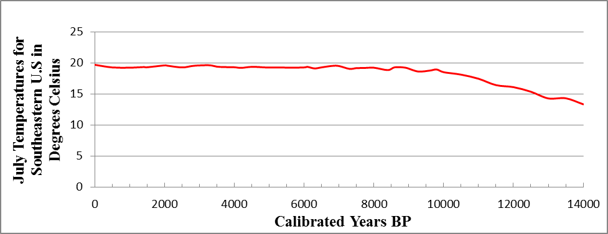
Figure 3.2: Mean July temperatures for the Southeastern United Stated, after Viau et al. 2006.

After 8,900 cal BP, a warming and drying trend marked by the Hypsithermal Warming episode had widespread effects on the forest composition of eastern North America (Delcourt 1979:277). The forests of the midlatidudes became more xeric, dominated by oak, ash, and hickory (Delcourt 1979; Delcourt et al. 1983:885). By the end of the mid-Holocene, the Mixed Mesophytic Forests in the region were established (Delcourt 1979).
The story of the Eastern Woodlands forests is also one of change, beginning with the Pleistocene/Holocene transition, followed later by the Hypsithermal Warming episode, and eventually by climatic events that marked the transition from the Late Archaic to the Early Woodland period. The changing forest conditions had major effects, not only on the plant and animal communities, but also on the prehistoric populations that relied upon those resources. The decisions made by foragers in the region as a response to these environmental alterations and changing resources on the landscape eventually led to initial plant domestication in the region. Understanding how these resources changed and how foragers reacted to those changes is imperative to understanding the initial domestication of plants. Understanding environmental changes and the effects that they had on prehistoric populations, and changes that were occurring concomitantly across the cultural landscape are equally important. I will now shift the discussion from environmental change to culture change.

Cultural Environment of the Southern Cumberland Plateau
Changes in plant and animal communities brought about by warmer Holocene climates forced populations relying upon wild food resources to adapt and make changes to their daily lives and routines. Changes also had to be made in response to a changing cultural landscape. The archaeological record recovered from across the region shows that the Archaic period was a time of dynamic change as populations responded to a changing physical and cultural landscape. The end result of this experiment was plant domestication and intensification. These plants provided a stable and predictable food base for Late Archaic groups and had an even greater impact on Woodland populations. In the following section, I discuss the changing cultural landscape of the project area and the greater Eastern Woodlands.

The Archaic Period (11,500 – 3,200 cal yr BP)
In the Eastern Woodlands, the Archaic period represents the longest stage of cultural development, lasting from approximately 11,500 until 3,000 cal yr BP (Anderson 2001:156; Anderson and Sassaman 1996, 2004; Bense 1994:62). Projectile points remain the most significant temporal indicators of Archaic period sites. These sites are identified by the presence of stemmed and notched projectile points. Improved ground and polished stone techniques were used to produce axes, celts, and ornamental items (Caldwell 1968:12; Griffin 1952, 1967:178). Other technological innovations associated with Archaic sites include ceramics during the Late Archaic, wood and stone containers, and shell tools and ornaments (Bense 1994:62). Long-distance exchange networks, mounds, and earthen works all appear and help identify the Archaic period in the Southeast (Bense 1994:62; Johnson and Brookes 1989; Meeks 1998). The period is divided into Early, Middle, and Late, based on changes in demography, environmental conditions, hafted bifaces, and subsistence technologies (Anderson and Sassaman 2012:66) This tripartite classification system is not considered to be universal across the region by any means. The Archaic period is viewed as a long transitory period between the initial colonization of North America and higher levels of socio-political organization, more permanent settlements, and larger population densities witnessed during the Woodland and Mississippian periods (Anderson and Sassaman 2012:66).

Early Archaic Period (11,500 – 8,900 cal yr BP)
The end of the Younger Dryas and the onset of the Holocene mark the beginning of the Early Archaic period across the region (Anderson 2001; Anderson and Sassaman 2012:71). The northward expansion of oak and hickory species as a result of increasing temperature had a substantial impact on hunter-gatherer populations in the region that were reliant on wild plant and animal food resources for survival. Side-notched, corner-notched, and bifurcate based projectile points, such as Big Sandy, Palmer, Kirk Corner-Notched, MacCorkle, and LeCroy types, are used to identify Early Archaic sites across the region (Anderson et al. 1996:15; Coe 1964:67; Chapman 1985:147). Though there is some level of continuity with chipped stone technologies from the Late Paleoindian period, for example the Dalton tradition, the change from lanceolate to side-notched points is thought to reflect a change in hunting practices shifting away from larger mammoth and mastodon towards smaller game resources such as white-tailed deer, turkey, and waterfowl (Anderson and Sassaman 2012:72). An increase in the number of sites and artifacts recovered suggests that populations rapidly expanded during the Early Archaic period (Steponaitis 1986; Smith 1986). It is during the Early Archaic Dalton period that we see the first extensive use of rockshelters and cave sites (Wathall 1998). Groups are also believed to have become more oriented towards specific physiographic ranges, valuable raw material resources, or plant resources, for instance, and tied together into larger networks to facilitate information and mate exchange (Anderson and Hanson 1988; Daniel 1998, 2001; Hollenbach 2009). These organizational changes are believed to reflect group’s responses to changing plant and animal resources brought about by post-glacial warming. As with the beginning of the Early Archaic period, the end also coincides with a significant climatic event at approximately 8,900 cal BP—the onset of the Hypsithermal warming event (Anderson 2001; Anderson and Hanson 1988; Anderson et al. 1996:15, 2007).
In Eastern Tennessee and Northern Alabama, the Early Archaic period sites are recognized by the shift from fluted projectile points used during the Paleoindian period to corner-notched points. This shift is seen in the presence of Dalton, Big Sandy, and Kirk cluster projectile points, Kanawha, LeCroy, and St. Alban bifurcate stem projectile points, and different side-notched point variants recovered from sites excavated in the Duck, Elk, and Little Tennessee River valleys in eastern Tennessee and from sites in northern Alabama (Chapman 1977:124, 1985:38; Davis 1990: Faulkner and McCollough 1977:150; Kimball 1977:276; Sherwood et al. 2004; Solis and Futato 1987:3; Walthall 1980:55). There is no evidence for structures during this period, but the presence of hearths and other features at sites served as foci for seasonal activities (Chapman 1977:124, 1985:40). Textile or basketry impressions found on prepared clay hearths at the Dust Cave and the Ice House Bottom sites provide some of the earliest evidence for the production of textiles (Chapman 1977:124; Hollenbach 2005; Sherwood and Chapman 2005:70).
Subsistence patterns reconstructed from plant and animal food remains indicate that hickory and acorn played an important role in the diets of prehistoric populations during the period. Black walnuts and hazelnuts were also exploited but played a lesser role in the diet. Wild fruits like grapes, hackberry, honey locust, maypop, sumac, raspberries, and blackberries as well as wild seeds like chenopods, smart weed, weedy legumes, and wild legumes also played an important role in the diet during this period. Leafy greens from chenopods, purslane, and pokeweed were also exploited (Chapman and Shea 1981; Hollenbach 2005, 2009, 2010). White-tailed deer provided the bulk of animal protein consumed, but black bear, raccoon, squirrel, and rabbit along with several types of birds were also hunted, including waterfowl, turkey, and passenger pigeon (Morey 1996; Walker 1998; Walker et al. 2001; Weigel et al. 1974). Several types of fishes, mussel, and gastropod were also collected from the local rivers and streams (Clench 1974; Curren Jr. et al. 1977; Parmalee 1994; Warren 1975).

Middle Archaic period (8,900 – 5,800 cal yr BP)
Considered a time of “dramatic cultural change,” the Middle Archaic period lasted from ca. 8,900 until 5,800 cal BP (Anderson 2001:158, 2007; Anderson and Sassaman 2012:73; Kidder and Sassaman 2009:667). Evidence of interpersonal violence, long distance trade networks, the appearance of shell and earthen mounds, and new tool forms all indicate that local cultures were growing in both scale and complexity (Anderson 2001:158, 2002, 2004:270, 2007; Anderson and Sassaman 2004; Caldwell 1958:14; Ford and Willey 1941:335; Kidder and Sassaman 2009:667; Jefferies 1995, 1996, 1997; Lewis and Kneberg 1959:161; Sassaman 2005, 2010; Walthall 1980:38). Early Archaic notched projectile points were replaced regionally with stemmed projectile points such as Kirk Stemmed/Serrated, Eva/Morrow Mountain, Sykes/White Mountains, and Benton points (Chapman 1985:148; Kidder and Sassaman 2009). In northern Alabama and eastern Tennessee, the Middle Archaic period is recognized by the appearance of stemmed projectile points, namely Kirk Stemmed, Stanly, Eva, Morrow Mountain, Skyes, and Guilford projectile points (Davis 1990:58; Faulkner and McCollough 1974:574: Walthall 1980:58). Three interrelated trends mark the beginning of the Middle Archaic period: the Hypsithermal warming event, increased territoriality and regional diversity of projectile points, and new innovations in technology involving groundstone, bone, and antler tools (Walthall 1980:58).
The Hypsithermal climatic event led to considerably variable climates across the Eastern Woodlands resulting in greater extremes in both temperatures and precipitation (Anderson 2001:158; Bense 1994:74; Deevey and Flint 1957). The hot and dry weather conditions caused a change in the composition of the forests and a change in the hydrology of river valley floodplains (Anderson and Sassaman 2004; Bense 1994:74; Schuldenrein 1996). Decreased rainfall stabilized river channels, resulting in the expansion of floodplains and the creation of oxbow lakes and swamps that stayed wet most of the year. Areas outside of the main river channels provided favorable environments for shellfish exploitation by humans (Clench 1974; Dye 1996; Smith 1986:22; Warren 1975). As a result, shellfish became a major constituent of the Middle Archaic diet which helped to situate populations near southeastern river valleys (Anderson 2001:160; Clench 1974; Ford and Willey 1941:332; Griffin 1952; Klippel and Morey 1986; Parmalee 1994; Styles and Klippel 1996; Sassaman 2005:88; Smith 1986:22; Warren 1975).
Restricted group mobility, a direct effect of increasing population, forced people to live closer on the landscape and created an environment for competition and exchange (Anderson 2001:160; Jefferies 1995, 1996, 1997; Meeks 1998). Human burials are found in significant numbers at sites for the first time in the Southeast, some recovered with imbedded projectile points, displaying clear signs of violence (Anderson et al. 2007; Bense 1994:78; Shields 2003). Increased territoriality can be observed in mobility patterns and lithic technologies. Constraints on mobility led to a dependence on local raw materials and regional stylistic diversity of lithic toolkits (Amick and Carr 1996:44; Meeks 1998:115; Sassaman 1995:179; Walthall 1980:58). The changes in lithic technologies that occurred reflect large scale behavioral and organizational changes that influenced the way people operated on the landscape. These technologies shift towards a more expedient toolkit associated with logistically organized mobility and away from the heavily curated lithic technologies of the Paleoindian and Early Archaic lithic toolkits associated with residential mobility (Amick and Carr 1996:43-44).
Great technological innovations made in groundstone tool technologies are also a hallmark of the Middle Archaic period (Griffin 1967:156; Kidder and Sassaman 2009:671; Smith 1986:18). The considerable labor invested in producing these new groundstone tools, such as grooved axes and other formal woodworking tools, atlatl weights, and netsinkers, is evidence of the growing importance of plant resources, as well as evidence of a diversifying economic base (Bense 1994; Griffen 1952; Smith 1986). The preponderance of netsinkers recovered from sites across the Midsouth emphasizes a shift towards riverine resources. Beads, pendants, and ornaments made of shell, bone, and stone were also popularized during the Middle Archaic period and are thought to have been moved across long distance trade networks developed as a means to acquire ornaments, raw materials, and other materials sought as symbols of high status (Bense 1994:75; Ford and Willey 1941:333; Johnson and Brookes 1989; Meeks 1998).

Late Archaic period (5,800 – 3,800 cal yr BP)
The end of the Hypsithermal Warming event led to the establishment of modern climate conditions and marks the transition from the Middle Archaic period to the Late Archaic period. Population increase is reflected by a forty percent increase in sites across the region from the previous Middle Archaic period with no recognizable geographic gaps in their distribution (Anderson and Sassaman 2012:74). While Late Archaic sites are recognized by variations in stone tool technologies (Savannah River Stemmed, Ledbetter Stemmed), the addition of pottery and soapstone vessels assist in their identifications (Anderson and Sassaman 2012:75; Saunders and Hayes 2004).
During the Late Archaic period, four plants indigenous to the Eastern Woodlands were domesticated. Morphological variability resulting from human interaction (harvesting, storing, planting) is exhibited in the fruits and seeds of goosefoot (Chenopodium berlandieri ssp. jonesianum), sumpweed (Iva annua var. macrocarpa), pepo gourds (Cucurbita pepo ssp. ovifera), and sunflower (Helianthus annuus var. macrocarpus). This provides the earliest evidence of domestication of these plants in the region. Along with these four domesticates, maygrass (Phalaris caroliniana), erect knotweed (Polygonum erectum), little barley (Hordeum pusillum) and giant ragweed (Ambrosia trifida) occur in large quantities but lack the morphological variability associated with domestication and are referred to as cultigens (Cowan 1985:207; Gremillion 2004:216; Smith and Yarnell 2009:6562). These native seed crops were part of the initial farming systems that were being established in the river valleys and uplands of eastern North America.
In the Duck and Elk River valleys of the Highland Rim, the Late Archaic period is divided into the Hicks and the Wade phases. The Hicks phase is thought to bridge the Middle Archaic Morrow Mountain phase and the Late Archaic Ledbetter phase (Faulkner and McCollough 1977:265). The Wade phase is considered either a Terminal Archaic or transitional Archaic-Woodland period, and is recognized by the Wade type projectile points that are similar to the Ledbetter point type, but have an expanded stem (Faulkner and McCollough 1974:576). Deeper middens, higher concentrations of features, and burials associated with this cultural phase suggest more intensive occupation of sites by higher populations of people. The presence of large storage pits suggests a higher degree of sedentism at these sites that are still considered to be seasonally occupied (Faulkner and McCollough 1974:575, 1977:48). The most distinctive characteristic of the Wade phase, however, is the appearance of steatite vessels. The presence of the exotic material suggests an increase in trade during this period (Faulkner and McCollough 1974:576).
In the Ridge and Valley, a major increase in population during the Late Archaic period is indicated by a greater number of archaeological sites and the larger size of those sites (Chapman 1985:50). The exchange of marine shells, copper, and steatite vessels speaks to an increase in interregional exchange and social stratification that occurred across the larger Eastern Woodlands (Chapman 1985:51; Davis 1990:219). Evidence for food production appears for the first time. The recovery of amaranth, chenopod, gourds, knotweed, maygrass, and ragweed indicate increased reliance on domesticated and cultivated plant food resources (Chapman 1985:52; Chapman and Shea 1981; Schroedl 2012:85).
In the Ridge and Valley, the Late Archaic period is divided into the Savannah River and Iddins phases (Davis 1990:58). Lithic assemblages from the earlier Savannah River phase are dominated by Savannah River Stemmed projectile points made of quartzite and slate, end scrapers, perforators, abraders, hammerstones, and atlatl weights. Large concentrations of fire-cracked rock, fire pits, pits, and fired basins were also characteristic of Savannah River phase sites. These features were also common on Iddins phase sites along with high densities of Undifferentiated Stemmed points, netsinkers, and grooved axes (Davis 1990:58). Lower site densities during the Savannah River phase led to the interpretation that groups had more limited occupations focused on resource procurement (Davis 1990). Higher site densities in the lower Little Tennessee River Valley and Tellico River Valley suggests that the settlement patterns of these later Iddins phase groups were much more focused on extraction of local aquatic resources (Davis 1990:226).
In northern Alabama, the Late Archaic is identified by the presence of large stemmed projectile points assigned to the Pickwick and the later Wade clusters, and which are very similar to the Ledbetter and Wade clusters found in the Normandy Reservoir (Futato 1977:235). Projectile points associated with the Pickwick cluster include Pickwick, Ledbetter, and Little Bear Creek, while those associated with the Wade cluster include Wade, Elora, and Cotaco Creek types (Futato 1977:236). Occupation of previously uninhabited areas demonstrates continued population increase (Solis and Futato 1987:4; Walthall 1980:67).

Gulf Formational Stage of the Middle Tennessee Valley
Defined in 1976 by Wathall and Jenkins, the Gulf Formational stage is identified by the addition of ceramics to Late Archaic sites. The stage was divided into two regions. The eastern region extends from eastern Alabama to the Atlantic Coast and includes the Guntersville Basin. The western region encompasses the area between the Tombigbee drainage and the lower Mississippi valley (Walthall and Jenkins 1976:43). The Gulf Formational Stage was further divided into three periods: the Early (2500 – 1200 B.C.), the Middle (1200 – 500 B.C.), and the Late (500 – 100 B.C.). In the Middle Tennessee River Valley and the Guntersville Basin this includes two ceramic traditions—the Wheeler, that is considered Middle Gulf Formational, and the Alexander complex, that is viewed as Late Gulf Formational (Futato 1977:237, 1998:213; Little et al. 2012:103). The introduction of fiber-tempered Wheeler variant pottery complexes during the Middle Gulf Formational period is accompanied by Wade, Cotaco Creek, and Motley projectile points. The Late Gulf Formational period is identified by sand-tempered Alexander variant assemblages in association with Flint Creek projectile points (Futato 1998:213; Little et al. 2012:105; Walthall and Jenkins 1976:47).

Woodland Period (3,200 – 1,020 cal yr BP)
For decades, Woodland period sites were identified by the presence of the earliest pottery traditions, the first domesticated plants, and the beginnings of monumental architecture (Griffin 1967:180). Today, however, we know that each of these benchmarks occurred in the preceding Archaic period. The regionalism once thought to be a characteristic of Woodland period societies appears to have roots in the Archaic period, leading many to focus on long-term trends that eventually led to the development of the Mississippian societies (Anderson and Sassaman 2012:114). Now panregional religious movement associated with monumental architecture, elaborate mortuary ceremonialism, animal effigies, and the acquisition and trade of exotic raw materials are thought to more accurately reflect regional traditions across the Eastern Woodlands (Anderson and Sassaman 2010:112). As with the Archaic period, the Woodland is also subdivided into the Early, Middle, and Late, based on general trends that include the widespread adoption of ceramics and domesticated plants (Early); the rise and fall of a panregional, ceremonially based exchange network (Middle); and political fragmentation, population increase, and agricultural intensification (Late) (Anderson and Mainfort 2002:1).

Early Woodland period (3,200 – 2,225 cal yr BP)
The Early Woodland Period begins with an apparent decrease in archaeological resolution as a result of changing land use and settlement patterns. This change has been attributed to changing climatic conditions or the disruption of social networks (Anderson and Sassaman 2012:115; Kidder 2006, 2010). That reduced visibility ends briefly after the beginning of the Early Woodland period with the widespread manufacture and use of pottery. Variability in surface treatments and form of vessels is suggestive of distinct traditions (Anderson and Mainfort 2002:5; Anderson and Sassaman 2012:116). The widespread use of pottery during this time has been attributed to a greater reliance on small seed crops or acorns (Caldwell 1958). The gardening of small plots became important across the Midwest and Interior Southeast. Though domesticated during the Late Archaic period, starchy and oily seeds recovered during the Early Woodland period suggests that they were increasing in importance (Gremillion 2002).
The Early Woodland period also witnessed the appearance of a new type of mound construction where earthen mounds were constructed for the disposal of the dead. While several groups used this practice, it climaxed with the conical earthen mounds of the Adena tradition. These large mounds were used for repeated interments and were usually accompanied by grave goods made of exotic or non-local raw materials. These practices preceded the elaborate mortuary traditions of the Hopewell during the Middle Woodland period (Anderson and Mainfort 2002:7; Anderson and Sassaman 2012:116).
In Eastern Tennessee, the earliest Woodland culture is represented by the Watts Bar phase (Davis 1990:58; Faulkner 2002:188). Features associated with this tradition are deep conical or circular storage pits and small circular basins, both similar to those found in earlier Late Archaic sites (Faulkner 2002:188; Faulkner and McCollough 1982). These features contained Watts Bar Fabric Marked quartz-tempered pottery and Adena-like stemmed and Wade corner-notched points (Faulkner 2002:188). These sites are believed to have been occupied seasonally by small group. Watts Bar sites have only been recovered in the Duck River Valley, leading Faulkner to suggest that these sites may have been on the western edge of this tradition (Faulkner 2002:189).
In the Duck and Elk River valleys, substantial changes to the Watts Bar artifact assemblages occur during the later Early Woodland Long Branch phase. Namely, stemless points replace the stemmed and corner-notched points of the Watts Bar phase, and limestone-tempered ceramics replace quartz-tempered vessels (Faulkner 2002:189). Earth ovens appeared at sites alongside storage pits and shallow food-processing pits (Faulkner 2002:189). While some sites look very similar to previously excavated Watts Bar phase sites, for example the Jernigan II and the Aaron Shelton site, many sites appear to have been reoccupied more frequently, foreshadowing changing settlement patterns witnessed in the Neel and McFarland phases (Faulkner 2002:189). The Jernigan II and the Aaron Shelton sites also have burials associated with clusters of features.
Radiocarbon dates place the Neel phase between the Long Branch phase of the Early Woodland and the McFarland phase of the Middle Woodland period. These dates have led some to conclude that the Neel phase was simply a cultural variant of the former and later phases and possibly represented special mortuary camps (Faulkner 1988:81, 2002:190). Two sites specifically, the Yearwood site (40LN16) in the Upper Elk Valley and the Park site (40CF5) located in the Upper Duck River, are thought to represent these types of special mortuary camps. At the Yearwood site, eleven structures and the recovery of non-local or exotic goods, like copper, mica, galena, Flint Ridge chert, quartz crystals, and rocker-stamped ceramics, led to the conclusion that the site was used ritually to dispose of the dead and to redistribute exotic goods within the Hopewell Interaction Sphere (Butler 1979; Faulkner 1988:80, 2002:190). At the Park site, a similar set of features and artifacts led to an interpretation similar to that for the Yearwood site (Faulkner 1988:80, 2002:191; Bacon 1982:177-180).
In northern Alabama, Early Woodland period (600 – 100 B.C.) sites have been assigned to the Colbert phase (Little et al. 2012:106; Solis and Futato 1987:4; Walthall 1980:112). Colbert phase ceramic assemblages are dominated by Long Branch Fabric Marked and Mulberry Creek Plain pottery along with the presence of Ebenezer, Greenville, and Upper Valley cluster projectile points (Futato 1998:216; Solis and Futato 1987:4; Walthall 1980:112). Increased regional interaction is documented by the presence of pottery types more indicative of northern traditions including Watts Bar, Dunlap Fabric Marked, and Mossey Oak Simple Stamped pottery sherds (Futato 1998:217; Solis and Futato 1987:5).

Middle Woodland Period (2,225 – 1,725 cal yr BP)
The most significant and distinguishing characteristic of the Middle Woodland period across the Eastern Woodlands is the intensification and spread of mortuary mound ceremonialism associated with the Hopewell tradition of the Midwest (Anderson and Sassaman 2012:122; Chapman and Keel 1979). Connections between Hopewell and related ceremonial complexes are based on the presence of Hopewellian ritual items including ceramic and copper earspools, quartz crystals, flint blades, effigies made out of mica, and shell beads (Anderson and Mainfort Jr. 2002:9; Anderson and Sassaman 2012:122). Expressions of Hopewell traditions have been seen as far away as Pinson mounds in southwest Tennessee, Kolomoki mounds in Georgia, Bynum mounds in Mississippi, and Markeville mounds in Louisiana (Anderson and Mainfort Jr. 2002:12; Anderson and Sassaman 2012:122).
In eastern Tennessee, the earliest cultural phase of the Middle Woodland period is the McFarland phase (200 B.C.–A.D. 200) found in the upper Duck Valley and the Patrick phase (200 B.C–A.D. 350) in the Little Tennessee River Valley (Davis 1990:59; Faulkner 2002:193; Faulkner and McCollough 1974:576). Both are identified by medium-sized triangular and expanded stemmed projectile points similar to those associated with the Greeneville-Nolichucky-Camp Creek Early Woodland series (Davis 1990:59; Faulkner 1988; Faulkner and McCollough 1974:577; Lewis and Kneberg 1957:19). The dominant ceramics type associated with these Early Middle Woodland phases are limestone-tempered Wright Check Stamped, with simple stamped, plain, and fabric marked vessels making up minority types (Faulkner 1977:191, 1988, 2002:191; Faulkner and McCollough 1974:577). Greenstone celts, sandstone pipes, and insect effigy gorgets are also commonly associated with McFarland sites (Davis 1990:59; Faulkner 1988:79).
Sites associated with early Middle Woodland occupations are believed to have been more intensively occupied than those from previous periods, with evidence for exterior earth ovens, cylindrical storage pits, windbreak shelters, and tensioned pole structures with storage pits and basins (Davis 1990:59; Faulkner 1988:79, 2002:194; Faulkner and McCollough 1974:577). These small villages were thought to be highly organized with separate dwelling and food-processing areas (Faulkner 2002:194). Carbonized plant remains recovered from earth oven and pit features demonstrate that groups were relying more heavily on domesticated and cultivated seed crops, such as chenopod, knotweed, and sunflower, while still exploiting wild fruits and nuts from the surrounding region (Faulkner and McCollough 1977:157). Burial patterns also shift from fleshed inhumations and cremations in the domestic sphere to mainly cremations (Faulkner 2002:1940).
Based on dates and changes in artifact assemblages, the McFarland phase is divided into Early (200 – 100 BC), Middle (BC 100 – 100 AD), and Late (100 – 200AD) (Faulkner 1988:79). Early McFarland sites are very similar to Early Woodland period Long Branch sites in terms of artifact assemblages, community configurations, and subsistence patterns (Faulkner 1988:80). Projectile points include triangular and stemmed varieties. Ceramics are primarily limestone tempered fabric-marked vessels. Though sites do have evidence for structure in the form of postholes. These structures are considered to be some sort of temporary or seasonal shelters (Faulkner 1988:80). Storage pits and food processing basins are associated with these structures.
The Middle McFarland phase is distinguishable from previous cultural phases by the presence of two distinct community patterns. One is a small family base camp consisting of outside activity areas, such as food processing or lithic reduction sites, located adjacent to an oval hut containing hearths and storage pits found at sites such as Eoff I (Faulkner 1988:81). The second community pattern associated with the Middle McFarland phase is found at the Ewell III site, and is considered to represent an emerging village pattern with seasonally occupied dwellings and functionally specific activity areas (Faulkner 1988:84). The Old Stone Fort ceremonial center was established during the Middle McFarland phase and is believed to have played a role in settlement patterns in the local area (Faulkner 1988:85).
The Late McFarland phase is characterized by increasing populations and larger communities. Structures were built formally and substantially with deeply-set postholes. The structures were uniform in size and contained interior storage pits and shallow basins (Faulkner 1988:85). The substantial structures and clustered dwellings have been interpreted as evidence of more permanent settlements than seen in previous Middle Woodland phases (Faulkner 1988:85). This has been attributed to increased reliance on domesticated and cultivated plants that have been recovered from sites with a Late McFarland phase. These sites were believed to have been permanently occupied, but for shorter periods of time, possibly indicating that the groups were still shifting settlements to acquire wild plant and animal food resources (Faulkner 1988:95, 2002:194).
Similar to the McFarland phase, the early Middle Woodland Patrick phase was also divided into the Patrick I and Patrick II (Davis 1990:59; Schroedl 2009:74). Excavations at the Patrick site, Calloway Island, and Rose Island indicate more intensive occupations than any seen during the earlier Woodland and Archaic period (Davis 1990:233). While not thought to indicate permanent settlements, artifact densities, numerous postholes, storage pits, and more substantial houses suggest longer periods of habitation by larger groups. The Patrick II phase possessed a much more diverse ceramic assemblage, where limestone-tempered fabric-impressed sherds still dominated the assemblage (Davis 1990:59). Lithic assemblages associated with Patrick phase occupations include Camp Creek, Greeneville, and Nolichucky type projectile points, along with drills, scrapers, celts, axes, hammerstones, pitted cobbles, and gorgets.
The Late Middle Woodland Owl Hollow phase (A.D. 200–600) in Eastern Tennessee is distinguished from previous cultural phases by the presence of structures at sites such as Banks III, that suggests a higher degree of sedentism than seen in previous periods (Faulkner 1988:88; Faulkner and McCollough 1974:578). These substantial structures, extensive middens, and debris-free plazas suggest that people were living in large, permanent villages. A dual structure pattern is consistent with these settlements. The main structures, referred to as “double oven houses” or “earth oven houses” were permanent oval winter lodges that contained two large earth ovens. The superstructures consisted of four large interior posts set around the centrally placed ovens. The interior posts are believed to have supported horizontal timbers that held rafters to form a conical roof. Exterior walls were constructed of vertical posts set into shallow postholes that supported the lower end of the rafters. The walls are believed to have been covered with bark and earth (Faulkner 1988:88, 2002:196). These structures have been designated as winter houses. The companion structure was a less substantial pole house. There tends to be more variation in these structures as they range from round with a tensioned wall-roof framework to more formal rectangular buildings with wall posts and gabled roofs (Faulkner 1988:88). Due to the lighter framework and absence of large ovens, these structures are designated as summer houses. The permanence of these structures and the recovery of abundant plant food remains, including wild resources, domesticates, and cultigens, reflect a settlement and subsistence pattern consistent with increased sedentism and reliance on domesticated seed crops (Faulkner 1988:88).
The material culture of the Owl Hollow phase does not differ that much from the previous McFarland phase. Projectile point types include Lanceolate Spike, Expanded Stem, and shallow notched points. Stone gorgets and polished beads are also characteristic of the Owl Hollow phase (Faulkner 1988:88). While limestone remained the dominant temper type, a mixed limestone-chert-tempered, crushed-quartz-tempered, and sand-tempered vessels are also found. While Plain surfaced vessels or Mulberry Creek Plain and simple stamped or Bluff Creek Simple Stamped are the dominant surface treatments during the Owl Hollow phase; however, check stamped, complicated stamped, and cord-marked types are still recovered (Faulkner 1978:189, 1988:88; Faulkner and McCollough 1974:579). Subconical jars with notched rims are also common (Faulkner 1988:88).
The Owl Hollow phase is divided into three sub-phases, the Early (A.D. 200–400), the Middle (A.D. 400 – 600), and the Late (A.D. 600) (Faulkner 1988:90). The Early Owl Hollow phase is characterized by two types of habitation sites, a large village pattern characteristic of the Owl Hollow type site (40FR7), and a less intensively occupied site characteristic of the Banks II site (Faulkner 1988:90). The former are most commonly believed to be restricted to the Upper Elk River valley; the latter to the Upper Duck River Valley. The larger villages appear to have been concentrically structured with large earth oven winter lodges situated around the periphery and summer homes forming an interior circle around an open plaza. The second type of habitation site consists of a single double-oven house and accompanying summer structure (Faulkner 1988:90, 2002:197).
The Middle Owl Hollow phase (A.D. 400 – 600) is characterized by a concentration of sites located in the floodplains of the Highland Rim and Nashville Basin transitional zone (Faulkner 1988:92). Habitation sites consist of paired winter-summer houses, but the double-oven winter structures are larger than those of the Early Owl Hollow phase. A preference for settlements on floodplains during the Middle Owl Hollow phase has been attributed to a subsistence shift towards gardening with a greater emphasis on crops like maygrass and chenopods (Crites 1978). More intensive gardening practices also have been used to explain a shift towards more formal dual-house settlements, as villages were occupied for longer periods of time to insure the success of crops. This was not necessary during the McFarland phase when small garden plots did not require as much maintenance (Faulkner 1988:94).
Though the Late Owl Hollow phase may have existed into the ninth century A.D. in the Upper Duck and Elk River valleys, little is known about the settlement patterns. Only two sites, the Raus site (40BD46) and the Hamby site (40CF214), have been tested and no structural remains have been found. Plain-surfaced vessels increase during this phase while simple stamped vessels virtually disappear. Projectile points are shallow side-notched or lanceolate “spike” forms (Faulkner 1978:191, 2002:199).
The Ice House Bottom phase (A.D. 350 – 600) of the Little Tennessee River Valley represents the Late Middle Woodland cultures of the area (Davis 1990:59). Though contemporaries of the Owl Hollow phase of the Duck and Elk River valleys, no sites have produced evidence of structures, although numerous postholes were identified (Davis 1990:59). High artifact densities and features suggest that sites were used repeatedly and most likely represent semi-permanent residential sites (Davis 1990:234). Increased frequency of site use is also reflected in the paleoethnobotanical remains recovered from the site that suggest occupants were engaged in early agricultural pursuits. The main difference between Ice House Bottom phase sites and those of the preceding Patrick phase is the lack of burials associated with the former. Patrick phase sites produced large numbers of burials while excavations of Ice House Bottom components produced none, leading Chapman to speculate that groups were possibly using burial mounds along neighboring ridgelines (Davis 1990:235).
Lithic assemblages from Ice House Bottom phase sites include Connestee Triangular and Bradley Spike projectile points along with knives, various flake tools, hammestones, celts, pitted cobbles, netsinkers, and digging implements. The ceramic assemblages contain limestone-tempered plain, simple stamped, and brushed pottery of the Connestee series (Davis 1990:59). The presence of rocker-stamped ceramics, cut mica, and small prismatic blades made of Flint Ridge chert all provide evidence of increased regional interaction Davis (1990:235).
The Middle Woodland period in northern Alabama is defined as the Copena culture, a name derived from the first three letters of copper and the last three of galena, materials frequently found associated with burials during this period. The Copena culture was originally associated with a complex of burial mounds discovered in the Tennessee Valley region of northern Alabama (Walthall 1980:116; Webb and Wilder 1951:273). Sites include burial mounds, habitation sites, and burial caves. The burial mounds are typically low-lying, subconical structures made of sand and clay built on top of burial pits. Grave goods commonly recovered include copper gorgets, ear spools and bracelets, projectile points, marine shell cups and beads, galena nodules, and steatite pipes (Walthall 1980:119).
Settlement patterns are very similar to the Early Woodland Colbert culture, including open-air villages with subterranean storage and upland rockshelter camps (Walthall 1980:127). Middle Woodland period sites also demonstrate a continuation in the manufacture of Long Branch Fabric Marked pottery, but assemblages also include high percentages of both limestone-tempered Mulberry Creek plain and carved-paddle stamped ceramics (Wright Check Stamped, Pickwick Complicated Stamp, and Bluff Creek Simple Stamped) (Futato 1998:218; Solis and Futato 1987:5). Lithic assemblages are dominated by medium-sized triangular and expanded stemmed projectile points similar to those associated with the Greeneville-Nolichucky-Camp Creek Early Woodland series found in the Upper Tennessee Valley and the Copena cultures of Northern Alabama and a variety of shipped stone tools and greenstone celts (Davis 1990:59; Faulkner 1988; Faulkner and McCollough 1974:577; Futato 1977:243; Lewis and Kneberg 1957:19; Walthall 1980:128).

Late Woodland Period (1,725 – 1,020 cal yr BP)
The Middle Woodland period came to an end with a shift in influence from the Midwest towards the lower Mississippi Valley and Gulf Coast (Anderson and Sassaman 2012:126). The period is characterized by populations shifted on the landscape, settlements consolidated, warfare erupted, and new mound traditions appeared (Anderson and Sassaman 2012:126; Nassaney and Cobb 1991). This has been attributed largely to a disruption of the long distance trade networks that helped support the Hopewell traditions of the Midwest. While it has been traditionally viewed as a period of cultural decline, the Late Woodland period today is seen as a period of “appreciable cultural change” (Anderson and Mainfort 2002:15), defined by increasing populations, major technological advances, and a new tradition in mound building, dominated by platform mounds (Anderson and Mainfort 2002:17). Some have attributed this breakdown to a greater level of localized autonomy to effective pottery and the introduction of the bow and arrow (Blitz 1988:123; Nassansey and Pyle 1999).
On the Highland Rim of eastern Tennessee, the Late Woodland period Mason phase is characterized by a break in the cultural continuity that had existed in the region for centuries (Faulkner 2002:199). Crushed-chert-tempered vessels replaced limestone-tempered vessels, and cord marking and net-impressed surface treatments replaced plain and simple stamped surface treatments. Shallow side-notched and lanceolate “spike” projectile points were replaced by small triangular points from the Hamilton cluster (Faulkner 2002:200; Faulkner and McCollough 1977:169). A break in settlement patterns also occurred as the highly organized villages of the McFarland and Owl Hollow phases were replaced by smaller, more dispersed habitation sites. Structures tend to be ill-defined and erratically built with little evidence for construction episodes as seen during previous cultural phases (Faulkner 1968a:128; Faulkner and McCollough 1982:560). However, large pits attest to a semi-permanent occupancy at sites and the recovery of seeds from these pits indicates a reliance of wild and domesticated plant foods (Milligan 1968:243). Burial patterns also changed. Flesh inhumations were the preferred style, but there were also three other types of mortuary patterns discovered. The first, found at the type site, was a flexed burial placed in a shallow pit, covered by a large rock that was then burned. The second type was an oval pit that included a flexed child and an adult. The third was found at the Park site where flexed burials were placed in a cluster of refuse-filled storage pits (Faulkner 2002:200).
In the Ridge and Valley, the Late Woodland period Hamilton phase is thought to have derived from previous Middle Woodland groups in the region. The almost exclusive use of plain and brushed ceramics, small triangular Hamilton points, and items of personal adornment made from marine shell has led some to speculate about a level of cultural continuity with earlier Early Woodland groups (Faulkner and Graham 1966:131). Lithic assemblages from Hamilton phase sites include the diagnostic Hamilton Incurvate Triangular projectile points, a variety of stemmed projectile points, hafted end scrapers, and blades, along with several groundstone tools including celts, grooved axes, stone gorgets, pipes, beads, and pestles (Lewis and Kneburg 1946:117). Small sites associated with shell middens during the Hamilton phase suggest that groups were seasonally occupying the areas to exploit aquatic resources, wild plant and animal resources, and possibly cultivated or domesticated plant food resources (Faulkner and Graham 1965; 1966:131; Lewis and Kneburg 1946:37; McCollough and Faulkner 1973:125). Burial mounds are also a defining characteristic of the Late Woodland Hamilton phase (Lewis and Kneburg 1946:136).
In the Guntersville Basin of northern Alabama, the Late Woodland ceramic assemblages lacked the cord-marked surface treatment seen in the Hamilton cultures of East Tennessee (Futato 1997:244). This Flint River culture is identifiable by Mulberry Creek Plain and Flint River Brushed ceramics (Futato 1977: 244, 1998:225; Solis and Futato 1987:5; Walthall 1980:131). Projectile points from the Flint River culture are small, triangular points assigned to the Hamilton cluster. Three main settlement types are found including large, summer floodplain sites believed to have been occupied in the summer and fall, small winter base camps, and temporary upland hunting camps (Futato 1977:245).
The beginning of the Mississippian period represents a major change of lifestyle across much of the Eastern Woodlands. Woodland lifeways were replaced by large, palisaded villages with temple mounds arranged around open plazas, inherited inequality, and a reliance on maize agriculture (Anderson and Sassaman 2012:155). These societies were the culmination of prehistoric life and the recipients of thousands of years of adaptations to a changing environmental and cultural landscape. The story of the Archaic and Woodland periods is one of dynamic change in response to a changing landscape. Decisions were made that greatly impact future groups. One of these decision was to collect, store, and plant the seeds of oily and starchy seed crops (used prior to this decision), which led to initial plant domestication and early food producing societies. The impact of early food production on Late Archaic and Woodland societies can be seen in the archaeological record. What remains to be seen are the specifics behind those early decision-making processes that eventually led to food producing societies in the Eastern Woodlands.

Chapter 4: The Sites
The five sites included in this study were selected to test the hypothesis that plant domestication was the result of deliberate human actions. Michaels Shelter, Uzzelles Shelter, Mussel Beach, Widows Creek, and Russell Cave were selected based on their proximity to one another, geographic locations, and occupational histories. These sites span the uplands and lowlands along the southern Cumberland Plateau and the floodplains of the adjacent Tennessee River Valley, providing a continuum between the two geographic areas argued to have been the original loci of plant domestication. By evaluating AMS C14 dating, artifacts, and site history, together with plant assemblages, from each of these sites, I provide a new understanding of the cultural processes that influenced and ultimately resulted in initial plant domestication in the region.

The Michaels Shelter (40FR276)
Michael's Shelter is located on the Southern Cumberland Plateau, on the University of the South (Sewanee) Domain. The site was initially documented in 1998 when a local resident brought the site's location to the attention of part-time University archaeologist Major McCullough. Like many upland shelters, the site had been looted repeatedly and the decision was made to survey the site and the surrounding areas. Following an intensive surface collection that recovered artifacts from the Early Archaic though the Middle Woodland periods, a small scale excavation was started around the margins of the looter hole. In 1998, a 1-m-x-1-m test unit was partially excavated revealing intact deposits. Between 1998 and 2004, McCullough and his student David Michaels directed students from the University of the South in the excavation of additional 1-m-x-1-m test units at the east and north limits of the looted areas, to learn more about the long-term, intermittent occupation of the shelter. During these excavations, ten full or partial units were excavated in 10 centimeter levels and deposits were passed through a 0.25 inch screen. Random float samples were collected along with fine-screen samples and radiocarbon samples. Six features were identified and excavated separately. The nature of these features is uncertain. During this initial study no formal vertical profiles or site maps were prepared.
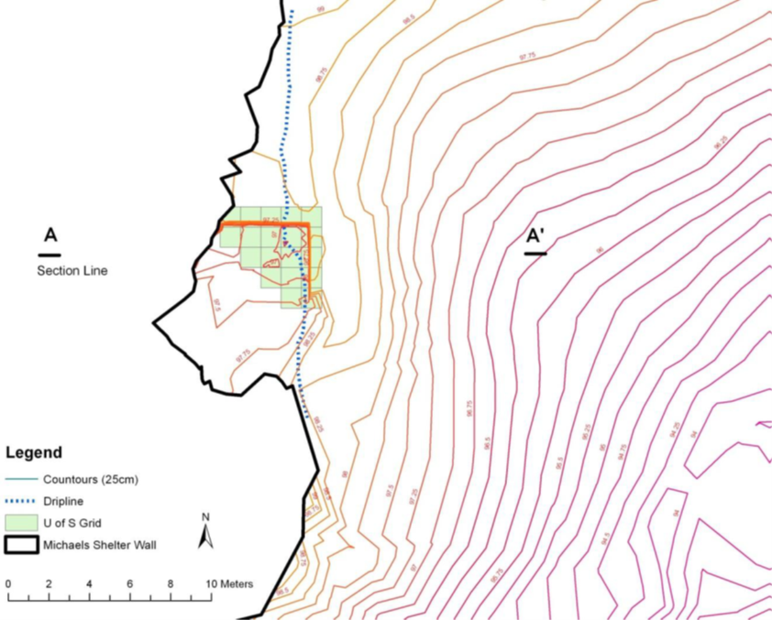
Figure 4.1: Plan view site map following 2011 excavation and cleanup efforts.

During the University of the South's 2011 field school, Dr. Sarah Sherwood directed a cleaning and thorough documentation of the shelter. For over five years, the shelter had remained open and unprotected and, as a result, the profiles had slumped and the floor had filled with debris. The team excavated the base of the existing units that had been left incomplete, cut back the profiles (in 10 cm levels, using a 0.25 in mesh to recover artifacts) and extensively documented the stratigraphy, using a total station to produce a detailed map of the excavation and the area around the shelter (Figure 4.1). During the cleaning of the shelter, a rock midden/prepared rock surface was identified. Additionally, ground penetrating radar (GPR) profiles beyond the drip line were collected to determine the extent of the Early Archaic rock midden evident in the base of the cultural deposits. Two flotation columns were collected, one from the north wall and one from the east wall. The two 50-cm-x-50-cm columns were collected in arbitrary 5-cm levels within natural zones, to capture the complete occupational sequence.
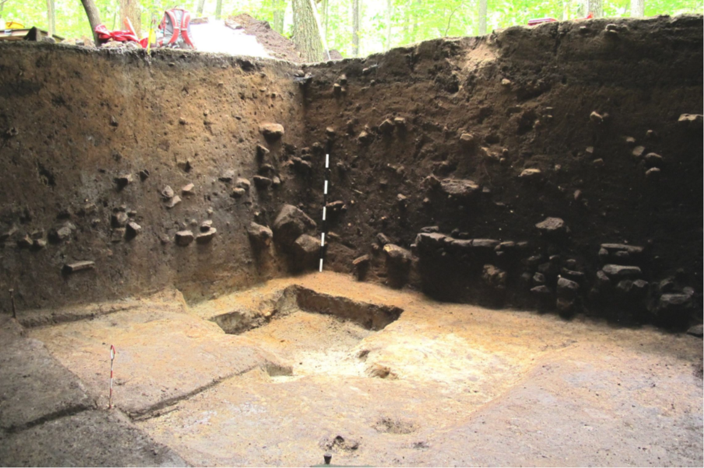
Figure 4.2: Image showing cleaned floor and north and east profiles following the 2012 excavation. Image courtesy Sherwood et al. 2012.

During the 2012—2013 school year, Sherwood and her students cataloged all the materials excavated up to this point from the previous excavations. Diagnostic artifacts included Late Woodland through the Early Archaic projectile points and ceramics. Sherwood also began working on the organization of the documentation that occurred in the early excavations.
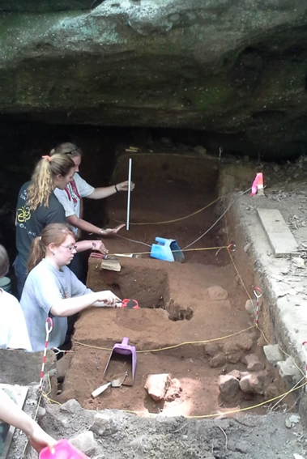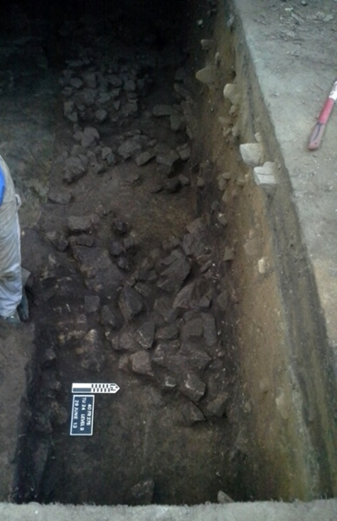
Figure 4.3: (Left) Image of excavations along north wall and (right) post excavation photo showing exposed prepared rock surface along the north wall.

During the 2013 field season, nine new 1-m-x-1-m meter test units and two 1-m-x-50-cm test units were excavated. Four 1-m-x-1-m test units were opened along the exposed north profile (Figure 4.3) of the excavation and three 1-m-x-50-cm test units were opened along the exposed east profile wall in to explore the prepared rock surface identified during the 2011 field season. Two 1-x-1 meter test units were opened adjacent to the two 1x50 centimeter test units along with two additional 1-x-1 meter test unit opened north of the main excavation to delimit or establish the boundaries of the prepared rock surface (Figure 4.4). Test units were excavated in arbitrary 10-cm levels within natural zones. All sediments were passed through 0.25 inch screens on site. Two additional flotation columns were collected during the excavation. The two 50-cm-x-50-cm columns were collected in arbitrary 5-cm levels within natural zones to capture the complete occupational sequence. Micromorphology samples and samples for organic biomarkers were also collected. After the 2013 field season concluded and all samples necessary for future analyses were collected, Michael’s Shelter was backfilled.
Nine AMS radiocarbon dates returned from the site indicate that Michaels Shelter was occupied from the Early Archaic period through the Late Woodland period (Table 4.1). These dates along with its uplands setting makes Michaels Shelter an ideal location to test the hypothesis that indigenous plant domestication resulted from decisions made by individuals familiar with the landscape and not dependant upon a specific geographic setting.
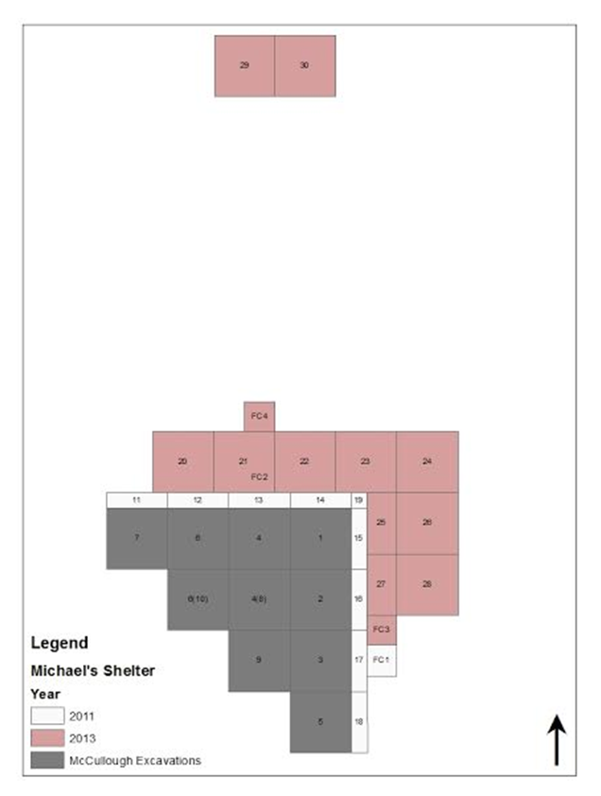
Figure 4.4: Image showing the location of test units from 2011 and 2013 excavations from the Michael’s Shelter.

Table 4.1: AMS Radiocarbon Dates from Michaels Shelter.
Lab # | Context | Component | Material | Conventional Date | Weighted Mean | 1-sigma | 2-sigma
ISGS A1976 | Float Column 1 Level 3 | Late Woodland | Carbonized Nutshell | 1370 ± 15 | 1294 ± 6 | 1300 - 1287 | 1307 - 1280
ISGS A1977 | Float Column 1 Level 9 | Late Woodland | Carbonized Nutshell | 1670 ± 20 | 1574 ± 33 | 1600 - 1538 | 1686 - 1527
ISGS A1978 | Float Column 1 Level 13 | Late Archaic | Carbonized Nutshell | 4050 ± 20 | 4514 ± 62 | 4569 - 4446 | 4780 - 4438
ISGS A1979 | Float Column 1 Level 26 | Early Archaic | Carbonized Nutshell | 7670 ± 30 | 8461 ± 38 | 8512 - 8412 | 8540 - 8405
Beta-354569 | Float Column 2 Level 23 base | Early Archaic | Carbonized Nutshell | 7130 ± 40 | 7954 ± 39 | 7998 - 7934 | 8020 - 7865
Beta-354565 | Float Column 3 Level 16 | Early Archaic | Carbonized Nutshell | 5910 ± 30 | 6728 ± 38 | 6775 - 6676 | 6794 - 6663
Beta- 354566 | Float Column 3 Level 21 | Early Archaic | Carbonized Nutshell | 6910 ± 40 | 7743 ± 46 | 7786 - 7688 | 7835 - 7670
Beta- 354567 | Float Column 3 Level 22 | Early Archaic | Carbonized Nutshell | 6800 ± 40 | 7638 ± 30 | 7672 - 7611 | 7690 - 7580
Beta- 354569 | Float Column 3 Level 24 | Early Archaic | Carbonized Nutshell | 7140 ± 40 | 7963 ± 37 | 7999 - 7939 | 8024 - 7869
Calibrations in OxCal 4.2.2 (Bronk Ramsey 2013) using IntCal09 curve (Reimer et al. 2009).

The Uzzelles Shelter (40FR267)
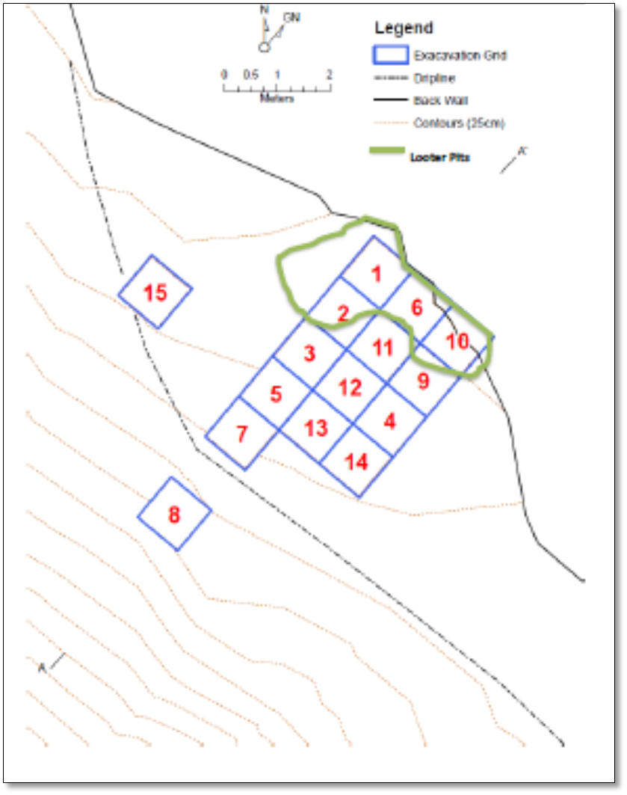
Figure 4.5: Plan view map of the Uzzelles Site (courtesy of Nicholas P. Herrmann).

The Uzzelles Shelter is also located on the Southern Cumberland Plateau, on the University of the South (Sewanee) Domain. Excavations at the site began in the summer of 2009 and concluded in the summer of 2010 under the direction of Dr. Sarah Sherwood through the Sewanee Environmental Institute archaeological field school. Before the initial testing of the shelter, looters disturbed the intact deposits. The damage included the removal of approximately five square meters along the back wall as well as potholes within the dripline (Bow 2012:48). Test Units 1, 2, 6, and 10 most were affected the greatest (Figure 4.5). Fifteen 1-m-x-1-m test units revealed cultural deposits roughly one meter in depth, deeper along the back wall of the shelter and dropping off towards the front of the shelter at the dripline. Radiocarbon dates obtained from the site, along with diagnostic artifacts recovered during excavation, indicate the site was occupied from the Early Archaic period through the Woodland period (Table 4.2). Based on this evidence, the Uzzelles Shelter, like Michael’s Shelter, holds promising potential to address the hypothesis put forth in this research.
Over the course of the excavations, two midden deposits were encountered and designated as the Upper and Lower Middens (Figure 4.6). The Lower Midden was concentrated at the entrance of the shelter (Bow 2012:58; Sherwood et al. 2011, 2012). Radiocarbon dates from the Lower Midden situate it securely within the Early Archaic period, which is consistent with the presence of several Early Archaic projectile points. The Upper Midden yielded a radiocarbon age consistent with traditional dates for the Early Woodland period in the adjacent Duck and Elk River valleys (Table 4.2).

Table 4.2: Radiocarbon Ages from the Uzzelles Shelter.
Lab Number | Analysis Type | Context | Component | Material | Conventional Date | Weighted Mean | 1-sigma |  |  | 2-sigma
ISGS A1809 | AMS | Upper Midden Level 7 | Woodland | Carbonized Nutshell | 2560+/- 20 | 2702 +/- 55 | 2743 - 2716 |  | 2750-2544
ISGS A1811 | AMS | Feature 9 | Early Archaic | Carbonized Nutshell | 7725+/- 40 | 8501+/- 44 | 8546--8451 |  | 8586-8426
AA102303 | AMS | FC 3 Level 5 | Woodland | Carbonized Nutshell | 2521+/-42 | 2599 +/- 86 | 2737 - 2503 | 2748 - 2466
AA102304 | AMS | FC 3 Level 10 | Early Archaic | Carbonized Nutshell | 7,920+/-55 | 8781+/- 111 | 8970 - 8633 | 8980 - 8604
Calibrations in OxCal 4.2.2 (Bronk Ramsey 2013) using IntCal09 curve (Reimer et al. 2009)

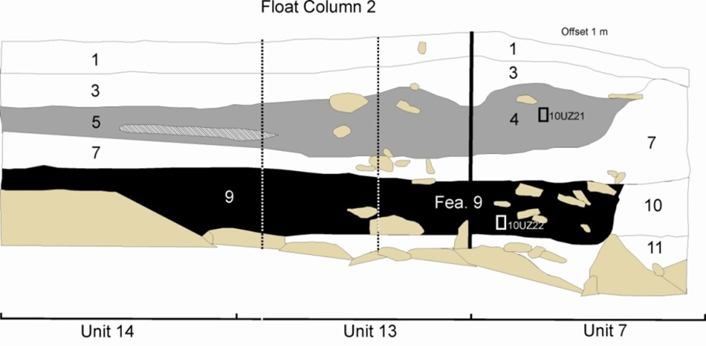
Figure 4.6: South profile from the Uzzelles Shelter showing location of middens and float column 2.

Previous Research: Lithic Analysis
A preliminary analysis of diagnostic projectile points recovered from the site confirms the temporal sequence indicated by radiocarbon dates. Thirty diagnostic projectile points were recovered during the 2009 and 2010 excavations, representing occupation from the Early Archaic period through the Late Woodland period (Table. 4.3) (Sherwood et al. 2011). Nineteen of the thirty points are diagnostic of Early Archaic period horizons including Kirk Corner Notched (n=8), Palmer (n=3), Lost Lake (n=2), MacCorkle (n=2), Kirk Serrated (n=1), and Kanawha (n=3) (Figure 4.7, Table 4.3).
Only two Middle Archaic period projectile points were recovered, one Kirk Stemmed and one Crawford Creek (Figure 4.6, Table 4.3). This decline in the frequency of Middle Archaic points may reflect an absence of Middle Archaic occupation on the larger plateau that is believed to have been the result of changing environmental conditions that made river valleys and drainages more favorable for human occupation.
A Late Archaic period occupation is indicated by the presence of one McIntire and one Kay’s type projectile point. The single Wade point recovered reflects the site’s use during the Late Archaic/Early Woodland transition.
In addition, six Woodland period points were recovered, including one Early Woodland Adena point; four Middle Woodland point types, specifically two Camp Creek, one Copena Triangular, and one Nolichucky; and one Late Woodland Jack’s Reef Corner-notched point (Bow 2012; Sherwood et al. 2011). All of the Middle Woodland points recovered from the site were excavated from the Upper Midden. The increase in Middle Woodland points may reflect an increase in occupation of the area during this period, also witnessed on the Upper Cumberland Plateau (Bow 2012; Des Jean and Benthall 1994:133).

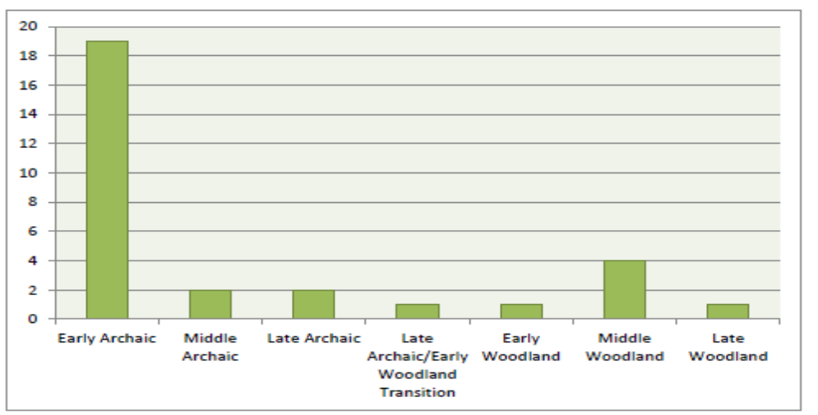
Figure 4.7: Incidence of diagnostic projectile points from Uzzelles Shelter.

Table 4.3. Diagnostic Projectile Point Distribution from the Uzzelles Shelter.
FS# |  | Unit |  | Level |  | Depth |  | Point Type |  | Period
2009-165-1 |  | 10 |  | 3 |  | 20-30 |  | Kirk Corner Notched |  | Early Archaic
2010-53-1-1 |  | 13 |  | 9 |  | 45-50 |  | Kirk Corner Notched |  | Early Archaic
2009-73-1 |  | 4 |  | 4 |  | 50-60 |  | Kirk Corner Notched |  | Early Archaic
2010-111-5 |  | 12 |  | 10 |  | 75-80 |  | Kirk Corner Notched |  | Early Archaic
2009-118-4 |  | 2 |  | 10 |  | 20-30 |  | Kirk Corner Notched |  | Early Archaic
2010-42-4 |  | 14 |  | 1 |  | 0-10 |  | Kirk Corner Notched |  | Early Archaic
2010-146-1-1 |  | 13 |  | 20 |  | 100-105 |  | Kirk Corner Notched |  | Early Archaic
2009-56-1 |  | 4 |  | 3 |  | 40-50 |  | Kirk Corner Notched |  | Early Archaic
2010-123-3 |  | 5 |  | 11 |  | 105-110 |  | Kirk Corner Notched |  | Early Archaic
2010-81-1-1 |  | 14 |  | 8 |  | 40-55 |  | Kirk Corner Notched |  | Early Archaic
2009-146-1-1 |  | 6 |  | 3 |  | 30-50 |  | Kirk Corner Notched |  | Early Archaic
2009-174-1 |  | 10 |  | 5 |  | 40-50 |  | Kirk Corner Notched |  | Early Archaic
2009-53-3 |  | 2 |  | 3 |  | 20-30 |  | Kirk Corner Notched |  | Early Archaic
2010-99-4 |  | 12 |  | 9 |  | 70-75 |  | MacCorkle (Bifurcate) |  | Early Archaic
2010-91-2-1 |  | 3 |  | 15 |  | 110-115 |  | MacCorkle (Bifurcate) |  | Early Archaic
2009-150-10 |  | 6 |  | 4 |  | 50-60 |  | Kanawha (Bifurcate) |  | Early Archaic
2010-75-8-1 |  | 13 |  | 10 |  | 48-53 |  | Kanawha (Bifurcate) |  | Early Archaic
2010-124-1-1 |  | 7 |  | 12 |  | 90-95 |  | Kanawha (Bifurcate) |  | Early Archaic
2010-124-2 |  | 7 |  | 12 |  | 90-95 |  | Kirk Serrated |  | Early Archaic
2010-29-1-1 |  | 13 |  | 5 |  | 25-30 |  | Kirk Stemmed |  | Middle Archaic
2009-59-3 |  | 2 |  | 5 |  | 40-50 |  | Crawford Creek |  | Middle Archaic
 | 2010-27-5 |  | 12 |  | 5 |  | ? |  | Kays |  | Late Archaic
 | 2009-30-2 |  | GSC |  |  |  |  |  | McIntire |  | Late Archaic
 | 2009-23-2 |  | 1 |  | 1 |  | 0-10 |  | Wade |  | Trans. Woodland
 | 2009-42-1 |  | 3 |  | 4 |  | 30-40 |  | Adena |  | Early Woodland
 | 2010-14-1-1 |  | 11 |  | 3 |  | 20-30 |  | Nolichucky |  | Middle Woodland
 | 2009-43-8 |  | 4 |  | 1 |  | 0-26 |  | Camp Creek |  | Middle Woodland
 | 2009-177-1 |  | 4 and 9 |  |  |  |  |  | Camp Creek |  | Middle Woodland
 | 2009-78-1 |  | 8 |  | 3 |  | 20-30 |  | Copena Triangular |  | Middle Woodland
 | 2009-75-2 |  | 8 |  | 1 |  | 0-10 |  | Jack's Reef Corner Notched |  | Late Woodland

Identifications assisted by Matthew Gage.

Ceramic Analysis
Analysis of the Uzzelles ceramic assemblage was conducted by Sierra Bow as part of her 2012 M.A. thesis at The University of Tennessee, Knoxville, titled A Tale of Two Shelters: Using XRF Analysis to Assess Compositional Variability of Pottery from Two Sites in Franklin County, Tennessee. She conducted a standard typological analysis of the recovered sherds along with an experimental pXRF analysis to explore the elemental composition of the paste. Bow’s typological analysis focused on attributes (e.g. temper, surface treatment, vessel form, and thickness) as opposed to named pottery types because many of these designations from the surrounding river valleys are not appropriate to collections recovered on the Plateau itself (Bow 2012:58). The pXRF analysis focused on elements including Rubidium (Rb), Strontium (Sr), Yttrium (Y), Zirconium (Zr), and Niobium (Nb). Each of these elements is found within clay sources and variation in their distributions is thought to represent differences in source regions for their materials (Bow 2012:68).
Table 4.4: Pottery Recovered from the Uzzelles Shelter.
Surface Treatment | Temper | Count | Percentage of Assemblage
Plain / Scraped | Limestone | 51 | 26
Plain | Limestone | 36 | 18
Checked Stamped | Limestone | 43 | 21
Fabric Marked | Limestone | 12 | 6
Other | Limestone | 1 | <1
Residual | Limestone | 57 | 28
Total |  | 200 | 100
Table after Bow 2012.

Despite the relatively small sample size, all of the pottery recovered from the excavations at Uzzelles represent a chronological sequence spanning the Early through Late Woodland periods (Bow 2012:85). The total assemblage consisted of 200 sherds, including 192 body sherds, seven rim sherds, and one pode (Table 4.4) (Bow 2012:85). The assemblage is comprised entirely of limestone-tempered sherds with surface treatments of fabric marked, plain, plain scraped, and check stamped (Bow 2012:85). The largest percentage of identifiable sherds are limestone-tempered plain/scraped sherds comprising 25 percent (n=51) of the total assemblage. These were found in deposits with limestone-tempered plain sherds (n=36). The two types were recovered in high frequencies from the top 20 centimeters of the excavation. None were recovered below 40 centimeters. Plain types are more commonly found in Middle Woodland contexts with plain/scraped types increasing in frequencies during the Late Woodland period (Bow 2012:90). Limestone-tempered checkstamped sherds make up 21 percent of the total assemblage (n=43). They are stylistically similar to the Wright Check Stamped formal type commonly found in Early Woodland deposits. Over half of these sherds were recovered between 40 and 50 centimeters below surface (Bow 2012:87). Limestone-tempered fabric-marked sherds comprise 6 percent of the total assemblage (n=12). These sherds are similar stylistically to the formal Long Branch Fabric Marked type associated with the Early Woodland period. Several of these were recovered from deposits associated with Early Woodland period radiocarbon dates within the Upper Midden. Fifty-seven sherds, or 28 percent, could not be classified based on surface treatment so were classified as residual. One sherd was classified as limestone-tempered other. Though surface erosion complicated the identification, it is believed to be from the knot-roughened variety (Bow 2012:90).
One-hundred ten sherds from the Uzzelles assemblage were included in the pXRF analysis. This included 41 plain/scraped, 32 check stamped, 26 plain, and 10 fabric-marked sherds (Bow 2012:92). A MANOVA analysis revealed that each of five types is significantly different from the others (Bow 2012:97). The assemblage appears to be scattered and discrete groupings can be seen (Bow 2012:100). The fabric-marked Early Woodland vessels are segregated from the Middle Woodland check-stamped vessels, and both of these groups are segregated from Middle to Late Woodland plain and plain/scraped vessels, which overlap. The analysis suggests that different clay sources were likely exploited during the three different time periods represented in the collection, the Early, Middle, and Late Woodland periods (Bow 2012).
Despite the small sample size recovered from the shelter, a few conclusions can be made about the nature of the assemblage. The pottery types identified from the shelter represent a chronological sequence spanning the Woodland period, from Early to Late (Bow 2012:91). Also, based on the similarities in manufacturing techniques, it is believed that most of the pottery recovered from the shelter was made locally and by the same group of people but from different clay sources (Bow 2012:91).

The Mussel Beach Site (40MI70)
Located on the south bank of the Tennessee River, below the Nickajack Dam in Marion County, Tennessee, Mussel Beach is a deeply stratified prehistoric site (Figure 4.8) (Gregory et al. 2011:1). Originally recorded in 1976 during an archaeological survey for the TVA barge terminal at the Nickajack Port, the site was described as a “riverbank shell midden with sparse pottery” and a lithic scatter (Polhemus 1976:7). Subsurface testing at the site in 1981, in the mid-80s, and again in 1991, resulted in the identification of intact Late Archaic, Early Woodland, Middle Woodland, and Late Woodland deposits, based on diagnostic artifacts (Alexander 1991; Gregory et al. 2011:15; Soils and Futato 1987).

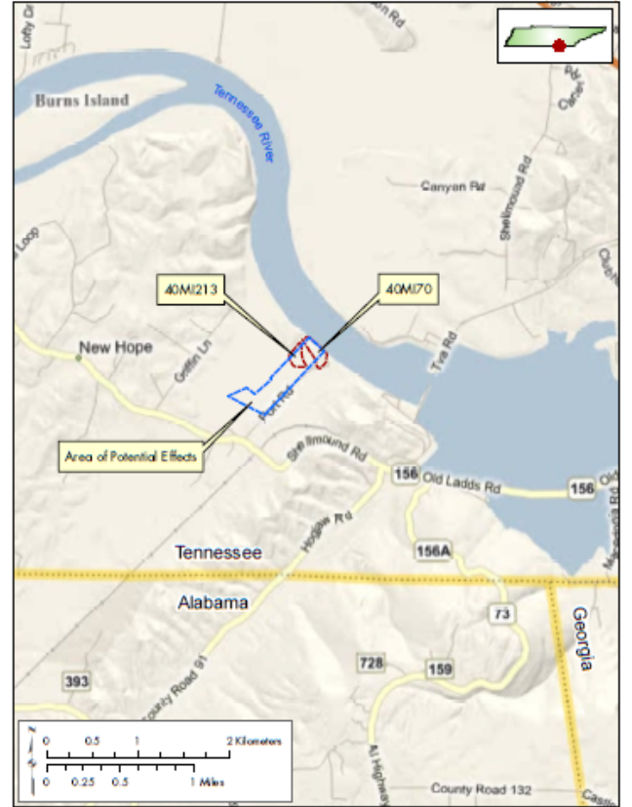
Figure 4.8: Location of the Mussel Beach site in the Tennessee River Valley.

Following an archaeological survey in 2008 (Alexander and Redwine 2008), the site was determined to be eligible for National Register of Historic Places due to the site’s potential contribution to the prehistory of the Sequatchie Valley and surrounding area (Gregory et al. 2011:4).
Proposed construction of a fabrication facility by Chicago Bridge and Iron threatened the cultural deposits at the site, leading TVA to require data recovery and monitoring during the construction activities. As a result, during the summer of 2009, New South Associates began data recovery that included mechanical excavation of eight trenches (Trenches 1-8) and the excavation of two 50-cm-x-50 cm control units (Control Units 1-2). The Phase III excavation began in October of 2009 and was completed in January of 2010 (Figure 4.9) (Gregory et al. 2011). These investigations included the hand-excavation of 92 1-m-x-1-m units, 23 backhoe-excavated trenches, 2,543 square meters of machine-assisted stripping, the investigation of 189 radar anomalies, and the excavation of 108 features from the site (Gregory et al. 2011:49) that revealed the site as a multi-component site with five prehistoric components: three Late Archaic components (Late Archaic I, II, and III), one Middle Woodland component, and one Late Woodland component (Table 4.5.) (Gregory et al. 2011:5). Eighteen standard radiometric dates and 19 AMS dates firmly place these occupations between 5,480 and 910 B.P (Table 4.6) (Gregory et al. 2011:7).
Table 4.5: Summary of Temporal Components from the Mussel Beach Site.
Component | Age (years B.P.) | Dating Method | Strata | Site Type
Late Archaic I | 4,850 – 5,480 | AMS | V, V a | Lithic Activity Area
Late Archaic II | 3,890 – 4,700 | Relative, C14, AMS | IV a, IV b | Reused Campsite
Late Archaic III | 2,340 – 2,940 | Relative, C14, AMS | IV | Reused Campsite
Middle Woodland | 1,230 – 2,170 | Relative, C14, AMS | III b, III c | Village/Hamlet
Late Woodland | 910 – 1,260 | Relative, C14, AMS | III d | Campsite
Table after Gregory et al. 2011.

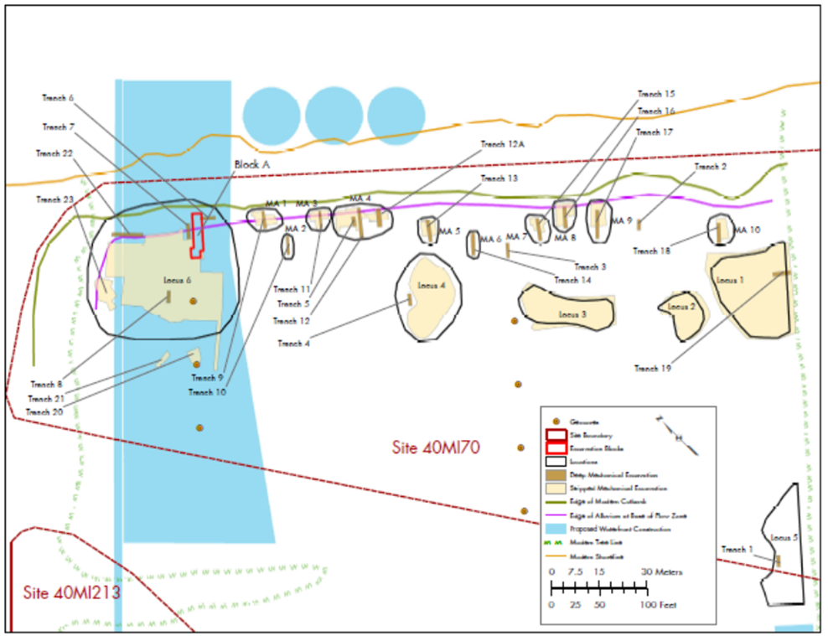
Figure 4.9: Plan view of initial excavation including trenches, midden areas, and features. Image courtesy of Gregory et al. 2011.

Table 4.6: Radiocarbon Dates from Sites from the Mussel Beach Site.
Lab Number | Analysis Type | Context | Component | Material | Conventional Date | Weighted Mean | 1-sigma |  | 2-sigma
Beta-281378 | AMS | Unit 13 | Late Archaic I | Wood charcoal | 4680+/-40 | 5416+/-70 | 5467 – 5323 | 5577 - 5315
Beta - 281379 | AMS | Unit 1 | Late Archaic I | Wood charcoal | 4360+/-40 | 4935+/-61 | 4965 – 4865 | 5040 – 4849
Beta-280286 | AMS | Feature 424 | Late Archaic II | Wood charcoal | 3760+/-40 | 4123+/-72 | 4226 4009 | 4242 – 3985
Beta- 280289 | AMS | Feature 496 | Late Archaic II | Wood charcoal | 3790+/-40 | 4174+/-74 | 4236 – 4094 | 4351 – 3994
Beta-281223 | C14 | Feature 423 | Late Archaic II | Wood charcoal | 3990+/-40 | 4466+/-104 | 4569 – 4317 | 4786 – 4247
Beta-281224 | AMS | Feature 456 | Late Archaic II | Wood charcoal | 2830+/-40 | 2941+/-59 | 2988 – 2872 | 3073 – 2846
Beta-281234 | C14 | Feature 483 | Late Archaic II | Wood charcoal | 4000+/-80 | 4489+/-139 | 4782 – 4299 | 4814 – 4237
Beta-281375 | AMS | Feature 413 | Late Archaic II | Wood charcoal | 3840+/-40 | 4259+/-78 | 4377 – 4155 | 4410 – 4104
Beta-280283 | AMS | Feature 394 | Late Archaic III | Wood charcoal | 2780+/-40 | 2879+/-52 | 2946 – 2809 | 2968 – 2778
Beta-280285 | C14 | below Feature 383 | Late Archaic III | Wood charcoal | 2670+/-80 | 2788+/-101 | 2870 – 2730 | 2972 – 2496
Beta-281226 | C14 | Feature 472 | Late Archaic III | Wood charcoal | 2480+/-40 | 2564+/-96 | 2707 – 2487 | 2719 – 2365
Beta-281222 | AMS | Feature 406 | Late Archaic III | Wood charcoal | 2420+/-40 | 2491+/-106 | 2669 – 2356 | 2701 – 2348
Beta-280287 | AMS | Feature 248 | Late Archaic III | Wood charcoal | 2430+/-40 | 2504+/-107 | 2675 – 2359 | 2702 – 2351
Beta- 280288 | AMS | Feature 484 | Middle Woodland | Wood charcoal | 2400+/-40 | 2466+/-100 | 2471 – 2350 | 2698 – 2342
Beta-281221 | C14 | Feature 392 | Middle Woodland | Wood charcoal | 2050+/-80 | 2032+/-108 | 2120 – 1925 | 2304 – 1825
Beta-283763 | AMS | Feature 42 | Middle Woodland | Wood charcoal | 1970+/-40 | 1922+/-45 | 1984 – 1878 | 1998 – 1825
Beta-280280 | AMS | Feature 395 | Middle Woodland | Wood charcoal | 1900+/-40 | 1839+/-52 | 1898 – 1747 | 1928 – 1727
Beta-283764 | AMS | Feature 43 | Middle Woodland | Wood charcoal | 1910+/-40 | 1852+/-51 | 1919 – 1819 | 1945 – 1735
Beta-280282 | AMS | Feature 340 | Middle Woodland | Wood charcoal | 1770+/-40 | 1687+/-62 | 1735 – 1613 | 1816 – 1570
Beta-280279 | C14 | Feature 350 | Middle Woodland | Wood charcoal | 1640+/-50 | 1546+/-106 | 1686 – 1414 | 1775 – 1342
Beta-280284 | C14 | Feature 383 | Middle Woodland | Wood charcoal | 2610+/-50 | 2675+/-153 | 2852 – 2494 | 2927 – 2360
Beta-259873 | AMS | Feature 254 | Middle Woodland | Wood charcoal | 1360+/-40 | 1280+/-37 | 1314 – 1262 | 1346 – 1181
Beta-283759 | C14 | Feature 462 | Middle Woodland | Wood charcoal | 1350+/-50 | 1265+/-48 | 1311 – 1185 | 1349 – 1175
Beta-281227 | C14 | Feature 439 | Middle Woodland | Wood charcoal | 1420+/-40 | 1328+/-28 | 1347 – 1296 | 1386 – 1284
Beta-281228 | C14 | Feature 438 | Middle Woodland | Wood charcoal | 1370+/-40 | 1291+/-35 | 1318 – 1269 | 1352 – 1183
Beta-281229 | C14 | Feature 432 | Middle Woodland | Wood charcoal | 1430+/-40 | 1334+/-29 | 1351 – 1299 | 1392 – 1288
Beta-281320 | C14 | Feature 435 | Middle Woodland | Wood charcoal | 1480+/-40 | 1370+/-44 | 1401 – 1330 | 1509 – 1299
Beta-281230 | C14 | Feature 430 | Middle Woodland | Wood charcoal | 1670+/-40 | 1580+/-59 | 1685 – 1528 | 1697 – 1420
Beta-281231 | C14 | Feature 461 | Middle Woodland | Wood charcoal | 1460+/-50 | 1361+/-47 | 1385 - 1307 | 1510 – 1288
Table 4.6(cont): Radiocarbon Dates from Sites from the Mussel Beach Site.
Lab Number | Analysis Type | Context | Component | Material | Conventional Date | Weighted Mean | 1-sigma |  | 2-sigma
Beta-281232 | C14 | Feature 436 | Middle Woodland | Wood charcoal | 1390+/-40 | 1309+/-29 | 1334 - 1285 | 1378 - 1262
Beta-281233 | C14 | Feature 441 | Middle Woodland | Wood charcoal | 1620+/-60 | 1511+/-76 | 1561 - 1415 | 1692 - 1382
Beta-283761 | C14 | Feature 494 | Middle Woodland | Wood charcoal | 1380+/-60 | 1295+/-56 | 1352 - 1262 | 1393 - 1178
Beta-283760 | C14 | Feature 258 | Middle Woodland | Wood charcoal | 1330+/-80 | 1234+/-81 | 1318 - 1173 | 1378 - 1065
Beta-280278 | AMS | Feature 351 | Late Woodland | Wood charcoal | 1100+/-40 | 1011+/-45 | 1055 - 964 | 1122 - 929
Beta-281376 | AMS | Feature 197 | Late Woodland | Wood charcoal | 1180+/-40 | 1104+/-60 | 1171 - 1059 | 1234 - 979
Beta-281377 | AMS | Feature 262 | Late Woodland | Wood charcoal | 1260+/-40 | 1197+/-55 | 1271 - 1172 | 1283 - 1080
Beta-281225 | AMS | Feature 256 | Late Woodland | Wood charcoal | 1260+/-40 | 1197+/-55 | 1271 - 1172 | 1283 - 1080
Beta-280281 | AMS | Feature 378 | Late Woodland | Wood charcoal | 990+/-40 | 887+/-53 | 956 - 802 | 965 - 794
Calibrations in OxCal 4.2.2 (Bronk Ramsey 2013) using IntCal09 curve (Reimer et al. 2009)

Previous Research: Lithic Analyses
Lithic analyses on the recovered materials were conducted by Danny Gregory of New South Associates. Artifacts were divided into three categories: tools, debitage, and other. The tools were analyzed using tool types defined by the New South Associates laboratory manual. Initially, each was classified as a flaked-stone, groundstone, or other. They were then placed into technological classes such as biface, mano, hoe, projectile point, or scraper (Table 4.7). Then, based on technological class, several attributes were recorded including raw material type, weight, size, and use wear (Gregory et al. 2011:339). Debitage analysis was carried out using a general artifact analysis and in-depth lithic attribute analysis. The general lithic analysis was conducted on all debitage and included recording raw material type, weight, provenience, and debitage category (flake, flake fragment, or angular debris). The in-depth lithic attribute analysis was carried out on approximately 25 percent of the recovered debitage sample and recorded 13 lithic attributes. These attributes included debitage type, raw material type, raw material quality, weight, size, completeness, portion, dorsal cortex, platform remnant morphology, termination, retouch, use wear, and thermal alteration (Gregory 2011:340).
Table 4.7: Lithic Tools Recovered from the Mussel Beach Site.
Lithic Tool Type | Late Archaic I | Late Archaic II | Late Archaic III | Middle Woodland | Late Woodland | Mixed | Totals
Abrader | 0 | 1 | 0 | 2 | 0 | 0 | 3
Biface | 7 | 20 | 45 | 17 | 2 | 22 | 113
Burin | 1 | 1 | 0 | 0 | 0 | 0 | 2
Celt | 0 | 0 | 1 | 0 | 0 | 0 | 1
Core | 2 | 4 | 20 | 13 | 3 | 17 | 59
Drill | 0 | 1 | 0 | 1 | 0 | 3 | 5
Flake-Retouched | 2 | 2 | 13 | 5 | 1 | 8 | 31
Flake-Tool | 0 | 0 | 1 | 0 | 0 | 2 | 3
Hammerstone | 1 | 5 | 3 | 6 | 0 | 2 | 17
Hoe | 0 | 0 | 0 | 3 | 0 | 2 | 5
Mano | 0 | 0 | 0 | 2 | 0 | 0 | 2
Nutting Stone | 0 | 1 | 0 | 1 | 0 | 1 | 3
Plummet Stone | 0 | 0 | 0 | 1 | 0 | 0 | 1
PP/K | 3 | 13 | 35 | 37 | 1 | 28 | 117
Scraper | 0 | 0 | 0 | 2 | 0 | 0 | 2
Spokeshave | 0 | 0 | 1 | 0 | 0 | 0 | 1
Unidentified Tool | 0 | 0 | 1 | 1 | 0 | 0 | 2
Utilized Flake | 2 | 2 | 1 | 0 | 0 | 0 | 5
Totals | 18 | 50 | 121 | 91 | 7 | 85 | 372
Table after Gregory et al. 2011:343.

More tools were recovered from the Late Archaic III and Middle Woodlands components than all others. Projectile points/knives (PP/Ks) were the most common tool recovered, followed by bifaces, cores, expedient flake tools, and hammerstones (Table. 4.8). In general, these five were the most common types recovered in four of the five components, the exception being the Middle Woodland. Another noteworthy trend is the overall lack of formal scrapers recovered from the site. Only one was recovered from the Middle Woodland component. The lack of scrapers has been attributed to high frequencies of retouched flakes that could have been used for processing large hides. The Middle Woodland component contained the second largest tool assemblage and also exhibited the widest variety of tools including several that were only found during this component such as plummet stones, and scrapers. Additionally, the Middle Woodland component contained more tools that are commonly associated with horticulture, including hoes and manos.
Thirty of the thirty-seven temporally diagnostic lithic tools recovered were Late Archaic projectile points. The oldest, a Benton Stemmed, is associated with the Late Archaic I. Paris Island, Kays Stemmed, Ledbetter, Cotaco Creek, and Iddens Stemmed projectile points were all found in Late Archaic II contexts (Gregory et al. 2011:348). Coosa, Wade, and Bradley Spike projectile point types were recovered from Late Archaic III. Unspecified Late Archaic projectile points included Allendale, Elora, and Small Savanah River points. Middle Woodland point types recovered include Copena Triangular, Nolichucky, and Baler’s Creek (Gregory et al. 2011:348). The only point recovered from Late Woodland contexts was a Jack’s Reef Pentagonal. Also, a single Middle Archaic point was recovered at the site, a Morrow Mountain Type 1. It was recovered from the plow zone in Block A and considered a curated item or an isolated find (Gregory et al. 2011:349).
As is common with most sites, debitage was the most common lithic artifact type found. In total, 28,132 pieces were recovered and included in various different types of analysis. The entire debitage collection was included in a general analysis and a 23 percent sample (6,532 pieces) was selected for a more in-depth, attribute based analysis (Gregory et al. 2011:349). The general lithic analysis involved recording raw material type, debitage category (flake, flake fragment, or angular debris), weight, and provenience. The in-depth attribute analysis included macrodebitage recovered from the 0.25-inch screened samples as well as microdebitage recovered from floatation samples. Samples were chosen from the four intact temporal components.
Results of the debitage analysis confirmed the Late Archaic I component’s designation as a lithic reduction area. The assemblage contained the most evidence for the reduction of cores based on the large number of flakes recovered containing cortex. This component had the highest density of both microdebitage (2,500 specimens per 100 liters) and macrodebitage (350 specimens per 100 liters) (Gregory et al. 2011:383). The debitage assemblages from the Late Archaic II and III components were very similar. They both represent all stages of reduction, typical of reused campsites. The main difference between the two components is that the Late Archaic II assemblage appears to be the results of early stage reduction activities whereas the Late Archaic III assemblage is more indicative of late stage tool reduction. The assemblage from the Middle Woodland occupation indicates that the occupants at the time were more heavily engaged in tool maintenance, primarily the resharpening of bifacial tools (Gregory et al. 2011:385).
Only two artifacts recovered were not included in either the formal tool or debitage analysis. Classified as “other,” a single broken slate gorget was recovered a from Middle Woodland context. The second, also an ornament, was a polished chert bead recovered from a Late Archaic I context (Gregory et al. 2011:388).

Ceramics Analyses
Specialized ceramic analysis was conducted by Chris Espenshade and Brian Tucker. All ceramics large enough for identification were included in their vessel-based analysis (N= 3,118) (Gregory et al. 2011:391). This type of analysis was considered more favorable than a sherd-based methodology and thought to be well-suited for addressing technological choice and tradition (Gregory et al. 2011:392). Sample Vessels (a term used to designate each vessel lot and represents the grouping of sherds based on attributes) were reconstructed based on surface decoration, temper content, general thickness, interior surface treatment, paste, and color (Table 4.8) (Gregory et al. 2011:392). Sixty-two vessels were identified; however, this number does not represent an absolute minimum number of vessels.
As indicated by the results in Table 4.9 clear changes in time are apparent in both temper content and surface decoration even though some types occur widely across the site (Gregory et al. 2011:451). Five ceramic components were identified based on technological and stylistic similarities within dated contexts (Table 4.9). Based on their analysis of ceramics recovered from the Mussel Beach site, Espenshade and Tucker concluded that occupations at that site were short-term occupations, even with the presence of houses identified at the site. Based on that conclusion, they suggest that shell procurement activities at the site were carried out by small task groups as these activities do not require large numbers of individuals (Gregory et al. 2011:464).
Table 4.8: Summary of Sample Vessels Analysis from the Mussel Beach Site.
Temper Content | Surface Treatment | Count
Limestone | Plain | 15
Limestone | Plain (smoothed over check stamp) | 5
Limestone | Plain (smoothed over fabric impressed) | 1
Limestone | Fabric Impressed | 5
Limestone | Check Stamped | 8
Limestone | Simple Stamped | 6
Limestone | Complicated Stamp | 4
Limestone | Incised | 1
Limestone | Zoned Punctated | 1
Limestone | Tetrapodal Supports | 4
Quartz | Plain | 2
Quartz | Brushed | 1
Quartz | Fabric Impressed | 5
Quartz | Simple Stamped | 1
Shell | Plain | 2
Shell | Eroded | 1
N/A | Check Stamped | 1
Total |  | 62
Table after Gregory et al. 2011:397.

Faunal Analysis
The faunal assemblage from the Mussel Beach site includes vertebrates and invertebrate taxa. The vertebrate samples were collected from ¼ -inch and 2.0 millimeter screening of heavy fraction floatation samples, while the invertebrates, both gastropods and bivalves, were selected from mollusk shell samples (Gregory et al. 2011:482). These remains were recovered from Locus 1, 4, and 6, and from Midden Areas 1, 3, 4, 5, and 6 (Gregory et al. 2011:534) (Figure4.8).

Table 4.9: Inferred Ceramic Chronology from Mussel Beach Site.
Ceramic Component | Temporal Range | Ceramic Traits
Mississippian | Post A.D. 1000 | Shell-tempered plain
Late Woodland | 950 - 1,100 B.P. | Limestone-tempered check stamped
 |  | Limestone-tempered plain
 |  | Limestone-tempered zoned punctated
 |  | Limestone-tempered incised?
 |  | Check stamped with no apparent temper
 |  | Plain with quartz tempers
Middle Woodland B | 1,150 - 1,350 B.P. | Limestone-tempered complicated stamped
 |  | Limestone-tempered plain
Middle Woodland A | 1,400 - 1,850 B.P. | Limestone-tempered simple stamped
 |  | Limestone-tempered plain
 |  | Limestone-tempered with tetrapods
Late Archaic III | 2,650 - 2,350 B.P. | Fabric-impressed, limestone or quartz tempers
 |  | Brushed, quartz tempers
Table after Gregory et al. 2011:454.
Vertebrate and invertebrate remains were absent from Late Archaic I deposits at the site (Table 4.10, 4.11, 4.12, 4.13). Faunal remains collected from Late Archaic II contexts were small, and did not allow for quantification but rather only a limited interpretation (Gregory et al. 2011:536). All 38 specimens were vertebrate remains. Of the 38 specimens recovered, only 15 were identifiable to the level of class including bird (NISP=8), mammal (NISP=3), reptile (NISP=3), and fish (NISP=1) with the remaining being identified as unidentifiable vertebrates (NISP=23) (Table 4.10). Only two specimens were identifiable below the level of class, one undifferentiated catfish and one white-tailed deer (Gregory et al. 2011:536).
Nineteen of the 38 specimens revealed evidence of primary taphonomic modification including burning or calcination (NISP=4), butchery (NISP=14), and cut marks or chopping (NISP=1) (Gregory et al. 2011:537).

Table 4.10: Vertebrate Assemblage from Mussel Beach Site by Time Period.
Locus | Midden Area | Component | NISP/n | Weight (g)
1 |  | Middle Woodland | 7 | 12.4
1 |  | Late Archaic III | 7 | 4.79
1 |  | Modern | 5 | 8.42
1 |  | Middle Woodland | 77 | 83.25
1 |  | Various | 2 | 5.2
4 |  | Middle Woodland | 4 | 4.48
6 |  | Late Archaic III | 16 | 9.14
6 |  | Late Archaic II | 37 | 20.81
6 |  | Late Archaic III | 190 | 210.31
6 |  | Late Woodland | 9 | 3.14
6 |  | Middle Woodland | 366 | 433.946
6 |  | Middle Woodland / Late Archaic | 3 | 22.57
6 |  | Middle Woodland / Late Archaic | 23 | 63.52
6 |  | Middle Woodland / Late Woodland | 14 | 13.57
6 |  | Unknown | 2 | 0.5
6 |  | Various | 2 | 0.31
 | 1 | Late Woodland | 28 | 34.45
 | 1 | Middle Woodland | 3 | 1.03
 | 3 | Middle Woodland | 159 | 28.63
 | 4 | Middle Woodland | 107 | 114.87
 | 4 | Various | 1 | 1.02
 | 5 | Late Archaic III | 3 | 2.13
 | 5 | Various | 2 | 0.68
 | 6 | Late Archaic II | 1 | 0.38
 | 6 | Late Archaic III | 6 | 0.86
Totals |  |  | 1,074 | 1080.41
Table after Gregory et al. 2011:482 – 483.
The interpretation of the Late Archaic II occupation at the site, though limited, suggests that occupants exploited a variety of land and water species. The high percentage of butchered remains that lacking calcination, suggests that Locus 6 of the site was used for processing.

Table 4.11: Vertebrate Remains Recovered from the Mussel Beach Site.
Class | Order | Family | Genus and Species | Common Name | NISP/n | Weight (g)
Actinopterygii | N/A | N/A | N/A | Unidentifiable Fish | 9 | 4.6
 | Perciformes | Sciaenidae | Aplodinotus grunniens | Drum | 6 | 27.29
 | Perciformes | N/A | N/A | Unidentifiable Perciform | 2 | 1.16
 | Semionotiformes | Lepisosteidae | Lepisosteus sp. | Gar | 3 | 0.71
 | Siluriformes | Iclaturide | Ictalurus sp. | Unidentifiable Catfish | 4 | 1.98
Aves | Galliformes | Phasianidae | N/A | Possible Turkey | 1 | 1.36
 | Galliformes | Phasianidae | Meleagris gallopavo | Turkey | 2 | 2.25
 | N/A | N/A | N/A | Unidentifiable Bird | 46 | 22.22
 | Strigiformes | Tytonidae | Tyoto alba | Barn Owl | 1 | 0.28
 | Strigiformes | Strigidae | Bubo virginianus | Great Horned Owl | 1 | 0.3
Mammalia | Carnivora | Procyonidae | Procyon lotor | Raccoon | 6 | 9.75
 | Artiodactyla | Cervidae | Odocoileus virginianus | White-tailed Deer | 61 | 254.31
 | N/A | N/A | N/A | Unidentifiable Large Mammal | 1 | 3.51
 | N/A | N/A | N/A | Unidentifiable Mammal | 3 | 3.57
 | N/A | N/A | N/A | Unidentifiable Medium Mammal | 1 | 0.45
 | N/A | N/A | N/A | Unidentifiable Medium-Large Mammal | 245 | 336.82
 | N/A | N/A | N/A | Unidentifiable Rodent | 7 | 0.77
 | N/A | N/A | N/A | Unidentifiable Small Mammal | 3 | 0.45
 | Rodentia | Suridae | Scurius sp. | Unidentifiable Squirrel | 7 | 1.17
Reptilia | Crocidilia | Alligatoridae | Alligator sp. | Alligator | 2 | 0.4
 | Testudines | Emydidae | Terrapene carolina | Box Turtle | 3 | 1.11
 | Testudines | N/A | N/A | Unidentifiable Turtle | 190 | 83.83
 | Testudines | Trionchidae | N/A | Unidentifiable Soft Shell Turtle | 21 | 25.71
 | Testudines | Chelydridae | Chelydra serpentina | Snapping Turtle | 2 | 1.58
Unidentifiable | N/A | N/A | N/A | Unidentifiable Vertebrate | 447 | 294.44
Table after Gregory et al. 2011.

Table 4.11(cont): Vertebrate Remains Recovered from the Mussel Beach Site.
Class | Order | Family | Genus and Species | Common Name | NISP/n | Weight
Gastropoda / Bivalvia | N/A | N/A | N/A | Unidentifiable | 400 | 17,779.22
Bivalvia | Unionoida | Unionoidae | Actinonasias ligamentina | Mucket | 49 | 1252.4
Bivalvia | Unionoida | Unionoidae | Actinonasias ligamentina c.f. | Mucket c.f. | 2 | 26.91
Bivalvia | Unionoida | Unionoidae | Amblema plicata | Threeridge | 10 | 459.45
Bivalvia | Unionoida | Unionoidae | Dromus dromus | Dromedary Pearlmussel | 196 | 3668.76
Bivalvia | Unionoida | Unionoidae | Dromus dromus c.f. | Dromedary Pearlmussel c.f. | 1 | 10.96
Bivalvia | Unionoida | Unionoidae | Ellipsaria lineolata | Butterfly | 212 | 3333.18
Bivalvia | Unionoida | Unionoidae | Ellipsaria lineolata c.f. | Butterfly c.f. | 3 | 26.2
Bivalvia | Unionoida | Unionoidae | Elliptio crassidens | Elephant Ear | 18 | 189.13
Bivalvia | Unionoida | Unionoidae | Elliptio sp. | Elliptio sp. | 1 | 5.76
Bivalvia | Unionoida | Unionoidae | Epioblasma sp. | Epioblasma sp. | 1 | 17.04
Bivalvia | Unionoida | Unionoidae | Epioblasma torulosa | Tubercled Blossum | 168 | 2450.37
Bivalvia | Unionoida | Unionoidae | Fusconaia subrotunda | Longsolid | 8 | 109.45
Bivalvia | Unionoida | Unionoidae | Obovaria retusa | Ring Pink | 19 | 493.27
Bivalvia | Unionoida | Unionoidae | Obovaria retusa c.f. | Ring Ping c.f. | 6 | 176.67
Bivalvia | Unionoida | Unionoidae | Plethobasus cooperiauns | Orangefoot Pimpleback | 164 | 2824.19
Bivalvia | Unionoida | Unionoidae | Plethobasus plenum or rubrum | Rough or Pyramid Pigtoe | 572 | 10,826.79
Bivalvia | Unionoida | Unionoidae | Pluurobema sp. / Obovaria retuse | Pyramid Pigtoe / Ring Pink | 1 | 40.3
Gastropoda | Architaenioglossa | Viviaridae | Campeloma sp. | Campeloma sp. | 146 | 538.29
Gastropoda | Neotaenioglossa | Plueroceridae | Pluerocera sp. | Hornsnail | 290 | 553.63
Gastropoda | Neotaenioglossa | Plueroceridae | Pluerocera sp. c.f. | Hornsnail c.f. | 1 | 2.21
Gastropoda | Stylommatophora | Discidae | Anguispira alternata | Flamed Tigersnail | 210 | 6.4
Table after Gregory et al. 2011.
Table 4.12. Identified Freshwater Mussel by Component from the Mussel Beach Site.
 |  | LA III | MW | LW
Class | Common Name | NISP
Bivalve | Mucket | 1 | 25 | 13
Bivalve | Threeridge |  | 10
Bivalve | Dromedary Pearlmussel | 3 | 137 | 56
Bivalve | Butterfly | 3 | 159 | 50
Bivalve | Elephant Ear |  | 10 | 8
Bivalve | Tubercled Blossum | 3 | 142 | 23
Bivalve | Longsolid |  | 5 | 3
Bivalve | Ring Pink | 1 | 16 | 2
Bivalve | Orangefoot Pimpleback / Purple Wartyback | 2 | 140 | 22
Bivalve | Rough or Pyramid Pigtoe | 21 | 481 | 71
Gastropod | Campeloma sp. | 8 | 128 | 10
Gastropod | Hornsnail | 9 | 265 | 16
Gastropod | Flamed Tigersnail | 5 | 147 | 58
Totals |  | 56 | 1665 | 332

Table 4.13. Combined NISP and Weights for all Invertebrates from the Mussel Beach site.
Component | NISP | Weight
Late Archaic III | 56 | 20068.55
Middle Woodland | 1986 | 34376.17
Late Woodland | 432 | 8,363.86
Totals | 2474 | 62808.58
Table after Gregory et al. 2011:483.
The Late Archaic III occupation at the site was much more intensive than the previous Late Archaic II occupation. Two-hundred four vertebrate specimens were recovered from Loci 1 and 6 and from Midden Areas 5 and 6 (Table 4.10). Of the 204 recovered specimens, 143 were identified to class including mammal (NISP=87), reptile (NISP=47), bird (NISP=6), and fish (NISP=3). The remaining 61 specimens were unidentifiable vertebrates. Thirty-seven specimens were identifiable below class including gar (NISP=2), raccoon (NISP=3), undifferentiated rodent (NISP=7), white-tailed deer (NISP=13), box turtle (NISP=2), snapping turtle (NISP=2), and soft-shell turtle (NISP=8).
Primary taphonomic modification of the Late Archaic III faunal assemblage included thermal alteration (NISP=18) and butchery (NISP=46). Evidence for butchery included cut long bones as well as spiral fractures consistent with marrow extraction. These patterns were observed on the long bones of unidentifiable birds, mammals, and other vertebrates (Gregory et al. 2011:538).
The entire invertebrate assemblage collected from the Late Archaic III occupation came from Locus 6, and was small in comparison to the Woodland assemblage (Table 4.13). The assemblage was dominated by bivalves (NISP=34) over gastropods (NISP=22). Bivalve taxa included butterfly, dromedary pearlymussel, mucket, orangefoot pimpleback or purple wartyback, ring pink, rough or pyramid pigtoe, and tubercled blossom. The gastropods included campeloma, flamed tigersnail, and hornsnail (Table 4.12, 4.13) (Gregory et al. 2011:538).
The Middle Woodland occupation at the site was the most intensive, as illustrated by the large vertebrate and invertebrate assemblages recovered. The vertebrate remains were recovered from Loci 1 and 6, and from Midden Areas 1, 3, and 4, while the invertebrate remains were collected from Loci 1 and 6 and from Midden Areas 3 and 4 (Tables 4.10 and 4.13) (Gregory et al. 2011:541).
Seven-hundred twenty-three vertebrate specimens were recovered from Middle Woodland contexts. The assemblage was represented by mammals (NISP=197), reptiles (NISP=160), birds (NISP=32), and fish (NISP=14). The remaining 320 specimens were unidentifiable vertebrates. The specimens identified below class included drum (NISP=3), gar (NISP=1), catfish (NISP=3), undifferentiated perciform (NISP=1), barn owl (NISP=1), great horned owl (NISP=1), turkey (NISP=2), squirrel (NISP=7), white-tailed deer (NISP=36), possible alligator (NISP=2), box turtle (NISP=1), and undifferentiated soft-shell turtle (NISP=13) (Gregory et al. 2011:541).
One-hundred fifty-four specimens were thermally altered, a much larger percentage than in the previous Late Archaic samples. Thirty percent of specimens (118) showed evidence of butchery, including cut marks and spiral fractures. These butchery patterns were seen on long bones of turkey, squirrel, white-tailed deer, as well as unidentifiable bird and mammal.
The large invertebrate sample recovered from the Middle Woodland occupation at the site was again dominated by bivalves as opposed to gastropods (Table 4.13). Identified bivalves included butterfly, dromedary pearlymussel, elephant ear, longsolid, mucket, orangefoot pimpleback or purple wartyback, ring pink, rough or pyramid pigtoe, threeridge, and tubercled blossom. Identified gastropods included campeloma, flamed tigersnail, and hornsnail (Gregory et al. 2011:542). The high occurrence of the flamed tigersnail, a terrestrial gastropod that feeds on food refuse, was concentrated in Loci 1 and 6, and in Midden Area 4.
The large invertebrate samples recovered from Middle Woodland contexts allowed for greater interpretations than the smaller Late Archaic samples. The bivalves recovered equally represent spring/summer and fall/winter spawning species, possibly suggesting a year-round occupation (Gregory et al. 2011:542). These species represent a possible year-round exploitation practice and also reflect a variety of environments and collection methods. The identified species suggests a focus on bivalves that would have lived in shallow sand or gravel substrates that would have been collected by hand. The species distribution also suggests that year-round processing occurred at Locus 6 and Midden Area 4, while warm weather collection and processing most likely occurred at Locus 1 and Midden Area 3 (Gregory et al. 2011:542).
Five-hundred thirteen shell specimens from the site were modified through thermal alteration (n=22) or were culturally modified and used as expedient tools (n=491) (Gregory et al. 2011:542). While Gregory et al. acknowledges that the valve modifications could be the result of shucking activities for consumption, ethnographic data indicate that shucking was too time consuming of a process, whereas steaming in shallow pits was a preferred method for dietary consumption (Gregory et al. 2011:543). Gregory et al. also believe that the modifications to the shell most likely represent an expedient tool industry. The invertebrate assemblage displayed high proportions of natural modification as well as cultural modification, including erosion, abrasion, fragmentation, and evidence for carnivore gnawing, as well as high quantities of predatory land snails (Gregory et al. 2011:543). Based on the evidence of cultural and natural modification, the Middle Woodland faunal remains were determined to have been processed and deposited in open contexts where they were exposed to a cultural activities, like cooking, but also exposed to natural elements prior to their burial (Gregory et al. 2011:545).
A less intense Late Woodland occupation resulted in a much smaller faunal assemblage than the Middle Woodland period occupation. Vertebrate remains analyzed were collected from Locus 6 and Midden Area 1 while invertebrate samples were collected from Loci 4 and 6 and Midden Area 1 (Tables 4.10 and 4.13) (Gregory et al. 2011:545).
` A total of 37 vertebrate specimens were recovered representing mammals (NISP=15), reptiles (NISP=3), fish (NISP=2), and birds (NISP=1) with 16 unidentifiable vertebrates (Gregory et al. 2011:545). Of this limited sample, only drum (NISP=2), white-tailed deer (NISP=1), and undifferentiated turtle (NISP=3) were identified below the class level. Though a small percentage of the sample showed evidence for burning or calcination (8 percent by weight), 67 percent of the assemblage by weight had evidence of butchering, mainly spiral fractures, consistent with marrow extraction (Gregory et al. 2011:545).
The invertebrate assemblage was again dominated by bivalves in comparison to gastropods (Table 4.13) (Gregory et al. 2011:545). Bivalve species recovered from Late Woodland contexts included butterfly, dromedary pearlymussel, elephant ear, longsolid, mucket, orangefoot pimpleback or purple wartyback, ring pink, rough or pyramid pigtoe, and tubercled blossom. Gastropods included campeloma, flamed tigersnail, and hornsnail (Gregory et al. 2011:546). The assemblage demonstrated consistency in exploitation strategies from the previous Middle Woodland period contexts where shallow and shoal environments were preferred and species taken on a possible year round basis. Midden Area 1 has been interpreted as a primary processing and discard area while Locus 4 is viewed as a fall/winter activity area.
` A similar proportion of shell specimens collected from Late Woodland contexts showed evidence for cultural modification (NISP=157) as from the previous Middle Woodland components. Thirty-nine specimens were burned or calcined. Another 120, two of which were also burned, showed evidence of cultural modification, resulting from either shucking activities or from tool production (Gregory et al. 2011:546). Unlike the Middle Woodland invertebrate assemblage, taphonomic evidence from the Late Woodland assemblage suggests that the sample was disposed of and buried quickly by natural forces (Gregory et al. 2011:547).
Based on the faunal analysis outlined, the Mussel Beach site was described as a temporary camp or activity area, where inhabitants appear to have focused on shellfish procurement and processing on a year-round basis. The invertebrate assemblage is comparable to several other Archaic and Woodland sites in the region, including Widow’s Creek. The vertebrate assemblage, while small in size, suggests that occupants of the site exploited deer, squirrel, and turkey, as well as aquatic resources such as bivalves, fishes, and turtles. In terms of major differences seen between 40MI70 and other sites in the region, there is an apparent lack of formalized bone tools, shell tools, and ornaments; however, more detailed analysis being conducted by graduate student Megan King at the University of Tennessee may provide new information regarding the use of shell tools at the site.

Botanical Analysis
The paleoethnobotanical dataset from 40MI70 is derived from 257 bulk flotation samples that were collected from 101 cultural features and 41 test units (Gregory et al. 2011:568). Each sample was processed using a modified SMAP flotation system. Once the samples were processed the light fractions samples were weighed and separated using nested geologic sieves (4.0 mm, 2.36 mm, 2.00 mm, 1.18 mm, 1.00 mm, 0.71 mm, 0.50 mm). Samples from 57 features and from six test unit contexts were fully sorted (Tables 4.14 and 4.15).
From these samples, all carbonized plant materials greater than 2.36 millimeters were pulled, identified, and quantified by material type, weight, and count under the direction of Dr. Leslie Branch-Raymer. Only small seeds and acorn shells were separated and counted from the materials smaller than 2.36 millimeters. Samples from 54 features and from 36 test unit contexts were partially scanned as opposed to being fully sorted (Table 4.15). Those samples were passed through geologic sieves and scanned for approximately 30 minutes. Seeds were counted, recorded and pulled from the samples but nutshell and wood were left unrecorded. The following is a discussion of the plant remains identified from the sites five cultural components and their interpretation.
The Late Archaic I period paleoethnobotanical assemblage derives from six samples collected from excavation units. Sixty-one liters of fully sorted plant materials and 15 liters of partially scanned materials produced 120 nutshell fragments and 14 seeds (Table 4.17) (Gregory et al. 2011:610). Acorn (n=1), hickory (n=112), and walnut (n=7) nutshell were all recovered from Late Archaic I deposits with hickory being the most common. The seeds recovered included chenopod (n=1), maygrass (n=1), bedstraw (n=7), and five that were unidentifiable. The lack of features, structures, the low wood charcoal density, and sparse plant food remains recovered led Gregory et al. to conclude that during the Late Archaic I period the site was used primarily as a warm weather, short-term campsite (Gregory et al.2011:611). These data suggest that the collection and processing of seeds and nuts was not an important endeavor by the occupants of the site.
The plant assemblage recovered from Late Archaic II deposits was again dominated by nutshell fragments (Table 4.18). Hickory nutshell far outnumbered both acorn and walnut. The high number of nutshell and the four-to-one nutshell-to-wood charcoal ratio indicates that bulk processing the Late Archaic II inhabitants was a major focus of the sites by (Gregory et al. 2011:612). Seed counts were again low with only a total of 82, suggesting that the collecting, processing, and consuming of these resources was still not of great importance during the period. However, the number of taxa increased greatly from six in the previous occupation to fifteen. In addition to chenopod and maygrass that were both recovered from Late Archaic I samples, we now see knotweed, gourds, and either sumpweed or sunflower. Also, fruits, including blueberries, grapes, and sumac, are included in the diet (Gregory et al. 2011:611).

Table 4.14: Fully Sorted Paleoethnobotanical Samples Analyzed from the Mussel Beach Site.
Bag | Feature | TCA | Feature Type | Unit | Block | Midden Area | Locus | Weight (g) | Volume (L)
903 | 351 | Late Woodland | Shell Processing Midden | 63 |  | 1 |  | 4.75 | 2
908 | 380 | Middle Woodland | Pit-Stain | 62 |  | 1 |  | 17.47 | 8
909 | 351 | Late Woodland | Shell Processing Midden | 64 |  | 1 |  | 9.21 | 1.5
926 | 385 | Middle Woodland | Busted Pot |  |  | 3 |  | 18.5 | 7
928 | 351 | Late Woodland | Shell Processing Midden | 62 |  | 1 |  | 2.73 | 2
941 | 350 | Middle Woodland | Shell Processing Midden | 68 |  | 3 |  | 7.12 | 1
951 | 350 | Middle Woodland | Shell Processing Midden | 68 |  | 3 |  | 3.04 | 2
952 | 392 | Middle Woodland | Pit-Thermal | 2,3,14,15 | A |  | 6 | 33.58 | 10
954 | 351 | Late Woodland | Shell Processing Midden | 62 |  | 1 |  | 1.8 | 2
958 | 394 | Late Archaic III | Pit-Thermal | 14,15,26,27 | A |  | 6 | 8.01 | 10
961 | 351 | Late Woodland | Shell Processing Midden | 62 |  | 1 |  | 2.48 | 2
965 | 343 | Middle Woodland | Pit-Thermal | 69 |  | 4 |  | 38.12 | 10
970 | 351 | Late Woodland | Shell Processing Midden | 62 |  | 1 |  | 0.83 | 1.5
978 | 351 | Late Woodland | Shell Processing Midden | 62 |  | 1 |  | 0.69 | 1.5
985 | 402 | Middle Woodland | Post Mold | 2,3 | A |  | 6 | na | 10
986 | 406 | Late Archaic III | Pit-Storage | 74 | A |  | 6 | 17.24 | 9
989 | 410 | Middle Woodland | Post Mold | 83 |  | 6 |  | 0.51 | 0.5
991 | 409 | Middle Woodland | Pit-Thermal | 73,78 | A |  | 6 | 18.76 | 10
1002 | 413 | Late Archaic II | Pit-Thermal | 65 |  | 2 |  | 10.76 | 3
1003 | 415 | Late Archaic II | Pit-Thermal | 65 |  | 2 |  | 13.92 | 10
1012 | 340 | Middle Woodland | Shell Processing Midden | 88 |  | 4 |  | 19.4 | 10
1020 | 418 | Middle Woodland | Pit-Thermal |  |  | 4 |  | 18.44 | 10
1024 | 340 | Middle Woodland | Shell Processing Midden | 89 |  | 4 |  | 34.72 | 10
1029 | 42 | Middle Woodland | Shell Processing Midden | 58 |  |  | 1 | 36.27 | 10
1030 | 383 | Middle Woodland | Refuse Midden | 8 | A |  | 6 | 28.06 | 10
1032 | 383 | Middle Woodland | Refuse Midden | 9 | A |  | 6 | 145.98 | 10
1034 |  |  |  | 7 | A |  | 6 | 74.06 | 10
1035 | 421 | Middle Woodland | Burned Rock Concentration |  |  | 4 |  | 40.21 | 7
1042 | 422 |  |  |  |  |  | 1 | 80.72 | 10
Table 4.14 (cont.): Fully Sorted Paleoethnobotanical Samples Analyzed from the Mussel Beach Site.
Bag | Feature | TCA | Feature Type | Unit | Block | Midden Area | Locus | Weight (g) | Volume (L)
1044 | 42 | Middle Woodland | Shell Processing Midden | 55 |  |  | 1 | 49.65 | 10
1046 | 395 | Middle Woodland | Shell Processing Midden | 69 |  | 4 |  | 20.09 | 2
1047 | 383 | Middle Woodland | Refuse Midden | 18 | A |  | 6 | 45.68 | 10
1048 | 420 | Middle Woodland | Pit-Thermal | 75,76 | A |  | 6 | 10.05 | 10
1052 | 383 | Middle Woodland | Refuse Midden | 34 | A |  | 6 | 23.03 | 10
1053 | 42 | Middle Woodland | Shell Processing Midden | 57 |  |  | 1 | 32.01 | 10
1054 | 43 | Middle Woodland | Shell Processing Midden | 59 |  |  | 1 | 9.65 | 1.5
1055 | 42 | Middle Woodland | Shell Processing Midden | 55 |  |  | 1 | 27.65 | 2
1056 | 42 | Middle Woodland | Shell Processing Midden | 57 |  |  | 1 | 12.42 | 1.5
1057 | 423 | Late Archaic II | Pit-Thermal | 73,74 | A |  | 6 | 33.53 | 10
1058 | na |  |  | 73 |  |  |  | 3.88 | 1.5
1060 | 197 | Late Woodland | Shell Processing Midden | 42 |  |  | 4 | 9.65 | 2
1063 | 424 | Late Archaic II | Pit-Thermal | 73,77,78,79 | A |  | 6 | 11.67 | 10
1064 | na |  |  | 14 | A |  | 6 | 1.04 | 1.5
1065 | 454 | Late Archaic II | Pit-Thermal | 27 | A |  | 6 | 143.24 | 10
1066 | 455
1067 | 248 | Late Archaic III | Refuse Midden |  |  |  | 6 | 21.37 | 6
1068 | 453 | Late Archaic II | Hearth | 5,6,17,18 | A |  | 6 | 8.52 | 10
1070 | 197 | Late Woodland | Shell Processing Midden | 42 |  |  | 4 | 23.18 | 7
1071 | 426 | Middle Woodland | Pit-Thermal | 1,13 | A |  | 6 | 5.1 | 5
1073 | 426 | Middle Woodland | Pit-Thermal | 1,13 | A |  | 6 | 6.92 | 10
1074 | 456 | Late Archaic II | Pit-Thermal | 17,18,29,30 | A |  | 6 | 12.45 | 10
1075 | 256 | Late Woodland | Shell Processing Midden |  |  |  | 6 | 6.18 | 10
1078 | 256 | Late Woodland | Shell Processing Midden |  |  |  | 6 | 7.96 | 4.5
1079 | 256 | Late Woodland | Shell Processing Midden |  |  |  | 6 | 26.26 | 6
1083 | 428 | Middle Woodland | Burned Post |  |  |  | 6 | 213.65 | 6
1084 | 246 | Middle Woodland | Clay Floor |  |  |  | 6 | 3.74 | 6
1088 | 472 | Late Archaic III | Burned Post |  |  |  | 6 | 134.48 | 5
1090 | 439 | Middle Woodland | Burned Post |  |  |  | 6 | 120.03 | 2
Table 4.14 (cont.): Fully Sorted Paleoethnobotanical Samples Analyzed from the Mussel Beach Site.
Bag | Feature | TCA | Feature Type | Unit | Block | Midden Area | Locus | Weight (g) | Volume (L)
1091 | 425 | Late Archaic II | Pit-Thermal | 75 | A |  | 6 | 7.82 | 10
1092 | 425 | Late Archaic II | Pit-Thermal | 75 | A |  | 6 | 3.06 | 10
1093 | 438 | Middle Woodland | Burned Post |  |  |  | 6 | 179.93 | 4
1095 | 432 | Middle Woodland | Burned Post |  |  |  | 6 | 43.62 | 2
1097 | 435 | Middle Woodland | Burned Post |  |  |  | 6 | 168.95 | 2.5
1099 | 262 | Late Woodland | Shell Processing Midden |  |  |  | 6 | ??? | 10
1101 | 430 | Middle Woodland | Burned Post |  |  |  | 6 | 97.09 | 10
1102 | 461 | Middle Woodland | Burned Post |  |  |  | 6 | 35.76 | 2
1103 | 462 | Middle Woodland | Collared Hearth
1104 | 482 | Middle Woodland | Pit-Thermal |  |  |  | 6 | 39.37 | 10
1105 | 434 | Middle Woodland | Burned Post |  |  |  | 6 | 12.38 | 1
1106 | 481 | Late Archaic II | Pit-Stain |  | A |  | 6 | 25.97 | 10
1108 | 258 | Middle Woodland | Earth Oven |  |  |  | 6 | 66.85 | 10
1110 | 485 | Middle Woodland | Pit-Storage |  |  |  | 6 | 21.37 | 2
1111 | 436 | Middle Woodland | Burned Post |  |  |  | 6 | 163.84 | 2
1116 | 441 | Middle Woodland | Burned Post |  |  |  | 6 | 120.21 | 5.5
1117 | 462 | Middle Woodland | Collared Hearth |  | A |  | 6 | 28.73 | 8
1120 | 483 | Late Archaic II | Hearth | 79 | A |  | 6 | 14.44 | 10
1124 | 444 | Middle Woodland | Pit-Thermal |  |  |  | 6 | 47.07 | 10
1125 | 483 | Late Archaic II | Hearth | 79 | A |  | 6 | 12.5 | 10
1126 | 462 | Middle Woodland | Collared Hearth |  |  |  | 6 | 61.53 | 8
1129 | 484 | Middle Woodland | Pit-Storage |  |  |  | 6 | 38.81 | 10
1130 | 464 | Middle Woodland | Clay Floor |  |  |  | 6 | 6.35 | 6
1131 | 494 | Middle Woodland | Earth Oven |  |  |  | 6 | 40.61 | 10
1132 | na |  |  | 28 | A |  | 6 | 4.79 | 10
1133 | na |  |  | 13 | A |  | 6 | 3.94 | 10
1134 | na |  |  | 13 | A |  | 6 | 3.8 | 10
1135 | na |  |  | 13 | A |  | 6 | 4.11 | 10
1137 | 485 | Middle Woodland | Pit-Storage |  |  |  | 6 | 63.08 | 10
Table 4.14 (cont.): Fully Sorted Paleoethnobotanical Samples Analyzed from Mussel Beach Site.
Bag | Feature | TCA | Feature Type | Unit | Block | Midden Area | Locus | Weight (g) | Volume (L)
1141 | 462 | Middle Woodland | Collared Hearth |  |  |  | 6 | 135.55 | 10
1144 | 462 | Middle Woodland | Collared Hearth |  |  |  | 6 | 18.86 | 1.5
1145 | 495 | Middle Woodland | Pit-Shell Filled |  |  |  | 6 | 44.42 | 10
1147 | 484 | Middle Woodland | Pit-Storage |  |  |  | 6 | 2.16 | 1.5
1150 | 496 | Late Archaic II | Hearth |  | A |  | 6 | 13.45 | 10
1151 | 496 | Late Archaic II | Hearth |  | A |  | 6 | 17.65 | 10
1152 | 496 | Late Archaic II | Hearth |  | A |  | 6 | 21.98 | 8
1153 | 496 | Late Archaic II | Hearth |  | A |  | 6 | 17.72 | 10
1154 | 462 | Middle Woodland | Collared Hearth |  |  |  | 6 | 21.84 | 1.5
1155 | 462 | Middle Woodland | Collared Hearth |  |  |  | 6 | 3.81 | 1.5
1156 | 485 | Middle Woodland | Pit-Storage |  |  |  | 6 | 28.17 | 6
1157 | 485 | Middle Woodland | Pit-Storage |  |  |  | 6 | 29.06 | 10
1158 | 485 | Middle Woodland | Pit-Storage |  |  |  | 6 | 35.03 | 10
1159 | 485 | Middle Woodland | Pit-Storage |  |  |  | 6 | 21.33 | 10
1160 | na |  |  | 1 | A |  | 6 | 2.2 | 10
1161 | na |  |  | 1 | A |  | 6 | 2.49 | 11
1162 | 490 | Middle Woodland | Pit-Cache |  |  |  | 6 | 17.68 | 10
Table after Gregory et al. 2011.

Table 4.15: Scanned Paleoethnobotanical Samples from the Mussel Beach Site.
Bag | Unit | Feature | TCA | Feature Type | Midden Area | Locus | Volume (L) | Weight (g) | Scanned %
806 | 7 | na | Middle Woodland |  |  | 6 | 2 | 2.36 | 100
900 | 63 | 351 | Late Woodland | Shell Processing Midden | 1 |  | 2 | 5.64 | 100
901 | 64 | 351 | Late Woodland | Shell Processing Midden | 1 |  | 2 | 5.48 | 100
902 | 62 | 351 | Late Woodland | Shell Processing Midden | 1 |  | 2 | 8.89 | 100
904 | 62 | 351 | Late Woodland | Shell Processing Midden | 1 |  | 2 | 6.77 | 100
905 | 64 | 351 | Late Woodland | Shell Processing Midden | 1 |  | 1.5 | 5.28 | 100
906 | 62 | 351 | Late Woodland | Shell Processing Midden | 1 |  | 2 | 6.88 | 100
907 | 63 | 351 | Late Woodland | Shell Processing Midden | 1 |  | 3 | 10.98 | 100
910 | 62 | 379 | Middle Woodland | Post Mold | 1 |  | 2 | 10.22 | 100
911 | 30 | na | Mixed |  |  | 6 | 2 | 0.09 | 100
912 | 63 | 351 | Late Woodland | Shell Processing Midden | 1 |  | 2 | 4.32 | 100
913 | 62 | 351 | Late Woodland | Shell Processing Midden | 1 |  | 2 | 3.39 | 100
914 | 62 | 351 | Late Woodland | Shell Processing Midden | 1 |  | 1 | 2.71 | 100
915 | 64 | 351 | Late Woodland | Shell Processing Midden | 1 |  | 2 | 1.84 | 100
916 | 63 | 351 | Late Woodland | Shell Processing Midden | 1 |  | 3 | 3.64 | 100
917 | 6 | na | Middle Woodland |  |  | 6 | 3 | 6.77 | 100
918 | 18 | na | Middle Woodland |  |  | 6 | 2 | 12.43 | 100
919 | 64 | 351 | Late Woodland | Shell Processing Midden | 1 |  | 2 | 1.84 | 100
920 | 17 | na | Middle Woodland |  |  | 6 | 2 | 3.84 | 100
921 | na | 384 | Middle Woodland | Pit Storage | 3 |  | 10 | 22.38 | 100
922 | 63 | 351 | Late Woodland | Shell Processing Midden | 1 |  | 3 | 2.85 | 100
923 | 62 | 351 | Late Woodland | Shell Processing Midden | 1 |  | 2 | 3.27 | 100
924 | 64 | 351 | Late Woodland | Shell Processing Midden | 1 |  | 3 | 2.91 | 100
925 | 31 | na | Mixed |  |  | 6 | 2 | 2.83 | 100
927 | 32 | na | Mixed |  |  | 6 | 1.5 | 3.55 | 100
929 | 64 | 351 | Late Woodland | Shell Processing Midden | 1 |  | 2 | 1.72 | 100

Table 4.15 (cont.): Scanned Paleoethnobotanical Samples from the Mussel Beach Site.
Bag | Unit | Feature | TCA | Feature Type | Midden Area | Locus | Volume (L) | Weight (g) | Scanned %
930 | 63 | 351 | Late Woodland | Shell Processing Midden | 1 |  | 2 | 2.68 | 100
931 | 5 | na | Middle Woodland |  |  | 6 | 3 | 2.31 | 100
932 | 63 | 351 | Late Woodland | Shell Processing Midden | 1 |  | 3 | 10.33 | 100
933 | 64 | 351 | Late Woodland | Shell Processing Midden | 1 |  | 2 | 1 | 100
934 | 62 | 351 | Late Woodland | Shell Processing Midden | 1 |  | 1.5 | 1.36 | 100
935 | 63 | 351 | Late Woodland | Shell Processing Midden | 1 |  | 2 | 0.84 | 100
936 | 64 | 351 | Late Woodland | Shell Processing Midden | 1 |  | 2.5 | 3.04 | 100
937 | 62 | 351 | Late Woodland | Shell Processing Midden | 1 |  | 2 | 0.62 | 100
938 | 64 | 351 | Late Woodland | Shell Processing Midden | 1 |  | 2 | 1.78 | 100
939 | 63 | 351 | Late Woodland | Shell Processing Midden | 1 |  | 3 | 1.07 | 100
940 | 67 | 350 | Middle Woodland | Shell Processing Midden | 3 |  | 1.5 | 5.4 | 100
942 | 65 | 387 | Middle Woodland | Thermal Pit | 2 |  | 10 | 6.08 | 100
943 | 62 | 351 | Late Woodland | Shell Processing Midden | 1 |  | 2 | 1.18 | 100
944 | 67 | 350 | Middle Woodland | Shell Processing Midden | 3 |  | 1.5 | 5.38 | 100
945 | 68 | 350 | Middle Woodland | Shell Processing Midden | 3 |  | 1.5 | 7.44 | 100
946 | 64 | 390 | Middle Woodland | Pit-Shell filled | 1 |  | 10 | 5.37 | 100
947 | 66 | 388/382 | Middle Woodland | Pit-Thermal | 2 |  | 6 | 7.37 | 100
948 | 65 | 388/382 | Middle Woodland | Pit-Thermal | 2 |  | 8 | 11.43 | 100
949 | 62 | 351 | Late Woodland | Shell Processing Midden | 1 |  | 2 | 1.63 | 100
950 | 64 | 351 | Late Woodland | Shell Processing Midden | 1 |  | 2.5 | 2.7 | 100
953 | 64 | 351 | Late Woodland | Shell Processing Midden | 1 |  | 2 | 2.35 | 100
955 | 69 | 343 | Middle Woodland | Pit-Thermal | 4 |  | 8 | 19.38 | 100
956 | 69 | 343 | Middle Woodland | Pit-Thermal | 4 |  | 1.5 | 9.72 | 100
957 | 72 | 340 | Middle Woodland | Shell Processing Midden | 4 |  | 1.5 | 4.88 | 100
959 | 71 | 340 | Middle Woodland | Shell Processing Midden | 4 |  | 2 | 1.52 | 100
960 | 29 | 396 | Middle Woodland | Post Mold |  | 6 | 6 | 7.57 | 100
962 | 63 | 351 | Late Woodland | Shell Processing Midden | 1 |  | 3 | 1.11 | 100

Table 4.15(cont.): Scanned Paleoethnobotanical Samples from the Mussel Beach Site.
Bag | Unit | Feature | TCA | Feature Type | Midden Area | Locus | Volume (L) | Weight (g) | Scanned %
964 | 64 | 351 | Late Woodland | Shell Processing Midden | 1 |  | 3 | 2.03 | 100
966 | 15 | 398 | Middle Woodland | Post Mold |  | 6 | 1.5 | 2.88 | 100
967 | 71 | na | Middle Woodland |  | 4 |  | 1 | 2.27 | 100
968 | 63 | 351 | Late Woodland | Shell Processing Midden | 1 |  | 2.5 | 1.83 | 100
969 | 65 | 387 | Middle Woodland | Pit-Thermal | 2 |  | 2 | 3.09 | 100
971 | 28 | 397 | Middle Woodland | Post Mold |  | 6 | 5 | 5.65 | 100
972 | 72 | 395 | Middle Woodland | Shell Processing Midden | 4 |  | 1.5 | 6.35 | 100
973 | 64 | 351 | Late Woodland | Shell Processing Midden | 1 |  | 2 | 1.91 | 100
974 | 71 | 395 | Middle Woodland | Shell Processing Midden | 4 |  | 1.5 | 6.41 | 100
975 | 28 / 16 | 400 | Middle Woodland | Post Mold |  | 6 | 1.5 | 2.87 | 100
976 | 63 | 351 | Late Woodland | Shell Processing Midden | 1 |  | 2 | 2.05 | 100
977 | 3 / 15 | 399 | Middle Woodland | Post Mold |  | 6 | 5 | 11.28 | 100
979 | 64 | 351 | Late Woodland | Shell Processing Midden | 1 |  | 2 | 4.06 | 100
980 | 71 | na | Middle Woodland |  | 4 |  | 2 | 0.83 | 100
981 | 80 | 401 | Middle Woodland | Post Mold | 6 |  | 4.5 | 23.18 | 100
982 | 17 | 403 | Middle Woodland | Post Mold |  | 6 | 3 | 5.67 | 100
983 | 17 | 404 | Middle Woodland | Post Mold |  | 6 | 2.5 | 14.06 | 100
984 | 82 | 408 | Middle Woodland | Post Mold | 6 |  | 1.5 | 2.44 | 100
988 | 74 | 4.06 | Late Archaic III | pit-storage |  | 6 | 9 | 56.13 | 50
990 | 2 | 407 | Middle Woodland | Post Mold |  | 6 | 4 | 8.69 | 100
992 | 74 / 75 | 412 | Middle Woodland | Post Mold |  | 6 | 4 | 14.4 | 100
993 | 74 | 411 | Middle Woodland | Post Mold |  | 6 | 3 | 10.04 | 100
994 | 80 | na | Late Archaic II |  | 6 |  | 1.5 | 2.27 | 100
995 | 82 | na | Late Archaic II |  | 6 |  | 2 | 1.91 | 100
996 | 83 | na | Middle Woodland |  | 6 |  | 1.5 | 1.24 | 100
997 | 80 | na | Late Archaic II |  | 6 |  | 1.5 | 1.47 | 100
998 | 27 | 414 | Middle Woodland | Post Mold |  | 6 | 1 | 1.83 | 100
Table 4.15(cont.): Scanned Paleoethnobotanical Samples from the Mussel Beach Site.
Bag | Unit | Feature | TCA | Feature Type | Midden Area | Locus | Volume (L) | Weight (g) | Scanned %
999 | 82 | na | Late Archaic II |  | 6 |  | 2 | 3.73 | 100
1000 | 80 | na | Middle Woodland |  | 6 |  | 2 | 1.91 | 100
1001 | 83 | na | Middle Woodland |  | 6 |  | 2 | 5.25 | 100
1004 | 13 | na | Late Archaic II |  |  | 6 | 2 | 2.78 | 100
1005 | 63 | na | Middle Woodland |  | 1 |  | 1.5 | 2.25 | 100
1006 | 63 | na | Middle Woodland |  | 1 |  | 2.5 | 0.72 | 100
1007 | 63 | na | Middle Woodland |  | 1 |  | 2 | 1.68 | 100
1008 | 13 | na | Late Archaic II |  |  | 6 | 2 | 2.73 | 100
1009 | 1 | 416 | Middle Woodland | Post Mold |  | 6 | 1 | 6.02 | 100
1010 |  | 378 | Late Woodland | Post Mold | 1 |  | 1 | 13.95 | 100
1011 | 89 | 340 | Middle Woodland | Shell Processing Midden | 4 |  | 10 | 20.93 | 100
1013 | 69 | 343 | Middle Woodland | Pit-Thermal | 4 |  | 1.5 | 11.32 | 100
1014 | 88 | 340 | Middle Woodland | Shell Processing Midden | 4 |  | 10 | 16.27 | 100
1015 | 94 | 419 | Middle Woodland | Pit-Stain | 8 |  | 3 | 7.75 | 100
1016 | 95 | 419 | Middle Woodland | Pit-Stain | 8 |  | 6 | 13.33 | 100
1017 | 69 | 343 | Middle Woodland | Pit-Thermal | 4 |  | 10 | 54.41 | 50
1018 | 88 | 340 | Middle Woodland | Shell Processing Midden | 4 |  | 10 | 29.84 | 75
1021 | 89 | 340 | Middle Woodland | Shell Processing Midden | 4 |  | 10 | 23.85 | 75
1022 |  | 419 | Middle Woodland | Pit-Stain | 8 |  | 10 | 43.92 | 50
1023 |  | 418 | Middle Woodland | Pit-Thermal | 4 |  | 10 | 52.25 | 50
1025 | 89 | 340 | Middle Woodland | Shell Processing Midden | 4 |  | 10 | 15.22 | 100
1026 | 30 | 383 | Middle Woodland | Refuse Midden |  | 6 | 10 | 61.48 | 50
1027 | 6 | na | Middle Woodland |  |  | 6 | 3 | 9.37 | 100
1028 | 69 | na | Late Archaic II |  | 4 |  | 2 | 5.49 | 100
1031 | 33 | 383 | Middle Woodland | Refuse Midden |  | 6 | 10 | 29.45 | 50
1033 | 31 | na | Late Archaic II |  |  | 6 | 10 | 55.85 | 18.95
1036 | 14 + 15 | 394 | Late Archaic III | Pit-Thermal |  | 6 | 10 | 4.61 | 100
Table 4.15(cont.): Scanned Paleoethnobotanical Samples from the Mussel Beach Site.
Bag | Unit | Feature | TCA | Feature Type | Midden Area | Locus | Volume (L) | Weight (g) | Scanned %
1038 | 26 |  | Late Archaic II |  |  | 6 | 10 | 50.12 | 50
1039 | 57 | 42 | Middle Woodland | Shell Processing Midden |  | 1 | 10 | 24.5 | 75
1040 | 55 | 42 | Middle Woodland | Shell Processing Midden |  | 1 | 6 | 17.08 | 100
1041 | 78 | na | Late Archaic II |  |  | 6 | 1.5 | 1.82 | 100
1043 | 21 | na | Middle Woodland |  |  | 6 | 10 | 58.5 | 19.28
1045 | 58 | na | Late Archaic II |  |  | 1 | 1.5 | 15.67 | 100
1049 | 32 | 383 | Middle Woodland | Refuse Midden |  | 6 | 7 | 32.8 | 50
1051 |  | 422 | Modern | Bioturbation |  | 1 | 1.5 | 17.97 | 100
1051 | 10 | 383 | Middle Woodland | Refuse Midden |  | 6 | 10 | 19.55 | 50
1059 | 42 | 197 | Late Woodland | Shell Processing Midden |  | 4 | 7 | 40.85 | 75
1061 | 22 | na | Middle Woodland |  |  | 6 | 10 | 47.96 | 75
1062 | 73,77,78,79 | 424 | Late Archaic II | Pit-Thermal |  | 6 | 10 | 27.89 | 50
1072 | 1,13 | 426 | Middle Woodland | Pit-Thermal |  | 6 | 10 | 5.03 | 100
1076 |  | 256 | Late Woodland | Shell Processing Midden |  | 6 | 5 | 23.8 | 100
1077 |  | 256 | Late Woodland | Shell Processing Midden |  | 6 | 7 | 35.15 | 100
1080 |  | 256 | Late Woodland | Shell Processing Midden |  | 6 | 5 | 35.75 | 75
1081 |  | 258 | Middle Woodland | Earth Oven |  | 6 | 1.5 | 9.2 | 100
1082 | 73 | na | Late Archaic I |  |  | 6 | 2 | 0.5 | 100
1085 | 75 | 425 | Late Archaic II | Pit-Thermal |  | 6 | 10 | 9.59 | 100
1086 |  | 433 | Middle Woodland | Burned Post |  | 6 | 2 | 44.75 | 75
1087 |  | 429 | Middle Woodland | Burned Post |  | 6 | 1.5 | 6.49 | 100
1089 |  | 440 | Middle Woodland | Burned Post |  | 6 | 1.5 | 12.71 | 100
1094 |  | 480 | Middle Woodland | Burned Post |  | 6 | 3 | 4.59 | 100
1096 |  | 427 | Middle Woodland | Burned Post |  | 6 | 2 | 19.72 | 100
1098 |  | 262 | Late Woodland | Shell Processing Midden |  | 6 | 10 | 133.18 | 33
1100 | 28 | na | Late Archaic II |  |  | 6 | 1.5 | 1.53 | 100
1107 | 75 | 425 | Late Archaic II | Pit-Thermal |  | 6 | 8 | 5.44 | 100

Table 4.15(cont.): Scanned Paleoethnobotanical Samples from the Mussel Beach Site.
Bag | Unit | Feature | TCA | Feature Type | Midden Area | Locus | Volume (L) | Weight (g) | Scanned %
1109 |  | 460 | Middle Woodland | Burned Post |  | 6 | 1 | 6.05 | 100
1112 |  | 484 | Middle Woodland | Pit-storage |  | 6 | 8 | 11.11 | 100
1113 |  | 437 | Middle Woodland | Burned Post |  | 6 | 1.5 | 4.52 | 100
1114 |  | 476 | Middle Woodland | Pit-Stain |  | 6 | 3 | 20.78 | 100
1115 |  | 442 | Middle Woodland | Burned Post |  | 6 | 6 | 221.8 | 59.63
1118 |  | 484 | Middle Woodland | Pit-storage |  | 6 | 10 | 51.35 | 50
1119 |  | 485 | Middle Woodland | Pit-storage |  | 6 | 10 | 20.29 | 33
1121 | 27 | na | Late Archaic I |  |  | 6 | 3 | 6.04 | 100
1122 |  | 484 | Middle Woodland |  |  | 6 | 10 | 106.84 | 50
1123 | 29 | na | Late Archaic I / II |  |  | 6 | 2 | 1.05 | 100
1127 |  | 485 | Middle Woodland | pit-storage |  | 6 | 10 | 10.65 | 50
1128 |  | 444 | Middle Woodland | Pit-Thermal |  | 6 | 10 | 63.58 | 33
1136 | 13 | na | Late Archaic I |  |  | 6 | 10 | 4.83 | 100
1139 |  | 492 | Middle Woodland | Burned Post |  | 6 | 2 | 19.1 | 100
1140 |  | 493 | Middle Woodland | Burned Post |  | 6 | 4 | 117.87 | 49.72
1142 |  | 495 | Middle Woodland | Pit-Shell filled |  | 6 | 10 | 54.23 | 75
1143 |  | 495 | Middle Woodland | Pit-Shell filled |  | 6 | 6 | 42.02 | 50
1148 |  | 485 | Middle Woodland | Pit-storage |  | 6 | 10 | 27.93 | 33
1149 |  | 485 | Middle Woodland | Pit-storage |  | 6 | 10 | 21.34 | 50
1163 | 88 | 340 | Middle Woodland | Shell Processing Midden | 4 |  | 1.5 | 1.11 | 100

Table: 4:16 Taxa Identified from Mussel Beach Site.
 |  |  |  |  | Component
Common Name | Scientific Name | Seasonality |  | Edible Portion | LA. I | LA. II | LA. III | M.W. |  | LW.
Acorn | Quercus spp. | Sept - Nov |  | Nut | X | X | X | X |  | X
Bean Family | Fabaceae |  |  |  |  |  |  | X
Bedstraw | Galium spp. | May - August |  | Seed / Greens | X | X |  | X |  | X
Black Walnut | Juglans nigra | October |  | Nut | X | X | X | X |  | X
Blackberry / Raspberry | Rubus spp. | June - July |  | Fruit |  |  |  | X |  | X
Blueberry | Vacinnium spp. | July - October |  | Fruit |  | X | X
Burclover | Medicago sp. | July - September |  | Seed pods |  |  |  | X
Cheno - Am | Chenopodium / Amaranthus | June - Frost |  | Potherbs / Seed |  |  |  | X |  | X
Cherry / Plum | Prunus spp. | July - September |  | Fruit |  |  |  | X
Deervetch | Lotus sp. | June - September |  |  |  |  |  | X
Erect Knotweed | Polyganum erectum | June - October |  | Potherb / Seeds |  |  |  | X
Goosefoot | Chenopodium sp. | June - Frost |  | Potherb / Seeds | X | X | X | X |  | X
Goosefoot | Chenopodium c.f. berlandieri | June - Frost |  | Potherb / Seeds |  | X |  | X
Grape | Vitis spp. | August - October |  | Fruit |  |  |  | X |  | X
Grass family | Poaceae |  |  |  |  |  |  | X |  | X
Hawthorne | Crataegus spp. | September - October |  | Fruit |  |  |  | X
Hickory | Carya spp. | October |  | Nut | X | X | X | X |  | X
Holly | Ilex sp. | Year round |  | Leaves |  |  |  | X |  | X
Honeylocust | Gleditsia tricanthus | August - early winter |  | Pod |  |  |  | X
Jointvetch | Aeschynomene | August - September |  |  |  |  |  | X
Knotweed family | Polygonaceae | June - October |  | Potherb / Seeds |  |  |  | X
Knotweed | Polygonum sp. | June - October |  | Potherb / Seeds |  | X |  | X
Little Barley | Hordeum pusillum | May - June |  | Seed |  |  |  | X
Maygrass | Phalaris caroliniana | April - June |  | Seed |  | X | X | X |  | X
Morning Glory | Ipomoea sp. | Year round |  | Root |  |  |  | X
Red Mulberry | Morus rubra | May - June |  | Fruit |  |  | X | X |  | X
Nightshade | Solanum sp. | June - October |  |  |  |  |  | X
Panic grass | Panicum sp. | June - October |  | Seed |  |  |  | X
Pigweed | Amaranthus sp. | June - October |  | Seed |  |  |  | X
Pokeweed | Phytolacca americana | May - Frost |  | Potherbs / Fruit |  | X |  | X |  | X
Sedge | Cyperus sp. | May - August |  | Tuber |  |  |  | X
Coffeeweed | Sesbania sp. | July - September |  |  |  |  |  | X
Table 4.16 (cont.): Taxa Identified from Mussel Beach Site.
 |  |  |  |  | Component
Common Name | Scientific Name | Seasonality | Edible Portion |  | LA. I | LA. II | LA. III |  | M.W. | LW.
Spurge | Euphorbia sp. | June - October |  |  |  |  | X |  | X
Strawberry | Frageria spp. | May - July |  | Fruit |  |  |  |  | X | X
Squash rind | Cucurbita pepo ssp. pepo | June - Frost |  | Fruit |  |  |  |  | X
Sumac | Rhus spp. | June - October |  | Fruit |  | X |  |  | X
Sumpweed | Iva annua | June - Frost |  | Seed |  |  |  |  | X
Sumpweed / Sunflower | Helianthus / Iva | June - Frost |  | Seed |  |  |  |  | X
Tarweed | Madia sp. | July - August |  | Nutlet |  |  |  |  | X
Thistle | Cirsium sp. | June - October |  | Potherbs |  | X |  |  | X
Tickclover | Desmodium sp. | July - September |  |  |  |  |  |  | X
Unidentified Grass Type 1 | Gramineae |  |  |  |  | X |  |  | X
Watermelon | Citrullus sp. | June - Frost |  | Fruit |  |  |  |  | X
Table after Gregory et al. 2011 562 - 567.

Table 4.17: Taxa Identified from Late Archaic I Samples from the Mussel Beach Site.
Category | Common Name | Scientific Names | Late Archaic I
 |  |  | Counts
Nuts | Acorn nutshell | Quercus sp. | 1
 | Hickory nutshell | Carya spp. | 112
 | Walnut nutshell | Juglans spp. | 7
Edible Seed | Goosefoot | Chenopodium sp. | 1
 | Maygrass | Phalaris caroliniana | 1
Herb | Bedstraw | Galium spp. | 7
Unidentifiable |  |  | 5
Seed count Totals |  |  | 14
Table after from Gregory et al. 2011 562 - 567.

Table 4.18: Taxa Identified from Late Archaic II Samples from the Mussel Beach Site.
Category | Common Name | Scientific Name | Late Archaic II
 |  |  | Counts
Nuts | Acorn nutshell | Quercus sp. | 70
 | Hickory nutshell | Carya sp. | 6537
 | Walnut nutshell | Juglans sp. | 33
Edible Seed | Chenopod | Chenopodium sp. | 7
 | Domesticated chenopod | Chenopodium berlandieri ssp. jonesianum | 1
 | Knotweed | Polygonum sp. | 2
 | Maygrass | Phalaris caroliniana | 11
 | Squash rind | Cucurbita sp. | 2
 | Sumpweed / Sunflower | Iva / Helianthus sp. | 1
Fruit | Blueberry | Vacinnium sp. | 20
 | Grape | Vitis sp. | 1
 | Sumac | Rhus sp. | 7
Grass | Unidentified Grass Type 1 | Gramineae | 1
Herb | Bedstraw | Galium sp. | 2
 | Pokeweed | Phytolacca americana | 5
 | Thistle | Cirsium sp. | 1
Unidentifiable |  |  | 21
Total seed counts |  |  | 82
Table after Gregory et al. 2011 562 - 567.

The increase in the total number of seeds, the proportion of seeds to nutshell, and the increase in the number of edible seeds all indicates that the Late Archaic III occupants of the site began to focus on the cultivation of seed crops as a major part of their subsistence base (Table 4.19) (Gregory et al. 2011:613). The high proportion of edible seeds recovered suggests that inhabitants at the site began to intensify gardening practices and their reliance on these resources (Gregory et al. 2011:614). Also, the high occurrence of maygrass seeds recovered is a trend that continues through the Late Woodland occupation. Another interesting trend that also continues throughout the sites use is an increase in the importance of acorns over hickory nutshell. An increase in wood charcoal during the Late Archaic III has been used to suggest that the site was being occupied during colder weather months; a notion that is further supported by a general decrease in the presence of fruits and greens (Gregory et al. 2011:613).
Table 4.19: Taxa Identified from Late Archaic III Samples from the Mussel Beach Site.
Category | Common Name | Scientific Name | Late Archaic III
 |  |  | Counts
Nuts | Acorn nutshell | Quercus sp. | 10
 | Hickory nutshell | Carya sp. | 157
 | Walnut nutshell | Juglans sp. | 4
Edible Seed | Chenopod | Chenopodium sp. | 1
 | Maygrass | Phalaris caroliniana | 95
Fruit | Blueberry | Vacinnium sp. | 1
 | Mulberry | Morus sp. | 1
Herb | Spurge | Euphorbia sp. | 3
Unidentifiable | Unidable |  | 9
Total seed counts |  |  | 110
Table after from Gregory et al. 2011 562 - 567.

Table 4.20: Taxa Identified from Middle Woodland samples from the Mussel Beach Site.
Category | Common Name | Scientific Name | Middle Woodland
 |  |  | Counts
Nuts | Acorn nutshell | Quercus spp. | 687
 | Hickory nutshell | Carya spp. | 5882
 | Walnut nutshell | Juglans spp. | 102
Edible Seed | Cheno – Am | Chenopodium / Amaranthus sp. | 8
 | Erect Knotweed | Polygunum c.f. erectum | 1
 | Chenopod | Chenopodium spp. | 941
 | Domesticated chenopod | Chenopodium berlandieri | 859
 | Knotweed family | Polygonaceae | 1
 | Knotweed | Polygonum sp. | 16
 | Little Barley | Hordeum pusillum | 11
 | Maygrass | Phalaris caroliniana | 1456
 | Pigweed | Amaranthus sp. | 3
 | Squash rind | Cucurbita pepo | 13
 | Squash seed | Cucurbita pepo | 1
 | Sumpweed | Iva annuua | 2
 | Sumpweed / Sunflower | Helianthus / Iva sp. | 11
Fruit | Blackberry / Raspberry | Rubus spp. | 26
 | Cherry / Plum | Prunus spp. | 2
 | Grape | Vitis spp. | 10
 | Hawthorne | Crataegus sp. | 4
 | Honeylocust | Gleditsia tricanthus | 236
 | Mulberry | Morus spp. | 49
 | Strawberry | Frageria spp. | 4
 | Sumac | Rhus spp. | 4
 | Watermelon | Citrullus sp. | 1
Grass | Grass family | Gramineae | 2
 | Panic grass | Panicum sp. | 2
 | Unidentified Grass Type 1 | Gramineae sp. | 383
Herb | Bean Family | Fabaceae | 4
 | Bedstraw | Galium spp. | 32
 | Burclover | Medicago sp. | 20
 | Deervetch | Lotus sp. | 1
 | Holly | Ilex sp. | 5
 | Jointvetch | Aeschynomene | 1
 | Morning Glory | Ipomoea sp. | 1
 | Nightshade | Solanum sp. | 10
 | Pokeweed | Phytolacca americana | 3
 | Sedge | Cyperus sp. | 2
 | Coffeeweed | Sesbania sp. | 2
 | Spurge | Euphorbia sp. | 2

Table 4.20(cont.): Taxa Identified from Middle Woodland samples from the Mussel Beach Site.
Category | Common Name | Scientific Name | Middle Woodland
 |  |  | Counts
 | Tarweed | Madia sp. | 1
 | Thistle | Cirsium sp. | 4
 | Tickclover | Desmodium sp. | 77
Unidentifiable |  |  | 376
Total seed counts |  |  | 4587
Table after Gregory et al. 2011 562 - 567.

The Middle Woodland occupation at the site is by far the most intensive. A continuation in the cultivation and use of indigenous plants is exhibited by the Middle Woodland period assemblage. The total number of seeds, ratio of seeds to nutshell, diversity of taxa, and high proportion of edible seeds indicate that the trend that began in the Late Archaic III continues and intensifies during the Middle Woodland. Alongside the rise in the use of indigenous plants is an increase in the use of greens, herbs, and fruits (Table 4.20) (Gregory et al. 2011:614). The large numbers of maygrass and domesticated Chenopodium suggest that occupants of the site were maintaining large gardens and prepared crops for bulk storage. The high levels of nutshell during this period seem to suggest that they also played an important role in the subsistence strategies of the period. Noted during the previous Late Archaic III period, acorn seems to be favored over hickory once adjustment ratios were calculated (after Yarnell and Black 1985).
While the number of edible seeds drops considerably during the Late Woodland period, the proportions of edible seeds to nutshell suggest that these crops remained a major focus (Table 4.21) (Gregory et al. 2011:617). The bulk processing of mast resources appears to lessen in importance with acorn still playing a major role once ratios are corrected. A decrease in wood charcoal again suggests that the site was primarily occupied during warmer weather periods.
Table 4.21: Taxa Identified from Late Woodland samples at the Mussel Beach Site.
Category | Common Name | Scientific Name | Late Woodland
 |  |  | Counts
Nuts | Acorn nutshell | Quercus sp. | 28
 | Hickory nutshell | Carya sp. | 258
Edible Seed | Cheno – Am | Chenopodium / Amaranthus sp. | 1
 | Chenopod | Chenopodium sp. | 1
 | Maygrass | Phalaris caroliniana | 102
Fruit | Blackberry / Raspberry | Rubus sp. | 5
 | Grape | Vitis sp. | 6
 | Mulberry | Morus sp. | 1
 | Strawberry | Frageria spp. | 1
Grass | Grass family | Poaceae | 2
Herb | Bedstraw | Galium sp. | 1
 | Holly | Ilex sp. | 1
 | Pokeweed | Phytolacca americana | 1
Unidentifiable | Unidentifiable |  | 49
Total seed counts |  |  | 171
Table after Gregory et al. 2011 562 - 567.

General Site Interpretation
Based on the analysis of artifacts from the Mussel Beach site, the following conclusions were reached about the prehistoric use of the site by Gregory and colleagues (2011). The authors concluded that the Late Archaic I occupation (5,480 – 4,850 cal B.P.) contained no features or diagnostic artifacts. However, the high lithic density recovered from the deposits and the proximity of the site to a local chert source led to the components’ designation as a lithic activity area, used primarily by groups moving up and down the river (Gregory et al. 2011:128). Fourteen ceramic sherds were determined to have been intrusive from later components. No faunal remains were recovered and the low density of plant remains recovered did not provide much evidence for plant use during the period (Gregory et al. 2011:641).
The Late Archaic II occupation (4,700 – 3,890 B.P.) was described as a logistical campsite primarily used for hunting and processing of nuts for storage during the fall. The artifact assemblage included 5,349 lithics, 56 ceramic sherds, 38 vertebrate faunal specimens; cultigens and the seeds of local fruits, grasses, and herbs were also found. Fifteen features were associated with this component, including three hearths, eight thermal pits, and four undifferentiated soil stains (Gregory et al. 2011:128). Similar to the Late Archaic I occupation, large amounts of lithic debitage were recovered and a wide variety of formal and expedient tools (Gregory et al. 2011:643). A small faunal assemblage was recovered but only white-tailed deer and catfish were identifiable. No invertebrates were recovered (Gregory et al. 2011:644). Evidence for butchering suggests that a variety of species were processed in the area but the lack of evidence of burning may indicate that they were processed at the site and cooked elsewhere (Gregory et al. 2011:645). A much larger plant assemblage was recovered, including a high proportion of mast resources and a variety of cultigens, but not enough to suggest that they played a major role in subsistence practices during this occupation. Together this evidence led to the conclusion that the site was possibly a re-occupied logistical camp site used for a broad array of activities, including lithic reduction, animal processing, and bulk processing of hickory nuts (Gregory et al. 2011:647).
The Late Archaic III occupation (2,940 – 2,340 cal B.P.) contained the largest artifact assemblage. The lithic assemblage included 10,574 pieces of debitage and 121 tools (Gregory et al. 2011:648). Ceramics also appear at the site for the first time (n=986) and the vertebrate assemblage contained 206 specimens. Invertebrates were also recovered for the first time, with both bivalves (n=34) and gastropods (n=22) (Gregory et al. 2011:651). The richness of vertebrate and invertebrates recovered suggest a possible year-round collection strategy. An increase in the use of cultigens coinciding with a decrease in the use of nuts indicates that the site occupants were focusing on and relying more heavily on seed crops. Eight features were assigned to this component, including a refuse midden, two thermal pits, a storage pit, a burned post, two post holes, and a cultural surface (Gregory et al. 2011:129). The evidence recovered from the Late Archaic III occupation suggests that the site was used as a logistical camp with a possible long-term habitation (Gregory et al. 2011:654).
Two clusters of radiocarbon dates from the Middle Woodland component were identified. The earliest cluster dates to the Early/Middle Woodland transition, between 2,100 and 1,700 cal B.P. These dates come from four shell processing middens and a pit described as a logistical campsite for the bulk processing of shellfish. The later cluster of dates falls between 1,500 and 1,200 cal B.P. These dates are from an intensive winter occupation that featured a winter house, a large refuse midden, and several domestic features, including storage pits and earth ovens and an extensive assemblage of floral and faunal specimens (Gregory et al. 2011:7). The lithic assemblage was made up of 93 tools and 4,133 pieces of debitage. The Middle Woodland assemblage shows the greatest amount of tool diversity, and included several tool types associated with horticulture that only appeared in the Middle Woodland including hoes, manos, scrapers, and plummet stones (Gregory et al. 2011:658). The ceramic assemblage contained 1,143 sherds and supported the radiometric dates that indicated there were two larger occupations during the period. Features from the earlier occupation contained higher amounts of simple stamped sherds while the latter had more complicated stamped sherds (Gregory et al. 2011:659). The largest faunal assemblage emerged from the Middle Woodland occupation and was composed of 723 vertebrate specimens and 1,686 invertebrates. The invertebrate assemblage was made up of 1,145 bivalves and 541 gastropods recovered primarily from areas designated as shell processing middens. The plant assemblage also represents the largest and most diverse from the site, suggesting the occupants at the site were relying heavily on cultivated seed crops and mast resources (Gregory et al. 2011:665).
The dates for the Late Woodland component at the site fall between 1,260 and 910 cal yr B.P. The deposits from this occupation were heavily damaged by plowing but the remains of a few postholes and processing middens provide insight into prehistoric activities at the site. What was recovered is believed to be only a fraction of a much larger material record. The artifact assemblage was small, reflecting the condition of the deposits. It included a small lithic assemblage, 251 ceramic sherds, 37 vertebrate specimens, and 336 invertebrate specimens. Six features were associated with this component, including four shell processing middens and two postholes (Gregory et al. 2011:132). While the lithic assemblage was too small for much meaningful interpretation, the ceramics recovered were representative of Late Woodland types from the region. The faunal assemblage that was recovered was also small, most likely reflecting the same level of disturbance witnessed in the lithic assemblage. Identified vertebrates included gar and white-tailed deer while invertebrates included mainly bivalves recovered from processing middens. The plant assemblage showed a high proportion of edible seeds which suggests that Late Woodland occupants were still focused on indigenous plants, with less attention being paid to bulk processing of mast resources (Gregory et al. 2011:677). While the site is believed to have witnessed many different activities, the disturbed deposits leave primarily evidence for shellfish processing.
The well-dated Late Archaic and Woodland period deposits and evidence for domesticated plant food resources make the Mussel Beach site relevant to the hypothesis presented. Analysis of the plant assemblage as well as the artifacts recovered from the site should provide a clearer picture of the decisions made by prehistoric groups in regards to subsistence strategies, and site selection and location.

Widows Creek (1JA305)
The Widows Creek site is also located on the banks of the Tennessee River, below its confluence with Widows Creek in Jackson County, Alabama (Figure 4.10). The site was identified in the early 1970s during a survey conducted to identify areas of potential impact prior to the construction of the Tennessee Valley Authority Widows Creek Power Plant (Little et al. 2012:5). The site was described as measuring 300–500 yards in length by 75–100 yards in width containing both shell middens and stratified deposits. Ceramics from the area suggested the site was occupied during the entire Woodland sequence (Little et al. 2012:24). Excavations were recommended prior to any construction activities in the area. In 1973, The University of Tennessee, Chattanooga began excavations at Widows Creek to establish a site grid, collect data for site mapping, and establish site boundaries. An extensive excavation of three trenches and their excavation units began (Figure 4.11). Trench 1 contained thirteen 10-ft-x-10-ft. excavations units that were excavated to a depth of twelve feet below surface (24 levels). Trench 2 had five excavation units and five control blocks. Fourteen levels were removed from the deepest excavation unit, reaching a depth of 6.5 feet. Trench 3 contained four excavation units and four controls blocks that extended to a maximum depth of 3.62 feet below surface (Little et al. 2012:28). The excavations revealed 12 stratigraphic zones with deposits ranging from 2.5 to 4.5 feet deep, representing Late Archaic period through Mississippian period occupations (Figure 4.12).

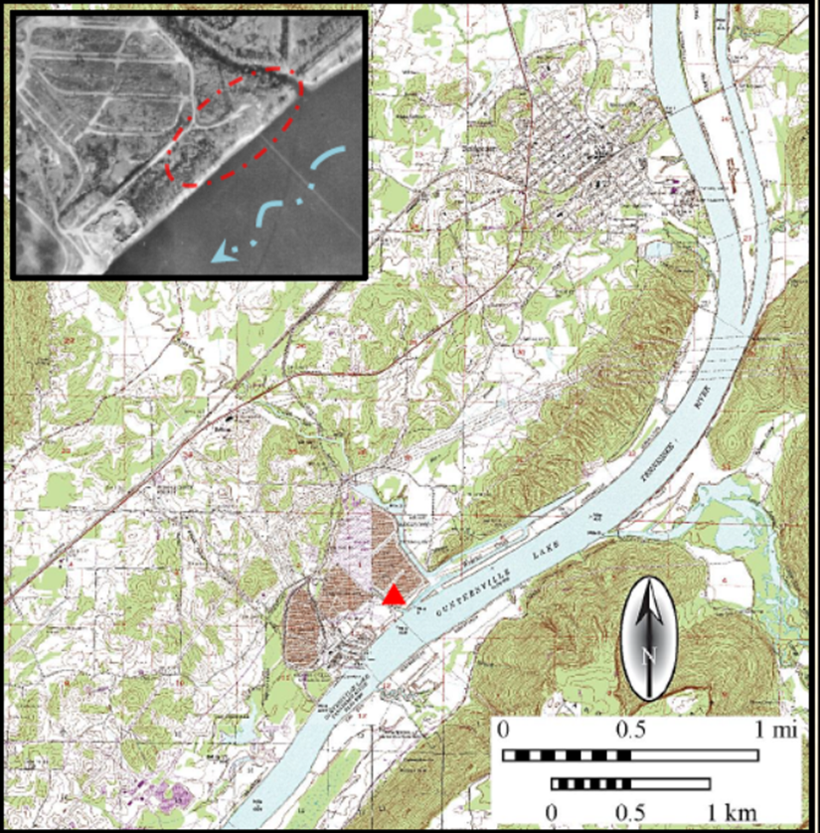
Figure 4.10: Arial view of the Widows Creek site.

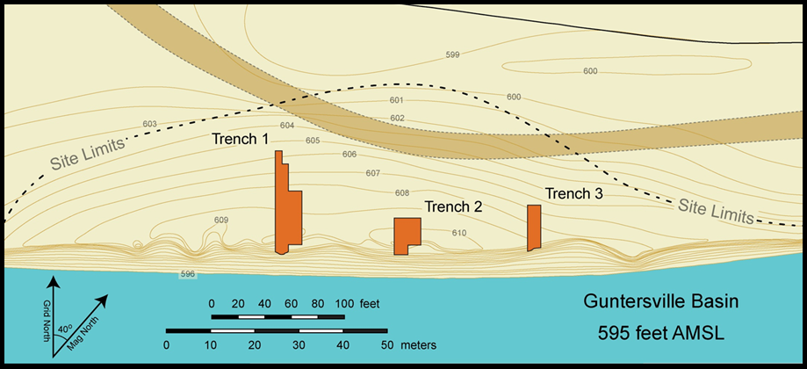Figure 4.11: Plan view of Widows Creek site showing location of excavation trenches. Image courtesy Howard Cyr.

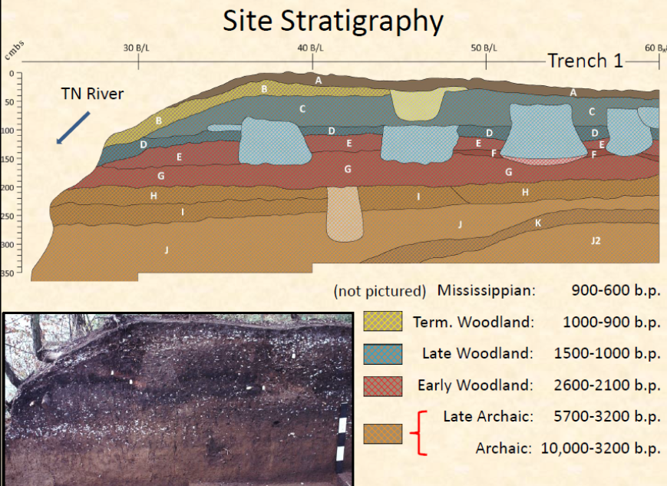
Figure 4.12: Image shows profile of Trench 1 and the assigned cultural deposits.

Following the excavations, all collections were moved to The University of Tennessee, Chattanooga for processing but a final report of the investigation was never completed. The collections eventually were deposited at the University of Alabama’s Museum of Natural History repository facilities in Moundville, Alabama (Little et al. 2012:28). Several specialized studies have been conducted on the collections, providing a great deal of information about the site and its occupants. A recent re-examination of collections by Little and colleagues (2012) along with 45 recently-acquired AMS dates (Table 4.22) provided new information while offering further support for earlier findings of Late Archaic through Mississippian period occupations at the site.

Previous Analysis: Faunal Remains
The first extensive report on Widows Creek material was Robert Warren’s 1975 thesis which focused on fresh water mussel utilization. Warren identified 60,360 specimens from two control blocks, 40R10 and 30R10, and 26 features (Tables 4.23) (Little et al. 2012:29; Warren 1975). The remains represented a minimum number of individual (MNI) of 32,313 comprising 23 genera and 49 species (Morey 1996:125; Warren 1075:51). His study focused on the use of shell for manufacturing artifacts, mollusks as proxies for paleoenvironmental reconstruction, and seasonality, and their nutritional contributions in prehistoric diets.
Several patterns Warren observed involving species composition, concentrations, and condition of the shell found within the two control columns and 26 features (Warren 1975:112). While variation in species composition appeared to have been minor, Dromus dromas did increase at the expense of Elliptio dilatatus in the control columns as well as features (Warren 1975:119). Specimen preservation varied considerably over time as well. Deterioration of shell from the lower portions of the site occurred in both control columns and features, resulting in a higher degree of unidentifiable specimens in the lower deposits (Warren 1975:128). A decrease in concentration of shell is also witnessed in the lower deposits (Warren 1975:128). However, a dense concentration of shell found in Feature 156, associated with Zone J, led Warren to conclude that the variability in concentrations from the lower to the upper deposits is more a reflection of post-depositional erosion than a deference to fresh water mussels by earlier inhabitants of the site (Warren 1975:129).
Warren also used the analyzed species to recreate the past environmental conditions at the site using four variables including body type (eg. Large-river, medium-river, and small-river), water depth, velocity, and substrate composition (Warren 1975:132). The presence of large river and small-river/large-steam species recovered from the site, whose habitats do not overlap, suggests that the site was situated conveniently between two separate ecological habitats exploited by occupants of the site (Warren 1975:139). Also, he concluded that the local ecological variation was one of a micro-environmental scale and those conditions necessary to maintain both were available locally. He also found that the majority of species preferred shallow waters (1 to 3 feet) with a strong current velocity, with a substrate composed primarily of gravels and gravelly sands (Warren 1975:145). These findings suggested that shoal conditions existed in the river adjacent to the site (Warren 1975:147). This conclusion is further supported by the analysis of gastropods from the site, which all prefer similar habitats. While these conditions are favorable for many species of fresh water mussels they also provide an ideal habitat for human collection.

Table 4.22: AMS C14 Dates Returned from the Widows Creek site.
Lab Number | Analysis Type | Context | Component | Material | Conventional Date | Weighted Mean | 1-sigma |  | 2-sigma
Beta-281801 | AMS | Feature 85 | Late Woodland | Carbonized nutshell | 930+/-40 | 846+/-47 | 910 | 796 | 928 | 745
Beta-281799 | AMS | Feature 67 | Late Woodland | Carbonized nutshell | 950+/-40 | 856+/-46 | 923 | 798 | 935 | 768
Beta-281809 | AMS | Feature 120 | Late Woodland | Carbonized nutshell | 960+/-40 | 861+/-47 | 927 | 798 | 954 | 785
Beta-281802 | AMS | Feature 87 | Late Woodland | Carbonized nutshell | 970+/-40 | 868+/-48 | 931 | 799 | 956 | 791
Beta-281800 | AMS | Feature 76 | Late Woodland | Carbonized nutshell | 970+/-40 | 868+/-48 | 931 | 799 | 956 | 791
Beta-281821 | AMS | Feature 166 | Late Woodland | Carbonized nutshell | 1080+/-40 | 996+/-43 | 1052 | 937 | 1062 | 929
Beta-281826 | AMS | Feature 176 | Late Woodland | Carbonized nutshell | 1100+/-40 | 1011+/-45 | 1055 | 964 | 1122 | 929
Beta-281794 | AMS | Feature 42 | Late Woodland | Carbonized nutshell | 1100+/-40 | 1011+/-45 | 1055 | 964 | 1122 | 929
Beta-281822 | AMS | Feature 169 | Late Woodland | Carbonized nutshell | 1120+/-40 | 1029+/-51 | 1061 | 974 | 1169 | 937
Beta-281786 | AMS | Feature 19 | Late Woodland | Carbonized nutshell | 1120+/-40 | 1029+/-51 | 1061 | 974 | 1169 | 937
Beta-281818 | AMS | Feature 139 | Late Woodland | Carbonized nutshell | 1130+/-40 | 1040+/-55 | 1069 | 970 | 1170 | 959
Beta-281827 | AMS | Feature 180 | Late Woodland | Carbonized nutshell | 1140+/-40 | 1052+/-58 | 1120 | 975 | 1172 | 963
Beta-281813 | AMS | Feature 128 | Late Woodland | Carbonized nutshell | 1140+/-40 | 1052+/-58 | 1120 | 975 | 1172 | 963
Beta-281788 | AMS | Feature 24 | Late Woodland | Carbonized nutshell | 1140+/-40 | 1052+/-58 | 1120 | 975 | 1172 | 963
Beta-281825 | AMS | Feature 175 | Late Woodland | Wood charcoal | 1150+/-40 | 1065+/-60 | 1167 | 982 | 1173 | 970
Beta-281784 | AMS | Feature 15 | Late Woodland | Carbonized nutshell | 1150+/-40 | 1065+/-60 | 1167 | 982 | 1173 | 970
Beta-281793 | AMS | Feature 39 | Late Woodland | Carbonized nutshell | 1160+/-40 | 1079+/-61 | 1169 | 1005 | 1176 | 971
Beta-281792 | AMS | Feature 35 | Late Woodland | Carbonized nutshell | 1160+/-40 | 1079+/-61 | 1169 | 1005 | 1176 | 971
Beta-281819 | AMS | Feature 142 | Late Woodland | Carbonized nutshell | 1170+/-40 | 1092+/-61 | 1171 | 1014 | 1225 | 975
Beta-281810 | AMS | Feature 124 | Late Woodland | Carbonized nutshell | 1170+/-40 | 1092+/-61 | 1171 | 1014 | 1225 | 975
Beta-281807 | AMS | Feature 115 | Late Woodland | Carbonized nutshell | 1170+/-40 | 1092+/-61 | 1171 | 1014 | 1225 | 975
Beta-281824 | AMS | Feature 174 | Late Woodland | Carbonized nutshell | 1180+/-40 | 1104+/-60 | 1171 | 1059 | 1234 | 979
Beta-281823 | AMS | Feature 173 | Late Woodland | Wood charcoal | 1180+/-40 | 1104+/-60 | 1171 | 1059 | 1234 | 979
Beta-281797 | AMS | Feature 56 | Late Woodland | Carbonized nutshell | 1190+/-40 | 1116+/-59 | 1171 | 1065 | 1256 | 984
Beta-281791 | AMS | Feature 27 | Late Woodland | Carbonized nutshell | 1190+/-40 | 1116+/-59 | 1171 | 1065 | 1256 | 984
Beta-281820 | AMS | Feature 145 | Late Woodland | Carbonized nutshell | 1200+/-40 | 1128+/-59 | 1174 | 1066 | 1261 | 1004
Beta-281803 | AMS | Feature 95 | Late Woodland | Carbonized nutshell | 1200+/-40 | 1128+/-59 | 1174 | 1066 | 1261 | 1004
Beta-281814 | AMS | Feature 129 | Late Woodland | Carbonized nutshell | 1210+/-40 | 1139+/-60 | 1220 | 1066 | 1264 | 1014

Table 4.22: AMS C14 Dates Returned from the Widows Creek site.
Lab Number | Analysis Type | Context | Component | Material | Conventional Date | Weighted Mean | 1-sigma |  | 2-sigma
Beta-281795 | AMS | Feature 49 | Late Woodland | Carbonized nutshell | 1210+/-40 | 1139+/-60 | 1220 | 1066 | 1264 | 1014
Beta-281798 | AMS | Feature 58 | Late Woodland | Carbonized nutshell | 1240+/-40 | 1175+/-59 | 1261 | 1092 | 1270 | 1069
Beta-281789 | AMS | Feature 25 | Late Woodland | Carbonized nutshell | 1240+/-40 | 1175+/-59 | 1261 | 1092 | 1270 | 1069
Beta-281783 | AMS | Feature 13 | Late Woodland | Carbonized nutshell | 1260+/-40 | 1197+/-55 | 1271 | 1172 | 1283 | 1080
Beta-281815 | AMS | Feature131 | Late Woodland | Carbonized nutshell | 1270+/-40 | 1207+/-51 | 1269 | 1176 | 1289 | 1082
Beta-281806 | AMS | Feature 106 | Late Woodland | Carbonized nutshell | 1270+/-40 | 1207+/-51 | 1269 | 1176 | 1289 | 1082
Beta-281811 | AMS | Feature 125 | Late Woodland | Carbonized nutshell | 1290+/-40 | 1223+/-45 | 1280 | 1180 | 1297 | 1095
Beta-281808 | AMS | Feature 119 | Late Woodland | Carbonized nutshell | 1280+/-40 | 1215+/-48 | 1274 | 1179 | 1293 | 1089
Beta-281805 | AMS | Feature 100 | Late Woodland | Carbonized nutshell | 1280+/-40 | 1215+/-48 | 1274 | 1179 | 1293 | 1089
Beta-281785 | AMS | Feature 18 | Early Woodland | Carbonized nutshell | 2120+/-40 | 2107+/-78 | 2149 | 2009 | 2302 | 1992
Beta-281817 | AMS | Feature 137 | Early Woodland | Carbonized nutshell | 2140+/-40 | 2144+/-86 | 2297 | 2053 | 2306 | 1999
Beta-281816 | AMS | Feature 134 | Early Woodland | Carbonized nutshell | 2200+/-40 | 2225+/-61 | 2307 | 2152 | 2331 | 2123
Beta-281804 | AMS | Feature 96 | Early Woodland | Carbonized nutshell | 2280+/-40 | 2266+/-63 | 2347 | 2184 | 2353 | 2156
Beta-281790 | AMS | Feature 25A | Early Woodland | Carbonized nutshell | 2280+/-40 | 2266+/-63 | 2347 | 2184 | 2353 | 2156
Beta-281796 | AMS | Feature 54 | Early Woodland | Carbonized nutshell | 2300+/-40 | 2290+/-67 | 2354 | 2207 | 2363 | 2155
Beta-281812 | AMS | Feature 126 | Early Woodland | Carbonized nutshell | 2350+/-40 | 2396+/-79 | 2455 | 2333 | 2678 | 2211
Beta-281787 | AMS | Feature 23 | Early Woodland | Carbonized nutshell | 2430+/-40 | 2504+/-107 | 2675 | 2359 | 2702 | 2351
Calibrations in OxCal 4.2.2 (Bronk Ramsey 2013) using IntCal09 curve (Reimer et al. 2009)

Table 4.23: Unionacean Species Identified from the Widows Creek Site.
Species | Origin | Total | MNI | %MNI
Elliptio dilatatus | Interior Basin | 16,962 | 8,911 | 27.31
Dromus dromas f. dromas | Cumberlandian | 14,142 | 7,304 | 22.38
Pleurobema cordatum fs. catillus, cordatum, plenum, pyradatum | Interior Basin | 6,455 | 3,398 | 10.41
Actinonaias carinata f. gibba | Cumberlandian | 4,802 | 2,570 | 7.88
Cyclonaias tuberculata fs. tuberculata and granifera | Interior Basin | 3,723 | 2,044 | 6.26
Obovaria retusa | Interior Basin | 1,617 | 883 | 2.71
Lexingtonia dolabelloides f. dolabelloides | Cumberlandian | 1,253 | 699 | 2.14
Fusconaia subrotunda f. subrotunda | Interior Basin | 1,129 | 644 | 1.97
Pleurobema clava | Interior Basin | 1,114 | 636 | 1.95
Dysnomia torulosa fs. torulosa and cincinnatiensis | Interior Basin | 949 | 561 | 1.72
Dysnomia propinqua | Cumberlandian | 904 | 520 | 1.60
Plethobasus cooperianus | Interior Basin | 845 | 486 | 1.49
Elliptio crassidens | Interior Basin | 827 | 4461 | 1.41
Quadrula metanevra f. metanevra | Interior Basin | 599 | 358 | 1.10
Unidentified Valves |  | 541 | 321 | 0.98
Plethobasus cicatricosus f. detectus | Interior Basin | 446 | 261 | 0.80
Obovaria subrotunda f. subrorunda | Interior Basin | 437 | 262 | 0.80
Ptychobranchus fasciolare | Unknown | 435 | 256 | 0.78
Dysnomia flexuosa f. flexuosa | Interior Basin | 371 | 233 | 0.71
Lampsilis ovata f. ovate | Interior Basin | 357 | 209 | 0.64
Quadrula pustulosa f. pustulosa | Interior Basin | 334 | 198 | 0.61
Fusconaia edgariana f. edgarina | Cumberlandian | 317 | 196 | 0.60
Dysnomia arcaeformis | Cumberlandian | 262 | 170 | 0.52
Cyprogenia irrorata | Unknown | 187 | 127 | 0.39
Amblema costata | Interior Basin | 146 | 88 | 0.27
Dysnomia stewardsoni | Cumberlandian | 116 | 76 | 0.23
Quadrula cylindrica f. cylindrical | Interior Basin | 111 | 81 | 0.25
Dysnomia haysiana | Cumberlandian | 111 | 79 | 0.24
Dysnomia capsaeformis | Cumberlandian | 110 | 70 | 0.21
Dysnomia brevidens | Cumberlandian | 95 | 66 | 0.21
Ptychobranchus subtentum | Cumberlandian | 78 | 52 | 0.16
Plethobasus cyphyus f. cyphyus | Interior Basin | 73 | 47 | 0.14
Fusconaia cuneolus f. appressa | Cumberlandian | 70 | 54 | 0.17
Quadrula cintermedia fs. intermedia and tuberosa | Cumberlandian | 63 | 47 | 0.14
Dysnomia flexuosa f. flewisii | Cumberlandian | 61 | 42 | 0.13
Conradilla caelata | Cumberlandian | 61 | 43 | 0.13
Pleurobema oviforme f. holstonense | Cumberlandian | 60 | 41 | 0.13
Obovaria subrotunda f. lens | Interior Basin | 46 | 34 | 0.10
Lampsilis fasciola | Interior Basin | 39 | 29 | 0.09
Carunclina moesta f. moesta | Cumberlandian | 38 | 26 | 0.08
Villosa taeniata | Cumberlandian | 24 | 19 | 0.06
Fusconaia barnesiana f. tumescens | Cumberlandian | 17 | 13 | 0.04
Ligumia recta f. latissimi | Interior Basin | 8 | 6 | 0.02
Dysnomia triquetra | Unknown | 4 | 3 | 0.01
Obliquaria reflexa | Interior Basin | 3 | 2 | 0.01

Table 4.23(cont.): Unionacean Species Identified from the Widows Creek Site.
Species | Origin | Total | MNI | %MNI
Dysnomia biemarginata | Cumberlandian | 2 | 2 | 0.01
Anodonta grandis | Interior Basin | 1 | 1 | 0.00
Actinonaias pectorosa | Cumberlandian | 1 | 1 | 0.00
Plagiola lineolata | Interior Basin | 1 | 1 | 0.00
Leptodea fragilis | Interior Basin | 1 | 1 | 0.00
Villosa fabalis | Unknown | 1 | 1 | 0.00
Villosa vanuxemi f. pybasii | Cumberlandian | 1 | 1 | 0.00
Totals |  | 60, 350 | 32,634 | 99.98
*Cumberlandian fauna defined by Orton (1924) as fauna from Cumberland and Tennessee River systems.
**Interior Basin refers to species endemic to the Mississippi, Ohio, and western drainages.
Table constructed from Warren 1975: 52-55.

Warren also explored the use of shell as a raw material for tool manufacture. Two artifacts recovered from the site were recognized as culturally modified and believed to have been ground, perforated, and worn as some type of “suspended ornament” (Warren 1975:168). Additionally, sixteen were thought to bear evidence of cultural modification. He concluded that the numbers of modified shell identified in the assemblage were consistent with modified shell artifacts found at other sites in the region.
Freshwater mussel shell was also associated with 23 of the 28 burials excavated. While most contained moderate to low amounts of shell, Burials 5, 7, 8, 9, and 15 were associated with a shell lens indicative of Hamilton period burials. One of those burials, Burial 8, was that of a semi-flexed adult male. Five Hamilton projectile points were found in association with the burial and the skull appeared to have been removed and replaced with a single mussel shell placed over the second cervical vertebra (Warren 1975:169). Noting the importance of the use of shell in these two instances, as either objects of personal adornment or in funerary practices, Warren suggested that the use of shell was peripheral to its primary function as a subsistence resource (Warren 1975:169).
Finally, Warren explored the nutritional value and contributions of freshwater mussels to the prehistoric diet at Widows Creek (Warren 1975:203). Based on the MNI identified from the site (n=32,313) Warren calculated that approximately 893 pounds of tissue would have been exploited at the site (Warren 1975:203). He determined that to be approximately 1,273.7 gm/ft³ per feature and 516.6 gm/ft³ for unit contexts. Based on those calculations, he concluded that freshwater mussels were less important to prehistoric populations than previously believed and that it would be much easier to procure equivalent amounts of meat from larger vertebrate species (Warren 1975:207). He further explained that the amount of tissue weight obtained from the total freshwater mussel collection at the site could have been equaled by 98 freshwater drum, 119 snapping turtles, 105 turkeys, 112 raccoons, 9 white-tailed deer, or 2.5 elk (Warren 1975:207). But while they were shown to supply inadequate sources of calories (8.46 calories/specimen), they did provide high allowances of iron, phosphorus, and calcium. All of this led to the conclusion that these resources served as a dietary supplement during summer and autumn months and that collection was conditioned by local abundance and availability (Warren 1975:210).
Table 4.24: Density of Fresh Water Mussels by Control Column From the Widows Creek Site (MNI per cubic foot of deposit).
 | Control Column 30R10 |  |  |  |  |  |  | Control Column 40R10
Zone | TCA | Cut | MNI | Volume (ft³) | Density |  | Zone | TCA | Cut | MNI | Volume (ft³) | Density
B | Late Woodland | 1 | 126 | 2.00 | 63.00 |  | A-B | Mixed | 3 | 402 | 2.00 | 201.00
D | Late Woodland | 2 | 57 | 2.00 | 28.50 |  | B | Late Woodland | 4 | 1531 | 2.00 | 765.50
D | Late Woodland | 3 | 54 | 2.00 | 27.00 |  | C | Late Woodland | 7 | 28 | 2.00 | 14.00
E | Early Woodland | 4 | 68 | 2.00 | 34.00 |  | D | Late Woodland | 8 | 29 | 2.00 | 14.50
G | Early Woodland | 5 | 198 | 2.00 | 99.00 |  | E | Early Woodland | 9 | 24 | 2.00 | 12.00
G | Early Woodland | 6 | 62 | 2.00 | 31.00 |  | E | Early Woodland | 10 | 51 | 2.00 | 25.50
H | Late Archaic | 7 | 59 | 2.00 | 29.50 |  | G | Early Woodland | 11 | 97 | 2.00 | 48.50
H | Late Archaic | 8 | 177 | 2.00 | 88.50 |  | G | Early Woodland | 12 | 106 | 2.00 | 53.00
I | Late Archaic | 9 | 104 | 2.00 | 52.00 |  | G | Early Woodland | 13 | 65 | 2.00 | 32.50
I | Late Archaic | 10 | 11 | 2.00 | 5.50 |  | G | Early Woodland | 14 | 26 | 2.00 | 13.00
I-J | Late Archaic | 11 | 10 | 2.00 | 5.00 |  | H | Late Archaic | 15 | 0 | 2.00 | 0.00
J | Late Archaic | 12 | 0 | 2.00 | 0.00 |  | H-I | Late Archaic | 16 | 7 | 2.00 | 3.50
J | Late Archaic | 13 | 2 | 2.00 | 1.00 |  | I | Late Archaic | 17 | 1 | 2.00 | 0.50
J | Late Archaic | 14 | 0 | 2.00 | 0.00 |  | J | Late Archaic | 18 | 0 | 2.00 | 0.00
J | Late Archaic | 15 | 0 | 2.00 | 0.00 |  | J | Late Archaic | 19 | 0 | 2.00 | 0.00
J | Late Archaic | 16 | 0 | 2.00 | 0.00 |  | J | Late Archaic | 20 | 0 | 2.00 | 0.00
J | Late Archaic | 17 | 0 | 2.00 | 0.00 |  | J | Late Archaic | 21 | 1 | 2.00 | 0.50
J | Late Archaic | 18 | 0 | 2.00 | 0.00 |  | J | Late Archaic | 22 | 0 | 2.00 | 0.00
J | Late Archaic | 19 | 0 | 2.00 | 0.00 |  | J | Late Archaic | 23 | 1 | 2.00 | 0.50
J | Late Archaic | 20 | 0 | 2.00 | 0.00 |  | J | Late Archaic | 24 | 0 | 2.00 | 0.00
Table constructed from Warren 1975:120 and Little et al. 2012:96-97.

Table 4.25: Vertebrate Remains Recovered from Features and Control Column Sample from the Widows Creek Site.
 | Taxonomic Group | Late Archaic |  |  | Early Woodland |  |  | Middle / Late Woodland |  |  | Total NISP
 |  | Feature | Control Column | MNI | Feature | Control Column | MNI | Feature | Control Column | MNI
Fish | Sturgeon / Gar |  | 1 | 1 |  | 1 | 1 | 11 |  | 4 | 13
Fish | Suckers | 1 |  | 1 | 7 | 4 | 2 | 68 | 3 | 10 | 83
Fish | Catfish | 3 | 1 | 1 | 3 | 1 | 2 | 63 | 6 | 11 | 77
Fish | Sunfish / Walleye |  |  |  | 2 |  | 1 | 27 | 5 | 6 | 34
Fish | Drum |  | 5 | 1 | 4 | 7 | 2 | 135 | 17 | 15 | 168
Reptile | Mud / Musk Turtle | 3 | 3 | 1 | 2 | 5 | 1 | 38 | 4 | 3 | 55
Reptile | Box Turtle | 1 | 3 | 2 | 3 | 10 | 3 | 90 | 8 | 10 | 115
Reptile | Large Aquatic Turtle |  | 2 | 1 | 3 | 4 | 4 | 57 | 6 | 6 | 72
Reptile | Soft-shell Turtle |  | 4 | 1 | 12 | 7 | 1 | 92 | 17 | 4 | 118
Bird | Aquatic Birds |  | 1 | 1 | 2 |  | 2 | 5 | 1 | 3 | 9
Bird | Turkey / Misc. |  | 5 | 1 | 6 | 7 | 4 | 81 | 6 | 9 | 79
Mammal | Opossum |  | 5 | 2 | 1 | 2 | 2 | 48 | 1 | 7 | 57
Mammal | Raccoon | 1 | 3 | 1 | 5 | 3 | 2 | 45 | 1 | 4 | 58
Mammal | Aquatic Mammals |  | 1 | 1 | 2 | 2 | 1 | 13 | 1 | 3 | 19
Mammal | Canid / Feline |  |  |  | 1 | 4 | 3 | 23 | 3 | 6 | 30
Mammal | Sciurid | 1 | 4 | 2 | 8 | 6 | 3 | 104 | 6 | 11 | 129
Mammal | Rabbit / Skunk |  | 4 | 2 | 3 | 2 | 2 | 20 |  | 3 | 29
Mammal | Deer | 2 | 11 | 3 | 8 | 13 | 4 | 210 | 13 | 15 | 257
Mammal | Black Bear |  |  |  |  |  |  | 3 |  | 1 | 3
 | Total | 12 | 53 |  | 72 | 78 |  | 1,133 | 97 |  | 1,445
Table after Morey 1996:54.

In 1996, Darcy Morey analyzed the vertebrate remains from the site. He examined 2,556 unmodified bones specimens from 24 features and five control columns (30R10, 40R10, 50R10, 60R10, and 70R10 (Tables 4.24 and 4.25) (Morey 1996:15). All bone specimens greater than 6.4 mm were included in his study and the 1.6 mm fraction was included from features 19, 106, and 115, and from control column 60R10, to explore temporal changes in microfauna (Morey 1996:21). Sixty different species were identified including mammals (n=23), birds (n=9), reptiles (n=8), amphibians (n=4), and fish (n=16) (Little et al. 2012:29: Morey 1996:17).
His analysis indicated that white-tailed deer, raccoon, and opossum were critical mammal resources, while turkey and drum played a major role in the diet as well (Table 4.25). While white-tailed deer appears to have been the most important vertebrate resource during all occupational periods, fish were second in importance, followed by opossum, raccoons, and beavers (Morey 1996:74). With the exception of turkey, birds played a small role in the diet of the site’s inhabitants. Turtle also played a minor role in the diet (Morey 1996:148). Morey also re-analyzed the invertebrate data previously analyzed by Warren and concluded that shellfish were an important dietary resource at Widows Creek, contrary to Warren’s findings (Little et al. 2012:30; Morey 1996:148).

Bone Tools
Two studies have focused on bone modified as a result of technological manufacturing processes (Coughlin 1996; Coughlin and Morey 1996). The samples selected for analysis were taken from the same 24 features and five control columns used in the analysis of unmodified bone and from an additional set of features and general level columns from the R10 trench (Table 4.26) (Coughlin and Morey 1996:95). In total, 586 specimens were examined. Included in their studies were finished implements, debitage, or items thought to be incomplete or unfinished implements. They examined the raw material type, manufacturing techniques, manufacturing stage, and morphological category (Tables 4.27, 4.28, 4.29, and 4.30) (Coughlin 1996:43). The analysis sought to compare differences in assemblages between the Late Archaic, Early Woodland, and Middle/Late Woodland occupations at the site as well as across the Guntersville Basin (Coughlin 1996:1; Coughlin and Morey 1996:95).
Table 4.26: Distribution of Bone Tools from the Widows Creek Site.
Provenience Type | Number of Specimen per Temporal Period
 | Late Archaic | Early Woodland | Middle Late Woodland | N/A | Total
Features | 2 | 44 | 241 | 0 | 287
Control Columns | 18 | 31 | 26 | 2 | 77
General Levels | 18 | 47 | 135 | 22 | 222
Total | 38 | 122 | 402 | 24 | 586
Table after Coughlin and Morey 1996:99.
Of the 586 modified bone specimens selected for analysis, 562 were assignable to a cultural period at the site. The Middle Late Woodland component had the largest assemblage (n=385), followed by the Early Woodland period (n=122), and then the Late Archaic period (n=37) (Table 4.25) (Coughlin 1996:92; Coughlin and Morey 1996). Despite the difference in sample sizes from each component, trends were apparent within the assemblage.
There appeared to be very little variability in raw material used across the three time periods. Miscellaneous mammal bone represents the largest quantity of modified raw material for all three periods. It represented 68 percent of the Late Archaic assemblage, 65 percent of the Early Woodland assemblage, 51 percent of the Middle Late Woodland assemblage, and 55 percent of the entire analyzed collection. Deer bone was the next highest in the Middle Late Woodland and Late Archaic periods, with antler being the second highest in the Early Woodland period. Most of the miscellaneous mammal fragments are thought to be deer but lack the landmarks necessary for proper identifications. The only noticeable difference among the assemblages is the quantity of turtle seen in the Middle Late Woodland period, which may be a reflection of a larger sample size (Table 4.26) (Coughlin 1996:94). This trend is consistent with Morey’s 1996 analysis that showed an increase in the use of turkey in the vertebrate assemblage.
As with raw material utilization, very little diversity is seen in modification attributes across time at the site. Modified bone from each component show high levels of grinding, and carving, and incising. The most noticeable difference is the high percentage of carving and incising and an increase in percussion flaking that occurs in the Middle Late Woodland assemblage (Table 4.26).
In regards to manufacturing modified bone, the Early Woodland and Middle Late Woodland have the highest frequencies of completed implements, at 29 and 31 percent, respectively (Table 4.29). The percentage is much lower during the Late Archaic period at around 18 percent. When byproduct and discard categories are combined, there appeared to be a decrease through time. In the Late Archaic assemblage there was a higher frequency of byproducts/discards whereas in the Early Woodland there was a higher frequency of complete tools. This pattern led Coughlin to conclude that tools were being made and discarded off site during the Late Archaic while during the Early Woodland period they were being produced elsewhere and brought to the site. The equal numbers of both categories during the Middle to Late Woodland period suggest that the tools were being made and used at the site (Coughlin 1996:104).
The largest morphological category represented at the site was manufactured points, which remained true for all three time periods. The higher frequency during the Middle Late Woodland period is thought to be a function of sample size. However, the presence of bipointed objects recovered from the period is significantly different and thought to reflect a specialized metapodial manufacturing industry at the site (Coughlin 1996:109).
Based on the analysis detailed above, Coughlin concluded that there were observable patterns and trends in the data. In terms of raw materials, the greatest difference through time was an increase in the use of white-tailed deer metapodial during the Middle Late Woodland period. Data from the manufacturing stage classification led to the greatest understanding of site function and tool production. These data imply that more tools were being produced on site and used elsewhere during the Late Archaic period, a trend that reverses during the Early Woodland period. The Middle Late Woodland assemblage suggests that those tools were being made, used, and discarded near the site based on the equal proportions of completed tools and manufacturing byproducts and debris. Coughlin also believed there was a specific industry during this time based on the production of bipointed objects, fishhooks, and cylindrical objects made of antler. Overall, there appeared to be a change from a more generalized site use during the Late Archaic and Early Woodland occupation to a more specialized use of the site during the Middle Late Woodland period (Coughlin 1996:116).

Table 4.27: Raw Material Types by Temporal Component at Widows Creek Site.
 | Late Archaic |  | Early Woodland |  | Middle/Late Woodland |  | Totals
Raw Material Type | Count | % | Count | % | Count | % | Count | %
Misc. Mammal | 26 | 68 | 79 | 65 | 206 | 51 | 311 | 55
Deer Bone | 6 | 16 | 13 | 11 | 77 | 19 | 96 | 17
Bird Bone | 3 | 8 | 10 | 8 | 49 | 12 | 62 | 11
Antler | 2 | 5 | 14 | 11 | 45 | 11 | 61 | 11
Turtle Shell | 1 | 3 | 0 | 0 | 21 | 6 | 22 | 4
Indeterminate | 0 | 0 | 6 | 5 | 4 | 1 | 10 | 2
Total | 38 | 100 | 122 | 100 | 402 | 100 | 562 | 100
Table after from Coughlin 1996.

Table 4.28: Primary Manufacturing Evidence on Modified Bone by Temporal Component.
 | Late Archaic |  | Early Woodland |  | Middle/Late Woodland |  | Totals
Manufacturing Traces | Count | % | Count | % | Count | % | Count | %
Ground / Smoothed | 24 | 63 | 62 | 51 | 100 | 25 | 186 | 33
Groove and Snap | 6 | 16 | 2 | 2 | 33 | 8 | 41 | 7
Carving / Incising | 4 | 10 | 49 | 40 | 236 | 59 | 289 | 51
Chopped | 0 | 0 | 1 | 1 | 0 | 0 | 1 | <1
Drilled | 1 | 3 | 1 | 1 | 2 | 1 | 4 | <1
Grooved | 2 | 5 | 1 | 1 | 8 | 2 | 11 | 2
Percussion Flaked | 1 | 3 | 5 | 4 | 20 | 5 | 26 | 5
Indeterminate | 0 | 0 | 1 | 1 | 3 | 1 | 4 | <1
Total | 38 | 100 | 122 | 100 | 402 | 101 | 562 | 100
Table after from Coughlin 1996.

Table 4.29: Manufacturing Stage of Modified Bone by Temporal Component.
 |  | Late Archaic |  |  | Early Woodland |  |  |  |  | Late Woodland |  |  |  | Total
Manufacturing Stage |  | Count |  | % | Count |  |  | % |  | Count |  | % |  | Count | %
Stage 1: Complete Objects
Unbroken |  | 2 |  | 5 | 10 |  |  | 8 |  | 34 |  | 8 |  | 46 | 8
Recent Break |  | 1 |  | 3 | 1 |  |  | 1 |  | 11 |  | 3 |  | 13 | 2
Non-recent Break |  | 4 |  | 10 | 25 |  |  | 20 |  | 80 |  | 20 |  | 109 | 19
Stage 2: Byproduct / Discard
Fishhook Discard |  | 2 |  | 5 | 2 |  |  | 2 |  | 20 |  | 5 |  | 24 | 5
Fishhook – Aborted |  | 1 |  | 3 | 1 |  |  | 1 |  | 0 |  | 0 |  | 2 | <1
Groove and Snap Discard – End |  | 1 |  | 3 | 1 |  |  | 1 |  | 9 |  | 2 |  | 11 | 2
Groove and Snap Discard – Fragment |  | 3 |  | 8 | 4 |  |  | 3 |  | 19 |  | 5 |  | 26 | 5
Grooved Only |  | 4 |  | 10 | 2 |  |  | 2 |  | 6 |  | 1 |  | 12 | 2
Groove and Snap Discard – Turkey |  | 0 |  | 0 | 0 |  |  | 0 |  | 4 |  | 1 |  | 4 | <1
Stage 3: Deer Metapodial Manufacturing
Half Shaft Section |  | 1 |  | 3 | 2 |  |  | 2 |  | 16 |  | 4 |  | 19 | 3
Quarter Shaft Section |  | 0 |  | 0 | 0 |  |  | 0 |  | 11 |  | 3 |  | 11 | 2
Half or Quarter Shaft Section |  | 1 |  | 3 | 1 |  |  | 1 |  | 12 |  | 3 |  | 14 | 2
Proximal Section |  | 1 |  | 3 | 1 |  |  | 1 |  | 2 |  | 1 |  | 4 | <1
Distal End |  | 0 |  | 0 | 0 |  |  | 0 |  | 3 |  | 1 |  | 3 | <1
Stage 4: Misc. Byproduct/Discard
White-tailed Deer Element |  | 0 |  | 0 | 3 |  |  | 2 |  | 4 |  | 1 |  | 7 | 1
Turtle Shell Fragment |  | 1 |  | 3 | 0 |  |  | 0 |  | 20 |  | 5 |  | 21 | 4
Stage 5: Indeterminate
Metapodial Fragments |  | 0 |  | 0 | 0 |  |  | 0 |  | 2 |  | 1 |  | 2 | <1
Other Fragments |  | 16 |  | 42 | 69 |  |  | 56 |  | 149 |  | 37 |  | 234 | 42
Total |  | 38 |  | 101 | 122 |  |  | 100 |  | 402 |  | 101 |  | 562 | 100
Table after from Coughlin 1996.
Table 4.30: Morphological Categories of Modified Bones by Temporal Component.
 | Late Archaic |  |  |  |  | Early Woodland |  |  | Late Woodland |  |  |  | Totals
Morphological Category | Count |  | % |  |  | Count | % |  | Count |  | % |  | Count |  |  | %
Manufactured Point -Straight | 3 |  | 8 |  |  | 7 | 6 |  | 29 |  | 7 |  | 39 |  |  | 7
Manufactured Point - Curved | 0 |  | 0 |  |  | 0 | 0 |  | 3 |  | <1 |  | 3 |  |  | <1
Manufactured Point - Tip Only | 0 |  | 0 |  |  | 13 | 11 |  | 34 |  | 8 |  | 47 |  |  | 8
Manufactured Point - Bipointed | 0 |  | 0 |  |  | 1 | 1 |  | 11 |  | 3 |  | 12 |  |  | 2
Non-manufactured Point - Antler | 1 |  | 3 |  |  | 4 | 3 |  | 2 |  | <1 |  | 7 |  |  | 1
Non-manufactured Point - Antler Tips | 0 |  | 0 |  |  | 6 | 5 |  | 9 |  | 2 |  | 15 |  |  | 3
Non-manufactured Point - Canines | 0 |  | 0 |  |  | 1 | 1 |  | 1 |  | <1 |  | 2 |  |  | <1
Cylindrical - Closed Channel | 1 |  | 3 |  |  | 1 | 1 |  | 16 |  | 4 |  | 18 |  |  | 3
Cylindrical - Open Channel | 1 |  | 3 |  |  | 0 | 0 |  | 1 |  | <1 |  | 2 |  |  | <1
Beveled - Longitudinally | 0 |  | 0 |  |  | 1 | 1 |  | 6 |  | 1 |  | 7 |  |  | 1
Beveled - Distal | 0 |  | 0 |  |  | 2 | 2 |  | 10 |  | 2 |  | 12 |  |  | 2
Beveled - Fragment | 1 |  | 3 |  |  | 0 | 0 |  | 3 |  | <1 |  | 4 |  |  | <1
Unassigned | 15 |  | 39 |  |  | 17 | 14 |  | 126 |  | 31 |  | 158 |  |  | 28
Indeterminate | 16 |  | 42 |  |  | 69 | 56 |  | 151 |  | 40 |  | 236 |  |  | 42
Total | 38 |  | 101 |  |  | 122 | 101 |  | 402 |  | 100 |  | 562 |  |  | 100
Table after from Coughlin 1996.

Human Skeletal Remains
The remains of 28 burials from Widows Creek were examined to study demographic, dietary, health, and cultural relationships between groups in the Guntersville Basin of Alabama (Table 4.31) (Norton 2006).
The burial population from Widows Creek comprised 12 Early Woodland and 16 Middle Late Woodland burials. Though the sample size is small, significant differences were apparent in the manner of interment and the grouping of graves by age. While the population at Widows Creek is represented by both adults and subadults, there was a higher than anticipated level of infants and juvenile burials (Norton 2006:68). Early Woodland burials were predominantly juveniles and subadults while Late Middle Woodland burials were mainly adults. Norton explained this trend as being indicative of differential burial practices for adults and subadults by Early Woodland groups occupying the site (Norton 2006:100).
In terms of health and nutrition, many of the Early Woodland period remains showed evidence of linear enamel hypoplasia (LEH), anomalies typically associated with nutritional stress in childhood (Table 4.31). While many of the individuals exhibited evidence of multiple hypoplasia events, they were typically very mild, and not unusual (Norton 2004:74). Another indicator of nutritional stress is the presence of cribra orbitalia or hyperostosis. These are indicative of iron deficiency, or anemia. Of the 23 individuals assessed only six, three adults and three subadults, exhibited mild evidence of lesions associated with anemia. Each case of porotic hyperostosis is believed to have been inactive at the time of death, and therefore unlikely to have been the cause of death (Norton 2004:81). Another indicator of diet and nutrition is the presence and degree of dental caries. Of the 398 teeth examined, only four percent had evidence of caries. The evidence from Widows Creek is consistent with studies that have shown a correlation between subsistence practices and the percentages of caries, where the percentage of caries increases with diets higher in carbohydrates found in agricultural societies.
Table 4.31: Cultural Affiliation, Age, and Sex of Burials from Widows Creek.
Burial | TCA | Age | Sex | Trauma
1 | MLW | Adult | Male | Mild Arthritis
2 | MLW | Adult | Male
3 | EW | 15 | Male | Caries, Porotic hyperostosis
4 | MLW | 30 to 40 | Female | Hypoplasia
5 | MLW | Adult | ???
6 | EW | 8 to 9 | ???
7 | MLW | 35 to 50 | Female | Porotic hyperostosis, heavy tooth wear
8 | MLW | 18 | Female
9 | MLW | 30 to 35 | Male | Porotic hyperostosis, treponematosis, heavy tooth wear, hypoplasia
10 | MLW | 15 | ??? | Lesion on femur, hypoplasia, caries
11 | MLW | 20 to 25 | Female | Porotic hyperostosis, Cribia orbitalia, caries, antemorteum tooth loss
12 | EW | 3 to 4 | ???
13 | MLW | 35 to 40 | Male | Hypoplasia, grooving wear pattern on front teeth
14 | MLW | 5 to 6 | ???
15 | MLW | 18 | ??? | Mild hypoplasia, porotic hyperostosis
16 | EW | 1 | ???
17 | EW | 2 | ???
18 | EW | 12 | ??? | Mild hypoplasia, porotic hyperostosis
19 | EW | newborn | ???
20 | MLW | 25 to 35 | Female | Mild hypoplasia
21 | MLW | fetus | ???
22 | EW | 1 | ???
23 | MLW | 2 | ???
24 | EW | 45 | Female | Syphilis
25 | EW | 14 | ???
26 | EW | 3 | ??? | Porotic hyperostosis
27 | EW | 6 month | ???
28 | EW | 7 | ???
Table after from Norton 2004.

Evidence of infectious lesions can also provide information about the overall health of prehistoric populations. As with dental caries, the rate at the site was very low. Two individuals show signs of treponematosis, sometimes referred as “saber shin”, that is indicative of endemic syphilis. One individual, a subadult, showed sign of having periostitis. No evidence of tuberculosis or osteomyelitis was recorded (Norton 2004:83).
Very little evidence of inter- or intrapopulation violence or conflict was observed in the Widows Creek remains (Little et al. 2012:30; Norton 2004:88). What was found was considered questionable by Norton (2004). The first instance was a fracture on the pelvis of an eight to nine year old child. Norton suggested that this was likely the result of a metal probe and occurred during the excavation (Norton 2004:88). The second instance is that of a broken and healed proximal phalanx on a 35 to 40 year old male. No other trauma was observed on the skeleton (Norton 2004:88).
Various types of grave goods were associated with burials at the site including animal bones, pottery, lithic material, olivella beads, copper beads, and groundstone tools (Table 4.32). While no patterns were discernable by age or sex, copper beads found in association with Burials 10, and 20 and 21, and a conch shell ornament found with Burial 23, may provide evidence for participation in long-distance trade. Neither find is unusual nor surprising based on the Middle Woodland cultural affiliation of these burials.
Based on the indicators of nutrition and analysis of caries rates, Norton concluded that the Widows Creek population was generally healthy and probably subsisted of off a transitional diet, consuming both plants and animals. The lack of evidence for infectious disease within the population further supported this conclusion. Norton suggested that, based on the distribution of grave goods, special treatment was not afforded to a particular age or sex at the site. Grave goods were recovered in association with male and females, old and young (Norton 2004:108).

Ceramic Analysis
Ceramic material recovered from the site was analyzed to evaluate the temporal relationships within the site and to situate the site within the region. A total of 44,796 specimens was analyzed from excavation units and feature samples. Though 18,725 or roughly 42 percent of the assemblage was excluded from analysis based on size, 22,560 specimens were assigned to nineteen previously defined formal types (Little et al. 2012:37). An additional 3,511 sherds were assigned to 52 residual categories. Attributes measured in the analysis included temper, surface treatment, lip morphology, bottom morphology, and the presence or absence of clay straps.
General trends in the ceramic data showed that Long Branch Fabric Marked types initially dominated the assemblage but through time were replaced by Mulberry Creek Plain ceramics and eventually Flint River Brushed (Little et al. 2012:60). There is some indication in the data that two types, Flint River Cord Marked and Flint River Brushed, may occur earlier than originally expected. Flint River Brushed ceramics were found in the lowest deposits of 50R100 and 50R200 and in Level 11 of 60R10 (Tables 4.33, 4.34, and 4.35) (Little et al. 2012:60). While there is always the possibility that this is the result of anthropogenic mixing or post-depositional factors, it is still noted as worthy of consideration in future studies (Little et al. 2012:61).
Table 4.32: Grave Goods Associated with Burials from Widows Creek Site.
Burial | TCA | Age | Sex | Associated Grave Goods
3 | EW | 15 | Male | Pottery sherds, utilized lithic material
6 | EW | 8 to 9 |  | Pottery, projectile point in right hand
12 | EW | 3 to 4
16 | EW | 1 |  | Pottery, necklace of animal bone
17 | EW | 2 |  | Pottery, non-human bone
18 | EW | 12 |  | Bone artifact, utilized lithic material, pottery sherds
19 | EW | newborn |  | Pottery
22 | EW | 1
24 | EW | 45 | Female | Projectile point lodges in vertebra
25 | EW | 14 |  | Projectile points attached to bone, fabric marked rim sherd, hoe, projectile points associated with remains
26 | EW | 3 |  | lithic debitage and pottery sherds
27 | EW | 6 month |  | Lithic debitage and pottery sherds
1 | MLW | Adult | Male | Unidentified projectile Point, scraper, ceramic sherd
2 | MLW | Adult | Male | End scraper, deer antler tine, pottery
4 | MLW | 30 to 40 | Female | Pottery, stone debitage, stone tools, placed on bed of olivella beads
5 | MLW | Adult |  | Pottery, lithic debitage, shell layer covered remains
7 | MLW | 35 to50 | Female | Stone net sinker, pottery, shell layer covered remains
8 | MLW | 18 | Female | 5 Hamilton points, pottery sherd, lithic debitage, shell layer covered remains
9 | MLW | 30 to 35 | Male | Pottery and lithics, shell layer covered remains
10 | MLW | 15 |  | Limestone spade, limestone tool, copper beads
11 | MLW | 20 to 25 | Female | Large triangular biface
13 | MLW | 35 to 40 | Male
14 | MLW | 5 to 6 |  | Shell artifact
15 | MLW | 18 |  | Pottery
20 | MLW | 25 - 35 | Female | Groundstone tool, pottery sherds, copper beads, burial 21 found below knees
21 | MLW | fetus
23 | MLW | 2 |  | Olivella beads, shell gorget, conch shell
28 | EW | 7
Table constructed from Norton 2004.

Table 4:33: Ceramic Types Identified by Level from 60R100.
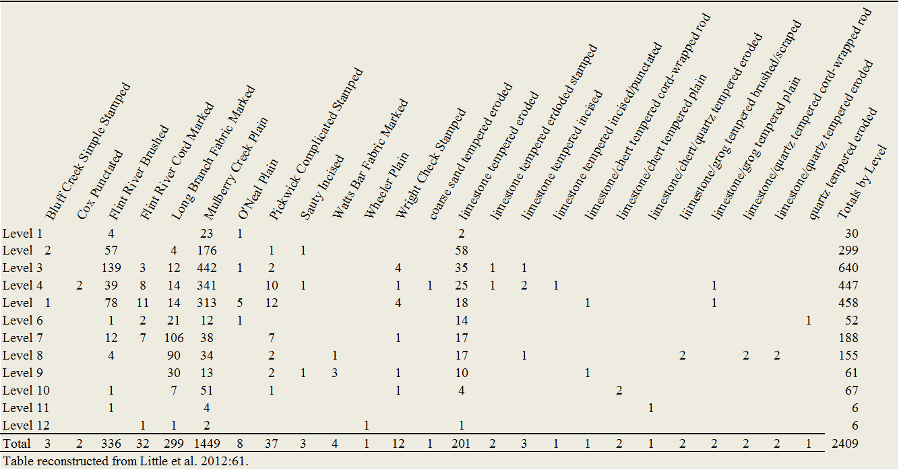

Table 4:34: Ceramic Types Identified by Level from 50R100.
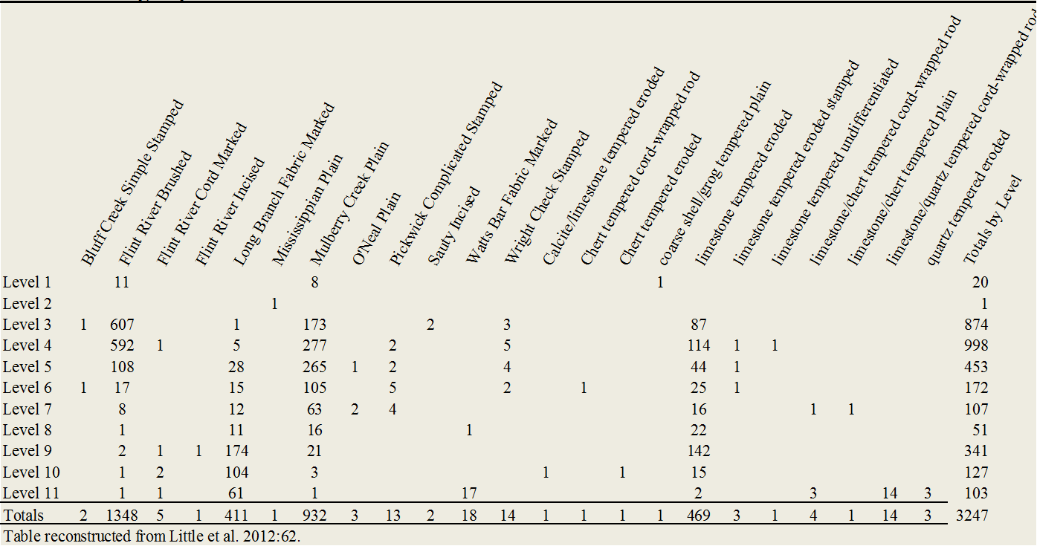

Table 4:35: Ceramic Types by Level from 50R200.
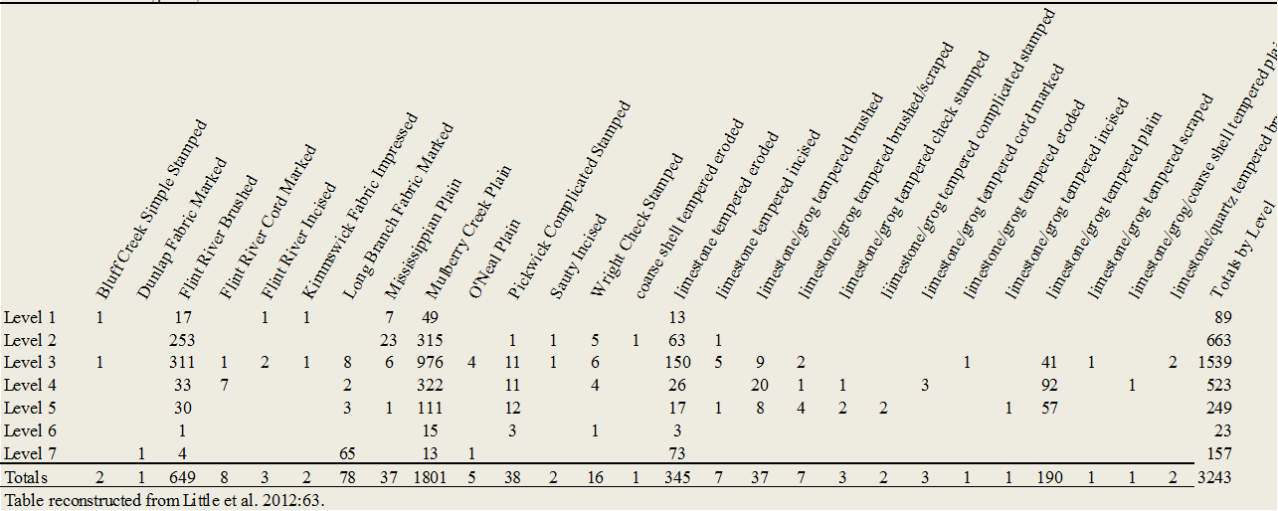

Ceramics from 85 features were also included in the analysis (Table 4.36). Forty-five 14C AMS dates were obtained from features that yielded 50 or more ceramic specimens. While some inconsistencies did occur between returned radiocarbon dates and ceramics associated with those features in general, the distribution of dates produced four interesting clusters; one in the final 400 years B.C, another from ca. 700–1000 A.D, another ca. 1,100 A.D, and an interesting lack of dates for the first 600 years A.D. (Figure 4.13) (Little et al. 2012:68).
The earliest cluster of dates ranges from 400 to 100 cal B.C. and is consistent with the Colbert culture found at other sites in the region. The Colbert phase is recognized by the predominance of Long Branch Fabric Marked ceramics with Mulberry Creek Plain, Watts Bar Fabric Marked, Dunlap Fabric Marked, and Wright Checked Stamped making up minority types (Little et al. 2012:76). Two Colbert subphases, I and II, are recognized and distinguished by the presence of Wright Checked Stamped ceramics as a minority type in the latter.
The lack of dates coming from the first few centuries A.D. indicates a lack of Middle Woodland occupations at the site. The lack of Middle Woodland component at the site corresponds well with reduced shell accumulations during the same time period at other sites around the region (Little et al. 2012:76).
By ca. 700 A.D. the site was reoccupied once again. The Late Woodland assemblage is dominated by Mulberry Creek Plain ceramics with a substantial amount of Flint River Brushed and minor amounts of Flint River Cord Marked and Pickwick Complicated Stamped, Flint River Incised, Sauty Incised, and Wright Checked Stamp (Little et al. 2012:76). The high proportions of Flint River Brushed ceramics in several of the dated features seem to suggest a
Terminal Woodland occupation, classified as a Terminal Woodland Widows Creek phase (Little et al. 2012:78).
The features that made up the last cluster of dates were dominated by shell-tempered Mississippian Plain and Kimmswick Fabric Impressed pottery, both indicative of the Early Mississippian Langston phase (Little et al. 2012:79). The overlap in dates from the sites however suggests that these two phases are contemporaneous and not necessarily sequential.
Table 4.36: Pottery types recovered from features at the Widows Creek Site.
Pottery Types | Totals from Features
Mulberry Creek Plain | 6738
Long Branch Fabric Marked | 2262
Flint River Brushed | 1789
Limestone tempered eroded | 1703
Flint River Cord Marked | 255
Pickwick Complicated Stamped | 233
Wright Check Stamped | 126
Limestone/grog tempered plain | 58
Watts Bar Fabric Marked | 40
O'Neal Plain | 27
Limestone/quartz tempered cord-wrapped rod | 20
Sauty Incised | 16
Flint River Incised | 12
Cox Punctated | 10
Limestone/chert tempered cord-wrapped rod | 10
Limestone tempered eroded stamped | 9
Limestone tempered incised | 8
Wheeler Plain | 5
Calcite tempered eroded | 4
Chert tempered cord-wrapped rod | 4
Limestone/coarse shell tempered plain | 4
Quartz tempered eroded | 4
Dunlap Fabric Marked | 3
Fine sand tempered eroded | 3
Limestone/grog tempered eroded | 3
Swift Creek Complicated Stamped | 2
Fine sand tempered fire coiled | 2
Limestone/chert tempered plain | 2
Limestone/grog tempered brushed/scraped | 2
Quartz/limestone tempered cord-wrapped rod | 2
Table 4.36(cont): Pottery Types Recovered from Features at the Widows Creek Site.
Pottery Types | Totals from Features
Mississippian Plain | 1
Calcite/chert tempered cord wrapped rod | 1
Chert tempered simple stamped | 1
Coarse sand tempered complicated stamped | 1
Coarse sand/limestone tempered plain | 1
Fiber tempered eroded | 1
Fine sand/grog tempered plain | 1
Limestone tempered cob impressed | 1
Limestone tempered fire coiled | 1
Limestone tempered punctated | 1
Limestone tempered undifferentiated | 1
Limestone/bone tempered plain | 1
Limestone/calcite tempered eroded | 1
Limestone/coarse shell tempered brushed | 1
Limestone/fine sand tempered plain | 1
Limestone/grog tempered check stamped | 1
Limestone/grog tempered cord stamped | 1
Limestone/grog tempered cord-wrapped rod | 1
Limestone/grog coarse shell tempered plain | 1
Limestone/quartz tempered eroded | 1
Undifferentiated tempered fire coiled | 1
Totals | 13,377

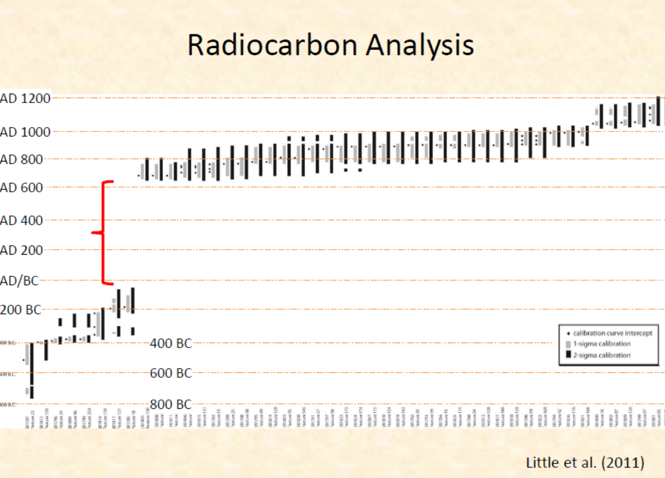
Figure 4.13: Radiocarbon dates from the Widows Creek site. Red line indicates break in occupation at the site.

Geoarchaological Analysis
Geoarchaeological analysis was conducted by Howard J. Cyr from The University of Tennessee Archaeological Research Laboratory to determine the relationship between periods of human occupation at the site and changes in the depositional environment (Cyr 2012:384). The analyses of physical and chemical properties from 34 sediment samples taken from two stratigraphic profiles (Trench 1 and 2) were used to assess these changes (Figure 4.14, 4.15, and 4:16). Physical analysis included grain size, organic matter, and magnetic susceptibility and the chemical analysis measured pH, calcium (Ca), phosphorous (P), magnesium Mg), and potassium (K) (Cyr 2012:384). The results of this analysis were then compared to the occupations zones described in the original project.
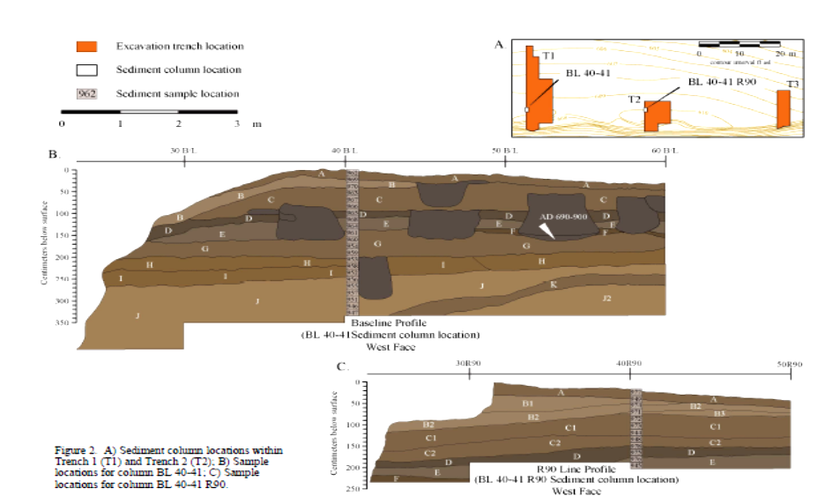
Figure 4.14: Figure shows locations of columns samples used for geoarchaeological analysis. Courtesy of Howard J. Cyr.

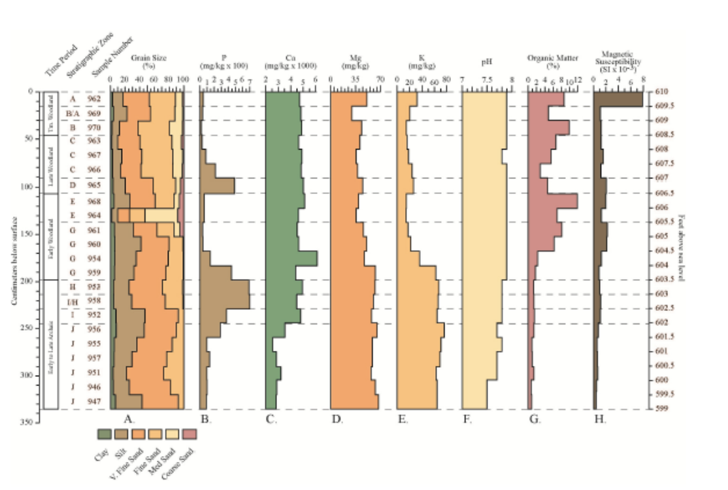
Figure 4.15: Laboratory data from Trench 1, BL 40 - 41. Images provided courtesy of Howard Cyr.

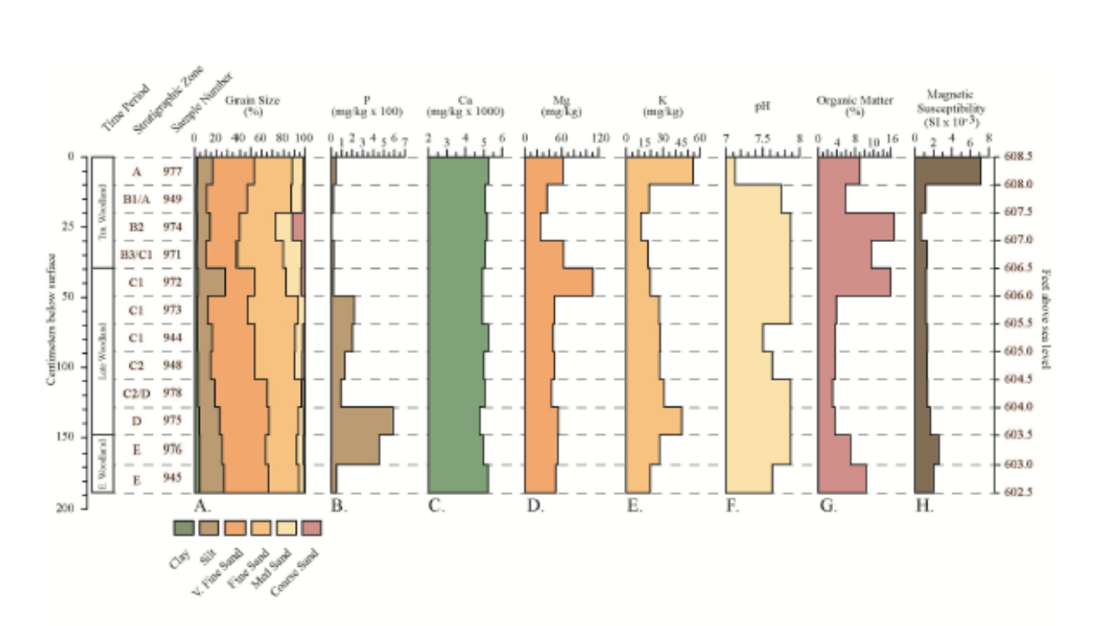
Figure 4.16: Laboratory analysis from Trench 2, BL 40 - 41 R90. Images provided courtesy of Howard J. Cyr.
Based on the 1973 profiles and the analysis of particle size, geochemical data, and organic matter, interpretations about the depositional environment of the floodplain that the site formed upon and surface stability at the site were explored (Cyr 2012:399). The sediment stratigraphy analyzed from Widows Creek represents a series of overbank levee deposits interspersed by periods of stability exhibited by anthropogenically modified soils and features (Cyr 2012:400). The deposits in Zones J through G suggest a period of stable and predictable floodplain environment. Increases in silts as well as a slight increase in phosphorous indicate a period of weak soil development characteristic of landscape stability. In addition to a spike in phosphorous, elevated levels of magnesium, potassium, and calcium, suggest an increase in the accumulation of animal bones. The physical and chemical signatures found in these deposits correspond well with a long term occupation of the site demonstrated by midden accumulation in Zone H. A pattern of weak soil development and landscape stability continued into Zone G during the Early Woodland deposits (Cyr 2012:401).
A drastic change in depositional environment at the site occurred at the end of the Early Woodland period (Cyr 2012:401). Elevated levels of medium and coarse sands found in the upper deposits of Zone G and the lower deposits of Zone E suggest there was an increase in stream velocity and flooding. Increased precipitation and flooding would have increased the volume of water flowing in the Tennessee River as well as in Widows Creek. This increase in seasonal flooding may explain the mixing of Early and Late Woodland deposits in excavation unit 60R10, as well as the lack of Middle Woodland deposits at the site (Cyr 2012:401; Little et al. 2012).
The sediments in Zones E, D, C, and B, are dominated by fine-and-medium-grained sands with decreased silts. This is indicative of a stable depositional environment along the floodplain during the Middle and Late Woodland period. This is further supported by anthropogenically modified soils, middens deposits, and features, which also suggest enough stability of the levee for occupation. Increased levels of silts on Zones D and C and of very fine silts in Zones B and A indicated the onset of long term landscape stability (Cyr 2012:402). Increases in P, Mg, K, and Ca, found in Zones D and C are also indicative of a long term occupation and further supported by archaeological evidence of human occupation.

General Site Interpretation Based on Artifact Analysis
The lack of diagnostic projectile points limited the Archaic chronology at the site (Little et al. 2012:99). So while early studies indicated the possible presence of a Middle Archaic component, there are no currently available data to suggest a pre-Late Archaic occupation occurred. The deepest deposits at the site, associated with Zones I and J, contain “bone-rich anthropogenic midden deposits (Little et al. 2012:101). Sediment analysis suggests that the landscape was stable during the Late Archaic period at the site.
Zone H, at the site represents a Late Archaic/Middle Gulf Formational occupation. Coarser-grained sediments associated with this zone suggest increased flooding occurred during this occupation.
The Early Woodland deposits found in Zones E through G reflect a more stable landscape, based on finer-grained sediment. Mollusk remains indicate that stream levels were lower. Coarser sediments found in the upper portion of Zone E suggest that increased precipitation and flooding likely occurred at the end of the Early Woodland period. These data would correspond well with the lack of Middle Woodland deposits at the site, as well as other Middle Woodland period sites in the Tennessee River Valley, where increased rainfall and flooding reduced shellfish availability (Little et al. 2012:102).
Sediments associated with Late Woodland zones Zone C and D, indicate less stability than during the Late Archaic and Early Woodland deposits. The presence of coarse-grained sediments at the top of Zone C indicates another period of increased flooding at the site near the end of the late Woodland period.
With the exception of a possible structure found in Zone H, deposits associated with the Gulf Formational period suggest that late summer/early fall shellfishing activities were responsible for the shell deposits at the site. These processes are thought to have been repeated ephemeral seasonal visits as opposed to more substantial long-term occupation (Little et al. 2012:102).
Similar to the Mussel Beach site, Widows Creek is a well-dated floodplain site with deposits that span the period of initial domestication of indigenous plants in the Eastern Woodlands. For this reason, and the sites’ proximity to the other sites selected for this study, the Widows Creek site will be instrumental in examining plant domestication and whether that was the result of highly disturbed, rich alluvial soils, or the result of decisions and actions carried out with intent and purpose on the landscape by prehistoric groups.

Russell Cave (1JA181)
Located in Jackson County, Alabama, Russell Cave (1Ja181) has one of the longest prehistoric occupational sequences known in the southeastern U.S., spanning approximately 9,000 years of human occupation. Three separate excavations between 1953 and 1962 were conducted by the Chattanooga Chapter of the Tennessee Archaeological Society (1953—1955) the Smithsonian Institute in conjunction with the National Geographic Society (1956-1958) and finally by the National Park Service under direction of John W. Griffin in 1962 (Brown 1954; Broyles 1958; Griffin 1974; Miller 1956, 1958).
Initial excavations of Russell Cave began in 1953 by members of the Chattanooga Chapter of the Tennessee Archaeological Society. Excavations continued in 1954 and 1955. During these excavations a trench 40 feet long and 10 feet wide was excavated along the north wall of the cave. The trench was excavated in one-foot levels. The upper six feet of deposits were excavated from the trench except for a small portion of the west end of the trench that was taken to approximately seven feet (Brown 1954:25; Broyles 1958:2; Griffin 1974:4). Pottery was recovered from all levels above five feet below surface (Griffin 1974:4). Recognizing the importance of the site, the Chattanooga Chapter of the Tennessee Archaeological Society reported the site to the Director of the Bureau of American Ethnology, Smithsonian Institution which resulted in a report written by Carl F. Miller (Griffin 1974:4).
As a result of Miller’s report, a collaborative effort between the Smithsonian Institution and the National Geographic Society began in 1956 under direction of Carl F. Miller (Broyles 1958:2: Griffin 1974:5). These excavations were conducted over ten months from 1956 to 1958 (Griffin 1974:5). Miller’s excavations ranged between ca. 32 and 43 feet below the surface of the cave (Griffin 1974:6).
Between July and November of 1962 the National Park Service continued excavation at Russell Cave under the direction of John Griffin in an attempt to prepare an exhibit of the stratified deposits from within the cave (Griffin 1974:5). Heavy looting at the site between 1958 and 1962 made it virtually impossible to tie into the previous grid system left by Miller (Griffin 1974:5). A trench 25-ft-x-15-ft composed of five-foot squares was established and seven units or layers defined, layers A through G (Griffin 1974:8). Sixteen radiocarbon dates were acquired from the 1962 excavations and confirmed the 9,000 years of occupation that the cave witnessed, with dates ranging from 8,435 +/-275 B.P. to 370 +/-100 B.P.(Griffin 1974:14). These sixteen dates, along with others obtained by Carl Miller and Bruce Smith, have helped to define the archaeological framework of the cave (Table 4.37).

Previous Research: Ceramic Analysis
To date, 14,314 pottery sherds recovered from excavations at Russell Cave have been analyzed. These include 1,236 sherds that were recovered during the 1953 through 1956 excavations and 13,078 sherds recovered during the 1962 NPS excavation. Both Broyles (1958:3) and Ingmanson and Griffin (1974:29) noted the preponderance of limestone-tempered sherds that composed 98 percent of the assemblage analyzed by Broyles and 99 percent of the assemblage by analyzed Ingmanson and Griffin (1974). Mulberry Creek Plain was the dominant type. Only fourteen sherds analyzed by Broyles were not limestone-tempered; twelve were shell-tempered and two were sand-tempered (Table 4.38 and 4.39) (1958:3). Table 4.40 displays a ceramic chronology based on 6,687 sherds recovered from seven squares from the 1962 NPS excavations. The percentages from the two assemblages compare favorably. Both assemblages contain small percentages of shell-tempered pottery clustered in the uppermost deposits and high proportions of limestone-tempered sherds throughout. Layer D is believed to be the earliest in situ pottery recovered (Griffin 1974:35). Both assemblages are consistent with others collections from the Tennessee River Valley.

Table 4:37: Radiocarbon Dates from the Russell Cave Site.
Lab Number | Analysis Type | Context | Component | Material | Conventional Date |  | Weighted Mean | 1-sigma |  |  | 2-sigma
??? | C14 | 14 ft. below surface | Early Archaic | Wood Charcoal | 8160+/-300 | 9089+/-366 |  |  | 9452 | 8723 |  | 9886 | 8385
M557 | C14 | 4 - 5 ft. below surface | Late Woodland | Wood Charcoal | 1103+/-200 | 1034+/-188 |  |  | 1260 | 800 |  | 1379 | 673
SI5502 | C14 | Basket/lined pit 7 ft. | Woodland | Grass fragments | 1975+/-55 | 1931+/-66 |  |  | 1990 | 1875 |  | 2109 | 1817
Beta-11882 | AMS | Basket/lined pit 7 ft. | Woodland | Chenopodium fruit | 2340+/-120 | 2406+/-177 |  |  | 2695 | 2158 |  | 2739 | 2115
I-829 | C14 | Square A Layer B | Late Woodland | Wood Charcoal | 370+/-100 | 392+/-110 |  |  | 504 | 316 |  | 627 | -3
I-983 | C14 | Square J Layer C | Woodland | Wood Charcoal | 1165+/-110 | 1091+/-112 |  |  | 1228 | 966 |  | 1300 | 804
I-825 | C14 | Square M Layer C | Woodland | Wood Charcoal | 1210+/-100 | 1129+/-100 |  |  | 1263 | 1015 |  | 1297 | 938
I-826 | C14 | Square P Layer C | Woodland | Wood Charcoal | 1500+/-175 | 1432+/-185 |  |  | 1615 | 1263 |  | 1816 | 1065
I-824 | C14 | Square D Layer D | Early Woodland | Wood Charcoal | 2100+/-200 | 2103+/-250 |  |  | 2339 | 1870 |  | 2701 | 1617
I-831 | C14 | Square B Layer E | Late Archaic / Early Woodland | Wood Charcoal | 1995+/-180 | 1972+/-222 |  |  | 2291 | 1726 |  | 2359 | 1524
I-2236 | C14 | Square B Layer E1 | Late Archaic | Wood Charcoal | 2900+/-105 | 3061+/-138 |  |  | 3208 | 2889 |  | 3335 | 2793
I-830 | C14 | Square B Layer E | Late Archaic | Wood Charcoal | 5490+/-200 | 6280+/-227 |  |  | 6477 | 6004 |  | 6742 | 5766
I-823 | C14 | Square A Layer F | Middle Archaic | Wood Charcoal | 5980+/-200 | 6844+/-235 |  |  | 7156 | 6570 |  | 7305 | 6400
I-702 | C14 | Square N Layer F | Middle Archaic | Wood Charcoal | 6250+/-190 | 7125+/-208 |  |  | 7415 | 6941 |  | 7555 | 6720
I-2238 | C14 | Square V Layer F | Middle Archaic | Wood Charcoal | 6310+/-140 | 7203+/-157 |  |  | 7417 | 7028 |  | 7490 | 6885
I-2237 | C14 | Square W Layer F | Early Archaic | Wood Charcoal | 7770+/-190 | 8649+/-233 |  |  | 8967 | 8389 |  | 9091 | 8187
I-827 | C14 | Square AA Layer G | Early Archaic | Wood Charcoal | 7565+/-250 | 8425+/-288 |  |  | 8628 | 8048 |  | 9016 | 7875
I-828 | C14 | Square S Layer G | Early Archaic | Wood Charcoal | 8095+/-275 | 9012+/-330 |  |  | 9395 | 8640 |  | 9601 | 8377
I-822 | C14 | Square N Layer G | Early Archaic | Wood Charcoal | 8435+/-275 | 9437+/-369 |  |  | 9740 | 9019 |  | 10186 | 8724
I-2239 | C14 | Square H Layer G | Early Archaic | Wood Charcoal | 8500+/-320 | 9535+/-423 |  |  | 10110 | 9034 |  | 10287 | 8633
Calibrations in OxCal 4.2.2 (Bronk Ramsey 2013) using IntCal09 curve (Reimer et al. 2009

Table 4.38: Breakdown of Ceramic Surface Treatments by Level from the Russell Cave Site.
 | Plain |  | Brushed |  | Fabric, Net, or Cord Marked |  | Stamped |  | Incised |  | Punctated
Level | Count | % | Count | % | Count | % | Count | % | Count | % | Count | % | Total
0 - 1' | 66 | 62.9 | 3 | 2.9 | 7 | 4.7 | 29 | 27.6 | 2 | 1.9 | 0 | 0 | 105
1' - 2' | 210 | 68 | 20 | 27.6 | 24 | 7.4 | 53 | 17.1 | 3 | 1 | 0 | 0 | 309
2' - 3' | 398 | 80.6 | 38 | 7.7 | 13 | 2.6 | 43 | 8.7 | 1 | 0.02 | 1 | 0.02 | 494
3' - 4' | 113 | 77.4 | 3 | 2 | 2 | 1.4 | 27 | 18.5 | 1 | 0.7 | 0 | 0 | 146
4' - 5' | 77 | 72.7 | 2 | 1.9 | 5 | 4.7 | 21 | 19.8 | 0 | 0 | 1 | 0.09 | 106
N/A | 18 |  | 2 |  | 5 |  | 46 |  | 2 |  | 0 |  | 76
Total | 882 | 70.6 | 68 | 5.5 | 56 | 4.6 | 219 | 17.6 | 9 | 0.07 | 2 | 0.02 | 1236
Table after Broyles 1958.
Table 4.39: Stamped Patterns on Ceramics Found by Level from the Russell Cave site.
 | Simple Stamped |  | Check Stamped |  | Line Block |  | Angular Design |  | Curvilinear Design
Level | Count | % | Count | % | Count | % | Count | % | Count | % | Total
Surface - 1' | 3 | 10.3 | 12 | 41.5 | 3 | 10.3 | 1 | 3.4 | 10 | 34.5 | 29
1' - 2' | 2 | 3.8 | 30 | 56.6 | 4 | 7.5 | 3 | 5.7 | 14 | 26.4 | 53
2' - 3' | 1 | 2.3 | 21 | 48.8 | 3 | 7 | 6 | 14 | 12 | 27.9 | 43
3' - 4' | 0 | 0 | 19 | 70.4 | 0 | 0 | 2 | 7.4 | 6 | 22.3 | 27
4' - 5' | 0 | 0 | 18 | 85.7 | 0 | 0 | 3 | 14.3 | 0 | 0 | 21
N/A | 1 |  | 20 |  | 2 |  | 16 |  | 7 |  | 46
Total | 7 |  | 120 |  | 12 |  | 31 |  | 49 |  | 219
Table after Broyles 1957.
Table 4.40: Ceramic Chronology Based on the 1962 NPS Excavations.
 | Below D |  | Layer D |  | Layer C |  | Layer B |  | Layer A |  | Totals
Limestone-Tempered | Count | % | Count | % | Count | % | Count | % | Count | % | Count | %
Mulberry Creek Plain | 203 | 69.04 | 462 | 39.5 | 2,332 | 85 | 1,941 | 88.15 | 410 | 86.32 | 5,348 | 77.87
Long Branch Fabric Marked | 60 | 20.4 | 565 | 48.15 | 81 | 2.96 | 31 | 1.41 | 14 | 2.95 | 751 | 10.9
Wright Check Stamped | 18 | 6.12 | 104 | 8.9 | 156 | 5.72 | 79 | 3.58 | 20 | 4.2 | 377 | 5.48
Bluff Creek Simple Stamped | 0 | 0 | 7 | 0.6 | 4 | 0.18 | 13 | 0.59 | 0 | 0 | 24 | 0.35
Complicated Stamped | 10 | 3.4 | 26 | 2.23 | 119 | 4.36 | 64 | 2.09 | 17 | 3.58 | 236 | 3.42
Napier Motif | 6 | 2.03 | 6 | 0.53 | 44 | 1.61 | 25 | 1.17 | 2 | 0.42 | 83 | 1.21
Woodstock Motif | 0 | 0 | 1 | 0.09 | 13 | 0.48 | 0 | 0 | 3 | 0.63 | 17 | 0.25
Line Block Motif | 2 | 0.68 | 0 | 0 | 23 | 0.84 | 12 | 0.55 | 2 | 0.42 | 39 | 0.57
Swift Creek Motif | 2 | 0.68 | 18 | 1.54 | 30 | 1.1 | 3 | 1.09 | 6 | 1.26 | 79 | 1.15
Misc. Complicated Stamped | 0 | 0 | 1 | 0.09 | 9 | 0.33 | 4 | 0.18 | 4 | 0.84 | 18 | 0.26
Sauty Incised | 0 | 0 | 0 | 0 | 5 | 0.18 | 6 | 0.27 | 0 | 0 | 11 | 0.16
Flint River Cordmarked | 2 | 0.68 | 0 | 0 | 5 | 0.18 | 0 | 0 | 0 | 0 | 7 | 0.1
Flint River Brushed | 1 | 0.34 | 1 | 0.09 | 13 | 0.66 | 38 | 1.73 | 4 | 0.84 | 62 | 0.9
Misc. decorated | 0 | 0 | 3 | 0.26 | 3 | 0.11 | 2 | 0.09 | 3 | 0.63 | 11 | 0.16
Shell-Tempered
Plain | 0 | 0 | 0 | 0 | 5 | 0.18 | 27 | 1.22 | 5 | 1.05 | 37 | 0.53
Decorated | 0 | 0 | 0 | 0 | 0 | 0 | 1 | 0.04 | 2 | 0.42 | 3 | 0.04
Totals | 294 | 99.98 | 1,168 | 99.75 | 2,728 | 99.53 | 2,202 | 99.98 | 475 | 99.98 | 6,867 | 99.91
Table after Ingmanson and Griffin 1974.

Lithic Analysis
Chipped stone tools from all three excavations have been analyzed, some in greater detail than others. These artifacts include projectile points, knives, scrapers, drills, gravers, choppers, and axes (Broyles 1958:20; Griffin 1974:36; Miller 1958:436). Records from the earlier excavation are less detailed. Only 54 of the recovered 154 projectile points were assigned to a specific level. The general trend noted by Broyles (1958:20) is a continuum from large, heavy points in the lower levels to smaller, triangular Mississippian points in the upper deposits (Broyles 1958:20).
The most comprehensive treatment of projectile points came after the 1962 excavations and was conducted by James W. Cambron in 1963 (Ingmanson and Griffin 1974:36). Fifty-eight type, six provisional categories, and two residual categories were represented in the assemblage. Twenty-three types were represented by one specimen and the remaining 35 types by less than five specimens (Table 4.41). Because of disturbances and intrusions, only 417 of the 475 analyzed projectile points were assigned to a specific layer. That disturbance is highlighted by the cases of point types being recovered from multiple layers. The following typology was constructed using the projectile point sequence in conjunction with the site stratigraphy and radiocarbon dates. The highly disturbed surface deposits led to the omission of points from Layer A, and Layer G was divided into upper and lower (Ingmanson and Griffin 1974:41).

Table 4.41: Typed Projectile Points from the 1962 NPS Russell Cave Excavations.
Named Types | Total Collection | Layer G | Layer F | Layer E | Layer D | Layer C | Layer B
 | Count | E.Archaic | M. Archaic | L. Archaic | E. Woodland | Woodland | Mixed
Total | 475 | 84 | 64 | 77 | 30 | 106 | 56
Adena | 1 |  |  |  | 1
Benton Stemmed | 4 |  | 1 | 2 |  | 1
Big Sandy I | 5 | 3
Washington | 1 |  |  |  |  | 1
Camp Creek | 11 |  |  |  | 2 | 5 | 4
Candy Creek | 2 |  |  | 1 |  | 1
Catahoula | 1 |  |  |  |  |  | 1
Copena | 2 |  |  |  | 1 | 1
Copena Triangular | 4 |  |  |  |  | 1 | 2
Jacks Reef Corner Notched | 45 |  |  | 1 | 1 | 22 | 1
Knight Island | 6 |  |  |  |  | 1 | 3
Coosa | 2 |  |  |  |  | 2
Crawford Creek | 1 | 4 | 3 | 2 |  | 1
Greenbriar Dalton | 1 |  | 1
Elk River | 3 | 1 | 1 | 1
Elora | 1 |  |  | 1
Eva | 1 | 1
Evans | 1
Flint Creek | 6 | 1 |  |  | 1 | 2
Flint River Spike | 1 |  |  |  |  | 1
Fort Ancient | 3 |  |  |  |  |  | 2
Frazier | 1 | 1
Gary | 2 |  |  | 1 | 1
Greenbrier | 1 | 1
Greenville | 8 | 1 |  |  | 2 | 3 | 1
Hamilton | 4 |  |  |  |  | 1 | 2
Kays | 1 |  | 1

Table 4.41(cont.): Typed Projectile Points from the 1962 NPS Russell Cave Excavations.
Named Types | Total Collection |  | Layer G |  | Layer F |  | Layer E |  | Layer D |  | Layer C |  | Layer B
 | Count |  | E.Archaic |  | M. Archaic |  | L. Archaic |  | E. Woodland |  | Woodland |  | Mixed
Kirk Corner Notched |  | 5 |  | 1 |  |  |  |  |  | 1 |  | 1
Kirk Serrated |  | 19 |  | 14 |  | 4 |  |  |  |  |  | 1
LeCroy |  | 3 |  | 3
Ledbetter |  | 1 |  |  |  |  |  | 1
Guntersville |  | 3 |  |  |  |  |  |  |  |  |  | 2
Madison |  | 5 |  |  |  |  |  |  |  |  |  |  |  | 5
Jacks Reef Pentagonal |  | 9 |  |  |  |  |  |  |  |  |  | 6 |  | 3
Morrow Mountain |  | 4 |  | 1 |  | 1 |  | 1
Morrow Mountain Straight Base |  | 2 |  | 1 |  | 1
Morrow Mountain Rounded Base |  | 3 |  |  |  | 3
Mud Creek |  | 1
Osceola |  | 1
Paint Rock Valley |  | 2 |  |  |  |  |  | 2
Pickwick |  | 4 |  |  |  |  |  | 3
Pine Tree |  | 1 |  | 1
Pine Tree Corner Notched |  | 1 |  | 1
Plevena |  | 1
Randolph |  | 2 |  |  |  |  |  |  |  |  |  |  |  | 2
Palmer |  | 1 |  | 1
Stanly |  | 2 |  | 2
Swan Lake |  | 6 |  |  |  |  |  |  |  | 1 |  | 5
Damron |  | 1 |  |  |  |  |  | 1
White Springs |  | 1 |  | 1
Limestone |  | 2 |  |  |  | 1 |  |  |  | 1
McIntire |  | 1 |  |  |  |  |  | 1
Ebenezer |  | 9 |  |  |  |  |  |  |  | 1 |  | 4 |  | 3
Hamilton Stemmed |  | 2 |  |  |  |  |  |  |  |  |  | 1
Motley |  | 2 |  |  |  |  |  |  |  |  |  | 1

Table 4.41(cont.): Typed Projectile Points from the 1962 NPS Russell Cave Excavations.
Named Types | Total Collection | Layer G | Layer F | Layer E | Layer D | Layer C | Layer B
 | Count | E.Archaic | M. Archaic | L. Archaic | E. Woodland | Woodland | Mixed
Mountain Fork | 11 |  |  |  |  | 7 | 1
Sublett Ferry | 1 |  | 1
Russell Cave | 8 | 8
P1 Stemmed | 117 | 16 | 29 | 35 | 9 | 17 | 3
P2 Expanded Stem | 61 | 6 | 1 | 19 | 2 | 6 | 5
P8 Corner Notched | 7 | 4 | 2
P9 Side Notched | 17 | 4 | 3 | 2 | 2 | 2
P11 Triangular | 12 | 2 | 1 | 3 |  | 5 | 7
P12 Rounded Base | 3 | 2 |  |  | 1
Midsection | 1 | 1 |  |  | 3 | 3 | 2
Distal End | 6 | 2 | 1 |  |  | 2
Table after Ingmanson and Griffin 1974:38-39.
The earliest projectile points recovered from Russell Cave came from Layer G. Forty points representing nine named types, six provisional categories, and two residual categories were identified from the lower deposits in the layer (Table 4.41). Big Sandy, Russell Cave, and LeCroy types are the most common. Forty-four points representing eleven point types and four provisional categories were identified and assigned to the Upper deposits of Layer G. These points were distinguishable from those from the lower deposits in Layer G based on an increase in stemmed forms at the expense of expanded-stem and side-notched seen in the lower deposits (Ingmanson and Griffin 1974:44). The most common points found in these deposits are Kirk Serrated, Crawford Creek, and Stanly points. Layer G is defined as Early Archaic based on the projectile point types described above and the radiocarbon dates obtained from these deposits.
Sixty-four points representing eleven named types, five provisional categories, and one residual category were recovered from Layer F (Table 4.41) (Ingmanson and Griffin 1974:44). Kirk Serrated and Morrow Mountain points were the most abundant types recovered from this layer. There was a dramatic increase in points assigned to the provisional category P-1 Stemmed, an unclassified stemmed point class. Deposits from Layer F were defined as Middle Archaic based on the presence of Morrow Mountain points and radiocarbon dates obtained from these deposits.
Seventy-seven projectile points representing thirteen named types and four provisional categories were recovered from the Late Archaic deposits of Layer E (Ingmanson and Griffin 1974:44). An increase in stemmed points at the expense of expanded-stem and side-notched points seen in the underlying Layer F deposits continues in the deposits of Layer D. Eighty-five percent of the points recovered from Layer E had either stemmed or expanded stemmed bases; 45 percent were identified as P-1 Stemmed. The points recovered from this layer are consistent with Late Archaic points found in the region (Ingmanson and Griffin 1974:46).
Layer D was more difficult to identify by projectile points but the appearance of pottery clearly defined the deposits as Early Woodland. Only 30 projectile points were recovered from Layer D, the least recovered from any of the layers at Russell Cave. The 30 points represented eleven named types, four provisional categories, and one residual category (Ingmanson and Griffin 1974:46). Several of the named types found in Layer D were also found in Layers E and C. This made determining which point types to associate with ceramics recovered from these deposits difficult. However, the presence of Camp Creek, Greenville, Adena, and Copena points in Early Woodland deposits is consistent with other sites in the region.
The highest numbers of projectile points recovered were found in Layer C, referred to as Woodland deposits. One hundred and six points representing 23 named types, four provisional categories, and two residual categories were excavated (Ingmanson and Griffin 1974:46). Jack’s Reef Corner Notched points make up 20 percent of the Layer C assemblage. The recovery of three Kirk points from the layer is attributed to the high level of disturbance resulting from the increased digging of pits during the period.
Similar to Layer C, the point types recovered from Layer B represent popular Woodland point types of the region. Fifty-six points were recovered representing thirteen named types, three provisional categories, and one residual category (Table 4.37) (Ingmanson and Griffin 1974:46). Jack’s Reef Corner Notched points continue to be the dominant point type. Madison and Fort Ancient point types also appear in Layer B. Their appearance is believed to be related to the small Mississippian representation witnessed in the ceramics (Ingmansan and Griffin 174:46).
In addition to projectile points, the excavations also uncovered a variety of unifacial and bifacial tools, including knives, scrapers, drills, gravers, choppers, and axes (Table 4.42) (Brown 1954; Broyles 1958:20; Ingmanson and Griffin 1974:48; Miller 1958:436). Ninety unifacial tools were identified from the 1962 excavation and placed into seven different groups of scrapers, flakes, and utilized blades (Table 4.42) (Ingmanson and Griffin 1974:48). While they were most heavily concentrated in the Archaic Layer G (60%) unifacial tools were recovered from all layers with the exception of Layer A. In addition 130 bifacial tools were recovered and assigned to ten different groups (Table 4.43) (Ingmanson and Griffin 1974:48). The distribution of bifacial tools is greater than that of unifacial tools.
Several different types of ground stone tools were also recovered, including mullers, hammerstones, mortars, nutting stones, and digging tools, as well as other non-utilitarian items like pipes and stone beads (Table 4.44) (Broyles 1958:23; Ingmanson and Griffin 1974:52). While the majority of these items come from Layer G and Layer C they are distributed throughout the site.
Table 4.42: Distribution of Unifacial Tools from the 1962 Russell Cave Excavation.
Category |  | Layer G |  | Layer F |  | Layer E |  | Layer D |  | Layer C |  | Layer B | Totals
 |  | E.Archaic |  | M.Archaic |  | L.Archaic |  | E.Woodland |  | Woodland |  | Mixed
Core scrapers |  | 16 |  | 1 |  | 1 |  |  |  |  |  |  | 18
Oblong, thick end scrapers |  | 4 |  | 3 |  | 3 |  | 1 |  |  |  |  | 11
Flat, ovoid end scrapers |  | 10 |  |  |  | 2 |  | 1 |  |  |  | 1 | 14
Trapezoidal scrapers |  | 9 |  | 4 |  | 1 |  |  |  |  |  |  | 14
Small, trapezoidal scrapers |  | 6 |  | 1 |  | 1 |  | 1 |  |  |  | 1 | 10
Pointed unifacial blades |  | 4 |  | 1 |  | 3 |  | 3 |  | 2 |  |  | 13
Utilized flakes |  | 5 |  | 1 |  | 1 |  | 2 |  |  |  | 1 | 10
Totals |  | 54 |  | 11 |  | 12 |  | 8 |  | 2 |  | 3 | 90
Table 4.43: Distribution of Bifacial Tools from the 1962 Russell Cave Excavation.
Category | Layer G |  | Layer F |  | Layer E |  | Layer D |  | Layer C |  | Layer B |  |  | Totals
 | E. Archaic |  | M. Archaic |  | L. Archaic |  | E. Woodland |  | Woodland |  | Mixed
Triangular blades | 10 |  | 13 |  | 1 |  | 4 |  | 7 |  | 3 |  |  | 38
Ovoid blades | 2 |  | 6 |  | 5 |  |  |  | 4 |  | 2 |  |  | 19
Round-based blades |  |  |  |  | 1 |  | 1 |  |  |  | 1 |  |  | 3
Leaf-shaped blades | 2 |  |  |  | 2 |  |  |  | 3 |  | 1 |  |  | 8
Thick, pointed blades | 1 |  | 4 |  | 1 |  | 2 |  | 3 |  | 2 |  |  | 13
Rounded, oblong blades |  |  | 2 |  |  |  |  |  | 1 |  |  |  |  | 3
Asymmetrical blades | 2 |  | 5 |  | 2 |  | 1 |  | 1 |  | 1 |  |  | 12
Skewed-base blades | 2 |  | 2 |  | 1 |  |  |  |  |  |  |  |  | 5
Stemmed end scrapers |  |  |  |  |  |  | 1 |  | 1 |  |  |  |  | 2
Drills | 1 |  | 4 |  | 4 |  | 6 |  | 10 |  | 2 |  |  | 27
Totals | 20 |  | 36 |  | 17 |  | 15 |  | 30 |  | 12 |  |  | 130

Table 4.44: Distribution of Groundstone Artifacts from the 1962 Russell Cave Excavation.
Category | Layer G | Layer F | Layer E | Layer D | Layer C | Layer B | Totals
 | E.Archaic | M.Archaic | L.Archaic | E.Woodland | Woodland | Mixed
Bell-shaped mullers |  | 2 |  |  |  |  | 2
Conoidal pestles | 1 | 1 |  |  | 1 |  | 3
Conoidal hammers | 1 | 1 | 1 |  |  |  | 3
Leaf-shaped mullers |  |  |  | 1 | 2 |  | 3
Anvil stones | 7 |  | 3 |  | 1 | 1 | 12
Shallow mortars |  |  | 2 |  |  |  | 4
Flat mortars |  |  |  |  | 2 |  | 2
Nutstones |  |  | 3 |  |  |  | 3
Hammerstones | 5 | 4 | 1 |  | 1 | 1 | 12
Digging tools | 2 | 1 | 1 | 1 | 5 |  | 10
Awl sharpeners | 1 |  | 1 |  | 1 |  | 3
Boatstone |  |  | 1 |  |  |  | 1
Gorgets |  |  |  | 2 |  |  | 2
Plummets |  |  |  |  | 1 |  | 1
Polished hematite | 7 | 2 | 3 | 1 | 2 | 2 | 16
Spindle whorl |  |  |  |  | 1 |  | 1
Stone pipe |  |  |  |  | 1 |  | 1
Stone bead |  |  | 1 |  |  |  | 1
Pitted pebble |  |  |  |  | 1 |  | 1
Polished limestone |  |  |  | 1 |  |  | 1
Totals | 26 | 11 | 17 | 6 | 19 | 4 | 82

Bone Artifacts
A large number of well-preserved bone tools was also recovered from Russell Cave (Table 4.45) (Brown 1954:31; Broyles 1958:19; Ingmanson and Griffin 1974:57; Miller 1956: 557; 1958:429). They were recovered from all levels with no apparent differences by depth (Broyles 1958:19). Most appear to have been made of deer and bird bones. Several fishhooks were recovered, a box turtle carapace dish and spoon, a bird bone bead, a worked woodchuck incisor, and two turkey callers made from deer toe bone (Table 4.445) (Broyles 1958:19-20: Miller 1956:547).
Table 4.45: Distribution of Bone Tools from the 1962 Russell Cave Excavation.
Category | Layer G | Layer F | Layer E | Layer D | Layer C | Layer B | Totals
 | E.Archaic | M.Archaic | L.Archaic | E.Woodland | Woodland | Mixed
Split Bone Awl | 29 | 23 | 23 | 9 | 12 | 2 | 98
Small Mammal ulna awls | 2 | 2 |  |  |  |  | 4
Double-tapered awls | 17 | 9 | 5 | 2 | 2 |  | 33
Bone Pins |  | 2 | 8 | 4 | 5 | 1 | 20
Bone needles | 1 | 1 | 1 | 1 | 7 | 1 | 12
Bone perforators |  |  |  |  | 1 | 1 | 2
Blunt-bitted tools | 6 | 4 | 2 |  | 2 |  | 14
Fish bone awls |  |  |  |  | 2 |  | 2
Bone tube |  |  | 1 |  |  |  | 1
Bird bone "gouge" |  |  | 1 |  |  |  | 1
Perforated mandible | 1 |  |  |  |  |  | 1
Bone fishhooks | 1 | 2 |  | 1 |  |  | 4
Bone bead |  |  | 1 |  |  |  | 1
Perforated teeth |  |  |  | 6 |  |  | 6
Carved teeth | 1 |  | 1 |  | 1 |  | 3
Bone cylinders |  |  |  |  | 2 |  | 2
Misc. cut bone and antler | 3 | 2 | 1 | 1 | 1 | 2 | 10
Antler perforators | 2 | 1 |  |  |  |  | 3
Antler flakers | 4 | 2 | 3 | 2 | 2 |  | 13
Unidentified tips | 2 | 2 |  |  |  | 1 | 5
Antler drifts | 2 | 1 |  | 1 | 3 |  | 7
Antler beads | 1 |  | 1 |  |  |  | 2
Shell pendant’s |  |  | 1 |  | 2 |  | 3
Shell beads |  | 1 |  | 1 |  | 1 | 3
Shell bands |  |  |  |  | 2 |  | 2
Totals | 75 | 53 | 49 | 31 | 49 | 9 | 266

Human Skeletal Remains
During the 1962 excavation, six burials were excavated. With the exception of Burial 2 found in Layer G, the other five burials are from Layer F, Middle Archaic period deposits (Table 4.46). Burial 1 was the most complete of all the skeletons recovered. It was recovered from Levels 16 and 17 of Squares T and N (Snow and Reed 1974:67). Burial 2, an infant found at the base of Square H (Level 16), was the oldest burial recovered and dated to 8,500 B.P. Burial 3, another infant, was found only a few feet away from Burial 1 in Level 17 of Square T. Burial 4, an adult male, was recovered from Level 16 of Square V. The remains of Burial 5 are thought to be the remains of a male child between the ages of 4 or 5. The remains were recovered from levels 15 and 16 of Square Q. Burial 6 was identified as the remains of an adolescent female between the ages of 11 and 13. The remains were recovered from Level 14 of Square P.
Table 4.46: Human Skeletal Remains Recovered from Russell Cave.
Burial No. | Sex | Age Group | Assessed Age | Layer Assigned | Associated C14 Date
1 | F | Old Adult | 40 - 50 years | F | 6250 +/- 190 B.P.
2 | M? | Infant | 20 - 24 months | G | 8,500 +/- 320 B.P.
3 | F? | Infant | 10 - 12 months | F
4 | M | Adult | ca. 35 years | F | 6310 +/- 140 B.P.
5 | M? | Child | 5 - 6 years | F
6 | F? | Adolescent | 12 - 14 years | F

Vertebrate Remains
Analysis of vertebrate remains was conducted after the 1953–1955 excavations conducted by the Chattanooga Chapter of the Tennessee Archaeological Society and following the 1962 National Park Service Excavation (Tables 4.47, 4.48, 4.49, and 4.50). From the earliest excavation, only 272 of the 364 specimens recovered were identifiable. Of the 30,000 bone fragments recovered during the 1962 excavation, roughly ten percent were identifiable. In total, 66 taxa were identified (Parmalee 1958; Weigel et al. 1974). With the exception of Bald Eagle, Haliaetus leucocephalus, all taxa identified by Parmalee were also identified during the later analysis.
The mammal assemblage is dominated by species such as deer, turkey, raccoon, and squirrel (Parmalee 1958; Weigel et al. 1974:81). Deer dominate the assemblage, consistent with assemblages from most sites across the region. Squirrels were also found in relatively large numbers and dominate the assemblage recovered from Layer G, the Early Archaic occupation. Of particular interest is the recovery of the now extinct Pleistocene peccary, from the lowest occupational level at the site (Weigel et al. 1974:85).
Very few bird bones were recovered with the exception of turkey and passenger pigeon remains (Table 4.48). The common loon and teal are both aquatic species and most likely taken from the nearby Tennessee River. Wood ducks, two species of hawks, barred owls, and red-bellied woodpecker are all found in swamp and bottomlands in the surrounding area today (Weigel et al. 1074:83). As noted above, Parmalee identified the remains of a Bald Eagle that was not identified from the 1962 excavations.
Nineteen species of amphibians and reptiles were also identified in the faunal assemblage (Table 4.49). Frogs are the most common amphibians recovered from the site and, while they could have been eaten by occupants of the cave, it is also possible that they were occupants of the cave themselves (Parmalee 1958; Weigel et al. 1974:83). Turtles and snakes were the only reptiles recovered from the site (Table 4.49.). The reptile remains exhibit more evidence of butchering and cooking than do the amphibians, including scratches on the inner surface of a box turtle carapace and the calcined bones of an Eastern Spiny Soft-shell turtle recovered from Layers B, D, and E (Weigel et al. 1974:84).
Only twelve species of fish were identified from the 229 fish bones recovered from the site (Table 4.50) (Parmalee 1958; Weigel et al. 1974:84). Based on the species recovered from the site and their size, it is believed that most species were taken from the nearby Tennessee River, and not from smaller streams and creeks around the site (Weigel et al. 1974:85).
The vertebrate assemblage recovered from the site suggests that the productive Tennessee River and surrounding bottomlands provided ample resources for the sites occupants during all time periods. The predominance of mammals and the lack of smaller vertebrates including birds, amphibians, reptiles, and fishes, is more likely a reflection of sampling strategies and the use of .25 inch screens at the site and not an accurate reflection of the diet of the prehistoric occupants.

Invertebrate Remains
Analysis of freshwater mollusks was also conducted after the 1953–1955 and 1962 excavations (Table 4.51) (Clench 1974:86; Parmalee 1958). Land snails are not thought to have played a major role in prehistoric diets and are considered to have either occupied the cave or been introduced during flood episodes (Clench 1974:86). Conversely, freshwater mussels and snails are thought to have been brought from the Tennessee River and its tributaries, six or seven miles southeast of Russell Cave (Clench 1974:86). Clench suggested that the mussels could have been brought from those areas and placed in Dry Creek or Crownover Spring until eaten (1974:86).
.
Table 4.47: Mammalian Remains Recovered from 1962 NPS Russell Cave Excavation.
 | Layer G |  | Layer F |  | Layer E |  | Layer D |  | Layer C |  | Layer B |  | Layer A
 | E. Archaic |  | M. Archaic |  | Late Archaic |  | E. Woodland |  | Woodland |  | Mixed |  | Mixed
Common Name | Count | MNI | Count | MNI | Count | MNI | Count | MNI | Count | MNI | Count | MNI | Count |  | MNI
Opossum | 11 | 2 | 2 | 1 | 2 | 1 | 1 | 1 | 5 | 2 | 3 | 1 | 0 |  | 0
Eastern Mole | 0 | 0 | 0 | 0 | 1 | 1 | 0 | 0 | 0 | 0 | 0 | 0 | 0 |  | 0
Eastern Cottontail | 32 | 3 | 14 | 3 | 1 | 1 | 1 | 1 | 6 | 1 | 3 | 1 | 0 |  | 0
Gray Squirrel | 788 | 155 | 47 | 15 | 9 | 3 | 6 | 1 | 18 | 3 | 29 | 4 | 11 |  | 3
Fox Squirrel | 1 | 1 | 2 | 1 | 0 | 0 | 0 | 0 | 0 | 0 | 0 | 0 | 1 |  | 1
Woodchuck | 5 | 1 | 2 | 1 | 2 | 1 | 1 | 1 | 2 | 1 | 2 | 1 | 0 |  | 0
Chipmunk | 11 | 8 | 4 | 1 | 1 | 1 | 1 | 1 | 0 | 0 | 3 | 1 | 0 |  | 0
Beaver | 0 | 0 | 0 | 0 | 0 | 0 | 0 | 0 | 2 | 1 | 1 | 1 | 0 |  | 0
Eastern Rice Rat | 1 | 1 | 0 | 0 | 0 | 0 | 0 | 0 | 10 | 1 | 0 | 0 | 0 |  | 0
Florida Packrat | 2 | 1 | 0 | 0 | 1 | 1 | 0 | 0 | 0 | 0 | 1 | 1 | 0 |  | 0
Muskrat | 1 | 1 | 0 | 0 | 0 | 0 | 0 | 0 | 0 | 0 | 0 | 0 | 0 |  | 0
Porcupine | 14 | 4 | 4 | 1 | 0 | 0 | 0 | 0 | 2 | 1 | 0 | 0 | 0 |  | 0
Wolf | 2 | 1 | 3 | 1 | 0 | 0 | 1 | 1 | 0 | 0 | 0 | 0 | 0 |  | 0
Gray Fox | 9 | 1 | 3 | 1 | 1 | 1 | 0 | 0 | 2 | 2 | 1 | 1 | 0 |  | 0
Black Bear | 0 | 0 | 1 | 1 | 3 | 1 | 1 | 1 | 5 | 1 | 26 | 2 | 10 |  | 2
Raccoon | 63 | 5 | 11 | 3 | 7 | 1 | 5 | 1 | 14 | 3 | 4 | 1 | 1 |  | 1
Striped Skunk | 15 | 3 | 5 | 2 | 1 | 1 | 0 | 0 | 5 | 2 | 2 | 1 | 1 |  | 1
River Otter | 2 | 1 | 0 | 0 | 0 | 0 | 0 | 0 | 0 | 0 | 0 | 0 | 0 |  | 0
Mountain Lion | 0 | 0 | 0 | 0 | 1 | 1 | 0 | 0 | 1 | 1 | 1 | 1 | 0 |  | 0
Bobcat | 5 | 1 | 1 | 1 | 0 | 0 | 0 | 0 | 2 | 1 | 0 | 0 | 1 |  | 1
Extinct Peccary | 2 | 1 | 0 | 0 | 0 | 0 | 0 | 0 | 0 | 0 | 0 | 0 | 0 |  | 0
Whitetail deer | 140 | 8 | 93 | 3 | 52 | 2 | 48 | 2 | 108 | 7 | 70 | 5 | 18 |  | 1
Table after Griffin 1974:82 and Parmalee 1958.*

Table 4.48: Avian Remains Recovered During the 1962 Russell Cave Excavation.
 | Layer G |  |  |  | Layer F |  |  | Layer E |  |  |  | Layer D |  |  |  | Layer C |  |  | Layer B |  |  |  | Layer A
 | E.Archaic |  |  |  | M. Archaic |  |  | Late Archaic |  |  |  | E.Woodland |  |  |  | Woodland |  |  | Mixed |  |  |  | Mixed
Common Name | Count |  |  | MNI | Count | MNI |  | Count |  | MNI |  | Count |  | MNI |  | Count | MNI |  | Count |  | MNI |  | Count |  | MNI
Common Loon | 1 |  |  | 1 | 0 | 0 |  | 0 |  | 0 |  | 0 |  | 0 |  | 0 | 0 |  | 0 |  | 0 |  | 0 |  | 0
Blue-winged Teal | 0 |  |  | 0 | 1 | 1 |  | 0 |  | 0 |  | 0 |  | 0 |  | 0 | 0 |  | 0 |  | 0 |  | 0 |  | 0
Wood Duck | 4 |  |  | 1 | 0 | 0 |  | 0 |  | 0 |  | 0 |  | 0 |  | 0 | 0 |  | 0 |  | 0 |  | 0 |  | 0
Red-shouldered Hawk | 1 |  |  | 1 | 0 | 0 |  | 0 |  | 0 |  | 0 |  | 0 |  | 1 | 1 |  | 0 |  | 0 |  | 0 |  | 0
Red-tailed Hawk | 6 |  |  | 2 | 1 | 1 |  | 0 |  | 0 |  | 0 |  | 0 |  | 0 | 0 |  | 0 |  | 0 |  | 0 |  | 0
Quail | 2 |  |  | 2 | 0 | 0 |  | 0 |  | 0 |  | 0 |  | 0 |  | 0 | 0 |  | 0 |  | 0 |  | 0 |  | 0
Turkey | 248 |  |  | 20 | 40 | 5 |  | 9 |  | 2 |  | 7 |  | 2 |  | 24 | 3 |  | 19 |  | 1 |  | 5 |  | 1
Passenger Pigeon | 11 |  |  | 2 | 13 | 4 |  | 3 |  | 2 |  | 0 |  | 0 |  | 1 | 1 |  | 0 |  | 0 |  | 0 |  | 0
Barred Owl | 1 |  |  | 1 | 0 | 0 |  | 0 |  | 0 |  | 0 |  | 0 |  | 0 | 0 |  | 0 |  | 0 |  | 0 |  | 0
Chuck-will's Widow | 0 |  |  | 0 | 1 | 1 |  | 0 |  | 0 |  | 0 |  | 0 |  | 0 | 0 |  | 0 |  | 0 |  | 0 |  | 0
Red-bellied Woodpecker | 0 |  |  | 0 | 1 | 1 |  | 0 |  | 0 |  | 0 |  | 0 |  | 0 | 0 |  | 0 |  | 0 |  | 0 |  | 0
Raven | 1 |  |  | 1 | 0 | 0 |  | 0 |  | 0 |  | 0 |  | 0 |  | 0 | 0 |  | 0 |  | 0 |  | 0 |  | 0
Crow | 1 |  |  | 1 | 0 | 0 |  | 0 |  | 0 |  | 0 |  | 0 |  | 1 | 1 |  | 0 |  | 0 |  | 0 |  | 0
Table after Griffin (1974:84) and Parmalee (1958).*

Table 4.49: Amphibian and Reptile Remains Recovered from the 1962 Russell Cave Excavation.
 | Layer G |  | Layer F |  | Layer E |  | Layer D |  | Layer C |  | Layer B |  | Layer A
 | E.Archaic |  | M. Archaic |  | L.Archaic |  | E. Woodland |  | Woodland |  | Mixed |  | Mixed
Common Name | Count | MNI | Count | MNI | Count | MNI | Count | MNI | Count | MNI | Count | MNI | Count | MNI
Eastern Spadefoot | 0 | 0 | 4 | 2 | 2 | 2 | 51 | 2 | 1 | 1 | 27 | 2 | 0 | 0
American Toad | 0 | 0 | 0 | 0 | 1 | 1 | 0 | 0 | 0 | 0 | 0 | 0 | 0 | 0
Bullfrog | 0 | 0 | 0 | 0 | 0 | 0 | 0 | 0 | 2 | 1 | 0 | 0 | 0 | 0
Green Frog | 0 | 0 | 4 | 1 | 0 | 0 | 0 | 0 | 0 | 0 | 0 | 0 | 0 | 0
Leopard Frog | 1 | 1 | 0 | 0 | 0 | 0 | 0 | 0 | 0 | 0 | 0 | 0 | 0 | 0
Snapping Turtle | 0 | 0 | 0 | 0 | 0 | 0 | 0 | 0 | 1 | 1 | 0 | 0 | 0 | 0
Stinkpot | 1 | 1 | 0 | 0 | 0 | 0 | 0 | 0 | 0 | 0 | 2 | 1 | 0 | 0
Mud Turtle | 0 | 0 | 5 | 1 | 0 | 0 | 0 | 0 | 6 | 1 | 0 | 0 | 0 | 0
Box Turtle | 144 | 6 | 19 | 3 | 6 | 1 | 25 | 1 | 40 | 3 | 44 | 3 | 12 | 2
False Map Turtle | 0 | 0 | 0 | 0 | 0 | 0 | 0 | 0 | 4 | 1 | 0 | 0 | 0 | 0
Pond Slider | 9 | 1 | 1 | 1 | 5 | 1 | 3 | 1 | 1 | 1 | 8 | 1 | 0 | 0
Eastern Spiny Softshell | 0 | 0 | 0 | 0 | 4 | 1 | 1 | 1 | 5 | 1 | 3 | 1 | 2 | 1
Common Garter Snake | 1 | 1 | 0 | 0 | 0 | 0 | 0 | 0 | 0 | 0 | 0 | 0 | 0 | 0
Racer | 0 | 0 | 0 | 0 | 0 | 0 | 0 | 0 | 0 | 0 | 2 | 1 | 0 | 0
Coachwhip | 0 | 0 | 0 | 0 | 0 | 0 | 0 | 0 | 1 | 1 | 0 | 0 | 1 | 1
Corn Snake | 0 | 0 | 1 | 1 | 0 | 0 | 0 | 0 | 0 | 0 | 4 | 1 | 0 | 0
Pine Snake | 0 | 0 | 1 | 1 | 0 | 0 | 0 | 0 | 0 | 0 | 0 | 0 | 0 | 0
Copperhead | 0 | 0 | 0 | 0 | 0 | 0 | 0 | 0 | 0 | 0 | 3 | 1 | 0 | 0
Timber Rattlesnake | 38 | 1 | 7 | 1 | 4 | 1 | 4 | 1 | 8 | 1 | 21 | 1 | 6 | 1
Table after Griffin (1974:84) and Parmalee (1958).*

Table 4.50: Fish Remains Recovered from the 1962 Russell Cave Excavation.
 | Layer G |  | Layer F |  | Layer E |  | Layer D |  | Layer C |  | Layer B |  | Layer A
 | E. Archaic |  | M. Archaic |  | L. Archaic |  | E. Woodland |  | Woodland |  | Mixed |  | Mixed
Common Name | Count | MNI | Count | MNI | Count | MNI | Count | MNI | Count | MNI | Count | MNI | Count | MNI
Bowfin | 0 | 0 | 1 | 1 | 0 | 0 | 0 | 0 | 3 | 3 | 0 | 0 | 0 | 0
Gar | 1 | 1 | 0 | 0 | 0 | 0 | 0 | 0 | 0 | 0 | 0 | 0 | 0 | 0
Longnose Gar | 0 | 0 | 0 | 0 | 0 | 0 | 0 | 0 | 2 | 1 | 1 | 1 | 0 | 0
Pike | 0 | 0 | 0 | 0 | 0 | 0 | 0 | 0 | 1 | 1 | 0 | 0 | 0 | 0
Sucker | 0 | 0 | 0 | 0 | 5 | 1 | 0 | 0 | 14 | 1 | 2 | 2 | 0 | 0
Buffalofish | 2 | 1 | 2 | 1 | 0 | 0 | 0 | 0 | 0 | 0 | 0 | 0 | 0 | 0
Redhorse | 0 | 0 | 0 | 0 | 0 | 0 | 0 | 0 | 9 | 3 | 1 | 1 | 0 | 0
Catfish | 0 | 0 | 0 | 0 | 0 | 0 | 9 | 2 | 5 | 3 | 1 | 1 | 2 | 1
Catfish | 0 | 0 | 1 | 1 | 1 | 1 | 1 | 1 | 12 | 2 | 0 | 0 | 1 | 1
Channel Cat | 0 | 0 | 0 | 0 | 0 | 0 | 0 | 0 | 1 | 1 | 0 | 0 | 0 | 0
Blue Cat | 0 | 0 | 1 | 1 | 0 | 0 | 0 | 0 | 0 | 0 | 0 | 0 | 0 | 0
Catfish | 0 | 0 | 0 | 0 | 0 | 0 | 3 | 1 | 0 | 0 | 0 | 0 | 1 | 1
Perch | 0 | 0 | 0 | 0 | 0 | 0 | 0 | 0 | 1 | 1 | 0 | 0 | 0 | 0
Bass | 0 | 0 | 0 | 0 | 0 | 0 | 0 | 0 | 0 | 0 | 3 | 3 | 0 | 0
Bass | 0 | 0 | 0 | 0 | 0 | 0 | 1 | 1 | 1 | 1 | 1 | 1 | 0 | 0
Largemouth Bass | 0 | 0 | 0 | 0 | 1 | 1 | 0 | 0 | 0 | 0 | 0 | 0 | 0 | 0
Drum | 4 | 3 | 6 | 4 | 0 | 0 | 3 | 2 | 20 | 3 | 3 | 3 | 1 | 1
Table after Griffin (1974:85) and Parmalee 1958.*

In terms of patterns, Campeloma regularis, a river snail, and the large river mussels were not recovered from the earliest deposits. Species recovered from the earliest deposits were snails and mussels found in the small creeks around the cave. River snails and mussels were recovered in all layers above Layer G (Clench 1974:86). Two species of periwinkles, Pleurocera canaliculata and Goniobasis laqueata, were the most commonly recovered mollusk species. Based on the assemblage analyzed from the cave, it appears that most species were recovered from the mouth of Widows Creek, where it flows into the Tennessee River. Plethobasus cyphyus, Proptera alata, Micromya iris, and Quadrula pustulosa were identified by Parmalee but not during the later excavation. Because no depths were recorded for these species they are not included in Table 4.51.

Table 4.51: Mollusk Remains Recovered from the 1962 Russell Cave Excavation.
 |  | Layer G | Layer F | Layer E | Layer D | Layer C | Layer B | Layer A
 |  | E. Archaic | M. Archaic | L. Archaic | E. Woodland | Woodland | Mixed | Mixed
Scientific Name
Strophitius undulatus | Bivalve | x
Elliptio dilatatus* | Bivalve |  | x | x | x | x | x | x
Elliptio crassidens* | Bivalve |  |  |  |  | x | x
Quadrula cylindrica | Bivalve |  |  |  |  | x
Pleurombema clava | Bivalve |  |  |  | x |  | x | x
Pleurombema cordata | Bivalve |  |  |  |  | x | x
Cyclonaias tuberculata | Bivalve |  |  | x |  | x | x | x
Obliquaria reflexa | Bivalve |  |  | x |  |  | x
Ptychobranchus subtentis | Bivalve |  |  |  |  | x
Dromus dromus* | Bivalve |  |  | x | x | x | x
Lampsilis ovata | Bivalve |  | x | x | x | x | x | x
Actinonaias carinatus | Bivalve |  |  | x |  | x | x
Villosa nebulosa | Bivalve | x | x
Carunculina parva | Bivalve |  | x
Dysnomia triquetra | Bivalve |  |  |  |  | x
Dysnomia haysiana | Bivalve |  |  |  |  | x | x
Dysnomia arcaeformis | Bivalve |  |  |  |  | x | x
Dysnomia lewisi | Bivalve |  |  |  |  | x
Campeloma regularis | Gastropod |  | x | x | x | x | x | x
Pleurocera canaliculata | Gastropod | x | x | x | x | x | x | x
Goniobasis laqueata | Gastropod | x | x | x | x | x | x | x
Goniobasis angulata | Gastropod |  |  |  | x | x | x | x
Lithasia verrocosa | Gastropod |  |  | x | x
Anculosa subglobosa | Gastropod |  |  |  | x |  | x
Anculosa virgata | Gastropod |  |  |  |  |  | x
Pomatiopsis lapidaria | Gastropod | x
Table after Clench 1974:88 and Parmalee 1958.*

Botanical Analysis
To date, the only knowledge of plant use at the site comes from the Miller excavations conducted between 1956 and 1958. During the first year of excavations, a basket containing small seeds was encountered approximately seven feet below the surface, two feet lower than ceramic-bearing deposits, in the 30-ft-long trench that was being excavated along the northwestern wall of the cave (Griffin 1974; Miller 1956:545; Smith 1992:117). Miller described the basked as being “saucer-shaped, about 10 inches in diameter, and made of coiled strands of grass fibers sewed together” (Miller 1956:555). He noted that both seeds and basket were charred. The decision was made to leave the basket in situ overnight and excavate it upon returning to the site the next day. Miller, however, picked up some of the loose seeds and basketry. That turned out to be a fortunate decision, because upon returning to the site the next day, they discovered that a portion of the trench had been destroyed by looters overnight and the basket and its contents were gone (Miller 1956:555). Those seeds were eventually identified by experts at the United States Department of Agriculture as belonging to the family Chenopodiaceae (Miller 1960:31; Smith 1992:117). Later, in a 1960s publication, Miller contradicted his earlier statement regarding the context of the basket by stating that it came from Early Woodland contexts (Miller 1960:31-2), further complicating our understanding today regarding the stratigraphic location of the basket.
In 1982, the charred basketry and seeds sampled by Miller were found in a Tampa Nugget Sublimes cigar box labeled “Basket F.S. 23” in a drawer of uncatalogued Russell Cave materials at the National Museum of Natural History (Smith 1984:165, 1985:51, 1992:118). Accompanying the carbonized Chenopodium fruits in the cigar box were carbonized hickory nutshell fragments, carbonized oak and wax myrtle leaves, and carbonized large and small bluestem fragments (Smith 1992:119). The large amount of grass stem fragments and leaves led Bruce D. Smith to suggest that the basket described by Miller was possibly a grass-lined storage pit (Smith 1992:119). A radiocarbon date of 1,975 +/- 55 B.P. was returned on a sample of the grass fragments (Smith 1992:119). This date compared favorably to dates of 1,995 +/- 180 B.P. and 2,100 +/- 200 B.P. obtained by Griffin (Griffin 1974:13) from Layer D at the site. A later radiocarbon date of 2,340 +/- 120 B.P. was returned from a sample of the ruptured Chenopodium fruits themselves (Smith 1992:129).
After carefully separating the content of the cigar box further, the Chenopodium fruits were analyzed and determined to all be carbonized. Only 581 of the fruits were either unruptured by the heat or minimally damaged. Each of these fruits was observed at a magnification of 40X to 80X to record different variables including diameter, margin configuration, pericarp patterning, and maturity or distortion (Smith 1992:120). The ruptured fruits were passed through nested geologic screens, sorted by size, and then 100 from each size class were weighed to the nearest hundredth of a milligram to determine a total fruit count estimate. Based on measurements taken, the total estimated number of ruptured fruits was determined to be 49,650 (Smith 1992:121).
Based on pericarp morphology, margin configuration, and measurements of seed coat thickness measurements, the large collection of Chenopodium fruits collected from Russell Cave appear to represent a stored fall harvest from a domesticated stand with little representation by wild or weedy varieties (Smith 1992:123). The collection helped to establish Eastern North America as one of the eight worldwide regions of independent plant domestication.

General Site Interpretations of Russell Cave
The most comprehensive description of the 9,000 year occupation at Russell Cave came about as a result of the 1962 excavation and the analysis of the recovered artifacts. The earliest deposits at the site, Layer G, are assigned to the Early Archaic period. During the Early Archaic period occupation the site is believed to have been occupied by small groups of hunter-gatherers during winter months. These groups subsisted primarily off of animals hunted from the forests around the site, primarily deer and squirrel, and on at least one occasion a now-extinct species of peccary (Griffin 1974:111). While there is little evidence of plant use during the Early Archaic period, the presence of plant processing tools suggests that plant materials were also being processed for consumption.
During the Middle Archaic period, represented by Layer F, subsistence practices appear to have been very similar to those from the Early Archaic period. The major distinctions between the Early Archaic and Middle Archaic deposits are the appearance of storage pits and burials. No storage pits were encountered during the Early Archaic period deposits and five of the six burials found during excavations came from Layer F.
The least intensive occupation at the site occurred during the Late Archaic period, represented by Layer E. This occupation has been interpreted as specialized use of the cave, where hunting activities were favored over others (Griffin 1974:112). With exception to the appearance of nutting stones, there were no new additions to the artifact assemblage.
The most noticeable break in occupation layers at the site occurs between Layer E and Layer D was the Early Woodland occupation. Large projectile points were replaced by smaller points and pottery appeared for the first time.
The later Woodland period deposits of Layers B and C are associated with a higher proportion of limestone-tempered pottery (Griffin 1974:113). The occupation is considered to have been a purely winter-time hunting camp; however, there is also a sharp increase in the appearance of pits implying that the occupants were also focused on plant foods (Griffin 1974:113).
Layer A contained a mixture of Mississippian and Woodland period artifacts, although the Mississippian period use of the cave is thought to have been limited.
Today, our knowledge of Russell Cave comes from very limited excavations and equally limited data sets. However, this partial picture does demonstrate the importance of the site and the potential for future analysis of existing collections. Additionally, the analysis of plant materials included in this study provides a new dataset to inform interpretations of site use in and around the cave, a dataset that to this point has been largely absent.

Summary
Each of the five sites included in this study hold great potential to address questions regarding the specific geographic location of plant domestication in the Eastern Woodlands as well as test the hypothesis that plant domestication was the result of skillful and deliberate actions taken by individuals and small groups based on their knowledge of the physical landscape. Radiocarbon dates and artifact assemblages clearly demonstrate that each site was occupied during the appropriate time periods to examine plant use prior to, during, and immediately following initial domestication. The sites are located in the uplands, floodplains, and in the case of Russell Cave, situated in between the two geographic positions argued to have been the initial location of indigenous plant domestication. The previous analysis of collections from Mussel Beach, Russell Cave, and Widows Creek will be instrumental in detailing landscape use and showing how familiarity and knowledge of these landscapes, both uplands and floodplains, resulted in the initial domestication of indigenous plants. I now move to a discussion of the plant assemblages analyzed in this research from the sites discussed above.

Chapter 5: Paleoethnobotanical Methods and Datasets
The shift from a foraging-based economy to one centered on incipient horticulture marks one of the greatest cultural and environmental transformations in prehistory. The transition changed successful, well-established relationships between people and their natural environments as well as relationships between individual members within these groups. In the Eastern Woodlands, this transition is recorded in the carbonized plant remains left behind by prehistoric societies and recovered by modern excavations. Rather than the result of happenstance or coincidence, these plant assemblages are the product of decisions made by prehistoric groups. The five sites included in this study all have archaeological components that capture all phases of prehistoric plant use prior to, during, and after, the initial adoption of domesticated plant use. I begin this chapter by describing the nature of the samples from each site and the methods used to collect them. I then discuss the methods used to identify, analyze, and quantify the plant remains from the samples.

Preservation and Recovery of Plant Remains
The plant remains analyzed in this study were all preserved through the process of carbonization, a result of their exposure to fire during use, processing, or storage. Carbonization is a highly variable process that affects plants differentially, based on the temperature of the fire, length of exposure of the plant material to the fire, moisture content of the plant tissue, density of the plant tissues, and the plant parts surface area (Braadbaart and Wright 2007:152; Lentz 2001:372;Wright 2008,2010). During this process the organic materials are replaced by inorganic materials, making them more durable and indestructible (Dimbleby 1978:96; Lopinot 1984:97; Miksicek 1987:219). The carbonization process reduces the remains to somewhere between 50 and 60 percent elemental carbon, protecting the remains from elemental decay and microbial activity (Miksicek 1987:219; Popper 1988:57). However, if remains are exposed to extremely high temperatures in oxygen-rich environments, an adverse effect can occur, reducing the plant remains to ash. While the carbonization process makes the remains more stable, they are still susceptible to post-depositional mechanical damage as well as damage during recovery and processing, which can destroy the carbonized remains (Miksicek 1987:219). Though carbonization tends to exclude plant foods that are eaten raw and those that are fragile, and underrepresent those that do not have byproducts that can be used as fuel, many still believe that these remains still provide the best link between botanical data and human behavior. As a result, these remains are crucial to understanding the interrelationships between past populations and plants (Pearsall 2000:247).
Plant remains are introduced to the archaeological record through intentional or accidental processes (Helbaek 1952:232; Popper and Hastorf 1988:5). Whether or not these remains preserve depends largely upon the physical properties of the plant, such as its size and density (Dennell 1976:231; Popper and Hastorf 1998:5). Plant parts that are more dense and inedible, for example nutshell, corncobs, and olive pits, have been used throughout history as a source of fuel. Their intentional introduction to fire ensures their remains will be preserved and appear in large numbers in the archaeological record (Fritz 1994:22; Miksicek 1987:220). Plant remains can also be exposed to flame accidentally. Small seeds that were usually parched, toasted, or boiled could have spilled into a hearth during these processes. Their complete carbonization could be viewed as accidental. Non-dense plant foods, such as leafy greens, tubers, and fruits are likely to be underrepresented in the archaeological record because they are not frequently exposed to fire (Dennell 1976:231; Fritz 1994:22; Miksicek 1987:220; Van Derwarker and Peres 2010:3). Because of their high water and/or sugar content, exposure to fire would make their identification difficult. The chemical content of certain plants may also affect the rarity or absence in the archaeological record. Experiments on sunflower and sumpweed achenes have demonstrated that plant parts higher in oils and lipids may be more adversely affected during the carbonization process and may be more susceptible to damage during recovery as a result (Braadbaart and Wright 2007; Miksicek 1987:221; Wilson 1984; Wright 2008). Though the archaeological plant assemblages are biased by differential preservation outlined above they still hold powerful information for investigating economic and culture change in prehistoric societies.
Once carbonized plant remains entered the archaeological record, they must be recovered in a manner that will allow for their identification. Plant remains are collected from archaeological sites and recovered from sediments through the process of flotation. Developed in the 1960s by Stuart Streuver, the process is considered to be “50 times as effective as quarter-inch field screening” for recovering plant remains (Munson et al. 1971:421; Wagner 1988:23). Flotation involves the introduction of sediments collected from archaeological sites to water. Objects that have a specific gravity less than that of the water can then be poured or scooped off of the surface. These items are referred to as the “light fraction.” The remains that are too heavy to float, but too large to pass through the 1/16th inch screen used, are collected and referred to as the “heavy fraction” (Pearsall 1989, 2000; Wagner 1988:19). Once the light and heavy fractions are dried they are set aside for sorting and analysis.
Although biases exist in the analysis of botanical remains (sample sizes in relation to the original assemblage, factors regarding deposition, and preservation and recovery), the insights that can be gained from the analysis can be very powerful. Analysis of botanical remains from archaeological sites provides direct evidence of the economic systems of prehistoric populations, the changing relationships between human-plant behaviors through time, and can provide valuable information regarding the economic bases that are involved in culture changes (Fritz 1994:29; Johannessen 1988:145).

The Samples
For this dissertation, I analyzed 183 paleoethnobotanical samples collected from five sites over a fifty year period. As a result of their different origins, they vary in size, collection technique, and processing method. That being stated, regardless of the variability that exists from site to site and sample to sample, these specimens contain invaluable data that inform our ideas about the transition to food production economies in the region.

Michaels Shelter (40FR267)
Forty-eight samples collected from two float columns excavated during the 2011 field school at Michaels Shelter were analyzed as part of this study (Table 5.1). Each 50-cm-x-50cm flotation columns was collected through the complete occupational sequence. The levels were excavated in five- centimeter arbitrary levels, within stratigraphic zones. The samples were processed using a modified shell midden archaeological project or SMAP machine (Watson 1976), where heavy fractions were captured in 1 mm mesh and light fractions were collected in 0.03 mm mesh. Radiocarbon dates obtained from these flotation columns, along with artifacts recovered from the site indicate that occupation lasted from the Early Archaic period through the Late Woodland period, making Michaels Shelter an ideal site to include in this study.

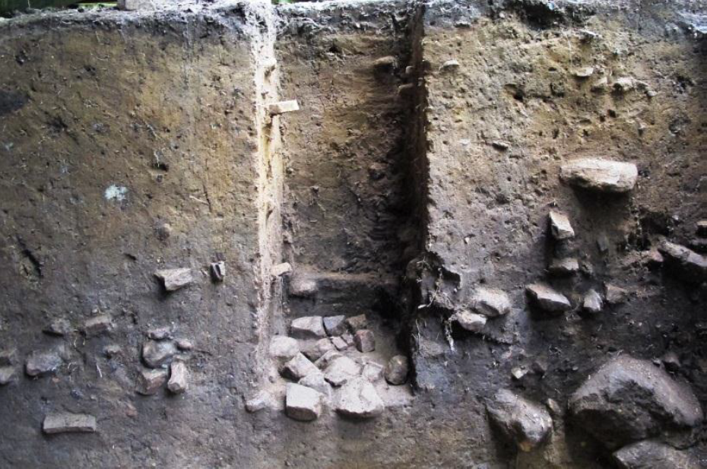
Figure 5.1: Image shows float column 1 from Michaels Shelter.

Table 5.1: Paleoethnobotanical Samples Analyzed from the Michaels Shelter
FS# | FC |  | Level |  | Context | Volume(l) |  | Sample Weight(g)
2011-190 |  | 1 |  | 1 | A horizon |  | 10 |  | 1358.7
2011-191 | 1 |  | 2 |  | B horizon | 11 |  | 1302.01
2011-193 | 1 |  | 3 |  | B horizon | 11.5 |  | 1524.32
2011-194 | 1 |  | 4 |  | Upper Midden | 10 |  | 676.23
2011-195 | 1 |  | 5 |  | Upper Midden | 11 |  | 1002.48
2011-197 | 1 |  | 6 |  | Upper Midden | 12 |  | 1173.53
2011-198 | 1 |  | 7 |  | Upper Midden | 12 |  | 3304.93
2011-200 | 1 |  | 8 |  | Upper Midden | 9 |  | 947.37
2011-201 | 1 |  | 9 |  | Upper Midden | 11 |  | 1143.1
2011-202 | 1 |  | 10 |  | Lower midden | 10 |  | 917.22
2011-203 | 1 |  | 11 |  | Lower midden | 11 |  | 1077.76
2001-204 | 1 |  | 12 |  | Lower midden | 9 |  | 912.48
2011-205 | 1 |  | 13 |  | Lower midden | 14 |  | 852.07
2011-206 | 1 |  | 14 |  | Lower midden | 9 |  | 537.71
2011-207 | 1 |  | 15 |  | Lower midden | 9 |  | 1019.45

Table 5.1(cont.): Paleoethnobotanical Samples Analyzed from the Michaels Shelter.
FS# | FC | Level | Context | Volume(l) | Sample Weight(g)
2011-208 | 1 | 16 | Lower midden | 13 | 670.96
2011-209 | 1 | 17 | Lower midden | 9.5 | 807.99
2011-210 | 1 | 18 | Lower midden | 13 | 783.31
2011-227 | 1 | 19 | Lower midden | 10 | 1445.58
2011-228 | 1 | 20 | Lower midden | 8 | 571.65
2011-229 | 1 | 21 | Lower midden | 9 | 718.86
2011-233 | 1 | 22 | Lower midden | 9 | 684.77
2011-235 | 1 | 23 | Lower midden | 9 | 578.45
2011-239 | 1 | 24 | Base of column | 14 | No data
2011-211 | 2 | 1 | Zone A | 3 | 428.81
2011-212 | 2 | 2 | Zone B | 7 | 284.33
2011-213 | 2 | 3 | Zone B | 11 | 1,177.20
2011-214 | 2 | 4 | Zone B | 13.5 | 512.17
2011-215 | 2 | 5 | Zone B | 18 | 717.82
2011-217 | 2 | 6 | Zone B | 13 | 425.01
2011-218 | 2 | 7 | Zone B | 17 | 768.71
2011-219 | 2 | 8 | Zone B | 16 | 468.81
2011-220 | 2 | 9 | Zone B | 12 | 387.58
2011-221 | 2 | 10 | Zone B | 18 | 580.46
2011-222 | 2 | 11 | Zone B | 14 | 539.26
2011-223 | 2 | 12 | Zone B | 11 | 308.93
2011-225 | 2 | 13 | Zone B | 4 | 659.02
2011-226 | 2 | 14 | Zone C | 7 | 603.28
2011-230 | 2 | 15 | Zone C | 18 | 2096.92
2011-231 | 2 | 16 | Zone C | 9.5 | 204.91
2011-232 | 2 | 17 | Zone C | 12 | 831.17
2011-234 | 2 | 18 | Zone C | 11 | 336.64
2011-236 | 2 | 19 | Zone C | 18 | 4647.18
2011-237 | 2 | 20 | Zone C | 8.5 | 255.21
2011-238 | 2 | 21 | Zone C | 15 | 2294.93
2011-240 | 2 | 22 | Zone C | 19 | 528.04
2011-241 | 2 | 23 | Zone C | 9 | 882.19
2011-242 | 2 | 24 | Zone C | 9 | 1111.67

Uzzelles Shelter (40FR267)
Three 50-cm-x-50-cm flotation columns were collected during the 2010 excavation at Uzzelles Shelter. Each column was excavated in five-centimeter arbitrary levels, within stratigraphic zones. Float Column 2 was collected from the south wall of Test Unit 13 and captures the entire occupational sequence at the site (Figure 5.2 and 5.3). Float Column 3 also captures the entire occupational sequence at the site and was collected from Test Unit 15 (Figure 5.3). Float Column 1 was collected only from the Upper Midden of Test Unit 13. The samples were processed using a modified SMAP machine (Watson 1976), where heavy fractions were captured in 1 mm mesh and light fractions were collected in 0.03 mm mesh. All 34 samples collected from the three flotation columns were included in this study (Table 5.2).
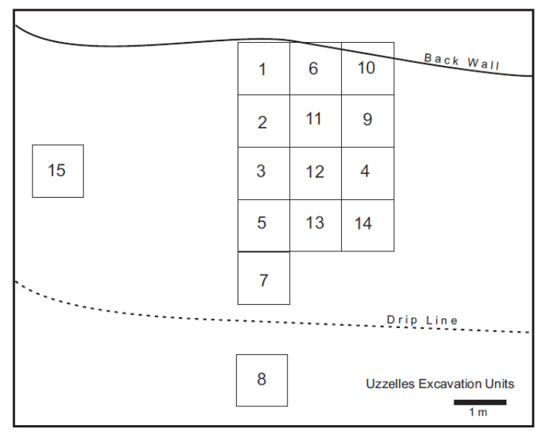
Figure 5.2: Plan view of Uzzelles Shelter excavation units.

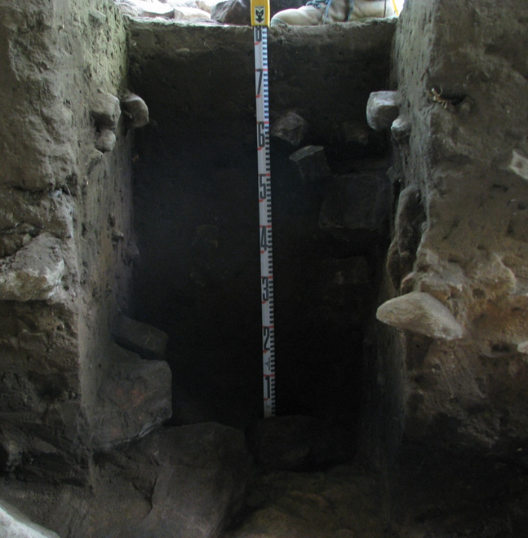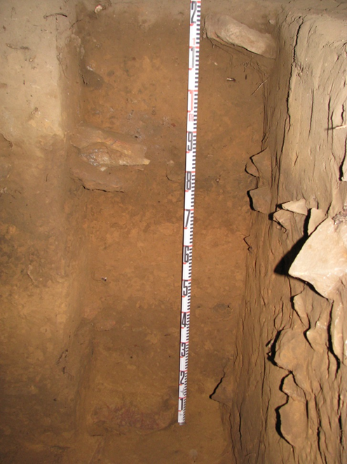
Figure 5.3: Profile photos of Float Columns 2 (left) and Float Column3 (right).

Table 5.2: Paleoethnobotanical Samples Analyzed from the Uzzelles Shelter.

FS | Component | Column | Unit |  |  | Level |  | Volume(l) |  | Weight(g)
2010-017 | Woodland | 1 | 13 |  |  | 3 |  | 8 |  | 473.85
2010-018 | Woodland | 1 | 13 |  |  | 4 |  | 7.5 |  | 366.76
2010-028 | Woodland | 1 | 13 |  |  | 5 |  | 11 |  | 1299.97
2010-034 | Woodland | 1 | 13 |  |  | 6 |  | 11 |  | 1223.36
2010-38 | Woodland | 1 | 13 |  |  | 7 |  | 9 |  | 912.79
2010-047 | Woodland | 1 | 13 |  |  | 8 |  | 10 |  | 780.43
2010-052 | Woodland | 1 | 13 |  |  | 9 |  | 9 |  | 817.11
2010-154 | Woodland | 2 | S wall Unit 13 |  |  | 1 |  | 9 |  | 672.08
2012-155 | Woodland | 2 | S wall Unit 13 |  |  | 2 |  | 10 |  | 1396.54
2010-156 | Woodland | 2 | S wall Unit 13 |  |  | 3 |  | 12 |  | 1198.01
2010-157 | Woodland | 2 | S wall Unit 13 |  |  | 4 |  | 10 |  | 401.86
2010-158 | Woodland | 2 | S wall Unit 13 |  |  | 5 |  | 10 |  | 668.22
2010-160 | Woodland | 2 | S wall Unit 13 |  |  | 6 |  | 11 |  | 930.97
2010-162 | Woodland | 2 | S wall Unit 13 |  |  | 7 |  | 10 |  | 1124.75
2010-165 | Woodland | 2 | S wall Unit 13 |  |  | 8 |  | 11 |  | 1254.01
2010-167 | M/L Archaic | 2 | S wall Unit 13 |  |  | 9 |  | 12 |  | 2028.07
2010-169 | M/L Archaic | 2 | S wall Unit 13 |  |  | 10 |  | 10 |  | 1285.05
2010-171 | E.Archaic | 2 | S wall Unit 13 |  |  | 11 |  | 13 |  | 2072.52
2010-172 | E.Archaic | 2 | S wall Unit 13 |  |  | 12 |  | 10 |  | 901.35
2010-174 | E.Archaic | 2 | S wall Unit 13 |  |  | 13 |  | 11 |  | 1039.85
2010-176 | E.Archaic | 2 | S wall Unit 13 |  |  | 14 |  | 14 |  | 1266.29
2010-178 | E.Archaic | 2 | S wall Unit 13 |  |  | 15 |  | 15 |  | 1974.14
2010-161 | Woodland | 3 | 15 |  |  | 1 |  | 10 |  | 826.19
2010-163 | Woodland | 3 | 15 |  |  | 2 |  | 4 |  | 510.63
2010-164 | Woodland | 3 | 15 |  |  | 3 |  | 13 |  | 226.32
2010-166 | Woodland | 3 | 15 |  |  | 4 |  | 9 |  | 611.77
2010-168 | Woodland | 3 |  | 15 |  | 5 |  | 6 |  |  | 1007.87
2010-170 | Woodland | 3 |  | 15 |  | 6 |  | 13 |  |  | 2254.4
2010-173 | Woodland | 3 |  | 15 |  | 7 |  | 10 |  |  | 2739.3
2010-175 | M/L Archaic | 3 |  | 15 |  | 8 |  | 8 |  |  | 700.95
2010-177 | E.Archaic | 3 |  | 15 |  | 9 |  | 9 |  |  | 957.25
2010-179 | E.Archaic | 3 |  | 15 |  | 10 |  | 9 |  |  | 1463.15
2010-180 | E.Archaic | 3 |  | 15 |  | 11 |  | 6 |  |  | 656.36
2010-181 | E.Archaic | 3 |  | 15 |  | 12 |  | 9 |  |  | 1036.35

Mussel Beach (40MI70)
During Phase III excavation at the site, 257 bulk floatation samples were collected from 101 features and 41 excavation units. Initial analysis of these botanical materials was conducted by Leslie Branch-Raymer and staff from the New South Laboratory Facilities. Each sample was processed, or floated, using a SMAP flotation device by New South Associates (Shell Mound Archaeological Project) (Watson 1976). Heavy fractions were collected in a 0.8-millimeter wire mesh, while light fraction samples were collected with a 0.3 millimeter mesh (Branch-Raymer 2012:569). Once floated, the light fraction samples were weighed and then separated using graduated geologic sieves (4.0 mm, 2.36 mm, 2.0 mm, 1.18 mm, 1.0 mm, 0.71 mm, 0.5 mm). For the samples that were fully processed, all carbonized plant remains greater than 2.36 millimeters were pulled, separated by material type, and then weighed, and counted (Branch-Raymer 2012:569). In the materials smaller than 2.36 millimeters, only the carbonized acorn nutshells and seeds were removed. Samples that were partially scanned were also separated using graduated geologic sieves. Each sample was scanned for 30 minute and all seeds were removed and recorded. Nutshell and wood charcoal were noted but no attempt was made to remove or quantify the material (Branch-Raymer 2012:569).
In total, samples from 57 features and from six unit contexts were fully sorted while the other samples were only partially scanned (Gregory et al. 2011:568). For this study, I fully analyzed the remaining 35 partially scanned samples from unit contexts so the data could be incorporated with the data compiled by Branch-Raymer (Table 5.3).
Table 5.3: Paleoethnobotanical Samples Analyzed from the Mussel Beach Site.
Bag | Unit | TCA | Midden Area | Locus | Volume(l) | Sample Weight(g)
806 | 7 | Middle Woodland |  | 6 | 2 | 2.36
917 | 6 | Middle Woodland |  | 6 | 3 | 6.77
918 | 18 | Middle Woodland |  | 6 | 2 | 12.43
920 | 17 | Middle Woodland |  | 6 | 2 | 3.84
925 | 31 | Mixed |  | 6 | 2 | 2.83
927 | 32 | Middle Woodland |  | 6 | 1.5 | 3.55
931 | 5 | Middle Woodland |  | 6 | 3 | 2.31
967 | 71 | Middle Woodland |  | 4 | 1 | 2.27
980 | 71 | Middle Woodland | 4 |  | 2 | 0.83
994 | 80 | Late Archaic II | 6 |  | 1.5 | 2.27
995 | 82 | Late Archaic II | 6 |  | 2 | 1.91
996 | 83 | Middle Woodland | 6 |  | 1.5 | 1.24
997 | 80 | Late Archaic II | 6 |  | 1.5 | 1.47
999 | 82 | Late Archaic II | 6 |  | 2 | 3.73
1000 | 80 | Middle Woodland | 6 |  | 2 | 1.91
1001 | 83 | Middle Woodland | 6 |  | 2 | 5.25
1004 | 13 | Late Archaic II |  | 6 | 2 | 2.78
1005 | 63 | Middle Woodland | 1 |  | 1.5 | 2.25
1006 | 63 | Middle Woodland | 1 |  | 2.5 | 0.72
1007 | 63 | Middle Woodland | 1 |  | 2 | 1.68
1008 | 13 | Late Archaic II |  | 6 | 2 | 2.73
1027 | 6 | Middle Woodland |  | 6 | 3 | 9.37
1028 | 69 | Late Archaic II | 4 |  | 2 | 5.49
1033 | 31 | Late Archaic II |  | 6 | 10 | 55.58
1038 | 26 | Late Archaic II |  | 6 | 10 | 50.12
1041 | 78 | Late Archaic II |  | 6 | 1.5 | 1.82
1043 | 21 | Middle Woodland |  | 6 | 10 | 58.5
1045 | 58 | Late Archaic II |  | 1 | 1.5 | 15.67
1061 | 22 | Middle Woodland |  | 6 | 10 | 47.96
1082 | 73 | Late Archaic I |  | 6 | 2 | 0.5
1100 | 28 | Late Archaic II |  | 6 | 1.5 | 1.53
1121 | 27 | Late Archaic I |  | 6 | 3 | 6.04
1122 | 0 | Middle Woodland |  | 6 | 10 | 106.84
1123 | 29 | Late Archaic I/II |  | 6 | 2 | 1.05
1136 | 13 | Late Archaic I |  | 6 | 10 | 4.83

The Widows Creek Site (1JA305)
Similar to the samples collected from Russell Cave, those from Widows Creek are small in nature. During the 1973 excavation, column soil samples were collected from the western profiles of Trenches 1 and 2 (Figure 4.3). These 34 samples were approximately one-quart in size and were collected from a series of arbitrary 0.5-foot levels from the top to the bottom of the two trenches. Half of each sample was previously processed for microartifacts and plant remains and partially analyzed by Dr. Kandace Hollenbach and volunteers at The University of Tennessee, Knoxville, Archaeological Research Laboratory and yielded significant amounts of botanical materials. I processed the other half of each sample, removing 200 grams for future studies, and used paint strainers, due to the small nature of the samples. These samples were then fully analyzed along with the remainder of Hollenbach’s samples. The data were then combined and will be compared to samples from the other sites included in the study.

Table 5.4: Paleoethnobotanical Samples Analyzed from the Widows Creek Site.
FS | Trench | Zone | TCA | Column | Level | Sample Wt. (g)
962 | 1 | A/B | Terminal Woodland | BL40-41 | 1 | 217.35
969 | 1 | A/B | Terminal Woodland | BL40-41 | 2 | 263.15
970 | 1 | B/C | Late Woodland | BL40-41 | 3 | 358.2
963 | 1 | C | Late Woodland | BL40-41 | 4 | 196.19
967 | 1 | C | Late Woodland | BL40-41 | 5 | 175.43
966 | 1 | C | Late Woodland | BL40-41 | 6 | 72.41
965 | 1 | D | Late Woodland | BL40-41 | 7 | 116.22
968 | 1 | E | Early Woodland | BL40-41 | 8 | 184.45
964 | 1 | E | Early Woodland | BL40-41 | 9 | 253.79
961 | 1 | G | Early Woodland | BL40-41 | 10 | 166.48
960 | 1 | G | Early Woodland | BL40-41 | 11 | 109.52
954 | 1 | G | Early Woodland | BL40-41 | 12 | 93.15
959 | 1 | G | Early Woodland | BL40-41 | 13 | 81.95

Table 5.4(cont.): Paleoethnobotanical Samples Analyzed from the Widows Creek Site.
FS | Trench | Zone | TCA | Column | Level | Sample Wt.(g)
953 | 1 | H | Late Archaic | BL40-41 | 14 | 30.91
958 | 1 | H/I | Late Archaic | BL40-41 | 15 | 45.56
952 | 1 | I | Late Archaic | BL40-41 | 16 | 69.52
956 | 1 | J | Early to Late Archaic | BL40-41 | 17 | 30.74
955 | 1 | J | Early to Late Archaic | BL40-41 | 18 | 9.83
957 | 1 | J | Early to Late Archaic | BL40-41 | 19 | 6.56
951 | 1 | J | Early to Late Archaic | BL40-41 | 20 | 6.24
946 | 1 | J | Early to Late Archaic | BL40-41 | 21 | 14.58
947 | 1 | J | Early to Late Archaic | BL40-41 | 22 | 7.96
977 | 2 | A | Terminal Woodland | 40-41R90 | 1 | 99.97
949 | 2 | A/B1 | Terminal Woodland | 40-41R90 | 2 | 372.57
974 | 2 | B1/B2 | Terminal Woodland | 40-40R90 | 3 | 1279.42
971 | 2 | B2/B3/C1 | Terminal Woodland | 40-41R90 | 4 | 616.7
972 | 2 | C1 | Late Woodland | 40-41R90 | 5 | 219.41
973 | 2 | C1 | Late Woodland | 40-41R90 | 6 | 56.78
944 | 2 | C1 | Late Woodland | 40-41R90 | 7 | 135.44
948 | 2 | C2 | Late Woodland | 40-41R90 | 8 | 51.55
978 | 2 | C2/D | Late Woodland | 40-41R90 | 9 | 58.41
975 | 2 | D | Late Woodland | 40-41R90 | 10 | 45.39
976 | 2 | E | Early Woodland | 40-41R90 | 11 | 135.66
945 | 2 | E | Early Woodland | 40-41R90 | 12 | 162.57

The Russell Cave Site (1JA181)
The plant remains analyzed from Russell Cave were collected during the excavations conducted between 1956 and 1958 by the Smithsonian Institution in conjunction with the National Geographic Society, under the direction of Carl F. Miller (Figure 5.4) (Miller 1956, 1958). Because they were collected prior to the adoption of standardized floatation techniques, they vary in size, ranging from a few tablespoons to no larger than one quart, or 1.10 liters. Though they vary in size, their interpretive value should not be overlooked or discounted. Given the 9,000 year occupation sequence at the site, the known presence of domesticated Chenopodium seeds recovered from the site, and the location of Russell Cave on the landscape, these samples hold great potential for contributing to a better understanding of prehistoric plant use and the transition to food production.
In total, 64 samples were collected by Miller’s crew and eventually stored at the University of Alabama’s Office of Archaeological Research. All 64 samples were requested for this study. After an initial evaluation of the samples, 32 were selected for analysis. Because flotation is a destructive form of analysis and these samples are all that remain from the site today, it was agreed that 200 grams would be removed and saved from each sample for future research. All samples smaller than this threshold were excluded from analysis. Each of the 32 samples that met this criterion was analyzed (Table 5.5). Twenty samples required processing to recover the plants remains and were placed in paint strainers with a mesh size of 0.05 millimeters and then soaked in water. This process was used to increase recovery of plant materials while doing as little damage as possible to the small samples. The remaining twelve samples were dry and were not floated. All of the sediments from these samples were placed in nested geologic sieves, processed accordingly, with all fill retained. This method is preferred when possible because it prevents additional damage to plant remains when they are introduced to water and the possibility of additional mechanical damage to any existing plant remains in the samples during the flotation process (Ford 1979:302; Wagner 1988:19).

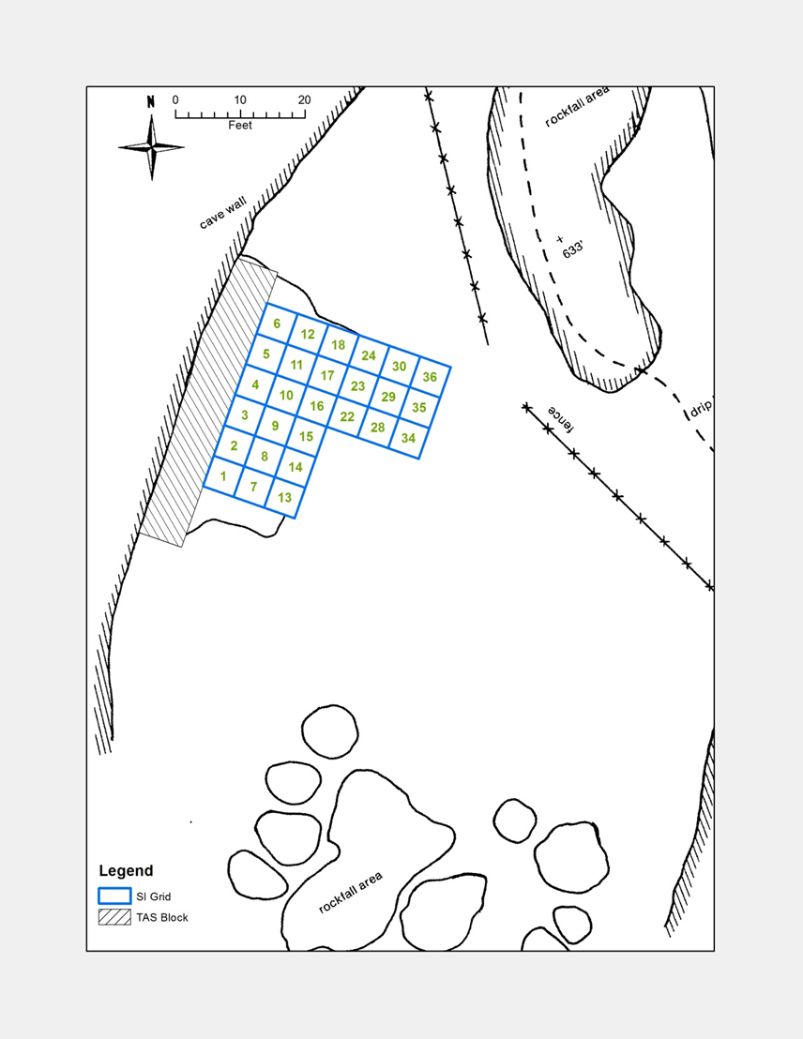
Figure 5.4: Image showing 1956-58 excavations and test units from the Russell Cave Site (courtesy of N.P. Hermann).

Table 5.5: Paleoethnobotanical Samples Analyzed from the Russell Cave Site.
FS# | Processing Method | Square | Depth | Sample Weight(g)
1995.31.118 | Flotation | 2A | 10 | 176.26
1995.31.154 | Flotation | 4A | 7.5 | 73.45
1995.31.155 | Flotation | 4A | 7.5 | 143.94
1995.31.195 | Flotation | 5A | 10 | 102.48
1995.31.265 | Flotation | 6A | 8.0-8.5 | 64.02
1995.31.267 | Flotation | 6A | 8.0-8.5 | 223.47
1995.31.288 | Flotation | 7A | 7.5 | 77.49
1995.31.334 | Flotation | 12 | 10.01 | 111.16
1995.31.340 | Flotation | 12 | 6.5 | 84.59
1995.31.341 | Flotation | 12 | 7.5 | 56.84
1995.31.398 | Dry Sieve | 22 | 4.5 | 130.22
1995.31.405 | Flotation | 22 | 6 | 109.78
1995.31.406 | Flotation | 22 | 6 | 105.62
1995.31.407 | Flotation | 22 | 6 | 97.69
1995.31.411 | Dry Sieve | 23 | 8 | 450.91
1995.31.418 | Dry Sieve | 30 | 3 | 176.52
1995.31.419 | Flotation | 30 | 8 | 59.88
1995.31.420 | Flotation | 30 | 8 | 91.79
1995.31.421 | Flotation | 30 | 8 | 72.52
1995.31.435 | Dry Sieve | 36 | 2.0-3.0 | 166.6
1995.31.436 | Dry Sieve | 36 | 2.0-3.0 | 176.86
1995.31.437 | Dry Sieve | 36 | 2.0-3.0 | 144.83
1995.31.438 | Dry Sieve | 36 | 5 | 356.16
1995.31.439 | Dry Sieve | 36 | 5 | 328.36
1995.31.440 | Dry Sieve | 36 | 5 | 429.89
1995.31.551 | Flotation | 1 | 12 | 115.36
1995.31.552 | Flotation | 1 | 12 | 58.19
1995.31.553 | Flotation | 1 | 12 | 63.59
1995.31.628 | Flotation | S.Wall | 1.0-2.0 | 107.99
1995.31.1022 | Dry Sieve | 16-22 | 2.0-3.0 | 281.37
1995.31.2891 | Dry Sieve | 10 | 2 | 158.25
1995.31.2892 | Dry Sieve | 24 | 2.5 | 268.82

Laboratory Methods
Following processing, each sample was processed, and analyzed according to standard paleoethnobotanical methods described by Pearsall (2000) and Hastorf and Popper (1988). In the laboratory, each sample was weighed and separated by size (.25 inch, 2 mm, 1.4 mm, 0.7 mm, 0.5 mm, and pan) using nested geologic sieves. All materials greater than 2.00 mm in size were separated into categories, for example, bone, lithics, shell, different taxa of plant materials, and contaminant (e.g. rocks, gravel, uncarbonized plant material). Plant materials, excluding wood, were further identified to the lowest possible taxonomic level, weighed, and counted. The items in the remaining categories were then counted and weighed. Shell was always removed only from the largest sieve in which it was found, so when recovered from the .25 inch sieve, the shell would be counted and weighed, rather than separated out from the smaller sieves. Lithic materials and bone were separated and weighed from both the .25 inch and 2-mm sieve. Plant taxa that were not recovered from the 2 mm sieve were removed from the 1.4-mm sieve, along with small seeds. Acorn shell is more fragile and fragmented more easily than other more-dense nutshell, like hickory, and, because of this, is thought to be underrepresented in most archaeobotanical assemblages (Lopinot 1984:112; Miksicek 1987:221). Based on its friable nature both acorn shell and meat were pulled from the 2 mm and 1.4 mm sieves, to account for these sampling biases.

Quantitative Analysis
Ubiquity, or presence analysis, is one method of quantifying archaeobotanical data. This method provides a measure of the number of samples in which a specific taxon is present or absent, while disregarding the absolute count, which can be biased by preservation, collection, and recovery. The ubiquity value is represented by a percentage that reflects the number of samples in which a particular taxon is present, divided by the total number of samples analyzed. An important aspect of ubiquity is that the scores provided remain independent from one taxon to the next.
Ratios also provide a useful way of constructing intrasite and intersite comparisons of samples of disproportionate sizes and to evaluating quantities and relationships between different categories of materials. Density measures use the total volume of a sample as the denominator which allows for comparison of samples of varying sizes. The numerator is the count of a particular taxon. By employing counts as opposed to weights, these measures allow for the comparison of categories of disproportionate weights, such as hickory and acorn nutshell. Relative density measures are also utilized and are important because they measure particular plants relative to other plant material. Relative density is calculated by dividing the count of a specific taxon by the total combined weight of all of the plant remains from the same sample (Scarry 1986:206). This measure is effective because the results do not rely on the volume of the entire sample, as do measures of density. The advantage of relative density is that it adjusts the denominator, so as not to bias the presence of smaller quantities of plant remains that may be found in only a few samples. While density and relative density measures both provide an ideal way of comparing samples within and between sites, the lack of volumetric data collected for some of the samples included in this study will preclude them from this type of analysis.
Exploratory data analysis is also used in this study. This analysis is especially informative because it advocates the use of robust descriptions of data, such as medians and quartiles, which are less influenced by outliers common in data that cannot be assumed to follow a normal distribution, such as archaeobotanical data. Also, exploratory data analysis employs the use of graphs to aid in the discovery of patterns that can be found within the data. The graphs concisely sum up the datasets visually, while assisting in the identification of outliers (Hollenbach 2005).
In particular, boxplots are employed in this research to show changes in the use of botanical materials through time. The boxplots present the data and allow for easy comparison between samples from different time periods. The range of the data is displayed in the form of a notched box, where the “waist” represents the median, and the top and bottom ends of the box mark the 25th and 75th percentiles of the data. The notch itself represents the 95 percent confidence interval around the median. If the notches of two boxes overlap, then the differences between the two medians are not statistically significant at the 95 percent confidence level, and the null hypothesis of equal medians is accepted. If the notches of two plots do not overlap the null hypothesis of equal medians is rejected. In Figure 5.5, the difference between the medians of sample A and sample C is not statistically significant, but the differences between the medians of samples A and C, and between samples A and B, are significant.
“Whiskers” extend from the top and bottom of the boxes to the lowest values within 1.5 times the hinge spread, which represents the distance between the 25th and 75th percentiles. Outliers in the data are displayed as asterisks, and are considered to be any value beyond 1.5 times the hinge spread. Extreme outliers are 3.0 times the hinge spread and are displayed as open circles (Figure 5.5) (Hollenbach 2005; Scarry 1986).

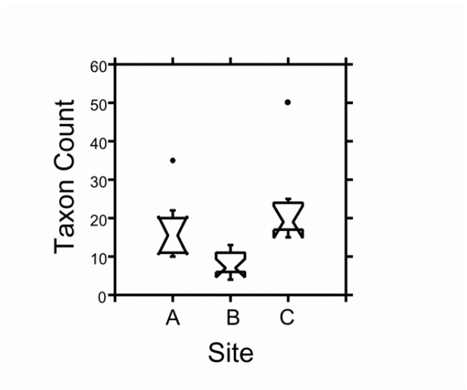
Figure 5.5: Image of boxplot showing the comparison of data from three sites (Image courtesy of Hollenbach 2005).

Although the analysis of plant remains from archaeological sites is somewhat biased by factors such as deposition, preservation, and recovery, their value for generating and testing hypotheses about the evolution of economic and cultural systems cannot be overlooked or undervalued (Johannessen 1988:145). Though laboratory analyses were kept as consistent as possible to help in comparability of the samples included in this study, the variability in sampling strategies and recovery methods over the fifty years that separate the excavations rendered quantitative analysis more difficult from site to site. Missing volumetric data, small sample sizes, and different recovery techniques are clearly present and acknowledged in the plant assemblages included in this study. While qualitative analysis is employed where possible, qualitative analyses will also be used and useful in understanding the transition from foraging to early horticultural systems in the defined project area, as well as across the Eastern Woodlands.
Left behind either intentionally or accidentally, the story of prehistoric subsistence change is well-documented in the paleoethnobotanical record recovered from archaeological sites scattered across the Eastern Woodlands. While the five sites included in this study exhibit great variability in terms of excavation methods and techniques they demonstrate the power of this record. Their preservation, recovery, and analysis hold powerful and informative data regarding the shift from foraging to incipient horticulture in the region. I now shift to a discussion of the results.

Chapter 6: Results
The plant materials identified from the five sites included in this study represent wild, domesticated, and cultigens. These diverse sets of resources were heavily relied upon by prehistoric groups that inhabited the project area, as well as the larger Eastern Woodlands (Table 6.1). In the following chapter, I have placed these remains into five categories for the purpose of presenting similarities, dissimilarities, and general trends in their use through time. These categories include wood, nuts, fruits, edible seeds, and miscellaneous taxa. Identified nut taxa include acorn (shell, meat, and caps), black walnut, and hickory nutshell. Identified fruits remains include blackberry/raspberry, cherry/plum, grape, hackberry, honey locust, and persimmon. The edible seed category represents the most diverse group of plant species identified in this study and includes amaranth, bottle gourd, wild and domesticated chenopods, cucurbit gourds, knotweed, little barley, maygrass, ragweed, sunflower, and two genera of wild beans, Strophostyles spp. and Phaseolus polystachios. The miscellaneous category is comprised of seeds or carbonized plant materials that have no known dietary use, or ones that are usually considered commensal taxa and were introduced to sites accidentally. This category includes bedstraw, dogwood, magnolia, and sycamore. River cane was also included in the miscellaneous taxa. While river cane was an important resource used in the production of basketry, mats, and tools, and also to provide lighting, the parts recovered and identified in this study were not likely used for nutrition. No river cane seeds were identified during this study.
To reemphasize a previously stated point, quantitative analysis varies from site to site because of different collections and processing techniques used across the 60-year period separating the earliest excavation from the most recent. Michaels Shelter, Mussel Beach, and Uzzelles Shelter were all excavated in the past five years and modern excavation techniques were employed. Though Widows Creek and Russell Cave were excavated years before, in 1973 and during the 1950s and 1960s, respectively, the samples included came from bulk sediment samples taken during those excavations which were curated without processing. This allowed the samples to be processed using modern flotation techniques, similar to those from the modern excavations.
Table 6.1: Identified Plant Remains from the Five Research Sites.
Category | Taxon | Scientific Name | Seasonality
Nuts | Acorn | Quercus spp. | Fall
Nuts | Black Walnut | Juglans nigra | Fall
Nuts | Hickory | Carya spp. | Fall
Edible Seeds / Crops | Amaranth | Amaranthus sp. | Late Summer/Fall
Edible Seeds / Crops | Bottle gourd seed | Lagenaria siceraria | Late Summer/Fall
Edible Seeds / Crops | Chenopod | Chenopodium sp. | Late Summer/Fall
Edible Seeds / Crops | Cucurbit rind | Cucurbita pepo | Late Summer/Fall
Edible Seeds / Crops | Erect Knotweed | Polygonum erectum | Late Summer/Fall
Edible Seeds / Crops | Little Barley | Hordeum pusillum | Spring/Early Summer
Edible Seeds / Crops | Maygrass | Phalaris caroliniana | Spring/Early Summer
Edible Seeds / Crops | Ragweed | Ambrosia trifidia | Late Summer/Fall
Edible Seeds / Crops | Sunflower | Helianthus annuus | Late Summer/Fall
Edible Seeds / Crops | Wild Bean | Phaseolus polystachios | Late Summer/Fall
Edible Seeds / Crops | Wild Bean | Strophostyles sp. | Mid-Summer/Fall
Fruits | Blackberry/Raspberry | Rubus spp. | Mid - Late Summer
Fruits | Cherry/Plum | Prunus spp. | Mid - Summer/Fall
Fruits | Grape | Vitis spp. | Mid - Summer/Fall
Fruits | Hackberry | Celtis occidentalis | Fall/Winter
Fruits | Honey Locust | Gleditsia triacanthos | Late Summer/Fall
Fruits | Persimmon | Diospyros virginiana | Fall
Fruits | Sumac | Rhus spp. | Summer/Fall
Greens
Greens | Amaranth | Amaranthus spp. | Spring/Summer
Greens | Chenopod | Chenopodium spp. | Spring/Summer
Miscellaneous | Cane | Arundinaria gigantea | Late Summer/Fall
Miscellaneous | Bedstraw | Galium spp.
Miscellaneous | Dogwood | Cornus florida | Fall
Miscellaneous | Magnolia | Magnolia grandiflora | Late Summer/Fall
Miscellaneous | Sycamore | Platanus occidentalis | Fall/Winter

The Michael’s Shelter
The plant assemblage recovered from the Michaels Shelter is dominated by nutshell, a patterns that indicates the inhabitants of the site were focused on the collection and processing of mast resources in and around the site (Table 6.2).
Hickory nutshell is ubiquitous at the Michaels Shelter site, with acorn being the second most ubiquitous resource recovered (Table 6.3). However, that ubiquity of acorn decreases slightly from 96 percent during the Early Archaic occupation to 71 percent during the Middle Archaic period, only to increase back to 93 percent during the Woodland period occupation, although never surpassing the use from the Early Archaic period occupation.
In terms of fruits, only one sumac seed was recovered from Early Archaic deposits at Michaels. An increase in the presence of fruits occurs at the shelter during the Woodland period occupation represented by grape, persimmon, and sumac. Fruits were absent from all Middle Archaic deposits at the site.
Edible seeds were completely absent from the Michaels Shelter. While these resources are absent, bedstraw and dogwood seeds were both recovered. These seeds are not thought to have had any nutritional value to prehistoric groups and are likely more representative of the local flora surrounding the site itself.
Table 6.2: Identified Plant Remains from the Michaels Shelter.
FS# | FC | Level | Context | Volume | Plant Wt. |  | Wood Ct |  | Wood Wt. |  | Name |  | Count |  | Weight
2011-190 | 1 | 1 | Woodland | 10 | 84.9 | 5447 |  | 59.68 |  | Hickory |  | 1601 |  | 24.65
 |  |  |  |  |  |  |  |  |  | Acorn |  | 99 |  | 0.4
 |  |  |  |  |  |  |  |  |  | Grape |  | 5 |  | 0.17
2011-191 | 1 | 2 | Woodland | 11 | 93.25 | 5034 |  | 42.32 |  | Hickory |  | 3535 |  | 50.18
 |  |  |  |  |  |  |  |  |  | Acorn |  | 257 |  | 0.64
 |  |  |  |  |  |  |  |  |  | Grape |  | 8 |  | 0.09
 |  |  |  |  |  |  |  |  |  | Bedstraw |  | 1 |  | 0.02
2011-193 | 1 | 3 | Woodland | 11.5 | 77.58 | 2699 |  | 19.44 |  | Hickory |  | 3938 |  | 58.01
 |  |  |  |  |  |  |  |  |  | Acorn |  | 85 |  | 0.06
 |  |  |  |  |  |  |  |  |  | Bedstraw |  | 3 |  | 0.05
 |  |  |  |  |  |  |  |  |  | Bud |  | 1 |  | 0.02
2011-194 | 1 | 4 | Woodland | 10 | 84.03 | 1568 |  | 12.22 |  | Hickory |  | 5371 |  | 71.63
 |  |  |  |  |  |  |  |  |  | Acorn |  | 61 |  | 0.16
 |  |  |  |  |  |  |  |  |  | Grape |  | 1 |  | 0.01
 |  |  |  |  |  |  |  |  |  | Bedstraw |  | 1 |  | 0.01
2011-195 | 1 | 5 | Woodland | 11 | 82.26 | 1885 |  | 13.75 |  | Hickory |  | 5101 |  | 68.47
 |  |  |  |  |  |  |  |  |  | Acorn |  | 10 |  | 0.04
2011-196 | 1 | 6 | Woodland | 12 | 89.55 | 1671 |  | 12.83 |  | Hickory |  | 5827 |  | 76.66
 |  |  |  |  |  |  |  |  |  | Acorn |  | 16 |  | 0.04
 |  |  |  |  |  |  |  |  |  | Bedstraw |  | 1 |  | 0.02
2011-198 | 1 | 7 | Woodland | 12 | 71.73 | 486 |  | 4.27 |  | Hickory |  | 5524 |  | 67.24
 |  |  |  |  |  |  |  |  |  | Acorn |  | 66 |  | 0.19
 |  |  |  |  |  |  |  |  |  | Sumac |  | 1 |  | 0.03

Table 6.2(cont): Identified Plant Remains from the Michaels Shelter.
FS# | FC | Level | Context | Volume | Plant Wt. |  |  | Wood Ct |  | Wood Wt. |  | Name |  | Count |  | Weight
2011-200 | 1 | 8 | Woodland | 9 | 45.75 | 259 |  |  | 2.51 |  | Hickory |  | 2994 |  | 43.03
 |  |  |  |  |  |  |  |  |  |  | Acorn |  | 33 |  | 0.21
2011-201 | 1 | 9 | Woodland | 11 | 44.92 | 171 |  |  | 1.32 |  | Hickory |  | 3781 |  | 43.59
2011-202 | 1 | 10 | Transitional | 10 | 42.86 | 300 |  |  | 2.2 |  | Hickory |  | 3772 |  | 40.61
 |  |  |  |  |  |  |  |  |  |  | Grape |  | 1 |  | 0.01
 |  |  |  |  |  |  |  |  |  |  | Cherry |  | 1 |  | 0.03
 |  |  |  |  |  |  |  |  |  |  | Bedstraw |  | 1 |  | 0.01
2011-203 | 1 | 11 | Transitional | 11 | 40.79 | 257 |  |  | 2.2 |  | Hickory |  | 3359 |  | 38.57
 |  |  |  |  |  |  |  |  |  |  | Acorn |  | 8 |  | 0.02
2001-204 | 1 | 12 | Archaic | 9 | 32.41 | 249 |  |  | 1.78 |  | Hickory |  | 2912 |  | 30.6
 |  |  |  |  |  |  |  |  |  |  | Acorn |  | 14 |  | 0.03
2011-205 | 1 | 13 | Archaic | 14 | 56.06 | 151 |  |  | 2.35 |  | Hickory |  | 4749 |  | 53.78
 |  |  |  |  |  |  |  |  |  |  | Acorn |  | 2 |  | 0.01
2011-206 | 1 | 14 | Archaic | 9 | 34.26 | 122 |  |  | 0.93 |  | Hickory |  | 2831 |  | 33.31
 |  |  |  |  |  |  |  |  |  |  | Acorn |  | 10 |  | 0.02
2011-207 | 1 | 15 | Archaic | 9 | 37.08 | 89 |  |  | 0.69 |  | Hickory |  | 3714 |  | 36.37
 |  |  |  |  |  |  |  |  |  |  | Acorn |  | 3 |  | 0.02
2011-208 | 1 | 16 | Archaic | 13 | 43.04 | 97 |  |  | 0.73 |  | Hickory |  | 3675 |  | 42.29
 |  |  |  |  |  |  |  |  |  |  | Acorn |  | 8 |  | 0.02
2011-209 | 1 | 17 | Archaic | 9.5 | 40.61 | 85 |  |  | 0.72 |  | Hickory |  | 3739 |  | 39.87
 |  |  |  |  |  |  |  |  |  |  | Acorn |  | 6 |  | 0.02
Table 6.2 (cont.): Identified Plant Remains from the Michaels Shelter.
FS# | FC | Level | Context | Volume | Plant Wt. |  |  | Wood Ct |  | Wood Wt. |  | Name |  | Count |  | Weight
2011-210 | 1 | 18 | Archaic | 13 | 34.13 |  | 168 |  | 1.75 |  | Hickory |  | 3054 |  | 32.34
 |  |  |  |  |  |  |  |  |  |  | Acorn |  | 5 |  | 0.04
2011-227 | 1 | 19 | Archaic | 10 | 21.33 |  | 113 |  | 0.99 |  | Hickory |  | 2061 |  | 20.3
 |  |  |  |  |  |  |  |  |  |  | Acorn |  | 7 |  | 0.04
2011-228 | 1 | 20 | Archaic | 8 | 15.29 |  | 130 |  | 1.61 |  | Hickory |  | 1138 |  | 13.64
 |  |  |  |  |  |  |  |  |  |  | Acorn |  | 10 |  | 0.03
 |  |  |  |  |  |  |  |  |  |  | Grape |  | 1 |  | 0.01
2011-229 | 1 | 21 | Archaic | 9 | 14.18 |  | 179 |  | 1.46 |  | Hickory |  | 1167 |  | 12.66
 |  |  |  |  |  |  |  |  |  |  | Acorn |  | 11 |  | 0.06
2011-233 | 1 | 22 | Archaic | 9 | 16.86 |  | 201 |  | 1.95 |  | Hickory |  | 1275 |  | 14.83
 |  |  |  |  |  |  |  |  |  |  | Acorn |  | 16 |  | 0.04
 |  |  |  |  |  |  |  |  |  |  | Sumac |  | 1 |  | 0.04
2011-235 | 1 | 23 | Archaic | 9 | 11.14 |  | 96 |  | 1.04 |  | Hickory |  | 939 |  | 10.06
 |  |  |  |  |  |  |  |  |  |  | Acorn |  | 16 |  | 0.04
2011-239 | 1 | 24 | Archaic | 14 | 26.8 |  | 232 |  | 1.89 |  | Hickory |  | 2064 |  | 24.89
 |  |  |  |  |  |  |  |  |  |  | Acorn |  | 2 |  | 0.01
 |  |  |  |  |  |  |  |  |  |  | Grape |  | 2 |  | 0.01
2011-211 | 2 | 1 | Woodland | 3 | 5.79 |  | 330 |  | 3.08 |  | Hickory |  | 147 |  | 2.67
 |  |  |  |  |  |  |  |  |  |  | Acorn |  | 3 |  | 0.02
 |  |  |  |  |  |  |  |  |  |  | Grape |  | 1 |  | 0.02
2011-212 | 2 | 2 | Woodland | 7 | 8.17 |  | 561 |  | 5.41 |  | Hickory |  | 178 |  | 2.72
 |  |  |  |  |  |  |  |  |  |  | Acorn |  | 12 |  | 0.01
 |  |  |  |  |  |  |  |  |  |  | Dogwood |  | 4 |  | 0.03
Table 6.2 (cont.): Identified Plant Remains from the Michaels Shelter.
FS# | FC | Level | Context | Volume | Plant Wt. |  |  | Wood Ct |  | Wood Wt. |  | Name |  | Count |  | Weight
2011-213 | 2 | 3 | Woodland | 11 | 8.11 |  | 524 |  | 3.97 |  | Hickory |  | 262 |  | 4.11
 |  |  |  |  |  |  |  |  |  |  | Acorn |  | 4 |  | 0.01
 |  |  |  |  |  |  |  |  |  |  | Bedstraw |  | 1 |  | 0.01
 |  |  |  |  |  |  |  |  |  |  | Dogwood |  | 1 |  | 0.01
2011-214 | 2 | 4 | Woodland | 13.5 | 14.82 |  | 655 |  | 6.37 |  | Hickory |  | 485 |  | 8.44
 |  |  |  |  |  |  |  |  |  |  | Acorn |  | 2 |  | 0.01
2011-215 | 2 | 5 | Woodland | 18 | 19.95 |  | 499 |  | 4.57 |  | Hickory |  | 897 |  | 15.33
 |  |  |  |  |  |  |  |  |  |  | Acorn |  | 7 |  | 0.03
2011-217 | 2 | 6 | Woodland | 13 | 14.62 | 451 |  |  | 3.71 |  | Hickory |  | 652 |  | 10.82
 |  |  |  |  |  |  |  |  |  |  | Acorn |  | 2 |  | 0.01
 |  |  |  |  |  |  |  |  |  |  | Persimmon |  | 1 |  | 0.08
2011-218 | 2 | 7 | M. Archaic | 17 | 24.48 | 568 |  |  | 5.56 |  | Hickory |  | 1180 |  | 18.88
 |  |  |  |  |  |  |  |  |  |  | Acorn |  | 3 |  | 0.02
 |  |  |  |  |  |  |  |  |  |  | Dogwood |  | 2 |  | 0.02
2011-219 | 2 | 8 | M. Archaic | 16 | 16.54 | 167 |  |  | 1.92 |  | Hickory |  | 871 |  | 14.62
2011-220 | 2 | 9 | M. Archaic | 12 | 19.05 | 164 |  |  | 1.57 |  | Hickory |  | 902 |  | 17.47
 |  |  |  |  |  |  |  |  |  |  | Acorn |  | 4 |  | 0.01
2011-221 | 2 | 10 | M. Archaic | 18 | 21.25 | 207 |  |  | 2.22 |  | Hickory |  | 1015 |  | 19.03
2011-222 | 2 | 11 | M. Archaic | 14 | 23.88 | 132 |  |  | 1.32 |  | Hickory |  | 1141 |  | 22.51
 |  |  |  |  |  |  |  |  |  |  | Acorn |  | 5 |  | 0.03

Table 6.2 (cont.): Identified Plant Remains from the Michaels Shelter.
FS# | FC |  | Level |  | Context |  | Volume |  | Plant Wt. |  |  |  | Wood Ct |  |  | Wood Wt. |  |  | Name |  |  | Count |  |  | Weight
2011-223 | 2 |  | 12 |  | M. Archaic |  | 11 |  | 13.78 |  | 135 |  |  | 1.84 |  |  | Hickory |  |  | 843 |  |  | 11.93
 |  |  |  |  |  |  |  |  |  |  |  |  |  |  |  |  | Acorn |  |  | 2 |  |  | 0.01
2011-225 | 2 |  | 13 |  | M. Archaic |  | 4 |  | 23.33 |  | 131 |  |  | 1.41 |  |  | Hickory |  |  | 1254 |  |  | 20.9
 |  |  |  |  |  |  |  |  |  |  |  |  |  |  |  |  | Acorn |  |  | 8 |  |  | 0.02
2011-226 |  | 2 |  | 14 |  | Archaic |  | 7 |  | 30.77 |  | 500 |  |  | 3.66 |  |  | Hickory |  |  | 2056 |  |  | 27.01
 |  |  |  |  |  |  |  |  |  |  |  |  |  |  |  |  | Acorn |  |  | 8 |  |  | 0.04
 |  |  |  |  |  |  |  |  |  |  |  |  |  |  |  |  | Bedstraw |  |  | 1 |  |  | 0.06
2011-230 | 2 |  | 15 |  | Archaic |  | 18 |  | 21.8 |  | 219 |  |  | 2.37 |  |  | Hickory |  |  | 1519 |  |  | 19.39
 |  |  |  |  |  |  |  |  |  |  |  |  |  |  |  |  | Acorn |  |  | 6 |  |  | 0.04
2011-231 | 2 |  | 16 |  | Archaic |  | 9.5 |  | 18.01 |  | 78 |  |  | 0.96 |  |  | Hickory |  |  | 925 |  |  | 17
 |  |  |  |  |  |  |  |  |  |  |  |  |  |  |  |  | Acorn |  |  | 7 |  |  | 0.03
 |  |  |  |  |  |  |  |  |  |  |  |  |  |  |  |  | Grape |  |  | 1 |  |  | 0.02
2011-232 | 2 |  | 17 |  | Archaic |  | 12 |  | 17.6 |  | 170 |  |  | 1.24 |  |  | Hickory |  |  | 1154 |  |  | 16.34
 |  |  |  |  |  |  |  |  |  |  |  |  |  |  |  |  | Acorn |  |  | 7 |  |  | 0.02
2011-234 | 2 |  | 18 |  | Archaic |  | 11 |  | 10.07 |  | 145 |  |  | 2.01 |  |  | Hickory |  |  | 728 |  |  | 8.04
 |  |  |  |  |  |  |  |  |  |  |  |  |  |  |  |  | Acorn |  |  | 13 |  |  | 0.02
2011-236 | 2 |  | 19 |  | Archaic |  | 18 |  | 44.6 |  | 231 |  |  | 2.24 |  |  | Hickory |  |  | 3128 |  |  | 42.24
 |  |  |  |  |  |  |  |  |  |  |  |  |  |  |  |  | Acorn |  |  | 4 |  |  | 0.12
2011-237 | 2 |  | 20 |  | Archaic |  | 8.5 |  | 6.02 |  | 42 |  |  | 0.38 |  |  | Hickory |  |  | 505 |  |  | 5.64
2011-238 | 2 |  | 21 |  | Archaic |  | 15 |  | 34.74 |  | 243 |  |  | 2.3 |  |  | Hickory |  |  | 2478 |  |  | 32.39
 |  |  |  |  |  |  |  |  |  |  |  |  |  |  |  |  | Acorn |  |  | 19 |  |  | 0.03

Table 6.2 (cont.): Identified Plant Remains from the Michaels Shelter.
FS# | FC | Level | Context | Volume | Plant Wt. |  | Wood Ct |  | Wood Wt. |  | Name |  | Count |  | Weight
 |  |  |  |  |  |  |  |  |  | Bedstraw |  | 1 |  | 0.01
 |  |  |  |  |  |  |  |  |  | Dogwood |  | 1 |  | 0.01
2011-240 | 2 | 22 | Archaic | 19 | 10.74 | 154 |  | 2.66 |  | Hickory |  | 620 |  | 8.06
 |  |  |  |  |  |  |  |  |  | Acorn |  | 2 |  | 0.02
2011-241 | 2 | 23 | Archaic | 9 | 13.33 | 152 |  | 1.59 |  | Hickory |  | 985 |  | 11.72
 |  |  |  |  |  |  |  |  |  | Acorn |  | 8 |  | 0.02
2011-242 | 2 | 24 | Archaic | 9 | 10.65 | 129 |  | 1.53 |  | Hickory |  | 710 |  | 9.11
 |  |  |  |  |  |  |  |  |  | Acorn |  | 4 |  | 0.01

Table 6.3: Ubiquity of Plant Remains Recovered from the Michaels Shelter.
Category | Common Name | Scientific Name | Early Archaic Midden  (n =24)  % | Middle Archaic  (n=7)  % | Woodland Midden (n=15)  %
Nuts | Acorn | Quercus sp. | 96 | 71 | 93
 | Hickory | Carya sp. | 100 | 100 | 100
Fruits | Grape | Vitis sp. | 0 | 0 | 27
 | Persimmon | Diospyros virginiana | 0 | 0 | 6
 | Sumac | Rhus sp. | 4 | 0 | 6
Other | Bedstraw | Galium sp. | 8 | 14 | 27
 | Dogwood | Cornus florida | 4 | 14 | 13

With the exception of the transitional levels and the difference between the Middle Archaic and Woodland period midden at Michaels Shelter, there are no statistically significant differences in the median density of plant materials recovered from the site (Figure 6.1). However, some patterns do emerge when viewed in terms of individual taxa. There is a statistically significant increase in wood during the Woodland period occupation of the site when compared to the preceding Archaic period occupations (Figure 6.2). While there is no difference in the density of hickory between the Early Archaic and Woodland period deposits, there is a statistically significant decrease in the density of hickory nutshell during the Middle Archaic deposits at the site (Figure 6.2). The density of acorn remains consistent throughout the use of the site. The density of fruits is similar between the Early Archaic and Woodland period occupations but absent from Middle Archaic deposits.

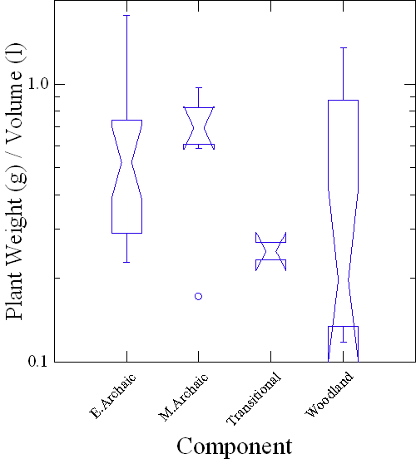
Figure 6.1: Boxplot showing the density of plant materials recovered through time at the Michaels Shelter. Note that the y-axis is scaled logarithmically.

When explored in terms of relative density many of these patterns hold true. There is a statistically significant increase in the relative density of wood in the Woodland period deposits. There is also a statistically significant decrease in the relative density of hickory nutshell from the Early Archaic deposits to the later Middle Archaic and subsequent Woodland period deposits, which can most likely be explained by the increase in wood (Figure 6.3). This trend may suggest that hickory nutshell was used as a source of fuel during earlier periods and as hickory nutshell decreases through time at the site, it is replaced by wood as a fuel source. There is no noticeable change in the relative density of acorn between the different occupations at the site. The relative density of fruit is similar between the Early Archaic and Woodland period deposits, but again, fruit is absent from the Middle Archaic deposits.
The plant assemblage from the Michaels Shelter seems to indicate consistency through time. Michaels Shelter appears to have been a site favored for its proximity to mast resources. The reuse of the shelter and redundancy of the plant remains suggest that its location on the landscape allowed groups to collect and process mast resources successfully from the areas surrounding the site.

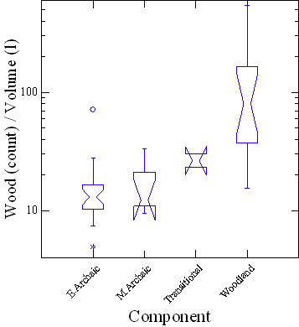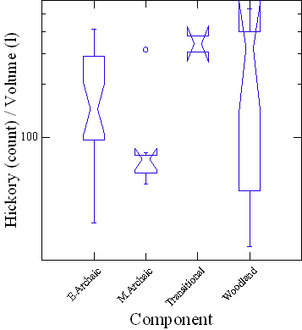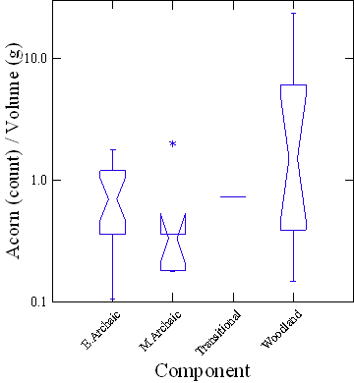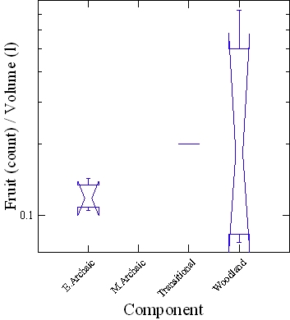
Figure 6.2: Boxplots displaying the density of wood, hickory, acorn, and fruits from the Michaels Shelter site. Note that the y-axes are scaled logarithmically.

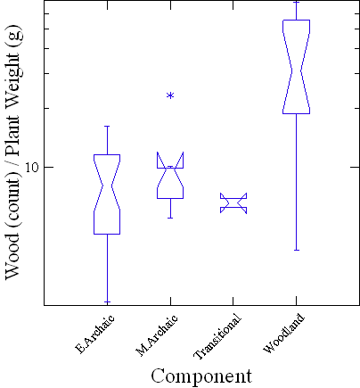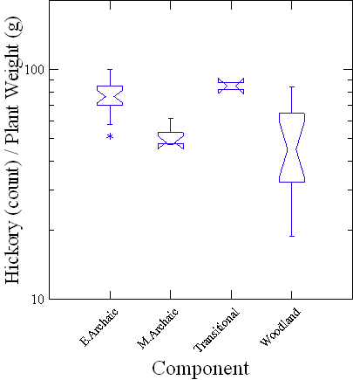
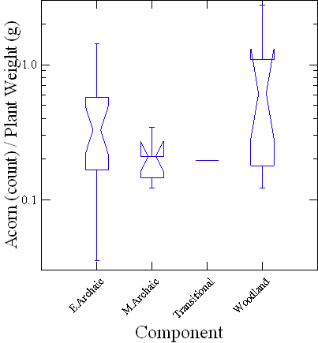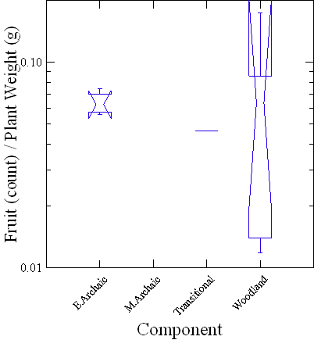
Figure 6.3: Boxplots displaying the relative density of wood, hickory, acorn, and fruits from the Michaels Shelter site. Note that the y-axes are scaled logarithmically.

The Uzzelles Shelter
The plant remains identified from the Uzzelles Shelter were collected from two middens and the transitional levels between. The results are displayed in Table 6.4. As discussed previously, the Lower Midden represents an Early Archaic occupation while the Upper Midden represents an Early, Middle, and Late Woodland occupation, based on diagnostic artifacts and AMS C14 dates.

Table 6.4: Plant Remains Identified from the Uzzelles Shelter.
FS | Depth | Zone | TCA | FC | Volume | Plant Wt. | Wood Ct | Wood Wt. | Name | Count | Weight
2009-152 |  | C | Woodland |  | 10 | 0.86 | 15 | 0.05 | Hickory | 70 | 0.75
 |  |  |  |  |  |  |  |  | Acorn | 20 | 0.05
 |  |  |  |  |  |  |  |  | Wild Bean | 1 | 0.01
2010-130 |  | A | E.Archaic |  | 12 | 0.18 | 15 | 0.07 | Hickory | 15 | 0.1
 |  |  |  |  |  |  |  |  | Acorn | 2 | 0.01
2010-126 |  | A | E.Archaic |  | 63.5 | 7.61 | 89 | 0.66 | Hickory | 570 | 6.9
 |  |  |  |  |  |  |  |  | Acorn | 19 | 0.04
 |  |  |  |  |  |  |  |  | Chenopod | 2 | 0.01
2010-017 | 15-20 | C | Woodland | 1 | 8 | 18.76 | 32 | 0.31 | Hickory | 1199 | 18.36
 |  |  |  |  |  |  |  |  | Acorn | 12 | 0.09
 |  |  |  |  |  |  |  |  | Chenopod | 2 | 0.01
 |  |  |  |  |  |  |  |  | Sunflower | 1 | 0.01
2010-018 | 20-25 | C | Woodland | 1 | 7.5 | 19.64 | 51 | 0.25 | Hickory | 1459 | 19.34
 |  |  |  |  |  |  |  |  | Acorn | 10 | 0.05
2010-028 | 25-30 | C | Woodland | 1 | 11 | 36.19 | 115 | 0.77 | Hickory | 2069 | 35.31
 |  |  |  |  |  |  |  |  | Acorn | 2 | 0.01
 |  |  |  |  |  |  |  |  | Chenopod | 1 | 0.01
2010-034 | 30-35 | C | Woodland | 1 | 11 | 40.36 | 73 | 0.55 | Hickory | 2421 | 39.84
 |  |  |  |  |  |  |  |  | Acorn | 1 | 0
Table 6.4(cont.): Plant Remains Identified from the Uzzelles Shelter
FS | Depth | Zone | TCA | FC | Volume | Plant Wt. | Wood Ct. | Wood Wt. | Name | Count | Weight
2010-38 | 35-40 | C | Woodland | 1 | 9 | 17.93 | 222 | 2.01 | Hickory | 1627 | 15.88
 |  |  |  |  |  |  |  |  | Chenopod | 5 | 0.01
 |  |  |  |  |  |  |  |  | Grape | 1 | 0.03
2010-047 | 40-45 | C | Woodland | 1 | 10 | 18.49 | 119 | 2.12 | Hickory | 1084 | 16.36
 |  |  |  |  |  |  |  |  | Chenopod | 4 | 0.01
2010-052 | 45-50 | C | Woodland | 1 | 9 | 7.95 | 237 | 1.73 | Hickory | 395 | 6.23
 |  |  |  |  |  |  |  |  | Chenopod | 1 | 0
2010-154 | 0-5 | C | Woodland | 2 | 9 | 4.26 | 327 | 2.61 | Hickory | 173 | 1.61
 |  |  |  |  |  |  |  |  | Grape | 6 | 0.04
2012-155 | 5-10 | C | Woodland | 2 | 10 | 9.35 | 475 | 4.7 | Hickory | 382 | 4.63
 |  |  |  |  |  |  |  |  | Chenopod | 1 | 0.01
2010-156 | 10-15 | C | Woodland | 2 | 12 | 11.49 | 198 | 4.32 | Hickory | 503 | 7.08
 |  |  |  |  |  |  |  |  | Maygrass | 1 | 0
 |  |  |  |  |  |  |  |  | Grape | 2 | 0.02
2010-157 | 15-20 | C | Woodland | 2 | 10 | 10.97 | 42 | 0.31 | Hickory | 720 | 10.51
 |  |  |  |  |  |  |  |  | Acorn | 2 | 0.01
2010-158 | 20-25 | C | Woodland | 2 | 10 | 18.22 | 88 | 0.67 | Hickory | 1193 | 17.51
 |  |  |  |  |  |  |  |  | Acorn | 3 | 0.02
 |  |  |  |  |  |  |  |  | Chenopod | 5 | 0.01
Table 6.4(cont.): Plant Remains Identified from the Uzzelles Shelter.
FS | Depth | Zone | TCA | FC | Volume | Plant Wt. | Wood Ct. | Wood Wt. | Name | Count | Weight
2010-160 | 25-30 | C | Woodland | 2 | 11 | 6.35 | 115 | 0.72 | Hickory | 602 | 5.54
 |  |  |  |  |  |  |  |  | Acorn | 7 | 0.02
 |  |  |  |  |  |  |  |  | Hackberry | 1 | 0.07
 |  |  |  |  |  |  |  |  | Grape | 1 | 0.01
 |  |  |  |  |  |  |  |  | Blackberry / Raspberry | 1 | 0.01
2010-162 | 30-35 | C | Woodland | 2 | 10 | 5.79 | 77 | 0.42 | Hickory | 647 | 5.34
 |  |  |  |  |  |  |  |  | Acorn | 9 | 0.02
 |  |  |  |  |  |  |  |  | Maygrass | 1 | 0.01
2010-165 | 35-45 | C | Woodland | 2 | 11 | 3.22 | 53 | 0.24 | Hickory | 312 | 2.94
 |  |  |  |  |  |  |  |  | Acorn | 6 | 0.01
2010-167 | 45-50 | B | Transitional | 2 | 12 | 1.76 | 29 | 0.39 | Hickory | 133 | 1.37
2010-169 | 50-55 | B | Transitional | 2 | 10 | 1.35 | 29 | 0.79 | Hickory | 63 | 0.54
 |  |  |  |  |  |  |  |  | Acorn | 7 | 0.02
2010-171 | 55-60 | A | E.Archaic | 2 | 13 | 0.58 | 19 | 0.07 | Hickory | 80 | 0.49
 |  |  |  |  |  |  |  |  | Acorn | 8 | 0.02
2010-172 | 60-65 | A | E.Archaic | 2 | 10 | 1.89 | 38 | 0.26 | Hickory | 175 | 1.54
 |  |  |  |  |  |  |  |  | Acorn | 39 | 0.09
2010-174 | 65-70 | A | E.Archaic | 2 | 11 | 0.77 | 31 | 0.18 | Hickory | 83 | 0.57
 |  |  |  |  |  |  |  |  | Acorn | 12 | 0.02
Table 6.4(cont.): Plant Remains Identified from the Uzzelles Shelter.
FS | Depth | Zone | TCA | FC | Volume | Plant Wt. | Wood Ct. | Wood Wt. | Name | Count | Weight
2010-176 | 70-80 | A | E.Archaic | 2 | 14 | 0.77 | 42 | 0.34 | Hickory | 61 | 0.4
 |  |  |  |  |  |  |  |  | Acorn | 13 | 0.03
2010-178 | 80-85 | A | E.Archaic | 2 | 15 | 0.24 | 23 | 0.14 | Hickory | 15 | 0.1
2010-161 | 0-10 | C | Woodland | 3 | 10 | 4.77 | 252 | 2.48 | Hickory | 176 | 2.15
 |  |  |  |  |  |  |  |  | Acorn | 9 | 0.03
 |  |  |  |  |  |  |  |  | Grape | 10 | 0.1
 |  |  |  |  |  |  |  |  | Chenopod | 10 | 0.01
2010-163 | 10-15 | C | Woodland | 3 | 4 | 3.45 | 44 | 0.23 | Hickory | 288 | 3.2
 |  |  |  |  |  |  |  |  | Acorn | 10 | 0.01
2010-164 | 15-25 | C | Woodland | 3 | 13 | 1.94 | 52 | 0.28 | Hickory | 136 | 1.59
 |  |  |  |  |  |  |  |  | Acorn | 34 | 0.07
 |  |  |  |  |  |  |  |  | Chenopod | 1 | 0
2010-166 | 25-35 | C | Woodland | 3 | 9 | 7.35 | 59 | 0.32 | Hickory | 656 | 7.01
 |  |  |  |  |  |  |  |  | Grape | 1 | 0.1
 |  |  |  |  |  |  |  |  | Chenopod | 1 | 0.01
2010-168 | 35-45 | C | Woodland | 3 | 6 | 14.12 | 60 | 0.55 | Hickory | 1234 | 13.57
2010-170 | 45-58 | C | Woodland | 3 | 13 | 8.73 | 58 | 0.43 | Hickory | 758 | 8.29
 |  |  |  |  |  |  |  |  | Acorn | 2 | 0.01
2010-173 | 58-68 | B | Transitional | 3 | 10 | 0.45 | 1 | 0.01 | Hickory | 46 | 0.4
Table 6.4(cont.): Plant Remains Identified from the Uzzelles Shelter.
FS | Depth | Zone | TCA | FC | Volume | Plant Wt. | Wood Ct. | Wood Wt. | Name | Count | Weight
2010-175 | 68-78 | B | Transitional | 3 | 8 | 0.26 | 15 | 0.03 | Hickory | 56 | 0.22
 |  |  |  |  |  |  |  |  | Acorn | 1 | 0.01
2010-177 | 78-87 | B | Transitional | 3 | 9 | 0.72 | 21 | 0.18 | Hickory | 64 | 0.52
2010-179 | 87-98 | A | E.Archaic | 3 | 9 | 1.02 | 49 | 0.52 | Hickory | 51 | 0.49
2010-180 | 98-108 | A | E.Archaic | 3 | 6 | 0.33 | 7 | 0.02 | Hickory | 42 | 0.31
2010-181 | 108-122 | A | E.Archaic | 3 | 9 | 0.33 | 3 | 0.01 | Hickory | 41 | 0.32

Hickory nutshell is ubiquitous, recovered from all collected samples (Table 6.5). This is not an uncommon occurrence from sites across the region and speaks to the importance of the resource to prehistoric groups. Acorn nutshell was also recovered from both middens and the transitional levels. An increase in occurrence from 50 percent to 63 percent suggests that during the Woodland period groups relied more heavily upon acorn than during previous times.
Table 6.5: Ubiquity of Plant Remains from the Uzzelles Shelter.
 |  |  | Archaic (n=10) | Transitional (n=5) | Woodland (n=22)
Category | Taxon | Scientific Name | % | % | %
Nuts | Hickory | Carya sp. | 100 | 100 | 100
Nuts | Acorn | Quercus sp. | 50 | 40 | 63
Edible Seeds | Chenopod | Chenopodium sp. | 10 | 0 | 45
 | Maygrass | Phalaris caroliniana | 0 | 0 | 9
 | Sunflower | Helianthus sp. | 0 | 0 | 4
 | Wild Bean | Strophostyles sp. | 0 | 0 | 4
Fruits | Grape | Vitis sp. | 0 | 0 | 27
 | Blackberry / Raspberry | Rubus sp. | 0 | 0 | 4
 | Hackberry | Celtis occidentalis. | 0 | 0 | 4

The only edible seeds recovered from the Lower Midden were two wild Chenopodium seeds. A dramatic increase in the use of edible seeds occurred during the Woodland occupation of the site. Intensification in the use of Chenopodium is seen in the ubiquity values that increase from ten percent during the Early Archaic period to 45 percent during the Woodland period. This increase in the ubiquity values of Chenopodium is accompanied by morphological changes that are associated with the domestication process (Smith 1984, 1985). These morphological changes in the seeds themselves suggest that the plant was domesticated in or around the vicinity of the shelter. This increase in the use of Chenopodium seeds during the Woodland period occupation of the site coincides with the appearance of other seeds crops including maygrass, sunflower, and wild beans.
Absent during the Early Archaic occupation of the site, fruits also appear for the first time during the Woodland period occupations of the shelter. These include grape, blackberry/raspberry, and hackberry.

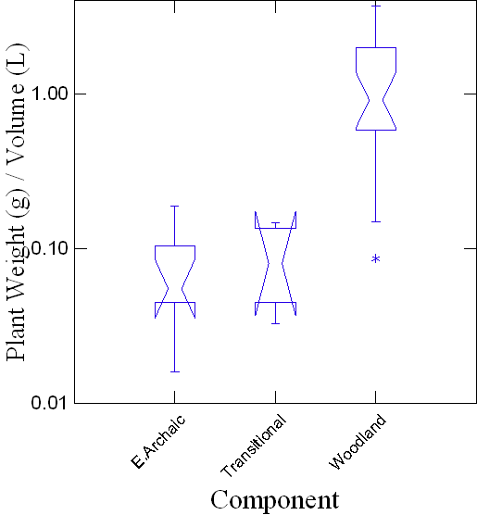
Figure 6.4: Boxplot showing changes in density of plant materials through time at Uzzelles Shelter. Note that the Y-axis is scaled logarithmically.

The apparent increased reliance upon plant food resources through time is further documented by the volumetric density (Figure 6.4). The increase in use of plant materials during the Woodland occupation is statistically significant from that during the Early Archaic occupation. This significant increase is also exemplified in the density of wood, hickory, and edible seeds from the site (Figure 6.5). While the use of acorn appears to increase when viewed in terms of ubiquity measures, the density of acorn between the two occupations at the site proves to be fairly consistent (Figure 6.5).
The use of acorn is consistent through time when viewed in terms of relative density (Figure 6.6). The slight decrease in the use of both hickory nuts and acorn, though not statistically significant, occurs at a time when there is an apparent increase in the use of edible seeds and fruits by inhabitants of the site. This decrease in the use of mast resources and increase in the use of other seasonal resources might indicate a shift in landscape use specific to the Uzzelles Shelter. While the resources recovered and identified from the Early Archaic occupation suggest that the site was being utilized during the fall, the presence of maygrass seeds, grapes, and blackberry/raspberry seed indicate that the site was occupied more frequently during the Woodland period.
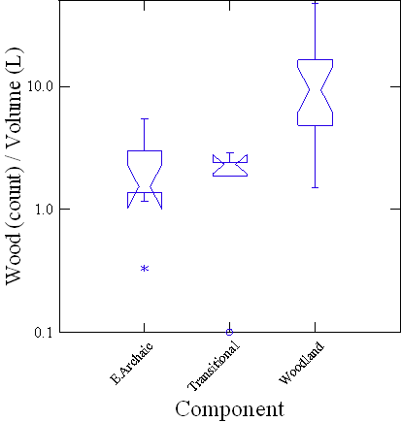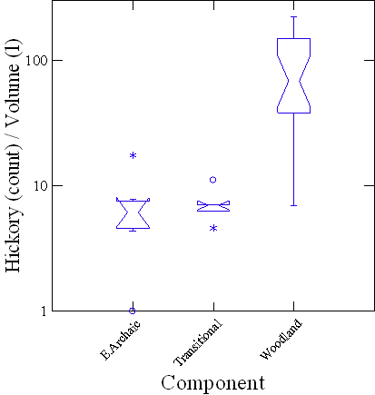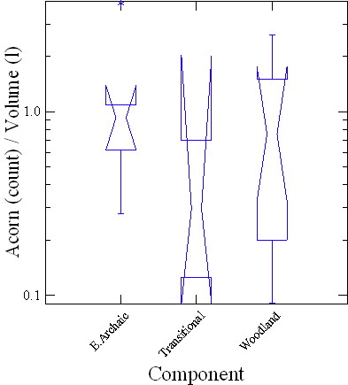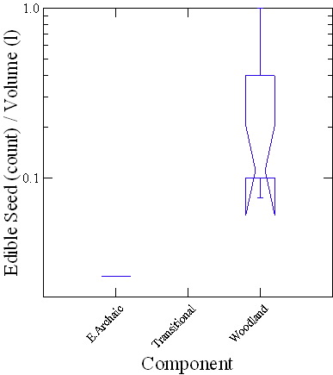
Figure 6.5: Boxplots displaying the density of wood, hickory, acorn, and edible seeds from Uzzelles Shelter. Note that the y-axes are scaled logarithmically.

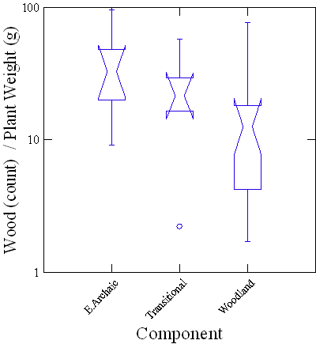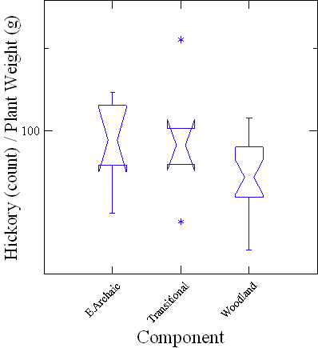
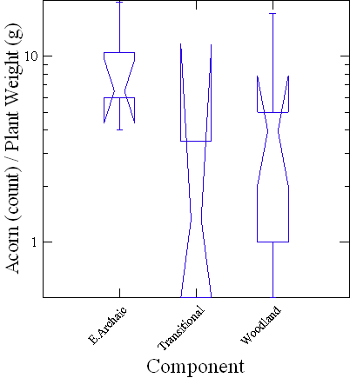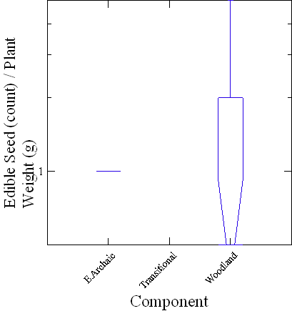
Figure 6.6: Boxplots displaying the relative density of wood, hickory, acorn, and edible seeds from Uzzelles Shelter. Note that the y-axes are scaled logarithmically.

The Mussel Beach Site
The Mussel Beach site is one of the two floodplain sites included in this study, chosen for comparison with the upland sites. However, because only light fraction samples were available for analysis, the following discussion is limited to qualitative analysis of the plant remains identified by New South Associates and the author, displayed in Table 6.6, to provide a complete picture of the overall plant use from the site.
As discussed in greater detail in Chapter Four, the Mussel Beach site has five separate occupational components. The earliest of these five is the Late Archaic I. The limited paleoethnobotanical samples collected provided a meager assemblage that was primarily comprised of wood, hickory, and acorn nutshell. Edible seeds identified from these deposits include maygrass and wild chenopod. No fruits were identified from these earliest deposits from the site.
Late Archaic II deposits were also dominated by hickory and acorn nutshells. Edible seeds identified from these deposits include maygrass, wild chenopod, and knotweed. However, the samples were dominated by maygrass and chenopod. Remains of fruits recovered from these deposits were limited to blackberry/raspberry, grape, hackberry, hawthorn, and sumac. An unidentified grass seed, referred to as Grass Type 1, was also recovered.
Plant remains identified from the Late Archaic III deposits from the site suggest that fewer resources were exploited during the last Late Archaic occupation. Again, hickory and acorn nutshell dominated the assemblage but the only edible seeds recovered were chenopod and maygrass. Blueberry and mulberry were the only fruit remains identified.
The Middle Woodland deposits represent the most intensive occupation of the site. Black walnut is included in the identified nutshell for the first time, alongside hickory and acorn. Several taxa of edible seeds make their first appearance, including domesticated Chenopodium, amaranth, little barley, sunflower, and sumpweed, which join maygrass, both identified in previous occupations. The remains of the sunflower and sumpweed were too fragmentary to determine whether or not they were domesticated. A greater number of fruits appear in the Middle Woodland assemblage including cherry/plum and honey locust, in addition to blackberry/raspberry, blueberry, grape, hawthorn, mulberry, and sumac, all of which were present in previous occupational deposits. The Unknown Grass Type I was also identified in the Middle Woodland deposits.
A decrease in the number of species identified occurred in the Late Woodland deposits, similar to that witnessed in the Late Archaic III deposits. Black walnut remains are absent from the deposits after appearing during the previous Middle Woodland period deposits, while hickory and acorn nutshell are again identified. The edible seed category is only represented by maygrass and chenopod. Blackberry/raspberry, grape, and mulberry were the only fruits recovered.

Table 6.6: Plant Remains Identified from the Mussel Beach Site.
Bag | TCA | Unit | Volume (L) | Weight (g) | Plant Wt.(g) | Wood Wt. (g) | Name | Count | Weight(g)
1082 | Late Archaic I | 73 | 2 | 0.5 | 0.03 | 0.02 | Hickory | 1 | 0.01
 |  |  |  |  |  |  | Maygrass | 1 | 0
1121 | Late Archaic I | 27 | 3 | 6.04 | 0.73 | 0.41 | Hickory | 29 | 0.31
 |  |  |  |  |  |  | Maygrass | 2 | 0.01
1136 | Late Archaic I | 13 | 10 | 4.83 | 1.12 | 0.14 | Hickory | 70 | 0.97
 |  |  |  |  |  |  | Acorn | 1 | 0.01
1123 | Late Archaic I / II | 29 | 2 | 1.05 | 0.04 | 0 | Hickory | 6 | 0.04
997 | Late Archaic II | 80 | 1.5 | 1.47 | 0.01 | 0.02 | Acorn | 1 | 0.01
999 | Late Archaic II | 82 | 2 | 3.73 | 0.55 | 0.23 | Hickory | 46 | 0.32
1004 | Late Archaic II | 13 | 2 | 2.78 | 0.05 | 0.03 | Hickory | 5 | 0.02
1008 | Late Archaic II | 13 | 2 | 2.73 | 0.33 | 0.07 | Hickory | 16 | 0.21
 |  |  |  |  |  |  | Maygrass | 1 | 0
 |  |  |  |  |  |  | Grape | 1 | 0.02
 |  |  |  |  |  |  | Hawthorne | 1 | 0.03
1028 | Late Archaic II | 69 | 2 | 5.49 | 0.06 | 0.01 | Hickory | 5 | 0.02
 |  |  |  |  |  |  | Hackberry | 1 | 0.03
1033 | Late Archaic II | 31 | 10 | 55.85 | 3.62 | 3.08 | Hickory | 27 | 0.48
 |  |  |  |  |  |  | Acorn | 9 | 0.03

Table 6.6(cont.): Plant Remains Identified from the Mussel Beach Site.
Bag | TCA |  |  | Unit |  |  |  |  | Volume (L) |  |  |  |  | Weight (g) |  |  |  |  | Plant Wt.(g) |  |  |  |  | Wood Wt. (g) |  |  |  | Name | Count |  |  |  | Weight(g)
 |  |  |  |  |  |  |  |  |  |  |  |  |  |  |  |  |  |  |  |  |  |  |  |  |  |  |  | Maygrass |  |  |  | 7 | 0.03
 | Late Archaic II |  |  |  | 26 |  |  |  |  | 10 |  |  |  |  | 50.12 |  |  |  |  | 10.19 |  |  |  |  | 8.92 |  |  | Hickory |  |  |  | 89 | 1.18
 |  |  |  |  |  |  |  |  |  |  |  |  |  |  |  |  |  |  |  |  |  |  |  |  |  |  |  | Acorn |  |  |  | 21 | 0.04
 |  |  |  |  |  |  |  |  |  |  |  |  |  |  |  |  |  |  |  |  |  |  |  |  |  |  |  | Maygrass |  |  |  | 14 | 0.05
1045* | Late Archaic II |  | 58 |  |  |  |  | 1.5 |  |  |  |  | 15.67 |  |  |  |  | 3.03 |  |  |  |  | 3.01 |  |  |  |  | Hickory |  | 2 |  |  |  | 0.02
1100* | Late Archaic II |  | 28 |  |  |  |  | 1.5 |  |  |  |  | 1.53 |  |  |  |  | 0.04 |  |  |  |  | 0.01 |  |  |  |  | Hickory |  | 5 |  |  |  | 0.03
994* | Late Archaic II |  | 80 |  |  |  |  | 1.5 |  |  |  |  | 2.27 |  |  |  |  | 0.05 |  |  |  |  | 0.02 |  |  |  |  | Acorn |  | 5 |  |  |  | 0.03
995* | Late Archaic II |  | 82 |  |  |  |  | 2 |  |  |  |  | 1.91 |  |  |  |  | 0.26 |  |  |  |  | 0.02 |  |  |  |  | Hickory |  | 18 |  |  |  | 0.21
 |  |  |  |  |  |  |  |  |  |  |  |  |  |  |  |  |  |  |  |  |  |  |  |  |  |  |  | Acorn |  | 2 |  |  |  | 0.03
1041* | Late Archaic II |  | 78 |  |  |  |  | 1.5 |  |  |  |  | 1.82 |  |  |  |  | 0.24 |  |  |  |  | 0.19 |  |  |  |  | Hickory |  | 10 |  |  |  | 0.05
806* | Middle Woodland |  | 7 |  |  |  |  | 2 |  |  |  |  | 2.36 |  |  |  |  | 0 |  |  |  |  | 0
917* | Middle Woodland |  | 6 |  |  |  |  | 3 |  |  |  |  | 0 |  |  |  |  | 0 |  |  |  |  | 0
918* | Middle Woodland |  | 18 |  |  |  |  | 2 |  |  |  |  | 12.43 |  |  |  |  | 0.19 |  |  |  |  | 0.1 |  |  |  |  | Hickory |  | 8 |  |  |  | 0.08
 |  |  |  |  |  |  |  |  |  |  |  |  |  |  |  |  |  |  |  |  |  |  |  |  |  |  |  | Chenopod |  | 1 |  |  |  | 0
 |  |  |  |  |  |  |  |  |  |  |  |  |  |  |  |  |  |  |  |  |  |  |  |  |  |  |  | Amaranth |  | 1 |  |  |  | 0
920* | Middle Woodland |  | 17 |  |  |  |  | 2 |  |  |  |  | 3.84 |  |  |  |  | 0 |  |  |  |  | 0
931* | Middle Woodland |  | 5 |  |  |  |  | 3 |  |  |  |  | 2.31 |  |  |  |  | 0 |  |  |  |  | 0
967* | Middle Woodland |  |  |  | 71 |  |  |  |  | 1 |  |  |  |  | 2.27 |  |  |  |  | 0 |  |  |  |  | 0
Table 6.6(cont.): Plant Remains Identified from Mussel Beach site.
Bag | TCA | Unit |  |  |  |  | Volume (L) |  |  |  |  | Weight (g) |  |  |  |  | Plant Wt.(g) |  |  |  |  | Wood Wt. (g) |  |  |  |  | Name |  | Count |  |  |  | Weight(g)
980* | Middle Woodland |  |  |  | 71 |  |  |  |  | 2 |  |  |  |  | 0.83 |  |  |  |  | 0.08 |  |  |  |  | 0 |  |  | Hickory | 3 |  |  |  | 0.83
996* | Middle Woodland |  |  |  | 83 |  |  |  |  | 1.5 |  |  |  |  | 1.24 |  |  |  |  | 0.07 |  |  |  |  | 0.03 |  |  | Hickory | 8 |  |  |  | 0.04
1000* | Middle Woodland |  |  |  | 80 |  |  |  |  | 2 |  |  |  |  | 1.91 |  |  |  |  | 0.06 |  |  |  |  | 0 |  |  | Acorn | 6 |  |  |  | 0.06
1001* | Middle Woodland |  |  |  | 83 |  |  |  |  | 2 |  |  |  |  | 5.25 |  |  |  |  | 0 |  |  |  |  | 0
1005* | Middle Woodland |  |  |  |  | 63 |  |  |  |  | 1.5 |  |  |  |  | 2.25 |  |  |  |  | 0.01 |  |  |  |  | 0 |  | Maygrass |  |  | 2 |  |  |  | 0.01
1006* | Middle Woodland |  |  | 63 |  |  |  |  | 2.5 |  |  |  |  | 0.72 |  |  |  |  | 0.06 |  |  |  |  | 0.05 |  |  |  | Maygrass | 3 |  |  |  | 0.01
1007* | Middle Woodland |  |  | 63 |  |  |  |  | 2 |  |  |  |  | 1.68 |  |  |  |  | 0.15 |  |  |  |  | 0.11 |  |  |  | Acorn | 7 |  |  |  | 0.03
 |  |  |  |  |  |  |  |  |  |  |  |  |  |  |  |  |  |  |  |  |  |  |  |  |  |  |  | Maygrass | 1 |  |  |  | 0.01
1027* | Middle Woodland |  |  | 6 |  |  |  |  | 3 |  |  |  |  | 9.37 |  |  |  |  | 0.78 |  |  |  |  | 0.19 |  |  |  | Hickory | 51 |  |  |  | 0.57
 |  |  |  |  |  |  |  |  |  |  |  |  |  |  |  |  |  |  |  |  |  |  |  |  |  |  |  | Acorn | 1 |  |  |  | 0.01
 |  |  |  |  |  |  |  |  |  |  |  |  |  |  |  |  |  |  |  |  |  |  |  |  |  |  |  | Maygrass | 2 |  |  |  | 0.01
1043* | Middle Woodland |  |  | 21 |  |  |  |  | 10 |  |  |  |  | 58.5 |  |  |  |  | 7.56 |  |  |  |  | 5.3 |  |  |  | Hickory | 185 |  |  |  | 2.16
 |  |  |  |  |  |  |  |  |  |  |  |  |  |  |  |  |  |  |  |  |  |  |  |  |  |  |  | Acorn | 24 |  |  |  | 0.04
 |  |  |  |  |  |  |  |  |  |  |  |  |  |  |  |  |  |  |  |  |  |  |  |  |  |  |  | Maygrass | 15 |  |  |  | 0.06
 |  |  |  |  |  |  |  |  |  |  |  |  |  |  |  |  |  |  |  |  |  |  |  |  |  |  |  | Chenopod | 1 |  |  |  | 0
1061* | Middle Woodland |  |  | 22 |  |  |  |  | 10 |  |  |  |  | 47.96 |  |  |  |  | 10.73 |  |  |  |  | 7.47 |  |  |  | Hickory | 199 |  |  |  | 2.69
 |  |  |  |  |  |  |  |  |  |  |  |  |  |  |  |  |  |  |  |  |  |  |  |  |  |  |  | Acorn | 11 |  |  |  | 0.37
 |  |  |  |  |  |  |  |  |  |  |  |  |  |  |  |  |  |  |  |  |  |  |  |  |  |  |  | Maygrass | 74 |  |  |  | 0.19
 |  |  |  |  |  |  |  |  |  |  |  |  |  |  |  |  |  |  |  |  |  |  |  |  |  |  |  | Chenopod | 3 |  |  |  | 0.01
927* | Middle Woodland |  |  | 32 |  |  |  |  | 1.5 |  |  |  |  | 3.55 |  |  |  |  | 0.05 |  |  |  |  | 0.04 |  |  |  | Hickory | 1 |  |  |  | 0.01
Table 6.6(cont.): Plant Remains Identified from Mussel Beach site.
Bag | TCA | Unit |  |  |  |  | Volume (L) |  |  |  |  | Weight (g) |  |  |  |  | Plant Wt.(g) |  |  |  |  | Wood Wt. (g) |  |  |  |  | Name |  | Count |  |  |  | Weight(g)
911* | Mixed |  |  | 30 |  |  |  |  | 2 |  |  |  |  | 0.09 |  |  |  |  | 0.09 |  |  |  |  | 0.09
925* | Mixed |  |  | 31 |  |  |  |  | 2 |  |  |  |  | 2.83 |  |  |  |  | 0.01 |  |  |  |  | 0 |  |  |  | Acorn | 1 |  |  |  | 0.01
*Data in table combination of analysis conducted by Raymer (2011) and Carmody.

The Widows Creek Site
Results of the analysis from the Widows Creek samples are displayed in Table 6.7. Although the samples sizes were small, the results demonstrate the richness of the samples and the significant contribution that these deposits make. The ubiquities of hickory and acorn nutshell during all time periods at the site again demonstrate the importance of the resources to prehistoric groups (Table 6.8). While hickory again appears to make the greatest contribution to the diet in terms of nuts, the ubiquity of acorn through time is informative. Black walnut also appears at the site during the Early Woodland period but represents a smaller percentage of the diet than other nut taxa with ubiquity values of thirteen percent and eighteen percent, respectively.
Weedy legumes represent the only edible seed taxa recovered from the earliest deposits at the site, the Early through Late Archaic deposits, and are absent during all other time periods (Table 6.7.). During the Late Archaic period, chenopod and maygrass seeds appear for the first time. Wild Chenopodium seeds have a ubiquity measure of 66 percent during the Late Archaic period but then decrease through time to 50 percent during the Early Woodland period, and to nine percent during the Late Woodland, before slightly increasing to seventeen percent during the Terminal Woodland occupation at the site. Based on morphological characteristics, domesticated Chenopodium seeds appear for the first time during the Early Woodland period. Unlike chenopod, which appears during the Late Archaic period and decreases through time, maygrass increases during the Early Woodland period occupation to 63 percent ubiquity before decreasing to 27 percent during the Late Woodland period and seventeen percent during the Terminal Woodland. Little Barley, cucurbit gourds, and corn all appear during the Late Woodland period occupation of the site little barley and cucurbit gourds are only present during the Late Woodland period with ubiquity measures of 27 percent and nine percent respectively. Corn appears alongside little barley and cucurbit gourds with a ubiquity measure of nine percent during the Late Woodland period, increasing to seventeen percent during the Terminal Woodland period occupation. This change occurs across the greater landscape with the heavy reliance on indigenous plants replaced by maize agriculture.
Fruits, such as persimmon and blackberry/raspberry are the earliest recovered fruits from the site appearing during the Early Woodland period. Blackberry/raspberry is absent from later deposits. Persimmon decreases from 38 percent during the Early Woodland period to eighteen percent during the Late Woodland period and was not recovered from Terminal Woodland period deposits. The only other fruits identified from the site are grape and hackberry. They both appear during the Terminal Woodland period with a ubiquity value of seventeen percent.
Both bedstraw and cane are also recovered from the site. Bedstraw was identified from Terminal Woodland period deposits with a ubiquity value of seventeen percent. River cane was only identified from Late Woodland deposits with a ubiquity value of 45 percent.
Exploring the relative density of these samples helps to account for the small sample sizes (Figure 6.7 and 6.8). The relative density of wood appears consistent through time with the only statistically significant difference occurring between the Early Woodland period and Terminal Woodland period occupations. While there is a slight decrease in the reliance of hickory through time, the only statistically significant decrease is between the Early through Late Archaic period deposits and the Late Woodland period deposits. The use of acorn remains consistent through time, a trend present at both upland rock shelter sites. When black walnut was utilized, its use was also very consistent.
The use of edible seeds and crops remains relatively consistent through time at Widows Creek with the exception of the Terminal Woodland period occupation (Figure 6.8). Chenopodium and maygrass usage was maintained during this period, showing the importance of these native plants through time. What this decrease may represent are the substantial changes brought about by the introduction and widespread adoption of maize, which required completely different field preparation, planting, and harvesting strategies than the native domesticates and cultigens that were heavily relied upon prior to adoption of maize agriculture.
When present, the use of fruits remains consistent through time, with no statistically significant changes (Figure 6.8).
Figure 6.9, below, shows changes in the use of chenopods, maygrass, and little barley through time at the site. As discussed previously in terms of ubiquity values, chenopod use decreases through time while the use of maygrass increases. Little barley is only recovered from Late Woodland period deposits.

Table 6.7: Identified Plant Materials Recovered from the Widows Creek site.
FS | Trench | Level | Depth | Zone | TCA | Plant Wt. | Wood Ct | Wood Wt. | Name | Count | Weight
962 | 1 | 1 | 610.00-609.50 | A/B | T. Woodland | 0.14 | 7 | 0.04 | Hickory | 7 | 0.05
 |  |  |  |  |  |  |  |  | Acorn | 6 | 0.02
 |  |  |  |  |  |  |  |  | Chenopod | 2 | 0.01
 |  |  |  |  |  |  |  |  | Maygrass | 3 | 0.01
 |  |  |  |  |  |  |  |  | Pitch | 1 | 0.01
969 | 1 | 2 | 609.5-609.0 | A/B | T. Woodland | 0.08 | 3 | 0.02 | Hickory | 5 | 0.04
 |  |  |  |  |  |  |  |  | Unidentified | 3 | 0.02
970 | 1 | 3 | 609.0-608.50 | B/C | L. Woodland | 0.75 | 56 | 0.39 | Hickory | 20 | 0.24
 |  |  |  |  |  |  |  |  | Acorn | 16 | 0.03
 |  |  |  |  |  |  |  |  | Black Walnut | 4 | 0.07
 |  |  |  |  |  |  |  |  | Chenopod | 1 | 0.01
 |  |  |  |  |  |  |  |  | Bark | 1 | 0.01
963 | 1 | 4 | 608.50-608.00 | C | L. Woodland | 0.98 | 32 | 0.2 | Hickory | 42 | 0.65
 |  |  |  |  |  |  |  |  | Acorn | 35 | 0.08
 |  |  |  |  |  |  |  |  | Corn Cupule | 1 | 0.01
 |  |  |  |  |  |  |  |  | Persimmon | 1 | 0.01
 |  |  |  |  |  |  |  |  | Cane | 1 | 0.01
 |  |  |  |  |  |  |  |  | Pitch | 7 | 0.02
967 | 1 | 5 | 608.00-607.50 | C | L. Woodland | 0.35 | 14 | 0.08 | Hickory | 18 | 0.17
 |  |  |  |  |  |  |  |  | Acorn | 72 | 0.07
 |  |  |  |  |  |  |  |  | Acorn Meat | 1 | 0.01

Table 6.7 (cont.): Plant Remains Identified from the Widows Creek Site.
FS | Trench | Level | Depth | Zone | TCA | Plant Wt. | Wood Ct | Wood Wt. | Name | Count | Weight
 |  |  |  |  |  |  |  |  | Persimmon | 1 | 0.01
 |  |  |  |  |  |  |  |  | Cane | 1 | 0.01
966 | 1 | 6 | 607.50-607.00 | C | L. Woodland | 0.26 | 7 | 0.02 | Hickory | 15 | 0.16
 |  |  |  |  |  |  |  |  | Acorn | 14 | 0.02
 |  |  |  |  |  |  |  |  | Black Walnut | 1 | 0.01
 |  |  |  |  |  |  |  |  | Maygrass | 1 | 0.01
 |  |  |  |  |  |  |  |  | Cucurbita rind | 1 | 0.01
 |  |  |  |  |  |  |  |  | Cane | 8 | 0.03
965 | 1 | 7 | 607.00-606.50 | D | L. Woodland | 0.28 | 22 | 0.14 | Hickory | 16 | 0.11
 |  |  |  |  |  |  |  |  | Acorn | 9 | 0.02
 |  |  |  |  |  |  |  |  | Little Barley | 2 | 0.01
968 | 1 | 8 | 606.50-606.00 | E | E. Woodland | 0.6 | 26 | 0.13 | Hickory | 44 | 0.4
 |  |  |  |  |  |  |  |  | Acorn | 19 | 0.04
 |  |  |  |  |  |  |  |  | Maygrass | 4 | 0.01
 |  |  |  |  |  |  |  |  | Bark | 2 | 0.02
964 | 1 | 9 | 606.00-605.50 | E | E. Woodland | 0.31 | 24 | 0.12 | Hickory | 22 | 0.16
 |  |  |  |  |  |  |  |  | Acorn | 20 | 0.02
 |  |  |  |  |  |  |  |  | Persimmon (cf) | 1 | 0.01
961 | 1 | 10 | 605.50-605.00 | G | E. Woodland | 0.72 | 16 | 0.13 | Hickory | 35 | 0.55
 |  |  |  |  |  |  |  |  | Acorn | 5 | 0.01
 |  |  |  |  |  |  |  |  | Chenopod | 5 | 0.01
Table 6.7(cont.): Plant Remains Identified from the Widows Creek Site.
FS | Trench | Level | Depth | Zone | TCA | Plant Wt. | Wood Ct | Wood Wt. | Name | Count | Weight
 |  |  |  |  |  |  |  |  | Maygrass | 2 | 0.01
 |  |  |  |  |  |  |  |  | Persimmon | 1 | 0.01
960 | 1 | 11 | 605.00-604.50 | G | E. Woodland | 0.37 | 6 | 0.04 | Hickory | 27 | 0.27
 |  |  |  |  |  |  |  |  | Acorn | 7 | 0.02
 |  |  |  |  |  |  |  |  | Chenopod | 5 | 0.01
 |  |  |  |  |  |  |  |  | Persimmon | 3 | 0.03
954 | 1 | 12 | 604.50-604.00 | G | E. Woodland | 0.24 | 8 | 0.1 | Hickory | 10 | 0.12
 |  |  |  |  |  |  |  |  | Acorn | 3 | 0.01
 |  |  |  |  |  |  |  |  | Chenopod | 2 | 0.01
959 | 1 | 13 | 604.00-603.50 | G | E. Woodland | 0.14 | 3 | 0.01 | Hickory | 11 | 0.12
 |  |  |  |  |  |  |  |  | Chenopod | 1 | 0
 |  |  |  |  |  |  |  |  | Blackberry/Raspberry | 1 | 0.01
953 | 1 | 14 | 603.50-603.00 | H | L. Archaic | 0.07 | 1 | 0.01 | Hickory | 4 | 0.04
 |  |  |  |  |  |  |  |  | Acorn | 2 | 0.01
 |  |  |  |  |  |  |  |  | Acorn meat | 2 | 0.01
 |  |  |  |  |  |  |  |  | Chenopod | 1 | 0
958 | 1 | 15 | 603.00-602.50 | H/1 | L. Archaic | 0.19 | 9 | 0.04 | Hickory | 12 | 0.13
 |  |  |  |  |  |  |  |  | Acorn | 4 | 0.01
 |  |  |  |  |  |  |  |  | Chenopod | 2 | 0.01
952 | 1 | 16 | 602.50-602.00 | I | L. Archaic | 2.25 | 130 | 2.13 | Hickory | 10 | 0.1
 |  |  |  |  |  |  |  |  | Acorn | 11 | 0.02

Table 6.7(cont.): Plant Remains Identified from the Widows Creek Site.
FS | Trench |  | Level |  | Depth |  | Zone |  | TCA |  | Plant Wt. |  | Wood Ct |  | Wood Wt. |  | Name |  | Count |  | Weight
 |  |  |  |  |  |  |  |  |  |  |  |  |  |  |  |  | Maygrass |  | 1 |  | 0
956 | 1 |  | 17 |  | 602.00-601.50 |  | J |  | E. to L. Archaic |  | 0.04 |  | 2 |  | 0.02 |  | Hickory |  | 1 |  | 0.01
 |  |  |  |  |  |  |  |  |  |  |  |  |  |  |  |  | Hickory nutmeat |  | 1 |  | 0.01
 |  |  |  |  |  |  |  |  |  |  |  |  |  |  |  |  | Acorn |  | 1 |  | 0
955 | 1 |  | 18 |  | 601.50-601.00 |  | J |  | E. to L. Archaic |  | 0.06 |  | 1 |  | 0.01 |  | Hickory |  | 6 |  | 0.04
 |  |  |  |  |  |  |  |  |  |  |  |  |  |  |  |  | Acorn |  | 3 |  | 0.01
957 | 1 |  | 19 |  | 601.00-600.50 |  | J |  | E. to L. Archaic |  | 0.11 |  | 2 |  | 0.01 |  | Hickory |  | 12 |  | 0.1
951 | 1 |  | 20 |  | 600.50-600.00 |  | J |  | E. to L. Archaic |  | 0.24 |  | 5 |  | 0.03 |  | Hickory |  | 30 |  | 0.19
 |  |  |  |  |  |  |  |  |  |  |  |  |  |  |  |  | Acorn |  | 2 |  | 0.01
 |  |  |  |  |  |  |  |  |  |  |  |  |  |  |  |  | Weedy legume |  | 1 |  | 0.01
946 | 1 |  | 21 |  | 600.00-599.50 |  | J |  | E. to L. Archaic |  | 0.02 |  | 0 |  | 0 |  | Hickory |  | 8 |  | 0.02
947 | 1 |  | 22 |  | 599.50-599.00 |  | J |  | E. to L. Archaic |  | 0.01 |  | 1 |  | 0.01
977 | 2 |  | 1 |  | 608.5 - 608 |  | A |  | T. Woodland |  | 0.07 |  | 4 |  | 0.03 |  | Hickory |  | 1 |  | 0.01
 |  |  |  |  |  |  |  |  |  |  |  |  |  |  |  |  | Acorn |  | 1 |  | 0.01
 |  |  |  |  |  |  |  |  |  |  |  |  |  |  |  |  | Hackberry |  | 1 |  | 0.01
 |  |  |  |  |  |  |  |  |  |  |  |  |  |  |  |  | Bedstraw |  | 1 |  | 0.01
949 | 2 |  | 2 |  | 608-607.5 |  | A/B1 |  | T. Woodland |  | 0.09 |  | 10 |  | 0.03 |  | Hickory |  | 8 |  | 0.04
 |  |  |  |  |  |  |  |  |  |  |  |  |  |  |  |  | Acorn |  | 4 |  | 0.01
 |  |  |  |  |  |  |  |  |  |  |  |  |  |  |  |  | Corn cupule |  | 1 |  | 0.01
Table 6.7(cont.): Plant Remains Identified from the Widows Creek Site.

FS |  | Trench |  | Level |  | Depth |  | Zone |  | TCA |  | Plant Wt. |  | Wood Ct |  | Wood Wt. |  | Name |  | Count |  | Weight
974 |  | 2 |  | 3 |  | 607.5-607.0 |  | B1/B2 |  | T. Woodland |  | 0.08 |  | 4 |  | 0.02 |  | Hickory |  | 5 |  | 0.04
 |  |  |  |  |  |  |  |  |  |  |  |  |  |  |  |  |  | Black Walnut |  | 3 |  | 0.02
971 |  | 2 |  | 4 |  | 607.0-606.5 |  | B2/B3/C1 |  | T. Woodland |  | 1.97 |  | 52 |  | 0.33 |  | Hickory |  | 49 |  | 0.57
 |  |  |  |  |  |  |  |  |  |  |  |  |  |  |  |  |  | Acorn |  | 38 |  | 1.06
 |  |  |  |  |  |  |  |  |  |  |  |  |  |  |  |  |  | Grape |  | 1 |  | 0.01
972 |  | 2 |  | 5 |  | 606.5-606.00 |  | C1 |  | L. Woodland |  | 0.14 |  | 10 |  | 0.04 |  | Hickory |  | 7 |  | 0.06
 |  |  |  |  |  |  |  |  |  |  |  |  |  |  |  |  |  | Acorn |  | 27 |  | 0.03
 |  |  |  |  |  |  |  |  |  |  |  |  |  |  |  |  |  | Bark |  | 1 |  | 0.01
973 |  | 2 |  | 6 |  | 606.00-605.5 |  | C1 |  | L. Woodland |  | 1.45 |  | 8 |  | 0.02 |  | Hickory |  | 117 |  | 1.35
 |  |  |  |  |  |  |  |  |  |  |  |  |  |  |  |  |  | Acorn |  | 48 |  | 0.06
 |  |  |  |  |  |  |  |  |  |  |  |  |  |  |  |  |  | Acorn meat |  | 1 |  | 0.02
944 |  | 2 |  | 7 |  | 605.5-605.0 |  | C1 |  | L. Woodland |  | 0.19 |  | 8 |  | 0.04 |  | Hickory |  | 12 |  | 0.1
 |  |  |  |  |  |  |  |  |  |  |  |  |  |  |  |  |  | Acorn |  | 43 |  | 0.04
 |  |  |  |  |  |  |  |  |  |  |  |  |  |  |  |  |  | Maygrass |  | 1 |  | 0.01
948 |  | 2 |  | 8 |  | 605.0-604.5 |  | C2 |  | L. Woodland |  | 0.4 |  | 26 |  | 0.12 |  | Hickory |  | 17 |  | 0.16
 |  |  |  |  |  |  |  |  |  |  |  |  |  |  |  |  |  | Acorn |  | 40 |  | 0.08
 |  |  |  |  |  |  |  |  |  |  |  |  |  |  |  |  |  | Maygrass |  | 4 |  | 0.02
 |  |  |  |  |  |  |  |  |  |  |  |  |  |  |  |  |  | Little Barley |  | 7 |  | 0.01
 |  |  |  |  |  |  |  |  |  |  |  |  |  |  |  |  |  | Cane |  | 2 |  | 0.01
978 |  | 2 |  | 9 |  | 604.5-604.00 |  | C2/D |  | L. Woodland |  | 0.12 |  | 8 |  | 0.04 |  | Hickory |  | 10 |  | 0.06

Table 6.7(cont.): Plant Remains Identified from the Widows Creek Site.

FS | Trench | Level | Depth | Zone | TCA | Plant Wt. | Wood Ct | Wood Wt. | Name | Count | Weight
 |  |  |  |  |  |  |  |  | Little Barley | 1 | 0
 |  |  |  |  |  |  |  |  | Cane | 1 | 0
975 | 2 | 10 | 604.00-603.50 | D | L. Woodland | 0.19 | 6 | 0.03 | Hickory | 21 | 0.14
 |  |  |  |  |  |  |  |  | Acorn | 15 | 0.02
976 | 2 | 11 | 603.50-603.00 | E | E. Woodland | 0.23 | 7 | 0.04 | Hickory | 13 | 0.15
 |  |  |  |  |  |  |  |  | Acorn | 21 | 0.02
 |  |  |  |  |  |  |  |  | Black Walnut | 1 | 0.01
 |  |  |  |  |  |  |  |  | Maygrass | 1 | 0.01
945 | 2 | 12 | 603.00-602.50 | E | E. Woodland | 0.4 | 19 | 0.14 | Hickory | 29 | 0.23
 |  |  |  |  |  |  |  |  | Acorn | 19 | 0.02
 |  |  |  |  |  |  |  |  | Maygrass | 2 | 0.01
*The data in this table are compiled from analysis conducted by Hollenbach (2012) as well as the author.
Table 6.8: Ubiquity of Plant Remains Recovered from the Widows Creek Site.
Category | Taxon | Scientific Name | E. - L. Archaic (6) | L. Archaic (3) | E. Woodland (8) | L. Woodland (11) | T. Woodland (6)
Nuts | Acorn | Quercus spp. | 50 | 100 | 88 | 100 | 83
 | Black Walnut | Juglans nigra. | 0 | 0 | 13 | 18 | 0
 | Hickory | Carya spp. | 83 | 100 | 100 | 100 | 100
Edible Seeds | Chenopod | Chenopodium sp. | 0 | 66 | 50 | 9 | 17
 | Corn | Zea mays. | 0 | 0 | 0 | 9 | 17
 | Cucurbits | Cucurbita sp. | 0 | 0 | 0 | 9 | 0
 | Little Barley | Hordeum pusillium | 0 | 0 | 0 | 27 | 0
 | Maygrass | Phalaris caroliniana | 0 | 33 | 63 | 27 | 17
 | Weedy Legume | Strophystoles hevola | 17 | 0 | 0 | 0 | 0
Fruits | Blackberry/Raspberry | Rubus spp. | 0 | 0 | 13 | 0 | 0
 | Grape | Vitis spp. | 0 | 0 | 0 | 0 | 17
 | Hackberry | Celtis occidentalis. | 0 | 0 | 0 | 0 | 17
 | Persimmon | Diospyros virginiana | 0 | 0 | 38 | 18 | 0
Other | Bedstraw | Galium spp. | 0 | 0 | 0 | 0 | 17
 | Cane | Arundinaria gigantea | 0 | 0 | 0 | 45 | 0

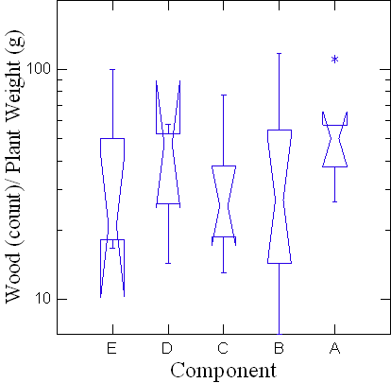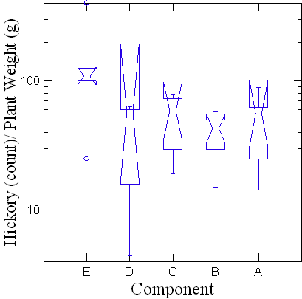

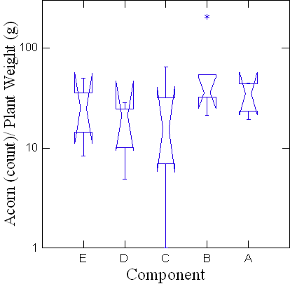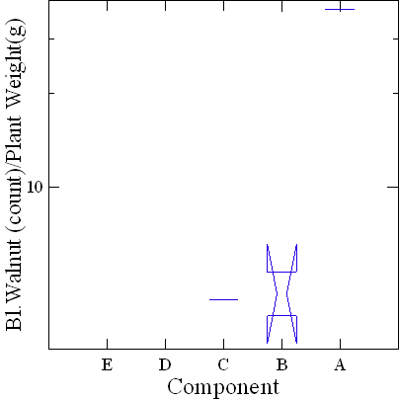

Figure 6.7: Boxplots showing the relative densities of wood, hickory, acorn, and black walnut from the Widows Creek site. E represents Early Archaic through Late Archaic deposits, D represents Late Archaic deposits, C represents Early Woodland deposits, B represents Late Woodland deposits, and A represents Terminal Woodland deposits. Note that the y-axes are scaled logarithmically.

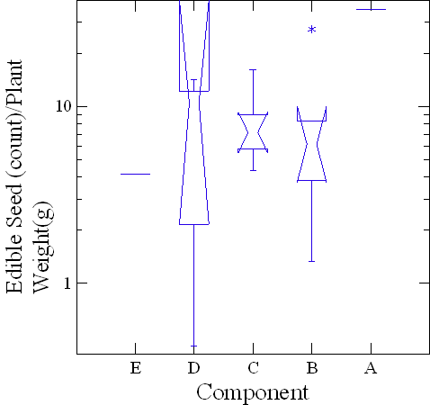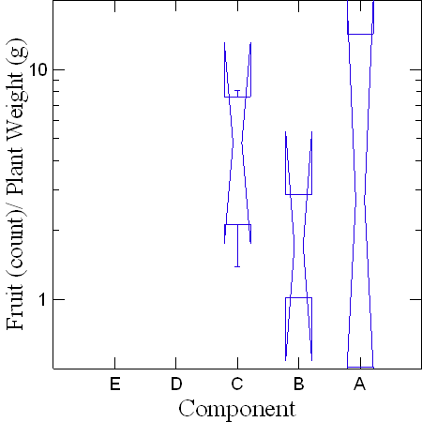

Figure 6.8: Boxplots showing the relative densities of edible seeds and fruits from the Widows Creek site. E represents Early Archaic through Late Archaic deposits, D represents Late Archaic deposits, C represents Early Woodland deposits, B represents Late Woodland deposits, and A represents Terminal Woodland deposits. Note that the y-axes are scaled logarithmically.

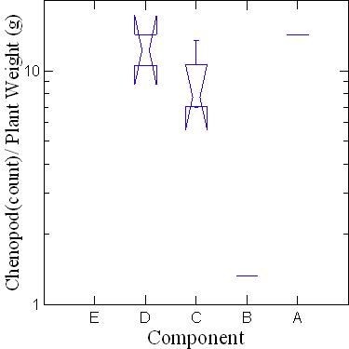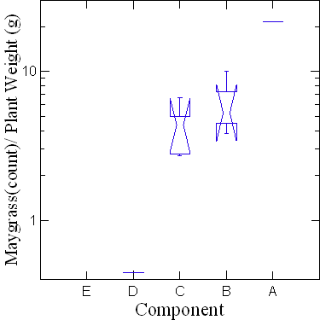
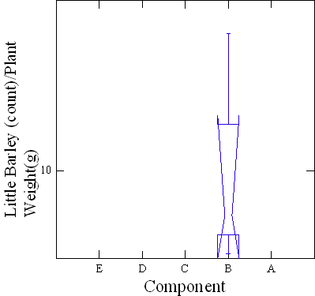
Figure 6.9: Boxplots showing the relative densities of chenopods, maygrass, and little barley from the Widows Creek site. E represents Early Archaic through Late Archaic deposits, D represents Late Archaic deposits, C represents Early Woodland deposits, B represents Late Woodland deposits, and A represents Terminal Woodland deposits. Note that the y-axes are scaled logarithmically.

The Russell Cave Site
The position of Russell Cave on the landscape, between the uplands and floodplains, makes its occupational history and plant assemblage of particular interest to this study (Table. 6.9). Hickory nutshell dominates the earliest deposits from the site and is ubiquitous in the Early Archaic samples (Table 6.10). Acorn nutshell has a ubiquity value of 67 percent in these deposits. The only other plant food remain recovered from these deposits are the remains of a single cherry/plum.
In the Middle Archaic deposits, hickory nutshell is again ubiquitous while the ubiquity value of acorn drops from 67 percent to 25 percent (Table 6.10). Again, no edible seeds were recovered from these deposits but grape and hackberry both appear with ubiquity values of 25 percent.
There is an overall drop in the number of plants recovered from Late Archaic period deposits with only hickory nutshell being recovered from all four samples (Table 6.10).
An enormous increase in plant food resources is identified from the Early Woodland deposits. Both hickory and acorn nutshell were recovered from each of the four samples analyzed, and for the first time at the site, black walnut shell was recovered and has a ubiquity value of 75 percent (Table 6.10). The increase in nutshell remains is also seen with edible seeds. Maygrass appears initially in the Early Woodland period deposits, and like hickory and acorn nutshell, is also ubiquitous. Domesticated chenopod also appears for the first time and has a ubiquity value of 75 percent. Cucurbit rinds were identified and have a ubiquity value of 50 percent, while bottle gourd seeds and ragweed both have ubiquity values of 25 percent. Remains of fruits were also recovered in higher frequencies than in previous deposits. Grape is ubiquitous in Early Woodland deposits, followed by cherry/plum with a ubiquity value of 75 percent, persimmon and blackberry/raspberry with ubiquity values of 50 percent, and honey locust and sumac with ubiquity values of 25 percent. River cane was identified in two of the four Early Woodland samples along with sycamore and magnolia seeds, both with ubiquity values of 25 percent.
There is a general decrease in plant taxa identified during the general Woodland period deposits. The ubiquity of hickory nutshell decreases from 100 percent during the Early Woodland period deposits to 75 percent while acorn also decreases from 100 percent to twelve percent (Table 6.10). Only maygrass and chenopod seeds were recovered and also in decreased amounts. The ubiquity of maygrass drops from 100 percent to 38 percent while the ubiquity of chenopod drops from 75 percent to twelve percent. River cane was recovered again but also in diminished quantities with its ubiquity value dropping from 50 percent to 25 percent.

Table 6.9: Identified Plant Remains from the Russell Cave Site.
FS# | Square | Depth | Component | Sample Wt. |  | Plant Wt. |  | Wood Ct |  | Wood Wt. |  | Name |  | Count | Weight
1995.31.628 | S.Wall | 1.0-2.0 | Woodland | 107.99 |  | 45.37 |  | 1710 |  | 44.17 |  | Hickory |  | 16 | 1.2
1995.31.435 | 36 | 2.0-3.0 | Woodland | 166.6 |  | 77.93 |  | 6935 |  | 77.93 |  | Hickory |  | 0 | 0
1995.31.436 | 36 | 2.0-3.0 | Woodland | 176.86 |  | 102.37 |  | 6203 |  | 102.22 |  | Hickory |  | 6 | 0.1
 |  |  |  |  |  |  |  |  |  |  |  | Chenopod |  | 1 | 0.01
 |  |  |  |  |  |  |  |  |  |  |  | Maygrass |  | 15 | 0.03
 |  |  |  |  |  |  |  |  |  |  |  | Unidentified |  | 1 | 0.03
1995.31.437 | 36 | 2.0-3.0 | Woodland | 144.83 |  | 106.63 |  | 5026 |  | 106.62 |  | Hickory |  | 0 | 0
 |  |  |  |  |  |  |  |  |  |  |  | Maygrass |  | 2 | 0.01
1995.31.1022 | 16-22 | 2.0-3.0 | Woodland | 281.37 |  | 107.99 |  | 7411 |  | 102.86 |  | Hickory |  | 195 | 5.13
1995.31.2891 | 10 | 2 | Woodland | 158.25 |  | 90.76 |  | 116 |  | 20.22 |  | Hickory |  | 7 | 0.42
 |  |  |  |  |  |  |  |  |  |  |  | Acorn |  | 2 | 0.01
 |  |  |  |  |  |  |  |  |  |  |  | Cane |  | 1867 | 70.1
 |  |  |  |  |  |  |  |  |  |  |  | Pitch |  | 1 | 0.01
1995.31.2892 | 24 | 2.5 | Woodland | 268.82 |  | 159.69 |  | 2234 |  | 116.29 |  | Hickory |  | 40 | 3.5
 |  |  |  |  |  |  |  |  |  |  |  | Maygrass |  | 1 | 0.01
 |  |  |  |  |  |  |  |  |  |  |  | Cane |  | 369 | 39.89
1995.31.418 | 30 | 3 | Woodland | 176.52 |  | 104.74 |  | 2600 |  | 104.56 |  | Hickory |  | 8 | 0.18
1995.31.398 | 22 | 4.5 | E.Woodland |  | 130.22 |  | 10.8 |  | 941 |  | 8.87 |  | Hickory | 13 | 0.35
 |  |  |  |  |  |  |  |  |  |  |  |  | Acorn | 364 | 1.24
 |  |  |  |  |  |  |  |  |  |  |  |  | Acorn meat | 1 | 0.04
 |  |  |  |  |  |  |  |  |  |  |  |  | Maygrass | 776 | 0.29
 |  |  |  |  |  |  |  |  |  |  |  |  | Grape | 1 | 0.01

Table 6.9 (cont.): Identified Plant Remains from the Russell Cave Site.
FS# | Square | Depth | Component | Sample Wt. | Plant Wt. | Wood Ct | Wood Wt. | Name |  | Count |  | Weight
1995.31.438 | 36 | 5 | E.Woodland | 356.21 | 103.74 | 549 | 12.3 | Hickory | 327 |  | 31.88
 |  |  |  |  |  |  |  | Acorn | 3524 |  | 45.47
 |  |  |  |  |  |  |  | Acorn meat | 5 |  | 0.94
 |  |  |  |  |  |  |  | Bl. Walnut | 9 |  | 6.7
 |  |  |  |  |  |  |  | Chenopod | 39 |  | 0.08
 |  |  |  |  |  |  |  | Maygrass | 10 |  | 0.02
 |  |  |  |  |  |  |  | Ragweed | 1 |  | 0.01
 |  |  |  |  |  |  |  | Cucurbit | 2 |  | 0.11
 |  |  |  |  |  |  |  | Grape | 5 |  | 0.06
 |  |  |  |  |  |  |  | Plum/Cherry | 2 |  | 0.18
 |  |  |  |  |  |  |  | Rubus sp. | 1 |  | 0.01
 |  |  |  |  |  |  |  | Unidable | 4 |  | 0.03
 |  |  |  |  |  |  |  | Bark | 1 |  | 0.03
 |  |  |  |  |  |  |  | Cane | 255 |  | 5.72
 |  |  |  |  |  |  |  | Unid'd | 5 |  | 0.11
1995.31.439 | 36 | 5 | E.Woodland | 328.36 | 106.78 | 147 | 5.28 | Hickory | 169 |  | 23.67
 |  |  |  |  |  |  |  | Acorn | 6061 |  | 49.35
 |  |  |  |  |  |  |  | Acorn meat | 39 |  | 7.14
 |  |  |  |  |  |  |  | Bl. Walnut | 19 |  | 7.24
 |  |  |  |  |  |  |  | Chenopod | 57 |  | 0.06
 |  |  |  |  |  |  |  | Maygrass | 19 |  | 0.04
 |  |  |  |  |  |  |  | Cucurbits |  | 5 |  | 0.17
 |  |  |  |  |  |  |  | Bottle gourd |  | 2 |  | 0.07
 |  |  |  |  |  |  |  | Persimmon |  | 2 |  | 0.16
 |  |  |  |  |  |  |  | Grape |  | 3 |  | 0.03
 |  |  |  |  |  |  |  | Plum /Cherry |  | 7 |  | 0.32
 |  |  |  |  |  |  |  | Sumac |  | 1 |  | 0.01

Table 6.9 (cont.): Identified Plant Remains from the Russell Cave Site.
FS# | Square | Depth | Component | Sample Wt. |  | Plant Wt. |  | Wood Ct |  | Wood Wt. |  | Name |  | Count |  | Weight
 |  |  |  |  |  |  |  |  |  |  |  |  | Honey Locust |  | 1 |  | 0.04
 |  |  |  |  |  |  |  |  |  |  |  |  | Magnolia |  | 1 |  | 0.16
 |  |  |  |  |  |  |  |  |  |  |  |  | Cane |  | 280 |  | 11.09
 |  |  |  |  |  |  |  |  |  |  |  |  | Unid'd |  | 5 |  | 0.72
1995.31.440 | 36 | 5 | E.Woodland |  | 429.89 |  | 65.1 |  | 188 |  | 2.81 |  | Hickory |  | 793 |  | 27.53
 |  |  |  |  |  |  |  |  |  |  |  |  | Acorn |  | 4538 |  | 28.98
 |  |  |  |  |  |  |  |  |  |  |  |  | Acorn meat |  | 5 |  | 0.58
 |  |  |  |  |  |  |  |  |  |  |  |  | Bl. Walnut |  | 11 |  | 4.74
 |  |  |  |  |  |  |  |  |  |  |  |  | Chenopod |  | 21 |  | 0.03
 |  |  |  |  |  |  |  |  |  |  |  |  | Maygrass |  | 2 |  | 0.01
 |  |  |  |  |  |  |  |  |  |  |  |  | Persimmon |  | 1 |  | 0.04
 |  |  |  |  |  |  |  |  |  |  |  |  | Grape |  | 3 |  | 0.11
 |  |  |  |  |  |  |  |  |  |  |  |  | Plum / Cherry |  | 2 |  | 0.21
 |  |  |  |  |  |  |  |  |  |  |  |  | Rubus sp. |  | 1 |  | 0.01
 |  |  |  |  |  |  |  |  |  |  |  |  | Sycamore |  | 1 |  | 0.01
 |  |  |  |  |  |  |  |  |  |  |  |  | Unid'd |  | 5 |  | 0.04
1995.31.405 | 22 | 6 | L.Archaic |  | 109.78 |  | 2.14 |  | 100 |  | 0.56 |  | Hickory |  | 222 |  | 1.58
1995.31.406 | 22 | 6 | L.Archaic |  | 105.62 |  | 2.5 |  | 124 |  | 0.7 |  | Hickory |  | 303 |  | 1.8
1995.31.407 | 22 | 6 | L.Archaic |  | 97.69 |  | 2.14 |  | 223 |  | 0.83 |  | Hickory |  | 185 |  | 1.31
1995.31.340 | 12 | 6.5 | L.Archaic |  | 84.59 |  | 3.15 |  | 279 |  | 1.48 |  | Hickory |  | 201 |  | 1.67
1995.31.154 | 4A | 7.5 | M.Archaic | 73.45 |  | 6.63 |  | 421 |  | 4.79 |  | Hickory |  | 137 |  | 1.84

Table 6.9(cont.): Identified Plant Remains from the Russell Cave Site.
FS# | Square | Depth | Component | Sample Wt. | Plant Wt. | Wood Ct | Wood Wt. | Name | Count | Weight
1995.31.155 | 4A | 7.5 | M.Archaic | 143.94 | 5.09 | 194 | 1.68 | Hickory | 218 | 3.39
 |  |  |  |  |  |  |  | Grape | 2 | 0.01
 |  |  |  |  |  |  |  | Unid'd | 1 | 0.01
1995.31.288 | 7A | 7.5 | M.Archaic | 77.49 | 4.72 | 41 | 0.42 | Hickory | 454 | 4.29
 |  |  |  |  |  |  |  | Acorn | 2 | 0.01
1995.31.341 | 12 | 7.5 | M.Archaic | 56.84 | 8.01 | 6.47 | 4.95 | Hickory | 242 | 3.05
 |  |  |  |  |  |  |  | Hackberry | 1 | 0.01
1995.31.411 | 23 | 8 | E.Archaic | 450.91 | 0.48 | 26 | 0.12 | Hickory | 19 | 0.29
 |  |  |  |  |  |  |  | Acorn | 29 | 0.07
1995.31.419 | 30 | 8 | E.Archaic | 59.88 | 3.42 | 265 | 1.94 | Hickory | 161 | 1.43
 |  |  |  |  |  |  |  | Acorn | 23 | 0.05
1995.31.420 | 30 | 8 | E.Archaic | 91.79 | 3.32 | 248 | 1.63 | Hickory | 215 | 1.63
 |  |  |  |  |  |  |  | Acorn | 12 | 0.02
 |  |  |  |  |  |  |  | Plum / Cherry | 1 | 0.04
1995.31.421 | 30 | 8 | E.Archaic | 72.52 | 7.43 | 330 | 4.34 | Hickory | 369 | 2.96
 |  |  |  |  |  |  |  | Acorn | 46 | 0.12
1995.31.265 | 6A | 8.0-8.5 | E.Archaic | 64.02 | 2.85 | 141 | 1.36 | Hickory | 126 | 1.48
 |  |  |  |  |  |  |  | Acorn | 2 | 0.01
1995.31.267 | 6A | 8.0-8.5 | E.Archaic | 223.47 | 0.01 | 0 | 0 | Hickory | 1 | 0.01
1995.31.118 | 2A | 10 | E.Archaic | 176.26 | 0.03 | 0 | 0 | Hickory | 3 | 0.03
1995.31.195 | 5A | 10 | E.Archaic | 102.48 | 3.19 | 163 | 1.14 | Hickory | 188 | 2.05

Table 6.9(cont): Identified Plant Remains from the Russell Cave Site.
FS# | Square | Depth | Component | Sample Wt. | Plant Wt. | Wood Ct | Wood Wt. | Name | Count | Weight
1995.31.334 | 12 | 10.01 | E.Archaic | 111.16 | 9.8 | 353 | 2.19 | Hickory | 674 | 7.54
 |  |  |  |  |  |  |  | Acorn | 14 | 0.07
1995.31.551 | 1 | 12 | E.Archaic | 115.36 | 4.87 | 383 | 1.79 | Hickory | 349 | 3.05
 |  |  |  |  |  |  |  | Acorn | 9 | 0.03
1995.31.552 | 1 | 12 | E.Archaic | 58.19 | 5.41 | 314 | 2.59 | Hickory | 269 | 2.82
1995.31.553 | 1 | 12 | E. Archaic | 63.59 | 3.95 | 249 | 1.96 | Hickory | 207 | 1.98
 |  |  |  |  |  |  |  | Acorn | 3 | 0.01

Table 6.10: Ubiquity of Plant Remains Recovered from the Russell Cave Site.
Category | Taxon | Scientific Name | E. Archaic  (n=12)  % | M. Archaic n=(4)  % | L. Archaic (n=4)  % | E. Woodland (n=4)  % | Woodland (n=(8)  %
Nuts | Hickory | Carya spp. | 100 | 100 | 100 | 100 | 75
Nuts | Acorn | Quercus spp. | 67 | 25 | 0 | 100 | 12
Nuts | Black Walnut | Juglans nigra. | 0 | 0 | 0 | 75 | 0
Edible Seeds / Crops | Maygrass | Phalaris caroliniana | 0 | 0 | 0 | 100 | 38
Edible Seeds / Crops | Chenopod | Chenopodium sp. | 0 | 0 | 0 | 75 | 12
Edible Seeds / Crops | Cucurbits | Cucurbita pepo | 0 | 0 | 0 | 50 | 0
Edible Seeds / Crops | Ragweed | Ambrosia trifidia | 0 | 0 | 0 | 25 | 0
Edible Seeds / Crops | Bottle gourd | Lagenaria siceraria | 0 | 0 | 0 | 25 | 0
Fruits | Blackberry/Raspberry | Rubus spp. | 0 | 0 | 0 | 50 | 0
Fruits | Cherry / Plum | Prunus spp. | 8 | 0 | 0 | 75 | 0
Fruits | Grape | Vitis spp. | 0 | 25 | 0 | 100 | 0
Fruits | Hackberry | Celtis occidentalis | 0 | 25 | 0 | 0 | 0
Fruits | Honey Locust | Gleditsia triacanthos | 0 | 0 | 0 | 25 | 0
Fruits | Persimmon | Diospyros virginiana | 0 | 0 | 0 | 50 | 0
Fruits | Sumac | Rhus spp. | 0 | 0 | 0 | 25 | 0
Other | Sycamore | Platanus occidentalis | 0 | 0 | 0 | 25 | 0
Other | Magnolia | Magnolia grandiflora | 0 | 0 | 0 | 25 | 0
Other | Cane | Arundinaria gigantea | 0 | 0 | 0 | 50 | 25

The relative densities of plant materials identified were also explored (Figures 6.11. and 6.12). The relative density of wood decreased during the Early Woodland occupation at the site but not significantly. The relative density of hickory initially increases through the Middle Archaic period before decreasing significantly during the general Woodland period deposits. The decrease in the Early Woodland period is statistically significant from the Early and Late Archaic period samples as well as the Early Woodland period deposits. The relative density of acorn increases significantly during the Early Woodland period deposits. Fruit remains are absent from three of the five occupations at the site. The decrease in the relative density during the Early Woodland period is statistically significant from that of the Early Woodland period but not the Middle Archaic period. While the relative density of edible seeds decreases from the Early Woodland period to the general Woodland period, the decrease is not statistically significant. The decrease in maygrass between the two Woodland period occupations is not significant while the decrease in the relative density of chenopod is statistically significant (Figure 6.11).

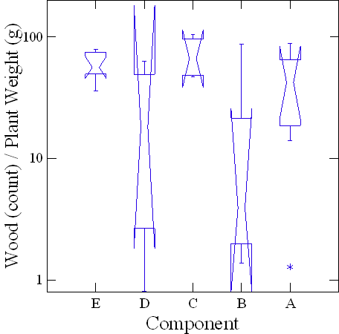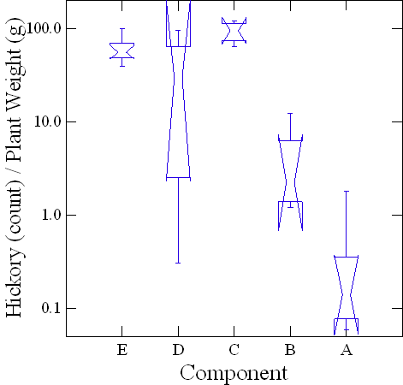

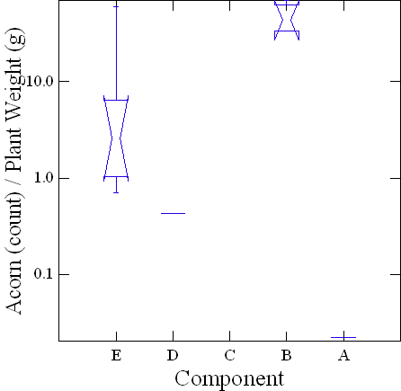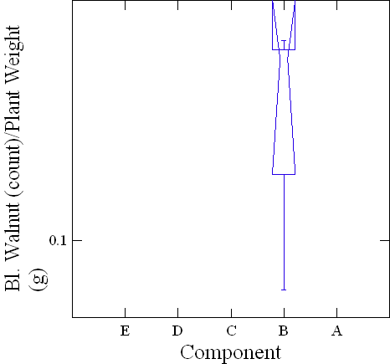
Figure 6.10: Boxplots displaying the relative density of wood, hickory, acorn, and black walnut from the Russell Cave site. E represents Early Archaic deposits, D represents Middle Archaic deposits, C represents Late Archaic deposits, B represents Early Woodland deposits, and A represents mixed Woodland period. Note that the y-axes are scaled logarithmically.

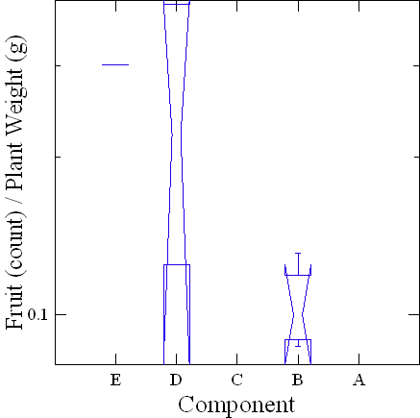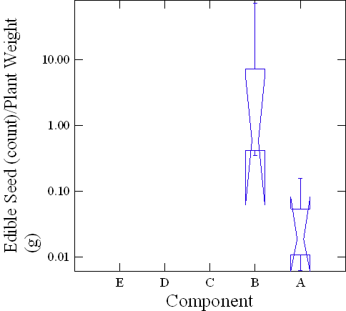
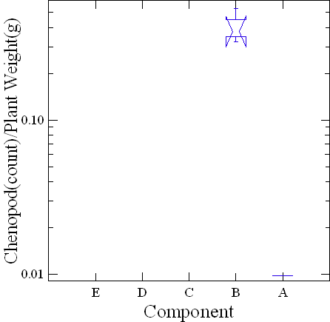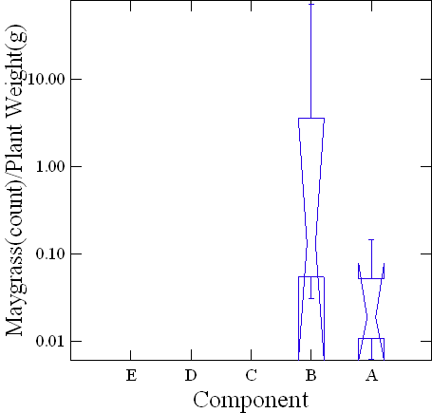
Figure 6.11: Boxplots displaying the relative density of fruits, edible seeds, maygrass, and chenopods from the Russell Cave site. E represents Early Archaic deposits, D represents Middle Archaic deposits, C represents Late Archaic deposits, B represents Early Woodland deposits, and E represents mixed Woodland period. Note that the y-axes are scaled logarithmically.

Summary
In summary, while the data from the Mussel Beach site is limited to qualitative analysis, some interesting patterns can be seen when plant assemblages of the five sites are compared in terms of their position on the landscape. Of particular interest is the intensive Middle Woodland occupation at the Mussel Beach site and the absence of similar deposits from the Widows Creek site. Also, black walnut is only recovered from the two floodplain sites, Widows Creek and Mussel Beach, and from Russell Cave, and only from Woodland period deposits. In terms of edible seeds, chenopod, maygrass, and sunflower seeds were recovered from both upland and floodplain sites and also from Russell Cave, located strategically between the two regions. Cucurbit gourds were recovered from Russell Cave and the two floodplain sites, while little barley was only recovered from the two floodplain sites.
While the focus of this chapter has been the detailed analysis of plant foods recovered with particular interest to changes through times at and between sites, the following chapter elucidates the growth habitats, seasonality, and nutritional qualities of these specific plants. In Chapter Eight, I will revisit these differences in assemblages between sites and how these patterns and trends may have been affected by the specifics of each plant.

Chapter 7: The Plants
Forager subsistence is based on wild food resources acquired by the gathering, collecting, hunting, fishing, and trapping of resources from surrounding communities (Winterhalder 1992:12). These resources are categorized by abundance, quality, and timing of access, which results in a highly flexible use of the landscape that varies from year to year (Smith 2007:31). Domesticated and cultivated plant food resources provided foragers a new set of resources to work into their existing foraging practices and ranges. Closely examining the habitat, seasonality, and nutritional values of individual plant species identified in this study will provide a clearer understanding of subsistence strategies leading up to initial plant domestication in the region, and how those practices were changed or altered to include this new suite of resources in pre-existing regimes. This discussion begins with an examination of the availability, seasonality, nutritional values, and uses of the various plant taxa recovered from Early Archaic period through Late Woodland period components across multiple landscapes on the Southern Cumberland Plateau.
Table 7.1 displays the seasonal availability of the plant resources recovered. These resources represent a variety of different habitats, nutritional qualities, and seasonal availabilities.

Table 7.1: Seasonality of Plant Remains Recovered from the Five Research Sites.
Category | Species | Common Name | May | June | July | Aug | Sept | Oct | Nov | Dec | Jan | Feb | March | April
Nuts | Carya spp. | Hickory |  |  |  |  | X | X | X
Nuts | Juglans nigra | Walnut |  |  |  |  |  | X | X | X
Nuts | Quercus spp. | Red acorn |  |  |  |  | X | X | X | X | X
Nuts | Quercus spp. | White acorn |  |  |  |  | X | X | X
Fruits | Celtis spp. | Hackberry |  |  |  | X | X | X | X | X | X | X | X
Fruits | Diospyros virginiana | Persimmon |  |  |  |  | X | X | X | X | X | X
Fruits | Gleditsia triacanthos | Honey locust |  |  |  |  | X | X
Fruits | Morus rubra | Mulberry |  | X | X
Fruits | Prunus serotina | Black cherry |  |  | X | X | X | X
Fruits | Rhus spp. | Sumac |  |  |  | X | X | X | X | X
Fruits | Rubus sp. | Raspberry/Blackberry |  | X | X | X | X
Fruits | Vitis spp. | Grapes |  |  | X | X | X | X | X
Fruits | Crataegus sp. | Hawthorn |  |  |  | X | X
Fruits | Vaccinium sp. | Blueberry |  |  |  |  |  | X | X | X | X | X | X | X
Edible Seed / Crop | Amaranthus sp. | Pigweed |  |  |  |  |  | X | X | X
Edible Seed / Crop | Chenopodium sp. | Chenopod |  |  |  |  | X | X | X | X | X
Edible Seed / Crop | Cucurbita pepo | Squash |  |  |  | X | X
Edible Seed / Crop | Lagenaria siceraria | Bottle gourd
Edible Seed / Crop | Polygonum sp. | Knotweed |  |  |  |  | X | X | X | X | X | X
Edible Seed / Crop | Phalaris caroliniana | Maygrass | X |  |  |  |  |  |  |  |  |  | X | X
Edible Seed / Crop | Zea mays | Maize
Edible Seed / Crop | Hordeum pussillum | Little barley
Edible Seed / Crop | Iva annua | Sumpweed
Edible Seed / Crop | Helianthus annuus | Sunflower

Table 7.1(cont.): Seasonality of Plant Remains Recovered from the Five Research Sites.
Category | Species | Common Name | May | June | July | Aug | Sept | Oct | Nov | Dec | Jan | Feb | March | April
 | Phaseolus polystachios | Wild legume
 | Strophostyles hevula | Wild legume
Greens | Amaranthus sp. | Amaranth | X
Greens | Chenopodium sp. | Chenopod | X |  |  |  |  |  |  |  |  |  | X | X
Greens | Galium spp. | Bedstraw | X |  |  |  |  |  |  |  |  |  | X | X
Greens | Phalaris caroliniana | Maygrass | X |  |  |  |  |  |  |  |  |  | X | X
Misc. | Cornus florida | Dogwood |  |  |  |  | X | X
Misc. | Magnolia grandiflora | Magnolia |  |  |  | X | X | X
Misc. | Platanus occidentalis | Sycamore |  |  |  |  | X | X
Misc. | Arundinaria sp. | River cane | X | X | X | X | X | X

Nuts
Mast resources are considered to be one of the most important wild food plants exploited by Native Americans from Paleoindian through prehistoric times (Caldwell 1958; Scarry 2003:56; Yarnell and Black 1985). Since the different taxa present in the Southeast each produce edible nuts that ripen in the fall, they are sometimes treated as a single category; however, they each provide different nutritional qualities and require different processing, storage, and collecting techniques (Scarry 2003:57). Mast resources (hickory, acorn, and walnut) provided larger portions of carbohydrates and vegetable fats than any other resource through prehistory, with hickory being the most abundantly recovered nutshell during all periods (Gremillion 1996:104, 2003; Scarry 2003; Yarnell and Black 1985).

Acorn (Quercus spp.)
Acorn shells and meats are the second most common mast resource recovered from archaeological sites in eastern North America, behind hickory nuts. Across the Eastern Woodlands, they were relied upon heavily by both human and animal populations for survival during winter months, serving as a significant food resource during prehistoric times (Reidhead 1981:183; Scarry 2003:65). While acorn remains are recovered in lower frequencies than hickory, it has been argued that their importance to prehistoric populations has been masked by problems involving preservation and recovery techniques (Lopinot 1984; Miksicek 1987:221). In addition, hickory nutshell is often used as a fuel source, increasing its likelihood of preservation and recovery (Lopinot 1984).
Twenty-seven different species of white and red oak trees are found in the Eastern Woodlands. The greatest differences between the two types of trees are the availability and sweetness of the nuts they produce. Acorns from white oaks are sweet, easily processed, and mature in one year, whereas acorns from red oak trees mature in two years and produce a more bitter nut that must be leached to remove high levels of tannic acid before they can be consumed (Scarry 2003:65-66). Good crops are produced every two to three years, meaning that one type of acorn would usually be available in large quantity. However, due to the thin shell of both acorns types, they are susceptible to insects and mold, and tend to sprout quickly after they fall. The sweeter white oak acorns are also a favorite of birds and mammals and must be collected quickly (Petruso and Wickens 1984:366; Scarry 2003:66). One-hundred eighty-six different animal species, including squirrels, mice, deer, and turkeys, are known to feed on acorns, demonstrating the level of competition that prehistoric populations would have encountered for this nut resource (Petruso and Wickens 1984:373; Reidhead 1981:183).
Acorns from white oak trees are most commonly found in open and mid-slope environments (Petruso and Wickens 1984:363). They require less processing than those from the red oak group. Because they are consumed by mammals, birds, and insects, and are also susceptible to mold and sprouting, their optimal collection period is between October and November. Unlike red oak acorns, they germinate and sprout quickly after falling and would need to be collected quickly (Petruso and Wickens 1984:374). The more bitter acorns from the red oak group are commonly found in mid-slope and gravelly upland environments with poor soils and have a mast cycle of two to five years (Petruso and Wickens 1984:363). They are available from mid-October until mid-December, but in some years are available until late February (Munson 1984:468; Schopmeyer 1974:695). Unlike the white oak acorns, which sprout quickly after falling, red acorns can remain on the ground for a much longer period of time without sprouting, allowing for collection throughout the winter months, and possibly making them more favorable for storage (Reidhead 1981:183). Acorns of species of oak in the red oak group are usually only affected by animal populations after sweeter acorn populations are depleted (Petruso and Wickens 1984:366; Scarry 2003:67).
Acorns contain one-third to one-half the amount of proteins, fats, fiber and calories provided by other nuts, but they offer higher levels of carbohydrates. They were most commonly prepared by pulverizing the meats into a meal, which was then baked like a cake or pancake or cooked as a gruel or porridge. Acorns were also added to soups, and their grounds used to make a coffee-like beverage (Petruso and Wickens 1984:362-363). Red oak acorns contain three to four times more fat than acorns from white oaks, in addition to more calories, but they do not reach the level of fat provided by other mast resources (Scarry 2003:67). Because of their higher levels of tannin, which require longer leaching and boiling times, the nutritional levels of proteins and fats in red acorns are reduced, along with water-soluble vitamins (Petruso and Wickens 1984:367). Removing the tannic acid from acorns also presents an additional step in processing acorns, one that is absent in the processing of hickory and black walnut. Higher processing costs associated with acorn nuts possibly contributed to its decrease in use through time, especially when compared to hickory, which was as abundant and less costly to process. Several different methods have been employed by Native American tribes to remove the tannins, including parching, boiling, roasting, immersion or burial of the meats, soaking the nuts in fresh water, and soaking or boiling in ash-treated waters (Petruso and Wickens 1984:362).
Problems associated with the recovery of acorn shell and meats are well documented in the archaeological literature and raise questions as to the real importance of acorn to prehistoric populations. The problem has been referred to as “selective preservation” (Asch et al. 1972:10; Munson et al. 1971:426). Acorn meats are rarely preserved, and when present, the meats are often difficult to identify. Acorn shells are less dense than hickory shells. They are believed to turn to ash when exposed to prolonged and intense heat, and when they are only partially carbonized they will decompose. This means that only a small percentage will be preserved and recovered (Petruso and Wickens 1984:360). As a result, Yarnell and Black (1985:97-98) recommended multiplying the weight of acorn shell fragments recovered by 50 to gain a better understanding of the important role acorn played relative to hickory nuts in prehistoric times. Their compensation factor of 50 is based on calculations from Lopinot (1982) where he determined that acorn is underrepresented relative to hickory nut by factors ranging from 5 to 200 (Yarnell and Black 1985:98).

Black Walnut (Juglans nigra)
Black walnut are a medium-to-large, deciduous forest tree reaching heights of over 100 feet. They are found in the Eastern Woodlands from Massachusetts to Florida and from Minnesota to Texas (Radford et al. 1964:133; USDA 1948:201). They typically grow best in well-drained, neutral soils found on slopes and rich bottomlands. They are intolerant of shade and do best in natural openings or forest edges (Munson et al. 1984:340). Because they grow as solitary trees, rather than in stands like hickories and oaks, harvesting large numbers of walnuts is more difficult.
Black walnut fruits were commonly used by prehistoric populations in eastern North America. They are available from late September until late December, but most optimally from mid-October to early December (Munson 1984:465; Schopmeyer 1974: USDA 1948:202). Because they are not as desirable to squirrels and other animals, they have a longer period of availability than other nuts.
Although they provide a better source of plant protein than all other nut resources found in the Eastern Woodlands, other factors made them less desirable to collect and process, such as processing costs (Scarry 2003:64). Under the right growing conditions a tree can produce around 600 pounds, or 16 bushels, a year, but on average produce approximately two bushels a year (Munson et al. 1984:340). Also, higher processing costs relative to hickory nuts may have discouraged greater use of both black walnuts and hazelnuts (Gardner 1997; Scarry 2003:64; Talalay et al. 1984).

Hickory (Carya spp.)
Hickory nutshells are the most abundant type of plant remains recovered from archaeological contexts, especially during the Archaic period in the Eastern Woodlands. Hickories are found in groves in mixed hardwood forests and are often the dominant tree where they occur. The trees produce heavier, or bumper, crops every two to three years that would have provided large quantities of nuts at low search and travel costs. They are also advantageous because they can be collected and stored in bulk, and, if properly stored and kept free from moisture and rodents, hickory nuts can be kept somewhere between three and five years (Gardner 1997:172; Schopmeyer 1974:271). While hickory trees produce high yields, their period of availability is very small because they are a staple for squirrels and other animals. They disappear quickly from trees and the forest floor. Nuts can be collected from late September through late November, though mid-October through mid-November is the optimal period for collection (Munson 1984:462; Scarry 2003:60).
The exceptional amounts of hickory nutshell recovered from the archeological record speak to their importance of hickory nuts in the subsistence strategies of populations dating back to the Late Paleoindian period (Asch et al. 1972; Gremillion 2003; Munson 1984:462; Yarnell and Black 1985). Hickory, referred to as a “first line food” by Asch et al. (1972), provided a high source of energy to prehistoric diets (Scarry 2003:60). While the value of hickory nuts, in terms of calories, fat, and amino acids, cannot be underestimated, they provided inadequate levels of carbohydrates. Only 349 g of dry hickory nutmeats are required to meet the daily caloric intake needs (2,220 kcal) in contrast to acorn (427 g) and maize (604 g) (Gardner 1997:162). Hickory nutmeats are also higher than acorn and maize in eight out of the ten amino acids. Even more important than calories and amino acids is the amount of fat provided by hickory nuts, especially in the winter and early spring when animal fat may be scarce (Gardner 1997:172; Speth 1990; Speth and Spielman 1983; Thomas 2009:166). The fat content in hickory nuts is twice that of acorns and 16 times higher than the fat content of maize kernels (Fritz et al. 2001:5; Gardner 1997:162-164).
It is believed that hickory nuts were mainly processed for oils and milk to avoid the labor-intensive task of removing the meats from the shells (Thomas 2009:172). Ethnohistoric accounts indicate that unshelled nuts were crushed and placed in boiling water; the oil would be skimmed off the top as the nutshells sank (Fritz et al. 2001; Scarry 2003:61). Processing nuts to make the traditional Cherokee soup Ku-nu-che dish was an alternative way to process hickory nuts. Ku-nu-che is produced by cracking and pounding the nuts and shells into a mixture of the two that is then formed into balls, which can then be boiled with water, strained and served as soup (Fritz et al. 2001:1). This traditional form of hickory nut preparation is still commonly practiced by Cherokee people because of its significance as a traditional food that has been passed down through oral tradition and thought to be responsible for group survival during times of famine. Today it provides insight into harvesting and processing techniques possibly used by past populations (Fritz et al. 2001:3).
No early ethnohistorical records indicate the forming of balls from shell and hickory nutmeats; instead the emphasis has been more focused on the use of hickory in liquid form, as an oil or milk, reduced through a boiling process (Fritz et al. 2001:23; Gardner 1998; Reidhead 1981:193). Fritz et al. (2001) suggest that the weight and bulk of hickory nuts could have been reduced by processing the nutmeats and shells and forming them into balls. This process would have made transportation easier for groups moving hickory nuts from camps to bases once they had been made and the weather had cooled to prevent them from spoiling. Return rates calculated for crushing and boiling the nuts are much greater because the handling costs decrease dramatically. Experimentation with processing techniques has shown that cracking shells and picking the meats provides an extremely low or even negative return rate (Munson 1986:4; Thomas 2009:172). Munson (1986) attributes the increase in hickory nutshell recovered from Middle Archaic contexts along with an increase in the number of shallow pits and fire-cracked rocks to the development of hickory oil extraction techniques. He believes that the pits were lined with hides and then filled with heated stones and crushed hickory nuts, resulting in a hickory milk or oil (Munson 1986; Scarry 2003:61).

Edible Seeds/Crops

Amaranth (Amaranthus sp.)
Amaranth plants are weedy, mainly annual herbs containing small, dry, one-seeded fruits. The plants are hardy and can grow in almost any environment (Taylor 1938:18). The plants flower in the early summer, between May and July, and seeds form during September and October. Numerous seeds are produced on each plant in small clusters in the axils or in terminal spikes (Steyermark 1963:623). The seeds are circular, flat and usually black in their nondomesticated forms, varying in diameter from 0.7 to 1.5 mm (Gleason 1952: 101; Peterson and Munson 1984:317). Although Taylor indicated that these plants had “no garden importance”, it was the small seeds that made the plant an important food resource to prehistoric groups in the Eastern Woodlands (Taylor 1938:18).
Prehistorically, amaranth plants were cultivated for their seeds, greens, and dye (Peterson and Munson 1984:318: Steyermark 1963:624). Their importance in prehistoric subsistence systems has often been overlooked considering their use as food around the globe today as well as prehistorically, their high food value, and their recovery from archaeological contexts from sites across the Eastern Woodlands (Fritz 1984:570, 2007:288). Their recovery from excavations in the Ozarks of Missouri and Arkansas demonstrated the importance of their seeds in prehistoric subsistence regimes. The recovery of amaranth in association with corn, squash, sunflower, chenopods, and ragweed led Gilmore (1931) to state that amaranth along with the other plants were cultivated prehistorically. Based on similar finds in Kentucky, Jones (1936:163) concluded that eastern North America might have been a center for the origin of cultivation focused primarily on local weedy seeds prior to the introduction of maize. Later, in 1951, Jones stated that when and where amaranth seeds do occur they appear to be secondary crops pushed aside by plants with larger seeds. He also stated that amaranth plants were an ideal resource for gathering peoples, particularly those using baskets and seed beaters, because they produce an extraordinary number of seeds (Jones 1951:91). In 1957, Melvin Fowler used the arguments put forward by both Gilmore and Jones and incorporated Anderson’s 1952 “dump heap” hypothesis to suggest that agricultural beginnings in the region centered around sunflower, maygrass, chenopod, and amaranth (Fowler 1971a, 1971b:402). During the 1960s and 1970s, Stuart Struever included amaranth in several discussions of the Eastern Agricultural Complex and ‘mud-flat agriculture’ in the Midwest (Struever 1962, 1964:99-103; Struever and Vickery 1973:1,212). However, Yanovsky’s 1936 detailed survey of ethnographic and historical literature only uncovered two references for the use of amaranth, and interestingly in both cases for the leaves, other larger surveys of the literature failed to produce any accounts of the plants’ use (Gilmore 1919; Yarnell 1964), leading some to be skeptical of its significance.
The seeds of the amaranth plant are highly nutritious as they are high in proteins, oils, and calories. The protein quality of the seeds are only surpassed by a few species of legumes, however, certain preparation methods can compromise the amount of protein available (Peterson and Munson 1984:328). If introduced to high levels of heat, which can be used to puff or parch the seeds, the quality of the protein is greatly affected. The seeds can also be boiled in water to form a type of gruel or porridge. On the other hand, the seeds can be milled into flour and used for bread products that are higher in protein (Peterson and Munson 1984:327).
Domesticated amaranth seeds (Amaranthus hypochondriacus) have a reduced seed coat thickness resulting in white, yellow, or red seeds, whereas wild seeds are black (Fritz 2004, 2007:291; Sauer 1950, 1967). The seed heads are more compact than those from their wild ancestors. So color and shape are indicators of domestication in amaranth (Fritz 2007:291; Sauer 1950, 1967). Domesticated in Mexico, Amaranthus hypochondriacus it made its way to the Eastern Woodlands by the end of the first millennium C.E., the earliest evidence coming from Holman and Alum Rockshelters in the Ozarks of Arkansas (Fritz 1986, 2007:293).
Experiments conducted during the 1970s demonstrated the efficiency with which these seeds could be harvested, the costs associated with collection and processing, and the productivity of the plants in the wild (Peterson and Munson 1974:322). First, the study indicated that the most efficient time to collect the seeds was three to four weeks after the first frost of the fall, usually in November. Prior to that the seeds were more difficult to extract and samples contained a higher percentage of immature seeds (Peterson and Munson 1984:322). Three different processing techniques were used to recreate methods described ethnographically by Jones (1951): using a paddle and bucket, hand stripping, and seed head cutting. Of the three methods the third method proved to be the most successful. Dried seed heads were cut from the plants and placed in a bag. The seed heads were easy to cut and a large number could be collected in a short period of time. Three timed experiments using this method showed that on average 2,124 grams of seeds could be collected in one hour; however, this method also produced a large number of stems and bracts along with seeds (Peterson and Munson 1984:323).
While ample yields were produced by processing and winnowing in the experiment, time and costs had to be calculated to provide a more accurate picture of prehistoric plant collection and processing. Several threshing methods were employed to remove the seeds from the bracts including flailing with a stick, trampling or grinding underfoot, and manually twisting the seed heads (Peterson and Munson 1984:323). What was left was a combination of seeds and chaff that was further separated successfully by floating the remains in water. The mature seeds sank to the bottom while the immature seeds and chaff floated on the surface and could be poured off (Peterson and Munson 1984:323). While time was not tightly controlled it was estimated that successfully processing the seed heads into a product palatable for human consumption would require twice the amount of time it took to collect them. When collection times, processing, and winnowing are all combined the results indicate that one hour of harvesting/processing (twelve minutes of harvesting, twenty four minutes of threshing, and twenty four minutes of winnowing) would have yielded 425 grams of seeds, a much higher yield than that of chenopod and knotweed.
Acknowledging that several factors including water, sunlight, space, and nutrients all affect the growth and density of plants like amaranth, predictions of yield-per-unit-area were also calculated. On average plants collected during the experiment yielded 2.4 grams of seeds. In the areas tested, plant- per-unit-area averaged approximately 8.5 plants per square meter. Combined, these results suggest that an average yield would be 20.4 grams-per-square-meter or 189.4 pounds- per-acre (Peterson and Munson 1984:325). This is much lower than comparable measures for chenopod, suggesting that amaranth was not as productive as other weedy plants found in similar habitats.
Chenopod (Chenopodium sp.)
Species of Chenopodium are perennial herbs that produce small lenticular and ovoid fruits, or utricles (Judd and Ferguson 1999:366; Wahl 1954:3). The fruits are small, between 0.5 and 2.0 millimeters in diameter, and have a diagnostic reticulate (net-like), alveolate (pitted) dorsal pericarp. The primary habitat of Chenopodium berlandieri plants in eastern North America is river valley floodplains, particularly of large meandering rivers such as the Mississippi and its tributaries (Smith 1987; 1992:173). They thrive in annually scoured sandy soils in the understory of black willow forest communities (Smith 1987, 1992:173).
The seeds of wild and weedy chenopods are morphologically different from those of the domesticated species (Chenopodium berlandieri subsp. jonesianum) and are identifiable by a biconvex cross-section, rounded or equatorial-banded shape, and a thick testa or seed coat (Asch and Asch 197721; Smith 1984:166; Wilson 1980:254). There are two variants of domesticated Chenopodium found archaeologically in in eastern North America. In comparison to their wild counterparts they have a truncated margin, a rectanguloid cross-section, and a smooth testa surface (Smith 1984:166, 1985a:6, 1985b:120, Smith and Funk 1985:447). The darker seeded Chenopodium berlandieri subsp. jonesianum has a greatly reduced seed coat (Smith and Funk 1985), while the pale colored variant has seeds that lack the hard black, outer epidermal layer (Wilson 1982).
Five interrelated morphological changes resulted from an adaptive response to artificial environments created by human intervention in the life cycle of Chenopodium plants that further distinguish wild from domesticated Chenopodium: infructescences compaction, loss of shatter mechanism, uniform maturation of fruit, increased perisperm, and loss or reduction of seed coat (Harlan et al. 1973:316; Wilson 1980; Wilson and Heiser 1979:199; Smith 1985a:57). In wild varieties of Chenopodium the flower clusters, inflorescences that turn into the fruiting heads, or infructescences, are small and randomly distributed along the branches of the plant (Wilson 1980; Smith 1992110). Domesticated plants have fewer but larger infructescences that are denser and located at the terminal ends of the plants. Because “plants that contribute the most seeds to a harvest are most likely to contribute more offspring to the next generation” (de Wet and Harlan 1975; Harlan et al. 1973:318), plants with visible and easily accessible fruits during harvests would benefit the most. This could have been selected for consciously during harvest or could have automatically developed without selective pressures (Smith 1992:110).
The loss of shatter mechanism is also a trait that is strongly selected for during harvest. This is the most diagnostic of the morphological characteristics that distinguish wild from domesticated seed-bearing plants (de Wet and Harlan 1975; Harlan et al. 1973:314; Smith 1992:111). Plants that retain their seeds through harvest periods are more likely to contribute to the next generation than those that disperse their seeds naturally, as they ripen. This is unlikely to be identified archaeologically unless infructescences fragments are preserved intact.
The third characteristic is uniform maturation of fruits. Sequential flowering and staggered maturation of fruits is typical in wild varieties of Chenopodium, as well as other seed-bearing plants. However, harvesting activities select against fruit maturation over longer periods of time (Harlan et al. 1973:316; Smith 1992:111). In garden or field plots, plants that have simultaneous flowering and synchronized fruit maturation will make a greater genetic contribution to the next generation of plants. Whereas the loss of a shatter mechanism is likely undetectable archaeologically, the uniform maturation of fruits found in domesticated plants should result in less variability witnessed in fruit sizes and a lower percentage of immature fruits recovered from plants harvested from wild stands (Wilson 1981:234).
An increased perisperm, or food reserve for seed growth, is the fourth characteristic seen in domesticated Chenopodium plants. While planting in prehistoric gardens would have reduced competition from outside plant species, it would have increased competition between seedlings of the same species, or other plant species found within the same garden plots. As Harlan et al. (1973:318) described the first seeds to sprout and the most vigorous are more likely to contribute to the next generation than those that do not. To survive and pass along genetic material, selection favors plants with increased perisperm or cotyledon volume, which allows plants to sprout more quickly and grow more vigorously. Archaeologically this is witnessed by an increase in the external dimensions of the seeds or fruits, which was noted as early as the 1930s by both Gilmore and Jones. However, this increase is not necessarily witnessed by a larger size in terms of external diameter (Smith 1992:113). Domesticated seeds have a more rectanguloid cross section as opposed to a more rounded or biconvex cross section seen in wild varieties. While the overall increase in not as dramatic as that seen in sunflower and sumpweed, it has been explained as a balance where a plant with the largest number of seeds yielding competitive seedlings is more advantageous than a plant with the largest seeds (de Wet and Harlan 1975; Harlan et al. 1973:318). The change in the cross section of the seed, truncated margins, and increased internal seed volume are all seen as good archaeological indicators of domestication.
The fifth characteristic that distinguishes wild from domesticated Chenopodium is a loss or reduction in a thick outer epiderm or testa (Gremillion 1993:164; Smith 1992:114; Wilson 1981). In wild populations the presence of a thick, black, hard outer seed coat provides a mechanism to ensure germination dormancy and prevent premature germination of mature seeds that have fallen from the plant (Smith 1992:114). This ensures viable seeds in the soil beyond the next growing season. Though advantageous in weedy or wild plants, physical dormancy is nonadaptive in domesticated plants where selective pressures are stronger for seeds that sprout quickly once planted (de Wet 1975; de Wet and Harlan 1975; Harlan and de Wet 1973; Harlan et al. 1973:319; Smith 1992:114). This reduced germination dormancy is witnessed in the reduction, and in some cases absence, of the seed coat or testa.
Experiments were also conducted to determine the productivity and harvesting and processing costs of chenopod (Asch and Asch 1978; Smith 1992; Seeman and Wilson 1984). Harvest yields were highly variable across the areas tested. High and low estimates for approximate yields vary between roughly 440 and 800 pounds of processed seeds per acre, depending on the level of human involvement from high to relatively low, and yields of between 7 to 16 pounds-per-acre as weeds in cultivated fields (Seeman and Wilson 1984). Smith’s numbers ranged from a low of 608 pounds-per-acre to a high of 6,291 pounds-per-acre (Smith 1992:175). Numbers presented by Asch and Asch (1978:313) reported a low and high of 2,932 and 3,836 pounds-per-acre, respectively. The most likely explanation for the differences between estimated harvest yields is related to the different habitats and conditions under which the harvested plants lived. Based on these considerations, Smith (1987, 1992) suggested that an average yield for poorly maintained or overgrown garden plots would range between 16 and 30 pounds-per-acre, and for domesticated chenopods this number would decrease by 30 percent to 11 and 23 pounds-per-acre due to the absence of that thick, inedible seed coats present in wild varieties (Smith 1987:46, 1992:117). Average harvest values also varied greatly based on differences in size, degree of compactness, terminalization of infructescences, shade, and weediness of plots. Conservative harvest rates were considered to be between one to two and a half pounds-per-hour (Smith 1992:176). These studies demonstrate that Chenopodium could have been an “exploitable resource of considerable potential” (Seeman and Wilson 1984).
The harvesting of plants was accomplished by hand-stripping the infructescences and placing the seeds into bags. A total of 12,000 plants were harvested from a 250 square meter plot, for an average of 50 plants-per-square-meter. Three hundred infructescences were stripped in 22 minutes yielding 460 grams of clean fruits after winnowing (Smith 1987:43, 1992:167).
Chenopodium seeds are ripe and usually ready for harvest after the first frost of the season, stands can retain up to 90 percent of their fruits into late December and January (Smith 1987:51; Seeman and Wilson 1984:303; Wahl 1954). The persistence of harvestable seeds into the winter months, when many other plant foods are unavailable, should be considered a major factor for the importance of chenopod to prehistoric populations, especially at a time when harvesting efforts may have been more focused on mast resources. This potentially had significant implications in terms of the timing of harvest events in the fall when there is an abundance of resources available between ripening fruits, mast harvests, and game animals (Smith 1992:258).
Chenopod seeds provide relatively high amounts of calories, protein, and fat. The seeds can be eaten raw or stored, but were more commonly parched and ground into a flour that was used to made porridge or bread (Hollenbach 2005; Kavasch 1977:21; Kuhnlein and Turner 1991:152; Moerman 2004; Peterson 1977:152; Yanovsky 1936:22).

Giant Ragweed (Ambrosia trifida)
Ragweed is found commonly across the Eastern Woodlands in the alluvial soils of thickets, forest opening and clearings, and along streams and ponds (Steyermark 1963:1538). Ragweed is an herb that grows between three and twelve feet tall, and flowers between July and September (Steyermark 1963:1538). The plant has large, three-to-five lobed leaves and numerous flowers in spike-like clusters (Radford et al. 1964:321; Taylor 1936:866). In 1931, Melvin Gilmore suggested that giant ragweed was cultivated by prehistoric groups in the Ozarks of Arkansas. He based this on the large quantities found in caches with other seeds crops, the large size of the seeds when compared to modern seeds, and the lighter color of seeds in archaeological sites compared to these wild populations (Gilmore 1931).
The achenes of the plant are easily removed by simple hand-stripping techniques (Cowan 1985:215). Once removed the achenes need to be dried for a few days before they can be cleaned by hand, which required three to four times longer than the actual harvesting of the achenes. These results suggested that return rates were comparable to those of sumpweed where 0.5 kg of kernels were harvested per hour. They also highlighted the fact that ragweed would have been the least efficient plant included in the Eastern Agricultural Complex (Cowan 1985:215).

Gourds (Cucurbita pepo ssp.ovifera)
Wild gourds (Cucurbita) are vining, monoecious annuals that produce large flowers, and have sinuously lobed leaves (Cowan and Smith 1993:19). They are most commonly found in floodplains, along gravel bars, or in deposits left behind by spring flood events. These environments represent annually disturbed habitats in which wild gourds are successful competitors (Cowan and Smith 1993:50). Their vines can extend for up to 30 meters along the ground and climb up to 4 feet (Cowan and Smith 1993:50). Their ability to self-pollinate ensures their ability to survive if isolated during flood events. The buoyant, hard-walled fruits are ideal for seed dispersal. Their ability to climb, produce large quantities of both seed and fruits, and self-pollinate implies a long-term, highly-successful adaption to flood plain environments (Cowan and Smith 1993:50).
Although evidence suggests that wild cucurbits existed in Florida 12,000 years ago (Newsom et al. 1993), their origins in eastern North America have long been questioned. It has been argued that they were part of the indigenous flora of the region, a garden escapee from populations in Texas, or even introduced from Mexico. Recent isozyme data, numerical analysis of seeds, and allozyme studies have contributed to our understanding of the origins and domestication of gourds from Eastern North America. These studies show that C. pepo ssp. ovifera found in eastern North America and C. pepo ssp. pepo domesticated in Mexico are from separate lineages, domesticated independently (Decker 1985, 1988; Decker-Walters 1993; Decker and Newsom 1988; Decker-Walters et al. 1993).
The recovery of small seeds and thin rinds from wild species of Cucurbita pepo across archaeological sites in eastern North America indicates that gourds were being used as early as 8,000 years B.P., although evidence for their domestication indicated by larger seeds (>11 millimeters), a variety of colors, thicker rinds (>2 millimeter), epidermal warting or lobing, and a peduncle diameter exceeding 8 millimeters, does not appear until ca. 4,440 +/- 75 B.P. from the “squash and gourd zone” at the Phillips Spring site in Missouri (Cowan and Smith 1993; Kay et al. 1980; King 1985; Newson et al. 1993; Smith 1989, 1997, 2006).
Believed to have been introduced to sites either by flood or from human collection of floodplain stands, Cucurbita plants could have taken advantage of disturbed soils at habitation areas and thrived with little human intervention as weedy invaders, initially being tolerated and eventually encouraged to grow, leading to its domestication (Smith 1993:102). Prior to domestication the seeds and flesh of Cucurbita pepo were extremely bitter due to chemicals known as cucurbitacins, which made them inedible without costly processing techniques such as soaking, boiling, or crushing and boiling (Hart 2004:1632; King 1985:78). While it is possible that the rinds and seeds of the wild variety provided an important food resource for prehistoric Native Americans, others have suggested that wild cucurbits may have played a more significant role in fishing technology, used as floats for fishing nets, and also as containers, spoons, and cups, even after the invention of ceramics (Cutler and Whitaker 1962:474; Fritz 1999:424; Gremillion 2003:32). However, Cowan (1997:70) suggests that the thin walled gourds were too fragile to have served as containers, believing that they were more important for their nutritional content.
Cucurbit seeds contain high amounts of oils, and greater amounts of protein and amino acids than sunflower seeds. Providing 553 calories per 100 grams, they exceed the caloric value of maize and beans, and are comparable to sunflower and sumpweed (King 1985:77). Small-fruited Cucurbita pepo are the best producers of oil because each plant produces a large number of fruits with a greater amount of seeds. Ironically, the evolutionary trend witnessed with domesticated gourds in the region favored fewer, larger fruits that contained fewer seeds. So while thin-walled gourds were initially selected for their seeds, later selectivity was for larger fruits with a higher quality flesh (King 1985:77).
Current archaeological evidence indicates that cucurbit gourds were the first plants domesticated in eastern North America. Patches of wild gourds would have been easily recognized and recreated by spreading their seeds along river banks and shoals. Cowan suggested that because gourds are so easy to manipulate, expanding their ranges would have been a way for prehistoric groups to buffer against interannual variability of mast resources, referring to their domestication as “the first conscious alteration of a plant population” (Cowan 1997:72).

Bottle Gourd (Lagenaria siceraria)
The bottle gourd is a vigorous, annual, running or climbing vine that prefers light, sandy or loamy, well-drained soils. The vine is branched and climbs by means of tendrils along the stem. Each vine can grow up to sixteen feet long and is covered with large, dark green leaves and trumpet-shaped, white summer flowers. The large leaves are covered with soft hairs and have a velvety texture because of the fine hairs, especially on the undersurface (Taylor 1936:424).
Great variation occurs in bottle gourds. Fruits grow in a variety of different shapes, including rounded, bottle-shaped, or crookneck-shaped, and in a variety of different color combinations of light green or dark green, turning yellow or light brown when ripe (Taylor 1936:424). The fruits also vary in size between two to twelve inches in diameter and from four to forty inches in length. When the fruits mature the white pulp dries, leaving the hard outer shell with the seeds inside. While the oily seeds are edible, the value of the plant is in the thick-walled gourds. When dried the hard shells are waterproof and can be used for a variety of different non-food purposes including containers, floats, smoking pipes, musical instruments, penis sheaths, or ornamental decoration (Clarke et al. 2006:893; Decker-Walters et al. 2001:370; Heiser 1979). They would have provided a great resource to prehistoric populations prior to the invention of pottery (Heiser 1979:320; King 1985:77; Smith 1985a:63).
The origin of the bottle gourd in North America has been as perplexing as the origin of maize and cucurbit gourds. Originally an African crop, it is believed to have spread to Asia and the Americas between 15,000 and 10,000 years ago, where it was independently domesticated (Decker-Walters 2001:369; Heiser 1979:320). It was the only domesticate that had a global distribution in prehistoric times (Kistler et al. 2014:2937). Its entry point into North America has been debated for decades. The earliest recorded evidence for bottle gourd in North America comes from the Windover site in Florida, and dates to 7,290 +/- 120 radiocarbon years (Doran et al. 1990). Initially, the distribution of the species was believed to be a result the seaworthiness of the dried fruit. Studies have shown that seeds will remain viable after floating for more than seven months (Whitaker and Carter 1954:697). However, results of DNA analysis in 2005 suggested that the bottle gourds recovered in North America had DNA identical to the modern Asian reference groups used in the study. This led to the conclusion that, like dogs, bottle gourds crossed Beringia with early human populations settling the continent (Erickson et al. 2005:18315). Yet a more recent DNA study questioned those conclusions and suggested that their results were strongly influenced by a “small genetic dataset” (Kistler et al. 2014:2938). They concluded that bottle gourds recovered from North America were more closely related to African bottle gourd. They further questioned the findings from the previous study and suggested that the scenario is improbable based on two factors. First, that the bottle gourd thrives in tropical and subtropical climates making the Late Pleistocene climate of Beringia inhospitable for the plants propagation and survival, and second, that there is no archaeological or ethnographic evidence for the use of the plant in the region of Siberia or Alaska (Kistler et al. 2014:2937). From ocean drift simulations and DNA analysis, Kistler et al. (2014) concluded that bottle gourds found in North America are more closely related to African bottle gourds and believe that the transoceanic drift hypothesis explains their entry into North America.

Knotweed (Polygonum sp.)
Knotweed is a trailing or climbing perennial herb found in low, damp woodlands and on stream banks across the Eastern Woodlands (Radford et al. 1964:145: Steyermark 1963:586). The plants have small white or pink flowers on terminal spikes or loose racemes (Taylor 1936:634). Like sunflower and sumpweed the seed is an achene, or a single kernel enclosed in a dry, indehiscent shell or pericarp. The achenes are dimorphic. There is a shorter but wider type with a thick reticulate pericarp and a longer and narrower achene with a smooth thin pericarp. Both types occur on the same plants with the frequency of smooth seeds increasing later in the fruiting season (Asch and Asch 1985:184). The first fruits ripen during the summer, but the majority mature during October. The fruits, or achenes, develop on axillary locations. Like maygrass the fruits ripen at different times making the harvest of the achene impractical. The ripened fruits can be harvested by pulling up the whole plant and shaking or by stripping the seed heads (Asch and Asch 1985:185). Knotweed is harvested from mid-October until mid-January (Munson 1984:467). It was one of four starchy seeds plants important to prehistoric groups in eastern North America.
Little Barley (Hordeum pusillum)
Hordeum is a perennial grass found widely across temperate regions of North America, in fields and in forest openings (Radford et al. 1964:65). The plants have flat, grass-like leaves with terminal flower clusters with three of four spikelet’s at each node of the stalk (Taylor 1936:368). It flowers from late April through June (Steyermark 1965:133)
Little barley is the fourth starchy seed recognized to have played an important role in early horticultural systems in eastern North America. Little barley would have been harvested a few weeks after maygrass, at a time when no other cultivated foods would have been available (Asch and Asch 1985:193). To render the plant edible, separation of the bract from the grain would have been necessary. Experiments have shown this to be “quite the laborious task” (Asch and Asch 1985:193).

Maize (Zea mays)
At the time of European contact in North America maize (Zea mays) had been established and recognized as the “staff of life” (Galinat 1985:245), with over one hundred different types of maize being grown. It was the most widely distributed New World crop, ranging from the boreal forests of Canada in North America south into Argentina and Chile. As a result, the ear underwent many phenotypic and genotypic changes resulting in a variety of different colors, sizes, and shapes. While the economic importance of maize has been recognized and attributed to the rise of the Mississippian cultures in eastern North America, we now know that maize was more than just a dietary staple and permeated into other aspects of daily life, including religion and healing (Staller 2010:1). While most scholars agreed on the significance of maize to prehistoric cultures in eastern North America, the story of its origin was much more contentious.
In 1875, Ascherson discovered and reported on teosinte, providing the first possible evidence for the existence of a wild maize species (Iltis 2006:23; Staller 2010:99). Based on the presence of “silks”, it was sometimes mistakenly referred to as a variety of maize (Staller 2010:99). But, because teosinte was so morphologically different than domesticated maize and absent from the early archaeological record, many scholars doubted an evolutionary relationship between the two plants (Galinat 1985; Iltis 2006:25; Staller 2010:99). For nearly a century the topic was the preoccupation of archaeologists, botanists, and geneticists.
During the twentieth century two hypotheses dominated this debate. George W. Beadle continued to pursue the ancestry of modern maize, believing that its relative could be found in the grass family. He focused on annual teosinte, largely because he noticed that when its seeds were exposed to heat they produced popcorn identical to that of modern maize (Beadle 1939:247 Staller 2010:100). In 1939, while Beadle published evidence to suggest teosinte was the ancestor of domesticated maize, Mangelsdorf and Reeves (1939) proposed the “Tripartite Hypothesis”, which concluded that domesticated maize was the result of a hybridization event between unknown wild maize and a species of Tripsacum (Beadle 1939; Mangelsdorf 1974:1974; Mangelsdorf and Reeves 1931; Staller 2010:97). These dueling hypotheses proposed by Beadle and Mangelsdorf and Reeves in 1939 were elucidated by genetic studies nearly half century later in the late 1990s and early 2000s.
The controversy that dominated discussions regarding the ancestry of maize for most of the twentieth century was resolved using molecular techniques in the last decade of the century (Benz 2006:11; Doebley 1990; Doebley and Stec 1991, 1993; Doebley et al. 1997; Matsuoka et al. 2007). These studies conclusively showed that maize and teosinte were closely related by isolating the genes that distinguished the two, resulting in a phenotype that demonstrated domestication (Doebley et al. 1997). Other studies further substantiated the findings of Doebley et al. 1997 by showing that changes in glume morphology, which is the first distinguishing characteristic that differentiates domesticated maize from teosinte, are controlled at a single genetic locus. This confirmed the hypothesis that maize had originated from one or more varieties of teosinte (Zea mays ssp. parviglumis and Zea mays ssp. mexicana) (Dorweiler and Doebley 1997:1314; Matsuoka et al. 2002). From genetic evidence we know today that the crucial mutation required to unlock the seeds was probably a “one-time modest mutation”, referred to as Teosinte glume architecture 1 or Tga1, that opened and reduced the glume fruitcase, softened the glume, and unlocked the fruits, making them accessible to harvest (Doebley and Stec 1991; Dorweiler and Doebley 1997; Dorweiler et al. 1993; Iltis 2006).
While the origin of maize has largely been determined, several other questions surround the initial spread of maize from Central America into North America. Today, based on the most current archaeological data, the earliest dates returned on maize are from Guila Naquitz Cave in Oaxaca (5,420 +/- 60 cal years B.P.) and from San Marcos Cave in the Tehuacan Valley (4,700 +/- 110 cal years B.P.) (Long et al. 1989; Piperno and Flannery 2001). It appears that maize spread into northern Mexico and into the American Southwest approximately 3,000 years ago, the earliest specimen recovered from the Fresnel Shelter in New Mexico (2,495 +/- 55 cal years B.P.) (Blake 2006:57; Tagg 1996). From there, maize spread northeast into tributaries of the Mississippi River. The earliest dates returned on maize recovered from eastern North America come from the Holding site in the American Bottoms. Two AMS radiocarbon dates from a kernel and a cob fragment produced dates of 2017 +/- 50 years B.P and 2077 +/-70 years B.P., respectively (Fritz 1993:52; Reily et al.1994). Genetic characteristics shared between maize from the Southwest and the American Bottoms suggest a direct link between the two regions (Blake 2006:57; Matsuoka et al. 2002:6084). Other early dates in the region come from the Ice House Bottom site in Tennessee and the Edwin Harness Mound site in Ohio, both dating to the second century A.D. (Chapman and Crites 1987; Fritz 1987:53). Current archaeological evidence suggests that maize reached the Eastern Woodlands and was slowly added to a suite of native plants that were domesticated and cultivated. By 1000 AD, maize had surpassed all other food plants and is believed to have been the single most important food item produced in eastern North America (King 1994:36). Partially due to its great productivity and adaptability to a range of growing conditions, maize is considered by many to have been the driving force behind the cultural complexity seen during the Mississippian period (Galinat 1971:534). Because of its large cobs, which make harvesting, storage, and shelling easy and can be used as a source of fuel, maize is well-represented at archaeological sites (Galinat 1971:534; King 1994:36). Maize agriculture requires a different type of field preparation than seed crops produced during the Late Archaic and subsequent Woodland period occupations.

Maygrass (Phalaris caroliniana)
Maygrass (Phalaris caroliniana), a native eastern North American grass, has long been recognized as an important plant food resource in early horticultural systems based on its recovery alongside a suite of indigenous domesticates today referred to as the Eastern Agricultural Complex (Gilmore 1931; Harrington 1960; Jones 1936:152). Much of what we know about this plant comes from Cowan’s 1978 work titled “The Prehistoric Use and Distribution of Maygrass in Eastern North America”. Without any evidence for phenotypic or genetic change that could distinguish archaeological specimens of maygrass from its wild ancestors, Cowan concluded that it was undoubtedly “intentionally propagated from seed” based on the association of maygrass with other members of the Eastern Agricultural Complex and its presence at sites north of the plants native range in the Fall Line Hills. Thirty-five years later these conclusions still hold true, although, based on the quantities of seeds recovered from late Archaic through Mississippian sites, maygrass was grown at an even greater distance from its natural range than originally believed in 1978.
Maygrass is an annual with erect stems that ranges between 30 cm to 1 meter in height (Cowan 1975:267). Unlike many other members of the grass family, maygrass cannot reproduce through vegetative propagation and relies on reproduction from seeds produced on an annual basis (Cowan 1978:267). The plant flowers between the second week in April and the first week in May, as implied by its name. Because maygrass has an indeterminate type of inflorescence, where flowers at the extreme tip mature first with those below successively reaching maturity, mature seeds are not present along the entire inflorescence at the same time. The seeds fall from the plant as they ripen beginning in late May and are usually gone by the second week in July (Cowan 1978:267). The tightly packed seeds at the plant’s terminal inflorescence could explain its attractiveness to prehistoric groups (Cowan 1985:213).
As a food source, maygrass has several advantages. First, the seeds ripen in early spring, providing an early carbohydrate resource when few others would be available and during a time when stored foods might be running low (Cowan 1978, 1985:213). Second, wild maygrass florets are easily removed from the seed heads, have no awns or inhibiting bracts, and the lemma and palea surrounding each caryopsis, or grass grain, are edible, which importantly allows for the digestion of the grain’s nutrients without having to employ costly and time-consuming processing. This appears to be evident based on analysis of maygrass recovered from paleofecal samples (Fritz 2014). Third, the seed heads are easily harvested and can be removed without the use of tools. The heads can be pulled from the rest of the plant or the whole plant pulled from the ground.
The nutritional value of maygrass is high relative to that of other plant foods included in the diet of Native Americans (Crites and Terry 1984:984). The nutrient density value of 5.33 for protein surpasses that of maize, chenopod, sumpweed, sunflower, Cucurbita pepo seeds, black walnuts, and hickory nuts; however, protein quality is limited by the low availability of most essential amino acids, especially lysine. A 100 gram portion of maygrass provides 370 kilocalories, which is higher than maize or chenopod seeds, but lower than nuts or oily-seeded crops. Maygrass is also rich in the vitamins thiamin, riboflavin, and niacin, and the minerals calcium and iron (Crites and Terry 1984:117).
While much research has focused on the nutritional values provided by maygrass, it is also important to point out that others have suggested that maygrass was also used ritually, as an ingredient in a fermented beverage ingested by Early Woodland period cavers in Kentucky (Schoenwetter 1998; 2001), and that maygrass may have held special ritual status in feasts at early Cahokia (Kelly and Fritz 2006).
The temporal and geographical patterns exhibited by archaeologically-recovered maygrass fit generally into the overall development of native eastern North American food-producing economies. Maygrass becomes visible archaeologically during the Late Archaic, in the same regions of Illinois, Tennessee, and Kentucky where sunflower, sumpweed, pepo squash and chenopod were being domesticated. Approximately 2,000 years ago, during the Middle Woodland period, maygrass becomes much more visible archaeologically, possibly as a result of Hopewellian trade networks. During the Late Woodland period, maygrass use surpasses that of chenopod and knotweed in areas of Ohio. The use of maygrass continues into the Mississippian period, but maygrass declines in popularity like many other seed crops with the rising importance of maize in the region.

Sumpweed (Iva annua)
Sumpweed is an oily-seeded annual, found in the alluvial soils and river valleys between central Illinois and central Arkansas (Asch and Asch 1978:308; Black 1963:542; Yarnell 1978:291). It is an edge species found predominantly between permanently wet and more well-drained soils along streams, ponds, and sloughs (Steyermark 1963:1536). It is grown in stands of various size that some have described as “rarely larger than a few plants” (Asch and Asch 1978:309; Smith 1992:53), while others have described stands as “exceeding 1,000 square meters and containing as many as 300,000 plants” (Smith 1992:53, 194). Its range is dictated by competition from other plants; where it is the tallest plant it can occur in dense stands. The plants flower between July and October, and, because flowering is photoperiodically timed, the fruits, or achenes, ripen at around the same time within a given region (Asch and Asch 1978:311; Yarnell 1978:290). They are usually ripe and ready to drop in mid-October, and can be harvested for roughly two weeks afterwards, but that time can be shortened by heavy rain and winds (Asch and Asch 1978:311).
The earliest archaeological sumpweed achenes were recovered from Middle Archaic contexts at the Koster site in Illinois. With mean achene lengths of 3.2 and 3.4 millimeters, they are comparable to modern wild populations, and clearly not large enough to be domesticated (Smith 1992:49). The oldest domesticated sumpweed achenes were recovered from the Napoleon Hollow site (Asch and Asch 1985:160). The achenes were 30 percent larger (mean achene length 4.2 mm) than those found in modern wild populations and those recovered from the Koster site. Their size met the baseline for domestication of 4.0 millimeters, placing the domestication of sumpweed at around 4,000 B.P. (Smith 1992:49). Based on larger achene sizes and its presence in large frequencies outside of its native range, sumpweed is considered one of the four indigenous plants domesticated by prehistoric populations in eastern North America (Asch and Asch 1978:301; Asch and Asch 1985:159).
Two experimental studies were conducted to test the harvest potential of sumpweed (Asch and Asch 1978; Smith 1992). Harvesters fastened sacks to their waists and striped the seed by hand. Harvest yields were comparable between the two studies with overall average yields of 509 pounds-per- acre (Asch and Asch 1978) and 746 pounds-per-acre (Smith 1992:196). Correcting for the weight of the achenes, harvest yields range between 227 and 553 pounds-per-acre (Smith 1992:197). Average harvest rates from the two studies ranged from 1.6 pounds-per-hour (Asch and Asch 1978) to 1.99 pounds-per-hour (Smith 1992:197).
Collection times varied from between 15 minutes and three hours based on plant density, but the average collection rate from the experiments was 0.52 kernels-per-hour or 2,800 calories-per-hour, meaning that the return from one hour of harvesting meets one adult’s daily energy requirements (Asch and Asch 1978:313). These harvest rates are comparable to other plants like sunflower. Based on these numbers, if a harvest season lasted for two weeks and workers collected for eight hours a day, then one gatherer could collect approximately 123 pounds of kernels per season. This yield would provide one adult 125 days of caloric needs based on a diet of 2,500 calories a day (Asch and Asch 1978:313). However, these numbers should be viewed as generous at best. Both Asch and Asch (1978) and Smith (1992) concluded that sumpweed would have made a substantial contribution to prehistoric groups if grown as a field crop rather than in a small garden plot.
The most effective processing technique found by Asch and Asch (1978) involved boiling the achenes for a few minutes causing the pericarp to split open. After they are boiled the kernels harden as they dry. The achenes can then be rubbed by hand, which separates the kernels from the pericarps (Asch and Asch 1978:302).
The fruits of sumpweed are also quite nutritious. While the fiber, minerals, lipids, and proteins found in the shell would be indigestible without milling, the kernels are a good source of food energy because of their high fat and low moisture content. They provide fewer calories than mast resources, similar amounts to other oily seeds like sunflower, but much more than starchy seeds like chenopods and maygrass (Asch and Asch 1978:303). The kernels also provide a good source of protein, but the quality of the protein is poor based on a limited supply of lysine, an essential amino acid. Sumpweed is also a good source of vitamins and minerals. Prehistorically, sumpweed seeds would have been one of the best sources of calcium, with comparable amounts found only in greens, mussels, and bone (Asch and Asch 1978:306). It also provided a good source of iron, phosphorus, potassium, thiamine, and riboflavin.

Sunflower (Helianthus annuus)
The common sunflower, Helianthus annuus, is comprised of three varieties, H. annuus var. lenticularis or wild sunflower, H.annuus var. annuus or weedy/ruderal sunflower, and H. annuus var. marocarpus or the domesticated, giant sunflower (Heiser 1951:432, 1954:319-320). The wild variety is a branched sunflower with small heads and few rays and is widely distributed across western North America. The weedy sunflower is also branched but has more heads and rays than the wild variety and is primarily found in the midwestern United States. The domesticated variety is unbranched, has a single large head and multiple rays, and is found worldwide (Heiser 1951:432).
The earliest evidence for domesticated sunflower in eastern North America comes from the Hayes site, a stratified, multi-component Archaic period site in middle Tennessee (Crites 1993:146). A date of 4,840 cal years B.P. returned recovered during the excavation pushed the date for the earliest appearance of domesticated sunflower in the region back 1,400 years. Following reconstruction factors provided by Yarnell (1978), the mean length and width of the sunflower achenes recovered was 6.9 mm x 3.0 mm; however, three of the seeds recovered exceeded the 7 millimeter baseline for a domesticated sunflower seeds established by Heiser (1985). Correction factors recommended by Yarnell (1978:296) allow for compensation due to shrinkage. Achene lengths and widths are increased by 11 percent and 27 percent respectively, while kernel lengths and widths are increased 30 percent and 45 percent respectively.
The fruits of sunflowers are achenes which consist of a single seed enclosed in a dry, indehiscent pericarp (Yarnell 1978:290). These achenes of sunflowers were gathered by Native Americans and used for food, medicine, and in ceremonies (Heiser 1951:432). The seeds were eaten raw, mixed with other ingredients and made into cakes, and roasted and ground into flour. Medicinally, infusions were made and used to treat a variety of illnesses and diseases, and also snakebites (Heiser 1951:433). The flowers of the sunflower were used in ceremonies by many tribes in the western United States. The variety of ways in which the plant was used is thought to have contributed to its spread into the Eastern Woodlands (Heiser 2008:12).
Wild Beans
Two of the three species identified as wild legumes in the Eastern Woodlands, Phaseolus polystachios and Strophostyles helvola, were identified from sites included in this study. Phaseolus polystachios is a climbing or trailing perennial whose leaves, vines, and pods resemble those of cultivated beans (Norton and Walls 1905:119: Steyermark 1963:867). The plant flowers between July and September, but the seeds are not ripe until late summer or early fall. The seeds develop in pods, similar to the common beans, which twist and push them out once ripened (USDA 2004). The plant usually grows in ravines, rocky open woods, and thickets. Its range extends from New Jersey and Ohio in the north, south to Texas and Florida (Steyermark 1963: 949-950).
Strophostyles helvola is a low climbing annual vine that grows to between two and eight feet long. It prefers the sandy soils along streams, field openings, and in clearings (Norton and Wall 1905:119: Radford et al. 1964:211), and in many of the same environmental settings as Phaseolus polystachios, such as the banks of rivers and streams, in open woodlands, and along abandoned fields and roadsides across (Radford et al. 1964:211). Though the plant prefers sandy soils, these weedy colonizers are commonly found in a wide range of medium to fine-textured upland soils. The plant produces pods between 3 and 8 centimeters long that contain four to six small, black, edible seeds. The plants flower between late summer and early fall. The seed pods break open and disperse the seeds when they are ripe. Their frequent association with other crop plants led Yarnell to suggest that they were tolerated and encouraged when they entered gardens (Scarry 2003:71; Yarnell 1993:13). These plants would have provided a good source of proteins and carbohydrates.

Fruits

Blackberry/Raspberry (Rubus spp.)
Blackberries and raspberries are perennial trailing shrubs or vines that grow in patches and thrive in open or edge environments. The flowers bloom in spring or early summer and the fruits ripen unevenly between July and September (Munson 1984:469: Steyermark 1963:834; USDA 1948:325). The fruit is an aggregate of small, succulent drupelets, each containing a single hard pit or seed. The fruits should be picked from the vines soon after they ripen to prevent loss from birds and other mammals.
The fruits can be eaten raw or dried for later consumption. A tea was made with the leaves and used in the treatment of diarrhea and as an aid in childbirth (Moerman 1998:490). The Cherokee also used the shoots of blackberry plants as greens, to make salad or as potherbs. The fruits were mashed into cakes and used to flavor soups and breads (Moerman 1998:490; Petty 1974:57).

Black Cherry (Prunus serotina)
Wild black cherry is a shade-intolerant medium to tall tree found in the eastern deciduous forests of North America (Munson 1984:467). It is found scattered across various types of mesic woods and second-growth hardwood forests, usually confined to canyons, valleys, and rich bottomlands (Radford et al. 1964:189: Steyermark 1963:858).
Flowers appear in the spring, between March and June, before or with the leaves. The fruit is a one-seeded drupe with a thick, fleshy pulp. Though fruit production varies based on tree size, habitat, and year, it is believed that trees average approximately two liters of fruit annually. The fruits ripen as early as July and should be collected, once ripened, in late summer or early fall (Munson 1984:467; USDA 1948:277). The fruits can be hand-picked, gathered from the ground, and shaken or knocked from the tree.
Many ethnographic accounts detail the use of black cherry fruits. Native American groups highly valued the fruits, which were eaten raw, cooked into a sauce, or dried for winter use (Gilmore 1918). Several accounts suggest that the fruits and stones were pounded or ground together and then used in a variety of different applications (Gilmore 1928:321; Parker 1910:95; Reagan 1928:235). Because the stones were ground the fruit can be difficult to identify in the archaeological record. The Cherokees used the bark of the tree to make tea to treat several different ailments including fever, measles, colds, pains associated with childbirth, and to increase appetite (Banks 1953:64; Moerman 1998:443).

Blueberry (Vaccinium spp.)
Blueberry is a native, upright shrub with a large geographic range (Steyermark 1963:1163). The most common habitats are wet to moist, slightly acidic soils around marshes, swamps, and lakes, and in drier areas on rocky hillsides and oak woods (Radford et al. 1964:261; Steyermark 1963:1163; USDA 1948:325, 2004). The small white or pink flowers bloom between February and June, and fruits appear between April and October, roughly 60 days after flowering. The fruits are blue-black berries loaded with seeds (Steyermark 1963:1163). They were eaten fresh, dried for future use, and used to flavor soups, stews, and breads (Gilmore 1928:321). They have one of the highest concentrations of iron found in temperate fruits.

Hackberry (Celtis occidentalis)
Hackberry trees and shrubs are widely distributed in the eastern United States. The trees are commonly found on slopes and bluffs and on limestone outcrops in bottomlands. Their widespread distribution provides evidence of the various climatic and soil conditions that the tree can withstand (HARPER 1965:141; Radford et al. 1964:139).
Hackberry produce fruits, or drupes, that have a sweet, edible flesh that surrounds a large seed, or stone (Harper 1965:139; Munson 1984:462). They ripen between September and early October but collection is much easier in mid-October once the leaves have fallen from the trees. The fruits can remain on the trees until mid-March and it has been estimated that one acre of trees can produce approximately 18 pounds of fruit (Munson 1984:462). The trees produce good crops most years and lighter crops in intervening years (Harper 1965:141; Young and Young 1992:91). The fruit can be harvested by picking or shaking the trees or branches. Because it is inefficient to remove the small amount of fruit from the seed, the fruits were often smashed into a paste and added to various preparations of corn and meat. The Cherokees used the bark to treat sore throat, and venereal diseases. The berries were also used to flavor meats and ground into porridge (Moerman 1998:147).

Hawthorn (Crataegus spp.)
Hawthorn is a deciduous, small tree growing to heights of 40 feet in optimal conditions. The tree prefers rich, bottomland soils and is found as far north as Southern Ontario and as far south as Tennessee (Radford et al. 1964:187). The showy white flowers produced between April and June result in fleshy fruits that ripen between late August and September (Steyermark 1963:802; USDA 1948:157). The fruits can be hand-picked or shaken from the trees once they begin to ripen.
The fruits were used in a variety of ways. They were eaten raw, dried and stored for winter, and mashed and turned into cakes. Medicinally, a concoction was made from the root and used to treat a variety of “female weaknesses” (Moerman 1998:184).

Honey Locust (Gleditsia triacanthos)
Honey locust is a woody, deciduous legume, capable of growing to heights of 100 feet. It is a pioneering woody species commonly found in overgrown pastures, fields, and fence lines, as well as in the uplands and along river bank habitats (Radford et al. 1964:195; Munson 1984:465). The trunks and branches are protected by clusters of thorns (Taylor 1936:367). The tree has a large geographic range across the entire Eastern Woodland, but is found in greatest concentrations within the central portions of North America. These trees prefer moist, fertile alluvial soils, but can withstand periods of drought and prolonged wetness.
The trees flower between May and June. Long, twisted seed pods form in late summer and turn from green to dark brown as they mature; they remain on the tree until December (Steyermark 1963:873). The size of these pods is highly variable but they produce numerous seeds. The long seeds pods contain a sweet and edible pulp. They give off a very strong, sweet aroma when they ripen and fall to the ground (Radford et al. 1964:195). They can be collected from the ground or directly from the trees once ripe.
While the sweet pulp of the pod was primarily used, the Cherokee would powder the seed pods to sweeten corn and drinks (Moerman 1998:249; Petty 1974:46; Swanton 1946:285). A tea was also made from the bark to improve circulation and to drink or be bathed in by ballplayers prior to games so as to protect themselves from tacklers (Banks 1953:61).

Red Mulberry (Morus rubra)
Mulberry trees are deciduous trees or shrubs found in rich, loamy soils in temperate to subtropical regions of North America (USDA 1948:241). They prefer alluvial woods, river and stream margins, and their adjacent lower slopes. Under favorable conditions the tree can grow to 60 feet high (Radford 1964:139; Steyermark 1963:562; Taylor 1936:512).
Mulberry fruits are aggregates composed of small, tightly clustered drupes that ripen between early June and August, but are gone quickly after they ripen when targeted by birds and other wildlife (Munson 1984:466; Taylor 1936:512). The fruits may be collected by hand stripping, shaking, or knocking from the tree by stick or pole into baskets below or collected from the ground. The fruits can be eaten raw or sun-dried and stored for later use.
Mulberry was used by several different Native American groups as food and also for its perceived medicinal value. The fruits were eaten raw or stored for later use. They were also used to sweeten drinks and breads (Petty 1974:49). The Cherokees made a tea from the leaves of the plant for treatment of dysentery, weakness, and difficulty urinating (Hamel and Chiltoskey 1975).

Persimmon (Diospyros virginiaia)
Persimmon trees are present in low numbers in a variety of different forest habitats in the midwestern and southeastern United States (Munson 1984:463; Steyermark 1963:1174). They are found in habitats ranging from dry, sterile, sandy woodlands and rocky hillsides to river bottoms but optimal habitats are large streams, and river bottoms with clays and wet flats, shallow sloughs, and swamp margins (Radford et al. 1964:264; Taylor 1936:600). They thrive in full sun but are also shade-tolerant and can persist in the understory (USDA 2004).
Persimmon trees flower between May and June. The fruits produced are a large fleshy berry that contains between one and ten flat seeds (Taylor 1936:600). The fruits ripen between mid-September and mid-November, and can remain on trees until late January, with great variation from tree to tree. Production also varies from tree to tree. While some trees never produce fruits others average between 10 and 20 pounds of fruits annually (Munson 1984:464).
Often recovered in small amounts from the archaeological record, the presence of persimmon actually complicates our understanding of seasonality due to the length of time the fruits can remain on the tree (Munson 1984:464). These fleshy fruits are not palatable until after the first frost of autumn at which time they can be eaten fresh, or preserved. Ethnographic accounts detail different processes used to preserve the fruits for future use in breads, cakes, pudding, or to simply dry them over fire (Moerman 1998:201; Munson 1984:464; Petty 1974:38; Swanton 1946).

Sumac (Rhus spp.)
Species of Sumac are members of the mango family comprised of tropical and temperate zone shrubs, vines, and trees (Taylor 1936:21). They are distributed throughout temperate forests of North America, preferring open and edge environments (Radford et al. 1964:222). They flower between May and June. The fruits are small, smooth or hairy drupes, with a dry and thin flesh covering a small seed. The red hairs contain malic acids, which are high in vitamins (Taylor 1938:21; USDA 1948:313, 2004). The fruits form in tight clusters which ripen in the fall, but can remain on the trees into the winter months. They can be picked by hand from the shrubs as soon as they are ripe. Ethnobotanical literature suggests that the seeds were usually chewed for medicinal purposes, or boiled or soaked to make a tea or a lemonade-type beverage to treat mouth sores, kidney trouble, and gonorrhea. The seeds were stored for use during winter (Banls 1953:79; Lopinot 1982:764; Munson 1984:469; Tomikel 1976:51).

Wild Grapes (Vitis spp.)
Wild grapes tend to occur on alluvial soils near riverbeds and streams, and along field edges (Steyermark 1963:1038). They are deciduous climbing or trailing vines that often ascend high into nearby trees (Lopinot 1982:766). The flowers are dioecious and form in clusters during May and June. The fruits form in clusters of blue-black or purplish-black berries that ripen between September and November (USDA 1948:374). They can be collected once they are ripe by stripping the clusters from the vines or by shaking the vines. Ethnobotanical literature suggests that grapes were eaten fresh or stored for later use (Munson 1984:470). A medicinal drink was also made from the sap and twigs (Lopinot 1982:766).

Greens
It is worth noting that a few of the plants identified in this study could have been targeted for the use of their leaves and young shoots, which could have been eaten raw or cooked as potherbs (Petty 1974:13). Our knowledge is limited based on the lack of archaeological evidence for the use of greens, but seeds of plants are recovered that have edible greens (Scarry 2003:73). In fact, Yarnell and Black (1985:98) suggested that the use of grains from several of these plants was developed as a result of an earlier use of their greens. These plants include amaranth, bedstraw, chenopod, and knotweed.
Available in early spring, greens were likely an important seasonal addition to the diets of hunter-gatherers. They are rich in minerals and vitamins and would have been a welcome inclusion after a winter diet that was low in greens and high in lean meat and stored nuts (Hollenbach 2005:233; Moerman 1998; Scarry 2003:73). Leaves of chenopod were eaten raw by the Cherokees, primarily in salads; knotweed plants were cooked like vegetables (Petty 1975:53).

Miscellaneous Taxa
A few plants species were identified during these studies that are not believed to have played a role in the diet and nutrition of prehistoric groups. The following discussion includes those plants.

Bedstraw (Galium spp.)
Bedstraw is found in hardwood and river bottom forests and can tolerate a wide range of climatic conditions (Radford et al. 1964:309). Though it favors moist but well-drained soils it can tolerate a range of acidities and textures. The shoots and leaves can be cooked as greens, dried seeds can be used as a coffee substitute, and the plant can be dried and used to make tea (Duke 1992:100; Tomikel 1976:59). Bedstraw also had several medicinal uses among native North American peoples (Stepp and Moerman 2001). The stems and leaves of bedstraw were used as a cure for rheumatism and to heal skin irritations and rashes, while infusions of the whole plant were used as a diuretic and to combat vitamin C deficiencies, kidney disorders, and gallstones (Moerman 1986:192, 1998:242).
Flowering Dogwood (Cornus florida)
Flowering dogwood is a deciduous multi-branched small tree or shrub, characterized by branches that usually spread wider than its height. The tree is native to the northeastern and southeastern United States, occurring from Maine to Florida, and west to eastern Texas, Missouri, Illinois, and southern Michigan (USDA 1948, 2004). The flowers appear between March and June, and persist for 2 to 4 weeks. The fruit are yellow to red berry-like drupes that ripen in September and October.
While the fruits of some dogwood trees are poisonous to humans, the fruits of flowering dogwood are not. Though ethnographic records indicate that the fruits were consumed by prehistoric groups, it appears that other parts of the tree were used more commonly (Yanovsky 1936:39). The root bark was used by Native Americans as a fever reducer, skin astringent, an antidiarrheal agent, and as a pain reliever for headaches, sores, and muscle inflammations. It was also used to counteract the effects of poisons and as a tonic for indeterminate ailments. The bark was used for headache and backache relief, as a throat aid, and as a drink for childhood diseases like worms and measles. A drink was made from the flowers to reduce fever and relieve colic pains (Banks 1953:96; Densmore 1974:360; Hamel and Chiltoskey 1975:32).

American Sycamore (Platanus occidentalis)
The American Sycamore tree is one of the largest trees found in the eastern deciduous forest, reaching heights of 120 feet (USDA 1948, 2004). Its leaves are star-shaped and are often as broad as or broader than they are long. The flowers are arranged in ball-shaped clusters. The fruits are single-seeded and indehiscent (USDA 2004).
American sycamore has a wide geographic range and is found throughout the eastern United States, from the mountains of northeast Mexico north to southern Ontario (Radford et al. 1964:179; USDA 1948, 2004).
While the tree is considered a pioneer species, on upland sites it is primarily found on bottomland and alluvial soils, occurring on creek banks, mesic coves and lower slopes in a wide range of soil types (USDA 1948, 2004). It is a major pioneer species in the floodplains of large rivers and occurs on a variety of wet sites, including shallow swamps, sloughs, and wet river bottoms where soils are saturated.
Flowers appear between April and May and the fruits ripen between September and October, when they begin to fall from the tree, seeds fall throughout the winter and into the spring months. The trees produce good seed crops every one to two years with lighter crops in between (USDA 1948, 2004).
Native Americans used sycamore fruit for a variety of medicinal purposes, including cold and cough remedies, as well as dietary, dermatological, gynecological, respiratory, and gastrointestinal aids. A tea was made from the inner bark to treat infant rashes and measles (Hamel and Chiltoskey 1975:58; USDA 1948, 2004).

Southern Magnolia (Magnolia grandiflora)
Magnolias are deciduous trees or shrubs that occur in rich moist soils along the coast from North Carolina to Florida and through the Gulf Coastal region into Texas and Arkansas (USDA 1948, 2004). While they grow best on rich, loamy, moist soils along streams and near swamps they are also found in mesic upland sites, most commonly at elevations between 300 and 400 feet above sea level, and never above 500 feet (USDA 2004).
The tree is best known for its showy white flowers that appear between April and June. The fleshy, cone-like fruits mature between August and October. When the fruits matures and open, seeds 6 to 13 mm long emerge and hang by slender threads before dropping to the ground. These seeds are drupe-like, with a soft outer seed coat and an inner stony portion.
While the seeds of the southern magnolia are not known to have great nutritive value to prehistoric populations, they were used for a variety of medicinal purposes. A blend of warm bark was used to cure toothaches. A tea made from the bark was also used for stomach or abdominal cramps and to cure sinus problems (Hamel and Chiltoskey 1975:44)

Giant River Cane (Arundinaria gigantea)
Giant river cane is a member of the grass family and is the only bamboo native to the eastern United States. Its erect, perennial, woody stems, or culms, grow approximately two centimeters thick and can reach over 30 feet tall (Hitchcock and Chase 1951; Hughes 1951; USDA 2004). While the culm leaves are deciduous, the foliage leaves are evergreen (Clark and Triplett 2007). The inflorescence is a raceme or panicle that dies after fruiting (Crow and Hellquist 2000; Platt et al. 2004). In many populations the plants only flower every 10 to 15 years and die afterwards (Gagnon 2009).
River cane grows in twenty-two states ranging from Florida to Texas in the south, as far north as New York (USDA 2004). It is found at sea level on the coastal plain and inland up to 2,000 feet in elevation in the Appalachian Mountains (Platt and Brantley 1997). It grows best in loose, well-drained alluvium.
Dense stands of cane have been referred to as a “supermarket,” offering material for many purposes (Kniffen et al. 1987). The Cherokees used cane to make basketry, hair ornaments, game sticks, musical instruments, toys, weapons, and tools (Hamel and Chiltoskey 1975; Hill 1997; Fogelson 2004; Kniffen et al. 1987). Young shoots were cooked as a potherb, and ripe seeds were gathered in the summer or fall and ground into flour for food (Hitchcock and Chase 1951; Morton 1963). Flint (1828) said that the subspecies of giant cane, Arundinaria gigantea ssp. macrosperma, “produces an abundant crop of seed with heads like those of broom corn. The seeds are farinaceous and are thought to be similar to wheat (Platt and Brantley 1997:16). Giant cane also has medicinal properties. A decoction of the roots was used to stimulate the kidneys, renew strength, and serve as a cathartic (Speck 1941; Moerman 1998).
Summary
The discussion in this chapter highlights the variety of plant food resources exploited by prehistoric groups across the study area. Very particular characteristics of these plants made them favorable to prehistoric populations and led to their presence in the archaeological record. These characteristics will certainly help explain why these plants were important to these groups and how they fit into the subsistence practices of hunter/gatherers and early horticulturalists.

Chapter 8: The Models
In the following discussion, I apply the data outlined in Chapter Six with two optimal foraging theory models, the diet breadth and the central place foraging models. While these models are normally used to explore the costs and benefits of resources selected by forging groups, they are utilized here to examine the transition from foraging to food production systems. In my adaptations of these foraging models, I focus on specific aspects of each foraging model, to highlight the specifics of search, handling, and travel costs. Through these models I demonstrate the important role played by individuals within small-scale societies and how their decisions resulted in the use and re-use of certain geographic locations, the reshaping the physical landscape, and the eventual domestication of indigenous plants.

Diet Breadth Model
The diet breadth model attempts to predict which resources will be selected based on variations in abundance, amount of potential energy available from a particular resource, amount of energy expended to harvest the resource, and the time necessary to acquire the energy once that resource is harvested (Bettinger 1991:84; Kelly 2007:83). Each resource is ranked in terms of its post-encounter return rate, factoring in pursuit, harvest, and handling costs (Figure 8.1). By calculating these return rates and ranking the resources accordingly, assumptions can be made regarding which resources should be selected and which should be passed over upon encounter (Bettinger 1987:132). The model allows for experiments into how an individual’s response will change with respect to a change in an independent variable, such as environmental change. Resource depression, climatic change, or factors that diminish encounter rates of highly-ranked resources increase search costs and lower foraging efficiency, which should cause foragers to generalize, increasing their diet breadth to include lower ranked resources. Conversely, an increase in the density of highly-ranked resources should lead foragers to specialize, and to a constriction in diet breadth, as lower ranked resources are dropped from the diet (Bettinger 1987:132; Emlen 1966:613; Gremillion 2002:144; Kaplan and Hill 1992; Pulliam 1974:68; Schoener 1971; Shettleworth 1984:184; Winterhalder 1981:23, 2001:159-160). The use of the diet breadth model to explore transitions in hunter-gatherer subsistence practices is common, and its use in analyzing the transition to agriculture has become more prevalent (Gremillion 1996; Keegan 1986; Winterhalder and Goland 1997). The link between the diet breadth model and search costs has significant implications for subsistence transitions.

r = e ^{obt} – e ^{exp}
t
where:
r is return rate (kcal per hr.)
e^{obt} is energy obtained per load (kcal)
e^{exp} is energy expended in procuring one load of the resource (kcal)
and t is time spent procuring one load (hr).
Figure 8.1: Algorithm used to calculate return rate (kcal) of plant food resources identified in this research.

By focusing specifically on search costs and pursuit and handling costs, resource choices that are central to the subject of plant domestication can be evaluated. Based on the model, for a resource to move into an optimal diet, its pursuit and handling efficiency must be greater than the foraging efficiency of the diet without it (Bettinger 2009:4; MacArthur and Pianka 1966; Winterhalder and Goland 1997:128). This can happen as the result of an increase in high-ranked food resources, reduced search costs, as well as changes in resource distribution or increases in pursuit and handling efficiencies of items in the diet (Winterhalder and Goland 1997:148). Using foraging theory, these pressures can be separated into those that affect a resources rank, like processing and harvesting, and those that affect density. Exploring the costs and trade-offs in terms of nutritional values and processing and handling costs provided by both wild plant resources and seed crops may help better explain the timing, selection, and intensified use of these resources, which eventually led to their domestication. The net acquisition rate, or NAR, of all resources identified in this study are calculated by using commonly accepted nutritional values, handling costs, and travel costs found in archaeological literature, as in Table 8.1 (e.g. Carmody 2009; Gremillion 2006; Hollenbach 2005; Scarry 2003; Thomas 2009; Winterhalder and Goland 1997; UDSA 2004; Zeanah 2010).
As pointed out by other researchers who have applied the diet breath model, it is rare that hickory should ever be excluded from the diet and, when available, should almost always be exploited exclusively (Gremillion 2002:147). Because it is unlikely that hickory shortages were ever common or persistent, its recovery with other plant food resources from early deposits clearly violates implications of the diet breadth model. This applies to other highly-ranked resources, including almost all of the fruits recovered that have return rates equivalent to, or that exceed, those of hickory. Also, the high processing and harvests costs associated with all of the edible seed crops prevent them from ever being included in the optimal diet of foragers. Though these problems have plagued researchers, attempts to apply the model still provide a useful framework for exploring long-term subsistence change.
Tables 8.2 through 8.7 show the changing diet breath of plant use at each of the five sites. Post-encounter return rates for each food are displayed to the far left of each table and across the bottom the number of resources exploited during each occupational component from each site are shown.
Table 8.2 shows the changing diet breath through time at the Widows Creek site. In the earliest occupation of the site, only three resources were exploited: hickory, acorn, and weedy legumes. During the Late Archaic period, chenopod and maygrass are added to the diet, with weedy legumes falling out of the diet. The diet breadth takes a jump from four plant food resources exploited during the Late Archaic period to seven during the Early Woodland period with the inclusion of black walnut and fruits such as persimmon and blackberry/raspberry.

The diet breadth again increases during the Late Woodland period, from seven plant food resources to nine. Most notable is the introduction of maize to the site. This introduction may explain the drop in plant food resources during the Terminal Woodland period, from nine to seven, as cucurbits and little barley are removed from the diet.
Based on the principles of the diet breadth model, the inclusion of acorn and especially weedy legumes during the Early through Late Archaic period occupation of the site suggests that the availability of hickory, a highly-ranked resource, became more scarce, resulting in the addition of lower-ranked resources. Acorn and weedy legumes should have never been included in an optimal diet if more highly-ranked resources, like hickory, were available in abundance. The addition of both chenopod and maygrass during the Late Archaic period and their persistence throughout the occupation of the site suggests that they became important and predictable resources, but, like weedy legumes, these should not have been present in an optimal diet based on processing and harvest costs (Table.8.1).

Table 8.1: Post-Encounter Return Rates Calculated for Plant Resources Recovered from the Five Research Sites.
 | Common Name | Cal/Kg | Load Size | Edible Portion | kcal / per Load | Handling Time | Handling Costs | Return Rate
 |  |  | (kg) | (kg) | e obt/kcal | hours / load | (kcal/load) | (kcal/hour)
Nuts | Hickory | 6,960 | 15 | 5.57 | 38,767.20 | 11.3 | 4,086 | 3,069.13
Nuts | Acorn (Red) | 5,050 | 15 | 4.47 | 22,573.50 | 18.6 | 6,696 | 853.62
Nuts | Acorn (White) | 5,050 | 15 | 4.47 | 22,573.50 | 18.6 | 6,696 | 853.62
Nuts | Black Walnut | 6,210 | 15 | 2.91 | 18,071.10 | 30.6 | 11,016 | 230.55
Edible Seeds | Amaranth, strip | 3,740 | 15 | 12 | 44,880 | 51.5 | 18,540 | 511.45
Edible Seeds | Chenopod (w), strip | 2,729 | 15 | 12 | 32,748 | 64.4 | 23,184 | 148.5
Edible Seeds | Chenopod(d), strip | 3,740 | 15 | 12 | 44,880 | 64.4 | 23,184 | 336.89
Edible Seeds | Cucurbit seeds | 5,600 | 12.5 | 0.35 | 1,960 | 15.5 | 5,580 | -233.54
Edible Seeds | Cucurbit rind | 190 | 12.5 | 9.4 | 1,786 | 15.5 | 5,580 | -244.77
Edible Seeds | Erect Knotweed | 3,396 | 15 | 12 | 40,752 | 64.4 | 23,184 | 272.79
Edible Seeds | Little Barley | 3,070 | 15 | 12 | 36,840 | 64.4 | 23,184 | 212.04
Edible Seeds | Maygrass | 3,700 | 15 | 12 | 44,400 | 64.4 | 23,184 | 329.44
Edible Seeds | Ragweed | 3,813 | 15 | 12 | 45,756 | 64.4 | 23,184 | 350.49
Edible Seeds | Sumpweed | 5,350 | 15 | 12 | 64,200 | 64.4 | 23,184 | 636.89
Edible Seeds | Sunflower (wild) | 5,600 | 15 | 12 | 67,200 | 120.75 | 43,470 | 196.52
Edible Seeds | Wild Bean(P) | 3,370 | 15 | 12 | 40,440 | 94.5 | 34,020 | 67.93
Edible Seeds | Wild Bean(S) | 3,370 | 15 | 12 | 40,440 | 94.5 | 34,020 | 67.93
Fruits | Blackberry/Raspberry | 730 | 15 | 15 | 10,950 | 3.3 | 1,188 | 2,958.18
Fruits | Blueberry | 620 | 15 | 15 | 9,300 | 3.3 | 1,188 | 2,458.18
Fruits | Cherry / Plum | 580 | 15 | 9 | 5,220 | 0.75 | 270 | 6,600
Fruits | Grape | 690 | 15 | 12.75 | 8,797.50 | 3.3 | 1,188 | 2,305.90
Fruits | Hackberry | 1,620 | 15 | 3.75 | 6,075 | 0.75 | 270 | 7,740
Fruits | Mulberry | 430 | 15 | 14.55 | 6,256.50 | 0.75 | 270 | 7,982
Fruits | Persimmon | 1,270 | 15 | 10.5 | 13,335 | 0.75 | 270 | 17,420
Fruits | Sumac | 1,470 | 15 | 3.75 | 5,512.50 | 0.75 | 270 | 6,990
Greens | Amaranth raw | 230 | 15 | 6 | 1,380 | 2.5 | 900 | 192
Greens | cooked | 210 | 15 | 6 | 1,260 | 2.5 | 900 | 144
Greens | Chenopod raw | 430 | 15 | 6 | 2,580 | 2.5 | 900 | 672
Greens | cooked | 320 | 15 | 6 | 1,920 | 2.5 | 900 | 408

Table 8.2: Diet Breadth from the Widows Creek Site.
Post Encounter Return Rate | Common Name | Scientific Name | E. - L. Archaic | L. Archaic | E Woodland | L. Woodland | T. Woodland
17420 | Persimmon | D. virginiana |  |  | X | X
7740 | Hackberry | Celtis occidentalis |  |  |  |  | X
3069 | Hickory | Carya spp. | X | X | X | X | X
2958 | Blackberry/Raspberry | Rubus spp. |  |  | X
2305 | Grape | Vitis spp. |  |  |  |  | X
1854 | Corn | Zea mays |  |  |  | X | X
853 | Acorn | Quercus spp. | X | X | X | X | X
329 | Maygrass | P. caroliniana |  | X | X | X | X
230 | Black Walnut | Jugulans nigra |  |  | X | X
212 | Little Barley | H. pusillium |  |  |  | X
148 | Chenopod | Chenopodium sp. |  | X | X | X | X
126 | Cucurbits | Cucurbita pepo |  |  |  | X
67 | Weedy Legume | Legume sp. | X
Total Resource Exploited Through Time |  |  | 3 | 4 | 7 | 9 | 7

The diet breadth from the Mussel Beach site looks very similar to that from the Widows Creek site, as does the actual plant assemblage (Tables 8.3 and 8.4). The earliest occupation at the site, the Late Archaic I, has the fewest number of resources exploited, including hickory, acorn, wild chenopods, and maygrass, all of which remain in the diet during each occupational component. As mentioned previously, acorn, chenopods, and maygrass should not be included in an optimal diet if hickory were available and abundant. The number of resources exploited jumps to eleven during the Late Archaic II, and includes the addition of several fruits as well as knotweed and cucurbits to the suite of edible seed crops already present. The diet breath decreases during the Late Archaic III occupation and includes only six plant food resources but chenopod and maygrass remain in the diet. The number of plant food resources exploited during the Middle Woodland occupation of the site triples from the previous Late Archaic III occupation to eighteen and includes a variety of fruits, mast resources, and edible seeds. The large number of foods exploited reflects a more sedentary occupation as described in Chapter 3. The diet breadth decreases again during the Late Woodland occupation, again reflecting a shift in site use, where many of the fruits and edible seeds are no longer exploited.
The diet breadth at the Russell Cave site, shown in Table 8.5, changes in a similar fashion to that found at Widows Creek and Mussel Beach, where the diet breadth greatly expands during initial periods of increased or prolonged sedentism across the region. Occupants of the site exploited hickory, acorn, and cherry/plum during the Early Archaic occupation. During the following Middle Archaic occupation, hickory and acorn are continually exploited, along with hackberry and grape. The diet breadth decreases to only hickory during the Late Archaic period. This decrease could represent an increase in the availability of hickory, which would have resulted in groups focusing more or specializing in the exploitation of hickory, as implied by the diet breadth model. During the Early Woodland period the diet expands significantly to include hickory, acorn, and black walnuts, as well as a variety of fruits, and many different types of edible seeds (Table 8.5). During the final occupation of the site, considered to be a general Woodland occupation, the diet breadth decreases and only includes hickory, acorn, chenopods, and maygrass, a trend that is seen at other sites included in this study.
The two upland sites, Michaels Shelter and Uzzelles Shelter, have patterns similar to those seen at the two riverine sites and Russell Cave in terms of diet breadth, where diets expand during or after periods of increased sedentism (Tables 8.6 and 8.7). Three plant food resources are recovered from each shelter during their earliest occupations. Hickory and acorn are recovered from both while wild chenopod is found at Uzzelles and sumac at Michaels. During the Middle Archaic occupation at Michaels, the diet contracts to only include hickory and acorn. During the Woodland occupation at both sites, the diet expands at Michaels to include five plant food resources including hickory, acorn, persimmon, sumac, and grape. At Uzzelles, the diet expands to include nine plant food resources including hickory, acorn, blackberry/raspberry, and grape. These are mast and fruit resources also seen at Michaels, Uzzelles but differs in that it also includes the presence of edible seeds including domesticated chenopods, maygrass, wild sunflower, and wild beans. This difference will be more thoroughly discussed in Chapter 9.

Table 8.3: Diet Breadth from Mussel Beach Site Test Units.
Post Encounter Return Rate | Common Name | Scientific Name | Late Archaic I | Late Archaic II | Middle Woodland
7740 | Hackberry | Celtis occidentalis |  | X
3069 | Hickory | Carya spp. | X | X | X
2305 | Grape | Vitis spp. |  | X
853 | Acorn | Quercus spp. | X | X | X
511 | Amaranth | Amaranthus spp. |  |  | X
329 | Maygrass | Phalaris caroliniana | X | X | X
148 | Chenopod | Chenopodium sp. | X |  | X
N/A | Hawthorne | Crataegus spp. |  | X
Resources Exploited Through Time |  |  | 4 | 6 | 5

While the archaeological record clearly violates some of the principles of the model, it still provides a powerful heuristic tool for examining long-term subsistence change. In this study, the diet breadth models allows for more in-depth examination of how diets change over time and which resources are exploited differently as a result of horticultural and agricultural practices. Hickory and acorn are heavily exploited throughout all time periods and at each of the sites. Fruits are also commonly exploited during all time periods and at each site, and may provide better information about seasonality and diet choice than calories and return rates. What is clearly evident by examining diet breadth at each site is that chenopod and maygrass played an important role in subsistence practices across the study area despite the contradiction to the model. Though several other edible seed crops appear after periods of increased sedentism, maygrass and chenopod remain important components of the diet even after the initial appearance of maize. Also, the return rates of each should prevent the two from ever being included in an optimal diet.

Table 8.4: Diet Breadth from the Mussel Beach Site Features.
Post Encounter Return Rate | Common Name | Scientific Name | L. Archaic II | L. Archaic III | M. Woodland | L. Woodland
3,069.00 | Hickory | Carya spp. | X | X | X | X
7982 | Red Mulberry | Morus rubra |  | X | X | X
6990 | Sumac | Rhus spp | X |  | X
6600 | Cherry / Plum | Prunus spp. |  |  | X
2958 | Blackberry/Raspberry | Rubus spp. | X |  | X | X
2458 | Blueberry | Vaccinium spp. |  | X
2305 | Grape | Vitis spp. |  |  | X | X
853 | Acorn | Quercus spp. | X | X | X | X
636 | Sumpweed | Iva annua |  |  | X
511 | Amaranth | Amaranthus spp |  |  | X
329 | Maygrass | Phalaris caroliniana | X | X | X | X
272 | Knotweed | Polygonum sp | X |  | X
230 | Black Walnut | Juglans nigra |  |  | X
212 | Little Barley | Hordeum pusillium |  |  | X
196 | Sunflower | Helianthus sp |  |  | X
144 | Chenopod | Chenopodium sp. | X | X | X | X
115 | Cucurbits | Cucurbita pepo | X |  | X
N/A | Hawthorne | Crataegus spp. |  |  | X
N/A | Honey Locust | Gleditsia triacanthos |  |  | X
Resources Exploited Through Time |  |  | 8 | 6 | 18 | 7

Table 8.5: Diet Breadth from the Russell Cave Site.
Post Encounter Return Rate | Common Name | Scientific Name | E.Archaic | M. Archaic | L. Archaic | E. Woodland | Woodland
17420 | Persimmon | Diospyros virginiana |  |  |  | X
7740 | Hackberry | Celtis occidentalis |  | X
6990 | Sumac | Rhus spp. |  |  |  | X
6600 | Cherry/Plum | Prunus spp. | X |  |  | X
3069 | Hickory | Carya spp. | X | X | X | X | X
2958 | Blackberry/Raspberry | Rubus spp. |  |  |  | X
2305 | Grape | Vitis spp. |  | X |  | X
853 | Acorn | Quercus spp. | X | X |  | X | X
350 | Ragweed | Ambrosia trifidia |  |  |  | X
336 | Chenopod | Chenopodium sp. |  |  |  | X | X
230 | Black Walnut | Juglans nigra |  |  |  | X
230 | Maygrass | P. caroliniana |  |  |  | X | X
115 | Cucurbit rind | Cucurbita pepo |  |  |  | X
N/A | Bottle gourd seed | Lagenaria siceraria |  |  |  | X
N/A | Honey Locust | Gleditsia triacanthos |  |  |  | X
Resources Exploited Through Time |  |  | 3 | 4 | 1 | 14 | 4

Table 8.6: Diet Breadth from the Michaels Shelter Site.
Post Encounter Return Rates | Common Name | Scientific Name | E.Archaic Midden | Middle Archaic |  | Woodland Midden
17,420 | Persimmon | Diospyros virginiana |  |  |  |  | X
6,990 | Sumac | Rhus spp. | X |  |  |  | X
3,069 | Hickory | Carya spp. | X |  | X |  | X
2,305 | Grape | Vitis spp. |  |  |  |  | X
853 | Acorn | Quercus spp. | X |  | X |  | X
Resources Exploited Through Time |  |  | 3 |  | 2 |  | 5

Table 8.7: Diet Breadth from the Uzzelles Shelter.
Post Encounter Return Rates | Common Name | Scientific Name | E.Archaic Midden | Transitional Woodland | Woodland Midden
7,740 | Hackberry | Celtis spp. |  |  | X
3,069 | Hickory nutshell | Carya spp. | X | X | X
2,958 | Blackberry/Raspberry | Rubus spp. |  |  | X
2,305 | Grape | Vitis spp. |  |  | X
853 | Acorn nutshell | Quercus spp. | X | X | X
329 | Maygrass | Phalaris caroliniana |  |  | X
196 | Sunflower | Helianthus annuus. |  |  | X
148 | Chenopod | Chenopodium sp. | X |  | X
67 | Wild Bean | Strophostyles sp. |  |  | X
Resources Exploited Through Time |  |  | 3 | 2 | 9

Central Place Foraging Model
The central place foraging model states that groups will attempt to locate habitation sites near valuable resources or at locations central to a dispersed assortment of valuable resources from which they can forage in a circular pattern, not consuming the resources where they are collected but returning to a fixed central place (Orians and Pearson 1979). The model has been used more commonly in hunter/gatherer studies, similar to the diet breadth model (Bettinger et al. 1997; Hollenbach 2005; Metcalfe and Barlow 1992; Zeanah 2002, 2010), but the usefulness of the central place foraging model in investigating transitions to agriculture has been demonstrated (Gremillion 2006). The model assumes that individuals travel from a home base, through unproductive environments, to reach more productive food procurement areas. The basic unit of central place foraging is the round trip, which includes an outbound trip, a foraging trip, and a return trip, where energy is expended in each step but acquired in only the second, and where the return trip is more expensive than the outbound trip because of load costs (Orians and Pearson 1979:156). The basic prediction of the model is that, as roundtrip travel costs increase with a load on the return trip, foragers should become more selective about the resources they seek. If they must travel far, only the most valuable resources will be exploited (Winterhalder and Kennett 2006:17). This model looks to address questions regarding how foragers should select patches, prey, and load sizes, and, based on these factors, where foragers should locate a central place (Gremillion 2006:50; Orians and Pearson 1979:156).
As foraging tasks became more logistically organized, the re-use of well-known, productive locations on the landscape should be expected. Analysis of travel costs to stands of new plants should shed new insight into how resource selection was affected by the introduction of domesticates and cultigens into these systems. The analysis of travel costs from both upland and lowland sites should forward our understanding of how this process might have played out in these different environments, possibly making it more favorable in one area than another. In addition, the application of the model will show how the introduction of new plants would have influenced foraging rounds from sites that were used prior to the initial domestication of plants and also how the adoption of these new plants affected site and landscape use in the area. By harvesting, storing, and planting seeds of selected crops, prehistoric populations created new plant species that relied on human intervention for their survival. This made it possible to move these plants from their native ranges into areas being routinely occupied by these groups.
Table 8:8: Costs Associated with Travel (1 km) Along Various Slope Angles.
Slope | Walking Costs | Carrying Costs | Carrying Cost/Load | Total Costs
% | kcal/km | kcal/kg | 15 kg | kcal/km
-40 | 88.4 | 2.78 | 41.7 | 130.1
-35 | 76.8 | 1.85 | 27.75 | 104.55
-30 | 72.6 | 1.85 | 27.75 | 100.35
-25 | 69.2 | 1.11 | 16.65 | 85.85
-20 | 60 | 1.11 | 16.65 | 76.65
-15 | 39.6 | 0.42 | 6.3 | 45.9
-10 | 36.6 | 0.42 | 6.3 | 42.9
-5 | 39.8 | 0.4 | 6 | 45.8
0 | 50.6 | 0.4 | 6 | 56.6
5 | 75.4 | 0.74 | 11.1 | 86.5
10 | 115.2 | 1.32 | 19.8 | 135
15 | 140.2 | 2.1 | 31.5 | 171.7
20 | 169.4 | 3.13 | 46.95 | 216.35
25 | 202.8 | 4.46 | 66.9 | 269.7
30 | 239.8 | 6.11 | 91.65 | 331.45
35 | 281.2 | 8.01 | 120.15 | 401.35
40 | 325.2 | 10.24 | 153.6 | 478.8
Table after Hollenbach 2005:310.

In addition to energy obtained per load, also used in the diet breadth model, the central place foraging model calculates several other variables involved in energy expenditures per load, including various aspects of handling costs and round-trip travel costs. These additional variables include the angle and distance of slope traveled to and from the nearest patch of a resource (km), the cost of walking across slope (kcal/km), the cost of carrying that one load across the given slope, and walking speed (km/hr.) (Figure 8.2) (Table 8.8) (Hollenbach 2005; Zeanah 2000). All of these factors should impact resource selection and how prehistoric groups used the landscape.
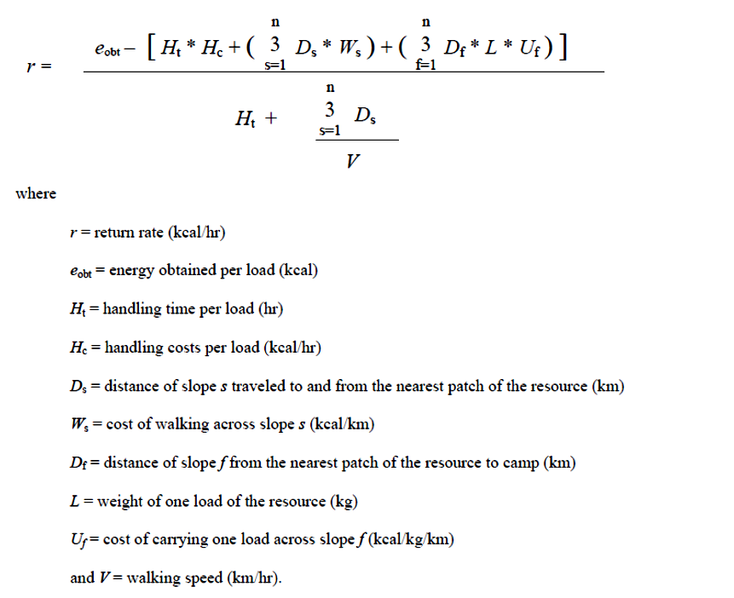

Figure 8.2: Central place foraging model algorithm used to calculate return rates (kcal) for plant food resources identified from research sites. Adapted from Hollenbach 2005:305.

Table 8.9: Roundtrip Cost Associated with Carrying One 15-kg Load Along Slopes.
Slope | Total Costs (kcal) by Distance (km)
% | 1 km | 2 km | 3 km | 4 km | 5 km | 6 km | 7 km | 8 km | 9 km | 10 km
40 | 283.2 | 566.4 | 849.6 | 1132.8 | 1416 | 1699.2 | 1982.4 | 2265.6 | 2548.8 | 2832
35 | 238.9 | 477.8 | 716.7 | 955.6 | 1194.5 | 1433.4 | 1672.3 | 1911.2 | 2150.1 | 2389
30 | 202.03 | 404.05 | 606.07 | 808.1 | 1010.12 | 1212.15 | 1414.18 | 1616.2 | 1818.23 | 2020.25
25 | 169.45 | 338.9 | 508.35 | 677.8 | 847.25 | 1016.7 | 1186.15 | 1355.6 | 1525.05 | 1694.5
20 | 138.18 | 276.35 | 414.52 | 552.7 | 690.87 | 829.05 | 967.23 | 1105.4 | 1243.58 | 1381.75
15 | 105.65 | 211.3 | 316.95 | 422.6 | 528.25 | 633.9 | 739.55 | 845.2 | 950.85 | 1056.5
10 | 85.8 | 171.6 | 257.4 | 343.2 | 429 | 514.8 | 600.6 | 686.4 | 772.2 | 858
5 | 63.15 | 126.3 | 189.45 | 252.6 | 315.75 | 378.9 | 442.05 | 505.2 | 568.35 | 631.5
0 | 56.5 | 107.2 | 163.7 | 220.2 | 276.7 | 333.2 | 389.7 | 440.4 | 491.1 | 553.4

Table 8.9 shows the costs (kcal) associated with a round trip across various slope angles and distances. Carrying costs were included for the most calorically expensive leg of the trip. These costs reiterate how important location would be to early horticultural pursuits. As expected, and displayed in Table 8.9, travel at higher elevations is much more costly in terms of calories expended than travel in areas with less of an incline. The real question becomes how much of an affect these costs actually had on resource selection at sites occupying different positions on the landscape.
Table 8.10 shows the results of those travel costs when calculated against the resources recovered from each of the five sites. What these calculations reveal is that those costs are minimal at best when calculated for the more highly-ranked resources while having a greater effect on resources that are lower-ranked. High-ranked resources, such as hickory, persimmon, and grapes, could be collected from greater distances before those costs would affect their caloric returns. Acorn and the small edible seeds were most greatly impacted by travel costs associated with higher elevation and slope. The range at which these could be collected efficiently was cut in half between the floodplains and upland sites (Figures 8.3, 8.4. 8.5, 8.6, and 8.7). These results are somewhat surprising, as travel in upland settings has often been cited as a potential reason that floodplains were more favorable locations for early horticultural practices. The presence of chenopod in the earliest deposits at Uzzelles indicates that the resource was available in the local environment and used. Based on the results in Table 8.10, each of the small seed crops recovered from Uzzelles could have been efficiently collected if placed in closer proximity to the site. Moving plant food resources around on the landscape was not a new practice by the time these resources appear at Uzzelles during the Woodland period.

Conclusions
For decades the processing costs associated with the earliest domesticated and cultivated seed crops have been cited as a prohibitive factor in their use and spread. The heavy reliance on these resources for approximately four thousand years tells a different story. The models presented in Chapter Eight each highlight important aspects of plant and landscape use. The diet breadth model showed the value of highly-ranked resources and the important role that they may have played in site selection and use. It also showed that edible seeds were unlikely to have ever been included in an optimal diet based on processing costs. However, the central place foraging model shows that they could be efficiently collected from each of the sites examined, although from farther distances at lower elevations. In terms of those more highly-ranked resources, these would have been efficient to collect from greater distances and less likely affected by travel in upland locations.

Table 8.10: Effective Foraging Radii for the Five Research Sites.
Position | Site | Plant Food Resource | Effective Foraging Radius
 | Mussel Beach | Hickory | > 10 km
Floodplains |  | Mulberry | > 10 km
Floodplains |  | Sumac | > 10 km
Floodplains |  | Cherry/Plum | > 10 km
Floodplains |  | Blackberry/Raspberry | > 10 km
Floodplains |  | Blueberry | > 10 km
Floodplains |  | Grape | > 10 km
Floodplains |  | Acorn | > 10 km
Floodplains |  | Sumpweed | > 10 km
Floodplains |  | Amaranth | 8 km
Floodplains |  | Maygrass | 5 km
Floodplains |  | Knotweed | 4 km
Floodplains |  | Black Walnut | 3 km
Floodplains |  | Little Barley | 3 km
Floodplains |  | Sunflower | 3 km
Floodplains |  | Chenopod | 2 km
Floodplains |  | Cucurbits | 2 km
Floodplains | Widows Creek | Persimmon | > 10 km
Floodplains |  | Hackberry | > 10 km
Floodplains |  | Hickory | > 10 km
Floodplains |  | Blackberry/Raspberry | > 10 km
Floodplains |  | Grape | > 10 km
Floodplains |  | Corn | > 10 km
Floodplains |  | Acorn | > 10 km
Floodplains |  | Maygrass | 5 km
Floodplains |  | Black Walnut | 3 km
Floodplains |  | Little Barley | 3 km
Floodplains |  | Chenopod | 2 km
Floodplains |  | Cucurbits | 2 km
Floodplains |  | Weedy Legume | 1 km

Table 8.10(cont.): Effective Foraging Radii for the Five Research Sites.
Position | Site | Plant Food Resource | Effective Foraging Radius
Dorans Cove | Russell Cave | Persimmon | > 10 km
Dorans Cove |  | Hackberry | > 10 km
Dorans Cove |  | Sumac | > 10 km
Dorans Cove |  | Cherry / Plum | > 10 km
Dorans Cove |  | Hickory | > 10 km
Dorans Cove |  | Blackberry/Raspberry | > 10 km
Dorans Cove |  | Grape | > 10 km
Dorans Cove |  | Acorn | 5 km
Dorans Cove |  | Ragweed | 2 km
Dorans Cove |  | Chenopod | 2 km
Dorans Cove |  | Black Walnut | < 2 km
Dorans Cove |  | Maygrass | < 2 km
Dorans Cove |  | Cucurbit rind | < 1 km
Uplands | Michaels Shelter | Sumac | > 10 km
Uplands |  | Grape | > 10 km
Uplands |  | Hickory | > 10 km
Uplands |  | Persimmon | > 10 km
Uplands |  | Acorn | 4 km
Uplands | Uzzelles Shelter | Hackberry | > 10 km
Uplands |  | Hickory | > 10 km
Uplands |  | Blackberry/Raspberry | > 10 km
Uplands |  | Grape | 9 km
Uplands |  | Acorn nutshell | < 4 km
Uplands |  | Maygrass | 1 km
Uplands |  | Sunflower | < 1 km
Uplands |  | Chenopod | < 1 km
Uplands |  | Wild Bean | < 1 km

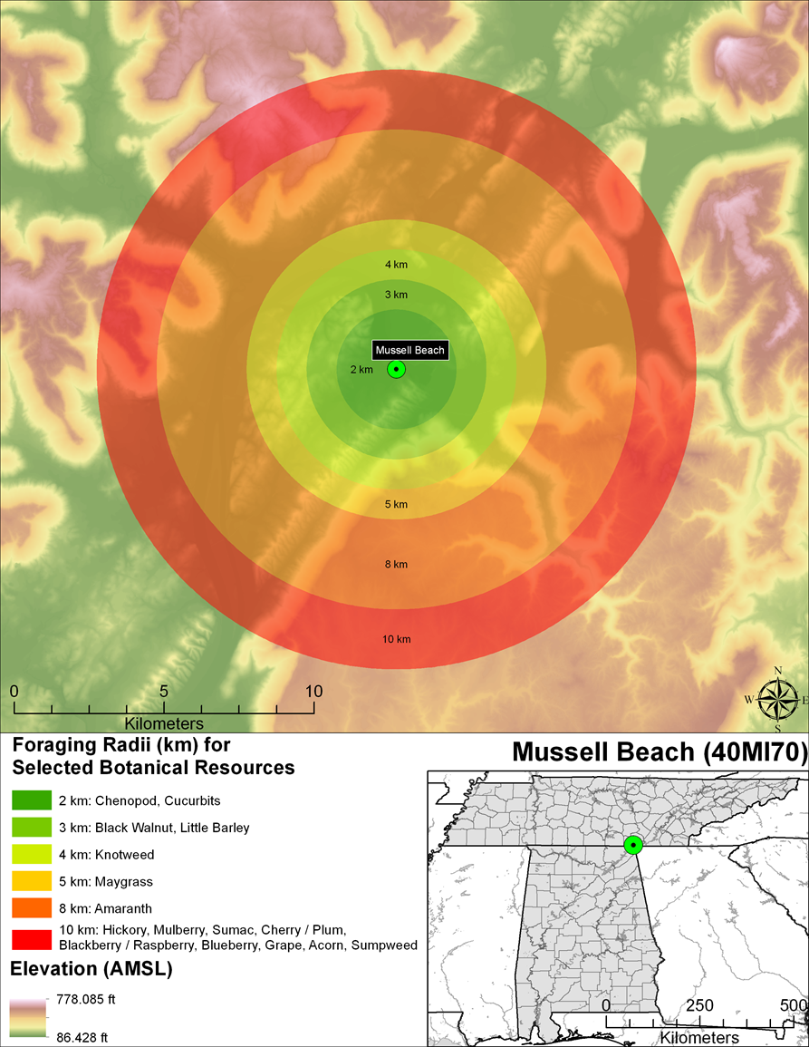
Figure 8.3: Image showing the effective foraging radius of different resources recovered from the Mussel Beach site.

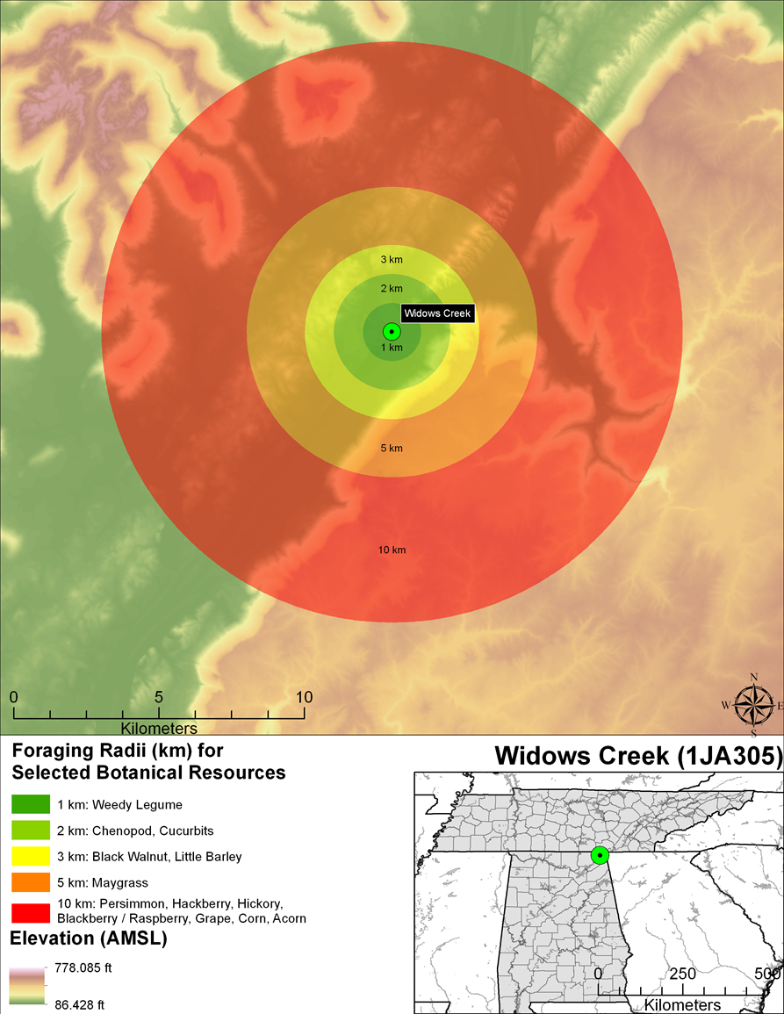
Figure 8.4: Images shows the effective foraging radius for resources recovered from the Widows Creek site.

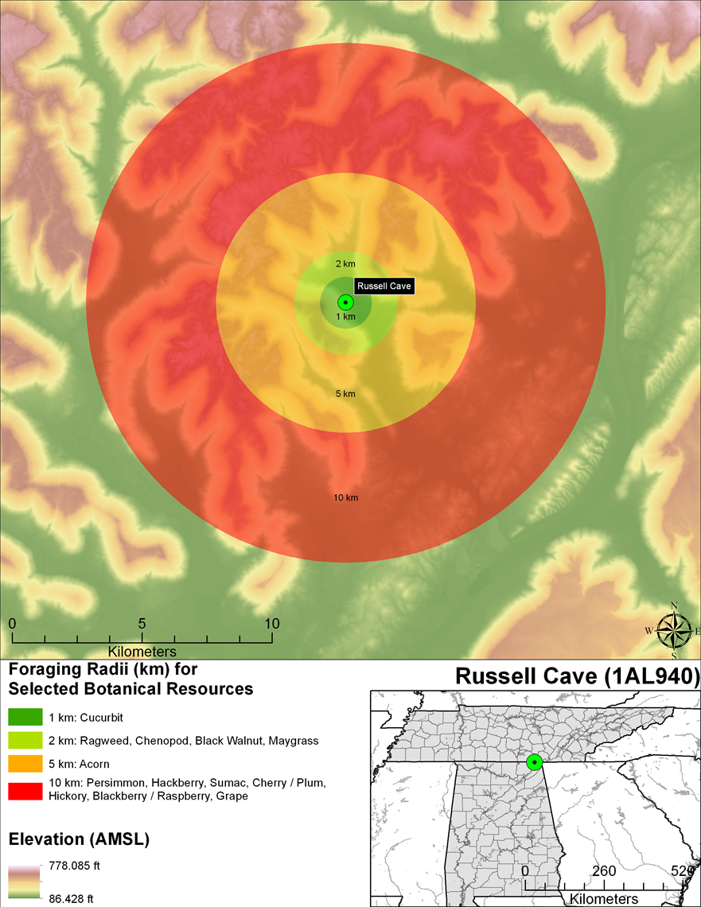
Figure 8.5: Images shows the effective foraging radius for resources recovered from the Russell Cave site.

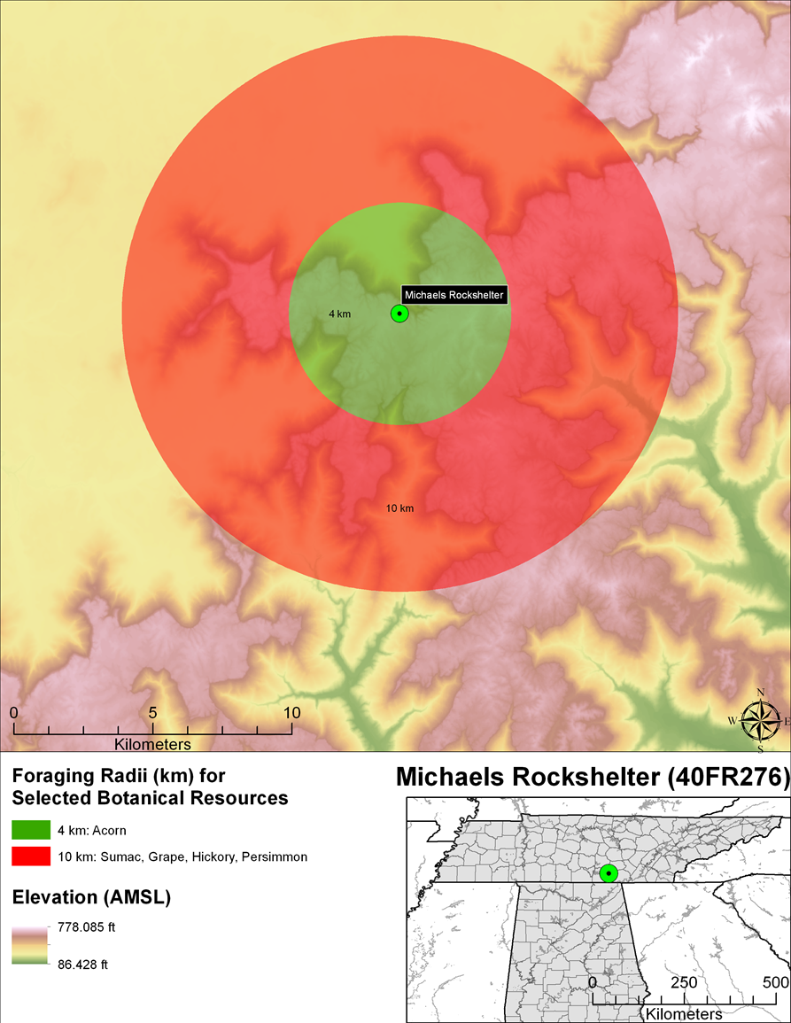
Figure 8.6: Images showing the effective foraging radius for resources recovered from the Michaels Shelter.

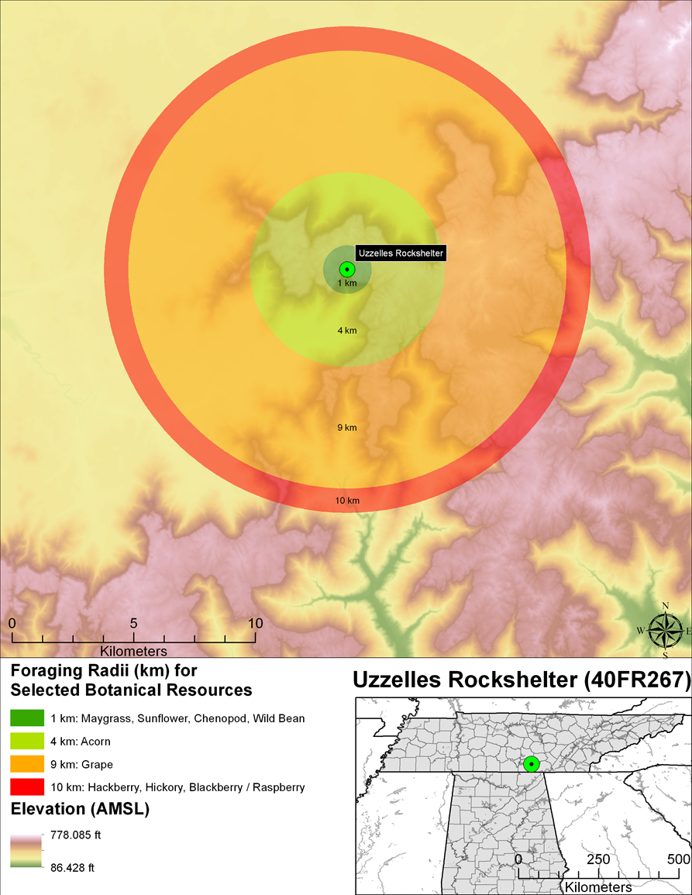
Figure 8.7: Image shows the effective foraging radius for resources recovered from the Uzzelles Shelter.

The diet breadth model suggests that highly-ranked food resources should always be included in the diet, however rare, and that conversely, those that fall outside of an optimal diet should never be included unless those highly-ranked resources become scarcer. It also states that a change that increases pursuit and handling efficiency of a previously unharvested resource should move that resource into the optimal set of resources. Winterhalder and Goland (1997:148) cite four possible causes that can lead to an increase in foraging efficiency or lead to a resource becoming more efficient to exploit, including increases in the density of highly ranked food resources, reduced search costs, changes in resource distribution, or increases in pursuit and handling efficiency (e.g. transportation, technology).
Based on previous research (Carmody 2009; Gardner 1997; Reidhead 1981) the likelihood that a shortage in mast resources would have resulted in edible seed crops inclusion into an optimal diet is unlikely. Acorn and especially hickory were calorically rich, abundant, and seasonally available. In years with bumper crops both would have even been available in greater numbers, although it is possible that these crops became a way to buffer against shortages in years between bumper crops. With the exception of limestone hoes recovered from Russell Cave and Uzzelles during Woodland period occupations, there appear to be no major technological innovations resulting in increases in pursuit and handling efficiency. The technology used to process edible seed crops is similar to that used to process nuts. In fact, large roasting pits, prepared clay surfaces, and grinding stones are found as early as the Late Paleoindian period across the Southeast. While historically, people would have argued that pottery predated and facilitated the production of seed crops, today it is clear that the domestication of seed crops predates early pottery traditions. While there is no doubt that pottery later plays a role in processing and preparing seeds for consumption and storage, this role could have been occupied by large pits in earlier times periods. Pots most likely represent a mobile form of previously used technology, such as pits and prepared clay surfaces. Although fired clay technology was not new, pottery allowed people to use that technology in new locations on the landscape, as settlement patterns changed.
Lowering the search costs and increasing the density of edible seed crops could have both been achieved by creating garden plots. Gardening would have created predictable stands of resources in select locations on the landscape that were either already being used for their perceived economic value or in locations that prehistoric groups selected. These sites could have been chosen for their proximity to other resources such as water, lithic resources, clay sources, and trade routes. The presence of wild chenopod in the earliest deposits at Uzzelles Shelter, Mussel Beach, and Widows Creek, followed by the addition of maygrass and domesticated Chenopodium in later deposits, suggests that this may have been the strategy. If prehistoric groups were using these locations for their predictable wild resources they could have added to those resources by moving other plants, like maygrass (Cowan 1985), to those locations and creating garden plots. This would have decreased search costs and increased plant densities at sites where more highly-ranked resources were still available, but maybe at greater distances. Those distances would not greatly impact the value of those resources as shown in Table 8.10.
Uzzelles Shelter would have been an ideal location for collecting and processing mast resources in the fall where chenopod was available and collected. Later, these interactions resulted in the domestication of chenopod and the addition of maygrass and sunflower. Mussel Beach and Widows Creek were possibly occupied for their proximity to wild resources, such as chenopod and hickory in the late summer and fall. Again, these interactions led to the domestication of Chenopodium, and other seed crops being introduced to the sites. Later, shellfish were collected adding to the importance of each site. Both Mussel Beach and Widows Creek sites were close to lithic outcrops and water that would have made travel and trade easier. So while these seed resources were not terribly important to foragers, by increasing their density and predictability, groups would have been able to settle into smaller territories as population pressure reduced territory size. Increasing densities made these plants valuable to horticulturalists, where their respective value to foragers may have been minimal, but not because they were nutritionally superior, but because they made the landscape more productive.
Table 8.11 shows the return rates of amaranth, chenopod, and sumpweed, based on the productivity and harvests yields of large, dense, wild stands encountered during research studies conducted by Asch and Asch (1977) and Smith (1992). These three resources are included here because experimental studies have provided the data necessary where other plants have not been subject to such detailed studies. They provide a baseline for further discussions about the value of seed crops and the values of increased densities. Large stands of each plant were found growing in the wild. Experiments involving collection and processing provided the data used to calculate the numbers in Table 8.11. The return rates (kcal) for each of the plants is greater than normal return rates for each of the plants. A travel distance of two kilometers was used to show that if these densities or similar increases in densities occurred in close proximity to a site return rates could be increased. The increase in return rate would still not likely move these plants into an optimal diet but does suggest that if these resources were managed their utility could be amplified.
Table 8.12 shows how travel costs from each of the selected research sites would have affected return rates of these plant food resources. Surprisingly, travel costs have a negligible effect on the overall return rates provided by the increase in density of these three resources. The return rates for amaranth and chenopod vary by approximately twenty calories between the floodplains and the uplands. The greatest difference is between the return rates for sumpweed where the return rate drops by approximately fifty calories between the two regions in question. Again, this highlights the importance that travel plays in foraging models and the effects of travel at various different locations across the landscape. There appears to be a minimal effect at best and not one that would exclude one location from being favored over the other.
Where the diet breadth model revealed the value of post encounter return rates on resource selection, the central place foraging model demonstrated how round-trip travel affected resource selection, and maybe more importantly, site selection. Another important assumption of the central place foraging model is that it posits that individuals travel from a home base, through unproductive environments, to reach more productive food procurement areas. While the benefit of garden plots for resource density was presented above, garden plots also had the ability to greatly augment efficiency of central place foragers. The creation of garden plots would reduce those unproductive areas or at least reduce the distance to productive areas by turning them into productive gardens. By moving plants to people, as opposed to moving to and through those resource patches and unproductive areas, efficiency would be greatly increased by reducing the amounts of unproductive areas on the landscape between sites and productive resource patches.

Table 8.11: Return Rates for Crops Based on Yields from Wild Stands.
 |  |  | Harvesting |  |  |  |  | Processing |  |  |  |  |  | Travel |  |  |  |  |  |  |  |  | Total Return
Taxon | Acres | kcal | Hours | Costs/Kcal |  | Hours |  |  | Costs/Kcal |  |  | km |  |  | Loads |  | Costs/Kcal |  |  |  | Kcal |  |  | Kcal/hrs.
Amaranth | 1 | 321,640 | 58 | 20,743 |  | 430 |  |  | 154,800 |  |  | 2 |  |  | 12 |  | 1,598 |  |  |  | 144,499 |  |  | 296
Chenopod | 2.5 | 4,862,000 | 867 | 312,120 |  | 6,500 |  |  | 2,340,000 |  |  | 2 |  |  | 190 |  | 25,137 |  |  |  | 2,184,743 |  |  | 297
Sumpweed | 2.5 | 3,210,000 | 461 | 165,960 |  | 1,200 |  |  | 432,000 |  |  | 2 |  |  | 127 |  | 16,802 |  |  |  | 2,595,238 |  |  | 1562
Table compiled from data provided by Smith 1992 and Gremillion 2002
Harvest and Processing costs calculated at 360 kcal/hr.

Table 8.12: Estimated Return Rates for Crops Placed Within A 1-km Radius of Sites.
Floodplain sites (5% slope)
 | Kcal | Cost kcal(p+h+t) | Net yield | Hours | Return
Amaranth | 321,640 | 177,141 | 144,499 | 492 | 293.69
Chenopod | 4,862,000 | 2,677,257 | 2,184,743 | 7,371 | 296.39
Sumpweed | 3,210,000.00 | 614,762 | 2,595,238 | 1,665 | 1558.70
Russell Cave (20% slope)
 | Kcal | Cost kcal (p+h+t) | Net yield | Hours | Return
Amaranth | 321,640 | 179,059 | 142,581 | 492 | 289.79
Chenopod | 4,862,000 | 2,707,790 | 2,154,210 | 7,371 | 292.25
Sumpweed | 3,210,000.00 | 635,171 | 2,574,829 | 1,665 | 1546.44
Uzzelles Shelter (35% slope)
 | Kcal | Cost kcal (p+h+t) | Net yield | Hours | Return
Amaranth | 321,640 | 185,131 | 136,509 | 492 | 277.45
Chenopod | 4,862,000 | 2,803,930 | 2,058,070 | 7,371 | 279.21
Sumpweed | 3,210,000.00 | 699,433 | 2,510,567 | 1,665 | 1507.84

Optimal foraging is thought to produce one of two results, either time minimization or resource maximization (Hames 1992:206). Resource maximization allows individuals to accumulate resources at a higher rate, whereas time minimizers optimize so that they may complete tasks in the shortest time possible, freeing up time for other activities. Time minimization however does not lead to increased foraging because greater fitness is achieved through the participation of activities that occur in the time gained as opposed to increased consumption (Hames 1992:206). For resource maximizers, increased foraging efficiency leads to increases in foraging because fitness is enhanced more through foraging than through engaging in alternative activities (Hames 1992:206; Winterhalder 1983:75-76). As populations increased, more food was required to support these rising numbers. Increased foraging efficiency could have been achieved where resource densities could be increased, search cost reduced, and unproductive areas between resources greatly reduced and replaced with a predictable food supply through the creation of garden plots
Based on the application of the diet breadth and central place foraging models, I believe that initial plant domestication in the region was not dependent on a specific ecological context, i.e., uplands or lowlands, but instead was the result of decisions made by individuals informed by knowledge of the local environment including the seasonal availability of plant food resources and the timing and scheduling of foraging activities. Knowledge of the physical landscape and the specific habitats of plants would have allowed groups to move plants outside of their native ranges if necessary to create gardens in specific areas on the landscape that were occupied heavily at certain times of the year. These gardens demonstrated the knowledge possessed by encouraging wild resources and creating new ones, and by creating new landscapes that allowed increased productivity on smaller tracts of land. These decisions would have greatly affected the density and distribution of the plant food resources, allowing for increased harvest yields alongside decreased processing and transportation costs. These changes made these plant food resources more valuable to prehistoric populations involved in the initial stages of food production. As certain plants were moved across the landscape, their densities were increased, making horticultural practices significant and beneficial. Garden plots were managed which improved efficiency in pursuit and handling and increased resource density and spatial distribution allowing these seemingly costly resources to find their way into the diet of prehistoric occupants across the Eastern Woodlands.

Chapter 9: Discussion
In this chapter, I incorporate the results of the botanical analysis from Chapter 6, the specifics of those plants including seasonality, habitat, and nutritional qualities outlined in Chapter 7, and the results of the models provided in Chapter 8 to answer questions about the geographic context of plant domestication in the Eastern Woodlands. I begin by briefly discussing the five sites and exploring the role that each played in the decision-making processes of early horticulturalists. I then discuss the landscape management practices employed by prehistoric, proto-historic, and modern Native American groups to better understand how these practices could have influenced early horticultural practices. I will then discuss the role of gender as it applies to landscape management and plant food resources. I conclude by offering some new perspectives on early horticultural societies and how each of the topics discussed influenced decisions of prehistoric populations leading to the domestication of plants in the Eastern Woodlands.
As presented earlier, the discussion regarding the specific region of plant domestication focuses on two geographic areas, the uplands and the floodplains. And while there is no doubt that this occurred “within the context of a stable, long-term adaptation to resource-rich environmental settings” (Smith and Yarnell 2009:6), the question of where those environments were found still persists. Were those environmental settings found in the floodplains at sites like Mussel Beach and Widows Creek, as suggested by Bruce Smith (1987, 1992), or in the surrounding uplands at sites like the Michaels and Uzzelles Shelters as suggested by various other researchers (Fritz 1990, 1997; Gardner 1997; Gremillion 2002; Munson 1986; Watson 1985, 1988), or both?

The Floodplain Sites
Currently, the most widely accepted theory for plant domestication in the Eastern Woodlands is the Floodplain Weed theory proposed by Dr. Bruce D. Smith in 1987. His theory suggested that prehistoric groups came into contact with cucurbit gourds, chenopod, and sumpweed that grew in the disturbed floodplain habitats of the Midsouth prior to the Middle Archaic period. However, that relationship changed during the Middle Archaic period as sites were occupied more frequently, creating open and disturbed habitats favorable for floodplain weeds that thrived in these new environments. Based on their abundance and substantial yields, these plants became favored resources. The use and storage of these plants eventually led to their domestication, exemplified by morphological changes in the seeds. Smith stated that cucurbits gourds, chenopod, and sumpweed began as floodplain colonizers and today “exist as well-adapted, long-established components of river valley vegetational communities” that are “tightly tethered to the disruptive ability of floodwaters to modify the landscape and create open habitats” (Smith 1992:28). Rich alluvial soils in areas of resource abundance have led to the conclusion that floodplains are the most likely candidates for the initial locations of plant domestication. The plant assemblages from Mussel Beach and Widows Creek, located on the banks for the Tennessee River, support that argument.

The Mussel Beach Site
The earliest definable occupation at the Mussel Beach site takes place during the Late Archaic period, with three distinct occupations. The Late Archaic I was described as a lithic reduction area by Gregory et al.(2011:641). He based this interpretation on the presence of lithic materials and the absence of faunal remains. Gregory also claimed that not much information could be gleaned from the plant assemblage recovered. However, if evaluated in terms of seasonality as opposed to return rates (Chapter 8), it may be possible to make more useful interpretations. The presence of both fall and spring available resource suggests that the site was visited more frequently than previously thought (Table 9.1). The presence of wild chenopod also suggests that it grew in the area surrounding the site and was most likely encountered and collected during the collection of other fall ripening resources, like hickory and acorn. By the Late Archaic II, the site appears to have been more intensively occupied based on the seasonality of the plant remains recovered, again demonstrating that the site was not merely a fall logistical camp site (Gregory et al. 2011:647). The shell middens and variety of plant remains recovered from the Middle Woodland component suggest that the site was heavily occupied and that the occupants were engaged in several different activities including extensive horticultural practices related to the appearance of domesticated chenopod for the first time at the site.
Table 9.1: Seasonality Implied from the Mussel Beach Site Features and Test Units.
Seasonality | Common Name | Scientific Name | L. Archaic I | L. Archaic II | L. Archaic III | M. Woodland | L. Woodland
Spring/Early Summer | Little Barley | Hordeum pusillium |  |  |  | X
Spring/Early Summer | Maygrass | P.caroliniana | X | X | X | X | X
Summer | Red Mulberry | Morus rubra |  |  | X | X | X
Mid to Late Summer | Blackberry/Raspberry | Rubus sp. |  | X |  | X | X
Mid to Late Summer | Blueberry | Vaccinium sp. |  |  | X
Mid-Summer/Fall | Cherry/Plum | Prunus sp. |  |  |  | X
Mid-Summer/Fall | Grape | Vitis sp. |  |  |  | X | X
Late Summer/Fall | Amaranth | Amaranthus sp. |  |  |  | X
Late Summer/Fall | Chenopod | Chenopodium sp. | X | X | X | X | X
Late Summer/Fall | Cucurbits | Cucurbita pepo |  | X |  | X
Late Summer/Fall | Honey Locust | Gleditisia triacanthos |  |  |  | X
Late Summer/Fall | Knotweed | Polygonum sp |  | X |  | X
Late Summer/Fall | Sumac | Rhus spp |  | X |  | X
Late Summer/Fall | Sumpweed | Iva annua. |  |  |  | X
Late Summer/Fall | Sunflower | Helianthus sp |  |  |  | X
Fall | Acorn | Quercus spp. | X | X | X | X | X
Fall | Black Walnut | Juglans nigra. |  |  |  | X
Fall | Hawthorne | Crataegus spp. |  |  |  | X
Fall | Hickory | Carya spp. | X | X | X | X | X

Table 9.2: Seasonality Implied from the Widows Creek Site Plant Assemblage.
Season | Common Name | Scientific Name | E. - L. Archaic | L.Archaic | E.Woodland | L.Woodland | T.Woodland
Spring /Early Summer | Little Barley | Hordeum pusillum |  |  |  | X
Spring /Early Summer | Maygrass | Phalaris caroliniana |  | X | X | X | X
Mid-Summer / Fall | Grape | Vitis spp. |  |  |  |  | X
Mid - Late Summer | Blackberry/Raspberry | Rubus spp. |  |  | X
Late Summer / Fall | Chenopod | Chenopodium sp. |  | X | X | X | X
Late Summer / Fall | Corn | Zea mays |  |  |  | X | X
Late Summer / Fall | Cucurbits | Cucurbita pepo |  |  |  | X
Fall | Acorn | Quercus spp. | X | X | X | X | X
Fall | Hackberry | Celtis occidentalis |  |  |  |  | X
Fall | Black Walnut | Juglans nigra |  |  | X | X
Fall | Hickory | Carya spp. | X | X | X | X | X
Fall | Persimmon | Diospyros virginiana |  |  | X | X
Fall | Weedy Legume | Fabaceae | X

The Widows Creek Site
The Widows Creek site has an occupational history similar to the Mussel Beach site, with a few interesting and distinguishing characteristics. The site has a general Archaic occupation that predates the occupation at Mussel Beach. The loss of chipped stone tools makes a more fine-grained interpretation of those deposits difficult. In those deposits, however, are acorn, hickory, and weedy legumes (Table 9.2), all fall-ripening plant food resources. During the Late Archaic occupation of the site acorn, hickory, and wild chenopod, along with maygrass, a spring-ripening resource, were all recovered. This pattern is very similar to that seen at the Mussel Beach site. The Early Woodland plant assemblage looks much like the Late Archaic assemblage from the site, with an increase in the number of resources exploited, suggesting a more intensive occupation at the site, and intensification in horticultural practices based on the appearance of domesticated chenopods. During the Late Woodland period, little barley, cucurbits, and maize were added to the suite of plant resources grown near the site.
Soils
While the soils of plant assemblages from the two sites look similar, two significant differences persist. The first is the absence of burials at the Mussel Beach site as opposed to the large number recovered from the Widows Creek site. Twelve burials were recovered from the Early Woodland deposits at the Widows Creek site and sixteen were recovered from Late Woodland deposits. There are several different interpretations for burials or cemeteries in the archaeological record. While opinions vary about the true meaning of burials, some have suggested that they represent or mark the centers, edges or boundaries of a group’s territory. The appearance of burials or cemeteries in the archaeological record shows a changing relationship between populations and their territories, creating a form of social geography (Pearson 1999:141). Hunter-gatherers lived in a social environment, or network of neighboring bands, not in a vacuum. Hunter-gatherers territories were maintained through habitual use and were delineated through distance from other groups, familiarity with local landscapes and environments, and by the natural landscape (Wobst 1974:153). Placing ancestors in a fixed location is believed to have been a social act carried out in order to create groups’ access or rights to natural resources, and express their relationships to the land (Pearson 1999:141). The remains of ancestors are also believed to signify a relationship of ownership to the land (Charles and Buikstra 1983:121).
The second difference between the two sites is the absence of a Middle Woodland occupation at the Widows Creek site, a time when the Mussel Beach site was most intensively occupied. Increased rainfall during the late Early Woodland and early Middle Woodland are believed to have resulted in the erosion of these deposits at the site (Cyr et al. 2013). The heavy Middle Woodland occupation upriver at the Mussel Beach site indicates that groups were still occupying the river valley during the Middle Woodland period.
The earliest definable occupation at both floodplain sites occurred during the Late Archaic period. At each site during these earliest occupations wild chenopod and maygrass are present. Because these sites fall out of the natural range of maygrass, its presence at the sites implies that it was brought in and most likely was grown in soils that supported other edible seed plants. This may have been a way for prehistoric groups to produce a separate plant food resource that would have been available during a different season. Domesticated chenopod appears at both sites during Woodland period occupations: during the Early Woodland period occupation at Widows Creek, and during the intensive Middle Woodland occupation at the Mussel Beach site. These were determined to be domesticated based on morphological variability seen between wild and weedy chenopods and these, changes described in Chapter Six. Both chenopod and maygrass are found in each occupational component at both sites. Eventually the sites’ occupants incorporated other seed crops into the crop complexes including amaranth, cucurbit gourds, knotweed, little barley, maize, sumpweed, and sunflower. Based on the plant assemblages from these sites, it appears that both locations were considered favorable for occupation before domestication occurred. These sites were most likely selected based on the presence and/or abundance of wild plant and mammal resources, access to waterways for travel and trade, and/or their proximity to lithic resources, and were eventually favorable locations for the collection of shellfish. Whether or not the wild plant resources were the primary reason for the location of these sites, they were available for collection and provided a food source for occupants. The duration of occupations at each site suggests that these sites had economic and social value. This is further indicated by the presence of burials at Widows Creek. These burials may provide evidence of a landscape that was being divided, where ownership over valuable economic resources was being displayed.
Rich alluvial soil is a critical component of the Floodplain Weed theory of plant domestication proposed by Smith (1987). The soils found in and around both Mussel Beach and Widows Creek are mapped as rich in essential plant nutrients and support the theory. They are suitable for horticultural activities that are indicated by the paleoethnobotanical analyses from the two sites. The soils at the Mussel Beach site consist of silty sands and loams with clay-like subsoils typical of river terraces (Figure 9.1) (Gregory et al. 2011:13). The primary soil series found within the site are Huntington silt loams, characterized as fluventic hapludolls. These soils are developed in well-drained alluvium formed from limestone washed down from the surrounding uplands (UDSA-NCR). They are rich in organic matter, highly fertile, and would have been ideal for horticultural and later agricultural practices. Lindside silt loams found nearby are classified as fluvaquentic eutrudepts (USDA-NCR). These soils are also common in floodplains and formed from limestone-rich alluvium washed down from nearby upland settings. They are moderately well-drained and also good for agriculture. Downriver from the Mussel Beach site, the Widows Creek site soils are similar to those in the area surrounding the Mussel Beach site. Lindside silt loams are the predominant soils with Huntington silt loams also present in the surrounding area (Figure 9.2).
Rich alluvial soil is a critical component of the Floodplain Weed theory of plant domestication proposed by Smith (1987). The soils found in and around both Mussel Beach and Widows Creek are mapped as rich in essential plant nutrients and support the theory. They are suitable for horticultural activities that are indicated by the paleoethnobotanical analyses from the two sites. The soils at the Mussel Beach site consist of silty sands and loams with clay-like subsoils typical of river terraces (Figure 9.1) (Gregory et al. 2011:13). The primary soil series found within the site are Huntington silt loams, characterized as fluventic hapludolls. These soils are developed in well-drained alluvium formed from limestone washed down from the surrounding uplands (UDSA-NCR). They are rich in organic matter, highly fertile, and would have been ideal for horticultural and later agricultural practices. Lindside silt loams found nearby are classified as fluvaquentic eutrudepts (USDA-NCR). These soils are also common in floodplains and formed from limestone-rich alluvium washed down from nearby upland settings. They are moderately well-drained and also good for agriculture. Downriver from the Mussel Beach site, the Widows Creek site soils are similar to those in the area surrounding the Mussel Beach site. Lindside silt loams are the predominant soils with Huntington silt loams also present in the surrounding area (Figure 9.2).
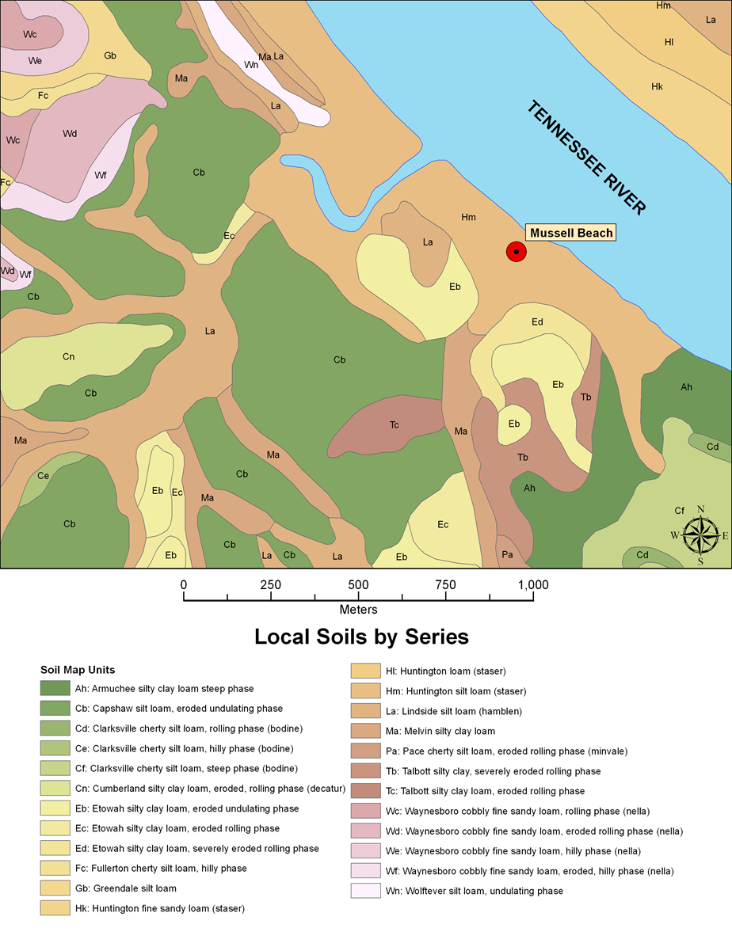
Figure 9.1: Soils in the vicinity of the Mussel Beach site and surrounding areas.

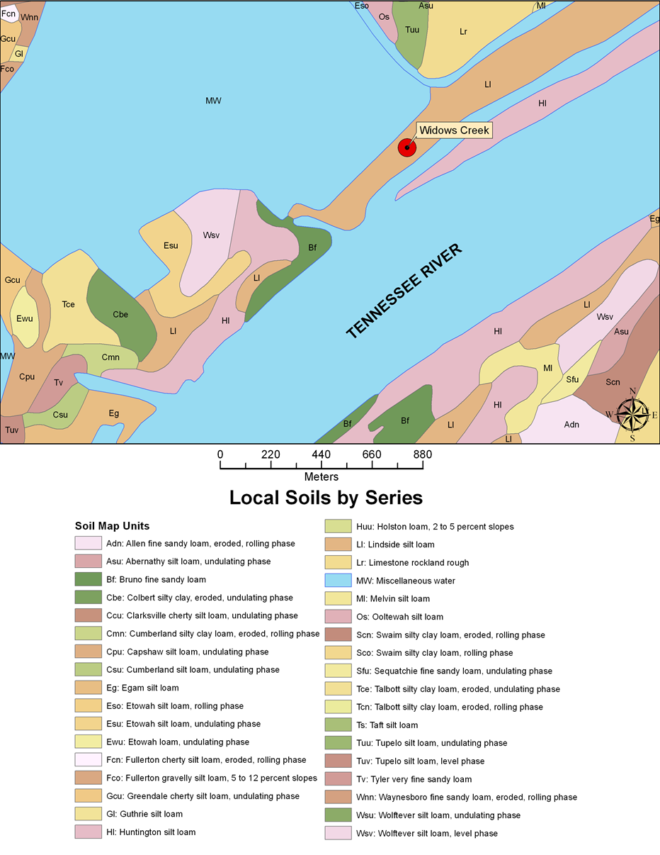
Figure 9.2: Soils found in the area surrounding the Widows Creek site.

The Upland Sites
While the Floodplain Weed theory is the most popular idea for initial plant domestication in the Eastern Woodlands, several researchers have suggested that the uplands of the Midsouth are equally as favorable a location, citing many of the same factors used by Smith (Fritz 1990, 1997; Gardner 1997; Gremillion 2002; Munson 1986; Watson 1985, 1988). Studies have shown that upland soils are as fertile as soils found in the floodplains due to high levels of organic carbon, available P, and C: N ratios. These studies also claim that increased levels of rainfall during the Middle Archaic period led to increased slope failures that would have created open and disturbed habitats favorable for weedy invaders (Gremillion et al. 2008:387; Windingstad et al. 2008:1717). It has also been suggested that hillsides would have been preferable over floodplains because fire, which was used to promote crops, would have been more effective on drier slopes than in floodplains where increased levels of moisture would have greatly reduced fire intensity, resulting in ineffective burning of large, dense stands of river cane (Ison 1991).
Also central to Smith’s hypothesis is the assumption that three of the four indigenous plants domesticated in the Eastern Woodlands were natural floodplain species and that their shared habitats and profiles as strong colonizers of disturbed floodplain soils provides enough evidence for their domestication in floodplain settings (Smith 1992:98). However, Smith has also acknowledged that plants like sumpweed and chenopod could have just as easily thrived in disturbed upland soils (Smith 1987, 1992:165). Also, modern surveys have provided evidence to suggest that Chenopodium might not have been as abundant in the floodplains as suggested and would have been equally as productive if cultivated in the uplands, where it would have had less competition (Asch and Asch 1977:26, 1978:319). Today sumpweed is found as commonly in upland settings, where it could have successfully grown prehistorically (Smith 1992:193). Even when introduced intentionally, no evidence exists that it would have been an aggressive colonizing plant (Asch and Asch 1978:319). Unlike chenopod and sumpweed, gourds are believed to have naturally occurred in river valleys. However, prior to domestication, the seeds and flesh were extremely bitter due to chemicals known as cucurbitacins, which would have made them inedible without costly processing techniques such as soaking, boiling, or crushing and boiling (Hart 2004:1632). As discussed in the previous chapter, even after domestication they would not have been considered a valuable food source. For these reasons, many researchers believe that they played a more significant role in fishing technology, used as floats for fishing nets, and possibly as containers, spoons, and cups (Cutler and Whitaker 1962:474; Fritz 1999:424; Gremillion 2003:32; Hart et al. 2004:141). Wild and weedy ancestral forms of sunflower, not included in Smith’s floodplains colonizers, have been documented through much of western and mid-western North America in a multitude of geographic settings between sea level and 2,500 meters above, and in areas of low and moderate rainfall (Arias and Reisberg 1995:240; Heiser 1954:299; Rieseberg and Seiler 1990:80; Smith 2014:57).
Each of these factors outlined above has led researchers over the years to question the Floodplain Weedy theory and look for alternative explanations and locations for the initial domestication of these indigenous plants. Michaels and Uzzelles Shelters provide an insight into an alternative location, the uplands.
Table 9.3: Seasonality Implied from the Michaels Shelter Plant Assemblage.
Seasonality | Common Name | Scientific Name | E.Archaic Midden | Middle Archaic | Woodland Midden
Summer / Fall | Sumac | Rhus spp. | X |  | X
Mid-Summer / Fall | Grape | Vitis spp. |  |  | X
Fall | Acorn | Quercus spp. | X | X | X
Fall | Hickory | Carya spp. | X | X | X
Fall | Persimmon | Diospyros virginiana |  |  | X

Table 9.4: Seasonality Implied from the Uzzelles Shelter Plant Assemblage.
Seasonality | Common Name | Scientific Name | E.Archaic Midden | Trans. Woodland | Woodland Midden
Spring / Early Summer | Maygrass | Phalaris caroliniana |  |  | X
Mid-Summer/Fall | Grape | Vitis spp. |  |  | X
Mid-Summer / Fall | Wild Bean | Strophystoles sp. |  |  | X
Mid / Late Summer | Blackberry/Raspberry | Rubus spp. |  |  | X
Late Summer/Fall | Chenopod | Chenopodium sp. | X |  | X
Late Summer/Fall | Sunflower | Helianthus annus |  |  | X
Fall | Acorn nutshell | Quercus spp. | X | X | X
Fall | Hackberry | Celtis occidentalis |  |  | X
Fall | Hickory nutshell | Carya spp. | X | X | X

The Michaels Shelter Site
Table 9.3 shows the seasonality of plants recovered from the Michaels Shelter. The analysis of plant remains indicates that the shelter was used primarily for the processing of acorns and hickory nuts, in the fall, during each period of occupation. This idea is further supported by the consistency in density of plant materials and relative densities of both hickory and acorn between the sites occupational components (Chapter Six). The lack of edible seeds further supports that idea and highlights the main difference between the plant assemblages recovered from the two upland shelters.

The Uzzelles Shelter Site
Table 9.4 shows the seasonality of plants recovered from the Uzzelles Shelter. Unlike the Michaels Shelter, there are noticeable changes over time in the plant assemblage recovered from Uzzelles. During the Early Archaic occupation of Uzzelles Shelter, each of the resources recovered represents a late summer to fall occupation of the site. The presence of wild chenopod suggests that it grew near the shelter. During the Woodland period occupation, maygrass and sunflower are added to the suite of small seeds used at the site along with domesticated chenopods. This evidence suggests the use of domesticates. Sunflower could have also grown in the area around the shelter or could have been introduced during the Woodland period occupation, along with maygrass. I argue that the introduction of maygrass along with the domestication of chenopod around the shelter strongly suggests that by the Woodland period groups were creating gardens in the uplands as well as in the floodplains to recreate natural stands of plant food resources lost as territories constricted and access to those resources was restricted. Their familiarity with the productivity of the landscape based on previous seasonal use of the site would have provided that knowledge.
Described previously in Chapter Four, Michaels Shelter formed in the Sewanee Conglomerate while Uzzelles Shelter formed in the Warren Point Sandstone. The main difference in these formations is the underlying geology and soils (Figure 9.3). These differences may provide a greater insight into the microenvironments of the two shelters, including why one shelter provided more suitable growing conditions than the other. Analysis of the mapped catena, the lateral variability of soils on a slope due to slope position and slope gradient, from the top of slope to the base of the drainage for each rockshelter reveals important differences between the landscape positions of the two shelters. Both areas contain sandy hapludults at the top of the plateau above the shelters. These soils are generally nutrient poor and have low natural fertility (Carmody and Sherwood 2014). While the soils around the two sites are similar in nature, there is other important difference between the two shelters that could explain the differential use of the sites. Michaels Shelter has a north-northeast aspect and is located at the top of the Plateau in a porous sandstone conglomerate where springs frequently form. Relative to Uzzelles, the upper slope is gentle with a taxonomic soil transect of Dystrudepts (the greatest area) - Eutrudepts (sandstone) – Eutrudepts (limestone). Uzzelles Shelter has a southern aspect and formed in a more resistant sandstone at the top of the steep slope with a taxonomic soil transect of Eutrudepts (sandstone) - Bouldery Sandstone Colluvium – Eutrudepts (limestone). The catena’s are similar in composition but have two important differences. The southern aspect of Uzzelles is more conducive to sun exposure and heat retention. The second difference is the steep slope surrounding Uzzelles relative to the gentle slope more typical of the Sewanee Conglomerate shelters located higher in the geologic sequence (Figure 9.4). The steep slopes at the Uzzelles shelter is made up of a type of Eutrudepts which is prone to rotational landslides. The soils, disturbance through landslides, and exposure to sunlight all found at the Uzzelles Shelter, and lacking at Michaels Shelter, may explain why the area around the Uzzelles Shelter was used to grow seed crops and why Michaels Shelter was used repeatedly as a mast processing site.
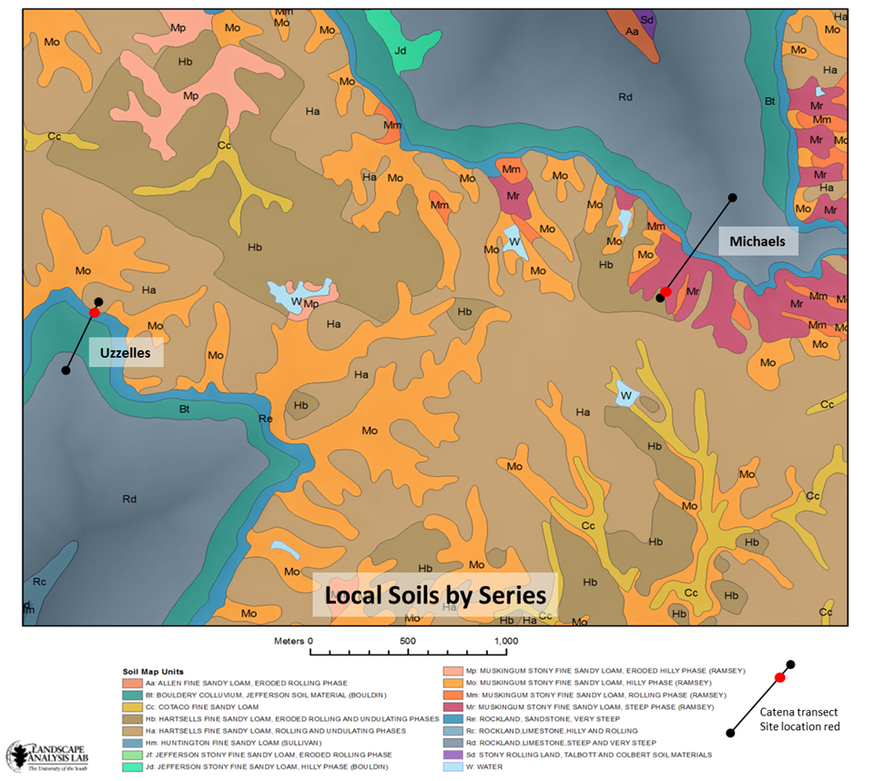
Figure 9.3: Soil profiles for the Uzzelles and Michaels Shelter.

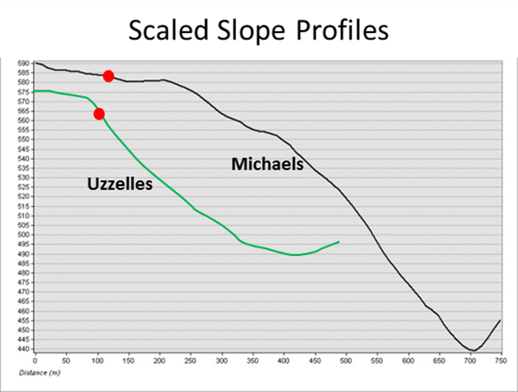
Figure 9.4: Scaled slope profiles for the Michaels and Uzzelles Shelters.

Table 9.5: Seasonality Implied from the Russell Cave Site Plant Assemblage.
Seasonality | Common Name | Scientific Name | E. Archaic | M. Archaic | L. Archaic | E.Woodland | Woodland
Spring/Early Summer | Maygrass | Phalaris caroliniana |  |  |  | X | X
Mid to Late Summer | Blackberry/Raspberry | Rubus spp. |  |  |  | X
Mid-Summer/Fall | Sumac | Rhus spp. |  |  |  | X
Mid-Summer/Fall | Cherry/Plum | Prunus spp. | X |  |  | X
Mid-Summer/Fall | Grape | Vitis spp. |  | X |  | X
Late Summer/Fall | Bottle gourd seed | Lagenaria siceraria |  |  |  | X
Late Summer/Fall | Chenopod | Chenopodium sp. |  |  |  | X | X
Late Summer/Fall | Cucurbit rind | Cucurbita pepo |  |  |  | X
Late Summer/Fall | Ragweed | Ambrosia trifidia |  |  |  | X
Fall | Acorn | Quercus spp. | X | X |  | X | X
Fall | Black Walnut | Juglans nigra |  |  |  | X
Fall | Hackberry | Celtis occidentalis |  | X
Fall | Hickory | Carya spp. | X | X | X | X | X
Fall | Honey Locust | Gleditsia triacanthos |  |  |  | X
Fall | Persimmon | Diospyros virginiana |  |  |  | X

Russell Cave
Russell Cave represents a different position on the landscape, located between the uplands and the floodplains. The use of the site has been determined through the analysis of lithics, faunal remains, and ceramics. Based on the analysis of plant materials included in this study it appears that Russell Cave was used seasonally by its earliest inhabitants. The plants recovered from each of the Archaic occupations suggest that the site was used during the fall, which complements previous analyses of the site’s use (Table 9.5) (Griffin 1974). A major shift in site use comes during the Early Woodland period when there appears to be an intensive occupation at the site accompanied by the appearance of storage pits containing caches of chenopod seeds and maygrass. Other Early Woodland deposits contained several other cultigens and domesticates found across the Eastern Woodlands. Based on the plant remains recovered it appears that the site was occupied for a greater period of time than during the Archaic period occupations. Deposits described as general Woodland, positioned above the definable Early Woodland deposits, were highly disturbed but tend to suggest that occupation of the site was not as intense during the later Woodland and Mississippian occupations.

The presence of six burials from the Early and Middle Archaic period deposits at Russell Cave makes the interpretation of the site more interesting. As previously discussed, in regards to the Widows Creek site, several interpretations for burials exist. Most believe that burials represent territorial boundaries and reflect a change in social geographies (Pearson 1999:141). The burials discussed at the Widows Creek site were recovered from Early and Late Woodland contexts, while those recovered from Russell Cave were found in earlier Archaic deposits. As noted above, in the Midwest, Charles and Buikstra (1983) have suggested that burials were a way for Archaic populations to mark their territories, especially when they were located near valuable resources, establishing rights to sites among kin groups, and using cemeteries to ritually signify a relationship to lands and territories. The remains of ancestors also signify a relationship of ownership to the land (Charles and Buikstra 1983:121). If people were planting gardens in the uplands above Russell Cave, at locations like Uzzelles Shelter and Russell Cave, the cave itself would have provided an ideal storage location. Its proximity to Dry Creek would have made it an easy location to get in and out of for storage purposes. This type of landscape use is similar to patterns observed today in California among the Sierra Me-Wuk, a tribe whose villages owned small tracts of land and the rights to its resources. People accumulated surpluses in the uplands during productive seasons and then moved to and stored these resources in the foothills, before snowfall would have prevented winter habitation (Whelan et al. 2013). This type of landscape use has important implications for understanding early horticultural societies in the Eastern Woodlands and the role that defined territories played in that process.
The soils around Russell Cave are more varied than those found around the other four sites. The soils above the cave are Rockland limestone soils. They are poorly developed, shallow loamy soils formed in colluvium on steep slopes. The soils around the cave entrance, however, are rich soils of the Jefferson and Holston series. Both soils are described as Paleudults or old, well-drained soils that would be suitable for horticulture. The Jefferson series soils are more susceptible to rotational landslides that would have created open areas in deciduous forests, ideal microenvironments for weedy species. Holston series soils are described as deep, well-drained soils that form in old limestone alluvium or colluvium. These soils were also favorable for farming. Below the cave the soils are predominantly mapped as the Sequatchie series (NRCS web soil). This series consist of deep, well-drained soils that form in loamy alluvium found on low terraces, foot slopes, and benches in limestone valleys. They contain low to moderate amounts of organic matter so are generally low in fertility. They also would have been suitable for horticulture but not as good as those soils of the Jefferson and Holston series found around the cave.
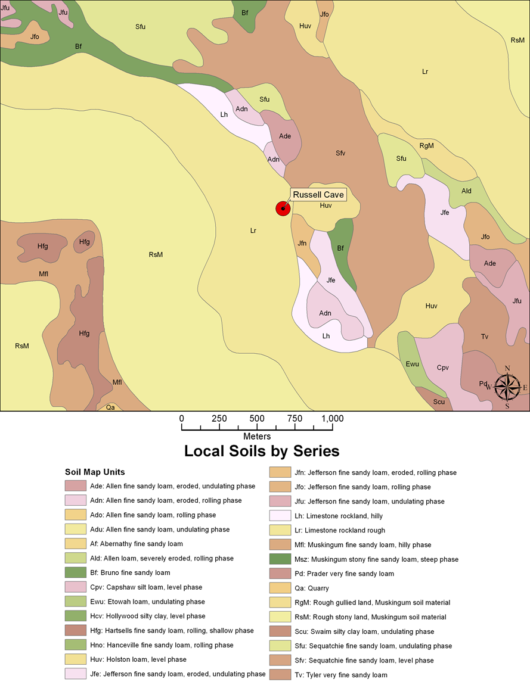
Figure 9.5: Soils from around the Russell Cave site.

Summary
In summary, the presence of wild chenopod at Mussel Beach and Widows Creek is not surprising; its presence in the Early Archaic deposits at the Uzzelles Shelter has greater implications for initial plant domestication in areas where prehistoric groups encountered the resources in the wild. The addition of maygrass, and possibly sunflower, into a multiple cropping system at the Uzzelles site suggests that groups understood the economic potential of the land and not only were able to cultivate wild plant foods that occurred in the area naturally but were able to introduce non-native species successfully. The dissimilar plant assemblage recovered from the Michaels Shelter seems to suggest that the landscape and its ecology were well understood as well as the economic potential that it possessed. The plant assemblage at Michaels indicates that, throughout the site’s long use, it was primarily used for the collection and processing of mast resources, mainly hickory and acorn, while a few miles away at the Uzzelles Shelter a suite of crops were introduced and produced. The two rockshelter assemblages analyzed in this study shed light into the use of the landscape over several thousand years of prehistory on the southern Cumberland Plateau. They speak of larger patterns at play on the landscape involving mobility and organization. The proximity of the two shelters and the differences in the plants recovered provide unique insight into the use of the uplands and reinforces the idea that landscapes should never be viewed as homogenous territorial wholes (Johnson 1977:488). Moreover, these insights indicate that classifications like the uplands versus floodplains often trivialize the unique aspects of individual sites and helps reveal why they were selected for use and reuse prehistorically. The extensive occupations at each of the sites analyzed provides great insight into shifting foraging practices as well as the transition in subsistence practices between foraging and initial horticultural economies across the region. The time depth represented by multiple occupations at each site speaks to the economic and social importance of each.

Land Management Practices and the Formation of Gardens
Native Americans had an intimate knowledge of the natural world and its resources. Today, models like Caldwell’s Primary Forest Efficiency model (1958) have been largely refuted, as research has demonstrated that all prehistoric populations modified the natural landscape to their advantage. A great deal of literature has been dedicated to the prehistoric use of fire by Native Americans in the Eastern Woodlands, enough at least to suggest that pre-Columbian peoples were well aware of the effects that burning had on the natural landscape (Abrams and Nowacki 2008:1123; Delcourt and Delcourt 2004; Hammett 1992, 1997) and the resulting increased productivity of seed crops (Chapman and Shea 1981; Chapman et al. 1982:115; Cowan 1985b; Fowler 1986:91; Watson 1974; Yarnell 1974, 1993:25).
Arboriculture, or silviculture, is believed to have been practiced in the Eastern Woodlands, with groups curating productive stands of oak and hickory trees (Delcourt and Delcourt 2004; Gremillion 2010; Hammett 1992, 1997; Munson 1986; Yarnell 1964:82). The creation of orchards and movement of perennial fruit vines, bushes, and trees has also been suggested by several researchers (Abrams and Nowacki 2008; Fowler 1986:91; Gremillion 1998, 2010; Hammett 1997:201; Swanton 1946:281) and recorded by early explorers and ethnographers. Ethnohistoric accounts suggest that Native Americans manipulated the landscape in order to produce orchards of fruit and nut trees. In 1773, while traveling through the Southeast, William Bartram reported observing “orchards” of persimmon, honey locust, and red mulberry along with hickory and black walnut trees “thriving and fruitful” (Bartram 1973:343). He further noted that these trees were “native to the forest, yet thrive better and are more fruitful in cultivated plantations” (Bartram 1973:38). Early accounts from Spaniards reported traveling through “leagues of fields and found sufficient grain to feed the army for months on end” (Scarry 2008:396). Plants like tobacco and yaupon holly, both plants that were held in high regard for the medicinal or spiritual purposes, were also transplanted and managed (Fowler 1986:91; Hammett 1992:200; Winter 1991). The type of knowledge and skill necessary to create and maintain stands of hickories and oaks, as well as fruit trees, certainly would not have been lost on other plant food resources, like the domesticates and cultivars relied upon so heavily across the Eastern Woodlands. Clearing practices, the use of fire, and communal ownership of natural resources all would have had serious implications towards land use and early horticultural practices. These practices would have increased plant densities, as well as crop yields, through minimal amounts of labor. These changes would have been apparent and might indicate why the sites were used repeatedly throughout prehistory.
The planting of indigenous crops by Native Americans should have been approached with the same levels of intensity and vigor that was applied to tending stands of fruit and mast producing trees. Broadcasting seeds would have resulted in dense stands as demonstrated by husbandry practices used today on analogous plants like quinoa, buckwheat, and millet (Gade 1970:60; Halstead and Jones 1989:42; Scarry 2008:397). Le Page du Pratz described the Natchez of Mississippi planting “choupicoul”, which many believe to have been Chenopodium, writing that both women and children sowed the grain and then covered it with their feet, but did not tend it during the growing season (Gilmore 1931; Scarry 2008:397; Smith 1992). This type of planting, similar to broadcasting, is believed to be the method that would have been used by Native Americans to plant indigenous seed crops. The recovery of maygrass and chenopod from Mussel Beach, Russell Cave, Uzzelles, and Widows Creek suggests that these crops were planted in close proximity to each other. Smith (1992) suggests that the presence of domesticated Chenopodium along with maygrass represents the initial adoption of, or a substantial addition to, a pre-maize field cropping system from an earlier system of small garden-plot cultivation, and that this shift represents a major economic and social transformation. Maygrass, providing a yield in late May/early June, and chenopod, a fall-maturing crop, could have formed a primary-secondary starchy seed crop complex providing important nutrients at two important times of the year. Also, he suggests that the harvesting of maygrass would have overlapped with the planting of Chenopodium in garden plots, further supporting the possibility of a multiple cropping system.
Scarry (2008) suggested that initial horticultural practices could have been approached similarly to maslins in Europe. Maslins are similar crops that are planted together. Seeds are mixed and then spread by broadcasting, resulting in fields of crops that were harvested together also, similar to fields of wheat (Halstead and Jones 1989:51). Scarry (2008) suggested that possibly spring-ripening maygrass and little barley and fall-ripening chenopod and knotweed could have been planted this way and that archaeological evidence supports the practice. While there are caches of a single species, such as chenopods at Russell Cave in Alabama and Ash Cave in Ohio (Griffin 1974; Miller 1960; Smith 1985a, 1985b) and sheaves of maygrass recovered from Ozark Bluff shelters in Arkansas and Newt Kash Hollow in Kentucky (Fritz 1986; Gilmore 1931; Jones 1936), caches or mixtures of seeds have also been recovered from various sites, suggesting that there were a variety of practices used by Native Americans across the Eastern Woodlands. This type of practice would have increased yields in gardens with little effort or maintenance required.
The practices and techniques necessary to manage gardens would have been familiar to groups who had managed landscapes. Establishing gardens would have become economically necessary through time as territories became smaller and access to resources became more restricted. Knowledge acquired during annual foraging rounds was critical to the success of early horticultural systems and future agricultural systems. It was in these gardens that plants whose use dated back to the Paleoindian period were changed genetically and phenotypically, beginning as wild plants that grew outside of human-made habitats, which became weedy plants that were adapted to and tolerated within human environments, and eventually were cultivated with a few undergoing genetic alteration and phenotypic morphological changes. The process of domestication changed the relationship between prehistoric groups and nature. Where hunter-gatherers’ daily activities were structured by the distribution of natural resources that they depended upon, horticulturalists, and later agriculturalists, manipulated the natural world to their advantage, living outside of nature (Ingold 1996).
While there is no doubt that these garden plots had important economic implications, they also would have been critically important socially. The knowledge of the physical landscape and the natural world once shared and passed on in annual foraging rounds was now shared in garden contexts. Gardens were more than just inanimate places where wild and cultivated plants grew; they became the place where relationships between individuals and nature grew and developed. These plots were places where environmental knowledge was learned and where social roles and identities were created and maintained (Johnston 2005:212). The success of these systems depended on rules and relationships that were as complex as those that existed in the rest of society. These relationships created through gardening practices, like the preparation and consumption of food, are cultural and structured by social relations and identity (Johnston 2005:218). These practices also provided conditions for identity to be expressed and maintained, and many have suggested a connection between food processing areas and activities and the emergence of increased differentiation between the political roles of men and women, or the definition of gender roles through gardening based on the division labor, rights to access and use, and/or control of knowledge (Johnston 2005:218).

Gardens and Gender
In 1995, Watson stated that any explanation for a transition to agriculture “must accommodate intentional decision making and problem solving by humans of all ages and both sexes” (Watson 1995:37). Worldwide, horticultural activities in non-traditional farming societies have been viewed as communal and gendered, where men assisted in clearing, planting, and harvesting, but women were primarily responsible for preparing fields, planting, weeding, and harvesting (i.e. nurturing) (Boserup 1970:16 -19; Scarry 2008:395; Scarry and Scarry 2005:261; Swanton 1946). Ethnographic and ethnohistorical literature suggest that women in foraging societies possess extensive knowledge of plants because they are responsible for gathering, collecting, harvesting, and processing these resources (Boserup 1970; Watson and Kennedy 1991:268). At the time of European contact in North America women were the primary agents involved in activities surrounding plants (Fritz 2000:248). Archaeological studies have shown that women were most likely responsible for gathering plant resources; occupation and activity sites were selected and annual rounds structured around the seasonal availability of gathered plant food resources (Hollenbach 2005, 2009; Jackson 1991). And while that knowledge of the plant world is greatest among women, who collect, gather, harvest, and process plant food resources, that knowledge extended beyond food to include dyes, textiles, and medicines (Watson and Kennedy 1992: 269). If these roles were truly those belonging to women in prehistoric societies, then the important role that women played throughout prehistory in scheduling, collecting, processing, and preparing plant food resources suggests that they played a critical role in the domestication of plants. However, while most researchers have no problem crediting women for the role they played in plant collection, processing, and preparation in prehistoric societies, there is an incredible reluctance in many instances to credit women with any role in the domestication of plants. If women were responsible for the majority of activities associated with plant use, then it makes sense that women were most likely responsible for making decisions that led to initial plant domestication, such as how and where to move plants outside of their native range, storing, and planting seed crop plants (Fritz 2000:248; Hastorf 1998:779; Watson and Kennedy 1992:269)
Mussel Beach and Widows Creek are interesting sites in terms of gender-related activities because both shellfishing and the collection of plant food activities are considered to be largely the work of women (Claasen1992; Waselkov 1987). Claasen stated that women were always the primary collectors of shellfish while Waselkov stated that in all societies; women participated more heavily in shellfishing activities than men (Claasen 1992:277; Waselkov 1987:99). Perhaps the fact that each of these activities is believed to have resulted in the collection of sub-par, economically-inferior food resources suggests that their collection was less about their economic potentials and more about personal choices in resource selection. Or, perhaps it reflects an attitude where hunting of game is a more important activity than the gathering of plants or shellfish.
Shellmound sites reflect long-term use sites in resource-rich areas with rich alluvial soils. Both shell-bearing sites included in this study were occupied prior to the accumulation of shell deposits and in both of the earliest occupations chenopod and maygrass were recovered, reflecting use of the site in the spring and in the fall. With the addition of shellfish in later occupations, both sites could have been occupied for longer periods of time with spring resources of maygrass and little barley, summer resources of shellfish, fruits, and sunflower, and fall-ripening resources including chenopod and knotweed. While these resources on their own may not be economically beneficial, when viewed as a suite of resources, gardens of seed crops in addition to shellfish in the floodplains and possibly mast resources in the uplands provide stable and predictable resource bases. Additionally, men could hunt from these logistical base camps that were situated to facilitate women’s foraging and collecting activities (Zeenah 2004). Gardens would have served as logistical plant processing sites used for wild and domesticated/cultivated resources. The knowledge of the plant world would have allowed women to select plants that they knew produced at certain times and in certain places. This would have allowed women to forage closer to home and watch small children who were more burdensome on longer foraging trips, resulting in decreased levels of efficiency for long foraging trips, but increased efficiency with garden plots (Bird and Bleige Bird 2005:135; Bleige Bird 1999; Blurton et al. 1994; Hames 1992; Hawkes et al. 1997:560; Hurtado et al. 1985; Hurtado et al. 1992; Marlowe 2003:219, 2005:189; Tucker and Young 2005:151). The distribution of shell midden and rockshelter sites may represent logistical base camps distributed across the landscape purposefully or intentionally, similar to acorn processing and storage facilities reported by Jackson (1991:303). These sites were strategically centered on areas where production focused, revealing patterns of inter-site spatial organization.
The knowledge of the natural landscape and plants should be viewed as the initial stage of domestication. With that knowledge groups were able to relocate plants and create gardens most likely in areas that were already of some economic value and where they were familiar with the landscape and the opportunities that it provided. The time depth represented at each of the sites included in this study speaks to their importance on the landscape. As women created and maintained gardens, they set up conditions necessary for domestication to occur. Evidence of domestication in the form of morphologically altered seeds is the end result of this process, and dates across the region are well-established and commonly accepted. The interesting question revolves around when these processes began. If changes in settlement/subsistence models, decreasing foraging ranges, and increased territories are an indication, then it is likely these events began to unfold during the Middle Archaic period, when we see evidence of these events. How often these gardens were revisited in order for plants to undergo the morphological changes that we recognize as the unquestionable signatures of domestication are unknown.
In the end, whether domestication was a purely economic endeavor is and will remain uncertain but the fact that women were principally involved is not. Domestication is about relationships between people, the plants that they exploited, and the landscapes that they acted upon. To disregard the role that men, women, and children played in the incredibly transformative process discredits the experimental, innovative, and creative nature of humans and allows for the process of domestication to be attributed only to the “faceless blobs” (Tringham 1992:94). Gender, like domestication, is also about relationships or sets of relationships. As relationships changed between people and the landscape they also changed between individuals within groups. Many have suggested that the creation of gender developed or accelerated as a result of the division of labor in food production. Gardens became the locations where these changing relationships between nature and society were played out. They were biologically necessary for the food and nutrition that they created and provided, but were as important socially for constructing and reproducing society.

Chapter 10: Conclusion
"The cultural landscape is fashioned from a natural landscape by a culture group. Culture is the agent, the natural area is the medium, the cultural landscape is the result" (Carl O. Sauer 1963).
The five sites included in this dissertation research represent different locations across the physical landscape that were selected for use due to the economic and social benefits that they provided. As such they represent the larger cultural landscape of the Eastern Woodlands, meaningful and constructed, and as such have the potential to inform us about prehistoric life and more importantly the environmentally and culturally transformative process of domestication. Through the research presented, I have presented the case that plant domestication on the southern Cumberland Plateau, and likely the greater Eastern Woodlands, was the direct result of deliberate and skillful actions of prehistoric groups occupying the region. Their decisions to modify and reshape the landscape resulted in phenotypic and genetic changes in plant species and had equally as consequential effects on prehistoric lifeways. Plant domestication is the story of relationships and how those relationships changed through time between people, plants, and the greater landscape.

Changing Relationships between People
During the Early Archaic period hunter/gatherers moved relatively freely across the landscape in pursuit of wild game and plant food resources, relocating from resource patch to resource patch as required. However, as populations increased and residential mobility patterns gave way to logistical foraging strategies the landscape was used in a much different way (Binford 1980:17; Eder 1984:851; Kelly 1992:53). Reduced mobility during the Middle Archaic period is witnessed in changes involving trade, territoriality, and demography (Kelly 1992:43). Long-distance trade networks, exemplified by the Benton Interaction Sphere and the trade of bone pins across the region, have been viewed as a way of averaging spatial variation of resources due to greater competition and population pressures (Brookes and Johnson 1989; Cashden 1992; Jefferies 1995, 1996, 1997; Meeks 1998). Territoriality is evident in the emergence of cemeteries at sites like Widows Creek and Russell Cave, and through evidence of interpersonal violence in the archaeological record during this period (Sherwood et al. 2004; Shields 2003).
As territories and mobility were reduced, so were resources bases, and once familiar foraging patches would have been lost. The intimate knowledge of the plant world and communities would have allowed those with the knowledge to move plants they once relied upon into new locations. These new resources patches, or gardens, would have most likely been placed in locations that were used seasonally prior to the restructuring of territories, and where these resources naturally occurred. The type of logistical organization that replaced residential territoriality involves a different level of organizational complexity in which tasks and task groups perform specific activities at favorable locations. Specialized tasks groups associated with this type of mobility are critical when there are time limits involved in harvesting wild resources, and would have allowed groups to procure large amounts of food at lower costs. The type of cooperation necessary in logistical mobility is important in the formation of social hierarchies seen during the Middle Archaic period (Anderson 2004:270; Boone 1992:311; Kidder and Sassaman 2009:674). Over time these logistical systems create an archaeological record that becomes more redundant at a site as the environment increasingly becomes divided between groups on the landscape, a pattern witnessed at each of the sites included in this study (Ames 1991:165; Binford 1983; Graham and Roberts 1985). These logistical systems and tasks groups would have enabled the recreation of wild resources patches within limited spaces and territories. They would have created more dense resource stands that favored foraging groups by limiting travel, increasing resources within a confined area. I argue then that the early stages of plant domestication indeed began during the Middle Archaic period as a result of a changing landscape.

Changing Relationships with Plants
As relationships between people changed, so did the relationship between people and plants. There is no greater evidence of this change than the phenotypic variability expressed by the seeds of a limited suite of wild and domesticated taxa and the increased reliance upon other plant taxa whose seeds do not exhibit those morphological changes indicative of domestication. The general knowledge of the plant world would have accrued over time from exploiting these natural resources. That relationship changed as groups became more aware of where these plants occurred naturally, that they were present from year to year, and eventually could be moved on the landscape. Wild and weedy plants were utilized, later encouraged and cultivated, and eventually domesticated. Where cultivation is seen as more of a natural process, domestication is the unintentional consequence of very deliberate and intentional actions. Early horticulturalists were active participants in the natural world in which they lived. They actively altered their environments and as a result domesticated plants, changing the relationship that existed between them.
The end result of this process is a change to the genotype and phenotype of these plants as they became reliant upon humans for their reproductive success. This process can be intentional or unintentional as humans have repeated interactions with the wild ancestors or their domesticated forms. Domesticates are new varieties or subspecies created from existing or wild populations as a result of incidental or active selection by people (Winterhalder 2006:3). Selection led to biological changes that were advantageous to people, such as larger seeds sizes and thinner seed coats. These new species depended on humans for their survival. The link between hunter-gatherers and agriculturalists were those groups who began practicing mixed foraging-cultivation strategies, or low-level food production (Winterhalder and Kennett 2006:3). These groups relied significantly on hunting and gathering wild resources, while using some cultigens or domesticated animals. Horticulture or the small-scale planting of domesticated species accompanied by a large reliance on the hunting and gathering of wild resources would fall into this category. This type of economy was practiced successfully for thousands of years before prehistoric populations became fully reliant upon agriculture (Winterhalder and Kennett 2006:4).

Changing Relationships with the Landscape
Hunting and gathering involves fulfilling daily sustenance needs through the pursuit and collection of wild foods, or resources whose reproduction and survival do not depend on human involvement (Winterhalder and Kennett 2006:3). Eventually, though, hunter/gatherers transformed the landscapes upon which they lived by burning, transferring plant and animal species between natural habitats, and interjecting themselves into the life cycles of other species (Hastorf 1999; Smith 1998; Winterhalder and Kennett 2006:3). Those relationships that altered plants from wild to domesticate had a profound impact on these populations’ relationships with the landscape as well as on the landscape itself. The new plants that were created through active management practices and decisions relied on humans for their growth and reproduction. The benefits that these new plants provided resulted in the reoccupation of sites on the landscape because of these newly created garden plots. Maintenance of environments led to the alteration of landscapes or repeated uses of rich economic areas, in both uplands (shelters) and floodplains (shell middens). This practice of resource intensification, however, should not be considered the reason for settled life but rather a condition under which these strategies were adopted as a result of more long-lasting commitment to a place or landscape (Johnston 2005:220). Physical landscapes were transformed into cultural landscapes with economic and social importance. These locations provided a setting wherein the relationships between people and the landscapes they operated in and the plants that occupied those landscapes were transformed.

Concluding Thoughts
To conclude, the analysis of plant materials presented in this research demonstrates that people used domesticated plants at sites that were occupied long before that change occurred. This plant use was probably predicated on frequent encounters on the landscape where more highly valued resources were being exploited. That familiarity with those resources and where they occurred eventually led to their re-use, movement, and practices that led to increases in density and eventually their domestication.
The application of the human behavioral ecology and optimal foraging models in Chapter Eight showed that these edible plant food resources were not highly ranked and would not have been included in an optimal diet, even when densities were increased. The models also demonstrated that while travel costs were higher in the uplands that would not have excluded the uplands as a location for plant domestication. Plants could have been grown and economically exploited in these regions, as well as in floodplains. Further analysis presented in Chapter 9 clearly shows that upland locations were as productive for crops as were the floodplain sites. Human behavioral ecology and optimal foraging models employed in this study vary from the previously employed approaches exploring the transition from foraging to food production. They do not look for prime movers and are more concerned with the role of human decision-making processes and how those decisions led to events like plant domestication. Ultimately, it is through these decisions that prehistoric groups changed the local landscape, and the plant communities within which these groups lived - eventually leading to the greatest cultural and environmental transformation of the landscape ever witnessed.
The decisions made by prehistoric groups to use and move plant resources across the landscape, even with their marginal value calorically, suggests that their adoption, use, and subsequent domestication were part of optimal behavior practices by prehistoric groups in the region for approximately four thousand years. Domestication led to greater efficiency by placing a greater resource base in smaller areas. Greater efficiency was achieved not by increasing the return rates of a plant species or two, but by increasing the productivity of the landscape, by creating gardens of resources that reduced search costs, increased densities, and consolidated resources in smaller spaces, eventually producing surpluses that helped buffer against shortfalls in any one resource. Even in time of resource abundance efficient foraging frees up time for alternative activities, which will lessen exposure to risks associated with foraging (Smith 1979; Winterhalder and Kennett 2006:14). By increasing the amount of food resources within a smaller space, and within larger wild resource patches, resources could be maximized while time spent in the food quest minimized. While these gardens provided greater efficiency overall the marginal value of the plants domesticated still suggests that there was more to their adoption than just economic utility, discussed in Chapter Nine.
Through this research I hope to have added to a general discussion of plant domestication in the Eastern Woodlands by exploring the initial geographic settings where the process occurred and social factors that contributed to the process. I have successfully demonstrated that the uplands were a productive environment for early horticultural societies and that the dichotomous uplands versus floodplain hypotheses for the original location of plant domestication in the region oversimplifies a complex process as well as oversimplifies the way the landscape was used by prehistoric inhabitants of the Eastern Woodlands. The stark difference that exists in the plant assemblages from the two rockshelters speaks to the complex nature of landscape use by Native Americans. The shell midden and rockshelter sites examined demonstrate the economic potential of each location, exemplified in their long-term use, further suggesting that the landscapes were not seen as merely floodplains and uplands but as dynamic environments that provided all of the necessities that life required.
Second, I have shown that indigenous plants were domesticated on the landscape where they were encountered by Native Americans. I believe that domestication was the unforeseen outcome of very deliberate actions taken by prehistoric peoples who attempted to re-create to their advantage the natural landscapes that they once roamed freely. Their intimate knowledge of local landscapes and resources and the experiences and environmental knowledge allowed for the successful recreation of natural habitats in gardens within resource-rich areas that were once visited on seasonal rounds. As territories constricted, early horticulturalists created garden plots around frequently utilized sites to re-create the larger natural world that they once operated within. Horticulture began as a way for groups to more efficiently utilize smaller tracts of land.
Third, I have added to a discussion regarding the role of gender in initial food-producing societies of the Eastern Woodlands. As garden plots replaced wild stands for resource collection they also became loci for the transmission of cultural knowledge that surrounded plants and plant food resources. Because women are typically seen as the primary procurers of plant food resources, and processors of those resources, and producers of meals, then it only makes sense that women should be credited with making the decisions that led to the creation of garden plots and eventual plant domestication. Women built their families as well as their social worlds with every meal they produced (Hastorf 1998:780). These early horticulturalists, whether male or female, should be seen as specialized craft persons, equal to stone tool producers, potters, and those who produced trade goods in the regions. The knowledge that they possessed was used to re-create the natural world and provide sustenance. As these garden plots became more efficient they provided surplus that should be considered equally as important to Middle Woodland period complexity as maize is to the later Mississippian farmers.

Work Cited

Alexander, Lawrence S.
1991 Phase I Archaeological Survey and Evaluation of a Proposed Wood Chipping and Barge Loading Facility at the Port of Nickajack Industrial Complex, Marion County, Tennessee. Alexander Archaeological Consultants. Chattanooga, Tennessee.

Alexander, Lawrence S. and Charles P. Redwine
2008 Phase I Cultural Resources Survey of 61.14 Acre Chicago Bridge and Iron, Nuclear Fabrication Facility, Guntersville Reservoir (RM 423.8L) Marion County, Tennessee.Alexander Archaeological Consultants. Chattanooga, Tennessee.

Alley, Richard B., P.A. Mayewski, T.Sowers, M. Struiver, KC. Taylor and P.U. Clark
1997 Holocene Climate Instability: A Preminent Widespread Event 8,200 years Ago. Geology 25(6): 483 – 486.

Alvey, Jeffery S.
2005 Middle Archaic Settlement Organization In The Upper Tombigee Drainage: A View From the Uplands. Southeastern Archaeology 24(2):199—208.

Amick, Daniel S., and Phillip J. Carr
1996 Technological Innovations in Economic and Social Contexts. In Archaeology of the Mid-Holocene Southeast, edited by K. E. Sassaman. and. D. G. Anderson, pp. 57-75. University of Florida Press, Gainesville.

Amick, H. C. and L. H. Rollins
1937 The Geology of Tennessee. Ginn Press, New York.

Anderson, David G
1996a Models of Paleoindian and Early Archaic Settlements in the Lower Southeast. In The Paleoindian and Early Archaic Southeast, edited by David G. Anderson and Kenneth E. Sassaman, pp. 29–45. University of Alabama Press, Tuscaloosa.
1996b Modeling Regional Settlement in the Archaic Period Southeast. In The Archaeology of the Mid-holocene Southeast, edited by Kenneth E. Sassaman and David G. Anderson, pp. 157–176. University Press of Florida, Gainsville.
2001 Climate and Culture Change in Prehistoric and Early Historic Eastern North America. Archaeology of Eastern North America 29:143–186.
2002 The Evolution of Tribal Social Organization in the Southeastern United States. In The Archaeology of Tribal Societies, edited by William A. Parkinson, pp. 246-277. International Monographs in Prehistory Archaeological Series 15, Ann Arbor.
2004 Archaic Mounds and the Archaeology of Southeastern Tribal Societies. In Signs of Power: The Development of Complexity in the Southeast, edited by John L. Gibson and Philip J. Carr, pp. 270-299. The University of Alabama Press, Tuscaloosa.

Anderson, David G., and Glen T. Hanson
1988 Early Archaic Occupations in the Southeastern United States: A Case Study from the Savannah River Basin. American Antiquity 53:262–286.

Anderson, David G and Kenneth E. Sassaman
1996 Modeling Paleoindian and Early Archaic Settlements in the Southeast: A Historical Perspective on the Paleoindian, edited by David G. Anderson and Kenneth E. Sassaman, pp. 16–28. University of Alabama Pres, Tuscalossa.
2004 Early and Middle Holocene Periods 9,500—3,750 BC. In Smithsonian Handbook of North American Indians, Vol.14, The Southeast, edited by Raymond D. Fogelson, pp. 87 – 100. Smithsonian Institute, Washington, D.C.
2012 Recent Developments in Southeastern Archaeology: From Colonization to Complexity. The Society for American Archaeology Press, Washington D.C.

Anderson, David G., and Robert C. Mainfort, Jr.
2002 The Woodland Southeast, edited by David G. Anderson and Robert C. Mainfort, Jr. University of Alabama Press, Tuscaloosa.

Anderson, David G, Michael Russo, and Kenneth E. Sassaman
2007 Mid-holocene Cultural Dynamics in southeastern North Amercia. In Climate Change and Cultural Dynamics:A Global Perspective on Mid-Holocene Transition, edited by David G. Anderson, Kirk A. Maasch, and Daniel H. Sandweiss, pp. 457–489. Elsevier Inc.

Anderson, Edgar
1952 Plants, Man, and Life. Little, Brown, and Company, Boston, Ma.

Andrews, Edward B.
1877 An Exploration of Ash Cave in Benton Township, Hocking County, Ohio. Peabody Museum Annual Reports 2:48–50.

Anthony, Darlene M. and Darryl E. Granger
2004 A Late Tertiary Origin for Multilevel Caves along the Western Escarpment of the Cumberland Plateau, Tennessee and Kentucky, Established By Cosmogenic ²⁶ AL and ¹⁰ BE. Journal of Cave and Karst Studies. 66(2) 46–55.

Arias, D. M. and Loren H. Rieseberg
1995 Genetic Relationships among Domesticated and Wild Sunflowers (Helianthus annuus, Asteraceae). Economic Botany 49(3): 239–248.

Arnold, Edward Gaither
2005 A Pedological Investigation of Soils of the Cumberland Plateau of Tennessee. Thesis presented for the Maters of Science Degree. University of Tennessee, Knoxville. pp.123.

Asch, Nancy B, and David L. Asch
1978 The Economic Potential of Iva annua and its Prehistoric Importance in the Lower Illinois Valley. In The Nature and Status of Ethnobotany, edited by Richard I. Ford, pp. 301–341. Anthropological Papers No. 67, Museum of Anthropology, University of Michigan, Ann Arbor.

Asch David L., and Nancy B. Asch
1977 Chenopodium as Cultigen: A Reevaluation of Some Prehistoric Collections from Eastern North America.
1985 Prehistoric Plant Cultivation in West-Central Illinois. In Prehistoric Food Production in North America, edited by Richard I. Ford, pp.149–203. Anthropological Papers pp.75. Museum of Anthropology, University of Michigan, Ann Arbor.

Ashley, George H.
1911 The Coal Fields of Tennessee. The Resources of Tennessee State Geological Survey, Nashville, TN. Vol 1(5)188–202.

Bacon, William S.
1982 Structural Data Recovered from the Banks III Site (40CF108) and the Parks Site (40CF5), Normandy Reserviour, Coffee County, Tennessee. Tennessee Anthropologist 7(2):176–197.

Bailey, Robert G.
1976 Map Ecoregions of the United States. United States Department of Agriculture, Forest Service. Scale 1:7,500,000. Reston, VA. The Survey.
1980 Descriptions of the Ecoregions of the United States. United States Department of Agriculture, Miscellaneous Publication Number 1391.

Bailey, Thomas L.
1918 Report on the Caves of Eastern Highland Rim and Cumberland Mountains. The Resources of Tennessee 8(2)85–138. State geological Survey Nashville, TN.

Banks, William H.
1953 Ethnobotany of the Cherokee Indians. M.A. Thesis, University of Tennessee, Knoxville.

Barr, Jr Thomas C.
1961 Caves of Tennessee Department of Conservation and Commerce Division of Geology Bulletin 64 Nashville, Tn.

Barker Graeme
2006 The Agricultural Revolution in Prehistory. Why Did Foragers Become Farmers? Oxford University Press, Oxford.

Beadle, George W.
1939 Teosinte and the Origin of Maize. Journal of Heredity 30:244–247.

Belovsky, G.E.
1987 Hunter-gatherer foraging: A linear programming approach. Journal of Anthropology and Archaeology 6:29–76.

Bender, Barbara
1978 Gatherer-hunter to Farmer: A Social Perspective. World Archaeology 10:204–222.
Bense, Judith A.
1994 Archaeology of the Southeastern United States: Paleoindian to World War II. Academic Press, Orlando.

Benz, Bruce F.
2006 Maize in the Americas. In The Histories of Maize: Multidisciplinary Approaches to the Prehistory, Linguistics, Biogeography, Domestication, and Evolution of Maize, edited by Staller, Tykot, and Benz, pp. 9–18. Academic Press, New York.

Bettinger, Robert L.
1987 Archaeological Approaches to Hunter-Gatherers. Annual Review of Anthropology 16:121–142.
1991 Hunter-Gatherers: Archaeological and Evolutionary Theory. Plenum Press, New York.
Bettinger, Robert L., and Ripan Malhi
1997 Central Place Models of Acorn and Mussel Processing. Journal of Archaeological Science 24:887–889.

Binford, Lewis R.
1968 Post-Pleistocene adaptations. In New Perspective in Archaeology, edited by Lewis R. Binford and Sally R. Binford, pp. 31–34. Aldine, Chicago.

Bird, Douglas W., and Rebecca Bliege Bird
2005 Martu Children’s Hunting Strategies in the Western Desert, Australia. In Hunter-Gatherer Childhoods: Evolutionary, Developmental, and Cultural Perspectives, edited by Barry S. Hewlett and Michael E. Lamb, pp. 129–146. Transaction Press, New Jersey.

Bird, Douglas W. and James E. O’Connell,
2006 Behavioral Ecology and Archaeology. Journal of Archaeological Research 14:143–188.

Black, Meredith J.
1963 The Distribution and Archaeological Significance of Marshelder, Iva annua L. Papers of the Michigan Academy of Sciences, Arts and Letters 48:541–547.

Blake, Michael
2006 Dating the Initial Spread of Zea mays. In The Histories of Maize: Multidisciplinary Approaches to the Prehistory, Linguistics, Biogeography, Domestication, and Evolution of Maize, edited by Staller, Tykot, and Benz, pp. 55–72. Academic Press, New York.

Bliege Bird, Rebecca
1999 Cooperation and Conflict: The Behavioral Ecology of the Sexual Division of Labor. Evolutionary Anthropology 8:65–75.

Blitz, John H.
1988 The Adoption of the Bow in Prehistoric North America. North American Archaeologist 9:123–145.

Blurton, Jones, N., Kristen Hawkes, and Patricia Draper
1994 Foraging Patterns of !Kung Adults and Children: Why Didn’t !Kung Children Forage? Journal of Anthropological Research 50(1):217–248.

Bond, Gerard, William Showers, Maziet Cheseby, Rusty Lotti, Peter Almasi, and Peter de Menoca
1997 A Pervasive Millennial-Scale Cycle in North Atlantic Holocene and Glacial Climates. Science 278(5341):1257–1263.

Bond, Gerald, Bernd Kromer, Juerg Beer, Raimund Muscheler, Michael N. Evans, William
Showers, Sharon Hoffmann, Rusty Lotti-Bond, Irka Hajdas and Georges Bonani
2001 Persistent Solar Influence on North Atlantic Climate during the Holocene. Science 294(5549):2130–2136.

Bonnichsen, Robson, Dennis Stanford, and James L Fastook
1987 Environmental Change and Developmental History of Human Adaptive Patterns; the Paleoindian Case. In North America and Adjacent Oceans during the Last Deglaciation, edited by W. F. Ruddiman and H. E. Wright, pp. 403-424. Geologic Society of America, Boulder.

Boserup, Ester
1965 The Conditions of Agricultural Growth: The Economics of Agrarian Change under Population Pressure. Aldine, Chicago.
1970 Role in Economic Development. Aberdeen Press.

Bow, Sierra M.
2012 A Tale of Two Shelters: Using XRF Analysis to Assess Compositional Variability of Pottery from Two Sites in Franklin County, Tennessee. Unpublished M.A Thesis, University of Tennessee, Knoxville.

Braadbaart, Freek and Patti J. Wright
2007 Changes in Mass and Dimension of Sunflower Achenes and seeds Due to Carbonization. Economic Botany 61:137–163.

Braidwood, R.J.
1963 The Agricultural Revolution. Scientific American 203(4):130–141.

Braun, Lucy E.
2001 Deciduous Forests of the Eastern United States. Blackburn Press: New Jersey.

Broughton, Jack M. and James F. O’Connell
1999 On Evolutionary Ecology, Selectionist Archaeology, and Behavioral Archaeology. American Antiquity 64(1):153–165.

Brown, Paul H.
1954 A Cave Shelter: A Cooperative Project of the Chattanooga Chapter. Tennessee Archaeologist Vol. X No. 2, pp. 25–31.

Broyles, Betty
1958 Russell Cave in Northern Alabama. Tennessee Archaeological Society Miscellaneous Paper No.4, pp. 1–35. Knoxville, TN.

Byrne, James G. and Charles R. Gass, Craig K. Losche
1963 Relation of Forest Composition to Certain Soils in the Southern Appalachian Plateau. In Forest-Soil Relationships in North America. Papers presented at the Second North American Forest Soils Conference Edited by Chester T. Youngberg Oregon State University Press, Corvallis. Pp. 199–214.

Bushnell, D.L., Jr.
1909 The Choctaw of Bayou Lacomb, St. Tammany Parish, Louisiana. Bureau of American Ethnology Bulletin, Number 48. Smithsonian Institution, Washington, D.C.

Caddell, Gloria May
1982 Plant Resources, Archaeological Plant Remains, and Prehistoric Plant Use Patterns in the Central Tombigbee River Valley. Bulletin No. 7. Alabama Museum of Natural History, University of Alabama, Alabama.

Caldwell, Joseph R.
1958 Trend and Tradition in the Prehistory of the Eastern United States. Memoirs of the American Anthropological Association No. 88, Menasha, Wisconsin.

Callen, E.O.
1969 Diet as revealed by Coprolites. In Science in Archaeology: A Survey of Progress and Research, pp. 235–244, edited by Don Brothwell and Eric Higgs. Praeger Publishers, New York.

Cannon M.D. and J.D. Broughton.
2010 Evolutionary ecology and archaeology: an introduction. In Evolutionary Ecology and Archaeology: Applications to Problems in Human Evolution and Prehistory, edited by J. M. Broughton and M. D. Cannon, pp. 1–12. University of Utah Press.

Carr, Archie
1952 Handbook of Turtles. Cornell Uiversity, Ithica.

Carmody Stephen B. and Sarah C. Sherwood
2014 Evidence for Upland Origins of Indigenous Plant Domestication on the Southern Cumberland Plateau of Tennessee. Poster Presented at the 79th Annual Meeting of the Society of American Archaeology, Austin, TX
Chapman, Jefferson
1985 Archaeology and the Archaic Period in the Southern Ridge – and – Valley Province. In Structure and Process in Southeastern Archaeology, edited by Roy S. Dickens and H. Trawick Ward, pp. 137–53. University of Alabama Press, Tuscaloosa.

Chapman, Jefferson and Andrea Brewer Shea
1981 The Archaeobotanical Record: Early Archaic Period to Contact in the Lower Little Tennessee River Valley. Tennessee Anthropologist 6:61–84.

Chapman Jefferson and Gary D. Crites
1987 Evidence for Early Maize (Zea mays) from the Ice House Bottom Site, Tennessee. American Antiquity 52:352–354.

Chapman, Jefferson et al.
1982 Man-Land Interaction: 10,000 Years of American Indian Impact on Native Ecosystems in the Lower Tennessee River Valley. Southeastern Archaeology 2:115–121.

Charles, Douglas J., and Jane E. Buikstra
1983 Mortuary Sites in the Mississippi Drainage. In Archaic Hunters and Gatherers of the American Midwest, edited by James L. Phillips and James A. Brown, pp. 117–141. Academic Press, New York.

Charnov, E.L., and G.H. Orians
1973 Optimal Foraging: Some Theoretical Explanations. Manuscript available form Department of Biology, University of Utah.

Childe, V. Gordon
1936 Man Makes Himself. Watts, London.
1952 New light on the most Ancient East. Praeger, New York.
Chinyere, Chinyere G., Emmanual I. Akubugwo, Nwaukwa I Chinenye, and A.E.Ugbogu
2009 Nutritive Value of Lagenaria Seed (Wild Bottle Gourds) from South-Eastern Nigeria. Pakistan Journal of Nutrition 8(3):284–287.

Chomko, Stephen A.
1978 Phillips Spring, 23HI216: a multicomponent site in the western Missouri Ozarks. Plains Anthropologists 23(81):235–255.

Claasen, Cheryl P.
1991. Gender, Shellfishing, and the Shell Mound Archaic. In Engendering Archaeology: Women and Prehistory, edited by Joan M. Gero and Margaret W. Conkey, pp. 276–300. Oxford: Basil Blackwell

Clark, L.G. and J.K. Triplett.
2007 Arundinaria. Pages 17-20 in: Flora of North America vol. 24. Magnoliophyta: Commelinidae (in part): Poaceae, Part 1. Flora of North American Editorial Committee. Oxford University Press, New York, N.Y.

Clarke, Andrew C., Michael K. Burtenshaw, Particia A. McLenachan, David Erickson, and David Penny
2006 Reconstructing the Origins and Dispersal of the Polynesian Bottle Gourd. Molecular Biology and Evolution 23(5):893–900.

Coe, Joffre L.
1964 The Formative Cultures of the Carolina Peidmont. Transactions of the American Philosophical Society 54(5). Philadelphia.

Cohen, Mark N.
1977a Population pressure and the origins of agriculture: An archaeological example from the coast of Peru. In Origins of Agriculture, edited by C.A. Reed, pp. 135–178. Mouton, The Hague.
1977b The World Food Crisis in Prehistory: Overpopulation and the Origins of Agriculture. Yale University Press, New Haven.

Conkey Margaret W. and Joan M. Gero
1992 Tensions, Pluralities, and Engendering Archaeology: An Introduction to Women and Prehistory. In Engendering Archaeology: Women and Prehistory, edited by Joan M. Gero and Margaret W. Conkey, pp. 3–30. Oxford: Basil Birdwell.

Coughlin, Sean Patrick
1996 A Technical Analysis of Modified Bone from the Widows Creek Site (1JA305), Alabama. Masters thesis, Department of Anthropology, The University of Tennessee,
Knoxville

Cowan, C. Wesley
1978 The Prehistoric Use and Distribution of Maygrass in Eastern North America: Cultural and Phyto-Geographical Implications. In The Nature and Status of Ethnobotany, edited by R. Ford, pp. 263-288. Museum of Anthropology, Anthropological Paper No. 67. University of Michigan, Ann Arbor.
1985a From Foraging to Incipient Food Production: Subsistence Change and Continuity on the Cumberland Plateau of Eastern Kentucky. Ph.D. dissertation, Department of Anthropology, University of Michigan, University Microfilms, Ann Arbor.
1985b Understanding the Evolution of Plant Husbandry in Eastern North America: Lessons from Botany, Ethnography, and Archaeology. In Prehistoric Food Production in North America, edited by R. Ford, pp.205-244. Anthropological Paper No. 75. Museum of Anthropology, University of Michigan, Ann Arbor.
Cowan, Wesley C., and Bruce D. Smith
1993 New Perspectives on Gourds in eastern North America. Journal of Ethnobiology 13:17–54.

Cowan, C. Wesley, and Patty Jo Watson (editors)
1992 The Origins of Agriculture: An International Perspective. Smithsonian Institution Press, Washington.

Cowan, C. Wesley, Edwin Jackson, K. Moore, A. Kickelhoff, and T. Smart
1981 The Cloudsplitter Rockshelter, Menifee County, Kentucky: A Preliminary Report. Southeastern Archaeological Conference Bulletin 24:60–75.

Crites, Gary D.
1978 Plant Food Utilization Patterns during the Middle Woodland Owl Hollow Phase in Tennessee: A Preliminary Report. Tennessee Anthropologist 3:79–92.
1985 Middle Woodland Paleoethnobotany of the Eastern Highland Rim of Tennessee: An Evolutionary Perspective on Change in Human-Plant Interaction. Ph.D.dissertation, Department of Anthropology, University of Tennessee, Knoxville.
1987 Human-Plant Mutualism and Niche Expression in the Paleoethnobotanical Record: A Middle Woodland Example. American Antiquity 52:725–740.
1991 Investigations into Early Plant Domesticates and Food Production in Middle Tennessee: A Status Report. Tennessee Archaeologist 16:69–87.
1993 Domesticated Sunflower in Fifth Millennium B.P. Temporal Contexts: New Evidence from Middle Tennessee. American Antiquity 58:146–148.

Crites, Gary D, and R. Dale Terry
1984 Nutritive Value of Maygrass, Phalaris caroliniana. Economic Botany 38:114–120.

Cronk, Lee
1991 Human Behavioral Ecology. Annual Review of Anthropology 20:25–53.

Crothers, George M.
2007 From Foraging to Farming: The Emergence of Exclusive Property Rights in Kentucky Prehistory. In Economies and the Transformation of Landscape, edited by Lisa Cliggett, and Christopher A. Pool, pp.127–147. Alta Mira Press.

Crow, G.E. and C.B. Hellquist.
2000. Aquatic and Wetland Plants of Northeastern North America. Vol II: Angiosperms: Monocotyledons. A Revised and Enlarge Edition of Norman C. Fassett’s A Manual of Aquatic Plants. University of Wisconsin Press, Madison

Curren Jr., Cailup B., Betsy Reitz and James Walden
1977 Faunal Remains, Bone, and Shell Artifacts. In The Bellefonte Site (1JA300). Research Series No. 2 Office of Archaeological Research, The University of Alabama. Published by The Tennessee Valley Authority.

Cutler, Hugh C., and Thomas W. Whitaker
1961 History and Distribution of the Cultivated Cucurbits in the Americas. American Antiquity 26(4):469–485.

Daniel, Glyn and Colin Renfrew
1988 The Idea of Prehistory. University Press, Edinburgh

Daniel, I. Randolph
1998 Hardaway Revisited: Early Archaic Settlement in the Southeast. University of Alabama Press, Tuscaloosa.
2001 Stone Raw Material Availability and Early Archaic Settlement in the Southeastern United States. American Antiquity 66:237–265.

Davis, Stephen
1990 Aboriginal Settlement Patterns in the Lower Little Tennessee River Valley. Report of Investigation 50, Department of Anthropology, University of Tennessee, Knoxville, and Publications in Anthropology 54, Tennessee Valley Authority, Knoxville, Tennessee.

Davis, W.M.
1930 Origin of Limestone Caverns Bulletin of the Geological Society of America Vol.41 pp.475–628, edited by John Stanley Brown. New York.

Decker, Deena S.
1985 Numerical Analysis of Allozyme Variation in Cucurbita pepo. Economic Botany 39:300–309.
1988 Origins, Evolution, and Systematics of Cucurbita pepo. Economic Botany 42:4–15.

Decker-Walters, Deena S.
1993 New Methods for Studying the Origins of New World Domesticates: The Squash
Example. In Foraging and Farming in the Eastern Woodlands, edited by C. Margaret Scarry, pp. 91–97. University Press of Florida, Gainesville.

Decker-Walters, Deena S., and Terrance Walters, Wesley Cowan, Bruce Smith
1993 Isozymic Characterizations of Wild Populations of Cucurbita pepo. Journal of Ethnobiology 13:55–72.

Decker-Walters, Deena, Jack Staub, Ana Lopez-Sese, and Eijiro Nakata
2001 Diversity in landraces of cultivars of bottle gourd (Lagenaria siceraria; Cucurbitaceae) as assessed by random amplified polymorphic DNA. Genetic Resources and Crop Evolution 48:369–380.

Decker, Deena S., Lee A. Newsom
1988 Numerical Analysis of Archaeological Cucurbita pepo Seeds from Hooton Island, Florida. Journal of Ethnobiology 8:35–44.

Deevey, Edward S. and Richard Foster Flint
1957 Postglacial Hypsithermal Interval. Science 125(3240):182-184.

Delcourt, Hazel R.
1979 Late-Quaternary Vegetation History of the Eastern Highland Rim and Adjacent Cumberland Plateau of Tennessee. Ecological Monographs 49(3):255–280.

Delcourt, Hazel R., and Paul A. Delcourt
1985 Quaternary Palynology and the Vegetational History of the Southeastern United States. In Pollen Records of Late-Quaternary North American Sediments, edited by V. M. B. J. a. R. G. Holloway, pp. 1–37. American Association of Stratigraphic Palynologists Foundation.

Delcourt, Paul A. and Hazel Delcourt
1987 Long-term Forest Dynamics of the Temperate Zone: A Case Study of Late Quaternary Forests in Eastern North America. Springer—Verlag Press, New York.
2004 Prehistoric Native Americans and Ecological Change. Cambridge University Press, Cambridge.

Delcourt, Hazel R., Paul A Delcourt., and Elliot C.Spiker
1983 A 12,000 Year Record of Forest History from Cahaba Pond, St. Clair County, Alabama. Ecology 64(4):874–887.

de Wet, J.M.J.
1975 Evolutionary Dynamics of Cereal Domestication. Bulletin of the Torrey Botanical
Club 102:307–312.

de Wet, J.M.J., and Jack R. Harlan
1975 Weeds and Domesticates: Evolution in the Man-Made Habitat. Economic Botany 29:99–107.

Denham, Tim
2007 Early agriculture: recent conceptual and methodological developments. In The Emergence of Agriculture: A Global View, edited by Tim Denham and Peter White, pp.1–26, Routledge, New York.

Dennell, Robert W.
1976 The Economic Importance of Plant Resources Represented on Archaeological Site.
Journal of Archaeological Science 3:229–247.

Doebley, John
1990 Molecular evidence and the evolution of maize. Economic Botany, 44(3):6–27.

Doebley, John and Adrian Stec
1991 Genetic analysis of the morphological differences between maize and teosinte. Genetics 129(1):285–295.
1993 Inheritance of the morphological differences between maize and teosinte. Genetics 134(3):559–570.

Doebley, John, Adrian Stec, and Laura Hubbard
1997 The Evolution of Apical Dominance in Maize. Science 386:485–488.

Dorweiler, John E., and John Doebley
1997 Developmental Analysis of Teosinte Glume Architecture 1: a key locus in the evolution of maize. American Journal of Botany 84(10): 1313–1322.

Dorweiler, John E., and Adrian Stec, J. Kermicle, John Doebley
1993 Teosinte Glume Architecture 1: A Genetic Locus Controlling a Key Step In Maize Evolution. Science 262:233–235.

Doran, Glen H., David N. Dickel, and Lee A. Newsom
1990 A 7,290-Year-Old Bottle Gourd from the Windover Site, Florida. American Antiquity 55(2) 354–360.

Dye, David H.
1996 Riverine Adaptation in the Midsouth. In Of Caves and Shell Mounds, edited by Kenneth C. Carstens and Patty Jo Watson, pp. 140-158. University of Alabama Press, Tuscaloosa.

Emlen, J.M.
1966 The role of time and energy in food preference. American Naturalist 100:611–617.

Emerson William D.
1878 Indian Corn and its Culture. Wrightson & Co., Cinncinnati,

Erickson, David L., Bruce D. Smith, Andrew C. Clarke, Daniel H. Sandweiss, and NoreenTuross
2005 An Asian origin for a 10,000-year-old domesticated plant in the Americas. Proceedings of the National Academy of the Sciences 102(51):18315–18320.

Faulkner, Charles T.
1968a Archaeological Investigations in the Tims Ford Reservoir, Tennessee, 1966.
Report of Investigations 6, Department of Anthropology, The University of
Tennessee, Knoxville.
1968b A Review of Pottery Types in the Eastern Tennessee Valley. Proceedings of the
Southeastern Archaeological Conference, Bulletin No. 8, pp.23–116.
1977 The Mississippian-Woodland Transition in the Middle South. Proceedings of the
Southeastern Archaeological Conference Bulletin 8:23–35.
1978 Ceramics of the Owl Hollow Phase in South-Central Tennessee: A Preliminary
Report. Tennessee Anthropologist 3(2):188–202.
1988 Middle Woodland Community and Settlement Patterns on the Eastern Highland
Rim, Tennessee. In Middle Woodland Settlement and Ceremonialism in the Mid-
South and Lower Mississippi Valley, edited by R.C. Mainfort, Jr., pp. 78–98.
Archaeological Report No. 22, Mississippi Department of Archives and History,
Jackson.
1991 Prehistoric Diet and Parasitic Infection in Tennessee: Evidence from the Analysis of Desiccated Human Paleofeces, American Antiquity 56(4)687–700.
2002 Woodland Cultures of the Elk and Duck River Valleys, Tennessee: Continuity
and Change. In The Woodland Southeast, edited by D.G. Anderson and R.C.
Mainfort, Jr., pp.185–203. The University of Alabama Press, Tuscaloosa.
Faulkner, Charles H. and Major C.R. McCollough
1973 Introductory Report of the Normandy Reservoir Salvage Project: Envorinmental
Setting, Typology, and Survey. University of Tennessee, Department of
Anthropology, Report of Investigations 11. Knoxville.
1974 Excavations and Testing, Normandy Reservior Salvage Project: 1972 Season.
University of Tennessee, Department of Anthropology, Report of Investigations
12. Knoxville.
1977 Fourth Report of the Normandy Archaeological Project: 1973 Excavations of the Hicks I (40CF62), Eoff I (40CF32), and Eoff II (40CF107) Sites. University of
Tennessee, Department of Anthropology, Report of Investigations 19. Knoxville
1978 Fifth Report of the Normandy Archaeological Project: 1973 Excavations of the Banks V Site (40CF111). University of Tennessee, Department of Anthropology, Report of Investigations 20. Knoxville.

Flannery, Kent J.
1969 Origins and ecological effects of early domestication in Iran and the Near East. In The Domestication and exploitation of plants and animals, edited by Peter J. Ucko and G.W. Dimbleby, pp.73–101. Aldine, Chicago.
Flint
1828 Western States. (complete citation not available).

Fogelson, R.D.
2004 Cherokee in the East. In: Handbook of North American Indians Vol. 14, edited by R.D. Fogelson, pages 337–353. Smithsonian Institution, Washington, D.C.

Foley, Robert
1985 Optimality Theory in Anthropology. Man 20(2)222–242.

Ford, Richard I. (editor)
1979 Paleoethnobotany in American Archaeology. In Advances in Archaeological Method and Theory, 2:285–336.
1985 Prehistoric Food Production in North America. Museum of Anthropology, University of Michigan No. 75, Ann Arbor, Michigan.

Fowler, Catherine S.
1996 Historical Perspectives on Timbisha Shoshone Land Management, Death Valley, California. In Case Studies in Environmental Archaeology, edited by Elizabeth J. Reitz, Lee A. Newsom, and Sylvia J. Scudder, pp.87–100. Plenum Press, New York.

Fowler, Melvin L.,
1971a The Origins of Plant Cultivation in the Central Mississippi Valley: A Hypothesis. In Prehistoric Agriculture, edited by Stuart Struever, pp. 122–128. Double Day Book Co. New York.
1971b Agriculture and Village Settlement in the North American East: the Central Mississippi Valley Area, A Case History. In Prehistoric Agriculture, edited by Stuart Struever, pp. 391–403. Double Day Book Co. New York.

Fritz, Gayle J.
1984 Identification of Cultigen Amaranth and Chenopod from Rockshelter Sites in Northwest Arkansas. American Antiquity 49(3):558–572.
1986 Prehistoric Ozark Agriculture: The University of Arkansas Rockshelter Collections. Ph.D dissertation, Department of Anthropology, University of North Carolina at Chapel Hill. University Microfilms, Ann Arbor, Michigan.
1990 Multiple Pathways to Farming in Pre-contact Eastern North America. Journal of World Prehistory 4(4):387–435.
1993 Early and Middle Woodland Period Paleoethnobotany. In Foraging and Farming in the Eastern Woodlands, edited by C. Margaret Scarry, pp. 39–56. Ripley P. Series. University Press of Florida, Gainesville.
1994a In Color and in Time: Prehistoric Ozark Agriculture. In Agricultural Origins and Development in the Midcontinent, edited BY William Green, pp.105–127. Iowa City, Iowa.
1994b The Value of Archaeological Plant Remains for Paleodietary Reconstruction. In Paleonutrition: The Diet and Health of Prehistoric Americans, edited by Kristen Sobolik, pp.21–33. Center for Archaeological Investigations Occasional Paper No. 23, Carbondale.
1997 A Three-Thousand-Year-Old Cache of Crop Seeds from Marble Bluff, Arkansas. In People, Plants, and Landscapes: Studies in Paleoethnobotany, edited by Kristen J. Gremillion, pp. 43–62. University of Alabama Press, Tuscallosa.
2000 Native Farming Systems and Ecosystems in the Mississippi River Valley. In Imperfect Balance: Landscape Transformations in the PreColombian Americas, edited by David L.Lentz, pp. 225–249. Columbia University Press, New York.
2007 Pigweeds for the Ancestors: Cultural Identities and Archaeobotanical Identification Methods. In The Archaeology of Food and Identity, edited by Katheryn C. Twiss. Center for Archaeological Investigations, Occasional Paper No. 34, pp.288–307. Carbondale, Il.
2014 Maygrass: Its Role and Significance in Native Easern North American Agriculture. In New Lives for Ancient and Extinct Crops, edited by Paul E. Minnis, University of Arizona Press, Tuscon.

Fritz, Gayle and B. Smith
1988 Old Collections and New Technology: Documenting the Domestication of Chenopodium in Eastern North America. Midcontinental Journal of Archaeology 13:3–27.

Funkhouser, W.D. and W.S. Webb
1930 Rock Shelters of Wolfe and Powell Counties, Kentucky. In The University of Kentucky Reports of Archaeology and Anthropology 4(1) 239–306. Lexington, Ky.

Futato, Eugene M.
1977 The Bellefonte Site, 1JA300. The University of Alabama Office of Archaeological Research, Research Series 2.
1998 Ceramic Complexes of the Tennessee River Drainage, Alabama. Journal of Alabama
Archaeology 44(1-2):208-241.

Gade, D.W.
1970 Ethnobiology of Canihua (Chenopodium pallidicuale), Rustic Seed Crop of the Altiplano, Economic Botany 24(1):55–61.

Galinat, Walton C.
1971 The Evolution of Corn and Culture in North America. In Prehistoric Agriculture, edited by Stuart Struever, pp534–543. The Natural History Press, New York.
1985 Domestication and Diffusion of Maize. In Prehistoric Food Production in North America, edited by Richard I. Ford, pp. 245–279. Anthropological Papers 75, Museum of Anthropology, University of Michigan, Ann Arbor.

Gagnon, P.R.
2009 Fire in floodplain forests in the Southeastern USA: insights from disturbance ecology of native bamboo. Wetlands 29(2):520–526.

Gardner, Paul
1987 Plant Food Subsistence at Salts Cave, Kentucky: New Evidence. American Antiquity 52:358–364.
1997 The Ecological Structure and Behavioral Implications of Mast Exploitation Strategies. In People, Plants, and Landscapes: Studies in Paleoethnobotany, edited by Kristen J. Gremillion, pp. 161–178. University of Alabama Press, Tuscallosa.

Gebauer, A.B., and T.D. Price
1992b Transitions to Agriculture in Prehistory, Monographs in World Archaeology, No.4, edited by A.B. Gebauer and T.D. Price, Prehistory Press, Madison, WI.

Gilmore, Melvin R.
1919 Uses of Plant by the Indians of the Missouri River Region. Bureau of American Ethnology, Annual Report 33. pp. 43–154.
1931 Vegetal Remains of the Ozark Bluff-Dweller Culture. Papers of the Michigan Academy of Science, Arts and Letter, Volume 14, pp. 83–102.

Gleason, Henry A.
1952 The New Britton and Brown Illustrated Flora of the Northeastern United States and Adjacent Canade, Vol.2. New York: New York Botanical Gardens.

Glenn, L.C.
1915 Physiographic Influences in the Development of Tennessee. The Resources of Tennessee 5(2)44–64. State Geological Survey Nashville, TN.

Goette, Susan, Michelle Williams, Sissel Johannessen, and Christene A. Hastorf
1994 Towards Reconstructing Ancient Maize: Experiments in Processing and Charring. Journal of Ethnobiology 14 (1):1–21.

Graham, Russell W., and Jim I. Mead
1987 Environmental Fluctuations and Evolution of Mammalian Faunas during the Last Deglaciation in North America. In North America and Adjacent Oceans during the Last Deglaciation, Vol. K-3, edited by William F. Ruddiman and H.E. Wright, Jr., pp. 371-402. Geological Society of America, Boulder, Colorado.

Gregory, Danny, Leslie Branch-Raymer, Chris Espenshade, and R. Jeannine Windham
2011 Mussel Beach: Shellfish Smoking on the Tennessee River Data Recovery Excavations at 40MI70. New South Associates Technical Report 2026.

Gremillion, Kristen J.
1993a The evolution of seed morphology in domesticated Chenopodium: an archaeological case study. Journal of Ethnobiology 13:149–169.
1993b Crop and Weed in prehistoric eastern North America: The Chenopodium example. American Antiquity 58:496–509.
1993c Plant Husbandry At The Archaic/Woodland Transition: Evidence From Cold Oak Shelter, Kentucky. Midcontinental Journal of Archaeology 18(2)161–189.
1994 Evidence of Plant Domestication from Kentucky Caves and Rockshelters. In Agricultural Origins and Developments in the Midcontinent. In Agricultural Origins and Developments in the Midcontinent. Report 19. Edited by William Green, pp. 87–103. Office of the State Archaeologist, The University of Iowa, Iowa City.
1996 Diffusion and Adoption of Crops in Evolutionary Perspective. Journal of Anthropological Archaeology 15:183–204.
1998 Changing Roles of Wild and Cultivated Plant Resources among Early Farmers of Eastern Kentucky. Southeastern Archaeology 17:140–157.
2002 The Development and Dispersal of Agricultural Systems in the Woodland Period Southeast. In The Woodland Southeast, edited by David G. Anderson and Robert C. Mainfort Jr., pp. 483-501. University of Alabama Press, Tuscaloosa.
2003 Eastern Woodlands Overview. In People and Plants in Ancient Eastern North America, edited by Paul E. Minnis, pp. 17–49. Smithsonian Books, Washington
2004 Seed Processing and the Origins of Food Production in Eastern North America.
American Antiquity 69: 215–234.
2006 Central Place Foraging and Food Production on the Cumberland Plateau, Eastern
Kentucky. In Behavioral Ecology and the Transition to Agriculture, edited by Douglas J.
Kennett and Bruce Winterhalder, pp. 41–62. University of California Press, Berkeley

Gremillion, Kristen J., and Jason Windingstad, Sarah S. Sherwood.
2008 Forest Opening, Habitat Use, and Food Production on the Cumberland Plateau, Kentucky: Adaptive Flexibility in Marginal Settings. American Antiquity 73:387–411.

Griffin, James B. (editor)
1952 Culture Periods in Eastern United States Archaeology. University of Chicago Press, Chicago.
1967 Eastern North American Archaeology: A Summary. Science 156(3772):175-191.

Griffin, John W.
1974 Investigations in Russell Cave. Publications in Archaeology No. 13. National Park Service, Dept. of the Interior, Washington, D.C.

Grootes, P.M., M. Struiver, J.W.C. White, S.J. Johnson, and J. Jouzel
1993 Comparison of oxygen isotope records from the GISP2 and GRIP Greenland ice cores. Nature 366:553–554.

Halstead, P.W., and G.E.M. Jones
1989 Agrarian Ecology in the Greek Islands: Time Stress, Scale, and Risk. The Journal of Hellenic Studies 109:41–55.

Hamel, Paul B., and Mary U. Chiltoskey
1975 Cherokee Plants and There Uses: A 400 Year History. Hearld Publishing Co, Sylva, NC.

Hames, Raymond
1992 Time Allocation. In Evolutionary Ecology and Human Behavior, edited by Eric A. Smith and Bruce Winterhalder, pp. 203–235. Aldine de Gruyter, New York.

Hammett, Julia E
1997 Interregional Patterns of Land Use and Plant Management in Native North America. In People, Plants, and Landscapes: Studies in Paleoethnobotany, editd by Kristen J. Gremillion, pp. 195–216. University of Alabama Press, Tuscaloosa.

Harlan J.R. and J.M.J. de Wet
1973 On the Quality of Evidence for Origins and Dispersal of Cultivated Plants. Current Anthropology 14:51–62.

Harlan, J.R., J.M.J. de Wet, and E.Glen. Price
1973 Comparative Evolution of Cereals. Evolution 27:311–325.

Harpending, H.C. and H. Davis.
1977 The spatial structure of resources: some implications for hunter-gatherer. Ecology. 8:275–286.

Harper, Roland M.
1913 Economic Botany of Alabama, Part I. Monograph 8. Geological Survey of Alabama, University.
1942 Natural Resources of the Tennessee Valley Region in Alabama. Special Report 17.Geological Survey of Alabama, University.

Harris, David R.
1977 Alternative pathways toward agriculture. In Origins of Agriculture, edited by Charles A. Reed, pp. 179–243, The Hague, Mouton.
1989 An evolutionary continuum of people-plant interaction. In Foraging and Farming: The evolution of plant exploitation, edited by David R. Harris and Gordon C. Hillman, pp. 11–26. Unwin Hyman, London.
2007 An evolutionary continuum of people-plant interaction. In The Emergence of Agriculture: A Global View, edited by Tim Denham and Peter White, pp.26–42, Routledge, New York.

Hart, John P.
2004 Can Cucurbita pepo Gourd Seeds Be Made Edible? Journal of Archaeological Science 31(11):1631–1633.

Hart, John P., Robert A. Daniels, and Charles J. Sheviak
2004 Do Cucurbita pepo Gourds Float Fishnets? American Antiquity 69(1):141–148.

Hastorf, Christine A.
1991. Gender, Space, and Food in Prehistory. In Engendering Archaeology: Women and Prehistory, edited by Joan M. Gero and Margaret W. Conkey, pp. 132–162. Oxford: Basil Blackwell.
1998 The Cultural life of early domestic plants. Antiquity 72(278): 773–786.

Hastorf, Christine A., and Virginia S. Popper (eds)
1988 Current Paleoethnobotany: Analytical Methods and Cultural Interpretations of Archaeological Plant Remains. University of Chicago Press, Chicago.

Hawkes, Kristen, James F. O’Connell, and N.G. Blurton Jones
1997 Hadza Women’s Time Allocation, Offspring Provisioning, and the Evolution of Long Postmenopausal Life Spans. Current Anthropology 38(4):551–557.

Hawkes, Kristen, Kim Hill, and James F. O’Connell
1982 Why Hunters Gather: Optimal Foraging and the Ache of Eastern Paraguay. American Ethnologist 9(2):379–398.

Hayden, Brian
1972 Population Control Among Hunter-Gatherers. World Archaeology 4:205–221.
1986 Resources, Rivalries, and Reproduction: The Influence of Basic Resource Characteristics on Reproductive Behavior. In Culture and Reproduction, edited by Penn Handwerker, pp. 176–197. Westview Press, Boulder, Colorado.
1990 Nimrods, piscators, pluckers, and planters: The emergence of food production. Journal of Anthropological Archaeology 9:31–69.
1992 Models of Domestication. In Transitions to Agriculture in Prehistory, Monographs in World Archaeology, No.4, edited by A.B. Gebauer and T.D. Price, pp.11–19, Prehistory Press, Madison, Wi.
1995 A New Overview of Domestication. In Last Hunters First Farmers: New Perspectives on the Prehistoric Transition to Agriculture, edited by T. Douglas Price and Anne Birgitte Gebauer, pp.273–301, School of American Research Press, Santa Fe, New Mexico
2001 Richman, Poorman, Beggarman, and Chief: The Dynamics of Social Inequality. In Archaeology at the Millen nium, A Sourcebook, edited by Gary M. Feinman and T. Douglas Price, pp.231 –272.

Hayes, C. Willard
1896 The Southern Appalachians in The Physiography of the United States. American Book Company New York. Pp 305-336.

Heiser, Charles B.
1951 The Sunflower among the North America Indians. Proceedings of the American Philosophical Society 95(4):432–448.
1954 Variation and Subspeciation in the Common Sunflower, Helianthus annuus. The American Midland Naturalist 51:287–305.
1979a Origins of Some Cultivated New World Plants. Annual Review of Ecology and Systematics 10:309–326.
1979b The Gourd Book. University of Oklahoma Press, Norman.
2008 Sunflower in North America: Further evidence for a North American domestication.
Genetic Resource of Crop Engineering (55):9–13.

Helbaek, Hans
1952 Early Crops in Southern England. Proceedings of the Prehistoric Society 18(2):194233.

Herrmann Nicholas P. and Sarah Zaleski
2011 Preliminary Assessment of the Burials Recovered from Russell Cave during the 1956—1958. Miller Excavations. Paper presented at the Sixty-Eighth Annual Southeastern Archaeological Conference, Jacksonville, Florida.

Hickman, Mary E.
1937 A Contribution to the Mollusca of East Tennessee. M.A. Thesis, University of Tennessee, Knoxville.

Hill, Kim
1988 Macronutrients of Optimal Foraging Theory: An Approach Using Indifference Curves Applied to Some Modern Foragers. Human Ecology 16(2):157–197.

Hill, Kim, and Hawkes, Kristen.
1983 Neotropical hunting among the Ache of eastern Paraguay. In Adaptive Responses of Native Amazonians, edited by R. Hames and W. Vickers.

Hill, K., Kaplan, H., Hawkes, K., and Hurtado, A. M.
1987 Foraging decisions among Ache hunter-gatherers: New data and implications for optimal foraging models. Ethology and Sociobiology 8: 1–36.

Hill, S.H.
1997 Weaving New Worlds: Southeastern Cherokee Women and their Basketry. The University of North Carolina, Chapel Hill.

Hinkle, C, Ross
1978 Segregation of Forest Communities and Selected Species as related to ephadic and site factors on the Cumberland Plateau in Tennessee. Ph.D dissertation, University of Tennessee,
1989 Forest Communities of the Cumberland Plateau Journal of the Tennessee Academy of Sciences 64(3)123–129

Hitchcock, A.S. and A. Chase.
1951 Manual of the Grasses of the United States. U.S.D.A. Miscellaneous Publication No. 200. United States Government Printing Office, Washington, D.C.

Hollenbach, Kandace D.
2007 Gathering in the Late Paleoindian and Early Archaic Periods in the Middle Tennessee River Valley, Northern Alabama. Unpublished Ph.D. dissertation, Department of Anthropology, University of North Carolina, Chapel Hill.
2009 Foraging in the Tennessee River Valley 12,500 to 8,000 Years Ago. Tuscaloosa: University of Alabama Press.

Hughes, R.H.
1951 Observations of cane (Arundinaria) flowers, seed, and seedlings in the North Carolina Coastal Plain. Bulletin of the Torrey Botanical Club 78(2):113–121.

Hurtado, A. Magdalena, Kristen Hawkes, Kim P. Hill, and Hillard Kaplan
1985 Female Subsistence Strategies among Ache Hunter-Gatherers of Eastern Paraguay. Human Ecology 13:1–47.

Hurtado, A. Magdalena, Kim R. Hill, Hillard Kaplan, and Ines Hurtado
1992 Tradeoffs between Female Food Acquisition and Childcare among Hiwi and Ache Foragers. Human Nature 3: 185–216.

Iltis, Hugh H.
2006 Origin of Polystichy in Maize. In The Histories of Maize: Multidisciplinary Approaches to the Prehistory, Linguistics, Biogeography, Domestication, and Evolution of Maize, edited by Staller, Tykot, and Benz, pp. 22–50. Academic Press, New York.

Ingmanson, John Earl and John W. Griffin
1974 Material Culture. In Investigations in Russell Cave, Publications in Archaeology 13, edited by John W. Griffin, pp. 29–63. National Park Service, Dept. of the Interior, Washington, D.C.

Ingold, Tim
1996 Growing Plants and Raising Animals: an anthropological perspective on domestication. In The Origins of Agriculture and Pastoralism in Eurasia, edited by David R. Harris, pp.12–25. UCL Press, London.
2000 The Perception of the Environment: essays on livelihood, dwelling, and skill. Routledge, London.

Ison, Cecil R.
1991 Fire on the Edge: Prehistoric Fire along the Escarpment Zone of the Cumberland Plateau. Proceedings from the Workshop on Fire, People, and the Central Hardwoods Landscape.
Jackson, Thomas L.
1991. Pounding Acorns: Women’s Production as Social and Economic Focus. In Engendering Archaeology: Women and Prehistory, edited by Joan M. Gero and Margaret W. Conkey, pp. 301–328. Oxford: Basil Blackwell

Jefferies, Richard W.
1995 Late Middle Archaic Exchange and Interaction in the North American Midcontinent. In Native American Interaction: Multiscalar Analysis and Interpretations in the Eastern Woodlands, edited by Michael S. Nassaney and Kenneth E. Sassaman, pp. 73–100. The University of Tennessee Press, Knoxville.
1996 The Emergence of Long Distance Trade Network. In Archaeology of the Mid-Holocene Southeast, edited by Kenneth E. Sassaman and David G. Anderson, pp. 222–235. University of Florida, Gainesville.
1997 Middle Archaic Bone Pins: Evidence of Mid-Holocene Regional-Scale Social Groups in the Southern Midwest. American Antiquity 62(3):464–487.

Johannessen, Sissel
1988 Plant Remains and Culture Change: Are Paleoethnobotanical Data Better Than We Think? In Current Paleoethnobotany: Analytical Methods and Cultural Interpretations of Archaeological Plant Remains, edited by Christine A. Hastorf and Virginia S. Popper, pp. 145–166. Prehistoric Archaeology and Ecology Series. University of Chicago Press, Chicago.
1993 Farmers of the Late Woodland. In Foraging and Farming in the Eastern Woodlands, edited by C. Margaret Scarry, pp. 57–77. University of Florida Press, Gainsville.

Johnson, Jay K., and Samuel O. Brookes
1989 Benton Points, Turkey Tails and Cache Blades: Middle Archaic Exchange in the Southeast. Southeastern Archaeology 8:134-145
Johnston, Robert
2005 A Social Archaeology of garden plots in the Bronze Age of northern and western Britain. World Archaeology 37(2): 211–223

Jones, Volney H.
1936 The Vegetal Remains of the Newt Kash Shelter. University of Kentucky Reports on Archaeology and Anthropology 19(1):147–167.

Judd, Walter S., and I. K. Ferguson
1999 The Genera of Chenopodiaceae in the Southeastern United States. Harvard Papers of Botany 4(2): 365–416.

Kaplan, Hillard, and Kim Hill
1992 The Evolutionary Ecology of Food Acquisition. In Evolutionary Ecology and Human Behavior, edited by Eric A. Smith and Bruce Winterhalder, pp. 167–201. Aldine De Gruyter, New York.

Keegan, William F.
1986 The Optimal Foraging Analysis of Horticultural Production. American Anthropologist 88(1)92–107.
Keene, Arthur S.
1979 Economic optimization models and the study of hunter gatherer subsistence settlement systems. In Transformations: Mathematical Approaches to Culture Change, edited by C. Renfrew, K. Cooke, Academic Press, London.
1980 Nutrition and economy: models for the study of prehistoric diet. In Techniques for the study of prehistoric diet, edited by R. Gilbert, J. Mielke. University of Mississippi Press, Oxford.
1981 Optimal Foraging in a non-marginal environment: A model of prehistoric subsistence strategies in Michigan. In Hunter-Gatherer Foraging Strategies, edited by Bruce Winterhalder and Eric A. Smith. University of Chicago Press, Chicago.

Kelly Lucretia and Gayle Fritz
2006 Big Bash in the Bottom: Integrating Zooarchaeological and Paleoethnobotanical Remains from Sub-Mound 51, Cahokia. Paper presented to the 71st Annual Meeting of the Society for American Archaeology, San Juan, Puerto Rico, April 2006.

Kelly, Robert L.
2007 The Foraging Spectrum: Diversity in Hunter Gatherer Lifeways. 2nd edition, Percheron Press, New York.

Kidder, Tristram R.
2006 Climate Change and the Archaic to Woodland Transition (3000—2500 cal B.P.) in the Mississippi River Basin. American Antiquity 71:195—231.
2010 Trend, Tradition, and Transitionat the End of the Archaic. In Trend, Tradition, and Turmoil: What Happened to the Southeastern Archaic? Edited by David Hurst Thomas and Matthew C. Sanger, pp. 23—32. Proceedings of the Third Caldwell Conference, St. Catherines Island, Georgia, May 9—11, 2008. Anthrooplogical Papers 93. American Museum of Natural History, New York.

Kidder, T.R, and Kenneth E. Sassaman
2009 The View from the Southeast. In Archaic Societies: Diversity and Complexity across the Midcontinent. Edited by Thomas E. Emersom, Dale L. McGrath, and Andrew C. Fortier. pp.667-697.

King, Frances B.
1985 Early cultivated cucurbits in eastern North America. In Prehistoric Food Production in North America, edited by Richard I. Ford, pp. 73–98. Anthropological Papers 75, Museum of Anthropology, University of Michgan, Ann Arbor.

1994 Variability in cob and kernel characteristics of North American maize cultivars. In Corn and Culture in the Prehistoric New World, edited by Sissel Johannessen and Christine A. Hastorf, pp. 34–54. Westview Press, Boulder, Colorado.

Kistler, Logan and Beth Shapiro
2011 Ancient DNA confirms a local origin of domesticated chenopod crop in eastern North America. Journal of Archaeological Science 38(12):3549–3554.

Kistler, Logan, Alvaro Montenegro, Bruce D. Smith, John A. Gifford, Richard E. Green, Lee A.Newsom, and Beth Shapiro
2014 Transoceanic drift and the domestication of the African bottle gourds in the Americas.
Proceedings of the National Academy of the Sciences 111(8):2937–2941.

Klippel, Walter E., and Paul M. Parmalee
1974 Freshwater Mussels as a Prehistoric Food Source. American Antiquity 39(3):421-434.
1982 Diachronic Variation in Insectivores from Cheek Bend Cave and Environmental Change in the Midsouth. Paleobiology 8(4):447-458.

Klippel, Walter E., and Darcy F. Morey
1986 Contextual and Nutritional Analysis of Freshwater Gastropods from Middle Archaic Deposits at the Hayes Site, Middle Tennessee. American Antiquity 51(4):799-813.

Kniffen, F.B., H.F. Gregory, and G.A. Stokes
1987 Tribes of Louisiana from 1542 to the Present. Louisiana State University Press, Baton Rouge.

Knoll, Martin A., and Donald B. Potter
1998 Introduction to the Geology of the Sewanee Tennessee Area. In Journeys Through TAGS: 1998 National Speleological Society Convention Guidebook, edited by Geary M Schindel and John L. Hickman, pp 144 – 152, Sewanee, Tennessee.

Krebs John R., and Nicholas B. Davies (eds)
1997 Behavioral Ecology: An Evolutionary Approach. Blackwell, Oxford.

Kuhne, Eugene R.
1939 A Guide to the Fishes of Tennessee and the Midsouth. Nasheville, Tennessee.

Leftwich, R.L.
1970 Arts and Crafts of the Cherokee. Cherokee Publications, Cherokee, NC.

Lentz, David L., Mary E.D. Pohl, Kevin O. pope, and Andrew R. Wyatt
2001 Prehistoric Sunflower (Helianthus annuus L.) domestication in Mexico. Economic Botany 55:370–376.

Lewis, T. M. N., and Madeline Kneberg
1959 The Archaic Culture in the Middle South. American Antiquity 25(2):161-183.

Little, Keith J., Hunter B. Johnson, and Russell Holloway
2012 The Widows Creek Site: A Contextual Study of Site Chronology, Formation, and Use. Tennessee Valley Archaeological Research, Special Investigation 2.

Linton, Ralph
1924 The Significance of Certain Traits in North American Maize Culture. American Anthropologist 26:345–349.

Long, A., and F. Benz, D.J. Donahue, A.J.T. Hull, and J. Toolin
1989 First Direct AMS Dates on Early Maize from Tehuacan, Mexico. Radiocarbon 31:1035–1040.

Lopinot, Neal H.
1982 The Carrier Archaeological Project: An Introduction. In The Carrier Mills Archaeological Project: Human Adaptation in the Saline Valley, Illinois, edited by Richard W. Jefferies and Brian M. Butler, Southern Illinois University Center for Archaeological Investigations, Research Paper 33.
1984 Archaeobotanical Formation Processes and Late Archaic Human-Plant Interrelationships in the Midcontinental U.S.A., Ph.D. dissertation, Department of Anthropology, Southern Illinois University, Carbondale. University Microfilms, Ann Arbor.

MacArthur, Robert H.
1958 Population ecology of some warblers of northeastern coniferous forests. Ecology 39:599–619.
1960 On the relations between the reproductive values and optimal predation. Proceedings of the National Academy of the Sciences 46:143–145.
1961 Population effects of natural selection. The American Naturalists 95:195–199.

MacArthur Robert H., and Eric R. Pianka
1966 On Optimal Use of a Patchy Environment. The American Naturalist 100(916):603–609.

MacNeish, Richard S.
1964 The Origins of New World Civilization. Scientific American 211(5)29–37.

Mangelsdorf, Paul C., and R.G. Reeves
1931 Hybridization of maize, tripsacaum, and euchlaena. Journal of Heredity 22:329–343.

Marlowe, Frank
2003 A Critical Period for Provisioning by Hadza Men: Implications for Pair Bonding. Evolution and Human Behavior 24:217–229.
2005 Who Tends Hadza Children? In Hunter Gatherer Childhoods: Evolutionary, Developmental, and Cultural Perspectives, edited by Barry S. Hewlett and Michael E. Lamb, pp. 177–190. Transaction Press, New Jersey.

Matsuoka, Y, Vigouroux Y, Goodman MM, Sanchez J, Buckler E, and John Doebley.
2002 A single domestication for maize shown by multilocus microsatalite genotyping. Proceedings of the National Academy of the Sciences 99(9):6080–6084.

Maynard-Smith, J
1978 Optimization theory in evolution. American Review of Ecological Systems 9:31–56.

Meeks, Scott C.
1998 The Use and Function of Late Middle Archaic Projectile Points in the Midsouth, University of Alabama.

Meinzer, Oscar Edward
1923 The Occurrence of Ground Water in the United States. Water Supply Paper 489 US Geological Survey Washington

Metcalfe, D., and K. R. Barlow.
1992 A model for exploring the optimal trade-off between field processing and transport. American Anthropologist 94 (2):340–356

Miksicek, Charles H.
1987 Formation Processes of the Archaeobotanical Record. Advances in Archaeological Method and Theory 10:211–247.

Milici, Robert C.
1968 The Physiography of the Sequatchie Valley and Adjacent Portions of the Cumberland Plateau, Tennessee. State of Tennessee Dept. of Conservation Division of Geology Report of Investigation No.22 Volume 8(4) 179–193. Nashville, TN.

Miller, Carl F.
1956 Life 8,000 Years Ago Uncovered in an Alabama Cave. National Geographic 110 (4-6), pp. 542–558.
1958 Russell Cave: New Light on Stone Age Life. National Geographic 113(1-3), pp. 426–437.
1960 The Use of Chenopodium Seeds as a Source of Food by the Early Peoples in Russell Cave, Alabama. Southern Indian Studies 12:31–32.

Miller, R.A.
1916 The Tennessee Coal Field South of the Tennessee Central Railroad. The Resources of Tennessee. State Geological Survey, Nashville, TN. Vol.VI (3) 155–183.
1974 The Geologic History of Tennessee. Tennessee Division of Geology Bulletin 74.

Milligan, Joseph W
1968 Tucker Rock Shelter (40FR16). In Archaeological Investigations in the Tims Ford Reservoir, Tennessee, 1966, pp. 215–248. Report of Investigations 6, Department of Anthropology, The University of Tennessee, Knoxville.

Moerman, Daniel E.
1998 Native American Ethnobotany. Timber Press, Portland, OR.

Morey, Darcy
1996 Vertebrate Resource Utilization at the Widows Creek Site (1JA305), Jackson County, Alabama. Technical report submitted to the Tennessee Valley Authority, Contract TVA.

Morton, J.F.
1963 Principal wild food plants of the United States excluding Alaska and Hawaii. Economic Botany 17(4):319–330.

Morgan, Lewis Henry
1877 Ancient Society. New York, Holt.
1881 Houses and Home-life of the American Aborigines. Washington D.C., Government Printing Office, Contributions of North American Ethnology IV.

Munson, Patrick J.
1984 Comments on Some Additional Species, and Summery Of Seasonality. In Experiments and Observations in Aboriginal Wild Food Procurement, Prehistoric Research Series, VI, No.2, pp. 459–473.
1986 Hickory Siliviculture: A Subsistence Revolution in the Prehistory of Eastern North America. Paper presented at Emergent Horticultural Economies of the Eastern Woodlands Conference, Southern Illinois University, Carbondale.

Munson, Patrick J., Paul W. Parmalee, and Richard A. Yarnell
1971 Subsistence Ecology of Scovill, a Terminal Middle Woodland Village. American Antiquity 36(4):410–431.

Nassaney, Michael S., and Charles R. Cobb (editors)
1991 Stability, Transformation, and Variation: The Late Woodland Southeast. Plenum Press, New York.

Nassaney, Michael S., ans Kendra Pyle
1999 The Adoption of the Bow and Arrow in Eastern North America: A View from Central Arkansas. American Antiquity 64:243–263.

Newsom, Lee A., S. David Webb, and James S. Dunbar
1993 History and Geographic Distribution of Cucurbita pepo Gourds in Florida. Journal of Ethnobiology 13(1): 75–97.

Nilsson, S
1868 The Primitive Inhabitants of Scandinavia. London, Longman.

Norton, Dale Clayton
2004 Relationship of the Widows Creek (1JA305) and Williams Landing (1JA306) Sites from the Guntersville Basin, Alabama:A Holistic Evaluation Utilizing Demographic,
Health, Diet, Genetic and Cultural Data, Masters thesis, The University of Southern
Mississippi.

Norton, J.B.S. and E.P. Walls
1905 The Wild Legumes of Maryland and their Utilization. In The Maryland Agricultural Experiment Station, Bulletin No. 100:23–124.

O'Brien, S.R., P. A. Mayewski, L. D. Meeker, D. A. Meese, M. S. Twickler and S. I.Whitlow
1995 Complexity of Holocene Climate as Reconstructed from a Greenland Ice Core. Science 270 (5244):1962–1964.

O'Connell, J., and Hawkes, K.
1981 Alywara plan use and optimal foraging theory. In Hunter-Gatherer Foraging Strategies, edited by Bruce Winterhalder and Eric A. Smith. University of Chicago Press, Chicago.

Orians, Gordon H.
1969 On the Evolution of Mating Systems in Birds and Mammals. The American Naturalist, 103(934)589–603

Orians, Gordon H. and Nolan E. Pearson
1979 On The Theory Of Central Place Foraging. In Analysis of Ecological Systems, edited by David J. Horn, Gordon R. Stairs, and Rodger D. Mitchell, pp. 155–179. Ohio State University Press, Columbus.

Oster, George F. and Edward O. Wilson
1984 A Critique of Optimization Theory in Evolutionary Biology. In Conceptual Issues in Evolutionary Biology: An Anthology, edited by Elliot Sober, pp.217–288. MIT Press, Massachusetts.

Parker, Arthur C.
1910 Iroquois Uses of Maize and Other Plant Foods. New York State Museum Bulletin 144.

Parmalee, Paul W.
1994 Freshwater Mussels from Dust Cave and Smith Bottom Caves. Alabama. Journal of Alabama Archaeology 40(1 and 2):135–163.

Parmalee, Paul W., and Walter E. Klippel
1981 Remains of the Wood Turtle Clemmys insculpta (Le Conte) from a Late Pleistocene Deposit in Middle Tennessee. American Midland Naturalist 105(2):413-416.

Pearsall, Deborah M.
2000 Paleoethnobotany: A Handbook of Procedures. Academic Press Inc, San Diego.

Pearson, Mike Parker
1999 The Archaeology of Death and Burial. Texas A&M University Press, College Station.

Peterson, Frederick A. and Patrick Munson
1984 Amaranth As a Food Resource in the Prehistoric Midwestern United States. In Experiments and Observations in Aboriginal Wild Food Procurement, Prehistoric Research Series, VI, No.2, pp. 317–336.

Petty, Myra Jean
1974 Food Use of Wild Plants by Cherokee Indians. Master’s Thesis, University of Tennessee, Knoxville.

Piperno, Delores R. and Kent V. Flannery
2001 The earliest Archaeological maize (Zea mays L.) from the Highland Mexico: New mass accelerator dates and their implications. Proceedings of the National Academy of the Sciences of the United States of America, 98(4):2101–2103.

Platt, S.G. and C.G. Brantley
1997 Canebrakes: an ecological and historical perspective. Castanea 62(1):8–21.

Platt, S.G., C.G. Brantley, and T.R. Rainwater.
2004 Observations of flowering cane (Arundinaria gigantea) in Louisiana, Mississippi, and South Carolina.

Polhemus, James H.
1976 Archaeological Survey of Coal Loading and Barge Terminal, Guntersville Reservoir, Marion County, Tennessee. Report submitted to the Tennessee Valley Authority.

Popper, Virginia S.
1988 Selecting Quantitative Measurements in Paleoethnobotany. In Current Paleoethnobotany: Analytical Methods and Cultural Interpretations of Archaeological Plant Remains, edited by Christine A. Hastorf and Virginia S. Popper, pp. 53–71. University of Chicago Press, Chicago.

Popper, Virginia S. and Christine A. Hastorf
1988 Introduction. In Current Paleoethnobotany: Analytical Methods and Cultural Interpretations of Archaeological Plant Remains, edited by Christine A. Hastorf and Virginia S. Popper, pp1–17. University of Chicago Press, Chicago and London.

Price, T. Douglas
2009 Ancient Farming in eastern North America. Proceedings of the National Academy of the Sciences. 106(16):6427–6428.

Price, T. Douglas, and Anne Birgitte Gebauer
1995 New Perspectives on the Transition to Agriculture. In Last Hunters First Farmers: New Perspectives on the Prehistoric Transition to Agriculture, edited by T. Douglas Price and Anne Birgitte Gebauer, pp. 3–21, School of American Research Press, Santa Fe, New Mexico.

Pulliam, H. R.
1974 On the theory of optimal diets. American Naturalists 108:59–74.
1975 Diet optimization with nutrient constraints. American Naturalist 109: 765–768.

Pumpelly, Raphael
1904 Exploration in Turkestan: Expeditions of 1904. Carnegie Institution, Washington, D.C.

Pyke, Graham H.
1984 Optimal Foraging Theory: A Critical Review. Annual Review of Ecology and Systematics 15:523–575.

Pyke, Graham H., H. R. Pulliam, and Eric L. Charnov
1977 Optimal Foraging: A Selective Review of Theory and Tests. The Quarterly Review of Biology 52(2):137–154.

Radford, Albert E., Harry F. Ahles, and C. Ritchie Bell
1964 Guide to the Vascular Flora of the Carolinas. The University of North Carolina, Chapel Hill.

Rapport, D. J.
1971 An optimization model of food selection. American Naturalist 105: 575–587.
1980 Optimal foraging for complementary resources. American Naturalist 116: 324–346.

Reagan, Albert B.
1928 Plants used by the Bois Fort Chippewa Indians. Wisconsin Archaeologist 7(4):230–48.

Redding, Richard W.
1988 A General Explanation of Subsistence Change: From Hunting and Gathering to Food Production. Journal of Anthropological Archaeology (7):56–97.

Reidhead, Van A.
1979 Linear programming models in archeology. Annual Review of Anthropology. 79: 543–578.
1980 The economics of subsistence change: an optimization model. In Subsistence Change: Economics and Ecological Models in Prehistory, edited by T. K. Earle and A. Christenson. Academic Press, New York.
1981 A Linear Programming Model of Prehistoric Subsistence Optimization: A Southeastern Indiana Example. Prehistory Research Series, Volume 6, No. 1. Indiana Historical Society, Indianapolis.

Rieseberg Loren H. and Gerald J. Seiler
1990 Molecular Evidence and the Origin and Development of the Domesticated Sunflower
(Helianthus annuus, Asteraceae). Economic Botany 44(3):79–91.

Riley, Thomas J., Gregory R. Walz, Charles J. Bareis, Andrew C. Frontier, and Kathryn E. Parker
1994 AMS dates confirm early Zea mays in the Mississippi River Valley. American Antiquity 59(3):490–498.

Rindos, David
1984 The origins of agriculture: An evolutionary perspective. Academic Press, New York.
2007 Darwinism and its role in the explanation of domestication. In The Emergence of Agriculture: A Global View, edited by Tim Denham and Peter White, pp.42–59, Routledge, New York.

Safford, James M and J.B. Kilbrew
1900 The Elements of Geology of Tennessee. Foster & Webb Nashville, Tn.

Sassaman, Kenneth E.
2005 Structure and Practice in the American Southeast. In North American Archaeology, edited by Timothy R. Pauketat and Diana DiPaolo Loren, pp. 79-107. Blackwell Studies in Global Archaeology. Blackwell Publishing, Malden, Massachusetts.
2010 The Eastern Archaic Histoicized. Alta Mira Press, Lanham, Maryland.

Sauer, Carl O.
1963 The Morphology of Landscape. In Landand Life: A Selection from the writings of Carl Ortwin Sauer, edited by J. Leighly, pp. 315–350. University of California Press, Berkeley.

Sauer, Jonathon D.
1950 The Grain Amaranths: A Survey of Their History and Classification. Annals of the Missouri Botanical Garden 37:561–632.
1967 The Grains Amaranth and Their Relatives: A Revised Taxanomic and Geographic Survey. Annals of the Missouri Botanical Garden 54(2): 103–137.

Saunders, Rebecca, and Christopher T. Hayes (editors)
2004 Early Pottery: Technology, Function, Style, and Interaction in the Lower Southeast. University of Alabama Press, Tuscaloosa.

Scarry Margaret C.
2008 Crop Husbandry Practices in North America’s Eastern Woodlands. In Case Studies in Environmental Archaeology, 2nd edition, edited by Elizabeth Reitz, C. Margaret Scarry, and Sylvia J. Scudder, pp. 391–404, Springer, New York.

Scarry Margaret C. and John F. Scarry
2005 Native American ‘garden agriculture’ in southeastern North America. World Archaeology 37(2):259–274.

Schoener, T. W.
1971 Theory of feeding strategies. Annual Review of Ecology and Systematics, (2)307–343.
Schoenwetter, James
1998 Rethinking the paleoethnobotony of Early Woodland caving. Midcontinental Journal of Archaeology 23 (1), 23–44.
2001 Ethnobotanical Expressions of Prehistoric Ritual: An Early Woodland Case. In Fleeting Identities, edited by Penelope B. Drooker, Carbondale, IL: Center for Archaeological Investigations.

Schuldenrein, Joseph
1996 Geoarchaeology and the Mid-Holocene Landscape History of the Greater Southeast. In Archaeology of the Mid-Holocene Southeast, edited by K. E. S. a. D. G. Anderson, pp. 1-28. University of Florida Press, Gainesville.

Seeman, M.F., and H.D. Wilson
1984 The Food Potential of Chenopodium for the Prehistoric Midwest. In Experiments and Observations on Aboriginal Wild Plant Food Utilization in Eastern North America, edited by Patrick Munson. Prehistoric Research Series 6(2). Indianan Historical Society, Bloomington.

Shennan, Stephen
2002 Archaeology and Evolutionary Ecology. World Archaeology 34(1):1–5.

Sherwood, Sarah C., Boyce N. Driskell, Asa R. Randall, and Scott C. Meeks
2004 Chronology and Stratigraphy at Dust Cave, Alabama. American Antiquity 69(3):533-554.

Sherwood, Sarah C and Jefferson Chapman
2005 The Identification and Potential of Early Holocene Prepared Clay Surfaces: Examples from Dust Cave and Icehouse Bottom. Southeastern Archaeology 24:70–84.

Sherwood, Sarah C., Stephen B. Carmody,Sierra Bow, Kandace R. Hollenbach, Nicholas P. Herman, Martin Knoll, Leila Donn, Annie Blankenship, and Alan Cressler.
2011 Preliminary Results from Uzzelles Rockshelter Excavations:A Woodland and Archaic Upland Site in Sewanee, Tennessee. Paper presented at the Current Research in Tennessee Archaeology meetings, January 2011.

Sherwood, Sarah C., Stephen B. Carmody, Nicholas P. Herrmann, Martin M. Knoll and
Sierra M. Bow
2012 Sandstone Rockshelter Site Formation on the Southern Cumberland Plateau of Tennessee:
Geoarchaeology, Archaeobotany, Artifact Analysis and Remote Sensing. Poster presented at the 77th Annual Meeting of the Society of American Archaeology, Memphis, TN

Shettleworth, Sara J.
1984 Learning and Behavioral Ecology. In Behavioral Ecology: An Evolutionary Approach, 2nd ed., edited by J. R. Krebs and N. B. Davies, pp. 170–196. Sinauer Associates Inc, Publishers, Sunderland, Massachusetts.

Shields, Ben M.
2003 An Analysis of the Archaic Human Burials at the Mulberry Creek (1CT27) Shell Mound, Colbert County, Alabama. Unpublished Master’s thesis, Department of Anthropology, University of Alabama, Tuscaloosa.

Shuman, Bryan, Patrick Bartlein, Nathaniel Logar, Paige Newby, and Thompson Webb III
2002 Parallel climate and vegetation responses to the early Holocene collapse of the Laurentide Ice Sheet. Quaternary Science Reviews 21:1793–1805.

Shuman, Bryan, Thompson Webb III, Patrick Bartlein and John W. Williams
2002 The anatomy of a climatic oscillation: vegetation change in eastern North America during the Younger Dryas chronozone. Quaternary Science Reviews 21:1777–1791.

Sih, A., and Milton, K.
1985 Optimal diet theory: Should the !Kung eat mongongos. American Anthropologist 87(2): 395–400.

Skeen, James N., Phillip D. Doerr, and David H. Van Lear
1993 Oak-Hickory-Pine Forests. In Biodiversity of the Southeastern United States: Upland Terrestrial Communities, edited by William H. Martin, Stephen G. Boyce, and Arthur C. Echternacht, pp. 1–34. John Wiley and Sons, New York.

Solis, Carlos and Eugene Futato
1987 Cultural Resource Investigations in the Guntersville Reservoir Area, Marshall and Jackson Counties, Alabama and Marion County, Tennessee. The University of Alabama, Office of Archaeological Research, Report of Investigations 48. Tuscaloosa

Speck, F.G.
1941 A list of plant curatives obtained from the Houma Indians of Louisiana. Primitive Man 14:49–75.

Smith, Bruce D.
1984 Chenopodium as a Prehistoric Domesticate in Eastern North America: Evidence from Russell Cave, Alabama. Science 226:165–167.
1985a The Role of Chenopodium as a Domesticate in Pre-Maize Garden Systems of the Eastern United States. Southeastern Archaeology 4:51–72.
1985b Chenopodium berlandieri ssp. jonesianum: Evidence for a Hopewellian Domesticate
from Ash Cave, Ohio. Southeastern Archaeology 4:107–133.
1986 The Archaeology of the Southeastern United States: from Dalton to de Soto
10,500-55 B.P. Advance in World Archaeology 5: 1–92.
1987 The Economic Potential of Chenopodium Berlandieri in Prehistoric Eastern North America. Journal of Ethnobiology 7:29–54.
1989 Origins of Agriculture in Eastern North America. Science 246(4937):1566–1571.
1992 The Economic Potential of Iva annua in Eastern North America. In Rivers of Change: Essays on Early Agriculture in Eastern North America, pp. 185–200. Smithsonian Institution Press, Washington, D.C.
1993 Prehistoric Plant Husbandry in Eastern North America. In The Origins of Agriculture: An International Perspective, edited by C. Wesley Cowan and Patty Jo Watson, pp. 101–120. Smithsonian Institution Press, Washington.
1994 The Emergence of Agriculture. Scientific American Library, New York.
1995 Seed plant domestication in eastern North America. In Last Hunters, First Farmers: New perspectives on Prehistoric Transitions to Agriculture, edited by T. Douglas Price and Anne Birgitte Gebauer, pp. 193-214. School of American Research Press, Santa Fe.
1997 The Initial Domestication of Cucurbita pepo in the Americas 10,000 Years Ago. Science 276(5314):932–934.
2001 Low Level Food Production. Journal of Archaeological Research 9(1)1–43.
2006 Eastern North America as an Independent Center of Plant Domestication. Proceedings of the National Academy of Sciences of the United States of America 103(33):12223–12228.
2011 The cultural context of plant domestication in eastern North America.
Current Anthropology 52 (Special Supplement 4):471–484.
2014 The Domestication of Helianthus annuus L.(sunflower). Vegetational History and Archaeobotany 23:57– 4.

Smith, Bruce D. and C. Wesley Cowan
2003 Domesticated Crop Plants and the Evolution of Food Producing Economies in Eastern North America. In People and Plants In Ancient Eastern North America, edited by Paul E. Minnis, pp.105–125. Smithsonian Press, Washington.

Smith, Bruce D., and Vicki A. Funk
1985 A Newly Described Subfossil Cultivar of Chenopodium (Chenopodiaceae). Phytologia 5(7) 445–448.
Smith, Bruce D. and Richard A. Yarnell
2009 Initial formation of an indigenous crop complex in Eastern North America at 3800 BP. Proceedings of the National Academy of the Sciences 106(16):6561–6566.
Smith, Eric A.
2000 Three styles in the evolutionary study of human behavior. In Human Behavior and Adaptation: An Anthropological Perspective, edited by Lee Cronk, William Irons, and Napoleon Chagnon, pp 27–46. Aldine, New York.

Smith, Eric A., and Bruce Winterhalder
1992 Evolutionary Ecology and the Social Sciences. In Evolutionary Ecology and Human Behavior, edited by Eric A. Smith and Bruce Winterhalder Aldine De Gruyter, New York.

Staller, John E
2010 Maize Cobs and Cultures: History of Zea mays L. Springer, New York.

Stark, Barbara
1986 The Origins of Food Production in the New World. In American Archaeology: Past and Present, edited by David Meltzer, D. Dowler, and Jeremy Sabloff, pp.277–321. Smithsonian Institute Press, Washington D.C.

Stephens, David W., and John R. Krebs
1986 Foraging Theory. Princeton University Press, Princeton

Steponaitis Vincas P.
1986 Prehistoric Archaeology in the Southeastern United States, 1970—1985. Annual Review in Anthropology 15:363–404.

Steyermark, Julian A.
1964 Flora of Missouri. Iowa State University Press, Ames.

Struever, Stuart
1962 Implications of Vegetal Remains from an Illinois Hopewell Site. American Antiquity 27(4): 584–587.
1964 The Hopewell Interaction Sphere in Riverine-Western Great Lakes Culture History. In Hopewellian Studies, edited by Joseph R. Campbell and Robert C. Hall. Illinois State Museum Scientific Papers 12, pp. 86–106.

Struever, Stuart and Kent D. Vickery
1973 The Beginnings of Cultivation of Chenopodium or Amaranthus. Procedeings of the 21st Southeastern Archaeological Conference, Bulletin 3, pp. 64–65.

Styles, Bonnie W., and Walter E. Klippel
1996 Mid-Holocene Faunal Exploitation in the Southeastern United States. In Archaeology of the Mid-Holocene Southeast, edited by Kenneth E. Sassaman and David G. Anderson, pp. 115-133. University of Florida Press, Gainesville.

Swanton, J.R.
1931 Source material for the social and ceremonial life of the Choctaw Indians. Smithsonian Institution Bureau of American Ethnology Bulletin 103.
1946 The Indians of the Southeastern United States. Smithsonian Institution Bureau of American Ethnology Bulletin 137. United States Government Printing Office, Washington, D.C.

Swenson, G.A., Robert Wildermuth, B.H. Williams, Hoyt Sherard, C.L. McIntire, H.P. Thomas, Aaron Baxter, E.D. McCall, and R.S. Farnham
1954 Soil Survey of Jackson County, Alabama. United States Department of Agriculture, Soil Conservation Services. Washington.

Tagg, Martyn D.
1996 Early cultigens from Fresnel Shelter, Southeast New Mexico. American Antiquity 61(2):311–324.

Talley, Thomas S. and Steve Monteith
1994 Wet Soils of Tennessee. Tennessee Wetlands Conservation Strategy Technical Report Series. Tennessee State Planning Office. Nashville, TN.

Taylor, Norman
1936 The Garden Dictionary: An Encyclopedia of Practical Horticulture Garden Management and Landscape Design. Houghton Mifflin Co, New York.

Tringham, Ruth E.
1991. Households with Faces: The Challenge of Gender in Prehistoric Architectural Remains. In Engendering Archaeology: Women and Prehistory, edited by Joan M. Gero and Margaret W. Conkey, pp. 93–131. Oxford: Basil Blackwell
Tucker, Bram, and Alyson G. Young
2005 Growing Up Mikea: Children’s Time Allocation and Tuber Foraging in Southwestern Madagascar. In In Hunter Gatherer Childhoods: Evolutionary, Developmental, and Cultural Perspectives, edited by Barry S. Hewlett and Michael E. Lamb, pp. 147–171. Transaction Press, New Jersey.

Vanderford, Charles F.
1897 The Soils of Tennessee. The University of Tennessee Agricultural Experiment Station Bulletin Vol.X No.3 Knoxville, Tn. Bean, Warters, and Gaut.

Viau, Andre E., Konrad Gajewski, Philippe Fines, David E. Atkinson and Michael C. Sawada
2002 Widespread evidence of 1500 yr climate variability in North America during the past 14,000 yr. Geology 30(5):455–458.

Viau, Andre E., Konrad. Gajewski, Michael C. Sawada, and Philippe. Fines
2006 Millennial-Scale Temperature Variation in North America during the Holocene. Journal of Geophysical Research, Vol 111. D09102.

Wagner, Gail E.
1986 The Corn and Cultivated Beans of the Fort Ancient Indians. Missouri Archaeologists 47:107–135.
1988 Comparability among Recovery Techniques. In Current Paleoethnobotany, edited by Christine A. Hastorf and Virginia S. Popper, pp. 17–35. University of Chicago Press, Chicago.

Wahl, Herbert A.
1952 A Preliminary Study of the Genus Chenopodium in North America. Bartonia 27:1–46.
Whitaker, T.W. and G.F. Carter
1954 Oceanic Drift of gourds – experimental observations. American Journal of Botany 41:697–700.

Walker, Renee Beauchamp
1998 The Late Paleoindian through Middle Archaic Faunal Evidence From Dust Cave, Alabama. Unpublished Ph.D. dissertation, Department of Anthropolgoy, University of Tennessee, Knoxville.

Walker, Renee B., Kandace R. Detwiler, Scott C. Meeks, and Boyce N. Driskell
2001 Berries, Bones, and Blades: Reconstructing Late Paleoindian Subsistence Economy at Dust Cave, Alabama. Midcontinental Journal of Archaeology 26(2):169–197.

Walthall, John A.
1980 Prehistoric Indians of the Southeast: Archaeology of Alabama and the Middle South. University of Alabama Press, Tuscaloosa.
1998 Rockshelters and Hunter-Gatherer Adaptation to the Pleistocene/Holocene Transition. American Antiquity 63(2):223-238.

Walthall, John A. and Ned J. Jenkins
1976 The Gulf Formational Stage in Southeastern Prehistory. In Southeastern Archaeological Conference Bulletin 19, edited by Drexel A. Peterson, Jr., pp. 43–49. Memphis.

Warren, Robert E.
1975 Prehistoric Unionacean (Freshwater Mussel) Utilization at the Widows Creek Site
(1JA305), Northeast Alabama. Masters thesis, Department of Anthropology, University
of Nebraska, Lincoln.
1991 Freshwater Mussels as Paleoenvironmental Indicators: A Quantitative Approach to Assemblage Analysis. In Beamers, Bobwhites, and Blue-Points: Tributes to the Career
of Paul W. Parmalee, edited by James R. Purdue, Walter E. Klippel, and Bonnie W.
Styles, pp. 23-66. Illinois State Museum Scientific Papers XXIII, Springfield.

Waselkov, Gregory A.
1987 Shellfish Gathering and Shell Midden Archaeology. In Advances in Archaeological Method and Theory, vol. 10, pp. 93–210, edited by Michael Schiffer. Academic Press, New York.
1997 Indian Field Location in the Early Southeast. In People, Plants, and Landscapes: Studies in Paleoethnobotany, edited by Kristen J. Gremillion, pp.179–195. University of Alabama Press, Tuscaloosa.

Watson, Patty Jo.
1974 Prehistoric Horticulturalists. In Archaeology of the Mammoth Cave Area, edited by Patti Jo Watson, pp. 233–238. Academic Press, New York.
1985 The Impact of Early Horticulture in the Upland Drainages of the Midwest and Midsouth. In Prehistoric Food Production in North America, edited by R. Ford, pp. 99–147. Museum of Anthropology, Anthropological Papers No. 75. University of Michigan, Ann Arbor.
1988 Prehistoric Gardening and Agriculture in the Midwest and Midsouth. In Interpretations of Culture Change in the Eastern Woodlands during the Late Woodland Period, edited by R. Yerkes, pp. 39–67. Department of Anthropology, Occasional Paper in Anthropology, Ohio State University, Columbus.
1989 Early Plant Cultivation in the Eastern Woodlands of North America. In Foraging and Farming: The Evolution of Plant Exploitation, pp. 555–571, edited by David R.Harris and C.G. Hillman. Unwin Hyman, London.
1995 Explaining the Transition to Agriculture. In Last Hunters First Farmers: New Perspectives on the Prehistoric Transition to Agriculture, edited by T. Douglas Price and Anne Birgitte Gebauer, pp. 21–38, School of American Research Press, Sante Fe, New Mexico.

Watson, Patty J. and Mary C. Kennedy
1991. The development of horticulture in the eastern Woodlands in North America: Women's role. In Engendering Archaeology: Women and Prehistory, edited by Joan M. Gero and Margaret W. Conkey, pp. 255–277. Oxford: Basil Blackwell
Webb, George W.
1959 The Changing Agricultural Scene on the Cumberland Plateau. Journal of the Tennessee Academy of Science Vol.XXXIV, No.3 189–197.

Webb, Thompson III, Patrick J. Bartlein, Sandy P. Harrison, and Katherine H. Anderson
1991 Vegetation, Lake Levels, and Climate in Eastern North America for the Past 18,000 Years. In Global Climates since the Last Glacial Maximun, edited by H.E. Wright Jr., J.E. Kutzbach, T. Webb III, W.F. Ruddiman, F.A. Street-PErrott, and P.J. Bartlein, pp. 415–467. University of Minnesota Press, Minneapolis.

Webb, W.S. and W.D. Funkhouser
1936 Rockshelters of Menifee County Kentucky. In The University of Kentucky Reports in Archaeology and Anthropology 3(4)105–167. Lexington, Ky.

Westropp, Hodder
1872 Prehistoric Phases. Bell and Daldy, London.

Whelan, Carly S., Adrian R. Whitaker, Jeffery S. Rosenthal, and Eric Wohlgemuth
2013 Hunter-Gatherer Storage, Settlement, and the Opportunity Costs of Women’s Foraging. American Antiquity 78(4) 662–678Wilson, Hugh
1980 Artificial Hybridization among Species of Chenopodium sect. Chenopodium. Systematic Botany 5(3):253–263.

Williams, John W., Bryan N. Shuman, and Thompson Webb III
2001 Dissimilarity Analyses of the Late-Quartenary Vegetation and Climate in Easter North America. Ecology 82(12):3346 –3362.

Williams, John W., Bryan N. Shuman, Thompson Webb III, P.J. Bartlein, and P.L. Leduc
2004 Late Quartenary Vegetation Dynamics in North America: Scaling from Taxa to Biomes. Ecological Monographs 74: 309–334.

Wilson, Charles B. Jr and Richard G. Stearns
1958 Structure of the Cumberland Plateau, Tennessee. Bulletin of the Geological Society of America Vol.69. 1283–1296.

Wilson, Hugh and Charles B. Heiser Jr.
1979 The Origin and Evolutionary Relationship of “Huauzontle” (Chenopodium nuttalliae Stafford) Domesticated Chenopodium in Mexico. American Journal of Botany 66(2):198–206.

Windingstad, Jason D., Sarah C. Sherwood, Kristen J. Gremillion, and N.S. Eash,
2008 Soil fertility and slope processes in the Western Cumberland Escarpment of Kentucky: influences on the development of horticulture in the Eastern Woodlands. Journal of Archaeological Science 35: 1717–1731.

Winterhalder, Bruce
1980 Environmental Analysis in Human Evolution and Adaptation Research. Human Ecology 8(2)135–170.
1981 Optimal Foraging Strategies and Hunter Gatherer Research in Anthropology: Theory and Models. In Hunter-Gatherer Foraging Strategies: Ethnographic and Archaeological Analyses, edited by Bruce Winterhalder and Eric Alden Smith, pp. 13–36. University of Chicago Press, Chicago.
2001 The Behavioral Ecology of Hunter-Gatherers. In Hunter-Gatherers: An Interdisciplinary Perspective, edited by Catherine Panter-Brick, Robert H. Layton, and Peter Rowley-Conwy, pp. 1–35. Cambridge University Press, New York.

Winterhalder, Bruce and Carol Goland
1993 On Population, Foraging Efficiency, and Plant Domestication. Current Anthropology 34(5):710–715.
1997 An Evolutionary Ecology Perspective on Diet Choice, Risk, and Plant Domestication. In People, Plants and Landscapes: Studies in Paleoethnobotany, edited by Kristen J. Gremillion, pp. 123–160. University of Alabama Press, Tuscaloosa.

Winterhalder, Bruce D. and Douglas J. Kennett.
2006 Behavioral ecology and the transition from hunting and gathering to agriculture. In Behavioral Ecology and the Transition to Agriculture, edited by Douglas J. Kennett and Bruce Winterhalder, pp. 1–21. Berkeley: University of California Press.

Winterhalder, Bruce and Smith Eric A.
1981 New Perspectives on Hunter Gatherer Socioecology. In Hunter Gatherer Foraging Strategies, edited by Bruce Winterhalder and Eric Alden Smith. University of Chicago Press, Chicago.
1992 Evolutionary Ecology and the Social Sciences. In Evolutionary Ecology and Human
Behavior, edited by Eric Alden Smith and Bruce Winterhalder, pp. 3–24. Aldine de Gruyter, New York.

Wobst, Martin H.
1974 Boundary Systems for Paleolithic Social Systems: A Simulation Approach. American Antiquity 39(2):147–148.

Wright, Henry E., Jr.
1968 Natural Environment of early food production north of Mesopotamia. Science 194:334–339.
1977 Environmental Change and the Origins of Agriculture in the Old and New Worlds. In Origins of Agriculture, edited by Charles A. Reed, pp. 281–318.
1986 The Quaternary. Geological Society of America, Boulder, Co.
1991 Environmental Conditions for Paleoindian Immigration. In The First Americans: Search and Research, edited by T. D. D. a. D. J. Meltzer. CRC Press, Boca Raton.

Wright, Patti J.
2008 Understanding the Carbonization and Preservation of Sunflower and Sumpweed Remains. Midcontinental Journal of Archaeology 33:139–153.
2010 Methodological Issues in Paleoethnobotany: A Consideration of Issues, Methods, and Cases. In Integrating Zooarchaeology and Paleoethnobotany, edited by Amber M. VanDerwarker and Tanya M. Peres, pp. 37–64, Springer, New York.

Yarnell, Richard A.
1964 Aboriginal Relationships between Culture and Plant Life in the Upper Great Lakes Region. University of Michigan Museum of Anthropology, Anthropological Papers 23.
1972 Iva annua var. macrocarpa: Extinct American Cultigen? American Anthropologist 74(3):335–341.
1974 Plant Food and Cultivation of the Salts Cavers. In Archaeology of the Mammoth Cave Area, edited by Patti Jo Watson, pp. 113–122. Academic Press, Orlando, Florida.
1978 Domestication of Sunflower and Sumpweed in Eastern North America. In The Nature and Status of Ethnobotany, edited by R. Ford, pp. 285–299. Museum of Anthropology, Anthropological Paper No. 67. University of Michigan.
1993 The Importance of Native Crop during the Late Archaic and Woodland Periods. In Foraging and Farming in the Eastern Woodlands, edited by C. Margaret Scarry, pp. 13–26. University Press Florida, Gainesville.
1994 Investigations Relevant to the Native Development of Plant Husbandry in Eastern North America: A Brief and Reasonably True Account. In Agricultural Origins and Developments in the Midcontinent. Report 19. Edited by William Green, pp. 9–24. Office of the State Archaeologist, The University of Iowa, Iowa City.

Yarnell, Richard A. and M. Jean Black
1985 Temporal Trends Indicated by a Survey of Archaic and Woodland Plant Food Remains from Southeastern North America. Southeastern Archaeology 4(2):93–106.

Appendices

Appendix A
Table A.1: Detailed Data from the Michaels Shelter Column Samples
FS# | FC | Context | TCA | Level (cm) | Volume(l) | Sample Wt(g) | Contaminant(g) | Residue(g) | Plant Wt(g) | Wood (g)
2011-190 | 1 | A horizon | Mixed | 1(40-45) | 10 | 1358.7 | 541.69 | 731.3 | 84.9 | 59.68
2011-191 | 1 | B horizon | Woodland | 2(45-50) | 11 | 1302.01 | 496.8 | 609.43 | 93.25 | 42.32
2011-193 | 1 | B horizon | Woodland | 3(50-55) | 11.5 | 1524.32 | 1135.74 | 288.49 | 78.1 | 19.44
2011-194 | 1 | Upper Midden | Woodland | 4(55-60) | 10 | 676.23 | 246.84 | 333.63 | 84.07 | 12.22
2011-195 | 1 | Upper Midden | Woodland | 5(60-65) | 11 | 1002.48 | 402.97 | 509.05 | 82.26 | 13.75
2000-196 | 1 | Upper Midden | Woodland | 6(65-70) | 12 | 1173.53 | 597.27 | 474.39 | 89.53 | 12.83
2011-198 | 1 | Upper Midden | Woodland | 7(70-75) | 12 | 3304.93 | 2975.63 | 251.12 | 71.73 | 4.27
2011-200 | 1 | Upper Midden | Woodland | 8(75-80) | 9 | 947.37 | 660.52 | 196.26 | 45.66 | 2.51
2011-201 | 1 | Upper Midden | Woodland | 9(80-85) | 11 | 1143.1 | 743.21 | 297.02 | 44.92 | 1.32
2011-202 | 1 | Lower midden | Woodland | 10(85-90) | 10 | 917.22 | 533.2 | 316.57 | 42.95 | 2.2
2011-203 | 1 | Lower midden | Woodland | 11(90-95) | 11 | 1077.76 | 562.96 | 442.05 | 40.97 | 2.2
2001-204 | 1 | Lower midden | E.Archaic | 12(95-100) | 9 | 912.48 | 507.69 | 358.7 | 32.41 | 1.78
2011-205 | 1 | Lower midden | E.Archaic | 13(100-105) | 14 | 852.07 | 563.74 | 221.79 | 56.14 | 2.35
2011-206 | 1 | Lower midden | E.Archaic | 14(105-110) | 9 | 537.71 | 338.67 | 152.09 | 34.26 | 0.93
2011-207 | 1 | Lower midden | E.Archaic | 15(110-115) | 9 | 1019.45 | 611.5 | 362.05 | 37.08 | 0.69
2011-208 | 1 | Lower midden | E.Archaic | 16(115-120) | 13 | 670.96 | 460.76 | 160.83 | 43.1 | 0.73
2011-209 | 1 | Lower midden | E.Archaic | 17(120-125) | 9.5 | 807.99 | 626.88 | 122.77 | 40.62 | 0.72
2011-210 | 1 | Lower midden | E.Archaic | 18(125-130) | 13 | 783.31 | 566.65 | 134.2 | 34.13 | 1.75
2011-227 | 1 | Lower midden | E.Archaic | 19(130-135) | 10 | 1445.58 | 1103.79 | 307.74 | 21.33 | 0.99
2011-228 | 1 | Lower midden | E.Archaic | 20(135-140) | 8 | 571.65 | 430.25 | 114.09 | 15.29 | 1.61
2011-229 | 1 | Lower midden | E.Archaic | 21(140-145) | 9 | 718.86 | 512.48 | 188.92 | 14.18 | 1.46
2011-233 | 1 | Lower midden | E.Archaic | 22(145-150) | 9 | 684.77 | 473.4 | 191.33 | 16.86 | 1.95
2011-235 | 1 | Lower midden | E.Archaic | 23(150-155) | 9 | 578.45 | 453.62 | 110.42 | 11.14 | 1.04

Table A.1(cont): Detailed Data from Michaels Shelter Column Samples
FS# | FC | Context | TCA | Level (CM) | Volume(l) | Sample Wt(g) | Contaminant Wt(g) | Residue Wt(g) | Plant Wt(g) | Wood Wt(g)
2011-239 | 1 | base of column | E.Archaic | 24(155-173) | 14 | ??? | 717.1 | ??? | 26.8 | 1.89
2011-211 | 2 | Zone A | Mixed | 1(0-12) | 3 | 428.81 | 359.05 | 58.75 | 5.78 | 3.08
2011-212 | 2 | Zone B | Woodland | 2(12-22) | 7 | 284.33 | 170.72 | 105.36 | 8.17 | 5.41
2011-213 | 2 | Zone B | Woodland | 3(22-27) | 11 | 1,177.20 | 752.62 | 415.44 | 8.14 | 3.97
2011-214 | 2 | Zone B | Woodland | 4(27-32) | 13.5 | 512.17 | 327.43 | 157.42 | 14.82 | 6.37
2011-215 | 2 | Zone B | Woodland | 5(32-37) | 18 | 717.82 | 388.9 | 307.85 | 19.95 | 4.57
2011-217 | 2 | Zone B | Woodland | 6(38-43) | 13 | 425.01 | 264.9 | 144.78 | 14.63 | 3.71
2011-218 | 2 | Zone B | M.Archaic | 7(43-48) | 17 | 768.71 | 417.29 | 320.69 | 24.49 | 5.56
2011-219 | 2 | Zone B | M.Archaic | 8(48-53) | 16 | 468.81 | 264.68 | 184.2 | 16.54 | 1.92
2011-220 | 2 | Zone B | M.Archaic | 9(53-58) | 12 | 387.58 | 232.21 | 136.05 | 19.08 | 1.57
2011-221 | 2 | Zone B | M.Archaic | 10(58-63) | 18 | 580.46 | 243.55 | 308.6 | 21.27 | 2.22
2011-222 | 2 | Zone B | M.Archaic | 11(63-68) | 14 | 539.26 | 338.98 | 173.88 | 23.88 | 1.32
2011-223 | 2 | Zone B | M.Archaic | 12(68-73) | 11 | 308.93 | 137.57 | 157.45 | 13.78 | 1.84
2011-225 | 2 | Zone B | M.Archaic | 13(73-75) | 4 | 659.02 | 323.64 | 310.48 | 23.33 | 1.41
2011-226 | 2 | Zone C | E.Archaic | 13(73-78) | 7 | 603.28 | 350.9 | 215.66 | 30.77 | 3.66
2011-230 | 2 | Zone C | E.Archaic | 14(78-83) | 18 | 2096.92 | 1928.08 | 139.89 | 21.8 | 2.37
2011-231 | 2 | Zone C | E.Archaic | 15(83-88) | 9.5 | 204.91 | 125.83 | 60.32 | 18.01 | 0.96
2011-232 | 2 | Zone C | E.Archaic | 16(88-93) | 12 | 831.17 | 612.32 | 199.51 | 17.6 | 1.24
2011-234 | 2 | Zone C | E.Archaic | 17(93-98) | 11 | 336.64 | 204.71 | 121.73 | 10.07 | 2.01
2011-236 | 2 | Zone C | E.Archaic | 18(98-103) | 18 | 4647.18 | 4291.98 | 297.61 | 44.61 | 2.24
2011-237 | 2 | Zone C | E.Archaic | 19(103-108) | 8.5 | 255.21 | 178.61 | 54.13 | 6.02 | 0.38
2011-238 | 2 | Zone C | E.Archaic | 20(108-113) | 15 | 2294.93 | 1914.37 | 334.32 | 34.74 | 2.3
2011-240 | 2 | Zone C | E.Archaic | 21(113-118) | 19 | 528.04 | 275.82 | 211.57 | 10.74 | 2.66
2011-241 | 2 | Zone C | E.Archaic | 22(118-123) | 9 | 882.19 | 668.57 | 199.27 | 13.33 | 1.59
2011-242 | 2 | Zone C | E.Archaic | 23(123-128) | 9 | 1111.67 | 650.24 | 450.3 | 10.65 | 1.53

Table A.2: Artifactual Data from Michaels Shelter Paleoethnobotanical Column Samples
FS# | FC | Level (CM) | Context | TCA | Volume | Lithic Ct |  | Lithics Wt(g) |  | Bone Ct |  | Bone Wt(g) |  | Ceramics Ct |  | Ceramics Wt(g)
2011-190 | 1 | 1(40-45) | A horizon | Mixed | 10 |  | 19 |  | 0.81 |  | 0 |  | 0 |  | 0 |  | 0
2011-191 | 1 | 2(45-50) | B horizon | Woodland | 11 |  | 24 |  | 0.76 |  | 2 |  | 0.07 |  | 10 |  | 1.7
2011-193 | 1 | 3(50-55) | B horizon | Woodland | 11.5 |  | 53 |  | 3.69 |  | 1 |  | 0.03 |  | 5 |  | 18.27
2011-194 | 1 | 4(55-60) | Upper Midden | Woodland | 10 |  | 44 |  | 7.43 |  | 2 |  | 0.24 |  | 3 |  | 4.02
2011-195 | 1 | 5(60-65) | Upper Midden | Woodland | 11 |  | 60 |  | 4.59 |  | 0 |  | 0 |  | 1 |  | 3.61
2000-196 | 1 | 6(65-70) | Upper Midden | Woodland | 12 |  | 78 |  | 9.41 |  | 0 |  | 0 |  | 6 |  | 2.93
2011-198 | 1 | 7(70-75) | Upper Midden | Woodland | 12 |  | 73 |  | 10.82 |  | 0 |  | 0 |  | 154 |  | 13.63
2011-200 | 1 | 8(75-80) | Upper Midden | Woodland | 9 |  | 64 |  | 23.49 |  | 0 |  | 0 |  | 27 |  | 21.44
2011-201 | 1 | 9(80-85) | Upper Midden | Woodland | 11 |  | 66 |  | 6.4 |  | 0 |  | 0 |  | 0 |  | 0
2011-202 | 1 | 10(85-90) | Lower midden | Woodland | 10 |  | 87 |  | 24.49 |  | 0 |  | 0 |  | 0 |  | 0
2011-203 | 1 | 11(90-95) | Lower midden | Woodland | 11 |  | 70 |  | 31.96 |  | 0 |  | 0 |  | 0 |  | 0
2001-204 | 1 | 12(95-100) | Lower midden | E.Archaic | 9 |  | 81 |  | 13.68 |  | 0 |  | 0 |  | 0 |  | 0
2011-205 | 1 | 13(100-105) | Lower midden | E.Archaic | 14 |  | 102 |  | 10.4 |  | 0 |  | 0 |  | 0 |  | 0
2011-206 | 1 | 14(105-110) | Lower midden | E.Archaic | 9 |  | 59 |  | 12.69 |  | 0 |  | 0 |  | 0 |  | 0
2011-207 | 1 | 15(110-115) | Lower midden | E.Archaic | 9 |  | 82 |  | 8.82 |  | 0 |  | 0 |  | 0 |  | 0
2011-208 | 1 | 16(115-120) | Lower midden | E.Archaic | 13 |  | 95 |  | 6.26 |  | 2 |  | 0.01 |  | 0 |  | 0
2011-209 | 1 | 17(120-125) | Lower midden | E.Archaic | 9.5 |  | 99 |  | 17.72 |  | 0 |  | 0 |  | 0 |  | 0
2011-210 | 1 | 18(125-130) | Lower midden | E.Archaic | 13 |  | 128 |  | 48.24 |  | 0 |  | 0 |  | 0 |  | 0
2011-227 | 1 | 19(130-135) | Lower midden | E.Archaic | 10 |  | 144 |  | 12.86 |  | 0 |  | 0 |  | 0 |  | 0
2011-228 | 1 | 20(135-140) | Lower midden | E.Archaic | 8 |  | 92 |  | 11.94 |  | 1 |  | 0.08 |  | 0 |  | 0
2011-229 | 1 | 21(140-145) | Lower midden | E.Archaic | 9 |  | 62 |  | 3.07 |  | 1 |  | 0.02 |  | 0 |  | 0
2011-233 | 1 | 22(145-150) | Lower midden | E.Archaic | 9 |  | 47 |  | 3.17 |  | 3 |  | 0.01 |  | 0 |  | 0
2011-235 | 1 | 23(150-155) | Lower midden | E.Archaic | 9 |  | 13 |  | 3.27 |  | 0 |  | 0 |  | 0 |  | 0
2011-239 | 1 | 24(155-173) | base of column | E.Archaic | 14 |  | 21 |  | 0.83 |  | 0 |  | 0 |  | 0 |  | 0
2011-211 | 2 | 1(0-12) | Zone A | Mixed | 3 |  | 6 |  | 5.23 |  | 0 |  | 0 |  | 0 |  | 0

Table A.2(cont.): Artifactual Data from Michaels Shelter Paleoethnobotanical Column Samples
FS# | FC | Level (CM) | Context | TCA |  | Volume |  | Lithic Ct |  |  | Lithics Wt(g) |  |  | Bone Ct |  |  | Bone Wt(g) |  |  | Ceramics Ct |  |  | Ceramics Wt(g)
2011-212 | 2 | 2(12-22) | Zone B |  | Woodland |  | 7 |  |  | 2 |  |  | 0.08 |  |  | 0 |  |  | 0 |  |  | 0 |  |  | 0
2011-213 | 2 | 3(22-27) | Zone B | Woodland |  | 11 |  |  | 3 |  |  | 1 |  |  | 0 |  |  | 0 |  |  | 0 |  |  | 0
2011-214 | 2 | 4(27-32) | Zone B | Woodland |  | 13.5 |  |  | 8 |  |  | 12.5 |  |  | 0 |  |  | 0 |  |  | 0 |  |  | 0
2011-215 | 2 | 5(32-37) | Zone B | Woodland |  | 18 |  |  | 9 |  |  | 1.12 |  |  | 0 |  |  | 0 |  |  | 0 |  |  | 0
2011-217 | 2 | 6(38-43) | Zone B | Woodland |  | 13 |  |  | 4 |  |  | 0.79 |  |  | 0 |  |  | 0 |  |  | 0 |  |  | 0
2011-218 | 2 | 7(43-48) | Zone B | M.Archaic |  | 17 |  |  | 11 |  |  | 6.24 |  |  | 0 |  |  | 0 |  |  | 0 |  |  | 0
2011-219 | 2 | 8(48-53) | Zone B | M.Archaic |  | 16 |  |  | 9 |  |  | 3.39 |  |  | 0 |  |  | 0 |  |  | 0 |  |  | 0
2011-220 | 2 | 9(53-58) | Zone B | M.Archaic |  | 12 |  |  | 9 |  |  | 0.24 |  |  | 0 |  |  | 0 |  |  | 0 |  |  | 0
2011-221 | 2 | 10(58-63) | Zone B | M.Archaic |  | 18 |  |  | 12 |  |  | 7.04 |  |  | 0 |  |  | 0 |  |  | 0 |  |  | 0
2011-222 | 2 | 11(63-68) | Zone B | M.Archaic |  | 14 |  |  | 10 |  |  | 2.52 |  |  | 0 |  |  | 0 |  |  | 0 |  |  | 0
2011-223 | 2 | 12(68-73) | Zone B | M.Archaic |  | 11 |  |  | 4 |  |  | 0.13 |  |  | 0 |  |  | 0 |  |  | 0 |  |  | 0
2011-225 | 2 | 13(73-75) | Zone B | M.Archaic |  | 4 |  |  | 16 |  |  | 1.57 |  |  | 0 |  |  | 0 |  |  | 0 |  |  | 0
2011-226 | 2 | 13(73-78) | Zone C | E.Archaic |  | 7 |  |  | 36 |  |  | 5.95 |  |  | 0 |  |  | 0 |  |  | 0 |  |  | 0
2011-230 | 2 | 14(78-83) | Zone C | E.Archaic |  | 18 |  |  | 21 |  |  | 7.15 |  |  | 0 |  |  | 0 |  |  | 0 |  |  | 0
2011-231 | 2 | 15(83-88) | Zone C | E.Archaic |  | 9.5 |  |  | 9 |  |  | 0.75 |  |  | 0 |  |  | 0 |  |  | 0 |  |  | 0
2011-232 | 2 | 16(88-93) | Zone C | E.Archaic |  | 12 |  |  | 25 |  |  | 1.74 |  |  | 0 |  |  | 0 |  |  | 0 |  |  | 0
2011-234 | 2 | 17(93-98) | Zone C | E.Archaic |  | 11 |  |  | 7 |  |  | 0.13 |  |  | 0 |  |  | 0 |  |  | 0 |  |  | 0
2011-236 | 2 | 18(98-103) | Zone C | E.Archaic |  | 18 |  |  | 54 |  |  | 12.98 |  |  | 0 |  |  | 0 |  |  | 0 |  |  | 0
2011-237 | 2 | 19(103-108) | Zone C | E.Archaic |  | 8.5 |  |  | 15 |  |  | 16.45 |  |  | 0 |  |  | 0 |  |  | 0 |  |  | 0
2011-238 | 2 | 20(108-113) | Zone C | E.Archaic |  | 15 |  |  | 67 |  |  | 11.5 |  |  | 0 |  |  | 0 |  |  | 0 |  |  | 0
2011-240 | 2 | 21(113-118) | Zone C | E.Archaic |  | 19 |  |  | 9 |  |  | 29.91 |  |  | 0 |  |  | 0 |  |  | 0 |  |  | 0
2011-241 | 2 | 22(118-123) | Zone C | E.Archaic |  | 9 |  |  | 17 |  |  | 1.02 |  |  | 0 |  |  | 0 |  |  | 0 |  |  | 0
2011-242 | 2 | 23(123-128) | Zone C | E.Archaic |  | 9 |  |  | 11 |  |  | 0.48 |  |  | 0 |  |  | 0 |  |  | 0 |  |  | 0

Appendix B
Table B.1. Detailed Data for Russell Cave Paleoethnobotanical Samples
FS# | Component | Square |  | Depth |  | Volume(ml) |  | Sample Wt(g) |  | Contam. Wt(g) |  | Residue Wt(g) |  | Plant Wt(g) |  | Wood Ct |  | Wood Wt(g)
1995.31.628 | Woodland | S.Wall | 1.0-2.0 |  | 450 |  | 107.99 |  | 2.08 |  | 60.36 |  | 45.37 |  | 1710 |  | 44.17
1995.31.435 | Early Woodland | 36 | 2.0-3.0 |  | 600 |  | 166.6 |  | 2.4 |  | 36.26 |  | 77.93 |  | 6935 |  | 77.93
1995.31.436 | Early Woodland | 36 | 2.0-3.0 |  | 700 |  | 176.86 |  | 11.85 |  | 62.64 |  | 102.37 |  | 6203 |  | 102.22
1995.31.437 | Early Woodland | 36 | 2.0-3.0 |  | 800 |  | 144.83 |  | 1.66 |  | 36.34 |  | 106.63 |  | 5026 |  | 106.62
1995.31.1022 | Early Woodland | 16-22 | 2.0-3.0 |  | 700 |  | 281.37 |  | 29.73 |  | 146.65 |  | 107.99 |  | 7411 |  | 102.86
1995.31.2891 | Woodland | 10 | 2 |  | 750 |  | 158.25 |  | 23.08 |  | 41.76 |  | 90.76 |  | 116 |  | 20.22
1995.31.2892 | Early Woodland | 24 | 2.5 |  | 450 |  | 268.82 |  | 0 |  | 101.24 |  | 159.69 |  | 2234 |  | 116.29
1995.31.418 | Woodland | 30 | 3 |  | 675 |  | 176.52 |  | 50.44 |  | 21.34 |  | 104.74 |  | 2600 |  | 104.56
1995.31.398 | Late Archaic | 22 | 4.5 |  | 800 |  | 130.22 |  | 27.45 |  | 91.77 |  | 10.8 |  | 941 |  | 8.87
1995.31.438 | Late Archaic | 36 | 5 |  | 650 |  | 356.21 |  | 46.88 |  | 203.13 |  | 103.69 |  | 549 |  | 12.3
1995.31.439 | Late Archaic | 36 | 5 |  | 800 |  | 328.36 |  | 24.52 |  | 189.19 |  | 106.78 |  | 147 |  | 5.28
1995.31.440 | Late Archaic | 36 | 5 |  | 650 |  | 429.89 |  | 85.91 |  | 276.27 |  | 65.1 |  | 188 |  | 2.81
1995.31.405 | Middle Archaic | 22 | 6 |  | 500 |  | 109.78 |  | 26.94 |  | 75.03 |  | 2.14 |  | 100 |  | 0.56
1995.31.406 | Middle Archaic | 22 | 6 |  | 500 |  | 105.62 |  | 26.05 |  | 64.47 |  | 2.5 |  | 124 |  | 0.7
1995.31.407 | Middle Archaic | 22 | 6 |  | 500 |  | 97.69 |  | 27.62 |  | 63.85 |  | 2.14 |  | 223 |  | 0.83
1995.31.340 | Middle Archaic | 12 | 6.5 |  | 700 |  | 84.59 |  | 9.76 |  | 52.05 |  | 3.15 |  | 279 |  | 1.48

Table B.1 (cont.): Detailed Data for Russell Cave Paleoethnobotanical Samples
FS# | Component | Square |  | Depth |  | Volume(ml) |  | Sample Wt(g) |  | Contam. Wt(g) |  | Residue Wt(g) |  | Plant Wt(g) |  | Wood Ct |  | Wood Wt(g)
1995.31.154 | Early Archaic | 4A | 7.5 |  | 200 |  | 73.45 |  | 22.01 |  | 40.34 |  | 6.63 |  | 421 |  | 4.79
1995.31.155 | Early Archaic | 4A | 7.5 |  | 400 |  | 143.94 |  | 69.82 |  | 64.81 |  | 5.09 |  | 194 |  | 1.68
1995.31.288 | Early Archaic | 7A | 7.5 |  | 325 |  | 77.49 |  | 17.71 |  | 48.14 |  | 4.72 |  | 41 |  | 0.42
1995.31.341 | Early Archaic | 12 | 7.5 |  | 450 |  | 56.84 |  | 18.5 |  | 25.2 |  | 8.01 |  | 6.47 |  | 4.95
1995.31.411 | Early Archaic | 23 | 8 |  | 950 |  | 450.91 |  | 59.39 |  | 385.8 |  | 0.48 |  | 26 |  | 0.12
1995.31.419 | Early Archaic | 30 | 8 |  | 400 |  | 59.88 |  | 7.91 |  | 37.8 |  | 3.42 |  | 265 |  | 1.94
1995.31.420 | Early Archaic | 30 | 8 |  | 500 |  | 91.79 |  | 18.59 |  | 62.64 |  | 3.32 |  | 248 |  | 1.63
1995.31.421 | Early Archaic | 30 | 8 |  | 350 |  | 72.52 |  | 10.32 |  | 39.38 |  | 7.43 |  | 330 |  | 4.34
1995.31.265 | Early Archaic | 6A | 8.0-8.5 |  | 200 |  | 64.02 |  | 10.8 |  | 42.43 |  | 2.85 |  | 141 |  | 1.36
1995.31.267 | Early Archaic | 6A | 8.0-8.5 |  | 200 |  | 223.47 |  | 190.2 |  | 33.15 |  | 0.01 |  | 0 |  | 0
1995.31.118 | Early Archaic | 2A | 10 |  | 350 |  | 176.26 |  | 128.78 |  | 47.42 |  | 0.03 |  | 0 |  | 0
1995.31.195 | Early Archaic | 5A | 10 |  | 250 |  | 102.48 |  | 47.3 |  | 47.88 |  | 3.19 |  | 163 |  | 1.14
1995.31.334 | Early Archaic | 12 | 10.01 |  | 550 |  | 111.16 |  | 13.52 |  | 78.51 |  | 9.8 |  | 353 |  | 2.19
1995.31.551 | Early Archaic | 1 | 12 |  |  |  | 115.36 |  | 59.82 |  | 48.9 |  | 4.87 |  | 383 |  | 1.79
1995.31.552 | Early Archaic | 1 | 12 |  | 500 |  | 58.19 |  | 10.43 |  | 40.54 |  | 5.41 |  | 314 |  | 2.59
1995.31.553 | Early Archaic | 1 | 12 |  |  |  | 63.59 |  | 9.97 |  | 48.02 |  | 3.95 |  | 249 |  | 1.96

Table B.2: Artifactual Data for Russell Cave Paleoethnobotanical Samples
FS# | Component | Square | Depth | Volume(ml) | Sample Wt(g) | Lithics Ct | Lithics Wt(g) | Bone Ct | Bone Wt(g) | Ceramics Ct | Ceramics Wt(g)
1995.31.628 | Woodland | S.Wall | 1.0-2.0 | 450 | 107.99 | 0 | 0 | 1 | 0.18 | 0 | 0
1995.31.435 | Early Woodland | 36 | 2.0-3.0 | 600 | 166.6 | 1 | 0.01 | 0 | 0 | 0 | 0
1995.31.436 | Early Woodland | 36 | 2.0-3.0 | 700 | 176.86 | 0 | 0 | 0 | 0 | 0 | 0
1995.31.437 | Early Woodland | 36 | 2.0-3.0 | 800 | 144.83 | 1 | 0.2 | 0 | 0 | 0 | 0
1995.31.1022 | Early Woodland | 16-22 | 2.0-3.0 | 700 | 281.37 | 0 | 0 | 0 | 0 | 0 | 0
1995.31.2891 | Woodland | 10 | 2 | 750 | 158.25 | 0 | 0 | 1 | 2.65 | 0 | 0
1995.31.2892 | Early Woodland | 24 | 2.5 | 450 | 268.82 | 1 | 1.3 | 0 | 0 | 0 | 0
1995.31.418 | Woodland | 30 | 3 | 675 | 176.52 | 0 | 0 | 0 | 0 | 0 | 0
1995.31.398 | Late Archaic | 22 | 4.5 | 800 | 130.22 | 4 | 0.01 | 1 | 0.19 | 0 | 0
1995.31.438 | Late Archaic | 36 | 5 | 650 | 356.21 | 2 | 1.71 | 7 | 0.8 | 0 | 0
1995.31.439 | Late Archaic | 36 | 5 | 800 | 328.36 | 1 | 1.5 | 3 | 6.37 | 0 | 0
1995.31.440 | Late Archaic | 36 | 5 | 650 | 429.89 | 0 | 0 | 10 | 2.61 | 0 | 0
1995.31.405 | Middle Archaic | 22 | 6 | 500 | 109.78 | 29 | 3.21 | 21 | 2.46 | 0 | 0
1995.31.406 | Middle Archaic | 22 | 6 | 500 | 105.62 | 46 | 3.22 | 65 | 9.38 | 0 | 0
1995.31.407 | Middle Archaic | 22 | 6 | 500 | 97.69 | 4 | 0.24 | 51 | 3.84 | 0 | 0
1995.31.340 | Middle Archaic | 12 | 6.5 | 700 | 84.59 | 27 | 18.18 | 38 | 1.45 | 0 | 0
1995.31.154 | Early Archaic | 4A | 7.5 | 200 | 73.45 | 22 | 1.84 | 72 | 2.63 | 0 | 0
1995.31.155 | Early Archaic | 4A | 7.5 | 400 | 143.94 | 22 | 1.03 | 70 | 3.17 | 0 | 0

Table B.2 (cont): Artifactual Data for Russell Cave Paleoethnobotanical Samples.
FS# | Component | Square | Depth | Volume(ml) | Sample Wt(g) | Lithics Ct | Lithics Wt(g) | Bone Ct | Bone Wt(g) | Ceramics Ct | Ceramics Wt(g)
1995.31.288 | Early Archaic | 7A | 7.5 | 325 | 77.49 | 7 | 5.57 | 37 | 1.35 | 0 | 0
1995.31.341 | Early Archaic | 12 | 7.5 | 450 | 56.84 | 12 | 2.11 | 43 | 3.02 | 0 | 0
1995.31.411 | Early Archaic | 23 | 8 | 950 | 450.91 | 10 | 0.59 | 8 | 0.79 | 1 | 3.86
1995.31.419 | Early Archaic | 30 | 8 | 400 | 59.88 | 33 | 9.25 | 32 | 1.5 | 0 | 0
1995.31.420 | Early Archaic | 30 | 8 | 500 | 91.79 | 33 | 5.95 | 46 | 1.29 | 0 | 0
1995.31.421 | Early Archaic | 30 | 8 | 350 | 72.52 | 40 | 12.68 | 65 | 2.71 | 0 | 0
1995.31.265 | Early Archaic | 6A | 8.0-8.5 | 200 | 64.02 | 38 | 3.31 | 36 | 4.63 | 0 | 0
1995.31.267 | Early Archaic | 6A | 8.0-8.5 | 200 | 223.47 | 1 | 0.02 | 1 | 0.09 | 0 | 0
1995.31.118 | Early Archaic | 2A | 10 | 350 | 176.26 | 1 | 0.01 | 1 | 0.02 | 0 | 0
1995.31.195 | Early Archaic | 5A | 10 | 250 | 102.48 | 15 | 2.05 | 108 | 2.06 | 0 | 0
1995.31.334 | Early Archaic | 12 | 10.01 | 550 | 111.16 | 26 | 7.22 | 54 | 2.11 | 0 | 0
1995.31.551 | Early Archaic | 1 | 12 | 600 | 115.36 | 1 | 0.01 | 61 | 1.7 | 0 | 0
1995.31.552 | Early Archaic | 1 | 12 | 500 | 58.19 | 0 | 0 | 38 | 1.81 | 0 | 0
1995.31.553 | Early Archaic | 1 | 12 | 550 | 63.59 | 3 | 0.02 | 59 | 1.63 | 0 | 0

Appendix C
Table C.1. Detailed Data from Uzzelles Shelter Paleoethnobotanical Samples.
FS# | Flt. Column |  | Level |  | Depth(cm) |  | Zone | TCA |  | Volume(l) |  | Sample Wt(g) |  | Plant Wt(g) |  | Contaminant Wt(g) |  | Residue Wt(g)
2010-017 |  | 1 |  | 3 |  | 15-20 | C |  | Woodland |  | 8 |  | 473.85 |  | 18.76 |  | 312.06 | 140.41
2010-018 |  | 1 |  | 4 |  | 20-25 | C |  | Woodland |  | 7.5 |  | 366.76 |  | 19.64 |  | 276.18 | 66.57
2010-028 |  | 1 |  | 5 |  | 25-30 | C |  | Woodland |  | 11 |  | 1299.97 |  | 36.19 |  | 1004.75 | 241.82
2010-034 |  | 1 |  | 6 |  | 30-35 | C |  | Woodland |  | 11 |  | 1223.36 |  | 40.36 |  | 1045.97 | 128.02
2010-38 |  | 1 |  | 7 |  | 35-40 | C |  | Woodland |  | 9 |  | 912.79 |  | 17.93 |  | 721.2 | 76.07
2010-047 |  | 1 |  | 8 |  | 40-45 | C |  | Woodland |  | 10 |  | 780.43 |  | 18.49 |  | 601.67 | 147.58
2010-052 |  | 1 |  | 9 |  | 45-50 | C |  | Woodland |  | 9 |  | 817.11 |  | 7.95 |  | 724.8 | 73.64
2010-154 |  | 2 |  | 1 |  | 0-5 | C |  | Woodland |  | 9 |  | 672.08 |  | 4.26 |  | 613.23 | 53.21
2012-155 |  | 2 |  | 2 |  | 5-10 | C |  | Woodland |  | 10 |  | 1396.54 |  | 9.35 |  | 1209.04 | 156.15
2010-156 |  | 2 |  | 3 |  | 10-15 | C |  | Woodland |  | 12 |  | 1250.51 |  | 11.49 |  | 1155.62 | 81.84
2010-157 |  | 2 |  | 4 |  | 15-20 | C |  | Woodland |  | 10 |  | 401.86 |  | 10.97 |  | 275.18 | 87.03
2010-158 |  | 2 |  | 5 |  | 20-25 | C |  | Woodland |  | 10 |  | 668.22 |  | 18.22 |  | 510.57 | 126.22
2010-160 |  | 2 |  | 6 |  | 25-30 | C |  | Woodland |  | 11 |  | 930.97 |  | 6.35 |  | 787.91 | 129.98
2010-162 |  | 2 |  | 7 |  | 30-35 | C |  | Woodland |  | 10 |  | 1124.75 |  | 5.79 |  | 1020.97 | 8.24
2010-165 |  | 2 |  | 8 |  | 35-45 | C |  | Woodland |  | 11 |  | 1254.01 |  | 3.22 |  | 1162.12 | 79.06
2010-167 |  | 2 |  | 9 |  | 45-50 | B |  | Transitional |  | 12 |  | 2028.07 |  | 1.76 |  | 1679.03 | 317.12
2010-169 |  | 2 |  | 10 |  | 50-55 | B |  | Transitional |  | 10 |  | 1285.05 |  | 1.35 |  | 1138.1 | 139.54
2010-171 |  | 2 |  | 11 |  | 55-60 | A |  | E.Archaic |  | 13 |  | 2072.52 |  | 0.58 |  | 1971.82 | 80.17
2010-172 |  | 2 |  | 12 |  | 60-65 | A |  | E.Archaic |  | 10 |  | 901.35 |  | 1.89 |  | 670.58 | 207.35
2010-174 |  | 2 |  | 13 |  | 65-70 | A |  | E.Archaic |  | 11 |  | 1039.85 |  | 0.77 |  | 723.55 | 258.95
2010-176 |  | 2 |  | 14 |  | 70-80 | A |  | E.Archaic |  | 14 |  | 1266.29 |  | 0.77 |  | 1040.06 | 202.57
2010-178 |  | 2 |  | 15 |  | 80-85 | A |  | E.Archaic |  | 15 |  | 1974.14 |  | 0.24 |  | 1832.33 | 94.28
2010-161 |  | 3 |  | 1 |  | 0-10 | C |  | Woodland |  | 10 |  | 826.19 |  | 4.77 |  | 686.07 | 94.27

Table C.1 (cont.): Detailed Data from Uzzelles Shelter Paleoethnobotanical Samples.
FS# | Flt. Column |  | Level |  | Depth(cm) |  | Zone | TCA |  | Volume(l) |  | Sample Wt(g) |  | Plant Wt(g) |  | Contaminant Wt(g) |  | Residue Wt(g)
2010-163 |  | 3 |  | 2 |  | 10-15 | C |  | Woodland |  | 4 |  | 510.63 |  | 3.45 |  | 465.72 | 39.74
2010-164 |  | 3 |  | 3 |  | 15-25 | C |  | Woodland |  | 13 |  | 226.32 |  | 1.94 |  | 182.15 | 40.36
2010-166 |  | 3 |  | 4 |  | 25-35 | C |  | Woodland |  | 9 |  | 611.77 |  | 7.35 |  | 556.51 | 47.24
2010-168 |  | 3 |  | 5 |  | 35-45 | C |  | Woodland |  | 6 |  | 1007.87 |  | 14.12 |  | 962.5 | 25.06
2010-170 |  | 3 |  | 6 |  | 45-58 | C |  | Woodland |  | 13 |  | 2254.4 |  | 8.73 |  | 2177.25 | 62.02
2010-173 |  | 3 |  | 7 |  | 58-68 | B |  | Transitional |  | 10 |  | 2739.3 |  | 0.45 |  | 2665.83 | 68.96
2010-175 |  | 3 |  | 8 |  | 68-78 | B |  | Transitional |  | 8 |  | 700.95 |  | 0.26 |  | 672.47 | 25.98
2010-177 |  | 3 |  | 9 |  | 78-87 | B |  | Transitional |  | 9 |  | 957.25 |  | 0.72 |  | 926.14 | 30.23
2010-179 |  | 3 |  | 10 |  | 87-98 | A |  | E. Archaic |  | 9 |  | 1463.15 |  | 1.02 |  | 1422.7 | 38.82
2010-180 |  | 3 |  | 11 |  | 98-108 | A |  | E. Archaic |  | 6 |  | 656.36 |  | 0.33 |  | 623.96 | 31.52
2010-181 |  | 3 |  | 12 |  | 108-122 | A |  | E. Archaic |  | 9 |  | 1036.35 |  | 0.33 |  | 999.94 | 35.8
2009-152 |  | Fea.1 |  |  |  |  | C |  | Woodland |  | 10 |  | 591.69 |  | 0.86 |  | 532.37 | 59.32
2010-126/30 |  | Fea.9 |  |  |  |  | A |  | E.Archaic |  | 75.5 |  | 6457.79 |  | 7.79 |  | 5628.16 | 723

Table C.2: Artifactual Data from Uzzelles Shelter Paleoethnobotanical Samples.
FS# | Flt. Column | Level | Depth(cm) | Zone | TCA | Volume(l) | Lithics Ct | Lithics Wt(g) | Bone Ct | Bone Wt(g)
2010-017 | 1 | 3 | 15-20 | C | Woodland | 8 | 18 | 1.26 | 31 | 0.94
2010-018 | 1 | 4 | 20-25 | C | Woodland | 7.5 | 18 | 1.94 | 38 | 2.19
2010-028 | 1 | 5 | 25-30 | C | Woodland | 11 | 24 | 11.08 | 44 | 5.28
2010-034 | 1 | 6 | 30-35 | C | Woodland | 11 | 67 | 3.57 | 59 | 1.18
2010-38 | 1 | 7 | 35-40 | C | Woodland | 9 | 62 | 95.48 | 30 | 2.11
2010-047 | 1 | 8 | 40-45 | C | Woodland | 10 | 71 | 11.07 | 34 | 0.87
2010-052 | 1 | 9 | 45-50 | C | Woodland | 9 | 44 | 9.65 | 12 | 0.69
2010-154 | 2 | 1 | 0-5 | C | Woodland | 9 | 13 | 0.73 | 15 | 0.63
2012-155 | 2 | 2 | 5-10 | C | Woodland | 10 | 20 | 21.07 | 12 | 0.93
2010-156 | 2 | 3 | 10-15 | C | Woodland | 12 | 12 | 0.94 | 29 | 0.72
2010-157 | 2 | 4 | 15-20 | C | Woodland | 10 | 31 | 23.27 | 29 | 5.23
2010-158 | 2 | 5 | 20-25 | C | Woodland | 10 | 36 | 12.72 | 21 | 0.9
2010-160 | 2 | 6 | 25-30 | C | Woodland | 11 | 45 | 4.12 | 46 | 1.78
2010-162 | 2 | 7 | 30-35 | C | Woodland | 10 | 67 | 12.11 | 38 | 2.47
2010-165 | 2 | 8 | 35-45 | C | Woodland | 11 | 46 | 7.76 | 26 | 1.29
2010-167 | 2 | 9 | 45-50 | B | Transitional | 12 | 35 | 29.06 | 12 | 0.85
2010-169 | 2 | 10 | 50-55 | B | Transitional | 10 | 42 | 4.77 | 11 | 0.36
2010-171 | 2 | 11 | 55-60 | A | E.Archaic | 13 | 99 | 19.9 | 43 | 1.5
2010-172 | 2 | 12 | 60-65 | A | E.Archaic | 10 | 68 | 15.26 | 44 | 3.12
2010-174 | 2 | 13 | 65-70 | A | E.Archaic | 11 | 48 | 7.36 | 58 | 2.23
2010-176 | 2 | 14 | 70-80 | A | E.Archaic | 14 | 87 | 18.34 | 87 | 1.95
2010-178 | 2 | 15 | 80-85 | A | E.Archaic | 15 | 47 | 46.05 | 26 | 1
2010-161 | 3 | 1 | 0-10 | C | Woodland | 10 | 17 | 40.29 | 16 | 0.79
2010-163 | 3 | 2 | 10-15 | C | Woodland | 4 | 3 | 0.93 | 7 | 0.79
2010-164 | 3 | 3 | 15-25 | C | Woodland | 13 | 2 | 0.03 | 6 | 0.1
2010-166 | 3 | 4 | 25-35 | C | Woodland | 9 | 5 | 0.15 | 0 | 0

Table C.2 (cont.): Artifactual Data from Uzzelles Shelter Paleoethnobotanical Samples.
FS# | Flt. Column | Level | Depth(cm) | Zone | TCA | Volume(l) | Lithics Ct | Lithics Wt(g) | Bone Ct | Bone Wt(g)
2010-168 | 3 | 5 | 35-45 | C | Woodland | 6 | 10 | 6.19 | 0 | 0
2010-170 | 3 | 6 | 45-58 | C | Woodland | 13 | 12 | 6.4 | 3 | 0.01
2010-173 | 3 | 7 | 58-68 | B | Transitional | 10 | 10 | 4.05 | 2 | 0.01
2010-175 | 3 | 8 | 68-78 | B | Transitional | 8 | 14 | 2.22 | 1 | 0.02
2010-177 | 3 | 9 | 78-87 | B | Transitional | 9 | 9 | 0.16 | 0 | 0
2010-179 | 3 | 10 | 87-98 | A | E. Archaic | 9 | 1 | 0.61 | 0 | 0
2010-180 | 3 | 11 | 98-108 | A | E. Archaic | 6 | 10 | 0.53 | 0 | 0
2010-181 | 3 | 12 | 108-122 | A | E. Archaic | 9 | 12 | 0.28 | 0 | 0
2009-152 | Fea.1 |  |  | C | Woodland | 10 | 28 | 1.75 | 1 | 0.01
2010-126/30 | Fea.9 |  |  | A | E.Archaic | 75.5 | 49 | 39.89 | 197 | 5.63

Appendix D
Table D.1: Detailed Data from Widows Creek Paleoethnobotanical Samples.
FS | Trench | Zone | Component | Flt Column | Level | Depth | Sample Wt(g) | Contaminant Wt(g) | Residue Wt(g) | Plant Wt(g)
962 | 1 | A/B | T. Woodland | BL40-41 | 1 | 610.0-609.5 | 217.35 | 174.49 | 72.68 | 0.14
969 | 1 | A/B | T. Woodland | BL40-41 | 2 | 609.5-609.0 | 263.15 | 143.6 | 43.16 | 0.08
970 | 1 | B/C | L. Woodland | BL40-41 | 3 | 609.0-608.5 | 358.2 | 270.02 | 76.45 | 0.75
963 | 1 | C | L. Woodland | BL40-41 | 4 | 608.5-608.0 | 196.19 | 91.36 | 98.36 | 0.98
967 | 1 | C | L. Woodland | BL40-41 | 5 | 608.0-607.5 | 175.43 | 79.46 | 90.94 | 0.35
966 | 1 | C | L. Woodland | BL40-41 | 6 | 607.5-607.0 | 72.41 | 26.64 | 45.31 | 0.26
965 | 1 | D | L. Woodland | BL40-41 | 7 | 607.0-606.5 | 116.22 | 78.58 | 33.65 | 0.28
968 | 1 | E | E. Woodland | BL40-41 | 8 | 606.5-606.0 | 184.45 | 108.43 | 73.31 | 0.6
964 | 1 | E | E. Woodland | BL40-41 | 9 | 606.0-605.5 | 253.79 | 179.73 | 73.66 | 0.31
961 | 1 | G | E. Woodland | BL40-41 | 10 | 605.5-605.0 | 166.48 | 101.75 | 61.92 | 0.72
960 | 1 | G | E. Woodland | BL40-41 | 11 | 605.0-604.5 | 109.52 | 71.28 | 34.99 | 0.37
954 | 1 | G | E. Woodland | BL40-41 | 12 | 604.5-604.0 | 93.15 | 48.65 | 42.9 | 0.24
959 | 1 | G | E. Woodland | BL40-41 | 13 | 604.0-603.5 | 81.95 | 25.31 | 56.44 | 0.14
953 | 1 | H | L. Archaic | BL40-41 | 14 | 603.5-603.0 | 30.91 | 21.05 | 9.81 | 0.07
958 | 1 | H/I | L. Archaic | BL40-41 | 15 | 603.0-602.5 | 45.56 | 6.3 | 39.07 | 0.19
952 | 1 | I | L. Archaic | BL40-41 | 16 | 602.5-602.0 | 69.52 | 25.5 | 38.3 | 2.25
956 | 1 | J | E. to L. Archaic | BL40-41 | 17 | 602.0-601.5 | 30.74 | 2.61 | 28.1 | 0.04
955 | 1 | J | E. to L. Archaic | BL40-41 | 18 | 601.5-601.0 | 9.83 | 0.58 | 9.13 | 0.06
957 | 1 | J | E. to L. Archaic | BL40-41 | 19 | 601.0-600.5 | 6.56 | 0.35 | 6.1 | 0.11
951 | 1 | J | E. to L. Archaic | BL40-41 | 20 | 600.5-600.0 | 6.24 | 0.59 | 5.42 | 0.24
946 | 1 | J | E. to L. Archaic | BL40-41 | 21 | 600.0-599.5 | 14.58 | 0.27 | 14.29 | 0.02
947 | 1 | J | E. to L. Archaic | BL40-41 | 22 | 599.5-599.0 | 7.96 | 1.44 | 6.51 | 0.01
977 | 2 | A | T. Woodland | 40-41R90 | 1 | 608.5 - 608 | 99.97 | 50.87 | 47 | 0.07

Table D.1 (cont.): Detailed Data from Widows Creek Paleoethnobotanical Samples.
FS | Trench | Zone | Component | Flt Column | Level | Depth | Sample Wt(g) | Contaminant Wt(g) | Residue Wt(g) | Plant Wt(g)
949 | 2 | A/B1 | T. Woodland | 40-41R90 | 2 | 608-607.5 | 372.57 | 283.48 | 77.47 | 0.09
974 | 2 | B1/B2 | T. Woodland | 40-40R90 | 3 | 607.5-607.0 | 1279.42 | 1173.99 | 105.35 | 0.08
971 | 2 | B2/B3/C1 | T. Woodland | 40-41R90 | 4 | 607.0-606.5 | 616.7 | 423.89 | 119.99 | 1.97
972 | 2 | C1 | L. Woodland | 40-41R90 | 5 | 606.5-606.0 | 219.41 | 115.15 | 103.94 | 0.14
973 | 2 | C1 | L. Woodland | 40-41R90 | 6 | 606.0-605.5 | 56.78 | 32.57 | 21.03 | 1.45
944 | 2 | C1 | L. Woodland | 40-41R90 | 7 | 605.5-605.0 | 135.44 | 73.13 | 62.1 | 0.19
948 | 2 | C2 | L. Woodland | 40-41R90 | 8 | 605.0-604.5 | 51.55 | 29.26 | 21.21 | 0.4
978 | 2 | C2/D | L. Woodland | 40-41R90 | 9 | 604.5-604.0 | 58.41 | 25.65 | 26.56 | 0.12
975 | 2 | D | L. Woodland | 40-41R90 | 10 | 604.0-603.5 | 45.39 | 23.42 | 15.89 | 0.19
976 | 2 | E | E. Woodland | 40-41R90 | 11 | 603.5-603.0 | 135.66 | 92.88 | 36.08 | 0.23
945 | 2 | E | E. Woodland | 40-41R90 | 12 | 603.0-602.5 | 162.57 | 109.79 | 51.85 | 0.4

Table D.2. Artifactual Data from Widows Creek Paleoethnobotanical Samples.
FS | Trench | Zone | Component | Flt Column | Level | Lithic Ct | Lithics Wt(g) | Bone Ct | Bone Wt(g) | Ceramics Ct | Ceramics Wt(g)
962 | 1 | A/B | T. Woodland | BL40-41 | 1 | 9 | 1.78 | 1 | 0.04 | 4 | 9.78
969 | 1 | A/B | T. Woodland | BL40-41 | 2 | 21 | 3.65 | 1 | 0.24 | 2 | 72.42
970 | 1 | B/C | L. Woodland | BL40-41 | 3 | 5 | 0.06 | 3 | 0.07 | 7 | 10.79
963 | 1 | C | L. Woodland | BL40-41 | 4 | 15 | 0.19 | 9 | 1.1 | 4 | 4.2
967 | 1 | C | L. Woodland | BL40-41 | 5 | 8 | 4.54 | 3 | 0.16 | 0 | 0
966 | 1 | C | L. Woodland | BL40-41 | 6 | 3 | 0.12 | 4 | 0.08 | 0 | 0
965 | 1 | D | L. Woodland | BL40-41 | 7 | 11 | 2.34 | 6 | 1.22 | 3 | 0.17
968 | 1 | E | E. Woodland | BL40-41 | 8 | 5 | 1.65 | 14 | 0.46 | 0 | 0
964 | 1 | E | E. Woodland | BL40-41 | 9 | 2 | 0.09 | 0 | 0 | 0 | 0
961 | 1 | G | E. Woodland | BL40-41 | 10 | 5 | 1.99 | 6 | 0.21 | 0 | 0
960 | 1 | G | E. Woodland | BL40-41 | 11 | 7 | 2.25 | 9 | 0.63 | 0 | 0
954 | 1 | G | E. Woodland | BL40-41 | 12 | 5 | 0.15 | 3 | 1.23 | 0 | 0
959 | 1 | G | E. Woodland | BL40-41 | 13 | 3 | 0.01 | 4 | 0.06 | 0 | 0
953 | 1 | H | L. Archaic | BL40-41 | 14 | 0 | 0 | 0 | 0 | 0 | 0
958 | 1 | H/I | L. Archaic | BL40-41 | 15 | 0 | 0 | 4 | 0.01 | 0 | 0
952 | 1 | I | L. Archaic | BL40-41 | 16 | 15 | 2.14 | 5 | 1.33 | 0 | 0
956 | 1 | J | E. to L. Archaic | BL40-41 | 17 | 0 | 0 | 0 | 0 | 0 | 0
955 | 1 | J | E. to L. Archaic | BL40-41 | 18 | 1 | 0.06 | 0 | 0 | 0 | 0
957 | 1 | J | E. to L. Archaic | BL40-41 | 19 | 0 | 0 | 0 | 0 | 0 | 0
951 | 1 | J | E. to L. Archaic | BL40-41 | 20 | 0 | 0 | 0 | 0 | 0 | 0
946 | 1 | J | E. to L. Archaic | BL40-41 | 21 | 0 | 0 | 0 | 0 | 0 | 0
947 | 1 | J | E. to L. Archaic | BL40-41 | 22 | 0 | 0 | 0 | 0 | 0 | 0
977 | 2 | A | T. Woodland | 40-41R90 | 1 | 0 | 0 | 0 | 0 | 1 | 1.73
949 | 2 | A/B1 | T. Woodland | 40-41R90 | 2 | 5 | 0.01 | 2 | 0.12 | 6 | 1.95
974 | 2 | B1/B2 | T. Woodland | 40-40R90 | 3 | 0 | 0 | 0 | 0 | 0 | 0

Table D.2 (cont.): Artifactual Data from Widows Creek Paleoethnobotanical Samples.
FS | Trench | Zone | Component | Flt Column | Level | Lithic Ct | Lithics Wt(g) | Bone Ct | Bone Wt(g) | Ceramics Ct | Ceramics Wt(g)
971 | 2 | B2/B3/C1 | T. Woodland | 40-41R90 | 4 | 24 | 5.67 | 20 | 52.67 | 2 | 12.49
972 | 2 | C1 | L. Woodland | 40-41R90 | 5 | 0 | 0 | 2 | 0.02 | 0 | 0
973 | 2 | C1 | L. Woodland | 40-41R90 | 6 | 7 | 0.22 | 16 | 0.34 | 5 | 1.11
944 | 2 | C1 | L. Woodland | 40-41R90 | 7 | 3 | 0.02 | 0 | 0 | 0 | 0
948 | 2 | C2 | L. Woodland | 40-41R90 | 8 | 3 | 0.63 | 0 | 0 | 0 | 0
978 | 2 | C2/D | L. Woodland | 40-41R90 | 9 | 3 | 0.08 | 2 | 0.28 | 9 | 5.72
975 | 2 | D | L. Woodland | 40-41R90 | 10 | 0 | 0 | 0 | 0 | 4 | 5.89
976 | 2 | E | E. Woodland | 40-41R90 | 11 | 3 | 0.24 | 2 | 0.09 | 3 | 6.09
945 | 2 | E | E. Woodland | 40-41R90 | 12 | 0 | 0 | 2 | 0.01 | 2 | 0.48

Vita
Stephen Carmody was born in Shreveport, LA on November 26, 1974. In 2006, he received a B. S. in Anthropology with a minor in archaeology from the College of Charleston, in South Carolina. He entered the graduate program at the University of Tennessee, Knoxville in the fall of 2006 where he received his M.A. in Anthropology during the Fall of 2009. Stephen is currently pursuing his doctorate in anthropology at the University of Tennessee, Knoxville.

