The Studies of Effects of Vitamin A Status on Type 2 Diabetes in Zucker Diabetic Fatty Rats and Retinoic Acid on Glucose Transporter 4 Expression in L6 Cells

A Dissertation Presented for the
Doctor of Philosophy
Degree
The University of Tennessee, Knoxville

Tiannan Wang
August 2021

Copyright © 2021 by Tiannan Wang.
All rights reserved.

Dedication
I’d like to dedicate my dissertation work to my family and many friends. Especially my parents, Songzhang Wang and Feifei Fan, who have always loved me unconditionally, without their great attention to my education and their endless encourage and support over the years, I would not be able to complete this work.

Acknowledgments
My time at the University of Tennessee Knoxville (UTK) was a very meaningful experience. I completed not only my graduate degree at UTK but also my undergraduate degree, so I am very grateful to everyone in the Department of Nutrition. I am proud to be a student in the Department of Nutrition at UTK.
I would like to express my heartfelt thanks to my advisor, Dr. Guoxun Chen. His passion and dedication to research influenced and inspired me. Dr. Chen not only provided me with a lot of biological knowledge and technical skills but also trained me in logic and independent thinking, which is very important for researchers. When I encountered challenges and confusion, he was always there to help and support me. His guidance is crucial to the completion of this dissertation. I would like to thank my committee members Dr. Ling Zhao, Dr. Jiangang Chen and Dr. Qixin Zhong for their advice and support to my dissertation.
I would also like to thank the past and present laboratory members. I want to say that I am very fortunate to study and work with Heqian Kuang, Yan Zhang, Aaron Armstrong and Xinge Hu. They helped me overcome the difficulties of studying and researching life. When I encountered some problems in my studies, Heqian Kuang and Yan Zhang helped me a lot. Xinge Hu and Aaron Armstrong provided me with any help they could provide. I am grateful that they are by my side when I need help in my research.
Finally, I would like to thank the Department of Nutrition at UTK for the financial support for my study and research.

Abstract
The epidemic of metabolic diseases such as diabetes has become a public health concern. Previous research data from our lab have shown that vitamin A (VA) status and retinoic acid (RA), a metabolite of VA, contribute to the glucose and lipid metabolism in the body and cells. As the skeletal muscle contributes to metabolic homeostasis, the effects of VA signaling system on its glucose metabolism are worth to be investigated. Here in this dissertation, the following two projects were carried out to study the VA’s role in the control of metabolism. (1) The effects of VA status on the development of type 2 diabetes mellitus (T2DM) were studied in Zucker diabetic fatty (ZDF) rats fed a VA deficient (VAD), VA marginal (VAM) or VA sufficient (VAS) diet with basal fat (BF) or high fat (HF) content for 8 weeks. Zucker lean (ZL) rats fed the same diets were used as controls. We found that VA statuses affect body mass gain in ZL/ZDF rats in BF/HF diets. The mRNA and protein levels of lipogenic genes were reduced when the dietary VA dropped in ZL/ZDF rats fed the BF diets. Interestingly, the effects of VA status on lipogenesis in ZDF rats were masked in the presence of HF diets. Therefore, controlling VA intake and its metabolism may help to prevent obesity and T2DM in ZDF rats. (2) The effects of insulin and RA on the glucose transporter 4 (GLUT4) expression in L6 cells were studied. To determine the specificity of commercially available antibodies, we constructed a recombinant adenovirus overexpressing GLUT4 protein (Ad-mGLUT4), and successfully used it to determine a functional and workable antibody for the detection of GLUT4 in L6 cells. The rats L6 muscle cells were treated with or without 10 nM insulin in the absence or presence of 1μM RA for 4 or 6 days and fractionated to prepare different lysates. We found that RA alone and in combination with insulin induced the translocation of GLUT4 on the membrane of differentiated L6 muscle cells. RA + insulin induced the GLUT4 expression in total lysate of L6 cells on day 4.

Table of Contents
Chapter One Introduction 1
1. Vitamin A (VA) 3
1.1 The Discovery of VA 3
1.2 Sources, Digestion, and Absorption of VA 4
1.3 Metabolism of VA 6
1.4 VA’s Role in Metabolism 7
1.5 VA Assessment, Deficiency and Toxicity 8
2. Skeletal Muscle 10
2.1 Skeletal Muscle Development 10
2.2 L6 Rat Skeletal Muscle Cells (L6 cells) 11
3. Diabetes 12
3.1 VA and Diabetes 13
3.2 Zucker Diabetic Fatty (ZDF) Rats for Diabetes Studies 14
4. Glucose Transport 15
4.1 Glucose Transporters (GLUTs) 15
4.2 Insulin and GLUTs 18
4.3 GLUT4 Gene, its Tissue Distribution, and Physiological Functions 19
4.3.1 GLUT4 in the Skeletal Muscle 21
4.4 Recombinant DNA Techniques Used in the Studies of GLUT4 26
4.4.1 The Common Cloning Techniques 28
4.4.2 The Gene Knockout Techniques 32
4.4.3 The Gene Knockdown Techniques 33
4.4.4 Molecular Techniques Used in the Study of GLUT4 Functions 35
4.4.4.1 Whole-body and Tissue Specific Slc2a4 Knockout Studies 36
4.4.4.2 GLUT4 Knockdown Studies 40
4.4.4.3 GLUT4 Transgenic Studies 43
5. Conclusion 49
Chapter Two The Effects of Vitamin A Status on the Development of Type 2 Diabetes in Zucker Diabetic Fatty Rats 52
Abstract 53
1. Introduction 54
2. Materials and Methods 55
2.1 Reagents 55
2.2 Animals 57
2.3 Rat Genotyping 58
2.4 Diets and Experimental Groups 59
2.5 Insulin Tolerance Test (ITT), Oral Glucose Tolerance Test (OGTT), and Tissue Samples 61
2.6 Plasma Parameter Measurements 62
2.7 RNA Extraction and Quantitative Real-time PCR 63
2.8 Protein Extraction and Western Blot 64
2.9 Preparation of the Hepatic Sample for the Detection of Total Retinol Using Reversed-phase High Performance Liquid Chromatography (HPLC) 65
2.10 Statistics Analysis 67
3. Results 67
3.1 The Effects of VA Status on Body Mass (BM), Food Intake, and PBG Levels in ZL and ZDF Rats 67
3.2 The Effects of VA Status on the Body Compositions of ZL and ZDF Rats 70
3.3 Hepatic Retinol Content in the ZL and ZDF Rats Fed Diets with Different VA Contents 71
3.4 The Effects of VA Status on ITT and OGTT of ZL and ZDF Rats 72
3.5 The Effects of VA on Plasma Levels of Glucose, TG, Cholesterol, Insulin, Glucagon, and Leptin in ZL and ZDF Rats 76
3.6 The Effects of VA on the mRNA Expression Levels of Hepatic Genes for Glucose and Lipid Metabolism in ZL and ZDF Rats 79
3.7 The Effects of VA on the Protein Levels of Hepatic Genes for Glucose and Lipid Metabolism in ZL and ZDF Rats 84
4. Discussion 91
5. Conclusion 96
Chapter Three The Effects of RA and Insulin on the Expression of GLUT4 in Differentiated L6 Myocytes 98
Abstract 99
1. Introduction 99
2. Materials and Methods 101
2.1 Reagents 101
2.2 Cultures of HEK 293, HL1C, and L6 cells 102
2.3 Construction of the Recombinant Adenovirus Overexpressing GLUT4 (Ad-mGLUT4) 103
2.4 Detection of GLUT4 Proteins in the Total Lysates of Ad-mGLUT4 Infected cells 104
2.5 Lysis of L6 Rat Skeletal Muscle Cells 105
2.5.1 Preparation of the Whole Cell Lysates of L6 Cells Treated without or with 10 nM Insulin in the Absence or Presence of 1μM RA for 4 or 6 Days (Method A) 105
2.5.2 Preparation of the Whole Cell Lysates of L6 Cells Treated without or with 10 nM Insulin in the Absence or Presence of 1μM RA for 4 or 6 Days (Method B) 106
2.5.3 Preparation of Subcellular Fractions of Rat L6 Cells treated without or with RA in the absence or Presence of 10 nM Insulin for 6 Days (Method C) 107
2.6 Protein Isolation, Determination, and Immunoblotting (Western Blot) 108
2.7 Statistical Analysis 110
3. Results 110
3.1 Anti GLUT4 antibodies from different sources detected distinct bands in Western blot 110
3.2 Confirmation of GLUT4 Proteins in Lysates of Ad-mGLUT4 Infected Cells 112
3.3 Evaluation of anti GLUT4 antibodies using total cell lysates of 293 cells without or with infection of Ad-mGLUT4 113
3.4 GLUT4 Levels in L6 Cells Treated without or with 10 nM Insulin in the Absence or Presence of 1μM RA for 4 or 6 Days in Whole Cell Lysates Prepared using Method B 114
3.5 Rat L6 Cells in the Absence or Presence of 1μM RA Without or with 10 nM Insulin for 6 Days in different subcellular fractions prepared by Method C 117
4. Discussion 118
5. Conclusion 122
Chapter Four Conclusions and Future Directions 124
1. Conclusion 125
2. Future Directions 127
2.1 Animal studies 128
2.2 GLUT4 studies 129
3. Summary 131
List of References 133
Vita 153

List of Tables
Table 1-1: Summary of Glucose Transporter Family Members 16
Table 1-2: Recent studies of GLUT4 expression and translocation in the skeletal muscle. 23
Table 1-3: Comparison of different gene cloning methods 30
Table 1-4: Comparison of ZFNs, TALENs, and CRIPR/Cas9 33
Table 1-5: Summarized of small interfering RNA (siRNA) or short hairpin RNA (shRNA)) and antisense oligonucleotides (ASOs) 34
Table 1-6: Methods of creation and confirmation, animals and tissues studied, and observations of whole body and tissue specific Slc2A4 knockout. 37
Table 1-7: Methods of creation and confirmation, cells used, observations of GLUT4 knockdown studies. 42
Table 1-8: The transgenic studies using the SLC2A4 mini gene and its promoter for the whole-body expression in mice. 44
Table 1-9: Tissue specific transgenic studies of GLUT4. 46
Table 2-1: Antibody sources and operation methods 57
Table 2-2: Protein, carbohydrate, fat. VA and caloric content of each diet used in the study 60
Table 2-3: Real-time PCR primer sequences of the indicated genes 64
Table 3-1: Summary of GLUT 4 antibodies used in this chapter 102
Table 3-2: Summary of GLUT4 antibodies in detected vs. predicted molecular weight 112

List of Figures
Figure 1-1: Schematic of insulin-induced translocation of GLUT4 from cytosol to the cell membrane. 20
Figure 2-1: A representative gel of genotyping. 1-20 are samples of rats at 14 days age, fa/+, fa, + are positive control. 60
Figure 2-2: Experimental design. 61
Figure 2-3: Body Mass of ZL or ZDF rats fed a VAD, VAM or VAS diet with BF or HF content for 8 Weeks. 68
Figure 2-4: Food intake of ZL or ZDF rats fed a VAD, VAM or VAS diet with BF or HF content for 8 Weeks. 69
Figure 2-5: Peripheral blood glucose levels of ZL or ZDF rats fed a VAD, VAM or VAS diet with BF or HF content for 8 Weeks. 70
Figure 2-6: The ratios of liver/BM and WAT/BM were calculated and compared between VAD/VAM/VAS-BF/HF ZL and ZDF rats. 71
Figure 2-7: Hepatic Retinol Content of ZL and ZDF rats fed a VAD, VAM or VAS diet with BF or HF content. 72
Figure 2-8: Peripheral glucose levels of ZL or ZDF rats fed a VAD, VAM or VAS diet with BF or HF content after insulin tolerance test at 6.5 weeks. 74
Figure 2-9: Peripheral glucose levels and Glucose Area Under the Curve (AUC) after oral glucose tolerance test of ZL or ZDF rats fed a VAD, VAM or VAS diet with BF or HF content at 7.5 weeks. 75
Figure 2-10: Area under the curve (AUC) values of the oral glucose tolerance test in ZL and ZDF rats fed a VAD, VAM or VAS diet with BF or HF content. 75
Figure 2-11: The plasma levels of glucose, TG, insulin, cholesterol, leptin, glucagon and HOMA-IR in ZL and ZDF rats fed a VAD, VAM or VAS diet with BF or HF content. 78
Figure 2-12: The mRNA levels of Gck, Srebp-1c, Srebp2, Pck1, Fas, Acl, Raldh1, Igfbp1, Scd1, CD36, G6p and Rgn in ZL and ZDF rats fed a VAD, VAM or VAS diet with BF or HF content. 84
Figure 2-13: The Protein levels of ACC, FAS, ACL, IRβ, PEPCK, GCK, GS, P-GS, GSK-3β, RGN, and AGPAT2 in ZL and ZDF rats fed a VAD, VAM or VAS diet with BF or HF content. 90
Figure 3-1: Schematic of production of recombinant adenovirus, Ad-mGLUT4. 104
Figure 3-2: Methods to lysates L6 cells treated with media without or with 10 nM insulin in the absence or presence of 1μM RA for 4 or 6 days. 106
Figure 3-3: Methods to obtain lysates of L6 cells treated with media without or with 10 nM insulin in the absence or presence of 1μM RA for 4 or 6 days. 107
Figure 3-4: GLUT4 expression levels in cytosol, membrane and nuclear fractions of L6 treated without or with 1uM RA in the absence or presence of 10 nM insulin for 6 days. 108
Figure 3-5: GLUT4 antibodies from indicated companies detect protein band at different location in L6 cell lysate in western blot experiment. 111
Figure 3-6: Comparing GLUT4 expression level in transfected and untransfected 293 or HL1c cells using EMD antibody in western blot. 113
Figure 3-7: GLUT4 antibodies from different companies detect GLUT4 protein overexpressing in lysis of 293 cell with or without Ad-mGLUT4. 114
Figure 3-8: The GLUT4 protein levels of rat L6 muscle cells in the absence or presence of 1μM RA without or with 10 nM insulin for 4 days in Different Preparation Lysates. 116
Figure 3-9: The GLUT4 protein levels of rat L6 muscle cells in the absence or presence of 1μM RA without or with 10 nM insulin for 6 days in Different Preparation Lysates. 117
Figure 3-10: The GLUT4 protein levels of rat L6 muscle cells in the absence or presence of 1μM RA without or with 10 nM insulin for 6 days in cytosol, membrane and nucleus. 118
Figure 4-1: GLUT4 expression level in Ad-mGLUT4 infected L6 cell before or after differentiation. 132

List of Abbreviations
ACC | Total acetyl-CoA carboxylase
ACL, Acl | ATP citrate lyase
Ad-mGLUT4 | Recombinant adenovirus overexpressing GLUT4 protein
AGPAT2 | 1-acylglycerol-3-phosphate-O-acyltransferase 2
AICAR | 5-aminoimidazole-4- carboxamide ribonucleotide
ANOVA | Analysis of variance
Apo | B48 Apolipoprotein B48
ASOs | Antisense oligonucleotides
BAT | Brown adipose tissue
BCA | Bicinchoninic acid
BCO1 | β-carotene-15,15’-oxygenase 1
BF | Basal fat
BHT | 2,6-di-t-butyl 4-methyl phenol
BM | Body mass
Cas 9 | CRISPR associated protein 9
cDNA | Complementary DNA
CLA | Conjugated linoleic acid
CRABPs | Cellular RA Binding proteins
CRBP-II | Cellular retinol binding protein type II
CRISPR | Clustered regularly interspaced short palindromic repeat
CYP26A1 | Cytochrome P450 family 26 subfamily A member 1
DMEM | Dulbecco's Modified Eagle Medium
EDL | Extensor digitorum longus
FAs | Fatty acids
FAS, Fas | Fatty acid synthase
FBS | Fetal bovine serum
G4KO | GLUT4 knock-out
G6p | Glucose 6-phosphatase
GCK, Gck | Glucokinase
GLUT4 | Glucose transporter 4
gRNA | Guide RNA
GS | Glycogen Synthase
GSK-3β | Glycogen synthase kinase-3 beta
HF | High fat
HIV | Human immunodeficiency virus
HOMA-IR | Homeostasis model assessment for insulin resistance
HS | Horse serum
ICR | Institute of Cancer Research
Igfbp1 | Insulin-like growth factor-binding protein 1
IRAP | Insulin-regulated aminopeptidase
IRS | Insulin receptor substrates
Irβ | Insulin receptor β subunit
ITT | Insulin Tolerance Test
IU | International Unit
kDa | Kilodalton
LIC | Ligation Independent Cloning
LRAT | Lecithin:retinol acyltransferase
MFS | Major facilitator superfamily
MW | Molecular weight
OGTT | Oral Glucose Tolerance Test
P-GS | Phospho-Glycogen Synthase
P/S | Penicillin/streptomycin
PBG | Peripheral blood glucose
PBS | Phosphate-buffered saline
PCR | Polymerase chain reaction
PEPCK, Pck1 | Phosphoenolpyruvate carboxykinase 1
PI3K | Phosphatidylinositol 3-kinase
PIP2 | Phosphatidylinositol-4,5-bisphosphate
PIP3 | Phosphatidylinositol-3,4,5-triphosphate
PKB/AKT | Protein kinase B
PLD | Phospholipase D
RA | Retinoic acid
RAE | Retinol activity equivalent
RALDH | Retinaldehyde dehydrogenase
Raldh1 | Retinaldehyde dehydrogenase 1
RARs | RA receptors
RBP4 | Retinol binding protein 4
RDA | Recommended Dietary Allowance
RDHs | Retinol dehydrogenases
RE | Retinyl esters
REH | Retinol ester hydrolase
RGN | Regucalcin/SMP30
RNAi | RNA interference
RXRs | Retinoid X receptors
SC | Seamless cloning
Scd1 | Stearoyl-CoA desaturase-1
shRNA | Short hairpin RNA
siRNA | Small interfering RNA
SREBP-1c, Srebp-1c | Sterol regulatory element-binding protein 1
Srebp2 | Sterol regulatory element-binding protein 2
STZ | Streptozotocin
T1DM | Type 1 diabetes mellitus
T2DM | Type 2 diabetes mellitus
TALENs | Transcription activator-like effector nucleases
TBE | Tris-borate-EDTA
TBST | Tris-buffered saline with 0.1% Tween
TG | Triglyceride
VA | Vitamin A
VAD | Vitamin A deficient
VAM | Vitamin A marginal
VAS | Vitamin A sufficient
WAT | White adipose tissue
ZDF | Zucker diabetic fatty
ZF | Zucker lean
ZFNs | Zinc finger nucleases

Introduction
Parts of this chapter were originally published by Tiannan Wang, Jing Wang, Xinge Hu, Xianju Huang, and Guoxun Chen:
Wang T, Wang J, Hu X, Huang XJ, Chen GX. Current understanding of glucose transporter 4 expression and functional mechanisms. World J Biol Chem. 2020;11(3):76-98. doi:10.4331/wjbc.v11.i3.76
Some parts of this chapter, which were from the published article have been briefly revised in the following ways: section order changes, font changes, figure and table numbers change to adapt to the format of this dissertation, and some detailed instructions have been added.
The content published in this article is contributed by Tiannan Wang. Guoxun Chen is the corresponding author and contributed to the outline and writing of the manuscript.

1. Vitamin A (VA)

1.1 The Discovery of VA
VA (retinol) is an essential micronutrient for normal growth, vision, reproduction, immunity, cell differentiation and metabolism in humans (1). As a fat-soluble micronutrient, VA activity was observed during the study of the role of dietary fats. In the 1880s, Nicolai Lunin showed an unknown substance in milk that is essential for nutrition (2). He found that mice cannot live on a diet of pure casein, fat, sucrose, minerals and water, but can live with whole milk and grow normally (3). In 1912, Hopkins showed that "accessory factors" in milk supported life for the normal growth of rats (2). After that VA was discovered by E. V. McCollum in 1913 when he had found a fat-soluble factor that promoted growth in rats and showed that this factor was essential for growth and survival (3). The "accessory factor" was named “fat-soluble factor A” in 1918, later, factor A and then VA in 1920 (2). Also, Thomas Osborne and Lafayette Mendel at exactly the same time performed similar experiments (3). Paul Karrer isolated β-carotene (the main dietary provitamin A) and retinol (VA), and described VA chemical structure in 1932 (4, 5). Harry Holmes and Ruth Corbet isolated and crystallized VA in 1937 (6). Later, David Adrian van Dorp and Jozef Ferdinand Arens developed a method for the synthesis of VA in 1946 (7), and Otto Isler and colleagues completed the full chemical synthesis of VA in 1947 (8). VA is required for humans to develop the normal functions of the nervous and visual systems (9). The visual cycle requires the formation of retinal. In addition, VA can also affect cell differentiation and proliferation, maintain epithelial cell integrity, immune function and reproduction (9).

1.2 Sources, Digestion, and Absorption of VA
VA cannot be synthesized by mammals themselves, so it needs to be obtained from dietary sources. Dietary VA activity exists in two forms, preformed VA and provitamin A. Preformed VA is classified as retinyl ester, retinol, retinal, retinoic acid (RA), and found in foods from animal products such as meat, fish, liver, poultry, and dairy products (10). Liver and fish oil have the highest concentration of preformed VA (11). Provitamin A, carotenoids, is mainly found in plant sources, such as leafy green vegetables, orange and yellow vegetables, tomato products, fruits, and some vegetable oils (11). Representative sources of provitamin A include carrots, broccoli, cantaloupe, squash, peas, and spinach, etc (1). There are three different isomers of carotenoids present in foods. The most important provitamin A carotenoid is β-carotene, which is present abundantly in carrots and yellow and green leafy vegetables (1). Other provitamin A carotenoids are α-carotene and β-cryptoxanthin. Carrots and red palm oil are the major contributor of α-carotene; and β-cryptoxanthin is mainly found in fruits (1). Carotenoids must be converted to retinoid first. In the small intestinal cells, β-carotene is enzymatically converted into two molecules of retinal.
Different forms of molecules with VA activity are absorbed from the diet. In the diet derived from animal source, retinol is often esterified with fatty acids (FAs) to form retinyl esters (RE). In the stomach, dietary REs and carotenoids are in complexes with proteins, which are digested by pepsin (a protease). The REs and carotenoids are released after digestion and coalesce to form fat globules. These fat globules are then moved into the duodenum where proteolytic enzymes further hydrolyze proteins and release more REs or carotenoids. In the lumen of the small intestine, REs cannot enter the intestinal mucosa and must first be digested by the intraluminal retinol ester hydrolase (REH) to produce a free retinol and FAs (12). In the water-soluble micelles formed by bile salts, the solubilized REs and triglycerides (TGs) are hydrolyzed by various hydrolases into retinol and other products (1). REs can be hydrolyzed into retinol and FAs by intestinal brush border or nonspecific pancreatic enzymes (such as pancreatic TG lipase and cholesterol ester hydrolase) in the intestinal lumen, and then the products are absorbed by the enterocytes. Dietary retinol is directly absorbed by mucosal cells (13).
Contrary to preformed VA in the diet, carotenoids (such as β-carotene) in the diet can be converted into retinal within the enterocyte or absorbed unmodified by these cells (12). Carotenoids are also solubilized into micelles in the intestinal lumen from which they are absorbed into duodenal mucosal cells by a passive diffusion mechanism (1). After being taken up by enterocytes, retinol can bind to the retinol binding protein type II (CRBP-II). This protein helps to dissolve retinol and prevent its degradation. Then, retinol associated with CRBPII is reesterified with long-chain fatty acids mainly by the action of lecithin:retinol acyltransferase (LRAT) to form RE.
The digested dietary lipids are reesterified into TGs and phospholipids, and then packed with apolipoprotein B48 (Apo B48) and other dietary lipophilic factors in the enterocytes (14). The newly formed REs are also packaged with triacylglycerols, phospholipids, and cholesterol esters into nascent chylomicrons in the enterocytes and secreted into the lymphatic system before entering into the general blood circulation (12). TGs are hydrolyzed by lipoprotein lipase in the general circulation and formed as chylomicron remnants (15). REs and carotenoids in chylomicron remnants are transported to the liver through plasma. After that, REs are hydrolyzed, and then reesterified and stored in liver cells. Some REs can also be taken up directly by peripheral tissues (1). The liver is the major organ for VA storage. Some REs are stored in the liver parenchymal cells, but almost 80%-95% of REs are stored in the stellate cells (16).
REs are stored together with lipid droplets in stellate cells until it is necessary to maintain a normal blood retinol concentration. To meet tissue needs for VA, the released retinol from the liver binds with retinol binding protein 4 (RBP4), which is released with VA into the circulation then transported to various tissues (including the eye) of the body through the blood for normal metabolism (17). RBP4 is mainly synthesized in hepatocytes and is a specific transporter protein of retinol in the blood. Almost all circulating retinol binds to RBP4, while CRBPs and cellular RA Binding proteins (CRABPs) carry retinoids in cells (18, 19).

1.3 Metabolism of VA
Retinol is metabolized in the liver to a variety of products, and some of which are combined with glucuronic acid or taurine to be excreted in the bile (1). When the liver VA exceeds the critical concentration, the amount of VA metabolite excreted in the bile increases. This increased excretion is believed to be a protective mechanism that reduces the risk of excessive storage of VA. Other VA metabolites are excreted in the urine (1).
Retinol derived from REs and provitamin A carotenoids is oxidized to retinal and then to RA. Retinol can be released from RE stores through the action of REH, and retinol can be reesterified at its hydroxyl group again to produce REs by LRAT. Retinol can be oxidized to retinal by retinol dehydrogenase. Provitamin A, β-carotene is cleaved by β-carotene-15,15‘-oxygenase 1 (BCO1) to retinaldehyde. Retinaldehyde can be reduced to retinol by retinol dehydrogenases (RDHs) or oxidized into RA by retinaldehyde dehydrogenase (RALDH). RA possess a carboxylic acid group (-COOH). After RA synthesis, it is translocated to the nucleus, where it regulates gene expressions through activations of transcription factors such as RA receptors (RARs) and retinoid X receptors (RXRs). RA induces the expression of cytochrome P450 enzymes (CYP26A1), which modifies RA and contributes to RA homeostasis. CYP26A1 controls RA catabolism to maintain RA levels in vivo (12).

1.4 VA’s Role in Metabolism
As an essential and lipophilic micronutrient, VA is implicated in the regulation of glucose and lipid metabolism (17). VA status has played a role in regulating the expression of critical genes in different metabolic pathways, such as in glucose, FA and TG metabolism. In 1937, liver samples from patients who died of diabetes showed elevated levels of VA (17). The direct effects of RA on the expression of glucokinase gene (Gck) in primary rat hepatocytes have been studied (20). Glucokinase serves as an insulin-dependent modulator of glucose utilization in the liver and functions as a glucose sensor in pancreatic β-cells (21). We showed that retinoid and insulin can synergistically induce the expression of Gck and Sterol regulatory element-binding protein 1 (Srebp-1c) in primary rat hepatocytes. Srebp-1c is a critical transcription activator for hepatic cholesterol and fatty acid biosynthesis, and their homeostasis (22). On the other hand, retinoids attenuate insulin-inhibited the cytosolic form of phosphoenolpyruvate carboxykinase 1 (Pck1) expression in the same cells, which is the rate limiting enzyme of hepatic gluconeogenesis and impacts lipid metabolism (17).
Hepatic VA content seems to be directly related to the hepatic glycogen content as reduced hepatic glycogen content in the liver of vitamin A deficient (VAD) rats has been observed in our laboratory (17). When rats were fed foods containing excessive VA, an increase in liver glycogen content was observed. In addition, we have found that VA status can affect the development of obesity in Zucker fatty (ZF) rats and control plasma TG levels in ZL and ZF rats (17). The plasma glucose, TG, insulin and leptin levels of VAD ZL and ZF rats were lower than those of corresponding vitamin A sufficient (VAS) rats. The liver glycogen content of VAD rats, the net weight of epididymal fat and liver, and the ratio of fat to body weigthBM (ZL only) were also lower than those of VAS rats (17).

1.5 VA Assessment, Deficiency and Toxicity
Before the clinical signs and symptoms of VA deficiency or toxicity appear, there are methodological difficulties in assessing the VA status in the population. The xerophthalmia classification is traditionally used to identify people with VA deficiency (23). Currently, the dietary intake of VA, night blindness, and dark adaptation have been used as assessment methods in population evaluation (23). Plasma retinol concentrations and blood RBP4 levels are also used to determine the risk of VA deficiency. However, in healthy individuals, the plasma retinol concentration is under homeostatic control and will not start to decline until the liver's VA reserve drops to a very low level (23). Although it is difficult to obtain liver samples, liver RE content is considered the best indicator of VA status because the majority of VA is stored in the liver. Because all these methods have limitations, the most reliable nutritional assessment of VA status may be a combination of them.
The uptake of the right amount of VA is very important to human health. The Dietary Reference Intakes established by the Food and Nutrition Board at the Institute of Medicine (IOM) of the National Academies provides recommendations for the intake of VA and other nutrients (1). For many years, the International Unit (IU) has been used to define VA activity. However, in 2001, the American IOM recommended the use of the new unit. According to age and gender, the Recommended Dietary Allowance (RDA) of VA is given in micrograms (μg) of retinol activity equivalent (RAE) to illustrate the different biological activities of retinol and provitamin A carotenoids. These are all converted by the body into retinol. One microgram of RAE is equivalent to 1 microgram of retinol, 2 micrograms of supplementary β-carotene, 12 micrograms of dietary β-carotene or 24 micrograms of dietary α-carotene or β-cryptoxanthin (1). According to data from IOM, the RDA for VA is 900 μg RAE for men, 700 μg RAE for women, and 770 μg RAE for pregnant women at age between 19 to 50 years old (1).
VA's involvement in cell morphogenesis, differentiation and proliferation is essential for gene regulation. In addition, its function as an antioxidant can reduce the damage of DNA by free radicals (24). Both VA deficiency and VA toxicity due to excess VA can negatively affect many physiological processes in the body. Adequate VA is defined as plasma retinol levels> 1.05 umol/L. A retinol level <0.7 umol/L is defined as VA deficiency. VA deficiency is rare in the United States, but is common in many developing countries. This is usually because residents cannot obtain food containing preformed VA from animal food sources, and due to poverty, they usually do not consume available food containing β-carotene (11).
VA deficiency is thought to cause xerophthalmia. One of the early signs of xerophthalmia is night blindness, which is the inability to see in low light or darkness. In addition, the growth of children may be affected due to a lack of VA (25). Excessive amounts of VA may cause various adverse effects. A single intake of 25,000 IU/kg or more of VA may cause acute toxicity. Signs and symptoms include nausea, vomiting, diarrhea, dizziness, drowsiness, drowsiness, increased intracranial pressure, and skin changes such as erythema, itching, or scaling (10). Excessive intake of 4,000 IU/kg or more of VA per day may cause chronic toxicity for 6-15 months. Signs and symptoms include low-grade fever, headache, fatigue, anorexia, intestinal disorders, hepatosplenomegaly, anemia, hypercalcemia, subcutaneous swelling, nocturia, joint and bone pain, and skin changes such as yellowing, dryness, hair loss and photosensitivity (10). If excessive amount of VA is taken during pregnancy, it is highly teratogenic (26).

2. Skeletal Muscle

2.1 Skeletal Muscle Development
The term "muscle" covers a variety of cell types. Mammals have four main types of muscle cells: skeletal, heart, smooth, and myoepithelial cells. They are different in function, structure and development (27). The skeletal muscle mass accounts for 40% of the total body mass, and the regulation of skeletal muscle glucose metabolism will significantly affect the body's glucose homeostasis (28-30). Skeletal muscle is composed of many muscle fibers connected by collagen and reticular fibers. Each skeletal muscle fiber is a syncytium that derives from the fusion of many myoblasts. Myoblasts proliferate in large quantities, but once fused, they no longer divide. The fusion usually follows the onset of myoblast differentiation (27). Different fiber types have distinct contractile and metabolic properties (31). The skeletal muscle maintains skeletal structure and essential daily activities (32). Also, it is a source of proteins that can be broken down into amino acids for the body to use.
Skeletal muscle is the main target of insulin-stimulated glucose uptake. Skeletal muscle can store glucose in the form of glycogen and use it for energy production in physical activity (33). Obesity and T2DM have a negative effect on skeletal muscle glucose metabolism. Therefore, skeletal muscle can not only maintain the physical performance of the body, but also protect against various metabolic diseases such as insulin resistance (32), it is important to understand the relationship between muscle glucose metabolism and metabolic diseases.

2.2 L6 Rat Skeletal Muscle Cells (L6 cells)
L6 rat skeletal muscle cells (L6 cells) were isolated from the thigh tissue of a newborn rat (34). L6 cells can still maintain their myoblast morphology, have a high differentiation rate, and can differentiate and fuse to form multinucleated fibers (35). They have been used to study the proliferation and differentiation of myoblasts. L6 myotubes have been used to study the insulin-stimulated glucose transport. They uptake glucose in response to insulin stimulation, an important biological response for glucose usage (28). In response to insulin, these cells have shown greater glucose uptake and glucose transporter 4 (GLUT4) translocation than other in vitro murine skeletal muscle model systems (28). Therefore, L6 cells are an effective model for studying skeletal muscle glucose metabolism.

3. Diabetes
Currently, diabetes is a problem of public health (36). Based on the American Diabetes Association’s definition, diabetes is a serious chronic health condition of your body that causes blood glucose levels to rise higher than normal, which will lead to multiple complications if hyperglycemia is left untreated or mismanaged (37). Diabetes occurs when your body cannot make insulin or cannot effectively respond to insulin to regulate blood glucose level. A fasting blood glucose level of 99 mg/dL or lower is normal, 100 to 125 mg/dL means prediabetes, and 126 mg/dL or higher indicates diabetes (38). There are two type of diabetes, insulin-dependent type 1 diabetes mellitus (T1DM) and -independent T2DM. T2DM accounts for about 90% to 95% of all diagnosed cases of diabetes, and is due to the lack of responses to insulin in the body (39).
Insulin resistance is a characteristic of T2DM. For a person with diabetes, a major challenge is to control or manage blood glucose level. Diabetes can lead to complications, such as stroke, blindness, heart attack, kidney failure and amputation. Take the United States as an example, more than 30 million people in the United States have diabetes (38). It is believed that through diet and lifestyle interventions, T2DM can be reversed due to the correction of overweight and obesity. Although more and more people are beginning to pay attention to how to control the prevalence of diabetes, the roles of micronutrients in diabetes have not been fully revealed.

3.1 VA and Diabetes
Recently, research data have shown that VA as a micronutrient participates in the regulation of glucose and lipid metabolism (40). Since diabetes is a metabolic disease, it is imperative to reveal the relationship of VA and diabetes.
Common changes in VA metabolism in T1DM are the decrease in plasma VA levels in human and animal studies, and the increase in the liver VA storage in animal studies. Studies in Europe and the United States seem to indicate that T1DM reduces blood retinol levels in the studied population, while studies in Japan are uncertain. In the French population, blood VA levels in T1DM patients were lower compared to that in the control group (41). A Canadian study shows that adolescent and young adults with T1DM have lower blood VA and RBP levels than the control subjects (42). In the Italian population, the plasma retinol levels of young TIDM diabetic patients were lower than those of the control group (43). In Spain, adults (male and female) with T1DM have a lower VA status (44). In addition, a study of multi-case families in the United States showed that serum retinol and RBP levels in patients with T1DM were lower than those in non-diabetic patients (45). In the studies of streptozotocin (STZ)-induced diabetic rats, the elevation of hepatic VA store at 3 weeks after the onset of diabetes seems to show strain differences among Wistar Furth, Sprague Dawley and Wistar (46). This indicates that the reduction of plasma retinol level depends on rat strains, which matches the human studies.
The dietary VA intake and plasma VA levels of T2DM patients vary depending on the population studied. Whether different dietary behaviors, regional food choices, genetic backgrounds, and disease stages play a role remains to be studied. Also, there has been a lack of research investigating plasma VA levels in T2DM animals. RA is the active metabolite of VA and has been extensively studied for the treatment of diabetes complications (11, 40). Current data seem to indicate that the development of diabetes is related to changes in VA metabolism.
3.2 Zucker Diabetic Fatty (ZDF) Rats for Diabetes Studies
ZF rats have a mutated leptin receptor leading to hyperphagia and development of obesity (47). They have glucose intolerance, although do not develop diabetes. ZDF rats are a substrain of the ZF rats, and develop hyperglycemia, which is a model for diabetes studies (48). ZDF rats are characterized by developing diabetes at age between 7 to 12 weeks.
In 1977, the first ZDF rat was observed in a colony of Zucker rats and developed into a production colony in the late 1980s (49). The genome of ZDF rats has a missense mutation in the gene encoding the leptin receptor (fa/fa) (50), and ZDF rats spontaneously develop into insulin resistance, T2DM, hyperlipidemia, moderate hypertension, obesity, and progressive renal injury (51). ZDF male rats are more widely used as models of T2DM and diabetic nephropathy. ZDF female rats show insulin resistance and obesity comparable to male rats. However, hyperglycemia occurs only when they receive a diabetes diet (52). ZDF rats have become the primary rat model for studying T2DM.

4. Glucose Transport

4.1 Glucose Transporters (GLUTs)
Glucose is a common molecule used for production of energy or other metabolites in cells. As a quick energy source, glucose can be metabolized aerobically or anaerobically depending on the availability of oxygen or cell characteristics (53). Glucose is a hydrophilic molecule and cannot diffuse into or out of a cell freely. It needs transporters to cross the cell membrane. GLUTs are proteins that serve this purpose. The concept of GLUTs appeared in 1948 when it was found that glucose could not pass through the cell membrane freely (54).
GLUTs are members of the major facilitator superfamily (MFS) transporters, which are responsible for the transport of a large array of small molecules such as nutrients, metabolites and toxins across the cell membrane (55). Multiple members have been identified in each family of MFS transporters, and changes of their functions have been associated with several diseases (55). Members of MFS transporters have 12 transmembrane helices, and transport their substrates as uniporters, symporters or antiporters (55). Upon binding of the substrates on one side of the membrane, a conformation change occurs, which is achieved through coordinative interactions of those helices through a ‘clamp-and-switch’ mechanism. Structural studies have shown that the substrate specificity is achieved through the conserved amino acid residues within each family (55). Thus, it is important to understand GLUT functions, expressions and regulations for the control of blood glucose homeostasis. The first transporter identified is GLUT1, which is expressed universally in all cells, and responsible for basal glucose transport (56).
Since the identification and cloning of GLUT1, 13 additional GLUTs have been cloned using recombinant DNA techniques (57). Table 1-1 summarizes names, numbers of amino acids, Kms, expression profiles and potential functions of those GLUTs. Based on their phylogeny or genetic and structural similarities, GLUTs are classified into three classes. Class I includes GLUTs 1-4, and GLUT14 which are responsible for glucose transfer. Class II consists of GLTUs 5, 7, 9 and GLUT 11 which are considered as fructose transporters. Class III contains GLTUs 6, 8, 10, 12 and GLUT 13 (58). All the GLUTs have a lot of structural similarity. All GLUTs have nearly 500 amino acid residues arranged in a 12 membrane spanning helices (57).
Table 1-1: Summary of Glucose Transporter Family Members
Protein  (gene) | Amino  acids | Km  (mM) | Expression sites | Function/substrates | References
GLUT1 (SLC2A1) | 492 | 3~7 | Ubiquitous distribution in tissues and culture cells | Basal glucose uptake; glucose, galactose, glucosamine, mannose | (59-65)
GLUT2 (SLC2A2) | 524 | 17 | Liver, pancreas, brain, kidney, small intestine | High-capacity low-affinity transport; glucose, galactose, fructose, glucosamine, mannose | (60-62, 64-69)
GLUT3 (SLC2A3) | 496 | 1.4 | Brain and nerves cells | Neuronal transport; glucose, galactose, mannose | (60-62, 64, 65, 68-70)
GLUT4 (SLC2A4) | 509 | 5 | Muscle, fat, heart, hippocampal neurons | Insulin-regulated transport in muscle and fat; glucose, glucosamine | (60-62, 64-66, 71, 72)
GLUT5 (SLC2A5) | 501 | 6 | Intestine, kidney, testis, brain | Fructose | (60-62, 64, 65, 69, 73-77)
GLUT6 (SLC2A6) | 507 | 5 | Spleen, leukocytes, brain | Glucose | (60-62, 64, 65, 78)
GLUT7 (SLC2A7) | 524 | 0.3 | Small intestine, colon, testis, liver | Fructose and glucose | (60-62, 64, 65, 73)
GLUT8 (SLC2A8) | 477 | 2 | Testis, blastocyst, brain, muscle, adipocytes | Insulin-responsive transport in blastocyst; glucose, fructose, galactose | (60-62, 64, 65, 79, 80)
GLUT9 (SLC2A9) | Major 540, Minor 512 | 0.9 | Liver, kidney | Glucose, fructose | (60-62, 64, 65, 81-83)
Table 1-1 Continued
Protein  (gene) | Amino  acids | Km  (mM) | Expression sites | Function/substrates | References
GLUT10 (SLC2A10) | 541 | 0.3 | Heart, lung, brain, skeletal muscle, placenta, liver, pancreas | Glucose and galactose | (60-62, 64, 65, 83, 84)
GLUT11 (SLC2A11) | 496 | 0.2 | Heart, muscle, adipose tissue, pancreas | Muscle-specific; fructose and glucose transporter | (60-62, 64, 65, 85-89)
GLUT12 (SLC2A12) | 617 | 4-5 | Heart, prostate, skeletal muscle, fat, mammary gland | Glucose | (60-62, 64, 65, 88, 90)
GLUT13 (SLC2A13) | Rat 618, human 629 | 0.1 | Brain (neurons intracellular vesicles) | H+-myo-inositol transporter | (60-62, 64, 65, 91)
GLUT14 (SLC2A14) | Short 497, Long 520 | unknown | Testis | Glucose transport | (60-62, 64, 65, 92)
GLUTs play a key role in transporting glucose across the plasma membranes in animals and regulating glucose sensing and metabolic homeostasis. Each GLUT has its own unique affinity and specificity for its substrate, tissue distribution, intracellular location, regulatory mechanisms and physiological functions (93). The most well studied and known members are GLUTs 1-6. The first transporter identified is GLUT1, which is expressed universally in all cells, and responsible for basal glucose transport (56). GLUT1 is found evenly distributed in the fetal tissues. In human adults, GLUT1 level is high in erythrocytes and endothelial cells. It is responsible for basal glucose uptake (94). GLUT2 is expressed in the liver and pancreas, and contributes to glucose sensing and homeostasis (93). In enterocytes, GLUT2 is responsible to transport the absorbed glucose, fructose and galactose out of the basolateral membrane to enter into the blood circulation through the portal vein (95). GLUT3 just like GLUT1 is expressed in almost all mammalian cells and is responsible for the basal uptake of glucose. GLUT3 is considered as the main GLUT isoform expressed in neurons and the placenta, but has also been detected in the testis, placenta, and skeletal muscle (96-98). GLUT5 is specific for the uptake of fructose in a passive diffusion manner, and is expressed in the small intestine, testes and kidney (93). GLUT6 is expressed in the spleen, brain, and leukocytes as well as in muscle and adipose tissue (57, 99). GLUT6 has been shown to move from the intracellular locations and plasma membrane of rat adipocytes in a dynamin-dependent manner (99).

4.2 Insulin and GLUTs
Dietary starch is first digested into glucose before being absorbed into the body and utilized (53). Insulin stimulates glucose utilization in the body. This is in part through the insulin-induced glucose uptake in the muscle and adipose tissues (100). In addition to insulin stimulation, physical activity can also increase glucose entering into the skeletal muscle cells (101).
The observation that insulin promotes the redistribution of GLUTs from intracellular locations to the plasma membrane in adipocytes began in the 1980s (102-104). Few years later, the insulin-induced glucose transport was also found in muscle cells (105, 106). To understand the underlying mechanism of insulin-stimulated glucose uptake, antibodies against membrane glucose transport proteins were created (107). Subcellular fractionation, cytokinin B (glucose-sensitive ligand), and glucose absorption into isolated vesicles were used to study the phenomenon. It was proposed that these GLUTs are moved from intracellular components to the plasma membrane of adipocytes and muscle cells upon insulin stimulation (56). In 1988, a specific antibody against a GLUT sample preparation was created, which eventually led to the identification of a molecular clone that encodes an insulin-induced GLUT from mouse adipocytes (56). It was named GLUT4. Since the 1990s, fluorescent-labeled fusion proteins, GLUT4-specific antibodies, photoaffinity labeling reagents, immunofluorescence microscopy, and high-resolution electron microscope have been used to confirm the insulin-induced translocation and underlying mechanisms (56).
It has been widely accepted that insulin mainly stimulates transfer of GLUT4 from intracellular storage vesicles to the plasma membrane. Insulin stimulation accelerates the movement rate of GLUT4 containing vesicles to the cell membrane (108). When more GLUT4 is on the plasma membrane, more glucose enters the cells without any change of the GLUT4 specific activity. During insulin stimulation, GLUT4 is not statically maintained in the plasma membrane but continuously recycled (56). After insulin is removed, the amount of GLUT4 on the plasma membrane drops and the rate of movement returns to basal level.

4.3 GLUT4 Gene, its Tissue Distribution, and Physiological Functions
Human GLUT4 has 509 amino acid residues and is encoded by SLC2A4 gene in the human genome. It is mainly expressed in adipocytes and the skeletal muscle. The unique N- and C-terminal sequences are responsible for GLUT4's response to insulin signaling and membrane transport (100). The Km of GLUT4 is about 5 mM. In response to insulin stimulation, intracellular vesicles containing GLUT4 are moved from cytosol to the cell membrane. As shown in Figure 1-1, insulin receptor is a tetramer with two alpha-subunits and two beta-subunits linked by disulfide bonds (109). When insulin binds to its receptor on the cell membrane, insulin receptor beta subunits with a tyrosine kinase domain autophosphorylate each other. The phosphorylated β-subunits recruit insulin receptor substrates (IRS) and phosphorylate them. Then phosphorylated IRSs bind to and activate phosphatidylinositol 3-kinase (PI3K) which is recruited to the plasma membrane and converts PIP2 to PIP3. On the plasma membrane, PI3K activates PIP3 dependent protein kinase, which phosphorylates and activates AKT (also referred to as protein kinase B, PKB). AKT activation triggers vesicle fusion, which results in the translocation of GLUT4 containing vesicles from intracellular compartments to the plasma membrane. The elevation of GLUT4 on the membrane leads to increase of glucose entry into the cell.
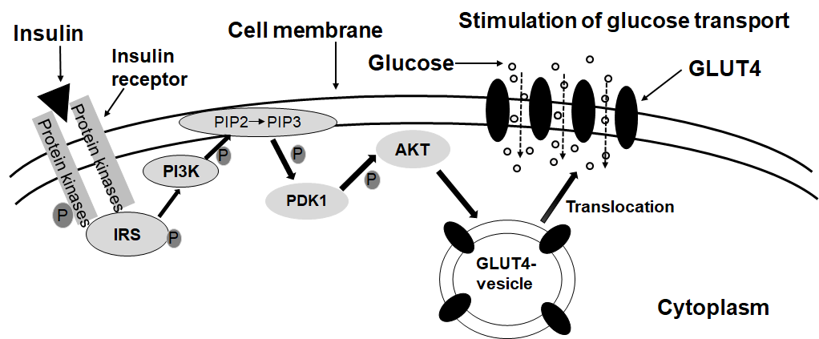
Figure 1-1: Schematic of insulin-induced translocation of GLUT4 from cytosol to the cell membrane.
The binding of insulin to its receptors initiates a signal transduction cascade, which results in the activation of Akt. Akt acts on the GLUT4 containing vesicles in the cytosol to facilitate their fusion with the cell membrane. When more GLUT4 molecules are present in the membrane, the rate of glucose uptake is elevated.
In the fed state, elevated glucose levels in the blood stimulates insulin secretion from pancreatic beta cells. Insulin stimulates GLUT4 translocation to the cell membrane, which increases glucose uptake in cells, and achieves glucose homeostasis (110, 111). After the insulin stimulation disappears, GLUT4 is transferred back into the cytosol from the plasma membrane. More than 90% of GLUT4 is in the intracellular body, trans-Golgi network, and heterogeneous tube-like vesicle structure, etc., which constitute the GLUT4 storage vesicle (GSV). In an unstimulated state, most GLUT4 is in the intracellular vesicles of muscle and adipocytes (112).
The amount of GLUT4 on the cell membrane is determined by the rate of the movement from intracellular GSV to the cell membrane. In adipocytes and skeletal muscle cells, insulin increases the rate of GLUT4 translocation from GSVs to membrane and decreases the rate of GLUT4 movement from membrane back to the vesicles, which lead to elevation of GLUT4 content on the cell membrane by 2-3 times (113). Moreover, in adipocytes, insulin increases the GLUT4 recirculation to maintain a stable and releasable vesicle (114).
So far, the insulin-induced GLUT4 translocation has been studied extensively. However, questions remain. Methods and reagents used to determine the expression levels of GLUT4 and its translocation mechanism deserve to be summarized and analyzed. Therefore, we searched the relevant articles in PubMed and investigated the methods and reagents used in the studies. “Glucose transporter 4” and “GLUT4” as the protein and “SLC2A4” as the gene name were used as keywords in the search. To have a more clearly overview, we further focused on the search of GLUT4 in the skeletal muscle.

4.3.1 GLUT4 in the Skeletal Muscle
Insulin stimulates glucose uptake and utilization in the skeletal muscle. GLUT4 plays a key role in the uptake process. Glucose can be stored as glycogen, which is used as a quick source of energy in physical activity (115). In the skeletal muscle, exercise helps increase insulin sensitivity and stimulates SLC2A4 gene transcription (110). Physiological factors such as the type of muscle fibers can also affect the GLUT4 level. An increase in physical activity will induce the GLUT4 levels, whereas a decrease in activity level will reduce GLUT4 (31). The skeletal muscle not only maintains the activities, but also regulates the glucose homeostasis in the body, which plays a key role in the development of metabolic diseases (32). Obesity and T2DM have a negative impact on skeletal muscle glucose metabolism (116).
The skeletal muscle is a highly specialized tissue made of well-organized muscle fibers. The unique structural characteristic of muscle inherits difficulties to be lysed for biochemical studies. Therefore, we want to focus on the sample preparation of skeletal muscle in GLUT4 studies. To review the methods and reagents of GLUT4 studies in skeletal muscle, "GLUT4, skeletal muscle" and "SLC2A4, skeletal muscle" as keywords were used to search the PubMed database to retrieve relevant articles. The retrieved articles were screened mainly according to the research methods and reagents used for skeletal muscle preparation, experimental groups included, Slc2a4 mRNA and GLUT4 protein measurements and the source of GLUT4 antibodies obtained. In the end, 10 representative articles were selected for analysis and summary as shown in Table 1-2.

Table 1-2: Recent studies of GLUT4 expression and translocation in the skeletal muscle.
Methods | Materials | Comparisons | Observations/conclusions | References
Western blot. | Cell fractions of rat L6 myotubes, 3T3-L1, and mouse muscle and adipose tissues.  Anti-GLUT4 from Santa Cruz Biotechnology (1:1,000). | Cell: total cell lysate vs. membrane fractions.  Mouse tissues: control vs. high-fat diets. | Insulin treatments increases GLUT4 levels in membrane fractions without any change in the total cell lysate. GLUT4 levels in adipose tissue and muscle of mice fed a high-fat diet are lower in all fractions than that fed the control diet. | (117)
Western blot. | Whole cell and cell fractions from rat L6 and mouse C2C12 muscle cells, and soleus muscle of hind limb from mice.  Anti-GLUT4 from Santa Cruz. Biotechnology (1:1,000). | Whole cell lysate vs. membrane fractions.  Treatments without or with insulin or AICAR. | GLUT4 translocation occurs in L6 myotubes and 3T3‐L1 adipocytes stimulated by insulin and AICAR. GLUT4 translocation occurs in muscle at 15 to 30 minutes and in adipose tissue at 15 minutes after glucose treatment. | (118)
Western Blot. | Giant sarcolemmal vesicles from soleus muscles of Sprague-Dawley rats.  Anti-GLUT4 from Millipore (1:4,000). | Tissue samples without or with insulin released in the presence of glucose as a stimulant and lipid as a control. | A glucose-dependent insulinotropic polypeptide increases glucose transport and plasma membrane GLUT4 protein content. | (119)
Real-time PCR for Slc2a4 mRNA levels. | Total RNA of the skeletal muscle from male C57BL/6J and ICR mice fed different diets. | mRNA levels in muscle samples from mice fed the control or CLA supplement diet | Dietary CLA does not affect Slc2a4 mRNA levels in the mouse skeletal muscle | (120)
Western blot. | Preparations of sarcolemmal membrane fractions and crude lysates from male Muscovy ducklings.  Anti-GLUT4 from East Acres (1:500). | GLUT4 from a unique crude membrane fraction of rat skeletal muscle was used as an arbitrary unit and from erythrocyte ghost as a negative control | Polyclonal antibodies detect a protein of similar size (∼45 kDa) of GLUT4 in the crude membrane preparations from rat (positive control) and duckling skeletal muscle. No signal was obtained for rat erythrocyte ghost membrane preparation. | (121)

Table 1-2 Continued
Methods | Materials | Comparisons | Observations/conclusions | References
ATB-BMPA-labelling of glucose transporters, Immunoprecipitation, liquid-scintillation counting, Western blot. | Tissue samples of isolated and perfused EDL or soleus muscle from GLUT1 transgenic C57BL’KsJ-Leprdbj and control mice.  Anti-GLUT4 (R1184; C-terminal) from an unknown source. | Non-transgenic mice vs. transgenic mice. | Basal levels of cell-surface GLUT4 in isolated or perfused EDL are similar in transgenic and non- transgenic mice. Insulin induces cell-surface GLUT4 by 2-fold in isolated EDL and by 6-fold in perfused EDL of both transgenic and non-transgenic mice. Western blot results were not shown. | (122)
Preembedding technique (immune reaction occurs prior to resin embedding to label GLUT4), and observations of whole mounts by immunofluorescence microscopy, or after sectioning by immunogold electron microscopy. | Muscle samples from male Wistar rats.  Anti-GLUT4 (C-terminal, 1:1,000), and anti-GLUT4 (13 N-terminal, 1:500) from unknown species. | Rats were divided in four groups: control, contraction received saline, insulin and insulin plus contraction groups. They received glucose followed by insulin injection. | Two populations of intracellular GLUT4 vesicles are differentially recruited by insulin and muscle contractions. The increase in glucose transport by insulin and contractions in the skeletal muscle is due to an additive translocation to both the plasma membrane and T tubules. Unmasking of GLUT4 COOH-terminal epitopes and changes in T tubule diameters does not contribute to the increase in glucose transport. | (123)
Immunoprecipitation, and Western blot. | Membrane fractions from skeletal muscle of male Wistar rats treated without or with insulin.  Anti-GLUT-4 from Genzyme, Anti-GLUT-4 from Santa Cruz Biotechnology. | Crude membrane preparations and cytosolic fractions in samples of rats treated without or with insulin . | In vitro activation of PLD in crude membranes results in movement of GLUT4 to vesicles/microsomes. This GLUT4 translocation is blocked by the PLD inhibitor, neomycin, which also reduces insulin-stimulated glucose transport in rat soleus muscle. | (124)

Table 1-2 Continued
Methods | Materials | Comparisons | Observations/conclusions | References
Western blot for GLUT4 protein in homogenates of epitrochlearis muscles.  Tissue slices labeled with 2-[1,2-³H]-deoxy-d-glucose and counted in a gamma counter. | Muscle homogenate and slices from male Sprague-Dawley rats.  Anti- GLUT4 from Dr. Osamu Ezaki. | Sedentary control vs a 5-day swimming training group. | The change of insulin responsiveness after detraining is directly related to muscle GLUT-4 protein content.  The greater the increase in GLUT-4 protein content induced by training, the longer an effect on insulin responsiveness lasts after training. | (125)
Immunofluorescence for membrane preparations, and 2-Deoxyglucose uptake in isolated skeletal muscles. | Membrane preparations from L6 cells over-expressing GLUT4myc. Isolated skeletal muscle samples from mice.  Anti-GLUT4 from Biogenesis. | L6 cells over-expressing GLUT4myc treated without or with Indinavir. | HIV-1 protease inhibitor indinavir at 100 µmol/l inhibits 80% of basal and insulin-stimulated 2-deoxyglucose uptake in L6 myotubes with stable expression of GLUT4myc. | (126)
Note: AICAR, 5-aminoimidazole-4- carboxamide ribonucleotide; CLA, conjugated linoleic acid; EDL, extensor digitorum longus; HIV, human immunodeficiency virus; ICR, institute of Cancer Research; PLD, phospholipase D.
Overall, the current research methods of GLUT 4 studies in the skeletal muscle are listed below. 1) Samples were homogenized to prepare membrane fractions for analysis of GLUT 4 in Western blot using monoclonal or polyclonal antibodies. 2) Real-time PCR was used to determine the mRNA abundance of Slc2a4. 3) Immunocytochemical staining was used to detect GLUT4 in situ. The fibers were labeled for GLUT4 by a preembedding technique and observed as whole mounts by immunofluorescence microscopy or after sectioning, by immunogold electron microscopy. Preembedding is a technique to label GLUT4 immediately after tissues or cells are collected, which allows that the antibody interacts with the antigen before denaturation. 4) Muscle cell lines stably expressing tagged GLUT4 were established to study the translocation. 5) Radiolabeled 2-Deoxyglucose was used to determine the glucose uptake in muscle tissue slices.
The antibodies used in these articles were from Santa Cruz, Millipore, East Acres, Biogenesis and other sources not specified. Only two of the publications have a positive control group of GLUT4 expression using overexpression of a fusion protein and tissue preparation as a standard for determination. Positive controls are important when Western blot and fusion protein immunofluorescence methods are used to determine the GLUT4 protein levels.
According to studies summarized in Table 1-2, the following key points can be obtained. Insulin and muscle contraction increase glucose uptake in the skeletal muscle, which is associated with increases of GLUT4 content and its translocation (117-119). Neomycin, a phospholipase D inhibitor, blocks GLUT4 translocation (124). In the skeletal muscle isolated from GLUT1 transgenic mice, insulin-induced GLUT4 translocation response is lost, which is not due to down-regulation of GLUT4 expression (122). Conjugated linoleic acid in the diet does not affect the Slc2a4 mRNA expression in the skeletal muscle (120). Indinavir, an HIV-1 protease inhibitor, can block the glucose uptake mediated by GLUT4 in normal skeletal muscle and adipocytes with or without insulin stimulation (126). More studies are anticipated to elucidate how insulin resistance and T2DM affect the functions of GLUT4 system and whether overnutrition plays a role in it.

4.4 Recombinant DNA Techniques Used in the Studies of GLUT4
Genes in an organism are codes responsible for genetic traits. In most cases, genes usually exist in the form of nucleotide sequences. In a cell, the DNA sequence of a gene is first transcribed into mRNA, which serves as the template for protein translation. The newly synthesized proteins contribute to biological processes in an organism. To understand the biochemical, biophysical, and genetic functions of a give gene and its protein, recombinant DNA technologies have been developed and used extensively. Since 1970s, the discovery of restriction enzymes has allowed the manipulation of DNA sequences selectively and specifically to create novel recombinant molecules (127). Molecular cloning methods have been created to insert DNA fragments into vectors to form recombinant genetic materials for functional studies and productions of recombinant proteins. The vectors carry the recombinant DNA and replicate it for subsequent uses. The first recombinant DNA molecule was produced and studied in 1972 after the genes responsible for metabolism of galactose in E. coli were fused into the SV40 DNA genome (128). For the past few decades, procedures of molecular cloning have been simplified and standardized to construct recombinant DNA with various sizes for different purposes (129). All these have been applied to generate transgenic organisms and produce recombinant proteins for the use in variety of research and clinical settings.
The development of molecular cloning techniques allows isolation, generation, and production of DNA sequence independence of the species and organisms that carry the original sequences. DNA fragments can be isolated from genomes or created via polymerase chain reaction (PCR) using a template of cDNA or genomic DNA, and inserted into vectors that can replicate and express in the host cells, and in turn alter the genetic features of the host cells, tissues or organisms (130). The development of PCR technique facilitates molecular cloning tremendously as it produces many copies of a specific DNA sequence in a few hours instead of days.

4.4.1 The Common Cloning Techniques
Restriction enzyme-based cloning is the traditional cloning technology, which is currently the most widely used cloning technology. The gene of interest is inserted into the vector by enzyme digestion and DNA ligation. The main advantage is that the technology is stable; the disadvantage is that the errors in any link will affect the success or failure of the clone construction because of multiple steps. Ligation Independent Cloning (LIC) is a technique developed as an alternative to restriction enzyme/ligase cloning. Inserts are usually PCR amplified and vectors are made linear either by restriction enzyme digestion or by PCR. This creative technique uses the 3’ → 5’ exo activity of T4 DNA Polymerase to create overhangs with complementarity between the vector and insert (131). The 5' sequence of the primer used to amplify the insert should be complementary to the LIC vector. The 3'→5' exonuclease activity of T4 DNA polymerase can form a single-stranded sticky end on the insert in a short time, then stopped by adding dCTP to the reaction. Since the prepared insert and the vector can only anneal to each other to form a product, this method is very fast and efficient, and it is directional cloning. Due to the complexity of its operation and the limitation of use, it has evolved to many useful variations; sequence and ligation independent cloning is one of the useful variation (131). Seamless cloning (SC) technology is similar to LIC and relies on matching the short sequence at the end of the DNA fragment with the short sequence on the plasmid vector (132).
TA cloning must use a commercial linearized vector. There is a thymine (T) at the 3´ end of the linear vector, which exactly matches the adenine (A) at the 3´ end of the PCR amplified product. These complementary base pairs on different DNA fragments are ligated together using Taq DNA ligase. The biggest advantage of this cloning is that the vector is easy to use, and the amplified product can be cloned directly into the vector. Similar as TA cloning, the key to TOPO cloning is the enzyme DNA topoisomerase I, which functions both as a restriction enzyme and as a ligase. It can digest DNA at specific site 5’-(C/T)CCTT-3’ and ligates at 3’ phosphate group of thymidine base (133).
Gateway cloning is a molecular cloning technology that uses specific primers to insert specific gene sequences on both sides of the desired gene by PCR. Gateway cloning uses two enzyme mixtures, BP Clonase and LR Clonase. The gene is cloned into an entry vector using BP Clonase, and then this entry clone is used to transfer the gene to the expression vector through LR Clonase (134). Golden Gate cloning is a method that relies on type II restriction enzymes, the plasmid contains type II restriction sites or is amplified by PCR to add type II restriction enzyme sites. Type II restriction sites are eliminated after enzymatic ligation and will not appear in the final vector. Therefore, this is an irreversible gene assembly method. Once the gene is inserted into the vector, it can never be cut with the same restriction enzyme (135). Infusion cloning is a simple one-step cloning technique that amplifies genes by PCR with 15bp extension complementary to the vector ends and clones the PCR products into linearized vector without ligation (136). Table 1-3 summarizes common cloning methods including restriction enzyme-based cloning, LIC, SC, TA cloning, TOPO cloning, gateway cloning, infusion cloning, golden gate cloning.
Table 1-3: Comparison of different gene cloning methods
 | Enzymes | Advantages | Disadvantages | Applications
Restriction enzyme based cloning | Restriction enzyme, T4 DNA ligase | High cost performance | Low cloning efficiency, difficulty in selecting restriction sites, many steps, long operating time, limited experimental applicability
Ligation independent cloning (LIC) | T4 DNA Polymerase | Not restricted by restriction sites, multi-fragment ligation | Low cloning efficiency
Seamless cloning (SC) | Recombinant enzyme, equires a DNA polymerase and a DNA ligase | Simple, flexible, efficient, allows insertion of multi-DNA fragment into a vector | High primer synthesis cost
TA cloning | T4 DNA ligase | The carrier construction connection is directional, multi clones, can used for cloning or vector construction | Only TA cloning can be performed, enzyme cutting site is required, positive rate low, steps are cumbersome and need to recycle fragments, time consuming
TOPO cloning | Topoisomerase I (TI) | Very efficient, simple and fast, don’t need to use restriction enzymes or ligase | Specific primers are needed, efficiency of cloning can vary depending on the polymerase used
Gateway cloning | BP (attB sites and attP sites) Clonase, LR (attL sites and attR sites) Clonase | High throughput cloning, fast, efficient | Limited by vector carrier, enzymes expensive and unstable, the steps are cumbersome, connection of 1-4 fragments | High-throughput construction

Table 1-3 Continued
 | Enzymes | Advantages | Disadvantages | Applications
Infusion cloning | Specific infusion enzyme | Simple, fast, efficient, can cloning with any vector and any gene fragment, does not rely on restriction enzyme sites for cloning. | the vector and the insert must overlap by 15bp | linearized cloning vector
Golden Gate cloning | Type II restriction enzymes, T4 DNA ligase | High-throughput cloning, multi-fragment ligation | Limited by vector carrier, limited range of applications | CAS9 vector construction
In addition, large numbers of DNA copies obtained in recombinant DNA technologies can be used for sequencing analysis and further subcloning procedures. Knowing the DNA sequences allows us to explore its biological functions. It also allows preparations of large amounts of protein, such as growth hormone, insulin and clotting factors for therapeutic purposes (137). DNA sequences of different organisms can be compared to determine the evolutionary relationship within and between species (138). Functional regions of a gene can be identified after the sequences are compared (27). Recombinant DNA technologies can be used in gene therapies to treat diseases such as immunodeficiency diseases and metabolic disorders (139) and diagnosis of genetic diseases (140).
The basic molecular cloning procedure includes vector preparations and isolations of target DNA fragments (DNA inserts), ligation of insert fragments with vectors to create recombinant molecules, transformation of recombinant plasmids into bacteria (such as competent E. coli) for the screen and identification of positive clones. The cloned DNA fragments can be further manipulated to create mutations for the study of protein and gene functions. The mutated DNA fragment is inserted into cells or organisms, replaced the wild-type sequence of the gene, and used to investigate the effects of the mutation. For example, the altered DNA sequence can be used for gene knockout, in which only the targeted gene sequence is changed in a genome (27).

4.4.2 The Gene Knockout Techniques
Genetically modified organisms or genetically engineered organisms can be created via alterations of the genetic sequences of the chromosome or insertions of the foreign DNA fragments into the genome to alter the phenotypes of the offspring (141). Genes in plants, animals and microorganisms have been deleted or knocked down to investigate their functions (142). It is applied to research in labs, and clinical treatments of genetic diseases. There are several methods that can be used to silence or remove the target gene, such as gene silencing, conditional knockout, homologous recombination, and gene editing (100, 142). Homologous recombination occurs in cells to produce new DNA sequence during meiosis (143). This has been used to exchange genetic materials between different strains and types of bacteria and viruses (143). Homologous recombinases (nucleases) can recombine two linearized nucleotide fragments with the same terminal sequences to create a novel DNA fragment for molecular manipulations (144). This makes accurate gene editing possible and becomes emerging tools in genetics (145). Various nucleases based gene knockout technologies, such as zinc finger nucleases (ZFNs), transcription activator-like effector nucleases (TALENs), and clustered regularly interspaced short palindromic repeat (CRISPR) are developed and shown differences in knockout efficiency, completion time, and off-target efficiency (142) (Table 1-4). Each of these techniques uses a nuclease to introduce DNA double-strand breaks at the targeted locations with the guidance of homologous binding proteins or RNA (146).
Table 1-4: Comparison of ZFNs, TALENs, and CRIPR/Cas9
 | ZFNs | TALENs | CRISPR/Cas9
Advantages | High specificity, low immunity | Modular assembly, less cytotoxic effects | easy to generate, higher target efficiency, ability to multiply for targeting of multiple genes
Disadvantages | Difficult to predict cytotoxic effetcs, required to target specific DNA sequence, target site choice limited | Difficult to constructs, large protein size, binding is negatively impact by DNA methylation | Higher off-target effects, biding efficiency impacted by chromatin accessibility
Target specificity | Zinc Finger proteins | TALEN | Cas9 nuclease, gRNA
Target | Pair | Pair | Single
Target site size (bp) | 18-36 | 30-40 | 22
Guiding sequence | Protein | Protein | gRNA
Nuclease and Cleavage | FokI, single strand cleavage | FokI, single strand cleavage | Cas9, double strand cleavage
Efficiency | Variable | High | High
Note: Cas 9, CRISPR associated protein 9; gRNA, guide RNA.

4.4.3 The Gene Knockdown Techniques
Gene knockdown is to inactivate or suppress the expression of the gene, instead of being deleted completely. RNA-based RNA interference, small interfering RNA (siRNA) and short hairpin RNA (shRNA), and antisense oligonucleotides (ASOs) have been used for gene knockdown (147). RNA interference (RNAi) is triggered by double-stranded RNA and causes the sequence-specific mRNA degradation of the single-stranded target RNA (148). Small non-coding RNA molecules can also act to inhibit RNA translation (149). Table 1-5 shows the similarities and differences of shRNA, siRNA and ASOs are summarized.

Table 1-5: Summarized of small interfering RNA (siRNA) or short hairpin RNA (shRNA)) and antisense oligonucleotides (ASOs)
 | Small interfering RNA (siRNA) | Short hairpin RNA (shRNA) | Antisense oligonucleotides (ASOs)
Delivery to the cell | Cytoplasm | Nucleus | Nucleus
Range | Approximately 20 base pairs (bp) | Approximately 19 to 29 base pairs (bp) | Approximately 18 to 30 base pairs (bp)
Persistence | Degraded in a few days | Expressed for up to a few years | Could be rapidly digested
Advantages | Can be easily introduced into cells with high efficiency, easily fast to use, less off-target effects. | High transduction efficiencies, transduced cells can be selected through drug resistance or reporter. long term effect | Can knockdown nuclear long non-coding RNA.
Disadvantages | Non-renewable resource, cells might not be transfectable, short term effect. | Virus-mediated toxic effects | Less effective to cytoplasmic long non-coding RNA, higher off-target effect
In addition to deletion or inactivation of a gene, recombinant DNA techniques have been used to generate tagged proteins or fusion proteins with novel properties (150). A fusion protein contains two or more domains from different proteins, which are transcribed and translated in frame as a single polypeptide in the targeted cell or tissues. The characteristics of fusion proteins are helpful for protein purification for their uses in research and clinical treatments, detection of the expression levels, and visualization of the location of the expressed proteins in a cell, tissue, or organism (151). These have been used to create vaccines, multifunctional enzymes, targeted drugs, thrombolytics, antimicrobial peptides, etc (152).

4.4.4 Molecular Techniques Used in the Study of GLUT4 Functions
GLUT 4 is encoded by SLC2A4 in human genome and Slc2a4 in others such as rodent genomes (153). Slc2a4 is cloned from rat adipose tissue, and is homologous with GLUT1, which is encoded by Slc2a1 gene (154-156). GLUT4 is expressed in not only adipose and muscle cells, but also other tissues such as the heart and brain (157). The current model is that in response to insulin stimulation, GLUT4 is translocated from the intracellular locations to the plasma membrane, where it facilitates the transport of glucose into cells (158). In addition, exercise has been shown to stimulate the express of SLC2A4 mRNA in the skeletal muscle and improve insulin sensitivity in patients (159), which may be mediated by GLUT4 (160). Insulin-stimulated glucose transport is significantly impaired in the skeletal muscles of patients with T2DM (161). Therefore, understanding the role of GLUT4 in the regulation of glucose homeostasis is critical for the prevention and treatment of T2DM.
Here, we summarize the recombinant DNA technologies that have been used to study expression profiles and functions of GLUT4 in tissues and cells. Key words as indicated in the following sections were used to search PubMed. The methods used to manipulate the expression levels of GLUT4 in vivo and in vitro and reported observations in retrieved studies were summarized here.
GLUT4 overexpression and knockdown, and Slc2a4 gene knockout in vitro and in vivo have been developed to study insulin-stimulated GLUT4 translocation and glucose homeostasis, which contribute significantly to our understanding of the role of GLUT4 (56). To review the techniques of molecular biology in the study of GLUT4, "GLUT4, molecular biology" and "SLC2A4, molecular biology" as keywords were used to search the PubMed database to retrieve relevant articles. We have focused on the techniques used in Slc24a knockout, knockdown and transgenic studies, and results associated with the genetic changes in vivo and in vitro. Various methods such as in situ hybridization, fluorescent microscopy, immunohistochemistry, Western blotting for protein and Northern blot and real-time PCR for mRNA used to determine endogenous or transgenic GLUT4 expressions are also summarized in this review.

4.4.4.1 Whole-body and Tissue Specific Slc2a4 Knockout Studies
Slc2a4 mRNA expression is detected not only in brown and white adipose tissue, skeletal and cardiac muscle, but also other tissues such as neurons (162). To study GLUT4 functions, mice with the Slc2a4 deletion in the whole body or specific tissues or cells have been created. We searched PubMed to retrieve the original articles that initially reported the Slc2a4 deletions. Table 1-6 shows the techniques for creating knockouts, experimental animals, methods to confirm the gene deletion and expression, and observations. In the end, 7 representative articles that the research groups generated a specific knockout model to study GLUT4 and clearly describe the methods of GLUT4 deletion are summarized here as shown in Table 1-6. Also, the animal models were also used by many other groups. These articles were selected for analysis and summary as shown in Table 1-6.

Table 1-6: Methods of creation and confirmation, animals and tissues studied, and observations of whole body and tissue specific Slc2A4 knockout.
Methods | Animals | Confirmation | Tissues | Observations | References
Homologous recombination was initiated using a linearized construct containing a disrupted mouse Slc2a4 gene and electroporated into WW6/22 embryonic stem (ES) cells, which were microinjected into C57Bl/ 6 blastocysts. | GLUT4-null mice and wild-type control mice. | Southern blot for DNA from ES cells and animal tissues.  Northern blot for mRNA in the skeletal muscle.  Western blot for GLUT4 protein in the skeletal muscle. | Skeletal muscle | The Slc2a4-/-mice have normal glycemia, and show growth-retardation, decreased longevity, cardiac hypertrophy and severely reduced adipose tissue deposits.  The male Slc2a4-/-mice have lower and higher blood glucose levels than the control ones in fasted and fed states, respectively.  Both female and male Slc2a4-/- mice show postprandial hyperinsulinemia, and reduced insulin sensitivity. | (163)
GLUT4 loxP mice containing an 18-kb fragment of the coding region of Slc2a4 gene (from a mouse 129 λ bacteriophage library) were crossed with mice containing cre recombinase driven by α-myosin heavy-chain (α-MHC) promoter | Cardiac-selective Slc2a4-/-deletion mice (G4H–/– mice) and control mice | Southern blotting and PCR for DNA changes.  Western blot analysis for GLUT4 levels in cardiac muscle using antisera from different sources. | Heart | Life span and serum levels of insulin, glucose, FFAs, lactate, and β-hydroxybutyrate are normal in G4H–/– mice.  Basal cardiac glucose transport and GLUT1 expression are increased, but insulin-stimulated glucose uptake is abolished in G4H–/– mice, which develop modest cardiac hypertrophy. | (164)

Table 1-6 Continued
Methods | Animals | Confirmation | Tissues | Observations | References
Mice carrying a Slc2a4 allele with exon 10 flanked by loxP sites (GLUT4lox mice) as shown in (164) were crossed with mice carrying the transgene encoding Cre driven by the muscle creatine kinase promoter. | Muscle-G4KO mice and heterozygous deletion of Slc2a4 (Het KO mice) in the background of 129SV and C57Bl/6J. | Reverse transcription–PCR for mRNA in gastrocnemius muscle.  Western blot for GLUT4 protein (anti-GLUT4 AB1346). | Skeletal muscle | Muscle-G4KO mice show a reduction in basal and near-absence of insulin- or contraction-stimulated glucose transport.  Muscle-G4KO mice show severe insulin resistance and glucose intolerance from an early age. | (165)
The MLC-GLUT4-null mice were obtained by crossing GLUT4-null mice with transgenic mice expressing GLUT 4 under the control of the myosin light chain (MLC) promoter (MLC-GLUT4) (166). | MLC-GLUT4-null mice having GLUT4 in the fast-twitch extensor digitorum longus (EDL) muscle, GLUT4 null mice, and control mice. | Western blot for GLUT4 protein (rabbit polyclonal antiserum). | EDL muscle and soleus muscle | MLC-GLUT4-null mice lack GLUT4 in white adipose tissue (WAT, 20% of the control) of female mice and soleus muscle of both sexes.  The MLC-GLUT4-null mice have less adipose tissue deposits, adipocyte size, and plasma free fatty acid levels in the fed state.  2-deoxyglucose uptake in the EDL muscle of MLC-GLUT4-null mice is normalized in males and above normal in females, but not in the soleus muscle. | (167)
GLUT4–lox mice were crossed transgenic mice expressing Cre recombinase under the aP2 promoter to obtain GLUT4 (G4A-/-) | Mice with adipose-selective deletion of GLUT4 (G4A-/-), and control mice | Western blot for GLUT4 protein in brown adipose tissue (BAT) and WAT | Adipose tissues | G4A-/- mice have impaired insulin-stimulated glucose uptake in adipocytes, and develop glucose intolerance and hyperinsulinemia, and show insulin resistance in the muscle and liver. | (168)
Table 1-6 Continued
Methods | Animals | Confirmation | Tissues | Observations | References
The adipose-GLUT4-KO mice (168) were crossed with the muscle-GLUT4-KO mice (165) to generate adipose/muscle-GLUT4 double knockout (AMG4KO) mice | Adipose-GLUT4-KO mice, muscle-GLUT4-KO mice, and AMG4KO mice. | Western blot for GLUT4 protein using antibodies from H. Haspel in the Charles River Laboratory. | Adipose tissue and the skeletal muscle | AMG4KO mice develop fasting hyperglycemia and glucose intolerance and are at risk for greater insulin resistance than mice lacking GLUT4 in only one tissue. | (169)
Mice expressing Cre driven by the neuron-specific Nestin promoter were crossed with GLUT4–lox mice (FVB strain) to generate brain-specific GLUT4 knockout (BG4KO) mice | BG4KO and control mice | Western blot for GLUT4 protein in brain (1:1,000, from Chemicon, Temecula, CA) | Whole-brain tissue | BG4KO mice have glucose intolerance, insulin resistance, and impaired glucose sensing, indicating that the brain GLUT4 plays a key role in sensing and responding to changes in blood sugar. | (170)
In1995, the mouse Slc2a4 locus was disrupted using homologous recombination in embryonic stem cells and have generated mice without GLUT4 expression (GLUT4-null) in the whole body (163). The GLUT4-null mice showed growth retardation, enlarged hearts and complete lack of white adipose tissue (163). GLUT4-null mice have normal glucose tolerance and basal glucose turnover rates. However, they are insulin intolerant, suggesting insulin resistance. Later on, the GLUT4-null mice (163) have been used to create mice expressing GLUT4 specifically in the extensor digitorum longus (EDL) muscle (167).
Tissue specific GLUT4 knockout mice have been created by crossing mice carrying a Slc2a4 allele with exon 10 flanked by loxP sites with those carrying Cre driven by tissue specific promoters (164, 165, 168, 170). The various phenotypes of these knockout mice help us to understand the roles of GLUT4 in different tissues and glucose metabolism. For example, the muscle-specific GLUT4 knock-out mice (muscle-G4KO) were bred by breeding mice carrying the Slc2a4 exon 10 flanked by loxP sites with mice carrying a transgene encoding Cre recombinase under the control of the muscle creatine kinase promoter (165). Compared with GLUT4-null mice, muscle-G4KO mice have normal body weight and fat pad weight at least before 6 months of age (165). The skeletal muscle mass is also normal. The increase in heart weight is consistent with GLUT4-null mice (163) and cardiac-G4KO mice (164). Compared with the shortened lifespan of GLUT4-null mice, the life span of muscle-G4KO mice is normal. In contrast to GLUT4-null mice and cardiac-G4KO mice, adipose-G4KO mice (168) is similar as muscle-G4KO mice. However, adipose-G4KO mice have glucose intolerance (168). Interestingly, unlike other GLUT4 knockout mice, the heart weight of adipose-G4KO mice is normal.
In addition, adipose and muscle double knockout mice are also created by crossing the respective tissue knockout mice (169). Interestingly, these double knockout mice develop hyperglycemia in the fasting state (169). It appears that GLUT4 also plays a role in a physiological condition that does not need insulin-stimulated glucose uptake.

4.4.4.2 GLUT4 Knockdown Studies
The deletion of a gene completely stops the genetic information flow. Another way to block the protein expression is to knockdown a gene’s expression, which temporarily stops or reduces the expression of the targeted gene. Unlike knockout, gene knockdown involves the methods interfering with RNA molecules (mRNA or non-coding RNA) that bridges DNA and proteins. "GLUT4, knockdown" and "SLC2A4, knockdown" as keywords were used to search the PubMed database to retrieve relevant articles. Table 1-7 summarizes the methods of knockdown and confirmation, cell used, observations of GLUT4 knockdown studies.
Recently, RNAi has emerged as a powerful tool for the study of gene function in mammalian cells (171). After transfection, the short hairpin RNAs (shRNAs) molecules are transcribed under promoters in constructs that drive the RNA synthesis within the targeted cells. Oligo nucleotides with sequences of shRNAs may be transfected directly into the cells (171). In all studies summarized in Table 1-7, shRNAs method is used to achieve GLUT4 knockdown (172-174), which is delivered via recombinant retroviruses. Two of three studies investigated the roles of GLUT4 in 3T3-L1 adipocytes. It appears that GLUT4 expression is needed for the lipogenesis after differentiation in 3T3-L1 cells but not necessary for lipogenesis during differentiation (174). In addition, insulin-regulated aminopeptidase (IRAP) trafficking is not always associated with the GLUT4 movement (173).

Table 1-7: Methods of creation and confirmation, cells used, observations of GLUT4 knockdown studies.
Methods | Cells | Confirmation | Observations | References
Recombinant lentivirus was created to express short hairpin RNA (shRNA) using SLC2A4 sequence (NM_001042.3) | Human head and neck squamous cancer cell lines, HSC-2 and HSC-3-M3 | Western blot for GLUT4 protein (Epitomics, Cambridge, MA, USA) | The knockdown of GLUT4 expression in HSC-2 cells leads to elevated DEXD-H-box helicase 58and 2′-5′-Oligoadenylate synthetase Like expressions.  The cells with GLUT4 knockdown decrease migratory ability. | (172)
Recombinant retroviruses were created using pSIREN RetroQ system to produce shRNAs corresponding to mouse Slc2a4 sequence GGTGATTGAACAGAGCTAC (GenBank ID was not specified by authors) . | 3T3-L1 adipocytes | Immunofluorescence of phase-contrast and epifluorescence images for GLUT4 protein using antibodies (rabbit anti-GLUT4, a gift from Dr. Sam Cushman (National Institutes of Health). | GLUT4 knockdown does not affect insulin-regulated aminopeptidase (IRAP) trafficking, demonstrating that IRAP traffics is independent of GLUT4. | (173)
Recombinant lentivirus-mediated shRNA under the control of  human H1-RNA promoter was created using the mouse Slc2a4 mRNA sequence (GenBank ID was not included). | 3T3-L1 adipocytes | Immunofluorescence microscopy and Western blot for GLUT4 (rabbit anti-GLUT4 polyclonal antibody, from Chemicon International Inc. (Temecula, CA)) | In GLUT4 knockdown 3T3-L1 adipocytes, insulin-stimulated glucose uptake was only reduced by 50-60%.  GLUT4 knockdown leads to impaired expression of IRAP depending on whether GLUT4 is knocked down during the differentiating or differentiated stage.  The knockdown reduces the complete lipogenic capacity of differentiated adipocytes, but not lipogenesis during differentiation. | (174)

4.4.4.3 GLUT4 Transgenic Studies
We have used key words “GLUT4 transgenic” (314 hits) results when and “GLUT4 overexpression” (609 hit) to search PubMed to retrieve GLUT4 transgenic studies. After going through the titles or abstracts containing “GLUT4 overexpression/ GLUT4 transgenic”, we found 15 papers that have described their original methods or clearly cited the methods used by them, confirmed the GLUT4 overexpression in mice and provided results. Table 1-8 summarize the techniques used to overexpress GLUT4, the methods to confirm the expression and results observed in those animals.
In 1992, a 2.4-kb fragment of 5’ flanking DNA of human SLC2A4 promoter fused with the bacterial chloramphenicol acetyltransferase (CAT) as a reporter construct was developed and used as a reporter to indicate the SLC2A4 expression in mice (175). In 1993, an 11.5-kb SLC2A4 mini gene in pHSS6 vector was created and used to overexpress human GLUT4 in the whole body of mice (176). As shown in Table 1-8, the mouse line containing the 11.5-kb mini gene has been used in 7 out of 8 papers testing the effects of overexpression of human GLUT4 in the mouse whole body on metabolism (176-182). CAT activity, SLC2A4 mRNA and/or GLUT4 protein level in adipose tissue and skeletal muscle and other tissues have been analyzed to confirm the success of the transgenic expression (176, 177). In general, the whole-body human GLUT4 overexpression reduces blood glucose in both fasting and fed states and increased glucose uptake in mice but affects the blood insulin level in wild type mice and diabetic mice differentially (177). Whole body GLUT4 overexpression do not alter body weight but can reduce blood glucose level and affect serum insulin level.
Table 1-8: The transgenic studies using the SLC2A4 mini gene and its promoter for the whole-body expression in mice.
Constructs | Confirmation | Results | References
A 11.5-kb mini gene of human SLC2A4 starts with a 5.3-kb fragment upstream of transcription start and terminates within exon 10 of the gene followed by the bacterial chloramphenicol acetyltransferase (CAT) in pHSS6 vector. | GLUT4 mRNA and protein overexpression in both adipose tissue, heart and skeleton muscle via RNase protection assay and Western blot, respectively. | The hGLUT4-11.5kb mRNA expression was detected in white and brown adipose tissue, heart and skeleton muscle of the transgenic mice.  Compared to that in the control mice, GLUT4 protein level is increased in adipose tissue, liver, heart and skeleton muscle. Female transgenic mice have higher GLUT4 protein in the adipose tissue and less SLC2A4 mRNA in skeleton muscle than male ones. | (176)
The 11.5-kb minigene with the CAT marker as shown in (176). | SLC2A4 mRNA overexpression in cardiac and hindquarter muscle, brown and white adipose tissue via reverse transcription PCR.  Immunofluorescent test for GLUT4 translocation. | Compared to the control diabetic mice, transgenic diabetic mice grew similarly for 10 weeks of age when the control mice stopped gaining weight, whereas transgenic mice continued until 15 weeks old; have lower blood glucose in both fasting and fed states; have lower serum insulin level during fasting and higher after refeeding; and higher glycogen levels in cardiac and skeleton muscle; higher GLUT4 translocation and cell surface GLUT4 protein content. | (177)
The 11.5 kb minigene with the CAT marker as shown in (176). | GLUT4 overexpression in gastrocnemius muscles via Western blot. | Compared to the control mice, transgenic mice have lower serum glucose level in both fasting and fed state, higher insulin level during fasting and lower after fed, and similar glycogen content in fasting and fed state. | (178)
The 11.5 kb minigene with the CAT marker as shown in (176) | GLUT4 overexpression in heart via Western blot. | Compared to the control mice, transgenic mice have increased glucose uptake, glycolysis and glycogen content, but not glucose and fatty acid oxidation in the heart, and lost insulin-stimulated glycolysis rate and glycogen synthesis. | (179)
The 11.5 kb minigene with the CAT marker as shown in (176) | GLUT4 protein overexpression in muscle, brown and white adipose tissue (no data shown)  GLUT4 protein overexpression in cardiac myocyte and adipocyte via Immunofluorescence | Compared to the control mice, transgenic mice have similar body weight; increased levels of triglycerides, beta-Hydroxybutyrate and free fatty acids; parametrial, but not epididymal, adipose tissue weight and adipocyte cell size; and significantly lower glucose level after an oral glucose challenge; lower insulin level after an insulin injection, and impaired insulin-stimulated glucose uptake. | (180)
Table 1-8 Continued
Constructs | Confirmation | Results | References
A 2.4-kb of 5’ flanking DNA fragment of human SLC2A4 promoter fused with the CTA as a reporter construct. | CAT activity and mRNA via RNase protection assay. | In transgenic mice, CAT activity can be detected in the tissues that generally express GLUT4, including white and brown tissue, smooth, skeleton and cardiac muscle, but not the liver. | (175)
The authors cited the paper that described a 2.4-kb of 5’ flanking DNA of human SLC2A4 promoter fused to CAT based on description in (175) | GLUT4 overexpression in both adipose and skeleton muscle via Western blot. | Compared to the control mice, transgenic mice have reduced rises of blood glucose, but no different in glucose and insulin levels during pentobarbital sodium anesthesia; and glucose infusion rate increased by 40% during hyper insulinemic euglycemic clamp. | (181)
The authors cited a paper that described a 2.4-kb of 5 flanking DNA of human SLC2A4 promoter fused to CAT based on description in (175) | Not done but cited previous publications(175) | Compared to the control mice, transgenic mice have lower blood glucose, higher lactate and β-hydroxybutyrate during both fasting and fed states, and improved glucose transport in the soleus muscle when fed a high-fat and high-sugar diet. | (182)
GLUT4 has been overexpressed in a tissue specific manner as shows in Table 1-9. Majority of the studies been focused on adipose tissues (183-187). There is one in the skeleton muscle (166) and one in adipocytes (188). A 6.3-kb genomic DNA fragment of human SLC2A4 gene driven by the mouse ap2 (183) promoter has been used to overexpress GLUT4 in mouse adipose tissues. This method was first published in 1993 (183) and was used in many other studies in the genetic settings of wild-type mice and diabetic mice (184-187). Like the papers summarized in the Table 1-9, a human SLC2A4 gene under a tissue-specific promoter was used to overexpress GLUT4.
Human SLC2A4 cDNA was also used to overexpress GLUT4 in adipocytes (188), but mouse Slc2a4 gene was used to express GLUT4 in the hindlimb muscle (166). All adipose tissue specific GLUT4 overexpression studies (166, 183-187) tested the SLC2A4 mRNA or GLUT4 protein level to confirm GLUT4 expression, which is found to be expressed in both brown and white adipose tissues.
In conclusion, adipose tissue specific GLUT4 overexpression in mice can cause increase in body weight and adipose tissue weights (183, 184). The adipose tissue specific GLUT4 transgenic mice also have higher glucose disposal rate, maybe caused by increased basal and insulin stimulated glucose transport rate. It is interesting to find out that the elevated expression of GLUT4 in the adipose tissue only can increase glucose transport rate and adipose tissue weight, which is associated with the significant increase in body weight, suggesting the importance of GLUT4 expression in adipose tissue.
Table 1-9: Tissue specific transgenic studies of GLUT4.
Tissue | Techniques | Confirmations | Results | References
Adipose tissue specific overexpression. | A 6.3-kb genomic DNA fragment of human SLC2A4 gene under the control of a 5.4-kb’ DNA fragment of mouse ap2 promoter.  Gateway cloning. | GLUT4 protein overexpression in both brown and white adipose tissue via Western blot. | Compared to the control mice, transgenic mice have lower blood glucose in the fasting, insulin level in the fed state, higher body weight and body fat at 18 to 21weeks of age, and higher basal and insulin-stimulated glucose transport rates in epididymal, parametrial, and subcutaneous adipocytes. | (183)
Adipose tissue specific overexpression | Same as in (183) | Not done but cited previous publications (183). | Compared to the control mice, transgenic mice have higher body weight, parametrial fat pad weight, parametrial adipocyte size and body lipid, and glucose transport in both fasting and fed states; lower plasma insulin level and glucose level after glucose challenge; | (184)

Table 1-9 Continued
Tissue | Techniques | Confirmations | Results | References
Adipose tissue specific overexpression | Same as in (183) | Not done but cited previous publications (183). | Compared to the control mice, transgenic mice have higher glucose disposal in a glucose tolerance test, and palmitic acid-hydroxy stearic acid levels in serum, white and brown adipose tissue. | (185)
Adipose tissue specific overexpression | Same as in (183) | GLUT4 protein overexpression in both brown and white adipose tissue via Western blot. | Compared to those fed a low-fat diet, transgenic mice fed a high-fat diet have stable expression of GLUT4, and higher glucose disposal rate, no increase of body fat. | (186)
Adipose tissue specific overexpression | Same as in (183) | GLUT4 protein overexpression in both brown and white adipose tissue via Western blot. | Compared to the control mice, transgenic mice have higher gonadal adipose weight, basal and maximum insulin stimulated glucose transport in isolated adipocytes, glucose transport rate, triglyceride synthesis and CO2 production. | (187)
Hindlimb muscle overexpression | A 4.5-kb DNA fragment of the mouse Slc4a2 gene under the control of a 3-kb fragment of the mouse myosin light chain lf gene promoter | GLUT4 mRNA overexpression in hindlimb muscle, fat, heart, kidney, brain, liver and heart via Northern blot  GLUT4 protein overexpression in hindlimb muscle and gastrocnemius via Western blot. | Compared to the control mice, transgenic mice have higher basal and insulin-stimulated glucose uptake and turnover, glycogen content in skeleton muscle, higher insulin sensitivity, and higher free fatty acid and ketone levels in both fasting and fed state, and lower fasting glucose level. | (166)
Cell over expression | Human SLC2A4 cDNA driven by the cytomegalovirus promoter in pCIS2 vector. | GLUT4 protein overexpression in rat adipose cell via immunofluorescence | Rat adipose cell transfected with GLUT4-HA had significantly higher antibody bonding rate under insulin stimulation. | (188)

Overall, a variety of methods have been used to study GLUT4 system and insulin action in different target tissues or cells. Results of glucose tolerance are different between mice with whole body and tissue specific GLUT4 knockout. Although the explanation for this difference is not clear, differences in genetic background and in developmental stages where GLUT4 is deleted have been proposed. Moreover, whether the loss of GLUT4 in a specific tissue (muscle or fat) or the expression of GLUT4 in other tissues without gene deletion plays a role in this difference is worth to be investigated. More importantly, the hyperglycemia in these double knockout mice develops in the fasting state, rather than fed state (169). This phenomenon appears to indicate that GLUT4 plays an important role in the control of glucose homeostasis during fasting, a state that insulin level is low.
On the other hand, the GLUT4 knockdown studies used the shRNAs method and have been done in cell lines to reduce GLUT4 expression. This may be helpful for us to understand the GLUT4 functions and the underlying mechanisms in particular cells. The GLUT4 overexpression in transgenic mice at whole-body level reduces blood glucose in both fasting and fed states and increased glucose uptake, glycolysis and glycogen level (48). Compared to the control mice, overexpression of GLUT4 in adipose tissue in mice cause lowered blood glucose in the fasting state, and increase in body weight and adipose tissue weight (54). The levels of GLUT4 in adipose tissue and the skeleton muscle affect the rate of whole-body glucose disposal, may be caused by the increased basal and insulin stimulated glucose transport rate. This lowered blood glucose level in the transgenic mice also indicates that GLUT4 probably plays a role in the basal glucose uptake.
It is safe to say that more research works are anticipated in the future to precisely define the role of GLUT4 in the control of glucose homeostasis at whole body and tissue levels. In so doing, we develop effective ways to prevent and treat T2DM.

5. Conclusion
VA, as a fat-soluble micronutrient, is involved in immune function, vision, reproduction, and cell differentiation and proliferation. Most of the physiological functions of VA are exerted through the action of RA. VA and insulin play a key role in the regulation of fuel metabolism. They work together to regulate metabolism in vivo and in vitro.
The mass of skeletal muscle accounts for almost half of the body mass, and the regulation of skeletal muscle glucose metabolism will significantly affect the body's glucose homeostasis. Insulin stimulates glucose uptake and utilization in skeletal muscle. GLUT4 is important for this in the skeletal muscle. In skeletal muscle, exercise also helps to increase insulin sensitivity and stimulate SLC2A4 gene transcription. In addition, the type of muscle fibers can also affect GLUT4 levels.
So far, various methods from gene knockout to immunohistochemistry have been used to study the mechanisms of Slc2a4 mRNA and GLUT4 expressions, and its translocation in different cells. Every technique has its pros and cons. Based on the studies summarized here, anti-GLUT4 antibodies from a variety of sources have been used to study GLUT4 expression and translocation. The conclusions of these studies are based on the experimental results derived from the use of those antibodies. A positive control derived from a cell or tissue with unique overexpression or silencing of GLUT4 is critical to confirm the antibody’s specificity to pick up a right signaling in the study system. This is especially true when Western blot is used to detect GLUT4 protein expression. It appears that some of the studies did not include control groups like this. Another challenge facing biochemical study of GLUT4 translocation in the muscle may be sample preparations. This probably explains why fusion proteins and stable cell lines are developed to enhance signals and specificities for detection. Confirmation of the antibody specificity in a particular system probably should be done first.
As glucose homeostasis is a complicate process involved in many players. It is anticipated to see that many proteins play a role in the regulation of GLUT4 system. In addition, other GLUTs are also expressed in the same area. How GLUT4 works with other GLUTs to regulate metabolism also deserves to be investigated. Overall, further understanding of VA signaling system and GLUT4 system will be very helpful for us to combat the development of T2DM.
Here, to understand the effect of VA on its glucose metabolism, we hypothesized that VA status affects glucose and FA metabolism, and regulates obesity and T2DM development in ZDF rats, and an interaction of RA and insulin in the regulation of GLUT4 expression in L6 cells. Therefore, we have conduct research in the following areas. (1) We have studied the effect of VA status on the development of T2DM in ZDF rats using ZL rats as the normal controls. Controlling VA intake and its metabolism may affect the occurrence of obesity and T2DM in ZDF rats. (2) We have also studied the effects of insulin and RA on the expression of GLUT4 in L6 skeletal muscle cells. We have successfully constructed a recombinant adenovirus overexpressing GLUT4 protein and use it to compare the GLUT4 antibodies from different commercial sources. The validated antibodies have been used to determine the GLUT4 expression levels in L6 cells treated with or without insulin in the presence or absence of RA. The results are shown in this dissertation.

The Effects of Vitamin A Status on the Development of Type 2 Diabetes in Zucker Diabetic Fatty Rats

Abstract
Previous studies in our laboratory have shown that VA status regulates glucose and lipid metabolism in male Zucker fatty rats. Obesity development is attenuated in ZF rats fed a VAD diet. Here, we studied the effects of VA status on the development of obesity and T2DM in ZDF rats. ZL and ZDF rats were fed diets with different VA statuses in the presence or absence of BF or HF content for 8 weeks. The morphometrics, serum biochemical markers, expression levels of genes and proteins in the liver, and hepatic retinol content were determined. VA statuses affect body mass (BM) gain in ZL and ZDF rats fed a BF or a HF diet. VAS-BF/HF ZDF rats from 6w had respectively higher PBG levels than VAD/VAM-BF/HF ZDF rats. There was no significant difference in PBG levels of different diets in ZL rats. The OGTT AUC values of VAS-BF/HF ZL/ZDF rats were respectively higher than that of VAD/VAM-BF/HF ZL/ZDF rats. In ZDF rats, we observed lower weight levels of liver and WAT to BM ratio, plasma glucose, TG, cholesterol, insulin, and leptin of VAD diets than those of VAS in same intake of fat content and compared with ZL rats. The hepatic Gck mRNA and its protein levels in VAD-BF ZL rats were lower than those in VAS-BF ZL rats. The hepatic levels of Fas, and Acl mRNA and FAS, and ACL proteins in VAM/VAS-HF ZF rats were higher than those in VAM/VAS-HF ZL rats. The hepatic retinol content of VAD-BF/HF ZL/ZDF rats was lower than that of VAM-BF/HF ZL/ZDF rats, which was lower than that of VAS-BF/HF ZL/ZDF rats. The expression levels of mRNAs and proteins in the fatty acid biosynthesis pathways were reduced in VAD-HF ZDF rats. The effects of VA on fatty acid biosynthesis in ZDF rats were masked in a HF diet setting. These data showed that reduced VA intake prevents obesity and T2DM in ZDF rats.

1. Introduction
The high prevalence of obesity indicates that patients with metabolic diseases such as T2DM will increase in the future (189). Diabetes has become a public health problem (36). Food intake, physical activity, genetics, environment, disease, and drug interactions are factors that lead to the development of obesity and diabetes (190). Abnormal glucose and lipid metabolisms are usually associated with the development of obesity and T2DM (191). Although there is a clear link between overconsumption of nutrients and the development of obesity and T2DM, the role of individual micronutrients has not yet been clarified.
As a micronutrient, VA (retinol) plays a role in many physiological processes. Retinyl palmitate and RA have been used as molecules with VA activity to determine the effects of VA on T2DM in animal models. RA-treated female mice have reduced body weight, improved intraperitoneal glucose and insulin tolerance test results, and reduced plasma retinol and RBP4 levels (192). Female rats fed a HF diet for 6 weeks developed obesity, hyperglycemia, and insulin resistance, and completely corrected hyperglycemia and hyperinsulinemia under fasting conditions by taking VA (12.8μg/kg/day) for 2 weeks (193). RA (10 mg/kg/day) treatment for 2 weeks reduced blood glucose levels in 9-week-old male ZDF rats (194). On the other hand, in male albino rats fed with excessive retinyl palmitate for 2 days, liver total lipids (TG, cholesterol), glycogen and VA contents increased (195). It appears that an excessive intake of VA contributes to the development of fatty liver in rats (195). In the same system, rats fed excessive amounts of VA had impaired glucose tolerance (196).
ZDF rats have been used as a common model for the study of T2DM (197). ZDF rats develop insulin resistance, T2DM, hyperlipidemia, moderate hypertension, obesity and progressive renal injury (198). Previous studies in our laboratory have shown that VA plays a role in regulating glucose and lipid metabolisms in Zucker rats (199, 200). Feeding a VAD diet can attenuate the development of obesity in ZF rats (199). The intake of a HF diet has been shown to cause the development of metabolic diseases such as obesity and insulin resistance in animal models (201). However, whether the VA status plays a role in the development of diabetes in ZDF rats fed a BF or HF diet remains to be investigated.
We hypothesized that VA status affects glucose and FA metabolisms and regulates obesity and T2DM development in ZDF rats. In the present study, ZL and ZDF rats were fed a diet with different VA statuses in the BF or HF condition for 8 weeks

2. Materials and Methods

2.1 Reagents
Methanol, hexane, KOH, Dextrose (D-Glucose CAS 50997), acetic acid, and ammonium acetate were from Fisher Scientific (Waltham, MA). Retinol and retinyl acetate were from Sigma-Aldrich Corp. (St. Louis, MO).
McKesson TURE METRIX Blood Glucose Meter and McKesson TURE METRIX test strips (McKesson Medical-Surgical Inc) were used to measure the whole blood glucose level. Human insulin used in the insulin tolerance test (IGT) was from Novolin® R (100 units/ml, U-100, NDC 0169183302). BD Vacutainer tubes, K3 EDTA (K3E) coated vacuum blood collection tubes, were from BD (Franklin Lakes, NJ). The insulin (FIN, Cat. # SRI-13K) and glucagon (Cat. # GL-32K) RIA kits were purchased from Millipore Corporation (Billerica, MA). Agarose was from VWR international (Radnor, PA). Colorimetric kits for plasma glucose, TG and total cholesterol levels were purchased from Stanbio Laboratory (Boerne, TX). Rat leptin ELISA kit was purchased from RayBiotech (Norcross, GA). DNA-free and cDNA synthesis kits, and 2 x SYBR Green real-time PCR Master Mix were from Life Technologies (Grand Island, NY). Pyrogallol was obtained from Chemsavers Inc. (Bluefield, VA).
The bicinchoninic acid (BCA) protein assay kit was purchased from Pierce Biotechnology, Inc (Rockford, IL) to test the protein concentration. Immobilon-PSQ PVDF membrane was purchased from EMD Millipore Corp (Billerica, MA). Non-fat dry milk of Food Club was purchased from a grocery store and was used to block membrane and to dissolve the first antibodies (ACC, ACL, FAS, β-Actin, PEPCK, GCK, IRβ) and second antibody. Bovine serum albumin (BSA) protease-free powder from Fisher BioReagents™ also was used to prepare the antibodies solution.
For Western blot, antibodies (shown in Table 2-1) to total acetyl-CoA carboxylase (ACC, Cat #3676), fatty acid synthase (FAS, Cat #3180 s), ATP citrate lyase (ACL, Cat #4332 s), glycogen synthase (15B1, GS, Cat #3886), phospho-glycogen synthase (Ser641, P-GS, Cat #3891S), glycogen synthase kinase-3 beta (D5C5Z, GSK-3β, Cat#12456), 1-acylglycerol-3-phosphate-O-acyltransferase 2 enzyme (AGPAT2, Cat #14937S), Regucalcin/SMP30 (RGN, Cat #48864S), β-actin (Cat #4970 s) and goat anti-rabbit IgG conjugated to horseradish peroxidase (#7074) secondary antibody were from Cell Signaling Technology (Danvers, MA). Antibodies to the cytosolic form of phosphoenolpyruvate carboxykinase (PEPCK-C, #10004943) and glucokinase (GCK, sc-7908) were from Cayman Chemical (Ann Arbor, MI) and Santa Cruz Biotechnology (Dallas, TX), respectively. Insulin receptor β subunit (IRβ #610109) was from BD Transduction Laboratories. ECL Western blotting substrate was purchased from Pierce Biotechnology, Inc (Rockford, IL), which was used to visualize the recognized proteins.
Table 2-1: Antibody sources and operation methods
Protein name | Catalog No. | Dilution ratio | Manufacture
Total acetyl CoA carboxylase (ACC) | #3676 | 1: 1000 | Cell Signaling Technology
Fatty acid synthase (FAS) | #3180S | 1: 1000 | Cell Signaling Technology
Glycogen Synthase (15B1, GS) | #3886 | 1: 1000 | Cell Signaling Technology
Phospho-Glycogen Synthase (Ser641, P-GS) | #3891S | 1: 1000 | Cell Signaling Technology
Glycogen synthase kinase-3 beta (D5C5Z, GSK-3β) | #12456 | 1: 1000 | Cell Signaling Technology
ATP citrate lyase (ACL) | #4332S | 1: 1000 | Cell Signaling Technology
1-acylglycerol-3-phosphate-O-acyltransferase 2 enzyme (AGPAT2) | #14937S | 1: 1000 | Cell Signaling Technology
Regucalcin/SMP30 (RGN) | #48864S | 1: 1000 | Cell Signaling Technology
Glucokinase (GcK) | #sc-7908 | 1: 500 | Santa Cruz Biotechnology Inc
Phosphoenolpyruvate carboxykinase (PEPCK-C) | #10004943 | 1: 1000 | Cayman Chemical
Insulin receptor β subunit (IRβ) | #610109 | 1: 1000 | BD Biosciences
β-actin | #4970 s | 1: 1000 | Cell Signaling Technology
Anti-rabbit IgG, HRP-linked Antibody | #7074 | 1: 1000 | Cell Signaling Technology
Note: Antibodies are diluted in TBST (10 mM Tris, 150 mM NaCl, 0.1% Tween 20, pH 7.5) containing 5% bovine serum albumin (BSA) or 5% non-fat milk. All antibodies were used according to the manufacturer’s instructions.

2.2 Animals
To establish a breeding colony of Zucker rats, male and female heterozygous Zucker rats (Strain code, 380fa/+) were obtained from Charles River (Wilmington, MA). They were paired as one male to one or two female(s) per cage and fed a Teklad rodent chow (#8604, Envigo). Breeding pairs were housed in the animal facility in the Department of Nutrition at University of Tennessee, Knoxville on a 12-hour light-dark cycle under constant temperature and humidity. Male ZL (fa/+ or +/+) and ZDF (fa/fa) rats at 21 days of age were weaned and used in the dietary study as indicated below. All procedures were approved by the Institutional Animal Care and Use Committee at the University of Tennessee at Knoxville (Protocol #1256, #2647).

2.3 Rat Genotyping
Genotypes of ZL (Fa/+ and +/+) and ZDF (fa/fa) rats were determined using a PCR based procedure as indicated in (47). Forward 5’-CGTATGGAAGTCACAGA-3’ and reverse 5’GAATTCTCTAAATATTTCAGC-3’ primers were designed to amplify a 101bp of fa allele in the genomic DNA fragment flanking the rat Lepr mutation. The reverse primer was designed to anneal close to the mutation site and introduce a single base substitution (C to G) in the second base at the 3 'end of the primer to create a Pvu II restriction site in the wild-type allele and no restriction site in the mutant allele. To obtain tissue genomic DNA for analysis, ear samples of rats after 14 days old were collected though ear punching. Seventy-five ul of alkaline lysis buffer (25 mM NaOH/0.2 mM EDTA) was added to each tissue sample, and then the mixture was incubated at 95 ℃ for 30 mins. After that, 75 µl of 40 mM Tris HCl buffer was added. Then, the mixture was vortexed and spun in microfuge at 20,000 x g for 5 minutes to obtain the tissue lysate, which contains the genomic DNA as the template for the PCR reaction.
Each PCR reaction with a 25 µl reaction volume contained the following, 2.5 µl tissue lysate, 2.5 µl 10 x PCR buffer, 2.5 µl 25mM MgCl₂, 1 µl 100mM dNTP, 0.5 µl 5U/µl Taq DNA polymerase, 1µl 10µM forward/reverse primer and 14 µl H₂O. PCR amplification started at 95 ℃ for 5 minutes, which was followed by 40 cycles of 95 ℃ for 30 seconds, 60 ℃ for 30 seconds, and 72 ℃ for 30 seconds. Twenty µl of the PCR product were digested with 2 units of Pvu II (New England Biolabs) in a 28 ul volume for 1 hour at 37 ℃. After digestion, 20 µl of the digested product were mixed with 5µl loading buffer (60% sucrose) and were loaded onto a 4% agarose gel and electrophoresed in 0.5 x Tris-borate-EDTA (TBE) solution. The agarose gel and TBE buffer contained 10 mg/ml ethidium bromide. As shown in a representative gel in Figure 2-1, the wildtype genotype (+/+) shows the presence of an 80 bp band, whereas the mutant genotype (fa/fa) shows the presence of a 101 bp band. The heterozygotes (fa/+) genotype shows the presence of both bands (Figure 2-1).

2.4 Diets and Experimental Groups
Male ZL (fa/+ or +/+) and ZDF (fa/fa) rats at weaning (3 weeks of age) were divided into 6 dietary groups with different VA statuses and dietary fat contents as shown in Table 2-2. They were VA deficient with BF (VAD-BF, 0 mg retinyl palmitate/kg diet and 22.5% energy from fat), VA marginal with BF (VAM-BF, 0.35 mg retinyl palmitate/kg diet), VA sufficient with BF (VAS-BF, 4.0 mg retinyl palmitate/kg diet), VAD with HF (VAD-HF, 60% energy from fat), VAM with HF (VAM-HF) and VAS with HF (VAS-HF) diets. The BF and HF diets with different VA statuses were formulated and purchased from Envigo (#TD. 190036-190041). The BF diets contained around 19.7% and 57.9% of energy (3.8 kcal/g) from protein and carbohydrate, respectively. The HF diets contained around 18.5% and 21.4% of energy (5.1 kcal/g) from protein and carbohydrate, respectively. At least 5 rats after weaning in each of these 6 groups received their respective diets for 8 weeks as shown in Figure 2-2. During the feeding period, rats were housed at 1 to 3 per cage depending on the number and genotypes of rats available at weaning. The body mass (BM), total food intake, and peripheral blood glucose (PBG) were measured weekly during the same period.
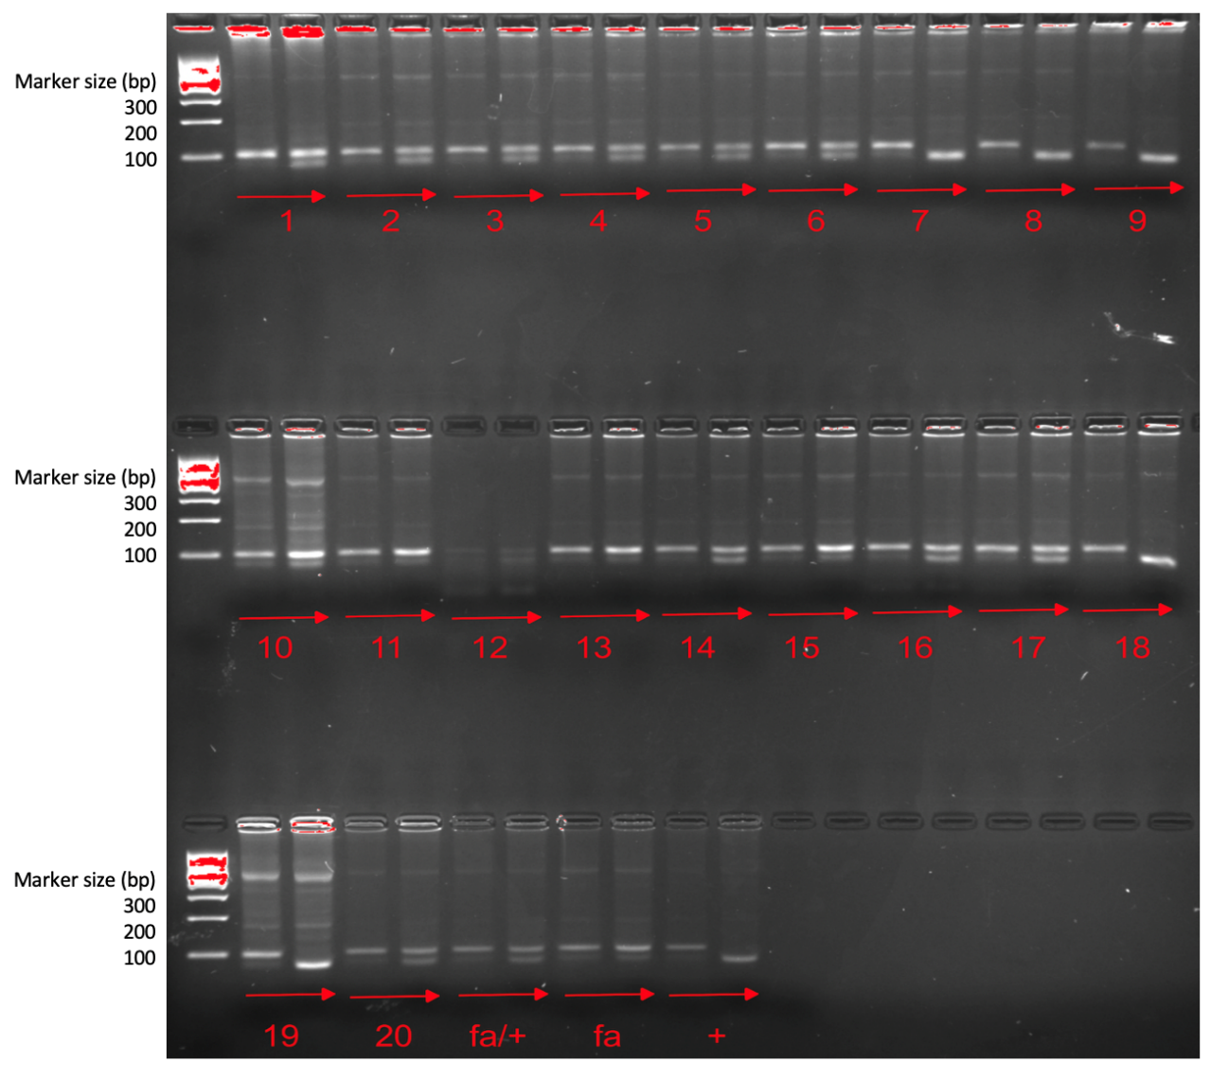
Figure 2-1: A representative gel of genotyping. 1-20 are samples of rats at 14 days age, fa/+, fa, + are positive control.
The PCR products without and with Pvu II digestion of each sample were run side-by-side for comparison. Number 1 to 20 are samples from different pups.

Table 2-2: Protein, carbohydrate, fat. VA and caloric content of each diet used in the study
 | Basal fat (BF) |  |  | High fat (HF)
VA statuses  Catalog NO. | VAD  #TD. 190039 | VAM  #TD. 190040 | VAS  #TD. 190041 | VAD  #TD. 190036 | VAM  #TD. 190037 | VAS  #TD. 190038
Protein (% kcal) | 20.1 | 19.5 | 19.5 | 18.9 | 18.3 | 18.3
Carbohydrate  (% kcal) | 57.8 | 57.9 | 57.9 | 21.3 | 21.4 | 21.4
Fat (% kcal) | 22.1 | 22.7 | 22.7 | 59.7 | 60.3 | 60.3
VA (mg/kg) | 0 | 0.35 | 4.0 | 0 | 0.35 | 4.0
Calories (Kcal/g) | 3.8 | 3.8 | 3.8 | 5.1 | 5.1 | 5.1
Note: BF diet (BF, 22% of Energy as fat) and HF diet (HF, 60% of Energy as fat) with different concentration of VA, VA deficient (VAD, 0 mg retinyl palmitate/kg diet), VA marginal (VAM, 0.35 mg retinyl palmitate/kg diet), VA sufficient (VAS, 4.0 mg retinyl palmitate/kg diet).

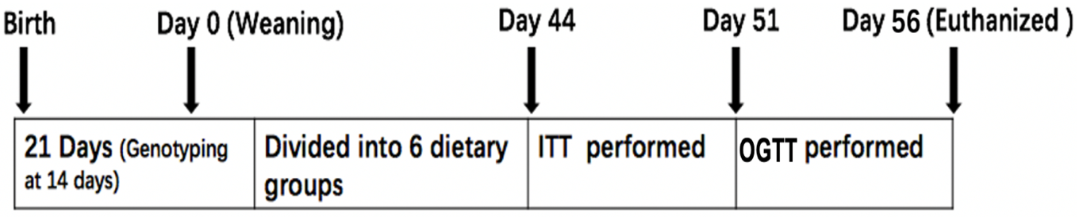
Figure 2-2: Experimental design.
ZL/ZDF rats in different diets treated for 8 weeks.

2.5 Insulin Tolerance Test (ITT), Oral Glucose Tolerance Test (OGTT), and Tissue Samples
An ITT was performed after the animals were fed their respective diets for 6.5 weeks (44 days after weaning). Rats were fasted for overnight and their tail tip whole blood glucose levels via percutaneous punching were measured as time 0 (the baseline data). The short-acting insulin (Novolin® R insulin human injection, U-100) was administrated to ZDF (0.25 U/kg bm) and ZL (0.125 U/kg) rats intravenously. After the administration of insulin, tail tip whole blood glucose levels at 5, 10, 15, 20, 30, 40, and 60 minutes were determined via percutaneous punching.
An OGTT was performed after the animals were fed their respective diets for 7.5 weeks (51 days after weaning). Rats were fasted overnight and whole blood glucose levels collected from tail tip via percutaneous punching were measured as time 0 (the baseline data). Glucose solution was administered to ZDF and ZL rats at a dose of 2 g/kg BW via gavage. After the administration of glucose, tail tip whole blood glucose levels at 10, 20, 30, 60, and 120 minutes were determined via percutaneous punching.

2.6 Plasma Parameter Measurements
At the end of the 8-week feeding protocol, rats were fasted for 6 hours and euthanized via CO₂ inhalation for the collection of plasma and tissue samples for further analysis. Accumulated venous blood was collected using the K3 EDTA coated BD vacuum blood collection tubes to block coagulation and placed on ice before further processing. Whole blood samples were centrifuged at 2,000 x g for 30 minutes at 4ºC after they were collected. The supernatant (plasma) was transferred to new microcentrifuge tube for storage. The liver was collected after the accumulated venous blood was drained up. Liver weight was recorded before frozen in liquid nitrogen. The two pads of epididymal white adipose tissue (WAT) were removed carefully, weighed, and immediately frozen in liquid nitrogen. The plasma and tissue samples were stored at -80ºC until being used for further analysis.
The plasma concentrations of blood glucose, TG and total cholesterol levels were determined using kits from Stanbio Laboratory (Boerne) following the manufacture’s manual. The plasma insulin and glucagon levels were measured using the RIA kits according to the manufacture’s manuals. The plasma leptin level was measured using the ELISA kit following the manufacture’s manual.
The homeostasis model assessment for insulin resistance (HOMA-IR) was calculated with the formula: HOMA-IR (nIU/ml × mM) = fasting blood glucose (mmol/L) × fasting insulin (μU/mL)/22.5. 22.5 is the constant of glucose turnover when glucose is expressed in insulin sensitivity index (S.I.) units.

2.7 RNA Extraction and Quantitative Real-time PCR
Total RNA was extracted from about 100 mg frozen rat liver sample using 1 ml of TRIzol reagent (#98903, Life Technologies, Carlsbad, CA, USA) according to the manufacture’s protocol. The contaminated DNA was removed using DNA-free kit (Applied Biosystems™, Foster City, CA, USA), and 2 μg of DNA-free RNA was reverse-transcribed into complementary DNA (cDNA) using cDNA synthesis kit (Applied Biosystems™ GeneAmp™ RNA PCR kit, Foster City, CA, USA). For the quantitative real-time PCR, oligo nucleotide primer sequences for detecting glucokinase (Gck), Sterol regulatory element-binding protein 1 (Srebp-1c), Sterol regulatory element-binding protein 2 (Srebp2), Phosphoenolpyruvate Carboxykinase 1 (Pck1), Fas, Acl, retinaldehyde dehydrogenase 1 (Raldh1), insulin-like growth factor-binding protein 1 (Igfbp1), Stearoyl-CoA desaturase-1 (Scd1), CD36, Glucose 6-phosphatase (G6p) and Regucalcin/SMP30 (Rgn) are shown in Table 2-3. Each SYBR green based real-time PCR reaction contains, in a final volume of 14 μl, cDNA from 14 ng of reverse transcribed total RNA, 2.33 pmol primers, and 7 μl of 2 x SYBR Green PCR Master Mix (Applied Biosystems). Triplicate PCR reactions were carried out in 96-well plates using 7300 Real-Time PCR System. The conditions are 50ºC for 2 min, 95ºC for 10 min, followed by 40 cycles of 95ºC for 15 seconds (s) and 60ºC for 1 min. The mRNA level of the indicated gene was normalized to that of invariable control gene, 36B4. -∆ cycle threshold (C_{T}) values were obtained by subtracting the C_{T} value of 36B4 (an invariable control gene) from the C_{T} values of the indicated genes. It indicates the difference between the expression levels of 36B4 and the indicated genes.
Table 2-3: Real-time PCR primer sequences of the indicated genes
Gene name | Forward Sequence | Reverse Sequence
Gck | 5'-CCTGGGCTTCACCTTCTCCTT-3' | 5'-GAGGCCTTGAAGCCCTTGGT-3'
Srebp-1c | 5′-GGAGCCATGGATTGCACATT-3′ | 5′-AGGCCAGGGAAGTCACTGTCT-3′
Srebp2 | 5'-CTGCAGATCCCGCAGTACAG-3' | 5'-GGTGGATGAGGGAGAGAAGGT-3'
Pck1 | 5'-AGTCACCATCACTTCCTGGAAGA-3' | 5'-GGTGCAGAATCGCGAGTTG-3'
Fas | 5'-CAGGAACTGAACGGCATTACCTC-3' | 5'-CATTTTCTAGGGATAACAGCAC-3'
Acl | 5'-GCTGAAGACATTAAGAGACACCTGTT-3' | 5'-AAATTGAATAGGCCGGAGATGA-3'
Raldh1 | 5'-ACTGTGTCATCTGCTCTG-3' | 5'-TTACTCTGCTGGCTTCTT-3'
Igfbp1 | 5'-GATCACTGACCTCAAGAAATGGAA-3' | 5'-GCGGCACGTAATCTCTCTAACA-3'
Scd1 | 5'-AAGATATCCACGACCCCAGCTA-3' | 5'-TGCAGCAGGGCCATGAG-3'
CD36 | 5'-CGGCGATGAGAAAGCAGAA-3' | 5'-CAACCAGGCCCAGGAGC-3'
G6p | 5'-GACCTCAGGAACGCCTTCTATG-3' | 5'-ATTGATGCCCACAGTCTCTTGA-3'
Rgn | 5'-TCAAAGACTGTCTGCCGATG-3' | 5'-GACTGTCGAAGTGCCACTGA-3'
Gck, glucokinase; Srebp-1c, Sterol regulatory element-binding protein 1; (Srebp2), Sterol regulatory element-binding protein 2; (Pck1), Phosphoenolpyruvate Carboxykinase 1; Fas, Fatty acid synthase; Acl, ATP citrate lyase; Raldh1, retinaldehyde dehydrogenase 1; (Igfbp1), insulin-like growth factor-binding protein 1; (Scd1), Stearoyl-CoA desaturase-1; G6p, Glucose 6-phosphatase and Rgn, Regucalcin/SMP30

2.8 Protein Extraction and Western Blot
For protein sample preparation, approximately 100 mg of liver tissue was homogenized in 1 ml liver lysis buffer (50 mM Hepes, 10 mM EDTA, 10% glycerol, 1% NP-40 and 1% Triton X-100, 100 mM NaF, 1 mM sodium molybdate, 1 mM sodium β-glycerophsphate, 5 mM sodium orthovanadate, 1.9 mg / ml aprotinin, 5 μg / ml leupeptin, 1 mM benzamide, 2.5 mM PMSF, pH 8.0), using a tissue homogenizer (Tissue Master 240, OMNI International, Kennesaw, Georgia) at 300 x g. This liver lysate was put on ice for at least 20 minutes, and then centrifuged at 16,000 x g for 10 minutes. The supernatant (total hepatic lysate) was transferred to a fresh microcentrifuge tube until being used. The protein concentration in the total hepatic lysate was determined using the PIERCE BCA protein assay kit (Rockford, Illinois). The protein in the total hepatic lysate (60 μg /well) was separated on an 8% or 10% reducing SDS-PAGE gel, transferred to a PVDF membrane, and detected with a primary antibody against the indicated protein. All the antibodies were used according to the protocols provided by the manufacturers. Bound primary antibodies were visualized by chemiluminescence (ECL Western Blotting Substrate, Thermo Scientific) using horseradish peroxidase-conjugated goat anti-rabbit IgG diluted 1: 2,000 (# 7074, Cell Signaling Technology). The membrane was exposed to X-ray film to observe the protein band. Image J was used to measure the signal intensity of the protein bands. The ratio of target gene protein band to β-actin band in the same sample was calculated and used for quantification.

2.9 Preparation of the Hepatic Sample for the Detection of Total Retinol Using Reversed-phase High Performance Liquid Chromatography (HPLC)
All procedures were done in glass containers and conducted in dim light. About 50 mg liver sample was homogenized in 2 ml of 100% ethanol and 100 μl of 1.0 g/ml KOH using an OMNI international tissue master 240 (Kennesaw, GA) at 6,000 x rpm. The homogenate was kept at room temperature in the dark for 60 minutes. In a fresh tube containing 1.4 ml of 100% ethanol, 600 μl of lysate or distilled deionized water as the blank control was added. After that, 100 μl 20% pyrogallol (pyrogallol dissolve in 100% ethanol) was then added to each tube, and the mixture was vortexed to mix for 30 seconds. The tubes were incubated at 55 °C in water bath for 30 minutes and allowed to cool down to room temperature. After that, 4 ml of hexanes (with BHT, 100μg/ml) and 2 ml ddH2O were added, shaken and vortexed to mix and kept at 4 °C for overnight. After the separation of layers, samples were centrifuged at 1,600 rpm for 15 minutes, and then approximately 3.5 ml of the upper hexanes phase was transferred into a fresh tube, which 10 μl of retinyl acetate solution in 100% methanol (130 μmol/L) as internal standard was added. The mixture was dried under nitrogen gas stream at room temperature in the dim light. Each dried sample was reconstituted in 100 μl of methanol and kept in brown vials before HPLC analysis.
An Agilent 1260 chromatograph equipped with a variable wavelength detector operating at 325 nm was used to detect retinoids. Samples were separated on a KR100-5C18 column (4.6 × 250 mm, No. E8218, Kromasil, S-44580 Bohus, Sweden). Elution solvents were (A) ddH2O containing 0.01 M ammonium acetate (v/v) and (B) methanol at 21-23 °C column temperature and a flow rate of 1 ml/minute. The injection volume was 20 μl. The total length of runs was 45 minutes and the gradient program was set as follows: 0 minute A: 5%, B: 95%; 10 min A: 30%, B: 70%; 20 minutes A: 20%, B: 80%; 25 minutes A: 5%, B: 95%; and 40 minutes A: 0%, B: 100%. Based on the areas of retinyl acetate standards, a standard linear regression equation was obtained. The areas of retinyl acetate and retinol in the HPLC elution curves were used to obtain the content of hepatic retinol, which was presented as pmol/mg liver weight. The calculate equation is Concentration of the unknown = Area unknown/(Area Internal Standard in unknown x Concentration of the retinyl acetate standard)

2.10 Statistics Analysis
Statistical analyses were performed with GraphPad Prism 8.0 (GraphPad Software, Inc., San Diego, CA). The results of two groups were compared using the Student's t-test with 95% confidence interval (CI), and where necessary natural log transformation was performed before analysis. One-way ANOVA with LSD post-hoc statistical analysis was used to compare the means of three or more treatments. Data were presented as means ± S.E.M. The difference was considered significant when the p-value was less than 0.05.

3. Results

3.1 The Effects of VA Status on Body Mass (BM), Food Intake, and PBG Levels in ZL and ZDF Rats
To determine the effects of VA status on BM, food intake, and PBG levels of ZL or ZDF rats fed a VAD, VAM or VAS diet with BF or HF content for 8 Weeks, we measured these parameters weekly for 8 weeks. As shown in Figure 2-3, VAS-BF ZL and ZDF rats from 7 weeks had respectively higher BM than VAD/VAM-BF ZL and ZDF rats, respectively. VAS-HF ZL and ZDF rats from 6 weeks had respectively higher BM than VAD/VAM-HF ZL and ZDF rats. The BM comparing to the previous week in VAD ZL rats stopped at week 6 in both BF and HF diet groups, whereas VAS ZL rats continued to gain BM throughout the experimental period. The BM of ZDF rats in the VAS-BF/HF diet groups started to rise significantly in week 4 compared to those fed the VAD-BF/HF and VAM-BF-HF diet groups, respectively. These results demonstrate the role of VA in BM gain in both ZL and ZDF rats. ZDF rats are more sensitive to VA status than ZL rats in HF. As ZL, but not ZDF, VAM rats fed the diets with BF are able to maintain growth (at a lowered rate) at week 7 and week 8. HF diet seems to induce BM gain associated with VA as VAM and VAS rats have significantly higher BM than VAD rats in both lean and fatty genotypes after 4 weeks treatment while ZL and ZDF rats have significantly difference after 6 weeks treatment.
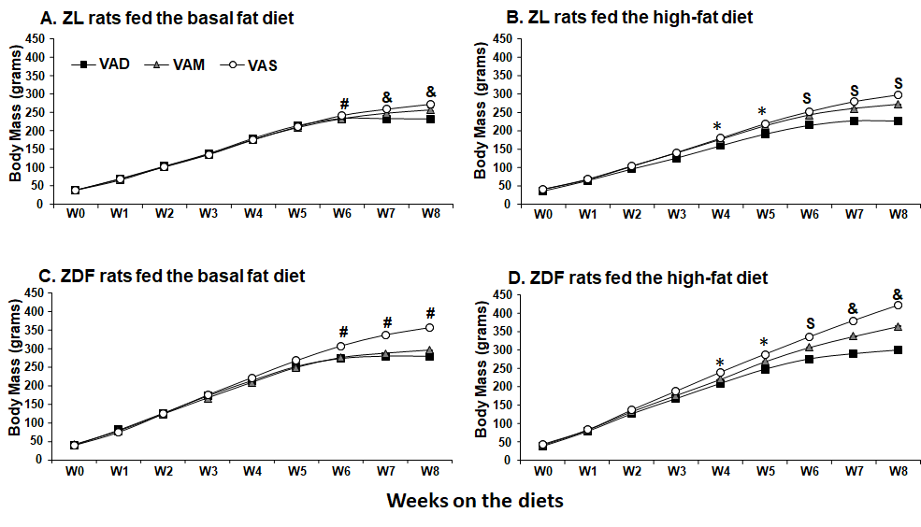
Figure 2-3: Body Mass of ZL or ZDF rats fed a VAD, VAM or VAS diet with BF or HF content for 8 Weeks.
The body mass of ZL or ZDF rats fed with diet were measured once a week (VAD-BF ZL (n = 6), VAM-BF ZL (n = 6), VAS-BF ZL (n = 5), VAD-HF ZL (n = 5), VAM-HF ZL (n = 6), VAS-HF ZL (n = 5), VAD-BF ZDF (n = 5), VAM-BF ZDF (n = 5), VAS-BF ZDF (n = 5), VAD-HF ZDF (n = 6), VAM-HF ZDF (n = 6), and VAS-HF ZDF (n = 5)). Data were expressed as mean ± SEM; * For VAD< VAS; # for VAD/VAM<VAS; $ for VAD<VAM/VAS; & for VAD<VAM<VAS using one way ANOVA at the time point indicated, all p < 0.05.
The average of food intake of ZL and ZDF rats started to decrease from 6 weeks when the ITT and OGTT were preformed (Figure 2-4). Compared with that of the VAD-HF ZL and ZDF rats, the food intakes of VAS-HF ZL and ZDF rats respectively increased significantly. A problem for the food intake measurement is that it was very difficult to measure it accurately since the rats were housed in groups with 1 to 3 per cage. Therefore, the difference in dietary intake of rats in the early stage is not obvious.
For the PBG levels, there is no significant change in ZL rats fed diets in BF or HF contents except for the ZL rats fed the VAS-BF diet, which is higher than those fed the VAD/VAM-BF diet at week 8. VAS-BF ZDF rats from week 5 week had higher PBG levels than VAD/VAM-BF ZDF rats (Figure 2-5C). Interestingly, as shown in Figure 2-5D, VAM/VAS-HF ZDF rats from 4 weeks had a higher PBG levels than VAD-HF ZDF rats, which is one week earlier than ZDF rats fed BF diet. Finally, VAS-HF ZDF rats had the highest PBG levels than VAD/VAM-HF ZDF rats.
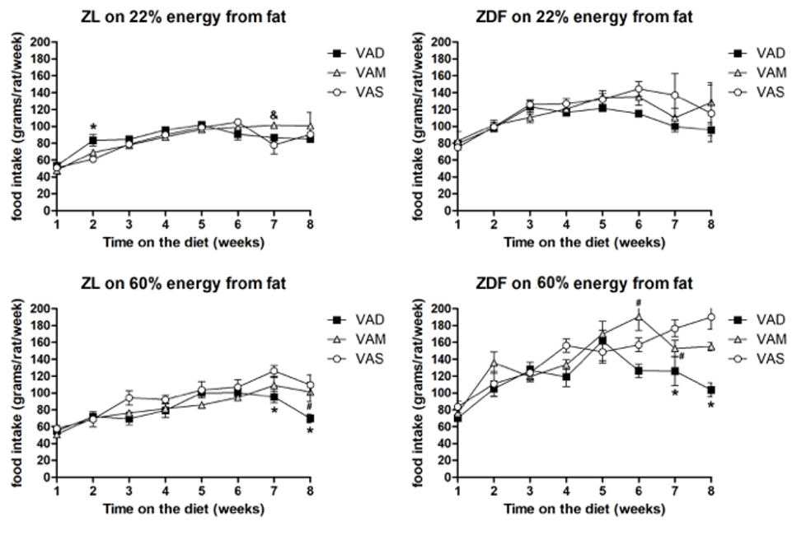
Figure 2-4: Food intake of ZL or ZDF rats fed a VAD, VAM or VAS diet with BF or HF content for 8 Weeks.
The average amount of diet consumed by ZL or ZDF rats fed with diet were measured once a week (VAD-BF ZL (n = 6), VAM-BF ZL (n = 6), VAS-BF ZL (n = 5), VAD-HF ZL (n = 5), VAM-HF ZL (n = 6), VAS-HF ZL (n = 5), VAD-BF ZDF (n = 5), VAM-BF ZDF (n = 5), VAS-BF ZDF (n = 5), VAD-HF ZDF (n = 6), VAM-HF ZDF (n = 6), and VAS-HF ZDF (n = 5)). Data were expressed as mean ± SEM; *VAD vs. VAS, # VAD < VAM, & VAM > VAS, all p < 0.05.
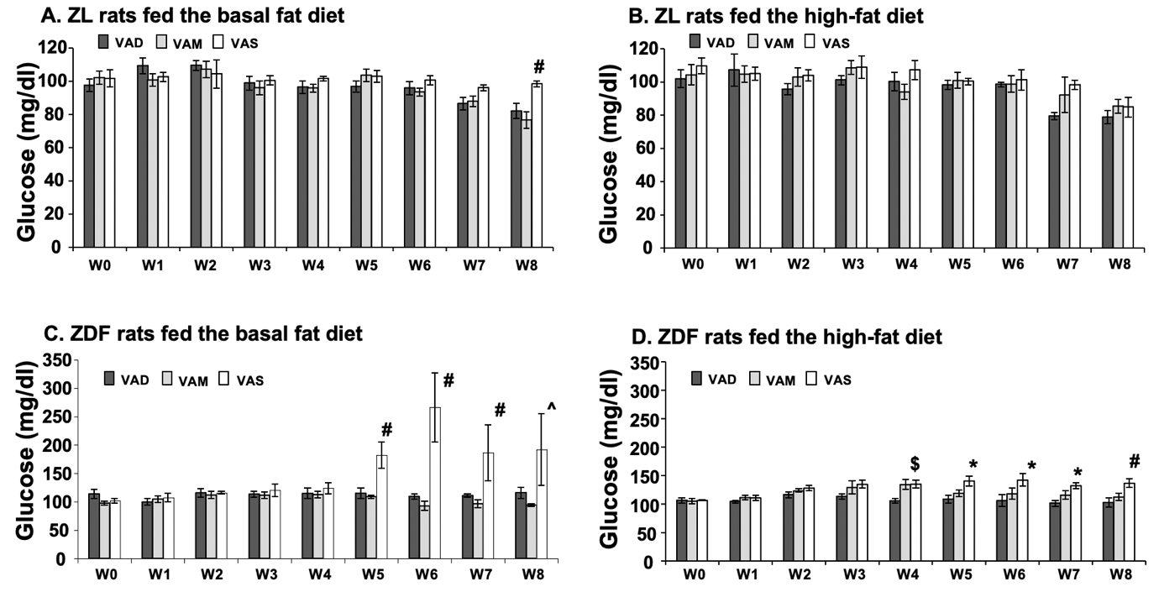
Figure 2-5: Peripheral blood glucose levels of ZL or ZDF rats fed a VAD, VAM or VAS diet with BF or HF content for 8 Weeks.
The PBG level from rat tail tips were measured once a week (VAD-BF ZL (n = 6), VAM-BF ZL (n = 6), VAS-BF ZL (n = 5), VAD-HF ZL (n = 5), VAM-HF ZL (n = 6), VAS-HF ZL (n = 5), VAD-BF ZDF (n = 5), VAM-BF ZDF (n = 5), VAS-BF ZDF (n = 5), VAD-HF ZDF (n = 6), VAM-HF ZDF (n = 6), and VAS-HF ZDF (n = 5)).. Data were expressed as mean ± SEM; * For VAD< VAS; ^ for VAM<VAS: # for VAD/VAM<VAS; $ for VAD<VAM/VAS, all p < 0.05.

3.2 The Effects of VA Status on the Body Compositions of ZL and ZDF Rats
The ratios of the liver to BM (liver/BM) and the epididymal WAT to BM (WAT/BM) were calculated to determine the effects of VA status on the body compositions of VAD/VAM/VAS-BF/HF ZL and ZDF rats. As shown in Figure 2-6A, at the time of sacrifice, the liver/BM ratio of VAD/VAM-BF ZDF rats were significantly lower than that of VAS-BF ZDF rats. The liver/BM ratios of VAD-HF ZDF rats were lower than that of VAS-HF ZDF group. The liver/BM ratios of VAS-BF ZDF rats were higher than that of VAS-BF ZL rats. Also, the liver/BM ratios of VAS-BF ZDF were higher than that of VAS-HF ZDF rats. As shown in Figure 2-6B, the WAT/BM ratios of VAD-HF ZDF rats were lower than that of VAS-HF groups which shown the same trend as the liver/BM ratio. There is no difference in VAM-BF/HF ZL/ZDF group The HF diets can increase the WAT/BM ratio in ZDF rats as the values of VAS-HF ZDF rats were higher than that of VAS-BF ZDF rats. The WAT/BM ratios of ZDF rats were higher than ZL rats fed same diets. All these data indicated that VA status does affect liver/BM ratio and WAT/BM ratio in ZDF rats.
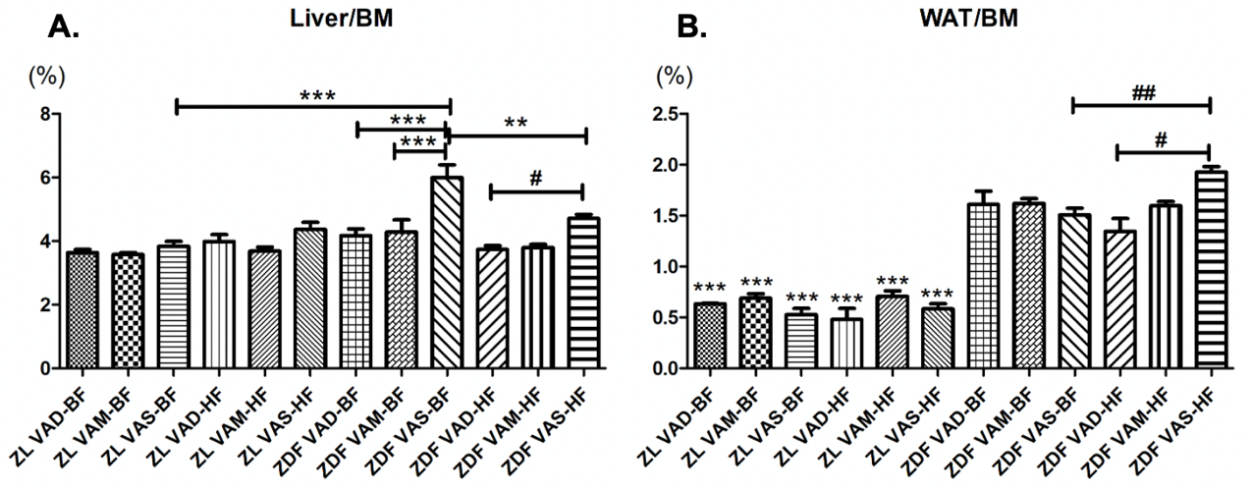
Figure 2-6: The ratios of liver/BM and WAT/BM were calculated and compared between VAD/VAM/VAS-BF/HF ZL and ZDF rats.
The ratios of liver/BM and WAT/BM were calculated and compared (VAD-BF ZL (n = 6), VAM-BF ZL (n = 6), VAS-BF ZL (n = 5), VAD-HF ZL (n = 5), VAM-HF ZL (n = 6), VAS-HF ZL (n = 5), VAD-BF ZDF (n = 5), VAM-BF ZDF (n = 5), VAS-BF ZDF (n = 5), VAD-HF ZDF (n = 6), VAM-HF ZDF (n = 6), and VAS-HF ZDF (n = 5)). Data were represented means ± SEM of 12 independent groups. In liver/BM * p<0.05, ** p<0.01,*** p<0.001 VAS-BF ZDF rats vs. other groups; # p<0.05, ## p<0.01 VAS-HF ZDF rats vs. other group. In WAT/BM, * p<0.05, ** p<0.01,*** p<0.001 ZL rats vs. ZDF rats in same diet; # p<0.05, ## p<0.01 VAS-HF ZDF rats vs. other group. Data were represented as means ± SEM.

3.3 Hepatic Retinol Content in the ZL and ZDF Rats Fed Diets with Different VA Contents
Figure 2-7 shows that the hepatic retinol content in VAD-BF/HF ZL groups and VAD-HF ZDF groups were respectively lower than that in VAM-BF/HF ZL groups and VAM-HF ZDF groups, which is respectively lower than that in VAS-BF/HF ZL groups and VAS-HF ZDF groups. The hepatic retinol content in VAD/VAM-BF ZDF groups were significantly lower than that in VAS-BF ZDF group. In ZL rats, the retinol contents of VAD/VAM/VAS-HF groups were significantly higher than that of VAD/VAM/VAS BF groups, respectively. The hepatic retinol content of VAS-BF ZDF group was higher than that in VAS-BF ZL group. The hepatic retinol results show that VA statuses of ZL and ZDF rats reflect their dietary VA contents. ZL rats fed a HF diet store more VA in the liver than those fed a BF diet. ZDF rats fed a VAS-BF diet will store more VA in the liver than ZL rats, which probably reflects the excessive VA intake of ZDF rats.
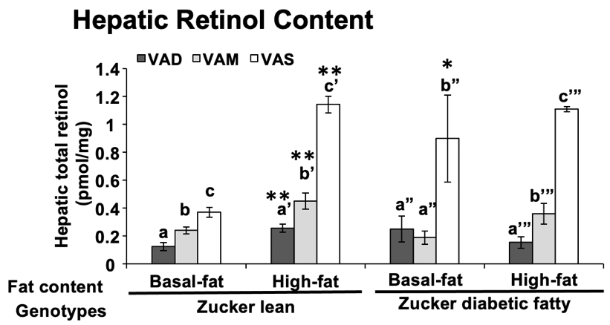
Figure 2-7: Hepatic Retinol Content of ZL and ZDF rats fed a VAD, VAM or VAS diet with BF or HF content.
liver tissues were harvested and prepared for analysis (VAD-BF ZL (n = 6), VAM-BF ZL (n = 6), VAS-BF ZL (n = 5), VAD-HF ZL (n = 5), VAM-HF ZL (n = 6), VAS-HF ZL (n = 5), VAD-BF ZDF (n = 6), VAM-BF ZDF (n = 6), VAS-BF ZDF (n = 6), VAD-HF ZDF (n = 6), VAM-HF ZDF (n = 6), and VAS-HF ZDF (n = 6)). a<b<c, a’<b’<c’, a”<b”, and a’”<b’”<c’” for comparing the groups in the same dietary fat content and genotype using one way ANOVA; * for comparing ZL and ZDF groups fed the same diet; ** for comparing BF with HF groups within the same genotype

3.4 The Effects of VA Status on ITT and OGTT of ZL and ZDF Rats
After overnight fast, ITT were measured at morning around 10-11 am. In ITT, PBG levels of VAD/VAS-BF and VAM-BF ZL rats dropped until 15 mins and 20 mins, respectively. PBG levels of VAD-HF and VAM/VAS-HF ZL rats declined until 30 mins and 15 mins, respectively. PBG levels of VAM-BF and VAS-BF ZDF rats dropped until 15 mins and 5 mins, respectively. PBG levels of VAD-BF ZDF rats started to drop after 10 mins and stopped after 20 mins. PBG levels of VAD/VAM-HF and VAS-HF ZDF rats dropped to the lowest until 15 mins and 20 mins, respectively (Figure 2-8). PBG levels of VAS-HF ZDF rats in ITT was significantly greater than that in VAD/VAM-HF ZDF rats, indicating insulin resistance in them.
After overnight fast, OGTT were measured at morning around 10-11 am. The OGTT results showed that PBG levels of VAS-BF ZL rats peaked at 10 minutes. VAS-BF/HF ZL rats had significantly higher PBG levels than VAD/VAM-BF/HF ZL rats, respectively. PBG levels of all ZDF rats peaked at 60 mins (except for VAS-BF ZDF rats at 30) before dropped (Figure 2-9). Both VAS-BF/HF ZL and ZDF groups also displayed higher blood glucose levels during the OGTT respectively compared to VAD/VAM-BF/HF ZL and ZDF groups. In Figure 2-10, the OGTT area under the curve (AUC) values of VAS-BF ZL rats were higher than that of VAD/VAM-BF ZL rats. In HF diet condition, the AUC values of VAS-HF ZL rats were higher than that of VAM-HF ZL rats, and that of VAM-HF ZL rats were higher than that of VAD-HF ZL rats. In ZDF, the OGTT AUC values of VAS-BF/HF ZDF rats were higher than that of VAD/VAM-BF/HF ZDF rats, respectively. The comparison of ZL and ZDF groups with the same diet, ZDF rats’ AUC values were significantly higher than that of ZL rats. This indicating an impaired glucose tolerance in VAS-BF/HF ZL or ZDF rats.
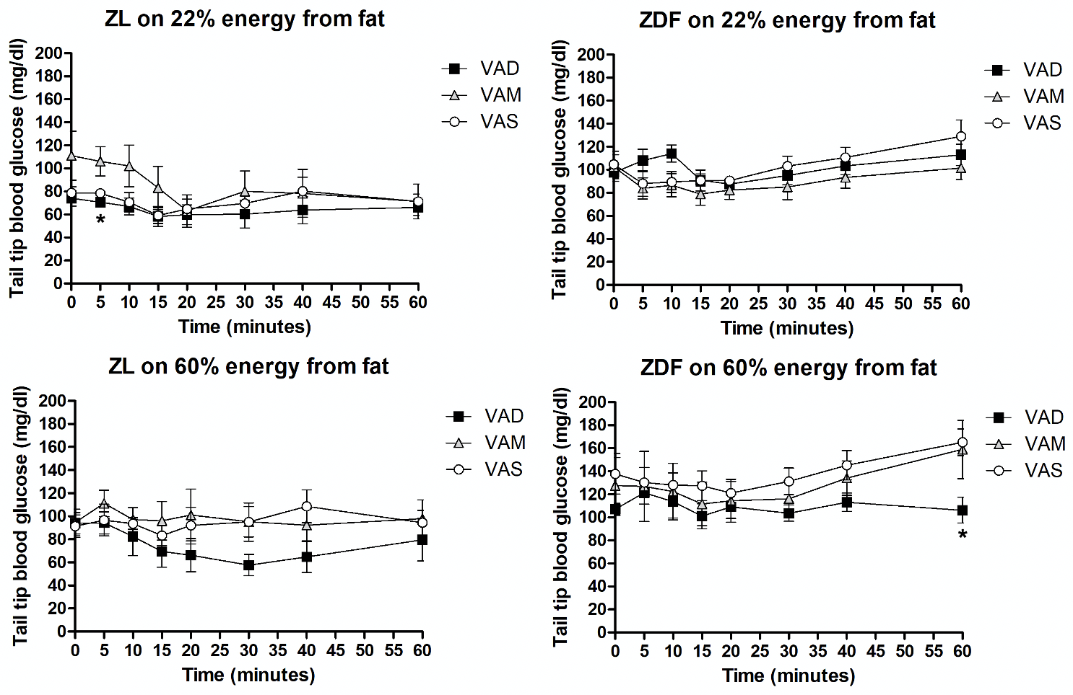
Figure 2-8: Peripheral glucose levels of ZL or ZDF rats fed a VAD, VAM or VAS diet with BF or HF content after insulin tolerance test at 6.5 weeks.
Data were expressed as mean ± SEM, * p<0.05. VAD-BF ZL (n = 6), VAM-BF ZL (n = 6), VAS-BF ZL (n = 5), VAD-HF ZL (n = 5), VAM-HF ZL (n = 6), VAS-HF ZL (n = 5), VAD-BF ZDF (n = 5), VAM-BF ZDF (n = 5), VAS-BF ZDF (n = 5), VAD-HF ZDF (n = 6), VAM-HF ZDF (n = 6), and VAS-HF ZDF (n = 5).

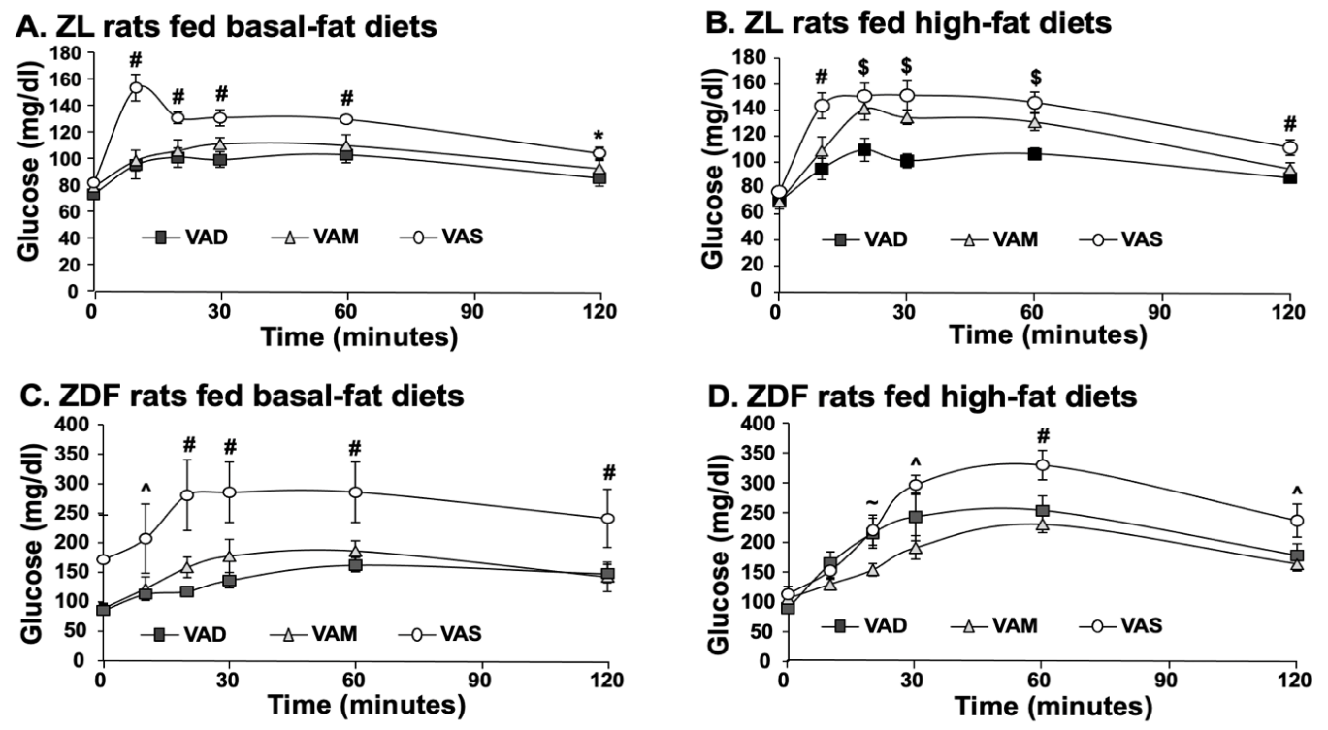
Figure 2-9: Peripheral glucose levels and Glucose Area Under the Curve (AUC) after oral glucose tolerance test of ZL or ZDF rats fed a VAD, VAM or VAS diet with BF or HF content at 7.5 weeks.
Data were expressed as mean ± SEM, (A-D) * for VAD<VAS; ^ for VAM<VAS; # for VAD/VAM<VAS; $ for VAD<VAM/VAS; ~ for VAM<VAD/VAS, p<0.05. VAD-BF ZL (n = 6), VAM-BF ZL (n = 6), VAS-BF ZL (n = 5), VAD-HF ZL (n = 5), VAM-HF ZL (n = 6), VAS-HF ZL (n = 5), VAD-BF ZDF (n = 5), VAM-BF ZDF (n = 5), VAS-BF ZDF (n = 5), VAD-HF ZDF (n = 6), VAM-HF ZDF (n = 6), and VAS-HF ZDF (n = 5).

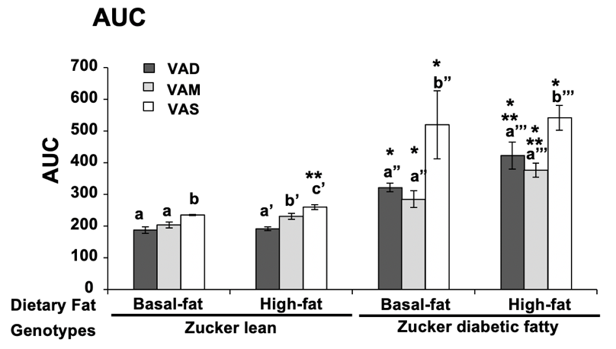
Figure 2-10: Area under the curve (AUC) values of the oral glucose tolerance test in ZL and ZDF rats fed a VAD, VAM or VAS diet with BF or HF content.
a<b, a’<b’, a”<b”, and a’’’<b’’’ for comparing the groups in the same fat content and genotype using one way ANOVA; * for comparing ZL and ZDF groups with the same diet; ** for comparing BF with HF groups within the same genotype, p<0.05. VAD-BF ZL (n = 6), VAM-BF ZL (n = 6), VAS-BF ZL (n = 5), VAD-HF ZL (n = 5), VAM-HF ZL (n = 6), VAS-HF ZL (n = 5), VAD-BF ZDF (n = 5), VAM-BF ZDF (n = 5), VAS-BF ZDF (n = 5), VAD-HF ZDF (n = 6), VAM-HF ZDF (n = 6), and VAS-HF ZDF (n = 5)

3.5 The Effects of VA on Plasma Levels of Glucose, TG, Cholesterol, Insulin, Glucagon, and Leptin in ZL and ZDF Rats
To investigate the effects of VA status on glucose and lipid metabolism, we compared the plasma levels of glucose, TG, and cholesterol in ZL and ZDF rats fed a VAD, VAM or VAS diet with BF or HF diet. Figure 2-11 A shows that the plasma glucose levels of VAD/VAM/VAS-HF ZDF rats were higher than that in HF ZL rats. Compared with that of ZL rats, the glucose levels of VAM-BF rats were significantly higher than VAD/VAS-BF. The glucose levels of venous plasma were significantly lower in VAD-HF ZDF rats than VAM/VAS-HF ZDF rats. These results demonstrating that VA deficiency results in a reduction in plasma glucose level of ZL and ZDF rats.
Figure 2-11 C shows that the plasma insulin levels of VAD/VAM/VAS-BF/HF ZL rats were significantly lower than that in ZDF rats. The plasma insulin levels of VAD/VAM-BF/HF ZDF rats were significantly lower than that in VAS-BF/HF ZDF rats. These results indicate that the dietary VA may directly affects plasma insulin levels in ZDF rats. Also, the genetic predisposition to diabetes is more influential on plasma insulin levels than VA status when comparing between VAD-BF ZL rats and VAD-BF ZDF rats.
The TG and cholesterol levels of vena cava plasma in VAD/VAM/VAS-BF ZDF rats were higher than that in BF ZL rats (Figure 2-11 B and D). These levels in VAD/VAM/VAS-HF ZDF rats were higher than that in HF ZL rats. These results reveal that body fat mass affects the plasma TG and cholesterol levels, a normal physiological phenomenon. The plasma TG levels of VAD-BF/HF ZL or ZDF rats were lower than VAS-BF/HF ZL or ZDF rats respectively, which means VA deficiency results in a reduction in plasma glucose and TG levels in ZL and ZDF rats. The plasma cholesterol levels in VAD/VAM-BF/HF ZDF rats significantly decreased compared with that in VAS-BF/HF ZDF rats.
Figure 2-11 E shows that the leptin levels of VAD/VAM-BF/HF ZDF rats were lower than that of VAS-BF/HF ZDF rats. The VAD/VAM-HF ZL group had lower leptin levels than VAS-HF ZL group. The leptin levels of VAD/VAM/VAS-BF/HF ZL rats were significantly lower than that of VAD/VAM/VAS-BF/HF ZDF rats respectively, probably due to the reduction of body fat mass. There is a significant increase of plasma leptin levels in VAS-HF ZL rats compare with that in VAS-BF ZL rats. These results indicate that VA status may affect the plasma leptin levels via the control of adiposity in rats, and the dietary VA does not affect the plasma leptin level in ZL rats with a BF diet based on this ELISA assay. The glucagon levels of vena cava plasma in VAS-HF ZDF rats were higher than that in VAS-HF ZL rats and lower than that in VAS-BF ZDF rats (Figure 2-11 F).
VAS-BF/HF ZDF rats had respectively higher HOMA-IR values than that of VAD/VAM-BF/HF ZDF rats. The HOMA values of VAM/VAS-HF ZDF rats were higher than that of VAM/VAS-BF ZDF rats. These results indicate that ZDF rats use more insulin than ZL rats to keep blood glucose in balance, indicating that VAS-BF/HF ZDF rats are the most insulin resistant compared with VAS-BF/HF ZL rats and VAD/VAM-BF/HF ZDF rats, respectively.
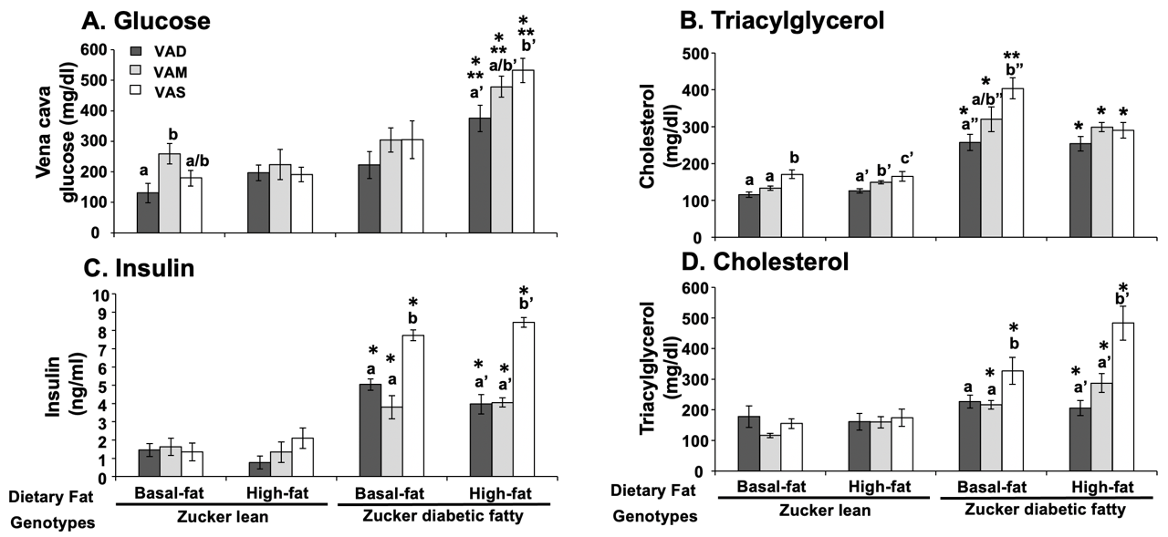
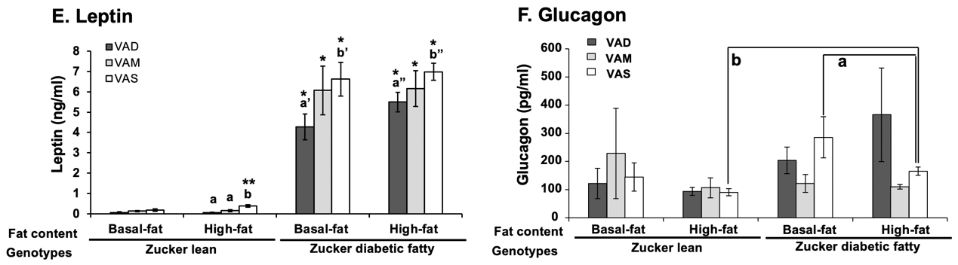
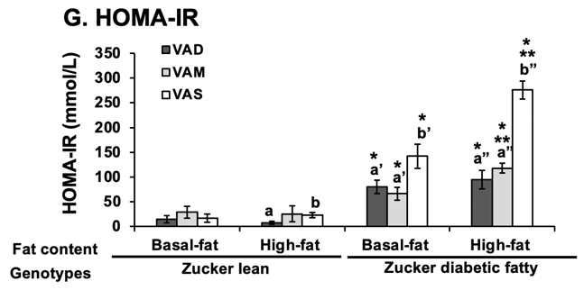
Figure 2-11: The plasma levels of glucose, TG, insulin, cholesterol, leptin, glucagon and HOMA-IR in ZL and ZDF rats fed a VAD, VAM or VAS diet with BF or HF content.
(A-E, G) a<b, a’<b’, a”<b”, and a’’’<b’’’ for comparing the groups in the same fat content and genotype using one way ANOVA; * for comparing ZL and ZDF groups with the same diet; ** for comparing BF with HF groups within the same genotype, P<0.05. (F) a for comparing the BF and HF conditions with the same rat genotype and VA status; b for comparing the ZL and ZDF rats in the same VA status and dietary fat content. VAD-BF ZL (n = 6), VAM-BF ZL (n = 6), VAS-BF ZL (n = 5), VAD-HF ZL (n = 5), VAM-HF ZL (n = 6), VAS-HF ZL (n = 5), VAD-BF ZDF (n = 6), VAM-BF ZDF (n = 6), VAS-BF ZDF (n = 6), VAD-HF ZDF (n = 6), VAM-HF ZDF (n = 6), and VAS-HF ZDF (n = 6)

3.6 The Effects of VA on the mRNA Expression Levels of Hepatic Genes for Glucose and Lipid Metabolism in ZL and ZDF Rats
To confirm whether the VA status in the liver contributes to the regulation of the hepatic glucose and fatty acid metabolism, we compared the hepatic mRNA levels of Gck (glycolysis), Srebp-1c (fatty acid synthesis), Srebp2 (cholesterol synthesis), Pck1(gluconeogenesis), Fas (fatty acid synthesis), Acl (fatty acid synthesis), Raldh1 (retinal dehydrogenase 1), Igfbp1(insulin-like growth factor binding protein), Scd1 (lipogenesis), CD36 (facilitates fatty acid uptake), G6p (gluconeogenesis) and Rgn (cellular growth and apoptosis) in ZL and ZDF rats fed a VAD, VAM or VAS diet with BF or HF content. The Ct numbers of these genes are normalized to the Ct number of 36B4 (a control gene) as -ΔCt in the same sample. Based on the values of -ΔCt, we found that these genes are expressed at a meaningful level in rat liver.
Figure 2-12A shows that in both BF and HF conditions, the hepatic mRNA expression levels of Gck in VAD/VAM ZL groups were lower than that in VAS group. In ZL rats, the Gck mRNA levels in VAS-HF group were increased significantly compared with that in VAS-BF group. Also, the Gck mRNA levels in VAD-BF ZDF rats were significantly higher than that in VAD-BF ZL rats. These results demonstrate that VA is needed to sustain the hepatic expression of Gck in ZL rats, and especially in HF diet condition. VA status regulates the hepatic expression of Gck.
Figure 2-12B shows that the mRNA levels of Srebp-1c of ZL rats in VAD-BF group were lower than in VAM/VAS-BF and VAD-HF groups. In contrast, Srebp2 mRNA levels of VAD-BF ZL rats were higher than that of VAM/VAS-BF and VAD-HF ZL rats (Figure 2-12C). The Srebp-1c mRNA levels in VAM-HF ZDF group were higher than that in VAM-BF ZDF group. The Srebp2 mRNA levels of VAS-BF ZDF rats were lower than that of VAD-BF ZDF rats. Also, VAM-HF ZDF rats have higher Srebp-1c mRNA expression levels than VAM-HF ZL rats. In contrast, ZDF rats in all dietary groups had significantly lower Srebp2 mRNA expression levels than ZL rats fed the same diets respectively (except VAS-HF group). This demonstrates that VA induces Srebp-1c, and depresses Srebp2 mRNA levels in BF condition, and does not affect Srebp-1c and Srebp2 mRNA levels in HF condition.
As shown in Figure 2-12D, the hepatic expression levels of Pck1 in VAD/VAS-HF ZL groups were higher than that in VAM-HF group. The hepatic expression levels of Fas in ZL rats (Figure 2-12E) showed the same pattern as Pck1. The levels Pck1 (Figure 2-12D) and Raldh1 (Figure 2-12G) in VAM-HF ZDF group were lower than that in VAD/VAS-HF groups, respectively. The mRNA levels of Fas (Figure 2-12E) and Acl (Figure 2-12F) in VAS-HF ZDF group were significantly higher than that in VAD/VAM-HF group. The Pck1mRNA levels of ZDF rats in all dietary groups were decreased compared with that of ZL rats in same dietary groups, respectively. In contrast, the Fas mRNA levels in both BF and HF of ZDF rats were significantly increased compared with that of the ZL rats in same dietary groups (except for the VAD-HF group). The Acl mRNA levels of VAM-BF and VAD/VAM/VAS-HF ZDF groups were significantly increased compared with that of ZL rats in the same dietary groups, respectively.
The Raldh1 mRNA levels of VAM-HF ZDF rats were decreased compared with that of VAM-HF ZL rats. The Pck1 and Fas mRNA levels of VAM-HF group were significantly higher than that of VAM-BF group in ZL rats. In contrast, Raldh1 and Acl mRNA levels of VAM-HF group were lower than that of VAM-BF group in ZL rats. Also, the Pck1 and Acl mRNA levels of VAS-BF group were significantly lower than that of VAS-HF group in ZDF rats. Thus, VA status affects the expression levels of Pck1, Fas, Acl, and Raldh1 at BF or HF conditions in ZL and ZDF rats. The expression levels of Pck1, Fas, Acl, and Raldh1 in VAM-HF group are lower than the VAD/VAS-HF groups, showing a possible bidirectional regulation of these genes in response to VA status in HF conditions.
The hepatic of Igfbp1 mRNA levels in VAD-BF/HF groups of ZL rats and VAD-HF groups of ZDF rats were significantly higher than that of other groups (Figure 2-12H). The Igfbp1 mRNA levels in both BF and HF of ZDF rats were significantly reduced compared with that of ZL rats in the same dietary groups (except VAM-BF group), respectively. In both ZL and ZDF rats, the Igfbp1 mRNA levels in VAM-HF groups were significantly decreased compared with that in the BF groups. VAD diets dramatically induced the expression levels of Igfbp1 mRNA, showing that VA deficiency induces the hepatic Igfbp1 expression in both ZL and ZDF rats.
The hepatic expression levels of Scd1, CD36, G6p and Rgn were elevated in VAS-HF ZDF group compared with that of VAD/VAM-HF ZDF groups (Figure 2-12I-L). In ZL rats, CD36 mRNA levels of VAD-BF group were higher compared with that of VAM/VAS-BF groups (Figure 2-12J). In contrast, the G6p and Rgn mRNA levels of VAD-BF ZL group were lower compared with that of VAM/VAS-BF ZL groups, respectively (Figure 2-12K and L). Also, the Scd1mRNA levels in VAD-BF ZL group were lower than that in VAM-BF ZL group, which were lower than that in VAS-BF ZL group. The Rgn mRNA levels in VAD/VAM-HF ZL groups were also decreased compared with that in VAS-HF ZL group. In ZDF rats, the mRNA levels of Scd1, CD36 and Rgn in VAD/VAM-HF group were lower than that in VAS-HF group. The G6p mRNA levels in VAM-HF ZDF group were lower than that in VAD-HF ZDF group, which were lower than that in VAS-HF ZDF group.
The Scd1 mRNA levels of VAD/VAM-BF groups and VAM/VAS-HF groups in ZDF rats were significantly higher than that of same diets in ZL rats. The CD36 m RNA levels of VAM-BF group and VAS-HF group in ZDF rats were higher than that of same diets in ZL rats, respectively. The G6p mRNA levels of VAS-BF/HF groups and VAM-HF group in ZDF rats were lower than that of same diets in ZL rats. The Rgn mRNA levels of all dietary groups in ZDF rats were respectively lower than that in ZL rats.
The Scd1 mRNA levels of VAS-BF group were higher than that of VAS-HF group in ZL rats. The Rgn mRNA levels of VAS-HF ZL group were higher than VAS-BF ZL group. The Scd1, G6p and Rgn mRNA levels of VAS-HF ZDF group were higher in than that of VAS-BF ZDF group. The CD36 mRNA levels of VAM-HF were lower than that of VAM-BF in ZDF rats. These results show that VA deficiency contributes to the reduced levels of hepatic Scd1, G6p and Rgn and induced levels of CD36 in ZL rats fed a BF diet. Also, VA deficiency reduces Rgn expression in ZL rats fed a HF diet. Enough VA significantly supports the hepatic expression of Scd1, and G6p in ZDF rats fed a HF diet. Adequate VA intake may suppress CD36 expression in ZDF rats fed a HF diet. Enough VA maintains the hepatic Rgn mRNA levels in ZL and ZDF rats fed a BF or HF diet.
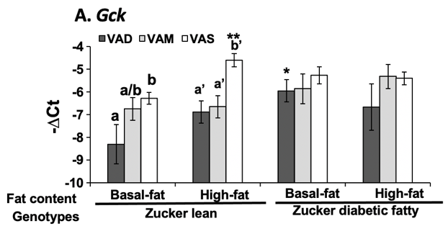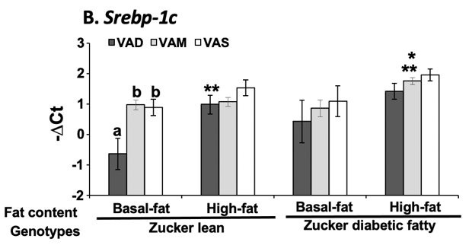
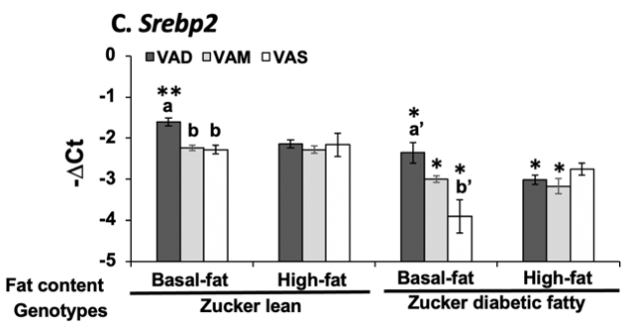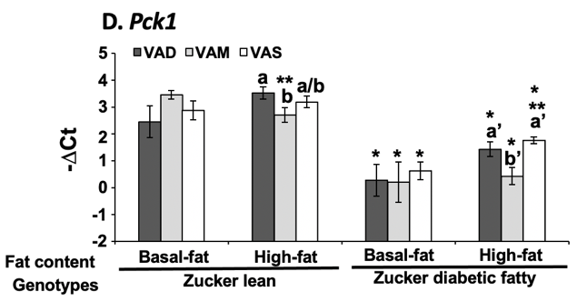
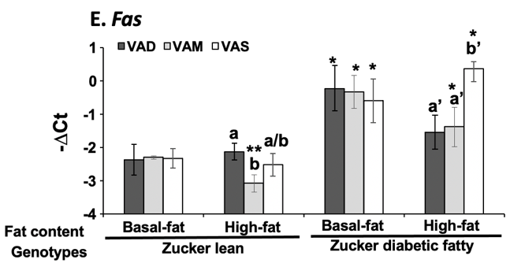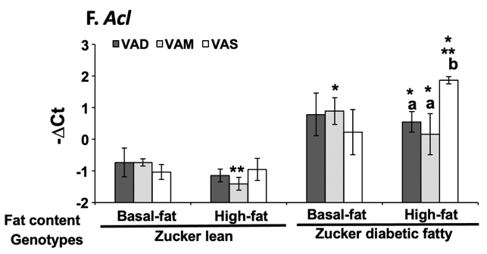
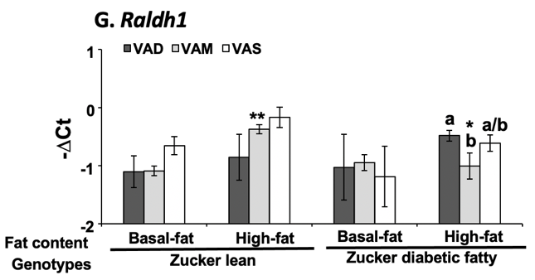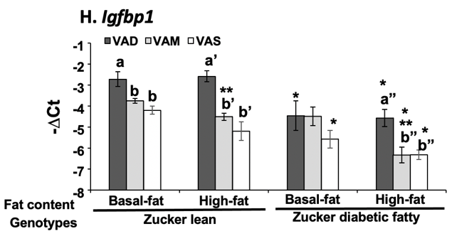

Figure 2-12 Continued
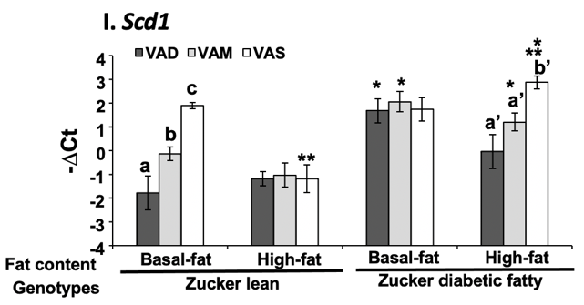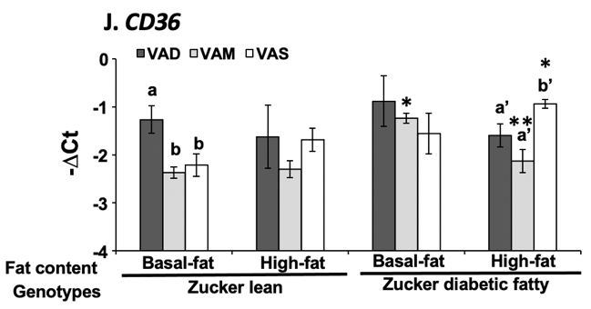
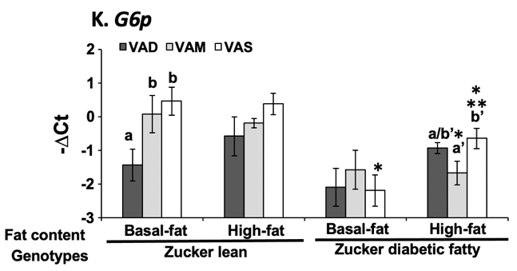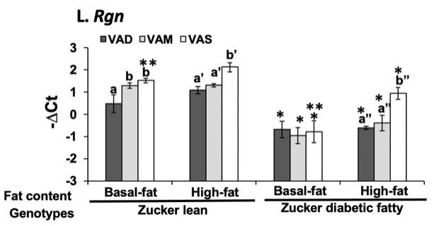
Figure 2-12: The mRNA levels of Gck, Srebp-1c, Srebp2, Pck1, Fas, Acl, Raldh1, Igfbp1, Scd1, CD36, G6p and Rgn in ZL and ZDF rats fed a VAD, VAM or VAS diet with BF or HF content.
Liver tissue samples were collected at the end of the treatment (VAD-BF ZL (n = 6), VAM-BF ZL (n = 6), VAS-BF ZL (n = 5), VAD-HF ZL (n = 5), VAM-HF ZL (n = 5), VAS-HF ZL (n = 5), VAD-BF ZDF (n = 6), VAM-BF ZDF (n = 5), VAS-BF ZDF (n = 6), VAD-HF ZDF (n = 5), VAM-HF ZDF (n = 5), and VAS-HF ZDF (n = 5)). Total RNAs were extracted and subjected to real-time PCR analysis. Results were presented as means ± SEM of the -∆CT. (A, B, F, I, K, L) a<b<c, a’<b’, a”<b”, and a’’’<b’’’ for comparing the groups in the same fat content and genotype using one way ANOVA. (C, D, G, H) a>b, a’>b’, and a” >b” in the same genotype and dietary fat content groups using one way ANOVA. (E, J) a>b and a’<b’ in the same genotype and dietary fat content groups using one way ANOVA. All shown * for comparing ZL and ZDF groups with the same diet; ** for comparing BF with HF groups within the same genotype, P<0.05.

3.7 The Effects of VA on the Protein Levels of Hepatic Genes for Glucose and Lipid Metabolism in ZL and ZDF Rats
To investigate the effect of VA status on the hepatic proteins for the fatty acid synthesis, glucose metabolism, glycogen synthesis and insulin signaling pathways in ZL and ZDF rats, we analyzed the hepatic expression levels ACC, FAS, ACL, IRβ, PEPCK, GCK, GS, P-GS, GSK-3β, RGN, and AGPAT2 proteins using immune-blot.
Figure 2-13A shows that the hepatic ACL levels in VAD-BF ZL group were lower than that in VAM-BF ZL group, which is lower than that in VAS-BF ZL group. The IRβ, GCK, GS, GSK-3β, and RGN levels in VAD/VAM-BF ZL groups were respectively lower than that in VAS-BF ZL group. The PEPCK levels in VAM-BF ZL group were lower than that in VAS-BF ZL group. The levels of AGPAT2 in VAM-BF ZL group were higher than that in VAD-BF ZL group. The other proteins levels were not significantly changed by the VA and dietary fat statuses. These results demonstrate that VA status affects the expression levels of ACL, IRβ, PEPCK, GCK, GS, GSK-3β, RGN and AGPAT2 protein in liver. In ZL rats, enough VA supports the hepatic expression levels of ACL, IRβ, PEPCK, GCK, GS, GSK-3β and RGN in BF conditions, and adequate VA intake could elevate hepatic proteins expression of AGPAT2 in BF conditions.
As shown in Figure 2-13B, the ACL expression levels in VAD-HF ZL group were lower than that in VAS-HF ZL group, which were lower than that in VAM-HF ZL group. The IRβ expression levels in VAS-HF ZL group were lower than that in VAD-HF ZL group. The GS protein expression levels in VAS-HF ZL group were lower than that in VAD/VAM-HF ZL groups. The presence of VA supports the hepatic ACL expression, and sufficient VA might suppress the expressions of IRβ and GS in ZL rats fed a HF diet.
Figure 2-13C shows that ACC and ACL levels in VAD/VAM-BF ZDF groups were significantly lower than that of VAS-BF ZDF group. In contrast, IRβ levels in VAD/VAM-BF ZDF groups were significantly higher than that in VAS-BF ZDF group. FAS and PEPCK levels in VAD-BF ZDF group were significantly lower than that of VAS-BF ZDF group. RGN levels in VAD-BF ZDF groups were lower than that in VAM/VAS-BF ZDF groups. AGPAT2 levels in VAD-BF ZDF group were lower than that in VAM-BF ZDF group, which were lower than that in VAS-BF ZDF group. Enough VA supports the hepatic ACC, FAS, ACL, PEPCK, RGN, and AGPAT2 expressions, and depresses IRβ expression in ZDF rats fed a BF diet.
Figure 2-13D shows that ACC, FAS, and ACL levels in VAD/VAM-HF ZDF groups were significantly lower than that of VAS-HF ZDF group. IRβ levels in VAM-HF ZDF group were significantly higher than that in VAS-HF ZDF group. The GCK, RGN, and AGPAT2 levels in VAD-HF ZDF groups were significantly lower than that in VAM/VAS-HF ZDF groups. The GS levels were lower in VAS-HF group than that in VAD-HF ZDF group, which were lower than that in VAM-BF ZDF group. However, p-GS levels were not significantly different among these groups. GSK-3β levels in VAD-HF ZDF group were lower than that in VAS-HF ZDF group. These results show that VAS status suppresses IRβ and GS levels, and supports ACC, FAS, ACL, GCK, GSK-3β, RGN, and AGPAT2 expressions in ZDF rats fed a HF diet.

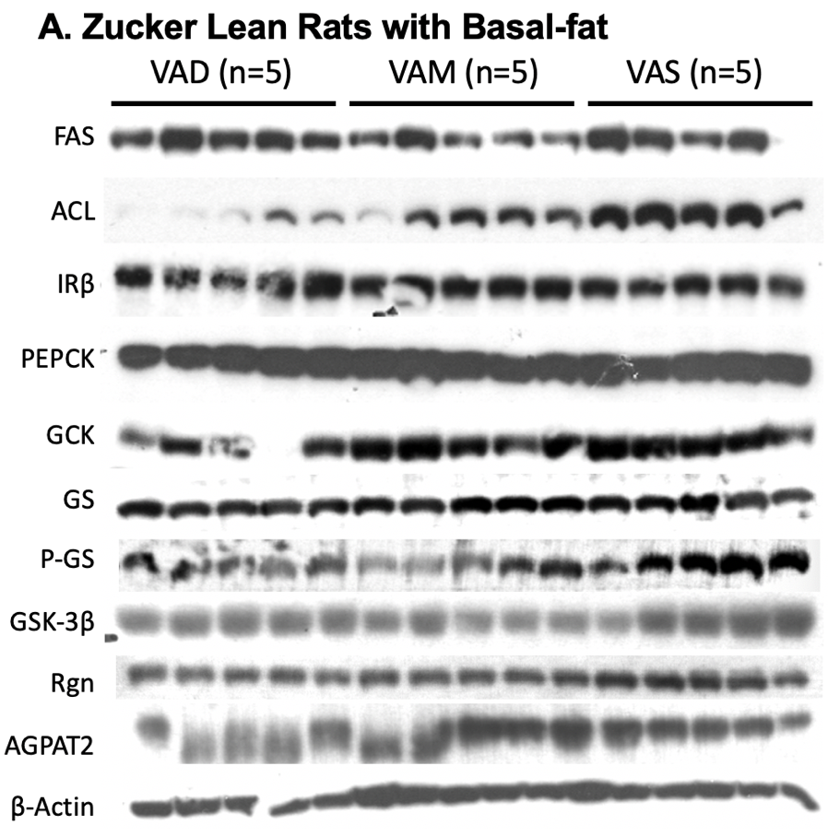
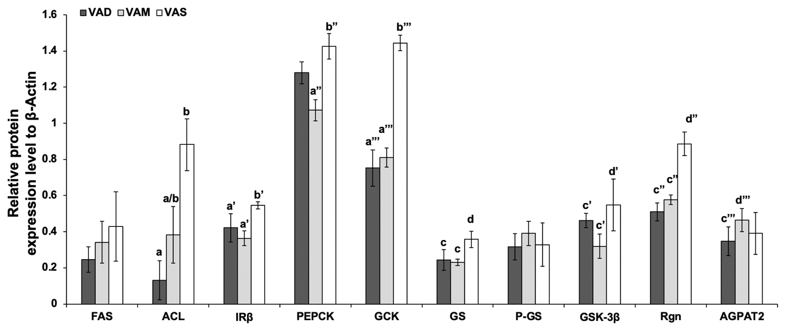

Figure 2-13 Continued
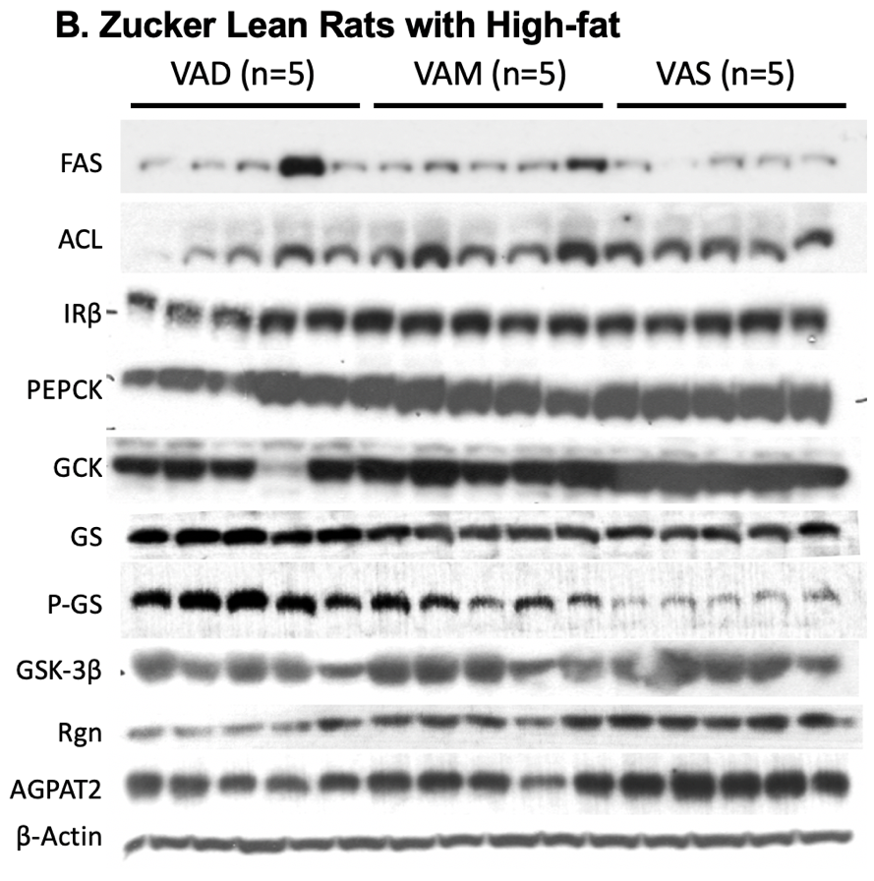
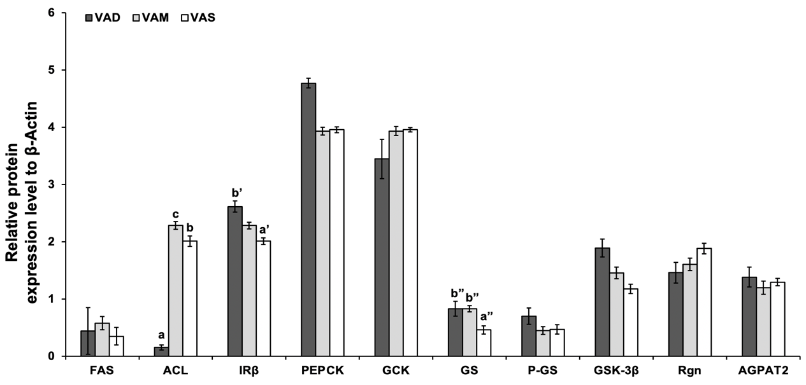

Figure 2-13 Continued
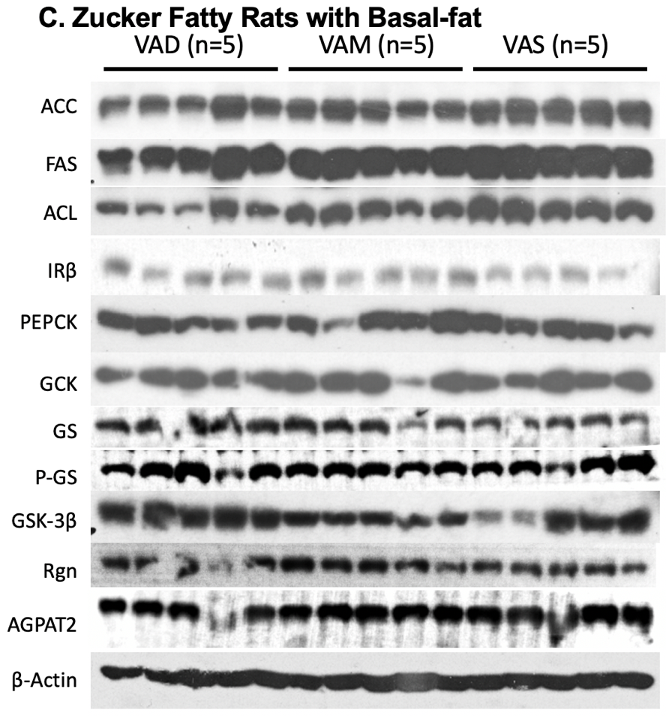
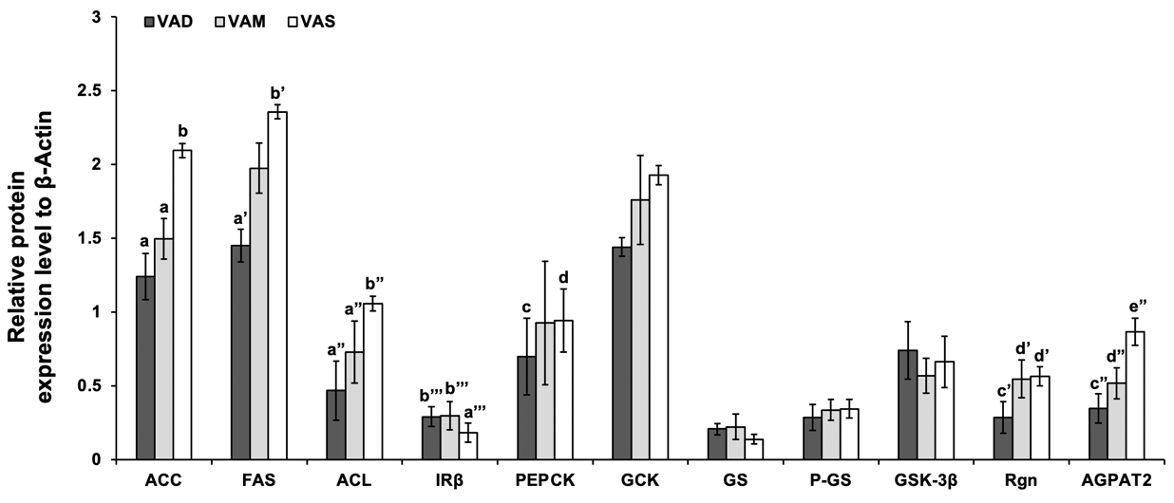

Figure 2-13 Continued
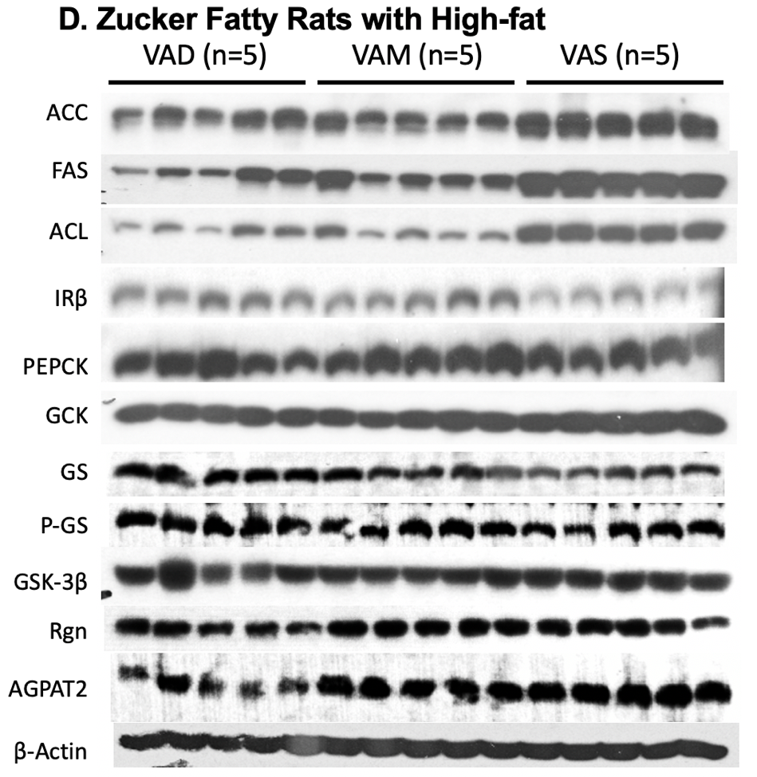
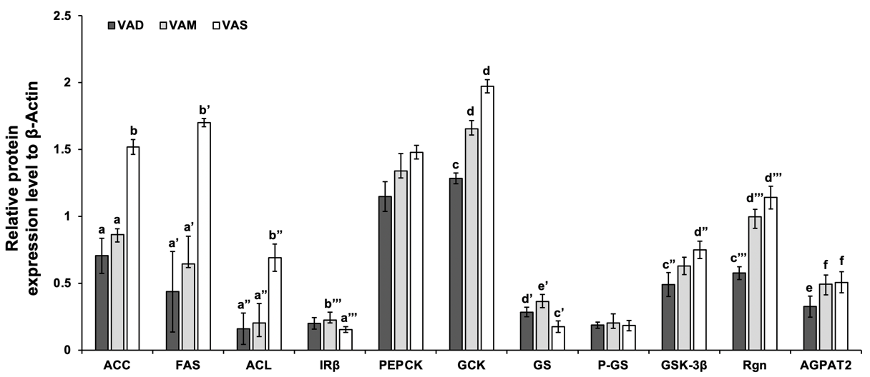
Figure 2-13: The Protein levels of ACC, FAS, ACL, IRβ, PEPCK, GCK, GS, P-GS, GSK-3β, RGN, and AGPAT2 in ZL and ZDF rats fed a VAD, VAM or VAS diet with BF or HF content.
Liver samples were collected at the end of the treatment. Proteins (60 μg/well) in whole cell lysates were isolated and subjected to western blot analysis. The ImageJ Software was used to determine the densitometry of a protein band. Results were presented as means ± SEM of the ratio of the measured protein to β-actin. (A) a<b, a’<b’, a”<b”, a’’’<b’’’, c<d, c’<d’, c”<d”, and c’’’<d’’’ for comparing the groups in the same fat content and genotype using one way ANOVA, P<0.05. (B) a<b<c, a’<b’, and a”<b” for comparing the groups in the same fat content and genotype using one way ANOVA, P<0.05. (C, D) a<b, a’<b’, and a”<b”, a’’’<b’’’, c<d, c’<d’<e’, c”<d”, c’’’<d’’’<e’’’, and e<f for comparing the groups in the same fat content and genotype using one way ANOVA, P<0.05.

4. Discussion
To understand the development and progression of metabolic diseases, the role of VA in obesity diabetes and metabolic abnormalities is of great importance. We studied the effects of the intake of VA associated with obesity and diabetes. ZDF rats which bear a loss-of-function leptin receptor gene, have been extensively used to study the pathogenesis of T2DM, obesity, leptin signaling, and the interactions among the three (202). This animal model develops obese and insulin resistance with dyslipidemia due to hyperphagia (202). Here, we investigated the effects of dietary VA status on the glucose and lipid metabolism of ZL and ZDF rats in BF and HF conditions. The nutritional, morphometrics, serum biochemical markers, liver gene and protein expressions of glucose and fatty acid metabolism, and hepatic retinol content were investigated.
The content of hepatic retinol meets the intake of dietary VA. There are two sources of VA in the liver: VA stored in the hepatic stellate cells and VA in the diet. VAD rats that deplete liver VA storage and cause VA deficiency need to obtain VA from their diet. VAS rats have sufficient VA storage in the liver to maintain a constant plasma VA level. The contents of hepatic retinol in ZL and ZDF rats indicate that VA intake is needed to maintain the hepatic VA status. The HF condition appears to increase the hepatic VA content in both ZL and ZDF rats. Therefore, VAM and VAS still had endogenous VA to regulate the expression of VA responsive genes and proteins, whereas VAD rats have extremely low hepatic retinol content. All these results clearly demonstrate that the current experimental setting alters the VA status in ZL and ZD rat. Therefore, ZL and ZDF rats fed diets with different contents of VA are functional models to study the impact of VA on glucose and lipid metabolisms.
The BM data indicate that rats fed a VAD diet gain less BM than those fed a VAM or VAS diet depending on the genetic setting of the rats and dietary fat content. ZDF rats fed the VAS diets gain more weight than ZL rats fed the VAS diet in BF and HF conditions, respectively. This is due to the hyperphagia of ZDF rats. These results are similar to what we have observed in ZL and ZF rats fed a VAD or VAS diet with normal fat content as shown in (200, 203, 204). Also, in both ZL and ZDF rats, HF diets promote more BM gain than BF diets. The VAM-HF ZL and ZDF rats gain more BM than VAD-HF ZL and ZDF rats, indicating that HF diets might have lowered the needs of VA in VAM rats. VA deficiency reduces the obesity development in ZDF rats.
The data of previous studies have shown that ZL and ZF rats reduce food intake when they reach VA deficiency (200, 204-206). In this study, ZL or ZDF rats were fed a VAD-BH/HF, VAM-BH/HF or VAS-BH/HF diet for 8 weeks. The development of VA deficiency causes a suppression of appetite in both BF and HF content of ZL and ZDF rats. Compared with ZDF rats fed the VAD or VAM, diets, the food intakes of VAS-BF/HF ZDF rats continuously increase. One possibility is the inhibition of fatty acid synthesis or an increase in fatty acid oxidation in the brain (where appetite is regulated) of VAD animals. It has been shown that alteration of fatty acid synthesis and oxidation in the brain reduces food intake and causes weight loss in animals (207). This indicates that VA status contributes to BM gain and food intake in ZL and ZDF rats, a process that can be affect by dietary fat content to certain extent.
The PBG levels of VAS-BF/HF ZDF rats are respectively higher than that of VAD/VAM-BF/HF ZDF rats at the same weeks, which correspond to significant BM differences due to VA statuses (after 5 weeks of feeding of the BF and 4 weeks of feeding of HF diets). ZDF rats develop obesity, insulin resistance, hyperinsulinemia, hyperlipidemia, and obesity-induced diabetes (48). Insulin from β cells regulates blood glucose and blood lipid levels (208). Glucagon promotes liver glucose production, glycogenolysis, and ketone production in response to hypoglycemia, while insulin promotes glucose processing, glycogenesis, and lipogenesis in response to elevated blood glucose levels (208). Insulin resistance is a state in which cells cannot respond effectively to insulin stimulation leading to hyperglycemia (209). With the increase of VA intake, the increase in blood glucose concentration is consistent with the metabolic disorder in VAS-BF/HF ZDF rats. ITT and OGTT assays were given after the respective diets are fed for 6 weeks and ZDF rats already develop obesity and diabetes. The data show insulin resistance in VAS-HF ZDF rats and impaired glucose tolerance in VAS-BF/HF ZDF rats. The accumulated venous plasma glucose levels in VAS-HF ZDF rats were also significantly increased with the elevation of VA status (Figure 2-10A). These results in ZDF rats were consistent with previous observations in ZF rats (204). It shows the important role of VA status in the regulation of plasma glucose hemostasis.
Previous research results from our lab have shown that VA deficiency leads to reduction of plasma leptin and insulin levels in ZL and ZF rats (204-206). The plasma levels of insulin and leptin levels in ZDF rats are also decreased with the reduction of VA status (Figure 2-10C). The development of hyperinsulinemia precedes the development of diabetes, which is associated with change of hepatic genes involved in glucose and lipid metabolism (200). Insulin stimulates leptin synthesis and secretion, whereas leptin can also affect the insulin secretion and functions (210). In addition, the TG and cholesterol levels in ZL and ZDF rats are all lowered with the reduction of VA status, demonstrating the roles of VA in the regulation of TG and cholesterol metabolism. The hyperinsulinemia, hyperglycemia and hyperleptinemia in ZDF rats show the correlations of these plasma parameters, which all can be attenuated by the reduction of VA status. The underlying mechanisms by which VA status regulates glucose, insulin and leptin levels in obesity and diabetes deserve to be studied further.
To explain the changes of plasma parameters, we investigated the effects of VA status on the mRNA and protein levels of hepatic genes for glucose and lipid metabolism in ZL and ZDF rats fed BF or HF diets with different VA statues. Glucose is a main energy source for the body. In hepatocytes, it is phosphorylated by hexokinase IV (glucokinase, GCK) to produce glucose 6-phosphate. GCK is the first enzyme of hepatic glycolysis, and contributes to glucose homeostasis in the body (211). Our previous studies have shown that retinoids and insulin synergistically induce the hepatic Gck mRNA expression (212). Here, the reduction of VA status is associated with a lowered Gck mRNA expression in ZL, but not ZDF, rats fed the BF or HF diets. This is an interesting observation. Whether the elevated plasma insulin levels in ZDF rats mask the VA effects on Gck mRNA expression remains to be investigated.
The expression levels of mRNAs and proteins in the fatty acid biosynthesis pathways were reduced in VAD-HF ZDF rats. SREBP-1c regulates the hepatic cholesterol and fatty acid synthesis, and induces the expression of FAS and ACL (213). The Srebp-1c mRNA of VAD-BF-ZL rats is lowered than that of VAM/VAS-BF ZL rats. This change could not be observed in ZL fed a HF diet or ZDF rats, suggesting the interactions of VA status with dietary fat content and genetic changes. The increased expression levels of hepatic lipogenic genes, such as Srebp-1c, may be responsible for the higher plasma TG levels in VAS-BF/HF ZL/ZDF groups, which could also explain the increased WAT/BM ratio of VAS-HF ZDF group.
The protein expression data in Western blot are largely consistent with the mRNA data derived from real-time PCR. GCK, PEPCK, GS, and GSK-3β play a role in the regulation of glucose metabolism. PEPCK and G6P are the enzymes involved in gluconeogenesis (214). GSK-3β is a serine/threonine kinase that phosphorylates GS and inhibits glycogenesis (215). VA status changes the protein levels of GCK, PEPCK, GS, and GSK-3 as shown in this study. GCK catalyzes the conversion of glucose to glucose 6-phosphate, which can be used for glycolysis and glycogen synthesis (216). The results shown here indicate that the liver GCK protein levels in the VAD-BF ZL and VAD-HF ZDF groups were lower than those in the VAS-BF ZL and VAS-HF ZDF groups, respectively. GSK-3β protein levels follow that same trend as GCK. In the VAM-BF ZL and VAD-BF ZDF groups, the protein levels of PEPCK, which involved in gluconeogenesis, are lower than that in the VAS-BF ZL and VAS-BF ZDF groups, respectively. Interestingly, our previous study found that there was no change in PEPCK levels in ZL rats fed a VAD diet with a normal fat content compared with rats fed a VAS diet (204). Therefore, it suggests that VA status might change the PEPCK levels in ZL and ZDF rats in the current experimental setting. The decreases in the hepatic GCK and PEPCK levels may help to regulate glucose utilization in the liver of VAD/VAM-BF ZL and VAD-BF/HF ZDF rats. Further studies are needed to determine the mechanism by which VA status on the hepatic GCK and PEPCK levels in ZDF rats.
The hepatic levels of ACL, ACC, and FAS, which contribute to hepatic lipogenesis, are all lowered in VAD-BF/HF ZDF group. The expression levels of hepatic genes involved in lipid metabolism are partly regulated by insulin (22). Compared with the VAS-BF ZDF group, the higher IRβ protein levels in the liver of the VAD-BF ZDF group may indicate that the VAD-BF ZDF group is more sensitive to insulin than the VAS-BF ZDF group. AGPAT2 catalyzes the acylation of lysophosphatidic acid to phosphatidic acid, which is the precursor for the synthesis of TGs and phospholipids (217, 218). The level of AGPAT2 protein indicates that ZDF rats have increased lipogenesis. Therefore, reduced VA intake prevents obesity and T2DM in ZDF rats.
Regucalcin/SMP30 has been involved in the regulation and control of many basic biological processes (cell growth, apoptosis, cell metabolism) (219). With the reduction of VA status, the levels of Rgn mRNA and RGN levels of ZL and ZDF rats decrease, showing the impact of VA status on the expression of genes beyond the glucose and lipid metabolism in ZL and ZDF.

5. Conclusion
In conclusion, T2DM has insulin resistance and hyperglycemia that relates to liver (220). Therefore, insulin resistance is always related to changes in the expression levels of hepatic glucose and fatty acid metabolism genes (221). On the other hand, elevated TG levels will lead to elevated free fatty acid levels, which may lead to insulin resistance and β-cell dysfunction (222, 223). These results may accelerate the development of T2DM. This study shows that the influence of VA status helps to regulate the expression of liver glucose and lipid metabolism genes and proteins, and sufficient VA induce expressions of FAS, ACL, GCK and other glucose and fatty acid enzyme genes and proteins in ZDF rats. VA also affects liver insulin sensitivity at the level of IRβ protein expression. The results also support our previous observation that VA status affects the weight gain of ZL and ZDF rats with different fat content (203, 206, 224). Due to the lack of VA, fatty acid synthesis in the liver of ZDF rats is reduced. The effect of VA status on liver glucose metabolism can be adjusted by increasing dietary fat intake. These findings indicate that reducing VA intake may have a protective effect on the development of liver insulin resistance, which may help to find solutions to combat metabolic diseases. The implication of these observations is that VA status may regulate glucose and fatty acid metabolism, glycogen synthesis, and insulin resistance. More research is needed to understand the role of VA in animal models and humans, especially in high dietary fat intake conditions. Our research indicates that caution should be exercised when recommending VA supplementation for obese or T2DM patients.

The Effects of RA and Insulin on the Expression of GLUT4 in Differentiated L6 Myocytes

Abstract
Glucose enters the skeletal muscle cells through GLUTs, a process that is stimulated by insulin through the movement of GLUT4 to the cell membrane. Here, we studied the effects of RA and insulin on GLUT4 expression in L6 muscle cells. First, we constructed a recombinant adenovirus overexpressing GLUT4 protein (Ad-mGLUT4). We used Ad-mGLUT4 to identify that EMD company’s GLUT 4 antibody was able to detect the correct band of GLUT4. Rat L6 muscle cells were treated without or with 1 μM RA in the absence or presence of 10 nM insulin for 4 or 6 days. Cells were fractionated to prepare different lysates for analysis. 1) Cells were lysed to get the supernatant and pellet or total lysate directly in 1 x SDS loading buffer. 2) Cells were fractionated into cytosol, membrane and nuclear fractions. The GLUT4 protein levels in these samples were determined via Western Blot. Results indicate that the lysis buffers tested here may not completely solubilize differentiated L6 cells, suggesting the importance of cell lysis methods and reagents in the analysis of membrane proteins. RA and/or insulin treatments for 4 and 6 days affected GLUT4 expression and translocation. We conclude that RA affects the expression of GLUT4 in differentiated L6 cells, suggesting the role of RA in the glucose uptake in the muscle.

1. Introduction
VA is an essential lipophilic micronutrient, which is related to the regulation of glucose, protein and lipid metabolisms (17). Retinol, which is derived from REs and provitamin A carotenoids, is oxidized to retinal and then oxidized to RA by enzymes. RA exists in many isomeric forms, such as all-trans RA and 9-cis RA. The main function of VA is mediated by RA (199). It is important to understand the function of RA, because its signals affect glucose metabolism (199).
The skeletal muscle contributes significantly to glucose homeostasis (28-30). It uses glucose and FAs as energy sources. It can also store glucose in the form of glycogen, or directly oxidize it to produce energy after ingesting glucose under different metabolic conditions (9). Glucose enters cells via the help of GLUTs that play an important role in regulating glucose sensing and metabolic homeostasis (93). Insulin stimulation induces the movement of GLUT4 from cytosol to the cell membrane (112). The increase in GLUT4 on cell membrane facilitates glucose entering cells. GLUT4 is mainly expressed in adipocyte and skeletal muscle (100). It plays a key role in the insulin-stimulated glucose uptake in the skeletal muscle (100). Therefore, understanding muscle glucose metabolism and GLUT4 translocation is helpful to prevent the development of diabetes.
L6 muscle cells have been used to study the proliferation and differentiation of muscle cells (225-227). It has been shown to respond to both RA and insulin in rat L6 skeletal muscle cells (228, 229). RA can promote insulin-stimulated glucose uptake and increase GLUT4 mRNA levels in L6 cells (229). The focus of our lab is to study the roles of VA in the regulation of glucose and lipid, metabolic homeostasis. We have shown that the long-term treatment of RA and insulin increases the glucose usage in L6 cells during differentiation, which is attributed to elevation of glycogenesis (230).
The hypothesis of this study is that RA interacts with insulin in the regulation of GLUT4 expression in L6 cells. Here, the effects of RA and insulin on GLUT4 expression in differentiating L6 muscle cells were studied. L6 cells were treated with RA alone or with insulin during differentiation for 4 and 6 days. The expression levels of GLUT4 in the total cell lysates, pellets, and cell fractions were determined after validation of the anti GLUT4 antibodies using a recombinant adenovirus overexpressing GLUT4.

2. Materials and Methods

2.1 Reagents
For cell culture and L6 rat skeletal muscle differentiation, Dulbecco's Modified Eagle Medium (DMEM), and penicillin/streptomycin (P/S) were purchased from Mediatech (Manassas, VA, U.S.A.). Fetal bovine serum (FBS) was purchased from Life Technologies (Grand Island, NY, U.S.A.). Horse serum (HS) was purchased from Hyclone Laboratories (Logan, UT, U.S.A.). Insulin and all-trans retinoic acid (RA, diluted in ethanol) were purchased from Sigma Aldrich Corporation (St. Louis, MO, U.S.A.). The BCA protein assay kit was purchased from Pierce Biotechnology, Inc (Rockford, IL, U.S.A.) for the determination of the protein concentration. Immobilon-PSQ PVDF membrane was purchased from EMD Millipore Corp (Billerica, MA, U.S.A.). Non-fat dry milk of Food Club was purchased from to a grocery store and was used to block membrane and to prepare antibodies. Bovine serum albumin (BSA) protease-free powder was purchased from Fisher BioReagents™ to make the second antibody. Table 3-1 summarized the sources, catalog number, description of, and expected sizes of the detected proteins by the antibodies tested in this study. For immunoblotting, GLUT4 antibody (C-terminus) was purchased from EMD Millipore Corp (Billerica, MA, U.S.A.). β-Actin (#4970) antibodies and Goat anti-rabbit IgG conjugated to horseradish peroxidase (#7074) secondary antibody were purchased from Cell Signaling Technology (Danvers, MA, U.S.A.). ECL Western Blotting Substrate was purchased from Pierce Biotechnology, Inc (Rockford, IL, U.S.A.), which was used to visualize the recognized proteins.
Table 3-1: Summary of GLUT 4 antibodies used in this chapter
Companies | Catalogue Number | Description | Molecular Weight
EMD Millipore Corp | #07-1404 | C-terminus,  1:1,000 dilution for western blotting analysis | ~58 kDa
Santa Cruz Biotechnology | SC-53566, #G1017 | mouse monoclonal  1:1,000 dilution | 50-63 kDa
Bioss Antibodies | bs-0384R-FR | Rabbit Polyclonal | ~50 kDa
Cell Signaling Technology | #2213S | Mouse IgG1 | 50 kDa
Sino Biological | #100733-T42 | Polyclonal Rabbit IgG against human C-terminus,  , 1:1,000 dilution | 54 kDa
Bethyl Laboratories | A304-377A-T | Polyclonal Rabbit IgG, 1:1,000 dilution | ~70 kDa

2.2 Cultures of HEK 293, HL1C, and L6 cells
Rat L6 cells were cultured as described in (230). L6 cells in 60 mm dishes were maintained and sub-cultured in DMEM with 4.5 g/L (25 mM) glucose supplemented with 10% FBS + 1% penicillin/streptomycin at 37°C and 5% CO2. When cells reached ~100% confluence, the cell medium was changed to DMEM containing 25 mM glucose with 2% HS + 1% penicillin/streptomycin to induce differentiation. To study the effects of RA and insulin on GLUT4 expression in differentiated L6 muscle cells, L6 cells at confluence were induced to differentiation in media with 2% HS containing control or 1uM RA with or without 10 nM insulin for 4 or 6 days. Fresh media containing the same reagents were changed every two days.
The HEK293 cells were cultured in DMEM containing 4.5 g/L (25 mM) glucose with 10% FBS + 1% penicillin/streptomycin at 37°C and 5% CO2. When cells reached 50~80% confluence, the cell medium was changed to growth medium without serum and antibiotics one day before transfection. The HL1C rat hepatoma cells were cultured in DMEM containing 4.5 g/L (25 mM) glucose with 5% FBS + 1% penicillin/streptomycin at 37°C and 5% CO2.

2.3 Construction of the Recombinant Adenovirus Overexpressing GLUT4 (Ad-mGLUT4)
To find a positive control to evaluate GLUT 4 antibodies from different companies, we decided to construct a recombinant adenovirus overexpressing GLUT 4 protein. The recombinant and replication-deficient adenovirus was generated via homologous recombination (231).
The pCMV3-mSLC2A4-HA (Cat# MG57001-CY) plasmid was obtained from Sino Biological (Chesterbrook, PA). The mouse Slc2a4 cDNA was inserted into plasmid pACCMV5 as shown in Figure 3-1. A DNA fragment containing the mouse Slc2a4 cDNA was released from pCMV3-mSLC2A4-HA after digestion with KpnI and XbaI. The fragment with the Slc2a4 cDNA was inserted into the vector pACCMV5 digested by the same enzymes to obtain plasmid pACCMV5-mSLC2A4. After that, equimolar amounts of pACCMV5-mSLC2A4 (0.4 μg) and the plasmid pJM17 (1.6 μg) were co-transfected into HEK 293 cells using lipofectin reagent (Invitrogen). pJM17 is a plasmid contains a full-size, circular adenovirus genome, and 293 cells are engineered cells for the recombinant adenovirus to replicate and pack viral particles. Transfected HEK 293 cells were incubated in DMEM containing 2% FBS at 37°C and 5% CO2 until plaques were formed due to the cell lysis. The generation of recombinant adenovirus occurred about 10 to 20 days after the transfection. After that, the lysed cells and media were collected as stocks, and stored at -80°C. This mixture was frozen and thawed twice to obtain crude lysates, which contains Ad-mGLUT4.
To generate crude lysate, HEK 293 cells were grown at 70-80% confluence in 100 mm tissue culture plates and were infected with the original crude lysate containing Ad-mGLUT4. The ratio of medium to crude lysate is 10:1. The cells are lysed approximately 48 hours after infection, and the cell culture medium (crude lysate) is collected and stored at -80°C until use.
Figure 3-1: Schematic of production of recombinant adenovirus, Ad-mGLUT4.

2.4 Detection of GLUT4 Proteins in the Total Lysates of Ad-mGLUT4 Infected cells
After Ad-mGLUT4 was obtained, 500 µl of crude lysate were add to 293 cells or HL1c cells at 100% confluency in each 60 mm dish which contained 4 ml DMEM culture medium. Cells were incubated at 37°C and 5% CO2 for 24 hours. Then, 400 µl of 1 x SDS loading buffer was added in one 60 mm dish to directly lyse the cells and obtain the total cell lysate. For the analysis of transgenic expression in Western blot, 30 ul of total lysate of transfected or untransfected cells were loaded into each well in 10% SDS-page gels for protein separation.
To determine the GLUT4 expression in L6 cells, membrane fraction from L6 muscle cells treated in absence or presence of 1μM RA without or with 10 nM insulin for 6 days were used to analyze antibodies from different companies.

2.5 Lysis of L6 Rat Skeletal Muscle Cells

2.5.1 Preparation of the Whole Cell Lysates of L6 Cells Treated without or with 10 nM Insulin in the Absence or Presence of 1μM RA for 4 or 6 Days (Method A)
For whole cell lysis experiment, L6 cells at 100% confluence were incubated in media with 2% HS containing in the absence or presence of 1μM RA with or without 10 nM insulin for 4 or 6 days. Fresh media with the indicated reagents were replaced every two days. Then, L6 cells were lyzed in lysis buffer (50 mM HEPES pH 7.5, 10 mM EDTA, 10% Glycerol) containing 1% NP-40 and 1% Triton X-100 (Lysis Buffer A) or 2% NP-40 and 2% Triton X-100 (Lysis Buffer B) with or without 40 strokes of Dounce homogenizer to ensure that L6 muscle cells can be completely lysed (Method A). The lysate was centrifuged at 12,000 x g for 15 minutes at 4°C for the collection of the supernatant (contain cell membrane, cytoplasmic and nuclear proteins), which was named the Whole Cell lysate and used to determine GLUT4 protein level by Western blot (Figure 3-2).

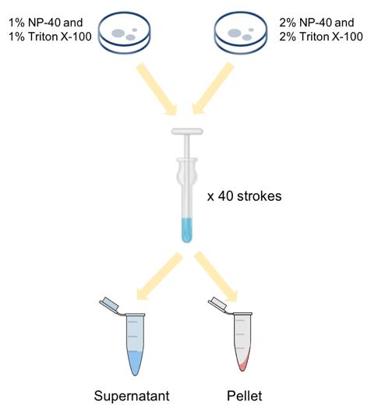
Figure 3-2: Methods to lysates L6 cells treated with media without or with 10 nM insulin in the absence or presence of 1μM RA for 4 or 6 days.

2.5.2 Preparation of the Whole Cell Lysates of L6 Cells Treated without or with 10 nM Insulin in the Absence or Presence of 1μM RA for 4 or 6 Days (Method B)
To study the distribution of GLUT4 in the cell fractions, differentiating L6 cells were treated without or with 10 nM insulin in the absence or presence of 1μM RA for 4 or 6 days were lyzed in two methods (Method B) as shown in Figure 3-3. 1) Four hundred ul of lysis buffer B containing 50 mM HEPES pH 7.5, 10 mM EDTA, 10% Glycerol, 2% NP-40 and 2% Triton X-100 was added to each 60 mm dish. Cells was scraped to a microcentrifuge tube and kept on ice for 20 minutes with vortex every 10 minutes to enhance lysis process. After that, the lysate was centrifuged at 12,000 x g for 15 minutes at 4°C for the collection of both the supernatant and pellet. Pellets were directly lysate in three hundred ul 1x SDS loading buffer. 2) To obtain the complete total cell lysate, L6 cells after the indicated treatments were directly lyzed in 500 µl 1 x SDS loading buffer (Figure 3-3).
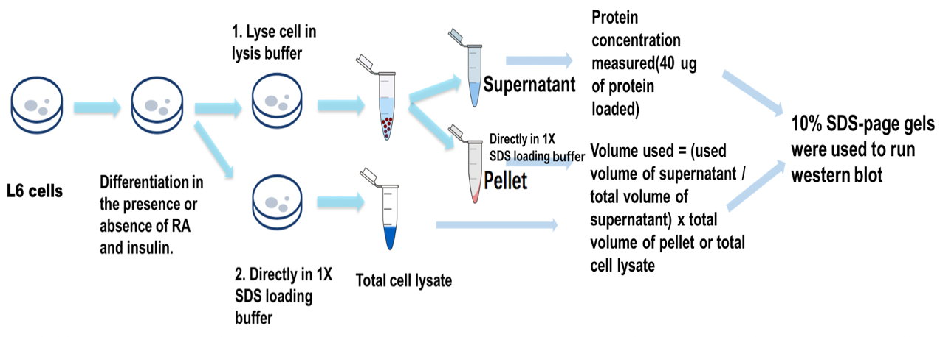
Figure 3-3: Methods to obtain lysates of L6 cells treated with media without or with 10 nM insulin in the absence or presence of 1μM RA for 4 or 6 days.

2.5.3 Preparation of Subcellular Fractions of Rat L6 Cells treated without or with RA in the absence or Presence of 10 nM Insulin for 6 Days (Method C)
To find out a better way to lyze differentiating L6 cells and analyzes the effects of insulin and RA in translocation of GLUT4, L6 cells were fractionated to obtain cytosol, membrane and nuclear subcellular fractions. When L6 cells reach to 100% confluence, we differentiated them in the presence or absence of RA with or without insulin for 6 days. As shown in Figure 3-4, L6 cells were lysed in 1 ml of buffer C (20 mM HEPES pH 7.6, 0.3 M Sucrose, 10 mM NaCl, 1.5 mM MgCl₂, 0.5% NP40, 1 mM Spermidine) and homogenized after 20 strokes using a Dounce homogenizer on ice. Then the lysate was centrifuged at 500 x g for 10 minutes at 4°C and collect both supernatant and pellet, pellet were lysis by adding 300 µl of lysis buffer D (20 mM HEPES pH 7.6, 1.5 mM MgCl₂, 1M DTT, 0.5 M NaCl, 1 mM EDTA pH 7.6, 1 mM EGTA pH 7.6, 25% Glycerol) and store on ice for 30 mins, then centrifuged at 100,000 x g for 30 minutes at 4°C to obtain supernatant as nuclear extract. The supernatant which should contain cytosol and membrane was centrifuged at 55,000 x g for 30 minutes at 4°C to obtain supernatant as cytosol and pellet as membrane. Membrane pellet was solubilized by adding 200 ul of membrane lysis buffer E (10 nM Tris HCl pH 6.8, 100 mM NaCl, 1% SDS). After the centrifugation, the upper part of supernatant was cloudy. Therefore, the supernatant of cytosolic faction was collected as the upper cytosol and lower cytosol fractions.
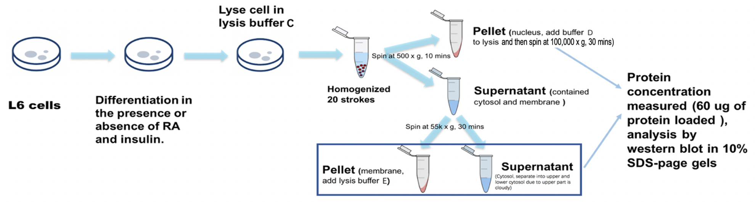
Figure 3-4: GLUT4 expression levels in cytosol, membrane and nuclear fractions of L6 treated without or with 1uM RA in the absence or presence of 10 nM insulin for 6 days.

2.6 Protein Isolation, Determination, and Immunoblotting (Western Blot)
All cell dishes were kept on the ice and then culture medium was pumped out through aspiration. Cells were washed once on ice with 3 ml Phosphate-buffered saline (PBS) before being lysed as described in the previous sections. The protein concentrations in the cell lysates and fractions were determined with PIERCE BCA protein assay kit (Rockford, IL). Reagent A was mixing with reagent B (50:1) to make working reagent. Five μl of each cell lysate protein was add into 495 ul dd H2O in centrifugation tubes separately to get a finally 500 ul sample. The standard protein stock (2 mg/mL) was diluted to 0, 5, 10, 20, 40, and 80 ug/uL for making standard curve. In 1 ml reaction, 500 μl of the working reagent and 500 ul sample/standard protein sample was added together. The reaction was incubated in 37°C for 30 mins then a triplicate of 300 ul per well was added to a 96 well plate. OD reading at 560 nm was measured on a 96-plate reader (GloMax®-Multi Detection System (Promega, Madison, WI). A standard curve was prepared by plotting the average blank-corrected 560 nm OD readings vs. the concentrations in μg/mL. A formula derived from regression was obtained and used to determine the total protein concentration of each sample. The final protein concentration of each sample was adjusted to 2μg/ul. The concentration adjusted protein sample and loading buffer were mixed and incubated in water bath at 100°C for 10 minutes. The resulted loading samples were stored at -20°C until being used.
For Western blot, 40 µg proteins of each sample were loaded to each well and separated on 10% SDS-PAGE gels. The separated proteins were transferred from gel to a PVDF membrane, which was blocked with 5% milk diluted in 1x TBST (Tris-buffered saline with 0.1% Tween) at room temperature for one hour. The primary antibodies were diluted in TBST containing 5% BSA or dry milk according to the manufactures’ instructions. The membrane was incubated in the primary antibody at 4 °C for overnight. The membranes were washed three times with 1x TBST, 5 minutes each time after overnight incubation. The second antibody was diluted in 5% milk in 1x TBST (1:1000) and the membrane was incubated in the second antibody for one hour at room temperature. The membrane was washed again for three times with 1x TBST (5 minutes each time). After that, ECL Western Blotting Substrate was used to cover the membrane for visualization of the protein bands. Konica SRX 101A Film Processor was used to develop the film.
Quantification analysis was performed on Image J software (NIH, Bethesda, Maryland, USA). The density of a protein band was calculated by subtracting the background in an area of the same size near it. Then, the ratio of the densities of the indicated protein to that of the control protein (indicated protein/β-actin) was calculated for quantification.

2.7 Statistical Analysis
All experiments were repeated for three times. One-way ANOVA with LSD post-hoc statistical analysis was conducted using GraphPad Prism 8.0 (GraphPad Software, Inc., San Diego, CA). Data were presented as means ± S.E.M. The difference was considered significant when the p-value was less than 0.05.

3. Results

3.1 Anti GLUT4 antibodies from different sources detected distinct bands in Western blot
To evaluate which antibody can detect the correct GLUT4 protein bands at right molecular weight, GLUT 4 antibodies from different companies were compared using the same set of membrane preparations of L6 cells treated with or without 1 µM RA in the absence or presence of 10 nM insulin for 4 days, which were prepared by Method A. The same set of samples were loaded on the same gels for comparing the proteins detected by GLUT4 antibodies (Table 3-1) in Western Blot. As shown in Figure 3-5, GLUT4 antibodies from different sources detected protein bands with different molecular masses and at different locations in the same membrane fractions of L6 cells. The antibody from EMD Millipore Corp detected a band at about 56 kilodalton (kDa) in contrast to its predicted molecular weight (MW) of 58 kDa. The antibody from Santa Cruz Biotechnology detected a band at 43 kDa in contrast to its predicted MW of 50~63 kDa in the product description. The antibody from Bioss Antibodies detected a band at 56 kDa in contrast to its predicted MW of 55 kDa in their product description. The antibody from Cell Signaling Technology detected multiple bands and the strongest band detected at 43 kDa in contrast to its predicted MW of 50 kDa in their product description. The antibody from Sino Biological detected a band at 72 kDa in contrast to its predicted MW of 54 kDa in their product description. The antibody from Bethyl Laboratories detected a band above 43 kDa in contrast to its predicted MW of 70 kDa in their product description (Table 3-2).
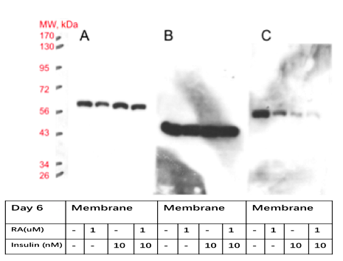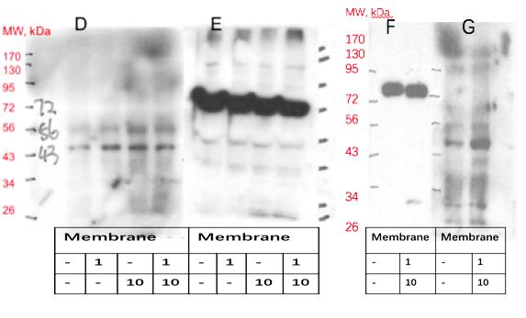
Figure 3-5: GLUT4 antibodies from indicated companies detect protein band at different location in L6 cell lysate in western blot experiment.
A: EMD Millipore Corp (#07-1404) shows band at about 56 kda; B: Santa Cruz Biotechnology (SC-53566, #G1017) shows the band at 43 kda; C: Bioss Antibodies (bs-0384R-FR) shows band at 56 kda; D: Cell Signaling Technology (#2213S) shows multiple band and the strongest band dected at 43 kda; E and F: Sino Biological (#100733-T42) shows the band at 72 kda; and G: Bethyl Laboratories (A304-377A-T) detected a strongest band above 43 kda.
Table 3-2: Summary of GLUT4 antibodies in detected vs. predicted molecular weight
Company name | Detected molecular weight (kDa) | Predicted molecular weight (kDa)
EMD Millipore Corp (#07-1404) | 56 | 58
Santa Cruz Biotechnology (SC-53566, #G1017) | 43 | 50~63
Bioss Antibodies (bs-0384R-FR) | 56 | 55
Cell Signaling Technology (#2213S) | Multiple bands and the strongest band at 43 kDa | 50
Sino Biological (#100733-T42) | 72 | 54
Bethyl Laboratories (A304-377A-T) | Above 43 | 70

3.2 Confirmation of GLUT4 Proteins in Lysates of Ad-mGLUT4 Infected Cells
To establish a positive control for the evaluation of GLUT 4 antibodies from different companies, mouse Slc2a4 cDNA was obtained and inserted into pACCMV5 to produce recombinant adenovirus Ad-mGLUT4 as described in the Materials and Methods section. To confirm that we have successfully obtained Ad-mGLUT4, the GLUT4 protein levels in the whole cell lysates of 293 and HL1C cells uninfected or infected with four batches of Ad-mGLUT4 crude lysates were determined using EMD’s anti-GLUT4 antibody in Western blot. The total cell lysates of 293 and HL1C cells without infection did not show any GLUT4 protein expression. Compared to that of the uninfected cells, total cell lysates of Ad-mGLUT4 transfected cells clearly showed the overexpression of GLUT4 at 56 kDa (kilodalton) molecular weight (Figure 3-6).
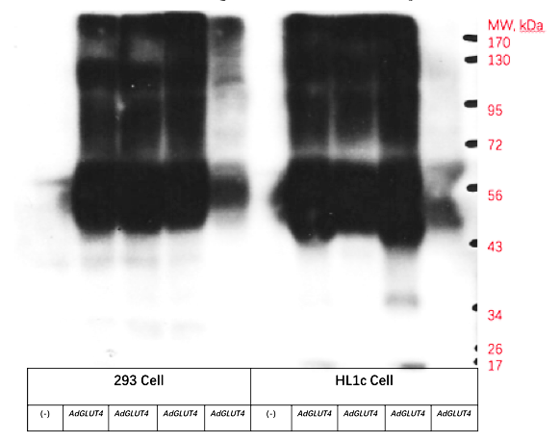
Figure 3-6: Comparing GLUT4 expression level in transfected and untransfected 293 or HL1c cells using EMD antibody in western blot.

3.3 Evaluation of anti GLUT4 antibodies using total cell lysates of 293 cells without or with infection of Ad-mGLUT4
Anti-GLUT4 antibodies from different companies were compared using the same set of whole cell lysate of 293 cells with or without transfection of Ad-mGLUT4. These samples were shown to have GLUT4 overexpression in the previous section. As shown in Figure 3-7, those anti-GLUT4 antibodies from different companies still detected an anticipated and overexpressed band of GLUT4. Compared to the results obtained using EMD company’s antibody (Figure 3-7A), the same band was detected at the same location in the Ad-mGLUT4 transfected 293 cells by antibodies from companies except for that from Bioss (Figure 3-7C), which detected an overexpressed band nearly at 72 Kda. The antibodies from Santa Cruz Biotechnology (Figure 3-7B) and Cell Signaling Technology (Figure 3-7D) seemed to show less interaction with the overexpressed GLUT4. All these results indicate that EMD company’s antibody detected the correct size band in membrane fraction of L6 cells and whole cell lysates of 293 cells (which do not express GLUT4) transfected with Ad-mGLUT4. Therefore, the EMD company’s antibody was selected to use in the following experiments.
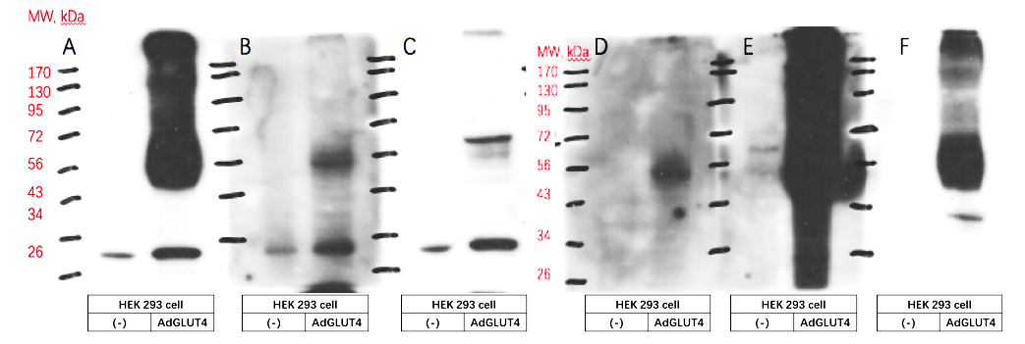
Figure 3-7: GLUT4 antibodies from different companies detect GLUT4 protein overexpressing in lysis of 293 cell with or without Ad-mGLUT4.
A: EMD Millipore Corp; B: Santa Cruz Biotechnology; C: Bioss Antibodies, D: Cell Signaling Technology; E: Sino Biological; F: Bethyl Laboratories.

3.4 GLUT4 Levels in L6 Cells Treated without or with 10 nM Insulin in the Absence or Presence of 1μM RA for 4 or 6 Days in Whole Cell Lysates Prepared using Method B
The effects of treatments of RA and insulin for 4 or 6 days on the protein expression of GLUT4 in differentiating L6 cells in supernatant, pellet and total cell lysates were studied. Cells were lysed using Method B. As shown in Figure 3-8, a representative blot of GLUT4 in L6 cells treated in the absence or presence of 1μM RA without or with 10 nM insulin for 4 days. The supernatants obtained from cells treated with insulin alone or with RA for 4 days had significantly less GLUT4 protein levels than that of the control group. The pellets of L6 cells treated with RA alone had significantly less GLUT4 expression than the control group, and that treated with insulin alone or insulin with RA had significantly higher GLUT4 protein levels than that of the control group and RA alone group. The GLUT4 protein levels in total cell lysates of the insulin + RA were significantly higher than the control group and RA alone group (Figure 3-8).
The supernatant of cells treated with insulin + RA for 6 days had significantly less GLUT4 protein levels than all other groups. The pellets of cells treated with insulin alone or insulin + RA had significantly higher GLUT4 protein levels than that of the control group and RA alone group. The GLUT4 protein levels in total cell lysates were not significantly different among the four treatment groups (figure 3-9).
In summary, given the fact that the GLUT4 protein levels in the supernatants and pellets of differentiating L6 cells were affected significantly by the treatments with RA and/or insulin for 4 and 6 days. Both 10 nM Insulin and 1 μM RA reduce the levels of GLUT4 in supernatants of L6 cells treated for 4 and 6 days. Interestingly, there appears to be an interaction between RA and insulin. By comparing the GLUT4 protein levels in different lysates, a significant amount of GLUT4 protein remained in the pellets of the total cell lysate prepared in buffer B using method B. It indicates that the lysis buffer B used here might not completely solubilize differentiating L6 muscle cells, and methods should be chosen carefully for the analysis of GLUT4 protein.

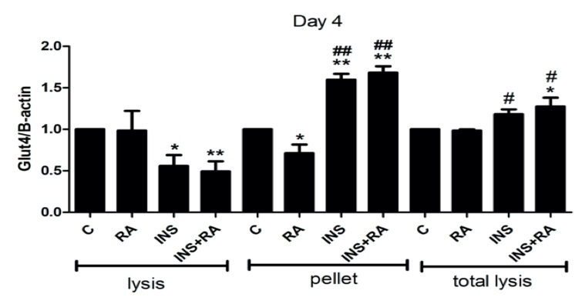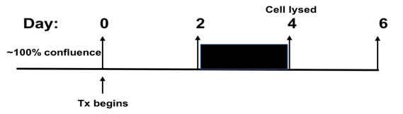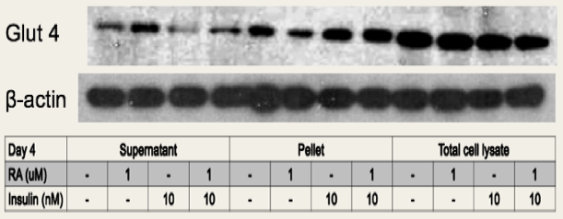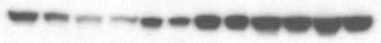
Figure 3-8: The GLUT4 protein levels of rat L6 muscle cells in the absence or presence of 1μM RA without or with 10 nM insulin for 4 days in Different Preparation Lysates.
Data were expressed as mean ± SEM for three independent experiments; */#p<0.05, for comparing the indicated group and the control group or RA group; **/## p<0.01, for comparing the indicated group with the control group or RA group.

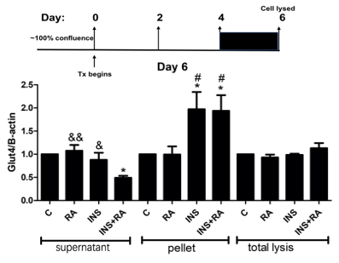
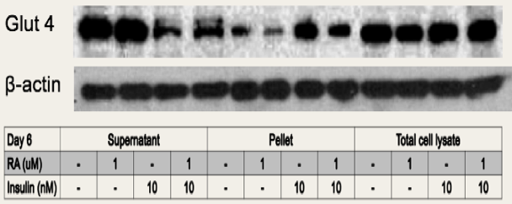
Figure 3-9: The GLUT4 protein levels of rat L6 muscle cells in the absence or presence of 1μM RA without or with 10 nM insulin for 6 days in Different Preparation Lysates.
Data were expressed as mean ± SEM for three independent experiments; */#p<0.05, for comparing the indicated group and the control group or RA group; & p<0.05, for comparing the indicated group with Insulin + RA group.

3.5 Rat L6 Cells in the Absence or Presence of 1μM RA Without or with 10 nM Insulin for 6 Days in different subcellular fractions prepared by Method C
The differentiating L6 cells treated with or without RA in the absence or presence of insulin for 6 days. The protein levels of GLUT4 in membrane and nuclear fractions prepared by Method C of cells treated with RA alone and RA+ insulin groups were significantly higher than that in the control group. GLUT4 in the membrane fraction of L6 cells treated with insulin + RA was significantly higher than all other groups. In nucleus, GLUT4 of insulin + RA group is significantly higher than that of insulin alone group. There is no significant difference of GLUT4 expression levels among the four treatment groups in cytosol (Figure 3-10).
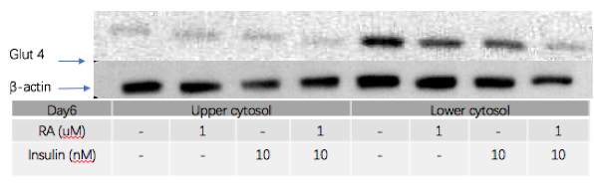
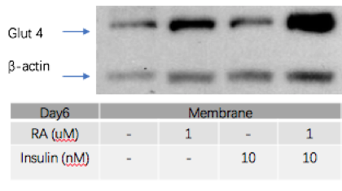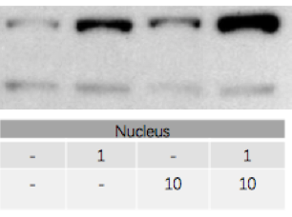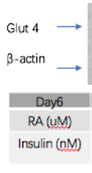
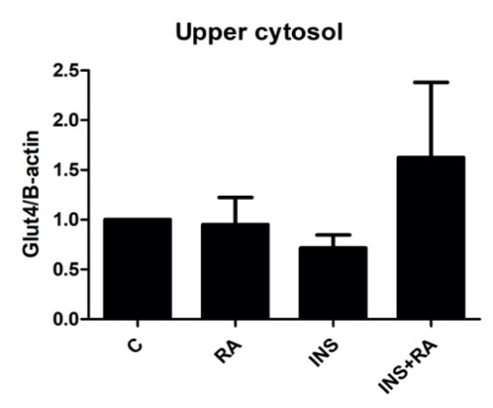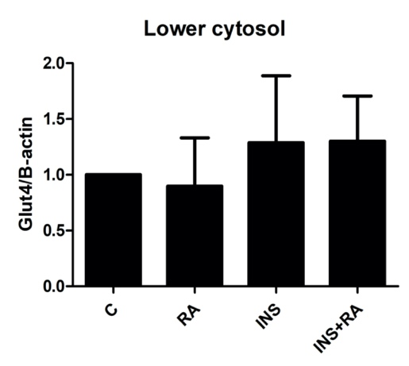
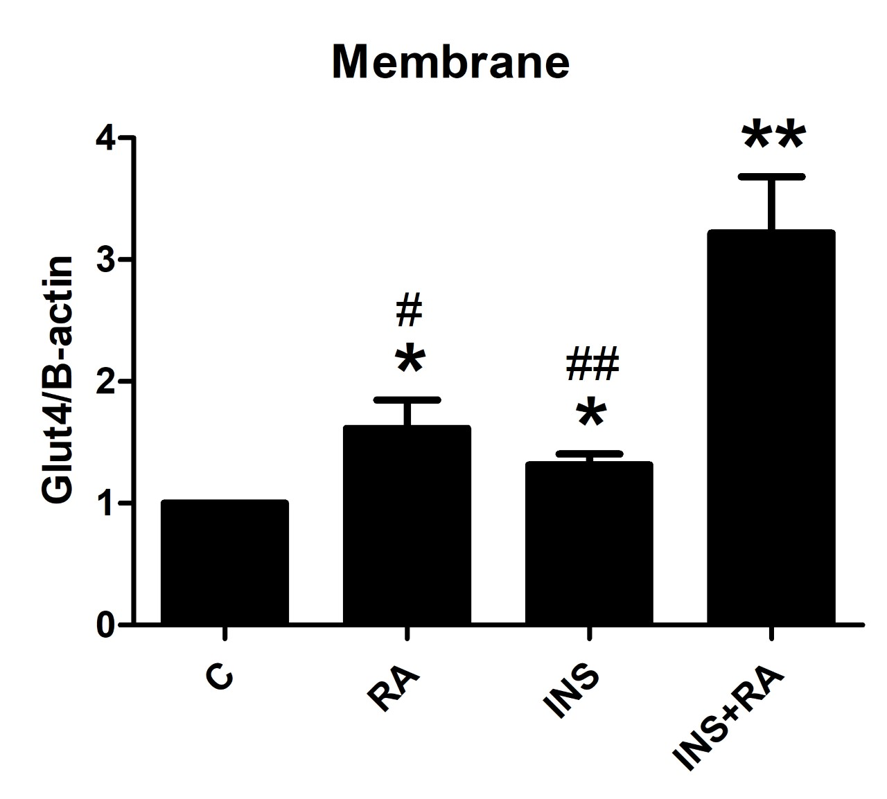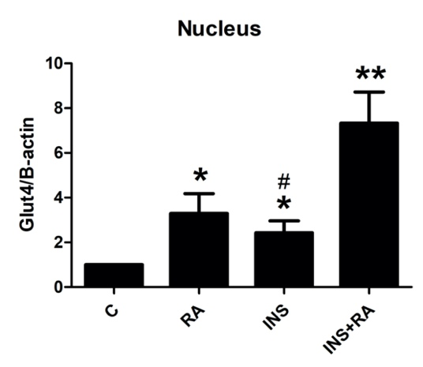
Figure 3-10: The GLUT4 protein levels of rat L6 muscle cells in the absence or presence of 1μM RA without or with 10 nM insulin for 6 days in cytosol, membrane and nucleus.
Data were expressed as mean ± SEM for three independent experiments; */#p<0.05, for comparing the indicated group and the control group or Ins+RA group; **/## p<0.01, for comparing the indicated group with the control group or Ins+RA group.

4. Discussion
The purpose of this study is to understand how RA affects the glucose metabolism in L6 skeletal muscle cells as we have observed elevation of glucose usage in L6 cells treated with RA and insulin previously (230). Here, we set up experiments to study the impacts of RA and insulin treatments on the GLUT4 expression levels in L6 cells during the differentiation process. However, we encountered challenges of lacking a validated anti GLUT4 antibody for the use in Western blot. Therefore, we constructed a recombinant adenovirus to overexpress mouse GLUT4 (Ad-mGLUT4), and evaluated the GLUT4 expression levels in L6 cells using the validated antibody.
Anti-GLUT4 antibodies from various sources have been used to study GLUT4 expression and translocation. The conclusions of the study are based on experimental results using these antibodies. As shown in Figure 3-5, anti GLUT4 antibodies from different companies detected bands with different molecule masses in Western blot. It is apparent that the lack of a control to indicate the correct band in Western blot was the problem. In 2016, the International Antibody Verification Working Group held a meeting to emphasize the necessity of verifying antibodies in common research applications (232). A positive control from a cell or tissue with unique overexpression or silencing of GLUT4 is essential to confirm the specificity of the antibody to obtain the correct signal in the research system. This is especially true for Western blotting. It may be necessary to confirm the specificity of the antibody in a particular system first. The data indicate in our limited survey, some of commercial antibodies failed to detect GLUT4 at correct location or recognized a nonspecific protein. We have summarized the studies using antibodies to study GLUT4 expression and translocation (233). Some of the studies did not use cells or tissue samples with deletion or overexpression of GLUT4 as a negative or positive control, respectively. Therefore, we should be cautious when a conclusion was drawn based on a study without this kind of controls.
To solve practical problems related to GLUT4 antibodies, we have produced Ad-mGLUT4. Adenovirus transfer vectors have a wide range of uses and applications (234). Recombinant adenoviruses have a high efficiency of gene transfer in broad species and cells. They can be used for in vitro protein expression and purification, research on the effect of gene products on cell biology, or in vivo research on multiple tissue types and multiple different species (235). Driven by CMV promoter, a very high level of expression of recombinant proteins can be achieved by recombinant adenoviruses (235). Although it has been found that adenoviral vectors can infect a variety of mammalian cells, not all cells allow infection. The expression of adenovirus genes occurs in two stages, early and late. The early genes are encoded by four different transcription units early regions E1-E4 (236). In most recombinant vectors, a foreign gene is inserted as a substitute for the E1 or E3 region. The replacement of the E1 region will result in a replication defective vector; E3 is involved in evading host immunity and is not necessary for virus production (236). Human embryonic kidney cells (HEK293) provide E1 to complement the defect of viral replication (236). Therefore, in this study we use HEK293 cells to obtain the recombinant adenovirus Ad-mGLUT4. We used 293 and HL1C cells to confirm that we have successfully constructed Ad-mGLUT4.
Based on GLUT4 protein bands detected in the lysates of 293 cells with or without infection of Ad-mGLUT4by antibodies from different companies, EMD company’s antibody appears to offer the best quality. It detects the same band in L6 cells and 293 or HL1C cells with GLUT4 overexpression. GLUT4 antibodies from other companies detect multiple bands or a band that is not at the correct location. Currently, researchers rely on antibodies company or other online resources when selecting antibodies. However, the quality of technical support provided by different companies varies greatly. Sometimes, the antibody detects unexpected increase of the band(s) that is not at the correct location. Therefore, misinterpretation of the research findings and poor reproducibility can occur without validation of the commercially available antibodies.
GLUT4 protein expression is a key factor in skeletal muscle glucose metabolism. Insulin is an important hormone that regulates skeletal muscle glucose metabolism. Both the expression of GLUT4 and the translocation of GLUT4 can be regulated by insulin (100, 237). Insulin can stimulate the mobilization of GLUT4. When the GLUT4 level in the plasma membrane increases, its level in cytosol decreases. As shown in Figures 3-8 and 3-9, insulin and RA + insulin treatments for 4 and 6 days appears to inhibit the levels of GLUT4 protein in supernatants of L6 skeletal muscle cells during differentiation prepared by Method B. However, GLUT4 levels of the pellets (insoluble fraction) in cells treated with insulin and RA + insulin groups are increased in comparison with that in the control or RA group. On the other hand, the total GLUT4 levels in the L6 cells treated with insulin or RA+ insulin for 4 days and lysed in 1 x SDS loading buffer are higher than that in the control cells. A challenge facing biochemical study of GLUT4 translocation in the muscle may be the sample preparation. When the differentiated L6 muscle cells were lysed using the traditional whole-cell lysate method, we found that the large amount of GLUT4 protein remains in the pellets. This indicates that the lysis buffer used here may not completely dissolve the differentiated L6 muscle cells. These results indicated that lysis buffer used in the preparations of whole cell lysates are crucial for the detection of GLUT4. The insulin treatment causes GLUT4 to stay in the insoluble pellet in our current experimental setting. Whether this insoluble structure is the real insulin-induced functional unit for glucose transport remains to be determined.
The skeletal muscle is made of many muscle fibers connected by connective tissue, which makes it difficult to dissolve in whole cell lysis buffer. The lysis Method C and buffers C, D and E used here might solubilize differentiating L6 cells efficiently, and can be used to analyze GLUT4 protein expression. The GLUT4 protein level in the cytosol is more difficult to be detected than that in membrane and nucleus. This probably due to that fact that GLUT4 is a protein associated with membrane all the time. Therefore, the amount of GLUT4 in cytosol is difficult to be detected. The nucleus probably may contain unfractionated or unbroken cells. Data shown in Figure 3-10 did not include the total cell lysate, which is something that we will perform in the future. Nevertheless, the GLUT4 protein levels in the membrane of differentiating L6 cells prepared by Method C and in buffer E were affected significantly by the treatments with RA and/or insulin.
In the future, to study the effects of RA and insulin on the subcellular movement of GLUT4 in differentiating L6 muscle cells, the total cell lysate should be included as a control group. It will help to compare GLUT4 levels in different subcellular fractions. Since a significant amount of GLUT4 protein can be detected in the nucleus, it probably means that there are still cells that are not completely broken in the current experimental setting. Therefore, more strokes of Dounce homogenizing might be needed to lyse and separate the cells into different fractions.

5. Conclusion
We have constructed the Ad-mGLUT4 recombinant adenovirus, which allows us to overexpress GLUT4, and successfully determine a functional anti GLUT4 antibody for our study. This Ad-mGLUT4 can be a useful tool to study the GLUT4 expression and translocation in L6 muscle cells treated with RA and insulin in the future. In addition, we have successfully determined the ideal method and lysis buffer that can be used in L6 cells. RA appears to interact with insulin to affect the expression and translocation of GLUT4 in L6 muscle cells during differentiation. This interaction may contribute to the elevated glucose usage in L6 cells treated with RA and insulin as shown in (230). All these have set up a stage for more future studies, which will help us to understand the role of VA in the regulation of glucose metabolism and in GLUT4 translocation in L6 cells.

Conclusions and Future Directions

1. Conclusion
The prevalence of metabolic diseases such as T2DM has become a public health problem (36). Skeletal muscle plays a key role in regulating glucose and metabolic homeostasis (28). In this dissertation, we have demonstrated that VA contributes to glucose and lipid metabolisms in vivo and in vitro. The goal of our lab is to find the effect of VA and dietary factors on glucose and lipid metabolisms in the whole body and liver, and the effect of VA on glucose metabolism in skeletal muscle cells with or without insulin. Specifically, we have used ZDF rats, a genetic model of T2DM, and rat L6 skeletal muscle cells to understand these two questions. (1) Does VA status affect the physiological functions and liver glucose and lipid metabolism of ZL and ZDF rats, and the development of T2DM in ZDF rats? (2) Does RA alone and in combination with insulin affect the expression level of GLUT4 in L6 skeletal muscle cells? The answers to these two questions are described in Chapters 2 and 3, which can provide insight into the mechanisms by which VA affects metabolism. The results presented in this dissertation will help us to find ways to intervene obesity and T2DM.
In Chapter 2, we investigated the effects of VA status and dietary fat content (BF or HF) on morphometrics, plasma biochemical markers, and hepatic expression levels of genes and proteins for glucose and lipid metabolism in ZL and ZDF rats, and obtained the following results. First, VA status affects food intake in both ZL and ZDF rats. The development of VAD will cause a reduction of appetite in ZL and ZDF rats. In addition, rats fed a VAM, or VAS diet gain more BM than those fed the VAD diet. The effects of VA status on the BM gain in both ZL and ZF rats fed a HF diet appeared at 4 weeks on the diet compared to those fed a BF diet at 6 weeks, suggesting an interaction between VA and dietary fat content. Second, ZDF rats fed a VAS-BF or a VAS-HF diet will development hyperglycemia after 5 weeks on the diets. Interestingly, the PBG levels in VAM-HF ZDF group were lower than VAD/VAS-HF ZDF group during OGTT, demonstrating the potential benefit of limiting the VA intake in ZDF rats to attenuate T2DM development. The ITT and OGTT data indicate insulin resistance and impaired glucose tolerance in VAS-HF and VAS-HF ZDF rats. Third, the ratios of liver and WAT to BM, plasma glucose, TG, cholesterol, insulin, and leptin in ZDF rats fed the VAD/VAM diets are lower than that of fed the VAS diet regardless the fat content. Fourth, the ZL rats in the VAD-BF ZL group have lower hepatic Gck, Srebp-1c, Scd1, G6p, and Rgn mRNA levels, and higher hepatic Srebp2, CD36 and Igfbp1 mRNA levels than those in the VAM/VAS-BF groups. The mRNA levels of Fas, Acl, Scd1, CD36, G6p, and Rng in the liver of VAS-HF ZDF group were increased compared with that of VAD/VAM-HF groups. The hepatic mRNA levels of Pck1, Raldh1, and G6p in ZDF rats of the VAM-HF group were lower than that of VAD/VAS-HF groups. All these demonstrated clearly that VA contributes to the control of hepatic expressions of genes for glucose and lipid metabolism as we have shown previous in ZF rat studies (200, 203, 204, 206) . Fifth, the lack of VA suppresses the hepatic protein levels of ALC, IRβ, GCK, GS, GSK-3β, and RGN in rats of the VAD-BF group, and ACC, FAS, ACL, RGN, and AGPAT2 in ZDF rats of the BF/HF groups, and induces the protein levels of IRβ and GS in ZL rats of the HF group. The feeding of the VAM diet induces the hepatic IRβ and GS protein levels in ZDF rats of the HF group. All these observations show that VA status affects the expression levels of hepatic genes for glucose and lipid metabolism in the liver ZDF rats, especially those fed a HF diet.
In Chapter 3, we investigated the effects of RA and insulin on GLUT4 expression in L6 muscle cells and obtained the following results. First, we observed that antibodies from multiple sources detect different bands on the Western blot membrane. This indicates that we could not rely on the “specificity” of an antibody to study the endogenous GLUT4 expression in L6 cells without validating the antibodies. A positive control group is needed to screen the antibodies from different sources. We successfully constructed the Ad-mGLUT4 recombinant adenovirus, which overexpresses mouse GLUT4 in cells. This allowed us to successfully determine a functional anti GLUT4 antibody for our study. Second, we encountered another problem which is to lyse muscle cells for the study of GLUT4 levels and its subcellular localizations. We have tested multiple buffer and methods to lyse and fractionate L6 cells. We have successfully determined methods that can help us to analyze the GLUT4 levels in total cell lysates and fractions. Insulin and RA + insulin treatments for 4 and 6 days appear to inhibit the levels of GLUT4 protein in supernatants of L6 skeletal muscle cells during differentiation prepared by whole cell lysates (Method B, and Lysis Buffer B). Third, the GLUT4 protein levels of differentiating L6 cells prepared by fractionated lysates were affected significantly by the treatments with RA and/or insulin. Collectively, in rat L6 skeletal muscle cells, RA and/or insulin treatment influence the levels of GLUT4 in different cell fractions.

2. Future Directions
This dissertation investigated that reducing the VA status can alleviate hyperinsulinemia, hyperglycemia and hyperleptinemia in ZDF rats. The potential mechanism of VA status in regulating liver glucose metabolism and glycogenesis is worthy of further study, and may help to assess the effect of VA on the development of T2DM in patients. Also, Ad-mGLUT4 may be a useful tool to study GLUT4-mediated glucose transport in skeletal muscle cells.

2.1 Animal studies
According to our experimental results about the effects of VA on the development of obesity development published previously using ZF rats (200, 206) and T2DM shown in this dissertation, it is suffice to say that supplementation of VA in patients with obesity and diabetes is something that should be considered cautiously and seriously. In addition, our observations also raise more questions about the underlying molecular mechanisms. We believe that the following research areas are worthy of further research.
The expression levels of hepatic genes involved in glucose and lipid metabolism are at least partially regulated by the action of insulin (22). We determine the protein hepatic expression levels of IRβ, which are reduced in VAS-BF/HF groups compared with that in VAD/VAM groups of ZDF rats, respectively. This probably reflects the difference of plasma insulin levels of these rats. Whether long term hyperinsulinemia in VAS ZDF rats is responsible for this reduction remains to be determined. Therefore, the effect of VA status related to the insulin sensitivity of ZDF rats is worth to be investigated further.
We obtained two pairs of heterozygous Zucker rats from the vender and established a breeding colony of Zucker rats by ourselves. The experimental rats received the treatments according to the date of their birth. One interesting phenomenon is that ZDF rats born at a later litter appear to develop hyperglycemia and get diabetes quicker or at a relative younger age than those born at an earlier litter. This happens when the environmental conditions in the animal facility were supposed to be unchanged. If we assume that the animal facility conditions have not varied during the experimental period, why those ZDF rats develop hyperglycemia and diabetes earlier is something worth to be investigated. Additional experiments are needed to confirm this observation. One possibility might be epigenetic modifications that might happen along with the aging of the breeding pairs. Epigenetic changes might have altered the metabolism in ZDF rats without changing the genetic coding sequence (238). There is increasing evidence that epigenetic mechanisms are related to T2DM, and these mechanisms may be studied in the future to explain possible differences here (238, 239).
Due to mutations in the leptin receptor, male ZDF rats have hyperphagia after weaning and develop diabetes at 8 to 10 weeks of age (240). In studies involving animals of a single age, the presence of hyperglycemia at that age does not necessarily reflect the length of time that hyperglycemia exists, which may be very important. Because our current study was terminated when the rats are 11 weeks old, it is not known whether ZDF rats will develop more severe insulin resistance at a later age and affected by VA status. The age at which β cell failure occurs is likely to be variable (240). Therefore, in future studies, we should extend the treatment time to see whether the blood sugar levels of those ZDF will rise even more, which allows us to see more dramatic differences among rats with different VA statuses.

2.2 GLUT4 studies
RA and/or insulin treatments affects the expression of GLUT4 in rat L6 skeletal muscle cells. It indicates that muscle glucose metabolism can be affected by VA signaling system. When L6 cells were fractionated to prepare different lysates for analysis of GLUT4 expression, the effect of RA and/or insulin were different in different fractions. This demonstrates that method and buffers of cell lysis should be chosen carefully for the analysis of GLUT4 protein in L6 skeletal muscle cells or muscle tissues in the future. An efficient method and a buffer need to be determined when we study GLUT4 levels.
The recombinant adenovirus (Ad-mGLUT4) constructed in this dissertation allows overexpression of GLUT4 in cells. Ad-mGLUT4 is not only a useful tool to confirm GLUT4 expression, but also a tool that can be used to study GLUT4-mediated glucose transport in cells. In order to determine whether Ad-mGLUT4 can be used in L6 cells before, during and after differentiation, we investigated whether Ad-mGLUT4 can infect L6 cells before or after differentiation, and affect the differentiation of L6 cells. We have done the following preliminary studies. (1) Ad-mGLUT4 and β-gal (a transfection control virus) were added to L6 cells, and then cells were allowed to differentiate for 2, 4 and 6 days before being lysed. L6 cells were directly lysed in 400 ul of 1 x SDS loading buffer to obtain the total cell lysate. The GLUT4 expression levels in L6 cells uninfected, and Ad-mGLUT4 or β-gal infected were determined using EMD’s anti-GLUT4 antibody in Western blot. As shown in Figure 4-1A, L6 can still successfully differentiate after being infected by Ad-mGLUT4. The expression level of GLUT4 transfected with Ad-mGLUT4 increases with L6 differentiation. (2) Ad-mGLUT4 or β-gal was added to L6 cells after the differentiation process started for 2, 4 and 6 days. Two days after the transfection, cells were directly lysed in 400 ul of 1 x SDS loading buffer to obtain the total cell lysate for Western blot analysis. The GLUT4 expression levels in L6 cells uninfected, infected with Ad-mGLUT4 or β-gal were determined using EMD’s anti-GLUT4 antibody in Western blot. L6 cells appeared to cease to differentiate after infected with Ad-mGLUT4. There is a decrease of GLUT4 overexpression when L6 cells infected by Ad-mGLUT4 after differentiated for 6 days and compare to that of L6 cells differentiated for 2 and 4 days (Figure 4-1B). In the future, these phenomena need to be investigated further to confirm the effects of GLUT4 overexpression on the L6 cells differentiation.

3. Summary
The work described in this dissertation helps us to understand the effect of VA status on the development of T2DM and the effect of VA signaling on the expression level of GLLUT4 in skeletal muscle. Reduction of VA status appears to ameliorate the obesity and T2DM development in ZDF rats. This phenomenon clearly shows that VA contributes to the T2DM development. Therefore, VA intake should be closely monitored for people with obesity and diabetes.

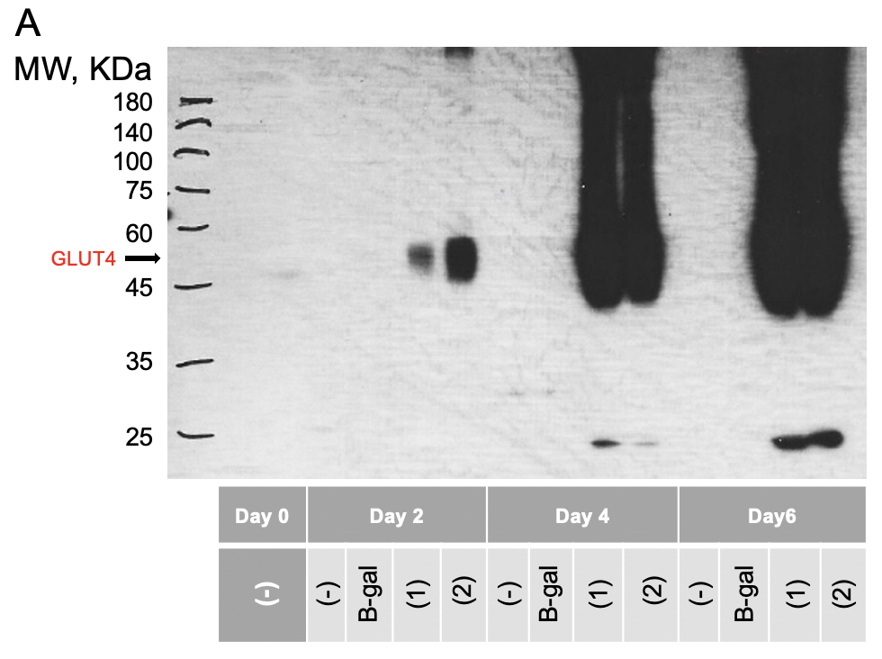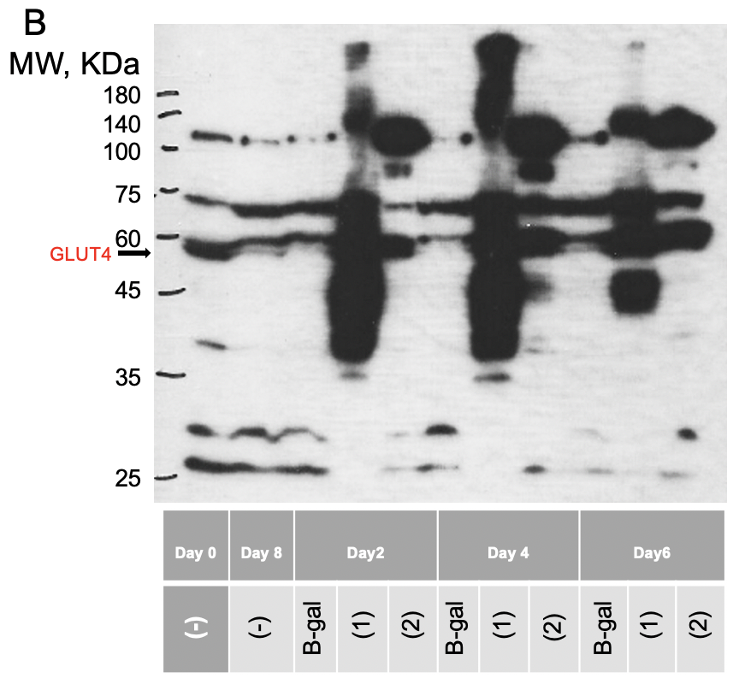
Figure 4-1: GLUT4 expression level in Ad-mGLUT4 infected L6 cell before or after differentiation.
(A) Ad-mGLUT4 (as (1) and (2)) and β-gal were added to infect L6 cells when L6 cells differentiate on day 2, 4 and 6. (B) Ad-mGLUT4 (as (1) and (2)) and β-gal added after the differentiation process of L6 cells started for 2, 4 and 6 days.

List of References
1. Medicine Io. Dietary Reference Intakes for Vitamin A, Vitamin K, Arsenic, Boron, Chromium, Copper, Iodine, Iron, Manganese, Molybdenum, Nickel, Silicon, Vanadium, and Zinc. Washington, DC: The National Academies Press; 2001. 800 p.
2. Semba RD. On the ‘Discovery’ of Vitamin A. Annals of Nutrition and Metabolism. 2012;61(3):192-8. doi: 10.1159/000343124.
3. Wolf G. A history of vitamin A and retinoids. Faseb j. 1996;10(9):1102-7. Epub 1996/07/01. doi: 10.1096/fasebj.10.9.8801174. PubMed PMID: 8801174.
4. Karrer P, Morf R, Schöpp K. Zur Kenntnis des Vitamins-A aus Fischtranen II. Helvetica Chimica Acta. 1931;14(6):1431-6. doi: https://doi.org/10.1002/hlca.19310140622.
5. Karrer P, Morf R, Schoepp K. Zur Kenntnis des Vitamins-A aus Fischtranen. Helvetica Chimica Acta. 1931;14:1036-40.
6. Holmes HN, Corbet RE. The Isolation of Crystalline Vitamin A1. Journal of the American Chemical Society. 1937;59(10):2042-7. doi: 10.1021/ja01289a075.
7. Arens JF, Van Dorp DA. Synthesis of some compounds possessing vitamin A activity. Nature. 1946;157:190. Epub 1946/02/16. doi: 10.1038/157190a0. PubMed PMID: 21015124.
8. Isler O, Huber W, Ronco A, Kofler M. Synthese des Vitamin A. Helvetica Chimica Acta. 1947;30(6):1911-27. doi: https://doi.org/10.1002/hlca.19470300666.
9. Blomhoff R, Blomhoff HK. Overview of retinoid metabolism and function. J Neurobiol. 2006;66(7):606-30. Epub 2006/05/12. doi: 10.1002/neu.20242. PubMed PMID: 16688755.
10. Chea EP, Lopez MJ, Milstein H. Vitamin A. StatPearls. Treasure Island (FL): StatPearls Publishing
Copyright © 2021, StatPearls Publishing LLC.; 2021.
11. CA R. Vitamin A. In: Paul M. Coates JMB, Marc R. Blackman, Gordon M. Cragg, Mark Levine, Joel Moss, Jeffrey D. White, editor. Encyclopedia of Dietary Supplements. 2nd Edition ed: London and New York: Informa Healthcare; 2010.
12. O'Byrne SM, Blaner WS. Retinol and retinyl esters: biochemistry and physiology. J Lipid Res. 2013;54(7):1731-43. Epub 2013/04/30. doi: 10.1194/jlr.R037648. PubMed PMID: 23625372; PMCID: PMC3679378.
13. Harrison EH. Mechanisms involved in the intestinal absorption of dietary vitamin A and provitamin A carotenoids. Biochim Biophys Acta. 2012;1821(1):70-7. Epub 2011/06/12. doi: 10.1016/j.bbalip.2011.06.002. PubMed PMID: 21718801.
14. Linton MF, Yancey PG, Davies SS, Jerome WG, Linton EF, Song WL, Doran AC, Vickers KC. The Role of Lipids and Lipoproteins in Atherosclerosis. In: Feingold KR, Anawalt B, Boyce A, Chrousos G, de Herder WW, Dhatariya K, Dungan K, Grossman A, Hershman JM, Hofland J, Kalra S, Kaltsas G, Koch C, Kopp P, Korbonits M, Kovacs CS, Kuohung W, Laferrère B, McGee EA, McLachlan R, Morley JE, New M, Purnell J, Sahay R, Singer F, Stratakis CA, Trence DL, Wilson DP, editors. Endotext. South Dartmouth (MA): MDText.com, Inc.
Copyright © 2000-2021, MDText.com, Inc.; 2000.
15. Cooper AD. Hepatic uptake of chylomicron remnants. Journal of Lipid Research. 1997;38(11):2173-92. doi: https://doi.org/10.1016/S0022-2275(20)34932-4.
16. Gropper SAS, Smith JL, Carr TP. Advanced nutrition and human metabolism2018.
17. Chen G. Roles of Vitamin A Metabolism in the Development of Hepatic Insulin Resistance. ISRN Hepatol. 2013;2013:534972. Epub 2013/01/01. doi: 10.1155/2013/534972. PubMed PMID: 27335827; PMCID: PMC4890907.
18. Alapatt P, Guo F, Komanetsky SM, Wang S, Cai J, Sargsyan A, Rodríguez Díaz E, Bacon BT, Aryal P, Graham TE. Liver retinol transporter and receptor for serum retinol-binding protein (RBP4). J Biol Chem. 2013;288(2):1250-65. Epub 2012/10/26. doi: 10.1074/jbc.M112.369132. PubMed PMID: 23105095.
19. Folli C, Calderone V, Ottonello S, Bolchi A, Zanotti G, Stoppini M, Berni R. Identification, retinoid binding, and x-ray analysis of a human retinol-binding protein. Proceedings of the National Academy of Sciences. 2001;98(7):3710. doi: 10.1073/pnas.061455898.
20. Cabrera-Valladares G, Matschinsky FM, Wang J, Fernandez-Mejia C. Effect of retinoic acid on glucokinase activity and gene expression in neonatal and adult cultured hepatocytes. Life Sci. 2001;68(25):2813-24. Epub 2001/07/04. doi: 10.1016/s0024-3205(01)01065-7. PubMed PMID: 11432447.
21. Johnson D, Shepherd RM, Gill D, Gorman T, Smith DM, Dunne MJ. Glucose-dependent modulation of insulin secretion and intracellular calcium ions by GKA50, a glucokinase activator. Diabetes. 2007;56(6):1694-702. Epub 2007/03/16. doi: 10.2337/db07-0026. PubMed PMID: 17360975.
22. Horton JD, Goldstein JL, Brown MS. SREBPs: activators of the complete program of cholesterol and fatty acid synthesis in the liver. J Clin Invest. 2002;109(9):1125-31. Epub 2002/05/08. doi: 10.1172/jci15593. PubMed PMID: 11994399; PMCID: PMC150968.
23. Tanumihardjo SA. Assessing vitamin A status: past, present and future. J Nutr. 2004;134(1):290s-3s. Epub 2004/01/06. doi: 10.1093/jn/134.1.290S. PubMed PMID: 14704336.
24. Dawson MI. The importance of vitamin A in nutrition. Curr Pharm Des. 2000;6(3):311-25. Epub 2000/01/19. doi: 10.2174/1381612003401190. PubMed PMID: 10637381.
25. World Health O. Vitamin and mineral requirements in human nutrition. 2nd ed ed. Geneva: World Health Organization; 2005.
26. Mills JP, Terasawa E, Tanumihardjo SA. Ingestion of excessive preformed vitamin A by mothers amplifies storage of retinyl esters in early fetal livers of captive Old World monkeys. Comp Med. 2007;57(5):505-11. Epub 2007/11/03. PubMed PMID: 17974134.
27. Alberts B JA, Lewis J, et al. Molecular Biology of the Cell. 4th edition ed: New York: Garland Science; 2002.
28. Sinacore DR, Gulve EA. The role of skeletal muscle in glucose transport, glucose homeostasis, and insulin resistance: implications for physical therapy. Physical therapy. 1993;73(12):878-91. Epub 1993/12/01. doi: 10.1093/ptj/73.12.878. PubMed PMID: 8248296.
29. Kim KM, Jang HC, Lim S. Differences among skeletal muscle mass indices derived from height-, weight-, and body mass index-adjusted models in assessing sarcopenia. Korean J Intern Med. 2016;31(4):643-50. Epub 2016/06/22. doi: 10.3904/kjim.2016.015. PubMed PMID: 27334763.
30. Yang J. Enhanced skeletal muscle for effective glucose homeostasis. Prog Mol Biol Transl Sci. 2014;121:133-63. Epub 2014/01/01. doi: 10.1016/b978-0-12-800101-1.00005-3. PubMed PMID: 24373237.
31. Daugaard JR, Richter EA. Relationship between muscle fibre composition, glucose transporter protein 4 and exercise training: possible consequences in non-insulin-dependent diabetes mellitus. Acta Physiologica Scandinavica. 2001;171(3):267-76. doi: 10.1046/j.1365-201x.2001.00829.x.
32. Brook MS, Wilkinson DJ, Phillips BE, Perez-Schindler J, Philp A, Smith K, Atherton PJ. Skeletal muscle homeostasis and plasticity in youth and ageing: impact of nutrition and exercise. Acta Physiol (Oxf). 2016;216(1):15-41. Epub 2015/06/21. doi: 10.1111/apha.12532. PubMed PMID: 26010896.
33. Nedachi T, Kanzaki M. Regulation of glucose transporters by insulin and extracellular glucose in C2C12 myotubes. Am J Physiol Endocrinol Metab. 2006;291(4):E817-28. Epub 2006/06/01. doi: 10.1152/ajpendo.00194.2006. PubMed PMID: 16735448.
34. Abdelmoez AM, Sardón Puig L, Smith JAB, Gabriel BM, Savikj M, Dollet L, Chibalin AV, Krook A, Zierath JR, Pillon NJ. Comparative profiling of skeletal muscle models reveals heterogeneity of transcriptome and metabolism. American Journal of Physiology-Cell Physiology. 2019;318(3):C615-C26. doi: 10.1152/ajpcell.00540.2019.
35. Richler C, Yaffe D. The in vitro cultivation and differentiation capacities of myogenic cell lines. Dev Biol. 1970;23(1):1-22. Epub 1970/09/01. doi: 10.1016/s0012-1606(70)80004-5. PubMed PMID: 5481965.
36. Al-Lawati JA. Diabetes Mellitus: A Local and Global Public Health Emergency! Oman Med J. 2017;32(3):177-9. doi: 10.5001/omj.2017.34. PubMed PMID: 28584596.
37. Flamme KEL, Mor G, Gong D, Tempa TL, Fusaro VA, Grimes CA, Desai TA. Nanoporous Alumina Capsules for Cellular Macroencapsulation: Transport and Biocompatibility. Diabetes Technology & Therapeutics. 2005;7(5):684-94.
38. [CDC] CfDCaP. Diabetes Basics [updated May 30, 2019; cited 2021 June, 10]. Available from: https://www.cdc.gov/diabetes/basics/index.html.
39. Salt IP, Johnson G, Ashcroft SJ, Hardie DG. AMP-activated protein kinase is activated by low glucose in cell lines derived from pancreatic beta cells, and may regulate insulin release. Biochemical Journal. 1998;335(3):533-9.
40. Zhang Y, Wang T, Hu X, Chen G. Vitamin A and Diabetes. J Med Food. 2020. Epub 2020/11/25. doi: 10.1089/jmf.2020.0147. PubMed PMID: 33232625.
41. Krempf M, Ranganathan S, Ritz P, Morin M, Charbonnel B. Plasma vitamin A and E in type 1 (insulin-dependent) and type 2 (non-insulin-dependent) adult diabetic patients. International journal for vitamin and nutrition research Internationale Zeitschrift fur Vitamin- und Ernahrungsforschung Journal international de vitaminologie et de nutrition. 1991;61(1):38-42. Epub 1991/01/01. PubMed PMID: 1856044.
42. Basu TK, Tze WJ, Leichter J. Serum vitamin A and retinol-binding protein in patients with insulin-dependent diabetes mellitus. Am J Clin Nutr. 1989;50(2):329-31. Epub 1989/08/01. doi: 10.1093/ajcn/50.2.329. PubMed PMID: 2756919.
43. Martinoli L, Di Felice M, Seghieri G, Ciuti M, De Giorgio LA, Fazzini A, Gori R, Anichini R, Franconi F. Plasma retinol and alpha-tocopherol concentrations in insulin-dependent diabetes mellitus: their relationship to microvascular complications. International journal for vitamin and nutrition research Internationale Zeitschrift fur Vitamin- und Ernahrungsforschung Journal international de vitaminologie et de nutrition. 1993;63(2):87-92. Epub 1993/01/01. PubMed PMID: 8407170.
44. Granado F, Olmedilla B, Gil-Martínez E, Blanco I, Millan I, Rojas-Hidalgo E. Carotenoids, retinol and tocopherols in patients with insulin-dependent diabetes mellitus and their immediate relatives. Clinical science (London, England : 1979). 1998;94(2):189-95. Epub 1998/04/16. doi: 10.1042/cs0940189. PubMed PMID: 9536928.
45. Krill D, O'Leary L, Koehler AN, Kramer MK, Warty V, Wagner MA, Dorman JS. Association of retinol binding protein in multiple-case families with insulin-dependent diabetes. Human biology. 1997;69(1):89-96. Epub 1997/02/01. PubMed PMID: 9037897.
46. Tuitoek PJ, Lakey JR, Rajotte RV, Basu TK. Strain variation in vitamin A (retinol) status of streptozotocin-induced diabetic rats. International journal for vitamin and nutrition research Internationale Zeitschrift fur Vitamin- und Ernahrungsforschung Journal international de vitaminologie et de nutrition. 1996;66(2):101-5. Epub 1996/01/01. PubMed PMID: 8843983.
47. Durham HA, Truett GE. Development of insulin resistance and hyperphagia in Zucker fatty rats. American Journal of Physiology-Regulatory, Integrative and Comparative Physiology. 2006;290(3):R652-R8. doi: 10.1152/ajpregu.00428.2004.
48. King A, Austin A. Animal Models of Type 1 and Type 2 Diabetes Mellitus. Animal Models for the Study of Human Disease: Second Edition: Elsevier Inc.; 2017. p. 245-65.
49. Schmidt RE, Dorsey DA, Beaudet LN, Peterson RG. Analysis of the Zucker Diabetic Fatty (ZDF) type 2 diabetic rat model suggests a neurotrophic role for insulin/IGF-I in diabetic autonomic neuropathy. Am J Pathol. 2003;163(1):21-8. Epub 2003/06/24. doi: 10.1016/s0002-9440(10)63626-7. PubMed PMID: 12819007; PMCID: PMC1868158.
50. Phillips MS, Liu Q, Hammond HA, Dugan V, Hey PJ, Caskey CJ, Hess JF. Leptin receptor missense mutation in the fatty Zucker rat. Nat Genet. 1996;13(1):18-9. Epub 1996/05/01. doi: 10.1038/ng0596-18. PubMed PMID: 8673096.
51. Kong L-l, Wu H, Cui W-p, Zhou W-h, Luo P, Sun J, Yuan H, Miao L-n. Advances in Murine Models of Diabetic Nephropathy. Journal of Diabetes Research. 2013;2013:797548. doi: 10.1155/2013/797548.
52. Corsetti JP, Sparks JD, Peterson RG, Smith RL, Sparks CE. Effect of dietary fat on the development of non-insulin dependent diabetes mellitus in obese Zucker diabetic fatty male and female rats. Atherosclerosis. 2000;148(2):231-41. Epub 2000/02/05. doi: 10.1016/s0021-9150(99)00265-8. PubMed PMID: 10657558.
53. Martha H Stipanuk MC. Biochemical, Physiological, and Molecular Aspects of Human Nutrition. third ed2012. 968 p.
54. Mueckler M, Caruso C, Baldwin SA, Panico M, Blench I, Morris HR, Allard WJ, Lienhard GE, Lodish HF. Sequence and structure of a human glucose transporter. Science. 1985;229(4717):941-5. Epub 1985/09/06. doi: 10.1126/science.3839598. PubMed PMID: 3839598.
55. Quistgaard EM, Löw C, Guettou F, Nordlund P. Understanding transport by the major facilitator superfamily (MFS): structures pave the way. Nature reviews Molecular cell biology. 2016;17(2):123-32. Epub 2016/01/14. doi: 10.1038/nrm.2015.25. PubMed PMID: 26758938.
56. Klip A, McGraw TE, James DE. Thirty sweet years of GLUT4. J Biol Chem. 2019;294(30):11369-81. Epub 2019/06/07. doi: 10.1074/jbc.REV119.008351. PubMed PMID: 31175156.
57. Mueckler M, Thorens B. The SLC2 (GLUT) family of membrane transporters. Mol Aspects Med. 2013;34(2-3):121-38. doi: 10.1016/j.mam.2012.07.001. PubMed PMID: 23506862.
58. Chen L, Tuo B, Dong H. Regulation of Intestinal Glucose Absorption by Ion Channels and Transporters. Nutrients. 2016;8(1):43. doi: 10.3390/nu8010043. PubMed PMID: 26784222.
59. Takata K, Kasahara T, Kasahara M, Ezaki O, Hirano H. Erythrocyte/HEPG2-type glucose transporter is concentrated in cells of blood-tissue barriers. Biochemical and Biophysical Research Communications. 1990;173(1):67-73. doi: https://doi.org/10.1016/S0006-291X(05)81022-8.
60. Joost HG, Thorens B. The extended GLUT-family of sugar/polyol transport facilitators: nomenclature, sequence characteristics, and potential function of its novel members (review). Molecular membrane biology. 2001;18(4):247-56. Epub 2002/01/10. doi: 10.1080/09687680110090456. PubMed PMID: 11780753.
61. Zhao F-Q, Keating AFJCg. Functional properties and genomics of glucose transporters2007;8(2):113-28.
62. Szablewski L. Glucose Homeostasis and Insulin Resistance: Bentham Science Publishers; 2011. 211 p.
63. Paul W. Hruz MMMJMmb. Structural analysis of the GLUT1 facilitative glucose transporter2001;18(3):183-93.
64. Long W, Cheeseman CI, editors. Structure of, and functional insight into the GLUT family of membrane transporters2015.
65. Olson AL, Pessin JE. Structure, Function, and Regulation of the Mammalian Facilitative Glucose Transporter Gene Family. Annual Review of Nutrition. 1996;16(1):235-56. doi: 10.1146/annurev.nu.16.070196.001315.
66. Uldry M, Ibberson M, Hosokawa M, Thorens B. GLUT2 is a high affinity glucosamine transporter. FEBS letters. 2002;524(1-3):199-203. Epub 2002/07/24. doi: 10.1016/s0014-5793(02)03058-2. PubMed PMID: 12135767.
67. Johnson JH, Newgard CB, Milburn JL, Lodish HF, Thorens B. The high Km glucose transporter of islets of Langerhans is functionally similar to the low affinity transporter of liver and has an identical primary sequence. J Biol Chem. 1990;265(12):6548-51. Epub 1990/04/25. PubMed PMID: 2182619.
68. Colville CA, Seatter MJ, Jess TJ, Gould GW, Thomas HM. Kinetic analysis of the liver-type (GLUT2) and brain-type (GLUT3) glucose transporters in Xenopus oocytes: substrate specificities and effects of transport inhibitors. Biochem J. 1993;290 ( Pt 3)(Pt 3):701-6. Epub 1993/03/15. doi: 10.1042/bj2900701. PubMed PMID: 8457197; PMCID: PMC1132337.
69. Longo N, Elsas LJ. Human glucose transporters. Advances in pediatrics. 1998;45:293-313. Epub 1998/09/22. PubMed PMID: 9742306.
70. Kayano T, Fukumoto H, Eddy RL, Fan YS, Byers MG, Shows TB, Bell GI. Evidence for a family of human glucose transporter-like proteins. Sequence and gene localization of a protein expressed in fetal skeletal muscle and other tissues. J Biol Chem. 1988;263(30):15245-8. Epub 1988/10/25. PubMed PMID: 3170580.
71. Kasahara T, Kasahara M. Characterization of rat Glut4 glucose transporter expressed in the yeast Saccharomyces cerevisiae: comparison with Glut1 glucose transporter1The nucleotide sequence data of rat GLUT4 reported in this paper have been submitted to the GenBank/DDBJ/EMBL database under the accession number D28561.1. Biochimica et Biophysica Acta (BBA) - Biomembranes. 1997;1324(1):111-9. doi: https://doi.org/10.1016/S0005-2736(96)00217-9.
72. Fukumoto H, Kayano T, Buse JB, Edwards Y, Pilch PF, Bell GI, Seino S. Cloning and characterization of the major insulin-responsive glucose transporter expressed in human skeletal muscle and other insulin-responsive tissues. J Biol Chem. 1989;264(14):7776-9. Epub 1989/05/15. PubMed PMID: 2656669.
73. Li Q, Manolescu A, Ritzel M, Yao S, Slugoski M, Young JD, Chen XZ, Cheeseman CI. Cloning and functional characterization of the human GLUT7 isoform SLC2A7 from the small intestine. American journal of physiology Gastrointestinal and liver physiology. 2004;287(1):G236-42. Epub 2004/03/23. doi: 10.1152/ajpgi.00396.2003. PubMed PMID: 15033637.
74. Burant CF, Takeda J, Brot-Laroche E, Bell GI, Davidson NO. Fructose transporter in human spermatozoa and small intestine is GLUT5. J Biol Chem. 1992;267(21):14523-6. Epub 1992/07/25. PubMed PMID: 1634504.
75. Drozdowski LA, Thomson AB. Intestinal sugar transport. World journal of gastroenterology. 2006;12(11):1657-70. Epub 2006/04/06. doi: 10.3748/wjg.v12.i11.1657. PubMed PMID: 16586532; PMCID: PMC4124338.
76. Douard V, Ferraris RPJAJoP-E, Metabolism. Regulation of the fructose transporter GLUT5 in health and disease2008;295(2):E227-E37.
77. Rand E, Depaoli A, Davidson N, Bell G, Burant CJAJoP-G, Physiology L. Sequence, tissue distribution, and functional characterization of the rat fructose transporter GLUT51993;264(6):G1169-G76.
78. Doege H, Bocianski A, Joost HG, Schürmann A. Activity and genomic organization of human glucose transporter 9 (GLUT9), a novel member of the family of sugar-transport facilitators predominantly expressed in brain and leucocytes. Biochem J. 2000;350 Pt 3(Pt 3):771-6. Epub 2000/09/06. PubMed PMID: 10970791; PMCID: PMC1221309.
79. Schmidt S, Joost H-G, Schurmann AJAJoP-E, Metabolism. GLUT8, the enigmatic intracellular hexose transporter2009;296(4):E614-E8.
80. Ibberson M, Uldry M, Thorens B. GLUTX1, a novel mammalian glucose transporter expressed in the central nervous system and insulin-sensitive tissues. J Biol Chem. 2000;275(7):4607-12. Epub 2000/02/15. doi: 10.1074/jbc.275.7.4607. PubMed PMID: 10671487.
81. Phay JE, Hussain HB, Moley JFJG. Cloning and expression analysis of a novel member of the facilitative glucose transporter family, SLC2A9 (GLUT9)2000;66(2):217-20.
82. Augustin R, Carayannopoulos MO, Dowd LO, Phay JE, Moley JF, Moley KHJJoBC. Identification and characterization of human glucose transporter-like protein-9 (GLUT9) alternative splicing alters trafficking2004;279(16):16229-36.
83. Dawson PA, Mychaleckyj JC, Fossey SC, Mihic SJ, Craddock AL, Bowden DW. Sequence and functional analysis of GLUT10: a glucose transporter in the Type 2 diabetes-linked region of chromosome 20q12-13.1. Molecular genetics and metabolism. 2001;74(1-2):186-99. Epub 2001/10/11. doi: 10.1006/mgme.2001.3212. PubMed PMID: 11592815.
84. McVie-Wylie AJ, Lamson DR, Chen YT. Molecular cloning of a novel member of the GLUT family of transporters, SLC2a10 (GLUT10), localized on chromosome 20q13.1: a candidate gene for NIDDM susceptibility. Genomics. 2001;72(1):113-7. Epub 2001/03/15. doi: 10.1006/geno.2000.6457. PubMed PMID: 11247674.
85. Doege H, Bocianski A, Scheepers A, Axer H, Eckel J, Joost HG, Schürmann A. Characterization of human glucose transporter (GLUT) 11 (encoded by SLC2A11), a novel sugar-transport facilitator specifically expressed in heart and skeletal muscle. Biochem J. 2001;359(Pt 2):443-9. Epub 2001/10/05. doi: 10.1042/0264-6021:3590443. PubMed PMID: 11583593; PMCID: PMC1222165.
86. Scheepers A, Schmidt S, Manolescu A, Cheeseman CI, Bell A, Zahn C, Joost HG, Schürmann A. Characterization of the human SLC2A11 (GLUT11) gene: alternative promoter usage, function, expression, and subcellular distribution of three isoforms, and lack of mouse orthologue. Molecular membrane biology. 2005;22(4):339-51. Epub 2005/09/13. doi: 10.1080/09687860500166143. PubMed PMID: 16154905.
87. Wu X, Li W, Sharma V, Godzik A, Freeze H. Cloning and characterization of glucose transporter 11, a novel sugar transporter that is alternatively spliced in various tissues. Molecular genetics and metabolism. 2002;76:37-45. doi: 10.1016/S1096-7192(02)00018-5.
88. Manolescu AR, Witkowska K, Kinnaird A, Cessford T, Cheeseman CJP. Facilitated hexose transporters: new perspectives on form and function2007;22(4):234-40.
89. Sasaki T, Minoshima S, Shiohama A, Shintani A, Shimizu A, Asakawa S, Kawasaki K, Shimizu N. Molecular cloning of a member of the facilitative glucose transporter gene family GLUT11 (SLC2A11) and identification of transcription variants. Biochem Biophys Res Commun. 2001;289(5):1218-24. Epub 2001/12/14. doi: 10.1006/bbrc.2001.6101. PubMed PMID: 11741323.
90. Rogers S, Macheda ML, Docherty SE, Carty MD, Henderson MA, Soeller WC, Gibbs EM, James DE, Best JDJAJoP-E, Metabolism. Identification of a novel glucose transporter-like protein—GLUT-122002;282(3):E733-E8.
91. Uldry M, Ibberson M, Horisberger JD, Chatton JY, Riederer BM, Thorens B. Identification of a mammalian H(+)-myo-inositol symporter expressed predominantly in the brain. The EMBO journal. 2001;20(16):4467-77. Epub 2001/08/14. doi: 10.1093/emboj/20.16.4467. PubMed PMID: 11500374; PMCID: PMC125574.
92. Wu X, Freeze H. GLUT14, a Duplicon of GLUT3, Is Specifically Expressed in Testis as Alternative Splice Forms. Genomics. 2003;80:553-7. doi: 10.1006/geno.2002.7010.
93. Navale AM, Paranjape AN. Glucose transporters: physiological and pathological roles. Biophys Rev. 2016;8(1):5-9. Epub 2016/01/19. doi: 10.1007/s12551-015-0186-2. PubMed PMID: 28510148.
94. Grefner NM, Gromova LV, Gruzdkov AA, Komissarchik YY. Interaction of glucose transporters SGLT1 and GLUT2 with cytoskeleton in enterocytes and Caco2 cells during hexose absorption. Cell and Tissue Biology. 2015;9(1):45-52. doi: 10.1134/S1990519X15010034.
95. Sareen S. Gropper JLS, Timothy P. Carr. Advanced Nutrition and Human Metabolism. seventh ed. Cengage learning2016. 640 p.
96. Bell GI, Kayano T, Buse JB, Burant CF, Takeda J, Lin D, Fukumoto H, Seino S. Molecular Biology of Mammalian Glucose Transporters. Diabetes Care. 1990;13(3):198. doi: 10.2337/diacare.13.3.198.
97. Haber RS, Weinstein SP, O'Boyle E, Morgello S. Tissue distribution of the human GLUT3 glucose transporter. Endocrinology. 1993;132(6):2538-43. doi: 10.1210/endo.132.6.8504756.
98. Stuart CA, Wen G, Gustafson WC, Thompson EA. Comparison of GLUT1, GLUT3, and GLUT4 mRNA and the subcellular distribution of their proteins in normal human muscle. Metabolism: clinical and experimental. 2000;49(12):1604-9. Epub 2001/01/06. doi: 10.1053/meta.2000.18559. PubMed PMID: 11145124.
99. Lisinski I, Schürmann A, Joost HG, Cushman SW, Al-Hasani H. Targeting of GLUT6 (formerly GLUT9) and GLUT8 in rat adipose cells. Biochem J. 2001;358(Pt 2):517-22. doi: 10.1042/0264-6021:3580517. PubMed PMID: 11513753.
100. Vargas E, Podder V, Carrillo Sepulveda MA. Physiology, Glucose Transporter Type 4 (GLUT4). StatPearls. Treasure Island (FL)2020.
101. Richter EA, Derave W, Wojtaszewski JF. Glucose, exercise and insulin: emerging concepts. J Physiol. 2001;535(Pt 2):313-22. doi: 10.1111/j.1469-7793.2001.t01-2-00313.x. PubMed PMID: 11533125.
102. Cushman SW, Wardzala LJ. Potential mechanism of insulin action on glucose transport in the isolated rat adipose cell. Apparent translocation of intracellular transport systems to the plasma membrane. J Biol Chem. 1980;255(10):4758-62. Epub 1980/05/25. PubMed PMID: 6989818.
103. Suzuki K, Kono T. Evidence that insulin causes translocation of glucose transport activity to the plasma membrane from an intracellular storage site. Proceedings of the National Academy of Sciences of the United States of America. 1980;77(5):2542-5. Epub 1980/05/01. doi: 10.1073/pnas.77.5.2542. PubMed PMID: 6771756; PMCID: PMC349437.
104. Wardzala LJ, Cushman SW, Salans LB. Mechanism of insulin action on glucose transport in the isolated rat adipose cell. Enhancement of the number of functional transport systems. J Biol Chem. 1978;253(22):8002-5. Epub 1978/11/25. PubMed PMID: 711732.
105. Klip A, Ramlal T, Young DA, Holloszy JO. Insulin-induced translocation of glucose transporters in rat hindlimb muscles. FEBS letters. 1987;224(1):224-30. Epub 1987/11/16. doi: 10.1016/0014-5793(87)80452-0. PubMed PMID: 2960560.
106. Wardzala LJ, Jeanrenaud B. Potential mechanism of insulin action on glucose transport in the isolated rat diaphragm. Apparent translocation of intracellular transport units to the plasma membrane. J Biol Chem. 1981;256(14):7090-3. Epub 1981/07/25. PubMed PMID: 6265437.
107. James DE, Brown R, Navarro J, Pilch PF. Insulin-regulatable tissues express a unique insulin-sensitive glucose transport protein. Nature. 1988;333(6169):183-5. Epub 1988/05/12. doi: 10.1038/333183a0. PubMed PMID: 3285221.
108. Olson AL. Regulation of GLUT4 and Insulin-Dependent Glucose Flux. ISRN Mol Biol. 2012;2012:856987-. doi: 10.5402/2012/856987. PubMed PMID: 27335671.
109. George Grunberger YZ. Insulin Signaling: From Cultured Cells to Animal Models. Taylor & Francis2003. 448 p.
110. Bryant NJ, Govers R, James DE. Regulated transport of the glucose transporter GLUT4. Nature Reviews Molecular Cell Biology. 2002;3(4):267-77. doi: 10.1038/nrm782.
111. Watson RT, Pessin JE. GLUT4 translocation: the last 200 nanometers. Cellular signalling. 2007;19(11):2209-17. Epub 2007/07/17. doi: 10.1016/j.cellsig.2007.06.003. PubMed PMID: 17629673.
112. Stöckli J, Fazakerley DJ, James DE. GLUT4 exocytosis. J Cell Sci. 2011;124(Pt 24):4147-59. doi: 10.1242/jcs.097063. PubMed PMID: 22247191.
113. Blot V, McGraw TE. GLUT4 is internalized by a cholesterol-dependent nystatin-sensitive mechanism inhibited by insulin. The EMBO journal. 2006;25(24):5648-58. Epub 2006/11/30. doi: 10.1038/sj.emboj.7601462. PubMed PMID: 17139247.
114. Govers R, Coster ACF, James DE. Insulin increases cell surface GLUT4 levels by dose dependently discharging GLUT4 into a cell surface recycling pathway. Mol Cell Biol. 2004;24(14):6456-66. doi: 10.1128/MCB.24.14.6456-6466.2004. PubMed PMID: 15226445.
115. Nedachi T, Kanzaki M. Regulation of glucose transporters by insulin and extracellular glucose in C2C12 myotubes. American Journal of Physiology-Endocrinology and Metabolism. 2006;291(4):E817-E28. doi: 10.1152/ajpendo.00194.2006.
116. Stanford KI, Goodyear LJ. Exercise and type 2 diabetes: molecular mechanisms regulating glucose uptake in skeletal muscle. Adv Physiol Educ. 2014;38(4):308-14. doi: 10.1152/advan.00080.2014. PubMed PMID: 25434013.
117. Nishiumi S, Ashida H. Rapid preparation of a plasma membrane fraction from adipocytes and muscle cells: application to detection of translocated glucose transporter 4 on the plasma membrane. Biosci Biotechnol Biochem. 2007;71(9):2343-6. Epub 2007/09/11. doi: 10.1271/bbb.70342. PubMed PMID: 17827673.
118. Yamamoto N, Yamashita Y, Yoshioka Y, Nishiumi S, Ashida H. Rapid Preparation of a Plasma Membrane Fraction: Western Blot Detection of Translocated Glucose Transporter 4 from Plasma Membrane of Muscle and Adipose Cells and Tissues. Curr Protoc Protein Sci. 2016;85:29.18.1-29.18.2. Epub 2016/08/02. doi: 10.1002/cpps.13. PubMed PMID: 27479506.
119. Snook LA, Nelson EM, Dyck DJ, Wright DC, Holloway GP. Glucose-dependent insulinotropic polypeptide directly induces glucose transport in rat skeletal muscle. American journal of physiology Regulatory, integrative and comparative physiology. 2015;309(3):R295-303. Epub 2015/06/05. doi: 10.1152/ajpregu.00003.2015. PubMed PMID: 26041107; PMCID: PMC4525324.
120. Takahashi Y, Kushiro M, Shinohara K, Ide T. Dietary conjugated linoleic acid reduces body fat mass and affects gene expression of proteins regulating energy metabolism in mice. Comp Biochem Physiol B Biochem Mol Biol. 2002;133(3):395-404. Epub 2002/11/15. doi: 10.1016/s1096-4959(02)00164-1. PubMed PMID: 12431407.
121. Thomas-Delloye V, Marmonier F, Duchamp C, Pichon-Georges B, Lachuer J, Barré H, Crouzoulon G. Biochemical and functional evidences for a GLUT-4 homologous protein in avian skeletal muscle. The American journal of physiology. 1999;277(6):R1733-40. Epub 1999/12/22. doi: 10.1152/ajpregu.1999.277.6.R1733. PubMed PMID: 10600921.
122. Etgen GJ, Jr., Zavadoski WJ, Holman GD, Gibbs EM. Insulin-sensitive regulation of glucose transport and GLUT4 translocation in skeletal muscle of GLUT1 transgenic mice. Biochem J. 1999;337 ( Pt 1)(Pt 1):51-7. Epub 1998/12/17. PubMed PMID: 9854024; PMCID: PMC1219935.
123. Ploug T, van Deurs B, Ai H, Cushman SW, Ralston E. Analysis of GLUT4 distribution in whole skeletal muscle fibers: identification of distinct storage compartments that are recruited by insulin and muscle contractions. The Journal of cell biology. 1998;142(6):1429-46. Epub 1998/09/23. doi: 10.1083/jcb.142.6.1429. PubMed PMID: 9744875; PMCID: PMC2141761.
124. Kristiansen S, Nielsen JN, Bourgoin S, Klip A, Franco M, Richter EA. GLUT-4 translocation in skeletal muscle studied with a cell-free assay: involvement of phospholipase D. Am J Physiol Endocrinol Metab. 2001;281(3):E608-18. Epub 2001/08/14. doi: 10.1152/ajpendo.2001.281.3.E608. PubMed PMID: 11500317.
125. Kawanaka K, Tabata I, Katsuta S, Higuchi M. Changes in insulin-stimulated glucose transport and GLUT-4 protein in rat skeletal muscle after training. Journal of applied physiology (Bethesda, Md : 1985). 1997;83(6):2043-7. Epub 1998/02/14. doi: 10.1152/jappl.1997.83.6.2043. PubMed PMID: 9390979.
126. Rudich A, Konrad D, Török D, Ben-Romano R, Huang C, Niu W, Garg RR, Wijesekara N, Germinario RJ, Bilan PJ, Klip A. Indinavir uncovers different contributions of GLUT4 and GLUT1 towards glucose uptake in muscle and fat cells and tissues. Diabetologia. 2003;46(5):649-58. Epub 2003/04/25. doi: 10.1007/s00125-003-1080-1. PubMed PMID: 12712244.
127. Nathans D, Smith HO. Restriction Endonucleases in the Analysis and Restructuring of DNA Molecules. Annual Review of Biochemistry. 1975;44(1):273-93. doi: 10.1146/annurev.bi.44.070175.001421. PubMed PMID: 166604.
128. Jackson DA, Symons RH, Berg P. Biochemical method for inserting new genetic information into DNA of Simian Virus 40: circular SV40 DNA molecules containing lambda phage genes and the galactose operon of Escherichia coli. Proc Natl Acad Sci U S A. 1972;69(10):2904-9. doi: 10.1073/pnas.69.10.2904. PubMed PMID: 4342968.
129. Rebecca Tirabassi BB. Foundations of Molecular Cloning - Past, Present and Future New England BioLabs Inc. Available from: https://www.neb.com/tools-and-resources/feature-articles/foundations-of-molecular-cloning-past-present-and-future.
130. Leicester Uo. Recombinant DNA and genetic techniques No date [May 29, 2021]. Available from: https://www2.le.ac.uk/projects/vgec/schoolsandcolleges/topics/recombinanttechniques.
131. Ligation Independent Cloning (LIC) New England BioLabs Inc [cited 2021 June 26]. Available from: https://international.neb.com/applications/cloning-and-synthetic-biology/ligation-independent-cloning.
132. Kroemer T. A Quick Overview of Molecular Cloning Gold Biotechnology [cited 2021 June 25]. Available from: https://www.goldbio.com/articles/article/cloning-overview.
133. The Technology Behind TOPO Cloning Thermo Fisher Scientific. Available from: https://www.thermofisher.com/us/en/home/life-science/cloning/topo/topo-resources/the-technology-behind-topo-cloning.html.
134. Reece-Hoyes JS, Walhout AJM. Gateway Recombinational Cloning. Cold Spring Harb Protoc. 2018;2018(1):pdb.top094912. Epub 2018/01/04. doi: 10.1101/pdb.top094912. PubMed PMID: 29295908; PMCID: PMC5935001.
135. Weber E, Engler C, Gruetzner R, Werner S, Marillonnet S. A modular cloning system for standardized assembly of multigene constructs. PLoS One. 2011;6(2):e16765. Epub 2011/03/03. doi: 10.1371/journal.pone.0016765. PubMed PMID: 21364738; PMCID: PMC3041749 Genetics GmbH has filed a patent application on the vector system presented in this article. This does not alter the authors' adherence to all the PLoS ONE policies on sharing data and materials.
136. Park J, Throop AL, LaBaer J. Site-specific recombinational cloning using gateway and in-fusion cloning schemes. Curr Protoc Mol Biol. 2015;110:3.20.1-3..3. Epub 2015/04/02. doi: 10.1002/0471142727.mb0320s110. PubMed PMID: 25827088; PMCID: PMC4492480.
137. Britannica TEoE. Biotechnology: Encyclopedia Britannica; 2019 [cited May 29, 2021]. Available from: https://www.britannica.com/technology/biotechnology.
138. Determining Evolutionary Relationships. 2021.
139. Khan S, Ullah MW, Siddique R, Nabi G, Manan S, Yousaf M, Hou H. Role of Recombinant DNA Technology to Improve Life. Int J Genomics. 2016;2016:2405954-. Epub 2016/12/08. doi: 10.1155/2016/2405954. PubMed PMID: 28053975.
140. Institute of Medicine (US) Committee on Assessing Genetic Risks; Andrews LB FJ, Holtzman NA, et al. Assessing Genetic Risks: Implications for Health and Social Policy: Washington (DC): National Academies Press (US); 1994.
141. Gordon JW, Ruddle FH. Integration and stable germ line transmission of genes injected into mouse pronuclei. Science. 1981;214(4526):1244-6. Epub 1981/12/11. doi: 10.1126/science.6272397. PubMed PMID: 6272397.
142. Gene Knockout: Steps, Methods and Applications Genetic Education2019. Available from: https://geneticeducation.co.in/gene-knockout-steps-methods-and-applications/.
143. Generalized Recombination and RecA. 2021.
144. Jacobus AP, Gross J. Optimal cloning of PCR fragments by homologous recombination in Escherichia coli. PLoS One. 2015;10(3):e0119221. Epub 2015/03/17. doi: 10.1371/journal.pone.0119221. PubMed PMID: 25774528; PMCID: PMC4361335.
145. Li H, Yang Y, Hong W, Huang M, Wu M, Zhao X. Applications of genome editing technology in the targeted therapy of human diseases: mechanisms, advances and prospects. Signal Transduction and Targeted Therapy. 2020;5(1):1. doi: 10.1038/s41392-019-0089-y.
146. LaFountaine JS, Fathe K, Smyth HD. Delivery and therapeutic applications of gene editing technologies ZFNs, TALENs, and CRISPR/Cas9. Int J Pharm. 2015;494(1):180-94. Epub 2015/08/19. doi: 10.1016/j.ijpharm.2015.08.029. PubMed PMID: 26278489.
147. Behlke M. Mini-review on current strategies to knockdown long non-coding RNAs. Journal of Rare Diseases Research & Treatment. 2016;1:66-70. doi: 10.29245/2572-9411/2016/3.1066.
148. Antisense Oligonucleotides and RNA Interference. Encyclopedic Reference of Molecular Pharmacology. Berlin, Heidelberg: Springer Berlin Heidelberg; 2004. p. 122-8.
149. Hoopes L. Introduction to the gene expression and regulation topic room Nature Education 1(1):160 2008 [cited 2021 June 26]. Available from: https://www.nature.com/scitable/topic/gene-expression-and-regulation-15/.
150. Riggs P. Fusion Protein. In: Maloy S, Hughes K, editors. Brenner's Encyclopedia of Genetics (Second Edition). San Diego: Academic Press; 2013. p. 134-5.
151. Riggs P. Fusion Proteins. In: Brenner S, Miller JH, editors. Encyclopedia of Genetics. New York: Academic Press; 2001. p. 739-40.
152. Costa S, Almeida A, Castro A, Domingues L. Fusion tags for protein solubility, purification and immunogenicity in Escherichia coli: the novel Fh8 system. Frontiers in Microbiology. 2014;5(63). doi: 10.3389/fmicb.2014.00063.
153. Huang S, Czech MP. The GLUT4 glucose transporter. Cell Metab. 2007;5(4):237-52. Epub 2007/04/04. doi: 10.1016/j.cmet.2007.03.006. PubMed PMID: 17403369.
154. Birnbaum MJ. Identification of a novel gene encoding an insulin-responsive glucose transporter protein. Cell. 1989;57(2):305-15. Epub 1989/04/21. doi: 10.1016/0092-8674(89)90968-9. PubMed PMID: 2649253.
155. Charron MJ, Brosius FC, 3rd, Alper SL, Lodish HF. A glucose transport protein expressed predominately in insulin-responsive tissues. Proc Natl Acad Sci U S A. 1989;86(8):2535-9. Epub 1989/04/01. doi: 10.1073/pnas.86.8.2535. PubMed PMID: 2649883; PMCID: PMC286951.
156. James DE, Strube M, Mueckler M. Molecular cloning and characterization of an insulin-regulatable glucose transporter. Nature. 1989;338(6210):83-7. Epub 1989/03/02. doi: 10.1038/338083a0. PubMed PMID: 2645527.
157. Wang T, Wang J, Hu X, Huang XJ, Chen GX. Current understanding of glucose transporter 4 expression and functional mechanisms. World J Biol Chem. 2020;11(3):76-98. Epub 2020/12/05. doi: 10.4331/wjbc.v11.i3.76. PubMed PMID: 33274014; PMCID: PMC7672939.
158. Thorens B, Mueckler M. Glucose transporters in the 21st Century. Am J Physiol Endocrinol Metab. 2010;298(2):E141-5. Epub 2009/12/17. doi: 10.1152/ajpendo.00712.2009. PubMed PMID: 20009031; PMCID: PMC2822486.
159. Bryant NJ, Govers R, James DE. Regulated transport of the glucose transporter GLUT4. Nat Rev Mol Cell Biol. 2002;3(4):267-77. Epub 2002/05/08. doi: 10.1038/nrm782. PubMed PMID: 11994746.
160. Shepherd PR, Kahn BB. Glucose transporters and insulin action--implications for insulin resistance and diabetes mellitus. N Engl J Med. 1999;341(4):248-57. Epub 1999/07/22. doi: 10.1056/nejm199907223410406. PubMed PMID: 10413738.
161. Andréasson K, Galuska D, Thörne A, Sonnenfeld T, Wallberg-Henriksson H. Decreased insulin-stimulated 3-0-methylglucose transport in in vitro incubated muscle strips from type II diabetic subjects. Acta Physiol Scand. 1991;142(2):255-60. Epub 1991/06/01. doi: 10.1111/j.1748-1716.1991.tb09154.x. PubMed PMID: 1877373.
162. Charron MJ, Katz EB, Olson AL. <em>GLUT4</em>Gene Regulation and Manipulation *. Journal of Biological Chemistry. 1999;274(6):3253-6. doi: 10.1074/jbc.274.6.3253.
163. Katz EB, Stenbit AE, Hatton K, DePinho R, Charron MJ. Cardiac and adipose tissue abnormalities but not diabetes in mice deficient in GLUT4. Nature. 1995;377(6545):151-5. Epub 1995/09/14. doi: 10.1038/377151a0. PubMed PMID: 7675081.
164. Abel ED, Kaulbach HC, Tian R, Hopkins JCA, Duffy J, Doetschman T, Minnemann T, Boers M-E, Hadro E, Oberste-Berghaus C, Quist W, Lowell BB, Ingwall JS, Kahn BB. Cardiac hypertrophy with preserved contractile function after selective deletion of GLUT4 from the heart. The Journal of Clinical Investigation. 1999;104(12):1703-14. doi: 10.1172/JCI7605.
165. Zisman A, Peroni OD, Abel ED, Michael MD, Mauvais-Jarvis F, Lowell BB, Wojtaszewski JF, Hirshman MF, Virkamaki A, Goodyear LJ, Kahn CR, Kahn BB. Targeted disruption of the glucose transporter 4 selectively in muscle causes insulin resistance and glucose intolerance. Nat Med. 2000;6(8):924-8. Epub 2000/08/10. doi: 10.1038/78693. PubMed PMID: 10932232.
166. Tsao TS, Burcelin R, Katz EB, Huang L, Charron MJ. Enhanced insulin action due to targeted GLUT4 overexpression exclusively in muscle. Diabetes. 1996;45(1):28-36. Epub 1996/01/01. doi: 10.2337/diab.45.1.28. PubMed PMID: 8522056.
167. Tsao TS, Stenbit AE, Li J, Houseknecht KL, Zierath JR, Katz EB, Charron MJ. Muscle-specific transgenic complementation of GLUT4-deficient mice. Effects on glucose but not lipid metabolism. J Clin Invest. 1997;100(3):671-7. Epub 1997/08/01. doi: 10.1172/jci119579. PubMed PMID: 9239415; PMCID: PMC508236.
168. Abel ED, Peroni O, Kim JK, Kim YB, Boss O, Hadro E, Minnemann T, Shulman GI, Kahn BB. Adipose-selective targeting of the GLUT4 gene impairs insulin action in muscle and liver. Nature. 2001;409(6821):729-33. Epub 2001/02/24. doi: 10.1038/35055575. PubMed PMID: 11217863.
169. Kotani K, Peroni OD, Minokoshi Y, Boss O, Kahn BB. GLUT4 glucose transporter deficiency increases hepatic lipid production and peripheral lipid utilization. J Clin Invest. 2004;114(11):1666-75. Epub 2004/12/04. doi: 10.1172/jci21341. PubMed PMID: 15578099; PMCID: PMC529279.
170. Reno CM, Puente EC, Sheng Z, Daphna-Iken D, Bree AJ, Routh VH, Kahn BB, Fisher SJ. Brain GLUT4 Knockout Mice Have Impaired Glucose Tolerance, Decreased Insulin Sensitivity, and Impaired Hypoglycemic Counterregulation. Diabetes. 2017;66(3):587-97. Epub 2016/11/01. doi: 10.2337/db16-0917. PubMed PMID: 27797912; PMCID: PMC5319720.
171. Moore CB, Guthrie EH, Huang MT, Taxman DJ. Short hairpin RNA (shRNA): design, delivery, and assessment of gene knockdown. Methods Mol Biol. 2010;629:141-58. Epub 2010/04/14. doi: 10.1007/978-1-60761-657-3_10. PubMed PMID: 20387148; PMCID: PMC3679364.
172. Chang Y-C, Chi L-H, Chang W-M, Su C-Y, Lin Y-F, Chen C-L, Chen M-H, Chang PM-H, Wu ATH, Hsiao M. Glucose transporter 4 promotes head and neck squamous cell carcinoma metastasis through the TRIM24-DDX58 axis. Journal of Hematology & Oncology. 2017;10(1):11. doi: 10.1186/s13045-016-0372-0.
173. Jordens I, Molle D, Xiong W, Keller SR, McGraw TE. Insulin-regulated aminopeptidase is a key regulator of GLUT4 trafficking by controlling the sorting of GLUT4 from endosomes to specialized insulin-regulated vesicles. Mol Biol Cell. 2010;21(12):2034-44. Epub 2010/04/23. doi: 10.1091/mbc.e10-02-0158. PubMed PMID: 20410133; PMCID: PMC2883947.
174. Liao W, Nguyen MTA, Imamura T, Singer O, Verma IM, Olefsky JM. Lentiviral Short Hairpin Ribonucleic Acid-Mediated Knockdown of GLUT4 in 3T3-L1 Adipocytes. Endocrinology. 2006;147(5):2245-52. doi: 10.1210/en.2005-1638.
175. Liu ML, Olson AL, Moye-Rowley WS, Buse JB, Bell GI, Pessin JE. Expression and regulation of the human GLUT4/muscle-fat facilitative glucose transporter gene in transgenic mice. J Biol Chem. 1992;267(17):11673-6. Epub 1992/06/15. PubMed PMID: 1601840.
176. Olson AL, Liu ML, Moye-Rowley WS, Buse JB, Bell GI, Pessin JE. Hormonal/metabolic regulation of the human GLUT4/muscle-fat facilitative glucose transporter gene in transgenic mice. J Biol Chem. 1993;268(13):9839-46. Epub 1993/05/05. PubMed PMID: 8486663.
177. Gibbs EM, Stock JL, McCoid SC, Stukenbrok HA, Pessin JE, Stevenson RW, Milici AJ, McNeish JD. Glycemic improvement in diabetic db/db mice by overexpression of the human insulin-regulatable glucose transporter (GLUT4). J Clin Invest. 1995;95(4):1512-8. Epub 1995/04/01. doi: 10.1172/jci117823. PubMed PMID: 7706456; PMCID: PMC295634.
178. Brozinick JT, Jr., McCoid SC, Reynolds TH, Wilson CM, Stevenson RW, Cushman SW, Gibbs EM. Regulation of cell surface GLUT4 in skeletal muscle of transgenic mice. Biochem J. 1997;321 ( Pt 1)(Pt 1):75-81. Epub 1997/01/01. doi: 10.1042/bj3210075. PubMed PMID: 9003403; PMCID: PMC1218038.
179. Belke DD, Larsen TS, Gibbs EM, Severson DL. Glucose metabolism in perfused mouse hearts overexpressing human GLUT-4 glucose transporter. Am J Physiol Endocrinol Metab. 2001;280(3):E420-7. Epub 2001/02/15. doi: 10.1152/ajpendo.2001.280.3.E420. PubMed PMID: 11171596.
180. Liu ML, Gibbs EM, McCoid SC, Milici AJ, Stukenbrok HA, McPherson RK, Treadway JL, Pessin JE. Transgenic mice expressing the human GLUT4/muscle-fat facilitative glucose transporter protein exhibit efficient glycemic control. Proc Natl Acad Sci U S A. 1993;90(23):11346-50. Epub 1993/12/01. doi: 10.1073/pnas.90.23.11346. PubMed PMID: 8248251; PMCID: PMC47979.
181. Marshall BA, Mueckler MM. Differential effects of GLUT-1 or GLUT-4 overexpression on insulin responsiveness in transgenic mice. Am J Physiol. 1994;267(5 Pt 1):E738-44. Epub 1994/11/01. doi: 10.1152/ajpendo.1994.267.5.E738. PubMed PMID: 7977725.
182. Marshall BA, Hansen PA, Ensor NJ, Ogden MA, Mueckler M. GLUT-1 or GLUT-4 transgenes in obese mice improve glucose tolerance but do not prevent insulin resistance. Am J Physiol. 1999;276(2):E390-400. Epub 1999/02/10. doi: 10.1152/ajpendo.1999.276.2.E390. PubMed PMID: 9950801.
183. Shepherd PR, Gnudi L, Tozzo E, Yang H, Leach F, Kahn BB. Adipose cell hyperplasia and enhanced glucose disposal in transgenic mice overexpressing GLUT4 selectively in adipose tissue. J Biol Chem. 1993;268(30):22243-6. Epub 1993/10/25. PubMed PMID: 8226728.
184. Gnudi L, Jensen DR, Tozzo E, Eckel RH, Kahn BB. Adipose-specific overexpression of GLUT-4 in transgenic mice alters lipoprotein lipase activity. Am J Physiol. 1996;270(4 Pt 2):R785-92. Epub 1996/04/01. doi: 10.1152/ajpregu.1996.270.4.R785. PubMed PMID: 8967408.
185. Yore MM, Syed I, Moraes-Vieira PM, Zhang T, Herman MA, Homan EA, Patel RT, Lee J, Chen S, Peroni OD, Dhaneshwar AS, Hammarstedt A, Smith U, McGraw TE, Saghatelian A, Kahn BB. Discovery of a class of endogenous mammalian lipids with anti-diabetic and anti-inflammatory effects. Cell. 2014;159(2):318-32. Epub 2014/10/11. doi: 10.1016/j.cell.2014.09.035. PubMed PMID: 25303528; PMCID: PMC4260972.
186. Gnudi L, Tozzo E, Shepherd PR, Bliss JL, Kahn BB. High level overexpression of glucose transporter-4 driven by an adipose-specific promoter is maintained in transgenic mice on a high fat diet, but does not prevent impaired glucose tolerance. Endocrinology. 1995;136(3):995-1002. Epub 1995/03/01. doi: 10.1210/endo.136.3.7867610. PubMed PMID: 7867610.
187. Tozzo E, Shepherd PR, Gnudi L, Kahn BB. Transgenic GLUT-4 overexpression in fat enhances glucose metabolism: preferential effect on fatty acid synthesis. Am J Physiol. 1995;268(5 Pt 1):E956-64. Epub 1995/05/01. doi: 10.1152/ajpendo.1995.268.5.E956. PubMed PMID: 7762651.
188. Quon MJ, Guerre-Millo M, Zarnowski MJ, Butte AJ, Em M, Cushman SW, Taylor SI. Tyrosine kinase-deficient mutant human insulin receptors (Met1153-->Ile) overexpressed in transfected rat adipose cells fail to mediate translocation of epitope-tagged GLUT4. Proc Natl Acad Sci U S A. 1994;91(12):5587-91. Epub 1994/06/07. doi: 10.1073/pnas.91.12.5587. PubMed PMID: 8202531; PMCID: PMC44041.
189. Schulze MB, Hu FB. Primary prevention of diabetes: what can be done and how much can be prevented? Annu Rev Public Health. 2005;26:445-67. Epub 2005/03/12. doi: 10.1146/annurev.publhealth.26.021304.144532. PubMed PMID: 15760297.
190. [CDC] CfDCaP. Overweight & Obesity [updated March 23, 2021; cited 2021 June, 13]. Available from: https://www.cdc.gov/obesity/adult/causes.html.
191. Boden G, Laakso M. Lipids and Glucose in Type 2 Diabetes. Diabetes Care. 2004;27(9):2253. doi: 10.2337/diacare.27.9.2253.
192. Manolescu DC, Sima A, Bhat PV. All-trans retinoic acid lowers serum retinol-binding protein 4 concentrations and increases insulin sensitivity in diabetic mice. J Nutr. 2010;140(2):311-6. Epub 2009/12/25. doi: 10.3945/jn.109.115147. PubMed PMID: 20032483.
193. El-Sayed MM, Ghareeb DA, Talat HA, Sarhan EM. High fat diet induced insulin resistance and elevated retinol binding protein 4 in female rats; treatment and protection with Berberis vulgaris extract and vitamin A. Pak J Pharm Sci. 2013;26(6):1189-95. Epub 2013/11/06. PubMed PMID: 24191325.
194. Nizamutdinova IT, Guleria RS, Singh AB, Kendall JA, Jr., Baker KM, Pan J. Retinoic acid protects cardiomyocytes from high glucose-induced apoptosis through inhibition of NF-κB signaling pathway. J Cell Physiol. 2013;228(2):380-92. Epub 2012/06/22. doi: 10.1002/jcp.24142. PubMed PMID: 22718360; PMCID: PMC3470832.
195. Singh VN, Singh M, Venkitasubramanian TA. Early effects of feeding excess vitamin A: mechanism of fatty liver production in rats. J Lipid Res. 1969;10(4):395-401. Epub 1969/07/01. PubMed PMID: 5797525.
196. Singh M, Singh VN, Venkitasubramanian TA. Early effects of feeding excess vitamin A: hepatic glycogen, blood lactic acid, plasma NEFA and glucose tolerance in rats. Life Sci. 1968;7(5):239-47. Epub 1968/03/01. doi: 10.1016/0024-3205(68)90197-5. PubMed PMID: 5641716.
197. Szabadfi K, Pinter E, Reglodi D, Gabriel R. Chapter One - Neuropeptides, Trophic Factors, and Other Substances Providing Morphofunctional and Metabolic Protection in Experimental Models of Diabetic Retinopathy. In: Jeon KW, editor. International Review of Cell and Molecular Biology: Academic Press; 2014. p. 1-121.
198. Mohammed-Ali Z, Carlisle RE, Nademi S, Dickhout JG. Chapter 16 - Animal Models of Kidney Disease. In: Conn PM, editor. Animal Models for the Study of Human Disease (Second Edition): Academic Press; 2017. p. 379-417.
199. Chen G. Roles of Vitamin A Metabolism in the Development of Hepatic Insulin Resistance. ISRN Hepatology. 2013;2013:534972. doi: 10.1155/2013/534972.
200. Chen W, Howell ML, Li Y, Li R, Chen G. Vitamin A and Feeding Statuses Modulate the Insulin-Regulated Gene Expression in Zucker Lean and Fatty Primary Rat Hepatocytes. PLOS ONE. 2014;9(8):e100868. doi: 10.1371/journal.pone.0100868.
201. Wali JA, Jarzebska N, Raubenheimer D, Simpson SJ, Rodionov RN, O'Sullivan JF. Cardio-Metabolic Effects of High-Fat Diets and Their Underlying Mechanisms-A Narrative Review. Nutrients. 2020;12(5):1505. doi: 10.3390/nu12051505. PubMed PMID: 32455838.
202. Wang B, Chandrasekera PC, Pippin JJ. Leptin- and leptin receptor-deficient rodent models: relevance for human type 2 diabetes. Curr Diabetes Rev. 2014;10(2):131-45. doi: 10.2174/1573399810666140508121012. PubMed PMID: 24809394.
203. Kuang H, Wei CH, Wang T, Eastep J, Li Y, Chen G. Vitamin A status affects weight gain and hepatic glucose metabolism in rats fed a high-fat diet. Biochem Cell Biol. 2019;97(5):545-53. Epub 2019/02/26. doi: 10.1139/bcb-2018-0284. PubMed PMID: 30802138.
204. Li Y, Li R, Chen W, Chen G. Vitamin A status and its metabolism contribute to the regulation of hepatic genes during the cycle of fasting and refeeding in rats. The Journal of Nutritional Biochemistry. 2016;30:33-43. doi: https://doi.org/10.1016/j.jnutbio.2015.11.012.
205. Zhang Y, Chen W, Li R, Li Y, Ge Y, Chen G. Insulin-Regulated Srebp-1c and Pck1 mRNA Expression in Primary Hepatocytes from Zucker Fatty but Not Lean Rats Is Affected by Feeding Conditions. PLOS ONE. 2011;6(6):e21342. doi: 10.1371/journal.pone.0021342.
206. ZhangYan, LiRui, LiYang, ChenWei, ZhaoShi, ChenGuoxun. Vitamin A status affects obesity development and hepatic expression of key genes for fuel metabolism in Zucker fatty rats. Biochemistry and Cell Biology. 2012;90(4):548-57. doi: 10.1139/o2012-012 %M 22554462.
207. Loftus TM, Jaworsky DE, Frehywot GL, Townsend CA, Ronnett GV, Lane MD, Kuhajda FP. Reduced food intake and body weight in mice treated with fatty acid synthase inhibitors. Science. 2000;288(5475):2379-81. Epub 2000/07/06. doi: 10.1126/science.288.5475.2379. PubMed PMID: 10875926.
208. Unger RH. How obesity causes diabetes in Zucker diabetic fatty rats. Trends in Endocrinology & Metabolism. 1997;8(7):276-82. doi: https://doi.org/10.1016/S1043-2760(97)00094-5.
209. Cerf ME. Beta cell dysfunction and insulin resistance. Front Endocrinol (Lausanne). 2013;4:37-. doi: 10.3389/fendo.2013.00037. PubMed PMID: 23542897.
210. Paz-Filho G, Mastronardi C, Wong M-L, Licinio J. Leptin therapy, insulin sensitivity, and glucose homeostasis. Indian J Endocrinol Metab. 2012;16(Suppl 3):S549-S55. doi: 10.4103/2230-8210.105571. PubMed PMID: 23565489.
211. Lenzen S. A fresh view of glycolysis and glucokinase regulation: history and current status. J Biol Chem. 2014;289(18):12189-94. Epub 2014/03/17. doi: 10.1074/jbc.R114.557314. PubMed PMID: 24637025.
212. Chen G, Zhang Y, Lu D, Li N-Q, Ross AC. Retinoids synergize with insulin to induce hepatic Gck expression. Biochem J. 2009;419(3):645-53. doi: 10.1042/BJ20082368. PubMed PMID: 19173678.
213. Horton JD, Bashmakov Y, Shimomura I, Shimano H. Regulation of sterol regulatory element binding proteins in livers of fasted and refed mice. Proc Natl Acad Sci U S A. 1998;95(11):5987-92. doi: 10.1073/pnas.95.11.5987. PubMed PMID: 9600904.
214. Hatting M, Tavares CDJ, Sharabi K, Rines AK, Puigserver P. Insulin regulation of gluconeogenesis. Ann N Y Acad Sci. 2018;1411(1):21-35. Epub 2017/09/03. doi: 10.1111/nyas.13435. PubMed PMID: 28868790.
215. Nikoulina SE, Ciaraldi TP, Mudaliar S, Carter L, Johnson K, Henry RR. Inhibition of glycogen synthase kinase 3 improves insulin action and glucose metabolism in human skeletal muscle. Diabetes. 2002;51(7):2190-8. Epub 2002/06/28. doi: 10.2337/diabetes.51.7.2190. PubMed PMID: 12086949.
216. Iynedjian PB. Molecular physiology of mammalian glucokinase. Cell Mol Life Sci. 2009;66(1):27-42. Epub 2008/08/30. doi: 10.1007/s00018-008-8322-9. PubMed PMID: 18726182; PMCID: PMC2780631.
217. Agarwal AK, Sukumaran S, Cortés VA, Tunison K, Mizrachi D, Sankella S, Gerard RD, Horton JD, Garg A. Human 1-acylglycerol-3-phosphate O-acyltransferase isoforms 1 and 2: biochemical characterization and inability to rescue hepatic steatosis in Agpat2(-/-) gene lipodystrophic mice. J Biol Chem. 2011;286(43):37676-91. Epub 2011/08/30. doi: 10.1074/jbc.M111.250449. PubMed PMID: 21873652; PMCID: PMC3199511.
218. Yamashita A, Hayashi Y, Matsumoto N, Nemoto-Sasaki Y, Oka S, Tanikawa T, Sugiura T. Glycerophosphate/Acylglycerophosphate acyltransferases. Biology (Basel). 2014;3(4):801-30. Epub 2014/11/22. doi: 10.3390/biology3040801. PubMed PMID: 25415055; PMCID: PMC4280512.
219. Yamaguchi M, Murata T. Involvement of regucalcin in lipid metabolism and diabetes. Metabolism: clinical and experimental. 2013;62(8):1045-51. Epub 2013/03/05. doi: 10.1016/j.metabol.2013.01.023. PubMed PMID: 23453039.
220. Taylor R. Insulin Resistance and Type 2 Diabetes. Diabetes. 2012;61(4):778. doi: 10.2337/db12-0073.
221. Savage DB, Petersen KF, Shulman GI. Disordered lipid metabolism and the pathogenesis of insulin resistance. Physiol Rev. 2007;87(2):507-20. doi: 10.1152/physrev.00024.2006. PubMed PMID: 17429039.
222. Lee Y, Hirose H, Ohneda M, Johnson JH, McGarry JD, Unger RH. Beta-cell lipotoxicity in the pathogenesis of non-insulin-dependent diabetes mellitus of obese rats: impairment in adipocyte-beta-cell relationships. Proc Natl Acad Sci U S A. 1994;91(23):10878-82. Epub 1994/11/08. doi: 10.1073/pnas.91.23.10878. PubMed PMID: 7971976; PMCID: PMC45129.
223. Briaud I, Harmon JS, Kelpe CL, Segu VB, Poitout V. Lipotoxicity of the pancreatic beta-cell is associated with glucose-dependent esterification of fatty acids into neutral lipids. Diabetes. 2001;50(2):315-21. Epub 2001/03/29. doi: 10.2337/diabetes.50.2.315. PubMed PMID: 11272142; PMCID: PMC3547289.
224. Chen W, Chen G. The Roles of Vitamin A in the Regulation of Carbohydrate, Lipid, and Protein Metabolism. J Clin Med. 2014;3(2):453-79. doi: 10.3390/jcm3020453. PubMed PMID: 26237385.
225. Shah OJ, Kimball SR, Jefferson LS. Glucocorticoids abate p70S6k and eIF4E function in L6 skeletal myoblasts. American Journal of Physiology-Endocrinology and Metabolism. 2000;279(1):E74-E82. doi: 10.1152/ajpendo.2000.279.1.E74. PubMed PMID: 10893325.
226. Fu R, Liu J, Fan J, Li R, Li D, Yin J, Cui S. Novel evidence that testosterone promotes cell proliferation and differentiation via G protein-coupled receptors in the rat L6 skeletal muscle myoblast cell line. J Cell Physiol. 2012;227(1):98-107. Epub 2011/03/05. doi: 10.1002/jcp.22710. PubMed PMID: 21374593.
227. Allen RE, Boxhorn LK. Regulation of skeletal muscle satellite cell proliferation and differentiation by transforming growth factor-beta, insulin-like growth factor I, and fibroblast growth factor. J Cell Physiol. 1989;138(2):311-5. Epub 1989/02/01. doi: 10.1002/jcp.1041380213. PubMed PMID: 2918032.
228. Walker PS, Ramlal T, Donovan JA, Doering TP, Sandra A, Klip A, Pessin JE. Insulin and glucose-dependent regulation of the glucose transport system in the rat L6 skeletal muscle cell line. J Biol Chem. 1989;264(11):6587-95. Epub 1989/04/15. PubMed PMID: 2649505.
229. Sleeman MW, Zhou H, Rogers S, Ng KW, Best JD. Retinoic acid stimulates glucose transporter expression in L6 muscle cells. Mol Cell Endocrinol. 1995;108(1-2):161-7. Epub 1995/02/27. doi: 10.1016/0303-7207(95)03473-k. PubMed PMID: 7758830.
230. Goff MR, Chen G. Long-term treatment with insulin and retinoic acid increased glucose usage in L6 muscle cells via glycogenesis. Knoxville, Tennessee: University of Tennessee, Knoxville; 2016.
231. Li Y, Zhang Y, Li R, Chen W, Howell M, Zhang R, Chen G. The Hepatic Raldh1 Expression Is elevated in Zucker Fatty Rats and Its Over-Expression Introduced the Retinal-Induced Srebp-1c Expression in INS-1 Cells. PLOS ONE. 2012;7(9):e45210. doi: 10.1371/journal.pone.0045210.
232. Uhlen M, Bandrowski A, Carr S, Edwards A, Ellenberg J, Lundberg E, Rimm DL, Rodriguez H, Hiltke T, Snyder M, Yamamoto T. A proposal for validation of antibodies. Nat Methods. 2016;13(10):823-7. Epub 2016/09/07. doi: 10.1038/nmeth.3995. PubMed PMID: 27595404.
233. Wang T, Wang J, Hu X, Huang X-J, Chen G-X. Current understanding of glucose transporter 4 expression and functional mechanisms. World journal of biological chemistry. 2020;11(3):76-98. doi: 10.4331/wjbc.v11.i3.76.
234. Wold WSM, Toth K. Adenovirus vectors for gene therapy, vaccination and cancer gene therapy. Curr Gene Ther. 2013;13(6):421-33. doi: 10.2174/1566523213666131125095046. PubMed PMID: 24279313.
235. Von Seggern DJ, Nemerow GR. ADENOVIRAL VECTORS FOR PROTEIN EXPRESSION. Gene Expression Systems. 1999:111-56. Epub 2007/09/02. doi: 10.1016/B978-012253840-7/50006-7. PubMed PMID: PMC7150134.
236. He T-C, Zhou S, da Costa LT, Yu J, Kinzler KW, Vogelstein B. A simplified system for generating recombinant adenoviruses. Proceedings of the National Academy of Sciences. 1998;95(5):2509. doi: 10.1073/pnas.95.5.2509.
237. Atkinson BJ, Griesel BA, King CD, Josey MA, Olson AL. Moderate GLUT4 Overexpression Improves Insulin Sensitivity and Fasting Triglyceridemia in High-Fat Diet–Fed Transgenic Mice. Diabetes. 2013;62(7):2249. doi: 10.2337/db12-1146.
238. Toubal A, Treuter E, Clément K, Venteclef N. Genomic and epigenomic regulation of adipose tissue inflammation in obesity. Trends Endocrinol Metab. 2013;24(12):625-34. Epub 2013/10/31. doi: 10.1016/j.tem.2013.09.006. PubMed PMID: 24169451.
239. Nilsson E, Jansson PA, Perfilyev A, Volkov P, Pedersen M, Svensson MK, Poulsen P, Ribel-Madsen R, Pedersen NL, Almgren P, Fadista J, Rönn T, Klarlund Pedersen B, Scheele C, Vaag A, Ling C. Altered DNA methylation and differential expression of genes influencing metabolism and inflammation in adipose tissue from subjects with type 2 diabetes. Diabetes. 2014;63(9):2962-76. Epub 2014/05/09. doi: 10.2337/db13-1459. PubMed PMID: 24812430.
240. Finegood DT, McArthur MD, Kojwang D, Thomas MJ, Topp BG, Leonard T, Buckingham RE. β-Cell Mass Dynamics in Zucker Diabetic Fatty Rats. Diabetes. 2001;50(5):1021. doi: 10.2337/diabetes.50.5.1021.

Vita
Tiannan Wang was born in Guangzhou, Guangdong, China. She is the daughter of Songzhang Wang and Feifei Fan. She attended high school in Guangzhou, China. Then she studied in the United States and completed her bachelor's degree in the Department of Nutrition in the University of Tennessee, Knoxville (UTK). In 2016, she applied and was admitted to the PhD program at UTK, and she joined Dr. Guoxun Chen’s lab to study the roles of vitamin A in the regulation of glucose and lipid metabolism. During that time, she worked as a graduate assistant in the animal facility. Now, she is finishing her Ph.D. degree in Cellular and Molecular Nutrition.

