Supervisor-Subordinate Relationships and Its Effect on Job Satisfaction and Job Performance
Charles Thomas Hampton, Jr.
The University of Tennessee, Knoxville
Haslam College of Business
Senior – Management

Abstract
In a fast-paced work environment, any supervisor must be very weary of the way that they handle relationships with their subordinates. Research would support that the job satisfaction and job performance of the subordinate would be closely tied to the state of the relationship with the supervisor. Perceived Organizational Support (POS), Leader-Member Exchange Theory (LMX), and Organizational Hierarchies are factors that play into the satisfaction of the subordinate. This research paper will delve into these different subjects and the reasons why they play a huge role in job performance and job satisfaction. Additionally, considering all of the topics discussed, this paper will propose a model that a supervisor can follow as a self-assessment guide to ensure that either a subordinate either has no issues with their job performance and job satisfaction. This chart can also allow a manager to discover the reasoning behind a lack of either job performance or job satisfaction is due to a reason that is outside of the manager’s relationship with them.

Table of Contents
INTRODUCTION 2
LITERATURE REVIEW 3
DETAILED DISCUSSION 7
SELF-ACTUALIZATION 7
PERCEIVED ORGANIZATIONAL SUPPORT (POS) 8
LEADER-MEMBERSHIP EXCHANGE THEORY (LMX) 9
MANAGERIAL DEVELOPMENT 10
ORGANIZATIONAL HIERARCHY 12
LOYALTY 12
CONCLUSIONS 14
PROPOSED SUBORDINATE ASSESSMENT TABLE 17
FLOW CHART 20
FIGURE PAGE 21
WORKS CITED 22

INTRODUCTION

This research paper is meant to gather different resources pertaining to the subject of organizational management, focused specifically on the relationships between managers and their subordinates. Several different fields have been researched regarding subordinate job performance and job satisfaction. One common factor for satisfaction is a healthy relationship with supervisors. Whether these parties have a positive or negative relationship will have some sort of affect on the performance and satisfaction of the subordinate. Research shows that when employees build strong relationships with their supervisors, they are more likely to be pleased with their job and likely perform better than they would if the relationship with their supervisor was negative.
This paper will delve into some of the reasons why the state of a relationship between a supervisor and subordinate is important and different areas that can affect the state of a relationship between these parties. Additionally, this paper will compile many different areas of managerial research pertaining to the topic and come to a conclusion regarding the most important ways that organizations can focus in and improve their subordinate-supervisor relationships.

Literature Review
Most people in the labor force have experienced times when their direct supervisor met one of two qualities. In one case, they may have a supervisor that has been really encouraging and been part of a great supervisor to employee relationship. On the other side of this, there may have been a supervisor that was counteractive to positive relationships and been part of a negative supervisor to subordinate relationship. This paper aims to delve into the world of supervisor to subordinate relationships and see what these relationships can do to the job performance of an employee, the overall job satisfaction that an employee finds in their job, and how a positive relationship with a supervisor can increase corporate loyalty. Hopefully this will be very informative and lead you to a better understanding of this important subject.
As we dig into this subject-matter, it is important to start with the positive nature of good supervisor to employee relationships. Justin Conway, in his paper titled, “Effects of Supervisor-Employee Relationship on Job Performance,” speaks heavily on a concept called Perceived Organizational Support (POS). This term stems from Organizational Support Theory (qtd. in Eisenberger, 1986). This is a term that he defines as the degree that an employee feels that they are well appreciated by their organization and how they perceive their work to be deemed as beneficial to the organization. POS is defined as, “the extent to which an employee believes that his/her company cares about them and appreciates his/her contributions to the company” (Eisenberger, 1986). Conway follows this with the idea that an employee’s POS is greatly altered by the relationship that they have with their supervisor. This leads to an employee making personal decisions on their thoughts related to their current standing in the company.
A subject similar to Perceived Organizational Support is Leader-Member Exchange Theory, originally created by Fred Densereau, Willian Haga, and George Graen in 1975. This is a theory that really dives deep into the relationships between a supervisor and a subordinate. It is stated that when the quality of an exchange between a supervisor and their subordinate is poor, it is likely to be followed by worse levels of support (Deluga, 1998). Similarly, when there are strong qualities of a supervisor-subordinate relationship, this is likely to be followed by high levels of support. There is the idea that given a limited amount of time available, it would be tough for a supervisor to be able to engage with their employees to the same extent (O’Connor, 2010).
To expound on this Conway follows with thoughts related to the specifics of employee motivation in relation to this subject. According to him, what an employee thinks about his or her specific relationship with their supervisor will lead to either a positive or negative change in motivation. This motivation is directly related to their performance, because a less motivated worker will more than likely do less on a job if they do not personally want to do the work that they are assigned. Many people can attest to this being the case when they feel negatively towards their manager.
Many of Conway’s thoughts point back to “Perceived Organizational Support: A Review of the Literature” by Linda Rhoads and Robert Eisenberger (2002). This journal delves into several different ways that an employee finds their value within an organization and determines their POS. Eisenberger and Rhoades delve into subjects such as Supervisor Support, Organizational Rewards, and Fairness. These, and several other factors, play a role in how an employee decides the level to which an organization values their work and presence.
This issue of motivation in relation to perception of an employee’s supervisor can also be a very positive thing. If someone is working for a manager that they feel very positively about, they are likely to complete their work with a much better attitude. This increase in motivation can save an organization a lot of money that would otherwise be lost on a demotivated employee doing less work than they should be doing. This should be a key factor in supervisors being trained to build great relationships with their employees rather than solely trained to get tasks accomplished through their employees.
A prime example of how good relationships with supervisors can lead to reduced cost or higher growth can be seen in what Joseph Carl Vann writes in his dissertation titled, “Relationships Between Job Satisfaction, Supervisor Support, and Profitability Among Quick Service, Industry Employees,” that Fast Food restaurants can see specific increases in organizational profitability. Because of how vital employee motivation is to this business and the speed at which business must be accomplished, motivation is key. Vann states that as an employee is more satisfied in their job, they are more likely to be more productive, thus allowing an organization to grow more than it would have been able to otherwise.
Managerial Coaching (Karachi, 2018) is said to be a way that supervisors can home in on subordinate success. This resource specifically states that when a subordinate has a poor relationship with a supervisor or does feel well-treated, they will have a poorer job performance. Additionally, this lack of equal treatment will result in enjoying their job less and likelihood of “withdrawal behavior” and “absenteeism”. These factors indicate exactly what this paper intends to address, that the state of relationships between supervisors and subordinates are directly related to job performance and job satisfaction. Along the same line of managerial coaching, developing relationships is something that ties in very closely to these relationships (Valerius, 1998). An employee is more likely to be productive and enjoy their job if there is some sort of functioning communication with their supervisor. This sort of communication serves as an emotional connection to a portion of an organization.
Another resource used when researching this topic was Elwood Chapman’s 9th Edition of “Your Attitude is Showing.” Chapter 9 of this textbook is completely dedicated to Supervisor to Employee relationships and how to build them. Chapman states that out of all the responsibilities that a supervisor has, the primary one that they must take care of is their relationship with the employees that they are managing. He states that when a manager pours into their employees, they are more likely to have consistent productivity, which leads to a higher quality of work as a whole. This can also be noted when managing an employee with low performance. The employee with a lower performance is likely feels that they are at a low level in the organizational hierarchy (Shelton, 2000). Shelton notes that the employees, even if it is not actually vocalized, know exactly where they land in terms of the supervisor’s thoughts. If an employee feels that they are not thought of highly, they are likely to perform at a lower level.
Additionally, a healthy supervisor to subordinate relationship can help promote corporate loyalty. When employees feel connected to the manager that they directly report to, they are likely to enjoy their job more (Which we have discussed earlier in this paper). This job satisfaction is key to an employee connecting with the mission that an organization attempts to accomplish. It makes sense that an employee that feels strongly about their employer’s mission would be loyal to that company. One of the primary results that often comes from this loyalty is a decrease in employee turnover. The more that an employee connects with their manager, the more likely they are to stick with the company longer than they might if their relationship with the supervisor was negative. This would lead to less money spent on training new employees, thus being significant reason to spend time training supervisors to invest in deep workplace relationships with their employees.
DETAILED DISCUSSION
Self-Actualization
With all of this in mind, it is necessary to show how this specific topic relates to organizational behavior. One commonly used model in organizational behavior is Maslow’s Hierarchy of Needs Model (Maslow, 1943) (Figure 1). This model describes five levels of personal needs. The base needs in this model are necessities of life such as food and water. The top three tiers of this model are all needs that have to do with emotions. The middle tier relates to how a person connects with others and the second to top tier covers how one feels about what they have done and how they are viewed by others. This progresses all the way up to what is listed as Self-Actualization. Self-Actualization is when a person is completely aware of their abilities and subsequently desires to achieve their full potential. Self-Actualization is something that plays a great role within an organization and the relationship that an employee develops with a supervisor.
The needs that are listed as Esteem Needs (Figure 1) directly correlate to how one feels when they feel accepted and trusted by a supervisor. As stated above, a person is more motivated when they have a good relationship with their supervisor and in turn produce work that is a higher quality. This higher quality work then correlates to an employee that feels that they have accomplished more than they would have if they were demotivated by a supervisor. Once this self-esteem need is met, a person is much more likely to achieve the self-actualization need that is listed atop Maslow’s Hierarchy of Needs.
It is is immensely important for an organization to spend time developing supervisors that see their primary goal as employee development rather than solely, “getting the job done.” When an employer focuses on managerial development, they are developing a manger that will focus on an employee’s Esteem Needs. Once an organization can satisfy these Esteem Needs, they can push an employee towards Self-Actualization. The achievement of Self Actualization is vital and allows an employee to accomplish their own organizational goals, which is always paired with a high job satisfaction and performance.

POS and How it Pertains to Job Satisfaction
As explained by Justin Conway (2011) and Robert Eisenberger (2002), organizations have to worry about their employees’ views of the company. When an employee feels that they are being treated well by their employer, they are likely to also view the employer in a positive light. This employee will assume that the organization values the work of the employee. Appreciation of work means that the employee will feel valued by the company. Additionally, when an employee feels they are being treated negatively or positively their Perceived Organizational Satisfaction will be affected in the same manner. Conway (2011) states that an organization is something that does not have a “physical body of its own” and that when an employee feels that they are treated well and supported, it is due to other people within the organization, namely supervisors. He (Conway, 2002) additionally proceeds to discuss the idea that a “High POS” is due to an employee experiencing more positive interactions with their supervisors compared to negative interactions. Eisenberger (2002) states that supervisors are “agents of the organization.” This means that supervisors play a large role in how a subordinate feels regarding their value as it pertains to the company.
Eisenberger (2002) expounds on the a few different ways that organizations need to focus on their employees. The first of these is supervisor support. Eisenberger (2002) states that supervisors are “agents of the organization.” This means that supervisors play a large role in how a subordinate feels regarding their value as it pertains to the company. When a subordinate goes through some sort of review process, employees are aware that it will make its way to higher level supervisors. If the direct supervisor of an employee views them positively and makes that known, it means that the employee will likely view higher level managers as having a similar view.

Leadership-Member Exchange Theory
Leadership-Member Exchange theory (LMX) is a term that is used to define specific aspects of the supervisor-subordinate relationship. It is important, within any workplace, to make note of the ways that supervisors interact with their subordinates. If there is a lack of positive interaction, it is likely that the employee will have a low satisfaction of their job. Similarly, with a positive supervisor-subordinate relationship, there is likely to be a high level of satisfaction of the job.
The relationship between a supervisor and subordinate can often time affect satisfaction of work in two separate ways, intrinsically and extrinsically (O’Connor, 2010). The intrinsic part of LMX refers to the way that someone’s work is perceived as desirable. When someone’s job allows them to do some sort of task that is internally rewarding and enjoyable. A leader of an organization must realize their subordinate’s intrinsic needs and allowing them to make progress towards finding their work valuable. The second part of these needs are the extrinsic needs. This would be referred to as the extent to which someone’s workplace is physically desirable. This can be things such as the compensation, the office quality, and the additional benefits of the job itself. A leader is also responsible for recognizing the extrinsic needs of their employees to maintain satisfaction of their job
Another factor that plays into LMX is how similar the personalities are between the leader and member (Deluga, 1998). If there is some quality between two people that is intrinsically appealing, there is a higher likelihood that some sort of respect will be fostered between the two. The higher the similarity is between the supervisor and subordinate, the higher the quality of the relationship will be. This is important because when a supervisor and subordinate have a good relationship, there is a higher likelihood that the subordinate feels valued and enjoys their work.

Managerial Development
A common theme among various resources is that employers seem to recognize that there needs to be ample time spent developing employees to reach their full potential. “Managerial coaching is a developmental relationship between the subordinate and the supervisor, where subordinate is the ultimate beneficiary of this relationship” (Karachi, 2018). Managerial coaching is essential to the success of any organization. By investing and coaching employees, a manager can ensure that an employee feels that they are being led towards greater things.
By taking the time to invest in employees, managers can ensure that these employees feel valued. This sense of value allows an employee to take responsibility in their work. A sense of pride that makes the employee feel like their work is allowing the organization to function at a higher level than it would without their contribution. This makes the employee’s job performance increase due to the care that a supervisor shows. This concept of managerial coaching is vital when contemplating an employee reaching self-actualization (Figure 1). When an employee makes it to this point, they are likely at the peak of their job satisfaction and job performance. When they realize that they have a large amount of potential, they are likely to put in the work to make it to that point. This is only made possible through managerial coaching.
It is necessary for a supervisor and subordinate to communicate properly so that a relationship can form (Valerius, 1998). When a manager goes out of their way to make sure that an employee feels valued, either by encouragement or general acknowledgement, that employee will feel more positively to the organization that they would have otherwise. This sort of managerial coaching is vital. An employee needs to have some sort of motivation that makes their work seem valuable. Without this, work can become monotonous and likely boring. This sort of feeling in the workplace can be very harmful and lead to very low job satisfaction.
Another vital piece of this sort of managerial coaching/development is creating an environment where employees feel like they can communicate openly and honestly. The ideal version of this environment would be a supportive one (Valerius, 1998). This allows employees to really feel like they can voice their opinions when they need to, but also always feel respected. This sort of respect is vital in a workplace that an employee can enjoy. It is a common virtue of life to be respected, so this is something that is very important when it comes to the workplace.

Organizational Hierarchy
When looking at the structure of an organization, specifically when viewed in the lens of corporate culture, an employee will likely be able to clearly see where they fall in terms of a supervisor’s organizational hierarchy (Shelton, 2000). At times, the supervisor may not even be aware of the ways that they are making certain employees feel either great about themselves or terrible about themselves. This sort of favoritism is seen through every single organization, whether vocalized or not.
This prompts a specific response to the behavior of organizational hierarchy. This response is simply to recognize that it exists. When a manager takes the time to understand that they have an unspoken hierarchy of their employees, they can begin to look for areas to improve relationships with the employees that feel less valuable. Often times, one quick glance at a performance report can be an easy way to recognize which employees are not receiving the sort of attention and care that they need to be successful. A true leader in an organization has the desire for their employees to succeed, thus taking the time to recognize potential areas that cause an employee to fail can be vital. By taking the time to recognize something that a supervisor is likely unaware of, the supervisor can take steps in the right direction towards potentially allowing an employee to reach success. However, this can often be the case, but there are times where an employee is not performing up to speed solely due to a lack of required skills (Shelton, 2000).
Loyalty
The longer employees stay with an organization, the less money that a company must spend on training, which should be enough reason for investment in supervisors that develop employees. The more time that is invested in an employee, the more likely that they will be loyal to the company. This is a major factor that plays into job satisfaction. When an employee feels that their supervisor is pouring into them and looking out for their success, they are more likely to perform well and desire to work for that company.
Additionally, the idea of trust plays a huge role in the loyalty of any subordinate. If someone feels that they can trust the company that they work for and the supervisor directly over them, they are more likely to feel valued. This value that an employee may feel is critical. Trust is something that is not easily earned inside a person’s mind, thus when that is achieved there is a high likelihood that this trust will result in a higher level of satisfaction in the relationship between them and their manager.
Also, in terms of managerial style, if a supervisor tends to micromanage their employees, this can lead to distrust amongst the group. When someone feels that they cannot do their job without the fear of their manager watching them every step of the way, then they may feel a level of distrust being asserted. Any employee that does feel like they are trusted by their manager to complete their work as asked may like what they do less because it feels like they have no option of autonomy. This autonomy can be vital to some employees in an organization. Additionally, someone may not be able to perform to their best ability if they feel that their creativity is being limited. Thus, when a relationship between a manager and their subordinate is plagued with heavy amounts of micromanaging, the job performance of the employee at hand will be lower than it otherwise could be with creative freedom.

CONCLUSIONS
There are tons of factors that affect job performance and job satisfaction, but there are several factors regarding the supervisor-subordinate relationships that play a role in affecting job performance and job satisfaction. Some very clear conclusions can be made, but it is imperative that there is a distinction made about this subject. Often, it can be assumed that this subject is just referring to the affect on the subordinate’s job performance and job satisfaction. This is misinformed, because a supervisor may also experience a change in their job performance and job satisfaction due to the status of the relationship with their subordinates. With this key issue addressed, the following conclusions will expound in both the lens of the subordinate and the lens of the supervisor.
To begin, the main conclusions should be drawn about how subordinates’ job performance and job satisfaction are affected by the relationship shared with their supervisor(s). Subordinates are key to the functionality of any organization. Within any department, there is a distinction between the managers and the normal employees. The employees that are being led within any department have various ways that their job performance and job satisfaction can be affected. A manager oversees ensuring employees are reaching their self-actualization needs. These self-actualization needs are the key to top-tier employee performance, because it means that they will be performing to the level that they finally realize they are capable (Maslow, 1943).
This self-actualization is reached through managerial development (Karachi, 2018). When a leader within an organization takes the time to pour into their employees, they allow that member to feel valued. Most people would agree that when they have a sense of feeling valued, they feel a higher need or responsibility to reciprocate that value by putting in the time and effort to complete their work at a high level. Thus, managerial coaching is essential to the success of an employee. This is an aspect of management that is often left unnoticed. Managers will coach their employees at the beginning of employment but decide to leave their employees to their own devices after training. This can be extremely harmful to an employee because it gives them a false sense of satisfaction. It gives them a glimpse into the ways that their manager can affect how much they feel valued, but this level of value can often get ripped away after the initial phase of employment. Thus, it is imperative that a manager be intentional about keeping close coaching ties to their employees.
The next portion of a subordinate’s satisfaction within the workplace is the actual relationship that is shared between them and their manager. When a manager goes out of their way to ensure that a positive relationship is maintained between them and their subordinate, it plays a great role in the likelihood that their subordinate will be satisfied with the role that they occupy. Additionally, when this relationship is positive, the subordinates Perceived Organizational Support will be higher than otherwise noted (Conway, 2011).
As stated above, an often-time missed portion of the supervisor-subordinate relationship discussion is the ability of the subordinate to change the job performance and job satisfaction of the supervisor. This is a key issue because it means that the subordinate is not always in control of the way that their organization functions. For example, if a supervisor has an incompetent subordinate that contributes to poor communication between the two parties, then the supervisor will likely be affected and have a lower level of job satisfaction. A subordinate could have a very high job performance yet cause their manager to have a lower job satisfaction because of a poor relationship in the workplace. For example, if a professor were to be teaching students during a semester and several of the students are highly disrespectful, this could easily affect the job satisfaction. This could happen despite the students potentially being smart and performing well on assignments that would commonly result in a high level of job satisfaction for the professor because their students that are performing well.
With these two different aspects of the supervisor-subordinate relationship noted, it is important to make suggestions on how negative relationships between supervisors and subordinates can be mended.
In both cases, the most important aspect of the relationship between the two parties is the amount of time that is spent in communication. When a supervisor recognizes that a subordinate seems to not be performing well or seems to have a low job satisfaction, the first step taken needs to be evaluation of self. Any manager should be aware that they are likely a common source of motivation for their employees. If a manager can do self-reflection, they can determine if there is any aspect of the subordinate’s feelings that can be attributed to a lack of care on the manager’s part. The manager can identify if they have been subject to creating a skewed corporate hierarchy (Shelton, 2002). The next section will delve into a proposal of a process to assess the relationship between the parties, but specifically focused on the job performance and job satisfaction of the subordinate.
All of the concepts mentioned above are vital to the success of an organization. It is often stated that management and leadership are two separate concepts. Management can often times be about making sure a task gets accomplished. A manager would likely only be focused on the job performance of a subordinate. The key factor that distinguished a leader from a manager is the focus on a subordinate’s job satisfaction. If an employee truly wants to work for an organization, no matter the field, there must be some sort of interest in the job itself. A leader truly cares for the employee’s job satisfaction, alongside the job performance. That is what makes a leader much better than a manager. With all of this in mind, many people would argue that the relationship that a supervisor has with a subordinate is a key factor that influences job performance and job satisfaction.
PROPOSED SUPERVISOR-SUBORDINATE ASSESSMENT TABLE
When assessing the job performance and satisfaction of an employee, one of the two needs to take precedence. Considering the performance of an employee is vital to the success of an organization, this factor must take precedence. Thus, the first piece of the assessment will be whether or not the employee is performing well. If not, several criteria will be assessed. If the employee is satisfied with their job, then the same criteria will be assessed.
The first step will be to focus on a potential organizational hierarchy. To fix an organizational hierarchy, a manager needs to take the time to reevaluate the current state of the employees that are being managed. The supervisor needs to evaluate their relationship with each employee, one-by-one. After taking the time to reflect on this, they can decide if they are putting forth a lack of attention to the employee in question. By taking the time to evaluate their, often unnoticed, corporate hierarchy, they can pick out trends among their employees and work towards fixing this unbalanced level of attention. They can realize areas where certain employees have come to fall short and evaluate if that may be due to a lack of attention on the part of the manager. This is such a vital part of running a successful organization. The subordinate can directly benefit from a manager taking time out of their busy schedule to evaluate the current state of their organization.
The next portion of the self-reflection process would be to assess if there is a healthy relationship between the supervisor and the subordinate. Having healthy discourse is important in the workplace and allows a subordinate to trust their supervisor. Additionally, being in a position where both parties enjoy being around each other, or at the very least having a neutral relationship, is critical. If either party has a feeling towards the other that is negative, there is no way that the two could positively work together on anything.
If the supervisor does not, or no longer has, an organizational hierarchy and has a positive relationship with the subordinate, the last step to take would be to ensure that the subordinate is being regularly developed. Managerial development (Karachi, 2018) is key to the success of an organization. A supervisor must take adequate time not only to spend time with an employee, but also take the time to teach and build the employee to become better at what they do. This focuses on the subordinate’s ability to reach self-actualization. Maslow was very specific on self-actualization being the peak of a human’s needs (Malow, 1943) (Figure 1). If a manager is takes time to develop their employee, but the job performance is still low, then there must be some assessment of whether the job is right for them, but the self-assessment is key to this portion of the issue and may prevent employee turnover if done correctly
After considering the job performance of a subordinate, a supervisor would then need to assess the job satisfaction of their employees. Like stated in the conclusions, this aspect of the evaluation that separated a manager from a leader. The leader would truly care about the well-being of an employee and want the best for that person. If a subordinate is either already performing well or has turned around and has started performing well due to assessing the relationship of between the two parties, the last thing to do is assess the job satisfaction of the employee. This is a valuable thing for a manager to evaluate regularly if they want to have a lower level of turnover. If a subordinate is not satisfied with their job, a manager needs to ensure that this is not a result of a poor supervisor-subordinate relationship. By following the same original steps when a subordinate is not performing well, then a manager can make sure that the problem is not in their own hands.
If a subordinate is not the victim of a poor organization hierarchy, has a positive relationship with their supervisor, and is being developed regularly, but still is dissatisfied with their job, there must be something outside the relationship that must be assessed. This could be a key indicator that the employee is not satisfied with the job they currently have. An employee might not like the field they are currently in, they may desire a raise, they may desire to work in a different role, or they just may not like the company. There are lots of things that could be the reasoning behind the employee’s dissatisfaction with the job Luckily, if the manager is following the steps proposed in this assessment, they can be confident that there is not a fault in the relationship between the manager and the subordinate.
During the self-reflection process, the manager may come across a time where the subordinate has changed their mind and is both performing well and is satisfied with their job. At this point, the manager can rest assured that there is no issue. If an employee is performing well and is satisfied, then they are in a good spot and there is no issue. Unless the employee was originally performing well and satisfied, the supervisor now knows that there was some sort of disconnect between them and their subordinate.

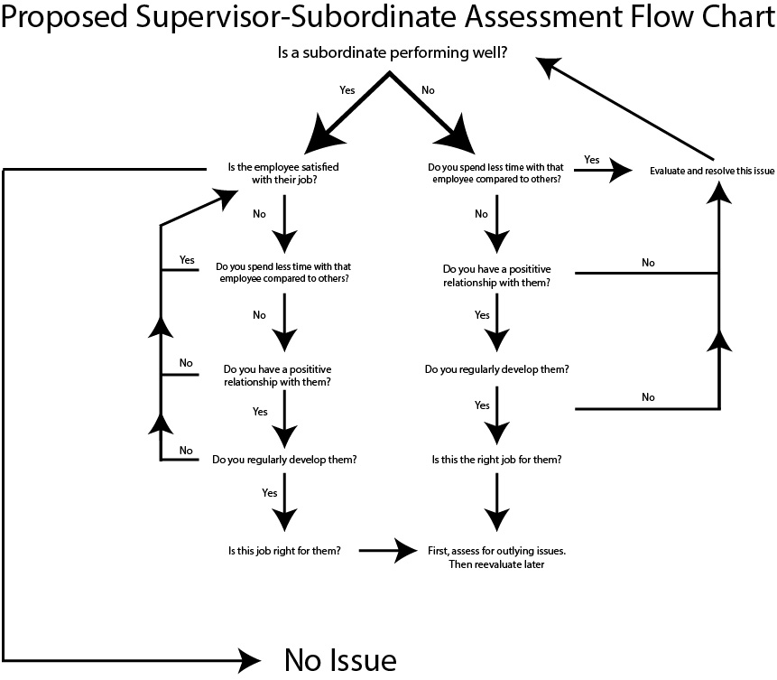

FIGURE PAGE

Figure 1. Maslow’s Hierarchy of Needs from: Mcleod, Saul. “Maslow's Hierarchy of Needs.” Simply Psychology, Simply Psychology, www.simplypsychology.org/maslow.html.

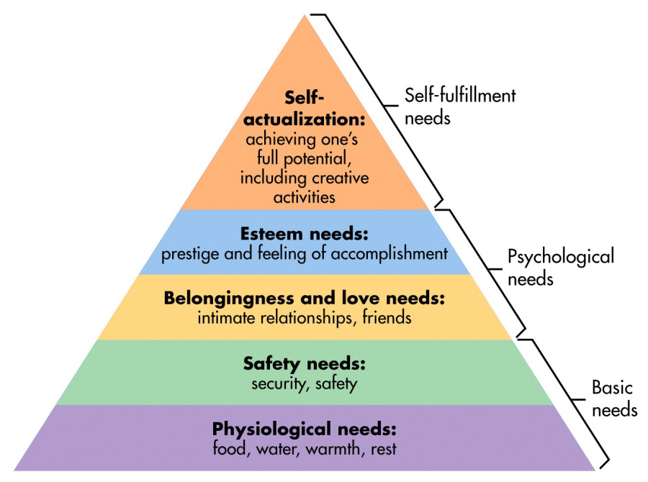

Works Cited

Bibi, Annam, and Bilal Afsar. "LEADER-MEMBER EXCHANGE AND INNOVATIVE WORK BEHAVIOR: THE ROLE OF INTRINSIC MOTIVATION, PSYCHOLOGICAL EMPOWERMENT, AND CREATIVE PROCESS ENGAGEMENT." Perspectives of Innovations, Economics and Business, vol. 18, no. 1, 2018, p. 25+. Business Collection
Brunetto, Yvonne & Teo, Stephen & Shacklock, Kate & Farr-Wharton, Rodney & Shriberg, Art. (2016). The impact of supervisor–subordinate relationships and a trainee characteristic upon police officer work outcomes. Journal of Management & Organization. -1. 1-14. 10.1017/jmo.2016.27.
Conway, Justin (2011). “Effects of Supervisor-Employee Relationship on Job Performance.” Department of Applied Psychology, NYU Steinhardt, steinhardt.nyu.edu/appsych/opus/issues/2011/fall/effects.
Deluga, Ronald J. "Leader-member exchange quality and effectiveness ratings: the role of subordinate-supervisor conscientiousness similarity." Group & Organization Management, June 1998, p. 189+. Business Collection,
Dienhart, John R., and Mary B. Gregoire. “Job Satisfaction, Job Involvement, Job Security, and Customer Focus of Quick-Service Restaurant Employees.” Hospitality Research Journal, vol. 16, no. 2, 1993, pp. 29–43., doi:10.1177/109634809301600205.
Eisenberger, R., Huntington, R., Hutchison, S., & Sowa, D. (1986). Perceived organizational support. Journal of Applied Psychology
Goodwin, Cliff, and Dan Griffith. Supervisor's Survival Kit. 9th ed., Pearson/Prentice Hall, 2009.
"IMPACT OF MANAGERIAL COACHING ON EMPLOYEE THRIVING AT WORK: THE MODERATING ROLE OF PERCEPTION OF ORGANIZATIONAL POLITICS." Journal of Business Strategies [Karachi], 30 June 2018, p. 87. Academic OneFile
Maslow, A.H. (1943). “A Theory of Human Motivation”. In Psychological Review, 50 (4), 430-437. Washington, DC: American Psychological Association.

O'Connor, Christine, and Sanjeev Srinivasan. "Influence of employment type on LMX, Organisational Commitment and Job Satisfaction." Employment Relations Record, July 2010, p. 75+. Business Collection,
Rhoades, L., & Eisenberger, R. (2002). “Perceived Organizational Support: A Review of the Literature.” Journal of Applied Psychology, 87(4), 698-714.
Shelton, Michael. "A Look at the Supervisor-Employee Relationship." Camping Magazine, Jan. 2000, p. 36. Student Resources in Context,
Valerius, Laura. "Supervisor-Subordinate Relationships." Parks & Recreation, Jan. 1998, p. 38+. Student Resources in Context,
Vann, Joseph Carl. “Relationships Between Job Satisfaction, Supervisor Support, and Profitability Among Quick Service Industry Employees.” ScholarWorks, Walden University, 2017, scholarworks.waldenu.edu/dissertations/3372/.

