High-Throughput Functional System for

Encapsulated Networks of Model Cell Membranes

A Dissertation Presented for the

Doctor of Philosophy

Degree

The University of Tennessee, Knoxville

Mary-Anne K. Nguyen

May 2017

Copyright © 2017 by Mary-Anne K. Nguyen.
All rights reserved.

DEDICATION

To my parents

Tai and Yen Nguyen

my two sisters and brother

Mary, Jasmine, and Paul

and my fiancé

Steven Powell

ACKNOWLEDGEMENTS

First and foremost, thank you to my advisor and mentor, Andy Sarles. None of this would be possible without his guidance, expertise, and patience. Andy has positively influence my life in the lab and personally. He has helped me grow to be a better researcher by improving my writing skills and public speaking, pushing me to think out side the box, and constantly stay up to date on literature. I am forever grateful for the opportunities and mentorship Andy has given me.

I also want to thank my labmates and colleagues, Graham Taylor, Guru Venkatesan, and Nima Tamaddoni. They welcomed me into the lab and have since become my lifetime friends. To my fellow women engineers, Tayler Schimel and Emily Morin, thanks for being there for me throughout this journey.

The work describe herein would not be possible without the advice and assistance from several key individuals. I want to acknowledge Pat Collier, Scott Lenaghan, Eric Freeman, Paul Dalhaimer, Scott Retterer, and Bernadeta Srijanto for their support. Thanks to Air Force Office of Scientific Research (AFOSR) Basic Research Initiative Grant number FA9550-12-1-0464 for financial support. Also, thanks to the Center for Nanophase Materials Sciences, which is a DOE Office of Science User Facility where all the device fabrication was conducted.

ABSTRACT

Synthetic lipid bilayers provide models of cell membranes to study biomolecular interactions and signal transduction. The droplet interface bilayer (DIB) is a highly versatile technique for assembling planar lipid membranes between water droplets in oil. The DIB method thus provides a unique capability for developing digital, droplet-based membrane platforms for rapid membrane characterization, drug screening and ion channel recordings. In this work, a new microfluidic system is presented that automates droplet generation, sorting, and sequential trapping in designated locations to enable rapid assembly of arrays of DIBs along with in situ electrical measurements. This platform provides repeatable processes for forming long-lasting bilayer arrays for numerous membrane-based applications. In this proposed research, the objectives are limited to studies of membrane properties and membrane-mediated sensing and energy conversion. Specifically, studies on asymmetric lipid membranes are performed to understand how nature creates and maintain non-equilibrium in cells. In addition, the developed trapping design for DIBs is modified to capture singe cell protoplasts for transformation. Together the proposed research contributes to an increase understanding of membrane-based studies for enhanced sensing and single cell screening.

TABLE OF CONTENTS

Chapter 1 Introduction and literature review 1
1.1 Droplet interface bilayer 1
1.2 Droplet based microfluidics 2
1.3 Asymmetric lipid membranes 3
1.4 Single cell isolation 4
1.3 Gaps, goals, and research plan 4
1.3.1 Gaps and goals 4
1.3.2 Research plan 5
Chapter 2 Experimental methods and data analysis 6
2.1 Microfluidics device design and fabrication 6
2.1.1 Microchip fabrication 6
2.1.2 Thin-film electrode fabrication 6
2.1.3 Device operations 7
2.2 Electrical measurements to monitor bilayer formation and quantify membrane properties 7
2.2.1 Lipid bilayers as RC circuits 7
2.2.2 Electrical recordings 8
2.2.3 Cyclic voltammetry with alamethicin insertion 8
Chapter 3 A method for encapsulating an array of droplet interface bilayers with electrical measurments 9
3.1 Resistive circuit model for microfluidic channels 10
3.1.1 Resistive flow model for sorting 10
3.1.2 Resistive circuit model for droplet trapping 11
3.1.3 Resistance based droplet sorting 16
3.1.4 Hydrodynamic traps for droplet positioning and bilayer formation 17
3.2 Electrical characterization of encapsulated bilayer arrays 20
3.2.1 Bilayer confirmation 22
3.2.2 Transduction measurements 23
3.3 Chapter summary and conclusions 25
Chapter 4 Asymmetric droplet interface bilayers with in situ electrical measurements 26
4.1 Alternating droplet compositions to form asymmetric droplet interface bilayers 26
4.1.1 Alternating droplet generation 26
4.2 Asymmetric lipid composition characterization 28
4.3 Asymmetric transduction measurements 30
4.4 Chapter summary and conclusions 31
Chapter 5 Microfluidic device for single cell capture 33
5.1 Resistive flow modeling for single cell trapping 33
5.2 Protoplast capture in microfluidic device 33
5.3 In situ transformation 33
5.4 Chapter summary and conclusions 33
Chapter 6 Conclusion 34
6.1 Research overview 34
6.2 Conclusions 34
6.2.1 Objective 1 34
6.2.2 Objective 2 34
6.2.3 Objective 3 34
6.3 Research product and outputs 34
6.3.1 Journal publications 34
6.3.2 Peer reviewed conference proceedings 34
6.3.3 Other conference presentations and posters 34
References 35
Appendix 40
VITA 41

LIST OF TABLES

Table 1. Hydrodynamic resistances and pressures for empty and filled trap of 1 and 3 DIBs. 20
Table 2. Capacitance, resistance, area, and specific capacitance for each DIB pair and the averages from one trial. 23
Table 3. Calculated transmembrane potentials for eight DIBs and locations of the lipids. 30

LIST OF FIGURES

Figure 1. Side schematic of a droplet interface bilayer. 1
Figure 2. Examples of DIB systems used to study and employ biomolecular functionality. 2
Figure 3. Schematic of droplets entering the shunt when shunt resistance, R_{shunt}, is less than resistance of total trap array, R_{TrapArray}, downstream. 11
Figure 4. Schematic of hydrodynamic flow resistances in a single, 2-droplet trap. (A) Diagram of an unfilled trap designed for two droplets, where each lane of the unfilled trap has an equivalent resistance of R_{a}+R_{b}. (B) Droplet 1 enters the trap when the total trap resistance, R_{T}, is less than resistance of the main channel, R_{M}. (C) Droplet 2 enters the open lane of the same trap if R_{T} through the remaining portion of the trap is still less than R_{M}. (D) R_{T} becomes greater than R_{M} once two droplets are trapped, causing following droplets to bypass the filled trap. 12
Figure 5. Schematics and equivalent circuits for three trap array layouts: (A) Model 1 includes a main channel that returns to connect every trap’s bleed valves; (B) Model 2 features a lower channel that reconnects to the upper main channel at the end of the array; and (C) Model 3 includes an individual return line for each trap. (D) Calculated flow rate ratio through an empty trap versus the main channel as a 100-trap system is being filled. The unshaded region identifies when traps fill via direct trapping, while the shaded region identifies those filled via indirect trapping. (E) Estimated pressure drop within a filled trap versus location in the array, where the shaded region identifies locations in the array where droplets would be squeezed through the bleed valves due to excessive pressure. 14
Figure 6. (A) Top view of fabricated microchip. (B) Image of T-junction and droplets entering the shunt channel when outlet is open. (C) Droplets bypass the shunt channel when shunt channel outlet is sealed. (D) Layout of the serial hydrodynamic trap array. Each trap is designed for 125 µm diameter droplets, and the dimensions satisfy the resistance ratio for direct trapping. 18
Figure 7. (A-C) Image sequence of GMO-coated droplets being trapped sequentially in designated locations with no droplet squeeze-through. (D) Hydrodynamic traps are expanded hold multi-bilayer networks such as four droplets linearly to form three bilayers. 19
Figure 8. Electrical characterization of microfluidic GMO DIBs: (A) Top view of microchip with thin-film electrodes and soldered wires. (B) Image of DIB residing on top of thin-film electrodes. Sensing electrodes are those on the outer side, while the shared ground electrode in the middle is pseudo colored red. (C) Equivalent electrical circuit of a DIB on top of Ag/AgCl thin-film electrodes. (D) Current measurements of 8 DIBs measured concurrently show increases in current amplitudes that correspond to the growth in bilayer capacitances during DIB formation. Currents are induced by a 40 mV, 50 Hz triangular waveform voltage. 21
Figure 9. (A) Simultaneous recordings of alamethicin gating activity in 8 DPhPC DIBs at a holding potential of +170 mV. (B) Conductance versus time of a single measurement channel. (C) Histogram of conductance values for alamethicin channels computed from the multiple gating events in (B). 24
Figure 10. (A) Two opposing T-junctions producing droplet stream of alternating compositions. Food coloring is used to distinguish between to aqueous fluids. (b) Trapped asymmetric DIBs. 27
Figure 11. Current plotted for two different pairs of DIBs as a function of voltage for asymmetric membranes of DPhPC and DOPhPC. Inset schematics illustrate the location of the lipids based on the transmembrane potential offset. A symmetric DPhPC case is included for comparison. 29
Figure 12. (A) Simultaneous recording of alamethicin ion channel activity in 4 different DIBs with a holding potential at +170 mV. (B) Current voltage sweep response when DC step routine is applied for one DIB pair. The color shows the order of the cycle beginning with the blue and ending with red. The connecting line is included to identify the trend. 31

Chapter 1
Introduction and literature review

Droplet interface bilayer
Bioinspired material systems utilize principles and functionalities found in nature to benefit the development of engineered systems. In recent years, the use of biological molecules such as phospholipids, transmembrane proteins, and ion channels have contributed to the development of new types of membrane-based assemblies that are able to autonomously [1] and even collectively [1, 2] respond to internal or external physical stimuli.

The development of these material systems utilizes a synthetic lipid membrane to house biological molecules that attribute specific functionality to the system [3-6]. The droplet interface bilayer (DIB) is highly versatile technique for constructing model cell membranes (i.e. lipid bilayers) between lipid-coated water droplets in oil (Figure 1) [7-9].
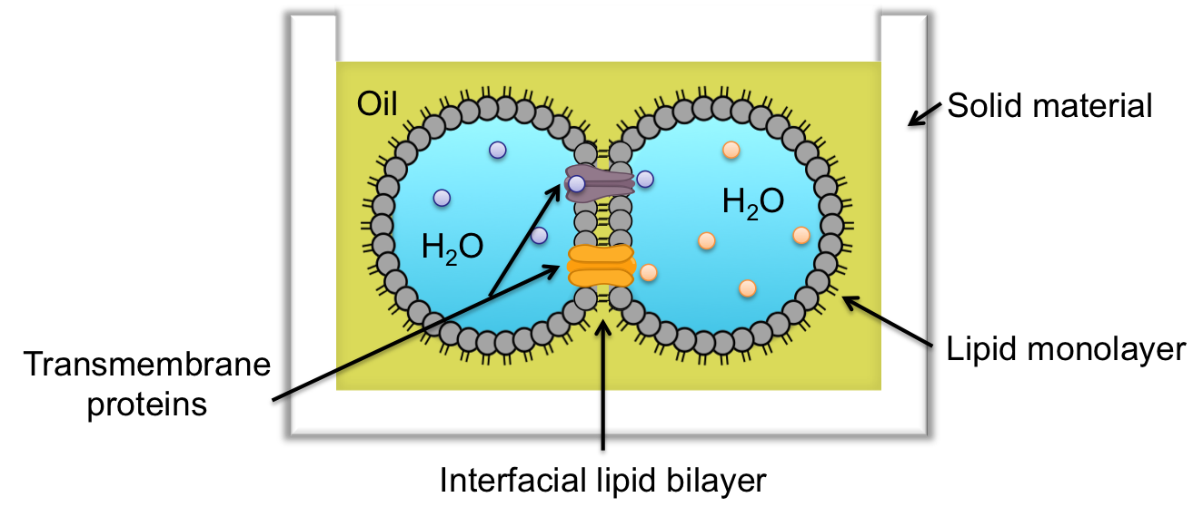
Figure 1. Side schematic of a droplet interface bilayer.

DIB assemblies provide a suitable environment for studying many aspects of membrane transport including antimicrobial peptide or pore-forming protein insertion and gating [7, 9, 10]. DIB systems have also been employed recently to use biomolecular functionality for sensing [6, 11, 12], actuation [13], and energy conversion [14, 15] applications (Figure 2).
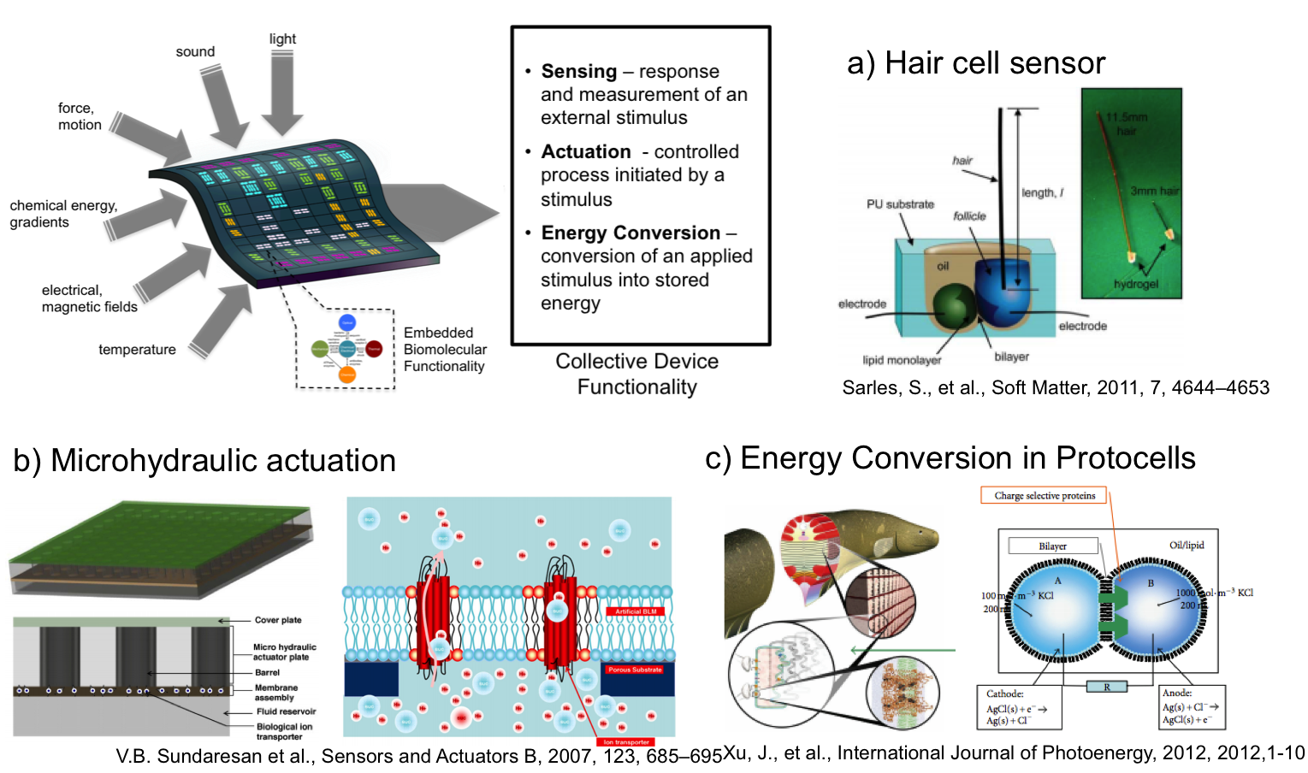
Figure 2. Examples of DIB systems used to study and employ biomolecular functionality.

There are several reported methods for forming lipid-coated droplets in oil to form DIBs. Common techniques include positioning droplets within the fixed geometry of a rigid, solid substrate [9], moving droplets via electrodes attached to micromanipulators [8], using mechanical force to control the compression of the solid substrate containing the droplets, thereby regulating contact between adjacent droplets [10, 16], and droplet manipulation using electric fields (i.e. dielectrophoresis and electrowetting on dielectrics) [17, 18], light-induced heating [19], magnetic fields [20], and even inkjet printing of droplets at defined positions [21]. While these methods are repeatable, most are not well suited for quickly assembling large numbers of DIBs. Additionally, most of these techniques also require manual dispensing of droplets using micropipettes, which is suitable only for creating DIBs with large droplets (>100 μm diameter, >50 nL in volume) due to the minimum volume that can be readily pipetted in this manner.

Droplet based microfluidics
Droplet-based microfluidics provide precise droplet control and manipulation to generate and package a multi-droplet DIB array. There are numerous techniques to form and position droplets within a microfluidic device [22, 23]. Droplet formation usually occurs on-chip in an oil-filled channel, and the process can be divided into three main categories based on flow regimes: (1) droplet formation in cross flowing (T-junction) streams of oil and water, (2) droplet formation in flow-focusing streams, and (3) droplet formation in co-flowing oil and water streams [24]. In these approaches, droplet size and production rate are dictated by adjusting the oil and water flow rates and the channel dimensions, which range from 1 μm to several hundred micrometers. Although these techniques have been proven successful for high-throughput droplet generation, it is known that steady state production of mono-disperse droplet sizes is not achieved immediately. This transient results in a need for downstream sorting prior to droplet collection in applications where droplet size is important.

In addition, there are a handful of studies that have demonstrated hydrodynamic, or flow-induced, methods for trapping a single droplet or bead within a microfluidic substrate. Droplet positioning can be guided by intra-channel structural elements that create parallel paths for fluid flow. For example, circular traps or pillar arrays enable to position a droplet while maintaining oil flow through the device [25-28]. So far, this approach of hydrodynamic microarrays has been mainly used to capture one individual microsphere or bead per trap. Also, there have been reports of efforts to assemble functional arrays or networks of DIBs as a single unity or discrete pairs. Typically these networks are two-dimensional and have less than four interfaces per droplet [8, 26, 29-31]. More recently, a droplet-on-rail strategy was used to produce parallel droplet bilayer networks up to 20 interfaces [32]. Additionally, higher order three-dimensional DIB arrays can be formed via manual techniques [21, 33] or a microfluidic approach [34, 35].

However, the ability to electrically interrogate specific lipid bilayers in multi-layer droplet arrays, especially those assembled within a microfluidic device, has not been addressed to date. The presence and properties of lipid bilayers are typically quantified using electrical measurements of membrane capacitance and resistance [8, 29, 36, 37]. DIBs formed with large droplets (i.e. >50 nL) allow for wire-type electrodes to be manually inserted into the droplets. However, droplets formed within a microfluidic platform have the potential to be much smaller in size from 2-350 µm [22] and are enclosed within a sealed substrate. While, optical and fluorescence imaging have been employed to obtain qualitative visualization of bilayer presence [25, 38], they do not provide complete characterization of the interface such as resistivity and durability. Recently, there has been a successful effort to insert silver wire into a microfluidic system [39]. In that particular system, a single DIB is formed and measured before it is ejected and new droplet(s) occupy the region where electrodes are present.

Asymmetric lipid membranes
Cell membranes are asymmetric where the content on one side of the bilayer is different from the other and the lipids of the membrane itself differ from the inner and outer leaflets. One example is the plasma membranes of eukaryotic cells where aminophospholipids are primarily in the cytosolic leaflet while phosphatidylcholine and sphingomyelin dominate in the outer leaflet [40].

Implementing asymmetric lipid bilayers creates a more biological relevant model systems, and it enables the addition of a “sidedness” to the system that can be used to store, convert, and dissipate energy. For example, Zheng et al. developed an asymmetric membrane structure that is highly selective of ionic transport to create a concentration-gradient driven energy harvesting device [41]. Another study used asymmetric pH environments to control ion channel activities [42]. More recently there are studies investigating the effects of membrane asymmetry on the behavior of transmembrane pore and channels with respect to bilayer leaflet compositions [43, 44].

One research area of interest is to understand the flip-flop rates of the lipids in asymmetric membranes. For instance it is known that cell membrane asymmetry is maintained by a combination of activities: (a) flip, an energy-dependent movement of phospholipids from the outer to inner leaflet; (b) flop, an energy-dependent movement of phospholipids from the inner to outer leaflet [7]. However, the phospholipid flip-flop rates have been challenging to obtain along with the influence of composition including the presence of transmembrane proteins on flip-flop rates [45].

1.4 Single cell isolation

1.3 Gaps, goals, and research plan
To date, many of the studies involving synthetic lipid bilayer involve experimentation with a single DIB. For many applications, however, it is advantageous to create a system with an array of bilayers that can enhance sensing and increase experimental output and efficiently. One of the goals is to create a microfluidic system with repeatable processes for forming long-lasting bilayer arrays for applications such as membrane-mediated studies, sensing, and energy conversion. The remaining goals will use the microfluidic platform to investigate properties and interactions of the bilayer membranes.

Gaps and goals
Gap 1. The droplet interface bilayer (DIB) is a highly versatile technique for constructing model cell membranes (lipid bilayers) between lipid-coated water droplets in oil. For instance each droplet composition can be controlled. Also, this method enables electrical access via wire typed electrodes for bilayer measurements to calculate membrane capacitance, resistance, and area. However, there is need for an automated, a higher throughput droplet generation and arrangement systems for greater experimental capacity and efficiency.

Goal 1: In order to increase bilayer production and experimental efficiency, this first goal is to develop a device that is capable of forming arrays of DIBs and house them in predetermined locations while maintaining the bio-functionalities of a traditional DIB system. With this high-throughput DIB system on hand, it would be straightforward to investigate numerous basic lipid bilayer studies and membrane-mediated processes.

Gap 2. In order to achieve a more biologically relevant model cell membrane, studies of lipid asymmetry are of high interest. For instance, the influence of bilayer composition on flip-flop rates is not well understood [45]. There are several reports addressing this but these studies have problems with the method such as use of bulky lipid fluorescence dyes that can alter physical properties of the model membrane formed and discrepancies between studies [45-47]. Therefore, studies determining the effects of asymmetric membranes formed between lipids with different dipole potentials and lipids with different head group charge are needed. Also, the effects of temperature and transmembrane peptides and pumps on flip-flop rate can be valuable information towards understanding natural cell membranes and enhance the use of DIBs for rapid drug screening and studies of membrane mediated process.

Goal 2: The second goal is to measure flip-flop rates of various lipids using DIBs consisting of asymmetric phospholipid leaflets as a function of time, temperature, and transmembrane peptides and pumps. The results from Goal 1 will provide a platform to accomplish this goal.

1.3.2 Research plan

Chapter 2
Experimental methods and data analysis

A version of this chapter was originally published by Nguyen, M., Srijanto, B., Collier, C.P., Retterer, S.T., Sarles, S.A.
Nguyen, M., Srijanto, B., Collier, C.P., Retterer, S.T., Sarles, S.A., Hydrodynamic trapping for rapid assembly and in situ electrical characterization of droplet interface bilayer arrays. Lab Chip, 2016, 16, 3576-3588.

2.1 Microfluidics device design and fabrication

2.1.1 Microchip fabrication
A T-junction is used for droplet production. The incoming droplet stream is routed through microchannels and captured using series of hydrodynamic traps branching from the main channel. Each trap has an area designed to capture droplets serially with bleed valves that serve to direct the droplets into the vacant trap without allowing the droplets to escape after capture. Bleed valves are spaced such that the trapped droplets are close enough to connect to form a DIB. The device dimensions are tailored for 125 μm diameter droplets.

The microchips are fabricated using standard photo- and soft-lithography techniques.[48] Briefly, a silicon wafer is spin-coated with photoresist and exposed to UV light through a chrome photomask using a photolithography aligner such that unmasked areas are cross-linked. Then, a deep reactive-ion etching process is employed to further etch the silicon wafer to a depth of 125 μm. After the master wafer is stripped of remaining photoresist and silanized to prevent adhesion during soft-lithography, uncured Sylgard 184 (Dow-Corning) PDMS (10:1 wt-wt ratio of base to curing agent) is poured over the wafer, degassed, and baked for at least 2 hours at 80°C. Cured substrates are sliced and peeled off the master wafer. Inlet and outlet access holes are pierced using a 0.75 mm diameter biopsy punch. The PDMS substrate is bonded to a PDMS coated glass cover slide or a slide with deposited thin-film electrodes after an oxygen plasma treatment. The sealed devices are baked at 80°C for at least 48 hours to create a hydrophobic environment.

2.1.2 Thin-film electrode fabrication
Electrodes are placed strategically such that each pad is directly under the trapped droplet. Similar to the microfluidic fabrication, a chrome photomask with the desired electrodes design is developed followed by photolithography with a glass wafer (Borofloat). A single electrode pathway includes a 30x30 µm droplet pad with leads extending in width increments connecting to a large 3x3 mm pad.

A dual gun electron beam evaporation chamber is used to deposit 10 nm adhesive layer of chrome and 300 nm of silver onto the glass wafer. Next, lift-off in acetone and isopropyl alcohol is performed to remove unattached metals. Prior to bonding with PDMS microchannels, bleach is pipetted onto the 30x30 µm electrode pads to form silver-silver chloride reversible electrodes. Chloride exposure is limited to less than 30 seconds to prevent over-bleaching. Then, the electrodes are thoroughly washed with deionized water. Microchips undergo plasma oxidation, bonded to PDMS, and baked at 80°C for at least 48 hours. Then, silver wire is soldered onto the 3x3 mm pads in order to connect to the patch clamp amplifier.

2.1.3 Device operations
A dual syringe pump (Gemini 88, KD Scientific) is used to control the flow rates of the oil and water injections. PTFE tubing and 23 gage blunt stainless steel needles are used to connect syringes to inlet ports in microfluidic device. Images are obtained using a digital camera (Canon G12) connected through the camera port of a stereomicroscope (Leica M80). The device is also reusable and can be cleared via simple oil backwashed (see ESI video of device flushing) through the outlet.

2.2 Electrical measurements to monitor bilayer formation and quantify membrane properties

2.2.1 Lipid bilayers as RC circuits
Electrical measurements of adjoined droplets residing on a pair of electrode pads is used to characterize both the droplet-electrode interfaces as well as the membrane formed between droplets. The passive electrical properties of lipid bilayers are well established;[49, 50] the membrane is represented by a resistor, R_{m}, in parallel with a capacitor, C_{m}. An additional series resistance, R_{e}, accounts for the electrolyte resistance of the aqueous phases on both side of the membrane (Figure 7C). The resistance of a lipid bilayer is often greater than 1 GΩ, while the electrolyte resistance is typically on the order of 1 kΩ. If the droplet-electrode interface is resistive (i.e. the electrode makes direct contact with the aqueous interior of the droplet), then the equivalent circuit shown in Figure 7C indicates that the dominant electrical impedance between two electrode pads is simply given by R_{m} and C_{m}. This condition implies that if the membrane fails (i.e. droplets coalesce), current flow between electrodes would increase significantly due to the lower value of R_{e}. However, if oil were to remain between the electrode pad and the droplet, then we expect a non-conductive, capacitance to exist at this interface (not shown in Figure 7C). In this case, a dc current would remain low upon coalescence because of the capacitive contact with the droplets. In this study, we find that droplets form resistive connections with the Ag/AgCl electrode pads when n-decane or squalene are used as the oil, which is confirmed by a saturation of measured current when a single aqueous volume spans two electrodes (not shown). However, capacitive connections are established when hexadecane is used as the oil phase. Since electrophysiology of membranes typically requires a resistive connection between the electrodes and the electrolyte, we perform electrical measurements of microfluidic DIBs in squalene. Squalene is also preferred because it is not absorbed by PDMS.

2.2.2 Electrical recordings
The electrical current of the lipid bilayers are monitored using an 8-channel patch clamp amplifier (Triton, Tecella LLC) and TecellaLab software to digitally control the applied voltage to the sensing electrode and measure the induced currents in the network. Each electrode is connected to a separate measurement channel on the amplifier. A picture of a device connected to the amplifier is shown in Figure S5 in the SI. A triangular voltage waveform (40 mV, 50 Hz) is applied as needed on independent electrodes to monitor bilayer capacitance. Measured current is sampled at 2 kHz or 20 kHz for alamethicin, filtered at 1 kHz using a low-pass filter, and digitized using 16-bit A/D conversion within the Triton. Local shielding with aluminum foil around the wired electrodes attached to the amplifier is used to reduce the noise. The calculated RMS noise in all experiments is less than ±10 pA, and we observe that the noise does not increase when the syringe pump is running and solution is flowing through the channels.

2.2.3 Cyclic voltammetry with alamethicin insertion

Chapter 3
A method for encapsulating an array of droplet interface bilayers with electrical measurments

A version of this chapter was originally published by Nguyen, M., Srijanto, B., Collier, C.P., Retterer, S.T., Sarles, S.A.
Nguyen, M., Srijanto, B., Collier, C.P., Retterer, S.T., Sarles, S.A., Hydrodynamic trapping for rapid assembly and in situ electrical characterization of droplet interface bilayer arrays. Lab Chip, 2016, 16, 3576-3588.

This chapter describes work that begins to address the research goal of fabricating a microfluidic device to increase bilayer production and experimental efficiency as identified in Chapter 1. One major contribution is the development of a microfluidic device capable of forming DIBs in predetermined locations with electrical interrogation capabilities via thin-film surface electrodes. The fabrication of the device was first developed using resistive circuit modeling to analyze the flow resistances to place droplets in precise locations and remain in the prescribed area. Next, thin-film electrodes were introduced to measure electrical properties of the captured DIBs. Recently, a design modification has been made to address the need for asymmetric DIBs.

This paper demonstrates a new, low-volume microfluidic system that automates droplet generation, sorting, and sequential trapping in designated locations to enable the rapid assembly of arrays of DIBs. The channel layout of the device is guided by an equivalent circuit model, which predicts that a serial arrangement of hydrodynamic DIB traps enables sequential droplet placement and minimizes the hydrodynamic pressure developed across filled traps to prevent squeeze-through of trapped droplets. Furthermore, the incorporation of thin-film electrodes fabricated via evaporation metal deposition onto the glass substrate beneath the channels allows for the first time in situ, simultaneous electrical interrogation of multiple DIBs within a sealed device. Combining electrical measurements with imaging enables measurements of membrane capacitance and resistance and bilayer area, and our data show that DIBs formed in different trap locations within the device exhibit similar sizes and transport properties. Simultaneous, single channel recordings of ion channel gating in multiple membranes are obtained when alamethicin peptides are incorporated into the captured droplets, qualifying the thin-film electrodes as a means for measuring stimuli-responsive functions of membrane-bound biomolecules. This novel microfluidic-electrophysiology platform provides a reproducible, high throughput method for performing electrical measurements to study transmembrane proteins and biomembranes in low-volume, droplet-based membranes.

3.1 Resistive circuit model for microfluidic channels
Our understanding of droplet behavior within a microfluidic device is guided by relating fluidic systems to electrical circuits. Using an electrical circuit analogy, a resistive flow model is developed to determine appropriate dimensions for the fluid channels used for droplet sorting and trapping as well as for designing the layout of a multi-trap array within the encapsulating substrate. In a single-phase laminar flow, the pressure difference along a section of a microchannel is equal to the product of the applied volumetric flow rate, Q, and the hydrodynamic resistance of the channel, R. The hydrodynamic resistance for Poiseulle flow in a rectangular channel [51] is given by
 | 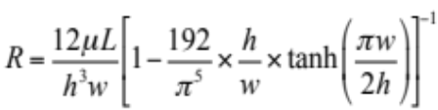 | (1)
where L, w, and h are the length, width, and height, respectively, of a particular segment of the channel, and μ is the viscosity of the carrier fluid (i.e. oil for a DIB system). Assuming that the presence of dispersed droplets in the oil does not significantly affect the relationship between pressure and applied flow rate, Equation 1 can be used to design channels of specific dimensions to dictate the flow resistance in regions of a device and thereby affect the course of droplet travel.

3.1.1 Resistive flow model for sorting
Production of droplets with uniform diameters and intra-droplet spacing is not instantaneous in a microfluidic device, often requiring several minutes of continuous injection to reach a steady state. Heterogeneous droplet production is problematic because hydrodynamic traps downstream can become filled with a variety of sizes and number of droplets, which complicates DIB formation and interrogation. Droplets much larger than the specified trap dimensions can also overfill the trap as well as clog the main channel, which disrupts the dynamics of droplet trapping downstream. Therefore, a pre-trap shunt is implemented as a way to remove unwanted sized droplets from the array prior to droplet trapping. The shunt channel is designed such that when the shunt outlet is open, the shunt offers a lower hydrodynamic resistance (R_{Shunt}) than that of the trap array (R_{TrapArray}), which causes droplets to exit the device via the shunt instead of filling the trap array (Figure 3A). Once droplets of desired size are obtained from the T-junction, the shunt outlet is manually sealed with tape, causing the droplet stream to now bypass the shunt and continue through the main channel to be trapped downstream.
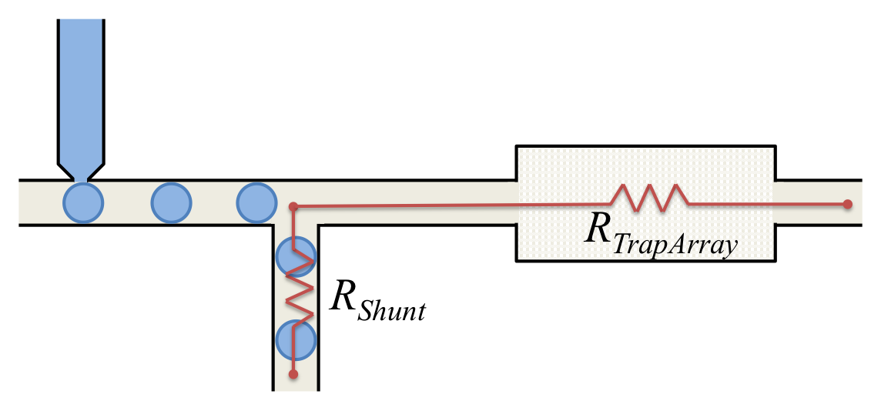
Figure 3. Schematic of droplets entering the shunt when shunt resistance, R_{shunt}, is less than resistance of total trap array, R_{TrapArray}, downstream.

3.1.2 Resistive circuit model for droplet trapping
In our device, a trap consists of a rectangular compartment that resides adjacent to the main flow channel, which carries lipid-coated droplets in a stream of oil. Opposite entry from the main channel, each trap also features narrow exit channels, which we refer to as bleed valves. The trap design and its ability to collect droplets carried in the main stream are thus based on the hydrodynamic resistance of the trap relative to that of the bypassing main channel. For instance, a droplet will prefer to enter an empty trap that has a hydrodynamic resistance (R_{T}) less than that of the resistance offered by bypassing the trap and flowing through the main channel (R_{M}). First note, the hydrodynamic resistance of an n-droplet trap is approximated by dividing the trap into n-parallel lanes (from main channel to bleed valve) of equal hydrodynamic resistance (Figure 4A). These lanes represent the contribution to total flow resistance as would be experienced by a droplet as it travels across each half of the trap from the main chain to the bleed valve. The flow resistance of each lane (i.e. 1 droplet) in a trap is calculated by
 | 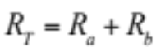, | (2)
where R_{a} is the portion of lane resistance due to the rectangular body of the trap and R_{b} represents the contribution to lane resistance from the bleed value. In this way, the total resistance for an unfilled, two-droplet trap would be given by R_{T}/2, which represents the parallel addition of two equal lane resistances.

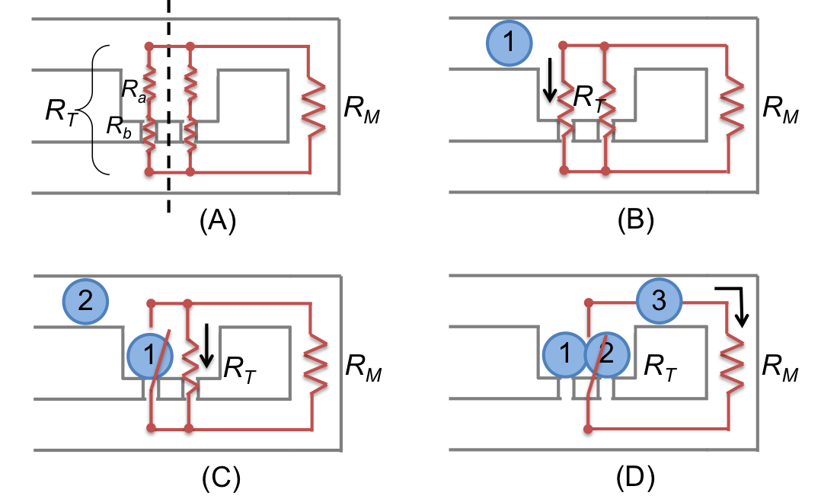
Figure 4. Schematic of hydrodynamic flow resistances in a single, 2-droplet trap. (A) Diagram of an unfilled trap designed for two droplets, where each lane of the unfilled trap has an equivalent resistance of R_{a}+R_{b}. (B) Droplet 1 enters the trap when the total trap resistance, R_{T}, is less than resistance of the main channel, R_{M}. (C) Droplet 2 enters the open lane of the same trap if R_{T} through the remaining portion of the trap is still less than R_{M}. (D) R_{T} becomes greater than R_{M} once two droplets are trapped, causing following droplets to bypass the filled trap.

In this scenario, the first droplet in an incoming droplet train will divert from the main channel and come to rest in the hydrodynamic trap near one of the bleed valves when R_{T} is less than R_{M} (Figure 4B). If the total flow resistance through the remaining portion of the trap and the open bleed valve are still less than that offered by the main channel, a second droplet will also preferentially flow into the open half of the same trap (Figure 4C). The bleed valves halt the droplets within the trap as long as they are narrower than the droplets, and as long as the resulting pressure drop that develops across a droplet blocking a bleed valve does not cause the droplets to squeeze-through and escape. Specifically, the fluid pressure drop across a filled trap must remain less than the Laplace pressure, ΔP_{L}, across the droplet residing at the entrance of a bleed valve, which can be calculated via
 | 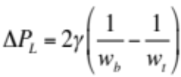, | (3)
where, γ is interfacial tension of droplet-oil interface and w_{b} and w_{t} are widths of the bleed valve and trap, respectively [51]. Once a trap fills, the presence of droplets at the entry to all bleed valves in a trap causes the flow resistance through the filled trap to increase significantly. As a result, a third droplet in the train bypasses the filled trap, preferring to remain in the main channel because of the now greater hydrodynamic trap resistance caused by the captured droplets covering the exit channels (Figure 4D). In regards to droplet motion, an open trap acts as a closed switch (with low resistance and high flow rate) while a filled trap acts as an open switch (with high resistance and low flow rate) in an equivalent circuit. This mechanism is known as direct trapping [51] because designing for a relatively lower trap resistance enables droplets to directly enter vacant traps and detour filled traps. Indirect trapping is associated with open traps that exhibit a higher relative resistance compared to the main channel.[51] For these, filling of traps occurs when droplets present in a section of the main channel pass the trap momentarily increase its local resistance, thereby redirecting successive droplets into the open trap.

The concept of direct trapping is essential for automatically filling many traps in a device with multiple droplets for DIB array formation. However, because the hydrodynamic resistance offered by both the main channel and a trap depend on the connection of these sections to additional traps or channels located downstream, designing a device to operate in a direct trapping mode must consider the entire fluidic resistance of the device. This information is especially necessary for understanding how to configure arrays of traps such that large networks of DIBs can be efficiently and quickly assembled in a microfluidic device. Thus, we develop a resistive circuit model that enables calculation of fluid flow rates and pressure drops between channel intersections for characterizing the direct trapping performance of a multiple-trap device.

For this analysis, we consider three configurations of trap arrays that include both parallel and serial arrangements of traps within a network (Figure 3A-C). In Model 1, the main channel connects the entrances to successive traps arranged in parallel before looping back to reconnect the outlets of each trap before exiting the device—we refer to the main channel as “returning” to the traps before exit. The second model is similar to Model 1; however, there is no return path of the main channel. Instead a parallel channel that conducts between the exits of the traps and intersects the main channel at the end of the trap array is used to route excess oil flow away from the traps. Finally, Model 3 showcases a serial trap layout, where each trap has its own return path for excess oil that intersects the main channel prior to the next trap.

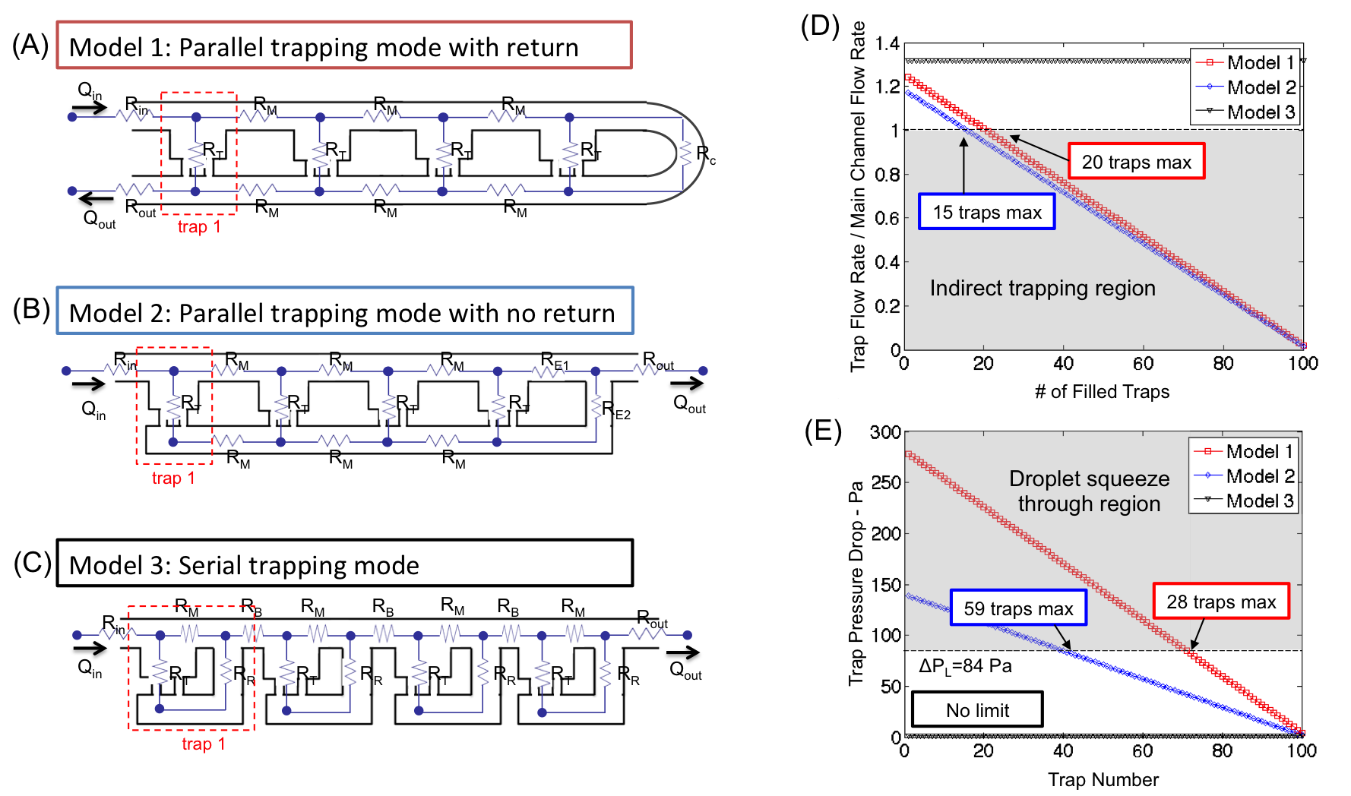
Figure 5. Schematics and equivalent circuits for three trap array layouts: (A) Model 1 includes a main channel that returns to connect every trap’s bleed valves; (B) Model 2 features a lower channel that reconnects to the upper main channel at the end of the array; and (C) Model 3 includes an individual return line for each trap. (D) Calculated flow rate ratio through an empty trap versus the main channel as a 100-trap system is being filled. The unshaded region identifies when traps fill via direct trapping, while the shaded region identifies those filled via indirect trapping. (E) Estimated pressure drop within a filled trap versus location in the array, where the shaded region identifies locations in the array where droplets would be squeezed through the bleed valves due to excessive pressure.

To enable sufficient comparisons of these layouts, values of channel resistances used in the modeling analysis are based on identical rectangular traps, each with a total width of 240 µm and a length of 130 µm, and using equal bleed valves that are 35 µm wide and 20 µm long. These dimensions reflect the approximate sizes need to capture a pair of 125 µm diameter droplets in a trap. Sections of main channel are assigned equal widths of 125 µm and all channels have a depth of 125 µm. These dimensions correspond to equivalent resistances of 770 Pa-s/µL and 1.3x10³ Pa-s/µL for R_{T} and R_{M}, respectively.

To evaluate each layout, we write Kirchoff’s Current Law for fluid flow at each channel intersection in an array. This establishes a set of coupled equations as given by
 | 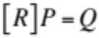, | (4)
where [R] represents a square coefficient matrix of reciprocal hydrodynamic resistances (i.e. conductance values) between nodes, P is a column vector of unknown absolute pressures at each node, and Q is a column vector of known applied flow rates. Analysis is performed on arrays of up to 100 traps by developing the appropriate form of Equation 4 for each of the three array types and by applying a fixed input flow rate, Q₁, at the intersection of the main channel and the entry to trap 1. Solving these matrix equations thus allows us to compute the pressure distribution in the array (i.e. analogous to the voltage at each node) and calculate for each trap in an array the ratio of fluid flow entering the trap to that which bypasses the trap, which allows us to determine if direct trapping occurs. These calculations are performed sequentially for a decreasing number of traps in an array to predict how changes in trapping mode and pressure distribution can arise from sequential trap filling. Recall that once a trap is filled, it acts like an open circuit, which thereby eliminates it from the circuit. Additional details regarding the general form of these matrix equations and sample MATLAB scripts for the three models are provided in Section S1 of the supporting information (SI).

The flow rate within each section of a multi-trap model is computed by dividing the difference in absolute pressure between nodes by the hydrodynamic resistance of that section. Figure 3D shows the ratio of flow rate entering the first trap of a section of successive unfilled traps to the flow rate bypassing that first trap. This calculation is performed sequentially by varying the number of filled traps in a 100-trap model. Therefore, the flow rate ratio reflects the preference of a droplet approaching the first unfilled trap to either enter the trap or bypass it. A ratio greater than one indicates direct trapping as marked by the unshaded region in Figure 3D. Only Model 3 provides constant direct trapping during complete filling of the 100-trap array. This result is due to the fact that the pathway exiting each trap rejoins the main channel prior to the next trap, which effectively decouples the ratio of R_{T} to R_{M} of a trap from the remaining portion of the array. Said differently, only the local channel geometry affects the resistance ratio, which ensures direct trapping is maintained across all traps. Model 1 and Model 2 also exhibit a flow rate ratio greater than one for small numbers of filled traps. However their ratios of flow rates decrease steadily as traps fill, caused by an increase in effective trap resistance that results when the number of unfilled traps in the array decreases (i.e. fewer traps in parallel produces a higher effective resistance of flow through traps). Figure 3D shows that the threshold for transitioning between direct and indirect trapping is 20 and 15 traps, respectively, for these two models.

The pressure drop across each trap is computed by determining the difference in absolute pressure between the entrance and exit nodes of the trap. This calculation is performed for all traps in a filled array to determine if droplet squeeze-through will occur (i.e. during filling of successive traps when the applied flow rate at the inlet is nonzero) for each model (Figure 3E). Arrays of filled traps are considered specifically since this condition represents the highest absolute pressure a system can experience and corresponds to when droplets could be squeezed through the bleed valves. The following comparison is based on a filled array consisting of 100 equal traps, and the occurrence of squeeze-through is assessed when the pressure drop across a trap is higher than a Laplace pressure of 84 Pa (shown as the shaded region) determined using a droplet surface tension of 2 mN/m and trap and bleed valve widths of 130 µm and 35 µm, respectively.

This analysis shows that successive traps arranged in a parallel scheme (in Models 1 and 2) display linearly decreasing pressure drops with increasing trap number, where the first filled trap in a 100-trap array exhibits the highest pressure drop (275 Pa and 148 Pa, respectively) and the last filled trap exhibits the lowest pressure drop. Identifying where these two regressions cross the critical Laplace pressure of 84 Pa shows the maximum number (counting from the end of the series) of traps that can be configured in that way before squeeze-through occurs. For example, only the last 28 traps in Model 1 will not experience droplet squeeze-through the bleed valve—this result can be interpreted as a maximum of 28 traps arranged in parallel with a return (as shown by Model 1) can be assembled without squeeze-through occurring when all are filled. Model 2 exhibits a lower pressure profile, with the final 59 traps in the array being able to retain the captured droplets. However, in the serial model (Model 3), we find that the pressure drop across each trap in the series is equal (~1.5 Pa), which shows that the pressure across a filled trap is independent of the remaining number of filled traps, and far less than 84 Pa. Thus, while the absolute pressure at the inlet to a serial array does increase with increasing numbers of filled traps, the pressure across each trap is not large enough to cause squeeze-through. Therefore, based on the fact that direct trapping is maintained as traps are successively filled and that the pressure across filled traps will not cause squeeze-through, a microfluidic device with a serial trap layout is chosen to capture droplets and form DIBs in designated traps.

3.1.3 Resistance based droplet sorting
Aqueous droplets are generated at a T-junction, where the width of the main channel for the continuous oil phase is 125 µm and the minimum width of the dispersed phase channel (buffer) is 30 µm. All channels in the fabricated device have a depth of 125 µm. With these fixed geometries, we can vary the average droplet diameter produced at the T-junction from 70-125 µm by varying the relative oil and water flow rates (see Figure S2). Flow rates of 0.4-1 µL/min for oil and 0.05-0.5 µL/min for aqueous phase are used to produce 90-125 µm diameter droplets, which is the target droplet size for the trap dimensions. The transient time required for the device to produce stable droplet sizes from the T-junction following a change in the applied flow rates is approximately 5-10 minutes.

From the T-junction, the droplet stream continues through the main channel to a point where droplets can either enter the shunt channel or continue through the main channel to the trap array as shown in Figure 5A. The fabricated shunt is 125 µm wide and 2.5 mm long, which yields a resistance of 4.2x10³ Pa-s/µL from the intersection to the outlet. This value is an order of magnitude less than that offered by smallest total downstream resistance created by the 16-trap array, which has a value of 4.3x10⁴ Pa-s/µL. Large droplets (i.e. slugs) are discarded through the outlet by keeping the shunt outlet open (Figure 5B). The shunt outlet is then sealed with tape to enable trapping droplets that are similar diameter to the width of the main channel (Figure 5C). Videos of droplet sorting are provided with the supporting information.

3.1.4 Hydrodynamic traps for droplet positioning and bilayer formation
Following the results of our circuit analysis, we fabricated microchips containing serial arrangements of either 16 or 40 identical hydrodynamic traps (Figure 5D). Like Model 3 in Figure 3C, the fabricated device features individual traps arranged in series, where the return channel for each trap re-enters the main channel at the entrance to the next trap (i.e. the value of R_{m} between traps is zero). However in the fabricated device, the serially connected traps are arranged in a zig-zag pattern rather than a linear arrangement to position more traps in the viewing area of our microscope. Based on these trap dimensions, the fluidic resistance of a single lane of an open trap, R_{T}, is computed to be 770 Pa-s/µL, versus a main channel resistance, R_{M}, of 1.1x10³ Pa-s/µL. Since R_{T}<R_{M}, the fabricated devices are expected to exhibit direct trapping. Figure 6A-C confirms this behavior in a 16-trap microchip, by showing the sequence of filling events in which droplets enter traps sequentially. Additionally, we observe no droplet squeeze-through in either 16-trap or 40-trap devices, which confirms that the pressure drop across the traps remain less than the critical Laplace pressure of 84 Pa.

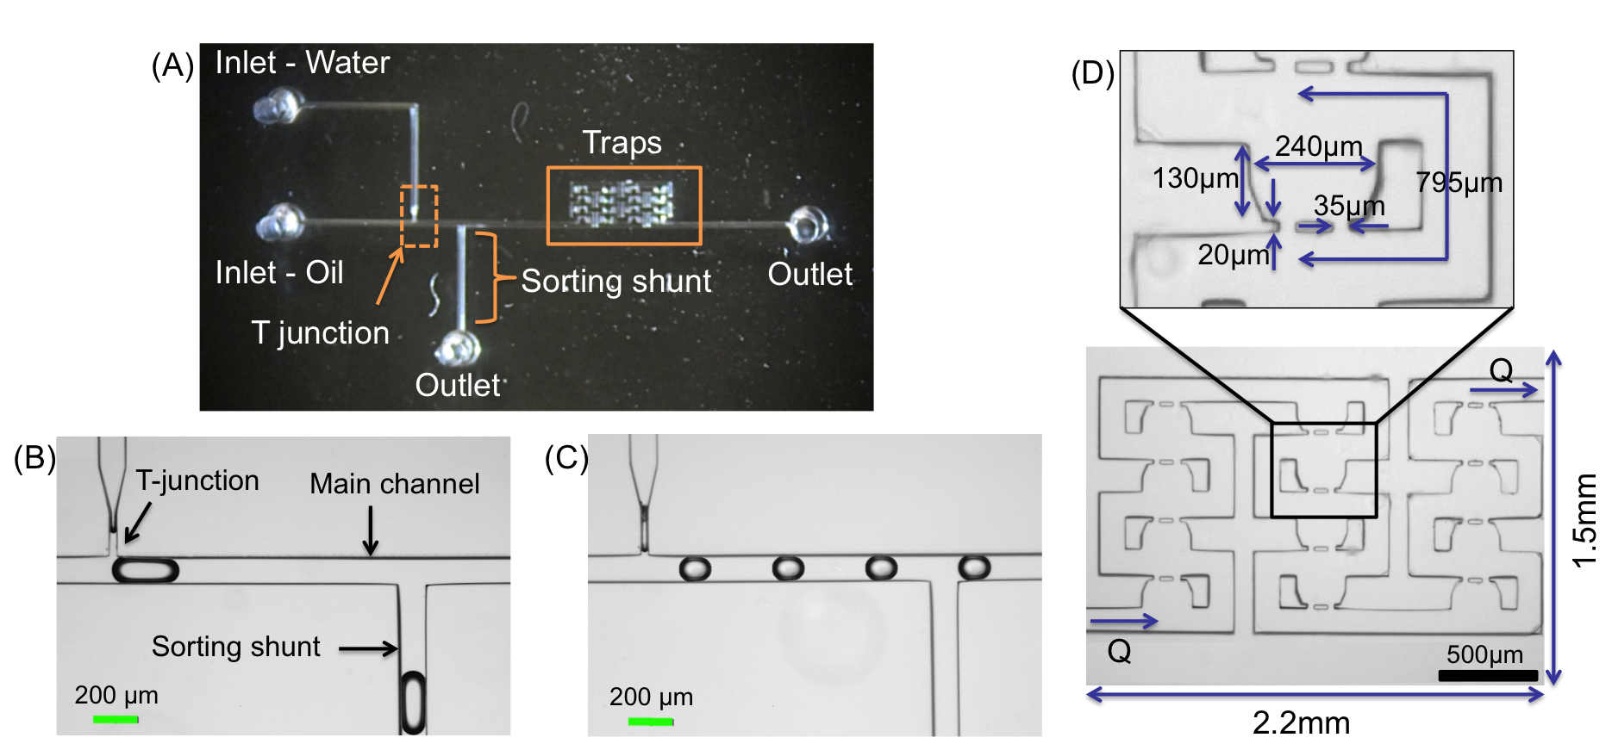
Figure 6. (A) Top view of fabricated microchip. (B) Image of T-junction and droplets entering the shunt channel when outlet is open. (C) Droplets bypass the shunt channel when shunt channel outlet is sealed. (D) Layout of the serial hydrodynamic trap array. Each trap is designed for 125 µm diameter droplets, and the dimensions satisfy the resistance ratio for direct trapping.
Microfluidic DIBs formed in this work are constructed from either glyceryl monooleate (GMO) lipids dissolved in the oil or 1,2-diphytanoyl-sn-glycero-3-phosphocholine (DPhPC) lipids incorporated as liposomes within the droplets. Both lipid types were found to yield stable DIB formation when the continuous phase is squalene, indicating that lipid monolayer assembly results in well-packed monolayers around the droplets. Spontaneous bilayer formation between neighboring lipid-coated droplets in a trap is identified by the emergence of a bright, planar connection between adhered droplets. For instance, the droplet pairs in the three bottom leftmost traps in Figure 6A appear to have formed GMO bilayers, whereas the pair of droplets in the upper leftmost trap have not yet formed a bilayer since the dark outline of each droplet is still present. Successive images of the filling processing show that a droplet enters a trap every 1-2 seconds and DIBs form within 2-3 seconds of adjacent droplets landing in a trap. The entire capturing process takes less than 2 minutes to fill 16-40 traps. Further, images reveal that captured DIBs are stable within the device for up to 12 hours after assembly, and we observe very low rupture rates during or immediately after trap filling, which indicates that each droplet becomes well coated with a lipid monolayer prior to entering a trap. Note that while a hydrodynamic pressure develops across each trap due to continued oil flow, this pressure is oriented parallel to the plane of the membrane. As a result, we do not believe continual oil flow to affect the stability of the membrane. However, any residual pressure-driven oil flow through the bleed valves of a filled-trap may also create a localized suction that pulls droplets together. Membrane rupture and droplet coalescence consistently occur after the 12-hour mark as a result of significant droplet shrinkage due to evaporation of water into the oil.[52, 53]

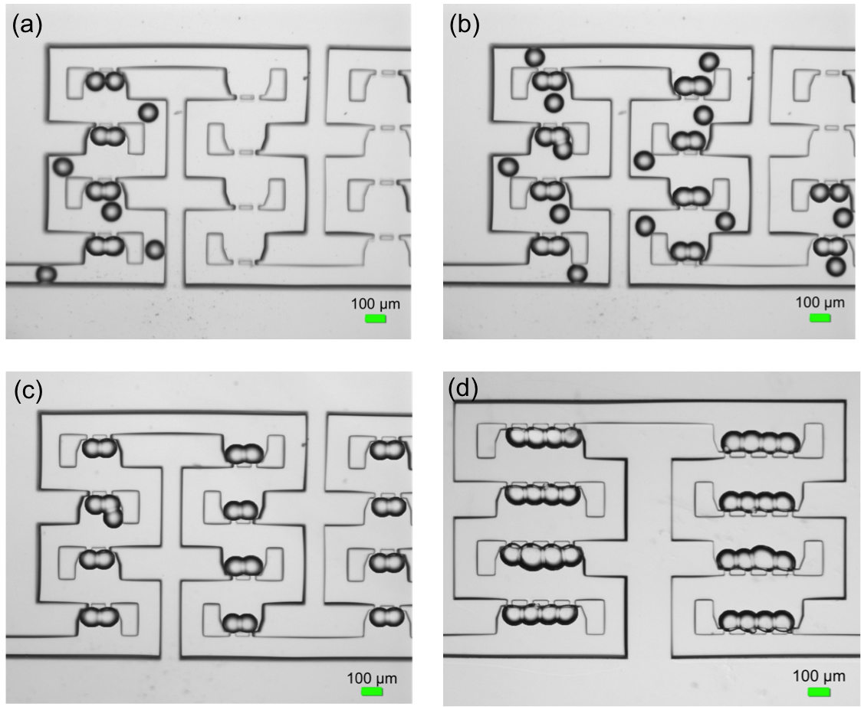
Figure 7. (A-C) Image sequence of GMO-coated droplets being trapped sequentially in designated locations with no droplet squeeze-through. (D) Hydrodynamic traps are expanded hold multi-bilayer networks such as four droplets linearly to form three bilayers.

Over the course of 10 droplet trapping and DIB formation experiments on 40-trap devices (n=400 total traps analyzed), we observed that sequential droplet and DIB formation is highly reproducible. Specifically, the number of droplets captured in a trap matched the number of bleed valves (e.g. 2 droplets enters a trap with 2 bleed valves) in 95% of traps analyzed. The factors that led to a trap not containing the correct number of droplets include too low of an oil flow rate or too small of a droplet based on the trap dimensions. For instance, a third droplet may enter a two-droplet trap and form an additional bilayer if the oil flow rate is low (<0.4 μL/min) or if droplet diameters are <90 μm as seen in the second from the top, leftmost trap in Figure 6B,C. These conditions, along with a small amount of oil still flowing through the bleed valves of a filled trap, can allow for a successive droplet to “dip” into an occupied trap and potentially form an additional bilayer. Once droplets were captured, successful and stable DIB formation occurred in 94% of traps. The success rate was lower than 100% due to the fact that neighboring droplets occasionally coalesce to form a large single droplet within a trap. When this occurs, the single volume can block only one bleed valve, which allows a new incoming droplet to be filtered out of the stream and captured to form a new membrane interface, or block both bleed valves, such that the trap does not attract a new droplet to form a DIB.

The serial arrangement of hydrodynamic traps maintains direct trapping even as we increase the number of droplets and bilayers in each trap. Figure 6D shows an image of 8 traps in a 16-trap device where each trap has been expanded to capture more than two droplets to form serially connected DIB clusters. In this device, the main channel resistance is approximately 1.3x10³ Pa-s/µL compared to a single droplet lane trap resistance of 641 Pa-s/µL. Therefore, droplets entering multi-DIB traps maintain the same direct trapping mechanism as before and are captured sequentially. Also, the pressure drop across a four-droplet trap (~22 Pa) is still less than the critical Laplace pressure required to cause squeeze-through (Table 1).

Table 1. Hydrodynamic resistances and pressures for empty and filled trap of 1 and 3 DIBs.
Scenario | R_{T}  (Pa-s/µL) | R_{M}  (Pa-s/µL) | Q  (µL/min) | ΔP  (Pa)
Empty trap - 1 DIB | 770 | 1.1x10³ | 1 | 7.6
Filled trap - 1 DIB | --- | 1.1x10³ | 1 | 18.4
Empty trap - 3 DIB | 641 | 1.3x10³ | 1 | 7.17
Filled trap - 3 DIB | --- | 1.3x10³ | 1 | 22

3.2 Electrical characterization of encapsulated bilayer arrays
Incorporating Ag/AgCl thin-film electrodes onto the glass surface (Figure 7A) beneath the droplets provides a complementary method to imaging for characterizing DIBs and provides a more-efficient alternative to wire-type electrodes inserted into the microchannel.[39] Figure 7B shows the fabricated electrode pattern design where each hydrodynamic trap has two electrode pads, with one designated as the sensing electrode and one connected to ground. A common ground electrode is shared between all eight pairs and is pseudo-colored red in the image. Electrode pad placement is determined from imaging the positions of trapped droplets observed in prior experiments. The total resistance of a single thin film electrode path is approximately 204 Ω from the droplet pad to connector pad where a cooper wire is soldered. In addition, we found the Ag/AgCl thin-film electrodes to be stable during experiments lasting up to 15 hours. During this time, there was no visual degradation when droplets containing 1 M NaCl reside on top of the electrodes.

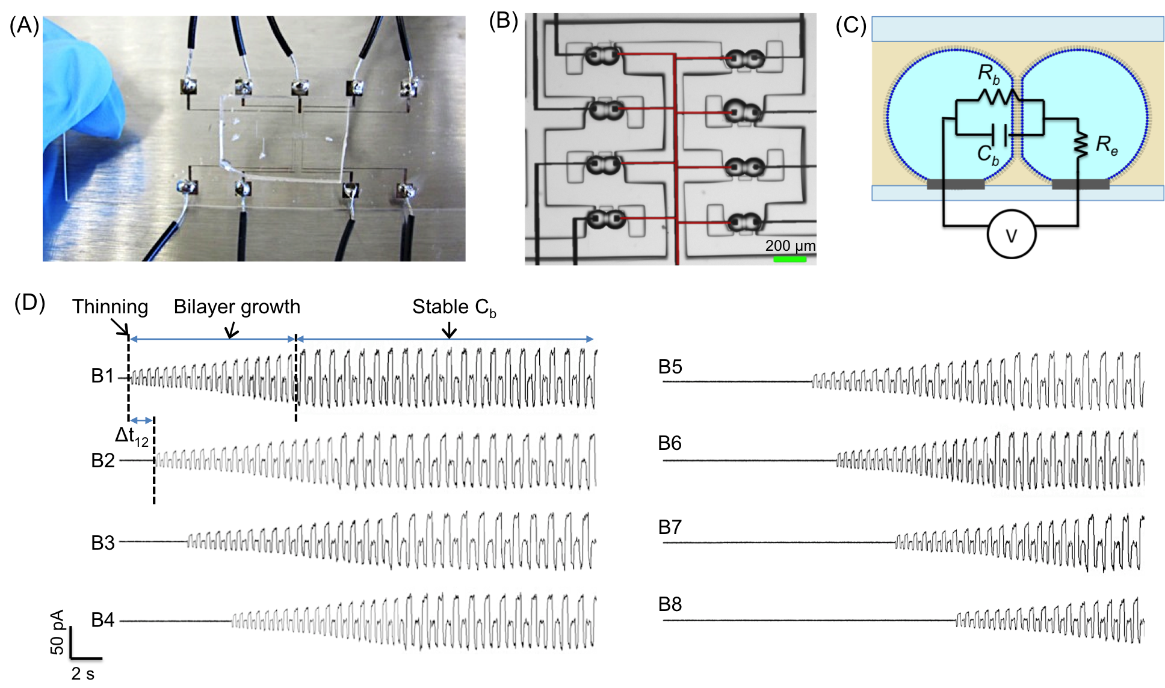
Figure 8. Electrical characterization of microfluidic GMO DIBs: (A) Top view of microchip with thin-film electrodes and soldered wires. (B) Image of DIB residing on top of thin-film electrodes. Sensing electrodes are those on the outer side, while the shared ground electrode in the middle is pseudo colored red. (C) Equivalent electrical circuit of a DIB on top of Ag/AgCl thin-film electrodes. (D) Current measurements of 8 DIBs measured concurrently show increases in current amplitudes that correspond to the growth in bilayer capacitances during DIB formation. Currents are induced by a 40 mV, 50 Hz triangular waveform voltage.

Electrical measurements of adjoined droplets residing on a pair of electrode pads is used to characterize both the droplet-electrode interfaces as well as the membrane formed between droplets. The passive electrical properties of lipid bilayers are well established;[49, 50] the membrane is represented by a resistor, R_{m}, in parallel with a capacitor, C_{m}. An additional series resistance, R_{e}, accounts for the electrolyte resistance of the aqueous phases on both side of the membrane (Figure 7C). The resistance of a lipid bilayer is often greater than 1 GΩ, while the electrolyte resistance is typically on the order of 1 kΩ. If the droplet-electrode interface is resistive (i.e. the electrode makes direct contact with the aqueous interior of the droplet), then the equivalent circuit shown in Figure 7C indicates that the dominant electrical impedance between two electrode pads is simply given by R_{m} and C_{m}. This condition implies that if the membrane fails (i.e. droplets coalesce), current flow between electrodes would increase significantly due to the lower value of R_{e}. However, if oil were to remain between the electrode pad and the droplet, then we expect a non-conductive, capacitance to exist at this interface (not shown in Figure 7C). In this case, a dc current would remain low upon coalescence because of the capacitive contact with the droplets. In this study, we find that droplets form resistive connections with the Ag/AgCl electrode pads when n-decane or squalene are used as the oil, which is confirmed by a saturation of measured current when a single aqueous volume spans two electrodes (not shown). However, capacitive connections are established when hexadecane is used as the oil phase. Since electrophysiology of membranes typically requires a resistive connection between the electrodes and the electrolyte, we perform electrical measurements of microfluidic DIBs in squalene. Squalene is also preferred because it is not absorbed by PDMS.

3.2.1 Bilayer confirmation
Membrane formation in a DIB array is assessed electrically by simultaneously measuring the currents induced by an equal triangular waveform voltage applied between each electrode pair. When droplets are adjacent but not yet adhered, the presence of oil between them causes the induced current to be less than the background noise. As a bilayer forms, the increase in membrane capacitance causes a square waveform current to appear and then increase in amplitude. This sequence reflects the initial thinning and subsequent areal growth of the bilayer between droplets.[54] Figure 7D shows electrical currents recorded during the spontaneous formation of 8 separate GMO DIBs (B1-B8). The 3-5 second time lag between onsets of successive DIB formation represents the time required for the next trap to fill and then a bilayer to form in that trap. Each membrane reaches a stable capacitance within ~10 seconds of the onset of thinning.

The raw current traces in Figure 7D are used to compute the nominal capacitance and resistance of the bilayer as described elsewhere.[36] In parallel to electrical recordings, DIB area is calculated from the projected length of contact between droplets, which is measured from images of the droplet pair (such as those in Figure 7B) using Image J software. This horizontal length of contact, or DIB lateral length,[55, 56] is assumed to be equal to the circular diameter of the interface. Table 2 shows the steady-state membrane properties obtained from a single experiment for 8 GMO DIBs formed using ~100 µm diameter droplets. Nominal capacitance and membrane resistance for an 8-DIB array are plotted versus time in Section S3 in the SI. From this experiment on 8 DIBs, the average membrane capacitance is 11.0±0.02 pF and the average membrane resistance is 8.3±0.3 GΩ. The image analysis shows that the average length of contact between droplets is 42.7±2.3 µm, yielding an average circular area of 1431±4 µm². Specific membrane capacitance is computed for each DIB by dividing C_{m} by DIB area. The average specific capacitance from the 8 DIBs formed in the microchip is 0.771±0.001 µF/cm², which is within the range of values of 0.75-0.81 µF/cm² found in literature for GMO in squalene.[57] Multiplying R_{m} by area yields an average membrane resistivity of 0.12±0.01 MΩcm², which is comparable to typical liquid-supported lipid bilayers.[7, 16]

The low standard deviation in membrane capacitance, resistance, and area within a set of 8 DIBs illustrates the uniformity of the droplets produced during a given experiment. However, multiple DIB array formation and electrical characterization experiments reveal that variations in average droplet size from one experiment to another are the primary cause for differences in nominal DIB properties between separate trials. For example, the average bilayer areas computed from two additional experiments (each using measurements from 8 GMO DIBs) are 2176±4 µm² and 1671±9 µm², respectively (Table 2). The droplet sizes were ~125 µm and ~110 µm in diameter, respectively. However, the average values of specific capacitance and membrane resistivity for DIBs formed in the three trials shown are very similar, which indicates that DIBs formed in the device exhibit consistent values of thickness and permeability from one experiment to the next. Tables providing individual bilayer properties from these additional trials are presented in section S4 of the SI.

Table 2. Capacitance, resistance, area, and specific capacitance for each DIB pair and the averages from one trial.
DIB  pair # | Capacitance final (C_{F}) –  pF | Resistance final (R_{F}) –  GΩ | Area final (A_{F}) –  µm² | Specific capacitance (C_{M}) - µF/cm² | Normalized resistance (R_{N}) - MΩcm²
Pair 1 | 11.0 | 8.1 | 1425 | 0.772 | 0.12
Pair 2 | 11.0 | 8.8 | 1432 | 0.770 | 0.13
Pair 3 | 11.0 | 8.0 | 1432 | 0.771 | 0.12
Pair 4 | 11.0 | 8.1 | 1432 | 0.771 | 0.12
Pair 5 | 11.0 | 8.1 | 1432 | 0.770 | 0.12
Pair 6 | 11.1 | 8.8 | 1432 | 0.772 | 0.13
Pair 7 | 11.0 | 8.2 | 1425 | 0.772 | 0.12
Pair 8 | 11.1 | 8.1 | 1438 | 0.769 | 0.12
Averages | 11.0±0.02 | 8.3±0.3 | 1431±4 | 0.771±0.001 | 0.12±0.01

3.2.2 Transduction measurements
Alamethicin peptides, which exhibit concentration- and voltage-dependent pore formation in membranes,[58] are incorporated into the aqueous droplets to demonstrate parallel single-channel recordings in multiple DIBs using the thin-film electrodes. Voltage-induced gating is recorded with +170 mV applied equally across all 8 DPhPC DIBs; we found this level necessary to elicit pore formation for a final peptide concentration of 1 µM in the droplets. Simultaneous recordings of the resulting currents from all 8 DIBs are shown in Figure 8A. For each membrane, we observe that the current stochastically fluctuates between discrete levels, which signifies transient pore formation and closure caused by peptides in the membrane.[59] Figure 8B,C shows the calculated conductance versus time for one of the measurement channels (i.e. one of the DIBs). The ratios of alamethicin pore conductance relative to the subconductance level are found to be 1, 4.18, 8.73, and 14.07. These values are consistent with previous measurements of alamethicin activity in single DIBs.[16, 37, 60, 61] However, this platform provides for the first time a reproducible and high throughput microfluidic method to simultaneously measure single-channel gating responses in multiple DIBs.

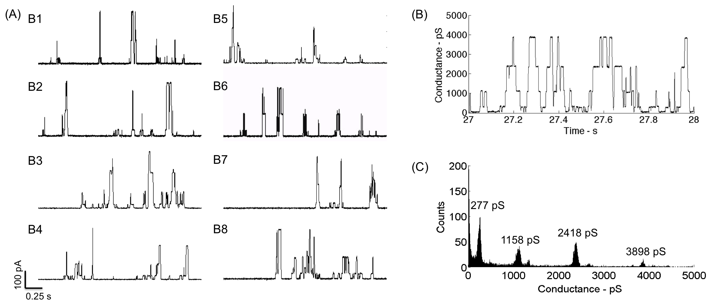
Figure 9. (A) Simultaneous recordings of alamethicin gating activity in 8 DPhPC DIBs at a holding potential of +170 mV. (B) Conductance versus time of a single measurement channel. (C) Histogram of conductance values for alamethicin channels computed from the multiple gating events in (B).

In the lipid-in[62] DIB technique used herein, liposomes contained within the droplets must fuse at the oil-water interface to form a monolayer prior to bilayer formation between droplets. Therefore while vesicle fusion after membrane formation is one way that alamethicin peptides reach the bilayer, it is highly likely that many alamethicin peptides are pre-associated with the monolayers coating the droplets prior to DIB formation. Our experiments with alamethicin consistently show immediate voltage-dependent ion channel formation after bilayer formation, which supports the notion that peptides are present on the membrane surface when the membrane forms.

Nonetheless, our microfluidic system to assemble and interrogate arrays of DIBs is equally well suited for lipid-out DIB formation, in which the lipids are incorporated outside of the droplets in the oil. Placing lipids in the oil ensures that the only bilayer membranes in the system are those that separate adjoined droplets. Further, incorporating the lipids in a separate phase from transmembrane proteins or other water-soluble species provides more control over the interactions between these species and the membrane[63, 64] and enables easier application of osmotic gradients,[65, 66] since the interiors of the droplets do not contain an excess of liposomes or proteoliposomes.

3.3 Chapter summary and conclusions
In this work, we designed and fabricated microfluidic devices developed to generate, sort, and trap droplets to form DIBs in designated traps. Specifically, hydrodynamic traps were designed using an equivalent circuit model to capture two, three, or four droplets to form either single bilayers or serially connected multi-DIB clusters in each trap. Through the circuit modeling analysis, we were able to design multiple-trap arrays that enable sequential droplet trapping and subsequent DIB formation between multiple pairs of droplets in a single device. The chosen serial configuration provides a constant, low-pressure drop across each filled trap, which is far less than the Laplace pressure across a droplet. Therefore, captured droplets are retained and are not pushed through the bleed valves after trapping. Trapping order will be especially important in future work, where captured droplets of alternating compositions are desired. In contrast, our analysis of multi-trap arrays that feature traps arranged in a parallel fashion did not fulfill the maximum pressure and direct trapping criteria, which placed limits on the number of traps that could be included within a device. Hence, these designs were not fabricated.

For the first time to our knowledge, we demonstrated the incorporation of thin-film electrodes and in situ electrical interrogation of multiple DIBs within an enclosed device. We used these conductive traces to simultaneously apply a voltage stimulus and measure the resulting currents through as many as 8 DIBs. Combined electrical and optical access allowed for measurements of membrane capacitance, resistance, and bilayer area for each DIB, and our experiments revealed that arrays of DIBs formed from a droplet stream exhibit consistent sizes and values of membrane resistivity. Also, parallel single channel recordings of alamethicin peptides were obtained via the thin-film electrodes in 8 DIBs at once. This capability for simultaneous electrical measurement in multiple DIBs supports the use of microfluidics and DIBs for high-throughput, low-volume electrophysiology experiments related to studying proteins, performing biosensing, and conducting drug-screening assays.

Chapter 4
Asymmetric droplet interface bilayers with in situ electrical measurements

A version of this chapter was originally published by Nguyen, M., and Sarles, S.A.
Nguyen, M., and Sarles, S.A., Microfluidic Generation, Encapsulation and Characterization of Asymmetric Droplet Interface Bilayers. ASME Conference Proceedings 2016 – Conference on Smart Materials, Adaptive Structures and Intelligent Systems, Stowe, VT, September 28-30, 2016.

4.1 Alternating droplet compositions to form asymmetric droplet interface bilayers

4.1.1 Alternating droplet generation
We fabricated a PDMS microchip featuring two, directly-opposed T-junctions to produce binary streams of aqueous droplets of alternating compositions as shown in Figure 8A. The oil-filled main channel is 125 µm wide and the two T-junctions are 40 µm at their exits. All channels have a depth of 125 µm. The flow rates to produce 90-120 µm diameter droplets and create alternating droplets range from 0.4-1 μL/min for oil and 0.05-0.5 μL/min for the aqueous phases. The flow conditions required to form a steady flow of alternating droplets in a microchannel are characterized as a function of the capillary number, C_{a}, and water fraction, w_{f} [67]. The capillary number is a measurement of viscous stress relative to the interfacial tension stress, such that
 | 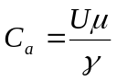, | (5)
where U and µ are the flow velocity and dynamic viscosity, respectively of the oil and γ is the surface tension at the interface between the aqueous droplet and the oil. The water fraction is computed as the ratio of the combined aqueous solutions flow rates to the total flow rate of the oil and aqueous phases, given by
 | 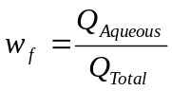. | (6)
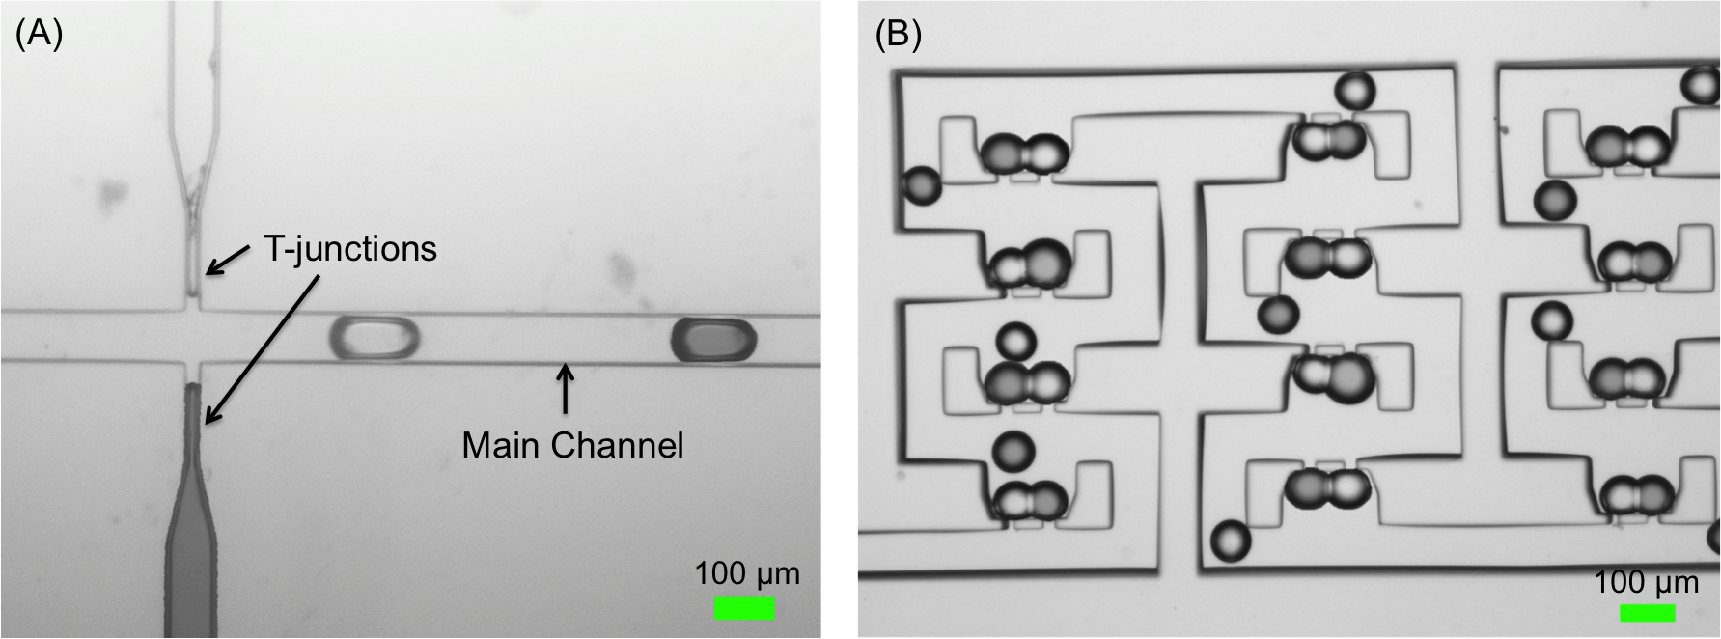
Figure 10. (A) Two opposing T-junctions producing droplet stream of alternating compositions. Food coloring is used to distinguish between to aqueous fluids. (b) Trapped asymmetric DIBs.

A continuous stream of alternating droplets is produced from the opposing T-junctions when both C_{a} and w_{f} are in appropriate ranges. A prior study demonstrated alternating water droplet production in fluorinated oils for C_{a} between 0.001 and 0.05 and w_{f} between 0.2 and 0.8 [67]. Our experiments at varying oil and water flow rates confirm that alternating droplets are produced at C_{a} values as low as 0.002 and as high as 0.04 and w_{f} values between 0.4 and 0.8. Using values of 12 cP and 1.2 mN/m, respectively for the viscosity of squalene and the surface tension of a squalene-water interface decorated with lipids [68], the water and oil flow rates mentioned for generating alternating droplets 90-120 µm in diameter correspond to a C_{a} value of 0.005 and a w_{f} value of 0.6.

Within the working range of droplet production, increasing the water fraction of the total fluid increases the droplet size and decreases the distance between adjacent droplets in the stream. Stable alternating droplets are produced at low water fractions (<0.8). When C_{a} is too low, aqueous volumes are dispensed from the opposing junctions at the same time and they coalesce upon exiting. Conversely, when C_{a} is too high, the junctions generate continuous streams rather than discrete droplets. Furthermore, when the water fraction is too high (>0.8), it is difficult to form stable alternating droplet regardless of the capillary number due to laminar aqueous flow that results in a single continuous stream.

Alternating droplets are routed to and captured sequentially by a series of hydrodynamic traps. The traps in the device were the same design as previously described above to ensure direct trapping of droplets during the filling of all traps, which is necessary to maintain the alternating arrangements, and to prevent droplets from squeezing through the bleed valves once trapped [69]. Figure 8B shows a DIB formed between two different aqueous droplets in each trap. This result and the observation that the stream of droplets bypassing the traps is alternating in composition confirm that droplet production is alternating and droplet trapping occurs sequentially. While the prototype devices fabricated for this study have 16 traps, our equivalent-circuit model [69] predicts that direct trapping in serial layout of traps can work for any number of traps. Thus, we believe this approach can be applied to generate hundreds to thousands of DIBs in a compact device.

4.2 Asymmetric lipid composition characterization
With the capability of forming asymmetric DIBs on a microfluidic platform, we are able to investigate leaflet asymmetry by incorporating different liposome compositions within each aqueous inlet. Specifically, one aqueous solution contains DPhPC liposomes, while the second aqueous solution contains liposomes consisting of DOPhPC, an ether form of the same synthetic lipid. Captured pairs of alternating droplets containing different liposomes will become encased in their monolayers of different composition and result in asymmetric DIB membranes with different leaflet compositions, as was shown previously with a non-microfluidic approach [43]. Even though both lipids used herein are zwitterionic (i.e. zero net headgroup charge) and have similar chemical structures, they exhibit different values of dipole potential, a quantity that is dependent on the area per lipid molecule in the monolayer. Specifically, Yasmann, et al. showed that DPhPC has a dipole potential of ~350 mV and DOPhPC exhibits a dipole potential of ~200 mV when both the lipids in both monolayers are maximally packed (i.e. minimum area per lipid) [70]. As a result of the difference in dipole potential, an asymmetric membrane exhibits a non-zero potential difference equal to the difference in magnitudes of dipole potential [44]. For the two lipids considered here, an asymmetric DPhPC-DOPhPC membrane should exhibit a +135 mV potential with respect to the leaflet containing DPhPC. To confirm the asymmetry that is established when a DPhPC- coated droplet attaches to a DOPhPC droplet, measurements of membrane capacitance, C, versus DC bias, V, are performed to quantify the net membrane potential, V_{r}, as given by the following relationship [71]:
 | 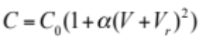. | (7)
In this expression, C₀ represents the membrane capacitance at V = 0, and α is the fractional increase in capacitance per square volt due to electrowetting [72, 73]. Equation 7 shows that membrane capacitance is a quadratic function of the applied voltage, which reaches a minimum at V = -V_{r}.

Here, asymmetric DPhPC-DOPhPC lipid bilayers are formed using the alternating droplet generation technique and capture methods described above. After the droplets land in each trap and a bilayer spontaneously forms between them, a 40 mV, 50 Hz triangular waveform voltage is applied to record the capacitive current induced by the formation of the membrane [36, 69]. To determine the membrane potential for an asymmetric DIB, an applied dc offset is added to the triangle wave voltage and it is increased in a step-wise fashion at a rate of 10 mV at every 20 seconds until the bias reaches 290 mV. The procedure enables membrane capacitance at each dc voltage step to be calculated from the induced square wave current [36].

Representative capacitance data for two of the eight asymmetric DIBs are plotted in Figure 4b to illustrate the offset of the location of minimum capacitance due to membrane asymmetry resulting from binary droplet compositions. In comparison, measurements of capacitance versus voltage for a symmetric DPhPC DIB obtained using manual methods for droplet formation and positioning are also shown. Unlike a symmetric DIB that exhibits a zero membrane potential, our measurements confirm that DIBs constructed from monolayers of different lipid types result in a non-zero membrane potential. Specifically, we find that there is a ~137 mV difference for asymmetric DIB membranes formed with DPhPC and DOPhPC, which is consistent with other reported experimental values [44, 70] and close to the dipole potential difference. Table 1 summarizes the transmembrane potentials measured for each of the eight DIB pairs interrogated simultaneously during the same experiment.

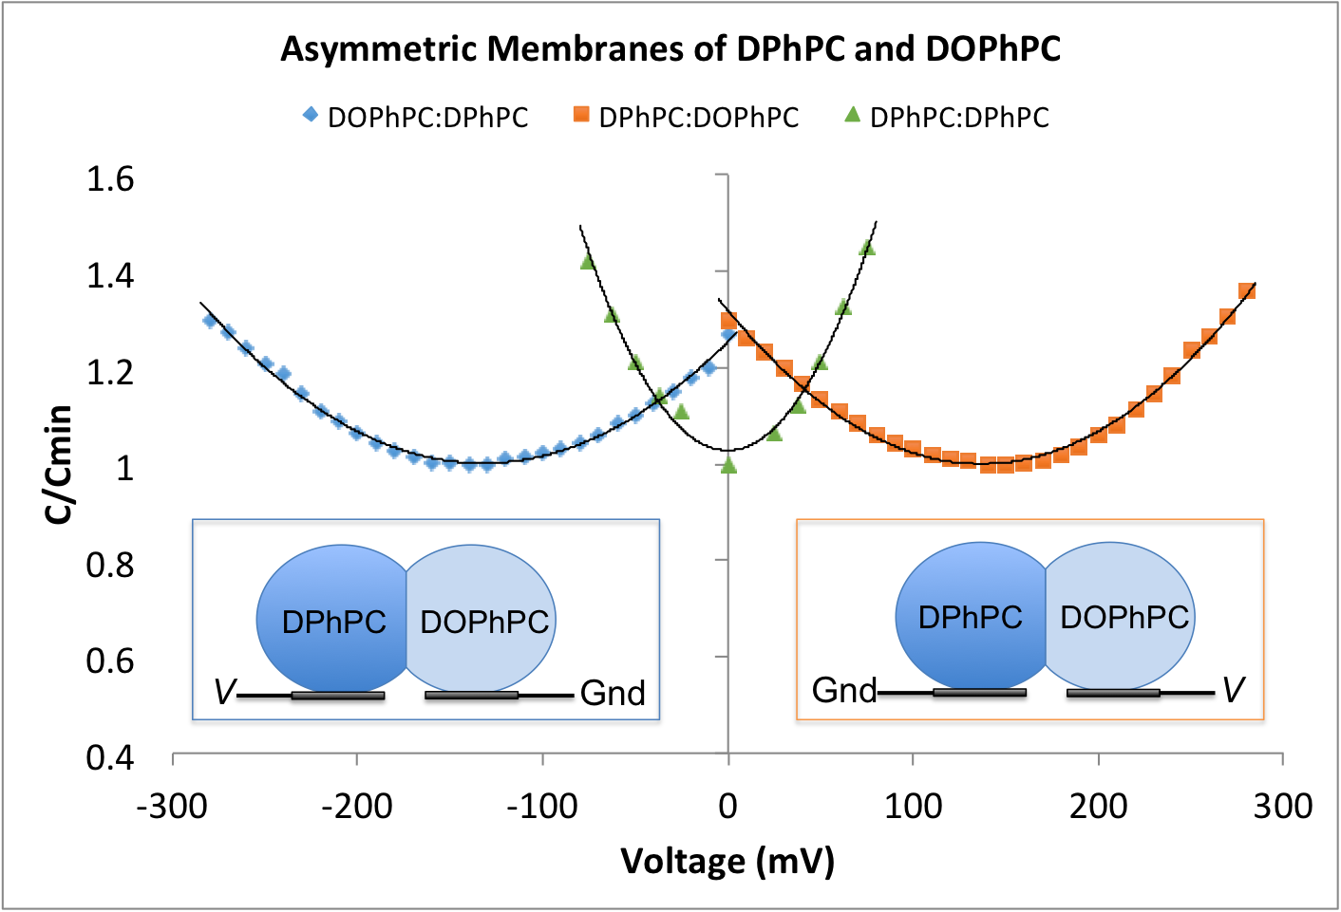
Figure 11. Current plotted for two different pairs of DIBs as a function of voltage for asymmetric membranes of DPhPC and DOPhPC. Inset schematics illustrate the location of the lipids based on the transmembrane potential offset. A symmetric DPhPC case is included for comparison.

In addition to determining the magnitude of each membrane’s potential, we are also able to determine which lipid is on which side of a particular DIB by considering the polarity of the voltage where minimum capacitance occurs relative to the position of the sensing and ground electrodes in the device. For example, a positive transmembrane potential (i.e. which corresponds to minimum capacitance at a negative voltage of each magnitude) suggests that the droplet resting on the ground electrode contains DOPhPC liposomes, while the droplet on the sensing electrode contains DPhPC liposomes (shown in the left inset in Figure 4b). Since the polarity of the membrane potential alternates, these results of an 8 DIB array in Table I also illustrate that in our device, the arrangements of DIBs formed between alternating droplets alternate with respect to the sensing and ground electrodes. In summary, these results showcase that a microfluidic approach can be used to increasing the experimental output and efficiency for studying asymmetric membranes formed with alternating droplet compositions.

Table 3. Calculated transmembrane potentials for eight DIBs and locations of the lipids.
Pair # | Transmembrane potential (mV) | Lipid on ground electrode | Lipid on sensing electrode
DIB 1 | +137 | DOPhPC | DPhPC
DIB 2 | -137 | DPhPC | DOPhPC
DIB 3 | +137 | DOPhPC | DPhPC
DIB 4 | -137 | DPhPC | DOPhPC
DIB 5 | +137 | DOPhPC | DPhPC
DIB 6 | -137 | DPhPC | DOPhPC
DIB 7 | +137 | DOPhPC | DPhPC
DIB 8 | -137 | DPhPC | DOPhPC

4.3 Asymmetric transduction measurements
Alamethicin peptides are incorporated into one of the aqueous channels such that symmetric DPhPC DIBs are formed between one droplet with peptides and one without. This alternating placement of peptides should lead to one-side interactions between the membrane and the peptides. In particular, alamethicin peptides induce voltage-dependent current upon directional pore formation in the bilayer at transmembrane voltages greater than ~+70 mV with respect to the side of insertion [74]. Thus, we expect that pore-formation will only occur at a single polarity in each membrane, the sign of which depends on the position of the droplet containing peptides on the sensing and ground electrodes.

Figure 5a shows simultaneous current measurements for four of the eight membrane containing alamethicin. In each trace, the current signal stochastically fluctuates between discrete levels signifying pore formation and closure [59]. Here, these gating events occur at +170 mV due to the fact that the droplets containing alamethicin in each of these DIBs are residing on sensing electrodes. While not shown, channel formation activity is only observed at -170 mV for the other four DIBs, where alamethicin is contained in the droplet resting on the ground electrode.

The sided-ness of alamethicin pore formation is also demonstrated through cyclic voltammetry (CV) measurements as shown in Figure 5b. During this measurement, the current through the membrane is recorded as the voltage is cycled across a range of values. The voltage in this CV sweep begins at 0 mV, increases at a constant rate of 10 mV/sec to +170 mV then decreases at the same rate to -170 mV, ending back at 0 mV. The measurement plotted in Figure 5b shows that the current exhibits an exponential increase at positive voltages above ~100 mV, which confirms that that alamethicin inserts in the bilayer only from one side of the membrane and suggests that the droplet residing on the sensing electrode contains alamethicin. Because there is no current activity during the negative voltages of the CV sweep, we can assume there is no alamethicin present in other droplet. Similar to the alternating values of membrane potential for asymmetric DIBs, increases in membrane current at the opposite polarity are observed when the position of the alamethicin droplet is switched to the ground electrode. For instance when droplets with alamethicin is on the ground electrode, there is gating activity at negative voltages and no current present at positive voltages. This further demonstrates the traps captured asymmetric DIBs.

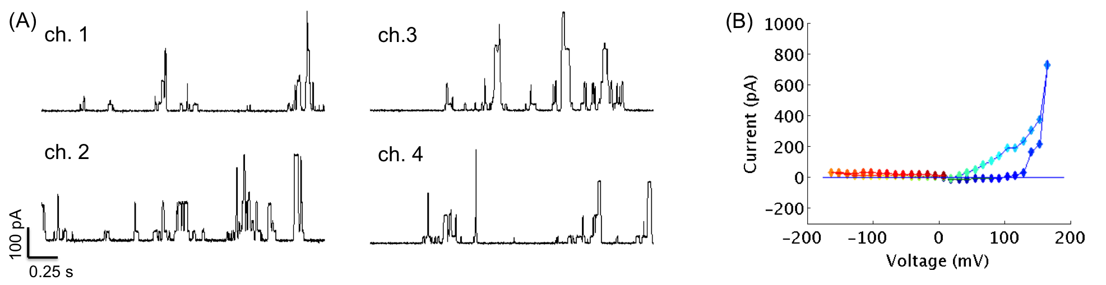
Figure 12. (A) Simultaneous recording of alamethicin ion channel activity in 4 different DIBs with a holding potential at +170 mV. (B) Current voltage sweep response when DC step routine is applied for one DIB pair. The color shows the order of the cycle beginning with the blue and ending with red. The connecting line is included to identify the trend.

4.4 Chapter summary and conclusions
This work examined a method to create streams of alternating droplet compositions, i.e. A-B-A-B, via two opposing T-junctions within a microfluidic device. In the same device, the droplets were sequentially captured in predetermined locations to enable the spontaneous formation of synthetic lipid bilayers between droplets of different compositions. Contrasting our prior work demonstrating microfluidic DIB formation, this revised system maintains a key component of the DIB technique by allowing bilayer formation to occur between droplets of differing compositions, which allow asymmetric conditions within and across the membrane to be prescribed.

Using this system, we then demonstrated the assembly and interrogation of asymmetric DIBs consisting of different lipid compositions in each leaflet of the bilayer. The asymmetric DPhPC-DOPhPC bilayers formed resulted in a dc, non-zero membrane potential of |137mV| across each membrane due to the difference in dipole potentials of the two lipid types. Furthermore based on the measured polarity of this potential, we were able to determine which droplet contains DPhPC and DOPhPC. The observed alternating polarity of membrane potentials within the 8 DIB array illustrates that the arrangements of sequential DIBs formed between alternating droplets reverse with respect to the sensing and ground electrodes.

In the second study, alamethicin peptides were included in only one of two droplets in each DIB pair, which enabled voltage-dependent insertion to occur only at one polarity. Cyclic voltammetry measurements confirmed the direction of insertion of alamethicin channels in bilayers. Because peptide insertion and gating occurred at a single polarity in each membrane, the sign of the voltage again determined the position with respect to the electrodes of the droplet containing the peptides. Also, these results showcase the ability to simultaneously perform electrical measurements on multiple DIBs, which motivates the use of a microfluidic approach to increase the efficiency of membrane studies. This is a step forward to creating smart materials with model membranes that can be used for autonomic sensing, actuation, and energy conversion.

Chapter 5
Microfluidic device for single cell capture

5.1 Resistive flow modeling for single cell trapping

5.2 Protoplast capture in microfluidic device

5.3 In situ transformation

5.4 Chapter summary and conclusions

Chapter 6
Conclusion

6.1 Research overview

6.2 Conclusions

6.2.1 Objective 1

6.2.2 Objective 2

6.2.3 Objective 3

6.3 Research product and outputs

6.3.1 Journal publications

6.3.2 Peer reviewed conference proceedings

6.3.3 Other conference presentations and posters

References

1. Xia, F. and L. Jiang, Bio-Inspired, Smart, Multiscale Interfacial Materials. Advanced Materials, 2008. 20(15): p. 2842-2858.
2. McConney, M.E., et al., Bioinspired Material Approaches to Sensing. Advanced Functional Materials, 2009. 19(16): p. 2527-2544.
3. Hirano-Iwata, A., et al., Stable Lipid Bilayers Based on Micro- and Nano-Fabrication. Analytical Sciences, 2012. 28: p. 1049-1057.
4. Reimhult, E. and K. Kumar, Membrane biosensor platforms using nano- and microporous supports. Trends Biotechnol, 2008. 26(2): p. 82-9.
5. Sarles, S.A. and D.J. Leo, Membrane-based biomolecular smart materials. Smart Materials and Structures, 2011. 20(9): p. 094018.
6. Sackmann, E., Supported Membranes: Scientific and Practical Applications. Science, 1996. 271: p. 43-48.
7. Bayley, H., et al., Droplet interface bilayers. Mol Biosyst, 2008. 4(12): p. 1191-208.
8. Holden, M.A., D. Needham, and H. Bayley, Functional Bionetworks from Nanoliter Water Droplets. J. Am. Chem. Soc., 2007. 129(27): p. 8650-8655.
9. Funakoshi, K., H. Suzuki, and S. Takeuchi, Lipid Bilayer Formation by Contacting Monolayers in a Microfluidic Device for Membrane Protein Analysis. Anal. Chem., 2006. 78(24): p. 8169-8174.
10. Sarles, S.A. and D.J. Leo, Regulated Attachment Method for Reconstituting Lipid Bilayers of Prescribed Size within Flexible Substrates. Analytical Chemistry, 2010. 82(3): p. 959–966.
11. Sarles, S.A., J.D.W. Madden, and D.J. Leo, Hair cell inspired mechanotransduction with a gel-supported, artificial lipid membrane. Soft Matter, 2011. 7(10): p. 4644.
12. Bayley, H. and P.S. Cremer, Stochastic sensors inspired by biology. Nature, 2001. 413: p. 226-230.
13. Sundaresan, V.B., et al., Biological transport processes for microhydraulic actuation. Sensors and Actuators B: Chemical, 2007. 123(2): p. 685-695.
14. Xu, J., T.K. Vanderlick, and D.A. LaVan, Energy Conversion in Protocells with Natural Nanoconductors. International Journal of Photoenergy, 2012. 2012: p. 1-10.
15. Xu, J., F.J. Sigworth, and D.A. LaVan, Synthetic protocells to mimic and test cell function. Adv Mater, 2010. 22(1): p. 120-7.
16. Sarles, S.A. and D.J. Leo, Physical encapsulation of droplet interface bilayers for durable, portable biomolecular networks. Lab Chip, 2010. 10(6): p. 710-7.
17. Poulos, J.L., et al., Electrowetting on dielectric-based microfluidics for integrated lipid bilayer formation and measurement. Applied Physics Letters, 2009. 95(1): p. 013706.
18. Aghdaei, S., et al., Formation of artificial lipid bilayers using droplet dielectrophoresis. Lab Chip, 2008. 8(10): p. 1617-20.
19. Dixit, S.S., et al., Light-Driven Formation and Rupture of Droplet Bilayers. Langmuir, 2010. 26(9): p. 6193-6200.
20. Wauer, T., et al., Construction and Manipulation of Functional Three-Dimensional Droplet Networks. ACS Nano, 2013. 8(1): p. 771-779.
21. Villar, G., A.D. Graham, and H. Bayley, A tissue-like printed material. Science, 2013. 340(6128): p. 48-52.
22. Seemann, R., et al., Droplet based microfluidics. Rep Prog Phys, 2012. 75(1): p. 016601.
23. Teh, S.Y., et al., Droplet microfluidics. Lab Chip, 2008. 8(2): p. 198-220.
24. Christopher, G.F. and S.L. Anna, Microfluidic methods for generating continuous droplet streams. Journal of Physics D: Applied Physics, 2007. 40(19): p. R319-R336.
25. Bai, Y., et al., A double droplet trap system for studying mass transport across a droplet-droplet interface. Lab Chip, 2010. 10(10): p. 1281-5.
26. King, P.H., et al., Interdroplet bilayer arrays in millifluidic droplet traps from 3D-printed moulds. Lab Chip, 2014. 14(4): p. 722-9.
27. Zagnoni, M. and J.M. Cooper, A microdroplet-based shift register. Lab Chip, 2010. 10(22): p. 3069-73.
28. Xu, X., et al., Optimization of microfluidic microsphere-trap arrays. Biomicrofluidics, 2013. 7(1): p. 14112.
29. Hwang, W.L., et al., Electrical Behavior of Droplet Interface Bilayer Networks- Experimental Analysis and Modeling. J. Am. Chem. Soc., 2007. 129: p. 11854-11864.
30. Nguyen, M.-A. and S.A. Sarles, Micro-Encapsultation and Tuning of Biomolecular Unit Cell Networks in ASME 2014 Smart Materials, Adaptive Structures and Intelligent Systems2014: Newport, RI.
31. Nisisako, T., S.A. Portonovo, and J.J. Schmidt, Microfluidic passive permeability assay using nanoliter droplet interface lipid bilayers. Analyst, 2013. 138(22): p. 6793-800.
32. Carreras, P., et al., A microfluidic platform for size-dependent generation of droplet interface bilayer networks on rails. Biomicrofluidics, 2015. 9(6): p. 064121.
33. Wauer, T., et al., Construction and Manipulation of Functional Three-Dimensional Droplet Networks. ACS Nano, 2014. 8: p. 771-779.
34. Stanley, C.E., et al., A microfluidic approach for high-throughput droplet interface bilayer (DIB) formation. Chem Commun (Camb), 2010. 46(10): p. 1620-2.
35. Elani, Y., et al., Novel technologies for the formation of 2-D and 3-D droplet interface bilayer networks. Lab Chip, 2012. 12(18): p. 3514-20.
36. Gross, L.C.M., et al., Determining Membrane Capacitance by Dynamic Control of Droplet Interface Bilayer Area. Langmuir, 2011. 27(23): p. 14335-14342.
37. Sarles, S.A. and D.J. Leo, Tailored Current--Voltage Relationships of Droplet-Interface Bilayers Using Biomolecules and External Feedback Control. Journal of Intelligent Material Systems and Structures, 2009. 20(10): p. 1233-1247.
38. Villar, G., A.J. Heron, and H. Bayley, Formation of droplet networks that function in aqueous environments. Nature Nanotechnology, 2011. 6: p. 803-808.
39. Czekalska, M.A., et al., A droplet microfluidic system for sequential generation of lipid bilayers and transmembrane electrical recordings. Lab Chip, 2015. 15(2): p. 541-8.
40. Devaux, P.F. and R. Morris, Transmembrane Asymmetry and Lateral Domains in Biological Membranes. Traffic, 2004. 5: p. 241-246.
41. Zhang, Z., et al., Engineered Asymmetric Heterogeneous Membrane: A Concentration-Gradient-Driven Energy Harvesting Device. J Am Chem Soc, 2015. 137(46): p. 14765-72.
42. Zhang, H., et al., Bioinspired artificial single ion pump. J Am Chem Soc, 2013. 135(43): p. 16102-10.
43. Hwang, W.L., et al., Asymmetric Droplet Interface Bilayers. J. Am. Chem. Soc., 2008. 130: p. 5878–5879.
44. Freeman, E.C., et al., The mechanoelectrical response of droplet interface bilayer membranes. Soft Matter, 2016. 12: p. 3021-3021.
45. Marquardt, D., B. Geier, and G. Pabst, Asymmetric lipid membranes: towards more realistic model systems. Membranes (Basel), 2015. 5(2): p. 180-96.
46. Kornberg, R.D. and H.M. McConnell, Lateral Diffusion of Phospholipids in a Vesicle Membrane. Proceedings of the National Academy of Sciences of the United States of America, 1971. 68(10): p. 2564-2568.
47. John, K., et al., Transbilayer movement of phospholipids at the main phase transition of lipid membranes: implications for rapid flip-flop in biological membranes. Biophysical Journal, 2002. 83(6): p. 3315-3323.
48. McDonald, J.C. and G.M. Whitesides, Poly(dimethylsiloxane) as a Material for Fabricating Microfluidic Devices. Accounts of Chemical Research, 2002. 35(7): p. 491-499.
49. Montal, M. and P. Mueller, Formation of Bimolecular Membranes from Lipid Monolayers and a Study of Their Electrical Properties. Proceedings of the National Academy of Sciences, 1972. 69(12): p. 3561-3566.
50. Wiegand, G., et al., Electrical Properties of Supported Lipid Bilayer Membranes. The Journal of Physical Chemistry B, 2002. 106(16): p. 4245-4254.
51. Bithi, S.S. and S.A. Vanapalli, Behavior of a train of droplets in a fluidic network with hydrodynamic traps. Biomicrofluidics, 2010. 4(4): p. 44110.
52. Mruetusatorn, P., et al., Dynamic morphologies of microscale droplet interface bilayers. Soft Matter, 2014. 10(15): p. 2530-2538.
53. Boreyko, J.B., et al., Evaporation-Induced Buckling and Fission of Microscale Droplet Interface Bilayers. Journal of the American Chemical Society, 2013. 135(15): p. 5545-5548.
54. Tamaddoni, N., et al., Reversible, voltage-activated formation of biomimetic membranes between triblock copolymer-coated aqueous droplets in good solvents. Soft Matter, 2016. 12(23): p. 5096-5109.
55. Punnamaraju, S. and A.J. Steckl, Voltage control of droplet interface bilayer lipid membrane dimensions. Langmuir, 2011. 27(2): p. 618-26.
56. Taylor, G.J., et al., Direct in situ measurement of specific capacitance, monolayer tension, and bilayer tension in a droplet interface bilayer. Soft Matter, 2015. 11(38): p. 7592-7605.
57. White, S.H., Formation of "Solvent-free" Black Lipid Bilayer Membranes from Glyceryl Monooleate Dispersed in Squalene. Biophysical Journal, 1978. 23: p. 337-347.
58. Vodyanoy, I., J.E. Hall, and T.M. Balasubramanian, Alamethicin-induced current-voltage curve asymmetry in lipid bilayers. Biophysical Journal, 1983. 42: p. 71-82.
59. Gordon, L.G. and D.A. Haydon, Kinetics and stability of alamethicin conducting channels in lipid bilayers. Biochimica et biophysica acta, 1976. 436(3): p. 541-556.
60. Boreyko, J.B., et al., Air-stable droplet interface bilayers on oil-infused surfaces. Proceedings of the National Academy of Sciences, 2014. 111(21): p. 7588–7593.
61. Taylor, G.J. and S.A. Sarles, Heating-enabled formation of droplet interface bilayers using Escherichia coli total lipid extract. Langmuir, 2015. 31(1): p. 325-37.
62. Hwang, W.L., et al., Asymmetric Droplet Interface Bilayers. J. Am. Chem. Soc., 2008. 130(18): p. 5878-5879.
63. Nisisako, T., S.A. Portonovo, and J.J. Schmidt, Microfluidic passive permeability assay using nanoliter droplet interface lipid bilayers. Analyst, 2013. 138(22): p. 6793-6800.
64. Fischer, A., et al., Ultrasensitive detection of protein translocated through toxin pores in droplet-interface bilayers. Proceedings of the National Academy of Sciences, 2011. 108(40): p. 16577-16581.
65. Michalak, Z., et al., Tunable crystallization via osmosis-driven transport across a droplet interface bilayer. CrystEngComm, 2012. 14(23): p. 7865-7868.
66. Michalak, Z., et al., Effect of Monoglyceride Structure and Cholesterol Content on Water Permeability of the Droplet Bilayer. Langmuir, 2013. 29(51): p. 15919-15925.
67. Zheng, B., J.D. Tice, and R.F. Ismagilov, Formation of Droplets of Alternating Composition in Microfluidic Channels and Applications to Indexing of Concentrations in Droplet-Based Assays. Anal Chem, 2004. 76: p. 4977-4982.
68. Venkatesan, G.A., et al., Adsorption Kinetics Dictate Monolayer Self-Assembly for Both Lipid-In and Lipid-Out Approaches to Droplet Interface Bilayer Formation. Langmuir, 2015. 31(47): p. 12883-93.
69. Nguyen, M.-A., et al., Hydrodynamic trapping for rapid assembly and in situ electrical characterization of droplet interface bilayer arrays. Lab Chip, 2016. Under Review.
70. Yasmann, A. and S. Sukharev, Properties of diphytanoyl phospholipids at the air-water interface. Langmuir, 2015. 31(1): p. 350-7.
71. Genco, I., et al., Electroporation in symmetric and asymmetric membranes. Biochimica et Biophysica Acta, 1993. 1149: p. 10-18.
72. Alvarez, O. and R. Latorre, Voltage-dependent capacitance in lipid bilayers made from monolayers. Biophysical Journal, 1978. 21: p. 1-17.
73. Mosgaard, L.D., K.A. Zecchi, and T. Heimburg, Mechano-capacitive properties of polarized membranes. Soft Matter, 2015. 11: p. 7899-7910.
74. Mottamal, M. and T. Lazaridis, Voltage-dependent energetics of alamethicin monomers in the membrane. Biophys Chem, 2006. 122(1): p. 50-7.

Appendix

VITA

Mary-Anne K. Nguyen was born in Baton Rouge, Louisiana. She received her B.S. in Biological Engineering at Louisiana State University in May 2012 and is currently set to graduate in spring 2017 with a Ph.D. in Biomedical Engineering at University of Tennessee, Knoxville.

While at LSU, she participated in the LA-STEM scholars program. Mary-Anne did her undergraduate research in the Biological Engineering department studying photocleavable cage oligonucleotides. Throughout her undergraduate career, Mary-Anne served as a mentor through the College of Engineering and Office of Strategic Initiatives. She also is a recipient of the LSU Distinguished Communicator award.

As a graduate student, Mary-Anne’s work mainly centered on the field of synthetic biology particularly the use of droplet interface bilayers and microfluidics. Her research has resulted in several conference proceedings and presentations. Also, she has published a first-author paper with two more papers in preparation.

When she is not in lab at the microscope, Mary-Anne enjoys spending her time baking, sewing, and drinking coffee.

