Fungicide sensitivity, race structure, and host pathogenicity of Phytophthora nicotianae in Tennessee and North Carolina

A Thesis Presented for the

Master of Science

Degree

The University of Tennessee, Knoxville

Taylor Giovanna Miller

May 2023

Copyright © 2023 by Taylor Giovanna Miller
All rights reserved.

ACKNOWLEDGEMENTS

I would like to express my deepest appreciation to my department head, Dr. DeWayne Shoemaker, and assistant department head / graduate student advisor, Dr. Bonnie Ownley for guiding me as a graduate student in the Department of Entomology and Plant Pathology. This endeavor would not have been possible without the support and mentorship of my advisor, Dr. Zachariah Hansen, and committee members, Dr. Mitchell Richmond and Dr. Denita Hadziabdic. Dr. Hansen’s lab was welcoming, challenging, exciting, and fulfilling, and I will forever cherish my time as a member of it. Dr. Richmond and Dr. Hadziabdic’s knowledge and expertise aided me to achieve my goals and grow as a scientist. Dr. Matthew Vann was instrumental in producing this research, and I am grateful for his contributions. Additionally, the opportunity to conduct this research would not have been possible without the support from Altria Client Services, who financed my research.
I am also grateful for the lab members, especially Kate Turner and Alyssa Counce, for being selfless volunteers throughout my research, supporting my projects, and providing wonderful friendship and comradery the last two years. I would also like to extend a thanks to the Northeast Tennessee Research and Education Center, East Tennessee Research and Education Center, and Highland Rim Research and Education Center staff members and University of Tennessee extension agents for helping me conduct my research and teach me about Tennessee tobacco production.

Lastly, words cannot express my gratitude to my family and fiancé. Mom, Dad, Gramps, Grams, and Troy - thank you for cheering me on and being there throughout this incredible journey. Ryan - you are my rock and I am so grateful for your never-ending support, encouragement, and love. My sanity would have been lost a long time ago if not for my dog Rocky, so thank you for making me laugh during stressful times.

ABSTRACT
Phytophthora nicotianae, a hemibiotrophic oomycete, is the causal agent of disease of over 300 hosts, notably tobacco, tomato, citrus, strawberry, and ornamentals. Black shank of tobacco is a devastating disease that can result in up to 100% yield loss if left untreated, and buckeye rot of tomato compromises the marketability and yield of fruit impacted by P. nicotianae. Black shank and buckeye rot have been reported throughout the state of Tennessee. Therefore, the goal of this work was to 1) analyze fungicide sensitivity of P. nicotianae isolated from tobacco and tomato, 2) characterize the race structure of P. nicotianae, and 3) evaluate host specificity of P. nicotianae on tomato and tobacco. The fungicide sensitivity study tested mefenoxam, oxathiapiprolin, mandipropamid, and fluopicolide on 155 P. nicotianae isolates collected in 2021 and 2022. Resistance was not found and baseline sensitivity levels were established. Subsets of the 2021 and 2022 isolates were screened in a race-typing host differential study utilizing the following tobacco varieties: Hybrid 404LC (fully susceptible to both race 0 and 1), ms KY14XL8LC (fully resistant to race 0, fully susceptible to race 1), and KT215LC (fully resistant to race 0, partially resistant rating 9/10 to race 1). The study revealed 92% of 2021 isolates as race 1, and 89% of the 2022 isolates were determined race 1, indicating race 1 to be the dominant race of P. nicotianae in tobacco fields. Greenhouse studies testing the pathogenicity of P. nicotianae isolated from tobacco on ten popular tomato varieties produced in Tennessee revealed no disease following root, fruit, and foliar inoculations. A field trial was conducted using the ten tomato varieties in a field with a history of repeated tobacco production and a known presence of P. nicotianae, and it did not yield disease on the tomato varieties. The concluding detached leaf and fruit assay revealed host specificity among P. nicotianae isolates aligning with their hosts of origin.

TABLE OF CONTENTS

CHAPTER I: Literature Review 1
Tobacco Production Introduction 2
Black Shank Disease Introduction and Disease History 3
Phytophthora nicotianae in Tomato: Buckeye Rot 4
Phytophthora nicotianae Biology 6
Phytophthora nicotianae Reproductive Structures 7
Sexual reproduction 7
Asexual reproduction 8
Race Types 9
Management of Black Shank 10
Host resistance 10
Cultural and biological methods 11
Chemical control 12
Fungicide Resistance 14
Fungicide resistance of Phytophthora nicotianae in tobacco 14
Phytophthora nicotianae fungicide resistance detected in crops 15
Resistance among Phytophthora species 15
Purpose of Study and Research Gap 17
Materials and Methods 19
Sampling and isolate collection 19
Fungicide sensitivity 20
Greenhouse trials 20
References 22

CHAPTER II: Sensitivity of Phytophthora nicotianae in Tennessee and North Carolina to Mefenoxam, Oxathiapiprolin, Mandipropamid, and Fluopicolide 32
Abstract 33
Introduction 34
Materials and Methods 37
P. nicotianae isolation 37
Isolate identification through morphological assessment 38
Isolate identification through PCR and sequencing 38
Chemicals tested 40
Sensitivity of 2021 and 2022 P. nicotianae isolates to mefenoxam 40
Sensitivity of 2021 P. nicotianae isolates to oxathiapiprolin, mandipropamid, and fluopicolide using dilution series 41
Sensitivity of 2022 P. nicotianae isolates to oxathiapiprolin, mandipropamid, and fluopicolide using discriminatory doses 42
EC₅₀ and EC₇₅ calculations 43
Results 44
Isolate collection 44
Morphological and molecular identification 45
Sensitivity to mefenoxam 46
Sensitivity to oxathiapiprolin 46
Sensitivity to mandipropamid 47
Sensitivity to fluopicolide 47
Discussion 47
References 53
Appendix 57

CHAPTER III: Race Structure of Phytophthora nicotianae in Tennessee and North Carolina 74
Abstract 75
Introduction 76
Materials and Methods 79
Isolate collection 79
Species identification 80
Tobacco variety preparation and selection 83
Inoculum preparation 84
Race determination 84
Results 85
Species and race identity 85
Discussion 86
Acknowledgements 89
References 90
Appendix 94

CHAPTER IV: Phytophthora nicotianae Shows Host Specificity for Tobacco and Tomato in Tennessee 98
Abstract 99
Introduction 100
Materials and Methods 103
Tomato varieties 103
P. nicotianae isolates 103
Greenhouse studies 104
Field trial 105
Detached fruit and leaf assay 106
Results 107
Discussion 108
References 112
Appendix 116

CHAPTER V: Conclusion 120
Fungicide Sensitivity 121
Race Structure 122
Pathogenicity of P. nicotianae on Tomato and Tobacco 122
References 124

VITA 126

LIST OF TABLES

Table 1.1. 2021 Phytophthora nicotianae in vitro fungicide sensitivity data from 61 isolates. 57

Table 1.2. 2022 Phytophthora nicotianae in vitro discriminatory dose fungicide sensitivity data from 94 isolates. 57

Supplementary Table 1. S1. 2021 Phytophthora nicotianae isolate data. 64

Supplementary Table 1. S2. 2022 Phytophthora nicotianae isolate data. 66

Supplementary Table 1. S3. 2021 Phytophthora nicotianae fungicide sensitivity data (Average growth for mefenoxam; average EC₅₀ & EC₇₅ for oxathiapiprolin, mandipropamid, and fluopicolide ) 69

Supplementary Table 1. S4. 2022 Phytophthora nicotianae fungicide sensitivity data 71

Table 2.1. Race distribution of P. nicotianae recovered from burley, dark, and Connecticut broadleaf tobacco varieties in 2021 94

Table 2.2 Race distribution of P. nicotianae recovered from burley, dark, and flue-cured tobacco varieties in 2022 95

Table 3.1. Results of detached leaf and fruit assays using P. nicotianae isolated from tobacco and tomato hosts. 116

LIST OF FIGURES

Figure 1.1. Average relative percent growth of 2021 Phytophthora nicotianae isolates on 100 µg/mL mefenoxam-amended media. 58

Figure 1.2. Average relative percent growth of 2022 Phytophthora nicotianae isolates on 100 µg/mL mefenoxam-amended media. 58

Figure 1.3. Average EC₅₀ of 2021 Phytophthora nicotianae isolates on oxathiapiprolin-amended media. 59

Figure 1.4. Average EC₇₅ of 2021 Phytophthora nicotianae isolates on oxathiapiprolin-amended media. 59

Figure 1.5. Average relative percent growth of 2022 Phytophthora nicotianae isolates on discriminatory dose of 0.00058 µg/mL oxathiapiprolin-amended media. 60

Figure 1.6. Average EC₅₀ of 2021 Phytophthora nicotianae isolates on mandipropamid-amended media. 60

Figure 1.7. Average EC₇₅ of 2021 Phytophthora nicotianae isolates on mandipropamid-amended media. 61

Figure 1.8. Average relative percent growth of 2022 Phytophthora nicotianae isolates on discriminatory dose of 0.019 µg/mL mandipropamid-amended media. 61

Figure 1.9. Average EC₅₀ of 2021 Phytophthora nicotianae isolates on fluopicolide-amended media. 62

Figure 1.10. Average EC₇₅ of 2021 Phytophthora nicotianae isolates on fluopicolide-amended media. 62

Figure 1.11. Average relative percent growth of 2022 Phytophthora nicotianae isolates on discriminatory dose of 0.44 µg/mL fluopicolide-amended media. 63

Figure 2.1. Race 0 phenotype with Hybrid 404LC dead two weeks after inoculation (KT215LC race 0 10/10 resistance and race 1 9/10 resistance; Hybrid 404LC race 0 0/10 resistance and race 1 0/10 resistance; and 14xL8LC 10/10 resistance and race 1 0/10 resistance) 96

Figure 2.2. Race 1 phenotype with Hybrid 404LC and ms 14XL8LC dead two weeks after inoculation (KT 215LC race 0 10/10 resistance and race 1 9/10 resistance; Hybrid 404LC race 0 0/10 resistance and race 1 0/10 resistance; and 14xL8LC 10/10 resistance and race 1 0/10 resistance) 96

Figure 2.3. Non-inoculated control (KT 215LC race 0 10/10 resistance and race 1 9/10 resistance; Hybrid 404LC race 0 0/10 resistance and race 1 0/10 resistance; and 14xL8LC 10/10 resistance and race 1 0/10 resistance) 97

Figure 3.1. Greenhouse fruit inoculation 2 weeks after inoculation. 117

Figure 3.2. Field trial at NETREC with known high tobacco black shank (BS) pressure. Tobacco plants succumbing to BS are visible in the background. Tomato plants remained symptom free. 117

Figure 3.3. Detached fruit assay on tomato fruit 5 days after inoculation with P. nicotianae isolated from tomato. 118

Figure 3.4. Detached fruit assay on tomato fruit 5 days after inoculation with P. nicotianae isolated from tobacco. 118

Figure 3.5. Detached leaf assay on tobacco 5 days after inoculation with P. nicotianae isolated from tomato & tobacco. Dark green-brown, decaying leaves inoculated by tobacco isolates; light green healthy leaves inoculated by tomato. 119

Figure 3.6. Detached leaf assay on tomato 5 days after inoculation with P. nicotianae isolated from tomato & tomato. Dark brown leaves inoculated by tomato isolates; green leaves with small brown spots inoculated by tobacco isolates. 119

CHAPTER I: Literature Review

Tobacco Production Introduction

Tobacco production has been a part of the United States agriculture economy since the 17th century (Hahn 2011). Originating in the Chesapeake Bay region of Virginia, United States tobacco production increased throughout the 18th century to dominate the global market. Major tobacco growing regions were established in southern Virginia, Maryland, North Carolina, and the Kentucky-Tennessee border.
There are many types of tobacco produced in the United States that fall into six general classes: cigar wrapper, filler and binder; and air-, fire-, and flue-cured (Hahn 2011). Flue-cured tobacco is found within combustible cigarettes. In recent years, flue-cured tobacco has had a trending reduction in demand due to the Family Smoking Prevention and Tobacco Control Act of 2009. This act resulted in an increase in taxes on cigarette packs, widely adopted policies banning public smoking, and new smokeless tobacco and tobaccoless products containing nicotine (Family Smoking Prevention and Tobacco Control Act, 2009). Flue-cured tobacco is predominantly grown in the Piedmont region along the Virginia-North Carolina border, the Coastal Plain region of eastern North Carolina, and the Pee Dee-Lumber River region of southeast North Carolina and eastern South Carolina (Gale et al. 2000). Burley tobacco is considered a light air-cured tobacco and is utilized predominantly in American-style blended cigarettes. The majority of today’s burley tobacco production is located in Kentucky and Tennessee (USDA 2021). Dark tobacco, specifically dark air-cured and dark fire-cured tobacco, are produced in Kentucky and Tennessee (USDA 2021). Dark tobacco is used to produce smokeless tobacco products, specifically chewing tobacco, snuff, and snus (Murillo, 2017). Other tobacco types include Connecticut broadleaf and Pennsylvania seedleaf used for cigar wrapper, cigar filler, and cigar binder.
The state of Tennessee is responsible for 35.8% of the dark air-cured tobacco acreage, 7.2% of the burley tobacco acreage, and 40.3% of the fire-cured dark tobacco acreage within the United States (USDA, 2021). Tennessee is the second largest producer of dark air-cured tobacco, dark fire-cured tobacco, and burley tobacco out of the tobacco-producing states, behind Kentucky (Colebank et al. 2013). Robertson County, Tennessee cultivates the largest tobacco yield in the state followed by Macon, Montgomery, Cheatham, and Smith counties. With a national downward trend in combustible tobacco purchasing, dark tobacco production for smokeless tobacco products has a positive outlook. Therefore, it is essential that Tennessee tobacco growers choose the most economical and durable varieties of tobacco in alignment with today’s tobacco consumption trends as well as in response to prominent diseases and pests. Educated choices for cultural, biological, and chemical control are essential to maintain the profitability of dark tobacco and burley tobacco farms in the state of Tennessee.

Black Shank Disease Introduction and Disease History
Phytophthora nicotianae is a soilborne oomycete responsible for causing the disease black shank of tobacco (Nicotiana tabacum). In addition to tobacco, P. nicotianae has a diverse range of hosts which include over 300 species (Taylor et al. 2012). Phytophthora nicotianae has been found to be a contributing pathogen to the following diseases: crown rot in strawberry, spear and root rot in asparagus, tuber rot and foliar blight in potato, gummosis and root rot of citrus, and buckeye rot in tomato (Marin et al. 2018; Li et al. 2018; Taylor et al. 2007; French et al. 2011).
Symptoms of black shank infection are observed on the leaves, stem and roots (Antonopoulos et al. 2010). Black shank infection results in the formation of black lesions on the stem, root and stem necrosis, leaf wilt, chlorosis, and disking and drying of the pith stem tissue (Gallup et al. 2018). Leaves of infected plants turn yellow and then brown and hang down over the stalk (Shew & Lucas 1991). Tobacco is susceptible to black shank at any stage of plant growth, and infection is most severe in warm, humid climates. Rainy weather spreads the disease by splashing the pathogen-infested soil onto lower leaves of healthy, neighboring plants. In addition, rainwater containing P. nicotianae spores will disperse the pathogen throughout the field to susceptible, healthy hosts.
The first description and detection of black shank was made in Indonesia in 1896 (Shew & Lucas 1991). The disease was introduced into the United States in Georgia around 1915 and spread quickly to neighboring Florida by 1922 (Shew and Lucas 1991). North Carolina, Tennessee, and Kentucky had confirmed cases of black shank by the 1930s (Shew and Lucas 1991). Black shank remains an established, challenging disease in the United States tobacco-growing states. Population diversity of P. nicotianae has contributed to the annual presence of black shank disease. There have been three documented races of P. nicotianae; race 0, 1, and 3, in the United States tobacco belt, which require different approaches to control (Gallup & Shew 2010; Johnson 2002). Once a field contains P. nicotianae, it is nearly impossible to fully eradicate (Hansen & Zeng 2022).

Phytophthora nicotianae in Tomato: Buckeye Rot
Phytophthora nicotianae is an oomycete and is one of several Phytophthora species capable of causing buckeye rot in tomatoes (Tomato, Buckeye Rot 2021). Phytophthora capsici and P. drechsleri also cause buckeye rot, but genetic sequencing is required to properly identify the specific Phytophthora spp. if a tomato displays symptoms of buckeye rot (Aysan 1991). Buckeye rot is distinguished by initial small brown lesions on the skin of the fruit that grow to large, round, bullseye-like lesions containing rings of light and dark brown color. Similar to black shank in tobacco, buckeye rot favors warm and wet conditions above 18°C. When found in the field, a soil-borne pathogen like P. nicotianae is challenging to eradicate once it becomes established (Paret et al. 2013; Rabab & Barbanti 2017).
Spores of P. nicotianae are dispersed by surface water, splashing rain, and furrow irrigation as well as soil residue (Aysan 1991). The symptoms of buckeye rot are often observed at the fruit-soil interface and look similar to late blight caused by Phytophthora infestans (Kluepfel et al. 2021; Rabab & Barbanti 2017). Continually moist conditions promote white, fuzzy fungal growth on the lesions. Areas of repeated tomato cultivation are more susceptible to major outbreaks of buckeye rot and can lead to evolutionary divergence in pathogen populations from the continual generations of P. nicotianae (Chowdappa et al. 2016). Therefore, it is critical to correctly identify initial symptoms of buckeye rot and mitigate the disease as quickly as possible. Cultural methods to prevent outbreaks of buckeye rot include avoiding heavy and poorly draining soils, utilizing raised planting beds, trellising to prevent leaves from touching the soil surface, annual crop rotation with non-hosts of P. nicotianae, and mulching to create a barrier between the crop and soil (Kluepfel et al. 2021; Tomato, Buckeye Rot 2021). Plastic mulch and staking are effective tools at preventing contact of infected soil with the fruit (Paret et al. 2013).

Phytophthora nicotianae Biology

The species Phytophthora nicotianae is classified in the Family Peronosporaceae, Order Peronosporales, Phylum Oomycota within Kingdom Chromista. Although they are fungal-like in behavior and morphology, they are biologically distinct from organisms within the Kingdom Fungi (Lamour & Kamoun 2013). True fungi and oomycetes are both filamentous, eukaryotic organisms that form spores from asexual and sexual reproduction (Latijnhouwers et al. 2003). Oomycetes physiologically differ from fungi because they possess diploid nuclei in their mycelium, cellulosic cell walls, and coenocytic hyphae except during sexual reproduction to separate the gametangium (Gareth Jones et al. 2014, Kamoun 2009). In comparison, fungi have cell walls containing chitin, haploid nuclei, and hyphae separated by septae. Oomycetes do not synthesize ergosterol, nor do they have chitin in their cell wall, so chemical management using conventional fungicides such as azoles and nikkomycin and polyoxin D are ineffective (Latijnhouwers et al. 2003). Hyphae of Phytophthora are hyaline and approximately 5-7 µm in diameter with right angle branching (Ho 2018). Modern molecular and biochemical analysis finds oomycetes taxonomically more closely related to brown algae and diatoms than to fungi (Kamoun 2009). In general, oomycetes are responsible for an array of devastating diseases including seedling blights, damping-off, foliar blights, root rots, and downy mildew (Fry & Grünwald 2010). Complete eradication of P. nicotianae is rare because the pathogen’s asexual and sexual spores overwinter in the soil following their infection (Fry 2010, Panabieres 2016).

Phytophthora nicotianae Reproductive Structures

Sexual reproduction
Phytophthora nicotianae is heterothallic and sexually reproduces through the production of oospores (Panabieres et al. 2016). Some oomycetes are homothallic, meaning that they can mate in a single culture with one mating type. For heterothallic oomycetes, sexual reproduction requires the presence of both A1 and A2 mating types to induce oospore production (Panabieres et al. 2016). The male and female gametangia form from swollen hyphal tips. The oogonial female reproductive structures develop from coenocytic hyphae extending out from filamentous mycelium, specifically from a structure called the thallus, and provides most of the cytoplasm to the oospores (Lamour & Kamoun 2009). The male counterpart structure, the antheridia, forms from filamentous branches containing septae. Meiosis occurs in the separate gametangia prior to the actual fertilization of the oogonia. The antheridia chemotropically grows towards the oogonia and branches around the structure (Watkinson et al. 2016). The antheridia will adhere itself to the oogonia, and the nuclei of the antheridia will migrate into the female oogonia through a fertilization tube (Kamoun 2009, Lamour & Kamoun 2009). Oogonia are smooth and spherical and contain oospheres, which then develop into thick, multilayer-walled oospores after fertilization from the antheridia (Shew & Lucas 1991, Lamour and Kamoun 2009). This method of sexual reproduction contributes to genetic variability within P. nicotianae, which alters the organism’s pathogenicity and virulence (Panabieres et al. 2016). Phytophthora nicotianae’s persistence in soil is attributed to the production of oospores, due to their ability to survive many years and eventually germinate in favorable conditions (Kamoun 2009). High soil moisture content and temperatures above 20° C are considered ideal conditions for oospores to germinate and produce sporangia or directly infect the host through a germ tube (Shew & Lucas 1991, Lamour & Kamoun 2009, Panabières 2016). Oospores can go through a period of “constitutive dormancy,” and remain undetected for years (Lamour & Kamoun 2009).

Asexual reproduction
A sporangium is a spherical fruiting body that acts as the primary asexual reproduction structure of P. nicotianae (Kamoun 2009). A sporangium releases zoospores under favorable environmental conditions (damp soil, high humidity, and warm temperatures between 15 - 25°C) or it germinates directly (Shew & Lucas 1991). A sporangium releases wall-less, uninucleate zoospores, with an average of 5 to 30 zoospores released from an individual sporangium (Panabieres et al. 2016, Watkinson et al. 2016, Shew & Lucas 1991). Individual zoospores each have two flagella that enable them to swim to host tissue by chemotaxis and electrotaxis mechanisms (Lamour & Kamoun 2008). Zoospores encyst to the host’s roots and germinate, forming germ tubes to puncture the plant tissue with an appressorium and penetration peg to initiate infection (Kamoun 2009). Cell-wall-degrading enzymes, including cellulases, hemicellulases, and pectinases, are secreted by zoospores to colonize the host plant tissue (Lamour 2013). Dissemination of zoospores in bodies of water such as soil water, irrigation water, and heavy rain, spreads the disease to vulnerable hosts (Panabieres et al. 2016, Shew & Lucas 1991). In addition, recurring secondary disease cycles from the dispersal and germination of zoospores increases the development of black shank epidemics throughout the summer growing season (Shew & Lucas 1991). In addition to oospores, P. nicotianae’s long term survival in soil and plant tissue is also attributed to the production of chlamydospores (Panabieres et al. 2016). Chlamydospores develop when hyphae sense unfavorable surrounding conditions such as low soil moisture (Meng et al. 2014). Chlamydospores are thick-walled, asexual spores produced from the tip and middle part of the hyphae (Gallup et al. 2006). Like zoospores, chlamydospores contribute to the dissemination of the pathogen in irrigation water, heavy rain, and soil water. Studies have found chlamydospores to have the fitness to survive in soil for several years and induce primary infections (Meng et al. 2014).

Race Types

Proper identification of Phytophthora nicotianae race types is critical for management of black shank. Five races of P. nicotianae have been discovered around the world (Gutiérrez & Mila 2007). Races 0 and 1 dominate the tobacco growing regions of the United States. Race 2 has only been detected in South Africa whereas race 3 has been sparsely found throughout North Carolina, Virginia, and Connecticut. Furthermore, potential race 4 was recently discovered in North Carolina and Virginia (Li 2017 et al., Gutiérrez & Mila 2007). The population race structure in the United States has shifted because of the increase in use of resistant varieties (Sullivan et al. 2005).
The use of resistant varieties is the most cost-effective approach to managing black shank. The first resistant variety was developed from wild species of N. tabacum. Wild species N. plumbaginifolia and N. longiflora were used to confer oligogenic black shank resistance to cigar variety ‘Florida 301’ in 1931 (Johnson et al. 2002). This resistance source provides partial black shank resistance to both race 0 and 1 in flue-cured and burley tobacco varieties. Monogenic resistance was integrated into varieties using the Php gene from N. plumbaginifolia for flue-cured tobacco and the Phl gene from N. longiflora for burley tobacco (Gutiérrez & Mila 2007). Single-gene resistance has been utilized in flue-cured and burley tobacco varieties since their release in the 1990’s (Sullivan et al. 2005). Coker 371-Gold was the first commercial flue-cured variety to be released to growers that contains monogenic resistance from the Php gene and low levels of resistance from Florida 301. However, Coker 371-Gold variety was not widely deployed due to poor agronomic qualities (Gallup & Shew 2010). Breeding lines NC-1071 and L8 exhibit complete resistance to race 0. Resistance is derived from the N. plumbaginifolia gene Php for NC-1071 and the N. longiflora gene Phl for L8. These sources of resistance have been widely deployed for the last 30 years (Johnson et al. 2002). Some dark tobacco varieties possessing resistance to P. nicotianae include KTD14LC and most recently released from the Kentucky-Tennessee Tobacco Improvement Initiative, KTD17LC, with full resistance to race 0 and partial resistance to race 1. Varieties PD7302LC, PD7305LC, PD7309Lc, PD7318LC, and PD7319LC all have full resistance to race 0 but little to no resistance against race 1 (Bailey et al. 2022).
Continuous planting of varieties completely resistant to race 0 through single-gene resistance has shifted the population race structure of P. nicotianae toward race 1. Accurate identification of race provides growers with better guidance on how to manage black shank. Race 0 detection gives the grower more options for variety selection than if race 1 is detected (Csinos 2005). Farmers may need to conduct additional fungicide treatments to manage black shank if the majority of the P. nicotianae population in their field is race 1.

Management of Black Shank

Host resistance
Control of black shank in tobacco requires comprehensive management strategies to prevent major yield losses and fungicide resistance. A simple and effective approach to reducing black shank is selecting varieties that contain either partial or complete resistance to the pathogen (Sullivan et al. 2005). Burley, dark, and flue-cured varieties containing single-gene resistance against race 0 of P. nicotianae are available to growers (Antonopoulous et al. 2010). These varieties possess complete resistance to race 0 from the integration of the Php and Phl gene. Flue-cured varieties from the Florida 301 breeding line contain partial resistance to both race 1 and race 0 (McCorkle et al. 2017). This breeding line provides root resistance; however, it does not provide significant stem and leaf protection. Coker 371-Gold also provides resistance to race 0, although it is an unpopular variety to grow. To date, these varieties are the only options in the market that contain resistance against P. nicotianae, but there are new varieties being explored such as the cigar tobacco variety Beinhart 1000. Studies have been conducted to investigate above- and below-ground partial resistances levels of a double haploid line from Beinhart 1000 and highly susceptible Hicks variety (McCorkle et al. 2013). The deployment of varieties with complete resistance to race 0 has shifted the race population to predominantly race 1, which puts emphasis on integrated management that includes cultural, biological, and chemical controls (Ji et al. 2014).

Cultural and biological methods
Phytophthora nicotianae is a soil inhabiting oomycete that favors high soil moisture levels for spore production and dispersal (Peterson 2016). Overwintering oospores and chlamydospores allow for P. nicotianae to persist in host fields. Reducing inoculum can be done by incorporating crop rotations of non-hosts in the affected field. Longer crop rotations of up to five years are more effective than shorter rotations, but it is challenging to fully eradicate the pathogen in the soil (Sullivan et al. 2005). Removing infected plant debris that has fallen onto the soil and actively sanitizing farm equipment are also effective methods to reduce the spread of the pathogen to surrounding non-infested fields (Antonopoulous et al. 2010). Using disease-free tobacco transplants produced in float systems is encouraged (Bailey et al. 2022). There has been a shift to investigate biofumigant options, such as biosolarization using plastic tarps along with organic amendments including Brassica as dehydrated seed meal amendments to eradicate P. nicotianae oospores and chlamydospores. Decomposing Brassica tissue helps suppress soilborne diseases by contributing biocidal compounds including non isothiocyanates, isothiocyanates, sulfur-containing compounds, fatty acids, and organic matter into the soil. Organic amendments may help control P. nicotianae by competing with the pathogen for nutrients, promoting host plant growth, and inducing naturally-occurring resistance (Ren et al. 2012). Biocontrol agents are not widely adopted within tobacco farming, but with the threat of conventional fungicide resistance, there are studies underway testing isolated bacterial species for plant-growth promoting and biocontrol properties (Ren et al. 2012). A fertilizer cocktail of Paenibacillus polymyxa C5, a rhizobacteria species, and various amino acids were shown to colonize root tips and the elongation zone of the root surfaces which block the pathogen from entry through lesions or openings on the roots. The use of binucleate rhizoctonia fungi (BNR) within soilless mixes reduced the development of black shank from root colonization in tobacco seedlings grown in greenhouse float trays as well (Cartwright and Spurr 1998).

Chemical control
Chemical control of P. nicotianae is a widely adopted approach to prevent and suppress black shank. If there is a history of black shank in the field, initial soil applications of registered fungicides promptly following the transplanting of tobacco may be effective at protecting the seedlings (Hansen & Zeng 2022). This type of application provides banded coverage directly adjacent to transplanted seedlings. Mefenoxam, the stereoisomer of metalaxyl, is a widely used active ingredient that has been available for decades as the fungicide Ridomil Gold (FRAC 4). Its mode of action systemically transports the active ingredients through the plant’s xylem and inhibits the growth of mycelium and production of sporangia (Antonopoulos et al. 2010). Ridomil Gold’s label permits applications of 1.3 to 3.0 pints per acre (Rivera & Thiessen 2017). Because mefenoxam has been deployed for decades as one of the only fungicides available for black shank control, there is a risk of resistance developing in P. nicotianae (Qu et al. 2016). With more fungicides available to control P. nicotianae, it is essential to use multiple modes of action to avoid selecting for fungicide resistance. Oxathiapiprolin is an active ingredient within the new piperidinyl-thiazole-isoxazoline fungicides class (FRAC 49), labelled as Orondis, that can be applied before transplanting and throughout the growing season (Ji et al. 2014). Orondis acts by inhibiting the oxysterol binding protein of oomycetes’ cell wall (Pasteris 2016). Fluopicolide is an active ingredient in the pyridinylmethyl-benzamide class (FRAC 43) recently developed and formulated in the product Presidio, that reduces the growth of mycelium by “delocalizing the spectrin-like proteins” (Qu et al. 2016). Fluopicolide is also combined with another active ingredient, propamocarb hydrochloride, in the product Infinito to control various Phytophthora diseases (Ren 2018). Mandipropamid is another active ingredient of the mandelic acid amine group (FRAC 40), formulated for tobacco use as Revus, that compromises cellulose synthesis of P. nicotianae (Qu et al. 2016). Oxthiapiprolin, fluopicolide, and mandipropamid all act to inhibit mycelium growth, sporangium production, and germination of zoospores, which is critical for reducing secondary disease cycles during the growing season. In addition to controlling P. nicotianae, it is also beneficial that growers control nematodes to prevent black shank-root knot complexes (Johnson et al. 1992). Nematodes produce lesions in the tobacco roots creating entry points for the pathogen to enter the host. Control can be done by deploying both nematicides and fungicides, potentially through irrigation sources.

Fungicide Resistance

Fungicide resistance of Phytophthora nicotianae in tobacco
Fungicides are valuable tools to control black shank in tobacco; however, there are limited active ingredients available. Mefenoxam, a systemic fungicide within the phenylamides group (FRAC 4), entered the market in 1996 as an active isomer of metalaxyl (Bittner & Mila 2015). Phenylamides are labeled as highly active against oomycetes by site selective inhibition of ribosomal RNA synthesis on a wide range of hosts (Hu et al. 2008). Because of its site-selectivity, mefenoxam is at risk of resistance development in P. nicotianae in tobacco, but there have been no reports of significant insensitivity in any of the tobacco-producing states. Rotation of active ingredients in fungicide applications is necessary to avoid a reduction of mefenoxam sensitivity (Bittner & Mila 2015). New modes of action were developed in the last decade that have been adopted into rotational fungicide programs. These active ingredients include oxathiapiprolin, fluopicolide, and mandipropamid, with oxathiapiprolin having the highest intrinsic activity on P. nicotianae out of the three options (Qu et al. 2016). The grape downy mildew pathogen Plasmopara viticola was found to have resistance to mandipropamid, which is considered a low to medium resistance risk (Siegenthaler & Hansen 2021). There has been no reported resistance to these fungicides from isolates of P. nicotianae collected from tobacco to date.

Phytophthora nicotianae fungicide resistance detected in crops
Resistance has been detected in fungicides used to manage diseases caused by P. nicotianae in crops other than tobacco. P. nicotianae isolates collected from infected floriculture crops Petunia Petunia × hybrida and vinca Catharanthus roseus in North Carolina were found to be insensitive to mefenoxam (Hwang & Benson 2005). The isolates displayed a 50% growth inhibition (EC₅₀) at 269.2 and 346.7 µg a.i./ml concentration of mefenoxam, with baseline sensitivity EC₅₀ concentrations between 1 to 100 µg a.i./ml. Mefenoxam resistance detected in floriculture production should be combated by using it only as a rotational product alongside other labelled active ingredients. Another report found that P. nicotianae isolates collected from ornamentals in Virginia including Petunia spp., C. roseus, and Lavandula angustifolia, along with isolates collected from irrigation water sources, were insensitive to mefenoxam with EC₅₀ values between 235.2 and 466.3 µg/mL, with baseline sensitivity EC₅₀ values of 100 µg a.i./ml (Hu et. al 2008). It is possible that repeated soil drench applications of mefenoxam throughout the growing season may be contributing to insensitivity of P. nicotianae. A recent report found P. nicotianae isolates detected in citrus infected with brown fruit rot to have varying levels of resistance against potassium phosphate with EC₅₀ values ranging from 25 µg/ml to more than 75 µg/ml (Hao et al. 2021).

Resistance among Phytophthora species
Phytophthora species pose a major risk to several fungicide classes due to their tendency to develop resistance. Mutation-based fungicide resistance is a heritable quality, which can result in populations moving towards fungicide insensitivity following repeated exposure to a given active ingredient (Deising et al. 2008). This is attributed to the members of the pathogen population surviving subsequent exposure to specific active ingredients leading to an increase in the proportion of fungicide-resistant genotypes over time. Fungicides with a single-site mode of action are more susceptible to fungicide resistance, specifically qualitative resistance, than those with multi-site modes of action, and this results in rapid loss of active ingredient efficacy (Stevenson et al. 2019). Quantitative resistance from repeated applications of an active ingredient modifies several interacting genes in the pathogen and is characterized by gradual loss in sensitivity to the fungicide. Sub-lethal fungicide stress is another factor responsible for quantitative resistance (Deising et al. 2008). It took only two years from the market release of the ​​phenylamides fungicide class for P. infestans to develop resistance. P. infestans, P. betacei, and P. pseudocryptogea were all tested in vitro at varying concentrations of mefenoxam and showed signs of resistance after a single previous exposure to the fungicide on a medium containing 1 µg/ml of mefenoxam (González-Tobón et al. 2018). The Phytophthora species in the same study were also analyzed for the development of reduced sensitivity to the two systemic fungicides fluopicolide and cymoxanil; however, results confirmed that the two active ingredients were still highly effective (González-Tobón et al. 2018). Phytophthora species worldwide have been reported with significant fungicide resistance on many hosts (Qi et al. 2012, Bhatt & Sharma 2020, McCoy et al. 2021, Peters et al. 2001). P. infestans, the cause of the potato and tomato late blight, showed immediate signs of resistance after the introduction of metalaxyl in the late 1970’s (Deising et al. 2008). Metalaxyl treatments being applied to potatoes in Ireland and the Netherlands to prevent late blight were found to have a reduction in efficacy in 1980, and ten years later reports of resistance were made in India (Bhatt 2020). Cucurbit and strawberry are both susceptible to diseases caused by Phytophthora spp. which include crown, root, leather and fruit rot (Lamour & Hausbeck 2000, Marin et a. 2021). Mefenoxam-insensitive isolates of P. cactorum were collected for four consecutive years from strawberry fields in Florida (Marin et al. 2021). This may be attributed to frequent deployment of mefenoxam attributed to heavy rainfall in Florida, which promotes the spread of crown and leather rot. Studies conducted on cucurbits grown in Michigan found that sexually-produced oospores of P. capsici, as well as insensitivity to fungicides, may be contributing to the long-term survival of the disease (Lamour & Hausbeck 2000). A 2021 study revealed that P. capsici isolates collected throughout Tennessee were found to have resistance to mefenoxam, fluopicolide, and oxathiapiprolin (Siegenthaler & Hansen 2021). This finding is of concern because those active ingredients are frequently applied to control P. nicotianae, so in-depth analysis is required to identify whether resistance is occurring in tobacco and tomato fields containing P. nicotianae. Crop rotation, good irrigation, along with the use of fungicides varying in modes of action during the growing season are critical management strategies to prevent the development of fungicide resistance among Phytophthora species.

Purpose of Study and Research Gap
Since it was first observed in the U.S. in 1915, black shank has been documented throughout the tobacco growing belt (Shew & Lucas 1991). The majority of studies on P. nicotianae have focused on isolates collected in North Carolina, Georgia, and Virginia. The findings of these studies provided growers with an overview of the race structures within these states; however, there has been no published research focused on the race population of P. nicotianae found in Tennessee (Csinos 2005, Gallup & Shew 2010, Gallup et al. 2018, Parkunuan et al. 2010, Sullivan et al. 2005). Fungicide sensitivity was also tested on isolates collected in North Carolina, Georgia, and Virginia to determine if there was insensitivity towards the following oomycete-specific active ingredients: mefenoxam, fluopicolide, mandipropamid, and oxathiapiprolin (Qu et al. 2016, Parkunuan et al. 2010, Sullivan et al. 2007). Knowledge concerning P. nicotianae race structure provides valuable information to aid in the management of black shank. Planting tobacco varieties with complete resistance against race 0 will not be effective in mitigating a field containing a majority race 1 population. Fields containing a large proportion of race 1 individuals will require more fungicide applications throughout the growing season, and the use of partially-resistant varieties may be successful in reducing disease. Gaining an understanding of the race structure of P. nicotianae in Tennesse is essential for long-term control of the disease.
The intention of this research is to improve our understanding of P. nicotianae throughout the state of Tennessee. Although there has been work conducted to identify race population structures within other tobacco-growing states, little is known about the race structure of P. nicotianae in Tennessee. In addition, isolates collected from tobacco farms throughout Tennessee will be assessed for insensitivity to popular active ingredients utilized by tobacco growers to control black shank. To date, there is no fungicide resistance documented for P. nicotianae found in tobacco. However, insensitivity in P. nicotianae to mefenoxam has been documented in ornamentals and most recently in strawberry, so the risk of resistance in tobacco remains high from repetitive use of site-specific fungicides and limited active ingredients (Hu et al. 2008, Hwang & Benson 2005, Marin et al. 2021).
In addition to causing tobacco black shank, P. nicotianae is also suspected of contributing to foliar blight and buckeye rot of tomato in Tennessee (Hansen, personal observation). Phytophthora nicotianae is known to be a pathogen of tomato, but several other Phytophthora species are known to cause buckeye rot and foliar blights of tomato, including P. capsici and P. drechsleri (Aysan 1991). It is known that P. nicotianae is widespread in Tennessee, and significant acreage of tomato is grown in Tennessee, but the importance of P. nicotianae as a tomato pathogen is not well understood. Therefore, the objectives of this work are:
- Identification and confirmation that P. nicotianae is causing buckeye rot of tomato
- Evaluate tomato varietal susceptibility to P. nicotianae
- Greenhouse trials to analyze pathogenicity of P. nicotianae on popular varieties of tomato grow in Tennessee
- Field trials to analyze tomato response in known field containing P. nicotianae
This research will provide Tennessee tobacco and tomato growers with effective management strategies in response to the presence and race population of P. nicotianae.

Materials and Methods

Sampling and isolate collection
Collection of diseased tobacco samples were collected for two consecutive growing seasons in 2021 and 2022. Samples were collected from farms reported to have black shank throughout Tennessee. Tomato samples reported to have buckeye rot will be collected as they are reported to the specialty crops pathology lab and the state diagnostic lab at the Soil, Plant, and Pest Center in Nashville, TN. The diseased tissue of the tobacco and tomato plants were plated on selective media (PARPH) to isolate P. nicotianae and then transferred to V8 plates for culture maintenance (Jeffers & Martin 1986). Morphological identification and internal transcribed spacer (ITS) sequencing were conducted to confirm the species of the isolates (Qu et al. 2016). Long-term storage of the P. nicotianae isolates was performed by colonizing sterile hemp seeds using mycelium plugs and sterile deionized water (Jackson et al. 2012). The colonized hemp seeds was stored at room temperature.

Fungicide sensitivity
Technical grade formulations of mefenoxam, fluopicolide, mandipropamid, and oxathiapiprolin, found in commercially available Ridomil Gold, Presidio, Revus, and Orondis, respectively, were screened for resistance. Mycelium plugs were removed from P. nicotianae cultures growing on V8 agar and placed on V8-agar plates amended with each active ingredient (Qu et al. 2016). A concentration range was analyzed for each active ingredient that determined the effective rate to reduce mycelium growth by 50% (EC₅₀) for the isolates and identify if there is insensitivity to the product.

Greenhouse trials
Race was determined based on the response of the variety following root inoculation or stem inoculation. Tobacco seedlings of varieties with known levels of resistance to race 0, 1, and 3 were inoculated with each individual isolate, and their disease incidence was assessed to determine the pathogen’s race. Tobacco varieties that we used for this portion of the research included: Hybrid 404LC, with no resistance genes; KY14X18LC with only the Phl gene which has full resistance to race 0 but no resistance to race 1; and KT215LC containing the Phl gene which have full resistance to race 0 populations and Florida 301 gene which provided 9/10 resistance to race 1 (Gallup & Shew 2010).
A subset of P. nicotianae isolates collected from tomato and tobacco was tested against several tomato culivars to determine their susceptibility to disease caused by P. nicotianae. Preliminary data obtained in the greenhouse study was used to design a tomato trial established in a field known to be infested with black shank, located at the Northeast Tennessee AgResearch and Education Center (NETREC).

References
Antonopoulos, D. F., Melton, T., & Mila, A. L. (2010). Effects of Chemical Control, Cultivar Resistance, and Structure of Cultivar Root System on Black Shank Incidence of Tobacco. Plant Disease, 94(5), 613–620. https://doi.org/10.1094/PDIS-94-5-0613
Aysan, Y (1991). Compendium of Tomato Diseases and Pests (2nd ed.). APS Press.
Bhatt, B., & Sharma, G. (2020). Metalaxyl resistance in Phytophthora infestans: An overview. International Journal of Chemical Studies, 8(4). https://doi.org/10.22271/chemi.2020.v8.i4ak.10114
​​Bittner, R. J., & Mila, A. L. (2016). Effects of oxathiapiprolin on Phytophthora nicotianae, the causal agent of black shank of tobacco. Crop Protection, 81. https://doi.org/10.1016/j.cropro.2015.12.004
Cartwright, D. K., & Spurr, H. (1998). Biological control of Phytophthora parasitica var. Nicotianae on tobacco seedlings with non-pathogenic binucleate Rhizoctonia fungi. Soil Biology and Biochemistry, 30(14). https://doi.org/10.1016/S0038-0717(98)00019-4
Chowdappa, P., Kumar, B. J. N., Kumar, S. P. M., Madhura, S., Bhargavi, B. R., & Lakshmi, M. J. (2016). Population Structure of Phytophthora nicotianae Reveals Host-Specific Lineages on Brinjal, Ridge Gourd, and Tomato in South India. Plant Disease, 106(12), 1553–1562. https://doi.org/10.1094/PHYTO-04-14-0099-R
Colebank, A., Kent, C., Phelps, T., Heather, O., & Womack, T. (2013). Tennessee Agriculture 2013 - Departmental Report and Statistical Summary. https://www.tn.gov/content/dam/tn/agriculture/documents/annualreports/annualreport13.pdf
Cooke, D. E., Drenth, A., Duncan, J. M., Wagels, G., & Brasier, C. (2000). A Molecular Phylogeny of Phytophthora and Related Oomycetes | Enhanced Reader. Fungal Genetics and Biology, 30(1), 17–32. https://www.sciencedirect.com/science/article/pii/S1087184500912027
Csinos, A. S. (2005). Relationship of Isolate Origin to Pathogenicity of Race 0 and 1 of Phytophthora parasitica var. nicotianae on Tobacco Cultivars. Plant Disease, 89(3), 332–337. https://doi.org/10.1094/PD-89-0332
Deising, H., Reimann, S., & Pascholati, S. (2008). Mechanisms and significance of fungicide resistance. Brazilian Journal of Microbiology, 39(2), 286–295.
Family Smoking Prevention and Tobacco Control Act - H.R.1256. (2009).
https://www.congress.gov/bill/111th-congress/house-bill/1256
French, J. M., Stamler, R. A., Randall, J. J., & Goldberg, N. P. (2011). First Report of Buckeye Rot Caused by Phytophthora nicotianae in Tomato in New Mexico. Plant Disease, 95(8). https://apsjournals.apsnet.org/doi/10.1094/PDIS-01-11-0049
Fry, W. E., & Grünwald, N. J. (2010). Introduction to Oomycetes. Plant Health Instructor. https://doi.org/10.1094/PHI-I-2010-1207-01
Gale Jr., H. F., Foreman, L., & Capehart, T. (2000). Tobacco and the Economy: Farms, Jobs, and Communities. USDA Agricultural Economic Report, 789, 1–39. http://www.ers.usda.gov/publications/aer789/AER789.PDF
Gallup, C. A., Sullivan, M. J., & Shew, H. D. (2006). Black Shank of Tobacco. The Plant Health Instructor. https://doi.org/10.1094/PHI-I-2006-0717-01

Gallup, C. A., McCorkle, K. L., Ivors, K. L., & Shew, D. (2018). Characterization of the Black Shank Pathogen, Phytophthora nicotianae, Across North Carolina Tobacco Production Areas. Plant Disease, 102(6), 1108–1114. https://doi.org/10.1094/PDIS-02-17-0295-RE
Gallup, C. A., & Shew, H. D. (2010). Occurrence of Race 3 of Phytophthora nicotianae in North Carolina, the Causal Agent of Black Shank of Tobacco. Plant Disease, 94(5), 557–562. https://doi.org/10.1094/PDIS-94-5-0557
Gareth Jones, E. B., Hyde, K. D., & Pang, K.-L. (2014). Freshwater Fungi and Fungal-Like Organisms. De Gruyter . https://doi.org/10.1515/9783110333480
González-Tobón, J., Childers, R., Olave, C., Regnier, M., Rodríguez-Jaramillo, A., Fry, W., Restrepo, S., & Danies, G. (2020). Is the Phenomenon of Mefenoxam-Acquired Resistance in Phytophthora infestans Universal? Plant Disease, 104(1). https://doi.org/10.1094/PDIS-10-18-1906-RE
Gutiérrez, W. A., & Mila, A. L. (2007). A Rapid Technique for Determination of Races of Phytophthora nicotianae on Tobacco. https://doi.org/10.1094/PDIS-91-8-0985
Hahn, B. M. (2011). Making Tobacco Bright: Creating an American Commodity, 1617-1937. Johns Hopkins University Press. https://doi.org/doi:10.1353/book.1933
Hansen, Z., & Zeng, Y. (2022). Disease Management. In 2023-2024 Burley and Dark Tobacco Production Guide (pp. 33-39).
http://www2.ca.uky.edu/agcomm/pubs/ID/ID160/ID160.pdf
Hao, W., Förster, H., & Adaskaveg, J. E. (2021). Resistance to Potassium Phosphite in Phytophthora Species Causing Citrus Brown Rot and Integrated Practices for Management of Resistant Isolates. Plant Disease, 105(4). https://doi.org/10.1094/PDIS-06-20-1414-RE
Ho, H. (2018). The Taxonomy and Biology of Phytophthora and Pythium. Journal of Bacteriology & Mycology: Open Access, 6(1), 40–45. https://doi.org/10.15406/jbmoa.2018.06.00174
Hu, J. H., Hong, C. X., Stromberg, E. L., & Moorman, G. W. (2008). Mefenoxam sensitivity and fitness analysis of Phytophthora nicotianae isolates from nurseries in Virginia, USA. Plant Pathology, 57(4). https://doi.org/10.1111/j.1365-3059.2008.01831.x
Hwang, J., & Benson, D. M. (2005). Identification, Mefenoxam Sensitivity, and Compatibility Type of Phytophthora spp. Attacking Floriculture Crops in North Carolina. Plant Disease, 89(2). https://doi.org/10.1094/PD-89-0185
Jackson, K. L., Yin, J., & Ji, P. (2012). Sensitivity of Phytophthora capsici on Vegetable Crops in Georgia to Mandipropamid, Dimethomorph, and Cyazofamid. Plant Disease, 96(9). https://doi.org/10.1094/PDIS-12-11-1082-RE
Jeffers, S. N., & Martin, S. B. (1986). Comparison of two media selective for Phytophthora and Pythium species. Plant Disease, 70(11), 1038–1043. doi:10.1094/PD-70-1038
Ji, P., Csinos, A. S., Hickman, L. L., & Hargett, U. (2014). Efficacy and Application Methods of Oxathiapiprolin for Management of Black Shank on Tobacco. Plant Disease, 98(11). https://doi.org/10.1094/PDIS-02-14-0172-RE
Johnson, A. W., Csinos, A. S., Golden, A. M., & Glaze, N. C. (1992). Chemigation for Control of Black Shank-Root-knot Complex and Weeds in Tobacco. Supplement to Journal of Nematology, 24(4S), 648–655.
Johnson, E. S., Wolff, M. F., Wernsman, E. A., & Shew, H. D. (2002). Origin of the Black Shank Resistance Gene, Ph, in Tobacco Cultivar Coker 371-Gold. Plant Disease, 86(10), 1080–1084. https://apsjournals.apsnet.org/doi/pdf/10.1094/PDIS.2002.86.10.1080
Kamoun, S. (2009). Plant Pathogens: Oomycetes (water mold). In Encyclopedia of Microbiology (Vol. 3, pp. 689–695). https://www.sciencedirect.com/science/article/pii/B9780123739445003497
Kluepfel, M., Blake, J. H., Keinath, A. P., & Williamson, J. (2021). Tomato Diseases & Disorders (HGIC 2217). Clemson Cooperative Extension - Home & Garden Information Center. https://hgic.clemson.edu/factsheet/tomato-diseases-disorders/
Lacasa, C. M., Martínez, V., Hernández, A., Ros, C., Lacasa, A., Guerrero, M. del M., Rodriguez-Molina, M. del C., Serrano-Pérez, P., & Larregla, S. (2015). Survival reduction of Phytophthora capsici oospores and P. nicotianae chlamydospores with Brassica green manures combined with solarization. Scientia Horticulturae, 197. https://doi.org/10.1016/j.scienta.2015.10.024
Lamour, K. (2013). Phytophthora: a global perspective. In K. Lamour (Ed.), Phytophthora: a global perspective (pp. 11–12). CABI. https://doi.org/10.1079/9781780640938.0113
Lamour, K. H., & Hausbeck, M. K. (2000). Mefenoxam Insensitivity and the Sexual Stage of Phytophthora capsici in Michigan Cucurbit Fields. Phytopathology, 90(4). https://doi.org/10.1094/PHYTO.2000.90.4.396
Lamour, K., & Kamoun, S. (2009). Oomycetes Genetics and Genomics - Diversity, Interactions, and Research Tools. John Wiley & Sons.
Latijnhouwers, M., De Wit, P. J. G. M., & Govers, F. (2003). Oomycetes and fungi: similar weaponry to attack plants. Trends in Microbiology, 11(10), 462–469. https://doi.org/10.1016/j.tim.2003.08.002
Li, D. L., Cao, J. F., Huo, C., Rajput, N. A., & Zhao, Z. J. (2018). First Report of Phytophthora nicotianae Causing Asparagus Spear and Root Rot in China. Plant Disease, 102(5). https://doi.org/10.1094/PDIS-05-17-0635-PDN
Li, Y., Harris-Shultz, K., Wang, H., Wadl, P. A., & Ji, P. (2017). Population Structure and Genetic Diversity of Phytophthora nicotianae from Tobacco in Georgia. Plant Disease, 101(7), 1113–1118. https://doi.org/10.1094/PDIS-01-17-0142-RE
Marin, M. V., Seijo, T., Oliveira, M. S., Zuchelli, E., Mertely, J., & Peres, N. A. (2018). First Report of Phytophthora nicotianae Causing Crown Rot of Strawberry in the United States. Plant Disease, 102(7). https://doi.org/10.1094/PDIS-08-17-1333-PDN
Marin, M. V., Seijo, T. E., Zuchelli, E., & Peres, N. A. (2021). Resistance to Mefenoxam of Phytophthora cactorum and P. nicotianae Causing Crown and Leather Rot in Florida Strawberry. Plant Disease. https://doi.org/10.1094/PDIS-11-20-2474-RE
McCorkle, K. L., Drake-Stowe, K., Lewis, R. S., & Shew, D. (2017). Characterization of Phytophthora nicotianae Resistance Conferred by the Introgressed Nicotiana rustica Region, Wz , in Flue-Cured Tobacco. Plant Disease, 102(2). https://doi.org/10.1094/PDIS-03-17-0339-RE
McCorkle, K., Lewis, R., & Shew, D. (2013). Resistance to Phytophthora nicotianae in Tobacco Breeding Lines Derived from Variety Beinhart 1000. Plant Disease, 97(2). https://doi.org/10.1094/PDIS-05-12-0480-RE
McCoy, A. G., Noel, Z. A., Jacobs, J. L., Clouse, K. M., & Chilvers, M. I. (2021). Phytophthora sojae pathotype distribution and fungicide sensitivity in Michigan. Plant Disease. https://doi.org/10.1094/PDIS-03-21-0443-RE
Meng, Y., Zhang, Q., Ding, W., & Shan, W. (2014). Phytophthora parasitica: a model oomycete plant pathogen. Mycology, 5(2). https://doi.org/10.1080/21501203.2014.917734
Murillo, J. L. (2017). Response to Docket No. FDA-2016-N-2527 (82 Fed. Reg. 8,004, January 23, 2017) - Tobacco Standard for N-Nitrosonornicotine Level in Finished Smokeless Tobacco Products. https://www.altria.com/-/media/Project/Altria/Altria/about-altria/federal-regulation-of-tobacco/regulatory-filings/documents/ALCSCommentstoFDAsProposedNNNStandardforSmokelessTobaccoProducts.pdf
Panabieres, F., Ali, G. S., Allaggui, M. B., Dalio, Ronaldo, J. D., Gudmestad, N. C., Kuhn, M.-L., Guha Roy, S., Schedna, L., & Zampounis, A. (2016). Phytophthora nicotianae diseases worldwide: new knowledge of a long-recognised pathogen. Phytopathologia Mediterranea, 55(1). https://oajournals.fupress.net/index.php/pm/article/view/5646/5644
Parkunan, V., Johnson, C. S., & Bowman, B. C. (2010). Population Structure, Mating Type, and Mefenoxam Sensitivity of Phytophthora nicotianae in Virginia Tobacco Fields. Plant Disease, 94(11), 1361–1365. https://doi.org/10.1094/PDIS-05-10-0338
Paret, M., Pernezny, K., & Roberts, P. (2013). Disease Control for Florida Tomatoes. PPP35. https://doi.org/https://doi.org/10.32473/edis-vh056-2013
Pasteris, R. J., Hanagan, M. A., Bisaha, J. J., Finkelstein, B. L., Hoffman, L. E., Gregory, V., Andreassi, J. L., Sweigard, J. A., Klyashchitsky, B. A., Henry, Y. T., & Berger, R. A. (2016). Discovery of oxathiapiprolin, a new oomycete fungicide that targets an oxysterol binding protein. Bioorganic & Medicinal Chemistry, 24(3). https://doi.org/10.1016/j.bmc.2015.07.064
Peters, R. D., Sturz, A. V., Matheson, B. G., Arsenault, W. J., & Malone, A. (2001). Metalaxyl sensitivity of isolates of Phytophthora erythroseptica in Prince Edward Island. Plant Pathology, 50(3). https://doi.org/10.1046/j.1365-3059.2001.00566.x
Peterson, P. (2016). Tobacco Disease Management. In South Carolina Pest Management Handbook for Field Crops - 2016 (pp. 278–279).
Qi, R., Wang, T., Zhao, W., Li, P., Ding, J., & Gao, Z. (2012). Activity of Ten Fungicides against Phytophthora capsici Isolates Resistant to Metalaxyl. Journal of Phytopathology, 160(11–12). https://doi.org/10.1111/jph.12009
Qu, T., Shao, Y., Csinos, A. S., & Ji, P. (2016). Sensitivity of Phytophthora nicotianae From Tobacco to Fluopicolide, Mandipropamid, and Oxathiapiprolin. Plant Disease, 100(10). https://doi.org/10.1094/PDIS-04-16-0429-RE
Rabab, S., & Barbanti, L. (2017). Fungal diseases on tomato plant under greenhouse condition. European Journal of Biological Research, 7(4), 299–308. http://dx.doi.org/10.5281/zenodo.1011161
Ren, X., Ji, X., Qi, W., Meng, Z., & Qiao, K. (2018). Evaluation of the combination of propamocarb hydrochloride and fluopicolide for management of black shank on tobacco. Crop Protection, 114. https://doi.org/10.1016/j.cropro.2018.08.013
Ren, X., Zhang, N., Cao, M., Wu, K., Shen, Q., & Huang, Q. (2012). Biological control of tobacco black shank and colonization of tobacco roots by a Paenibacillus polymyxa strain C5. Biology and Fertility of Soils, 48(6). https://doi.org/10.1007/s00374-011-0651-4
Rivera, Y., & Thiessen, L. (2017, October 20). Black Shank of Tobacco. https://content.ces.ncsu.edu/black-shank#section_heading_1544
Shew, H. D., & Lucas, G. B. (1991). Compendium of Tobacco. APS Press.
Siegenthaler, T. B., & Hansen, Z. (2021). Sensitivity of Phytophthora capsici from Tennessee to mefenoxam, fluopicolide, oxathiapiprolin, dimethomorph, mandipropamid, and cyazofamid. Plant Disease, 105(10). https://doi.org/10.1094/pdis-08-20-1805-re
​​Stevenson, K., McGrath, M., & Wyenandt, C. (2019). Fungicide Resistance in North America (Second). APS Press.
Sullivan, M. J., Melton, T. A., & Shew, H. D. (2005). Managing the Race Structure of Phytophthora parasitica var. nicotianae with Cultivar Rotation. Plant Disease, 89(12), 1285–1294. https://doi.org/10.1094/PD-89-1285
Sullivan, M. J., Melton, T. A., & Shew, H. D. (2005). Fitness of Races 0 and 1 of Phytophthora parasitica var. nicotianae. Plant Diseases, 89(11). https://doi.org/10.1094/PD-89-1220
Taylor, R. J., Pasche, J. S., Shew, H. D., Lannon, K. R., & Gudmestad, N. C. (2012). Tuber Rot of Potato Caused by Phytophthora nicotianae: Isolate Aggressiveness and Cultivar Susceptibility. Plant Disease, 96(5), 693–704. https://doi.org/10.1094/PDIS-01-11-0037
Taylor, R. J., Pasche, J. S., & Gudmestad, N. C. (2007). Etiology of a Tuber Rot and Foliar Blight of Potato Caused by Phytophthora nicotianae. Plant Disease, 99(4), 474–481. https://doi.org/10.1094/PDIS-05-14-0519-RE
Tomato, Buckeye Rot. (2021). Center for Agriculture, Food, and the Environment - University of Massachusetts Amherst. https://ag.umass.edu/vegetable/fact-sheets/tomato-buckeye-rot
USDA National Agricultural Statistics Service. (2021). https://quickstats.nass.usda.gov/results/375CD315-6048-3403-BA5D-C9368F8C4E27
Watkinson, S. C., Boddy, L., & Money, N. (2016). The Fungi (3rd ed.). Elsevier Science & Technology.

CHAPTER II: Sensitivity of Phytophthora nicotianae in Tennessee and North Carolina to mefenoxam, oxathiapiprolin, mandipropamid, and fluopicolide

A version of this chapter was originally submitted for publication by Taylor G. Miller, Mitchell Richmond, Matthew Vann and Zachariah Hansen to Plant Disease (in review)
This article was first authored by Taylor G. Miller with the editorial help of Dr. Zachariah Hansen (PI), Dr. Mitchell Richmond, and Dr. Matthew Vann

Abstract
Phytophthora nicotianae causes devastating disease in a range of hosts, including tobacco (N. tabacum L.), tomato, citrus, strawberry, and numerous ornamentals. Tobacco black shank, caused by P. nicotianae, is the most economically important disease caused by P. nicotianae in Tennessee and North Carolina. Black shank management includes the use of resistant varieties, crop rotation, and fungicides. Fungicide resistance is a concern for black shank management due to the limited number of active ingredients available, and the repeated exposure of pathogen populations to these products. In vitro fungicide sensitivity assays were conducted on 155 P. nicotianae isolates collected in Tennessee and North Carolina in 2021 and 2022 to determine their EC₅₀ values for oxathiapiprolin, mandipropamid, and fluopicolide. The P. nicotianae was isolated predominantly from burley, dark, and flue-cured tobacco showing symptoms of black shank as well as tomato with buckeye rot symptoms. A discriminatory dose was used to determine each isolate’s sensitivity to mefenoxam in 2021 and 2022. In 2021, EC₅₀ values were determined for oxathiapiprolin, mandipropamid, and fluopicolide. In 2022, discriminatory doses based on EC₇₅ values were used to determine each isolate’s sensitivity to these fungicides. All isolates from the two years were sensitive to mefenoxam, mandipropamid, and fluopicolide. One isolate in 2022 was moderately sensitive to oxathiapiprolin, while all other isolates were sensitive.

Introduction
Black shank, caused by the oomycete P. nicotianae, is a devastating disease to global tobacco production and is the most economically important tobacco disease in Tennessee and neighboring states, including North Carolina. Initial symptoms of black shank infection are wilting leaves that turn yellow, then brown, and soon die as the disease progresses (Shew & Lucas 1991). Other characteristic symptoms of black shank include the formation of a black lesion at the base of the stem, root and stem necrosis, leaf wilt, chlorosis, and disking of the pith tissue (Gallup et al. 2018). Foliar black shank is less prominent compared to systemic black shank, but symptoms include brown, circular lesions containing concentric rings situated on the lower canopy. This is most commonly observed in fields with high pressure of P. nicotianae (Rivera & Thiessen 2017).
P. nicotianae in tobacco has a polycyclic disease cycle and contains both asexual and sexual reproductive structures. Disease is initiated when sporangia, the asexual fruiting bodies, release biflagellate, mobile zoospores, or directly germinate in environmentally favorable conditions of damp soil, high humidity, and warm temperatures between 15 - 25°C (Panabieres et al. 2016, Watkinson et al. 2016, Shew & Lucas 1991). Infection begins when zoospores encyst on the host’s roots and germinate (Kamoun 2009). Thick-walled, multinucleate, asexual chlamydospores are produced from the hyphae in unfavorable conditions and can remain in the soil for years as the primary inoculum. Sporangia, zoospores, and chlamydospores are dispersed by splashing water, surface water, and rain as well as infected plant debris and contaminated farm equipment (Antonopoulous et al. 2010, Meng et al. 2014). Sexual reproduction is less critical for the disease cycle but contributes to genetic variation of P. nicotianae in a field (Meng et al. 2014). Phytophthora nicotianae is heterothallic and its sexual reproduction requires both A1 and A2 mating types to induce oospore production (Panabieres et al. 2016).
Management strategies to control black shank include planting resistant tobacco varieties, crop rotation, and fungicide applications (Gallup et al. 2018, Antonopoulous et al. 2010). Host resistance is the most effective tool to control black shank. Three physiological races (0, 1, and 3) of P. nicotianae have been reported in the tobacco growing regions of the United States (Bittner and Mila 2016, Gallup et al. 2018). Partially resistant varieties utilizing the cigar wrapper variety N. tabacum L. ‘Florida 301’ contain varying levels of resistance to all races (Gutiérrez & Mila 2007). Single gene resistance from N. longiflora Cav (Phl) for burley tobacco and N. plumbaginifolia (Php) for dark and flue-cured tobacco provides complete resistance to race 0 but no resistance to race 1. Black shank resistance is commonly rated on a 0-10 scale based on survivability of tobacco varieties under heavily infested black shank conditions (Bailey 2022). There are several burley, dark, and flue-cured varieties available with 10/10 race 0 resistance and varying levels of partial resistance race 1 resistance. Fields containing fully resistant varieties to race 0 may shift the P. nicotianae population to predominantly race 1, which encourages other integrated management methods to be utilized for black shank control. Crop rotation can reduce inoculum in black shank-infested fields. Longer crop rotations of up to five years are more effective than shorter rotations, but it is challenging to fully eradicate the pathogen from the soil (Sullivan et al. 2005). Removing infected plant debris that has fallen onto the soil and actively sanitizing farm equipment are also effective to reduce the spread of the pathogen to surrounding non-infested fields (Antonopoulous et al. 2010). The use of fumigation with compounds such as methyl bromide or Dazomet (Tetrahydro-3,5-dimethyl-2H-l,3,,5-thiadiazine-2-thione) is no longer a recommended practice due to its environmental and health concerns, as well as its cost in relation to other chemical and cultural practices available to control black shank (Csinos et al. 1997).
Variety selection and crop rotation are often insufficient to adequately manage black shank, therefore, growers typically incorporate fungicides into their production. Chemical control of P. nicotianae in tobacco is limited to the following four active ingredients: metalaxyl, mefenoxam, oxathiapiprolin, and fluopicolide (Csinos and Bertrand 1994, Bittner and Mila 2016, Ji et al. 2014, Qu et al. 2016). Metalaxyl has been deployed for decades as the first fungicide labeled to control black shank (Shew & Lucas 1991). Mefenoxam was developed as the more active stereoisomer of metalaxyl and has been readily adopted for black shank control since 1996. Both active ingredients (FRAC 4) possess a mode of action that inhibits ribosomal RNA synthesis, which inhibits mycelial growth and sporulation. Mefenoxam can be applied in transplant water at planting and applied to the soil throughout the growing season. Reports have found mefenoxam resistance from P. nicotianae collected from ornamental nurseries in North Carolina. However, no resistance has been reported for P. nicotianae isolated from tobacco (Hwang & Benson 2005, Hu et al. 2008). Oxathiapiprolin, a piperidinyl-thiazole-isoxazoline fungicide (FRAC 49), is a fungicide that controls black shank by inhibiting the oxysterol binding protein of oomycetes cell walls (Ji et al. 2014, Pasteris et al. 2016). It can be applied as a soil and root drench at transplanting and reapplied throughout the growing season. Fluopicolide is an active ingredient in the pyridinylmethyl-benzamide class (FRAC 43) that reduces the growth of mycelium by delocalizing the spectrin-like proteins (Qu et al. 2016). Although not labeled for control of P. nicotianae, the active ingredient mandipropamid is labeled to control blue mold in tobacco, which is caused by the oomycete Peronospora hyoscyami f.sp. tabacina . The mode of action of mandipropamid (FRAC 40) affects cellulose synthase of oomycetes. Sensitivity of P. nicotianae to mandipropamid was analyzed in previous studies utilizing isolates collected in Georgia and showed efficacious control of the pathogen. Growers are encouraged, and sometimes required by product labels, to rotate modes of action throughout the season to prevent the development of resistance to these single-site fungicides (Bailey et al. 2022).
While there have been surveys conducted in other tobacco growing states, such as North Carolina, Virginia, and Georgia, there has not been research on fungicide sensitivity of P. nicotianae collected from Tennessee (Gallup & Shew 2010, Parkunan et al. 2010, Qu et al. 2016). Dark and burley tobacco are economically important crops to Tennessee, and efficacious fungicides are essential for integrated management strategies to control black shank. The goal of this study was to assess the sensitivity of P. nicotianae collected in Tennessee to common black shank fungicides through two main objectives: (i) collect P. nicotianae isolates throughout Tennessee during two growing seasons and (ii) determine the sensitivity of P. nicotianae isolates to mefenoxam, oxathiapiprolin, mandipropamid, and fluopicolide. This research aims to provide growers with production recommendations and baseline fungicide sensitivity data for future studies.

Materials and Methods

P. nicotianae isolation
During the 2021 and 2022 growing seasons, 15 to 30 cm samples of symptomatic tobacco stem were collected, which contained a portion of healthy tissue and necrotic tissue at the margin of the black stem lesion. In 2021, five separate locations were sampled in east and middle Tennessee. In 2022, nine locations were sampled in east and middle Tennessee, and seven locations were sampled in North Carolina. Stems were cut open, and three to five 10x10mm pith tissue samples were removed from the margin of disease, incorporating both healthy and disease tissue. The tissue samples were surface sterilized using a 0.5% sodium hypochlorite and 10% ethanol solution, rinsed in sterile deionized water (SDW), and lightly dried on sterilized paper towel. Each surface-sterilized sample was plated on amended, semi-selective media, PARP-H, for Phytophthora culturing (17 g cornmeal agar, 0.4 ml pimaricin solution (25 mg/ml), 250 mg ampicillin, 1 ml rifampicin solution (10 mg/ml), 5 ml PCNB solution (5 mg/ml), and 2 mg hymexazol per 1 L) (Ferguson and Jeffers 1999). Plates were stored at ambient light and temperature on a laboratory bench for 48 to 72 hours until mycelium growth appeared. Each isolate was hyphal tipped and placed onto clarified V8 media to allow for optimal growth at ambient light at 25°C. Successfully cultured isolates were labeled and stored on the benchtop at 25°C.

Isolate identification through morphological assessment
Morphological features of P. nicotianae were identified including aseptate hyphae, lemon-shaped sporangia, zoospores, and brown clusters of chlamydospores. Isolates collected in 2021 and 2022 were analyzed at 40x and fruiting bodies and spores were noted.

Isolate identification through PCR and sequencing
The isolates collected in 2021 were subjected to direct-colony PCR using the Phire Plant Direct Kit (Thermo Fisher, Waltham, MA) to amplify a segment of the internal transcribed spacer (ITS) region of ribosomal DNA using primers ITS-4 (5’-TCCTCCGCTTATTGATATGC-3’) and ITS-5 (5’-GGAAGTAAAAGTCGTAACAAGG-3’) (Integrated DNA Technologies) (White et al. 1990). Each 20 µL reaction contained 10 µL of 2X Phire plant PCR buffer, 1 µL of 10 mM forward primer, 1 µL of 10 mM reverse primer, 7.6 µL of sterilized deionized water, and a small amount of mycelium from the individual isolate. Reactions were executed using a Bio-Rad T100 thermal cycler (Bio-Rad, Hercules, CA) using the following program: 5 min at 98°C , then 40 cycles of 98° C for 5 sec, 52°C for 5 sec, and 72°C for 20 sec, and a final phase of 72°C for 1 min. The isolates collected in 2022 were subjected to DNA extraction with the Wizard Genomic DNA Purification Kit (Qiagen, USA). A 5 mm plug of each isolate was grown in two, half-filled, 100 mm petri dishes containing 10% clarified V8 broth. The mycelium was vacuum filtered with filter paper and dried in an incubator at 37.5°C. 25 mg of the remaining mycelium was scraped off the filter paper and placed in 2 mL cryovials (Thermo Fisher, Waltham, MA). The cryovials were placed in liquid nitrogen for 10 seconds, and the contents were transferred to 2 mL round-bottom microcentrifuge tubes containing two metal beads. The mycelium was processed into a fine powder using a Mixer Mill (Qiagen, USA) at 30 Hz for 1 minute. The DNA was purified following the manufacturer’s procedure, and the resulting DNA was utilized in PCR. Each 25 µL reaction contained 12.5 µL GoTaq master mix (Promega, Madison, WI), 1 µL each of 10 mM forward and reverse primers, 7.5-9.5 µL of sterilized deionized water, and 1-3 µL of genomic DNA template. Amplified products were expected to be approximately 850 bp and were visualized on 1% agarose gel stained with Gel Red (EMD Millipore Corporation, Burlington, MA). All gels were run with positive controls of known P. nicotianae ITS products. Successful PCR products were prepared for Sanger sequencing with the DNA Clean & Concentrator kit (Zymo Research, Irvine, CA). Each 20 µL PCR product was loaded into a Zymo-Spin column and 2.0 mL centrifuge tube and received 100 µL of DNA binding buffer. The contents were centrifuged at 14,000g for 30 seconds, and the flow through was discarded. 200 µL of DNA wash buffer was added to each column and centrifuged at 14,000g for 30 seconds. The process was repeated with an additional 200 µL of DNA wash buffer. P. nicotianae DNA was removed from the Zymo-Spin column into a new 2.0 mL centrifuge tube using 26 µL DNA elution buffer and a centrifuge cycle of 14,000g for 30 seconds. The extracted DNA of each isolate was submitted for Sanger sequencing through Eurofins Genomics (Louisville, KY). The sequences were then entered into the NCBI Basic Local Alignment Search Tool (BLAST) and samples were considered P. nicotianae when search queries matched with 94% coverage and identity.

Chemicals Tested
Mefenoxam, oxathiapiprolin, and mandipropamid were analyzed using formulated products for in vitro fungicide sensitivity testing. Ridomil Gold (45.3% active ingredient (a.i.) mefenoxam), Orondis SC (18.7% a.i. oxathiapiprolin), and Revus (23.3% a.i. mandipropamid) were obtained from Syngenta Crop Protection (Basel, Switzerland) and technical-grade fluopicolide was purchased from Millipore Sigma (St. Louis, MO).

Sensitivity of 2021 and 2022 P. nicotianae isolates to mefenoxam
Mefenoxam sensitivity of all isolates was assessed with an in vitro radial growth assay. Five mm plugs of actively growing mycelium of each isolate were removed using a sterile cork borer and placed onto the center of 100-mm petri dishes containing 10% clarified V8. The media was amended with Ridomil Gold diluted to achieve the concentration of 10 and 100 µg a.i./mL mefenoxam and a control plate containing 0 µg a.i./mL mefenoxam. In 2022, the 100 µg a.i./mL dose was tested as the discriminatory dose based on the sensitivity data collected from the 2021 isolates to 10 µg a.i./mL and 100 µg a.i./mL. All plates were incubated at room temperature for three days. Two perpendicular diameter measurements of the mycelial growth were recorded per plate, averaged, and the diameter of the plug was subtracted. The relative growth percentage (RGP) of each isolate was calculated by dividing the average growth diameter of the mefenoxam-amended plates by the average growth diameter of the control plates and that value was multiplied by 100. Each isolate was tested with two technical replicates and the in vitro study was done twice.

Sensitivity of 2021 P. nicotianae isolates to oxathiapiprolin, mandipropamid, and fluopicolide using dilution series
All 61 P. nicotianae isolates collected in 2021 were plated onto 10% clarified V8 media and incubated for approximately two weeks at 25°C on the benchtop. 10% clarified V8 was autoclaved and cooled to 54°C prior to amendment with the fungicides. The following concentrations of each active ingredient (quantified as µg a.i./ml) were used in the study, and were chosen based on previous studies: 0, 0.00025, 0.0005, 0.00075, and 0.001 µg/ml oxathiapiprolin; 0, 0.01, 0.025, 0.075, and 0.1 µg/ml mandipropamid; and 0, 0.1, 0.25, 0.5, and 5 µg/ml fluopicolide (Qu et al. 2016, Siegenthaler 2021). Oxathiapiprolin and mandipropamid used in the study were both formulated products labeled as Orondis SC and Revus. They were diluted with sterile distilled water to achieve the desired concentrations. Fluopicolide used in the study was a technical grade a.i. dissolved in acetone and diluted to achieve the desired concentrations. A 5-mm plug containing actively growing mycelium of each isolate was transferred with a sterile cork borer onto the center of 100-mm amended plates. Unamended control plates of 10% clarified V8 received a 5-mm plug of each isolate and were compared to oxathiapiprolin and mandipropamid-amended plates. Unamended control plates of 10% clarified V8 containing equal volume of acetone to the fluopicolide-amended plates were used as controls. All plates were incubated at 25°C for 72 hours. Two perpendicular diameter measurements of mycelial growth were measured per plate, averaged, and the diameter of the plug was subtracted. The RGP of each isolate was calculated by dividing the average growth diameter of the fungicide-amended plates by the average growth diameter of the control plates, and that value was multiplied by 100. Each isolate was plated onto two plates of each fungicide concentration per experiment, and the in vitro study was replicated twice.

Sensitivity of 2022 P. nicotianae isolates to oxathiapiprolin, mandipropamid, and fluopicolide using discriminatory doses
All P. nicotianae isolates collected in 2022 were plated onto 10% clarified V8 media and incubated for approximately 2 weeks at 25°C on the benchtop. Five mm plugs of actively growing mycelium from each isolate were placed onto the center of 100-mm amended and unamended control plates. Oxathiapiprolin, mandipropamid, and fluopicolide sensitivity was analyzed using single discriminatory doses based on the sensitivity results of 2021 P. nicotianae isolates. The discriminatory doses were calculated as the EC₇₅ (concentration necessary to reduce radial growth by 75%) from the average EC₇₅ for each fungicide collected from the 2021 isolates. The discriminatory doses for each active ingredient were (µg a.i./ml): oxathiapiprolin 0.00058 µg a.i./ml, mandipropamid 0.019 µg a.i./ml, and fluopicolide 0.44 µg a.i./ml. Oxathiapiprolin and mandipropamid, formulated as Ridomil Gold and Revus, were diluted with sterile deionized water to achieve each discriminatory dose, and technical grade fluopicolide was diluted with acetone to achieve the discriminatory dose. All plates were incubated at 25°C on the benchtop for 72 hours. Two perpendicular measurements were collected from each plate, averaged, and the diameter of the plug was subtracted to calculate the final RGP. Relative growth percentage of each isolate was calculated as previously described. Each isolate was plated onto two plates of each discriminatory dose, and the in vitro study was replicated twice.

EC₅₀ and EC₇₅ calculations
The cumulative average relative growth percentage measured from the 2021 isolate collection for oxathiapiprolin, mandipropamid, and fluopicolide was utilized to calculate the average EC₅₀ and EC₇₅ for each a.i. Effective concentrations required to reduce mycelium growth by 50% (EC₅₀) and 75% (EC₇₅) for each fungicide was calculated using Excel (Microsoft Co, Redmond, WA). The EC₅₀ and EC₇₅ for each isolate was computed by probit-transforming the percent growth data against the base-10 logarithm of each fungicide concentration to solve a linear regression. Average EC₅₀ and EC₇₅ values were calculated for each isolate and each of the three active ingredients per experiment. A final average EC₅₀ and EC₇₅ value for each isolate was determined by averaging the results from the two replicated experiments. The average EC₇₅ for the entire 2021 isolate collection for each AI was calculated and used to determine the discriminatory doses used in the 2022 study.
Qualifications for sensitive, moderately sensitive, and resistant phenotypes
Qualifications for sensitive, moderately sensitive, and resistant phenotypes were adopted from a Phytophthora capsici study (Siegenthaler & Hansen 2021). Mefenoxam sensitivity of the 2021 and 2022 P. nicotianae isolates was characterized by the following: sensitive if average relative percent growth on 10 µg/ml was less than 40% growth of the unamended control; moderately sensitive if average relative percent growth on 10 µg/ml was greater than 40% growth of the unamended control but on 100 µg/ml was less than 40%; and resistant if growth on 100 µg/ml was greater than 40%. For oxathiapiprolin, mandipropamid, and fluopicolide sensitivity studies in 2021, resistant isolates were defined as having an average EC₅₀ that was higher than the highest concentration tested in the range. Moderately sensitive isolates were characterized by having an average EC₅₀ between the highest and second highest concentration tested. Sensitive isolates had an average EC₅₀ below the second highest concentration tested. Sensitivity for the 2022 isolates was determined from their response to the discriminatory dose. Isolates were determined to be resistant if average relative growth value was above 75% of the unamended control, moderately sensitive if average relative growth was 50% and 75% of the unamended control, and sensitive if average relative growth was calculated as less than or equal to 50% of the unamended control.

Results

Isolate collection
In 2021, P. nicotianae was isolated and collected from tobacco and tomato throughout Tennessee. In 2022, P. nicotianae isolates were collected from tobacco and tomato in both Tennessee and North Carolina. Four Tennessee counties were sampled in 2021, producing 26 isolates from two locations in Greene County, 7 isolates from one location in Cheatham County, 17 isolates from two locations in Robertson County, and 11 isolates from one location in Loudon County for a total of 61 P. nicotianae isolates (Table S1). Greene County, Cheatham County, and Robertson County isolates were collected from tobacco with severe symptoms of black shank. The isolates from Loudon County were cultured from tomatoes displaying ring-like lesions of buckeye rot. In 2022, 45 isolates were collected from tobacco at three different locations in Greene County, 7 were collected from tobacco at one location in Cheatham County, 3 were collected from tobacco at one location in Montgomery County, 1 was collected from tomato in Marshall County, and 27 were collected from tobacco at one location in Robertson County. In North Carolina, 4 isolates were collected from tobacco in Caswell County, 2 from tobacco in Rockingham County, 4 from tobacco from two locations in Johnston County, and 1 from tobacco in Sampson County. A total of 94 isolates were collected in 2022 (Table S2).

Morphological and molecular identification
All isolates of P. nicotianae were morphologically identified under a compound microscope at 40X magnification. Yellow or brown, lemon-shaped sporangia, coenocytic hyphae, motile zoospores, and chlamydospores were indications that the specimen was P. nicotianae. Isolates that were morphologically identified as P. nicotianae were also confirmed molecularly through PCR and sequencing. All isolates collected in 2021 and 2022 were identified by amplifying a portion of the internal transcribed spacer (ITS) region of ribosomal DNA using primers ITS4 and ITS5 using PCR (White et. al. 1990), and sequencing the resulting amplicons. Isolates confirmed to be P. nicotianae displayed an 850 bp size band in gel electrophoresis and resulted in at least 94% query coverage and 99.9% identity match to known P. nicotianae genomes in NCBI blast.

Sensitivity to mefenoxam
All 61 isolates collected in 2021 were sensitive to mefenoxam, defined as growing less than 40% relative to the unamended control. The average relative growth on mefenoxam at 10 µg/mL and 100 µg/mL was 8% ± 4% with a range of 0 to 19% and 5% ± 3% with a range of 0 to 15%, respectively (Fig. 1.1, Table 1.1) (All chapter tables and figures are included in an appendix at the end of each chapter). All 94 isolates collected in 2022 were sensitive to mefenoxam, with an average relative growth on plates amended with mefenoxam at 100 µg/mL of 7% ± 7% and a range of 0.7 to 34% (Fig. 1.2, Table 1.2).

Sensitivity to oxathiapiprolin
All 61 isolates collected in 2021 were sensitive, defined as having an average EC₅₀ below the second highest concentration tested. The average EC₅₀ for oxathiapiprolin for the 2021 isolates was 0.00023 ± 0.0001 µg/mL with a range of 0.00005 to 0.00062 µg/mL (Fig. 1.3, Table 1.1). The average EC₇₅ for oxathiapiprolin for the 2021 isolates was 0.00058 ± 0.00065 µg/mL with a range of 0.00016 to 0.00511 µg/mL and was used as the discriminatory dose for the 2022 experiment (Fig. 1.4, Table 1.1). 93 isolates collected in 2022 were sensitive to the discriminatory dose (EC₇₅) of oxathiapiprolin, with an average relative growth of 26% ± 7% and a range of 2% to 64% (Fig. 1.5, Table 1.2). One isolate collected in 2022 was found to be moderately sensitive, defined as an average relative growth from 51% to 75%. The isolate was collected from tomato in Marshall County and had an average relative growth of 63% ± 10%.

Sensitivity to mandipropamid
All 61 isolates collected in 2021 were sensitive to mandipropamid, defined as having an average EC₅₀ below the second highest concentration tested. The average EC₅₀ for mandipropamid for the 2021 isolates was 0.011 ± 0.007 µg/mL with a range of 0.001 to 0.028 µg/mL (Fig. 1.6, Table 1.1). The average EC₇₅ for mandipropamid for the 2021 isolates was 0.019 ± 0.014 µg/mL with a range of 0.004 to 0.067 µg/mL and was used as the discriminatory dose for the 2022 experiment (Fig. 1.7, Table 1.1). All 94 isolates collected in 2022 were sensitive to the discriminatory dose (EC₇₅) of mandipropamid, with an average relative growth of 10% ± 5% and a range of 1 to 44% (Fig. 1.8, Table 1.2).

Sensitivity to fluopicolide
All 61 isolates collected in 2021 were sensitive to fluopicolide, defined as having an average EC₅₀ below the second highest concentration tested. The average EC₅₀ for fluopicolide for the 2021 isolates was 0.16 ± 0.07 µg/mL with a range of 0.03 to 0.36 µg/mL (Fig. 1.9, Table 1.1). The average EC₇₅ for fluopicolide for the 2021 isolates was 0.44 ± 0.21 µg/mL with a range of 0.17 to 1.29 µg/mL and was used as the discriminatory dose for the 2022 experiment (Fig. 1.10, Table 1.1). All 94 isolates collected in 2022 were sensitive to the discriminatory dose (EC₇₅) of fluopicolide, with an average relative growth of 21% ± 7% and a range of 4 to 42% (Fig. 1.11, Table 1.2).

Discussion
This was the first study conducted in Tennessee to examine the sensitivity of P. nicotianae isolated from tobacco and tomato to common fungicides labeled to control oomycetes. Nearly all of the isolates collected in 2021 and 2022 were sensitive to mefenoxam, oxathiapiprolin, mandipropamid, and fluopicolide, with only one isolate found in 2022 that was moderately sensitive to oxathiapiprolin. Only four conventional fungicide active ingredients are available to control black shank in tobacco at the time of this writing, so determining levels of sensitivity in P. nicotianae is critical to evaluating fungicide resistance risk and providing integrated management solutions for growers. Metalaxyl was released in 1977, followed by its isomer, mefenoxam in 1996, and both have been used to control Phytophthora diseases in ornamentals, tobacco, citrus, fruit, and cucurbits (​​Bittner and Mila 2016, Csinos and Bertrand 1994, Hu et al 2008, Hwang & Benson 2005, Marin et al. 2021, Morales-Rodríguez et al. 2014, Siegenthaler & Hansen 2021). Mefenoxam remains the most popular fungicide to control black shank since its release. Oxathiapiprolin was released in 2015 as another fungicide registered to control Phytophthora diseases. Three applications of oxathiapiprolin showed a decrease in disease incidence in black shank when compared to mefenoxam applications on tobacco, and is recommended to be used in a rotational fungicide program with mefenoxam (Bitter and Mila 2015, Ji et al. 2014). Fluopicolide was also recently registered for application in tobacco production to mitigate black shank and was widely adopted within tobacco fungicide rotation programs.
The use of systemic phenylamide fungicides, like metalaxyl and mefenoxam, is common to control diseases in ornamentals, citrus, vegetables, strawberry, and tobacco. Mefenoxam is the most widely adopted fungicide to control black shank in tobacco. Studies conducted in North Carolina and Virginia testing P. nicotianae isolates collected from tobacco found all isolates to be sensitive to mefenoxam (Gallup et al. 2018, Parkunan et al. 2010). Gallup reported a range of EC₅₀ values from 0.3747 to 0.6388 µg/mL mefenoxam (Gallup et al. 2018). Parkunan’s study analyzed the average relative growth of P. nicotianae isolates at 5 µg/mL of mefenoxam and categorically defined the growth response as the following: highly sensitive 0 to 10% growth; sensitive 11 to 25% growth; intermediately sensitive 26 to 50% growth; and insensitive 51 to 100% growth. 68% of the isolates in Parkunan’s study were highly insensitive, 30% were sensitive, and 2% were intermediately sensitive. In the present study, higher doses of mefenoxam were used compared with the Parkunan study, but the responses in 2021 and 2022 aligned with Parkunan’s sensitivity findings. Metalaxyl sensitivity of P. nicotianae collected from diseased tobacco was analyzed in 1994 and found that sufficient control with this active ingredient may require 1-2 µg/mL to compensate for a population containing a range of sensitivities to metalaxyl (Csinos and Bertrand 1994). The experiment conducted in Tennessee was the most recent study to analyze the sensitivity of P. nicotianae to mefenoxam and found the active ingredient to be effective at inhibiting mycelium growth in vitro.
Despite the fact that mefenoxam resistance has not been found in P. nicotianae collected from tobacco, resistance has been reported on isolates collected from other crops. Mefenoxam resistance was detected in 56 (21% of P. nicotianae isolates collected in study) P. nicotianae isolates collected floriculture crops infected with Phytophthora blight, crown rot and root rot at either 1 and 100 µg/mL (Hwang and Benson 2005). The average EC₅₀ detected for the insensitive isolates collected from Vinca (Catharanthus roseus) was 346.7 µg/mL and another group collected from Petunia (Petunia × hybrida) was 269.2 µg/mL. Another study found 25 highly resistant P. nicotianae isolates in irrigation water and herbaceous annuals to rates of 100 µg/mL mefenoxam tested in vitro (Hu 2008). The insensitive isolates had average EC₅₀ values ranging from 235.2 to 466.3 μg/mL. The study utilized the resistant isolates in an in vivo study inoculating Pelargonium × hortorum cv. White Orbit seedlings and then applying 0.15 µg/mL mefenoxam and saw that the resistant isolates resulted in disease, whereas sensitive isolates did not colonize the plants. Metalaxyl resistance at 100 µg/mL has been found in P. nicotianae collected from citrus and ornamental hosts (Ferrin 1991, Timer et al. 1998). These findings suggest that mefenoxam-containing fungicides labeled to control tobacco black shank should have strong efficacy against the disease, but fungicide rotation with other active ingredients is recommended to avoid selecting for resistance in field populations.
Oxathiapiprolin resistance was not found in Tennessee, nor in other states that have conducted similar sensitivity studies with P. nicotianae isolated from tobacco. Previous studies analyzing the sensitivity of P. nicotianae collected from tobacco to oxathiapiprolin found the average EC₅₀ to inhibit mycelium growth to be 0.001 µg/mL and 0.004 µg/mL (Bittner and Mila 2016, Qu et al. 2016). Bittner and Mila conducted their study with isolates collected in North Carolina, and Qu conducted their study with isolates collected in Georgia. Bittner and Mila expanded their study to include a field study utilizing oxathiapiprolin as a black shank fungicide and found equal control of the disease to the industry standard, mefenoxam (Bittner and Mila 2016). We calculated the average EC₅₀ for oxathiapiprolin to inhibit mycelium growth to be 0.00023 ± 0.0001 µg/mL, which falls in between the two concentrations reported in the previous studies. Oxathiapiprolin has been available to growers for less than a decade, and only one study has reported resistance. A Phytophthora capsici isolate collected from cucumber was found to be resistant to oxathiapiprolin and had an average relative growth of 80% on the amended plate containing 0.0007 µg/ml (Siegenthaler and Hansen 2021). Although very little resistance to oxathiapiprolin has been reported in the literature, and none in P. nicotianae, FRAC states that “resistance risk assumed to be medium to high” because of the single site mode of action of this fungicide (FRAC 2022). Therefore, resistance management should be practiced when using this fungicide to manage tobacco black shank or other diseases caused by P. nicotianae.
Mandipropamid is not currently labeled to control black shank in tobacco, but it is labeled to manage blue mold (downy mildew) in tobacco caused by Peronospora hyoscyami f.sp. tabacina, and other downy mildew diseases (Hansen & Zeng 2022). A previous study found the average EC₅₀ to inhibit mycelium growth of P. nicotianae isolated from tobacco to be 0.04 µg/ml with a range of 0.008 to 0.07 µg/ml (Qu et al. 2016). The current study calculated an average EC₅₀ of 0.011 ± 0.007 µg/mL with a range of 0.001 to 0.028 µg/mL, which aligns with the previous study. In vitro sensitivity studies testing P. capsici collected from bell pepper found the average EC₅₀ to be 0.03μg/ml in 2012 (Jackson et al 2012). A study testing P. capsici collected from cucurbits found the average EC₅₀ to be 0.025 ± 0.007 μg/ml with a range of 0.01 to 0.064 μg/ml in 2021 (Siegenthaler & Hansen 2021). To date, there has not been reported resistance to mandipropamid among Phytophthora species. Mandipropamid is considered low to medium resistance risk (FRAC 2022). However, mandipropamid sensitivity should continue to be monitored in case reduced sensitivity of resistance arises.
Fluopicolide resistance was not detected in Tennessee, nor in other states that have conducted similar sensitivity studies with P. nicotianae isolated from tobacco. Fluopicolide is the most recently registered active ingredient to control black shank in tobacco. Previous studies analyzing the sensitivity of P. nicotianae collected from tobacco to fluopicolide found the average EC₅₀ to inhibit mycelium growth to be 0.09 µg/mL with a range of 0.06 to 0.15 µg/mL (Qu et al. 2016). The current study calculated the average EC₅₀ for fluopicolide to inhibit mycelium growth to be 0.16 ± 0.07 µg/mL, which is slightly higher than the previous studies but relatively similar. The only report of resistance to fluopicolide has been made for P. capsici collected in Rhea, Bledsoe, and Putnam County, TN from cucurbits in 2021 and 2022, which indicates the potential for resistance to develop in Phytophthora to this active ingredient (Siegenthaler and Hansen 2021).
Acknowledgments
We thank University of Tennessee extension agents and growers for sampling assistance; University of Tennessee Highland Rim Research and Education Center (HRREC) and the Northeast Tennessee Research and Education Center (ETREC) staff for support during sampling; Hansen lab members for isolate collection and processing; and Altria for funding the study.

References
Antonopoulos, D. F., Melton, T., & Mila, A. L. (2010). Effects of Chemical Control, Cultivar Resistance, and Structure of Cultivar Root System on Black Shank Incidence of Tobacco. Plant Disease, 94(5), 613–620. https://doi.org/10.1094/PDIS-94-5-0613
Bittner, R. J., & Mila, A. L. (2016). Effects of oxathiapiprolin on Phytophthora nicotianae, the causal agent of black shank of tobacco. Crop Protection, 81, 57–64. https://doi.org/10.1016/j.cropro.2015.12.004
Csinos, A. S., & Bertrand, P. F. (1994). Distribution of Phytophthora parasitica var. nicotianae races and their sensitivity to metalaxyl in Georgia. Plant Disease, 78(5), 471–474. https://doi.org/10.1094/PD-78-0471
Csinos, A. S., Johnson, W. C., Johnson, A. W., Sumner, D. R., McPherson, R. M., & Gitaitis, R. D. (1997). Alternative fumigants for methyl bromide in tobacco and pepper transplant production. Crop Protection, 16(6), 585–594. https://doi.org/10.1016/S0261-2194(97)00025-2
Ferguson, A. J., & Jeffers, S. N. (1999). Detecting Multiple Species of Phytophthora in Container Mixes from Ornamental Crop Nurseries. Plant Disease, 83(12). https://doi.org/10.1094/PDIS.1999.83.12.1129
Ferrin, D. M. (1991). In Vitro Insensitivity to Metalaxyl of Isolates of Phytophthora citricola and P. parasitica from Ornamental Hosts in Southern California. Plant Disease, 75, 1041–1044.
Fungicide Resistance Action Committee (FRAC). 2022. FRAC Code List 2022:
Fungal control agents sorted by cross-resistance pattern and mode of action. CropLife International. https://www.frac.info/docs/default-source/publications/frac-code-list/frac-code-list-2022--final.pdf?sfvrsn=b6024e9a_2
Gallup, C. A., McCorkle, K. L., Ivors, K. L., & Shew, D. (2018). Characterization of the Black Shank Pathogen, Phytophthora nicotianae, Across North Carolina Tobacco Production Areas. Plant Disease, 102(6), 1108–1114. https://doi.org/10.1094/PDIS-02-17-0295-RE
Gallup, C. A., & Shew, H. D. (2010). Occurrence of Race 3 of Phytophthora nicotianae in North Carolina, the Causal Agent of Black Shank of Tobacco. Plant Disease, 94(5), 557–562. https://doi.org/10.1094/PDIS-94-5-0557
Gutiérrez, W. A., & Mila, A. L. (2007). A Rapid Technique for Determination of Races of Phytophthora nicotianae on Tobacco. Plant Disease, 91(8), 985–989. https://doi.org/10.1094/PDIS-91-8-0985
Hansen, Z., & Zeng, Y. (2022). Disease Management. In 2023-2024 Burley and Dark Tobacco Production Guide (pp. 33-39).
http://www2.ca.uky.edu/agcomm/pubs/ID/ID160/ID160.pdf
Hu, J. H., Hong, C. X., Stromberg, E. L., & Moorman, G. W. (2008). Mefenoxam sensitivity and fitness analysis of Phytophthora nicotianae isolates from nurseries in Virginia, USA. Plant Pathology, 57(4). https://doi.org/10.1111/j.1365-3059.2008.01831.x
Hwang, J., & Benson, D. M. (2005). Identification, Mefenoxam Sensitivity, and Compatibility Type of Phytophthora spp. Attacking Floriculture Crops in North Carolina. Plant Disease, 89(2). https://doi.org/10.1094/PD-89-0185
Jackson, K. L., Yin, J., & Ji, P. (2012). Sensitivity of Phytophthora capsici on Vegetable Crops in Georgia to Mandipropamid, Dimethomorph, and Cyazofamid. Plant Disease, 96(9). https://doi.org/10.1094/PDIS-12-11-1082-RE
Ji, P., Csinos, A. S., Hickman, L. L., & Hargett, U. (2014). Efficacy and Application Methods of Oxathiapiprolin for Management of Black Shank on Tobacco. Plant Disease, 98(11). https://doi.org/10.1094/PDIS-02-14-0172-RE
Kamoun, S. (2009). Plant Pathogens: Oomycetes (water mold). In Encyclopedia of Microbiology (Vol. 3, pp. 689–695). https://www.sciencedirect.com/science/article/pii/B9780123739445003497
Marin, M. V., Seijo, T. E., Zuchelli, E., & Peres, N. A. (2021). Resistance to Mefenoxam of Phytophthora cactorum and P. nicotianae Causing Crown and Leather Rot in Florida Strawberry. Plant Disease, 102(7). https://doi.org/10.1094/PDIS-11-20-2474-RE
Meng, Y., Zhang, Q., Ding, W., & Shan, W. (2014). Phytophthora parasitica: a model oomycete plant pathogen. Mycology, 5(2). https://doi.org/10.1080/21501203.2014.917734
Morales-Rodríguez, C., Palo, C., Palo, E., & Rodríguez-Molina, M. C. (2014). Control of Phytophthora nicotianae with Mefenoxam, Fresh Brassica Tissues, and Brassica Pellets. Plant Disease, 98(1). https://doi.org/10.1094/PDIS-04-13-0393-RE
Panabieres, F., Ali, G. S., Allaggui, M. B., Dalio, Ronaldo, J. D., Gudmestad, N. C., Kuhn, M.-L., Guha Roy, S., Schedna, L., & Zampounis, A. (2016). Phytophthora nicotianae diseases worldwide: new knowledge of a long-recognised pathogen. Phytopathologia Mediterranea, 55(1). https://oajournals.fupress.net/index.php/pm/article/view/5646/5644
Parkunan, V., Johnson, C. S., & Bowman, B. C. (2010). Population Structure, Mating Type, and Mefenoxam Sensitivity of Phytophthora nicotianae in Virginia Tobacco Fields. Plant Disease, 94(11), 1361–1365. https://doi.org/10.1094/PDIS-05-10-0338
Pasteris, R. J., Hanagan, M. A., Bisaha, J. J., Finkelstein, B. L., Hoffman, L. E., Gregory, V., Andreassi, J. L., Sweigard, J. A., Klyashchitsky, B. A., Henry, Y. T., & Berger, R. A. (2016). Discovery of oxathiapiprolin, a new oomycete fungicide that targets an oxysterol binding protein. Bioorganic & Medicinal Chemistry, 24(3). https://doi.org/10.1016/j.bmc.2015.07.064
Qu, T., Csinos, A. S., & Ji, P. (2016). Sensitivity of Phytophthora nicotianae From Tobacco to Fluopicolide, Mandipropamid, and Oxathiapiprolin. Plant Disease, 100(16), 2119–2125. https://doi.org/10.1094/PDIS-04-16-0429-RE
Rivera, Y., & Thiessen, L. (2017, October 20). Black Shank of Tobacco. https://content.ces.ncsu.edu/black-shank#section_heading_1544
Shew, H. B., & Lucas, G. B. (1991). Compendium of Tobacco. APS Press.
Siegenthaler, T. B., & Hansen, Z. (2021). Sensitivity of Phytophthora capsici from Tennessee to mefenoxam, fluopicolide, oxathiapiprolin, dimethomorph, mandipropamid, and cyazofamid. Plant Disease, 105(10) https://doi.org/10.1094/pdis-08-20-1805-re
Sullivan, M. J., Melton, T. A., & Shew, H. D. (2005). Managing the Race Structure of Phytophthora parasitica var. nicotianae with Cultivar Rotation. Plant Disease, 89(12), 1285–1294. https://doi.org/10.1094/PD-89-1285
Timmer, L. W., Graham, J. H., & Zitko, S. E. (1998). Metalaxyl-Resistant Isolates of Phytophthora nicotianae : Occurrence, Sensitivity, and Competitive Parasitic Ability on Citrus. Plant Disease, 82(2), 254–261. https://doi.org/10.1094/PDIS.1998.82.2.254
Watkinson, S. C., Boddy, L., & Money, N. (2016). The Fungi (3rd ed.). Elsevier Science & Technology.

Appendix

Table 1.1. 2021 Phytophthora nicotianae in vitro fungicide sensitivity data from 61 isolates.

Fungicide | Concentration (µg/mL) | Average growth (%) | SD (%) | Min (%) | Max (%)
 | 10 | 8 | 4 | 0 | 19
Mefenoxam | 100 | 5 | 3 | 0 | 15
Fungicide | Concentration (µg/mL) | Average EC₅₀ (µg/mL) | SD (µg/mL) | EC₅₀ Min (µg/mL) | EC₅₀ Max (µg/mL)
Oxathiapiprolin | 0.00025, 0.0005, 0.00075, 0.001 | 0.00023 | 0.00010 | 0.00005 | 0.00062
Mandipropamid | 0.01, 0.025, 0.05, 0.1 | 0.011 | 0.007 | 0.001 | 0.028
Fluopicolide | 0.1, 0.25, 0.5, 5.0 | 0.16 | 0.07 | 0.03 | 0.36
Fungicide | Concentration (µg/mL) | Average EC₇₅ (µg/mL) | SD (µg/mL) | EC₇₅ Min (µg/mL) | EC₇₅ Max (µg/mL)
Oxathiapiprolin | 0.00025, 0.0005, 0.00075, 0.001 | 0.00058 | 0.00064 | 0.0002 | 0.0051
Mandipropamid | 0.01, 0.025, 0.05, 0.1 | 0.019 | 0.013 | 0.004 | 0.067
Fluopicolide | 0.1, 0.25, 0.5, 5.0 | 0.44 | 0.21 | 0.17 | 1.29

Table 1.2. 2022 Phytophthora nicotianae in vitro discriminatory dose fungicide sensitivity data from 94 isolates.

Fungicide | Concentration (µg/ml) | AVG Growth (%) | SD (%) | Min Growth (%) | Max Growth (%)
Mefenoxam | 100 | 7 | 7 | 1 | 34
Oxathiapiprolin | 0.00058 | 26 | 7 | 1 | 65
Mandipropamid | 0.019 | 10 | 5 | 1 | 44
Fluopicolide | 0.44 | 21 | 7 | 4 | 42

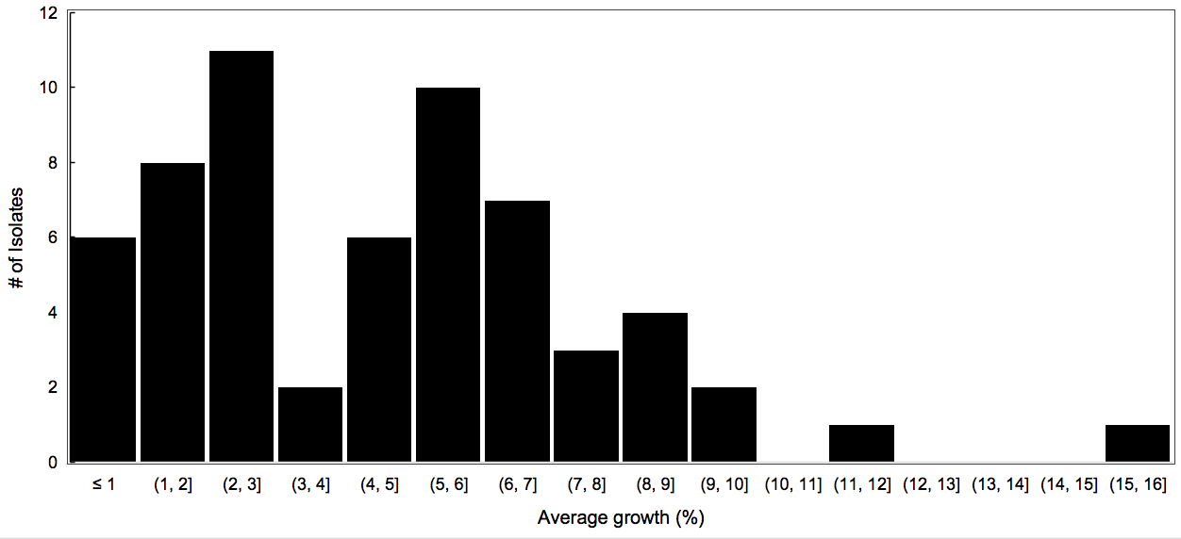

Figure 1.1. Average relative percent growth of 2021 Phytophthora nicotianae isolates on 100 µg/mL mefenoxam-amended media.

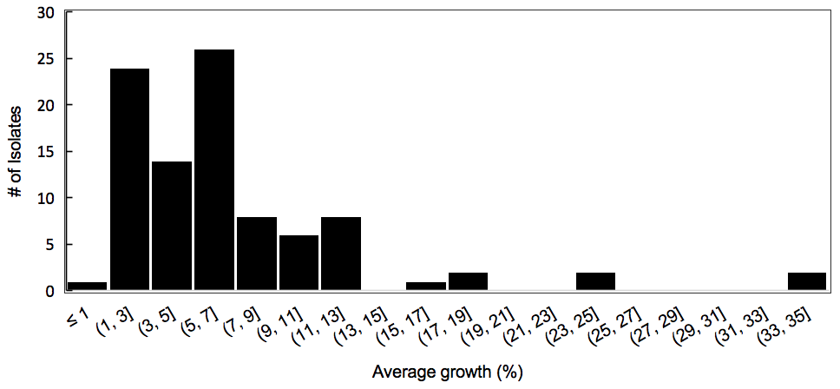

Figure 1.2. Average relative percent growth of 2022 Phytophthora nicotianae isolates on 100 µg/mL mefenoxam-amended media.

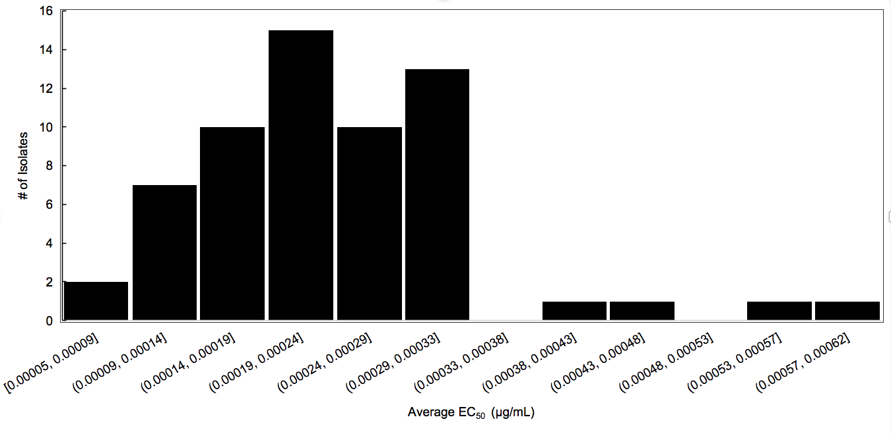

Figure 1.3. Average EC₅₀ of 2021 Phytophthora nicotianae isolates on oxathiapiprolin-amended media.

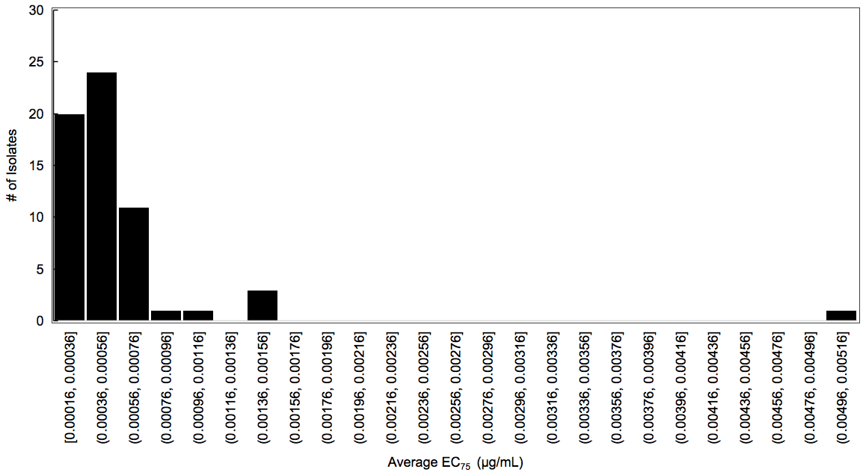

Figure 1.4. Average EC₇₅ of 2021 Phytophthora nicotianae isolates on oxathiapiprolin-amended media.

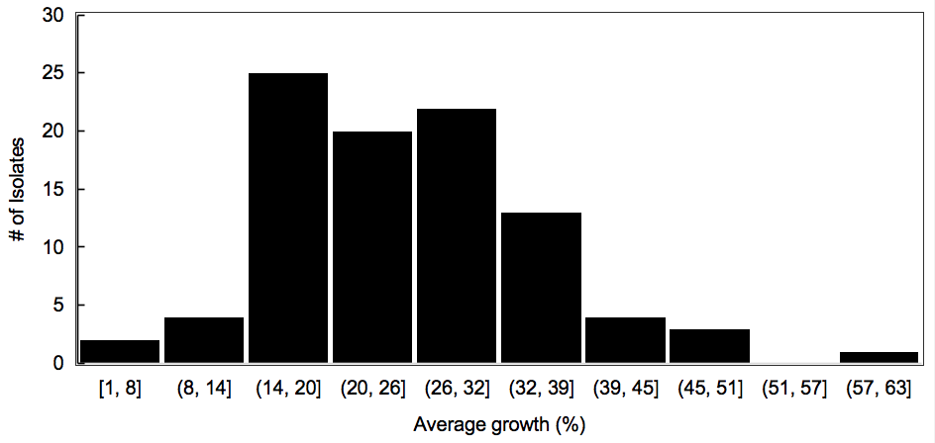

Figure 1.5. Average relative percent growth of 2022 Phytophthora nicotianae isolates on discriminatory dose of 0.00058 µg/mL oxathiapiprolin-amended media.

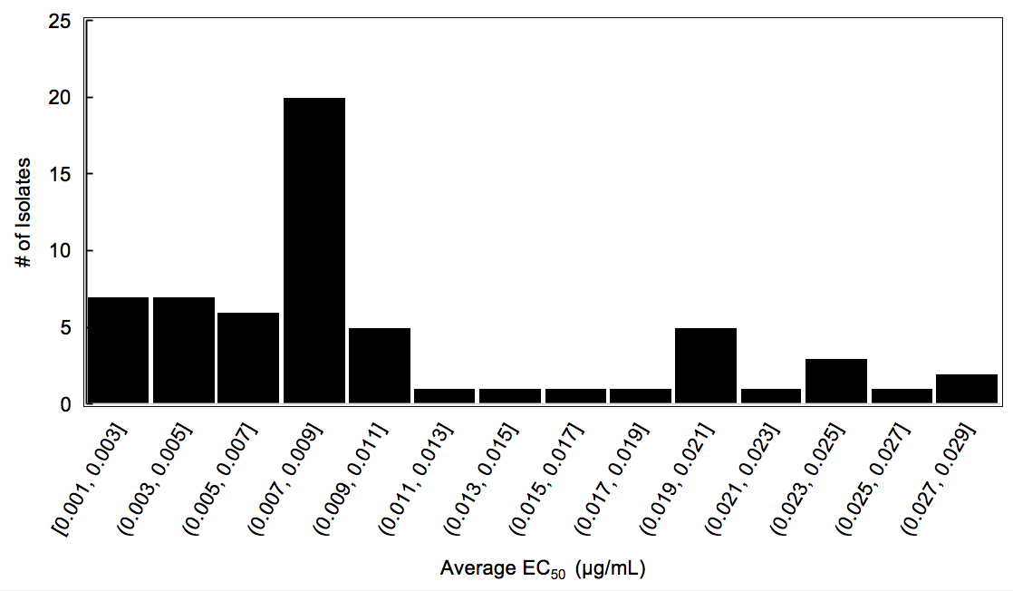

Figure 1.6. Average EC₅₀ of 2021 Phytophthora nicotianae isolates on mandipropamid-amended media.

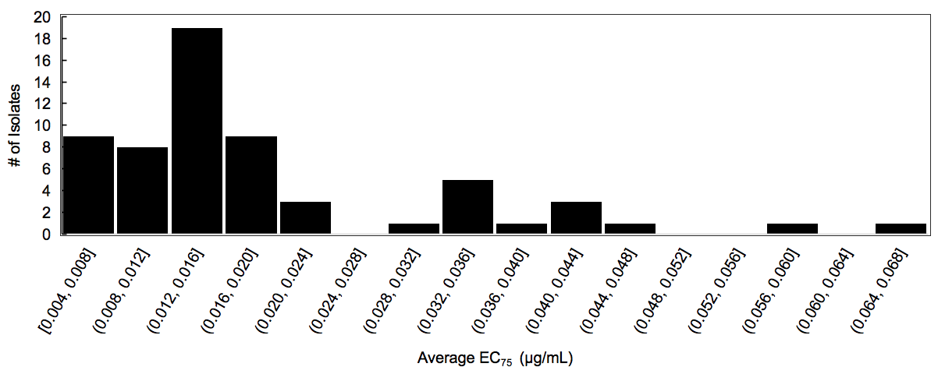

Figure 1.7. Average EC₇₅ of 2021 Phytophthora nicotianae isolates on mandipropamid-amended media.

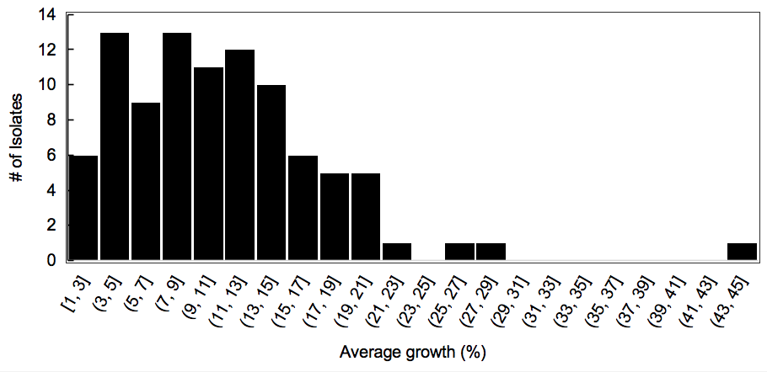

Figure 1.8. Average relative percent growth of 2022 Phytophthora nicotianae isolates on discriminatory dose of 0.019 µg/mL mandipropamid-amended media.

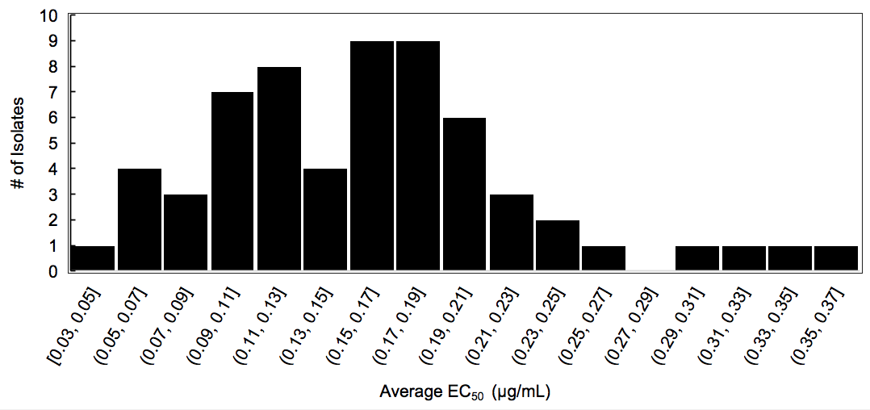

Figure 1.9. Average EC₅₀ of 2021 Phytophthora nicotianae isolates on fluopicolide-amended media.

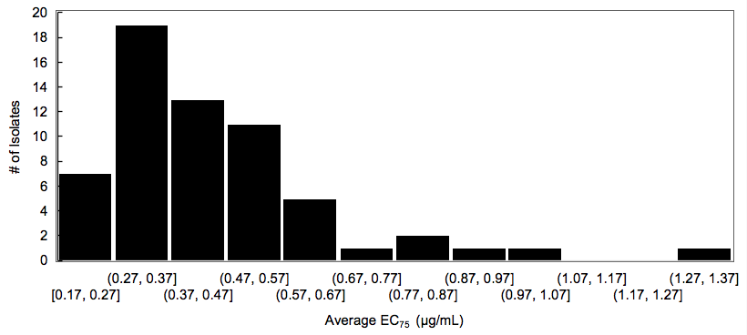

Figure 1.10. Average EC₇₅ of 2021 Phytophthora nicotianae isolates on fluopicolide-amended media.

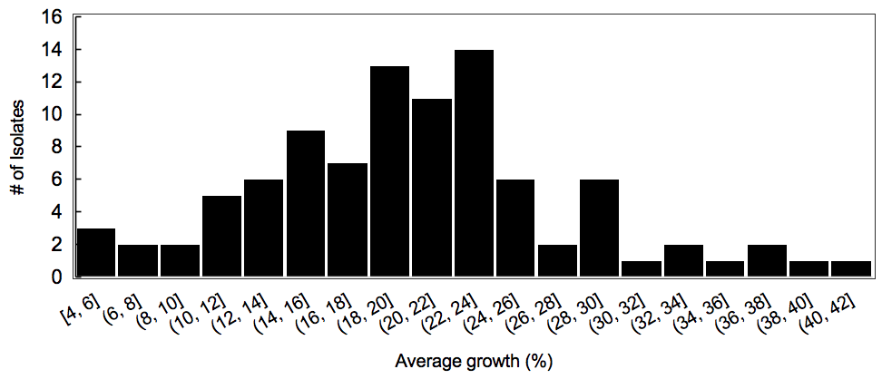

Figure 1.11. Average relative percent growth of 2022 Phytophthora nicotianae isolates on discriminatory dose of 0.44 µg/mL fluopicolide-amended media.

Supplementary Table 1. S1. 2021 Phytophthora nicotianae isolate data.
Isolate | Location (County) | Host | Variety | Collection Date
pntn21005 | Greene | Tobacco | TN90LC | 7/23/2021
pntn21012 | Greene | Tobacco | TN90LC | 7/23/2021
pntn21022 | Greene | Tobacco | TN90LC | 7/23/2021
pntn21029 | Greene | Tobacco | TN90LC | 7/23/2021
pntn21076 | Greene | Tobacco | ms KY14x18LC | 8/6/2021
pntn21077 | Greene | Tobacco | ms KY14x18LC | 8/6/2021
pntn21078 | Greene | Tobacco | ms KY14x18LC | 8/6/2021
pntn21084 | Greene | Tobacco | ms KY14x18LC | 8/6/2021
pntn21088 | Greene | Tobacco | ms KY14x18LC | 8/6/2021
pntn21089 | Greene | Tobacco | ms KY14x18LC | 8/6/2021
pntn21091 | Greene | Tobacco | ms KY14x18LC | 8/6/2021
pntn21094 | Greene | Tobacco | ms KY14x18LC | 8/6/2021
pntn21096 | Greene | Tobacco | ms KY14x18LC | 8/6/2021
pntn21098 | Greene | Tobacco | ms KY14x18LC | 8/6/2021
pntn21100 | Greene | Tobacco | ms KY14x18LC | 8/6/2021
pntn21103 | Greene | Tobacco | ms KY14x18LC | 8/6/2021
pntn21107 | Greene | Tobacco | ms KY14x18LC | 8/6/2021
pntn21109 | Greene | Tobacco | ms KY14x18LC | 8/6/2021
pntn21110 | Greene | Tobacco | ms KY14x18LC | 8/6/2021
pntn21112 | Greene | Tobacco | ms KY14x18LC | 8/6/2021
pntn21113 | Greene | Tobacco | ms KY14x18LC | 8/6/2021
pntn21115 | Greene | Tobacco | ms KY14x18LC | 8/6/2021
pntn21117 | Greene | Tobacco | ms KY14x18LC | 8/6/2021
pntn21118 | Greene | Tobacco | ms KY14x18LC | 8/6/2021
pntn21120 | Greene | Tobacco | ms KY14x18LC | 8/6/2021
pntn21122 | Greene | Tobacco | ms KY14x18LC | 8/6/2021
pntn21129 | Cheatham | Tobacco | TR Madole | 8/6/2021
pntn21132 | Cheatham | Tobacco | TR Madole | 8/6/2021
pntn21133 | Cheatham | Tobacco | TR Madole | 8/6/2021
pntn21138 | Cheatham | Tobacco | TR Madole | 8/6/2021
pntn21139 | Cheatham | Tobacco | TR Madole | 8/6/2021
pntn21140 | Cheatham | Tobacco | PD7313LC | 8/6/2021
pntn21145 | Cheatham | Tobacco | PD7313LC | 8/6/2021
pntn21161 | Robertson | Tobacco | DT558LC | 8/10/2021
Supplementary Table 1. S1 continued
Isolate | Location (County) | Host | Variety | Collection Date
pntn21162 | Robertson | Tobacco | DT558LC | 8/10/2021
pntn21164 | Robertson | Tobacco | DT558LC | 8/10/2021
pntn21165 | Robertson | Tobacco | DT558LC | 8/10/2021
pntn21167 | Robertson | Tobacco | DT558LC | 8/10/2021
pntn21176 | Robertson | Tobacco | DT558LC | 8/10/2021
pntn21177 | Robertson | Tobacco | DT558LC | 8/10/2021
pntn21182 | Robertson | Tobacco | DT558LC | 8/10/2021
pntn21183 | Robertson | Tobacco | DT558LC | 8/10/2021
pntn21191 | Robertson | Tobacco | C33 | 8/10/2021
pntn21192 | Robertson | Tobacco | C33 | 8/10/2021
pntn21197 | Robertson | Tobacco | C33 | 8/10/2021
pntn21199 | Robertson | Tobacco | C33 | 8/10/2021
pntn21200 | Robertson | Tobacco | C33 | 8/10/2021
pntn21201 | Robertson | Tobacco | C33 | 8/10/2021
pntn21203 | Robertson | Tobacco | C33 | 8/10/2021
pntn21207 | Robertson | Tobacco | C33 | 8/10/2021
pntn21252 | Loudon | Tomato | Super Sauce Hybrid | 7/21/2021
pntn21253 | Loudon | Tomato | Super Sauce Hybrid | 7/21/2021
pntn21254 | Loudon | Tomato | Super Sauce Hybrid | 7/21/2021
pntn21256 | Loudon | Tomato | German Queen | 7/21/2021
pntn21257 | Loudon | Tomato | German Queen | 7/21/2021
pntn21258 | Loudon | Tomato | Big Boy | 7/21/2021
pntn21259 | Loudon | Tomato | Big Boy | 7/21/2021
pntn21260 | Loudon | Tomato | Big Boy | 7/21/2021
pntn21262 | Loudon | Tomato | Big Boy | 7/21/2021
pntn21263 | Loudon | Tomato | Big Boy | 7/21/2021
pntn21265 | Loudon | Tomato | Big Boy | 7/21/2021

Supplementary Table 1. S2. 2022 Phytophthora nicotianae isolate data.
Isolate | Location (County) | Host | Variety | Collection Date
pntn22002 | Greene | Tobacco | TN90LC | 6/21/2022
pntn22003 | Greene | Tobacco | TN90LC | 6/21/2022
pntn22004 | Greene | Tobacco | TN97LC | 6/21/2022
pntn22011 | Greene | Tobacco | TN90LC | 6/21/2022
pntn22035 | Cheatham | Tobacco | PA Dark Air-Cured | 6/30/2022
pntn22036 | Cheatham | Tobacco | PA Dark Air-Cured | 6/30/2022
pntn22039 | Cheatham | Tobacco | PA Dark Air-Cured | 6/30/2022
pntn22049 | Greene | Tobacco | ms KY14x18LC | 7/11/2022
pntn22051 | Greene | Tobacco | ms KY14x18LC | 7/11/2022
pntn22052 | Greene | Tobacco | ms KY14x18LC | 7/11/2022
pntn22054 | Greene | Tobacco | ms KY14x18LC | 7/11/2022
pntn22057 | Greene | Tobacco | ms KY14x18LC | 7/11/2022
pntn22060 | Greene | Tobacco | ms KY14x18LC | 7/11/2022
pntn22063 | Greene | Tobacco | ms KY14x18LC | 7/11/2022
pntn22067 | Greene | Tobacco | ms KY14x18LC | 7/11/2022
pntn22073 | Greene | Tobacco | ms KY14x18LC | 7/11/2022
pntn22074 | Greene | Tobacco | ms KY14x18LC | 7/11/2022
pntn22075 | Greene | Tobacco | ms KY14x18LC | 7/11/2022
pntn22076 | Greene | Tobacco | ms KY14x18LC | 7/11/2022
pntn22077 | Greene | Tobacco | ms KY14x18LC | 7/11/2022
pntn22081 | Greene | Tobacco | ms KY14x18LC | 7/11/2022
pntn22088 | Greene | Tobacco | ms KY14x18LC | 7/11/2022
pntn22092 | Greene | Tobacco | ms KY14x18LC | 7/11/2022
pntn22096 | Greene | Tobacco | ms KY14x18LC | 7/11/2022
pntn22098 | Greene | Tobacco | ms KY14x18LC | 7/11/2022
pntn22099 | Greene | Tobacco | Hybrid 404LC | 7/11/2022
pntn22101 | Greene | Tobacco | Hybrid 404LC | 7/11/2022
pntn22103 | Greene | Tobacco | Hybrid 404LC | 7/11/2022
pntn22107 | Greene | Tobacco | Hybrid 404LC | 7/11/2022
pntn22109 | Greene | Tobacco | Hybrid 404LC | 7/11/2022
pntn22112 | Greene | Tobacco | Hybrid 404LC | 7/11/2022
pntn22123 | Greene | Tobacco | Hybrid 404LC | 7/11/2022
pntn22144 | Greene | Tobacco | Hybrid 404LC | 7/11/2022
Supplementary Table 1. S2. continued
Isolate | Location (County) | Host | Variety | Collection Date
pntn22152 | Greene | Tobacco | TN90LC | 7/11/2022
pntn22165 | Greene | Tobacco | TN97LC | 7/11/2022
pntn22166 | Greene | Tobacco | TN97LC | 7/11/2022
pntn22168 | Greene | Tobacco | TN90LC | 7/11/2022
pntn22184 | Montgomery | Tobacco | PD7305LC | 7/12/2022
pntn22201 | Montgomery | Tobacco | D17LC | 7/12/2022
pntn22218 | Montgomery | Tobacco | D17LC | 7/12/2022
pntn22226 | Marshall | Tomato | - | 7/19/2022
pntn22227 | Greene | Tobacco | ms KY14x18LC | 7/25/2022
pntn22228 | Greene | Tobacco | ms KY14x18LC | 7/25/2022
pntn22229 | Greene | Tobacco | ms KY14x18LC | 7/25/2022
pntn22231 | Greene | Tobacco | ms KY14x18LC | 7/25/2022
pntn22232 | Greene | Tobacco | ms KY14x18LC | 7/25/2022
pntn22233 | Greene | Tobacco | KT215LC | 7/25/2022
pntn22238 | Greene | Tobacco | KT215LC | 7/25/2022
pntn22241 | Greene | Tobacco | KT215LC | 7/25/2022
pntn22243 | Greene | Tobacco | KT215LC | 7/25/2022
pntn22245 | Greene | Tobacco | KT215LC | 7/25/2022
pntn22246 | Greene | Tobacco | KT215LC | 7/25/2022
pntn22247 | Robertson | Tobacco | ms KY14x18LC | 8/2/2022
pntn22248 | Robertson | Tobacco | ms KY14x18LC | 8/2/2022
pntn22249 | Robertson | Tobacco | ms KY14x18LC | 8/2/2022
pntn22251 | Robertson | Tobacco | experimental variety | 8/2/2022
pntn22252 | Robertson | Tobacco | experimental variety | 8/2/2022
pntn22253 | Robertson | Tobacco | experimental variety | 8/2/2022
pntn22254 | Robertson | Tobacco | experimental variety | 8/2/2022
pntn22258 | Robertson | Tobacco | ms KY14x18LC | 8/2/2022
pntn22260 | Robertson | Tobacco | ms KY14x18LC | 8/2/2022
pntn22261 | Robertson | Tobacco | ms KY14x18LC | 8/2/2022
pntn22263 | Robertson | Tobacco | unknown | 8/2/2022
pntn22264 | Robertson | Tobacco | unknown | 8/2/2022
pntn22265 | Robertson | Tobacco | unknown | 8/2/2022
pntn22268 | Robertson | Tobacco | unknown | 8/2/2022
Supplementary Table 1. S2. continued
Isolate | Location (County) | Host | Variety | Collection Date
pntn22271 | Robertson | Tobacco | unknown | 8/2/2022
pntn22273 | Robertson | Tobacco | ms KY14x18LC | 8/2/2022
pntn22274 | Robertson | Tobacco | ms KY14x18LC | 8/2/2022
pntn22275 | Robertson | Tobacco | ms KY14x18LC | 8/2/2022
pntn22276 | Robertson | Tobacco | ms KY14x18LC | 8/2/2022
pntn22277 | Robertson | Tobacco | ms KY14x18LC | 8/2/2022
pntn22280 | Robertson | Tobacco | KT206LC | 8/2/2022
pntn22281 | Robertson | Tobacco | KT206LC | 8/2/2022
pntn22282 | Robertson | Tobacco | KT206LC | 8/2/2022
pntn22283 | Robertson | Tobacco | KT206LC | 8/2/2022
pntn22287 | Robertson | Tobacco | ms KY14x18LC | 8/2/2022
pntn22288 | Robertson | Tobacco | ms KY14x18LC | 8/2/2022
pntn22307 | Caswell County, NC | Tobacco | GL365LC | 8/10/2022
pntn22309 | Caswell County, NC | Tobacco | CC603LC | 8/10/2022
pntn22310 | Caswell County, NC | Tobacco | CC603LC | 8/10/2022
pntn22311 | Caswell County, NC | Tobacco | CC603LC | 8/10/2022
pntn22312 | Rockingham County, NC | Tobacco | GL365LC | 8/15/2022
pntn22313 | Rockingham County, NC | Tobacco | GL365LC | 8/15/2022
pntn22321 | Johnston County, NC | Tobacco | NC196LC | 8/15/2022
pntn22329 | Johnston County, NC | Tobacco | PVH2254LC | 8/15/2022
pntn22333 | Johnston County, NC | Tobacco | CC143LC | 8/15/2022
pntn22334 | Johnston County, NC | Tobacco | CC143LC | 8/15/2022
pntn22336 | Sampson County, NC | Tobacco | K326LC | 8/15/2022
pntn22337 | Sampson County, NC | Tobacco | K326LC | 8/15/2022
pntn22339 | Cheatham | Tobacco | DT558LC | 9/2/2022
pntn22340 | Cheatham | Tobacco | DT558LC | 9/2/2022
pntn22342 | Cheatham | Tobacco | TN90LC | 9/2/2022
pntn22343 | Cheatham | Tobacco | PD7309LC | 9/2/2022

Supplementary Table 1. S3. 2021 Phytophthora nicotianae fungicide sensitivity data (Average growth for mefenoxam; average EC₅₀ & EC₇₅ for oxathiapiprolin, mandipropamid, & fluopicolide)
 |  |  | Mefenoxam |  |  |  |  | Oxathiapiprolin |  |  |  |  |  |  | Mandipropamid |  |  |  |  |  |  |  | Fluopicolide
Isolate | Growth (%) |  |  | SD (%) |  |  | EC₅₀ (µg/ml) |  |  | SD (µg/ml) |  | EC₇₅ (µg/ml) |  | SD (µg/ml) |  | EC₅₀ (µg/ml) |  | SD (µg/ml) |  | EC₇₅ (µg/ml) | SD (µg/ml) | EC₅₀ (µg/ml) | SD (µg/ml) | EC₇₅ (µg/ml) | SD (µg/ml)
pntn21005 | 10 |  |  | 1 |  |  | 0.00026 |  |  | 0.00009 |  | 0.00058 |  | 0.00020 |  | 0.004 |  | 0.005 |  | 0.006 | 0.009 | 0.03 | 0.01 | 0.97 | 0.05
pntn21012 | 8 |  |  | 1 |  |  | 0.00005 |  |  | 0.00003 |  | 0.00016 |  | 0.00010 |  | 0.002 |  | 0.003 |  | 0.004 | 0.006 | 0.06 | 0.03 | 0.37 | 0.22
pntn21022 | 4 |  |  | 2 |  |  | 0.00023 |  |  | 0.00012 |  | 0.00042 |  | 0.00023 |  | 0.028 |  | 0.029 |  | 0.020 | 0.013 | 0.06 | 0.08 | 0.79 | 0.38
pntn21029 | 11 |  |  | 7 |  |  | 0.00020 |  |  | 0.00000 |  | 0.00041 |  | 0.00013 |  | 0.001 |  | 0.002 |  | 0.004 | 0.005 | 0.06 | 0.03 | 0.23 | 0.02
pntn21076 | 7 |  |  | 3 |  |  | 0.00028 |  |  | 0.00009 |  | 0.00051 |  | 0.00015 |  | 0.003 |  | 0.004 |  | 0.007 | 0.007 | 0.07 | 0.04 | 0.23 | 0.10
pntn21077 | 6 |  |  | 8 |  |  | 0.00023 |  |  | 0.00000 |  | 0.00033 |  | 0.00008 |  | 0.003 |  | 0.005 |  | 0.006 | 0.009 | 0.08 | 0.10 | 0.27 | 0.01
pntn21078 | 6 |  |  | 5 |  |  | 0.00029 |  |  | 0.00001 |  | 0.00055 |  | 0.00002 |  | 0.003 |  | 0.004 |  | 0.006 | 0.009 | 0.08 | 0.06 | 0.19 | 0.10
pntn21084 | 9 |  |  | 8 |  |  | 0.00016 |  |  | 0.00018 |  | 0.00097 |  | 0.00059 |  | 0.004 |  | 0.005 |  | 0.008 | 0.009 | 0.08 | 0.01 | 0.23 | 0.05
pntn21088 | 5 |  |  | 6 |  |  | 0.00017 |  |  | 0.00003 |  | 0.00059 |  | 0.00035 |  | 0.005 |  | 0.007 |  | 0.007 | 0.009 | 0.09 | 0.11 | 0.78 | 0.04
pntn21089 | 8 |  |  | 4 |  |  | 0.00011 |  |  | 0.00002 |  | 0.00034 |  | 0.00009 |  | 0.003 |  | 0.002 |  | 0.008 | 0.003 | 0.10 | 0.07 | 0.28 | 0.12
pntn21091 | 8 |  |  | 1 |  |  | 0.00014 |  |  | 0.00001 |  | 0.00042 |  | 0.00011 |  | 0.004 |  | 0.005 |  | 0.008 | 0.010 | 0.10 | 0.07 | 0.30 | 0.12
pntn21094 | 7 |  |  | 10 |  |  | 0.00015 |  |  | 0.00007 |  | 0.00057 |  | 0.00029 |  | 0.003 |  | 0.003 |  | 0.005 | 0.006 | 0.10 | 0.13 | 0.75 | 0.22
pntn21096 | 7 |  |  | 1 |  |  | 0.00024 |  |  | 0.00015 |  | 0.00050 |  | 0.00020 |  | 0.004 |  | 0.006 |  | 0.008 | 0.010 | 0.10 | 0.07 | 0.52 | 0.22
pntn21098 | 7 |  |  | 4 |  |  | 0.00017 |  |  | 0.00006 |  | 0.00050 |  | 0.00007 |  | 0.008 |  | 0.003 |  | 0.018 | 0.003 | 0.11 | 0.03 | 0.43 | 0.05
pntn21100 | 9 |  |  | 4 |  |  | 0.00010 |  |  | 0.00010 |  | 0.00032 |  | 0.00016 |  | 0.010 |  | 0.003 |  | 0.017 | 0.003 | 0.11 | 0.02 | 0.33 | 0.14
pntn21103 | 2 |  |  | 2 |  |  | 0.00020 |  |  | 0.00008 |  | 0.00050 |  | 0.00013 |  | 0.009 |  | 0.003 |  | 0.018 | 0.003 | 0.11 | 0.10 | 0.29 | 0.22
pntn21107 | 3 |  |  | 1 |  |  | 0.00021 |  |  | 0.00003 |  | 0.00041 |  | 0.00004 |  | 0.009 |  | 0.001 |  | 0.016 | 0.004 | 0.11 | 0.07 | 0.38 | 0.14
pntn21109 | 10 |  |  | 4 |  |  | 0.00019 |  |  | 0.00004 |  | 0.00043 |  | 0.00008 |  | 0.009 |  | 0.004 |  | 0.016 | 0.006 | 0.11 | 0.15 | 0.27 | 0.14
pntn21110 | 4 |  |  | 2 |  |  | 0.00031 |  |  | 0.00014 |  | 0.00047 |  | 0.00019 |  | 0.010 |  | 0.002 |  | 0.015 | 0.002 | 0.13 | 0.01 | 0.33 | 0.25
pntn21112 | 7 |  |  | 1 |  |  | 0.00012 |  |  | 0.00016 |  | 0.00026 |  | 0.00020 |  | 0.006 |  | 0.002 |  | 0.015 | 0.005 | 0.13 | 0.10 | 0.56 | 0.01
pntn21113 | 8 |  |  | 3 |  |  | 0.00011 |  |  | 0.00011 |  | 0.00031 |  | 0.00017 |  | 0.008 |  | 0.002 |  | 0.016 | 0.003 | 0.13 | 0.10 | 0.48 | 0.06
pntn21115 | 6 |  |  | 3 |  |  | 0.00007 |  |  | 0.00006 |  | 0.00031 |  | 0.00004 |  | 0.009 |  | 0.003 |  | 0.022 | 0.013 | 0.13 | 0.07 | 0.65 | 0.09
pntn21117 | 11 |  |  | 5 |  |  | 0.00019 |  |  | 0.00000 |  | 0.00037 |  | 0.00003 |  | 0.007 |  | 0.006 |  | 0.014 | 0.009 | 0.13 | 0.11 | 0.64 | 0.08
pntn21118 | 6 |  |  | 6 |  |  | 0.00017 |  |  | 0.00010 |  | 0.00034 |  | 0.00007 |  | 0.009 |  | 0.002 |  | 0.016 | 0.004 | 0.13 | 0.08 | 0.58 | 0.09
pntn21120 | 4 |  |  | 0 |  |  | 0.00020 |  |  | 0.00007 |  | 0.00036 |  | 0.00007 |  | 0.009 |  | 0.003 |  | 0.018 | 0.008 | 0.14 | 0.01 | 0.48 | 0.16
pntn21122 | 3 |  |  | 3 |  |  | 0.00013 |  |  | 0.00017 |  | 0.00028 |  | 0.00028 |  | 0.009 |  | 0.003 |  | 0.015 | 0.003 | 0.15 | 0.00 | 0.51 | 0.19
pntn21129 | 13 |  |  | 4 |  |  | 0.00029 |  |  | 0.00013 |  | 0.00049 |  | 0.00013 |  | 0.006 |  | 0.004 |  | 0.010 | 0.003 | 0.15 | 0.11 | 0.56 | 0.27
pntn21132 | 3 |  |  | 5 |  |  | 0.00023 |  |  | 0.00002 |  | 0.00040 |  | 0.00014 |  | 0.008 |  | 0.005 |  | 0.013 | 0.006 | 0.16 | 0.00 | 0.37 | 0.25
pntn21133 | 5 |  |  | 3 |  |  | 0.00017 |  |  | 0.00015 |  | 0.00034 |  | 0.00000 |  | 0.013 |  | 0.003 |  | 0.018 | 0.001 | 0.16 | 0.06 | 0.37 | 0.26
pntn21138 | 7 |  |  | 1 |  |  | 0.00019 |  |  | 0.00024 |  | 0.00042 |  | 0.00006 |  | 0.012 |  | 0.004 |  | 0.021 | 0.008 | 0.16 | 0.09 | 0.40 | 0.27
pntn21139 | 11 |  |  | 6 |  |  | 0.00014 |  |  | 0.00000 |  | 0.00048 |  | 0.00022 |  | 0.009 |  | 0.000 |  | 0.015 | 0.001 | 0.16 | 0.16 | 0.55 | 0.53
Supplementary Table 1. S3. 2021 continued

 |  |  | Mefenoxam |  |  |  |  | Oxathiapiprolin |  |  |  |  |  |  | Mandipropamid |  |  |  |  |  |  |  | Fluopicolide
Isolate |  | Growth (%) |  |  | SD (%) | EC₅₀ (µg/ml) |  |  | SD (µg/ml) |  | EC₇₅ (µg/ml) |  | SD (µg/ml) |  | EC₅₀ (µg/ml) |  | SD (µg/ml) |  | EC₇₅ (µg/ml) |  | SD (µg/ml) | EC₅₀ (µg/ml) | SD (µg/ml) | EC₇₅ (µg/ml) | SD (µg/ml)
pntn21140 |  | 3 |  |  | 1 | 0.00019 |  |  | 0.00012 |  | 0.00032 |  | 0.00012 |  | 0.010 |  | 0.004 |  | 0.016 |  | 0.003 | 0.16 | 0.02 | 0.56 | 0.23
pntn21145 |  | 6 |  |  | 8 | 0.00024 |  |  | 0.00006 |  | 0.00039 |  | 0.00010 |  | 0.008 |  | 0.003 |  | 0.012 |  | 0.001 | 0.17 | 0.14 | 0.34 | 0.04
pntn21161 |  | 9 |  |  | 7 | 0.00017 |  |  | 0.00010 |  | 0.00031 |  | 0.00014 |  | 0.008 |  | 0.001 |  | 0.013 |  | 0.003 | 0.17 | 0.00 | 0.92 | 0.62
pntn21162 |  | 3 |  |  | 1 | 0.00024 |  |  | 0.00004 |  | 0.00031 |  | 0.00006 |  | 0.003 |  | 0.004 |  | 0.006 |  | 0.008 | 0.17 | 0.01 | 0.27 | 0.01
pntn21164 |  | 5 |  |  | 2 | 0.00013 |  |  | 0.00004 |  | 0.00034 |  | 0.00001 |  | 0.008 |  | 0.002 |  | 0.013 |  | 0.000 | 0.17 | 0.05 | 1.29 | 1.05
pntn21165 |  | 8 |  |  | 7 | 0.00019 |  |  | 0.00002 |  | 0.00033 |  | 0.00001 |  | 0.008 |  | 0.003 |  | 0.015 |  | 0.005 | 0.18 | 0.07 | 0.30 | 0.22
pntn21167 |  | 11 |  |  | 4 | 0.00021 |  |  | 0.00013 |  | 0.00039 |  | 0.00006 |  | 0.007 |  | 0.004 |  | 0.011 |  | 0.005 | 0.18 | 0.02 | 0.30 | 0.16
pntn21176 |  | 2 |  |  | 1 | 0.00020 |  |  | 0.00001 |  | 0.00030 |  | 0.00006 |  | 0.008 |  | 0.005 |  | 0.015 |  | 0.009 | 0.18 | 0.05 | 0.29 | 0.01
pntn21177 |  | 9 |  |  | 2 | 0.00015 |  |  | 0.00001 |  | 0.00033 |  | 0.00002 |  | 0.008 |  | 0.001 |  | 0.012 |  | 0.003 | 0.18 | 0.04 | 0.17 | 0.02
pntn21182 |  | 11 |  |  | 5 | 0.00023 |  |  | 0.00005 |  | 0.00034 |  | 0.00003 |  | 0.008 |  | 0.001 |  | 0.013 |  | 0.003 | 0.18 | 0.08 | 0.60 | 0.09
pntn21183 |  | 9 |  |  | 4 | 0.00021 |  |  | 0.00012 |  | 0.00031 |  | 0.00010 |  | 0.006 |  | 0.003 |  | 0.010 |  | 0.007 | 0.19 | 0.03 | 0.53 | 0.15
pntn21191 |  | 12 |  |  | 1 | 0.00027 |  |  | 0.00011 |  | 0.00067 |  | 0.00033 |  | 0.025 |  | 0.015 |  | 0.067 |  | 0.057 | 0.19 | 0.10 | 0.67 | 0.18
pntn21192 |  | 6 |  |  | 6 | 0.00032 |  |  | 0.00004 |  | 0.00050 |  | 0.00018 |  | 0.010 |  | 0.003 |  | 0.016 |  | 0.006 | 0.19 | 0.16 | 0.39 | 0.04
pntn21197 |  | 7 |  |  | 3 | 0.00054 |  |  | 0.00013 |  | 0.00095 |  | 0.00020 |  | 0.005 |  | 0.003 |  | 0.010 |  | 0.006 | 0.19 | 0.05 | 0.47 | 0.30
pntn21199 |  | 7 |  |  | 3 | 0.00031 |  |  | 0.00013 |  | 0.00074 |  | 0.00005 |  | 0.026 |  | 0.013 |  | 0.060 |  | 0.012 | 0.19 | 0.12 | 0.37 | 0.05
pntn21200 |  | 3 |  |  | 1 | 0.00031 |  |  | 0.00007 |  | 0.00047 |  | 0.00004 |  | 0.009 |  | 0.001 |  | 0.014 |  | 0.003 | 0.20 | 0.02 | 0.44 | 0.16
pntn21201 |  | 8 |  |  | 8 | 0.00027 |  |  | 0.00001 |  | 0.00040 |  | 0.00006 |  | 0.009 |  | 0.004 |  | 0.014 |  | 0.003 | 0.20 | 0.01 | 0.50 | 0.30
pntn21203 |  | 5 |  |  | 0 | 0.00032 |  |  | 0.00000 |  | 0.00051 |  | 0.00004 |  | 0.007 |  | 0.004 |  | 0.012 |  | 0.007 | 0.20 | 0.01 | 0.32 | 0.08
pntn21207 |  | 4 |  |  | 0 | 0.00026 |  |  | 0.00010 |  | 0.00040 |  | 0.00001 |  | 0.009 |  | 0.004 |  | 0.015 |  | 0.008 | 0.21 | 0.02 | 0.35 | 0.10
pntn21252 |  | 3 |  |  | 1 | 0.00062 |  |  | 0.00038 |  | 0.00511 |  | 0.00610 |  | 0.018 |  | 0.004 |  | 0.031 |  | 0.006 | 0.21 | 0.01 | 0.38 | 0.06
pntn21253 |  | 2 |  |  | 2 | 0.00040 |  |  | 0.00009 |  | 0.00137 |  | 0.00104 |  | 0.017 |  | 0.003 |  | 0.032 |  | 0.002 | 0.22 | 0.02 | 0.31 | 0.21
pntn21254 |  | 4 |  |  | 1 | 0.00044 |  |  | 0.00011 |  | 0.00137 |  | 0.00099 |  | 0.021 |  | 0.004 |  | 0.033 |  | 0.005 | 0.22 | 0.01 | 0.26 | 0.17
pntn21256 |  | 3 |  |  | 3 | 0.00030 |  |  | 0.00008 |  | 0.00149 |  | 0.00115 |  | 0.024 |  | 0.001 |  | 0.043 |  | 0.002 | 0.23 | 0.00 | 0.32 | 0.06
pntn21257 |  | 2 |  |  | 2 | 0.00033 |  |  | 0.00010 |  | 0.00070 |  | 0.00001 |  | 0.023 |  | 0.000 |  | 0.043 |  | 0.006 | 0.24 | 0.00 | 0.44 | 0.03
pntn21258 |  | 2 |  |  | 1 | 0.00030 |  |  | 0.00003 |  | 0.00063 |  | 0.00003 |  | 0.020 |  | 0.004 |  | 0.032 |  | 0.007 | 0.25 | 0.14 | 0.40 | 0.02
pntn21259 |  | 1 |  |  | 0 | 0.00032 |  |  | 0.00001 |  | 0.00056 |  | 0.00002 |  | 0.021 |  | 0.001 |  | 0.035 |  | 0.000 | 0.26 | 0.04 | 0.27 | 0.12
pntn21260 |  | 3 |  |  | 4 | 0.00029 |  |  | 0.00006 |  | 0.00061 |  | 0.00009 |  | 0.021 |  | 0.000 |  | 0.041 |  | 0.008 | 0.30 | 0.02 | 0.31 | 0.12
pntn21262 |  | 7 |  |  | 3 | 0.00031 |  |  | 0.00004 |  | 0.00063 |  | 0.00011 |  | 0.028 |  | 0.009 |  | 0.047 |  | 0.011 | 0.33 | 0.12 | 0.27 | 0.06
pntn21263 |  | 2 |  |  | 2 | 0.00024 |  |  | 0.00009 |  | 0.00075 |  | 0.00012 |  | 0.024 |  | 0.004 |  | 0.038 |  | 0.005 | 0.34 | 0.23 | 0.29 | 0.14
pntn21265 |  | 3 |  |  | 5 | 0.00028 |  |  | 0.00002 |  | 0.00059 |  | 0.00001 |  | 0.019 |  | 0.001 |  | 0.033 |  | 0.000 | 0.36 | 0.22 | 0.39 | 0.33

Supplementary Table 1. S4. 2022 Phytophthora nicotianae fungicide sensitivity data
 | Mefenoxam^{z} |  | Oxathiapiprolin^{y} |  | Mandipropamid^{x} |  | Fluopicolide^{w}
Isolate ID | AVG Growth (%) | SD (%) | AVG Growth (%) | SD (µg/ml) | AVG Growth (%) | SD (µg/ml) | AVG Growth (%) | SD (µg/ml)
pntn22002 | 12 | 11 | 34 | 14 | 11 | 1 | 16 | 7
pntn22003 | 11 | 12 | 37 | 16 | 7 | 6 | 21 | 8
pntn22004 | 12 | 7 | 35 | 0 | 12 | 9 | 20 | 3
pntn22011 | 8 | 5 | 42 | 9 | 17 | 7 | 19 | 6
pntn22035 | 4 | 3 | 50 | 36 | 8 | 4 | 12 | 1
pntn22036 | 3 | 2 | 47 | 26 | 3 | 2 | 11 | 2
pntn22039 | 6 | 7 | 27 | 11 | 4 | 5 | 20 | 12
pntn22049 | 6 | 1 | 35 | 19 | 13 | 4 | 17 | 7
pntn22051 | 1 | 1 | 24 | 8 | 10 | 6 | 13 | 5
pntn22052 | 10 | 12 | 20 | 0 | 20 | 5 | 15 | 11
pntn22054 | 6 | 6 | 19 | 3 | 6 | 6 | 13 | 4
pntn22057 | 7 | 3 | 21 | 12 | 7 | 9 | 20 | 5
pntn22060 | 6 | 1 | 14 | 5 | 17 | 4 | 29 | 0
pntn22063 | 12 | 8 | 20 | 7 | 15 | 8 | 27 | 2
pntn22067 | 4 | 3 | 19 | 4 | 9 | 4 | 23 | 5
pntn22073 | 7 | 1 | 14 | 5 | 9 | 5 | 24 | 13
pntn22074 | 34 | 41 | 29 | 16 | 14 | 6 | 27 | 12
pntn22075 | 5 | 3 | 19 | 2 | 10 | 2 | 18 | 5
pntn22076 | 10 | 10 | 16 | 13 | 3 | 4 | 18 | 6
pntn22077 | 1 | 0 | 16 | 1 | 8 | 5 | 20 | 5
pntn22081 | 17 | 18 | 18 | 1 | 14 | 13 | 15 | 10
pntn22088 | 2 | 2 | 16 | 1 | 15 | 0 | 22 | 4
pntn22092 | 2 | 0 | 19 | 6 | 8 | 6 | 20 | 21
pntn22096 | 23 | 13 | 20 | 10 | 10 | 3 | 20 | 16
pntn22098 | 2 | 3 | 16 | 3 | 10 | 2 | 23 | 21
pntn22099 | 9 | 8 | 27 | 8 | 22 | 1 | 19 | 6
pntn22101 | 1 | 0 | 15 | 1 | 15 | 5 | 20 | 3
pntn22103 | 6 | 2 | 13 | 3 | 7 | 7 | 18 | 15
pntn22107 | 3 | 0 | 16 | 1 | 17 | 8 | 22 | 14
pntn22109 | 8 | 8 | 25 | 0 | 13 | 4 | 24 | 20
pntn22112 | 5 | 3 | 28 | 12 | 16 | 1 | 24 | 19
pntn22123 | 4 | 2 | 25 | 4 | 13 | 8 | 25 | 22
pntn22144 | 2 | 1 | 34 | 13 | 4 | 4 | 21 | 15
pntn22152 | 2 | 2 | 27 | 3 | 11 | 14 | 23 | 19
pntn22165 | 6 | 3 | 20 | 1 | 15 | 11 | 18 | 12
Supplementary Table 1. S4. 2022 continued
 | Mefenoxam^{z} |  | Oxathiapiprolin^{y} |  | Mandipropamid^{x} |  | Fluopicolide^{w}
Isolate ID | AVG Growth (%) | SD (%) | AVG Growth (%) | SD (µg/ml) | AVG Growth (%) | SD (µg/ml) | AVG Growth (%) | SD (µg/ml)
pntn22166 | 5 | 3 | 27 | 8 | 13 | 7 | 24 | 10
pntn22168 | 12 | 11 | 27 | 0 | 7 | 5 | 21 | 10
pntn22184 | 11 | 12 | 19 | 5 | 11 | 13 | 14 | 3
pntn22201 | 12 | 7 | 18 | 0 | 12 | 3 | 30 | 8
pntn22218 | 8 | 5 | 20 | 3 | 4 | 3 | 35 | 9
pntn22226 | 4 | 3 | 63 | 10 | 44 | 1 | 22 | 10
pntn22227 | 3 | 2 | 28 | 9 | 19 | 19 | 40 | 11
pntn22228 | 6 | 7 | 30 | 7 | 5 | 6 | 20 | 1
pntn22229 | 6 | 1 | 33 | 10 | 5 | 5 | 22 | 9
pntn22231 | 1 | 1 | 27 | 6 | 10 | 1 | 19 | 9
pntn22232 | 10 | 12 | 18 | 1 | 11 | 3 | 30 | 23
pntn22233 | 6 | 6 | 17 | 6 | 10 | 8 | 26 | 16
pntn22238 | 7 | 3 | 14 | 1 | 8 | 4 | 29 | 33
pntn22241 | 6 | 1 | 17 | 0 | 14 | 9 | 37 | 33
pntn22243 | 12 | 8 | 22 | 8 | 8 | 6 | 30 | 17
pntn22245 | 4 | 3 | 19 | 1 | 12 | 9 | 38 | 20
pntn22246 | 7 | 1 | 27 | 0 | 25 | 17 | 34 | 15
pntn22247 | 34 | 41 | 44 | 24 | 19 | 3 | 22 | 16
pntn22248 | 5 | 3 | 27 | 20 | 12 | 13 | 29 | 24
pntn22249 | 10 | 10 | 38 | 5 | 4 | 3 | 16 | 6
pntn22251 | 1 | 0 | 37 | 18 | 10 | 7 | 21 | 9
pntn22252 | 17 | 18 | 35 | 7 | 6 | 7 | 16 | 9
pntn22253 | 2 | 2 | 25 | 13 | 3 | 1 | 21 | 1
pntn22254 | 2 | 0 | 35 | 2 | 4 | 4 | 19 | 12
pntn22258 | 23 | 13 | 27 | 16 | 2 | 0 | 8 | 9
pntn22260 | 2 | 3 | 32 | 17 | 4 | 1 | 11 | 9
pntn22261 | 9 | 8 | 25 | 13 | 5 | 4 | 16 | 11
pntn22263 | 1 | 0 | 31 | 19 | 3 | 2 | 17 | 8
pntn22264 | 6 | 2 | 30 | 10 | 14 | 9 | 23 | 4
pntn22258 | 23 | 13 | 27 | 16 | 2 | 0 | 8 | 9
pntn22260 | 2 | 3 | 32 | 17 | 4 | 1 | 11 | 9
pntn22261 | 9 | 8 | 25 | 13 | 5 | 4 | 16 | 11
pntn22263 | 1 | 0 | 31 | 19 | 3 | 2 | 17 | 8
pntn22264 | 6 | 2 | 30 | 10 | 14 | 9 | 23 | 4
pntn22265 | 5 | 1 | 36 | 8 | 13 | 2 | 33 | 1
pntn22268 | 3 | 0 | 25 | 2 | 3 | 4 | 25 | 11
Supplementary Table 1. S4. continued
 | Mefenoxam^{z} |  | Oxathiapiprolin^{y} |  | Mandipropamid^{x} |  | Fluopicolide^{w}
Isolate ID | AVG Growth (%) | SD (%) | AVG Growth (%) | SD (µg/ml) | AVG Growth (%) | SD (µg/ml) | AVG Growth (%) | SD (µg/ml)
pntn22271 | 8 | 8 | 29 | 11 | 3 | 0 | 25 | 2
pntn22273 | 5 | 3 | 30 | 4 | 11 | 12 | 30 | 4
pntn22274 | 16 | 6 | 29 | 4 | 3 | 1 | 23 | 15
pntn22275 | 8 | 3 | 27 | 6 | 7 | 6 | 23 | 5
pntn22276 | 8 | 3 | 19 | 10 | 6 | 8 | 14 | 5
pntn22277 | 6 | 2 | 39 | 11 | 2 | 1 | 17 | 4
pntn22280 | 6 | 7 | 22 | 1 | 12 | 14 | 23 | 10
pntn22281 | 4 | 1 | 24 | 6 | 6 | 4 | 16 | 5
pntn22282 | 5 | 6 | 32 | 4 | 3 | 2 | 12 | 6
pntn22283 | 7 | 3 | 25 | 6 | 20 | 14 | 42 | 7
pntn22287 | 3 | 1 | 45 | 11 | 1 | 1 | 10 | 6
pntn22288 | 3 | 2 | 21 | 7 | 1 | 1 | 25 | 20
pntn22307 | 1 | 0 | 20 | 6 | 17 | 10 | 22 | 4
pntn22309 | 2 | 2 | 19 | 0 | 18 | 7 | 14 | 7
pntn22310 | 6 | 4 | 21 | 6 | 15 | 6 | 23 | 6
pntn22311 | 4 | 2 | 22 | 14 | 10 | 4 | 16 | 0
pntn22312 | 8 | 6 | 23 | 3 | 12 | 12 | 8 | 1
pntn22313 | 6 | 2 | 20 | 6 | 6 | 2 | 5 | 1
pntn22321 | 4 | 2 | 28 | 17 | 10 | 8 | 9 | 1
pntn22329 | 2 | 2 | 35 | 6 | 13 | 12 | 12 | 9
pntn22333 | 3 | 0 | 1 | 2 | 7 | 1 | 5 | 2
pntn22334 | 6 | 5 | 4 | 1 | 7 | 0 | 19 | 2
pntn22336 | 4 | 1 | 34 | 24 | 19 | 15 | 15 | 16
pntn22337 | 5 | 5 | 39 | 12 | 11 | 4 | 13 | 6
pntn22339 | 3 | 2 | 18 | 6 | 27 | 25 | 23 | 7
pntn22340 | 6 | 8 | 8 | 6 | 2 | 2 | 4 | 2
pntn22342 | 8 | 6 | 22 | 14 | 9 | 10 | 21 | 6
pntn22343 | 3 | 1 | 18 | 4 | 5 | 1 | 25 | 14
^{z} Discriminatory dose for mefenoxam was 100 ug/mL
^{y} Discriminatory dose for oxathiapiprolin was 0.00058 ug/mL
^{x} Discriminatory dose for mandipropamid was 0.019 ug/mL
^{w} Discriminatory dose for fluopicolide was 0.44ug/mL

CHAPTER III: Race Structure of Phytophthora nicotianae in Tennessee and North Carolina

A version of this chapter was originally submitted for publication by Taylor G. Miller, Mitchell Richmond, Matthew Vann and Zachariah Hansen to Plant Disease (in review)
This article was first authored by Taylor G. Miller with the editorial help of Dr. Zachariah Hansen (PI), Dr. Mitchell Richmond, and Dr. Matthew Vann

Abstract
Tobacco black shank, caused by the soilborne oomycete Phytophthora nicotianae, is a devastating disease to the southeastern region of the United States. Four physiological races (0, 1, 2, and 3) of P. nicotianae have been reported globally, with races 0, 1, and 3 documented in the United States. A comprehensive statewide race structure assessment was conducted throughout burley and dark tobacco-production areas in 2021 and 2022, with additional isolates collected from flue-cured tobacco grown in North Carolina in 2022. Root inoculations were conducted on a set of host differentials: Hybrid 404LC (fully susceptible to both race 0 and 1), KY 14XL8 (fully resistant to race 0, fully susceptible to race 1), and KT215LC (fully resistant to race 0, partially resistant rating 9/10 to race 1). The 2021 collection yielded 48 isolates, and the 2022 collection yielded 94 isolates, with a subgroup of 62 isolates used in the race typing. Approximately 92% of isolates were race 1 in 2021 and 89% of isolates were race 1 in 2022. The remaining isolates were race 0. The results suggest that race 1 is the dominant race in Tennessee and North Carolina commercial tobacco fields.

Introduction
Black shank, caused by the hemibiotrophic oomycete Phytophthora nicotianae, is the most devastating disease to tobacco production in Tennessee and is a widespread issue to the southeastern United States (Sullivan & Shew 2005, Sullivan et al 2007). Black shank mitigation is important in Tennessee because the state produces approximately 12,900 acres of tobacco, valued at 84 million dollars (USDA 2023). Symptoms of black shank are characterized by black lesions at the base of the stem, root and stem necrosis, leaf wilt, chlorosis, and disking and drying of the pith stem tissue and will occur at all stages of plant growth (Gallup et al. 2018, Shew & Lucas 1991, Sullivan et al. 2005). Disease incidence increases in environmentally favorable conditions for P. nicotianae, and secondary disease cycles reoccur during the growing season. Wind and precipitation events that move water across the soil profile disseminates asexual zoospores to neighboring healthy plants, and the zoospores can also congregate in standing water and irrigation. The disease is most prevalent in fields with poor drainage and on farms that have disregarded crop rotation with non-hosts. Plants severely infected with black shank often collapse and die in hot and drought-like conditions (Csinos & Bertrand 1994).
Four physiological races have been reported around the world (race 0, 1, 2, and 3), with race 0, 1, and 3 reported in the United States, specifically in Georgia, North Carolina, Virginia, and Connecticut (Gallup & Shew 2010, McIntyre & Taylor 1973, Parkunan et al 2010, Qu et al. 2016). Race 2 has only been reported to be found in South Africa and is deemed epidemiologically insignificant (​​van Jaarsveld et al 2007, Prinsloo 1974). Races are characterized by their ability to infect varieties with different resistance genes, and there is currently no molecular tool available to differentiate races of P. nicotianae (Sullivan et al. 2005). Isolates of P. nicotianae that are considered race 0, the wild type, are non-pathogenic on varieties containing Ph genes, and isolates of P. nicotianae that are considered race 1 are pathogenic on varieties containing Ph genes (Apple 1962, Sullivan et al. 2005). Race 3 isolates can be confirmed by causing disease on varieties containing the Phl gene, but no disease on varieties containing the Php gene (Gallup & Shew 2010, McIntyre 1978). The latest reports of Tennessee’s P. nicotianae race structure throughout the state’s burley and dark tobacco growing regions were conducted in 1966, 1967, 1972, and 1981 (Flowers et al 1967, Gupton 1972, Hendrix & Flowers, 1968, Hunter et al. 1981, Litton et al. 1966). The first report of race 1 in Tennessee was in 1966, where researchers found a race 1 isolate in Smith County (Litton et al 1966). Studies done from 1966 through 1968 analyzed four farms within a 15-mile radius of Columbia, Tennessee, located in Maury County and found race 0 on two farms and race 1 on the other two farms (Hendrix & Flowers 1968). The 1967 report found both race 0 and race 1 in burley tobacco in Tennessee, with race 0 being the dominating race throughout the state and race 1 only isolated from Maury, Smith and Trousdale Counties (Flowers et al. 1967). The 1972 report found race 1 isolated from burley tobacco in Greene County, and the latest report in 1981 isolated both race 0 and race 1 from dark tobacco in Robertson County (Gupton 1972, Hunter et al. 1981).
The use of resistant tobacco varieties is the most effective method to prevent black shank. In addition to resistant varieties, disease management includes crop rotation with non-hosts to lower the pathogen population in infected fields, a rotational fungicide program, and cultural control (Antonopoulous 2010, Gutiérrez & Mila 2007, Sullivan et al. 2005). Breeding for P. nicotianae resistance began in the 1900’s and Tisdale utilized the cigar-wrapper variety Florida 301 to confer oligogenic black shank resistance to flue-cured and burley varieties until the 1960’s (Johnson 2002). The resistance from Florida 301 provides varying levels of partial resistance to both race 0 and race 1 (Gutiérrez & Mila 2007). P. nicotianae isolates sequentially exposed to partially resistant varieties have been reported to increase in virulence and cause an erosion of resistance over time (Sullivan et al. 2005, Jin et al. 2022 ). Consecutive planting of partially resistant varieties may increase disease incidence, from a higher production of sporangia, more increased aggressiveness in zoospores, and larger lesions on the root tips. Varieties containing complete resistance to race 0 possess single resistance genes, specifically the Php gene from Nicotiana plumbaginifolia Viv. and the Phl gene from N. longiflora Cav (Chaplin 1964, Valleau et al. 1960). Valleau discovered a highly resistant, homozygous line of burley tobacco, L8, which appeared to have a pair of N. longiflora chromosomes substituted for a pair of N. tabacum (Valleau et al. 1960). L8 was not an agronomically acceptable variety for growers, due to a severe physiological leaf spot associated with the Phl gene (Gallup & Shew 2010, Vallueau et al. 1960). The commercial variety ‘KY 14xL8’ was later developed to mitigate the unfavorable leaf spot, which was heterozygous for the Phl gene. Chaplin utilized N. plumbaginifolia and transferred its Php gene to cultivated flue-cured tobacco (Chaplin 1964, Gallup et al. 2010). The flue-cured variety Coker 371-Gold was released in 1984 and showed high levels of resistance to race 0 P. nicotianae (Sullivan et al. 2005). The origins of resistance were derived from Ph genes, bred from N. plumbaginifolia as well as low levels of Florida 301. Some dark tobacco varieties possessing resistance to P. nicotianae include KTD14LC and most recently released from the Kentucky-Tennessee Tobacco Improvement Initiative, KTD17LC, with full resistance to race 0 and partial resistance to race 1. Varieties PD7302LC, PD7305LC, PD7309LC, PD7318LC, and PD7319LC all have full resistance to race 0 but little to no resistance against race 1 (Bailey & Richmond 2022).
The production of tobacco varieties with strong resistance to race 0 imposes a selection pressure encouraging a shift in P. nicotianae field populations to race 1. Studies analyzing the race structure of P. nicotianae in Georgia and North Carolina indicate that the use of varieties with resistance to race 0 from Ph genes has increased the race 1 population (Csinos & Bertrand 1994, Sullivan et al. 2005). Sullivan noted an increase in race 1 P. nicotianae populations throughout the flue-cured growing regions in North Carolina in correlation to the adoption and deployment of race 0 resistant varieties containing the Ph gene. Race 1 isolates were recovered from a field in Duplin County with no previous history of race 1 populations after a single season of planting race 0-resistant tobacco. The objective of this study was to characterize the race structure of P. nicotianae isolates collected from infected burley and dark tobacco throughout Tennessee, as well as a smaller collection of P. nicotianae isolated from flue-cured tobacco collected in North Carolina.

Materials and Methods

Isolate collection
A survey was conducted to collect P. nicotianae isolates from diseased tobacco during the 2021 and 2022 growing seasons. Extension members from the University of Tennessee and North Carolina State University surveyed growers for reports of black shank, and a field collection followed to obtain symptomatic tobacco. Six-to-twelve-inch samples of symptomatic tobacco stem were collected, which contained a portion of healthy tissue and necrotic tissue at the margin of a black shank lesion. In 2021, five separate farm locations were sampled in east and middle Tennessee. In 2022, eight farm locations were sampled in east and middle Tennessee. The study expanded in 2022 to include a survey of seven farm locations in North Carolina. The P. nicotianae isolates were obtained by cutting the stem open and removing approximately three 10 x 10 mm tissue samples at the margin of disease, incorporating both healthy and disease tissue. The pieces were surface sterilized using a 0.5% sodium hypochlorite and 10% ethanol solution, rinsed in sterile deionized water (SDW), and lightly dried on sterilized paper towel. P. nicotianae isolates inside the surface-sterilized stem tissue were cultured with the semi-selective media PARP-H (17 g cornmeal agar, 0.4 ml pimaricin solution (25 mg/ml), 250 mg ampicillin, 1 ml rifampicin solution (10 mg/ml), 5 ml PCNB solution (5 mg/ml), and 2 mg hymexazol per 1 L) (Ferguson & Jeffers 1999). The plates were incubated in ambient light at 25°C for two to three days until mycelial growth appeared. Each isolate was hyphal tipped and placed onto clarified V8 media to allow for optimal growth at ambient light at 25°C. Successfully cultured isolates were labeled and stored on V8 media on the benchtop at 25°C.

Species identification
Isolates underwent a morphological assessment for distinct P. nicotianae fruiting bodies and hyphae including aseptae hyphae, sporangia, zoospores, chlamydospores, and oospores. They were wet-mounted on glass slides (Thermo Fisher, Waltham, MA) and analyzed at 40x magnification (Leitz Diaplan) and fruiting bodies and spores were noted.
Direct-colony PCR using the Phire Plant Direct Kit (Thermo Fisher, Waltham, MA) was utilized to identify the species of isolates collected in 2021. The internal transcribed spacer (ITS) region of ribosomal DNA was amplified using primers ITS-4 (5’-TCCTCCGCTTATTGATATGC-3’) and ITS-5 (5’-GGAAGTAAAAGTCGTAACAAGG-3’) (Integrated DNA Technologies) (White et al. 1990). 20 µL reactions contained 1 µL of 10 mM forward primer, 1 µL of 10 mM reverse primer, 7.6 µL of sterilized deionized water, 10 µL of 2X Phire plant PCR buffer, and a small amount of mycelium scraped from the individual isolate as DNA template. The following parameters were set for each PCR cycle: 5 min at 98°C , then 40 cycles of 98° C for 5 sec, 52°C for 5 sec, and 72°C for 20 sec, and a final phase of 72°C for 1 min using a Bio-Rad T100 thermal cycler (Bio-Rad, Hercules, CA).
Individual isolates collected in 2022 underwent DNA extraction with the Wizard Genomic DNA Purification Kit (Qiagen, USA) to produce DNA for PCR and for future applications. Mycelium was grown in two, half-filled, 90 x 90 mm petri dishes containing 10% clarified V8 broth with one 5 mm plug from each isolate. Mycelium from each isolate was subjected to vacuum filtration until partially dry and then fully dried at 37.5°C in an incubator for 12 hours. 25 mg of mycelium was scraped off the filter paper and placed in 2 mL cryovials (Thermo Fisher, Waltham, MA) for DNA extraction. The mycelium in the cryovials was bathed with liquid nitrogen for 10 seconds. The frozen mycelium was transferred to a new 2.0 mL, round bottom microcentrifuge tube containing two metal beads and processed into a fine powder using a Mixer Mill (Qiagen, USA) at 30 Hz for 1 minute. The DNA was purified following the manufacturer’s procedure with the following reagents (Promega, Madison, WI): 600 µL of Nuclei Lysis Solution was added to each microcentrifuge tube followed by a moderate vortex to homogenize the solution. The microcentrifuge tubes were incubated for 20-30 minutes at 65°C. 4 µL of RNase solution (1 ng/mL) was added to each microcentrifuge tube, inverted, and then heated for 15 minutes at 37°C. The microcentrifuge tubes were cooled to room temperature. 200 µL of protein precipitate solution was added to each microcentrifuge tube followed by a moderate vortex for 10 seconds. The tubes were centrifuged for 10 seconds at 14,000 rpm, and 600 µL of the resulting supernatant was added to a new 1.5 mL microcentrifuge tube containing 600 µL of 100% isopropanol (get manufacturer). The tubes were gently inverted then centrifuged for 2 minutes at 14,000 rpm. All of the remaining supernatant was removed following centrifugation, and 600 µL of 70% ethanol was added to each tube. Tubes were gently inverted and then centrifuged for 2 minutes at 14,000 rpm. The remaining supernatant was removed, and the tubes were opened and placed upside down until dry. 60 µL of DNA rehydration solution was added to the dry tubes and left overnight at 5° C.
The resulting DNA in the tubes were utilized in the following 25 µL PCR reaction. Each sample contained 7.5-9.5 µL of sterilized deionized water, 12.5 µL GoTaq polymerase master mix (Promega, Madison, WI), 1 µL each of 10 mM forward and reverse primer, and 1-3 µL of genomic DNA template. Positive controls of known P. nicotianae were included in the PCR reactions. Amplified samples containing P. nicotianae were present at 850 bp and were visualized on 1% agarose gel stained with 3 µL Gel Red (EMD Millipore Corporation, Burlington, MA). Gels were run with a positive control. PCR products that passed gel electrophoresis were sent for Sanger sequencing after being processed with the DNA Clean & Concentrator kit (Zymo Research, Irvine, CA). Zymo-Spin columns were loaded with 20 µL of the PCR product and 100 µL of DNA binding buffer and placed into a 2.0 mL centrifuge tube. The solution was centrifuged at 14,000g for 30 seconds. The remaining flow through was removed before the next addition of reagent. Each column received 200 µL of DNA wash buffer and was centrifuged at 14,000g for 30 seconds. An additional 200 µL of DNA wash buffer was added and the tubes were centrifuged at 14,000g for 30 seconds. 26 µL of DNA elution buffer was added to the contents remaining in the Zymo-Spin column and eluted into a new 2.0 mL microcentrifuge tube by centrifugation at 14,000g for 30 seconds. Purified PCR products were submitted for Sanger sequencing through Eurofins (Louisville, KY). NCBI Basic Local Alignment Search Tool (BLAST) was used on the returned sequences, and search queries that matched with 94% coverage and identity were considered to be P. nicotianae.

Tobacco variety preparation and selection
The following varieties were selected as host differentials: Hybrid 404LC (Clay’s Seed Inc, Carlisle, KY), KY 14xL8 (ProfiGen, Santa Cruz do Sul, Brazil) KT215LC (Workman Seed, Murray, KY). Tobacco was seeded into 288-cell Styrofoam float trays containing soilless media (Carolina Soil Company, Kinston, NC) and maintained in conditions reflective of commercial tobacco transplant production. Tobacco varieties were chosen for their black shank-resistance characteristics. Hybrid 404LC has no resistance genes and is fully susceptible to all races. KY 14xL8 has only the Phl gene with race 0 resistance of 10/10 and race 1 resistance of 0/10. KT215LC has race 0 resistance of 10/10 and a race 1 resistance of 9/10. Germinating float trays (10-14 days after sowing) were fertilized with nitrogen, phosphorous, and potassium (NPK, 2:1:2, Everris, Dublin, Ohio) at a rate of 15.1 g per 30 L of water or 4.2 lb NPK per 1000 gal water. The seedlings were grown for three to five weeks then transplanted into 6-cell pots (Paper Pot Company, Vista, CA) containing 1:1:1 (vol/vol/vol) mixture of steam pasteurized soil (Miracle-Grow, Marysville, OH), soilless media (Carolina Soil Company, Kinston, NC), and coarse builder’s sand (Quikrete, Jefferson City, TN). Two plants of each tobacco variety were placed into each 6-cell pot, and the number of pots was triplicated for each isolate. The seedlings acclimated in the 6-cell pots for approximately 10 - 14 days and were inoculated 5 - 6.5 weeks after sowing.

Inoculum preparation
All of the 48 successfully cultured isolates from 2021 were used in the study. In 2022, a subset of 62 isolates were selected for the study to represent each location they were collected from. Inoculum preparation was adopted from Gallup and Sullivan’s soil inoculation procedure (Gallup & Shew 2010, Sullivan et al. 2005a, Sullivan et al. 2005b). Inoculum was prepared by autoclaving 500 cm³ oat grains (GF Harvest LLC, Powell, Wyoming) with 500 mL of sterile deionized water for a 30 min sterilization cycle for three consecutive days. A 5 mm plug of each isolate was placed onto 10% clarified V8 media, and approximately 30 sterilized oat grains were poured on top and around the plug. All isolates were repeated on three plates to be used for each individual replicate. The plates were wrapped with parafilm and incubated at ambient temperature on the bench top for approximately 10 days to encourage mycelial growth. Plants were inoculated by placing three colonized oat grains around each stem of the 5 - 6.5 week old seedlings in the 6-cell pots.

Race determination
Disease was rated 14 days after inoculation. Each plant in the 6-cell pot was given a qualitative score of 0 if it survived the two-week inoculation, 0.5 if the plants were symptomatic of black shank, or a 1 if it died. Each set of triplicates received a compiled score from 0 to 6 after assessing the disease incidence for each individual plant used in the study. The scores from all three replicates were totaled to determine the race based on the total scores for each variety. Race 0 isolates were determined if only Hybrid 404LC varieties were killed following inoculation with a score of 1 to 6 (Fig 1.3). Race 1 isolates were determined if Hybrid 404LC and KY 14xL8 varieties both died, with scores from 1 to 6 (Fig 2.3). Race 3 isolates were determined if Hybrid 404 LC, KY 14xL8, and KT215LC died following inoculation, with scores of 6 for all three varieties. The root inoculation was repeated for each set of isolates to confirm the race. Non-inoculated controls received sterile oat seeds and were used as reference for the scoring (Fig. 3.3).

Results

Species and race identity
Morphological and molecular assessment confirmed 48 P. nicotianae isolates from the 2021 collection and 94 P. nicotianae isolates from the 2022 collection. Of the 48 isolates in 2021, 2 isolates (4%) were race 0, 44 isolates (92%) were race 1, and 2 isolates (4%) were undetermined based on their phenotypic response, with either inconsistent scoring between the repeating studies or showing symptoms for both a race 0 or race 1 isolate (Table 2.1). A subset of 62 isolates were tested from the 94 isolates collected in 2022. Of the 62 isolates, 7 isolates (11%) were race 0 and 55 isolates (89%) were race 1 (Table 2.2). All of the race 0 isolates found during this study were collected from one University of Tennessee black shank nursery research field in Greene County, TN during the two consecutive field seasons. Race 1 isolates were found in Greene, Cheatham, and Robertson counties in 2021. In 2022, race 1 isolates were collected from Greene, Cheatham, Robertson, and Montgomery counties in Tennessee and Caswell, Rockingham, Johnston, and Sampson counties in North Carolina.

Discussion
This was the most recent study analyzing the race structure of P. nicotianae isolated from burley, dark, and flue-cured tobacco types collected in Tennessee and North Carolina. The present study analyzed the largest collection of isolates to date and expanded the geographical locations of collections from former studies (Flowers et al. 1967, Gupton 1972, Hendrix & Flowers, 1968, Hunter et al. 1981). Race 1 is the dominant race throughout Tennessee and North Carolina commercial tobacco fields, which can be attributed to the adoption of race 0 resistant varieties. The most effective and economical strategy to manage black shank is the use of host resistance, exercising full resistance to race 0 from Ph genes or partial resistance to both race 0 and race 1 from Florida 301 genes. The continuous planting of race 0 resistant varieties likely contributes to field population shifts to race 1. Additional disease management tools and practices, such as fungicide application and non-host crop rotation should be implemented to reduce the race 1 inoculum load (Parkanun et al. 2010, Sullivan et al. 2005).
Previous work analyzing the race structure of P. nicotianae in Maury County, Tennessee noted that the race 0 isolates collected in the study originated from partially resistant or highly susceptible varieties to race 0, and the race 1 isolates were collected from highly resistant hybrid varieties to race 0 crossed with L8 (Hendrix & Flowers 1968). The current work isolated race 1 isolates from fully susceptible partially resistant burley and dark tobacco varieties: Hybrid 404LC with no resistance to either race, TR Madole with no resistance to either race, TN90 with partial resistance to both race 0 and 1, and DT558 with partial resistance to both race 0 and 1. Fully resistant varieties with Ph genes may have been planted alongside partially resistant varieties, and race 1 inoculum load could have been increased from this practice as well. Studies in Georgia also noted this observation after isolating race 1 from varieties that do not have the Ph gene, confirming that race 1 field populations may be well established even in fields that have been rotated to varieties with partial resistance from Florida 301 or no resistance (Csinos 2005). Nevertheless, since the first documentation of race 1 presence in Tennessee in 1966, it is notable that this race has expanded to become the predominant race across the state (Flowers et al. 1966, Litton 1966). Robertson and Cheatham counties are historically notable for producing high acreage of dark tobacco in the state. Since the 1981 report, many new dark tobacco hybrids have been bred containing partial or full resistance to race 0. The results of the current study indicate that the deployment of race 0 partially resistant or fully resistant dark tobacco varieties in this region has shifted many field populations to race 1.
The P. nicotianae race distribution results found in Tennessee align with the latest reports indicating that race 1 is now the dominant race among tobacco-producing states (Csinos 2005, Csinos & Bertrand 1994, Gallup et al. 2018, Gallup & Shew 2010, Parkunan et al 2010). Studies conducted in North Carolina, Virginia, and Georgia found approximately 75 to 83% of their isolates to be race 1 (Csinos 2005, Gallup et al. 2018, Parkunan et al. 2010). The recovery rate of race 1 isolates in Tennessee was between 89 to 92% in 2021 and 2022, which is slightly greater than the surrounding tobacco states. All isolates recovered from commercial fields in 2021 and 2022 were race 1, with the exception of the single research field in Greeneville, TN. The Greeneville location historically grew tobacco varieties containing partial resistance to both race 0 and race 1 (4/10 resistance to race 0, and 4/10 resistance to race 1) since 2018, which may be why the field location has a remaining race 0 population. The race 0 populations isolated in North Carolina, Virginia, and Georgia had a wider distribution throughout those states (Gallup et al. 2018, Parkunan et al. 2010, Qu et al. 2016). Studies have analyzed the difference in fitness between race 0 and race 1, and speculate that race 0 may have higher evolutionary fitness due to one-third more RxLR effectors than race 1, which function by suppressing host immunity (Gallup et al. 2018, Liu et al. 2016). The additional RxLR effects in race 0 P. nicotianae do not aid in their fitness in a field planted with tobacco varieties containing Ph genes with full resistance to race 0, which enable race 1 P. nicotianae to survive and disseminate, as seen in the current study. Another study analyzing the survival of both race 0 and race 1 in a field containing partially resistant host varieties found race 0 to have a higher inoculum density and survival rate following winter. (Sullivan et al. 2005). This theory was particularly accurate for the Greeneville location containing both race 0 and race 1, with the 2021 results containing 75% race 0 isolates and 25% race 1 isolates and 2022 results containing 87% race 0 isolates and 13% race 1 isolates. The results of the current study demonstrate that there has been a shift in race structure of P. nicotianae in Tennessee and North Carolina to race 1 due to the utilization of fully-resistant race-0 varieties, even with the discussed adaptive advantages of race 0. The previous study done on race structure in North Carolina detected race 0 and race 3, in addition to race 1; however, both studies showed race 1 to be the dominant race throughout the state (Gallup & Shew 2010).
In summary, this study demonstrates that the race structure of P. nicotianae in Tennessee has shifted from race 0 to race 1 since the last population structure assessments in 1966 and 1967 (Flowers et al. 1967, Hendrix et al. 1968). In addition, the race 1 population in Tennessee has become more geographically widespread, likely due to the adoption of tobacco varieties containing Ph genes that provide complete resistance to race 0. Currently there are no burley and dark tobacco varieties available with complete resistance to race 1, but action should be taken to choose varieties with partial resistance to race 1, as well as complete resistance to race 0. Integrated management strategies including crop rotation with nonhosts of P. nicotianae and fungicide applications are recommended tools in addition to host resistance in fields with severe black shank. The host differential bioassay utilized here is currently the only diagnostic method available for identifying P. nicotianae race. The development of a molecular race-typing diagnostic assay would be a faster and more efficient way to make P. nicotianae race determinations, which could ultimately improve black shank management through a better understanding of field-by-field race structure.

Acknowledgements
This project was supported by Altria Client Services. We thank University of Tennessee staff at the East Tennessee Research and Education Center (ETREC), Northeast Tennessee Research and Education Center (NETREC), and Highland Rim Research and Education Center (HRREC). Additionally, we thank Tennessee and North Carolina extension agents and growers for their assistance.

References

Antonopoulos, D. F., Melton, T., & Mila, A. L. (2010). Effects of Chemical Control, Cultivar Resistance, and Structure of Cultivar Root System on Black Shank Incidence of Tobacco. Plant Disease, 94(5), 613–620. https://doi.org/10.1094/PDIS-94-5-0613
Apple, J. L. (1962). Physiological specialization within Phytophthora parasitica var. nicotianae. Phytopathology, 52:351-354
Bailey, A. & Richmond, M. (2022). Selecting Dark Tobacco Varieties. In 2023-2024 Burley and Dark Tobacco Production Guide (pp. 7–10). http://www2.ca.uky.edu/agcomm/pubs/ID/ID160/ID160.pdf
Chaplin, J. F. (1964). Transfer of Black Shank Resistance from Nicotiana plumbaginifolia to Flue-cured N. tabacum. Tobacco Science, 6(44), 184–189.
Csinos, A. S., & Bertrand, P. F. (1994). Distribution of Phytophthora parasitica var. nicotianae races and their sensitivity to metalaxyl in Georgia. Plant Disease, 78(5), 471–474. https://doi.org/10.1094/PD-78-0471
Csinos, A. S. (2005). Relationship of Isolate Origin to Pathogenicity of Race 0 and 1 of Phytophthora parasitica var. nicotianae on Tobacco Cultivars. Plant Disease, 89(3), 332–337.
Flowers, R. A., Smiley, J. H., & Stokes, G. W. (1967). Distribution of race of Phytophthora parasitica var. nicotianae in Kentucky and Tennessee. Plant Disease Report, 51(9), 731–733.
Gallup, C. A., McCorkle, K. L., Ivors, K. L., & Shew, D. (2018). Characterization of the Black Shank Pathogen, Phytophthora nicotianae, Across North Carolina Tobacco Production Areas. Plant Disease, 102(6), 1108–1114. https://doi.org/10.1094/PDIS-02-17-0295-RE
Gallup, C. A., & Shew, H. D. (2010). Occurrence of Race 3 of Phytophthora nicotianae in North Carolina, the Causal Agent of Black Shank of Tobacco. Plant Disease, 94(5), 557–562. https://doi.org/10.1094/PDIS-94-5-055
Gorny, A., and Moparthi, S. (2022) Managing Diseases. Flue-Cured Tobacco Guide 2023. 111-115
Gupton, C. L. (1972). Occurrence of race 1 of Phytophthora parasitica var. nicotianae in east Tennessee. Plant Disease Reporter, 56(7), 593–594.
Gutiérrez, W. A., & Mila, A. L. (2007). A Rapid Technique for Determination of Races of Phytophthora nicotianae on Tobacco. Plant Disease, 91(9), 985–989. https://doi.org/10.1094/PDIS-91-8-0985
​​Hendrix, J. W., & Flowers, R. A. (1968). Development of races of Phytophthora parasitica var. nicotianae in mid-Tennessee in 1966. Tobacco Science, 12(31), 134–135.
Hunter, P. P., Jones, P., & Hilty, J. W. (1981). The Occurrence and Distribution of Races of Phytophthora parasitica var. nicotianae in Dark Tobacco in Tennessee. Tobacco Science, 25(7), 20–21.
Jin, J., McCorkle, K. L., Cornish, V., Carbone, I., Lewis, R. S., & Shew, H. D. (2022). Adaptation of Phytophthora nicotianae to Multiple Sources of Partial Resistance in Tobacco. Plant Disease, 106(3), 906–917. https://doi.org/10.1094/PDIS-06-21-1241-RE
Johnson, E. S., Wolff, M. F., Wernsman, E. A., Atchley, W. R., & Shew, H. D. (2002). Origin of the Black Shank Resistance Gene, Ph , in Tobacco Cultivar Coker 371-Gold. Plant Disease, 86(10), 1080–1084. https://doi.org/10.1094/PDIS.2002.86.10.1080
Litton, C. C., Stokes, G. W., & Smiley, J. H. (1966). Occurrence of race 1 of Phytophthora parasitica var. nicotianae. Tobacco Science, 10(17), 73–74.
Liu, H., Ma, X., Yu, H., Fang, D., Li, Y., Wang, X., Wang, W., Dong, Y., & Xiao, B. (2016). Genomes and virulence difference between two physiological races of Phytophthora nicotianae. GigaScience, 5(1), 3. https://doi.org/10.1186/s13742-016-0108-7
McIntyre, J. L., and Taylor, G. S. (1978). Race 3 of Phytophthora parasitica var. nicotianae. Phytopathology 68:35-38
Parkunan, V., Johnson, C. S., & Bowman, B. C. (2010). Population Structure, Mating Type, and Mefenoxam Sensitivity of Phytophthora nicotianae in Virginia Tobacco Fields. Plant Disease, 94(11), 1361–1365. https://doi.org/10.1094/PDIS-05-10-0338
Prinsloo, G. C., & Pauer, D. C. (1974). Die indentikikasie van rasse van Phytophthoranico-tianae B de Haan var. parasitica wat in Suid-Afrika voorkom. Phytophylaactica, 6, 217–220.
Qu, T., Shao, Y., Csinos, A. S., & Ji, P. (2016). Sensitivity of Phytophthora nicotianae From Tobacco to Fluopicolide, Mandipropamid, and Oxathiapiprolin. Plant Disease, 100(10). https://doi.org/10.1094/PDIS-04-16-0429-RE
Shew, H. B., & Lucas, G. B. (1991). Compendium of Tobacco. APS Press.
Sullivan, M. J., Melton, T. A., & Shew, H. D. (2005). Fitness of Races 0 and 1 of Phytophthora parasitica var. nicotianae. Plant Diseases, 89(11). https://doi.org/10.1094/PD-89-1220
Sullivan, M. J., Melton, T. A., & Shew, H. D. (2005). Managing the Race Structure of Phytophthora parasitica var. nicotianae with Cultivar Rotation. Plant Disease, 89(12), 1285–1294. https://doi.org/10.1094/PD-89-1285
USDA National Agricultural Statistics Service. (2023). Tobacco Production Statistics Summary. https://www.nass.usda.gov
Valleau, W. D., Stokes, G. W., & Johnson, E. M. (1960). Nine Years’ Experience with the Nicotiana Longiflora Factor for Resistance to Phytophthora Parasitica - Var. Nicotianae in the Control of Black Shank. Tobacco Science, 4(19), 92–94.
van Jaarsveld, E., Wingfield, M. J., & Drenth, A. (2002). Evaluation of Tobacco Cultivars for Resistance to Races of Phytophthora nicotianae in South Africa. Journal of Phytopathology, 150(8–9), 456–462. https://doi.org/10.1046/j.1439-0434.2002.00766.x

Appendix

Table 2.1. Race distribution of P. nicotianae recovered from burley, dark, and Connecticut broadleaf tobacco varieties in 2021
Tobacco type | Variety | Variety Resistance Levels* | Location | Race distribution - Number of isolates (%)
 |  |  |  | Race 0 | Race 1 | Race 3 | Undetermined
Burley | TN90LC | race 0 4/10  race 1 4/10 | Green Co., TN (NETREC) | 2 (66) | 1 (33) | 0 (0) | 0 (0)
Burley | KY 14xL8LC (Phl) | race 0 10/10  race 1 0/10 | Green Co., TN | 0 (0) | 20 (90) | 0 (0) | 2 (10)
Dark | TR Madole | race 0 0/10  race 1 0/10 | Cheatham Co., TN | 0 (0) | 5 (100) | 0 (0) | 0 (0)
Dark | PD7318LC | race 0 10/10  race 1 0/10 | Cheatham Co., TN | 0 (0) | 2 (100) | 0 (0) | 0 (0)
Dark | DT558LC | race 0 4/10  race 1 4/10 | Robertson Co., TN | 0 (0) | 9 (100) | 0 (0) | 0 (0)
Connecticut broadleaf | C33LC | race 0 0/10  race 1 0/10 | Robertson Co., TN (HRREC) | 0 (0) | 7 (100) | 0 (0) | 0 (0)
Total | - |  | - | 2 (4) | 44 (92) | 0 (0) | 2 (4)
*Variety resistance rating taken from the Burley and Dark Tobacco Production Guide 2023-2024

Table 2.2 Race distribution of P. nicotianae recovered from burley, dark, and flue-cured tobacco varieties in 2022
Tobacco type | Variety | Variety Resistance Level* | Location | Race distribution - Number of isolates (%)
 |  |  |  | Race 0 | Race 1 | Race 3
Burley | TN90LC | race 0 4/10, race 1 4/10 | Green Co., TN NETREC | 4 (80) | 1 (20) | 0 (0)
Burley | TN97LC | race 0 4/10, race 1 4/10 | Green Co., TN NETREC | 3 (100) | 0 (0) | 0 (0)
Burley | KY 14xL8LC (Phl) | race 0 10/10, race 1 0/10 | Green Co., TN BMN | 0 (0) | 5 (100) | 0 (0)
Burley | Hybrid 404LC | race 0 0/10, race 1 0/10 | Green Co., TN BMN | 0 (0) | 5 (100) | 0 (0)
Burley | KY 14xL8LC(Phl) | race 0 10/10, race 1 0/10 | Green Co., TN BSN | 0 (0) | 5 (100) | 0 (0)
Burley | KT215LC | race 0 10/10, race 1 0/10 | Green Co., TN BSN | 0 (0) | 6 (100) | 0 (0)
Dark | PA Dark Air Cured | N/A | Cheatham Co., TN | 0 (0) | 3 (100) | 0 (0)
Dark | DT558 | race 0 4/10, race 1 4/10 | Cheatham Co., TN | 0 (0) | 2 (100) | 0 (0)
Burley | TN90LC | race 0 4/10, race 1 4/10 | Cheatham Co., TN | 0 (0) | 1 (100) | 0 (0)
Dark | PD7309LC | race 0 10/10, race 1 0/10 | Cheatham Co., TN | 0 (0) | 1 (100) | 0 (0)
Dark | D17LC | race 0 10/10, race 1 6/10 | Montgomery Co., TN | 0 (0) | 2 (100) | 0 (0)
Dark | PD7305LC | race 0 10/10, race 1 0/10 | Montgomery Co., TN | 0 (0) | 1 (100) | 0 (0)
Dark | experimental variety | N/A | Robertson Co., TN | 0 (0) | 3 (100) | 0 (0)
Burley | KY 14xL8LC (Phl) | race 0 10/10, race 1 0/10 | Robertson Co., TN | 0 (0) | 6 (100) | 0 (0)
Burley | KT206LC | race 0 10/10, race 1 6/10 | Robertson Co., TN | 0 (0) | 4 (100) | 0 (0)
Flue | GL365LC | High resistance | Caswell Co., NC | 0 (0) | 1 (100) | 0 (0)
Flue | CC603LC | N/A | Caswell Co., NC | 0 (0) | 3 (100) | 0 (0)
Flue | GL365LC | High resistance | Rockingham Co., NC | 0 (0) | 2 (100) | 0 (0)
Flue | NC196LC | High resistance | Johnston Co., NC | 0 (0) | 1 (100) | 0 (0)
Flue | PVH2254LC | Medium resistance | Johnston Co., NC | 0 (0) | 1 (100) | 0 (0)
Burley | K326LC | Low resistance | Sampson Co., NC | 0 (0) | 2 (100) | 0 (0)
Total | - |  | - | 7 (11) | 55 (89) | 0 (0)
*Variety resistance rating taken from the Burley and Dark Tobacco Production Guide 2023-2024 and the 2023 Flue-Cured Tobacco Guide
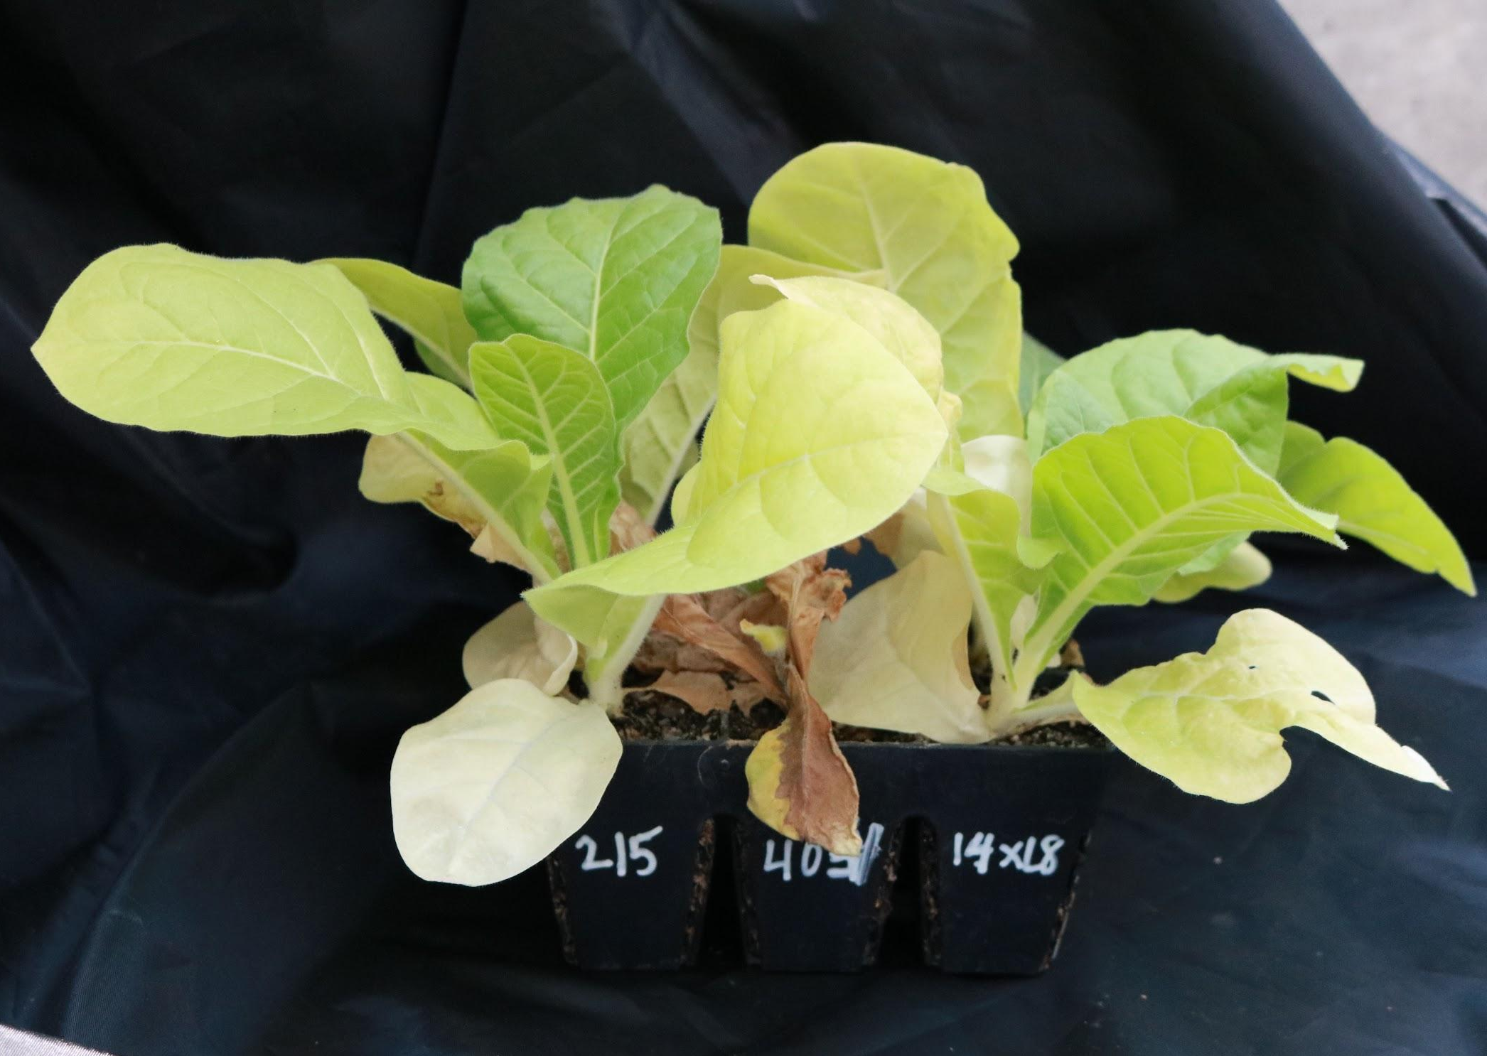

Figure 2.1. Race 0 phenotype with Hybrid 404LC dead two weeks after inoculation (KT215LC race 0 10/10 resistance and race 1 9/10 resistance; Hybrid 404LC race 0 0/10 resistance and race 1 0/10 resistance; and 14xL8LC 10/10 resistance and race 1 0/10 resistance)

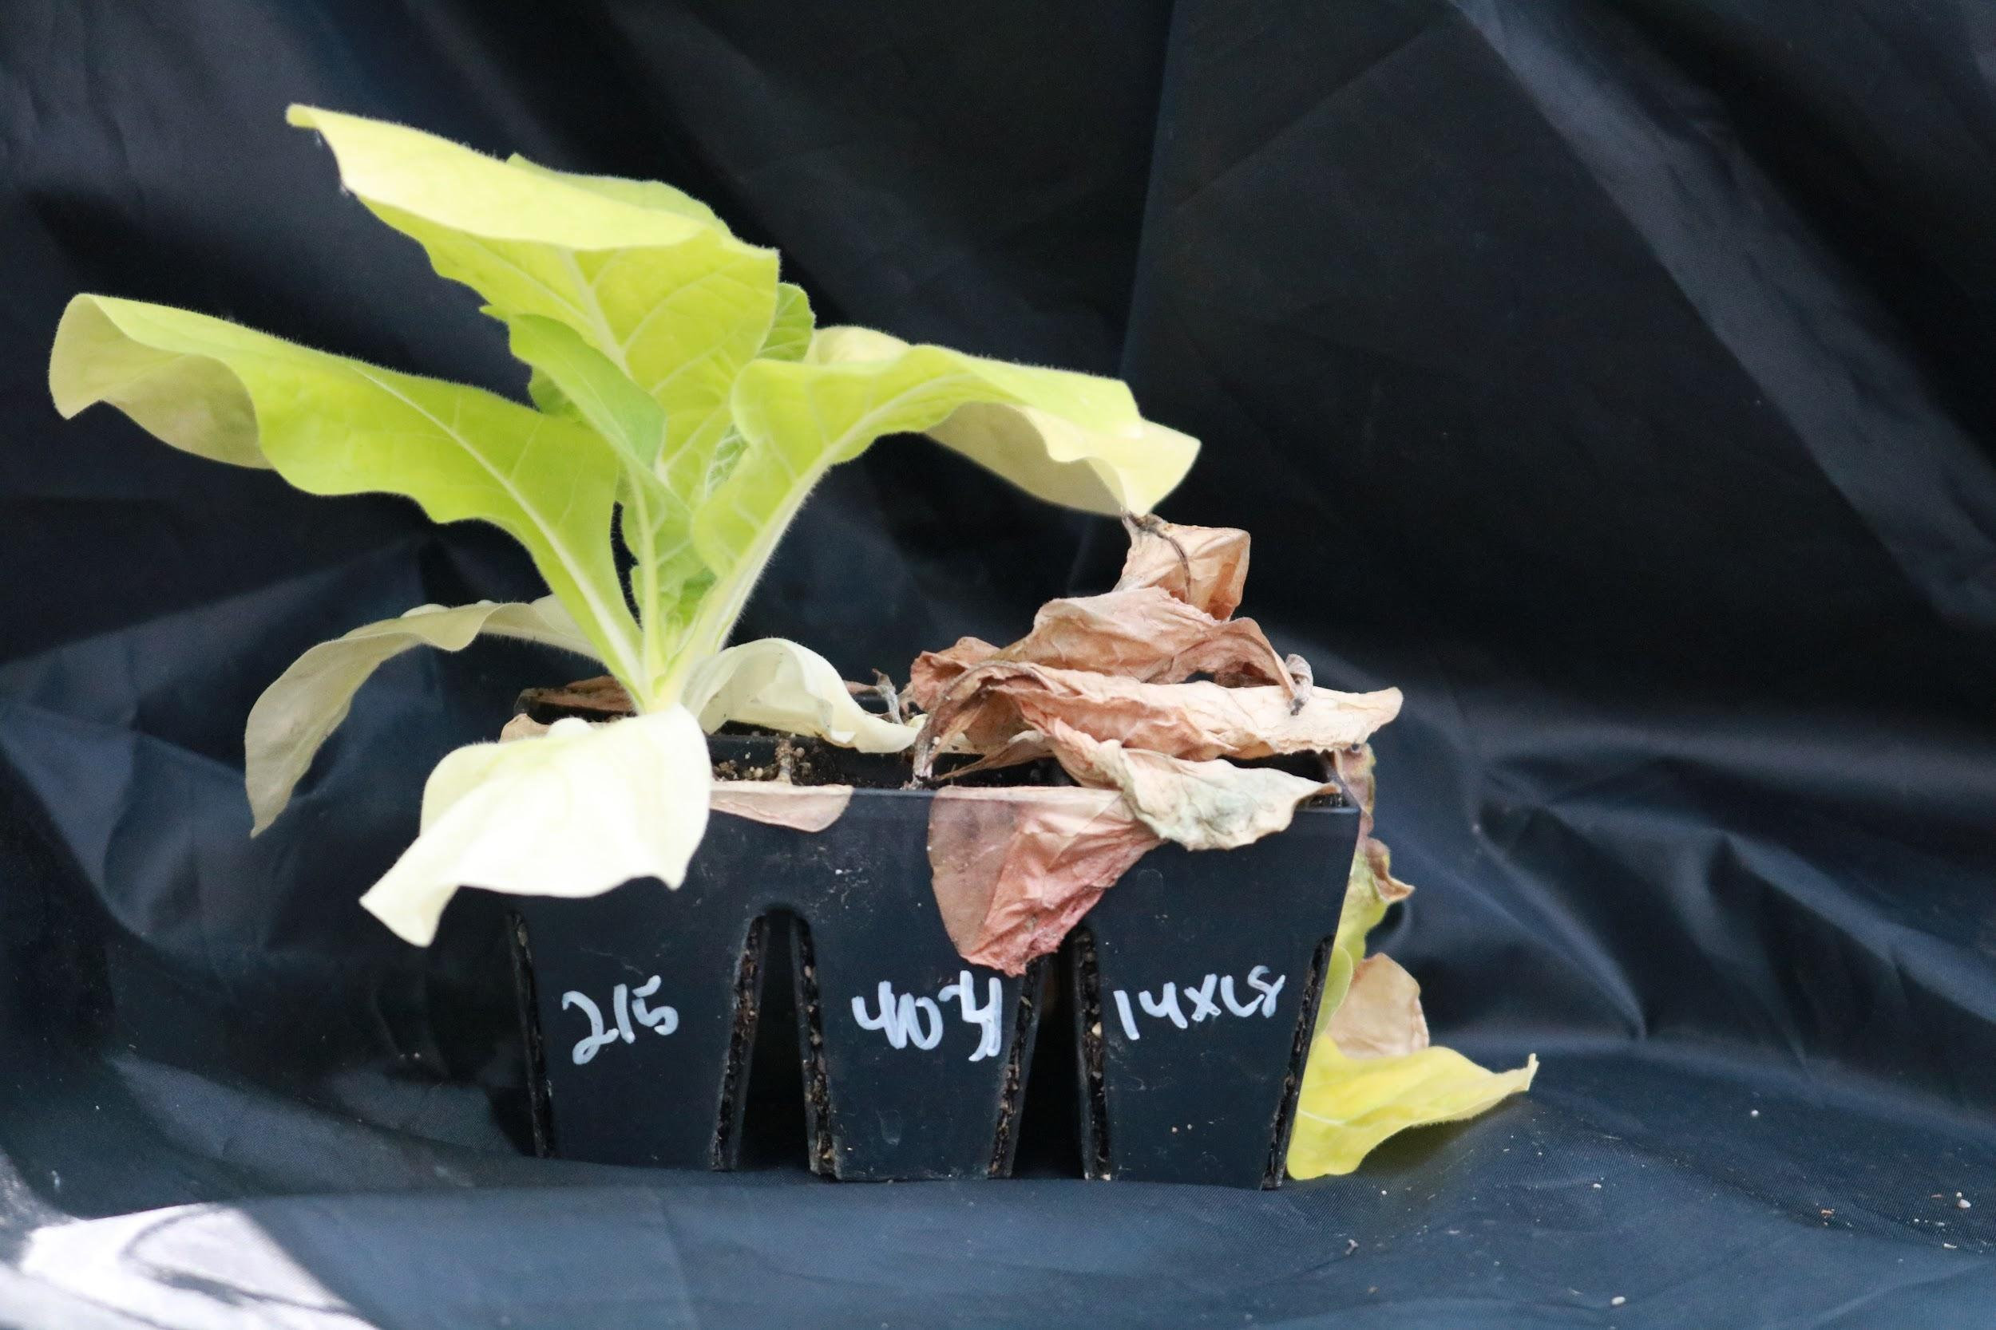

Figure 2.2. Race 1 phenotype with Hybrid 404LC and ms 14XL8LC dead two weeks after inoculation (KT 215LC race 0 10/10 resistance and race 1 9/10 resistance; Hybrid 404LC race 0 0/10 resistance and race 1 0/10 resistance; and 14xL8LC 10/10 resistance and race 1 0/10 resistance)

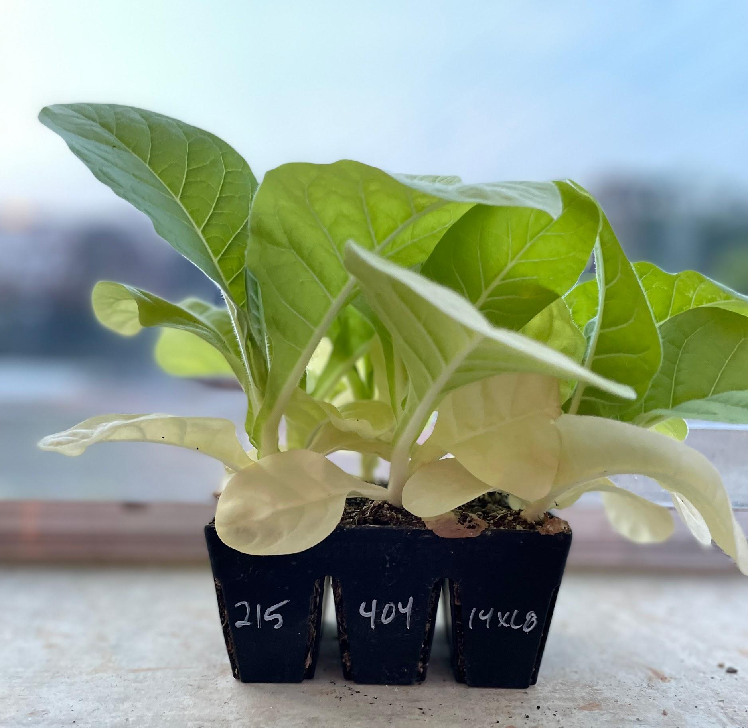

Figure 2.3. Non-inoculated control (KT 215LC race 0 10/10 resistance and race 1 9/10 resistance; Hybrid 404LC race 0 0/10 resistance and race 1 0/10 resistance; and 14xL8LC 10/10 resistance and race 1 0/10 resistance)

CHAPTER IV: Phytophthora nicotianae shows host specificity for tobacco and tomato in Tennessee

Abstract
Buckeye rot is a fruit disease caused by Phytophthora nicotianae that occurs on both young and mature tomato fruit. Disease incidence increases in high humidity and wet conditions, and P. nicotianae’s presence as a soilborne pathogen makes it challenging to eradicate once it becomes established. The state of Tennessee has a geographically wide distribution of P. nicotianae in fields with a history of tobacco (Nicotiana tabacum) production, causing black shank of tobacco. There is also significant acreage of tomato production occurring in the state, and numerous outbreaks of buckeye rot have been reported in recent years. A study was conducted in 2022 to identify if P. nicotianae isolated from tobacco caused buckeye rot on tomato. The study also analyzed tomato variety susceptibility to P. nicotianae isolated from tobacco in a greenhouse and field trial study. The greenhouse study tested 10 tomato varieties produced commercially and locally in Tennessee in a root, fruit, and foliar inoculation. There were three replicates of each variety exposed to the inoculations and three replicates of non-inoculated controls. The field trial measured the variety susceptibility among the 10 Tennessee varieties in a field historically producing tobacco and a known presence of P. nicotianae. No disease occurred in the greenhouse and field trials, and the study could not successfully culture P. nicotianae from the tomato plants. A detached-leaf assay was conducted to determine if there was host specificity among 10 P. nicotianae isolates (5 from tobacco, 5 from tomato), by inoculating tomato fruit and leaves (variety ‘BHN 589’) and burley tobacco leaves (variety ‘Hybrid 404LC’, fully susceptible to black shank). The tomato fruit were susceptible to only tomato isolates, tobacco leaves were susceptible to only tobacco isolates, and tomato leaves were mildly susceptible to tobacco isolates and highly susceptible to tomato isolates. This study provides evidence of host specificity among isolates of P. nicotianae in Tennessee.

Introduction
Buckeye rot, caused by Phytophthora nicotianae, is a destructive global disease affecting tomato (Solanum lycopersicum). Three species in the Phytophthora genus have been noted to result in buckeye rot: Phytophthora nicotianae, P. capsici, and P. dreschelri (Critopoulos 1955, Gupta et al. 2022, Stevenson 1991). Buckeye rot was first reported in Florida, USA in 1915 and was later reported from the west to east coasts of the country including in Arizona, Arkansas, Colorado, Florida, Illinois, Indiana, Louisiana, Maryland, Massachusetts, Mississippi, Missouri, New Jersey, New York, North Carolina, Ohio, Tennessee, Texas, Virginia, and West Virginia by 1941 (Sherbakoff 1915, Tompkins & Tucker 1941). Globally, buckeye rot has caused disease loss in Denmark, Italy, Germany, China, Sardinia, Sweden, and India (Gupta et al. 2022). Symptoms of buckeye rot include a distinct gray, green or brown lesion with concentric, bullseye-like rings (Sanoubar & Barbanti 2017, Shew & Lucas 1991). The lesions are firm and smooth and often occur at the blossom end or the interface between the fruit touching the soil. Incubation period of the soilborne pathogen is 48 hours, with symptoms appearing approximately 3 to 4 days after exposure (Gupta et al. 2022).
P. nicotianae is a hemibiotrophic, soilborne oomycete that reproduces both asexually and sexually. Warm and humid conditions above 18°C will induce the production of asexual, wall-less zoospores (Panabieres et al. 2016). Following attraction to host tissue, biflagellate zoospores will develop a cell wall and cysts to puncture the host tissue with a germ tube. An appressorium is formed at the end of the germ tube, which produces hyphae to yield haustoria-like structures (Meng et al. 2014). Hyphae invades the plant tissue and induces infection. Zoospores are easily disseminated through irrigation sources, soil water, and rainfall and may remain motile for up to 20 hours. Soil saturation from heavy rainfall stimulates the release and dissemination of infective zoospores, and studies have noted high tomato yield losses up to 90% in these favorable conditions (Kaur & Banyal 2019, Sanoubar & Barbanti 2017). Chlamydospores are produced from hyphae in unfavorable conditions and may survive in the soil for many years (Meng et al. 2014). Oospores are the sexual reproductive structure produced by P. nicotianae which contribute to the genetic variability of the species. Oospore production requires two different mating types (A1 and A2) and results from male and female gametangial fusion. Both chlamydospores and oospores act as survival structures of the pathogen and remain in the soil for years.
P. nicotianae is responsible for causing disease in a broad range of hosts, including foliar and fruit diseases, crown and root rots (Mammella et al. 2013). Some of the hosts include tobacco, citrus, strawberry, and herbaceous and woody plants (Hu et al. 2008, Mammella et al. 2013, Marin et al. 2021, Matheron & Matejka 1990, Shew & Lucas 1991). One of the most devastating, widespread diseases caused by P. nicotinae is black shank of tobacco. Black shank affects leaves, stems and roots of tobacco plants at all life stages and may result in up to 100% yield loss if crops are left untreated (Antonopoulos 2010, Gallup 2006, Shew & Lucas 1991). Black shank symptoms are characterized by wilt, chlorosis, disking and drying of the pith stem tissue, and a notable black lesion at the base of the stem (Gallup et al. 2018, Shew & Lucas 1991, Sullivan & Shew 2005). All commercial types of tobacco are susceptible to black shank, and the disease is prominent throughout the major tobacco growing regions in the world (Flowers et al. 1967, Gallup & Shew 2010, Li et al. 2017, Parkunan et al. 2010, Ren et al. 2018, Vanegas et al. 2022, van Jaarsveld et al. 2002). There are four physiological races of black shank detected throughout the world (race 0, 1, 2, and 3). Race 0 and 1 are dominant, race 2 is isolated only in South Africa, and race 3 is the most recent race detected and is growing in occurrence (Gallup & Shew 2010, van Jaarsveld et al. 2002). Disease mitigation includes the use of resistant varieties to race 0 and race 1, chemical control, and crop rotation with non-hosts of P. nicotianae (Shew & Lucas 1991).
Tobacco is a cash crop of Tennessee, with the state being the second largest producer of dark air-cured tobacco, dark fire-cured tobacco, and burley tobacco out of the tobacco-producing states, behind Kentucky (Colebank 2013, USDA 2023). Black shank from P. nicotianae is known to be widespread in TN, with race 1 becoming increasingly more prevalent with the planting of race-0-resistant varieties. Commercial tomato production is widespread throughout the state, with significant acreage grown in west and east Tennessee, but the importance of P. nicotianae as a tomato pathogen is not well understood (Rutledge et al. 1999). The latest reports (2015 and 2018) of total tomato acreage planted in Tennessee estimates 7,700 acres of tomatoes collectively for fresh market and processing (USDA 2023). P. nicotianae has been reported to cause foliar blight and buckeye rot of tomato in TN (Hansen, personal observation). With the prominent known population of P. nicotianae in tobacco fields as well as the various reports of buckeye rot occurring in Tennessee, the purpose of this study is to identify the pathogenicity of P. nicotianae isolated from tobacco on tomato, and analyze the host specificity of P. nicotianae collected from tobacco and tomato.

Materials and Methods

Tomato varieties
The following 10 tomato varieties were seeded into two, 72-cell trays with potting mix: ‘BHN 589’ (Johnny’s Seed, Winslow, ME), ‘Defiant PhR’ (Johnny’s Seed, Winslow, ME), ‘Florida 47R’ (Stoke’s Seed, Holland, MI), ‘Mountain Spring’ (Totally Tomatoes, Randolf, WI), ‘Big Boy’ (Knox Seed & Feed, Knoxville, TN), ‘Big Beef’ (Stoke’s Seed, Holland, MI), ‘Brandywine’ (Johnny’s Seed, Winslow, ME), ‘Celebrity’ (Johnny’s Seed, Winslow, ME), ‘Cherokee Purple’ (Stoke’s Seed, Holland, MI), and ‘Early Girl’ (Totally Tomatoes, Randolf, WI). Seedlings were maintained in the greenhouse following standard university recommendations until inoculation and transplanting.

P. nicotianae isolates
Eight P. nicotianae isolates were used in the greenhouse root, fruit, and foliar inoculation. All eight isolates were retrieved from tobacco in six locations across Tennessee. The eight isolates from tobacco were cultured from diseased stems on PARPH-V8 Phytophthora-selective media and replated onto V8 agar until further use (Jeffers et al. 1986). Morphological features of P. nicotianae, such as aseptae hyphae, lemon-shaped sporangia, zoospores, and brown clusters of chlamydospores were detected using wet mounts of mycelium from the V8 plates. The eight isolates were molecularly confirmed to be P. nicotianae from PCR and Sanger sequencing of a portion of the internal transcribed spacer (ITS) region of ribosomal DNA. Two of the isolates were confirmed as race 0, and six of the isolates were confirmed as race 1 in a greenhouse bioassay.
Ten P. nicotianae isolates were used in the detached leaf assay. Five of the isolates were the same isolates used in the greenhouse studies and represented both race 0 and race 1 of P. nicotianae isolated from tobacco. Five P. nicotianae isolates collected from tomato with buckeye rot symptoms were also included in the detached leaf assay. All isolates were confirmed as P. nicotianae from morphological identification, PCR, and Sanger sequencing as previously described.

Greenhouse studies
A randomized complete block design was imposed on ten tomato varieties (treatments) with three replicates of each cultivar to evaluate root disease. In addition, three replicates of non-treated controls for each cultivar were included. The tobacco variety, ‘Hybrid 404LC’ was also included in the trial as a positive control to ensure that the inoculum was pathogenic. ‘Hybrid 404LC’ is fully susceptible to black shank caused by P. nicotianae. Three replicates of ‘Hybrid 404LC’ plants were inoculated, and three replicates were negative controls. Seedlings were organized within a 72-cell tray. The root inoculum was prepared by placing 30 sterile oat grains on a petri dish containing V8 media and a 5 mm plug of a single P. nicotianae isolate. This process was repeated for all eight of the isolates used in this study. The plates were wrapped in Parafilm and incubated at room temperature for seven days. The resulting mycelium-covered oats from the eight isolates were scraped off from the media and combined in a sterile 500 mL beaker. Sterile deionized water (200 mL) was added to the oats, and the mixture was blended with handheld blender until homogenous. The tomato and tobacco replicates were inoculated at 4.5 weeks old with 1 mL of the homogenous oat-mycelium mixture placed on the soil surface surrounding the stem. Disease incidence was recorded two weeks after the inoculation.
Fruit and foliar greenhouse studies were conducted by transferring six seedlings of each tomato variety from 72-cell trays to 1-gallon, open top coco fiber grow bags (Riococo Worldwide, Irving, TX) for the duration of the study. Three replicates of each tomato variety were inoculated and three replicates were non-inoculated controls. The tomato plants were trellised vertically to encourage growth using tomato twine. Two inoculations occurred throughout the duration of the experiment using the same eight P. nicotianae isolates utilized in the greenhouse root study. The first inoculation was a spore suspension produced from the eight isolates at a total concentration of 255 sporangia/mL. The spore suspension was applied directly to entire 3.5-month-old plants on young fruit and leaves using a handheld 2-liter spray bottle. The second inoculation was applied one week after the first inoculation. The spore suspension produced from the 8 isolates at the concentration of 61,000 sporangia/mL in 400 mL volume was applied directly to one fruit and one leaflet on each treated replicate for all ten varieties. The treated fruit and leaves were bagged tightly for 12 hours with plastic bags to retain the humidity and ensure that the spore suspension remained on the surface. Leaves and fruit displaying potential symptoms of buckeye rot were taken to the laboratory for culturing and pathogen identification. Disease incidence was recorded two weeks after the first inoculation.

Field trial
The field trial was a randomized complete block design containing ten tomato varieties with four replicates. The field was 126 feet long and split to contain two, parallel 60-foot-long rows. Plots were six ft long, with three plants of each variety spaced one foot apart. Two-month old tomato plants were transplanted into a field located in Greene County, TN at Northeast Tennessee Research and Education Center with annual tobacco production and high black shank pressure. Plots were trellised using the “Florida-weave" method every two weeks or upon necessity to replicate commercial growing conditions. Drip irrigation was installed and applied as needed to maintain crop health. Fontelis (Dow AgroScience, Wilmington, DE) was applied at 24 oz/acre one month after transplanting and reapplied every two weeks to prevent early blight. Fontelis has no efficacy against diseases caused by Phytophthora. Plants were scouted every two weeks and leaves and fruit displaying symptoms of buckeye rot were taken back to the lab for species identification.

Detached fruit and leaf assay
Leaflets and fruit from the variety ‘BHN 589’ were collected from the field trial and used in the detached leaf and fruit assay. Leaves from ‘Hybrid 404 LC’, a tobacco variety fully susceptible to black shank, were also used in the experiment. The experiment included ten treatments (five P. nicotianae isolates from tomato, five P. nicotianae isolates from tobacco) that were replicated three times on tomato fruit, tomato leaves, and tobacco leaves. Each tomato leaf and fruit, and tobacco leaf had a non-inoculated control of deionized water that was triplicated. A spore suspension for each isolated (treatment) was applied to each fruit and leaf at the adjusted concentration of 100 sporangia/uL using a micropipette. The treated fruit and leaves were placed in plastic trays with moist paper towel on the bottom and covered with another plastic tray that had been sprayed with water. The enclosed plastic tub was then covered with an autoclave bag to ensure that the humidity was trapped for the duration of the experiment. Disease incidence was recorded five days after the spore suspension was applied.

Results
Buckeye rot symptoms were not observed in the greenhouse root, fruit, and foliar studies. All treated tomato variety replicates did not show disease following the root inoculation, while 100% of the inoculated Hybrid 404LC tobacco replicates died within two weeks after the inoculation. Neither the first or second foliar and fruit inoculations successfully yielded characteristic buckeye rot symptoms. Characteristic bullseye ring lesions were not observed on the fruit after the two inoculations. Scarce black lesions were found on the leaves following the second inoculation on the foliage; however, P. nicotianae was not cultured from the lesions.
The field trial did not yield disease on any of the tomato varieties. Blossom ends of the fruit were evaluated and no symptoms were present over the course of the three-month field trial. Leaves with potential symptoms of disease were removed and brought back to the laboratory for culturing, and P. nicotianae was not recovered throughout the duration of the experiment. Early blight and tomato spotted wilt virus was detected in the field following lesion culture and tomato spotted wilt virus (TSWV) ImmunoStrip test strips (Agdia, Elkhart, IL).
The detached leaf assay experiment was designed following the lack of results from the greenhouse and field trial. The tomato fruit inoculated by the five tomato isolates resulted in an average lesion of 4.0 mm, with average lesion size ranging 1.1 to 5.3 mm. Four of the five P. nicotianae isolates from tomato produced lesions on the fruit five days after inoculation, with only one isolate causing disease on one of three replicates. No tobacco P. nicotianae isolates produced lesions on the fruit following inoculation. All tobacco P. nicotianae isolates caused disease on the tobacco leaves, with 13 of the 15 leaves resulting in 100% disease severity. No tomato P. nicotianae isolates caused disease on the tobacco leaves. The average disease severity for the tomato leaves inoculated with the tomato P. nicotianae isolates was 71.4%, with a range of average disease severity between 44.7% to 84.5%. Three tobacco isolates produced lesions on the tomato leaves and had an average disease severity of 4.9%.

Discussion
The greenhouse root, fruit, and foliar inoculation trials indicate that P. nicotianae isolated from tobacco is not pathogenic to tomato. P. nicotianae was not successfully cultured from symptomatic tomato leaves and fruit. However, it was successfully cultured from the ‘Hybrid 404LC’ tobacco treatment which indicated that the inoculum was viable. Symptomatic leaves had approximately one cubic centimeter, black lesions that were recorded. However, P. nicotianae was never successfully recovered in culture or detected using Phytophthora ImmunoStrip test strips (Agdia, Elkhart, IL). Symptomatic fruit collected in the greenhouse looked similar to buckeye rot but was likely blossom end rot. The second inoculation of spore suspension on the single leaflet and fruit which included a longer period of humidity did not induce disease.
The field trial did not yield disease on the ten tomato varieties. Plants were heavily scouted for symptoms, particularly with low lying fruit, and no buckeye rot lesions were observed. Leaves with similar black lesions to those occasionally detected in the greenhouse did not successfully produce P. nicotianae in culture. The environmental conditions throughout the field trial were not particularly favorable to P. nicotianae. It was a considerably dry growing season which meant that there was a lack of dissemination of zoospores throughout the rows. There was one notable rainstorm while the tomatoes were transplanted, which produced favorable conditions to induce disease. The field trial location is a known as a black shank nursery and has been used for annual tobacco research for many years. P. nicotianae has been cultured from tobacco displaying symptoms of black shank out of the field, so a lack of inoculum is unlikely to be responsible for the results of the field trial.
The detached leaf and fruit assay results demonstrated that isolates of P. nicotianae are host specific. Similar to what was observed in the greenhouse and field trials, no tobacco isolates produced buckeye rot lesions on the tomato fruit replicates following the spore suspension application. Three tobacco isolates: pntn21012, pntn21129, pntn21165, produced small lesions on the leaves that resembled lesions detected on leaves throughout the greenhouse and field trial. All five tobacco isolates were extremely pathogenic on the ‘Hybrid 404LC’ tobacco leaves, causing 100% disease incidence except for one isolate, which resulted in 33% disease incidence. All five tomato isolates were highly pathogenic on the tomato fruit and leaves but did not induce disease incidence on the tobacco leaves. The detached leaf and fruit assays showed a fast incubation period of P. nicotianae on susceptible hosts, with symptoms developing after 24 hours and measurements taking place 5 days after inoculation.
The results from the study indicate host pathogenicity differences among P. nicotianae isolated from tobacco and tomato. A similar observation has been made in a study conducted by Matheron and Matejka on rough lemon and tomato (Matheron & Matejka 1990). Non-host and same-host isolates were tested on the rough lemon and tomato, and results showed that P. nicotianae isolated from walnut, silktree, jojoba, petunia, hibiscus, and peach did not cause crown rot on rough lemon. Only P. nicotianae isolated from citrus caused crown rot, with 54% recovery from diseased rootlets, whereas non-host isolates were recovered from 0.5% of the rootlets. Surprisingly, virulence of P. nicotianae from non-host isolates on tomato seedlings was high, resulting in lesions on the stems of tomato plants and eventual plant death. Citrus isolates were recovered from 25% of rootlets of tomatoes. Non-hosts (walnut, silktree, jojoba, petunia, hibiscus, and peach) were recovered from 40% of the tomato rootlets, and tomato isolates were recovered from 32% of the tomato rootlets. This study indicated that tomato appeared highly susceptible to P. nicotianae recovered from a variety of hosts other than tomato, although they did not test isolates recovered from tobacco so it is difficult to make direct comparisons between these experiments. Observations made by Elena (2000) testing tomato and tobacco with P. nicotianae isolated from hosts (tomato and tobacco) and non-hosts demonstrated similar host pathogenicity to what was found in the current study. Results suggest that isolates from tobacco did not induce disease on tomato, but two isolates colonized the tomato stem (Elena 2000). Additionally, a soil inoculation similar to the root inoculation of this study was investigated and concluded that P. nicotianae isolated from tobacco is a separate group with a specific pathogenicity to tobacco plants only. These observations aligned with Matheron and Matejka that non-host isolates of P. nicotianae can be virulent to tomato.
Population genetics research on P. nicotianae indicates that the pathogen genetics are strongly associated with the host, rather than geographic area (Mammella et al. 2013). A study utilizing 96 P. nicotianae isolates collected from various hosts from different geographical regions investigated four mitochondrial markers (trnG-rns, rns-cox2, cox2+spacer, and atp1-nad5) and three nuclear coding regions: hypothetical protein (hyp), SCP-like extracellular protein (scp), and β-tubulin (β-tub) genes. The study revealed that geographic structure did not impact the haplotype or alleles of P. nicotianae, while the species of the host had a specific association among molecular groups. The majority of isolates recovered from citrus throughout Italy, California, Florida, Syria, Albania, and the Philippines were clustered in the same mitochondrial group and shared at least one nuclear allele. P. nicotianae displayed a similar trend and was grouped into similar haplotypes. Another study in 1998 investigated the correlation of elicitin production, the protein responsible for inducing defense responses against Phytophthora and Pythium species, among P. nicotianae isolates collected from tomato and tobacco (Colas et al. 1998). The study found that in the elicitin-producing group collected from different geographical regions, two-thirds of the isolates could infect tomato, and 13 of 34 had high virulence. Conversely, tobacco was highly susceptible to infection from isolates collected from tobacco lacking elicitin production. The isolates lacking elicitin production were nonpathogenic on tomato. The study eluded that the inability to produce elicitin in isolates collected from tobacco indicates that black shank strains arise from rare mutation events that are followed by dissemination. There was low variability within the cluster of isolates collected from recurring tobacco-producing fields; and it differentiates its position outside the other isolates collected from non-tobacco hosts suggests it has evolved from a clonal origin under genetic isolation. This correlation may be an explanation for the lack of disease on tomatoes in the greenhouse and field trial from P. nicotianae isolated from tobacco. Further work is being explored to sequence full genomes of P. nicotianae isolated from tomato and tobacco, as well as subsets of race 0 and race 1 of P. nicotianae. This work would be useful to molecularly differentiate the P. nicotianae species from different hosts with ranging virulence on susceptible crops. The findings of the current study indicate that P. nicotianae present throughout Tennessee’s tobacco production regions does not pose a threat to tomato.

References
Antonopoulos, D. F., Melton, T., & Mila, A. L. (2010). Effects of Chemical Control, Cultivar Resistance, and Structure of Cultivar Root System on Black Shank Incidence of Tobacco. Plant Disease, 94(5), 613–620. https://doi.org/10.1094/PDIS-94-5-0613
Aysan, Y, et al. (1991). Compendium of Tomato Diseases and Pests (2nd ed.). APS Press.
Colebank, A., Kent, C., Phelps, T., Heather, O., & Womack, T. (2013). Tennessee Agriculture 2013 - Departmental Report and Statistical Summary. https://www.tn.gov/content/dam/tn/agriculture/documents/annualreports/annualreport13.pdf
Colas, V., Lacourt, I., Ricci, P., Vanlerberghe-Masutti, F., Poupet, A., & Panabières, F. (1998). Diversity of Virulence in Phytophthora parasitica on Tobacco, as Reflected by Nuclear RFLPs. Phytopathology, 88(3), 205–212. https://doi.org/10.1094/PHYTO.1998.88.3.205
Critopoulos, P. D. (1955). Foot Rot of Tomato Incited by Phytophthora capsici. Bulletin of the Torrey Botanical Club, 82(3), 168. https://doi.org/10.2307/2482464
Elena, K. (2000). Pathogenicity of Phytophthora nicotianae isolates to tobacco and tomato cultivars. Phytopathologia Mediterranea, 39(2), 245–250.
Hu, J. H., Hong, C. X., Stromberg, E. L., & Moorman, G. W. (2008). Mefenoxam sensitivity and fitness analysis of Phytophthora nicotianae isolates from nurseries in Virginia, USA. Plant Pathology, 57(4). https://doi.org/10.1111/j.1365-3059.2008.01831.x
Flowers, R. A., Smiley, J. H., & Stokes, G. W. (1967). Distribution of race of Phytophthora parasitica var. nicotianae in Kentucky and Tennessee. Plant Disease Report, 51(9), 731–733.
Gallup, C. A., McCorkle, K. L., Ivors, K. L., & Shew, D. (2018). Characterization of the Black Shank Pathogen, Phytophthora nicotianae, Across North Carolina Tobacco Production Areas. Plant Disease, 102(6), 1108–1114. https://doi.org/10.1094/PDIS-02-17-0295-RE
Gallup, C. A., & Shew, H. D. (2010). Occurrence of Race 3 of Phytophthora nicotianae in North Carolina, the Causal Agent of Black Shank of Tobacco. Plant Disease, 94(5), 557–562. https://doi.org/10.1094/PDIS-94-5-0557
Gallup, C. A., Sullivan, M. J., & Shew, H. D. (2006). Black Shank of Tobacco. The Plant Health Instructor. https://doi.org/10.1094/PHI-I-2006-0717-01
Gupta, S. K., Sharma, M., & Mukherjee, S. (2022). Buckeye Rot of Tomato in India: Present Status, Challenges, and Future Research Perspectives. Plant Disease, 106(4), 1085–1095. https://doi.org/10.1094/PDIS-04-21-0861-FE
Kaur, G., & Banyal, D. (2019). Management of buckeye rot of tomato caused by Phytophthora nicotianae var. parasitica under mid-hill conditions of Himachal Pradesh. International Journal of Chemical Studies, 7(4), 1782–1786. https://www.chemijournal.com/archives/2019/vol7issue4/PartAF/7-4-332-195.pdf
Li, Y., Harris-Shultz, K., Wang, H., Wadl, P. A., & Ji, P. (2017). Population Structure and Genetic Diversity of Phytophthora nicotianae from Tobacco in Georgia. Plant Disease, 101(7), 1113–1118. https://doi.org/10.1094/PDIS-01-17-0142-RE
Mammella, M. A., Martin, F. N., Cacciola, S. O., Coffey, M. D., Faedda, R., & Schena, L. (2013). Analyses of the Population Structure in a Global Collection of Phytophthora nicotianae Isolates Inferred from Mitochondrial and Nuclear DNA Sequences. Phytopathology, 103(6), 610–622. https://doi.org/10.1094/PHYTO-10-12-0263-R
Marin, M. V., Seijo, T. E., Zuchelli, E., & Peres, N. A. (2021). Resistance to Mefenoxam of Phytophthora cactorum and P. nicotianae Causing Crown and Leather Rot in Florida Strawberry. Plant Disease, 102(7). https://doi.org/10.1094/PDIS-11-20-2474-RE
Matheron, M., & Matejka J. (1990). Differential Virulence of Phytophthora parasitica Recovered from Citrus and Other Plants to Rough Lemon and Tomato. Plant Disease, 74(2), 138–140.
Meng, Y., Zhang, Q., Ding, W., & Shan, W. (2014). Phytophthora parasitica: a model oomycete plant pathogen. Mycology, 5(2). https://doi.org/10.1080/21501203.2014.917734
Panabieres, F., Ali, G. S., Allaggui, M. B., Dalio, Ronaldo, J. D., Gudmestad, N. C., Kuhn, M.-L., Guha Roy, S., Schedna, L., & Zampounis, A. (2016). Phytophthora nicotianae diseases worldwide: new knowledge of a long-recognised pathogen. Phytopathologia Mediterranea, 55(1). https://oajournals.fupress.net/index.php/pm/article/view/5646/5644
Parkunan, V., Johnson, C. S., & Bowman, B. C. (2010). Population Structure, Mating Type, and Mefenoxam Sensitivity of Phytophthora nicotianae in Virginia Tobacco Fields. Plant Disease, 94(11), 1361–1365. https://doi.org/10.1094/PDIS-05-10-0338
Ren, X., Ji, X., Qi, W., Meng, Z., & Qiao, K. (2018). Evaluation of the combination of propamocarb hydrochloride and fluopicolide for management of black shank on tobacco. Crop Protection, 114. https://doi.org/10.1016/j.cropro.2018.08.013
Rutledge, A., Willis, J., & Bost, S. (1999). PB737 Commercial Tomato Production, The University of Tennessee Agricultural Extension Service, PB737-4.5M-4/99(Rev) E12-2015-00-242-99, https://trace.tennessee.edu/utk_agexcrop/44

Sanoubar, R., & Barbanti, L. (2017). Fungal disease on tomato plant under greenhouse condition. European Journal of Biological Research, 7(4), 299–308.
Sherbakoff, C. (1917). Buckeye rot of tomato fruit. Phytopathology.
Shew, H. B., & Lucas, G. B. (1991). Compendium of Tobacco. APS Press.
Stevenson, W. R. (1991). Compendium of Tomato Diseases (2nd ed.). APS Press.
Sullivan, M. J., & Shew, H. D. (2005). Fitness of Races 0 and 1 of Phytophthora parasitica var. nicotianae. https://doi.org/10.1094/PD-89-1220
Tompkins, C. M., & Tucker, C. M. (1941). Buckeye Rot of Tomato in California. Journal of Agricultural Research, 62(8), 467–474.
USDA National Agricultural Statistics Service. (2021). https://quickstats.nass.usda.gov/results/375CD315-6048-3403-BA5D-C9368F8C4E27
USDA National Agricultural Statistics Service. (2023). https://quickstats.nass.usda.gov/results/3FC8BF85-1C45-3142-A40B-FFD689446E24
Vanegas, D. M., Navarro, R. A., Alfanador, L., Gutierrez, J. A., Morales, J. G., & Gaviria, B. M. (2022). Characterization of Phytophthora nicotianae isolates from tobacco plants (Nicotiana tabacum) in Colombia. Revista Ceres, 69(1), 78–91. https://doi.org/10.1590/0034-737x202269010011
van Jaarsveld, E., Wingfield, M. J., & Drenth, A. (2002). Evaluation of Tobacco Cultivars for Resistance to Races of Phytophthora nicotianae in South Africa. Journal of Phytopathology, 150(8–9), 456–462. https://doi.org/10.1046/j.1439-0434.2002.00766.x

Appendix

Table 3.1. Results of detached leaf and fruit assays using P. nicotianae isolated from tobacco and tomato hosts.

Isolate | Tomato fruit assay: average lesion diameter (cm) | Tobacco leaf assay: average disease severity (%) | Tomato leaf assay: Average disease severity(%)
pntn21012 (race 0)^{z} | 0.0 | 100.0 | 5.8
pntn21076 (race 0)^{z} | 0.0 | 100.0 | 0.0
pntn21129 (race 1)^{z} | 0.0 | 100.0 | 9.7
pntn21165 (race 1)^{z} | 0.0 | 33.3 | 0.0
pntn21201 (race 1)^{z} | 0.0 | 100.0 | 8.5
pntn21252^{y} | 1.1 | 0.0 | 80.3
pntn21253^{y} | 4.4 | 0.0 | 77.8
pntn21257^{y} | 4.6 | 0.0 | 69.8
pntn21258^{y} | 5.3 | 0.0 | 84.5
pntn21259^{y} | 4.2 | 0.0 | 44.7
^{z}P. nicotianae isolate collected from tobacco
^{y}P. nicotianae isolate collected from tomato

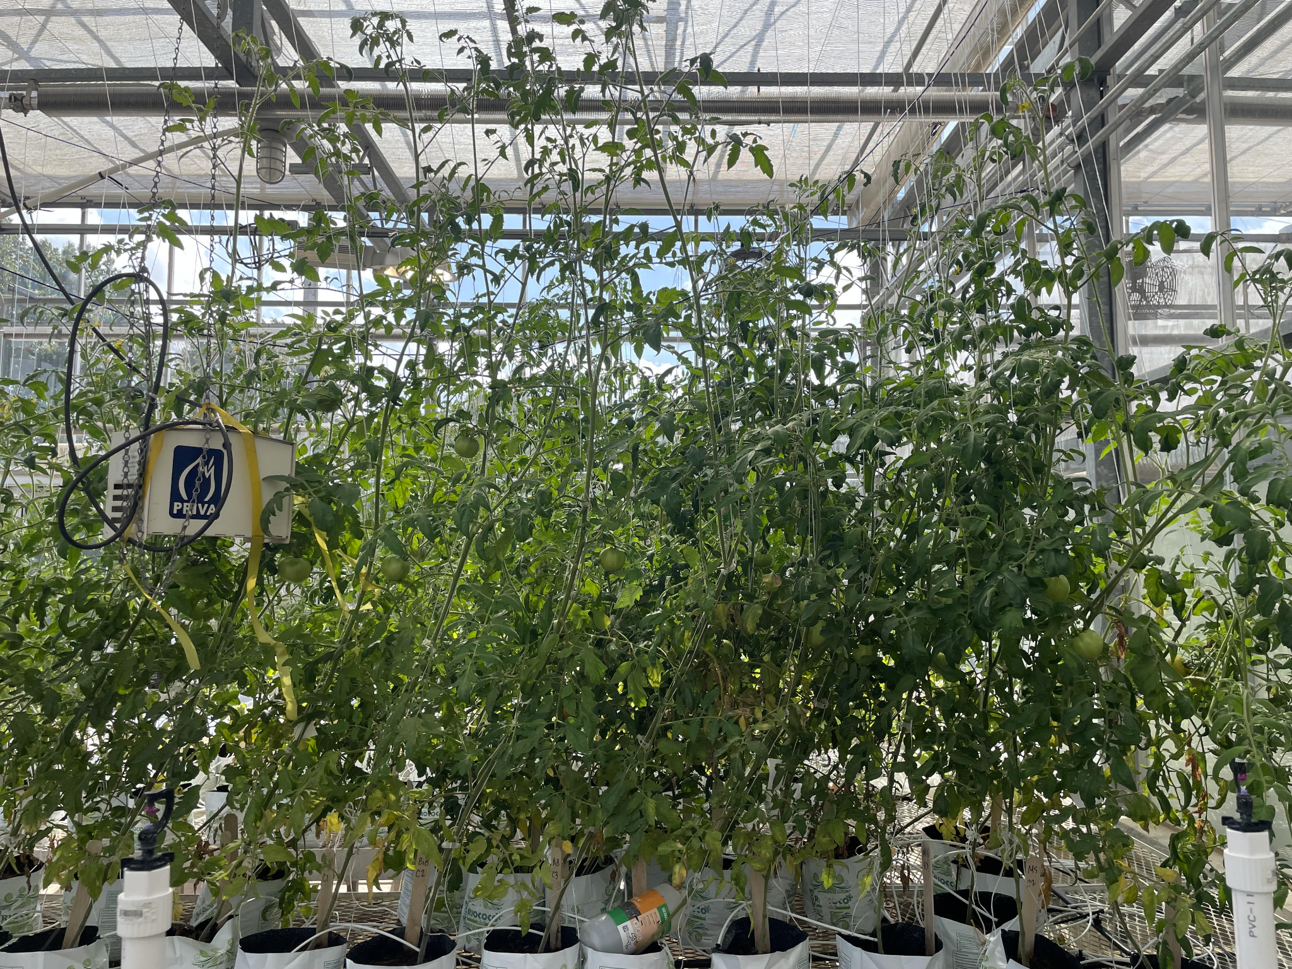

Figure 3.1. Greenhouse fruit inoculation 2 weeks after inoculation.

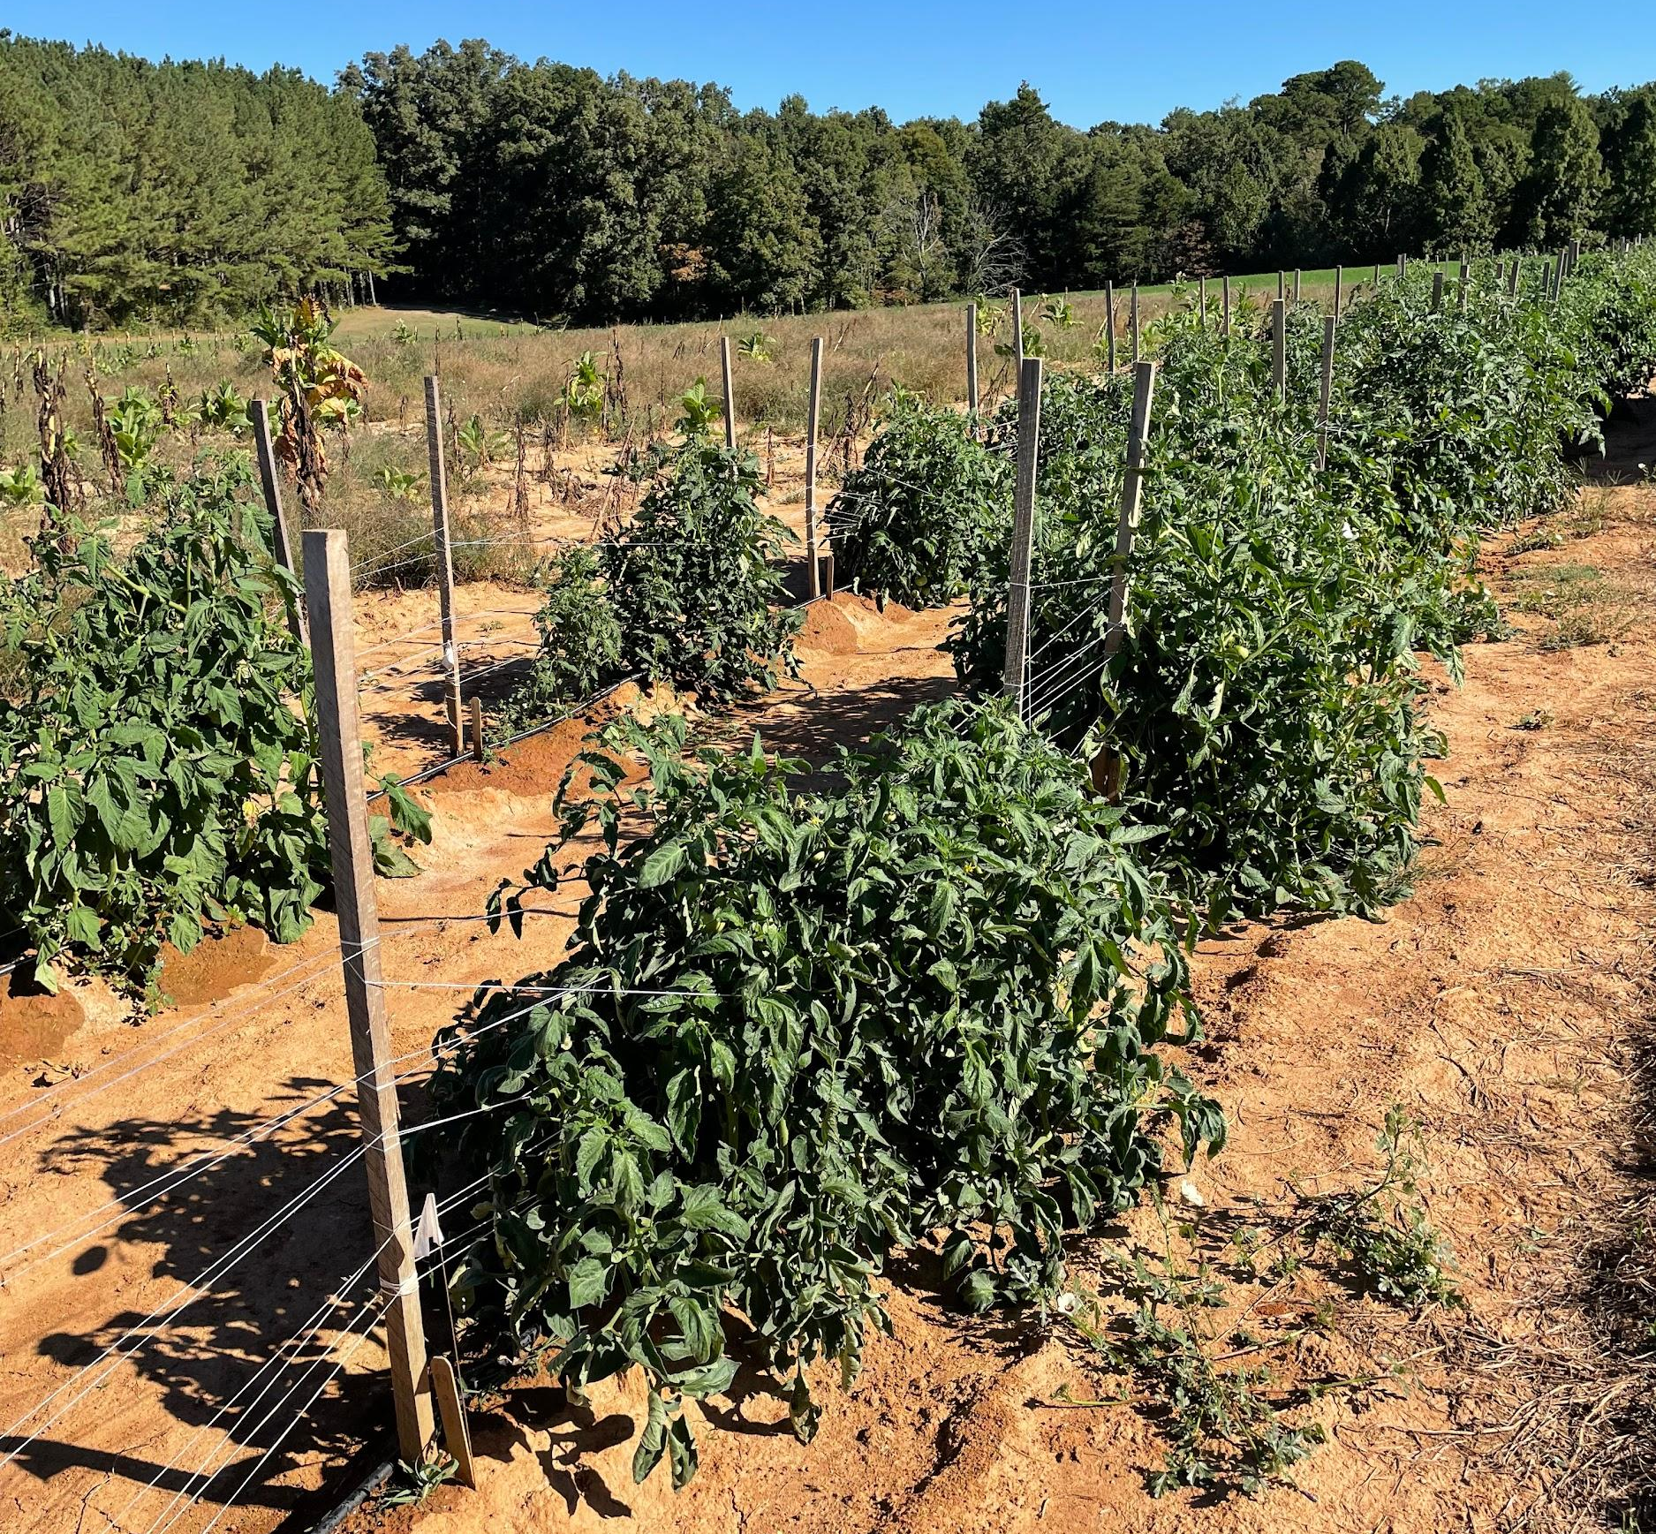

Figure 3.2. Field trial at NETREC with known high tobacco black shank (BS) pressure. Tobacco plants succumbing to BS are visible in the background. Tomato plants remained symptom free.

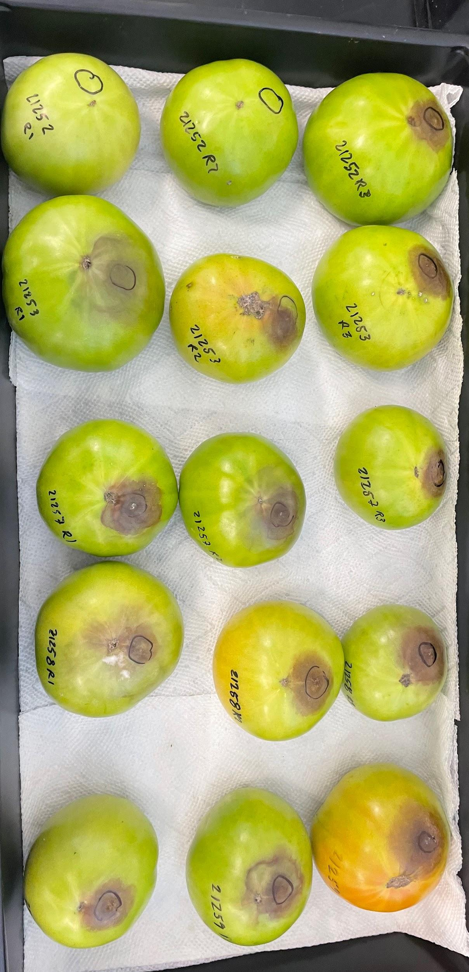

Figure 3.3. Detached fruit assay on tomato fruit 5 days after inoculation with P. nicotianae isolated from tomato.

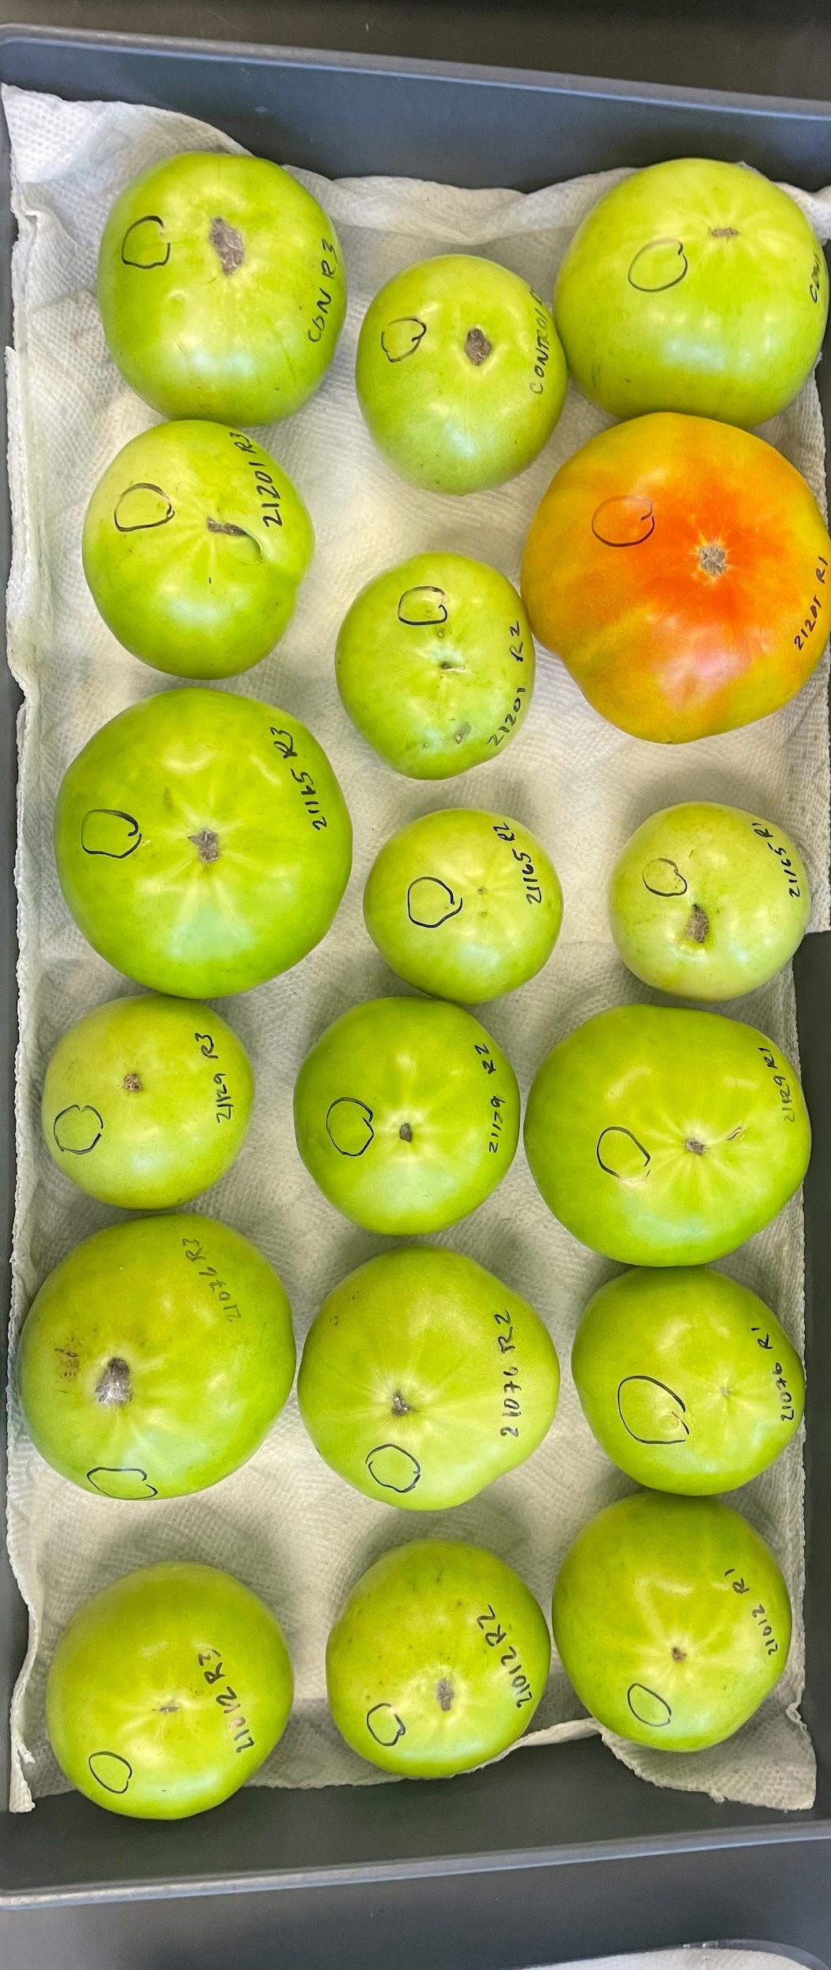

Figure 3.4. Detached fruit assay on tomato fruit 5 days after inoculation with P. nicotianae isolated from tobacco.

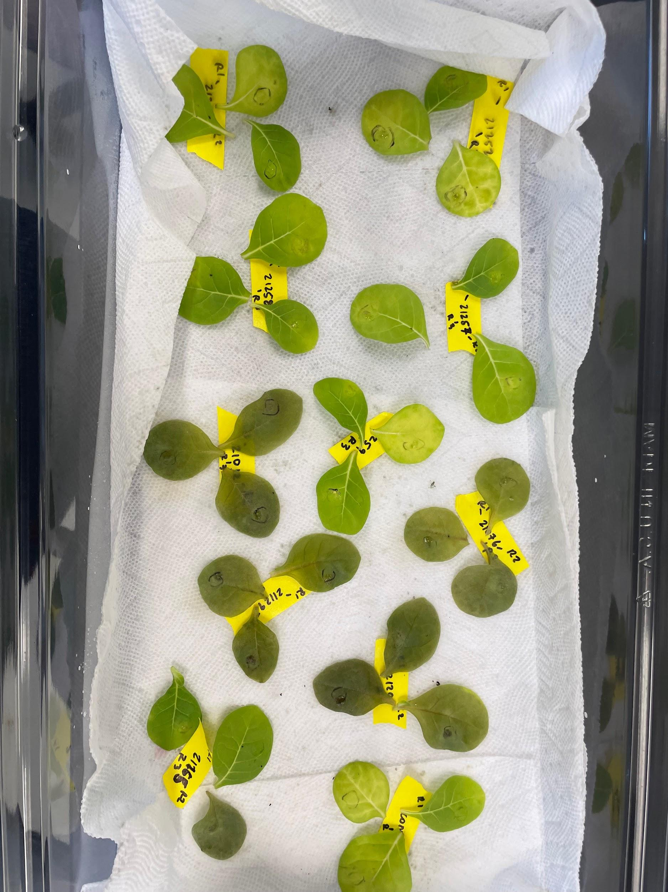

Figure 3.5. Detached leaf assay on tobacco 5 days after inoculation with P. nicotianae isolated from tomato & tobacco. Dark green-brown, decaying leaves inoculated by tobacco isolates; light green healthy leaves inoculated by tomato.

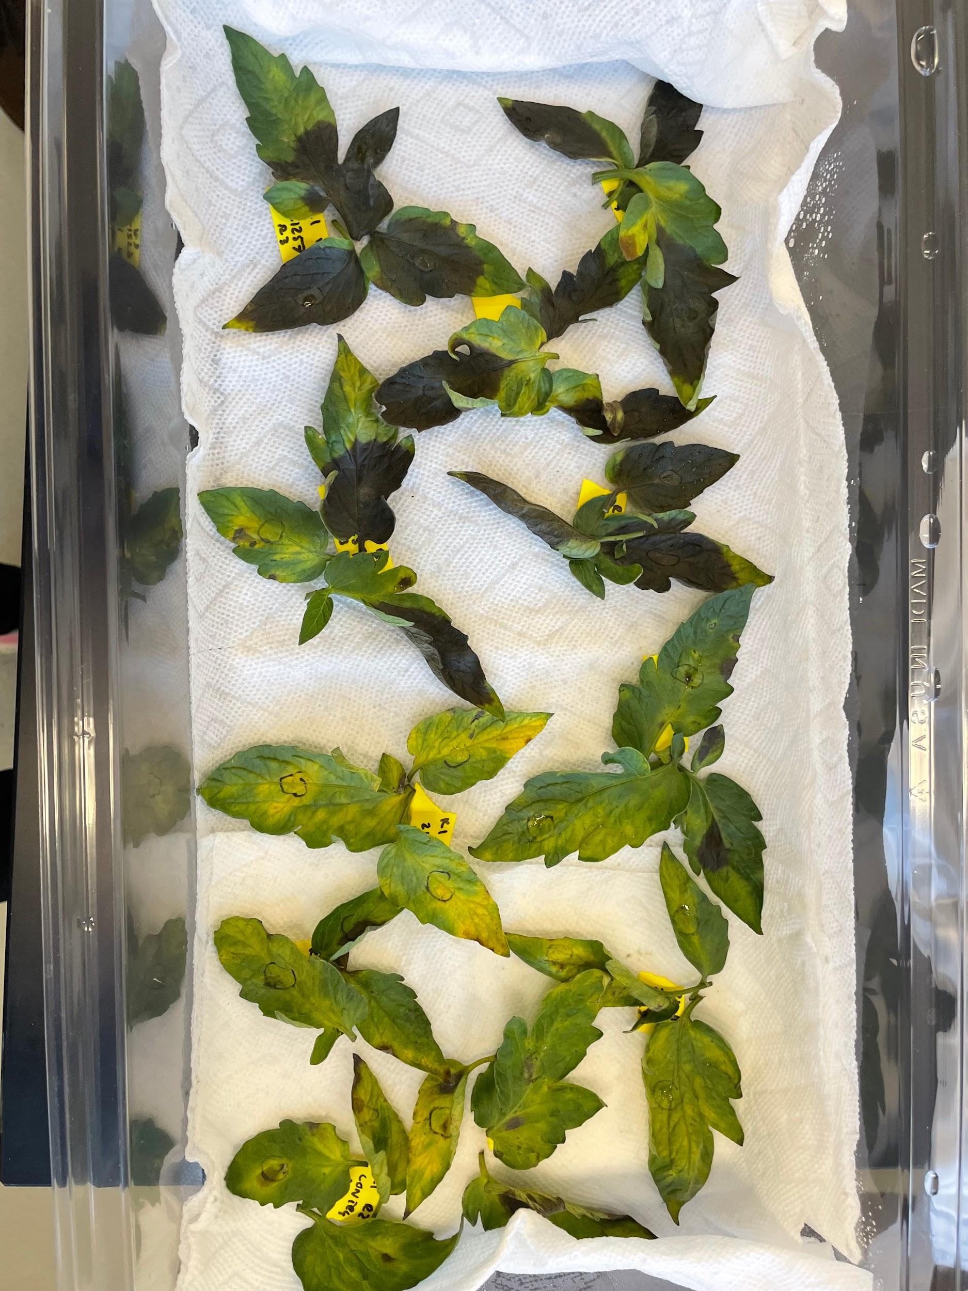

Figure 3.6. Detached leaf assay on tomato 5 days after inoculation with P. nicotianae isolated from tomato & tomato. Dark brown leaves inoculated by tomato isolates; green leaves with small brown spots inoculated by tobacco isolates.

CHAPTER V: Conclusion

Fungicide Sensitivity
The purpose of the study was to determine if P. nicotianae isolated in Tennessee and North Carolina was resistant to the fungicides mefenoxam, oxathiapiprolin, mandipropamid, and fluopicolide, registered to control oomycetes. In vitro fungicide sensitivity assays were conducted on P. nicotianae isolates collected in 2021 and 2022 from burley, dark, and flue-cured tobacco showing symptoms of black shank as well as tomato with buckeye rot symptoms. EC₅₀ values for the fungicides were determined in 2021 and used as discriminatory doses in 2022. The results showed all isolates from 2021 and 2022 as sensitive to mefenoxam, mandipropamid, and fluopicolide. One moderately sensitive isolate was found in 2022 to oxathiapiprolin, while the other isolates in the study were sensitive to oxathiapiprolin. These results align with recent studies conducted in tobacco-growing states with a geographically vast population of P. nicotianae, which emphasize that the four fungicides have strong efficacy on the pathogen (Parkunan et al. 2010, Qu et al. 2016). These findings suggest that a rotational fungicide program with these four active ingredients is an effective management practice to mitigate black shank in Tennessee. This was the first study of this nature conducted in the state of Tennessee, and it established baseline sensitivities for future work analyzing P. nicotianae fungicide sensitivity. Future studies should focus on collecting isolates from a vast geographic area to capture any differences in sensitivity to black shank fungicides. This type of study should be recommended by a extension agent to a grower experiencing severe black shank outbreaks with little affect from fungicides.

Race Structure
This experiment executed a comprehensive two-state race structure assessment throughout Tennessee burley and dark tobacco-production areas in 2021 and 2022, with additional isolates recovered from North Carolina. We hypothesized that the sampled fields would contain both race 0 and race 1, and potentially race 3. Host differentials Hybrid 404LC (fully susceptible to both race 0 and 1), ms KY 14XL8LC (fully resistant to race 0, fully susceptible to race 1), and KT215LC (fully resistant to race 0, partially resistant rating 9/10 to race 1) received root inoculations from individual isolates. The assessment calculated 92% of isolates to be race 1 in 2021 and 89% of isolates to be race 1 in 2022, suggesting race 1 to be the dominant race in Tennessee tobacco fields. There was a single field that yielded race 0 isolates in both 2021 and 2022. This information is critical for growers to select appropriate tobacco varieties with resistance to race 0 and race 1. Evidence also shows that the use of race-0 resistant varieties has shifted field populations of P. nicotianae to race 1, which encourages other black shank management practices, such as fungicides and crop rotation to be utilized. These findings also suggest that race 3 is not present in Tennessee, while neighboring states North Carolina and Georgia have reported this new race (Gallup & Shew 2010, Li et al. 2017). Future work will ideally pursue a molecular tool to differentiate race types.

Pathogenicity of P. nicotianae on Tomato and Tobacco
This study was conducted to determine if P. nicotianae isolated from tobacco caused buckeye rot on tomato and determine if there were susceptibility differences among tomato varieties. We hypothesized that P. nicotianae from tobacco is pathogenic on tomato based on recent field observations of buckeye rot and research indicating that P. nicotianae is one of three Phytophthora species responsible for causing buckeye rot (Gupta et al. 2022, Jones et al. 1991). Greenhouse trials included root, foliar, and fruit inoculations on tomato plants with spore suspensions containing P. nicotianae isolates from tobacco. These trials did not yield measurable disease. The field trial conducted with the same tomato varieties on a piece of land used for annual tobacco production and a known presence of P. nicotianae did not yield symptomatic fruit or measurable disease. The detached leaf and fruit assay proved that there was host specificity among 10 P. nicotianae isolates (5 from tobacco, 5 from tomato) on tomato fruit and leaves (variety ‘BHN 589’) and tobacco leaves (variety ‘Hybrid 404LC’, fully susceptible to black shank). This study provides evidence of host specificity among isolates of P. nicotianae. Previous studies done with tobacco, tomato, and citrus P. nicotianae isolates found similar results in host pathogenicity (Elena 2000, Matheron & Matejka 1990). Full genome sequencing of P. nicotianae collected from different hosts may provide crucial information on the molecular differences that drive pathogenicity (Mammella et al. 2013).

References
Elena, K. (2000). Pathogenicity of Phytophthora nicotianae isolates to tobacco and tomato cultivars. Phytopathologia Mediterranea, 39(2), 245–250.
Gallup, C. A., & Shew, H. D. (2010). Occurrence of Race 3 of Phytophthora nicotianae in North Carolina, the Causal Agent of Black Shank of Tobacco. Plant Disease, 94(5), 557–562. https://doi.org/10.1094/PDIS-94-5-0557
Gupta, S. K., Sharma, M., & Mukherjee, S. (2022). Buckeye Rot of Tomato in India: Present Status, Challenges, and Future Research Perspectives. Plant Disease, 106(4), 1085–1095. https://doi.org/10.1094/PDIS-04-21-0861-FE
Jones, J. B., Stall, R. E., & Zittner, T. E. (1991). Compendium of Tomato Diseases (1st ed.). APS Press.
Li, Y., Harris-Shultz, K., Wang, H., Wadl, P. A., & Ji, P. (2017). Population Structure and Genetic Diversity of Phytophthora nicotianae from Tobacco in Georgia. Plant Disease, 101(7), 1113–1118. https://doi.org/10.1094/PDIS-01-17-0142-RE
Mammella, M. A., Martin, F. N., Cacciola, S. O., Coffey, M. D., Faedda, R., & Schena, L. (2013). Analyses of the Population Structure in a Global Collection of Phytophthora nicotianae Isolates Inferred from Mitochondrial and Nuclear DNA Sequences. Phytopathology, 103(6), 610–622. https://doi.org/10.1094/PHYTO-10-12-0263-R
Matheron, M., & Matejka J. (1990). Differential Virulence of Phytophthora parasitica Recovered from Citrus and Other Plants to Rough Lemon and Tomato. Plant Disease, 74(2), 138
Parkunan, V., Johnson, C. S., & Bowman, B. C. (2010). Population Structure, Mating Type, and Mefenoxam Sensitivity of Phytophthora nicotianae in Virginia Tobacco Fields. Plant Disease, 94(11), 1361–1365. https://doi.org/10.1094/PDIS-05-10-0338
Qu, T., Csinos, A. S., & Ji, P. (2016). Sensitivity of Phytophthora nicotianae From Tobacco to Fluopicolide, Mandipropamid, and Oxathiapiprolin. Plant Disease, 100(16), 2119–2125. https://doi.org/10.1094/PDIS-04-16-0429-RE

VITA
Born in Santa Cruz, California, Taylor Giovanna Miller grew up along the central coast surrounded by agriculture. After high school, she attended Michigan State University and received a Bachelor of Science degree in Chemistry. After working for a herbicide laboratory at MSU, she pursued a career working as a project development engineer at the chemical company, Momentive Performance Materials. She designed adjuvant formulations and tested their compatibility with various pesticides, which sparked her interest in plant diseases. She chose to attend the University of Tennessee, Knoxville in 2021 to obtain a Master of Science degree in Plant Pathology. Her research including testing in vitro sensitivity of plant pathogens to fungicides, assessing the race structure of Phytophthora nicotianae collected from Tennessee commercial tobacco fields, and identifying host specificity differences of P. nicotianae on susceptible crops After graduating, Taylor plans to move up to Indianapolis, Indiana to start a role at UPL working as a Technical Service Manager for the fungicide products specializing in row crop disease control. She is extremely grateful for the opportunity to attend University of Tennessee, Knoxville and be a graduate student in the Department of Entomology and Plant Pathology.

