Using Poincaré and Coefficient Analyses to Assess Changes in Variability in Respiration as a Function of Leptin Status, Sex, and Buprenorphine in Mice.

Wateen Alami

University of Tennessee, Knoxville, TN

Submitted in Partial Fulfillment

of the

Requirements for an Undergraduate Honors Thesis in Psychology Department

Submitted 05 May, 2016

Abstract

Background: Opioids are the main class of drugs used for management of acute and chronic pain. One of the unwanted side effects of opioids, such as buprenorphine, is respiratory depression. Opioid-induced depression is especially problematic in obese and female patients, but the mechanisms underlying these associations are not understood. Recent studies have used descriptive and inferential statistics to evaluate the hypothesis that the cytokine leptin, secreted by fat cells, contributes to buprenorphine-induced respiratory depression in male and female mice. These analyses have begun to quantitatively phenotype breathing as a function of leptin status and buprenorphine administration. The goal of this honors thesis was to test the hypothesis that additional analytic techniques such as Poincaré analysis and coefficient of variation could reveal feature of breathing that are not visualized by inferential statistics.
Methods: The raw data included measures of minute ventilation (ml/min/g body weight) of both male and female mice after they were administered saline (control) or buprenorphine. Buprenorphine effects on breathing were measured in mice that 1) lack leptin and are obese (Lep^{ob}); 2) lack leptin receptors, are obese and diabetic (Lepr^{db}); 3) have normal weight and leptin levels (C57Bl/6J).
Results: The Poincaré analysis revealed that male mice showed more variability in breathing than female mice. In addition, normal, wild type mice showed more respiratory variability than obese mice. All mice showed decrease in variability in minute ventilation data after injection of buprenorphine.
Conclusion: The results support the hypothesis that Poincaré analyses were superior to coefficient of variation in visualizing and quantifying variability in control of breathing. The results are significant in demonstrating that Poincaré analyses provide a novel tool for efforts to better characterize the role of leptin dysfunction, difference in sex, and buprenorphine as contributors to respiratory depression.

Introduction:
Chronic pain (defined as persisting for 3 months) is a significant problem that effects 20-30% of population worldwide². The widespread presence of chronic pain will continue to accumulate as the prevalence of related diseases such as obesity and cancer increase². There has been a rise in opioid prescriptions as a result of the increased number of individuals experiencing pain². Opioids are analgesics that have been used for millennia²² due to their effectiveness in treating pain. Many opioids, such as morphine and fentanyl produce analgesia by activating mu opioid receptors throughout the nervous system and decreasing neuronal excitability. The activation of mu receptors not only causes an analgesic effect, but also leads to a euphoric feeling and respiratory depression, a common, unwanted effect of opioids. In the U.S. alone in 2014, there were 28,647 reported deaths involved opioids²³. Buprenorphine is a drug suggested to be more useful because it causes less respiratory depression while still providing an analgesia. Buprenorphine is a partial mu agonist, meaning it has high affinity for mu receptors, but a lower efficacy, the maximum response achievable, than a full mu agonists like morphine^{1, 15}. As a result, buprenorphine has a ceiling effect that allows for the increase of dosage without causing an increase in respiratory depression¹⁵. In addition, buprenorphine is a kappa opioid receptor antagonist with decreased abuse potential¹⁵.
Though buprenorphine is suggested to be a useful opioid because of its analgesic effects and lesser potential for respiratory depression and abuse potential, it has only been tested in normal healthy weight male subjects. This limited testing is problematic since individuals who are more likely to experience chronic pain are women and obese individuals^{8, 19, 25}. Buprenorphine testing limited to healthy male individuals makes it impossible to determine how factors such as sex and obesity, contribute to buprenorphine-induced respiratory depression. Recent preliminary studies using mice suggest that leptin, a cytokine secreted by fat cells, plays a role in buprenorphine-induced respiratory depression in male and female mice ^{4, 5}.
By using analytical techniques to characterize the variability in the respiratory data, breathing can be phenotyped as a function of leptin status, sex, and buprenorphine administration. A recent human study suggested that analyzing variability in minute ventilation and tidal volume predicted which subjects would experience opioid-induced respiratory depression¹². That study found that individuals who had more variability in their minute ventilation and tidal volume recordings, experienced less respiratory depression after opioid injections¹². Such a finding implies the potential to predict which patients are at greatest risk for opioid-induced respiratory depression.
Obese humans are at greater risk of experiencing opioid-induced respiratory depression than are age and sex-matched normal weight patients^{10, 18, 19} In addition, women also have a greater risk of having opioid induced-respiratory depression in comparison to their male counterparts of similar age and weight^{6, 11, 19}. Accordingly, this thesis research hypothesized that obese mice and female mice, which also exhibit buprenorphine-induced respiratory depression^{4, 5}, would display less variability in measures of minute ventilation. The hypothesis was tested by quantifying respiratory variability using Poincaré analyses and coefficient of variation in data reported recently ^{4, 5}. The results described in this thesis support the hypothesis that male mice showed more variability in their breathing than female mice, and normal, wild type, mice showed more respiratory variability than obese mice. The ability to respond to a ventilatory challenge requires being able to vary respiratory rate and volume of inspiration. Therefore, these results support the interpretation that leptin dysfunction and buprenorphine are associated with respiratory depression.

METHODS:

Drug Administration and Respiratory Measures
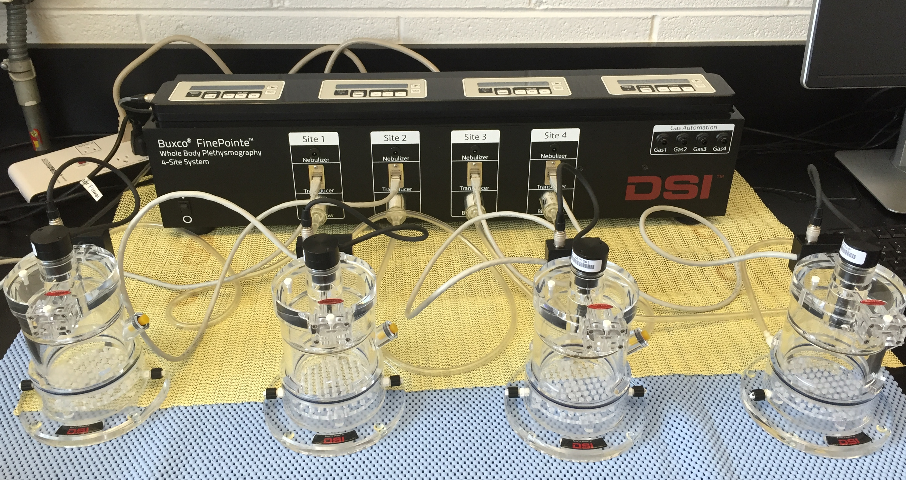
The data to be analyzed using Poincar$é$ and coefficient of variation were obtained from my previous studies on the respiratory effects of buprenorphine^{4, 5}. These studies began by purchasing three different genotypes of mice from the Jackson Laboratory (Bar Harbor, ME, USA). The three genotypes included mice that lack leptin and are obese (B6.Cg-Lep^{ob}/J: ob/ob: female n=10, male n=10), lack leptin receptors, are obese and diabetic (C57BLKS-Lepr^{db}: db/db: female n=10, male n=10), and wild-type (control) mice with normal weight and leptin levels (C57Bl/6J, female n=10, male n=10). Mice were allowed two weeks for adjustment to the laboratory and being handled. Each testing day began by preparing one of five different buprenorphine concentrations (0.1 mg/kg, 0.3 mg/kg, 1.0 mg/kg, 3.0 mg/kg, and 10.0 mg/kg). During drug preparation, the mice acclimated for 15 minutes in the chamber of the Buxco FinePointe Whole Body Plethysmograph (DSI, St. Paul, MN, USA). The DSI plethysmograph made it possible to quantify breathing from unrestrained, behaving mice (Figure 1). After termination of the acclimation period, mice were intraperitoneally injected with 0.3 mL of saline (vehicle control), or with 0.3 mL of buprenorphine solution. Breathing was measured every five seconds for 60 min after injection. Measures of breathing included frequency (f) in breaths per min, tidal volume (Tvb), minute ventilation (Mvb), inspiratory time (Ti), expiratory time (Te), total respiration time (Ttot) as the sum of duration of inspiration (Ti) plus expiration (Te). Additional measures included duty cycle (Ti/(Ttot) as an index of the active phase of respiration, and inspiratory flow (Tvb/Ti), an indirect measure of respiratory drive.
B
A
C
Figure 1 Buxco Whole Body Plethysmograph. Unrestrained mice were placed in each of the chambers (A) in order to monitor breathing. Transducers (B) detected changes in air pressure and volume. These changes were then amplified and transferred to a computer software, FinePointe, in order to be analyzed. The bias flow (C) supplied fresh air to the mice.

Measures of Variability
The purpose of this honors thesis was to test the hypothesis that variability in respiratory data differed as a function of sex, leptin status, and buprenorphine. The buprenorphine concentration of 0.3mg/kg, was chosen because it has been shown to produce antinociception in mice^{16, 17}. Previous efforts to quantify respiratory variability in rodents used the coefficient of variation of minute ventilation and tidal volume²⁴.
Therefore, the study reported here evaluated coefficient of variation and Poincaré analyses in an effort to determine which method of the two approaches could best quantify and visualize variability in breathing.
Quantitative Analyses
Poincaré Analysis of Minute Ventilation
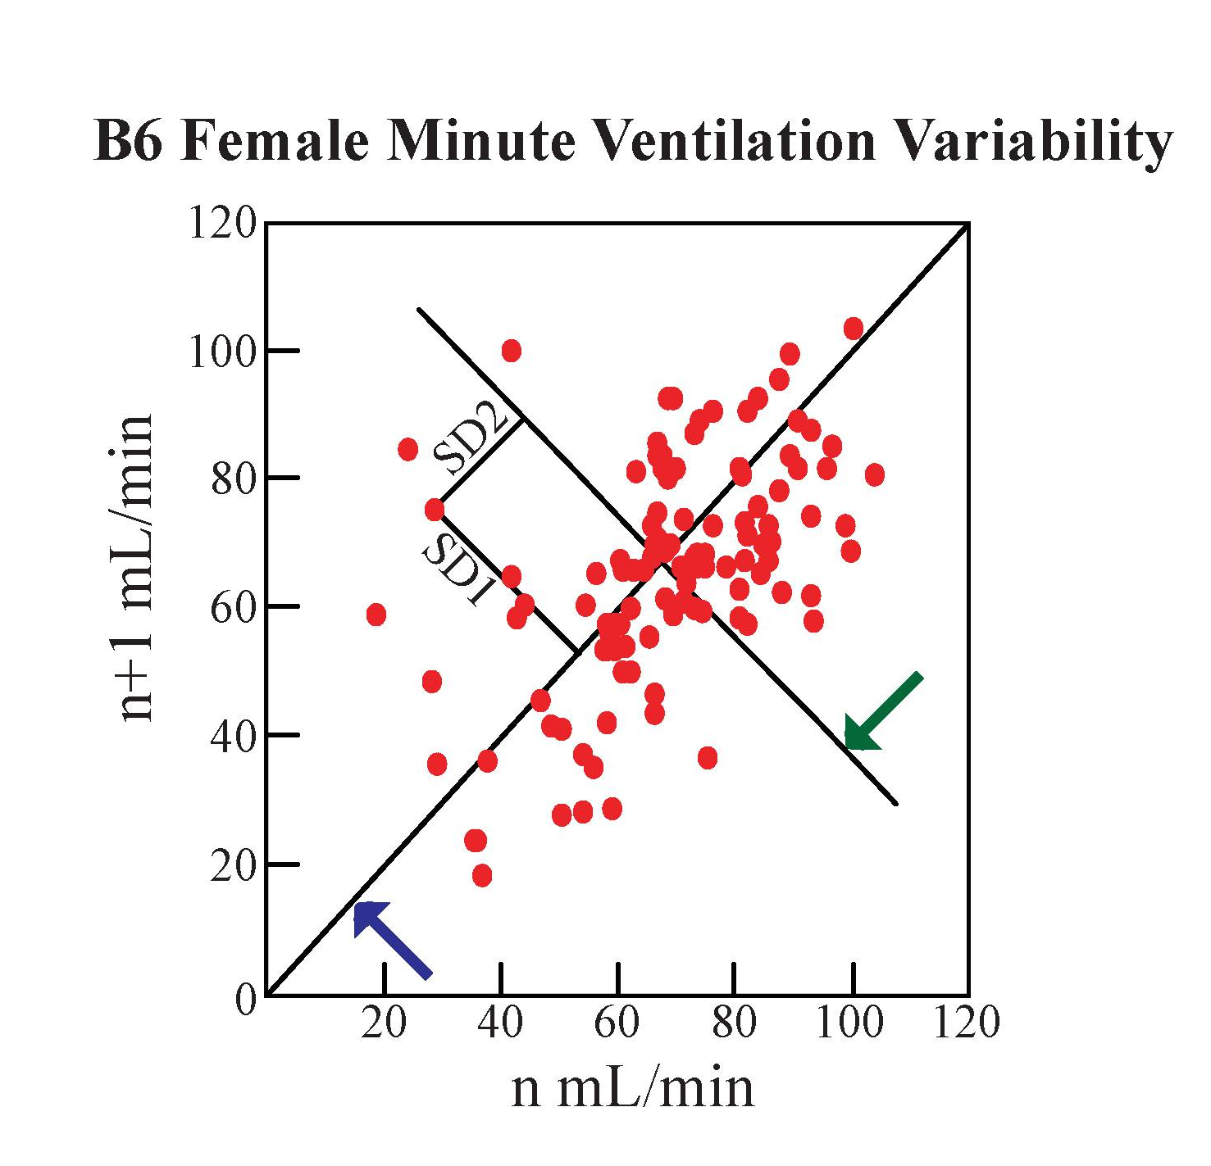
Poincaré plots are graphs in which each point, representing a repeating dependent measure, is plotted relative to a similar data point obtained earlier in time. Poincaré analyses assess variability in two different ways as illustrated by Figure 2. Standard Deviation 1 (SD1), is the short term variability, which is the variability in minute ventilation for one breath to the next breath^{14, 21}. SD1 calculations plot the average minute ventilation value from one time interval (x) to the next time interval (y), as can be seen in Figure 2. The line of identity, x=y, is plotted as the perpendicular line between each data point, as demonstrated by Figure 1. The line of identity is calculated using the Pythagorean Theorem. The standard deviation of all the distances is then calculated. Standard deviation 2 (SD2) expresses the long-term variability in minute ventilation over the course of the entire measurement period²¹. SD2 is acquired by plotting the average minute ventilation value for one time interval to the next time interval, y as a function of x as shown by Figure 2. The distance of each data point to the line perpendicular to and intersecting the line of identity is then calculated. Then the standard deviation of all the distances is calculated²¹. The point at which the line of identity and the line perpendicular to the line of identity intersect is called the centroid and is the mean minute ventilation value for all time intervals¹⁴. The more variability there is in a data set, the higher the SD1 and SD2 values²¹. Viewing the Poincaré plots and noting the degree to which the points are scattered also illustrates the variability in the data.
Figure 2 Each point seen on this Poincaré plot represents the mean minute ventilation value of a 5-minute interval graphed against the next 5 minute interval. The blue arrow points to the line-of-identity. The points perpendicular to the line-of-identity make up the SD₁. The green arrow points to the line perpendicular to and intersecting the line-of-identity. The standard deviation of the distances of each of the points to this line is then calculated in order to get the SD₂. The centroid, the point at which the line of identity and the line highlighted by the green arrow intersect at, indicates the overall minute ventilation mean.

Coefficient of Variation
The coefficient of variation is an analytic technique that makes it possible to compare the variability in a measurement relative to the mean of the measured values. An advantage of the coefficient of variation is that two different forms of measurement can be compared because the units of measurement are eliminated. The coefficient of variation is calculated by dividing the standard deviation by the mean. A higher coefficient of variation indicates more variability relative to the mean.

RESULTS:

Poincaré

Results from Poincaré analyses, Figure 3, supported the hypothesis that variability in respiratory data differed as a function of buprenorphine. Percent change calculations, as seen in Figure 5, Table A., showed there to be a 21.6 to 64.7% decrease in average SD1 minute ventilation values between vehicle and buprenorphine injections in all three mouse genotypes and in both sexes. As presented in Figure 5, Table B. , average SD2 minute ventilation data for vehicle and buprenorphine injections in all genotypes of mice and in both sexes revealed that percent change decreased by 38.8 to 61.5%. The decrease in SD1 and SD2 minute ventilation values, from vehicle to buprenorphine injections demonstrate how the plots collapse. These data show that variability is decreasing. Furthermore, unpaired t-test using Welch’s correction revealed that short term variability, SD1, seen in vehicle minute ventilation measurements, were significantly (p<0.05) less than the short term variability caused by buprenorphine. This was true for all genotypes and both sexes with the exclusion of ob/ob males. The unpaired t-test using Welch’s correction also showed that there was a statistical significant difference between the long-term variability, SD2, seen in vehicle minute ventilation measurements, which was less than the SD2 seen in buprenorphine minute ventilation measurements for all three genotypes and both sexes.
The results obtained from the Poincaré analyses also support the hypothesis that variability in breathing after buprenorphine administration differed as a function of mouse sex. Percent change calculations revealed that average SD1 values for vehicle injections in B6 and db/db female mice decreased by 10.8% and 26.8% respectively compared to the male mice, as seen in Figure 5, Table C. The female ob/ob mice had SD1 values increased by 5.2% from average male SD1 vehicle injection values (Figure 5, Table C). Average SD1 values after buprenorphine injections in female B6, db/db, and ob/ob decreased by 13.5%, 30.7%, and 28.1% respectively from average male SD1 values for buprenorphine injections in B6, db/db, and ob/ob mice, as noted by Table D and Figure 5. Table E in Figure 5 demonstrates that there was a 20.6% and 26.2% increase in the average SD2 minute ventilation vehicle value respectively for female B6 and db/db mice from their male counterparts. The average SD2 vehicle minute ventilation value for female ob/ob mice decreased by 7.07% compared to the male ob/ob SD2 minute ventilation vehicle value. Figure 5, Table F, shows that average SD2 values for buprenorphine injections in female B6, db/db, and ob/ob increased by 24.8%, 32.3%, and 16.8% respectively from average male SD2 values for buprenorphine injections in B6, db/db, and ob/ob mice. Additionally, the unpaired t-test using Welch’s correction results revealed that there was a statistical significant difference between male and female SD1 vehicle minute ventilation values for db/db mice and a statistical significant difference for SD1 buprenorphine minute ventilation values for db/db and ob/ob mice. There was no statistical significant difference between male and female SD2 values for either vehicle or buprenorphine minute ventilation values.
The results obtained from the Poincaré analyses support the hypothesis that variability in respiratory data differed as a function of buprenorphine’s effects on different mouse genotypes. There was a 37.9% decrease between female B6 mice and female db/db mice in average SD1 minute ventilation vehicle injections (Figure 5, Table G), while there was a 33.7% decrease between B6 average female SD1 minute ventilation vehicle values and average ob/ob SD1 minute ventilation vehicle values (Figure 5, Table H). Male db/db mice had a 44.1% increase in their average SD1 buprenorphine minute ventilation values in comparison to the B6 mice, as seen in Figure 5, Table G. Male ob/ob mice showed a 43.8% decrease in average SD1 minute ventilation vehicle values from the B6 mice (Figure 5, Table H). For average SD2 vehicle minute ventilation values, Figure 5, Table I, db/db had a 3.1% decrease from the average vehicle minute ventilation value for B6 mice. T-test calculations confirm these observations and showed that there was a statistical significant difference between vehicle SD1 minute ventilation values in female B6 vs female db/db mice, female B6 vs female ob/ob mice, and male B6 vs male ob/ob mice, where B6 mice, both male and female, had greater variability than db/db and ob/ob male and female mice. There was also a statistical significant difference between male B6 and male db/db mice for SD1 buprenorphine minute ventilation values and for SD2 vehicle minute ventilation values.

Coefficient of Variation
Coefficient of variation (CV) (Figure 4) calculations revealed that variability in respiratory data differed as a function of buprenorphine. CV values decreased after buprenorphine injections for all three genotypes of mice and in both sexes. CV values also showed that variability in respiratory data varied based on the genotype of the mouse. Overall, B6 mice, in both sexes, had higher vehicle minute ventilation data than db/db and ob/ob mice. Meanwhile female ob/ob mice had higher CV vehicle minute ventilation values in comparison to the female db/db mice. Male ob/ob mice had lower vehicle minute ventilation CV values than db/db male mice. After buprenorphine injections, db/db female mice had higher CV minute ventilation values compared to B6 and ob/ob female mice. Male db/db mice had higher CV minute ventilation values than ob/ob and B6 male mice. Coefficient of variation calculations were not very telling of sex differences in response to buprenorphine and vehicle calculations.

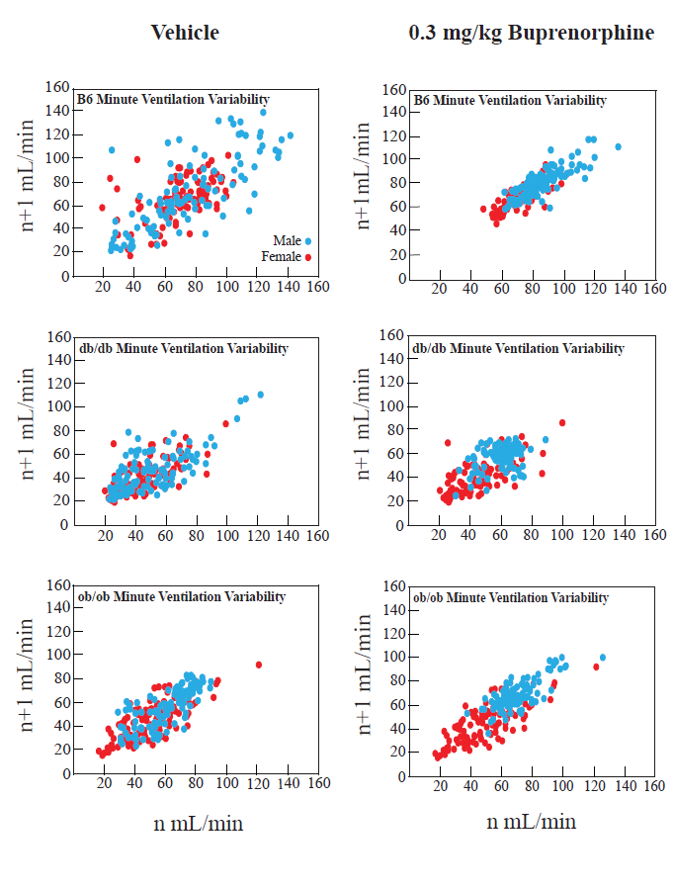
Figure 3: Poincaré plots demonstrate the amount of variability that can be seen in the monitoring of minute ventilation in B6, db/db, and ob/ob female and male mice after being injected with vehicle (saline) or 0.3 mg/kg buprenorphine dose.

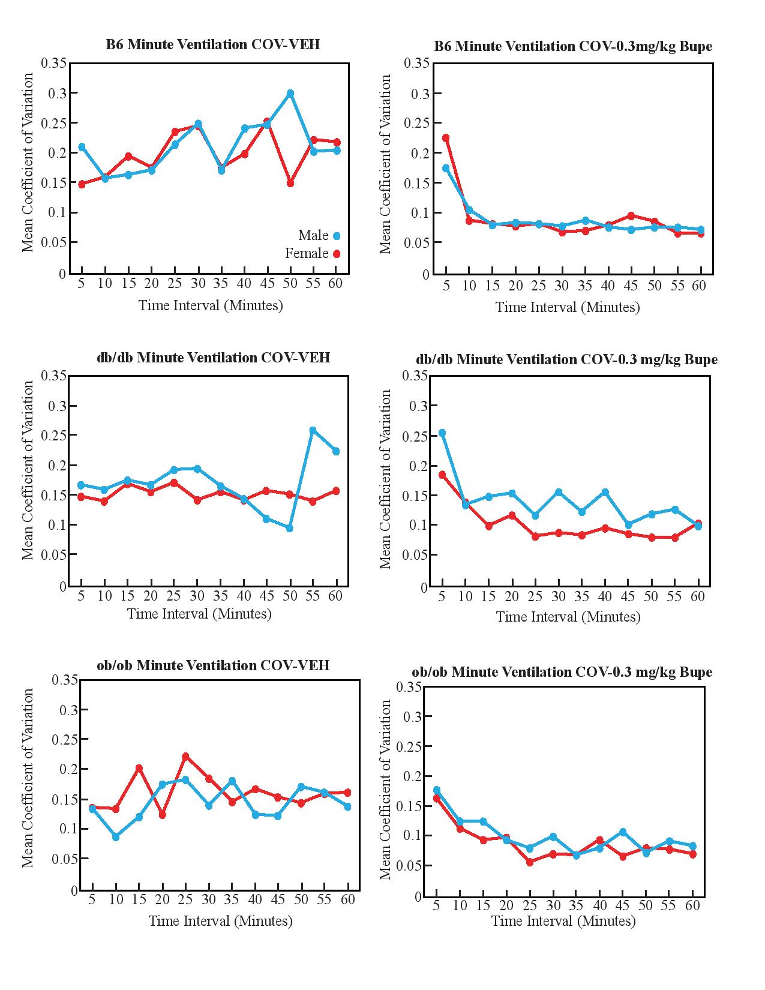
Figure 4: The coefficient of variation graphs show the variation relative to the mean minute ventilation value for each five minute segment over the course of an hour recording period. Coefficient of variation graphs were plotted for male and female B6, db/db, and ob/ob mice after vehicle and 0.3 mg/kg buprenorphine injections.

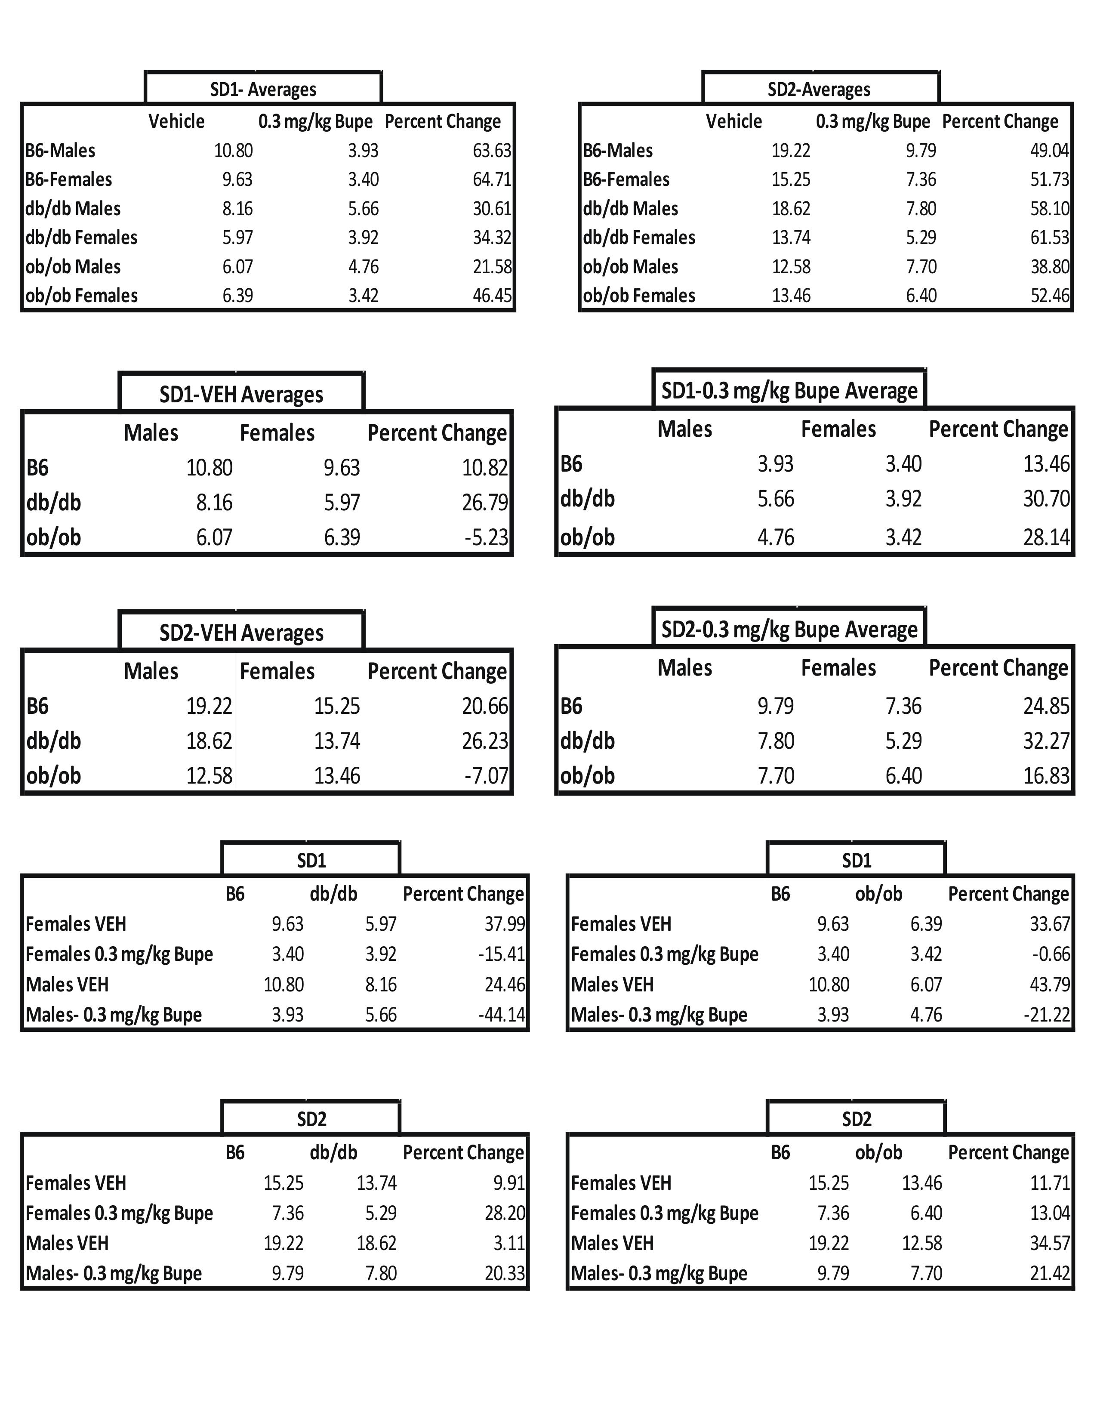
Figure 5: Table A. list percent change between average SD1 vehicle minute ventilation values and average SD1 buprenorphine minute ventilation values for male and female B6, db/db, and ob/ob mice. Table B. shows percent change between average SD2 vehicle minute ventilation values and average SD2 buprenorphine minute ventilation values for male and female B6, db/db, and ob/ob mice. Table C list percent change between average male SD1 vehicle minute ventilation values and average female SD1 vehicle minute ventilation values for all three genotypes of mice. Table D shows percent change between average male SD1 buprenorphine minute ventilation values and average female SD1 buprenorphine minute ventilation values for all three genotypes of mice. Table E list percent change between average male SD2 vehicle minute ventilation values and average female SD2 vehicle minute ventilation values for all three genotypes of mice. Table F shows percent change between average male SD2 buprenorphine minute ventilation values and average female SD2 buprenorphine minute ventilation values for all three genotypes of mice. Tables G and H show percent change between average SD1 minute ventilation vehicle and buprenorphine values between male/female B6 mice and male/female db/db mice and male/female B6 mice and ob/ob male/female mice respectively. Tables I and J show percent change between average SD2 minute ventilation vehicle and buprenorphine values between male/female B6 mice and male/female db/db mice and male/female B6 mice and male/female ob/ob mice respectively.
J.
I.
H.
G.
F.
E.
D.
C.
B.
A.

Discussion:

Results from Poincaré and coefficient of variation analyses supported the hypothesis that obese and female mice would exhibit less variability in measures of minute ventilation, since they are more susceptible to opioid-induced respiratory depression. Poincaré analysis revealed that although there was a difference in variability, the statistical significant difference (p<0.05) in variability was mostly noted in short-term variability. Even though female mice showed less variability than male mice, and normal weight mice showed more variability in respiratory data than overweight mice, both sexes and all three genotypes showed less variability in their data after buprenorphine injections. This supports the idea that the more variable the respiratory data, the more likely it is the subject is experiencing normal respiratory behavior. After injections of buprenorphine, even the healthy mice, showed less variable data since their breathing was compromised. The fact that variability is an indicator of a subject’s respiratory status demonstrates the fact that monitoring vehicle minute ventilation variability could be a more powerful way to predict which mouse is more likely to experience respiratory depression. Though all mice showed less variability in their minute ventilation data after buprenorphine injections, females showed less variability in their respiratory data than males. Based on coefficient of variation calculations, it was difficult to note any difference in variability in minute ventilation in sex responses to buprenorphine injections; however, Poincaré analysis revealed that the difference in short term variability was not significant after vehicle injections. However, a statistical difference between male and females was observed after buprenorphine injections, during which females exhibited less variability. Hence variability was correlated to respiratory status. There seemed to be no statistically significant difference between males and females average minute ventilation long-term variability in all three genotypes for vehicle or buprenorphine injections. Why there was only a statistical difference between male and females in short-term variability and not in long-term variability is still unknown. In addition, it is not known what causes short-term variability. Studies have investigated sex differences in active metabolism of buprenorphine in order to see if this had any effects on an individual’s respiratory response to buprenorphine³. One study found that females who received the same doses of buprenorphine as males had higher levels of the metabolite, norbuprenorphine-3-glucuronide²⁰. Further investigation of sex differences in response to buprenorphine is needed. Recently, it was found that women were overdosing on a Food and Drug Administration (FDA) approved drug, Ambien (Zolpidem), a medicine used to help with insomnia. These women were overdosing because they were prescribed the same dose as their male counterparts. The FDA then requested that women received half the dose as males⁹. It is cases like these that show the importance of investigating sex differences in response to opioid-induced respiratory depression and finding ways to detect susceptibility such as monitoring variability in baseline recordings of respiratory behavior.
Both Poincaré and coefficient of variation analysis revealed that B6 mice had more variability in their minute ventilation vehicle and buprenorphine injection data compared to db/db and ob/ob mice. Many studies have found that leptin not only acts as a satiety hormone, but could also be acting as a respiratory stimulant^{4, 13}. One can speculate that the overweight mice, db/db and ob/ob, do not experience the stimulatory effects of leptin due to the fact that db/db mice do not have functioning leptin receptors, and ob/ob mice do not have any leptin circulating in their system.
Though both Poincaré and coefficient of variation analyses revealed information about variability in minute ventilation, Poincaré offered more information about the variability. Not only did it provide information about long-term variability, it also offered more insight on short-term variability. In conclusion, differences in variability in respiratory data as a function of genotype, sex, and buprenorphine injections were more seen more clearly in Poincaré results than in the coefficient of variation results.

References

1. Clinical guidelines for the use of buprenorphine in the treatment of opioid addiction. 2004, Rockville, MD: Center for substance abuse treatment.
2. The role of opioids in the treatment of chronic pain 2014 March 5, 2015 [cited 2016 February 22]; Available from: https://prevention.nih.gov/programs-events/pathways-to-prevention/past-workshops/opioids-chronic-pain.
3. Alhaddad, H., Cisternino, S., Saubamea, B., Schlatter, J., Chiadmi, F., Risede, P., Smirnova, M., Cochois-Guegan, V., Tournier, N., Baud, F., and Megarbane, B., Gender and strain contributions to the variability of buprenorphine-related respiratory toxicity in mice. Toxicology 2013. 305: p.99-108.
4. Angel, C., Alami, W., Mihalko, S., Baghdoyan, H., and Lydic, R., Buprenorphine-Induced respiratory depression varies as a function of leptin-related genotype in normal weight and obese mice. . FASEB Journal 2016. 30: (717.7).
5. Angel, C., W., A., Mihalko, S., Baghdoyan, H., and Lydic, R., Sex, leptin status, and obesity modulate buprenorphine-induced respiratory depression in mice. The Physiologist 2016. 59: p. 22.
6. Barash, P., Cullen, B., Stoelting, R., Cahalan, M., Stock, C., and Ortega, R., Clinical Anesthesia. 2013, Philadelphia, PA: Lippincott Williams and Wilkins, a Wolters Kluwer Business
7. Barbour, S., Vandebeek, C., and Ansermino, M., Increased tidal volume varibility in children is a better marker of opioid-induced respiratory depression than decreased respiratory rate. Journal of Clinical Monitoring and Computing 2004. 18(3): p. 171-8.
8. Bartley, E. and Fillingim, R., Sex differences in pain: a brief review of clinical and experimental findings. British Journal of Anaesthesia, 2013. 111(1): p. 52-58.
9. Cahill, L., Equal the same: sex differences in human brain. Cerebrum 2014.
10. Dahan, A., Aarts, L., and Smith, T., Incidence, reversal, and prevention of opioid-induced respiratory depression. Anesthesiology, 2010. 112: p. 226-238.
11. Daoust, R., Paquet, J., Lavigne, G., Piette, E., and Chauny, J., Impact of age, sex, and route of administration on adverse events after opioid treatment in the emergency department: a retrospective study. Pain Research and Management 2015. 20(1): p. 23-28.
12. Davide, C., Jordan, B., and Edward, G., Respiratory Volume Variability Prior to Opioid Administration as an Indicator for Opioid-Induced Respiratory Depression, in A22. STRATEGIES TO ADDRESS QUALITY IMPROVEMENT. 2015, American Thoracic Society. p. A1081-A1081.
13. Foteini, M., Papaioannou, A., Gourgoulianis, K., and Daniil, Z., The role of leptin in the respiratory system: an overview. Respiratory Research 2010. 11(1).
14. Icaza, E.E., Huang, X., Fu, Y., Neubig, R.R., Baghdoyan, H., and Lydic, R., Isoflurane-Induced changes in righting response and breathing are modulated by RGS Proteins. PubMed Central 2011. 109(5): p. 1500-1505.
15. Johnson, R., Fudala, P., and Payne, R., Buprenorphine: considerations for pain management. Journal of Pain and Symptom Management, 2005. 29(3): p. 297-326.
16. Kabirullah, L., Shoshana, E., Camron, B., Yu, Y., Nazli, S., Wendy, W., Brigitte, K., Hiroshi, T., Ivy, C., Nigel, M., and Christopher, E., Buprenorphine- Induced antinociception is mediated by u-opioid receptors and compromised by concomitatn activation of opioid receptor-like receptors The Journal of Neuroscience, 2013. 23(32): p. 10331-10337.
17. Kamei, J., Saitoh, A., Suzuki, T., Misawa, M., Nagase, H., and Kasuya, Y., Buprenorphine exerts its antinociceptive activity via mu1-opioid receptors Life Sciences 1995. 56(15): p. 285-290.
18. Kryger, M., Roth, T., and Dement, W., Principles and practice of sleep medicine 2017, Philadelphia, PA: El Sevier.
19. Lee, L., Caplan, R., Stephens, L., Posner, K., Terman, G., Voepel-Lewis, T., and Domino, K., Postoperative opioid-induced respiratory depression: a closed claims analysis Anesthesiology 2015. 122(3): p. 659-665.
20. Moody, D., Fang, W., Morrison, J., and McCance-Katz, E., Gender Differences in Pharmokinetics of Maintenance Dosed Buprenorphine Drug Alcohol Depend, 2011. 118: p. 479-483.
21. Muncey, A., Saulles, A., Koch, L., Britton, S., Baghdoyan, H., and Lydic, R., Disrupted sleep and delayed recovery from chronic peripheral neuropathy are distinct phenotypes in a rat model of metabolic syndrome. Anesthesiology, 2010. 113: p. 1176-85.
22. Rosenblum, A., Marsch, L., Joseph, H., and Portenoy, R., Opioids and the treatments of chroni pain: controversies, current status, and future directions. Exp Clin Psychopharmacol, 2008. 16(5): p. 405-416.
23. Rudd, R., Aleshire, N., Zibbell, J., and Gladden, R. Increases in drug and opioid overdose deaths- United States, 2000-2014. 2016. 64, 1378-82.
24. Saponjic, J., Miodrag, R., and Carley, D., Injection of glutamate into the pedunculopontine tegmental nuclei of anesthetized rat causes respiratory dysrhythmia and alters EEG and EMG power. . Sleep Breath, 2005(9): p. 82-91.
25. Zdziarski, L., Wasser, J., and Vincent, H., Chronic pain management in the obese patient: a focused review of key challenges and potential excercise solutions Journal of Pain Research, 2015. 8: p. 63-77.

