The Astral Box
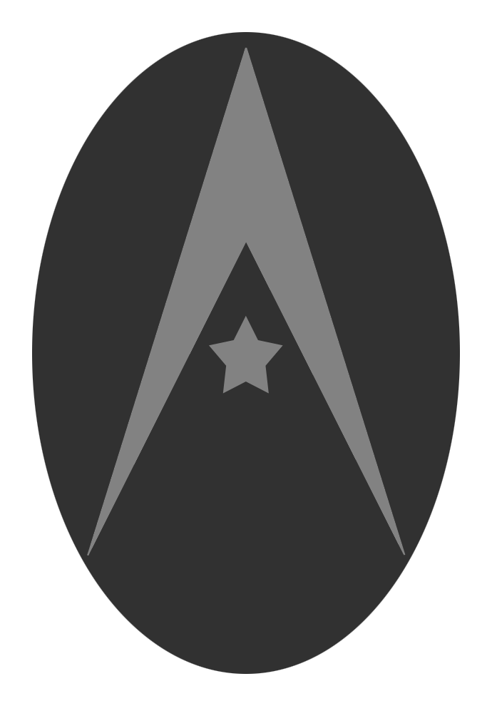
Project Team
Marshall Underwood, BS Computer Science 2014, University of Tennessee
Zack Hicks, BS Computer Science 2014, University of Tennessee
Jahan Hussaini, BS Computer Science 2014, University of Tennessee
Patrick Davis, BS Computer Science 2014, University of Tennessee

Project Mentor
Leonard Knight
Owner, Neighborhood Nerds
President, Entrepreneur Club of Knoxville

Project Website
http://web.eecs.utk.edu/~zhicks1/

This document describes Project Astral, a small electronic device designed to allow users to transfer images and video directly from their portable devices such as laptops and cell phones to their televisions.

Story

The average consumer needs a simpler way to transfer images and video from their computer to their television.

To the Dodds family, there was no day like Sunday. To Paul, his wife, Angela, and his 6-year old daughter Melissa, each one was a new adventure. Though it was the only day Paul had off from work every week, he and his family made the absolute most of it, spending it by doing everything from dog sledding to taxidermying together as a family. However, one aspect of Sunday always remained constant: the nine o'clock movie. Every Sunday night, the three of them would pop some popcorn, turn off the lights, and snuggle up on the couch to watch a movie together on their living room television. Melissa would often fall asleep before it ended, and Paul would carry her up to her bed and tuck her in, dreams of what they would do the following Sunday already boiling up to the surface of his mind.

One Sunday, Melissa got an idea. She wanted them to record their big Sunday excursion and make their own movie as a family. Then, they could watch that video as their nine o'clock movie later that night. Both he and Angela loving the idea, Paul got out his video phone, and after a long day at the history museum they had created their first short film: Dobbs In Time: The Myriad of Error.

That night, Paul and his family gathered around the couch, popped their popcorn, and prepared to watch their movie. Since Paul had used his video phone to film it, he and his family decided to just watch it directly on his phone. The movie was just as hilarious and entertaining as they expected, but having to crowd up by Paul's small phone and listen to its tinny, low-quality audio just wasn't as satisfying as they were hoping. They all agreed they would have preferred watching it on their television instead, especially if they planned to make any more movies in the future. Though Paul knew how to transfer the file to his computer, he had no clue how to get it on the television. To Paul, electronics were just magical devices that worked in ways man was not meant to understand. Therefore, having no interest in calling anything involving the words 'tech' or 'support', he decided to browse the Internet for some magic that could solve his problem.

After some online searching, he found a couple of products that would help his family get their home movie on their television. The Apple TV and the Roku were the first two products he discovered. They looked very promising and more than capable of doing what he needed, but their prices were a bit out of his budget. Looking for a cheaper solution, Paul stumbled upon the Chromecast, a simple-looking device that looked to be just the ticket he needed for his family to watch some higher quality movies.

It arrived in a few days, and Paul excitedly opened the box, wasting no time in trying it out. Quickly hooking it up to the television, he logged onto his computer and prepared to activate the mystical device that would make his movie move from the box with the keyboard to the box with surround sound. However, to his great dissatisfaction, he found that the Chromecast was only capable of streaming videos on the Internet, not directly from his computer. Not wanting to post a video of his family on the Internet for all to see, he did another quick Internet search to look for an extension that would help him get around this problem. After finding one, he finally managed to get his movie onto the television only to find that he couldn't get the audio to work. Paul was fed up. Clearly his family needed something better suited for watching their movie on their television.

Discouraged by his lack of success, Paul went back to the Internet one more time to find something to fix his problem. It was then that Paul discovered the Astral, and after carefully reading up on it, he decided the price was reasonable enough and sent back his Chromecast to buy one. After it arrived, he opened it up and connected it to his television, relieved to find it just as simple to set up as the Chromecast. And just as the product advertised, he was able to transfer the file to his television without having to post it online first. After all the headache he had gone through trying to get it to work, he was amazed at how simply the problem was resolved. Looking at the Astral's user manual, he was delighted to find that he would be able to store all his family's movies on the box so that they could both watch them and show them to friends with just a press of a button. He didn't understand any of it, but he knew one thing was true: he had found the magical device he was looking for.

The next Sunday, after an exciting day of fly fishing, the Dobbs family returned with their second home movie, Dobbs In the Depths, freshly recorded and ready for viewing. Paul told his family to go make the popcorn while he set up the movie and had everything ready before the first kernel was popped. They turned off the lights and watched their movie, finding the experience of watching it on the television that much more enjoyable by comparison. Truly this was just the beginning of their movie-making excitement.

After carrying Melissa up to bed and coming back down to turn off the television, Paul spotted his wife typing something on her computer. Finding it odd for her to be on it at this time, Paul asked what she was doing. She smiled at him and said she was just posting on her wall to tell everyone they knew about his success in getting the movie on the television. About half of their neighborhood each owed her ten dollars.

Motivation and Market Analysis

Though the computer and the television can both be described as metal boxes that light up and show pictures, they are far from being the same device. To your average consumer with no technological know-how, they may as well be alien technology. A computer has the ability to store information while the television specializes in simply outputting information. When stated in this manner, it seems like these two devices were made to work together, but with your average consumer having difficulty operating each device on its own, bringing them together can be much easier said than done.

First, the question must be asked: Why would someone need a device that could display the images stored in a computer on a television screen? The most obvious answer would probably be convenience. Televisions are designed with output as the key focus, making them often much better at displaying and sharing information with other people than a computer, especially for a large group. If a person has an image or a video on his or her computer that needs to be shared with others, it would be preferable to show it on a television, which most likely has a larger screen and superior audio.

Clearly a device that could bridge this complicated gap and display the images stored in a computer on a television screen would be useful, but that raises another question: Useful to whom? To answer this question, yet another question should be asked first: Who could benefit from using it? The most rudimentary answer to that question would be to anyone who uses both a computer and a television. According to an article on Huffington Post, seventy-seven percent of people who took an international online survey admitted to watching television while on the computer. While the article itself is about a rise in multitasking, it also reveals that a rough minimum of seventy-seven percent of all the people with a computer also own a television. According to World Internet Users Statistics Usage and World Population Stats, approximately 2.4 billion people on the planet have internet access out of the roughly 7 billion people on the planet, which is about thirty-four percent of the world population. Taking both stats into consideration, that means there are about 1.8 billion people minimum who could potentially use this device, certainly not a trivial number.

So we know that there's a market of people who could use this device. However, who out of those 1.8 billion people will find it useful? To answer that question, we would need to look for people who need to display their computer files on a television for some reason or another. For personal use, it would provide people with a convenient way to watch their videos on their television as well as store them to watch again later. For commercial use, it could be used to conveniently loop commercials on a television as a simple form of marketing. Also, teachers could then use it to display images and video on a television screen for class presentations. The key luxury of this device is convenience, which holds value to the average consumer and the average business owner alike. This product could be sold to anyone who values that convenience. However, in order for it to be considered useful, the value of the convenience must be justified by the cost.

How much should a person be expected to pay for a device like this? How much value does that convenience have to a person? Bank fees are one example of people paying for convenience. In order to conveniently retrieve their money, people are willing to pay a couple dollars for each withdrawal. However, then there's same-day delivery. Though it allows people to pay for convenience, most people opt to wait a little longer and save the extra ten dollars (Business & Money). While it's true that many people do opt for same-day delivery, it's clear that convenience and cost are competing factors in the average consumer's decision.

To better understand this decision, let's take a look at one of the most prolific examples of paying for convenience: the automobile. The average consumer spends about 30,000 dollars on the car itself and then a few more thousand annually for car insurance and gasoline (MoneyBuilder) (Bradford). Ignoring the cost of any repairs, that's an impressive amount of money for people to spend on convenience, and it really is all that they are paying for. A person could get from point A to point B without a car, but it would take a considerably longer amount of time, and that's the main point. The amount of time that the car saves makes it worth the cost, meaning in order for this product to be worth the cost, it needs to save an equivalent amount of time.

So how much time does this product save? Obviously, this would depend on the user, but the key component of time saving would be in simplifying the process of transferring files from the computer to the television. To those who know nothing about the process, this includes time it would take to find an alternative method to accomplish this goal, time it would take to take the necessary steps to accomplish this method, time it would take to repeat these steps every time they wanted to watch their video, and also time it would take to instruct their family and friends how to do it as well. A simplified method that any user can easily follow can save hours and hours of the user's time as well as the stress of having no idea what to do. A single payment of $50-$100 would be reasonable for that level of convenience.

Our primary source of income would be through our Kickstarter project, which would allow us to begin raising the funds for our product as well as get our name out there. As for selling our first prototype, our ideal first customer would probably be a small business owner who could benefit from using our device in a commercial setting.

Similar Work By Competitors

The three products that mostly resemble ours are the Apple TV, the Roku, and the Chromecast. Each one is a digital media player that allows people to either stream images and video from their computer to their television sets by connecting to it through the HDMI port, or to allow a user to view “channels” such as YouTube and Hulu on their TV’s via the device.

The Apple TV is a product from Apple with a small design and a simple setting-up process. It has a function called AirPlay that allows the user to wirelessly stream content from an iPhone, iPad, or iPod touch on the television as well as mirror it directly onto the screen. However, its library of entertainment channels is limited, and it has no ability to store content. It is also a closed-off system, as only Apple products can interact with it. This is a huge limitation, as not everyone owns a Mac, iPhone, or iPad.

The Roku is similar in design to the Apple TV but boasts a much larger number of entertainment channels. Its user interface is known for being very easy to navigate, and the box itself is about as simple to set up as the Apple TV. It also comes with a USB and microSD card slot for additional storage. It is, however, incapable of streaming content from your iTunes library, and it does not support YouTube.

The Chromecast is even smaller than the other two, taking the form of a dongle that plugs directly into an HDTV. It uses mobile apps and Web apps for all the main playback controls and uses a function called tab casting to mirror any content displayed by the Google Chrome web browser on the computer. It has the most limited app support of the three and like the Apple TV, has no method of storing content for later viewing. It is simply used to view Netflix or YouTube, and also content from the Google Play market. A user must pay to rent or buy media from the Google Play market.

The most important measurements we are looking at for these three products are diversity in file format support, the ability to store files, and the ability to freely stream or store files directly from your hard drive regardless of the brand of the computer the user has.

The Apple TV supports JPEG, BMP, GIF, TIF, and PNG for images and only runs video formats that can be run through iTunes and QuickTime Player, such as MP4. Roku supports even fewer with only MP4 and MKV for video and JPG and PNG for images. Chromecast is also limited in the types of files it can play, supporting the main formats like MP4, AVI, and JPEG and requiring an extension to transfer the more obscure ones.

Next, of the three other products, Roku is the only device capable of storage. It comes with a microSD card for additional storage, but the card cannot be used for storing personal files, only games and channels. The user can still store and view their files through the USB Media Player app, but it requires a thumb drive and doesn't store the files through the Roku itself.

Finally, the ability to freely stream files directly to the television from your hard drive is not very prevalent in any of the three other products. As previously stated, Roku has the USB Media Player app, which requires a thumb drive to play personal files. AppleTV has no ability to display movies or images that are not associated with the user's iTunes account, limiting what it can display by a great deal. Chromecast as well comes with no method of streaming video and images directly from the computer's hard drive. For both AppleTV and Chromecast, any streaming must be done through the Internet, and only through specific programs.

In terms of price, the AppleTV and the Roku are both roughly $100. At this price, neither of them stream files from the hard drive or allow storage directly on the device, and both only support a handful of file formats. Chromecast beats both of them in price at $35 dollars, but suffers from essentially the same problems. Furthermore, Chromecast supports a very limited number of apps and requires that you use Chrome, making it affordable but sufficiently lacking in convenience.

Altogether, these devices contain a good amount of functionality that is useful for the user, but taken alone as they are on the market, each device lacks in key ways that could be addressed. No one of these devices streams from the hard drive regardless of platform; can be controlled by any phone, computer or tablet; can cast videos from YouTube; is upgradable in storage; and is not locked down by a single brand. These devices limit the user, in that if the user doesn’t have the right device, or even wants to use a particular browser to send files, it will not work unless it is the one specified by the device.

Furthermore, while these devices seem to be built with simplicity in mind, they are not necessarily built with convenience in mind for the user; not one of these devices allows the user to upload his or her own season of a show and then play it from the comfort of his or her couch (by opening up an app on a phone and navigating to it for instance). Another example of the lack of convenience is the restriction on not just brands, but actual devices, namely with the Apple TV and Chromecast. Of course there is the Apple restriction, but Chromecast actually requires a mobile device to pause or play the media during playback. With the brand restriction of the devices (once again, namely the Apple TV and the Chromecast), it is not possible to truly make any device a remote for a television. These limitations on the user seem to be bred from the nature of locking devices to certain software and hardware, which is not necessary and not convenient for their own users.

Patents

https://www.google.com/patents/WO2002087239A1?cl=en&dq=Data+transfer+onto+television&hl=en&sa=X&ei=xNGHUt4TtbjgA6zUgBA&ved=0CDcQ6AEwAA

https://www.google.com/patents/US20130239132?dq=Apple+TV&hl=en&sa=X&ei=f9OHUoOUN-ig4AOH1oDwCQ&ved=0CEUQ6AEwAg

Measurement of Prototypes and Final Product

As we analyzed and measured all similar products within the same market, we were able improve on many parts of our prototype. Our device was a media system that had minimal capabilities during the beginning of the semester before understanding our competition. Our first prototype we created consisted of a single board computer hardware and a client server that communicated with any device with a browser which would upload a media file and automatically play it on the hardware that was connected to the TV through the HDMI. The first prototype lacked a sufficient media player that could play a media file format with maximum resolution of 1080p. This was an edge that our competitors had over us. The Google Chromecast, Roku, and Apple TV all supports 1080p resolution. The second prototype that we created consisted of the raspberry pi which was the hardware that supported a much better video quality. It also supported numerous media file format that our competitors do not. The Apple TV and Chromecast mainly supports MP4 and AVI. The Roku, on the other hand, supports only the MP4. Our second prototype not only supports all of these file formats but also formats such as AVI, MOV, TIF, MP3, and WAV, which is a music file. This visual graph will give a better understanding on the success rate of our second prototype in comparison to our competitors:
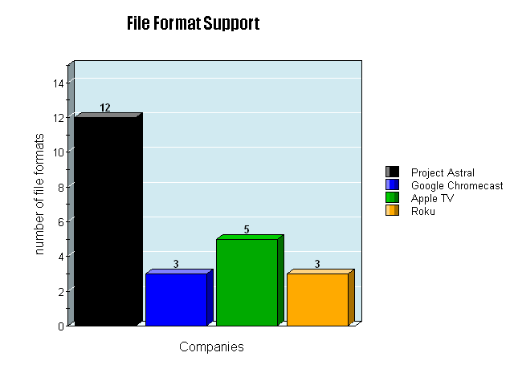
We focused extensively on our competitors limitations and weaknesses of their product which improved our third prototype. The limitations our competitors have is that the products they offer are not universal. These products are created to help advertise and support their existing products. For example, the Apple TV offers a media system that can be controlled with only apple products and will only receive data from such devices. The Apple products are the iPad, iPhone, and the Macbook, and only these will work with the Apple TV; there is no other compatibility for other devices. The Google Chromecast also has this limitation. It only supports the Google Chrome browser which is an existing product created by Google. This is a huge disadvantage to any consumer without these products. This brings us to our third prototype which we improved our design to be universal and can be controlled by any device with a browser. This ranges from any operating system to any portable devices. This visual graph gives a better understanding on browser capabilities between us and our competitors:

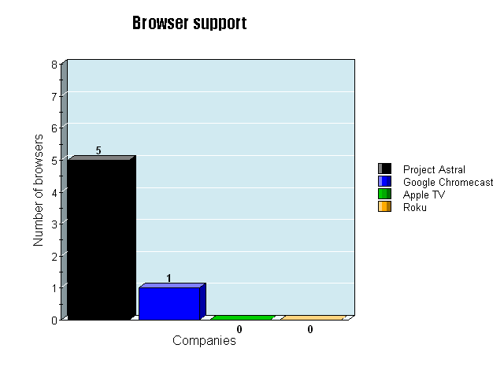
This gives us the advantage over these products because we do not limit our product in any way to a specific product. We give full video functions in our product as well which the Chromecast does not. Users can play/delete/stop/..etc any personal media file as they wish as long as their device is connected to ours. Our final product was all of the improvements combined as well as any feature that our competitors had that could be an advantage over us. Our final product consisted of not only all these features but also an android app and a Google Chrome extension that will send any youtube video to the device. This feature is what made the Google Chromecast unique to consumers because of the high usage of youtube on devices. The disadvantage about the Chromecast as i stated earlier was that this extension is only allowed on the Google Chrome Browser. Our extension is browser independent which can be extended to not only the Chrome browser but also browsers such as Mozilla Firefox, a very well known internet browser. The youtube video can be transferred within seconds to the device which will be played using the highest resolution the video can offer automatically. The final product also comes with memory storage that the user can store personal files and play them whenever they need. This is a distinct advantage over our competitors because their products do not have any storage and only allows constant streaming.

In conclusion our device supports all major file formats as well as several obscure ones, allowing most videos to be displayed on the television without the need to convert.
Our device allows the user to store files directly to the device itself and conveniently access them at any time without any external storage device required. Our product is specifically designed to stream and display media directly from the hard drive.

Now, as for the price of the Astral, we fall right in the middle at $60, and we fully believe this to be a competitive price. The Astral explicitly dominates the other products in all three areas mentioned above, making it already a better value than the Roku or AppleTV for people interested in those three areas. The Roku which is priced up to $80 and the Apple TV which is priced at $100. The Chromecast however, is priced at about $35. The difference between the Chromecast and the Astral is $25, meaning one investment of $25 will provide the user with the convenience of transferring files directly from the computer to a storage unit that can be viewed on their television any time they want as well as the ability to watch virtually any type of file they have without having to trek through the murky swamp of file conversion. The investment will also give you full control over the media files being played on the TV where the Google Chromecast does not. The Chromecast will not give you video controls unless it is on the android app that is installed on your Android tablet/device. The Astral on the other hand, gives you video function controls such as play/pause/delete...etc on any device that is connected to the Astral.

The Astral has no monthly subscription fees and is a permanent connection to the user's television, meaning the initial cost will be the entire cost for as long as the device remains functional. Though the additional $25 may seem steep, it's actually a major investment in convenience for the entire span of time that the user will own the device.

Design Decisions

Our entire design process was not thought out fully from the very beginning. This is especially apparent when looking at our first ideas. The original intention was to design a project around thermal cameras, which gave us our original team name: “Team Thermal”. The entirety of the first two weeks of our occasional team meetings were spent brainstorming ideas for inventions or innovations surrounding thermal vision and the uses for the infrared spectrum in general. However, every single idea that we came up with on our own turned out to have already been designed and implemented far more efficiently than a group of college students with little to no outside funding could hope to manage. Eventually we decided that nothing we could come up with, design, and implement in the span of a single semester would be new or unique enough to qualify for our Senior Design project, which led us to scrap our idea completely and start over. Each of us agreed to come up with at least three different ideas by the end of that week to present to the group, so that we would have at least a dozen different ideas and fields to choose from. When we next met, the list of options was incredibly varied, and included a fish tank monitor, several Android or iPhone apps, and home automation devices. Each of us had our three ideas, but none of us could agree on what was best or even what was bad enough to throw out. It was pointed out that between the four of us, we owned six BeagleBoards, and that they were powerful enough to be a fairly common prototyping choice despite their relatively new design. That was when we decided to use BeagleBoards to create some form of home automation or entertainment. That was turned into a rough design for a small home media server by Marshall. The media server idea was accepted because it was an idea that was rarely done well at a price that the average consumer could afford. After researching other home media devices, we had notes on what the competition was doing poorly and how we thought we could improve on their designs.

Another second change for our Senior Design project also involved working with the BeagleBoard. Marshall had a very basic server written with JavaScript through Node.js over a weekend, but there were several problems that could kill the project. The most serious was discovered by Zack. It turned out that even though the BeagleBoard included a micro HDMI port for audio and video output, it could not handle playing videos at a high enough quality to ever be considered part of a well functioning finished product. After some more group research on why the board was too slow for HD video, and searching for possible ways to free processing power from unnecessary parts of the BeagleBoard’s system, we decided that the board would have to be replaced. Patrick and Jahan found a replacement for the hardware in the form of a Raspberry Pi, which is another common prototyping board that is often used specifically for audio and video related projects, and is also easily used in projects that involve direct WiFi connections to devices or interfacing with machines across a network. Zack ordered the Pi and figured out that the best system for the board would be Raspian, which is a version of Debian Linux that has been optimized for the Raspberry Pi’s hardware. This was an important decision, because a prototyping board is extremely limited in the amount of processing power as compared to an average desktop PC or laptop. Any system that we flashed onto the Pi would have to work efficiently and minimize background processes that could quickly use up CPU cycles. The server’s software was copied over and tested with several HD videos, which all played smoothly. We now had a platform for our server to run on which was strong enough to handle any video we uploaded to it. The Raspberry Pi was a vast improvement over the BeagleBoard, which tended to either lock up or crash completely whenever a large picture or higher-than-average quality video was attempted to be displayed.

The last major change that the Team Astral project went through was the transition from wireless connection through Bluetooth to WiFi. We had initially decided that the best way for this project to be useable was for it to be made wireless. Plugging the Astral Box into a network router would work, but not everyone in our intended consumer base would have spare ethernet ports on their router or even necessarily have access to the router at all. For example, a college student in a campus dorm often has devices that connect to the network through WiFi, but could not connect through ethernet cables because of the security around the network hub, along with the sheer number of connections that a university dorm will service. We had heard that Bluetooth was much more secure than WiFi, so we initially decided that it was the best option. However, it was eventually discovered that the BeagleBoard, and later the Raspberry Pi, was having major difficulty with any Bluetooth adaptor that we used. Sometimes it would see other devices but not connect, and other times its scans would return empty lists of available devices. This, paired with the huge data rate advantage that WiFi offered, and with no real need for security, meant to us that the Bluetooth idea had to be scrapped and replaced with WiFi. Zack bought an adaptor online and tried it with the Pi, which turned out to have all the necessary settings for connection type that we needed. The change to WiFi from Bluetooth was an excellent decision which gave our project more stability, faster response times, and a more simplified code model for the server. It also granted us a wider reach to the user because of the higher numbers of WiFi enabled devices over the number of commonly owned Bluetooth devices.

User Manual

Warnings

Caution: Risk of electric shock. Do not open. Do not drop into water or other type of liquid while plugged in or otherwise.

Caution: Do not dispose of this product in a fire. Plastic may release fumes that are unsafe to breathe.

- Do not use this product for other than its intended use.
- To reduce the risk of fire or electric shock, do not expose this device to rain or moisture.
- Do not expose to excessive heat.
- Avoid spilling liquids onto/into the unit. If water or other liquid spills into this equipment, do not continue to use it. Continued use may lead to fire or electric shock.
- Do not allow foreign matter inside the product. Penetration by foreign objects may render the device inoperational or lead to fire/electric shock.
- Do not connect cables in ways other than those mentioned in this manual. Different connections may cause equipment damage and personal injury.
- Be sure to set this device on a firm, stable, horizontal surface. This product may break or cause injury if it falls.
- Do not place in locations subject to high amounts of humidity or dust. Excessive dust or humidity may cause equipment damage or fire.
- Do not place heavy objects on this product. Never sit, stand, or lean on this product. Product may break and result in personal injury.
- Before moving this product, unplug it and unplug all cables connected to it.
- Do not attempt to use if the device is damaged, missing instructions, or missing parts.
- Do not use this product outdoors or otherwise exposed to the elements.
- Do not place flower vases, pots, cups, cosmetics, liquids such as water, etc
- on or around the product.
- Do not place or store product where it can fall or be pulled into a tub or sink.
- Do not throw, kick, punch, drop, or do anything that applies unnecessary amounts of force to the product. Product may break and result in personal injury.
- Do not attempt to consume any part of the product.
- Keep all cables away from heated surfaces.
- Refer all servicing to qualified servicing personnel. Servicing is required when the product has been damaged in any way. such as any of the cables being damaged, liquid being spilled into the device, the device being exposed to rain or moisture, the device not operating normally, or the device's exterior being broken so that the interior is visible.
- Consult local disposal laws before disposing of this product.

Terms and Conditions

You should carefully read the following Terms and Conditions. By using our product(s), you are agreeing that you have read and accepted these Terms and Conditions, releasing Project Astral of the obligation for issues that may spring up later.

Project Astral grants you a nonexclusive limited license to use our product and all provided components (the "products") in accordance with these Terms of Use and Conditions (the "license") issued by Project Astral.

You are authorized to make any necessary modification(s) to our products to fit your purposes. You acknowledge that Project Astral is not responsible for any such modifications or any kind of damages resulting from them.

All images and video used with our product are copyrighted by their respective owners and are subject to limited use. You do not have rights to reuse the images or video in their modified or present forms anywhere else without the necessary permission from the respective owner. Furthermore, you do not have rights to resell/license/sub license/lease the images or video using our product under any circumstances.

You may not sub-license, assign, or transfer this license to anyone else without prior written consent from Project Astral.

Project Astral makes no claim that the Astral Box can effectively convert and play every known file format. Project Astral is not responsible for any data corrupted or lost during the file conversion process.

We offer refunds to any unsatisfied customer up to 30 days after the purchase was made. If you would like your money back, simply send us an email. This offer becomes invalid if the product has been modified in any way.

You agree that we are not responsible to you for anything that we may otherwise be responsible for, if it is the result of events beyond our control, including, but not limited to, acts of God, war, insurrection, riots, terrorism, crime, labor shortages (including lawful and unlawful strikes), embargoes, postal disruption, communication disruption, failure or shortage of infrastructure, shortage of materials, or any other event beyond our control.

You acknowledge that Project Astral shall not assume or have any liability for any action by Project Astral or its affiliates and licensees with respect to the use of content. To the fullest extent permitted by applicable law, including but not limited to, negligence, Project Astral shall not be liable to you for any indirect, incidental, special or consequential damages (including, without limitation, damages or loss of business, lost profits, business interruption, loss of business information, or any other pecuniary loss, even if Project Astral has been advised of the possibility of such damages, in connection with the Astral Box or with any other product or service provided by Project Astral, or resulting from the use of or the inability to use our product or any transaction entered into through or from Project Astral, or from unauthorized access to or alteration of your transmissions, data, or account. You specifically agree that Project Astral is not responsible or liable to you or anyone else for any threatening, defamatory, obscene, offensive or illegal conduct or speech of any other party or any infringement or violation of another's rights, including intellectual property rights, rights of publicity, or rights of privacy.

You agree not to use this product for any illegal purposes or purposes that infringe the rights of others. You may not place any of our products, modified or unmodified, on a diskette, CD, website or any other medium and offer them for redistribution or resale of any kind without prior written consent from our company.

You agree to defend, indemnify and hold harmless Project Astral and all its members, from and against any and all claims, damages, obligations, losses, liabilities, costs or debt, and expenses (including but not limited to attorney's fees) arising from:

- 1. your use of and access to the Astral Box;
- 2. your violation of any term of these Terms of Service;
You may not claim intellectual or exclusive ownership to any of our products, modified or unmodified. All products are property of independent content providers. The Astral Box is provided "as is" without warranty of any kind, either expressed or implied. You understand Project Astral is not responsible for the content, quality or merchantability of any information, product or service offered herein and you must assume full responsibility to evaluate independently the accuracy, completeness, quality and usefulness of any information or other content. Project Astral hereby expressly disclaims any and all warranties, expressed and implied, including but not limited to any warranties of accuracy, reliability, merchantability or fitness for a particular purpose by any vendor, customer, or associate offering information, products, any services linked to the Project Astral website.

If any term or provision of this Agreement is found to be unenforceable for any reason, this Agreement shall remain in full force and effect and shall be fully enforceable on its remaining terms and conditions.

You understand that Project Astral reserves the right to change or modify these terms with no prior notice.

Set-Up and Use

Congratulations! You have purchased an Astral Box and are ready to start streaming, storing and casting your favorite media files from any of your devices to your TV. Let’s start with the set up of the Astral Box, which you will find both easy and satisfying.

To begin, open up the box that your Astral Box came in. In it, you will find

- The Astral Box
- One (1) USB cable
- One (1) AC adapter for the USB cable
- This user manual
- A card with web addresses for your unique program and cast extension downloads

The only other thing that you will need is a standard HDMI cable. Simply place your Astral Box by your TV, plug the proper end of the HDMI cord into your Astral Box, and then the other end of the HDMI cord into your TV.
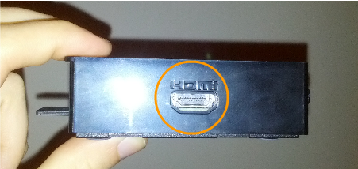
Pictured: HDMI port on the Astral Box

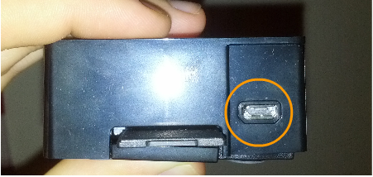
Pictured: USB power port on the Astral Box

Then all that’s left is to plug in the power to the Astral Box, which is conveniently just a standard USB cord. After plugging in the cord to the Astral Box, you can then plug the other end of the cord either into A) a USB port located on your TV, or B) the AC adapter that comes with the Astral Box, and then plug that into a wall socket.

That’s it for setting up the actual Astral Box! Now it’s time for the software that interacts with it. Using Astral’s interface, whether it’s in your browser, on your computer, or from your Android or iOS device is easy. The browser and downloadable program have the same interface, so let’s start with that.

Getting to the Astral Interface

A quick overview: to store and control playback on the Astral Box, you have quite a few options:

- Use any modern browser on any computer, tablet, or smartphone
- Use the Android app for your Android phone or tablet
- Use the iPhone app for your iPhone or iPad (coming soon)
- Use the downloadable Java program, which is available at the web address found on your unique card

To cast videos from Youtube to Astral, simply download the Google Chrome extension at the other web address found on your unique card.

Let’s start by going to the browser interface. All you have to do is open up your favorite browser, such as Firefox, Chrome, or Internet Explorer. You will know you have done it correctly if you see something like this:
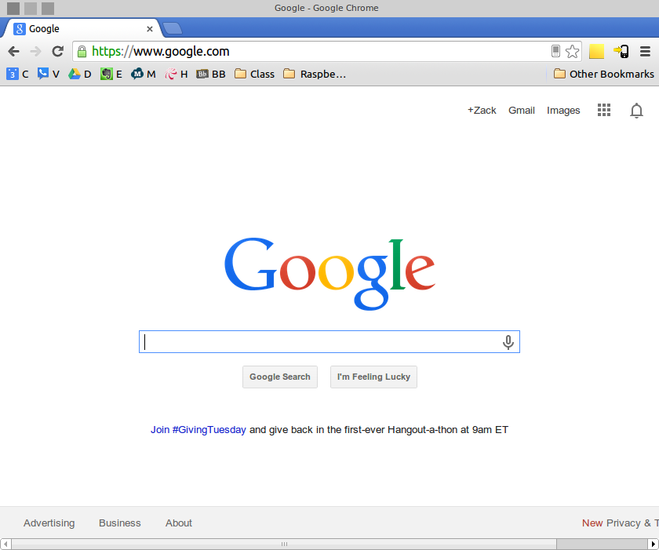

From there, go to your address bar and type in “astral.local”. Press enter. You will know you have done it correctly if you see this:

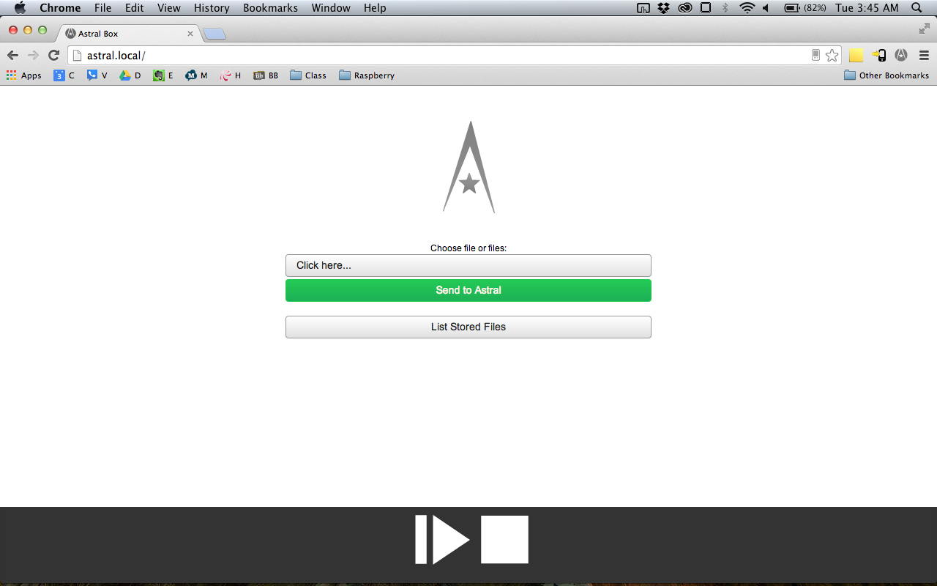

Here you will see the Astral Interface home page. It consists of five (5) buttons:

- The “Choose File” button. Click on this button to open up a menu for choosing a file. When that menu opens, you can navigate your folders and double click on a file. Once that is done, you will see the file name where the “Choose File” words once were.
- The “Send to Astral” button. After choosing a file, you can click this button to send it to Astral. After a few seconds, Astral will immediately begin playing the file (if it’s video or music) or it will display it if it is a picture!
- The “List Files on Astral” button. Clicking on this button will bring you to a new page, where you can view files that are currently on your Astral Box. Description of this page is below.
- The Play / Pause button. If you’re currently playing a video or a music file, you can click this button to pause it. If it’s already paused, you can click it to resume playing!
- The Stop button. If there is a media file or a picture currently being displayed on the Astral Box, you can click this button to stop its playback and go back to the Astral home screen.

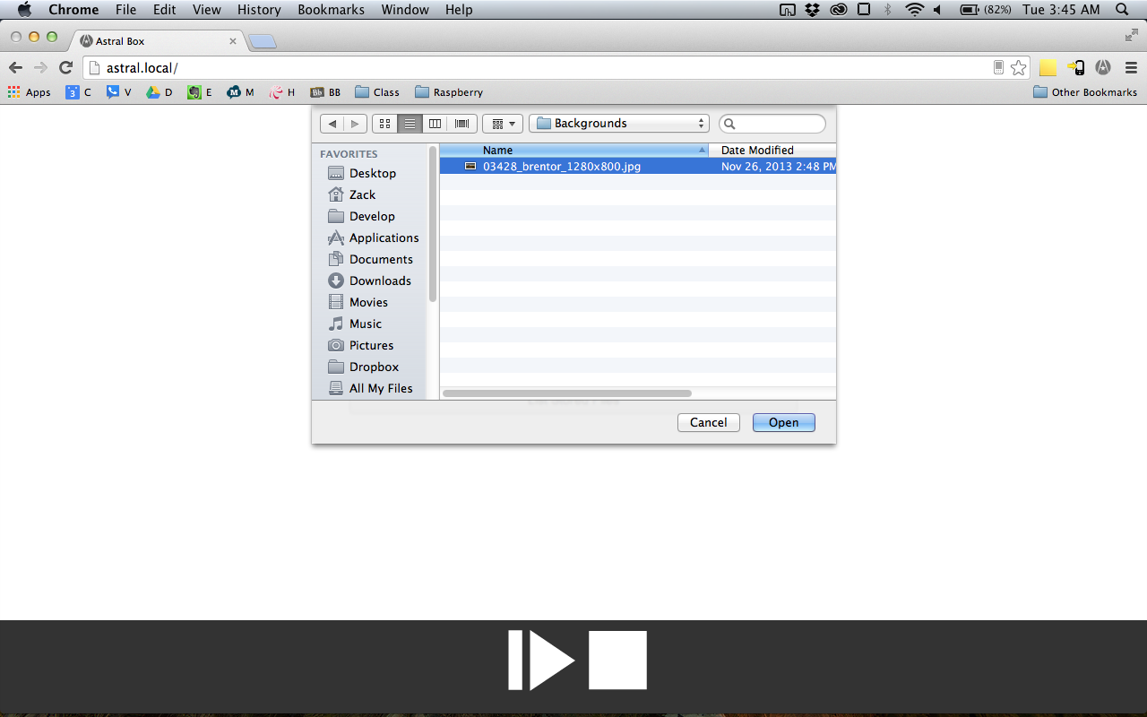
Pictured: Something similar to this should happen whenever you press the “Choose File” button

The “List Files on Astral” page:

On this page, you will find all files listed on Astral, as well as the amount of space used and available on your Astral Box. On each of these files, you will see two buttons:
- The Play button. Click on this button to make Astral immediately start playing the file!
- The Delete button. Clicking this red X will delete the file from Astral and free up the space that it was using. It will not delete the file on your computer, phone, etc.

If you see this, you are at the right place:
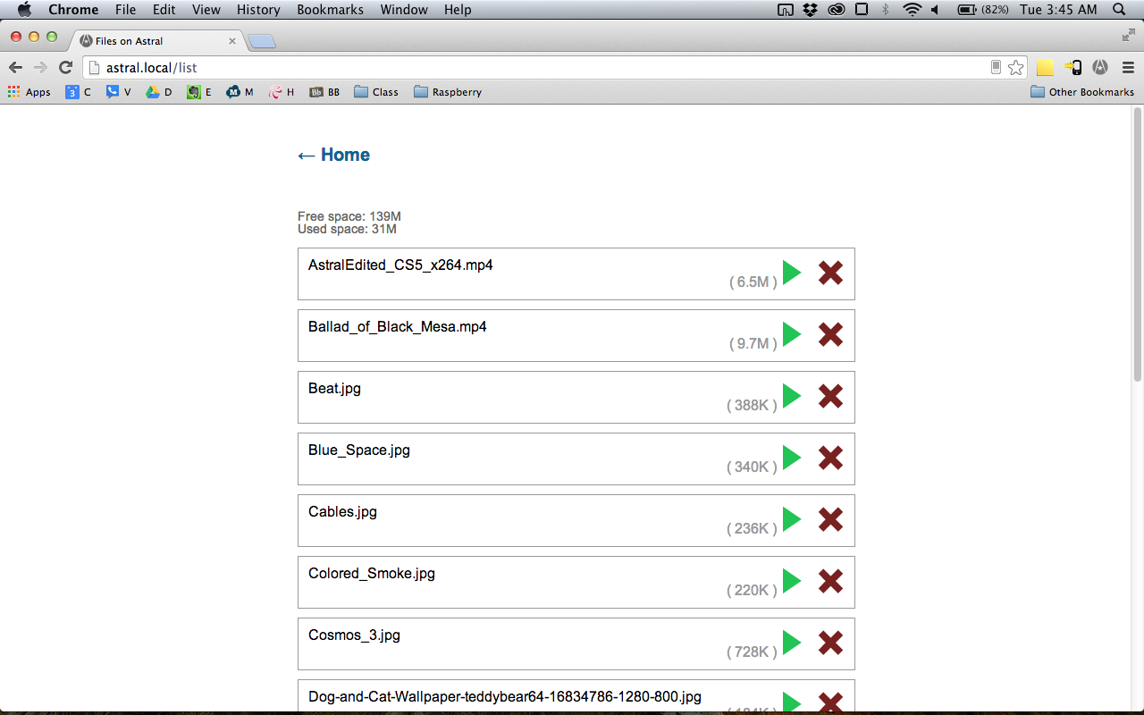

Above your listed files, you will also see a Back button. Click this button to go back to the main Astral page, where you can send a file, play / pause playback, and stop the file completely.

The Downloadable Program and Youtube Browser Extension

On your unique card included with your Astral Box, you will find two web addresses: 1) for the downloadable program and 2) for the web browser Youtube extension. To download these programs, just open up your favorite browser as before and type in the address.

Your file will download, and from there, you can double click on the program that you just downloaded. For the downloadable program, this will open up the same Astral Interface as if you opened it up from your favorite web browser. This downloadable program will run on your computer whether it is Windows, Mac, or a Linux computer. Move this downloadable program icon to your desktop for easy access later!

If you have downloaded the Chrome browser extension, all you have to do is double click on it, and it will install. To use it, simply go to http://www.youtube.com, find your favorite video, and click on the Astral extension logo, which will be found at the top right of your browser window. You will know you have done it correctly if you see this:

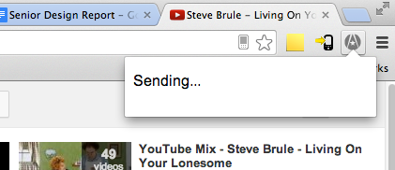

If you see a message like “You must be on a YouTube video!”, this means that you tried casting to Astral when you weren’t actually on a YouTube video. Try clicking on a particular YouTube video and then clicking cast for it to work.

Code Organization

Describe how your code is organized:

There a few different facets of the Astral Box. First and foremost is the actual Astral Box code itself, which is a node.js server that waits for input from the user over HTTP. Astral Box uses the node.js formidable module, which can be found at https://github.com/felixge/node-formidable.

There are five different files that constitute the main part of the Astral server, and the code is modeled after Manuel Kiessling’s “The Node Beginner Book” server example. Astral Box’s files are:

- index.js - sets up all request handlers
- router.js - for rerouting to 404 page
- server.js - starts the server
- helper.js - contains functions that help facilitate everything in requestHandlers
- requestHandler.js - this file handles the requests, i.e., what to do when the user uploads an image / video, presses Play / stop, presses List All Files, accepts a YouTube video cast, etc.

Besides the main Javascript for the server, there is a lot that goes into the Astral Box, which runs the Raspbian operating system as a basis. (A clone of the SD card is available if needed.)

The YouTube extension for Chrome can also be found in the source folder. It has three Astral icon files, a manifest, an HTML file, and a Javascript file. These files together can be loaded as an extension in the Chrome browser and will install easily.

Where are the files and the test cases?

The source for our code in the Astral Box can be found at http://web.eecs.utk.edu/~zhicks1/AstralCode.tar.gz.

The test cases for the Astral Box, rather than in a file that can be found, were manual tests run by this group until we were certain that the Astral Box was dependable and working. Test cases we ran including sending video, pictures, and music, playing and stopping the playback in all of those cases, listing the files and playing those files listed, doing all of this with the Android app, and also casting from the YouTube extension.

How to compile and install?

While the Astral Box cannot necessarily be “compiled and installed” since it depends on its operating system, as well as hardware, the .js source files available in the source folder contain the true functionality of the Astral Box.

The Chrome extension can be loaded by going to Chrome’s Menu -> Tools -> Extensions, and then selecting “Load unpacked extension.” Select the unzipped Chrome extension folder and it will load right up!

Where to change the code in order to add or improve function?

The place to start would be requestHandlers.js. Each function (handler) handles an individual case where the user has entered an action that results in the browser going to astral.local/doSomething - you can add your own requestHandler and get Astral Box to do your bidding!

How to get (check out, clone) a copy?

Our code can be found at http://web.eecs.utk.edu/~zhicks1/AstralCode.tar.gz. If an SD card clone is needed, feel free to contact zackrhicks@gmail.com.

References Cited

Bradford, Harry. "How Much Americans Spend On Gas Every Year [GRAPHIC]." The Huffington

Post. TheHuffingtonPost.com, 04 Mar. 2012. Web. 17 Nov. 2013.

"Business & Money." Business Money SameDay Delivery Losing Money Is OK If You're Winning

Over Customers Comments. N.p., n.d. Web. 17 Nov. 2013.

Grandoni, Dino. "77 Percent Of People Use Their Computers While Watching TV: Survey."The

Huffington Post. TheHuffingtonPost.com, 09 Apr. 2013. Web. 17 Nov. 2013.

MoneyBuilder. "Average Price of a New Car?" Forbes. Forbes Magazine, 10 May 2012. Web. 17

Nov. 2013.

"World Internet Users Statistics Usage and World Population Stats." World Internet Users Statistics
Usage and World Population Stats. N.p., n.d. Web. 17 Nov. 2013.

