CBE 488: Chemical and Biomolecular engineering Senior Desigh
Study Level Design and Economic Analysis of a Bromine-Polysulfide Redox Flow Battery (BPSRFB)
Group #4
Daniel Shane Tucker
David Dickenson
Samantha Hawks
Scott McCullough

Date Submitted: April 28, 2014

Department of Chemical and Biomolecular Engineering
University of Tennessee
419 Dougherty Engineering Bldg.
Knoxville, TN 37996-2200

Table of Contents

1.0 Introduction……………………………………………………………………………2

2.0 Synthesis Information for Processes…………………………………………………..2

3.0 Method of Approach…………………………………………………………………..7

4.0 Results………………………………………………………………………………..12

4.1 Capital Cost Estimates……………………………………………………….12

4.2 Operating Cost Estimates…………………………………………………….13

5.0 Discussion of Results………………………………………………………………...13

6.0 Conclusions…………………………………………………………………………..14

7.0 Recommendations…………………………………………........................................14

8.0 References……………………………………………………………………………15

9.0 Appendices…………………………………………………………………………...16
- Introduction

Purpose of manuscript: The purpose of this report is to document a study-level design and economic analysis of an electrical grid-scale bromine-polysulfide redox-flow battery (BPSRFB).

Brief background information: Redox flow batteries (RFBs) are the subjects of wide scale development activities due to their ability to store large amounts of electrical energy relatively cheaply and efficiently. Renewable-energy sources, such as solar and wind, are being deployed in larger numbers than ever before, but these sources are intermittent and often unpredictable and require energy storage for effective incorporation into the electrical supply grid. The BPSRFB is thought to have economic advantages over other energy storage battery concepts. The BPSRFB utilizes sodium bromide as the positive electrolyte and sodium polysulfide as the negative electrolyte. In this system, all of the electroactive species are anions, so a cation-exchange membrane is needed to prevent mixing of the anolyte and catholyte streams. Charge is carried via sodium ions through the membrane.

Rational/Design Objectives for project: The design objectives of this project are (1) to develop a flowsheet of a grid-size BPSRFB process, (2) to provide estimates of capital and operating costs and (3) evaluate the estimated economics of the BPSRFB. The power level of this project is specified at 4 MW and charge/discharge times of up to 12 hr. The charge discharge cycle is less than 365.25 cycles. The economic estimates are in 2014 US dollars. Details of important calculations are found in the Appendix.

Contributions of others: This project is supported by the Electric Power Research Institute in Palo Alto California (USA) and the Tennessee Solar Conversion and Storage using Outreach, Research and Education (TN-SCORE) project (NSF EPS 1004083).

Scope of manuscript/indication of report contents: This report documents a study-level design and economic analysis of an electrical grid-scale bromine-polysulfide redox-flow battery (BPSRFB) and was prepared in Spring Semester, 2014 as fulfillment of course requirements of CBE 488 (Sustainable Design Internship) at the University of Tennessee. Advisors for this project are Dr. Counce and Dr. Doug Aaron. Liaison with EPRI is provided by Chris Trublood.

- Synthesis Information for Processes

Overall Process Design Situation

The following economic analysis regards a redox flow battery based on the Regenysys design shown below (Figure 1). In this system, sodium bromide and sulfide/polysulfide electrolyte solutions are fed through electrochemical cells. The sulfide/polysulfide electrolyte is recycled directly while the spent sodium bromide electrolyte is regenerated through a crystallization and filtration system in order to remove any precipitated material from the solution. The electrolyte concentrations and number of cells will be optimized to achieve the most favorable economic setup.

Figure 1: Regenysys Patented BPSRFB System
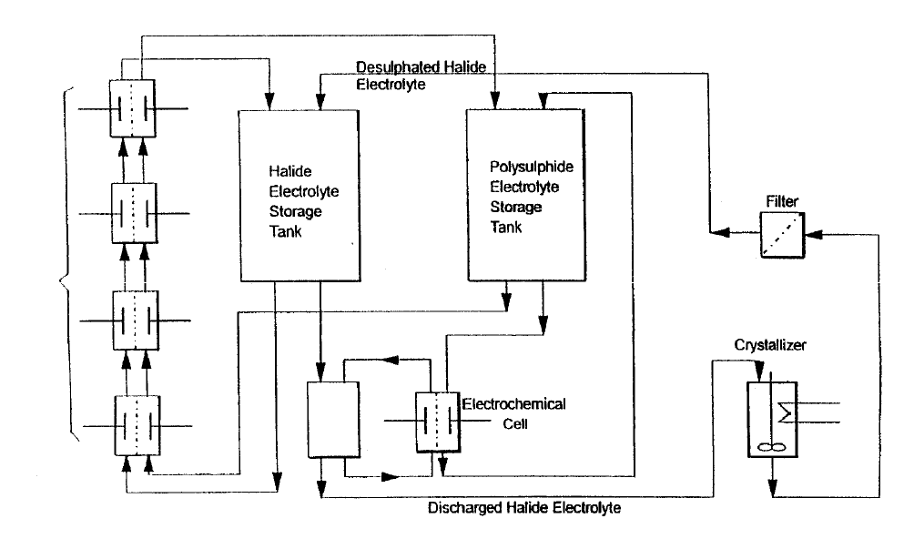
Source: Morrissey et al (2002)

Literature Summary

The current state of research on RFBs show that they have the potential to palliate the variable energy flow of lower cost energy sources by storing energy during off peak hours to be supplied during periods of high energy demand.

The Regenysys pilot plant offers practical insight on the implementation of this technology on a large scale. While our study assumes a more ideal situation, the information provided in the patent literature offers appropriate base case information from which we build our analysis. The relevant base case information is presented later in Table 2.

For our purposes, a current density of 40 mA/cm² will be used in order to remain consistent with the experimental data presented by C. Pounce de León (Ponce de León et al (2006)). Cycling data from this publication was used to estimate the power efficiency for our system at 100% state of charge (SOC) (Figure 2, Ponce de León et al (2006)).

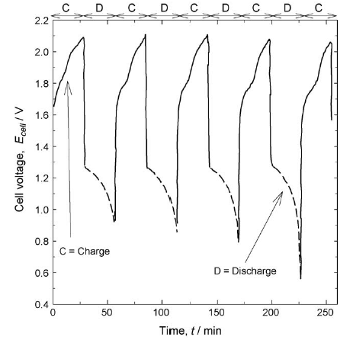
Figure 2: Cell potential vs. time response during charge/discharge cycles at a current density of 40mAcm⁻² for a sulfur/bromine monopolar test cell.
(Source: Ponce de León et al (2006)).

The power efficiency is calculated as the product of the current and voltage efficiencies. However in this analysis, side reaction and cross-over effects are ignored. Therefore, the current efficiency, which strongly depends on these effects, is assumed to be approximately 100%. Consequently, the power efficiency is assumed to equal the voltage efficiency and can be calculated by equation 1:

Equation 1:
$$n_{v}=\frac{Charge Voltage}{Discharge Voltage}$$

The values used for the charge and discharge voltages in equation 1 are marked by circles in Figure 2. These values give a power efficiency of approximately 63%.

List of materials and relevant properties

Following is a list of materials used in the proposed design along with relevant physical properties (Table 1).

Table 1: Relevant Physical Properties of System Components
Bromine Electrolyte
Components |  | Sodium Bromide (NaBr)
Molecular Weight |  | 102.9 g/mol
Density (anhydrous) |  | 3.21 g/cm³
Solubility in water (20°C) |  | 90.5 g/100 mL
NaBr concentration (M) |  | 5M
Polysulfide Electrolyte:
Safety Concerns | Can cause stress corrosion cracking in carbon steel and stainless steel
Components | Sulfur/Sodium Sulfide (Na₂S_{x+1}, where x can range from 1 to 4)
Nafion®:
Ideally sodium ions cross the membrane while all other ions are retained on their respective sides. Exhibits higher resistance to deterioration than other membranes as well as consistent manufacturing characteristics.

Input information for base case

The following table (Table 2) defines the design specifications for the proposed system. These values represent fundamental design information, not those required for an optimal design, and will be used as the basis for calculations throughout the analysis. The result of these calculations will serve as a base case which can be optimized to achieve/improve profitability.

Table 2: Base Case Input Information
Chemical Reaction and Related Information
Cathode/Anode Reactions | Half-cell: Br₂ (aq) + 2e- ↔ 2Br-
Cathode/Anode Reactions | Half-cell: S + 2e- ↔ S²⁻
Open Circuit Voltage | 1.74V
Temperature (°C) | 25°C
Polysulfide Concentration (M) | 5M
Bromide Concentration (M) | 5M
Power Capacity (MW) | 4MW
Energy Capacity (kW-h) | 24000 kW-h
State of Charge (%) | 0-100%
Design Details
Cycles per year | < 365 cycles
Cross-sectional area of cell (stacks) (m²) | 1 m²
Current Density (mA/cm²) | 40 mA/cm²
Cell Voltage Charge Efficiency (V) | 1.9 V
Cell Voltage Discharge Efficiency (V) | 1.2 V
Cell Power Efficiency (%) | 63%
Pressure Drop within the cell stack (bar) | 0.5 bar
Design Variables

State of charge (SOC): The state of charge defines the operating limits of the battery and therefore can be optimized to achieve the best results from the system. Our analysis will focus a 100% SOC case to determine whether the increase in cell capacity resulting from using fresh electrolyte, stored separately from the spent electrolyte, justifies the increase in capital cost associated with the extra tanks required for this setup.
Membrane type (efficiency, cross-over considerations): Cross-over is a significant source of inefficiency in this type of system. The membrane used within the system directly impacts the influence of this factor as well as the system cost. However, crossover is assumed to be insignificant in our system. This simplification is made in order to focus our analysis on other variables.
Electrolyte concentration/pump size optimization: Costs related to pump size and power requirements will be balanced with electrolyte concentration to achieve an optimized setup.
Charged/Discharge electrolyte storage: Costs related to separate storage for charged/discharged electrolyte should be considered against the associated performance improvement.

Cost Information (2014 US Dollars)

The following table (Table 3) lists the costs associated with the components and materials of the proposed system. The values presented are appropriate for 2014 U.S. dollars.

Table 3: Cost information of raw materials and cell components
Cost information
Price of output (peak) power | 0.16 | $/kW-h
Price per input power | 0.01 | $/kW-h
Bromine cost | 2.9 | $/kg
Sulfur cost | 0.25 | $/kg
Cell construction materials
Nickel | 1.5668 | $/m²
Polyolefin | 6 | $/m²
i. Ion-exchange membrane | 25 | $/m²
ii. Current collectors | 50 | $/m²
iii. Carbon felt | 20 | $/m²
Power conditioning | 100 | $/kW
Transformer Costs | 37 | $/kW
Breakers, Contacts, Cabling | 18 | $/kW

- Method of Approach

The following analysis will begin with defining the input design and specification values, followed by an input-output analysis which established the maximum economic potential. Then cost considerations associated with the power capacity, energy capacity, and the balance of the plant will studied individually and their influence on the economic potential of the system will be demonstrated. The analysis will conclude with a total capital investment estimation.

Assumptions

In our analysis, we make the following assumptions:

- Negligible cross-over effects
- Negligible side reactions
- Current efficiency estimated at approximately 100%
- Negligible membrane degradation over time
(Upkeep and replacement costs are not considered in this analysis)
- Membrane will be available at a lower cost, estimated at $25/m², due to an increase in demand
- One viscosity per solution is used for all concentration levels since it is assumed there would be little effect

Level 1:

The first level of this analysis defines the design specifications for the system, including the fundamental design information in addition to the costs of related components and materials (Tables 2 and 3). As stated previously, the values listed do not represent those required for an optimal design. These variables will be used as the basis for calculations throughout the analysis. The results of these calculation will serve as a base case which can be optimized to achieve/improve profitability or better approximate real world costs.

Level 2:

The maximum economic potential of the system can be estimated through costing the overall energy balance of the battery. The cost associated with charging the system represents the major operating costs, and the energy produced during system discharge provides the only source of revenue. Neglecting any equipment or processing costs, a simple balance of the product value and the energy input cost provides a good estimate for the maximum economic potential of the system. An example of a level 2 calculation is included in the appendix. Also shown in Figure 3 is a plot of the economic potential over the course of a year (up to 365 cycles per year).

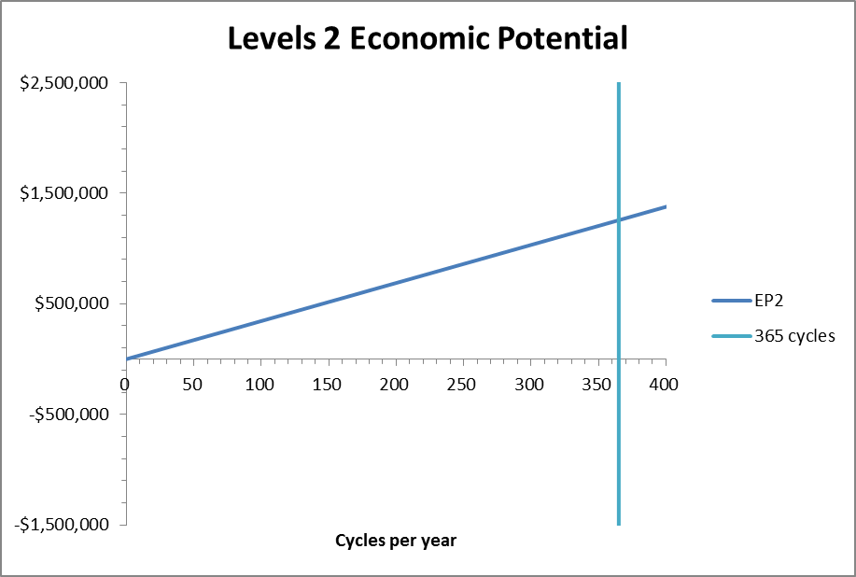
Figure 3: Economic Potential at Level 2 shown over the course of a year

As shown in Figure 3, the maximum economic potential of the proposed system gives a profit of $1,256,807 for 365 cycles per year.

Level 3:

The second major consideration is the cost related to the power capacity. This includes the cost associated with the cells and pumps. In order to estimate the cell cost, a basis of 100 cells per stacks was assumed. Also, the current density used in calculations represents that shown for laboratory scale systems (Ponce de León et al (2006)). Though our analysis is on the order of an industrial scaled system which would likely differ in current density, the value derived from laboratory scaled experiments serves as an appropriate starting point. An example of a level 3 calculation is included in the appendix. It should be noted that a nickel alloy is required as the pump material due to the corrosive component of the polysulfide electrolyte. Also included in Figure 4 is the economic potential plotted over the course of a year (up to 365 cycles per year).

Figure 4: Economic Potential for Levels 2 and 3 shown over the course of a year.

As shown in Figure 4, power capacity considerations lower the economic potential of the proposed system to a profit of $847,867 for 365 cycles per year. It should also be noted that at level 3 of this analysis, 110 cycles per year are required to recover the capital investment.

Level 4:

The next major consideration in analyzing the cost of the system involves the energy capacity which is determined by the amount of electrolyte used. At this level the cost considerations include the purchase cost of sulfur and bromine in addition to the costs associated with separate storage of both the fresh and spent electrolytes. The tanks used to hold the polysulfide electrolyte should be made of a rubber lined steel to withstand the corrosive effects of the polysulfide electrolyte. Additionally, the tanks used to store the bromine electrolyte should also be made of rubber lined steel to maintain consistency within the design. The costs associated with the storage of electrolyte are relatively small when compared to the cost of the cells. Therefore optimizing tank configuration does not offer any significant advantage. However, optimizing the electrolyte concentration does provide a significant advantage in that it lowers the power required for the pumps. An iterative approach was used to balance the costs related to pump size and power requirements with electrolyte concentration to achieve an optimized setup. An example of a level 4 calculation is included in the appendix. Also included in Figure 5 is the economic potential plotted over the course of a year (up to 365 cycles per year).
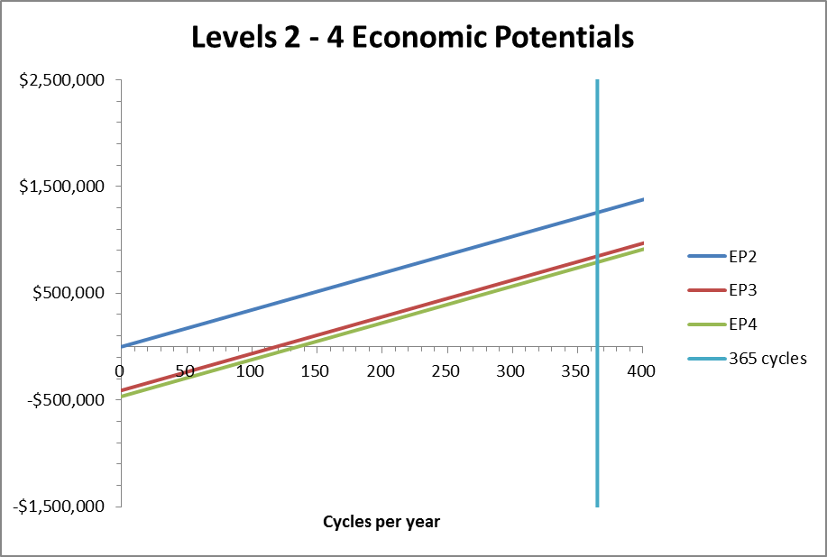
Figure 5: Economic Potential for Levels 2, 3, and 4 shown over the course of a year.

As shown in Figure 5, energy capacity considerations lower the economic potential of the proposed system to a profit of $791,134 for 365 cycles per year. It should also be noted that at level 4 of this analysis, 135 cycles per year are required to recover the capital investment.

Level 5:

The final considerations in this analysis are any remaining costs associated with the system, plant, or installation which have not yet been included. These costs include the cost of construction and various secondary system costs such as the control system. An example of a level 5 calculation is included in the appendix. Also included in Figure 6 is the economic potential plotted over the course of a year (up to 365 cycles per year).

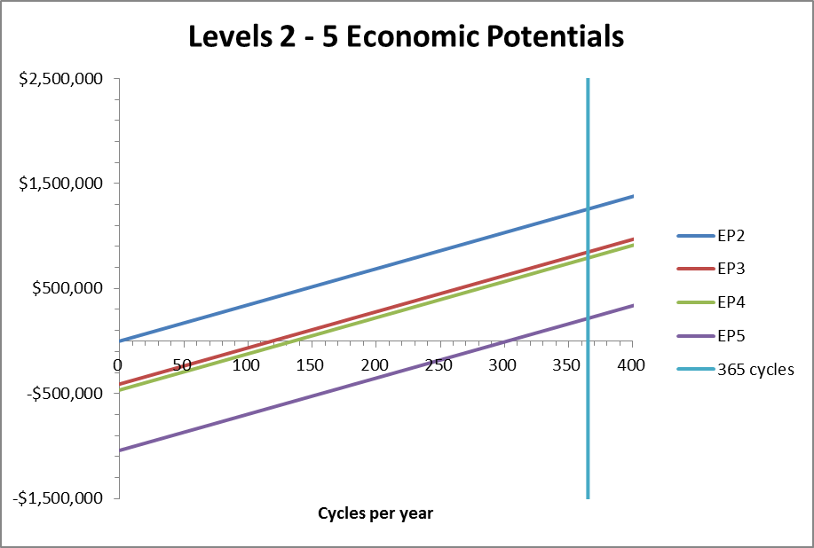
Figure 6: Economic Potential for Levels 2, 3, 4, and 5 shown over the course of a year.

As shown in Figure 6, balance of plant considerations lower the economic potential of the proposed system to a profit of $216,141 for 365 cycles per year. It should also be noted that at level 4 of this analysis, 300 cycles per year are required to recover the capital investment.

Level 6:

The remainder of this analysis involves estimating the capital investment required for the proposed system. Table 4 shown below presents the capital cost summary for this system. The operating costs were not included in this analysis, though they would likely represent a significant cost for the system.

Table 4: Capital Cost Summary
Equipment ID | Quantity/ capacity |  | Purchase cost | Instal. factor | Actual cost
Cell Stacks (100 cells ea.) | 57 | stacks | $770,499 | 1.4 | $1,078,698
Sulfur | 8,251 | kg | $2,063 | 1.1 | $2,269
Sulfur tanks | 51,464 | L | $23,692 | 1 | $23,692
Bromine | 41,120 | kg | $119,248 | 1 | $119,248
Bromine tanks | 102,928 | L | $33,846 | 3 | $101,538
Pumps | 0.79 | kW | $5,218 | 7 | $36,525
Power conditioning system |  |  | $620,000 | 1 | $620,000
Facility cost | 2,000 | m² | $2,171,803 | 1 | $2,171,803
Balance of plant costs |  |  | $224,000 | 1 | $224,000
Total cost |  |  | $3,970,368 |  | $4,377,774
Total annualized cost | $1,040,665

- Results

  - Overall Results

- Considering a simple input-output analysis, the maximum economic potential of the proposed system gives a profit of $1,256,807 for 365 cycles per year (Figure 3).

- Considering costs related to the power capacity of the system, the economic potential of the proposed system reduces to a profit of $847,867 for 365 cycles per year. At this level of analysis, 110 cycles per year are required to recover the capital investment (Figure 4).

- Considering costs related to the energy capacity of the system, the economic potential of the proposed system reduces to a profit of $791,134 for 365 cycles per year. At this level of analysis, 135 cycles per year are required to recover the capital investment (Figure 5).

- Considering costs related to the balance of the plant, the economic potential of the proposed system reduces to a profit of $216,141 for 365 cycles per year. At this level of analysis, 300 cycles per year are required to recover the capital investment (Figure 6).

  - Capital Cost Estimates

The estimated capital cost of the proposed system and its components are listed in Table 4 as a part of the Level 6 analysis.

  - Operating Cost Estimates

Operating costs for equipment are lumped into the annualizing term. However, the operating cost for the power to the pumps can be calculated directly. Table 5 below shows the pump power costs for the system.

Table 5: Pump operating costs for the proposed system

Pump Operating Cost
shaft work of pump(S) | 0.31 | kW
shaft work of pump(Br) | 0.48 | kW
Uptime | 95 | %
Days Operating Yearly | 347 | days
Cost to Purchase Power | 0.16 | $/kW-h
Yearly Pump Operating Cost (S) | 203.36 | $
Yearly Pump Operating Cost (Br) | 319.42 | $
Total Yearly Pump Operating Cost | 522.78 | $

- Discussion of Results

The major divers of cost in this system are the cells themselves and the facilities cost. The cost of the cell could only be reduced by either a decrease in material cost or an increase in cell efficiency, thus reducing the number of required cells/stacks. The facilities cost per area is assumed to be a fixed cost in this analysis. Therefore, the only way to reduce the overall cost is to reduce the area required by the proposed system. Likely this will depend on the number of cells/stacks as well.

Other system components, though less significant contributors to the overall costs, could be further optimized to reduce the total required capital. Optimizing the electrolyte composition could potentially reduce the pump costs and therefore reduce the required capital investment. Additional optimization variables include the current density and the number of stacks or cells per stack. The current density used in this analysis was based on laboratory-scale experiments and therefore may not accurately represent the industrial-scaled system which this analysis evaluates. The number of stack, chosen arbitrarily, was used to determine the number of cells per stack. As this value defines the voltage produced and thus the power generated by the system, iterative optimization of this variable would likely improve the economic potential of the system. However, that is not the focus of this analysis. This analysis evaluates the costs related to separate storage for fresh and spent electrolyte against the associated performance improvement in order to estimate the validity of such a design.

- Conclusions

This analysis demonstrates that the proposed system, all costs considered, will provide sufficient profit running 365 cycles per year to recover the annualized capital investment of $1,040,665 as well as a profit of $216,141. While the proposed system has proven profitable in our analysis, it should be noted that several simplifying assumptions were made which may not carry over to a physical system. It should also be noted that our estimates are based on laboratory scale experiments which may or may not reflect the behavior of a full-scale system.

- Recommendations

Our analysis shows that storing fresh and spent electrolyte solutions works well for this system. Due to the relatively low cost of the tanks, it is not advantageous to mix spent electrolyte with fresh electrolyte in the same tank. This can be achieved using a couple of different tank layouts. A setup with separate tanks allows for higher voltages and better power extraction. By using two tanks for each solution there is effectively twice the volume in tanks, which is an increase in costs. A setup with three or more tanks the volume could be used to cut down by keeping one tank empty when fully charged. In this case, the spent electrolyte could be pumped into the empty tank. Then, when the originally empty tank is full, the first tank drawn from can be used to store the spent electrolyte from the next tank containing charged electrolyte. However, for this case the costs associated with the multiple tank layouts is not justified due to the relatively small cost of the two tanks per electrolyte. In addition, there would be an increased cost of piping, valves and control system to make the multiple tank system work effectively thus increasing its cost beyond the point at which it would be justified. Therefore, we recommend the two tank per electrolyte system.

- References

Alotto P, Guarnieri M, Moro F (2014) Redox flow batteries for the storage of renewable energy: A review. Renewable and Sustainable Energy Reviews 29: 325

Bradbury, K. et al (2014) Economic viability of energy storage based on price arbitrage potential in real-time U.S. electricity markets. Applied Energy 114: 512

Morrissey et al (2002). U.S. Patent No. 6,461,495 B1. Washington, DC: U.S Patent and Trademark Office.

Ponce de León et al (2006) Redox Flow Cells for Energy Conversion. Journal of Power Sources 160: 716

Scamman D, Reade G W, Roberts E (2009) Numerical modelling of a bromine-polysulphide redox flow battery. Part 1: Modelling approach and validation for pilot-scale system. Journal of Power Sources 189: 1231

Scamman D, Reade G W, Roberts E (2009) Numerical modelling of a bromine-polysulphide redox flow battery. Part 2: Evaluation of a utility-scale system. Journal of Power Sources 189: 1231

Schaber C, Hammerschlag R, Mazza P (2004) Utility-Scale Storage of Renewable Energy. The Electricity Journal, Volume 17, Issue 6: 21

Webber A (2011) Redox Flow Batteries: A review. Journal of Applied Electrochemistry, Volume 41, Issue 10: 1137

- Appendices

9.1 Level 2 example calculations:

$$E_{charging}=\frac{E_{capacity}}{ε_{charging}}=\frac{24,000 kWh}{0.61}=39,669 kWh$$

$$E_{discharging}=E_{capacity}×ε_{discharging}=24,000 kWh×1=24,000 kWh$$

$${EP}_{2}=\left(E_{discharging}×\frac{\$}{{kWh}_{D}}-E_{charging}×\frac{\$}{{kWh}_{C}}\right)×\left(\frac{cycles}{year}\right)$$

$${EP}_{2}=\left(24,000 kWh×\frac{\$0.16}{{kWh}_{D}}-39,669 kWh×\frac{\$0.01}{{kWh}_{C}}\right)×\left(\frac{365 cycles}{year}\right)=\$1,256,807$$

9.2 Level 3 example calculations:

For annualizing a cost the dollar amount was multiplied by 0.24.

Number of stacks:

$$\frac{Power capacity (Wh)}{V_{cell}\left(\frac{\# cells}{stack}\right)I_{stack}}=\frac{4.0×{10}^{6}W}{1.74 V∙100∙400 A}=57 stacks$$

Flow rate of polysulfide:

$$\frac{\# {e^{-}}_{total}}{F ∙ \left({e^{-}}/{molecule}\right) ∙molarity}=\frac{2,298,850 e^{-}}{96485C/{mol}∙2 e^{-}∙5{mol}/L}=2.38L/s$$

Pump efficiency:

$$η_{pump}=\left(1-0.12\right){\left(\dot{v}\right)}^{-0.27}\left(1-μ^{0.8}\right)$$
$$η_{pump}=0.88{\left(0.0024{m^{3}}/s\right)}^{-0.27}\left(1-{\left(1.24×{10}^{-3}Pa∙s\right)}^{0.8}\right)=0.39$$

Shaft work of the pump:

$${Work}_{shaft}=\frac{\dot{v}∙∆P}{η_{pump}}\left(\frac{1W}{1000kW}\right)$$
$${Work}_{shaft}=\frac{0.0024\frac{m^{3}}{s}∙5×{10}^{4}Pa}{0.39}\left(\frac{1W}{1000kW}\right)=0.31 kW$$

9.3 Level 4 sample calculations:

Mass of polysulfide required:

$$m_{total}=\dot{v}∙t_{discharge}∙molarity∙MW$$

$$m_{total}=0.0024\frac{m^{3}}{s}∙6 hr\left(\frac{3600 s}{1 hr}\right)∙5 \frac{mol}{L}∙32.066\frac{g}{mol}\left(\frac{1 L}{1000 kg}\right)=8,251 kg$$

9.5 Level 5 calculations:

Area required:

$$A=500m^{2} per megaWatt=500m^{2}∙4 MW=2,000 m^{2}$$

Land costs:

$$2,000m^{2}∙{\$1075}/{m^{2}}=\$2,150,000$$

