A Platform for Dynamic Simulation and Neuromuscular Control of Movement:
Application in Predictive Simulations of Balance Recovery

A DISSERTATION PRESENTED FOR THE
DOCTOR OF PHILOSOPHY
DEGREE
THE UNIVERSITY OF TENNESSEE, KNOXVILLE

Misagh Mansouri Boroujeni
May 2015

Copyright© 2015

Misagh Mansouri Boroujeni
All rights reserved

DEDICATION

To my parents,
Saeid and Mina

To my sisters,
Mehrak and Maral

And to my love
Amanda DeBuhr Mansouri

ACKNOWLEGEMENTS

ABSTRACT

Numerical simulations play an important role in solving complex engineering problems and have the potential to revolutionize medical decision-making and treatment strategies. Musculoskeletal conditions alone cost the U.S. economy over $849 billion per year (7.7% of the U.S. Gross Domestic Product) and place great demands on healthcare systems worldwide (Jacobs et al., 2008). Study and treatment of these conditions could greatly benefit from combined software tools that offer better insights into neuromuscular biomechanics, and predictive capabilities for optimal surgical and rehabilitation treatment planning.
In this research, we create a platform to combine musculoskeletal modeling, forward dynamic simulation, optimization techniques, and neuromuscular control system design. We developed low-level spinal (stretch-reflex) and high-level supraspinal controls (operational space task based) controllers to test simulation-based hypotheses related to balance recovery and movement control. Balance is among the most challenging tasks for patients with neuromuscular disorders such as children with cerebral palsy. Using the platform we hope to develop scientific guidelines for understanding and improving balance disorders.
In the first phase of this research, we targeted a corrective procedure in children experiencing stiff-knee gait. Stiff-knee gait is a troublesome neuromuscular disorder among children with cerebral palsy. Patients experiencing stiff-knee gait typically adopt energy-inefficient movements due to over-activity of lower extremity muscles and are prone to falling and tripping. Currently, corrective procedures are based on qualitative observations during clinical examination and gait analysis, and the experience of the clinicians. Unfortunately, successful outcomes of such procedures are variable. Until there is a scientific basis for making treatment decisions, outcomes are not likely to improve. Combining clinical movement analysis and simulation-based approaches may lead to a better understanding of biomechanical consequences of stiff-knee gait and its treatments. In the next phase, we implemented operational space task-based controller to synthesize human balance due to support-surface perturbations. We then validated our results with the experimental data of healthy adults
The platform is used to investigate balance recovery in children with stiff-knee gait, functional consequences of a commonly used surgical intervention and examine how predictive simulations that synthesize normal healthy movement can identify the biomechanical factors that may affect postural responses.

TABLE OF CONTENTS

DEDICATION 3
ACKNOWLEGEMENTS 4
ABSTRACT 5
Chapter 1 1
Introduction 1
1.1 Motivation 1
1.2 Simulation Paradigm 2
1.3 Related Work 3
1.4. Overview and Specific Aims 5
Chapter 2 12
A platform for dynamic simulation and control of movement based on OpenSim and MATLAB 12
2.1. Introduction 12
2.2. Methods 14
2.2.1. Forward Dynamics Simulation of a Musculoskeletal Model 15
2.2.2. Interface between OpenSim and MATLAB/Simulink 16
2.2.3. Open-loop Model Application 19
2.2.4. Closed-loop Model Application 20
2.3. Results 22
2.4. Discussion 24
Chapter 3 29
Simulation and control pipeline for predictive patient-specific neuromuscular systems. 29
3.1 Create musculoskeletal models using OpenSim software for the specific application 30
3.2 Scale generic models based on specific subjects’ anthropometric data 31
3.3 Inverse Kinematics analyses to match the model motion with an experimental data 33
3.4 Forward dynamics simulation 34
3.5 Design controllers to perform predictive dynamic simulations 34
3.5.1 Low-level spinal stretch-reflex feedback controller 35
3.5.2 High-level controller to track kinematics 39
Chapter 4 42
Influence of the Biarticular Rectus Femoris Muscle on Balance Recovery in Children with Cerebral Palsy 42
4.1. Introduction 42
4.2. Methods 44
4.2.1. Musculoskeletal Models 44
4.2.2. Biologically-inspired Controller 46
4.2.3. Forward Dynamics Simulations 47
4.2.4. Dynamic Stability Margins 49
4.3. Results 49
4.4. Discussion 55
Chapter 5 61
Task-based Control of Movement 61
5.1. Task-based controller 61
5.2. Musculoskeletal Dynamics 61
5.3. Task-based Neuromuscular Control 62
5.4. Task-Based Control of Arm Example 65
Chapter 6 68
Prioritized Free-floating Multi-Task Whole Body Control 68
6.1. Musculoskeletal Model 69
6.1. Operational space Free-floating Dynamic Model formulation 71
6.1.1. Supporting Contact 72
6.1.2. Kinematics Constraint 74
6.1.3. Operational Space Control of CoG 75
6.2. Prioritized Multi-Task Control 76
6.3. Task-Based Control of Full Body Example 78
Chapter 7 83
Validation of Synthesized Motion using Experimental Balance Recovery Data 83
7.1. Experimental balance recovery experiment setup 84
7.2. Utilize a high-level controller to estimate muscle excitations to synthesize experimental balance recovery data using forward dynamics simulations 85
7.3. Change model parameters to examine how biomechanical factors such as muscle weakness may affect postural responses. 89
Chapter 8 90
Concluding Remarks 90
8.1. Research Innovation 90
8.2. Significance 91
8.3. Source Code 93
8.4. Summary 93
References 94
Vita 102

LIST OF FIGURES

Figure 1. 1: Diagram of the individual elements between neural command and movement. Rehabilitation strategies alter many elements and the effects are not easily measured. 16

Figure 2. 1: Flowchart illustrating components of forward dynamics in OpenSim and MATLAB/Simulink. Simulink (large blue rectangle) is used instead of the OpenSim Forward Dynamics Tool. The OpenSim transformations (orange rectangles) between a neural command and state derivatives (e.g., joint accelerations) involve musculotendon dynamics, musculoskeletal geometry, and multibody dynamics. Input files (green rectangles) are required by OpenSim for the model, controls (if applicable), initial states, and external loads (if applicable). The Simulink input signal (if applicable) and MATLAB transformation (red rounded rectangles) between joint accelerations and observed movement involves numerical integration. The interface can use MATLAB integrators instead of OpenSim integrators for the forward dynamics. The new S-function interface (red dotted rectangle) takes a controls file or Simulink signal and computes state derivatives subsequently integrated by MATLAB. 28
Figure 2. 2: Overview of the new S-function interface. (a) The interface links the rapid model-based design and control systems strengths of MATLAB/Simulink with the numerical simulation and human movement dynamics strengths of OpenSim. (b) Flowchart illustrating stages for each Simulink simulation. (c) OpenSim v1.9 (higher versions not shown) methods called during each simulation stage. 30
Figure 2. 3: Overview of an open-loop model application for arm flexion. (a) The Simulink graphical editor window shows input controls (U), the new S-function interface (middle), and the output states (Y). (b) The custom Simulink block parameter dialog box shows every input parameter required (or optional) by the OpenSim Forward Dynamics Tool to perform a simulation. (c) The output states may be displayed using a State Selector and Scope within the graphical editor or they may be loaded as a motion file in OpenSim to visualize the simulated movement. 32
Figure 2. 4: Example closed-loop Simulink model extending the open-loop case with control of a human arm balancing a pole. The desired pole angle (measured from vertical) was zero and used to compute a pole angle error. The proportional-integral-derivative (PID) controller, along with the muscle gain matrix was used to compute control correction signals for each of the six muscles to balance the pole, despite random force disturbances exerted on the pole. 34
Figure 2. 5: Open-loop simulation of elbow flexion and differences between movements generated by OpenSim and Simulink simulations. (a) A simple human arm model with 2 degrees of freedom and 6 muscle-tendon actuators (six time frame series of a one second elbow flexion movement shown). (b) Shoulder angles and (c) elbow angles for the OpenSim and Simulink simulations. 35
Figure 2. 6: Closed-loop simulation of balancing a pole despite random force disturbances. (a) A PID controlled human arm model balancing a pole (five time frame series from 0.25s to 0.55s shown). (b) Random force disturbances were exerted on the pole and (c) the pole angle measured from vertical remained small. 36

Figure 3. 1: Different OpenSim layers. The base layer is the computational layer provided by Simbody (in blue). Simbody components (e.g. integrators, optimizers) are available to all levels within OpenSim API. The next layer is modeling layer (green). The modeling layer is followed by analyses layer (orange). The top layer is the application layer (red) which is consumer of OpenSim API to generate applications such as OpenSim GUI or dynamic libraries. (Seth et al., 2011). 42
Figure 3. 2: Scaling the generic musculoskeletal model based on the experimental patient-specific data. The models are scaled to represent the length and mass of each segment of the experimental data. 43
Figure 3. 3: Over simplified model of human balance control using a simple inverted pendulum with two muscle-tendon actuators will be used to validate a more complex control problem such as human posture balance with 23 DOF and 92 muscle-tendon actuators. 48
Figure 3. 4: shows muscles’ activations during a one second forward dynamic simulation with stretch-reflex controller due to the initial pendulum velocity as a perturbation to the system. 48
Figure 3. 5: shows the inverted pendulum rotation angles () and rotation velocity during a one second forward dynamic simulation with stretch-reflex controller due to the initial pendulum velocity as a perturbation to the system. 49
Figure 3. 6: shows muscles’ fiber length during a one second forward dynamic simulation with stretch-reflex controller due to the initial pendulum velocity as a perturbation to the system. 49
Figure 3. 7: Schematic of the Computed Muscle Control Algorithm [1] 51

Figure 4. 1: Three-dimensional, 23 degree-of-freedom musculoskeletal model with 92 muscle-tendon actuators (shown in red) recovering balance on a support surface translating 7.5 cm over 0.55 seconds with a maximum velocity of 18 cm/s. The musculoskeletal model was used along with a biologically-inspired controller to create forward dynamic simulations of children with mild and moderate crouch to test our hypothesis regarding balance recovery following rectus femoris transfer surgery. Biarticular locations for the rectus femoris muscle are shown as (a) the pre-surgical attachment to patella and (b) the post-surgical transfer to the insertion of the sartorius on the tibia. 64
Figure 4. 2: Schematic of (a) the closed-loop forward dynamic simulation in Simulink and (b) the underlying algorithms. The inputs to the musculoskeletal model, or neural command, were calculated based on the low-level (stretch-reflex controller) and high-level (computed muscle control) feedback control system. Disturbances (e.g., support-surface translations) may also be introduced to the system as inputs. The outputs of the dynamic simulation are the model’s states. The stretch-reflex controller’s gains, k_{p} and k_{d}, were selected by a non-linear least squares optimization minimizing position and velocity errors between simulated and experimental center of mass displacements. l_{MTC_ref} is the reference muscle-tendon complex (MTC) length; l_{CE} is the contractile element (CE) length; l_{SE} is the series elastic (SE), or tendon, length; V_{CE} is the CE velocity; and $∆t$is the stretch-reflex latency. 67
Figure 4. 3: Shows the extrapolated center of mass of a pre-surgical model following posterior support-surface translation as a function of simulation time. CoM_{extrp} was chosen over CoM and center of pressure (CoP) in defining the stability margins because models may be moving toward a fall that occurs after the simulation time despite the CoP being located within the BoS throughout the simulation. The functions b and TtB are defined based on Hof et al., 2005 and the minimum values of these functions were used as an indicator of how stable the simulations are at each time step. 70
Figure 4. 4: Extrapolated center of mass displacements relative to the support-surface during anterior (top row) and posterior (bottom row) translations (shaded regions) for simulations before (pre) and after (post, unilateral and bilateral) rectus femoris tendon transfer for mild (left column) and moderate (right column) crouched postures. The displacements for simulations of the typically developing (TD) model without a spastic stretch reflex are shown as well. 72
Figure 4. 5: Simulated center of mass (CoM) displacements for Typically Developing (thin solid line) and pre-surgical, spastic Cerebral Palsy (thick solid line) models with mild crouch compared with experimental CoM displacements of healthy adults with upright posture from Ting, 2007 (square dot line) and Henry, et al., 1998 (dash line) during a) anterior and b) posterior support-surface translations. To compare the balance recoveries across support-surface translation magnitudes, the CoM displacements were normalized by the support-surface translations in each study. 78

Figure 5. 1: A task-level neuromuscular feedback controller (a) Task-level command input states. (b) Task space feedback linearization using estimation of the dynamic parameters. (c) Task space feedback loop for tracking task space commands. (d) Posture space control input. (e) Static optimization of muscle activations. (f) Activation feedback loop for tracking optimization solution. (g) Output as neural excitations. (Image courtesy: Goldfarb, 2014) 78
Figure 5. 2: a) Schematic model of the task-based neuromuscular controller implemented through OpenSim/MATLAB interface. The interface (dotted lines in a) calls the OpenSim arm model and closed-loop task force is calculated as an input to the interface. The task force then will be used to calculate the actuation force (joint torques) using the multibody dynamics and later the muscle excitations using the static optimization. All these steps are implemented inside the interface by calling OpenSim libraries. 79
Figure 5. 3: Disturbance was introduced to the center of mass of the pole to test the controller robustness in presence of external perturbation. 80
Figure 5. 4: The resultant muscle activations calculated through the task-based controller implemented during 10 second simulations of hand position control and pole balancing tasks. 80

Figure 6. 1: Free-floating musculoskeletal model. Pelvis body (free-floating base) has 6 degrees of freedom in space (3 translational and 3 rotational). 82
Figure 6. 2: Musculoskeletal model degrees of freedom. 83
Figure 6. 3: Resultant ground reaction forces on the foot are due to gravity and CoG accelerations. 85
Figure 6. 4: Foot-ground contact modeled as Hunt Crossly Forces inside the OpenSim’s model file. Five contact points (two on each side of the heel and two on each side of the metatarsal bones and one on the tip of the toes) were defined according to (ANDERSON REFERENCE) to represent the foot-ground contact. 86
Figure 6. 5: Schematic of the task-based neuromuscular controller implemented through OpenSim/MATLAB interface in Simulink environment. The interface (dotted lines in a) calls the OpenSim 2392 gait model, initial controls and initial states files and perform a forward dynamics simulation with a closed-loop task-based feedback control in operational space using the defined task forces required for performing a sequence of tasks. The task force is used to calculate the actuation force (joint torques) through multi-body system Jacobian transpose. Muscle excitations are calculated using the static optimization. All these steps are implemented inside the interface by calling OpenSim libraries. 91
Figure 6. 6: shows different tasks defined for the one leg balance example. All these tasks defined within the supporting contact constraint. Three task force vectors were defined. The first task was exerted on the whole body center of mass. The second task force was exerted on the swing leg foot and the third task force was exerted to our model head. The arrows on the foot-ground contacts are not the task forces. They show the foot-ground contact forces due to gravitational forces. The resultant ground reaction forces are summation of all those five contact forces and applied on the center of pressure of the model. 92
Figure 6. 7: a) The desired whole-body CoM trajectory defined for the musculoskeletal system through the points (1-4). The model is suppose to go through these point while maintain balance on one foot. b) Right leg (stance leg) joint torques required to perform the assigned task. 94
Figure 6. 8: Shows the reference whole-body CoM path (x, y and z) defined in our balance control example inside Simulink. 95

Figure 7. 1: CAREN System. (MotekMedical) 84
Figure 7. 2: Simulink Platform showing simulation of the task-based neuromuscular balance controller implemented through OpenSim/MATLAB interface. The interface (dotted lines in a) calls the OpenSim neuromuscular full-body model and closed-loop task force exerted on torso body is calculated as an input to the interface to track the model CoM. The task force then will be used to calculate the actuation force (joint torques) using the multibody dynamics and later the muscle excitations using the static optimization. All these steps are implemented inside the interface by calling OpenSim libraries. 87
Figure 7. 3: An example OpenSim musculoskeletal full body model. The task forces (green arrows) will be introduced to different bodies of the model based on tracking goals. 88

Chapter 1

Introduction

Motivation
Numerical simulations play an important role in solving complex engineering problems and have the potential to revolutionize medical decision-making and treatment strategies. Musculoskeletal conditions alone cost the U.S. economy over $849 billion per year (7.7% of the U.S. Gross Domestic Product) and place great demands on healthcare systems worldwide (Jacobs et al., 2008). Study and treatment of these conditions could greatly benefit from combined software tools that offer better insights into neuromuscular biomechanics, and predictive capabilities for optimal surgical and rehabilitation treatment planning.
In recent years, there has been lot of technological advances in gait-analysis experiments technologies and devices. From different motion captures systems that record human body positions and velocities [2-5], and force plates and pressure sensors that measures ground reaction forces and center of pressures [6, 7] , to different electromyography instruments [8] that detect muscle activity during various movements. These devices provide mainly a quantitative description of human movement; however, the experiments alone do not explain how muscles work together or how they individually contribute to certain motion or even how the control of these muscles can influence the resulting motion. Muscle-actuated simulations and bio-inspired control systems potentially give insights into the complex interaction between neural commands, musculoskeletal geometry, and resulting functional movements. Combining clinical movement analysis and simulation-based approaches may lead to a better understanding of biomechanical consequences of different human movement and its treatments.

Simulation Paradigm
Human movement involves many individual elements such as neural transformation, muscle coordination and musculoskeletal dynamics (Figure 1.1). A neural command is needed to excite muscles, the electrical potential of which can be recorded with electromyography (EMG). Muscles produce forces based on length and velocity properties of the muscle and tendon. The muscle forces can produce joint moments through the musculoskeletal geometry based on each muscle moment-arms, joint type and joint location. Moments are used to determine the accelerations and contact forces by solving the multibody dynamics. The way the human body moves affects subsequent neural commands to adjust the movement, and it affects the length and velocity of each muscle-tendon, the direction of muscle forces and moment arms, and the resulting dynamics of the multi-body system.
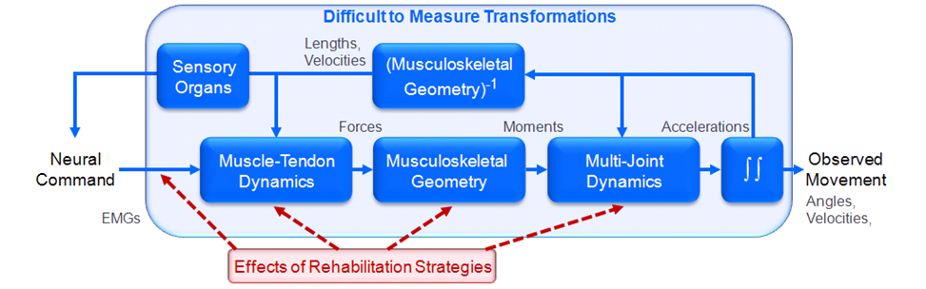

Figure 1. 1: Diagram of the individual elements between neural command and movement. Rehabilitation strategies alter many elements and the effects are not easily measured.

Many of these elements have been investigated through experiments. Muscle fibers have been electrically stimulated to produce force [9]. Cadaver parts have been used to measure muscle moment arms [10], and MRI images of live human body segments [11], have been placed in a different positions while measurements were made of individual muscle lengths and moment arms. However, experiments alone limit understanding of movement dynamics, simulations complement experiments. Although a few variables responsible for movement (e.g., kinematics, ground reaction forces, and EMG) can be measured, it is extremely difficult to measure important variables such as muscle activities and joint forces. It is even more difficult to establish cause-and-effect relationships that give insights into muscle function.
Similar to an observed movement, a simulated movement results from many individual elements. Models and simulations based on experiments are used to generate the musculoskeletal geometry and multi-joint dynamics during a simulated movement. This simulation enables cause-and-effect relationships to be identified and insights into the potential treatment for an abnormality may be investigated. Gait and Balance abnormalities commonly observed in children with cerebral palsy are typically treated by surgically altering muscle function. Unfortunately, the outcomes of such treatments are variable. Patient-specific simulations have utilities to determine the potential efficacy of surgical correction. The simulated movement also provides estimates of important variables involved in generating the movement. A new approach using patient-specific computational models, control system designs and optimization may be used to discover a new movement as a treatment and to predict functional outcome using pre-treatment data. Simulation is a vital tool for multidisciplinary study of human movement control because they can provide fundamental insights into the causes of movement and point the way to optimal treatment recommendations.

Related Work
Computational models and simulation-based approaches have emerged as powerful tools for investigating muscle coordination and function during human movement. Biomechanical models have been developed to estimate muscular forces in the lower extremity during balance [12, 13] , walking [14-17], running [18-20], cycling [21-23], jumping [24-26], kicking[27], and other physical activities [28-32]. Sophisticated muscle-actuated, dynamic simulations have been developed to address specific clinical questions. For example, studies have been conducted to assess electrical stimulation systems to restore unsupported gait to paraplegics [33], to evaluate exercise for persons with spinal cord injury [34, 35] and patients with patella-femoral pain [36], to examine the influence of foot positioning and joint compliance on ankle sprains [37, 38], and to investigate causes of stiff-knee gait [39-41]. These studies have demonstrated the potential utility of models and computer simulations for analyzing causes of abnormalities and the effects of treatments.
Given that underlying model affects the accuracy of a simulation, a model providing the closest representation of the experiment will produce the best variable estimations and relationship identifications. There is a rapidly growing community of engineers, therapists, and scientists eager to address clinically motivated questions on medical rehabilitation. Thus, the work proposed here promises to significantly impact more than one field.
First-generation patient-specific models [42-50] have laid the foundation for simulations to predict patient outcomes; however, patient-specific modeling and simulation technologies need to be advanced significantly to realize the full potential of personalized, simulation-based medicine [51]. Computer simulations have made a huge impact across different engineering disciplines and animations designs, and movie industries. For similar impacts to be made in human movement control, [52]multidisciplinary researches need to be formed to merge the simulations and experimental measurements with a higher-level control system and robotics researches that connect them [53, 54]. This synergistic relationship will not only produce the best possible simulation results, but it will transform this multidisciplinary field.
Furthermore, simulation and control of human movement is a challenging problem that requires simultaneous knowledge of human anatomy and physiology, physics, engineering, computer simulations, robotics and control system designs. While biomechanists aim to record and analyze movements to enhance athletic performances or design new rehabilitation techniques, researchers in the field of robotics try to improve robot designs and control algorithms to create human like movement. Both fields can benefit from software tools that merge these methodologies to answer complex questions regarding human movement.

In the field of robotics, there has been lots of research to emulate human motion and create human-like robots [52, 55-57]. Experimental human motion capture was mapped to different models using inverse dynamic approaches [58, 59] but these simulations were limited in predicting and synthesizing new motions. Inspired by human behaviors, goal-driven controllers was introduced to control task oriented dynamic problems in humanoid robots [60, 61] and synthesize human motion [62, 63]. Validating these controllers requires the use of complex physiological musculoskeletal models. Recent studies have shown successful applications of task-based controllers to create realistic human motion [63, 64]. In this research, the task-based controller will be utilized using complex upper body and lower body musculoskeletal models to investigate hypotheses regarding human movement and balance control.

1.4. Overview and Specific Aims

Numerical simulations are playing an important role in solving complex problems and have the potential to revolutionize medical decision making and treatment strategy. Musculoskeletal conditions cost the U.S. economy alone over $849 billion per year (7.7% of the U.S. Gross Domestic Product) and place great demands on healthcare systems worldwide. This area could greatly benefit from computational tools offering greater understanding of human movement and predictive capabilities for optimal treatment planning.
In this research, we create a platform to combine musculoskeletal modeling, forward dynamic simulation, optimization techniques, and neuromuscular control system design to test simulation-based hypotheses related to balance recovery and movement control. Balance is among the most challenging tasks for patients with neuromuscular disorders such as children with cerebral palsy. Using the platform we hope to develop scientific guidelines for understanding and improving balance recovery in patients with neuromuscular disorders.
Stiff-knee gait is a troublesome neuromuscular disorder among children with cerebral palsy. Patients experiencing stiff-knee gait typically adopt energy-inefficient movements due to over-activity of lower extremity muscles and are prone to falling and tripping. Currently, corrective procedures are based on qualitative observations during clinical examination and gait analysis, and the experience of the clinicians. Unfortunately, successful outcomes of such procedures are variable. Until there is a scientific basis for making treatment decisions, outcomes are not likely to improve. Combining clinical movement analysis and simulation-based approaches may lead to a better understanding of biomechanical consequences of stiff-knee gait and its treatments.

The objective of this study is to develop a simulation and control platform to test simulation-based hypotheses related to balance recovery and movement control. The platform is used to investigate balance recovery in children with stiff-knee gait, functional consequences of a commonly used surgical intervention and examine how predictive simulations that synthesize normal healthy movement can identify the biomechanical factors that may affect postural responses. To accomplish these, following specific aims will be addressed:

Aim1 will design a platform for dynamic simulation and control of movement based on OpenSim and MATLAB. We will combine the rapid model-based design, control systems and powerful numerical method strengths of MATLAB/Simulink with the simulation and human movement dynamics strengths of OpenSim by developing a new interface between the two software tools. OpenSim is integrated with Simulink using the MATLAB S-function mechanism, and the interface is demonstrated using both open-loop and closed-loop control systems. While the open-loop system uses MATLAB/Simulink to separately reproduce the OpenSim Forward Dynamics Tool, the closed-loop system adds the unique feature of feedback control to OpenSim, which is necessary for most human movement simulations. The new interface presented here not only integrates the OpenSim and MATLAB/Simulink software tools, but also will allow neuroscientists, physiologists, biomechanists, and physical therapists to adapt and generate new solutions as treatments for musculoskeletal conditions. To achieve this aim, we will:

- Develop a MATLAB® S-function (system-function) based on an OpenSim model as a Simulink® block written in C++ and compiled as a MEX-file using the MATLAB® mex utility.
              - Begin with an annotated S-function template containing skeleton implementations of all the required and optional callback methods that an S-function can implement
              - Update the S-function to include OpenSim header files
              - Implement parameter handling methods (e.g., mdlCheckParameters verifies new parameter settings whenever parameters change or are re-evaluated during a simulation) to operate on the desired OpenSim model.
              - Implement configuration and execution methods (e.g., mdlInitializeSizes, mdlStart, mdlOutputs, mdlDerivatives, and mdlTerminate) to operate on the desired OpenSim model.
              - Define required S-function trailer (e.g., identifying MEX-function interface mechanism to Simulink®).
- Create two Simulink® model examples that load and execute the OpenSim-based Sfunction developed in step 1.
              - Open loop control model.
              - Closed loop control model.
- Post all C++ source code, Simulink® model examples resulting from steps 1&2 on SimTK.org within a public SimTK.org project dedicated to the interface between OpenSim and MATLAB®/Simulink®.

Aim 2 will design a simulation and control pipeline using the OpenSim/MATALB platform for predictive patient-specific neuromuscular systems.
The next step is to design a pipeline for simulation and control of patient-specific neuromuscular systems. Human movement requires the coordination of many muscles and the transformations between neural control and purposeful movement are highly complex and involve many individual elements. Many of these individual elements have been characterized through experiments. However, experiments alone limit understanding of movement dynamics, simulations complement experiments. Although a few variables responsible for movement (e.g., kinematics, ground reaction forces, and EMG) can be measured, it is extremely difficult to measure important variables such as muscle activities and joint forces. Predictive modeling and simulation will provide tools to investigate these limitations. A new treatment strategy combining physical examination, movement analysis, and simulation-based approaches may lead to a better understanding of human movement control. To achieve this aim, we will follow the following pipeline:
              - Create musculoskeletal models using OpenSim software for each specific application.
              - Scale generic models based on specific subjects’ anthropometric data
              - Perform inverse kinematics analysis to determine model kinematics that best match the experimentally measured kinematics.
              - Run Forward Dynamics simulation to estimate states and generate motion due to muscle excitations.
              - Design different controllers to perform predictive dynamic simulations
  - Low-level spinal stretch-reflex feedback controller
  - High-level task based controller to track kinematics

Aim 3 will utilize the simulation and control pipeline to investigate role of rectus femoris muscle in balance in children with cerebral palsy. Stiff knee gait is a prevalent and troublesome movement disorder among children with cerebral palsy (CP), where peak knee flexion is diminished during the swing phase of gait due to over-activity of lower extremity muscles such as Rectus Femoris. Rectus femoris transfer surgery, a common treatment for stiff-knee gait, reattaches the distal tendon of this muscle from patella to the Sartorius insertion on the tibia. As a biarticular muscle, rectus femoris may play a unique role in motor control and have unrecognized benefits for maintaining balance. This study uses musculoskeletal modeling, forward dynamic simulation, optimization techniques, and neuromuscular control system design to investigate the role of the rectus femoris muscle on balance recovery following support-surface translations for in children with CP following rectus femoris transfer surgery. We hypothesized that due to the unique role of rectus femoris muscle as biarticular muscle as a hip flexor and a knee extensor, pre-surgical simulations would be more stable (greater disturbance rejection ability) than post-surgical simulations. To achieve this aim, we will:
              - Create patient specific musculoskeletal models of children with spastic CP before and after rectus femoris transfer surgery adopting either a mild or moderate crouched posture;
              - Design a biologically-inspired, closed-loop control system for balance recovery
              - Generate forward dynamic simulations to examine balance recovery following support-surface translations
              - Evaluate stability margins using the extrapolated center of mass position and minimum time-to-boundary of the base of support.

Aim 4 will utilize techniques to synthesize balance recovery data to examine how biomechanical factors may affect postural response. A scientific framework developed in aims 1-3 is needed in combination with experimental data to validate the simulation results and synthesize balance recovery data and predict functional outcome. Experimental balance recovery data of normal healthy adults will be used to investigate underlying neural strategies for balance control. Higher-level task based controller will be implemented to track the experimental balance recovery kinematics and synthesize new motions. Kinematics and muscle activation patterns will be compared to the experimental balance recovery data. Further analyses will be performed to examine how biomechanical factors such as muscle weakness may affect postural response. These simulations enable a more rational basis to be developed for deciding treatment planning and balance recovery in patients with neurological disorders. To achieve this aim, we will:
- Utilize the experimental balance recovery data of healthy adults (This data will be provided by the collaborators)
- Start with a generic model, run the patient-specific pipeline to modify, scale the model and match the kinematics to each individual experimental balance data.
- Utilize a high-level controller to estimate muscle excitations to synthesize experimental balance recovery data using forward dynamics simulations.
  - Define an initial task force to keep the extrapolated CoM under the base of support and maintain balance
  - Define secondary tasks to move the feet and take step accordingly to avoid falling in cases when extrapolated CoM is outside the base of support.
- Change model parameters to examine how biomechanical factors such as muscle weakness may affect postural responses.

Together, these aims will determine the roles of musculoskeletal modeling and balance control in patients with neurological disorders and direct future research for designing more effective treatment planning. The mechanisms behind human movement and balance control are exceptionally complex; yet, simulation gives insight into the complex interaction between muscle excitations, musculoskeletal geometry and observed multi-joint movements. Combining clinical gait analysis and simulation-based approaches may lead to a better understanding of biomechanical cause and treatment of movement disorders.

Chapter 2

A platform for dynamic simulation and control of movement based on OpenSim and MATLAB

Introduction
Numerical simulations play an important role in solving complex engineering problems and have the potential to revolutionize medical decision making and treatment strategies. Musculoskeletal conditions alone cost the U.S. economy over $849 billion per year (7.7% of the U.S. Gross Domestic Product) and place great demands on healthcare systems worldwide [73]. Modeling and simulation software allows biomechanists to view models, edit muscles, generate simulations, and analyze biomechanical systems. Separately, mathematical computing software allows engineers and scientists to develop algorithms, analyze data, visualize results, and perform numerical computations. The study and treatment of musculoskeletal conditions could greatly benefit from combined software tools that offer a better understanding of neuromuscular biomechanics, and predictive capabilities for optimal surgical and rehabilitation treatment planning.
Two general categories of commercial software packages (engineering and musculoskeletal) have been used for modeling and simulation of biomechanical systems. These systems have been studied using commercial engineering software packages such as ANSYS [74], CATIA [75], ADAMS [76, 77], SD-FAST [78], Working Model [79] and MATLAB [80]. However, it is difficult to use built-in mechanical and electrical elements in these packages to model biomechanical systems. To address this issue, commercial musculoskeletal software packages such as SIMM (MusculoGraphics, Inc.), Visual 3-D (C-Motion, Inc.), and AnyBody (AnyBody Technology) were developed to study different biomechanical systems such as lower limbs [81, 82] (Delp et al., 1990; Kepple et al., 1997), upper limbs [83, 84], and the cervical and lumbar spine [85, 86]. Unfortunately, these packages do not share model standards or support data exchange as the engineering packages do. Moreover, neither engineering nor musculoskeletal commercial software packages provide access to, or customization of source code, which makes it difficult for researchers to extend software capabilities.
OpenSim [87], a free and open-source (e.g. non-commercial, peer-produced and publicly accessible API header files) modeling and simulation platform, was developed as an extension to the commercial musculoskeletal software package SIMM [81, 88, 89] to create a custom software package for modeling and simulating biomechanical systems. This package has computational tools offering built-in tracking algorithms (e.g., computed muscle control), actuators (e.g., muscle models), and analyses (e.g., muscle-induced accelerations). Its graphical user interface provides a suite of high-level tools for viewing models, editing muscles, generating muscle-actuated simulations, and plotting results. OpenSim has been used to model musculoskeletal movements such as walking [90-92] and running [20, 93] and has been used to investigate biomechanical consequences of surgical treatment options [42, 66, 67]. Although users can extend OpenSim by writing their own plug-ins in C++, this software lacks the robust design and control components which are needed for real-time changes to input controls (e.g., excitations driving torque or muscle actuators), external forces, and initial conditions associated with each simulation.
The MATLAB/Simulink (Math Works, Inc.) package, a powerful mathematical computing and control software, is a natural choice to complement the OpenSim software. Whereas MATLAB provides a programming environment for algorithm development and numerical computation, Simulink extends MATLAB with a graphical environment for rapid model-based design, control, and simulation of complex dynamic systems. Despite its widespread use, this powerful package has limited resources for simulations of biomechanical systems and could benefit from an interface to the OpenSim musculoskeletal software package.
Currently, there is no freely available, open-source computational tool providing an interface between software packages for modeling and simulating biomechanical systems with robust design and control. Others developed tools (MMS) to convert models from a commercial musculoskeletal software package (SIMM) into Simulink blocks[94] or coupled commercial musculoskeletal tools (AnyBody) with a commercial engineering software package (ANSYS) [95]. Alternatively, some linked their non-commercial simulation software (MSMS) with MATLAB [96]; however, their package uses SimMechanics toolbox for simulating musculoskeletal dynamics. Our goal was to develop and disseminate a free interface (based on MATLAB’s well-documented S-Function) between OpenSim and MATLAB/Simulink that combines their relevant strengths such as rapid model-based design, control systems, numerical simulation, and human movement dynamics. The OpenSim and MATLAB/Simulink integrated platform contributes to the overall understanding of human movement and has the potential to improve surgical and rehabilitation treatment planning.

Methods
We start by defining the basic elements of a forward dynamics simulation of a musculoskeletal model and describe how it works in OpenSim. We then explain the basic concepts and algorithms underlying the new S-function (system function) interface between OpenSim and MATLAB/Simulink. Finally, we demonstrate its application in both open-loop and closed-loop control systems using a model of a human arm.

Forward Dynamics Simulation of a Musculoskeletal Model
A forward dynamics simulation is the integration of the differential equations that define the dynamics of a musculoskeletal model [1]. In forward dynamics, a mathematical model of the system describes how model states (e.g. joint positions and velocities, muscle activations and fiber lengths) change (due to applied neural excitations driving muscles, forces, and/or torque actuators) according to Newton’s second law (1):
(1)
where represents the model’s generalized coordinate accelerations vector due to joint torques (multiplication of the muscle moment arms matrix by the muscle forces vector), Coriolis and centrifugal forces vector, 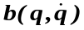, as a function of coordinates , and their velocities , gravity vector 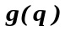, vector of generalized forces applied to the model , and the inverse of the mass matrix 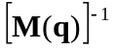.
The Forward Dynamics Tool in OpenSim (Figure 2.1, orange rectangles) uses a neural command from an input controls file (e.g., controls.xml) to generate an output states file (e.g., states.sto). Potential model inputs are excitations driving muscles, forces, and/or torque actuators. Using musculotendon dynamics, including activation-contraction and muscle-tendon dynamics, the forces actuating the model are computed; subsequently, using musculoskeletal geometry, the joint moments are computed. In addition to the internal loads, external loads such as ground reaction forces and moments are applied to the model for certain movements (e.g. human gait). Accelerations are then found with Eq. (1) as all parameters on the right hand side of the equation are known. OpenSim uses a 5th-order Runge-Kutta-Feldberg integrator (Runge-Kutta-Merson integrator in newer versions) to numerically solve the differential equations that define the dynamics of a musculoskeletal model and compute the output states of a model including joint positions and velocities (observed movement).

Interface between OpenSim and MATLAB/Simulink
The OpenSim and MATLAB/Simulink interface (Figure 2.2.a) is developed to combine relevant strengths of each software package and enable a user to perform musculoskeletal simulations directly in a model-based design and control system environment. The new interface uses the well-documented S-function API to interact with the Simulink engine. An S-function is a computer language description of a Simulink block written in MATLAB, FORTRAN, C, or C++ language (we chose C++ to have easy access to all OpenSim C++ functions and dynamically linked libraries) and compiled as MEX-files. This dynamically linked subroutine can be automatically loaded and executed by MATLAB/Simulink. This interaction is very similar to the interaction that takes place between the engine and built-in Simulink blocks.

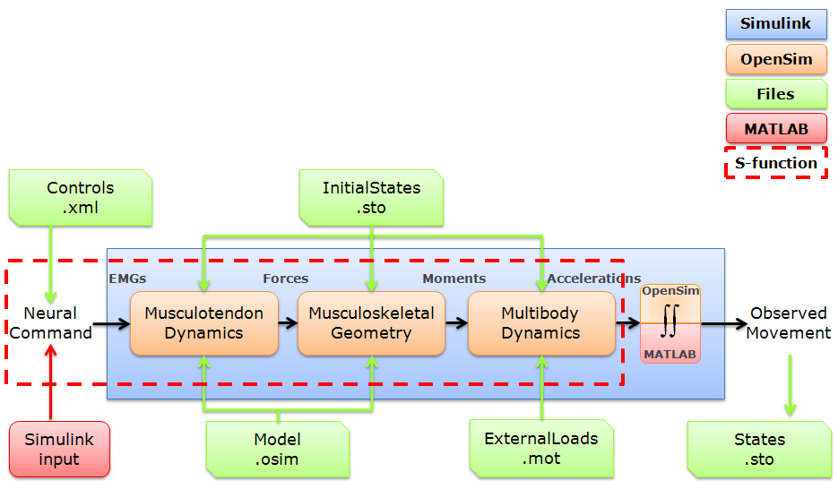

Figure 2. 1: Flowchart illustrating components of forward dynamics in OpenSim and MATLAB/Simulink. Simulink (large blue rectangle) is used instead of the OpenSim Forward Dynamics Tool. The OpenSim transformations (orange rectangles) between a neural command and state derivatives (e.g., joint accelerations) involve musculotendon dynamics, musculoskeletal geometry, and multibody dynamics. Input files (green rectangles) are required by OpenSim for the model, controls (if applicable), initial states, and external loads (if applicable). The Simulink input signal (if applicable) and MATLAB transformation (red rounded rectangles) between joint accelerations and observed movement involves numerical integration. The interface can use MATLAB integrators instead of OpenSim integrators for the forward dynamics. The new S-function interface (red dotted rectangle) takes a controls file or Simulink signal and computes state derivatives subsequently integrated by MATLAB.

Similar to the execution of built-in Simulink blocks, the execution of the S-function interface proceeds in a number of stages (Figure 2.2.b & 2.2.c). First, the Simulink model is initialized. Prior to the first simulation loop, the Simulink engine initializes the S-function’s block characteristics by creating a SimStruct (simulation structure) containing information such as the number and dimensions of input and output ports. In the next step, the S-function’s parameters are processed, which includes creating and setting up an OpenSim model, incorporating the block’s sample time, and allocating the required memory. Then, the simulation loop begins and a series of simulation steps begin. During each simulation step, the Simulink engine calls S-function methods that compute the OpenSim model’s states, state derivatives, and outputs for the current simulation time. In the next step, the initial conditions (i.e., OpenSim model states) for the integration are set, any defined outputs are calculated, and the states are updated, which synchronizes the OpenSim model and Simulink block states. The S-function then uses OpenSim methods to calculate the state derivatives necessary to solve (i.e., integrate) for the motion (i.e., states) of the OpenSim model. The Simulink engine repeats previous output and derivative stages at minor time steps to compute the integrated states for the S-function. The integration continues until the solver reaches the desired accuracy for the computed states over the simulation time.
The OpenSim and MATLAB/Simulink interface requires the same inputs as the OpenSim Forward Dynamics Tool such as an OpenSim model file, controls file, initial states file, and external loads file (Figure 2.1, green rectangles). In lieu of a controls file, the user is able to use a Simulink signal, MATLAB workspace structure, or a data file. The S-function uses OpenSim’s underlying Simbody dynamics engine and MATLAB integrators to generate the forward dynamics simulation of an OpenSim model (Figure 2.1, red dotted rectangle). The user can easily change Simulink configuration parameters (e.g., integration solver, error tolerance, etc.) to suit the requirements of the problem at hand.

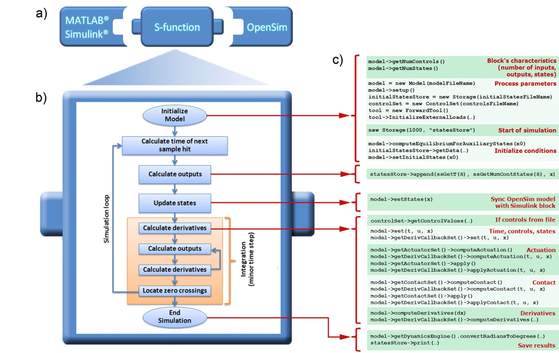

Figure 2. 2: Overview of the new S-function interface. (a) The interface links the rapid model-based design and control systems strengths of MATLAB/Simulink with the numerical simulation and human movement dynamics strengths of OpenSim. (b) Flowchart illustrating stages for each Simulink simulation. (c) OpenSim v1.9 (higher versions not shown) methods called during each simulation stage.

Open-loop Model Application
A generic open-loop Simulink model that loads and executes the OpenSim-based S-function was created (Figure 2.3.a). The Forward Dynamics Tool in OpenSim and the S-function block without feedback control in Simulink are both considered open-loop systems. For an open-loop forward dynamics simulation, controls (e.g., excitations driving torque or muscle actuators) are the inputs to the multibody system (e.g., musculoskeletal system) and states (e.g., motion) are the outputs. The output states are the system’s response to the input controls. The S-function interface works with any OpenSim model by defining block parameters for a particular simulation (Figure 2.3.b).
To demonstrate the open-loop characteristics and compare how well the S-function in MATLAB/Simulink agrees with the Forward Dynamics Tool in OpenSim, simple human arm model with 2 degrees of freedom (shoulder elevation and elbow flexion) and 6 muscle-tendon actuators (triceps brachii long head, triceps brachii lateral head, triceps brachii medial head, biceps brachii long head, biceps brachii short head, and brachialis) was utilized to simulate an elbow flexion movement during 1 second simulation. The model’s states were integrated in MATLAB using a variable step size, non-stiff, ode45 (Dormand-Prince) integrator. The error tolerance for the MATLAB integrator was the default value of 1e⁻³. The error tolerance of OpenSim’s integrator was set to 1e⁻³ to make it as accurate as the MATLAB integrator. The motions resulting from the OpenSim and Simulink simulations of elbow flexion were directly compared.

Closed-loop Model Application
A generic closed-loop Simulink model that loads and executes the OpenSim-based S-function was created (Figure 2.4). The open-loop Simulink model from the previous section is limited to using predefined input controls that cannot be changed; however, many human movement applications require closed-loop control systems that update input controls to generate a desired output. We extended the open-loop model by adding a proportional-integral-derivative (PID) controller with feedback.

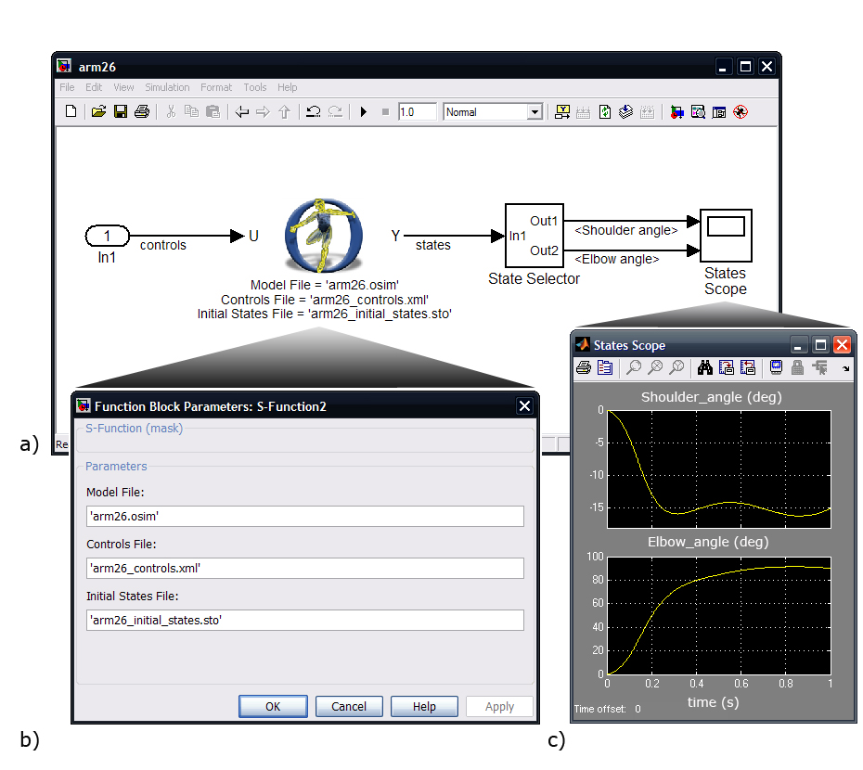
Figure 2. 3: Overview of an open-loop model application for arm flexion. (a) The Simulink graphical editor window shows input controls (U), the new S-function interface (middle), and the output states (Y). (b) The custom Simulink block parameter dialog box shows every input parameter required (or optional) by the OpenSim Forward Dynamics Tool to perform a simulation. (c) The output states may be displayed using a State Selector and Scope within the graphical editor or they may be loaded as a motion file in OpenSim to visualize the simulated movement.

To demonstrate the closed-loop characteristics, a human arm model balancing a pole was implemented in OpenSim. The pole was modeled in OpenSim as a cylinder with mass of 10 kg, height of 30 cm and base radius of 2.5 cm. This biomechanical system had three degrees of freedom (shoulder elevation, elbow flexion and pole rotation), 6 muscle-tendon actuators and a constraint on forearm (using OpenSim point on line constraint function) to keep the hand connection point with the pole joint to move along the horizontal direction. A PID controller was used to balance a pole above the hand by adjusting the required control for the mentioned arm muscles. We normalized the controller output based on each muscle’s maximum isometric force and designed the muscle’s gain matrix. We then multiplied the muscle’s gain matrix by the controller output to generate the realistic control signal for individual muscles. The controller gains were tuned using the classic Ziegler–Nichols method [97]. The desired pole angle (measured from vertical) was 0º. It was used to compute a pole angle error and, subsequently, a control correction. The initial controls, computed from static optimization, were used to maintain the arm position before a control correction was necessary. The combination of control correction and initial controls is analogous (but not identical) to the human neural command associated with the arm balancing a pole. Random force disturbances were added to the pole to cause an imbalance and the pole angle error was observed.

Results
The new interface between OpenSim and MATLAB/Simulink allowed rapid model-based design and numerical simulation of human movement using both open-loop (Figure 2.3 & 2.5) and closed-loop (Figure 2.4 & 2.6) control systems.
For the open-loop case, the Simulink generated shoulder angle matched the OpenSim generated angle within a 0.03º root mean square (RMS) difference (Figure 2.5b). The RMS difference for the elbow flexion angle was 0.06º (Figure 2.5c). Using the OpenSim integrator error tolerance of 1e-3, the computation time was 7.1 seconds with the graphical user interface (GUI) and 3.2 seconds without the GUI (computational speed was assessed on a 3.2 GHz Intel® Xeon® workstation with 3.00 GB of RAM). However, it took 3.9 seconds to generate the same forward dynamics simulation of the arm model using the new S-function and the MATLAB integrator.
For the closed-loop case, the PID controller successfully rejected random force disturbances ranging between ±30 N (Figure 2.6b) and balanced the pole with a maximum pole angle error from vertical of 1.19º (Figure 2.6c). Using the MATLAB integrator with the same error tolerance as the open-loop case, the computation time for the closed-loop system was 5.9 seconds.

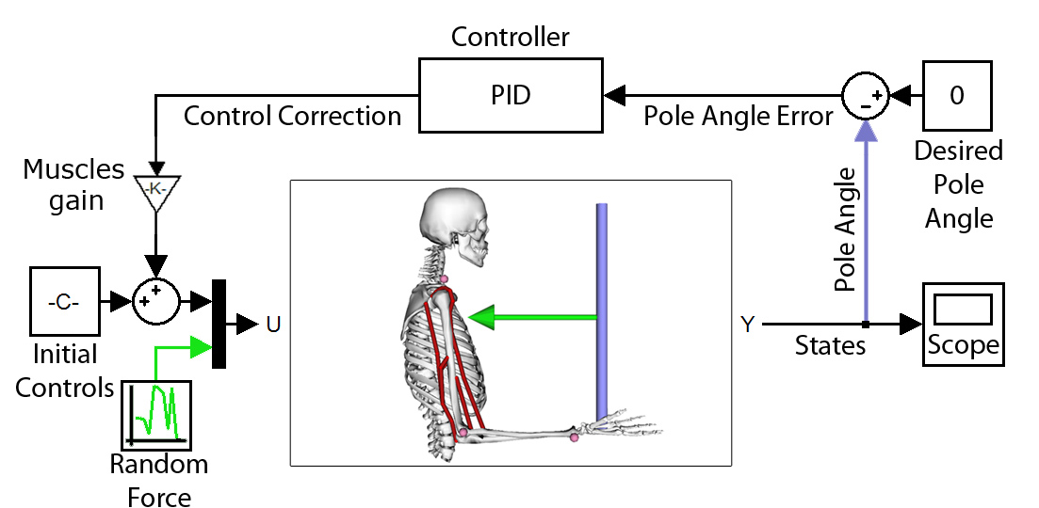
Figure 2. 4: Example closed-loop Simulink model extending the open-loop case with control of a human arm balancing a pole. The desired pole angle (measured from vertical) was zero and used to compute a pole angle error. The proportional-integral-derivative (PID) controller, along with the muscle gain matrix was used to compute control correction signals for each of the six muscles to balance the pole, despite random force disturbances exerted on the pole.

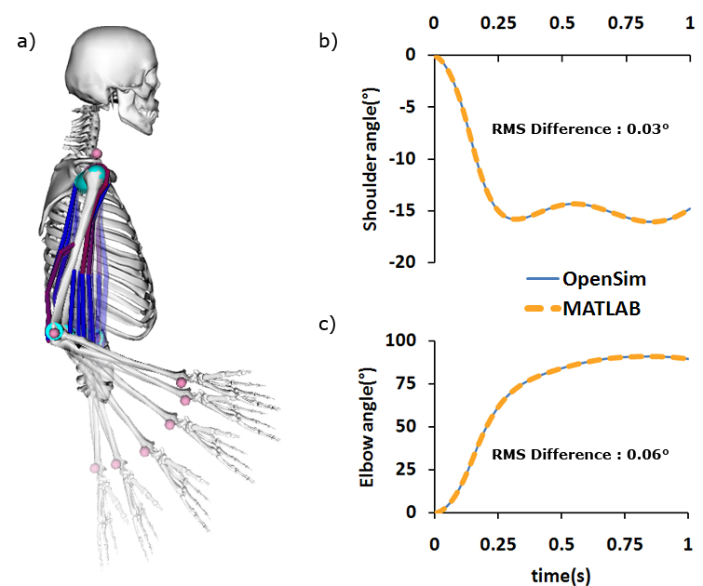
Figure 2. 5: Open-loop simulation of elbow flexion and differences between movements generated by OpenSim and Simulink simulations. (a) A simple human arm model with 2 degrees of freedom and 6 muscle-tendon actuators (six time frame series of a one second elbow flexion movement shown). (b) Shoulder angles and (c) elbow angles for the OpenSim and Simulink simulations.

Discussion
Rehabilitation and treatment of musculoskeletal conditions could greatly benefit from integrated computational tools to better understand of human movement and plan optimal treatments. Our goal was to develop an interface between OpenSim and MATLAB/Simulink that combines their relevant strengths. The new S-function interface combines the robust design, powerful math, and control system strengths of MATLAB with the numerical simulation and human movement dynamics strengths of OpenSim. This integrated platform has promise for better understanding movement control and the potential to improve treatment planning.

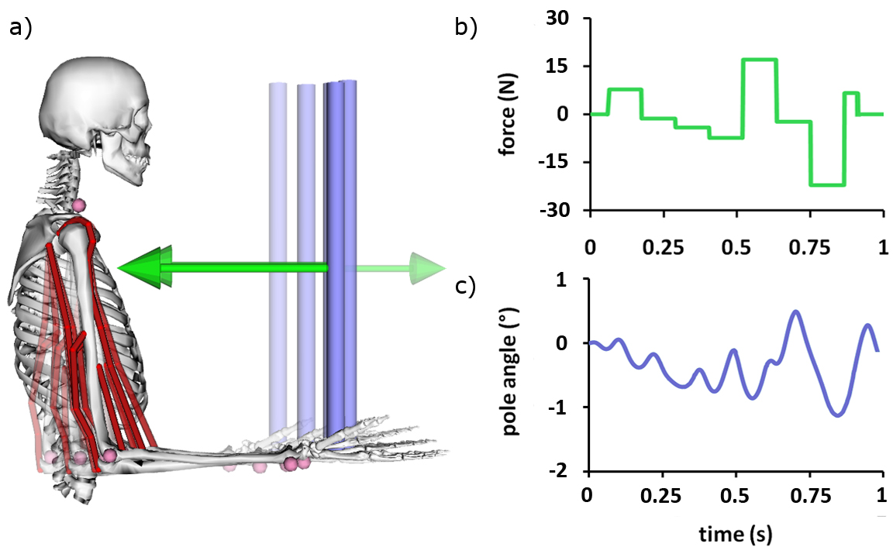
Figure 2. 6: Closed-loop simulation of balancing a pole despite random force disturbances. (a) A PID controlled human arm model balancing a pole (five time frame series from 0.25s to 0.55s shown). (b) Random force disturbances were exerted on the pole and (c) the pole angle measured from vertical remained small.

The RMS difference on the order of 1e-2º between OpenSim and Simulink simulated joint angles is reasonable given the differences between the two integrators. Whereas OpenSim uses a 5th-order Runge-Kutta-Feldberg integrator with the error tolerance of 1e-3, we used the MATLAB variable step size, ode45 (Dormand-Prince) integrator with the default error tolerance value of 1e-3. By tightening the error tolerance for each integrator, the RMS difference between MATLAB and OpenSim joint angles can be significantly reduced; unfortunately, this change increases computation time significantly. This time increase becomes even more significant for large, complicated OpenSim models such as the OpenSim gait2354 model used for walking movements. However, a new integrator in OpenSim (v2.2 and higher) uses an error controlled and robust Runge-Kutta-Merson algorithm from SimTK. This integrator is comparable to MATLAB’s integrators and is proving to be even faster for stiff problems such as contact modeling. We have ongoing projects employing this new OpenSim integrator.
The S-function and control systems software development in this study had several limitations. First, the compatible versions of OpenSim (v2.3.1), MATLAB (v7.13.0), and Simulink (v7.7) were based on those available at the time of the S-function interface development. Thus, generating the newer versions of the interface may be needed as future versions of these software packages may improve computational efficiency and add new features. However, the current version of the interface, which is compatible with all versions of OpenSim (v1.9-v2.3.1), seems to be sufficient as it contains all of the previous OpenSim features plus the new contact modeling capability. Unlike the biomechanical contact models which can be idealized into joints or constraints in older versions of OpenSim, the new contact model arises from deformations of the compliant materials from which biological systems are composed (e.g. Hertz contact model and Elastic Foundation model) [98]. Second, the Forward Dynamics Tool is the only OpenSim tool extended by the interface and other tools (e.g., Inverse Dynamics, Static Optimization, and Computed Muscle Control) are beyond the scope of this study. With the exception of Computed Muscle Control, OpenSim tools do not require feedback of model states to compute input controls. Third, the PID control was one of the simplest approaches among the many available closed-loop control systems for the balancing the pole. However, by applying the muscle gain in our closed-loop controller which was designed based on the muscle physiology and maximum isometric force, we made the control signal or muscle excitation to act analogous (but not identical) to the human neural command system. Fourth, despite the popularity and robustness of Ziegler-Nichols PID tuning method, the users should be careful in picking proportional controller gain which can venture into unstable regions and cause the system to become out of control. Although the controller development is not a focus of this study, the new interface allows custom, complex controllers to be developed, tested, and refined. The arm model was intended as a simple application for both open-loop and closed-loop control systems to demonstrate the developed S-function interface; however, complex dynamic and control systems are necessary for clinical problems.
Despite these limitations, the interface allows users to access any OpenSim model within MATLAB/Simulink and perform forward dynamics simulations using the Simbody™ dynamics engine and MATLAB integrators. There is no need for users to recompile the S-function each time they perform a simulation, change models, or switch integrators. The user is able to easily change the integrator within Simulink to suit the problem’s stiffness or desired error tolerance. The interface’s design is based on OpenSim menus and terminology, which make it easier for users to input the required files as S-function parameters. Moreover, it provides a single interface for all OpenSim-required input data files such as controls, initial states, and external forces. This input data can be provided by a Simulink signal, a MATLAB workspace variable, or a data file. This flexibility adds the unique ability of real-time changes to controls for OpenSim models, which has otherwise been unavailable to OpenSim users to this point and is necessary for feedback control systems to study musculoskeletal conditions. For example, insights into the potential treatment for gait abnormalities may be investigated. Gait abnormalities commonly observed in children with cerebral palsy are typically treated by surgically altering muscle functions. Unfortunately, this treatment strategy does not consistently result in improved outcomes. Patient-specific simulations have utility to determine the potential efficacy of surgical correction.
Although our interface shares some similarities with other interfaces, this work is fundamentally different from previous work focused on functional electrical stimulation [94] and finite element analysis [95]. Other interfaces are built on commercial dynamics engines such as SD/Fast, and employ commercial musculoskeletal software such as SIMM or AnyBody. In our case, we build on the freely available Simbody dynamics engine and employ the freely available OpenSim software. Unlike other interfaces that require additional steps to compile files containing the equations of motion for the simulation, the generated interface does not require additional compilation steps. The users also should not confuse the developed interface with OpenSim’s built-in capability of running the Forward Dynamics Tool using MATLAB command line feature, which only runs OpenSim tools from the command line, without any graphical representation. On the contrary, our tool uses OpenSim’s dynamic engine and MATLAB’s integrators and combines these in a Simulink block to add the potential of applying it in closed loop control systems.
The potential to use OpenSim and MATLAB/Simulink to study and perhaps improve treatments for musculoskeletal conditions is exciting and valuable. This project not only integrates software tools, but also allows integration of neuroscientists, physiologists, biomechanics, and physical therapists to adopt, adapt, and generate new solutions for musculoskeletal conditions. All of the source codes, Simulink model examples, and user documentation related to this work will be available on a SimTK.org project dedicated to the interface (https://simtk.org/home/opensim-matlab).

Chapter 3

Simulation and control pipeline for predictive patient-specific neuromuscular systems.

The next step is to design a pipeline for simulation and control of patient-specific neuromuscular systems. Human movement requires the coordination of many muscles and the transformations between neural control and purposeful movement are highly complex and involve many individual elements. Many of these individual elements have been characterized through experiments. However, experiments alone limit understanding of movement dynamics, simulations complement experiments. Although a few variables responsible for movement (e.g., kinematics, ground reaction forces, and EMG) can be measured, it is extremely difficult to measure important variables such as muscle activities and joint forces. Predictive modeling and simulation will provide tools to investigate these limitations. A new treatment strategy combining physical examination, movement analysis, and simulation-based approaches may lead to a better understanding of human movement control. In order to achieve this goal I used the following pipeline for the patient specific modeling, simulations and control of musculoskeletal models.
              - Create musculoskeletal models using OpenSim software for the specific application
              - Scale generic models based on specific subjects’ anthropometric data
              - Perform inverse kinematics analysis to determine model kinematics that best match the experimentally measured kinematics.
              - Run Forward Dynamics simulation to estimate states and generate motion due to muscle excitations.
              - Design different controllers to perform predictive dynamic simulations
  - Low-level spinal stretch-reflex feedback controller
  - High-level task-based controller to track kinematics

Create musculoskeletal models using OpenSim software for the specific application
All the musculoskeletal models will be developed using the OpenSim software. OpenSim is available through SimTK.org website. SimTK is the Simbios Biosimulation Toolkit, a collection of open source software tools supporting high-performance physics based simulation of biological structures and includes the OpenSim API. Simbody, SimTK’s multibody dynamics engine, is the underlying dynamic engines for OpenSim. Figure 3.1 [99] shows OpenSim’s computational and functional layers. OpenSim relies on the computational infrastructure provided by Simbody, particularly for creating and solving the multibody dynamics System. OpenSim [87], a free and open-source (e.g. non-commercial, peer-produced and publicly accessible API header files) modeling and simulation platform, was developed as an extension to the commercial musculoskeletal software package SIMM [81, 88, 89] to create a custom software package for modeling and simulating biomechanical systems.
Using OpenSim generic lower body and upper body model libraries, one can modify and add new degrees of freedom and costume joints (e.g. pin, ball, slider, pin-in-slot costume joints) based on the application and the requirements of the projects. For the first phase of this project and to test the interface, we used a simple upper body model with 2 degrees of freedom and 6 muscle actuator to test our developed S-function interface forward dynamics and control system design. In the next phase for balance recovery, the lower extremity model with 23 degrees of freedom and 92 muscle actuators will be used. Please refer to next chapter for the details of the lower extremity that was used for balance recovery simulations.
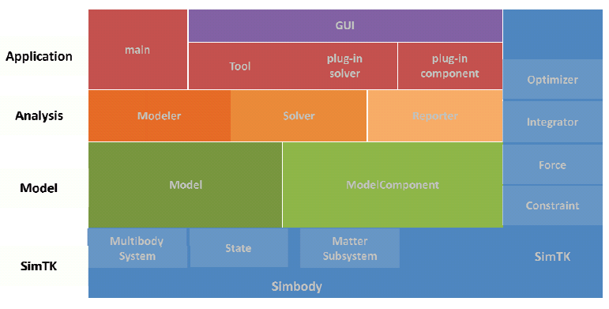

Figure 3. 1: Different OpenSim layers. The base layer is the computational layer provided by Simbody (in blue). Simbody components (e.g. integrators, optimizers) are available to all levels within OpenSim API. The next layer is modeling layer (green). The modeling layer is followed by analyses layer (orange). The top layer is the application layer (red) which is consumer of OpenSim API to generate applications such as OpenSim GUI or dynamic libraries. (Image Courtesy: Seth et al., 2011).

Scale generic models based on specific subjects’ anthropometric data
Next Step in is scale the generic models. The objective of scaling is to develop a subject specific model that has the same mass and anthropometric measurements as the subject performing the experiment. Using OpenSim Scaling toolbox, first the subjects mass is redistributed amongst the model body segments to replicate the subjects body mass. Body segment’s length and mass then can be adjusted either uniformly or individually using location of the subjects’ experimental markers. To reduce the error between the model and experimental markers, static pose will be used to calculate the average distance between the experimental and model markers. Manual iterations may be needed to get good maker positioning on the model that matches the experimental data.
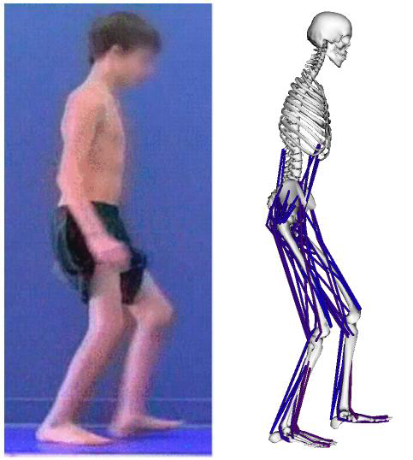

Figure 3. 2: Scaling the generic musculoskeletal model based on the experimental patient-specific data. The models are scaled to represent the length and mass of each segment of the experimental data.

Inverse Kinematics analyses to match the model motion with an experimental data
This step is only necessary when the experimental marker data is available and is irrelevant in cases where the output motion is synthesized or predicted due to a set of muscle excitations or joint torque actuators. Synthesized simulations motions can be compared to the experimental motion calculated using the Inverse Kinematics tools to validate the simulated motions.
The inverse kinematics tool in OpenSim steps through experimental data at each time step (e.g. balance recovery kinematics data) and places the model in a pose that "best matches" experimental marker and coordinate data for that time step. The "best match" is the minimum of sum of squared errors of markers and coordinates.
Inverse kinematics derives the joint angles from the experimental marker data. A weighted least square algorithm (Equation 3.1) is used to decrease these errors between the experimental and model markers ($X_{i}^{exp}, X_{i}\left(q\right)$) and generalized coordinates ($q_{j}^{exp},q_{j}$), where $w_{i}$ and $ω_{j}$ are the user defined weightings.

$$\begin{matrix}min \\ q\end{matrix}\left[\sum_{iϵmarkers}{w_{i}{\left\|X_{i}^{exp}-X_{i}\left(q\right)\right\|}^{2}+\sum_{jϵunprescribed coords}{ω_{j}{\left(q_{j}^{exp}-q_{j}\right)}^{2}}}\right] (3.1)$$

$$q_{j}=q_{j}^{exp} for all prescribed coordinates j$$

The result of this step is model joint angles and positions and velocities that accurately match the experimental movement.

Forward dynamics simulation
As discussed thoroughly in the previous chapter, the Forward Dynamics Tool in OpenSim uses a neural command from an input controls file (e.g., controls.xml) to generate an output states file (e.g., states.sto). Potential model inputs are excitations driving muscles, forces, and/or torque actuators. Using musculotendon dynamics, including activation-contraction and muscle-tendon dynamics, the forces actuating the model are computed; subsequently, using musculoskeletal geometry, the joint moments are computed. In addition to the internal loads, external loads such as ground reaction forces and moments are applied to the model for certain movements.
The OpenSim forward dynamics is extended using feedback controllers to provide state information via feedback controllers from dynamical system output motion to modify the system’s input controls according to the desired control criteria. The inputs are modified to generate desired movement. In order to achieve this goal, and based on the complexity of the movements, different control algorithms are investigated.

Design controllers to perform predictive dynamic simulations

Forward dynamics simulations in OpenSim software are limited to using predefined input controls that cannot be changed (fixed muscle excitations or joint torques); however, many human movement applications require control systems that update input controls to generate a desired output. By Interfacing the OpenSim with Matlab/Simulink, users will have access to input controls and output states at each integration time step. This will greatly benefit the control system development for various neuromuscular applications that otherwise was not available in traditional biomechanical modeling and simulations software packages.
Human movement is controlled by a complex network of neurons. It is believed that the Central Nervous System (CNS) forms the foundation of this complex movement and it is consisted of high-level supraspinal and low-level spinal signals. Central pattern Generators (CPGs) are biological neural networks that produce rhythmic patterned outputs [100]. Spinal reflexes are on the other hand part of this complex network, and contribute to selection of movement patterns, the timing of the muscle activities [101]. Combinations of these high-level and low-level signals have developed into essential tools for studying different control strategies in human locomotion.

Low-level spinal stretch-reflex feedback controller
Spinal reflexes associate sensory information about legged mechanics into the muscle activations via alpha motor neurons, and bypass central inputs. Studies showed that positive force feedback of leg extensor muscles play an important role in load-bearing [102], and compliant leg behavior during stance gait [103], suggesting importance of a muscle reflex in explaining important mechanical behavior of the system. Moreover, muscle-reflexes models that encodes principles of legged mechanics [104] showed successful in producing human walking dynamics and muscle activities.
The low-level controller utilizes a stretch reflex based on a combination of muscle spindles and Golgi-tendon organ (GTO) [105]. The muscle spindle provides the CNS with information about length and contraction velocity of muscles. The GTO provides the CNS with information about forces in muscle-tendon complex (MTC) and helps to stabilize posture. Together, these afferent mechanisms provide a simple feedback estimate of muscle-tendon length, velocity, and force for controlling postural responses (Equation 1).

(3.2)

l_{MTC_ref} is the reference muscle-tendon complex (MTC) length; l_{CE} is the contractile element (CE), or the muscle fiber length; l_{SE} is the series elastic (SE), or tendon, slack length; V_{CE} is the CE velocity; $∆t$ is the monosynaptic latency (25ms) [106]; k_{p} and k_{d} are the constant position and velocity gains for the stretch reflex.
In the first phase of our control development procedure, stretch reflex was developed to test the balance controller. We start with a simple inverted pendulum problem with one degree of freedom (DOF), and two muscle-tendon actuators, to test the stretch-reflex controller (Figure 3.3). We ran one second forward dynamics simulation with a closed-loop stretch reflex controller to simulate the inverted pendulum balance control problem. Initial velocity (-2rad/s) was introduced to the center of mass of the pendulum to perturb the stable position. The resulting motion, muscles’ fiber lengths and activations are plotted in Figure 3.4, 3.5&3.6
In the next chapter, the controller was extended for more complex musculoskeletal problems such as human balance control with 23 DOF and 92 muscle-tendon actuators (see next chapter for the human balance control model and results).

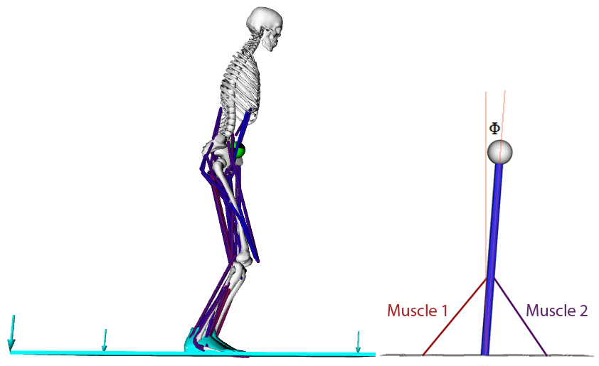
Figure 3. 3: Over simplified model of human balance control using a simple inverted pendulum with two muscle-tendon actuators will be used to validate a more complex control problem such as human posture balance with 23 DOF and 92 muscle-tendon actuators.
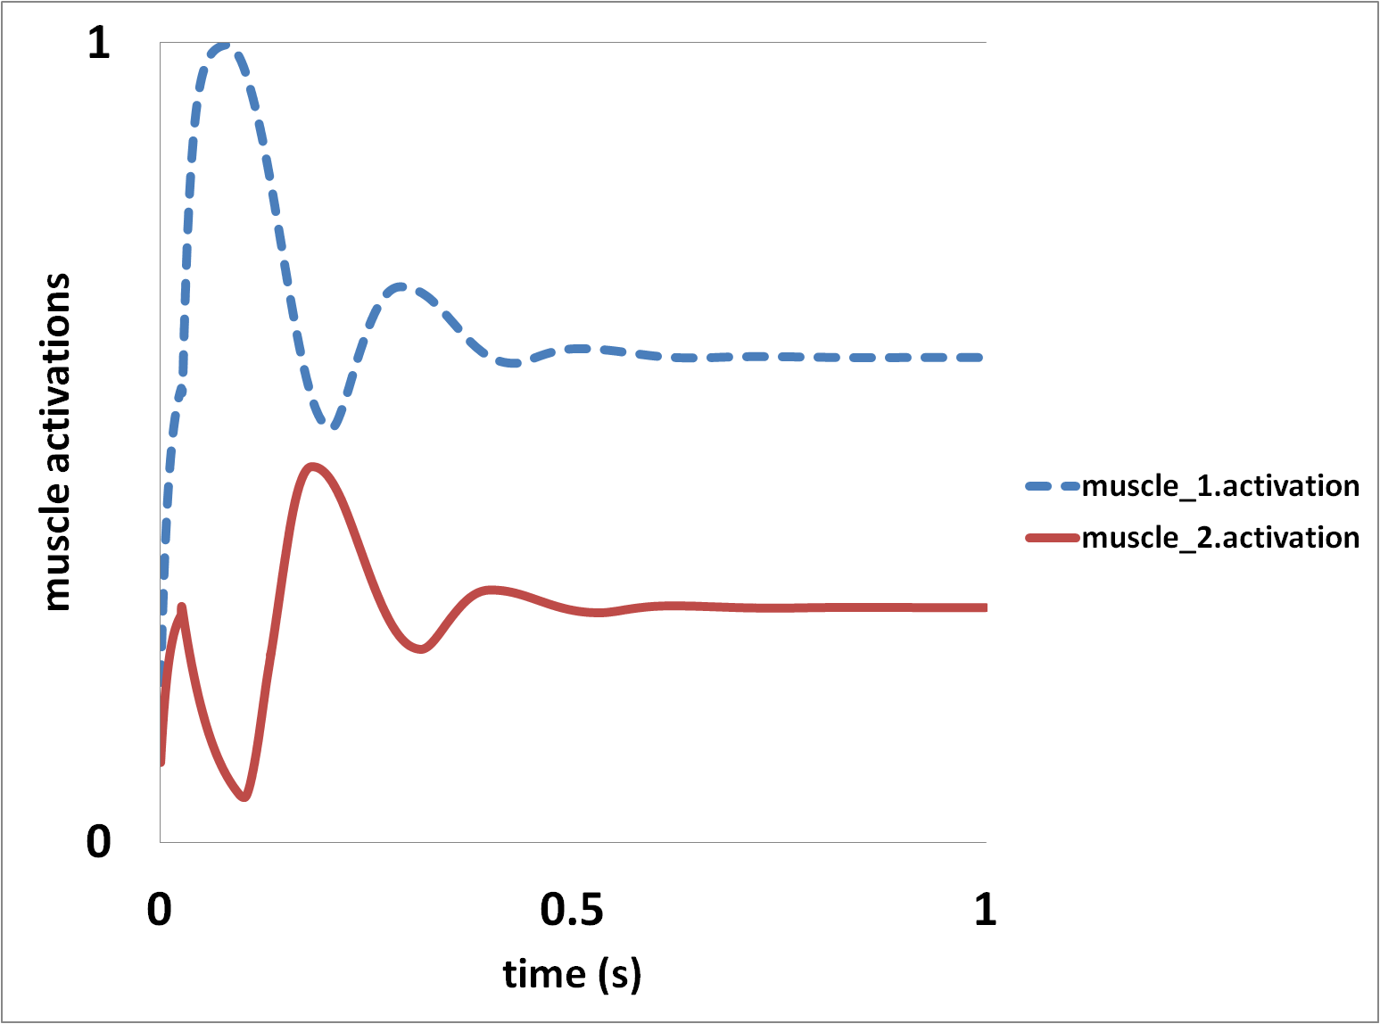
Figure 3. 4: shows muscles’ activations during a one second forward dynamic simulation with stretch-reflex controller due to the initial pendulum velocity as a perturbation to the system.

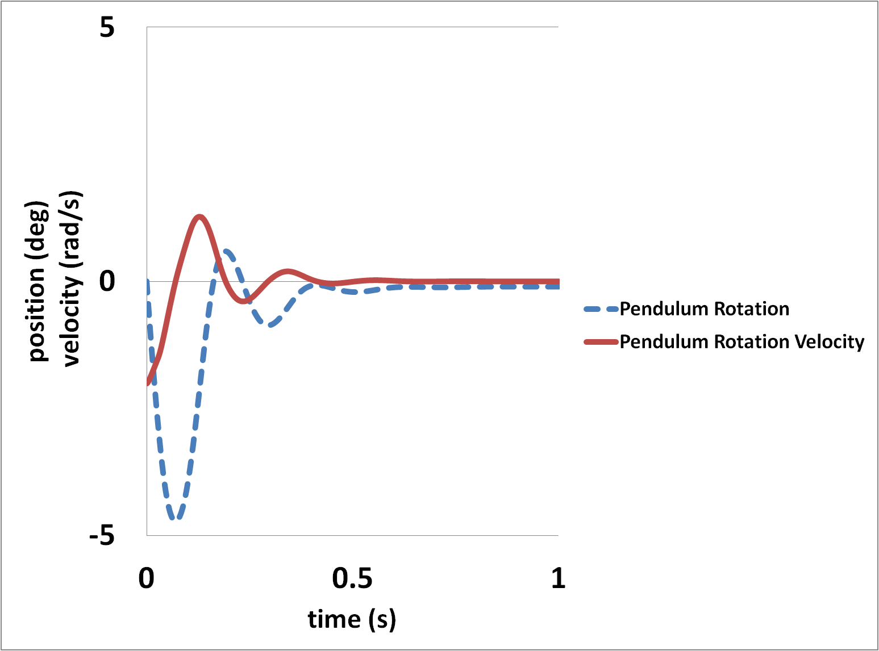
Figure 3. 5: shows the inverted pendulum rotation angles () and rotation velocity during a one second forward dynamic simulation with stretch-reflex controller due to the initial pendulum velocity as a perturbation to the system.

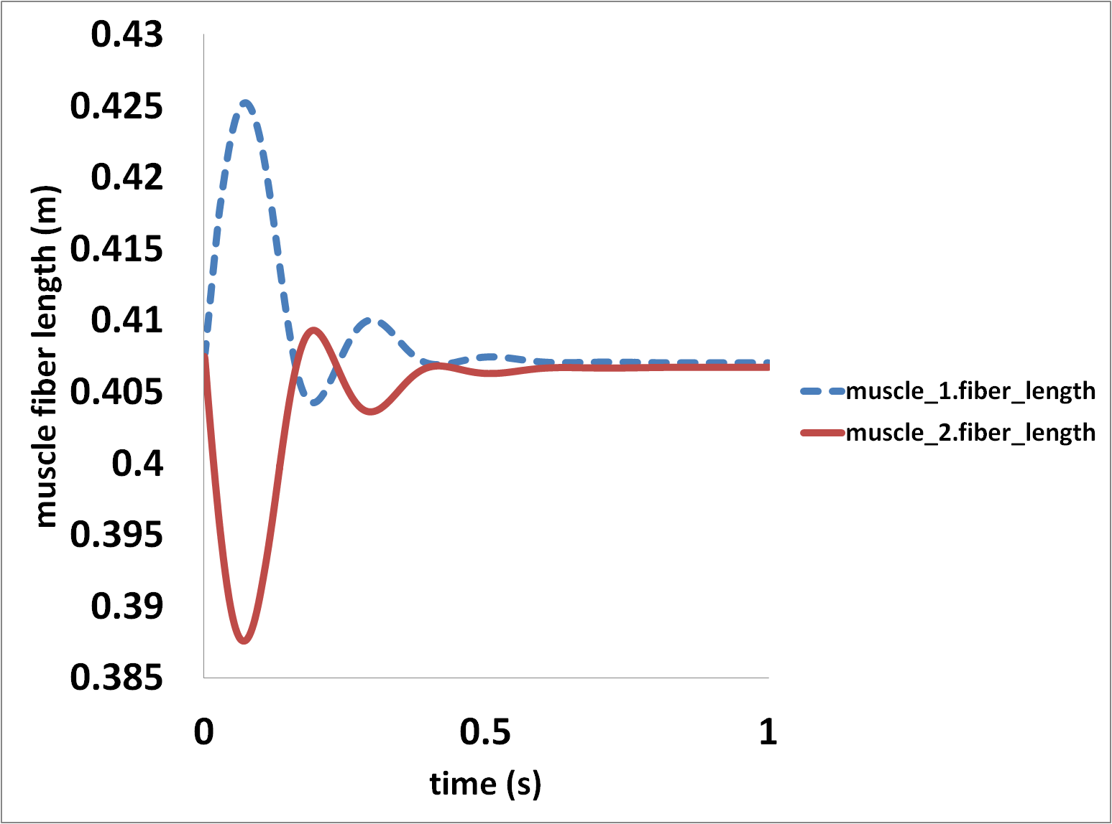
Figure 3. 6: shows muscles’ fiber length during a one second forward dynamic simulation with stretch-reflex controller due to the initial pendulum velocity as a perturbation to the system.

High-level controller to track kinematics
The low-level stretch-reflex controller is a good start for designing a controller that reject disturbances and balance the models; however, more complex controllers need to be implemented in order to fully represent complex human musculoskeletal movement and balance. High-level control signals are believe to be part of the control loop to track different joint angles or track a specific task by integration of multiple sensory inputs such as vestibular, visual and proprioceptive signals. The controller does not use these sensory inputs directly due to modeling complexity of each of these sensory systems; alternatively the high-level controller uses detailed neuromuscular model’s dynamics to locate each joint and body position and velocity.
Following are the details of the two controller that was used to track the joint angles directly (computed muscle control) or track different tasks without tracking every joint individually (task-based controller).

3.5.2.1. Computed Muscle Control
We utilized OpenSim Computed Muscle Control (CMC) to calculate muscle excitations that will drive a dynamic musculoskeletal model to track a set of desired kinematics. The CMC algorithm computes excitations using a combination of proportional-derivative control and static optimization to track joint angles of desired kinematics (Figure 3.7).
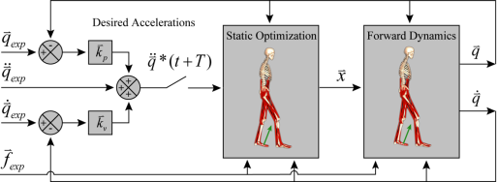

Figure 3. 7: Schematic of the Computed Muscle Control Algorithm [1]. (Image Courtesy: Thelen, 2003)

CMC algorithm computes a set of desired accelerations (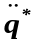) that will drive the model coordinates (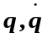) toward the experimentally-derived coordinates (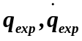). The desired accelerations are computed using the following PD control law (Equation:

(3.3)
where 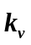and 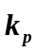 are the velocity and position feedback gains, respectively. Feedback gains tuned to reduce the error between the desired and experimental coordinates to zero using critically damped convention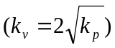.
Next, applying static optimization to determine actuator controls () to achieve desired accelerations. These controls can be in form of joint moments or muscles excitations.
The CMC algorithm utilizes a combination of feedback control, static optimization and forward dynamics to estimate muscles excitations required for tracking a movement [1]. The forward dynamics portion uses muscle excitations calculated from static optimization to drive a model that replicates the experimental joint motion. The feedback controller ensures the muscle excitations generate a simulated movement that tracks the experimental one. These procedures will be repeated till the end of simulations time to calculate required muscles excitations for specific motions.
In the next chapter, we use combination of a stretch-reflex controller and a computed muscle control to investigate balance recovery in children with cerebral palsy. Although CMC is shown successful in tracking coordinates during a motion, computational costs of such simulations will be reduced by using novel robotic controller techniques that not only can track but also synthesize new motions. A defined higher-level task such as keeping the center of mass of the whole body over base of support to control balance instead of tracking every single joint will improve the quality of controls and will enable predictive simulations.

Chapter 4

Influence of the Biarticular Rectus Femoris Muscle on Balance Recovery in Children with Cerebral Palsy

4.1. Introduction

Stiff-knee gait is one of the most prevalent and troublesome movement abnormalities among children with CP and its symptoms are treatable with surgery involving the rectus femoris muscle. There are approximately 573,000 individuals affected by spastic CP in the United States. Patients experiencing stiff-knee gait typically adopt energy-inefficient movements to compensate for reduced toe-clearance and avoid tripping or falling due to spastic, over active lower-extremity muscles. Stiff-knee gait is often accompanied by excessive knee flexion during stance (crouch gait) [69], which may also play a role in balance control [70]. Over-activity of the rectus femoris is attributed as a primary cause of stiff-knee gait [113]. Various surgical procedures can treat CP symptoms by altering the function of problematic muscles including the rectus femoris [114, 115]. Rectus femoris transfer surgery is one such procedure, which aims to convert the muscle’s knee extension moment to a knee flexion moment. Unfortunately, outcomes following surgery are met with variable success [116, 117].
Rectus femoris is a biarticular muscle, acting as both a hip flexor and knee extensor, and may play a unique role in maintaining balance during dynamic tasks [118, 119]. Some have suggested biarticular muscles act as energy transfer straps across joints [120]. Furthermore, others have suggested that biarticular muscles play a unique role in motor control and are among the first muscles affected in persons with CP [121]. As a biarticular muscle, rectus femoris may be important in maintaining balance and may have deleterious effects when transferred to become a knee flexor.
Recommendations for rectus femoris transfer surgeries are generally based on physical examinations along with clinical movement analysis and surgical treatments; the biomechanical consequences and outcomes following rectus femoris transfer surgery are rarely considered. Physical examination of a single passive joint motion does not address coordinated multi-joint movement. Clinical movement analysis characterizes the motion of limb segments, but not the individual muscle contributions causing this motion. Muscle-actuated simulations and bio-inspired control systems potentially give insights into the complex interaction between neural commands, musculoskeletal geometry, and resulting functional movements. Combining clinical movement analysis and simulation-based approaches may lead to a better understanding of biomechanical consequences of stiff-knee gait and its treatments.
The objective of this study was to determine the effect of simulated rectus femoris transfer surgeries on the balance recovery of children with CP under two different crouched postures. We hypothesized that the stability of pre-surgical simulations would be different (i.e., have better or worse balance recovery) than post-surgical simulations of unilateral or bilateral rectus femoris transfers. {Henry, 1998 #2232}We tested this hypothesis by comparing the minimum distance from the extrapolated whole body center of mass (CoM_{extrp}) to the base of support (BoS) boundary as well as the minimum time for the CoM_{extrp} to reach the BoS boundary for each simulation [122]. We also used these muscle-actuated simulations of balance recovery to determine whether moderate crouched postures are more stable than mild crouched postures.

4.2. Methods

We determined the influence of the biarticular rectus femoris muscle on balance recovery in children with CP by performing the following four steps: 1) creating patient specific musculoskeletal models of children with spastic CP before and after rectus femoris transfer surgery adopting either a mild or moderate crouched posture; 2) designing a biologically-inspired, closed-loop control system for balance recovery; 3) generating forward dynamic simulations to examine balance recovery following support-surface translations; and 4) evaluating stability margins using the extrapolated center of mass position and minimum time-to-boundary of the base of support.

4.2.1. Musculoskeletal Models

Three-dimensional musculoskeletal models with 92 muscles and 23 degrees of freedom were constructed in OpenSim [123]. The Hill-type muscle-tendon model was used as the basis for each muscle in the simulations [110]. The foot-ground contact geometry were based on 3D scans of cadaver feet [124] and ground reaction forces were modeled using elastic foundation mesh-based contact [123]. The models were scaled to represent the size of children with spastic CP [125]. To simulate rectus femoris transfer surgery, we modified the pre-surgical models to create post-surgical ones by reattaching the distal tendon of the rectus femoris from the patella (Figure 1a) to the insertion of the sartorius on the tibia (Figure 4.1b). The tendon slack length of the transferred muscle was scaled to ensure the muscle fibers operated near their pre-surgical length ranges [113]. The tendon attachments on bones and muscle via-points are defined based on the MRI images of subjects with CP [126] and modeled using OpenSim via points. The unilateral model represented a simulated transfer on the left limb only, while the bilateral model represented a transfer on both limbs. The crouched postures of the models were selected based on average lower-extremity kinematics of children with cerebral palsy adopting mild (ankle, knee and hip angle of 13.8°, 20.9° and 17.5°, respectively) and moderate (ankle, knee and hip angle of 20.6°, 37.3° and 28.1°) crouch gait. For each model to maintain balance during forward dynamic simulations, a control system design was necessary.
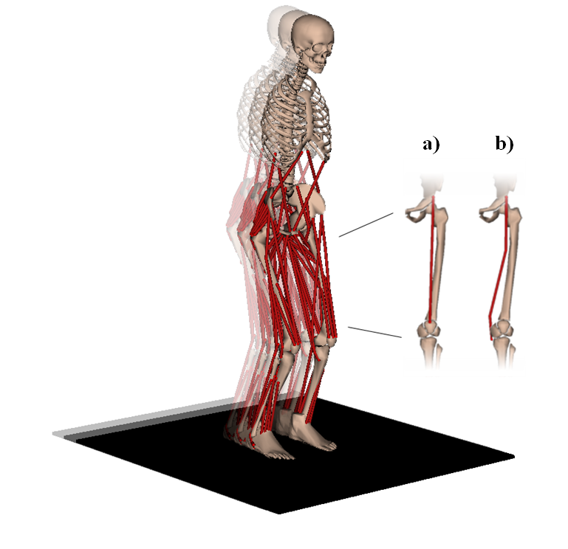
Figure 4. 1: Three-dimensional, 23 degree-of-freedom musculoskeletal model with 92 muscle-tendon actuators (shown in red) recovering balance on a support surface translating 7.5 cm over 0.55 seconds with a maximum velocity of 18 cm/s. The musculoskeletal model was used along with a biologically-inspired controller to create forward dynamic simulations of children with mild and moderate crouch to test our hypothesis regarding balance recovery following rectus femoris transfer surgery. Biarticular locations for the rectus femoris muscle are shown as (a) the pre-surgical attachment to patella and (b) the post-surgical transfer to the insertion of the sartorius on the tibia.

4.2.2. Biologically-inspired Controller

Each musculoskeletal model used a biologically-inspired controller to track the experimental CoM displacements similar to the Central Nervous System (CNS) combination of high-level supraspinal and low-level spinal signals in controlling human balance. The high-level controller utilized computed muscle control (CMC) [1] to calculate muscle excitations (peripheral nerve action potential, which initiates the muscles excitation-to-activation process signals) to maintain a static posture despite the forces of gravity. The CMC algorithm utilizes a combination of feedback control, static optimization and forward dynamics to estimate muscles excitations required for tracking a movement [1]. The forward dynamics portion uses muscle excitations calculated from static optimization to drive a model that replicates the experimental joint motion. The feedback controller ensures the muscle excitations generate a simulated movement that tracks the experimental one. The low-level controller utilized a stretch reflex based on a combination of muscle spindles and Golgi-tendon organ (GTO) [105]. The muscle spindle provides the CNS with information about length and contraction velocity of muscles. The GTO provides the CNS with information about forces in muscle-tendon complex (MTC) and helps to stabilize posture. Together, these afferent mechanisms provide a simple feedback estimate of muscle-tendon length, velocity, and force for controlling postural responses (Equation 1, Figure 4.2).

$Excitation\left(t\right)= CMC\left(t\right)+ k_{p}\left[l_{MTC_{ref}}\left(t\right)- l_{CE}\left(∆t\right)-l_{SE}\left(∆t\right)\right]+k_{d}\left[-V_{CE}\left(∆t\right)\right].$ (1)

l_{MTC_ref} is the reference MTC length; l_{CE} is the contractile element (CE), or the muscle fiber length; l_{SE} is the series elastic (SE), or tendon, slack length; V_{CE} is the CE velocity; $∆t=t-0.25$is the time minus monosynaptic latency (25ms) [127]; k_{p} and k_{d} are the position and velocity gains for the stretch reflex.
Stretch-reflex gains were chosen to represent subjects with non-spastic, typically developing and spastic CP responses to stretch. The gains were determined using a non-linear least squares optimization in MATLAB (lsqnonlin) minimizing the CoM position and velocity errors between simulated and experimental CoM displacements [128] for typically developing subjects. The optimization was performed over different time periods (0.55s, 1s, 2s and 2.8s); however, simulation time increase in optimization did not have a major effect on resulting gains after the first 55s. In addition, we tracked hip, knee and ankle joints in the cost function to avoid unrealistic joint motions. An upper- and lower-bound for the design variables were used to avoid unrealistic gains. Spasticity was simulated by multiplying the non-spastic position and velocity gains by a factor (1.1) to increase the sensitivity of the controller [129].

4.2.3. Forward Dynamics Simulations

The musculoskeletal models and biologically-inspired controller were used to create forward dynamic simulations of balance recovery to test our hypothesis regarding stability of children with CP before and after transfer surgery as well as comparing different crouched postures (Figure 4.1). We used an OpenSim/MATLAB interface [130] to generate simulations of balance recovery following support-surface translations. The translation was defined using a generalized cross-validation spline function prescribing the position of the support surface as a function of time based on clinical studies [131]. The support surface was translated 7.5 centimeters in the anterior or posterior directions with a peak velocity of 18 cm/s, which took 0.55s to complete. A total of 21 forward dynamic simulations were performed for combinations of non-spastic, spastic, mild crouch, moderate crouch, pre-surgical, and post-surgical models (Tables 4.1 and 4.2). Each 4-second simulation involved the 0.55s support-surface translation and 3.45s of balance recovery to record the dynamic stability margins and potential fall due to oscillations.
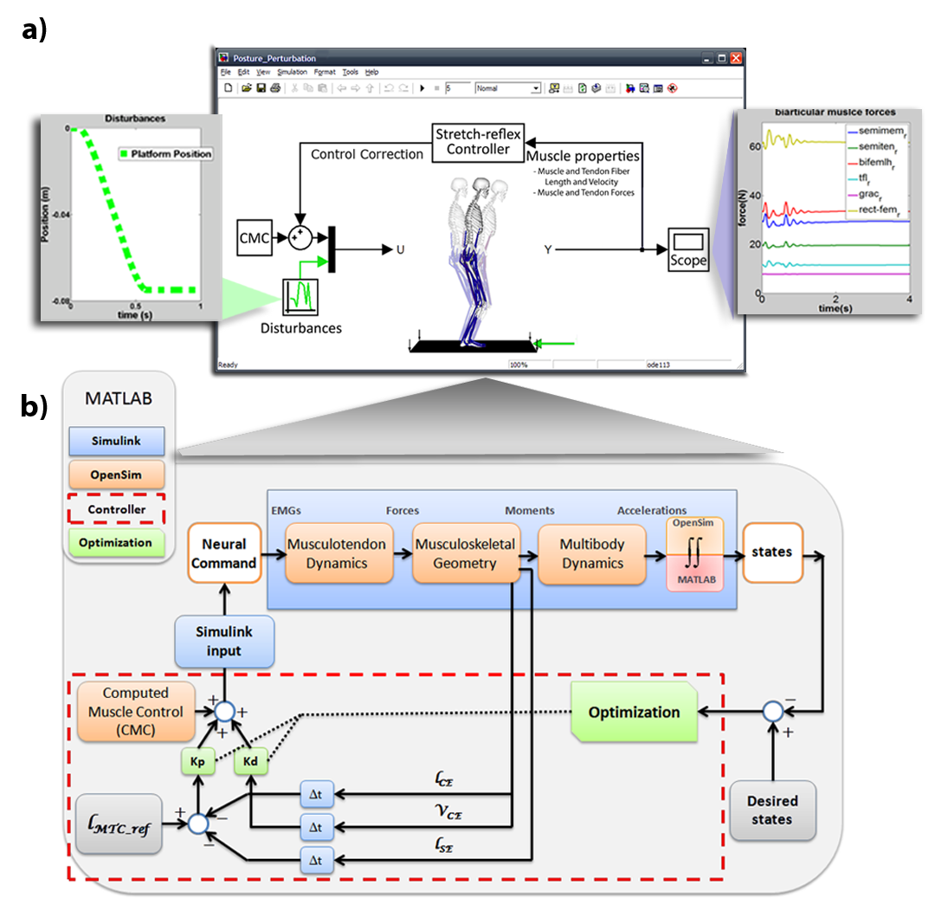
Figure 4. 2: Schematic of (a) the closed-loop forward dynamic simulation in Simulink and (b) the underlying algorithms. The inputs to the musculoskeletal model, or neural command, were calculated based on the low-level (stretch-reflex controller) and high-level (computed muscle control) feedback control system. Disturbances (e.g., support-surface translations) may also be introduced to the system as inputs. The outputs of the dynamic simulation are the model’s states. The stretch-reflex controller’s gains, k_{p} and k_{d}, were selected by a non-linear least squares optimization minimizing position and velocity errors between simulated and experimental center of mass displacements. l_{MTC_ref} is the reference muscle-tendon complex (MTC) length; l_{CE} is the contractile element (CE) length; l_{SE} is the series elastic (SE), or tendon, length; V_{CE} is the CE velocity; and $∆t$is the stretch-reflex latency.

4.2.4. Dynamic Stability Margins

Based on the criteria for dynamic stability equation from Hof, et al. [122], we quantified balance recovery by defining a spatial stability margin (b_{min}) as the minimum distance between extrapolated center of mass (CoM_{extrp}) and the BoS boundary, and defining a temporal stability margin (TtB_{min}) as the minimum time-to-boundary for the CoM_{extrp} to reach the BoS boundary (Figure 4.3). The CoM_{extrp} is the CoM displacement extrapolated in the direction of its velocity. Larger b_{min} values indicate the CoM_{extrp} is farther from the BoS boundary and the simulated condition is more stable than other conditions with smaller b_{min} values. Likewise, larger TtB_{min} values indicate more time is necessary for the CoM_{extrp} to reach the BoS boundary and the condition is more stable than others.
We evaluated our hypothesis regarding the stability of children with CP under different surgical conditions by comparing the changes in TtB_{min} values, which are functions of b_{min} and CoM_{extrp} velocity. A two-tailed, paired t-test at the 0.05 significance level was performed against the alternative hypothesis that the stability of pre-surgical simulations is different from post-surgical ones. We analyzed the differences in b_{min} and TtB_{min} stability margins by comparing pre-surgical simulations to post-surgical ones following anterior and posterior support-surface translations; in addition, we analyzed differences between mild and moderate crouched postures.

4.3. Results

The balance recovery of all pre-surgical simulations of children with CP (b_{min} = 2.31+1.12cm, TtB_{min} = 0.19+0.10s) was significantly different (p=0.022), on average, than post-surgical ones (b_{min} = -4.94+11.38cm, TtB_{min} = -0.09+0.32s) of both unilateral and bilateral rectus femoris transfers. Following posterior support-surface translations, all pre-surgical simulations (b_{min} = 3.09+0.95cm, TtB_{min} = 0.27+0.09s) were significantly more stable, on average, than post-surgical ones (b_{min} = -11.79 +15.10cm, TtB_{min} = -0.34+0.23s) (Table 4.1). Following anterior support-surface translations, all pre-surgical simulations (b_{min} = 1.52+0.61cm, TtB_{min} = 0.12+0.04s) were not significantly different, on average, from post-surgical ones (b_{min} = 1.89+0.82cm, TtB_{min} = 0.15+0.06s). The pre-surgical simulations maintained balance following both anterior and posterior support-surface translations (Figure 4.4). On the contrary, the post-surgical simulations (unilateral and bilateral transfers) were not able to recover balance following posterior support-surface translations (Figure 4.4, bottom row).
Balance recovery was also influenced by crouched posture (Figure 4.4, columns). Following anterior support-surface translations, the moderate crouch simulations (b_{min} = 2.36+0.42cm, TtB_{min} = 0.18+0.03s) were more stable than the mild crouch simulations (b_{min} = 1.18+0.27cm, TtB_{min} = 0.095+0.02s) (Table 4.1). Following posterior support-surface translations, the stability of moderate crouch simulations (b_{min} = -0.78+3.54cm, TtB_{min} = _0.05+0.27s) was not significantly different, compared with mild crouch simulations (b_{min} = -12.87+19.18cm, TtB_{min} = -0.22+0.48s).

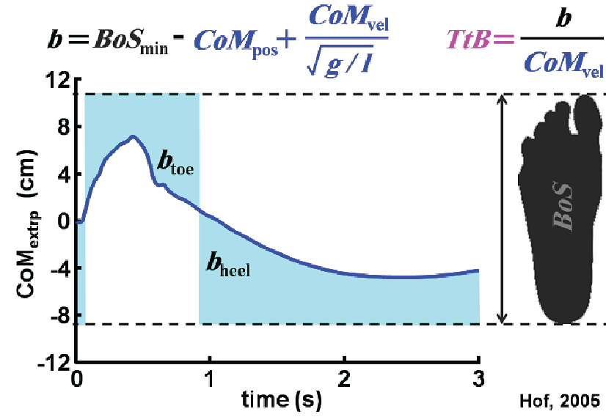

Figure 4. 3: Shows the extrapolated center of mass of a pre-surgical model following posterior support-surface translation as a function of simulation time. CoM_{extrp} was chosen over CoM and center of pressure (CoP) in defining the stability margins because models may be moving toward a fall that occurs after the simulation time despite the CoP being located within the BoS throughout the simulation. The functions b and TtB are defined based on Hof et al., 2005 and the minimum values of these functions were used as an indicator of how stable the simulations are at each time step.

Table 4.1: Comparison across simulations of balance recovery defined by a spatial stability margin, b_{min}, which was the minimum distance between extrapolated center of mass (CoM_{extrp}) and the BoS boundary, and a temporal stability margin, TtB_{min}, which was the minimum time-to-boundary for the CoM_{extrp} to reach the BoS boundary. The negative values on the table show the CoM_{extrp} is outside of BoS and the model is indeed falling. Additional information about these simulations of balance recovery is available as supplementary material (Table 4.2)

Crouched posture | Support-surface translation | Pre-surgery |  |  | Post-surgery
Crouched posture | Support-surface translation |  |  |  | Unilateral |  |  | Bilateral
Crouched posture | Support-surface translation | b_{min} (cm) | TtB_{min} (s) |  | b_{min} (cm) | TtB_{min} (s) |  | b_{min} (cm) | TtB_{min} (s)
Mild | Anterior | 1.09 | 0.09 |  | 0.98 | 0.08 |  | 1.49 | 0.12
Mild | Posterior | 3.76 | 0.33 |  | -33.86 | -0.55 |  | -8.52 | -0.44
Moderate | Anterior | 1.96 | 0.15 |  | 2.32 | 0.19 |  | 2.80 | 0.21
Moderate | Posterior | 2.42 | 0.21 |  | -0.20 | -0.03 |  | -4.58 | -0.33

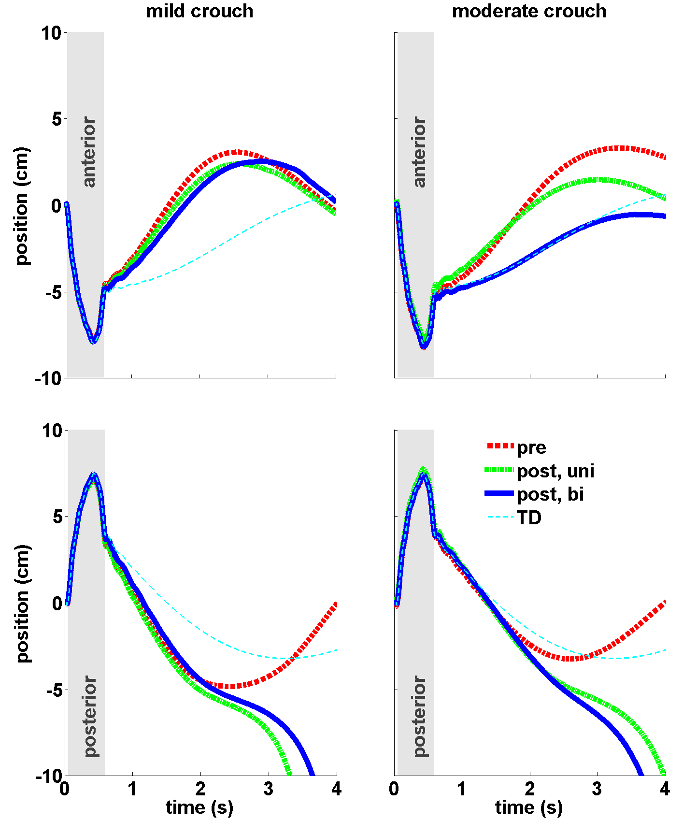
Figure 4. 4: Extrapolated center of mass displacements relative to the support-surface during anterior (top row) and posterior (bottom row) translations (shaded regions) for simulations before (pre) and after (post, unilateral and bilateral) rectus femoris tendon transfer for mild (left column) and moderate (right column) crouched postures. The displacements for simulations of the typically developing (TD) model without a spastic stretch reflex are shown as well.

Table 4.2: Quantitative values of CoM_{extrp}, CoM_{vel} and CoP which was used to calculate the comparison of stability across simulations of balance recovery.

Crouched posture | Support-surface translation | Pre-surgery |  |  |  | Post-surgery
Crouched posture | Support-surface translation |  |  |  |  | Unilateral |  |  |  | Bilateral
Crouched posture | Support-surface translation | CoM_{extrp}  (cm) | CoM_{vel} (cm/s ) | CoP (cm) |  | CoM_{extrp}  (cm) | CoM_{vel} (cm/s ) | CoP (cm) |  | CoM_{extrp}  (cm) | CoM_{vel} (cm/s ) | CoP (cm)
Mild | Anterior | 3.93 | 5.83 | 8.04 |  | 3.98 | 5.91 | 8.79 |  | 3.82 | 5.28 | 7.88
Mild | Posterior | 3.33 | 5.64 | 6.56 |  | 10.86 | 13.83 | 8.41 |  | 6.33 | 6.93 | 7.14
Moderate | Anterior | 4.04 | 5.18 | 5.15 |  | 3.69 | 5.12 | 5.24 |  | 4.42 | 4.62 | 5.35
Moderate | Posterior | 2.91 | 4.87 | 3.22 |  | 4.82 | 5.48 | 4.66 |  | 6.55 | 6.41 | 5.16

4.4. Discussion

Rectus femoris transfer surgery is a common procedure for treating stiff-knee gait, converting the function of this the biarticular muscle from a knee extensor to a knee flexor, which may influence an individual’s ability to maintain balance. Several studies have suggested that biarticular muscles act as energy transfer straps across joints, are among the first muscles affected in persons with CP, and play a unique role in motor control [118, 120, 121]. The objective of this study was to determine the how the biarticular rectus femoris muscle influences the balance recovery of children with CP. Our results confirm that changing the rectus femoris muscle’s function as a knee extensor to that of a knee flexor had a negative effect on balance recovery during simulations following different perturbations. Pre-surgical simulations were significantly more stable than post-surgical ones during posterior support-surface translations. Balance recovery was also influenced by crouched posture. The moderate crouched postures were more stable than mild crouched postures; however, this difference was only significant following anterior support-surface translations.
The significant differences in balance recovery observed in pre- and post-surgical simulations and during anterior versus posterior support-surface translations can be explained by following biomechanical concepts. For anterior support-surface translations, the joint motions to maintain balance require flexing the knee to compensate for an extension induced by the anterior motion of support surface. For posterior support-surface translations, the inability to maintain balance in post-surgical simulations (both unilateral and bilateral transfers) was apparent. Joint motions to maintain balance require the simulation to extend the knee to compensate for a flexion induced by the posterior motion of support surface. In addition, dynamic coupling play a major role in human movement dynamics. Zajac and Gordon [132] showed due to dynamic coupling, the biarticular muscles can induce accelerations in direction opposite to the joint moment they generate. The transfer surgery eliminated the role of biarticular rectus femoris as a knee extensor, which resulted in a negative effect on balance recovery following support-surface translations. Furthermore, Clark [133] showed that negative effects on balance were minimal in absence of other monoarticular knee extensor such as vastus medialis. These results show that the rectus femoris plays a key role modulating the kinematics of the knee to compensate for external perturbations and maintain balance.
These results for anterior and posterior support-surface translations also hold true for both the mild and moderate crouch simulations. The moderate crouched postures were more stable than mild crouched postures; however, this difference was only significant following anterior support-surface translations. Our simulation results for mild and moderate crouch subjects in this study were similar to crouched postures from Hoang, et al. [70] that found several crouched postures afford the lower limb muscles the ability of muscles to generate increased ground reaction forces. Furthermore, our results in both perturbation directions of a control subject undergoing perturbation showed good conformity with the experimental healthy, upright adults from Ting [134] and Henry, et al. [128] (Figure 4.5). Results from this study highlight the importance of the rectus femoris muscle as a biarticular muscle in balance recovery regardless of the degree of crouch adopted by the subjects. Further research is needed to determine whether mild and moderate crouch simulations possess clinically meaningful differences in the context of balance recovery.
This study had several challenges and our findings should be interpreted within the context of modeling assumptions and capabilities to perform predictive simulations. First, we did not report our simulation results for different subject sizes. However, after uniformly scaling models to different sizes and support-surface translations, there is negligible to no differences in balance recovery due to model size. Moreover, Feldesman [135] showed that the ratios of femur to stature in children range between 8 to 18 had a very tight standard deviation (male [mean =26.97, SD = 0.32] and female [mean = 27.11, SD = 0.46]) and the conclusions are unlikely to change according to Alonso, et al. [136] that found poor correlations between postural balance and the lower-limb length. Second, the balance recovery simulations used foot-ground contact modeling that depends upon parameters such as geometry, stiffness and dissipation. The stiffness and dissipation values were chosen based on material properties of skin (foot) and concrete (ground) materials. The same contact model parameters were used in each simulation, so observed differences are not the result of foot-ground differences. Third, although the controller design was not the focus of this study, the simulation was sensitive to stretch-reflex gains. Multiple optimizations seeded with random initial guesses were used to avoid local minima and determine control parameters for maintaining balance while tracking experimental whole-body CoM position and velocity [128]. Forth, we did not consider the stretch-reflex latency differences between muscles in this study. Alternatively, we focused on musculoskeletal geometry differences between muscle attachments and muscle moment arms to indicate a change in balance recovery for different postures, tendon locations, and stretch controller gains. Fifth, the difference between the experimental and simulated CoM (Figure 4.5) can be explained with the fact that the bio-inspired controller is not a full representation of the CNS including vestibular, visual, and proprioceptive sensory information; however, our controller uses information about the current whole body CoM to adjust the stretch-reflex controller gains. In spite of this limitation, our results are consistent with the experimental balance recovery data [128, 134]. We believe these challenges do not influence the answers to the underlying question about what role the biarticular rectus femoris muscle plays in balance recovery before and after transfer surgery for subjects adopting mild and moderate crouched postures. Although the predicted stability margins may change if we made different modeling assumptions, the conclusions regarding the surgical alteration of the rectus femoris muscle’s function having an influence on balance recovery are unlikely to change.
There are several opportunities for future research to build upon the results of this study. Investigation of alternative treatment procedures such as distal transfer of the rectus femoris to the iliotibial band for stiff-knee gait and Achilles tendon lengthening for equinus gait may contribute additional insight into the influence of other biarticular muscles in postural control [67]. In terms of controller development, applying synergistic control to functional muscle groups (e.g., hip flexors or extensors) may potentially make the control strategy more robust for complex human movement control problems such as dynamic stability during gait.

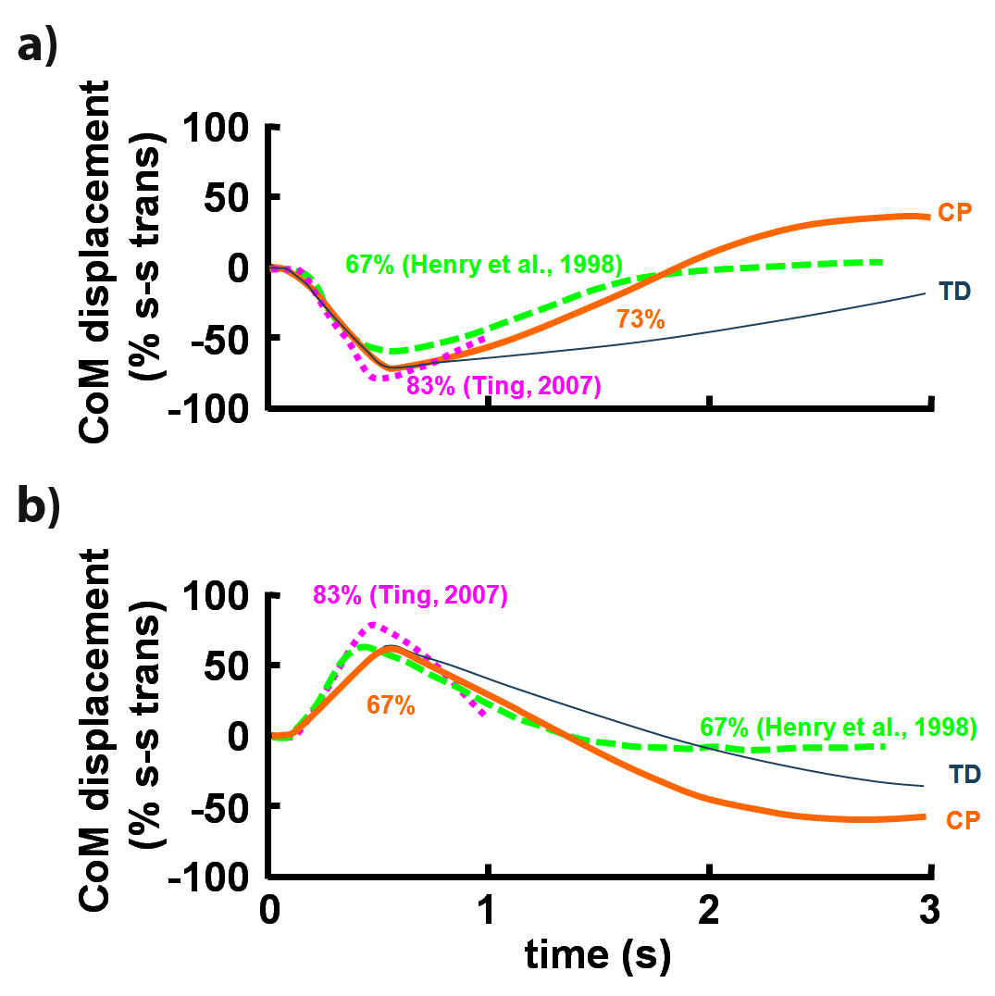
Figure 4. 5: Simulated center of mass (CoM) displacements for Typically Developing (thin solid line) and pre-surgical, spastic Cerebral Palsy (thick solid line) models with mild crouch compared with experimental CoM displacements of healthy adults with upright posture from Ting, 2007 (square dot line) and Henry, et al., 1998 (dash line) during a) anterior and b) posterior support-surface translations. To compare the balance recoveries across support-surface translation magnitudes, the CoM displacements were normalized by the support-surface translations in each study.

The musculoskeletal modeling, neuromuscular control system design, and forward dynamic simulation in this study identified that distal transfer of the rectus femoris muscle to the insertion of the sartorius may change control of balance provided by the muscle path for patients with spastic CP. The pre-surgical simulations maintained balance following both anterior and posterior support-surface translations while post-surgical ones did not maintain balance following posterior translations. Balance recovery was also influenced by crouched postures where moderate crouch was better than mild crouch in helping recover from anterior support-surface translations but not necessarily posterior translations. These results indicate that rectus femoris plays an important role in postural response to support-surface translations. This study provides a foundation for the identification of other biomechanical factors contributing to movement abnormalities and potentially improve surgical and rehabilitation treatments for patients with neurological disorders.

Chapter 5

Task-based Control of Movement

5.1. Task-based controller

Motivated from the robotics community, synthesizing human motion control using high-level control commands can be addressed by merging approaches from the biomechanics and robotics. Task-based controller using operational space approach is investigated in robotics field for many years [62, 107, 108]. Although robotics community researched task-level controller using computational musculoskeletal models [63, 109], integration of these methodologies with more complex musculoskeletal models to achieve human-like movement is very promising in the biomechanics and rehabilitation fields. This work also utilizes the operational space methodologies in muscle-driven simulations. In addition, the OpenSim/MATLAB interface provides the ability of interacting of our musculoskeletal models with novel control systems via a feedback control algorithms which otherwise was not available.
Task-based controller is a model-based controller which utilizes the information of the musculoskeletal system. By choosing a physiological task this controller models certain aspects of central nervous system (CNS) behavior. Using the feedback in physics-based simulations provides a robust, real-time interaction that is missing in other approaches such as feed-forward optimization approaches.

5.2. Musculoskeletal Dynamics

Task-based controller is a model-based controller which utilizes precise model multibody dynamics through the system Jacobian. General multibody dynamical system can be described by a set of generalized coordinates, 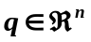 and the following system of n equations,
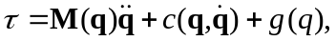
where 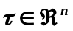 is the vector of generalized actuator forces (e.g. joint torques), 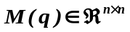 is the system mass matrix, 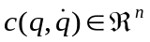is the vector of centrifugal and coriolis terms, and 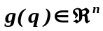is the vector of gravitational terms.
The vector is the idealized torques and is related to musculotendon actuators through the muscle kinematics. The musculotendon length is a function of generalized coordinates, that is 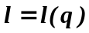, and differential changes in can be explained with the muscle Jacobian 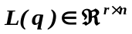 with the following equation,
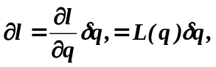
from the principle of virtual work, we have:
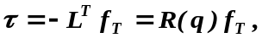
where 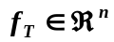, is the vector of net muscle forces including both active and passive muscle forces and 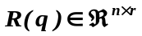is the matrix of moment arms. By plugging this into our equation of motion, the muscle-actuated equation of motion will be formed.

5.3. Task-based Neuromuscular Control

In robotics, the operational space formulation [60] was introduced to relate robot task space and force. This work utilizes Operational space control strategies to implement control algorithms for complex musculoskeletal models. A task is any desired activity that can be shown as the generalized coordinates function. Given the models described before, the task coordinates are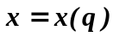, the task Jacobian is defined as:
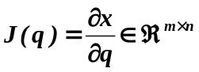
The dynamic behavior in task space is calculated by projecting multibody dynamics into the task space using a dynamically consistent inverse of the Jacobian.
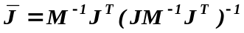
The generalized actuator, can be written as 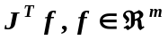is the task or operational space force. We can map the equation of motion onto the operational space using the following:
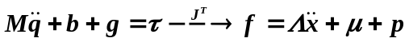
where, the operational space mass matrix,
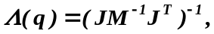
the operational space centrifugal and coriolis vector,
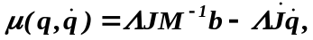
the operational space gravity vector,
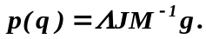
The dimension of task is always less than or equal to the operating space. When this dimension is strictly less than dimension of operating space, the system called as redundant with respect to the task. In this case the null space of the task is linked with posture space of the motion [107] that complement the task term through the fallowing decomposition equation.
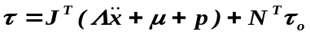
where, 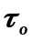, is an arbitrary generalized force and
.
Furthermore to the model, a control law needs to be incorporated. This includes designing a control response,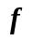and a simple quadratic potential field, 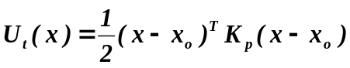.
So, specifying a proportional control law as the input to the decoupled system:
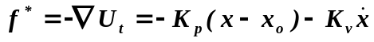,
and
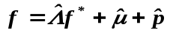
where represents estimates of operational space dynamic properties. Placing this into the equation of motion, we obtain:
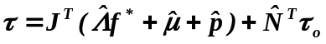
To solve for muscle forces, we used static optimization to minimize muscle activations squared,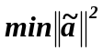 that satisfy the inequality condition of 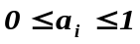.

Figure 5.1 shows the task-level computed muscle control algorithm which uses states as inputs and output the neural excitations required for performing a task such as balance control or any other tracking problem. Some properties of the task-based controller can be tuned such as optimizers cost function, task space tracking error. Other neuromuscular model parameters such as muscle properties (to make it weaker or stronger), muscle activity (spastic/non-spastic), and activation/deactivation time constant.

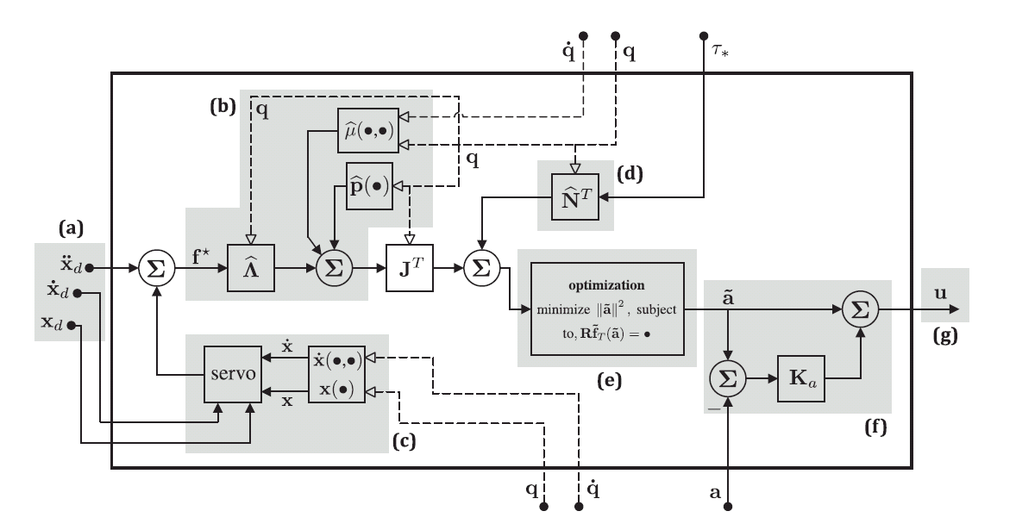
Figure 5. 1: A task-level neuromuscular feedback controller (a) Task-level command input states. (b) Task space feedback linearization using estimation of the dynamic parameters. (c) Task space feedback loop for tracking task space commands. (d) Posture space control input. (e) Static optimization of muscle activations. (f) Activation feedback loop for tracking optimization solution. (g) Output as neural excitations. (Image courtesy: Goldfarb, 2014)

5.4. Task-Based Control of Arm Example

Using OpenSim/MATLAB interface (Figure 5.2), we implement the tasked-based controller on human arm with 3 degrees of freedom including the pole and 6 muscle actuators (Figure 5.3). Task command inputs (hand positions and pole rotation) were specified. The hand was driven to three locations inside the working space of the arm (pink spheres) while balancing a pole (keep the pole from falling). There was no actuator on the hand-pole joint. The pole is modeled as a cylinder with distributed mass of 1kg and height of 0.25m, and is connected to the hand through a 1 degree of freedom pin joint. Disturbance is introduced to the pole as a forces vector to the pole center of mass at certain simulation time (green arrow). The static optimization was implemented inside the S-function interface using the IPOPT optimizer to minimize the muscle’s activation squared and solve for muscle controls.

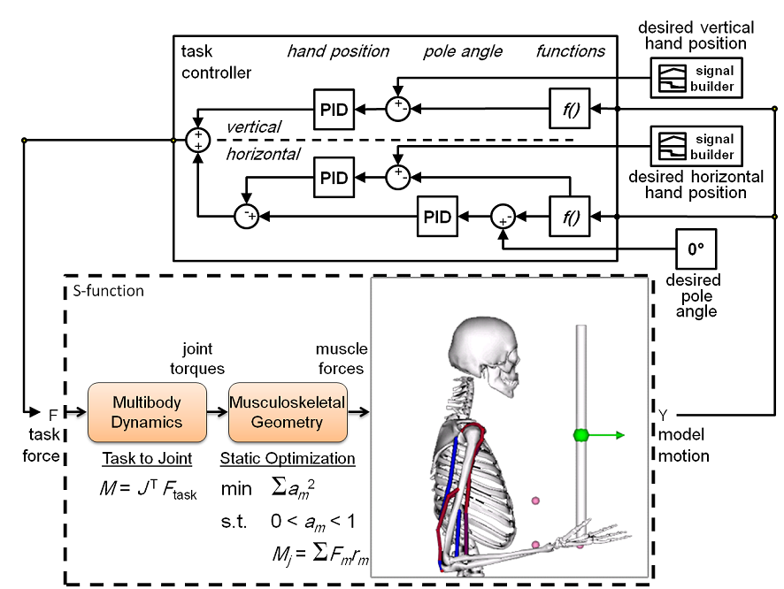

Figure 5. 2: Schematic model of the task-based neuromuscular controller implemented through OpenSim/MATLAB interface. The interface (dotted lines in a) calls the OpenSim arm model and closed-loop task force is calculated as an input to the interface. The task force then will be used to calculate the actuation force (joint torques) using the multibody dynamics and later the muscle excitations using the static optimization. All these steps are implemented inside the interface by calling OpenSim libraries.

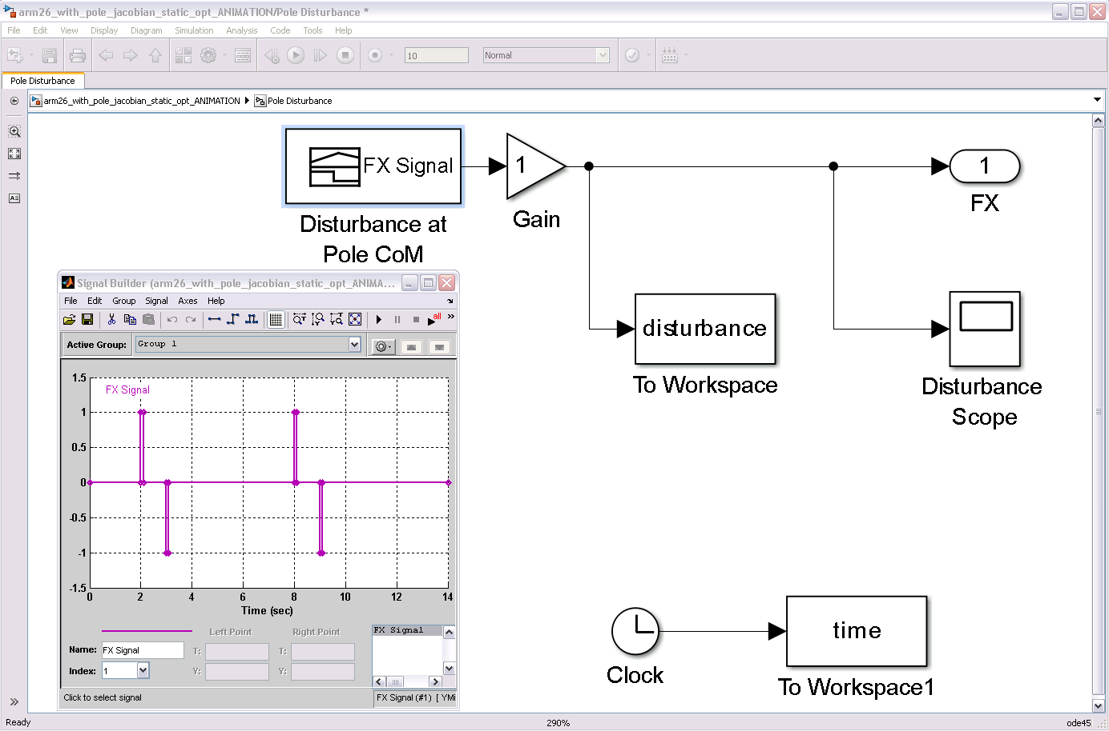

Figure 5. 3: Disturbance was introduced to the center of mass of the pole to test the controller robustness in presence of external perturbation.

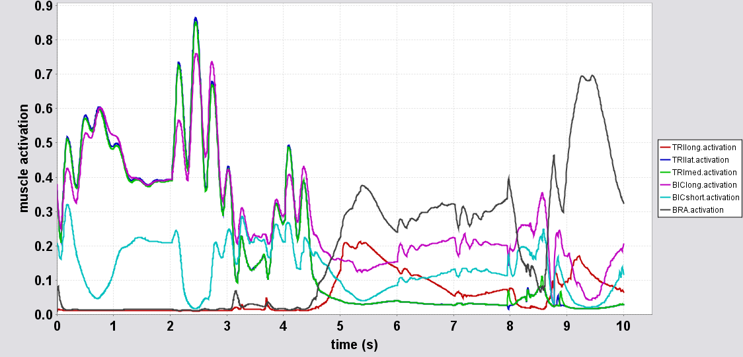

Figure 5. 4: The resultant muscle activations calculated through the task-based controller implemented during 10 second simulations of hand position control and pole balancing tasks.

Chapter 6

Prioritized Free-floating Multi-Task Whole Body Control

In this chapter, we used task prioritization to control whole-body for synthesizing the human balance. Contrary to most robotic manipulators that uses open chain kinematics formulations, and similar to humanoid robots, our models uses free-floating formulation which permits the system to detach from the ground [137]. Gravity forces exerted on our musculoskeletal models push the models to the ground and foot contact modeling was used to generate ground reaction forces required for moving the model in different directions. Furthermore, the motion of our musculoskeletal system is not only defined by bodies and joints position and velocities but also by relative positions and orientations with respect to the moving (inertia) reference frame.
Multiple operational tasks need to be implemented to control a complex human model. In robotics, the operational space formulation [60] was introduced to relate robot task space and force. This work utilizes Operational space control strategies to implement control algorithms for complex musculoskeletal models. Task priority formulations have been first researched at the inverse kinematics level [138-140]. Later, the operational space and control of prioritized tasks introduced at the dynamic level [60, 137, 141].
In this chapter we go through implementation of prioritized task-based control formulation for free-floating musculoskeletal models. Free-floating control of robots was first introduced in Cartesian space by Arai and Tachi [1]. The formulation of extended generalized Jacobian or free-floating Jacobian was extended by [22], [7] and [17], which they included dynamic interaction of generalized forces of the base segment. Later [137] introduced formulation of free-floating dynamics in operational space. We implemented dynamic formulation in operational space presented in [64, 137, 141, 142] in the following section.

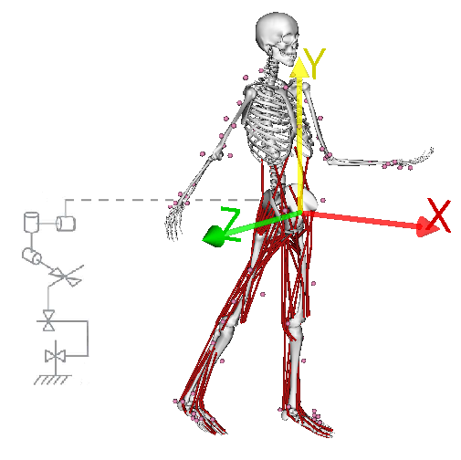
Figure 6. 1: Free-floating musculoskeletal model. Pelvis body (free-floating base) has 6 degrees of freedom in space (3 translational and 3 rotational).

6.1. Musculoskeletal Model

We started with generic OpenSim model with 23 DOF and 92 muscle actuators. We added 5 Hunt and crossly contact spheres under each foot to model the foot-ground contact modeling [15]. The model had 10 body segments; subtalar (2x), talus (2x), shank (2x), thigh (2x), pelvis and torso. The subtalars, ankles and knees were modeled as revolute joints where hips and lumbar were modeled as ball joints. The pelvis body (free-floating base) has 6 degrees of freedom in space (3 translational and 3 rotational).

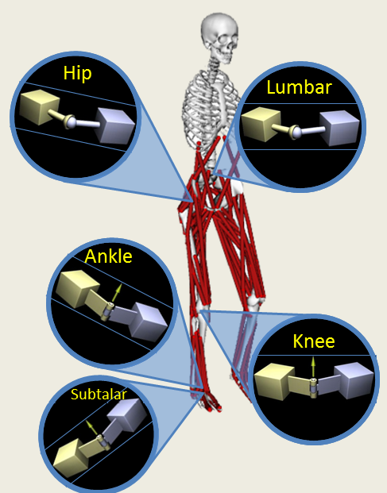
Figure 6. 2: Musculoskeletal model degrees of freedom.

Operational space Free-floating Dynamic Model formulation
The Free-floating human dynamics under supporting contact can be presented as follow:

$$M_{sys} \left(\begin{matrix}{\dot{v}}_{b} \\ \ddot{q}\end{matrix}\right)+ c_{sys}+ g_{sys}+ J_{s}^{T} F_{r}= \left(\begin{matrix}0 \\ Γ\end{matrix}\right)$$

where $M_{sys}$, is the $(n)×(n)$ mass matrix, $b_{sys}$is the $(n)×1$ Coriolis/centripetal and $g_{sys}$is the $\left(n\right)×1$ gravity component , ${\dot{v}}_{b}$ is a $6×1$ vector of base body (pelvis) accelerations (three translational and three rotational), $\ddot{q}$ is the $(n-6)×1$ vector of joint accelerations, $J_{s}^{T}$is the transpose of the Jacobian of all the supporting links and $F_{r}$ is the summation of all the foot-ground contact forces and moments and $Γ$ is the $(n-6)×1$ vector of joint torques ($n$ is number of model’s coordinates and 6 is number of base (pelvis) degrees of freedoms).
The resultant foot-ground contact forces are related to the forces and moments acting of the model’s coordinates, $Γ_{s}$through the following equation:
$${Γ_{s}=J}_{s}^{T} F_{r} ∈ R^{(n)}$$
The support Jacobian, $J_{s}$ is consisted of the base Jacobian $J_{s(b)}$ and the $J_{s\left(r\right)}$ and $J_{s(l)}$. The foot support constraint relates the base joint displacements to the feet displacements.
The Simbody’s frame Jacobian was used to formulate this relationship. The frame Jacobian calculates generalized forces $Γ$, resulting from a set of spatial task forces in the task frame fixed on the body. Each task force measured and expressed in the Ground frame. The rotational part of a Jacobian is the same for any frame fixed to the same body, so the frame’s origin point need to be specified on the body. The system Jacobian is a Frame Jacobian that the task frames are the same as body frames [98].

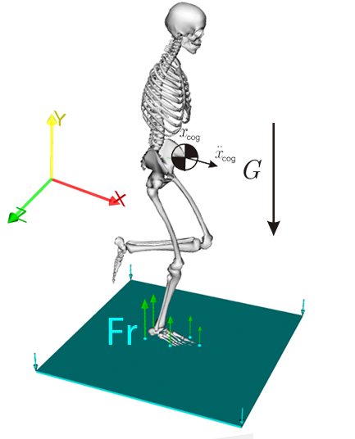
Figure 6. 3: Resultant ground reaction forces on the foot are due to gravity and CoG accelerations.

Supporting Contact

The foot-ground contact was modeled in OpenSim using Hunt and Crossley dissipation model [143] and Stribek friction model. We used five contact points to represent the foot-ground interaction. For each contact element, a force composed of stiffness, dissipation, and friction was produced [98]:
$$F_{r}= f_{stiffness}+ f_{dissipation}+ f_{friction}$$
The contacts were implemented in OpenSim model files as a force set. The following code shows the sample xml code and the contact parameters (stiffness, dissipation, static, dynamic and viscous friction, and transition velocity) that were used in our simulations:
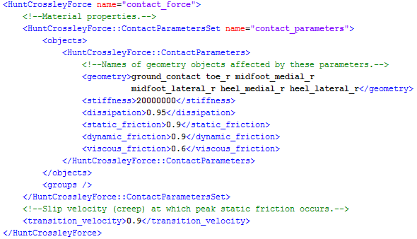
Figure 6. 4: Foot-ground contact modeled as Hunt Crossly Forces inside the OpenSim’s model file. Five contact points (two on each side of the heel and two on each side of the metatarsal bones and one on the tip of the toes) were defined according to (ANDERSON REFERENCE) to represent the foot-ground contact.

Ground contact forces transform into generalized forces that actuate the joints. The balance is achieved through controlling internal forces to keep the foot on ground with no relative movement with respect to ground contact point. As a result, relative velocities at the contact points are equal to zero ($v_{b}=0$ and ${\dot{v}}_{b}=0$).
The actuation matrix $S_{q}=[0_{(n-6)×6} I_{(n-6)×(n-6)}]$ was defined to select model’s active coordinates and the base joint and is used to express the right hand side of the equation, $\left(\begin{matrix}0_{6×1} \\ Γ\end{matrix}\right)= S^{T}Γ$, and plug it in to the equation of motion and using the constraint ${\dot{v}}_{b}=0$, we have:
$$F_{r}={\overline{J}}_{s}^{T} S^{T}Γ- {\overline{J}}_{s}^{T} \left(c+g\right)+ Λ_{s}{\dot{J}}_{s}\left(\begin{matrix}v_{b} \\ \dot{q}\end{matrix}\right).$$
where,
$$Λ_{s}={({J_{s}M^{-1}J}_{s}^{T})}^{-1},$$
is the inertia matrix at the supporting links, and
$${\overline{J}}_{s}=M^{-1}J_{s}^{T}Λ_{s},$$
is a dynamically consistent generalized inverse of $J_{s}$. Based on (khatib 1987), the dynamically consistent null space of a supporting contact $J_{s}$can be written as:
$$N_{s}=I- {\overline{J}}_{s} J_{s},$$
and defines a generalized space of motion that has no force coupling effects on the supporting links.

Kinematics Constraint

The base position in our musculoskeletal model can be derived from the position of actuated joints alone while our system is constrained by supporting ground [144].This means that the base and joints velocities are not arbitrary but they are defined in the null space of the support Jacobian. Constrained joint velocities can we derived as:
$${\dot{q}}^{*}=SN_{s}\left(\begin{matrix}v_{b} \\ \dot{q}\end{matrix}\right)$$
The matrix $SN_{s}$ is full rank in single support stance and so the ${\dot{q}}^{*}$ can take arbitrary values. Support consistent generalized inverse of $SN_{s}$ that satisfy the constraint $v_{b}=0$ can is derived as following equation:
$$\overline{SN_{s}}= M^{-1} {\left(SN_{s}\right)}^{T}{{(ϕ}^{*})}^{+},$$
where, during single support stance ($SN_{s}$is full rank) the pseudo-inverse(+) becomes an inverse and,
$$ϕ^{*}= SN_{s}M^{-1}{\left(SN_{s}\right)}^{T},$$
is the constrained projection of our model inertia matrix inverse, $M^{-1}$.
Using above equations, the support consistent reduced Jacobian ($J^{*})$, that shows the dependency of the base velocity on other joints velocities can be define as:
$$J^{*}=J \overline{SN_{s}}.$$

Operational Space Control of CoG

Balance was achieved by defining a task force for controlling of the CoG horizontal and vertical positions. Assuming the support constraint maintained the foot-ground contact, the CoG position and its Jacobian can be defined as:
$$x= \frac{1}{M}\sum_{i=1}^{n}{m_{i}x_{cog(i)}, } J= \frac{1}{M}\sum_{i=1}^{n}{m_{i} J_{cog(i)}, }$$
where M is total musculoskeletal body mass, m is the mass of the i^{th} body, and x_{cog(i)} is the center of mass of the i^{th} body, and $J_{cog(i)}$ is the Jacobian of the same body. Using the support consistent reduced Jacobian for CoG is:
$$J_{cog}^{*}=J_{cog} \overline{SN_{s}},$$
and therefore, the support consistent full Jacobian can be derived as:
$$J_{cog|s}=JN_{s}$$
where the subscript cog|s shows that the task Jacobian (cog) is projected in the support consistent constraints. The dynamically consistent generalized inverse of the Jacobian is then defined as:
$${\overline{J}}_{cog|s}= M^{-1} J_{cog|s}^{T}Λ_{cog|s}$$
where
$$Λ_{cog|s}={(J_{cog|s} M^{-1} J_{cog|s}^{T})}^{-1},$$
is a task space inertia matrix and is used to form the task space equation of motion:
$$Λ_{cog|s} \ddot{x}+μ_{cog|s}+p_{cog|s}+F_{c}= {\overline{J}}_{cog|s}^{T}{\left(SN_{s}\right)}^{T}Γ,$$
and $μ_{cog|s}$ is the Coriolis/centrifugal and $p_{cog|s}$is the gravitational terms in task space of COG under supporting constraints.
$$μ_{cog|s}= {\overline{J}}_{cog|s}^{T}b-(Λ_{cog|s} {\dot{J}}_{cog|s}+{\overline{J}}_{cog|s}^{T}{ J}_{s}^{T} Λ_{s}{ \dot{J}}_{s})\left(\begin{matrix}v_{b} \\ \dot{q}\end{matrix}\right)$$
$$p_{cog|s}={\overline{J}}_{cog|s}^{T} g.$$
The operational space control torque vector is formed then as:
$$Γ= J_{cog}^{*}F_{cog},$$
where F is a vector of CoG task forces that is formed as follow:
$$F_{cog}=Λ_{cog|s} a^{ref}+ μ_{cog|s}+p_{cog|s},$$
and $a^{ref}$ is a reference CoG acceleration vector.

Prioritized Multi-Task Control

In this section we will explain control algorithms for multiple operational tasks using prioritized control strategies. This allow controling of complex human movement while ensuring that critical tasks (e.g. CoG control) are accomplished without lower priority tasks (hand movement, swing leg position , torso orientation) interferance .
Task Prioririty and multi-task control has been studied in robotics field for many years [140, 141, 145]. Prioritized multi-Task control, considering the supporting constraints was introduced later in operational space [144]. We implemented and extended the work by Sentis, 2007, in this section.
Multi-task control can be used to simplify the syntheses of human movement by identifying sequencing individual tasks that explain the more complex motion. For example for balance control of a musculoskeletal model, considering the supporting contact constraints on the stance foot explained above, the first CoG control in three directions (x, y, z), to stay above the base of support boundaries (region of stability). The lower priority subtask, that we defined in this study was the swing leg (left leg) control task and the upper-body (torso) orientation in ground. Based on the complexity of the desired movement, other tasks may need to be defined. In general form, for the torque structure that controls N arbitrary tasks, we can write:
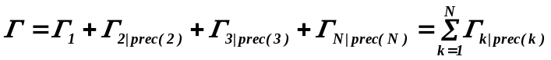
where, k-th task operates in the null space of all higher priority tasks and
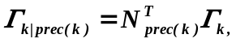
and 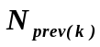is the null space of all higher priority tasks to the k^{th} task.
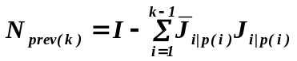
Based on the torque structure formula above, we can derive a general operational space equation for the torques:
where, the prioritized Jacobian related to the k^{th} task is :
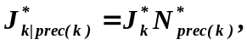
and 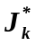is the constrained Jacobian and 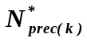is the prioritized bull space of all tasks preceding the k^{th} one.
To solve for muscle forces, we used static optimization to minimize muscle activations squared, that satisfy the inequality condition of .
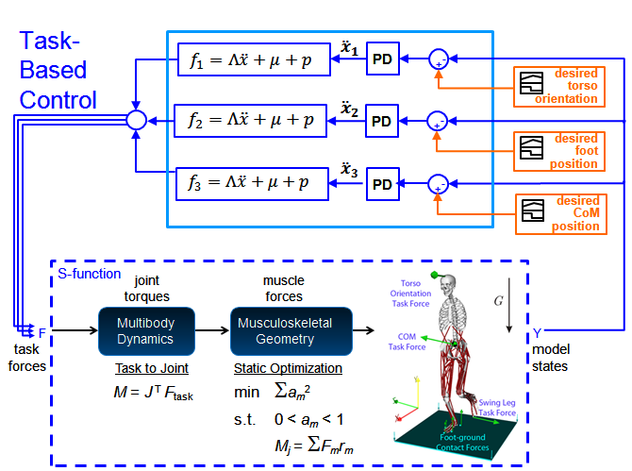
Figure 6. 5: Schematic of the task-based neuromuscular controller implemented through OpenSim/MATLAB interface in Simulink environment. The interface (dotted lines in a) calls the OpenSim 2392 gait model, initial controls and initial states files and perform a forward dynamics simulation with a closed-loop task-based feedback control in operational space using the defined task forces required for performing a sequence of tasks. The task force is used to calculate the actuation force (joint torques) through multi-body system Jacobian transpose. Muscle excitations are calculated using the static optimization. All these steps are implemented inside the interface by calling OpenSim libraries.

Task-Based Control of Full Body Example

We implemented the prioritized multi-tasks controller using the described musculoskeletal model with 23 DOF and 92 muscle-actuators in OpenSim and MATLAB interface (Figure 6.5, 6.6). We defined 3 different tasks for this specific example. The task’s order is shown in the following table.

Task Primitive | Priority Level
CoG Balance | 1
Swing Leg | 2
Torso Orientation | 3

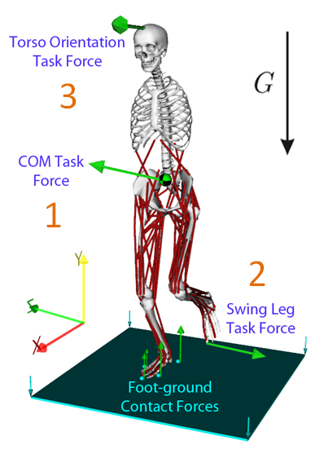
Figure 6. 6: shows different tasks defined for the one leg balance example. All these tasks defined within the supporting contact constraint. Three task force vectors were defined. The first task was exerted on the whole body center of mass. The second task force was exerted on the swing leg foot and the third task force was exerted to our model head. The arrows on the foot-ground contacts are not the task forces. They show the foot-ground contact forces due to gravitational forces. The resultant ground reaction forces are summation of all those five contact forces and applied on the center of pressure of the model.
The primary task was to keep the model balance on one foot while moving from point 1 to point 4 in numeric order (Figure 6.7a, pink spheres and Figure 6.8). The CoG control task was defined within the supporting contact constraint. This means the supporting leg’s foot-ground contact was enforced during these tasks. However, the individual contact points can still leave the ground depending on the defined task. The highest priority task CoG is then defined as keeping the whole body CoG projection over the base of support or more specifically over the mid-foot (middle point between heel and toes) as equilibrium and a reference balance point. The task force $F_{cog}$ (derived priviously) was exerted on the CoG of our model and was tuned based the acceleration error between the desired CoG and the actual simulated CoG ($a^{ref}= \ddot{x}$). The second task was defined on the swing leg (left leg) to keep the foot in a fixed position in space while keeping the model from falling and performing the main task. Second task will be implemented in the null space of the tasks prior to this task as following equation:
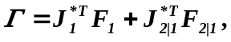
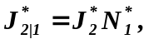
where subscript (1) shows the first task (CoG) and subscript (2) is the second task (swing leg).
We defined the third task as upper body (torso) orientations in ground reference frame. We defined the desired torso orientation with zero rotations in x, y, and z coordinates to keep the torso upright. The compound torque then can be written as:
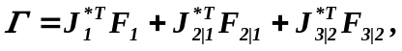
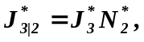
where subscript (1) shows the first task (CoG) and subscript (2) is the second task (swing leg) and the subscript (3) is the third task (torso orientation). The individual right leg (stance leg) torques (N.m) during an 8-second simulation required for performing the mentioned tasks in this example is shown in Figure 6.7b.

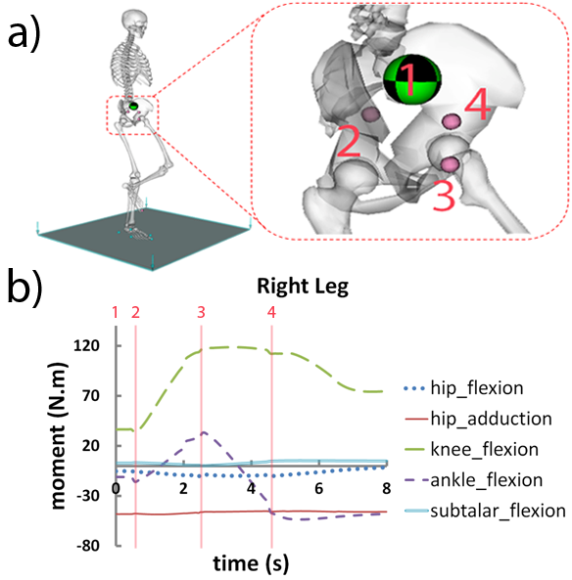
Figure 6. 7: a) The desired whole-body CoM trajectory defined for the musculoskeletal system through the points (1-4). The model is suppose to go through these point while maintain balance on one foot. b) Right leg (stance leg) joint torques required to perform the assigned task.

The static optimization was implemented inside the S-function interface using the IPOPT optimizer to minimize the muscle activations squared, $\min{\sum{{a_{m}}^{2}}}$ and solve for muscle controls that satisfy the inequality condition of$0≤a_{m}≤1$.

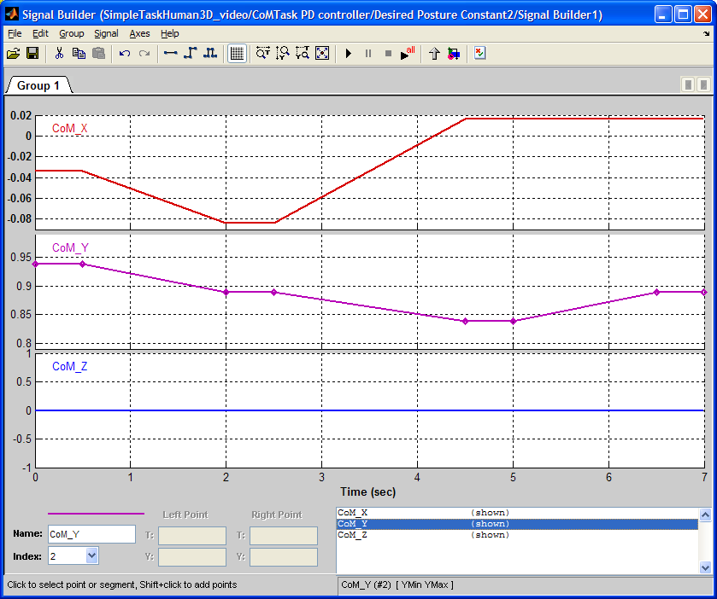
Figure 6. 8: Shows the reference whole-body CoM path (x, y and z) defined in our balance control example inside Simulink.

Chapter 7

Validation of Synthesized Motion using Experimental Balance Recovery Data

A scientific framework developed in previous chapters is needed in combination with experimental data to validate the simulation results and synthesize balance recovery data and predict functional outcome. Experimental balance recovery data of normal healthy adults will be used to investigate underlying neural strategies for balance control. Higher-level task based controller will be implemented to track the experimental balance recovery kinematics and synthesize new motions. Kinematics and muscle activation patterns will be compared to the experimental balance recovery data. Further analyses will be performed to examine how biomechanical factors such as muscle weakness may affect postural response. These simulations enable a more rational basis to be developed for deciding treatment planning and balance recovery in patients with neurological disorders. To achieve this aim, we will:
- Utilize the experimental balance recovery data of healthy adults (This data will be provided by the collaborators)
- Utilize a high-level controller to estimate muscle excitations to synthesize experimental balance recovery data using forward dynamics simulations.
  - Define an initial task force to keep the extrapolated CoM under the base of support and maintain balance.
  - Define secondary tasks to move the feet and take step accordingly to avoid falling in cases when extrapolated CoM is outside the base of support.
- Change model parameters to examine how biomechanical factors such as muscle weakness may affect postural responses.

Experimental balance recovery experiment setup

We collected experimental balance recovery data through our collaborators at University of Western Australia and Liverpool John Moores that served as the basis for validation of our task-based control simulation data of balance recovery. The advantage of this collaboration is access to state of the art CAREN (Computer Assisted Rehabilitation Environment) system (MotekMedical, Amsterdam, The Netherlands). CAREN [146] provides software driven six degrees of freedom movable platform together with complete motion analysis system including a Vicon Nexus system with sixteen infrared cameras, force platform and electromyography (Figure 7.1). Two young healthy adults (one male and one female) will be recruited for the balance experiment. 3D marker trajectories, ground reaction forces (GRF) (Kinematic sample rate, 250 Hz, GRF 2,000 Hz) and surface electromyography (EMG 2,000 Hz) of 8 muscles will be collected for each subject (gluteus maximus, rectus femoris, vastus lateralis, vastus medialis, bicep Femoris, semitendinosus, medial gastrocnemius, tibialis anterior).
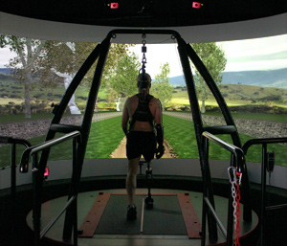

Figure 7. 1: CAREN System. (MotekMedical)

The platform under the feet of the subjects will be translated in anterior-posterior directions for 6cm and 12cm with maximum viable working speed. The subjects will stand on the platform with both double leg and single to induce stepping during the experiment. During double leg support, feet will be positioned shoulder width apart. During single leg-support, the contra-lateral leg will be lifted a minimum of 10 cm from the floor. Timing of perturbations for all trials will be the same. Perturbation will be triggered randomly between 1 and 3 seconds after the trial has been initiated. Instruction to participants for all trials will be the same. Participants will not be given a familiarization session. Participants are not allowed to use their hands for balance.

Utilize a high-level controller to estimate muscle excitations to synthesize experimental balance recovery data using forward dynamics simulations

Motivated from the robotics community, synthesizing human motion control using high-level control commands can be addressed by merging approaches from the biomechanics and robotics. Task-based controller using operational space approach is investigated in robotics field for many years [62, 107, 108]. Although robotics community researched task-level controller using computational musculoskeletal models [63, 109], integration of these methodologies with more complex musculoskeletal models to achieve human-like movement is very promising in the biomechanics and rehabilitation fields. This work also utilizes the operational space methodologies in muscle-driven simulations. In addition, the OpenSim/MATLAB interface provides the ability of interacting complex musculoskeletal models with novel control systems via a feedback control algorithms which otherwise was not available.
Synthesizing the motion based on experimental data is a multi-step process. The experimental data first need to be converted and imported into the OpenSim software. After this step is done, we need a model to load the data. We start with OpenSim generic musculoskeletal full body model with 23 DOF and 92 muscle actuators. Models will be scaled based on the experimental maker data using OpenSim scaling toolbox explained in previous chapters. The motion of the subjects then will be used as a reference for our controller design. One way to generate the muscle excitations that track a specific motion is using the computed muscle control to track every single joint and estimate muscle forces that produce that motion. This method however as mentioned before is very computationally expensive. It is also limited in cases when unexpected changes such as external perturbations are introduced into the simulation while there is no feedback data is available. Despite these limitations, CMC can be used as an alternative controller to estimate muscle excitations while EMG is not available for all muscles in our models. In addition, we showed that stretch-reflex controller was successful in rejecting the disturbances and balance in our models of children with cerebral palsy. However, the exact experimental trajectory was not reproduced using this controller and there is a need for a high-level controller to complement this signals.
To overcome these limitations and improve the controller we utilized the task-based controller. Task-based controller is a model-based controller which utilizes the information of the musculoskeletal system. By choosing a physiological task this controller models certain aspects of central nervous system (CNS) behavior. Using the feedback in physics-based simulations provides a robust, real-time interaction that is missing in other approaches such as feed-forward optimization approaches.
Different task forces will be introduced to different bodies of the model based on the control problem. For the balance case if both feet stays in grounds, then the only task needed to be accomplish is keeping the whole extrapolated body center of mass (XCoM), explained in the previous chapter, under the base of support (BoS). The task force will be exerted to the torso body in this case. The task force then will be used to calculate the actuation force (joint torques) using the multibody dynamics and later the muscle excitations using the static optimization (Figure 5.2). All these steps are implemented inside the interface by calling OpenSim libraries. In case of platform perturbation these tasks can still exerted on the same body but trying to track the experimental CoM trajectories. In case of one foot off the ground, second task may be needed to track the desired foot trajectory, while the other task is to keep the XCoM under the BoS (Figure 5.3).

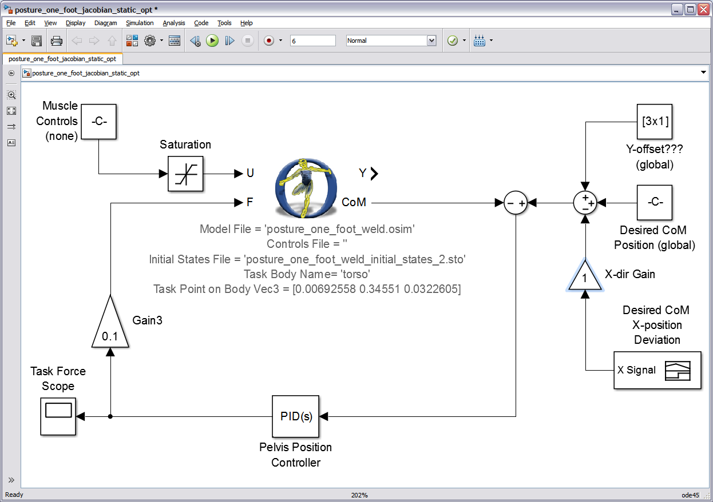

Figure 7. 2: Simulink Platform showing simulation of the task-based neuromuscular balance controller implemented through OpenSim/MATLAB interface. The interface (dotted lines in a) calls the OpenSim neuromuscular full-body model and closed-loop task force exerted on torso body is calculated as an input to the interface to track the model CoM. The task force then will be used to calculate the actuation force (joint torques) using the multibody dynamics and later the muscle excitations using the static optimization. All these steps are implemented inside the interface by calling OpenSim libraries.

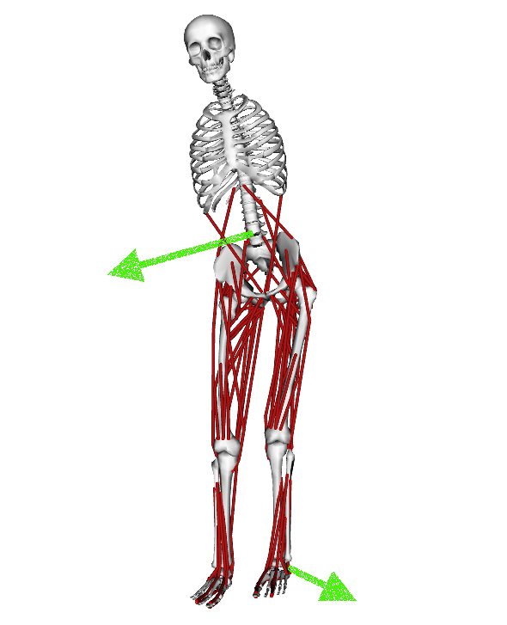

Figure 7. 3: An example OpenSim musculoskeletal full body model. The task forces (green arrows) will be introduced to different bodies of the model based on tracking goals.

The last step in designing in our controller design is to validate the how well the simulated muscle activation can match the experimental EMG data for the recorded muscles. In order to this, we will compare the peak and trend of simulated muscle activation with the filtered EMG data and will report the results. Other analyses such as metabolic energy and effort calculations can be also performed on the both experimental and simulated data to quantify differences.

Change model parameters to examine how biomechanical factors such as muscle weakness may affect postural responses.
After creating the musculoskeletal model with a controller that synthesize the experimental motions, and validating the simulations, predictive simulation can be tested on the models to predict outcome of a biomechanical factor such as weakness or spasticity of the muscles. These results can test the utility of simulation-based medicine to identify new treatments and rehabilitation strategies in different individuals. This study provides a foundation for the identification of other biomechanical factors contributing to movement abnormalities and potentially improve surgical and rehabilitation treatments.

Chapter 8

Concluding Remarks

8.1. Research Innovation

This research is innovative in many different ways. The interface combines the numerical simulation and human movement dynamics strengths of OpenSim with the robust design, powerful math, and control system strengths of MATLAB. This integrated platform has promise for better understanding movement control and the potential to improve treatment planning. This also enables us to add closed-loop forward dynamics simulation which was not previously available through OpenSim software. The open-loop model is limited to using predefined input controls that cannot be changed; however, many human movement applications require closed-loop control systems that update input controls to generate a desired output.
In addition, complex patient-specific musculoskeletal model with 23 degrees of freedom 92 muscle actuators was used for our musculoskeletal modeling. This provides a more realistic modeling and simulation tool to analyze human movement. Elastic foundation was used for modeling foot-ground contact and generating ground reaction forces. This allows us to predict forces and motion in applications where using traditional motion capture systems are not feasible.
The biologically-inspired controller acts similar to central nervous system (CNS) in controlling human balance. The controller uses combination of high-level supraspinal signals and low-level spinal signals to examine the hypotheses regarding human movement.
Treatment recommendations and rehabilitation techniques for many biomechanical conditions are generally based on qualitative observations of the patient’s gait, experimental gait analyses, clinical examinations and intuition of the clinical team. Even though, experimental approaches have advanced our understanding of biomechanics, they are limited in predicting functional outcome and identifying cause-affect relationships (i.e. muscle contributions to movement) between muscle forces and joint biomechanics. Muscle-actuated simulations and biologically-inspired controller design gives insight into the complex interaction between muscle excitations, musculoskeletal geometry and observed multi-joint movements.
This research will create an environment for modeling and analyzing important biomechanical conditions such as balance and control in human with neuromuscular control deficits by merging the experimental capabilities of physicians, physical therapist and kinesiologists with the computer simulation capabilities and control system designs of engineers. In addition, we can develop subject-specific models from freely available open -source software. Thus implying that the discoveries can be readily shared, investigated and discussed with other researchers to promote dialogue amongst researchers in both clinical and computational disciplines and help advance the field toward the end goal of understanding the underlying mechanisms behind balance and movement disorders.

8.2. Significance
Neurological disorders are the leading cause of long-term disability in the US and patients are commonly left with sensorimotor deficits and reduced mobility, with fewer than half of surviving patients achieving community-based walking for everyday activities [65]. Outcome of traditional rehabilitation methods and surgical procedures have been variable [66, 67].
Balance control is among the most challenging movement disorder in patients with neurological disorders such as cerebral palsy. Stiff-knee gait is the most prevalent and troublesome movement abnormality among children with cerebral palsy. Patients experiencing stiff-knee gait typically adopt energy-inefficient movements due to spasticity and over-activity of lower extremity muscles to compensate for reduced toe-clearance to avoid tripping or falling [67, 68]. There are approximately 573,000 children and adults affected by spastic cerebral palsy in the United States. Stiff-knee gait is often accompanied by an excessive knee flexion during stance (crouch) [69], which can also play a role on their balance control [70]. Various surgical procedures can treat cerebral palsy symptoms by altering the function of problematic muscles. Unfortunately, successful outcomes in correcting knee flexion following this procedure are variable [41, 71, 72]. Moreover, currently, treatment plans and surgeries are solely based on qualitative observations of the patient’s gait, gait analysis, and the intuition and experience of the clinical team. The treatment planning can be improved with development of quantitative simulation to examine biomechanical cause-affect and functional consequences of commonly-used interventions on patients balance control.
We developed new tools which utilize dynamic simulations, control system design and optimization techniques to identify role of biomechanical factors (e.g. musculoskeletal geometry, individual muscle function, muscle moment arms, ground reaction force, and control system ...) in solving complex biological systems. We anticipate that the insights gained from this work will provide new guidelines for simulation and control of movement in the field of biomechnaics.
The objective of this work is to investigate how patient-specific modeling and simulations, optimization techniques and control system design can benefit outcome of a clinical procedure. Patients' treatment outcomes are more likely to be favorable when interventions are performed that address the underlying biomechanical sources as identified from the proposed simulations; outcomes are likely to be poor when interventions do not address the primary sources of the patients' movement disorders.

8.3. Source Code
Our interface will be implemented in freely available musculoskeletal modeling and simulation software (OpenSim), which enables these results to be shared with other research groups. Over the past four years, there have been over 63,000 unique downloads of models, simulations, and software from the project’s website (see simtk.org/home/opensim) with over 15,000 unique users of these freely available biomechanics tools. This project will continue this development and the source code and executables of this project will be available for download for researchers. Thus, the work proposed here will have broad impact for basic studies of neuromuscular biomechanics and control.

8.4. Summary

References

[1] Thelen DG, Anderson FC, Delp SL. Generating dynamic simulations of movement using computed muscle control. J Biomech. 2003;36:321-8.
[2] Komistek RD, Dennis DA, Mahfouz M. In vivo fluoroscopic analysis of the normal human knee. Clin Orthop Relat R. 2003:69-81.
[3] Wu JJ. Clinical-Application of Vicon System to Evaluate the Gait Pattern after Toe-to-Thumb Reconstruction. J Biomech. 1987;20:910-.
[4] Schmid J, Sandholm A, Chung F, Thalmann D, Delingette H, Magnenat-Thalmann N. Musculoskeletal Simulation Model Generation from MRI Data Sets and Motion Capture Data. Recent Advances in the 3d Physiological Human. 2009:3-19.
[5] Gall J, Stoll C, de Aguiar E, Theobalt C, Rosenhahn B, Seidel HP. Motion Capture Using Joint Skeleton Tracking and Surface Estimation. Cvpr: 2009 Ieee Conference on Computer Vision and Pattern Recognition, Vols 1-4. 2009:1746-53.
[6] Kram R, Griffin TM, Donelan JM, Chang YH. Force treadmill for measuring vertical and horizontal ground reaction forces. Journal of applied physiology. 1998;85:764-9.
[7] Luo ZP, Berglund LJ, An KN. Validation of F-Scan pressure sensor system: A technical note. Journal of Rehabilitation Research and Development. 1998;35:186-91.
[8] De Luca CJ. The use of surface electromyography in biomechanics. Journal of Applied Biomechanics. 1997;13:135-63.
[9] Robertson G, Coldwell G, Hamill J, Kamen G, Whittlesey S. Research Methods in Biomechanics. Champaign: Human Kinetics; 2004.
[10] Murray WM, Delp SL, Buchanan TS. Variation of muscle moment arms with elbow and forearm position. J Biomech. 1995;28:513-25.
[11] Arnold AS, Salinas S, Asakawa DJ, Delp SL. Accuracy of muscle moment arms estimated from MRI-based musculoskeletal models of the lower extremity. Comput Aided Surg. 2000;5:108-19.
[12] Kuo AD. An Optimal-Control Model for Analyzing Human Postural Balance. Ieee T Bio-Med Eng. 1995;42:87-101.
[13] Mergner T, Maurer C, Peterka RJ. A multisensory posture control model of human upright stance. Neural Control of Space Coding and Action Production. 2003;142:189-99.
[14] Davy DT, Audu ML. A dynamic optimization technique for predicting muscle forces in the swing phase of gait. Journal of Biomechanics. 1987;20:187-201.
[15] Anderson FC, Pandy MG. Dynamic optimization of human walking. J Biomech Eng. 2001;123:381-90.
[16] Neptune RR, Zajac FE, Kautz SA. Muscle force redistributes segmental power for body progression during walking. Gait Posture. 2004;19:194-205.
[17] Jonkers I, Stewart C, Spaepen A. The complementary role of the plantarflexors, hamstrings and gluteus maximus in the control of stance limb stability during gait. Gait Posture. 2003;17:264-72.
[18] Cole GK, Nigg BM, vandenBogert AJ, Gerritsen KGM. Lower extremity joint loading during impact in running. Clin Biomech. 1996;11:181-93.
[19] Gerritsen KG, van den Bogert AJ, Nigg BM. Direct dynamics simulation of the impact phase in heel-toe running. J Biomech. 1995;28:661-8.
[20] Hamner SR, Seth A, Delp SL. Muscle contributions to propulsion and support during running. J Biomech. 2010;43:2709-16.
[21] Neptune RR, Hull ML. Evaluation of performance criteria for simulation of submaximal steady-state cycling using a forward dynamic model. J Biomech Eng. 1998;120:334-41.
[22] van Soest AJK, Casius LJR. Which factors determine the optimal pedaling rate in sprint cycling? Medicine and Science in Sports and Exercise. 2000;32:1927-34.
[23] Redfield R, Hull ML. Prediction of Pedal Forces in Bicycling Using Optimization Methods. Journal of Biomechanics. 1986;19:523-40.
[24] Pandy MG, Zajac FE. Optimal muscular coordination strategies for jumping. J Biomech. 1991;24:1-10.
[25] Anderson FC, Pandy MG. A Dynamic Optimization Solution for Vertical Jumping in Three Dimensions. Comput Methods Biomech Biomed Engin. 1999;2:201-31.
[26] Bobbert MF, van Soest AJ. Why do people jump the way they do? Exerc Sport Sci Rev. 2001;29:95-102.
[27] Hatze H. The inverse dynamics problem of neuromuscular control. Biological Cybernetics. 2000;82:133-41.
[28] Gerritsen KGM, Nachbauer W, vandenBogert AJ. Computer simulation of landing movement in downhill skiing: Anterior cruciate ligament injuries. J Biomech. 1996;29:845-54.
[29] Kaufman KR, An KN, Litchy WJ, Chao EY. Physiological prediction of muscle forces--II. Application to isokinetic exercise. Neuroscience. 1991;40:793-804.
[30] Li G, Kaufman KR, Chao EYS, Rubash HE. Prediction of antagonistic muscle forces using inverse dynamic optimization during flexion extension of the knee. J Biomech Eng-T Asme. 1999;121:316-22.
[31] Shelburne KB, Pandy MG. A dynamic model of the knee and lower limb for simulating rising movements. Comput Methods Biomech Biomed Engin. 2002;5:149-59.
[32] Neptune RR, Wright IC, Van den Bogert AJ. Muscle coordination and function during cutting movements. Med Sci Sport Exer. 1999;31:294-302.
[33] Yamaguchi GT, Zajac FE. Restoring unassisted natural gait to paraplegics via functional neuromuscular stimulation: a computer simulation study. IEEE Trans Biomed Eng. 1990;37:886-902.
[34] Schutte LM, Rodgers MM, Zajac FE. Improving the efficacy of electrical stimulation-induced leg cycle ergometry: an analysis based on a dynamic musculoskeletal model. IEEE Transactions on Rehabilitation Engineering. 1993;1:17.
[35] Kirsch RF, Acosta AM, van der Helm FCT, Rotteveel RJJ, Cash LA. Model-based development of neuroprostheses for restoring proximal arm function. J Rehabil Res Dev. 2001;38:619-26.
[36] Neptune RR, Kautz SA. Knee joint loading in forward versus backward pedaling: implications for rehabilitation strategies. Clin Biomech. 2000;15:528-35.
[37] Wright IC, Neptune RR, van den Bogert AJ, Nigg BM. The influence of foot positioning on ankle sprains. J Biomech. 2000;33:513-9.
[38] Wright IC, Neptune RR, van den Bogert AJ, Nigg BM. The effects of ankle compliance and flexibility on ankle sprains. Med Sci Sport Exer. 2000;32:260-5.
[39] Piazza SJ, Delp SL. The influence of muscles on knee flexion during the swing phase of gait. J Biomech. 1996;29:723-33.
[40] Riley PG. Medicine as a moral art: the Hippocratic philosophy of Herbert Ratner, M.D. Linacre Q. 1998;65:5-38.
[41] Goldberg SR, Anderson FC, Pandy MG, Delp SL. Muscles that influence knee flexion velocity in double support: implications for stiff-knee gait. J Biomech. 2004;37:1189-96.
[42] Reinbolt JA, Haftka RT, Chmielewski TL, Fregly BJ. A computational framework to predict post-treatment outcome for gait-related disorders. Med Eng Phys. 2008;30:434-43.
[43] Reinbolt JA, Schutte JF, Fregly BJ, Koh B, Haftka RT, George AD, et al. Determination of patient-specific multi-joint kinematic models through two-level optimization. J Biomech. 2005;38:621-6.
[44] Koh BI, Reinbolt JA, Fregly BJ, George AD. Evaluation of parallel decomposition methods for biomechanical optimizations. Comput Methods Biomech Biomed Engin. 2004;7:215-25.
[45] Schutte JF, Koh BI, Reinbolt JA, Haftka RT, George AD, Fregly BJ. Evaluation of a particle swarm algorithm for biomechanical optimization. J Biomech Eng-T Asme. 2005;127:465-74.
[46] Schutte JF, Reinbolt JA, Fregly BJ, Haftka RT, George AD. Parallel global optimization with the particle swarm algorithm. Int J Numer Meth Eng. 2004;61:2296-315.
[47] Fregly BJ, Reinbolt JA, Rooney KL, Mitchell KH, Chmielewski TL. Design of patient-specific gait modifications for knee osteoarthritis rehabilitation. Ieee T Bio-Med Eng. 2007;54:1687-95.
[48] Fregly BJ, Reinbolt JA, Chmielewski TL. Evaluation of a patient-specific cost function to predict the influence of foot path on the knee adduction torque during gait. Comput Method Biomec. 2008;11:63-71.
[49] Koh BI, Reinbolt JA, George AD, Haftka RT, Fregly BJ. Limitations of parallel global optimization for large-scale human movement problems. Med Eng Phys. 2009;31:515-21.
[50] Reinbolt JA, Haftka RT, Chmielewski TL, Fregly BJ. Are patient-specific joint and inertial parameters necessary for accurate inverse dynamics analyses of gait? Ieee T Bio-Med Eng. 2007;54:782-93.
[51] Oden JT, Belytschko T, Fish J, Hughes TJR, Johnson C, Keyes D, et al. Report of the National Science Foundation Blue Ribbon Panel on Simulation-Based Engineering Science. 2006.
[52] Hirai K, Hirose M, Haikawa Y, Takenaka T. The development of Honda humanoid robot. 1998 Ieee International Conference on Robotics and Automation, Vols 1-4. 1998:1321-6.
[53] Darema F. Engineering/scientific and commercial applicaitons: differences, similarities, and future evolution. Second Hellenic European Conference on Mathematics and Informations1994. p. 367-74.
[54] Douglas C, Deshmukh A. Dynamic Data Driven Application Systems. NSF Workshop Report. 2000.
[55] Yamaguchi J, Soga E, Inoue S, Takanishi A. Development of a bipedal humanoid robot - Control method of whole body cooperative dynamic biped walking. Icra '99: Ieee International Conference on Robotics and Automation, Vols 1-4, Proceedings. 1999:368-74.
[56] Pollard NS, Hodgins JK, Riley MJ, Atkeson CG. Adapting human motion for the control of a humanoid robot. 2002 Ieee International Conference on Robotics and Automation, Vols I-Iv, Proceedings. 2002:1390-7.
[57] Nakamura Y, Yamane K, Fujita Y, Suzuki I. Somatosensory computation for man-machine interface LE from motion-capture data and musculoskeletal human model. Ieee T Robot. 2005;21:58-66.
[58] Safonova A, Hodgins JK, Pollard NS. Synthesizing physically realistic human motion in low-dimensional, behavior-specific spaces. Acm T Graphic. 2004;23:514-21.
[59] Ko H, Badler NI. Animating human locomotion with inverse dynamics. Ieee Comput Graph. 1996;16:50-9.
[60] Khatib O. A Unified Approach for Motion and Force Control of Robot Manipulators - the Operational Space Formulation. Ieee T Robotic Autom. 1987;3:43-53.
[61] Dariush B, Gienger M, Jian B, Goerick C, Fujimura K. Whole body humanoid control from human motion descriptors. 2008 Ieee International Conference on Robotics and Automation, Vols 1-9. 2008:2677-84.
[62] Khatib O, Demircan E, De Sapio V, Sentis L, Besier T, Delp S. Robotics-based synthesis of human motion. J Physiology-Paris. 2009;103:211-9.
[63] De Sapio V, Warren J, Khatib O, Delp S. Simulating the task-level control of human motion: a methodology and framework for implementation. Visual Comput. 2005;21:289-302.
[64] Khatib O, Demircan E, De Sapio V, Sentis L, Besier T, Delp S. Robotics-based synthesis of human motion. J Physiol Paris. 2009;103:211-9.
[65] Perry J, Garrett M, Gronley JK, Mulroy SJ. Classification of walking handicap in the stroke population. Stroke. 1995;26:982-9.
[66] Reinbolt JA, Fox MD, Schwartz MH, Delp SL. Predicting outcomes of rectus femoris transfer surgery. Gait Posture. 2009;30:100-5.
[67] Fox MD, Reinbolt JA, Ounpuu S, Delp SL. Mechanisms of improved knee flexion after rectus femoris transfer surgery. J Biomech. 2009;42:614-9.
[68] Gage JR, Perry J, Hicks RR, Koop S, Werntz JR. Rectus femoris transfer to improve knee function of children with cerebral palsy. Dev Med Child Neurol. 1987;29:159-66.
[69] van der Krogt MM, Bregman DJJ, Wisse M, Doorenbosch CAM, Harlaar J, Collins SH. How Crouch Gait Can Dynamically Induce Stiff-Knee Gait. Annals of Biomedical Engineering. 2010;38:1593-606.
[70] Hoang HX, Reinbolt JA. Crouched posture maximizes ground reaction forces generated by muscles. Gait Posture. 2012.
[71] Reinbolt JA, Fox MD, Schwartz MH, Delp SL. Predicting outcomes of rectus femoris transfer surgery. Gait Posture. 2009;30:100-5.
[72] Riewald SA, Delp SL. The action of the rectus femoris muscle following distal tendon transfer: does it generate knee flexion moment? Dev Med Child Neurol. 1997;39:99-105.
[73] Jacobs JJ, Andersson GBJ, Bell JE, Weinstein SL, Dormans JP, Gnatz SM, et al. The Burden of Musculoskeletal Diseases. Bone and Joint Decade. 2008.
[74] Otoole RV, Jaramaz B, Digioia AM, Visnic CD, Reid RH. Biomechanics for Preoperative Planning and Surgical Simulations in Orthopedics. Computers in Biology and Medicine. 1995;25:183-91.
[75] Kayis B, Iskander PA. A three-dimensional human model for the IBM/CATIA system. Appl Ergon. 1994;25:395-7.
[76] Adamczyk MM, Crago PE. Simulated feedforward neural network coordination of hand grasp and wrist angle in a neuroprosthesis. IEEE Trans Rehabil Eng. 2000;8:297-304.
[77] Lemay MA, Crago PE. A dynamic model for simulating movements of the elbow, forearm, an wrist. J Biomech. 1996;29:1319-30.
[78] Andrews BJ, Davoodi R, Kamnik R, Bajd T. Control of FES in paraplegia: modeling voluntary arm forces. Biomed Mater Eng. 1998;8:241-51.
[79] Loeb GE, Brown IE, Cheng EJ. A hierarchical foundation for models of sensorimotor control. Exp Brain Res. 1999;126:1-18.
[80] Barker TM, Kirtley C, Ratanapinunchai J. Calculation of multi-segment rigid body joint dynamics using MATLAB. P I Mech Eng H. 1997;211:483-7.
[81] Delp SL, Loan JP, Hoy MG, Zajac FE, Topp EL, Rosen JM. An interactive graphics-based model of the lower extremity to study orthopaedic surgical procedures. IEEE Trans Biomed Eng. 1990;37:757-67.
[82] Kepple TM, Siegel KL, Stanhope SJ. Relative contributions of the lower extremity joint moments to forward progression and support during gait. Gait Posture. 1997;6:1-8.
[83] Holzbaur KR, Murray WM, Delp SL. A model of the upper extremity for simulating musculoskeletal surgery and analyzing neuromuscular control. Ann Biomed Eng. 2005;33:829-40.
[84] Damsgaard M, Rasmussen J, Christensen ST, Surma E, de Zee M. Analysis of musculoskeletal systems in the AnyBody Modeling System. Simulation Modelling Practice and Theory. 2006;14:1100-11.
[85] Vasavada AN, Li S, Delp SL. Influence of muscle morphometry and moment arms on the moment-generating capacity of human neck muscles. Spine (Phila Pa 1976). 1998;23:412-22.
[86] de Zee M, Hansen L, Wong C, Rasmussen J, Simonsen EB. A generic detailed rigid-body lumbar spine model. J Biomech. 2007;40:1219-27.
[87] Delp SL, Anderson FC, Arnold AS, Loan P, Habib A, John CT, et al. OpenSim: open-source software to create and analyze dynamic simulations of movement. IEEE Trans Biomed Eng. 2007;54:1940-50.
[88] Delp SL, Loan JP. A graphics-based software system to develop and analyze models of musculoskeletal structures. Comput Biol Med. 1995;25:21-34.
[89] Delp SL, Loan JP. A computational framework for simulating and analyzing human and animal movement. Computing in Science & Engineering. 2000;2:46-55.
[90] Fox MD, Delp SL. Contributions of muscles and passive dynamics to swing initiation over a range of walking speeds. J Biomech. 2010;43:1450-5.
[91] Neptune RR, Kautz SA, Zajac FE. Contributions of the individual ankle plantar flexors to support, forward progression and swing initiation during walking. J Biomech. 2001;34:1387-98.
[92] Thelen DG, Anderson FC. Using computed muscle control to generate forward dynamic simulations of human walking from experimental data. J Biomech. 2006;39:1107-15.
[93] Sasaki K, Neptune RR. Muscle mechanical work and elastic energy utilization during walking and running near the preferred gait transition speed. Gait Posture. 2006;23:383-90.
[94] Davoodi R, Loeb GE. A software tool for faster development of complex models of musculoskeletal systems and sensorimotor controllers in Simulink (TM). Journal of Applied Biomechanics. 2002;18:357-65.
[95] Rasmussen J, Ozen M. AnyBody–ANSYS Interface: CAE Technology for the Human Body.”. CADFEM Medical. 2007.
[96] Hauschild M, Davoodi R, Loeb GE. A virtual reality environment for designing and fitting neural prosthetic limbs. Ieee T Neur Sys Reh. 2007;15:9-15.
[97] ZIEGLER JG, NICHOLS NB. Optimum Settings for Automatic Controllers. Trans ASME. 1942;64:759–68.
[98] Sherman MA, Seth, A., Delp, S. L. . Simbody: multibody dynamics for biomedical research. Procedia IUTAM, International Union of Theoretical and Applied Mechanics, Elsevier Science. 2011.
[99] Seth A, Sherman M, Reinbolt J, Delp S. OpenSim: a musculoskeletal modeling and simulation
framework for in silico investigations and exchange. procedia IUTAM, International Union of Theoretical and Applied Mechanics, Elsevier Science. 2011;2:212-32.
[100] Rybak IA, Stecina K, Shevtsova NA, McCrea DA. Modelling spinal circuitry involved in locomotor pattern generation: insights from the effects of afferent stimulation. J Physiol. 2006;577:641-58.
[101] Verdaasdonk BW, Koopman HF, Van der Helm FC. Resonance tuning in a neuro-musculo-skeletal model of the forearm. Biol Cybern. 2007;96:165-80.
[102] Prochazka A, Gillard D, Bennett DJ. Positive force feedback control of muscles. Journal of Neurophysiology. 1997;77:3226-36.
[103] Geyer H, Seyfarth A, Blickhan R. Positive force feedback in bouncing gaits? Proceedings Biological sciences / The Royal Society. 2003;270:2173-83.
[104] Geyer H, Herr H. A Muscle-Reflex Model That Encodes Principles of Legged Mechanics Produces Human Walking Dynamics and Muscle Activities. Ieee T Neur Sys Reh. 2010;18:263-73.
[105] Kistemaker DA, Van Soest AJK, Wong JD, Kurtzer I, Gribble PL. Control of position and movement is simplified by combined muscle spindle and Golgi tendon organ feedback. Journal of Neurophysiology. 2013;109:1126-39.
[106] Brodal P. The central nervous system : structure and function. New York: Oxford University Press; 1992.
[107] Khatib O. Inertial Properties in Robotic Manipulation - an Object-Level Framework. Int J Robot Res. 1995;14:19-36.
[108] Dariush B, Bin Hammam G, Orin D. Constrained Resolved Acceleration Control for Humanoids. Ieee Int C Int Robot. 2010.
[109] De Sapio V, Khatib O, Delp S. Task-level approaches for the control of constrained multibody systems. Multibody Syst Dyn. 2006;16:73-102.
[110] Thelen DG. Adjustment of muscle mechanics model parameters to simulate dynamic contractions in older adults. J Biomech Eng. 2003;125:70-7.
[111] Zajac FE. Muscle and tendon: properties, models, scaling, and application to biomechanics and motor control. Crit Rev Biomed Eng. 1989;17:359-411.
[112] Zajac FE. Muscle coordination of movement: a perspective. J Biomech. 1993;26 Suppl 1:109-24.
[113] Fox MD, Reinbolt JA, Ounpuu S, Delp SL. Mechanisms of improved knee flexion after rectus femoris transfer surgery. J Biomech. 2009;42:614-9.
[114] Muthusamy K, Seidl AJ, Friesen RM, Carollo JJ, Pan Z, Chang FM. Rectus femoris transfer in children with cerebral palsy: evaluation of transfer site and preoperative indicators. J Pediatr Orthop. 2008;28:674-8.
[115] Khouri N, Desailly E. Rectus femoris transfer in multilevel surgery: Technical details and gait outcome assessment in cerebral palsy patients. Orthop Traumatol-Sur. 2013;99:333-40.
[116] Rethlefsen SA, Kam G, Wren TA, Kay RM. Predictors of outcome of distal rectus femoris transfer surgery in ambulatory children with cerebral palsy. J Pediatr Orthop B. 2009;18:58-62.
[117] Sutherland DH, Santi M, Abel MF. Treatment of Stiff-Knee Gait in Cerebral-Palsy - a Comparison by Gait Analysis of Distal Rectus Femoris Transfer Versus Proximal Rectus Release. J Pediatr Orthoped. 1990;10:433-41.
[118] Prilutsky BI. Coordination of two- and one-joint muscles: Functional consequences and implications for motor control. Motor Control. 2000;4:1-44.
[119] Schenau GJV, Pratt CA, Macpherson JM. Differential Use and Control of Monoarticular and Biarticular Muscles. Hum Movement Sci. 1994;13:495-517.
[120] Metaxiotis D, Wolf S, Doederlein L. Conversion of biarticular to monoarticular muscles as a component of multilevel surgery in spastic diplegia. Journal of Bone and Joint Surgery-British Volume. 2004;86B:102-9.
[121] Gage JR, Deluca PA, Renshaw TS. Gait Analysis: Principles and Applications Emphasis on its use in Cerebral Palsy. The Journal of Bone and Joint Surgery. 1995;77-A:1607-23.
[122] Hof AL, Gazendam MGJ, Sinke WE. The condition for dynamic stability. J Biomech. 2005;38:1-8.
[123] Seth A, Sherman M, Reinbolt JA, Delp SL. OpenSim: a musculoskeletal modeling and simulation framework for in silico investigations and exchange. Proc Iutam. 2011;2:212-32.
[124] Erdemir A, Sirimamilla PA, Halloran JP, van den Bogert AJ. An Elaborate Data Set Characterizing the Mechanical Response of the Foot. J Biomech Eng-T Asme. 2009;131.
[125] Hicks JL, Schwartz MH, Arnold AS, Delp SL. Crouched postures reduce the capacity of muscles to extend the hip and knee during the single-limb stance phase of gait. J Biomech. 2008;41:960-7.
[126] Asakawa DS, Blemker SS, Rab GT, Bagley A, Delp SL. Three-dimensional muscle-tendon geometry after rectus femoris tendon transfer. J Bone Joint Surg Am. 2004;86-A:348-54.
[127] Brodal P. The central nervous system : structure and function. 4th ed. New York: Oxford University Press; 2010.
[128] Henry SM, Fung J, Horak FB. Control of stance during lateral and anterior/posterior surface translations. IEEE Trans Rehabil Eng. 1998;6:32-42.
[129] Jansen K, De Groote F, Aerts W, De Schutter J, Duysens J, Jonkers I. Altering length and velocity feedback during a neuro-musculoskeletal simulation of normal gait contributes to hemiparetic gait characteristics. J Neuroeng Rehabil. 2014;11:78.
[130] Mansouri M, Reinbolt JA. A platform for dynamic simulation and control of movement based on OpenSim and MATLAB. J Biomech. 2012;45:1517-21.
[131] Woollacott MH, Shumway-Cook A. Postural dysfunction during standing and walking in children with cerebral palsy: what are the underlying problems and what new therapies might improve balance? Neural Plast. 2005;12:211-9; discussion 63-72.
[132] Zajac FE, Gordon ME. Determining muscle's force and action in multi-articular movement. Exerc Sport Sci Rev. 1989;17:187-230.
[133] Clark A. Biarticular Muscles Influence Postural Responses: Tennessee; 2012.
[134] Ting LH. Dimensional reduction in sensorimotor systems: a framework for understanding muscle coordination of posture. Prog Brain Res. 2007;165:299-321.
[135] Feldesman MR. Femur/stature ratio and estimates of stature in children. Am J Phys Anthropol. 1992;87:447-59.
[136] Alonso AC, Luna NMS, Mochizuki L, Barbieri F, Santos S, Greve JMD. The influence of anthropometric factors on postural balance: the relationship between body composition and posturographic measurements in young adults. Clinics. 2012;67:1433-41.
[137] Sentis L, Khatib O. Control of free-floating humanoid robots through task prioritization. 2005 IEEE International Conference on Robotics and Automation (ICRA), Vols 1-4. 2005:1718-23.
[138] Hollerbach JM, Suh KC. Redundancy Resolution of Manipulators through Torque Optimization. Ieee T Robotic Autom. 1987;3:308-16.
[139] Maciejewski AA, Klein CA. Obstacle Avoidance for Kinematically Redundant Manipulators in Dynamically Varying Environments. Int J Robot Res. 1985;4:109-17.
[140] Nakamura Y, Hanafusa H, Yoshikawa T. Task-Priority Based Redundancy Control of Robot Manipulators. Int J Robot Res. 1987;6:3-15.
[141] Sentis L, Khatib O. Prioritized multi-objective dynamics and control of robots in human environments. Ieee-Ras Int C Human. 2004:764-80.
[142] Sentis L, Khatib O. A whole-body control framework for humanoids operating in human environments. Ieee Int Conf Robot. 2006:2641-8.
[143] Hunt KH, Crossley FRE. Coefficient of Restitution Interpreted as Damping in Vibroimpact. J Appl Mech-T Asme. 1975;42:440-5.
[144] Sentis L. Synthesis and Control of Whole-Body Behaviors in Humanoid Systems: Stanford University; 2007.
[145] Sadeghian H, Villani L, Keshmiri M, Siciliano B. Dynamic multi-priority control in redundant robotic systems. Robotica. 2013;31:1155-67.
[146] Lees A, Vanrenterghem J, Barton G, Lake M. Kinematic response characteristics of the CAREN moving platform system for use in posture and balance research. Med Eng Phys. 2007;29:629-35.

Vita

Misagh Mansouri was born in Esfahan, Iran, 1984. He graduated from Mobin High school, Tehran, Iran in 2002. He received his Bachelors of Science degree in Mechanical Engineering from Azad University, South Tehran Campus in 2006 and his Masters of Science degree in Mechatronics Engineering from Sharif University of Technology, Iran, in 2009. He then moved to United States in 2009, to pursue his PhD at University of Tennessee, Knoxville. He also received his second Masters of Science in Mechanical Engineering from University of Tennessee, Knoxville in 2014.

