A Study Comparing “Better Body Bags” Versus Standard White Body Bags to Estimate Relative Preservation of Human Genomic and Morphological Information

A Thesis Presented for the
Master of Arts
Degree
The University of Tennessee, Knoxville

Serena Thariath
December 2022
ACKNOWLEDGEMENTS
I would like to thank the International Committee of the Red Cross for the opportunity to work on this project and for providing funding and Better Body Bags (BBBs). Additionally, I would like to thank my advisor, Dr. Dawnie Steadman, for her steadfast guidance throughout this entire thesis. Thank you for entrusting this project to me and coaching me through how to be a proper scientist while maintaining care for those around me. I would also like to thank my committee members Dr. Giovanna Vidoli, Dr. Suni Edson, and Dr. Graciela Cabana for their guidance and patient feedback while I asked numerous questions. I could not have even begun to comprehend the DNA portion of this thesis without Dr. Cabana who gave up her weekends and evenings for the ever-fascinating event of watching me pipette for hours. I also cannot thank Dr. Edson enough for her work running the STR analysis in her laboratory in Dover, Delaware. I came to graduate school lacking confidence in my abilities as a scientist but having four strong women to serve as mentors throughout this process has left me feeling confident as I undertake the next stages of my career.
I also would like to thank the staff at the Forensic Anthropology Center, namely Mary, Stephanie, and Erin. Thank you, Mary, for answering the dozens of emails of questions I would send your way, and thank you Stephanie and Erin for your work both in the field with me and in the office as I struggled with Ibutton technology and photo work. I am also forever grateful for all my fellow graduate students, interns, and undergrads who picked up the physical parts of this project after I was unable to do so. Your kindness and hard work were invaluable to the completion of this project. A big thanks must also go to Dr. Xiaojuan Zhu who assisted me on the statistical analyses needed to make sense of the massive amount of data I had and Dr. Timothy P. McMahon, the Director of the DoD DNA Registry, who greenlit the STR analysis portion of this project.
A massive thank you must go to Bear Gibbs who was my research partner for the majority of the project and who somehow never complained about it. Thank you for your dedication to coming out every day and for chopping down vegetation in parts of lower ARF with me with just a hedge trimmer. This project would have been impossible without your help. I would also like to thank Sarah Hartman for her work on this project, not only as my research partner on the last trial but also as my dear friend and roommate without whom Tennessee would have been a very lonely place.
Finally, I would like to thank my friends and family. Thank you to Alex for your emotional support through the ups and downs of graduate school. I am inspired by your seemingly endless patience which I try, and fail, to replicate. I am also forever grateful to my brothers whose own ambitions inspire me every day and to my parents whose own hard work and sacrifice paved the way for me to succeed.

ABSTRACT
In disaster scenarios, identification of the dead usually is delayed until after help is given to the living. During delays in recovery and transport of deceased individuals, decomposition of soft tissues will occur at a fast rate if individuals are not refrigerated. The Better Body Bag, or BBB, was designed for the International Committee of the Red Cross (ICRC) with features such as a vacuum seal, reflective coating, and absorbent pad to help delay the onset of decomposition that could render someone unidentifiable. In this study, the BBB was tested to determine if the individuals placed within a BBB yielded a more complete Short Tandem Repeat (STR) profile and lower Total Body Score (TBS) score as compared to individuals within standard white body bags and individuals placed with no covering. Twenty-five donors total were placed at University of Tennessee’s Anthropology Research Facility (ARF) in experiments that tested the vacuum seal mechanism of the BBB or repeated opening and closure of the BBB. Each experiment lasted 21 days over the course of just over a year. The results of this study are statistically inconclusive as to if vacuum sealing assists in preservation of the individual, though they do indicate that the BBB is significantly better at preserving DNA than if an individual was left with no covering. Furthermore, a standard white body bag and a BBB are comparable for morphological preservation (TBS) among donors that were immediately placed into bags, though qualitatively, BBB donors appear to be visually in better condition on day 21 than standard white body bag donors if 48 hours has elapsed prior to placement in the bags. This study demonstrates that the BBBs are a viable alternative to standard white body bags in disaster scenarios if DNA analysis is expected to be the identification modality. In other cases, such as where antemortem dental or medical records exist, a standard white body bag may provide sufficient morphological preservation as compared to an uncovered individual during the time it takes for an identification to be made.
TABLE OF CONTENTS
Chapter 1 Introduction 1
Disaster Management 1
Research Questions 3
Objective 4
Chapter 2 BACKGROUND 6
Human Decomposition 6
Stage 1: Fresh 7
Stage 2: Early Decomposition 10
Stages 3-5: Advanced Decomposition, Skeletonization, and Degradation of Skeletal Material 12
Accelerators of Decomposition 13
Oxygen 13
Insects 13
Moisture 15
Temperature 15
TBS Scoring 16
DNA Degradation 21
Accelerators of DNA Degradation 25
DNA in Disaster Victim Identification 27
The Role of a Body Bag 29
The Potential Role of a BBB 30
Chapter 3 Materials and Methods 35
Donor Allocation 35
Experiments 38
DNA Data Collection 40
Metrics 43
Statistical Analysis 45
Chapter 4 Results 48
Reportable Loci 49
Statistical Analysis Between Conditions (BBB vs Standard White Body Bag vs Surface Control Placement) 49
TBS 49
Number of Reportable Loci 50
Relationship between TBS and Number of Reportable Loci by Condition 51
Temperature and Humidity 51
Placement Time (at 0 or 48 Hours) 56
Sampling Techniques 59
Brief Conclusions and Sample Size Issues 61
Chapter 5 Discussion 62
Effect of Condition 63
Visual Identification and Qualitative Analysis 64
Testing Experiment 1 64
Testing Experiment 2 66
Testing Experiment 3 68
Temperature and Humidity 71
Placement Time 74
Sample Location 74
Allelic Recovery, Mixture, and Overcounting 75
Chapter 6 Conclusions and Recommendations 76
Limitations of this Study 77
Recommended Features 78
Appendix 1.........................................................................................................................95
Experiment 1 Descriptions and TBS 96
Trial 1, Immediate Placement 96
Trial 2, Immediate Placement 97
Trial 3, Immediate Placement 99
Trial 4, Placement after 48 Hours in the field 101
Experiment 2 Descriptions and TBS 103
Trials 1 and 2, Immediate Placement 103
Trials 3 and 4, Placement after 48 Hours in the field 107
Experiment 3 Descriptions and TBS 109
Trial 1 and 2, Immediate Placement 109
Trial 1 and 2, Immediate Placement 109
Trial 3, Placement after 48 Hours in the field 111
RFU and Quantitation as it Relates to Reportable Loci 116
User-Experience 123
Conclusions from Experiment 1 123
Conclusions from Experiment 2 123
Conclusions from Experiment 3 123
Overall Trends Observed 124
Appendix A......................................................................................................................126
Vita.................................................................................................................................. 130

LIST OF TABLES
Table 3.1 Weights of Enrolled Donors 37
Table 3.2 Sampling Distribution by Experiment for BBB and Controls 39
Table 3.3 Type and Number of DNA Samples 41
Table 4.1 Estimated Marginal Means of TBS Scoring and Number of Loci Generated on Day 21 by Experiment 52
Table 4.2 Number of Reportable Loci by Sample Location and Donor Condition on Day 21 60
Table 6.1 TBS Scores for Experiment 1.1 98
Table 6.2 TBS Scores for Experiment 1.2 100
Table 6.3 TBS Scores for Experiment 1.3 102
Table 6.4 TBS Scores for Experiment 1.4 104
Table 6.5 TBS Scores for Experiment 2.1 and 2.2 106
Table 6.6 TBS Scores for Experiment 2.3 and 2.4 108
Table 6.7 TBS Scores for Experiment 3.1 and 3.2 112
Table 6.8 TBS Scores for Experiment 3.3 115

LIST OF FIGURES
Figure 2.1 Categories And Stages Of Decomposition For The Head And Neck (Megyesi et al. 2005) 17
Figure 2.2 Categories and Stages of Decomposition for the Torso (Megyesi et al. 2005) 18
Figure 2.3 Categories and Stages of Decomposition for the Limbs (Megyesi et al. 2005) 19
Figure 2.4 BBB prior to use. Observe the green valve pointed to by the red arrow. This is where the pump was attached to pump air out. The researchers are opening the seal. Observe the reflective coating here and how it reflects sunlight. 32
Figure 4.1 TBS Score by # of Reportable Loci by Condition 53
Figure 4.2 The Effect of Humidity on TBS Score by Condition 54
Figure 4.3 The Effect of Temperature on TBS Score by Condition 55
Figure 4.4 The Effect of Temperature on # of Loci Recovered by Condition 57
Figure 4.5 The Effect of Humidity on # of Loci Recovered by Condition 58
Figure 4.6 # of Loci and RFU Recovered by Condition 117
Figure 4.7 # of Loci Amplified and Quantitation by Condition 118
Figure 4.8 The Effect of Temperature on RFUs by Condition 119
Figure 4.9 The Effect of Temperature on Quantitation by Condition 120
Figure 4.10 The Effect of Humidity on RFUs by Condition 121
Figure 4.11 The Effect of Humidity on Quantitation by Condition 122
Figure 6.1 Photo of BBB with Ibutton Taped to Exterior 127
Figure 6.2 White Body Bag Before Ibutton was Taped to Exterior 127
Figure 6.3 Experiment 1.1: Blood Pressing on Seal of BBB (where red arrows point) 128
Figure 6.27 Punctured BBB with prints surrounding the hole 128
Figure 6.30 BBB Bloating 129

Introduction

Disaster Management
On January 12th, 2010, a 7.0 magnitude earthquake struck Haiti. It would eventually leave 316,000 people dead in its wake. The government of Haiti did not declare a state of emergency for six days (Hou, 2011). During those days, and for days afterwards, Damien Cave of The New York Times reported that government dump trucks, at least six a day, dropped off masses of unidentified human remains in front of morgues and then later in swamplands on the outskirts of Haiti’s capital, Port-au-Prince. There were no pictures taken of the victims and they would later be buried in mass graves, an egregious offense to Haitians who regard funeral rites as sacred (Cave, 2010). This disorganized disaster response was the result of infrastructure issues among many other inadequacies. Unfortunately, the response in Haiti was not unique; disorganized disaster responses plagued the identification efforts of hurricane Katrina and Rita in the United States in 2005, the 2004 tsunami in the Pacific, as well as countless other disaster responses.
Finding deceased individuals, placing them into body bags, and transporting them to where they can be stored and identified may be time consuming and result in decomposition. The morphological changes associated with decomposition of deceased individuals may preclude visual identifications, and the degrees of success of typical DNA identification techniques used in mass disasters also decreases with decomposition. Since delays are largely unavoidable, the development of an alternative body bag that could decrease decomposition changes may enhance the likelihood of identification. The International Committee of the Red Cross (ICRC), a global leader in humanitarian and disaster relief, has recognized the need for better postmortem storage aimed at reducing decomposition rates and has thus commissioned the production of the “Better
Body Bag,” or BBB, from the Social Solutions Research Association as a humanitarian aid.
The BBB differs from a standard white body bag in the following ways: it is larger, and contains the following features: a vacuum seal, reinforced handles, and pads made of super-absorbent cellulose (ICRC, 2019). Additionally, it is made of waterproof materials and has reflective foil on the surface, the composition of which is similar to an emergency space blanket designed to reduce the build-up of heat within the bag (https://blogs.icrc.org/inspired/2019/07/12/building-better-body-bag/, 2019). Conversely, a standard white body bag has 3 long black handles on either side, a zipper closure which runs along 3 sides of the bag, and a white coloration. It is made of low-density polyethylene and has sealed seams to minimize leakage during transport. It is of note that the terminology used here of “standard” white body bag refers to the types of bags the ICRC would usually use, as in ones that do not have the special characteristics of the BBB.
As part of a larger study that also examines morphological decomposition changes of the BBB, my thesis focused on DNA preservation of cadavers placed in the BBB compared to a standard white body bag, or to no body bag at all (surface deposition). By comparing Short Tandem Repeat (STR) profiles with morphological changes using Total Body Scoring (TBS) (Megyesi et al., 2005), I determined whether a more advanced TBS score, which means greater decomposition, correlates to an incomplete profile. STR analysis is the standard tool for identification of victims of mass disasters (Turingan, 2019). The rates of successful profiles (22 STR loci amplified) were then compared among individual donors in BBBs, standard white body bags, and no body bag. Furthermore, I determined if TBS/number of amplifiable loci can be correlated with the temperature and humidity peaks within the bags and compared to a surface control placement.

Research Questions
My research questions are posed to address the efficacy of the BBB features pertaining to morphological and DNA preservation.
- Is there is a significant difference between TBS scores or the number of amplifiable loci between a BBB donor, standard white body bag donor, and a control surface donor on day 21? For the DNA, does the sampling site chosen have a significant effect on the number of amplifiable loci present on day 21?
- If there are differences between BBB and the controls, does temperature or humidity influence the number of amplifiable loci or TBS scores between condition type?
- Does the time an individual is placed in the field (0 hours or 48 hours after surface placement) have a significant effect on the number of amplifiable loci or TBS scores between conditions? This simulates the delay seen between death and recovery in disaster scenarios.
To address these questions, I have developed three experiments, each with multiple trials, that examine whether the BBB can reduce morphological and genetic degradation compared to the controls with all of its components used, how the BBB functions if the oxygen is not removed, and the effects of periodic opening of the bags. In addition, some trials of each experiment include an additional variable whereby the donors were not placed into the body bag until after 48 hours of exposure.
My working hypothesis is that in all of these experimental conditions, the BBB will perform better than a standard white body bag or no body bag at all. This is because of the features the BBB possesses such as such as a vacuum seal to reduce oxygen exposure, absorbent pads, and a reflective coating to reduce temperature highs.
Research opinions were also explored as to the user experience of the design and the relative visual conditions of the faces of the individuals enrolled in the experiments. Should the BBB be deployed, it should be simple to use and result in visually better preservation of the individuals within. Thus, questions like the following were addressed: is the design intuitive? Does the BBB require multiple people to use? Is the design preferable to a standard white body bag to the users?
Furthermore, though visual identifications should not be the primary mode of identification, are the differences between BBB donors, standard white body bag donors, and control surface donors pronounced enough so that an observer can estimate what an individual may have looked like prior to decomposition?

Objective
This study will be used by the ICRC and the BBB designers to further refine the BBB for use in a humanitarian capacity to increase the number of positive identifications following a disaster. After disasters, the priority of care is reserved for the survivors, and it is often only later that identifications of the deceased and their burials can happen. During this period, a body will decompose, and if the deceased individual is not refrigerated or frozen, the rate of decomposition will proceed even more quickly. The BBB has been designed with the hope of decelerating the decomposition process better than a standard body bag, given that it becomes more and more difficult to make a positive identification as time passes. Quicker and more accurate identification serves the humanitarian purpose of providing information to the family and friends
of missing individuals.
The results from this study will ideally help future measures of prevention of decomposition for identification and storage of human remains. To date, there has been no other research regarding human decomposition in body bags; a study analyzing the possible differential decomposition of individuals within a BBB versus a standard white body bag versus no body bag could provide valuable insight to even those who do not have access to the ICRC’s resources. By examining temperature differences between conditions, how the vacuum seal affects preservation, and how repeated opening and closure of bags affects preservation as well, individuals without access to the BBB but with access to a standard body bag could implement certain measures (controlling for temperature, insect access, oxygen, etc.) that could slow decomposition even without a BBB.

BACKGROUND
The process of human decomposition is extremely varied. The progression of decomposition is dependent on variables like weather, coverings over the individual such as tarps or clothing, and insect/scavenger access among many other variables. Due to this variability, coherent description of decomposition can thus be a difficult task. However, efforts have been made to separate the decomposition process into stages first by Galloway et al. (1989) and then Megyesi et al., (2005). Additionally, the process of decomposition not only results in morphological changes, it also can result in damaged and degraded DNA (Holmes, 2018). Such breakdown becomes problematic as it can be more difficult to form a complete profile from degraded DNA. Though these issues exist, STR analysis is the ‘gold-standard’ for human identification as STRs are hypervariable, thus affording a high level of discrimination between individuals (Hares, 2015). The following subsections will cover the broad stages of human decomposition, the mechanism by which DNA undergoes degradation, and the usefulness of STR profiling as a tool in human identification.

Human Decomposition
The aim of the BBB is to mitigate the effects of human decomposition when identification efforts are delayed. In this research design, I rely on the following categorization of decomposition stages by Galloway et al. (1989) with special attention to relevant DNA studies. Galloway et al. (1989) describes five stages— “fresh,” “early decomposition”, “advanced decomposition”, “skeletonization”, and the “decomposition of skeletal material”. As this current study only encompasses 21 days, the focus is on the fresh and early decomposition stages.

Stage 1: Fresh
Autolysis begins at the termination of oxygen intake (Powers, 2005; Clark et al, 1997). Cell injury can be divided into two stages, the “early reversible” stage 1 and the “late irreversible” stage 2 (Gill-King, 1997). Stage 1 includes damage to mitochondrial membranes, failure of biosynthesis of different molecules, and osmotic imbalance leading to the swelling of cells. As the mitochondria fail to produce ATP, the body shifts to anaerobic fermentation to produce ATP (Marks et al., 2009; Gill-King, 1997). Further fermentation of lactic acid lowers cytoplasmic pH to the point where nuclear chromatin clumps, resulting in the elimination of RNA coding. This further reduces protein synthesis (Gill-King, 1997). Step 2 involves the leaking of hydrolytic enzymes from damaged lysosomes. This leakage enters the nucleus and damages chromatin and further leaks into the intercellular spaces. Tissues thus begin to necrotize, and macroscopically, the tissue looks paler in color (Marks et al., 2009; Gill-King, 1997). Autolysis is irreversible and will provide the byproducts utilized by bacteria to consume tissue in putrefaction.
Human decomposition begins soon after death as cells undergo necrosis from lack of oxygen (Vass et al., 2002). Except in situations where the ambient environmental temperature is at or above 37°C, the human body postmortem will begin to cool after death as there is no longer heat being generated. Metabolic heat production (mainly occurring in the liver and the muscles) and heat transfer through circulation ceases after death, which results in loss of heat to the environment (Meshram et al., 2017). This decrease in temperature is described as algor mortis. Furthermore, the skin of the individual will become ashen and pale and begin to lose elasticity. The corneas of the individual will become opaque, and the blood vessels will begin to fragment, a process called the ‘Kevorkian sign’ (Shedge et al., 2021). The blood of the individual will gradually become increasingly acidic as carbon dioxide and the byproducts of tissue breakdown are released into the bloodstream. This causes the body to stimulate coagulants, which result in blood clots throughout the individuals’ arteries and veins (Clark et al., 1997).
Postmortem, the muscles in the body relax (primary relaxation) followed by a stiffening (rigor mortis). Rigor begins at around one to two hours postmortem and begins with the muscles of the eyelids, neck, and jaw and then spreads to the rest of the body (Shedge et al., 2021; Gill- King, 1997). In living individuals, the ATP used in muscle contraction is almost immediately regenerated. However, in deceased individuals, the ATP usually present in the body is fully consumed, resulting in the fixed positioning of a recently deceased individual (Madea, 2015). As muscle cells begin to lose their structure, calcium ions enter into the sarcomere (a functional unit of muscle) resulting in the contraction of muscles. Then, in an ATP-dependent step, muscles should typically then relax as the calcium ions are pumped back into the sarcoplasmic reticulum. As there is no ATP being produced in a deceased person, this relaxation cannot occur. Rigor typically persists for 24 to 84 hours after which the muscles will begin to lose rigidity due to cellular breakdown (Gill-King, 1997).
Blood will also begin to leak from vessels and pool in the low-lying regions of the body due to the cessation of circulation and gravity. These patches of discoloration, a phenomenon called livor mortis, can appear as soon as fifteen minutes postmortem but are usually observed at about one to three hours postmortem. This discoloration can take a red hue initially but can also appear as purple and blue later due to enzymatic activity. In its initial stages, lividity is not fixed, meaning if one were to press on a discolored area and lift their finger, the pressure would push blood from the capillaries resulting in blanching, which will then refill (Clark et al., 1997). Fixed lividity refers to when that pressure will not result in blanching (Gill-King, 1997; Clark et al., 1997).
At the surface, intravascular hemolysis will result in a superficially marbled appearance to the skin. These effects will become visually apparent after a few days (Vass et al., 2002). The epidermis can become fragile and tear easily while skin blisters can erupt which can appear similar to a second-degree burn (Pinheiro, 2006). Large pieces of skin may slough off, exposing the red dermis, and additionally the skin on the hands and feet may be able to be removed much like a glove (Pinheiro, 2006). In areas with hair, the hair can be removed fairly easily (Pinheiro, 2006).
Tissues differ in their rates of autolysis. For instance, the liver, which has a number of active catabolic enzymes, undergoes rapid autolysis whereas tissues like muscle with more limited biochemical activity tend to undergo slower autolytic activity (Powers, 2005). The usual order of decomposition is the intestines, then stomach tissue (and other organs of digestion), and the heart decompose at first, followed by air passages and the lungs, which may undergo an exacerbation of decompositional effects as bacteria invade the decomposing bronchociliary barrier. Then come the kidneys, bladder, followed by brain and nervous tissue (with the exception of neurons which are very metabolically active and thus decompose earlier). The last elements to hydrolyze are skeletal muscles and connective tissues. Collagen has a unique structure that makes it resistant to the effects of decomposition and these connective tissues tend to persist especially in dry environments (Gill-King, 1997).
This normal autolysis pattern has significance for DNA analysis of decomposing remains in terms of tissue selection for sampling. Brain, lymph nodes, and skeletal muscle tend to retain DNA of high molecular weight for up to 3 weeks after death whereas the liver is considered to be a poor source of DNA—two days after death, the liver loses all high molecular weight DNA (Alaeddini, 2010). Turingan et al. (2020) demonstrated that buccal swabs from human donors placed on a ground surface at the University of Tennessee’s Anthropology Research Facility could generate full or close to full STR profiles (defined as 27 loci here) up to 11 days after placement. Deep muscle tends to be used frequently in disaster victim identification as 1) DNA persists longer in muscle tissue as compared to buccal cells and is 2) easier to process for DNA analysis than bone tissue samples or teeth (Sorenson et al., 2016, de Boer, 2018, Turingan, 2020). Turingan et al. (2020), however, illustrated that even muscle can result in incomplete profiles with some donors presenting partial STR profiles by day seven of environmental exposure.

Stage 2: Early Decomposition
After these autolytic effects have taken place, putrefaction occurs, which involves the destruction of soft tissue by different microorganisms and the resultant gas formation (Vass et al., 2002, Clark et al, 1997). Pinheiro (2006) describes putrefaction as consisting of the gradual dissolution of tissues to gases, liquids, and salts. As end stages of autolysis are reached, a perfect environment for the rapid growth of bacteria is created. In a living individual, the bacteria present include aerobic bacteria like Staphylococcus and Enterobacteriaceae. Throughout the putrefactive process, more anaerobic bacteria become present like Clostridia and Bacteroides (Janaway et al., 2009). As tissues begin to breakdown, these bacteria can move to other parts of the body and cause bloat (Janaway et al., 2009). The anaerobic environment in the large intestine houses anywhere from 96% to 99% of anaerobic bacteria which can quickly degrade proteins, lipids, and carbohydrates into acids and gases. Superficially, this results in color changes, strong odors, and bloating. During the early stage of putrefaction, deceased individuals can exhibit gray/green discoloration on the abdomen (Galloway et al., 1989). Because of the relative size and location (close to the skin’s surface), the greenish tinge is usually seen first around the right iliac fossa (Marks et al., 2008; Gill-King, 1997; Shedge et al., 2021). This “green abdominal stain” is the result of intestinal bacteria breaking down hemoglobin into sulfohemoglobin and other colored pigments (Pinheiro, 2006). Furthermore, the body will change colors as pancreatic cells release enzymes that attack bile transporting structures which then release pigments into the circulatory system (Marks et al., 2008). Such pigments are mainly produced in the liver, but the colors of the pigments depend on their exposure to oxygen; biliverdin is green and bilirubin is red. As tissue becomes increasingly acidic, this bilirubin can be reduced to brown urobilin. In more oxygen-rich superficial tissues, biliverdin can appear to have yellow or blue pigmentation (Gill-King, 1997).
Intestinal bacteria like Clostridium are also responsible for bloating, the distension of soft tissue from the accumulation of gases given off by the bacteria (Hyde et al., 2013, Vass et al., 2002, Clark et al., 1997). Hydrogen sulfide is one of the largest components of the gases that cause bloat, though it is not the only one. In the bowel area, bloat is especially apparent as anaerobic fermentation occurs in the gut (Vass et al., 2002). However, bloating is also seen in tissues with minimal elasticity like the eyelids, mouth, and tongue (Madea, 2015). Additionally, gas bubbles can be seen in certain organs like the liver during putrefaction (Clark et al., 1997). Bloat can eventually exert such pressure on the abdomen that it can cause purging of fluids from various orifices, especially the nose and mouth (Clark et al., 1997, Pinheiro, 2006).
In forensic contexts, putrefactive effects can result in DNA becoming so fragmented that a positive identification cannot be made. Sorensen et al. (2016) found that skin and muscle samples taken from individuals post-bloat had a marked decrease in quantity of DNA and thus lowered success of STR profiling as compared to individuals that were less decomposed. As an individual decomposes, their cells undergo cell death from autolysis. Postmortem DNA is subject to the removal of histone proteins and nucleases that can fragment DNA. Such DNA degradation is temperature dependent (at lower temperatures, these enzymes have a lower expression). Furthermore, as cell membranes rupture, nutritious fluids flood out, which promote the growth of microorganisms that will further degrade DNA (Alaeddini et al., 2010).

Stages 3-5: Advanced Decomposition, Skeletonization, and Degradation of Skeletal Material
“Advanced decomposition” is characterized by the collapse of the abdominal cavity after bloating. The aerobic and anaerobic bacteria, insects, and carnivores that are present at the culmination of the “early decomposition” stage are present throughout this “advanced decomposition” stage (Vass et al., 2002). Significant tissue loss can also become apparent in this stage due to extensive maggot activity along with possible mummification and desiccation (Galloway et al.,1989). This maggot activity is what leads to significant bone exposure (Mann et al.,1990), something that the BBB is designed to prevent.
The skeletonization stage occurs when most of the bones are exposed. This can occur at different times for different bodily regions. For example, the cranium often skeletonizes faster than the other regions of the body as it has the least soft tissues (Pinheiro, 2006). Skin, soft tissues, and organs are frequently lost much earlier, while ligaments and some tendons tend to persist into this stage (Pinheiro, 2006). Skeletonization comprises a transition from bones with greasy tissue and some body fluids all the way to dry bone (Galloway et al.,1989); the bones have not yet begun to break down. Adlam and Simmons (2007) describe skeletonization as a stage where more than half of the bone is exposed with minimal moisture present or when more than 30% of the bones have become bleached or weathered. At this stage, there is minimal insect activity, mostly by various species of mites (Braig and Perotti, 2009).
Finally, decomposition of skeletal material has taken place when bone becomes brittle due to loss of collagen and fragments, leading to trabecular bone exposure (Galloway et al.,1989). This point of decomposition can take years or even decades. If exposed to the elements, bone can further wear away due to acidic soils and water and become fractured and start to decalcify (Pinheiro, 2006).

Accelerators of Decomposition

Oxygen
Though studies have not been done regarding human decomposition in body bags, Forman (2015) completed a study regarding human remains that were wrapped in plastic, which may be analogous to an oxygen restricted environment like the inside of a BBB. She concluded that if remains were loosely wrapped in plastic, the decay rate was expedited as moist decomposition could continue for a longer period of time. If individuals were not wrapped, they would largely mummify. Additionally, when one individual was wrapped tightly, the rate of decay was greatly reduced (Forman, 2015). Thirty days after placement, the individual had no insect activity and only minor skin slippage. The trunk showed no signs of bloating or green discoloration, and the head looked relatively fresh with only minor purging and discolorations (Forman, 2015). Moreover, reduced oxygen levels have been shown by Henderson (1987) to preserve bodies in coffins—specifically, bodies stored in wooden coffins decomposed faster than those in lead shells due to lack of oxygen.

Insects
The majority of soft tissue destruction is due to the activity of various insects upon an individual (Mann et al., 1990). Such insects include sarco-saprophages, which consume bodily fluids and flesh, dermatophages, which eat hair, dried skin, and bone, and predaceous species, which consume the insects present on the carrion, among others (Al-Khalifa et al., 2020). Such insects can be found in both an outdoor and indoor environment, though indoor environments may delay the time at which, for example, a blowfly will find a place to lay eggs (Campobasso et al., 2001). Furthermore, weather conditions may affect the timing at which insects are active or choose to lay eggs; cloudy, rainy, or cold weather have all been shown to be conditions in which there is reduced insect activity (Campobasso et al., 2001).
As mentioned, insect access is an expediter of decomposition. Payne (1965) found in his study on Sus scrofa that an insect restricted domestic pig carcass decomposed slower as compared to pigs where insect access was not restricted. The difference was most apparent in the initial four days; the carrion not exposed to insects retained most of its weight (Payne, 1965). After 100 days, 20% of the original restricted pig was still present, while 90% of the carrion exposed to insects was gone within the first six days (Payne, 1965).
Tomlinson (2003) had similar results in her study using human cadavers showing that insects do indeed have an accelerating effect on human decomposition. In the experiment, which occurred during the summer months, two donors were placed in an insect-restricted environment at the Anthropology Research Facility at the University of Tennessee Knoxville (ARF) which was comprised of a structure with military issued netting, chicken wire, and hardware cloth. She also kept two unrestricted surface placements as her control. For her two controls, desiccation occurred on the legs at 10 and 12 days after placement. For her experimental group, desiccation occurred on the legs of one donor at 23 days after placement at ARF, and for her other experimental donor, desiccation never occurred (Tomlinson, 2003). Additionally, deflation of the abdomen region occurred for the experimental groups at 45.5 days and 20.5 days. For the control groups, deflation occurred at day 13 and day 15. This demonstrates that eliminating carrion insect infestation may prevent soft tissue destruction (Mann et al., 1990).

Moisture
Moisture and increased humidity have been correlated to an increased insect activity, which leads to faster skeletonization (Mann et al., 1990). Bodies decomposing in desert conditions result in mummified tissue displaying minimal insect activity (Galloway et al.,1989). Furthermore, skin with higher moisture content has been shown to aid in more effective colonization by some bacteria, which leads to faster decomposition (Janaway et al., 2009). Moderate moisture and temperature are two important variables in microorganism population size and density. Specifically, the bacteria and fungi that produce microscopic focal destruction (tunnels) in bones require moderate moisture and warm weather; focal destruction does not occur in water-logged or dry soil (Janaway et al., 2009).

Temperature
`Mann et al. (1990) describes temperature as being the greatest driver of human decomposition. As tissue loss relies on maggot activity, which is highly temperature dependent, during cold temperatures, where flies cannot lay viable eggs, decomposition proceeds much more slowly (Mann et al., 1990). Low temperatures can also kill off already hatched maggots (Mann et al., 1990). Temperature further affects the proliferation of bacteria which result in putrefaction resulting in a stagnation of decomposition (Campobasso et al., 2001). In Galloway et al.’s (1989) work, temperatures above 38°C were routinely recorded and such temperatures resulted in faster progression to bloat stages. In the winter, remains were reported as retaining a fresher appearance for longer with only minor changes in lividity (Galloway et al., 1989).
The BBB was designed to mitigate these accelerators of decomposition and slow down decomposition. This research will be utilizing the BBB to test if and how temperature, moisture, insect access, and oxygen impact the progress of decomposition. This will be further be compared to the progression of decomposition of an individual within a standard white body bag and also a surface control donor. In order to compare decomposition, a measure of morphological decomposition can be used in the form of TBS.

TBS Scoring
Megyesi et al. (2005) based TBS on Galloway et al.’s (1989) five stages of decomposition. Megyesi and colleagues examined photos of deceased individuals and assigned descriptive scores based on their degree of decomposition to estimate the postmortem interval (PMI). The scores are theoretically sequential, proceed unidirectionally, and are accompanied by separate descriptions and scores for the head, trunk, and limbs (due to their differing rates of decomposition). Such descriptions include mention of skin slippage, discoloration, bloat, moist decomposition, and dry bone. The scores are totaled to create a Total Body Score (TBS). In Megyesi et al.’s (2005) study, a TBS score of 17 or greater indicated that that individual was at least partially skeletonized. Figure 2.1 through 2.3 provide the specific scoring guidelines verbatim.
The TBS score is then inputted into a regression formula to calculate the estimated Accumulated Degree Days (ADD) necessary for that stage of decomposition which is the cumulative total of average daily temperatures (Larken et al., 2009). Investigators use local weather data to count days backwards until the ADD has been reached and a Post-mortem Interval (PMI) is estimated. ADD was a factor in Mundorff et al.’s, (2018) study that attempted to correlate more ADD with higher amounts of DNA degradation. However, the researchers found that there was no

- Fresh
- (1 pt) Fresh, no discoloration.
- Early decomposition
1. (2 pts) Pink-white appearance with skin slippage and some hair loss.
- (3 pts) Gray to green discoloration: some flesh still relatively fresh.
- (4 pts) Discoloration and/or brownish shades particularly at edges, drying of nose, ears and
lips.
- (5 pts) Purging of decompositional fluids out of eyes, ears, nose, mouth, some bloating of
neck and face may be present.
- (6 pts) Brown to black discoloration of flesh.
- Advanced decomposition
- (7 pts) Caving in of flesh and tissues of eyes and throat.
- (8 pts) Moist decomposition with bone exposure less than one half of that area being scored.
- (9 pts) Mummification with bone exposure less than one half of that area being scored.
- Skeletonization
- (10 pts) Bone exposure of more than half of the area being scored with greasy substances and
decomposed tissue.
- (11 pts) Bone exposure of more than half the area being scored with desiccated or mummified
- tissue.
- (12 pts) Bones largely dry but retaining some grease.
- (13 pts) Dry bone.

Figure 2.1 Categories And Stages Of Decomposition For The Head And Neck (Megyesi et al. 2005)

- Fresh
- (1 pt) Fresh, no discoloration.
- Early decomposition
1. (2 pts) Pink-white appearance with skin slippage and marbling present.
2. (3 pts) Gray to green discoloration: some flesh relatively fresh.
3. (4 pts) Bloating with green discoloration and purging of decompositional fluids.
4. (5 pts) Post-bloating following release of the abdominal gases, with discoloration changing from green to black.
- Advanced decomposition
- (6 pts) Decomposition of tissue producing sagging of flesh: caving in of abdominal cavity.
- (7 pts) Moist decomposition with bone exposure less than one half that of the area being scored.
- (8 pts) Mummification with bone exposure of less than one half that of the area being scored.
- Skeletonization
- (9 pts) Bones with decomposed tissue, sometimes with body fluids and grease still present.
- (10 pts) Bones with desiccated or mummified tissue covering less than one half of the area being scored.
- (11 pts) Bones largely dry but retaining some grease.
- (12 pts) Dry bone.
Figure 2.2 Categories and Stages of Decomposition for the Torso (Megyesi et al. 2005)

- Fresh
- (1 pt) Fresh, no discoloration.
- Early decomposition
- (2 pts) Pink-white appearance with skin slippage of hands and/or feet.
- (3 pts) Gray to green discoloration: marbling; some flesh still relatively fresh.
- (4 pts) Discoloration and/or brownish shades particularly at edges, drying of fingers, toes, and other projecting extremities.
- (5 pts) Brown to black discoloration, skin having a leathery appearance.
- Advanced decomposition
- (6 pts) Moist decomposition with bone exposure less than one half that of the area being scored.
- (7 pts) Mummification with bone exposure of less than one half that of the area being scored.
- Skeletonization
- (8 pts) Bone exposure over one half the area being scored, some decomposed tissue and body fluids remaining.
- (9 pts) Bones largely dry but retaining some grease.
- (10 pts) Dry bone.
Figure 2.3 Categories and Stages of Decomposition for the Limbs (Megyesi et al. 2005)

consistent relationship between ADD and DNA degradation, as allelic recovery occurred at significantly different ADDs. Mundorff et al. (2018) determined that TBS seemed to correlate better with allelic recovery rates.
There are, of course, complications when utilizing just one method of scoring decomposition. In a study using photos of decomposing pigs, participants routinely overestimated the TBS score for carcasses in the first stages of decomposition and underestimated the TBS of carcasses in the later stages (Nawrocka et al., 2016). Furthermore, the scores for remains in the later stages of decomposition were significantly less accurate than the early decomposition scores, which Nawrocka et al. (2016) claimed was partly due to the vague nature of Megyesi et al.’s (2005) descriptors: for example, the usage of “some flesh relatively fresh” instead of a specific description such as “exposure of ribs and sternum” (Nawrocka et al., 2016, p. 801). In instances involving human donors, biases such as perceived competency or also contextual information (knowing when a donor was placed) also affect how scorer will record TBS scores (Saurwein, 2018).
The TBS model also does not account for scavenging (Steadman et al., 2018). Mummification which slows insect activity could be brought on by minimal scavenging, while extensive scavenging leads to faster skeletonization. Thus, the PMI of an individual could be grossly overestimated. In Steadman et al.’s (2018) study comparing differential decomposition of rabbits, pigs, and humans, extensive scavenging led to an overestimation of ADD in the case of the human donor. Thus, though temperature is one of the most important drivers of decomposition, without incorporation of scavenging, Megyesi et al.’s, (2005) model is inaccurate.
Additionally, this model has been examined for use in different climates and geographies. Forbes
et al., (2019) demonstrated that the model was inaccurate in winters in Capetown, South Africa. In the summer, the Megyesi et al. (2005) model was partially accurate but only in later decomposition stages. This perhaps reinforces the need to establish regionally specific models of TBS as organisms do not decompose within the same time frame even when placed in the same environments (Wescott et al., 2018). Wescott et al. (2018) demonstrated as such in placements of human donors in sun and shade at the same facility. ADD was overestimated in most individuals with sun exposure. One subject in a shaded environment, though, also resulted in an overestimated ADD as they were colonized heavily by insects, which preferred the shaded, more humid environment (Wescott et al., 2018). Thus, the use of TBS as a decomposition metric is complicated as it does not consider different regions or environments.

DNA Degradation
The identification of individuals in mass disasters typically is carried out by comparison of postmortem data with antemortem data. Such comparisons can take the form of analyzing tattoos, scars, past injuries, and dental charts. However, in cases with extreme putrefaction or a lack of antemortem data (e.g., no previous medical or dental treatments), genetic analysis may be the preferred mode of identification. Thus, STR analysis was chosen as a metric to determine preservation in this study. STRs are short repeating units of DNA that account for about 3% of the human genome and have high variability among individuals (Fan and Chu, 2007; Curran, 2010). They are typically 1-6 bp in length, repeat, and can comprise a series up to 100 nucleotides (Fan and Chu, 2007; Lareu, 2013). This short length is ideal for amplification by polymerase chain reaction (PCR). Human STRs occur about once every 2kb in mostly noncoding regions—hence why they can be so variable (Fan and Chu, 2007). Opposite to other DNA sequences in the human genome which show a low mutation rate (10⁻⁹ nt per generation), mutation rates in STRs are exponentially higher (10⁻⁶ to 10⁻² nt per generation) (Fan and Chu, 2007).
These STR profiles can be uploaded to databases where they can be accessed in the event of crime or disaster. In 1997, the FBI originally identified 13 core STR loci for their Combined DNA Index System (CODIS) database; however, decades later they added seven additional STR loci to reduce the number of chance matches, increase the similarity with international standards, and increase the power of differentiation in cases of missing persons (Butler, 2006; Hares, 2015). The larger number of loci examined are important not only to increase that power of differentiation, but it is also useful when attempting to quantitively examine degraded samples—more loci mean more of a chance that some may have survived degradation. A variety of factors are found to increase the rate at which degradation of DNA occurs.
Generally speaking, DNA is a relatively stable molecule which can persist even after many years in some tissues (Tozzo et al., 2020). DNA usually takes the form of a double stranded, negatively charged polynucleotide where the two strands are linked with hydrogen-like bonds. Each single strand of DNA is made up of deoxyribose sugar molecules linked by phosphate ester groups. A purine or pyrimidine base is also attached as a carbon-nitrogen bond to the deoxyribose sugar molecules (Alaeddini et al., 2010). Furthermore, DNA is hydrated as it has 8 to 10 water molecules per nucleotide residue (Lindahl, 1996).
DNA, while considered to be one of the most stable components of a cell, is still vulnerable to denaturation (where the double stranded molecule breaks into single strands) after an organisms’ death (Tozzo et al., 2020). While much is known about cell death and DNA damage in living individuals, the details surrounding how exactly DNA degrades upon the death of the organism is less known (Johnson and Ferris, 2002). What is known is that upon cell death, lysosomal proteases remove histone proteins which destabilize the structure of chromatin. This facilitates DNA cleavage by endonucleases which work to decompose the DNA strand from the inside by shearing it into smaller and smaller fragments (Bär, 1988).
DNA fragments can additionally be shortened by exonucleases, which can cut single nucleotides from the ends of fragments (Bär, 1988). These DNA fragments are further subject to degradation from nucleases released by microorganisms. As time goes on, i.e., as the postmortem interval increases, degradation also increases. Xiong et al. (2010) showed in their study of kidney and liver tissues that as postmortem intervals increased from 48 to 72 hours, DNA content in these cells also decreased as measured through Raman micro spectroscopy, a technique that uses light to estimate concentrations of different compounds. Relative peak intensities of the Raman micro spectroscopy for the tissue cells decreased as the postmortem interval increased. Furthermore, deoxyriboses are more subject to hydrolysis than ribonucleases (Lindahl, 1993). The glycosidic base-sugar (sugars attached to a carbon in the DNA structure) are very susceptible to bond cleavage and thus bases or nucleotides can be lost. This reaction is temperature dependent as it occurs at lower rates in slightly warmer environments such as within living individuals. Depurination decreases with increasing pH, which describes why deceased individuals suffer from DNA degradation (Alaeddini et al., 2010). At 15°C and with only hydrolytic damage, it would take around 100,000 years to destroy all of one individual’s DNA (Alaeddini et al., 2010).
DNA damage, specifically the rate of DNA fragmentation, can be observed using comet assays, though this method relies on simply observation of a pattern and thus is a crude method of analysis. As the chromatin within a cell degrades, single- and double- stranded breaks can occur in the strands, causing the formation of small fragments. Placing these cells in agarose and running a current through them (gel electrophoresis) causes the smaller fragments of DNA to travel further in the gel, while the larger strands remain close to the cell’s nucleus. With a DNA-sensitive stain, this formation appears as a comet-like shape, where the head of the comet is comprised of the longer strands of DNA, and the tail is the smaller strands. Thus, a thicker tail would be evidence of an increasing quantity of comparatively smaller fragments. Johnson and Ferris (2002) conducted studies using these comet assays to study degradation using both human leukocytes and porcine animal cells.
Comet assays of the human leukocyte cells showed an increase in DNA fragmentation 2 to 22 hours after removal from the body (Johnson and Ferris, 2002). Past 22 hours after removal from the body, the majority of DNA was fragmented and left the nucleus, resulting in a thick tail. In porcine skeletal muscle, samples were collected from 3 to 72 hours postmortem (Johnson and Ferris, 2002). Comets showed thick comet tails with a smaller comet head, indicating that a large amount of the single-stranded DNA fragmentation occurs relatively early. The authors, Johnson and Ferris (2002), also performed a comet assay and concluded that there was an increase in fragmentation from 3 to 56 hours postmortem. After 56 hours, the comet image remained unchanged suggesting either the maximum of fragmentation or the limitations of comet assay imaging (Johnson and Ferris, 2002).
Examples describing degradation within older DNA samples (1 to 200 years old) and artificially mummified individuals may also be useful when looking at extremely degraded modern samples. A study by Kaiser et al. (2005) demonstrated that the rate of DNA degradation in bone is at its highest within a year postmortem. In addition, there appeared to be an inverse relationship with fragment length and PMI, where large fragments (763 bp) could only be detected within eight years after death, and smaller fragments of 507 bp could be detected 15 years after death. Except for two bones from the study, 150 bp fragments could be identified and PCR amplified in all other cases (Kaiser et al., 2005). Regarding STR analysis, as DNA degrades, allelic dropout may occur, which is when longer amplicons may not amplify (Shved et al., 2014).
DNA can also appear degraded due to inhibitors. Prior to STR analysis, DNA is amplified through polymerase chain reaction (PCR) which is a process that can suffer from certain inhibitors because of its enzymatic nature (Schrader et al., 2012). Post-PCR, these inhibitors can manifest in the sample exhibiting a low copy number (low quantity), though there may actually be a higher quantity of DNA present. These inhibitors are things that can commonly be found in both organic and inorganic compounds. Inhibitors include bile, urea, ethanol, hemoglobin, proteases, and even sodium chloride in certain concentrations (Schrader et al., 2012). Environmental inhibitors can be found in water, soil, and plants. Inhibition is the most common reason PCRs fail when there is enough DNA present (Alaeddini, 2011). These inhibitors could also degrade nucleic acids or interfere with cell lysis during extraction. Moderate inhibition can result in slight loss of alleles, while severe inhibition can result in full loss of alleles or false negatives (Alaeddini, 2011). As some of these inhibitors such as fulvic acids, pectin, and metal ions are environmental, a body bag could help protect against exposure to these inhibitors (Schrader et al., 2012).

Accelerators of DNA Degradation
Moisture, high (and extremely low) temperatures, and the presence of oxygen all can expedite DNA degradation (Lindahl, 1993, Alaeddini et al., 2010, Turingan et al., 2020). Atmospheric oxygen was shown to be a tissue degrader through experiments involving oxygen access to freeze-dried rat liver. In tissues where oxygen was restricted, DNA showed no evidence of degradation even after 24 weeks of storage (Matsuo et al., 1995). In tissues exposed to oxygen, within a few months, severe degradation had occurred (Matsuo et al., 1995). Colotte et al., (2011) further conducted a study with genomic DNA from horse blood at room temperature where they concluded that, at room temperature and left exposed to air, DNA will degrade. This is due to the amount of water present in the DNA molecule itself which will oxidize and suffer strand breakage (Colotte et al., 2011).
Temperature, humidity, and insect access further can degrade DNA. Maggot masses are known to generate their own heat (Heaton et al., 2014). Heaton et al. (2014) completed a study where they examined maggot masses in a laboratory setting and found that the larger the mass, the higher the temperature of the mass in a linear manner. The maggot mass was able to generate a mass that was 14°C above ambient temperatures. Hotter temperatures are known to degrade DNA. Depurination can occur faster at higher temperatures and decreasing temperatures by even 20°C can result in a ten-to-twenty-five-fold reduction in the rate of nucleotide decomposition (Alaeddini et al., 2010). By preventing maggot colonization, a vacuum sealed bag could thus preserve DNA through keeping the individual inside at a stable temperature post-mortem. High temperature was further explored as a factor in Perry et al.’s (1989) concerning human rib bone where high temperatures resulted in higher rates of DNA degradation. Similarly, Perry et al. (1988) also demonstrated that increased humidity resulted in the DNA in bone samples to be degraded faster as compared to low humidity conditions. Increased moisture aids in the degradation of DNA as moisture promotes bacteria growth and provides the substrate necessary for hydrolytic enzymes to destroy the structure of DNA (Alaeddini et al., 2010). While the BBB was not designed specifically with DNA degradation in mind, limiting the amount of ambient oxygen within the bag and moisture surrounding the individual may have the effect of preserving DNA within the bags.

DNA in Disaster Victim Identification
In recent years, DNA profiling has become a standard for identification of victims of events with mass casualties as nuclear DNA potentially offers a high level of discrimination (Watherson et al., 2018). For example, DNA analyses were used in the identification of victims in the 9/11 World Trade Center attack (Mundorff et al., 2009) and the 2004 Indian Ocean Tsunami (Montelius and Lindblom, 2011) as well as in smaller disasters such as the Colgan Air Crash (Steadman et al. 2014) and the 2018 Camp Fire wildfire (Turnigan et al. 2020). Prinz et al. (2007) recommended in their statement to forensic genetics laboratories that the collection and transport of deceased individuals should be a priority but should not interfere with assistance to living peoples in the event of a disaster. The obvious need to attend to the injured may constrain the setting up of mobile morgues and/or disaster protocols such that prolonged environmental exposure hampers DNA identification.
The Interpol Disaster Victim Identification (DVI) Guide for postmortem DNA collection recommends blood samples or buccal swabs for intact, non-decomposed remains, and red muscle, fingernails, or bladder swabs in decomposing remains (Mundorff et al., 2018; Montelius and Lindblom, 2011, “Interpol Disaster Victim Identification Guide”, 2018). Although buccal swabs are not generally recommended in situations where remains are in advanced decomposition, the use of buccal swabs may occasionally be a preferred mode of collection over blood samples (Reid and Heathfield, 2020). Blood samples are comparatively time consuming to collect, they are invasive, and involve the risk of a needle-stick injury that could expose respondents to pathogens. Swabs are non-invasive, involve less risk of injury to the collector, and are comparatively simpler to use (Reid and Heathfield, 2020).
In a study performed by Reid and Heathfield (2020), buccal swabs were taken from 100 cadavers who were stored in the Salt River Mortuary in Capetown, South Africa, for up to 887 days. The swabs were taken at random points during the 887 days. For example, cadaver A would have a buccal swab taken on day 30, while cadaver B would have a buccal swab taken on day 206. All swabs were stored at -20 °C. Swabs were processed after 100 days. They used a direct PCR approach in analyzing the swabs for DNA. That is, rather than perform an extraction and quantification, they used a kit that allowed them to skip those steps and immediately process their samples. In order to use such a kit, a buccal swab must be placed in buffer solution that facilitates the stabilization and release of nucleic acids. For this study, a commercial buffer solution was utilized: SwabSolution™ (Reid and Heathfield, 2020).
Reid and Heathfield (2020) had hypothesized that those cadavers who were in storage longer would not provide samples that could be sufficiently analyzed, that is, the rate of degradation would be so great that either only a partial autosomal STR profile (a sample where between three and 22 of the loci meet the analytical threshold) could be created, or none at all.. A complete STR profile was defined as 23 loci meeting the determined analytical threshold. A weak negative correlation (p=0.387) was found for their hypothesis as many of their samples yielded complete or partial profiles from the cadavers that were at the mortuary from between 1 and 100 days. However, a sample taken from a cadaver who had been at the mortuary for the full 887 days yielded a complete STR profile. Although this is promising, the success rate at creating full profiles peaked at around 79% in their study and that rate is still lower than what would be expected of a blood sample (Reid and Heathfield, 2020). This low level of success was hypothesized to be due to the high rate of cell death in soft tissue (Reid and Heathfield, 2020).
This being said, again it is important to reiterate that red muscle is the generally recommended source of DNA in decomposed remains (Mundorff et al., 2018). Laboratories which perform profiling often prefer muscle tissue to teeth or bone tissue as it is easier to process. This is with the caveat that muscle tissue should only be collected IF the sample is covered with uninjured skin; wounded body parts may have contaminated muscle and unlike bone or teeth cannot be bleached or sandblasted to remove exterior contamination (de Boer et al., 2018). Mundorff (et al., 2018) further demonstrated in a study that complete STR profiles from all red muscle tissue swabs could be garnered on day 20 given a donor was placed in early spring. However, in summer trials, allelic recovery dropped drastically as donors decomposed faster due to the hotter temperatures. In some summer trials, full profiles from muscle swabs were only able to be obtained up to two days after placement (Mundorff et al., 2018). This was hypothesized to also be a result of creating open wounds in the skin which accelerated decomposition as such a wound attracts insect activity promoting tissue loss and desiccation (Mundorff et al., 2018).

The Role of a Body Bag
A body bag minimally offers physical protection from the elements by reducing direct contact with the soil or weather conditions. A well-made bag prevents contact with groundwater, microorganisms in the soil, and insects, all factors which increase the rate of decomposition (Dent et al., 2003). A body bag also limits animal scavenging, which can accelerate the rate of decomposition (Campobasso, 2001; Steadman et al. 2018).
Additionally, a body bag prevents sunlight from reaching the inside contents. Srnka (2003) demonstrated that human donors placed in the sun progressed through the earlier stages of decomposition faster than those in the shade due to higher temperature fluctuations caused by sunlight. However, bodies in the shade reached full skeletonization faster than sun-exposed bodies as the sun exposed bodies stalled in their progression after the bloat stage. The sun exposed donors became covered in an oily substance that may have prevented the underlying tissue from dehydration (Srnka, 2003). As the body bag provides protection from the sun which accelerates decomposition within the early stages through both radiation and temperature fluctuations, DNA may be preserved in the soft tissues of donors that are within bags. UVA and UVB are known degraders of DNA which contribute to single- and double-strand breaks (Schuch et al., 2017). Furthermore, a bag could prevent exposure to the microorganisms involved in decomposition. These microorganisms can produce enzymes that fragment DNA (Latham and Miller, 2019). A bag prevents contact with soil, and exposure to soil microorganisms, moisture in the soil, and compounds within the soil that can further degrade DNA (Emmons et al., 2017).

The Potential Role of a BBB
Goodwin (2018) conducted the only test of the BBB, though it was done on domestic pigs rather than humans. Eight pigs were each placed in a BBB over three days with tissue for DNA sampling taken on the third day (Goodwin, 2018). As per Goodwin’s interpretation (no statistical data were provided), pigs in the BBB appeared to be in an earlier stage of decomposition than those in regular body bags. The study asserted that BBBs were better at preventing any sort of insect activity as compared to regular body bags as no maggot activity was reported. Goodwin (2018) also demonstrated the BBB reduced the peak temperature of the bags by as much as 10 degrees Celsius. Data were collected from the datalogger placed on the inside surface of the BBB just above the animal. Steadman et al. (2018) has demonstrated that pigs are not true analogues for human decomposition, and so it is imperative that it be tested on human donors. In addition, Goodwin (2018) only tested the bags for three days, and he did not test the vacuum seal aspect of the bag in that he never ran an experiment without utilizing that aspect.
The BBB has features that were developed to potentially reduce the decomposition of the individual within. The BBB contains a vacuum seal where air can be manually pumped out using a bicycle type pump, a reflective coating which may reduce temperature fluctuations, and absorbent pads that could keep the individual dry. Usage of all the features and then specifically the vacuum seal were be explored in this project to see there is any protection against decomposition and DNA degradation in human donors conferred by usage of a BBB instead of a standard white body bag. The relevant features are discussed in the following.
The BBB possesses a vacuum seal whereby the air is pumped out manually and a closure with interlocking groover and ridge (zip-lock) type closure which is designed to prevent exposure of the contents to air and the elements. This is demonstrated in Figure 2.4. Though there are no studies analyzing the effect of vacuum sealing humans, a crude analogy may be found in vacuum sealing meat. Taylor et al. (1977) completed work on the process of vacuum sealing for the preservation of meat for consumption (Taylor et al., 1977) with results revealing that a vacuum seal is only effective for beef preservation if the pH is below 6.2.
Additionally, Sawyer et. al’s study (1988) found that blood from cardiac patients postmortem showed a pH decrease from 7.0 to 5.5, which, combined with Donaldson and Lamont’s (2013) study which found that blood pH drops after death, could point to higher rates of preservation in vacuum sealed deceased individuals as the newly acidic tissues of the deceased individual could perhaps be preserved more effectively. However, acidic environments can degrade DNA by removing adenines and guanines (depurination) causing strand breakage (Alaeddini et al., 2010, Seymour et al., 2018). Neutral or slightly alkaline environments can favor DNA preservation (Alaeddini et al., 2010). Therefore, it is possible that the individual within the vacuum sealed BBB may visually appear preserved, but STR analysis may result in an incomplete profile

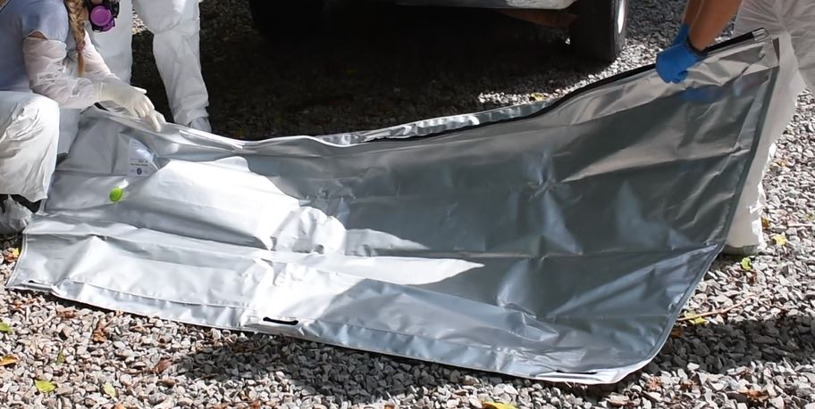Figure 2.4 BBB prior to use. Observe the green valve pointed to by the red arrow. This is where the pump was attached to pump air out. The researchers are opening the seal. Observe the reflective coating here and how it reflects sunlight.

However, the main purpose of the vacuum seal is to eliminate oxygen/air exposure and insect activity from the decomposition process. Access to oxygen not only results in the morphological changes previously presented, it also degrades DNA (Alaeddini et al., 2010). Therefore, a body bag which is truly airtight could perhaps result in both morphological preservation and the preservation of DNA of large strand sizes. Furthermore, this restriction of oxygen could also effectively prevent colonization by insects and thus prevent most soft tissue loss.
The goal of the absorbent pads is to reduce the amount of moisture surrounding a body. The presence of the absorbent pads in the BBB could serve to prevent the growth of moisture-loving bacteria and microorganisms, thus preserving DNA. Moisture is also an attracter of insects and a reduction in the ambient amount of moisture around an individual could lead to fewer insects being attracted to the bag. The reflective coating also present may result in lower temperatures overall. High temperatures again have been shown to degrade both DNA and result in higher morphological decomposition.
There is much variation in how an individual decomposes and much of it can be attributed to environmental causes. With the elimination of environmental drivers like insects, access to oxygen, and restriction from sun and soil, perhaps an individual may present in earlier stages of decomposition, thus making an identification easier. These environmental drivers also can lead to strand breakage and other types of DNA degradation, too. Therefore, a well-made bag that restricts the main drivers of decomposition could result in more complete DNA profiles for analysis. Though Goodwin (2018) had completed DNA experimentation involving the Better Body bags, he did so with only pigs and no human donors. Studies have shown that pig decomposition is not a true analogue for human decomposition (Dautartas et al., 2018). In addition, the vacuum seal was never tested in Goodwin’s (2018) study, a feature which could restrict expediters of decomposition such as air and insects. Goodwin only tested the BBBs for three days, which unfortunately is a fraction of the time an individual could be decomposing before identification. Therefore, this study focuses on how the BBB may delay decomposition and preserve DNA in a period of 21 days.

Materials and Methods
In disaster scenarios, deceased individuals may be left in body bags with no refrigeration and continue to decompose within a bag. Thus, a body bag that could reduce decomposition may increase the chance that that individual could be positively identified with DNA using soft tissues. To test the Better Body Bags, which were designed with this preservation in mind, the ICRC requested that the Forensic Anthropology Center (FAC) complete a 21-day study involving human trials. The three-week span of experimentation is designed to simulate the maximum amount of time a deceased individual would be ideally in the bags. To simulate a true disaster scenario where the bags are deployed, the ICRC requested photographs be taken of the face of individuals every five days in order to maintain a record of the individual’s face before the effects of decomposition have had a chance for gross morphological changes.
The goal of this current study is to understand if the BBB protects soft tissues over a 21-day period such that DNA from the remains can be successfully extracted and STRs profiled for identification purposes. This chapter will cover the guidelines by which donors were allocated, experiments conducted, sampling protocol and how DNA was typed, and the metrics by which decomposition was scored. Additionally, the statistical tests for these data will be briefly discussed.

Donor Allocation
The individuals for this study were body donations to the FAC. Donors are received by the FAC at the University of Tennessee through the Body Donation Program where they consent to be used in research at the Anthropology Research Facility (ARF). ARF is an outdoor research
facility where body donations are placed for decomposition and study.
Donors were eligible for this study if they lacked trauma that created open wounds, had not been embalmed, and ideally had not been autopsied, though a shortage of eligible donations caused by the COVID-19 pandemic meant including a few donors who had been autopsied. Within a trial, donors had to be within fifty pounds of each other as body mass has a significant effect on the rate of decomposition (Roberts et al., 2017). If a donor had been frozen, they were moved to a cooler a week before being placed in their assigned experimental condition at the ARF to completely thaw. By the time the donors were placed outside, all donor bodies had been equalized to the temperature within the cooler (35°F). Twenty-five donors were selected based on weights (Table 3.1). Note that this table shows experiments and trials in the format of Experiment.Trial which is a format that will be consistently used for the remainder of this thesis.
For each of the experiments, donors were placed into two control conditions: condition one is on the ground with no covering (a surface control), while condition two is placement into a standard white body bag. Placement into a BBB is the experimental condition. Body bags containing donors were placed at the ARF for 21 days total in the field. Additionally, control donors for other experiments within this study were also used as controls for multiple trials. For example, Experiment 2 had four donors enrolled, two in BBBs and one per each control condition. Therefore, two BBBs can be tested at once.
To simulate delay conditions of placement into body bags in humanitarian scenarios, donors were placed into body bags immediately after removal from the cooler (denoted as 0 hours) or were placed without covering at the ARF for two days (denoted as 48 hours) before placement into body bags. From placement into the bag, donors were left at ARF for the full 21 days.
Table 3.1 Weights of Enrolled Donors
Experiment and Trial | Donor | Weight (lbs)
1.1 | BBB01 | 107
1.1 | White01 | 106
1.1 | Control01 | 101
1.2 | BBB02 | 152
1.2 | White02 | 159
1.2 | Control02 | 174
1.3 | BBB03 | 201
1.3 | White03 | 213
1.3 | Control03 | 172
1.4 | BBB10 | 118
1.4 and 3.3 | White10-11 | 109
1.4 and 3.3 | Control10-11 | 119
3.1 | BBB04 | 103
3.1 and 3.2 | White04-05 | 118
3.1 and 3.2 | Control04-05 | 84
3.2 | BBB05 | 119
2.1 | BBB06 | 122
2.1 and 2.2 | White06-07 | 127
2.1 and 2.2 | Control06-07 | 116
2.2 | BBB07 | 130
2.3 | BBB08 | 113
2.3 and 2.4 | White08-09 | 109
2.3 and 2.4 | Control08-09 | 117
2.4 | BBB09 | 104
3.3 | BBB11 | 83

The allocation of donors can be found in Table 3.2. Experiment 1 Trial 1 had three donors enrolled and none were sampled for DNA. In all, 22 donors were sampled for DNA. Furthermore, as a shortage of donors became evident, trials had to be doubled up hence why Experiment 1 had three donors per trial (except for Trial 4), while Experiment 2 and 3 have four.

Experiments
Three experiments were thus completed to test different aspects of the BBB and compare them to two controls—a traditional body bag and a body placed on the ground surface with no coverings. View Figure 6.1 and 6.2 for photos of the bags in Appendix A.
Experiment 1: BBB with reflective surface and vacuum sealed placed on the ground surface for 21 days.
This is designed to serve as a control experiment for Experiment 2 and 3 as it employs the BBB as it is meant to be utilized, with all features intact.
Experiment 2: BBB without pumping the air out and placed on the ground surface for 21 days.
This is designed to test if pumping the air out, i.e., limiting oxygen, is indeed necessary for preservation of DNA and lower TBS scores.
Experiment 3: BBB with all features intact (reflective surface, vacuum sealed, absorbent pads) placed on ground surface with the BBB and standard white body bag opened briefly every five days to photograph the face and to take a DNA buccal swab.
Individuals who are recovering human remains may need to open the body bags multiple times before a decision is made to sample the victim for DNA, take photos of the face, or scan

Table 3.2 Sampling Distribution by Experiment for BBB and Controls
Experiment | BBB* |  | Controls |  |  | Total
Experiment |  |  | bb† |  | No bb‡
Exposed hours before placement | 0 hr | 48 hr | 0 hr | 48 hr | 0 hr
Experiment 1 | 3§§ | 1 | 3§§ | 1 | 4§§ | 12
Experiment 2 | 2 | 2 | 1 | 1 | 2 | 8
Experiment 3 | 2 | 1 | 1 | -§ | 1§ | 5
Totals | 7 | 4 | 5 | 2 | 7 | 25
*BBB – Better Body Bag
†bb – standard white body bag
‡no bb – ground exposure lacking any body bag
§bb and no bb for Experiment 3 Trial 3 utilized the same donors Experiment 1 Trial 4
§§ one of these individuals was not DNA sampled

fingerprints. This experiment is designed to test the following questions: can a BBB be opened and closed quickly enough so that insects or artifacts do not enter the bag? Does repeated exposure to the environment, even for only a small amount of time, influence the rate at which DNA degrades or the rate at which an individual morphologically decomposes?

DNA Data Collection
On day 0, placement day, DNA samples were taken from the inside of the mouth using a sterile foam swab (Whatman WB100032 Sterile Foam Applicator). One swab was taken per experimental condition (one from the BBB donor, one from the donor in the white body bag, and one from the surface placement control donor). The sampling distribution can be found in Table 3.3. The DNA samples were also partially applied from a swab onto a Whatman Indicating FTA Card. Both the swabs and the Indicating FTA card were allowed to dry for a few minutes before being packaged in sterile tubes and separate coin envelopes sealed with tape, respectively. Until the moment of DNA extraction, the swabs were stored in a -80°C freezer in a Styrofoam box, while the FTA cards were stored with silica packets and kept at room temperature and allowed to dry fully.
Following sampling, photos and initial TBS scoring was completed for each of the donors. A temperature and humidity logger (IButton) was taped both on the inside and outside of the bags and attached to a wooden post a few inches from the head of the surface control. The donors were then placed into their experimental condition—either within a BBB, standard body bag, or a surface placement. The bags were closed and sealed and, if necessitated by the experiment, air was pumped out of the BBB. Once donors were in their placement sites, photos were taken of the bags and the condition of the bags was recorded.

Table 3.3 Type and Number of DNA Samples
Day of Sampling | Type of Sampling | Number of DNA Samples
Day 0 | Buccal swab | One taken per each donor
Day 21 | Buccal swab, buccal tissue swab, thigh muscle tissue swab* | One of each taken per each donor
Day 5, Day 10, Day 15,  ONLY Experiment 3 | Buccal swab | One of each taken per each donor
*Thigh sampling was added later in experimentation, so donors enrolled in Experiment 1 Trial 2 and 3 lack samples from the thigh.

Each experiment ended on day 21, and one buccal swab was again taken and stored as per Table 3.3. To maximize the chance of recovering DNA, a small scalpel was used to create an incision around one inch on the inside of the individual’s cheek. As the incision accessed tissue not exposed to environmental conditions, the degradation of DNA within these buccal tissue cells should be less than that of the surface buccal cells (which are exposed to oxygen and insects) swabbed. This incision was then sampled once per individual, with the sample then applied onto an indicating FTA card.
The only exception to the above sampling procedure is in Experiment 3, where the BBBs and standard body bags were opened briefly every five days. All donors’ faces, including surface controls, were photographed and another buccal swab was taken per donor. The bag was opened quickly to minimize the amount of air and insects that could enter each bag, and after sampling, air was again pumped out of the Better Body Bags. The standard body bags were simply unzipped and rezipped.
The incision was made inside of the cheek rather than any other location to minimize the exposure of tissues to the environment. Mann et al. (1990) suggested that trauma could be an accelerator of decomposition; however, more recent studies have suggested that rather than the rate of decomposition being affected, it is the pattern of decomposition (Smith, 2014; Cross and Simmons, 2010). Oviposition will occur in sites of trauma as those sites are moist and drying and mummification often begin at trauma sites (Smith, 2014). This site was further chosen to minimize the amount of liquid that may leak from the trauma site into the body bag itself. Though the incision is made on day 21, the last day by which an individual would theoretically be identified, placement into the bags in a real disaster scenario may exceed 21 days. Therefore, it is in best interest to minimize the liquid that could be present in the bag.
However, to examine if the buccal tissue sampling site is a valid site for DNA collection, skeletal muscle from the leg was also sampled on day 21, as skeletal muscle is an advised site for collection of DNA samples because DNA persists in higher quantities and is less degraded in the thigh as compared with buccal cells (Turingan et al., 2020). This was done by placing a 3-inch incision into the red muscle of the left upper thigh. A swab was inserted into this incision and the resulting biological sample was applied onto an FTA card to examine if DNA persists in similar quantities in the buccal tissue and the thigh muscle samples.

Metrics
Hourly temperature and humidity were collected using a Thermochron IButton logger. Ibuttons were placed into plastic tubes, which were then duct taped near the chest area both within and outside the BBB and white body bag. An Ibutton within a tube was also duct taped onto a wooden stake near the head of the control surface placement.
Daily photos were taken of each BBB every day for 21 days along with a ranking of the odor experienced when standing next to a body bag or surface placement on a four point scale (where a score of 1 denotes no odor and 4 denotes a noxious odor). Additionally, every day the condition of the bags was logged with the following scale:
1) Bag intact, no evidence of scavenging or other breach, no leaking
1.5) Air evident in the bag but fluids contained by the seal
2) Bag intact but leaking of fluids
3) Bag breached by insects only
4) Bag breached by scavengers and insects are present
5) Bag breached by scavengers and insects are absent
6) Bag damaged by factors other than insects or scavengers like racoons
On the end date, bags were opened and the donors inside were photographed. To quantify decomposition, the Total Body Score, or TBS (Megyesi et al, 2005) was utilized every day during the 21 days for the surface control and the first and last days of placement for the experimental and white body bag donors. TBS is used with accumulated degree days to calculate the time since placement of the individual but is used here as a means to compare the stage of decomposition between the BBB and controls. Scores are assigned to three different regions: head, trunk, and limbs as the rate of decomposition has been shown to vary among different parts of a body.
DNA extraction took place at the Molecular Anthropology Laboratories at UTK using the QIAamp DNA Investigator Kit (Qiagen) following the manufacturer’s suggested protocol for isolation of DNA from blood and buccal samples dried onto FTA cards. Three mm diameter punches with a paper hole puncher were added to a 1.5 ml microcentrifuge tube. The hole puncher was decontaminated with a 10% household bleach solution followed by a rinse with UltraPure DNAase/RNAase water (Sigma) before use, and between punches. Although the manufacturer suggested adding carrier RNA for cases where only one 3 mm diameter punch was used, as the samples were presumably degraded, one microliter carrier RNA was added to all samples to maximize the chances of allelic recovery. In the final step, 40µL UltraPure DNAase/RNAase (Sigma) water was used to release the DNA from the membrane of the QIAamp MinELute column. As a quick quality check, 5µL of this extract were run on a 3% agarose gel to visually assess DNA quality and quantity, and to ensure that the negative controls did not yield DNA.
Extractions were also completed from FTA cards of buccal swabs of all three primary researchers. This was done with the Oragen saliva collection tube and the associated extraction kit. These STR profiles were created to control for contamination; if mixture was present in the experimental samples, these profiles were compared to the researchers’ profiles.
The remaining DNA extracts were sent to Dr. Suni Edson at the Armed Forces DNA Identification Laboratory in Dover, Delaware. Once the samples arrived at the lab, 5µL of each sample was quantified using Plexor® HY. The quantitation values were evaluated and the sample was diluted to 1.5ng before amplification. The target input is between 1.5 and 2.0 ng. If a sample did not meet the target, 15µL (the maximum volume of the provided extract) was added to the reaction. Samples were then amplified with the PowerPlex Fusion® kit (Promega, Madison, WI). The analytical threshold for peaks in PowerPlex Fusion is 70 RFU. Samples were then loaded onto an ABI 3500xl fragment analyzer with the addition of HiDI formamide and the WEN ILS 500 (internal lane standard). Finally, genotyping was performed using GeneMapper ID-X. Samples were analyzed for completeness of profile and drop-out with anomalous profiles retyped. Successful typing is defined as generation of 22 loci from the Powerplex Fusion kit that meet the analytical threshold of 70 RFU.

Statistical Analysis
At the end of data collection, a mixed-model ANOVA analysis determined if the TBS scores and number of loci in which there is a reportable result varied significantly from the BBB with the standard body bag and control surface placement. A mixed-model ANOVA was chosen as it compared differences between groups split on a “within subjects” factor and a “between subjects” factor. So for example, the dependent variables here are TBS and number of amplifiable loci, and this sampling is repeated (a within subject factor) because TBS scores and sampling was repeated on day 0 and 21 for all conditions (which are considered your between subjects factor). Significance was determined at p≤0.05. If there is statistical significance, post-hoc testing must be done in the form of Tukey’s post hoc test to compare the means of each group. All residuals were checked for normality using the Shapiro-Wilk normality test.
Mixed-model analysis was thus used to answer all the following research questions that were previously stated:
- Within an experiment, is there is a significant difference between the TBS scores between a BBB donor, standard white body bag donor, and a control surface donor on day 21?
- Within an experiment, is there is a significant difference between the number of amplifiable loci between a BBB donor, standard white body bag donor, and a control surface donor on day 21?
- Does temperature or humidity influence the number of amplifiable loci or TBS scores? Is this difference significant depending on the condition of placement (i.e., BBB, standard white body bag, surface control placement?
- Does the time an individual is placed in the field (0 hours or 48 hours after surface placement) have a significant effect on the number of amplifiable loci or TBS scores? Is this difference significant depending on the condition of placement (i.e., BBB, standard white body bag, surface control placement?
- Does the sampling site chosen have a significant effect on the number of amplifiable loci present on day 21?
Mixed-model ANOVA will also be done to compare the average RFUs and the quantification values of the samples with reportable loci to determine if the generated STR profiles are indeed valid. The average RFUs and quantification values will also be compared with temperature and humidity to determine if there is any relationship. All residuals were again checked for normality using the Shapiro-Wilk normality test.

Results
The experiments that were completed were as follows:
- Experiment 1 employed the BBB with all features intact
- Experiment 2 used the BBB with all features except the vacuum sealing removal of oxygen
- Experiment 3 involved opening and closing the BBB and standard white bags every five days.
Visual assessments and photographs of each donor on day 21, followed by a chart with TBS scores per trial (Tables 6.1 through 6.8) can be found in Appendix 1. Any notable occurrences during the 21-day span were also mentioned in Appendix 1. In this chapter itself, statistical analyses of effect of condition (i.e., BBB, white body bag, or surface control) was further analyzed as a factor which may result in different TBS or reportable loci by day 21. This factor was examined both within an experiment (e.g., comparing the TBS score / number of reportable loci of the BBB and white body bag donor in Experiment 1), comparing experiments (e.g., comparing the TBS score/number of reportable loci of the BBB in Experiment 1 vs 2), and comparing the grouped experiments (e.g., comparing the TBS score/number of reportable loci of all BBBs in the study vs all white body bag donors in the study vs all surface placements). Mixed-model ANOVAs were done comparing temperature and humidity within and outside the bags. Placement time (0 or 48 hours) is also examined as a factor which may cause differing TBS scores or reportable loci among conditions of the donor (BBB, white body bag, surface control) by day 21. Additionally, in order to examine any abnormalities in STR recovery, ANOVAs were completed examining the sample types (buccal card, buccal swab, and leg swab) and how relative fluorescence units (RFUs) and quantitation may have affected allelic recovery, the latter two of which can be found in Appendix 1.

Reportable Loci
Twenty-two markers were examined for profile completeness with AMEL and DYS391 excluded as both are sex determined markers. If one allele was present at the marker, the marker was counted as being successfully amplified (denoted as a reportable locus). Additionally, Relative Fluorescence Units (RFU) which are a measure of the amount of amplified DNA and quantitation (in ng/µL) were also analyzed in relation to number of reportable loci as a low RFU and quantitation may have a relationship with a low rate of allelic recovery. This can be found in Appendix 1.

Statistical Analysis Between Conditions (BBB vs Standard White Body Bag vs Surface Control Placement)

TBS
To reiterate, experiments that were completed were as follows: Experiment 1 involved the usage of the BBB with all features intact, Experiment 2 involved using the BBB with all features minus the vacuum sealing, and Experiment 3 involved opening and closing the bag every five days.
Within Experiment 1, 2, and 3 there was no significant difference between the effect of condition (BBB, white body bag, control surface donor) on TBS on day 21 (p=0.6569). In other words, the difference in TBS for Experiment 1’s BBB is not significantly different than the TBS score from the donor in the white body bag and surface control for the same experiment. The same is true for Experiments 2 and 3. Thus, the hypothesis postulated earlier that the BBBs of each respective experiment would result in lower TBS scores is not statistically true. Additionally, the difference in TBS Scores between the BBBs of Experiment 1 compared to the BBBs of Experiment 2 and the BBBs of Experiment 3 do not differ significantly.
With all experiments grouped by like conditions (meaning, comparing all BBBs vs all white body bag donors vs all control surface donors), TBS scores on day 21 were significantly affected by if a donor was a surface control or BBB (p=0.0004). Additionally, with all experiments grouped, TBS on day 21 was significantly affected by if a donor was in a white body bag or surface control (p= 0.0248). The difference in TBS scores between donors in white body bags and BBBs for all experiments on day 21 was not significant (p= 0.6783).

Number of Reportable Loci
Within Experiments 1, 2, and 3 there was no significant difference between the effect of condition (BBB, white body bag, control surface donor) on number of reportable loci on day 21 (p= 0.7927). In other words, the difference in number of recoverable loci for the full BBB features is not significantly different on day 21 than the number of recoverable loci from the white body bag and surface control for the same experiment. The same is true for Experiments 2 and 3. Additionally, the difference in reportable loci between the BBBs of Experiments 1, 2 and 3 do not differ significantly. Thus, the hypothesis postulated earlier that the BBBs of each respective experiment would result in more complete STR profiles as compared to both profiles of the controls is not statistically supported.
With all experiments grouped by like conditions (meaning, comparing all BBBs vs all white body bag donors vs all white body bag donors), the number of reportable loci was not significant on day 21 between the BBB group and white body bag group (p= 0.4127), nor between the white body bags and control surface placements (p= 0.6964). However, there was a significant difference between all the BBBs and control surface placements (p=0.0061).
Solely examining Experiment 3, statistically, there is no significant difference between number of loci recovered among day 0 vs day 5 vs day 10 vs day 15 vs day 21 for both the BBB donors and white body bag donors. In other words, a BBB donor did not have a statistically different number of loci amplified on day 0 vs day 5, day 5 vs day 10, day 10 vs day 15, day 15 vs day 21, or any combination of those (e.g., day 5 vs day 21). The same is true for the white body bag donor. This is also true for the surface control donor except when comparing the number loci able to be amplified on day 0 vs day 21 (p= 0.0002). A chart is provided in Table 4.1 which illustrates the estimated marginal means for TBS and number of loci amplified by experiment and condition.

Relationship between TBS and Number of Reportable Loci by Condition
The relationship between the number of loci recovered and TBS is condition dependent (p=0.0168). For every 1 locus increase, TBS decrease 0.30 units for BBBs. For every 1 locus increase, TBS decreases 0.566 units for control surface placements. For every 1 locus increase, TBS decreases 0.36 units for the white body bags. A graph illustrating the following is presented as Figure 4.1.

Temperature and Humidity
A research question was posed relating to the potential of temperature and humidity differences between conditions. Because BBBs possess reflective coatings and absorbent pads, then perhaps the BBB donors would overall present with lower TBS scores and more loci able to be amplified as compared to a surface control donor or a white body bag donor. The average temperature and humidity and its effect on TBS and number of loci able to be successfully amplified are demonstrated in Figure 4.2 and 4.3 by condition. The difference in temperatures outside and

Table 4.1 Estimated Marginal Means of TBS Scoring and Number of Loci Generated on Day 21 by Experiment
Experiment | Condition | Estimated Marginal Means of TBS Scores | Estimated Marginal Means of Number of Loci Generated
1 | BBB | 15.3917 | 21.46
2 | BBB | 16.8917 | 17.5
3 | BBB | 16.1001 | 21.33
1 | White Body Bag | 15.9334 | 14.75
2 | White Body Bag | 19.6001 | 6.75
3 | White Body Bag | 15.2251 | 14.75
1 | Control Surface Placement | 17.6417 | 10.35
2 | Control Surface Placement | 20.3501 | 1.75
3 | Control Surface Placement | 19.4334 | 7.33

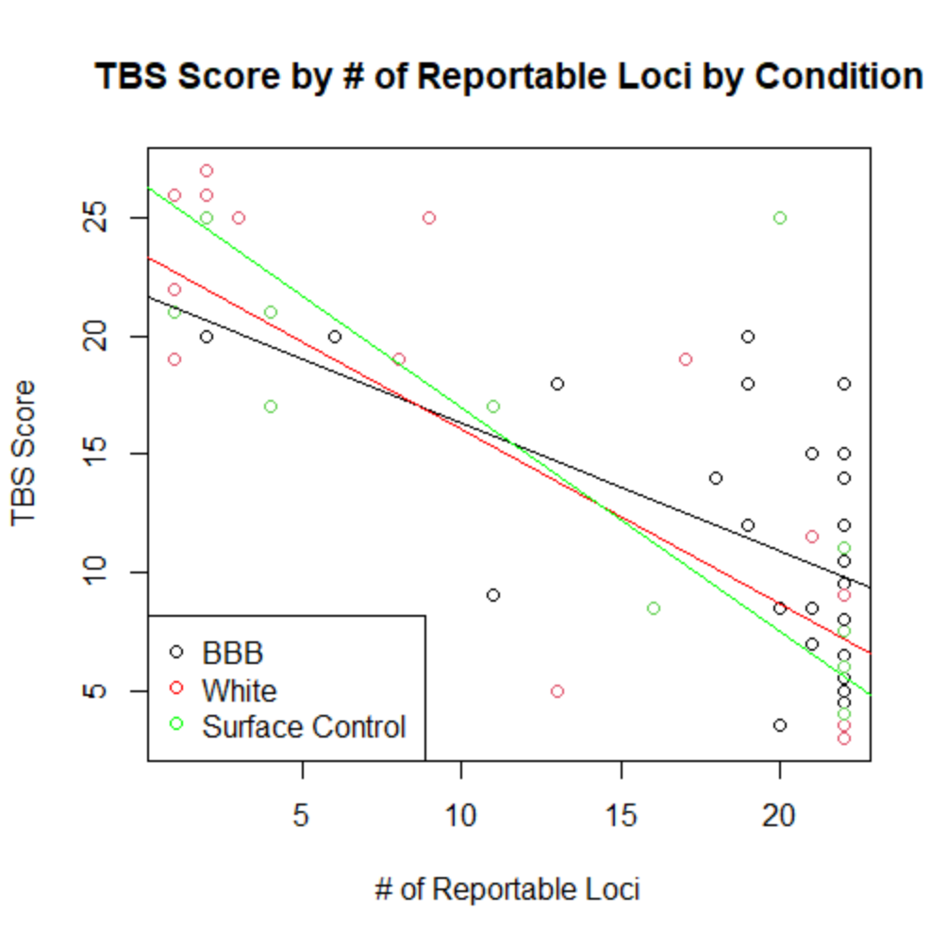
Figure 4.1 TBS Score by # of Reportable Loci by Condition

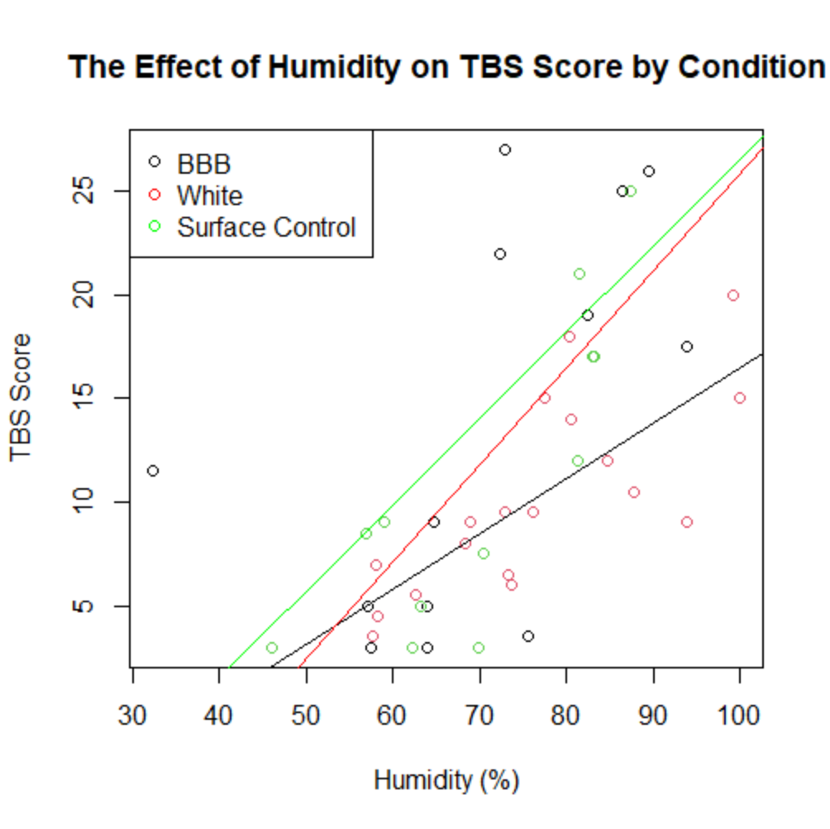
Figure 4.2 The Effect of Humidity on TBS Score by Condition

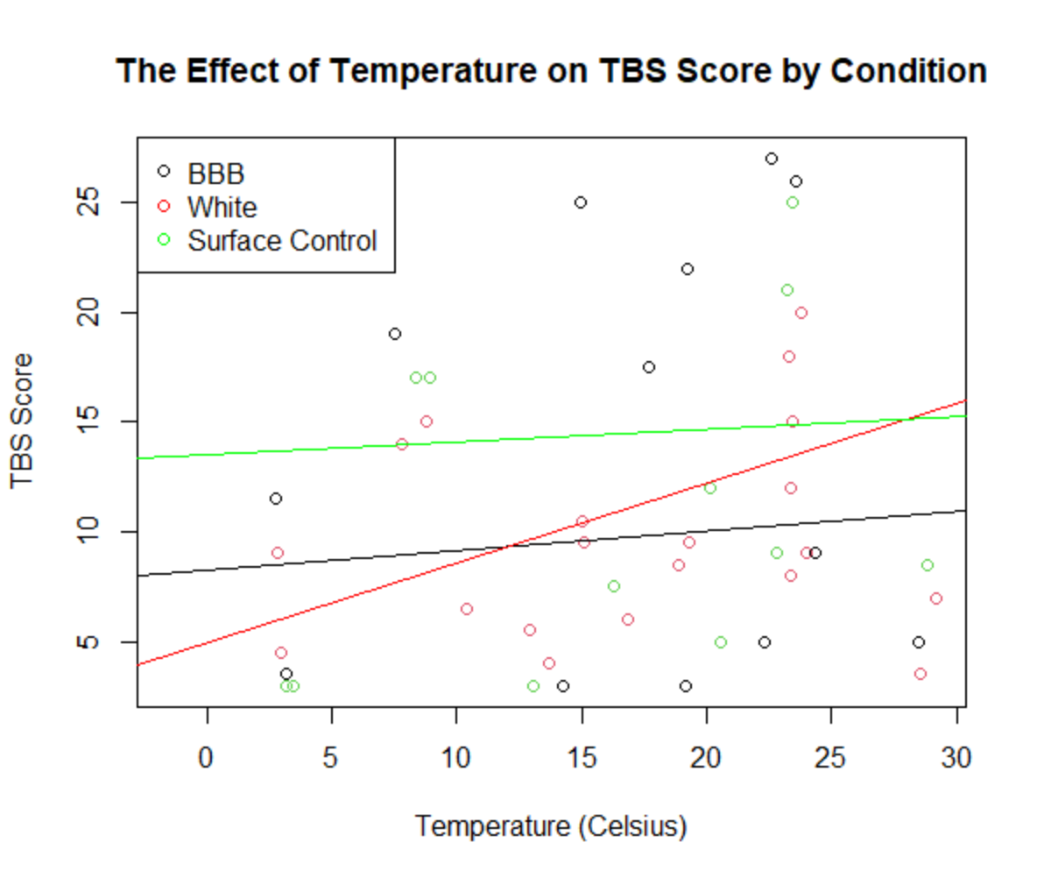
Figure 4.3 The Effect of Temperature on TBS Score by Condition

inside the BBB was not significant (p= 0.9042), nor was the difference in temperatures outside vs inside the white body bag (p= 0.9188). The difference in humidity between the outside and the inside of the bag for the white body bag was also not significant (p=0.9053). However, the difference in humidity was significant between the outside and inside of the BBB (p=<.0001) with the inside of the BBBs retaining more humidity than the exterior ambient environment.
The relationship between humidity and TBS scoring was significant (p<0.0001), and TBS does vary significantly with humidity between conditions (BBB, White, Surface Control) (p= 0.0065). One can appreciate the upward trend of TBS score as the percent humidity increases in Figure 4.2. The effect of temperature on TBS score was significant (p= 0.0322), and it was also significant by if a donor was a BBB, standard white body bag donor, or a surface control donor (p= 0.0105). Such is illustrated in Figure 4.3.
For STRs, the effect of temperature on the number of reportable loci was significant (p= 0.0027), and the effect of condition is also significant (p= 0.0043). This is illustrated in Figure 4.4. Additionally, the effect of humidity on the number of loci recovered was significant (p <0.0001), and the effect of condition (if an individual was a BBB, standard white body bag donor, or surface control) is also significant (p= 0.0097). This is illustrated in Figure 4.5. One can observe here that as humidity increases, there is a negative slope for the number of reportable loci.

Placement Time (at 0 or 48 Hours)
A question was also posed regarding exposure to the environment. Placement at 0 vs after 48 hours of being in the field did not result in significantly different TBS scores between BBBs of all experiments (p= 0.2021), white body bags of all experiments (p=0.0779), and control surface donors of all experiments (p= 0.8887) on day 21. Placement at 0 vs after 48 hours of being in the
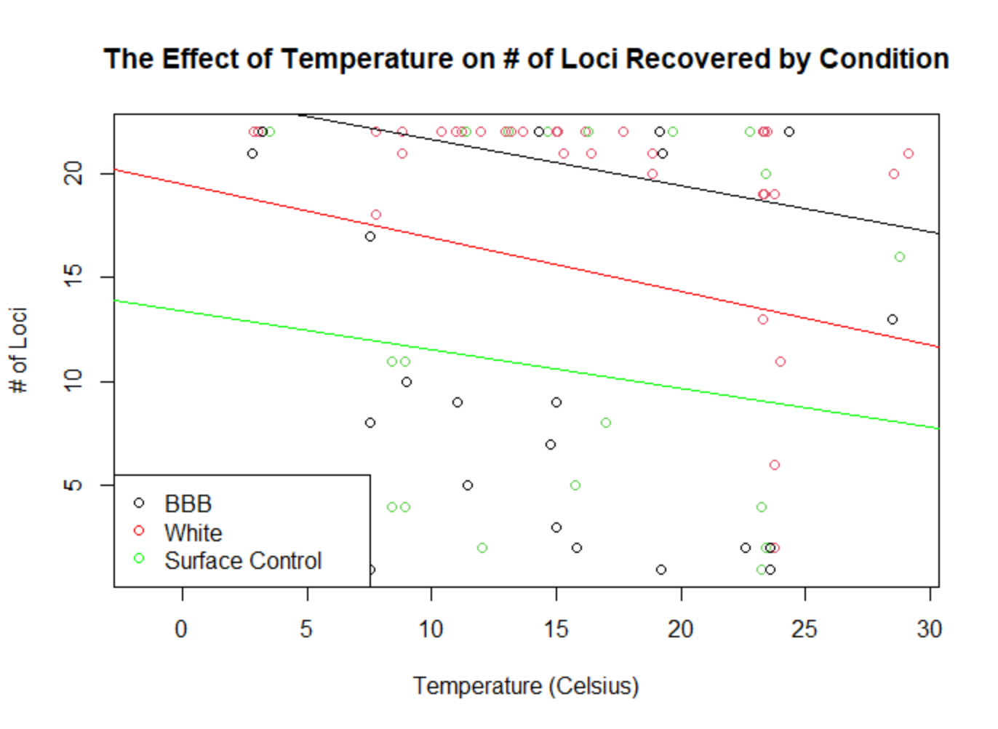
Figure 4.4 The Effect of Temperature on # of Loci Recovered by Condition

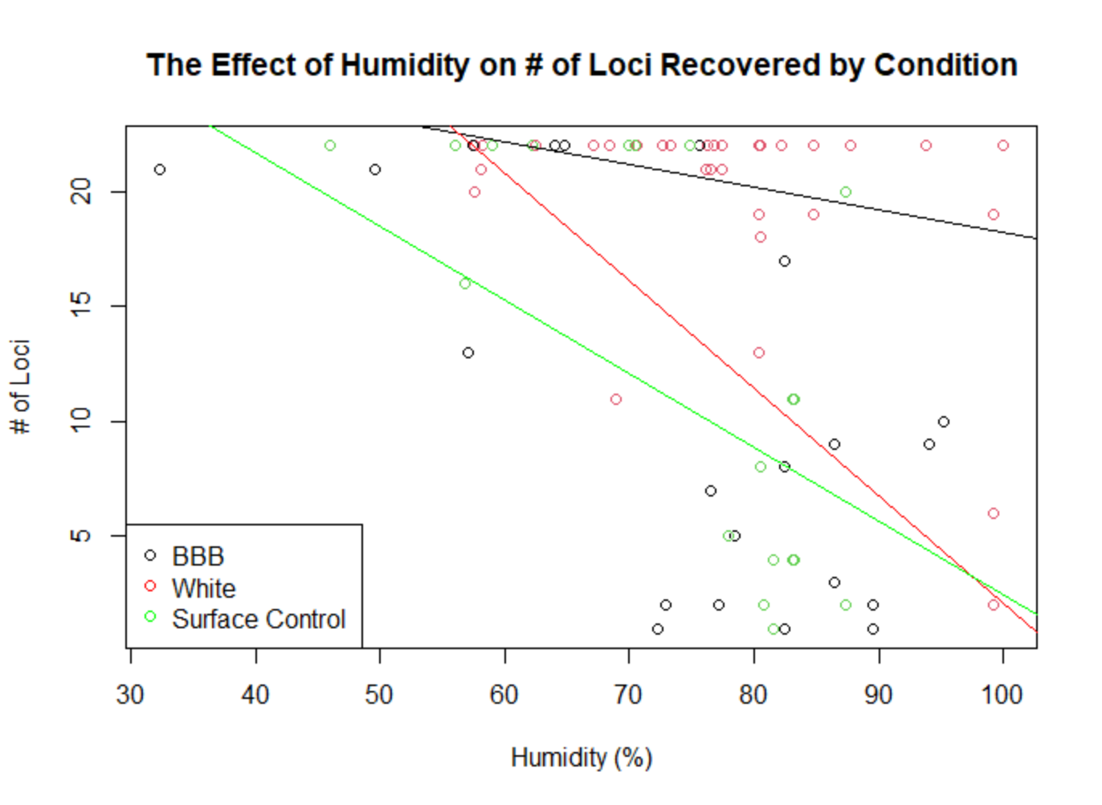
Figure 4.5 The Effect of Humidity on # of Loci Recovered by Condition

field also did not result in significantly different allelic recovery rates between BBBs of all experiments (p= 0.9986), white body bags of all experiments (p=0.1485), and control surface donors of all experiments (p= 0.4035) on day 21.
Placement time was also not significant when comparing the TBS between conditions (BBB vs white body bag vs control surface) within an experiment (p=0.1286). Placement time was also not significant when comparing the reportable loci between conditions within an experiment (p=0.4023).

Sampling Techniques
As per the methods section, three samples were taken on day 21: a buccal swab, a buccal tissue swab, and a leg tissue swab. These were then each swabbed onto FTA cards. All analyses were completed using these FTA card samples. A research question had been posed as to which sample site yielded the most number of reportable loci. On day 21, the difference between the number of reportable loci that were able to be generated regardless of condition (BBB, white body bag, surface placement) was not significant between the buccal samples and buccal tissue samples (p=1.000), nor was it significant between the buccal samples and the leg tissue samples (p=0.9900). This metric was also not significant between the buccal tissue and the leg tissue samples (p=0.6525) on day 21. Between day 0 and day 21, however, there is a significant difference in the number of reportable loci generated by a buccal swab (p= 0.0008). Furthermore, for solely the control surface placement, there is a significant difference between the location that the sample was taken and the number of reportable loci (p= 0.0541), whereby buccal tissue yielded the fewest reportable loci. This is demonstrated for all conditions in Table 4.2 using the estimated marginal means of the number of loci recovered.
Table 4.2 Number of Reportable Loci by Sample Location and Donor Condition on Day 21
Sample Location | Condition | Estimated Marginal Mean of # of Reportable Loci
Buccal | BBB | 18.90
Buccal Tissue | BBB | 19.90
Leg Tissue | BBB | 20.75
Buccal | White Body Bag | 20.29
Buccal Tissue | White Body Bag | 9.32
Leg Tissue | White Body Bag | 10.30
Buccal | Control Surface Placement | 6.37
Buccal Tissue | Control Surface Placement | 5.23
Leg Tissue | Control Surface Placement | 9.23

Brief Conclusions and Sample Size Issues
As further elucidated in the discussion, the effect of temperature and humidity on both TBS and number of amplifiable loci was significant. However, the effect of condition (BBB, white body bag, or surface placement control), was not significant for TBS and amplifiable loci within experiments. This, however, may be due to a small sample size as visually, there does appear to be a difference in preservation. Similarly, there was no significant difference in TBS or allelic recovery on day 21 between the donors immediately placed into bags (denoted as 0 hours) or placed into the bags after 48 hours in the field (denoted as 48 hours). This also may be due to a small sample size as this visually appears to not be the case. Donors left in the field for 48 hours prior to placement in the bag appeared to be much more decomposed by day 21 as compared to those placed immediately into experimental conditions.

Discussion
The results from this study indicate that BBBs overall (as in with all experiments grouped), with or without vacuum sealing or increased opening frequency, significantly preserve DNA better than a surface control placement. Additionally, both a white body bag and a BBB are better at preventing decomposition as evidenced by significantly lower TBS scores as compared to a surface control. However, without grouping like conditions across all experiments (BBB, white body bag, surface control), there appeared to be no significant differences in the preservation between individuals (both in TBS and loci amplification) in different conditions within the same experiment. In other words, the TBS scores and number of loci able to be amplified were not significantly different between all donors of Experiment 1, and the same is true for Experiment 2 and 3. Furthermore, the TBS scoring and number of loci able to be amplified did not differ significantly between BBBs of each experiment.
User-experience is an important facet to this thesis that will be discussed in Appendix 1. If the BBB is not an easier/similarly difficulty to use alternative to standard white body bags, the nonsignificant decrease in TBS of BBB donors compared to white body bag donors may not be worth it to the user. Furthermore, a BBB is designed to be used in areas of disaster or war, so it must be quick and easy to use for safety of the user. Refinement of the bags design thus must not only take into account what is most beneficial for preservation but also what users can easily manipulate.

Effect of Condition
There was no significant difference between the rate of allelic recovery and TBS scores between BBBs, white body bag donors, and control surface donors within an experiment on day 21. In other words, the TBS scores and number of recoverable loci were not statistically different between a BBB donor, white body bag donor, and control surface donor on day 21 within Experiments 1, 2 or 3. However, due to restrictions receiving donors within a timely fashion, the necessary sample size to have a high power for statistical significance was not achieved. Therefore, from the results of this study alone, the hypothesis that within an experiment the BBB will perform better than the controls remains statistically elusive but can perhaps be better tackled qualitatively.
The same issue of power and statistical significance was encountered regarding the number of amplifiable loci. Table 4.1 demonstrates what appears to be extremely strong differences between conditions in an experiment. However, only by grouping all like conditions (i.e., comparing all BBBs vs all white body bags vs all control surface donors) do we see statistical significance. On day 21, there was a significant difference in the number of loci recovered between BBB donors and control surface donors with donors in a BBB having higher allelic recovery.
In summary, the BBB and white body bag are comparable overall with their average TBS scores at the end of experimentation as they both result in a lower TBS score than the surface control. Regarding amplifiable loci, however, the BBB is markedly better at preserving DNA than a standard body bag, versus the condition of surface placement.

Visual Identification and Qualitative Analysis
*Figures 6.4 through 6.26 and Figures 6.28 and 6.29 contain imagery of decomposing donors. Thus, these figures are only available through request to the author of this thesis or her advisor*

Testing Experiment 1
The first experiment was designed to test if the fully intact BBB would result in lower TBS scores and more amplified loci than the controls. In Experiment 1, where the BBB was deployed with all features intact, statistical analysis did not show any significant differences between the TBS scores and amplifiable loci between the BBB, white body bag, and surface control. However, that is not to say there are no differences. Visual differences exist among donors, and this measure could prove useful for visual identifications. Thus, the condition and survivability of facial features such as the nose, lips, and eyes are important to consider in this thesis. When examining Figure 6.4 (available upon request), one can see clear visual differences in the conditions of the faces of all three donors enrolled in Trial 1. Only the BBB donor truly appears to have the potential for visual identification—their eyeballs are still intact, and tattoos are clearly visible. The face of the white body bag donor appears as if it was flattened, and there are no distinguishable features. The surface control donor has essentially mummified, and facial features are distorted. On day 21 in Trial 2, there are fewer visual differences between the white body bag and the BBB donors, with the white body bag donor visually better preserved than the BBB donor. Though the white body bag donor has skin slippage, they have not entered the bloat stage like the BBB donor who is also discolored. The surface control donor is unrecognizable as they are fully mummified with skeletonization evident. On day 21 in Trial 3, the BBB and white body bag donor are again somewhat similar to each other in terms of preservation, with slightly better preservation on the white body bag donor as there are no lividity changes like the BBB
donor. Both donors are markedly better preserved than the heavily scavenged surface control.
For Trial 4 of this experiment, the donors were placed into the bag after 48 hours in the field. All donors had been colonized by maggots at this point, and the BBB and white body bag donors had been scavenged and neither had eyeballs. However, on day 21, the white body bag donor was skeletonized, while the BBB donor only had undergone a bit of bloating and lividity changes. The surface control on day 21 was unrecognizable as it was fully mummified. There were some preservation differences between the donors in bags in this trial versus Trials 1-3 where the donors were not left out for 48 hours prior to placement into the bags. Namely, the white body bag donor in this trial was skeletonized at the end and completely unrecognizable as opposed to the white body bag donors in previous trials where some even were better preserved than the BBB donors. This is likely due to the continued effects of maggots. As these 48-hour donors are already colonized, placement into a white body bag offers almost the perfect environment for growth— dark, moist, and oxygen is present. In a BBB, oxygen is restricted with the vacuum seal, so when the BBB in this trial was opened at the end, there were only dead, suffocated maggots.
In summary, for two trials of Experiment 1, the BBB appeared to preserve the individual better, but for two other trials, the white body bag donors slightly appeared to be visually better preserved. This is supported by the estimated marginal means of the TBS scores for Experiment 1 (the means of Trials 1 through 4), where the means of the TBS scores between all BBBs of Experiment 1 vs all white body bags of Experiment 1 are virtually identical (Table 4.1). The surface placement donor, however, has a higher mean TBS score. The real differences lie in the means of the number of loci able to be generated. On day 21 for Experiment 1, the BBBs had on average 21.46 amplifiable loci, the white body bags had 14.75 amplifiable loci, and the control surface donors had 10.35 amplifiable loci. Though these differences were not statistically significant, likely due to the small sample size, they do show a difference in preservation between the individuals. Therefore, though not statistically significant that an intact BBB results in better preservation, the BBB does appear visually and genetically to be superior. The BBB donor and the white surface control donor are perhaps in better morphological condition than the surface control donor largely because of restriction of scavengers. The surface control donors in this trial were often mummified by the time of sampling on day 21, which is something that can occur in hot temperatures but also due to scavenging activity. Insect access was restricted in all BBBs, but in two standard white body bags, donors had maggot activity. This soft tissue destruction may account for the drop in the number of reportable loci for that condition. Additionally, TBS scores of the white and BBB donors averaged to similar scores due to the failures of the TBS system itself. As limbs remained fresher than the head and the trunk for standard white body bag donors, TBS scores were routinely underestimated, resulting in the individual scoring ‘fresher’ than they were.

Testing Experiment 2
The second experiment was designed to test if pumping the air out of the BBB had some effect on preservation. In Experiment 2, where air was not pumped out of the BBB, statistical analysis did not show any significant differences between the TBS scores and amplifiable loci between the BBB, white body bag, and surface control. Again, this may be due to the small sample size and perhaps visually examining Figures 6.9 and 6.11 (available upon request) will more clearly illustrate any differences. No donors were visually identifiable by the end of Trial 1 and 2 of this experiment. However, the BBB donors were more fleshed. The white body bag donor was essentially skeletonized with a mummified face. The control surface donor was mummified but was ultimately more fleshed than the white body bag donor. It is notable here that BBB06 was breached prior to opening as was the white body bag. BBB07 opened as it was being carried on day 21. Therefore, researchers postulated that perhaps the removal of air during vacuum sealing
helps the bag stay tightly closed.
In Trials 3 and 4 of this experiment, the donors were placed into the bag after 48 hours in the field. All donors had been colonized by maggots at this point, and all donors were heavily scavenged to the point that disarticulation was possible upon movement into the bags. On day 21, BBB08 appeared better preserved than BBB09, and both BBBs were better preserved than the white body bag donor. The white body bag donor was skeletonized on their face and their limbs quickly disarticulated upon movement out of the bag. The surface control donor was mummified and skeletonized on the face. There were no real visual differences between these 48-hour in the field trials vs Trials 1 and 2 of this experiment which involved immediate placement into the bags.
In summary, for all trials of this experiment, the BBB donors visually appeared to be better preserved than the controls. This is supported by the estimated marginal means of the TBS scores where the BBB donors on day 21 had an average score of around 16.90 while the white body bag donors had an average of 19.60, and the surface control donors had an average score on day 21 of 20.35. The difference in the number of amplifiable loci is even more stark with an average of 17.5 loci able to be amplified for the BBB donors, 6.75 for the white body bag donors and 1.75 for the surface control placements. Though these differences were not statistically significant due to the small sample size, they still demonstrate a difference. Therefore, though not statistically significant that a BBB employed without the air pumped out will result in better preservation than the controls, the BBB does appear to be superior based on TBS scores, number of loci able to be amplified, and visual analysis.
The stark difference in the number of amplifiable loci is perhaps due to the intense insect and scavenger activity present on the standard white body bag donors. For Trials 1 and 2, the associated white body bag had been breached early in experimentation, resulting in insect and scavenger activity that rendered the donor essentially skeletonized by day 21, which is reflected in visual analysis, TBS, and number of reportable loci. Furthermore, for Trials 3 and 4 of this experiment, the white body bad donor was again scavenged and colonized prior to placement into the bag. These insects had oxygen access in the white body bag and resulted in severe soft tissue loss on the fact and limbs. Therefore, swabbing the buccal surface in these trials meant picking a severely decomposed, insect -infested site to swab. Though the BBBs were also colonized prior to placement into the bags, the insect activity was lessened even though the air was not pumped out. This is probably not due to any temperature differential but perhaps due to the massive amounts of liquid present within the BBB. A guess is that the environment of the BBB is acidic as blood pH drops after death, and the BBBs enrolled in this experiment purged around 5200 ccs of blood as compared to the standard white body bag donor which purged around 500 ccs. This acidic environment may not be ideal for maggot activity as evidenced by Ma et al. (2018) who demonstrated that Black Soldier Fly larvae raised on acidic diets (pH of 2.0 to 4.0) were more likely to be underweight as compared to those raised on more neutral (pH of around 6.0). Thus, BBB donors escaped the bulk of soft tissue loss.

Testing Experiment 3
The third experiment was designed to test if the repeated opening and closing of the bags had some effect on preservation. In Experiment 3, where the BBB and white body bag were opened briefly every five days for sampling and photos, statistical analysis did not show any significant differences between the TBS scores and amplifiable loci between the BBB, white body bag, and surface control. Again, this may be due to the small sample size and perhaps visually examining Figures 6.19 and 6.29 (available upon request) will more clearly illustrate any differences. In both Trial 1 and 2, BBB04, BBB05, and the white body bag donor were markedly better preserved than the mummified and skeletonized control surface donor. However, the BBB donors did undergo bloating and lividity changes of the face. The white body bag donor, however, appeared to be slightly better preserved as they had evaded most of the bloating that had distorted the faces of the BBB donors.
In Trial 3 of this experiment, the donors were only placed into the bag after 48 hours in the field. All donors had been colonized by maggots at this point, and all the faces of the donors had been scavenged. By day 21, the BBB donor, despite lacking eyes and experiencing discoloration, appeared to be much better preserved than the white body bag donor (who was skeletonized) and the control surface donor (who was mummified). There were strong visual differences between this 48-hour trial and the immediate placement trials (trials 1 and 2) of the same experiment. In trial 3, the maggots that were present on the BBB donor were killed upon the removal of oxygen from the BBB, while they continued to develop in the white body bag and deflesh the white body bag donor.
In summary, for the first two trials of this experiment, the white body bag donors slightly edged out the BBB donors in terms of visual preservation, whereas in the third trial, the BBB donor outperformed the white body bag donor. However, all the bagged donors were better preserved than the surface control placement. This is supported by the estimated marginal means of the TBS scores where on day 21 the BBB donors scored about a 16.1, the white body bag donors scored a 15.2 and the control surface donors scored a 19.4. Interestingly, in terms of DNA preservation, the BBB appears to be much better suited to preservation as compared to the controls. On day 21, the BBB donors had an average of 21.33 amplifiable loci, the white body bag donors had an average of 14.75 amplifiable loci, and the control surface placements had an
average of 7.33 amplifiable loci.
Though these differences were not statistically significant due to the small sample size, the idea that a BBB opened every five days would still preserve an individual better than the control conditions appears to be true regarding the number of loci able to be amplified, but not true in terms of TBS scoring. This is due to the standard white bag donors averaging to be comparable to the BBBs TBS-wise due to the better morphological preservation during Trials 1 and 2 and then worse preservation TBS-wise for Trial 3. The repeated opening and closure of the bags had the effect of weakening the seal of the BBB so oxygen could enter. Thus, perhaps the TBS scores of the BBB donors in Trial 1 and 2 were inflated due to oxygen access which promoted lividity changes and bloat in the face. While the white body bag donor had continued oxygen access due to the zipper not being airtight, the increased oxygen access coupled with increased humidity of the BBB donor is what perhaps promoted more extreme degradation for the BBB condition. For Trial 3, the standard white body bag donor was essentially skeletonized in the face on day 21 due to continued maggot activity as oxygen was able to enter through the zipper of the bag and sustain the maggots. Thus, the drop in reportable loci of the standard white body bag donor can be attributed to the extreme tissue loss evident on their face. Though the seal did eventually fail on the BBB, even one airtight closure for a few days was enough to kill the maggots present after 48 days of exposure, which preserved tissue enough to be able to swab buccal locations on day 21.

Temperature and Humidity
There was no significant difference in temperature between the outside and the insides of the bags. Regarding humidity, there was again no significant difference between the ambient
humidity outside the bag and the interior of the white body bag. However, the BBB did retain a higher internal humidity than the white body bag. This is perhaps because the BBB is a completely sealed bag and any moist decomposition from the donor within simply stays within the bag. The white body bag is sealed with a zipper where air can freely move between the teeth of the zipper—as evidenced by insects that were able to enter the body bag through the zipper closure.
Furthermore, humidity and TBS did have a significant relationship, which was partly because of condition (if a donor is a BBB, standard white body bag donor, or surface control. An increase in TBS was seen as humidity increased. For every 1% humidity increase, TBS increased for the BBB donor by 0.267 units, for the white body bag donor by 0.367 units, and for the surface control by 0.417 units. Interestingly, though the donors within the BBBs experienced more humid conditions than their control surface placement and white body bag donor counterparts, their TBS scores increased at a slower rate. This may be due to a conflicting variable, such as the restriction of oxygen. Since the morphological differences between the BBB donors and the standard white body bag donors placed into their experimental conditions at 48 hours were so stark, it stands to reason that the vacuum seal’s ability to restrict oxygen and thus restrict maggot activity is perhaps the single most important feature of the BBB. This clearly results in soft tissue preservation which in turn results in lower TBS scores.
Additionally, temperature and TBS did have a significant relationship which was also influenced by condition. Like humidity, one can appreciate the positive correlation between TBS and temperature. For every 1 degree increase in temperature, TBS increased 0.254 units for the control surface placement, 0.164 units for the BBB donor, and 0.485 units for the white body bag donors. It appears as though temperature drives decomposition at a faster rate for the donor in the white body bag than even the control surface placement, while BBB donors maintain the slowest increase in TBS per temperature increase. Although this was not measured in these experiments, the pH of the donors placed within the BBB and vacuum sealed may have played a part in the visual preservation of these individuals. Blood pH drops after death and vacuum sealing can preserve tissue better if that tissue is already acidic.
The effect of humidity on the number of amplifiable loci was also significant due to experimental condition. For every 1% increase in humidity, the number of amplifiable loci decreased 0.32 units for the surface control placement, 0.03 units for the BBB donors, and 0.27 units for the white body bag donors. Higher humidity thus seems to correlate with lower amounts of recoverable loci, with the BBB resulting in the highest number of amplifiable markers. This is again curious as the BBB donor experienced the most humid environment compared to the surface control and white body bag donor. This humid environment is not only evidenced by the Ibutton loggers, but also the observation of the absorbent pads during experimentation. They likely had minimal effect on preservation as they simply did not absorb much liquid; upon opening the bags, BBBs harbored much more liquid than their white body bag counterparts, and moisture can result in the growth of bacteria and fungi that would destroy DNA. This high number of amplifiable markers from BBB donors thus becomes curious and may be due to some other factors. Despite the humid conditions, it is important to again consider the effect of the restriction of oxygen access. Oxygen is a known degrader of DNA, and through the 48-hour trials, it is again demonstrated that more marked soft tissue loss will occur in a standard white body bag as opposed to a BBB. Oxygen access is also synonymous with insect activity for the white body bag trials, and the loss of soft tissue of white body bag donors on day 21 made sampling buccal locations difficult if not impossible. As BBBs largely evaded this insect-driven
soft tissue loss, they, in turn, presented with higher numbers of reportable loci.
The effect of temperature on number of amplifiable loci was also significant due to condition. There is a negative correlation regardless of condition between temperature and reportable loci. For every one degree increase in temperature, allelic recovery decreased 0.615 units for the surface control, 0.194 units for the BBB donor, and 0.623 units for the white body bag donor. The average temperature within all BBBs was 16.61°C, while the average temperature within the white body bags was only slightly warmer at 17.34°C. The average temperature at the control surface donor was 16.79°C. Though there was no significant difference in temperatures between conditions, the BBB seemed to slow DNA degradation as temperature increased. As the BBB did not decrease temperature significantly as compared to the other conditions, there is perhaps an outside factor of the BBB which contributes to DNA preservation.
Such other factors could include the limiting of oxygen in the BBB, which serves the additional function of killing any insects already present in the bags. Though the white body bag in some cases preserved the individual better than a BBB, in all cases where the individuals were placed into bags after 48 hours in the field, the BBB was the superior bag in terms of both DNA preservation and TBS scoring. Limiting oxygen thus perhaps led to limiting strand breakage as when the DNA molecule oxidizes, it can result in fragmentation (Colotte et al., 2011).

Placement Time
Both within experiments and by grouping like conditions, there was no significant difference between the TBS scores and allelic recovery of individuals on day 21 between individuals that were placed immediately after removal from the cooler or after 48 hours in the field. As individuals are not usually found immediately after a disaster and placed into a bag, the finding that even after 48 hours there are no significant effects of decomposition taking place is promising. However, this again seems to be the result of a small sample size and lacking power, as visual differences are pronounced.
In the trials where a donor was only placed into a bag after 48 hours in the field, the maggots present on donors suffocated upon placement into the BBB. These maggots did not die on the white body bag donors as they still had oxygen access, and so soft tissue loss continued in these donors. As maggots prefer warm, dark, and moist locations to grow, having a covering is ideal as it provides shelter from both sunlight and evaporation of moisture (Hogsette, 1996). Therefore, maggots seemed to persist longer on white body bag donors than on control surface placements. This potentially has detrimental effects, as it appears that late placement into bags, that is placement after colonization of insects, is only beneficial to the preservation of the individual if most of the air is removed from the bag. If air is left in the bags, the bags may end up doing more harm than good as they may promote the rapid skeletonization of the individual inside.

Sample Location
In a surprising result, buccal swabs and leg swabs were somewhat comparable, with the swabs of the leg muscle tissue resulting in only marginally higher allelic recovery for all conditions except the white body bag. Buccal tissue does not seem to be a viable location to swab for DNA recovery. This study illustrates that leg muscle tissue is indeed the best location to swab for maximum allelic recovery as previously demonstrated by Mundorff et al. (2018). However, due to limitations in the field, be it inexperience with scalpels or needing to get a sample quickly, buccal swabs seem to be still a viable option after 21 days IF the individual is within some sort of covering and their cheeks are still intact.

Allelic Recovery, Mixture, and Overcounting
As a few degraded samples were amplified, DNA mixture was amplified along with our target. This mixture could be teased out as it could be compared to the original sample and unmatching markers were not counted. However, in a true disaster scenario, the original sample is unknown. Thus, as some of the samples in this experiment were counted as still having recoverable alleles though they had mixture, this perhaps led to an overreporting in the true number of recoverable alleles. In a real-life scenario, this mixture would be counted as a failure as it is not consistent with previous data. In such scenarios, this sample would be reexamined and reamplified to generate a profile that is reportable.
It was proven that none of the mixture was coming from the handlers as the extractions of the primary experimenters were given to compare profiles. Collectively, it had been decided to not extract or analyze swabs from the inside of the bags, so there is the potential that contamination could have been present on day 0 within the bags from their manufacture, transport, or storage. Contamination could have further been introduced during the extraction process due to inexperience of the author.

Conclusions and Recommendations
Though not statistically significant due to low power, the BBB overall resulted in lower TBS scores than the white body bag donors and, significantly lower TBS scores than the control surface donors. However, the difference between the BBB’s TBS scores as compared to the white body bag donor was so marginal that the difficulty and time it takes to operate a BBB as compared to a white body bag may not be worth the trouble. Additionally, the user-friendliness of the BBB leaves a lot to be desired especially when considering that the BBB is designed to be used in warring areas or areas that have undergone disasters where there may be limited access to electricity and refrigeration. In these situations, it is imperative that the user of these bags be able to place deceased persons quickly and efficiently into bags. The longer it takes to do this, the more at risk the user is and the higher chance that insects or other artifact may enter the bags.
Though visual preservation was used as a qualitative measure of the possibility of identification in this thesis, the Disaster Victim Identification (DVI) guide set forth by Interpol stresses that visual identification alone is not a reliable form of positive identification (“Interpol Disaster Victim Identification”, 2018). Victims can suffer traumatic, disfiguring injuries, and the relatives of the deceased brought to identify them may identify the victim incorrectly due to psychological stress. Therefore, visual identification is considered a ‘secondary’ means of identifying an individual, which groups it with things like clothing/ property found on the victim. Ideally, ‘primary’ identifiers like DNA analysis, fingerprints, or dental records are preferred, though the DVI does allow for visual identification in extraordinary circumstances (“Interpol Disaster Victim Identification”, 2018).
Though the BBB did result in a significantly higher number of amplifiable loci than the surface controls overall, DNA analysis is expensive and time consuming (Turnigan et al., 2020). Therefore, until faster techniques like perhaps the rapid-DNA kit used in Turnigan et al.’s, (2020) work can be implemented as a standard, STR analysis may be difficult to accomplish in the areas the BBB is supposed to be deployed to. Therefore, in conjunction with the visual preservation the TBS scores denote, perhaps other antemortem records like dental or medical records may be the preferred route to providing a positive ID.

Limitations of this Study
There were a number of limitations to this study. Perhaps most obvious is the lack of donors to achieve statistical significance. Therefore, it cannot be said whether the vacuuming out of air or the repeated opening and closure of the bags had any significant effect on preservation of the donors, though it may have appeared as if they did. Another limitation is only one climate was tested (east Tennessee in warm weather). A single trial (Experiment 1 Trial 3) was truly a cold weather trial as it occurred from January 28th, 2021, to February 18, 20201. Average temperatures were around 13° C cooler than other Experiment 1 trials. This did result in complete profiles for the BBB and standard white body bag donors on day 21 and almost complete (21/22 loci amplified) for the surface control donor. TBS was similar also for the BBB and white body bag donor, though the surface control donor had been heavily scavenged which inflated their TBS.
The BBB is meant to be deployed in areas that suffer from natural disasters or places where mass casualty events (like war) has occurred. The 2016 World Risk Report published by the United Nations University assessed the likelihood of natural events becoming natural disasters. A natural disaster would result if poor infrastructure and supply chain issues plagued the response to a natural event such as (but not limited to) typhoons, earthquakes, and tornadoes. This likelihood was examined for 171 countries and many of those countries are tropical (Garschagen et al., 2016). Thus, this study is limited in that it did not test the BBB in a tropical region, which is where it has a high likelihood of being deployed. Full sun, consistently high temperatures, and seasons like a monsoon could all result in differential decomposition that was not observed in this thesis.
Another limitation of this study is that it used a “standard white body bag” as a control. There is no universal standard. These bags were simply chosen for ease of comparison and because they resemble body bags the ICRC uses. The white coloration is additionally not a standard; body bags may come in any color including black or blue. No other color was tested here, and the use of such different color bags may result in different temperature highs as compared to the white bags. Also, the reflective coating, meant to reduce temperature highs, was not able to be tested against a BBB that lacked the coating, though this thesis demonstrated that there were no significant differences between temperatures inside and outside of BBBs.

Recommended Features
As there were no significant differences between the temperatures inside vs outside of a BBB, the reflective coating does not seem necessary based on the results of this study. Coupled with the knowledge that the coating is an expensive part of the manufacturing process, and there are reservations using such reflective bags in dangerous areas as they are highly visible, the coating has been deemed as an unnecessary part of the BBB. The absorbent pads also do not seem necessary as they held minimal liquid and may have contributed to higher ambient humidity in the bag. The pumping out of oxygen seems to be the most vital component of the BBB as it aids in both morphological and DNA preservation. Though researchers were frustrated in using the
pump, which should also be designed as a one-way suction only device if possible, and the seal itself, which required multiple people to operate and would often fail, the ability of the BBB donor to remain vacuum sealed is what is postulated to be the most crucial aspect to keeping an individual preserved and insect-free.

REFERENCES CITED

About the ICRC. (n.d.). Retrieved March 06, 2021, from https://careers.icrc.org/content/About-the-ICRC/?locale=en_GB
Adlam, R. E., & Simmons, T. (2007). The Effect of Repeated Physical Disturbance on Soft Tissue Decomposition-Are Taphonomic Studies an Accurate Reflection of Decomposition? Journal of Forensic Sciences, 52(5), 1007-1014. https://doi.org/10.1111/j.1556-4029.2007.00510.x
Alaeddini, R., Walsh, S. J., & Abbas, A. (2009). Forensic implications of genetic analyses from degraded DNA—A review. Forensic Science International: Genetics,, 4(3), 148-157. https://doi.org/10.1016/j.fsigen.2009.09.007
Alaeddini, R. (2012). Forensic implications of PCR inhibition—A review. Forensic Science International: Genetics, 6(3), 297–305. https://doi.org/10.1016/j.fsigen.2011.08.006
Al-Khalifa, M. S., Mashaly, A. M., & Al-Qahtni, A. H. (2020). Insect species colonized indoor and outdoor human corpses in Riyadh, Saudi Arabia. Journal of King Saud University - Science, 32(3), 1812–1817. https://doi.org/10.1016/j.jksus.2020.01.034
Bär, W., Kratzer, A., Mächler, M., & Schmid, W. (1988) DNA: Postmortem Stability in Various Human Organ Tissues. Advances in Forensic Haemogenetics, 392-395. Berlin, Heidelberg: Springer Berlin Heidelberg.
Braig, H. R., & Perotti, M. A. (2009). Carcases and mites. Experimental & applied acarology, 49(1-2), 45-84. https://doi.org/10.1007/s10493-009-9287-6
Butler, J.M. (2006). Genetics and genomics of core short tandem repeat loci used in human identity testing. Journal of Forensic Sciences. 51(2), 253-65. doi: 10.1111/j.1556-4029.2006.00046.x. PMID: 16566758.
Campobasso, C. P., Di Vella, G., & Introna, F. (2001). Factors affecting decomposition and Diptera colonization. Forensic Science International, 120(1), 18-27. https://doi.org/10.1016/S0379-0738(01)00411-X
Cave, D. (2010, January 18). As Haitians Flee, the Dead Go Uncounted. The New York Times.
Retrieved from https://www.nytimes.com/2010/01/19/world/americas/19grave.html
Clark, M. A., Worrell, M. B., & Pless, J. E. (1997). Postmortem Changes in Soft Tissue. In W. D. Haglund & M. H. Sorg (Eds.), Forensic Taphonomy (pp. 151-164). CRC press.
Colotte, M., Coudy, D., Tuffet, S., & Bonnet, J. (2011). Adverse Effect of Air Exposure on the Stability of DNA Stored at Room Temperature. Biopreservation and Biobanking, 9(1), 47–50. https://doi.org/10.1089/bio.2010.0028
Cross, P., & Simmons, T. (2010). The Influence of Penetrative Trauma on the Rate of Decomposition. Journal of Forensic Sciences—Wiley Online Library. Retrieved April 29, 2022, from https://onlinelibrary-wiley-com.utk.idm.oclc.org/doi/full/10.1111/j.1556-4029.2009.01277.x
Curran, J. (2010). Are DNA profiles as rare as we think? Or can we trust DNA statistics? Significance (Oxford, England), 7(2), 62-66. https://doi.org/10.1111/j.1740-9713.2010.00420.x
Dautartas, A., Kenyhercz, M. W., Vidoli, G. M., Meadows Jantz, L., Mundorff, A., & Steadman, D. W. (2018). Differential Decomposition Among Pig, Rabbit, and Human Remains. Journal of Forensic Sciences, 63(6), 1673–1683. https://doi.org/10.1111/1556-4029.13784
de Boer, H. H., Maat, G. J. R., Kadarmo, D. A., Widodo, P. T., Kloosterman, A. D., & Kal, A. J.
(2018). DNA identification of human remains in Disaster Victim Identification (DVI): An efficient sampling method for muscle, bone, bone marrow and teeth. Forensic Science International, 289, 253-259. https://doi.org/10.1016/j.forsciint.2018.05.044
Dent, B. B., Forbes, S. L., & Stuart, B. H. (2004). Review of human decomposition processes in soil. Environmental geology (Berlin), 45(4), 576-585. https://doi.org/10.1007/s00254-003-0913-z
Dixon, L. A., Dobbins, A. E., Pulker, H. K., Butler, J. M., Vallone, P. M., Coble, M. D., Parson, W., Berger, B., Grubwieser, P., Mogensen, H. S., Morling, N., Nielsen, K., Sanchez, J. J., Petkovski, E., Carracedo, A., Sanchez-Diz, P., Ramos-Luis, E., Brion, M., Irwin, J. A., … Gill, P. (2006). Analysis of artificially degraded DNA using STRs and SNPs—Results of a collaborative European (EDNAP) exercise. Forensic Science International, 164(1), 33–45.
Donaldson, A. E., & Lamont, I. L. (2013). Biochemistry Changes That Occur after Death: Potential Markers for Determining Post-Mortem Interval. PloS One, 8(11), e82011. https://doi.org/10.1371/journal.pone.0082011
Emmons AL, DeBruyn JM, Mundorff AZ, Cobaugh KL, Cabana GS. (2017).The persistence of human DNA in soil following surface decomposition. Science & Justice. 57(5):341-348. doi:
10.1016/j.scijus.2017.05.002. Epub 2017 May 13. PMID: 28889863.
Fan, H., & Chu, J.-Y. (2007). A Brief Review of Short Tandem Repeat Mutation. Genomics, Proteomics & Bioinformatics, 5(1), 7–14. https://doi.org/10.1016/S1672-0229(07)60009-6
Forbes, M. N. S., Finaughty, D. A., Miles, K. L., & Gibbon, V. E. (2019). Inaccuracy of accumulated degree day models for estimating terrestrial post-mortem intervals in Cape Town, South Africa. Forensic Science International, 296, 67–73. https://doi.org/10.1016/j.forsciint.2019.01.008
Forman, B. R. (2015). The Greenhouse Effect: Decomposition Rates in Human Remains Wrapped in Plastic. Master's Thesis, University of Tennessee,
https://trace.tennessee.edu/utk_gradthes/3474
Galloway, A., Birkby, W. H., Jones, A. M., Henry, T. E., & Parks, B. O. (1989). Decay Rates of Human Remains in an Arid Environment. Journal of Forensic Sciences, 34(3), 607-616. https://doi.org/10.1520/JFS12680J
Garschagen, M., Hagenlocher, M., Comes, M., Dubbert, M., Sabelfeld, R., Lee, Y. J., Grunewald, L., Lanzendörfer, M., Mucke, P., Neuschäfer, O., Pott, S., Post, J., Schramm, S., Schumann-Bölsche, D., Vandemeulebroecke, B., Welle, T., & Birkmann, J. (2016). World Risk Report 2016. Bündnis Entwicklung Hilft and UNU-EHS. http://collections.unu.edu/view/UNU:5763#viewMetadata
Gill-King, H. (1997). Chemical and Ultrastructural Aspects of Decomposition. In: Forensic Taphonomy. Haglund, W.D., Sorg, M.H. (eds.) Pp. 93-108. New York: CRC Press.
Goff, M.L. (2010). Early Postmortem Changes and Stages of Decomposition. In: Amendt, J., Goff, M., Campobasso, C., Grassberger, M. (eds) Current Concepts in Forensic Entomology. Springer, Dordrecht. https://doi.org/10.1007/978-1-4020-9684-6_1
Hares, D. R. (2015). Selection and implementation of expanded CODIS core loci in the United States. Forensic Science International: Genetics, 17, 33-34. https://doi.org/10.1016/j.fsigen.2015.03.006
Henderson, J. (1987). Factors Determining the State of Preservation of Human Remains. In: Boddington, A., Garland A. N. and Janaway, R. C. (eds.) Death Decay and Reconstruction: Approaches to Archaeology and Forensic Science. Manchester University Press, Manchester, 43-54
Heaton V, Moffatt C, Simmons T. (2014) Quantifying the temperature of maggot masses and its relationship to decomposition. Journal of Forensic Science, (3):676-82. doi: 10.1111/1556-4029.12396. Epub 2014 Feb 6. PMID: 24502332
Helm, K., Matzenauer, C., Neuhuber, F., Monticelli, F., Meyer, H., Pittner, S., & Gotsmy, W. (2021). Suitability of specific soft tissue swabs for the forensic identification of highly decomposed bodies. International journal of legal medicine, 135(4), 1319–1327. https://doi.org/10.1007/s00414-021-02601-3
Hogsette, J. A. (1996). Development of house flies (Diptera:Muscidae) in sand containing varying amounts of manure solids and moisture. Journal of Economic Entomology, 89(4), 940–945. https://doi.org/10.1093/jee/89.4.940
Holmes, A. S., Roman, M. G., & Hughes-Stamm, S. (2018). In-field collection and preservation of decomposing human tissues to facilitate rapid purification and STR typing. Forensic Science International: Genetics, 36, 124–129. https://doi.org/10.1016/j.fsigen.2018.06.015
How to Build a Better Body Bag. (2019, July 12). Retrieved from https://blogs.icrc.org/inspired/2019/07/12/building-better-body-bag/.
Hou, L., & Shi, P. (2011). Haiti 2010 earthquake—How to explain such huge losses? International journal of disaster risk science, 2(1), 25-33. https://doi.org/10.1007/s13753-011-0003-x
Hyde, E. R., Haarmann, D. P., Lynne, A. M., Bucheli, S. R., & Petrosino, J. F. (2013). The Living Dead: Bacterial Community Structure of a Cadaver at the Onset and End of the Bloat Stage of Decomposition. PLoS ONE, 8(10), e77733. https://doi.org/10.1371/journal.pone.0077733
INTERPOL Disaster Victim Identification Guide. (2018). 1–31.
Janaway, R.C., Percival, S.L., Wilson, A.S. (2009). Decomposition of Human Remains. In: Percival, S.L. (eds) Microbiology and Aging. Humana Press. https://doi.org/10.1007/978-1-59745-327-1_14
Johnson, L. A., & Ferris, J. A. J. (2002). Analysis of postmortem DNA degradation by single-cell gel electrophoresis. Forensic Science International, 126(1), 43–47. https://doi.org/10.1016/S0379-0738(02)00027-0
Kaiser, C., Bachmeier, B., Conrad, C., Nerlich, A., Bratzke, H., Eisenmenger, W., & Peschel, O. (2008). Molecular study of time dependent changes in DNA stability in soil buried skeletal residues. Forensic Science International, 177(1), 32–36. https://doi.org/10.1016/j.forsciint.2007.10.005
Lareu, M. (2013). Short Tandem Repeats. In J. A. Siegel, P. J. Saukko, & M. M. Houck (Eds.), Encyclopedia of Forensic Sciences (Second Edition), 219–226. Academic Press. https://doi.org/10.1016/B978-0-12-382165-2.00040-4

Larkin, B., Iaschi, S., Dadour, I., & Tay, G. K. (2010). Using accumulated degree-days to estimate postmortem interval from the DNA yield of porcine skeletal muscle. Forensic science, medicine, and pathology, 6(2), 83-92. https://doi.org/10.1007/s12024-009-9109-5
Latham, K. E., & Miller, J. J. (2019). DNA recovery and analysis from skeletal material in modern forensic contexts. Forensic sciences research, 4(1), 51-59. https://doi.org/10.1080/20961790.2018.1515594
Lindahl T. (1996). The Croonian Lecture, 1996: endogenous damage to DNA. Philosophical transactions of the Royal Society of London. Series B, Biological sciences, 351(1347), 1529–1538. https://doi.org/10.1098/rstb.1996.0139
Lindahl, T. (1993). Instability and decay of the primary structure of DNA. Nature (London), 362(6422), 709-715. https://doi.org/10.1038/362709a0
Ma, Junhua & Lei, Yanyan & Rehman, Kashif & Ziniu, yu & Zhang, Jibin & Li, Wu & Li, Qing & Tomberlin, Jeffery & Zheng, Longyu. (2018). Dynamic Effects of Initial pH of Substrate on Biological Growth and Metamorphosis of Black Soldier Fly (Diptera: Stratiomyidae). Environmental entomology. 47. 10.1093/ee/nvx186.
Madea, B. (Ed.). (2015). Estimation of the Time Since Death (3rd ed.). CRC Press. https://doi.org/10.1201/b19276
Mann, R. W., Bass, W. M., & Meadows, L. (1990). Time Since Death and Decomposition of the Human Body: Variables and Observations in Case and Experimental Field Studies. Journal of Forensic Sciences, 35(1), 103-111. https://doi.org/10.1520/JFS12806J
Marks, M., Love, J., Dadour, I., (2009). Taphonomy and Time: Estimating the Postmortem Interval. In Steadman, D. W. (Ed.). Hard Evidence: Case Studies in Forensic Anthropology (2nd ed.), 165-178, Routledge. https://doi.org/10.4324/9781315664057
Matsuo, S., Toyokuni, S., Osaka, M., Hamazaki, S., & Sugiyama, T. (1995). Degradation of DNA in Dried Tissues by Atmospheric Oxygen. Biochemical and Biophysical Research Communications, 208(3), 1021–1027. https://doi.org/10.1006/bbrc.1995.1436
Megyesi, M., Nawrocki, S., & Haskell, N. (2005). Using accumulated degree-days to estimate the postmortem interval from decomposed human remains. Journal of Forensic Sciences, 50(3), 618–626.
Meshram, S. K., Waghmare, S. A., Bhoi, S. B., Kamle, R. A., & Gupta, S. S. (2017). Estimation of Time Since Death from Algor Mortis—Still a Golden Method in the Modern Era. Medico-Legal Update, 17(2), 118–123. https://doi.org/10.5958/0974-1283.2017.00082.2
Montelius, K., & Lindblom, B. (2012). DNA analysis in disaster victim identification. Forensic Science, Medicine, and Pathology, 8(2), 140-147. https://doi.org/10.1007/s12024-011-9276-z
Mundorff, A. Z., Amory, S., Huel, R., Bilić, A., Scott, A. L., & Parsons, T. J. (2018). An economical and efficient method for postmortem DNA sampling in mass fatalities. Forensic science international: genetics, 36, 167-175. https://doi.org/10.1016/j.fsigen.2018.07.009
Nawrocka, M., Frątczak, K., & Matuszewski, S. (2016). Inter-Rater Reliability of Total Body Score—A Scale for Quantification of Corpse Decomposition. Journal of Forensic Sciences, 61(3), 798–802. https://doi.org/10.1111/1556-4029.13105
Payne, J. A. (1965). A Summer Carrion Study of the Baby Pig Sus Scrofa Linnaeus. Ecology (Durham), 46(5), 592-602. https://doi.org/10.2307/1934999
Perry WL 3rd, Bass WM, Riggsby WS, Sirotkin K. (1988). The autodegradation of deoxyribonucleic acid (DNA) in human rib bone and its relationship to the time interval since death. Journal of Forensic Sciences, 33(1):144-53. PMID: 3351452.
Pinheiro, J. (2006). Decay Process of a Cadaver. In Schmitt, A., Cunha, E., & Pinheiro, J. (2006). Forensic anthropology and medicine: Complementary sciences from recovery to cause of death. Totowa, N.J: Humana Press.
Powers R.H. (2005) The Decomposition of Human Remains. In: Rich J., Dean D.E., Powers R.H. (eds) Forensic Medicine of the Lower Extremity. Forensic Science and Medicine. Humana Press. https://doi.org/10.1385/1-59259-897-8:003
Prinz, Mechthild & Carracedo, Angel & Mayr, W.R. & Morling, N & Parsons, Thomas & Sajantila, Antti & Scheithauer, R & Schmitter, Hermann & Schneider, Peter M.. (2007). DNA Commission of the International Society for Forensic Genetics (ISFG): Recommendations regarding the role of forensic genetics for disaster victim identification (DVI). Forensic science international: Genetics. 1. 3-12. 10.1016/j.fsigen.2006.10.003.
Rahikainen, A.-L., Palo, J. U., de Leeuw, W., Budowle, B., & Sajantila, A. (2016). DNA quality and quantity from up to 16 years old post-mortem blood stored on FTA cards. Forensic science international, 261, 148-153. https://doi.org/10.1016/j.forsciint.2016.02.014
Reid, K. M., & Heathfield, L. J. (2020). Evaluation of direct PCR for routine DNA profiling of non-decomposed deceased individuals. Science & Justice, 60(6), 567-572. https://doi.org/https://doi.org/10.1016/j.scijus.2020.08.004
Reilly, P. (2001). Legal and public policy issues in DNA forensics. Nature reviews. Genetics, 2(4), 313-317. https://doi.org/10.1038/35066091
Roberts, L. G., Spencer, J. R., & Dabbs, G. R. (2017). The Effect of Body Mass on Outdoor Adult Human Decomposition. Journal of Forensic Sciences, 62(5), 1145–1150. https://doi.org/10.1111/1556-4029.13398
Sauerwein, Kelly Ann. (2018). "Perceptions and Cognitive Bias in Decomposition Scoring Methods in Forensic Anthropology. " PhD diss., University of Tennessee,
https://trace.tennessee.edu/utk_graddiss/4878
Sawyer, W. R., Steup, D. R., Martin, B. S., & Forney, R. B. (1988). Cardiac Blood pH as a Possible Indicator of Postmortem Interval. Journal of Forensic Sciences, 33(6), 1439-1444. https://doi.org/10.1520/JFS12588J
Scholl, K., & Moffatt, C. (2017). Plastic waste sacks alter the rate of decomposition of dismembered bodies within. International Journal of Legal Medicine, 131(4), 1141–1147. https://doi.org/10.1007/s00414-017-1535-4
Schrader, C., Schielke, A., Ellerbroek, L., & Johne, R. (2012). PCR inhibitors – occurrence, properties and removal. Journal of Applied Microbiology, 113(5), 1014–1026. https://doi.org/10.1111/j.1365-2672.2012.05384.x
Schuch, A. P., Moreno, N. C., Schuch, N. J., Menck, C. F. M., & Garcia, C. C. M. (2017). Sunlight damage to cellular DNA: Focus on oxidatively generated lesions. Free radical biology & medicine, 107, 110-124. https://doi.org/10.1016/j.freeradbiomed.2017.01.029
Schwark, T., Heinrich, A., & von Wurmb-Schwark, N. (2011). Genetic identification of highly putrefied bodies using DNA from soft tissues. International Journal of Legal Medicine, 125(6), 891–894. https://doi.org/10.1007/s00414-010-0537-2
Seymour, M., Durance, I., Cosby, B. J., Ransom-Jones, E., Deiner, K., Ormerod, S. J., . . . Creer, S. (2018). Acidity promotes degradation of multi-species environmental DNA in lotic mesocosms. Communications biology, 1(1), 4-4. https://doi.org/10.1038/s42003-017-0005-3
Shedge, R., Krishan, K., Warrier, V., & Kanchan, T. (2021). Postmortem Changes. In StatPearls. StatPearls Publishing. http://www.ncbi.nlm.nih.gov/books/NBK539741/
Shved, N., Haas, C., Papageorgopoulou, C., Akguel, G., Paulsen, K., Bouwman, A., Warinner, C., & Rühli, F. (2014). Post Mortem DNA Degradation of Human Tissue Experimentally Mummified in Salt. PLOS ONE, 9(10), e110753. https://doi.org/10.1371/journal.pone.0110753
Smith, A. C. (2014). The effects of sharp-force thoracic trauma on the rate and pattern of decomposition. Journal of Forensic Sciences, 59(2), 319–326. https://doi.org/10.1111/1556-4029.12338
Sorensen, A., Rahman, E., Canela, C., Gangitano, D., & Hughes-Stamm, S. (2016). Preservation and Rapid Purification of DNA from Decomposing Human Tissue Samples. Forensic science international : Genetics, 25, 182-190. https://doi.org/10.1016/j.fsigen.2016.05.013
Srnka, C. (2003). The Effects of Sun and Shade on the Early Stages of Human Decomposition. "Master's Thesis, University of Tennessee, https://trace.tennessee.edu/utk_gradthes/1814
Steadman, Dawnie Wolfe, Dennis C. Dirkmaat, Mark LeVaughn, Raymond G. Miller, Laura A. Regan and Dianne Vertes. (2014). Recovery and Identification of Victims of the Colgan Air Flight 3407 Crash. In: Bradley J. Adams and John E. Byrd (eds), Commingled Human Remains: Methods in Recovery, Analysis and Identification, 2nd ed. Academic Press.
Steadman, D. W., Dautartas, A., Kenyhercz, M. W., Jantz, L. M., Mundorff, A., & Vidoli, G. M. (2018). Differential Scavenging Among Pig, Rabbit, and Human Subjects,. Journal of Forensic Sciences, 63(6), 1684–1691. https://doi.org/10.1111/1556-4029.13786
Sutherland, A., Myburgh, J., Steyn, M., & Becker, P. J. (2013). The effect of body size on the rate of decomposition in a temperate region of South Africa. Forensic Science International, 231(1), 257–262. https://doi.org/10.1016/j.forsciint.2013.05.035
Taylor, A., & Shaw, B. (1977). The effect of meat pH and package permeability on putrefaction and greening in vacuum packed beef. International Journal of Food Science & Technology, 12(5), 515–521. https://doi.org/10.1111/j.1365-2621.1977.tb00136.x
Tomlinson, K. D. (2003). Death as a process : human decomposition in an insect-restricted environment. Master's Thesis, University of Tennessee. https://trace.tennessee.edu/utk_gradthes/5308
Tozzo, P., Scrivano, S., Sanavio, M., & Caenazzo, L. (2020). The Role of DNA Degradation in the Estimation of Post-Mortem Interval: A Systematic Review of the Current Literature. International journal of molecular sciences, 21(10), 3540. https://doi.org/10.3390/ijms21103540
Turingan, R. S., Brown, J., Kaplun, L., Smith, J., Watson, J., Boyd, D. A., . . . Selden, R. F. (2020). Identification of human remains using Rapid DNA analysis. International journal of legal medicine, 134(3), 863-872. https://doi.org/10.1007/s00414-019-02186-y
Vass, A. A., Barshick, S. A., Sega, G., Caton, J., Skeen, J. T., Love, J. C., & Synstelien, J. A. (2002). Decomposition Chemistry of Human Remains: A New Methodology for Determining the Postmortem Interval. Journal of Forensic Sciences, 47(3), 542-553. https://doi.org/10.1520/JFS15294J
Vass, A. A., Smith, R. R., Thompson, C. V., Burnett, M. N., Dulgerian, N., & Eckenrode, B. A. (2008). Odor Analysis of Decomposing Buried Human Remains. Journal of forensic sciences, 53(2), 384-391. https://doi.org/10.1111/j.1556-4029.2008.00680.x
Watherston, J., McNevin, D., Gahan, M. E., Bruce, D., & Ward, J. (2018). Current and emerging tools for the recovery of genetic information from post mortem samples: New directions for disaster victim identification. Forensic Science International: Genetics, 37, 270-282. https://doi.org/https://doi.org/10.1016/j.fsigen.2018.08.016
Wescott, D. J., Steadman, D. W., Miller, N., Sauerwein, K., Clemmons, C. M. J., Gleiber, D. S., McDaneld, C., Meckel, L., & Bytheway, J. A. (2018). Validation of the Total Body Score/Accumulated Degree-Day Model at Three Human Decomposition Facilities. Forensic Anthropology, 1(3), 143–150. https://doi.org/10.5744/fa.2018.0015
Wilson, A. S., Janaway, R. C., Holland, A. D., Dodson, H. I., Baran, E., Pollard, A. M., & Tobin, D. J. (2006). Modelling the buried human body environment in upland climes using three contrasting field sites. Forensic Science International, 169(1), 6-18. https://doi.org/10.1016/j.forsciint.2006.07.023
Xiong, P., Guo, P., & Zhang, J. (2010). Raman micro spectroscopic analysis of relationship between DNA degradation in tissue cells and postmortem interval. Guang Pu Xue Yu Guang Pu Fen Xi = Guang Pu, 30(6), 1511–1515.
Zhou, C., & Byard, R. W. (2011). Factors and processes causing accelerated decomposition in human cadavers – An overview. Journal of Forensic and Legal Medicine, 18(1), 6-9. https://doi.org/10.1016/j.jflm.2010.10.003

APPENDIX 1

Experiment 1 Descriptions and TBS
Experiment 1 consisted of testing the Better Body Bags using all the features: absorbent pads in the bag, vacuum seal, and air pumped out and comparing those bags to the white standard body bag and a control surface placement. Each trial had three donors: one in a BBB, one in a standard body bag, and one surface control. Experiment 1 had three trials that involved placement of all the donors into their experimental conditions after removal from the cooler and one trial (Trial 4) which involved placement into experimental conditions after 48 hours as a surface placement.

Trial 1, Immediate Placement
Trial 1 took place September 17, 2020, to October 8, 2020. This trial involved placement into the body bags immediately after removal from the cooler.
On October 8 (the final day of experimentation), the initial observation of the BBB demonstrated no scavenger damage or apparent leaks with minimal flies appearing around the outside of the bag. Additionally, there was no insect presence evident around or under the bag. There was blood pressing on the inner seal of the BBB (Figure 6.3 in Appendix A). Though this seal held the liquid from exiting, air had entered the bag during the trial. Inside the bag, the absorbent pad was saturated with blood, and there was a tremendous amount of liquid blood in the bag. The donor had a bloated scrotum, green gut, and bloating of abdomen. Tattoos were still visible. The smell of blood and sulfur was extreme and caused researchers to step away upon opening the bag. Flies immediately swarmed the donor as soon as the bag was opened.
In comparison, the white body bag had many flies on the outside of the bag and leakage from the zipper at the foot of the bag during this trial. It is notable that this individual had been autopsied, which may have resulted in fluid being present in the bag that may not have been there otherwise. There was no evidence of scavenging present on this donor. Underneath this bag, insects such as maggots and ants were evident. Inside the bag, the donor was in active decomposition with maggot activity. They presented with bloat and significant brown decay fluid in the bag. Qualitatively, there was much less fluid in this bag as compared to the BBB. Overall, it appeared the BBB donor was in better condition (less decomposed) than the white body bag donor.
The surface control donor appeared to be in a state of mummification with blackened skin around the eyes and mouth. There was minimal insect activity evident on day 21, though there had been insect activity while the individual was still fresh. The BBB donor’s face seemed to be more visually identifiable than the white body bag donor’s face and the surface control donor’s face. TBS scores for all donors in this experiment can be found in Table 6.1.

Trial 2, Immediate Placement
Trial 2 took place from October 20, 2020, to November 10, 2020. This trial involved placement into the body bags immediately after removal from the cooler.
The BBB’s vacuum seal held for the duration of this trial; no air had entered as it did during the first trial. However, blood again was pressing on the inner seal. Upon opening the seal, insects (blowflies and yellowjackets) came to the opening. There were initially no insects inside the bag. The liquid inside the bag was thin, watery, rancid, blood. There was no decomposition/purge fluid in the bag. The BBB donor appeared to be less decomposed than their white body bag counterpart as their face had largely evaded discoloration and skin loss. There was no bloat, at most the neck and limbs presented with a purple-blue discoloration and skin slippage was present throughout.

Table 6.1 TBS Scores for Experiment 1.1
Date | Donor Condition | Head and neck | Trunk | Limbs | TBS
09-17-20 | BBB01 | 2 | 3 | 1 | 6
Placement day | White | 1 | 2 | 2 | 5
 | Surface Control | 2 | 1.5 | 1.5 | 5
10-20-20 | BBB01 | 3 | 3.5 | 3 | 9.5
End day | White | 5 | 4 | 3 | 12
 | Surface Control | 9 | 4.5 | 4 | 17.5

Throughout the experiment, the white body bag was slightly inflated with air and had a consistent insect presence of flies and yellowjackets outside the body bag near the zipper. There was no leakage from the bag nor scavenger activity throughout the duration of this trial. Some liquid leaked from the bag during movement on day 21, and, upon opening the bag, there was minimal liquid pooling near the donor. The liquid that was present was dark red and watery in color. Additionally, the donor in the white bag had no maggots but did have skin slippage and a gray appearance with a bloated dark red scrotum. The face of the donor in the white body bag had blackened and their abdomen showed bloat.
The surface control donor was fully mummified by the end of the trial. There was no insect activity present on day 21, though there had been insects present before their mummification. TBS scores for all donors can be found in Table 6.2.

Trial 3, Immediate Placement
Trial 3 took place from January 28, 2021, to February 18, 2021, and ambient temperatures were about 13.72 degrees Celsius lower than that of the previous trials in the Fall; thus, less insect activity was expected. This trial involved placement into the body bags immediately after removal from the cooler (denoted as 0 hours).
There was neither scavenging nor insect activity evident throughout the 21 days on the BBB. In this trial, the BBB donor appeared to be more morphologically decomposed than the donor in the white body bag on day 21. When the BBB was opened, the donor had purple and red discoloration evident throughout their entire body. Additionally, there was no free liquid in the bag; the minimal liquid that was present had been absorbed by the absorbent pad. There was neither scavenging nor insect activity evident throughout the 21 days for the donor in the white
Table 6.2 TBS Scores for Experiment 1.2
Date |  | Donor Condition | Head & Neck | Trunk | Limbs | TBS
10-20-20 |  | BBB02 | 1 | 2 | 1 | 4
Placement Day |  | White | 1 | 2.5 | 2.5 | 6
 |  | Surface Control | 1 | 1 | 1 | 3
11-20-20 |  | BBB02 | 3 | 2.5 | 3 | 8.5
End Day |  | White | 4 | 4 | 3 | 11
 |  | Surface Control | 10 | 6.5 | 5.5 | 22

body bag. This donor appeared relatively unchanged after 21 days, even maintaining their same coloration. Visually, this donor appears to be in better condition than the BBB donor.
The surface control was in a more advanced stage of decomposition as compared to the BBB donor and the white body bag donor by day 21. There was scavenging present on the right leg and upper extremities along with much of the face. TBS scores for all donors can be found in Table 6.3.

Trial 4, Placement after 48 Hours in the field
This trial took place from October 13, 2021, to November 5, 2021. This trial involved placement into the body bags two days after donors were left as surface placements (denoted as 48 hours).
Because of a shortage of donors before winter, the white body bag control donor and the surface placement control were shared with Experiment 3 Trial 3. As the experimental conditions of Experiment 3 involved opening the bags every five days, the white body bag here was also opened every five days, though it was only for a few minutes at a time. The BBB involved in this trial was never opened besides during placement and on the final day of experimentation.
By the time the BBB donor was placed into the bag (48 hours after initial field placement), they were colonized by insects with portions of their face approaching skeletonization. A few days before the final opening on November 5th, researchers noticed increased racoon activity around the bags as evidenced by pawprints on the bags, however both the BBB and white body bag remained intact. Though the BBB’s seal remained intact, air was present inside the bag. The donor placed in the BBB had significant discoloration and skin slippage on the final day of the experiment. Qualitatively, the BBB donor seemed to be only slightly more decomposed than when they were placed into the bag.
Table 6.3 TBS Scores for Experiment 1.3
Date | Donor Condition | Head & Neck | Trunk | Limbs | TBS
1-28-21 | BBB03 | 1.5 | 1.5 | 1.5 | 4.5
Placement Day | White | 1 | 1 | 1 | 3
 | Surface Control | 1 | 1 | 1.5 | 3.5
2-18- 21 | BBB03 | 3.5 | 3 | 2.5 | 9
End Day | White | 1 | 1 | 1 | 3
 | Surface Control | 8 | 1.5 | 2 | 11.5

By the time the donor was placed into the white body bag (48 hours after initial field placement), the donor was colonized by insects with portions of their face approaching skeletonization. Upon opening the bag on day 21, there was significant smell from the donor in the white bag. The liquid present in the bag was not clear but rather a type of thick green-gray viscous liquid. The white body bag donor was in much worse condition than when they were placed into the bag with their face almost fully skeletonized. A few days before the final opening on November 5, researchers noticed increased racoon activity as evidenced by pawprints near and around the bags, however the white bag remained intact. The surface control donor was mummified within a few days of placement. Scavenging was observed on the right leg as well as the left foot. TBS for all donors can be found in Table 6.4.

Experiment 2 Descriptions and TBS
Experiment 2 tested the utility of the BBB vacuum seal, whereby BBB donors were placed with the seal closed, but air was not vacuumed out. There were two trials for this experiment that were run simultaneously for a period of 21 days. Four donors were used for Trials 1 and 2: two in BBBs (BBB06 and BBB07), one in white (standard body bag), and one surface placement control. Four additional donors were used for Trials 3 and 4: two in BBBs (BBB08 and BBB09), one in white (standard body bag), and one surface placement control.

Trials 1 and 2, Immediate Placement
These trials involved using the same white body bag donor and same surface control placement so that two BBBs (BBB06 and BBB07) could be tested simultaneously. Thus, BBB06 was enrolled in Trial 1 and BBB07 was enrolled in Trial 2. The white body bag and surface control donors were enrolled in both trials. Trial 1 and 2 took place from May 17, 2021, to June 7, 2021.
Table 6.4 TBS Scores for Experiment 1.4
Date | Donor Condition | Head & Neck | Trunk | Limbs | TBS
10-13-21 | BBB10 | 1 | 2 | 2 | 5
Initial Placement Day | White | 1 | 3 | 2 | 6
 | Surface Control | 1 | 1 | 1 | 3
10-15-21 | BBB10 | 4 | 2 | 2 | 8
Placement into the Bags | White | 4 | 3 | 2 | 9
 | Surface Control | 4 | 3 | 2 | 9
11-05-21 | BBB10 | 8 | 4 | 3 | 15
End Day | White | 10 | 4 | 3 | 17
 | Surface Control | 7 | 6 | 6 | 19

This trial involved placement into the body bags immediately after removal from the cooler. Both donors placed into the BBBs were autopsied. Scavenging was evident on BBB06 along with insect activity on day 21. One BBB (BBB06) was breached days prior to day 21, and it was leaking fluid from the seal. The seal of BBB07 was broken upon movement on day 21 from experimental site to the site where the donors would remain until skeletonization at ARF and began leaking noxious fluid. As researchers believed closing the bags would result in less biohazard leaking during movement on day 21, they attempted to close the bags. However, decomposition fluid had entered the seal and made the BBBs impossible to close. Neither of the faces of the donors placed within BBB06 nor BBB07 appeared to be visually identifiable. Both were missing eyes. Both BBBs had a large amount of decomposition fluid present and both donors were in stages of putrefaction and skeletonization.
The white body bag’s zipper had failed days prior to opening day, and researchers left the bag untouched. Scavengers had pulled the body bag open and scavenged the body within. Large amounts of flies, maggots, and other insects such as ants were also evident within the bag. The decomposition in the white body bag was what largely appeared to be purged fluid and adipocere, and the donor was essentially skeletonized and laying in that thick liquid.
The control surface placement experienced initial interest from insects and scavengers, but around day 10, when mummification had progressed, the donor was no longer noticeably covered in insects. The donor had stagnated in the Megyesi et al., (2005) stages as more of the individual became mummified, and day 21 resulted in the same scoring as day 16. TBS for all donors can be found in Table 6.5.

Table 6.5 TBS Scores for Experiment 2.1 and 2.2
Date | Donor Condition | Head & Neck | Trunk | Limbs | TBS
05-17-21 | BBB06 | 1 | 2 | 2 | 5
Placement Day | BBB07 | 2 | 2 | 2 | 6
 | White | 1 | 1 | 2 | 4
 | Surface Control | 1 | 1 | 1 | 3
06-07-21 | BBB06 | 8 | 6 | 6 | 20
End Day | BBB07 | 7 | 4 | 4 | 15
 | White | 8 | 7 | 6 | 21
 | Surface Control | 9 | 9 | 8 | 26

Trials 3 and 4, Placement after 48 Hours in the field
These trials involved using the same white body bag donor and same surface control placement so that two BBBs (BBB08 and BBB09) could be tested simultaneously. Thus, BBB08 was enrolled in Trial 3 and BBB09 was enrolled in Trial 4. Trials 3 and 4 took place from July 14, 2021, to August 6, 2021. Trials 3 and 4 involved placements into the body bags two days after donors were left as surface placements.
After 48 hours in the field, researchers had to take care when moving individuals into their respective BBBs as limb disarticulation was possible due to how decomposed the donors were. BBB08 had been scavenged prior to placement into the bag. Furthermore, during the trials the bags began to inflate with air. Both of the BBB donors on opening day were lacking eyeballs and their faces were in active decomposition. Upon opening the bags, flies immediately swarmed these individuals and there was a noxious, sulfur odor around these BBB donors. Preservation was poor in these two individuals, and no one was, qualitatively speaking, visually identifiable at the end of the trial. Scavenging and insect activity was present on the individual placed into the white body bag prior to them entering the bag. Throughout the trial, maggots and flies were present around the zipper of this bag. Upon opening the bag, the donor in the white body bag had a partially skeletonized face and one arm was fully skeletonized.
The surface control placement was a double leg amputee and had mummified around day 11 of the trial. There was minimal insect activity after initial mummification. TBS for all donors can be found in Table 6.6.

Table 6.6 TBS Scores for Experiment 2.3 and 2.4
Date | Donor Condition | Head & Neck | Trunk | Limbs | TBS
07-14-21 | BBB08 | 1 | 1 | 1 | 3
Initial Placement Day | BBB09 | 1 | 1 | 1 | 3
 | White | 1 | 1 | 1 | 3
 | Surface Control | 1 | 1 | 1 | 3
07-16-21 | BBB08 | 4 | 1 | 2 | 7
Placement in the Bags | BBB09 | 1 | 1 | 1.5 | 3.5
 | White | 4 | 3.5 | 1 | 8.5
 | Surface Control | 1 | 1 | 3 | 5
08-06-21 | BBB08 | 8 | 2 | 2 | 12
End Day | BBB09 | 8 | 6 | 4 | 18
 | White | 10 | 7 | 8 | 25
 | Surface Control | 11 | 8 | 8 | 27

Experiment 3 Descriptions and TBS
Experiment 3 examined the effect of repeated opening and closure of the body bags. Every five days, researchers opened both body bags for a few minutes (less than five). This was to take buccal swab samples and photograph the face of the donors. Afterward, the white bag was quickly zippered shut, and the BBBs were sealed, and air was again pumped out. There were two trials for this experiment that were performed simultaneously for a period of 21 days. Four donors were used for Trials 1 and 2: two in BBBs (BBB04 and BBB05) for Trial 1 and 2 respectively, one in white (standard) body bag, and one surface placement control. Three donors were used for Trial 3: one in a BBB (BBB11), one in white (standard), and one surface placement control.

Trial 1 and 2, Immediate Placement
Trials 1 and 2 took place from March 19, 2021, to April 9, 2021. These trials involved placement into the body bags immediately after removal from the cooler. trials for this experiment that were performed simultaneously for a period of 21 days. Four donors were used for Trials 1 and 2: twoin BBBs (BBB04 and BBB05) for Trial 1 and 2 respectively, one in white (standard) body bag, and one surface placement control. Three donors were used for Trial 3: one in a BBB (BBB11), one in white (standard), and one surface placement control.

Trial 1 and 2, Immediate Placement
Trials 1 and 2 took place from March 19, 2021, to April 9, 2021. These trials involved placement into the body bags immediately after removal from the cooler.
On day 5, BBB04’s vacuum seal was intact with minimal insect activity present around the bag (but not inside). Upon opening, the donor inside appeared to have a reddish discoloration, which was present upon placement into the bag and had not yet undergone skin slippage on the face. Similarly, BBB05 had growing lividity covering the right side of their face, that had been present (though to a lesser degree) upon placement into the bag. The white body bag donor was in similar condition that they were when they entered the bag as no discoloration was observed. The arms and face of the surface control donor, in comparison, was heavily scavenged. The cheeks of all these individuals were quickly swabbed after photography, and the bags were all resealed.
On day 10, the individual inside BBB04 looked almost identical to the earlier opening of the bag. In comparison, the individual inside BBB05 had purged blood from their mouth. Furthermore, it seemed as if the vacuum seal was damaging the soft tissues on this individual’s face; their nose had lost its rigidity and was crushed against the face. The individual in the white body bag had developed some coloration changes on the left side of their face (the side that was pressed against the bottom of the white body bag) and had purged a watery blood-like substance. By day 10, the control surface placement exhibited significant limb scavenging and was post-bloat. Their skin had largely darkened to a gray-black, and portions along the os coxae and face had mummified. The cheeks of these individuals were quickly swabbed after photography, and the bags were all resealed.
On day 15, the individual inside BBB04 looked almost identical to the earlier opening of the bag. The individual inside BBB05 also looked similar to the day 10 opening, with some blood purging from their mouth. The individual inside the white body bag had purged more blood and had developed green and purplish discoloration around their whole face. The control surface placement had become skeletal on portions of the limbs with mummification occurring on the face. The cheeks of these individuals were quickly swabbed after photography, and the bags were all resealed.
There was no insect activity or scavenging evident on either BBBs on the final day (day 21). BBB donors appeared to be in similar condition to the white body bag donor at the end of the trial. Both the BBB donors were in bloat and their faces were distorted with discoloration and swelling by the end of the trial. Minimal skin slippage was evident. Though the white body bag did have occasional insect activity during the trials, no scavenging was evident by day 21. The white body bag donor appeared to be in similar condition to the BBB donors upon opening, though slightly less decomposed. There was no skin slippage, and the donor had discoloration present throughout their abdomen and neck. The condition of the white body bag was also fair, with no breaching by scavengers.
The control surface placement appeared to be in similar states of mummification and skeletonization as they were on day 15. TBS scores for all donors can be found in Table 6.7.

Trial 3, Placement after 48 Hours in the field
This trial took place from October 13, 2021, to November 5, 2021. This trial involved placement into the body bags two days after donors were left as surface placements. Because of a shortage of donors before winter, the white body bag control donor and the surface placement control were shared with Experiment 1 Trial 4. Upon placement into the bag (48 hours after surface placement), the BBB11 donor had already been colonized by insects.
On day 5, the BBB was opened. The donor inside was covered with dead maggots and had minor coloration changes in their neck. The insects perished since air was pumped out of the BBB and sealed. On day 5, the white body bag donor exhibited a blackened face with foam coming from their eye sockets and mouth. As air was not restricted in the white body bag through vacuum sealing, the maggots present on this individual were still living on day 5. By day 5, the control
Table 6.7 TBS Scores for Experiment 3.1 and 3.2
Date | Donor Condition | Head & Neck | Trunk | Limbs | TBS
03-19-21 | 04B | 2 | 2.5 | 2 | 6.5
Placement Day | 05B | 1.5 | 2 | 2 | 5.5
 | White | 1 | 1 | 1 | 3
 | Control | 1 | 1 | 1 | 3
04-09-21 | 04B | 3.5 | 3 | 3 | 9.5
End Day | 05B | 3.5 | 4 | 3 | 10.5
 | White | 3 | 3.5 | 1 | 7.5
 | Control | 9 | 8 | 8 | 25

surface placement exhibited a blackened face and was approaching mummification. The cheeks of these individuals were quickly swabbed after photography, and the bags were all resealed. On day 10, BBB11 already had air within the bag before opening. The donor within was in similar condition as day 5, with the same dead maggots and coloration changes. The right orbit was visibly skeletonized on day 10, though it may have also been on day 5 as the maggot mass prevented researchers from observing this. The donor in the white body bag exhibited around 50% facial skeletonization. Maggots were again alive and present in all facial orifices. The control surface placement maintained their mummified appearance exhibited on day 5 on day 10. The cheeks of these individuals were quickly swabbed after photography, and the bags were all closed.
On day 15, the BBB donor appeared to have a bloated face. They additionally exhibited a gray-green coloration on their face. The white body bag donor exhibited similar amounts of facial skeletonization and much of the purge and soft tissue present on the face had fallen off into the bag. The surface control donor had been moistened by recent rainfall and appeared to be a gray-green color and in states of moist decomposition. There was scavenging present on the forearms of the surface control. The cheeks of these individuals were quickly swabbed after photography, and the bags were all resealed.
On day 21, the dead maggots were again present upon opening the BBB. A few days before the final opening, researchers noticed increased racoon activity (as evidenced by the gnaw marks on the BBB’s surface as well as pawprints on top of the bag). Two days prior to opening (day 19), the bag was punctured by a scavenger (Figure 6.27 in Appendix A), and on day 20, the BBB had been opened by scavengers and one arm of the donor was dragged out of the bag by the scavengers. This arm was extensively scavenged. On the final day of Experiment 3, the BBB donor had hollow orbits with no eyeballs present and had some skeletonization along their zygomatic and orbit of the right eye due to scavenging. On the whole, the coloration of this individual was a gray-green. This individual had a significant smell, though it was not noxious, meaning the smell did not cause burning of eyes or nose.
With regards to the white body bag donor on day 21 this individual was the same as Experiment 1 Trial 4’s white body bag donor, so the observations are the same as listed above. They are pasted here for ease:
“By the time the donor was placed into the bag (48 hours after initial field placement), the white body bag donor was colonized by insects with portions of their face approaching skeletonization. Upon opening the bag on day 21, there was significant smell from the donor in the white bag. The liquid present in the bag was not clear but rather a type of thick green-gray viscous liquid. The white body bag donor was in much worse condition than when they were placed into the bag with their face almost fully skeletonized. A few days before the final opening on 11/05, researchers noticed increased racoon activity as evidenced by pawprints near and around the bags, however the white bag remained intact.”
The surface control was also shared with Experiment 1 Trial 4, so the observations are the same as listed above. They are additionally pasted here for ease.
“The surface control donor was mummified within a few days of placement. Scavenging was observed on the right leg as well as the left foot.”
TBS for all donors can be found in Table 6.8.

Table 6.8 TBS Scores for Experiment 3.3
Date | Donor Condition | Head & Neck | Trunk | Limbs | TBS
10-13-21 | BBB11 | 1 | 3 | 2 | 6
Initial Placement Day | White | 1 | 3 | 2 | 6
 | Surface Control | 1 | 1 | 1 | 3
10-15-21 | BBB11 | 4 | 3 | 2 | 9
Placement into Bags | White | 4 | 3 | 2 | 9
 | Surface Control | 4 | 3 | 2 | 9
11-05-21 | BBB11 | 7 | 4 | 3 | 14
End Day | White | 10 | 4 | 3 | 17
 | Surface Control | 7 | 6 | 6 | 19

RFU and Quantitation as it Relates to Reportable Loci
Although there were no hypotheses relating to the Relative Fluorescence Units (RFUs) or quantitation, these are important contextual metrics by which completeness of STR profiles must be examined with. Only if certain thresholds (in this case 70 RFUs) were met, was the allele recorded as reportable. RFUs do have a significant relationship with the number of reportable loci (p<0.0001); as RFUs increase, the number of loci increase per condition. However, the quantitation value is nonsignificant as it relates to the number of reportable loci (p= 0.1824). This is demonstrated in Figures 4.6 and 4.7. The effect of temperature within the bags or near the control surface stake also significantly affects RFUs depending on condition (p=0.0074) with increasing temperatures leading to a decline in RFUs as demonstrated in Figure 4.8. However, the effect of temperature (again within the bags or near the control surface stake) is not significant for quantitation (p= 0.9508) as demonstrated in Figure 4.9. Humidity does have an effect on RFU values (p=0.0003), but this effect is not significant per condition (p=0.5068). The graph illustrating this finding can be found in Figure 4.10. The effect of humidity on quantitation is significant per condition (p= 0.0496). This graph can be found in Figure 4.11.

# of Loci Amplified and RFU by Condition

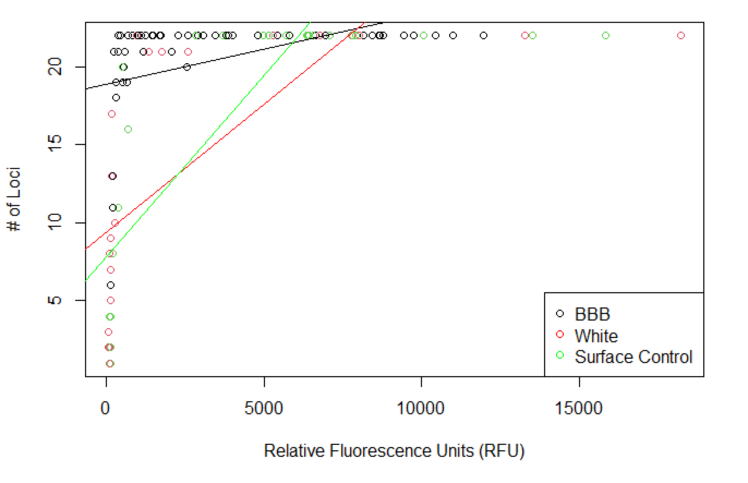
Figure 4.6 # of Loci and RFU Recovered by Condition

# of Loci Amplified and Quantitation by Condition
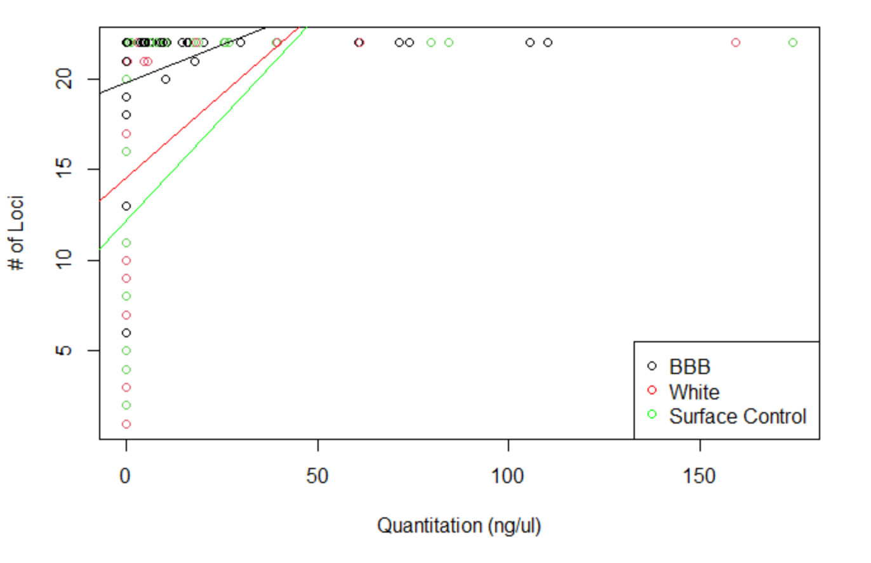
Figure 4.7 # of Loci Amplified and Quantitation by Condition
Recovered by Condition

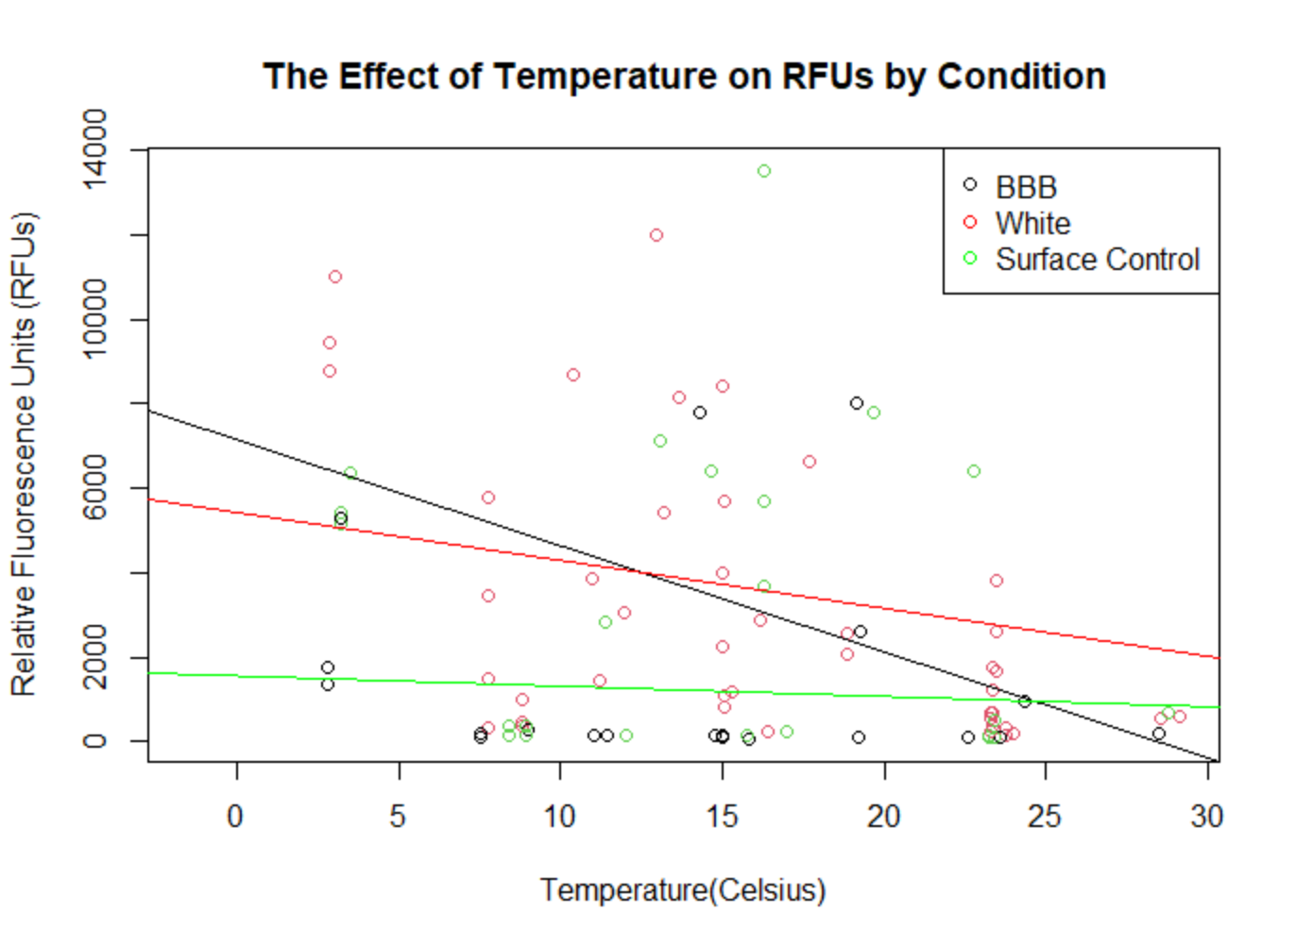
Figure 4.8 The Effect of Temperature on RFUs by Condition

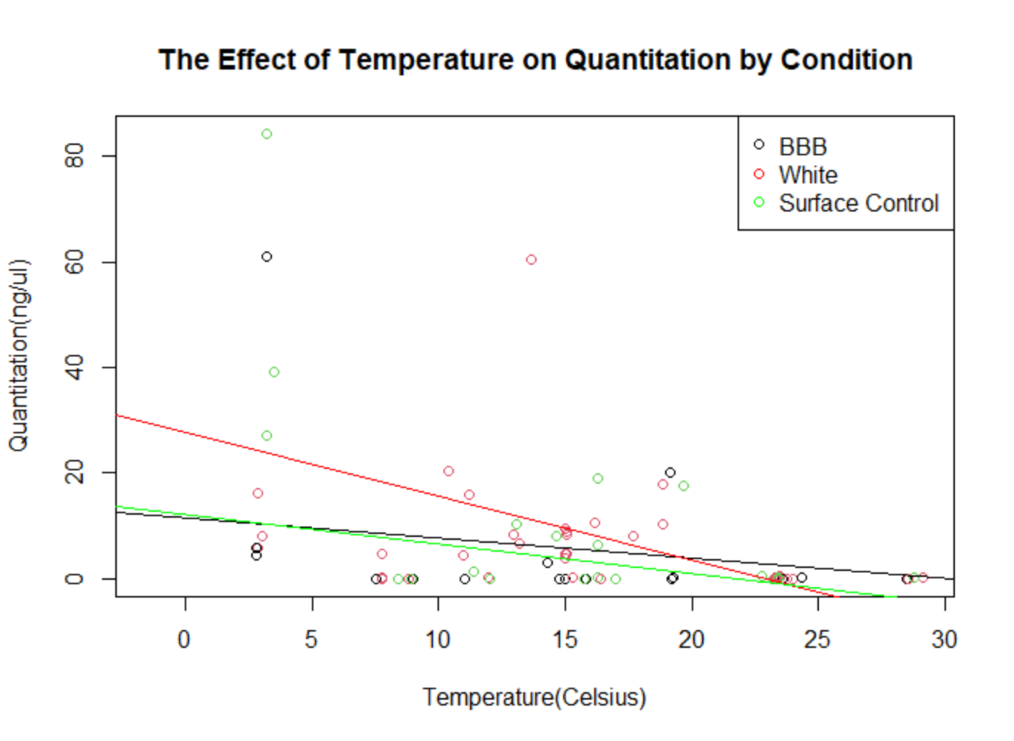
Figure 4.9 The Effect of Temperature on Quantitation by Condition
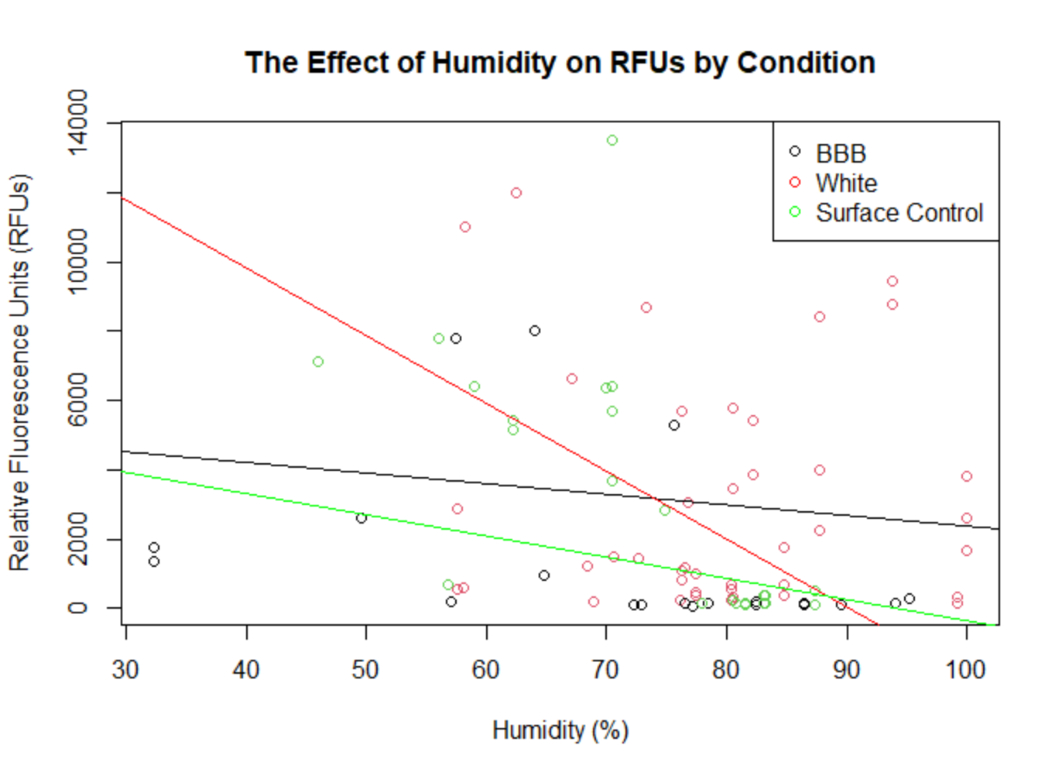
Figure 4.10 The Effect of Humidity on RFUs by Condition
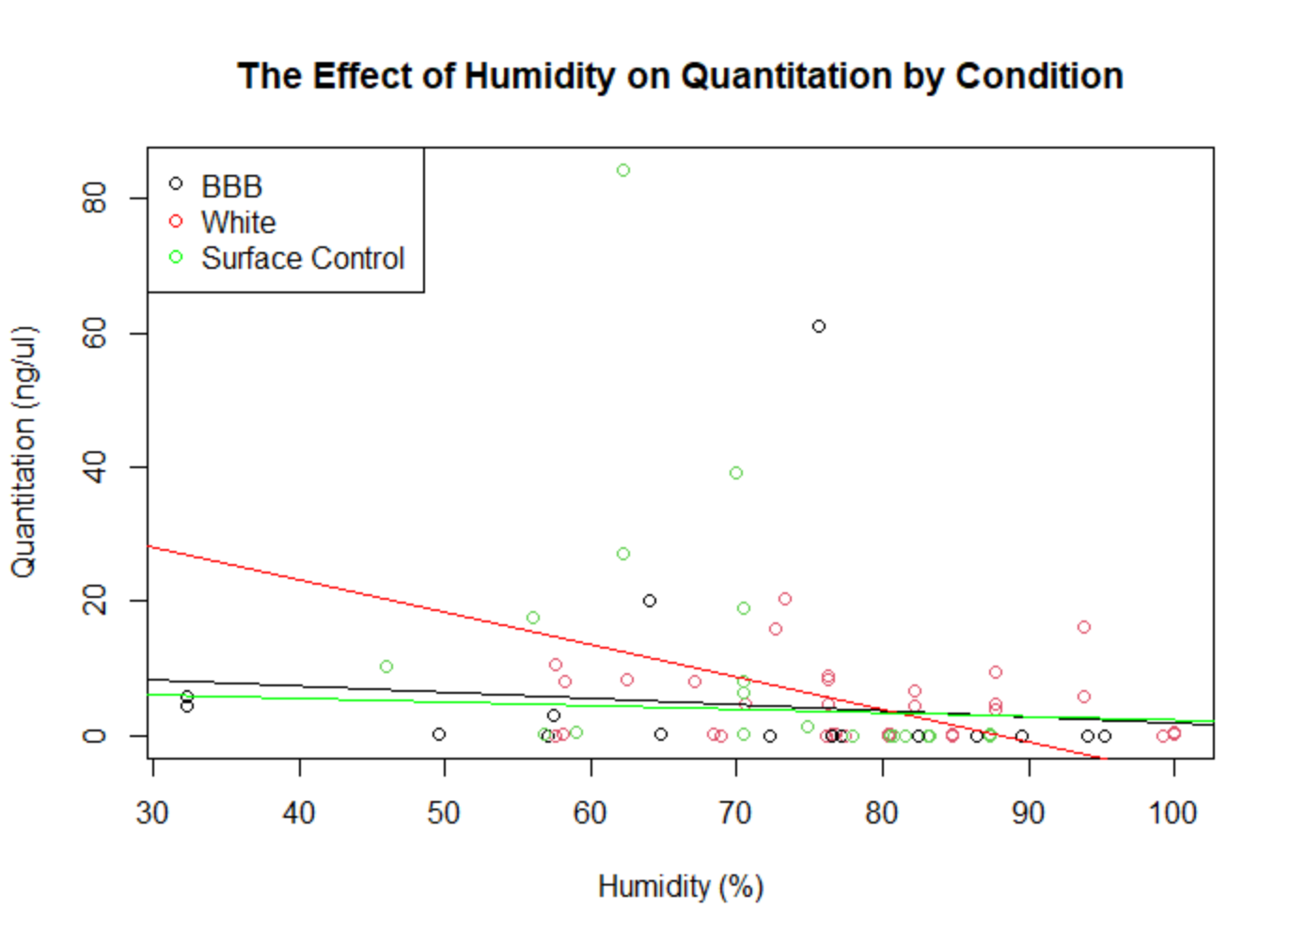
Figure 4.11 The Effect of Humidity on Quantitation by Condition

User-Experience
The following reflects notes and impressions by the researchers (the author and project assistant) on the usability of the BBB from a field technician perspective. This includes carrying the bags, issues with the BBB seal, and overall ease of use of the BBB.

Conclusions from Experiment 1
The BBBs had a marked odor upon opening in all these trials. Liquid from the bag was unable to escape the BBB as compared to the white body bag where it could exit through the zipper or surface control where the liquid was free to evaporate. This odor was extremely noxious and resulted in the researchers’ eyes burning due to the sulfuric quality of the smell. In subsequent experiments where the seal failed or the bag was opened during experimentation, the smell was greatly lessened.

Conclusions from Experiment 2
From Trials 2.1 and 2.2 researchers surmised that it was perhaps not the seal keeping the bag closed but rather the actual vacuuming out of the air that strengthens the seal. Though in previous trials, blood had pressed on the seal of the BBB throughout experimentation, no BBB had yet had a total seal failure prior to this experiment. The bag had been opened and scavenging had taken place within these trials, an occurrence which did not happen in any of Experiment 1’s trials.

Conclusions from Experiment 3
From Trial 3.1 and 3.2, it was hypothesized that repeated opening and closing of the seals weakened their ability to stay airtight. The seals of both BBBs failed in this trial. Air would enter each of the bags within a few days of resealing the bag. Additionally, it became more difficult to seal the bag well as time continued. Researchers estimated that this was due to the repeated tight vacuum closure, which eventually distorted the thin plastic seal mechanism. By the third (and last) time researchers had to reseal the bag, the seal had become very loose. One benefit to the repeated opening and closing, though, is that the noxious smell that had come to characterize the BBB donor on the last day was not present. The smell was significant but not noxious.
During these trials, while pumping the air out midway in the experiment, researchers pumped out decomposition fluid onto themselves. When operating the pump, it suctions up the contents of the bag, be it decomposition fluid or air. In our case, since the donor was on a slight slope and the hole for pump was located along that lower half, researchers pumped out fluid onto themselves and contaminated the pump. This not only is a biohazard risk but also carries implications of introducing these microorganisms and contaminants into other body bags should the pump be reused.

Overall Trends Observed
The vacuum seal must be truly airtight for the BBB to remain unbloated as the pressure keeping the bag shut must be higher than the pressure of the decomposition gases exiting the donor within the bag. If the bag is allowed to continue bloating, it may pop along the seams or seal, resulting in a hole where insects could enter the bags. The bloat described can be visualized in Figure 6.30 in Appendix A. Overall, however, the BBB was better at preventing insects from entering the bags as compared to the white body bag, where insects could enter through the zipper. In regard to scavenging, it is difficult to say which bag prevented scavenger access more effectively. In cases where the white body bag was opened by scavengers, oftentimes the BBB seals had also failed and scavengers had entered the BBB as well.
Additionally, throughout the course of experimentation, researchers found the BBB not intuitive to use due to its boat shape. The seal was also difficult and time consuming to use, and ultimately did not hold in many cases where the vacuum seal was not used or failed. Pumping the air out of the bag required minimum two people per bag where they had to take breaks afterwards, therefore limiting the number of BBBs that could be sealed within a period of time. Additionally, resealing the bags after use is not so simple as using the zipper either; in the time that the BBB was open, insects could enter the bag. In the event of inclement weather, which researchers experienced, the BBBs seal upon opening was caked in mud and unable to be resealed. The white body bag, in comparison, was intuitive to use and easily opened and closed.

APPENDIX A

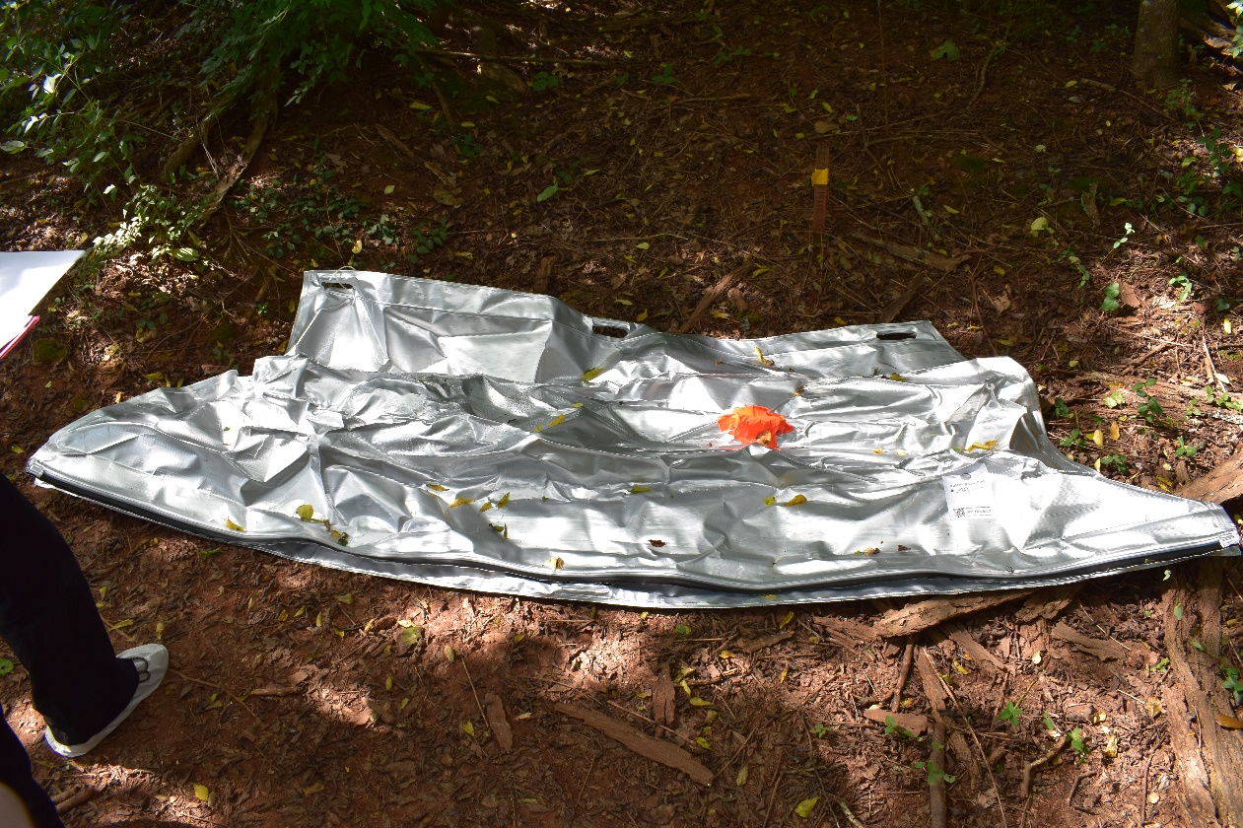
Figure 6.1 Photo of BBB with Ibutton Taped to Exterior

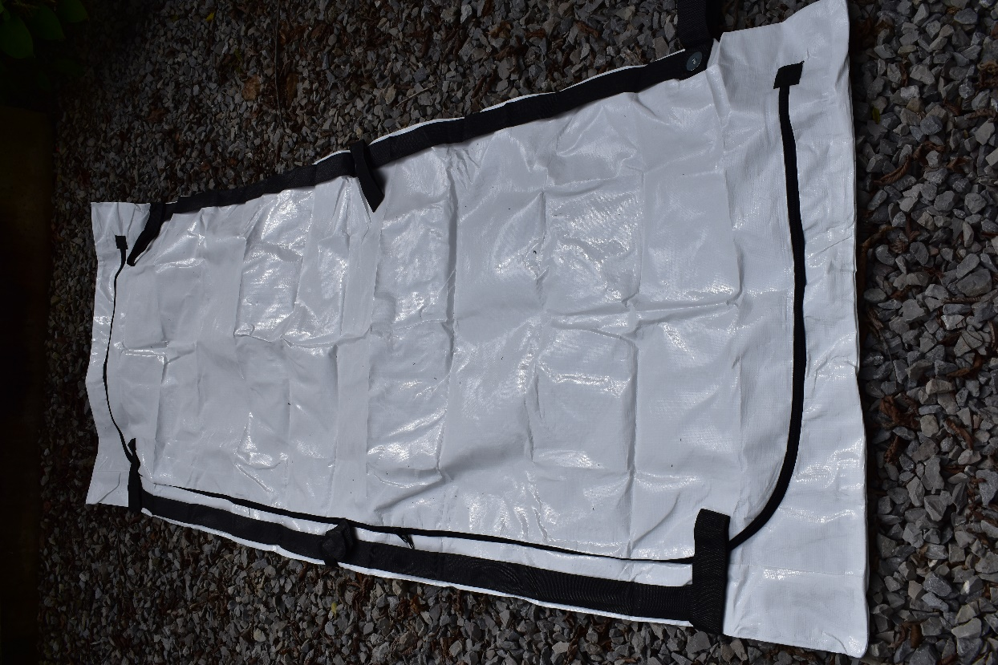
Figure 6.2 White Body Bag Before Ibutton was Taped to Exterior

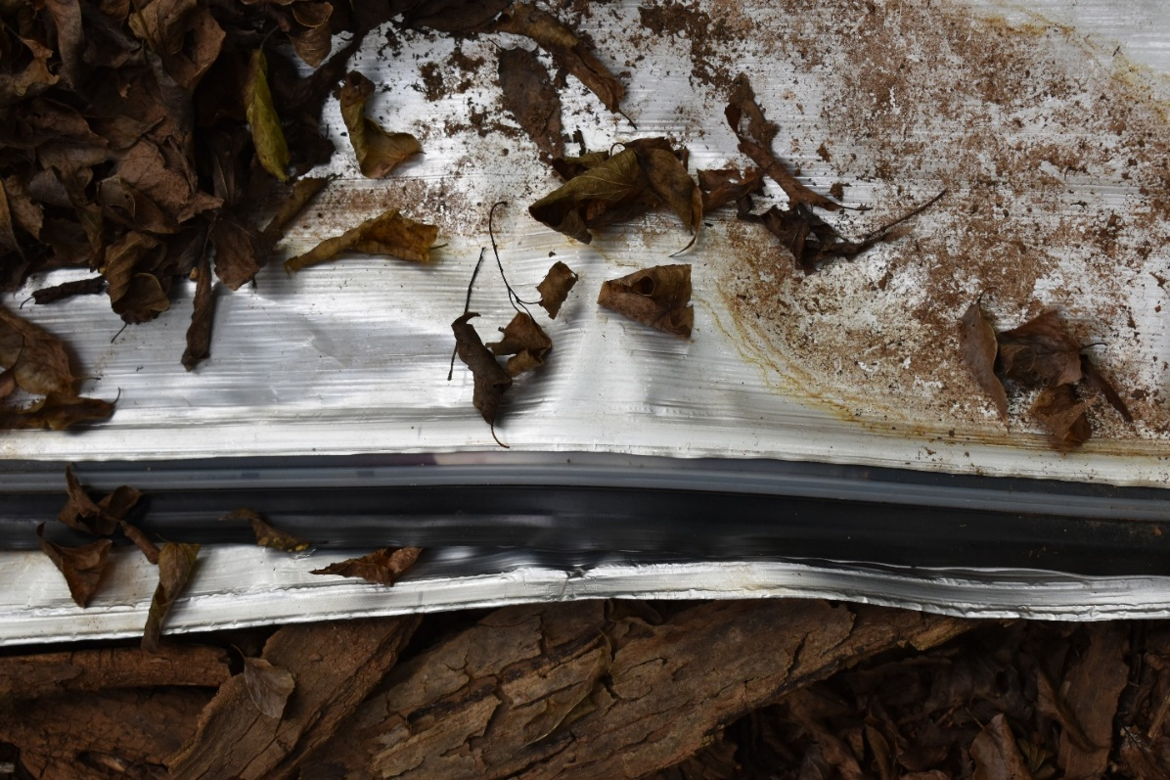
Figure 6.3 Experiment 1.1: Blood Pressing on Seal of BBB (where red arrows point)

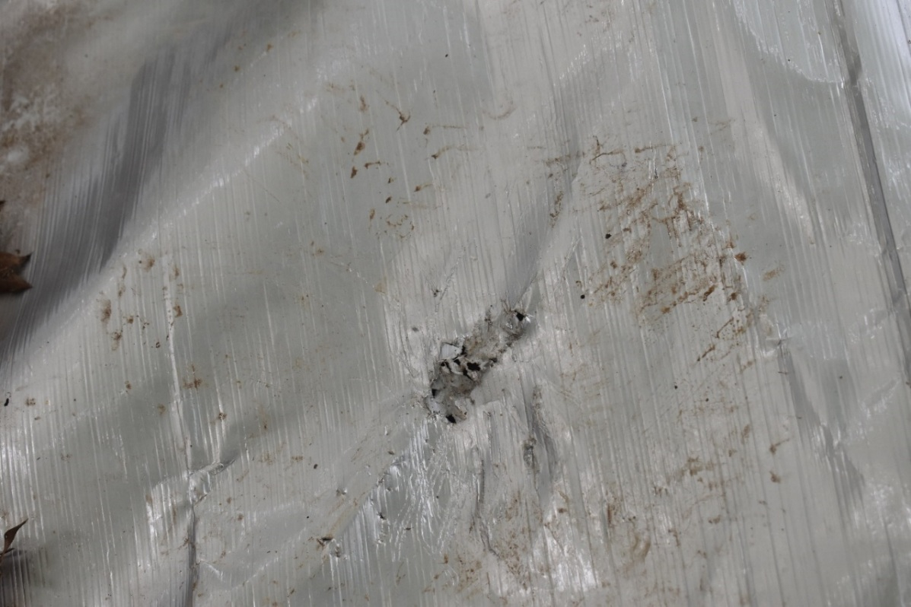
Figure 6.27 Punctured BBB with prints surrounding the hole

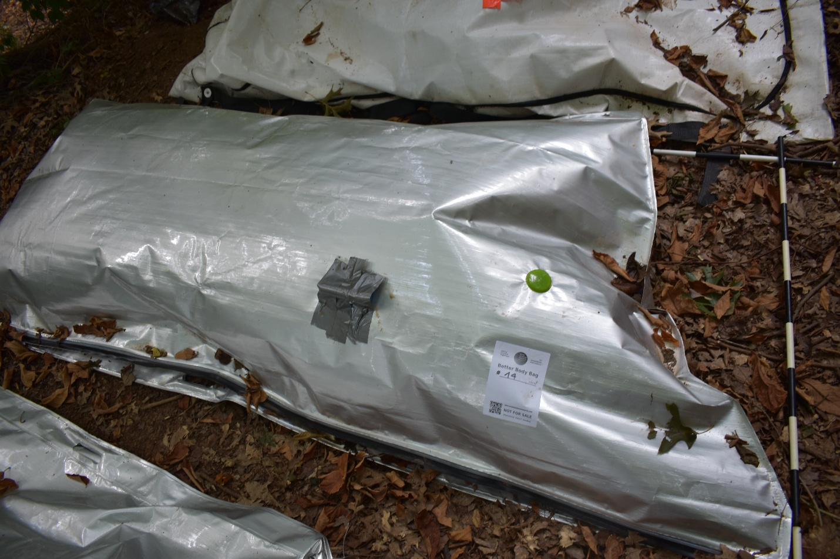
Figure 6.30 BBB Bloating

Vita
Serena Thariath was born and raised in the Chicagoland area. She attended the University of Michigan in Ann Arbor and graduated with a major in Evolutionary Anthropology and a minor in Crime and Justice in 2018. After spending a gap year working in a genetics laboratory for Michigan Medicine, Serena began her Master of Arts degree in 2019 under Dr. Dawnie Steadman. During her time at UTK, she has taught both human osteology and forensic anthropology courses to undergraduates, while additionally documenting decomposition as a daily photos photographer. She will receive her Master’s in Anthropology in December 2022 before continuing on to attend a post-baccalaureate pre-health program at Northwestern University.

