A Model for the Rapid Distribution of Critical Medical Countermeasures to Large U.S. Populations During a Public Health Emergency via the SNS-RSS-POD System

A Dissertation Presented for the
Doctor of Philosophy
Degree
The University of Tennessee, Knoxville

Roger Ivan Fiske
August 2015

Copyright © 2014 by Roger I. Fiske
All rights reserved.

DEDICATION

This dissertation is dedicated to the men and women who serve our country in the various governmental agencies and private sector organizations that design, operate, and support the complex emergency response programs that we all hope will never be needed.

ACKNOWLEDGEMENTS

I wish to acknowledge and thank my advisor and Doctoral Committee Chairman, Dr. Rapinder Sawhney, for his guidance and support on my Ph.D. journey.

I wish to acknowledge and thank my Doctoral Committee: Dr. Rapinder Sawhney,
Dr. Andrew J. Yu, Dr. Xueping Li, and Dr. David B. Clarke. I greatly appreciate their wisdom, guidance, support and encouragement.

I wish to acknowledge and thank Dr. Andrew J. Yu for his special assistance in the preparation of this dissertation.

I would further like to recognize and thank the members of the Tennessee Department of Health Emergency Preparedness Program, especially Dr. Paul E. Petersen and Robert F. Goff, for their progressive leadership in this field of public health. This team supported my research, offered insights, and graciously allowed me access to training exercises, meetings, and appropriately limited sensitive information regarding the SNS-RSS-POD system.

Finally, I would like to thank my family for their support of my pursuit of a Ph.D.
ABSTRACT

In the event of a large scale public health emergency in the United States, the need for emergency medical supplies may quickly exceed existing local and regional resources. In these circumstances, specific life-saving countermeasures may be released from the CDC (The United States Centers for Disease Control and Prevention) Strategic National Stockpile (SNS) and delivered to local Points of Dispensing (PODs) via a rapid emergency distribution system that involves multiple governmental agencies and private sector organizations. Included in this distribution system are temporary Receiving, Staging, Storage (RSS) warehousing operations. One of the primary objectives of this SNS-RSS-POD system is to treat the last person in need in the last active POD within 48 hours of the decision to activate this system. There is a concern that under certain conditions, some PODs may not have sufficient service (treatment) time to meet this 48 hour objective. This study explores this concern and focuses primarily on increasing the amount of available service time for the last active POD (and the other PODs) by reducing process times elsewhere in the system. A model is presented for designers and operators of these systems to assess their system, predict which POD is expected to be the last active POD, and estimate the amount of available service time for that last active POD. Further, utilizing Critical Path Methods (CPM), opportunities for process improvements are examined and recommendations are offered. A supporting mathematical model is developed that represents the SNS-RSS-POD system in terms of overall system time as well as time spent in individual subsections of this system. Recommended improvements are introduced into this mathematical model to assess the potential impact of implementing these changes. Finally, another supporting mathematical model is developed that expresses the potential impact of these recommended improvements in terms of human lives saved during a public health emergency under certain conditions in which the overall capability of the SNS-RSS-POD system is challenged.
PREFACE

Some large scale public health emergencies may be the result of terrorist activities. These terrorist events might include secondary activities that are intended to disrupt the emergency response systems. Accordingly, many of the details about these systems are considered sensitive, classified, or confidential; and are therefore protected from Freedom of Information access.

Information used in this study has been obtained from academic literature, official government web sites, and by simple experimentation (pulling carts, lifting boxes, etc.) to estimate unavailable actual data. Other information used in this study was obtained from personal observation and participation in various training and planning activities involving both multiple governmental agencies as well as some private sector organizations. In these situations, the scope and nature of the shared information was appropriately limited. Although based on reality, any information used in this study, such as the identification of actual medical supplies, site locations, projected travel times, and estimated populations to be served, has been coded or altered in such a manner as to protect this information without compromising the validity of the analysis.

It should be noted that every local response system is unique in terms of geographic features, infrastructure systems, population size and distribution, available resources, etc. This uniqueness will be further complicated by the unknown and disruptive nature of the event or situation that triggers the public health emergency. Accordingly the presented model is intended to be utilized on a more universal level by focusing on common strategic concepts that might be considered in the design, implementation, and operation of these local programs. However, once the presented conceptual model has been populated with either local data or expert opinion, the model may be utilized to explore and assess the impact of selectively changing individual variables or parameters.

TABLE OF CONTENTS
CHAPTER I: INTRODUCTION 1
Structure of this Study 1
Structure of the SNS-RSS-POD System 2
Emergency programs involving the SNS-RSS-POD system 3
The 12 Hour Push Package 3
Managed Inventory Program 4
Cities Readiness Initiative (CRI) 4
The SNS-RSS-POD 12-Hour Push Package Program 5
Objectives, Guidelines, and Features of the 12 Hour Push Package Program 6
"Current State" SNS-RSS-POD Model 7
Problem Statement 7
A Strategic Focus on the Last Person in Need in the Last Active POD 9
Public Health Perspective - Anthrax 9
Time: The Key Metric 15
Available (POD) Service Time versus Required (POD) Service Time 20
A Holistic Approach to Increasing Available Service Time in the Last Active POD 20
Chapter Organization 24
CHAPTER II: LITERATURE REVIEW 25
Public Health Perspective 34
Operations Perspective 35
Time as the Key Metric 36
CHAPTER III: METHODOLOGY 38
“Future State” SNS-RSS-POD Model 39
The Fiske Model 39
Critical Path Method (CPM) 44
The Mathematical Model 44
CHAPTER IV: CASE STUDY 59
The “Current State” Model 61
The “Future State” Model 79
Comparing the “Current State” with the “Future State” 96
Time Comparison 96
Time Saved = Lives Saved 101
CHAPTER V: Verification, Validation, Conclusions 107
Model Verification 107
Model Validation 108
Conclusions 109
Contributions of this Research 110
Contribution of These Models 110
LIST OF REFERENCES 113
APPENDIX 117
Appendix A: Notations 118
Appendix B: Recommendations 123
Vita 128

LIST OF TABLES
Table 1: Gaps in Literature 26
Table 2: Initial Basic POD Information for “Current State” 62
Table 3: Additional “Current State” Data and Expert Opinions 63
Table 4: Initial Required (POD) Service Times 68
Table 5: RSS to PODs and POD to POD Travel Times (minutes) 71
Table 6: “Current State” Route Schedules and Delivery Times 73
Table 7: Summary of “Current State” Metrics 75
Table 8: Additional Initial Information and Expert Opinions 84
Table 9: Revised Required (POD) Service Times 86
Table 10: Direct RSS to POD Travel Times (TP_{i}) 90
Table 11: Identification of the Last Active POD (POD_{LAP}) 93
Table 12: Sequence of POD Order Fulfillment (Ps_{i}) and T4_{LAP} 94

LIST OF FIGURES
Figure 1: "Current State" SNS-RSS-POD Model 8
Figure 2: Cumulative (Anthrax) Attack Probability- [Brookmeyer (2005)] 12
Figure 3: Incubation Period of Anthrax in Humans– [Brookmeyer (2005)] 13
Figure 4: Efficacy of Treatment versus Delay in Treatment [Wilkening (2008)] 14
Figure 5: Model of a Microbial (Anthrax) Event without Intervention 17
Figure 6: Model of a Microbial (Anthrax) Event with Timely Response 18
Figure 7: Model of Microbial (Anthrax) Event with Delayed Response 19
Figure 8: Impact of a Holistic System Paradigm 23
Figure 9: “Future State” SNS-RSS-POD Model 40
Figure 10: The Fiske Model 41
Figure 11: “Grid Map” of RSS – PODs Service Area 60
Figure 12: “Current State” Critical Path from Airport to RSS Times 65
Figure 13: “Current State” RSS Pick Area Layout 66
Figure 14: Initial Required (POD) Service Times (T5) 69
Figure 15: “Current State” RSS POD Service Area “Map” 70
Figure 16: “Current State” RSS to PODS Routing Map 72
Figure 17: “Current State” Required (POD) Service Times (T5) by Route Delivery Order 76
Figure 18: “Current State” T4 and T5 for PODs 77
Figure 19: Figure 18 Expanded Scale 78
Figure 20: SNS Cargo Plane to RSS Logistics – “Future State” 81
Figure 21: Critical Path in RSS Order Pick Area – “Future State” 82
Figure 22: Revised Required (POD) Service Times 87
Figure 23: Direct RSS to POD Delivery 89
Figure 24: “Future State” T4 and T5 for PODs 91
Figure 25: Figure 24 Expanded Scale 92
Figure 26: Comparison of T2 Highlights 97
Figure 27: Comparison of T3 Highlights 98
Figure 28: Comparison of T4 and T5 Highlights 99
Figure 29: Comparison of “Current State” and “Future State” Capabilities 100
Figure 30: Comparative Histograms of POD Start of Operations Times 102
Figure 31: Expected Anthrax Survival Curve (T_{i}) 103
Figure 32: Estimated Lives Saved by POD Area 105
Figure 33: Lives Saved as a % of the POD Area Population 106

CHAPTER I: INTRODUCTION

In the event of a large scale public health emergency in the United States, the need for emergency medical supplies may quickly exceed existing local and regional resources. In these circumstances, specific life-saving countermeasures may be released from the CDC (The United States Centers for Disease Control and Prevention) Strategic National Stockpile (SNS) and delivered to local Points of Dispensing (PODs) via a rapid emergency distribution system that involves multiple governmental agencies and private sector organizations. Included in this distribution system are temporary Receiving, Staging, Storage (RSS) warehousing operations. One of the primary objectives of this SNS-RSS-POD system is to treat the last person in need in the last active POD within 48 hours of the decision to activate this system.

The SNS was originally established in 1999 as the National Pharmaceutical Stockpile (NPS) because of growing concerns of bio-terrorist attacks [DHHS (2010)]. CDC activated the NPS response system for New York City following the attacks of September 11, 2001 and the post “911” anthrax attacks. In 2003, the NPS became the SNS [DHHS (2010)]. Since then, the SNS program has expanded its response capabilities to include other large scale man-made situations as well as major natural disasters. For example, the CDC activated the SNS-RSS-POD system for the Gulf Coast areas hit hardest by Hurricane Katrina in August of 2005.

Structure of this Study
The SNS-RSS-POD system is still a relatively new and evolving program from a research perspective. This study will focus on time as the key metric of interest. The main model (named the Fiske Model) is a methodology for converting initial data into units of time in order to stimulate and support process improvement activities while generating a strategic analysis of the overall system capability in terms of time saved and human lives saved. The Fiske Model creates and utilizes a supporting process flow model (named the SNS-RSS-POD Model) in which various time segments from population exposure to treatment are identified and analyzed. The Fiske Model will employ CPM (Critical Path Method) principles to identify opportunities to reduce time spent in many of these time segments. The Fiske Model will also create and utilize a Mathematical Model to organize and convert many operational variables and parameters of the SNS-RSS-POD system into units of time. A subcomponent of the Mathematical Model will utilize Microsoft Excel Solver to optimize a key time metric called Available Service Time for the Last Active POD. Based on academic literature [Brookmeyer (2005), Wilkening (2008), Stroud, C., et al. (2011)] additional supporting models are developed to stress the urgency of time in the both the onset of symptoms and the outcome results from exposure to anthrax.
Since an aerosol inhalation anthrax bio-terrorist event is one of the more time sensitive public health scenarios for the SNS-RSS-POD system, it will be a focus of this study.

Structure of the SNS-RSS-POD System
The exact numbers and locations of the SNS warehouses are considered to be sensitive information. However, they are networked and located so as to be able to deliver emergency medical supplies to any RSS location in the United States or its territories in 12 hours or less from the decision to activate this system. These warehouses are active on-going operations that receive, store, rotate (where appropriate) stock, and remain ready to deploy medical supplies on short notice. In some aspects, SNS warehouses are similar to fire stations in that the majority of their resources are spent in preparation for the alarm.

The exact numbers and locations of RSS operations are also sensitive information. As with the SNS warehouses, the RSS operations are networked so as to cover for each other in the event that one or more are unavailable. These operations are generally set up on a temporary basis in a large open floor facility such as a convention center, gymnasium, or warehouse. Amongst other requirements, RSS operations need to be able to function without electricity supplied via the local power infrastructure. Thus, by its very nature, it must have a simple yet robust design which is heavily dependent on manual labor. In essence, the operation consists of picking cases of medical supplies from the large transport containers and distributing these cases of supplies to meet the needs of the various area PODs.

The PODs are the locations where this system interacts with the public. On a simplistic basis, PODs are large volume clinics where people in need of service or treatment can go to receive lifesaving medical countermeasures. While the majority of PODs are considered “open” to the public, there are also “Closed PODs” (CPODs) that are designed to service or treat defined populations within large organizational entities such as universities, corporations, military bases, government complexes, etc. In some situations, CPODs may service populations with limited mobility (health care facilities) or other travel constraints (prisons). In addition to serving specific populations, CPODs also relieve pressure (demand) on the local “open” PODs servicing the rest of that area.

The SNS is managed by the federal (CDC) government. However, the RSS and POD operations are managed by state, territorial, tribal, and local health agencies. Responsibility for the released SNS supplies is formally transferred from the CDC to the appropriate health agency upon delivery at the RSS.

Emergency programs involving the SNS-RSS-POD system
There are three emergency programs that utilize the SNS-RSS-POD system or at least a significant portion of this system. They are the 12 Hour Push Package Program, the Managed Inventory Program, and the Cities Readiness Initiative. Since the 12 Hour Push Package Program appears to be the structure foundation for these other programs, it is being introduced first, but will be discussed later in further detail.

The 12 Hour Push Package
The 12 Hour Push Package may be the initial emergency response shipment of medical countermeasures from the SNS to an impacted area. The 12 Hour Push Package contains general medical supplies for a variety of situations and may be deployed while the exact nature and extent of the event are still unknown. For this study the 12 Hour Push Package will be divided into two unofficial categories based on the level of situational urgency. The first category will be the urgent response scenarios such as a natural disaster (Hurricane Katrina) where supplies, such as IV solutions, gloves, masks, etc. are needed to supply or replenish supplies to treatment centers such as hospitals, clinics, triage units, etc. The second category will be the critical response to very time sensitive scenarios such a nuclear reactor explosion or a biological (anthrax, etc.) terrorist attack. Within the 12 Hour Push Package there are specific medical counter-measures for these time sensitive situations. The primary distinguishing feature of these two categories may be the RSS to PODs logistics. In the first scenario heavier and bulkier supplies may be transported in a more traditional manner utilizing delivery trucks with sufficient time to consider logistical options such as routing. The second scenario, however, may just involve compact cartons of antibiotics, etc. which could be delivered directly to each POD utilizing emergency vehicles such as auxiliary police cars. This second scenario will be the focus of this study due to the higher potential loss of life as a function of time spent in the response system.

Managed Inventory Program
The second program that utilizes at least a portion of the SNS-RSS-POD system is the Managed Inventory Program. This program may not be as time sensitive as the 12-Hour Push Package program. It is generally activated after an initial assessment of the event has been made. It contains specific supplies for a specific situation or to replenish supplies already sent in a 12-Hour Push Package. These supplies may be shipped to the RSS from a SNS warehouse or directly from vendors through existing SNS-vendor agreements utilizing more traditional warehousing and transportation logistics. There appears to be an abundance of traditional supply chain research and literature that may be applicable to this situation. This program may be an area for future research.

Cities Readiness Initiative (CRI)
The third program is the Cities Readiness Initiative (CRI). This was created by the CDC in 2004. It is intended to enhance and focus on the preparedness of our largest U.S. population centers against a possible bioterrorist (i.e. anthrax) attack. There are currently 72 cities or metropolitan areas in this program. Like the 12 Hour Push Package, the objective of the CRI program is to dispense antibiotics to the entire impacted population within 48 hours of the decision to activate this program. One might assume that some SNS warehouses may be strategically located near these high population areas for very rapid SNS to RSS response times. Further, this program considers the option to utilize the U.S. Postal Service to deliver antibiotics to the population in these areas in addition to or in lieu of POD operations. While this program should indirectly benefit from this study, it should be considered as an area for future research.

The SNS-RSS-POD 12-Hour Push Package Program
The 12 Hour Push Package Program has already been introduced. To further examine this program a hypothetical case study involving an aerosol inhalation anthrax bio-terrorist attack will be considered since urgent response counter-measures against this particular event appear to be incorporated into the basic design of the current system. Since this study is exploring “certain circumstances” in which there may be a concern over the capability of the SNS-RSS-POD system, this case study will consider the additional challenges of a combined air and ground delivery scenario.

The 12-hour Push Package consists of approximately 130 color coded and numbered containers that are filled with cases of various medical countermeasures [CDC (2005)]. The interpretations of the coding as well as the exact medical resources are almost irrelevant to this analysis and are therefore not identified. There are two sizes (tall and short) of containers and they are shaped so as to be configured into a load that fits within a large cargo plane. The footprint of each container is 43 inches by 60.5 inches [CDC (2005)]. The delivery of the 12-hour Push Package from the SNS to the RSS in this case study will involve both air and ground transportation. In this situation, SNS assets are loaded into a cargo plane which flies to an airport near the RSS. The assets are then unloaded from the plane into 8 trucks and transported to the RSS. At the RSS, cases of supplies are picked from the containers to fulfill POD orders which are then shipped to the PODs for distribution to the impacted population.

Objectives, Guidelines, and Features of the 12 Hour Push Package Program
SNS-RSS-POD System Objective #1: SNS to the RSS in 12 hours or less
The first SNS-RSS-POD system objective (called Objective #1 in this study) is to deliver a 12 hour Push Package from a designated SNS warehouse to a designated RSS location in 12 hours (or less) of the decision to activate this system. While details regarding the locations of SNS warehouses and RSS sites are considered as sensitive information, there appears to be sufficient confidence by appropriate authorities that the current system is capable of meeting Objective #1.

SNS-RSS-POD System Objective #2: SNS to the Last Person in Need in 48 hours or less
The second SNS-RSS-POD system objective (called Objective #2 in this study) is to service or treat the last person in need in the Last Active POD in 48 hours or less of the decision to activate this system. The capability of the current SNS-RSS-POD system to achieve Objective #2 under certain conditions is a potential concern. The current status of this concern appears to be a matter of opinion since the system has not been actually activated and formerly tested under a variety of conditions. Limited support for this concern was found in the literature search. This study is intended to offer a methodology by which the capabilities of various regional or local SNS-RSS-POD programs may be assessed outside of an actual event in order to better understand and improve their particular system capabilities. The basic approach of this methodology is to focus on time as the key metric of interest and to consider the timeline of the event beginning with the initial exposure of the population and ending with the treatment of the last person in need in the Last Active POD. The system capability to achieve Objective #2 will be a focus of this study.

SNS-RSS-POD Guideline: Each PODs gets at least 24 hours to service or treat people
While it does not appear to be an official SNS-RSS-POD system objective, there seems to be a common expectation that the PODs will have at least 24 (of the 48) hours to provide services or treatment to their population in need. Some agencies divide the overall 48 hour period into “24 hours to ramp up” and “24 hours to dispense” segments. While not an official objective, this guideline will be considered when evaluating the design of the system model.
Assumed Feature #1: The sooner the treatment the better the outcome
An assumption is being made that the sooner treatment is received the better the outcome of the treatment. This appears to be especially true following the first 12 to 24 hour period after exposure to anthrax spores. This assumption will be applied on an individual basis as well as on an overall population basis.

Assumed Feature #2: A reduced range of start times for all PODs is desirable
An assumption is being made that it is desirable to have a small range of POD start times. In this age of social media and nearly instantaneous communications, a wide range of POD start times may result in unnecessary movements of the impacted population from unopened PODs to those PODs that are actively providing lifesaving countermeasures. Unplanned shifts in populations being serviced at each POD may overburden the active PODs.

"Current State" SNS-RSS-POD Model
The "Current State" SNS-RSS-POD Model (Figure 1) is a process flow diagram with two time periods. The first time period represents the time between the decision to activate the SNS-RSS-POD system and the delivery of the 12 Hour Push Package to the designated RSS facility. This represents Objective #1. The second overlapping time period represents the time between the decision to activate this system and the treatment of the last person in need in the Last Active POD. This represents Objective #2.

Problem Statement
In the event of a large scale public health emergency requiring the activation, release and distribution of a 12-Hour Push Package of medical countermeasures from the Strategic National Stockpile, there is a potential concern that, in certain circumstances, the current SNS-RSS-POD system may not have sufficient capability to meet its mandated objective to service or treat the last person in need in the Last Active POD within 48 hours of the decision to activate this system.

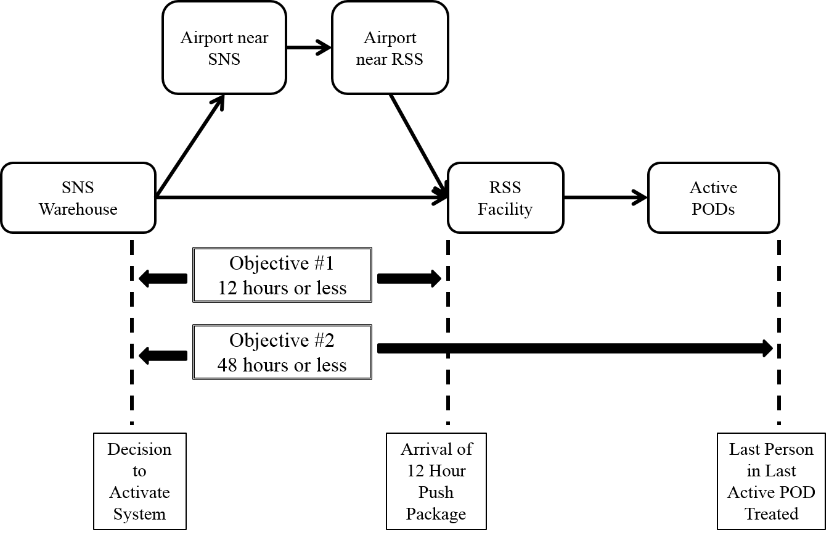
Figure 1: "Current State" SNS-RSS-POD Model

A Strategic Focus on the Last Person in Need in the Last Active POD
Given situations that could easily involve thousands, if not millions of people, a fair question might be why focus on the last person in need in the Last Active POD. One answer is that the last person in the Last Active POD is the focus and metric of Objective #2 which is the primary concern of the Problem Statement. Further, from a model development and analysis perspective as well as from a public health perspective, there are several strategically advantageous reasons to focus on this person. From the latter perspective, assuming the entire population was exposed at the same time, the last person in the last active POD will need to wait the longest to be serviced or treated. Recognizing a host of specific personal variables such as exposure dosage and pre-existing health conditions, a generalization might be made that the longer a person must wait for treatment, the greater the likelihood of being adversely impacted by the causal agent. Thus if the time from exposure to treatment is reduced sufficiently enough to "save" the last person, then everyone else should be "saved" as well.

From a model development and analysis perspective, a focus on the last person in the Last Active POD mandates a better understanding of the entire system while prioritizing where (often limited) process improvement resources might be most effectively applied. Simply identifying which POD is expected to be the Last Active POD will require an analysis of every POD in terms of required service time (POD performance) and available service time (system performance). Furthermore, as resources are applied to improve the Last Active POD, there is a possibility that the POD currently identified as the Last Active POD will no longer qualify as the Last Active POD. Thus process improvement resources will be redirected to the new Last Active POD until it is no longer the Last Active POD. While not specifically included in this study, it should be noted that the process improvement techniques and system recommendations offered in the presented model may (and should be) utilized to assess and manage every POD.

Public Health Perspective - Anthrax
Since this system is only activated when there is an existing or potential large scale public health emergency, a basic introduction of the public health aspects of aerosol inhalation anthrax is appropriate to emphasize the sense of urgency required to save lives by saving time in the response system. By definition, the 12 Hour Push Package is intended to be released while many of the details of the event are still unknown [CDC (2012)]. Consequently, it contains a variety of medical supplies for a variety of situations including natural disasters (hurricane, tsunami, earthquake, etc.), radiation exposures, and biological diseases (anthrax, flu, etc.). While time is always important, some situations are more time critical than others. If the SNS-RSS-POD system is designed handle of the most time sensitive situations than the system should have sufficient capability to function in other situations. Accordingly, this study will highlight aerosol inhalation anthrax which is currently considered amongst the most time sensitive and potentially dangerous terrorist weapons.

Anthrax
There is very little direct data relative to the incubation period of anthrax in human beings [Brookmeyer (2005), Sun (2012)]. The primary source of human inhalation anthrax data is the 1979 outbreak of aerosol inhalational anthrax in the Russian city of Sverdlovsk where anthrax spores were accidently released through an open vent at a military microbiology facility. This “estimated low concentration” of aerosol spores drifted across the city. No intervention measures were taken for several weeks. As a result, 70 cases of human anthrax developed.

Anthrax is a major security concern because the bacterium, Bacillus anthracis, can be found in the environment. Bio-terrorists can weaponize anthrax by creating large quantities of this bacterium in the spore form and releasing these spores into the air over a large population.

When anthrax spores are inhaled into the body, the body begins to clear them from the lungs by expelling them, swallowing them, or destroying them by macrophages. Unfortunately, this process may take several weeks. In the meantime the spores are incubating and may germinate into a vegetative state which will result in the natural production of toxins that are highly lethal for humans. The release of these toxins within the body results in the symptoms exhibited by the patient. Dosage (amount of spores inhaled) and the individual patient’s ability (age, general health, etc.) to clear the spores are factors determining who develops symptoms and how soon they exhibit symptoms [Brookmeyer (2005)]. One of the main treatments for inhalation anthrax is antibiotics. However, antibiotics do not kill spores and do not inactivate toxins. They only impact the vegetative cells. That is the basis for the current 60 day regiment of antibiotics dispensed at the PODs. The antibiotics will hopefully kill the vegetative cells if they germinate before the body can otherwise clear them. Since the toxins cause the clinical symptoms, there are limited treatment options (virtually none at the POD level and very little at an advanced care facility) once the illness has progressed to the point of exhibiting symptoms. While mortality rates may vary with the particular strain of anthrax, the expected mortality rates for those individuals who have advanced to the stage of exhibiting clinical symptoms will be between 80% and 100% [Brookmeyer (2005)].

Figure 2 prepared by Brookmeyer (2005) shows the estimated cumulative attack probability versus time with consideration for the dosage (D) of spores and the clearance rate (θ). This graph illustrates the time sensitivity of this disease and the projected exponential initial outbreak rate within the first few days following exposure.

Figure 3, also prepared by Brookmeyer (2005), is a graph that illustrates the incubation periods from the Sverdlovsk outbreak in which the few early expressions of symptoms are quickly followed by a significant portion of the impacted population.

Figure 4, prepared by Wilkening (2008), represents the efficacy of the treatment program as a function of time after exposure.

To summarize, an aerosol inhalation anthrax event could have very little warning, an exponential outbreak rate, and a high mortality rate. Time, from exposure to treatment, is a critical factor in the successful outcome of the treatment.

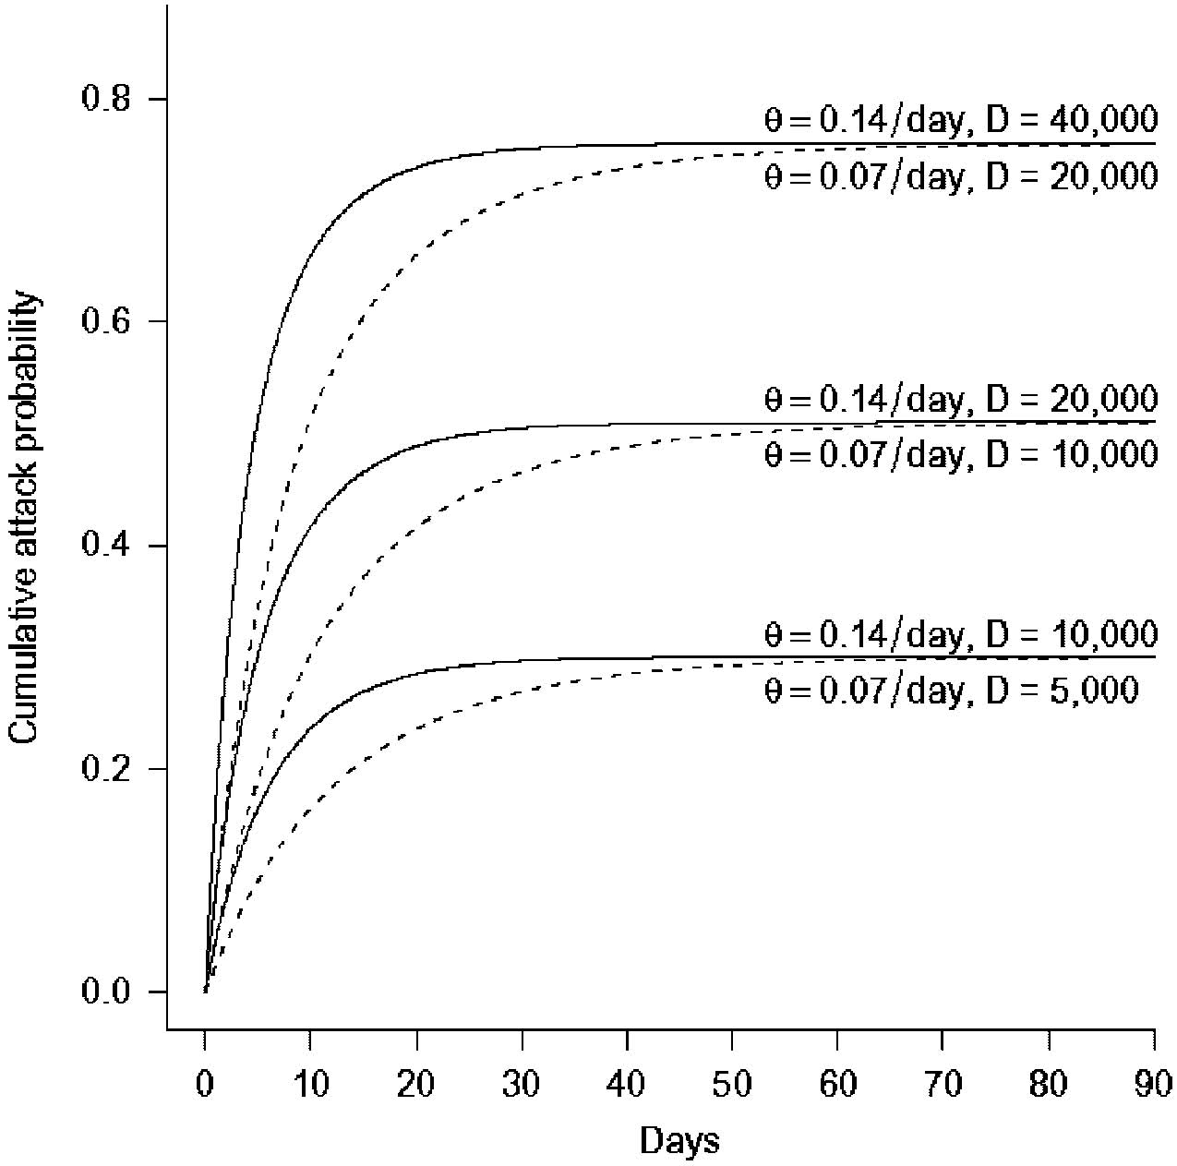
Figure 2: Cumulative (Anthrax) Attack Probability- [Brookmeyer (2005)]

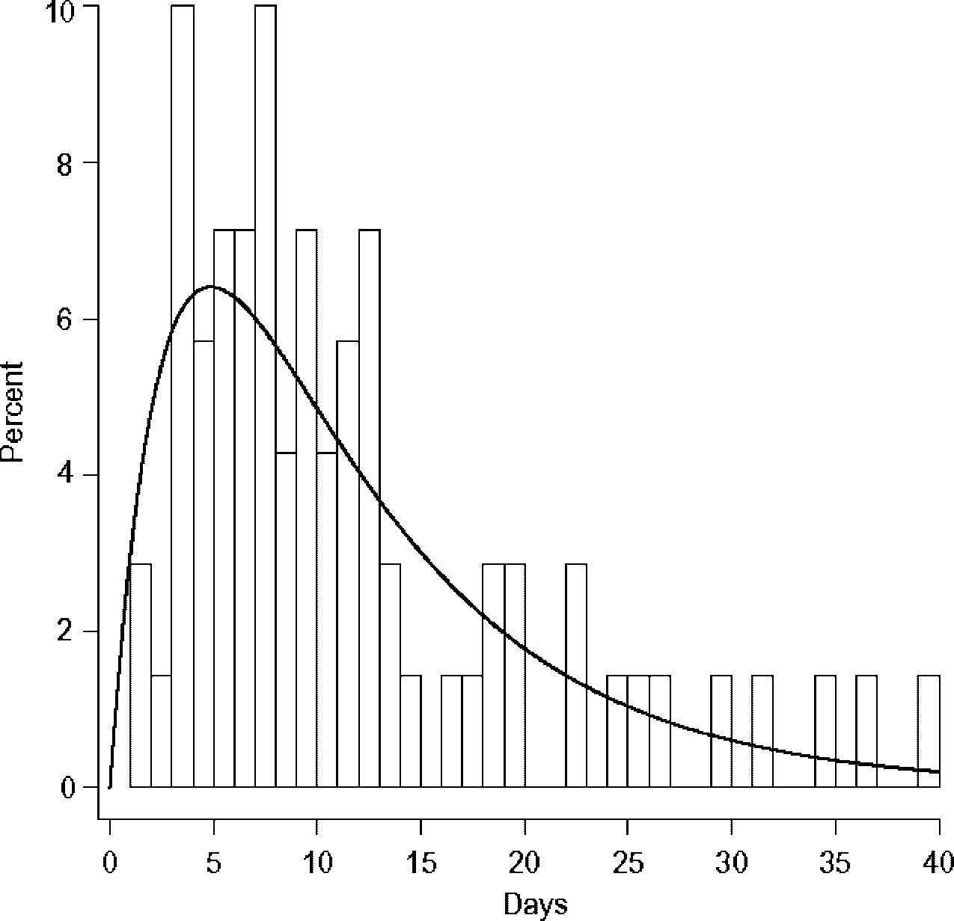
Figure 3: Incubation Period of Anthrax in Humans– [Brookmeyer (2005)]

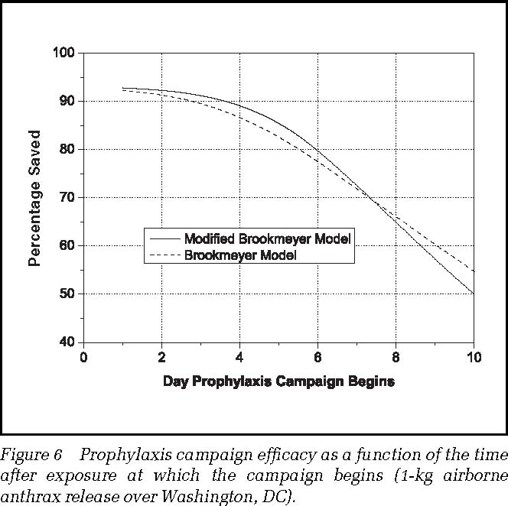

Figure 4: Efficacy of Treatment versus Delay in Treatment [Wilkening (2008)]

Time: The Key Metric
Time is the major system metric of interest. In the "Current State" SNS-RSS-POD model, the system clock starts when the decision is made to activate the system and deploy the SNS assets to a state. The collaborative system objective is to treat the last person in the Last Active POD within 48 hours of this decision to activate. The SNS commitment is to deliver the SNS supplies to any RSS in the country within the first 12 hours. This should leave at least 36 hours, including the time spent in the RSS and delivery operations, for these PODs to collectively treat thousands or potentially millions (in some scenarios) of people. Literally an extra minute spent in the RSS or delivery operation is a lost minute of treating people.

In this study, two distinct and somewhat independent time lines are presented. The first is the timeline of the public emergency from a medical perspective. The second timeline is that of the actual SNS-RSS-POD system. In the "current state" these two timelines are currently not sufficiently coordinated. One of the intentions of this study is to help to close this apparent gap.
To further emphasize the importance of time, it should be noted that there may be significant time differences between the actual commencements of the event, exposure time(s) of the population, recognition of the event, and the subsequent decision to activate the response system.
In some terrorist attacks such of “911”; there was a well-defined and well known event commencement time. However, in a major disease outbreak or certain forms of bio-terrorist attacks; the event commencement time may be initially unknown or even deliberately concealed. In these cases, recognition of the event may not occur until after people with some combination of earlier exposure, higher amounts (dosage) of exposure, and higher physical vulnerability begin to exhibit clinical symptoms such as illness or even death. That point of time may represent the beginning of an exponential population impact with a very small time window for administering effective counter-measures. In these situations, time (in hours and even minutes) can be literally translated into lives saved. Finally for those exhibiting symptoms, there is a mortality period where the chances of survival may be dependent more on the strain of the bacteria than the application of advanced medical treatment.

To illustrate this concern, Figure 5 represents a hypothetical model of a microbial (i.e. anthrax) public health event without any intervention: In this hypothetical model there are five zones:

Time A represents the Initial Population Exposure Time.
Time B represents the Asymptomatic Incubation Period
Time C represents the Early Symptomatic Period for a smaller portion of the exposed population.
Time D represents the Symptomatic Period for the majority of the exposed population
Time E represents the Mortality Period for those with the illness.

In Figure 6 the “Current State” SNS-RSS-POD model (Figure 1 on page 8) is superimposed on top of the event model (Figure 5 on page 17) in a scenario in which the SNS-RSS-POD system was activated in time to effectively treat the entire population in need.

In contrast, Figure 7 reflects a scenario in which the Decision to Activate the SNS-RSS-POD system was not made until after the early exhibition of clinical symptoms in the population and the subsequent recognition by the appropriate experts that a public health emergency has commenced. In such an aerosol inhalation anthrax event, the shaded (red) area under the D portion of the curve represents those individuals who did not receive treatment in time. If people are not effectively treated in a timely manner, a high mortality rate can be expected once the disease has progressed to the manifestation of clinical symptoms. The shaded (red) area under the E portion of the curve represents the expected number of deaths in this event. In this scenario hours and even minutes saved in providing treatment can literally be translated into lives saved

As illustrated in Figure 6 and Figure 7, the SNS-RSS-POD system timeline line is not anchored to the public health microbial event timeline. This represents a weakness in the “Current State” SNS-RSS-POD Model, for which this study will recommend a solution.

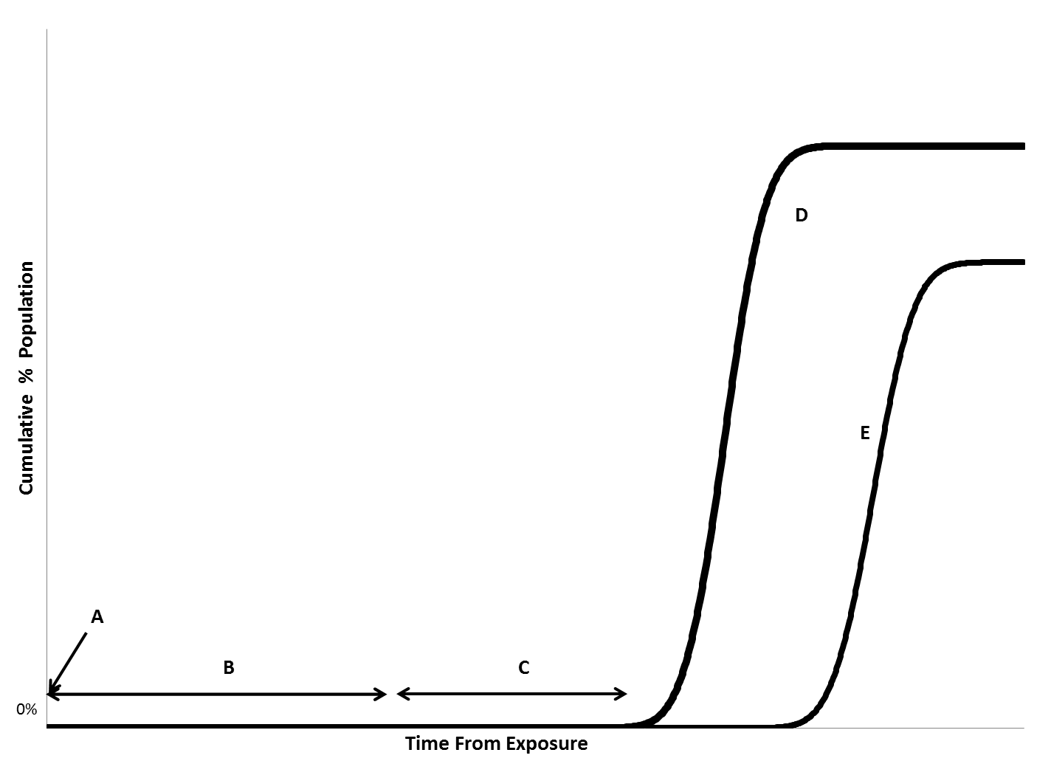
Figure 5: Model of a Microbial (Anthrax) Event without Intervention

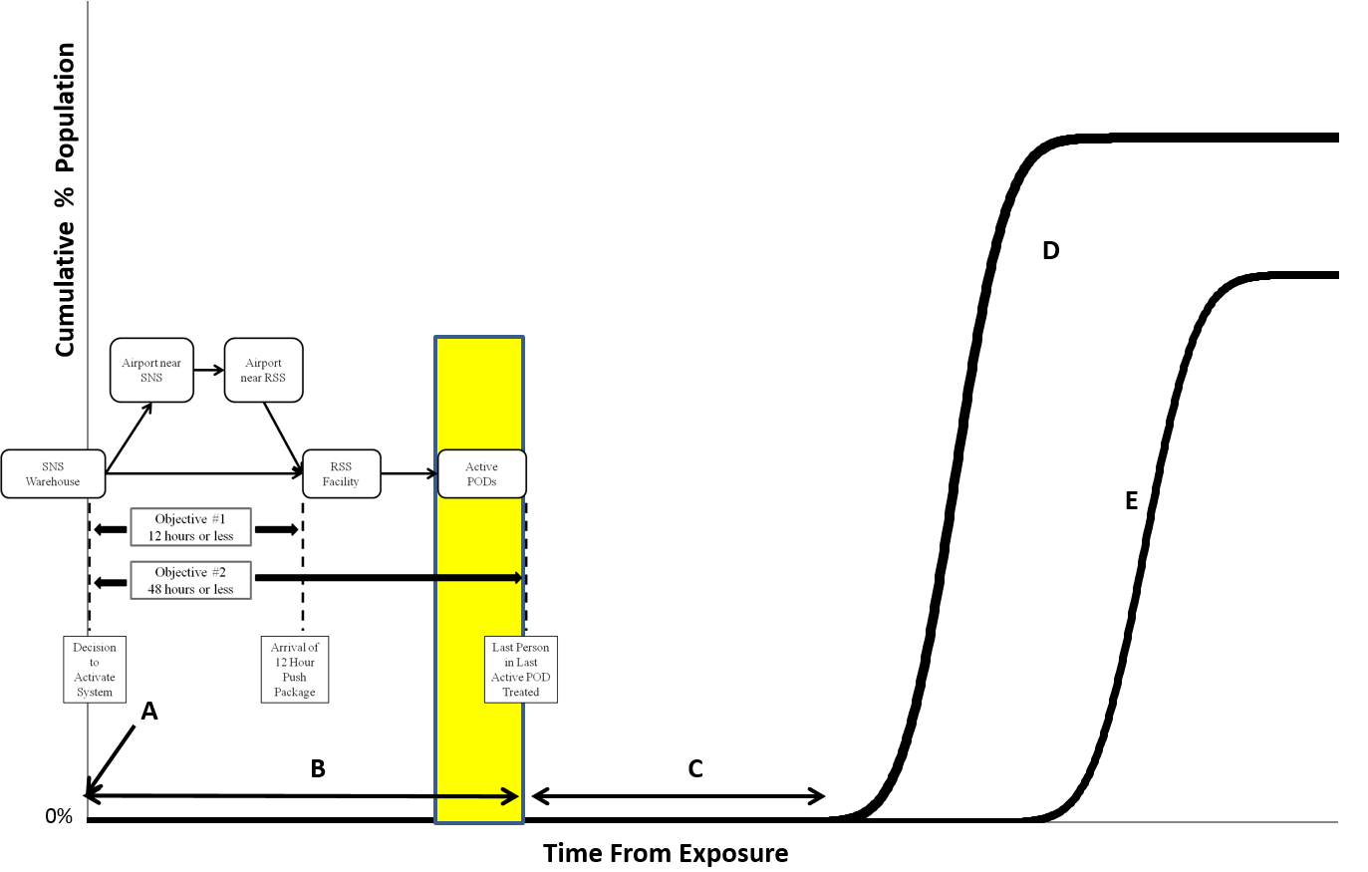
Figure 6: Model of a Microbial (Anthrax) Event with Timely Response

Figure 7: Model of Microbial (Anthrax) Event with Delayed Response
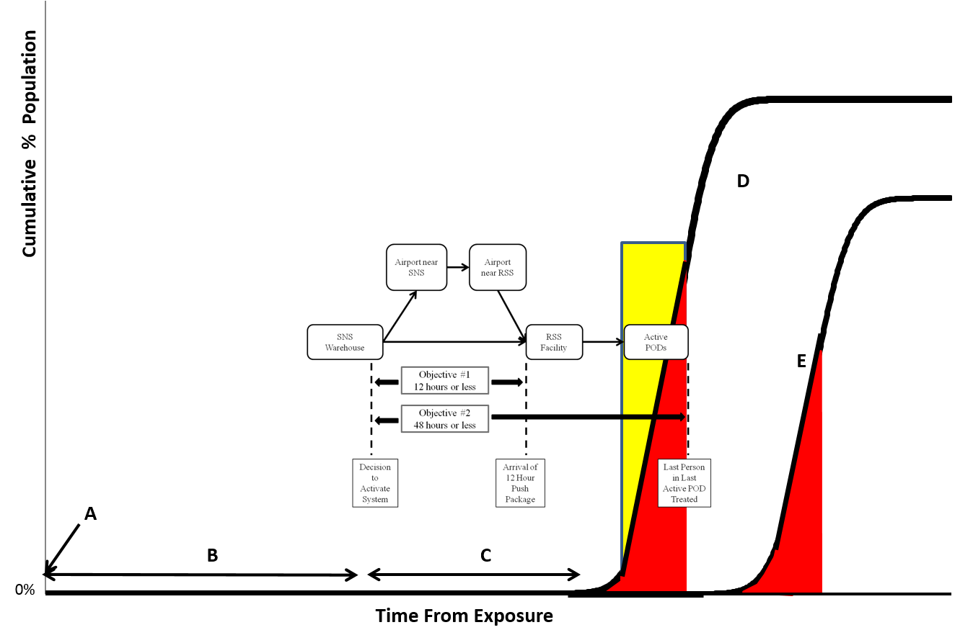

Available (POD) Service Time versus Required (POD) Service Time
A crucial element in this analysis is understanding and appreciating the differences between Available (POD) Service Time and Required (POD) Service Time. Since the 48 hour deadline in Objective #2 is non-negotiable, the objective of servicing or treating everyone in need within that 48 hours is, in essence, a mandate. Available (POD) Service Time is defined as the system time remaining in the 48 hour period after time has been consumed in getting these medical supplies from the SNS warehouse through the RSS operation and to each POD. On the other hand, Required (POD) Service Time is simply the amount of time necessary for each POD to complete its mission to service or treat everyone seeking help at their POD. Factors such as POD throughput rate (people treated per hour) and POD load (number of expected people seeking treatment) must be considered when calculating Required (POD) Service Times. Ideally, Available (POD) Service Time will exceed Required (POD) Service Time; but such an assumption could result in unnecessary pain, suffering, and death. A means of creating more Available (POD) Service Time within this fixed 48 hours period is to simply start the POD operations sooner. Thus the objective of this study is to reduce the amount of time required to get the SNS medical assets to and through the RSS operation and delivered to all of the PODs, especially the Last Active POD. However, since the performance metric for the overall system is based on this Last Active POD, it is essential to know which POD is expected to be the Last Active POD. The Fiske Model will identify the expected Last Active POD; present general recommendations to improve this segment of the process; and project which POD actually becomes the final expected Last Active POD after the recommendations have been implemented.

A Holistic Approach to Increasing Available Service Time in the Last Active POD
While this study will highlight various components of the SNS-RSS-POD system, it is essential to consider these individual components as integrated sub-processes of the overall deployment system. Specific areas that will be addressed are: how the SNS loads their containers and trucks, from the plane to the RSS logistics, the actual RSS process, and the RSS to POD transportation logistics. These all make a significant and inter-related contribution to the overall performance of this system.

In this study, the Fiske Model is utilized to assess "current state" practices and develop a proposed "future state" vision. However, the human reaction to change and the interaction of complex multiple organizational cultures are also significant factors that must be considered in the successful introduction and adoption of these "future state" recommendations.

While recognizing many notable exceptions, an assumption is being made that people and especially organizations (including government agencies) that are involved in complex inter-organizational systems tend to be “silo oriented” (or self-focused) rather than “overall process oriented” (or holistic) in how they behave and conduct their business. This paradigm is reinforced by rules, regulations, budgets, bureaucracy, performance evaluations, personal relationships, career path planning, comfort zones, and personal accountability. For clarification, this assumption also assumes that these people are all wonderful, dedicated, qualified, and well-intended individuals. As a result, silos of responsibility and accountability are created as each silo completes their responsibility and transfers the responsibility for the rest of the process to the next silo.

For example, imagine a multi-agency joint task force meeting to develop the SNS to RSS portion of this supply chain. One silo is responsible for loading the SNS supplies onto 8 trucks while another silo transports the trucks to the airport. Then another silo is responsible for loading the plane. The plane operation is yet another silo. Then there is another silo that is responsible for unloading the plane. The next silo is responsible for getting 8 trucks of product to the RSS. This sequential order of events allows everyone to complete their segment and then transfer the responsibility for the outcome to the next party. This includes convoying all 8 trucks together at one time to the RSS, possibly to accommodate the transportation and security silos. That is a “silo oriented” or “self-focused” system. If this same planning group was “overall process oriented” or holistic, they would focus on the time to get the necessary supplies to the last person in need in the Last Active POD. They would know that their RSS facility and operation is not designed to unload all 8 trucks at the same time. Their experts would estimate that it will take approximately 11 minutes (assumption in this analysis) to unload one truckload from the airplane. Unloading the entire plane to form the convoy would take approximately 88 minutes. Instead of a convoy, if each truck left the airport after being loaded, the RSS could start unloading trucks 77 minutes sooner and everyone would still have met their responsibilities.

As another example, imagine you are a POD manager responsible for placing the initial supply order with the RSS for your specific POD. The impact of this emergency on your POD is still unknown. If you do not order enough supplies, there will be a host of politicians, media groups, bureaucrats, and citizens second guessing you and your decision with their perfect hindsight vision. You can assume that there will be serious consequences for not ordering sufficient supplies. Fortunately for you, in a “silo oriented” or self-focused system there may be few, if any, consequences for you and your POD if you order too much. As a result, potentially limited resources and more importantly precious time will be consumed with your excessive order to the detriment of subsequent PODs to be serviced, but that problem is outside of your silo. In an “overall process oriented” or holistic system, an expert at the RSS level would assess the developing situation from a broader perspective and configure an appropriate (preferably standardized) initial order for each POD.

Whether currently existing or not; an “overall process oriented” or holistic paradigm along with coordinated, con-current activity planning and execution are essential elements to an improved system. One of the distinctive characteristics of this study is incorporating a holistic organizational paradigm into the "future state" process in order to achieve a significant increase in POD service time by reducing time elsewhere in the system. Figure 8 illustrates this concept.

Figure 8: Impact of a Holistic System Paradigm
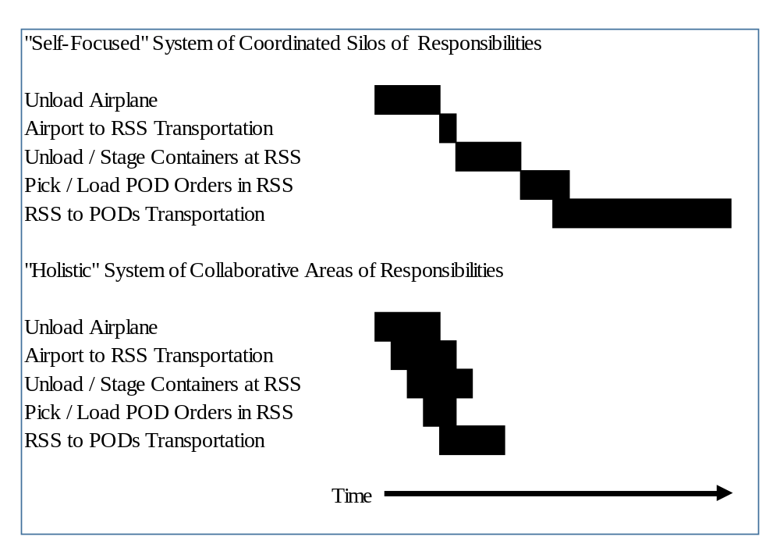

Chapter Organization
This study will be presented in the following manner:
Chapter 1: Introduction

Chapter II: Literature Review
There is limited academic literature available on this subject. Chapter II is divided into reviewing this literature from a public health perspective and an operations perspective with an emphasis on time as the key metric of interest

Chapter III: Methodology
Chapter III will introduce the Fiske Model along with supporting models and methodologies that include a process flow timeline model, two mathematical models, and the Critical Path Method of analysis.

Chapter IV: Case Study
Chapter IV will be a fictitious, yet realistic, case study in which a "current state" analysis is followed by a "future state" analysis to show the potential impact of implementing the recommendations being made in this study.

Chapter V: Verification, Validation, Conclusions
As the title implies, Chapter V will include the verification, validation, conclusions, and contributions of the Fiske Model.

CHAPTER II: LITERATURE REVIEW

While the SNS-RSS-POD system was conceived over a decade ago, it appears to still be a relatively unexplored topic from an academic research perspective. As previously mentioned, many of the operational and logistical details are considered to be “sensitive” or “confidential” and are therefore protected or exempt from Freedom of Information access by the public, including researchers. In order to supplement the limited available academic literature, some of the cited information utilized in this study is from a variety of governmental web sites.

A part of this study includes recommendations to improve the current system. Amongst these recommendations there are several key recommendations that significantly differentiate this model from the limited current literature. These key recommendations include:
- The SNS configuring the SNS to RSS shipment to enable downstream process improvements
- Avoiding the use of a truck convoy from the airport to the RSS
- Establishing a Process Cadence and a balanced work flow layout for the Picking and Shipping operations
- A redesigned and streamlined Pick Area layout within the RSS
- Standardized POD orders determined by authorities at the RSS
- Direct RSS to POD deliveries
- Utilizing emergency vehicles for RSS to POD deliveries
- Identifying the Last Active POD
- Holistic “overall process results” approach
- Time is the key metric

Table 1 illustrates the gaps between this model and the literature. The blackened squares indicate some relevant mention of these key areas of interest. The white squares represent gaps in the literature. This study will begin to fill these gaps.

Table 1: Gaps in Literature
Reference Number - Author | A | B | C | D | E | F | G | H | I | J
[1] Brookmeyer, R., Johnson, E., Barry, S. (2005)
[6] Chan, E.; et al..; (2009)
[7] Chervenic, M., (2012),
[8] Corvese, K. (2011).
[9] DC_DOH, 2012
[10] DHHS (2012).
[11] Guyton, J. et.al; (2011)
[12] King, K. and Muckstadt, J. (2009)
[13] Lee, L. (2008)
[15] Nelson, C., Chan, E. et al (2008).
[17] Robarge-Silkiner, S. (2007).
[18] Stroud, C., et al. (2011).
[19] Sun, Y. (2012)
[20] Wilkening, D. (2008),
[21] Winston, W. 2004.

Since the focus of this study is on the 12 Hour Push Package program and a response to an aerosol (inhalation) anthrax terrorist attack; the focus of this literature review will be the same.

Literature Review

[1] Brookmeyer, R., Johnson, E., Barry, S. (2005) Modeling the incubation period of anthrax, Statistics in Medicine; 2005; 24: 532-542

This is a statistical / medical article written by members of the Department of Biostatics, John Hopkins Bloomberg School of Public Health, in Baltimore, Maryland. The authors developed several statistical models primarily based on the 1979 outbreak of inhalational anthrax in the Russian city of Sverdlovsk where anthrax spores were accidently released through an open vent at a military microbiology facility. Much of this work was referenced in Chapter I, including Figure 2 (page 12) and Figure 3 (page 13).

Bioterrorism and particularly anthrax are hot topics of concern and rightly so. Many of our defense and response programs, including the SNS-RSS-POD system, consider anthrax in their design and operational performance criteria. It appears that this work may have served as a basis for Objective #2.

[6] Chan, E.; Fan, C.; Lewis, M.; King, K.; Dreyer, P.; Nelson, C.; (2009) The RSS-POD Supply Chain Management Game – An Exercise for Improving the Inventory Management and Distribution of Medical Countermeasures, Rand Health, WR-661-DHHS

RAND Health developed a Microsoft Excel based simulation game under the sponsorship of the U.S. Department of Health and Human Services (HHS). This “game” is intended to be a training aid for those responsible for managing the inventory supplies at an activated RSS during a public health emergency. In developing this “game”, RAND worked with state and county health departments in order to make realistic scenarios.

While “just a game”, the anticipated leanings can be interpreted as recommended practices or at least as an acknowledgement of the potential realities of an actual emergency operation. For example:
- The benefits of an RSS official determining initial POD order versus “blindly” filling potentially inflated orders from POD managers
- The need to obtain and maintain accurate inventory numbers both at the RSS and at the PODs
- Proper forecasting to enable appropriate allocations of limited resources amongst all of the PODs.
- Direct delivery from the RSS to individual PODs versus a multi-stop truck route plan.

[7] Chervenic, M., (2012), Wide Area Recovery and Resiliency Program (WARRP) Assessment of MCM Response Capabilities to an Anthrax Attack and Impact on Recovery, U.S. Department of Homeland Security

This apparently thorough and alarming study results in a recommendation to nearly completely restructure the existing SNS-RSS-POD system and place it under federal jurisdiction rather than turning SNS supplies over to the state and local health departments. This reports documents the inclusion of 48 hour SNS-RSS-POD system objective within the larger 96 hour maximum time window between the aerosol exposure to anthrax, the projected median time for the incubation of anthrax, and the subsequent development of symptoms. This additional time reflects the time required to confirm the presence of anthrax. It is interesting to note that the POD time has grown again from previous publications and is now between 36 and 48 hours. It is also important to note that the cumulative “worse case” or "high time” numbers total 120 hours which is well above the maximum 96 hour limit.

This report also projects that “every 4 hours of delay beyond the 96 total hours can cost
1% additional deaths of those exposed”. This article appears to be amongst the first to attempt to quantify the impact of the failure of the SNS-RSS-POD system to meet its mandated objectives.

What this report does not state is that the 24 to 48 hours required “to confirm anthrax” assumes that some appropriate official is aware that an anthrax exposure has occurred. If the aerosol anthrax exposure is a covert event, the entire 96 hour period may expire before any response is initiated.

[8] Corvese, K. (2011). A feasibility analysis of the point of dispensing (POD) model as a response to an anthrax bioterrorism event in Rhode Island. Yale University

Corvese explores “the feasibility of the POD program in Rhode Island as the primary means of providing prophylaxis to the population within the designated “36-hour timeframe for response”. She evaluates the feasibility of providing effective medical countermeasures using three variables: “state and municipal competence, throughput measurements, and the presence or absence of sufficient staffing resources”.

While Corvese concludes that Rhode Island can effectively distribute medication within the 36 (not 48 hours) hour window, it is interesting to note that their traditional model only allows them the “expected” 24 hours to dispense treatments. Corvese notes that Rhode Island’s small size allows them to claim “that POD set-up and Push Package delivery / distribution can be accomplished simultaneously within the (first) 12-hour window”.

This work reinforces the importance of saving time in the delivery, start time, and distribution of the medical supplies to the benefit of the PODs.

[10] DHHS (2012). Division of Strategic National Stockpile (DSNS) Program Review. A Report from the Board of Scientific Counselors (BSC). DHHS CDC OPHPR BSC

The Office of Public Health Preparedness and Response (OPHPR) Board of Scientific Counselors (BSC) asked six logistics and emergency preparedness experts to assess and consider opportunities to improve the SNS response to an aerosolized anthrax event. One of the key questions involved the benefits of PODs being able to start dispensing materials at 3, 6, or 9 hours sooner. The panel was unable to definitively answer any of the given questions due to a lack of meaningful data. Amongst their findings, they encouraged a focus on the “last mile” (the PODs) of the response system. They expressed concern over the PODs being the “weak link” in the entire program because it is the “most human-resource-intensive” and the hardest to test. They actually stated “DSNS can improve all facets of its processes and yet lives may be lost due to the bottlenecks in dispensing.” This appears to reaffirms the need to provide as much time as possible for the PODs to provide treatment to the people impacted by the event.

The fact that this panel of experts with apparent access to both published and classified information could not reach an informed opinion due to a lack of meaningful data, confirms a lack of relevant research in this area.

[11] Guyton, J. et.al; (2011) Appendix D Commissioned Paper: A Cost and Speed Analysis of Strategies for Prepositioning Antibiotics for Anthrax, National Academies Press (US)

This paper explores the concept of prepositioning medical countermeasures near large population areas in order to speed delivery of antibiotics in response to an aerosol anthrax bioterrorist attack. This would be an alternative model to the current SNS-RSS-POD model. The projected performance numbers for their SNS-RSS-POD model are considerably different from those presented in other papers a few years earlier. For example, the projected total system time is projected to be 50.49 hours which exceeds Objective #2. The unofficial breakdown of these 48 hours remains:
SNS to RSS: 12 hours
RSS operations and RSS to POD delivery: 12 hours
POD operations: 24 hours

This paper indicates that the combined times from the SNS to delivery at the PODs is now only 13.24 hours while POD operations has grown to 37.25 hours. These presented hours might be applicable to large urban population located near a SNS warehouse, but 13.24 hours may not be realistic in a scenario involving a dispersed rural population being serviced by an RSS that is remotely located away from the SNS warehouse.

[12] King, K. and Muckstadt, J. (2009) Evaluating Planned Capacities for Public Health Emergency Supply Chain Models Technical Report No. 1475, School of Operations Research and Information Engineering, Cornell University

King and Muckstadt develop and present a comprehensive linear programming model that covers the supply chain from the SNS warehouse through the PODs. They point out that few people are in a position to view the entire process therefore they tend to focus on just their part of the process. This supports the concern over "silos of responsibilities" and the need for a holistic “process oriented results” approach for this entire system.

As their paper continues and their model starts to evolve, it becomes clear that they are focusing on optimizing the Managed Inventory Program and basically ignoring the 12 hour Push Package program.

[13] Lee, L. (2008) Analyzing Dispensing Plan for Emergency Medical Supplies in the Event of Bioterrorism, Proceedings of the 2008 Winter Simulation Conference, pages 2600-2608

Young Lee utilized simulation modeling to assess the effective distribution of medical supplies within various time periods when considering the variation of RSS to POD delivery times and the variation of the number of people seeking treatment at the various PODs. Lee points out the likelihood of some PODs having surplus inventory while other PODs are still in need of more inventory. Lee introduces the need for cross shipping of inventories between PODs but points out the time and logistical inefficiencies of cross shipping.

It should be noted that recommendations associated with the Fiske Model emphasize the need for frequent J.I.T. (Just In Time) RSS to POD shipments of smaller quantities of supplies in order maintain better control of the main inventory at the RSS and thus minimize (if not eliminate) the need of cross-shipping supplies between PODs.

[18] Stroud, C., Viswanathan, K., Powell, T., & Bass, R. R. (2011). Current Dispensing Strategies for Medical Countermeasures for Anthrax.

This article basically summarizes the various components of the current SNS-RSS-POD system as well as some of the alternative methods being explored and tested such as utilizing the U.S. Postal Service to deliver antibiotics directly to the people at their homes. Another option being explored in Virginia involves home deliver utilizing school buses.

[20] Sun, Y. (2012). The SNS logistics network design: Location and vehicle routing. University of Louisville

In his Ph.D. dissertation, Yepeng Sun develops a SNS facility location model to use in selecting sites for RSS and RDN (Regional Distribution Nodes) to form a logistics network to deliver supplies to the PODs. Sun develops a SNS Vehicle Routing Problem (VRP) to assist in creating routing schedules and determining the type of trucks to be utilized. While Sun recognizes the criticality of time, his model constraints seem to be “within the required time window” rather than reducing the process time. Instead the focus appears to be “on reducing transportation cost caused by the traveling distance and the operation cost of operating facilities.”

This model may be more useful in designing secondary Managed Inventory delivery systems where time is not as critical.

[21] Wilkening, D. (2008), Modeling the Incubation Period of Inhalational Anthrax, Medical Decision Making 2008 28:593

In his article, Dean Wilkening applies the lognormal distribution the limited data from the Sverdlovsk, Russia anthrax incident to further refine the previous work of Brookmeyer (reviewed above). Wilkening also offers a refinement on the efficacy of the treatment program as a function of time after exposure. Figure 4 (page 14) suggests the percentage of people saved versus the time delay in beginning their treatment.

Wilkening makes an observation that appears to be incorporated into Objective #2 of the SNS-RSS-POD model.

“As a general proposition, the prophylaxis campaign must begin within approximately 3.5 days after exposure if more than 90% of the victims are to be saved,… Faster is better, but one reaches a point of diminishing returns for response times shorter that approximately 2 days. … At this point, one is much better off focusing on reducing the number of victims missed by the medical response that increasing its speed.”

While the majority of this article involves modeling the incubation period of Inhalational Anthrax based on limited data from the Sverdlovsk, Russia anthrax incident; Wilkening links his work to the SNS program by offering the following opinion:
“…. one should note that 3.5 days is a very demanding timeline for medical response …
Meeting this challenge is physically possible, but such timelines do not represent current US capability or that of any other country, for that matter.”

Literature Summary

Public Health Perspective
To summarize the relevant anthrax literature; an aerosol inhalation anthrax event could have very little warning, an exponential outbreak rate, and a high mortality rate. Several authors [Brookmeyer (2005), DHHS (2012), Winston (2004)] identify the first 3.5 to 4 days (90 to 96 hours) as the critical period in which to save lives. This period is subsequently divided into 48 hours to detect and confirm the event and 48 hours to respond. The 48 hour response period is further subdivided into 24 hours to (‘ramp up”) get antibiotics to the PODs and 24 hours for the PODs to (“dispense”) treat the impacted people. It should be noted that as these timelines were being developed and presented, there was (and remains) a concurrent concern [Stroud (2011), Wilkening (2008)] over the ability of the response system to effectively achieve these objectives within these time constraints.

Since the primary treatment for inhalation anthrax is a 60 day antibiotic regiment, the basic function of the SNS-RSS-POD system in this scenario is to distribute medical packets to the impacted population along with instructions for use over the treatment period. This plan allows for the PODs to target or only deal with one adult per household (referred to as the Head of Household or HOH) at the POD thereby increasing their effective coverage with a lower physical throughput rate of individuals at the POD. The lack of the need for every person to physically visit a POD opens the door for some alternative means of distributing these antibiotics in a more time effective manner. Accordingly the concept of prepositioning antibiotics has been explored [Guyton (2011), Robarge-Silkiner (2007), Stroud (2011)]. This basically involves bypassing the SNS-RSS-POD system and providing antibiotic kits to every household to store until needed. While a host of practical reasons (misuse, replacement of expired products, develop of drug resistant bacteria, and a potential mismatch between the stocked antibiotics and a given stain of anthrax) have discouraged this concept, its failure has only increased the pressure on the SNS-
RSS-POD system to be the most effective means of controlling the antibiotic inventories until needed while still being capable of distributing them in a timely manner.

Operations Perspective
In the “Current State” SNS-RSS-POD Model (Figure 1 on page 8) there three distinct operations: the SNS warehouse, the RSS facility, and numerous PODs. The location, size, and operation of the SNS warehouses are considered as “sensitive” information. While the majority of the SNS warehouse operations are outside the scope of this study; there appears to be a genuine lack of available literature in this area.

Likewise, the location of the RSS facilities is also “sensitive” information. While mentioned in the literature, there is little substantive information about the actual operations of a RSS. While some literature [Sun (2012)] offers models for the selection of effective locations for RSS facilities and PODs, the fact of the matter is that many, if not all, RSS operations are functionally inactive and reside in existing facilities that were created for other purposes and are actively being utilized for non-RSS activities. In many situations, the choices for potential RSS operations in any given area may be extremely limited; so complex selection models may have very limited practical application.

The RSS to PODs logistics has drawn some limited attention in the literature [Lee (2008)]. While some [Chan (2009)] recognize the value of direct RSS to POD delivery, others [King (2009), Lee (2008)] appear to be prioritizing the optimization of more traditional logistical considerations such as driver utilization, fuel consumption, routing, transferring inventories between PODs, etc.
The PODs may be the wild card in the success of the SNS-RSS-POD system. On one (very simplistic) hand, aside from an increased volume of people seeking service or treatment and extra security; PODs are basically clinics and public health agencies know how to run clinics. On the other hand, a panel of logistics and emergency preparedness experts expressed their concern over the PODs being the “weak link” in the entire program because it is the “most human-resource-intensive” and the “hardest to test” [DHHS (2012)]. This may be a caveat for system designers who base their POD Service Rates (people served per hour) on limited training exercises. This also appears to reaffirms the need to provide as much time as possible for the PODs to provide treatment to the people impacted by the event.

To emphasize the lack of valid data in this area, it should be noted that when, in 2012, the Office of Public Health Preparedness and Response (OPHPR) Board of Scientific Counselors (BSC) [DHHS (2012)] asked six logistics and emergency preparedness experts to assess and consider opportunities to improve the SNS response to an aerosolized anthrax event, the panel was unable to definitively answer any of the given questions due to a lack of meaningful data. The fact that this panel of experts with apparent access to both published and sensitive information could not reach an informed opinion due to a lack of meaningful data, also tends to confirm a lack of relevant research in this area.

Time as the Key Metric
While a good portion of the literature reviewed recognizes time as a key metric in this emergency response system, one particular article [Stroud (2011)] offers a mathematical equation to predict the impact of time delays in treatment in terms of survival rates. In response to a request from the Department of Health and Human Services, the Institute of Medicine formed a committee to explore options to strategically preposition medical countermeasures in order to reduce the response time to an anthrax attack in the United States. This article basically summarizes the various components of the current SNS-RSS-POD system as well as some of the alternative methods being explored and tested such as utilizing the U.S. Postal Service to deliver antibiotics directly to the people at their homes. In the course of their work, this committee consolidated several existing mathematical models into a first order equation to assess the overall effectiveness of this type of response system. Their equation will be utilized later in this study to assess the overall effectiveness of the Fiske Model in terms of estimated lives saved.

Conclusion
There exists a significant gap in the limited academic literature relative to the operation of the RSS facility. Further, there appears to be room to explore some alternative transportation logistics as well as an increased focus of treating the last person in the Last Active POD within 48 hours of the decision to activate the SNS-RSS-POD emergency response system. This study will help to close this gap and perhaps stimulate further research into this topic.

CHAPTER III: METHODOLOGY

Chapter III has three main segments. This first segment is the introduction of the “Future State” SNS-RSS-POD Model. While this model is actually a supporting model to the Fiske Model, it is being presented first as a framework upon which to discuss the Fiske Model and other supporting models. The second segment is the Fiske Model. This is the main model and represents a distinctive approach to this system and associated research. The third segment introduces the other supporting models and methodologies including a complex mathematical model that can be utilized to analyze the SNS-RSS-POD system in both the “current state” and the “future state” with time and “lives saved” being the key metrics of interest.

In developing the Fiske Model and selecting the supporting methodologies to utilize in this study, there were several significant considerations. The first is the fact that most of these component operations of the SNS-RSS-POD system are not active systems in a steady state mode of operation. While a few segments of some sub-systems may be repetitive for a few minutes or hours, the overall system is a series of subsystems that (if ever activated) set-up once, run once, and then shut down. Thus methodologies that analyze and refine the efficiencies of steady state operations have limited application in this study. The second consideration is the lack of meaningful data. This system has only been actually activated a few times under different and overall unique circumstances. Lessons learned appear to be primarily anecdotal. Likewise, full scale training exercises under simulated emergency conditions may be generally infeasible, costly, and situation specific. Methodologies that require sufficient data to provide a detailed analysis of process variation have limited application in this study. Instead, the selected supporting methodologies replace variables with parameters based on expert opinions or by simple experimentation. Comparative system performances for system design and operational planning purposes may be achieved by changing selected system parameters.

“Future State” SNS-RSS-POD Model
The “Current State” SNS-RSS-POD Model (Figure 1 on page 8) has several shortcomings that need to be considered in creating a more comprehensive “Future State” SNS-RSS-POD model. The major shortcoming is the failure to recognize the time period between the Initial Exposure of the Population and the Decision to Activate the SNS-RSS-POD system. In this study, this time period will be referred to as T1. Initial exposure of the population is the common event time that links the SNS-RSS-POD system time line (Figure 1 on page 8) with the medical time line of the public health emergency (Figure 5 on page 17). In the absence of the T1 connection; a plausible, yet disastrous, means of compliance with Objective #2 is to simply never decide to activate the system. Secondly, the “current state” model does not sufficiently focus on the Last Active POD treating the last person in need. Since Objective #2 involves the Last Active POD, the Last Active POD should be identified and incorporated into the system metrics. Finally, the “current state” model does not adequately address the allotted 36 hours of shared time arrangements between the RSS operation, RSS to POD logistics, and the actual POD operations.

In the “Future State” Model (Figure 9), this post-“Arrival of the 12 Hour Push Package” period has been separated into three subsections: RSS operations (referred to as T3), RSS to POD logistics (referred to as T4), and the actual POD operations or Available POD Service Time (T5). When focusing on the Last Active POD, T4 is referred to as T4_{LAP} and T5 is referred to as T5A_{LAP}. It should also be noted that a general assumption has been made that increasing (maximizing) the amount of Available Service Time (T5A) for any POD is a desirable system improvement in any scenario.

The Fiske Model
The main model of this study is the Fiske Model (Figure 10) which was specifically developed to organize, identify, analyze, and improve the SNS-RSS-POD system. Supporting models and methodologies include the SNS-RSS-POD Model, CPM, the Mathematical Model, and the Time Saved – Lives Saved Model.

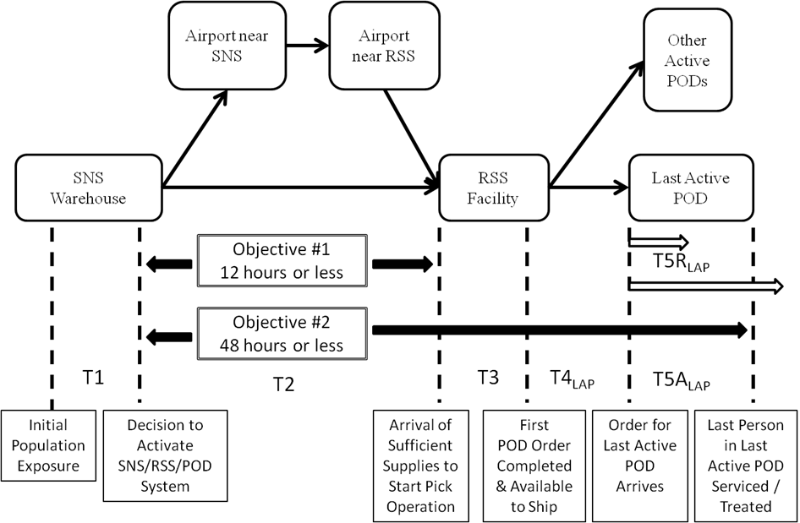
Figure 9: “Future State” SNS-RSS-POD Model
Note: An assumption is made that all PODs will otherwise be ready to open as soon as their POD Order is received.

- Monitor process
- Training and Exercises
- Apply CPM to all PODs
- Return to previous steps as needed
STEP A: Preliminary Stage
Obtain information on Relevant SNS, RSS, and PODs
Create “Future State” SNS-RSS-POD Model
Develop and Identify Critical Path (utilizing CPM) for T2 and T3
Populate Mathematical Model with Data and / or Expert Opinion
STEP B: Demand Assessment and Review
Calculate and Review
“Required POD Service Times” (T5R_{i}) vs. Maximum 24 Hour Guideline (MDST)
Redesign PODs as Needed
- Increase Service Rate
- Decrease POD Demand
- Create Additional PODs - Utilize CPM

Not Acceptable
STEP C: System Analysis and LAP Profile
Calculate
- RSS to POD Times (T4_{i}):
- Identify Last Active POD (POD_{LAP})
- Required (POD_{LAP}) Service Time (T5R_{LAP})
- RSS to POD_{LAP} Delivery Time (T4_{LAP})
- Complete Critical Path (RSS to LAP)
-Create Order Pick Sequence (PS_{i})

Acceptable
STEP D: Available Time Assessment and Review
Calculate and / or Optimize (Solver):
- SNS to RSS Time (T2),
- RSS Time (T3),
- Available Service Time: Last Active POD (T5A_{LAP})

9
No Feasible Solution

Feasible Solution Solution
Evaluate and Redesign
- “Last Active POD” (T5A_{LAP})
- Increase Service Rate (C_{LAP})
- Decrease POD Demand (H_{LAP})
- Create Additional PODs (n)
- Change RSS to POD Delivery
Method (T4_{LAP})
- Decrease position of POD Order
in Order Sequence (PS_{LAP})
- - Reduce Time in RSS (T3) - Utilize CPM
STEP E: Strategic Analysis
Compare Available Service Time (T5A_{LAP}) versus Required Service Time (T5R_{LAP}) for LAP
Calculate Estimated Number of Lives Saved (L_{i}):
Not Acceptable
Acceptable
STEP F: Implementation and Sustainment
- Implement the Designed Plan
- Implement Continuous Process Improvement Activities
IMPORTANT NOTE:
The designation of “Last Active POD” may shift between various PODs during this analysis.

Figure 10: The Fiske Model
For comparative purposes, Steps A – F of the Fiske Model may first be followed without any review and corrective measures in order to calculate “current state” condition. Then the full Fiske Model (Figure 10) may be followed with the assumption that all recommendations have been implemented thus creating the “future state” condition. It should be noted that designers may selectively assume various recommendations are implemented in order to assess the impact of any particular recommendation.

Step A: Preliminary Stage
Step A is primarily information gathering and foundational activities. Basic information about the SNS, the RSS, the PODs and the related logistics are entered here. While the “Current State” SNS-RSS-POD Model (Figure 1 on page 8) may be more applicable in some initial assessments; the “Future State” SNS-RSS-POD Model (Figure 9 on page 40) is recommended for both the “current state” and “future state” assessments in order to generate comparable numbers. Since T2 and T3 are time periods that apply to all PODs, the Critical Path in these time periods may be examined at this step. It should, however, be noted that changes made to reduce the time in the Critical Path are not applicable to the “current state” analysis.

Step B: Demand Assessment and Review
Step B is the first glimpse of potential POD capability problems. The Minimum Desired Service Time (MDST) is the 24 hour guideline in which each POD is expected to complete their mission. PODs with Required Service Times (T5R_{i}) in excess of this guideline should be reviewed for possible design changes. Since the MDST is merely a guideline, no immediate action is mandated until after the actual Available (POD) Service Times (T5A_{i}) are calculated. It should again be noted that changes made to improve these numbers are not applicable to the “current state” analysis.

Step C: System Analysis and LAP Profile
Step C is basically allowing the software (Excel, etc.) to analyze the status of every POD relative to operational time, travel time, and service time. This is where the Last Active POD (LAP) is identified. Now T4_{LAP} and T5R_{LAP} are calculated, the Critical Path may be extended to the Last Active POD and the POD Order Pick (start /completion) Sequence (PS_{i}) may be established.

Step D: Available Time Assessment and Review
Step D is where the “future state” of T2 and T3 are fine tuned. This is where the system constraint of 48 hours (to service the last person in need in the Last Active POD) is considered. In the “current state” analysis, this is a straight calculation and the outcome is reported “as is”. However, in the “future state” analysis, Excel Solver is utilized to optimize the solution. Solution feasibility is a pass / fail criteria for advancement in the “future state” methodology model. CPM has a major influence in this area and generates numerous recommendations of process improvements. Again, changes made to improve these numbers are not applicable to the “current state” analysis. With T2, T3, and T4_{LAP} now determined, T5A_{LAP} may be calculated.

Step E: Strategic Analysis
Step E is the assessment point for the capability of the SNS-RSS-POD system to meet Objective #2. If the Required Service Time for the Last Active POD exceeds the Available Service Time for that POD, then the system has failed to meet Objective #2. In the “current state” analysis, this is reported “as is”. In the “future state” analysis, this would trigger a system redesign or process improvement. Step E is also where “time saved” is converted into “lives saved” in every POD. This is a powerful and compelling argument for those who have yet to see that time is the key metric of interest in the design and operation of the SNS-RSS-POD system.

Step F: Implementation and Sustainment
Step F is the beginning of the sustainability and continuous process improvement phase of the SNS-RSS-POD system. Once the Last Active POD is in compliance, this methodology model may be utilized to go back and re-examine entire system and every POD to seek opportunities to increase Available Service Time in every POD. At this stage, best practices should be identified and resulting Standard Operating Procedures (SOPs) should be developed.

Supporting Models and Methodologies

Critical Path Method (CPM)
Critical Path Method (CPM) is an analytical technique for network modeling of complex projects involving numerous inter-related activities. The various activities are linked in their appropriate relationship to form a variety of process paths. When a metric such as time is identified and applied to each process segment, the resulting longest essential path becomes the Critical Path that determines the overall process time. In this model there are three overlapping sub-processes of interest where CPM is utilized to identify the Critical Path and opportunities to reduce time. The first area is time from the SNS warehouse to the arrival at the RSS. The second is the time in the actual RSS operation. The third is time from the RSS to the delivery of the POD order to the Last Active POD that will be treating the last person in need.

There are several advantages of CPM for the practitioner in the field. It is relatively simple and intuitive. Since detailed data may be very limited, this model may be easily completed for general planning purposes utilizing expert opinions. While a computer may enhance the presentation, simple hand drawn graphics and basic mathematics can effectively communicate the significant points of this analysis.

The Mathematical Model
The intent of the mathematical model is to identify the objectives, variables, parameters, and constraints of a system and express their relationships in one or more mathematical formulae.
As previously mentioned, there is a general (yet obviously fortunate) lack of statistically significant data from the repeated deployment of the same emergency response system to the same locations under the same circumstances. Thus analysis of the variation of the variables is somewhat limited and subjective. However, by replacing the variables with parameters based on expert opinion and / or limited experimentation; mathematical modeling may offer several insights to the designers and practitioners. Within this mathematical model, Microsoft Solver is utilized to optimize the amount of Available Service Time for the Last Active POD. As suggested in the Figure 9 (page 40), the mathematical model for this analysis will involve multiple equations. A full list of notations may be found in the Appendix. However, for clarity, the notations, equations, and constraints are presented in the following segments:

The Main Equation
The main equation focuses on the amount of Available Service Time for the Last Active POD (T5A_{LAP}). This is the amount of time left of the mandated 48 hour period after the POD order has actually been delivered to the Last Active POD. Designers and operators of the current system may confuse Available (POD) Service Times (T5A_{i}) with Required (POD) Service Times (T5R_{i}) which is calculated separately from Available (POD) Service Time. A gap between these times for the Last Active POD may be the foundation of the concern expressed in the Problem Statement.

General and Main Equation notations:
n = number of active PODs serviced by the RSS for POD_{i}, i=1, 2, … , n.
POD_{i} = POD identification number for POD_{i}, i=1, 2, … , n
POD_{LAP} = Last Active POD_{i}
T_{i} = Time (minutes) between Exposure of the Population to the harmful condition
and the treatment of the Population at POD_{i}, i=1, 2, … , n
T_{LAP}= T_{i} of POD_{LAP}
T1 = Time (minutes) between Exposure of the Population to the harmful condition
and the time of the Decision to Activate the SNS-RSS-POD system.
T2 = Time (minutes) from the Decision to Activate the SNS-RSS-POD system
to the delivery at the RSS of a sufficient portion of the 12 Push Package to enable
the POD Order Pick process to start.
T3 = Time (minutes) in RSS from the delivery of a sufficient portion of the 12 Hour Push
Package to enable the POD Order Pick process to start and the completion of the
first POD Order.
T4_{i} = Time (minutes) from the completion of the first POD Order to the delivery
of each specific POD Order to POD_{i} , i = 1, 2, …, n.
T4_{LAP} = T4_{i} for Last Active POD
T5A_{i} = Available Service Time (minutes) from the delivery of their POD Order to treating
the last person at POD_{i}, i = 1, 2, …, n.
T5A_{LAP} = T5A_{i} for Last Active POD
T5R_{i} = Required Service Time (minutes) from delivery of their POD Order to treating
the last person at POD_{i} , i = 1, 2, …, n.
T5R_{LAP} = T5R_{i} for Last Active POD
TS_{i} = Total SNS-RSS-POD System Time for POD_{i} , i = 1, 2, …, n.
TS_{LAP} = TS_{i} for Last Active POD
MDST = Minimum Desired Service Time (minutes) from the delivery of
their POD Order to actually treating the last person at POD_{i} , i = 1, 2, …, n.

General and Main Objective Function Equations:

General:
TS_{i}=T2 + T3 + T4_{i} + T5A_{i} (1)
TS_{LAP}=T2 + T3 + T4_{LAP} + T5A_{LAP} (2)
T_{i}=T1 + T2 + T3 + T4_{i} + T5A_{i} (3)
T_{LAP}=T1 + T2 + T3 + T4_{LAP} + T5A_{LAP} (4)

Main Objective Function:
Max T5A_{LAP} (5)

Subject to:
T5A_{LAP} = TS_{LAP} – T2 – T3 – T4_{LAP} (6)
TS_{i} ≤ 2880 minutes (48 hours) (7)
TS_{LAP} ≤ 2880 minutes (48 hours) (8)

Comments:
T1 is being introduced here, but it will not be utilized until the Lives Saved segment.
The decision variables for these equations are embedded within the individual equations for T2, T3, T4_{i}, and T4_{LAP} and will be identified in the appropriate segments. For general discussion, these decision variables include:
- The decision of the SNS to load the SNS trucks and cargo plane (when utilized) in a manner that enables and supports time opportunities in T2 and T3.
- The decision whether or not to form a truck convoy between the airport (when utilized) near the RSS and the RSS facility.
- The decision regarding the number of SNS containers to place in the immediate RSS Pick Area
- The decision whether or not to use standard initial POD Orders
- Decisions regarding RSS to POD logistics

Equation for SNS to RSS Time (T2)
The time period between the Decision to Activate the SNS-RSS-POD system and delivery of sufficient supplies to the RSS to enable the commencement of the POD Order Picking Operation is rather straight forward since it is undisclosed sensitive information. However, the CPM process identified two opportunities that are incorporated into the equation. The first opportunity is to avoid the apparent current plan to convoy all of the SNS trucks together from the airport (when utilized) near the RSS to the RSS. The second opportunity is to begin the POD Order Picking Operation before all of the SNS trucks are unloaded at the RSS docks and staged in the RSS. Both opportunities are dependent of enabling decision variables.

Notations:
C_{SNS} = Decision Variable {0= No, 1=Yes}: Load SNS trucks at SNS so as to support
RSS usage.
T_{CON} = Decision Variable {1=No, 0=Yes}: Form convoy of all trucks from airport to RSS

T2_{A} = Decision Variable {0= No, 1=Yes}: Utilize known SNS to RSS delivery
time (minutes)
T2_{D} = Decision Variable {0= No, 1=Yes}: Utilize Default SNS to RSS delivery
time (minutes)
T_{AIR} = Decision Variable {0=No, 1=Yes}: Utilize SNS to RSS air transportation
U_{AIR} = Unload time per truck from airplane into trucks bound for RSS (minutes)
V_{RSS} = Number of SNS to RSS trucks needed
V_{U} = Number of SNS to RSS trucks needed to transport at least of one of every container
configuration
T2_{AT} = Known SNS to RSS delivery time (minutes)
T2_{DT} = Default SNS to RSS delivery time (minutes)

Equation for Time Period 2 (T2) – SNS to RSS Transport Time
T2 = (T2_{A})(T2_{AT}) + (T2_{D})(T2_{DT}) - (C_{SNS})(T_{AIR})(T_{CON})(V_{RSS}-V_{U})(U_{AIR}) (9)

Subject to:
T2_{A} = {0,1} (10)
T2_{D} = {0,1} (11)
T2_{A} + T2_{D} = 1 (12)
T2_{AT} ≥ 0 (13)
T2_{DT} ≤ 720 (14)
C_{SNS} = {0,1} (15)
T_{CON} = {0,1} (16)
T_{AIR} = {0,1} (17)
V_{RSS} = integer (18)
V_{U} = integer (19)

Comments:
This equation allows designers to enter actual SNS to RSS transport times if they are available. Otherwise a default value (currently 720 minutes) is utilized.

Equation for Time in RSS Operations (T3)
This is the time period between the arrival of sufficient supplies to begin the POD Order Picking Operation and the completion of the first POD order. CPM was utilized extensively in this segment to reduce the Critical Path time.

Notations
T3_{A} = Time (minutes) from Arrival of enough SNS Trucks to Unload and Stage (set up)
enough SNS containers in Pick Area to start the Order Pick Operation.
T_{S} = Time (minutes per truck) to unload and Stage Truck Load in Pick Area
D_{RSS} = Maximum number of SNS trucks that can be unloaded and staged at the
same time (also known as number of available inbound RSS dock doors)
T3_{B} = Time (minutes) from beginning of Order Pick to the completion of the first POD
Order.
C_{P} = Number of containers in a 12 hour Push Package
C_{U} = Number of different container configurations in a 12 hour Push Package
P_{A} = Decision Variable: Number of Containers in the Immediate Pick Area
P_{Z} = Number of Containers in a Pick Zone (1 K unit) within Immediate Pick Area
K_{Q} = Cadence units required in Order Pick Cycle for Quality Inspection and Inventory
K_{M} = Cadence units required in Order Pick Cycle for Misc. Activities
K = Process cadence time (minutes)

Time Period 3 (T3) – RSS Operations Time
T3 = T3_{A} + T3_{B} (20)
T3_{A} = ((V_{RSS})(T_{S}) - (C_{SNS})(V_{RSS}-V_{U})(T_{S}))/D_{RSS} (21)
T3_{B} = ((P_{A} /P_{Z})+K_{Q}+K_{M})(K) (22)
Subject to:
T3_{A} > 0 (23)
T3_{B} > 0 (24)
C_{P} ≥ C_{U} (25)
C_{U} ≥ 0 (26)
P_{A} ≥ C_{U} (27)
P_{A} ≤ C_{P} (28)

Comments:
In addition to the enabling decision variables introduced in T2, the decision variable regarding the size of the immediate Pick Area is a significant T3 variable from a CPM perspective.

Equation for RSS to PODs Logistics: T4_{i}
This equation includes the time from the completion of the first POD Order to the delivery of the Last Active POD Order to the Last Active POD. It should be noted that the first completed POD Order may not be the POD Order for the Last Active POD.

Notations
TP_{i} = Direct route travel time (minutes) from RSS to POD_{i} , i = 1, 2, …, n.
T_{D} = Estimated average additional time (minutes) for travel diversion from the direct path
time added to delivery route for each POD serviced prior to POD_{i}, i = 1, 2, …, n.
T_{U} = Estimated average additional unload time (minutes) per delivery route stop for
each POD serviced prior to POD_{i} , i = 1, 2, …, n.
D_{A} = Decision Variable A: Utilize Direct Delivery time (minutes) based on direct
delivery with dedicated vehicles from RSS to POD_{i} , i = 1, 2, …, n.
D_{B} = Decision Variable B: Utilize Route Delivery time (minutes) based standard
estimated parameters for diversion times (T_{D}) from the direct route and the
standard estimated unload times (T_{U}) for each intermediate stop and the direct
delivery time from the RSS to POD_{i} , i = 1, 2, …, n.

D_{C} = Decision Variable C: Utilize Route Delivery time (minutes) based heuristically
developed routes with estimated travel times and standard estimated unload
times (T_{U}) for each intermediate stop from the RSS to POD_{i} , i = 1, 2, …, n.
D_{D} = Decision Variable D: Utilize Route Delivery time (minutes) based computer
optimized routes with estimated travel times and standard estimated unload
time (T_{U}) for each intermediate stop from the RSS to POD_{i} , i = 1, 2, …, n.
K = Process cadence time (minutes)
PS_{i} = Sequence in which POD Orders are started (and completed) within the RSS
for POD_{i} , i = 1, 2, …, n.
R_{r} = RSS to POD Delivery Route Number for POD_{i} , i = 1, 2, …, n and r = 1,2,…, R
R_{s} = RSS to POD Delivery Route Stop Number for POD_{i} , i = 1, 2, …, n
and s = 1, 2,…, S.
L_{S} = Estimated minimum Staging / Loading Time of a POD order in RSS Shipping Area
I = Number of available transport vehicles from RSS to PODs
TR_{i} = Specific estimated (D_{B} or D_{C}) or calculated (D_{D}) total RSS to POD delivery times
for route deliveries to POD_{i} , i = 1, 2, …, n

Time Period 4 (T4) – RSS to POD Transportation Time
(29)
Subject to:
D_{A} + D_{B} + D_{C} + D_{D} = 1 (30)
D_{A} = {0,1} (31)
D_{B} = {0,1} (32)
D_{C} = {0,1} (33)
D_{D} = {0,1} (34)
L_{S} ≥ 0 (35)
T_{U} ≥ 0 (36)
T_{D} ≥ 0 (37)
TR_{i} ≥ 0 (38)

Comments:
Equation 28 accommodates four different approaches to RSS to POD logistics and allows the Solver program to select. There is an option to manually override Solver in order to explore the impact of the various alternative methods.

Decision Variable D_{D} : A Vehicle Routing Model
Given the holistic approach of this study and the fact that time is the key metric and focus of the SNS-RSS-POD system; the direct delivery of these critical medical countermeasures from the RSS to each individual POD via a dedicated delivery vehicle is the ideal condition.

However, the real world conditions of a public health emergency may restrict the availability of planned individual direct delivery vehicles. Accordingly, it is beneficial to have a contingency plan that considers the option of combining multiple POD Orders into one or more common delivery vehicles that will deliver these supplies via multi-stop route(s) involving two or more PODs per route. This model will also be very useful when the SNS-RSS-POD system is in the Managed Inventory mode of operation. Further, this model may serve as a standalone contingency planning model.

Although Variable D_{D} and all of its associated notations, equations, and constraints are included in T4_{i}, they are being presented separately in this segment. This is the work of Dr. Andrew J. Yu who has graciously contributed his work [Yu 2015] to this study.

Notations:
I = number of available transport vehicles from RSS to PODs
J = number of PODs to be assigned.
r_{jk} = travel time between PODs j and k.
d_{j} = travel time between RSS facility and POD j.
D_{j} = demand at POD j.
T = maximum allowed travel time from RSS facility to any POD.
C_{i} = capacity of vehicle i.
$y_{ijkn}$ = 1 if vehicle i travels from POD j to k at the n^{th} stop, 0 otherwise.
$y_{i0k1}$ = 1 if vehicle i travels from RSS to POD k at the first stop, 0 otherwise.
$y_{ij0n}$ = 1 if vehicle i returns RSS from POD j at the n^{th} stop, 0 otherwise.
$x_{ij}$ = amount of load delivered by vehicle i to POD j.
$z_{in}$ = travel time of vehicle i from RSS to the POD at the n^{th} stop.

Objective Function:

Min $\sum_{i=1}^{I}{\sum_{n=1}^{N}{\sum_{j=0}^{J}{\sum_{k=1}^{J}{z_{in}y_{ijkn}}}}}$ (39)

Subject to:

$\sum_{j=1,j≠k}^{J}{y_{ijkn}}≥\sum_{l=0,l≠k}^{J}{y_{ikl\left(n+1\right)}}$, for all n = 2, 3, …, N-1; k = 1, 2, …, J and i = 1, 2, …, I
(40)
$y_{i0k1}≥\sum_{l=0,l≠k}^{J}{y_{ikl2}}$, for all k = 1, 2, …, J and i = 1, 2, …, I (41)

$y_{i0kn}=0$, for all n = 2, …, N; k = 0, 1, 2, …, J, and i = 1, 2, …, I (42)

$y_{ijk1}=0$, for all k = 0, 1, …, J; j = 1, 2, …, J and i = 1, 2, …, I (43)

$y_{ijjn}=0$, for all n = 1, 2, …, N; j = 0, 1, …, J and i = 1, 2, …, I (44)

$\sum_{k=0}^{J}{\sum_{n=1}^{N}{y_{ijkn}}}≤1$, for all j = 0, 1, …, J and i = 1, 2, …, I (45)

$\sum_{j=0}^{J}{\sum_{n=1}^{N}{y_{ijkn}}}≤1$, for all k = 0, 1, 2, …, J and i = 1, 2, …, I (46)
$x_{ik}≤C_{i}\sum_{j=0}^{J}{\sum_{n=1}^{N}{y_{ijkn}}}$, for all k = 1, 2, …, J and i = 1, 2, …, I (47)

$\sum_{i=1}^{I}{x_{ij}}=D_{j}$, for all j = 1, 2, …, J (48)

$\sum_{j=1}^{J}{x_{ij}}≤C_{i}$, for all i = 1, 2, …, I (49)

$z_{in}=\sum_{k=1}^{J}{d_{k}y_{i0k1}}+\sum_{m=1}^{n}{\sum_{j=1}^{J}{\sum_{k=1,k≠j}^{J}{r_{jk}y_{ijkm}}}}$, for all i = 1, 2, …, I and n = 1, 2, …, N
(50)
$z_{in}≤T$ for all i = 1, 2, …, I and n = 1, 2, …, N (51)

$y_{ijkn}=\left\{0,1\right\}$, for all n = 1, 2, …, N; k = 0, 1, …, J; j = 0, 1, …, J and i = 1, 2, …, I (52)

$x_{ij}≥0$ for all j = 1, 2, …, C and i = 1, 2, …, I (53)

$x_{ij}=integer$, for all j = 1, 2, …, J and i = 1, 2, …, I (54)

$z_{in}≥0$ for all i = 1, 2, …, I and n = 1, 2, …, N (55)

The objective of the model is to minimize the total delivery times from RSS to destinations for all the PODs. The underlying model is a mixed integer quadratic programming (MIQP) model. A key constraint in the model is in Equation (51), which defines the maximum travel time from RSS to any POD. The parameter T could be defined based on the maximum available time left to distribute the emergency supplies to each of the PODs. It could also be considered as a decision variable and its value can be determined as the solution of the same model defined above, except changing the objective function to the single decision variable T. The optimal T value obtained from the later model is basically the minimized maximum travel time from RSS to any POD. More constraints are explained below.

Constraints in Equation (40) make sure that, starting from the second stop of a route, a POD will not be a starting POD of the next stop if it is not the prior stop. Equation (41) implies, if a vehicle doesn’t leave RSS for its first stop in a route, there will be no route for the vehicle. Equations (42) and (43) enforce that the first stop of a route for any vehicle must be the one leaving RSS. Equation (44) means no stop of a route is allowed if the origin and the destination are the same POD. Constraints in Equations (45) and (46) mean that a vehicle travels from or to a particular POD only once at most in an entire route. Equation (47) enforces the constraint that a vehicle can only deliver to a POD if the POD is on the vehicle’s route. Equation (48) means demand for each POD will be satisfied. Equation (49) enforces the capacity constraint for a vehicle. Equation (50) defines the total travel time of vehicle i for the POD at the n^{th} stop. Equation (52) indicates that all y decision variables in the model are binary variables. Equations (53) and (54) indicate all x variables are non-negative integer variables. Equation (55) makes sure that all travel times are non-negative. The model presented here is a MIQP model.

Equations for Available POD Service Times: T5A_{i} and T5A_{LAP}
The notations for these equations have already been made in the General and Main Equation notations. In fact, these equations are very similar to the Main Objective Function (Equation 5 on page 46). Unlike Equation 5, these equations are intended to use to calculate current state Available POD Service Times rather than allow Solver to Maximize these times.

Equations:
T5A_{i} = TS_{i} – T2 – T3 –T4_{i} (56)
T5A_{LAP} = TS_{i} – T2 – T3 –T4_{LAP} (57)

Subject to:
TS_{i} = 2880 minutes Assumed (58)

Equation for Time Period 5: Required Service Time (T5R_{i}) – POD Operations
Most of the U.S. Census data deals with populations and family unit sizes within an area of interest. In response to an anthrax event, only one representative needs to come to a POD to pick up medication for the entire family unit. This equation converts area populations into expected Head of Household numbers or expected service demands for each POD.

Notations:
H_{i} = Population of area serviced by POD_{i} , i = 1, 2, …, n.
HH_{i} = Average Household Size in area serviced by POD_{i} , i = 1, 2, …, n.
HOH_{i} = Expected number of HOHs (Head of Household) seeking service or
treatment at POD_{i} , i = 1, 2, …, n.
C_{i} = Service Capability or Throughput Rate (people per minute) for POD_{i} , i = 1, 2, …, n.

Equations:
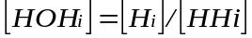 (59)

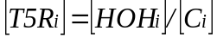 (60)

Subject to:
C_{i} > 0 for all active PODs (61)
MDST = 1440 minutes Assumed (62)
Comments:
Equation 59 converts population numbers into head of house hold numbers. Equation 60 then applies a throughput rate to the results of Equation 59 to obtain the Required (POD) Service Time.

Last Active POD Equation
These equations may be one of the distinguishing equations offered by this model. It basically considers the order fulfillment sequence in the RSS; the travel time between the RSS and each POD; and the Required Service Time for each POD to predict which POD is expected to be the Last Active POD.

Notations for Last Active POD (POD_{LAP})
Note: Several variables previously listed in General Notations
TS_{LAP} = TS_{i} for Last Active POD
PS_{LAP} = Position in POD Order start sequence for the Last Active POD

Equations:
POD_{LAP} = Max [[T4_{i}] + [T5R_{i}]] (63)
POD_{LAP, DA} = Max [[TP_{i}] + [T5R_{i}]] (64)

Comments:
Equation 63 is a simpler version of this concept that can be utilized when the direct delivery approach (DA) from RSS to each POD has been selected and the assumption is made that the Last Active POD will receive the first completed POD order.

Equation for Estimated Number of Lives Saved (L_{i}): Future State vs. Current State
To this point, the primary metric of interest has been time. However, the most valuable metric and the primary purpose of this study is saving lives. This equation is designed to compare the “future state” of this model with the “typical” “current state” of the SNS-RSS-POD system. It should be noted that various jurisdictions have developed their systems to various levels of effectiveness, so it is important to recognize the perils of making a broad general assumption regarding what is “typical”.

Notations for Estimated Number of Lives Saved (L_{i}): Future State vs. Current State
S_{i} = the expected fraction of the exposed population that will survive a release
M_{i} = Mortality Rate or the expected fraction of the exposed population that will die from a release
G_{i} = time (hours) between exposure and treatment of population for POD_{i}, i=1, 2, … , n.
f(g) = Survival function is taken from various incubation period curves where g is the time since exposure. [Stroud (2011)]
L_{i} = Expected number of Lives saved in each POD area by implementing recommended changes (Future State versus Current State)

Equations:
S_{i} = f(g) = 1 - (.004 g)², for all g = 1, 2, …, 150 and i = 1, 2, …, n (65)
M_{i} = 1 - S = (.004 g)² , for all g = 1, 2, …, 150 and i = 1, 2, …, n (66)
(67)

Subject to:
g ≤ 150 hours [Stroud (2011)] (68)

Comments:
Equation 65 is basically an equation [Stroud (2011)] that was developed to estimate survival rates versus time from exposure to treatment (T_{i}). Equation 66 coverts survival rates to mortality rates. Equation 67 creates a means of comparing the mortality rates of this model in the potential future state (all recommendations implemented) with this model utilizing current state practices. This perspective may be somewhat unique in that it converts time saved into estimated lives saved.

CHAPTER IV: CASE STUDY
In order to illustrate the functionality of the Fiske Model and supporting models presented in Chapter III; a fictitious, yet realistic, case study has been created in which the designers are preparing for a regional response to a large population exposure to aerosol anthrax.
The “Future State” SNS-RSS-POD Model (Figure 9 on page 40) will be utilized for this analysis. To assess the “current state” of the SNS-RSS-POD system this model will be followed without benefit of any reviews, recommendations, or corrective measures. For comparative purposes, the full model will be utilized with the assumption that all recommendations and corrective measures have been implemented in order to envision the “future state”.

In this planning scenario, the secondary SNS warehouse will be shipping the 12 Hour Push Package via a cargo plane and will require the full 12 hours (720 minutes) to deliver all 8 truckloads to the RSS. The RSS will be servicing 24 PODs within a 150 mile radius of the RSS. These PODs will service the populations of one large city, several rural areas, and two modest size cities in the outer sections of this area. The total population of this area is approximately 500,000 people.

The assumption is being made that none of the recommendations made in this study were in practice prior to the initial assessment. It is further being assumed that all of these recommendations will be implement immediately after the initial assessment. Although disguised for security purposes, this Fiske Model will be populated with data, parameters, and decision variables that are assumed to represent the “current state” of a “typical” SNS-RSS-POD system.

Figure 11 is a “grid map” of the impacted area. In reality this would be a real map (i.e. Google Map) with highways, rivers, mountains, forests, etc. and estimated travel times between all points. This illustrated “grid map” is not to scale. However, the RSS and POD locations utilized in this scenario were placed on a larger grid map with scaled x axis and y axis of travel times thus allowing for the triangulation of direct line travel times between all points.

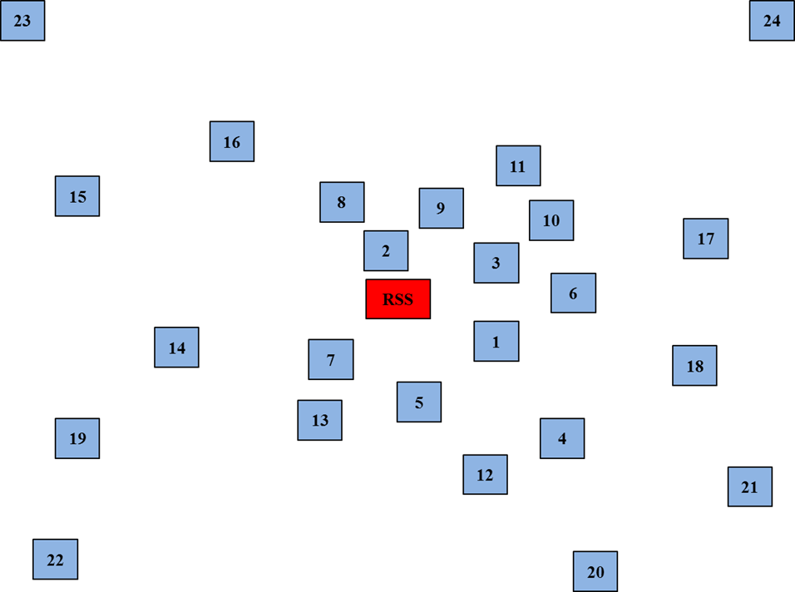

Figure 11: “Grid Map” of RSS – PODs Service Area
Note: This “grid map is not to Scale

The “Current State” Model
The “current state” model will consist of convoying the 8 SNS trucks from the airport to the RSS. Next all trucks are unloaded at the RSS facility and all 130 containers are set up in a storage / pick pattern. There are 4 aisles (part of the Critical Path) in which workers pull a pallet jack and pallet while picking orders from these containers for various PODs. Each POD will place one individual order for enough supplies to last the entire event (the details of which is not fully known at that time). Each POD order would be processed and a pick list would be generated. After being picked, the completed orders would be staged and then loaded into one of four available delivery trucks. Each delivery truck will have a designated route and deliver the POD orders to the various PODs along its route.

Note: The initial “current state” information regarding the SNS; RSS; and the number, locations and demographics of the PODs will be the same in the “future state” analysis.

Step A: Preliminary Stage
Table 2 is the basic POD information for this “current state” POD scenario.

Table 3 represents the additional preliminary data or expert opinions that might typically apply to the “current state” operation of the SNS-RSS-POD system.

Figure 9 (page 40) will serve as the “Future State” SNS-RSS-POD Model.

Figure 12 illustrates the general airplane to RSS Critical Path for the “current state” model in which all 8 trucks are unloaded from the airplane to form a convoy to the RSS where they all need to be unloaded and staged in the pick area prior to starting the order picking process.

Figure 13 illustrates the “current state” Critical Path (T3) through the RSS Pick Area. Based on the size of the containers and allowing for safety gaps between containers, each trip will be about 120 feet of travel distance within the pick area.
Table 2: Initial Basic POD Information for “Current State”
POD_{i} | H_{i} | HH_{i}* | HOH_{i} | C_{i} | Comment
1 | 23,500 | 2.20 | 10,682 | 8.00
2 | 22,500 | 2.20 | 10,227 | 8.00
3 | 500 | 2.20 | 227 | 3.00 | Closed POD
4 | 24,500 | 2.20 | 11,136 | 8.00
5 | 24,000 | 2.20 | 10,909 | 8.00
6 | 25,000 | 2.20 | 11,364 | 8.00
7 | 21,000 | 2.20 | 9,545 | 8.00
8 | 9,200 | 2.20 | 4,182 | 8.00
9 | 26,500 | 2.20 | 12,045 | 8.00
10 | 19,500 | 2.20 | 8,864 | 8.00
11 | 600 | 2.20 | 273 | 3.00 | Closed POD
12 | 22,500 | 2.20 | 10,227 | 8.00
13 | 19,000 | 2.20 | 8,636 | 8.00
14 | 28,500 | 2.20 | 12,955 | 8.00
15 | 24,500 | 2.20 | 11,136 | 8.00
16 | 21,500 | 2.20 | 9,773 | 8.00
17 | 26,000 | 2.20 | 11,818 | 8.00
18 | 7,500 | 2.20 | 3,09 | 8.00
19 | 8,700 | 2.20 | 3,955 | 8.00
20 | 6,900 | 2.20 | 3,136 | 8.00
21 | 29,500 | 2.20 | 13,409 | 8.00
22 | 50,000 | 2.20 | 22,727 | 8.00
23 | 15,100 | 2.20 | 6,864 | 8.00
24 | 34,000 | 2.20 | 15,455 | 8.00

Table 3: Additional “Current State” Data and Expert Opinions
Value | Notation | Description or Comment
1440 | MDST | Maximum Desired Service Time per POD (minutes)
0 | C_{SNS} | Decision Variable: Load SNS trucks to support RSS usage
0 | D_{A} | Decision Variable: RSS to POD Delivery Approach A
0 | D_{B} | Decision Variable: RSS to POD Delivery Approach B
1 | D_{C} | Decision Variable: RSS to POD Delivery Approach C
0 | D_{D} | Decision Variable: RSS to POD Delivery Approach D
2 | L_{S} | Staging / Loading Time of POD Order in RSS (minutes)
10 | T_{U} | Average Unload Time at the PODs (minutes)
20 | T_{D} | Average Diversion Time from Direct Delivery Route (minutes)
4 | V_{POD} | Number of Available RSS to POD Transport Vehicle
0 | T2_{A} | Decision Variable: Utilize known SNS to RSS delivery time
0 | T2_{AT} | Known SNS to RSS delivery time (minutes)
1 | T2_{D} | Decision Variable: Utilize Default SNS to RSS delivery time
720 | T2_{DT} | Default SNS to RSS delivery time (minutes)
1 | T_{AIR} | Decision Variable: Utilize SNS to RSS air transportation
11 | U_{AIR} | Unload time per truck from airplane into RSS trucks (minutes)
0 | T_{CON} | Decision Variable: Convoy SNS trucks from airport to RSS
8 | V_{RSS} | Number of SNS to RSS trucks needed
2 | V_{U} | Number of SNS to RSS trucks needed to transport at least of one of every container configuration
11 | U_{RSS} | Time to unload SNS truck at RSS and stage containers in Pick Area per truck (minutes)
130 | C_{P} | Number of containers in a 12 hour Push Package

Value | Notation | Description or Comment
40 | C_{U} | Number of different container configurations in the 12 Hour Push Package
2 | D_{RSS} | Max. number of SNS trucks unloaded at a time (# Available Inbound RSS Dock Doors)
130 | P_{S} | Number of Containers in the Pick Area
8 | P_{Z} | Number of Containers in a Pick Zone (1 KU) within Immediate Pick Area
2 | K | Process cadence time (minutes)
2 | K_{Q} | Cadence units required in Order Pick Cycle for Quality Inspection and Inventory Control
1 | K_{M} | Cadence units required in Order Pick Cycle for Misc. Activities
78 | T1 | Time from Exposure to Decision to Activate the SNS-RSS-POD system (hours)
Table 3: Continued

Legend | Color Code
Unload Containers from Airplane into Trucks
Transport Containers from Airport to RSS
Unload Trucks at RSS and Stage Pick Area
Start POD Order Picking

Time
Truck #1
Truck #2
Truck #3
Truck #4
Truck #5
Truck #6
Truck #7
Truck #8

Figure 12: “Current State” Critical Path from Airport to RSS Times

A |  |  |  |  | A | F |  | F | F |  | F
A |  | A | A |  | A | F |  | F | P |  | G
A |  | A | A |  | A | E |  | Q | G |  | G
U |  | A | B |  | B | E |  | E | O |  | H
U |  | V | B |  | B | E |  | E | H |  | H
X |  | X | B |  | B | D |  | S | H |  | H
X |  | X | B |  | B | D |  | D | N |  | I
X |  | X | B |  | B | D |  | D | I |  | I
X |  | X | B |  | B | D |  | T | K |  | J
Y |  | Z | B |  | B | M |  | R | J |  | J
W |  | W | B |  | B | R |  | R | J |  | J
AB |  | AF | B |  | B | R |  | R | J |  | J
AC |  | AD | B |  | B | C |  | C | J |  | J
AA |  | AE | B |  | B | B |  | B | J |  | J
AA |  | AA | B |  | B | B |  | B | J |  | J
AA |  | AA | B |  | B | B |  | B | L |  | J

Figure 13: “Current State” RSS Pick Area Layout

Step B: Demand Assessment and Review
Table 4 and Figure 14 reflect the Required (POD) Service Times (T5R_{i}) versus the Maximum Desired Service Time (MDST). Six PODs are above the MDST. Since this is the “current state” no action is being taken to reduce any Required (POD) Service Times. As illustrated, POD 22 is identified as the expected Last Active POD.

Step C: System Analysis and LAP Profile
Figure 15 represents the assumed geographic relationship between the RSS and the PODs it services. For this analysis, these PODs were placed on a grid with x and y coordinates in units of time travel. Accordingly travel vectors could be drawn between various location points and the travel vector value (travel time) could be calculated (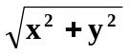) for each travel vector. Since route delivery is being utilized, it is necessary to determine both the RSS to POD travel times and all POD to POD travel times. Table 5 shows the results of a vector analysis of this “map”.

In reality the RSS and the PODs will all have street addresses. Mapping software (i.e. Google) may be utilized to calculate the shortest time routes and estimated travel times between these locations thus allowing for variables such as rivers, available highways, posted speed limits, etc. However, the resulting data would be presented in a similar table.

Based on the data in Table 5, the current state logistical plan was developed with 4 trucks delivering to 24 PODs on the routes illustrated in Figure 16.

The details of the vector analysis of route travel times for the RSS to PODs and PODs to PODs are outlined in Table 6. Intuitively, the route numbers are prioritized bases on the highest Required (POD) Service Time in each route and where that POD is on the delivery schedule. Thus Route #1 delivers supplies to POD 22; Route #2 delivers to POD 24; Route #3 delivers to POD 21, and Route #4 delivers to POD 9.

Table 4: Initial Required (POD) Service Times
POD_{i} | T5R_{i} | MDST
1 | 1,335
2 | 1,278
3 | 76
4 | 1,392
5 | 1,364
6 | 1,420
7 | 1,193
8 | 523
9 | 1,506 | >MDST (1,440)
10 | 1,108
11 | 91
12 | 1,278
13 | 1,080
14 | 1,619 | >MDST (1,440)
15 | 1,392
16 | 1,222
17 | 1,477 | >MDST (1,440)
18 | 426
19 | 494
20 | 392
21 | 1,676 | >MDST (1,440)
22 | 2,841 | >MDST (1,440)
23 | 858
24 | 1,932 | >MDST (1,440)

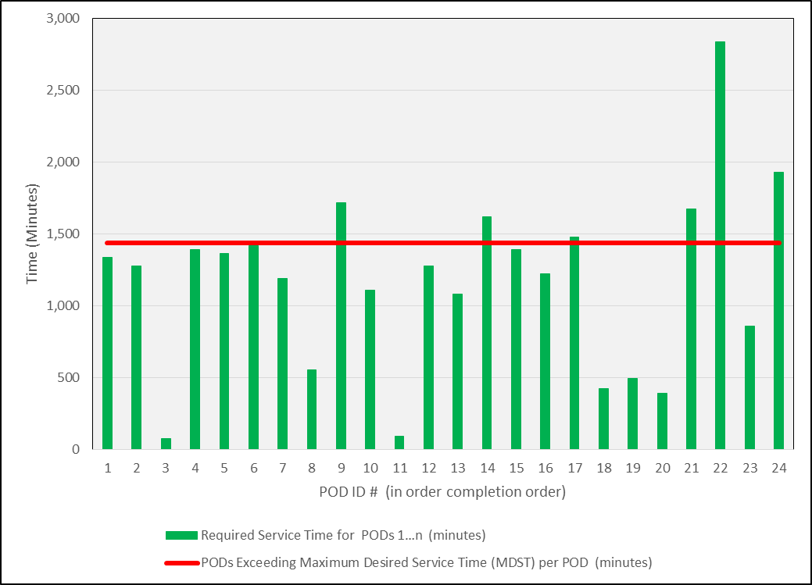

Figure 14: Initial Required (POD) Service Times (T5)

Figure 15: “Current State” RSS POD Service Area “Map”
Note: This illustration is not to scale

Table 5: RSS to PODs and POD to POD Travel Times (minutes)
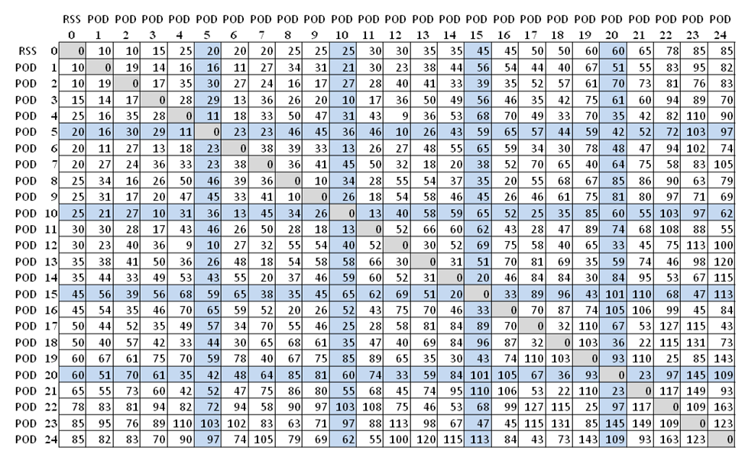

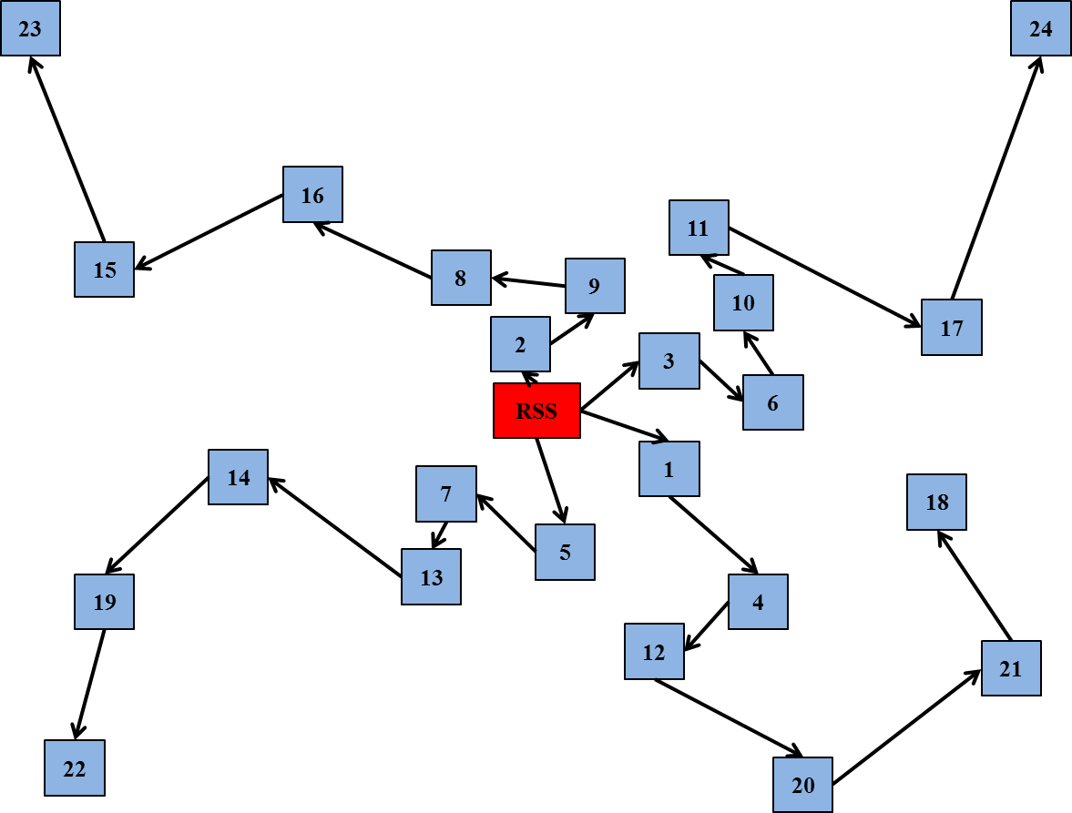
Figure 16: “Current State” RSS to PODS Routing Map
Note: This illustration is not to scale

Table 6: “Current State” Route Schedules and Delivery Times

Route #1  From | To | Segment Travel Time | Cumulative Travel Time | Prior Stop Unload Time | Cumulative Total Delivery Time
RSS | POD 5 | 20 | 20 | 0 | 20
POD 5 | POD 7 | 23 | 43 | 10 | 53
POD 7 | POD 13 | 18 | 61 | 10 | 81
POD 13 | POD 14 | 31 | 92 | 10 | 122
POD 14 | POD 19 | 30 | 122 | 10 | 162
POD 19 | POD 22 | 25 | 147 | 10 | 197

Route #2  From | To | Segment Travel Time | Cumulative Travel Time | Prior Stop Unload Time | Cumulative Total Delivery Time
RSS | POD 3 | 15 | 15 | 0 | 15
POD 3 | POD 6 | 13 | 28 | 10 | 38
POD 6 | POD 10 | 13 | 41 | 10 | 61
POD 10 | POD 11 | 13 | 54 | 10 | 84
POD 11 | POD 17 | 28 | 82 | 10 | 122
POD 17 | POD 24 | 43 | 125 | 10 | 175

Table 6: Continued

Route #3  From | To | Segment Travel Time | Cumulative Travel Time | Prior Stop Unload Time | Cumulative Total Delivery Time
RSS | POD 1 | 10 | 10 | 0 | 10
POD 1 | POD 4 | 16 | 26 | 10 | 36
POD 4 | POD 12 | 9 | 35 | 10 | 55
POD 12 | POD 20 | 33 | 68 | 10 | 98
POD 20 | POD 21 | 23 | 91 | 10 | 131
POD 21 | POD 18 | 22 | 113 | 10 | 163

Route #4  From | To | Segment Travel Time | Cumulative Travel Time | Prior Stop Unload Time | Cumulative Total Delivery Time
RSS | POD 2 | 10 | 10 | 0 | 10
POD 2 | POD 9 | 17 | 27 | 10 | 37
POD 9 | POD 8 | 10 | 37 | 10 | 57
POD 8 | POD 16 | 20 | 57 | 10 | 87
POD 16 | POD 15 | 33 | 90 | 10 | 130
POD 15 | POD 23 | 47 | 137 | 10 | 187

Once the route schedules are established, the “Current State” Required (POD) Service Times graph (Figure 17) is updated to reflect the various delivery routes. In practice, each route order will be picked in reverse order and loaded on the truck in a LIFO sequence. As previously stated, the scope of this study does not include the actual POD operations. However, individual POD demand (numbers to be serviced or treated) will be part of the “future state” discussions.

Figure 18 begins to compile the various time components of T4 and T5 for the PODs in the “current state”. The time scale for Figure 18 is expanded in Figure 19 in order to better illustrate the T4 variables that represent opportunities to reduce process time. On a percentage basis, these numbers may not appear to be significant, but in terms of lives saved, these numbers are very meaningful.

Combining the Order Pick Sequence (PS_{i}), RSS to POD travel times (T4_{i}), and the Required (POD) Service Times (T5R_{i}); POD 22 is identified as the Last Active POD.

Step D: Available Time Assessment and Review
Table 7 represents a summary of the times in the different periods of the "Future State" SNS-RSS-POD Model (Figure 9 on page 40).
Table 7: Summary of “Current State” Metrics
Variable | Value  (minutes) | Value  (hours) | Description
T2 | 720 | 12.00 | SNS to RSS Time
T3 | 83 | 1.38 | RSS Time to first completed POD order
T4_{LAP} | 221 | 3.68 | RSS to POD 22
T5A_{LAP} | 1,857 | 30.95 | Available Service Time for POD 22
T5R_{LAP} | 2,841 | 47.35 | Required Service Time for POD 22

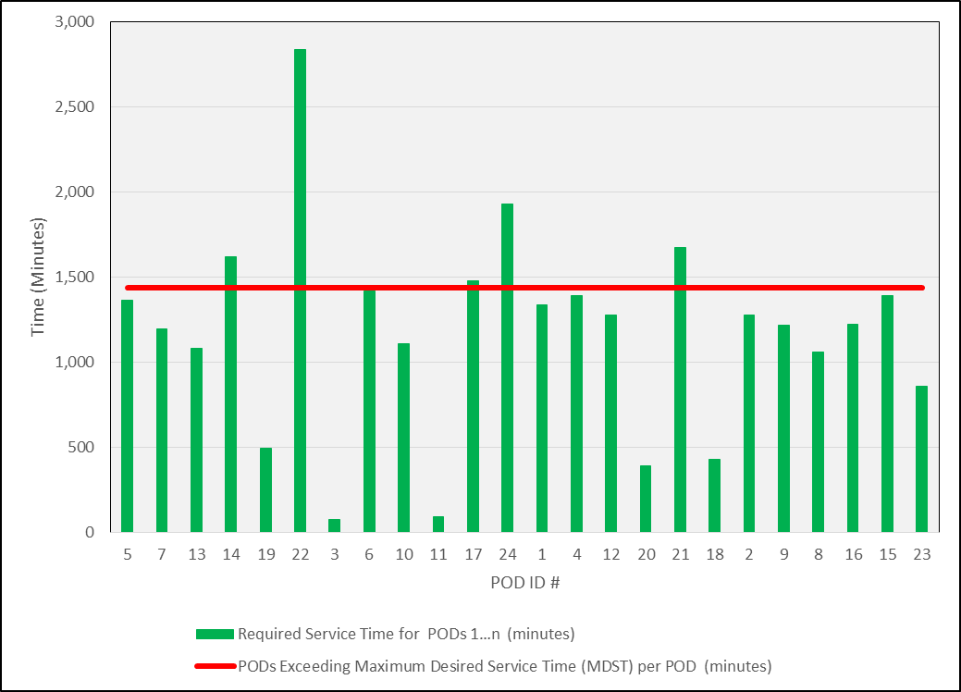

Figure 17: “Current State” Required (POD) Service Times (T5) by Route Delivery Order

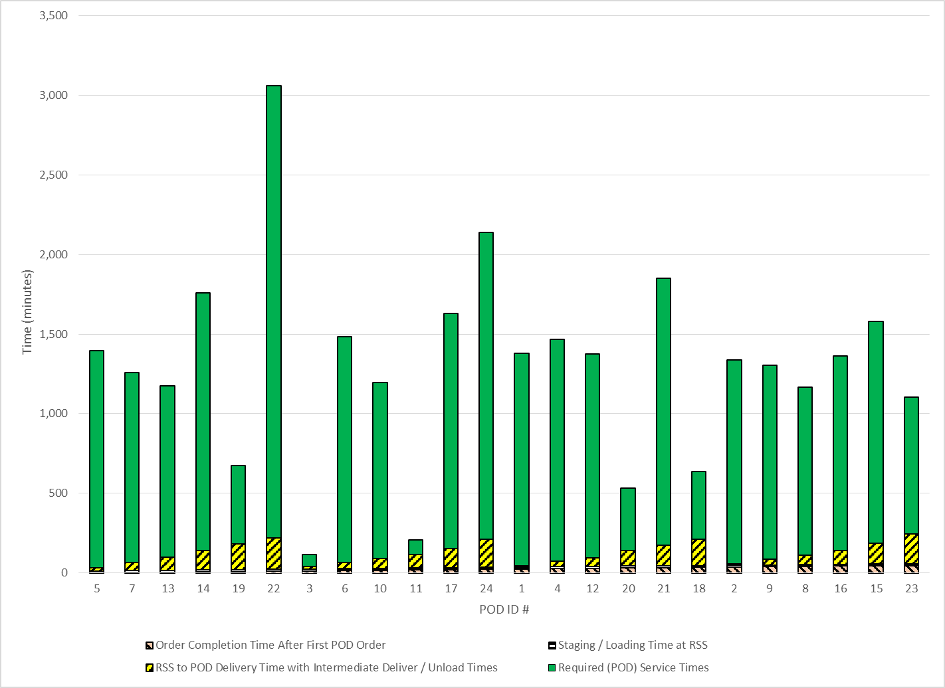

Figure 18: “Current State” T4 and T5 for PODs
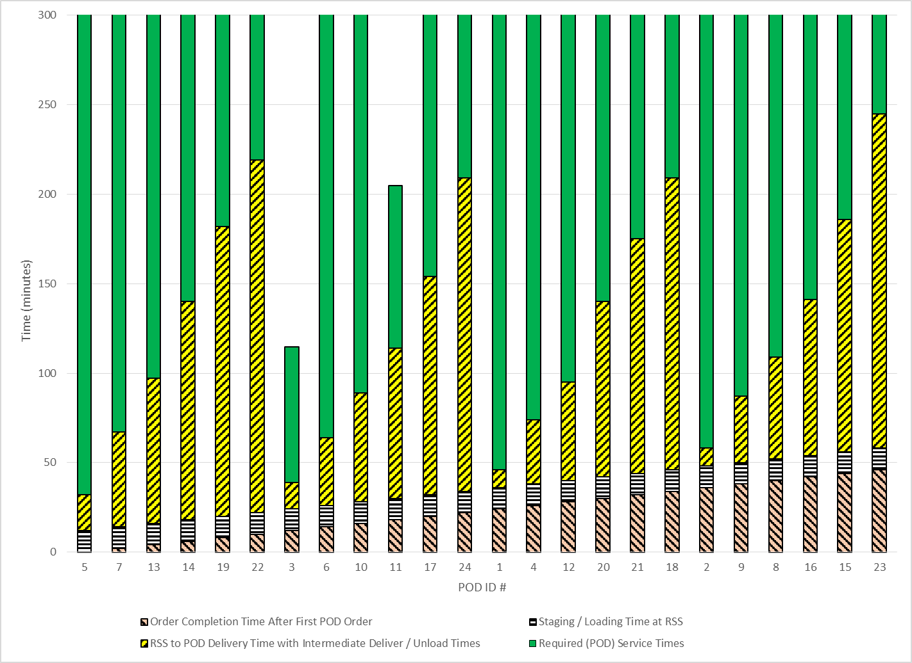
Figure 19: Figure 18 Expanded Scale
Step E: Strategic Analysis
In the given scenario with the given assumptions, this model indicates that the SNS-RSS-POD system will fail to meet its stated objective (Objective #2) of providing service or treatment to the last person in the Last Active POD within 48 hours of the Decision to Activate the system. In order to accomplish this objective, POD 22 would need to complete its operation in 30.95 hours; but instead it is currently projected to require 47.35 hours.

Lives Saved will be addressed following the “future state” analysis.

Step F: Implementation and Sustainment

Since no recommendations were implemented in the “current state”; there are no implementation comments. The “current system” can be sustained as is, but the question remains at what capability level it is being sustained at.

The “Future State” Model
Step A: Preliminary Stage
The initial information (Table 2 on page 62) regarding PODs is the same as the information provided for the “current state” analysis.

The "Future State” SNS-RSS-POD Model (Figure 9 on page 40) will also be the same as in the “current state”.

Developing and identifying the Critical Path for T2 and T3 is where the analysis begins to change. The initial Critical Path was identified between the SNS and the completion of the first POD order in the RSS. Then detailed observations and analyses were made at each step along this path. Recommendations were made and discussed with key authorities and operational personnel. Many of these recommendations can be found in the Appendix. Of particular note, the following recommendations are included in this “future state” model:
- The SNS warehouse will load their trucks and plane in such a manner as to include one of each type (40 different container configurations) of container configuration in the first two trucks to arrive at the RSS. Further, the remaining six SNS to RSS trucks will be loaded in a balanced manner to support the J.I.T (Just In Time) replenishment of the pick area while the remaining SNS to RSS trucks are still arriving at the RSS and being unloaded.
- The cargo plane to RSS trucks will be dispatched from the airport as they are loaded instead of forming a convoy. Therefore, T2 is assumed to be 12 hours or 720 minutes to deliver the entire convoy. It is also assumed that the SNS cargo plane can be unloaded at a rate of 1 truck every 11 minutes. Thus it should take 88 minutes to form a convoy. It is assumed that security and logistical considerations will allow the first loaded truck to leave the airport once it was loaded and thereby reach the RSS 77 minutes sooner. Likewise the second truck could leave the airport and arrive at the RSS 66 minutes sooner. Since the SNS warehouse has loaded one of every type of SNS container configuration within the first two trucks; the RSS should be able to start the Picking Operation 66 minutes sooner. Figure 20 illustrates this concept.
- The RSS Pick Area has been reduced to 40 containers (one of each configuration) with the one-of-a-kind containers in the middle. The duplicates are staged outside of the immediate Pick Zones and are available to replace empty containers as they occur. It should be noted that the actual size of the Pick Area will be determined while the 12 Hour Push Package is in transit from the SNS based on an ongoing assessment of the event. If certain SNS supplies are deemed irrelevant to the event they will be set aside upon arrival at the RSS. The green zone is the actual Pick Area and has 4 Pick Zones (1 cadence unit per zone) as part of a visual Kanban system. Figure 21 illustrates this layout.
- A direct RSS to POD delivery system has been designed to utilize emergency vehicles instead of trucks.

Legend | Color Code
Unload Containers from Airplane into Trucks
Transport Containers from Airport to RSS
Unload Trucks at RSS and Stage Pick Area
Start POD Order Picking

Truck #1
Truck #2
Truck #3
Truck #4
Truck #5
Truck #6
Truck #7
Truck #8

Time

Figure 20: SNS Cargo Plane to RSS Logistics – “Future State”

B | B | B | B | B | B | B | B | B | B |  |  |  | B |  |  |  |  |  |  | R |  |  |  | R | R | R | R
B | B | B | B | B | B | B | B | B | B |  |  |  | B |  |  | AF | T |  |  | D |  |  |  | D | D | D | D | D
B | B | B | B | B | B | B | B | B | B |  |  |  | A |  |  | AB | S |  |  | E |  |  |  | E | E | E | E
 |  | A | A | A | A | A | A | A | A |  |  |  | A |  |  | AC | Q |  |  | H |  |  |  | H | H | H | H
 |  |  |  |  |  |  |  |  | C |  |  |  | C |  |  | AD | P |  |  | G |  |  |  | G | G
 |  |  |  |  |  |  | AA | AA | AA |  |  |  | AA |  |  | AE | O |  |  | F |  |  |  | F | F | F | F | F
 |  |  | X | X | X | X | X | X | X |  |  |  | X |  |  | V | N |  |  | I |  |  |  | I | I
 |  |  |  |  |  |  |  |  | W |  |  |  | W |  |  | Y | K |  |  | M |  |  |  | J | J | J | J | J | J
 |  |  |  |  |  |  |  |  | U |  |  |  | U |  |  | Z | L |  |  | J |  |  |  | J | J | J | J | J | J | J

Figure 21: Critical Path in RSS Order Pick Area – “Future State”

- Due to smaller (several hour supply) standardized initial POD orders determined by the authorities in the RSS instead of the POD managers; the cadence of the system is one minute.
- The Last Active POD has been identified as part of the Critical Path and therefore received the first completed POD order from the RSS.

Summary of CPM analysis:
The impact of the above system improvements are assessed and translated into appropriate data and or expert opinions that are then utilized when populating the Mathematical Model. Table 8 summarizes the Additional Initial Information that is utilized in the “Future State” Mathematical Model.

Step B: Demand Assessment and Review
Table 4 (page 68) and Figure 14 (page 69) reflect the Initial Required (POD) Service Times (T5R_{i}) versus the Maximum Desired Service Time (MDST). It should be noted that this is the same information utilized in the “current state” analysis. However, in this “future state” analysis, several recommendations were made and implemented. These recommendations included the following:
- Several PODs (8, 18, 19, 20, and 23) appear to be relatively overstaffed for the population they will be servicing. This represents potential resources that might be better deployed elsewhere. Note: POD 3 and POD 11 are Closed PODs.
- POD 9 is over the MDST guideline. POD 9 is part of the city wide coverage and is adjacent to the POD 8 service area which is relatively under-utilized. It is recommended that the communication plan, etc., be redesigned to encourage 4,000 HOH (8,800 people) to go to POD 8 instead of POD 9.

Table 8: Additional Initial Information and Expert Opinions
Value | Notation | Description or Comment
1440 | MDST | Maximum Desired Service Time per POD (minutes)
1 | D_{A} | Decision Variable: RSS to POD Delivery Approach A
0 | D_{B} | Decision Variable: RSS to POD Delivery Approach B
0 | D_{C} | Decision Variable: RSS to POD Delivery Approach C
0 | D_{D} | Decision Variable: RSS to POD Delivery Approach D
2 | L_{S} | Staging / Loading Time of POD Order in RSS (minutes)
10 | T_{U} | Average Unload Time at the PODs (minutes)
20 | T_{D} | Average Diversion Time from Direct Delivery Route (minutes)
48 | V_{POD} | Number of Available RSS to POD Transport Vehicle
0 | T2_{A} | Decision Variable: Utilize known SNS to RSS delivery time
0 | T2_{AT} | Known SNS to RSS delivery time (minutes)
1 | T2_{D} | Decision Variable: Utilize Default SNS to RSS delivery time
720 | T2_{DT} | Default SNS to RSS delivery time (minutes)
1 | T_{AIR} | Decision Variable: Utilize SNS to RSS air transportation
11 | U_{AIR} | Unload time per truck from airplane into RSS trucks (minutes)
8 | V_{RSS} | Number of SNS to RSS trucks needed
2 | V_{U} | Number of SNS to RSS trucks needed to transport at least of one of every container configuration
11 | U_{RSS} | Time to unload SNS truck at RSS and stage containers in Pick Area per truck (minutes)
130 | C_{P} | Number of containers in a 12 hour Push Package
40 | C_{U} | Number of different container configurations in the 12 Hour Push Package

Value | Notation | Description or Comment
2 | D_{RSS} | Max. number of SNS trucks unloaded at a time (# Available Inbound RSS Dock Doors)
8 | P_{Z} | Number of Containers in a Pick Zone (1 KU) within Immediate Pick Area
1 | K | Process cadence time (minutes)
2 | K_{Q} | Cadence units required in Order Pick Cycle for Quality Inspection and Inventory Control
1 | K_{M} | Cadence units required in Order Pick Cycle for Misc. Activities
96 | T1 | Time from Exposure to Decision to Activate the SNS-RSS-POD system (hours)
Table 8: Continued

- Several other PODs (14, 17, 21 and 24) are also over the MDST guideline. Since most appear to be in relatively isolated areas, no immediate recommendations are being made to either consider shifting the population demand to neighboring POD areas or creating additional PODs. The status of these PODs will be reviewed again after the Available (POD) Service Times have been determined.
- POD 22 represents a serious design concern. This is a relatively isolated small city in which there is an obvious first choice for a POD operation. Accordingly, a single very large POD plan was developed. Based on the primary metric of time, a second (somewhat smaller) site was selected and POD 22 was split into POD 22.1 (28,000 population) and POD 22.2 (22,000 population). POD 22b will be staffed with surplus resources identified in recommendation 1.
- Table 9 and Figure 22 reflect the revised Required (POD) Service Times for the various PODs. Although PODs 14, 17, 21, and 24 are still greater than the MDST, no adjustments will be considered until after the actual Available (POD) Service Times have been determined.

Table 9: Revised Required (POD) Service Times
POD_{i} | T5R_{i} | MDST
1 | 1,335
2 | 1,278
3 | 76
4 | 1,392
5 | 1,364
6 | 1,420
7 | 1,193
8 | 1,057
9 | 1,216
10 | 1,108
11 | 91
12 | 1,278
13 | 1,080
14 | 1,619 | >MDST (1,440)
15 | 1,392
16 | 1,222
17 | 1,477 | +>MDST (1,440)
18 | 426
19 | 494
20 | 392
21 | 1,676 | >MDST (1,440)
22.1 | 1,591
22.2 | 1,250
23 | 858
24 | 1,932 | >MDST (1,440)

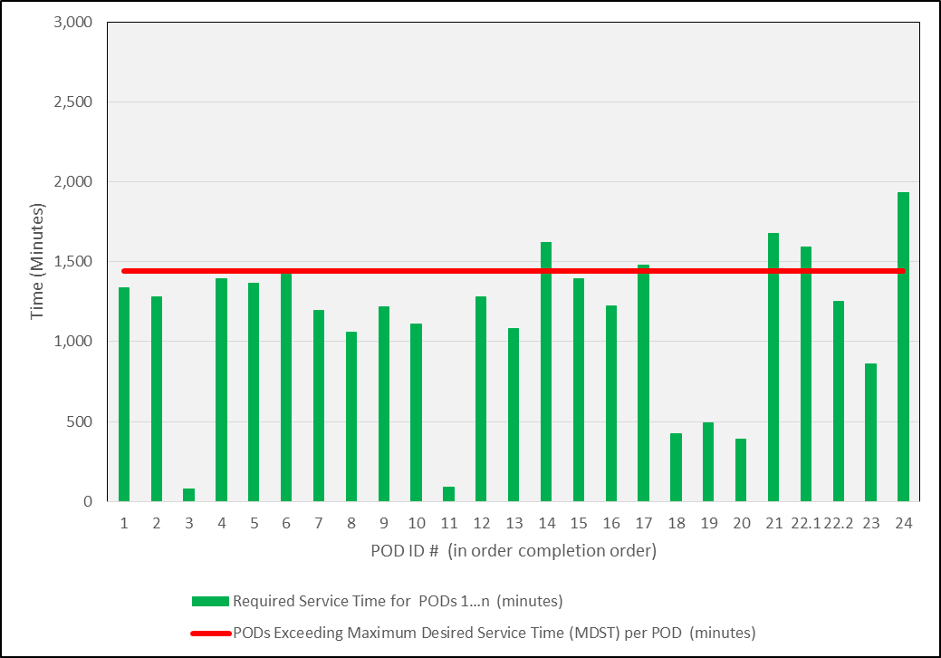

Figure 22: Revised Required (POD) Service Times

At this point Step B is considered tentatively acceptable and the analysis proceeds to
Step C.

Step C: System Analysis and LAP Profile
For this “future state” analysis, Delivery Approach D_{A} (direct RSS to POD deliveries) is the chosen Decision Variable. The “grid map” in Figure 23 illustrates this logistical routing strategy: While Figure 23 is not to scale; these POD locations were also located on a much larger grid layout where the x axis and the y axis were scaled in units of travel time. Thus the travel time vectors were calculated and recorded in Table 10.

Figure 24 begins to compile the various time components of T4 and T5 for the PODs in the “future state”. The time scale for Figure 24 is expanded in Figure 25 in order to better illustrate the T4 variables that represent opportunities to reduce process time. It should be noted in Figure 25 that the RSS does not necessarily ship to farthest PODs first. This is part of the holistic approach that contributes to the overall process reflected in Figure 24.

Referring to Table 12, the POD with the largest combined total of T5R_{i} plus TP_{i} is projected to be the Last Active POD.

Conclusions:
POD_{LAP} = POD 24
T5R_{LAP} = 1,932 minutes

In order to calculate T4_{LAP}, the sequence in which POD orders are started and completed must first be determined. The assumption made when determining the POD_{LAP} in the previous section was that the POD_{LAP} would be first and the following PODs would be served (PS_{i}) in a descending order based on total T5Ri and TP_{i} time. Thus the PODs in Table 12 are ranked accordingly.
Conclusion: T4_{LAP} = 88

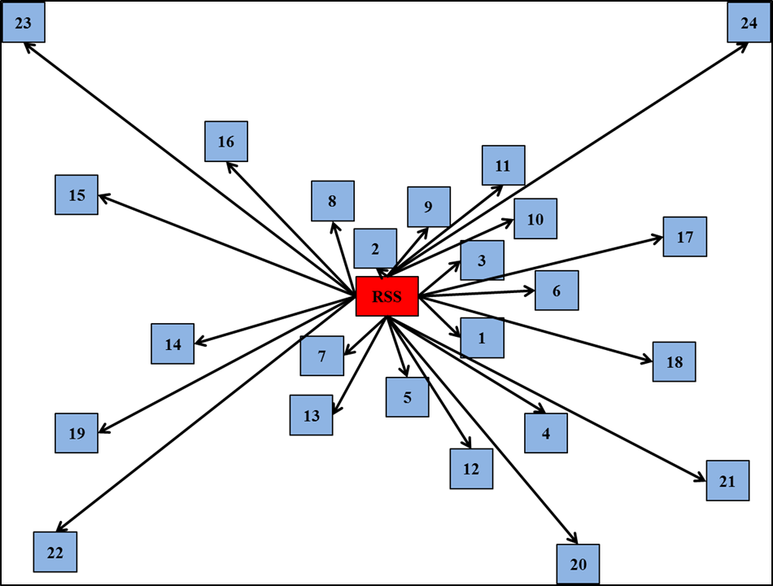

Figure 23: Direct RSS to POD Delivery
(Illustration is not to scale)

Table 10: Direct RSS to POD Travel Times (TP_{i})
POD_{i} | TP_{i} | Comment
1 | 10
2 | 10
3 | 15 | Closed POD
4 | 25
5 | 20
6 | 20
7 | 20
8 | 25
9 | 25
10 | 25
11 | 30 | Closed POD
12 | 30
13 | 35
14 | 35
15 | 45
16 | 45
17 | 50
18 | 50
19 | 60
20 | 60
21 | 65
22.1 | 78
22.2 | 78
23 | 85
24 | 85

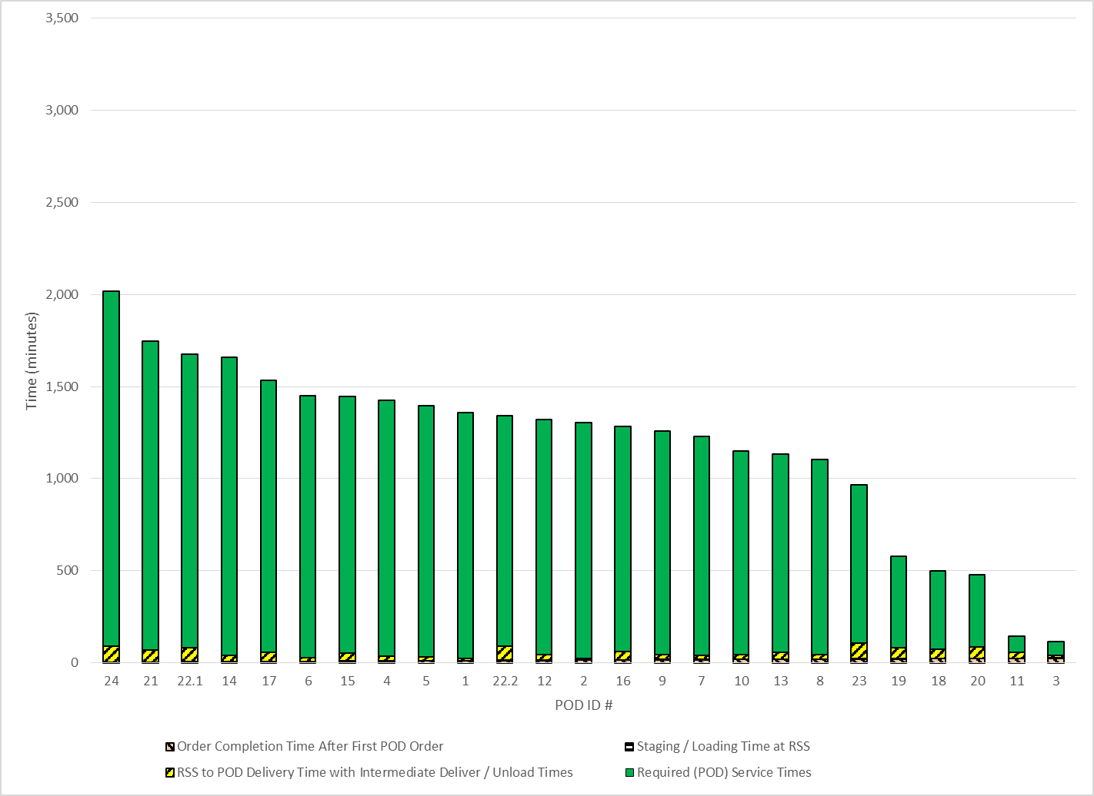

Figure 24: “Future State” T4 and T5 for PODs

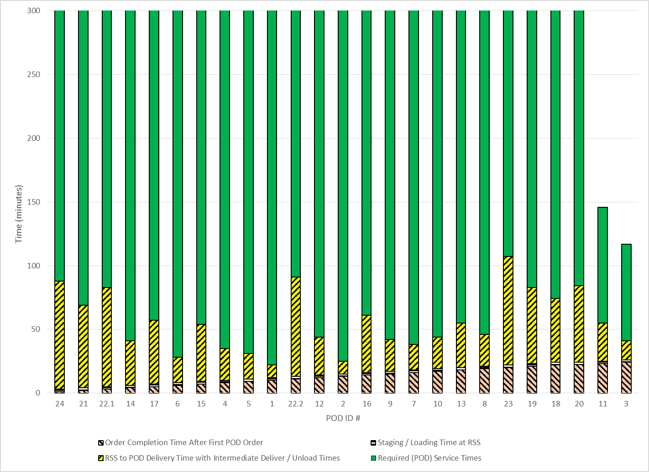

Figure 25: Figure 24 Expanded Scale
Table 11: Identification of the Last Active POD (POD_{LAP})
POD_{i} | T5R_{i} | TP_{i} | Total
1 | 1,335 | 10 | 1,345
2 | 1,278 | 10 | 1,288
3 | 76 | 15 | 91
4 | 1,392 | 25 | 1,417
5 | 1,364 | 20 | 1,384
6 | 1,420 | 20 | 1,440
7 | 1,193 | 20 | 1,213
8 | 1,057 | 25 | 1,082
9 | 1,216 | 25 | 1,241
10 | 1,108 | 25 | 1,133
11 | 91 | 30 | 121
12 | 1,278 | 30 | 1,308
13 | 1,080 | 35 | 1,115
14 | 1,619 | 35 | 1,654
15 | 1,392 | 45 | 1,437
16 | 1,222 | 45 | 1,267
17 | 1,477 | 50 | 1,527
18 | 426 | 50 | 476
19 | 494 | 60 | 554
20 | 392 | 60 | 452
21 | 1,676 | 65 | 1,741
22.1 | 1,591 | 78 | 1,669
22.2 | 1,250 | 78 | 1,335
23 | 858 | 85 | 943
24 | 1,932 | 85 | 2,017 | POD_{LAP}

Table 12: Sequence of POD Order Fulfillment (Ps_{i}) and T4_{LAP}
Sequence of Order Fulfillment by PODi | T5R_{i} | TP_{i} | T5R_{i}  TP_{i}  Total | T4i | T5R_{i}  T4_{i}  Total
POD_{LAP} 24 | 1,932 | 85 | 2,017 | 88 | 2,020
21 | 1,676 | 65 | 1,741 | 69 | 1,745
22.1 | 1,591 | 78 | 1,669 | 83 | 1,674
14 | 1,619 | 35 | 1,654 | 41 | 1,660
17 | 1,477 | 50 | 1,527 | 57 | 1,534
6 | 1,420 | 20 | 1,440 | 28 | 1,448
15 | 1,392 | 45 | 1,437 | 54 | 1,446
4 | 1,392 | 25 | 1,417 | 35 | 1,427
5 | 1,364 | 20 | 1,384 | 31 | 1,395
1 | 1,335 | 965 | 1,345 | 22 | 1,357
22.2 | 1,250 | 577 | 1,328 | 91 | 1,328
12 | 1,278 | 500 | 1,308 | 44 | 1,322
2 | 1,278 | 476 | 1,288 | 25 | 1,303
16 | 1,222 | 146 | 1,267 | 61 | 1,283
9 | 1,216 | 117 | 1,241 | 42 | 1,258
7 | 1,193 | 20 | 1,213 | 38 | 1,231
10 | 1,108 | 25 | 1,133 | 44 | 1,152
13 | 1,080 | 35 | 1,115 | 55 | 1,135
8 | 1,057 | 25 | 1,082 | 46 | 1,103
23 | 858 | 85 | 943 | 107 | 965
19 | 494 | 60 | 554 | 83 | 577
18 | 426 | 50 | 476 | 74 | 500
20 | 392 | 60 | 452 | 84 | 476
11 | 91 | 30 | 121 | 55 | 146
3 | 76 | 15 | 91 | 41 | 117

Step D: Available Time Assessment and Review
With the Microsoft Excel worksheet populated with data, parameters, equations, and expert opinions; Step D is basically a matter of running Solver to obtain the following:
SNS to RSS Tie (T2) = 654 minutes
RSS Time (T3) = 19 minutes
Available (POD) Service Time for the Last Active POD (T5A_{LAP}) = 2,119 minutes

Step E: Strategic Analysis
POD 24 has been identified as the projected Last Active POD.
In Step D, the Available Service Time for the Last Active POD (T5A_{LAP}) is 2,119 minutes.
In Step C, the Required Service Time for the Last Active POD (T5R_{i}) is 1,932 minutes.
Conclusions:
- While T5R_{i} (1,932 minutes) exceeds MDST (1440 minutes), there is sufficient T5A_{LAP} (2,119 minutes) to allow the system to meet Objective #2 with a time safety buffer of 187 minutes.
- It should be noted that if air transportation between the SNS and RSS was not necessary, but the entire 720 minutes was required, the system would still meet Objective #2 with a time safety buffer of 121 minutes.
- It should also be noted that the system would have failed to meet Objective #2 if the serious design flaw involving POD 22 was not identified and managed in Step B.
For this presentation, the lives saved calculations will be discussed in the next segment.

Step F: Implementation and Sustainment
The initial assessment is completed and the model has served its initial purpose. However, in order to save lives the plan must become a reality. The actual implementation of the recommendations is outside the scope of this study. The Fiske Model will serve as a tool to assess changing conditions or assist in “what if” process improvement activities.

Finally there is a separate mathematical model that attempts to quantify time saved in terms of lives saved. By design it is intended to compare the potential “future state” versus the estimated “current state” of the SNS-RSS-POD system. Accordingly the Lives Saved segment will be discussed in the next section.

Comparing the “Current State” with the “Future State”
From an overall perspective the “current state” may be compared to the “future state” on two levels: time saved and human lives saved.

Time Comparison
Time is the primary working metric of this model and one of the main objectives of this analysis. The strategy of this analysis has been to increase the amount of Available (POD) Service Time with a combination of reducing high POD demand and saving time elsewhere in the process. Figure 26 illustrates the relative time saved in T2. Highlights include the avoidance of airport to RSS convoys and the ability to start the RSS picking operation after unloading the first two trucks. Figure 27 illustrates the relative time saved in T3. The primary factors include the streamlining of the pick area and the adoption of smaller standardized initial POD orders. Figure 28 illustrates the time saved in T4 and T5. Several factors contribute to the smoothing effect of this chart including smaller initial POD orders for a faster pick cycle; direct loading into waiting vehicles to reduce staging and loading times, and the obvious time savings of direct RSS to POD deliveries. Figure 28 also illustrates the overall holistic focus on servicing or treating the last people in need. The 24 hour guideline for minimum POD Service Time served a purpose in the early assessment phase, but the real question is whether or not enough time was saved elsewhere
in the system to allow the Last Active POD (and other PODs) to meet the objective of treating the last person in need within 48 hours of the decision to activate the SNS-RSS-POD system.
Figure 29 illustrates the outcome of this analysis. The red vertical line in Figure 29 indicates the 48 hour (2880 minute) maximum limit to treat the last person in the Last Active POD. As previously discussed, POD 22 was identified early (Step B) in the future state model analysis as a serious design problem and was managed (split into two PODs) accordingly. As a result

Legend | Color Code
Unload Containers from Airplane into Trucks
Transport Containers from Airport to RSS
Unload Trucks at RSS and Stage Pick Area
Start POD Order Picking
Truck #1
Truck #2
Truck #3
Truck #4
Truck #5
Truck #6
Truck #7
Truck #8

“Current State”
Truck #1
Truck #2
Truck #3
Truck #4
Truck #5
Truck #6
Truck #7
Truck #8
“Future State”
Time
Figure 26: Comparison of T2 Highlights
A |  |  |  |  | A | F |  | F | F |  | F
A |  | A | A |  | A | F |  | F | P |  | G
A |  | A | A |  | A | E |  | Q | G |  | G
U |  | A | B |  | B | E |  | E | O |  | H
U |  | V | B |  | B | E |  | E | H |  | H
X |  | X | B |  | B | D |  | S | H |  | H
X |  | X | B |  | B | D |  | D | N |  | I
X |  | X | B |  | B | D |  | D | I |  | I
X |  | X | B |  | B | D |  | T | K |  | J
Y |  | Z | B |  | B | M |  | R | J |  | J
W |  | W | B |  | B | R |  | R | J |  | J
AB |  | AF | B |  | B | R |  | R | J |  | J
AC |  | AD | B |  | B | C |  | C | J |  | J
AA |  | AE | B |  | B | B |  | B | J |  | J
AA |  | AA | B |  | B | B |  | B | J |  | J
AA |  | AA | B |  | B | B |  | B | L |  | J
“Current State”
B | B | B | B | B | B | B | B | B | B |  |  |  | B |  |  |  |  |  |  | R |  |  |  | R | R | R | R
B | B | B | B | B | B | B | B | B | B |  |  |  | B |  |  | AF | T |  |  | D |  |  |  | D | D | D | D | D
B | B | B | B | B | B | B | B | B | B |  |  |  | A |  |  | AB | S |  |  | E |  |  |  | E | E | E | E
 |  | A | A | A | A | A | A | A | A |  |  |  | A |  |  | AC | Q |  |  | H |  |  |  | H | H | H | H
 |  |  |  |  |  |  |  |  | C |  |  |  | C |  |  | AD | P |  |  | G |  |  |  | G | G
 |  |  |  |  |  |  | AA | AA | AA |  |  |  | AA |  |  | AE | O |  |  | F |  |  |  | F | F | F | F | F
 |  |  | X | X | X | X | X | X | X |  |  |  | X |  |  | V | N |  |  | I |  |  |  | I | I
 |  |  |  |  |  |  |  |  | W |  |  |  | W |  |  | Y | K |  |  | M |  |  |  | J | J | J | J | J | J
 |  |  |  |  |  |  |  |  | U |  |  |  | U |  |  | Z | L |  |  | J |  |  |  | J | J | J | J | J | J | J
“Future State”

Figure 27: Comparison of T3 Highlights

“Future State”
“Current State”
Figure 28: Comparison of T4 and T5 Highlights

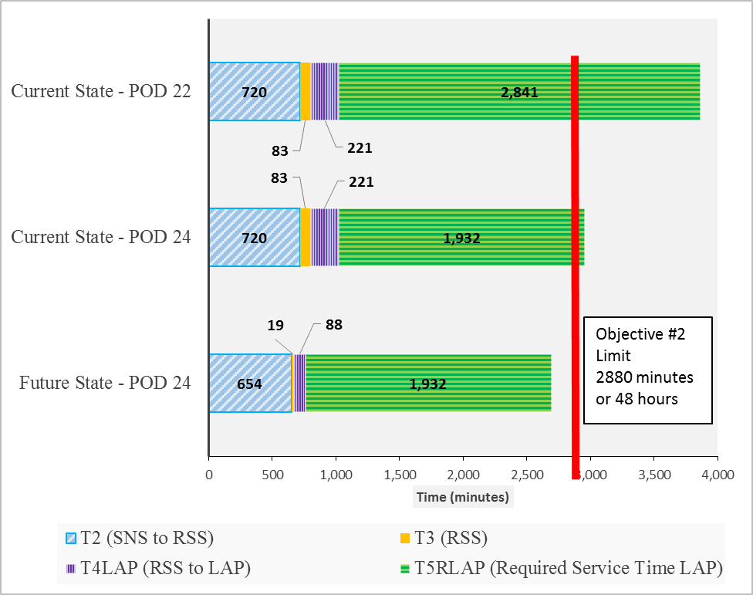

Figure 29: Comparison of “Current State” and “Future State” Capabilities

POD 24 became the Last Active POD in the future state. In the “current state” this design problem was not detected and thus POD 22 became the Last Active POD.
When comparing the Last Active PODs (POD 22 in “current state” and POD 24 in “future state”), the model clearly projects a failure of the “current state” to meet Objective #2 while the “future state” is expected to achieve its objective even though the Required Service Time (1,932 minutes) for POD 24 clearly exceeds the MDST guideline of 1,440 minutes.

Recognizing that POD 22 might be considered as a special cause situation, Figure 29 also includes a comparison between POD 24 in the “future state” and in the “current state” where it is the runner-up for the title of Last Active POD. In this case “future state” improvements in T2, T3, and T4 created sufficient Available Service Time to enable POD 24 to meet its lifesaving objective.

Assumed Features #1 and #2
Figure 30 illustrates the improvements in Assumed Features #1 and #2. With regard to Assumed Feature #1, from the time of the Decision to Activate the system every POD starts sooner in the “future state” with an average 23% decrease in start times from 927 minutes to 714 minutes. With regard to Assumed Feature #2, the range of POD start of operations time decreases 65% from 213 minutes to 75 minutes. Both figures represent a dramatic improvement in these assumed features.

Time Saved = Lives Saved
In an attempt to quantify the relationship between time saved and lives saved, Equations 66 and 67 (page 58) are based on Equation 65 (page 58) which was developed by the Institute of Medicine [Stroud (2011)]. When these equations were applied in the scenario utilized for this system analysis, a graph (Figure 31) was created.

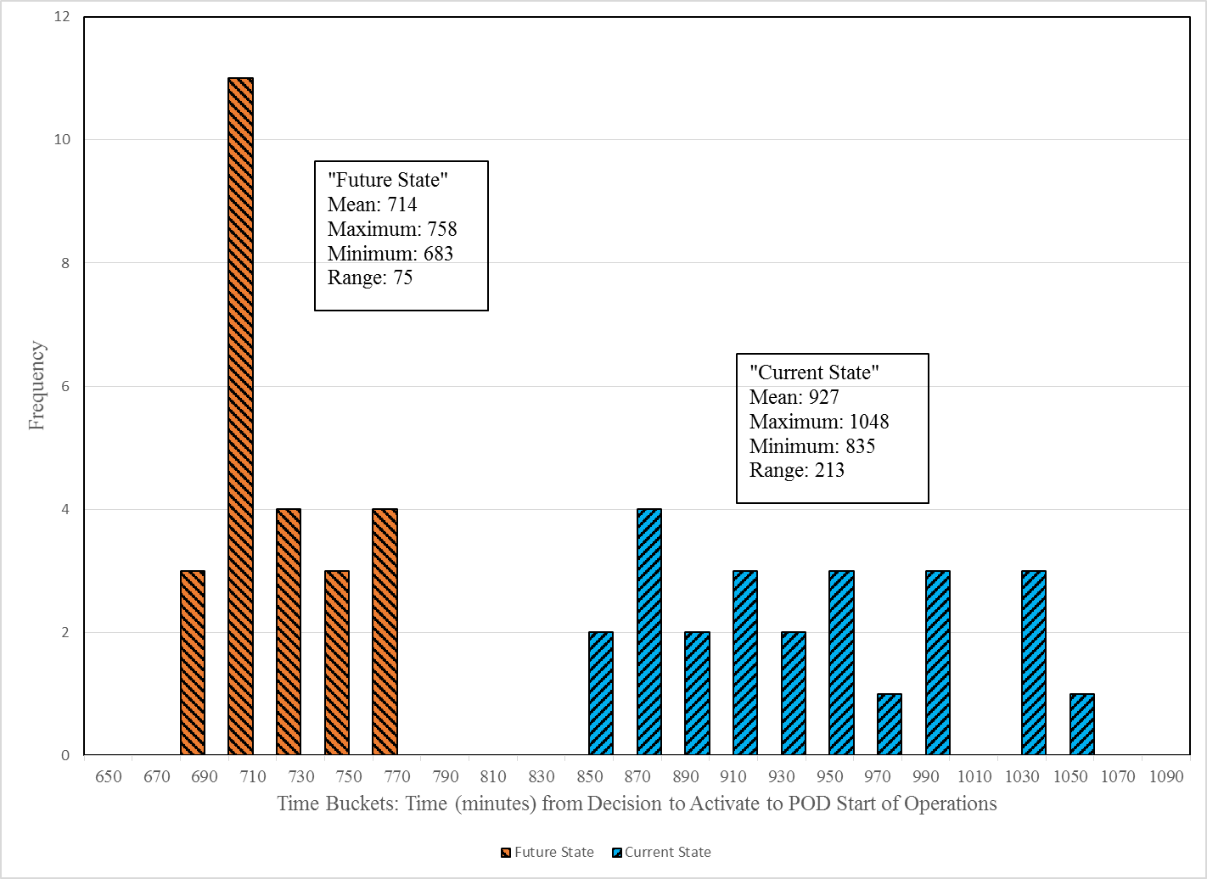

Figure 30: Comparative Histograms of POD Start of Operations Times

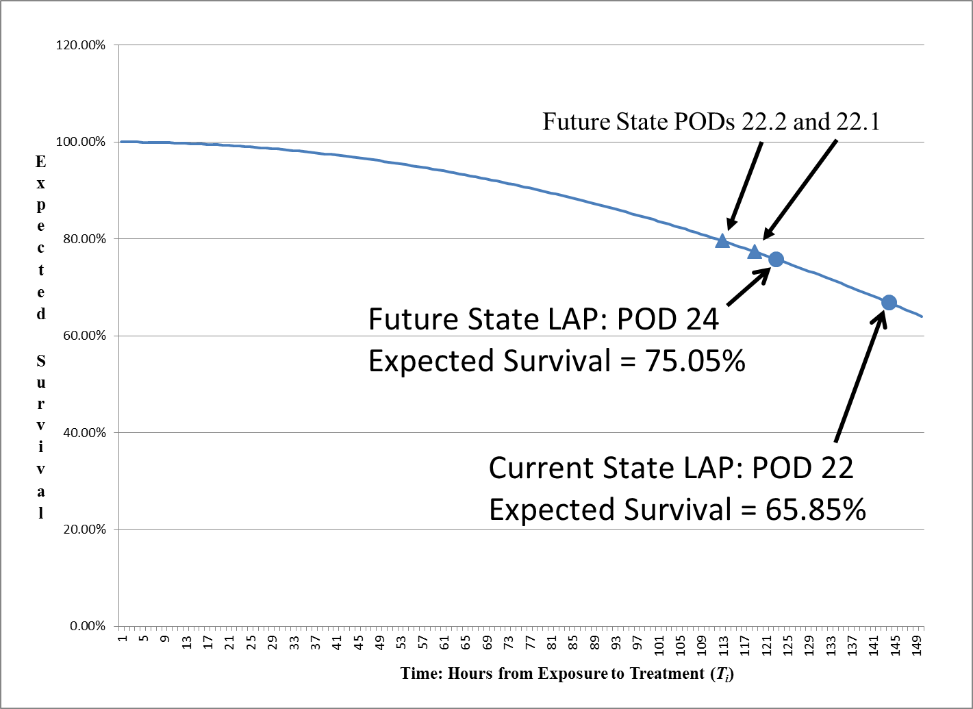

Figure 31: Expected Anthrax Survival Curve (T_{i})

In Chapter I, a model (Figure 7 on page 19) was introduced that illustrated a potential microbial (anthrax) event with a delayed response. Further time period (T1) was added to the “Future State” SNS-RSS-POD Model to represent the time between exposure of the population and the decision to activate the system. To see how lives might be impacted under certain circumstances, the system was challenged by a potentially realistic delay of 80 hours. This delay could represent the incubation period and detection of an anthrax event where the early onset of symptoms in small portion of the population is the first evidence of the event.

In viewing Figure 31 it should be noted that POD 22 is the apparent Last Active POD in the “current state” version. POD 22 was also an initial contender for the same title in the “future state” before POD 22 was divided into two PODs. As PODs 22.1 and 22.2 shifted to a slightly more desirable location on the curve, POD 24 became the Last Active POD in the “future state”.

To this point the focus of the model has been on the Last Active POD. The question to now consider is how this model impacts the rest of the PODs. The next graph (Figure 32) reflects the projected number of human lives saved in each POD area as a result of following the CPM recommendations as well as the protocol of the model. As stated earlier, time savings in T2, T3, and segments of T4 benefit multiple PODs. When viewing Figure 32, the obvious POD to discuss is POD 22. This POD was identified in Step B as a serious design issue. Accordingly POD 22 was split into PODs 22.1 and 22.2 thus contributing to the saving of over 5,700 lives.

The next graph (Figure 33) reflects the same results but from a perspective of lives saved as a percentage of the POD area population: PODs 22 has already been discussed. The interesting observation of this graph is that every POD benefited (saved lives in their area) from this model and the recommendations that were made. For example, POD 3 is a Closed POD that is 15 minutes away from the RSS. In the current state, POD 3 was the first stop on Route #2. In the future state, POD 3 is the last POD to receive their order, yet 3 more lives out of the 500 people receiving treatment are expected to be saved. This systemic benefit further supports the validation of this model as an improved methodology.
.

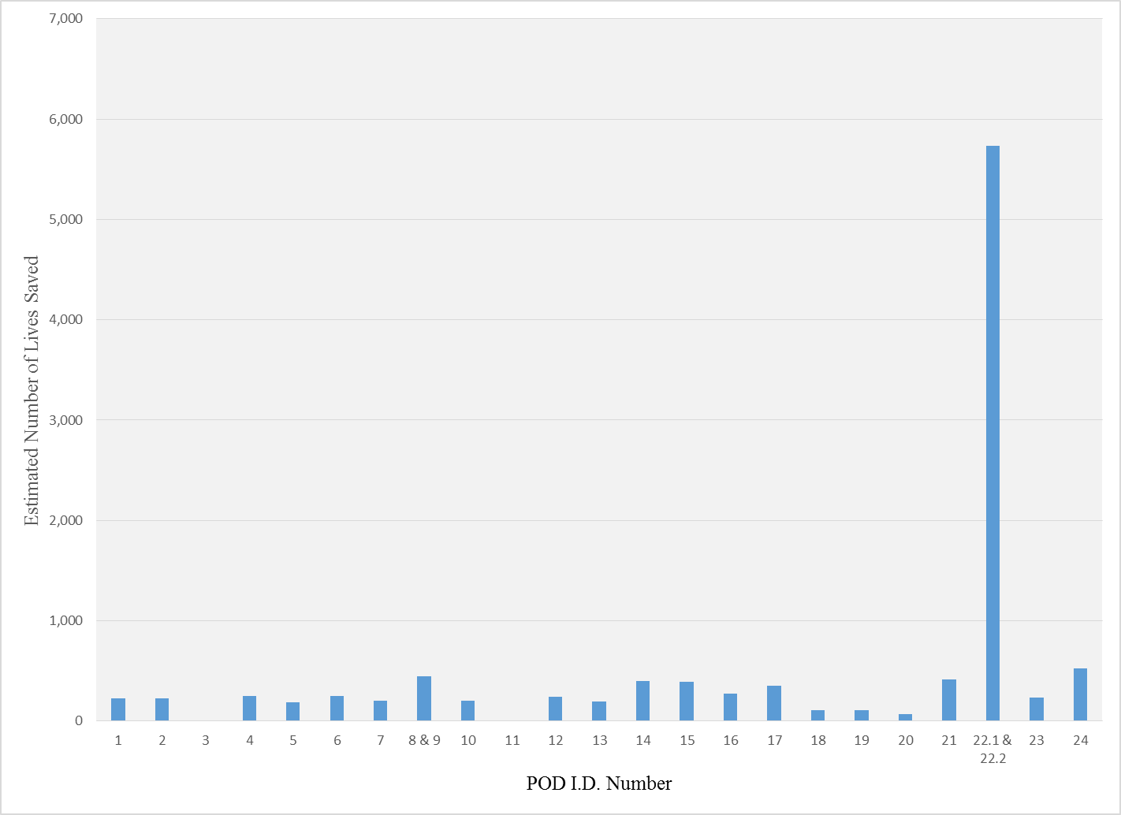
Figure 32: Estimated Lives Saved by POD Area

Figure 33: Lives Saved as a % of the POD Area Population
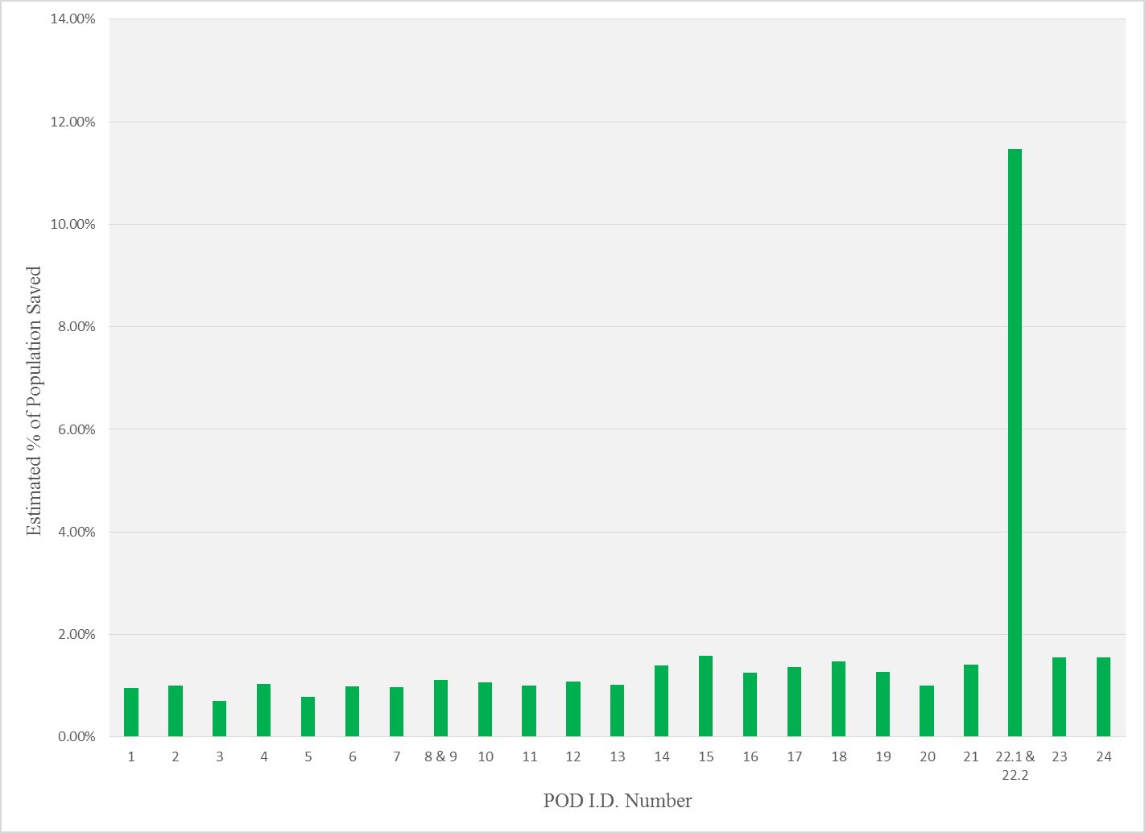

CHAPTER V: Verification, Validation, Conclusions

Model Verification
Model verification is basically a question of does the model perform the way it was designed to perform. In this study there is a main methodology model with several supporting models. Thus the verification of the main model is dependent on the verification of itself as well as the supporting models.

Methodology Model
The Fiske Model has been reviewed by subject matter experts. It was utilized in the analysis of the present case study and performed well.

"Future State" SNS-RSS-POD Model
This model has also been reviewed by subject matter experts.

Mathematical Model
From a verification perspective this is one of the most complicated models presented in this study. This model started with just the RSS segment. As the T3 formula was constructed the model was tested as each component was included. A realistic range of values for each variable was tested to assure that the model responded as expected. A similar procedure was followed for the applicable segments of T1, T2, T4, and T5. When utilizing Excel Solver, feasible solutions were verified by manual calculations. The model has also been reviewed by subject matter experts.

Time Saved = Lives Saved Model
This model is basically a re-formulization of the model developed by a panel of experts [Stroud, 2011]. This model was verified by changing variables and reviewing the model behavior.

Conclusion
The Model and supporting models perform as intended and are thus considered verified.

Model Validation
In order for this model to be considered validated this it must represent the real world in terms of assumptions, input values, model performance, resulting output values, and conclusions. Further the accuracy of the representation must be appropriate for the intended purposes of the model. In this case, the intended purposes of the model include assessing the capability of the SNS-RSS-POD system to meet Objective #2 under challenging circumstances; identifying the expected Last Active POD; and predicting the benefit of implementing recommended system improvements.

The study and model presented in this study have evolved over the past few years as the SNS-RSS-POD system continues to be developed and refined. Although disguised, the recommended SNS to RSS truck configurations and the RSS Pick Area design are based on a typical real world 12 Hour Push Package manifest. Travel time between various locations are typical of a real world SNS-RSS-POD situation. POD profiles including populations serviced and throughput capabilities are altered, yet realistic. This model has been reviewed by subject matter experts from the Tennessee Department of Health Emergency Preparedness Program who manage various segments of this system on a daily basis. Portions of this system have been tested by experimentation, computer simulation, table top exercises, and actual field exercises. Some of the recommendations made in this study have already been adopted by the Tennessee Department of Health Emergency Preparedness Program as part of their official concept of operations.

Conclusion
The presented model of the "current state" appears to adequately characterize the real world of a typical SNS-RSS-POD system. The conclusions reached in Chapter IV suggest that a “typical” SNS-RSS-POD system is capable of meeting Objective #2 under generally anticipated conditions. However, as with most systems, there are limits or circumstances beyond which the system will not be able to meet its objectives. This conclusion also characterizes the real world. This model represents a valid methodology by which to identify and extend the capability limits of the SNS-RSS-POD system.

Conclusions
The SNS-RSS-POD system is a large and complex system designed to provide critical medical countermeasures to large U.S. populations during a public health emergency. Aside from preparing for natural occurring epidemics, pandemics, and disasters; it appears to be evolving in a response to changing needs to prepare for chemical and biological terrorist attacks.
Since many aspects of this system are classified as sensitive information; there appears to be limited academic research or public information about the inner workings of this system. However, some of the limited literature express concerns over the ability of this system to meet one of its primary objectives to treat the last person in need in the Last Active POD within 48 hours of the decision to activate this system. These concerns are only increased in those potential time sensitive situations (such as a terrorist anthrax attack) where the commencement time of the event is unknown or deliberatively concealed thereby significantly delaying the recognition of the event and the subsequent decision to activate this system. In these events, such delays will seriously compromise the efficacy of the treatment for thousands of people. Delays of hours or even minutes could mean the difference between life and death.

The following problem statement was developed as the basis for this study:

In the event of a large scale public health emergency requiring the activation, release and distribution of a 12-Hour Push Package of medical countermeasures from the Strategic National Stockpile; there is a potential concern that the current deployment / distribution / treatment system may not have sufficient capability to meet its mandated objective to treat the last person in need of treatment in the last active treatment center within 48 hours of the decision to activate this system.
The Fiske Model was developed to assess this problem statement while assisting in the design and improvement of the SNS-RSS-POD system. To assist in this analysis, a mathematical model was developed and “hypothetically” populated with values that resemble what might be encountered in a real world SNS-RSS-POD system. The resulting conclusions of this analysis suggests that there may be reason for concern about the capability of the current state system to meet this critical 48 hour objective under certain conditions.

Following the Fiske Model and assuming recommendations made in this study were implemented; a "future state" model was created to demonstrate beneficial impact of these recommendations in increasing system capabilities and achieving Objective #2.

Contributions of this Research
As seen in the literature review, literature relevant to this specific area is rather limited. This study may be some of the first open research done on the internal operations of a RSS. This research will hopefully stimulate additional research by others and assist those practitioners who are actually responsible for these systems to continuously improve the design, operation, and preparedness of these complex systems. Under certain adverse conditions, the adoption and incorporation of the presented recommendations into the SNS-RSS-POD system could possibly make the difference between life and death for thousands of people impacted by a public health emergency.

Contribution of These Models
The models presented in this study will be helpful on several levels. Until such time as statistically significant data becomes available, the variables and parameters of these models may be populated with expert opinions to assess the overall capability of the system to meet its stated objectives.

By design, these many of these models may be useful on a modular basis to assist those professionals with sub-system responsibility to improve their segment of the process. Further these individuals may develop a more holistic perspective of the entire process by considering the variables and parameters in their segment of the system that are either enabling or constraining factors elsewhere in the system. Once these models have been populated with parameters (and available data); “what if” experimentations (and training “table top” exercises) may be performed to see the impact of potential variables on the overall system performance.
These models (especially the CPM) are expected to be particularly valuable to practitioners on two different levels. The first level is the design and operational review stage. These models create a holistic focus on the primary system performance objectives and especially the second objective (Objective #2) of providing treatment to the last person in need in the Last Active POD within 48 hours of the decision to activate the SNS-RSS-POD system. By identifying the projected Last Active POD, practitioners will hopefully focus on the following for this particular POD:
  - Optimizing the start time to pick the order for this POD
  - Optimizing the order preparation and order picking process of this POD
  - Optimizing the delivery means and vehicle dispatch time to this POD
  - Optimize the capacity and capability of this POD

As the system design and theoretical operation is improved to reduce the overall amount of time for the Last Active POD to provide their services, it is very likely that that particular POD may no longer be identified as the Last Active POD. Thus the continuous improvement process will shift to the new Last Active POD until that POD is no longer the Last Active POD. The Fiske Model will provide structure and priority to this continuous improvement process.

The second level of benefit of these models to the practitioners is providing focus on the primary system objectives during an actual public health emergency. Unfortunately, emergencies seldom occur under ideal conditions. Infrastructure systems may be damaged or disabled. All personnel may not be available. All delivery vehicles may not be available. The availability and function of the primary SNS warehouse, primary RSS facility, and some primary PODs may be impaired or totally disabled. The Fiske Model is designed to allow for flexibility.

While Objective #2 is based on the SNS activation time and the service time of the Last Active POD; there is an applied assumption that the entire population has a common (or undistinguishable) exposure time. However, in some situations such as a known active aerosol release of anthrax or a radioactive cloud, additional information such as wind direction and wind speed may enable experts to trace or predict the population exposure times in different areas to be serviced by the RSS. Design and operational features of the proposed models such as standardized POD orders and direct RSS to POD delivery vehicles will enable the authorities to quickly respond and adjust the dispatch queue of vehicles waiting to be loaded.

Social Contribution
The SNS-RSS-POD system is a complex system involving multiple organizations and multiple levels of cooperation and coordination. This system has evolved and will most likely continue to evolve in response to our ever changing world. There are opportunities to improve this system and there will most likely always be opportunities to improve this system.

The current SNS-RSS-POD system is prepared to effectively respond to a variety of public health emergencies under most circumstances. This study should contribute to refining the design and operation of this system to improve its effectiveness in all situations.

Finally, it is hoped that systems such as the SNS-RSS-POD system will always be ready but never needed.

LIST OF REFERENCES

[1] Brookmeyer, R., Johnson, E., Barry, S. (2005) Modeling the incubation period of anthrax, Statistics in Medicine; 2005; 24: 531-542

[2] CDC (website), 2005. “Receiving, Distributing, and Dispensing Strategic National Stockpile Assets”

[3] CDC (website), 2008. Point of Dispensing (POD) Standards, April 2008

[4] CDC (website). 2011. “Strategic National Stockpile (SNS)”.

[5] CDC (website). 2012. “Strategic National Stockpile (SNS)”.

[6] Chan, E.; Fan, C.; Lewis, M.; King, K.; Dreyer, P.; Nelson, C.; (2009) The RSS-POD Supply Chain Management Game – An Exercise for Improving the Inventory Management and Distribution of Medical Countermeasures, Rand Health, WR-661-DHHS

[7] Chervenic, M., (2012), Wide Area Recovery and Resiliency Program (WARRP) Assessment of MCM Response Capabilities to an Anthrax Attack and Impact on Recovery, U.S. Department of Homeland Security

[8] Corvese, K. (2011). A feasibility analysis of the point of dispensing (POD) model as a response to an anthrax bioterrorism event in Rhode Island. Yale University

[9] DC_DOH, 2012, “Closed Point of Dispensing Initiative”, Government of District of Columbia, Department of Health, Internet

[10] DHHS (2012). Division of Strategic National Stockpile (DSNS) Program Review. A Report from the Board of Scientific Counselors (BSC). DHHS CDC OPHPR BSC
[11] Guyton, J. et.al; (2011) Appendix D Commissioned Paper: A Cost and Speed Analysis of Strategies for Prepositioning Antibiotics for Anthrax, National Academies Press (US)

[12] King, K. and Muckstadt, J. (2009) Evaluating Planned Capacities for Public Health Emergency Supply Chain Models, Technical Report No. 1475, School of Operations Research and Information Engineering, Cornell University

[13] Lee, L. (2008) Analyzing Dispensing Plan for Emergency Medical Supplies in the Event of Bioterrorism, Proceedings of the 2008 Winter Simulation Conference, pages 2600-2608

[14] Lockheed Martin (website). 2009 “Lockheed Martin Successfully Demonstrates Use of Simulation in A Strategic National Stockpile emergency Preparedness Exercise”

[15] Nelson, C., Chan, E. et al (2008). Recommended Infrastructure Standards for Mass Antibiotic Dispensing. RAND Health

[16] Pennsylvania Department of Health (website). "Strategic National Stockpile Overview”

[17] Robarge-Silkiner, S. (2007). Introduction to the Strategic National Stockpile. Kansas Department of Health and Environment

[18] Stroud, C., Viswanathan, K., Powell, T., & Bass, R. R. (2011). Current Dispensing Strategies for Medical Countermeasures for Anthrax.

[19] Stroud, C., Viswanathan, K., Powell, T., & Bass, R. R. (2011). Prepositioning Antibiotics for Anthrax. Institute of Medicine of the National Academies

[20] Sun, Y. (2012). The SNS logistics network design: Location and vehicle routing. University of Louisville

[21] Wilkening, D. (2008), Modeling the Incubation Period of Inhalational Anthrax, Medical Decision Making 2008 28:593

[22] Winston, W. 2004. Operations Research – Applications and Algorithms, Brooks/Cole – Thomson Learning

[23] Carley, K. 1996. Validating Computational Models, Carnegie Mellon University

[24] Yu, A. J. (2015) "Multi-objective vehicle routing problem for emergency supply," Working paper, Industrial and System Engineering, University of Tennessee, Knoxville.

APPENDIX

Appendix A: Notations
General and Main Equation notations:
n = number of active PODs serviced by the RSS for POD_{i}, i=1, 2, … , n.
POD_{i} = POD identification number for POD_{i}, i=1, 2, … , n
POD_{LAP} = Last Active POD_{i}
T_{i} = Time (minutes) between Exposure of the Population to the harmful condition
and the treatment of the Population at POD_{i}, i=1, 2, … , n
T_{LAP}= T_{i} of POD_{LAP}
T1 = Time (minutes) between Exposure of the Population to the harmful condition
and the time of the Decision to Activate the SNS-RSS-POD system.
T2 = Time (minutes) from the Decision to Activate the SNS-RSS-POD system
to the delivery at the RSS of a sufficient portion of the 12 Push Package to enable
the POD Order Pick process to start.
T3 = Time (minutes) in RSS from the delivery of a sufficient portion of the 12 Hour Push
Package to enable the POD Order Pick process to start and the completion of the
first POD Order.
T4_{i} = Time (minutes) from the completion of the first POD Order to the delivery
of each specific POD Order to POD_{i} , i = 1, 2, …, n.
T4_{LAP} = T4_{i} for Last Active POD
T5A_{i} = Available Service Time (minutes) from the delivery of their POD Order to treating
the last person at POD_{i}, i = 1, 2, …, n.
T5A_{LAP} = T5A_{i} for Last Active POD
T5R_{i} = Required Service Time (minutes) from delivery of their POD Order to treating
the last person at POD_{i} , i = 1, 2, …, n.
T5R_{LAP} = T5R_{i} for Last Active POD
TS_{i} = Total SNS-RSS-POD System Time for POD_{i} , i = 1, 2, …, n.
TS_{LAP} = TS_{i} for Last Active POD
MDST = Minimum Desired Service Time (minutes) from the delivery of
their POD Order to actually treating the last person at POD_{i} , i = 1, 2, …, n.
T2 Notations:
C_{SNS} = Decision Variable {0= No, 1=Yes}: Load SNS trucks at SNS so as to support
RSS usage.
T_{CON} = Decision Variable {1=No, 0=Yes}: Form convoy of all trucks from airport to RSS
T2_{A} = Decision Variable {0= No, 1=Yes}: Utilize known SNS to RSS delivery
time (minutes)
T2_{D} = Decision Variable {0= No, 1=Yes}: Utilize Default SNS to RSS delivery
time (minutes)
T_{AIR} = Decision Variable {0=No, 1=Yes}: Utilize SNS to RSS air transportation
U_{AIR} = Unload time per truck from airplane into trucks bound for RSS (minutes)
V_{RSS} = Number of SNS to RSS trucks needed
V_{U} = Number of SNS to RSS trucks needed to transport at least of one of every container
configuration
T2_{AT} = Known SNS to RSS delivery time (minutes)
T2_{DT} = Default SNS to RSS delivery time (minutes)

T3 Notations
T3_{A} = Time (minutes) from Arrival of enough SNS Trucks to Unload and Stage (set up)
enough SNS containers in Pick Area to start the Order Pick Operation.
T_{S} = Time (minutes per truck) to unload and Stage Truck Load in Pick Area
D_{RSS} = Maximum number of SNS trucks that can be unloaded and staged at the
same time (also known as number of available inbound RSS dock doors)
T3_{B} = Time (minutes) from beginning of Order Pick to the completion of the first POD
Order.
C_{P} = Number of containers in a 12 hour Push Package
C_{U} = Number of different container configurations in a 12 hour Push Package
P_{A} = Decision Variable: Number of Containers in the Immediate Pick Area
P_{Z} = Number of Containers in a Pick Zone (1 K unit) within Immediate Pick Area
K_{Q} = Cadence units required in Order Pick Cycle for Quality Inspection and Inventory
K_{M} = Cadence units required in Order Pick Cycle for Misc. Activities
K = Process cadence time (minutes)

T4 Notations
TP_{i} = Direct route travel time (minutes) from RSS to POD_{i} , i = 1, 2, …, n.
T_{D} = Estimated average additional time (minutes) for travel diversion from the direct path
time added to delivery route for each POD serviced prior to POD_{i}, i = 1, 2, …, n.
T_{U} = Estimated average additional unload time (minutes) per delivery route stop for
each POD serviced prior to POD_{i} , i = 1, 2, …, n.
D_{A} = Decision Variable A: Utilize Direct Delivery time (minutes) based on direct
delivery with dedicated vehicles from RSS to POD_{i} , i = 1, 2, …, n.
D_{B} = Decision Variable B: Utilize Route Delivery time (minutes) based standard
estimated parameters for diversion times (T_{D}) from the direct route and the
standard estimated unload times (T_{U}) for each intermediate stop and the direct
delivery time from the RSS to POD_{i} , i = 1, 2, …, n.
D_{C} = Decision Variable C: Utilize Route Delivery time (minutes) based heuristically
developed routes with estimated travel times and standard estimated unload
times (T_{U}) for each intermediate stop from the RSS to POD_{i} , i = 1, 2, …, n.
D_{D} = Decision Variable D: Utilize Route Delivery time (minutes) based computer
optimized routes with estimated travel times and standard estimated unload
time (T_{U}) for each intermediate stop from the RSS to POD_{i} , i = 1, 2, …, n.
K = Process cadence time (minutes)
PS_{i} = Sequence in which POD Orders are started (and completed) within the RSS
for POD_{i} , i = 1, 2, …, n.
R_{r} = RSS to POD Delivery Route Number for POD_{i} , i = 1, 2, …, n and r = 1,2,…, R
R_{s} = RSS to POD Delivery Route Stop Number for POD_{i} , i = 1, 2, …, n
and s = 1, 2,…, S.
L_{S} = Estimated minimum Staging / Loading Time of a POD order in RSS Shipping Area
I = Number of available transport vehicles from RSS to PODs
TR_{i} = Specific estimated (D_{B} or D_{C}) or calculated (D_{D}) total RSS to POD delivery times
for route deliveries to POD_{i} , i = 1, 2, …, n
I = number of available transport vehicles from RSS to PODs
J = number of PODs to be assigned.
r_{jk} = travel time between PODs j and k.
d_{j} = travel time between RSS facility and POD j.
D_{j} = demand at POD j.
T = maximum allowed travel time from RSS facility to any POD.
C_{i} = capacity of vehicle i.
$y_{ijkn}$ = 1 if vehicle i travels from POD j to k at the n^{th} stop, 0 otherwise.
$y_{i0k1}$ = 1 if vehicle i travels from RSS to POD k at the first stop, 0 otherwise.
$y_{ij0n}$ = 1 if vehicle i returns RSS from POD j at the n^{th} stop, 0 otherwise.
$x_{ij}$ = amount of load delivered by vehicle i to POD j.
$z_{in}$ = travel time of vehicle i from RSS to the POD at the n^{th} stop.

T5 Notations:
H_{i} = Population of area serviced by POD_{i} , i = 1, 2, …, n.
HH_{i} = Average Household Size in area serviced by POD_{i} , i = 1, 2, …, n.
HOH_{i} = Expected number of HOHs (Head of Household) seeking service or
treatment at POD_{i} , i = 1, 2, …, n.
C_{i} = Service Capability or Throughput Rate (people per minute) for POD_{i} , i = 1, 2, …, n.
TS_{LAP} = TS_{i} for Last Active POD
PS_{LAP} = Position in POD Order start sequence for the Last Active POD

Notations for Estimated Number of Lives Saved (L_{i}):
S_{i} = the expected fraction of the exposed population that will survive a release
M_{i} = Mortality Rate or the expected fraction of the exposed population that will die from a release
G_{i} = time (hours) between exposure and treatment of population for POD_{i}, i=1, 2, … , n.
f(g) = Survival function is taken from various incubation period curves where g is the time since exposure. [Stroud (2011)]
L_{i} = Expected number of Lives saved in each POD area by implementing recommended changes

Appendix B: Recommendations
As a result of this analysis, several recommendations are presented for consideration by those who design, implement, and operate the actual SNS-RSS-POD systems. Key process recommendations that will need to be implemented in order to fully realize this “future state” system include:

It is recommended that the SNS load their trucks and any airplane so that the first two trucks arriving at the RSS contains at least one type of every container configuration of medical supplies. This will enable the order picking process to begin after the first two trucks are unloaded and staged rather than waiting for all 8 trucks to arrive and be unloaded. It is further recommended that the SNS load their trucks and any airplane so that the subsequent trucks arriving at the RSS contain a balanced mix of remaining supplies. This will enable the replenishment of the Pick Area while the remaining trucks are in transit or even still at the airport.

It is recommended that manufacturers of key medical supplies providing single lot numbers for each item within the 12 Hour Push Package so as to facilitate lot tracking along the “critical path” and especially within the RSS operation.

It is recommended that the SNS, manufacturers, RSS, and PODs develop and implement a modern inventory identification and tracking system such as RF (Radio Frequency) tags to enable “live” moving inventory management especially at the RSS. Accurate live inventory is essential, but not necessarily a Critical Path activity.

It is also recommended that the SNS standardize some of the current “mixed” container configurations thus reducing the number of different container configurations in the 12 hour Push Package. This will enable an even smaller Pick Area footprint thus saving time and worker energy.

It is also being recommended that, to the feasible extent possible, the number and location of PODs be designed so as to service similar population sizes with similar (best practice) throughput capabilities. This balancing of POD demands would further enhance the effectiveness of standardized “POD Push Packages”.

It is recommended that a centralized and standardized order planning process be implemented. This would be extremely beneficial in scenarios requiring resource allocations of limited medical supplies. Further, this recommendation will enable the RSS to maintain a higher level of inventory control by maintaining physical control of the inventory at the RSS and releasing it on an “as needed, J.I.T.” basis. This strategy should significantly reduce, if not eliminate, the concern over the need to transfer inventories between PODs.

It is also recommended that the initial RSS to POD deliveries be made by emergency vehicles, such as police vehicles, directly from the RSS to each individual POD. Aside from significant time savings, emergency vehicles offer several advantages over the large truck options in terms of lights, sirens, radios, armed officers, speed, maneuverability (especially in possibly disrupted or congested roadways), and reduced system impact from the loss or delay of any one vehicle. It is further recommended that these emergency vehicles be originally deployed from the local jurisdiction in which their POD is located. They would travel (outside of the Critical Path) to the RSS while the RSS is still be set up. These officers will be more likely to know alternative travel routes in their area in case their primary route is not a viable option. The use of police vehicles may be a concern since the regular police may be very busy during this type of emergency and the trunk of a regular police vehicle is often full with tactical gear. However, many police departments have auxiliary police personnel and auxiliary police vehicles (with basically empty trunks and back seat areas). A possible legitimate concern over the use of standard police vehicles may be the size (mainly volume) of the initial POD order versus the vehicle capacity (truck and backseat area). A response to this concern would be to first revisit the initial POD order to be sure it only represents the POD needs for a few hours. Secondly, the authorities may wish to develop a second option to utilize appropriately larger vehicles but still on a direct RSS to POD delivery basis. Finally this concern may prompt a larger question of whether or not the 12 Hour Push Package has actually evolved into two subsystems: the urgent delivery of medical countermeasures for the masses via POD service centers and the rapid delivery of medical supplies for large numbers of people at treatment centers. These are all details that should be resolved and planned in advance on a local basis.

It is recommended that a standardized container layout of the Pick Area be created in advance that includes a place in the Pick Area for each container configuration. With the use of emergency vehicles to deliver the POD orders, the layout of the Pick Area should consider the feasibility of picking the heavier cases last thereby reducing worker fatigue from pulling a heavier load though the Pick Area. This initial layout may be easily adjusted during the RSS setup period to reflect the actual Pick Area layout for the given event. This adjustment should merely be the elimination of unnecessary items and consolidating the Pick Area while still maintaining the light to heavy case sequence.

It is recommended that during the RSS setup period a standardized pattern be created for stacking cases on either a pallet or cart during the Pick Operation. This will facilitate the Quality and Inventory Control process.

It is recommended that the SNS send a detailed manifest of the shipment by truck load to the RSS upon its departure from the SNS. The shipment should be subsequently loaded in and out of any airplane in manner that preserves the accuracy of the truck manifests. This will allow the RSS to prioritize and expedite the unloading of the arriving trucks.

If feasible, it is recommended that the Security and Transportation groups support the individual vs. convoy truck logistics from the airport to the RSS. This will enable the RSS to begin order picking significantly sooner.

It is recommended that all relevant parties agree to the creation and deployment of standardized initial and secondary POD Push Packages for each POD. In addition to eliminating the confusion and variability of first orders submitted by the PODs, this will counteract the natural tendency to over-order by the PODs where there are only consequences for not having enough supplies. From a Critical Path perspective, time spent picking unnecessary supplies for one POD is time lost picking subsequent orders needed by other PODs. To accommodate the needs of larger PODs, a second round of initial POD Push Packages for select PODs may be required before commencing the secondary POD Push Package phase. Likewise, these larger PODs may also need a second round of secondary packages. A standardized POD Push Package will delay the need to assign any particular picked order to a specific POD until just before loading. Thus if one POD transport vehicle is yet on site when the RSS is ready to load it, the standardized POD order is simply loaded into the next available vehicle in the queue. When the delayed vehicle does arrive, it may go to the front of the prioritized line, receive a standardized POD Push Package and depart.

It is recommended that the RSS manage the POD inventories from the RSS and release supplies to the PODs on a J.I.T. (Just in Time) basis so as to better manage (balance / allocate) inventories of potentially limited supplies.

It is highly recommended that local governmental officials commit to providing appropriate emergency vehicles and personnel to transport the POD Push Packages from the RSS to the PODs in their jurisdiction. RSS officials and local governmental officials will need to develop plans for any subsequent deliveries to the PODs beyond the first two POD Push Packages. Whether continued use of emergency vehicles or slower larger truck deliveries, these deliveries will be less time sensitive since the PODs will already be functioning with adequate initial supplies. Once outside the paradigm of needing to ship these supplies on stretch-wrapped pallets; the use of school buses becomes a potentially available alternative transportation resource since schools will most likely be closed during the types of public health emergencies being considered.
It is recommended that government officials recognize that they do not have and cannot afford the resources to run this program by themselves. They must partner with private organizations especially with regard to RSS and POD real estate that will hopefully never be needed for a public health emergency. The term “partner” will require a major paradigm shift for some governmental agencies and officials. Further it is essential that the various governmental agencies and private sector organizations involved in this complex inter-organizational system possess a common “overall process oriented” versus a “silo oriented” attitude in how they conduct their business and interact with the other members of this system. This will allow for concurrent activities instead of just a series of silos performing their contribution in a sequential series of activities. This will also support the recognition and implementation of changes in one segment of the system that enable time saving results in other segments of the system.

Vita

Roger I. Fiske was born in Neptune, New Jersey and raised in Upstate New York. He graduated from Cornell University in 1970 with a B.S. degree in Food Science. He graduated from The University of Findlay in 1996 with a M.B.A. in Organizational Leadership. Roger has over 40 years of combined experience in government and private industry. He is a former Public Health Sanitarian in New York State and has been a Registered Sanitarian in Ohio since 1983. Roger is also a Registered Environmental Health Specialist / Registered Sanitarian with the National Environmental Health Association. Within the food industry, Roger has served as Director of Quality Control, Distribution Manager, Plant Manager, Vice President / Senior Plant Manager, and Vice President of Operations. He is a Professional Member of the Institute of Food Technologists. Roger’s primary professional interests include operational excellence and organizational change management. He is a former Adjunct Professor in Operations Management; has served in an advisory capacity to state and local health departments; and has done limited consulting on a national and international basis.

