State Estimation for VSC-MTDC Power Systems Considering Droop Control and Operating Limits

A Dissertation Presented for the
Doctor of Philosophy
Degree
The University of Tennessee, Knoxville

Wei Feng
December 2020

Acknowledgment
First, and most of all, I would like to express my deepest appreciation to my supervisor, Dr. Fangxing (Fran) Li for the continuous support and encouragement he has given me, during both the time I spent on research and the time I spent on engineering projects at the University of Tennessee. His patient and motivating guidance helped me in throughout the course of my study and the writing of this thesis.
My sincere thanks also go to the rest of my committee members: Dr. Yilu Liu, Dr. Hector Pulgar, and Dr. Mingzhou Jin for devoting time to my proposal defense and offering insightful suggestions to widen my research from various perspectives.
In addition, I gratefully acknowledge Dr. Guangyi Liu, Dr. Renchang Dai, Dr. Yuan Chen and all of my other colleagues from the Global Energy Interconnection Research Institute (GEIRI) North America for giving me the opportunity to join their research team. Their precious support and extensive experience also helped me to finish this dissertation.
I am very grateful the support and kind advice of graduate students with whom I have shared a research group throughout my course study and research. I would also like to thank all the students, staff, and professors in the Center for Ultra-Wide-Area Resilient Electric Energy Transmission (CURENT).
Finally, I offer my deep and sincere gratitude to my family for their continued support and unparalleled love throughout all my years aboard.

Abstract
Power systems with voltage source converter-based multi-terminal DC (VSC-MTDC) have received great interest in both the academic and industrial worlds in recent years. The introduction of VSC-MTDC systems into the power system industry brings not only significant benefits but also severe challenges due to the complex structures, different operating behaviors, and dynamic features of VSC-MTDC. State estimation (SE), an important function in the Energy Management System (EMS) for real-time monitoring, has become a challenging issue for VSC-MTDC systems. The traditional approach to dealing with this problem only considers the quasi-steady status of a VSC and ignores its dynamic features. Therefore, an in-depth study is presented in this dissertation to propose a generalized, high-efficiency, and accurate SE method for VSC-MTDC systems.
First, a systematic and detailed comparison is presented between two conventional methods, the unified method (UM) and the sequential method (SM) in three aspects, including estimation accuracy, computing speed and robustness. Detailed simulations and in-depth analysis point out the most applicable situations of each method. Results indicate that the SM associated with fast decoupled state estimation (FDSE) has the best overall performance. Therefore, the SM-FDSE is selected as the main method to be improved for SE analysis.
Second, graph-based computation is leveraged to facilitate the computing speed of the SM-FDSE. By modeling the system as a graph with vertices and edges, advanced parallel techniques including node-based parallel computing (NPC) and hierarchical parallel computing (HPC) can be used to accelerate SE computation. In addition, in view of the topology of VSC-MTDC systems and the shortcomings of the conventional SM, improved methods are also proposed to gain better convergence speed without compromising accuracy.
Third, this dissertation presents an estimation of VSCs with various types of droop control. A new bound-constrained nonlinear least square (BCNLS) algorithm is utilized to estimate VSCs with two-stage droops. In addition, to avoid divergence in the iterative calculation, the Levenberg-Marquardt method is leveraged to adjust searching steps.
Finally, another dynamic feature of operating limits on VSCs is taken into consideration for SE analysis. The capability of fast adjustment and self-regulation of VSCs is modeled as the equality constraints on the SM and subsequently solved by using Lagrangian relaxation. Therefore, the operating limits can be correctly reflected in estimations. In addition, the proposed estimator is further enhanced with Hachtel’s Augmented Matrix method to take bad data identification into consideration. Lagrangian multipliers can subsequently be used to help eliminate gross errors.

Keywords: bad data identification, bound-constrained nonlinear least square (BCNLS), droop control, Lagrangian relaxation, operating limits, sequential method (SM), state estimation (SE), unified method (UM), VSC-MTDC.

Table of Contents
Chapter 1 Introduction 1
1.1 Overview 1
1.2 Brief Description of State Estimation 2
1.3 Brief Description of VSC-MTDC Power Systems 6
1.3.1 Development direction of hybrid AC/DC systems 6
1.3.2 Challenges brought by VSC-MTDC power systems 7
1.4 Dissertation Outline 9
Chapter 2 Comparisons of the Unified and Sequential Methods for VSC-MTDC Power System State Estimation: Accuracy, Computing Speed and Robustness 11
2.1 Introduction 11
2.2 Background of SE Problem 15
2.2.1 Formulation of WLS algorithm 15
2.2.2 Formulation of FDSE algorithm 16
2.3 Generalized formulations and calculation processes of UM and SM 17
2.3.1 SE model of VSC-MTDC power systems 17
2.3.2 Calculation processes of UM and SM 20
2.3.3 Brief summaries of UM and SM 22
2.4 Comparison of estimation accuracy 26
2.4.1 Instructions and testing environments 26
2.4.2 Comparison of estimated accuracy 29
2.4.3 Summary of estimation accuracy 39
2.5 Comparison of computing speed 40
2.5.1 Instructions and testing environments 40
2.5.2 Comparison of computing speed 47
2.5.3 Summary of computing speed 53
2.6 Comparison of Robustness 54
2.6.1 Introduction and testing environments 54
2.6.2 Comparison of robustness 55
2.6.3 Robustness in different scenarios 58
2.6.4 Summary of robustness 63
2.7 Chapter Summary 63
Chapter 3 Improved SM with Graph Computing Techniques and Virtual Connection Method 65
3.1 Introduction 65
3.2 Improved SM with graph computing techniques 68
3.2.1 Power system modeling in a graph database (GDB) 68
3.2.2 Node-based parallel computing (NPC) 72
3.2.3 Hierarchical parallel computing (HPC) 74
3.2.4 Improved SM with graph computing techniques 76
3.3 Graph computing-based distributed power flow for hybrid systems 77
3.3.1 Distributed computation with graph partition 77
3.3.2 Implementation of graph computing techniques in SM for PF 78
3.3.3 Performance testing 83
3.4 Improved sequential SE algorithm using virtual connections 91
3.4.1 Procedure of generating virtual connections 91
3.4.2 Case study and simulation results 93
3.5 Chapter Summary 103
Chapter 4 SE for VSC-MTDC Systems with Droop Control Using Bound-Constrained Nonlinear Least Squares and Levenberg-Marquardt Method 104
4.1 Introduction 105
4.2 Quasi-steady-state models of droop control 107
4.2.1 Constant control strategies 107
4.2.2 Dynamic models of droop control 111
4.2.3 Quasi-steady-state models of droop control 114
4.3 SE formulation of droop control 115
4.3.1 Improved V-P droop control strategies 115
4.3.2 Operating equations of droop control 119
4.3.3 Measurements and state variables 120
4.4 Improved SE Algorithm to Include Droop Control 122
4.4.1 Intuitive piecewise SE method for droop control 124
4.4.2 LM method for nonlinear WLS algorithm 126
4.4.3 BCNLS method 131
4.4.4 Formulation and solution for droop control 133
4.4.5 Flow chart 135
4.5 Case study 138
4.5.1 Droop control settings 138
4.5.2 Simulation results and discussions 138
4.6 Chapter Summary 145
Chapter 5 Enforced Equality-Constrained SE Algorithm to Include Operating Limits of VSC with Bad Data Identification 149
5.1 Introduction 149
5.2 Operating limits of VSC 152
5.2.1 Dynamic control feature of VSC 152
5.2.2 Operating limits of VSC 155
5.2.3 Self-regulation for new control strategies 158
5.3 Formulation and solution 161
5.3.1 Pseudo-measurement method 161
5.3.2 Equality-constrained method 163
5.3.3 HAM method for bad data identification 166
5.4 Simulation study 169
5.4.1 Test systems and settings 169
5.4.2 Results and discussions 171
5.5 Chapter Summary 171
Chapter 6 Conclusions and Future Works 176
References 178
Publications 188
Vita 190
List of Tables
Table 2.1. Measurements and state variables of VSC-MTDC systems. 21
Table 2.2. Brief summaries of UM and SM. 27
Table 2.3. Testing environments of hardware and software. 28
Table 2.4. SE estimation results of AC grid in Case 1 ($σac=0.0235, σdc=0.016$). 31
Table 2.5. SE estimation results of DC grid in Case 1 ($σac=0.0235, σdc=0.016$). 32
Table 2.6. Comparison of eestimation accuracy of DC grid in Case 2. 33
Table 2.7. Average performance index values for the three methods in both cases. 34
Table 2.8. Standard systems in the first test group. 42
Table 2.9. Test cases in the second test group. 43
Table 2.10. Sizes of related data sets and matrices in VSC-MTDC systems with UM. 45
Table 2.11. Sizes of related data sets and matrices in VSC-MTDC systems with SM. 46
Table 2.12. Number of iterations with different methods (Cases 3 – 9). 48
Table 2.13. Number of iterations with different methods for the second test group (Case 5 and Cases 10 – 14). 51
Table 2.14. Largest five diagonal elements in the hat matrices of different methods. 57
Table 2.15. Comparison of three methods in case of interface data missing. 59
Table 2.16. Comparison of three methods in case of single measurement error at leverage point. 60
Table 2.17. Comparison of three methods in case of pseudo-measurements with large weights. 62
Table 3.1. Constructions of the large-scale test systems. 84
Table 3.2. Parameters of DC Line in IEEE 300-bus system. 85
Table 3.3. Comparisons of computing time with different methods. 87
Table 3.4. Comparison of time spent on two major procedures. 90
Table 3.5. Comparisons of largest mismatches for both cases. 97
Table 3.6. Comparisons of index values for both cases. 98
Table 3.7. Comparisons of iterations for both cases. 101
Table 3.8. Comparisons of total power loss (mw) for both cases. 102
Table 4.1. Measurements and state variables for V-P droop control. 123
Table 4.2. Comparison of three methods in solving WLS problem. 132
Table 4.3. The upper and lower boundary values in two-stage droop control. 136
Table 4.4. Preset operating points for the VSCs in the modified RTS-96 system. 141
Table 4.5. Measurements and true values of DC voltage in scenario 1. 142
Table 4.6. Measurements and true values of DC voltage in scenario 2. 143
Table 4.7. Measurements and true values of DC voltage in scenario 3. 144
Table 4.8. Comparisons of key estimations in scenario 1. 146
Table 4.9. Comparisons of key estimations in scenario 2. 147
Table 4.10. Comparisons of key estimations in scenario 3. 148
Table 5.1. Presetting operating points of VSCs in two test systems. 170
Table 5.2. Accuracy comparison of SE when limits are violated. 174

List of Figures
Figure 1.1. Reprehensive schema of a complete SE in system analysis. 4
Figure 1.2. The key development timeline of DC technologies. 8
Figure 2.1. Single-phase models of a VSC-MTDC system (a) power flow model. (b) topological decoupling model. 18
Figure 2.2. Generalized computing flow chart of UM ($x$ is the estimation). 23
Figure 2.3. Inner and outer computing loops of SM. 24
Figure 2.4. Generalized computing flow chart of SM ($x$ is the estimation). 25
Figure 2.5. Test systems (a) modified IEEE 5-bus system (b) modified RTS-96 system. 30
Figure 2.6 Comparison of eestimation accuracy of AC grid in Case 2 (a) UM. (b) SM-WLS. (c) SM-FDSE. 35
Figure 2.7. Average performance indices of different methods with reduced redundancy (a) Case 1 (b) Case 2. 37
Figure 2.8. Average performance indices of different methods with larger deviations (a) Case 1 with different AC deviations and fixed DC deviation. (b) Case 1 with different DC deviations and fixed AC deviation. (c) Case 2 with different AC deviations and fixed DC deviation. (d) Case 2 with different DC deviations and fixed AC deviation. 38
Figure 2.9. Four-terminal test network for SE analysis. 41
Figure 2.10. Comparison of computing time with different methods for the first test group (Cases 3 - 9). 49
Figure 2.11. Comparison of computing time with different methods for the second test group (Case 5 and Cases 10 – 14). 52
Figure 3.1. Comparison of one-line and graph models for IEEE 14-bus system. 70
Figure 3.2. Storage of power system modeling in two databases (a) RDB (b) GDB. 71
Figure 3.3. Application of NPC in processing admittance matrix. 73
Figure 3.4. Graph LU factorization (a) graph of matrix At, (b) fill-ins determination, (c) elimination tree and its partitions 75
Figure 3.5. Example of system partition by disconnecting DC lines. (a) No AC connections between areas (b) AC connections still exist. 79
Figure 3.6. Flow chart of graph computing-based distributed parallel AC/DC power flow. 80
Figure 3.7. Partition for generating the distributed areas. 81
Figure 3.8. Comparison of detailed time of the main calculating procedures. 88
Figure 3.9. Redrawn decoupled boundaries between AC and DC grids. 92
Figure 3.10. Extended AC grid for SE analysis with virtual connections. 94
Figure 3.11. Flow chart of the improved sequential SE algorithm for VSC-MTDC systems. 95
Figure 3.12. Comparisons of $ξ$ with reduced redundancy. 99
Figure 4.1. Constant active power control modes (a) constant $Ps$, (b) constant $Vdc$ (slack). 109
Figure 4.2. Improved constant control (a) slack bus with power limits (b) voltage margin. 110
Figure 4.3. Decoupled dq current control model (a) physical structure. (b) diagram of S-domain transfer function. 112
Figure 4.4. Two types of DC voltage droop control implementations (a) V-P droop control. (b) V-I droop control. 113
Figure 4.5 Basic and improved types of V-P droop control (a) Basic V-P. (b) V-P with power limits. (c) V-P with dead-band. (d) Two-stage V-P with dead-band. 116
Figure 4.6. Two-stage V-P droop control with voltage limits. 118
Figure 4.7. Generalized two-stage V-P droop control. 121
Figure 4.8. Measurement $Udcm$ and $Pdcm$ in two-stage droop control model. 125
Figure 4.9. Failure of the intuitive piecewise SE with droop control. 127
Figure 4.10. Flow chart of the improved method based on SM (a) the overall flow chart. (b) the detailed BCNLS flow chart. 137
Figure 4.11. Preset operating points for VSC 1-VSC 3. 139
Figure 4.12. Preset operating points for VSC 4-VSC 7. 140
Figure 5.1. Four-terminal VSC-MTDC system for BS test. 154
Figure 5.2. Dynamic performance with 150MW/60MVAr at the beginning of BS. 156
Figure 5.3. PQ capability chart (shadow area) with the given voltage and current limits. 159
Figure 5.4. Converter limits and adjustments (a) voltage violation of VSC1 in scenario 1 (b) no violations of VSC 2 in scenario 1 (c) voltage and current violation of VSC1 in scenario 2 (d) no violations of VSC2 in scenario 2. 160
Figure 5.5. Flow chart of the improved SM with pseudo-measurement method to consider the operating limits of VSCs. 162
Figure 5.6. Flow chart of the improved SM with equality constrained method to consider the operating limits of VSCs. 165
Figure 5.7. Limits violation and real operation for (a) VSC1 in IEEE-5. (b) VSC 3 in RTS-96. 172
Figure 5.8. Comparison of SE results on injected power (a) VSC1 in IEEE-5. (b) VSC3 in RTS-96. 173

List of Abbreviations
ASC AC Sides of Converter
BCNLS Bound-Constrained Nonlinear Least Square
BDI Bad Data Identification
BS Black Start
BSP Bulk Synchronous Parallel
CES Central Estimation Solution
EMS Energy Management System
FBS Forward-backward Substitution
FDPF Fast Decoupled Power Flow
FDSE Fast Decoupled State Estimation
GC Graph Computing
GDB Graph Database
HAM Hachtel’s Augmented Matrix
HVAC High Voltage Alternating Current
HPC Hierarchical Parallel Computing
HVDC High Voltage Direct Current
ISO Independent System Operator
LAV Least Absolute Value
LCC Line Commutated Converter
LM Levenberg-Marquardt
LNR Largest Normalized Residual
MTDC Multi-terminal Direct Current
NR Newton Raphson
NPC Node-based parallel computing
OL Operating Limits
PCC Point of Common Coupling
PF Power Flow
PI Proportional Integral
PWM Pulse Width Modulation
RDB Relational Database
SCADA Supervisory Control and Data Acquisition
SE State Estimation
SM Sequential Method
SVC Static Var Compensator
TSO Transmission System Operator
UM Unified Method
VSC Voltage Source Converter
WLS Weighted Least Square

Introduction
This chapter discusses the general functions and features of SE analysis, together with the techniques and the development of modern VSC-MTDC power systems.

Overview
To monitor and operate a power system accurately and safely, steady-state analysis is essential. The first and perhaps the important procedure is SE, which is utilized to filter out the errors and uncertainties in the massive measurements and consequently provide clean and accurate operating states for the following analyzing functions, such as power flow and contingency analysis. After over four decades of development [1], mature SE methods have become an integral part in the modern EMS. Mature and reliable SE approaches have demonstrated their efficiency and accuracy for AC systems [2]-[3]. In recent years, the growing needs for larger transmission capacity, longer transmission distance, greater reliability associated with the increasing penetration of renewable energy resources and the requirement of constructing ultra-wide-area systems have brought challenges to the traditional transmission network [4]-[5]. Therefore, VSC-MTDC techniques have aroused great interest in both academic research and engineering projects. However, the relevant research entails the added complexities of modeling the topology and steady-state operations of VSC-MTDC systems, which creates the following difficulties for SE.
- The implementation of VSC-MTDC techniques significantly expands the scale of power systems. Namely, there are more generations, load buses, transmission lines, and devices for control and conversion interconnected via AC and DC connections in the hybrid system [6]-[7]. Therefore, the computing burden is likely to be heavier than ever before.
- The topological connections, measurements and state variables of power electronic equipment complicate the modeling of SE formulation. In particular, as fully-controlled devices, VSCs introduce various control strategies that include different pre-set parameters and controlling coefficients. The accuracy may decrease if the topology and devices in the VSC-MTDC systems are not carefully modeled [8].
- The flexibility and capability for quick-adjustment of VSCs ensure that the operating ranges are strictly guaranteed without limit violations [9]-[10]. These specific features in VSC-MTDC systems are likely to result in the failure of conventional SE approaches owing to the neglect of the operating limits.
To overcome these difficulties and solve the aforementioned problems, it is necessary to propose a new SE approach for VSC-MTDC power systems.

Brief Description of State Estimation
The mission of SE is to convert redundant, noisy, and uncertain measurements and other available data into the reliable and accurate operating states of a system. This section first briefly introduces the components and functionalities in SE analysis to illustrate the main research objects in this dissertation.
To ensure the safe operation of a power system, continuous monitoring is essential for operators to observe the operating conditions and maintain the system in a safe state. In a modern EMS, SE is the first procedure in order to achieve reliable and accurate values for the following analysis functions, such as steady power flow, optimal power flow and contingency analysis. A complete and fully-functional SE process should include the components of topology processing, observability analysis, central estimation solution (CES), bad data identification (BDI), accuracy evaluation, etc. [11]-[13]. The representative schema of a complete SE, together with other system analysis is shown in Figure 1.1.
In general, as depicted in Figure 1.1, there are five main components in a fully-functional SE. The functionalities of each part are described as follows:
• Topology processing or network topology processing, is responsible for providing the connecting relationships of the measured system by identifying the electrical nodes and branches, generating proper trees, and configuring state vectors.
• Observability analysis is needed to determine if the estimations are achievable based on the given measurements and topological information. This process can be done off-line or on-line to detect the isolated observable islands in order to avoid SE failure for the entire system [14]. In particular, only an observable area can be state estimated.
• A CES, which is the core function in SE, utilizes different algorithms to efficiently exploit all types of redundant measurements and produce reliable estimations of system state. Besides the telemetered measurements, pseudo-measurements such as zero-injection, generator MVAr limits, load power limits and voltage limits can also be taken into consideration to increase redundancy and enforce the logic. Full WLS and FDSE are the two most commonly-used approaches [15]. However, accuracy and reliability can be greatly jeopardized if some measurements deviate significantly from reasonable ranges. Therefore, bad data must be eliminated to ensure the accuracy of SE.
• BDI is the task to be carried out following the CES, in order to identify and remove the bad data in the measurements in the previous CES. In general, measurement errors can be classified into two categories, namely analog measurement errors and network parameter
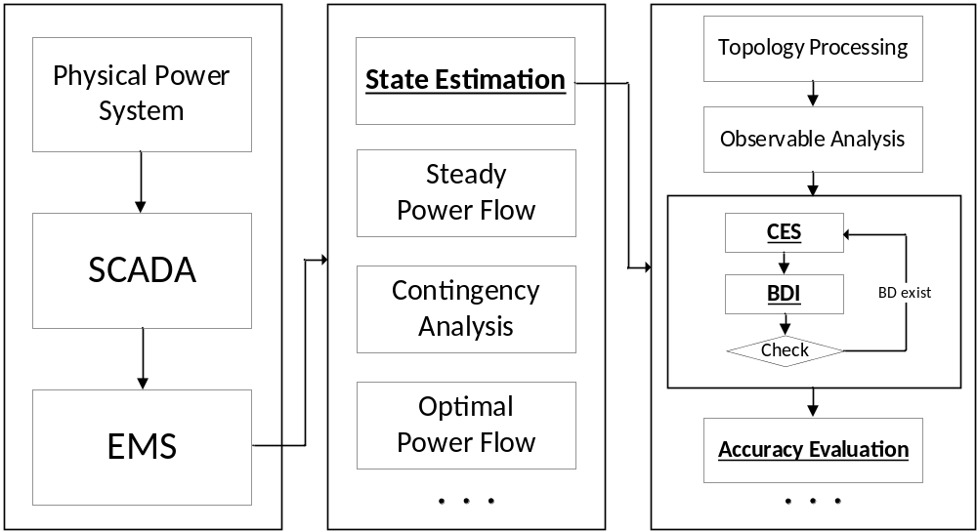
Figure 1.1. Reprehensive schema of a complete SE in system analysis.

errors. The analog measurements consist of voltage magnitude, line current, power injections and other telemetered measurements. The corresponding errors come from random noise due to the uncertainty of measuring equipment and communication interference. The network parameters refer to the intrinsic information such as line length, tap changer position, temperature, etc. [16]. This type of error usually comes from improper updates in the database and the miscalibration of mechanical devices. The CES and BDI are performed in pairs until no bad data exists.
• Accuracy evaluation is the process of comparing the estimated results, the measurements and true values in order to assess the approach used in the CES [17]. By introducing accuracy indices, different approaches can be compared, and the best approach for a specific system can be selected. Furthermore, a sensitivity analysis can also be done to sort out the most influential measurements [18].
In this dissertation, three assumptions are made to narrow this work: 1) The topology is given in advance; thus, topology processing is not needed. 2) The measurements are redundant and sufficient to ensure the observability of the system; thus, the observability analysis is omitted. 3) The network parameters such as line admittance and transformer taps are accurate and fixed; thus, only analog measurement errors should be dealt with. Based on these assumptions, this dissertation focuses on proposing a new CES approach for VSC-MTDC power systems. Meanwhile, accuracy and reliability are verified by performing BDI and accuracy evaluation.

Brief Description of VSC-MTDC Power Systems
The topic of SE methods for hybrid AC/DC power systems is not a new one, indeed research on this topic spans three decades [19]-[20]. The rapid development of DC techniques raises continuous challenges for SE analysis, such as topological complications, scale extension, the formulation of new electronic equipment, and mathematical modeling of featured control strategies. Some of the theoretical foundations of previous research are still utilized for state-of-the- art techniques, while some improvements must be made to meet the current needs of SE analysis. This section briefly introduces the development of DC techniques and points out the pressing challenges brought by modern VSC-MTDC power systems.

Development direction of hybrid AC/DC systems
Many hybrid AC/DC systems have been installed around the world since the first commercial installation in Gotland, Sweden in 1954 [21]. Though the Gotland system used the obsolete technique of mercury-arc valves, it demonstrated the feasibility and advantages of constructing a hybrid AC/DC system to the world of power engineering [22]. With increasing demand and greater supply flexibility, DC links were no longer limited to simply connecting isolated areas. Thyristor valves, which benefit from the features of large transmission capacity and silicon-controlled ability, were introduced into commercial usage in 1970. Since then, LCC-based techniques have helped to transport energy among ultra-wide regions at extremely high voltages (i.e. 800kV) and construct modern HVDC transmission systems [23]. In recent years, the increasing penetration of renewable energy exerts new pressure on engineers to enable more integration and boost reliability. VSC technology, which is based on IGBT thyristors, offers numerous benefits for composing the more complex VSC-MTDC systems connecting multiple asynchronous grids. The scale of early VSC-based hybrid systems was subject to the transmission capacity of converters. Thus, VSCs were mainly used for connecting short-distance offshore windfarms and for supplying islands [24]. Recently, the capacity restriction has been significantly widened as the upper range of VSCs can now reach over 3,000 MW and ±640 kV [25]. Now, therefore, more ultra-wide-area and high-capacity VSC-MTDC power systems are in use or planned [26]-[28]. The key development timeline is illustrated in Figure 1.2.
In summary, it is noticeable that VSC-MTDC power systems have become very promising and important components in the modern power engineering world [30].

Challenges brought by VSC-MTDC power systems
Based on the aforementioned development of VSC-MTDC technologies and a relevant study [31], the integration of VSC-MTDC power systems can bring three main aspects in the existing SE methods for hybrid AC/DC systems.
Challenge 1: System scale. One of the most important assumptions in SE analysis is that the supervised system is steady over time, which means there are no large variations during the SCADA sampling period. To guarantee this assumption, the execution of SE should be finished within several seconds [32]. To allow for closer monitoring, the time interval between consecutive SEs should be further shortened as well. However, the scale of VSC-MTDC systems can be significantly large given the systems’ capability for connecting multiple isolated AC grids. Thus, more computing time is needed to deal with more measurements, state variables and system parameters.
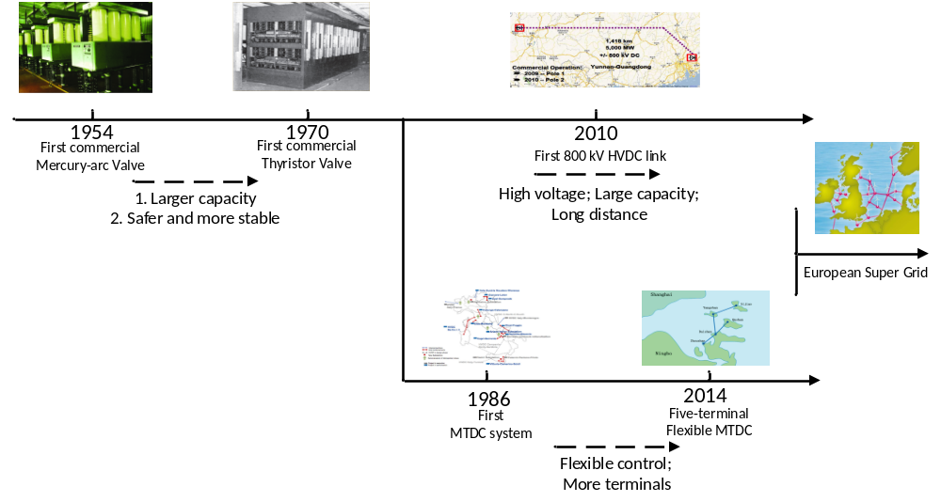
Figure 1.2. The key development timeline of DC technologies.

Challenge 2: VSC modeling. The challenge of VSC modeling can greatly affect SE accuracy. The proposed SE formulation of VSCs should include not only steady operating expressions but also different controlling equations. Beyond the conventional constant values control, VSCs have more flexibility to operate in droop control modes that contain additional and unique parameters and features. Therefore, to provide accurate and reliable estimations, all control strategies should be formulated for SE analysis.
Challenge 3: Operating limits. Compared with traditional generators and other AC equipment, VSCs can fast-regulate their output and self-adjust to new operating points once the restricted limits are violated. Benefitting from the PWM and PI controller, adjustments can be done accurately in a very short time. Therefore, VSCs are supposed to have clear operating limits and no violations can occur. However, measurement errors can affect the estimations of VSCs and violate the limits. To solve this problem, the proposed method should also take this feature into consideration.

Dissertation Outline
Chapter 2 compares two main methods, namely the UM and the SM, for estimating VSC-MTDC power systems. The test results are evaluated in three aspects including estimated accuracy, computing speed and robustness. The comparison study indicates that the SM is more suitable as the theoretical foundation to develop the new approach in this dissertation.
Chapter 3 presents graph-based computation to further accelerate the SM for VSC-MTDC systems. Parallel computation can be implemented in the SM after the original system is stored in GDB. Advanced parallel methods including NPC and HPC can naturally accelerate the SM. In addition, this chapter also proposes a virtual connection method to achieve better convergence speed without compromising accuracy.
Chapter 4 first presents the SE model of VSC-MTDC systems with various types of droop control. The droop coefficient can be estimated as a state variable in the new model. In addition, for complex two-stage droop control, the BCNLS algorithm is proposed to provide reliable and accurate estimations. Furthermore, the LM method is leveraged to help improve the searching steps during iterations.
Chapter 5 presents an in-depth study on the operating limits of VSCs. In this chapter, the behaviors and sequences of the adjustment and regulation when operating limits are violated are analyzed. Afterwards, the operating limits are modeled as equality constraints associated with WLS equations. The new measuring equations can be solved by using Lagrangian relaxation to accurately reflect the dynamic features of VSCs in SE analysis. In addition, to eliminate deterioration from gross errors, the inner estimator is further enhanced by leveraging the HAM method to identify bad data with the help of a Lagrangian multiplier.
Chapter 6 concludes the dissertation and discusses the potential directions for future work on robust SE for VSC-MTDC systems.

Comparisons of the Unified and Sequential Methods for VSC-MTDC Power System State Estimation: Accuracy, Computing Speed and Robustness
This chapter compares the two most widely-used methods, UM and SM, in dealing with the SE problem for hybrid systems including the conventional LCC based and VSC based systems. Since most of the early-proposed SE approaches were developed and improved based on these two methods, it is important to point out the advantages and shortages of both methods. However, the selection of previous studies mainly depended on the fuzzy engineering experiences, leading to the unclear and insufficient supports on developing new SE approach for modern VSC-MTDC power systems. Therefore, it is necessary to give the quantitative analysis and choose the suitable method as the theoretical basis to develop the new SE approach in this dissertation. Three important aspects, including estimation accuracy, computing speed and robustness, are compared by testing the two methods in various cases. Test results indicate that SM can better suit SE analysis for VSC-MTDC power systems, and the new approach in this dissertation is developed from SM.

Introduction
The growing deployment of renewable energy sources associated with the utilization of VSC technologies is redefining the modern power grid by supporting larger operating capacity, longer transmission distance, more flexible power exchange and greater reliability [33]-[35]. Benefitting from the capabilities of independent and flexible controlling strategies [36] and flexible control strategies [37], extensive MTDC systems have been introduced to cooperate with AC power grids in recent years and the near future [38], [39].
However, the penetration of VSC stations and DC links also significantly add the complexities of both system topology and operating modeling, leading to some research issues in the EMS [40]. Consequently, the monitoring of the extended DC connections alongside the conventional AC grids is very important. One urgent and important issue of analyzing the VSC-MTDC power systems is the SE, which is utilized to filter out the errors in raw measurement data and provide the reliable estimations. Compared with the AC transmission systems which can be well estimated by applying the mature WLS algorithm, the widely-accepted SE method for the hybrid AC/DC systems is still under discussion although some approaches were proposed in the early literatures. The relevant literature includes several studies dedicated to estimating the hybrid systems, and these studies can be generally classified into the Unified Method (a.k.a. the Simultaneous Method) and the Sequential Method. The UM, which was leveraged in [41]-[45], uses the simultaneous approach to integrate all the measurements, state variables, errors and operating models of both AC and DC grids. The integrated problem can be subsequently solved by using WLS algorithm and the estimations of the entire system can be achieved [43]. Note that the interface measurements and variables of the PCCs are incorporated into the estimator, UM is assumed to have better convergence and robustness by using the typical converter model [46]. Whereas, UM requires reprogramming the estimators and fails to utilize the existing approaches for AC grids. The involved Jacobian and Gain matrices are modified by adding the equations from DC links, leading to the poor usability of the FDSE which is efficient and timesaving for AC grids [47]. Thus, the computing time of UM can increase dramatically when used in estimating large-scale hybrid systems [48]. The SM, which is studied in [49]-[51], by comparison, decouples the original hybrid systems and subsequently estimates the AC and DC grids (including converters) separately. By comparing and updating the interface data at PCC from both AC and DC sides, the computation is performed sequentially until the global convergence is achieved. SM has the major advantage of being easily implemented as an extended function to AC estimators. The existing approaches are remained and exploited to model the DC measurements as pseudo injections. The double-layer computing loops in SM may also increase the computing time [52], [53]. Furthermore, the estimation accuracy can be lower if FDSE is utilized.
Both UM and SM are leveraged by researchers and operators to develop improved approaches to facilitate the estimation of VSC-MTDC systems. Whereas, it is controversial that which method is more adoptable and the selection in previous work was mainly based on engineering experience. Convincing and detailed comparisons on different important aspects are not given between the two methods. First, the estimation accuracy is the most important criterion in the selection and the estimator should provide unbiased results in all circumstances. Lower accuracy may occur in UM when the AC/DC system composes of several independent grids. The measurements of each area are transmitted and synchronized, leading to the accumulation of errors due to different sampling time and long-distance communication noise [50]. The accuracy of SM may also be affected if the interface data at PCC is treated as pseudo injections in the simplified model [48]. Furthermore, in view of the increasing scale of the VSC-MTDC systems, the calculation of SE can be time-consuming due to the size and complexity. However, as part of the real-time monitoring functions, the estimations should be given within several seconds [54]. Both Jacobian and Gain matrices of UM are extended to include the operating functions and variables of VSCs and DC links. On one hand the matrices become bigger and requires more computing time, and on the other hand, the problem can only be solved by using WLS which is slower than FDSE [42]. Although SM leverages existing AC estimators, sequential calculations with inner/outer loops should be executed until achieving global convergence, leading to longer computing time. Another key criterion of SE is robustness to abnormal conditions such as low redundancy, PCC measurements missing and data with large deviations. Previous research tested both methods in normal conditions and ignored some specific conditions that can degrade the reliability more significantly of one method over another.
Motivated by these concerns, this paper makes the contribution of comparing the UM and the SM in view of estimation accuracy, computing speed and robustness. A series of tests are performed on various VSC-MTDC systems with different scales, topologies, and measuring data. Test results are compared and summarized to denote the most applicable conditions for each method. Consequently, this work provides convincing and reasoned guidance to help researchers and operators to select the better method for specific systems.
The remainder of this chapter is arranged as follows. Section 2.2 briefly reviews the formulation and calculation methods of the state estimation problem. Section 2.3 presents the processes of UM and SM based on the generalized SE model of VSC-MTDC systems. Numerical comparisons on the estimation accuracy, computing speed and robustness are reported in Section 2.4, Section 2.5, and Section 2.6. Conclusions are outlined in Section 2.7.

Background of SE Problem

Formulation of WLS algorithm
Static SE is an important function for identifying the operating state of a system with reliable estimated values from noisy but redundant measurements. The SE model can be defined with the relationships between the measurement vector z (m-dimension) and the state variable vector x (n-dimension) as:
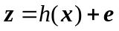
where h is the nonlinear operating functions relating measurements z to state variables x, e is the error vector. Given that the measurements are redundant ($m>n)$, is an overdetermined and can be solved as an optimization problem. The extensively used approach is WLS algorithm utilized to minimize the following converted problem:
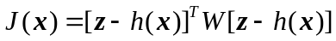
where W is the weight vector and is equal to $R^{-1}$, R is a diagonal matrix made up of the standard deviations ($σ$) of measurements. According to the first-order optimally conditions and Taylor series [45], can be iteratively solved with NR method:
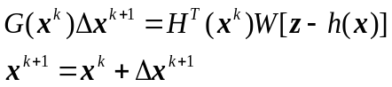
where $H\left(x^{k}\right)=∂h\left(x\right)/∂x$ is the Jacobian matrix and $G\left(x^{k}\right)=H^{T}\left(x^{k}\right)WH(x^{k})$ is the Gain matrix. More detailed descriptions and conditions of the WLS algorithm are discussed in [47]. The process is repeated several times to get the desired accuracy ($|∆x^{k+1}|<ε$) of estimated variables.

Formulation of FDSE algorithm
Although the WLS algorithm is well-defined to solve , it also brings computational burden on generating and inversing matrices H and G in every iteration. The computing time of performing WLS can dramatically increase for large-scale systems [56]. In analogy with the fast-decoupled power flow method, the sensitivity of the active/reactive power to changes in the voltage angle/magnitude is high for AC transmission systems. Measurements and state variables can be subsequently partitioned as:
Matrices H, G and W can be correspondingly represented as:
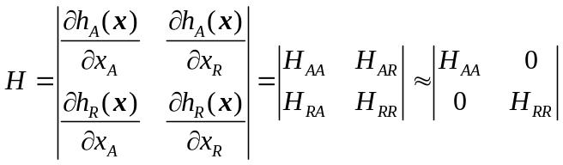
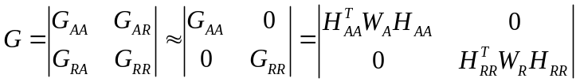
where the subscripts A and R stand for active and reactive components, respectively. Furthermore, assume that all voltage magnitudes are close to 1.0 p.u. and the neighbouring buses are in phase with each other, $H_{AA}$ and $H_{RR}$ can be further simplified to the constant matrices in terms of the admittance matrix [47]. can be consequently partitioned and solved as:
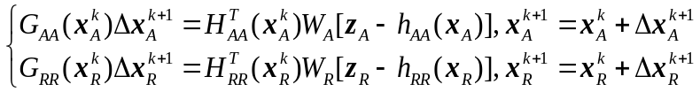
denotes that the active and reactive SE can be solved separately with constant matrices in terms of the admittance elements. Despite more iterations, it’s more efficient and timesaving than WLS because the processes of generating and inversing the matrices are only performed one time in the analysis. FDSE is widely accepted and implemented in control centers, providing reliable estimations with less computing time.

Generalized formulations and calculation processes of UM and SM
This section presents the generalized formulations and calculation processes of UM and SM based on the complete VSC models from previous studies. The summaries of both methods can be further analyzed in the following sections.

SE model of VSC-MTDC power systems
A typical VSC-MTDC system can be represented in a general format in Figure 2.1, which includes a power flow model (Figure 2.1(a)) and a topological model (Figure 2.1(b)). Obviously, the system can be naturally decoupled into three subsystems, the AC grids, DC grids and the interface connections including PCC and converters. $X_{si}$ and $R_{si}$ represent the equivalent reactance and resistance. As shown in Figure 2.1(b), the decoupled system can be modeled separately with different operating equations, variables, and measurements. First, the SE equations of AC grids are given as:
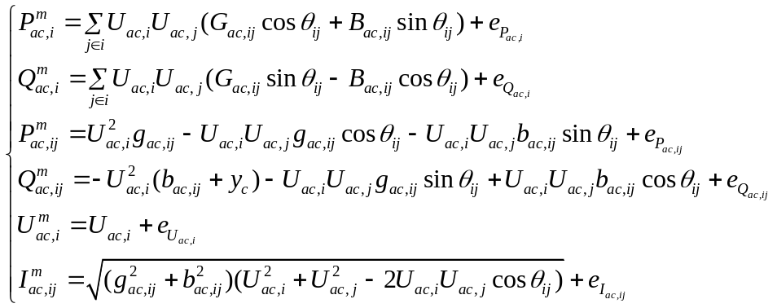

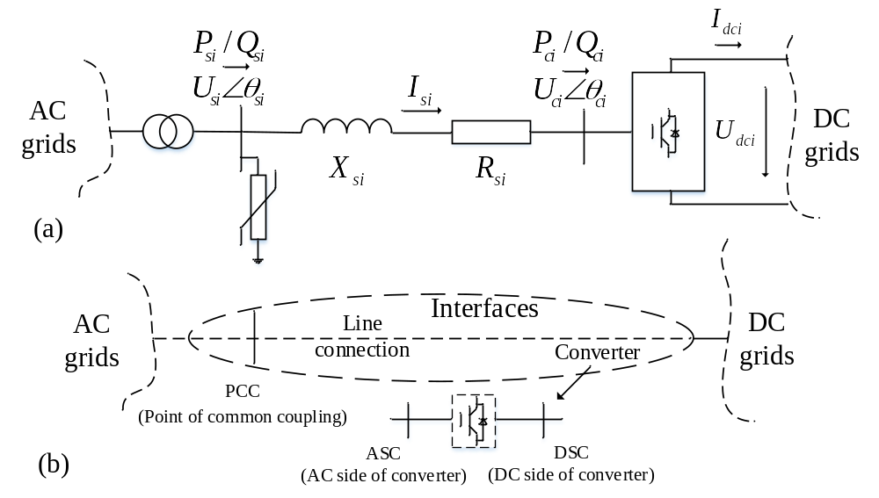
Figure 2.1. Single-phase models of a VSC-MTDC system (a) power flow model. (b) topological decoupling model.

where $U_{ac,i}, θ_{i}$ is the voltage magnitude and angle at bus i, $G_{ac,ij}, B_{ac,ij}$ is the ij^{th} element of the real and imaginary part of the admittance matrix, $g_{ac,ij}, b_{ac,ij}$ and $y_{c}$ stand for the admittance of branch ij and the shunt, respectively. The superscript m stands for ‘measurement’. Measurements of line currents are not commonly used due to the distortion of non-linear loadings [57].
The measurement equations of DC grids can be formed as:
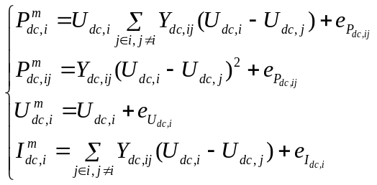
where $U_{dc,i}, I_{dc,i}$ and $P_{dc,i}$ stand for the voltage, current and power injected at DC bus i, respectively. $Y_{dc}$ is the admittance matrix of DC grids.
The summarized complete model of the coupled connections is presented as:
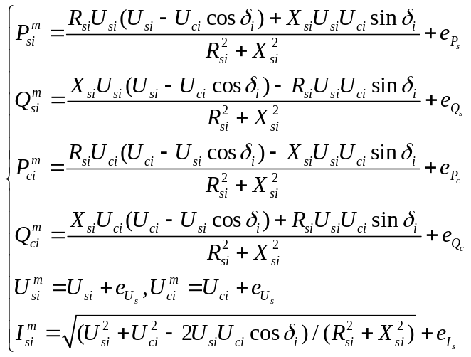
where $δ_{i}$ equals to $(θ_{si}-θ_{ci})$. Furthermore, the relationships of power balance and voltage conversion via VSC can be given as:
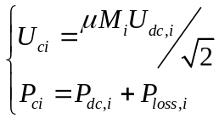
where $μ$ is the DC voltage utilization and $M_{i}$ is modulation index. $P_{loss,i}$ is the converter loss which can be represented in terms of the converter current as:
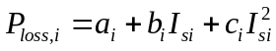
where $a_{i}, b_{i}$ and $c_{i}$ are coefficients. In general, the SE models of DC grids and the interface connections can be integrated to simplify analysis. The generalized formulations are consequently given from -, and the sets of measurements and state variables are listed in Table 2.1.
Furthermore, both the active and reactive power injection of VSC can be independently controlled with constant $P_{s}/U_{dc}$ (active power model) and constant $Q_{s}/U_{s}$ (reactive power model). Therefore, the preset operating values can be used as pseudo-measurements with high weights in SE analysis. UM and SM have different approaches to deal with the interface measurements and variables, the detailed calculation processes are given in the following section.

Calculation processes of UM and SM
As aforementioned, UM integrates all the involved measurements, state variables and SE equations as a whole problem to solve. The new equations are given as:
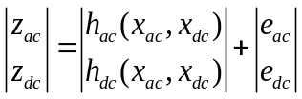
The corresponding H and G matrices are given as:
Table 2.1. Measurements and state variables of VSC-MTDC systems.
Type | AC side | DC side
Measurements | $$z_{ac}=[P_{ac,i}^{m},P_{ac,ij}^{m},Q_{ac,i}^{m},Q_{ac,ij}^{m},U_{ac,i}^{m},{(I}_{ac,i}^{m})]$$ | $$z_{dc}=[P_{dc,i}^{m},P_{dc,ij}^{m}, U_{dc,i}^{m},P_{si}^{m},$$  $$Q_{si}^{m},P_{ci}^{m},Q_{ci}^{m},U_{si}^{m},U_{ci}^{m},(,I_{si}^{m},I_{si}^{m})]$$
State variables | $$x_{ac}=[U_{ac,i},θ_{ac,i}]$$ | $$x_{dc}=[U_{dc,i},M_{i},δ_{i}]$$

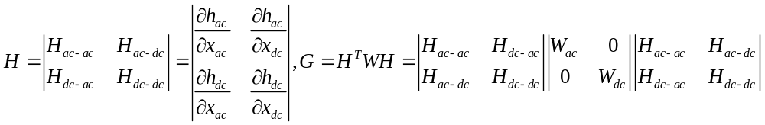
The flow chart is denoted in Figure 2.2. Obviously, the interface voltage $U_{s,i}^{m}$ is replaced by the connected AC bus voltage $U_{ac,i}^{m}$.
Inversely, SM leverages another strategy by performing the inner and outer computing loops to do SE analysis for AC and DC grids separately as shown in Figure 2.3.
Within the inner loops, the AC and DC grids are estimated independently based on the corresponding input data. Note that the power injections from DC sides are modeled as the dummy loads or generations, and the AC estimations can be solved by using both WLS and FDSE. The estimations are subsequently used to update the interface measurements for the following SE of DC grids. Within the outer loops, the interface data from both AC and DC sides are compared to check global convergence and updated if needed. The flow chart of SM is given in Figure 2.4. Note that the interface voltage value is estimated from AC side and used as the constant value in DC grids. Furthermore, the measurements of power injection $P_{si}^{m}$ and $Q_{si}^{m}$ are updated in each inner calculation from both AC and DC sides based on the corresponding estimations.

Brief summaries of UM and SM
Both UM and SM have been utilized as the basic methods and various improved estimators are derived from both methods. The significant similarities, differences and
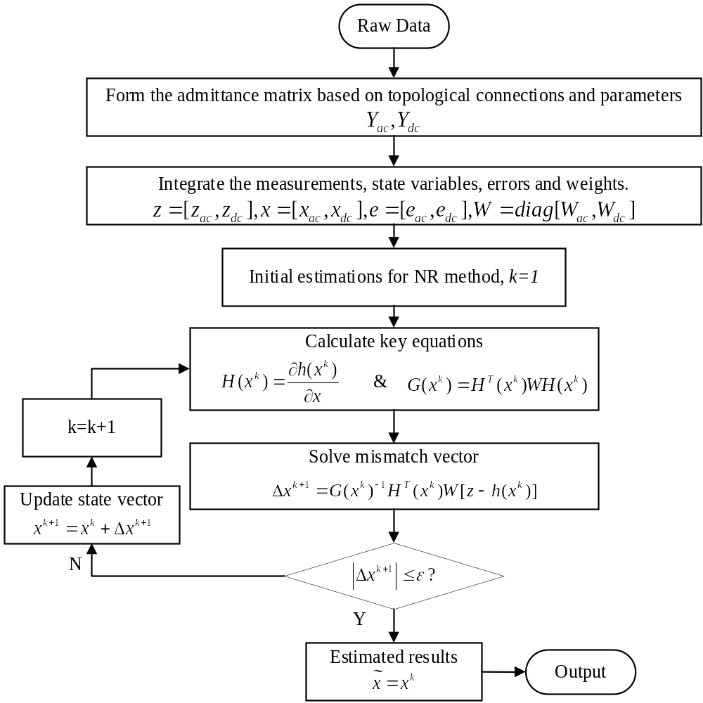
Figure 2.2. Generalized computing flow chart of UM ($\tilde{x}$ is the estimation).

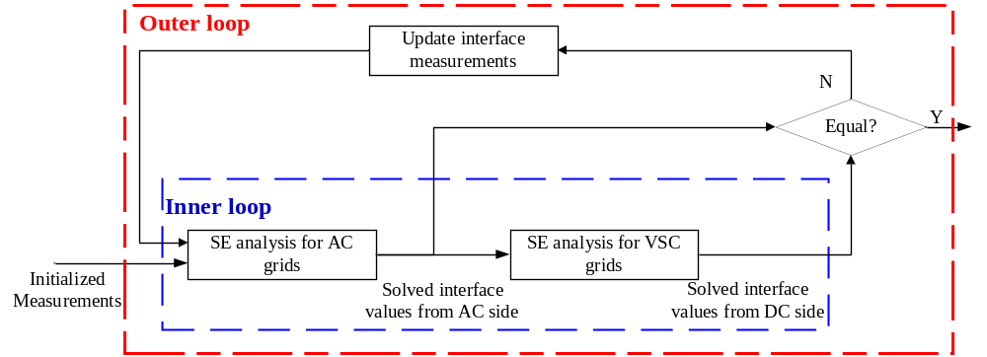
Figure 2.3. Inner and outer computing loops of SM.

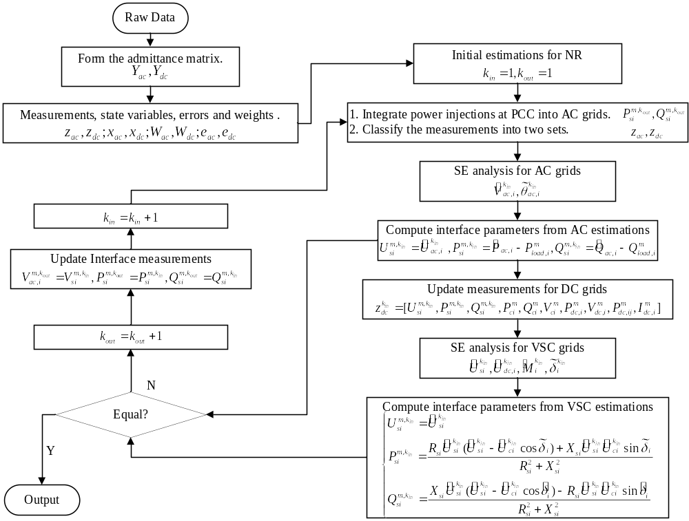
Figure 2.4. Generalized computing flow chart of SM ($\tilde{x}$ is the estimation).

unique features of both methods are briefly summarized in Table 2.2.
Besides the general summaries, more detailed comparisons should be given by testing on different system on multiple scenarios. The comprehensive comparisons are given in the following sections.

Comparison of estimation accuracy

Instructions and testing environments
Providing reliable and unbiased estimations from redundant but noisy measurements is always the primary consideration in SE. In this section, the generalized SE methods for VSC-MTDC systems are tested on two modified systems under different measuring conditions to compare estimation accuracy. First, the testing environments of both hardware and software are listed in Table 2.3.
The measurement data is simulated from the power flow results calculated by MATALB and PSS/E, and then added with random errors that satisfy Gaussian (Normal) distribution $N\sim (0,σ)$, in which $σ$ is the standard deviation. Both UM and SM are programmed in their most generalized forms in MATLAB and call some functions from MATPOWER [58] and MatACDC [59]. To guarantee the reliabilities of results, all tests are performed 50 times to reduce accidental errors. The estimated results are directly compared with the true values to verify the accuracy. Performance index is adopted to denote the overall accuracy and smaller index value denotes better accuracy as [42]:
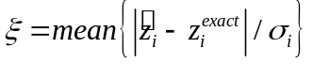
where $\tilde{z_{i}}$ is the estimated measurement and $z_{i}^{exact}$ is the true value based on power flow
Table 2.2. Brief summaries of UM and SM.
Summaries | UM | SM
Similarities | 1. Measurements, state variables, errors and SE equations are the same.  2. Both methods can be solved with WLS algorithm.
Differences | 1. Only WLS algorithm is suitable.  2. Single calculation loop. | 1. Both WLS and FDSE algorithms can be used.  2. Double calculation loops.
Unique features | 1. Both grids have the same convergence.  2. Data from all areas should be integrated and calculated simultaneously. | 1. The interface data is updated from both sides.  2. The initial measurements is corrected in the sequential calculations.

Table 2.3. Testing environments of hardware and software.
Software | Operating System (OS) | Windows 10
Software | Platforms | MATLAB 2020a, PSS/E V34.0
Software | Toolbox | MATPOWER v6.0, MatACDC v1.0
Hardware | CPU | I7-9700k (8 cores@5.0GHz)
Hardware | RAM | 32GB

results. Two modified systems, the modified IEEE 5-bus system (Case 1) and the RTS-96 system (Case 2), are tested in this section as shown in Figure 2.5. Detailed topologies, parameters and settings are presented in [52]. Since SM leverages both WLS and FDSE algorithms within the inner SE analysis of AC grids, both algorithms (SM-WLS and SM-FDSE) should be tested in the following experiments.

Comparison of estimated accuracy
Under the normal testing conditions, the following simulated SE measurements are considered: 1) All measurements are available to ensure redundance; 2) no bad data is injected; 3) measurement errors include both meter reading and full-scale errors given as:
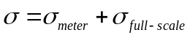
SE results for the modified IEEE 5-bus system are compared with true values in Table 2.4 and Table 2.5. Best estimations are highlighted. Furthermore, the estimation results for the modified RTS-96 system are compared with the true values and the comparisons are subsequently given in Table 2.6 and Figure 2.6.
As depicted in Tables 2.4 - 2.6 and Figure 2.6, all three methods can provide reliable and good estimations for both test cases. UM has the largest amount of best estimations (highlighted)for both AC and DC grids compared with SM-WLS and SM-FDSE. But the estimations are very close and the accuracy of all three methods are acceptable. To better evaluate the overall accuracy, the average performance index values of UM, SM-WLS and SM-FDSE are calculated by (15) and listed in Table 2.7.
As can be seen from Table 2.7, UM has the best overall estimation accuracy under normal conditions. The accuracy of SM based methods are slightly lower than UM’s, but the
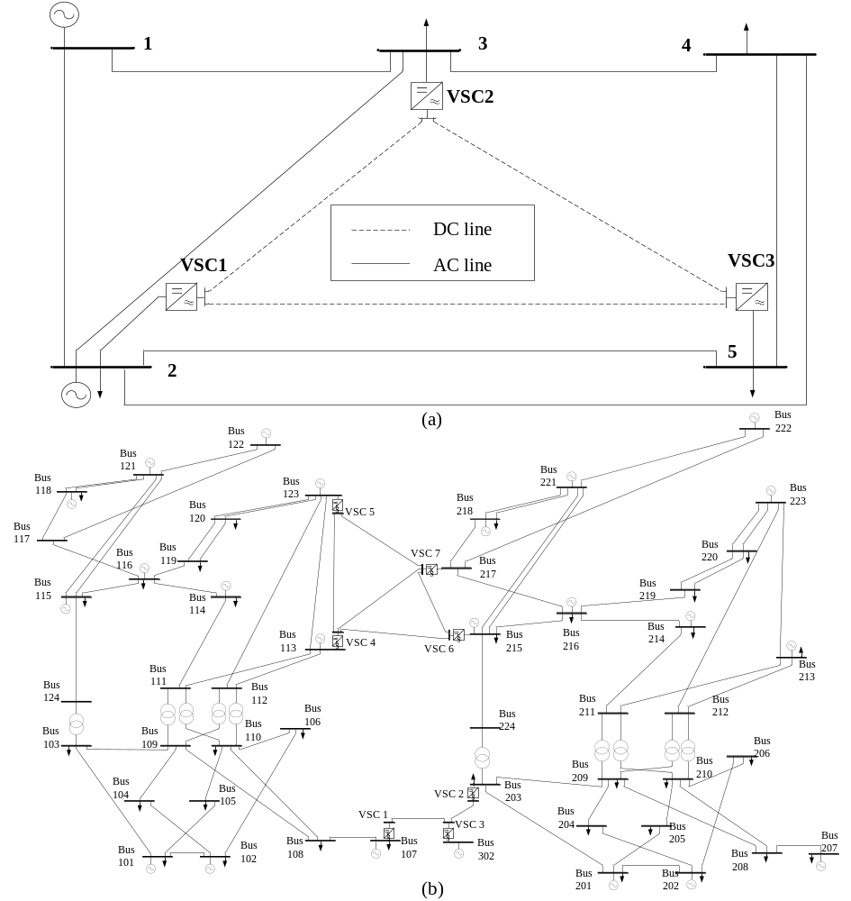
Figure 2.5. Test systems (a) modified IEEE 5-bus system (b) modified RTS-96 system.

Table 2.4. SE estimation results of AC grid in Case 1 ($σ_{ac}=0.0235, σ_{dc}=0.016$).
Bus | True values (TV) |  | UM |  | SM-WLS |  | SM-FDSE
Bus | $$|U_{ac}|$$ | $$θ_{ac}$$ | $$|U_{ac}|$$ | $$θ_{ac}$$ | $$|U_{ac}|$$ | $$θ_{ac}$$ | $$|U_{ac}|$$ | $$θ_{ac}$$
1 | 1.0600 | 0.000 | 1.0600 | 0.0000 | 1.0600 | 0.0000 | 1.0600 | 0.0000
2 | 1.0000 | -2.3021 | 0.9982 | -2.3071 | 1.0020 | -2.3091 | 1.0021 | -2.3113
3 | 1.0500 | -4.5614 | 1.0483 | -4.5634 | 1.0529 | -4.5633 | 1.0531 | -4.5776
4 | 1.0362 | -4.7500 | 1.0415 | -4.7533 | 1.0432 | -4.7354 | 1.0290 | -4.7292
5 | 1.0043 | -4.2507 | 1.0025 | -4.2522 | 1.019 | -4.2537 | 1.0062 | -4.2463

Table 2.5. SE estimation results of DC grid in Case 1 ($σ_{ac}=0.0235, σ_{dc}=0.016$).
VSC | VSC 1 |  |  | VSC 2 |  |  | VSC 3
VSC | $$U_{dc}$$ | $$M$$ | $$δ$$ | $$U_{dc}$$ | $$M$$ | $$δ$$ | $$U_{dc}$$ | $$M$$ | $$δ$$
TV | 1.0090 | 0.7641 | 5.4671 | 1.0000 | 0.9637 | -1.6845 | 0.9971 | 0.8296 | -2.9578
UM | 1.0093 | 0.7649 | 5.4689 | 1.0000 | 0.9628 | -1.6873 | 0.9974 | 0.8298 | -2.9542
SM-WLS | 1.0088 | 0.7651 | 5.4688 | 1.0000 | 0.9651 | -1.6877 | 0.9967 | 0.8295 | -2.9539
SM-FDSE | 1.0079 | 0.7633 | 5.4693 | 1.0000 | 0.9615 | -1.6854 | 0.9982 | 0.8305 | -2.9592

Table 2.6. Comparison of eestimation accuracy of DC grid in Case 2.
Absolute difference |  | VSC 1 | VSC 2 | VSC 3 | VSC 4 | VSC 5 | VSC 6 | VSC 7
$$|∆U_{dc}|$$ | UM | 0.0000 | 0.0008 | 0.0009 | 0.0000 | 0.0011 | 0.0014 | 0.0025
$$|∆U_{dc}|$$ | SM-WLS | 0.0000 | 0.0007 | 0.0011 | 0.0000 | 0.0015 | 0.0011 | 0.0031
$$|∆U_{dc}|$$ | SM-FDSE | 0.0000 | 0.0015 | 0.0009 | 0.0000 | 0.0021 | 0.0013 | 0.0030
$$|∆M|$$ | UM | 0.0035 | 0.0027 | 0.0105 | 0.0086 | 0.0080 | 0.0121 | 0.0052
$$|∆M|$$ | SM-WLS | 0.0044 | 0.0036 | 0.0098 | 0.0102 | 0.0092 | 0.0119 | 0.0063
$$|∆M|$$ | SM-FDSE | 0.0043 | 0.0040 | 0.0112 | 0.0074 | 0.0105 | 0.0132 | 0.0057
$$|∆δ|$$ | UM | 0.0021 | 0.0025 | 0.0102 | 0.0121 | 0.0085 | 0.0025 | 0.0019
$$|∆δ|$$ | SM-WLS | 0.0024 | 0.0021 | 0.0098 | 0.0117 | 0.0093 | 0.0042 | 0.0025
$$|∆δ|$$ | SM-FDSE | 0.0033 | 0.0033 | 0.0110 | 0.0116 | 0.0089 | 0.0037 | 0.0041

Table 2.7. Average performance index values for the three methods in both cases.
Methods | AC grid |  | DC grid |  | Whole system
Methods | Case 1 | Case 2 | Case 1 | Case 2 | Case 1 | Case 2
UM | 0.4336 | 0.7574 | 0.7431 | 0.8687 | 0.5884 | 0.8131
SM-WLS | 0.4353 | 0.8255 | 0.7526 | 0.8866 | 0.5940 | 0.8560
SM-FDSE | 0.4762 | 0.8256 | 0.7365 | 0.8911 | 0.6046 | 0.8583

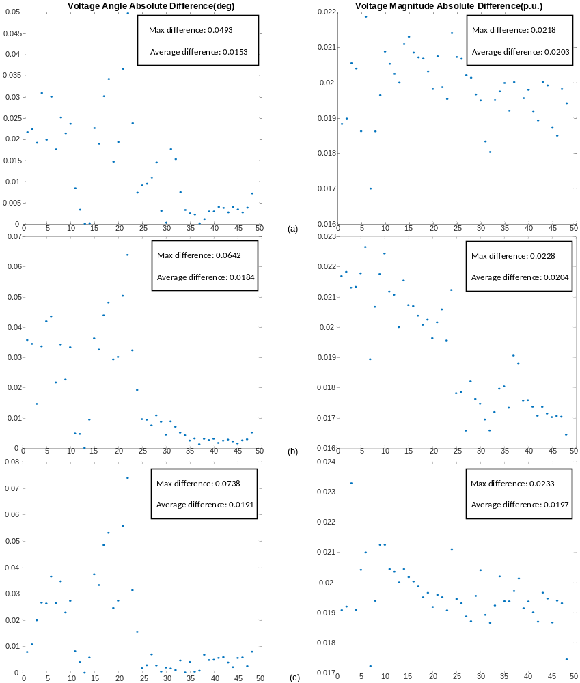
Figure 2.6 Comparison of eestimation accuracy of AC grid in Case 2 (a) UM. (b) SM-WLS. (c) SM-FDSE.

estimations of the three methods are very close.
Same experiments are repeated when the simulated measurements are reduced to lower redundancy and the deviations of errors are increased. These experiments help to present the estimation accuracy of the three methods in the real and practical operating environments. First, some of the non-critical measurements are removed and the estimation accuracy for both cases under lower redundancy are evaluated by calculating the performance indices. Results are given in Figure 2.7.
The results of Figure 2.7 show that all three methods can still filter out measurement errors and provide accurate estimations. However, with the decrease of redundancy, the accuracy of the three methods becomes lower. From this perspective, it is noted that both SM-WLS and SM-FDSE have better accuracy than UM when the redundancy is lower. For Case 1 and Case 2, when the redundancies are lower than 2.3 and 2.1 respectively, SM can provide more accurate estimations than UM. It is because SM performs multiple inner iterations, and the missing measurements can be calculated from the previous inner estimations. Thus, the redundancy is increased, leading to better accuracy.
Deviations also affect the estimation accuracy, and a reliable estimator should have the capability against various and large deviations. The average performance indices are shown in Figure 2.8. Given that the deviations of AC and DC grids can be different, the experiments in Figure 2.8 consider the different impacts on estimation accuracy of one deviation by fixing another one. The results of Figure 2.8 indicate that estimation accuracy of all three methods are little influenced when the deviation of AC grids increases while the DC deviation is fixed. However, it is noted that when the DC deviation is larger, the estimation accuracy of UM is decreased significantly while the SM based methods can still retain the accuracy. It is
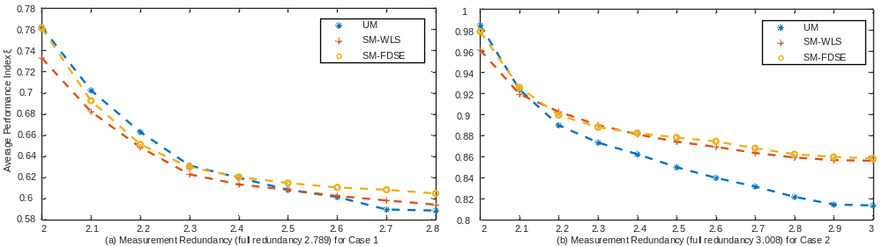
Figure 2.7. Average performance indices of different methods with reduced redundancy (a) Case 1 (b) Case 2.

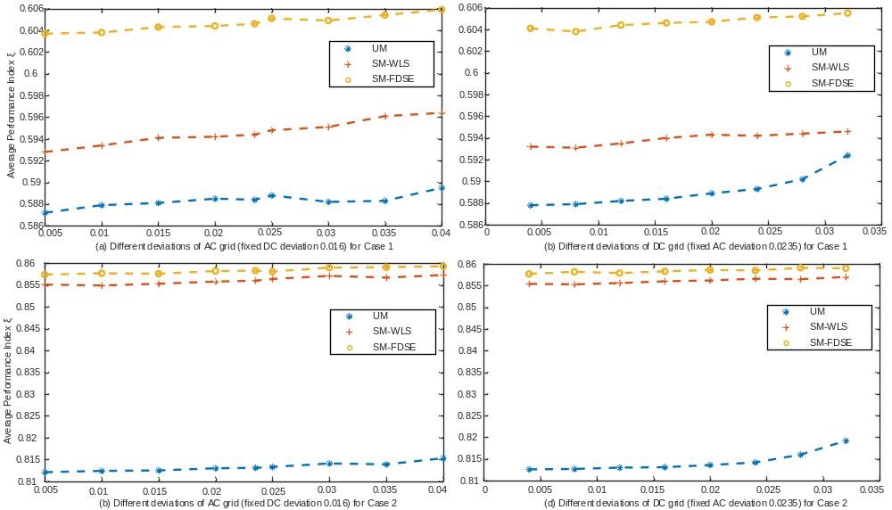
Figure 2.8. Average performance indices of different methods with larger deviations (a) Case 1 with different AC deviations and fixed DC deviation. (b) Case 1 with different DC deviations and fixed AC deviation. (c) Case 2 with different AC deviations and fixed DC deviation. (d) Case 2 with different DC deviations and fixed AC deviation.

because the interface data is calculated and updated from both AC and DC sides with multiple calculations in SM. Afterwards, the accurate estimations from AC grid can help improve the accuracy of DC estimations.

Summary of estimation accuracy
In this section, both UM and SM (including SM-WLS and SM-FDSE) are tested under different conditions on two modified standard systems. The estimations are compared with true values and the performance index is utilized to evaluate the overall accuracy. The comparisons of estimation accuracy can be summarized with the following points:
• Both UM and SM have good estimation accuracy under normal conditions. UM has better accuracy than SM-WLS and SM-FDSE, but the estimations of the three methods are extremely close.
• In view of reduced redundancy of measurements, SM-WLS and SM-FDSE have better accuracy than UM. It is because that the missing measurements can be calculated from the inner estimations and subsequently used for the following loops.
• All three methods can retain good accuracy against larger deviation of AC grid. However, when the DC deviation increases, the accuracy of SM-WLS and SM-FDSE is better. The reason is that the interface data in SM is calculated and updated from both AC and DC sides, and better estimations from AC side can help improve reduce the influence of larger DC deviations.

Comparison of computing speed

Instructions and testing environments
Besides the estimation accuracy, the computing speed of estimators is another vital criterion in evaluating the performance. To meet the requirements of real-time monitoring, estimators should complete the core analysis within several seconds [54]. However, although the fast development of VSC-MTDC techniques makes it possible to create the ultra-wide hybrid systems, but it also brings great challenges on the computing time [39], [60]. Both the system scale and analysis complexity are greatly increased due to the multiple interconnected AC grids and DC connections. Consequently, it is necessary and meaningful to test computing speed of the proposed methods.
First, the hardware and software environments are the same as listed in Table 2.3. To ensure the reliability of test results, all the computing speed is on average of 50 times repetition. Furthermore, the convergence tolerance is set as $ϵ=1e^{-6}$ and the initial guess is set as flat start for all methods.
The test systems in this section are categorized into two groups. The first group is based on the structure denoted in Figure 2.9, four identical AC grids are connected via the DC links that have the same topology and parameters as shown in Figure 2.5. By selecting different standard systems to be interconnected, the simulated VSC-MTDC networks can cover the scales from approximate 200 buses to 12,000 buses. The standard systems and topologies are listed in Table 2.8. The second group aims at studying the influence of multiple DC networks on computing speed. Therefore, the connected AC grids are fixed with SC 500-bus systems, but multiple four-terminal DC networks are used to interconnect the AC grids. The test cases in the second group are listed in Table 2.9. It is noted that the overall system
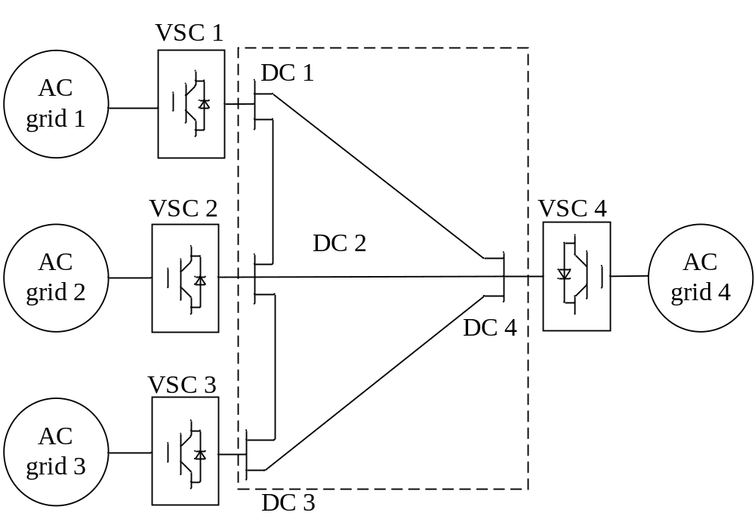
Figure 2.9. Four-terminal test network for SE analysis.

Table 2.8. Standard systems in the first test group.
Case | Case 3 | Case 4 | Case 5 | Case 6 | Case 7 | Case 8 | Case 9
Standard  system | IEEE  57-bus | IEEE  118-bus | IEEE 300-bus | SC 500-bus [61] | European  1354-bus | Polish  2383-bus | Polish  3012-bus
Topology | 4×AC grids  1×DC grid | 4×AC grids  1×DC grid | 4×AC grids  1×DC grid | 4×AC grids  1×DC grid | 4×AC grids  1×DC grid | 4×AC grids  1×DC grid | 4×AC grids  1×DC grid

Table 2.9. Test cases in the second test group.
Case | Case 10 | Case 11 | Case 12 | Case 13 | Case 14
Standard  system | SC  500-bus | SC  500-bus | SC  500-bus | SC  500-bus | SC  500-bus
Topology | 4×AC grids  2×DC grid | 4×AC grids  3×DC grids | 4×AC grids  4×DC grids | 4×AC grids  5×DC grids | 4×AC grids  6×DC grids

scales in the second group are very close due to the same interconnected AC grids. The only difference is the number of the four-terminal DC networks in the systems.
The two groups of extended systems can help to test the computing speed on UM and SM from two aspects: 1) the influence of increasing scales of the interconnected AC grids, and 2) the influence of more DC connections and converters
As discussed in section 2.2, the most principal theory in SE analysis is to solve an optimization problem aiming at minimizing the overall differences between real measurements z and estimated measurements h(x). Equations formulated as $Ax=B$, can be solved iteratively by utilizing NR method until achieving convergence. As studied in [63] and [64], the time spent on solving linear equations $Ax=B$ increases dramatically for large-scale systems. Furthermore, the computing time is related to the dimensions of matrices A and B. Therefore, the comparison of the dimensions of matrices H and G can facilitate the initial study on computing time of SE analysis. Assume that a hybrid VSC-MTDC systems composes of $n_{ac}^{b}$ buses and $n_{ac}^{br}$ branches in the AC grid, and $n_{dc}^{b}$ buses (converters) and $n_{dc}^{br}$ branches in the DC grid, the size of measurements, state variables and the dimensions of matrices for UM and SM are subsequently summarized in Table 2.10 and Table 2.11.
In Table 2.10 and Table 2.11, the corresponding partial differential elements of the slack buses in both AC and DC grids are set as constants without affecting the iterations. It is noted that the dimensions of matrices H and G of UM are much larger than SMs’ due to the integration in the unified formulation. The time spent on solving SE problem can be longer with UM than SM in a single calculation loop. However, SM requires several inner loops to
Table 2.10. Sizes of related data sets and matrices in VSC-MTDC systems with UM.
Type | Measurements  $$z$$ | State variables  $$x$$ | Measurement matrix  $$H={∂h(x)}/{∂x}$$ | Gain matrix  $$G=H^{'}WH$$ | Weight matrix  $W$ (diagonal)
Size | $$(3n_{ac}^{b}+2n_{ac}^{br})$$  $$+$$  $$(7n_{dc}^{b}+n_{dc}^{br})$$ | $$2n_{ac}^{b}$$  +  $$3n_{dc}^{b}$$ | $$(3n_{ac}^{b}+2n_{ac}^{br}+7n_{dc}^{b}+n_{dc}^{br})$$  $$×$$  $$(2n_{ac}^{b}+3n_{dc}^{b})$$ | $$(2n_{ac}^{b}+3n_{dc}^{b})$$  $$×$$  $$(2n_{ac}^{b}+3n_{dc}^{b})$$ | $$(3n_{ac}^{b}+2n_{ac}^{br})$$  $$+$$  $$(7n_{dc}^{b}+n_{dc}^{br})$$

Table 2.11. Sizes of related data sets and matrices in VSC-MTDC systems with SM.
Type | Measurements  $$z$$ | State variables  $$x$$ | Measurement matrix  $$H={∂h(x)}/{∂x}$$ | Gain matrix  $$G=H^{'}WH$$ | Weight matrix  $W$ (diagonal)
Size AC | $$3n_{ac}^{b}+2n_{ac}^{br}$$ | $$2n_{ac}^{b}$$ | $$(3n_{ac}^{b}+2n_{ac}^{br})×2n_{ac}^{b}$$ | $$2n_{ac}^{b}×2n_{ac}^{b}$$ | $$3n_{ac}^{b}+2n_{ac}^{br}$$
Size DC | $$7n_{dc}^{b}+n_{dc}^{br}$$ | $$3n_{dc}^{b}$$ | $$(7n_{dc}^{b}+n_{dc}^{br})×3n_{dc}^{b}$$ | $$3n_{dc}^{b}×3n_{dc}^{b}$$ | $$7n_{dc}^{b}+n_{dc}^{br}$$

achieve global convergence, and it may result in extra time cost compared with UM.

Comparison of computing speed
The testing conditions are the same as given in section 2.4.2. In addition, all the test systems from Case 3 to Case 14 are assumed to be operated under standard loads and the
power via DC transmission lines is not heavy. The performance of computing speed is evaluated by comparing the computing time that includes the main processes of generating matrices, solving equations, comparing, and updating data. All estimations have been compared with true values and proved to be accurate. First, the number of iterations for UM, SM-WLS and SM-FDSE are listed in Table 2.12.
It is noted that UM solves the equations within a single calculation loop including several iterations. However, SM requires both inner and outer loops to achieve global convergence. Take Case 4 as an example, UM requires 3 iterations to converge, SM-WLS performs two outer loops including 3 and 2 iterations for the inner loops, and SM-FDSE also has two outer loops with 8 and 6 iterations for the inner loops. The total computing time is compared in Figure 2.10.
Denoted in Table 2.12 and Figure 2.10, two conclusions can be summarized from the test results. First, UM has faster computing speed on estimating small-scale systems, while SM-WLS and SM-FDSE are faster for larger systems. UM is more efficient in solving smaller unified equations including the measurements and state variables of both AC and DC grids. However, the increasing system scale and complexity consumes more time with more iterations. Oppositely, the inner calculation loops estimate AC and DC grids separately, and the iterations in each calculation are close. Second, SM-FDSE has the fastest overall
Table 2.12. Number of iterations with different methods (Cases 3 – 9).
Case | Case 3 | Case 4 | Case 5 | Case 6 | Case 7 | Case8 | Case 9
UM | 3 | 3 | 3 | 4 | 4 | 4 | 5
SM-WLS | O*: 2  I*: 4 (2/2) | O: 2  I: 5 (3/2) | O: 2  I: 5 (3/2) | O: 2  I: 6 (3/3) | O: 2  I: 6 (3/3) | O: 2  I: 7 (4/3) | O: 2  I: 8 (5/3)
SM-FDSE | O: 2  I: 12 (8/4) | O: 2  I: 14 (8/6) | O: 2  I: 15 (9/6) | O: 2  I: 15 (10/5) | O: 3  I: 23 (8/8/7) | O: 3  I: 22 (9/7/6) | O: 3  I: 23 (9/7/7)
*: O* and I* stand for outer and inner calculation loops in SM, respectively.

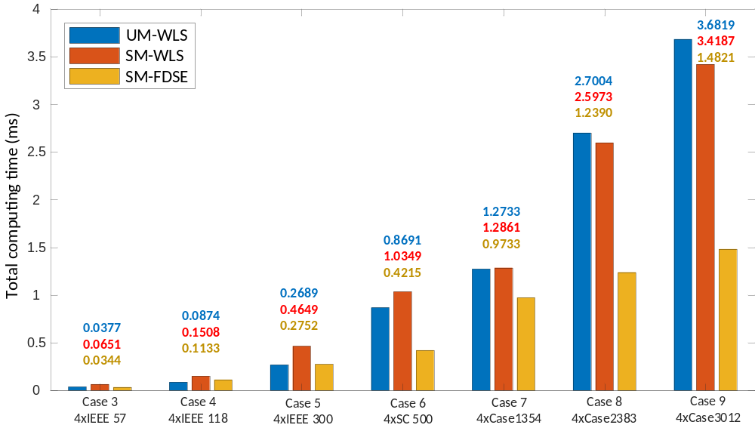
Figure 2.10. Comparison of computing time with different methods for the first test group (Cases 3 - 9).

computing speed because of the utilization of FDSE algorithm. Despite more iterations required, the constant matrices facilitate computation, and the timesaving is significant.
This section also places emphasis on the influence of the AC grids’ scales on the computing speed with different methods. In practical projects, the connected AC grids may maintain the same scales, but more DC networks are planned and installed to improve the transmission capacities among the AC grids. In this section, Cases 10 – 14 are tested to compare the computing speed with multiple DC networks in different methods. The number of iterations required by different methods are listed in Table 2.13.
As shown in Table 2.13, when more DC networks are installed in the VSC-MTDC systems, although the entire system scales are not greatly increased due to the same interconnected AC grids, both UM and SM requires more iterations before converging. The added interface measurements increase the computational complexity and reduce the convergence speed. Further comparison indicates that there is no significant increase on the iterations of the inner calculation loops with SM. The reason is that the inner calculation loops solve the decoupled AC grids separately without being affected by the decoupled measurements. The total computing time is compared in Figure 2.11.
In the second group, the overall scales of the test cases are close due to the same interconnected AC grids (SC 500), the only difference is the number of DC networks installed in the hybrid systems. It is noted that although all three estimators require more iterations with more DC networks installed the computing speed of UM is most affected. The reason is that UM estimates AC and DC grids simultaneously, and the increased interface data has slower converging speed due to lower redundancy. Therefore, the overall computing speed slows down significantly. On the contrary, the number of DC networks has
Table 2.13. Number of iterations with different methods for the second test group (Case 5 and Cases 10 – 14).
Case | Case 5 | Case 10 | Case 11 | Case 12 | Case 13 | Case 14
UM | 3 | 3 | 4 | 4 | 5 | 6
SM-WLS | O: 2  I: 5 (3/2) | O: 2  I: 5 (3/2) | O: 2  I: 5 (3/2) | O: 2  I: 6 (3/3) | O: 3  I: 7 (3/2/2) | O: 3  I: 8 (3/3/2)
SM-FDSE | O: 2  I: 15 (9/6) | O: 2  I: 15 (9/6) | O: 2  I: 16 (10/6) | O: 2  I: 16 (10/6) | O: 3  I: 22 (8/8/6) | O: 3  I: 23 (8/8/7)
Topology | 4×SC 500  1×DC grid | 4×SC 500  2×DC grids | 4×SC 500  3×DC grids | 4×SC 500  4×DC grids | 4×SC 500  5×DC grids | 4×SC 500  6×DC grids

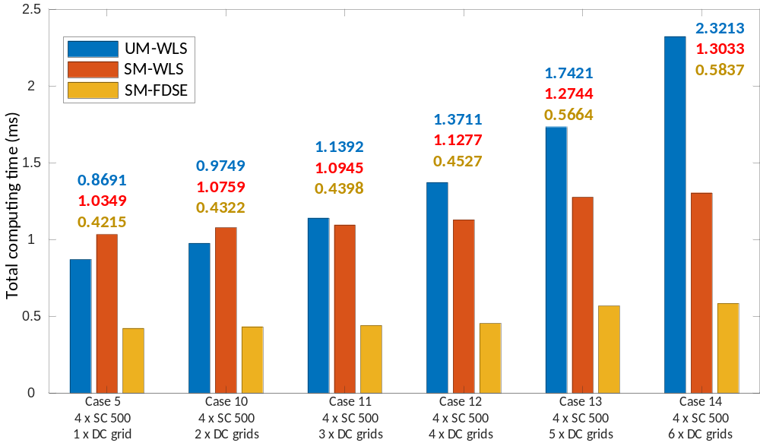
Figure 2.11. Comparison of computing time with different methods for the second test group (Case 5 and Cases 10 – 14).

less influence on SM-WLS and SM-FDSE. First, the added measurements and equations of DC networks do not modify the AC estimates that take up the major computing time. Therefore, the overall computing speed will not be significantly affected. Furthermore, the
interface data is updated twice within one inner loop from both AC and DC sides, leading to faster convergence than UM.

Summary of computing speed
In this section, two groups of cases are tested to compare the computing speed with different methods. The results are further analyzed to show the influences of system scales and multiple DC networks. The comparisons of computing speed can be summarized with the following points:
• Both the increased scales of interconnected AC grids and multiple DC networks can increase the computing time. In general, SM-FDSE has the fastest computing speed in estimating large-scale and complex VSC-MTDC systems.
• With the increasing scales of interconnected AC grids, the dimensions of computed matrices with UM have dramatical growth which slows down the computing speed. On the contrary, AC and DC grids are estimated separately in SM, and the problem size is much smaller. Furthermore, the more efficient FDSE can be leveraged in SM-FDSE to facilitate fast computation.
• Multiple DC networks can significantly complicate the SE problem due to the added interface measurements and state variables. Compared with UM which requires more iterations to converge, SM-WLS and SM-FDSE can still ensure the converging speed with the help of data updating from both AC and DC sides within the inner calculation loops.

Comparison of Robustness

Introduction and testing environments
The goal of detecting, identifying, and eliminating measurement errors is the main reason for using the estimators. An estimator can be considered statistically robust if the estimations remain insensitive to major deviations with limited redundant measurements [47]. Since WLS may yield estimations with bias when gross errors are in present, several approaches such as LAV (Least Absolute Value) and M-Estimators, have been proposed to improve the robustness [64]. However, the computation requirements of robust estimators are much heavier than WLS’s, especially when the system is large with nonlinear equations. Thus, WLS is most widely implemented in EMS for real-time monitoring. In view of the VSC-MTDC systems, even the measurements are assumed to be Gaussian distributed with zero mean, WLS based estimators can still be contaminated due to the branch parameters of DC networks, and the loss and errors of the interface data [56]. It is essential to analyze the robustness of UM and SM, and subsequently compare the generalized methods for different scenarios.
The hardware and software environments in this section are the same as listed in Table 2.3. The modified RTS-96 system (Case 2) is leveraged to compare UM and SM. There are 77 pairs of flow measurements, 50 pairs of injection measurements and 49 voltage measurements in the AC grids, resulting in the full redundancy of 3.09. In thee DC grids, there are 56 measurements in total with the full redundancy of 2.67. Therefore, if all measurements are available, the overall system has the redundancy of 3.01. To test and compare the robustness, different scenarios involving measurement loss and errors are simulated for SE analysis.
Furthermore, the normalized residual (NR) $r^{N}$ and hat matrix $K$ are introduced to detect bad data and assess the possibility of measurements behaving as the leverage point, respectively. The mathematical expressions for $r^{N}$ and $K$ are given in [47]. It is noted that throughout the simulations in this section, the topology parameters are assumed to be correct.

Comparison of robustness
As one of the primary functions, a reliable estimator should be capable of detecting bad data based on the estimations. LNR test is extensively used because of the ability to detect single or multiple bad data. However, LNR can be vulnerable to leverage points if the bad measurements are placed in these positions [65]. In such circumstance, LNR values corresponding to the leverage points will be extremely small even the measurements are contaminated. As such, bad data cannot be detected due to the non-violation of the identification threshold which is typically set as 3.0. The influence of leverage point on measurement residual can be expressed as:
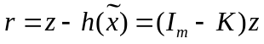
where the hat matrix is given as $K=HG^{-1}H^{T}W$, $I_{m}$ is the identity matrix with $m×m$ dimension. Denoted from , LNR may fail to represent the real mismatch of the measurement if $K_{ii}$ is close to 1. For a specific system with the number of measurements and state variables $m$ and $n$, the measurement is suspected to be a leverage point when $K_{ii}$ is larger than $\frac{2n}{m}$. Although the corresponding element in the hat matrix is not close to 1, detection of bad data can still be difficult by conventional approaches due to low measurement redundancy. In addition, leverage measurements can also be created under the following conditions: 1) injection measurement at the bus connected to many branches, 2) injection or flow measurements that are incident to branches with different impedance values, 3) specific measurements with large weights.
Therefore, leverage points are more likely to occur in VSC-MTDC systems. First, the introduction of DC measurements and variables lowers the overall redundancy. Furthermore, the equivalent impedance values between AC buses and converters are significantly different from AC branches’ values. Finally, the preset controlling values of VSCs are considered as pseudo-measurements with high weights. However, since UM and SM estimate the hybrid systems using different strategies, their robustness differs and can be assessed by checking the elements of the respective hat matrix. The largest five diagonal elements in the hat matrices of different estimators are listed in Table 2.14.
From Table 2.14, the three generalized methods, UM, SM-WLS and SM-FDSE have different largest five $K_{ii}$ values. For UM, four of the largest values come from the interface measurements between AC buses and converters. Furthermore, the corresponding $K_{ii}$ values
are much larger than the values of SM-WLS and SM-FDSE. It is because measurements, variables, and equations from both AC and DC grids are integrated in an entire problem to be solved. The redundancy is lowered, and the impedance differences between AC branches and DC branches affect the numerical structure of the matrix. For SM-WLS and SM-FDSE, the largest values mainly come from AC measurements that are incident to many connected branches. The overall $K_{ii}$ values are smaller and DC measurements are less influential by decoupling the physical connections. Hence, the interactions of interface data are eliminated. Further comparison also indicates that SM-WLS has lower $K_{ii}$ values than SM-FDSE. In general, SM-WLS and SM-FDSE has better robustness than UM based on the entries in hat matrix.
Table 2.14. Largest five diagonal elements in the hat matrices of different methods.
UM |  | SM-WLS |  | SM-FDSE
Measurements | $K_{ii}$ value | Measurements | $K_{ii}$ value | Measurements | $K_{ii}$ value
$$P_{s5} (B123-VSC5)$$ | 0.7933 | $$P_{ac,221-118}$$ | 0.6733 | $$P_{ac,221-118}$$ | 0.6968
$$P_{s6} (B215-VSC6)$$ | 0.7616 | $$P_{ac,123-113}$$ | 0.6696 | $$P_{ac,123-113}$$ | 0.6880
$$Q_{s6} (B123-VSC5)$$ | 0.7608 | $$P_{ac,123}$$ | 0.6339 | $$P_{ac,123}$$ | 0.6685
$$P_{ac,123}$$ | 0.7245 | $$P_{s5} (B123-VSC5)$$ | 0.6316 | $$Q_{ac,217}$$ | 0.6652
$$P_{s4} (B113-VSC4)$$ | 0.6933 | $$Q_{ac,217}$$ | 0.6273 | $$Q_{ac,221-215}$$ | 0.6641

Robustness in different scenarios
This subsection aims to compare the compare the estimations in different scenarios, including interface data missing, erroneous measurements and pseudo-measurements with large weights. In addition, parameter errors are not considered in this subsection.
1) Interface data missing. As denoted in Section 3, interface data, including $P_{s}$, $Q_{s}$, $P_{c}$, $Q_{c}$ and $V_{c}$, functions as the connection between AC and DC grids. Therefore, these measurements are prone to affecting the estimation accuracy. To test three methods under this circumstance, measurements $P_{s5}^{m}$, $P_{s6}^{m}$, $Q_{s6}^{m}$, and $P_{s4}^{m}$ are intentionally left out. The largest mismatches between the estimations and true values, LNR values and performance index values with three methods are listed in Table 2.15.
The results in Table 2.15 show that all three methods can accurately provide estimations when some interface measurements are missing. LNR test indicate that there is no bad data in measurements. Nevertheless, it is noted that the accuracy of UM is significantly decrease and the largest mismatches are larger than the values of SM-WLS and SM-FDSE. Thus, SM presents stronger robustness because the missing measurements are calculated from the previous inner loop and afterwards filled for next calculation loop. Consequently, better accuracy can be guaranteed.
2) Single measurement error at leverage point. To test the robustness of the three methods against single measurement error at leverage point, we consider measurement $P_{s5}$ contains gross errors of different percentages from 10% to 50%. LNR test is leveraged to identify bad data with three methods and the results are listed in Table 2.16.
Table 2.15. Comparison of three methods in case of interface data missing.
Methods | Mismatch of AC variables  ($θ$ degree/ $V_{ac}$ p.u.) | Mismatch of DC variables  ($V_{dc}$ p.u./ $M$/ $δ$ degree) | LNR | Performance index
UM | 0.0791/0.0162 | 0.0692/0.1375/0.0832 | 2.142 | 0.935
SM-WLS | 0.0127/0.0056 | 0.0125/0.0711/0.0102 | 1.773 | 0.932
SM-FDSE | 0.0132/0.0061 | 0.0149/0.0653/0.0127 | 1.812 | 0.941

Table 2.16. Comparison of three methods in case of single measurement error at leverage point.
Methods | LNR with  10% gross error | LNR with  20% gross error | LNR with  30% gross error | LNR with  40% gross error | LNR with  50% gross error
UM | 2.2161 | 2.3879 | 2.5644 | 2.8123 | 3.1837
SM-WLS | 3.2471 | 3.9729 | 4.7174 | 5.5491 | 6.3924
SM-FDSE | 2.8745 | 3.4423 | 3.9527 | 4.5714 | 5.2113

From the simulation results in Table 2.16, it is observed that the growth of LNR values is approximately linear with the increase of single gross error. SM-WLS can identify bad data with smallest gross error, and SM-FDSE takes second place with the identification of more than 20% gross error. For UM, gross error at leverage point has the greatest influence on bad data test. With the increase of gross errors from 10% to 50%, the LNR values only change from 2.2161 to 2.8123, leading to failing identification on bad data. When the gross error is further increased to 50%, bad data can be barely detected. The LNR results are consistent with the corresponding hat matrix.
3) Pseudo-measurements with large weights. As expressed in , if specific weights in $W$ are much larger than others, the corresponding values of $K_{ii}$ also dominate, leading to the possibility of creating leverage points. Consequently, bad data may not be identified even the gross error is large. For VSC-MTDC systems, pseudo-measurements with large weights are introduced according to different control strategies [42]. To test the robustness against large weights, $P_{s5}$ is intentionally made erroneous with the gross error of 50% and different levels of weights. LNR tests are carried out, and the simulation results are listed in Table 2.17. Although the gross error stays the same, the results in Table 2.17 indicate that large weights can greatly reduce LNR values and invalidate the identification of bad data. With the increase of the weights on pseudo-measurement $P_{s5}$, the corresponding LNR values
decrease for all three methods due to the change of $K_{ii}$. Compared with SM-WLS and SM-FDSE that can still identify bad data, UM is more sensitive to large weights. It is because the integrated matrix $W$ contains all smaller weights from AC measurements, and larger weights lead to more serious ill-condition.

Table 2.17. Comparison of three methods in case of pseudo-measurements with large weights.
Methods | LNR with  $$W^{*}=4×{10}^{3}$$ | LNR with  $$W=1×{10}^{4}$$ | LNR with  $$W=5×{10}^{4}$$ | LNR with  $$W=1×{10}^{5}$$ | LNR with  $$W=5×{10}^{5}$$ | LNR with  $$W=1×{10}^{6}$$
UM | 3.1837 | 2.2472 | 0.9674 | 0.3641 | 0.1243 | 0.0275
SM-WLS | 6.3924 | 5.2192 | 4.5371 | 3.6312 | 3.1795 | 3.0272
SM-FDSE | 5.2113 | 4.3716 | 3.6653 | 3.2329 | 3.0109 | 2.7329

Summary of robustness
In this section, the performances of robustness with three methods are tested and compared. Several scenarios including interface data missing, single gross error and pseudo-measurement with large weights are considered for VSC-MTDC systems. The robustness comparisons can be summarized with the following points:
• For VSC-MTDC systems, SE robustness can be lowered due to the complex interface connections, the parameter differences between AC and DC branches, and large weights on pseudo-measurements. All these factors increase the corresponding values in the hat matrix and create leverage points.
• Compared with SM-WLS and SM-FDSE, UM has the weaker robustness due to the integrated solving strategy and the interactions between AC and DC variables.

Chapter Summary
In this chapter, the conventional estimators for VSC-MTDC systems are generalized and classified into UM and SM (SM-WLS and SM-FDSE). These methods are tested and compared in three aspects that should be carefully considered for practical use, including estimation accuracy, computing speed and robustness. Various and diverse systems are leveraged for testing under in different measuring situations to provide sufficient results. Comparison results can be concluded as follows:
1) Estimation accuracy. Under normal conditions, UM has better accuracy over SM-WLS and SM-FDSE. In case of lower redundancy and larger deviations in the measurements, the accuracy of UM decreases more, and SM may provide better estimations depending on the specific measuring conditions. It is because that the estimations from previous inner calculation loop in SM help update and rebuild measurements that are used in the subsequent calculation loop.
2) Computing speed. For large scale systems, SM-FDSE has the fastest computing speed against both the increase scales of interconnected AC grids and multiple DC networks. Leveraging FDSE can save significant computing time in estimating the decoupled AC grids that take the major proportion in the hybrid systems. In addition, the dimensions of H and G matrices with SM are not influenced by the integration of DC networks, leading to further time saving.
3) Robustness. In view of the inherent complex connections, topological structure, and different branch parameters of VSC-MTDC system, leverage points in hat matrix is more likely to be created. Test results indicate SM -WLS and SM-FDSE have better robustness against interface data missing, single measurement error and large weights on pseudo-measurement. By decoupling AC and DC grids, the interactions are eliminated, and missing data can be calculated and added from inner estimations.
The comprehensive comparisons are expected to help operators and utilities to choose the better and more reasonable SE method to monitor VSC-MTDC systems based on specific features. Besides, this work can also facilitate the development of SE approaches to overcome existing problems.

Improved SM with Graph Computing Techniques and Virtual Connection Method
The SM is proved to be a promising method to develop an advanced SE approach for VSC-MTDC systems. Besides the obvious advantage of being easily implemented in the existing estimators developed for AC systems, the SM is demonstrated to have good accuracy, fast computing speed and strong robustness. However, compared with the UM, the SM exchanges some accuracy for speed. In this chapter, the generalized SM is further improved to achieve greater accuracy and faster speed. First, the computing speed is accelerated by leveraging graph computing techniques. By modeling and storing power systems in a GDB, advanced parallel computing approaches including NPC and HPC can significantly facilitate real-time steady analysis for power systems. Furthermore, a virtual connection method is proposed to enhance system integrity in SE analysis. Interface links and DC networks can be equivalently modeled as virtual AC buses and branches to strengthen the connections between AC and DC grids. Therefore, interface data can be directly estimated from both sides to achieve better accuracy and faster convergence speed.

Introduction
Modern power systems’ rapidly increasing capacity for power transmission has resulted in a pressing need to build large-scale AC/DC hybrid systems with HVDC transmission lines. The needs for high voltage level and large DC power in ultra-high voltage power systems [66] have led to the planning and implementation of more large-scale projects [67], [68]. The complexity and size of interconnected systems is also increasing. In addition to the physical challenges of such large systems, the DC links also complicate the steady-state analysis in an EMS that must be able to effectively deal with a large-scale hybrid system, providing accurate results faster than ever, to enhance the capability of system monitoring and the security of system operation [69], [70]. There are two widely used approaches for hybrid steady-state analysis, namely, the UM [71] and the SM [72], that were compared in detail in the previous chapter.
To reduce the computing time of the SM, there are two methods to be considered in the existing literature. The first method focuses on reducing the total amount of iterations. In [73], reactive power injections are modeled in terms of the AC voltage and participate in the AC analysis. Hence, the improved method converges to a solution in fewer iterations. In [74], power losses are modeled and updated along with the calculation of power exchange. Thus, the accuracy of each loop improves, and fewer iterations are needed. In [6], some extreme high-load cases leveraged virtual buses and optimal multipliers to guarantee convergence within limited calculation times. Since the initial estimate of the NR method is difficult to obtain due to the coupling of hybrid systems, the calculations have to be performed alternately many times. The second method aims at improving the computing speed of steady-state analysis. Some parallel approaches for solving a large sparse matrix, improving the NR method, and expediting data processing are proposed in [76]-[78]. Results indicate that parallel computation can help speed up calculation. Nevertheless, peripheral but time-consuming functions such as building matrices/vectors, checking convergence, and updating internal data are not addressed. Thus, there is a need to develop an efficient and holistic parallel or distributed method which can be used in all steps of calculation.
In the process of solving large-scale data-driven problems, graph computation has shown its parallel efficiency due to the protogenetic parallel database in modeling problems, and the underlying parallel algorithms based on vertex/edge [79]-[81]. Significant computing improvements with the application of graph-based methods have been demonstrated in the research fields of high-efficiency computation, social network analysis, security enhancement, etc. [82]-[84]. In recent years, graph computation has also been extended to power system problems, such as distribution network reconfiguration, parallel power flow calculation and real-time EMS development [85]-[87]. With the development of a GDB and graph models for parallel computing, more complex problems can be entirely solved using graph-based methods and achieve better overall computing performance [88]-[90]. Therefore, graph computation can be utilized to form the foundation for high-efficiency computation. In general, graph computing techniques can speedup the SM not only used in SE but also in PF, which is responsible for simulating true values for analysis. The time-consuming processes of generating matrices, LU factorization and forward-backward substitution can be accelerated by leveraging NPC and HPC. Therefore, graph computing techniques can be implemented in the SM to achieve faster computing speed without compromising accuracy.
Despite its features of being easily implemented and exploiting existing algorithms, the SM has its own shortcomings that may result in a drag on the performance, including estimation accuracy and convergence speed. The shortcomings arise from two main issues. First, the physical connecting relationships between AC and DC grids are ignored. The estimator only calculates part of the decoupled grids and the line parameters connecting AC and DC grids are excluded. In this way, the measurement matrices are simplified, and the estimations only cover the partial system. Second, the conventional SM treats the data at the PCC as constant injections or pseudo-measurements with large weights in the sequential calculation. The equivalent impedance of converter transformers and phase reactors is classified into the DC sides only. Therefore, the power loss is only calculated one time from the DC side within a single sequential loop. Motivated by these concerns, this chapter also proposes an improved algorithm based on the SM using virtual connections to enhance the topological relationships between AC and DC grids. PCCs, converters and DC grids are modeled as virtual AC buses and branches. The extended AC grids are subsequently enhanced to present the complete structure of the VSC-MTDC system. Furthermore, the measurements at PCCs and converters are considered as general AC measurements participating in AC estimations instead of being treated as constant injections. Consequently, both the estimation accuracy and the convergence speed are improved.
The rest of this chapter is summarized as follows. Section 3.2 introduces the GDB and graph computing techniques, and then explains how they can be applied to SE analysis. Section 3.3 proposes a distributed parallel power flow algorithm that can be used to simulate measurements for SE analysis. The virtual connection method is presented in Section 3.4. Section 3.5 concludes the chapter.

Improved SM with graph computing techniques

Power system modeling in a graph database (GDB)
Graph theory is an advanced area of mathematical study which models complex networks and performs complicated calculations between objects using ‘graphs’. Relevant graph-based techniques have been documented to significantly improve general computing performance [91]. Based on graph theory, a system network can be modeled as a graph, G(V, E). It consists of vertices representing all the objects in G, collected in set V={v₁, v₂, …, v_{n}}, and edges denoting all the connections and relations between objects, collected in set E={e_{ij}}. Taking advantage of the pairwise relations of buses, branches and other attached devices, the graph model of a power system is intuitively built, and the graph model vividly represents the system, as shown in Figure 3.1.
The components constituting a conventional power grid can be classified as either vertex-attached or edge-attached. For example, generators, loads, SVCs, and converters together with their parameters are vertex-attached. The topology and attributes of transmission lines, transformers, filters and breakers are edge-attached. Thus, the graph model includes information about both topology connections and related attributes. To illustrate the GDB in power system storage, the IEEE 5-bus system is used as an example.
As shown in Figure 3.2(a), the attribute of connecting buses is used to establish the relationships between branches, generators, loads, and transformers in their corresponding tables. Meanwhile, intricate bridge tables are needed to provide data join functions with redundant storage elements in an RDB. Moreover, with the increase of data size and types, internal search becomes complicated, significantly increasing time consumption. Conversely, in Figure 3.2(b), the connectivity of different components is defined directly in an abstract graph. All of the unstructured attributes are classified and stored on vertices and edges. The bus-based parameters such as component type, generator capacity, reactive power limits, and load active/reactive power can all be stored on the vertices. Similarly, the branch-based parameters such as line impedance, transformer ratio, and branch flow limits can all be stored on the edges. Since a GDB can reflect both connective relationships and
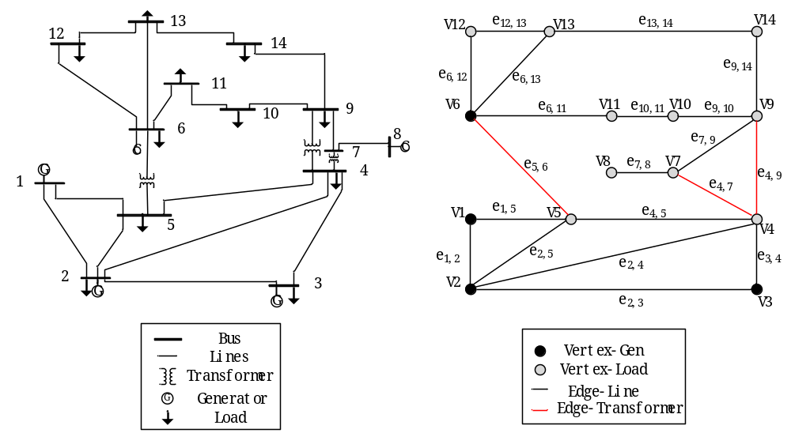
Figure 3.1. Comparison of one-line and graph models for IEEE 14-bus system.

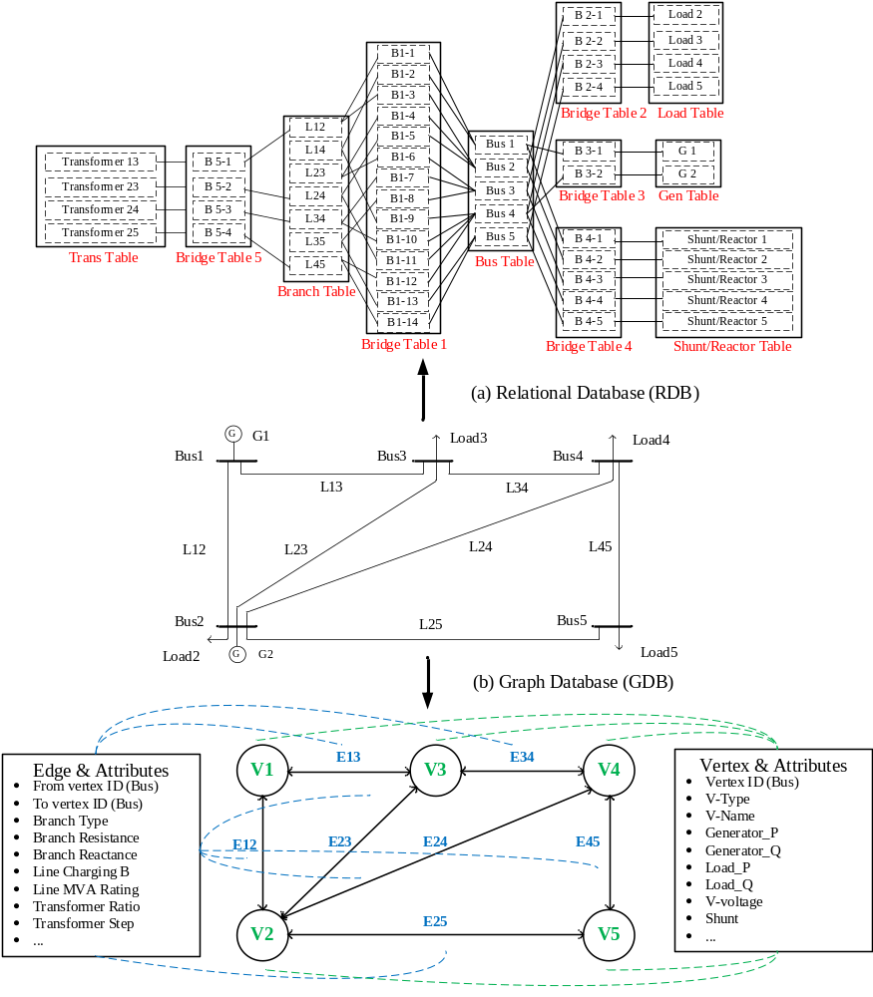
Figure 3.2. Storage of power system modeling in two databases (a) RDB (b) GDB.

attributes, operations on a GDB can be easier and faster. In [92], the query return tests on the system with over 10,000 buses indicate that the GDB model can be as much as 8 times faster than the conventional RDB model.
After modeling and storing a power system in a GDB, graph computing algorithms can be implemented and executed naturally on the underlying level with high parallel efficiency. The following subsections will introduce three graph-based algorithms and demonstrate their applications in analyzing power systems.

Node-based parallel computing (NPC)
In graph theory, computation can be executed on vertices via graph traversal, which is a seamless integration of the GDB. Since each vertex is capable of conducting local computation independently with information from itself and its neighbors, it is feasible and efficient to divide one problem into smaller sub-problems, and then conduct parallel calculations on each vertex. One of the examples is matrix formulation with NPC.
In Figure 3.3, the upper part illustrates the mapping relation of the expression of Ax=b between graph computing and matrix formulation. In a graph model, the connections (edges) between vertices are symbolized as non-zero off-diagonal elements in the A matrix. Similarly, the zero off-diagonal elements demonstrate that no direct connections between vertices exist in the graph. Regarding the NPC method, giving an example of the admittance matrix, the off-diagonal elements are locally constructed according to the impedance of the corresponding edges. Meanwhile, each diagonal element is independently and locally calculated with the processing of impedance attributes at the corresponding vertex and its connected edges. Therefore, the whole admittance matrix is developed with only one-step
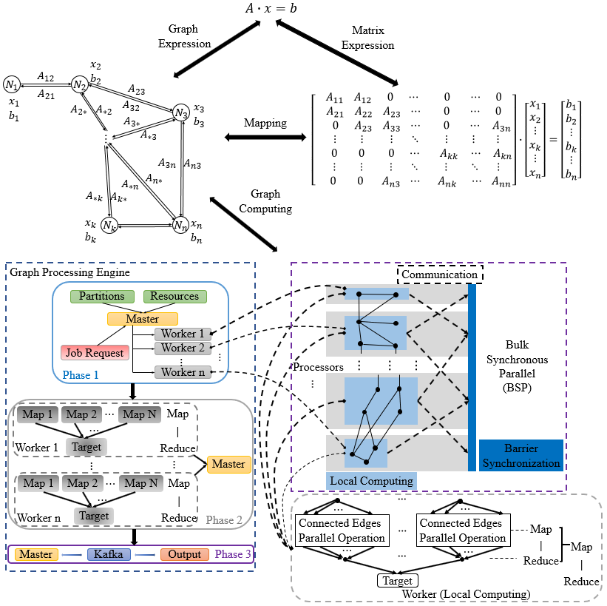
Figure 3.3. Application of NPC in processing admittance matrix.

graph computing and the values of all elements are calculated in parallel, which fits the GDB structure. The lower part gives the elaboration of the implementation of NPC. The workflow of the graph computing is constructed based on a bridging model of bulk synchronous parallel (BSP) [93]. The graph is initially stored in segments, and each segment contains a set of vertices, together with the corresponding outgoing edges. The master thread subsequently assigns segments to the worker thread with respect to the CPU’s resources. For each worker, local computation is conducted in parallel. After workers communicate and synchronize, the results are transferred back to the master for final integration.
One of the most efficient way to utilize NPC is for generating an admittance matrix. The pseudo code is shown in Algorithm 1.
Algorithm 1: Form admittance matrix
Step 1: Generate Graph $G(V,E)$
Step 2: Accum Select Vertex $i$ from $V$
Step 3: Select Vertex $j$ from V where $j∈E_{i}$
Step 4: $a_{ii}+=a_{ij}$

Hierarchical parallel computing (HPC)
Compared with NPC, which executes parallel calculations at each vertex, the HPC method assigns vertices to different levels based on the ordering of their connections. It performs parallel computation for vertices at the same level and solves the problem level by level in a hybrid sequential-parallel manner. One of the main applications is LU factorization [90]. As shown in Figure 3.4, three steps are involved to implement Cholesky factorization with HPC: 1) determining fill-ins, 2) forming an elimination tree, and 3) partitioning the elimination tree via HPC. In Figure 3.4(a), G(A_{t}) is the graph of matrix A_{t}, representing the
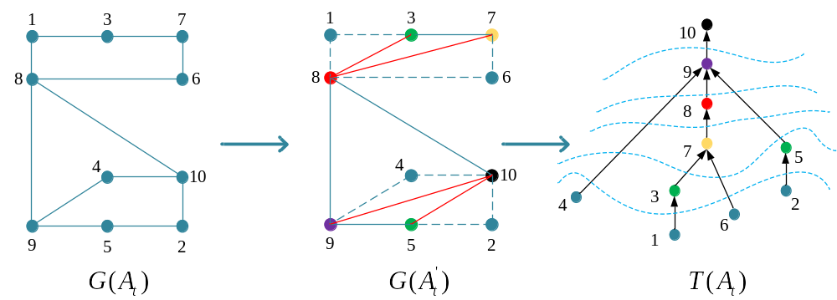
Figure 3.4. Graph LU factorization (a) graph of matrix At, (b) fill-ins determination, (c) elimination tree and its partitions

matrix A at time t. Structural analysis in Figure 3.4(b) exploits the vertex and edge distribution of G(A_{t}), which is a non-zero pattern of A_{t}, to find a reordering of the vertices in the corresponding graph, such that the number of fill-ins can be reduced during matrix factorization. Meanwhile, in Figure 3.4(c), a spanning tree T(A_{t}), also known as an elimination tree, is created for LU factorization and partitioned for parallelism. The vertices with the same color are grouped in the same level and can be computed simultaneously due to their independence from each other. In the graph model, the information on L_{t} and U_{t} is stored as an LU graph in T(A_{t})$T(A_{t} )$$T(A_{t})$ for problem solving.
Furthermore, HPC can be combined with NPC in performing forward-backward substitutions in calculating $Ax=b$. The generalized factorization and solving processes can be formed as:
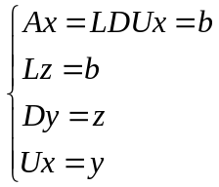
where $L$ and $U$ refer to a lower triangular matrix and an upper triangular matrix, respectively; $D$ is a diagonal matrix. It is noted that vertices within the same partition level can be done simultaneously when updating $z$ and $x$ in . The pseudo code is shown in Algorithm 2.

Improved SM with graph computing techniques
As studied in Chapter 2, multiple calculation loops might be needed in the SM for SE analysis before achieving global convergence. Since AC grids account for the main composition of VSC-MTDC systems, the majority of computing time is spent on estimating AC grids. Therefore, the computing speed can be acerated if FDSE can be improved by utilizing NPC and HPC. For the inner calculation loop, the method proposed in [86] is used
Algorithm 2: Solving $Ax=b$
Step 1: Symbolic factorization with fill-ins.
Step 2: Elimination tree (same level vertices).
Step 3: Node partition (same level independent, different levels dependent).
Step 4: Factorization $A=LDU.$
Step 5: Forward and backward substitution (FBS).
to speedup FDSE in AC grids. Furthermore, given that the process of comparing and updating interface data within the outer loops is executed on each PCC, NPC can be leveraged to realize parallel computation. Therefore, both the inner and outer loops can be accelerated with graph computing techniques.
In the next subsection, the improvements are demonstrated in detail by implementing graph computing techniques in another steady-state analysis, a.k.a., power flow analysis that can be used to simulate true operating values.

Graph computing-based distributed power flow for hybrid systems

Distributed computation with graph partition
Previous studies have presented the concept and advantages of graph computing, but graph computing solves the system as an entity and performs the calculation and analysis together. Thus, all the vertices have to do the same computation locally in the beginning, then communicate and wait for synchronization at the end.
To expedite the calculation, the connecting topology of the hybrid system is taken into consideration to partition the original power network for distributed computing. Since most DC links are built to connect several isolated AC grids crossing long distances, it is highly feasible to partition the network by disconnecting DC connections.
As shown in Figure 3.5, there are two steps to performing the graph partition for the AC/DC system. To begin with, the DC line is disconnected from the original network, and the coupled vertices $\{V_{4},V_{6}\}$$\{V_{4},V_{6}\}$,$v_{6}\}$ are recorded as the initial searching points. Subsequently, simultaneous path searches start to check if the corresponding coupled points are still connected. For example, there are no paths between vertices v₄ and v₆ in Figure 3.5(a), which means that the two AC grids are only connected via DC lines. In contrast, Figure 3.5(b) denotes that the network cannot be split.

Implementation of graph computing techniques in SM for PF
In this subsection, the proposed method with graph computing techniques is used to solve hybrid systems with LCC-based DC links [94]. Multiple cycles of PF calculation, equation formulation, PCC values updates, etc. make the conventional SM time-consuming. To speed up the overall calculation without altering the main algorithms or compromising accuracy, graph computing-based methods including graph partitioning, NPC, and HPC are employed, as shown in the Figure 3.6 flowchart. Where $A_{n}$$A_{n}$ is the n^{th} partitioned area, $α and γ$ are firing and extinction angles, and $∅_{R}/∅_{I}$$∅_{R}/∅_{I}$ are power factors in rectifier and inverter stations.
To further illustrate how graph partitioning is employed, a general model is given in Figure 3.7. First, graph partitioning is performed after the power system network is modeled and stored in the GDB. If we consider the topologies of existing projects, a large-scale hybrid system can be partitioned into two types of sub areas depending on the connection pattern, as described below.
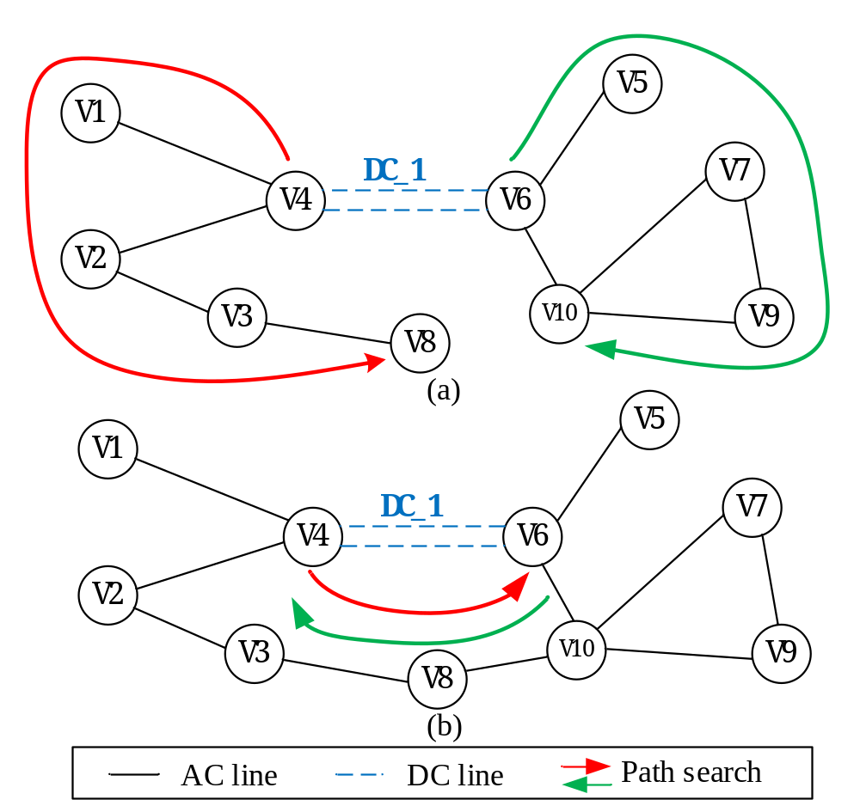
Figure 3.5. Example of system partition by disconnecting DC lines. (a) No AC connections between areas (b) AC connections still exist.

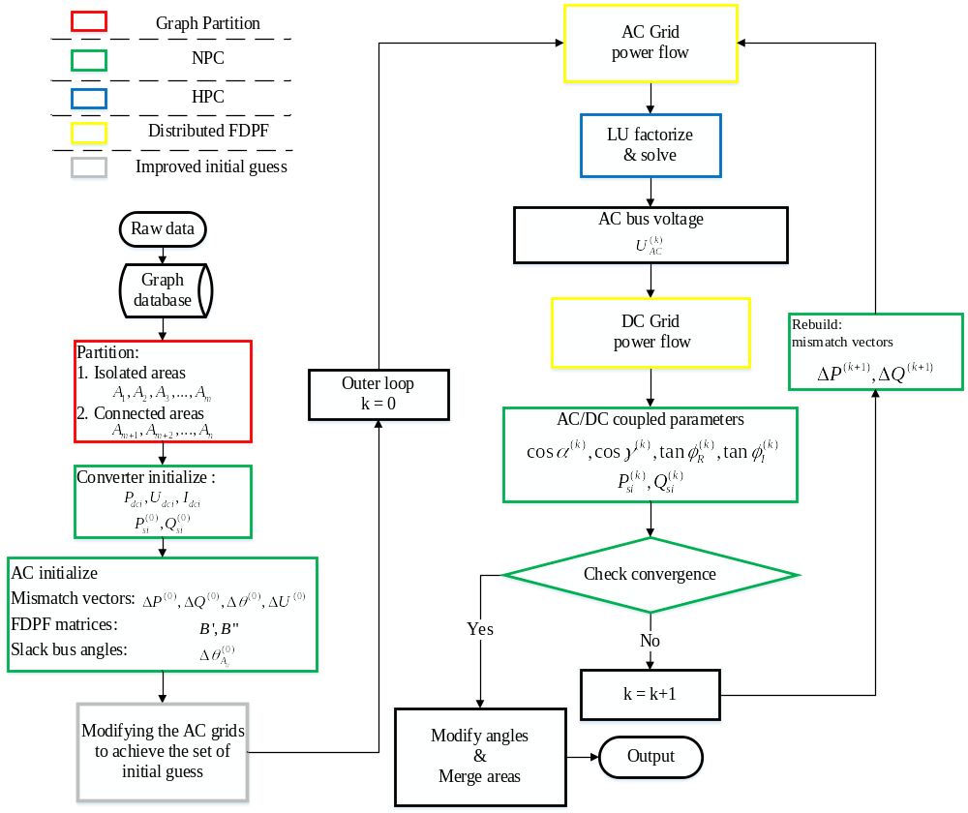
Figure 3.6. Flow chart of graph computing-based distributed parallel AC/DC power flow.

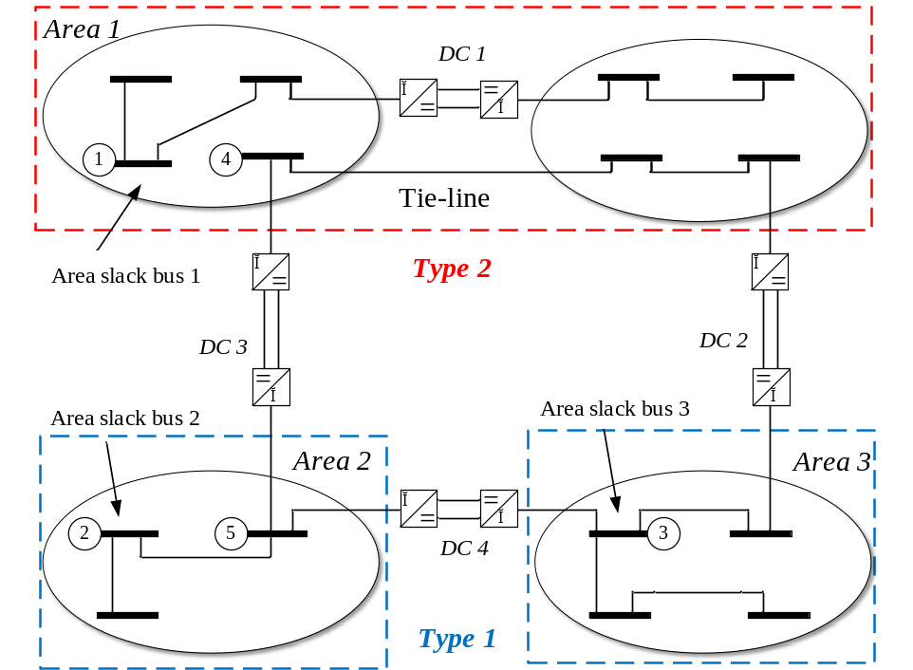
Figure 3.7. Partition for generating the distributed areas.

1. Type one—Isolated areas with pure AC components. After disconnecting DC lines, the subarea is only composed of AC components, and isolated from other areas, such as Area 2 and Area 3.
2. Type two—Connected AC areas with tie-line. The disconnection of DC lines does not divide the connected areas. In practical projects, long-distance HVAC and HVDC lines may coexist to enhance power transmission capacity. Thus, type two areas can be joined, generating a new larger area, as in Area 1 in Figure 3.7.
In the DC 3 branch example, A₁ and A₂, are interconnected and also connected to bus 4 and 5. During the process of partitioning, DC 3 is disconnected and the power on the DC converters is replaced by extra power injections at buses 4 and 5. The rest of the DC links are equivalently replaced as extra load injections. After the system is partitioned and equivalent power is injected, new area slack buses are selected for the isolated areas (buses 1, 2 and 3 in Figure 3.7). In this way, all of the areas can be calculated simultaneously with a much lower computational burden compared to the size of the original problem. The following will further explain how NPC and HPC are implemented to improve the calculation.
1) NPC-formulating PF equation (matrices and vectors), checking convergence and updating values. In the admittance matrix, the diagonal elements represent buses in the network and non-zero off-diagonal elements depict existing connections between buses. In addition, each row vector is related to a corresponding bus in the system. In each row vector, non-zero off-diagonal elements are linked edges from the corresponding node and the diagonal element represents the node itself. Consequently, all the elements of the matrices can be generated locally and independently, indicating the feasible application of NPC. The right-hand side vectors in (1) are updated similarly. Thus, all PF equations can be formulated using NPC. With the exception of equation formulation, convergence checks and status updates can also be conducted locally.
2) HPC-solving equations. The SM requires multiple processes of FDPF; thus, an efficient solver is able to quickly find the solution. In each cycle, HPC-based FDPF is performed on distributed areas at the same time. Vertices at the same level are analyzed and calculated in parallel.

Performance testing
The experiments are performed on a Linux server, with a programmable GDB platform, TigerGraph insalled. The server has a Xeon E7-8867 (V3 2.50 GHz) CPU and 64 GB memory with 16 cores which will serve as the platform for implementing the distributed AC/DC PF algorithm. The operating system is CentOS 6.8 and the GDB version is 2.2. To guarantee precision, the iterative tolerance of both the inner and outer loops is set as ${10}^{-5}$${10}^{-5}$.
To verify the accuracy and demonstrate the computing performance of the proposed method, the standard IEEE 300-bus system, two extended South Carolina 500-bus systems [95], and a practical AC/DC system in China are tested. The two extended South Carolina systems have 6,000 and 12,000 buses respectively, and the China system has 11,119 buses. To illustrate the structure of the extended South Carolina systems, we exemplify the 6,000-bus case in detail. The 6,000-bus case is composed of 12 of the same South Carolina systems, formatting a loop network with 12 identical DC line connections with each area only connecting to two neighboring grids. The structures of these three large-scale testing systems are listed in Table 3.1. The DC parameters are given in Table 3.2.
Table 3.1. Constructions of the large-scale test systems.
Cases | Topology
6,000-Bus | 12 South Carolina grids/12 DC lines
12,000-Bus | 24 South Carolina grids/24 DC lines
11,119-Bus | Hybrid grid in China/9 DC lines

Table 3.2. Parameters of DC Line in IEEE 300-bus system.
Type | Value
No. of bridges | 4
DC power (MW) | 100
DC voltage (kV) | 460
Resistance (Ω) | 6.8
Reactance (Ω) | 6.2
T-ratio | 0.7478
Firing angles (degree) | [15,20]/[18,20]

Compared with the extended ideal systems, which can be fully partitioned, the 11,119-bus case is complicated by two factors. First, some areas are still connected even after disconnecting the DC lines. Second, the operating parameters of the DC lines are diverse from each other as presented in [94].
To demonstrate the speedup in computing performance, four algorithms, including the graph computing (GC) based method, the conventional SM (CONV), the default UM and the modified SM in PSS/E (UPSS and SPSS), are compared. All the tests are performed on the same computing environment.
Table 3.3 compares the computing speed of the four methods for large-scale systems. Both the 6,000-bus case and the 12,000-bus case require two outer calculation loops for the SM, and the 11,119-bus case needs three outer loops. It can be seen that for large-scale systems, the graph-based method provides better performance when compared with the conventional method. For the extended ideal systems, since the size of each partitioned area is the same, the speedup is around 4.5. For the practical system in China, even though its connections are more complex, the speedup is still over 3. Compared with the UPSS, the improvement is significant. Apart from the overall speedup, the computing time of doing graph partitions, formulating PF equations (including building matrices, vectors and updating interface data), and performing inner FDPF is also compared to indicate the detailed improvements in Figure 3.8. As discussed previously, the major improvements are in the areas of graph partition, NPC, and HPC. Specifically, throughout the entire calculation, graph partitioning is only performed once at the beginning. A 10,000-bus system can be completely calculated within 50ms. Thus, the level of improvement justifies the extra cost.

Table 3.3. Comparisons of computing time with different methods.
Case | GC  (in ms) | CONV  (in ms) | UPSS  (in ms) | SPSS  (in ms)
6,000-Bus | 76.135 | 308.2 | 247.6 | 295.2
12,000-Bus | 126.18 | 563.4 | 453.2 | 587.3
11,119-Bus | 239.1 | 743.1 | 621.5 | 765.8

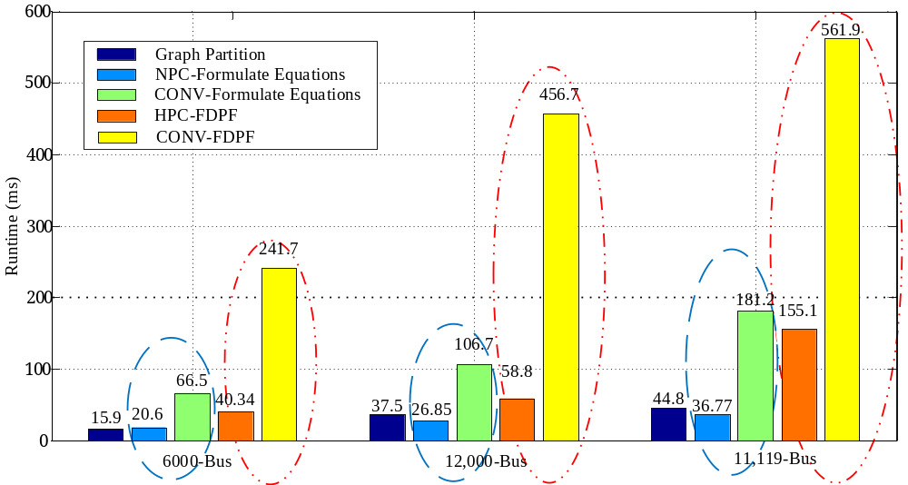
Figure 3.8. Comparison of detailed time of the main calculating procedures.

Further, the computing time for formulating equations and doing FDPF is compared in Table 3.4. The main features of graph computation can be analyzed as follows. First, the time spent on graph partitioning highly depends on the topological complexity of the hybrid systems. The parallel partition searches only 500 buses in each area for both the 6,000-bus case and the 12,000-bus case. Despite fewer DC lines, the longest search path in the 11,119-bus case has to cover 3,800 buses, increasing the time spent. Second, the speedup of NPC is affected by system scale. Since each vertex in the graph model can be seen as an independent logic and computing unit, time saved is more significant on a larger system. Consequently, the speedup for grids with over 10,000 buses can be as much as 4.9, compared with a speedup of 3.23 for a 6,000-bus system. Third, the performance of HPC is mainly affected by the number and size of partitioned areas. Since the two extended systems are ideally made up of same-size areas, the computing time for each area is close. However, because the sizes of partitioned areas in the 11,119-bus case vary widely, the overall computing time is determined by the largest area. Therefore, the speedup is a little smaller compared to the 6,000-bus and 12,000-bus cases.
In summary, after the system is modeled and stored in a GDB, the vertex and edge based parallel computation can be performed naturally and directly. With graph partitioning, the original large-scale system can be split into multiple independent AC grids, which are fit for distributed processing. Furthermore, the graph computing techniques based on NPC and HPC that efficiently utilize underlying multi-core computing architecture, are implemented in the SM to speed up the main time-consuming processes of formulating equations and solving FDPF. Simulation results on large-scale systems with over 10,000 buses show significant speedup of the proposed method without compromising accuracy.
Table 3.4. Comparison of time spent on two major procedures.
Cases | Formulate Equations  (in ms) |  | PF (in ms)
Cases | GC | CONV | GC | CONV
6,000-Bus | 10.3*2 | 33.2*2 | 20.1*2 | 120.9*2
12,000-Bus | 13.8*2 | 53.4*2 | 29.4*2 | 228.4*2
11,119-Bus | 12.3*3 | 60.4*3 | 51.7*3 | 187.3*3

Improved sequential SE algorithm using virtual connections

Procedure of generating virtual connections
In general, there are two shortcomings leading to worse computing performance, estimation accuracy, and convergence speed. First, the decoupled topologies reduce the connecting relationships between AC and DC grids. The interface data, including $P_{si}/Q_{si}$ at PCCs and $P_{ci}/Q_{ci}$ at converters, is only involved in SE of DC grids. However, measuring equations are not carefully considered in SE of AC grids. Namely, the interface data is only updated once from DC side within a single inner calculation loop. Therefore, more loops are required before achieving global convergence. Second, the calculation of converter power loss $P_{loss,i}$ in cannot be accurately solved together with the estimations. In fact, the power loss is expressed in terms of $I_{si}$ which is updated after each inner estimation. Since $I_{si}$ is classified into the DC grid in the conventional SM, its accuracy only relies on the DC measurements that are lower redundant.
To overcome the shortcomings without making great changes to the conventional SM, DC grids including interface components and DC lines, can be equally represented as virtual connections, and integrated into AC grids. Afterwards, the complete system structure can be considered, and interface data is calculated and updated from both AC and DC sides. Detailed steps are introduced as follows:
1) Redraw the decoupled boundaries between AC and DC grids. Unlike the conventional SM that selects PCCs as the boundaries between AC and DC grids, the new decoupled boundaries are at the AC sides of converters (ASC), as shown in Figure 3.9. Hence, the interface connections and the corresponding variables are included in the AC grids.
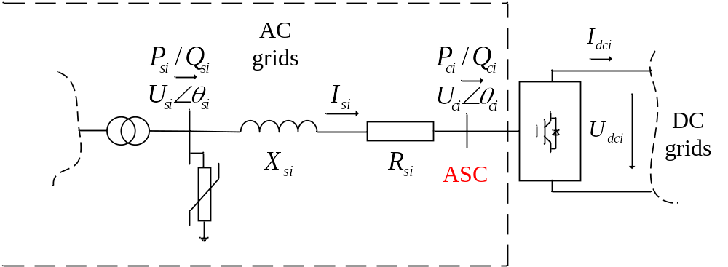
Figure 3.9. Redrawn decoupled boundaries between AC and DC grids.

2) Add virtual buses to represent ASC. As shown in Figure 3.10, ASCs can be seen as virtual AC buses for SE analysis with the measurements of $P_{si}^{m}, Q_{si}^{m}$ and $|U_{ci}^{m}|$. Afterwards, the original AC grids are extended to include the interface branches with the impedance of $R_{si}+jX_{si}$, and the virtual AC buses representing ASC.
3) Virtual connections for DC lines. To strengthen the connections of AC grids, DC branches can also be equivalent to virtual AC branches. Based on the volage conversion equation given in , the new parameters of virtual AC branches representing the DC lines can be given as:
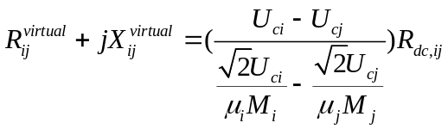
Note that $U_{c}$, $μ_{i}$ and $M_{i}$ are calculated from the estimations from inner calculation loops. Therefore, the virtual connections are dynamically updated and corrected together with the sequential estimation. Consequently, the accuracy of the equalization is improved during the process of SM calculation. By redrawing boundaries and adding virtual connections, the new topology for AC SE is shown in Figure 3.10. Consequently, the interface data is involved in both of the estimating processes. By extending the AC grids, the entire topology and system parameters can be approximately modeled in AC SE. Thus, the integrity is enhanced to achieve faster converging speed and estimation accuracy. The overall flow chart of the proposed improved sequential state estimation (ISSE) is shown in Figure 3.11.

Case study and simulation results
In this section, the proposed improved sequential SE algorithm is tested on two modified VSC-MTDC systems to verify its feasibility and efficiency in different situations. Detailed
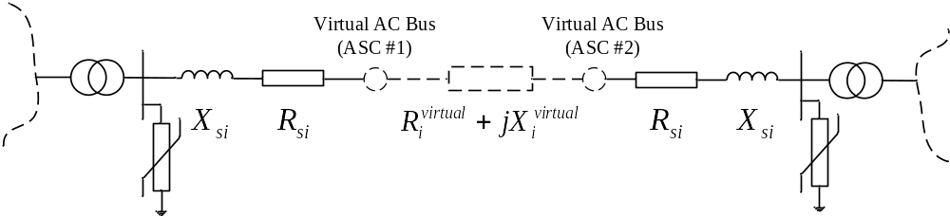
Figure 3.10. Extended AC grid for SE analysis with virtual connections.

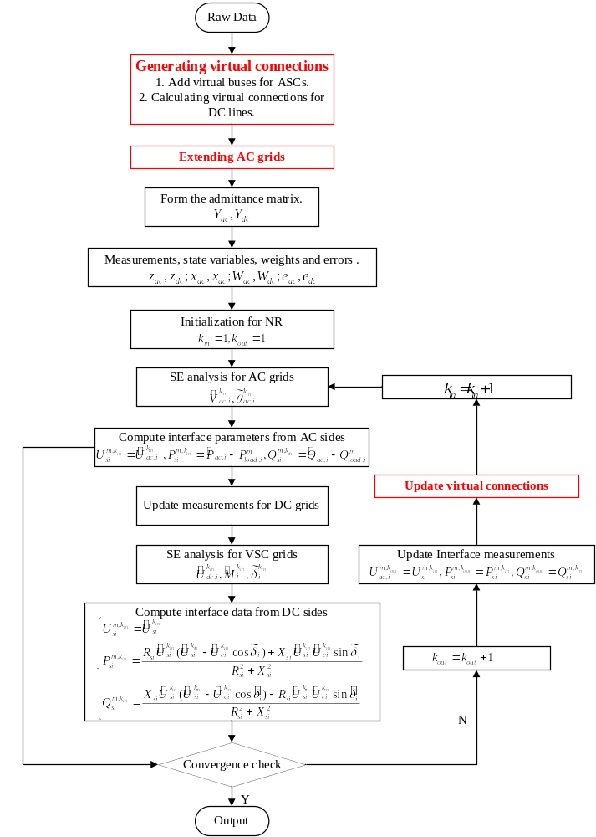
Figure 3.11. Flow chart of the improved sequential SE algorithm for VSC-MTDC systems.

structures, parameters and settings of the modified IEEE 5-Bus system (Case 1) and the modified RTS-96 Bus system (Case 2) can be found in [52] and [59]. To guarantee the reliability of the simulation results, all tests are executed 50 times to reduce accidental errors. The measurements are generated by adding random errors that follow Gaussian distribution, $N\sim (0,σ)$ on power flow results.
First, estimation accuracy is evaluated in two ways. Each estimation is initially compared with the corresponding true value (TV) to check the individual mismatch. And the overall accuracy is evaluated by using a performance index. Obviously, a smaller index value of $ξ$ denotes that estimations are close to TVs with better accuracy. In the first scenario, both cases are tested with full redundancy, meaning all measurements are applicable. The comparisons are given in Table 3.5 and Table 3.6. The units of voltage magnitude and angles are in p.u. and degrees, respectively. In addition, the standard deviations for AC and DC measurements are $σ_{ac}=0.0215, σ_{dc}=0.015$. Convergence tolerance is set as $1×{10}^{-8}$. Results with better accuracy are highlighted.
Note that when all measurements are applicable, test cases have the largest redundancy to filter out errors. Compared with the conventional SM, the proposed method has greater accuracy with smaller largest mismatches and index values, but the estimations are very close. We repeat the experiments with lower redundancy in AC measurements, and the changes of performance index values are shown in Figure 3.12. Obviously, the accuracy of both methods is reduced when redundancy is lowered, but the proposed method has greater robustness against the reduction, and the increase of the index value is smaller than the SM’s.
In addition to estimation accuracy, convergence speed is another important criterion that should be considered in SE analysis. Since the SM utilizes double loops to estimate, the
Table 3.5. Comparisons of largest mismatches for both cases.
Case | Largest  mismatch | AC estimations |  | DC estimations
Case | Largest  mismatch | $${|U}_{ac}|$$ | $$θ_{ac}$$ | $$|U_{dc}|$$ | $$M$$ | $$δ$$
Case 1 | ISSE | 0.0027 | 0.0015 | 0.0008 | 0.00019 | 0.0035
Case 1 | SM | 0.0035 | 0.0018 | 0.0017 | 0.0022 | 0.0036
Case 2 | ISSE | 0.0054 | 0.0021 | 0.0029 | 0.0103 | 0.0093
Case 2 | SM | 0.0063 | 0.0023 | 0.0031 | 0.0112 | 0.0093

Table 3.6. Comparisons of index values for both cases.
Case | $$ξ$$ | AC side | DC side | Whole system
Case 1 | ISSE | 0.4211 | 0.7331 | 0.5692
Case 1 | SM | 0.4251 | 0.7492 | 0.5862
Case 2 | ISSE | 0.7471 | 0.8587 | 0.7982
Case 2 | SM | 0.8255 | 0.8766 | 0.8342

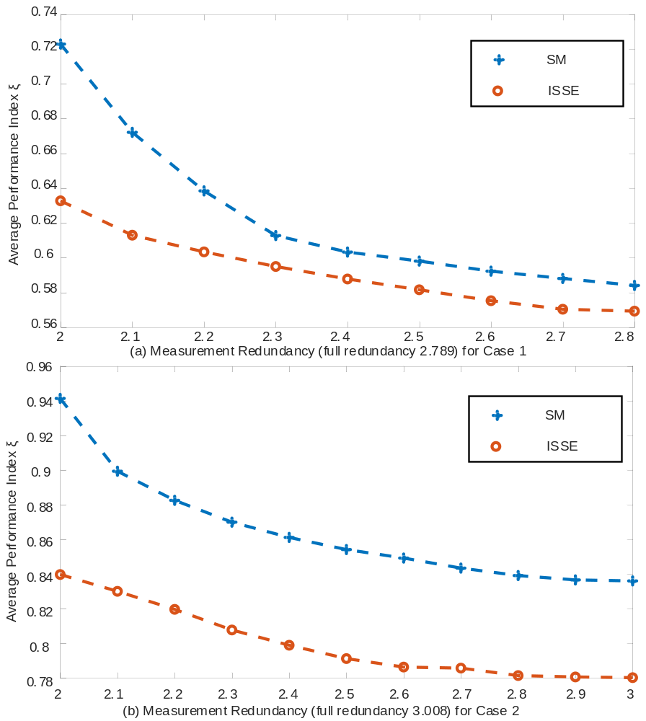
Figure 3.12. Comparisons of $ξ$ with reduced redundancy.

calculation can be time consuming if the convergence speed is slow. The comparisons of the number of iterations to achieve global convergence are listed in Table 3.7.
Table 3.7 lists the number of iterations for both inner and outer calculation loops. For example, to estimate Case 1, the improved sequential SE executes two outer loops containing 3 iterations in the first inner loop and 2 iterations in the second inner loop. It is noted that the proposed algorithm has faster convergence speed with fewer iterations to achieve global convergence because the interface data, together with power loss, is calculated and updated twice from both the AC and DC sides within one inner iteration. To better illustrate, the convergence of total power loss is compared in Table 3.8. Based on the PF calculation, the TVs of total power loss for both cases are 3.745 MW and 16.252 MW, respectively. By leveraging virtual connections, power loss can be calculated together with AC estimations and subsequently updated in DC estimations. Compared with the conventional method in which the power loss is calculated independently from inner loops, the improved algorithm is more efficient at providing more accurate power loss. Table 3.8 shows that although both methods can coverage after several outer calculations, the calculated power loss with the improved algorithm is closer to the true value with fewer iterations, leading to faster convergence speed.
In summary, to overcome the shortcomings of the conventional SM, the boundaries between AC and DC grids are redrawn in the first step. The interface connections and the ASCs can be modeled as virtual AC components, and subsequently integrated into AC grids. Furthermore, the DC lines can be dynamically equalized to virtual AC branches and updated together with inner estimations. Afterwards, the topology integrity of the SE model is enhanced. Interface data including power loss can be calculated and updated together with
Table 3.7. Comparisons of iterations for both cases.
Case | ISSE |  | SM
Case | Outer iterations | Inner iterations | Outer iterations | Inner iterations
Case 1 | 2 | 3/2 | 3 | 3/3/2
Case 2 | 3 | 4/3/3 | 5 | 5/4/3/2/2

Table 3.8. Comparisons of total power loss (mw) for both cases.
Case | Iteration | 1 | 2 | 3 | 4 | 5
Case 1 | ISSE | 3.983 | 3.735 | --- | --- | ---
Case 1 | SM | 4.021 | 3.842 | 3.734 | --- | ---
Case 2 | ISSE | 16.195 | 16.237 | 16.252 | --- | ---
Case 2 | SM | 16.039 | 16.157 | 13.211 | 16.243 | 16.252

estimating processes. Thereby, greater accuracy and faster convergence speed is achieved. The algorithm has been properly tested. Numerical simulations verify the feasibility and efficiency of the proposed algorithm.

Chapter Summary
In this chapter, the conventional SM is further improved to achieve better computing performance via two main methods. First, graph computing techniques are applied for faster computing speed. The hybrid systems are modeled as a graph with vertex and edge, and then stored in the GDB. Afterwards, advanced parallel computing methods of NPC and HPC are implemented in the SM. The calculation processes of generating admittance matrices, LU factorization and forward-backward substitution can be significantly accelerated. Furthermore, the shortcomings of low accuracy and slow convergence speed in the conventional SM are overcome by extending AC grids. The interface links and DC networks are equivalently modeled as virtual connections integrated into the AC grids. The structural integrity can be enhanced, and the interface data can be directly estimated from both sides. Consequently, both greater accuracy and faster convergence speed are achieved with the proposed method.
Utilization of graph computing techniques and the virtual connections method can significantly improve the computing performance including computing speed, estimation accuracy and convergence speed in the SM without making great changes in the calculation flow chart. Therefore, the two proposed methods are very useful and flexible.

SE for VSC-MTDC Systems with Droop Control Using Bound-Constrained Nonlinear Least Squares and Levenberg-Marquardt Method
Control strategies of VSCs describe the predetermined principles that can be used to precisely identify the operating states. Early literature only considers the simplest control strategy, namely constant control in the SE formulations and algorithms. However, the innovative, efficient, and flexible droop control strategies have not been integrated into SE analysis so far. Compared with the constant control strategies, droop control reflects the dynamic regulation feature of VSCs. In addition, a practical droop control strategy may be composed of several different operating stages to provide more flexibility. These dynamic features should be carefully considered in the quasi-steady SE analysis. In this chapter, an improved SE approach is proposed to include the droop control of VSCs in SE analysis. The operating behaviors of droop control are analyzed and formulated in the SE model. The new SE problem can be solved by using the BCNLS method which can accurately estimate the operating stage of VSCs. Afterwards, the LM method is leveraged to avoid divergence in solving SE equations. The verification study indicates that the proposed algorithm can accurately represent the operating functions of VSC droop control by introducing inequality constraints on the DC voltage.

Introduction
Modern power systems increasingly require bulk power transfer capability and long-distance transfer ability, and thus flexible controllable VSC devices and HVDC have aroused great interest. Existing engineering projects on VSC based hybrid systems have demonstrated the previously mentioned advantages. The advanced features of VSCs also make it easy to construct multi-terminal systems, which can integrate multiple asynchronous AC grids. Therefore, VSC-MTDC technology is regarded as a promising solution in building super grids to connect a variety of renewable energy sources from different areas.
In a meshed VSC-MTDC system, power balance and stability is indicated by the DC voltage on each DC bus. DC voltage is the essential factor that indicates the power balance and the stability of a VSC-MTDC system. Compared with a conventional AC grid with high inertia, the transient response in a DC grid is extremely fast [96]. Furthermore, the DC voltage control should be able to handle the fast-electromagnetic dynamics in the DC grid [97], [98]. Therefore, it is unrealistic to rely on telecommunications for MTDC control. Local control per terminal, at most modified by a slow central coordinating control, seems to be the favored control option. Such DC voltage control techniques can be categorized into centralized DC slack bus control, voltage margin control and distributed voltage droop control.
In the centralized DC slack bus control, only one VSC station is selected as the DC voltage control station to compensate for the power imbalance of the entire DC grid. Other stations are responsible for regulating the injected power, PCC voltage or AC frequency. However, if the slack station is over-rated or blocked, the stability of the entire DC grid will be lost. Therefore, slack bus control is more suitable for the two-terminal DC system which has a simple structure and is more likely to operate under lower voltage and capacity. Voltage margin control can be considered to be an improved DC slack bus control with multiple stages of alternative slack buses [99]. The role of voltage regulation can be taken over by another station once the old slack bus is offline or reaches its limit. However, several disadvantages remain for voltage margin control especially in a large MTDC system [100]. For example, the switch speed of stages in different stations is dependent on the reliability of telecommunications. In large-scale VSC-MTDC systems, the communication delay can increase drastically. On such occasions, the entire system may lose stability if the old slack station has exited but the new slack station has not been put into use on time.
Droop control can significantly enhance the reliability of the DC grid since all VSCs in different stations contribute to regulate DC voltage and power simultaneously without communications. Various types of voltage droop strategies, including voltage-power (V-P) droop [101], [102], voltage-current (V-I) droop [103] and two-stage voltage droop with different dead-bands and limits [104], have been proposed for VSC-MTDC systems. However, prior art has focused on the dynamic behaviors of voltage droop, while the steady-state aspect of various droop lines has not been addressed in detail. Droop control is likely to be employed in the interests of dynamics and stability, whereas the use of such quasi-steady-state droop characteristics could significantly increase the complexity of SE analysis. Under such situations, the operating point and power sharing of the system vary with the power disturbances and the impact of the quasi-steady-state droop lines on the SE analysis needs to be well understood. Furthermore, the relationships between DC voltage and DC power are restricted and described by the piecewise operating functions of different stages in droop control. The added parameters, operating equations and piecewise stages should be modeled in SE analysis to improve the accuracy.
This chapter is organized as follows: Section 4.2 presents the quasi-steady-state models of various droop control strategies. Section 4.3 formulates the modified measuring equations for SE analysis with droop control. Section 4.4 proposes the improved methods of BCNLS and LM to estimate VSC-MTDC systems with droop control. The accuracy and efficiency of the proposed estimator are verified in Section 4.5. Section 4.6 concludes this chapter.

Quasi-steady-state models of droop control
In this subsection, quasi-steady-state droop control models are formulated with detailed operating features. In addition to the basic preset operating points in constant control, droop control brings clear and precise operating relationships between DC voltage and DC power. Furthermore, the quasi-steady-state models also include advanced droop control techniques such as two-stage strategies and dead-band.

Constant control strategies
As fully-controllable electronic equipment, VSCs can independently control active and reactive power injection with respect to the AC system due to the decoupled current control [105]. As mentioned in Chapter 2, the active power control can be modeled in two different ways, namely constant $P_{s}$ and constant $U_{dc}$. Normally, in am MTDC grid composed of n VSC stations, only one converter is selected to be controlled with constant DC voltage and is responsible for compensating the power imbalance of the entire DC network. This selected converter also operates as a DC slack bus to adjust the power to account for DC grid power losses and keep up the voltage stability of the DC grids. The constant active power control modes are depicted in Figure 4.1.
For a large-scale VSC-MTDC system containing x different MTDC grids with a number of y VSCs in total, there will be (y-x) converters that are controlled with their output power and y converters that remain as slack buses. Therefore, as discussed in Chapter 2, the preset operating points can be seen as pseudo-measurements with high weights in SE analysis.
With the DC system voltage being the most crucial control variable, more focus has been dedicated towards the distributed control of the DC voltage with the help of multiple converters instead of the centralized control on a single converter. As depicted in Figure 4.2(a), the output power of a single converter is not finite. In practice, whether operating as a rectifier or as an inverter, the slack converter can only compensate for limited power imbalance due to its own capacity. When the power limits are violated, the old slack converter will switch to being controlled with constant $P_{s}$ and another converter will be selected to take the responsibility as the new slack bus.
In addition, when the aforementioned control structure is used in a multi-terminal configuration, voltage margin control can be utilized as the new scheme which provides a switchable DC slack converter in case the main slack VSC fails or is blocked. The steady-state V-P relationship is illustrated in Figure 4.2(b). The voltage margin at different converters can be determined such that different converters can take over the DC voltage control, given that only one converter at a time can control the DC voltage [106]. Essentially speaking, voltage margin control can be seen as the combination of multiple slack controls with different preset operating points. In one sampling period in SCADA, there is still one converter operating with precise DC reference voltage. Therefore, the measurements and
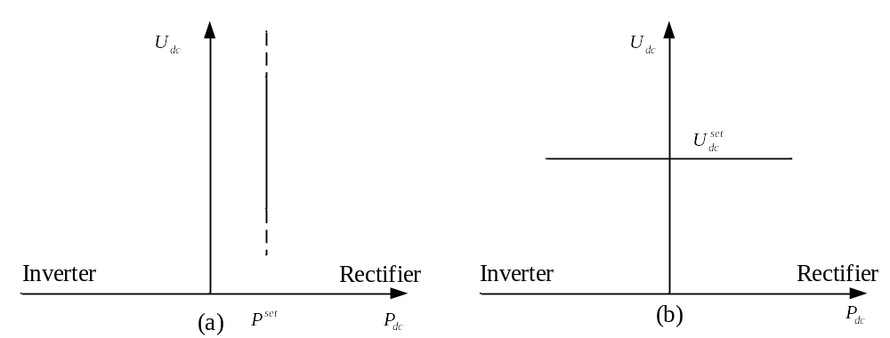
Figure 4.1. Constant active power control modes (a) constant $P_{s}$, (b) constant $V_{dc}$ (slack).

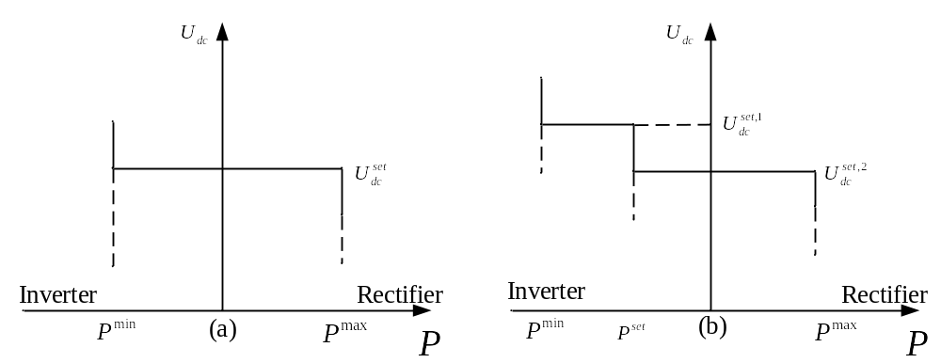
Figure 4.2. Improved constant control (a) slack bus with power limits (b) voltage margin.

operating functions are not affected in SE analysis.

Dynamic models of droop control
A VSC is able to independently control the output active and reactive power with the fast and decoupled dq current control. The decoupled control strategy schema is shown in Figure 4.3, which consists of both a physical structure and a time-domain control model. The dq control is made up of an outer control loop and an inner current control loop. The control structure with decoupled current compensation and voltage feed-forward compensation is adopted in the inner current control loop, which can track the reference current quickly. The outer controllers include the DC voltage controller, the active power controller, and the reactive power controller. PI regulators are used in all these outer controllers to eliminate the steady state errors. Obviously, the implementation of decoupled control and PI regulators can help control active and reactive power independently at the preset operating points [107], [108].
To further regulate the DC voltage and enhance the system stability, the so-called droop control is employed, which is a technique that enables power distribution among different VSCs without relying on long-distance communications. The droop control acts on the outer loop imposing a current reference to the inner loop. The current and, thus, the power in the converter are directly governed by the current control in accordance with the reference imposed by the voltage loop. A simplified diagram, together with a cascaded controller is depicted in Figure 4.4. Contrary to the standard constant control, which presets the fixed operating points, the droop control has larger operating range and can regulate all converters due to their own states.
Figure 4.3. Decoupled dq current control model (a) physical structure. (b) diagram of S-domain transfer function.

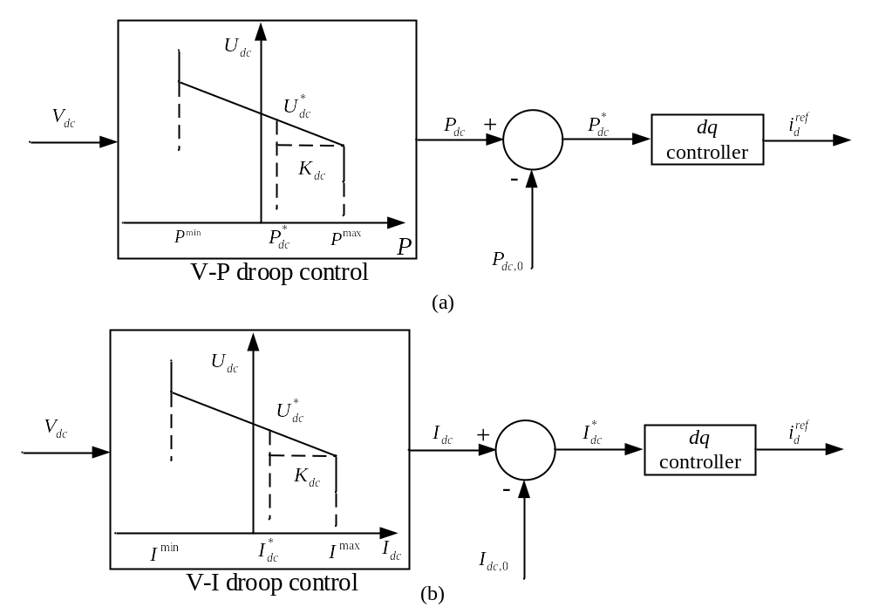
Figure 4.4. Two types of DC voltage droop control implementations (a) V-P droop control. (b) V-I droop control.

Quasi-steady-state models of droop control
In SE analysis, the fast-dynamic regulating processes can be considered much faster than the sampling speed of SCADA, and thus the droop control can be represented with quasi-steady-state models. Take the two types of droop control depicted in Figure 4.4 for example, if the V-P control is used for VSC i, the output DC power can be controlled according to:
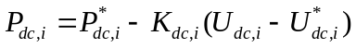
Similarly, if the V-I control is used for VSC i, then the output DC current can be controlled according to:
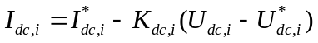
In addition, can be represented in terms of the output DC power by multiplying DC voltage as:
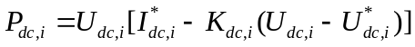
Specifically, based on the measurement functions given in Chapter 2, the DC power and DC current can be substituted in terms of DC voltage. Thus, the steady power balance of and can be rewritten as:
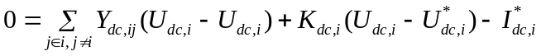
Obviously, both V-P droop control and V-I droop control can be represented in terms of DC voltage. In specific, the droop control can be seen as a strictly-restricted function as:
and are derivate from the most generalized form of droop control. However, in practical engineering, droop control can be enhanced with other features. The operating functions, together with SE formulations are discussed in the following subsection.

SE formulation of droop control
In this subsection, several practical droop control strategies are shown and modeled. For simplicity, the improved features are all based on V-P control. Furthermore, the operating equations, together with the measurements and state variables are prepared for SE analysis.

Improved V-P droop control strategies
To ensure coordinated operation and retention of viable operating points of the VSC stations, droop control can be realized with different strategies based on [109] and [110]:
• Basic V-P droop control [99]. Basic V-P droop control can be seen as a combination of constant active power control and constant DC voltage control. It tries to control power to its reference level while at the same time contributing some balancing power. The contradiction is handled by introducing a linear control equation in terms of active power and DC voltage. Assuming that VSC stations can compensate for power imbalance and regulate DC voltage within a large range, the operating characteristics are depicted in Figure 4.5(a). In general, basic V-P droop control is too idealistic to be used in practice.
• V-P droop control with power limits [111]. Given the capacity limitation in a VSC station, the regulating range of DC voltage is restricted within the range of lower and upper
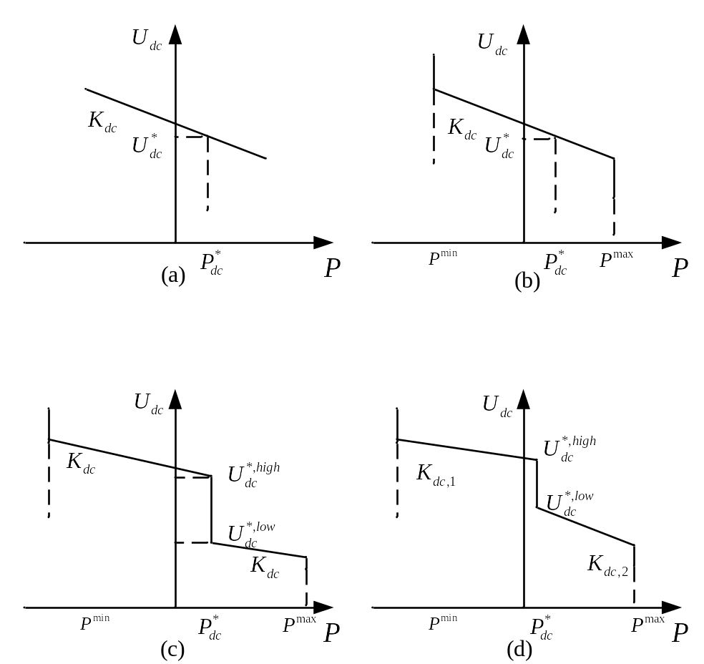
Figure 4.5 Basic and improved types of V-P droop control (a) Basic V-P. (b) V-P with power limits. (c) V-P with dead-band. (d) Two-stage V-P with dead-band.

boundaries of output active power. Under this circumstance, once the compensating power reaches the limits, the station will fix the output power and switch from droop control to constant power control, as depicted in Figure 4.5(b).
• V-P droop control with dead-band [112]. Just like with voltage margin control, the converter operates at a constant current/power control modus as long as the voltage is within the normal operation band or margin. If the voltage deviates to the limit of the dead-band, the controller switches to droop control. When the voltage droop with a power dead-band shown in Figure 4.5(c) is implemented, the scheduled power is produced by the converter as the DC voltage is maintained close to its nominal value. Once the voltage exceeds the dead-band zone, the converter power will adjust to contribute to the stabilization of the dc grid. On one hand, the implementation of dead-band can help converters work within the ideal and safe DC voltage range in normal operation. On the other hand, it also provides the ability to maintain the power balance when large vibrations occur.
• Two-stage V-P droop control [113]. This control strategy provides different droop constants depending on the operating states of VSCs. As depicted in Figure 4.5(d), when a VSC is operating under high DC voltage, the voltage margin is relatively small. Therefore, the droop constant should be large to ensure that the voltage limit is not violated. By contrast, when the voltage level is low, the VSC should be sensitive to power changes in order to adjust DC voltage. The two-stage V-P droop control is more flexible because it uses different droop constants. However, it also brings challenges on designation.
Based on the designing idea of two-stage V-P droop control, another efficient strategy is given in Figure 4.6. The voltage limits can be enabled by introducing two or more stages of
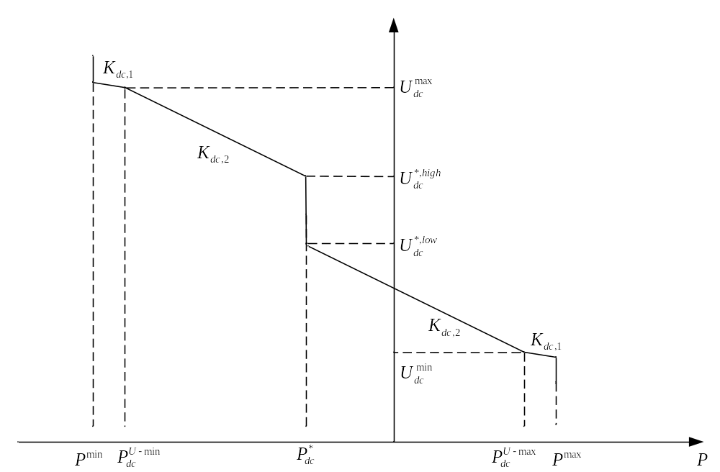
Figure 4.6. Two-stage V-P droop control with voltage limits.

droop. As the overvoltage or undervoltage threshold is violated, the droop control constants will be increased in order to maintain the voltage within an acceptable range.

Operating equations of droop control
Assume that the power limits are not violated, which means VSCs operate under droop control. In addition, take the most complex and practical two-stage V-P in Figure 4.6 as the example. Each voltage droop line is essentially a function between the voltage and desired
power output. Differentiated by the voltage level, these linear functions of the converter power can all be represented in the form of typical droop lines. To begin with, the output power corresponding to $U_{dc}^{max}$ and $U_{dc}^{min}$ can be calculated by:
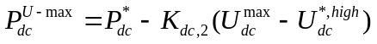
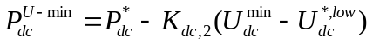
Then, the controlling equations in Figure 4.6 can be described with piecewise linear equations:
Substitute $P_{dc}^{U-max}$ and $P_{dc}^{U-min}$ in and with the expressions in and , respectively. Then, the unified piecewise equations are given as:
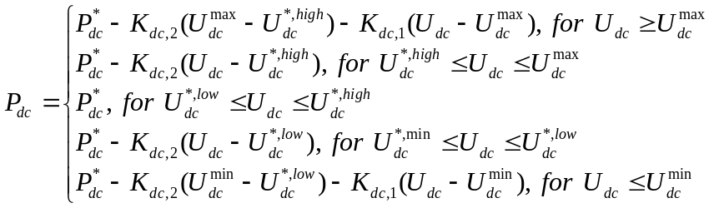

Measurements and state variables
Based on , the DC power can be described with a piecewise equation, which can also be seen as the measurement functions for SE analysis. Therefore, it is necessary to reconsider the set of measurements and state variables for droop control. For simplicity, a generalized two-stage V-P droop control is used as the example as depicted in Figure 4.7. Based on the generalized two-stage V-P control model, can be reformulated as:
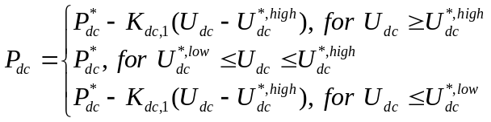
It is noticeable that is a piecewise linear equation composed of three segments. Based on the quasi-steady-state analysis, the droop constants are difficult to measure directly because of their small dynamic variations. Therefore, the parameters and variables in can be categorized into three types as follows:
1) Preset operating points include $P_{dc}^{*}$, $U_{dc}^{*,low}$ and $U_{dc}^{*,high}$. The values of these parameters are given in advance and can be seen as constant.
2) Measurements of DC power and DC voltage are similarly categorized into the set of $z_{ac-dc}$.

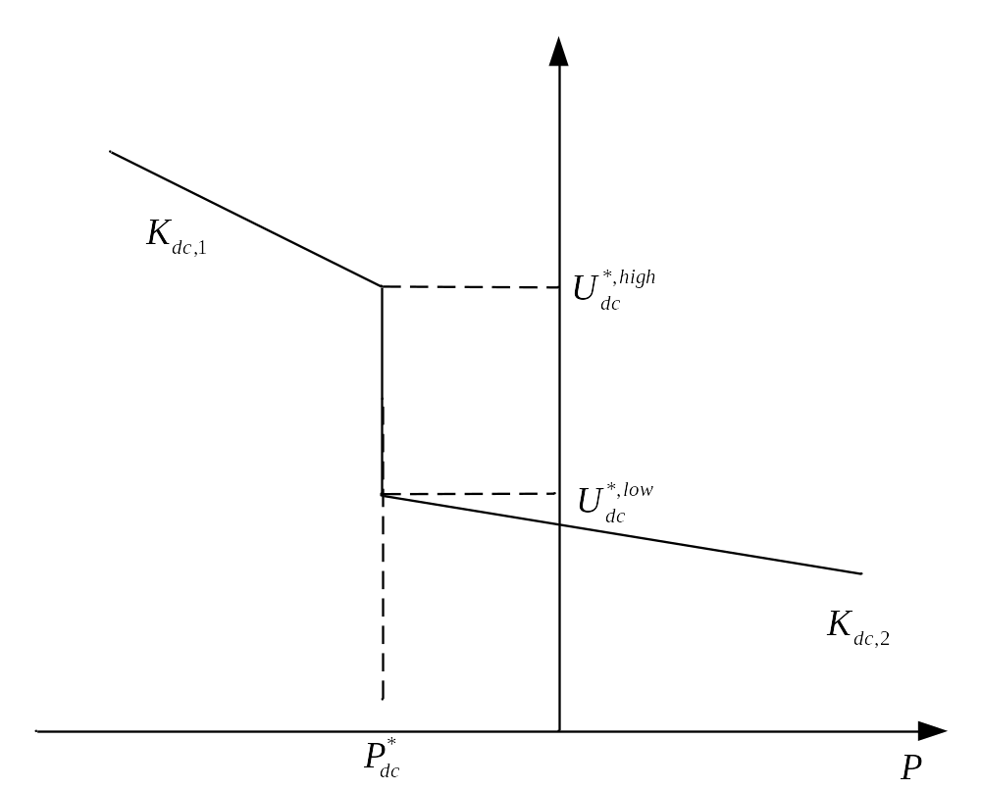
Figure 4.7. Generalized two-stage V-P droop control.

3) State variables of $K_{dc,1}$, $K_{dc,2}$ and $U_{dc}$ form the minimum vector of variables for all measurement functions.
Furthermore, since the constant active power control discussed in Chapter 2 is replaced by the droop control, the overall measurements and state variables should be reformulated as given in Table 4.1.
Obviously, the pseudo-measurements of $P_{si}^{set}$ and $U_{dc}^{set}$ are removed from the set of measurements. The state vector $x_{ac-dc}$ is enlarged with the integration of droop constant $K_{dc}$. Thus, can be rewritten in the shape of measurement functions $h(x)$ as:
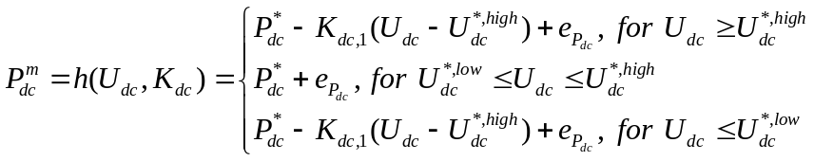
Consequently, all the measurement equations are given. In the next subsection, an improved SE algorithm will be given to show how the piecewise measurement function can be solved.

Improved SE Algorithm to Include Droop Control
In this subsection, an improved SE algorithm is proposed to include the SE formulation of a VSC with droop control. The innovative algorithm leverages the BCNLS method to enhance the accuracy of the estimator by remedying the boundary restrictions with inequality constraints. Furthermore, the modified SE problem is solved by using the LM method instead of the conventional NR method in order to improve convergence.

Table 4.1. Measurements and state variables for V-P droop control.
Type | Measurements | Type | State variables
$$z_{ac}$$ | $$P_{ac,i}^{m},P_{ac,ij}^{m},Q_{ac,i}^{m},Q_{ac,ij}^{m},U_{ac,i}^{m}$$ | $$x_{ac}$$ | $$U_{ac,i},θ_{ac,i}$$
$$z_{dc}$$ | $P_{dc,i}^{m},P_{dc,ij}^{m}, U_{dc,i}^{m}$,$P_{si}^{m},Q_{si}^{m},P_{ci}^{m},Q_{ci}^{m},U_{si}^{m},U_{ci}^{m}$ | $$x_{dc}$$ | $$U_{dc,i},M_{i},δ_{i},K_{dc}$$

Intuitive piecewise SE method for droop control
It should be noted that the implementation of droop control does not affect the AC grids in VSC-MTDC systems, and the FDSE algorithm can still be used to estimate the AC grids. Furthermore, the interface calculating procedures in the SM remain. Therefore, in the following discussions, all the research objects are focused on the estimations in VSC grids. That is to say, the goal of the SE is to minimize the residual equation as given by:
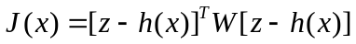
where the sets are limited in DC grids. Although the measurement function is piecewise, it can still be analyzed in a simple method by estimating each segment.
As illustrated in Figure 4.8, the measurements $U_{dc}^{m}$ and $P_{dc}^{m}$ can be detected before performing SE analysis. That is to say, based on the raw measurements, the operating state of VSC droop control can be pre-supposed. Back to Figure 4.8, given that the measurement of DC voltage is larger than the upper DC voltage of the dead-band, the VSC can be assumed to operate in Stage 1. Therefore, the measurement function can be equalized as:
Subsequently, the estimations of DC grids can be solved by integrating all the measuring equations. By executing the SM, the final converged results can be achieved, and the estimations can be solved:
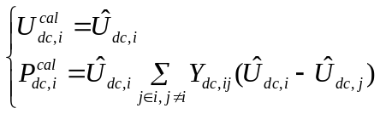
However, it should be noted that the previous calculation is based on two assumptions: 1) The measurements of DC voltage are accurate enough and $U_{dc}^{m}≥U_{dc}^{*,high}$ is correct. 2)
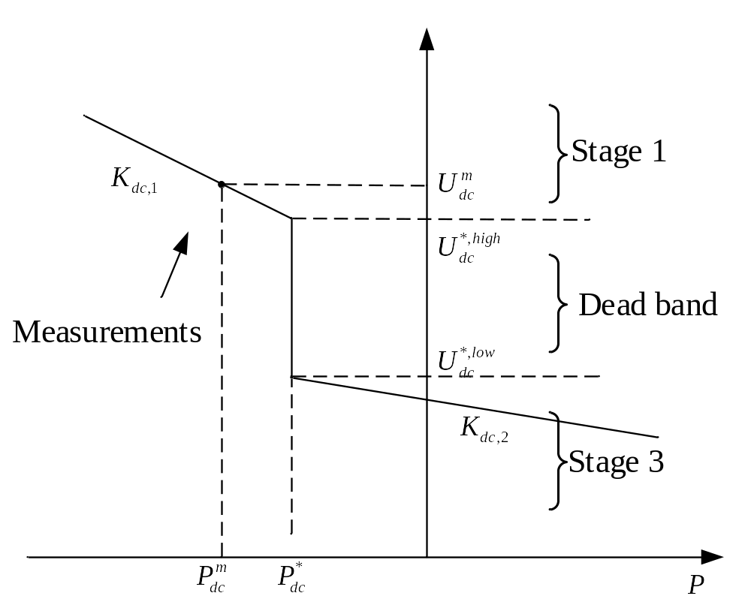
Figure 4.8. Measurement $U_{dc}^{m}$ and $P_{dc}^{m}$ in two-stage droop control model.

The calculated $U_{dc}^{cal}$ is also larger or equal than $U_{dc}^{*,high}$. If the estimated DC voltage violates the boundaries, the supposed operating state has to switch to another state and redo the calculation. As shown in Figure 4.9, when the measurement of DC voltage is very close to the endpoint $V_{dc}^{*,high}$, measurement errors can greatly affect the determination of the operating state. The test results of this method will be given and discussed in Section 4.5. Another potential problem is that the estimations of DC voltage from two different stages may oscillate around the endpoints, and the computation keeps going. These problems have two potential causes. First, the inequality constraints of DC voltage in are not considered in the WLS algorithm, leading to an unconstrained least-squares problem. Therefore, the optimization is not strictly restricted. Second, the Gauss-Newton method for the WLS algorithm is sensitive to the condition of metering strategy. Moreover, the WLS algorithm takes a large step while iterating such that the linear model becomes invalid or too approximate because of the quadratic nature of the criterion function J. In such a situation, the WLS estimator oscillates near the solution point increasing the error criterion function instead of decreasing it [114]. Therefore, it is important to enhance the positive definite feature of the gain matrix [115] .

LM method for nonlinear WLS algorithm
In this subsection, a generalized nonlinear WLS problem is reformulated and solved via different methods. Analysis of the comparisons demonstrate the LM method is more suitable for solving an SE problem when the gain matrix is ill-conditioned.
First, a nonlinear least-squares problem can be given in the general form as:

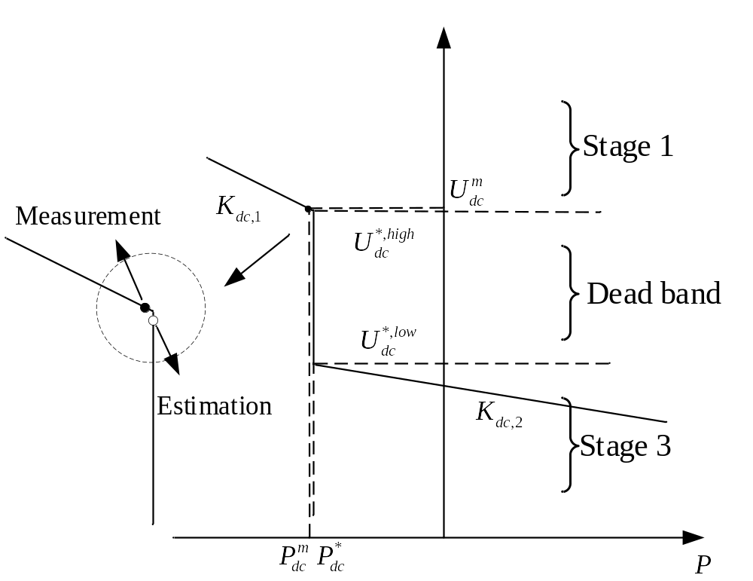
Figure 4.9. Failure of the intuitive piecewise SE with droop control.

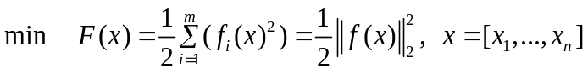
where the size of variables x is smaller than the set size of nonlinear objective functions f(x). For the overdetermined problem of , the values of optimized x can be estimated by solving the nonlinear least-squares problem iteratively. In general, this problem can be solved with line-search and trust-region methods [116], including the gradient descent method, the Gauss-Newton method and the LM method [117].
1) Gradient descent method. For , we give the Taylor series at the first order:
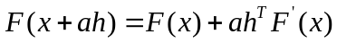
where $∆x=αh$, meaning the iterating correction is composed of the step and direction. When the step $α$ is small enough, we have:
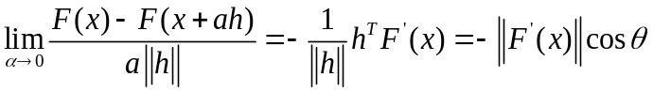
where $θ$ is the different angle between h and $F^{'}(x)$. Obviously, when $θ=π$, eq. has the largest value. Thus, the search direction should be $h_{sd}{=-F}^{'}(x)$ for each iteration. It should be noted that the gradient descent method can only guarantee fast search for the local minimum in each iteration. From a global view, the gradient descent method is slow. Therefore, it is not an ideal method for solving the nonlinear least-squares problems.
2) Gauss-Newton method. First, give the Taylor series of the i^{th} element in the function set f as:
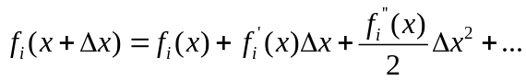
Retain the first order and $f_{i}(x+∆x)$ is approximately equal to:
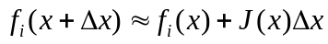
Thus, the Jacobian matrix of the first-order partial derivatives for the set f is given as:
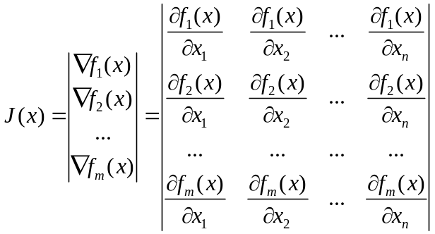
Afterwards, the goal is to find the best $∆x$ to minimize $||F(x+∆x){||}^{2}$. Similarly, $∆x^{*}$ can be achieved by solving another least-squares problem:
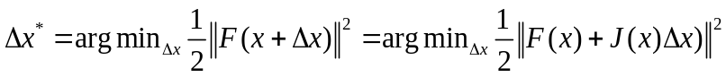
can be expanded to give:
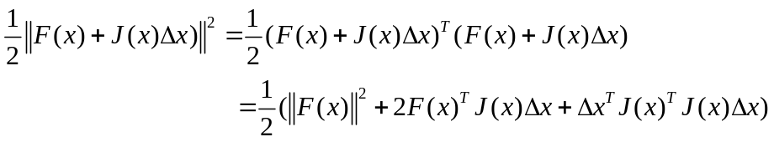
To get the optimal point, take the derivative of with respect to x. Then we have:
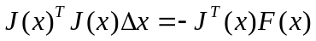
Thus, we get the Gauss-Newton function in terms of $∆x$, which can be simplified as:
The Hessian matrix H is essentially approximately achieved with $J^{T}(x)J(x)$. It should be noted that plays the most important role in achieving the solution. To guarantee the locally optimal solution, matrix H must be positive definite. However, in solving real problems, matrix H might be ill-conditioned, leading to divergence or a large error.
3) LM method. To improve the convergence of , the matrix H has to be strictly positive definite. Therefore, we can add the non-negative damping factor $λ$ to replace H. After that, is expressed as:
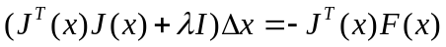
where I is the identity matrix with the dimension of $\left(n×n\right).$Therefore, even $J^{T}(x)J(x)$ is not positive definite or ill-conditioned, the augmented matrix $(J^{T}\left(x\right)J\left(x\right)+λI)$ can still be positive definite as long as $λ$ is large enough. In general, the damping factor can be adjusted by introducing a metric $ρ$ which is defined as:
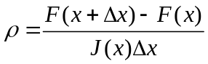
If $ρ$ is larger than the threshold, then $λ$ should be reduced to achieve a larger iterating step. Otherwise $λ$ is increased and the algorithm proceeds to the next iteration. That is to say, the LM method has better convergence when the matrix H is not positive definite or ill-conditioned. In addition, when the matrix H is positive definite, the LM method can also achieve the estimations with more iterations than the Gauss-Newton method [116].
The LM method is actually a combination of the two other minimization methods. In the gradient descent method, the sum of the squared errors is reduced by updating the parameters in the steepest-descent direction. In the Gauss-Newton method, the sum of the squared errors is reduced by assuming the least squares function is locally quadratic and finding the minimum of the quadratic. The LM method acts more like a gradient descent method when the parameters are far from their optimal value and acts more like the Gauss-Newton method when the parameters are close to their optimal value. Comparisons of the three methods are listed in Table 4.2.

BCNLS method
Studies in the previous subsection are established on the assumption that the least-squares problem is not constrained. That is to say, all variables are not bounded. However, in the real world, physical restriction can greatly affect the estimations. In general, the least-squares problem in should be formed as:
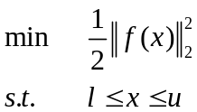
where l and u are vectors of lower and upper bounds on the state vector x. Thus, the modified least-squares problem and the bound-constrained problem, a.k.a. the BCNLS. Some algorithms have been proposed to solve this problem, such as ASTRAL, BCLS, L-BGFS-B and NEO Server [118]-[121]. In general, there are three goals in solving the BCNLS problem. First, the algorithm should serve both small and large problems well. Second, the algorithm should be fast enough to meet the computing speed requirement. Last but not least, the variables should always be feasible at each iteration.
Based on the bounded constraints in , the simple bound constraints can be superimposed on each iteration k as:
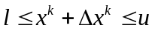
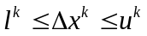
where $l^{k}=l-x^{k}$, and $u^{k}=u-x^{k}$ are the lower and upper bounds of ${∆x}^{k}$ at iteration k. Then, we combine with to get the new BCNLS problem in the form of:
Table 4.2. Comparison of three methods in solving WLS problem.
Method | Advantages | Drawbacks
Gradient Descent | 1. Computationally efficient.  2. Insensitive to initial estimations. | 1. Slow converging speed.
Gauss-Newton | 1. Fast quadratic convergence.  2. Approximate Hessian matrix. | 1. Sensitive to initial estimations.  2. Hessian matrix must be positive definite.
Levenberg-Marquardt | 1. Trust region.  2. Convergence guaranteed.  3. Fewer accumulated errors. | 1. Slower than Gauss-Newton method when Hessian matrix is strongly positive definite.  2. More complex than Gauss-Newton method.

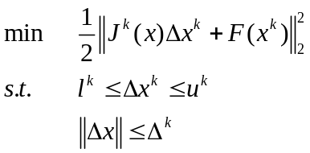
The subproblem can be transferred into a two-norm regularized problem as:
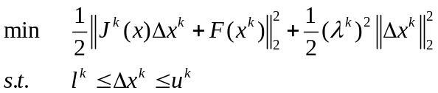
for some $λ^{k}≥0$. This problem can be solved directly with the soft package BCLS. The next step is to give a good $λ^{k}$ in each iteration to guarantee convergence. The selection of the damping factor $λ^{k}$ can be given by applying the self-adaptive damping strategy of the LM method. Consequently, the BCNLS problem can be solved with the method given in [122].

Formulation and solution for droop control
Now, let us go back from the generalized BCNLS problem to the specified WLS problem for SE analysis, and figure out how the operating characteristics can be implemented. First, the generalized LS equation is specified as:
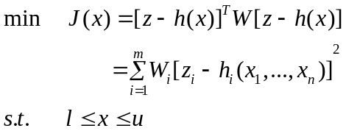
It should be noted that $J(x)$ and $z_{i}-h_{i}(x)$ stand for $F(x)$ and $f_{i}(x)$ in , respectively. Afterwards, the Jacobian matrix in SE is resented with $H(x)$:
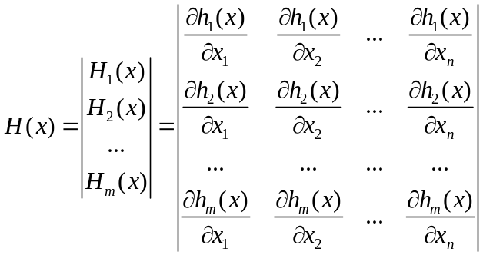
Note, in the traditional expression of SE, $H(x)$ is the Jacobian matrix instead of Hessian matrix. Furthermore, the approximate Hessian matrix can be achieved in terms of $H(x)$ and W:
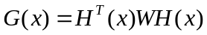
Note, the gain matrix $G(x)$ in SE analysis is modified by multiplying the weighted matrix W. However, the structure does not change. Finally, we have the iterative computation:
is the iterative equation for SE analysis, and is the generalized iterative equation for the least-squares problem. Obviously, they are structurally consistent. Therefore, the method proposed in Section 4.4.2 and Section 4.4.3 can be utilized in SE analysis.
Then the lower constrained equations in can be specified as:
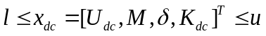
Specifically, only the DC voltage is considered to be limited in droop control. Thus, the bound-constraints can be loosened:
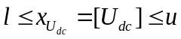
For different operating stages in droop control, the lower and upper boundaries of Figure 4.7 are listed in Table 4.3.
Subsequently, the SE formulation for the droop control of VSCs can be given as . It is noticeable that, for each operating stage, not only the measurement function h(x) but also the boundary constraints $V_{dc}∈[l,u]$ are formulated for SE analysis. Afterwards, can be solved by utilizing the LM method in order to improve the convergence and reduce accumulated errors.
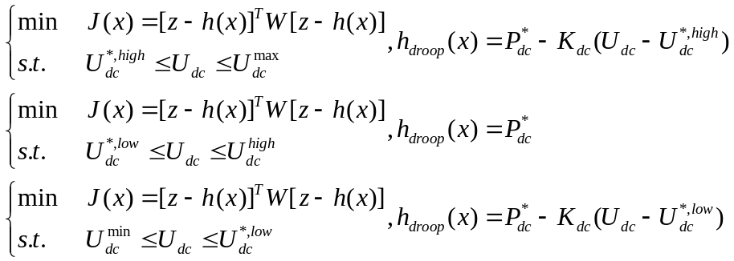
There are two major advantages of the proposed method: 1) Once the operating stage is presupposed, the estimation of DC voltage will definitely lie in the corresponding DC voltage range. Thus, the operators only need to check the calculated DC power. If $P_{dc}^{cal}$ violates the limitation of $P_{dc}^{*}$, then a new SE calculation for another operating stage of the droop control is required. 2) The calculation is promised to converge within limited iterations.

Flow chart
Based on the previous studies, a complete improved WLS algorithm with a constrained LM method to include the droop control of a VSC in SE can be given. The flow chart is depicted in Figure 4.10.
Table 4.3. The upper and lower boundary values in two-stage droop control.
Boundaries | Stage 1 | Dead band | Stage 3
u | $$U_{dc}^{max}$$ | $$U_{dc}^{*,high}$$ | $$U_{dc}^{*,low}$$
l | $$U_{dc}^{*,high}$$ | $$U_{dc}^{*,low}$$ | $$U_{dc}^{min}$$

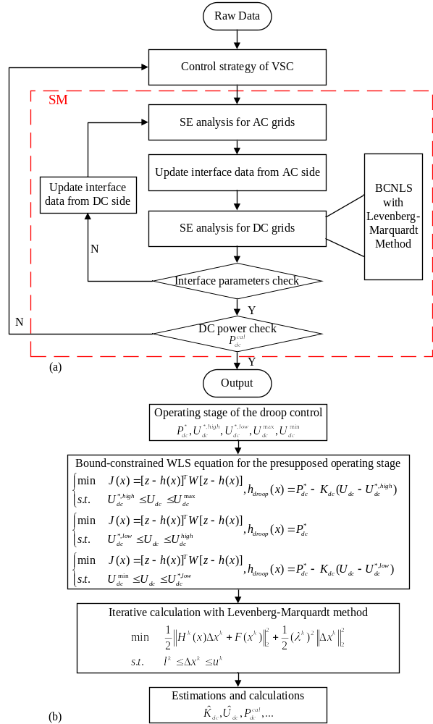
Figure 4.10. Flow chart of the improved method based on SM (a) the overall flow chart. (b) the detailed BCNLS flow chart.

Case study
In this section, the proposed approach is tested on the modified RTS-96 system, the structure of which is as same as the test system in Figure 2.5(b). By setting a detailed droop control, together with different measurements, the accuracy and feasibility of the proposed method is verified.

Droop control settings
First, the preset operating points and the relevant parameters are given in Figure 4.11, Figure 4.12, and Table 4.4.
Three scenarios of measurements are also given for testing. The simulated measurements, together with the true values of DC voltage are listed from Table 4.5 to Table 4.7.
• Scenario 1: VSC 5 and VSC 6 are operating in Stage 1. All measurements of DC voltage are in accordance with the true values, in the same range. No bad data exists.
• Scenario 2: VSC 5 and VSC 6 are operating in Stage 2. All measurements of DC voltage are in accordance with the true values, in the same range. No bad data exists.
• Scenario 3: VSC 5 is operating in the dead band and VSC 6 is operating in Stage 1. However, the operating points are really close to the endpoints of the piecewise functions. That is to say, the measurements and true values lie in different operating stages.

Simulation results and discussions
In this subsection, test results are given by using the proposed method. To demonstrate the efficiency, results are also compared with the estimations of an intuitive piecewise method.
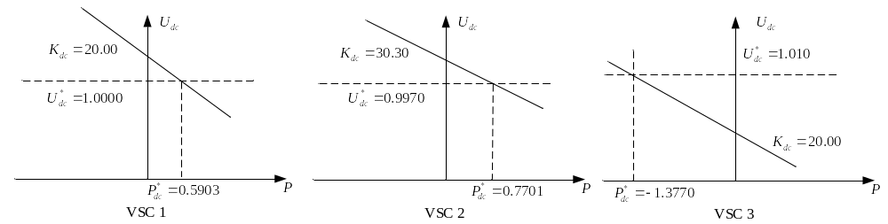
Figure 4.11. Preset operating points for VSC 1-VSC 3.

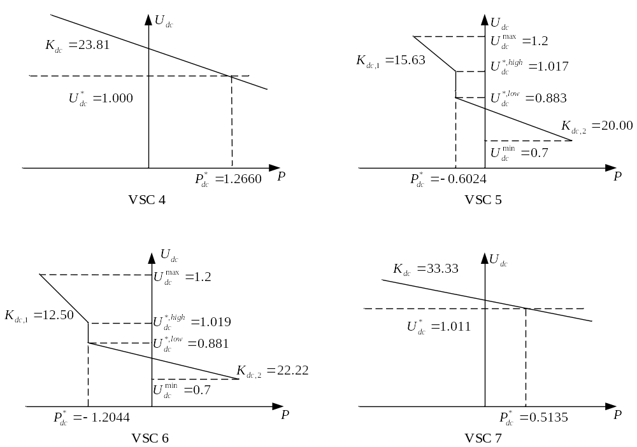
Figure 4.12. Preset operating points for VSC 4-VSC 7.

Table 4.4. Preset operating points for the VSCs in the modified RTS-96 system.
Type | VSC 1 | VSC 2 | VSC 3 | VSC 4 | VSC 5 | VSC 6 | VSC 7
$$K_{dc(1,2)}$$ | 20.00 | 30.30 | 20.00 | 23.81 | 15.63  20.00 | 12.50  22.22 | 33.33
$$P_{dc}^{*}$$ | 0.5903 | 0.7701 | -1.3770 | 1.2660 | -0.6024 | -1.2044 | 0.5135
$$U_{dc}^{*(high,low)}$$ | 1.0000 | 0.9970 | 1.0100 | 1.0000 | 1.0170  0.8830 | 1.0190  0.8810 | 1.0110
$$U_{dc}^{(max,min)}$$ | --- | --- | --- | --- | 1.2000  0.7000 | 1.2000  0.7000 | ---

Table 4.5. Measurements and true values of DC voltage in scenario 1.
Type | VSC1 | VSC2 | VSC3 | VSC4 | VSC5 | VSC6 | VSC7
Meas. | 0.9998 | 0.9968 | 1.0105 | 1.0735 | 1.0906 | 1.0923 | 1.0844
True | 1.0000 | 0.9972 | 1.0107 | 1.07406 | 1.0914 | 1.0922 | 1.0841

Table 4.6. Measurements and true values of DC voltage in scenario 2.
Type | VSC1 | VSC2 | VSC3 | VSC4 | VSC5 | VSC6 | VSC7
Meas. | 1.0002 | 0.9965 | 1.0104 | 0.8239 | 0.8433 | 0.8441 | 0.8371
True | 1.0000 | 0.9972 | 1.0107 | 0.8234 | 0.8438 | 0.8451 | 0.8362

Table 4.7. Measurements and true values of DC voltage in scenario 3.
Type | VSC1 | VSC2 | VSC3 | VSC4 | VSC5 | VSC6 | VSC7
Meas. | 0.9999 | 0.9972 | 1.0995 | 0.9987 | 1.0172 | 1.0189 | 1.0102
True | 1.0000 | 0.9972 | 1.0107 | 0.9993 | 1.0168 | 1.0192 | 1.0100

To begin with, the estimations of the VSC grids for scenario 1 and scenario 2 are listed in Table 4.8 and Table 4.9. The results also include the comparison with measurements and true values.
It is noticeable that, under normal circumstances, the proposed method can estimate the droop control of VSCs with good accuracy. Furthermore, the results of scenario 3 are also given and compared in Table 4.10. Key comparisons of VSC 5 and VSC 6 are highlighted. When the measurements are close to the endpoints, the estimations with the intuitive piecewise method (highlighted in green) fail to reflect the explicit operating stage. Nevertheless, the proposed method can still give accurate estimations by considering the operating constraints in different stages. Consequently, reasonable estimations can be achieved.

Chapter Summary
In this chapter, an improved SE algorithm is proposed to model and estimate a VSC-MTDC system with droop control. First, the quasi-steady-state operating behavior of droop control is modeled as a piecewise function in the SE formulation. Then, compared with the simple and intuitive piecewise method which may cause unexpected failures in SE analysis, the boundary values of the DC voltage are also considered as the bound-constraints to enforce the WLS algorithm. To solve the BCNLS problem, this chapter utilizes the LM method in the iterations to guarantee convergence. Test results indicate that the proposed method has good accuracy in all scenarios.

Table 4.8. Comparisons of key estimations in scenario 1.
VSC No. | Value Type | $V_{dc}$ (p.u.) | $P_{dc}$ (p.u.) | $$K_{dc}$$
VSC 1 | True | 1.0000 | 0.5903 | 20.00
VSC 1 | Measurements | 0.9998 | 0.5911 | ---
VSC 1 | Estimations | 0.9999 | 0.5904 | 20.02
VSC 2 | True | 0.9972 | 0.7700 | 30.30
VSC 2 | Measurements | 0.9968 | 0.7708 | ---
VSC 2 | Estimations | 0.9971 | 0.7702 | 30.34
VSC 3 | True | 10107 | -1.3769 | 20.00
VSC 3 | Measurements | 1.0105 | -1.3762 | ---
VSC 3 | Estimations | 1.0103 | -1.3766 | 19.95
VSC 4 | True | 1.07406 | 1.2778 | 23.81
VSC 4 | Measurements | 1.0735 | 1.2761 | ---
VSC 4 | Estimations | 1.0734 | 1.2776 | 23.82
VSC 5 | True | 1.0914 | -0.6147 | 15.63
VSC 5 | Measurements | 1.0906 | -0.6162 | ---
VSC 5 | Estimations | 1.0902 | -0.6150 | 15.58
VSC 6 | True | 1.0922 | -1.2183 | 12.50
VSC 6 | Measurements | 1.0923 | -1.2195 | ---
VSC 6 | Estimations | 1.0921 | -1.2185 | 12.51
VSC 7 | True | 1.0841 | 0.5298 | 33.33
VSC 7 | Measurements | 1.0844 | 0.5271 | ---
VSC 7 | Estimations | 1.0842 | 0.5299 | 33.36

Table 4.9. Comparisons of key estimations in scenario 2.
VSC No. | Value Type | $V_{dc}$ (p.u.) | $P_{dc}$ (p.u.) | $$K_{dc}$$
VSC 1 | True | 1.0000 | 0.5903 | 20.00
VSC 1 | Measurements | 1.0002 | 0.5921 | ---
VSC 1 | Estimations | 1.0001 | 0.5911 | 19.89
VSC 2 | True | 0.9972 | 0.7700 | 30.30
VSC 2 | Measurements | 0.9965 | 0.7722 | ---
VSC 2 | Estimations | 0.9975 | 0.7707 | 30.35
VSC 3 | True | 1.0107 | -1.3769 | 20.00
VSC 3 | Measurements | 1.0104 | -1.3775 | ---
VSC 3 | Estimations | 1.0109 | -1.3768 | 20.03
VSC 4 | True | 0.8234 | 1.2238 | 23.81
VSC 4 | Measurements | 0.8239 | 1.2249 | ---
VSC 4 | Estimations | 0.8235 | 1.2241 | 23.84
VSC 5 | True | 0.8438 | -0.5597 | 20.00
VSC 5 | Measurements | 0.8433 | -0.5571 | ---
VSC 5 | Estimations | 0.8439 | -0.5593 | 20.03
VSC 6 | True | 0.8451 | -1.1561 | 22.22
VSC 6 | Measurements | 0.8441 | -1.1537 | ---
VSC 6 | Estimations | 0.8448 | -1.1556 | 22.19
VSC 7 | True | 0.8362 | 0.4551 | 33.33
VSC 7 | Measurements | 0.8371 | 0.4559 | ---
VSC 7 | Estimations | 0.8365 | 0.4554 | 33.30

Table 4.10. Comparisons of key estimations in scenario 3.
VSC No. | Value Type | $V_{dc}$ (p.u.) | $P_{dc}$ (p.u.) | $$K_{dc}$$
VSC 1 | True | 1.0000 | 0.5903 | 20.00
VSC 1 | Measurements | 0.9999 | 0.5912 | ---
VSC 1 | Proposed Method | 0.9999 | 0.5906 | 19.97
VSC 1 | Intuitive Method | 1.0000 | 0.5907 | 19.96
VSC 2 | True | 0.9972 | 0.7700 | 30.30
VSC 2 | Measurements | 0.9972 | 0.7692 | ---
VSC 2 | Proposed Method | 0.9972 | 0.7699 | 30.35
VSC 2 | Intuitive Method | 0.9971 | 0.7693 | 30.11
VSC 3 | True | 1.0107 | -1.3769 | 20.00
VSC 3 | Measurements | 1.0995 | -1.3782 | ---
VSC 3 | Proposed Method | 1.0105 | -1.3773 | 19.92
VSC 3 | Intuitive Method | 1.0103 | -1.3776 | 19.93
VSC 4 | True | 0.9993 | 1.2660 | 23.81
VSC 4 | Measurements | 0.9987 | 1.2679 | ---
VSC 4 | Proposed Method | 0.9995 | 1.2664 | 23.89
VSC 4 | Intuitive Method | 0.9996 | 1.2652 | 23.57
VSC 5 | True | 1.0168 | -0.5834 | ---
VSC 5 | Measurements | 1.0172 | -0.5857 | ---
VSC 5 | Proposed Method | 1.0169 | -0.5841 | ---
VSC 5 | Intuitive Method | 1.0175 | -0.5852 | 15.74
VSC 6 | True | 1.0192 | -1.2234 | 12.50
VSC 6 | Measurements | 1.0189 | -1.2247 | ---
VSC 6 | Proposed Method | 1.0191 | -1.2236 | 12.46
VSC 6 | Intuitive Method | 1.0187 | -1.2233 | ---
VSC 7 | True | 1.0100 | 0.5135 | 33.33
VSC 7 | Measurements | 1.0102 | 0.5142 | ---
VSC 7 | Proposed Method | 1.0101 | 0.5137 | 33.25
VSC 7 | Intuitive Method | 1.0105 | 0.5139 | 33.16

Enforced Equality-Constrained SE Algorithm to Include Operating Limits of VSC with Bad Data Identification
Another important dynamic feature of the operating limits in VSCs should also be carefully considered in the quasi-steady-state SE analysis. This chapter presents an enhanced equality-constrained SE algorithm to reflect accurate operating states of VSCs. The proposed method is implemented within the inner calculation loops discussed in Chapter 2. There are three steps to implement the operating limits. In the first step, the operating limits of each VSC are predetermined by calculating the safe operating range (PQ capability). In the second step, the inner estimated results are compared with the limits. Once the specific limits are violated, an adjusted control strategy is involved to replace the previous one. In the third step, the new operating points are formed as equality constraints which are solved with the Lagrangian relaxation method to ensure the accuracy and reasonability of the estimations. Furthermore, to eliminate the impact of gross errors, the HAM method is utilized to cooperate with the operating limits. The calculated Lagrangian multipliers can thusly participate in BDI. Simulation tests are performed on the modified IEEE 5-bus system and RTS-96 system with different operating states. The results demonstrate the effectiveness of the proposed method.

Introduction
With modern power systems operations’ growing need for larger capacity, longer transmission distance, and higher reliability, HVDC projects have drawn great attention worldwide [123]-[124]. In addition to the outstanding features mentioned above, one of the advantages of VSC technology over the traditional LCC technology is the ability to connect multiple asynchronous AC grids to compose a larger system with multi-terminal links. Thus, various renewable energy sources can be integrated in one system. A number of VSC-MTDC systems have been established or planned in recent years [125]-[126].
Some related research issues come together with technical advantages. One issue is SE, which is one of the most important functions in EMSs. The extra complexities in modeling the topology and steady-state operations of VSC-MTDC systems bring great challenges to SE. In order to monitor hybrid systems, some SE methods have been proposed [127]-[129]. However, the important features of fast regulation and strict operating limits in VSCS have not been fully studied. Compared with generators and motors, which are hard to control accurately over a short time period due to large rotational inertia, VSCs can self-adjust their operating status quickly by PWM control. Therefore, under normal conditions, the operating points of VSC will not exceed the strict operating range. Hence, SE should monitor the violations and provide estimations to reflect accurate operating values. [45] implemented a bad data analysis in the SE algorithm for VSC-MTDC power systems, but it can only detect significantly wrong data. Violations can still occur even when all the measurements are considered to be accepted. [130] modeled different control strategies in the SE analysis to enhance the accuracy; however, switching between different strategies was not included in the SE calculation. [131] utilized virtual measurements which have higher weights to represent the real operating values of VSCs to develop a new SE method, which contains the operating limits, for VSC-MTDC system. The operating limits, which include restrictions on power, voltage and current, are analyzed and drawn based on an SE model. Then, a limit check process is implemented inside the sequential iteration. Once the limits are violated, the related parameter will be set as the boundary value and be updated as a high-weighted pseudo-measurement for the following calculation. Thus, the results of SE can guarantee accuracy without being affected by measurement errors. However, the large values of weights of the added pseudo-measurements may lead to the existence of extremely large elements in the weight matrix (W). That is to say, the use of very high weights for modeling very accurate pseudo-measurements can lead to ill-conditioning of the G matrix. Furthermore, due to global optimization features of the WLS algorithm, the residual of the estimations cannot be completely be zero. Even the very accurate pseudo-measurements can still be affected by other measurements. To accurately reflect the dynamic features of fast adjustment and self-regulation, [132] modeled the operating limits as equality constraints to enhance the SE algorithm. The equality-constrained problem can be subsequently solved using Lagrangian relaxation associated with the WLS algorithm. However, bad data with gross errors may lead to biased estimations that can significantly affect the reliability of the equality-constrained method [133].
To improve estimation accuracy and reflect the dynamic features in quasi-steady-state SE, an improved method is proposed in this chapter. There are four main contributions of this method. First, the VSC-MTDC system is modeled in detail for analyzing the operating limits. Second, the adjustments on the corresponding violations are illustrated and the procedure of violations check is added to improve the SM. Third, once violations are detected, the corresponding equality constraints will be added to the WLS equations and solved with Lagrangian relaxation. Finally, equality constraints can also participate in the BDI with the HAM method.
The rest of this chapter is structured as follows: Section 5.2 analyzes the quasi-steady-state operating limits of VSCs and the processes of self-regulation to establish new control strategies. Section 5.3 proposes the equality-constrained algorithms to include operating limits in SE analysis and BDI. Section 5.4 conducts the case studies and Section 5.5 concludes the chapter.

Operating limits of VSC

Dynamic control feature of VSC
Compared with other AC components that have high inertia [134], [135] or a long response time [136], [137], a VSC can be controlled and regulated on a very short time-scale [138]. Generally, in case of a disturbance, internal current control can be finished within 0.05 seconds and the terminal voltage control can proceed within 0.5 seconds. Correspondingly, the output power of VSCs can also be adjusted within 1.0 second [138]. That is to say, compared with the typical SCADA sampling rate of 5.0 to 10.0 seconds, the time scale of a VSC is much shorter [139]. In addition, given that SE analysis is done every few minutes, the measured system should be assumed to be steady-state. It is obvious that a VSC cannot be simply formulated as a steady-state model regardless of its dynamic features.
One example to show the importance of the dynamic control ability of VSCs is their application in restoring after a blackout, the most severe type of outage that may occur in an electric grid. With the development of HVDC technologies, the possibility of performing a BS with HVDC has been widely discussed. Installed to interconnect asynchronous AC systems, HVDC can function as a firewall during a blackout to prevent further propagation of outage [140], [141]. Hence, the BS power can be transferred from a remote healthy grid to the blackout grid, without risking the reverse expansion of outage. The first commercial HVDC system, linking the Gotland island with the Swedish mainland with LCCs, has the BS ability already by delivering power from the mainland to Gotland which has very few generating units [142]. Nevertheless, synchronous condensers are necessary for starting up the LCC, making the restoration too complex to be executed. In recent years, the introduction of VSC technologies has successfully addressed the deficiencies of LCCs. Hence, a VSC can be started up and self-commutated without synchronous condensers. Furthermore, the independent controllability of VSCs on both active and reactive power make VSCs suitable to support weak or passive AC grids in the process of BS [143], [144]. Field testing of VSC-based BS has been performed on the Estlink network (between Estonia and Finland) [145] and the Skagerrak-4 network (between Denmark and Norway) [146]. The testing results are satisfying with faster restoration speed and higher system stability compared with the traditional approaches. With the growing penetration of renewable energy, more VSC projects are being put into use to complement AC grids. In view of this, researchers and utilities have assessed VSCs as a promising option in their plans for performing BS [147], [148].
A test case of BS with the help of VSCs is given to show the dynamic control ability. The test system is a typical four-terminal VSC-MTDC in which four independent AC grids are connected via DC links. As shown in Figure 5.1, Grids 1-3 cooperate to provide BS power. The outage in Grid 4 will be restored by transferring required power. Three healthy grids are planned to provide 150 MW pick up generators and critical load at the beginning of BS. Meanwhile, the reactive power of 60MVAr is generated by VSC 4 to pick up critical load and energize high-voltage lines and transformers at the same time.
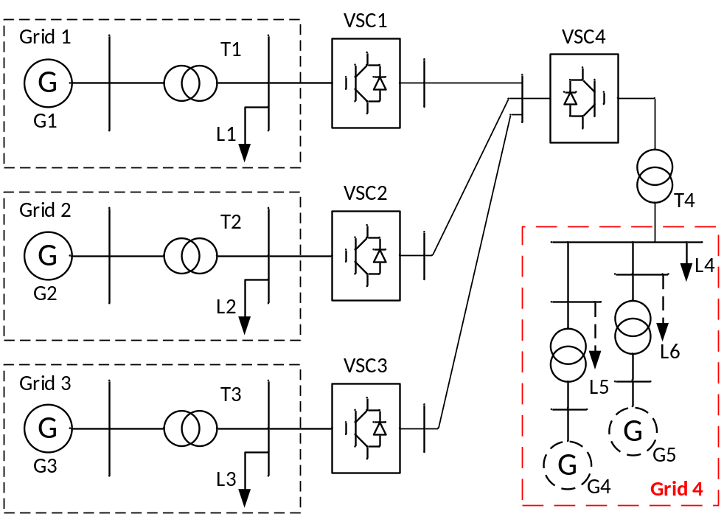
Figure 5.1. Four-terminal VSC-MTDC system for BS test.

Suppose that the initializing BS power of 150 MW and 60 MVAr is utilized to energize the transformer T4 (which is closest to the converter) and pick up load L4 simultaneously. In the simulation settings, assume that BS starts at 1.5 s which refers to the critical moment t=0. The key dynamic performances of the receiving end are illustrated by Figure 5.2.
In the first plot in Figure 5.2, a transient is excited on the DC voltage because of the sudden increase of injected power, but the DC voltage is quickly controlled close to 100 kV with a small oscillation. In addition, since VSC 4 is set to operate in ‘islanded mode’, the frequency and voltage magnitude of Grid 4 are quickly controlled to the reference values after small transients, as shown in plots 2 and 3. Furthermore, both active power and reactive power experience the overshoots shortly after the beginning of BS, and then are adapted to setpoints soon afterwards, as shown in the 4th plot in Figure 5.2.
It can be observed that the blackout grid can be picked up quickly with the help of a VSC link. The frequency and voltage magnitude in the AC grid are also stabilized, benefiting from the ‘islanded mode’.

Operating limits of VSC
In practice, a VSC operates with two main limits, the converter voltage limit, and the converter current limit. In general, the two limits can be critically set by adjusting power injections. First, to express the converter voltage $U_{ci}$ in terms of injected power $P_{si}$ and $Q_{si}$, the converter current can be given as:
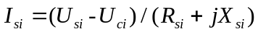
Then, rewrite as:

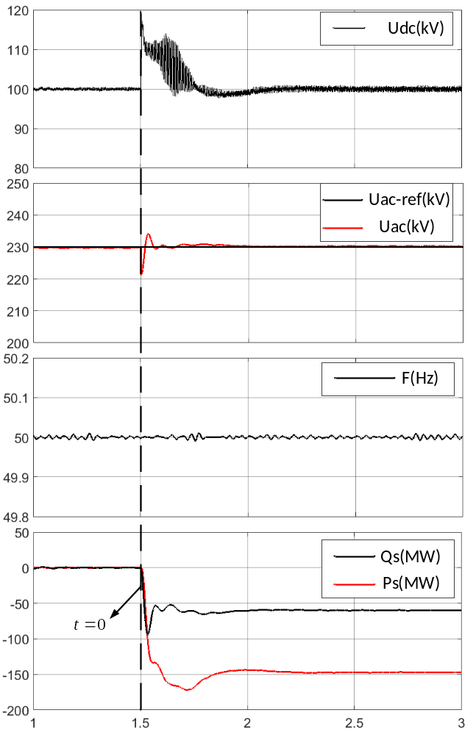
Figure 5.2. Dynamic performance with 150MW/60MVAr at the beginning of BS.

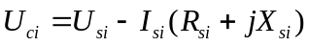
Then, substitute $U_{ci}$ to represent $I_{si}$ as:
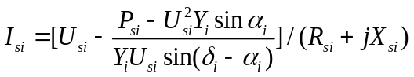
where we have $α_{i}=\tan^{-1}(R_{si}/X_{si})$ and $Y_{i}=1/\sqrt{R_{si}^{2}+X_{si}^{2}}$. Thus, $U_{ci}$ can be written in terms of $U_{si}$:
Thus, the relationship between $U_{si}$ and the injected power is expressed as:
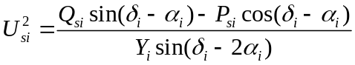
It should be noted that in , $V_{si}$ can be completely described only by $P_{si}$ and $Q_{si}$. Thus, it can be formulated with an abstract function, $U_{si}=f(P_{si},Q_{si})$. Consequently, substitute $U_{si}=f(P_{si},Q_{si})$ in , $U_{ci}$ is expressed as:
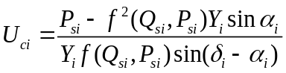
Therefore, the converter voltage can be controlled by adjusting the power injections. Furthermore, since the power injections are also restricted by the PWM factor, the boundaries of converter voltage can be preset. In general, the upper and lower limits, $U_{ci}^{max}$ and $U_{ci}^{min}$, are preset at the operating point to avoid overmodulation. Similarly, the limit of converter current can also be deduced from the power injections as:
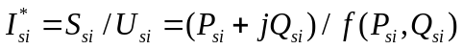
It should be noted that since the converter current is limited within the fixed value, the operating range of $I_{s}$ forms a cycle. The corresponding output power can be correspondingly calculated. In addition, the output power is also limited by the lower and upper boundaries of converter voltage. Finally, the safe operating range, a.k.a., the PQ capability of VSC can be determined as shown in Figure 5.3.

Self-regulation for new control strategies
To illustrate the limits and how the adjustment works, the modified IEEE 5-bus system in Figure 2.5(a) is utilized to show the simulation results on two different scenarios. The preset power injections via VSC 1 are set at -60 MW/-50 MW and -130 MW/-60 MW, respectively. Meanwhile, the limits of voltage are set at 0.9 and 1.1 p.u., and the maximum current is 1.2 p.u. Under these conditions, only VSC 1 violates the limits in two scenarios. Hence, the violations and self-regulations of VSC 1 are depicted in Figure 5.4.
As shown in Figure 5.4, the operating range of the VSC is restricted inside the shadow area, which is determined by two limits. Given the parameters in advance, we can predetermine the limits. Hence, no matter what the preset power injections are, the converter can self-adjust to ensure the outputs fall inside or on the boundaries. As depicted in Figure 5.4(b) and Figure 5.4(d), no actions are needed if the preset values do not violate the limits. However, for VSC 1, specific adjustments are required depending on the type of violations.
As shown in Figure 5.4(a), the converter value with power injections of -60MW/-50MW is 0.863 p.u., violating the lower voltage limit. Thus, the converter should reduce the reactive power injections along the y-axis until the voltage increases to 0.9 p.u. Hence, the real power
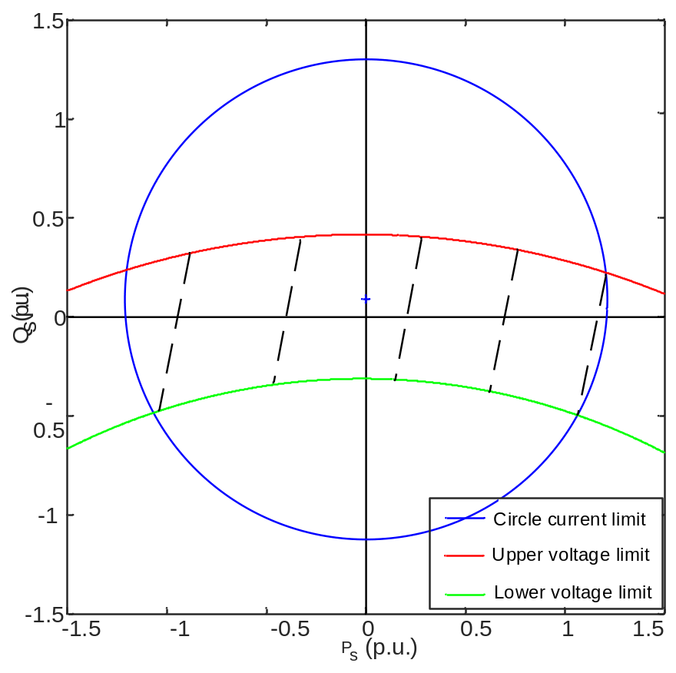
Figure 5.3. PQ capability chart (shadow area) with the given voltage and current limits.

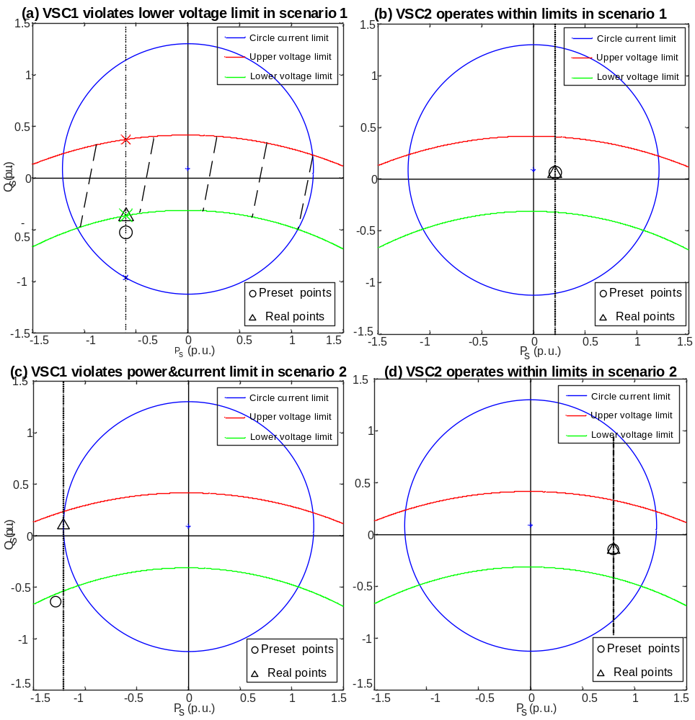
Figure 5.4. Converter limits and adjustments (a) voltage violation of VSC1 in scenario 1 (b) no violations of VSC 2 in scenario 1 (c) voltage and current violation of VSC1 in scenario 2 (d) no violations of VSC2 in scenario 2.

is changed to -36.25MW to ensure the voltage limit. In the second case, as Figure 5.4(c) depicts, the converter voltage is 0.893 p.u. and the current magnitude achieves 1.211 p.u., leading to the violations of two limits. Under this circumstance, both active and reactive power injections should be changed to the new operating values. Since controlling active power is the primary goal in VSC-MTDC system, the change of $P_{s}$ should be small. Thus, the new operating power is changed to -121.21 MW/8.96 MW. Consequently, the adjusted converter current and voltage is 1.2 p.u. and 1.062 p.u. to ensure the safe operation.

Formulation and solution
In this section, an equality-constrained algorithm is proposed to correctly reflect the operating limits and self-regulation in SE analysis. In addition, the equality constraints can also help with bad data identification by using the HAM method.

Pseudo-measurement method
Before presenting the equality-constrained algorithm, there is another rough method to consider operating limits. According to [8] and [129], the state estimation problem for VSC-MTDC systems can be solved by using the SM. Only the parameters on converters need to be updated and injected into the AC and DC grids. For example, the interface data, such as $P_{si}^{m}$ and $Q_{si}^{m}$, are solved and updated until achieving global convergence. Since all the limits are modeled in the converter, the procedures of checking limit violation and adding pseudo-measurements can be done in the internal sequential loop. The detailed steps are displayed in Figure 5.5.
To illustrate, after drawing the steady operating range, the boundary values are utilized
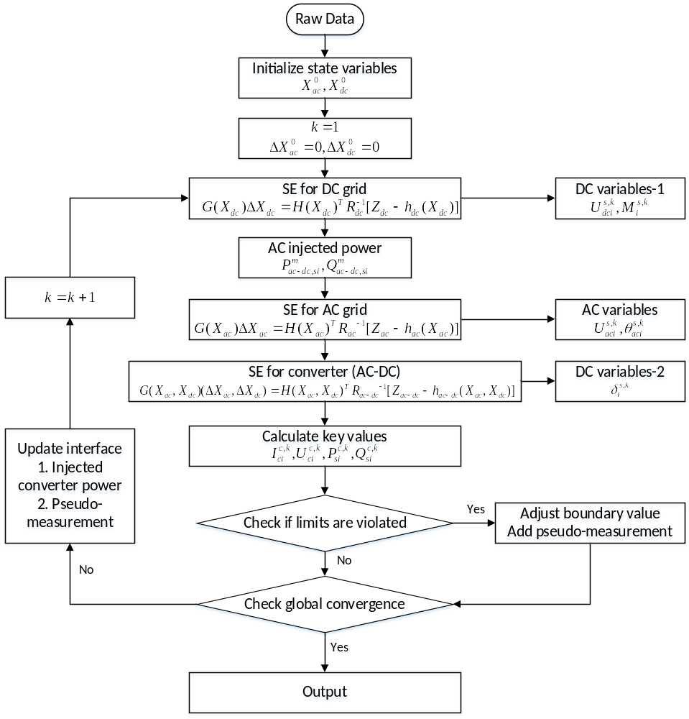
Figure 5.5. Flow chart of the improved SM with pseudo-measurement method to consider the operating limits of VSCs.

to compare with the estimations and calculations which are achieved from internal SE results. If the limits are violated, the corresponding parameters will be adjusted and converted to high-weighted pseudo-measurements for next calculating loop. Therefore, by performing limit check, the influence of measurement errors and the calculated deviation of the WLS algorithm can be eliminated.
The pseudo-measurement method is easy to implement in the conventional SM without the need for complex computation. However, the large weights of the pseudo-measurements can lead to the singularity of the Gain matrix, which may cause the divergence of the entire SE analysis. Therefore, another equality-constrained method is proposed.

Equality-constrained method
Taking the operating limits into account, we need two additional steps. First, the operating ranges of all converters are pre-calculated based on the device parameters. Then, the SE results achieved from raw measurement data are checked by the ranges. Once the limits are violated, the corresponding adjusted values will replace the measurements and be formulated as equality constraints to modify WLS. Taking VSC 1 in the first scenario as an example, the WLS can be improved as:
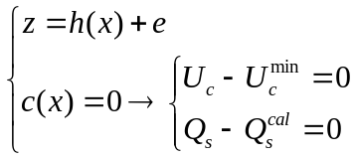
The equality constraint $c(x)$=0 in extends the original measuring equations. Based on [2], can be solved with a constrained WLS algorithm as:
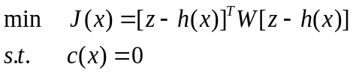
The problem can be reformulated and solved with Lagrangian relaxation as:
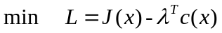
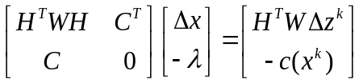
where $C={∂c(x)}/{∂x}$. According to the previous discussions on the operating limits, the adjustments of power injections, and the WLS with the equality constraint solved by Lagrangian relaxation, an improved SE method for VSC-MTDC is proposed. The detailed flow chart is depicted in Figure 5.6.
The calculation steps of the proposed method are given below:
Step 1: Read raw data from EMS.
Step 2-1: Classify the measurements, state variables and errors into two sets, ac and dc.
Step 2-2: Calculate the operating limits based on the preset operating points.
Step 3: Initialize state variables. Set the iteration number k=0.
Step 4: Perform SE analysis for each part separately with the WLS algorithm and get the inner estimations.
Step 5: Compute converter voltage and converter current based on the results from Step 4.
Step 6: Do violations check, compare $U_{c}^{cal,k}$ and ${ I}_{s}^{cal,k}$ with the operating limits calculated in Step 2-2. If violations happen, go to Step 7, otherwise, go to Step 9.
Step 7: Adjust power injections and add equality constraints to modify the WLS algorithm as $L^{k}\left(x,λ\right)=J^{k}\left(x\right)-λ^{T,k}c^{k}\left(x\right)$.
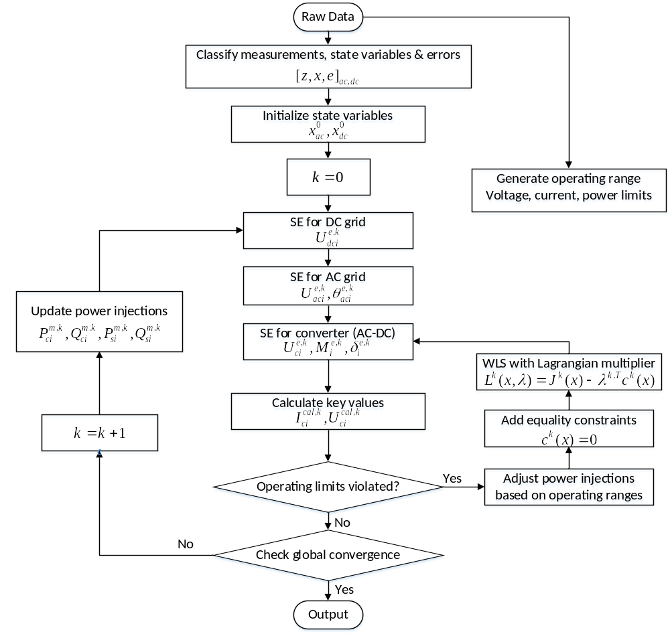
Figure 5.6. Flow chart of the improved SM with equality constrained method to consider the operating limits of VSCs.

Step 8: Redo SE for the converter (ac-dc) with Lagrangian relaxation.
Step 9: Check global convergence. If the convergence is achieved, go to Step 11, otherwise, go to Step 10.
Step 10: Set $k=k+1$. Update the measurements of power injections. Then go to Step 4.
Step 11: Print final SE results.
Obviously, the overall calculation structure is the same as the conventional SM. Also, the major SE analysis is still based on the WLS algorithm except for the Lagrangian relaxation.

HAM method for bad data identification
In the previous subsection, the operating limits are considered with the equality-constrained method in SE analysis. However, another important process of identifying bad data is not well considered. Due to the malfunction of meters and failure or delay in communication [2], gross errors may occur in the measurements. These errors cannot be filtered out with the conventional WLS algorithm and thusly must be called ‘bad data’. In the presence of bad data, estimations can be greatly biased. For SE analysis of VSC-MTDC systems, the most commonly used method to identify bad data is an LNR test. The LNR test is performed repeatedly as a post-process after each cycle of SE computation with one occurrence of bad data eliminated or corrected [42].
In the presence of bad data, estimation can be biased, and the violation check might fail. A conventional LNR test cannot reflect the equality constraints as internal relationships. To overcome this shortage, the HAM method is leveraged to take the Lagrangian multiplier that reflects the equality constraints into the calculation of BDI. Consequently, the impact of bad data can be eliminated, and the operating limits can be considered at the same time.
After a cycle of estimation is done, estimated measurements can be calculated based on the estimations as:
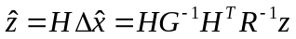
Residual vector $r$ can also be computed as:
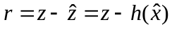
Using to substitute $\hat{z}$, can be expressed as:
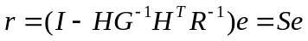
where matrix $S$ is also called the residual sensitivity matrix representing the sensitivity of residuals to errors. Subsequently, the residual covariance matrix can be formed as:
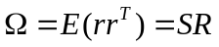
Consequently, the normalized residuals are computed as:
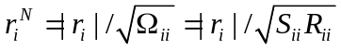
Normally, a positive threshold Th can be set up to compare with the result in for BDI. If the LNR value exceeds the threshold (typical 3.0), the corresponding measurement is considered to be bad data with a gross error. This measurement should be eliminated or corrected to avoid biased estimations. In general, to retain measurement redundancy, it is better to correct the identified bad data than to eliminate it. The correction function is formed as in [149]:
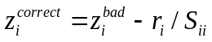
It should be noted that the LNR test is generally considered to be independent from the main SE computation as a post-processing test. To consider both the equality constraints and the LNR test in SE analysis, the HAM method can be utilized, and the new SE problem is formulated as:
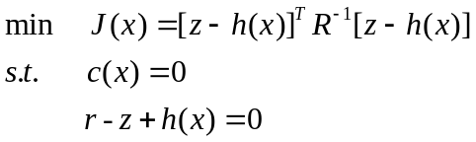
In , there are two equality constraints with different meanings. $c\left(x\right)=0$ stands for the preset or self-regulated operating values that are the same as given in . The second equation is associated with residuals with explicit state variables. can be transferred to the formulation with Lagrangian relaxation as:
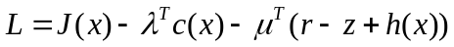
can be iteratively solved with the following equations:
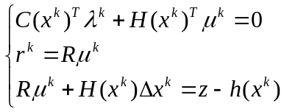
where $R=W^{-1}$. can be formed in the HAM as:
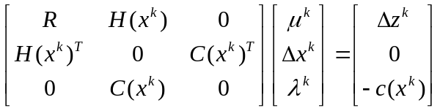
Consider the results in , the residual vector is given as:
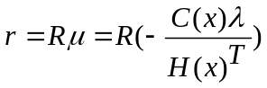
It is observed that the new residual vector is directly bounded with the equality constraints. The normalized residual value for each AC grid is given as:
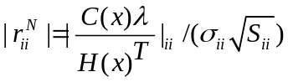
The new residual reflects not only the conventional LNR value but also the equality constraints from the operating limits. Bad data can be eliminated or corrected without affecting the violation check.

Simulation study

Test systems and settings
Two VSC-MTDC systems, including the modified IEEE 5-bus system (C1) and modified IEEE RTS-96 system (C2) are tested to illustrate the accuracy and efficiency of the proposed method. The SE data are simulated using the power flow results (true values) solved in MATLAB. Then, the corresponding measurement errors are modeled as Gaussian noise. The deviations are $σ_{ac}=0.04$ and $σ_{ac-dc}=0.03$.
Furthermore, to simulate the violations, the new presetting operating points of both systems are given in Table 5.1. It should be noted that, with these preset points, the violations occur in both systems. In C1, the converter voltage of VSC 1 violates the lower limit boundary and the reactive power is adjusted to meet the requirement. In C2, both the voltage and current of VSC 3 are violated, leading to the adjustments of active and reactive power injections.
Table 5.1. Presetting operating points of VSCs in two test systems.
Case and VSC No. |  | $P_{s}$ (MW) | $Q_{s}$ (MVAr)
C1 | VSC 1 | -130 | -5
C1 | VSC 2 | 0 | 0
C1 | VSC 3 | 35 | 5
C2 | VSC 1 | 0 | 50
C2 | VSC 2 | 75.3 | -50
C2 | VSC 3 | -241.9 | 40
C2 | VSC 4 | 131.5 | 75.9
C2 | VSC 5 | -61.7 | 0
C2 | VSC 6 | -123.4 | -10
C2 | VSC 7 | 50 | 20

Results and discussions
Under the previous settings, the SE results of the proposed method (PM) are compared with the true values (TV) and the estimations of the conventional method (CO), in Table 5.2. To better illustrate the efficiency, test results are depicted in Figure 5.7 and Figure 5.8.
It is noted that in Figure 5.8, the preset operating powers for VSC 1 and VSC 2 of -130.00 MW/-5.00 MVAr and -241.90 MW/40.00 MVAr violate the corresponding operating limits. The reactive power of VSC 1 is correspondingly changed to 8.960 MVAr. Similarly, for VSC 3 in C2, the output power is changed to -231.81 MW and 4.990 MVAr. Therefore, the equality constraints are set at the corresponding new active power values. As shown in Figure 5.7, Figure 5.8 and Table 5.2, the proposed method can reflect the accurate operating status of VSCs even when the preset values violate the operating limits.

Chapter Summary
In this chapter, an improved state estimation method is proposed for the VSC-MTDC system with the consideration of operating limits. The output power of VSCs is strictly limited by converter current and voltage, and the PQ capability can be determined to check violations. The conventional SM is modified so that the SE method can check the violations within the inner calculation loops and give an accurate estimation by using an equality-constraints method. First, a violation check procedure is implemented to monitor the estimations calculated from each loop. Then, once the violations occur, the corresponding equality constraints are added into the measuring equations, and subsequently solved by utilizing Lagrangian relaxation. In addition, the HAM method is leveraged to take the Lagrangian multipliers into the consideration of the LNR test for BDI. Thus, the improved
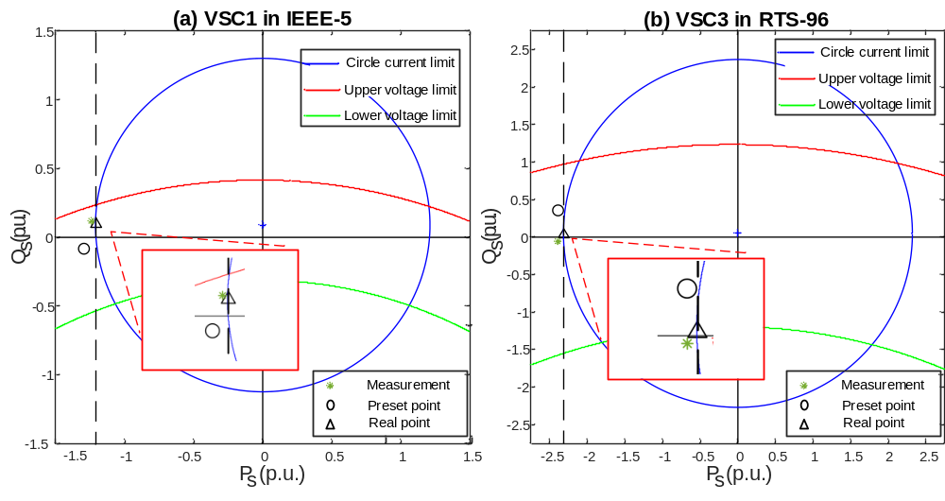
Figure 5.7. Limits violation and real operation for (a) VSC1 in IEEE-5. (b) VSC 3 in RTS-96.

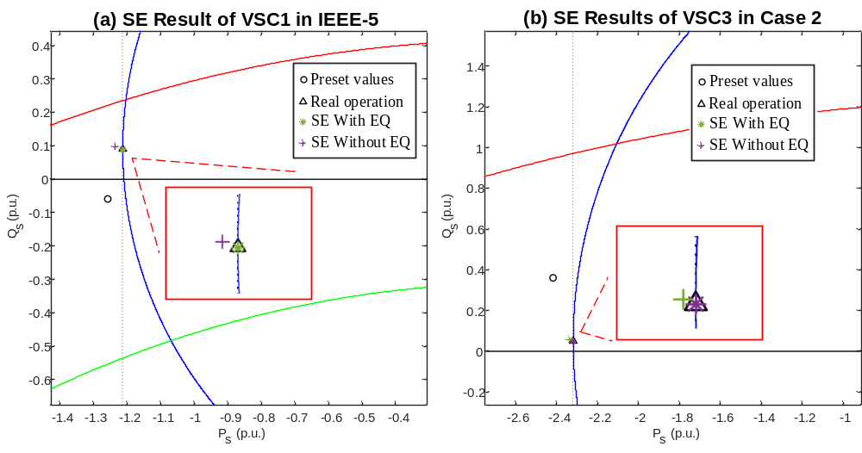
Figure 5.8. Comparison of SE results on injected power (a) VSC1 in IEEE-5. (b) VSC3 in RTS-96.

Table 5.2. Accuracy comparison of SE when limits are violated.
Case | SE | U_{dc} (p.u.) | M | δ (degree) | P_{s} (MW) | Q_{s} (MVAr)
C1  VSC1 | PM | 1.0205 | 0.6779 | 18.193 | -121.21 | 8.953
C1  VSC1 | CONV | 1.008 | 0.6437 | 17.717 | -123.46 | 9.753
C1  VSC1 | REAL | 1.019 | 0.6785 | 18.286 | -121.21 | 8.960
C2  VSC3 | PM | 1.0237 | 0.6657 | 15.423 | -231.81 | 4.924
C2  VSC3 | CONV | 1.011 | 0.6323 | 15.766 | -233.92 | 5.76
C2  VSC3 | REAL | 1.025 | 0.6662 | 15.39 | -231.81 | 4.990

method obtains accurate operating values, which are the same as the boundary limits. Test results verify the accuracy and efficiency of the proposed method.

Conclusions and Future Works
State estimation (SE) plays a very important role in monitoring the real-time operating status of power systems. Research on SE analysis for VSC-MTDC systems is insufficient and some of the key features have been ignored in conventional estimators. In this dissertation, Chapter 1 briefly introduces the development of VSC-MTDC systems and SE approaches.
Chapter 2 generalizes and classifies the conventional estimators for VSC-MTDC systems into the UM and the SM (SM-WLS and SM-FDSE). These methods are tested and compared across three aspects that should be carefully considered when implementing the methods for practical use, including estimation accuracy, computing speed and robustness. Various and diverse systems are leveraged for testing under different measuring situations to provide sufficient results. Comprehensive comparisons are expected to help operators and utilities to choose the better and more reasonable SE method to monitor VSC-MTDC systems based on specific features. Besides, this work can also facilitate the development of SE approaches to overcome existing problems
Chapter 3 further improves the computing performance of the UM by implementing graph computing techniques and a virtual connection method. First, graph computing techniques are applied for faster computing speed. The hybrid systems are modeled as a graph with vertexes and edges, and then stored in the graph database. Afterwards, advanced parallel computing methods of NPC and HPC are implemented in the SM. The calculation processes of generating admittance matrices, LU factorization and forward-backward substitution can be significantly accelerated. Second, the interface links and DC networks are equivalently modeled as virtual connections integrated into the AC grids. The structure integrity can be enhanced, and the interface data can be directly estimated from both sides. Consequently, better accuracy and faster convergence speed is achieved with the proposed method.
Chapter 4 proposes an improved SE algorithm to model and estimate VSC-MTDC systems with droop control. First, the quasi-steady-state operating behavior of droop control is modeled as a piecewise function in the SE formulation. Then, compared with the simple and intuitive piecewise method which may cause unexpected failures in SE analysis, the boundary values of the DC voltage are also considered as the bound-constraints to enforce the WLS algorithm. To solve the BCNLS problem, this chapter utilizes the LM method to avoid divergence.
Chapter 5 takes the dynamic features of fast adjustments and self-regulation in VSCs into the consideration of SE analysis. The operating limits are predetermined and utilized for a violation check. Once the limits are violated, the self-regulated power output is modeled as equality constraints to repeat the preset operating values. The modified measuring equations can be solved with the Lagrangian relaxation method, and the Lagrangian multipliers can be further used with the HAM method for bad data identification. Consequently, the improved method reflects the real operating status of the VSC-MTDC systems and obtains accurate estimations, which are the same as the boundary limits.
Future works will focus on robust SE analysis for VSC-MTDC systems and continue to develop high-efficiency bad data identification algorithms to meet the requirements of real-time monitoring.

References

- E. Handschin, F. C. Schweppe, J. Kohlas and A. Fiechter, "Bad data analysis for power system state estimation," IEEE Trans. Power App. and Syst., vol. 94, no. 2, pp. 329-337, March 1975.
- A. Abur and A. G. Exposito, Power System State Estimation: Theory and Implementation. New York, NY, USA: Marcel Dekker, 2004.
- A. Primadianto and C. Lu, "A Review on Distribution System State Estimation," IEEE Trans. Power Syst., vol. 32, no. 5, pp. 3875-3883, Sept. 2017.
- X. Kou, F. Li and W. Feng, "Transmission Constrained Economic Dispatch via Interval Optimization Considering Wind Uncertainty," 2018 IEEE Power & Energy Society General Meeting (PESGM), Portland, OR, 2018, pp. 1-5.
- W. Feng, X. Kou, Q. Zhang and F. Li, "Impact of Neutral Current on Concentric Cable Overloading," 2018 IEEE/PES Transmission and Distribution Conference and Exposition (T&D), Denver, CO, 2018, pp. 1-9.
- R. Shah, J. C. Sánchez, R. Preece and M. Barnes, "Stability and control of mixed AC–DC systems with VSC-HVDC: a review," IET Generation, Transmission & Distribution, vol. 12, no. 10, pp. 2207-2219, 29 5 2018.
- J. Yu, G. G. Karady and L. Gu, "Applications of embedded HVDC in power system transmission," 2012 Power Engineering and Automation Conference, Wuhan, 2012, pp. 1-6.
- W. Feng et al., "Graph Computation based Power Flow for Large-Scale AC/DC System," 2018 International Conference on Power System Technology (POWERCON), Guangzhou, 2018, pp. 468-473.
- H. Cui, F. Li and H. Yuan, "Control and limit enforcements for VSC multi-terminal HVDC in newton power flow," 2017 IEEE Power & Energy Society General Meeting, Chicago, IL, 2017, pp. 1-5.
- J. Beerten, D. Van Hertem and R. Belmans, "VSC MTDC systems with a distributed DC voltage control - A power flow approach," 2011 IEEE Trondheim PowerTech, Trondheim, 2011, pp. 1-6.
- O. Alsac, N. Vempati, B. Stott and A. Monticelli, "Generalized state estimation," IEEE Trans. Power Syst., vol. 13, no. 3, pp. 1069-1075, Aug. 1998.
- M. Bockarjova and G. Andersson, "Transmission Line Conductor Temperature Impact on State Estimation Accuracy," 2007 IEEE Lausanne Power Tech, Lausanne, 2007, pp. 701-706.
- Y. Lin and A. Abur, "Fast Correction of Network Parameter Errors," IEEE Trans. Power Syst., vol. 33, no. 1, pp. 1095-1096, Jan. 2018.
- A. Monticelli, "Electric power system state estimation," Proceedings of the IEEE, vol. 88, no. 2, pp. 262-282, Feb. 2000.
- L. Roy and T. A. Mohammed, "Fast super decoupled state estimator for power systems," IEEE Trans. Power Syst., vol. 12, no. 4, pp. 1597-1603, Nov. 1997.
- Y. Lin and A. Abur, "Enhancing Network Parameter Error Detection and Correction via Multiple Measurement Scans," IEEE Trans. Power Syst., vol. 32, no. 3, pp. 2417-2425, May 2017.
- Rice and Heydt, "Power Systems State Estimation Accuracy Enhancement Through the Use of PMU Measurements," 2005/2006 IEEE/PES T&D Conference and Exhibition, Dallas, TX, 2006, pp. 161-165.
- T. A. Stuart and C. J. Herczet, "A Sensitivity Analysis of Weighted Least Squares State Estimation for Power Systems," IEEE Trans. Power App. and Syst., vol. PAS-92, no. 5, pp. 1696-1701, Sept. 1973.
- H. R. Sirisena and E. P. M. Brown, "Inclusion of HVDC links in AC power-system state estimation," IEE Proc. C – Gen., Tran. and Dist., vol. 128, no. 3, pp. 147-154, May 1981.
- J. D. Glover and M. Sheikoleslami, "State Estimation of Interconnected HVDC/AC Systems," IEEE Trans. Power App. and Syst., vol. PAS-102, no. 6, pp. 1805-1810, June 1983.
- V. F. Lescale, "Modern HVDC: state of the art and development trends," POWERCON '98. 1998 International Conference on Power System Technology. Proceedings (Cat. No.98EX151), Beijing, China, 1998, pp. 446-450 vol.1.
- D. Tiku, "dc Power Transmission: Mercury-Arc to Thyristor HVdc Valves [History]," IEEE Power and Energy Magazine, vol. 12, no. 2, pp. 76-96, March-April 2014.
- R. E. Torres-Olguin, M. Molinas and T. Undeland, "Offshore Wind Farm Grid Integration by VSC Technology With LCC-Based HVDC Transmission," IEEE Trans. Sust. Energy, vol. 3, no. 4, pp. 899-907, Oct. 2012.
- F. Chen et al., "Reliability assessment method of composite power system with wind farms and its application in capacity credit evaluation of wind farms," Electric Power Systems Research, vol. 166, pp. 73-82, Jan. 2019.
- HVDC Light (VSC), https://new.abb.com/systems/hvdc/hvdc-light.
- D. V. Hertem and M. Ghandhari, "Multi-terminal VSC HVDC for the European supergrid: Obstacles," Renewable and Sustainable Energy Reviews, vol. 14, pp. 3156-3163, Dec. 2010.
- J. Cao et al., "Minimization of Transmission Loss in Meshed AC/DC Grids With VSC-MTDC Networks," IourentEEE Trans. Power Syst., vol. 28, no. 3, pp. 3047-3055, Aug. 2013.
- S. P. Teeuwsen, "Modeling the Trans Bay Cable Project as Voltage-Sourced Converter with Modular Multilevel Converter design," 2011 IEEE PES General Meeting, Detroit, MI, USA, 2011, pp. 1-8.
- W. Long and S. Nilsson, "HVDC transmission: yesterday and today," IEEE Power and Energy Magazine, vol. 5, no. 2, pp. 22-31, March-April 2007.
- N. Flourentzou et al., "VSC-Based HVDC Power Transmission Systems: An Overview," IEEE Trans. Power Elect., vol. 24, no. 3, pp. 592-602, March 2009.
- P. Rodriguez and K. Rouzbehi, "Multi-terminal DC grids: challenges and prospects," Journal of Modern Power Systems and Clean Energy, July, 2017.
- D. M. Falcao, F. F. Wu and L. Murphy, "Parallel and distributed state estimation," IEEE Trans. Power Syst., vol. 10, no. 2, pp. 724-730, May 1995.
- C. Huang, F. Li and Z. Jin, "Maximum Power Point Tracking Strategy for Large-Scale Wind Generation Systems Considering Wind Turbine Dynamics," IEEE Trans. Ind. Elect., vol. 62, no. 4, pp. 2530-2539, April 2015.
- S. Bernet, "Recent Developments of High Power Converters for Industry and Traction Applications," IEEE Trans. Power Elect., vol. 15, no. 6, pp. 1102-1117, Nov. 2000.
- J. I. Leon, et al., "The Essential Role and the Continuous Evolution of Modulation Techniques for Voltage-Source Inverters in the Past, Present, and Future Power Electronics," IEEE Trans. Ind. Elect., vol. 63, no. 5, pp. 2688-2701, May 2016.
- W. Wang, A. Beddard, M. Barnes and O. Marjanovic, "Analysis of Active Power Control for VSC–HVDC," IEEE Trans. on Power Delivery, vol. 29, no. 4, pp. 1978-1988, Aug. 2014.
- Y. Liu and Z. Chen, "A Flexible Power Control Method of VSC-HVDC Link for the Enhancement of Effective Short-Circuit Ratio in a Hybrid Multi-Infeed HVDC System," IEEE Trans. Power Syst., vol. 28, no. 2, pp. 1568-1581, May 2013.
- J. McCalley et al., "Wide-Area Planning of Electric Infrastructure: Assessing Investment Options for Low-Carbon Futures," IEEE Power and Energy Magazine, vol. 15, no. 6, pp. 83-93, Nov.-Dec. 2017.
- R. Teixeira Pinto, M. Aragüés-Peñalba, O. Gomis-Bellmunt and A. Sumper, "Optimal Operation of DC Networks to Support Power System Outage Management," IEEE Trans. Smart Grid, vol. 7, no. 6, pp. 2953-2961, Nov. 2016.
- L. Livermore, J. Liang and J. Ekanayake, "MTDC VSC Technology and its Applications for Wind Power," Universities Powe Engineering Conference (UPEC), 2010 45th International, IEEE, pp. 1-6.
- A. K. Sinha, L. Roy and H. N. P. Srivastava, "A decoupled second order state estimator for AC-DC power systems," IEEE Trans. Power Syst., vol. 9, no. 3, pp. 1485-1493, Aug. 1994.
- A. de la Villa Jaen, E. Acha and A. G. Exposito, "Voltage Source Converter Modeling for Power System State Estimation: STATCOM and VSC-HVDC," IEEE Trans. Power Syst., vol. 23, no. 4, pp. 1552-1559, Nov. 2008.
- J. Cao, W. Du and H. F. Wang, "The incorporation of generalized VSC MTDC model in AC/DC power system state estimation," Intern. Conference Sust. Power Gen. Supply (SUPERGEN 2012), Hangzhou, 2012, pp. 1-6.
- E. A. Zamora-Cardenas, et. al., "Hybrid state estimator considering SCADA and synchronized phasor measurements in VSC-HVDC transmission links," Electric Power Systems Research, vol. 133, pp. 42-50, April 2016.
- R. Martinez-Parrales and C. R. Fuerte-Esquival, "A new unified approach for the state estimation and bad data analysis of electric power transmission systems with multi-terminal VSC-based HVDC networks," Electric Power Systems Research, vol. 160, pp. 251-260, July 2018.
- A. Mouco and A. Abur, "Robust L1 Estimators for Interconnected AC/DC Power Systems," 2019 IEEE Milan PowerTech, Milan, Italy, 2019, pp. 1-6.
- V. Kekatos and G. B. Giannakis, "Distributed Robust Power System State Estimation," IEEE Trans. Power Syst., vol. 28, no. 2, pp. 1617-1626, May 2013.
- W. Feng et al., "Graph Computing Based Distributed Parallel Power Flow for AC/DC Systems with Improved Initial Estimate," Journal of Modern Power Systems and Clean Energy (in press).
- Q. Ding, T. Chung and B. Zhang, "An improved sequential method for AC/MTDC power system state estimation," IEEE Trans. Power Syst., vol. 16, no. 3, pp. 506-512, Aug. 2001.
- V. Donde, X. Feng, I. Segerqvist and M. Callavik, "Distributed State Estimation of Hybrid AC/HVDC Grids by Network Decomposition," IEEE Trans. Smart Grid, vol. 7, no. 2, pp. 974-981, March 2016.
- Q. Ding, B. Zhang and T. S. Chung, "State estimation for power systems embedded with FACTS devices and MTDC systems by a sequential solution approach," Electric Power Systems Research, vol. 81, pp. 995-1002, Sep. 2000.
- J. Beerten, S. Cole and R. Belmans, "Generalized Steady-State VSC MTDC Model for Sequential AC/DC Power Flow Algorithms," IEEE Trans. Power Syst., vol. 27, no. 2, pp. 821-829, May 2012.
- W. Feng, et. al., "A Graph Computation based Sequential Power Flow Calculation for Large-Scale AC/DC Systems," 2019 IEEE Power & Energy Society General Meeting (PESGM), Atlanta, GA, USA, 2019, pp. 1-5.
- A. A. El-Keib, J. Nieplocha, H. Singh and D. J. Maratukulam, "A decomposed state estimation technique suitable for parallel processor implementation," IEEE Trans. Power Syst., vol. 7, no. 3, pp. 1088-1097, Aug. 1992.
- C. Gomez-Quiles, A. de la Villa Jaen and A. Gomez-Exposito, "A Factorized Approach to WLS State Estimation," IEEE Trans. Power Syst., vol. 26, no. 3, pp. 1724-1732, Aug. 2011.
- M. Göl and A. Abur, "A Fast-Decoupled State Estimator for Systems Measured by PMUs," IEEE Trans. Power Syst., vol. 30, no. 5, pp. 2766-2771, Sept. 2015.
- C.E.M. Pereira and L.C. Zanetta, "Optimization algorithm for fault location in transmission lines considering current transformers saturation," IEEE Trans. Power Del., vol. 20, no. 2, pp. 603-608, April 2005.
- R. D. Zimmerman, C. E. Murillo-Sánchez and R. J. Thomas, "MATPOWER: Steady-State Operations, Planning, and Analysis Tools for Power Systems Research and Education," IEEE Trans. Power Syst,, vol. 26, no. 1, pp. 12-19, Feb. 2011.
- J. Beerten and R. Belmans, "Development of an open source power flow software for high voltage direct current grids and hybrid AC/DC systems: MATACDC," IET Gen., Trans. & Dist., vol. 9, no. 10, pp. 966-974, 2 7 2015.
- E. Pierri, O. Binder, N. Hemdan and M. Kurrat, "Challenges and Opportunities for a European HVDC Grid," Renewable and Sustainable Energy Reviews, vol. 70, pp. 427-456, April 2017.
- A. B. Birchfield, et al., "Grid Structural Characteristics as Validation Criteria for Synthetic Networks," IEEE Trans. Power Syst, vol. 32, no. 4, pp. 3258-3265, July 2017.
- X. Li, et al., "GPU-Based Fast Decoupled Power Flow with Preconditioned Iterative Solver and Inexact Newton Method," IEEE Trans. Power Syst., vol. 32, no. 4, pp. 2695-2703, July 2017.
- G. Zhou et al., "GPU-Based Batch LU-Factorization Solver for Concurrent Analysis of Massive Power Flows," IEEE Trans. Power Syst., vol. 32, no. 6, pp. 4975-4977, Nov. 2017.
- Y. Lin and A. Abur, "Robust State Estimation Against Measurement and Network Parameter Errors," IEEE Trans. Power Syst., vol. 33, no. 5, pp. 4751-4759, Sept. 2018.
- J. Zhao and L. Mili, "Vulnerability of the Largest Normalized Residual Statistical Test to Leverage Points," IEEE Trans. Power Syst., vol. 33, no. 4, pp. 4643-4646, July 2018.
- J. M. Maza-Ortega, et al., "Overview of power electronics technology and applications in power generation transmission and distribution," Journal of Modern Power Systems and Clean Energy, vol. 5, no. 4, pp. 499-514, July 2017.
- L. Zhang et al., "Modeling, control, and protection of modular multilevel converter-based multi-terminal HVDC systems: A review," CSEE Journal of Power and Energy Systems, vol. 3, no. 4, pp. 340-352, Dec. 2017.
- T. An, et al., "HVDC grid test models for different application scenarios and load flow studies," Journal of Modern Power Systems and Clean Energy, vol. 5, no. 2, pp. 262-274, March 2017.
- N. M. Haleem and A. D. Rajapakse, "Application of new directional logic to improve DC side fault discrimination for high resistance faults in HVDC grids," Journal of Modern Power Systems and Clean Energy, vol. 5, no. 4, pp. 560-573, July 2017.
- P. Palensky and D. Dietrich, "Demand Side Management: Demand Response, Intelligent Energy Systems, and Smart Loads," IEEE Trans. Ind. Inf., vol. 7, no. 3, pp. 381-388, Aug. 2011.
- J. Lei, T. An, Z. Du and Z. Yuan, "A General Unified AC/DC Power Flow Algorithm With MTDC," IEEE Trans. Power Syst., vol. 32, no. 4, pp. 2837-2846, July 2017.
- J. Beerten, S. Cole and R. Belmans, "Modeling of Multi-Terminal VSC HVDC Systems with Distributed DC Voltage Control," IEEE Trans. Power Syst., vol. 29, no. 1, pp. 34-42, Jan. 2014.
- J. R. Silve and C. P. Arnold, "A simple improvement to sequential AC/DC power flow algorithms," Int. Journal of Electrical Power & Energy Systems, vol. 12, no.3, pp. 291-221, July 1990.
- J. Beerten, S. Cole and R. Belmans, "A sequential AC/DC power flow algorithm for networks containing Multi-terminal VSC HVDC systems," IEEE PES General Meeting, Providence, RI, 2010, pp. 1-7.
- W. Feng, et al., "Using virtual buses and optimal multipliers to converge the sequential AC/DC power flow under high load cases," Electric Power Systems Research, vol.177, Dec. 2019.
- J. Wu and A. Bose, "Parallel solution of large sparse matrix equations and parallel power flow," IEEE Trans. Power Syst., vol. 10, no. 3, pp. 1343-1349, Aug. 1995.
- N. Garcia, "Parallel power flow solutions using a biconjugate gradient algorithm and a Newton method: A GPU-based approach," IEEE PES General Meeting, Providence, RI, 2010, pp. 1-4.
- C. Cheng, L. Bin, J. Shen and S. Liao, "A modular parallelization framework for power flow transfer analysis of large-scale power systems," Journal of Modern Power Systems and Clean Energy, vol. 6, pp. 679-690, July 2018.
- A. Lumsdaine, D. Gregor and B. Hendrickson, "Challenges in parallel graph processing," Parallel Processing Letters, vol. 17, no. 1, pp. 5-20, 2007.
- T. Kajdanowics, P. Kazienko and W. Indyk, "Parallel processing of large graphs," Future Generation Computer Systems, vol. 32, pp. 324-337, March 2014.
- G. Liu et al., "A High-Performance Energy Management System Based on Evolving Graph," IEEE Trans. Circuits and Systems II: Express Briefs, vol. 67, no. 2, pp. 350-354, Feb. 2020.
- A. Goldberg and C. Harrelson, "Computing the shortest path: A search meets graph theory," Proceedings of the sixteenth annual ACM-SIAM symposium on Discrete algorithms, Society for Industrial and Applied Mathematics, pp. 156-165, Jan. 2005.
- Y. Lu, J. Cheng, D. Yan and H .Wu, "Large-scale distributed graph computing systems: an experimental evaluation," Proceedings of the VLDB Endowment, vol. 8, pp. 281-292, 2014.
- R. Chen, et al., "Powerlyra: Differentiated graph computation and partitioning on skewed graphs," Proceedings of the VLDB Endownement, vol. 5, Jan. 2019.
- Q. Shi, et al., "Enabling Model-Based LTI for Large-Scale Power System Security Monitoring and Enhancement With Graph-Computing-Based Power Flow Calculation," IEEE Access, vol. 7, pp. 167010-167018, 2019.
- C. Yuan, et al., "Graph Computing-based WLS Fast Decoupled State Estimation," IEEE Trans. Smart Grid, in press, doi: 10.1109/TSG.2019.2955695.
- C. Yuan, et al., "Graph Computing based Distributed Fast Decoupled Power Flow Analysis," 2019 IEEE Power & Energy Society General Meeting (PESGM), Atlanta, GA, USA, 2019, pp. 1-5.
- A. K. Srivastava, T. A. Ernster, R. Liu and V. G. Krishnan, "Graph-theoretic algorithms for cyber-physical vulnerability analysis of power grid with incomplete information," Journal of Modern Power Systems and Clean Energy, vol. 6, pp. 887-899, Sep. 2018.
- J. Gonzalez, et al., "PowerGraph: Distributed graph-parallel computation on natual graphs," Proc. 10th USENIX Conf. Operating Syst. Des. Implementation, pp. 17–30, 2012.
- A. Kyrola, G. Blelloch, and C. Guestrin, "GraphChi : Large-Scale Graph Computation on Just a PC Disk-based Graph Computation," OSDI, pp. 31–46, 2012.
- R. S. Xin, J. E. Gonzalez, M. J. Fraklin and I. Stoica, "GraphX: a resilient distributed graph system on Spark," First International Workshop on Graph Data Management Experience and Systems, pp. 1-6, 2013.
- R. Dai, et al., "A Novel Graph-Based Energy Management System," in IEEE Transactions on Smart Grid, in press, doi: 10.1109/TSG.2019.2943815.
- L. G. Valiant, "A bridging model for parallel computation," Communications of the ACM, vol. 33, no. 8, 1990.
- X. Kou, F. Li and W. Feng, "Transmission Constrained Economic Dispatch via Interval Optimization Considering Wind Uncertainty," 2018 IEEE Power & Energy Society General Meeting (PESGM), Portland, OR, 2018, pp. 1-5.
- South Carolina 500-Bus System, TEXAS A&M Univ. Available: https://electricgrids.engr.tamu.edu/electric-grid-test-cases/activsg500.
- W. Wang and M. Barnes, "Power Flow Algorithms for Multi-Terminal VSC-HVDC With Droop Control," IEEE Trans. Power Syst., vol. 29, no. 4, pp. 1721-1730, July 2014.
- W. Wang, M. Barnes and O. Marjanovic, "Stability limitation and analytical evaluation of voltage droop controllers for VSC MTDC," CSEE Journal of Power and Energy Systems, vol. 4, no. 2, pp. 238-249, June 2018.
- J. Zhu, C. D. Booth, G. P. Adam, A. J. Roscoe and C. G. Bright, "Inertia Emulation Control Strategy for VSC-HVDC Transmission Systems," IEEE Trans. Power Syst., vol. 28, no. 2, pp. 1277-1287, May 2013.
- T. Nakajima and S. Irokawa, "A control system for HVDC transmission by voltage sourced converters," 1999 IEEE Power Engineering Society Summer Meeting. Conference Proceedings Edmonton, Alta., Canada, 1999, pp. 1113-1119 vol.2.
- R. Chai, B. Zhang and J. Dou, "Improved DC voltage margin control method for DC grid based on VSCs," 2015 IEEE 15th International Conference on Environment and Electrical Engineering (EEEIC), Rome, 2015, pp. 1683-1687.
- C. Dierckxsens, K. Srivastava, M. Reza, S. Cole, J. Beerten, and R. Belmans, “A distributed DC voltage control method for VSC MTDC systems,” Elect. Power Syst. Res., vol. 82, pp. 54–58, 2012.
- T. M. Haileselassie and K. Uhlen, “Impact of DC line voltage drops on power flow of MTDC using droop control,” IEEE Trans. Power Syst., vol. 27, pp. 1441–1449, 2012.
- ] O. Gomis-Bellmunt, J. Liang, J. Ekanayake, and N. Jenkins, “Voltage—Current characteristics of multiterminal HVDC-VSC for offshore wind farms,” Elect. Power Syst. Res., vol. 81, pp. 440–450, 2011.
- CIGRE WG B4-52, “HVDC grid feasibility study,” CIGRE Brochure 533, Apr. 2013.
- H. F. Latorre, M.Ghandhari and L. Soder, " Active and reactive power control of a VSC-HVDC, " Electric Power Systems Research, vol. 78, pp. 1756-1763, Oct. 2008.
- T. M. Haileselassie, M. Molinas, and T. Undeland, “Multi-terminal VSC-HVDC system for integration of offshore wind farms and green electrification of platforms in the North Sea,” in Proc. NORPIE 2008, Espoo, Finland, Jun. 19–21, 2008, p. 8.
- A. Yazdani and R. Iravani, Voltage-Sourced Converters in Power Systems: Modeling, Control and Applications. New York, NY, USA: Wiley, 2010.
- H. Chen, C. Wang, F. Zhang and W. Pan, "Control Strategy Research of VSC Based Multiterminal HVDC System," 2006 IEEE PES Power Systems Conference and Exposition, Atlanta, GA, 2006, pp. 1986-1990.
- H. Li, C. Liu, G. Li and R. Iravani, "An Enhanced DC Voltage Droop-Control for the VSC--HVDC Grid," IEEE Trans. Power Syst., vol. 32, no. 2, pp. 1520-1527, March 2017.
- T. K. Vrana, et al., "A Classification of DC Node Voltage Control Methods for HVDC Grids, " Electric Power Systems Research, vol. 103, pp. 137-144, Oct. 2013.
- J. Beerten and R. Belmans, "Modeling and Control of Multi-terminal VSC HVDC Systems, " Energy Procedia, vol. 24, pp. 123-130, Jan. 2012.
- M. A. Abdelwahed and E. F. El-Saadany, "Power Sharing Control Strategy of Multiterminal VSC-HVDC Transmission Systems Utilizing Adaptive Voltage Droop," IEEE Trans. Sust. Energy, vol. 8, no. 2, pp. 605-615, April 2017.
- C. Zhao and C. Guo, "Complete-independent control strategy of active and reactive power for VSC based HVDC system," 2009 IEEE Power & Energy Society General Meeting, Calgary, AB, 2009, pp. 1-6.
- N. D. Rao and S. C. Tripathy, "Power System Static State Estimation By the Levenberg-Marquardt Algorithm," IEEE Trans. Power App. Syst., vol. PAS-99, no. 2, pp. 695-702, March 1980.
- C. Lv et al., "Levenberg–Marquardt Backpropagation Training of Multilayer Neural Networks for State Estimation of a Safety-Critical Cyber-Physical System," IEEE Trans. Ind. Info., vol. 14, no. 8, pp. 3436-3446, Aug. 2018.
- K. Madsen, H. B. Nielsen and O. Tingleff, Methods for non-linear least squares problems, 2004.
- K. Schittkowski, "Solving constrained nonlinear least squares problems by a general purpose SQP-method, " Trends in Mathematical Optimization. pp.295-309, 1988.
- L. Xu and J. Burke. ASTRAL: An active set l∞-trust-region algorithm for box constrained optimization. Optimization online, July 2007.
- M. P. Friedlander. Available: https://www.cs.ubc.ca/~mpf/bcls/index.html. BCLS: Bound constrained least-squares, March 2007s.
- Y.X. Yuan. A review of trust region algorithms for optimization. In J. M. Ball and J. C. R. Hunt, editors, ICM99: Proceedings of the fourth international congress on Industrial and Applied Mathematics, pages 271–282. Oxford University Press, 2000.
- J. Czyzyk, M. P. Mesnier and J. J. More, "The NEOS Server," IEEE Computational Science and Engineering, vol. 5, no. 3, pp. 68-75, July-Sept. 1998.
- S. Shan. A Levenberg-Marquardt Method for Large-Scale Bound-Constrained Nonlinear Least-Squares. Diss. University of British Columbia, 2008.
- S. Khan and S. Bhowmick, "A comprehensive power-flow model of multi-terminal PWM based VSC-HVDC systems with DC voltage droop control, " International Journal of Electrical Power Energy Systems. vol. 102, pp. 71-83, 2018.
- B. Li, Q. Li, Y. Wang, W. Wen, B. Li and L. Xu, "A Novel Method to Determine Droop Coefficients of DC Voltage Control for VSC-MTDC System," IEEE Trans. Power Del.
- Y. Xue, X. Zhang and C. Yang, "AC filterless flexible LCC HVDC with reduced voltage rating of controllable capacitors," IEEE Trans. Power Syst., vol. 33, no. 5, pp. 5507-5518, Sept. 2018.
- O. E. Oni, I. E. Davidson and K. N. I. Mbangula, "A review of LCC-HVDC and VSC-HVDC technologies and applications," 2016 IEEE 16th International Conference on Environment and Electrical Engineering (EEEIC), Florence, 2016, pp. 1-7.
- D. Shu et al., "Sub- and super-synchronous interactions between STATCOMs and weak AC/DC transmissions with series compensations," IEEE Trans. Power Elect., vol. 33, no. 9, pp. 7424-7437, Sept. 2018.
- C. Guo, W. Liu, C. Zhao and R. Iravani, "A Frequency-Based Synchronization Approach for the VSC-HVDC Station Connected to a Weak AC Grid," IEEE Trans. Power Del., vol. 32, no. 3, pp. 1460-1470, June 2017.
- M. Haque and A. Kalam, "AC/Multiterminal DC power system state estimation-A sequential approach," Electric Machines and Electromechanics, vol. 12, no. 1, pp. 27-42, 1987.
- Y. Cho and G. Jang, "New technique for enhancing the accuracy of HVDC systems in state estimation," International Journal of Electrical Power & Energy Systems, vol. 54, pp.658-663, Jan. 2014.
- W. Feng et al., "Sequential state estimation containing the operating limits for VSC MTDC system," 2020 IEEE/PES T&D Conference and Exposition (T&D), Chicago, IL, 2020.
- W. Feng, et al., "Using Lagrangian Relaxation to Include Operating Limits of VSC-MTDC System for State Estimation, " 2020 IEEE/PES General Meeting, Montreal, Canada, 2020.
- Y. Lin and A. Abur, "A Highly Efficient Bad Data Identification Approach for Very Large Scale Power Systems," IEEE Trans. Power Syst., vol. 33, no. 6, pp. 5979-5989, Nov. 2018.
- T. Inoue, H. Taniguchi, Y. Ikeguchi and K. Yoshida, "Estimation of power system inertia constant and capacity of spinning-reserve support generators using measured frequency transients," IEEE Trans. Power Syst., vol. 12, no. 1, pp. 136-143, Feb. 1997.
- J. Fang, H. Li, Y. Tang and F. Blaabjerg, "Distributed Power System Virtual Inertia Implemented by Grid-Connected Power Converters," IEEE Trans. Power Elect., vol. 33, no. 10, pp. 8488-8499, Oct. 2018.
- H. Han, S. Gao, Q. Shi, H. Cui and F. Li, "Security-Based Active Demand Response Strategy Considering Uncertainties in Power Systems," IEEE Access, vol. 5, pp. 16953-16962, 2017.
- Q. Shi, C. Chen, A. Mammoli and F. Li, "Estimating the Profile of Incentive-Based Demand Response (IBDR) by Integrating Technical Models and Social-Behavioral Factors," IEEE Trans. Smart Grid, vol. 11, no. 1, pp. 171-183, Jan. 2020.
- M. Zhao, X. Yuan, J. Hu and Y. Yan, "Voltage Dynamics of Current Control Time-Scale in a VSC-Connected Weak Grid," IEEE Trans. Power Syst., vol. 31, no. 4, pp. 2925-2937, July 2016.
- Y. Chen, M. Rice and Z. Huang, "SCADA-rate parallel state estimation assessed with utility data," 2014 IEEE PES General Meeting | Conference & Exposition, National Harbor, MD, 2014, pp. 1-5.
- M. P. Bahrman and B. K. Johnson, "The ABCs of HVDC Transmission Technologies," IEEE Power and Energy Magazine, vol. 5, no. 2, pp. 32-44, March-April 2007.
- C. Li, S. K. Chaudhary, J. C. Vasquez and J. M. Guerrero, "Power flow analysis for droop controlled LV hybrid AC-DC microgrids with virtual impedance," 2014 IEEE PES General Meeting | Conference & Exposition, National Harbor, MD, 2014, pp. 1-4.
- R. Adapa, "High-Wire Act: HVdc Technology: The State of the Art," IEEE Power & Energy Mag., vol. 10, no. 6, pp. 18-29, Nov.-Dec. 2012.
- R. Guan, N. Deng, Y. Xue and X. Zhang, "Small-Signal Stability Analysis of the Interactions Between Voltage Source Converters and DC Current Flow Controllers," IEEE Open Access Journal of Power and Energy, vol. 7, pp. 2-12, 2020.
- C. Huang, F. Li, T. Ding, Z. Jin and X. Ma, "Second-Order Cone Programming-Based Optimal Control Strategy for Wind Energy Conversion Systems Over Complete Operating Regions," IEEE Trans. Sust. Energy, vol. 6, no. 1, pp. 263-271, Jan. 2015.
- Y. Jiang et al., "HVDC With Voltage Source Converters - A Powerful Standby Black Start Facility," 2008 IEEE/PES T&D Conference and Exposition, Chicago, IL, 2008, pp. 1-9.
- T. Midtsund et al., “A Live Black-start Capability Test of a Voltage Source HVDC Converter,” 2015 CIGRE Canada Conference, Paris, 2015.
- M. Bahrman and P. Bjorklund, "The New Black Start: System Restoration with Help from Voltage-Sourced Converters," IEEE Power and Energy Magazine, vol. 12, no. 1, pp. 44-53, Jan.-Feb. 2014.
- ISO New England, “2017 Black Start Study,” 2018.
- A. Monticelli and A. Garcia, “Reliable bad data processing for real-time state estimation,” IEEE Trans. Power App. Syst., vol. PAS-102, no. 5, pp. 1126–1139, May 1983.

Publications
Journal papers
- W. Feng et al., "Using virtual buses and optimal multipliers to converge the sequential AC/DC power flow under high load cases," Electric Power Systems Research, vol. 177, Sept. 2019.
- W. Feng et al., "Graph Computing-Based Distributed Parallel Power Flow for AC/DC Systems with an Improved Initial Estimate," Journal of Modern Power Syst. and Clean Energy. in press.
- W. Feng, Q. Shi, H. Cui and F. Li, "Optimal Power Allocation Strategy for Black Start in VSC-MTDC Systems Considering Dynamic Impacts," Electric Power Systems Research, under 3rd review.
- W. Feng et al., "Comparisons of the Unified and Sequential Methods for VSC-MTDC Power System State Estimation: Accuracy, Computing Speed and Robustness," Electric Power Systems Research, under review.
- F. Chen, F. Li, Wei Feng, et al., "Reliability assessment method of composite power system with wind farms and its application in capacity credit evaluation of wind farms," Electric Power System Research, vol. 166, pp.73-82, Jan. 2019.
- Q. Shi, C. Yuan, W. Feng, et al., "Enabling Model-Based LTI for Large-Scale Power System Security Monitoring and Enhancement with Graph-Computing-Based Power Flow Calculation," IEEE Access, vol. 7, pp. 167010-167018, 2019.

Conference papers:
- W. Feng, C. Yuan, R. Dai, G. Liu and F. Li, "Graph Computation based Power Flow for Large-Scale AC/DC System," 2018 International Conference on Power System Technology (POWERCON), Guangzhou, 2018, pp. 468-473.
- W. Feng, X. Kou, Q. Zhang and F. Li, "Impact of Neutral Current on Concentric Cable Overloading," 2018 IEEE/PES Transmission and Distribution Conference and Exposition (T&D), Denver, CO, 2018, pp. 1-9.
- W. Feng, et al., "A Graph Computation based Sequential Power Flow Calculation for Large-Scale AC/DC Systems," 2019 IEEE Power & Energy Society General Meeting (PESGM), Atlanta, GA, USA, 2019, pp. 1-5.
- W. Feng, et al., "Using Lagrangian Relaxation to Include Operating Limits of VSC-MTDC System for State Estimation, " 2020 IEEE/PES General Meeting, accepted.
- W. Feng, et al., " Sequential State Estimation Containing the Operating Limits for VSC MTDC System, " 2020 IEEE/PES T&D Conference, accepted.
- W. Feng et al., "An Improved Sequential State Estimation Algorithm for VSC-MTDC Systems Using Virtual Connections," 2021 IEEE/PES General Meeting, under review.
- X. Kou, F. Li and W. Feng, "Transmission Constrained Economic Dispatch via Interval Optimization Considering Wind Uncertainty," 2018 IEEE Power & Energy Society General Meeting (PESGM), Portland, OR, 2018, pp. 1-5.
- Q. Shi, Y. Xu, Y. Sun, W. Feng, F. Li and K. Sun, "Analytical Approach to Estimating the Probability of Transient Stability under Stochastic Disturbances," 2018 IEEE Power & Energy Society General Meeting (PESGM), Portland, OR, 2018, pp. 1-5.
- Q. Zhang, W. Feng, M. M. M. Kamel, B. Wang and F. Li, "Extended LMP under High-Penetration Wind Power," 2018 IEEE PES Transmission & Distribution Conference and Exhibition - Latin America (T&D-LA), Lima, 2018, pp. 1-5
- C. Yuan, Y. Lu, W. Feng, et al., "Graph Computing based Distributed Fast Decoupled Power Flow Analysis," 2019 IEEE Power & Energy Society General Meeting (PESGM), Atlanta, GA, USA, 2019, pp. 1-5.

Vita
Wei Feng joined Dr. Fangxing (Fran) Li’s group at The University of Tennessee at Knoxville in August 2016 to pursue his Ph.D. degree in Electrical Engineering. He received his B.S. degree from Tsinghua University, Beijing, China, in 2012, and his M.S. degree from the University of Chinese Academy of Sciences, Beijing, China, in 2015. His research interests include high-performance computation, steady-state analysis of VSC-MTDC systems and black start optimization.

